BEFORE THE FLORIDA PUBLIC SERVICE COMMISSION

In re: Petition for approval of modifications to rate schedule LS-1, lighting service and for approval of revisions to lighting service contract, by Duke Energy Florida, LLC. | DOCKET NO. 20180089-EI  ORDER NO. PSC-2018-0270-TRF-EI  ISSUED: May 30, 2018

The following Commissioners participated in the disposition of this matter:

ART GRAHAM, Chairman
JULIE I. BROWN
DONALD J. POLMANN
GARY F. CLARK
ANDREW GILES FAY

ORDER APPROVING REVISIONS TO SPECIFIED RATE SCHEDULES

BY THE COMMISSION:

Background
On April 4, 2018, Duke Energy Florida, LLC (DEF or utility) filed a petition for approval of modifications to its Lighting Service (LS-1) rate schedule and lighting service contract. The LS-1 tariff is applicable to any customer for the sole purpose of lighting roadways or other outdoor areas. The tariffs, in legislative format and as approved here, are shown in Attachment A to this order.
The proposed revisions are designed to update and clarify certain provisions of the LS-1 tariff; none of the rates and charges LS-1 customers currently pay are being modified. We have jurisdiction over this matter pursuant to Section 366.06, Florida Statutes.
Decision
DEF’s proposed revisions to its LS-1 rate schedule (Tariff Sheet Nos. 6.283 and 6.284) and lighting service contract (Tariff Sheet Nos. 7.110, 7.111, 7.112, and 7.113) are attached. The revisions are discussed below.
Each fixture shown in the LS-1 tariff indicates the lamp wattage (i.e., the amount of energy a lamp uses). DEF proposes to add language to indicate that actual wattages may vary up to five watts from the wattage shown in the tariff. DEF explained that the newer LED fixtures are more energy efficient in that they have equivalent lumen output with lower wattages compared to previous generation LED fixtures. Adding this language allows DEF to purchase more efficient products without having to update the LS-1 tariff to revise the wattages.
A lighting customer is required to pay a contribution in aid of construction (CIAC) when DEF extends its distribution facilities to provide lighting service. Currently, the CIAC is collected as a one-time payment. As an alternative to the one-time CIAC payment, DEF is proposing to allow customers to pay the CIAC amount as a monthly fee added to the bill. The monthly fee would apply as long as the customer takes service under the LS-1 tariff and is calculated as a percentage of the CIAC amount. The new language does not prohibit a customer from paying the total CIAC amount in a single payment.
In addition, DEF proposes tariff modifications to state that customers must notify the utility before installing customer-owned receptacles such as holiday lights. The added language helps the utility track the receptacles to manage electric load and to appropriately bill for energy consumption.
The proposed tariff is also revised to remove the language which states that the utility may consider installing and maintaining customer-owned systems. DEF states that, as a business practice, it will no longer consider such requests for customer-owned systems. Additionally, new language is included to clarify the pole replacement process making it consistent with the process currently used for replacing obsolete lighting fixtures.
The proposed revisions to the lighting service contract align it with proposed revisions to the LS-1 tariffs discussed above, remove language that is no longer necessary, and revise the utility’s name to reflect Duke Energy Florida, LLC.
Conclusion
We have reviewed DEF’s petition and we find that the proposed changes to the LS-1 rate schedule and lighting service contract are reasonable and appropriate. Therefore, DEF’s proposed changes to the LS-1 rate schedule and lighting service contract, as shown in Attachment A, are approved. The revised tariffs shall be effective May 8, 2018.

Based on the foregoing, it is

ORDERED by the Florida Public Service Commission that the proposed changes to Duke Energy Florida, LLC’s LS-1 rate schedule and lighting service contract as shown in Attachment A are approved. The revised tariffs shall be effective May 8, 2018. It is further

ORDERED that if a protest is filed within 21 days of the issuance of the order, the tariffs shall remain in effect, with any revenues held subject to refund, pending resolution of the protest. It is further

ORDERED that if no timely protest is filed, this docket shall be closed upon the issuance of a consummating order.

By ORDER of the Florida Public Service Commission this 30th day of May, 2018.

/s/ Carlotta S. Stauffer
CARLOTTA S. STAUFFER
Commission Clerk
Florida Public Service Commission
2540 Shumard Oak Boulevard
Tallahassee, Florida 32399
(850) 413-6770
www.floridapsc.com

Copies furnished: A copy of this document is provided to the parties of record at the time of issuance and, if applicable, interested persons.

KMS

NOTICE OF FURTHER PROCEEDINGS

The Florida Public Service Commission is required by Section 120.569(1), Florida Statutes, to notify parties of any administrative hearing or judicial review of Commission orders that is available under Sections 120.57 or 120.68, Florida Statutes, as well as the procedures and time limits that apply. This notice should not be construed to mean all requests for an administrative hearing or judicial review will be granted or result in the relief sought.

Mediation may be available on a case-by-case basis. If mediation is conducted, it does not affect a substantially interested person's right to a hearing.

The Commission's decision on this tariff is interim in nature and will become final, unless a person whose substantial interests are affected by the proposed action files a petition for a formal proceeding, in the form provided by Rule 28-106.201, Florida Administrative Code. This petition must be received by the Office of Commission Clerk, 2540 Shumard Oak Boulevard, Tallahassee, Florida 32399-0850, by the close of business on June 20, 2018.

In the absence of such a petition, this Order shall become final and effective upon the issuance of a Consummating Order.

Any objection or protest filed in this docket before the issuance date of this order is considered abandoned unless it satisfies the foregoing conditions and is renewed within the specified protest period.

Page 1 of 6
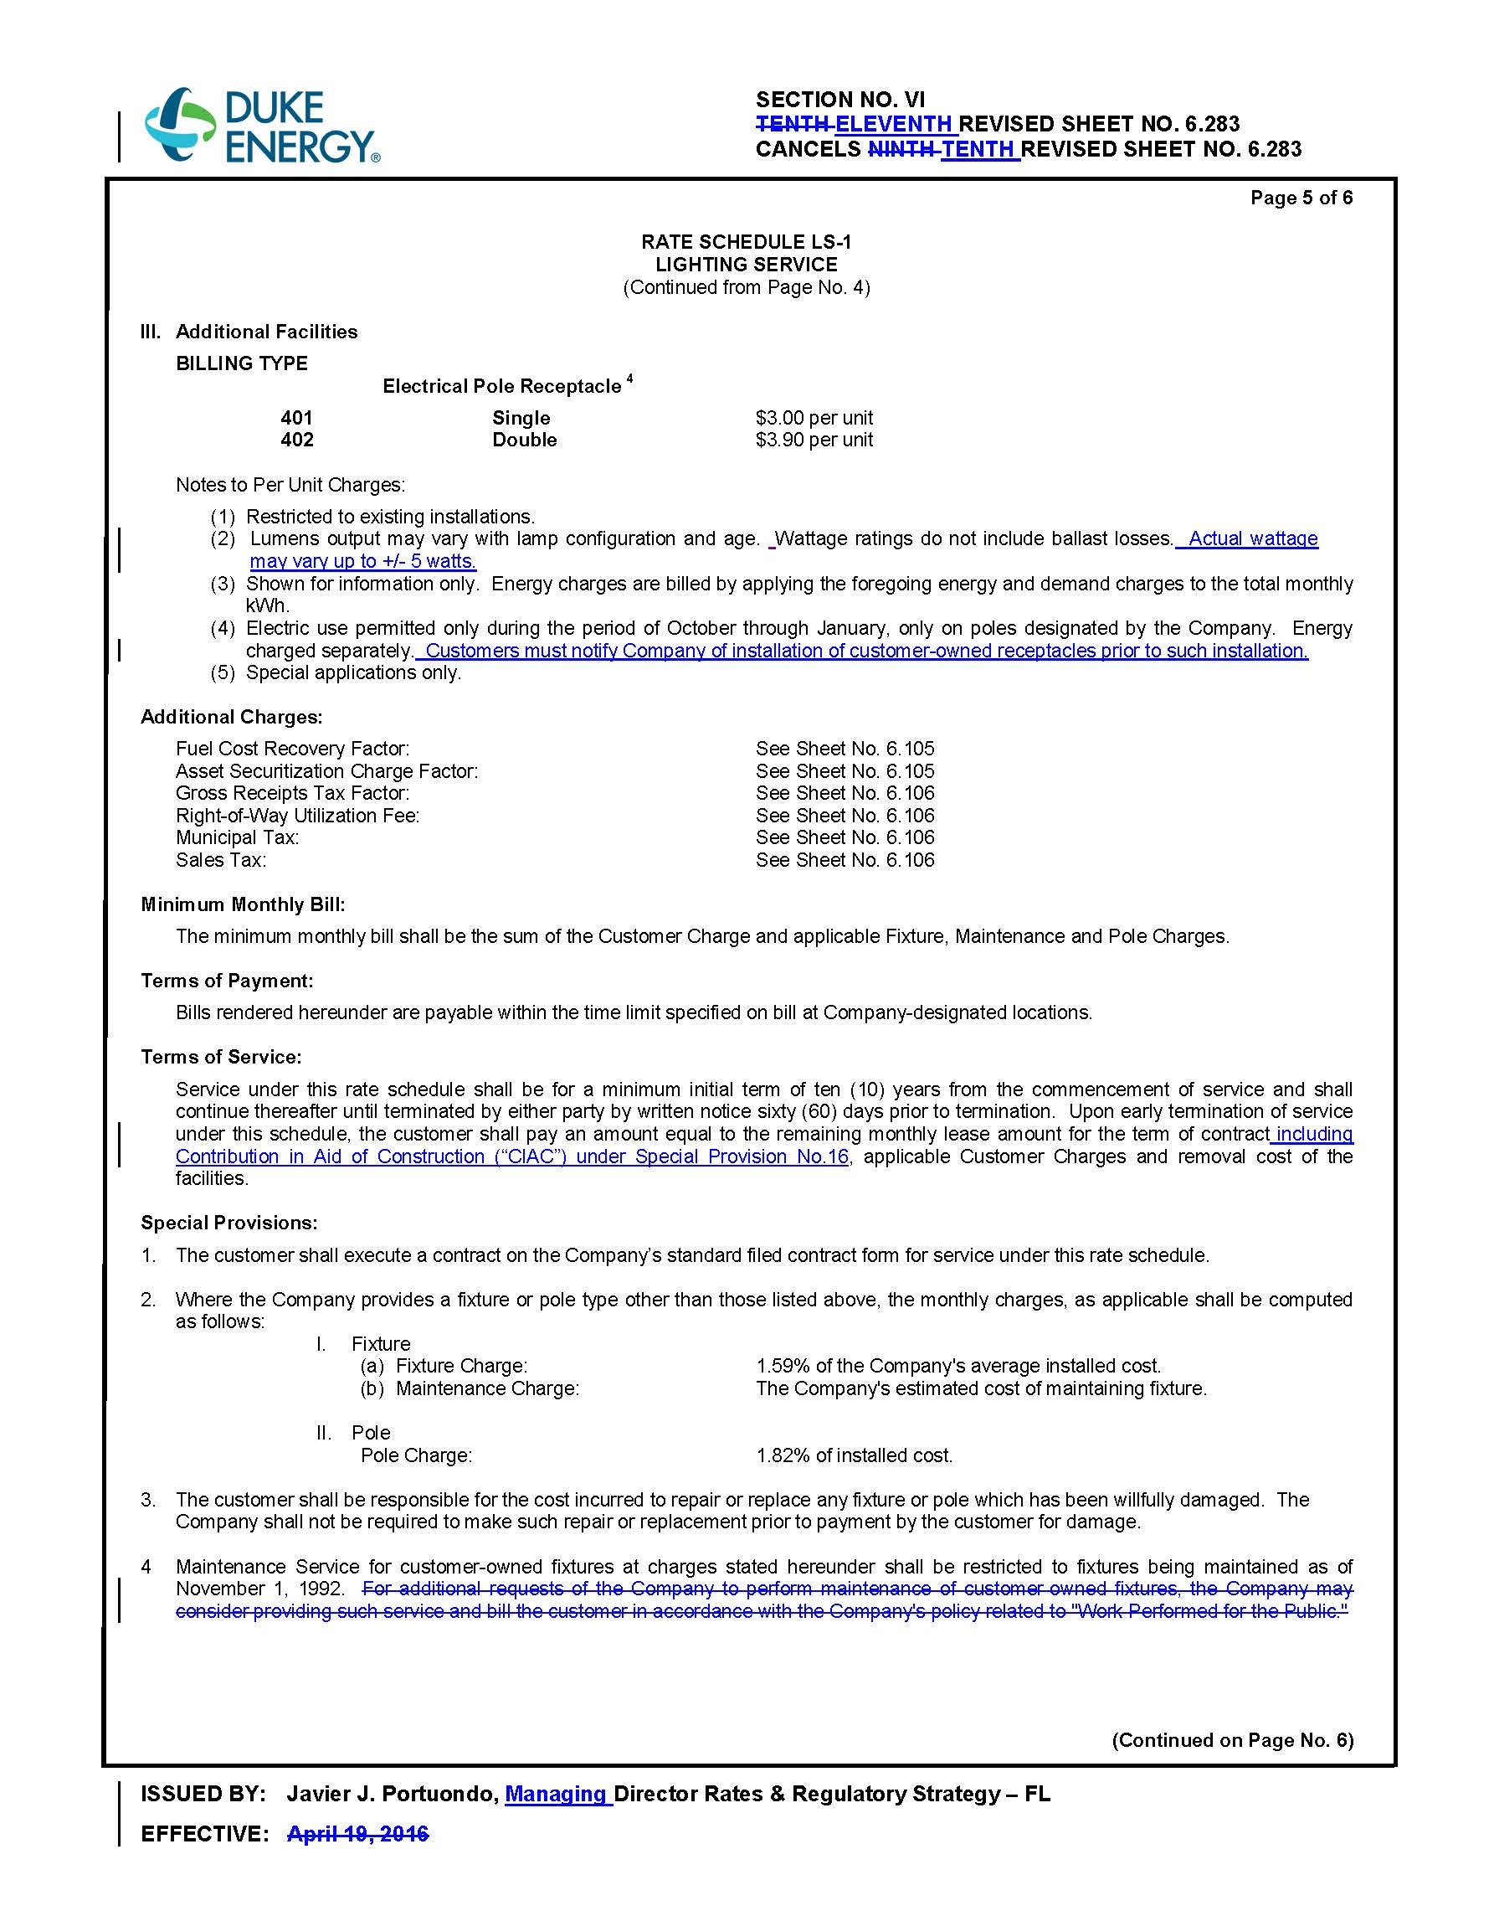
Page 2 of 6
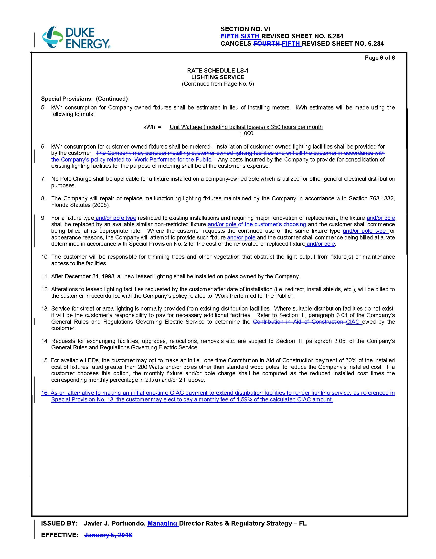
Page 3 of 6
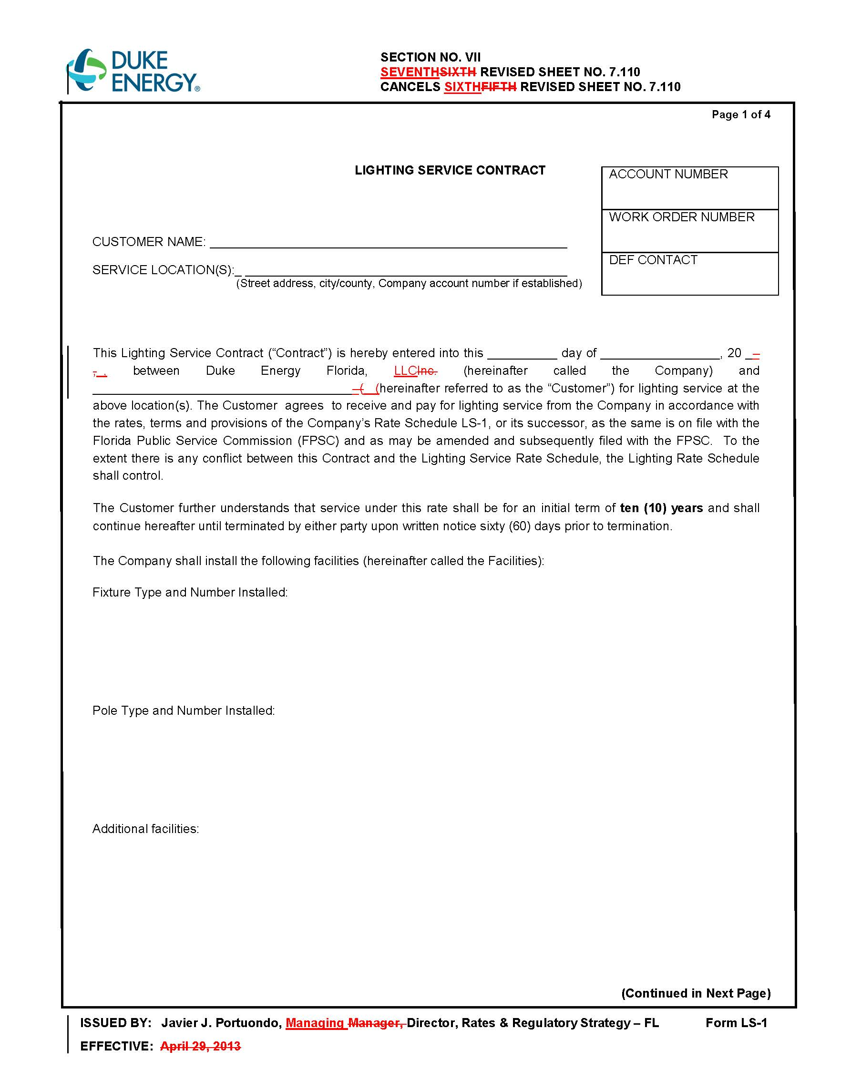
Page 4 of 6
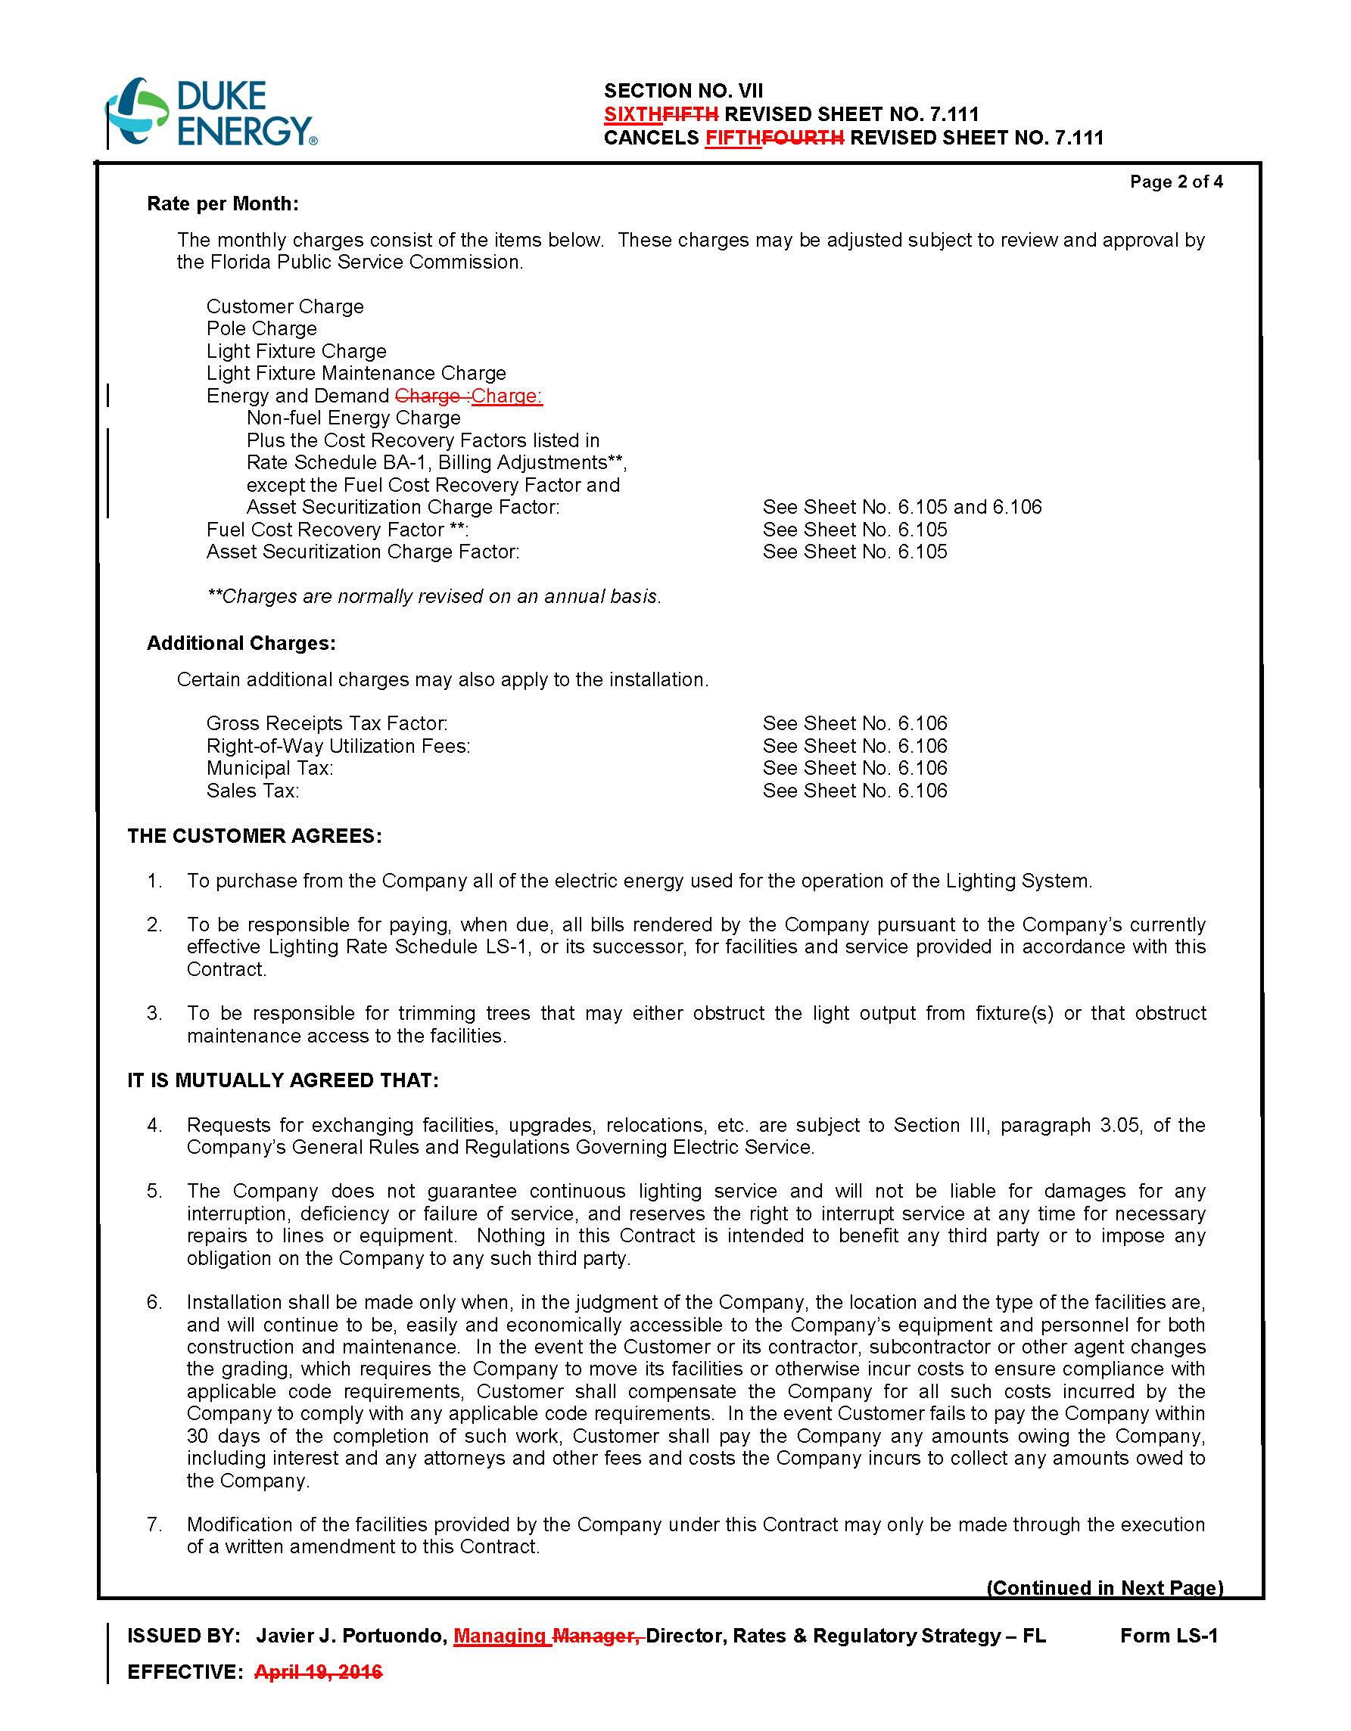
Page 5 of 6
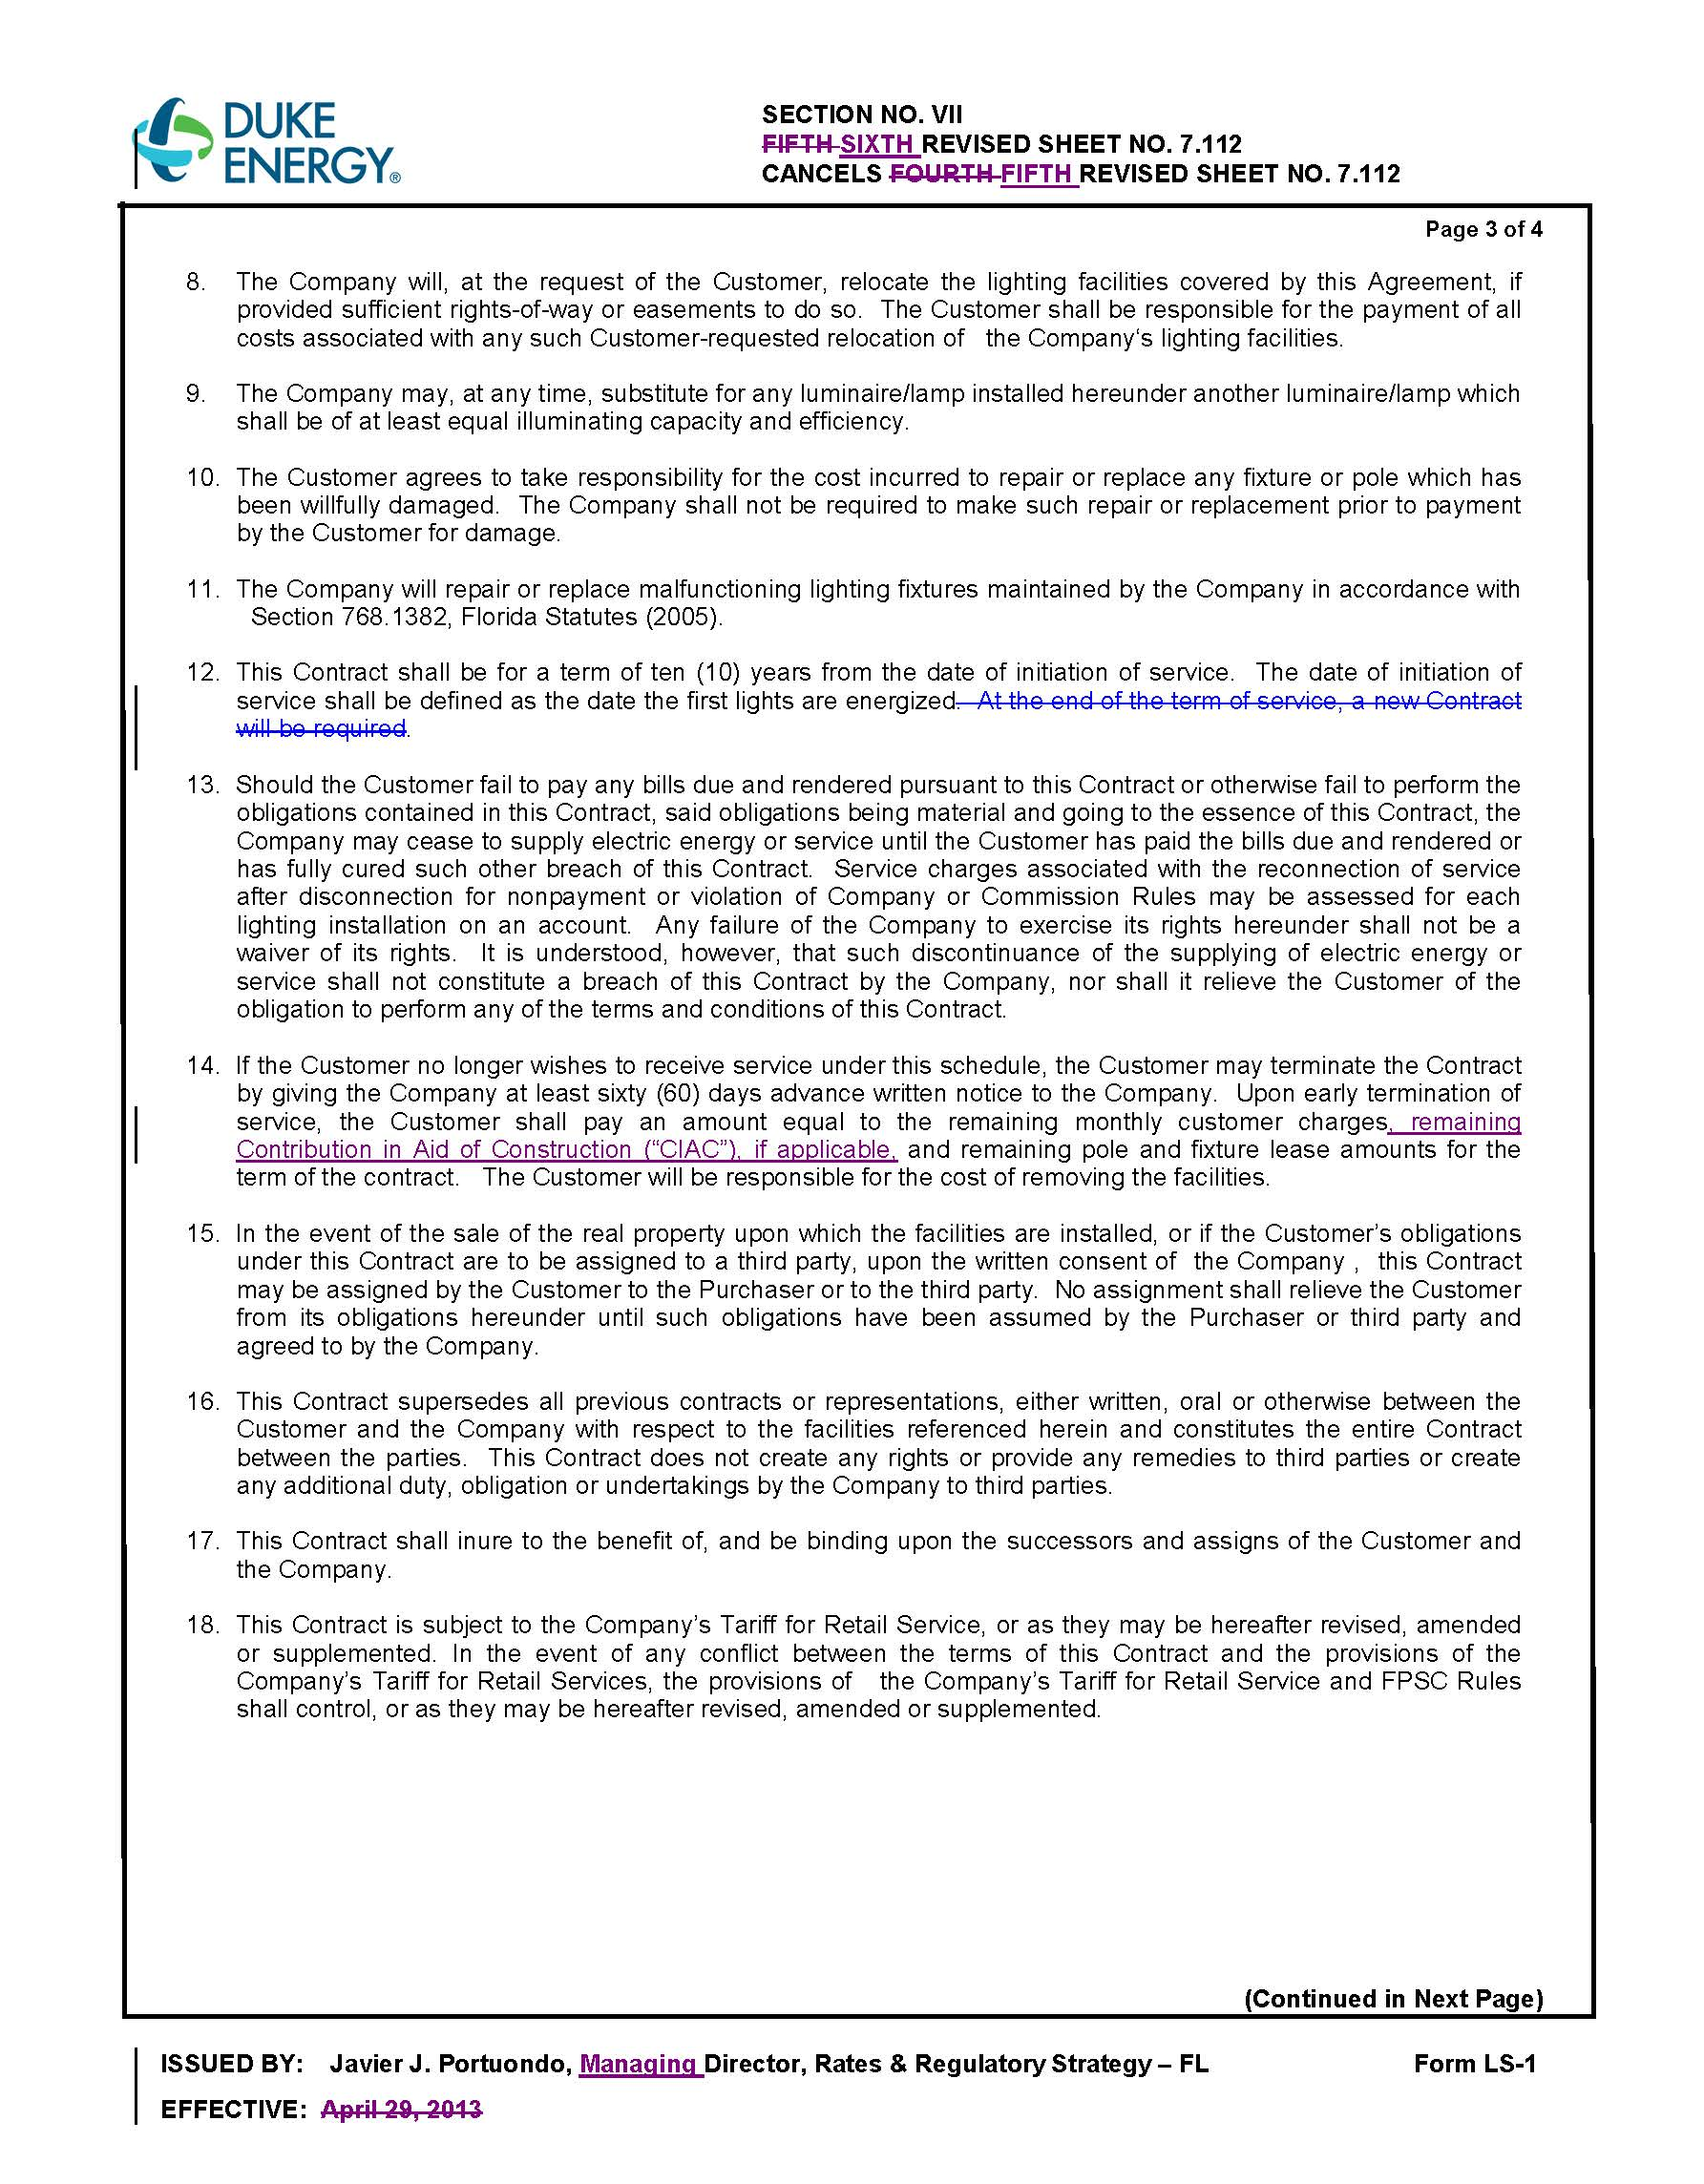
Page 6 of 6
