BEFORE THE FLORIDA PUBLIC SERVICE COMMISSION

In re: Petition for approval of area extension plan rate extension agreement with United States Sugar Corporation, by Florida City Gas. | DOCKET NO. 20180043-GU  ORDER NO. PSC-2018-0273-PAA-GU  ISSUED: May 31, 2018

The following Commissioners participated in the disposition of this matter:

ART GRAHAM, Chairman
JULIE I. BROWN
DONALD J. POLMANN
GARY F. CLARK
ANDREW GILES FAY

NOTICE OF PROPOSED AGENCY ACTION
ORDER APPROVING AREA EXTENSION PLAN AGREEMENT

BY THE COMMISSION:

NOTICE is hereby given by the Florida Public Service Commission that the action discussed herein is preliminary in nature and will become final unless a person whose interests are substantially affected files a petition for a formal proceeding, pursuant to Rule 25-22.029, Florida Administrative Code (F.A.C.).

BACKGROUND
On February 20, 2018, Florida City Gas (FCG or utility) filed a petition for approval of an Area Extension Plan Rate Extension Agreement (AEP Agreement) with United States Sugar Corporation (U.S. Sugar). The extension of the utility’s distribution facilities to serve U.S. Sugar and the surrounding area is known as the Glades AEP Project.
The Area Extension Plan (AEP) tariff is designed to provide FCG with an optional method to recover its capital investment to provide natural gas service to customers in a discrete geographical area who do not have gas service available. The AEP tariff provides for the determination of a surcharge based on the required investment and the projected gas sales to customers located in the geographical area. The surcharge is applied on a per therm basis over a ten year amortization period in addition to all other tariffed charges. The AEP tariff specifies the formula to calculate the charge. The utilization of the tariff itself does not require our approval.
The AEP tariff provides for a surcharge recalculation on the third anniversary of facilities being placed in service. The customers on the Glades AEP Project began taking service in 2012, therefore, a true-up was to occur in 2015. However, significant problems led FCG to request, in October 2015, that this Commission approve a variance to the AEP tariff to provide relief to customers on the Glades AEP Project. We approved FCG’s request in 2015 in Order No. PSC-16-0066-PAA-GU (2015 Order).
FCG stated that it has used the AEP tariff mechanism for eight projects since its 1995 implementation, and the AEP has proved helpful to the utility and customers that may have otherwise been unable to receive service. However, the primary customer on the Glades AEP Project, U.S. Sugar, continues to face unique and significant challenges and a surcharge recalculation pursuant to the 2015 Order may interfere with the economic wellbeing and development in the area. Therefore, FCG filed the instant petition. On April 18, 2018, FCG filed a supplemental amendatory petition to clarify that the AEP surcharge will terminate in 2024 for all Glades AEP Project customers except for U.S. Sugar as provided for in the AEP Agreement. The AEP Agreement is attached to this Order as Attachment A (Exhibit A to the AEP Agreement is not attached as it contains confidential information). We have jurisdiction over this matter pursuant to Section 366.06, Florida Statutes.

DECISION
In November 2012, when the customers on the Glades AEP Project first began taking service, the surcharge was calculated to be $0.241 per therm. This assumed reasonably forecasted natural gas usage and an amortization period of ten years. At the time of the original third year true-up, the utility determined that, to keep the amortization period to ten years, the new surcharge would have to be $0.515 per therm. This resulted from the unanticipated environmental issues, fewer new customers taking service than expected, and a citrus canker blight which caused U.S. Sugar to use significantly less natural gas than predicted. To reduce the financial strain on customers and encourage economic growth, FCG asked us to delay the surcharge recalculation by two years, until October 2017, with the amortization period extending through October of 2024. We approved the proposal and the rate remained $0.241 per therm.
In late 2017, the utility performed the true-up calculations required by our 2015 Order, but determined that extenuating factors have continued to impede natural gas usage and would make the recalculated rate increase to $0.629 per therm. FCG explained that the December 2017 through May 2018 citrus harvesting and processing season was on track to be the first productive year after more than a decade of disease, but Hurricane Irma destroyed up to 89 percent of the crops where U.S. Sugar sourced its fruit. The utility also notes that primarily the fruit, and not the trees, were damaged and citrus production should increase next season.
Being mindful of the significant economic impacts such a rate increase would have on the Glades AEP Project customers, including the largest industrial customer in the Glades project, U.S. Sugar, FCG proposed the special AEP Agreement with U.S. Sugar and revised AEP surcharges for all Glades customers. While the AEP Agreement is between the utility and U.S. Sugar and any affiliates (for whom the project was primarily designed), it provides benefits to all customers on the Glades AEP Project. The AEP Agreement and the revised AEP surcharges to all other Glades customers are discussed below.

Glades AEP Agreement

The AEP Agreement includes the following elements:
- The AEP surcharge will be set at $0.301 per therm instead of $0.629 (a reduction of $0.328 per therm).
- In exchange for the reduced rate, U.S. Sugar agrees to continue taking service for its Southern Gardens citrus processing facility (plant) and paying the AEP surcharge through November 2027 or until it has repaid 87.13 percent of the contribution in aid of construction (CIAC). In the event that a balance remains at the end of November 2027 or that U.S. Sugar terminates service at its plant early, U.S. Sugar will submit the remainder of the CIAC to FCG within 45 days.
- U.S. Sugar’s affiliates and subsidiaries agree to continue taking service and paying the AEP surcharge after the amortization period ends in 2024. Thereafter, if natural gas is no longer an economically viable option, U.S. Sugar’s affiliates and subsidiaries, excluding the plant, may provide reasonable documentation to that effect in order to cease taking service. U.S. Sugar’s affiliates and subsidiaries must provide at least 60 days notice to do so.
- Glades AEP surcharge recalculations will occur in November 2020 and November 2022, with one subsequent recalculation occurring upon U.S. Sugar demonstrating a six percent increase in annual natural gas consumption thereafter.

Other Glades AEP Customers

For the remaining customers on the Glades AEP Project, the AEP surcharge will also be set at $0.301 per therm (instead of the recalculated rate of $0.629 per therm). Similar to the AEP Agreement discussed above, AEP surcharge recalculations will occur in November 2020 and November 2022, with one subsequent recalculation occurring upon U.S. Sugar’s demonstrated six percent increase of natural gas consumption after November 2022. The utility explained that with U.S. Sugar being the largest customer in the Glades AEP Project, a six percent increase in consumption by U.S. Sugar would result in a reduction in the AEP surcharge, therefore benefitting all customers. As provided for in the 2015 Order, the AEP surcharge assessed to the Glades AEP Project customers will terminate in October 2024.
FCG stated that it has been able to contact 36 of 38 customers on the Glades AEP Project regarding the recalculated AEP rate. FCG claims that these customers have accepted the recalculated AEP rate. For the remaining two customers, FCG states that a representative left contact information.

Conclusion

The utility states that the proposed lower AEP surcharge will reduce recovery on the Glades AEP Project by approximately $5 million. However, according to the utility, the $5 million under-recovery will not affect the general body of rate payers and any unrecovered amount is a risk to the utility’s shareholders.
In FCG’s recent rate case, we approved changes to the AEP tariff that provides for true-ups on the third, fifth, seventh, and ninth anniversaries of the date when each AEP project goes into service. The utility stated that this will prevent spikes in AEP rates and allow for gradual adjustments over time, if needed. FCG also indicated that these true-up requirements will not apply to the Glades AEP Project.
After completing our review, we find that FCG’s proposal will benefit U.S. Sugar, the large industrial customer in the Glades Project area, who is facing unique economic challenges. The proposal will also give relief to the other customers by providing for a lower AEP rate. We therefore approve FCG’s request for the AEP Agreement and a variance from the AEP tariff.

Based on the foregoing, it is

ORDERED by the Florida Public Service Commission that the Area Extension Plan Rate Extension Agreement and Florida City Gas’s request for a variance from the Area Extension Plan tariff for the Glades Area Extension Plan Project is approved. It is further

ORDERED that the provisions of this Order, issued as proposed agency action, shall become final and effective upon the issuance of a Consummating Order unless an appropriate petition, in the form provided by Rule 28-106.201, Florida Administrative Code, is received by the Commission Clerk, 2540 Shumard Oak Boulevard, Tallahassee, Florida 32399-0850, by the close of business on the date set forth in the “Notice of Further Proceedings” attached hereto. It is further

ORDERED that, if no protest is filed by a person whose substantial interests are affected within 21 days of the issuance of the Order, this docket shall be closed upon the issuance of a Consummating Order.

By ORDER of the Florida Public Service Commission this 31st day of May, 2018.

/s/ Carlotta S. Stauffer
CARLOTTA S. STAUFFER
Commission Clerk
Florida Public Service Commission
2540 Shumard Oak Boulevard
Tallahassee, Florida 32399
(850) 413-6770
www.floridapsc.com

Copies furnished: A copy of this document is provided to the parties of record at the time of issuance and, if applicable, interested persons.

WLT

NOTICE OF FURTHER PROCEEDINGS OR JUDICIAL REVIEW

The Florida Public Service Commission is required by Section 120.569(1), Florida Statutes, to notify parties of any administrative hearing that is available under Section 120.57, Florida Statutes, as well as the procedures and time limits that apply. This notice should not be construed to mean all requests for an administrative hearing will be granted or result in the relief sought.

Mediation may be available on a case-by-case basis. If mediation is conducted, it does not affect a substantially interested person's right to a hearing.

The action proposed herein is preliminary in nature. Any person whose substantial interests are affected by the action proposed by this order may file a petition for a formal proceeding, in the form provided by Rule 28-106.201, Florida Administrative Code. This petition must be received by the Office of Commission Clerk, 2540 Shumard Oak Boulevard, Tallahassee, Florida 32399-0850, by the close of business on June 21, 2018.

In the absence of such a petition, this order shall become final and effective upon the issuance of a Consummating Order.

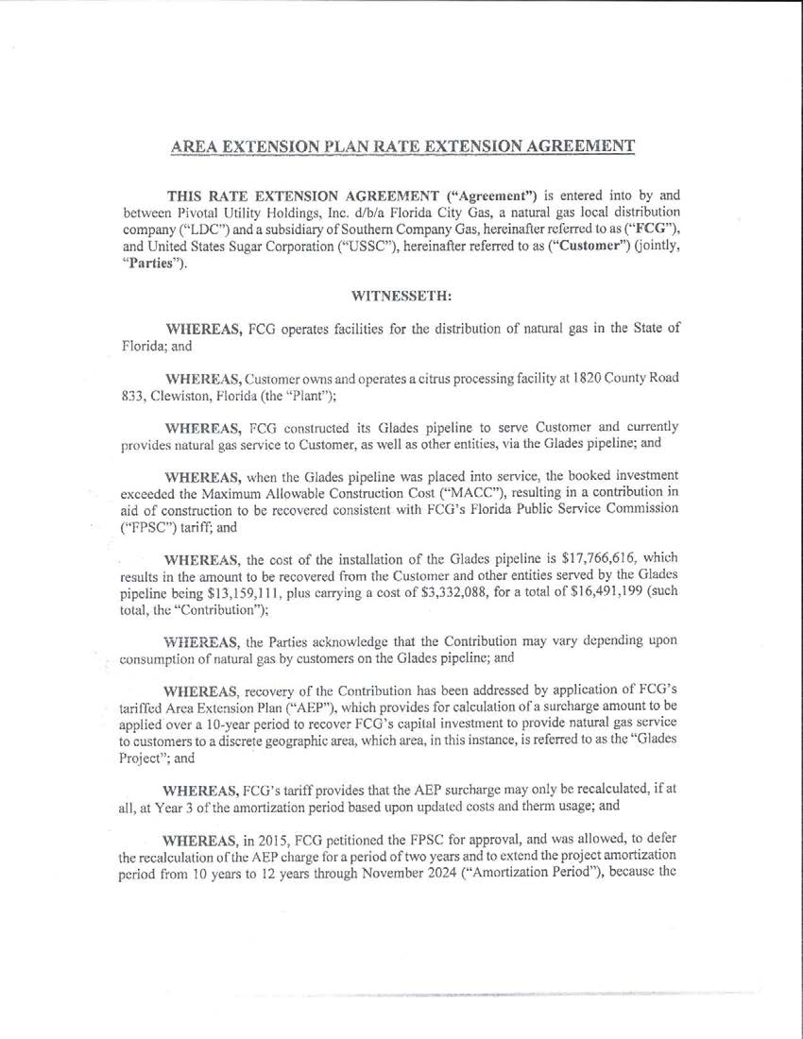
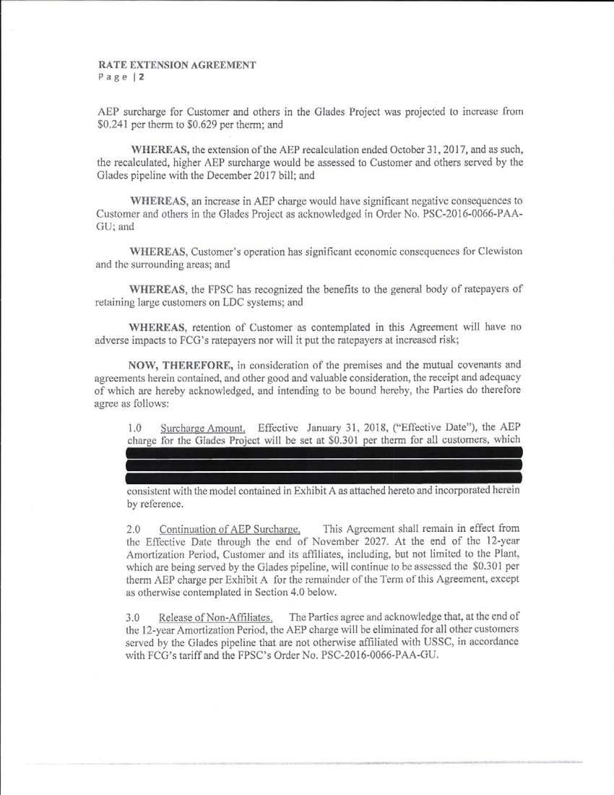

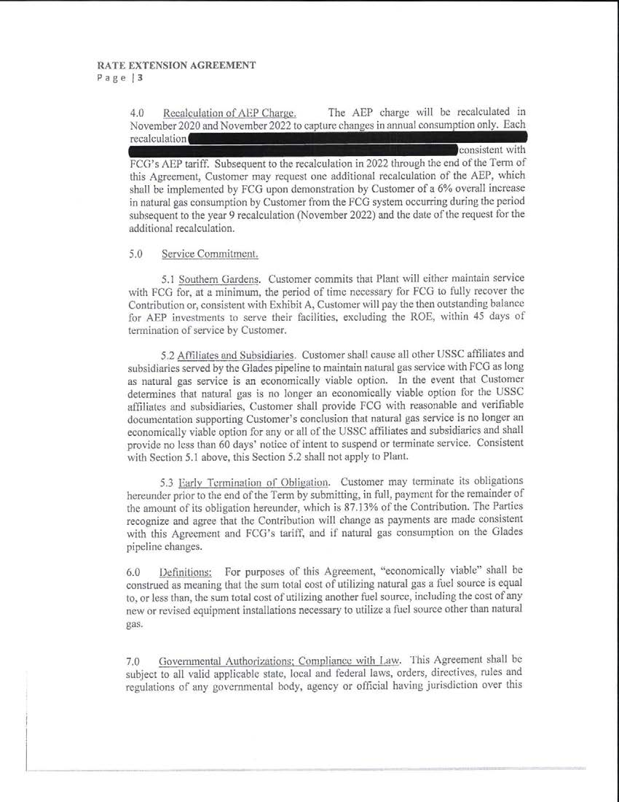

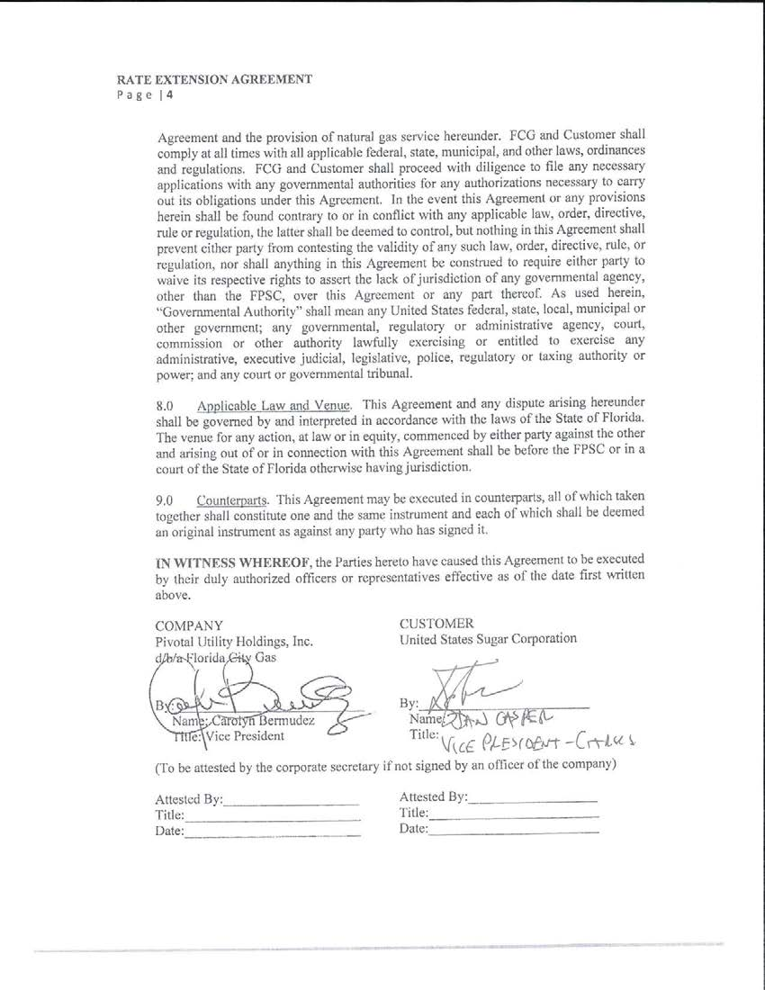

Order No. PSC-95-0506-FOF-GU, issued April 24, 1995, in Docket No. 950206-GU, In re: Petition for approval of tariffs governing extension of facilities by City Gas Company of Florida.
Order No. PSC-16-0066-PAA-GU, issued March 2, 2016, in Docket No. 150232-GU, In re: Petition for Approval of Variance to Delay Area Extension Program True-Up and Extend Amortization Period by Florida City Gas
Order No. PSC-2018-0190-FOF-GU, issued April 20, 2018, in Docket No. 20170179-GU, In re: Petition for rate increase by Florida City Gas

