BEFORE THE FLORIDA PUBLIC SERVICE COMMISSION

In re: Petition for limited proceeding to approve first solar base rate adjustment (SoBRA), effective September 1, 2018, by Tampa Electric Company. | DOCKET NO. 20170260-EI  ORDER NO. PSC-2018-0288-FOF-EI  ISSUED: June 5, 2018

The following Commissioners participated in the disposition of this matter:

ART GRAHAM, Chairman
JULIE I. BROWN
DONALD J. POLMANN
GARY F. CLARK
ANDREW GILES FAY

APPEARANCES:

JAMES D. BEASLEY, ESQUIRE, J. JEFFRY WAHLEN, ESQUIRE, Ausley McMullen, Post Office Box 391, Tallahassee, Florida 32302
On behalf of Tampa Electric Company (TECO).

CHARLES J. REHWINKEL, ESQUIRE, Deputy General Counsel, Office of Public Counsel, c/o The Florida Legislature, 111 West Madison Street, Room 812, Tallahassee, Florida 32399-1400
On behalf of the Citizens of the State of Florida (OPC)

WALT TRIERWEILER, ESQUIRE, Senior Attorney, Florida Public Service Commission, 2540 Shumard Oak Boulevard, Tallahassee, Florida 32399-0850
On behalf of the Florida Public Service Commission (Staff).

ROSANNE GERVASI, ESQUIRE, MARY ANNE HELTON, ESQUIRE, Florida Public Service Commission, 2540 Shumard Oak Boulevard, Tallahassee, Florida 32399-0850
Advisors to the Florida Public Service Commission.

KEITH HETRICK, ESQUIRE, General Counsel
Florida Public Service Commission, 2540 Shumard Oak Boulevard, Tallahassee, Florida 32399-0850
Advisors to the Florida Public Service Commission.

FINAL ORDER APPROVING TAMPA ELECTRIC COMPANY’S
FIRST SOLAR RATE BASE ADJUSTMENTS

BY THE COMMISSION:

BACKGROUND

In 2017, the Commission approved Tampa Electric Company’s (TECO) 2017 Amended and Restated Stipulation and Settlement Agreement (2017 Settlement Agreement) that included a Solar Base Rate Adjustment (SoBRA) mechanism, which provides for the recovery of costs associated with solar projects that meet the criteria laid out in the 2017 Settlement Agreement. As contemplated in the 2017 Settlement Agreement, on December 14, 2017, TECO filed its Petition for a Limited Proceeding to Approve First SoBRA Effective September 1, 2018 (SoBRA Petition). TECO filed an amended SoBRA Petition on February 14, 2018, which takes into account the impact of the Tax Cuts and Jobs Act of 2017 enacted by the United States Congress on December 20, 2017, and signed into law on December 22, 2017, by the President.

In its SoBRA Petition, TECO seeks approval for Tranche One--the Balm Solar and Payne Creek Solar projects (the 2018 SoBRA projects). The 2018 SoBRA projects are the first of four tranches for which TECO may seek approval pursuant to the 2017 Settlement Agreement. Under subparagraph 6(b) of the 2017 Settlement Agreement, September 1, 2018, is the earliest in-service and rate change date for Tranche One. Subparagraph 6(b) also establishes maximum MW and revenue requirement thresholds: Tranche One cannot exceed 150 MW and $30.6 million in revenue requirements. The projects must be cost effective and projected to fall under the $1500 per kilowatt alternating current (kWac) installed cost cap as required by subparagraphs 6(d) and 6(g).

The Office of Public Counsel (OPC) and the Florida Industrial Power Users Group (FIPUG) intervened. We held a hearing on May 7, 2018 to determine whether TECO fulfilled the 2017 Settlement Agreement requirements regarding the 2018 SoBRA projects. We have jurisdiction over the subject matter under the provisions of Chapter 366, Florida Statutes (F.S.).

DECISION

The Balm Solar project is a 74.4 MW project in Hillsborough County, and the Payne Creek Solar project is a 70.3 MW project in Polk County. Both projects have a September 1, 2018, in-service date. No party contested the $1,324 per kWac projected cost for Payne Creek Solar or the $1,480 per kWac projected cost for Balm Solar. Both projects fall below the installed Capital Cost threshold of $1,500 per kWac, established by subparagraph 6(d) of the 2017 Agreement. Under subparagraph 6(c), the average projected capital cost for both projects cannot exceed the $1,404 kWac threshold. Since the 2018 average for both projects is $1,475 kWac, they meet the average threshold established by subparagraph 6(c).

TECO Witness Rocha testified the 2018 SoBRA projects lower the utility’s projected cumulative present value revenue requirement (CPVRR) by $136.6 million when compared to the company’s projected CPVRR without the 2018 SoBRA projects included. We analyzed the CPVRR under a variety of fuel and emissions scenarios and found them to be cost effective under each scenario. Accordingly, we find the 2018 SoBRA projects are cost effective as required by subparagraph 6(g) of the 2017 Settlement Agreement.

In addition, TECO Witness Rocha calculated the revenue requirement using the projected installed cost provided in TECO Witness Ward’s testimony. The annual revenue requirement associated with TECO’s 2018 SoBRA projects is $24,245,000, of which $389,000 will be attributed to the sharing mechanism established by the 2017 Settlement Agreement. The sharing mechanism allows TECO to share with its customers any actual cost savings below the installed cost cap. We find the $24,245,000 annual revenue requirement falls below the $30,600,000 revenue requirement threshold established by the 2017 Settlement Agreement.

Based on the record before us and for the reasons discussed above, we find the 2018 SoBRA projects meet all of the eligibility requirements necessary for cost recovery pursuant to paragraph 6 of the 2017 Settlement Agreement. Therefore, TECO’s petition for cost recovery of the 2018 SoBRA projects is approved. In addition, at the conclusion of the hearing, OPC argued that after hearing the evidence, it still believed that the 2017 Settlement Agreement was in the public interest.

Having approved TECO’s petition for cost recovery, we approve the attached tariff sheets, which reflect the base rate increase necessary to recover the revenue requirement associated with the 2018 SoBRA projects. These tariff revisions are approved with a September 1, 2018, effective date.

Based on the foregoing, it is

ORDERED by the Florida Public Service Commission that the 2018 SoBRA projects are approved for cost recovery because they fulfill the requirements established by paragraph 6 of the 2017 Settlement Agreement. It is further

ORDERED that the attached tariffs reflecting the change in TECO’s revenue requirement are approved with a September 1, 2018, effective date. It is further

ORDERED this docket shall be closed.

By ORDER of the Florida Public Service Commission this 5th day of June, 2018.

/s/ Carlotta S. Stauffer
CARLOTTA S. STAUFFER
Commission Clerk
Florida Public Service Commission
2540 Shumard Oak Boulevard
Tallahassee, Florida 32399
(850) 413-6770
www.floridapsc.com

Copies furnished: A copy of this document is provided to the parties of record at the time of issuance and, if applicable, interested persons.

WLT

NOTICE OF FURTHER PROCEEDINGS OR JUDICIAL REVIEW

The Florida Public Service Commission is required by Section 120.569(1), Florida Statutes, to notify parties of any administrative hearing or judicial review of Commission orders that is available under Sections 120.57 or 120.68, Florida Statutes, as well as the procedures and time limits that apply. This notice should not be construed to mean all requests for an administrative hearing or judicial review will be granted or result in the relief sought.

Any party adversely affected by the Commission's final action in this matter may request: 1) reconsideration of the decision by filing a motion for reconsideration with the Office of Commission Clerk, 2540 Shumard Oak Boulevard, Tallahassee, Florida 32399-0850, within fifteen (15) days of the issuance of this order in the form prescribed by Rule 25-22.060, Florida Administrative Code; or 2) judicial review by the Florida Supreme Court in the case of an electric, gas or telephone utility or the First District Court of Appeal in the case of a water and/or wastewater utility by filing a notice of appeal with the Office of Commission Clerk, and filing a copy of the notice of appeal and the filing fee with the appropriate court. This filing must be completed within thirty (30) days after the issuance of this order, pursuant to Rule 9.110, Florida Rules of Appellate Procedure. The notice of appeal must be in the form specified in Rule 9.900(a), Florida Rules of Appellate Procedure.

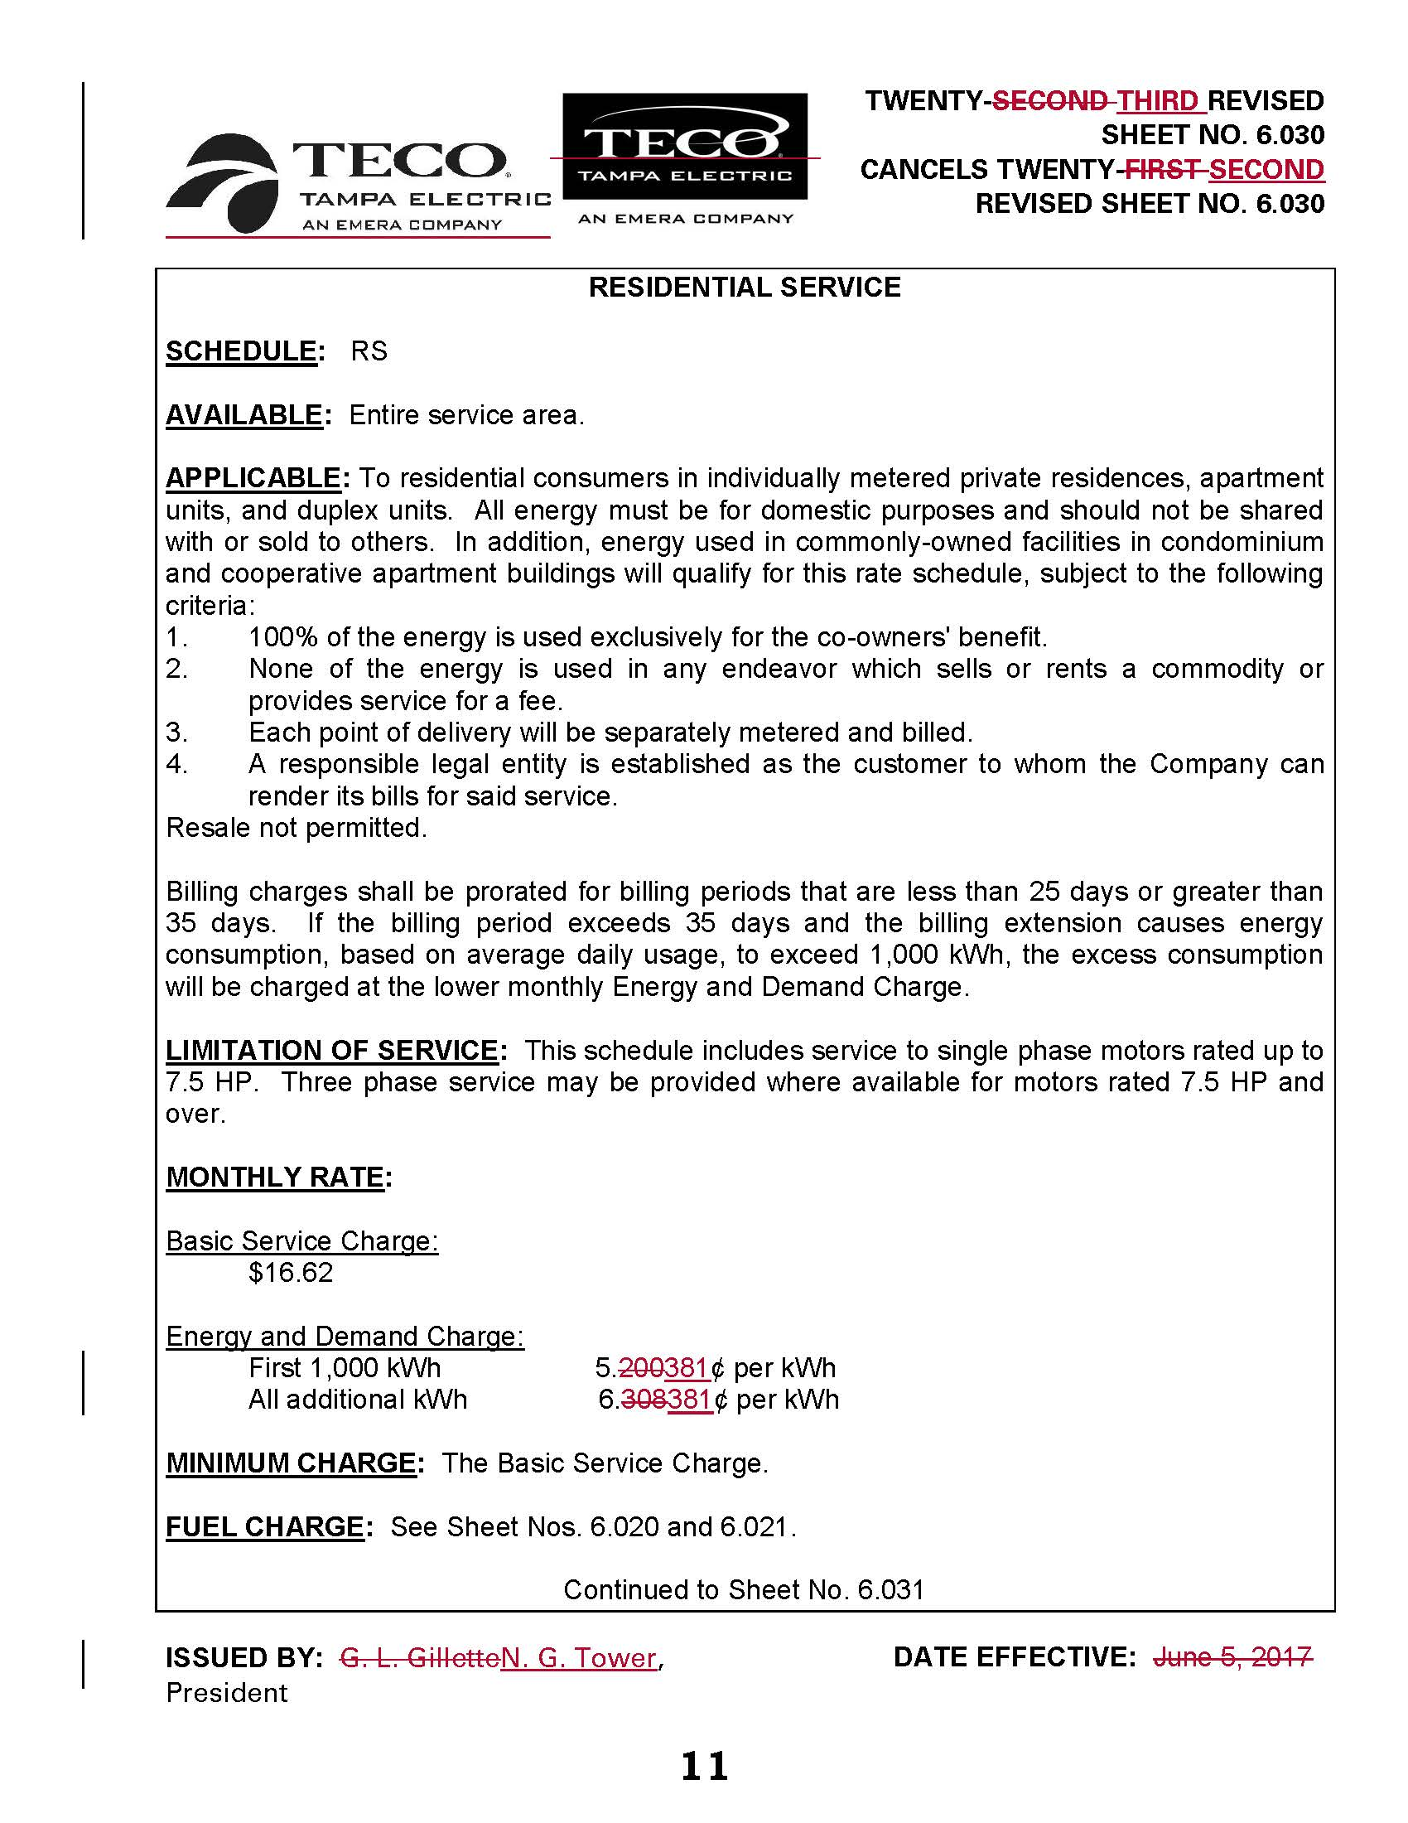

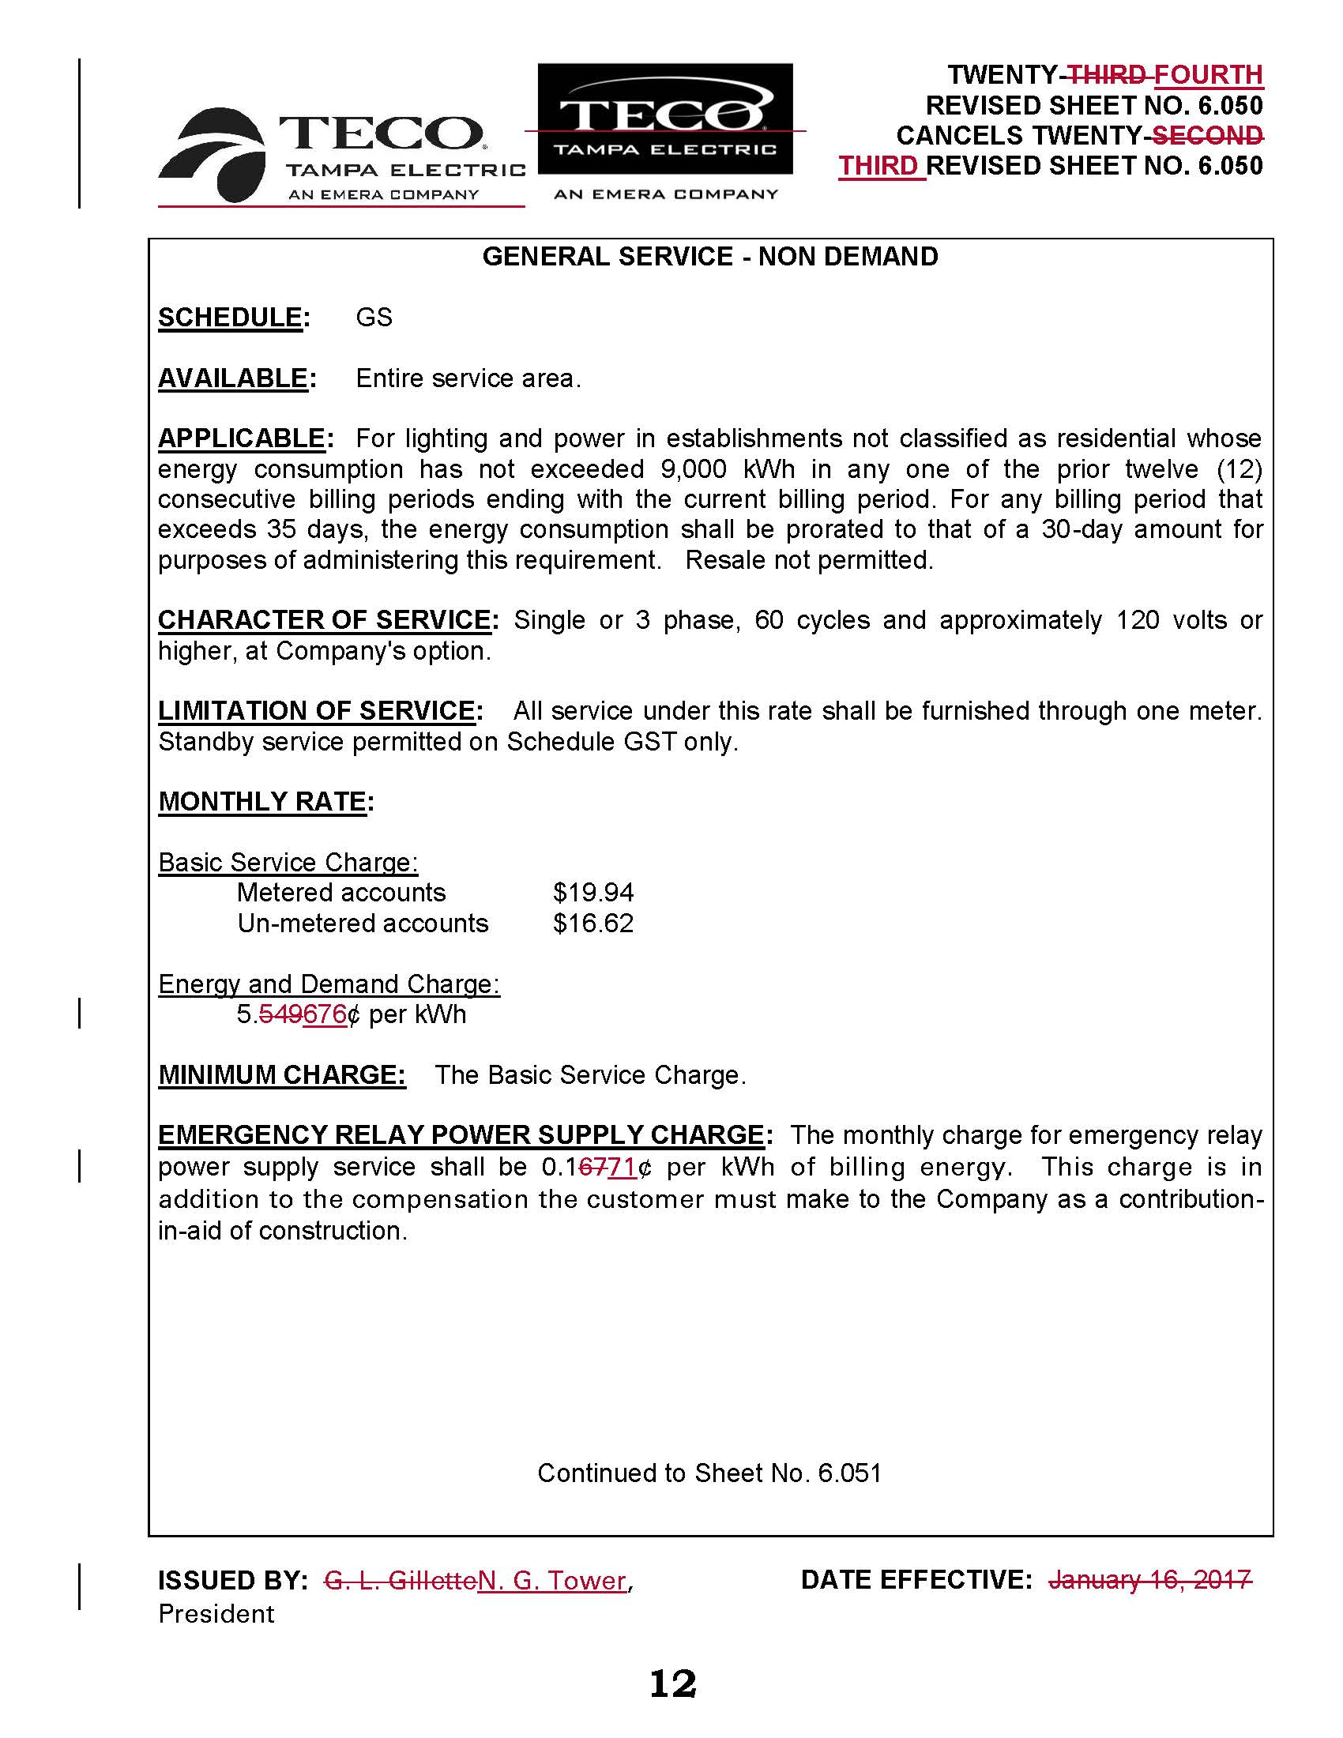

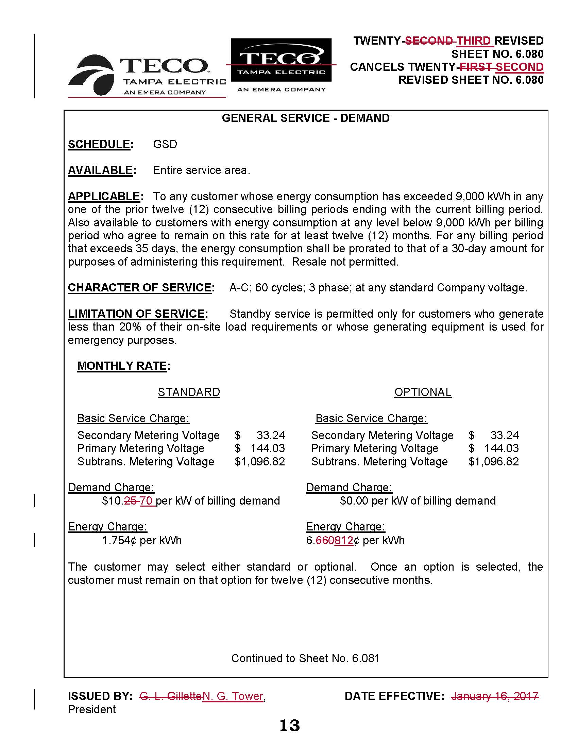

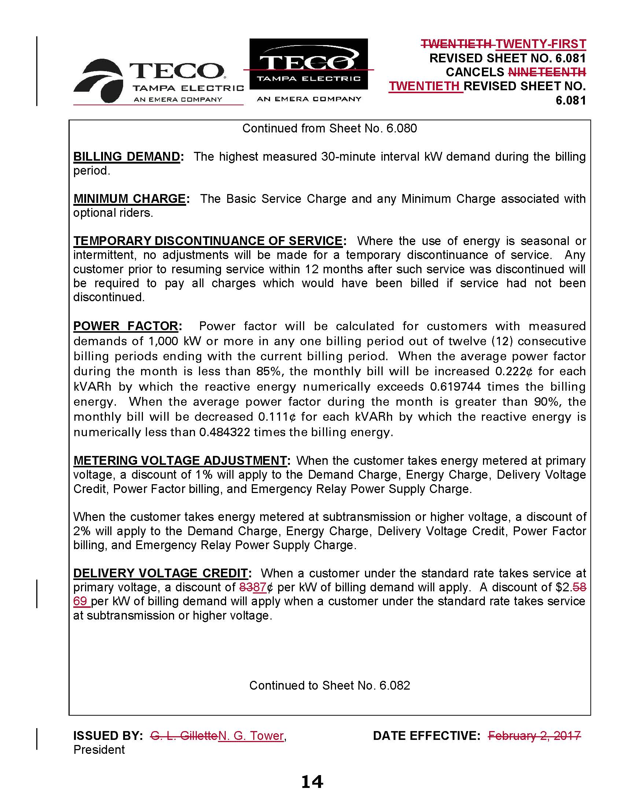

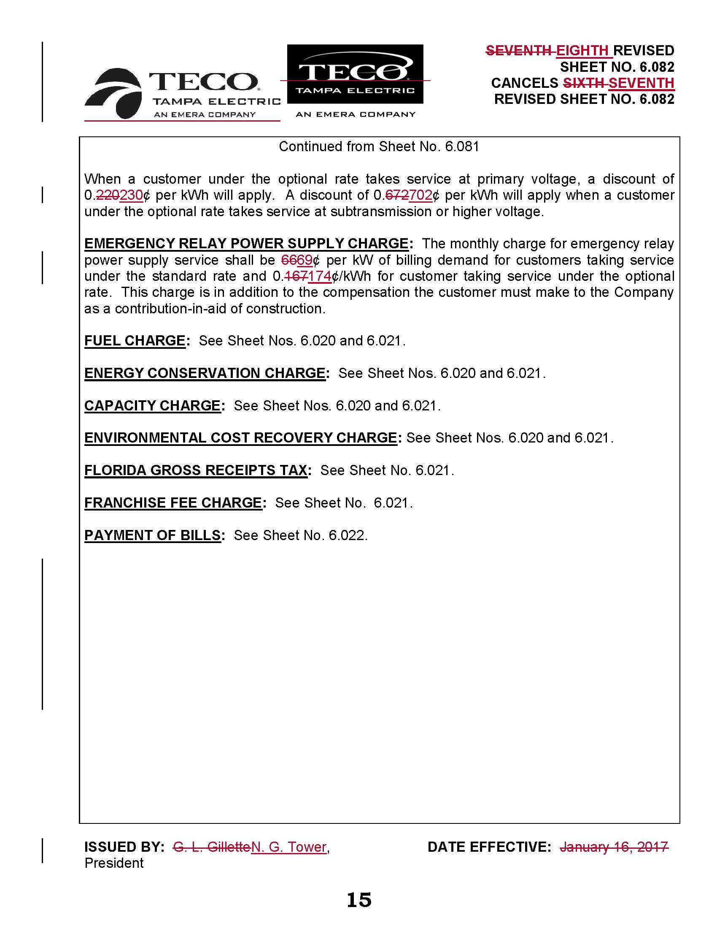

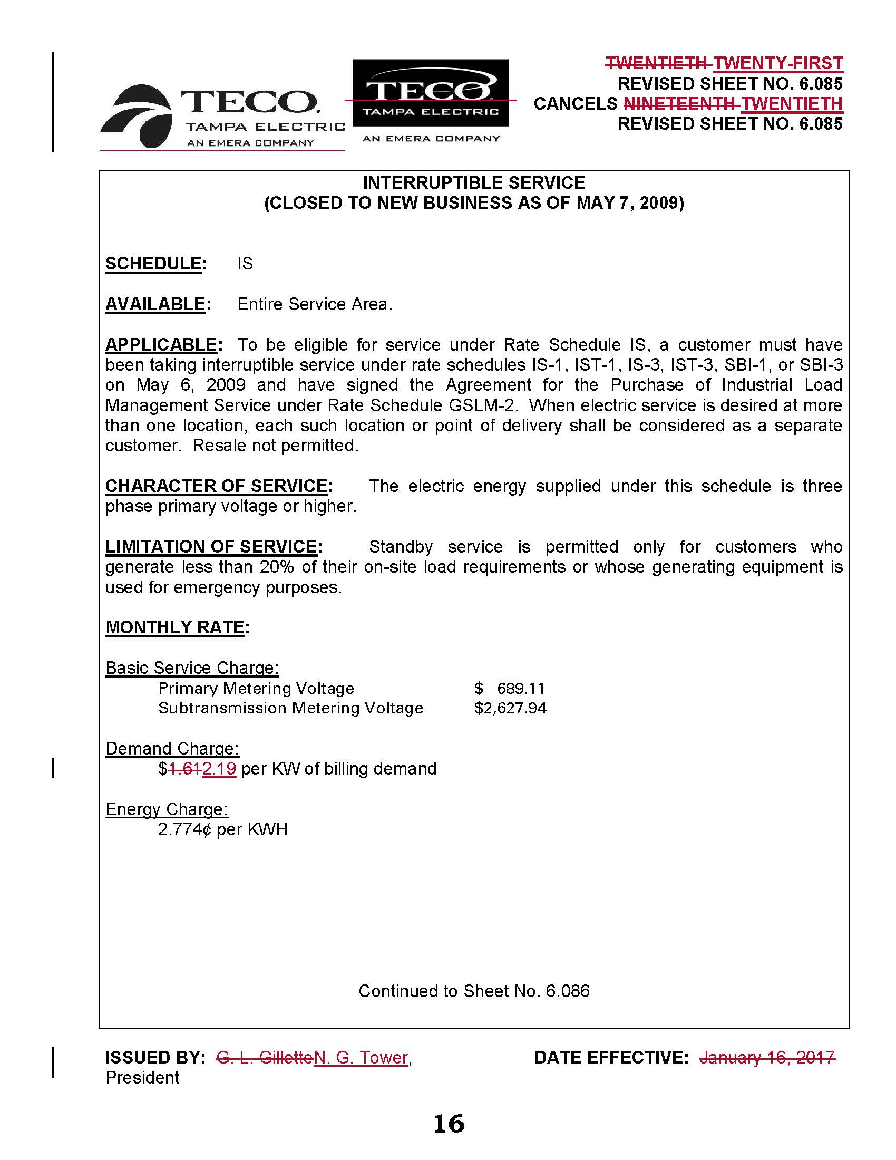

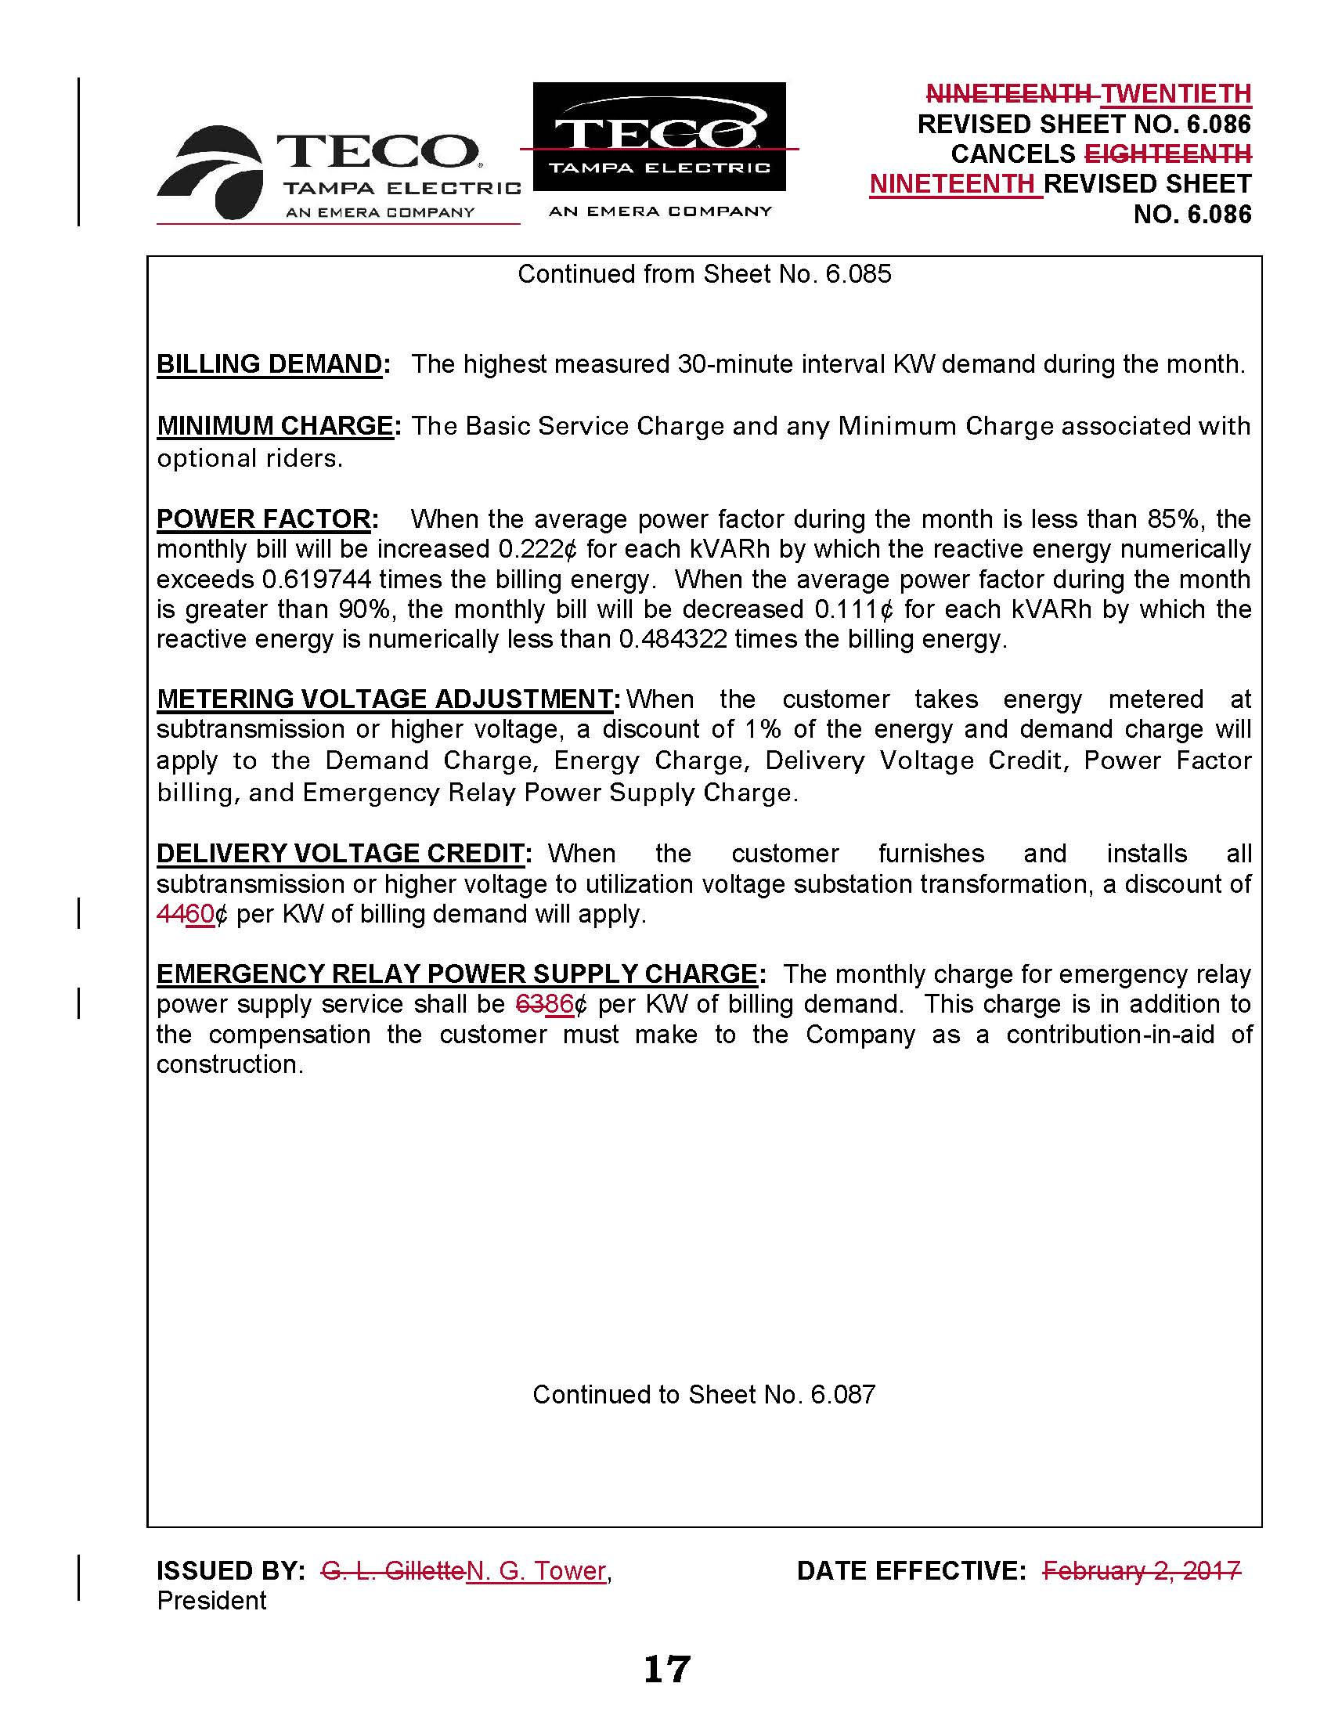

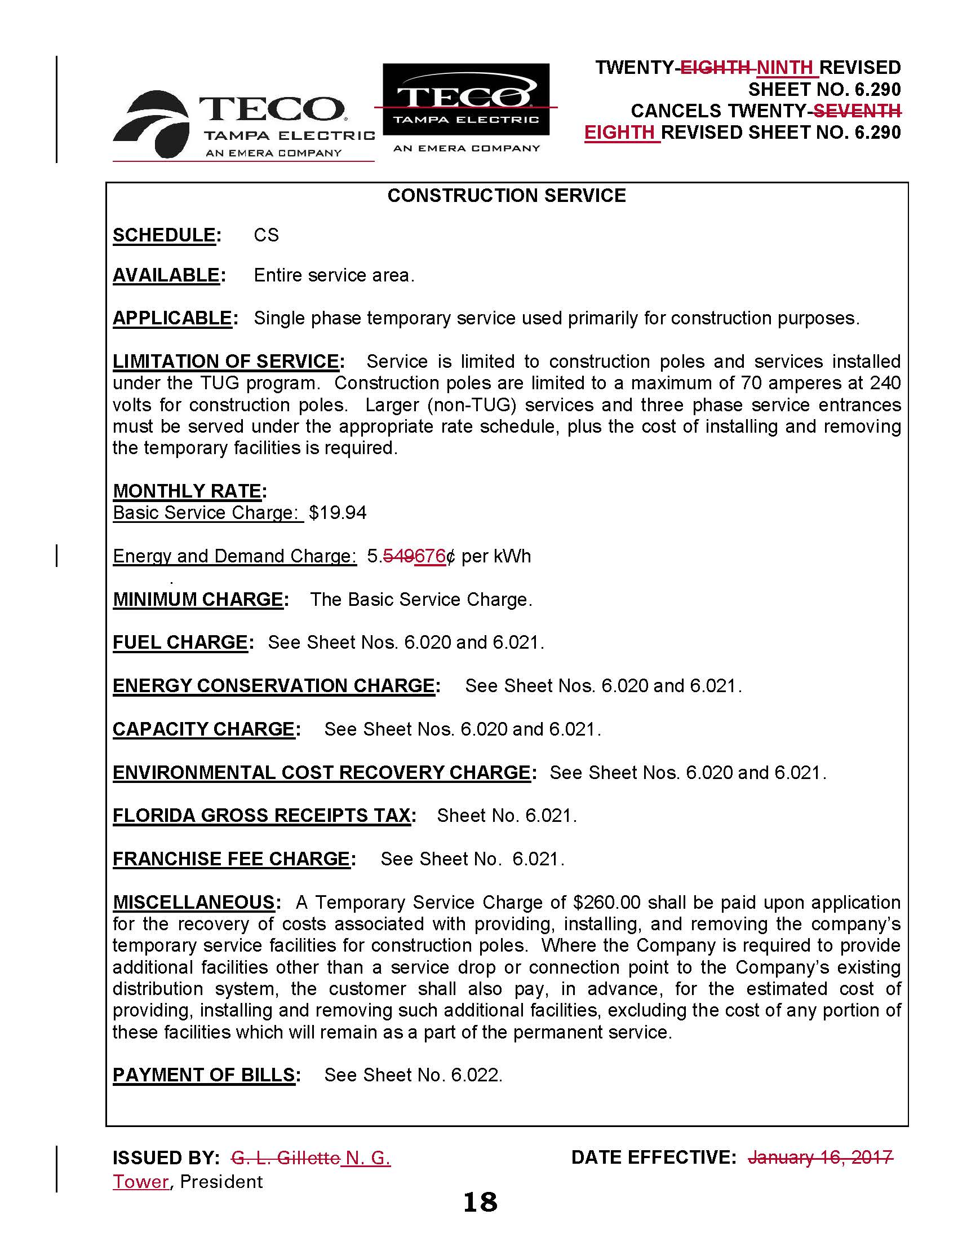

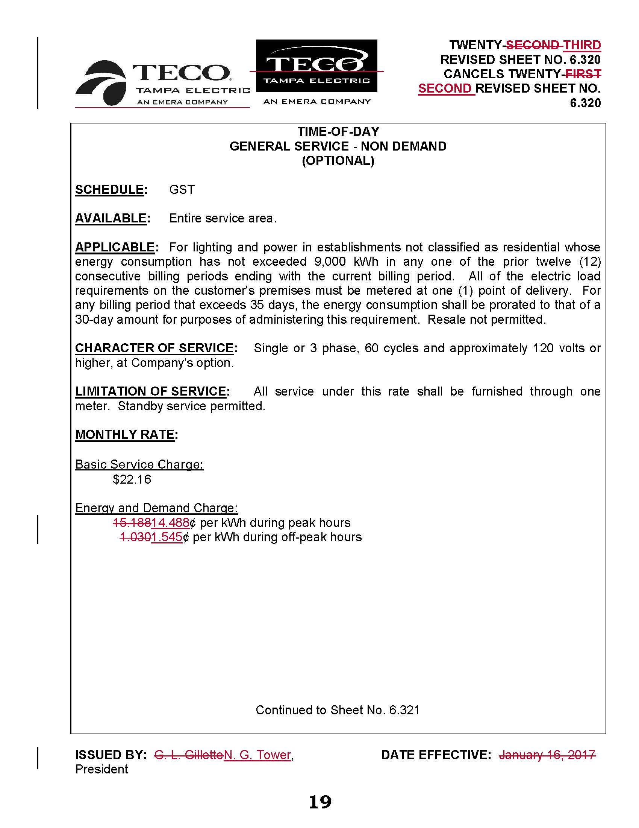

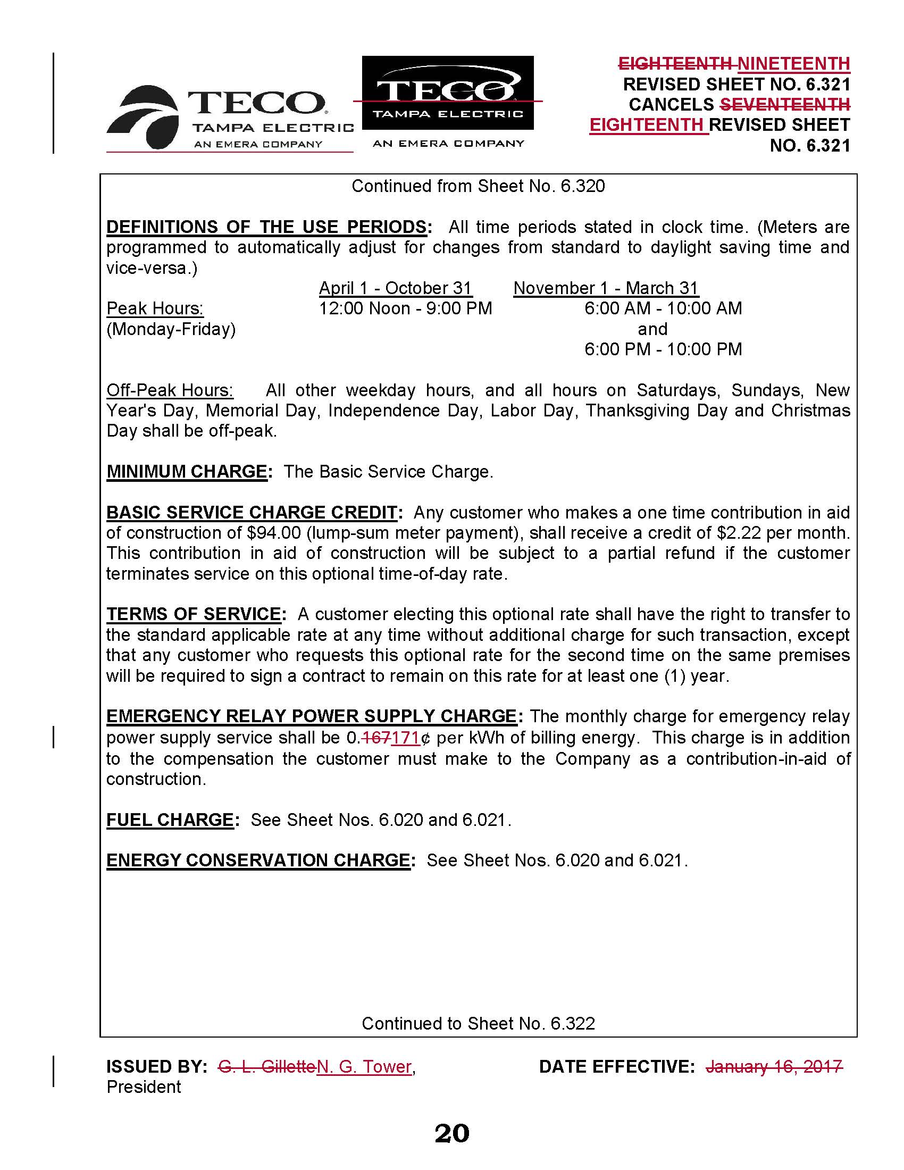

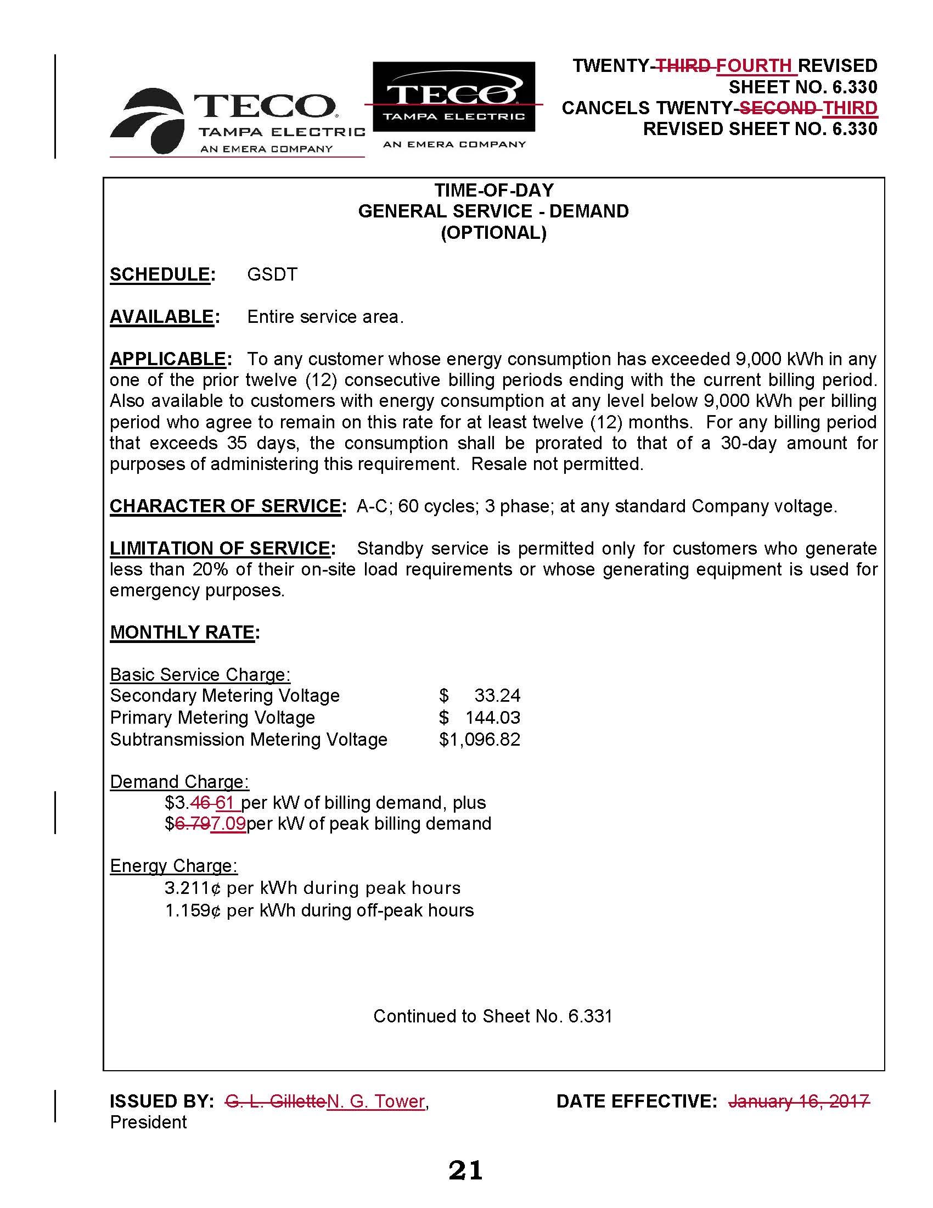

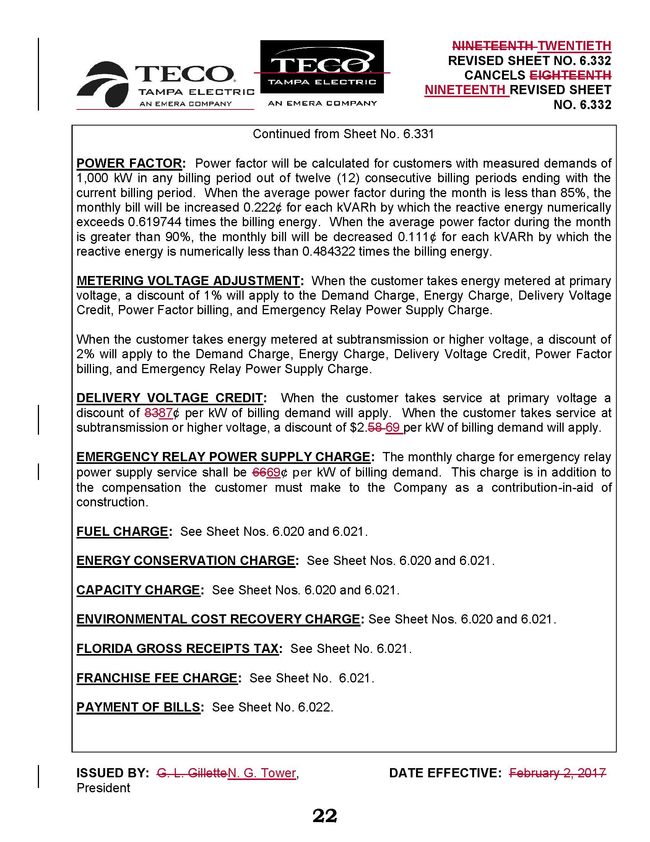

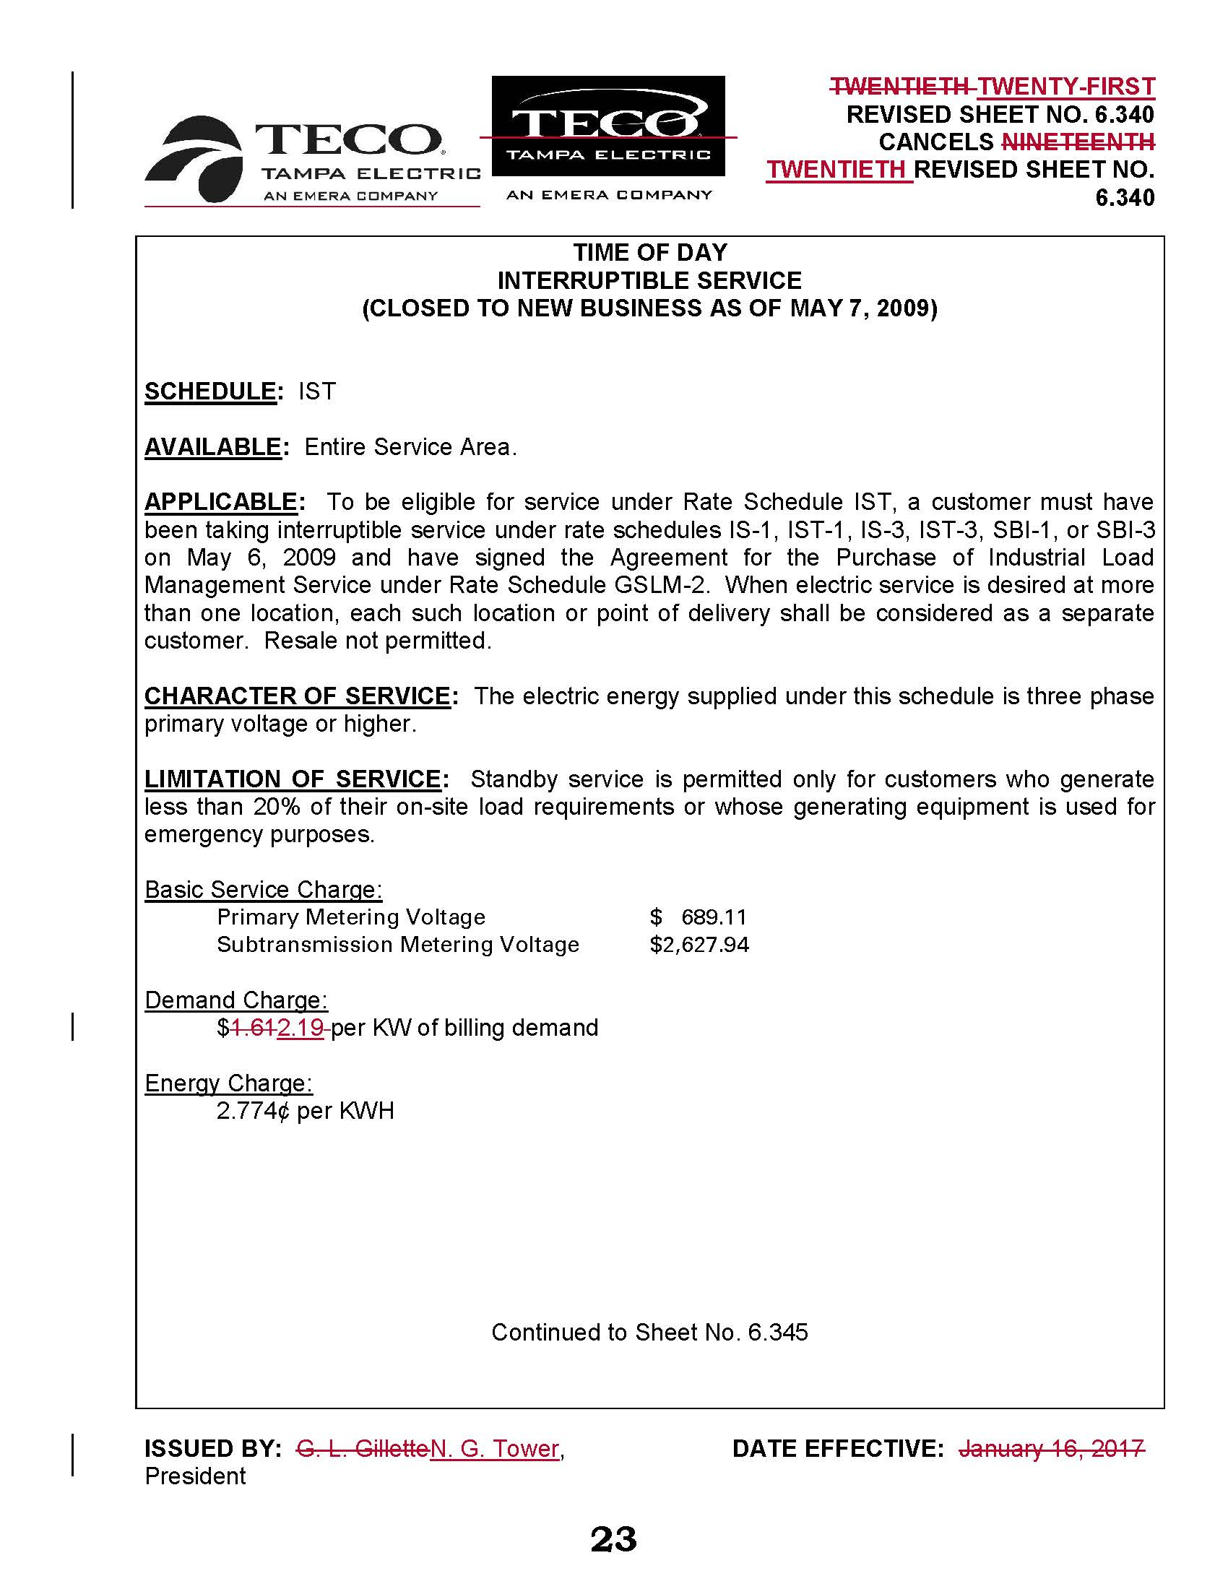

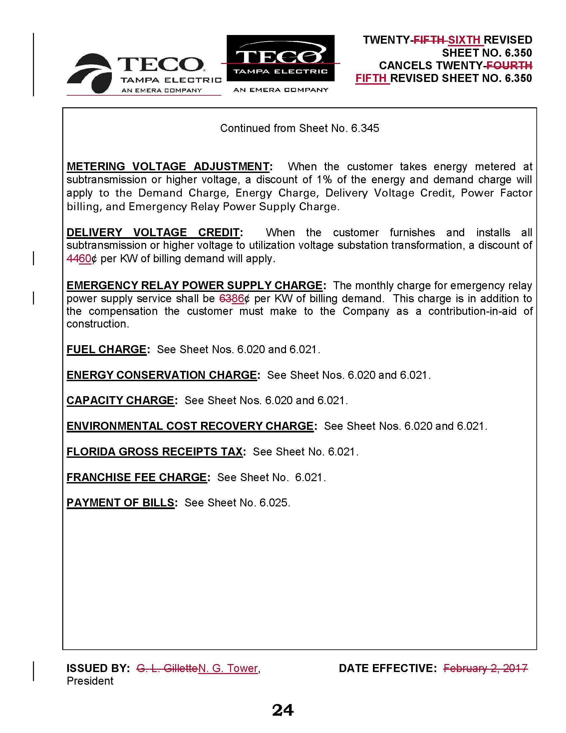

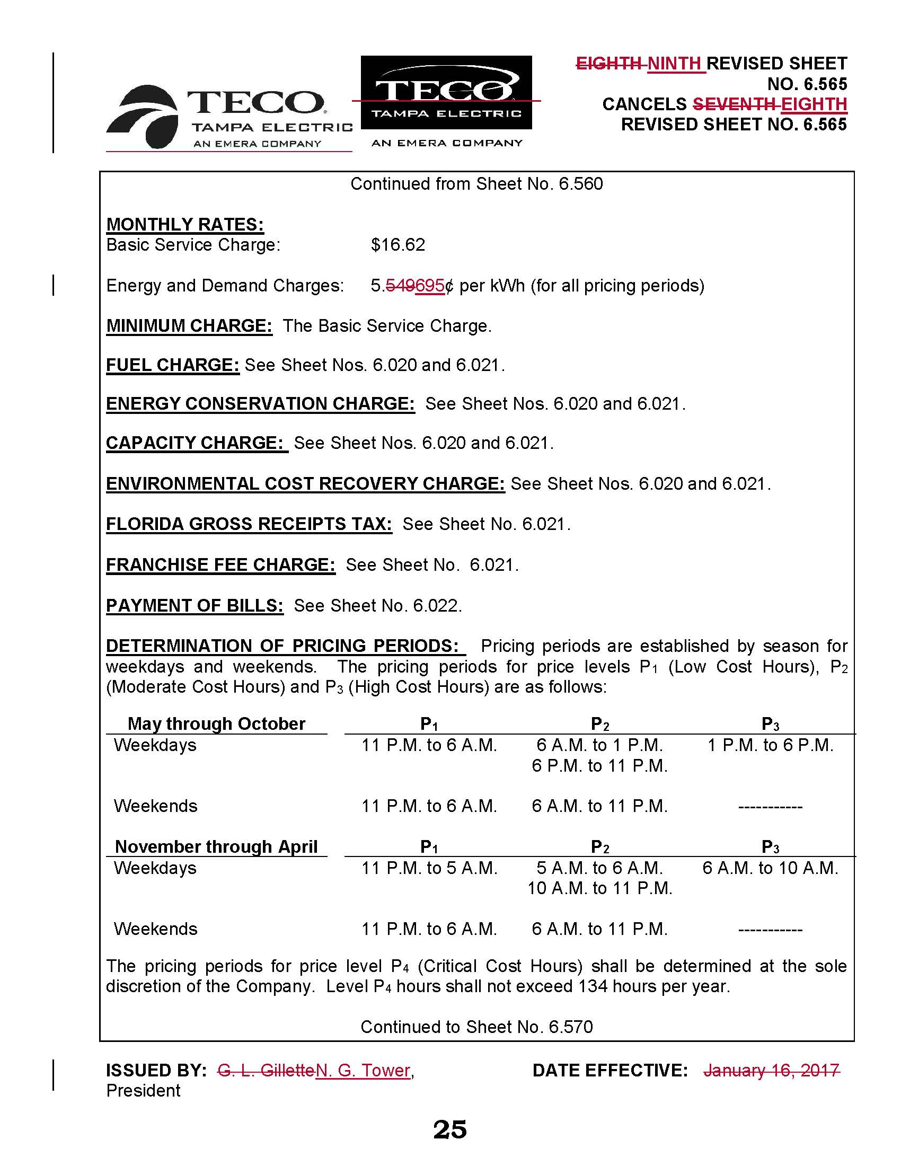

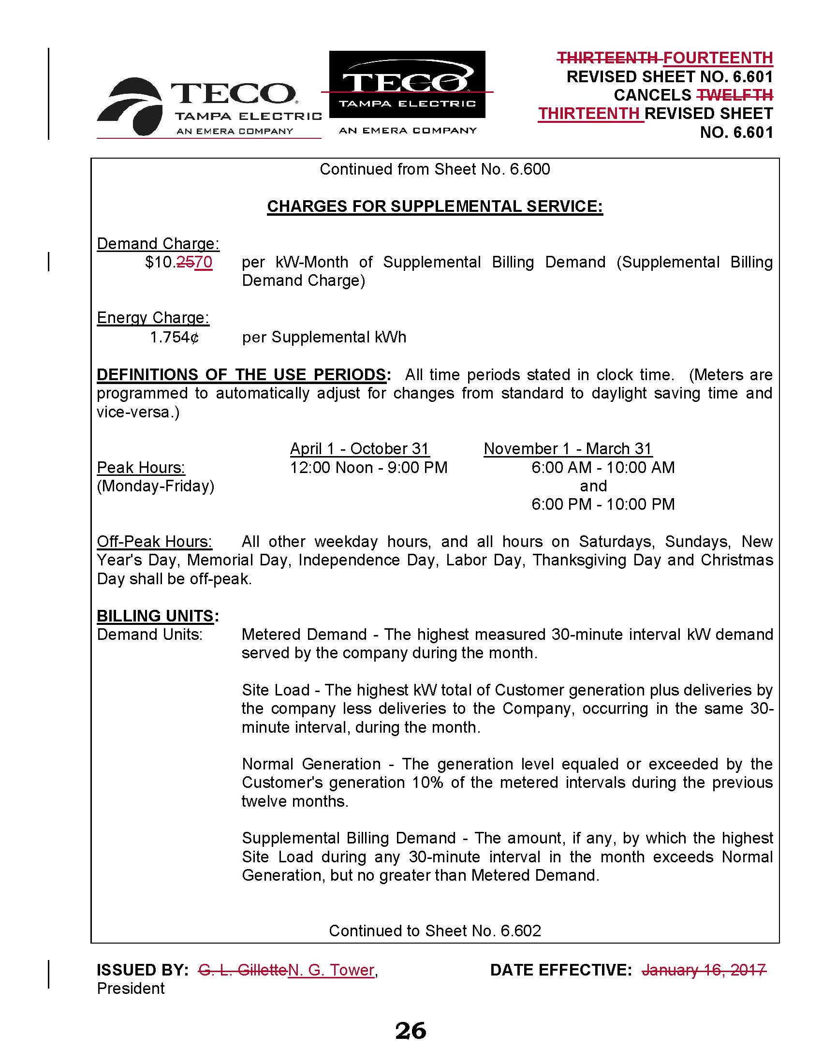

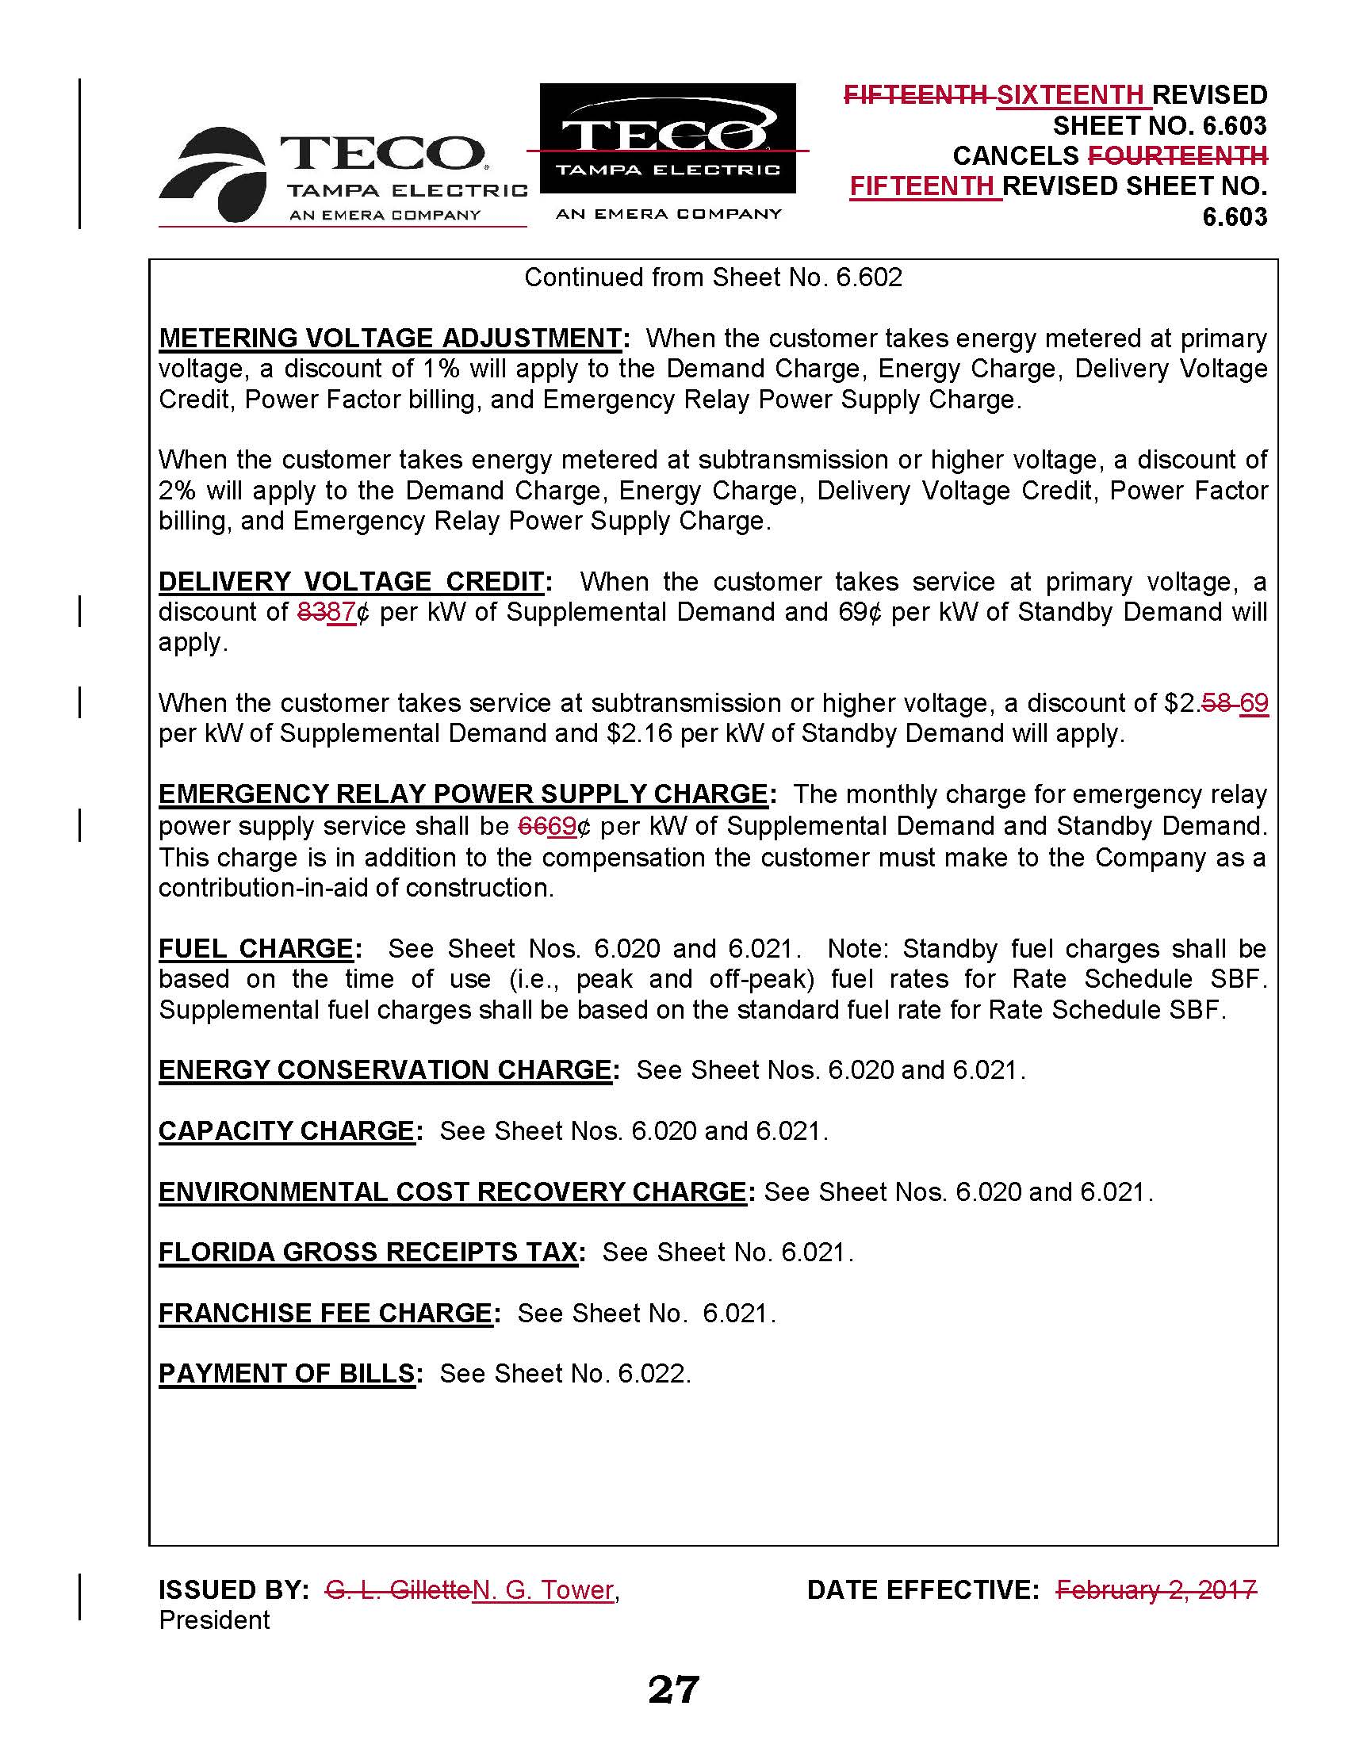

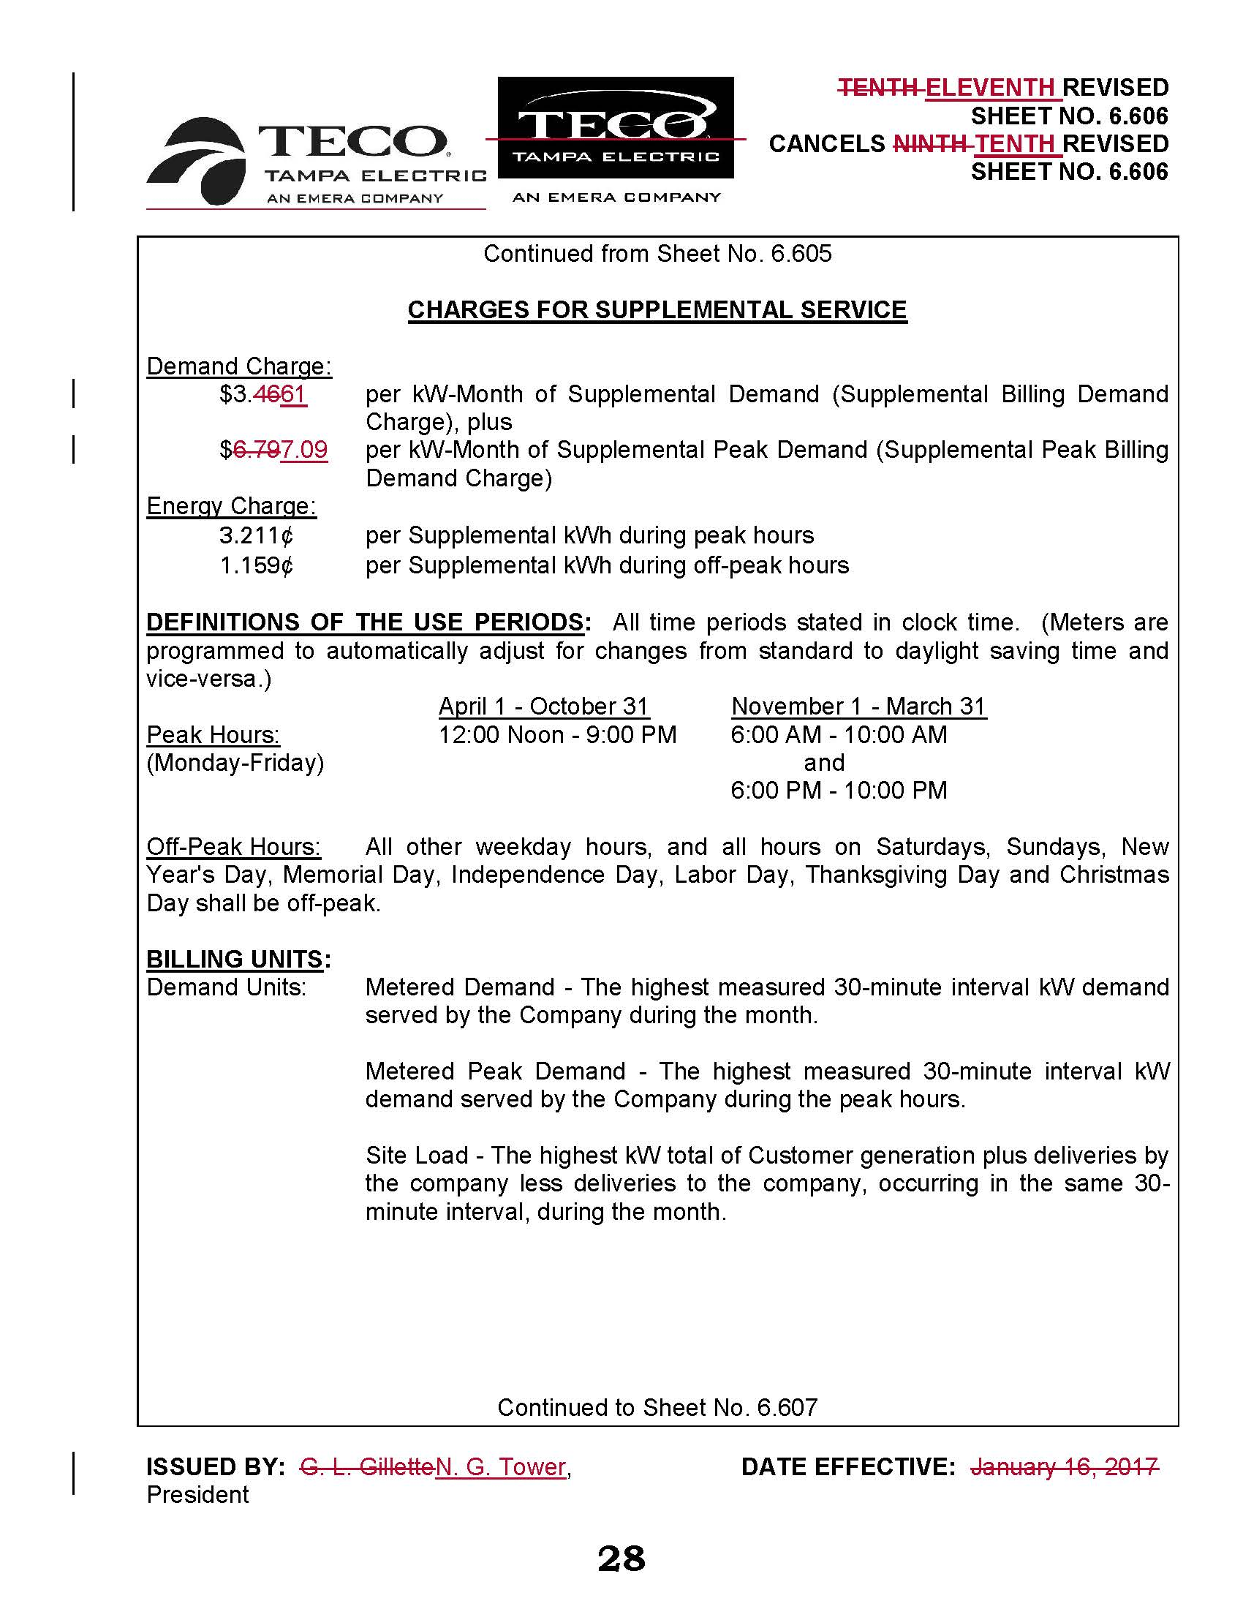

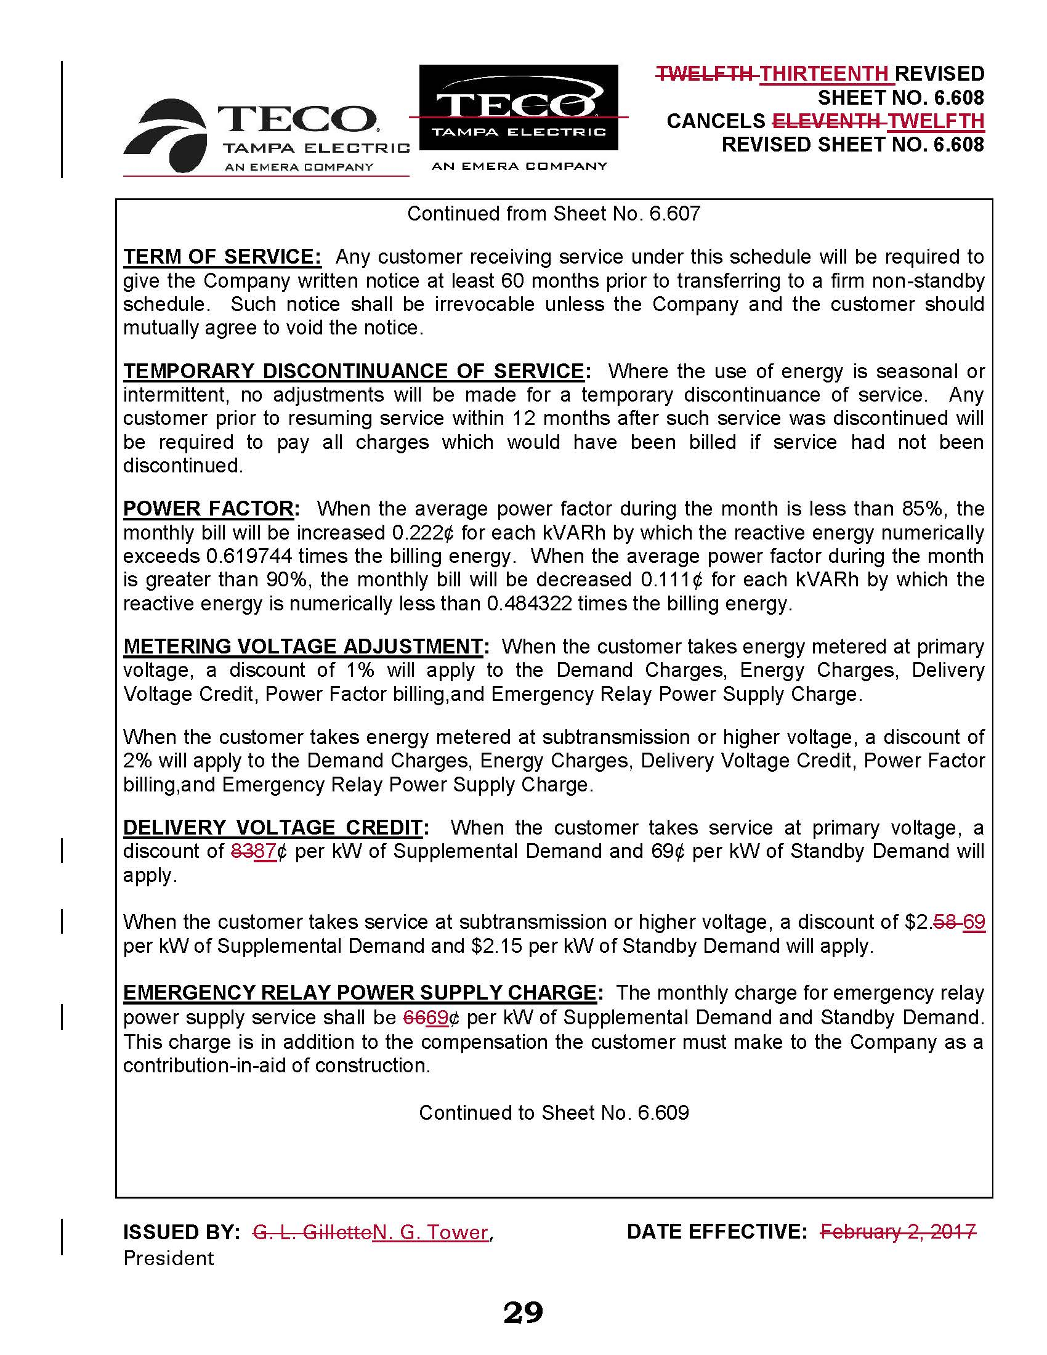

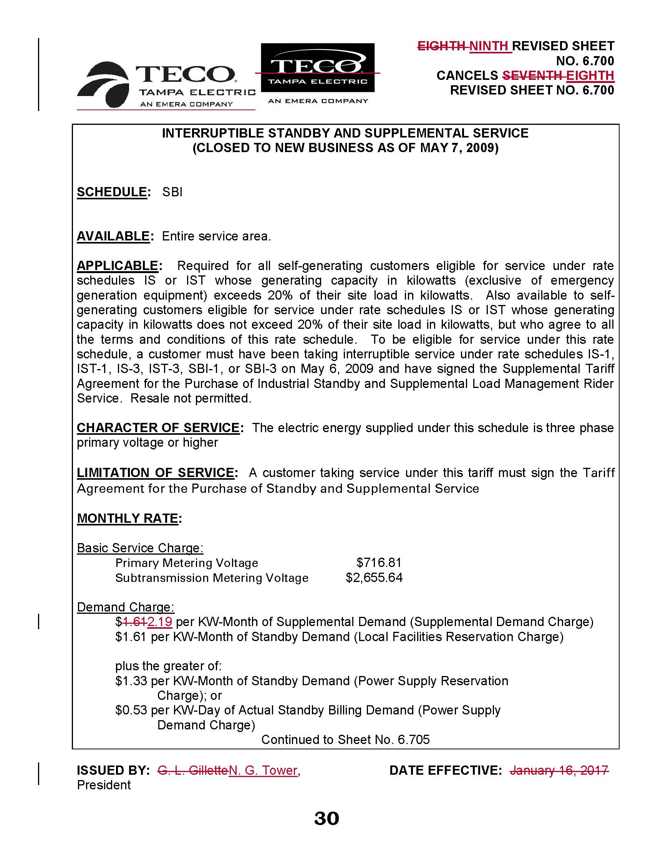

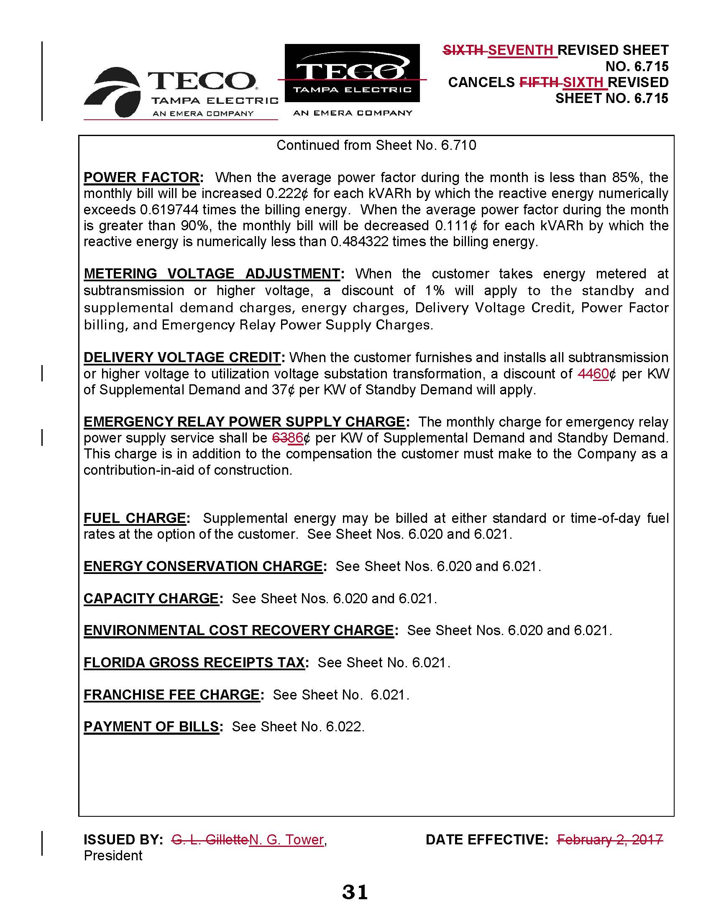

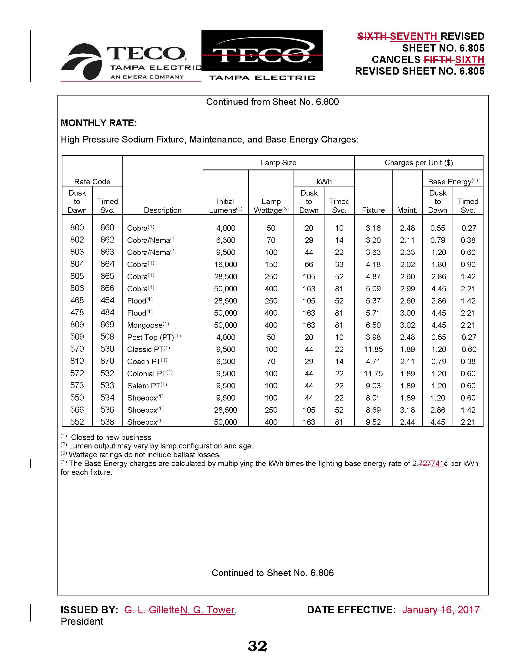

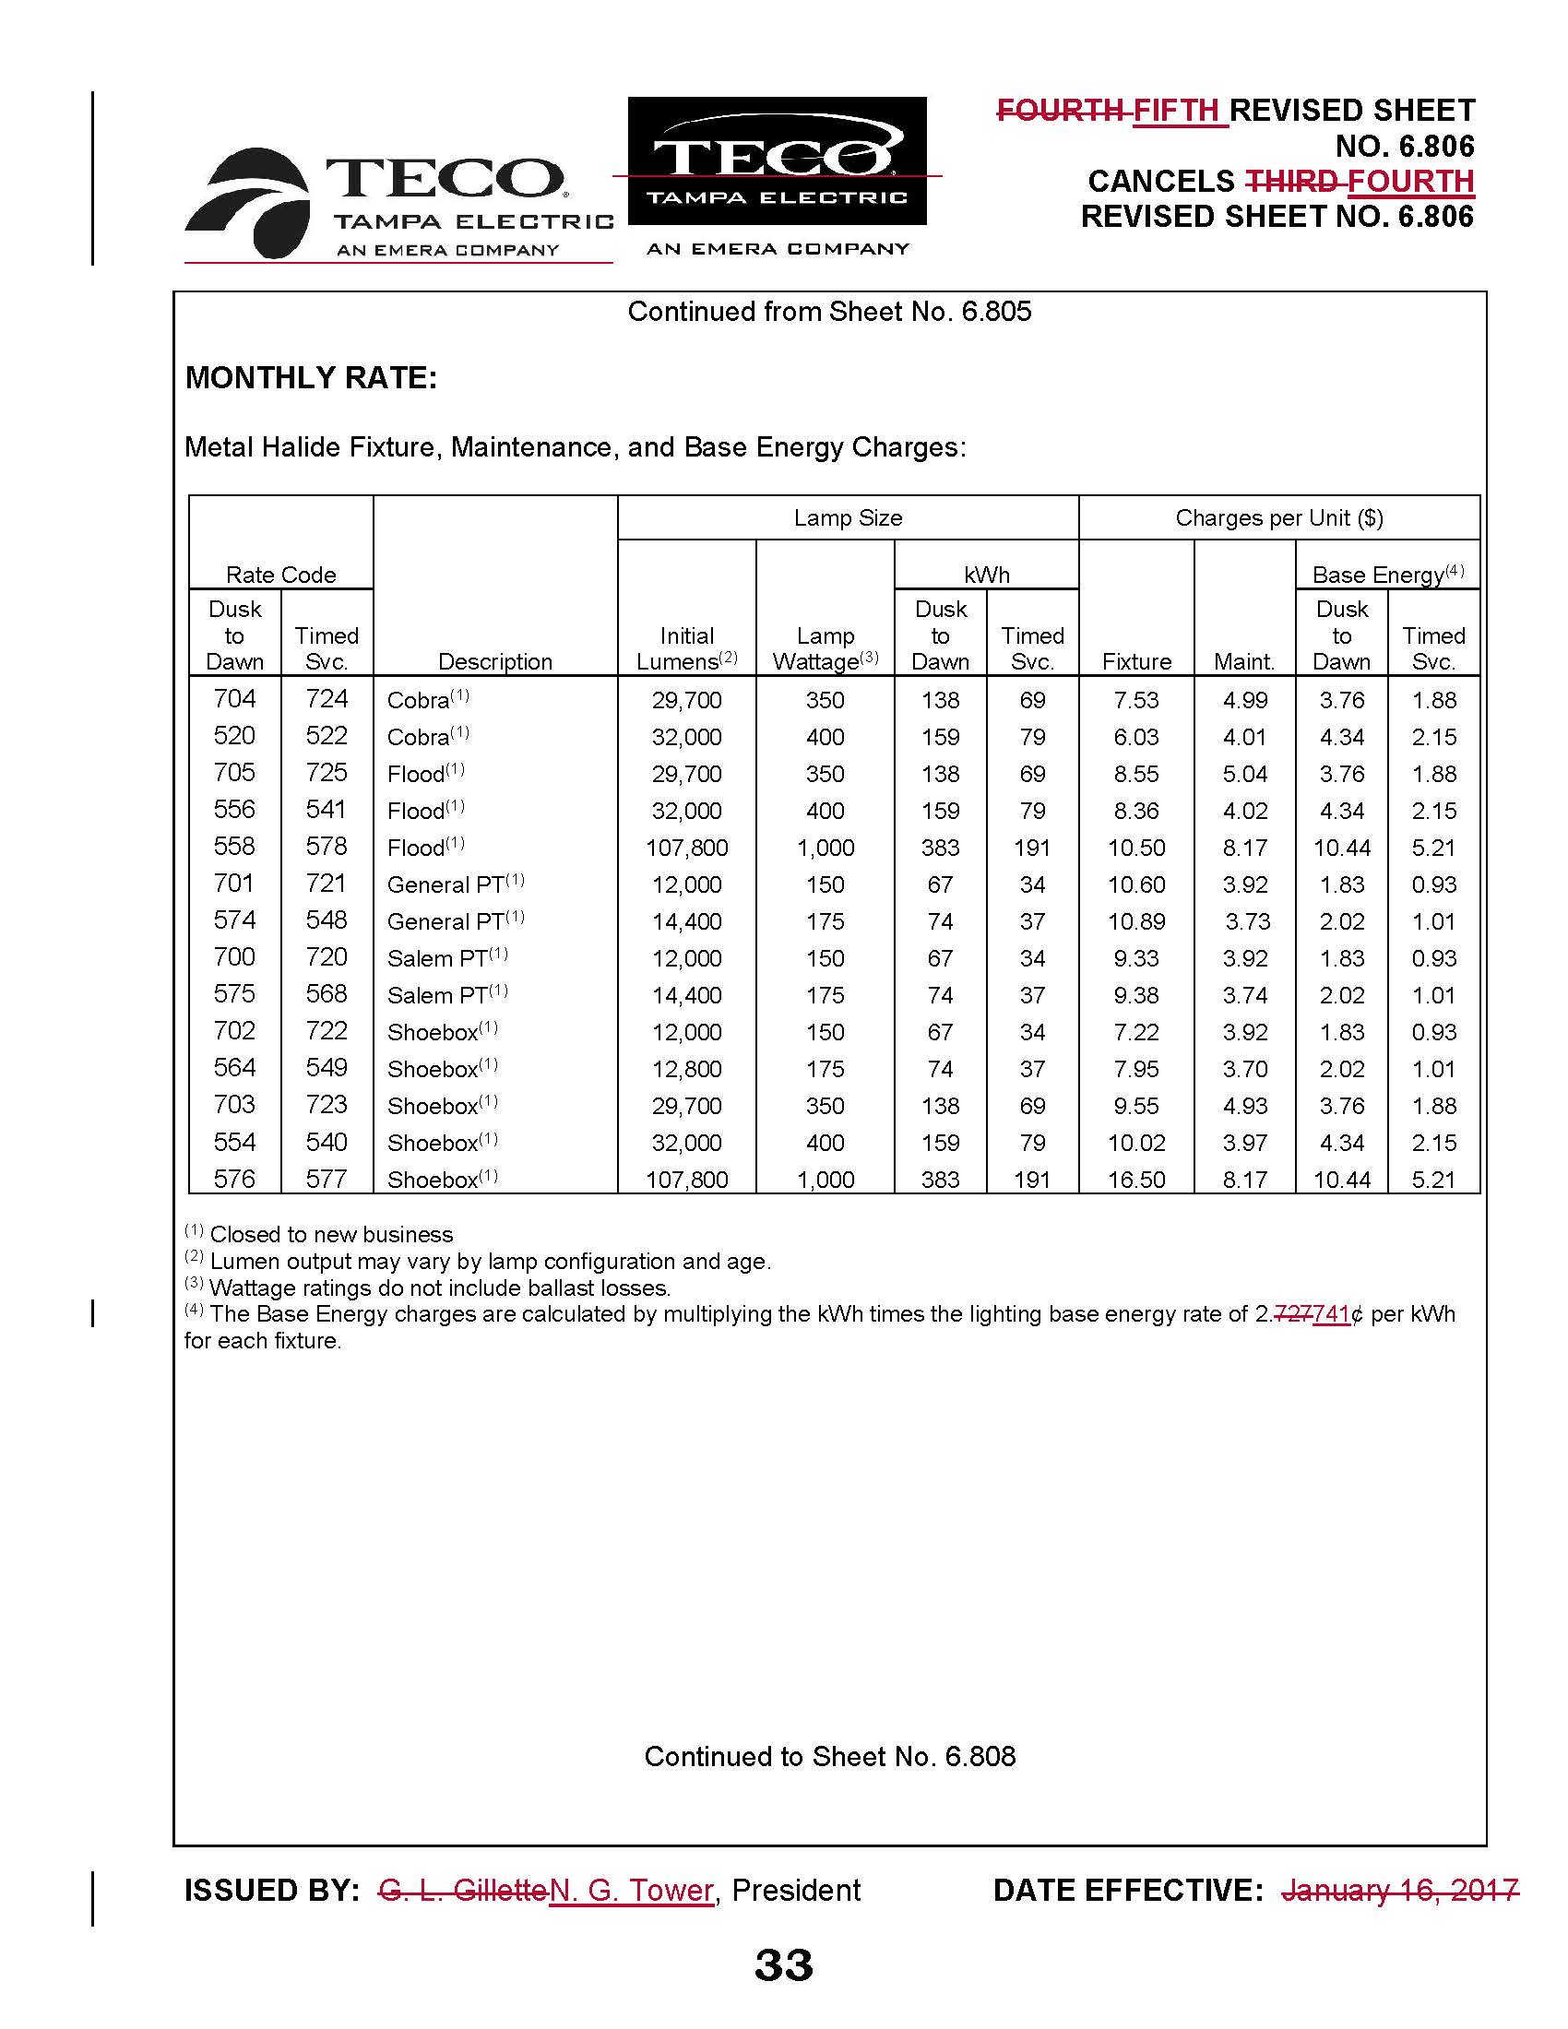

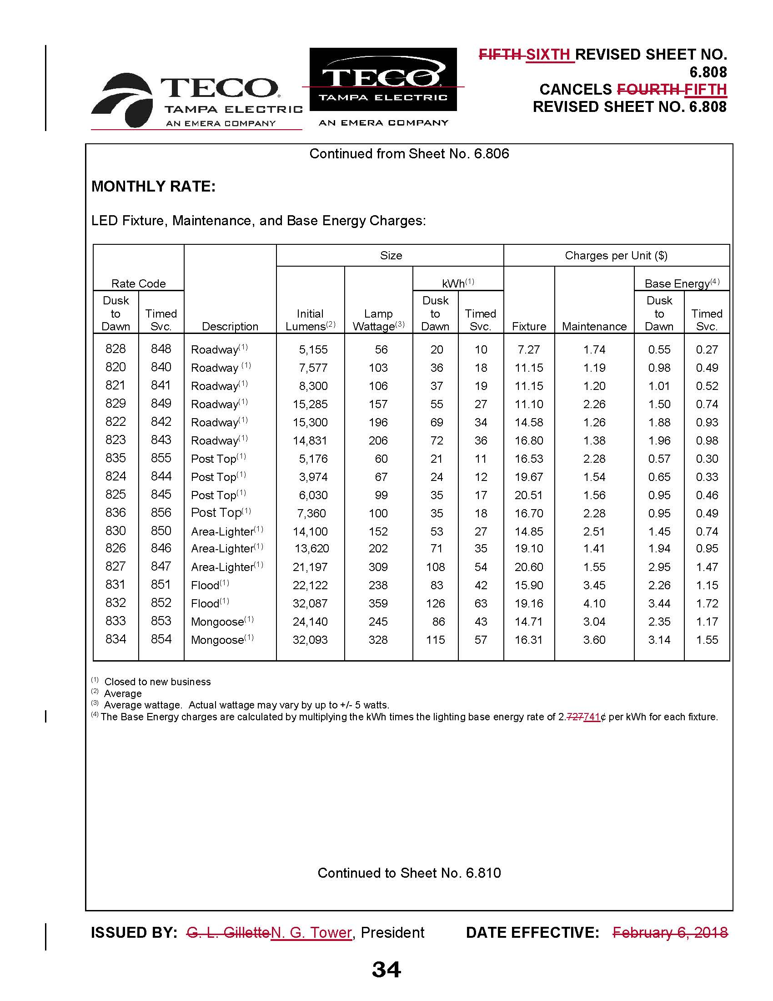

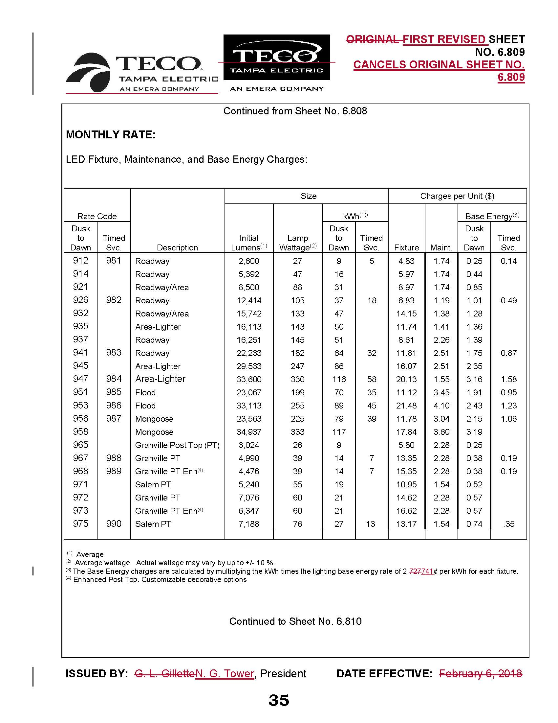

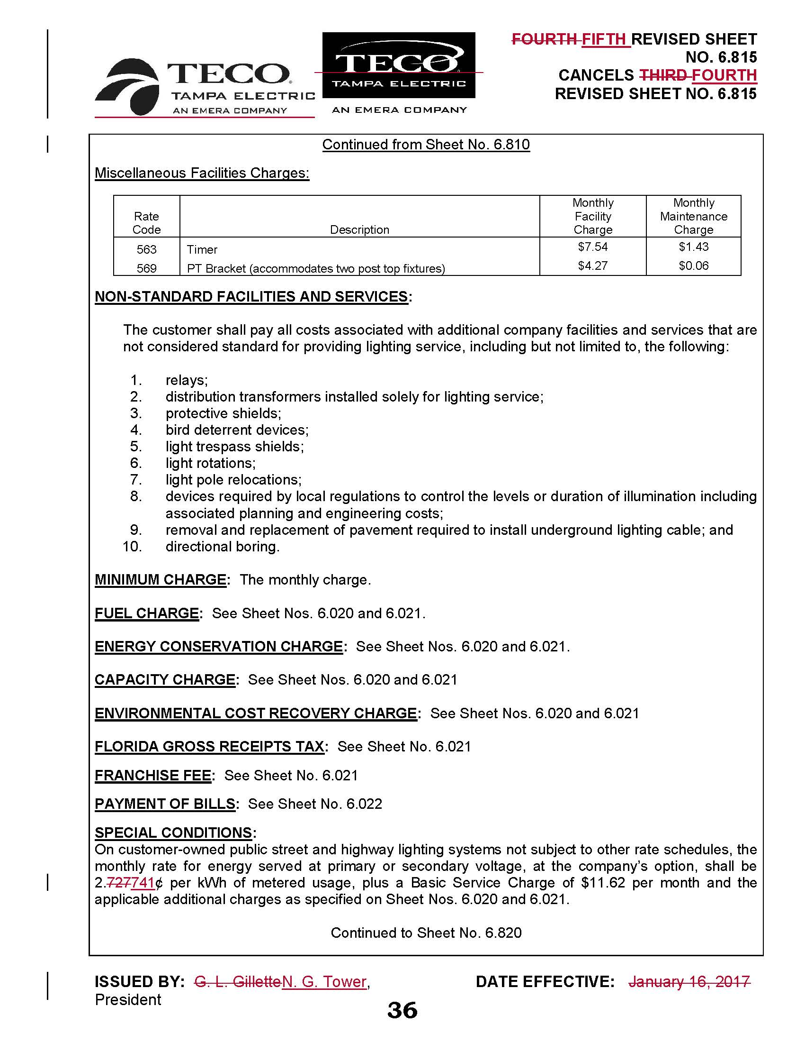

Order No. 2017-0456-S-EI, issued November 27, 2017, in Docket No. 20170210-EI, In re: Petition for limited proceeding to approve 2017 amended and restated stipulation and settlement agreement, by Tampa Electric Company.
Order No. PSC-2018-0068-PCO-EI, issued January 30, 2018, acknowledged OPC’s intervention, and Order No. PSC-2018-0187-PCO-EI, issued April 19, 2018, granted FIPUG’s intervention request.
Order No. 2017-0456-S-EI at p. 25, subparagraph 6(m).

