BEFORE THE FLORIDA PUBLIC SERVICE COMMISSION

In re: Petition for approval of revisions to standard offer for energy purchased from cogenerators and renewable generating facilities and standard offer contract for purchases of firm capacity and energy, by Florida Public Utilities Company. | DOCKET NO. 20180091-EQ  ORDER NO. PSC-2018-0310-PAA-EQ  ISSUED: June 12, 2018

The following Commissioners participated in the disposition of this matter:

ART GRAHAM, Chairman
JULIE I. BROWN
DONALD J. POLMANN
GARY F. CLARK
ANDREW GILES FAY

NOTICE OF PROPOSED AGENCY ACTION ORDER
APPROVING FLORIDA PUBLIC UTILITIES COMPANY’S
STANDARD OFFER CONTRACT AND SCHEDULE

BY THE COMMISSION:

NOTICE is hereby given by the Florida Public Service Commission (Commission) that the action discussed herein is preliminary in nature and will become final unless a person whose interests are substantially affected files a petition for a formal proceeding, pursuant to Rule 25-22.029, Florida Administrative Code (F.A.C.).

Background
Section 366.91(3), Florida Statutes (F.S.), requires that each investor-owned utility (IOU) continuously offer to purchase capacity and energy from renewable energy generators and small qualifying facilities. Rules 25-17.200 through 25-17.310, F.A.C., implement the statute, and require each IOU to file with this Commission, by April 1 of each year, a standard offer contract based on the next avoidable fossil fueled generating unit of each technology type identified in the Utility’s current Ten-Year Site Plan. On March 29, 2018, Florida Public Utilities Company (FPUC) submitted a petition for approval of its revised standard offer contract, pursuant to the rules cited above and Rules 25-9.003, 25-17.0825, and 25-17.0832, F.A.C. However, the petition was erroneously submitted to our Division of Economics. On April 5, 2018, FPUC filed its petition with the Office of Commission Clerk, requesting that we accept its late-filed petition.
Because FPUC, an IOU, does not own or operate any electric generating units, it does not have any avoidable units on which to base its standard offer contract. Rule 25-17.250(1), F.A.C., requires that, under these circumstances, the standard offer contract be based on avoiding or deferring a planned purchase. In its Northwest Division, FPUC currently purchases all of its electric power through purchased power agreements with Gulf Power Company (Gulf). FPUC has recently changed its full requirements purchased power supplier for the Northeast Division from JEA, formerly known as the Jacksonville Electric Authority, to Florida Power & Light Company (FPL). Revisions to FPUC’s standard offer contract and rate schedule are limited to changes reflecting FPL replacing JEA in the Northeast Division.
We have jurisdiction over this standard offer contract pursuant to Sections 366.04 through 366.06, and 366.91, F.S.

Review
Pursuant to Rule 25-17.250, F.A.C., an IOU must continuously make available a standard offer contract for the purchase of firm capacity and energy from renewable generating facilities (RF) and small qualifying facilities (QF) with a design capacity of 100 kilowatts (kW) or less. FPUC does not own or operate any of its own electric generating facilities, and thus does not file a Ten-Year Site Plan. Instead, FPUC purchases its electric energy under long-term, full requirements contracts with wholesale providers.
The standard offer rate schedule consists of three components: (1) the Standard Offer – As Available Schedule (SOA); (2) the Standard Offer – Firm Schedule (SOF); and (3) the Standard Offer Contract. Current revisions to FPUC’s standard offer contract and rate schedule are limited to changes reflecting FPL replacing JEA as FPUC’s full requirements supplier for FPUC’s Northeast Division. The revised standard offer rate schedule and standard offer contract, in type-and-strike format, are included as Attachment A. The capacity and energy payments under the proposed rate schedule depend on the terms of FPUC’s wholesale contracts with its suppliers for FPUC's Northeast Division and Northwest Division.

Northeast Division
At present, FPL is the full requirements supplier for FPUC’s Northeast Division, which consists of Fernandina Beach and Amelia Island. In response to Staff’s First Data Request, FPUC provided estimates of the annual payments to an operator of a 10 megawatt (MW) facility, operating at a capacity factor of 70 percent, under a 20 year contract for (1) RF/QF operators located inside the service territory and (2) for operators delivering power to interconnection with the territory. Under both of these scenarios, FPUC estimated that its annual energy payments would be approximately $1.9 million starting in 2019 and would increase annually, based on the full reduction in FPL billing to FPUC. FPUC’s estimated annual capacity payments are confidential.

Northwest Division
At present, Gulf is the full requirements supplier for FPUC’s Northwest Division, which consists of portions of Jackson, Calhoun, and Liberty counties. In response to Staff’s First Data Request, FPUC provided estimates of the annual payments to an operator of a 10 MW facility, operating at a capacity factor of 70 percent, under a 20 year contract for (1) RF/QF operators located inside the service territory and (2) for operators delivering power to interconnection with the territory. Under both of these scenarios, FPUC estimated that its annual energy payments would be approximately $2.1 million starting in 2019 and would increase annually, based on the full reduction in Gulf billing to FPUC. FPUC’s estimated annual capacity payments are confidential.

Decision

Upon review, we find that the provisions of FPUC’s revised standard offer rate schedule and standard offer contract conform to all the requirements of Rules 25-17.200 through 25-17.310, F.A.C., and reflect the avoidable costs associated with FPUC’s power purchase agreements. Thus, the revisions to the rate schedule and standard offer contract filed by FPUC are approved as filed.

Based on the foregoing, it is

ORDERED by the Florida Public Service Commission that Florida Public Utilities Company’s standard offer contract and schedule are approved. It is further

ORDERED that the provisions of this Order, issued as proposed agency action, shall become final and effective upon the issuance of a Consummating Order unless an appropriate petition, in the form provided by Rule 28-106.201, Florida Administrative Code, is received by the Commission Clerk, 2540 Shumard Oak Boulevard, Tallahassee, Florida 32399-0850, by the close of business on the date set forth in the “Notice of Further Proceedings” attached hereto. Potential signatories should be aware that, if a timely protest is filed, Florida Public Utilities Company’s standard offer contract may subsequently be revised. It is further

ORDERED that in the event this Order becomes final, this docket shall be closed.

By ORDER of the Florida Public Service Commission this 12th day of June, 2018.

/s/ Carlotta S. Stauffer
CARLOTTA S. STAUFFER
Commission Clerk
Florida Public Service Commission
2540 Shumard Oak Boulevard
Tallahassee, Florida 32399
(850) 413-6770
www.floridapsc.com

Copies furnished: A copy of this document is provided to the parties of record at the time of issuance and, if applicable, interested persons.

RD

NOTICE OF FURTHER PROCEEDINGS OR JUDICIAL REVIEW

The Florida Public Service Commission is required by Section 120.569(1), Florida Statutes, to notify parties of any administrative hearing that is available under Section 120.57, Florida Statutes, as well as the procedures and time limits that apply. This notice should not be construed to mean all requests for an administrative hearing will be granted or result in the relief sought.

Mediation may be available on a case-by-case basis. If mediation is conducted, it does not affect a substantially interested person's right to a hearing.

The action proposed herein is preliminary in nature. Any person whose substantial interests are affected by the action proposed by this order may file a petition for a formal proceeding, in the form provided by Rule 28-106.201, Florida Administrative Code. This petition must be received by the Office of Commission Clerk, 2540 Shumard Oak Boulevard, Tallahassee, Florida 32399-0850, by the close of business on July 3, 2018.

In the absence of such a petition, this order shall become final and effective upon the issuance of a Consummating Order.

Any objection or protest filed in this/these docket(s) before the issuance date of this order is considered abandoned unless it satisfies the foregoing conditions and is renewed within the specified protest period.

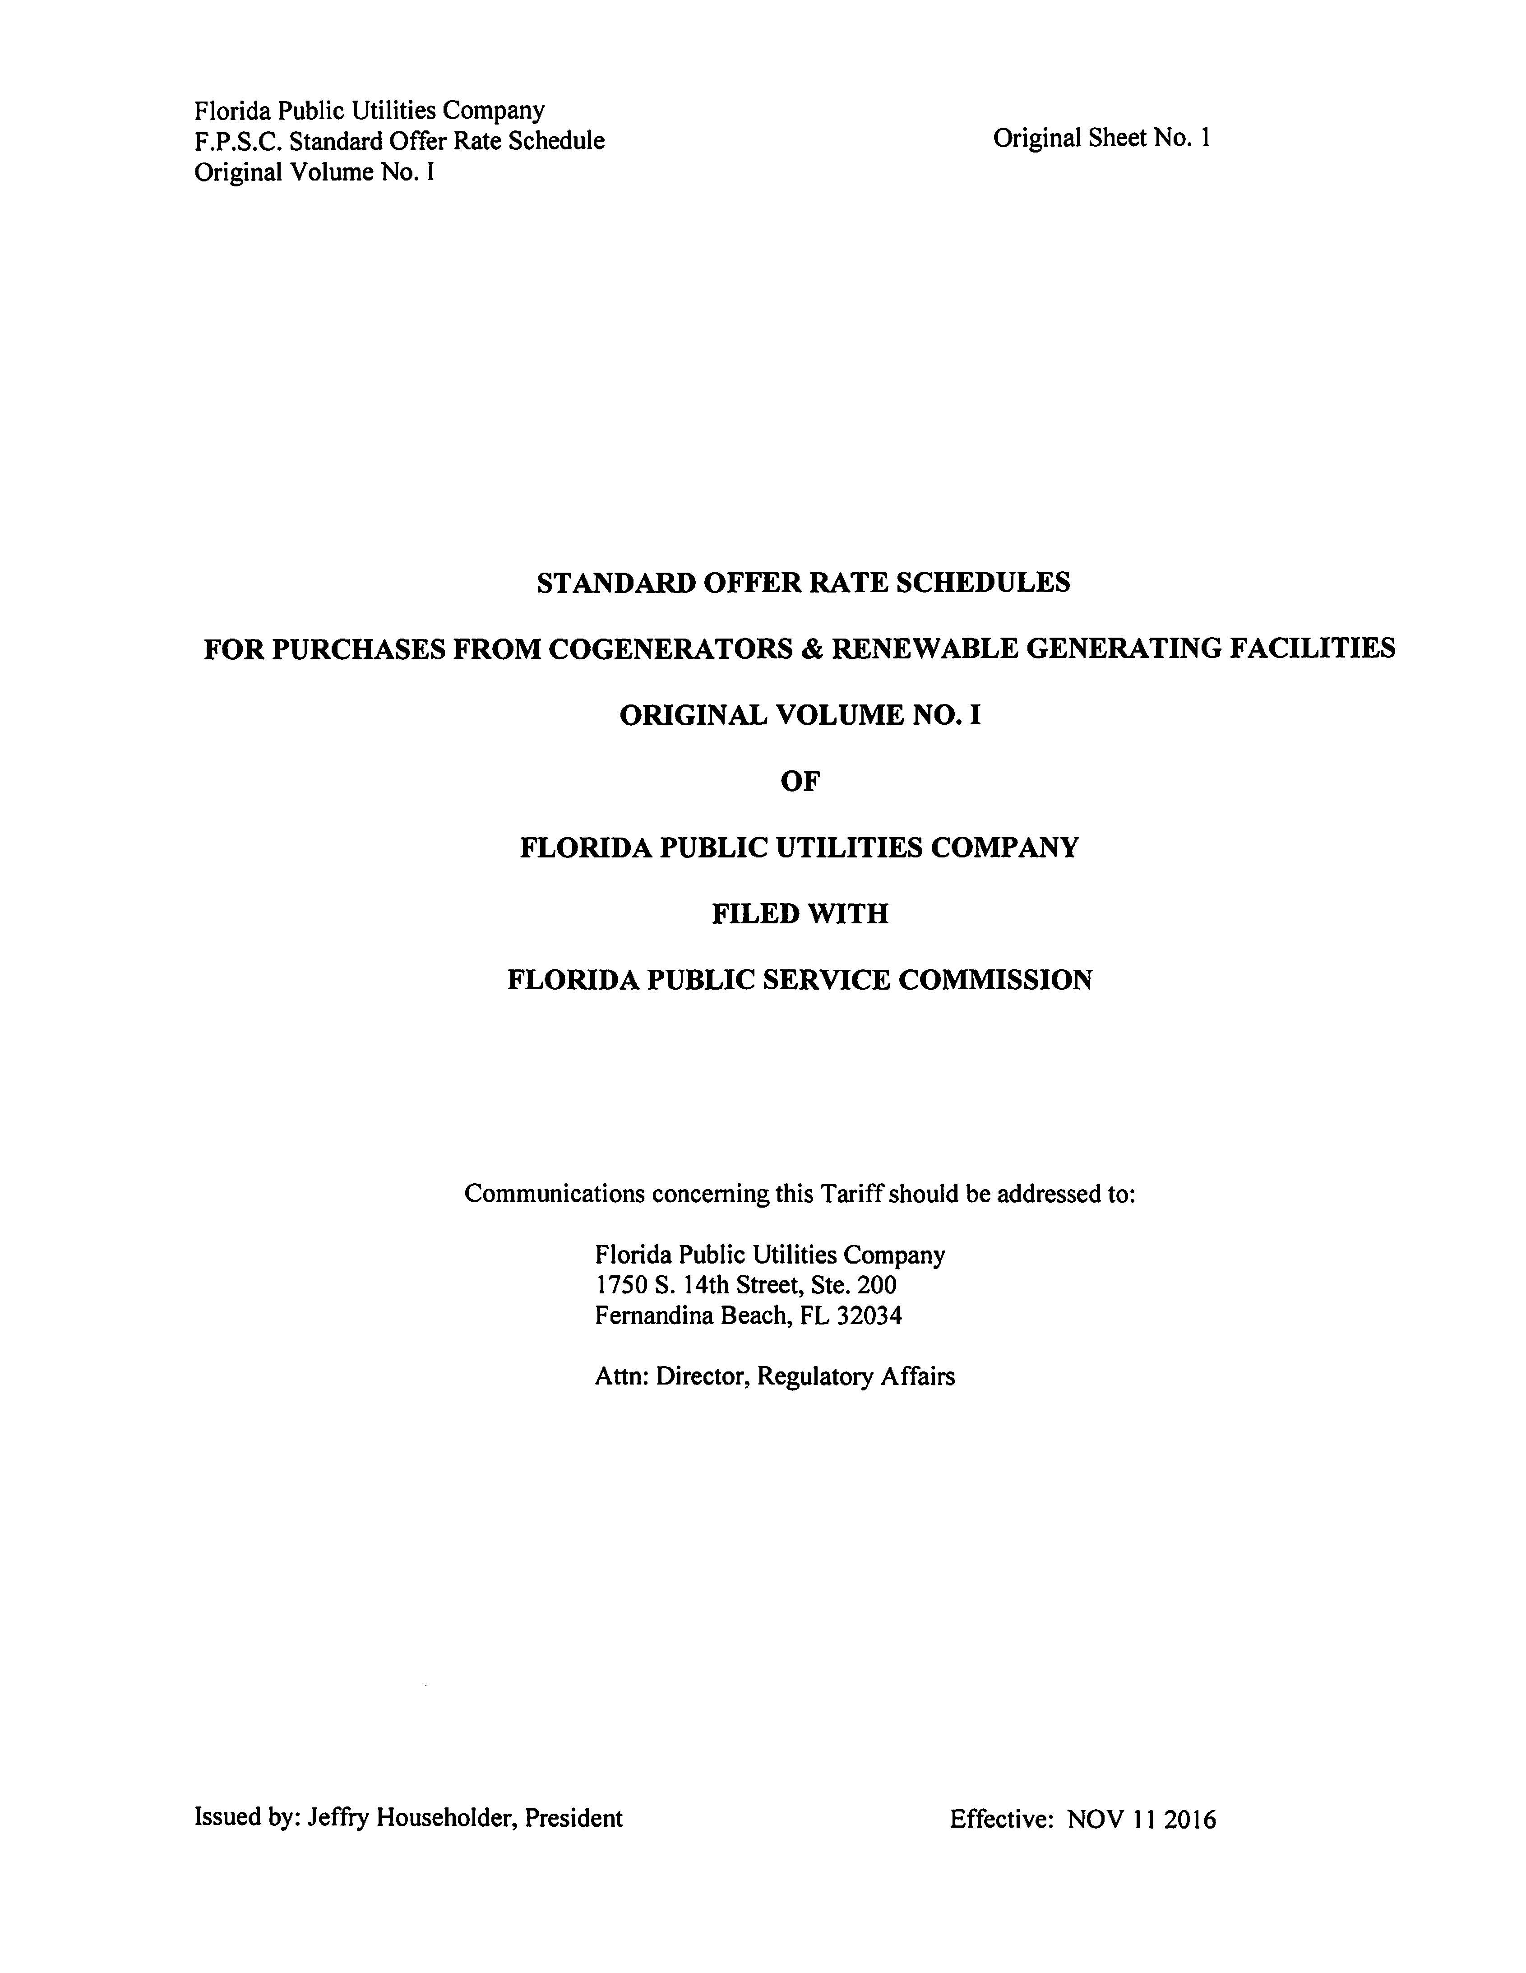

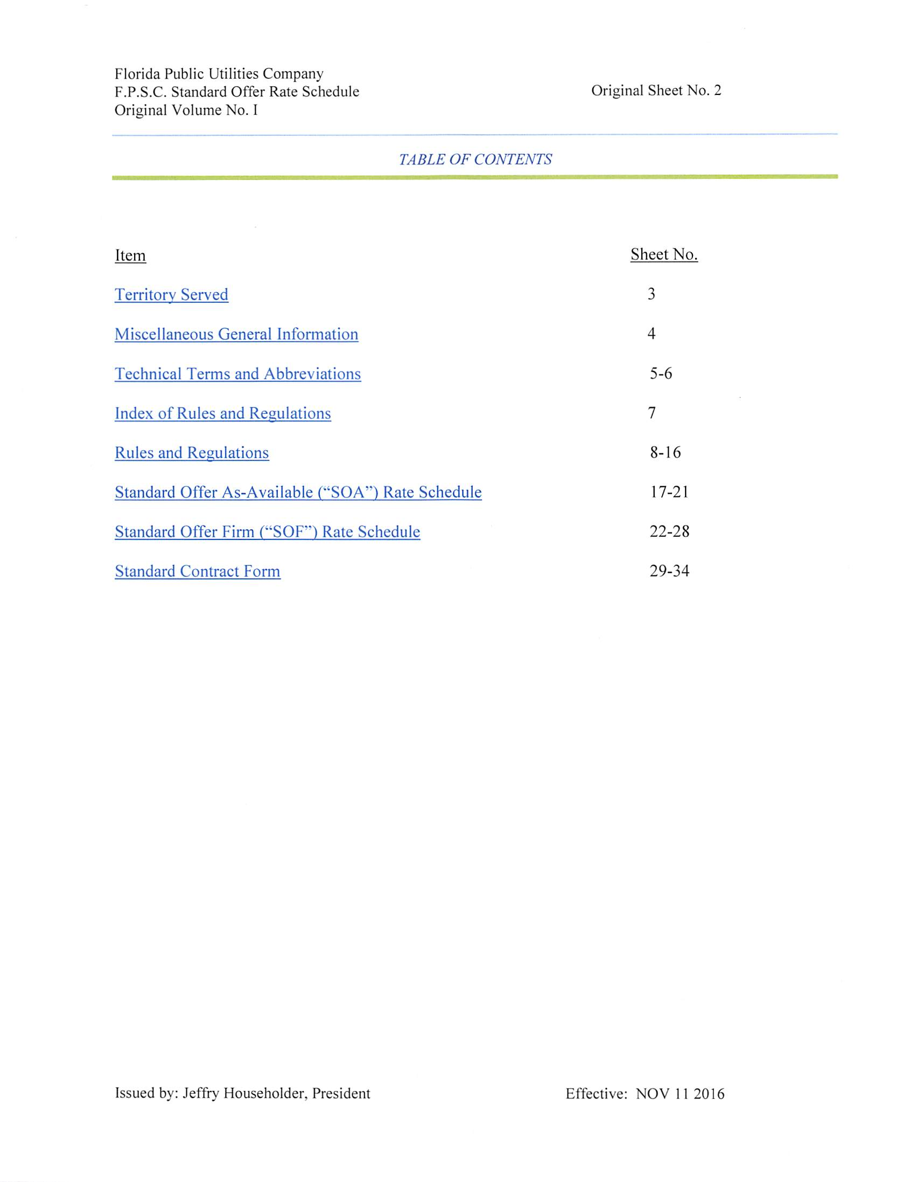

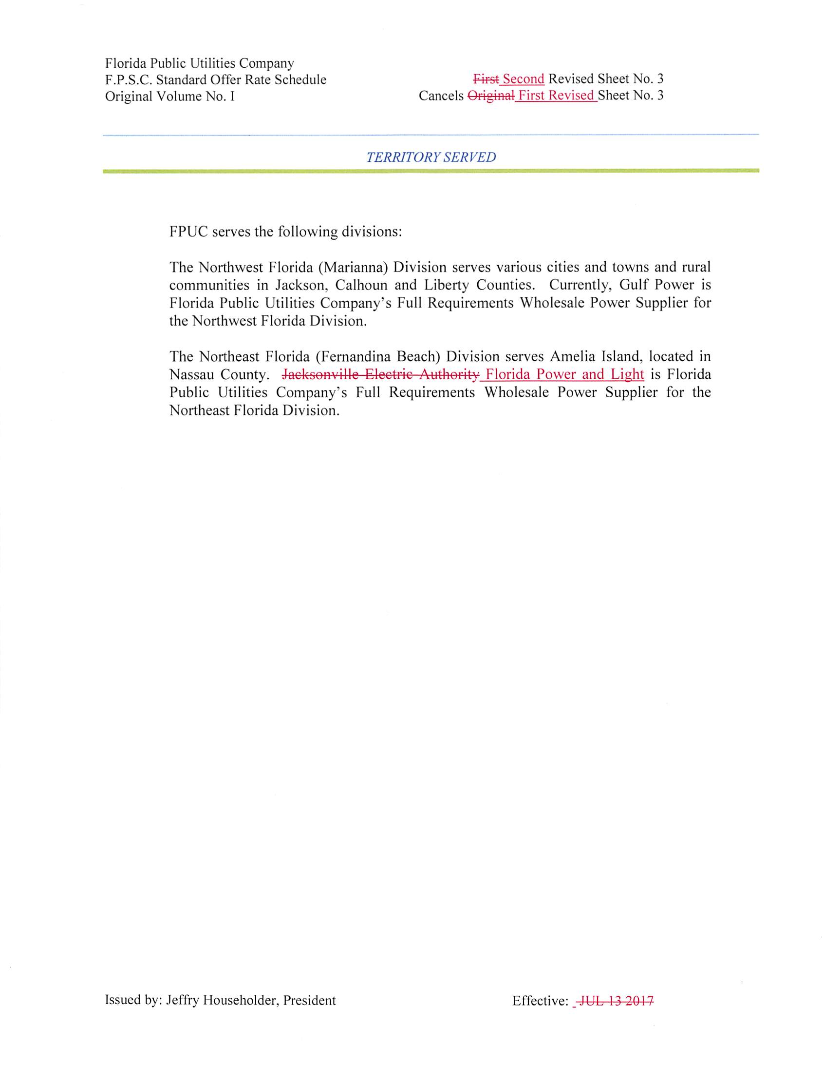

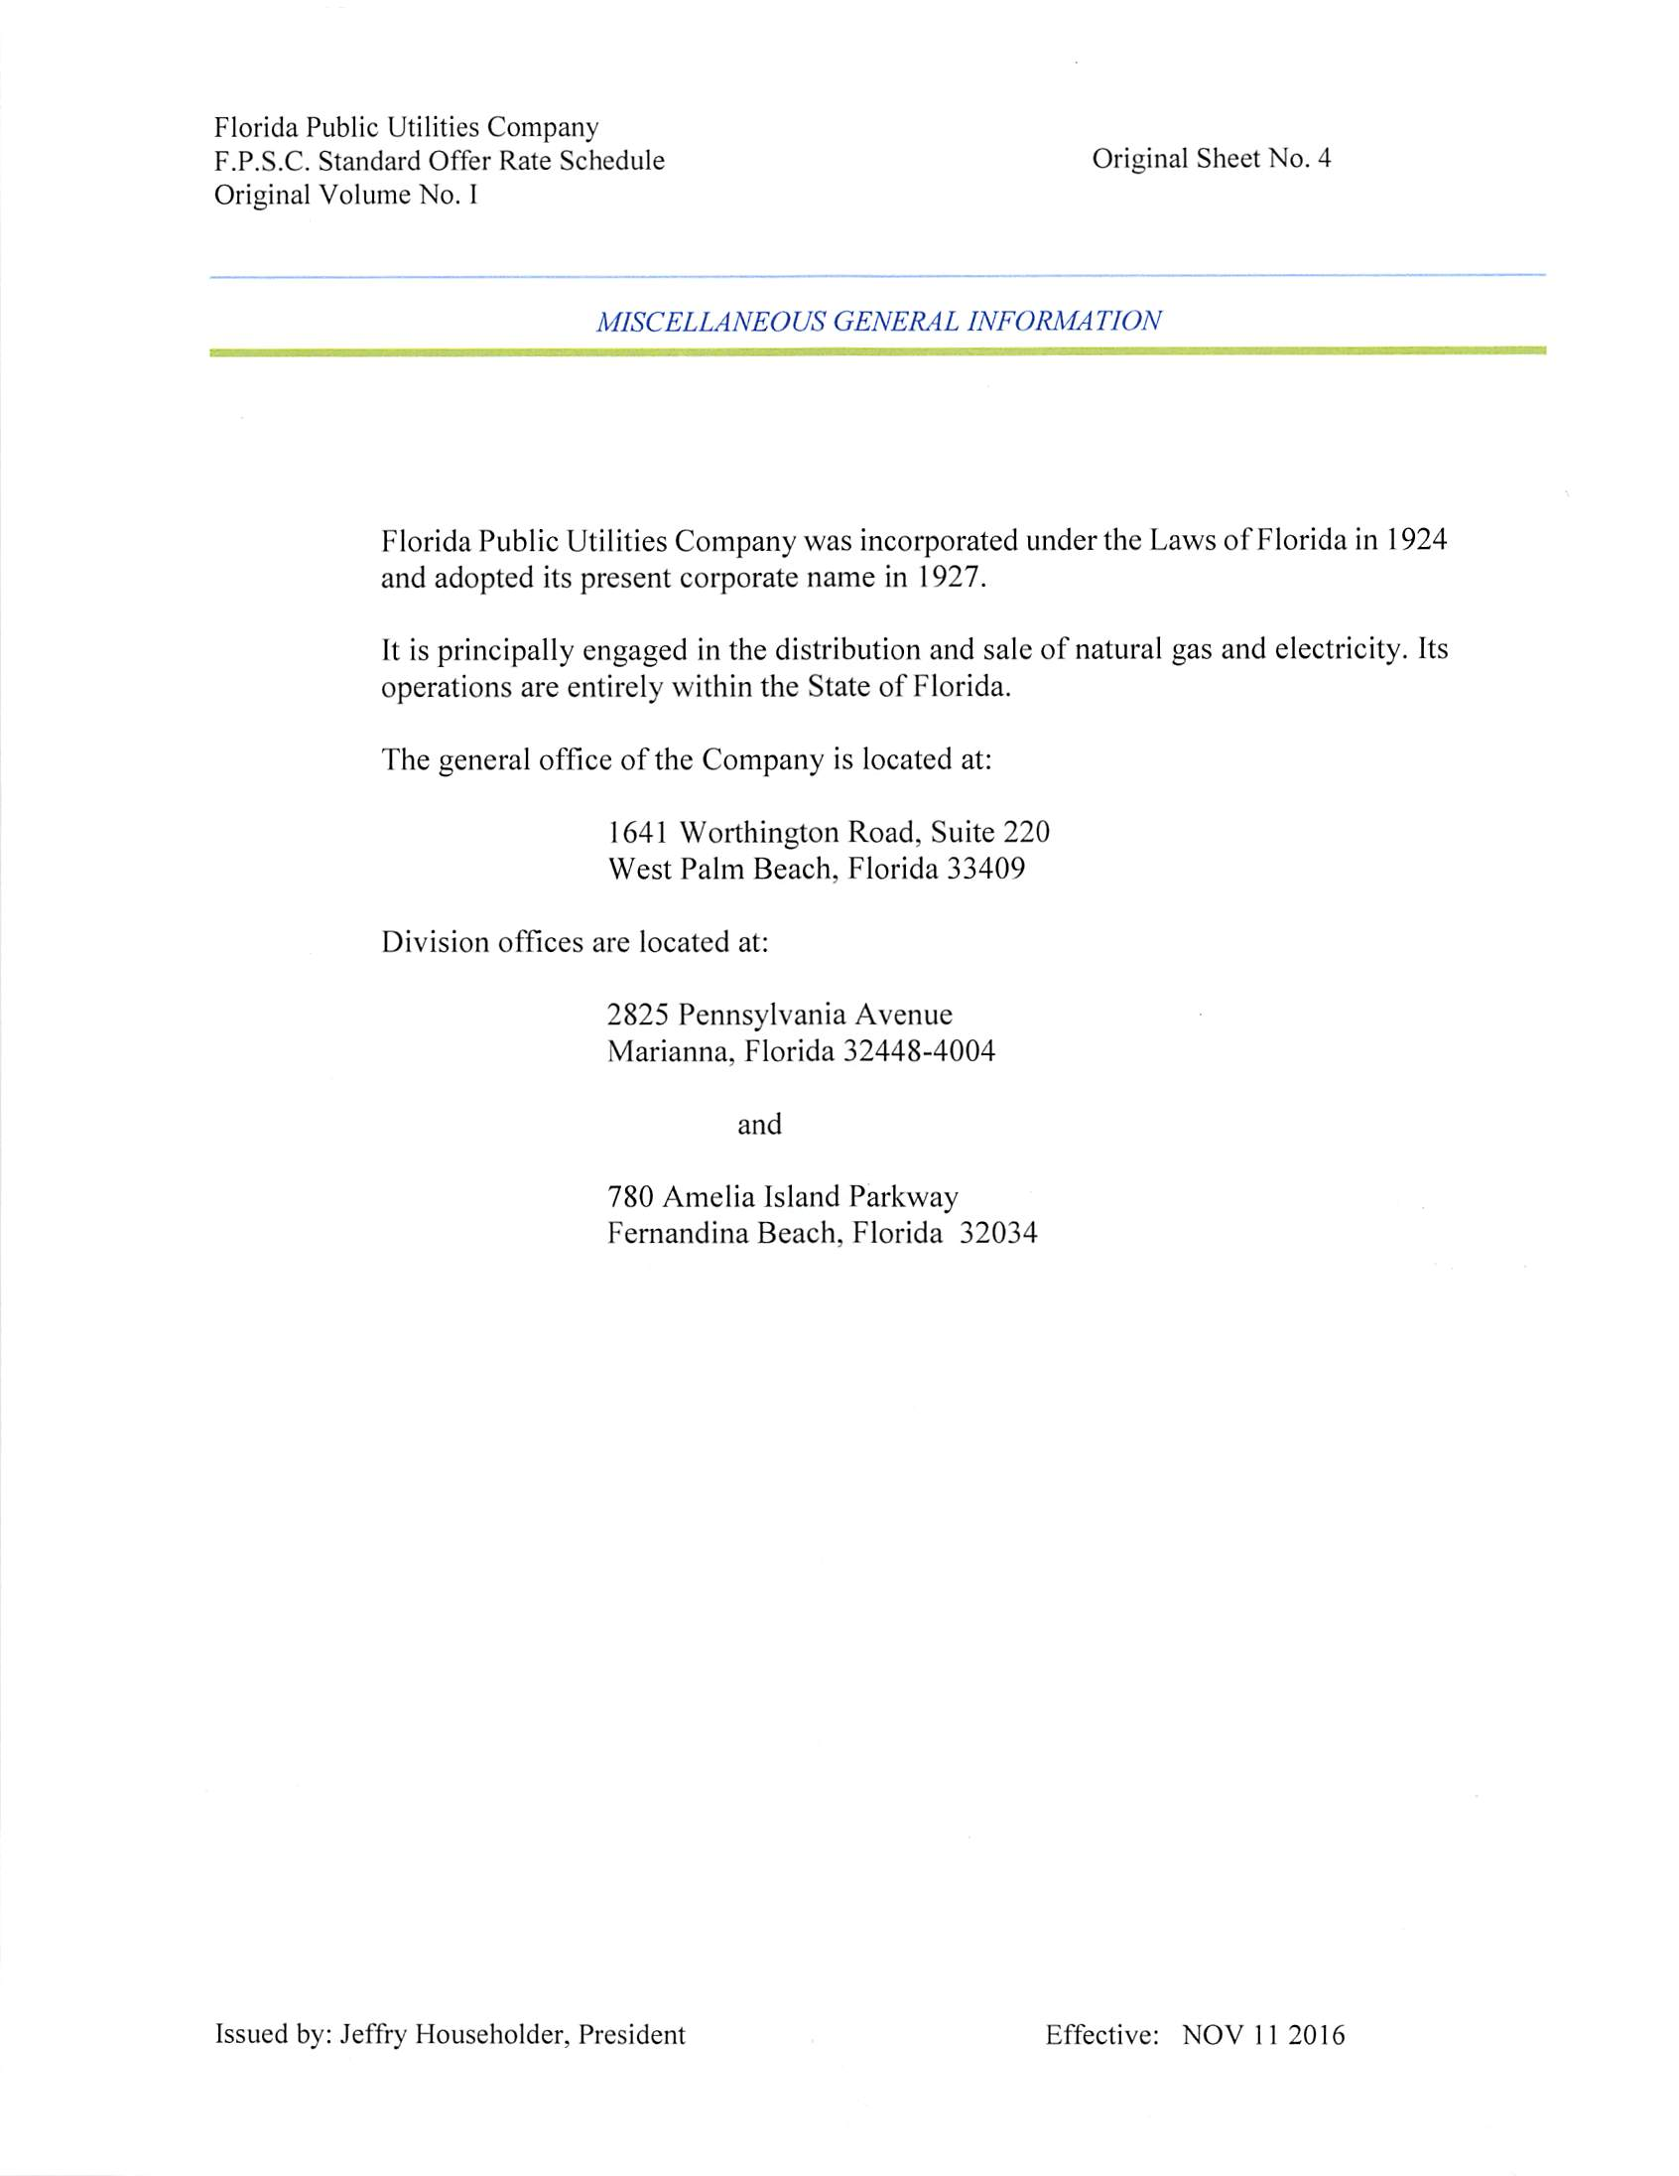

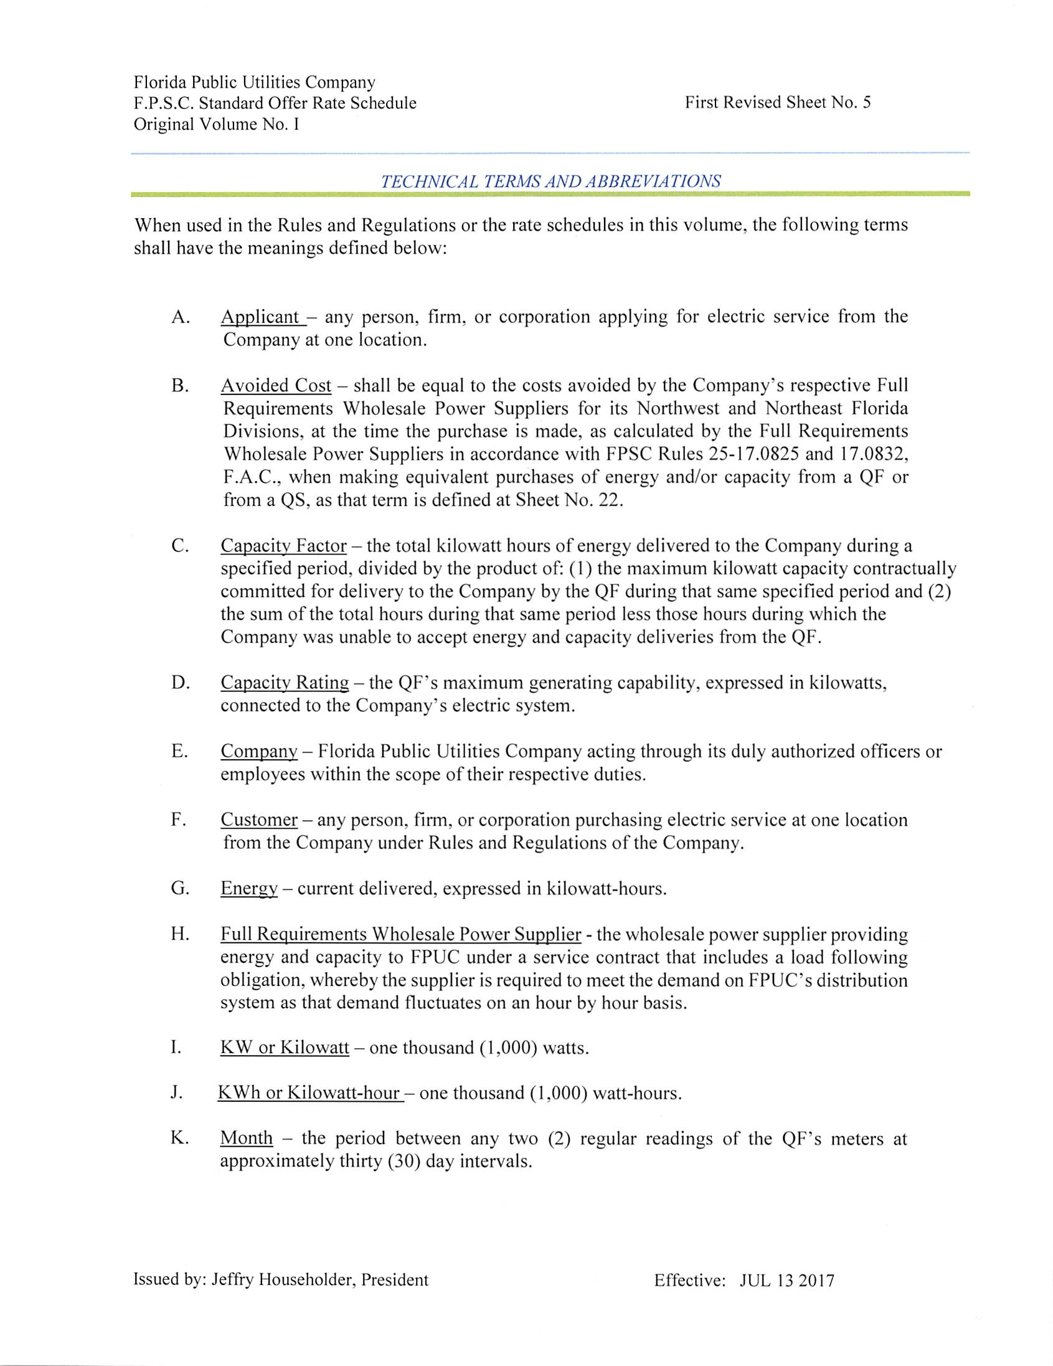

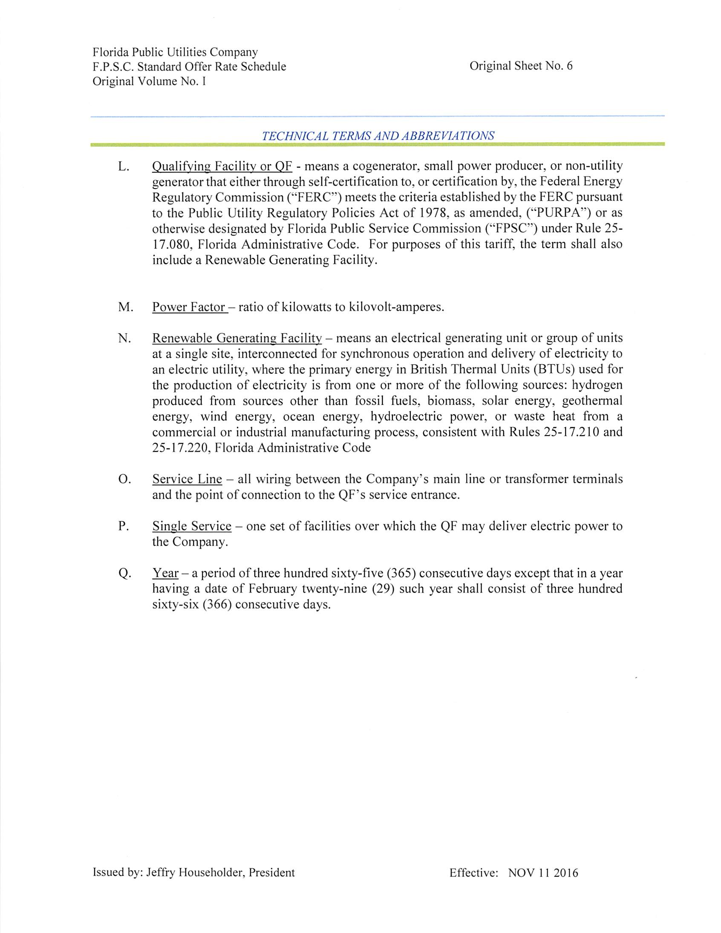

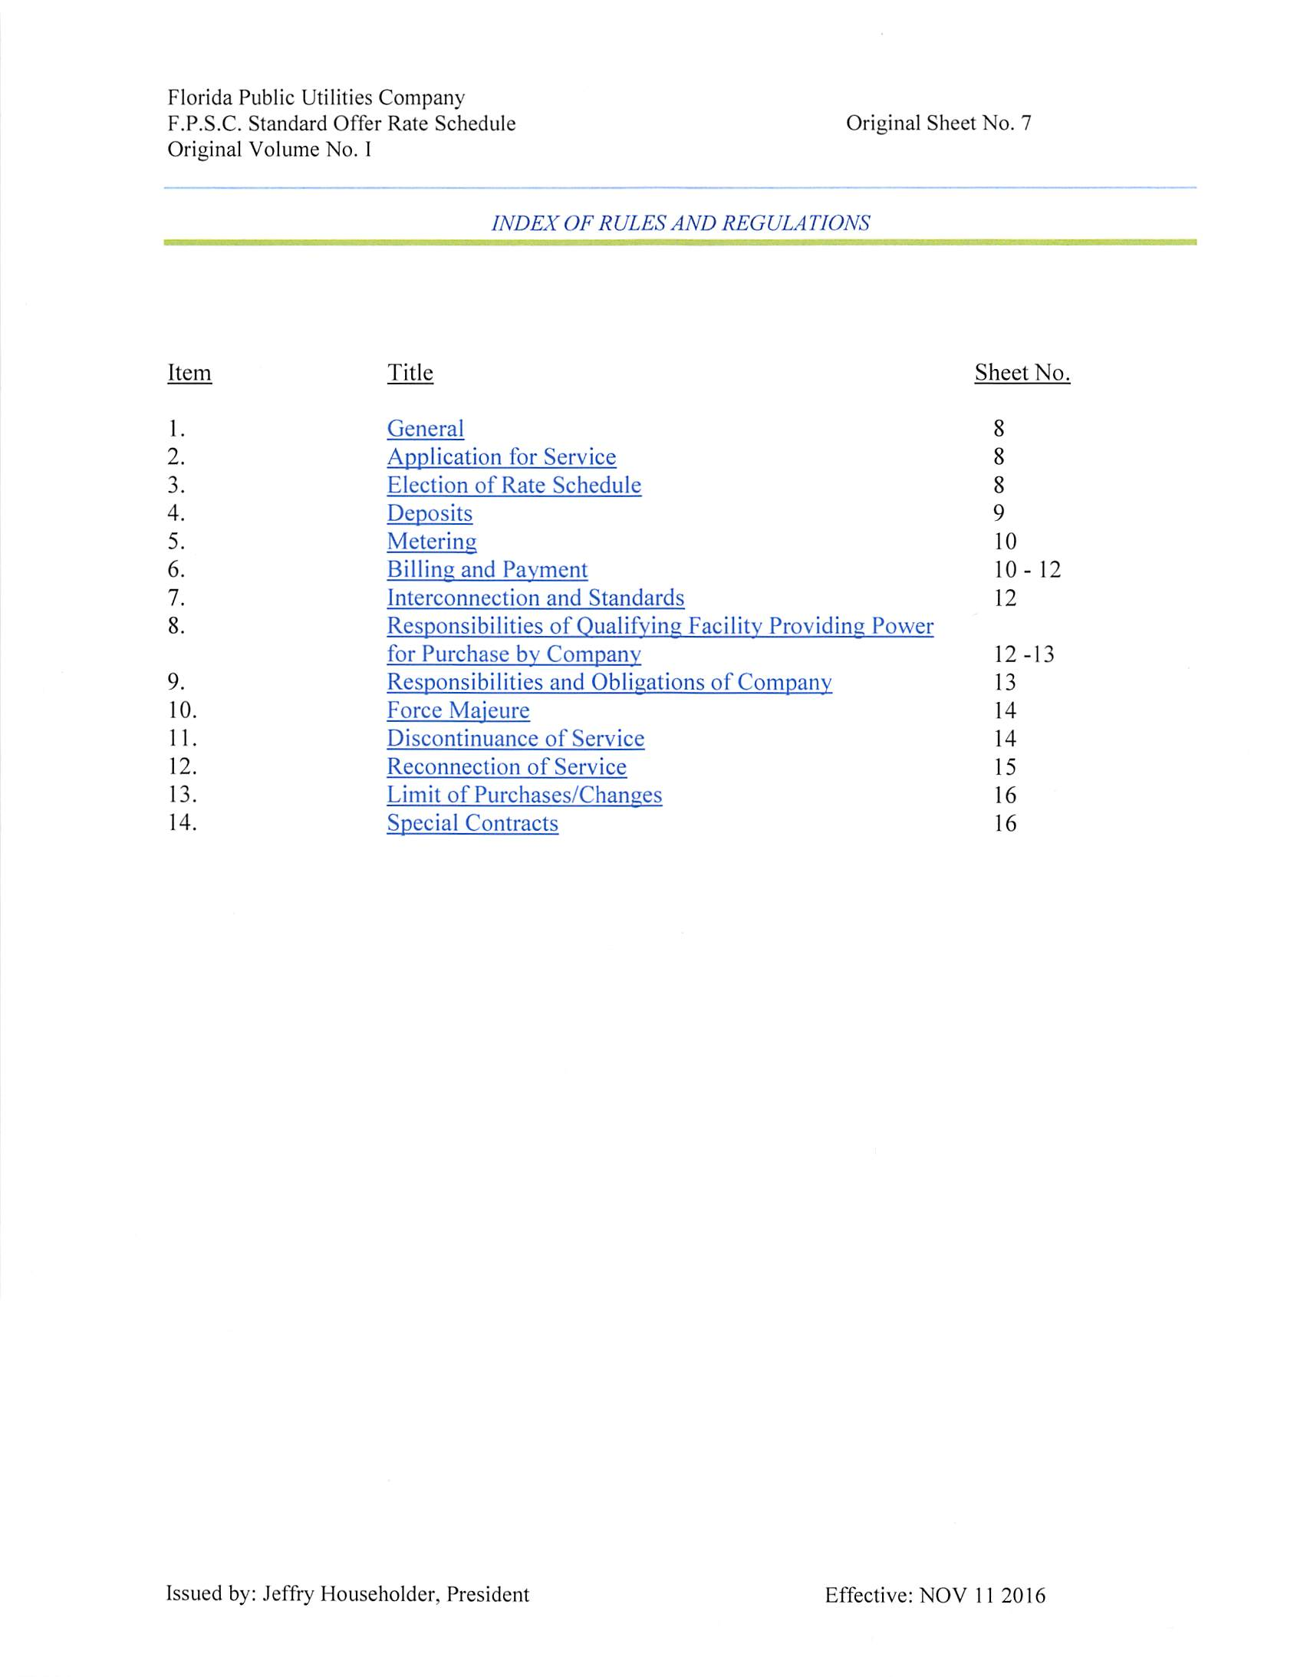

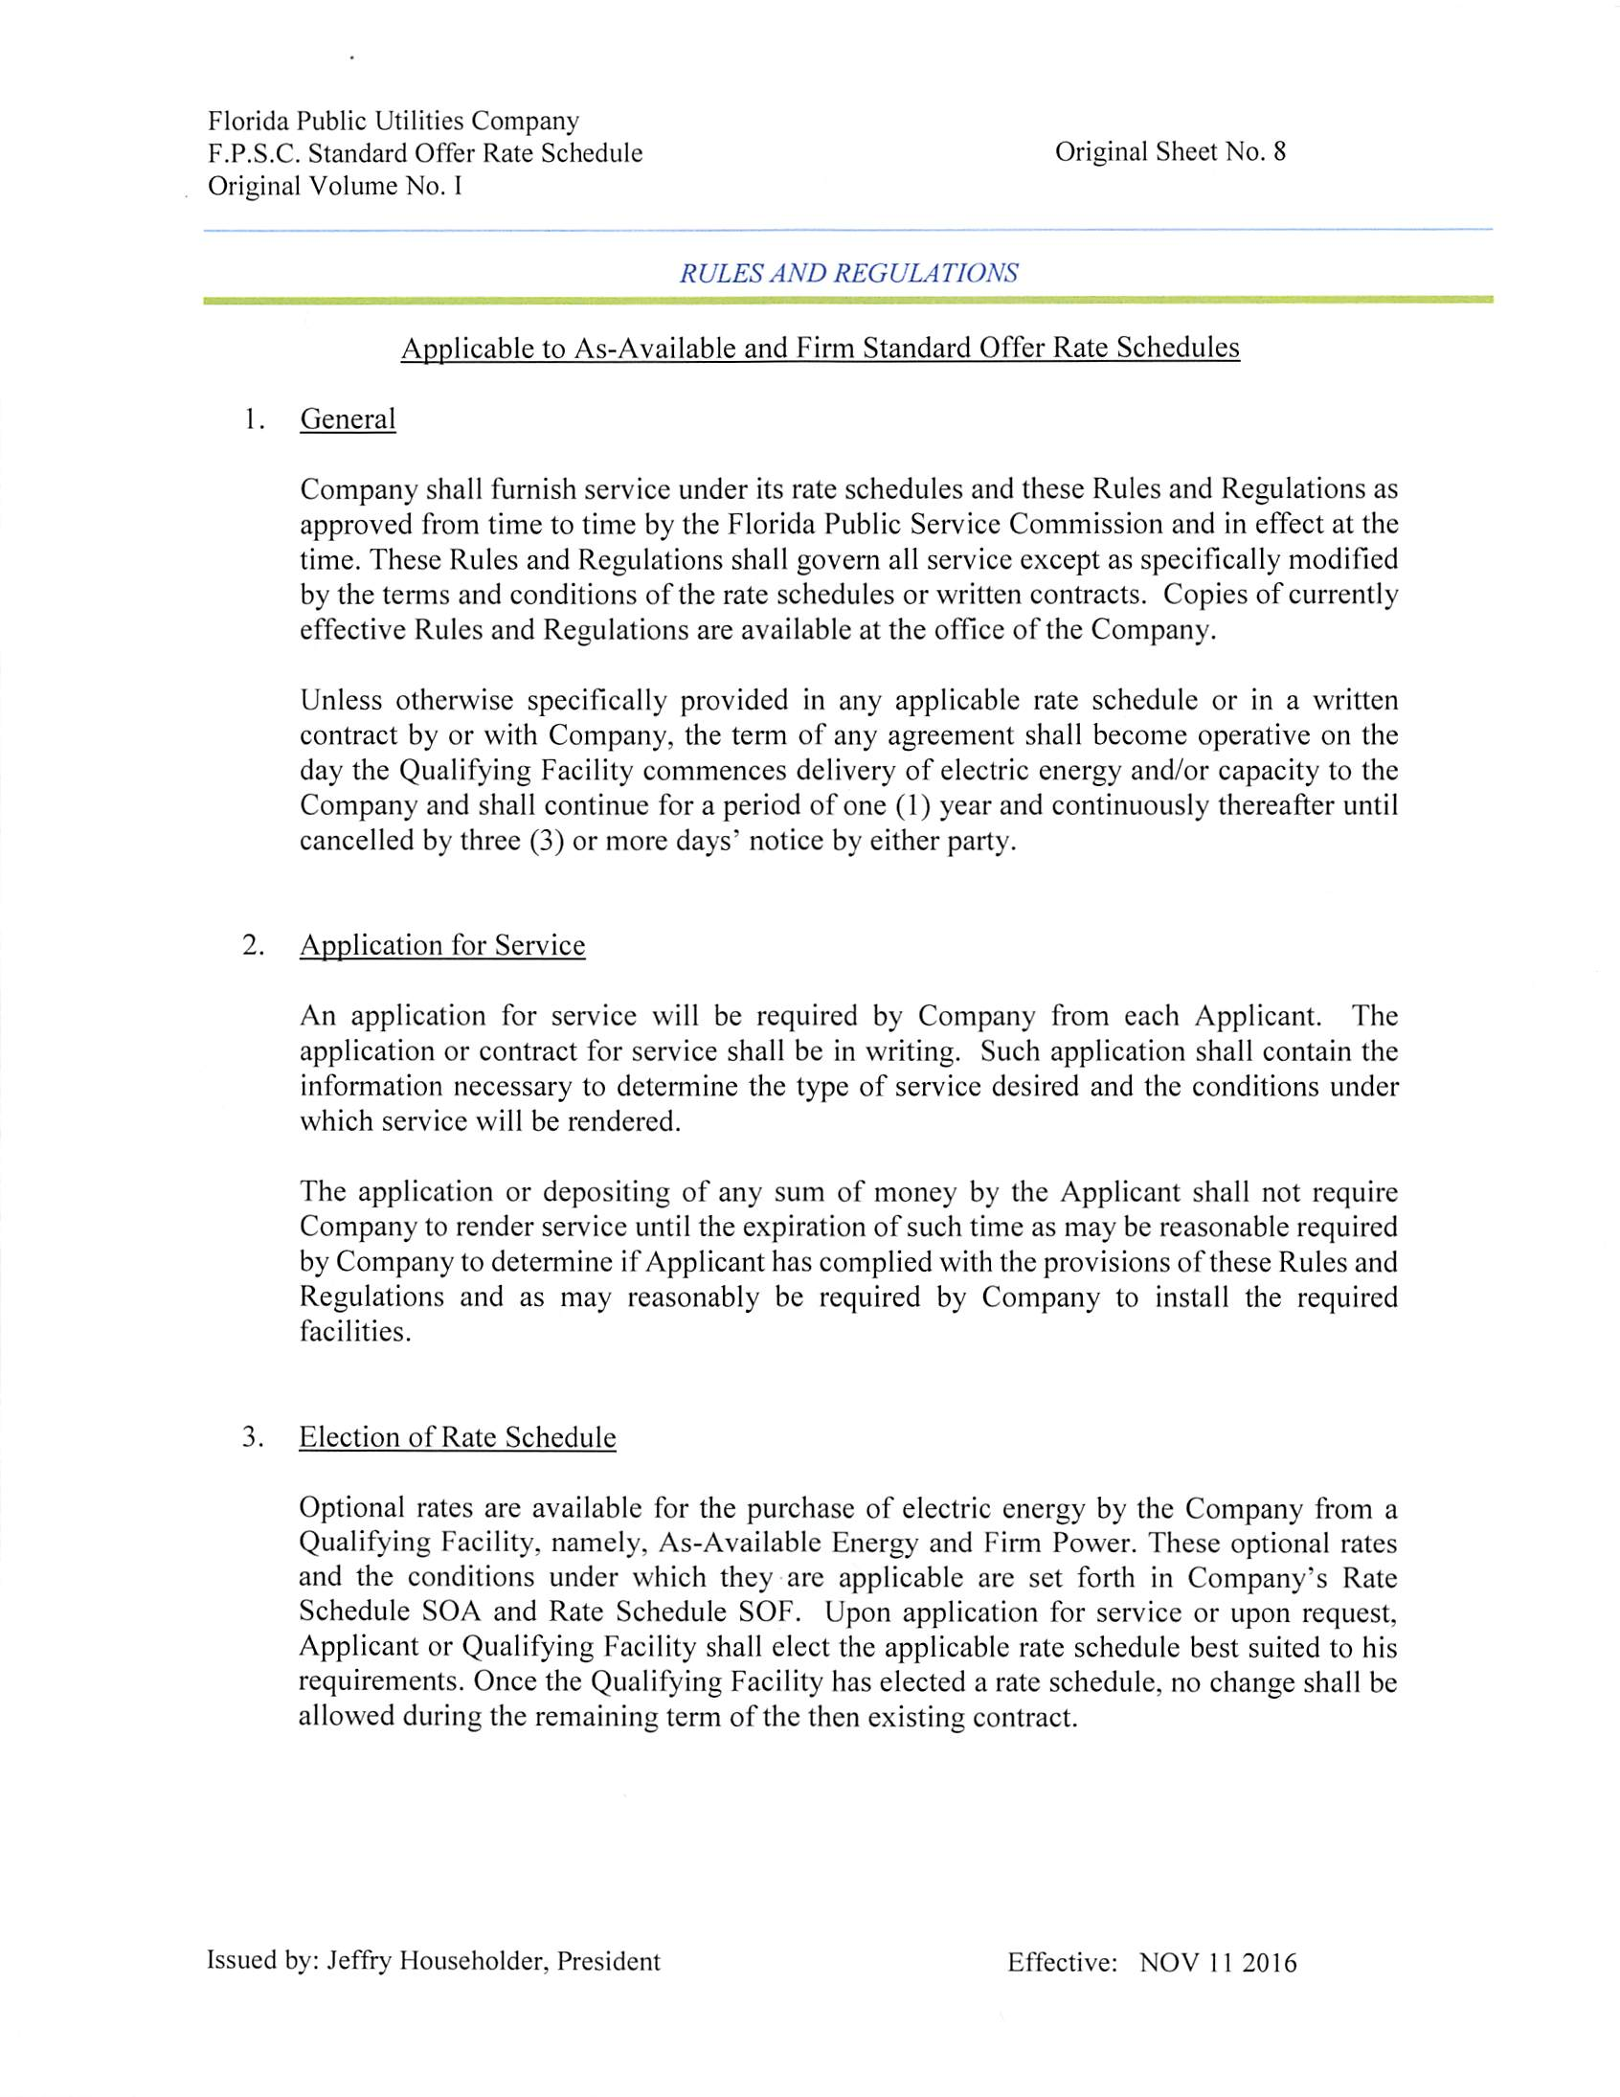

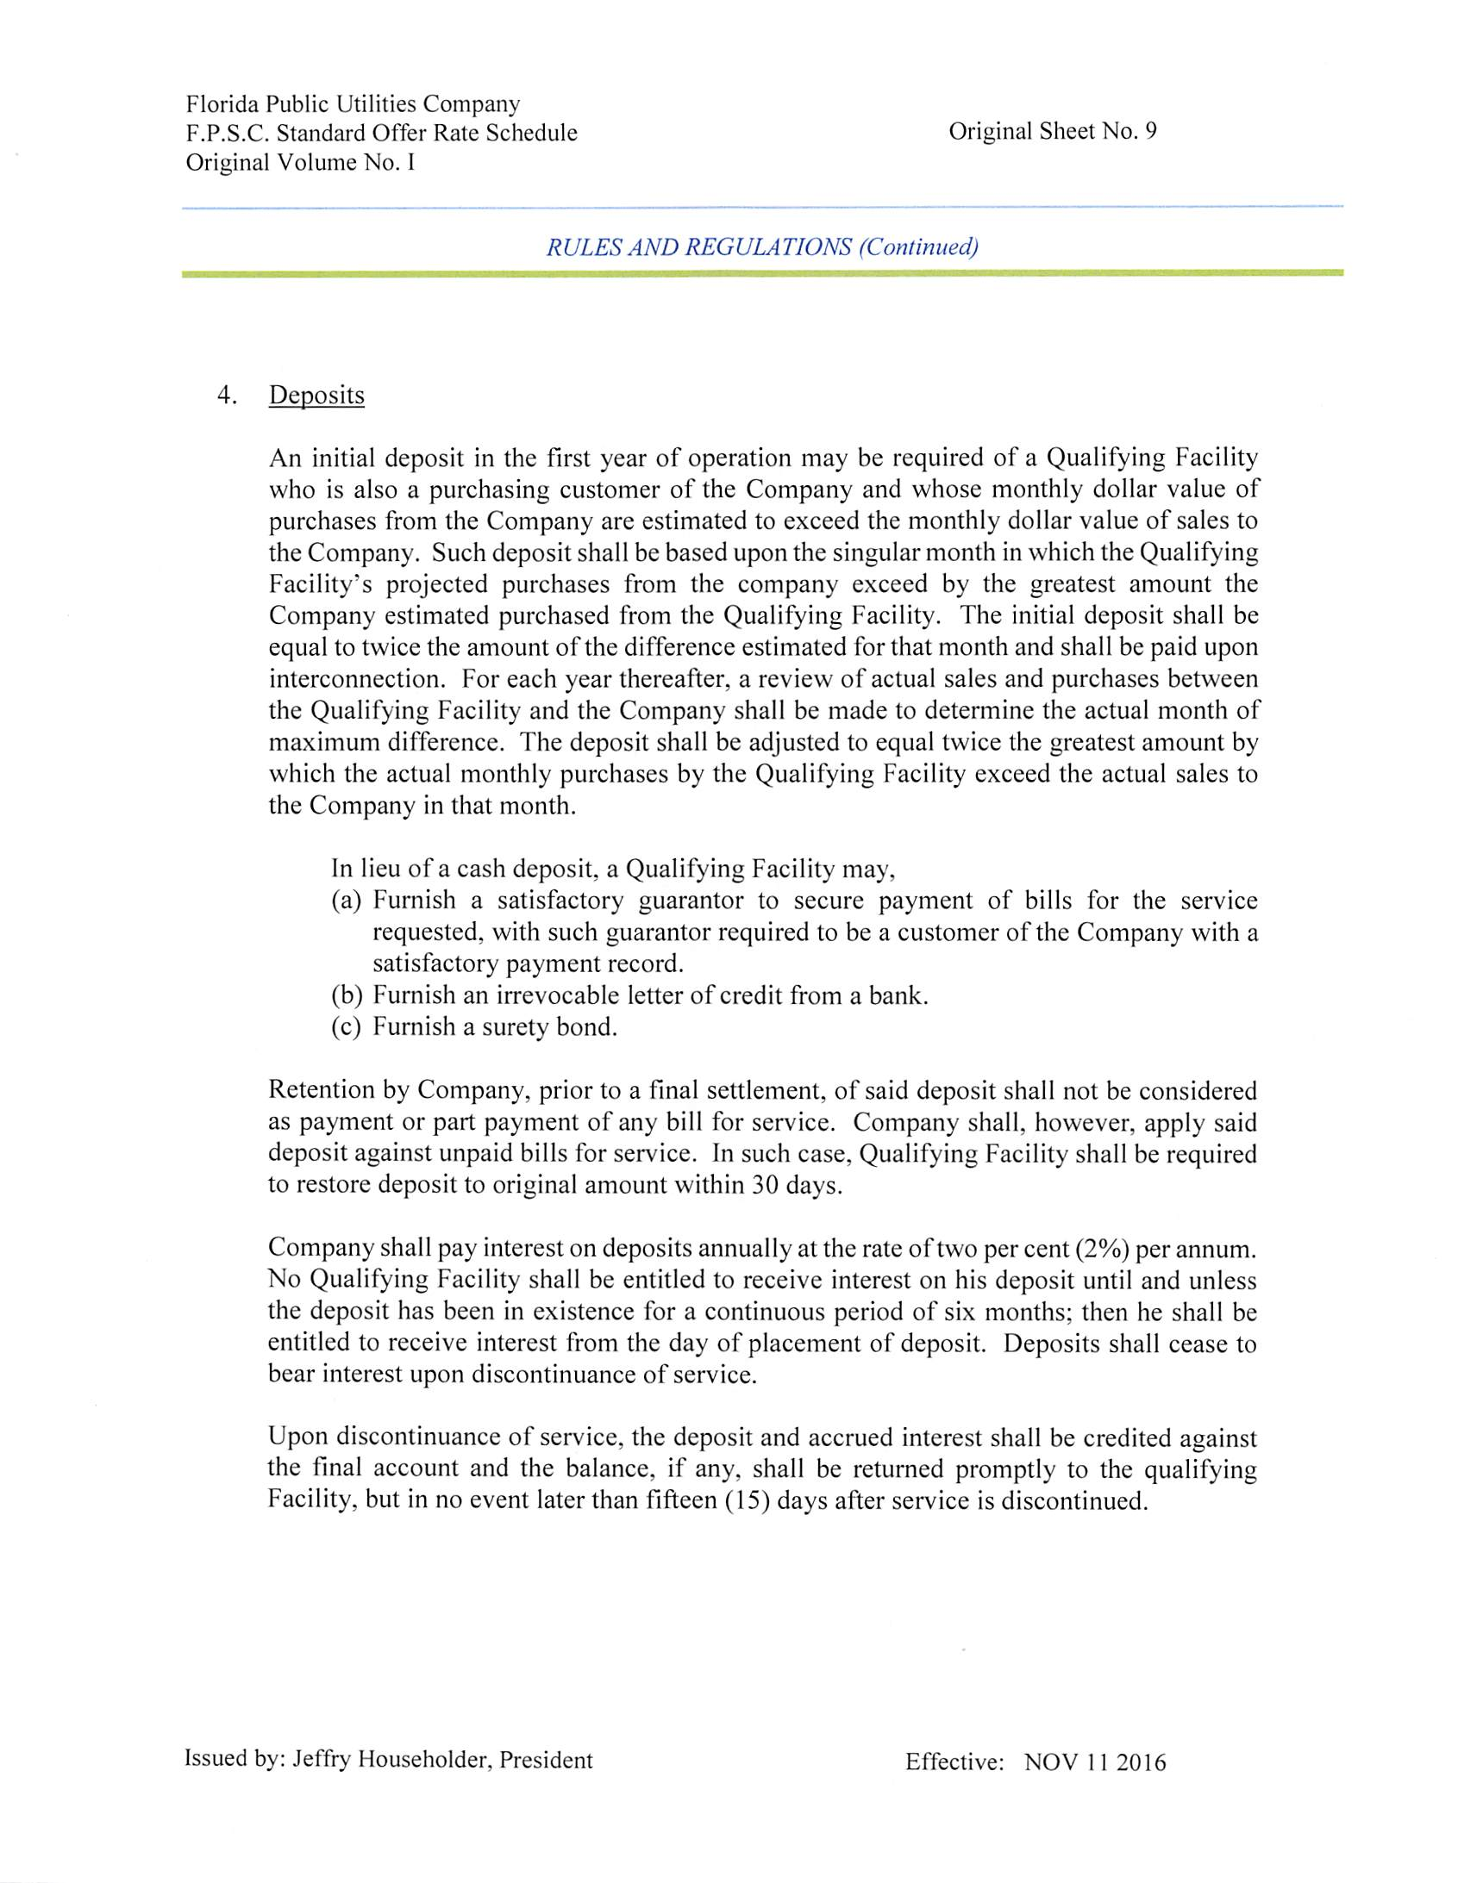

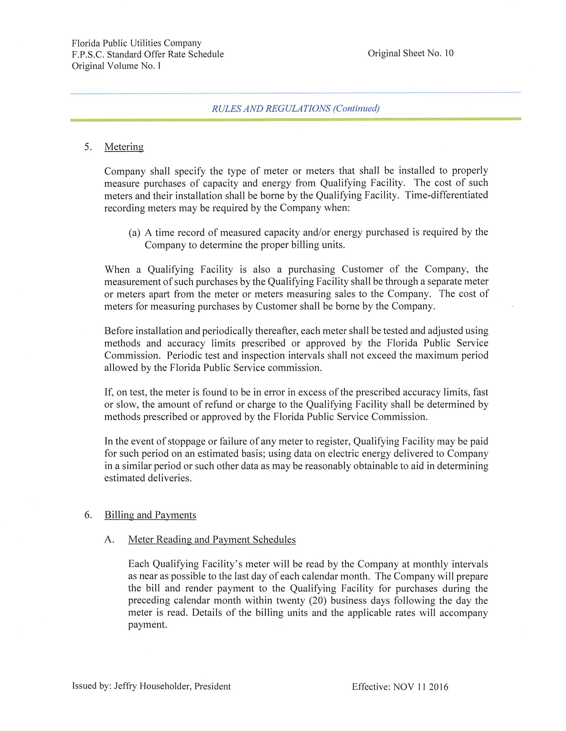

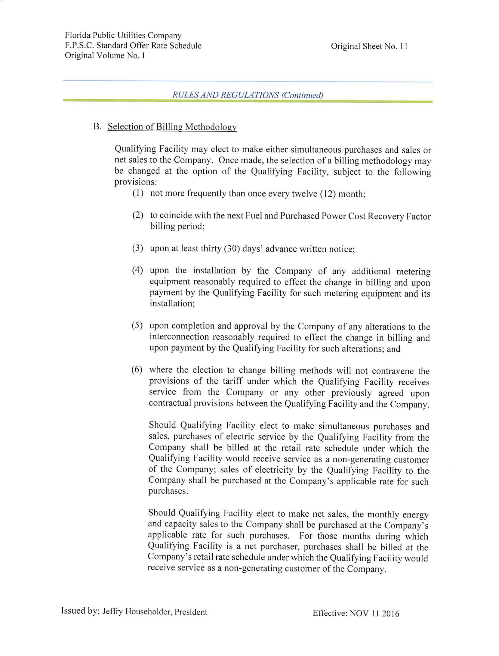
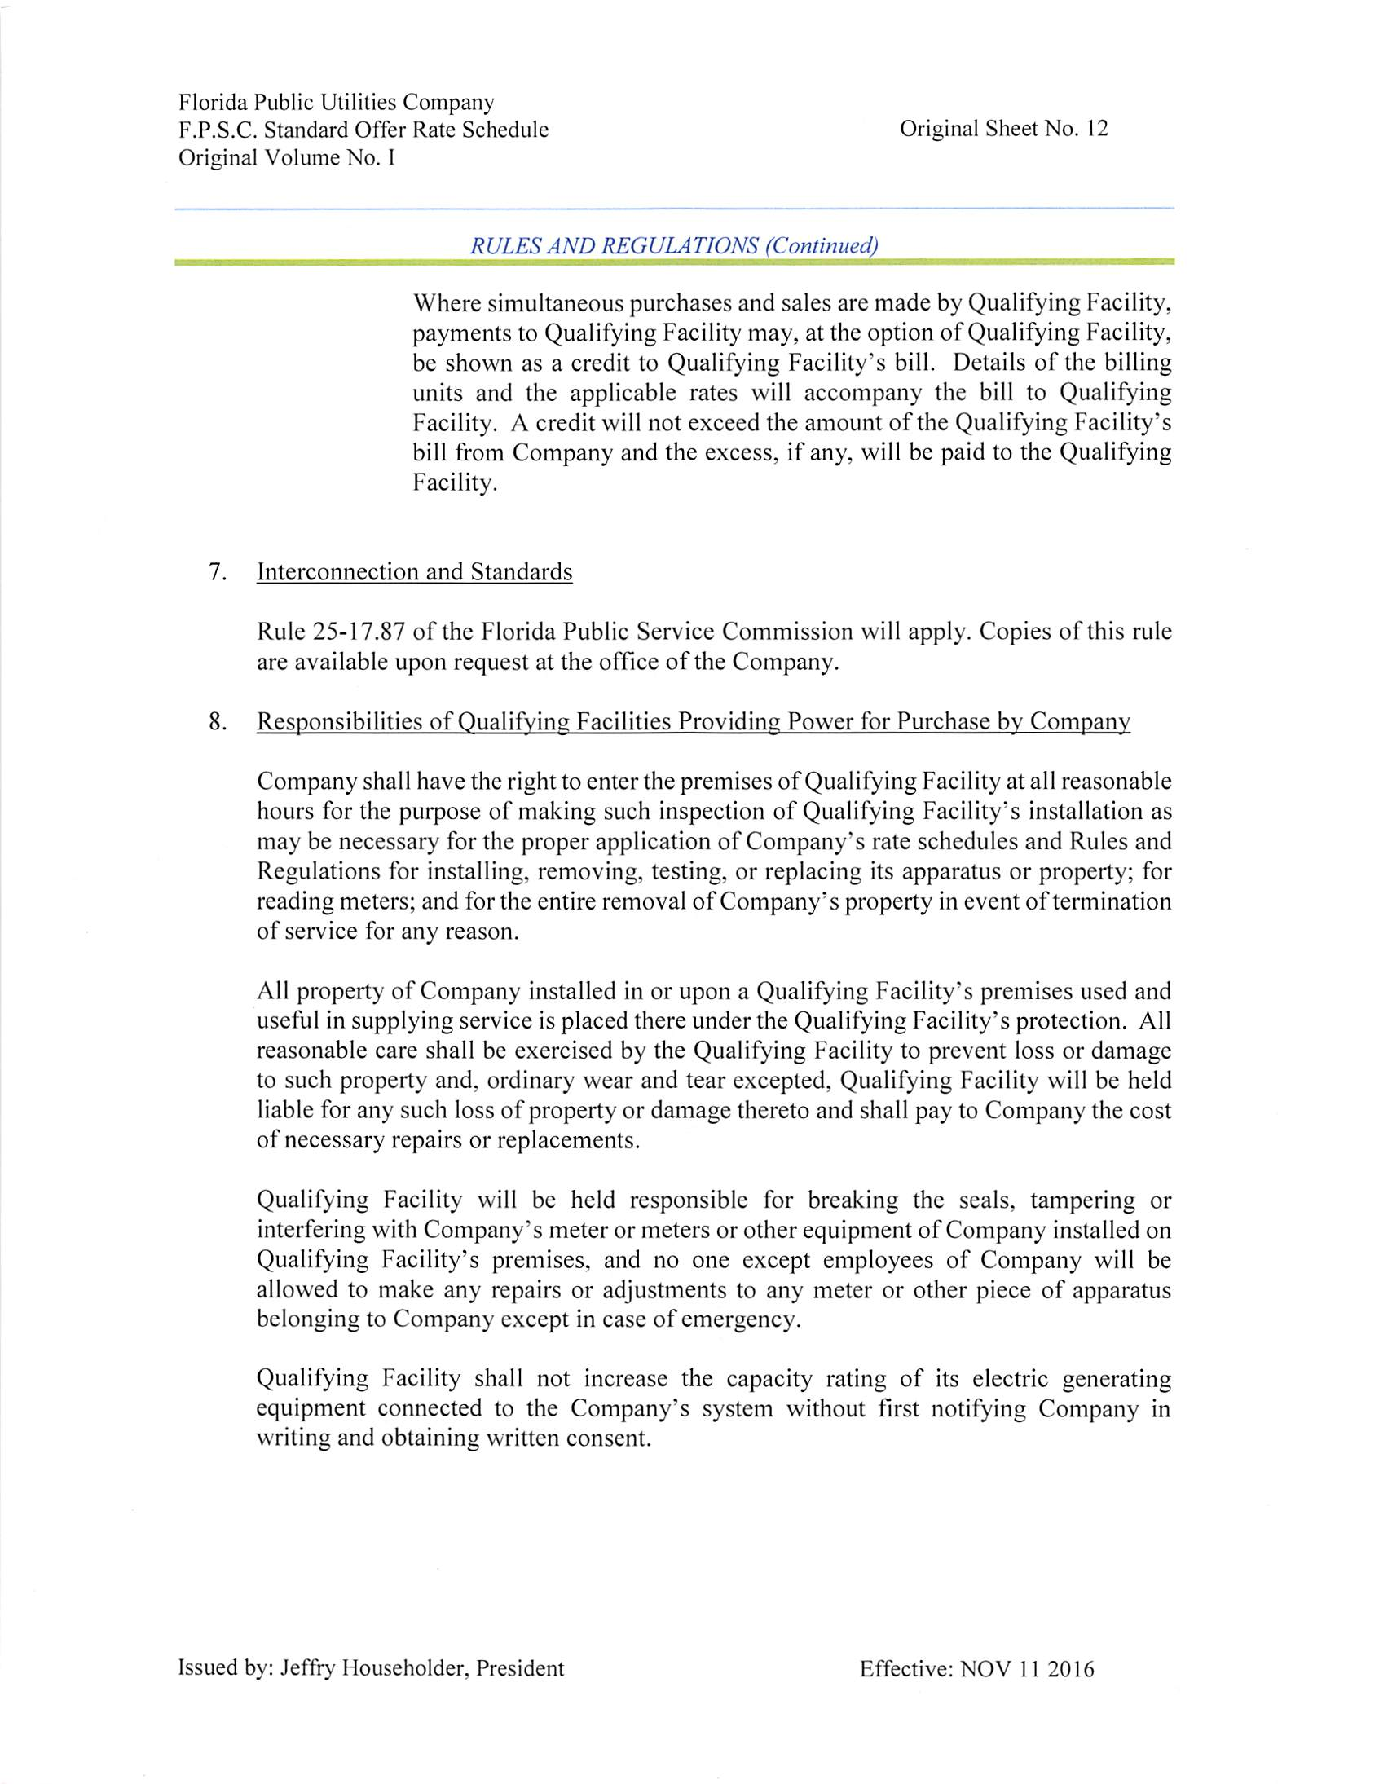

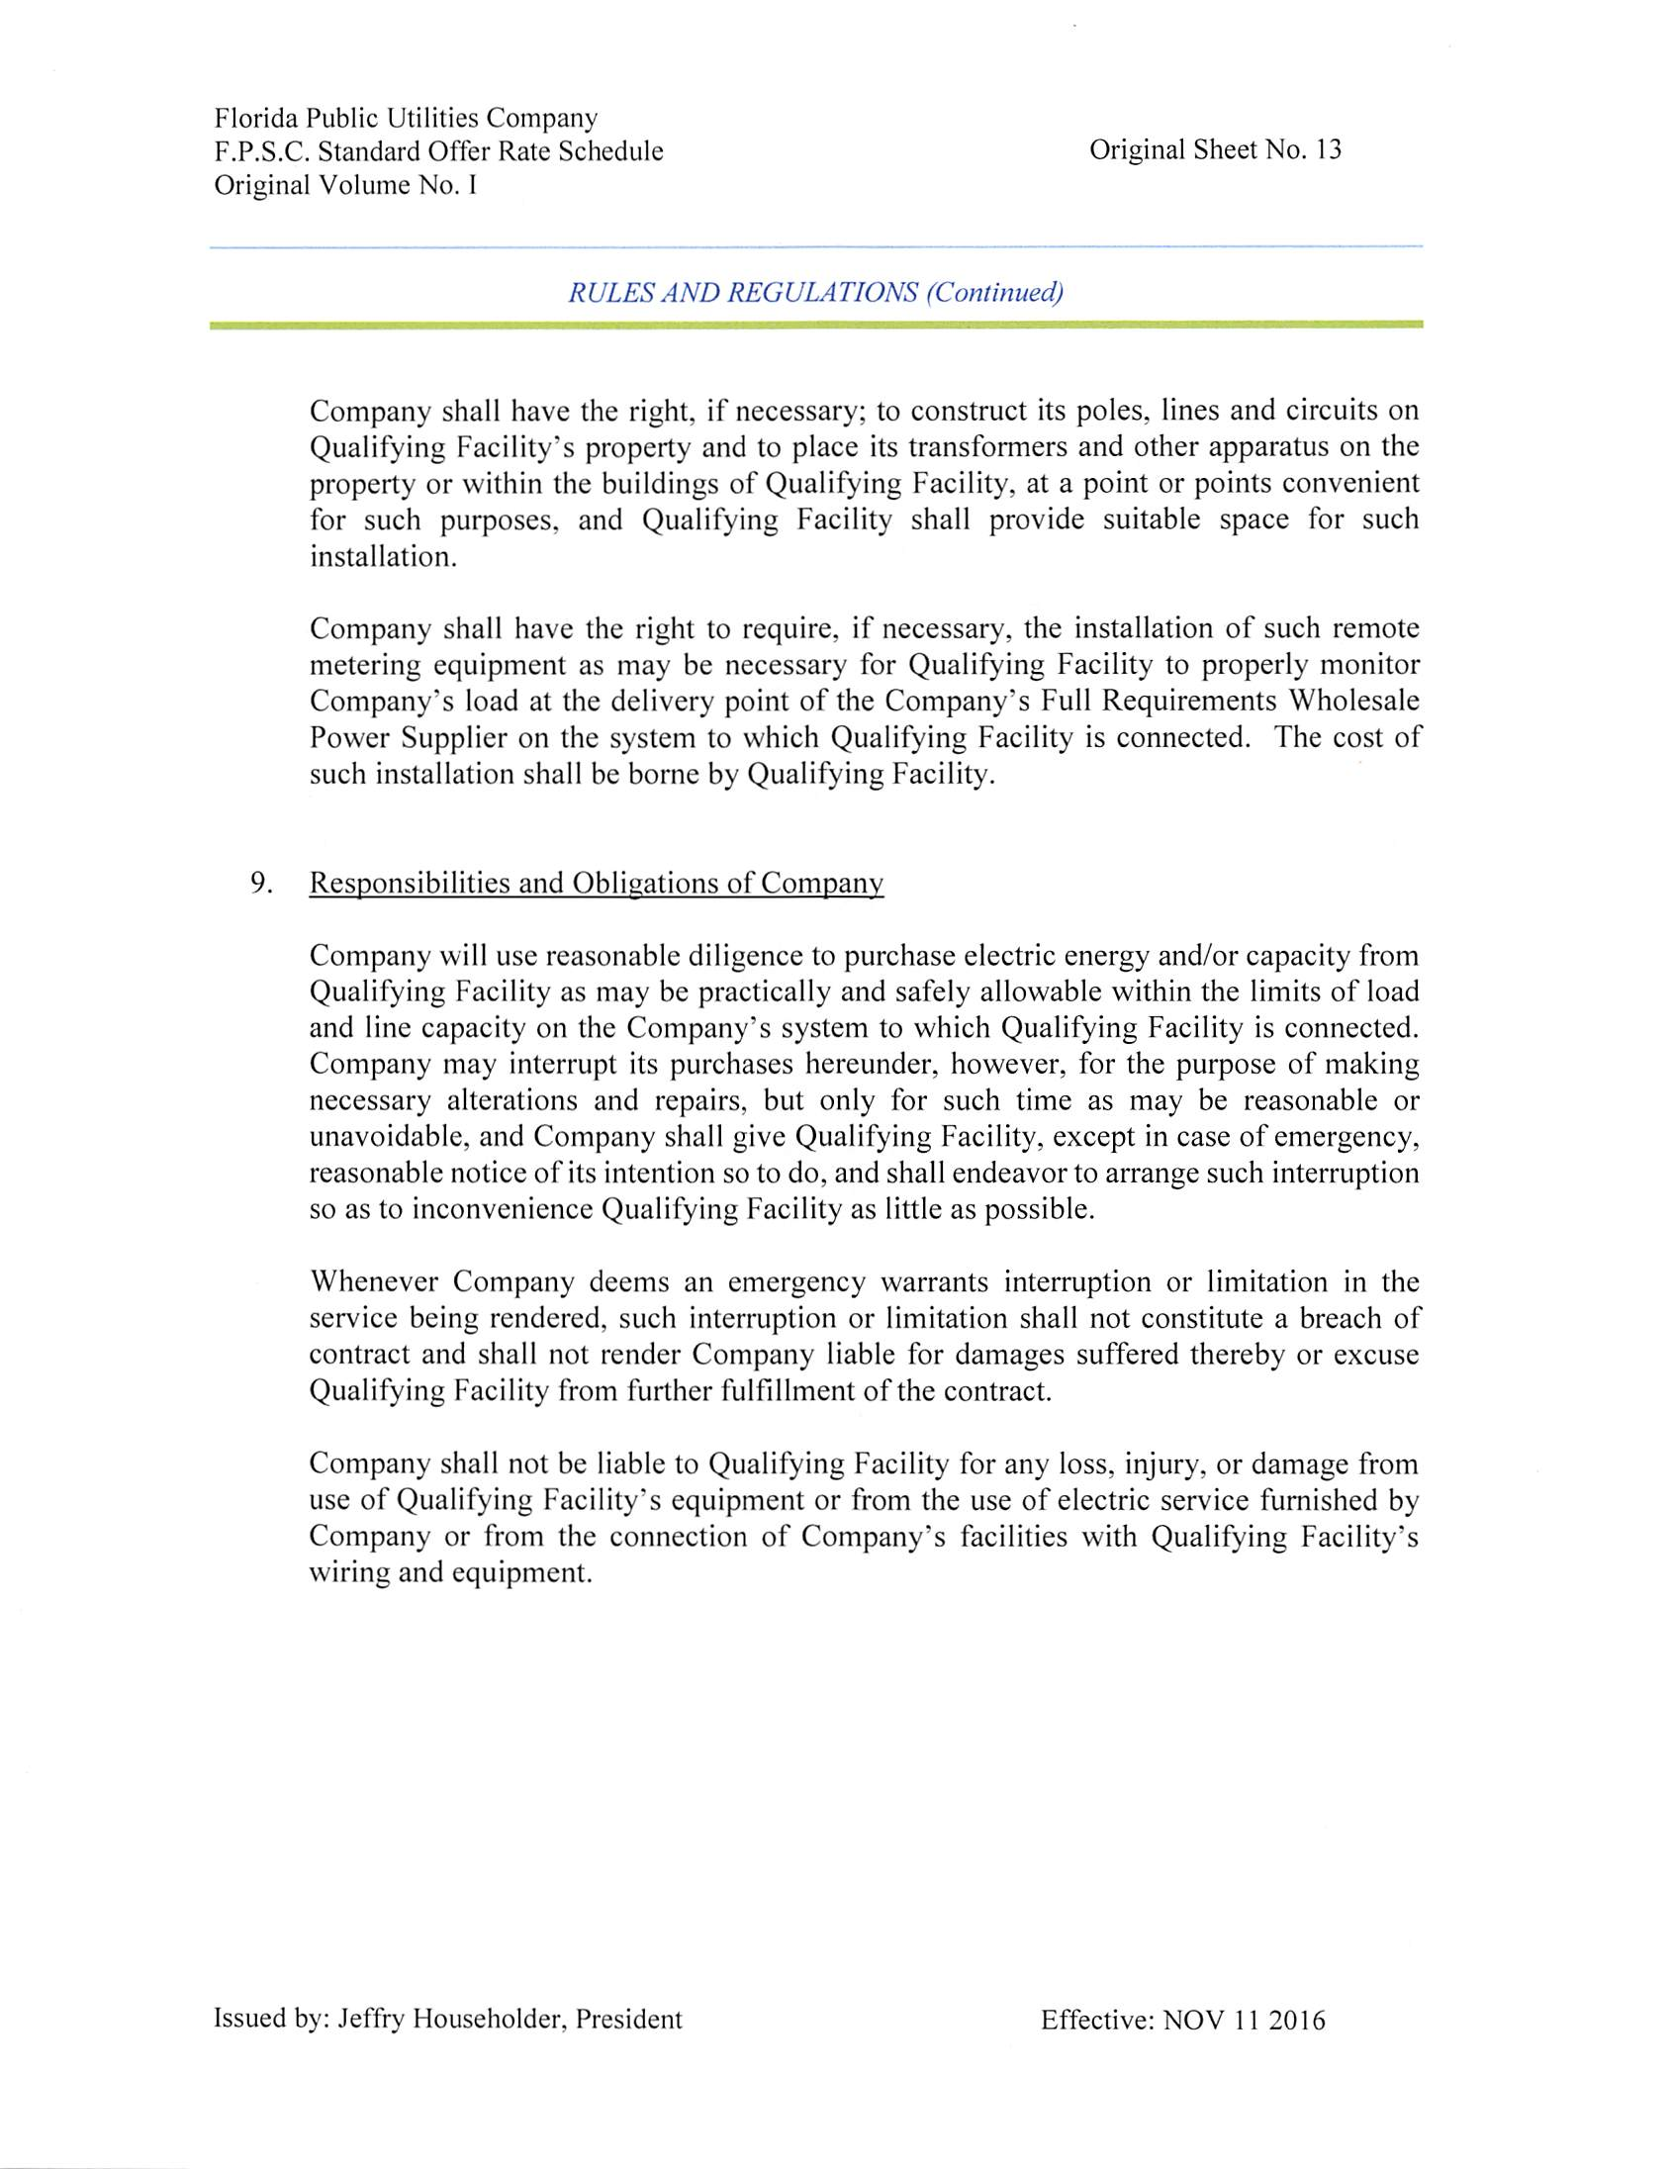

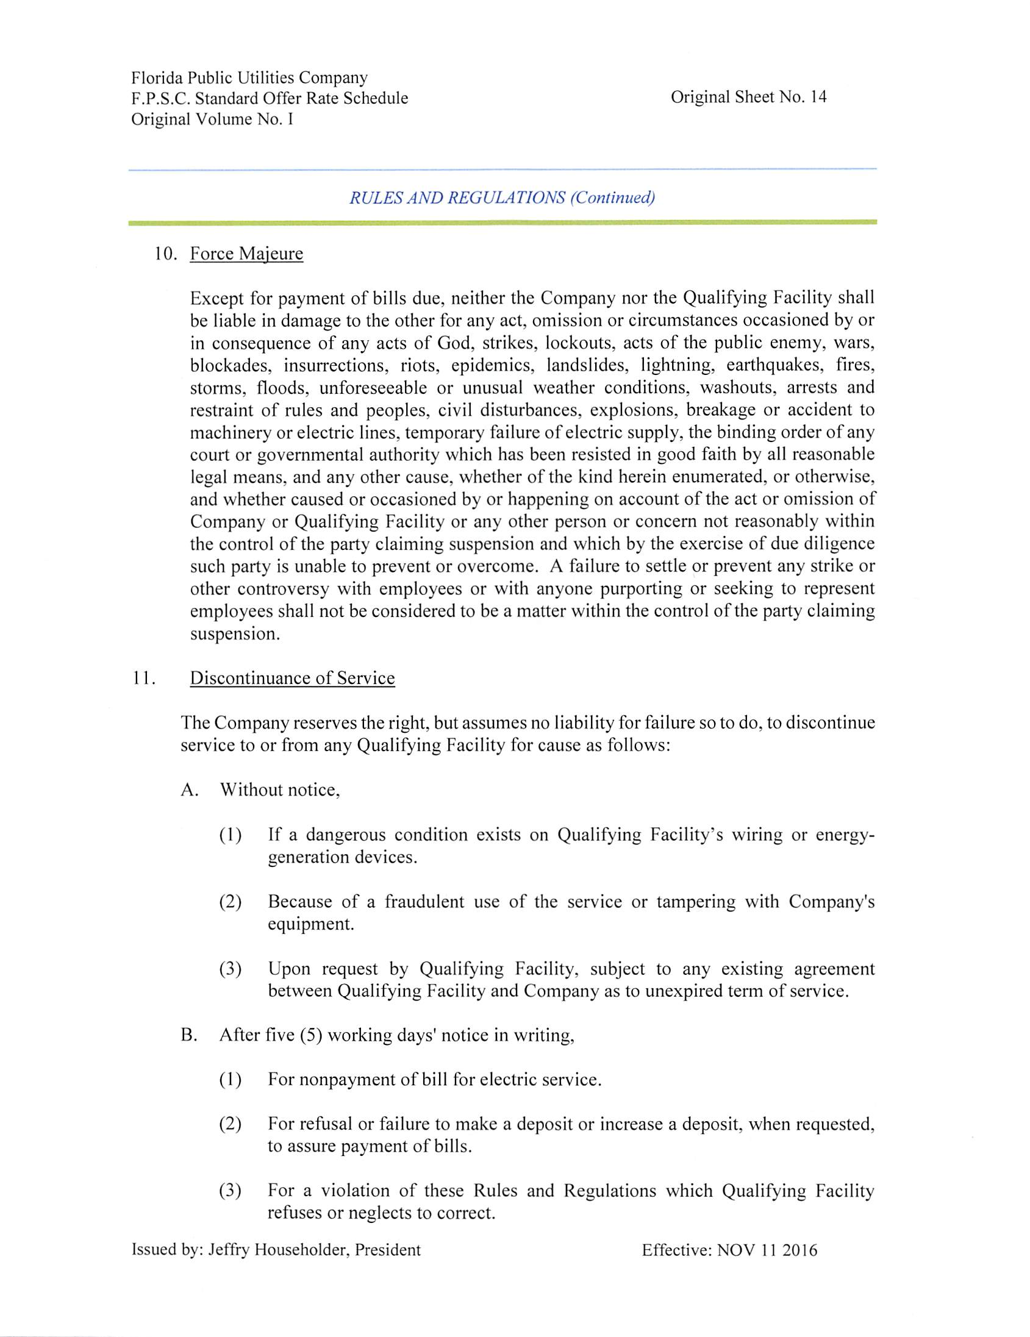

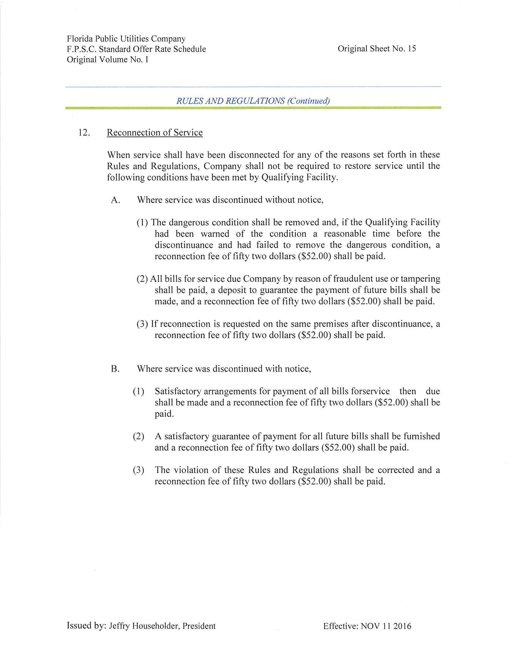

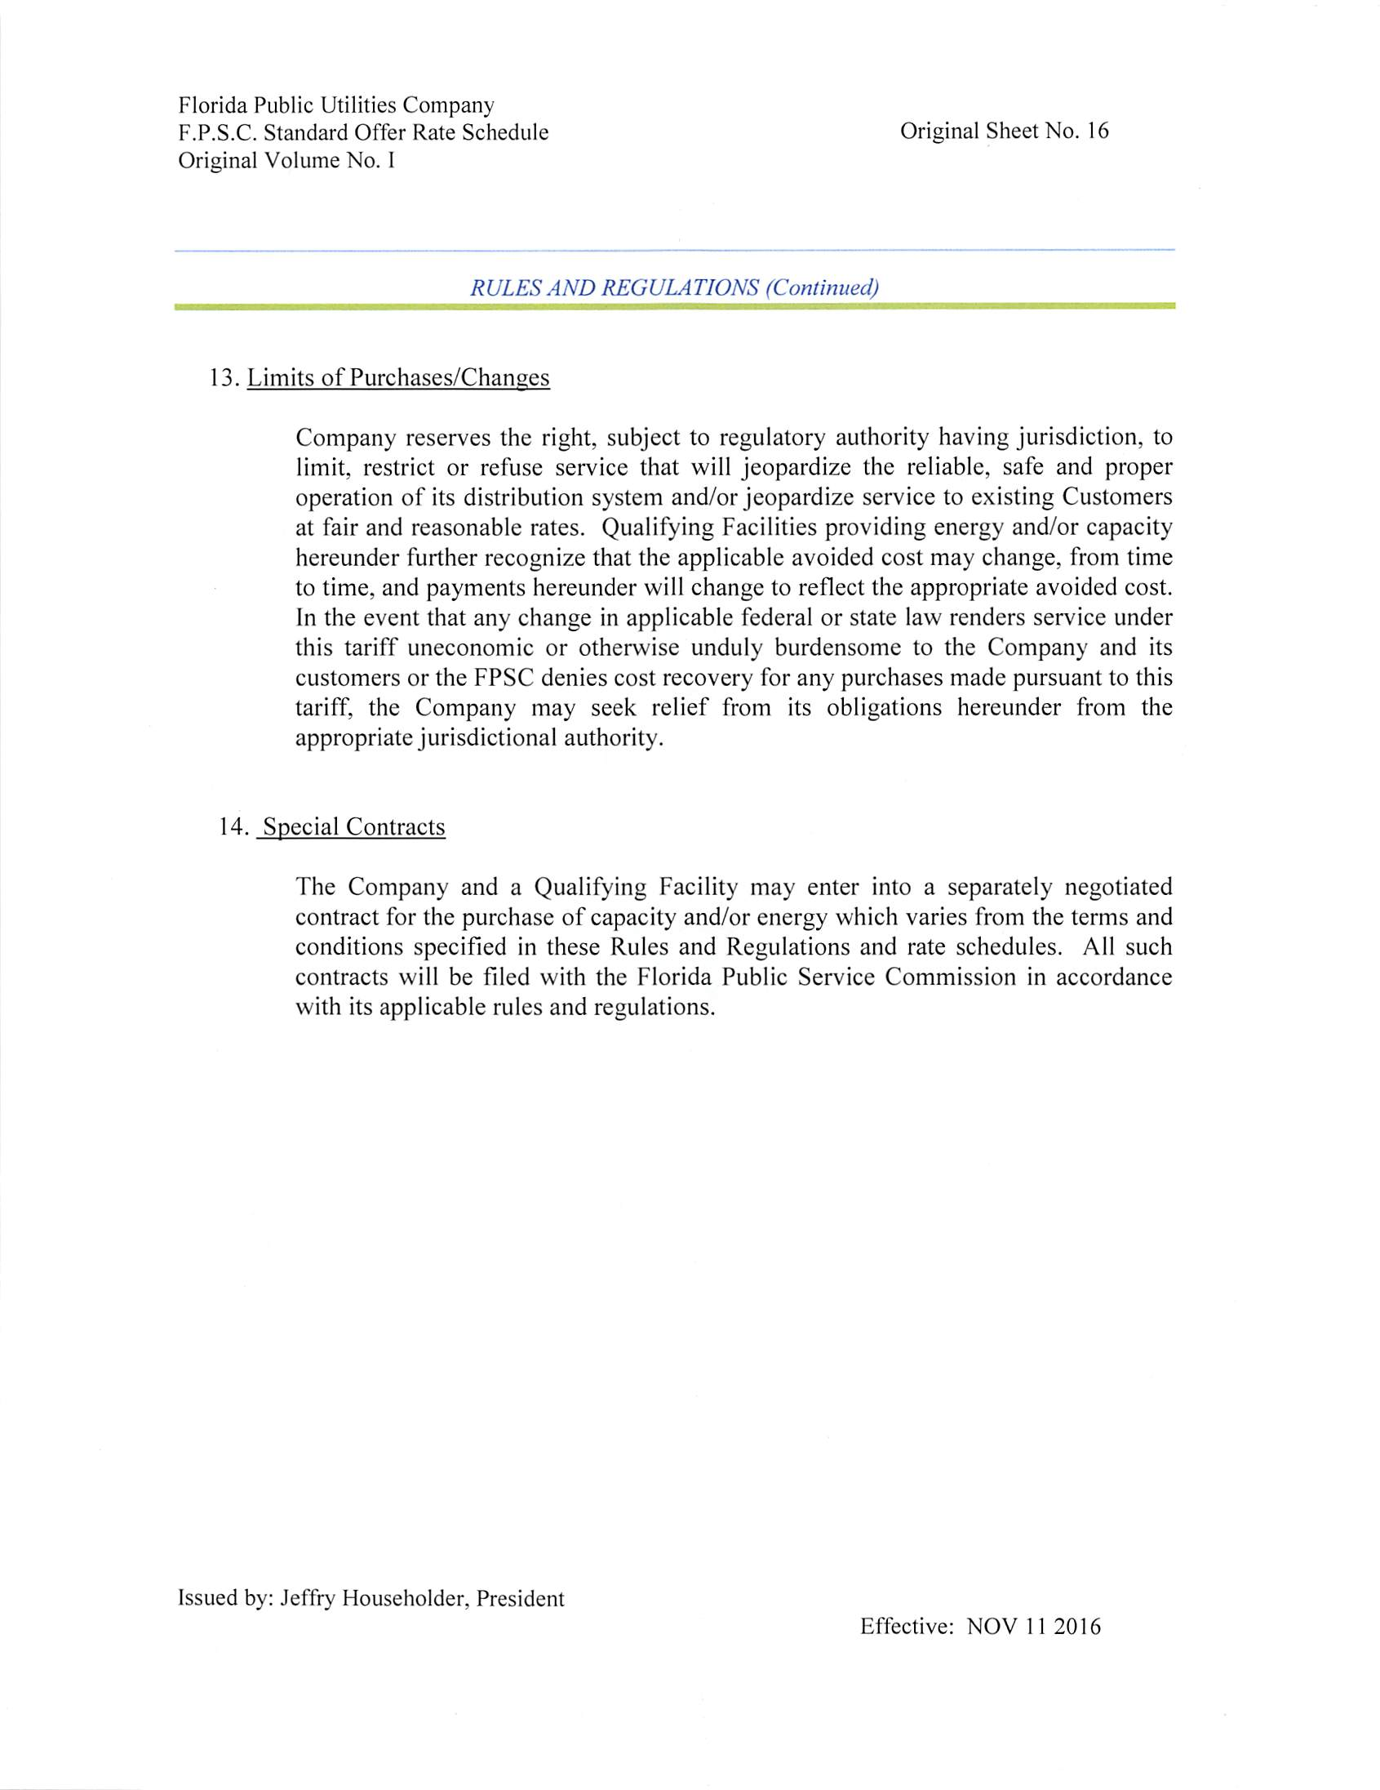

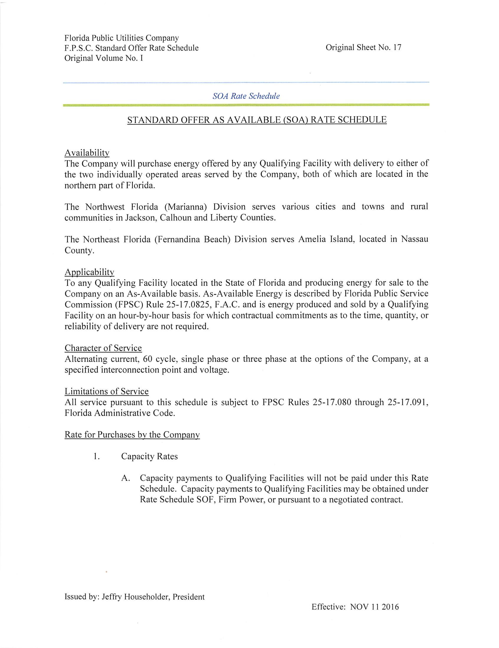

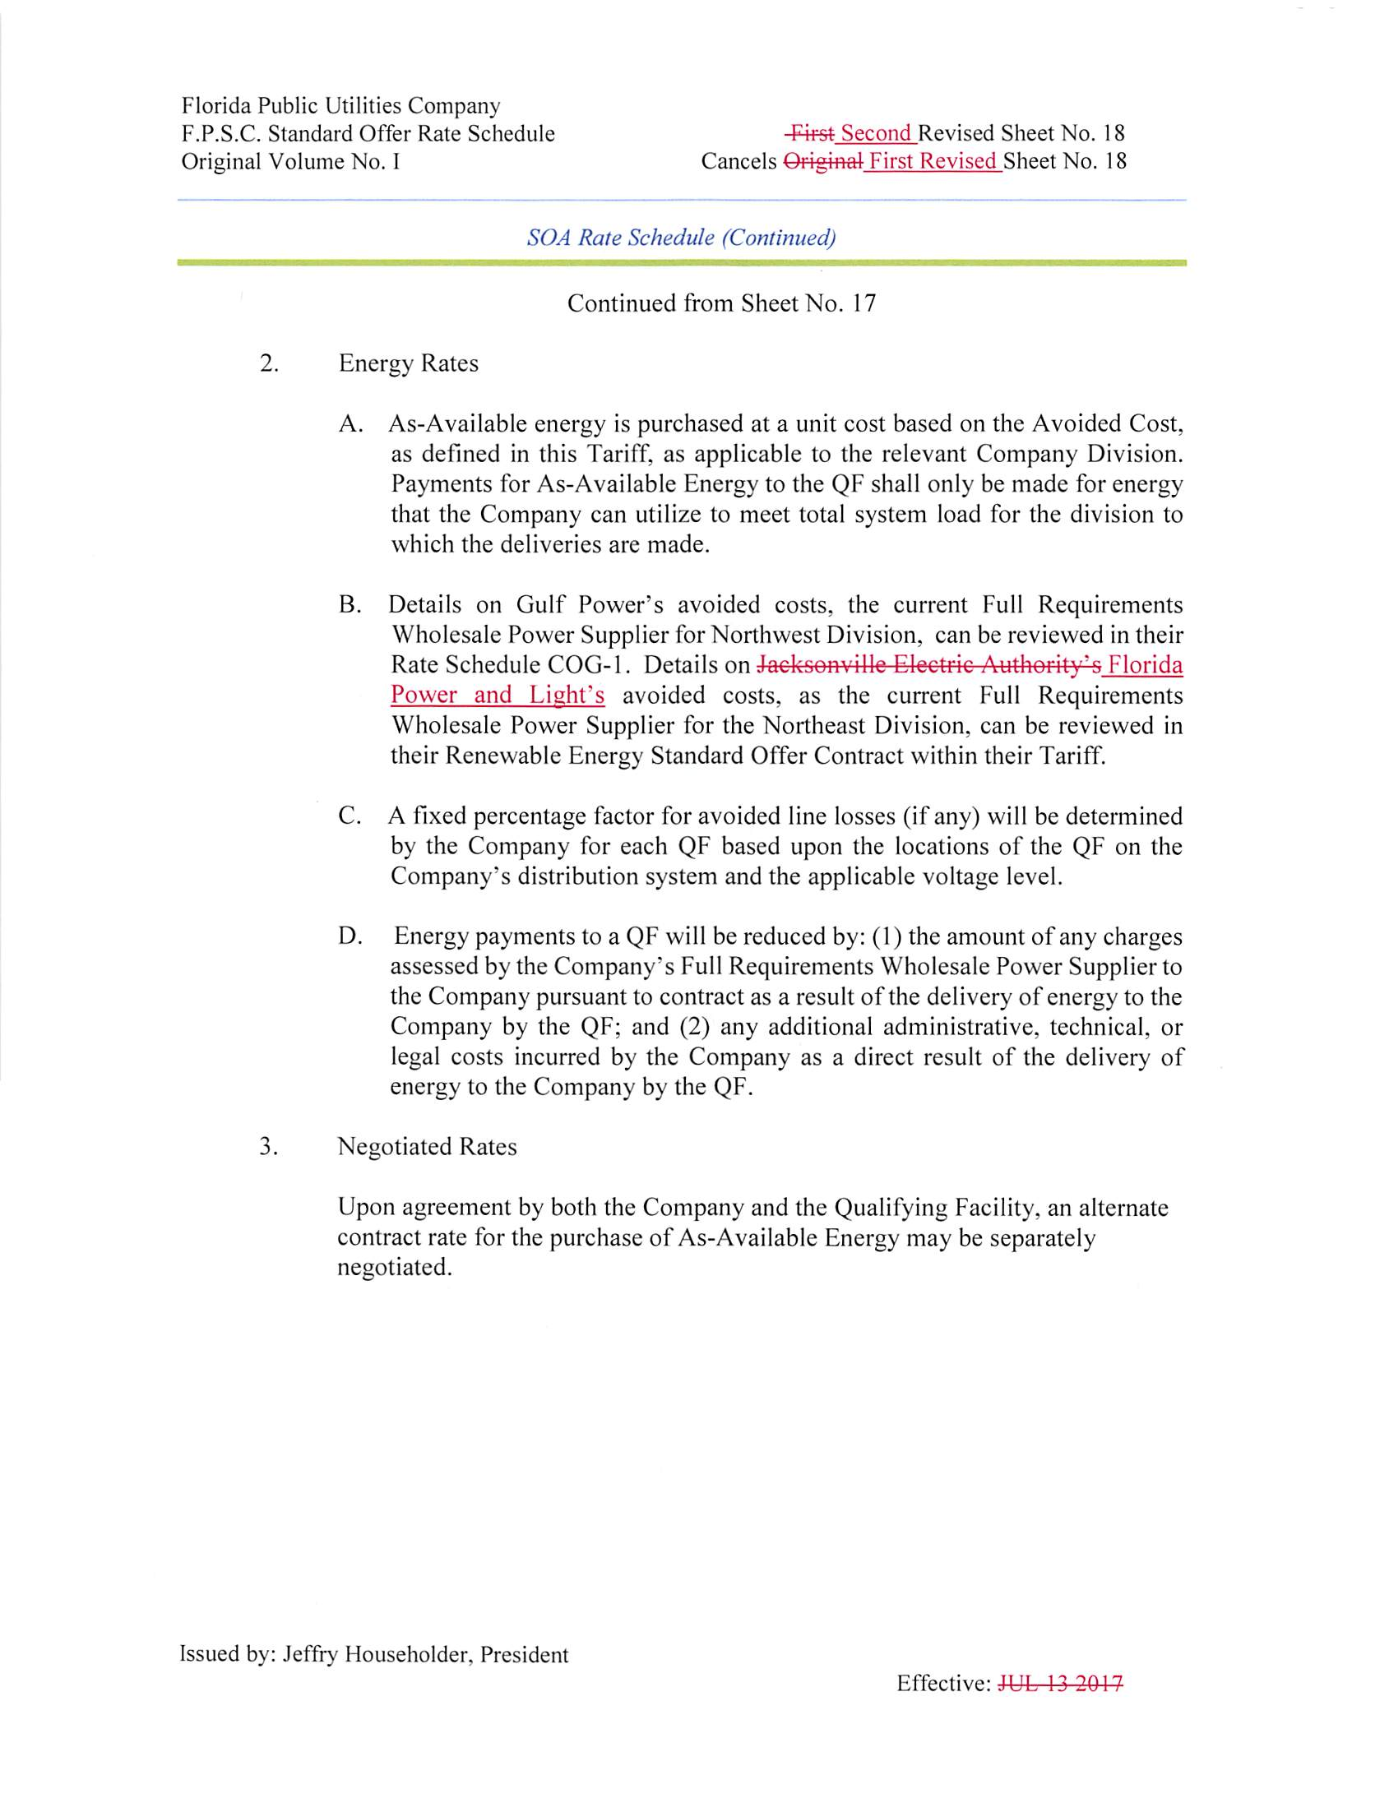

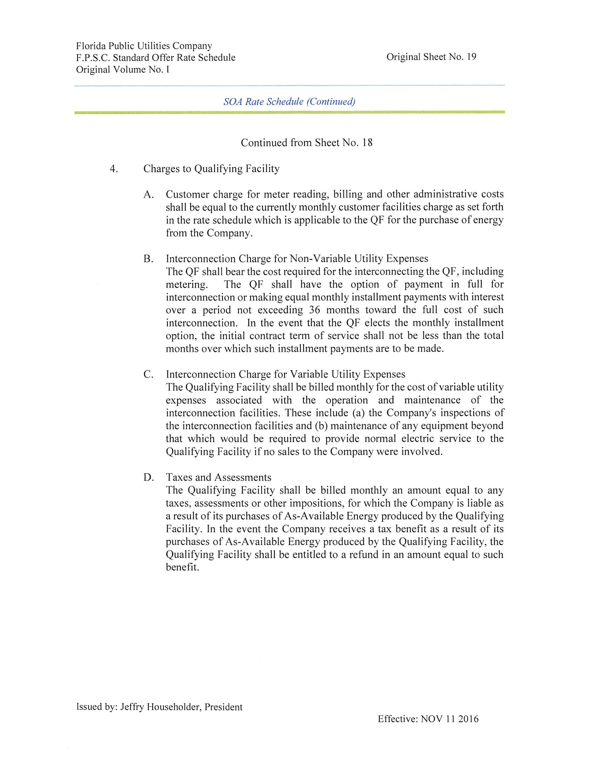

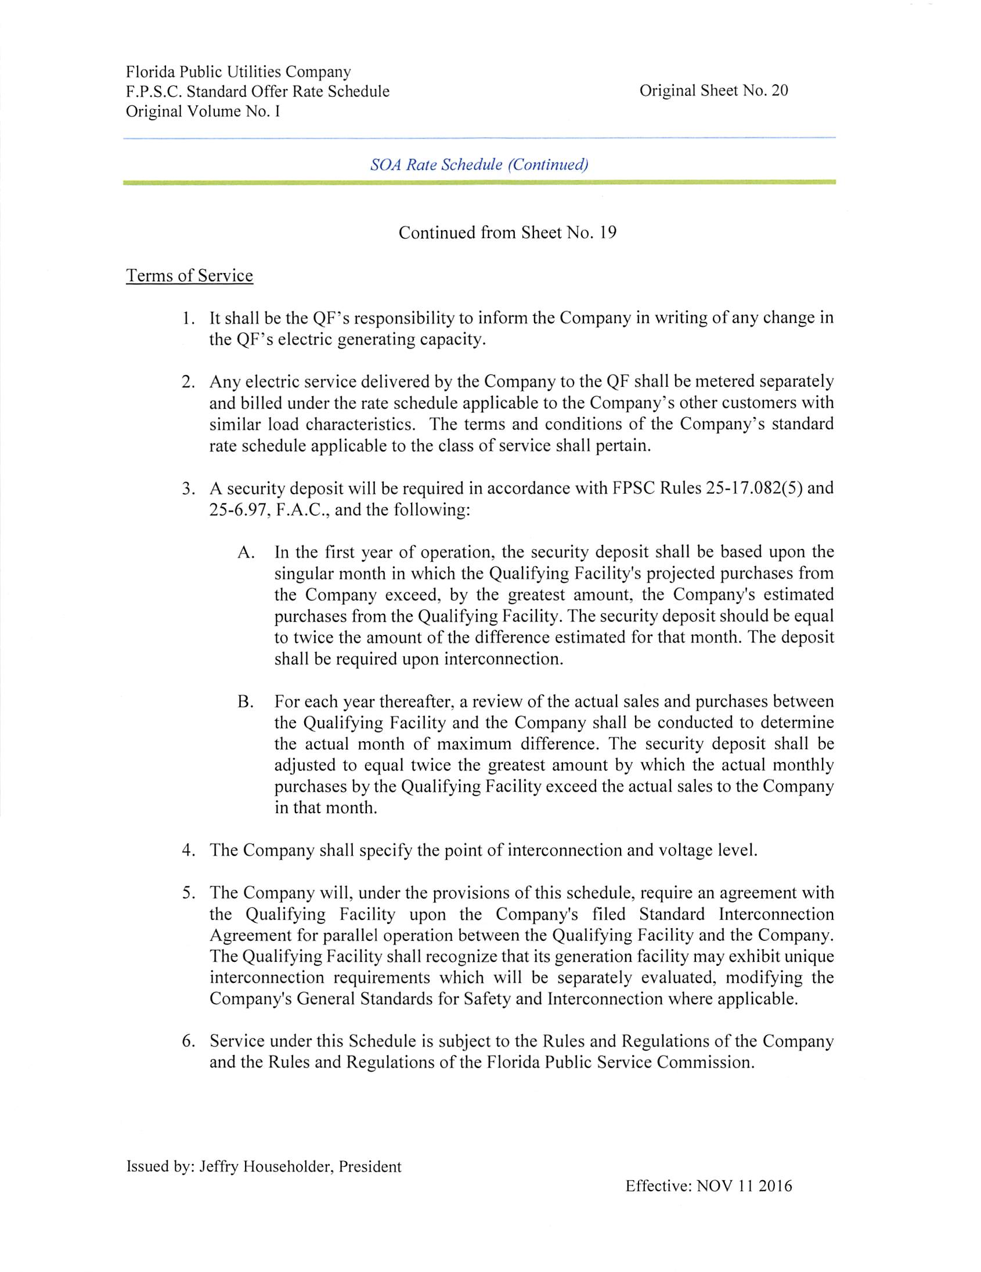

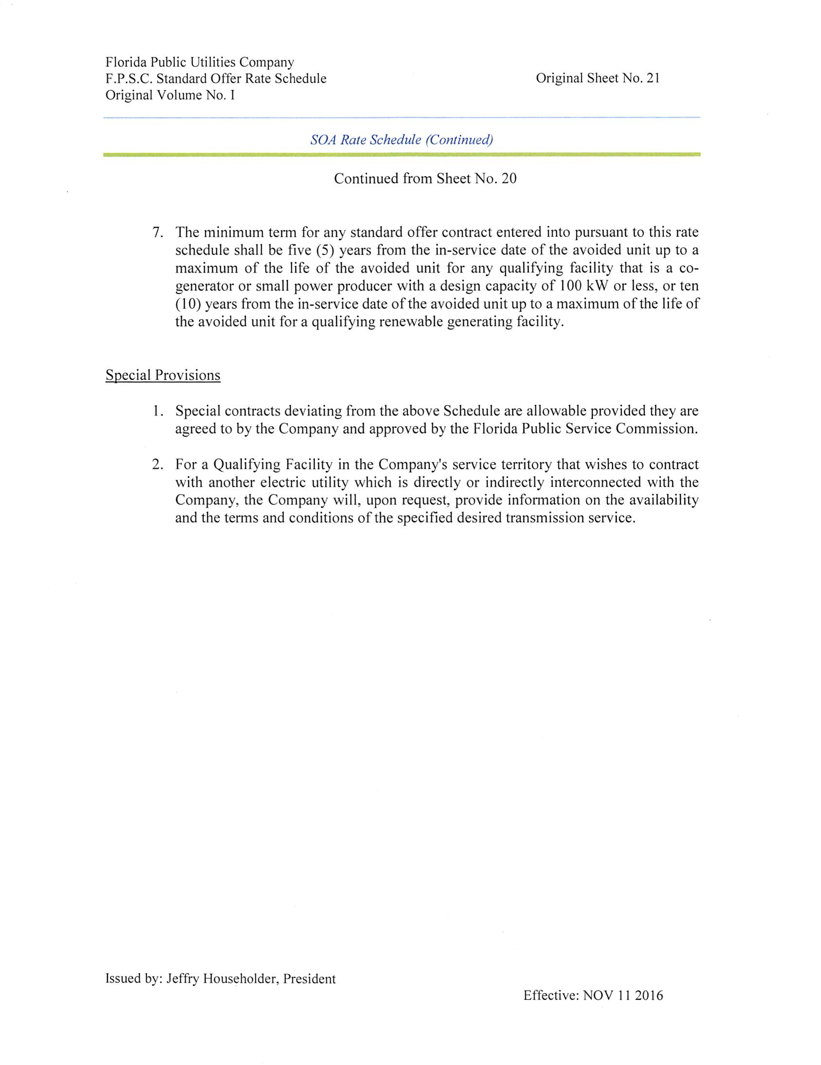

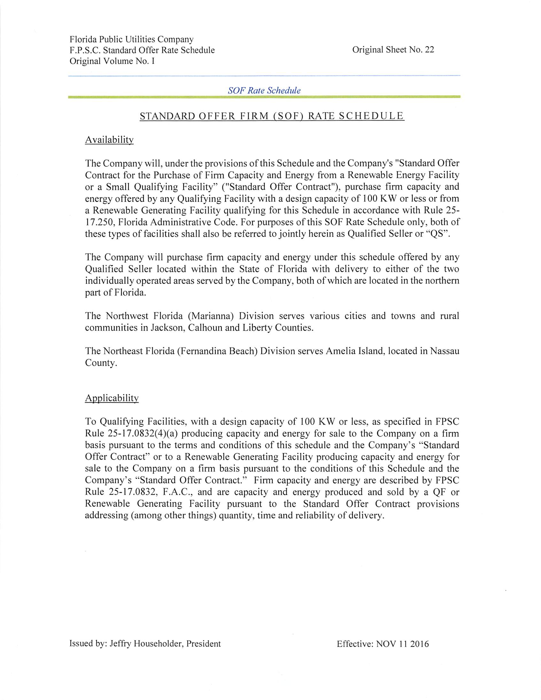

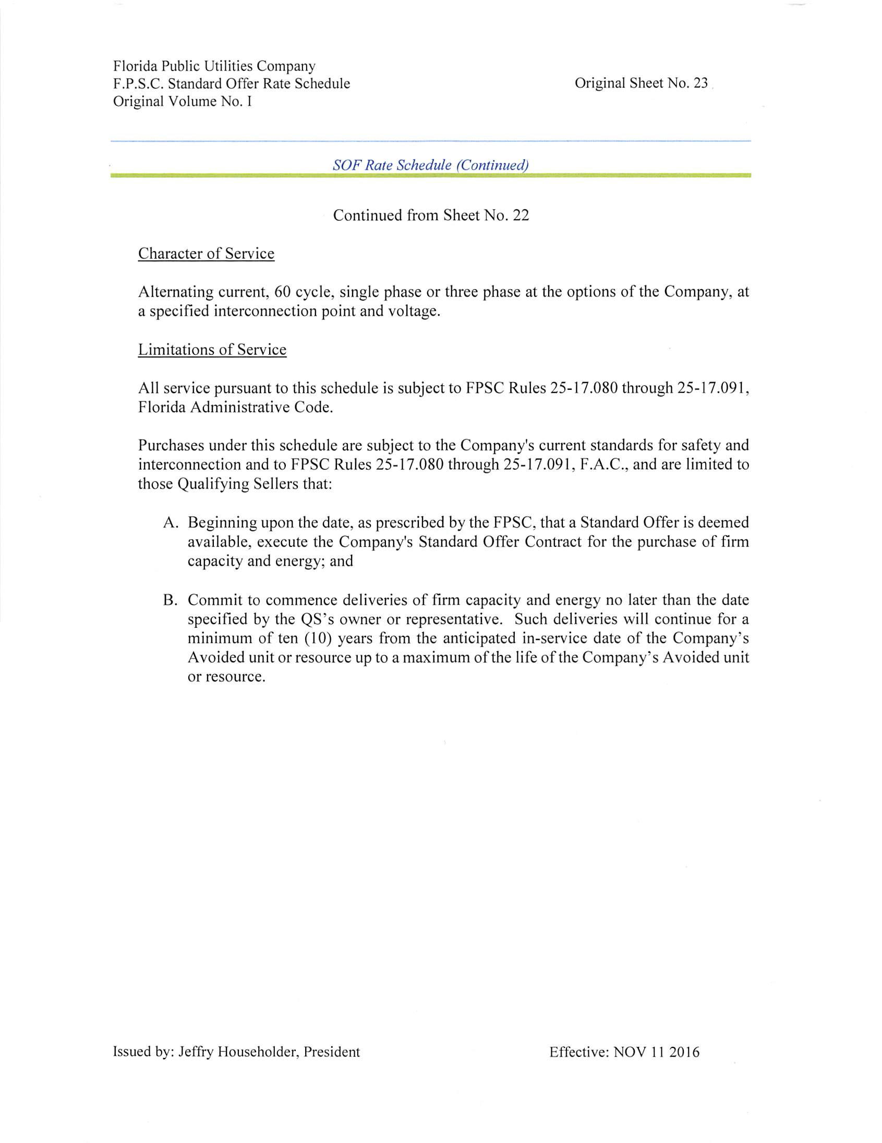

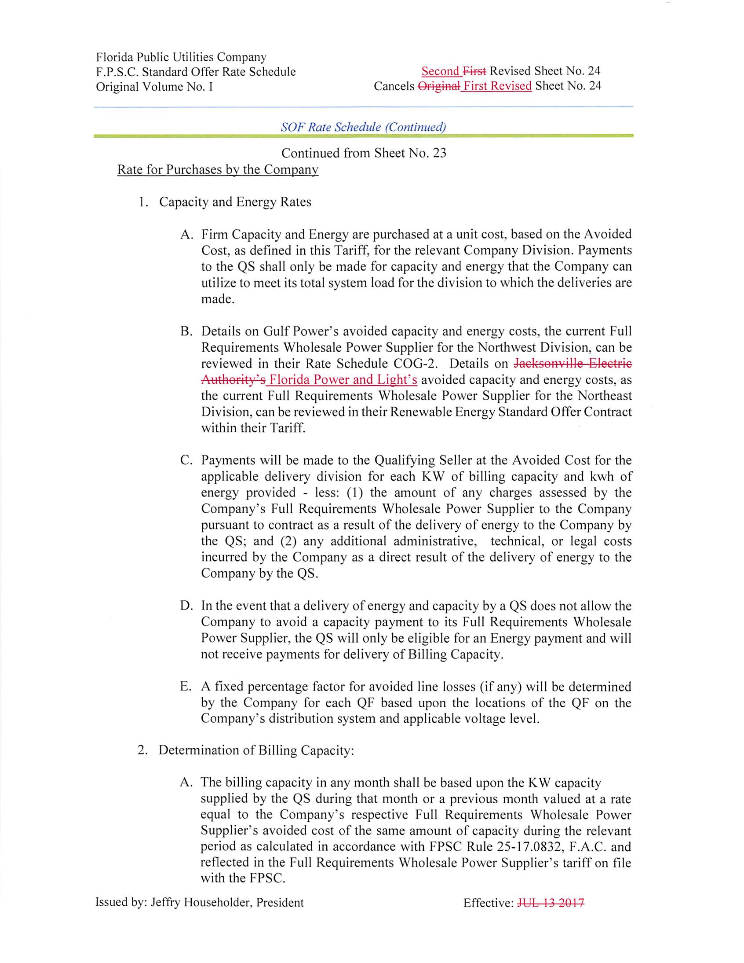

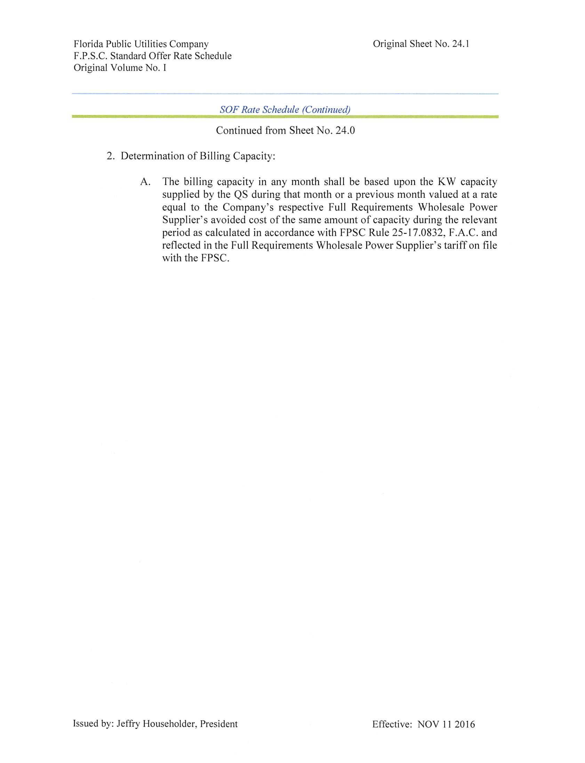

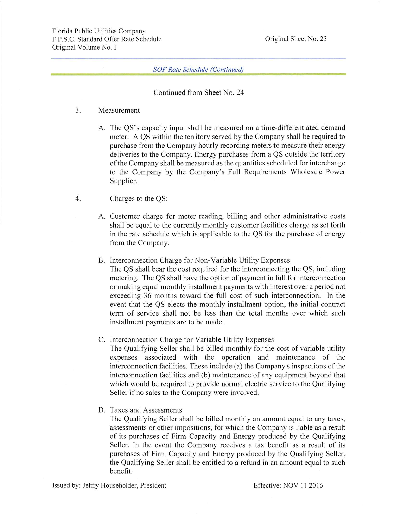

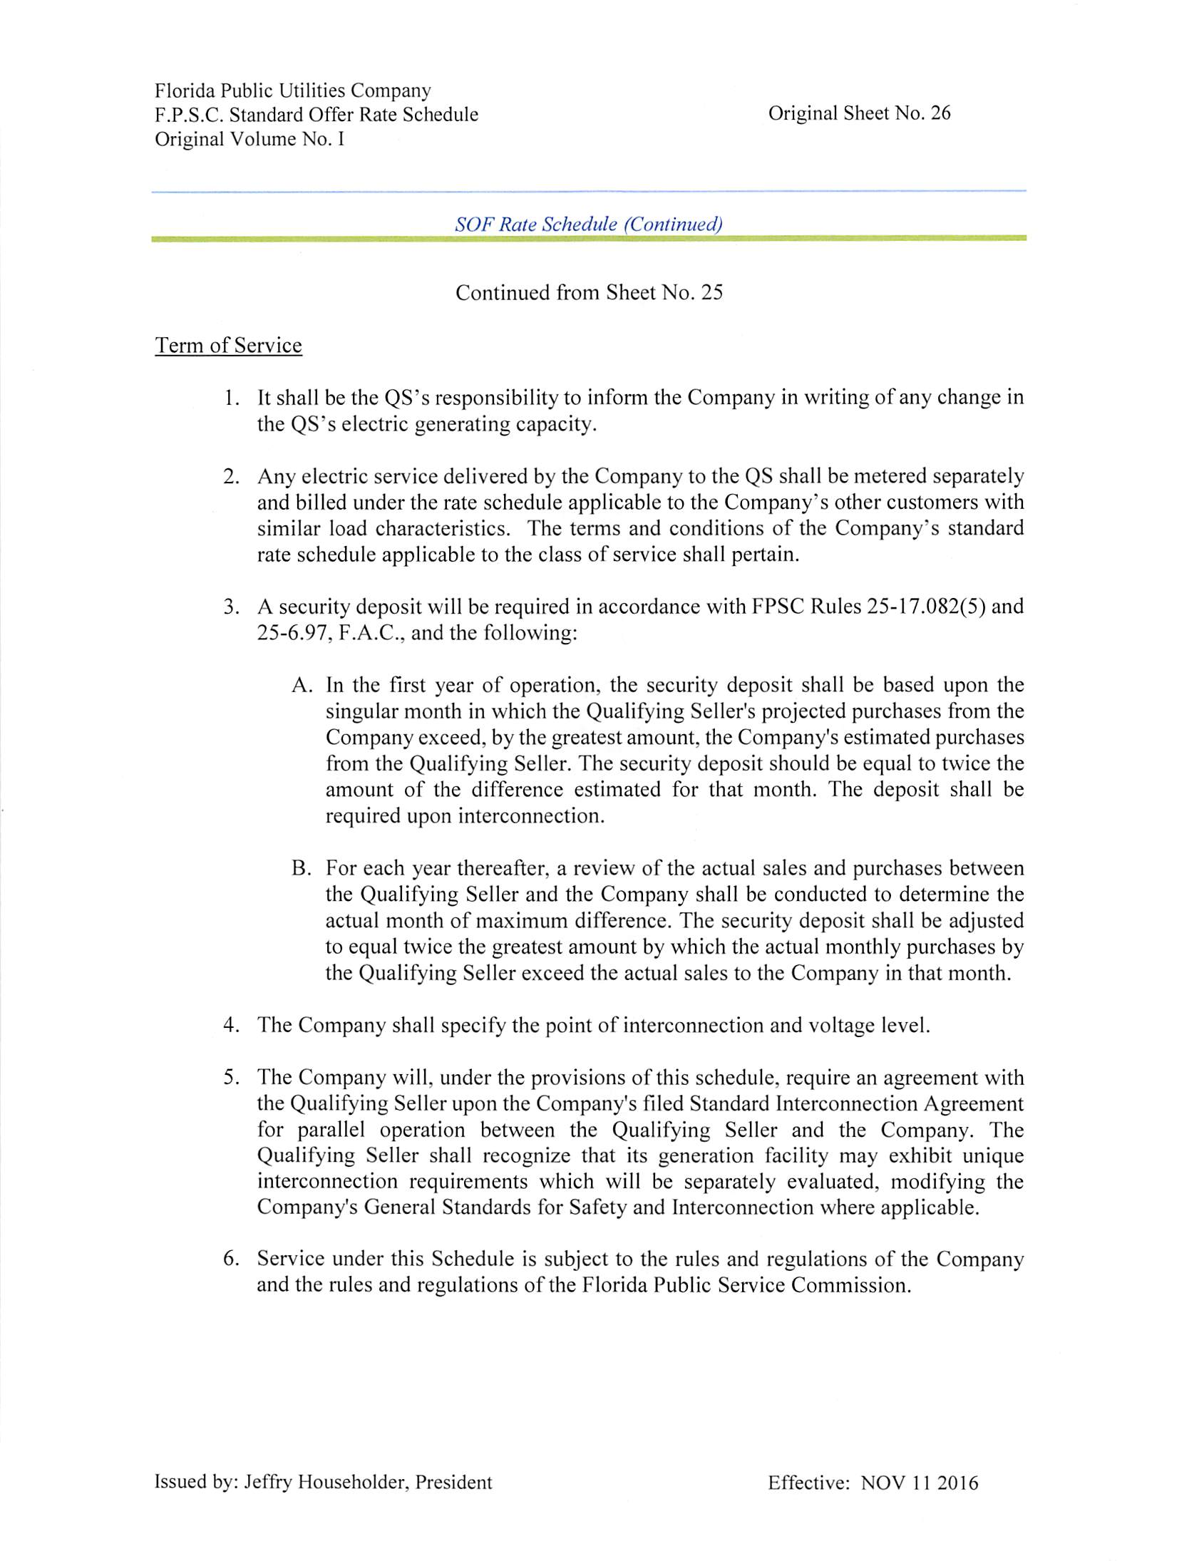

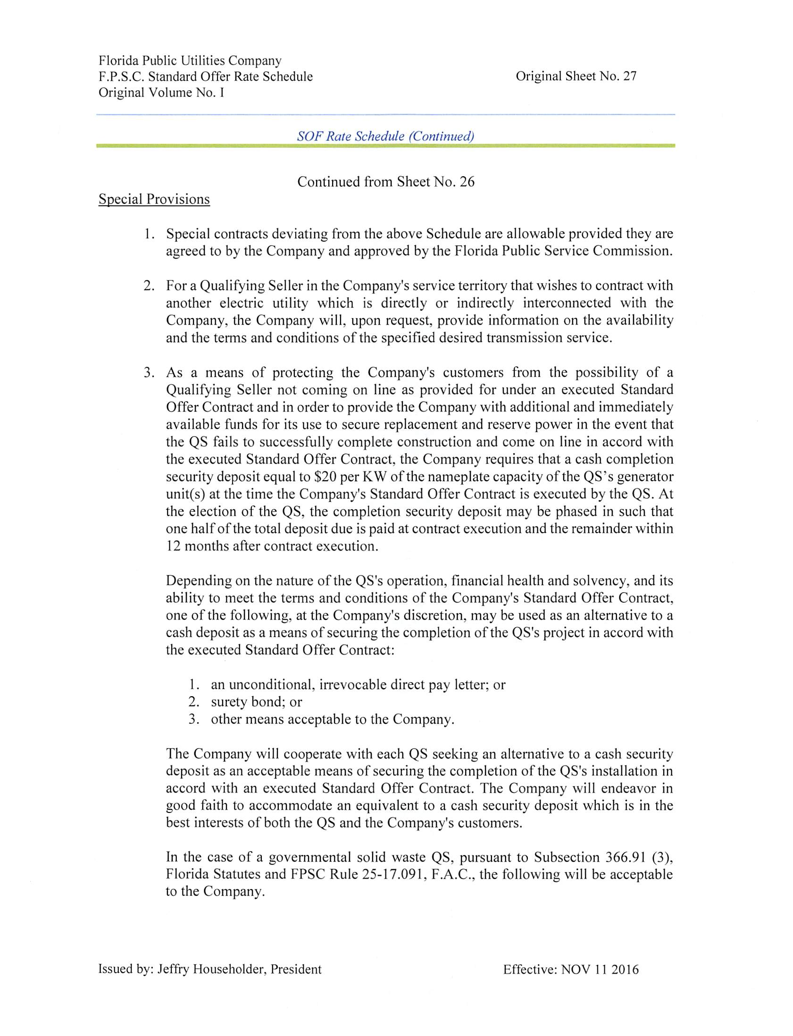

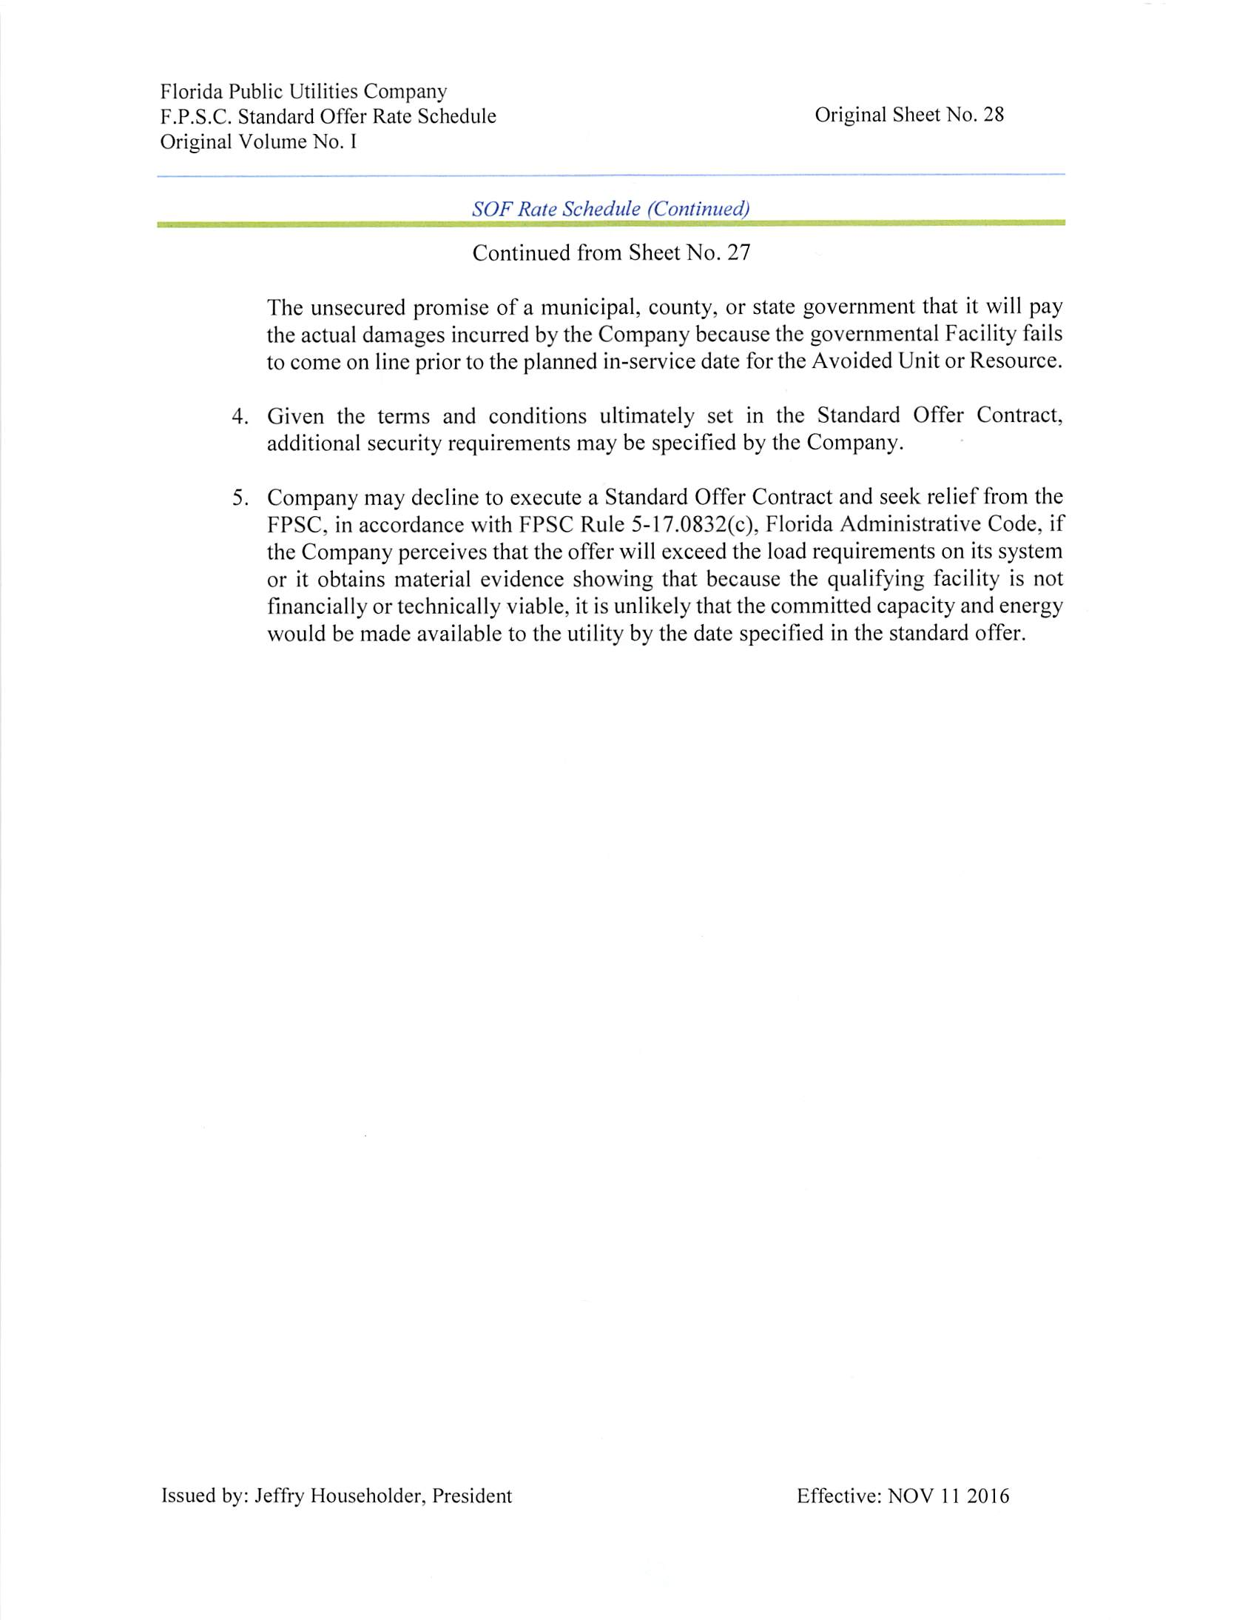

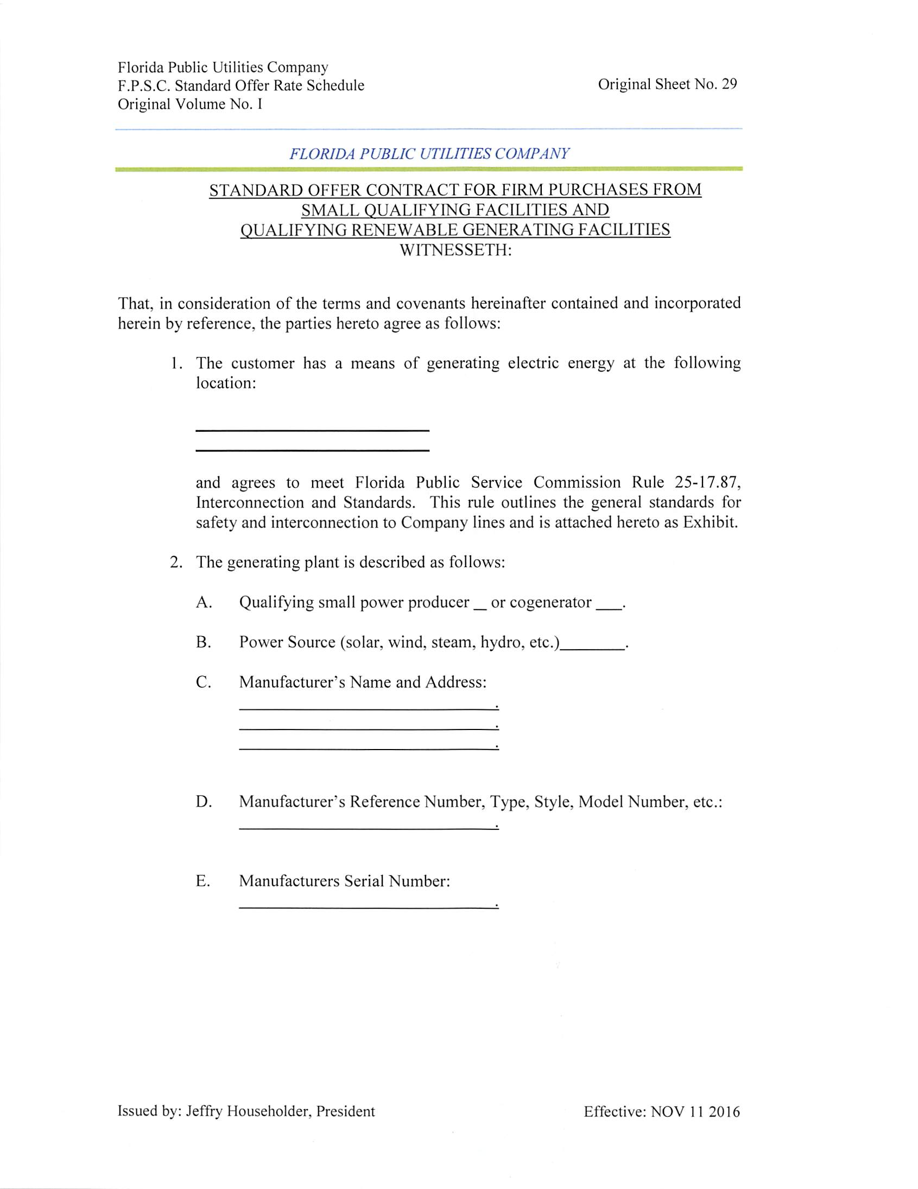

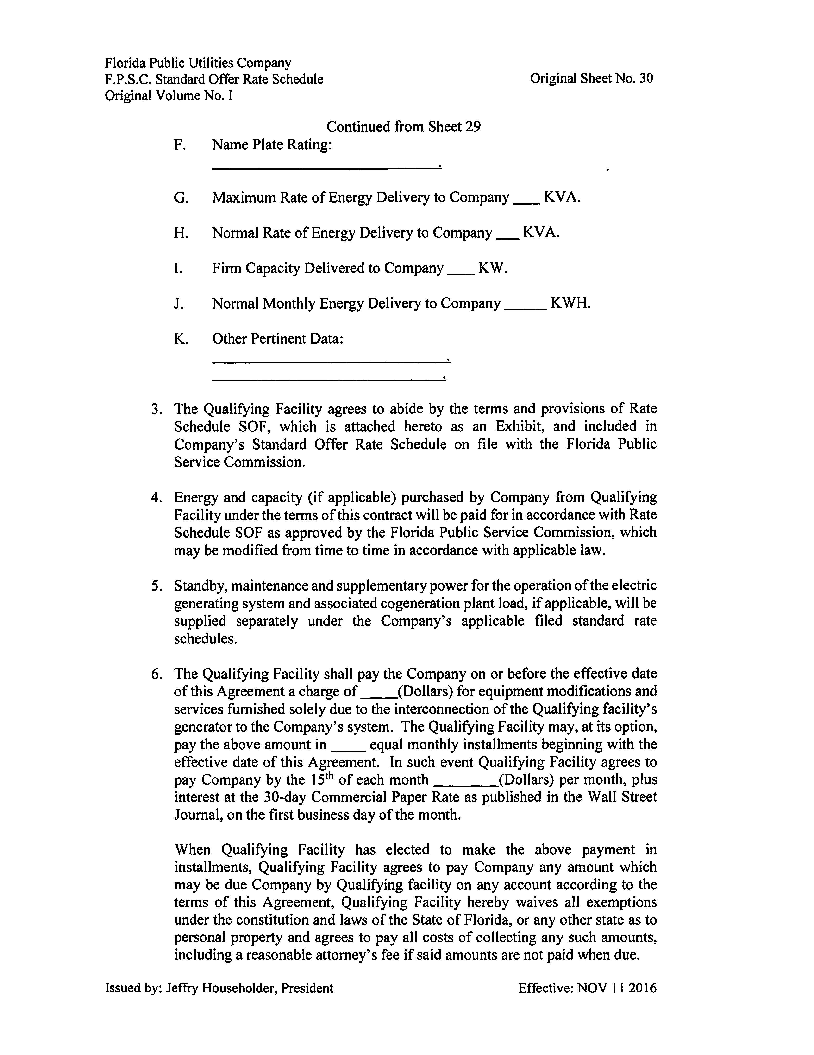

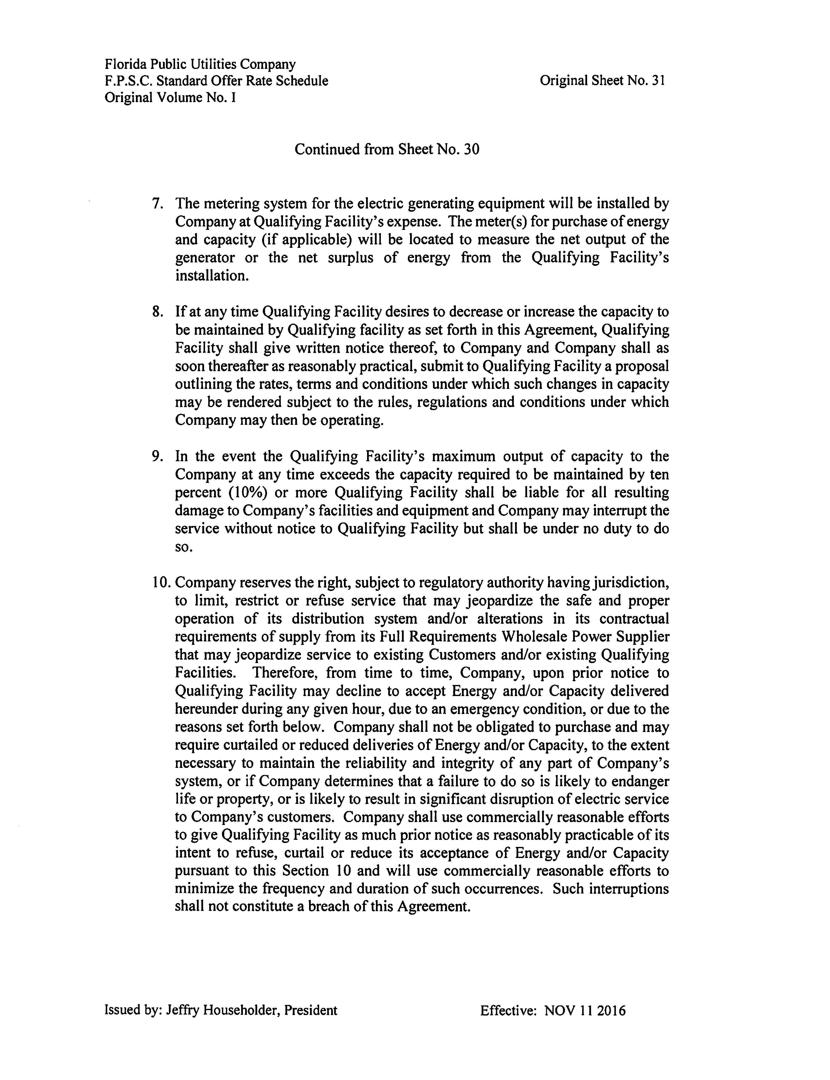

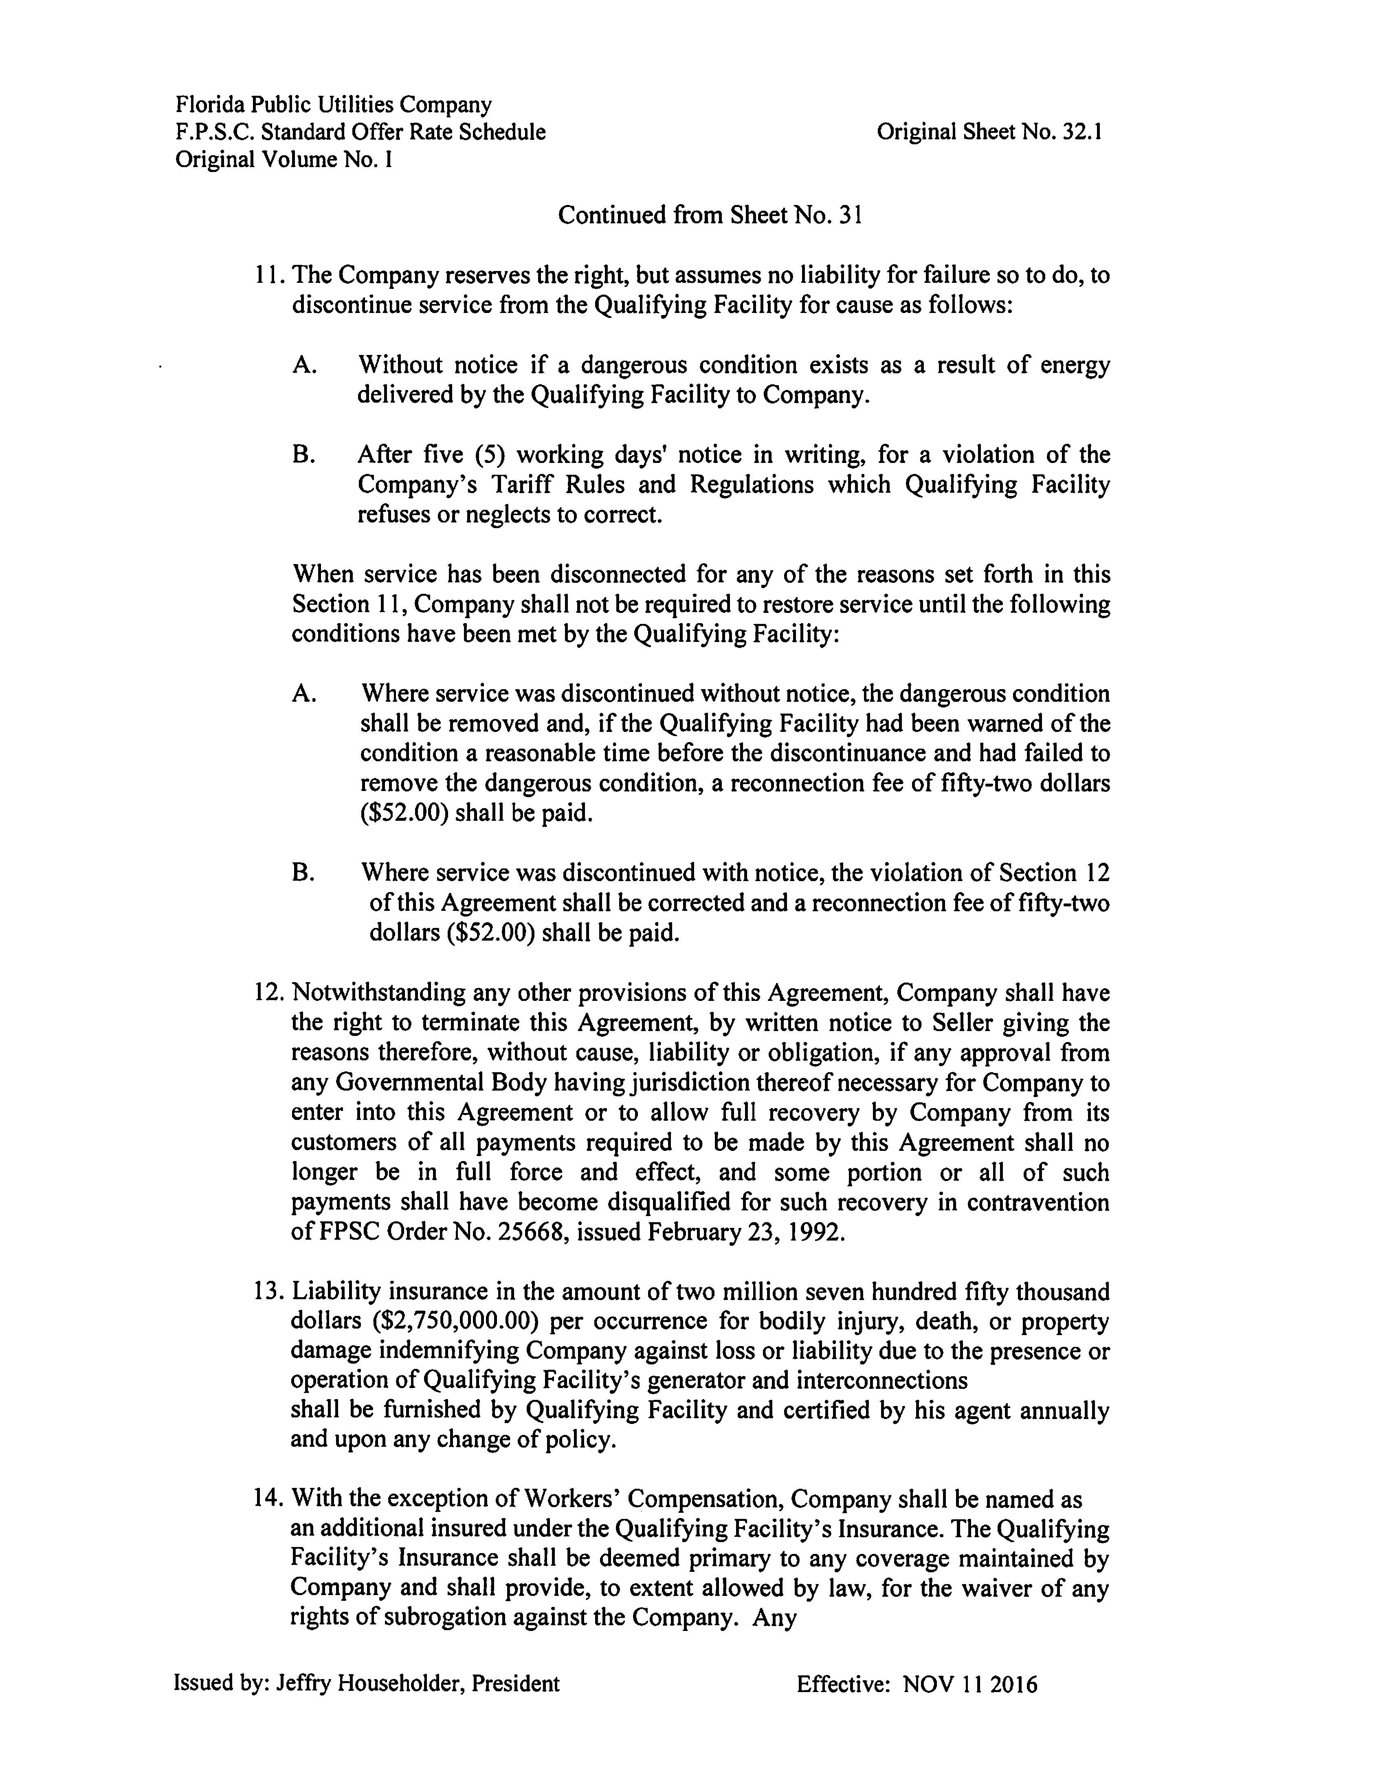

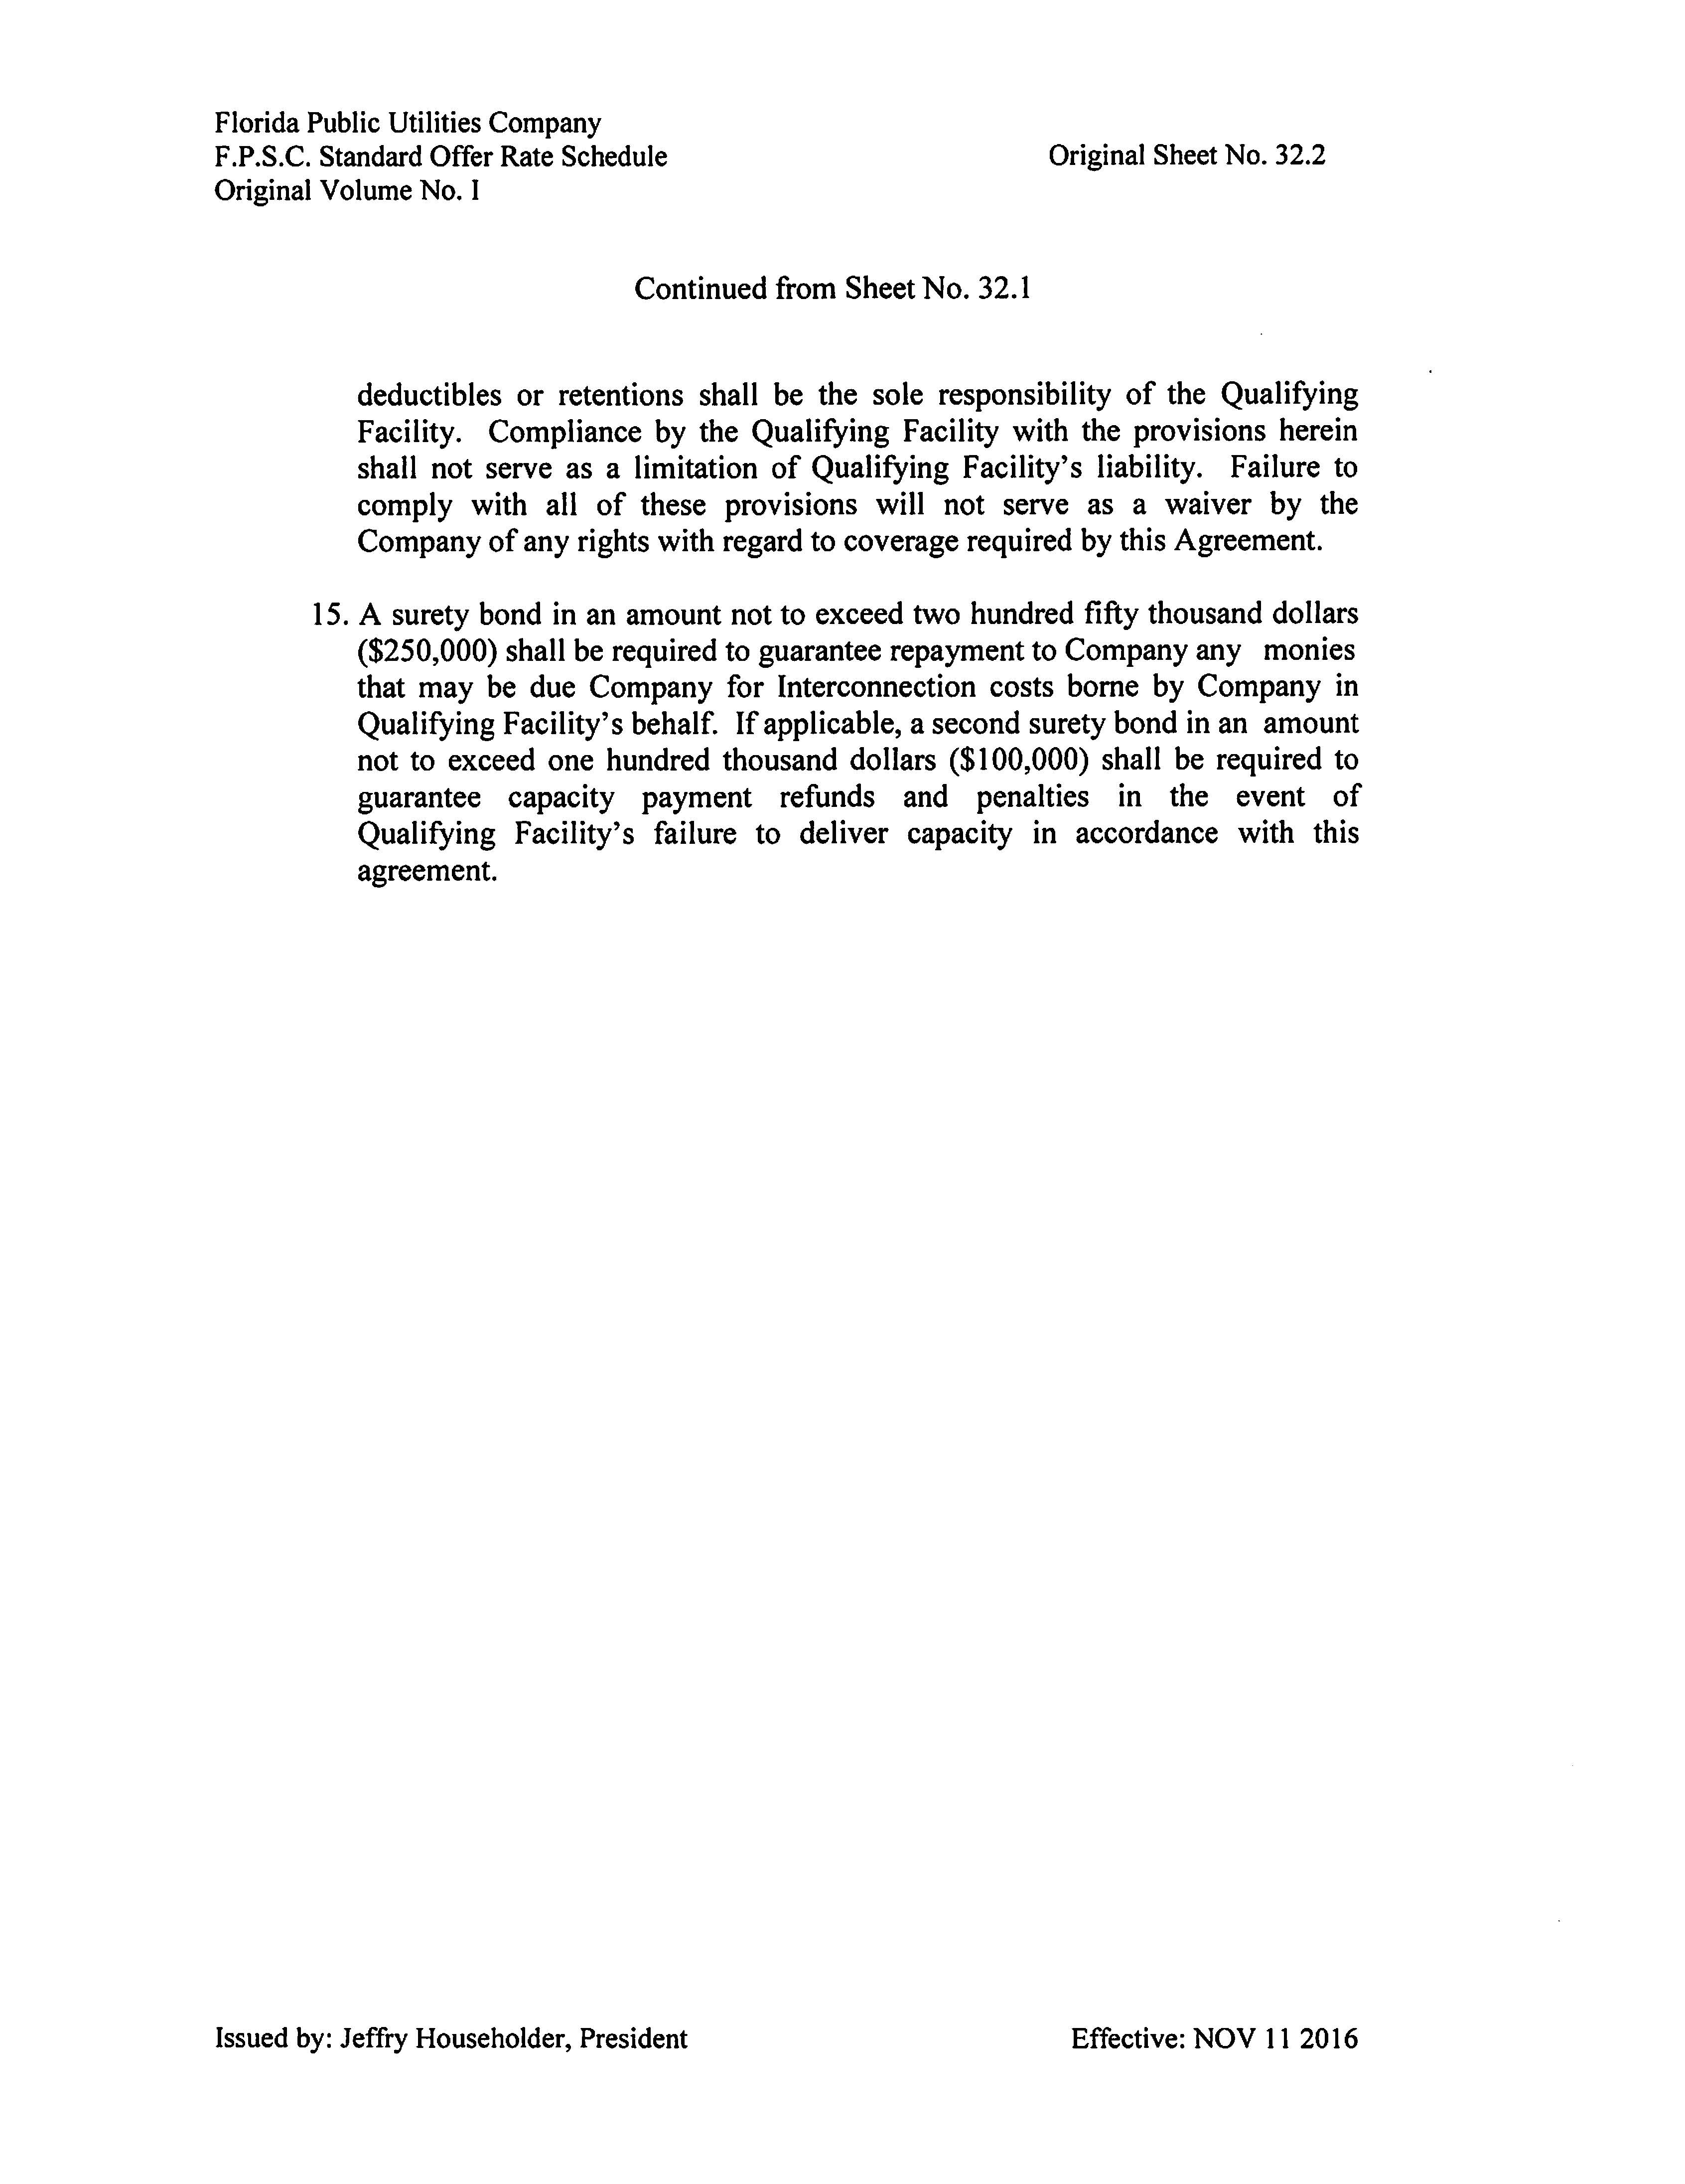

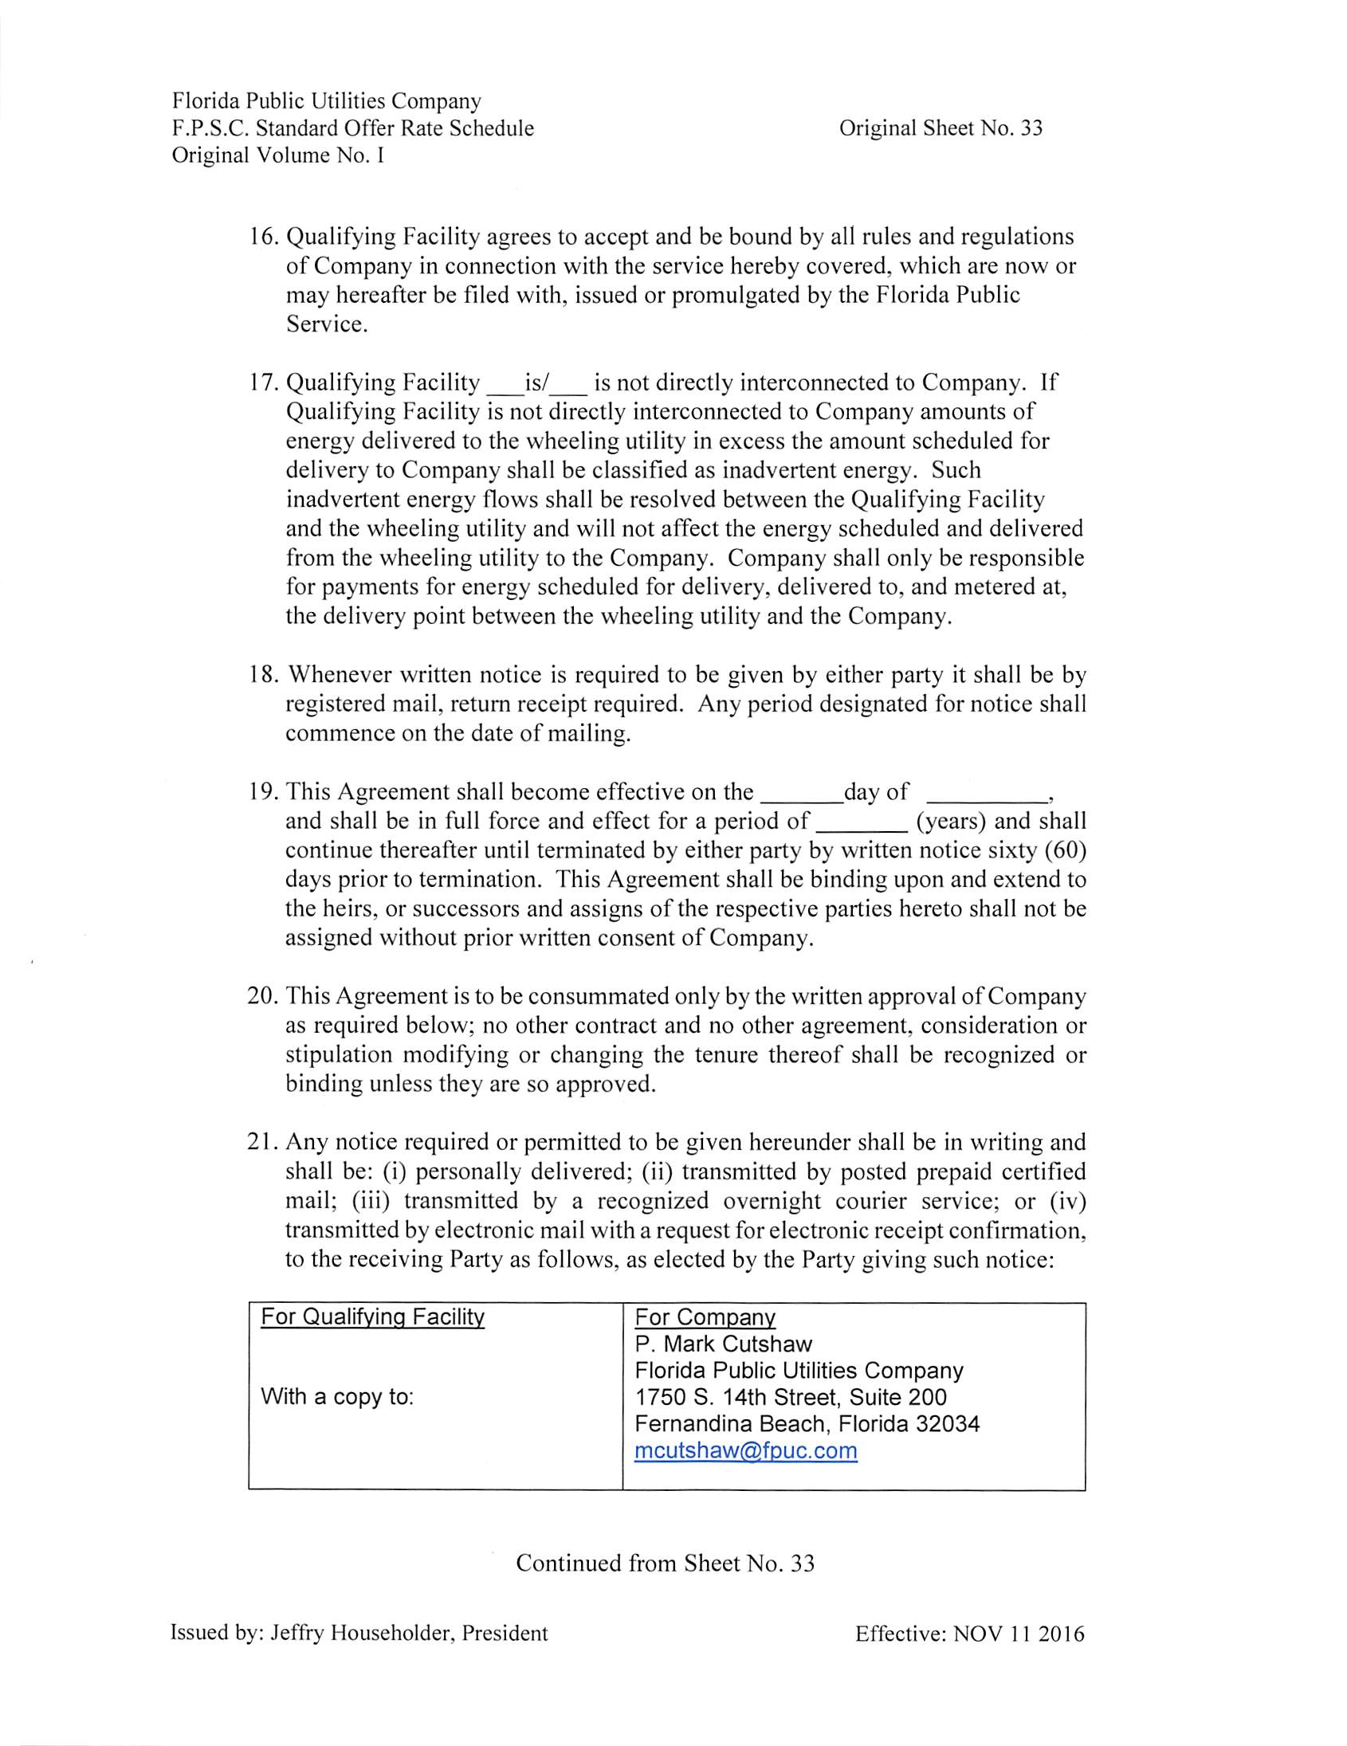

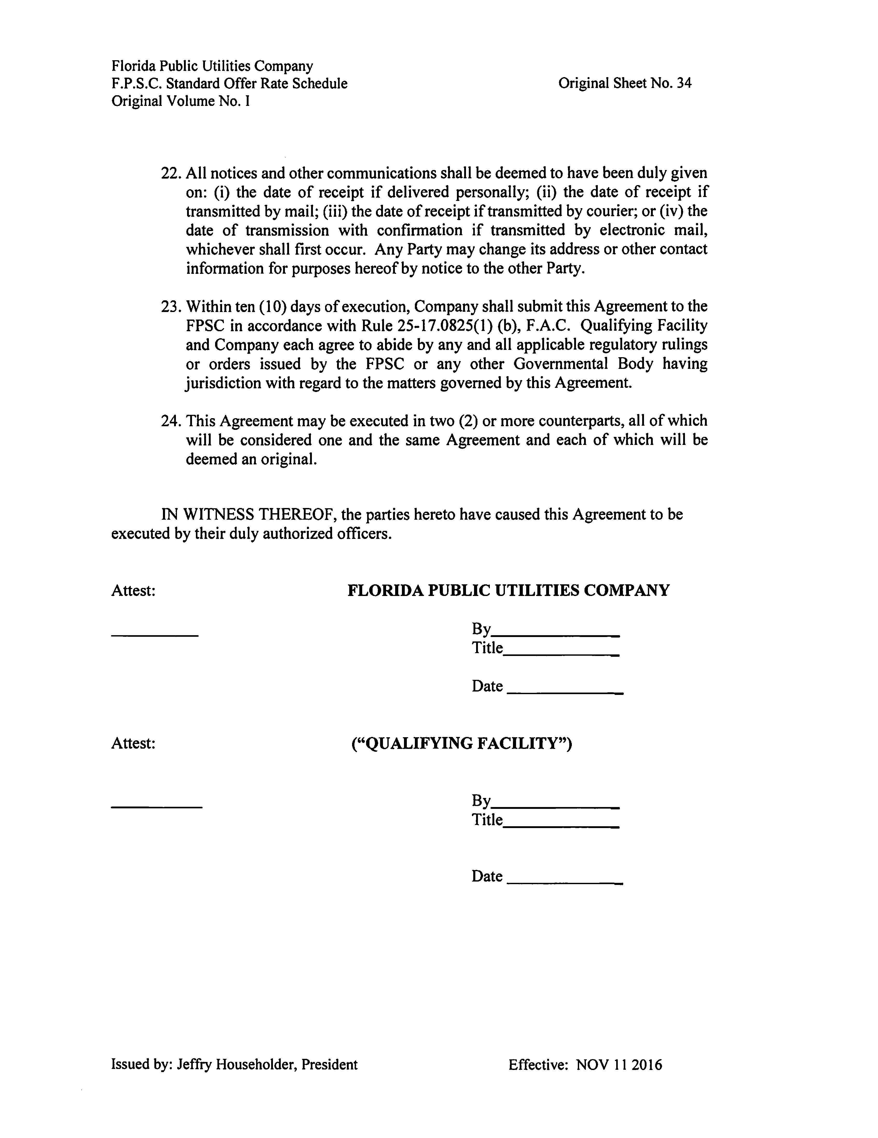

Document No. 03336-2018, filed April 30, 2018, in Docket No. 20180091-EQ.
Document No. 03336-2018, filed April 30, 2018, in Docket No. 20180091-EQ.

