BEFORE THE FLORIDA PUBLIC SERVICE COMMISSION

In re: Environmental cost recovery clause. | DOCKET NO. 20180007-EI  ORDER NO. PSC-2018-0318-PCO-EI  ISSUED: June 22, 2018

The following Commissioners participated in the disposition of this matter:

ART GRAHAM, Chairman
JULIE I. BROWN
DONALD J. POLMANN
GARY F. CLARK
ANDREW GILES FAY

ORDER APPROVING FLORIDA POWER & LIGHT COMPANY’S
MID-COURSE CORRECTIONS AND ASSOCIATED TARIFFS

BY THE COMMISSION:

Background
On April 16, 2018, Florida Power & Light Company (FPL or Company) filed a Petition for Mid-Course Corrections to its 2018 Environmental Cost Recovery Clause (ECRC) factors that reflect the impact of the Tax Cuts and Jobs Act of 2017 (Mid-Course Petition). By its Mid-Course Petition, FPL seeks to reduce the 2018 ECRC factors that were approved in Order No. PSC-2018-0100-FOF-EI.
Mid-course corrections are rare in the ECRC docket and are more typical in the fuel docket. Mid-course corrections are considered preliminary procedural decisions, and any over-recoveries or under-recoveries resulting from the approval by the Florida Public Service Commission (Commission) may be adjusted in the ECRC proceeding the following year.
The Tax Cuts and Jobs Act of 2017 (Tax Act) was signed into law on December 22, 2017, about four months after FPL filed its projection testimony and cost recovery schedules for 2018. In addition to filing its Mid-Course Petition in Docket No. 20180007-EI, the Company filed similar petitions in Docket Nos. 20180001-EI, and 20180046-EI.
We have jurisdiction over this matter pursuant to Sections 366.05 and 366.8255, Florida Statutes. (F.S.)

Analysis and Decision
The projected ECRC costs for 2018 were developed before the Tax Act was signed into law. The Tax Act will have the effect of lowering the federal income tax rate for corporations from 35 percent to 21 percent; therefore, some of the costs embedded into the total projected ECRC costs for 2018 are overstated. Federal income tax amounts are included in the calculation of the costs that have a capital component. Adjustments for tax impacts on revenue requirements recovered through the ECRC will change the currently-approved factors. The Tax Act is projected to result in an over-recovery of approximately $19.1 million or 9.2 percent. Approval of FPL’s Mid-Course Petition will result in a reduction to the typical 1,000 kWh monthly residential customer bill of $0.36. The tariffs associated with the mid-course corrections are included as Attachment A of this order. The Company will include a short bill insert on all customer bills 30 days in advance of the rates taking effect, and will provide updated rate schedules on its website.
FPL’s Mid-Course Petition was filed with the intention of the proposed decrease in rates becoming effective July 1, 2018. Typically, effective dates are set at a minimum of 30 days after our vote modifying the charges as the result of a mid-course correction. This time limit is imposed in order to not have new rates applied to energy consumed before the effective date of our action. However, we have also implemented charges in less than 30 days when circumstances warrant. In this instance, the interval between our vote on this matter and the proposed implementation date is 25 days. Because approval of the Mid-Course Petition results in a decrease to cost recovery factors, we find the 25 day interval to be sufficient.
Upon review, we find it appropriate to approve FPL’s Mid-Course Petition. This results in a reduction in the ECRC factors and a decrease in customer bills. The revised factors and associated tariffs shall become effective July 1, 2018.

Based on the foregoing, it is

ORDERED by the Florida Public Service Commission that Florida Power & Light Company’s Mid-Course Petition and associated tariffs are approved. The revised factors and associated tariffs shall become effective on July 1, 2018. It is further

ORDERED that the Environmental Cost Recovery Docket is on-going and shall remain open.

By ORDER of the Florida Public Service Commission this 22nd day of June, 2018.

/s/ Carlotta S. Stauffer
CARLOTTA S. STAUFFER
Commission Clerk
Florida Public Service Commission
2540 Shumard Oak Boulevard
Tallahassee, Florida 32399
(850) 413-6770
www.floridapsc.com

Copies furnished: A copy of this document is provided to the parties of record at the time of issuance and, if applicable, interested persons.

CWM

NOTICE OF FURTHER PROCEEDINGS OR JUDICIAL REVIEW

The Florida Public Service Commission is required by Section 120.569(1), Florida Statutes, to notify parties of any administrative hearing or judicial review of Commission orders that is available under Sections 120.57 or 120.68, Florida Statutes, as well as the procedures and time limits that apply. This notice should not be construed to mean all requests for an administrative hearing or judicial review will be granted or result in the relief sought.

Mediation may be available on a case-by-case basis. If mediation is conducted, it does not affect a substantially interested person's right to a hearing.

Any party adversely affected by this order, which is preliminary, procedural or intermediate in nature, may request: (1) reconsideration within 10 days pursuant to Rule 25-22.0376, Florida Administrative Code; or (2) judicial review by the Florida Supreme Court, in the case of an electric, gas or telephone utility, or the First District Court of Appeal, in the case of a water or wastewater utility. A motion for reconsideration shall be filed with the Office of Commission Clerk, in the form prescribed by Rule 25-22.0376, Florida Administrative Code. Judicial review of a preliminary, procedural or intermediate ruling or order is available if review of the final action will not provide an adequate remedy. Such review may be requested from the appropriate court, as described above, pursuant to Rule 9.100, Florida Rules of Appellate Procedure.
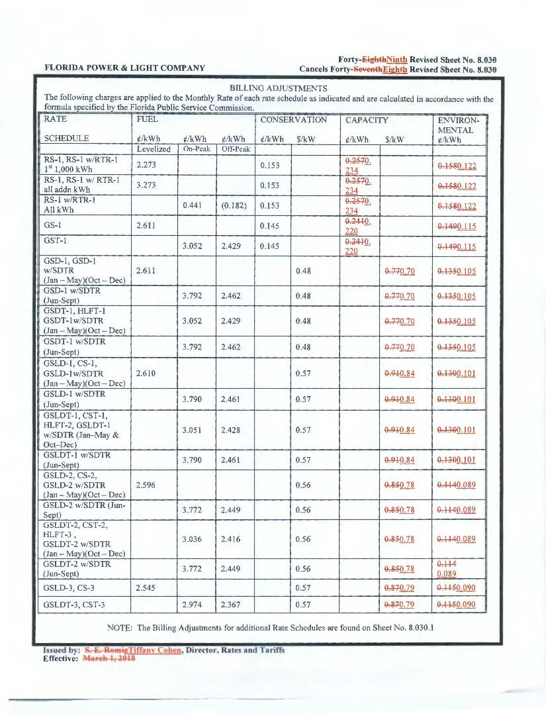
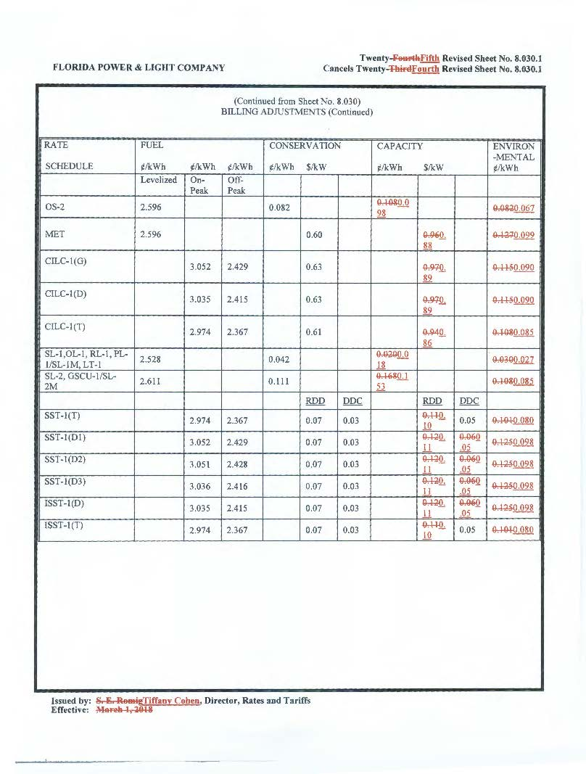

Issued February 22, 2018, in Docket No. 20180007-EI, In re: Environmental Cost Recovery Clause.
In re: Fuel and purchased power cost recovery clause with generating performance incentive factor.
In re: Consideration of the tax impacts associated with Tax Cuts and Jobs Act of 2017 for Florida Power & Light Company.

