BEFORE THE FLORIDA PUBLIC SERVICE COMMISSION

In re: Petition for limited proceeding for approval of a smart meter opt-out tariff, by Duke Energy Florida, LLC. | DOCKET NO. 20180088-EI  ORDER NO. PSC-2018-0435-TRF-EI  ISSUED: August 28, 2018

The following Commissioners participated in the disposition of this matter:

ART GRAHAM, Chairman
JULIE I. BROWN
DONALD J. POLMANN
GARY F. CLARK
ANDREW GILES FAY

ORDER GRANTING DUKE ENERGY FLORIDA, LLC’S
PETITION FOR APPROVAL OF A SMART METER OPT-OUT TARIFF

BY THE COMMISSION:

Background

On April 4, 2018, Duke Energy Florida, LLC (DEF or Utility) filed a petition for a limited proceeding for approval of a smart meter opt-out tariff (opt-out tariff). The tariff, as approved herein, is available to customers who elect to receive a non-communicating meter in lieu of the standard smart meter, or Automated Meter Infrastructure (AMI) smart meter.

On November 11, 2017, we approved DEF’s 2017 Second Revised and Restated Settlement Agreement (2017 Settlement), which includes a provision for a 15-year depreciable life for new AMI assets. On October 25, 2017, we held a hearing to consider the 2017 Settlement. At the hearing, DEF witness Portuondo testified that the base rate adjustments contained in the 2017 Settlement include AMI smart meters to be deployed by 2021 and a replacement of DEF’s customer information system, or billing system, to maximize the benefits of the AMI smart meters and provide customers with better tools to manage their consumption. At the hearing, witness Portuondo also stated that DEF will file an opt-out tariff, which DEF has done with the instant petition.

Consistent with the testimony provided during the 2017 Settlement hearing, the Utility states in the instant petition that smart meter deployment for residential and general service (small commercial) customers is set to begin in November 2018. Upon completion of the deployment, expected by December 2021, smart meters will become DEF’s standard meter. Associated with the AMI project is meter communication infrastructure needed to enable communication with the meters and DEF’s information technology system.

DEF’s current meters are Automated Meter Reading (AMR) meters that emit a radio frequency signal. That signal is picked up once a month by a meter reading vehicle driving by the neighborhood. DEF installed the AMR meters in 2005 and 2006 and states that at the time there was no public opposition to the AMR meter deployment. In the last five years, DEF has received a small number of complaints regarding radio frequency transmission, which is similar between the AMR and AMI smart meters. In all complaints so far, the AMR meter was retained as Duke does not have an opt-out tariff. However, DEF stated that some customers specifically requested an opt-out option and a meter that emits no radio frequency signal.
DEF anticipates that some customers will elect to forego the new AMI smart meters and request a non-communicating meter; therefore, DEF filed the instant petition and associated opt-out tariff. The opt-out tariff is applicable to customers that request a non-communicating, i.e., non-standard, meter and includes an initial one-time set-up fee of $96.34 and a monthly surcharge of $15.60. The requested charges are based on DEF’s incremental costs to provide the opt-out tariff.
We approved a similar opt-out tariff and charges ($89.00 one-time set-up fee, $13.00 monthly surcharge) for Florida Power & Light Company (FPL) in 2015. Several municipal electric utilities, City of Lakeland and Orlando Utilities Commission, and rural electric cooperatives, Sumter Electric, Talquin Electric, Tri-County Electric, and Peace River, also provide optional opt-out tariffs.
On April 18, 2018, DEF waived the 60-day file and suspend provision per Section 366.06(3), Florida Statutes (F.S.). DEF responded to several Commission staff data requests on May 3, June 4, June 20, and July 17, 2018. On May 23, 2018, DEF provided revised tariff sheets reflecting a minor correction. On July 23, 2018, DEF provided revised tariff sheet No. 6.400 to include language that an opt-out customer who already has a non-communicating meter installed would not be required to pay the $96.34 one-time set up fee. The legislative version of the revised opt-out tariff sheet No. 6.400 is shown in Attachment A to this Order. We have jurisdiction pursuant to Sections 366.03, 366.04, 366.05, and 366.06, F.S.

Decision

DEF is offering this opt-out tariff ahead of AMI deployment after reviewing the experiences of other utilities with their customers and smart meters. In its petition, the Utility states that FPL began deploying smart meters in 2010, but received customer complaints regarding smart meters and subsequently filed a petition for an opt-out tariff in August 2013. DEF notes that because it is not required to offer an alternative meter, all costs associated with the non-standard meters will be recovered from the participating customers.

The requested tariff includes two separate fees: a one-time set-up fee of $96.34 for the non-standard meter installation and a monthly surcharge of $15.60 for upfront IT costs and monthly meter readings. The set-up fee must be paid at the time the customer takes service under the opt-out tariff, regardless of the length of time the customer is enrolled. Customers can cancel service under the opt-out tariff at any time. These charges will be in addition to all other tariffed rates and charges applicable to an opt-out customer.

Customer Participation

DEF anticipates that approximately 0.15 percent of its AMI eligible customers will choose to opt out. The Utility examined FPL’s opt-out tariff participation rates as the basis for its own participation predictions. DEF states that FPL originally forecasted that 0.26 percent of its 4.9 million customers would participate when developing an opt-out tariff; however, actual participation for FPL in 2017 was about 0.12 percent, or 5,966 customers. DEF rounded up to predict that 0.15 percent—about 2,700— of its 1.8 million eligible customers will opt-out. The projected number of opt-out customers is used in developing the monthly surcharge.

Set-up Fee

The one-time set-up fee of $96.34 reflects the labor and vehicle costs to install each non-standard meter. In response to Commission staff’s data request, DEF stated that it is not creating any new positions to perform the incremental tasks associated with administering the opt-out tariff. However, DEF further stated that in the absence of the opt-out tariff, the current staffing of these positions may have been reduced.

The set-up fee is applicable to all opt-out tariff participants regardless of duration of service. The breakdown of the set-up fee components is shown in table 1 below.

Table 1
Set-up Fee Cost Components
Task | Time Per Customer | Cost Per Customer | Description
Customer service | 3 minutes | $1.40 | Customer Care Specialist to handle calls and enrollment in opt-out tariff, explain tariff details, and set up customer’s account as an opt-out customer.
Metering services work order management | 5 minutes | $2.93 | Work Force Management Specialist II to create initial work orders for opt-out meter programming, meter exchange, and manual meter routing.
Meter programming and labelling | 30 minutes | $29.09 | Field Meter Tech to program the opt-out meter and apply opt-out label to help ensure an opt-out meter is not replaced with an AMI smart meter. This work is performed at a DEF lab.
Meter exchange | 45 minutes | $43.63 | Field Meter Tech to travel to customer premises, remove existing meter, replace with opt-out meter, and close work orders.
Meter exchange -vehicle | 45 minutes | $4.61 | Vehicle used by Field Meter Tech for meter exchange. The cost is based on DEF’s cost to operate the vehicle used by field technicians.
Manual meter reading route analysis | 20 minutes | $14.68 | Meter Route Analyst to determine location of opt-out participant and find efficient meter reading route.
Total one-time cost per customer |  | $96.34
Source: Exhibit A to DEF’s Petition

DEF explained that the time per customer is based on a conservative average time estimate for the specific tasks to be performed. We find the time estimates to be reasonable. The cost per customer is calculated by multiplying the time to complete the task by the hourly rate of the job performer. DEF provided cost support for its hourly rates which includes the confidential annual salary, payroll tax, benefits, pension, and incentives (bonus payments). We reviewed hourly rate information provided by DEF in its 2009 rate case for customer service and field labor and find the hourly rates included in this docket are reasonable. Furthermore, DEF’s salaries are comparable to those approved for FPL’s opt-out charges.

In response to Commission staff’s data request, DEF clarified that if an opt-out customer already has a non-communicating meter installed at the premises, the customer would not be required to pay the $96.34 one-time set up fee as DEF would not incur the cost for the non-standard meter installation. This provision was not reflected in the original opt-out tariff filed by DEF; therefore, DEF filed a revised tariff to clearly state when the one-time fee would not be assessed.

Monthly Surcharge

The monthly surcharge to take service under the opt-out tariff is $15.60, which reflects a combination of upfront IT related and ongoing meter reading related service costs. DEF states that its upfront IT costs are predicted to be $374,014. This is the estimated cost to update the customer system and change business processes to accommodate the opt-out tariff program. DEF used a 5-year recovery period for its IT costs to derive monthly IT related costs of $4.58 per customer, which is the same recovery period we approved for FPL’s opt-out tariff.

After installation of a non-standard meter, the only ongoing costs to the Utility will be the monthly meter readings, which the Utility estimates to be $11.02 per customer. These costs reflect the meter reading position rates and the vehicle rates, both for an estimated 20 minutes per meter reading. In response to Commission staff’s data request, DEF stated that assuming that opt-out customers are spread across the Utility’s service territory, it is estimated to take 20 minutes to travel to the customer premises, get out of the vehicle, read the meter, log the read, and return to the vehicle to continue on the route.

Customer Notice and Deployment

The Utility states that AMI deployment is set to begin November 2018; therefore, DEF is requesting that the opt-out tariff be available the first billing cycle of December 2018. Two weeks prior to a customer receiving a smart meter, DEF shall mail a postcard to the customer informing them of the meter exchange and providing more information on smart meters. The postcard shall include a toll-free number to call for questions regarding smart meters and the option to opt out. Information regarding smart meter deployment and the opt-out tariff shall also be on the Utility’s website.

Reporting

Within three months after the AMI smart meter deployment is completed, December 2021, DEF shall report to this Commission on the costs of the program, revenues, and actual participation. We find that three months is a reasonable time to allow DEF to prepare and file a report in this docket, which shall happen no later than March 31, 2022. If AMI smart meter deployment is significantly delayed beyond the Utility’s anticipated completion date, the Utility shall notify this Commission with a filing in this docket.

It is noted that FPL is required to file annual smart meter progress reports; however, DEF, in response to Commission staff’s data request, stated that it does not believe a formal process of tracking costs is necessary. However, we find that actual participation rates and costs may vary, and that a comparison of estimated costs presented in this petition and actual costs incurred is important to ensure the opt-out tariff remains cost-based or else be adjusted through a revised tariff filing.

Conclusion

We find that the incremental costs to offer the proposed opt-out tariff shall be recovered from the participating customers. In our order approving FPL’s opt-out tariff, we stated that “since significant incremental costs would be incurred in providing [an opt-out tariff], it would be discriminatory to require standard meter customers to subsidize that service.” We find that DEF provided sufficient cost support in its petition and responses to Commission staff’s data requests to support its assertion that the proposed tariff is cost-based. Therefore, we hereby approve DEF’s proposed opt-out tariff. The effective date shall be on the first billing cycle of December 2018. Within three months after the AMI smart meter deployment is completed, DEF shall file a report within this docket on the costs of the program, revenues, and actual participation.

Based on the foregoing, it is

ORDERED by the Florida Public Service Commission that Duke Energy Florida, LLC’s petition for a limited proceeding for approval of a smart meter opt-out tariff is hereby granted, effective the first billing cycle of December 2018. It is further

ORDERED that two weeks prior to a customer receiving a smart meter, DEF shall mail a postcard to the customer informing them of the meter exchange and providing more information on smart meters. It is further

ORDERED that within three months after the Automated Meter Infrastructure smart meter deployment is completed, DEF shall file a report within this docket on the costs of the program, revenues, and actual participation. It is further

ORDERED that if a protest is filed within 21 days of the issuance of this Order, the tariff shall remain in effect with any charges held subject to refund pending resolution of the protest. It is further

ORDERED that if no timely protest is filed, this docket shall be closed upon the issuance of a Consummating Order.

By ORDER of the Florida Public Service Commission this 28th day of August, 2018.

/s/ Carlotta S. Stauffer
CARLOTTA S. STAUFFER
Commission Clerk
Florida Public Service Commission
2540 Shumard Oak Boulevard
Tallahassee, Florida 32399
(850) 413-6770
www.floridapsc.com

Copies furnished: A copy of this document is provided to the parties of record at the time of issuance and, if applicable, interested persons.
KRM

NOTICE OF FURTHER PROCEEDINGS

The Florida Public Service Commission is required by Section 120.569(1), Florida Statutes, to notify parties of any administrative hearing or judicial review of Commission orders that is available under Sections 120.57 or 120.68, Florida Statutes, as well as the procedures and time limits that apply. This notice should not be construed to mean all requests for an administrative hearing or judicial review will be granted or result in the relief sought.

Mediation may be available on a case-by-case basis. If mediation is conducted, it does not affect a substantially interested person's right to a hearing.

The Commission's decision on this tariff is interim in nature and will become final, unless a person whose substantial interests are affected by the proposed action files a petition for a formal proceeding, in the form provided by Rule 28-106.201, Florida Administrative Code. This petition must be received by the Office of Commission Clerk, 2540 Shumard Oak Boulevard, Tallahassee, Florida 32399-0850, by the close of business on September 18, 2018.

In the absence of such a petition, this Order shall become final and effective upon the issuance of a Consummating Order.

Any objection or protest filed in this docket before the issuance date of this order is considered abandoned unless it satisfies the foregoing conditions and is renewed within the specified protest period.

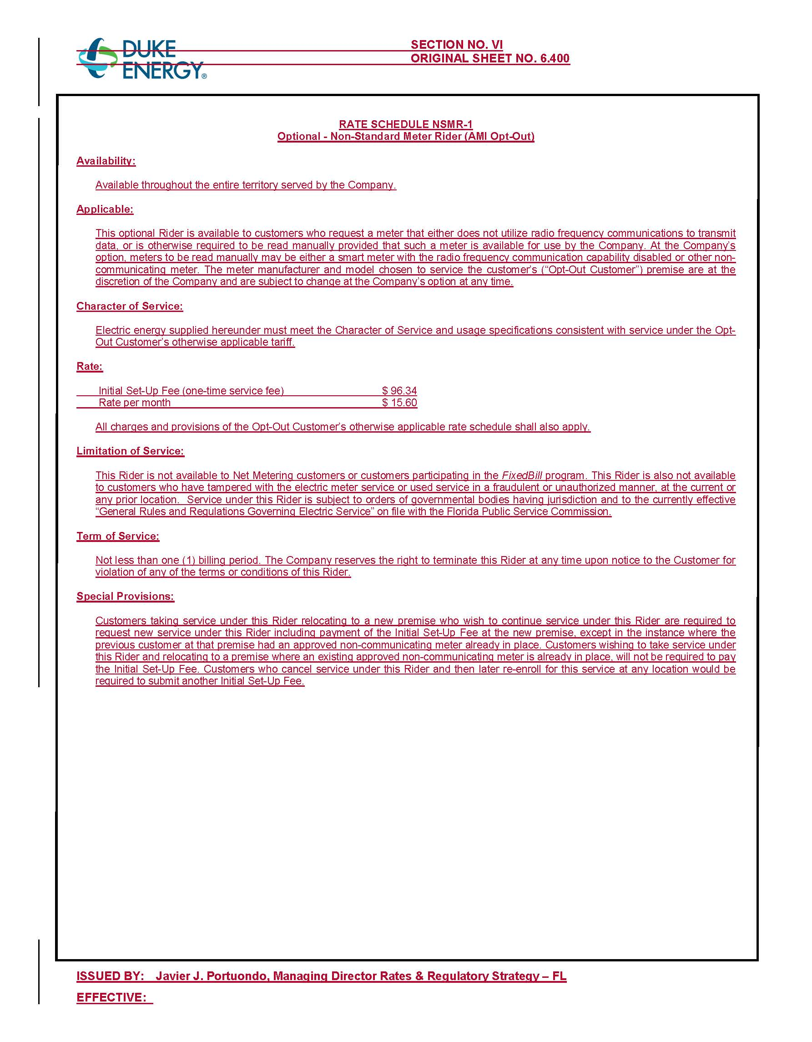

Order No. PSC-2017-0451-AS-EU, issued November 20, 2017, in Docket No. 20170183-EI, In re: Application for limited proceeding to approve 2017 second revised and restated settlement agreement, including certain rate adjustments, by Duke Energy Florida, LLC.
Document No. 09411-2017, filed on November 3, 2017, in Docket No. 20170183-EI.
Order No. PSC-15-0026-FOF-EI, issued on January 7, 2015, in Docket No. 130223-EI, In re: Petition for approval of optional non-standard meter rider, by Florida Power & Light Company.
DEF’s petition included other non-substantive tariff changes that have not been attached to this order.
Id.

