BEFORE THE FLORIDA PUBLIC SERVICE COMMISSION

In re: Consideration of the tax impacts associated with Tax Cuts and Jobs Act of 2017 for Peoples Gas System. | DOCKET NO. 20180044-GU  ORDER NO. PSC-2018-0501-S-GU  ISSUED: October 18, 2018

The following Commissioners participated in the disposition of this matter:

ART GRAHAM, Chairman
JULIE I. BROWN
DONALD J. POLMANN
GARY F. CLARK
ANDREW GILES FAY

FINAL ORDER APPROVING STIPULATIONS
AND GRANTING JOINT MOTION REQUESTING COMMISSION
APPROVAL OF SETTLEMENT AGREEMENT AND TARIFFS

BY THE COMMISSION:

CASE BACKGROUND

On February 21, 2018, the Florida Public Service Commission opened Docket No. 20180044-GU to consider the tax impacts on Peoples Gas System (Peoples Gas) due to the passage of the Tax Cuts and Jobs Act of 2017. By Order No. PSC-2018-0212-PCO-GU, the Order Establishing Procedure, issued April 25, 2018, the schedule and procedure were set. On May 24, 2018, a First Revised Order Establishing Procedure, Order No. PSC-2018-0260-PCO-GU, was issued to revise certain controlling dates. On May 31, 2018, Peoples Gas filed its petition for limited proceeding. The Office of Public Counsel (OPC) and the Florida Industrial Power Users Group (FIPUG) intervened.

At the Prehearing Conference held on August 6, 2018, the parties indicated that they had agreed to the stipulations of Issues 1-5, 8-18, 19 and 21, which are appended to this Order in Attachment A. The parties also indicated that they were working towards a settlement on the remaining four unresolved issues. On August 8, 2018, Peoples Gas, OPC, and FIPUG (the signatories) filed a joint motion seeking Commission approval of their Settlement Agreement proposing resolution of the remaining four issues. The Settlement Agreement also proposed changes to depreciation rates and recording of additional manufacturing gas plant expense that were outside the scope of this proceeding. In order to provide those who may be substantially affected by the new matters contained within the Settlement Agreement, the final hearing originally scheduled to begin on August 20, 2018, was postponed. Order No. PSC-2018-0405-PCO-GU, was issued on August 14, 2018, to establish the procedures to be followed to address the matters contained within the Settlement Agreement.
The final hearing was held on September 12, 2018, at which time the parties agreed that all identified issues were either stipulated as set forth in Exhibit A, or were resolved through a Settlement Agreement (SA), as set forth in Exhibit B.

PROPOSED STIPULATIONS

The parties have proposed stipulations to Issues 1-5, 8-17, 19, and 21, which are attached as Exhibit A.

SETTLEMENT AGREEMENT TO RESOLVE REMAINING ISSUES

The parties proposed a Settlement Agreement (SA) to resolve the remaining issues in the docket and it is attached as Exhibit B. The new tariffs that accompanied the SA are attached as Exhibit C. The new depreciation rates can be found at Exhibit D.

The following is a summary of the notable terms of the SA:

- Beginning January 1, 2019, Peoples Gas will reduce base rates by $11,599,038, an amount equal to the amount of the decrease in annual revenue requirement resulting from the benefits of the Tax Cut and Jobs Act.

- The depreciation rates in Exhibit C (Exhibit B of the SA), will supersede current rates and result in an estimated decrease of $10.3 million to the Utility’s 2019 depreciation expense, effective January 1, 2019.

- Peoples Gas shall book unamortized Manufactured Gas Plant expense of $10,947,747 in 2018 and offset this with forecasted 2018 annual revenue requirement reduction of $11,599,038.

- In 2018, Peoples Gas will request a Private Letter Ruling from the Internal Revenue Service regarding the classification of excess accumulated deferred income taxes.

- Peoples Gas shall be permitted to initiate a base rate proceeding in 2020 regardless of earned rate of return, provided new rates do not become effective prior to January 1, 2021.

- Except as modified above, the prior Settlement Agreement approved in Order No. PSC-17-0066-AS-GU remains in effect.

- The SA will take effect the day after it is approved by the Commission.

DECISION

The standard for approval of a settlement agreement is whether it is in the public interest. A determination of public interest requires a case-specific analysis based on consideration of the proposed settlement taken as a whole. Section 120.57(4), Florida Statutes (F.S.), permits us to informally dispose of any proceeding by stipulation, agreed settlement, or consent order. Section 120.57(2), F.S., permits this Commission to proceed with hearings not involving disputed issues of material fact. Pursuant to Rule 28-106.302(2), Florida Administrative Code, at the hearing prefiled testimony was entered into the record and we heard argument regarding Peoples Gas’s and Intervenors’ request for approval of the SA.

Based on our review of the SA, the prior 2017 Settlement Agreement, the exhibits entered into the record, the support of the Parties, the prefiled testimony and the stipulated issues, we find that the SA benefits the Utility’s customers and is in the public interest. We commend the parties for achieving an agreement wherein the customers of Peoples Gas would receive a base rate reduction of approximately 5 percent beginning January 1, 2019. Therefore, the SA, to include the new tariffs that reflect the final rates and charges, and the new depreciation rates, are hereby approved.

Based on the foregoing, it is

ORDERED by the Florida Public Service Commission that the stipulations, findings, and rulings herein are hereby approved. It is further

ORDERED that each utility that was a party to this docket shall abide by the stipulations, findings, and rulings herein which are applicable to it. It is further

ORDERED that all matters contained in the Settlement Agreement and the Exhibits attached to the Agreement, and incorporated by reference, are approved. It is further

ORDERED that the new and revised tariff sheets and depreciation sheets implementing the Settlement Agreement and reflecting the approved final rates and charges are approved. It is further

By ORDER of the Florida Public Service Commission this 18th day of October, 2018.

/s/ Carlotta S. Stauffer
CARLOTTA S. STAUFFER
Commission Clerk
Florida Public Service Commission
2540 Shumard Oak Boulevard
Tallahassee, Florida 32399
(850) 413-6770
www.floridapsc.com

Copies furnished: A copy of this document is provided to the parties of record at the time of issuance and, if applicable, interested persons.
WLT

NOTICE OF FURTHER PROCEEDINGS OR JUDICIAL REVIEW

The Florida Public Service Commission is required by Section 120.569(1), Florida Statutes, to notify parties of any administrative hearing or judicial review of Commission orders that is available under Sections 120.57 or 120.68, Florida Statutes, as well as the procedures and time limits that apply. This notice should not be construed to mean all requests for an administrative hearing or judicial review will be granted or result in the relief sought.

Any party adversely affected by the Commission's final action in this matter may request: 1) reconsideration of the decision by filing a motion for reconsideration with the Office of Commission Clerk, 2540 Shumard Oak Boulevard, Tallahassee, Florida 32399-0850, within fifteen (15) days of the issuance of this order in the form prescribed by Rule 25-22.060, Florida Administrative Code; or 2) judicial review by the Florida Supreme Court in the case of an electric, gas or telephone utility or the First District Court of Appeal in the case of a water and/or wastewater utility by filing a notice of appeal with the Office of Commission Clerk, and filing a copy of the notice of appeal and the filing fee with the appropriate court. This filing must be completed within thirty (30) days after the issuance of this order, pursuant to Rule 9.110, Florida Rules of Appellate Procedure. The notice of appeal must be in the form specified in Rule 9.900(a), Florida Rules of Appellate Procedure.

Type 1 Stipulated Issues.

ISSUE 1: In the absence of an approved agreement addressing the impact of federal tax reform, was it reasonable for Peoples Gas to use its 2018 forecasted earnings surveillance report filed on March 15, 2018 to calculate the impact of the Tax Cuts and Jobs Act of 2017 ("TCJA")?

STIPULATION: Yes. The 2018 Forecasted Earnings Surveillance Report as filed on March 15, 2018 should be used to calculate the annual impact of the TCJA on income tax expense and the Company's revenue requirement.

ISSUE 2: Were "protected excess deferred taxes" for 2018 using a 21 percent corporate tax rate appropriately calculated and flowed back?

STIPULATION: Yes. The amount of protected ADIT as of December 31, 2017 is $87.0 million; however, the flow back has yet to occur. Excess protected ADIT amounts were properly reflected in the calculation of 2018 income tax expense using the average rate assumption method in accordance with the Internal Revenue Code.

ISSUE 3: Were "unprotected excess deferred taxes" for 2018 using a 21 percent corporate tax rate appropriately calculated and flowed back?

STIPULATION: Yes. The amount of unprotected excess ADIT as of December 31, 2017 is an excess tax deficiency of $17.9 million and should be reduced ratably over a ten-year period; however, the flow back has yet to occur. The amount to be reflected in the calculation of income tax expense for 2018 is approximately $1.8 million.

ISSUE 4: Were Accumulated Deferred Income Taxes (ADIT) appropriately calculated?

STIPULATION: Yes. Peoples Gas identified the book-tax differences that would be impacted by the TCJA, then calculated income tax expense to remeasure ADIT balances at the new applicable corporate rate, 21 percent. All excess deferred taxes, the difference between the new rate and 35 percent, were reclassified as a regulatory asset or liability which will be included in the FPSC adjusted capital structure.
ISSUE 5: Are Peoples Gas’s classifications of the excess ADIT between "protected” and "unprotected” appropriate?
STIPULATION : Yes. As described in witness Felsenthal's testimony, PricewaterhouseCoopers has tested and verified the Company's classification of excess ADIT and its calculation of the impact of the TCJA.

ISSUE 8: Were appropriate adjustments made to Peoples Gas’s cast iron/bare steel replacement rider for the impact of the TCJA for the tax year 2018?

STIPULATION: Yes. Adjustments to the cast iron/bare steel replacement rider were made to consider the impact of the TCJA for the tax year 2018.

ISSUE 9: What is the forecasted tax expense for Peoples Gas’s for the tax year 2018 at a 21 percent corporate tax rate?

STIPULATION: The forecasted tax expense under the TCJA, for the tax year 2018 at a corporate tax rate of 21 percent for Peoples Gas is $17.3 million, a reduction in forecasted tax expense of $9.6 million when compared to tax expense without tax reform.

ISSUE 10: What is the forecasted tax expense for Peoples Gas for the tax year 2018 at a 35 percent corporate tax rate?

STIPULATION: The forecasted tax expense without tax reform for the tax year 2018 at a corporate tax rate of 35 percent for Peoples Gas is $26.9 million.

ISSUE 11: What is the forecasted NOI for the tax year 2018 at a 21 percent corporate tax rate?

STIPULATION: The forecasted FPSC adjusted 13-month average NOI for 2018 adjusted for the effects of the TCJA (21 percent tax rate) is $61.9 million.

ISSUE 12: What is the forecasted NOI for the tax year 2018 at a 35 percent corporate tax rate?

STIPULATION: The forecasted FPSC adjusted 13-month average NOI for 2018 using the normal budget process on a pre-TCJA basis (35 percent tax rate) is $53.0 million.

ISSUE 13: What is the forecasted capital structure for the tax year 2018 at a 21 percent
corporate tax rate?
STIPULATION: The average, mid-range, forecasted capital structure for the tax year 2018, under the TCJA at a 21 percent corporate tax rate on an FPSC adjusted basis is as follows:

 | Adjusted Retail | Ratio (%) | Cost Rate | Weighted Cost
 | ($000) | (%) | (%) | (%)
Long Term Debt | 241,612 | 27.10 | 5.03 | 1.36
Short Term Debt | 59,859 | 6.71 | 2.36 | 0.16
Residential Deposits | 6,555 | 0.74 | 2.00 | 0.01
Commercial Deposits | 18,150 | 2.04 | 3.00 | 0.06
Inactive Deposits | 375 | 0.04
Common Equity | 373,494 | 41.89 | 10.75 | 4.50
Deferred Income Taxes | 191,512 | 21.48
Total | 891,557 | 100.00 |  | 6.09

ISSUE 14: What is the annual forecasted capital structure for the tax year 2018 at a 35 percent corporate tax rate.
STIPULATION: The average, mid-range, forecasted capital structure for the tax year 2018, under the TCJA at a 35 percent corporate tax rate on an FPSC adjusted basis is as follows:
 | Adjusted Retail  ($000) | Ratio (%) (%) | Cost Rate (%) | Weighted Cost (%)
Long Term Debt | 241,237 | 27.00 | 5.03 | 1.36
Short Term Debt | 55,041 | 6.16 | 2.36 | 0.15
Residential Deposits | 6,555 | 0.73 | 2.00 | 0.01
Commercial Deposits | 18,150 | 2.03 | 3.00 | 0.06
Inactive Deposits | 375 | 0.04
Common Equity | 371,490 | 41.58 | 10.75 | 4.47
Deferred Income Taxes | 200,581 | 22.45
Total | 893,429 | 100.00 |  | 6.05

ISSUE 15: What is the forecasted annual revenue requirement for Peoples Gas for the tax year 2018 using a 21 percent corporate tax rate?

STIPULATION: The forecasted 13-month average NOI for Peoples Gas for the tax year 2018 using a 21 percent corporate tax rate is $61.9 million, and the application of the 0.74655 tax gross-up factor results in a revenue requirement of $82.9 million.

ISSUE 16: What is the forecasted annual revenue requirement for Peoples Gas for the tax year 2018 using a 35 percent corporate tax rate?

STIPULATION: The forecasted 13-month average NOI for Peoples Gas for the tax year 2018 using a 35 percent corporate tax rate is $53.0 million, and the application of the 0.74655 tax gross-up factor results in a revenue requirement of $70.9 million.

ISSUE 17: What is the forecasted annual revenue requirement decrease attributable to the TCJA for 2018?

STIPULATION: The full year annual revenue requirement decrease attributable to the TCJA for 2018, net of the rate base and overall rate of return impact is $11,599,038.

ISSUE 19: What process should the Commission use to approve the revised tariffs necessary to make the permanent base rate adjustment specified above?

STIPULATION: The Commission should direct Peoples Gas to submit proposed 2019 revised tariff sheets reflecting the approved revenue requirement decrease for administrative approval by Staff.

ISSUE 21: Should this docket be closed?

STIPULATION: The docket should remain open to consider feedback from the IRS through the PLR to ensure that the determination as to the treatment of certain excess deferred tax balances is proper.

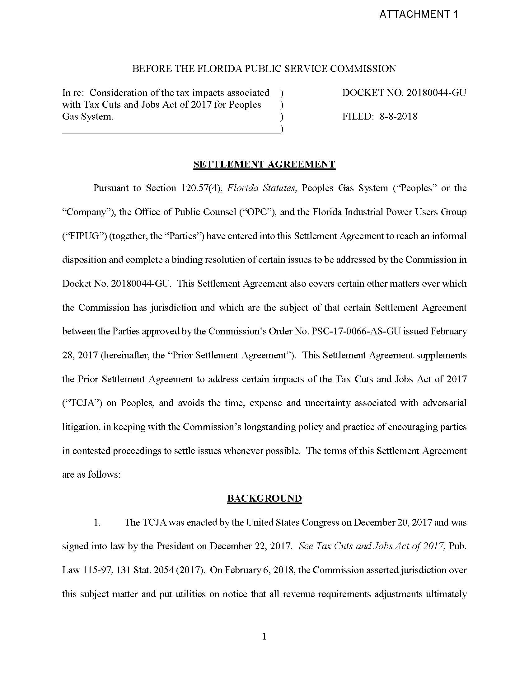
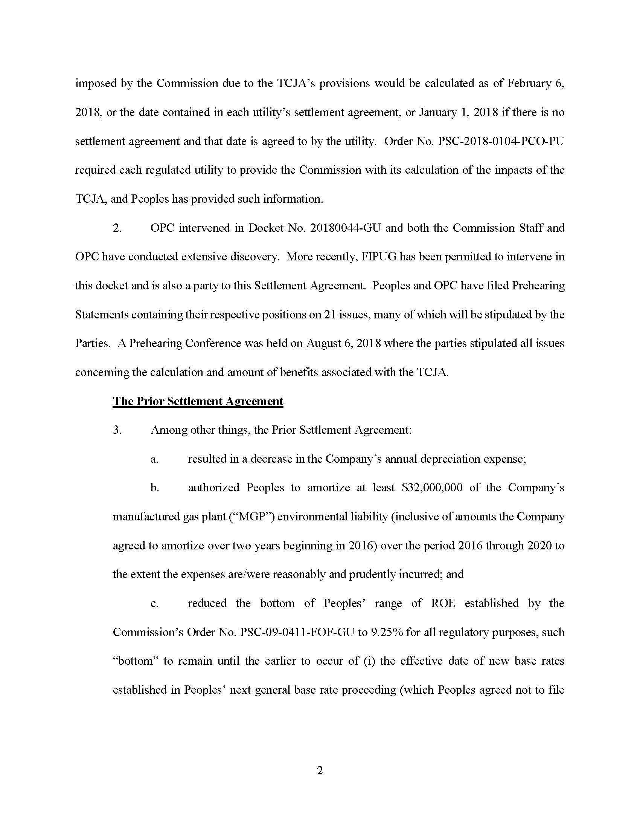
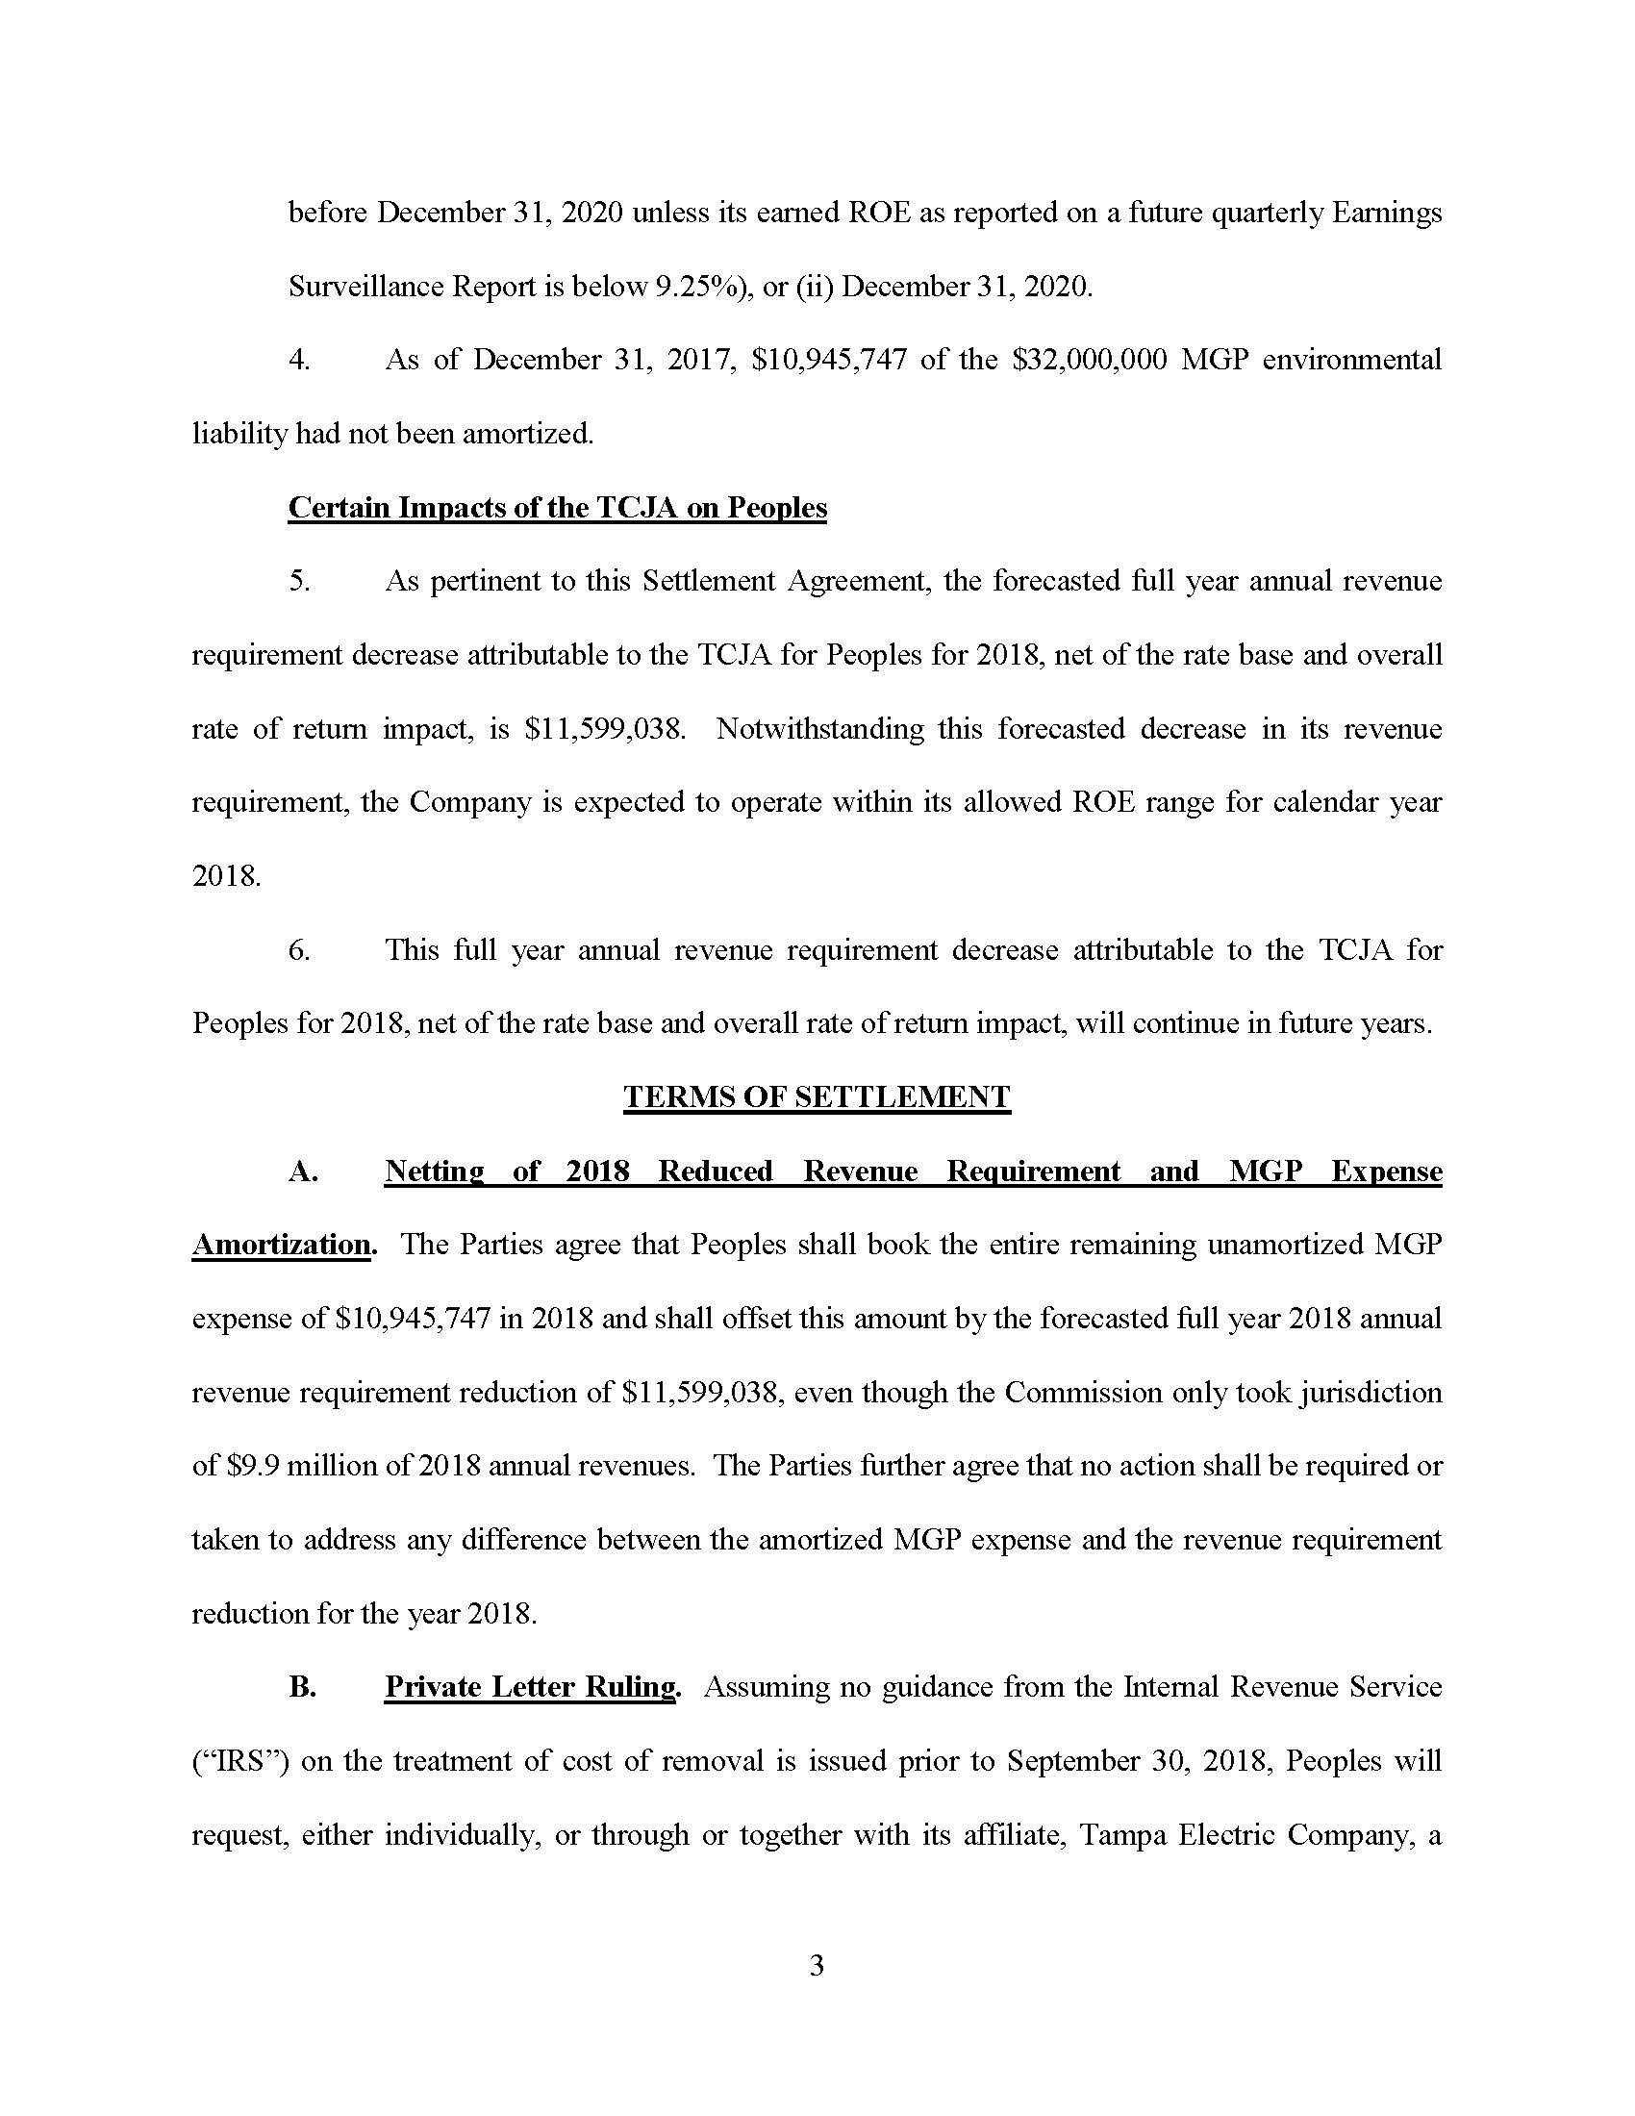
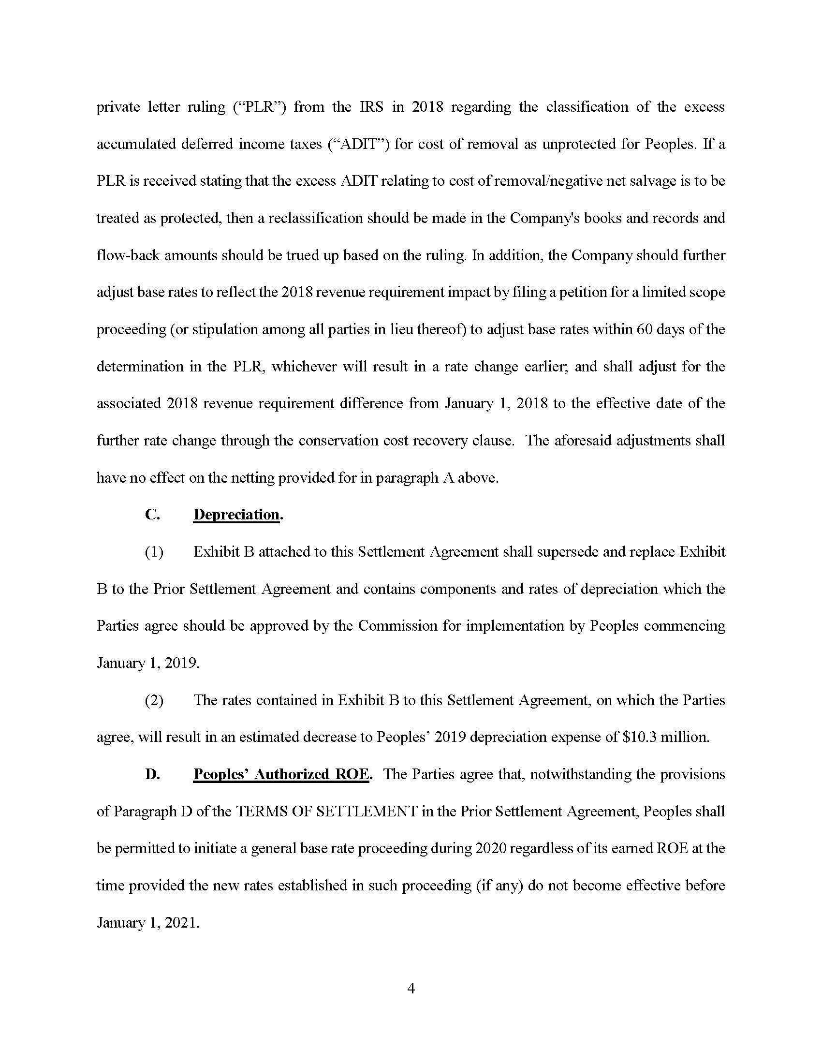
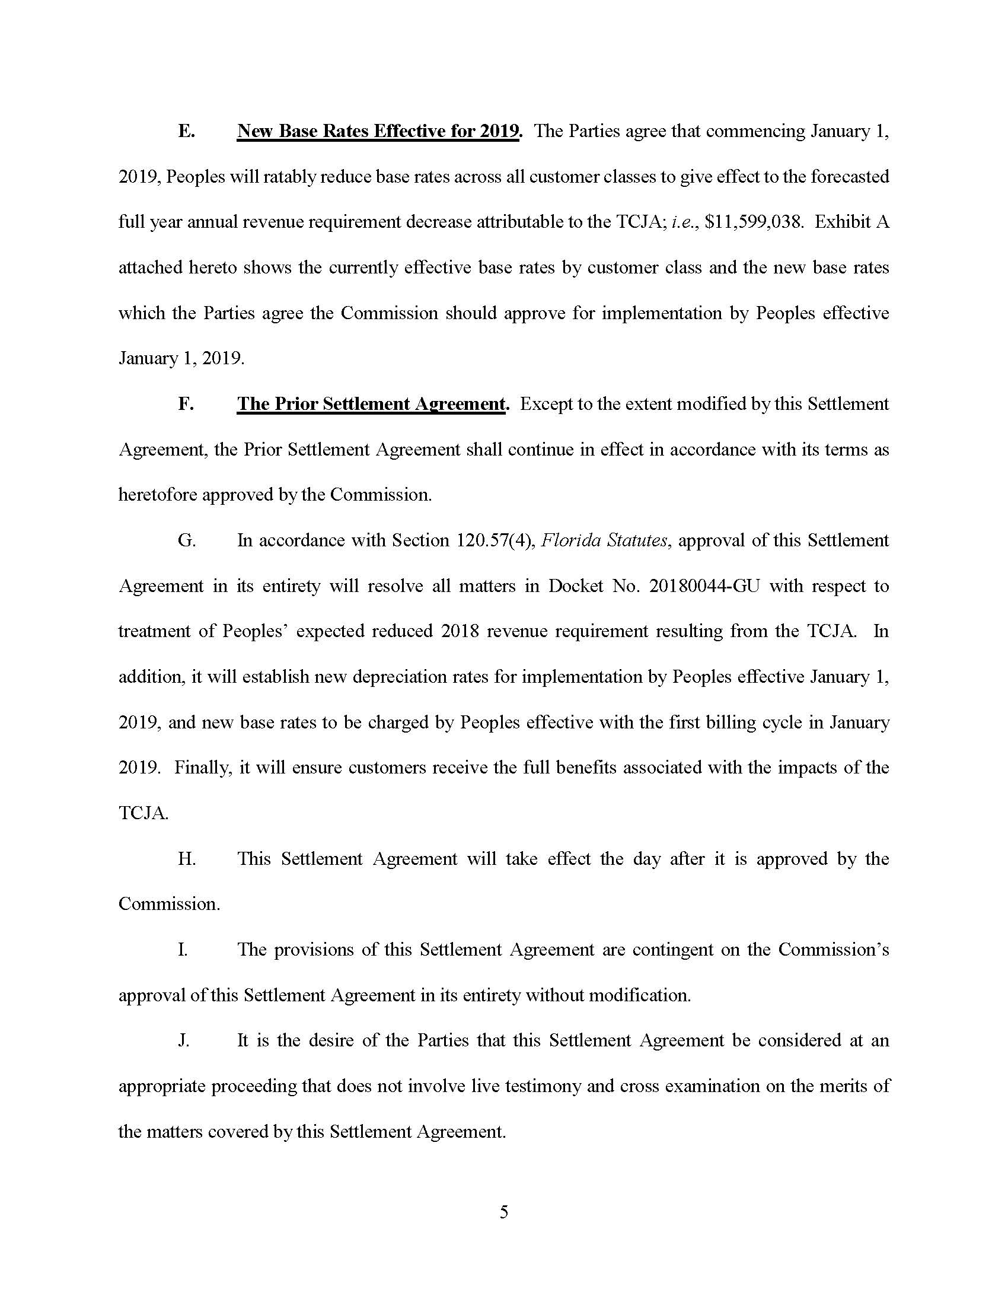
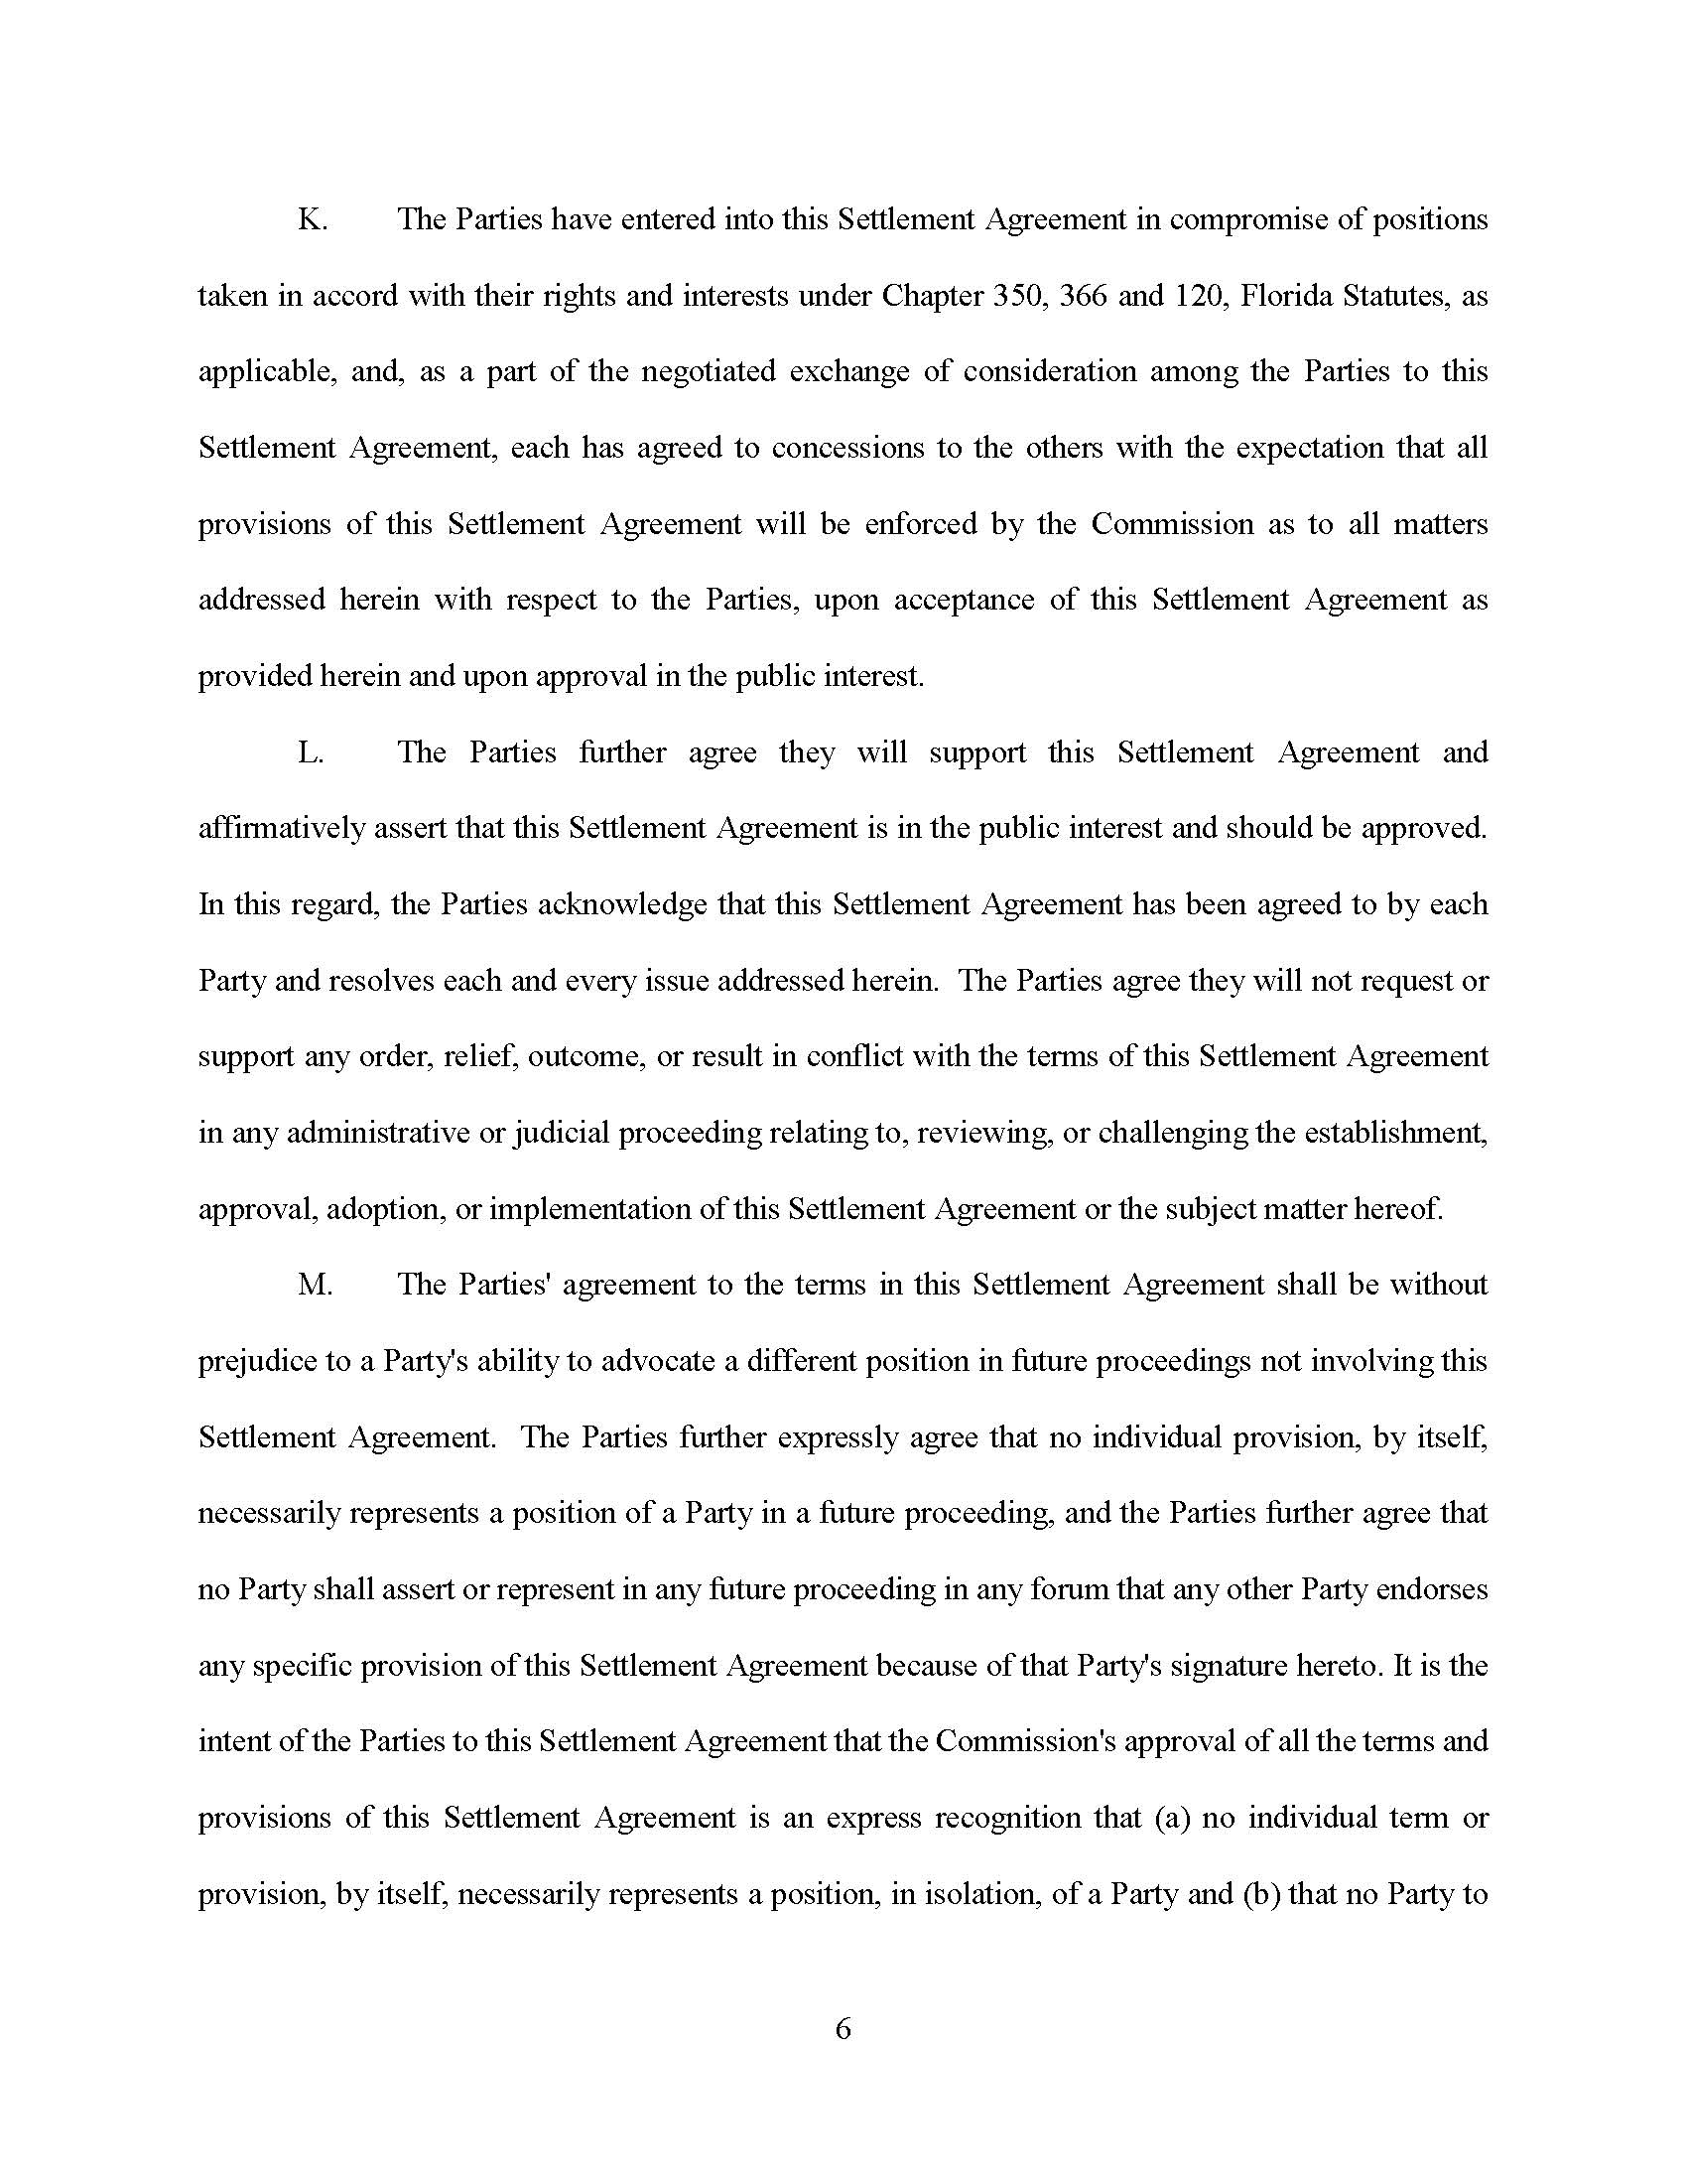
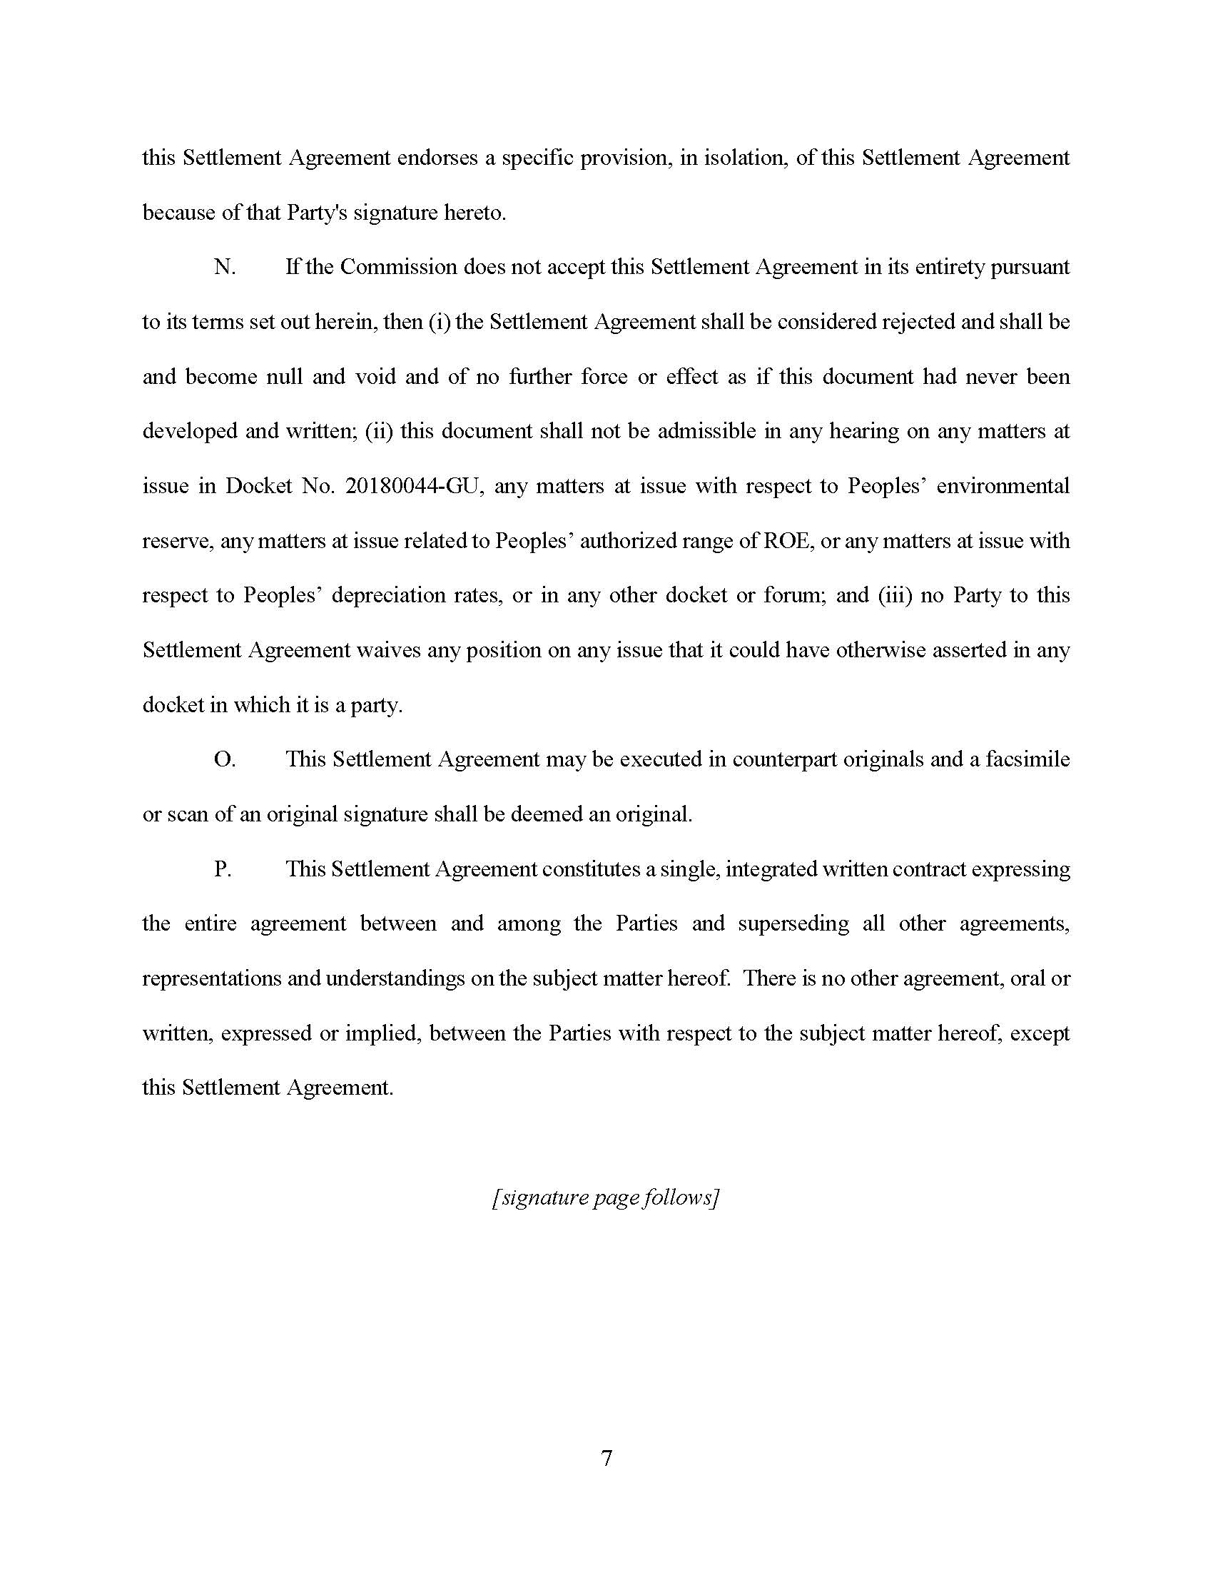
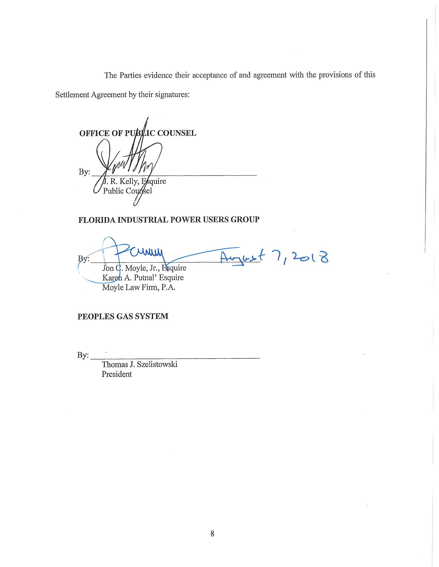
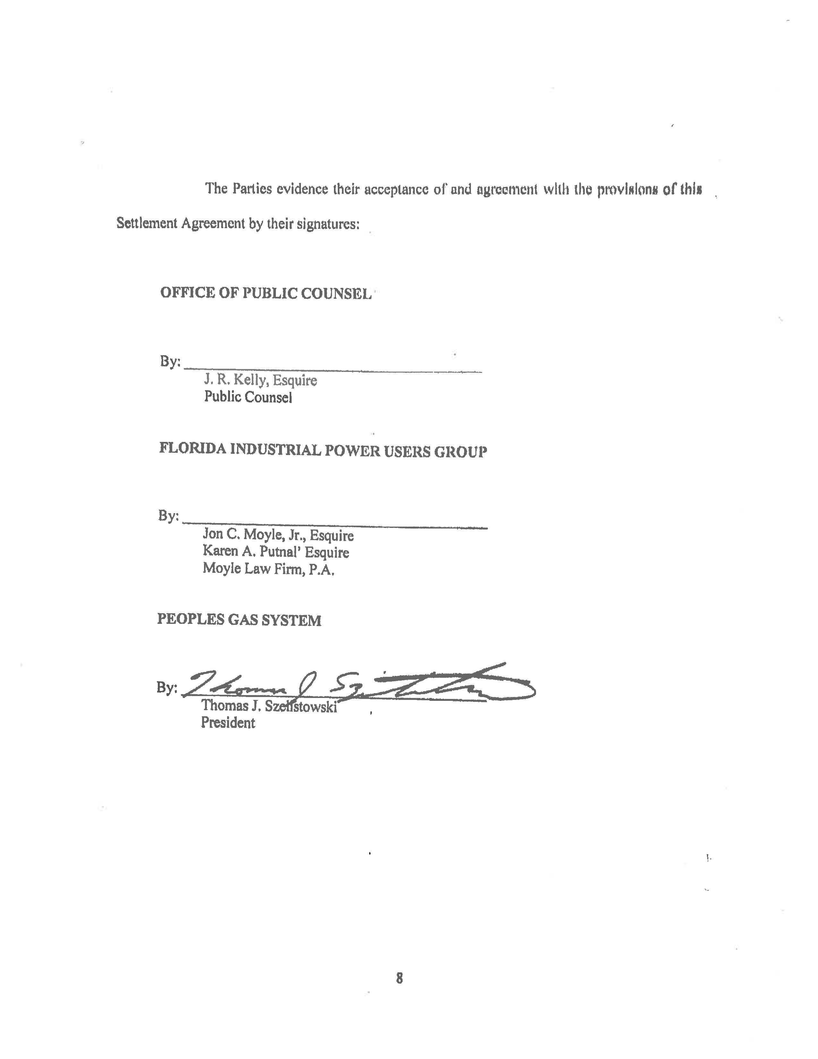

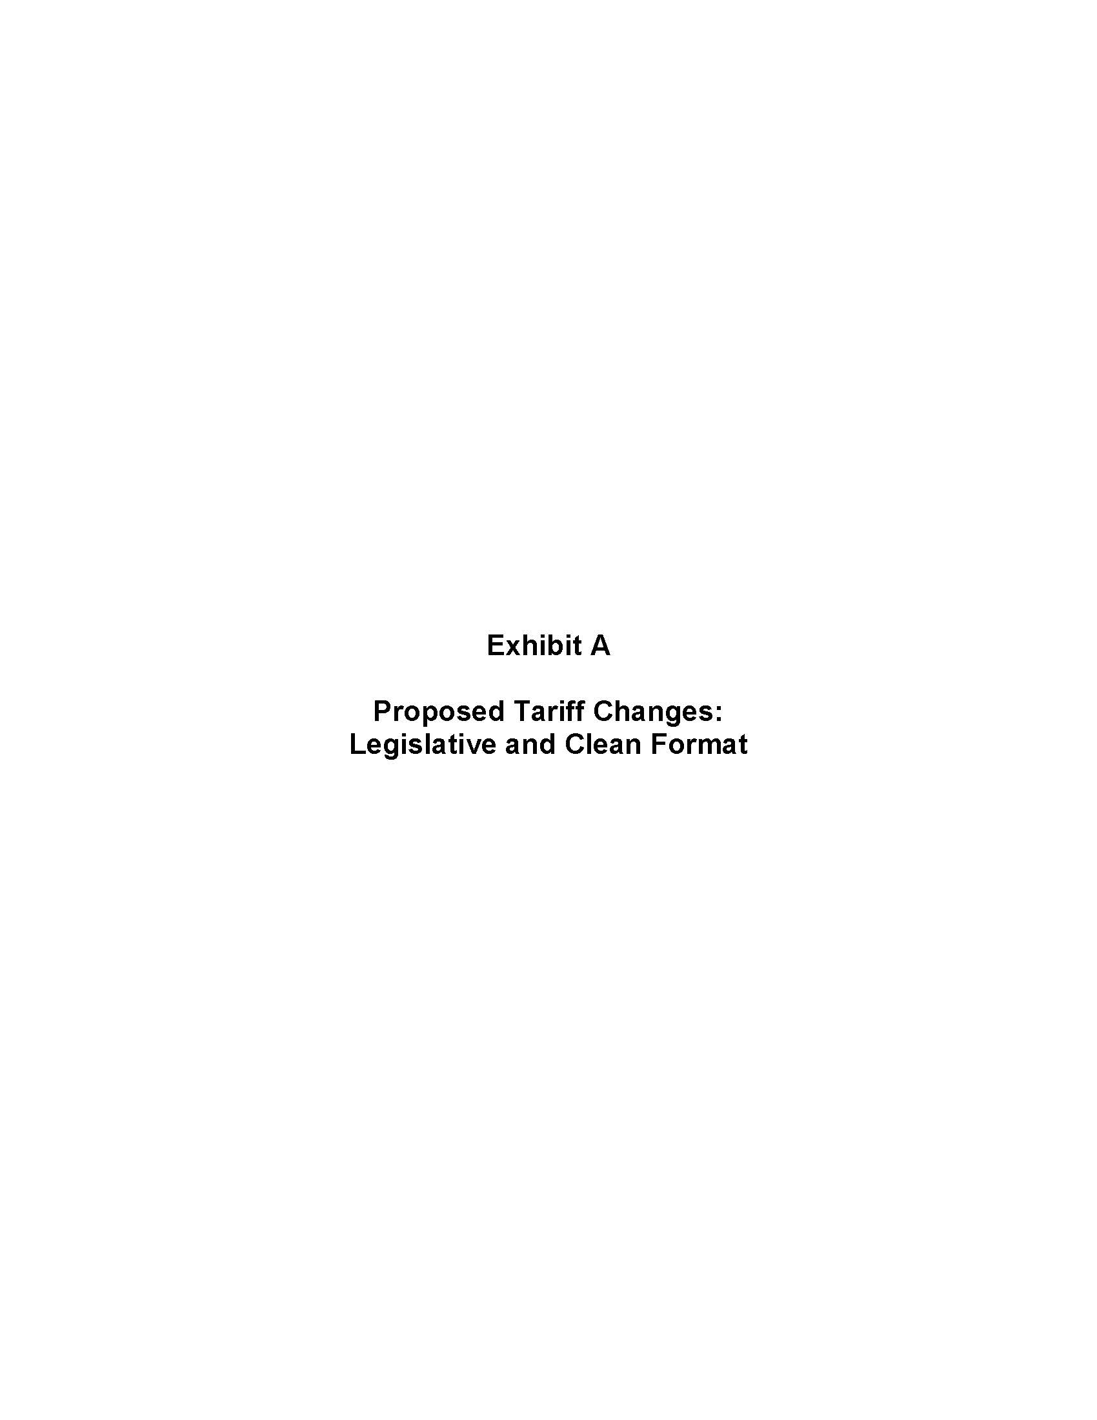

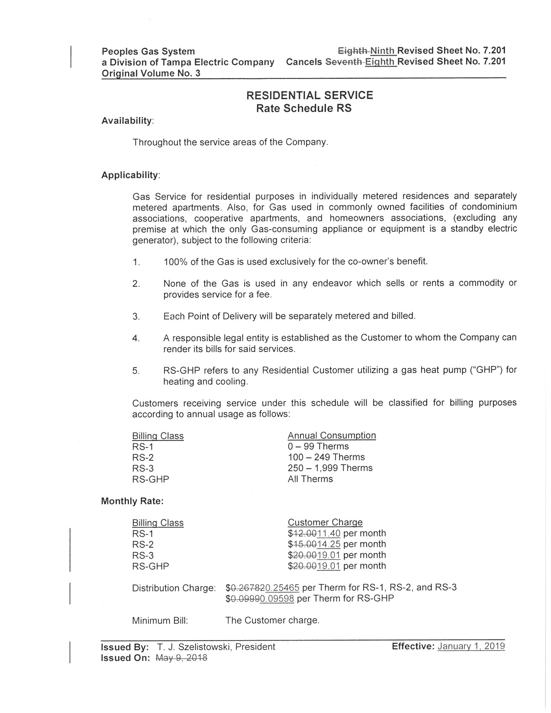

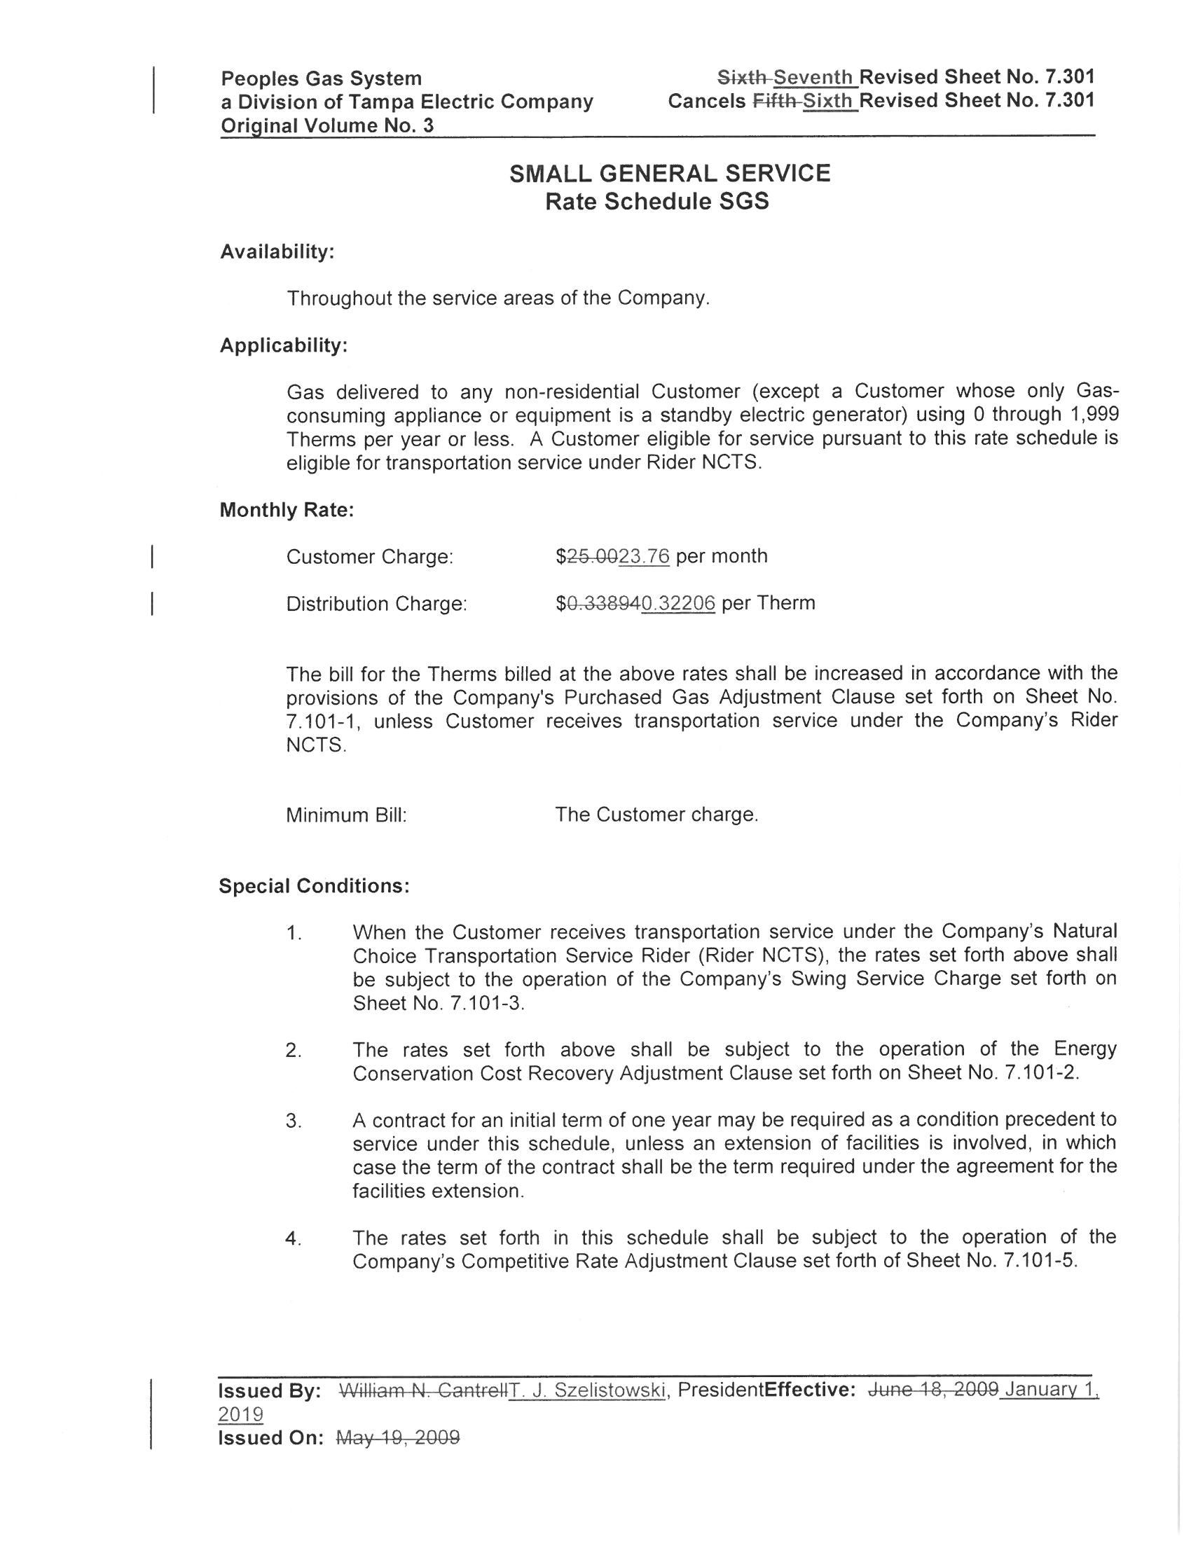

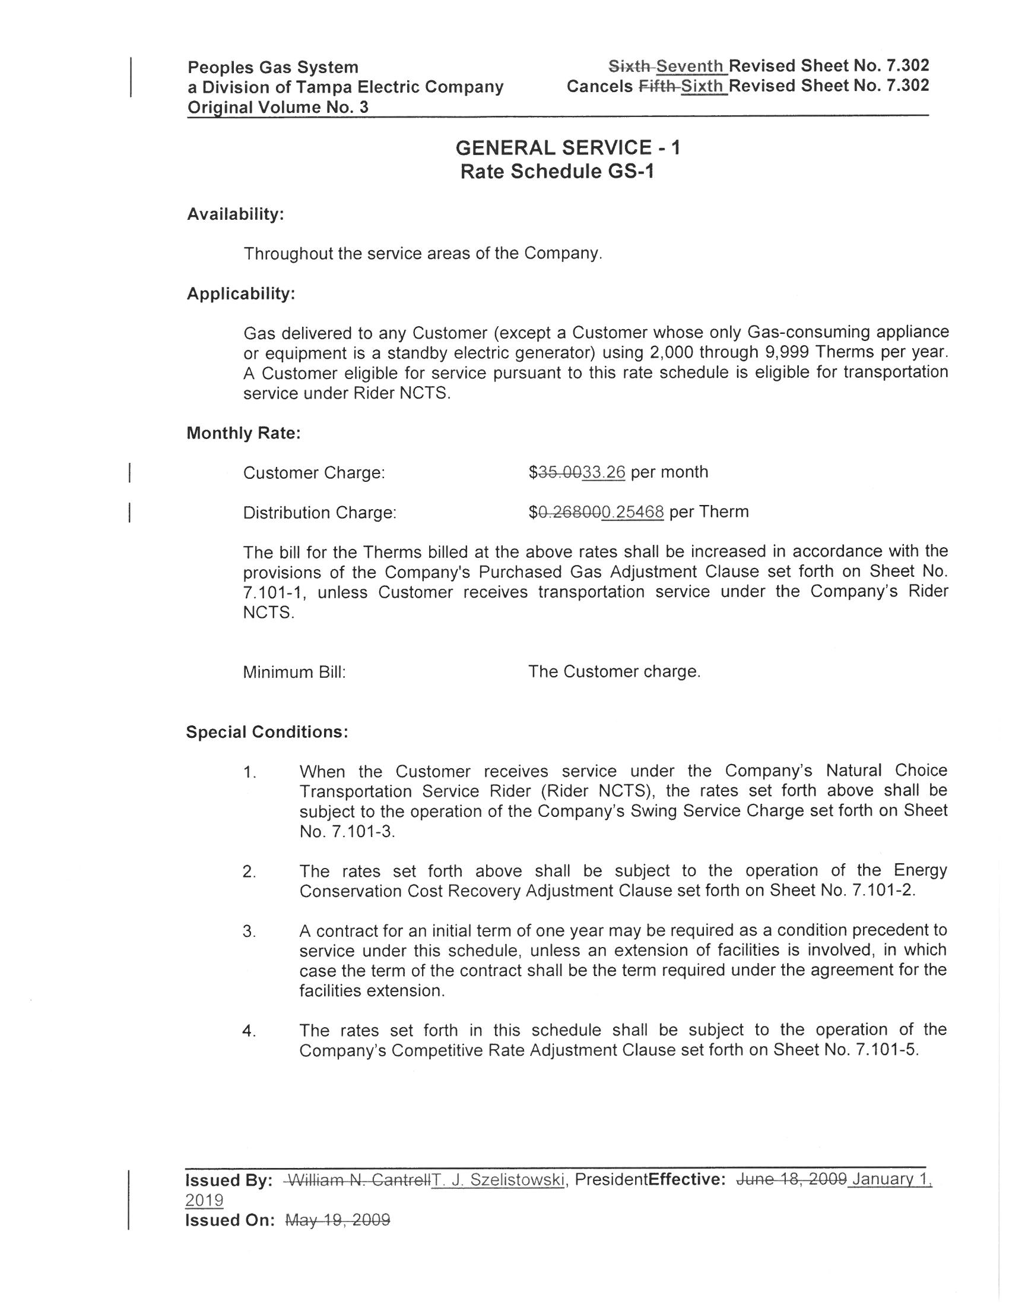

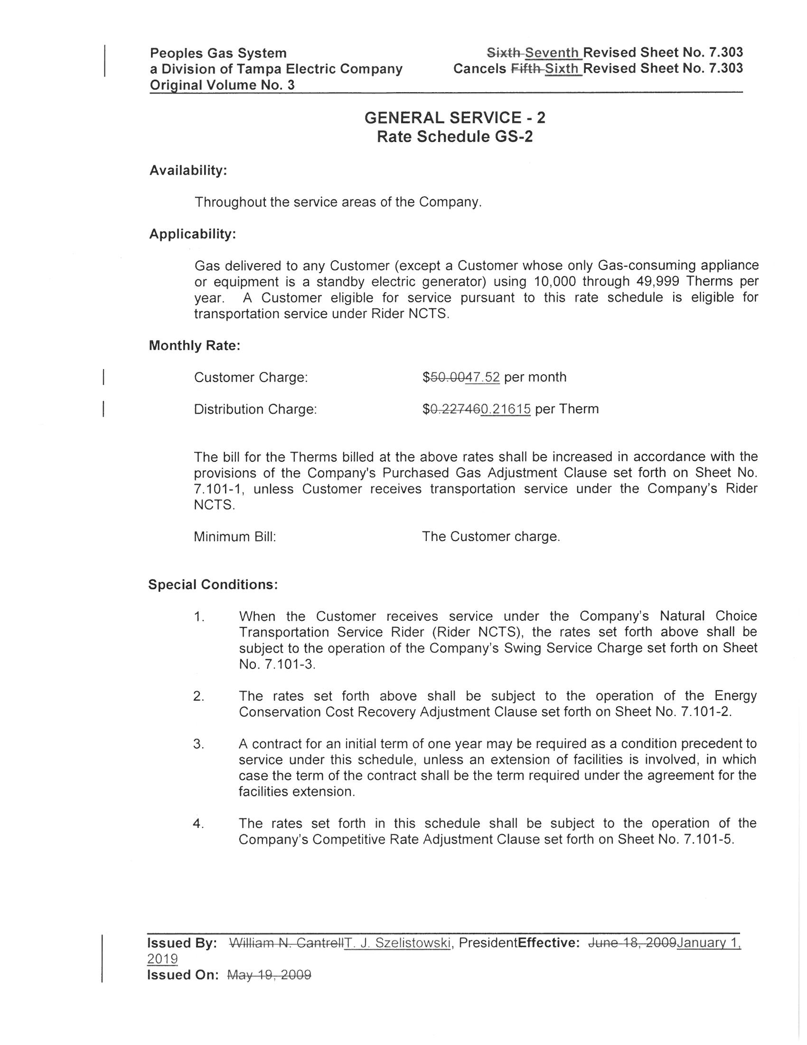

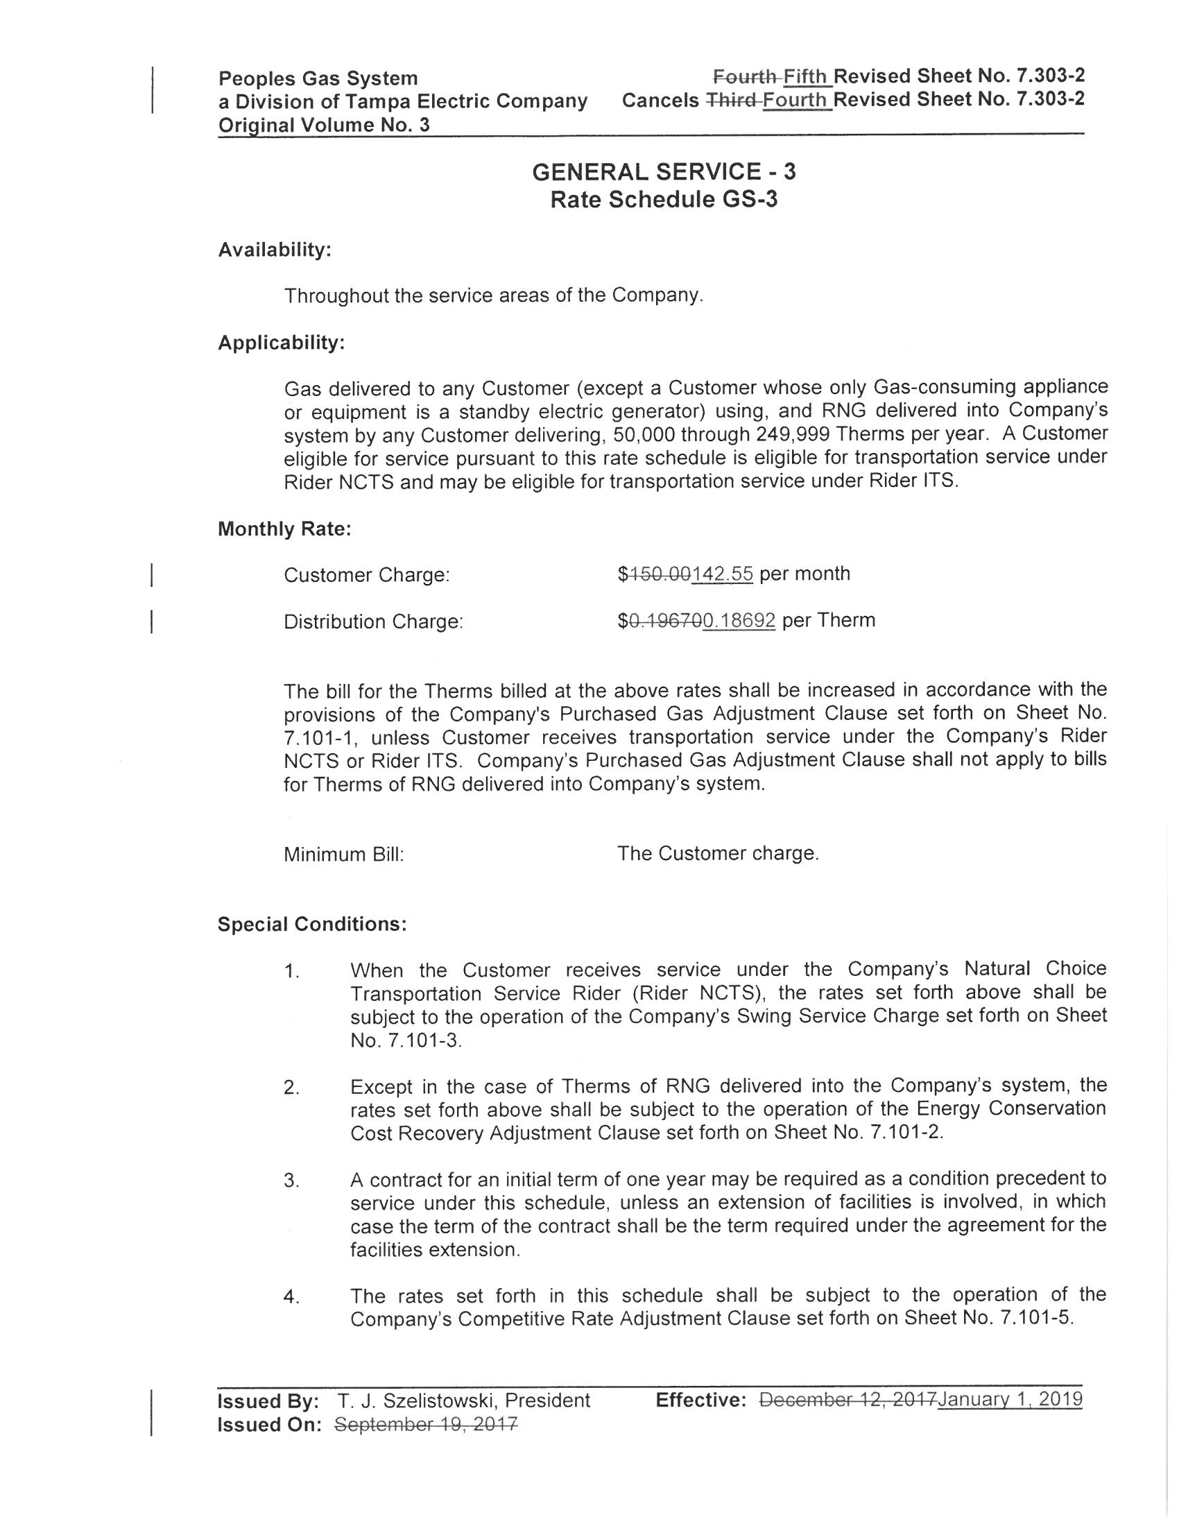

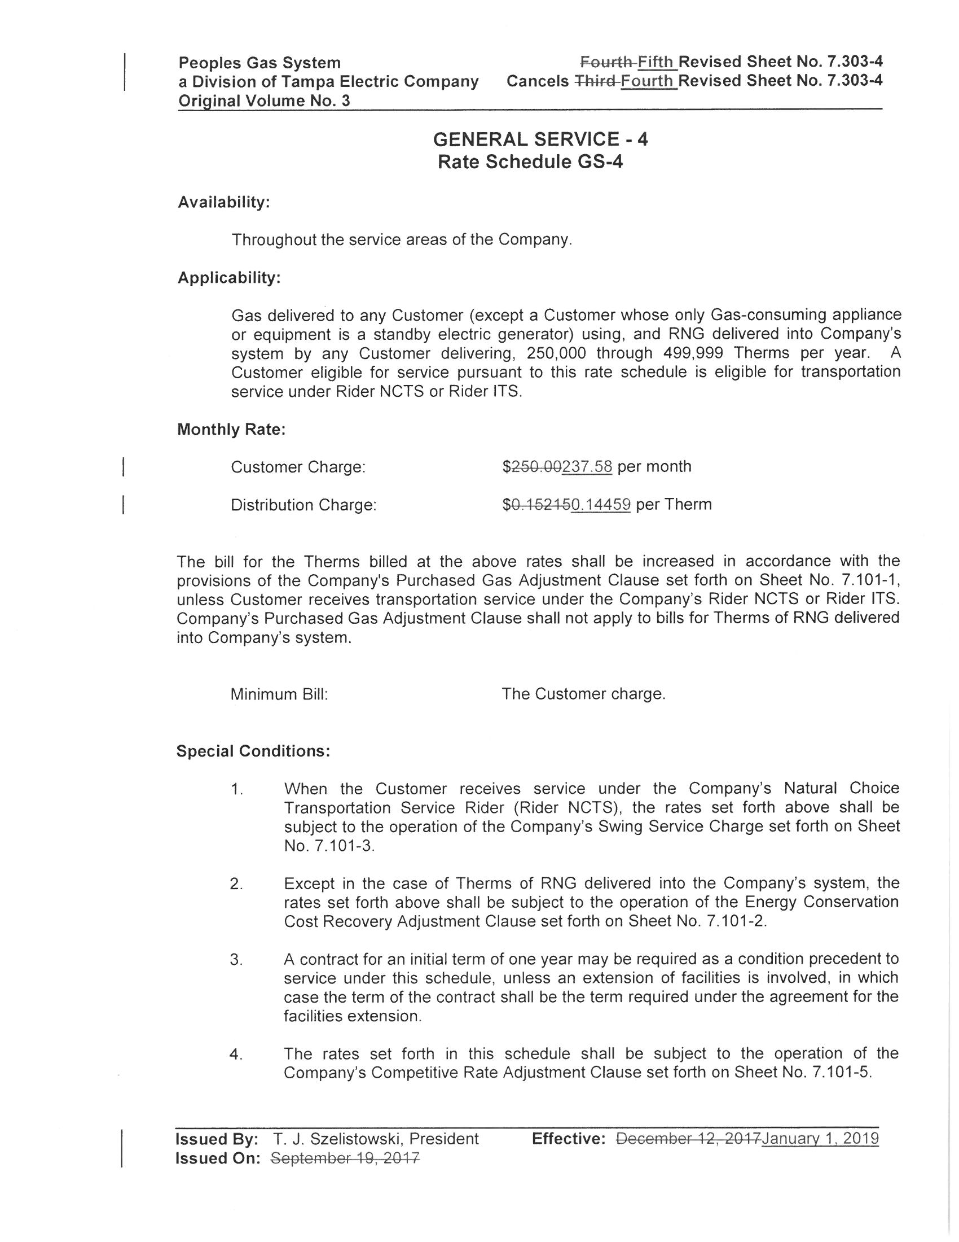

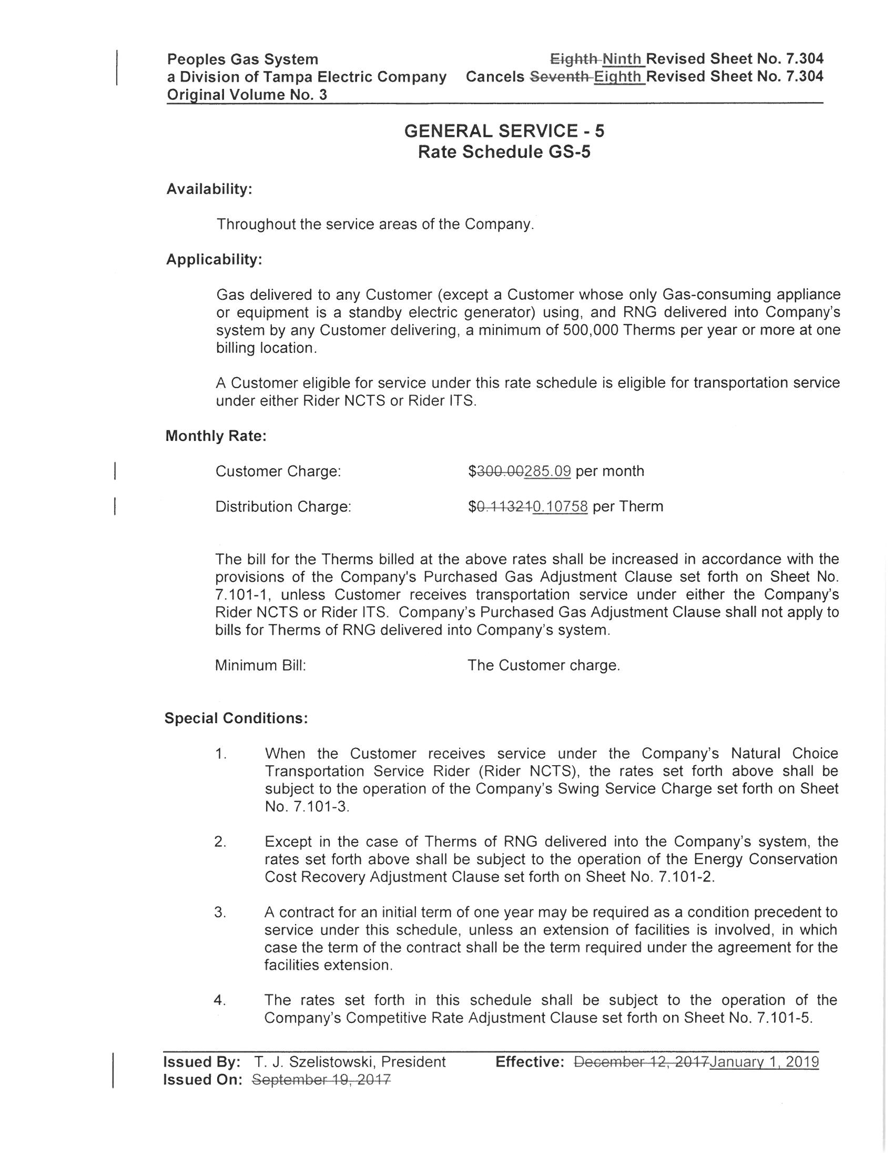

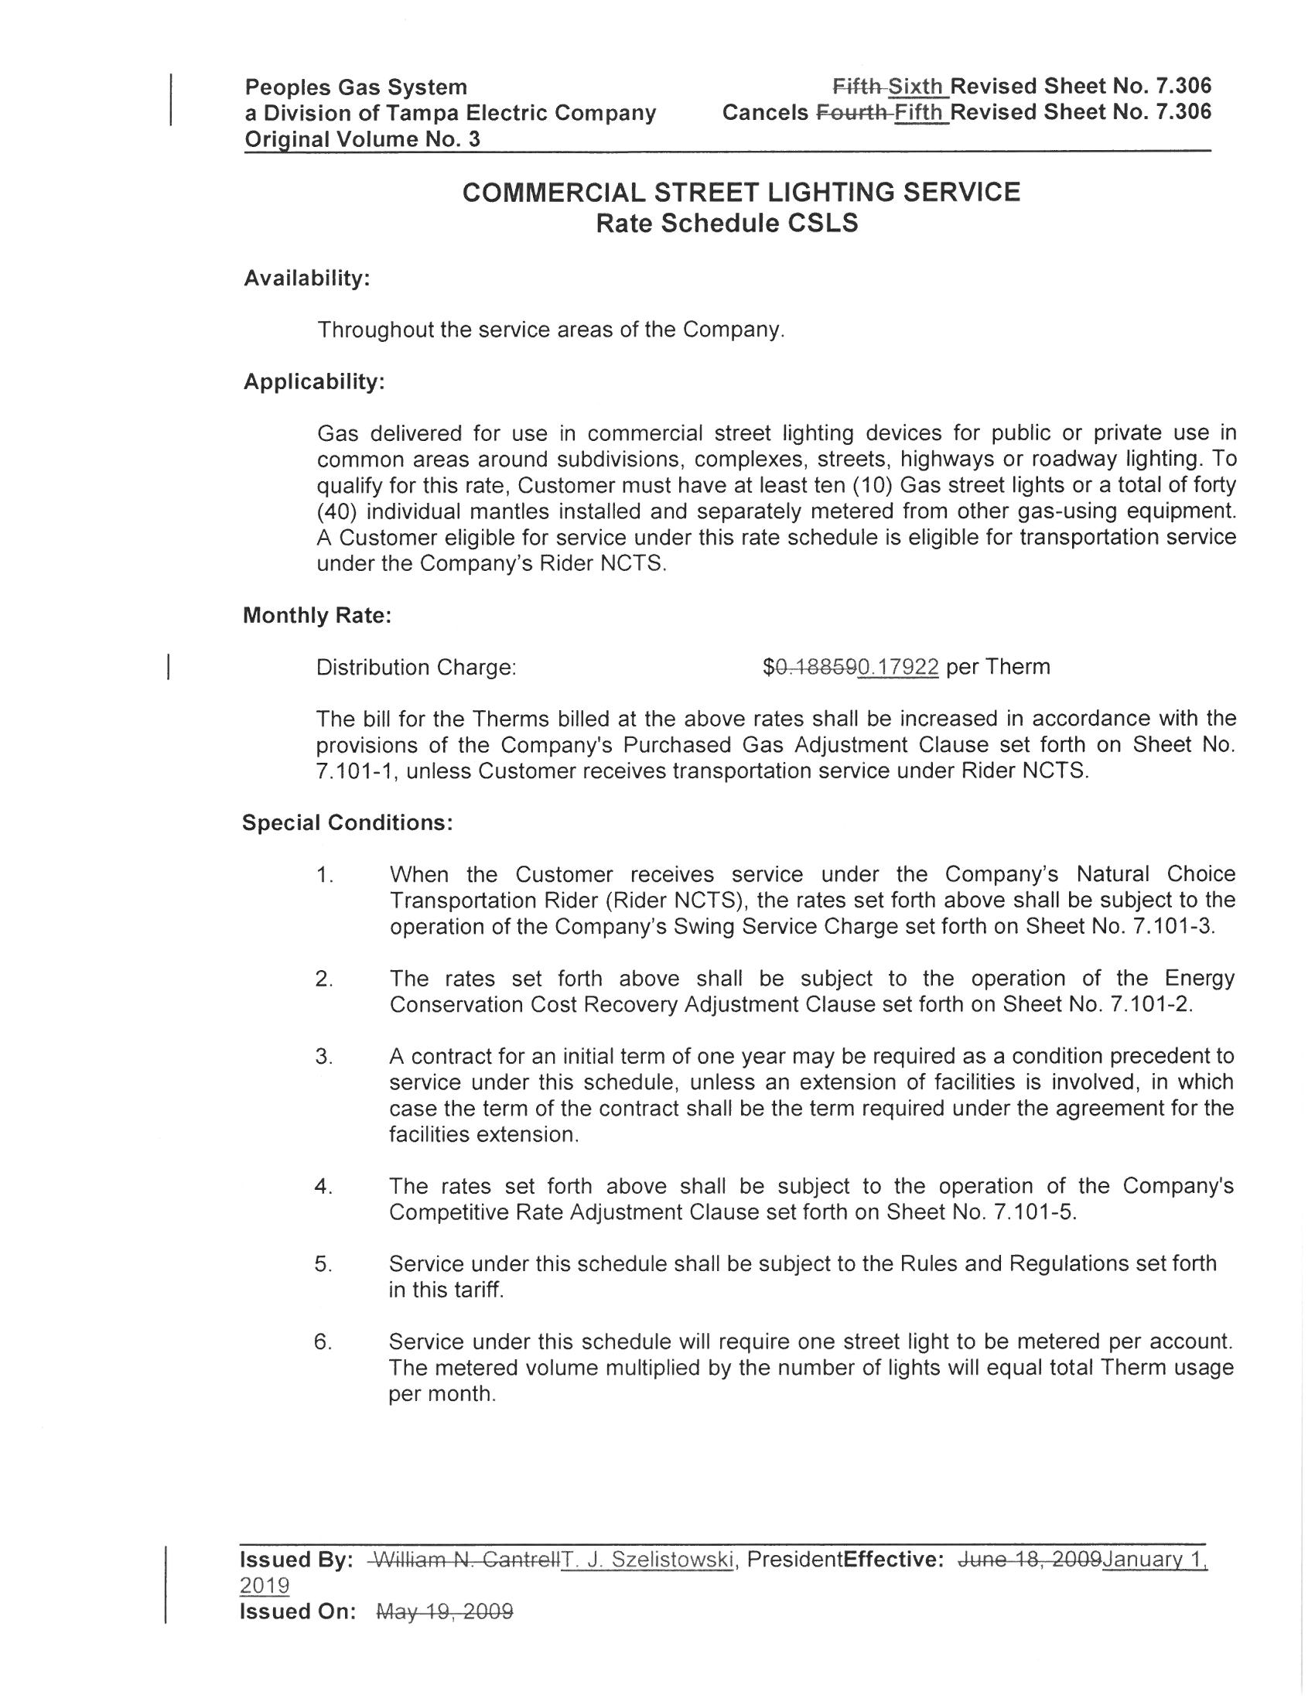

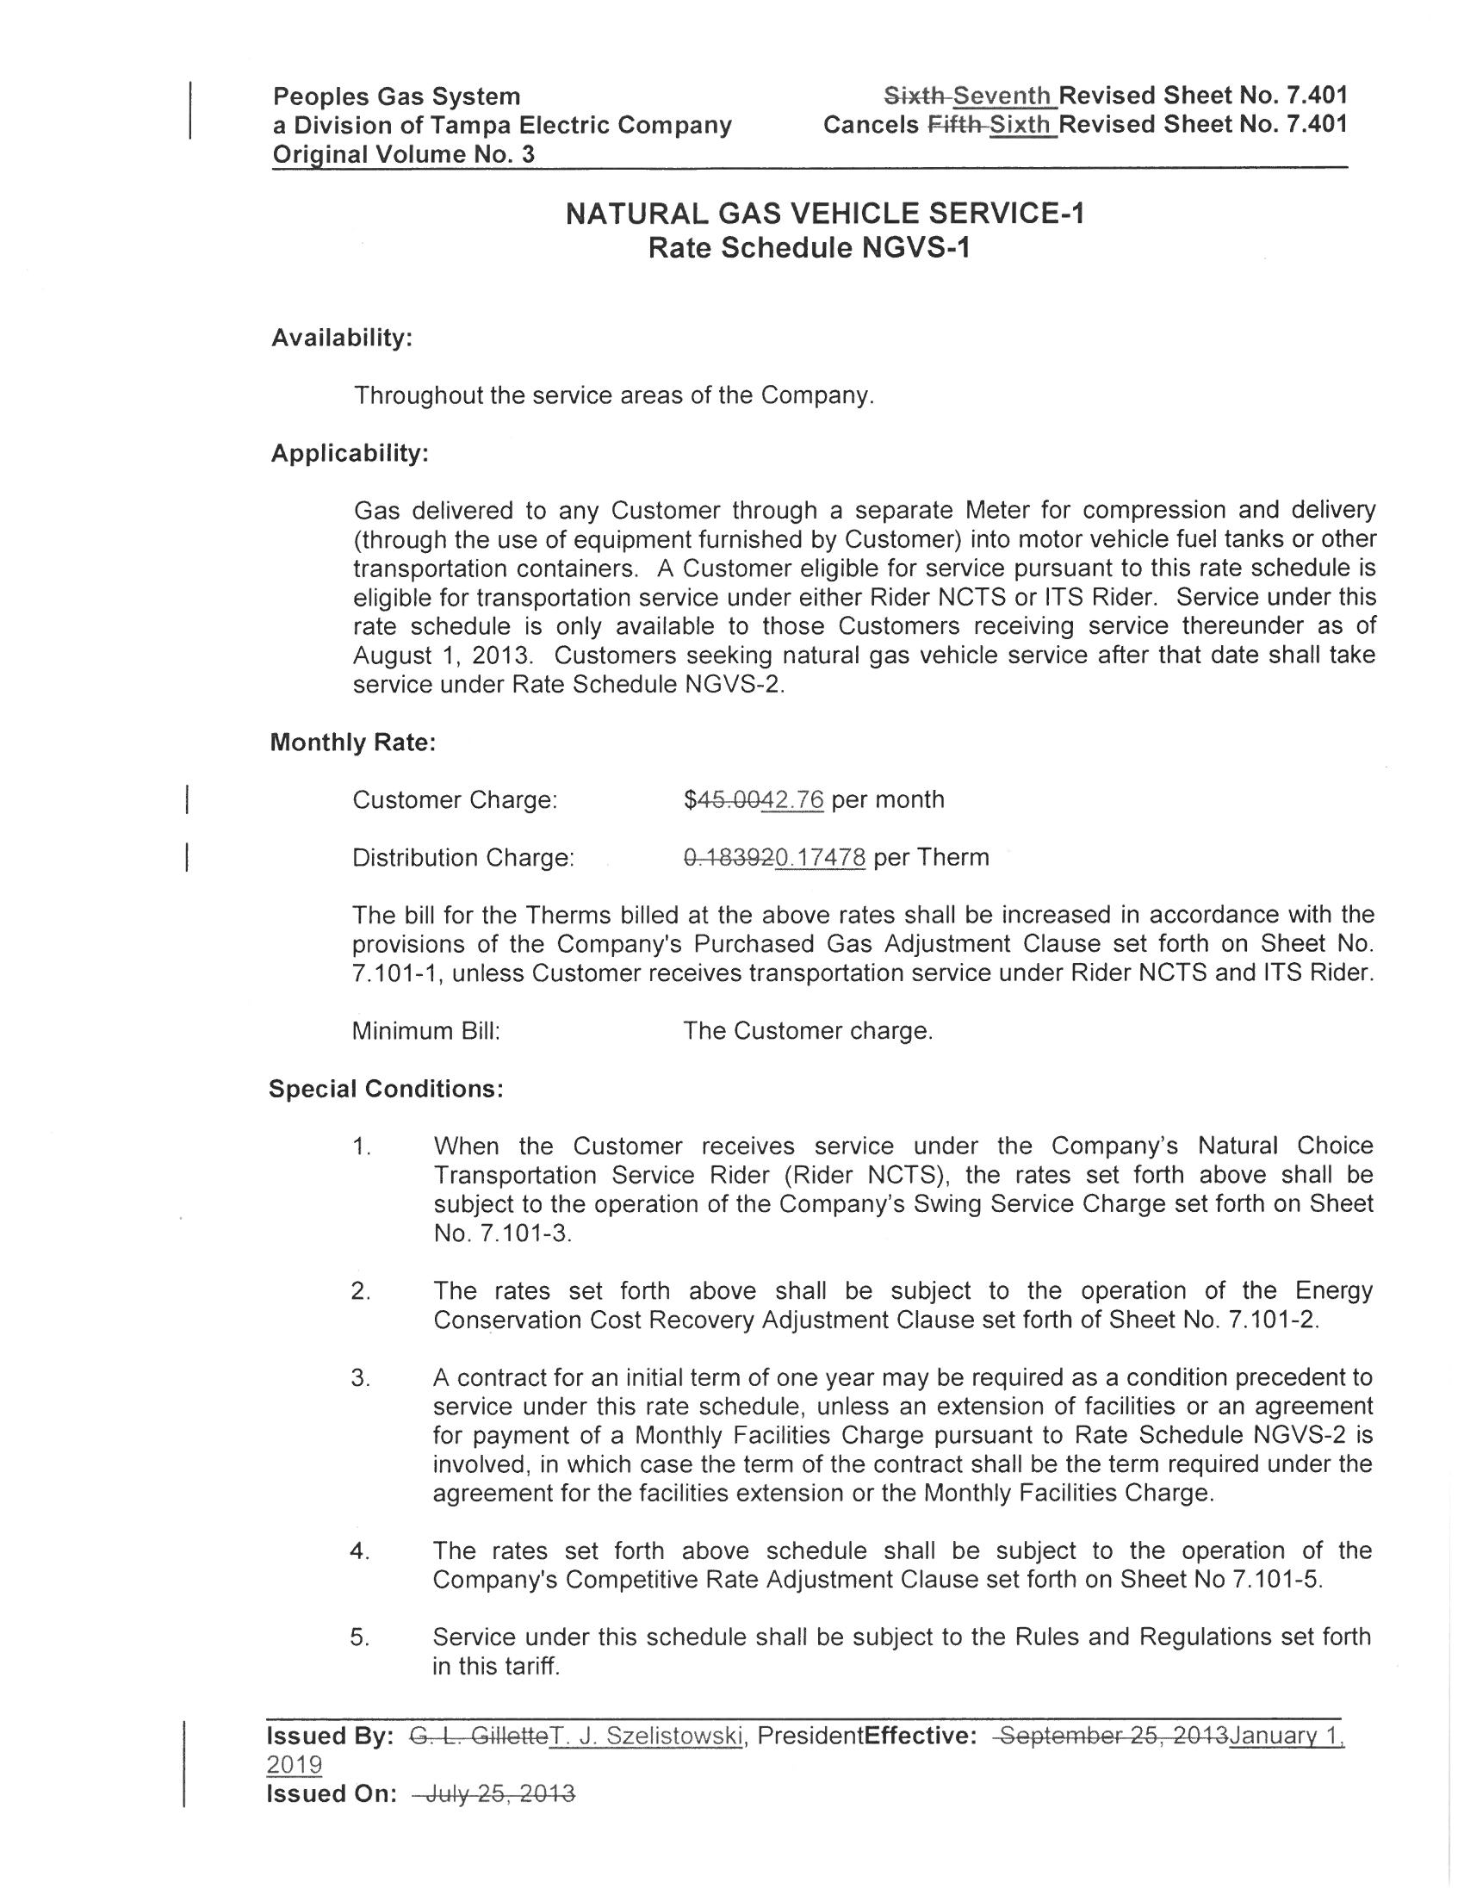

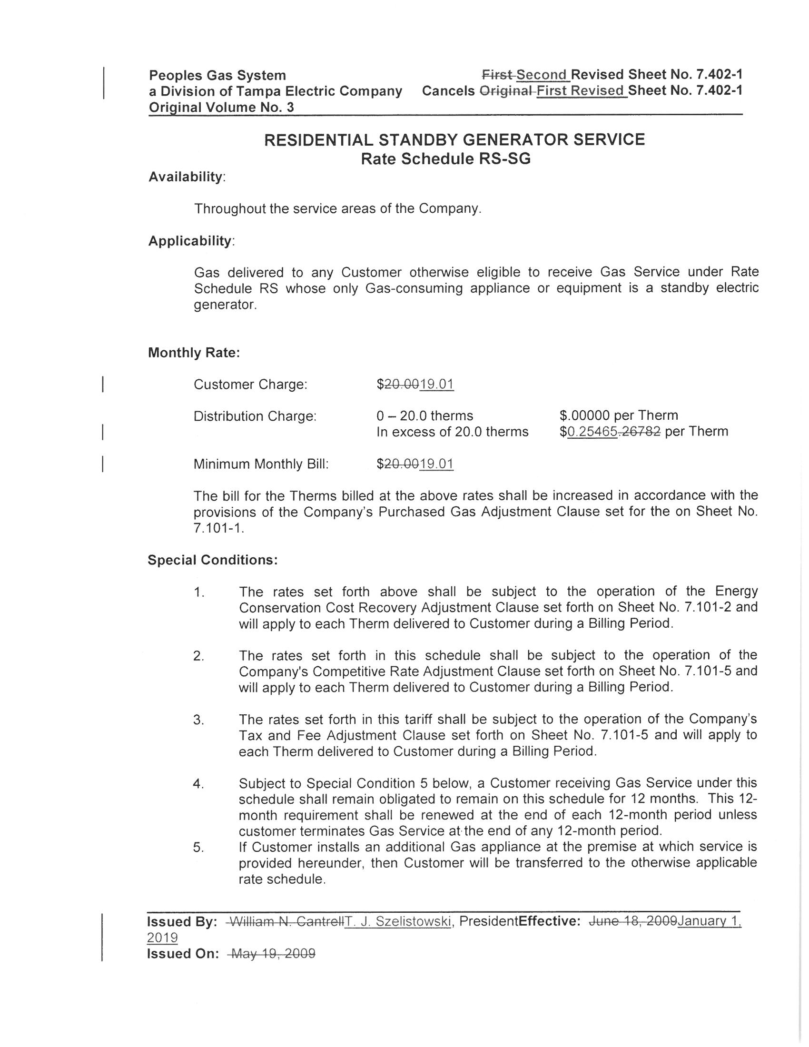

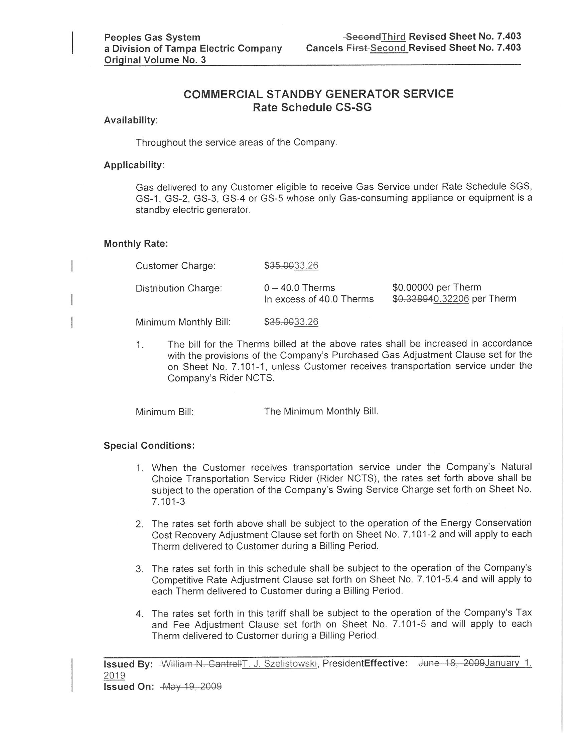

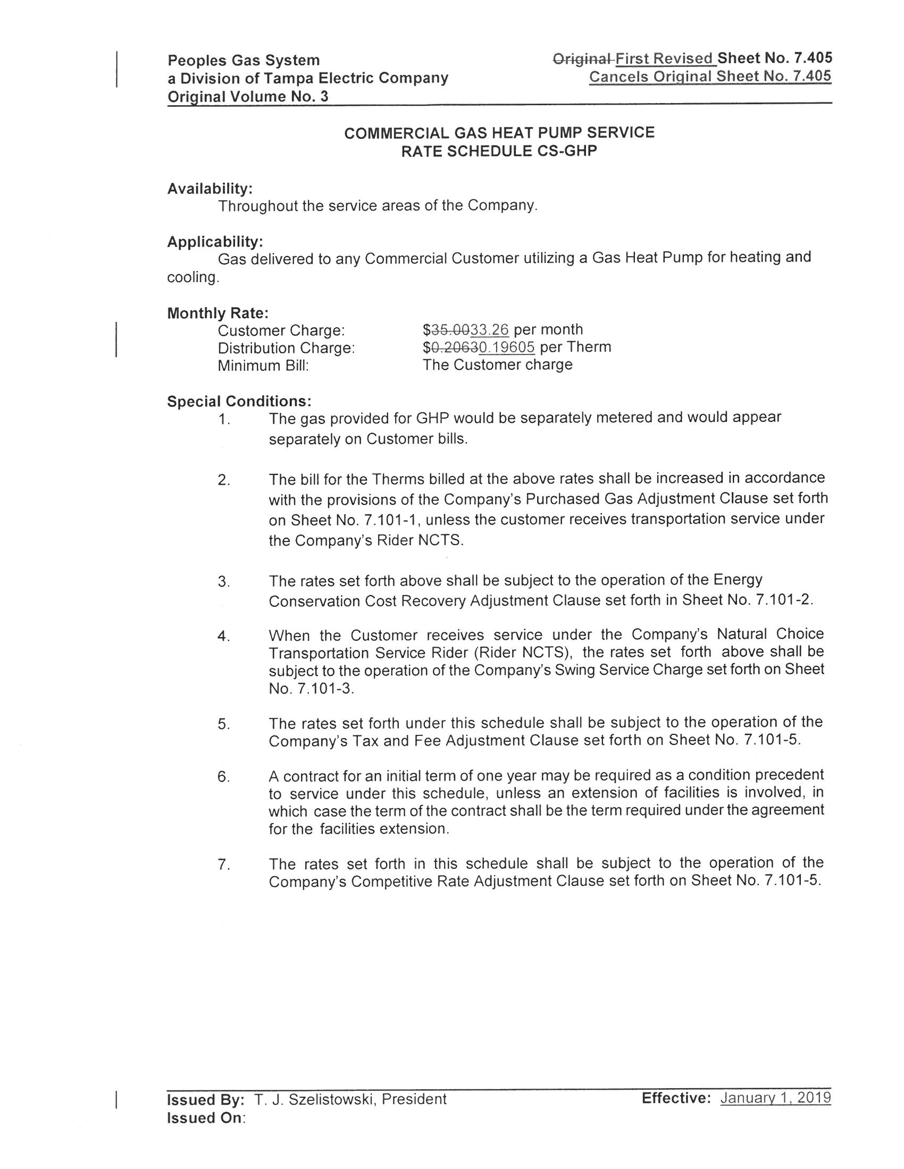

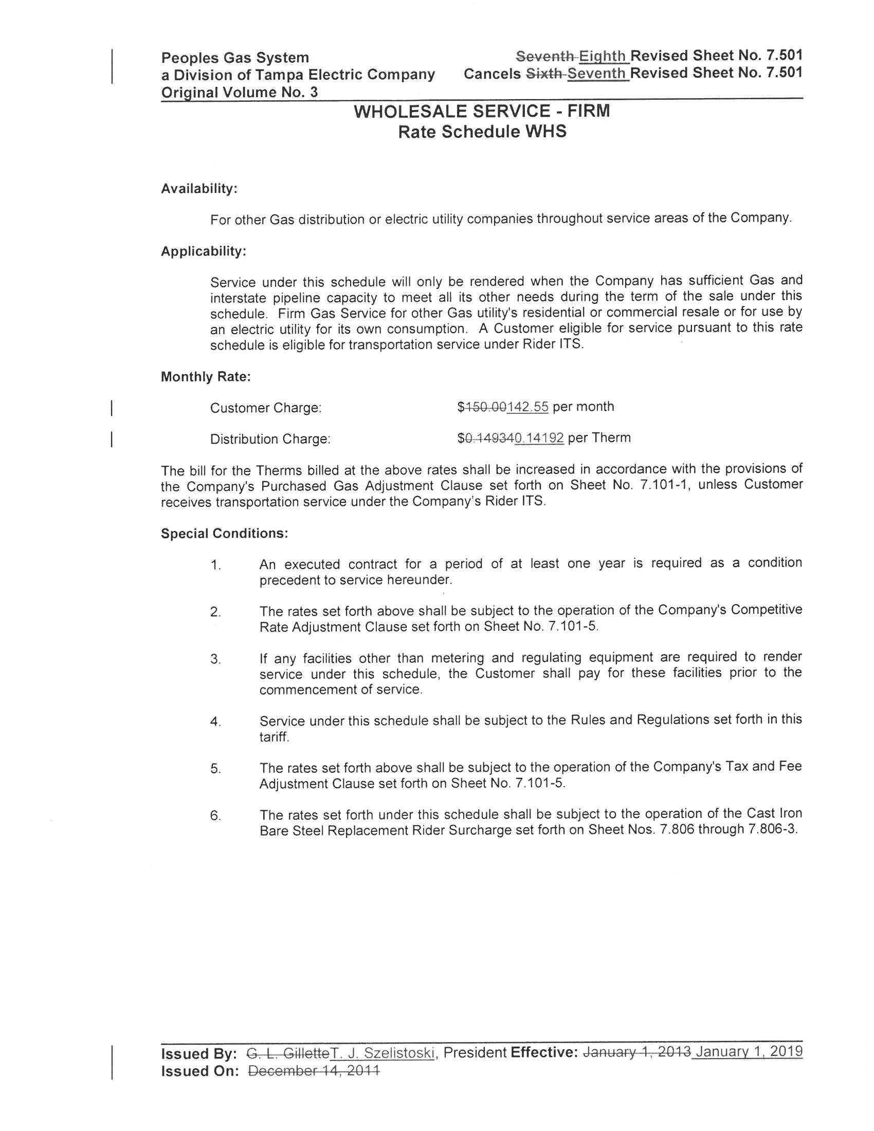

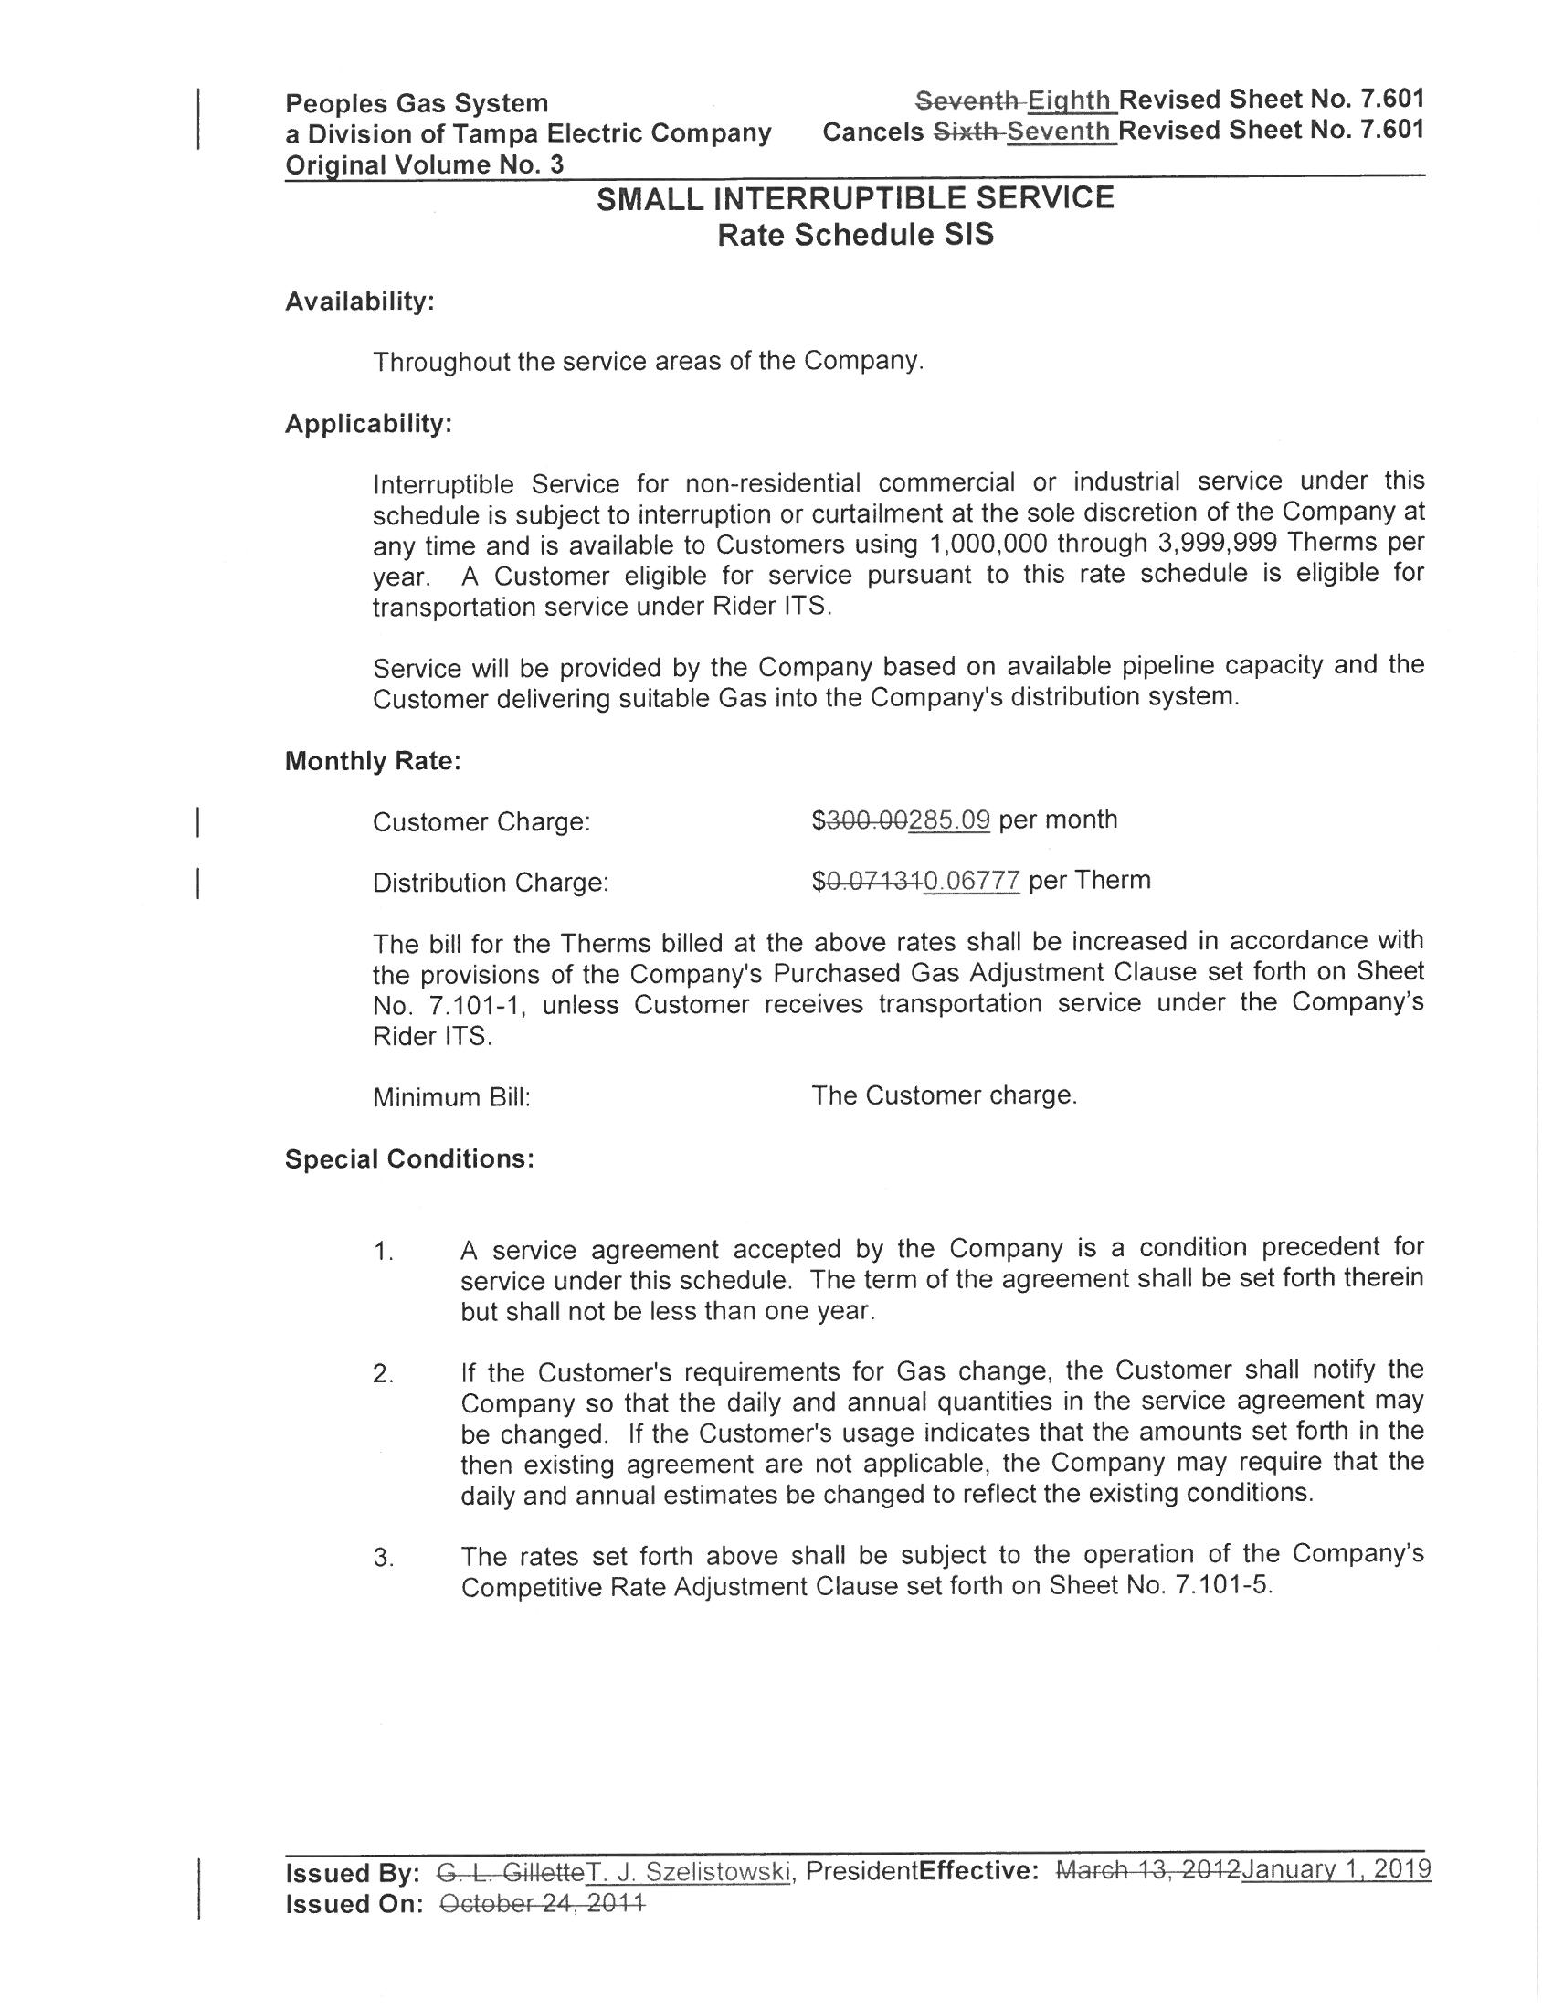

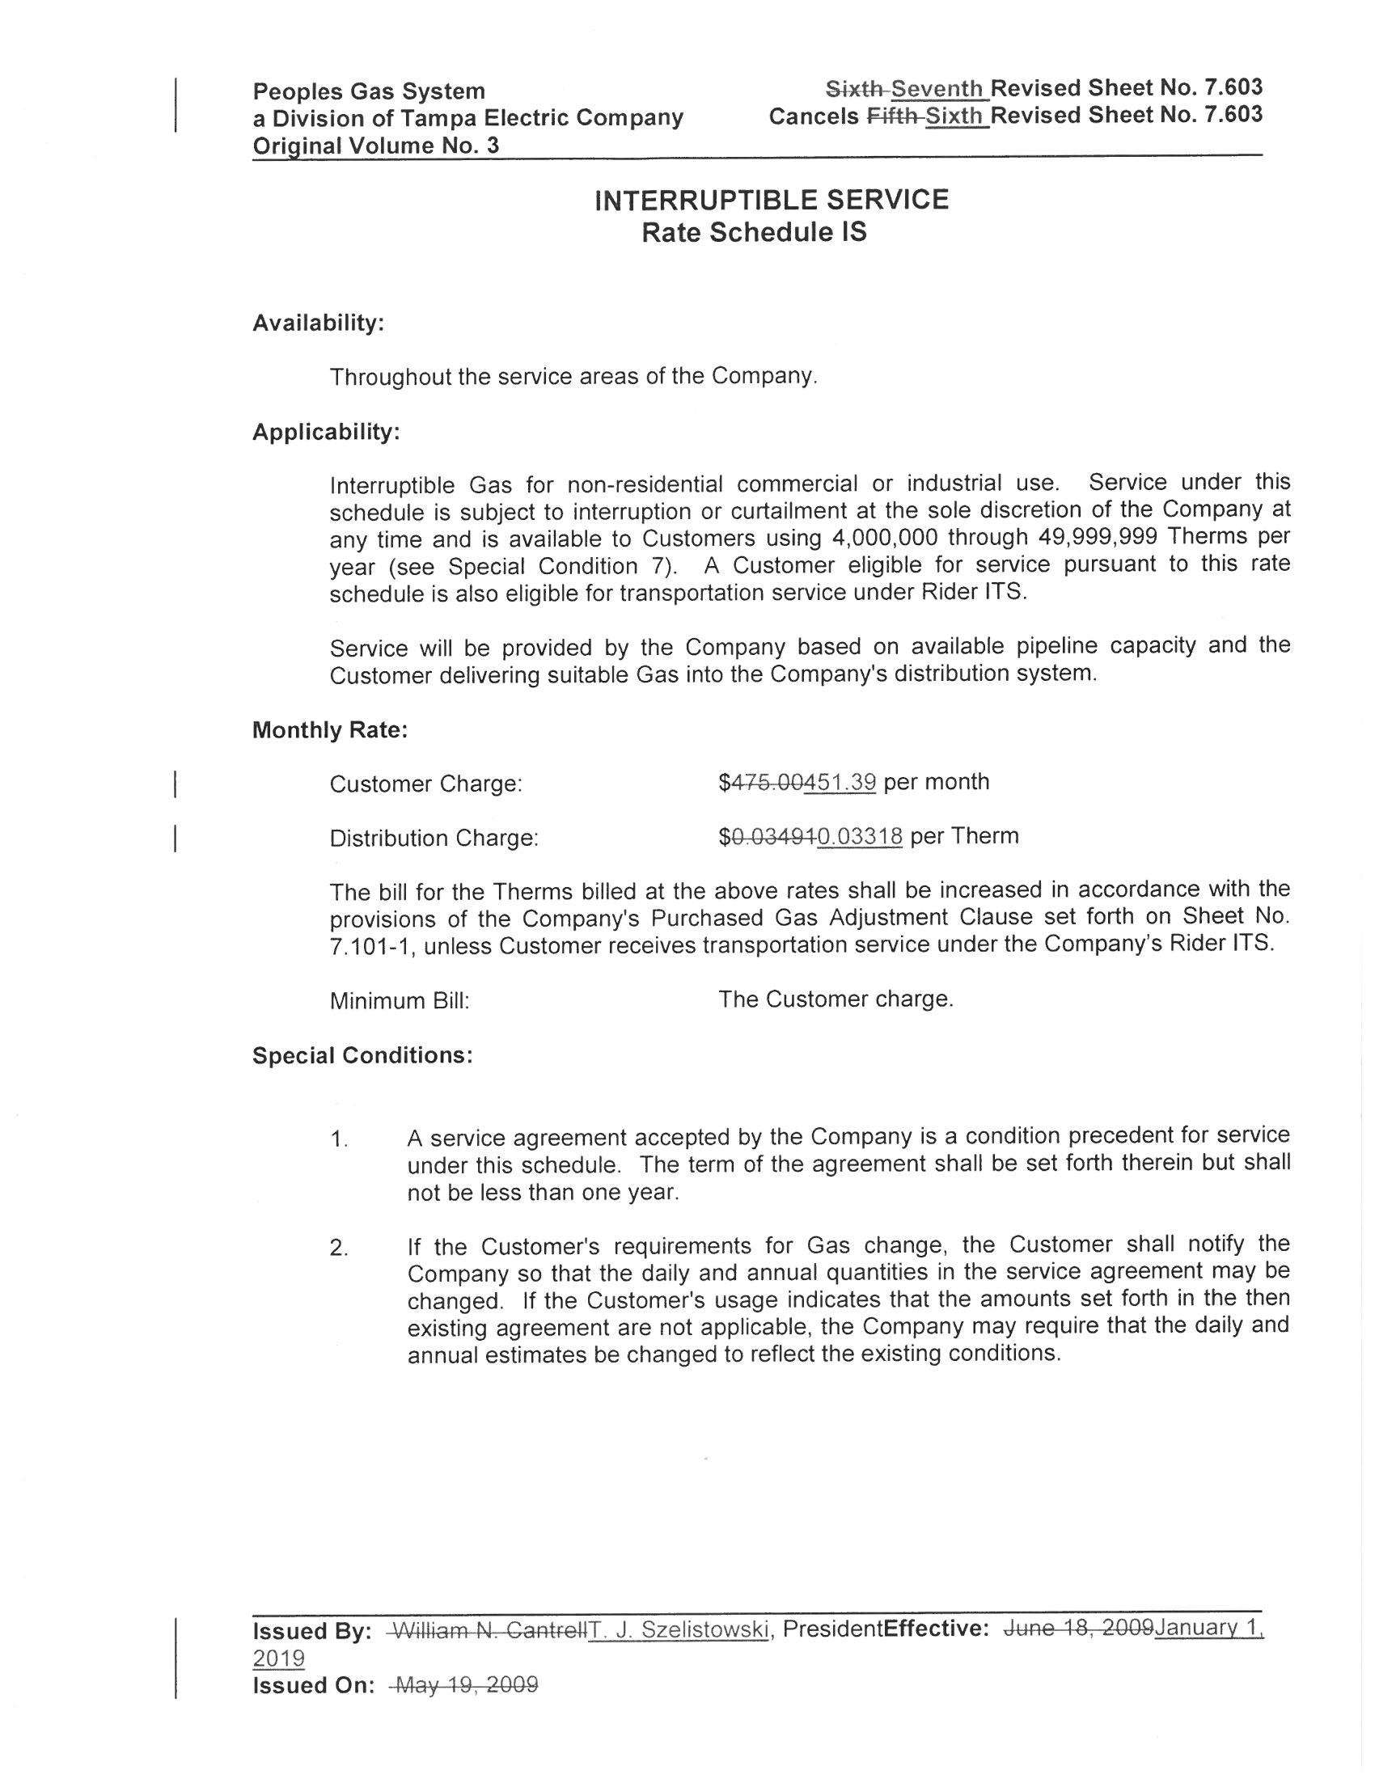

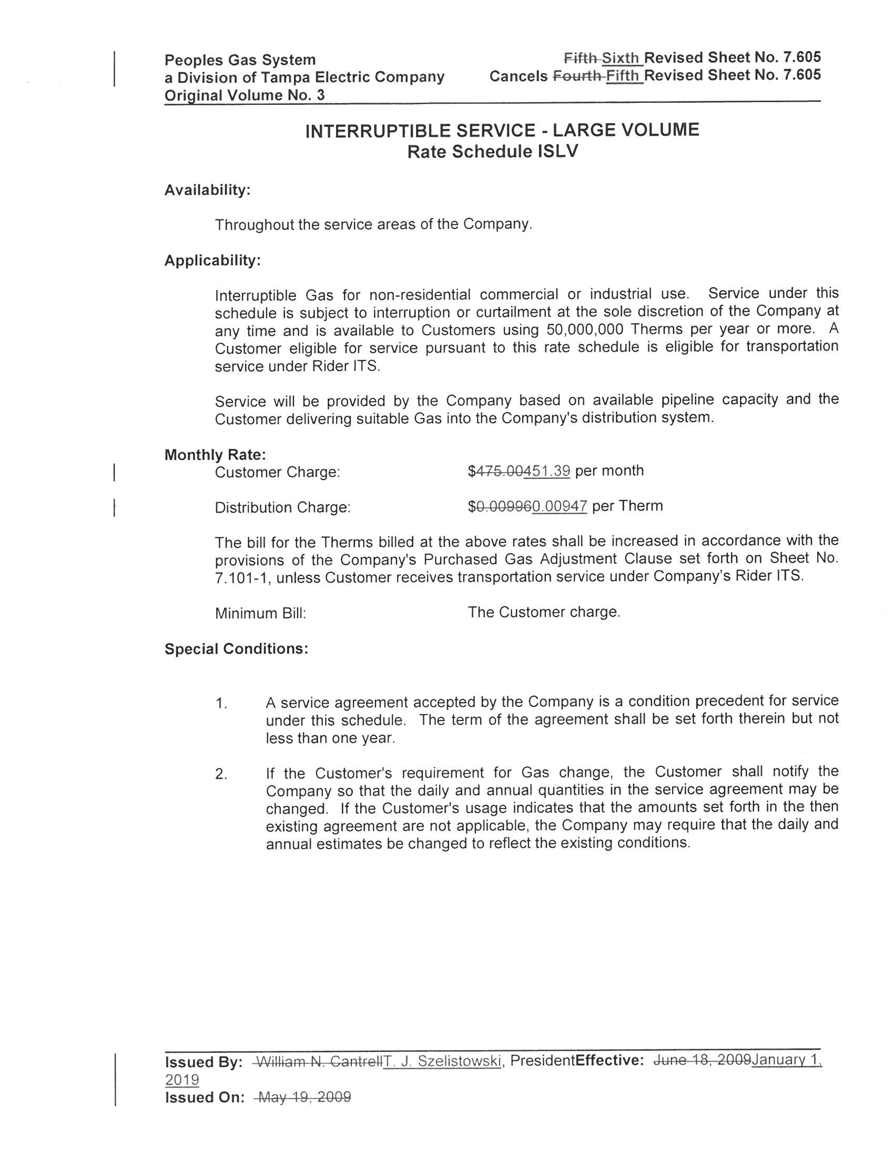

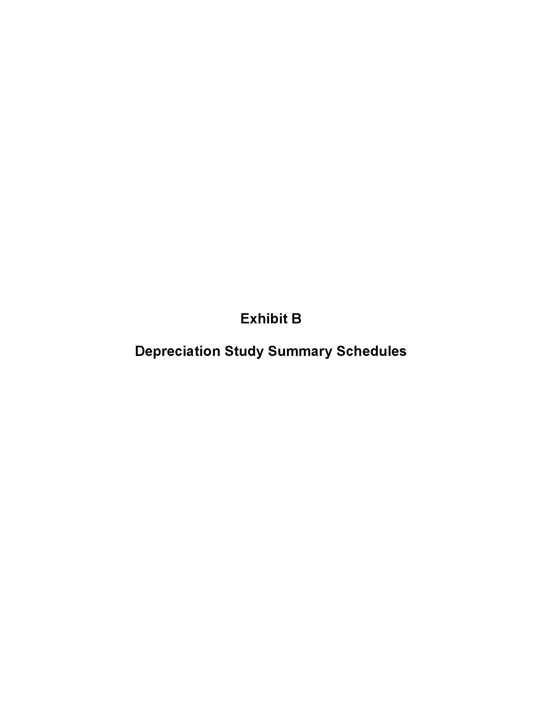

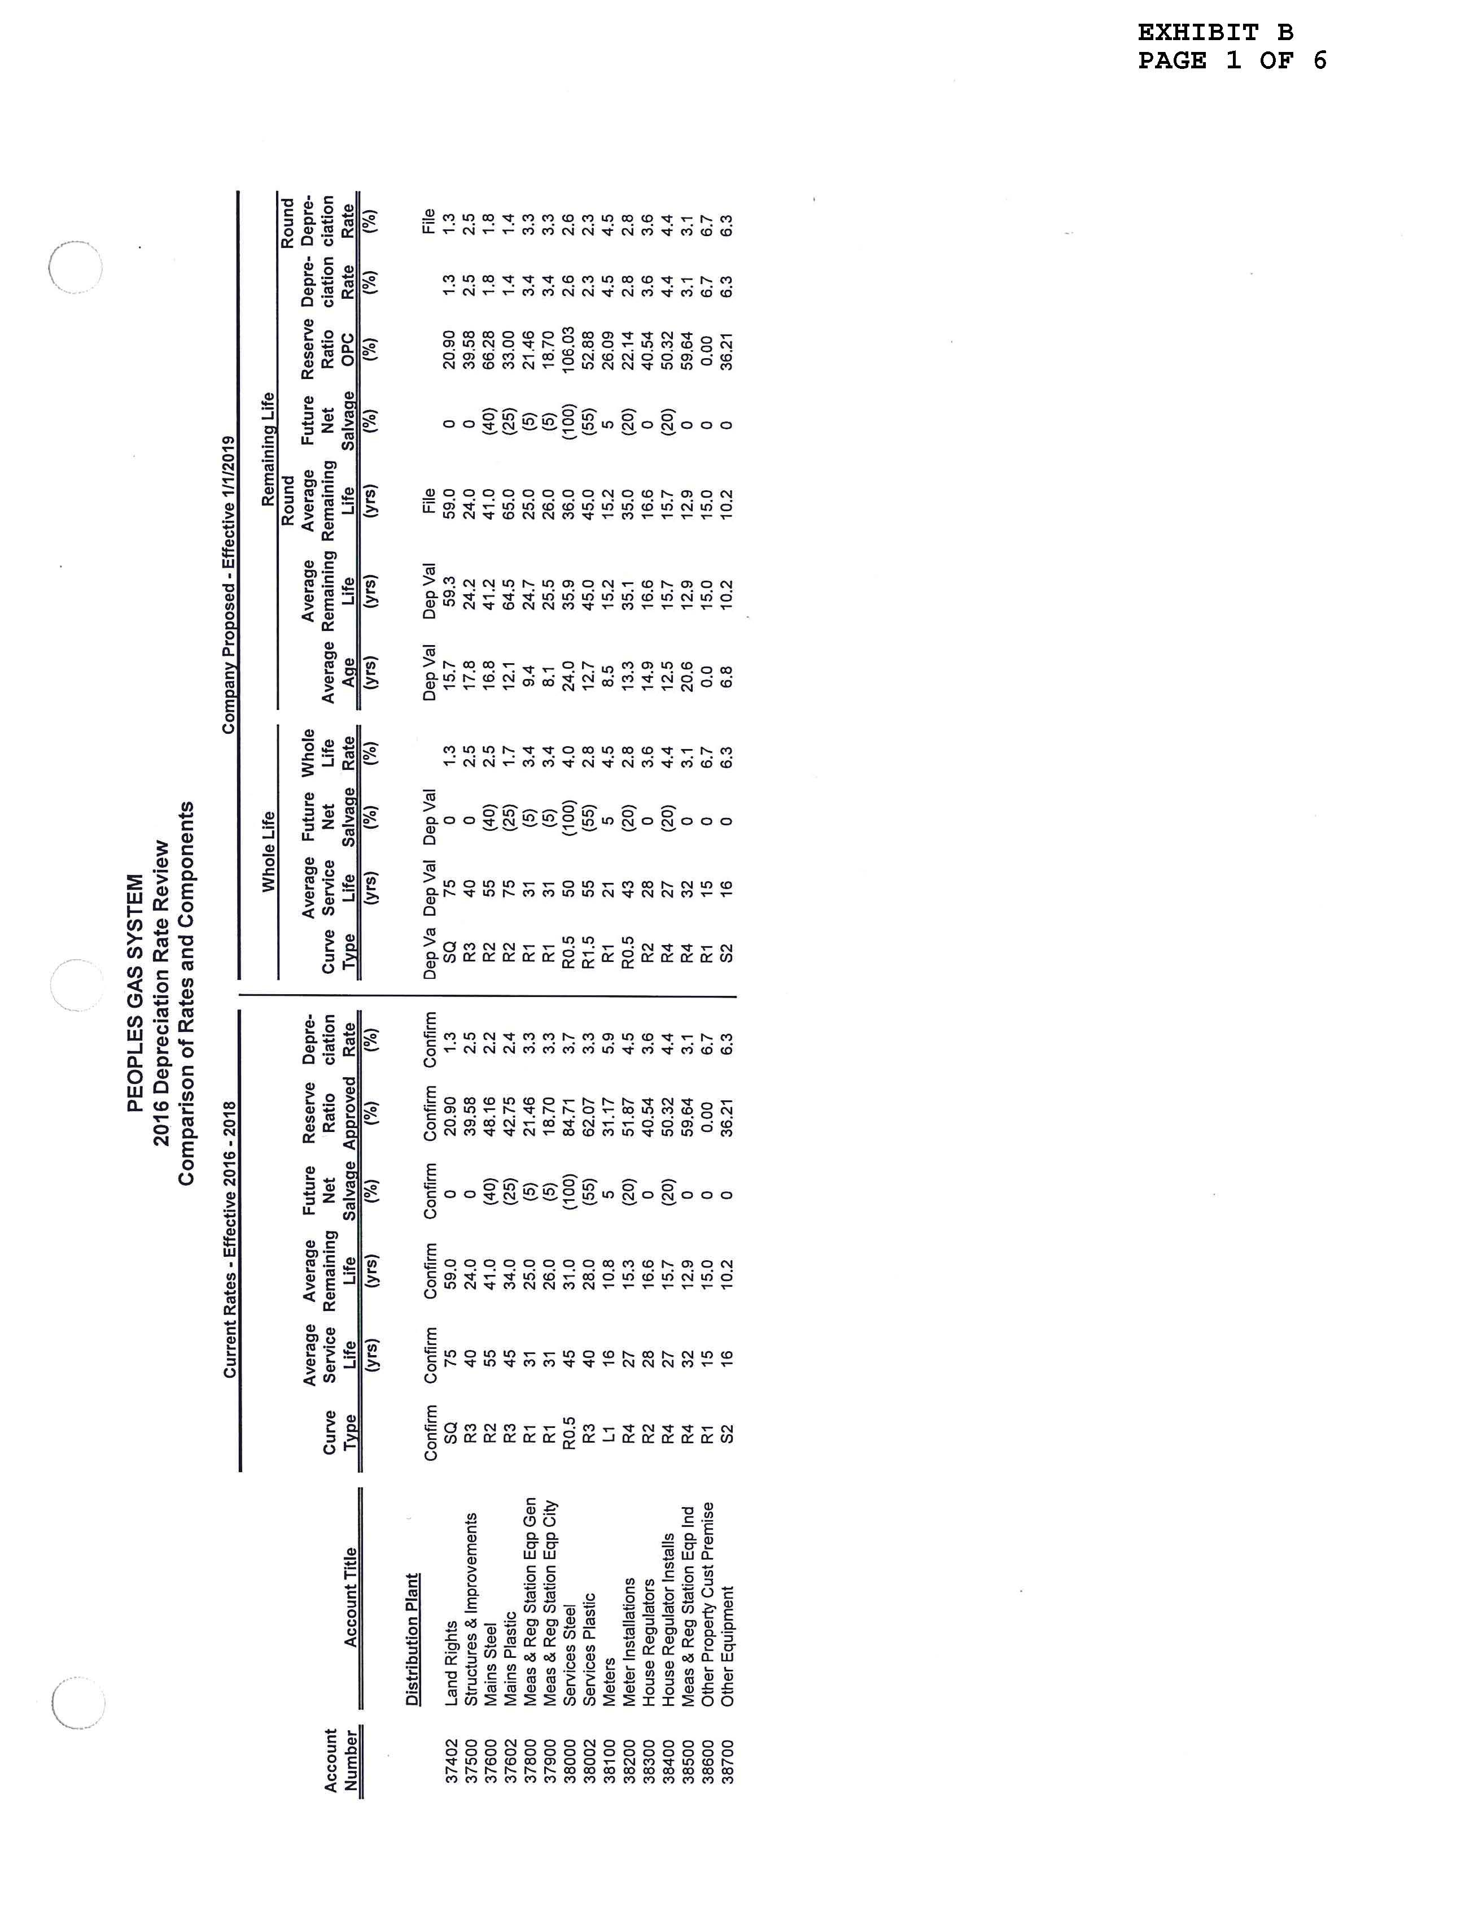

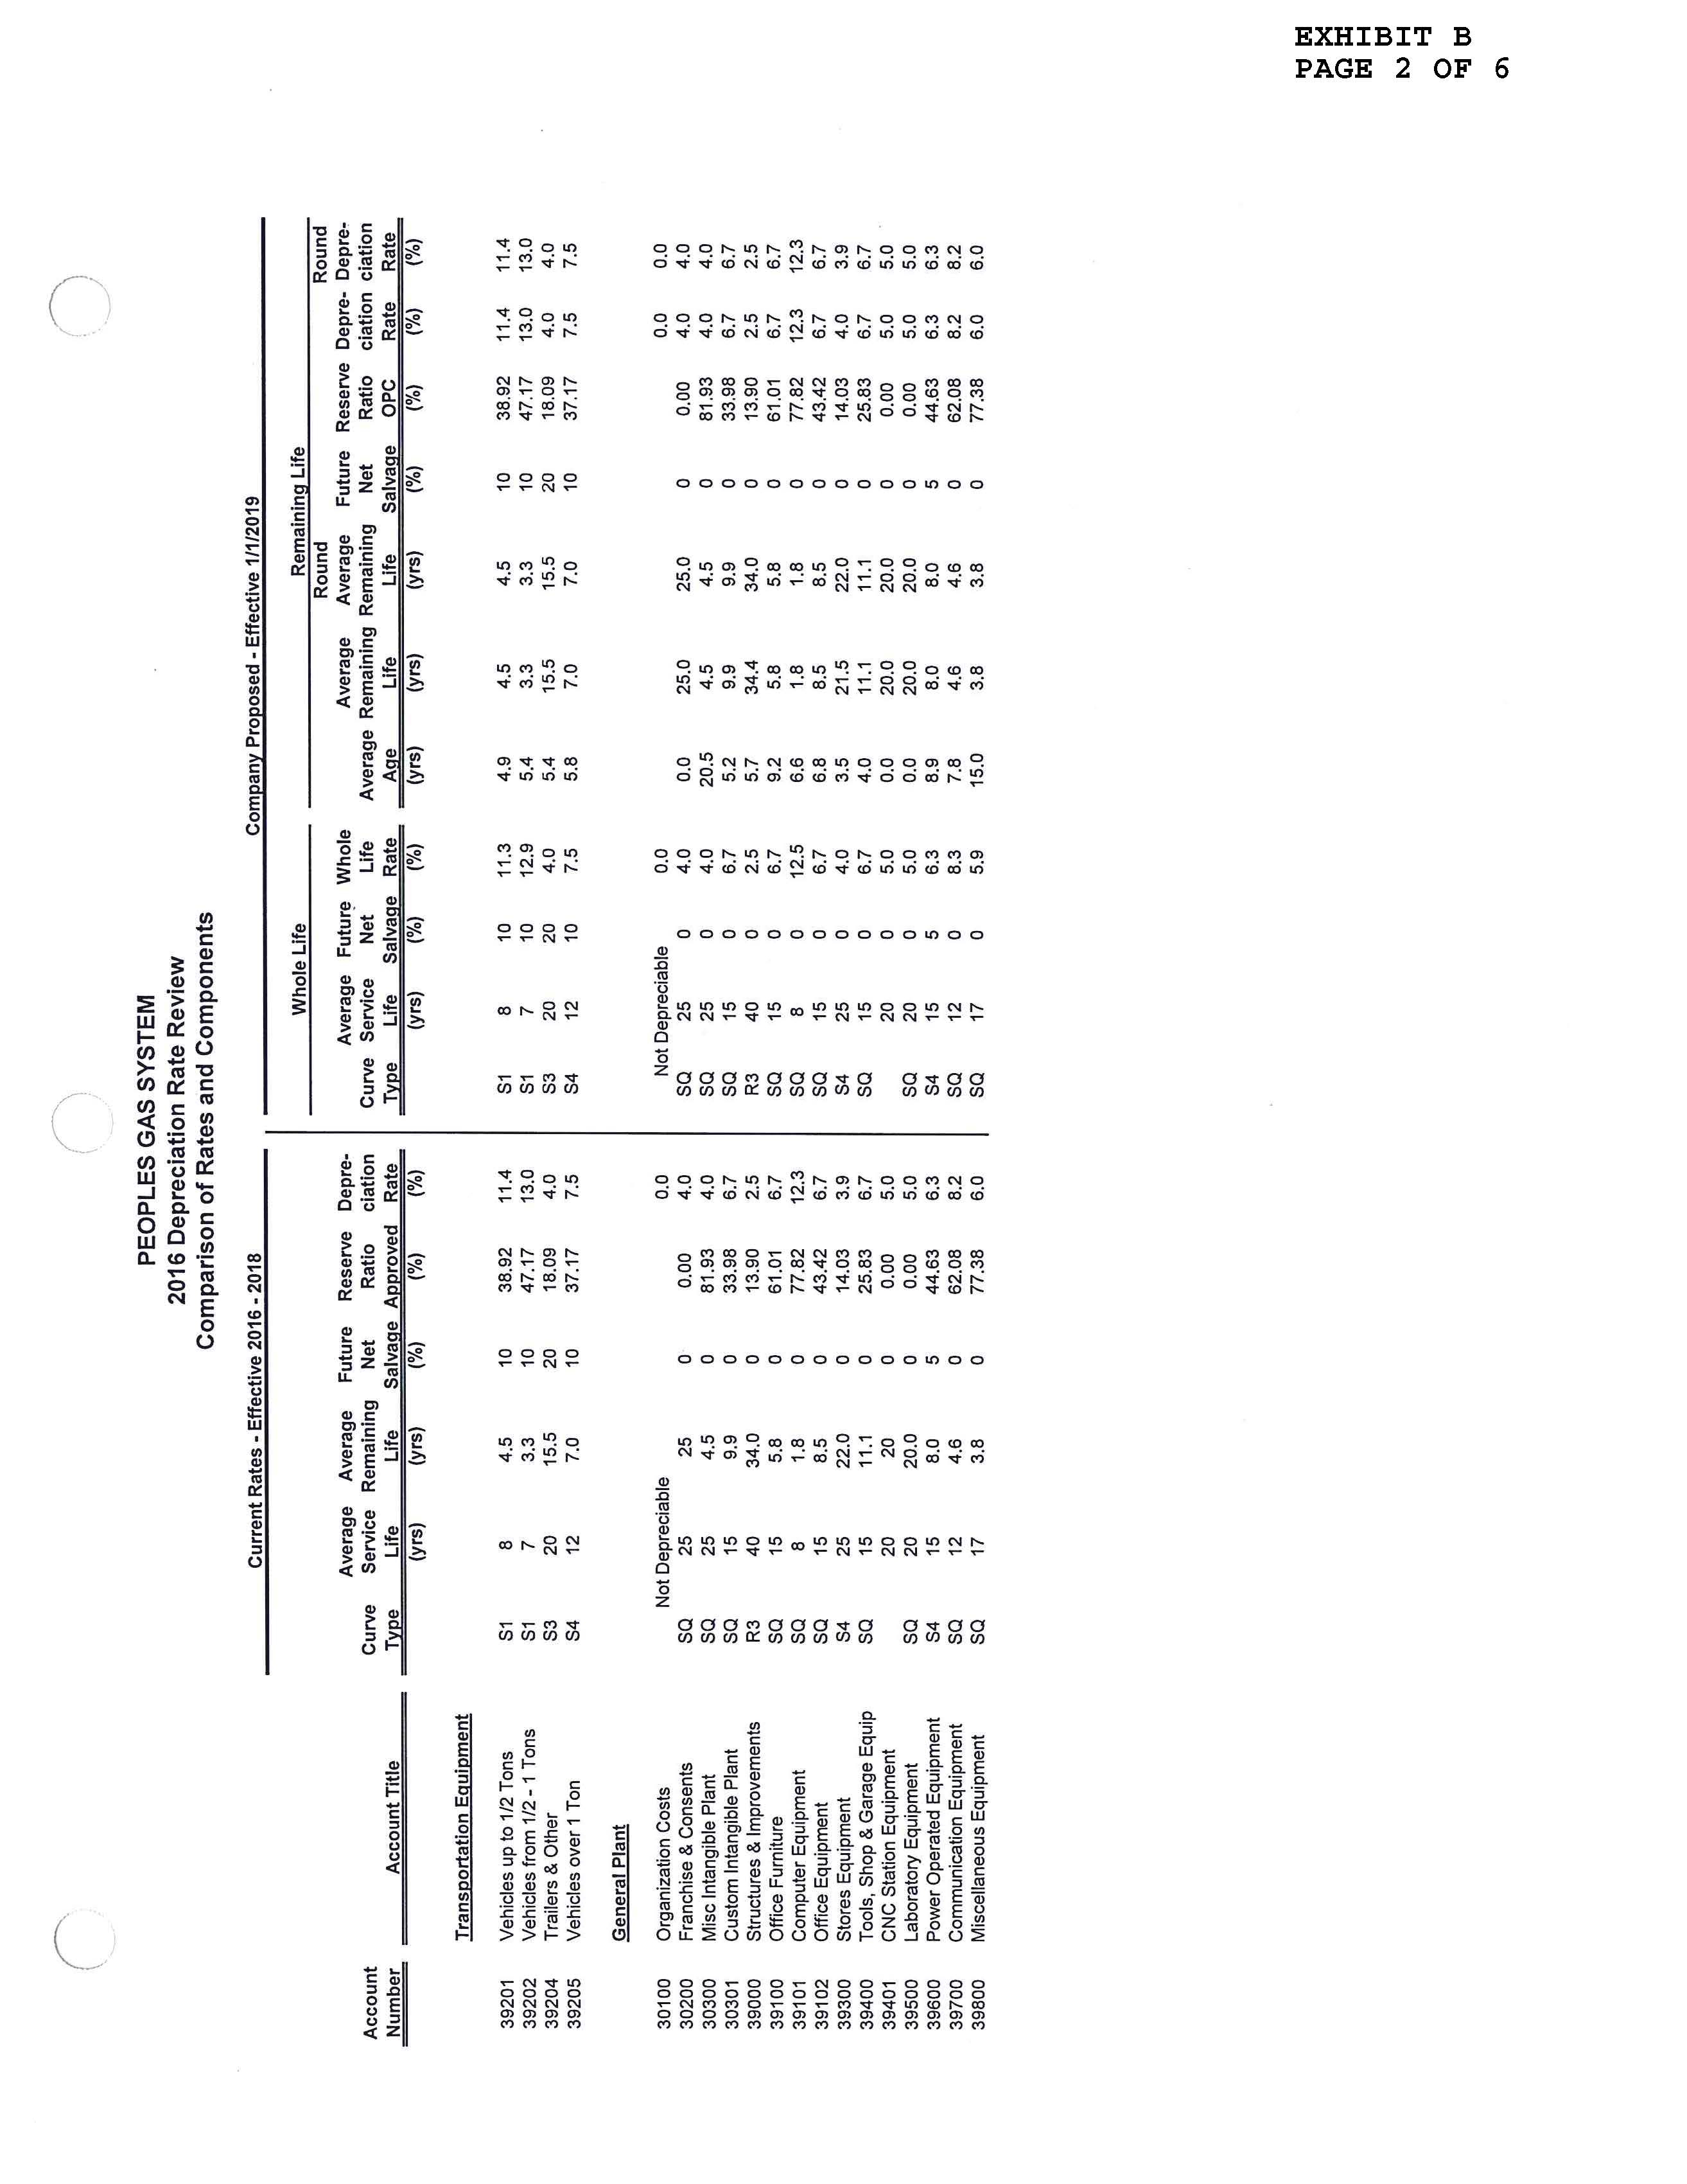

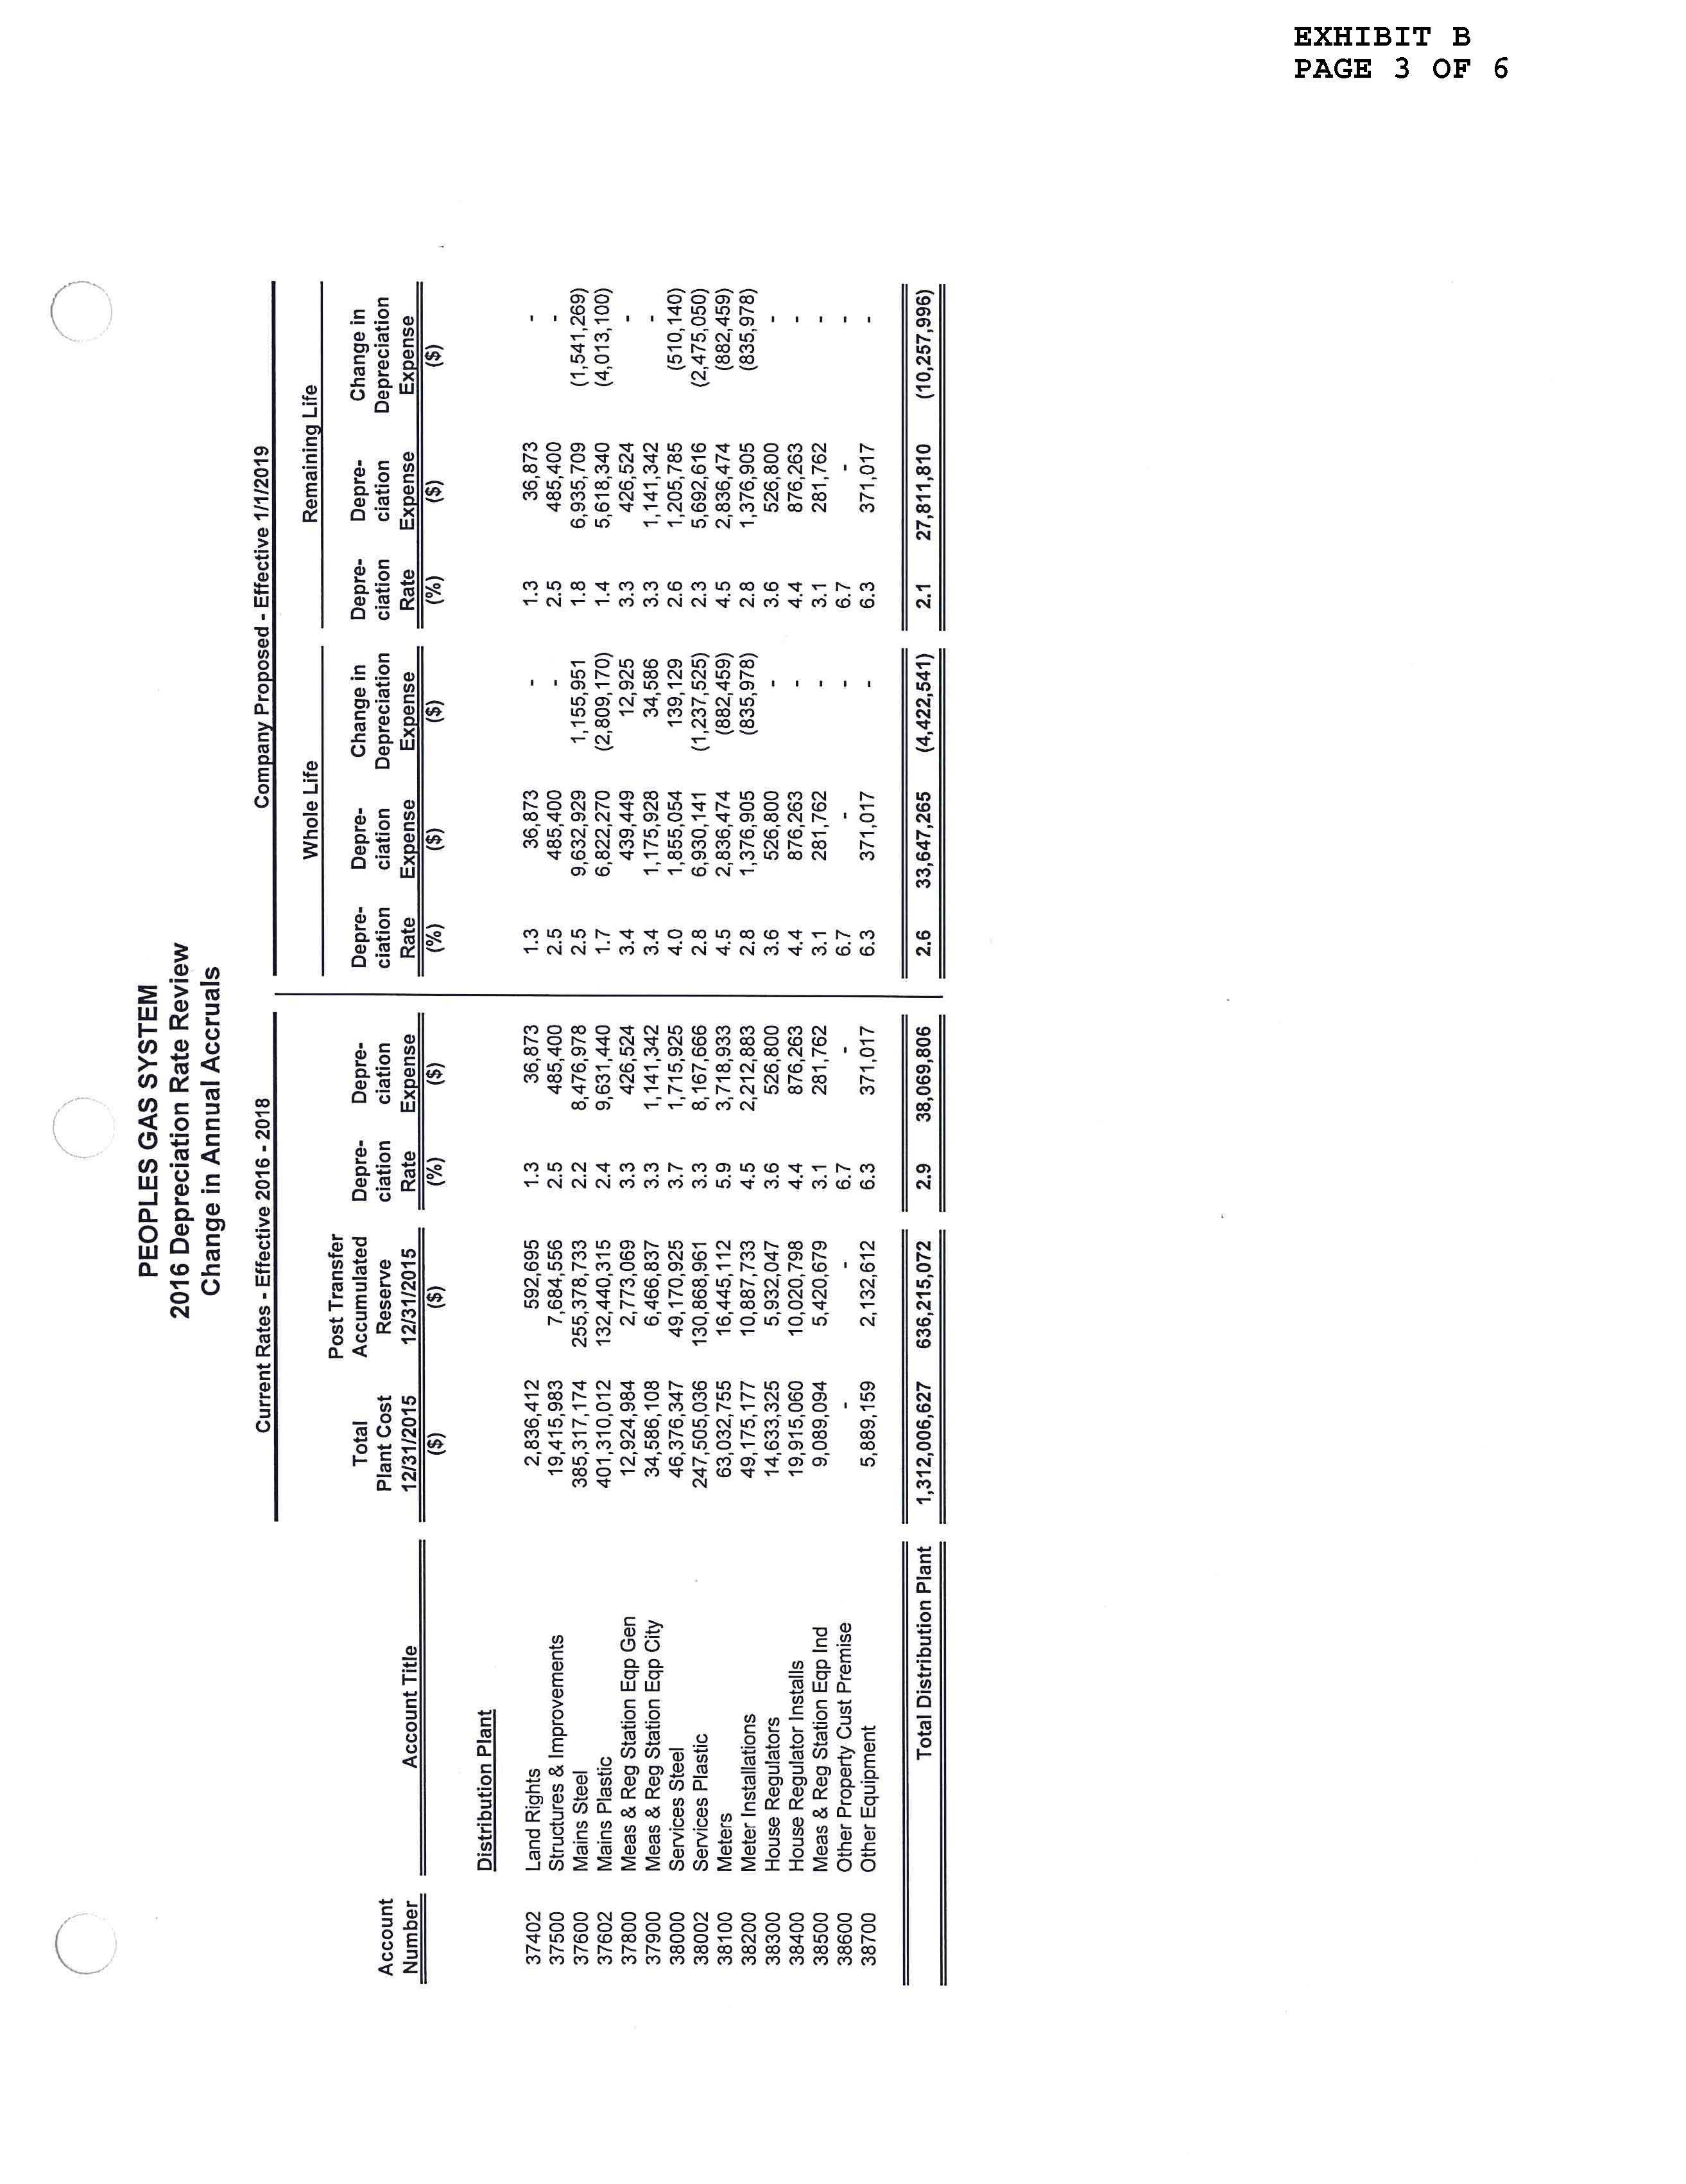

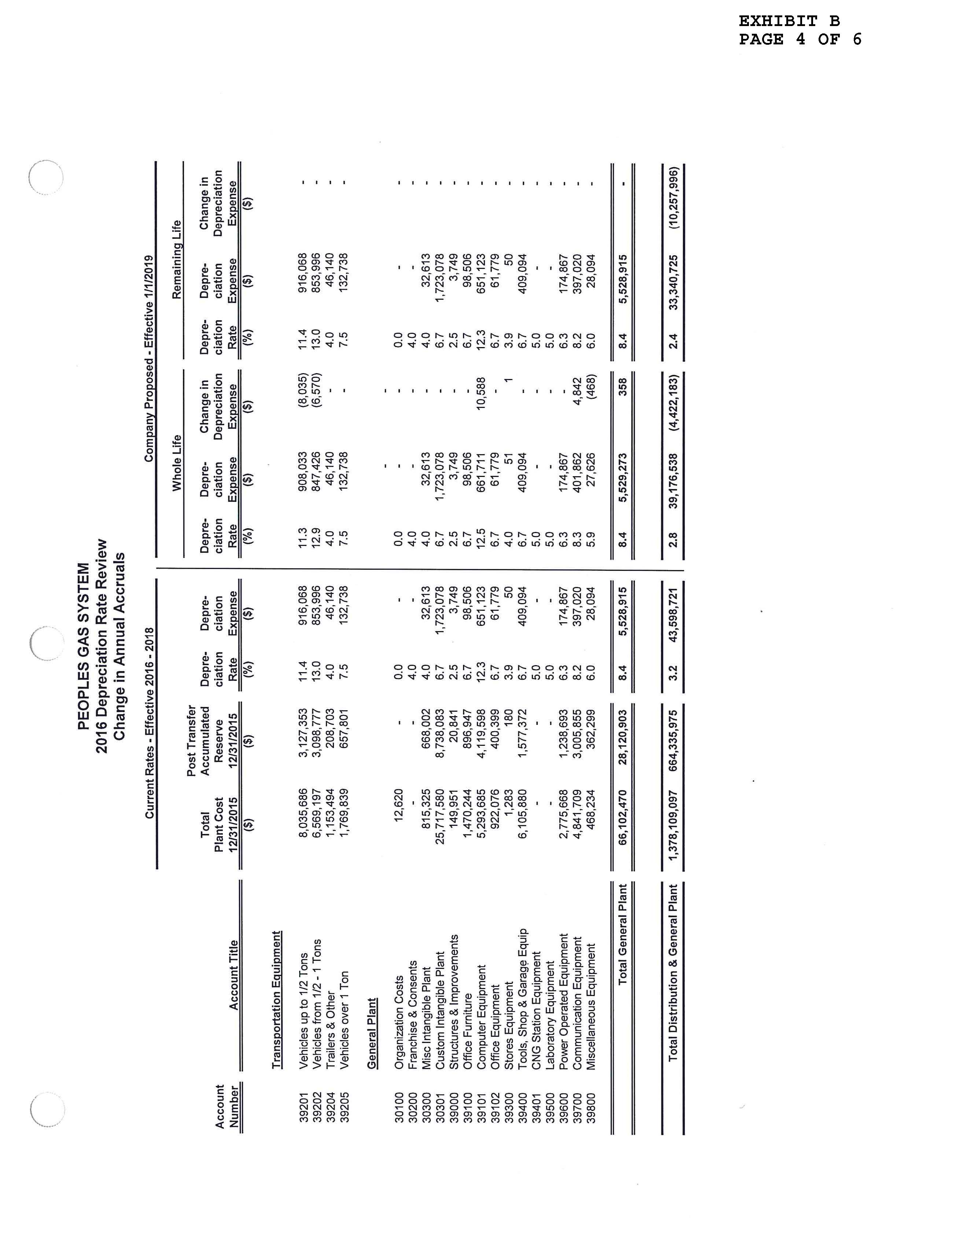

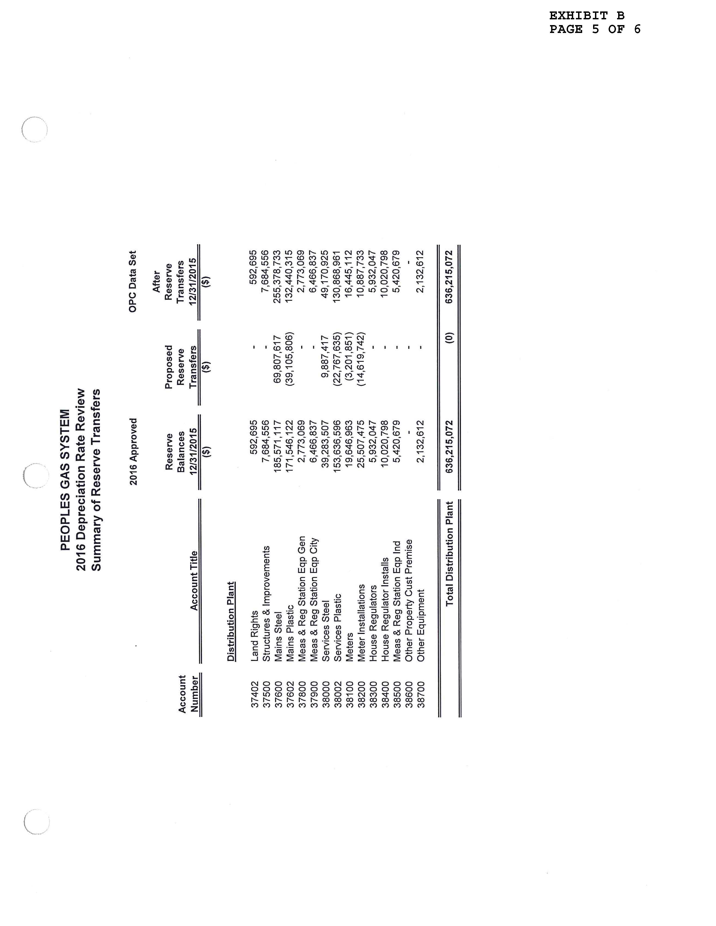

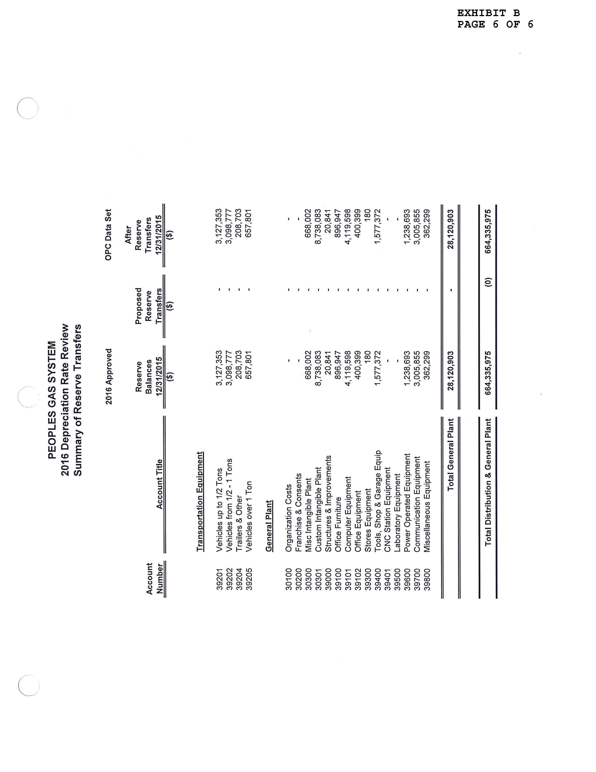

Order No. PSC-13-0023-S-EI, issued January 14, 2013, in Docket No. 120015-EI, In re: Petition for increase in rates by Florida Power & Light Company; Order No. PSC-11-0089-S-EI, issued February 1, 2011, in Docket Nos. 080677-EI and 090130, In re: Petition for increase in rates by Florida Power & Light Company and In re: 2009 depreciation and dismantlement study by Florida Power & Light Company; Order No. PSC-13-0023-S-EI, issued January 14, 2013, in Docket No. 120015-EI, In re: Petition for increase in rates by Florida Power & Light Company; PSC-10-0398-S-EI, issued June 18, 2010, in consolidated Docket Nos. 090079-EI, In re: Petition for increase in rates by Progress Energy Florida, Inc.; and 090144-EI, In re: Petition for limited proceeding to include Bartow repowering project in base rates, by Progress Energy Florida, Inc.; Docket No. 090145-EI, In re: Petition for expedited approval of the deferral of pension expenses, authorization to charge storm hardening expenses to the storm damage reserve, and variance from or waiver of Rule 25-6.0143(1)(c), (d), and (f), F.A.C., by Progress Energy Florida, Inc.; and Docket No. 100136-EI, In re: Petition for approval of an accounting order to record a depreciation expense credit, by Progress Energy Florida, Inc.; and Order No. PSC-05-0945-S-EI, issued September 28, 2005, in Docket No. 050078-EI, In re: Petition for rate increase by Progress Energy Florida, Inc..
Order No. PSC-13-0023-S-EI, at p. 7.
The terms of the prior 2107 Settlement Agreement shall continue and the Utility may seek a rate increase if earnings as reported in the future quarterly Earnings Surveillance Report fall below 9.25%.

