BEFORE THE FLORIDA PUBLIC SERVICE COMMISSION

In re: Petition for recovery of costs associated with named tropical systems during the 2015, 2016, and 2017 hurricane seasons and replenishment of storm reserve subject to final true-up, Tampa Electric Company. | DOCKET NO. 20170271-EI  ORDER NO. PSC-2019-0234-AS-EI  ISSUED: June 14, 2019

The following Commissioners participated in the disposition of this matter:

ART GRAHAM, Chairman
JULIE I. BROWN
DONALD J. POLMANN
GARY F. CLARK
ANDREW GILES FAY

ORDER APPROVING SETTLEMENT AGREEMENT

BY THE COMMISSION:

APPEARANCES

JAMES D. BEASLEY, J. JEFFRY WAHLEN JR., and MALCOLM MEANS ESQUIRES, Ausley Law Firm, Post Office Box 391, Tallahassee, Florida 32302
On behalf of Tampa Electric Company (TECO).

J.R. KELLY, CHARLES REHWINKEL, PATRICIA A. CHRISTENSEN and THOMAS A. DAVID ESQUIRES, Office of Public Counsel, c/o The Florida Legislature, 111 West Madison Street, Room 812, Tallahassee, Florida 32399-1400
On behalf of the Citizens of the State of Florida (OPC).

JON C. MOYLE, JR., KAREN PUTNAL, and IAN WALDICK, ESQUIRES, Moyle Law Firm, P.A., 118 North Gadsden Street, Tallahassee, Florida 32301
On behalf of Florida Industrial Power Users Group (FIPUG).

ROBERT SCHEFFEL WRIGHT and JOHN T. LAVIA, III, ESQUIRES, Gardner, Bist, Wiener, Wadsworth, Bowden, Bush, Dee, LaVia & Wright, P.A. 1300 Thomaswood Drive, Tallahassee, FL 32308
On behalf of the Florida Retail Federation (FRF).

KURT SCHRADER, ESQUIRE, Florida Public Service Commission, 2540 Shumard Oak Boulevard, Tallahassee, Florida 32399-0850
On behalf of the Florida Public Service Commission (Staff).

MARY ANNE HELTON, ESQUIRE, Deputy General Counsel, Florida Public Service Commission, 2540 Shumard Oak Boulevard, Tallahassee, Florida 32399-0850
Advisor to the Florida Public Service Commission.

KEITH C. HETRICK, ESQUIRE, General Counsel, Florida Public Service Commission, 2540 Shumard Oak Boulevard, Tallahassee, Florida 32399-0850
Florida Public Service Commission General Counsel.

BY THE COMMISSION:

Background

On December 28, 2017, pursuant to Rules 28-106.201 and 25-6.0143, Florida Administrative Code (F.A.C.), and Order No. PSC-2017-0456-S-EI, Tampa Electric Company (TECO) filed its Petition for Recovery of Costs Associated with Named Tropical Systems and Replenishment of Storm Reserve. TECO’s petition seeks recovery of incremental storm restoration costs associated with tropical systems named by the National Hurricane Center during the 2015, 2016 and 2017 hurricane seasons and the replenishment of its Storm Reserve in the amount of $87,377,388. On January 30, 2018, TECO filed an Amended Petition to increase its request for recovery to $102,476,127.

Also, on January 30, 2018, TECO filed a Motion to Approve Implementation Stipulation, which it amended on February 13, 2018. The Implementation Stipulation, as amended, sought to avoid volatility in customer rates by recognizing and then utilizing annual tax reform benefits resulting from the passage of the Tax Cut and Jobs Act of 2017 as a direct offset to avoid implementing separate cost recovery of storm damage costs that customers would otherwise have been obligated to pay. The Amended Implementation Stipulation provided that TECO would be entitled to make the appropriate adjustments to its regulated books and records to recover the entire estimated amount of storm costs that would have otherwise been recovered from customers over a nine month period in 2018, to instead recover such costs from the Company’s estimated annual tax savings over the same nine month period. By Order No. PSC-2018-0125-PCO-EI, issued on March 7, 2018, we approved the Amended Implementation Stipulation.

On February 16, 2018, we issued an Order Establishing Procedure, Order No. PSC-2018-0081-PCO-EI (Procedural Order), which established hearing procedures to govern this docket, including controlling dates and discovery response times. On March 7, 2018, Order No. PSC-2018-0126-PCO-EI was issued to modify the controlling dates in Section VIII of the Procedural Order. Order No. PSC-2018-0486-PCO-EI was issued on September 27, 2018, which further modified these dates along with revising the discovery response times. On January 16, 2019, Order No. PSC-2019-0042-PCO-EI was issued to further revise the controlling dates. The Office of Public Counsel (OPC), Florida Retail Federation (FRF), and the Florida Industrial Power Users Group (FIPUG) intervened.

On February 8, 2019, TECO filed revised testimony and reduced its request from $102,476,127 (as referred to in its January 30, 2018, Amended Petition) to $98,982,984 (Second Amended Petition). This reduction was based on TECO’s analysis of all of the invoices and other documentation associated with the work performed by other utilities and contractors who assisted in restoration efforts. On March 29, 2019, TECO filed an Unopposed Motion to Suspend Testimony Filing Schedule seeking to suspend the filing of further testimony, and other procedural deadlines as appropriate. In its Motion, TECO asserted that OPC, FRF, and FIPUG had reached an agreement in principle to resolve all issues in this docket. However, the parties needed additional time to memorialize their settlement to present to the Commission for approval. On April 3, 2019, Order No. PSC-2019-0120-PCO-EI was issued granting the motion and abating the remaining controlling dates except the dates for the prehearing conference, hearing, and filing briefs.

On April 9, 2019, TECO filed its Motion to Approve Storm Cost Settlement Agreement (Motion). In its Motion, TECO contends that it is in the public interest and in the best interests of TECO’s customers. On May 14, 2019, TECO filed an unopposed Motion to Approve Amended Storm Cost Settlement Agreement. The amendment revised the first unnumbered paragraph in the "Capitalized Costs" bullet on page 16 of the parties’ initial settlement agreement. The Storm Cost Settlement Agreement and the Amended Storm Cost Settlement Agreement (collectively referred to as the Settlement Agreement hereafter) are appended to this Order as Attachment A. OPC, FRF, and FIPUG support the Settlement Agreement.

An administrative hearing was held on May 21, 2019. During the hearing, TECO provided clarifications agreed to by the parties regarding two points from the Settlement Agreement. These clarifications are detailed below. Also, at the conclusion of the evidentiary portion of the hearing, the parties indicated that they were willing to waive the filing of post-hearing briefs, and we approved the Settlement Agreement, as set forth herein, by bench vote.

The Settlement Agreement

The Settlement Agreement provides a compromise between the parties regarding the amount of recoverable storm costs, and it sets forth an extensive set of storm restoration policies and procedures to follow during future storms (Process Improvements). The major elements of the Settlement Agreement are as follows:

- This Settlement Agreement reduces the Second Amended Petition by an additional $7,725,098. This would bring the total amount of recoverable storm costs to $91,257,886.
- A portion of the $7,725,098 reduction, $6.0 million, would be reclassified as capital and added to TECO’s electric plant in service balance in Account 364—Poles, Towers and Fixtures (vintage year 2017), for all surveillance and future rate setting purposes.
- The remaining $1,725,098 of the additional reduction would be reclassified as a regulatory deferred debit. TECO would eliminate the deferred debit and charge base rate Operations and Maintenance expense for $1,725,098 prior to the filing of its next general base rate case proceeding. Of this amount, $650,000 represents non-specific reductions related to incremental internal labor and $1,075,098 represents foreign contractor costs.
- TECO would be entitled to recover the entire estimated amount of storm costs from the Company’s estimated annual tax savings over a nine month period in 2018 instead of surcharging its customers over the same period.
- Based on the annual tax savings amount established in Docket No. 20180045-EI, In re: Consideration of the tax impacts associated with Tax Cuts and Jobs Act of 2017 for Tampa Electric Company, and the reduced recoverable amount, TECO would refund to customers $11,500,000 as a one-time bill credit. This one-time bill credit would be reflected as a separate line item on customer’s bills concurrently with meter readings for the first billing cycle of January 2020.
- The parties agreed to Process Improvements to allow cost effective and timely storm damage recovery and service restoration. The Process Improvements cover a broad range of storm cost recovery issues, including: contracting and vendor engagement, travel and work policies, cost documentation, auditing and regulatory recovery processes, and a methodology for determining incremental costs.
- The parties agreed to meet to evaluate the Process Improvements and consider any need to amend such improvements during the first quarter of 2021, and every two years thereafter.
At the administrative hearing, TECO provided two points of clarification regarding the Settlement Agreement. First, TECO stated that in regards to the Process Improvements, the parties agreed that TECO’s “primary objective will be power restoration for its customers.” Second, TECO also stated that the parties are in agreement as to a clarification of the phrase “superseded by action of the PSC,” located in paragraph eight of the Settlement Agreement. The parties agreed that the phrase means “actions taken by the Commission in any rule-making proceeding or in any evidentiary proceeding to which [TECO] is subject as initiated by [TECO], third parties or the Commission on its own motion, which addresses storm cost recovery and which has the effect of overriding or supplanting any provision of the settlement.”
Decision

The standard for approval of a settlement agreement is whether it is in the public interest. A determination of public interest requires a case-specific analysis based on consideration of the proposed settlement taken as a whole. By implementing the reductions and reclassifications above, the Settlement Agreement provides a fair and balanced resolution of the storm costs incurred by TECO. Also, as noted above, the Settlement Agreement and Amended Implementation Stipulation authorizes TECO to recover the entire estimated amount of storm costs that would have otherwise been recovered from customers over a nine month period in 2018 and instead collect the storm costs from the Company’s estimated annual tax savings over the same nine month period. Further, based on the annual tax savings amount established in Docket No. 20180045-EI and the storm cost reductions agreed to by the parties, TECO will issue an $11,500,000 refund to its customers as a one-time bill credit.

In addition, the Process Improvements represent a good-faith effort by the parties to recognize and mitigate the kinds of issues that present themselves in the storm restoration process. These Process Improvements are designed to reasonably balance the interests of customers to have service promptly restored with the customers’ interest to not pay excessive or improper costs to achieve such prompt storm restoration. The parties articulated that their goal was to implement the best practices for how to safely and timely restore power, and that the Process Improvements will not impede future storm recovery efforts. Instead, the Process Improvements are designed to reduce the number of disputes regarding storm restoration costs in the future. TECO also clarified that it would not permit the Process Improvements to impede speedy power restoration.

Based upon the TECO’s application, its subsequent filings, our review of the Settlement Agreement, evidence and testimony on the record, and the clarification provided by TECO at the hearing, we find that the Settlement Agreement is in the public interest and is approved. The Settlement Agreement resolves all of the issues in this docket.

Based on the foregoing, it is

ORDERED by the Florida Public Service Commission that the attached Settlement Agreement is approved as Amended. It is further

ORDERED that this docket shall be closed.

By ORDER of the Florida Public Service Commission this 14th day of June, 2019.

/s/ Adam J. Teitzman
ADAM J. TEITZMAN
Commission Clerk
Florida Public Service Commission
2540 Shumard Oak Boulevard
Tallahassee, Florida 32399
(850) 413-6770
www.floridapsc.com

Copies furnished: A copy of this document is provided to the parties of record at the time of issuance and, if applicable, interested persons.

KMS

NOTICE OF FURTHER PROCEEDINGS OR JUDICIAL REVIEW

The Florida Public Service Commission is required by Section 120.569(1), Florida Statutes, to notify parties of any administrative hearing or judicial review of Commission orders that is available under Sections 120.57 or 120.68, Florida Statutes, as well as the procedures and time limits that apply. This notice should not be construed to mean all requests for an administrative hearing or judicial review will be granted or result in the relief sought.

Any party adversely affected by the Commission's final action in this matter may request: 1) reconsideration of the decision by filing a motion for reconsideration with the Office of Commission Clerk, 2540 Shumard Oak Boulevard, Tallahassee, Florida 32399-0850, within fifteen (15) days of the issuance of this order in the form prescribed by Rule 25-22.060, Florida Administrative Code; or 2) judicial review by the Florida Supreme Court in the case of an electric, gas or telephone utility or the First District Court of Appeal in the case of a water and/or wastewater utility by filing a notice of appeal with the Office of Commission Clerk, and filing a copy of the notice of appeal and the filing fee with the appropriate court. This filing must be completed within thirty (30) days after the issuance of this order, pursuant to Rule 9.110, Florida Rules of Appellate Procedure. The notice of appeal must be in the form specified in Rule 9.900(a), Florida Rules of Appellate Procedure.

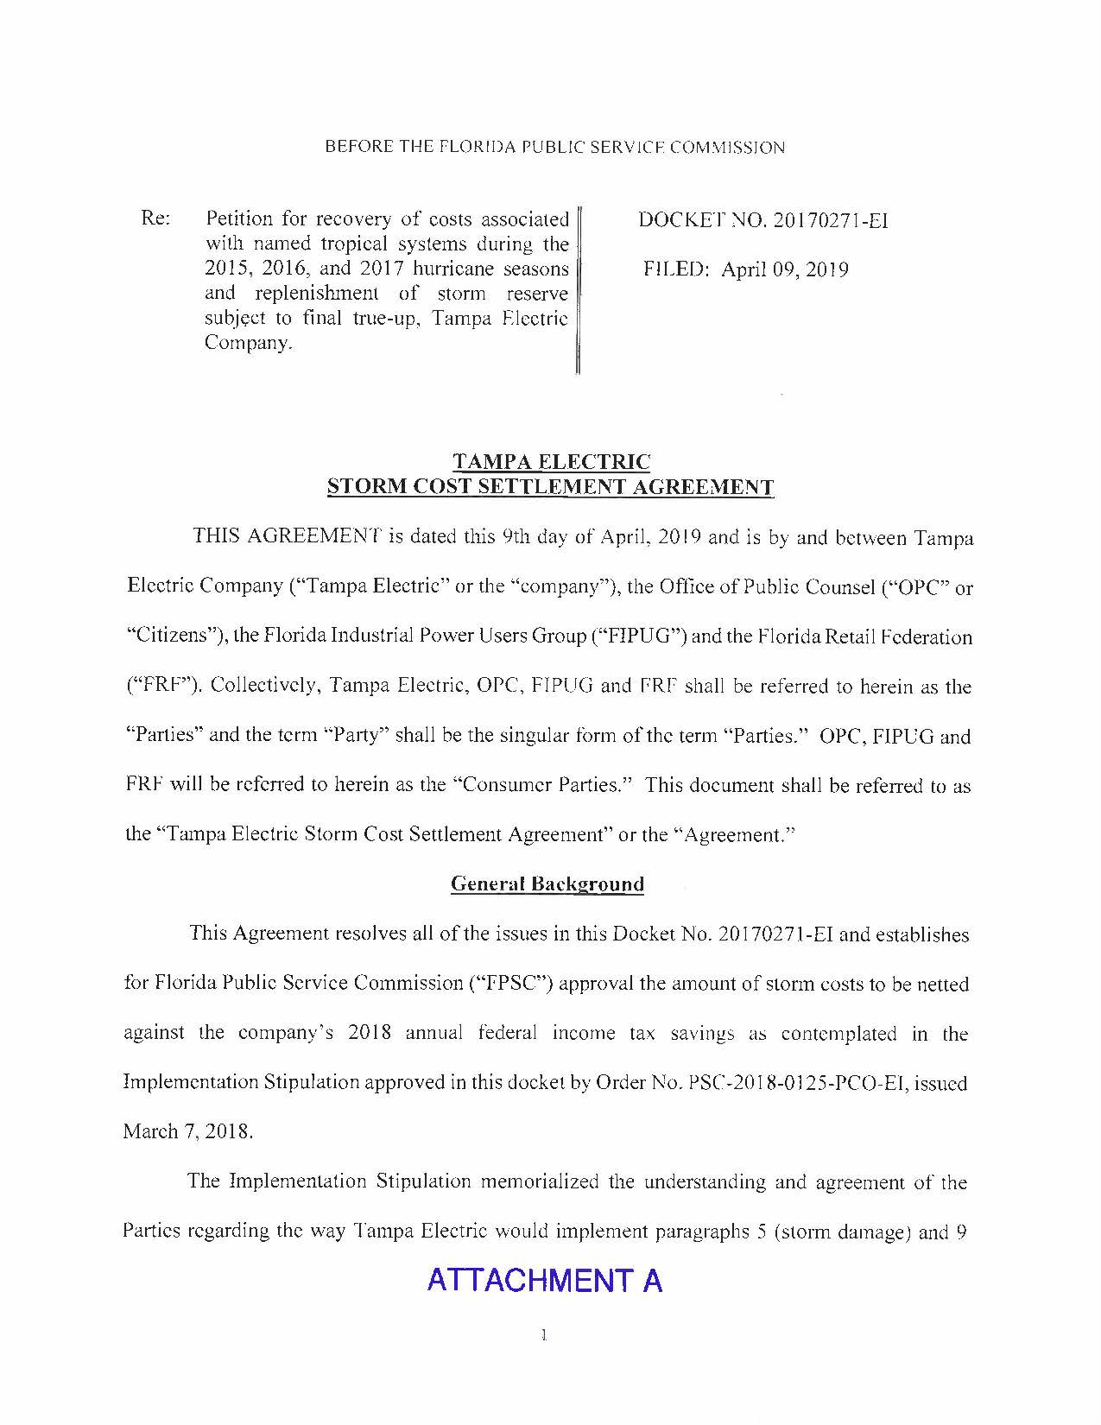

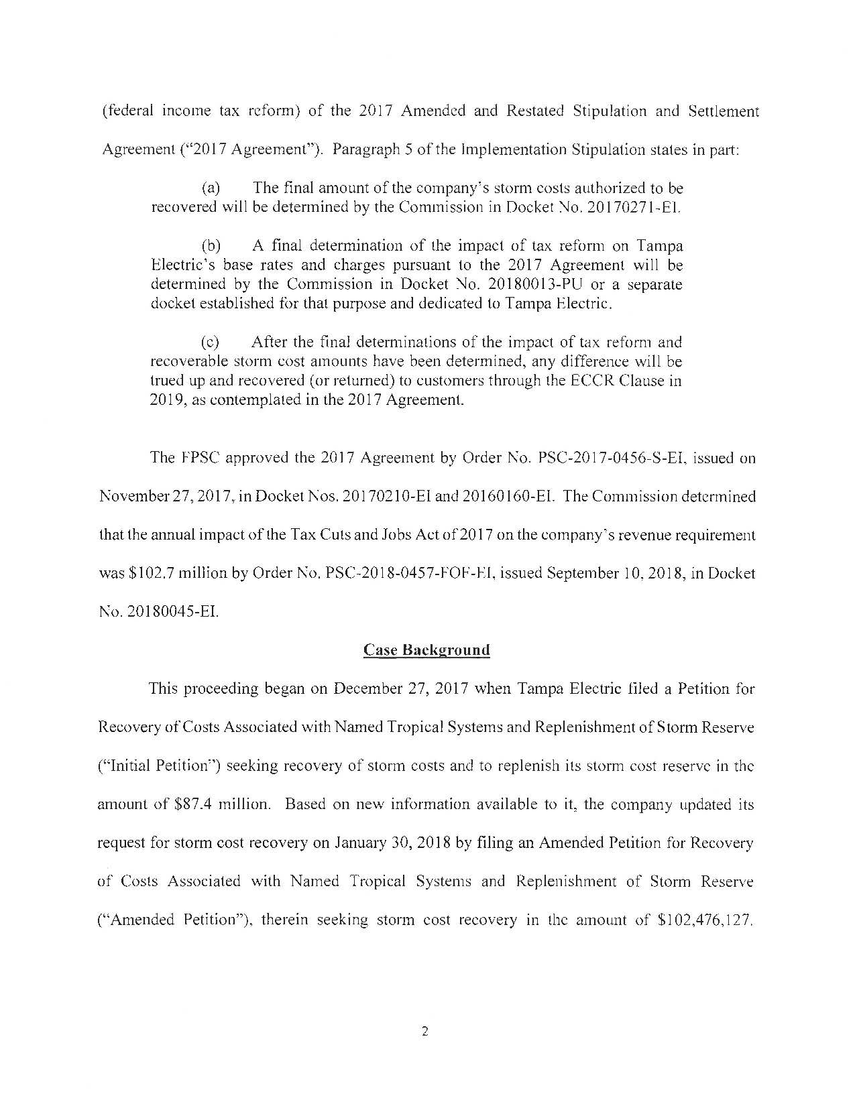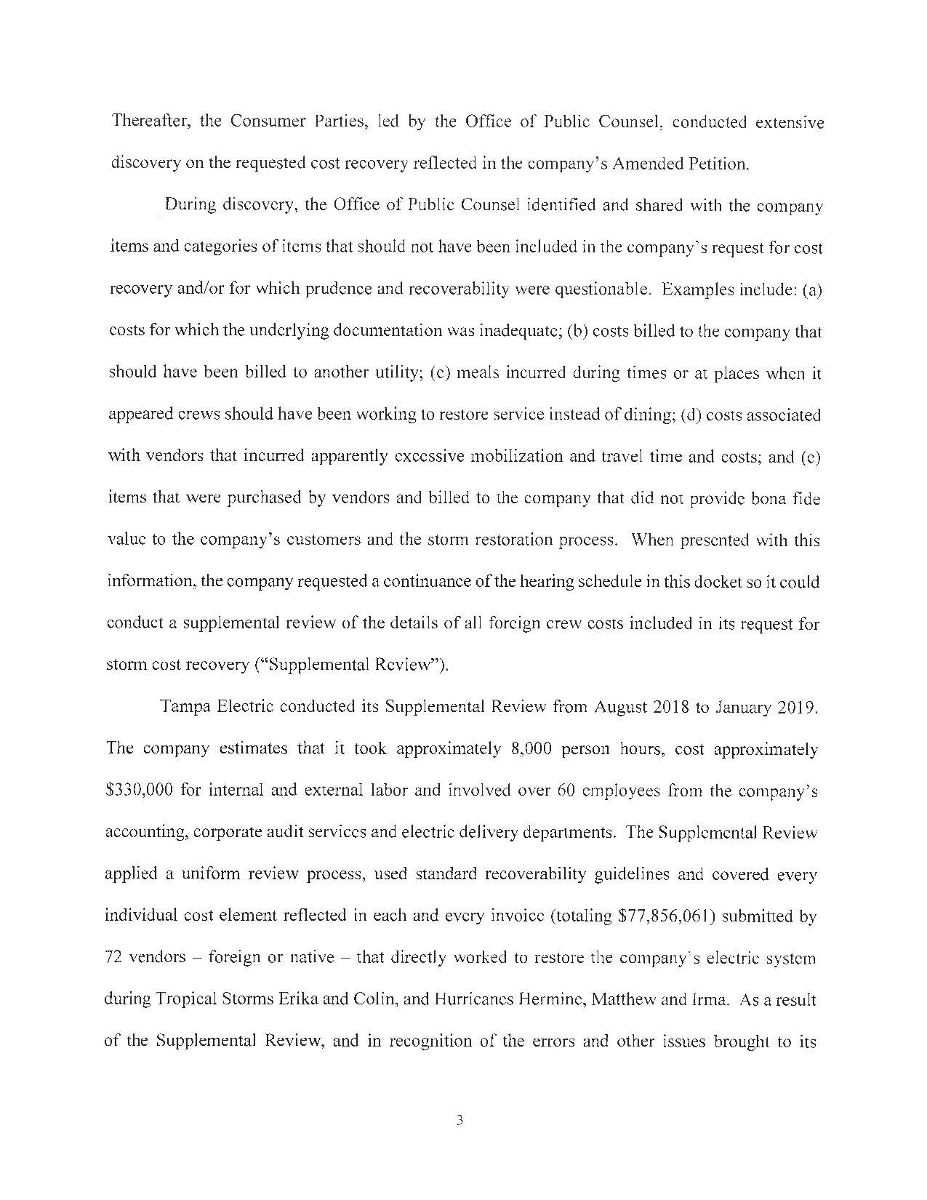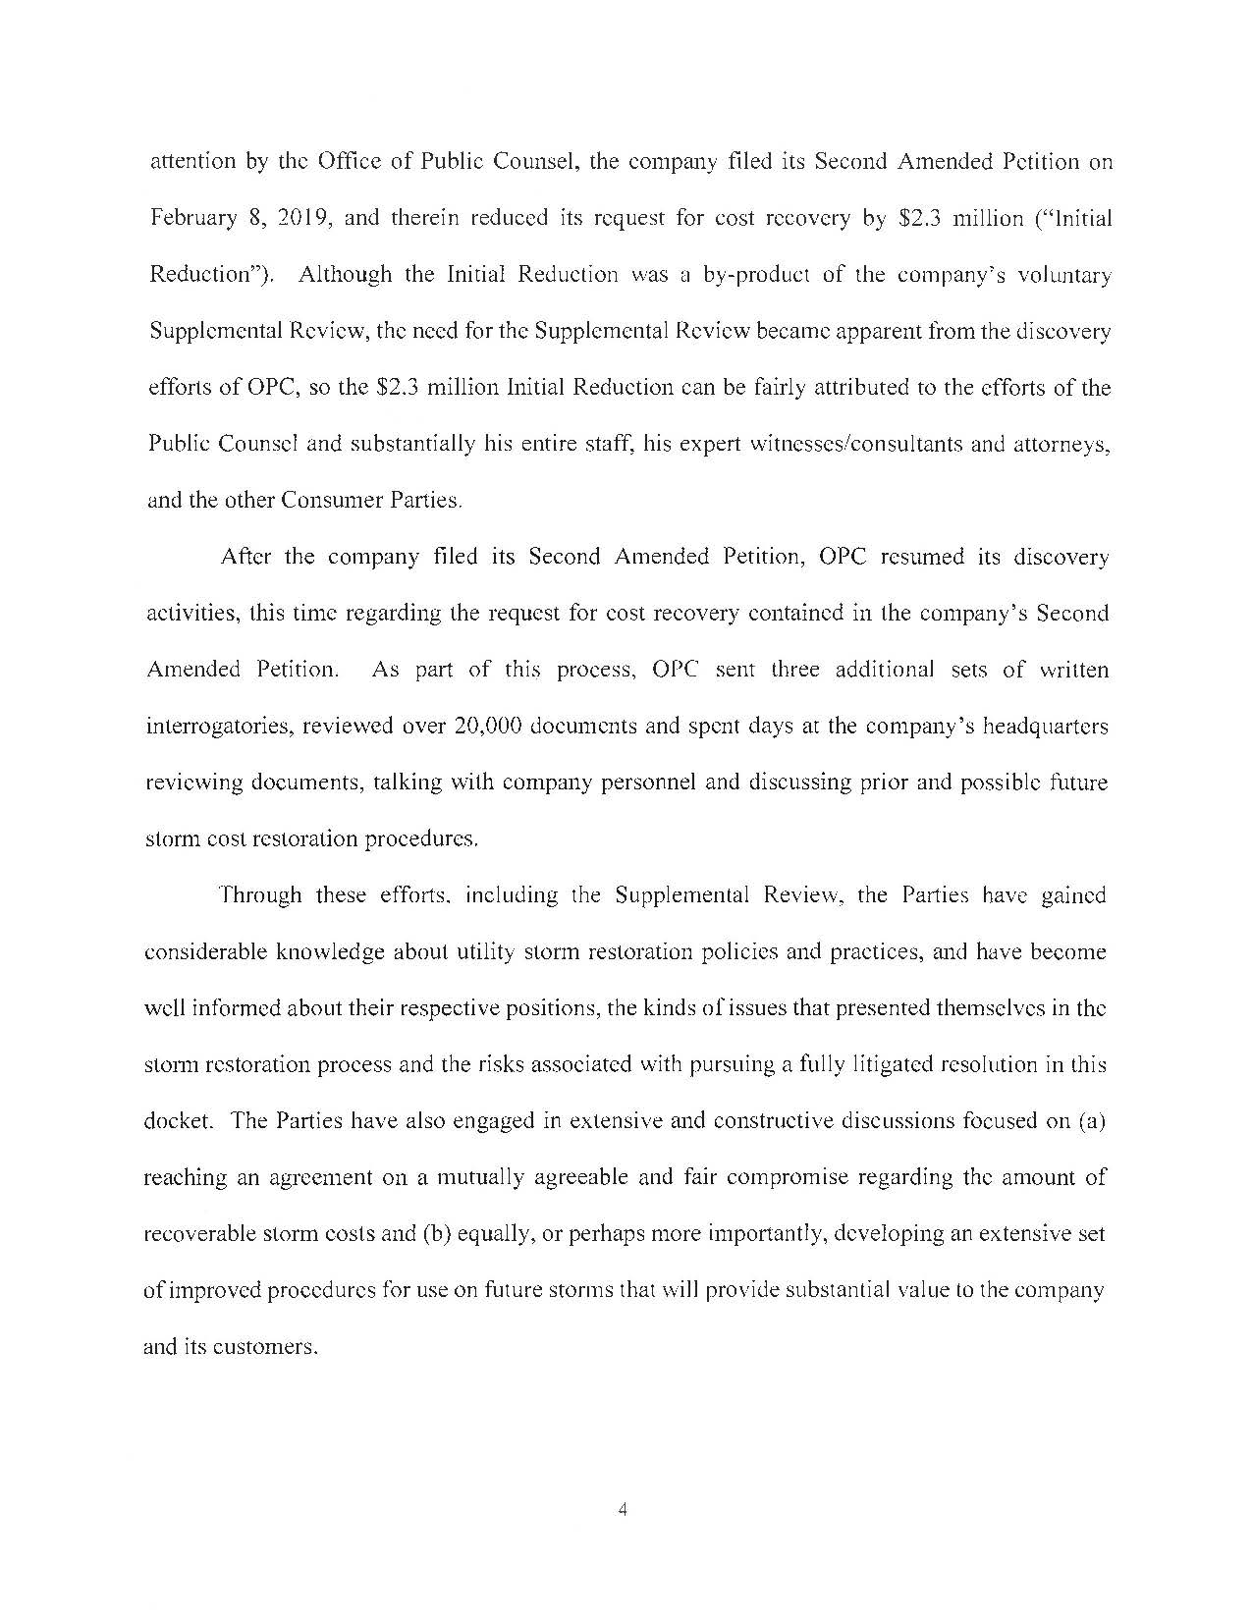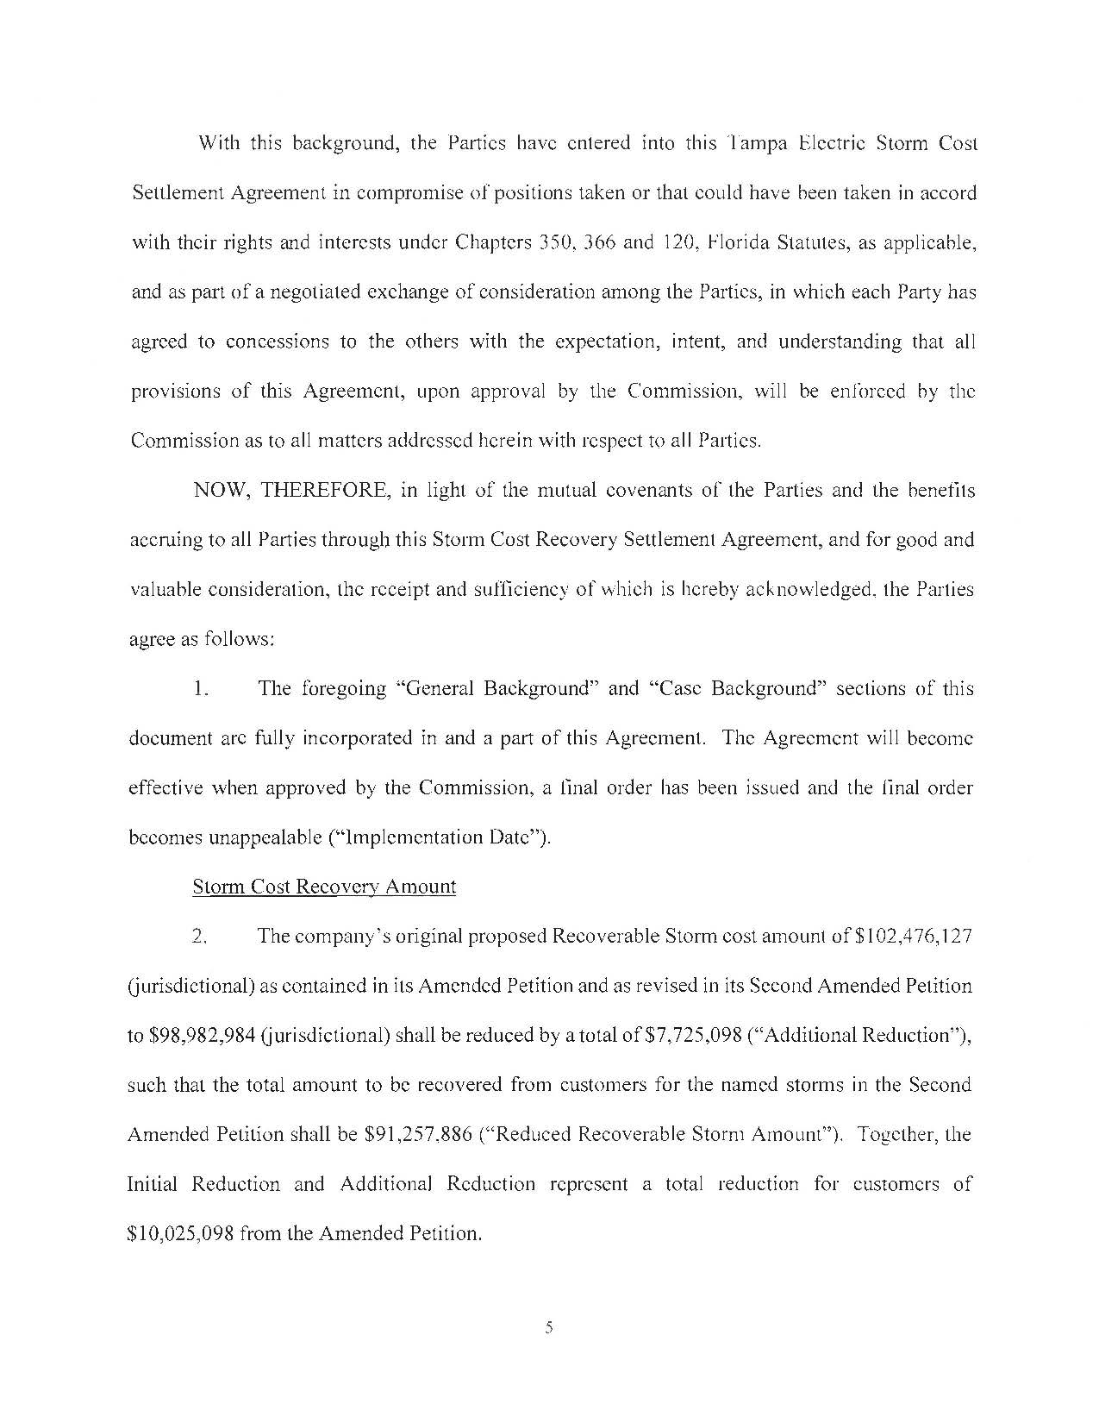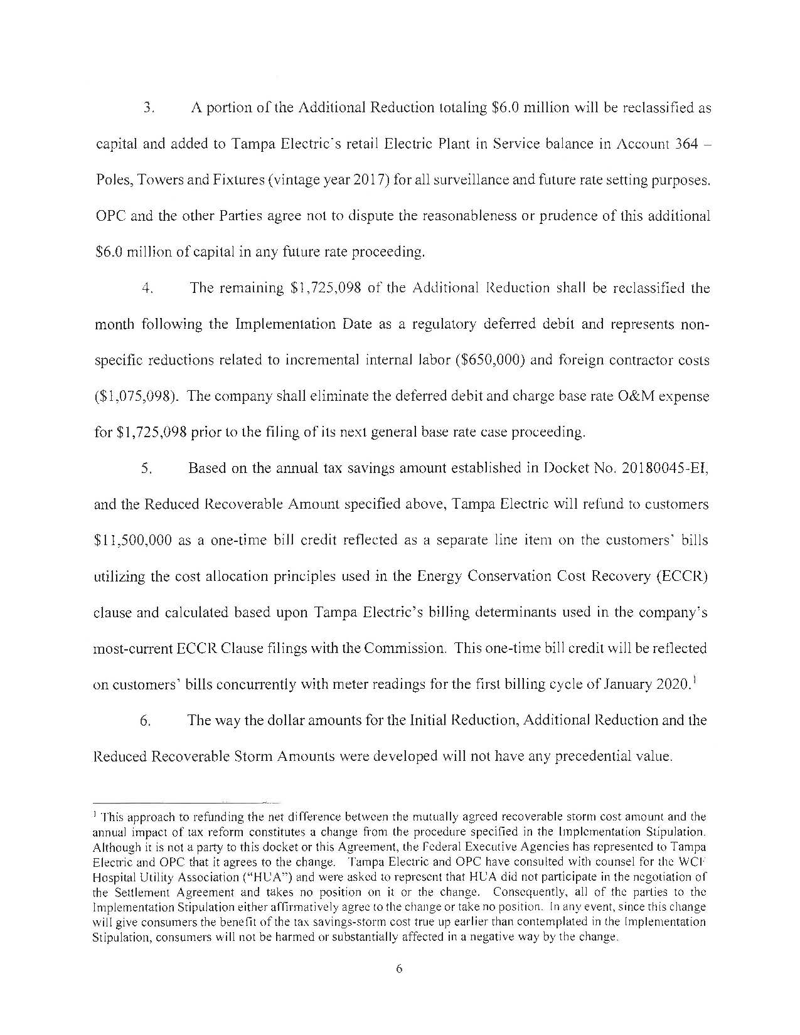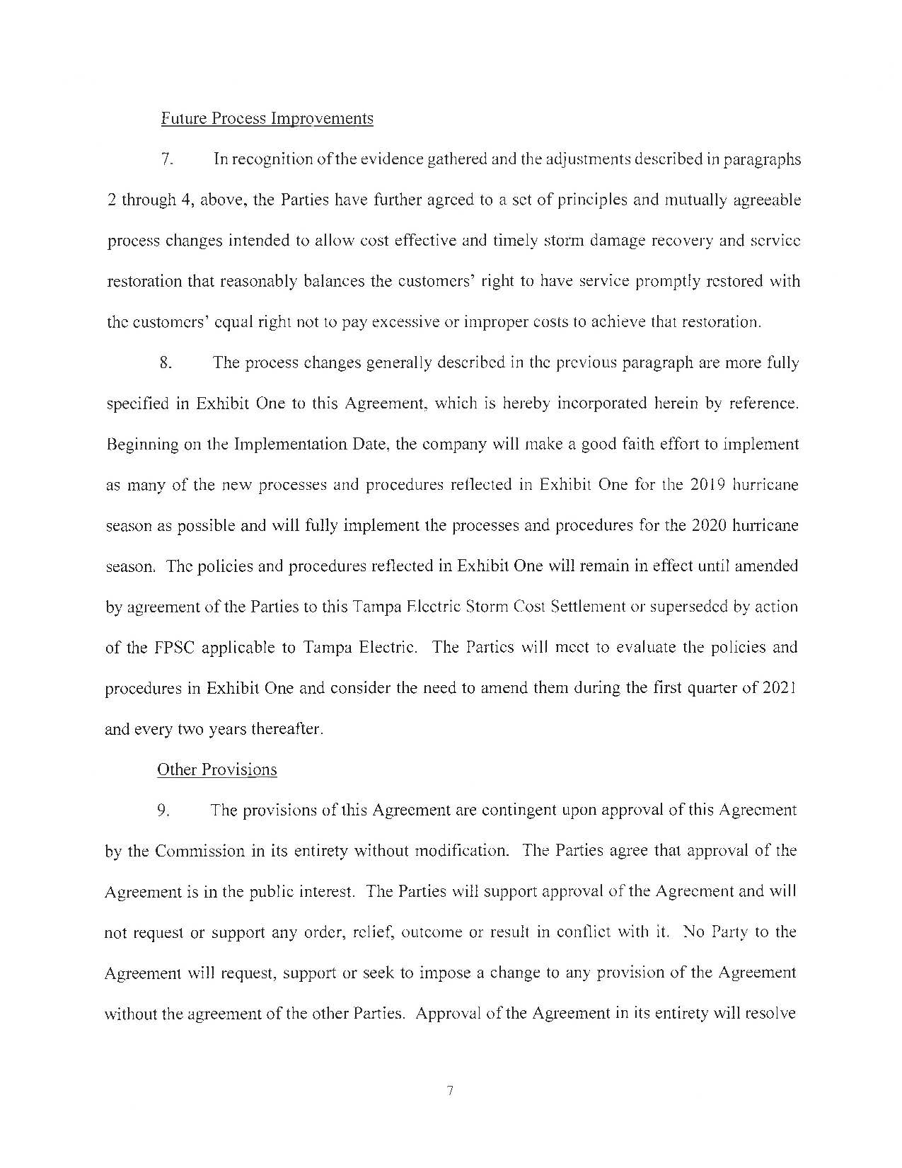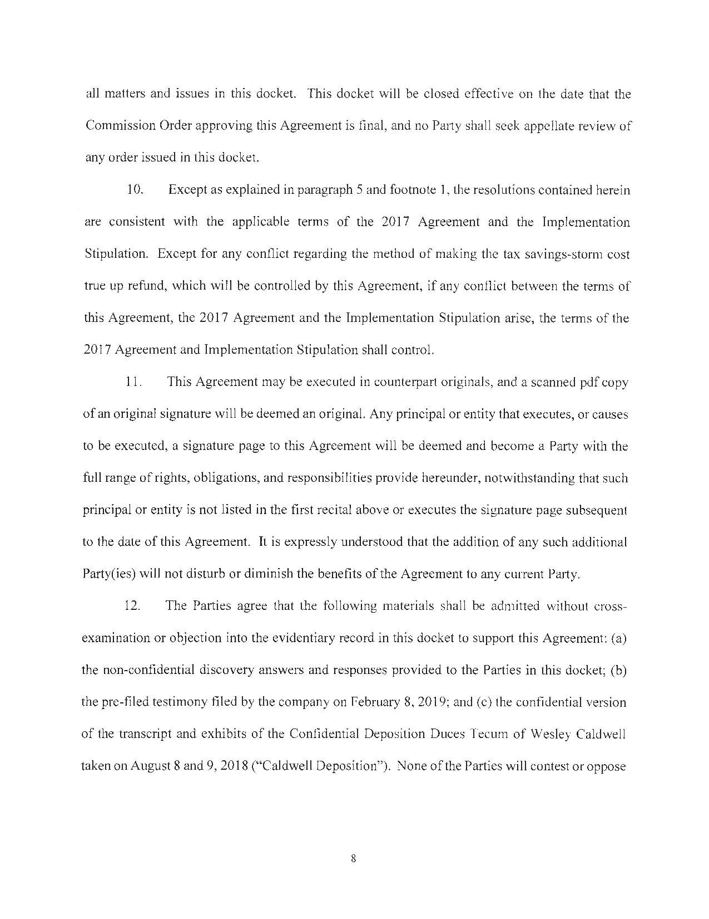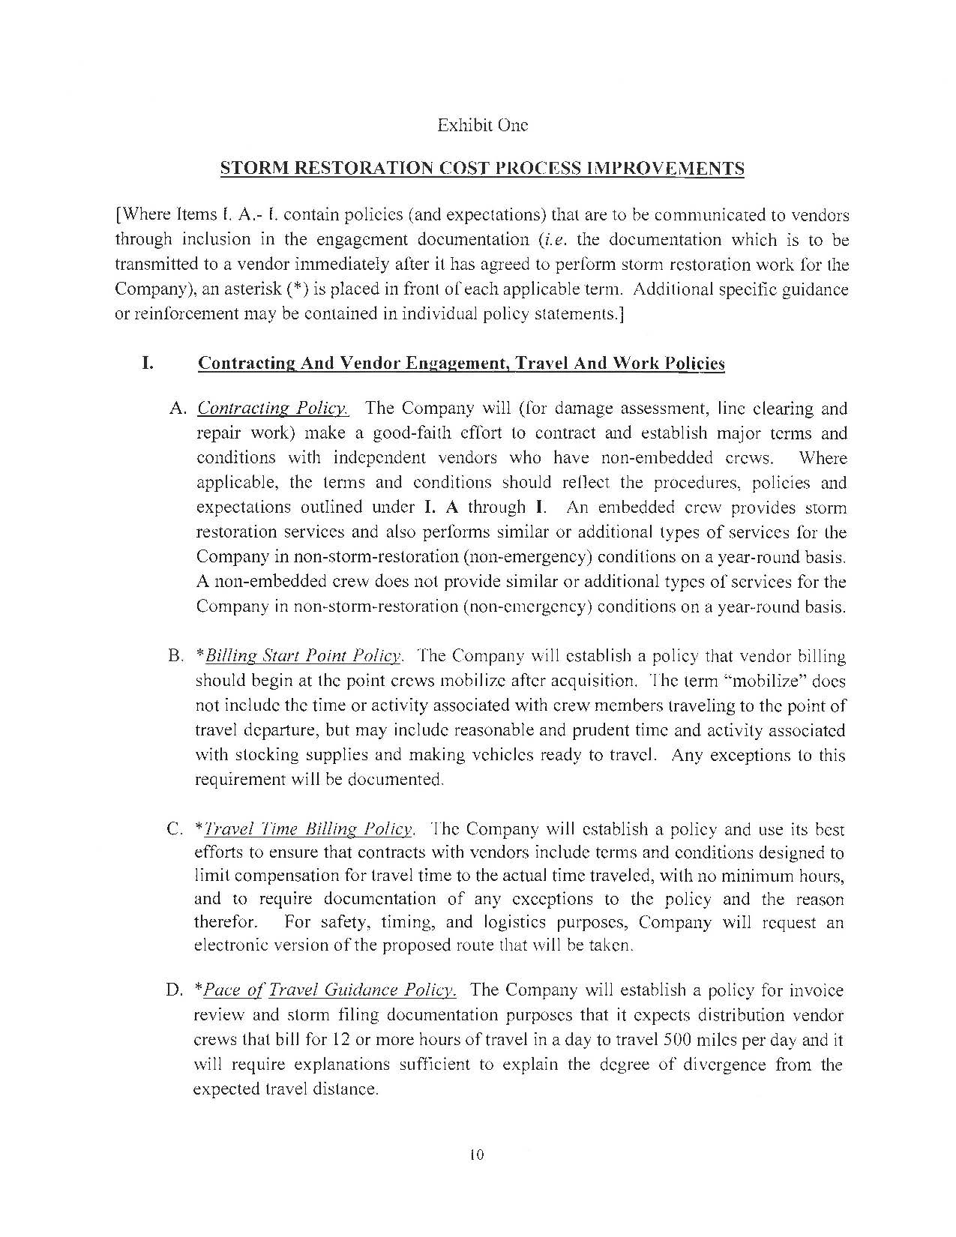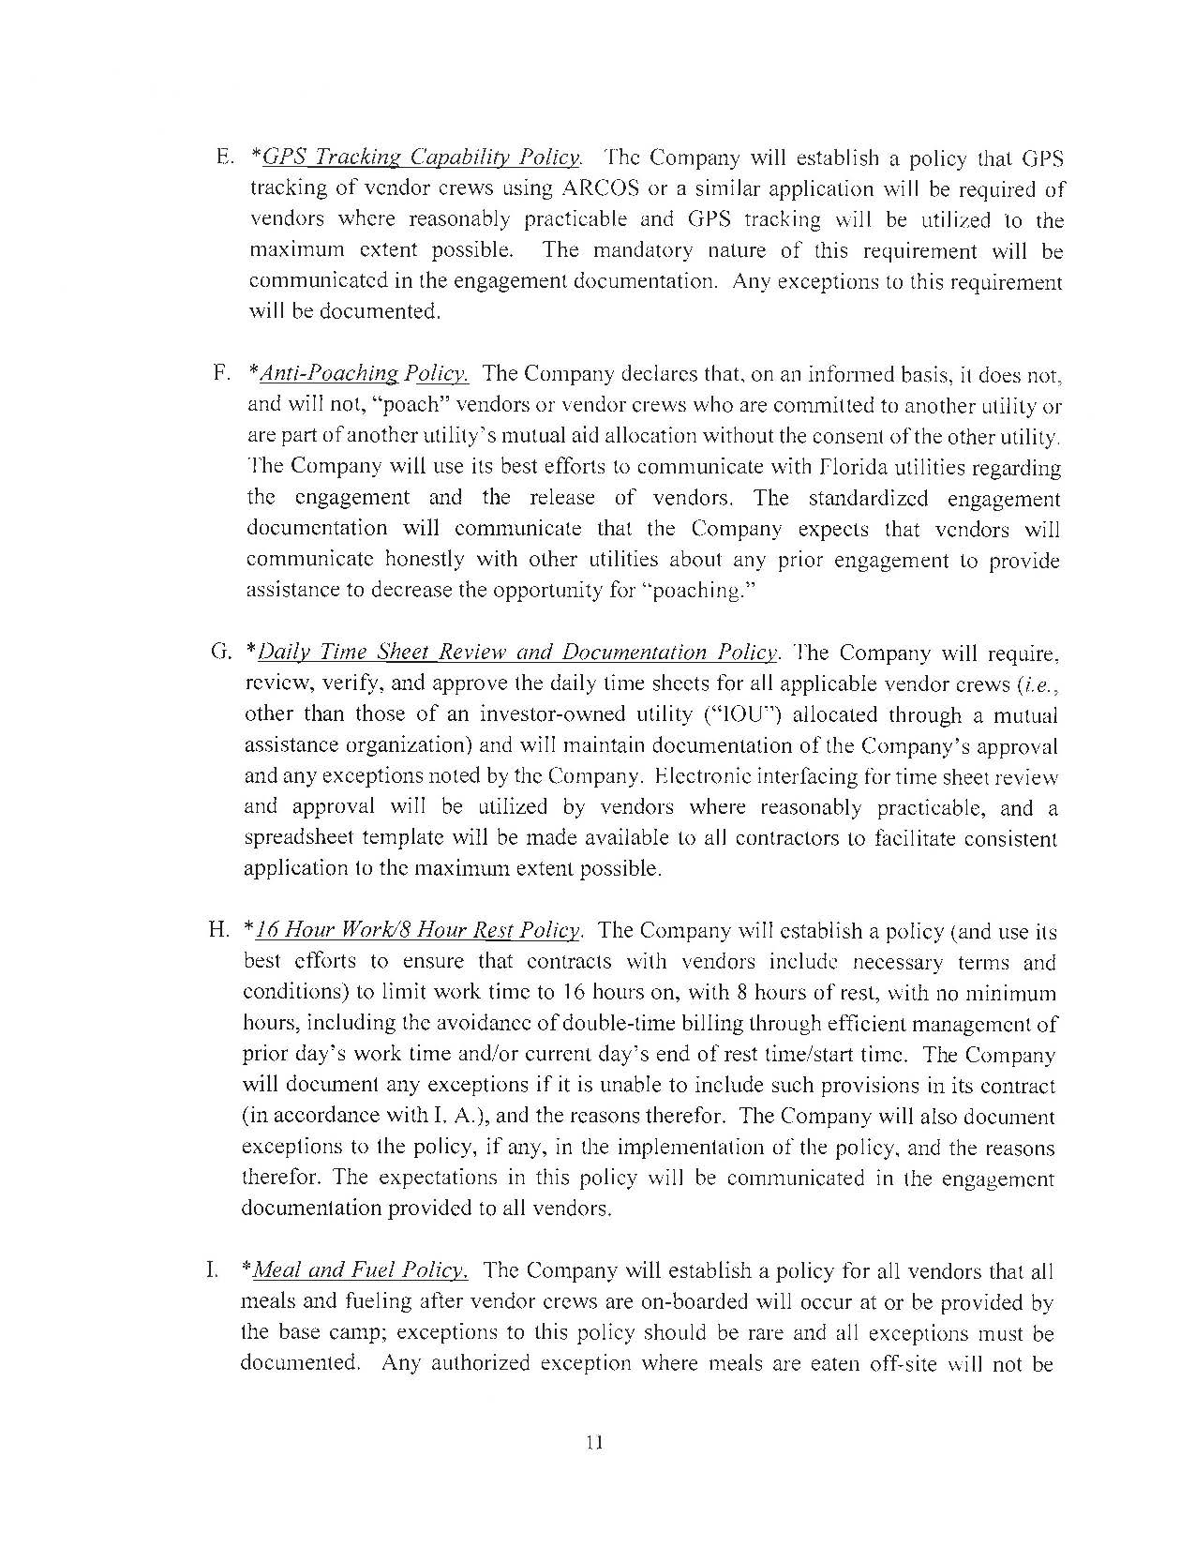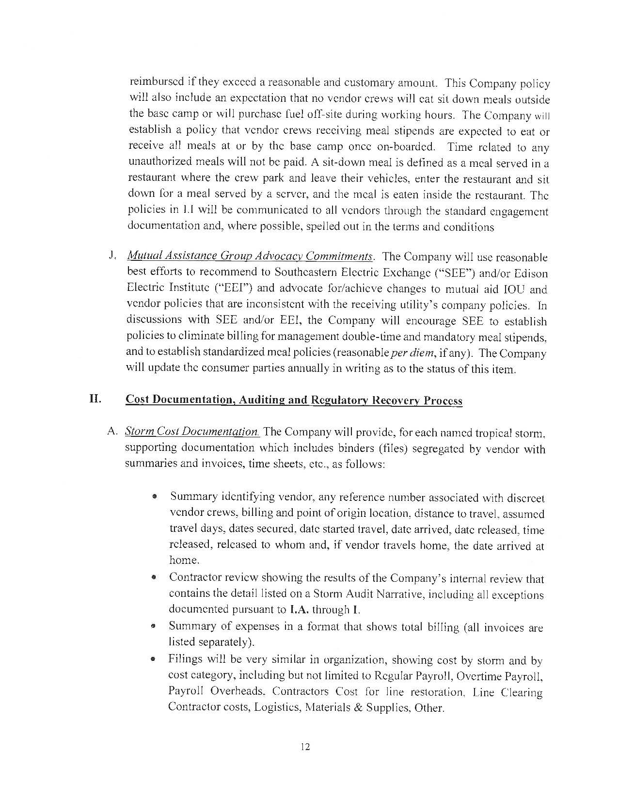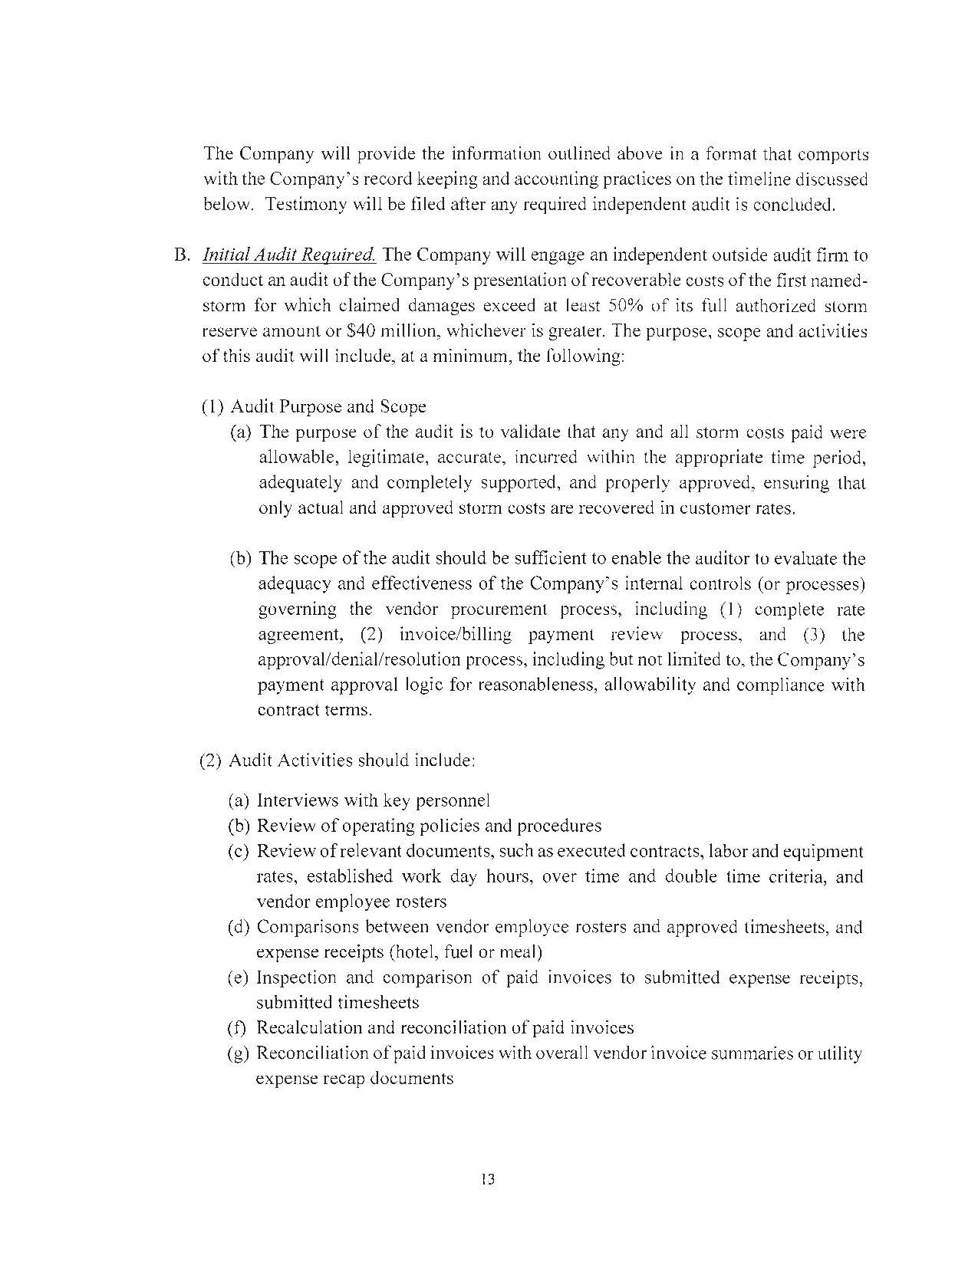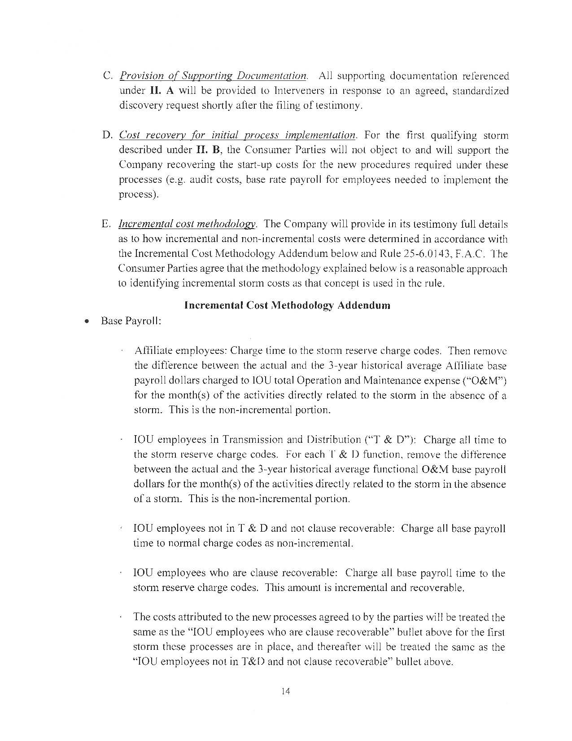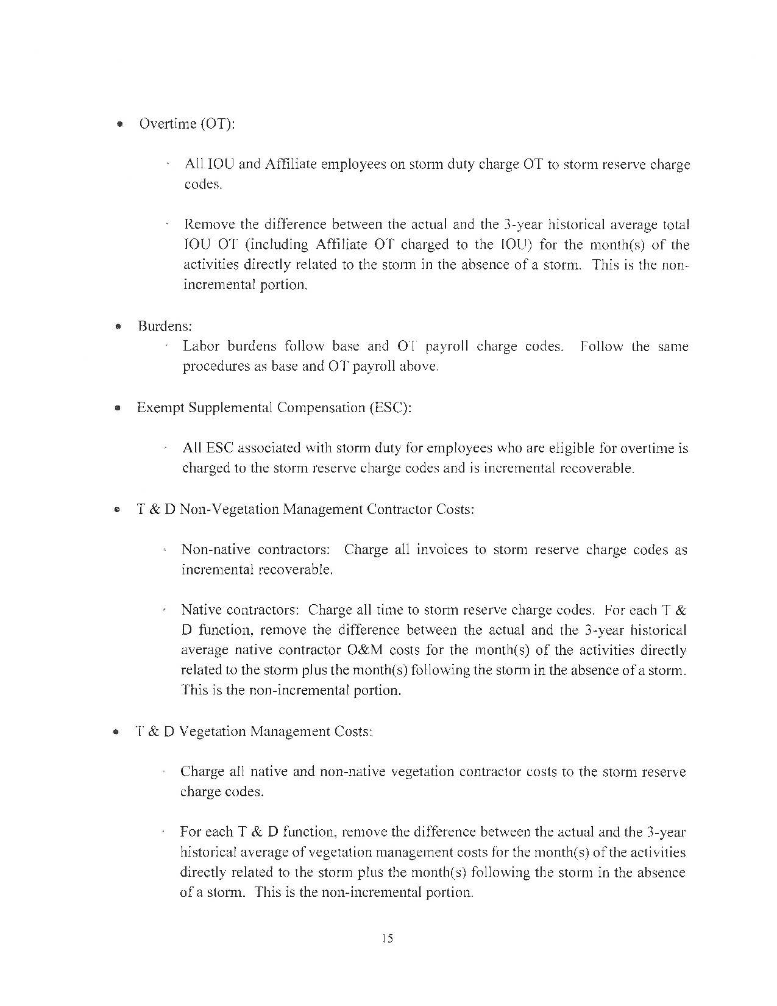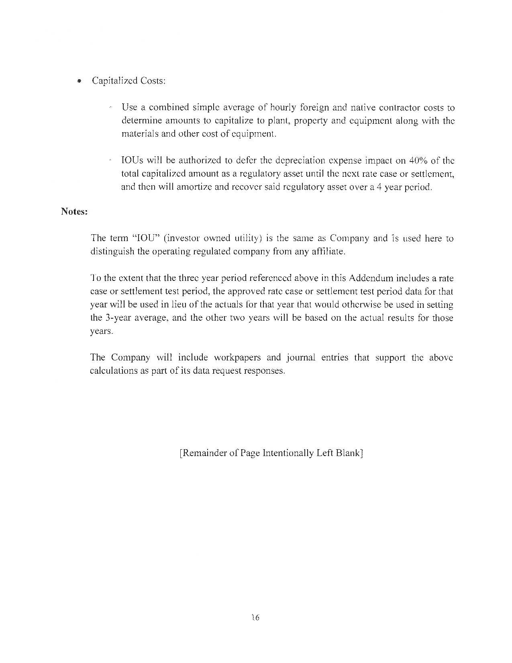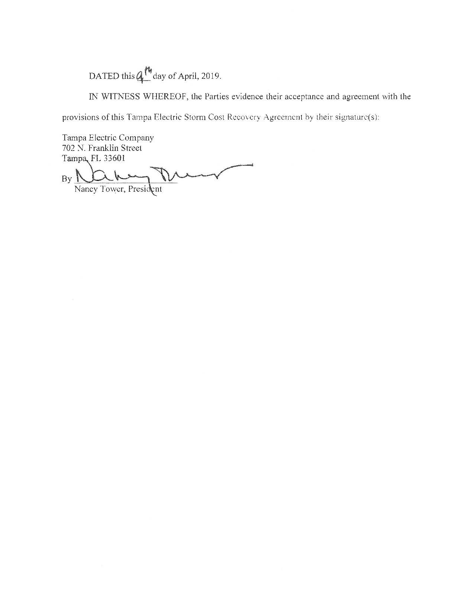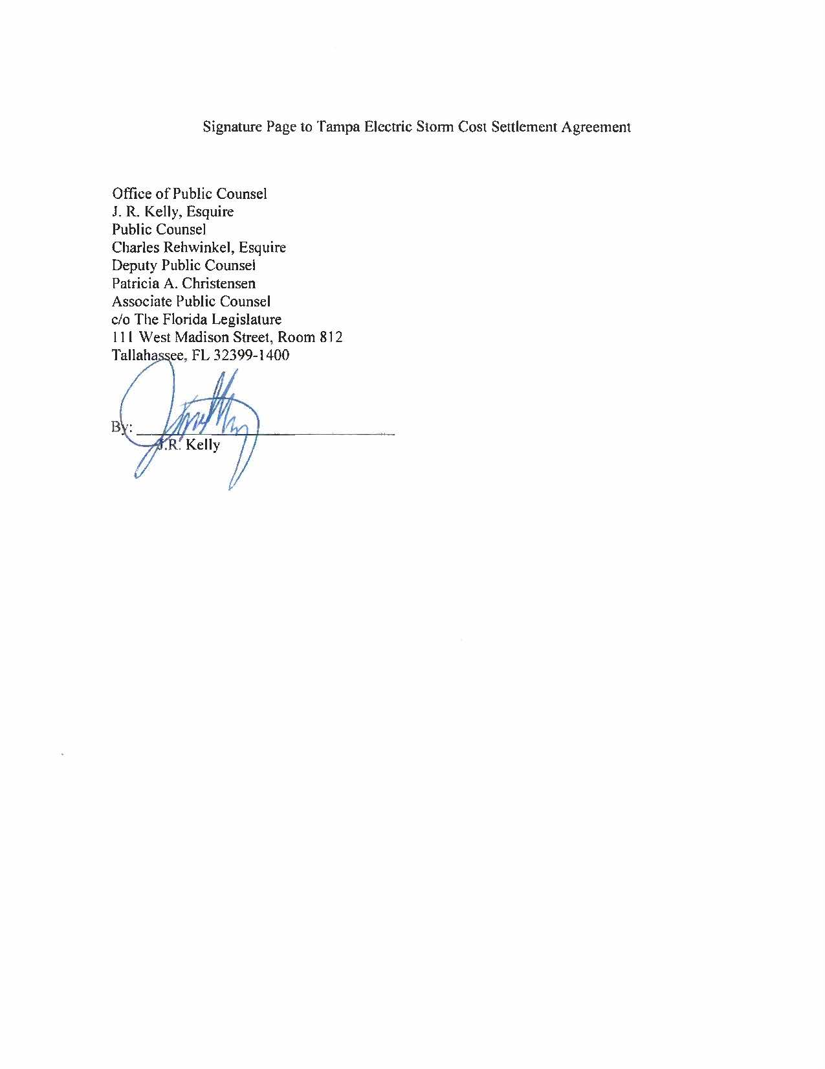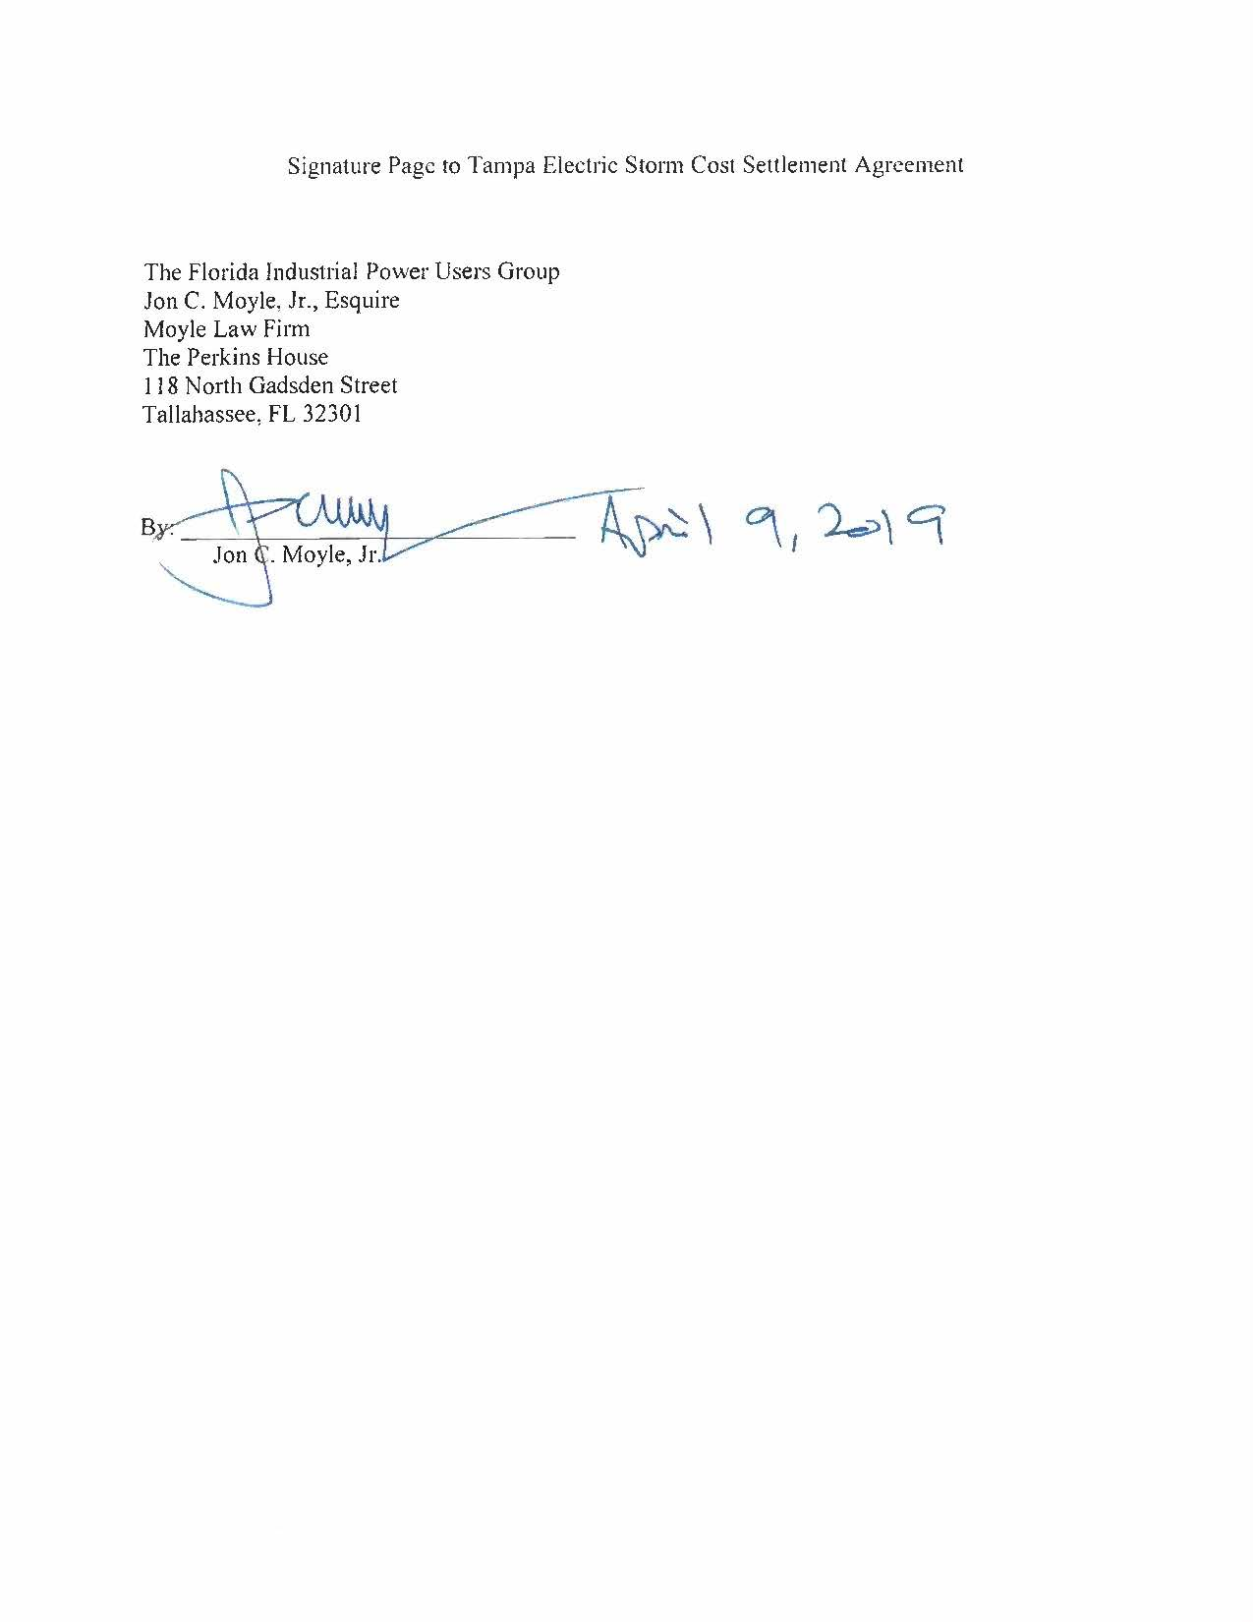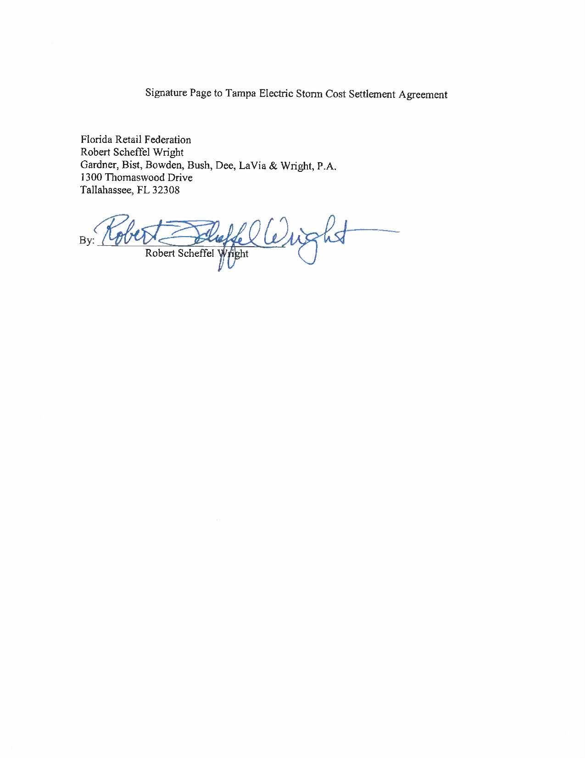

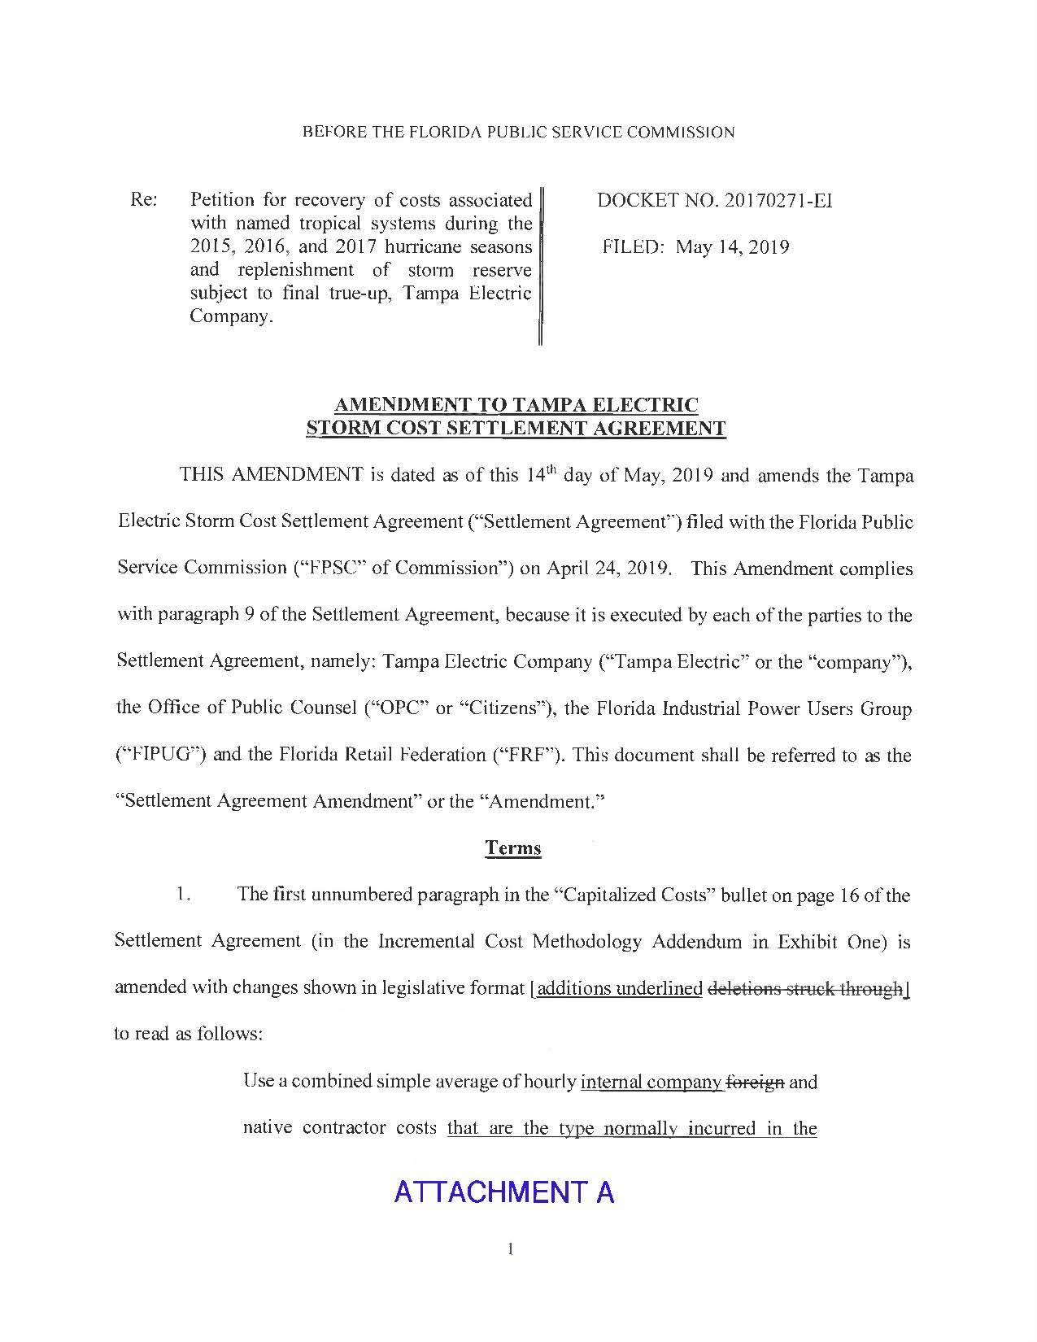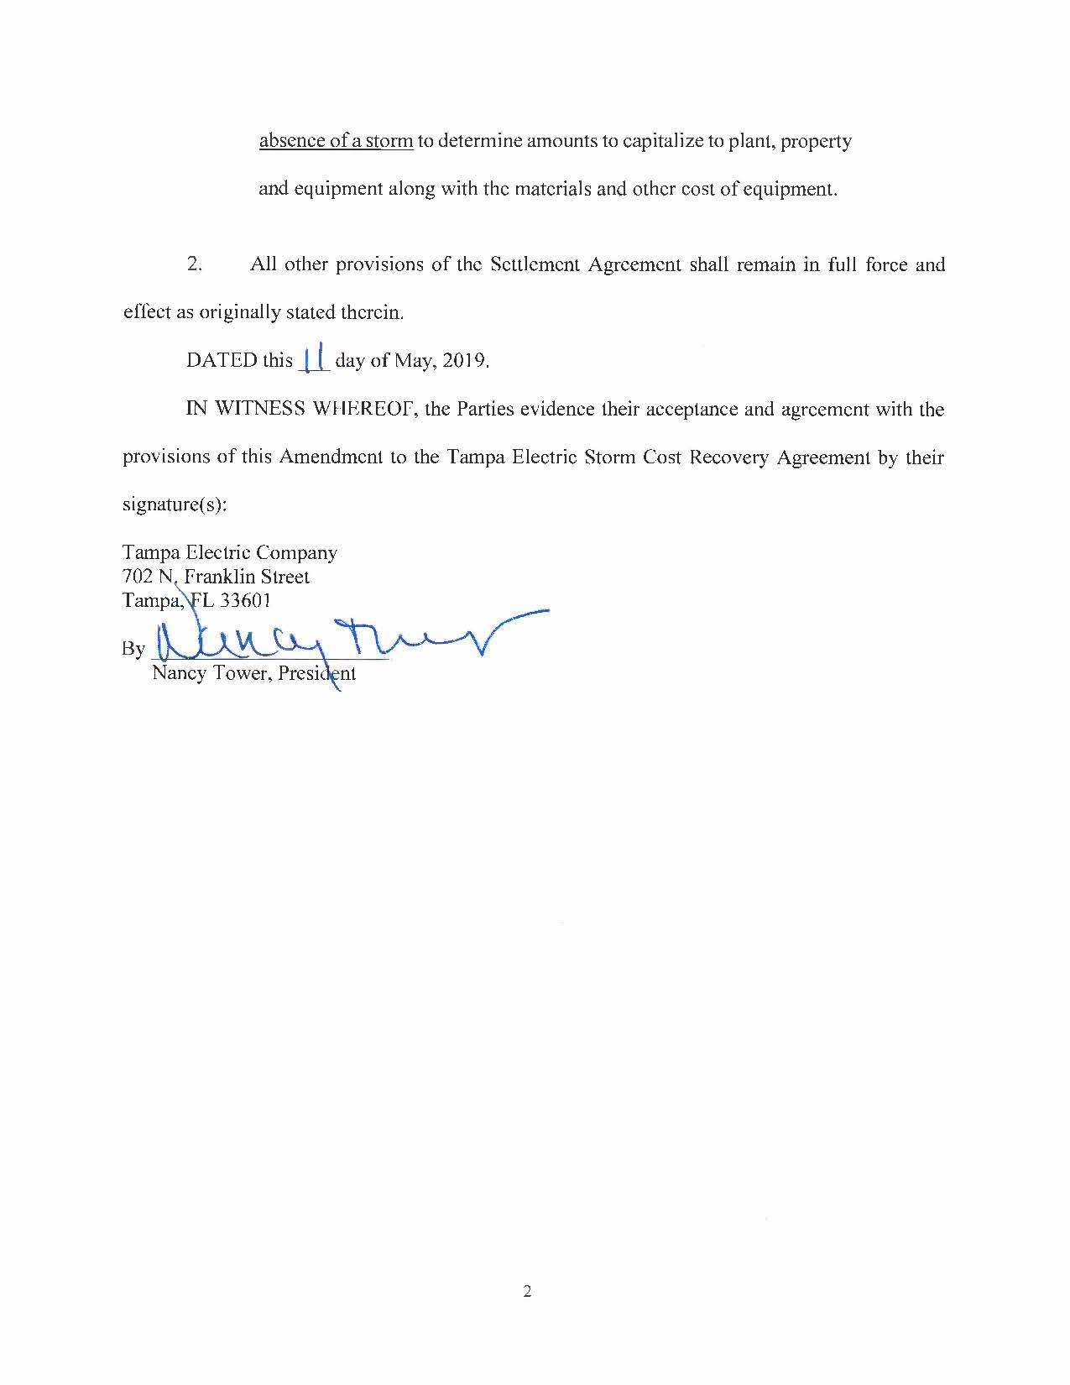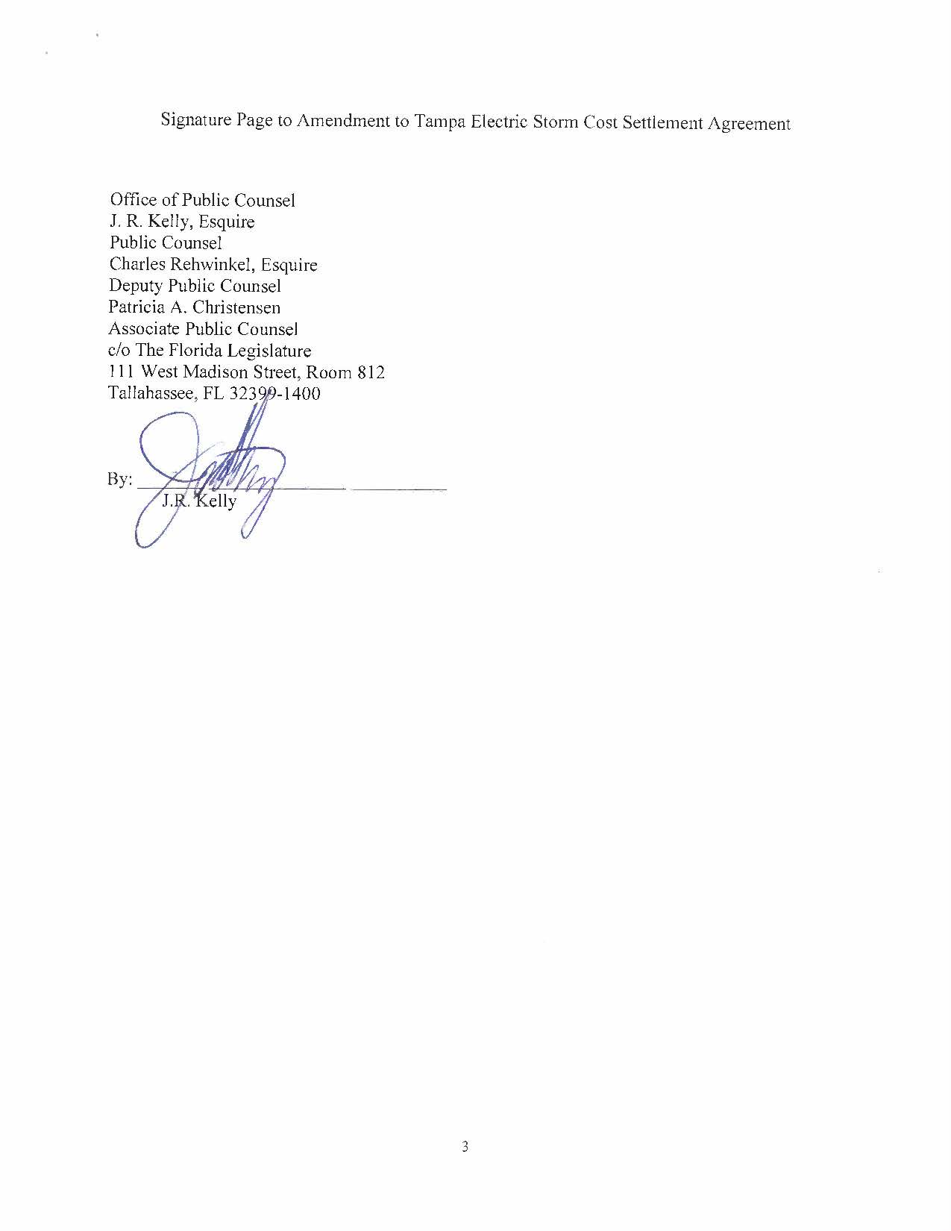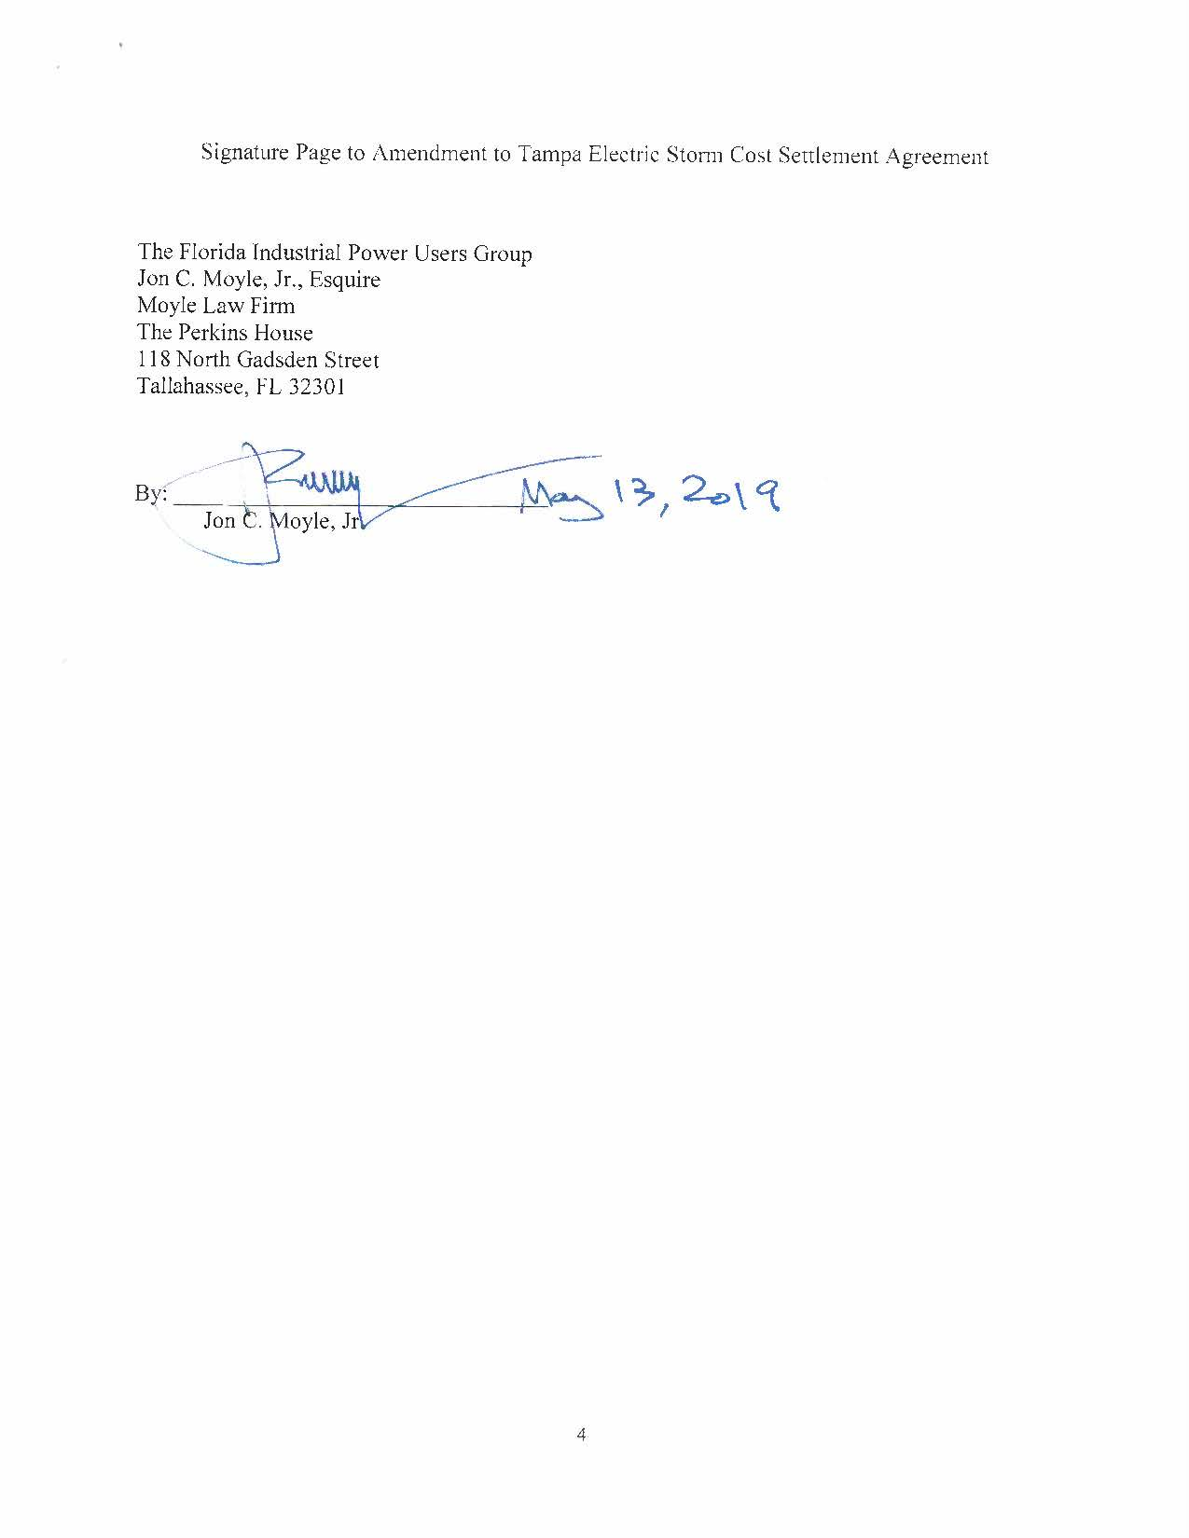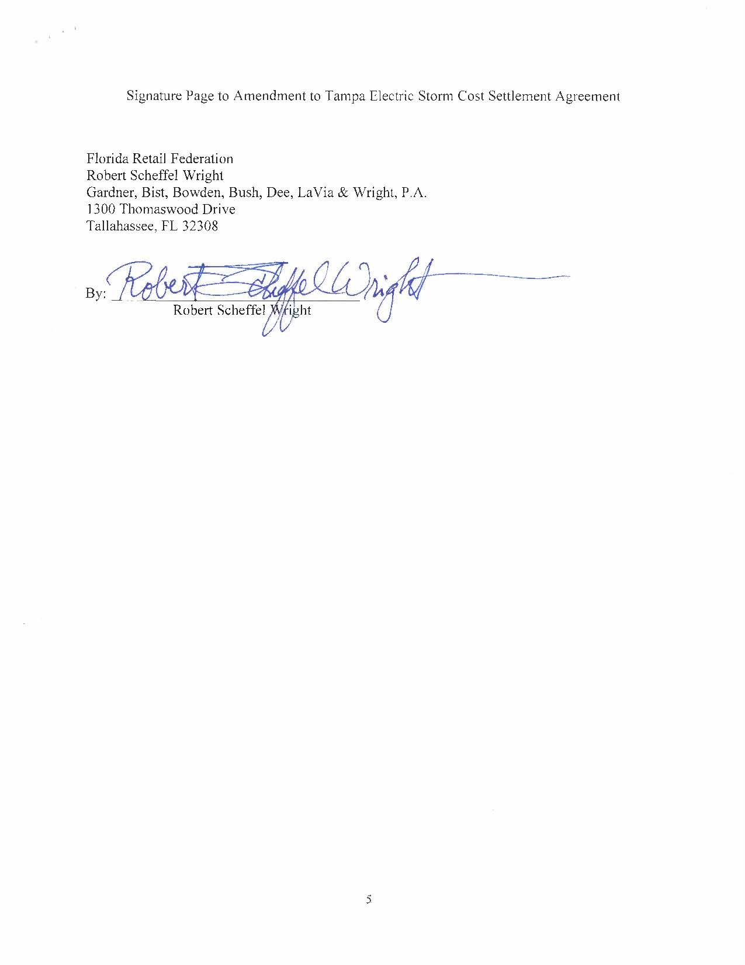

Order No. PSC-2017-0456-S-EI, issued on November 27, 2017, in Docket No. 20170210-EI, In re: Petition for limited proceeding to approve 2017 amended and restated stipulation and settlement agreement by Tampa Electric Company.
These tropical systems would include Tropical Storms Erika and Colin, and Hurricanes Hermine, Matthew and Irma.
Order No. PSC-13-0023-S-EI, issued on January 14, 2013, in Docket No. 120015-EI, In re: Petition for increase in rates by Florida Power & Light Company; Order No. PSC-11-0089-S-EI, issued February 1, 2011, in Docket Nos. 080677 and 090130, In re: Petition for increase in rates by Florida Power & Light Company and In re: 2009 depreciation and dismantlement study by Florida Power & Light Company; Order No. PSC-10-0398-S-EI, issued June 18, 2010, in Docket Nos. 090079-EI, 090144-EI, 090145-EI, 100136-EI, In re: Petition for increase in rates by Progress Energy Florida, Inc., In re: Petition for limited proceeding to include Bartow repowering project in base rates, by Progress Energy Florida, Inc., In re: Petition for expedited approval of the deferral of pension expenses, authorization to charge storm hardening expenses to the storm damage reserve, and variance from or waiver of Rule 25-6.0143(1)(c), (d), and (f), F.A.C., by Progress Energy Florida, Inc., and In re: Petition for approval of an accounting order to record a depreciation expense credit, by Progress Energy Florida, Inc.; Order No. PSC-05-0945-S-EI, issued September 28, 2005, in Docket No. 050078-EI, In re: Petition for rate increase by Progress Energy Florida, Inc.
Order No. PSC-13-0023-S-EI, at p. 7.

