BEFORE THE FLORIDA PUBLIC SERVICE COMMISSION

In re: Petition for limited proceeding for recovery of incremental storm restoration costs related to Hurricane Michael and approval of second implementation stipulation, by Duke Energy Florida, LLC. | DOCKET NO. 20190110-EI  ORDER NO. PSC-2019-0268-PCO-EI  ISSUED: July 1, 2019

The following Commissioners participated in the disposition of this matter:

ART GRAHAM, Chairman
JULIE I. BROWN
DONALD J. POLMANN
GARY F. CLARK
ANDREW GILES FAY

ORDER APPROVING INTERIM STORM RECOVERY CHARGE

BY THE COMMISSION:

Background
On April 30, 2019, Duke Energy Florida, LLC (DEF or Company) filed a petition for a limited proceeding seeking authority to implement an interim storm restoration recovery charge to recover a total of $223.5 million for the incremental restoration costs related to Hurricane Michael and to replenish its storm reserve. This amount includes $2.5 million for: interest, bond issuance expense, and the regulatory assessment fee gross-up. DEF’s storm reserve was depleted as a result of Hurricanes Irma and Nate, and DEF is seeking to replenish the storm reserve to the level authorized in the Second Revised and Restated 2017 Settlement Agreement (2017 Settlement) approved by this Commission in Order No. PSC-2017-0451-AS-EU.
DEF filed its petition pursuant to the provisions of the 2017 Settlement. Pursuant to the 2017 Settlement, DEF can recover storm costs, without a cap on the level of charges on customer bills, on an interim basis beginning 60 days following the filing of a petition for recovery. DEF proposes to implement an interim charge for a 12-month period effective July 2019. The interim charge results in an increase of $6.95 per 1,000 kilowatt hour (kWh) on a residential bill.
Included in the petition (and attached to this Order as Attachment A) is a Second Implementation Stipulation (Stipulation). At the Commission Conference on June 11, 2019, we approved the Stipulation, as it is in the public interest. The Stipulation allows DEF to apply the tax savings approved by this Commission in Order No. PSC-2019-0053-FOF-EI to offset the storm recovery surcharge that was requested in this docket, and would replenish the storm reserve to a level authorized in the 2017 Settlement. The authorized level in the 2017 Settlement was $132 million. DEF, the Office of Public Counsel, Southern Alliance for Clean Energy, and White Springs Agricultural Chemical, Inc. agreed to the Stipulation. Florida Retail Federation, and Florida Industrial Power Users group took no position on the Stipulation.
We have jurisdiction over this matter pursuant to Sections 366.04, 366.05, 366.06, and 366.076, Florida Statutes.

Decision

I. Authorization of Interim Storm Restoration Recovery Charge and Approval of the Second Implementation Stipulation

DEF filed a petition for a limited proceeding seeking authority to implement an interim storm restoration recovery charge to recover a total of $223.5 million for the incremental restoration costs related to Hurricane Michael. The $223.5 million includes $2.5 million for interest, bond issuance expense, and a regulatory assessment fee gross-up. The petition was filed pursuant to the provisions of the 2017 Settlement approved by this Commission in Order No. PSC-2017-0451-AS-EU. Pursuant to Paragraph 38 of the 2017 Settlement, DEF can begin recovery of storm costs, without a cap, 60 days following the filing of a petition for recovery. DEF has requested an interim storm restoration recovery charge to implement for a 12-month period, effective July 2019 through June 2020.

In its petition, DEF asserts that it incurred total retail recoverable costs of approximately $223.5 million as a result of Hurricane Michael. DEF further asserts that this amount was calculated in accordance with the Incremental Cost and Capitalization Approach (ICCA) methodology prescribed in Rule 25-6.0143, Florida Administrative Code (F.A.C.).
In its petition, DEF filed proposed Eighty-Fifth Revised Tariff Sheets Nos. 6.105, 6.106, and 6.107, to implement the approved storm recovery charge. However, following our approval of the Stipulation, DEF withdrew its proposed tariff sheets. DEF’s Stipulation seeks to avoid volatility in customer rates by recognizing and then utilizing annual tax reform benefits resulting from the Tax Cuts and Jobs Act of 2017 (Tax Act) as a direct offset to avoid implementing separate cost recovery of storm damage costs that customers would have otherwise been obligated to pay. With our approval of the Stipulation, DEF shall be entitled to record a monthly storm reserve accrual equal to one-twelfth of our approved annual revenue requirement impact of the Tax Act and credit the retail storm reserve from May 2020 through full recovery of our final approved actual storm recovery amount. Once the final approved actual storm recovery amount has been recovered, or offset, DEF shall reduce base rates in the manner prescribed in the 2017 Settlement and Order No. 2019-0053-FOF-EI.
Our approval of an interim storm restoration recovery charge is preliminary in nature and is subject to refund pending further review once the total actual storm restoration costs are known. After the actual costs are reviewed for prudence and reasonableness, and are compared to the actual amount recovered through the interim storm restoration recovery charge, a determination will be made whether any over/under recovery has occurred. The disposition of any over/under recovery, and associated interest, would be considered by us at a later date.
Based on a review of the information provided by DEF in its petition, we hereby authorize DEF to implement an interim storm restoration recovery charge subject to refund. Once the total actual storm costs are known, DEF shall be required to file documentation of the storm costs for Commission review and true-up of any excess or shortfall. This is not a confirmation or endorsement of the prudence of DEF’s forecasted costs and plans. This order only allows DEF to begin recovery on an interim basis in accordance with the 2017 Settlement. This interim recovery is subject to refund following a hearing or formal proceeding where the veracity and prudence of DEF’s actual restoration costs can be fully vetted.

II. Security for Interim Storm Restoration Recovery Charge

We find that all funds collected by DEF subject to refund shall be secured by a corporate undertaking. We reviewed DEF’s financial statements to determine if the Company can support a corporate undertaking to guarantee the funds collected for recovery of incremental storm restoration costs related to Hurricane Michael. The criteria for a corporate undertaking include sufficient liquidity, ownership equity, profitability, and interest coverage to guarantee any potential refund. DEF’s 2016, 2017, and 2018 financial statements were used to determine the financial condition of the Company. DEF’s financial performance demonstrates adequate levels of ownership equity, profitability, and interest coverage, but marginal liquidity due to negative working capital. However, the Company participates in Duke Energy Corporation’s money pool and has access to additional funds if needed.
DEF has adequate resources to support a corporate undertaking in the amount requested. Based on this analysis, we find that a corporate undertaking of $223.5 million is acceptable.

Based on the foregoing, it is

ORDERED by the Florida Public Service Commission that Duke Energy Florida, LLC is hereby authorized to implement an interim storm restoration recovery charge subject to refund. It is further

ORDERED that Duke Energy Florida, LLC shall file with this Commission documentation of the actual storm costs once those costs are known. It is further
ORDERED that Duke Energy Florida, LLC’s Second Implementation Stipulation is approved. It is further

ORDERED that all funds collected by Duke Energy Florida, LLC subject to refund shall be secured by a corporate undertaking. It is further

ORDERED that a corporate undertaking of $223.5 million is acceptable. It is further

ORDERED that this docket shall remain open for future disposition by this Commission.
By ORDER of the Florida Public Service Commission this 1st day of July, 2019.

/s/ Adam J. Teitzman
ADAM J. TEITZMAN
Commission Clerk
Florida Public Service Commission
2540 Shumard Oak Boulevard
Tallahassee, Florida 32399
(850) 413-6770
www.floridapsc.com

Copies furnished: A copy of this document is provided to the parties of record at the time of issuance and, if applicable, interested persons.

AJW

NOTICE OF FURTHER PROCEEDINGS OR JUDICIAL REVIEW

The Florida Public Service Commission is required by Section 120.569(1), Florida Statutes, to notify parties of any administrative hearing or judicial review of Commission orders that is available under Sections 120.57 or 120.68, Florida Statutes, as well as the procedures and time limits that apply. This notice should not be construed to mean all requests for an administrative hearing or judicial review will be granted or result in the relief sought.

Mediation may be available on a case-by-case basis. If mediation is conducted, it does not affect a substantially interested person's right to a hearing.

Any party adversely affected by this order, which is preliminary, procedural or intermediate in nature, may request: (1) reconsideration within 10 days pursuant to Rule 25-22.0376, Florida Administrative Code; or (2) judicial review by the Florida Supreme Court, in the case of an electric, gas or telephone utility, or the First District Court of Appeal, in the case of a water or wastewater utility. A motion for reconsideration shall be filed with the Office of Commission Clerk, in the form prescribed by Rule 25-22.0376, Florida Administrative Code. Judicial review of a preliminary, procedural or intermediate ruling or order is available if review of the final action will not provide an adequate remedy. Such review may be requested from the appropriate court, as described above, pursuant to Rule 9.100, Florida Rules of Appellate Procedure
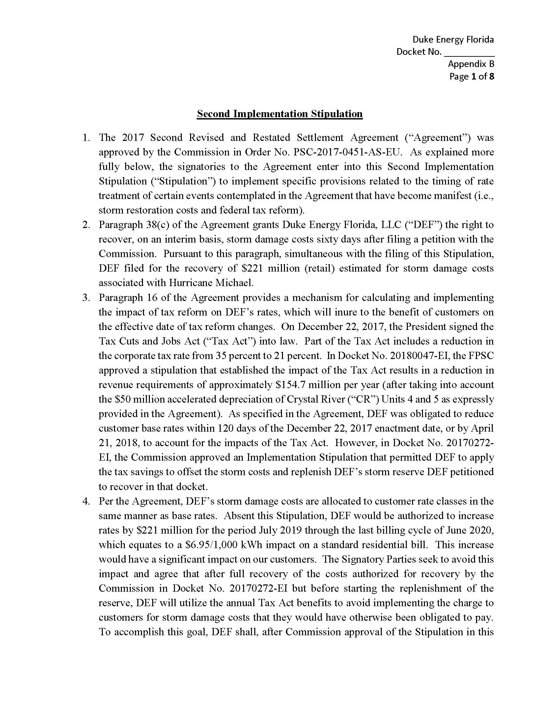
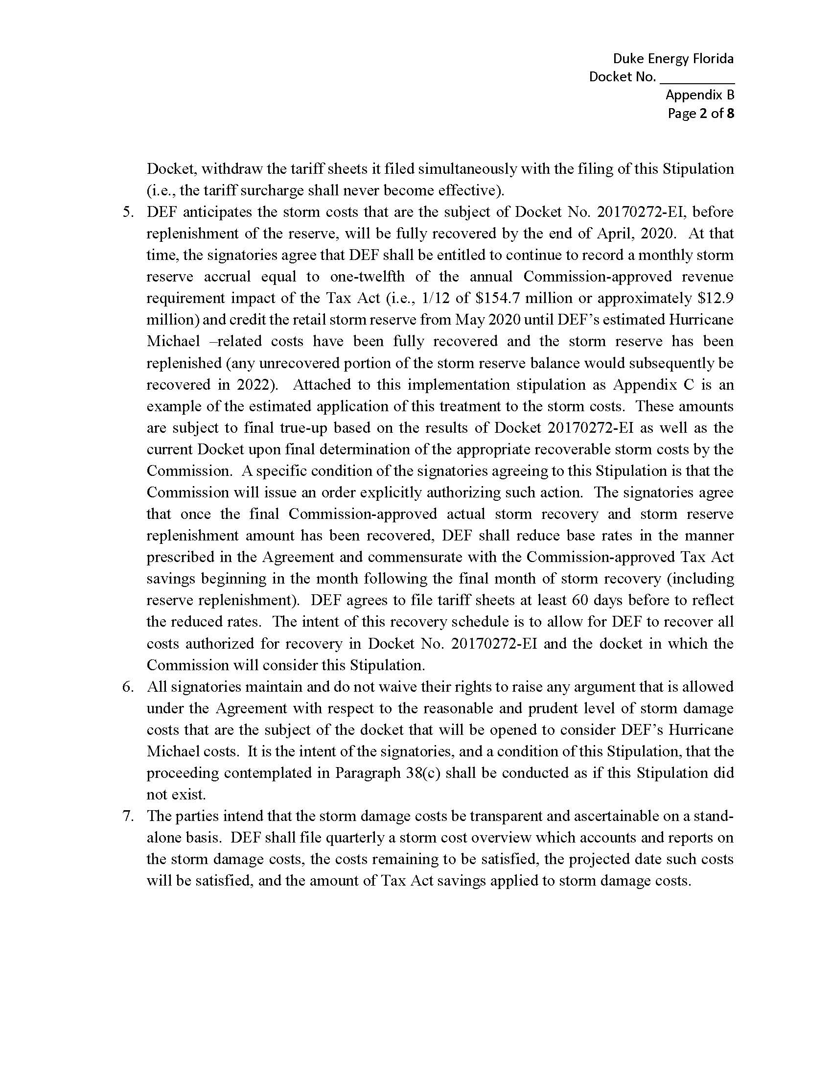
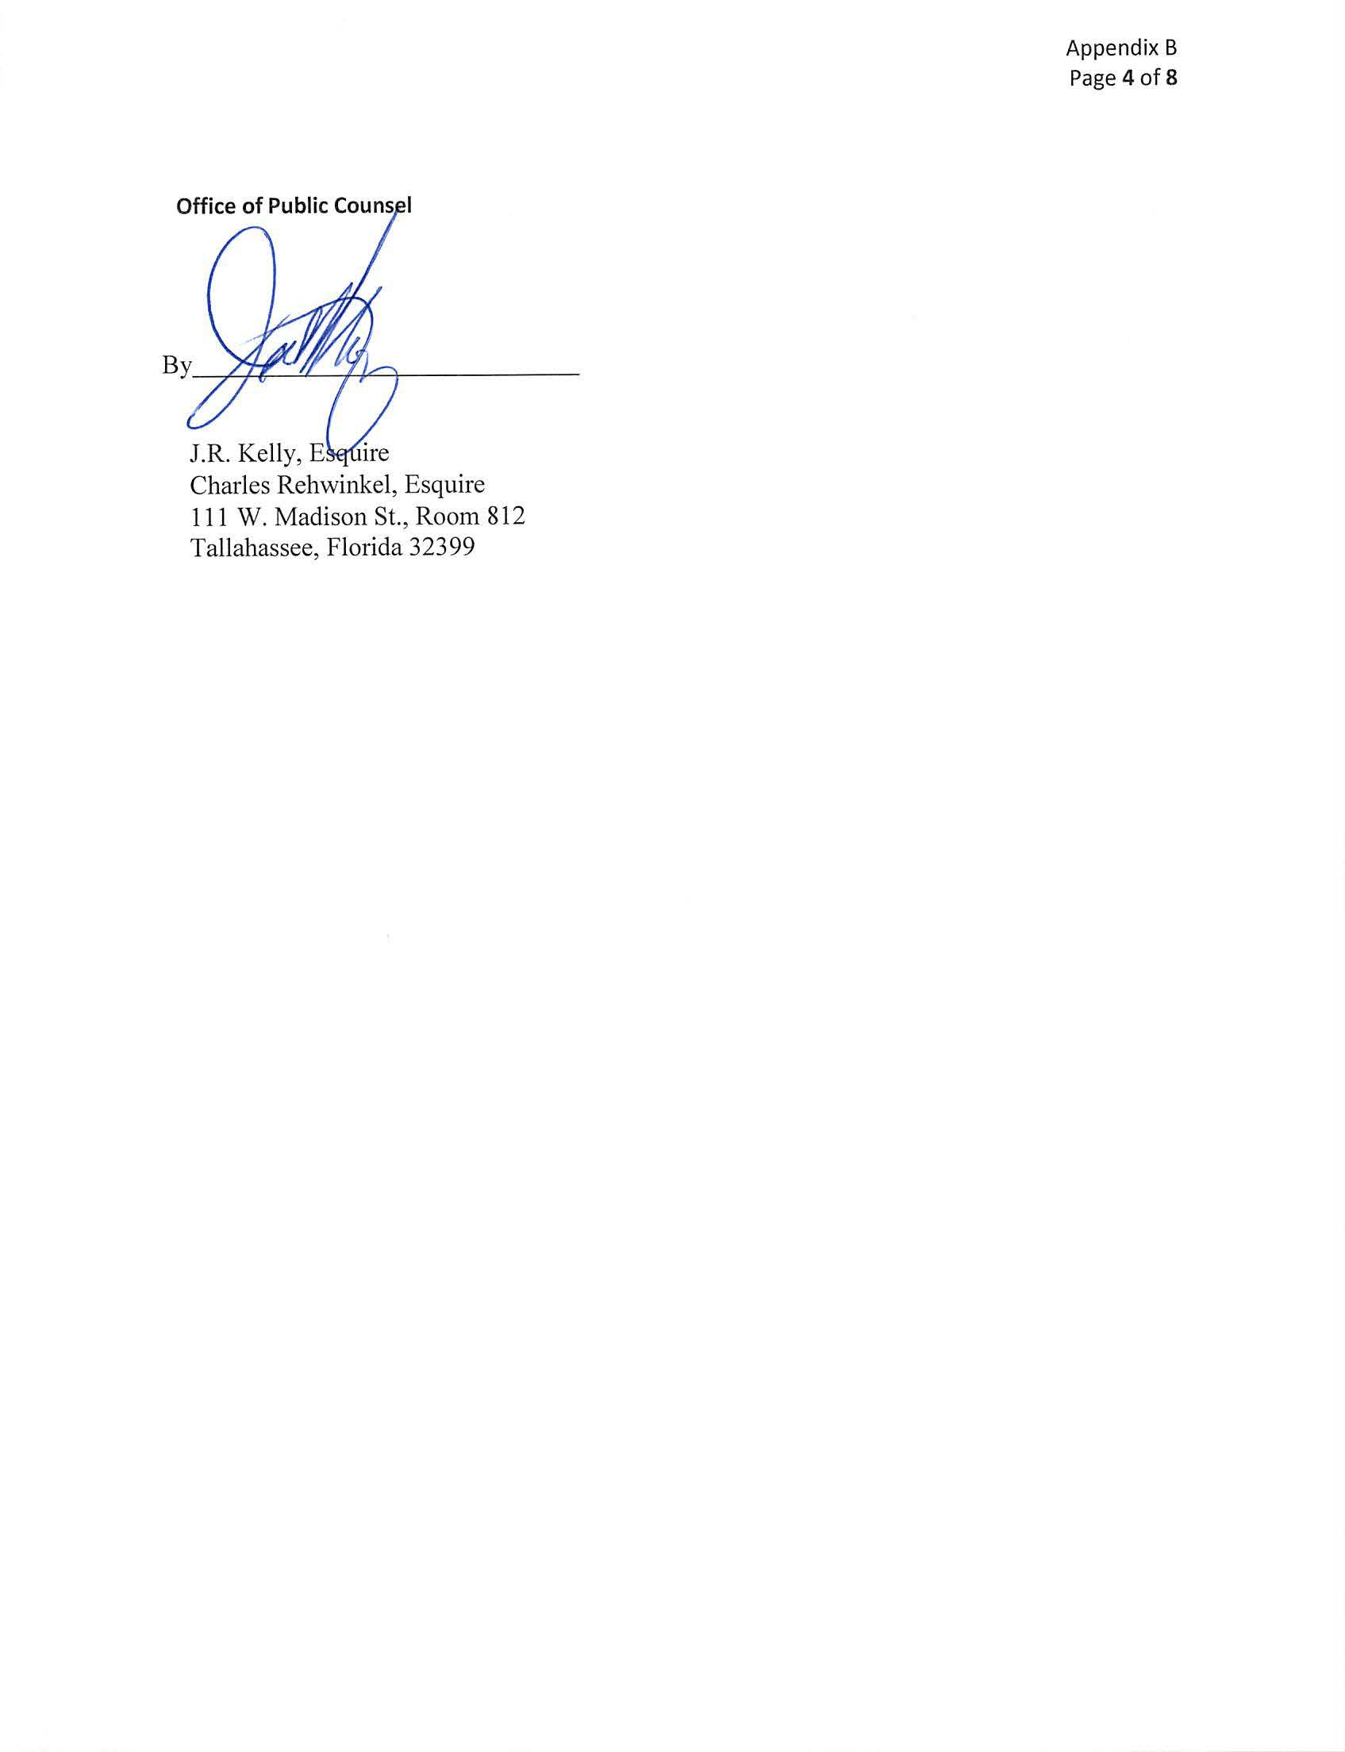
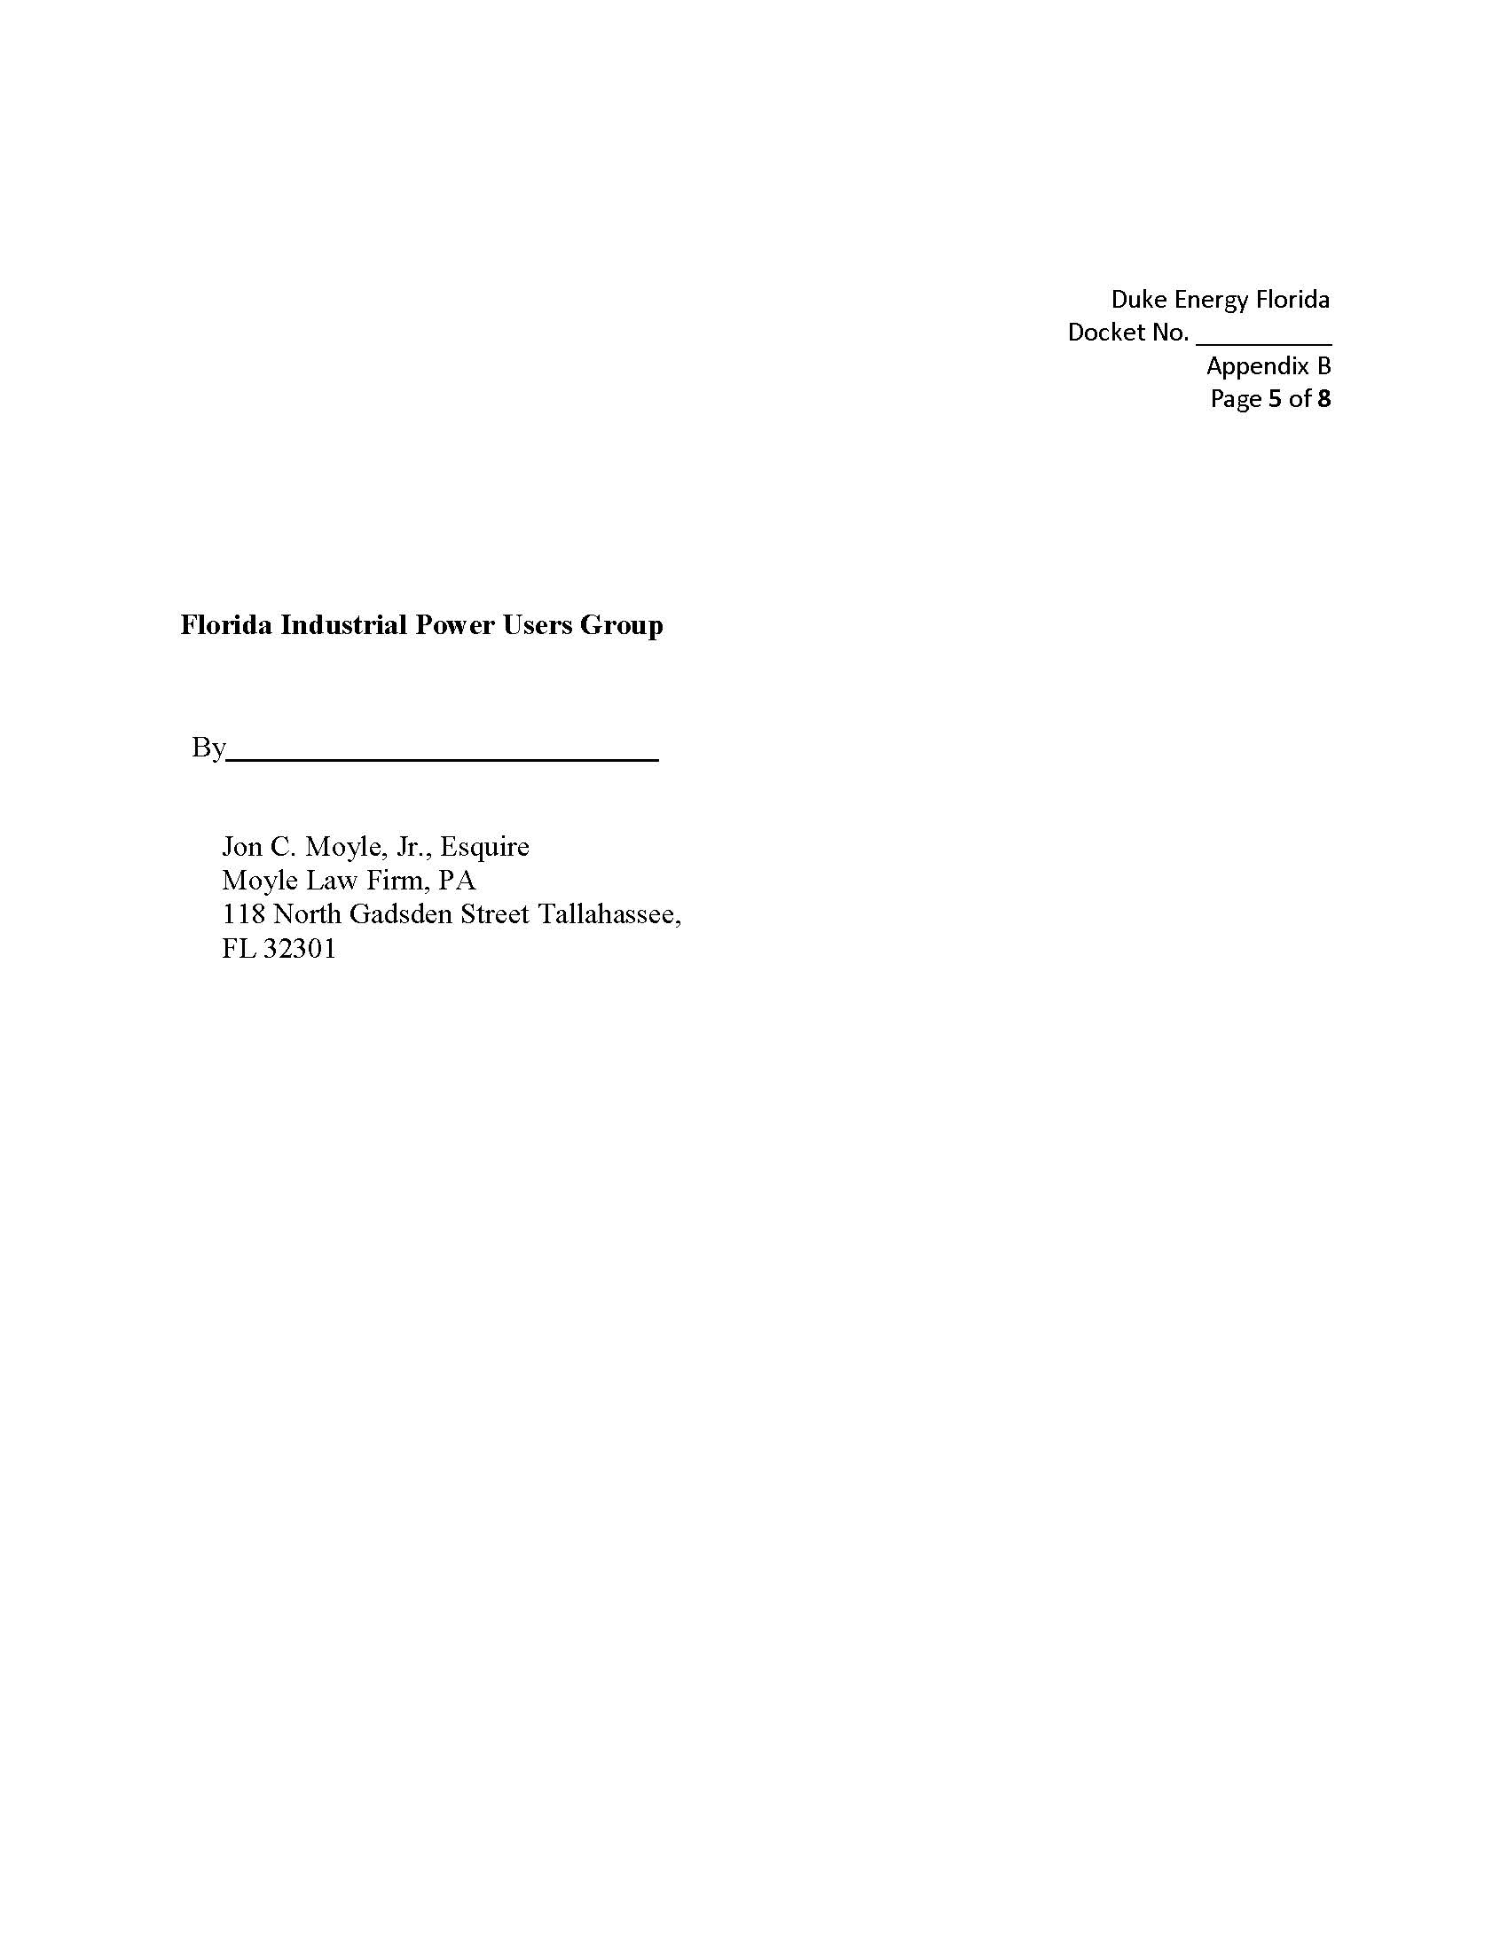
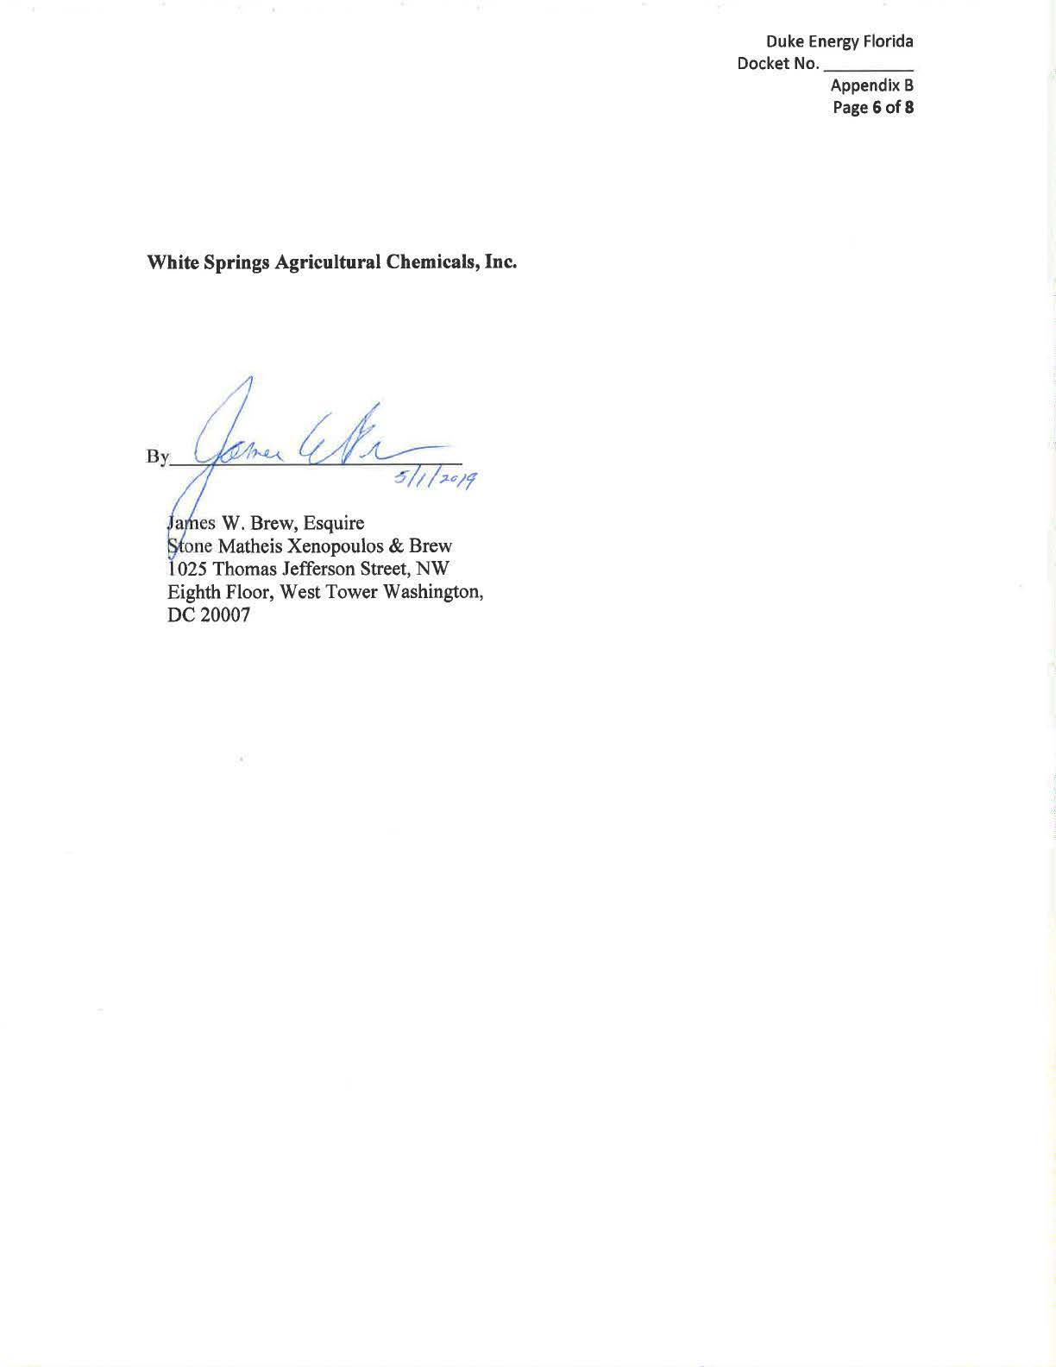
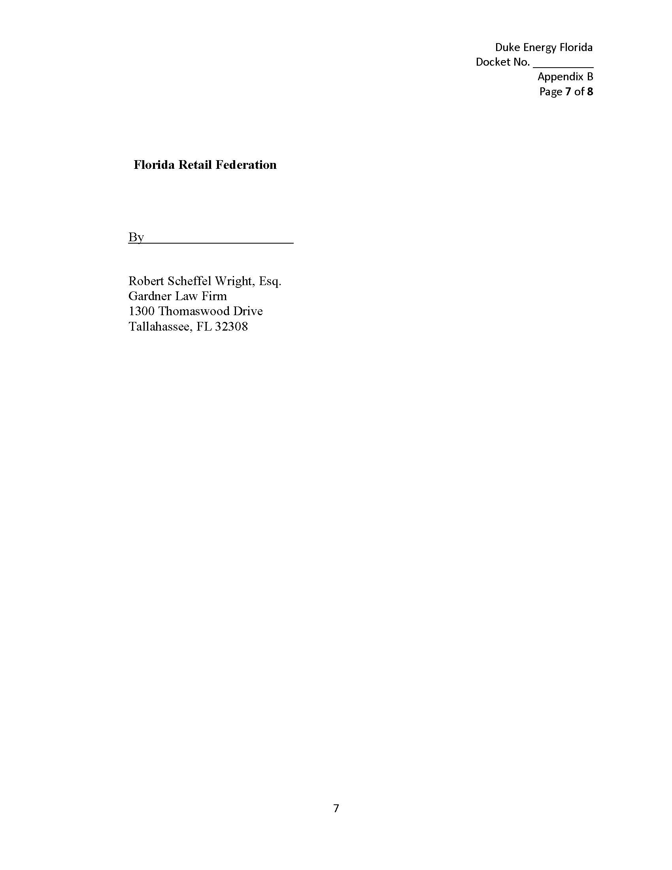

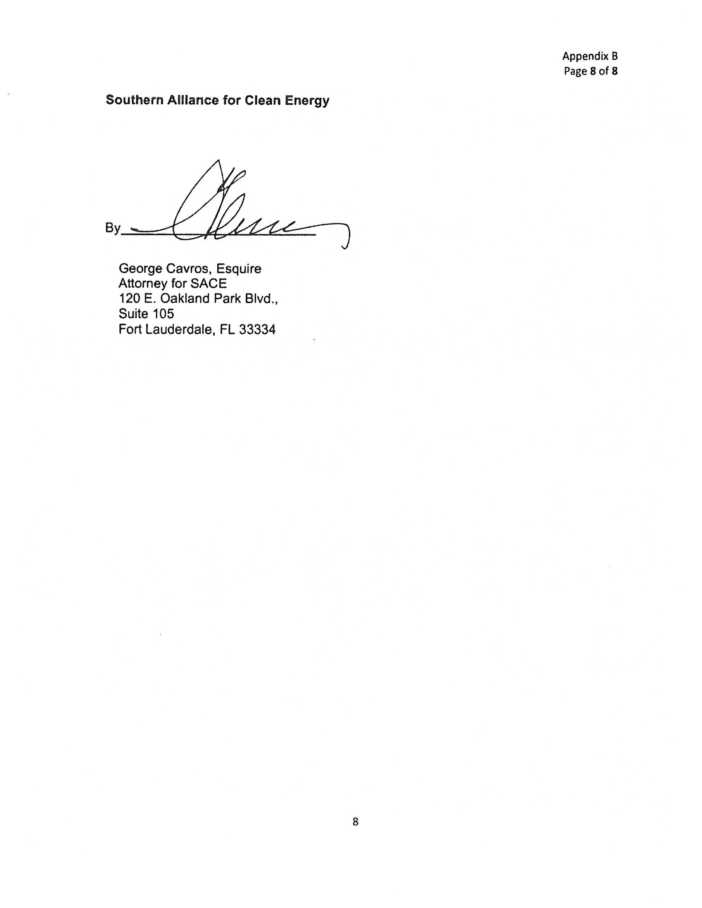

Order No. PSC-2017-0451-AS-EU, issued November 20, 2017, in Docket No. 20170183-EI, In re: Application for limited proceeding to approve 2017 second revised and restated settlement agreement, including certain rate adjustments, by Duke Energy Florida, LLC.
Order No PSC-2019-0053-FOF-EI, issued February 1, 2019, in Docket No. 20180047-EI, In re: Consideration of the tax impacts associated with Tax Cuts and Jobs Act of 2017 for Duke Energy Florida, LLC.
The tax reform benefits offset the approved storm recovery charge of $6.95 per 1,000 kWh on a residential bill.

