State of Florida |  | Public Service Commission  Capital Circle Office Center ● 2540 Shumard Oak Boulevard  Tallahassee, Florida 32399-0850  -M-E-M-O-R-A-N-D-U-M-
DATE: | August 22, 2019
TO: | Office of Commission Clerk (Teitzman)
FROM: | Division of Economics (Coston, Draper)  Office of the General Counsel (Brownless)
RE: | Docket No. 20190132-EI – Petition for authority for approval of non-firm energy pilot program and tariff by Florida Public Utilities Company.
AGENDA: | 09/05/19 – Regular Agenda – Tariff Filing – Interested Persons May Participate
COMMISSIONERS ASSIGNED: |  |  | All Commissioners
PREHEARING OFFICER: |  |  | Administrative
CRITICAL DATES: |  |  | 60-day suspension date waived by the utility until 09/05/2019
SPECIAL INSTRUCTIONS: |  |  | None

Case Background
On June 18, 2019, Florida Public Utilities Company (FPUC or utility) filed a petition for approval of a non-firm energy pilot program and tariff (pilot program). Under the proposed pilot program, FPUC would purchase non-firm energy from Florida Power & Light Company (FPL), pursuant to its wholesale purchased power contract with FPL, and resell the non-firm energy to qualifying industrial customers who own self-generation. The utility proposes the pilot to end on December 31, 2020.
On July 2, 2019, FPUC waived the 60-day file and suspend provision of Section 366.06(3), Florida Statutes (F.S.), until the September 5, 2019 Agenda Conference. On July 23, 2019, FPUC responded to staff’s first data request. In its response, FPUC included corrected tariff sheets. Specifically, FPUC removed the $500 monthly administrative charge that was erroneously included in the tariffs filed with the petition and corrected a tariff sheet’s numbering. On August 22, 2019, FPUC filed certain additional minor corrections to the proposed tariffs. The revised tariff sheets, as filed on August 22, 2019 are shown in Attachment A to this recommendation. The Commission has jurisdiction over this matter pursuant to Sections 366.04, 366.05, and 366.06, F.S.

Discussion of Issues

Issue 1:
Should the Commission approve FPUC’s petition for the approval of its pilot program and associated tariff?

Recommendation:
Yes, the Commission should approve FPUC’s petition for the pilot program and associated tariff effective September 5, 2019. The proposed tariff sheets are shown in Attachment A to this recommendation. If FPUC wishes to extend or make permanent the pilot program, FPUC should petition the Commission regarding the future of the pilot program prior to the December 31, 2020 expiration date. (Coston, Draper)

Staff Analysis:
FPUC does not generate electricity to serve its customers; rather, FPUC’s Northeast Division currently purchases power to serve its customers from FPL pursuant to a wholesale purchased power agreement. FPUC recovers its payments to FPL from its customers through the fuel and purchased power cost recovery clause factors (fuel factors) the Commission approves in the annual fuel hearing.
On April 10, 2017, FPUC and FPL executed a Native Load Firm All Requirements Power and Energy Agreement (agreement) that includes a provision allowing FPUC to purchase non-firm energy from FPL pursuant to FPL’s wholesale TS-1 tariff. The TS-1 tariff is an economy energy tariff under which FPL sells non-firm energy at FPL’s forecasted incremental fuel cost to wholesale customers. The TS-1 tariff has been approved by the Federal Energy Regulatory Commission (FERC).
The proposed pilot program is designed for FPUC to purchase non-firm energy from FPL pursuant to the TS-1 tariff and sell the non-firm energy to qualifying industrial customers. Specifically, to qualify for the proposed pilot program, customers must qualify for FPUC’s General Service Large Demand (GSLD), GSLD-1, or standby tariffs and own dispatchable self-generation. The proposed pilot program is limited to a maximum of three customers.
FPUC currently provides service to two industrial customers that would qualify for the proposed pilot program: Rayonier Advanced Materials (Rayonier) and WestRock. Both customers produce paper and lumber products and are operating on Amelia Island. FPUC explained that when the utility discussed with Rayonier and WestRock the option of being able to purchase non-firm energy from FPL, both customers expressed interest in a non-firm energy option to add to their generation mix.
Rayonier and WestRock have on-site generation that provides the majority of their energy and capacity requirements. FPUC explained that these two customers use coal, natural gas, or heat from burning wood by-products to generate electricity. FPUC serves as a back-up energy resource. The amount of energy Rayonier and WestRock purchase from the utility varies based on the operational status of the facilities. The utility states that the pilot program could allow the participants to purchase non-firm energy at a lower price than the cost to self-generate, which could provide a benefit to the production costs of Rayonier and WestRock.
Customers who choose to take service under the pilot program agree to a minimum of 12 months of service; service will continue thereafter until the customer submits a written notice of termination to FPUC. Pursuant to the proposed pilot program, FPL will notify FPUC each Friday morning of the hourly non-firm energy prices starting Sunday at midnight. FPUC will then notify the participating customers of the non-firm energy prices (expressed in dollars per megawatt-hour) by 10 am. The customers must submit to FPUC their non-firm energy purchases, or nominations, for the following week by 2 pm of the same day and FPUC will forward that information to FPL. Participating customers must purchase a minimum of 1,500 megawatt-hours per year.
The utility explained that Rayonier and WestRock would immediately benefit from the proposed pilot program. While the proposed pilot program would be available to three customers, FPUC explained that the utility is not aware of a third customer who currently would be interested in the pilot program.
The non-firm energy costs charged by FPL to FPUC will be directly passed by the utility to the non-firm pilot customers. The utility states it would not assess any administrative, energy, or demand surcharges under the proposed pilot program. FPUC explained that it expects its administrative cost to administer the non-firm pilot to be minimal; however, FPUC would petition the Commission to modify the pilot program tariff in the future should administrative charges be appropriate. Additionally, FPUC stated the cost to purchase non-firm energy from FPL and revenues received from customers participating in pilot program would not be included in the utility’s Purchased Power Cost Recovery filing, Docket No. 20190001-EI.
FPUC proposed to offer the non-firm tariff as a pilot in order to determine whether this energy supply option is beneficial to participating customers and the utility. FPUC states that the pilot program will be revenue neutral to the utility and the general body of ratepayers as the cost of the non-firm energy will be passed directly through to the customers participating in the pilot.
Furthermore, FPUC explained that the utility’s overall load factor in its Northeast Division is currently impacted by the demand and energy purchases from Rayonier and WestRock. When these customers make short term purchases of electricity from FPUC, it increases FPUC’s monthly maximum demand. However, this increase in demand does not increase the total energy amount by the same percentage, which results in a negative impact on the utility’s load factor. FPUC states that the proposed pilot program would provide participants the incentive to purchase energy over longer periods of time resulting in a positive impact on FPUC’s load factor in the Northeast Division. FPUC’s load factor is considered by wholesale energy providers when negotiating the pricing contained in purchased power contracts. An improved load factor would benefit FPUC’s general body of ratepayers through lower fuel factors when future agreements for wholesale power are negotiated.

Conclusion
The Commission should approve FPUC’s petition for the pilot program and tariff, as shown in Attachment A, effective September 5, 2019. This pilot program would allow FPUC to assess the benefits of offering a non-firm energy program to its industrial customers with self-generation. The pilot program would be revenue-neutral to the utility and have a potential benefit to both participants and FPUC’s general body of ratepayers. If FPUC wishes to extend or make permanent the pilot program, FPUC should be required to petition the Commission regarding the future of the program prior to the December 31, 2020 expiration date.

Issue 2:
Should this docket be closed?

Recommendation:
If a protest is filed within 21 days of the issuance of the order, this tariff should remain in effect, with any revenues held subject to refund, pending resolution of the protest. If no timely protest is filed, this docket should be closed upon the issuance of a consummating order. (Brownless)

Staff Analysis:
If a protest is filed within 21 days of the issuance of the order, this tariff should remain in effect, with any revenues held subject to refund, pending resolution of the protest. If no timely protest is filed, this docket should be closed upon the issuance of a consummating order.

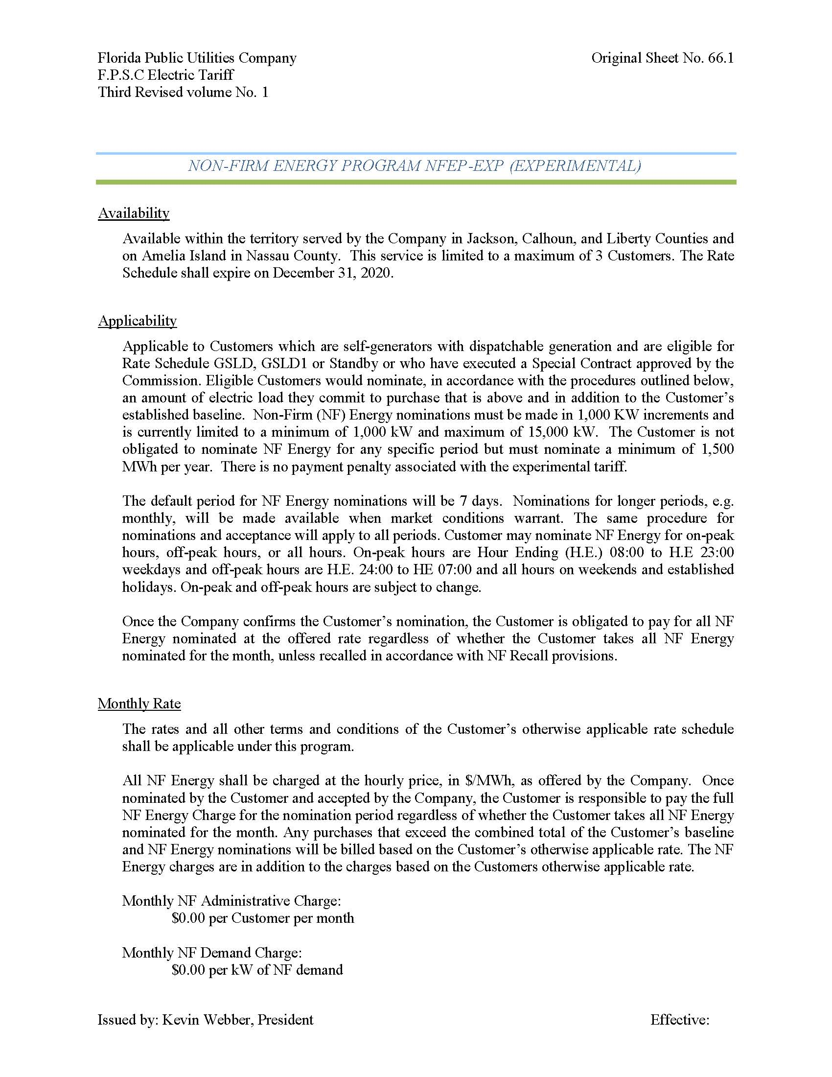

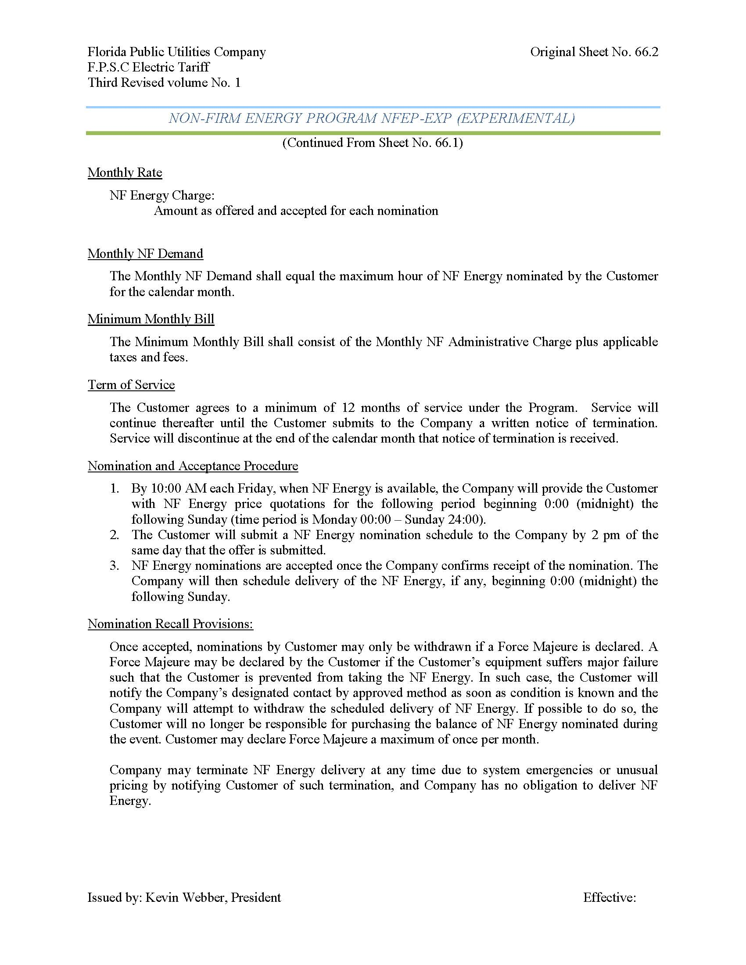

FPUC’s Northwest Division currently purchases power from Gulf Power Company pursuant to a wholesale purchased power agreement.

