BEFORE THE FLORIDA PUBLIC SERVICE COMMISSION

In re: Petition for approval of revised underground residential distribution tariffs, by Duke Energy Florida, LLC. | DOCKET NO. 20190076-EI  ORDER NO. PSC-2019-0443-TRF-EI  ISSUED: October 23, 2019

The following Commissioners participated in the disposition of this matter:

ART GRAHAM, Chairman
JULIE I. BROWN
DONALD J. POLMANN
GARY F. CLARK
ANDREW GILES FAY

ORDER GRANTING DUKE ENERGY FLORIDA, LLC’s
PETITION FOR APPROVAL OF REVISED UNDERGROUND
RESIDENTIAL DISTRIBUTION TARIFF MODIFICATION

BY THE COMMISSION:

Background
On April 1, 2019, Duke Energy Florida, LLC (Duke or utility) filed a petition for approval of revisions to its underground residential distribution (URD) tariffs. The URD tariffs apply to new residential subdivisions and represent the additional costs, if any, Duke incurs to provide underground distribution service in place of overhead service. The proposed (legislative version) URD tariffs are contained in Attachment A to this order. We approved Duke’s current URD charges in Order No. PSC-2017-0283-TRF-EI (2017 order).
We suspended Duke’s proposed tariffs by Order No. PSC-2019-0212-PCO-EI. Duke responded to Commission staff’s first data request on May 31, 2019. We have jurisdiction over this matter pursuant to Sections 366.03, 366.04, 366.05, and 366.06, Florida Statutes (F.S.).

Decision
Rule 25-6.078, Florida Administrative Code (F.A.C.), defines investor-owned utilities’ (IOU) responsibilities for filing updated URD tariffs. Duke filed the instant petition pursuant to subsection (3) of the rule, which requires IOUs to file supporting data and analyses for updated URD tariffs if the cost differential varies from the our approved differential by more than ten percent. On October 15, 2018, pursuant to Rule 25-6.078, F.A.C., Duke informed us that its differential for the low density subdivision decreased by 81 percent from the differential approved in the 2017 order, requiring Duke to file the instant petition.
The URD tariffs provide charges for underground service in new residential subdivisions and represent the additional costs, if any, the utility incurs to provide underground service in place of overhead service. The cost of standard overhead construction is recovered through base rates from all ratepayers. In lieu of overhead construction, customers have the option of requesting underground facilities. Any additional cost is paid by the customer as contribution-in-aid-of-construction (CIAC). Typically, the URD customer is the developer of a subdivision.
Traditionally, three standard model subdivision designs have been the basis upon which each IOU submits URD tariff changes for our approval: low density, high density, and a high density subdivision where dwelling units take service at ganged meter pedestals (groups of meters at the same physical location). While actual construction may differ from the model subdivisions, the model subdivisions are designed to reflect average overhead and underground subdivisions.
Costs for underground construction have historically been higher than costs for standard overhead construction and the additional cost is paid by the customer as a CIAC. However, as shown on Table 1, Duke’s proposed URD differential charges are $0 per lot for the low density and ganged meter subdivisions. Therefore, the URD customer shall not be assessed a CIAC charge for requesting underground service in the low density and ganged meter subdivisions. For the high density subdivision the proposed differential decreased from $403 to $34 per lot. The decrease in the differentials is primarily attributable to changes in Duke’s operational costs, as discussed in more detail in the section of our order titled operational costs.
Table 1 shows the current and proposed URD differentials for the low density, high density, and ganged meter subdivisions. The charges shown are per-lot charges.
Table 1
Comparison of URD Differential per Lot
Types of Subdivision | Current URD Differential | Proposed URD Differential
Low Density | $694 | $0
High Density | $403 | $34
Ganged Meter | $158 | $0
Source: Order PSC-2017-0283-TRF-EI and Duke’s 2019 Petition
The calculations of the proposed URD charges include (1) updated labor and material costs along with the associated loading factors and (2) operational costs. The costs are discussed below.

Labor and Material Costs
The installation costs of both overhead and underground facilities include the labor and material costs to provide primary, secondary, and service distribution lines, as well as transformers. The costs of poles are specific to overhead service while the costs of trenching and backfilling are specific to underground service. The utilities are required by Rule 25-6.078 (5), F.A.C., to use current labor and material costs.
Duke’s labor costs for overhead and underground construction are comprised of costs associated with work performed by both in-house employees and outside contractors. Duke’s in-house labor rates are based upon actual labor costs negotiated in bargaining unit contracts and labor rates with contractors are negotiated. Table 2 compares total 2017 and 2019 labor and material costs for the three subdivision models.
Table 2
Labor and Material Costs per Lot
 | 2017 Costs | 2019 Costs | Difference
Low Density
Underground Labor/Material Costs | $1,477 | $1,620 | $143
Overhead Labor/Material Costs | $1,069 | $1,323 | $254
Per lot Differential | $408 | $297 | ($111)
High Density
Underground Labor/Material Costs | $1,181 | $1,484 | $303
Overhead Labor/Material Costs | $865 | $1,009 | $144
Per lot Differential | $316 | $475 | $159
Ganged Meter
Underground Labor/Material Costs | $686 | $581 | ($105)
Overhead Labor/Material Costs | $609 | $750 | $141
Per lot Differential | $77 | ($169) | ($246)
Source: 2017 Order and Duke’s 2019 filing
As Table 2 shows, the majority of overhead and underground labor and material costs have increased since 2017. Because of a design change as discussed in more detail in the section of the order titled subdivision design changes, the only exception to the increase in costs can be seen in the underground ganged meter labor and material costs (decrease from $686 to $581).

Subdivision Design Changes

Duke stated that the utility began using a new underground design software in the fall of 2017. Duke explained that the new software incorporates the most recent loading parameters for cables and transformers to design the most cost-effective way (in terms of number of transformers, transformer size, and cable length) to serve a home. The high density subdivision design was modified to reflect front lot construction as required by Rule 25-6.0341(1), F.A.C.
With respect to the underground ganged meter subdivision design, Duke explained that the design was modified to reflect townhome construction. Duke has had very few new underground mobile home parks that are typically served by a ganged meter, but several new townhome projects taking underground service at a ganged meter. The result of incorporating townhome construction is more units served from the ganged meter, and therefore, reduced per lot costs. As seen in Table 2 above, the total underground labor and material costs decreased from $686 to $581.
The three overhead designs had minor modifications to meet both National Electric Safety Code and Duke’s construction standards. Specifically, the overhead design was modified to incorporate Duke’s current standards that require increased insulation levels, taller poles, and increased spaces between the phases.

Operational Costs

Rule 25-6.078(4), F.A.C., requires that the differences in net present value (NPV) of operational costs between overhead and underground systems, including average historical storm restoration costs over the life of the facilities, be included in the URD charge. The inclusion of the operational cost is intended to capture longer term costs and benefits of undergrounding.
Operational costs include operations and maintenance costs along with capital costs and represent the cost differential between maintaining and operating an underground versus an overhead system over the life of the facilities. The inclusion of the storm restoration cost in the URD calculations lowers the differential, since an underground distribution system generally incurs less damage than an overhead system as a result of a storm, and therefore, less restoration costs when compared to an overhead system.
The utility used a 5-year average of historical operational costs (2014-2018) for its calculations in this docket. The methodology used by Duke in this filing for calculating the NPV of operational costs was approved in Order No. PSC-12-0348-TRF-EI. We note that operational costs may vary among IOUs due to multiple factors, including differences in size of service territory, miles of coastline, regions subject to extreme winds, age of the distribution system, or construction standards.
Non-storm Operational Costs
Duke’s operational costs for an overhead system have increased more than the operational cost for an underground system. The resulting differentials are shown in Column B in Table 3. For the low density subdivision, the operational cost differential in 2017 was $350 (indicating that underground operational costs were higher than overhead operational costs). As shown in Table 3, the operational cost differential for the low density subdivision is now $80. For the high density and ganged meter subdivisions, the operational cost differentials decreased from $126 and $109 to -$20 and -$1, respectively, indicating that overhead operational costs are slightly higher than underground operational costs. Duke explained that the primary reason for this change in operational costs is the increase in overhead operational costs as a result of Duke’s increased maintenance, such as pole replacements, on its overhead distribution system.
Avoided Storm Restoration Costs
Duke explained that the recent hurricane season significantly increased the avoided storm restoration costs impacts. Specifically, Duke stated the utility incorporated overhead storm restoration costs for hurricanes Irma, Nate, Michael, Matthew, Hermine, and tropical storm Colin. Therefore, the amount representing avoided storm restoration costs significantly increased from 2017.
Table 3 presents the pre-operational, non-storm operational, and the avoided storm restoration cost differentials between overhead and underground systems. The proposed differential is $0 when the calculation results in a negative number.
Table 3
NPV of Operational Costs Differential per Lot
Type of Subdivision | Pre-Operational Costs  (A) | Non-storm Operational costs  (B) | Avoided Storm costs  (C) | Proposed URD Differentials  (A)+(B)+(C)
Low Density | $297 | $80 | ($726) | $0
High Density | $475 | ($20) | ($421) | $34
Ganged Meter | ($169) | ($1) | ($312) | $0
Source: 2019 Filing
Conclusion
We have reviewed Duke’s proposed URD tariffs and associated charges, its accompanying work papers, and its responses to Commission staff’s data request. We find the proposed URD tariffs and associated charges to be reasonable and approve Duke’s proposed URD tariffs and associated charges as shown in Attachment A, effective September 5, 2019.
Based on the foregoing, it is
ORDERED by the Florida Public Service Commission that Duke Energy Florida, LLC’s proposed URD tariffs and associated charges as shown in Attachment A, are approved effective October 3, 2019. It is further
ORDERED that if a protest is filed within 21 days of issuance of the Order, the tariff shall remain in effect with any charges held subject to refund pending resolution of the protest. It is further

ORDERED that if no timely protest is filed, this docket shall be closed upon the issuance of a Consummating Order.

By ORDER of the Florida Public Service Commission this 23rd day of October, 2019.

/s/ Adam J. Teitzman
ADAM J. TEITZMAN
Commission Clerk
Florida Public Service Commission
2540 Shumard Oak Boulevard
Tallahassee, Florida 32399
(850) 413-6770
www.floridapsc.com

Copies furnished: A copy of this document is provided to the parties of record at the time of issuance and, if applicable, interested persons.

WLT

NOTICE OF FURTHER PROCEEDINGS

The Florida Public Service Commission is required by Section 120.569(1), Florida Statutes, to notify parties of any administrative hearing or judicial review of Commission orders that is available under Sections 120.57 or 120.68, Florida Statutes, as well as the procedures and time limits that apply. This notice should not be construed to mean all requests for an administrative hearing or judicial review will be granted or result in the relief sought.

Mediation may be available on a case-by-case basis. If mediation is conducted, it does not affect a substantially interested person's right to a hearing.

The Commission's decision on this tariff is interim in nature and will become final, unless a person whose substantial interests are affected by the proposed action files a petition for a formal proceeding, in the form provided by Rule 28-106.201, Florida Administrative Code. This petition must be received by the Office of Commission Clerk, 2540 Shumard Oak Boulevard, Tallahassee, Florida 32399-0850, by the close of business on November 13, 2019.

In the absence of such a petition, this Order shall become final and effective upon the issuance of a Consummating Order.

Any objection or protest filed in this docket before the issuance date of this order is considered abandoned unless it satisfies the foregoing conditions and is renewed within the specified protest period.

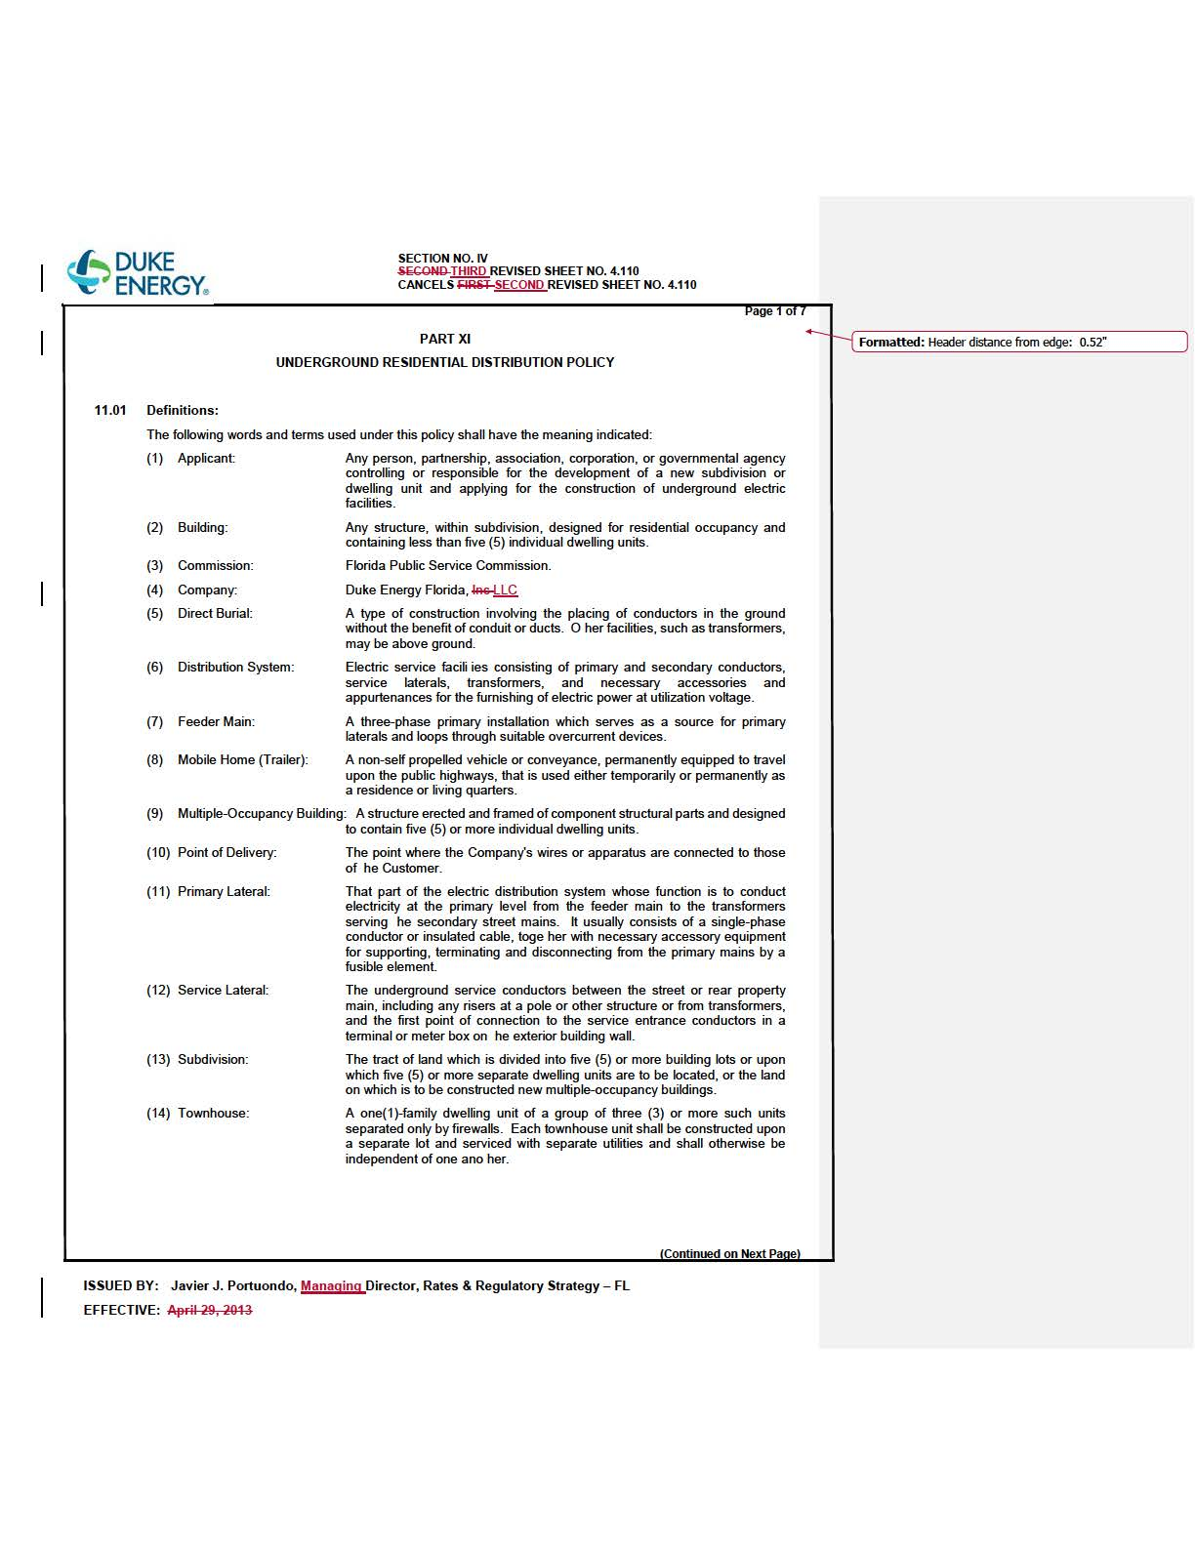

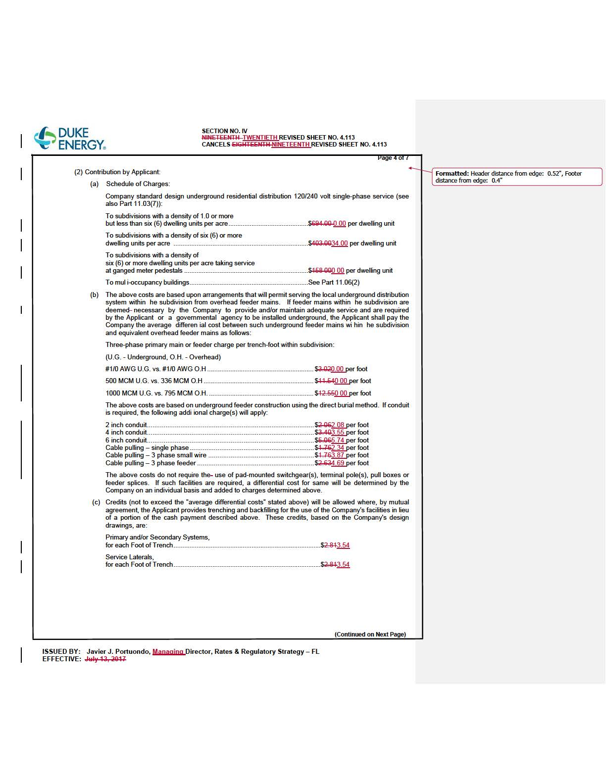

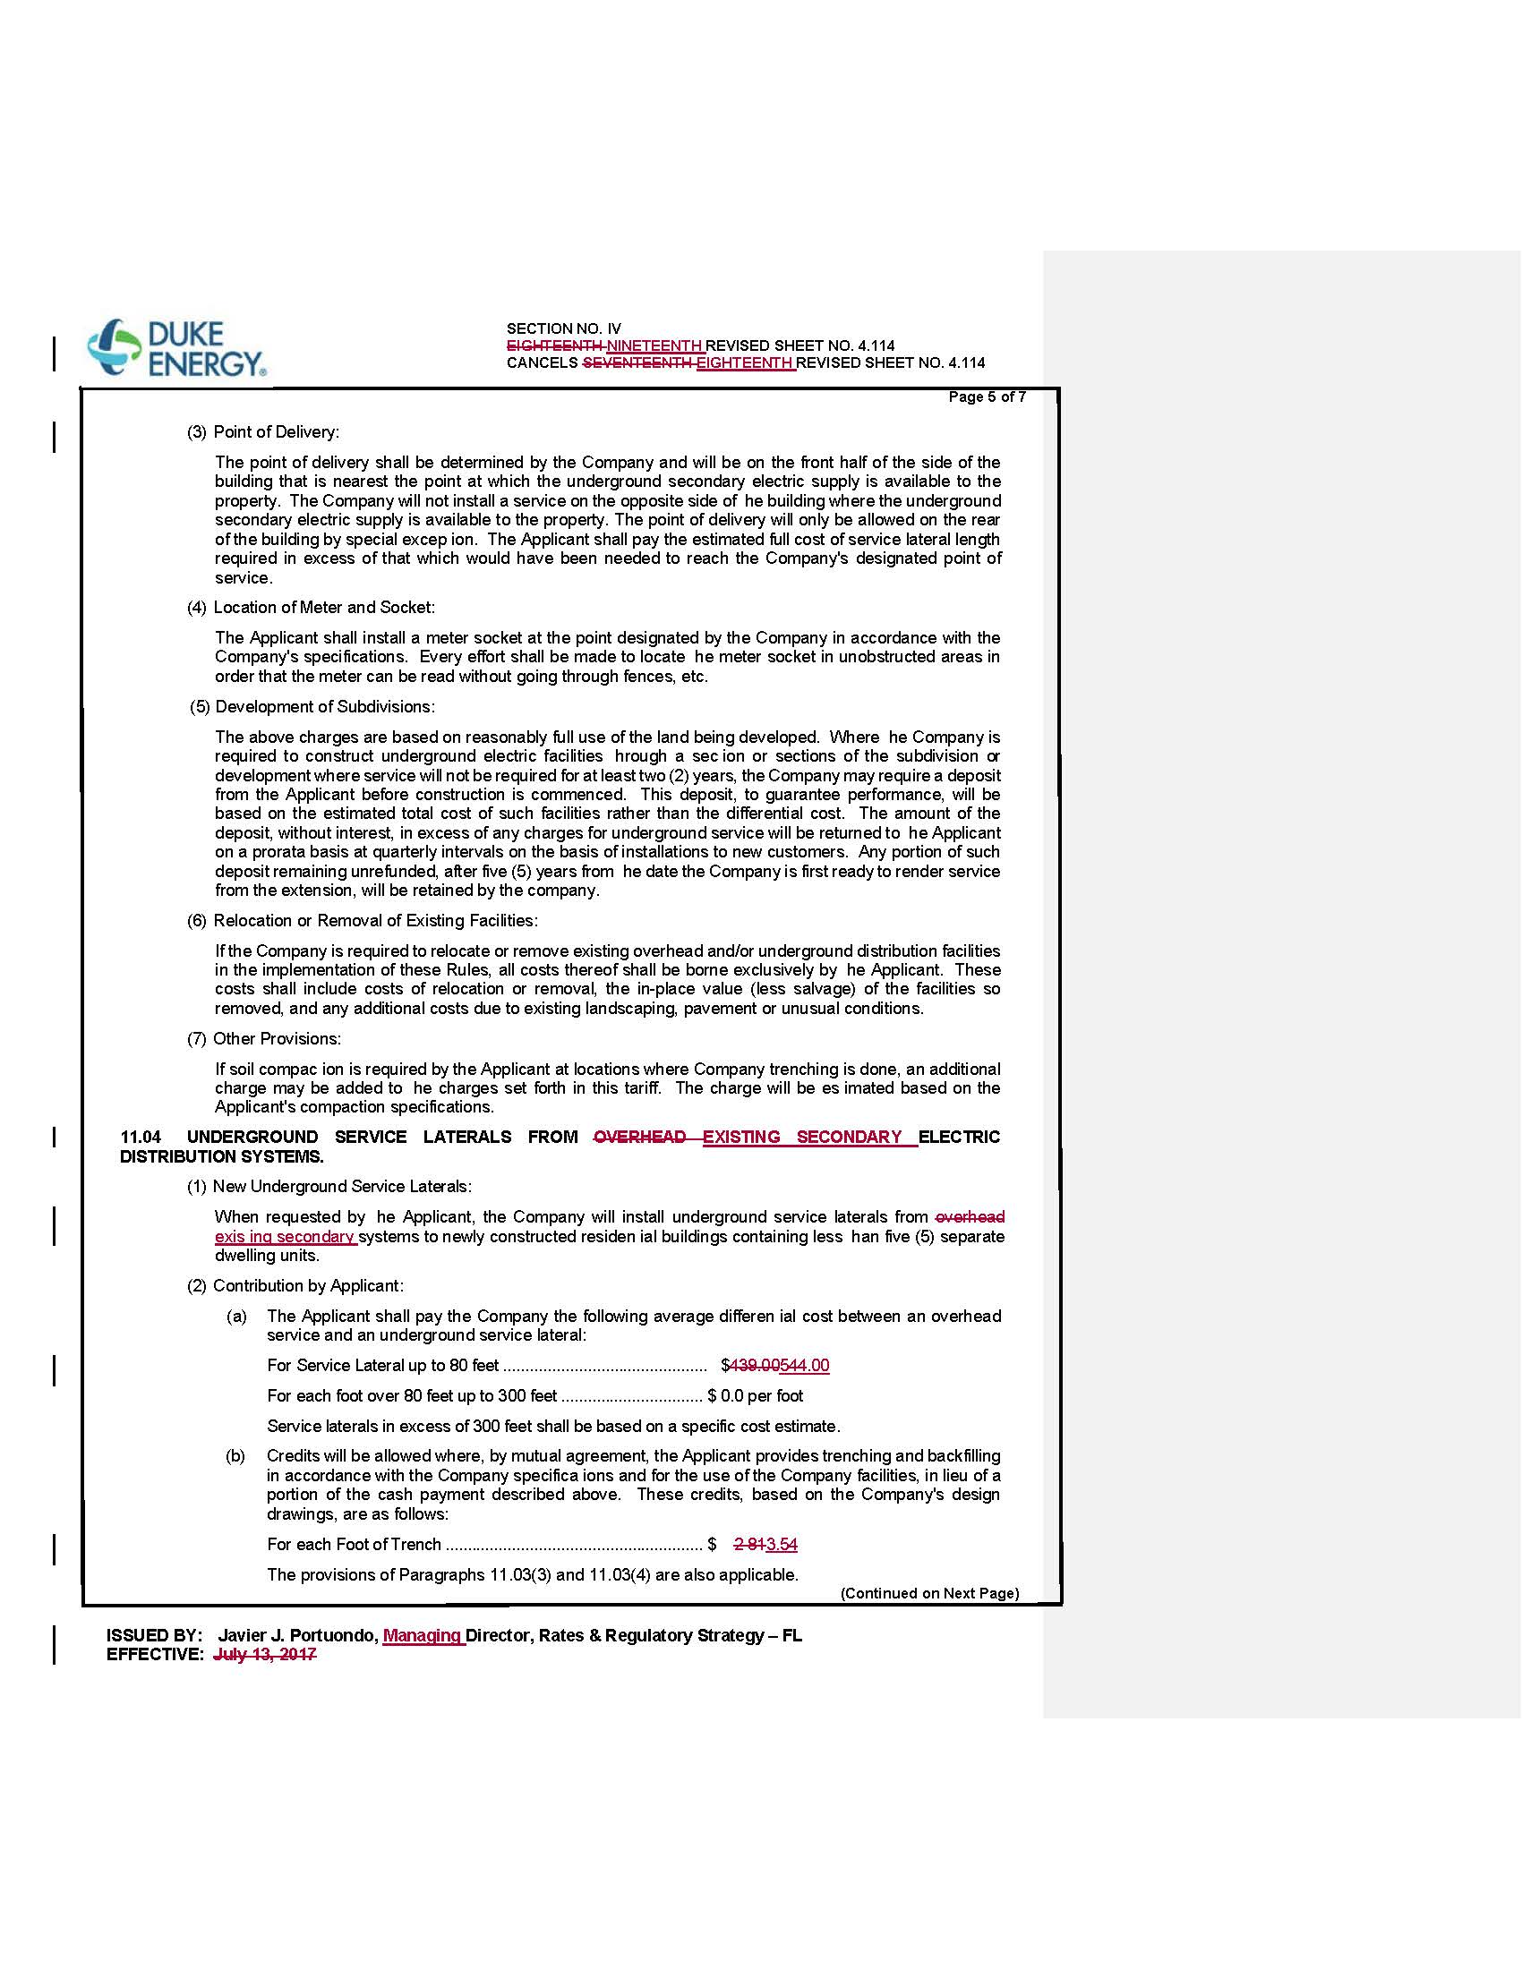

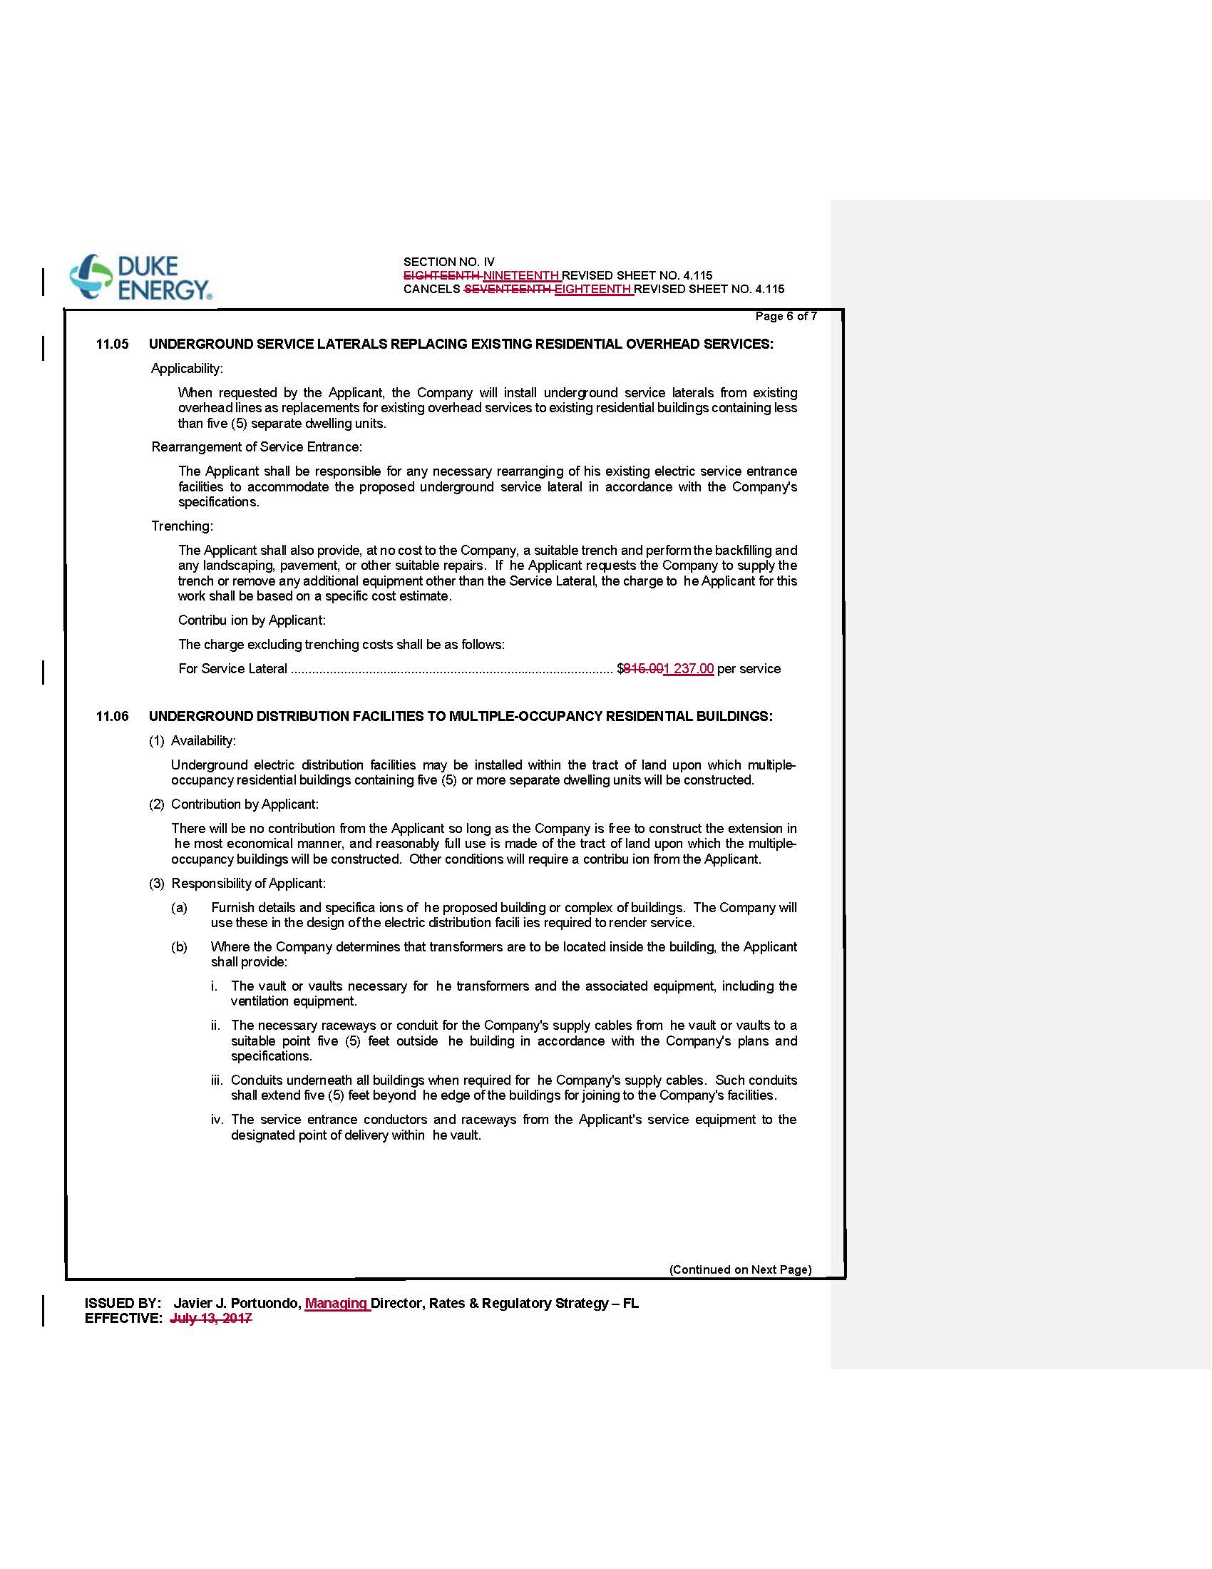

Order No. PSC-2017-0283-TRF-EI, issued July 24, 2017, in Docket No. 20170069-EI, In re: Petition for approval of revised underground residential distribution tariffs, but Duke Energy Florida, LLC.
Order No. PSC-2019-0212-PCO-EI, issued June 3, 2019, in Docket No. 20190076-EI, In re: Petition for approval of revised underground residential distribution tariffs, by Duke Energy Florida, LLC.
Order No. PSC-12-0348-TRF-EI, issued July 5, 2012, in Docket No. 110293-EI, In re: Petition for approval of revised underground residential distribution tariffs, by Progress Energy Florida, Inc.

