State of Florida |  | Public Service Commission  Capital Circle Office Center ● 2540 Shumard Oak Boulevard  Tallahassee, Florida 32399-0850  -M-E-M-O-R-A-N-D-U-M-
DATE: | October 24, 2019
TO: | Office of Commission Clerk (Teitzman)
FROM: | Office of Industry Development and Market Analysis (Deas, Fogleman, Wendel, Yglesias de Ayala)  Office of the General Counsel (Dziechciarz, Weisenfeld)
RE: | Docket No. 20190135-TP – Petition of North American Numbering Plan Administrator on behalf of the Florida telecommunications industry, for approval of relief plan for the exhaust of the 850 area code.
AGENDA: | 11/5/19 – Regular Agenda – Interested Persons May Participate
COMMISSIONERS ASSIGNED: |  |  | All Commissioners
PREHEARING OFFICER: |  |  | Polmann
CRITICAL DATES: |  |  | The estimated exhaust date for the 850 area code is third quarter 2021
SPECIAL INSTRUCTIONS: |  |  | None

Case Background
On June 27, 2019, the North American Numbering Plan Administrator (NANPA), on behalf of Florida’s telecommunications industry (Industry) filed a petition with the Florida Public Service Commission (Commission) for approval of the Industry’s consensus decision to implement an all-services overlay as the area code relief plan for the 850 Numbering Plan Area (NPA). NANPA projects that the supply of central office codes in the 850 NPA will exhaust during the third quarter of 2021. Consequently, NANPA is requesting that the Commission approve the recommended 13-month implementation schedule.
NANPA is the neutral third-party administrator that administers the North American Numbering Plan, which is the area code system shared by the United States, Canada, Bermuda, and 17 Caribbean countries. NANPA’s responsibilities include assigning area codes and prefixes, and tracking numbering usage to ensure effective and efficient utilization. NANPA is also responsible for forecasting the exhaust of geographic area codes and area code relief planning. NANPA publishes its forecasted exhaust of all area codes on a semi-annual basis. This forecast is used to determine when to start the area code relief process.

The area served by NANPA is divided into NPA which are each identified by a three-digit NPA code, commonly called an area code. Telephone numbers are in a 10-digit format, consisting of a 3-digit area code, a 3-digit central office code (NXX), and a 4-digit station address code (for example 850-413-0000). Each NPA is divided into local serving areas called rate centers. Rate center boundaries determine if a call is local or long distance. Originally, telephone numbers were assigned to carriers in number blocks of 10,000. However, in an effort to conserve numbering resources, the thousand-block number pooling system was implemented. The thousand-block number pooling system allocates telephone numbers to carriers in blocks of 1,000 instead of the historical 10,000. Under this system, an unused 1,000 number block can be reclaimed and returned to inventory if it is not activated within six months of being assigned, unless the carrier can provide the Commission with a valid reason for needing an extension. Each area code contains 792 usable prefixes containing 10,000 numbers each. Once all of the prefixes have been assigned, a new area code is necessary.

The 850 area code was introduced in 1997 when the 904 area code needed area code relief due to substantial growth in demand for telephone numbers. The Commission approved a geographic split as the form of relief for the 904 area code. The 850 area code was then assigned to the northern portion of Florida known as the Panhandle. This area is made up of 64 rate centers and 18 counties, which include cities such as Pensacola, Panama City and Tallahassee. Also located within the 850 area code are Eglin and Tyndall Air Force Bases. Proactive number conservation methods such as the implementation of thousand-block pooling in 2003 extended the life of the 850 area code.

In October 2018, NANPA forecasted a need for area code relief for the 850 area code. Subsequently, pursuant to the area code Relief Planning Guidelines, NANPA began the relief planning process by announcing the need for relief and distributing an initial planning document to the Industry. NANPA then hosted an Industry relief meeting on May 16, 2019, to discuss possible relief alternatives for the 850 area code. During the meeting, the Industry reviewed four relief options and reached a consensus to recommend the all-services distributed overlay plan to the Commission as the preferred method of relief for the 850 area code.

On June 27, 2019, NANPA filed a petition with the Commission on behalf of the Industry requesting approval of the consensus decision. The Commission has jurisdiction to address this issue pursuant to Section 364.16(7) and 120.80(13)(d), Florida Statutes, and 47 Code of Federal Regulations (C.F.R) § 52.19.

Discussion of Issues

Issue 1:
Should the Commission approve the Industry's consensus recommendation of an all-services distributed overlay as the area code relief plan for the 850 area code?

Recommendation:
Yes, the Commission should approve the Industry's consensus recommendation of an all-services distributed overlay as the area code relief plan for the 850 area code. (Deas, Fogleman, Wendel, Yglesias de Ayala, Dziechciarz, Weisenfeld)

Staff Analysis:
Area code relief responsibilities have been delegated to the states by the Federal Communication Commission (FCC) pursuant to 47 C.F.R. § 52.19. In Florida, the Commission is responsible for determining the appropriate form of area code relief when telephone numbers exhaust within an area code. There are a number of methods available to deal with area code exhaust issues; however, the two most commonly used methods are a geographic split or an overlay.

Geographic Split

The geographic split method divides the exhausting NPA into two geographic areas, leaving the existing area code to serve one NPA and assigning a new area code to serve the remaining NPA. This method generally acknowledges jurisdictional or natural boundaries, but for technical reasons and number optimization considerations, the actual boundaries must conform to existing rate center boundaries. Under this method, customers on both sides of the split would retain seven digit dialing; however, it would require one half of the customers to change their area code. The last split implemented in Florida was 17 years ago.

Industry guidelines specify that in the case of a geographic split, a difference in area code life expectancies between two areas should be 10 years or less. According to NANPA, a geographic split in the 850 NPA would result in an exhaust life that exceeds this 10 year limit between the two areas. Therefore, no split alternative was included in NANPA’s petition.

Overlay

The overlay method adds a new area code to the same geographic area served by the area code requiring relief. This results in the assignment of more than one area code to the same NPA. Current customers keep their existing area code and number; however, new customers or customers adding additional lines would receive the new area code. Once an overlay is implemented, the FCC requires 10-digit dialing for all local calls within the NPA. There are four potential implementation strategies for an overlay, which are as follows:

a) All-Services Distributed Overlay - The distributed overlay strategy may be considered in situations when growth in telephone numbers is expected to be more or less evenly distributed throughout the existing NPA. The new area code is added to the same geographic area as the area code requiring relief and shares exactly the same geographic boundaries.

b) Concentrated Growth Overlay - A concentrated growth overlay may be considered in situations when the majority of the new telephone numbers are expected to be concentrated in one section of the existing NPA. For example, a fast growing metropolitan area and a sparsely populated rural area could exist within the same NPA. The overlay area code would be assigned initially to the section of the NPA experiencing the fastest growth, and new phone numbers in that section would be assigned from the new area code. As more relief is required, the geographic area served by multiple area codes could expand to the rest of the NPA. This method is not appropriate for the 850 NPA because there are multiple concentrated rate centers through out the geographic area.

c) Boundary Elimination Overlay - With a boundary elimination overlay, the NPA requiring relief is adjacent to an NPA with available numbering resources. The boundary between these NPAs is eliminated, and spare telephone numbers from the adjacent area code are assigned within the original NPA boundary where relief is required. This solution has the advantage of not requiring a new area code, but it would not provide long-term relief for the 850 NPA.

d) Multiple Overlay - The multiple overlay strategy may be considered where relief is required in an NPA served by two or more area codes. The new area code would be assigned to overlay the multiple existing area codes serving the entire geographic area. The 850 NPA does not currently have multiple area codes; therefore, this option was not applicable.

On May 16, 2019, NANPA held an Industry meeting in order to reach a consensus on a relief plan for the 850 NPA. The following four relief plans were considered.

Alternative #1 – All-Services Distributed Overlay (see map in Attachment A)
A new area code would be assigned to the same geographic area occupied by the existing 850 area code. One of the advantages to this alternative is that existing customers would be able to retain their current telephone numbers, and it provides for easier customer education and minimizes customer confusion. Also, this alternative is easier to implement from a technical perspective. The projected life of this method would be approximately 41 years, which is the longest of all the alternatives. However, 10-digit local dialing would be required by all customers within the NPA.

Alternative #2 – NPA Boundary Elimination Overlay (see map in Attachment B)
The boundary between the existing 850 and 386 NPAs would be eliminated and the two area codes would be assigned to the same geographic area. This alternative would allow customers assigned to both the 850 and 386 area codes to retain their telephone numbers and would eliminate the need for a new area code. Eliminating the boundary between these NPAs would result in a projected life of approximately 19 years before additional relief would be required. However, it would require ten-digit dialing for customers within the now combined NPAs. The forecasted exhaust of the 386 area code is more than 30 years; therefore, this alternative would result in premature 10-digit dialing for customers in the 386 NPA.

Alternative #3 – NPA Boundary Elimination Overlay (see map in Attachment C)
The boundary between the existing 850, 386, and 904 NPAs would be eliminated, and all three area codes would be assigned to the same geographic area. Customers would retain their current telephone numbers; however, ten-digit dialing would be required. At exhaust of the 850 area code, all future telephone number assignments would be made from the 386 and 904 area codes. Eliminating the boundary between these NPAs would result in a projected life of approximately 18 years before additional relief would be required.

Alternative #4 – NPA Boundary Elimination Overlay (see map in Attachment D)
The boundary between the existing 850, 386, 904, and 352 NPAs would be eliminated. Customers would retain their current telephone numbers; however, ten-digit dialing would be required. At exhaust of the 850 area code all future telephone number assignments will be assigned from the 386, 904, and 352 area codes. Eliminating the boundary between these four NPAs would result in a projected life of approximately 18 years before additional relief would be required.

After review of the four alternatives and the related information, the Industry reached a consensus recommending Alternative No. 1, an all-services distributed overlay, as the relief plan for the 850 NPA. The Industry decided against the boundary elimination overlay alternatives for the following reasons: 1) the boundary elimination alternatives would force premature 10-digit dialing in the area codes that currently are not in need of relief; 2) the all-services distributed overlay provides a longer projected life for the overlay area; and 3) the boundary elimination overlay alternatives would pose complex customer education processes in multiple NPAs, which likely would lead to increased customer confusion.

Overlay Dialing Plan

If any of the four alternatives are approved by the Commission, the dialing plan will be as follows:

- Local Calls Will require 10-digit dialing (as required by the FCC)
- Toll Calls 1+10-digit dialing
- Operator Calls 0+10-digit dialing (credit card, collect, third party)

Proposed Implementation Schedule

The Industry has recommended a 13-month implementation schedule. This schedule includes six-months for network preparation, followed by a six-month permissive 10-digit dialing and customer education period. New codes are not activated until one month after the mandatory 10-digit dialing period. During the permissive dialing period, calls within the 850 area code can be completed using either 7-digits or 10-digits. The purpose of the permissive dialing period is to facilitate transition from 7-digit to 10-digit dialing by educating customers on the impending changes without impacting the calls. Following the six month permissive dialing period, mandatory 10-digit dialing will be required. If the required 10-digits are not dialed, the caller will receive a recorded message advising them that the area code is required to complete the call. This schedule will allow the Industry sufficient time to implement the new area code prior to exhaust of 850.

Discussion

In order to educate and receive customer input, staff held a customer workshop on September 6, 2019, in Tallahassee, Florida. During this workshop there were presentations by Commission staff and representatives from NANPA explaining the area code relief process, the relief options being considered, and the customer impact. Staff also allotted time for customers to ask questions or give comments. There were no customer comments during the workshop, however staff has since received one customer comment which was in favor of the all-services overlay alternative.

Staff notes that all four alternatives have similar advantages and disadvantages for customers. Basically, customers would be able to keep their telephone numbers; however, they will be required to dial 10-digits for all local calls. Staff believes the most significant customer impact will be the imposition of 10-digit dialing for customers who otherwise would not be affected for another 30 years or more. Therefore, staff agrees with the Industry that reducing the number of customers that would be impacted by 10-digit dialing is the more favorable approach.

Upon analysis of number utilization information, staff notes that in recent implementation of area code relief, once the new area code was available carriers immediately began to submit requests for numbers in the new area code. This practice has lead to numbers remaining available in the exhausting area code after the projected exhaust date. Based upon staff’s analysis, it appears carriers are prematurely requesting these numbers in order to obtain a specific range of numbers (i.e. vanity numbers). Staff believes this is an inefficient use of numbering resources and recommends that numbers in the new area code not be assigned until all remaining 850 area code prefixes have been assigned.

Conclusion

Staff agrees with the Industry that the boundary elimination alternatives would force premature 10-digit dialing in the area codes that currently are not in need of relief. Further, the boundary elimination alternatives would require complex customer education processes that would cause customer confusion. In addition, the projected life of a boundary elimination alternative would be shorter than the all-services overlay. Therefore, staff recommends that the Commission approve the Industry’s proposed all-services distributed overlay as the relief plan for the 850 area code. Additionally, staff recommends Commission approval of the proposed thirteen-month implementation schedule, which includes a six-month customer permissive dialing period. Finally, staff recommends the Commission order that telephone numbers, specifically central office codes in the new area code, be available for assignment only when all assignable prefixes in the 850 area code have been assigned.

Issue 2:
Should this docket be closed?

Recommendation:
Yes, staff recommends that this docket should be closed. (Dziechciarz, Weisenfeld)

Staff Analysis:
Upon issuance of the Order and conclusion of the protest period this docket should be closed.

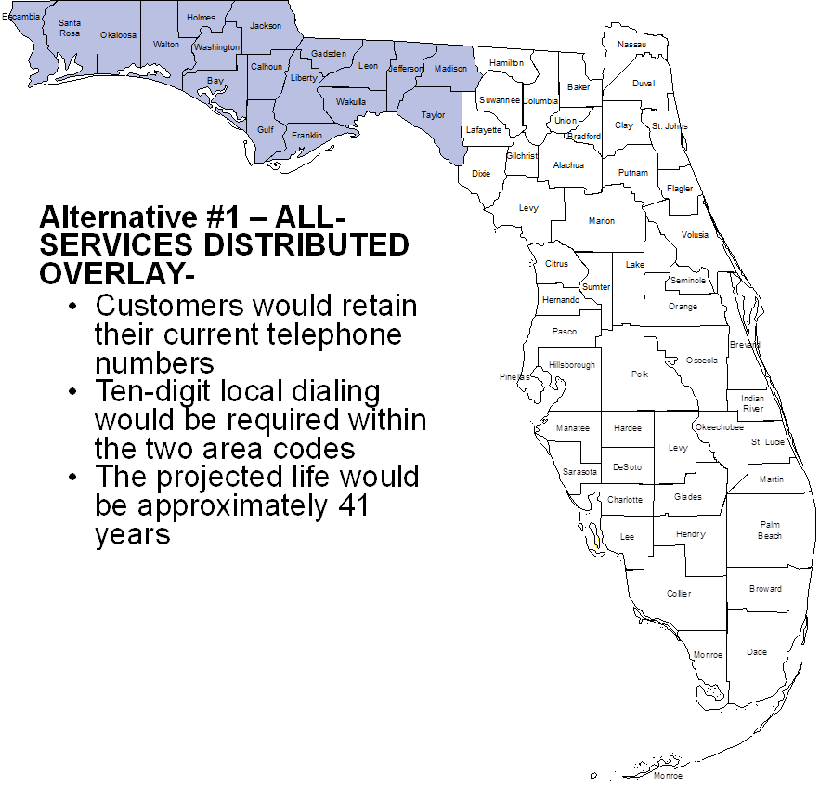

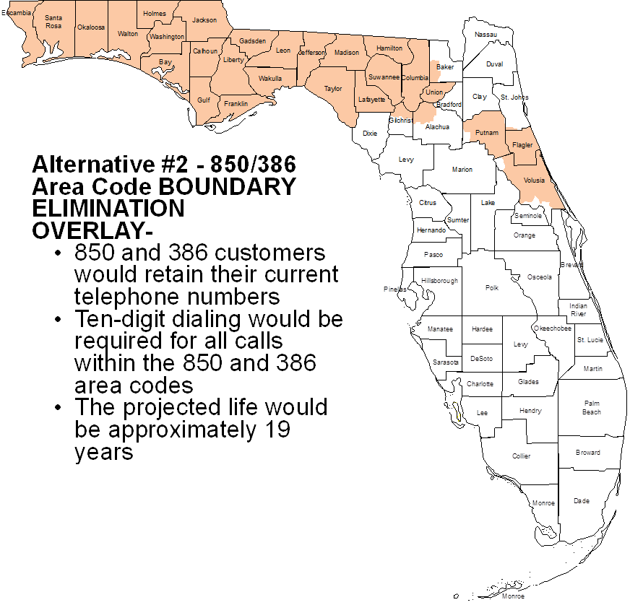

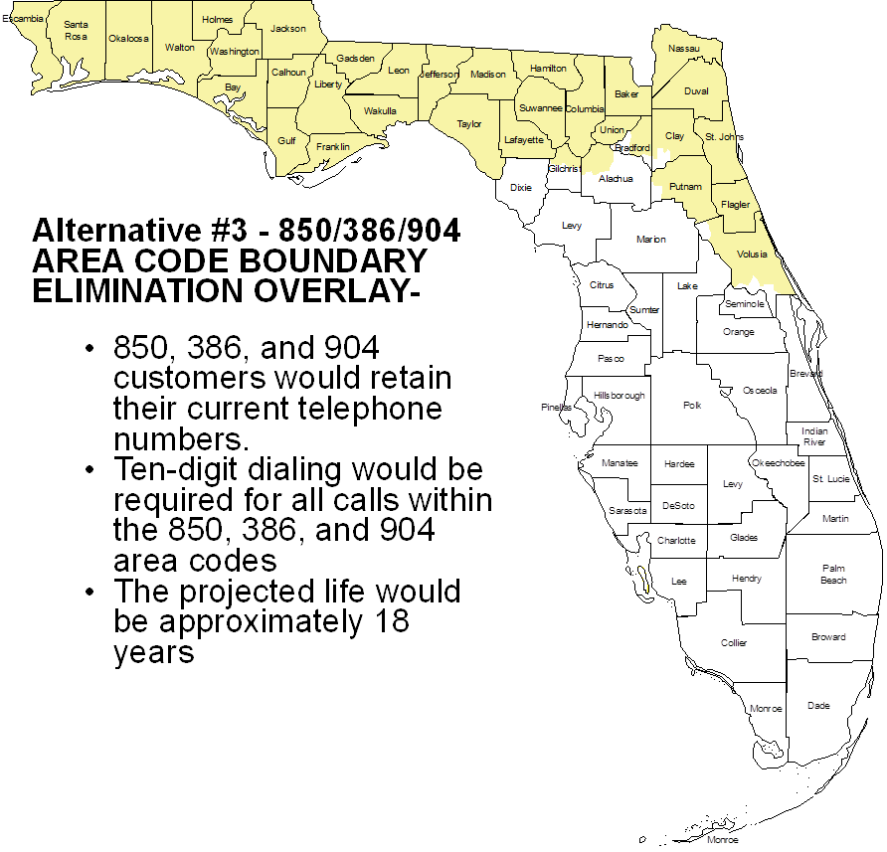

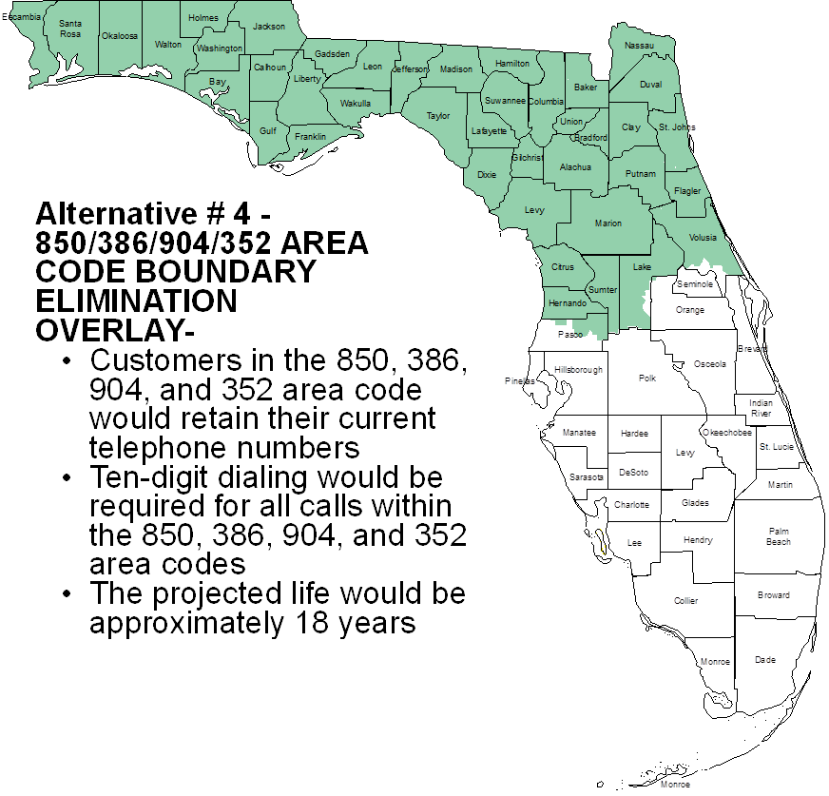

NANPA’s petition indicates the projected 850 area code exhaust date as first quarter 2022; however as of October 2019 the forecasted exhaust date is third quarter 2021.
This document included descriptions, maps, general facts and assumptions, and the projected life of two area code relief alternatives, an all-services distributed overlay and an area code boundary elimination overlay involving the 386 area code. A geographic split in the 850 area code did not meet the NPA code relief planning guidelines; therefore, NANPA did not recommend a geographic split for consideration. The Industry also proposed two additional boundary elimination overlay alternatives.
NPA Code Relief Planning & Notification Guidelines ATIS-0300061 – Section 5.0 (g).

