State of Florida |  | Public Service Commission  Capital Circle Office Center ● 2540 Shumard Oak Boulevard  Tallahassee, Florida 32399-0850  -M-E-M-O-R-A-N-D-U-M-
DATE: | October 31, 2019
TO: | Office of Commission Clerk (Teitzman)
FROM: | Office of the General Counsel (Harper, King)  Division of Accounting and Finance (Bulecza-Banks, Fletcher, Mouring)  Division of Economics (Coston, Draper, Galloway, Guffey, Higgins, McNulty)  Division of Engineering (Buys, Doehling, Graves, King)  Office of Industry Development and Market Analysis (Breman, Crawford, Eichler)
RE: | Docket No. 20190131-EU – Proposed adoption of Rule 25-6.030, F.A.C., Storm Protection Plan and Rule 25-6.031, F.A.C., Storm Protection Plan Cost Recovery Clause.
AGENDA: | 11/05/19 – Regular Agenda – Interested Persons May Participate
COMMISSIONERS ASSIGNED: |  |  | All Commissioners
PREHEARING OFFICER: |  |  | Fay
RULE STATUS: |  |  | Proposed – Subject to Statutory Deadlines under Section 120.54, F.S.
SPECIAL INSTRUCTIONS: |  |  | None

Case Background
The 2019 Florida Legislature passed SB 796 to enact Section 366.96, Florida Statutes (F.S.), entitled “Storm protection plan cost recovery.” Section 366.96, F.S., requires each investor-owned electric utility (IOU) to file a transmission and distribution storm protection plan (storm protection plan) for the Commission’s review and directs the Commission to hold an annual proceeding to determine each IOU’s prudently incurred costs to implement its plan and allow recovery of those costs through a Storm Protection Plan Cost Recovery Clause (SPPCRC).
Section 366.96(3), F.S., requires the Commission to adopt rules to specify the elements that must be included in an IOU’s filing for the Commission’s review of its storm protection plan. Section 366.96(11), F.S., further requires that the Commission adopt rules to implement and administer the section and mandates that the Commission propose a rule for adoption as soon as practicable after the effective date of the act, but not later than October 31, 2019.
In furtherance of the Legislature’s directive, the Commission’s Notice of Development of Rulemaking was published in Volume 45, No. 111, of the Florida Administrative Register (F.A.R.) on June 7, 2019. The notice included two new rules: Rule 25-6.030, Florida Administrative Code (F.A.C.), which would specify the elements that must be included in an IOU’s storm protection plan, and Rule 25-6.031, F.A.C., which would establish the SPPCRC.
The Commission voted to propose the adoption of Rules 25-6.030 and 25-6.031, F.A.C., at its October 3, 2019 Agenda Conference. Proposed Rules 25-6.030 and 25-6.031, F.A.C., were published in the October 7, 2019, edition of the F.A.R., Volume 45, Number 195. Proposed Rules 25-6.030 and 25-6.031, F.A.C., are appended as Attachment A. Affected persons had 21 days from the F.A.R. notice to request a hearing on the proposed rules pursuant to Section 120.54(3), F.S.
On October 25, 2019, pursuant to Section 120.54(3)(c), F.S., the Office of Public Counsel (OPC) timely filed a Petition for a Hearing on proposed Rules 25-6.030 and 25-6.031, F.A.C., (Petition) (Attachment B). Accordingly, a rule hearing has been scheduled before the full Commission on November 5, 2019, pursuant to notice appearing in the October 29, 2019 edition of the F.A.R., Volume 45, Number 211. This hearing is governed solely by the provisions of Section 120.54, F.S. Pursuant to Section 120.54(3)(c), F.S., when a public hearing is held, the agency must ensure that staff is available to respond to questions or comments regarding the rules.
The purpose of the public hearing is to give OPC an opportunity to present evidence and argument on all issues under consideration. The issue before the Commission is whether the Commission should make changes to proposed Rules 25-6.030 and 25-6.031, F.A.C. OPC states in its Petition that it “object[s] to these rules to the extent they exceed the statutory authority granted by the Legislature in section 366.96, Florida Statutes (2019), or are otherwise contrary to the state’s interests.”
Pursuant to Section 120.54(3)(d)1., F.S., any change to a rule after it has been proposed, other than a technical change that does that does not affect the substance of the rule, must be supported by the record of the public hearing held on the rule, must be in response to written material submitted to the agency within 21 days after the date of publication of the notice of proposed rule, or must be in response to a proposed objection by the Joint Administrative Procedures Committee (JAPC). JAPC did not file comments on these rules.
At the conclusion of the public hearing, the Commission has three options: (1) The Commission may decide to change the rule based on evidence and argument presented by OPC at the hearing. In that event, a Notice of Change would be published in the F.A.R., and the Commission would have to wait 21 days to file the rules for adoption with the Department of State. (2) Alternatively, the Commission may decide to keep the rules as proposed. If the Commission makes no changes to the rules, then the Commission must wait 14 days before the rules can be filed for adoption with the Department of State. (3) The Commission may also elect to take the matter under advisement, have staff write another recommendation based on the record at the rule hearing, and decide the matter at a subsequent rule hearing.
The Commission has jurisdiction pursuant to Sections 120.54 and 366.96, F.S.

25-6.030 Storm Protection Plan.
(1) Application and Scope. Each utility as defined in Section 366.96(2)(a), F.S., must file a petition with the Commission for approval of a Transmission and Distribution Storm Protection Plan (Storm Protection Plan) that covers the utility’s immediate 10-year planning period. Each utility must file, for Commission approval, an updated Storm Protection Plan at least every 3 years.
(2) For the purpose of this rule, the following definitions apply:
(a) “Storm protection program” – a category, type, or group of related storm protection projects that are undertaken to enhance the utility’s existing infrastructure for the purpose of reducing restoration costs and reducing outage times associated with extreme weather conditions therefore improving overall service reliability.
(b) “Storm protection project” – a specific activity within a storm protection program designed for the enhancement of an identified portion or area of existing electric transmission or distribution facilities for the purpose of reducing restoration costs and reducing outage times associated with extreme weather conditions therefore improving overall service reliability.
(c) “Transmission and distribution facilities” – all utility owned poles and fixtures, towers and fixtures, overhead conductors and devices, substations and related facilities, land and land rights, roads and trails, underground conduits, and underground conductors.
(3) Contents of the Storm Protection Plan. For each Storm Protection Plan, the following information must be provided:
(a) A description of how implementation of the proposed Storm Protection Plan will strengthen electric utility infrastructure to withstand extreme weather conditions by promoting the overhead hardening of electrical transmission and distribution facilities, the undergrounding of certain electrical distribution lines, and vegetation management.
(b) A description of how implementation of the proposed Storm Protection Plan will reduce restoration costs and outage times associated with extreme weather conditions therefore improving overall service reliability.
(c) A description of the utility’s service area, including areas prioritized for enhancement and any areas where the utility has determined that enhancement of the utility’s existing transmission and distribution facilities would not be feasible, reasonable, or practical. Such description must include a general map, number of customers served within each area, and the utility’s reasoning for prioritizing certain areas for enhanced performance and for designating other areas of the system as not feasible, reasonable, or practical.
(d) A description of each proposed storm protection program that includes:
1. A description of how each proposed storm protection program is designed to enhance the utility’s existing transmission and distribution facilities including an estimate of the resulting reduction in outage times and restoration costs due to extreme weather conditions;
2. If applicable, the actual or estimated start and completion dates of the program;
3. A cost estimate including capital and operating expenses;
4. A comparison of the costs identified in subparagraph (3)(d)3. and the benefits identified in subparagraph (3)(d)1.; and
5. A description of the criteria used to select and prioritize proposed storm protection programs.
(e) For the first three years in a utility’s Storm Protection Plan, the utility must provide the following information:
1. For the first year of the plan, a description of each proposed storm protection project that includes:
i. The actual or estimated construction start and completion dates;
ii. A description of the affected existing facilities, including number and type(s) of customers served, historic service reliability performance during extreme weather conditions, and how this data was used to prioritize the proposed storm protection project;
iii. A cost estimate including capital and operating expenses; and
iv. A description of the criteria used to select and prioritize proposed storm protection projects.
2. For the second and third years of the plan, project related information in sufficient detail, such as estimated number and costs of projects under every specific program, to allow the development of preliminary estimates of rate impacts as required by paragraph (3)(h) of this rule.
(f) For each of the first three years in a utility’s Storm Protection Plan, the utility must provide a description of its proposed vegetation management activities including:
1. The projected frequency (trim cycle);
2. The projected miles of affected transmission and distribution overhead facilities;
3. The estimated annual labor and equipment costs for both utility and contractor personnel; and
4. A description of how the vegetation management activity will reduce outage times and restoration costs due to extreme weather conditions.
(g) An estimate of the annual jurisdictional revenue requirements for each year of the Storm Protection Plan.
(h) An estimate of rate impacts for each of the first three years of the Storm Protection Plan for the utility’s typical residential, commercial, and industrial customers.
(i) A description of any implementation alternatives that could mitigate the resulting rate impact for each of the first three years of the proposed Storm Protection Plan.
(j) Any other factors the utility requests the Commission to consider.
(4) By June 1, each utility must submit to the Commission Clerk an annual status report on the utility’s Storm Protection Plan programs and projects. The annual status report shall include:
(a) Identification of all Storm Protection Plan programs and projects completed in the prior calendar year or planned for completion;
(b) Actual costs and rate impacts associated with completed activities under the Storm Protection Plan as compared to the estimated costs and rate impacts for those activities; and
(c) Estimated costs and rate impacts associated with programs planned for completion during the next calendar year.
Rulemaking Authority 366.96, FS. Law Implemented 366.96, FS. History–New _____.

25-6.031 Storm Protection Plan Cost Recovery Clause.
(1) Application and Scope. This rule applies to each utility as defined in Section 366.96(2)(a), F.S.
(2) After a utility has filed its Transmission and Distribution Storm Protection Plan (Storm Protection Plan), the utility may file a petition for recovery of associated costs through the Storm Protection Plan cost recovery clause. The utility’s petition shall be supported by testimony that provides details on the annual Storm Protection Plan implementation activities and associated costs, and how those activities and costs are consistent with its Storm Protection Plan. If the Commission approves the utility’s Storm Protection Plan with modifications, the utility shall, within 15 business days, file an amended cost recovery petition and supporting testimony reflecting the modifications.
(3) An annual hearing to address petitions for recovery of Storm Protection Plan costs will be limited to determining the reasonableness of projected Storm Protection Plan costs, the prudence of actual Storm Protection Plan costs incurred by the utility, and to establish Storm Protection Plan cost recovery factors consistent with the requirements of this rule.
(4) Storm Protection Plan cost recovery clause true-up amounts shall be afforded deferred accounting treatment at the 30-day commercial paper rate.
(5) Subaccounts. To ensure separation of costs subject to recovery through the clause, the utility filing for cost recovery shall maintain subaccounts for all items consistent with the Uniform System of Accounts prescribed by this Commission, pursuant to Rule 25-6.014, F.A.C.
(6) Recoverable costs.
(a) The utility’s petition for recovery of costs associated with its Storm Protection Plan may include costs incurred after the filing of the utility’s Storm Protection Plan.
(b) Storm Protection Plan costs recoverable through the clause shall not include costs recovered through the utility’s base rates or any other cost recovery mechanism.
(c) The utility may recover the annual depreciation expense on capitalized Storm Protection Plan expenditures using the utility’s most recent Commission-approved depreciation rates. The utility may recover a return on the undepreciated balance of the costs calculated at the utility’s weighted average cost of capital using the return on equity most recently approved by the Commission.
(7) Pursuant to the order establishing procedure in the annual cost recovery proceeding, a utility shall submit the following for Commission review and approval as part of its Storm Protection Plan cost recovery filings:
(a) Final True-Up for Previous Year. The final true-up of Storm Protection Plan cost recovery for a prior year shall include revenue requirements based on a comparison of actual costs for the prior year and previously filed costs and revenue requirements for such prior year for each program and project filed in the utility’s cost recovery petition. The final true-up shall also include identification of each of the utility’s Storm Protection Plan programs and projects for which costs were incurred during the prior year, including a description of the work actually performed during such prior year, for each program and project in the utility’s cost recovery petition.
(b) Estimated True-Up for Current Year. The actual/estimated true-up of Storm Protection Plan cost recovery shall include revenue requirements based on a comparison of current year actual/estimated costs and the previously-filed projected costs and revenue requirements for such current year for each program and project filed in the utility’s cost recovery petition. The actual/estimated true-up shall also include identification of each of the utility’s Storm Protection Plan programs and projects for which costs have been and will be incurred during the current year, including a description of the work projected to be performed during such current year, for each program and project in the utility’s cost recovery petition.
(c) Projected Costs for Subsequent Year. The projected Storm Protection Plan costs recovery shall include costs and revenue requirements for the subsequent year for each program filed in the utility’s cost recovery petition. The projection filing shall also include identification of each of the utility’s Storm Protection Plan programs for which costs will be incurred during the subsequent year, including a description of the work projected to be performed during such year, for each program in the utility’s cost recovery petition.
(d) True-Up of Variances. The utility shall report observed true-up variances including sales forecasting variances, changes in the utility’s prices of services and/or equipment, and changes in the scope of work relative to the estimates provided pursuant to subparagraphs (7)(b) and (7)(c). The utility shall also provide explanations for variances regarding the implementation of the approved Storm Protection Plan.
(e) Proposed Storm Protection Plan Cost Recovery Factors. The utility shall provide the calculations of its proposed factors and effective 12-month billing period.
(8) Recovery of costs under this rule does not preclude a utility from proposing inclusion of unrecovered Storm Protection Plan implementation costs in base rates in a subsequent rate proceeding.
Rulemaking Authority 366.96, FS. Law Implemented 366.96, FS. History–New _____.

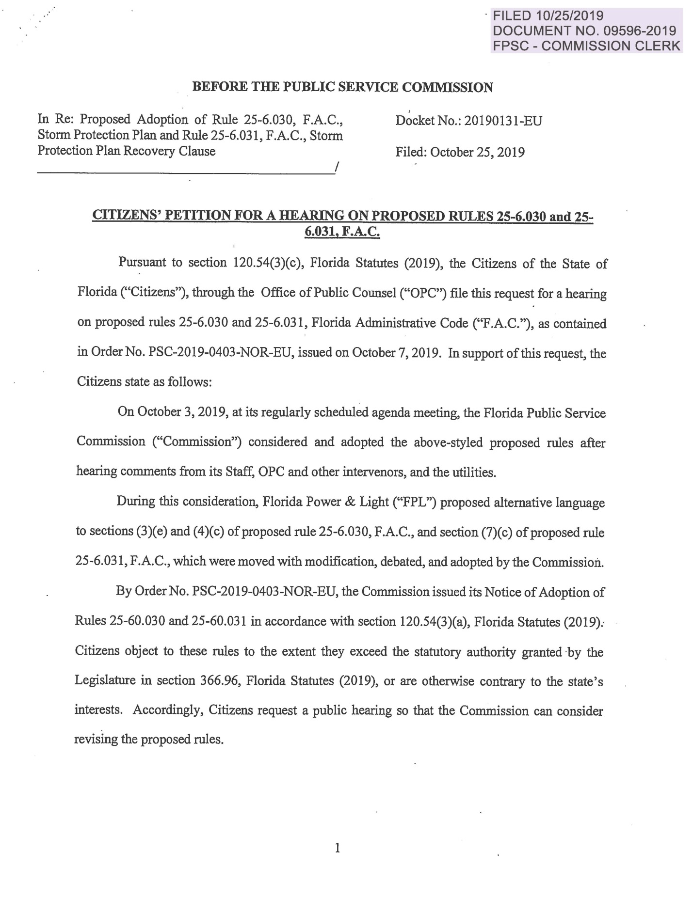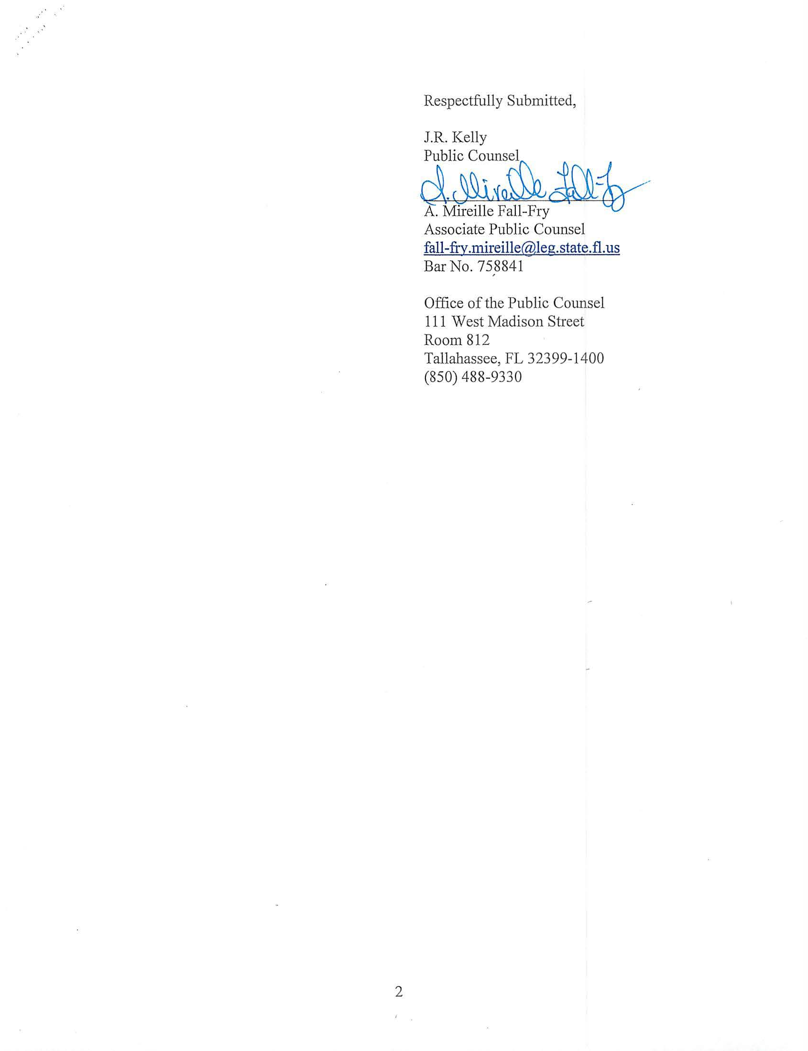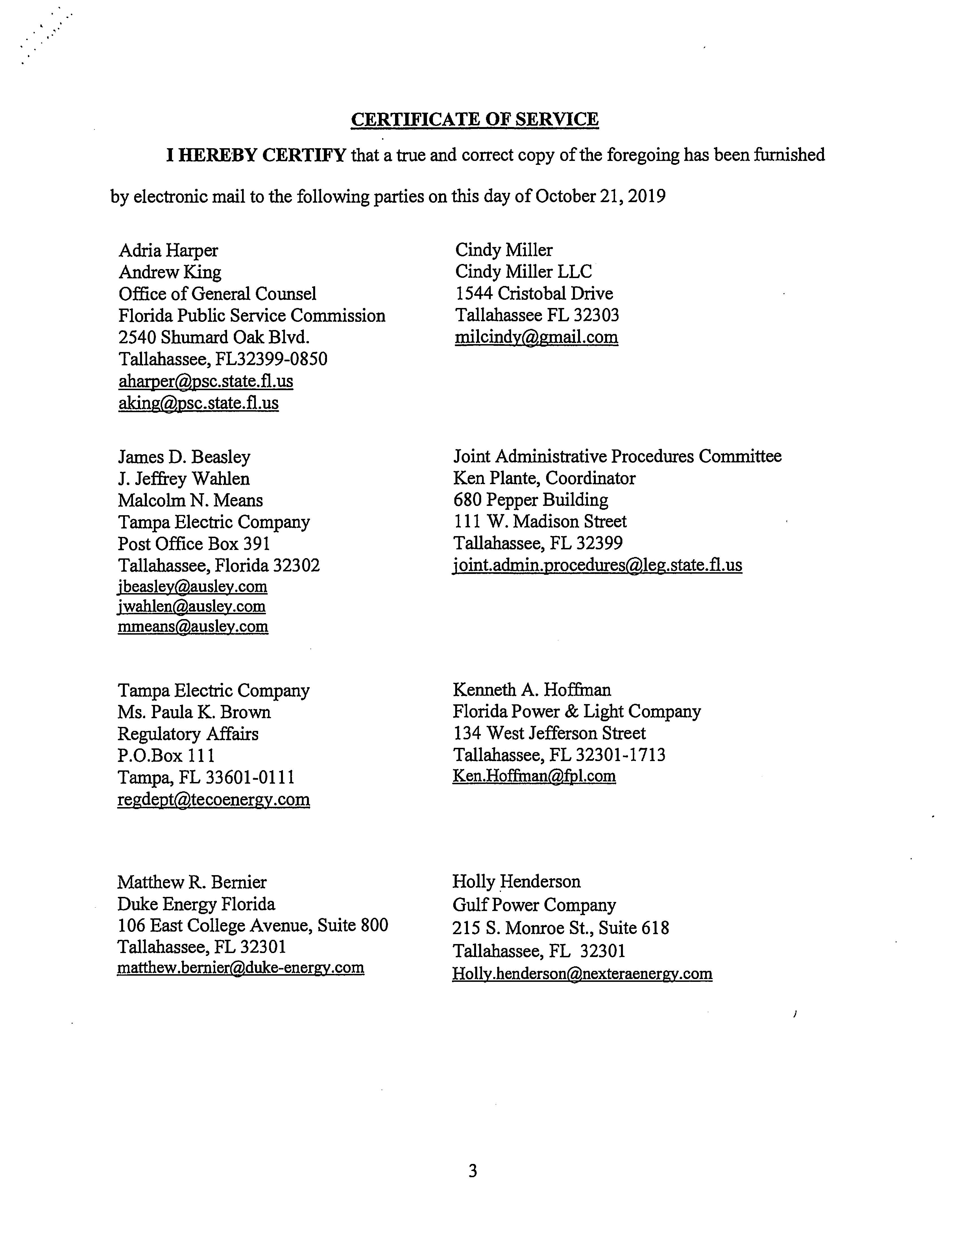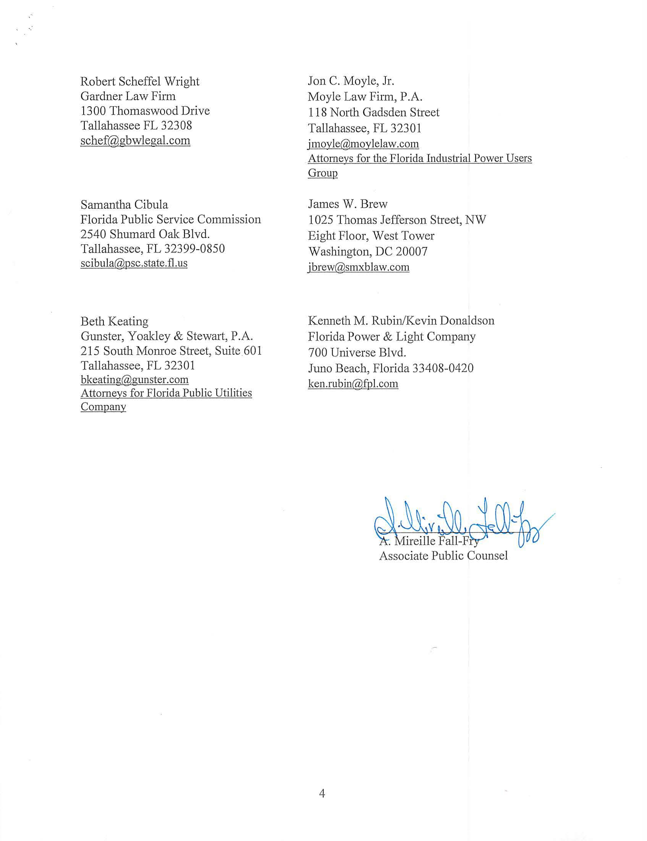

Pursuant to Section 120.54(3)(e)2., F.S., there are statutory deadlines by which the Commission must file the rules for adoption with the Department of State.

