State of Florida |  | Public Service Commission  Capital Circle Office Center ● 2540 Shumard Oak Boulevard  Tallahassee, Florida 32399-0850  -M-E-M-O-R-A-N-D-U-M-
DATE: | April 23, 2020
TO: | Office of Commission Clerk (Teitzman)
FROM: | Division of Accounting and Finance (Cicchetti, D. Buys, Hightower)  Office of the General Counsel (Brownless, Lherisson)
RE: | Docket No. 20200118-EU – Amended unopposed joint motion to modify Order PSC-2012-0425-PAA-EU regarding weighted average cost of capital methodology.
AGENDA: | 05/05/20 – Regular Agenda – Proposed Agency Action – Interested Persons May Participate
COMMISSIONERS ASSIGNED: |  |  | All Commissioners
PREHEARING OFFICER: |  |  | Fay
CRITICAL DATES: |  |  | None
SPECIAL INSTRUCTIONS: |  |  | None

Case Background
The cost recovery clause dockets, Fuel and Purchased Power Cost Recovery Clause (Fuel Clause), the Energy Conservation Cost Recovery Clause (ECCR), and the Environmental Cost Recovery Clause (ECRC) are continuing dockets that handle issues pertaining to Florida’s Investor-Owned electric Utilities (IOUs). These IOUs are Duke Energy Florida, LLC (DEF), Florida Power & Light Company (FPL), Gulf Power Company (Gulf), Tampa Electric Company (TECO), and Florida Public Utilities Company (FPUC) (collectively, the IOUs). Intervenors for all three cost recovery clauses include the Office of Public Counsel (OPC), Florida Industrial Power Users Group (FIPUG), and White Springs Agricultural Chemicals, Inc., d/b/a PCS Phosphate – White Springs (PCS Phosphate).
The Commission, when appropriate, allows recovery of a return on capital investments through the Fuel Clause, the ECCR and the ECRC. Historically, the Commission relied on the jurisdictional capital structure and cost rates for each component of the capital structure approved in each utility’s last base rate case to determine the appropriate weighted average cost of capital (WACC).
On August 16, 2012, the Commission issued Order No. PSC-2012-0425-PAA-EU approving a stipulation and settlement agreement entered into by the IOUs, OPC, and FIPUG to specify the methodology for calculating the WACC applicable to clause-recoverable investments. This methodology relied on the historical May Earnings Surveillance Report (ESR) WACC for the calendar year in which the filing is made for all three clause filings: the Projected Filing, the Actual/Estimated True-up Filing, and the Final True-up Filing.
The Internal Revenue Service (IRS) issued Private Letter Rulings (PLRs) on October 3, 2017, and August 11, 2017, regarding the IRS Normalization Rules. These PLRs state that IRC Treasury Regulation Section §1.167(1)-1(h)(6)(ii) requires public utilities to apply the Normalization Rules by utilizing a consistency adjustment and proration formula to compute the depreciation-related accumulated deferred income tax (ADIT) balance to be included for ratemaking purposes when a forecasted test period is utilized to set rates unless, as described in Issue 1, the Limitation Provision is met or exceeded.
On August 21, 2019, DEF filed an Unopposed Joint Motion to Modify Order No. PSC-2012-0425-PAA-EU, (attached to this recommendation) regarding the WACC methodology on behalf of the IOUs as it pertains to the clause-recovery dockets. In the Unopposed Joint Motion the IOUs proposed to change the methodology to comply with the Internal Revenue Code (IRC) Treasury Regulation.

On February 6 2020, the Commission staff held a noticed workshop regarding the IOUs’ proposed methodology to calculate the WACC as it pertains to depreciation-related accumulated deferred federal income taxes in clause-recovery dockets. In response to the February 6, 2020 workshop, the IOUs filed Joint Comments on March 13, 2020, in which the IOUs collectively agreed with Commission staff’s position as outlined at the workshop.

On March 26, 2020, the IOUs filed an Amended Unopposed Joint Motion to Modify Order No. PSC-2012-0425-PAA-EU regarding the methodology used to calculate the WACC in accordance with the February 6, 2020 workshop and the March 13, 2020 Joint Comments.

The Commission has jurisdiction over this matter pursuant to Chapter 120 and several provisions of Chapter 366, including Sections 366.04 and 366.06, Florida Statutes (F.S.).

Discussion of Issues

Issue 1:
Should the Commission approve the attached Amended Unopposed Joint Motion filed on March 26, 2020, to modify the methodology approved by Order No. PSC-2012-0425-PAA-EU to calculate the weighted average cost of capital on clause-approved investments in Docket Nos. 20200001-EI, 20200002-EG, and 20200007-EI, respectively, the Fuel and Purchased Power Cost Recovery Clause, the Energy Conservation Cost Recovery Clause, the Environmental Cost Recovery Clause, and any future cost recovery clauses that involve the recovery of a rate of return on investment?

Recommendation:
Yes. The Commission should approve the Amended Unopposed Joint Motion addressing the methodology for calculating the allowable rate of return on clause-approved investments. (Hightower, D. Buys, Cicchetti)

Staff Analysis:
On August 16, 2012, the Commission issued Order No. PSC-2012-0425-PAA-EU approving a stipulation and settlement agreement entered into by the IOUs, OPC, and FIPUG to specify the methodology for calculating the WACC applicable to clause-recoverable investments. The 2012 methodology uses a historical WACC to calculate the rate of return in a projected future clause recovery period. However, the 2012 methodology no longer comports with the IRS Normalization Rules regarding the calculation of the ADIT balance in the capital structure.
Treasury Regulation Section §1.167(1)-1(h)(6)(ii) provides that if a future period is solely used for such determination, the limit on the amount of depreciation-related ADITs for the period is the amount at the beginning of the future period with a pro rata adjustment for any increases or decreases during that period. There is a specific proration formula that must be applied to project changes in depreciation-related ADITs if the Limitation Provision is not met.
The IRS issued PLRs on October 3, 2017, and August 11, 2017, regarding IRS Normalization Rules. These PLRs state that IRC Treasury Regulation Section §1.167(1)-1(h)(6)(ii) requires public utilities to apply normalization by utilizing a consistency adjustment and proration formula to compute the depreciation-related ADIT balance to be included for ratemaking purposes when a forecasted test period is utilized to set rates unless the Limitation Provision is met or exceeded. The Limitation Provision in Treasury Regulation Section §1.167(1)-1(h)(6)(i) states that as long as the amount of depreciation-related ADIT used in ratemaking is lower than the amount that would have been used under the Consistency Rule, then there is no violation of normalization. The purpose of the IRS Normalization Rules is to preserve for regulated utilities the benefits of accelerated depreciation as a source of cost-free capital. Further, the purpose of the consistency rule and the proration formula is to prevent the immediate flow-through of the benefits of accelerated depreciation to ratepayers.
On March 26, 2020, the IOUs submitted their Amended Unopposed Joint Motion, revising the original, August 21, 2019 Joint Motion as it relates to the methodology proposed to comply with the IRC Treasury Regulation Section §1.167(1)-1(h)(6). The IOUs maintain that the modifications proposed herein are in the public interest because the modified methodology will accurately align current costs with cost recovery while enabling compliance with IRC Treasury Regulation Section §1.167(1)-1(h)(6). The IOUs would apply the new methodology starting with the 2021 clause filing cycle, which would begin with the 2021 Projection Filings to be filed in 2020, and then carried through to the 2021 Actual/Estimated Filings to be filed in 2021 and the 2021 Final True-Up Filings to be filed in 2022. The IOUs further propose that the Final True-Up Filing date for all clauses be no earlier than April 1 of each year in order to allow the IOUs enough time to incorporate the WACC from the December ESR, which is completed and filed with the Commission on or about February 15 each year.
Staff agrees with the IOUs that the WACC calculation methodology approved in Order No. PSC-2012-0425-PAA-EU no longer comports with the requirements of IRC §1.167(l)-1(h)(6). Further, staff believes the methodology for calculating the allowable rate of return on clause-approved investments described in the Amended Unopposed Joint Motion is in the public interest because the methodology more accurately reflects expected costs. Therefore, staff recommends that the Commission approve the Amended Unopposed Joint Motion, attached to this recommendation, and that the filing date for the Final True-Up Filings for all related clauses be no earlier than April 1 of each year to give time for filing of the December ESR.

Issue 2:
Should this docket be closed?

Recommendation:
If no person whose substantial interests are affected by this proposed agency action files a timely protest within 21 days of the issuance of the order, a consummating order should be issued and this docket should be closed. If a timely protest is filed, this docket should remain open to address the evidentiary issues presented. (Brownless, Lherisson)

Staff Analysis:
If no person whose substantial interests are affected by this proposed agency action files a timely protest within 21 days of the issuance of the order, a consummating order should be issued and this docket should be closed. If a timely protest is filed, this docket should remain open to address the evidentiary issues presented.
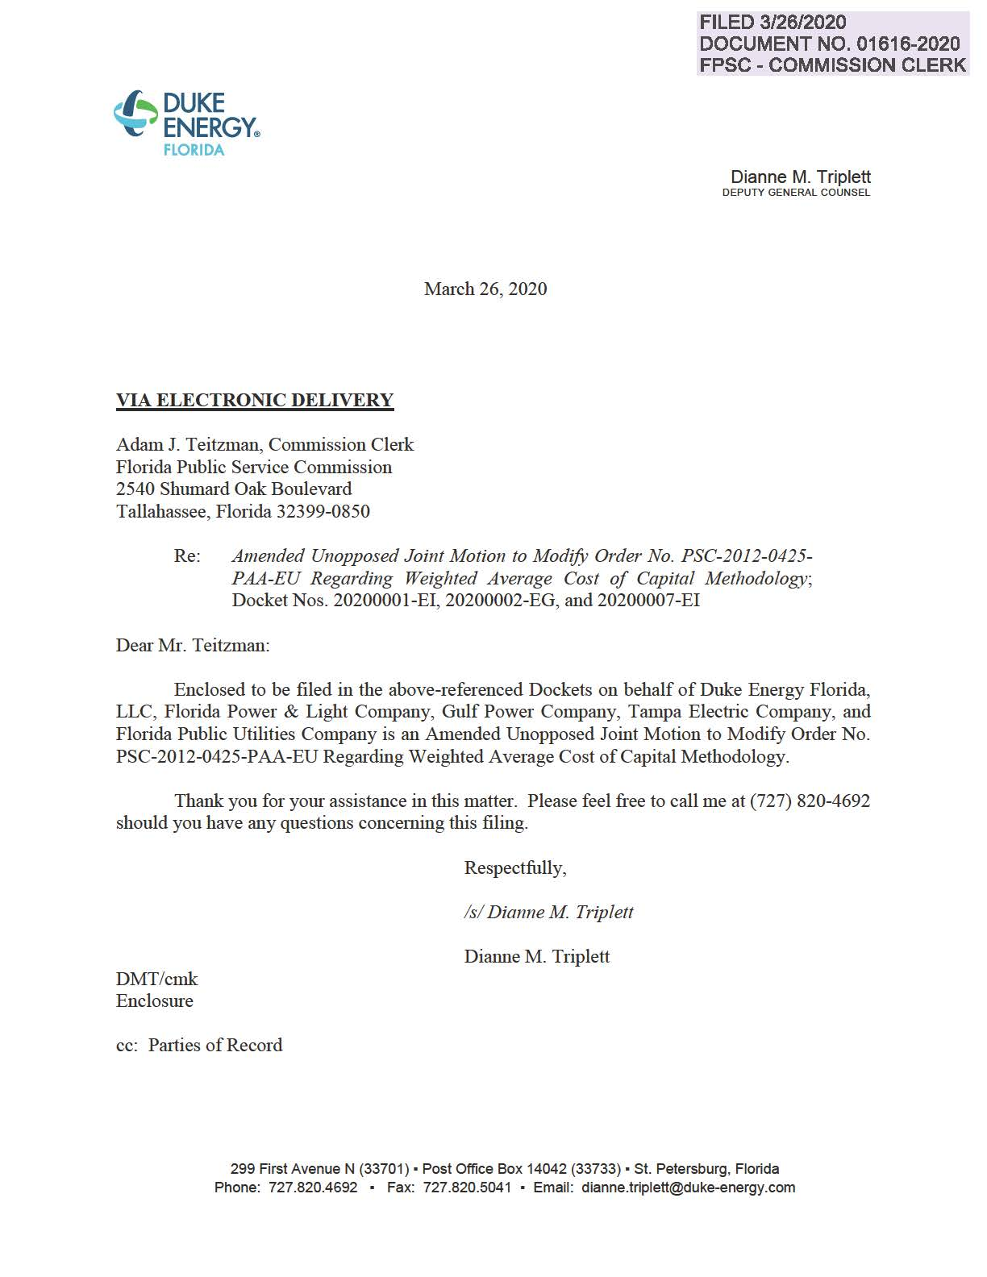

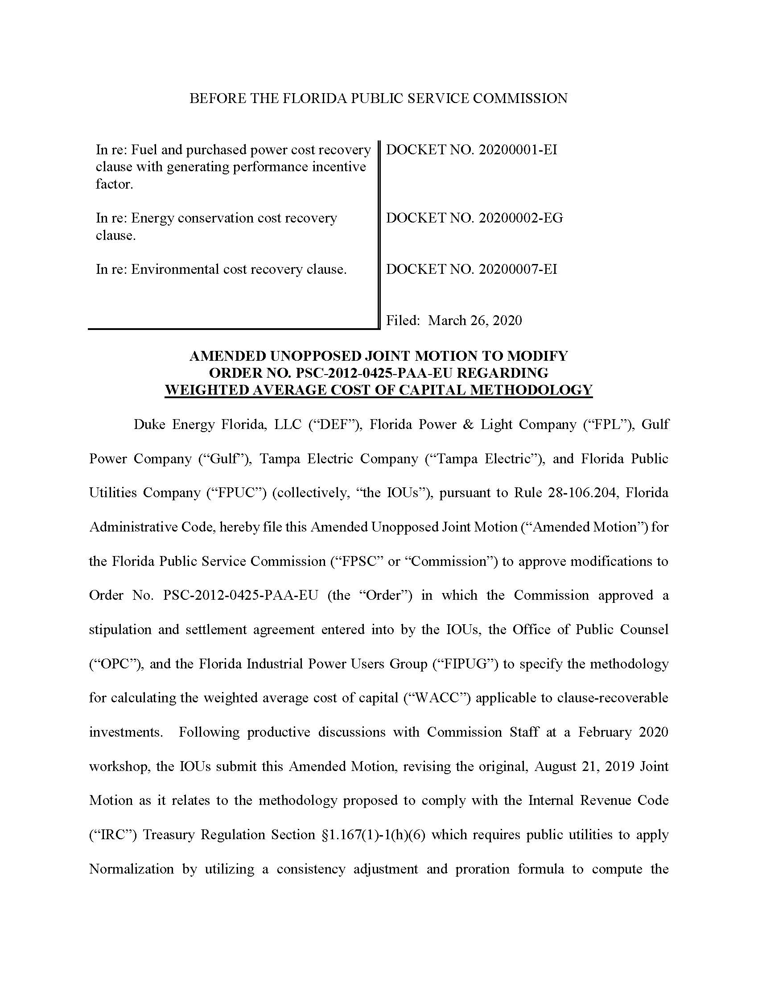

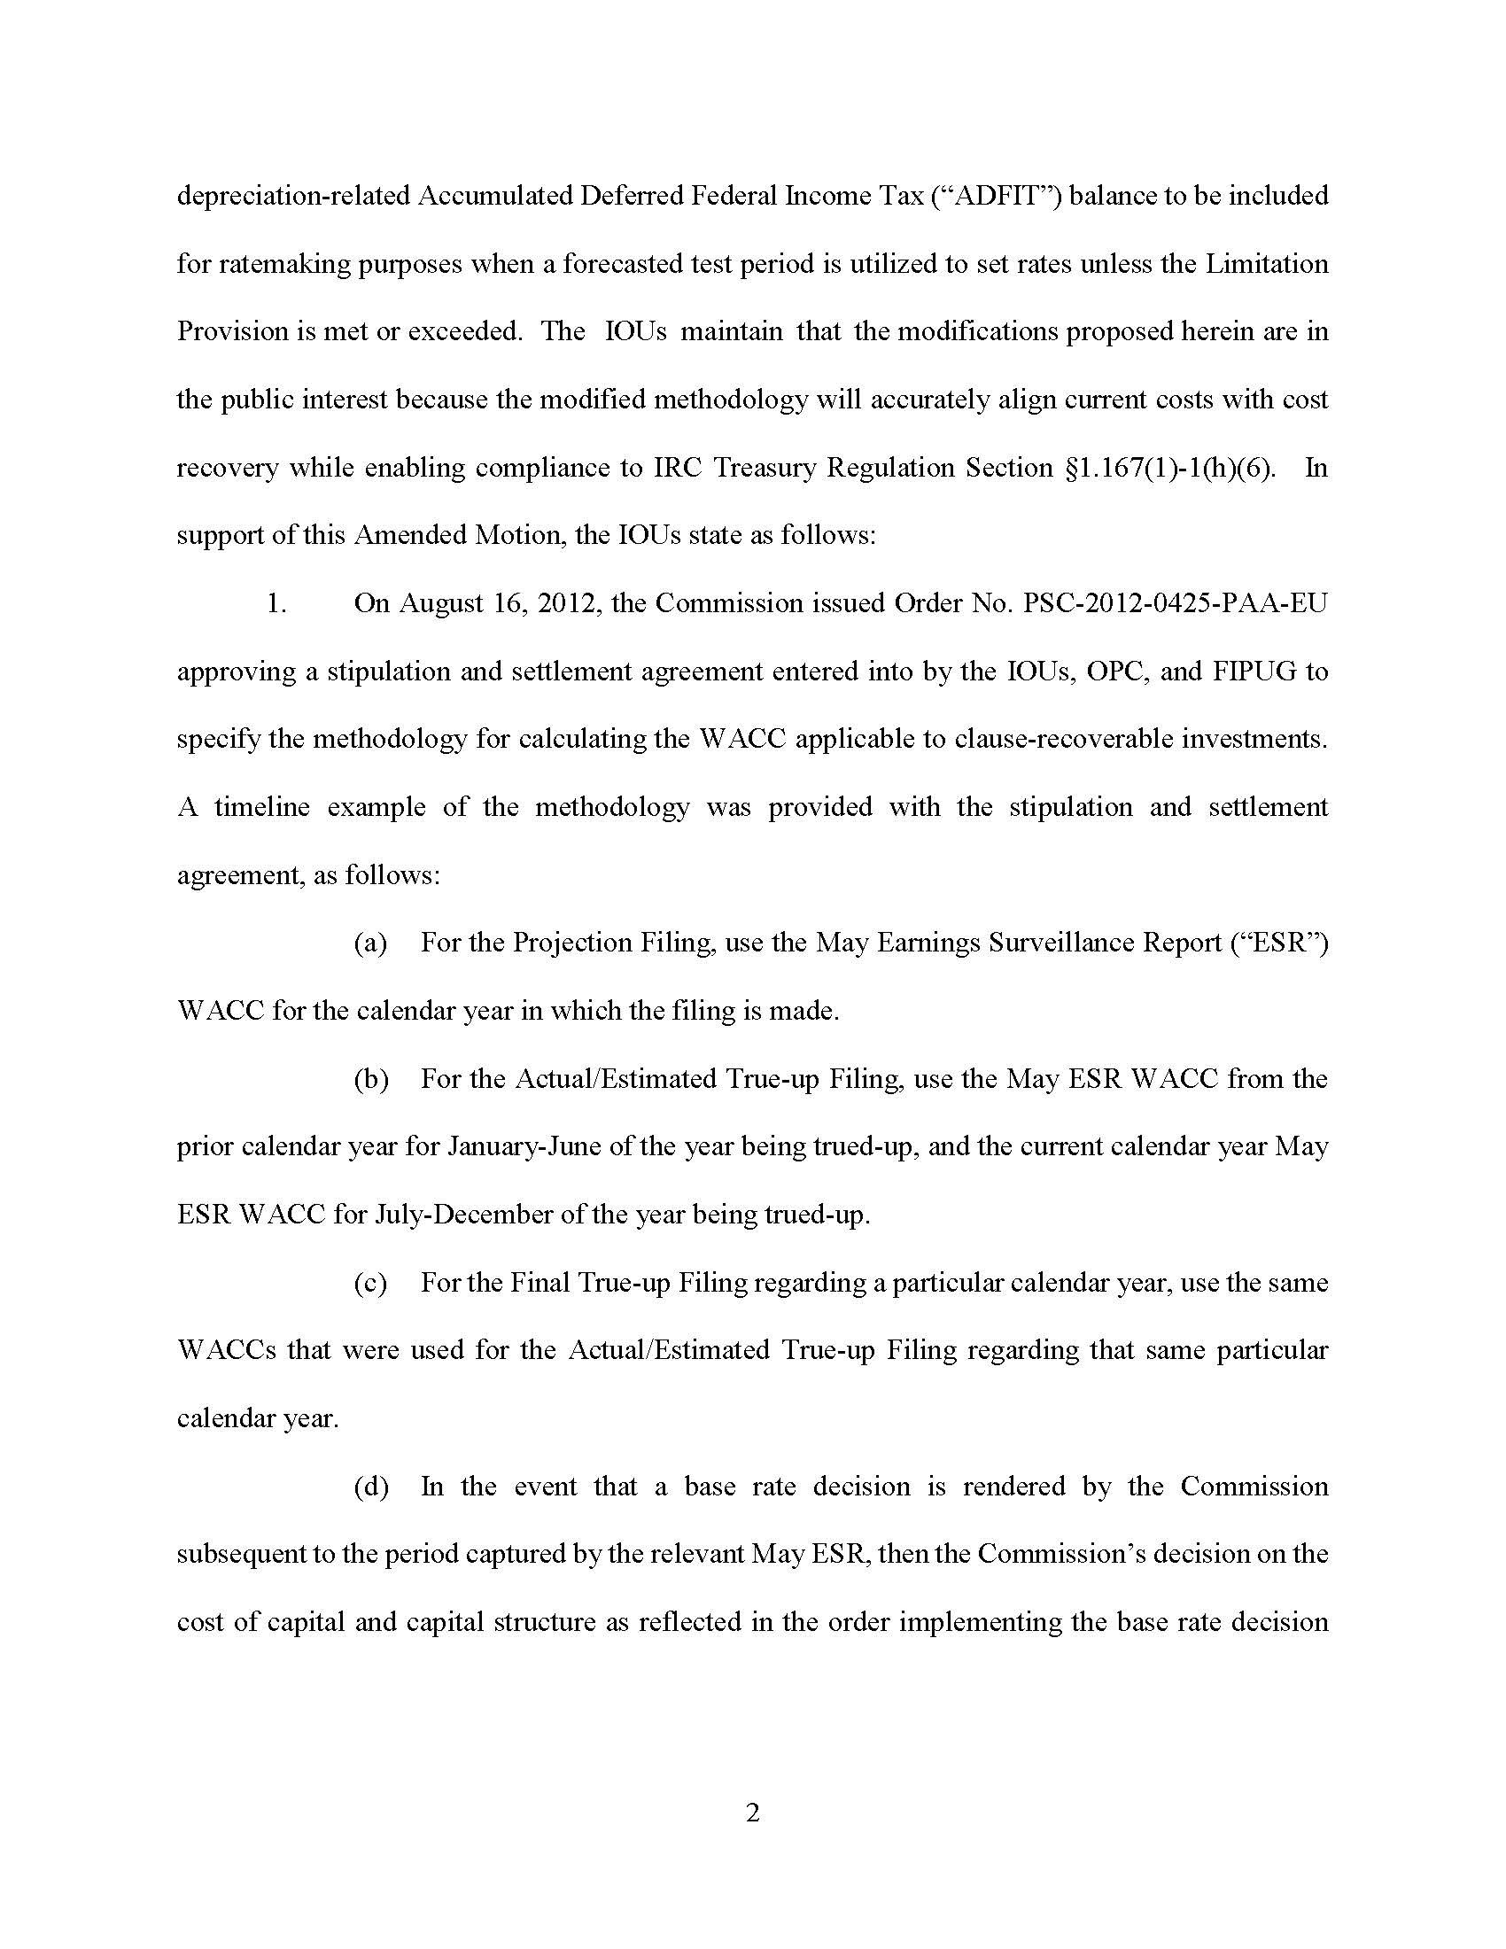

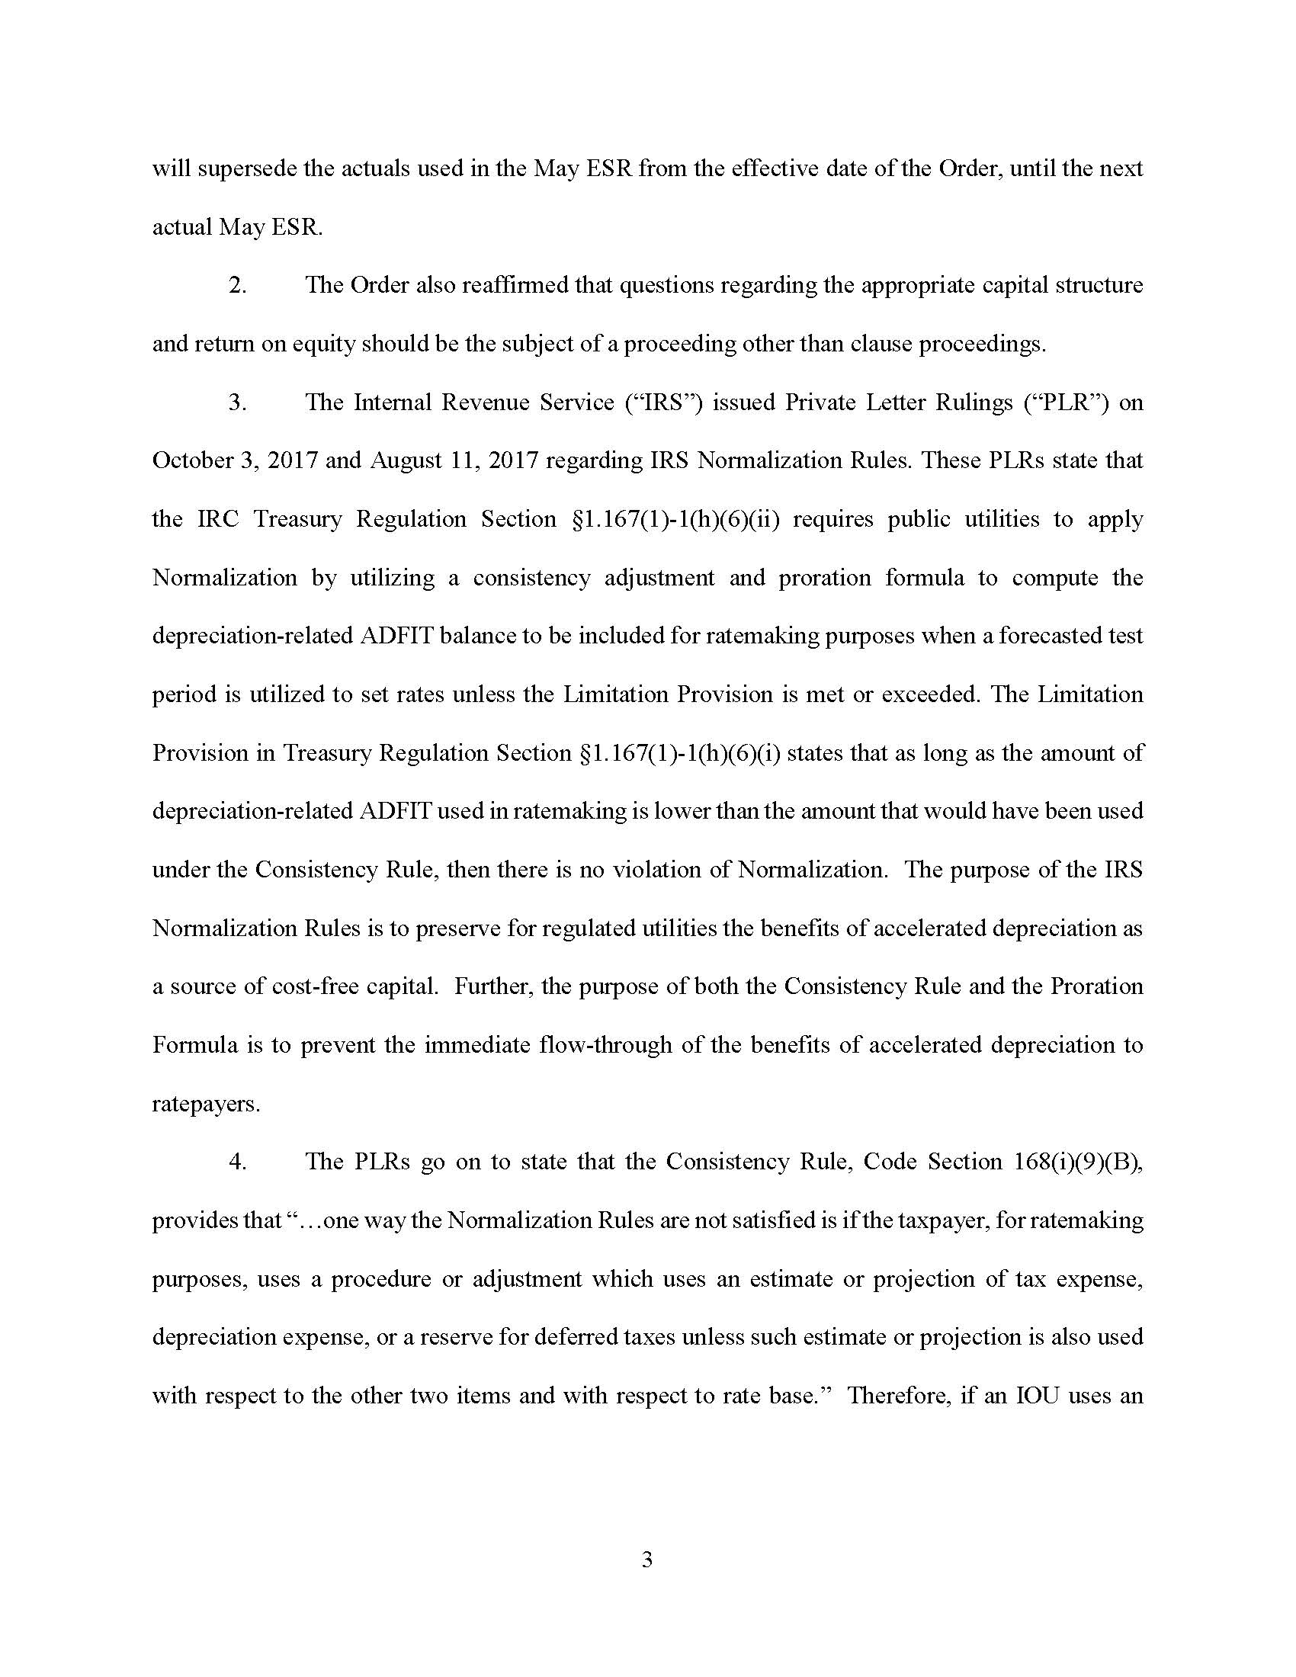

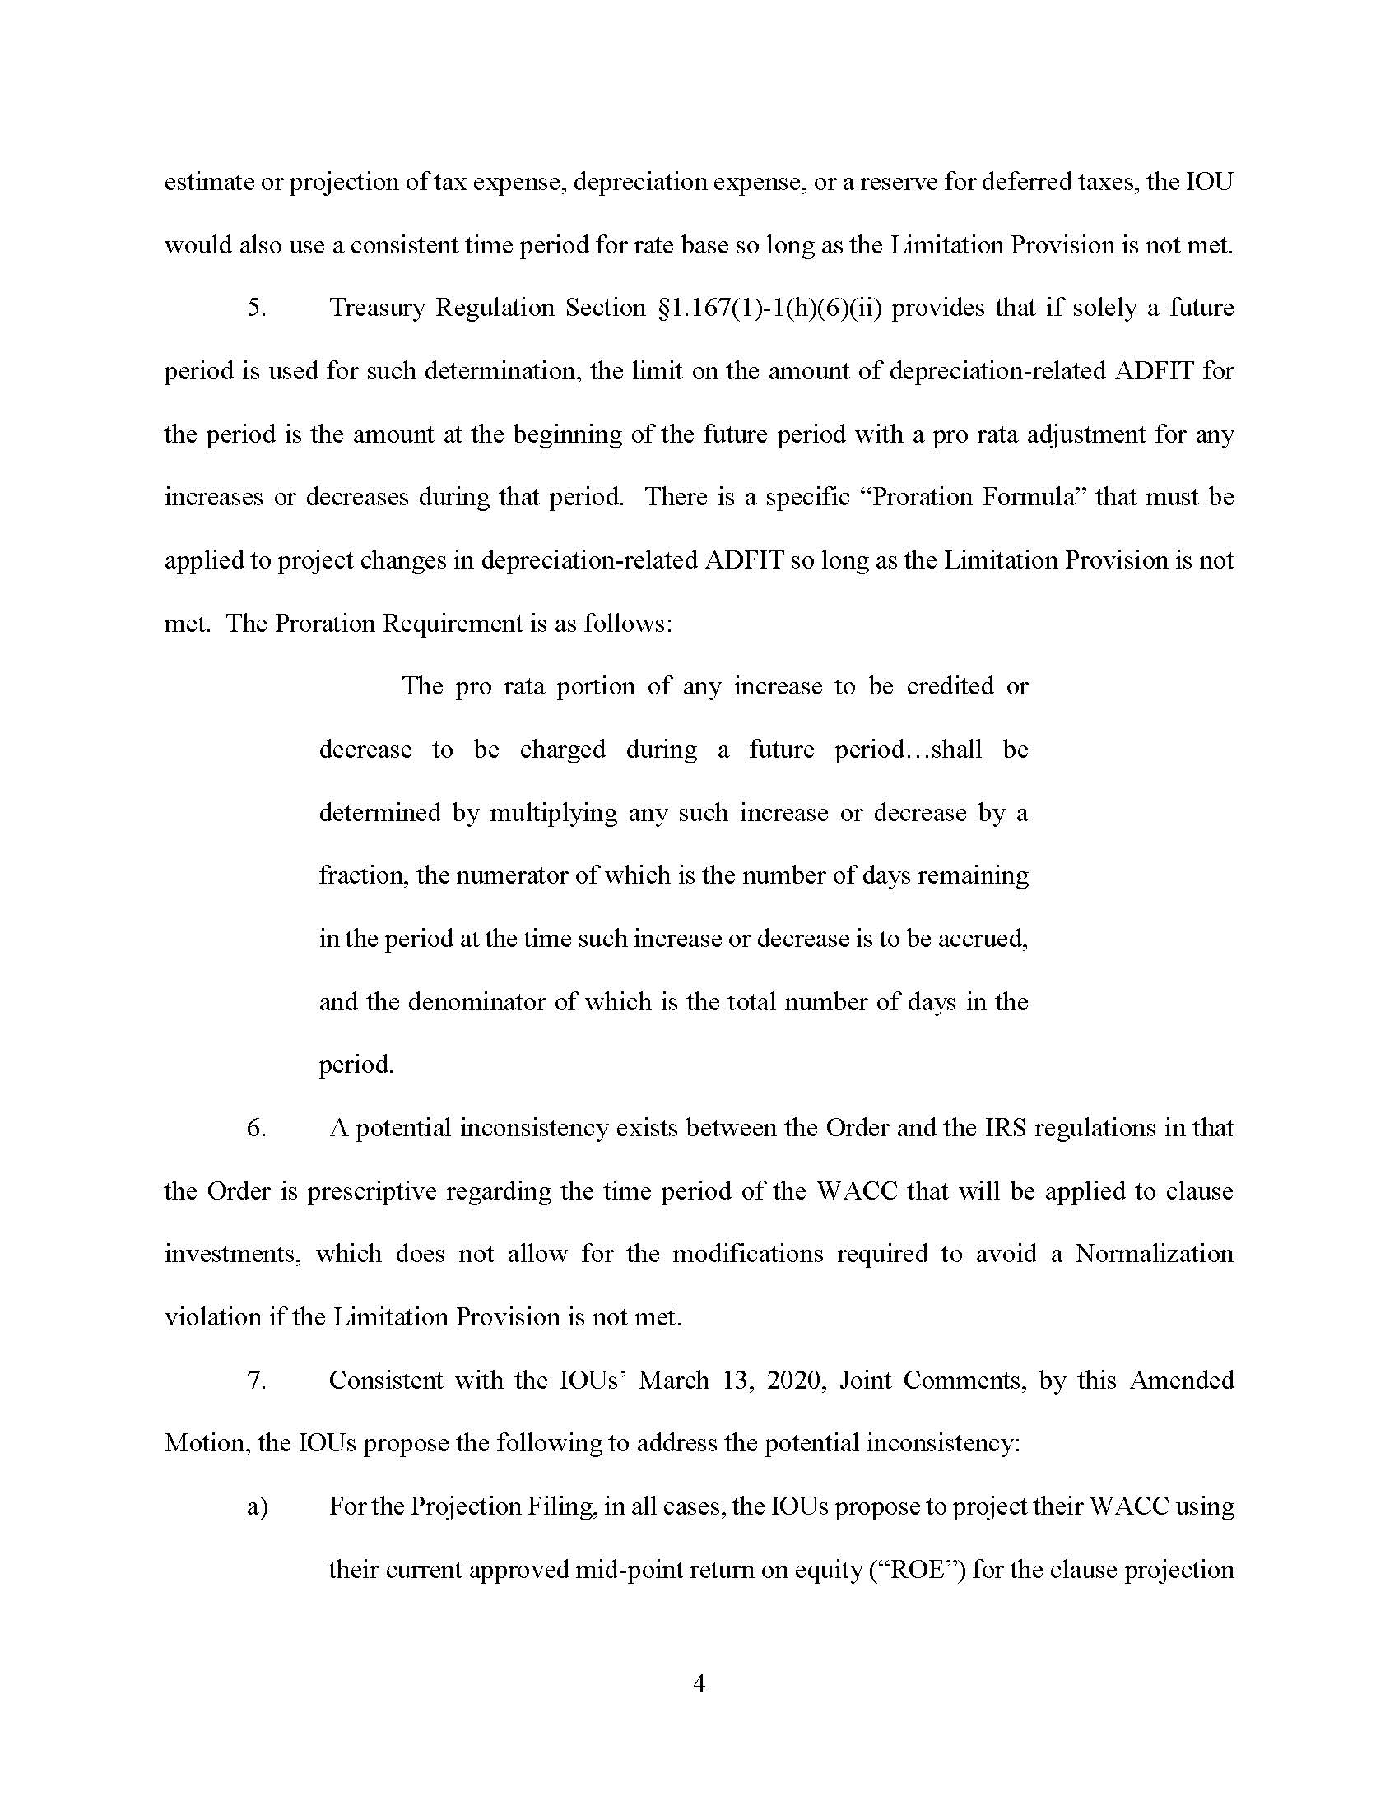

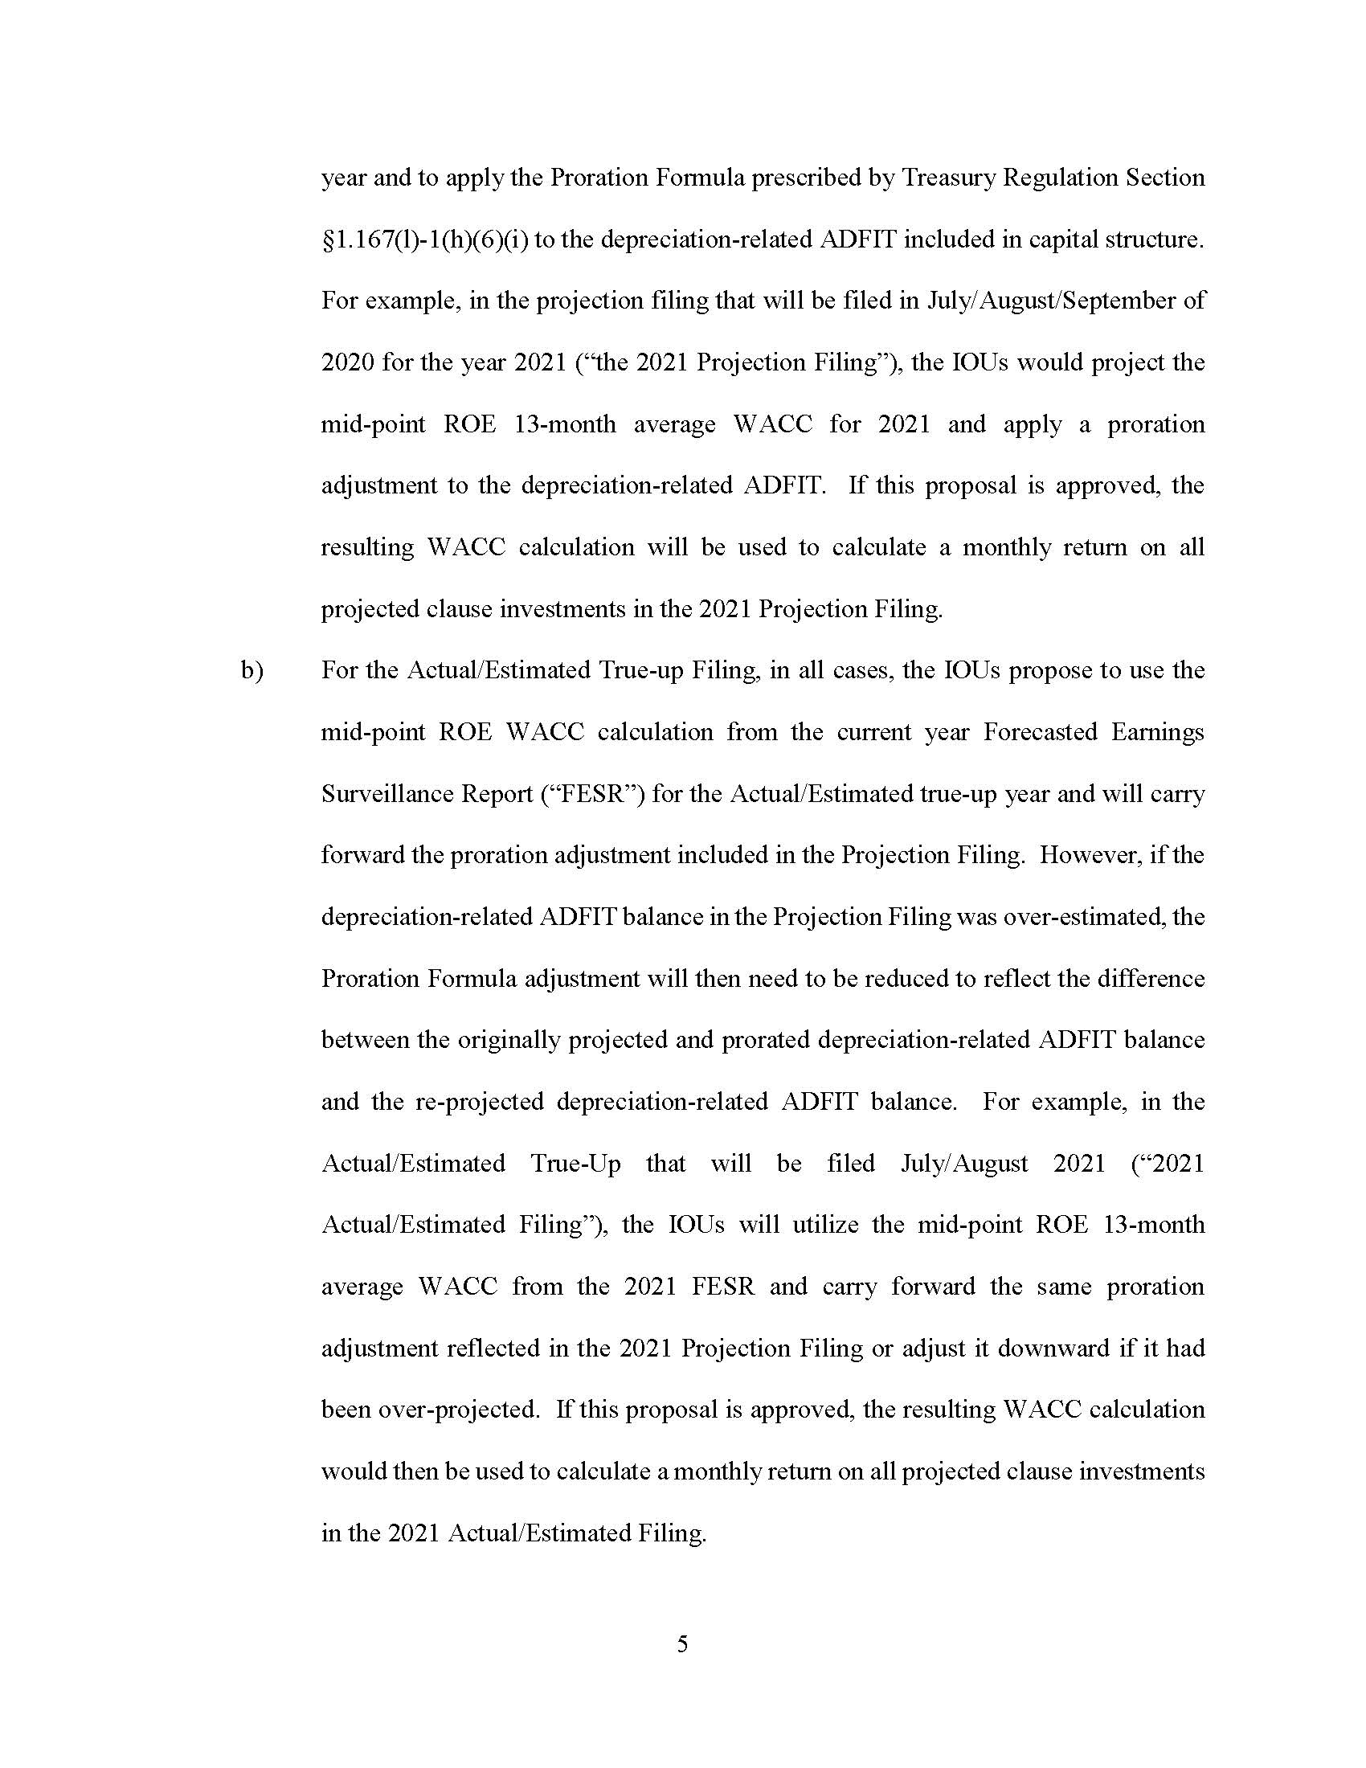

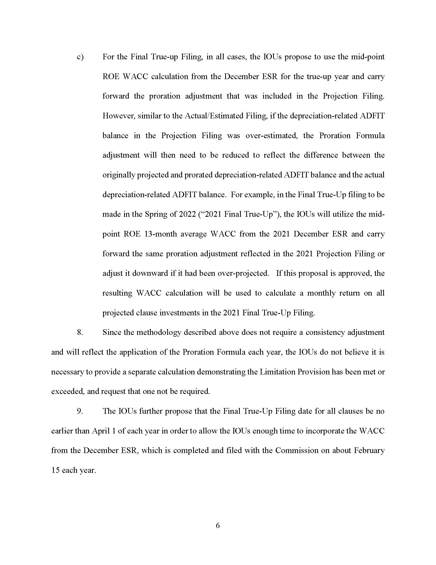

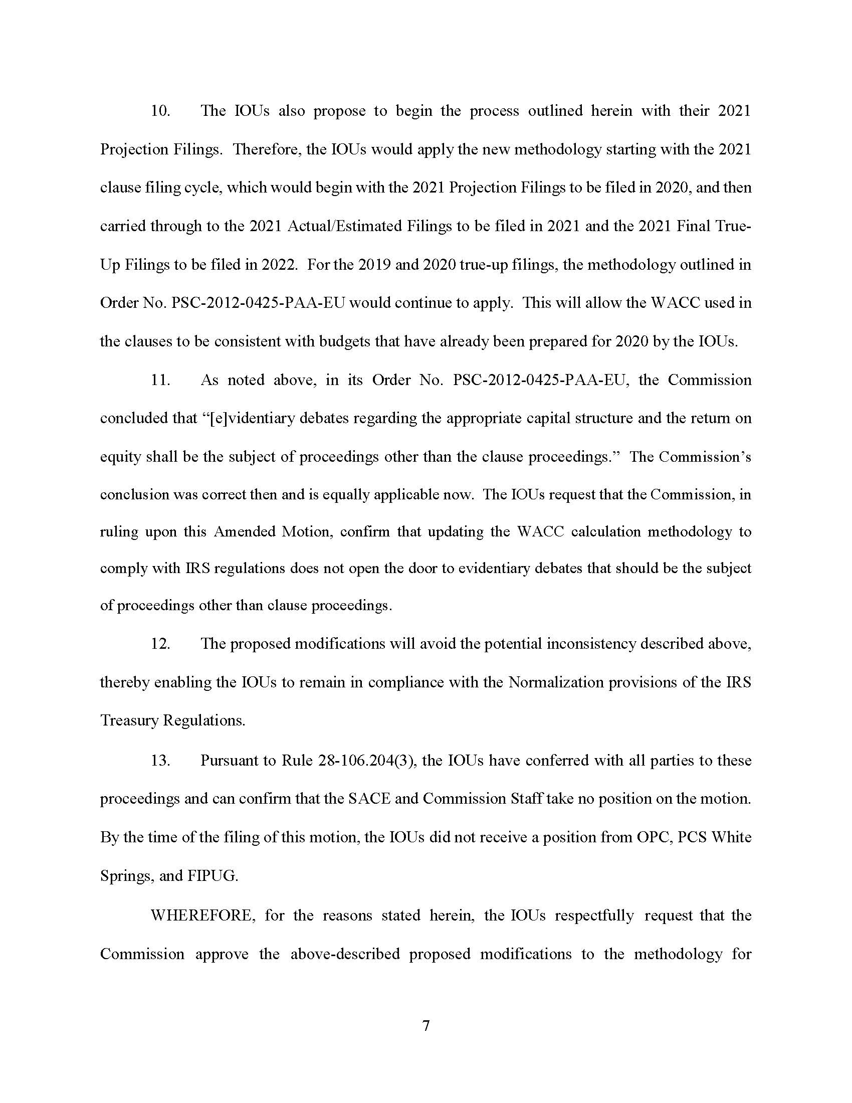

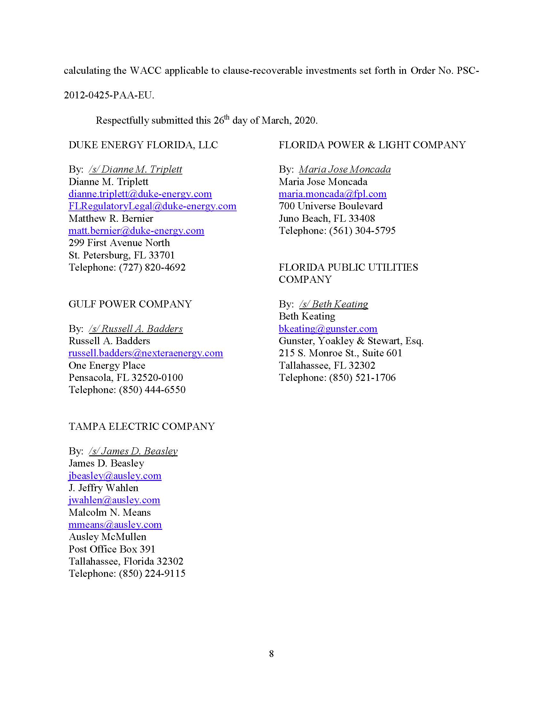

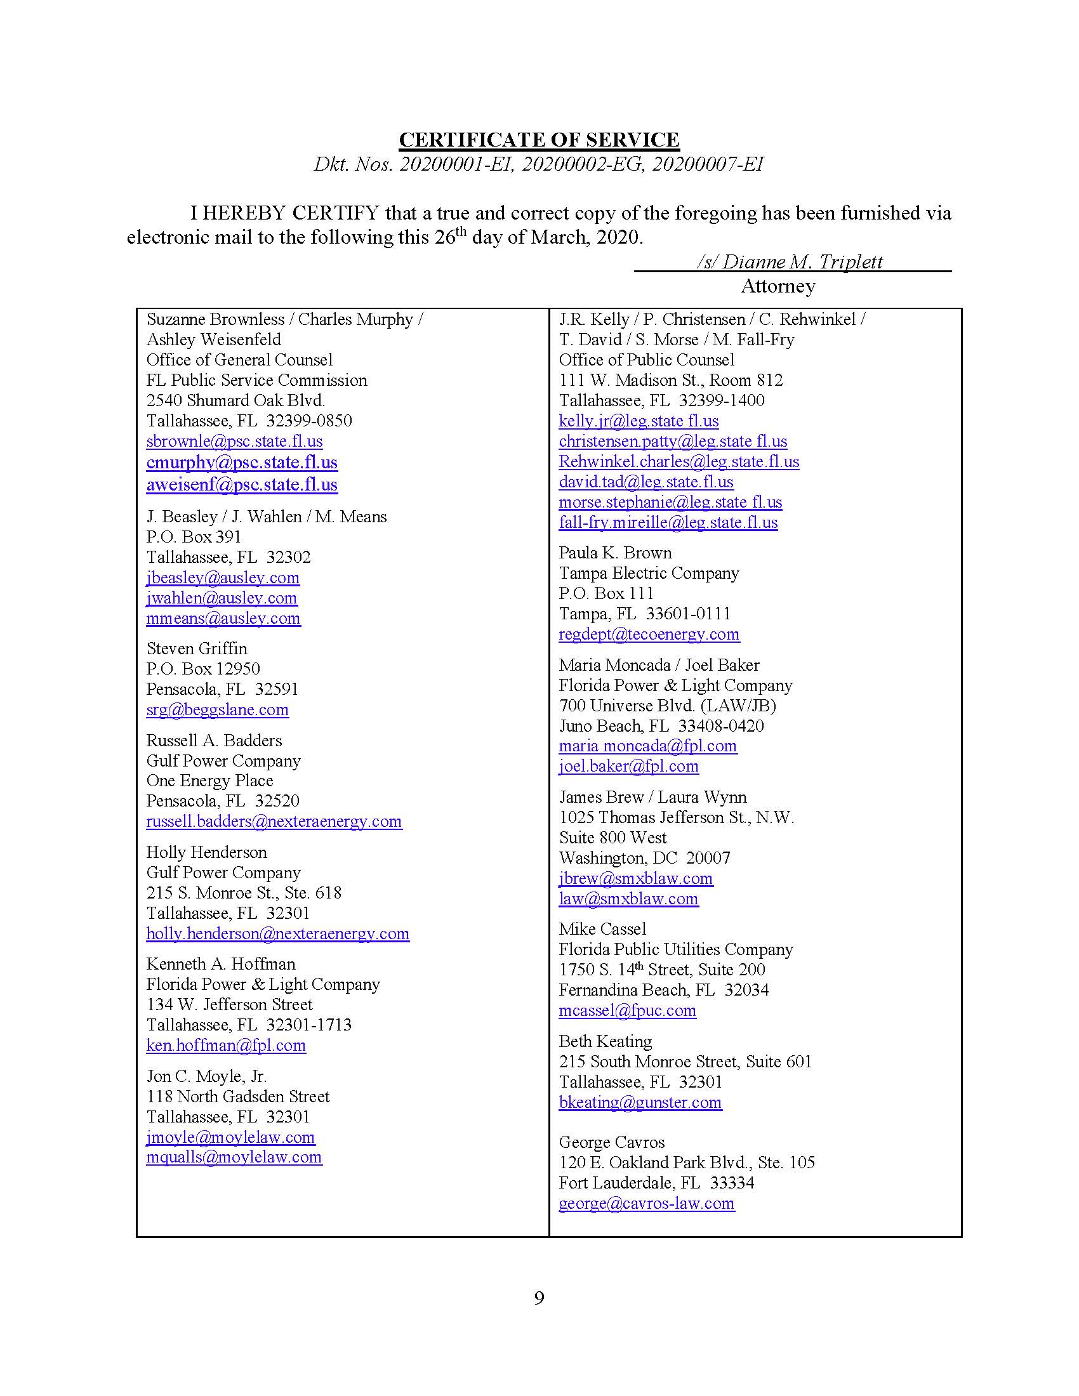

Order No. PSC-2012-0425-PAA-EU, issued August 16, 2012, in Docket No. 20120001-EI, In re: Fuel and purchased power cost recovery clause with generating performance incentive factor.
IRS Normalization Rules require public utilities to implement consistency between regulatory accounting for ratemaking and book accounting for income tax purposes when calculating income tax expense.
Document No. 08312-2019, filed August 21, 2019, in Docket No. 20190001-EI, In re: Fuel and purchased power cost recovery clause with generating performance incentive factor, Docket No. 20190002-EG, In re: Energy conservation cost recovery clause, and Docket No. 20190007-EI, In re: Environmental Cost Recovery Clause.
Document No. 00788-2020, filed February 4, 2020, in Docket No. 20200001-EI, In re: Fuel and purchased power cost recovery clause with generating performance incentive factor, Docket No. 20200002-EG, In re: Energy conservation cost recovery clause, and Docket No. 20200007-EI, In re: Environmental Cost Recovery Clause.
Document No. 01393-2020, filed March 13, 2020, in Docket No. 20200001-EI, In re: Fuel and purchased power cost recovery clause with generating performance incentive factor, Docket No. 20200002-EG, In re: Energy conservation cost recovery clause, and Docket No. 20200007-EI, In re: Environmental Cost Recovery Clause.
Document No. 01616-2020, filed March 26, 2020, in Docket No. 20200001-EI, In re: Fuel and purchased power cost recovery clause with generating performance incentive factor, Docket No. 20200002-EG, In re: Energy conservation cost recovery clause, and Docket No. 20200007-EI, In re: Environmental Cost Recovery Clause.
Treasury Regulation Section §168(i)(9).
The Consistency Rule states that in order for a utility to use a normalization method of accounting with respect to any public utility property, the utility must use a method of depreciation with respect to such property that is the same as, and a depreciation period that is no shorter than, the method and period used to compute its depreciation expense for such purposes, in computing its tax expense for purposes of establishing its cost of service for ratemaking purposes and reflecting operating results in its regulated books of account. If the amount allowable as a deduction under this section with respect to such property differs from the amount that would be allowable as a deduction under Treasury Regulation Section 167 using the method used to compute regulated tax expense under clause (i), the taxpayer must make consistency adjustments to a reserve to reflect the deferral of taxes resulting from such difference.
Id.

