GULF POWER COMPANY

Before the Florida Public Service Commission

Prepared Direct Testimony of

P. Chris Caldwell

Docket No. 110138-EI

In Support of Rate Relief

Date of Filing: July 8, 2011

Q. Please state your name, business address, employer, and position.
A. My name is Chris Caldwell. My business address is One Energy Place, Pensacola, Florida, and I am the Transmission Manager for Gulf Power Company (Gulf or the Company).

Q. What are your responsibilities as Gulf’s Transmission Manager?
A. I have responsibility for the planning, design, construction, operation and maintenance activities for Gulf’s transmission facilities. On Gulf’s system, transmission includes those facilities rated 46 kilovolts (kV) and above. My responsibilities include all compliance activities, planning, budgeting, trouble restoration, transmission vegetation management, and right-of-way management. The transmission department is also responsible for operation, construction, and maintenance of distribution facilities located within substations at Gulf Power.

Q. Please state your prior work experience and responsibilities.
A. I have been Gulf’s Transmission Manager since July 2010. Previous to my current position, I worked for Georgia Power Company. Since June 1999 I have held various roles in the transmission function. I have served in engineering roles in construction and field protection and control activities. I have been in leadership roles managing transmission maintenance activities in Atlanta, Georgia and in Augusta, Georgia. I have been in management roles at Georgia Power where I had responsibility for developing and implementing the maintenance program for all of Georgia Power’s transmission facilities. This role included managing the Operation and Maintenance (O&M) budget for the organization and developing proactive projects to replace obsolete equipment and facilities.

Q. What is your educational background?
A. I hold a Bachelor of Science in Engineering with a specialization in Mechanical Engineering from Mercer University’s School of Engineering in Macon, Georgia.

- What is the purpose of your testimony?
- My testimony discusses Gulf’s transmission system and the process we use to manage the system assets. I explain how we plan the system and develop our transmission budgets. Additionally, I discuss our current transmission investment and its usefulness in providing reliable service to our customers. I cover Gulf’s projected transmission capital expenditures and O&M expenses for the year 2012. My testimony then addresses Gulf’s transmission system performance.

Q. Are you sponsoring any exhibits?
A. Yes, I am sponsoring Exhibit PCC-1, Schedules 1 through 7. Exhibit PCC-1 was prepared under my direction and control, and the information contained therein is true and correct to the best of my knowledge and belief.

Q. Are you sponsoring or co-sponsoring any of the Minimum Filing Requirements (MFRs) filed by Gulf Power?
A. Yes. I sponsor or co-sponsor the MFRs shown on Exhibit PCC-1, Schedule 1. The information contained in the MFRs I sponsor or co-sponsor is true and correct to the best of my knowledge and belief.

I. Description of Gulf’s Transmission System

Q. What is the purpose and function of Gulf’s transmission system?
A. Gulf’s transmission system is used to move large amounts of power among the generation sources, neighboring utilities, and load centers. Gulf’s transmission system utilizes facilities at three voltage levels: 230,000 volts (230kV), 115,000 volts (115kV) and 46,000 volts (46kV). These facilities are tied together in a complex network to transport the power where it is needed.

When electricity is generated, the voltage is raised to transmission levels utilizing a transformer at the generating station. Once the power has been transmitted from the generation centers closer to the areas in which it is needed, the voltage is reduced to a lower level, by utilizing a transformer within a distribution substation as described by Gulf Witness Moore. The distribution facilities which branch out from the substation carry the power to the customers. Some large industrial customers receive service at transmission voltage and have their own internal distribution networks. Exhibit PCC-1, Schedule 2 offers a general depiction of the overall energy network and how power flows.

Q. Can you visually describe some of the components you reference?
A. I have included photographs of some typical transformers and transmission structures in Exhibit PCC-1, Schedule 3.

Q. What is the makeup of Gulf’s transmission facilities?
A. Gulf’s transmission facilities consist of approximately 1,600 miles of lines, which are operated at 230kV, 115kV, and 46kV. Exhibit PCC-1,
Schedule 4 is a map of Gulf’s transmission facilities. The Company’s 230kV system includes 437 miles of line and 1,142 structures. Gulf’s 115kV system is made up of approximately 1,060 miles of line and 13,962 structures. Gulf also has a 46kV system that consists of about 114 miles of line with 1,180 structures. The system (all of the lines regardless of voltage) is connected through 143 substations, 109 of which are classified as distribution or load serving.

Gulf’s 230kV system carries the bulk power flow from generation sources and neighboring utilities. These lines supply the path for power to flow from the generation sources to Gulf’s transmission level substations in the various regional areas of demand. The 115kV transmission facilities move the power from the transmission substations to one of our 109 distribution stations utilizing a transformer to reduce the voltage to a level appropriate for Gulf’s distribution network. In these distribution substations, the power is split into individual feeders for distribution to customer load centers. The 46kV system serves some of our more remote areas where lower amounts of power need to be directed to fewer loads. We also have a number of tie-lines with other utilities. These lines act as conduits for power to flow both into and out of our network, depending upon the current system conditions.

II. Transmission Asset Management Process

Q. Please describe Gulf’s method for oversight and management of its transmission system.
A. Gulf manages the transmission system through five major functions: planning, design, construction, operations, and maintenance. Through each of these functions we provide the oversight needed to ensure that Gulf maintains reliable service to our customers.

Q. Please describe the responsibilities of Gulf’s transmission planning function.
A. The transmission planning function evaluates Gulf’s transmission system to ensure we can reliably serve our customers’ needs today and into the future. The evaluation identifies potential facility overloads or other system issues in time to develop solutions and complete projects to mitigate the issue. This work is done using a complex system model and evaluating a multitude of possibilities in search of system issues or overloads. Given the complex nature of modeling and evaluating the system issues, Gulf utilizes the expertise of Southern Company Services (SCS) to run the studies and develop the list of issues annually. I discuss Gulf’s transmission planning process in detail later in my testimony.

Once a potential issue is identified through the planning process, Gulf uses a diverse team of experts to ensure that all aspects and impacts of the potential project are reviewed. Depending on the issue identified, this group may include Generation Planning, Environmental, Customer Service, Distribution, Land or any other personnel needed. In most cases, multiple alternatives are considered and cost estimates are developed for each alternative.

Ultimately, a solution is recommended and reviewed by transmission management. Once the scope and costs are approved, the projects are input into the budget for the appropriate years. At this point, a preliminary

estimate is prepared. This estimate is further refined during the design phase.

Q. Please describe the design phase.
A. With a solution and scope determined, the final design work can begin. Because of the specialized expertise needed, Gulf uses the resources of SCS for our design work. The Southern Company Transmission (SCT) Design and Maintenance Support group is our resource for the design work on transmission projects. Gulf has the ultimate responsibility and oversight for the design, and we work closely with the designers to ensure our customers receive a quality product and that the designs meet our needs. Using standard designs from SCT allows Gulf to take advantage of cost savings for materials, equipment, and labor for construction. Additionally, we are able to use the expertise from the SCT group to incorporate the latest in designs and technology advancements. Through the design process, our estimates for the project are revised, as appropriate, based on a more detailed engineering analysis of the scope and construction needed.

Q. Please describe the construction phase.
A. Gulf is responsible for all construction activities to ensure the projects are completed according to budget and schedule targets. We also have a rigorous inspection program for all projects to ensure our facilities are constructed as designed and are built with the quality needed for the reliable service we expect.

Q. Please describe the operations function.
A. After construction, the new facilities are incorporated into our existing systems for operations. Operations monitors our transmission system and the flow of power to our customers. Through our operations group, Gulf ensures reliable power and facilitates planned outages on components for construction or maintenance activities. Our operators are North American Electric Reliability Corporation (NERC) certified and are qualified to make critical decisions as contingencies develop.

Our operations group uses an Energy Management System (EMS) to monitor the transmission system and to operate devices in the field to control power flow as needed. EMS is critical to ensure the operators are aware of field conditions and can make adjustments to mitigate issues. EMS provides a digital display of our lines and substations along with data about voltages, current, and power flows. This system also provides for alarms indicating trouble with system equipment and other facilities.

Q. What is the process for maintaining Gulf’s transmission facilities?
A. All facilities are incorporated into our transmission maintenance programs. The goal of Gulf’s transmission maintenance programs is to provide reliable operations for our customers and to extend the life of the transmission assets. These programs generally consist of an inspection process that drives a repair program. The repair program is based on

issues or abnormal conditions documented during the inspection or otherwise discovered. A maintenance program is optimized for each type of equipment or facility, and maintenance is scheduled based on historical trends with similar equipment or facilities.

III. Transmission Planning Process

Q. Please describe Gulf’s process for planning its transmission system.
A. Gulf’s primary objective is to plan the transmission system well ahead of our customers’ needs in order to provide timely, cost-effective and reliable electrical service. Gulf develops a 10-year plan based on load forecasting and other operational considerations. The transmission system is planned to meet the needs during peak system conditions and various contingency scenarios so that lines or equipment do not experience overloads.

The planning process identifies limiting elements (lines, transformers, breakers or other equipment) where overloads may occur based on the studied loading, generation, and contingencies for the various scenarios. In addition to identifying equipment or facility overloads, the planning studies also identify other reliability and system stability issues related to area voltage support and generation impacts. Gulf’s planning process meets the applicable requirements of the NERC standards and any

applicable Southeastern Electric Reliability Corporation (SERC) standards.

Q. Please explain NERC and SERC and their involvement in the planning process.
A. In June 2007, the Federal Energy Regulatory Commission (FERC) granted NERC the authority to enforce reliability standards on all users, owners, and operators of the bulk power system in the United States and made compliance with those standards mandatory and enforceable. Non-compliance with these reliability standards can result in fines of up to $1,000,000 per day per occurrence. Included in this authority was a provision for NERC to delegate authority for the purpose of proposing and enforcing reliability standards in particular regions of the country by entering into delegation agreements with regional entities.

SERC serves as a regional entity with delegated authority from NERC for the purpose of proposing and enforcing reliability standards within the southeastern United States, consisting of all or portions of Missouri, Illinois, Oklahoma, Louisiana, Texas, Arkansas, Mississippi, Alabama, Georgia, Tennessee, Florida, South Carolina, North Carolina, Kentucky, and Virginia. Gulf is within the SERC Region. Compliance with the reliability standards is monitored and audited periodically by SERC.

Gulf certifies compliance with the standards as required by NERC and SERC. Gulf fosters a culture of compliance with all regulatory requirements through oversight programs and processes. Gulf was
audited by SERC on Reliability Standards Compliance in 2009 and was found fully compliant on all requirements.

The NERC and SERC reliability standards cover many aspects of the bulk power system, including the planning process. The requirements within the planning standards specify transmission system scenarios to be evaluated that ultimately produce projected system or component overloads or voltage issues that must be resolved. Once an issue or “problem” has been identified by the planning studies, the reliability standards require Gulf to develop a project to mitigate the problem, budget for the necessary funds, and ultimately complete the project before the problem causes a disturbance within the system. The process for a new substation or line can take years; therefore, Gulf must develop a planning process that looks at a horizon far into the future. As mentioned previously, the Company conducts an annual transmission assessment of the effects of forecasted future load growth, generation assumptions, and/or other changes to load flow over a 10-year period.

These planning studies also review the need to serve new load areas and/or large new customers, future interconnections with neighboring utilities, integration of new generation facilities, and firm contractual transmission service obligations. The changes in system performance due to these factors are simulated and analyzed for the present and future years to identify existing and future system limitations. Alternative solutions to these limitations are then developed, analyzed, and screened based on electrical performance. Viable alternatives are compared for their relative merits with respect to reliability, voltage, capacity, economics, and constructability. Transmission facility additions such as a new transmission line or addition of substation equipment are budgeted as a result of this process.

The entire Gulf transmission system is studied annually and the 10-year plan is revised. This 10-year plan includes the solutions and scope for projects along with the budget requirements for all transmission system improvement projects. This plan is reviewed and approved annually by the Transmission Manager.

IV. Transmission Capital additions budget

Q. Please describe the transmission capital additions budget process.
A. Transmission begins its capital additions budget process by reviewing two major components that make up the transmission capital expenditures: transmission infrastructure replacement projects and transmission planning generated projects. Transmission infrastructure replacement projects consist of routine replacements of poles, transformers, voltage regulation equipment, switches, conductors, and other assets. The transmission planning generated projects are a result of the transmission planning process that I mentioned previously. Both the transmission infrastructure replacement projects and transmission planning generated projects are developed to support reliability, safety, and customer demand.

Transmission infrastructure replacement projects and transmission planning generated projects are further subdivided into blanket and specific plant expenditure (PE) categories. Blanket PEs reflect repetitive expenditures based on historical trends. Blanket PEs include items such as pole, arm, conductor, shieldwire, breaker, regulator, and transformer replacements and other capital improvement projects. Specific PEs are related to transmission planning generated projects and major initiatives requiring transmission plant additions. Examples of specific PEs are substation upgrades, transmission line upgrades, new transmission lines and new substations.

The proposed capital additions budget is reviewed by the transmission management team. Once approved, the transmission management team submits a proposed capital additions budget to the Power Delivery General Manager and the Vice President of Customer Operations. Once reviewed and approved by the Vice President of Customer Operations, the transmission capital additions budget is presented to Corporate Planning for inclusion in the Company’s Capital Additions Budget. Gulf Witness

Buck will address Gulf’s capital additions budget process within Corporate Planning.

Q. Mr. Caldwell, Gulf Witness McMillan shows a total of $2.6 billion of plant in service investment in Gulf’s 2012 rate base in this case. Other witnesses have testified that these costs are properly recorded consistent with the Uniform System of Accounts and generally accepted accounting
principles. Are the transmission assets associated with these costs used and useful in the provision of electric service to the public?
A. Yes. The transmission assets, which comprise a total of $381,385,000 of the plant in service in Gulf’s 2012 rate base in this case, are used and useful in Gulf’s provision of electric service.

Q. Were these transmission costs reasonable and prudently incurred?
A. Yes. This investment includes, but is not limited to, the partially depreciated facilities included in Gulf’s last rate case and approved by the Florida Public Service Commission (FPSC or the Commission). Since then, Gulf has continued to follow its planning criteria and committed the necessary resources to meet the demands of our customers. We have made the capital investments in the transmission system to continue to provide reliable electric service to our customers.

Since Gulf’s last request for base rate relief, the transmission territorial system peak for Gulf has grown from 2,500 MW in 2003 to an all time peak of 2,634 MW in 2007. Gulf typically experiences annual peaks near 2,550 MW. The Company has invested $197.8 million during this period in the transmission system. These transmission investments have enabled Gulf to meet system needs during high load times. Gulf’s planning process ensures that transmission improvements are planned, designed, and built in concert with our system loads to ensure the transmission capacity is there when needed without overbuilding the system.

Q. Mr. Caldwell, what types of capital investments were made during the 2003 to 2010 time period?
A. The following are examples of the types of expenditures made in the 2003 to 2010 timeframe:
- Transmission Infrastructure Replacement Projects - $70.7 million
    - Transmission - $58.0 million
    - Distribution substation - $12.7 million
- Transmission Planning Generated Projects - $94.4 million
    - Transmission Line Improvements - $44.8 million
    - New Transmission Substations - $16.1 million
    - Substation Equipment Upgrades - $33.5 million
  - Distribution Planning Generated Projects – $32.7 million
    - New Distribution Substations – $19.3 million
    - Distribution Substation Equipment Upgrades - $13.4 million

Q. Please provide an example of a major project that was completed in the 2003 to 2010 time period that is included in transmission planning generated projects above.
A. The 10-year plan indicated a transformer overload on one of the 230kV to 115kV autotransformers in the Ft. Walton Beach area in the summer of 2006. After convening a team from the planning, design, maintenance, and construction departments, a solution was developed to build a new 230 kV to 115 kV substation in the Holley, Florida area. The resulting new substation, Miller Bayou, provided additional voltage stability for the Navarre and Gulf Breeze portions of the system along with solving the overload issue on the autotransformer in the Ft. Walton Beach area. Through the careful planning process, Gulf was able to strengthen the area’s transmission system while solving multiple issues in a cost-effective manner.
Q. What are Gulf’s transmission capital additions budgets for 2011 and 2012?
A. Gulf’s transmission capital additions budget for 2011 is $66,748,000 and for 2012 is $70,902,000. These two totals consist of transmission infrastructure replacement projects, Smart Grid Investment Grant (SGIG) projects, transmission planning generated projects, and distribution planning generated projects. The budget for 2011 through 2013 is shown in Exhibit PCC-1, Schedule 5.

Q. Please discuss the transmission infrastructure replacement projects.
A. The infrastructure projects account for $6,180,000 of the 2012 transmission capital additions budget. The infrastructure replacement projects consist of the replacement of deteriorated equipment inside substations such as breakers, transformers, switches, regulators, and relays; along with the replacement of poles,arms and hardware on the transmission lines. The need for the infrastructure improvement projects is driven primarily by aging infrastructure.

Gulf installed a significant amount of transmission infrastructure to support growth from 1960 to 1980. This infrastructure is approaching or is at the end of its useful life, which can result in increased failure rates. Gulf has been able to extend the life cycles of these facilities beyond the typical 30-year window because of its maintenance programs, which has provided benefits to our customers. However, there is a limit to the useful life of this investment, and proactive replacements must be part of our plans. Infrastructure replacement projects are prudent and necessary to avoid impacts to reliability. Proactive spending to replace these assets will also allow for better planning and more cost effective solutions compared to reacting once a failure has occurred.

Q. Please describe the SGIG projects included in the 2012 transmission capital additions budget.
A. Gulf’s SGIG projects included in the 2012 transmission capital additions budget account for $5,640,000. As part of the American Recovery and Reinvestment Act, Congress allocated funding to the Department of Energy (DOE) for grants to increase the rate of Smart Grid equipment deployment across the United States. The transmission portion of this grant has been dedicated to replacing protection and control equipment in substations with newer technologies which allow for better operation and control of the transmission network. These devices facilitate communication between remote field locations and the transmission control center, as well as allowing more advanced protection schemes to be implemented throughout Gulf.

Q. What is included in the transmission planning generated projects portion of the 2012 capital additions budget?
A. The transmission planning generated projects account for $56,107,000 of the 2012 transmission capital additions budget. The major items Included in the 2012 budget are:

- Smith – Laguna Beach – Santa Rosa transmission line and substation improvements ($25,872,000)
- Slocomb – Holmes Creek – Highland City transmission line and substation improvements ($28,750,000)

The transmission planning generated projects which Gulf will be working on in 2012 were developed through the Gulf standard planning process and underwent the same scrutiny as described in the transmission planning portion of my testimony. The projects will strengthen the transmission grid by creating new paths and improving existing paths to allow more power to flow across our system and will avoid potential overload conditions.

Q. Please describe the Smith – Laguna Beach – Santa Rosa project.
A. This $25,872,000 expenditure is for a portion of the upgrade of the line and substation between Plant Smith to Laguna Beach substation and the Santa Rosa substation. Gulf will be finishing the rebuild of the 14.2 miles of the Smith – Laguna Beach 115kV transmission line in 2012. The newly rebuilt line will create a second 230kV path from Plant Smith to the Laguna Beach substation. Another piece of this overall project is the modification of the existing Santa Rosa substation to include a 230kV ring bus terminal. The initial reconstruction of the Santa Rosa substation will take place during 2012.

Q. Please describe the Holmes Creek – Highland City project.
A. The initial phase of the project will begin in 2012 with expenditures of $28,750,000 to rebuild the first phase of the line from Holmes Creek to Marianna. This project is a new 230kV path from Alabama Power’s Plant Farley to the Panama City area. This new line from Slocomb substation in Alabama to Holmes Creek substation to Highland City substation will alleviate a potential overload on the existing 115kV line along this same path.

Q. Please account for the remaining $1,485,000 within the transmission planning generated projects portion of the 2012 transmission capital additions budget.
A. The remaining $1,485,000 in the transmission planning generated projects portion of the 2012 budget is accounted for by various smaller projects and projects currently in the design phase.

Q. Please discuss the distribution planning generated projects included in the 2012 transmission capital additions budget.
A. Distribution planning generated projects account for $2,975,000 of the 2012 transmission capital additions budget. These projects are recommended as a product of the Distribution Planning Process as discussed in Mr. Moore’s testimony. Transmission has the responsibility for all engineering, construction, and project management associated with these projects.

An example of one of these projects is the construction of Holiday substation. It will be constructed as a new 115kV to 12kV distribution substation in Gulf’s Eastern District. The substation will alleviate transformer overloading conditions at one of the other nearby substations. The new substation will allow for increased reliability to our customers along with additional operability options for our Distribution Operations Center. The new substation represents $2.0 million of the 2012 transmission capital budget.

Gulf’s 2012 transmission capital additions budget includes $975,000 to cover the cost of the remaining projects in this category. These projects include the addition of feeders and transformers in distribution substations.

V. Transmission O&M Budget

Q. Describe how the transmission Operations & Maintenance (O&M) budget is developed.
A. Gulf’s Corporate Planning organization provides a Budget Message with budget guidelines for preparing the budget. Following receipt of the Budget Message, Gulf’s transmission O&M budget is developed through a multi-step process that is implemented by employees who are well-experienced and very knowledgeable of the transmission systems they operate and maintain. Each year Gulf’s transmission organization develops a five-year O&M budget based on historical experience and projected maintenance in order to continue the safe operation and integrity of the transmission system. Gulf uses data collected through various inspection programs to assist in planning its O&M budget. I discuss these inspection programs later in my testimony. We review the repair work to be completed and estimate the costs of the maintenance programs to develop our budget requests. These repairs make up the majority of the variable O&M costs from year to year.

Gulf’s other transmission O&M costs are related to equipment, tools, and people. We conduct workforce planning reviews to ensure we are staffed appropriately and make adjustments as needed. One of the considerations in the staffing review is to ensure we have adequate resources to respond to trouble and outages on the system in a timely manner.

The 5-year O&M budget is scrutinized in a multilayer process that compares historical spends for transmission accounts and cost types. New programs or additional dollar requests must be validated and approved annually. This approval process closely follows our capital additions budget review and approval process. Each responsibility center within transmission develops a budget for the five year window annually. The total transmission budget is reviewed and approved by the Transmission Manager and then by the Power Delivery General Manager. Final review is completed by the Customer Operations Vice President and
the budget continues on in the process to approval as outlined in Mr. Buck’s testimony.

In addition to the rigorous multilayer budgeting approval process, Gulf also institutes a detailed process for monitoring, evaluating, and justifying current year O&M expenses and capital expenditures. Budget to actual costs are reviewed monthly and variances are documented. Each month, projections are made for the month ahead and for year-end. These monthly actual costs, variances, monthly projections, and year end projections are reviewed by the Transmission Manager, Power Delivery General Manager, and the Customer Operations Vice President.

Q. What is Gulf’s transmission O&M budget for 2011 and 2012?
A. Gulf’s transmission O&M budget for 2011 is $11,760,000 and for 2012 is $11,609,000, as shown in Exhibit PCC-1, Schedule 6.

Q. Are Gulf’s projected levels of transmission O&M expenses in 2011 and 2012 reasonable and prudent? Please explain.
A. Yes. Gulf’s projected levels of transmission O&M expense are reasonable, prudent, and necessary for Gulf to continue to provide adequate and reliable transmission service to meet our customers’ needs. The amounts were developed through Gulf’s transmission budget process and includes expenses for Protection & Control, Substation Maintenance Program, Substation Metering Services, Transmission Control Center, Transmission Line Inspection Program, Transmission Line Maintenance Programs, Transmission Engineering and Supervision, Transmission Vegetation Management, and SGIG.

Q. Please describe Gulf’s Protection & Control component of the 2012 O&M budget.
A. Gulf’s Protection & Control accounts for $413,000 of the 2012 transmission O&M budget. Transmission is responsible for the systems and equipment which monitor and automatically respond to abnormal conditions on the transmission grid. These controls and equipment are on a routine maintenance cycle as required by NERC. The maintenance program consists of relay calibration, circuit verification, and functional testing of the protection schemes.

Q. Please describe Gulf’s Substation Maintenance program.
A. Gulf’s Substation Maintenance program accounts for $1,406,000 in the 2012 transmission O&M budget. Gulf implements a performance and interval based Substation Maintenance Program. This program uses periodic diagnostic tests on equipment to assist in determining the level of maintenance needed. These inspections review the performance of the equipment and review the current conditions of components. Based on conditions observed during the inspection, additional maintenance or repairs may be performed. The expenses to perform the inspections and
follow through with the identified repairs are essential to the reliable operation of the system and to avoiding unexpected outages.

Q. Please describe Gulf’s Substation Metering Services component of the 2012 O&M budget.
A. Substation Metering Services accounts for $48,000 of the 2012 transmission O&M budget. The Substation Metering Services component of the transmission O&M budget accounts for the ongoing maintenance of metering equipment within Gulf’s distribution substations.

Q. Please describe what is included in the Transmission Control Center (TCC) operations O&M budget line item.
A. The 2012 transmission O&M budget includes $3,790,000 related to the Transmission Control Center operation. This expenditure is necessary for the safe and secure operation of Gulf’s transmission system. Our TCC operates 24 hours a day, 7 days a week, and 365 days a year. The NERC-certified operators are responsible for the reliable operation of the system and take action to mitigate emergent issues. These operators also assist with removing components from service for maintenance or construction activities and use EMS to monitor and control the transmission system and its components. This system relies on data from field devices that is processed by local servers and displayed for the operators’ use. This expense item also includes the bulk power operations functions performed by the Power Control Center (PCC).

Q. Please describe Gulf’s Transmission Line Inspection program.
A. Gulf’s Transmission Line Inspection Program accounts for $589,000 in the 2012 O&M budget. It consists of several inspection techniques to ensure the integrity of the system. A comprehensive, systematic transmission line inspection program is essential to the effective and orderly maintenance and safe and reliable operation of the transmission system. The objectives of this program are:
- To maximize plant facility life,
- To gather information to assist in prioritizing repairs, and
- To minimize unscheduled or emergency maintenance.

The program requires that every structure be inspected at least every 6 years by a ground inspection, climbing inspection, or a comprehensive aerial inspection by helicopter. This program is a part of Gulf’s 2010 Storm Hardening Plan, which was approved by the FPSC in Docket No. 100265-EI, Order No. PSC-10-0688-PAA-EI.

Based on data gathered during the inspection program, repairs that are not related to capital infrastructure projects are expensed. The cost of these repairs can be significant and are related to weather, age of infrastructure, and other environmental factors. Some examples of these types of expenses are repairing woodpecker holes, replacing rusted or broken guy wires, and repairing deteriorated foundations or structure components. These expenses are prudent and can delay a costly capital outlay to replace the facility if repairs are not made timely. Additionally, the data from our inspection programs allows Gulf to trend and develop other maintenance programs to extend the life of the facilities. Some examples of programs needed based on our inspection data include a structure painting program for all steel structures and additional foundation repairs.

Q. Please describe Gulf’s Transmission Line Maintenance Programs.
A. Gulf’s Transmission Line Maintenance Programs account for $593,000 of the 2012 transmission O&M budget. The Transmission Line Maintenance Programs consist of periodic repairs to facilities including guys, anchors, foundations, poles, and wire. The majority of these repairs are initiated based on the results of the Transmission Line Inspection Program. This program also covers reactive repairs to facilities.

Q. Please describe Gulf’s Transmission Engineering and Supervision.
A. Gulf’s Transmission Engineering and Supervision accounts for $2,694,000 of the 2012 transmission O&M budget. These expenses are for engineering, supervision, and administrative resources necessary to support the projects and programs in the transmission department.

Q. Please describe Gulf’s Transmission Vegetation Management program.
A. Gulf’s Transmission Vegetation Management program accounts for $1,943,000 in the 2012 O&M budget. Gulf manages the vegetation on Company transmission rights-of-way in a cost-effective manner ensuring high reliability of service and compliance with all environmental laws and regulations.

Gulf manages vegetation on its transmission rights-of-way through the use of an Integrated Vegetation Management (IVM) Program. IVM is a process that balances the use of mechanical, chemical, and biological treatments to establish and maintain a vegetative cover type that is compatible with the environment, economically feasible, and socially acceptable. The Company’s vegetation management program is designed to control the vegetation growing on the ground floor as well as along the sides of the corridor and adjacent to the right-of-way. Gulf also uses routine aerial inspections and ground patrols to identify danger trees and addresses those trees when found. This program is monitored, audited, and enforced by NERC reliability standards. Gulf reports quarterly on vegetation related outages and must certify compliance annually.

Q. Please describe Gulf’s SGIG expense.
A. Gulf’s SGIG expenses account for $133,000 in the 2012 transmission O&M budget. These expenses are for the cyber security and project management related to the previously discussed SGIG program.

Q. Is Gulf’s projected level of transmission O&M expenses of $11,609,000 in 2012 representative of a going forward level of transmission O&M expenses beyond 2012?
A. Yes. As shown in Exhibit PCC-1, Schedule 6, Gulf’s 2012 O&M budget is representative of projected future spending through 2015.

Q. What were Gulf’s transmission O&M expenses for 2010?
A. Gulf’s Transmission O&M expenses for 2010 were $9,362,595.

Q. Please explain the increase in transmission O&M expenses between 2010 and 2011.
A. Gulf’s 2011 transmission O&M expense has risen relative to 2010 expenses. In 2010, Gulf made every effort to tightly manage O&M expenses; however, Gulf must increase O&M expenses to prevent a decline in transmission reliability and to maintain customer service. We have managed our O&M costs through a thorough prioritization of repairs. These strategies are not sustainable over the long term, and our O&M spending must increase to fund programs at appropriate levels. Gulf has increased the asset base that we must maintain and we have an existing asset base that is aging. Increasing the funding of these programs will extend the life of these assets and potentially avoid a premature capital replacement cost. The level of O&M spending projected in 2012 and beyond will help to ensure our customers receive the most cost effective reliable service.

Q. The Commission has historically employed an O&M benchmark calculation in base rate proceedings. How do Gulf’s transmission O&M
expenses forecasted for 2012 compare to the O&M benchmark level of transmission expenses?
A. Gulf’s 2012 level of transmission O&M expenses is $95,000 below the 2012 O&M benchmark. The O&M benchmark level for Gulf is $11,704,000. Gulf is projecting to spend $11,609,000 for transmission O&M in 2012.

VI. TRANSMISSION WORKFORCE

Q. Mr. Caldwell, what was the number of Transmission employees included in Transmission’s 2012 Capital Additions and O&M budgets?
A. We assumed a Transmission work force, or complement, of 105 full time equivalent (FTE) employees.

Q. Would the labor costs for any of those FTEs be charged to adjustment clauses?
A. No. Transmission labor costs are recovered through base rates, either as O&M expense or as part of the capitalized cost of construction.

Q. What was Gulf’s Transmission complement as of the end of 2010?
A. At the end of 2010, Gulf had 92 Transmission FTEs filled.

Q. Please address why Transmission’s work force is projected to grow by 13 positions from the end of the 2010 level of 92 FTEs to the 2012 test year level of 105 FTEs.
A. The Company performed an organizational study and ultimately restructured Transmission to (1) better align our departments, (2) improve our management of our growing construction program, and (3) enhance our ability to maintain our transmission facilities. This organizational study and realignment resulted in both new positions and some delay in filling vacancies as we worked through the transition. At the end of 2010, the reorganization had not been completed and we were holding open some vacancies pending the completion of the study and potential implementation of the reorganization.

At the end of 2010, Transmission had 8 FTE vacancies. One of those vacancies was for a new position, Security Coordinator, which had been approved but not yet filled. Of the other 7 vacancies, 3 were on hold pending reorganization, and 4 vacancies were due to attrition. The 2012 Transmission budgets assume that all of these vacancies will be filled in 2012. The salaries for these eight positions are divided as follows between the O&M and Capital 2012 budgets: O&M – $264,000; Capital – $267,000.

The 2012 budget also includes 5 new positions that will be filled before 2012. One Right-of-Way (ROW) Specialist and one ROW Supervisor were added to document and address encroachments within and along our Transmission ROW corridors. These positions are needed to develop a comprehensive strategy to address encroachments and to provide the level of service needed to maintain our responsiveness to customers related to our ROWs. Gulf’s Transmission expansion plans efficiently use our existing corridors to route new and upgraded lines. As this work continues, our ROW group will be heavily involved in working with our customers and land owners along these corridors to address any encroachments or other concerns. Two other positions, a Project Control Specialist and a Line Specialist, were added primarily to assist in managing our growing Transmission construction program. The other new position, a NERC Analyst, was added to assist in managing our compliance activities, primarily with NERC. The FTEs and total salaries for these five new positions are divided as follows between the O&M and Capital 2012 budgets: O&M – $55,000; Capital – $259,000.

The filling of these eight vacancies and the hiring of these five new positions are necessary, reasonable and prudent. Efforts are underway during 2011 to fill all of these positions. The appropriate Transmission workforce necessary to provide safe and reliable service for our customers is 105 FTEs in 2012.

VII. Transmission System Performance

Q. Please discuss Gulf’s transmission system performance.
A. Gulf measures the reliability performance from the point of view of the customer. Our customers tell us our reliability has been good through the customer value benchmark scores related to reliability. Gulf also tracks reliability through our own internal measures. Two metrics are used by Gulf to measure transmission reliability. Gulf tracks Sustained Average Interruption Frequency Index (SAIFI), which measures the frequency of customer outages, and Sustained Average Interruption Durations Index (SAIDI), which measures the duration of customer outages. Each of these metrics uses sustained outages which are defined as outages lasting over five minutes. Also, each index is based on connected capacity and outage time experienced by the customers. See Exhibit PCC-1, Schedule 7 for the SAIDI & SAIFI data over the last five years. Over the past five years, Gulf’s performance on these metrics has been good and the Company has met the goal of maintaining the reliability of the system. This performance is only sustainable if we continue with the investment in the system required by our planning studies and if we increase our O & M spending as budgeted in 2011 and going forward to address maintenance issues on the system.

VIII. CONCLUSION

Q. Please summarize your testimony.
A. Gulf’s transmission system is well planned and the Company has continued to make the necessary improvements to maintain its reliability. Gulf’s transmission planning process is well thought out and meets all applicable regulatory requirements. Continued commitment to invest in the system to resolve system issues identified by our planning practices is extremely important. These capital investments are necessary for the continued reliability of our transmission system.

Gulf’s budgeted level of transmission O&M expenses in 2012 is under the benchmark. The Company has a rigorous budget approval and monitoring process to ensure the expenses are necessary and prudent. Gulf has sound maintenance practices for our transmission system and we continue to prioritize major repairs across the system. The transmission O&M expenses will be used to ensure our system continues to operate reliably and help to ensure we continue to maximize the life cycle of our current investment.

Q. Does this conclude your testimony?
A. Yes.

AFFIDAVIT

STATE OF FLORIDA ) Docket No. 110138-EI
)
COUNTY OF ESCAMBIA )

Before me the undersigned authority, personally appeared P. Chris Caldwell, who being first duly sworn, deposes, and says that he is the Transmission Manager of Gulf Power Company, a Florida corporation, and that the foregoing is true and correct to the best of his knowledge, information, and belief. He is personally known to me.

The signed original affidavit is attached to the
original testimony on file with the FPSC.

/s___________________________________

P. Chris Caldwell
Transmission Manager

Sworn to and subscribed before me this ______ day of __________________, 2011.

________________________________________

Notary Public, State of Florida at Large

Commission No. ___________________________

My Commission Expires _____________________

Florida Public Service Commission

Docket No. 110138-EI
GULF POWER COMPANY
Witness: P. Chris Caldwell
Exhibit ____ (PCC-1)

Schedule 1
Page 1 of 1

Responsibility for
Minimum Filing Requirements

Schedule Title
C-6 Budgeted Versus Actual Operating Revenues and Expenses
C-8 Detail of Changes in Expenses
C-9 Five Year Analysis-Change in Cost
C-34 Statistical Assumptions
C-41 O&M Benchmark Variance by Function
F-8 Assumptions

Florida Public Service Commission

Docket No. 110138-EI
GULF POWER COMPANY
Witness: P. Chris Caldwell
Exhibit ____ (PCC-1)

Schedule 2
Page 1 of 1
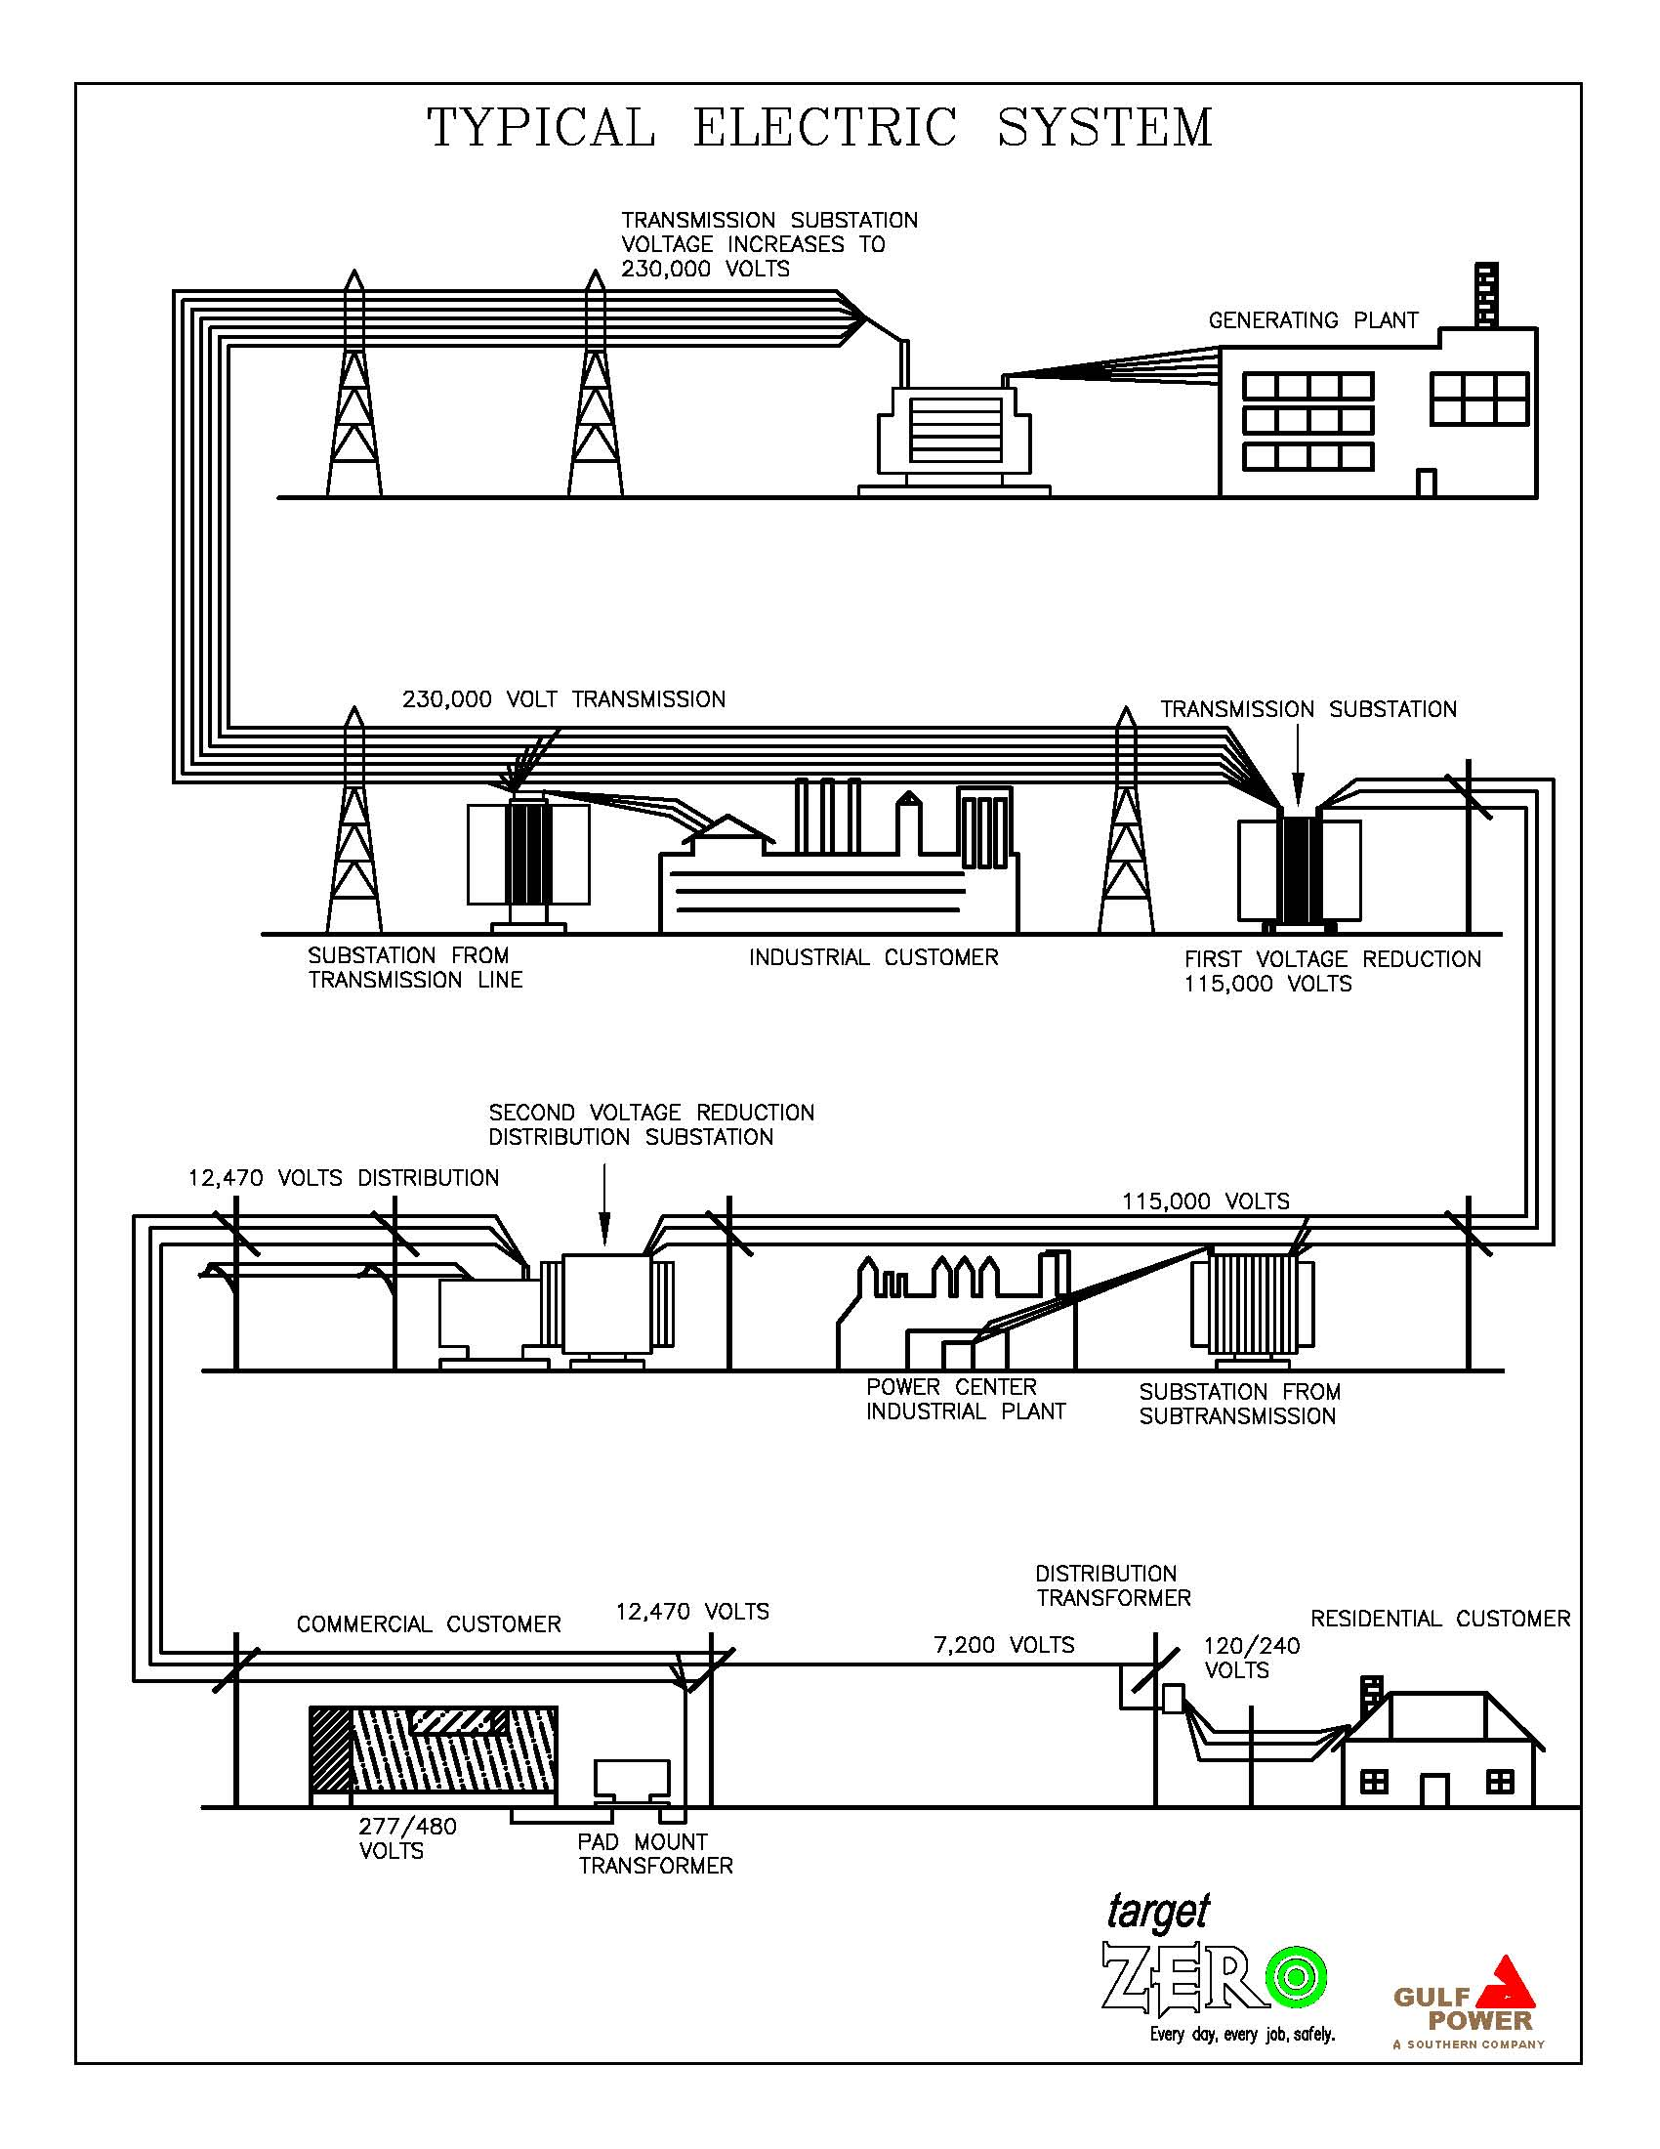

Florida Public Service Commission

Docket No. 110138-EI
GULF POWER COMPANY
Witness: P. Chris Caldwell

Exhibit No. ____ (PCC-1)
Schedule 3
Page 1 of 1

Florida Public Service Commission

Docket No. 110138-EI
GULF POWER COMPANY
Witness: P. Chris Caldwell

Exhibit No. ____ (PCC-1)
Schedule 4
Page 1 of 1

Map of Gulf’s Transmission Facilities

Florida Public Service Commission

Docket No. 110138-EI
GULF POWER COMPANY
Witness: P. Chris Caldwell

Exhibit No. ____ (PCC-1)
Schedule 5
Page 1 of 1

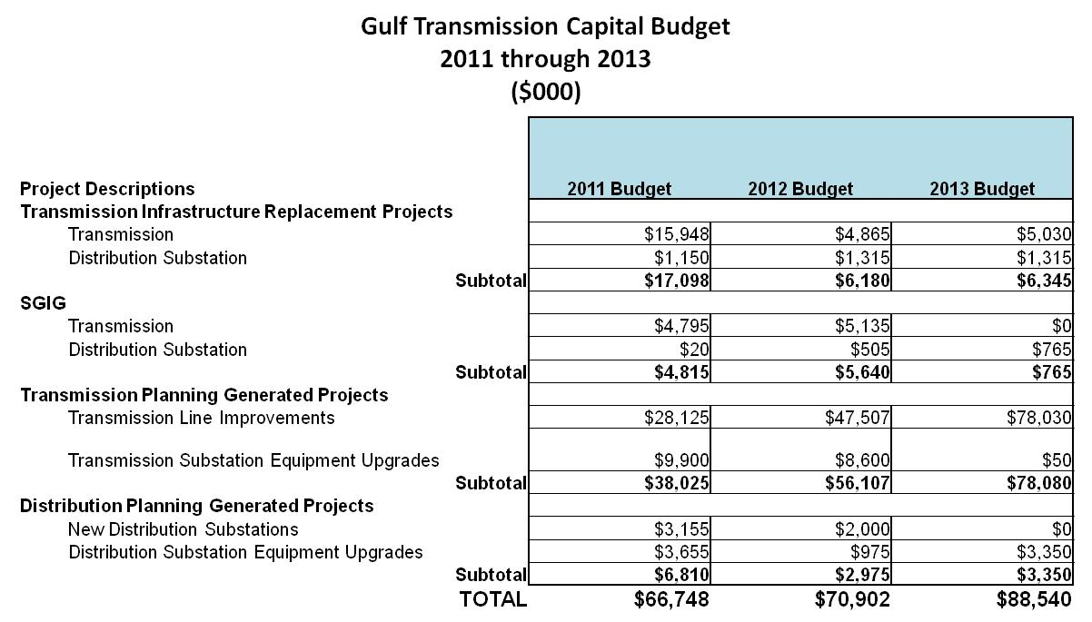

Florida Public Service Commission

Docket No. 110138-EI
GULF POWER COMPANY
Witness: P. Chris Caldwell
Exhibit No. ____ (PCC-1) Schedule 6
Page 1 of 1

Florida Public Service Commission

Docket No. 110138-EI
GULF POWER COMPANY
Witness: P. Chris Caldwell

Exhibit No. ____ (PCC-1)
Schedule 7
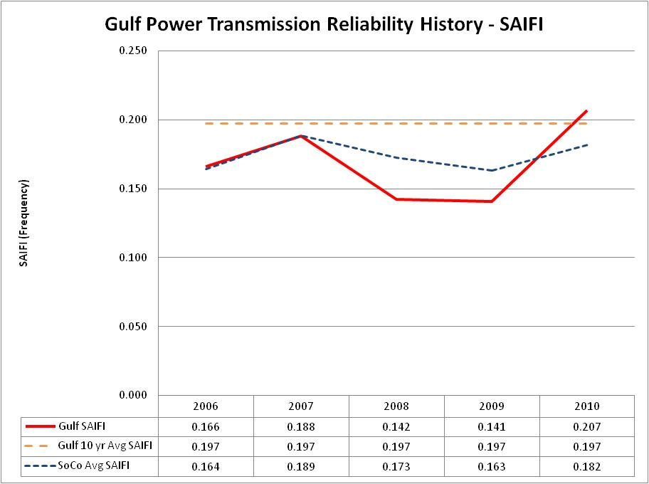
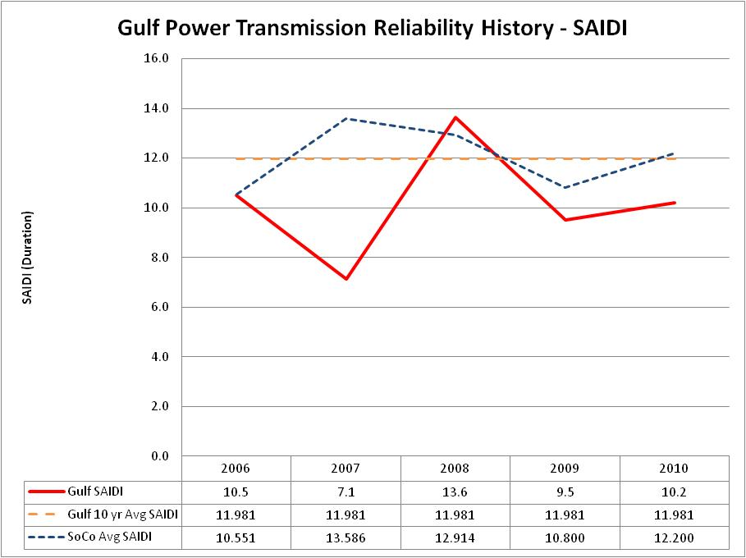
Page 1 of 1

