GULF POWER COMPANY

Before the Florida Public Service Commission

Prepared Direct Testimony of

Michael T. O'Sheasy

Docket No. 110138-EI

In Support of Rate Relief

Date of Filing: July 8, 2011

- Please state your name, business address and occupation.
- My name is Michael T. O'Sheasy. My business address is 5001 Kingswood Drive, Roswell, Georgia 30075. I am a Vice President with Christensen Associates, Inc.

- State briefly your education background and experience.
- I received a Bachelors of Industrial Engineering from the Georgia Institute of Technology in 1970. In 1974, I earned a Masters in Business Administration from Georgia State University. From 1971 to 1975, I was employed by the John W. Eshelman Company -- Division of the Carnation Company -- as a plant superintendent in their Chamblee, Georgia operation. From 1975 to 1980, I worked for the John Harland Corporation initially as an assistant plant manager and then as a plant manager in their Jacksonville, Florida plant, and finally as their plant manager in Miami, Florida. I joined Southern Company Services in 1980 as an engineering cost analyst and progressed through various positions to the position of supervisor, during which time I began serving as an expert witness in costing. I testified as Gulf Power Company's (Gulf or the Company) cost-of-service witness and provided other support to Gulf in matters before the Florida Public Service Commission (FPSC or the Commission).
In 1990, I became Manager of Product Design for Georgia Power Company and have testified before the Georgia Public Service Commission as an expert witness on rate design and pricing. I retired from Georgia Power Company on May 1, 2001 and became a consultant with Christensen Associates.

- Please identify the specific dockets in which you have previously testified before the FPSC.
- I testified before the FPSC on behalf of Gulf as their cost-of-service witness in their last rate case filing, Docket No. 010949-EI, and in prior rate cases in Docket Nos. 891345-EI and 881167-EI. I was extensively involved in the preparation of exhibits and Minimum Filing Requirements (MFRs) in those cases. Also, I was the back-up cost-of-service witness for Gulf in its 1984 rate case, Docket No. 840086-EI, where I helped prepare the related analyses. I also testified in Docket No. 850673-EU regarding standby back-up electric service.

- What is the purpose of your testimony in this proceeding?
- The purpose of my testimony is to support the development and results of the cost-of-service study for Gulf.

Q. Do you have any exhibits that contain information to which you will refer in your testimony?
A. Yes. My Exhibit MTO-1 (consisting of Schedules 1 to 3) and Exhibit MTO-2 (containing Schedules 1.0 to 6.9) were prepared under my supervision and direction by the Costing, Forecasting & Energy Analysis Department of Southern Company Services (SCS), which is the service company in the Southern electric system (SES). SCS provides engineering and other technical support for Gulf and the other SES operating companies. I have thoroughly reviewed the schedules in my exhibits and agree with their content.

Q. Are you the sponsor of certain MFRs?
- Yes. The MFRs which I am sponsoring, in part or in whole, are listed on Schedule 1 of Exhibit MTO-1. To the best of my knowledge, the information contained in these MFRs is true and correct.

- Please describe the contents of your Exhibit MTO-2.
- My Exhibit MTO-2 consists of a number of schedules and sub-schedules that set forth the results of the cost-of-service study used as a basis for this case. Each schedule was prepared in the manner approved by the Commission in its final order for Gulf's last retail rate case, Docket No. 010949-EI, with one modification, which is to utilize the Minimum Distribution System to more properly account for customer-related costs. The rationale and justification for this change will be explained in my subsequent testimony.

I. COST-OF-SERVICE METHODOLOGY

- What is a cost-of-service study?
- A cost-of-service study is a tool used to separate a utility's total electric investments, revenues and expenses first among the regulatory jurisdictions which an electric utility serves (jurisdictional separation) and then among the rate classes within each jurisdiction.

- Why is a cost-of-service study necessary?
- Gulf is regulated by the FPSC for retail sales and by the Federal Energy Regulatory Commission (FERC) for wholesale sales. Costs and revenues must be divided between the two jurisdictions using assignments and allocations so that each respective commission can evaluate the rates over which it has authority. In order for each regulatory commission to review the utility's earnings and to evaluate the contribution made by rate classes within its jurisdiction, it is also necessary to analyze the costs to serve the respective rate classes.

Gulf, like other electric utilities, maintains its books and records in accordance with the Uniform System of Accounts as directed by the FERC and this Commission. Although this system of accounting reveals company-wide information, it does not separate the Company's investments, revenues and expenses by jurisdiction or by rate classes within jurisdictions. The cost-of-service study that has been performed for Gulf accomplishes this objective.
- What is the goal of a cost-of-service study?
A. The goal of a cost-of-service study is to identify what costs are incurred to provide service to certain groups of customers. If it is performed well, it can be a useful (and often times the primary) tool for determining the adequacy of current rates. For those rate classes which the cost-of-service study reveals have inadequate returns at current rate levels, the cost-of-service study is an appropriate tool for determining what rate changes should be made. On the other hand, if a cost-of-service study is not performed well, erroneous conclusions can be drawn with resulting negative consequences if it influences subsequent rate design. Although there are other ways to allocate costs, the Company’s proposed methodology is objective, consistent with the methodology used in numerous prior cases, and provides the most accurate information.

Q. How was the cost-of-service study used by Gulf in this retail rate filing?
A. The jurisdictional separations of rate base and net operating income resulting from the study were used by Gulf Witness McMillan to determine the proposed jurisdictional revenue increase needed in order to achieve the requested rate of return. These jurisdictional separation factors were calculated according to accepted cost-of-service principles and followed the methodology accepted by the Commission. The retail jurisdiction was further divided into the respective rate classes using sound cost-causative methodologies. The resultant rate class information from the cost-of-service study was then considered by Gulf Witness Thompson as a basis for the design of proposed rates in this docket.
- In preparing a cost-of-service study, is there some overall guiding principle or concept that should be followed?
- Yes. The overall objective of a cost-of-service study is to assign or allocate costs fairly and equitably to all customers. This objective is accomplished when the resulting cost-of-service study reflects “cost causation,” i.e., those customers who caused a particular cost to be incurred by the Company in providing them service should be responsible for that cost.

When certain costs are readily identified with a particular customer group (rate class), the assignment of those costs to that group clearly reflects cost causation and is fair and equitable to all customers. However, most parts of an electric system are planned, designed, constructed, operated and maintained to serve all customers. Most of Gulf’s costs have been incurred to serve all customers. These costs are referred to as joint or common costs. Joint or common costs must be allocated to customer groups based on the nature (i.e., drivers) of the costs incurred, and the aggregate requirements and service characteristics of the customers that caused the costs to be incurred. By adhering to this fundamental and essential principle of cost causation, the results of the cost-of-service study will be fair and equitable to all customers.

Q. How is a cost-of-service analysis performed?
A. In order to determine the costs to serve each group of customers in a fair and equitable manner, the utility company's records are analyzed to determine how each group of customers influenced the actual incurrence of costs by the utility. This review discloses certain direct costs that should be assigned to the specific rate class for which these costs were directly incurred. This review also discloses costs which are incurred to perform a function within the electric system for multiple customer rate classes, referred to as common costs. These common costs are then allocated among those rate classes using an allocator that appropriately reflects the underlying cost causative relationship(s).

Q. Please elaborate on the distinctions between various types of direct and allocated costs.
A. Certain costs are directly associated with one particular group of customers and are, therefore, directly assigned to that group. An example is FERC Account 373 – Street Lighting. All costs associated with this account will be assigned to the street lighting rate class OS.

The majority of costs, however, are incurred jointly to serve numerous customer rate classes. An example of common costs is FERC Account 312 - Boiler Plant Equipment, which serves all rate classes. In order to allocate the various common costs like Account 312 to the rate classes, consideration must be given to the type and classes of customers, their load characteristics, their number, and various other expense and investment relationships in order to find the cost causative link.

Research of cost causative relationships reveals that costs normally possess one or more of three attributes that identify the link between customer and company. This cost categorization or componentization can be viewed as: (1) customer-related, which are costs that vary with the number of customers or the fact that customers must be able to receive service; (2) energy-related, which pertain to costs that vary with energy consumption (kWh); and (3) demand-related, which are costs that are incurred to serve peak needs for electricity.

Once the various common accounts have been analyzed to identify their appropriate cost component(s), the corresponding allocator(s) can be applied to apportion common costs to the area of responsibility. By summing the allocated common costs and the assigned direct costs by jurisdiction and rate class, the rate of return for each group can be determined.

Q. Please expand on the importance of accurate cost allocation.
A. The goal of a cost-of-service study is to identify what costs are incurred to provide service to certain groups of customers. It is based upon the principle of cost causation. As stated in the National Association of Regulatory Utility Commissioners (NARUC) Electric Utility Cost Allocation Manual, “The total revenue requirement of the utility is attributed to the various classes of customers in a fashion that reflects the costs incurred by each class as a major determinant.”

There are three primary drivers in causing costs to be incurred by an electric utility which enable accurate cost allocation: (1) peak demands, (2) kilowatt-hours (kWhs), and (3) customers. Each of these three drivers has its own separate and appropriate allocators to spread its respective costs to the associated rate class and jurisdiction. If conducted upon a sound basis of cost causation, the cost-of-service study can be the benchmark to determine the adequacy of current rates and how well rate groups are covering their costs.

Q. Please give an example of the consequences of proper and improper allocations in a cost-of-service study.
A. In general, a meter is necessary to measure the amount of electricity provided to a customer, but the meter can operate adequately regardless of the maximum demand or the overall quantity of electricity consumed. The cost of the meter incurred by the utility to serve the customer does not vary with the quantity of electricity consumed by the customer; it is driven by the fact that each customer needs a meter. As a result, utilities will usually consider meters to be customer-related, and allocate meter costs to the various rate classes using an allocator which reflects the number of customers in each rate class.

If meters were misclassified as kWh related, then the corresponding kWh allocator would spread more meter costs to large customers and less meter costs to small customers despite the fact that the large customers and the small customers both required the same meter and imposed the same costs on the utility. The large customers’ overall cost responsibility would ultimately be overstated and that of the smaller customers would be understated.

II. GULF’S COST-OF-SERVICE STUDY

Q. Please explain Schedule 1 of your Exhibit MTO-2.
A. Schedule 1 of Exhibit MTO-2 is the result of the cost-of-service study in summary form for the test year utilizing the Company's present rates. It shows the Company's total rate base, revenues, expenses, and net operating income, along with the corresponding responsibilities of the retail jurisdiction, as well as the rate classes within the retail jurisdiction. The column denoted “Wholesale” represents Gulf's wholesale customers, all of which are under the jurisdiction of the FERC.

Sub-schedule 1.00 is the present rate summary for each rate class. Sub-schedule 1.01 provides an equal rate of return summary for each rate class under present revenue. Sub-schedule 1.10 reveals the overall rate of return for each rate class that will exist under the Company's proposed
rates. Sub-schedule 1.11 presents the equal rate of return summary for each rate class under proposed revenue.

Q. What are the rate classes in the retail jurisdictional cost-of-service study for Gulf?
A. The rate classes in Gulf’s retail jurisdictional cost-of-service study are:
- Residential Rate Class
- Rate Class GS (Small Business)
- Rate Class GSD/GSDT (Medium Business)
- Rate Class LP/LPT (Large Business)
- Rate Class Major Accounts (Very Large Business)
- Rate Class Outdoor Service (OS)

Q. What is the purpose of Schedule 2 of Exhibit MTO-2?
A. Schedule 2 of Exhibit MTO-2 analyzes investment related accounts and either assigns or allocates them to the appropriate jurisdiction and then to rate class within the retail jurisdiction. It includes Gross Plant Sub-schedule 2.10, Accumulated Depreciation Reserve Sub-schedule 2.20, Materials and Supplies Sub-schedule 2.30, Other Working Capital Sub-schedule 2.40, and Other Rate Base Items Sub-schedule 2.50. Together these schedules flow to the summary Schedule 1 to provide rate base by jurisdiction and rate class.

Q. What is shown on the remaining schedules of Exhibit MTO-2?
A. Schedule 3 provides the Analysis of Revenues. Schedule 4 displays the Analysis of Expenses. Sub-schedule 4.10 details the allocation of Operations and Maintenance (O&M) expenses to jurisdiction and rate classes. Sub-schedule 4.20 describes the Depreciation expense allocation, and Sub-schedule 4.30 presents the Analysis of Taxes Other Than Income Taxes. Schedule 5.0 contains the Table of Allocators and Percentages. The results of these various schedules are summarized in Schedule 1. Schedules 6.1 to 6.9 show the development of the Minimum Distribution System.

Q. Please identify the steps that were undertaken in preparing the cost-of-service study shown in your Exhibit MTO-2.
A. The development began with the collection and analysis of load research data. This research provided the number of customers and their respective demand and energy sales by voltage level of service which were then used to produce the allocators.

The load research data for the test year was supplied by Gulf Witness McGee. He also provided total territorial supply and losses for annual energy and for demand. In addition, Mr. McGee provided annual energy sales, monthly coincident peak (MCP) demands, annual non-coincident peak (NCP) demands, and the average number of customers for the test year by rate class and voltage level. These inputs were then used to calculate the "12-MCP,” “NCP”, " "energy," and "number of customers" allocators.

Q. Please describe the 12-MCP and NCP concepts and why they are used.
A. The 12-MCP demand is the sum of the highest kilowatt load predicted to occur in each month of the test year divided by twelve. This 12-MCP concept recognizes the fact that Gulf's system is planned and operated for the purpose of meeting these demands for electricity every month of the year. It also reflects consideration of scheduled maintenance, firm sales and purchase commitments, and reliance on interconnections. In addition, 12-MCP has traditionally been the FERC's preferred allocation technique for determining the wholesale jurisdictional obligation. The 12-MCP demand allocator has been used to help make the split between retail and wholesale. Within the retail jurisdiction it is used to allocate generation level demand-related costs and transmission step-up substation and transmission line costs.

The NCP demand for each retail rate class is the highest demand occurring for that rate class during the test year. The NCP demand allocator was used to allocate distribution demand costs at Level 4 (primary distribution) and Level 5 (secondary distribution) and was similarly applied in Gulf’s last rate case.

Q. Please explain the steps that were used in developing the demand and energy allocators.
A. Balanced system load flows for demand and energy were first developed through a load flow program, which spreads total system losses to each voltage level. These levels, which are defined in more detail in MFR E-10, are used to describe the flow of electricity from generation, through the various transformations, across the various transmission and distribution lines, to the eventual delivery to the customer.
The load flow process begins by taking the total energy sales at Level 5, the secondary distribution level, multiplying these sales by the loss percentage at Level 5, and then combining these calculated losses and sales. This amount is then added to the sales at Level 4, and this new total is, in turn, multiplied by the loss percentage at Level 4. This procedure is continued up through Level 1, the generation level. The program adjusts the loss percentages at each level and then iterates the above process until the sum of the losses at each level matches the total system losses and a balanced flow is produced. These total system loss percentages are then applied to the rate classes by voltage level, thus computing energy allocators for each respective voltage level. A similar process is used to calculate the 12-MCP demand allocators. The NCP demand allocators for Levels 4 and 5 are developed similarly and use the loss percentages calculated by the 12-MCP demand flow, since there is no territorial input for NCP with which to balance.

Q. What other types of allocators were used besides demand and energy?
A. Customer-related allocators were also used in order to allocate customer-related costs.

Q. What was the next step in the development of Gulf's cost-of-service study?
A. Mr. McMillan provided the financial information for the projected test year. These investment, revenue and expense items were then assigned to jurisdiction and rate class if a direct cost causative relationship was known, or allocated to jurisdiction and rate class using the previously developed allocators.

Q. How were the allocations made between the wholesale and retail jurisdictions?
A. Where costs were identified as serving only the retail or wholesale jurisdictions, they were assigned to that respective jurisdiction. Where costs were common and served both jurisdictions, they were allocated. The jurisdictional separation for demand costs was based upon the 12-MCP allocation. A kWh allocator was employed for the allocation of energy-related costs. Again, this methodology is consistent with the one approved in Gulf's last rate case. The methodology also conforms to MFR E-1.

Q. Please describe the analysis within the retail jurisdiction.
A. Where known to serve a particular rate class, revenues and costs were directly assigned. For example, residential revenues were assigned to the residential rate class and outdoor lighting fixture costs were assigned to the outdoor service rate class. The majority of costs were common and therefore were allocated. Generation level costs were allocated on the basis of 12-MCP & 1/13 kWh (energy). Energy-related accounts were allocated upon the kWh allocator. Transmission, subtransmission and substations were allocated upon the12-MCP concept. Primary and secondary distribution demand-related costs were apportioned on the

corresponding NCP allocators, and customer-related costs were allocated upon the respective customer allocator.

Q. How does the cost-of-service methodology proposed by Gulf in this case compare to the methodology approved by the Commission in the Company’s last rate case?
A. It is the same except for a request to employ the Minimum Distribution System methodology to identify and allocate customer-related distribution system costs.

Although the Company does not agree that the use of 12-MCP & 1/13 kWh is a better allocator of generation level costs than a pure 12-MCP allocator would be, Gulf nevertheless prepared its study in this case using the Commission-approved methodology. Gulf continues to believe that a pure 12 MCP factor for generation results in a more accurate cost allocation. However, using the Commission’s preferred method does not result in major variances in cost allocation from the pure 12-MCP approach and does not significantly impair Gulf in designing efficient rates.

Q. Please explain why the Minimum Distribution System methodology is important to Gulf and its customers.
A. As I discuss in more detail later, some costs of the distribution system beyond the customer meter and service drop do not vary with customers’ use of electricity. The Minimum Distribution System (MDS) methodology is necessary to accurately determine and allocate these customer-related distribution costs. The misclassification of costs that results from not using the MDS methodology sends misleading price signals to customers. This misclassification also results in different customer rate classes bearing more or less costs than their cost-causative share of distribution costs. It is therefore important to examine these customer-related costs and classify them appropriately, which the MDS methodology enables us to do.

Q. Where are customer-related costs found?
A. Basically, they can be found in Customer Assistance, Customer Service and the FERC mass distribution accounts. They relate to the costs of being capable of providing electric service. In other words, regardless of the quantity of electricity demanded, the mere fact that the utility must be prepared to provide service at any time causes those costs to be incurred.

These customer-related costs are driven by the simple fact that each customer must have the ability to receive service.

This cost category which Gulf designates as “customer-related” includes all distribution costs which do not vary with demand or energy use. Some may vary directly with the number of customers to be served while others are a fixed requirement necessary for a distribution system regardless of quantity of usage. An example would be protective devices (found in FERC Account 368), which operate in the same manner with or without

load on the system in order to keep the lines available to as many customers as possible.

Q. Which FERC accounts require cost classification scrutiny to identify their customer-related component?
A. Accounts 364-370 usually require an analysis to properly apportion their overall costs into those which are customer-related and those which are demand-related.

Q. Does NARUC advocate accurate cost classification and the allocation of these accounts?
A. Yes. Its official guidebook, the Electric Utility Cost Allocation Manual, offers clear instructions. The following is an excerpt from page 90 of its January, 1992 edition:
Distribution plant Accounts 364 through 370 involve demand and customer costs. The customer component of distribution facilities is that portion of costs which varies with the number of customers. Thus, the number of poles, conductors, transformers, services, and meters are directly related to the number of customers on the utility's system. As shown in table 6-1, each primary plant account can be separately classified into a demand and customer component. Two methods are used to determine the demand and customer components of distribution facilities. They are, the minimum-size-of-facilities method, and the minimum-intercept cost (zero-intercept or positive-intercept costs, as applicable) of facilities.

Also a recently published treatise, Electricity Pricing: Engineering Principles and Methodologies (2009), by Lawrence J. Vogt identifies the zero-intercept and minimum system analysis as standard methodologies for classifying distribution costs. Mr. Vogt writes as follows:

The concept of a minimum distribution system recognizes that the primary and secondary distribution system has both customer-related and demand-related attributes. As discussed previously, the customer cost component is associated with no-load conditions, whereas the demand cost component is associated with load conditions….

When a single device has both customer-related and demand-related attributes, its total cost must be allocated. The minimum intercept or zero-intercept methodology provides a rational basis for separating the cost of a device between its customer and demand components. (Id. at pp. 498-500.)

Q. Does the NARUC manual require that the cost-of-service study be done in a certain manner?
A. No, the NARUC manual is a guide that offers reasonable and logical methodologies for cost allocation. The manual only discusses the major costing methodologies and acknowledges those that are acceptable.

Q. Can you expand on the logic of a customer-related component for distribution accounts?
A. Yes. Schedule 2 of Exhibit MTO-1 depicts a simple distribution network. Now, imagine three different usage scenarios of this network:

Scenario I: Imagine that houses A-E all have about the same load usage. Now imagine that houses A and B become unoccupied due to impacts of a downturn in the economy or a rental or vacation home now experiencing high vacancy rates. The result is that load on the system goes down, yet the cost of the distribution network remains the same.

Scenario II: Now imagine that all 5 houses are occupied with like load usage. Next, houses C & D employ energy efficiency improvements. Load on the system diminishes, yet the cost of the distribution network remains the same.

Scenario III: Next imagine that all 5 houses are occupied with like load usage. Now imagine that houses C, D, & E add energy efficiency improvements, but a new house F is added to the network with a load equal to what the energy efficiency improvements were for houses C, D, & E. The result is that the total load on the system remains the same, yet the cost of the distribution network must be expanded for new poles and lines.

In each scenario, one can see that the cost of the distribution network is influenced by the number of customers served, not by any changes in total demand or energy usage. Therefore allocating these customer-related costs on a basis other than a customer allocator would result in an inaccurate cost classification and allocation.

Q. Can you give us some idea of the harm that can be caused by inaccurate cost classification?
A. Assuming that an underage in properly defining customer cost is absorbed in demand cost, this inaccurate classification could lead to a demand or energy charge that is larger than its true cost. The customer receives a resultant price signal that is larger than it should be and consequently makes conservation and energy efficiency choices that overestimate the real costs avoided by the system.

Although some might argue that conservation and energy efficiency would subsequently be advanced by this costing flaw, I would argue that the “advance” is for the wrong reasons, and conservation and energy decreases in usage would fail to be cost-based and therefore not in the ultimate best interest of Gulf’s customers. Some might argue that this flaw could make up for omissions of other energy costs that fail to show up in embedded revenue requirements. It would be very difficult though to quantify these possible omissions and know whether they were commensurate with the customer-related costs which had been shifted into a demand classification.

Even if rate designs do not exactly follow cost-of-service, it is crucial to have a cost-causative cost-of-service study. It is important that both rate designers and policy makers have a true cost benchmark so rate excursions from true costs can be observed and considered. Otherwise, rate decisions will be based on inaccurate information about true cost responsibility and impacts.

III. MINIMUM DISTRIBUTION SYSTEM METHODOLOGY

Q. How do you determine the customer-related costs of distribution?
A. The process of identifying customer-related costs uses the concept mentioned in the NARUC manual called the Minimum Distribution System. (MDS). This concept is based on the fact that in order to simply connect a customer to the power system, a minimum amount of facilities and equipment are necessary. The minimum distribution facilities, along with meters and service drops, make up the plant investment portion of customer-related costs. The distribution facilities in excess of the

minimum are classified as demand-related costs because they relate to
capacity.

Q. How does one determine this minimum amount of facilities and equipment?
A. There are two common ways to do so: (1) minimum size (MS) and (2) zero-intercept (ZI). The philosophy of MS is that in order to simply connect a customer to the system, a minimum size of equipment is necessary. The cost of this minimum size equipment is then categorized as a customer-related cost. For example, suppose that a 10 kVa line transformer represents the smallest size transformer normally used. In this case the unit installed costs of a 10 kVa transformer would be employed as the basis for the customer cost of transformers, with the residual transformer costs treated as demand-related. This methodology, although logical, has a weakness because even the smallest standard size equipment such as the 10 kVa transformer is capable of carrying load, i.e., it has capacity. This capacity is demand-related and should therefore be embedded within another price component. The second method, Zero-Intercept (ZI) is an improved technique for determining customer-related costs that, by definition, removes any ability of carrying load. This avoids double counting of load with MDS.

Q. How does the Zero-Intercept method work?
A. The ZI method is based on a regression analysis of costs for several sizes of equipment in order to determine the zero capacity unit cost. The resultant regression equation is extrapolated back to a level of no-load. This can be observed in Schedules 6.1 and 6.2 of Exhibit MTO-2.

Q. Do you consider the MDS to be an unrealistic or fictional concept as has sometimes been claimed?
A. No. MDS is no more of a fictional concept than is a deposit requirement for a vacation rental on Pensacola Beach or a simple retainer fee. A deposit is required to preserve the ability to occupy the rental space for future use. Likewise, the retainer fee is required to secure the right of future service regardless of the magnitude of additional services to be rendered. Similarly, the MDS is the cost required to ensure the availability of service to a customer premises whether or not any electricity is ever actually consumed.

Q. Is any equipment built to zero load specifications?
A. No, there is none to my knowledge. Likewise, there is no generating plant that is built with exactly 1/13 of its capital cost to minimize fuel cost as required by one of the MFRs for allocation of production costs. This does not mean, though, that ZI is an illogical concept and therefore not to be used. Even though no equipment is built to serve zero load, the ZI concept is still a valid method of identifying the intrinsic customer-related cost of the equipment that is actually used.

Q. How does one account for inflation when developing the ZI regression equation?
A. Equipment is regressed and analyzed using current replacement costs. This is necessary since some equipment in service for Gulf has a more current vintage than others. Once the ZI unit costs for the customer-related piece are computed, these costs are multiplied by the number of units in service to develop the aggregate amount. The remainder of “current replacement cost” is the demand-related costs. This resultant split of replacement cost into a customer piece and a demand piece is then used to allocate the embedded vintage cost for the equipment into appropriate customer and demand component costs. This is done for all the various types of equipment which possess both customer-related and demand-related characteristics within their inherent make-up. Any equipment which has either a strictly demand-only make-up (for example substation equipment) or a strictly customer-only make-up (for example meters) is directly assigned to the respective component. An appropriate customer allocator then allocates customer-related costs to rate classes in the cost-of-service study. Demand-related costs are similarly allocated to rate classes using a demand-related allocator.

Q. What FERC mass distribution accounts are split and classified in this manner?
A. Distribution Accounts 365, 366, 367, and 368 use this ZI methodology. For FERC Account 364, we used the average of the smallest, most frequently used poles since the unit cost of different sized poles did not lend itself to regression analysis. Accounts 369 and 370 are considered as all customer-related. Any related expense accounts (for example depreciation expense) then utilize the corresponding 364-368 accounts to appropriately split expenses into customer and demand-related costs.

The computation of the splits for Accounts 364-370 are shown in Schedules 6.3 to 6.9 of Exhibit MTO-2.

Q. Are Account 369 (Service Drops) and Account 370 (Meters) usually classified as 100% customer-related?
A. Yes, this has been the traditional treatment for most utilities. Service Drops are the lines that provide the service connection between the secondary level distribution transformer and the customer’s meter and enable the customer to receive service. The meter, as previously mentioned, measures the amount of electricity that the customer consumes and is used for billing.

Q. What are the resultant customer/demand splits that Gulf is proposing?
A. The customer-related analysis performed for Gulf results in the customer/demand splits shown on Schedule 3 of Exhibit MTO-1. These are the splits which Gulf is proposing.

Q. Do any other electric utilities use MDS to determine the customer-related costs?
A. Yes. In fact, two other operating companies in the Southern electric system, Georgia Power Company and Mississippi Power Company, use MDS to determine the customer-related costs. Some other utilities that employ MDS include Kentucky Utilities, LG&E, Tennessee Valley Authority (TVA), Wisconsin Public Service, and Virginia Electric Power.

Q. You mentioned earlier that use of MDS is a change from the direction set forth in Gulf’s last rate case. Has this Commission ever approved MDS?
A. Yes, it was approved for Choctawhatchee Electric Cooperative Inc. in Docket No. 020537-EC.

Q. What effect will recognizing the use of MDS have on the various rate classes?
A. Using MDS and including the resultant customer component in the distribution accounts will increase the costs allocated to the residential rate class and decrease the costs allocated to large business classes. However, this is appropriate, since it better reflects the cost to serve these customer rate classes. When determining the cost of providing service to customers, who benefits should not be the deciding factor – cost causation should. In the past when this customer component was not recognized, large business customers were inappropriately allocated higher costs than cost-causation would justify. Even though the MDS methodology causes cost allocation to decrease for large business customers and to increase for smaller customers, it does so for rational reasons and properly allocates the costs to those customers who caused them to be incurred by the utility.

Q. What effect does including this customer-related component have for seasonal homes and vacation apartments?
A For months in which seasonal homes and vacation apartments are unoccupied yet still in service, cost allocation would be higher in cost-of-service studies than if these customer-related costs were misclassified in the demand component. However, this is indeed proper since even during months of vacancy Gulf must have its distribution system ready to provide service whenever the renter arrives. The seasonal customer should have the same cost responsibility as the year-round resident for these customer-related costs.

Q. It appears that you have included a customer-related component only for distribution equipment and not for transmission and subtransmission equipment. Why shouldn’t transmission and subtransmission include customer components?

A. One could make the argument that transmission and subtransmission should have customer components. However, equipment at the transmission and subtransmission is much larger and operates at higher voltage levels than does distribution equipment. Consequently, imputing a customer-related piece would likely result in a very small portion of the transmission and subtransmission being identified as customer-related. As a result, it has been common convention in the electricity industry to stop calculating a customer component at the distribution level.

Q. Does the NARUC manual propose a customer component for transmission or does it stop at distribution?
A. The NARUC manual stops at distribution for classifying costs as customer-related.
- Do you recommend MDS in spite of limited precedent in Florida for its use?
A. Yes, I do. I believe that this methodology provides the most appropriate cost assignments to assess rate class returns and to serve as a basis for rate design.

Q. In your opinion, are the results of the recommended cost-of-service study accurate representations of the rates of return by jurisdiction and rate class?
A. Yes. The results shown on Schedule 1 of the cost-of-service study in Exhibit MTO-2 are indeed fair and accurate statements of cost causation. The rates of return produced by jurisdiction and by rate class for Gulf 's test year are fair and accurate indications of how the rate classes are covering costs.

- Does this conclude your testimony?
- Yes, it does.

Responsibility for Minimum Filing Requirements

Schedule Title

B-6 Jurisdictional Separation Factors – Rate Base

C-4 Jurisdictional Separation Factors – Net Operating Income

E – 1 Cost of Service Studies

E – 2 Explanation of Variations from Cost of Service Study

E - 3a Cost of Service Study –
Allocation of Rate Base Components to Rate Schedule

E - 3b Cost of Service Study –
Allocation of Expense Components to Rate Schedule

E - 4a Cost of Service Study –
Functionalization and Classification of Rate Base

E - 4b Cost of Service Study –
Functionalization and Classification of Expenses

E – 5 Source and Amount of Revenues –
At Present and Proposed Rates

E - 6a Cost of Service Study – Unit Costs, Present Rates

E - 6b Cost of Service Study – Unit Costs, Proposed Rates

E – 9 Cost of Service – Load Data

E – 10 Cost of Service Study – Development of Allocation Factors

E – 11 Development of Coincident and Non-Coincident Demands for
Cost Study

E – 16 Customers by Voltage Level

E - 19a Demand and Energy Losses

E - 19b Energy Losses

E - 19c Demand Losses

Illustration of Simple Distribution Network

MDS Customer/Demand Percentages by FERC Account

Account | %Customer | %Demand
364 | 65.2% | 34.8%
365 | 13.2% | 86.8%
366 | 3.9% | 96.1%
367 | 4.8% | 95.2%
368 | 25.4% | 74.6%
369 | 100% | 0%
370 | 100% | 0%

Index of Michael T. O’Sheasy Exhibit MTO-2 Schedules

Cost of Service Study
Schedule 1.00 - Present Rate Summary
Schedule 1.01 - Equal ROR Summary – Present Rates
Schedule 1.10 - Proposed Rate Summary
Schedule 1.11 - Equal ROR Summary – Proposed Rates
Schedule 2.10 - Analysis of Gross Plant
Schedule 2.20 - Analysis of Accumulated Depreciation Reserve
Schedule 2.30 - Analysis of Materials and Supplies
Schedule 2.40 - Analysis of Other Working Capital
Schedule 2.50 - Analysis of Other Rate Base Items
Schedule 3.00 - Analysis of Revenues
Schedule 4.10 - Analysis of Operations and Maintenance Expense
Schedule 4.20 - Analysis of Depreciation Expense
Schedule 4.30 - Analysis of Taxes Other Than Income Taxes
Schedule 5.00 - Line Allocators and Percentages

Minimum Distribution System
Schedule 6.1 - Account 365 Overhead Regression
Schedule 6.2 - Account 368 Single Phase Transformer Regression
Schedule 6.3 - Account 364 - Poles, Towers and Fixtures Analysis
Schedule 6.4 - Account 365 – Ovhd Conductors & Devices Analysis
Schedule 6.5 - Account 366 - Underground Conduit Analysis
Schedule 6.6 - Account 367 - Underground Conductors Analysis
Schedule 6.7 - Account 368 - Line Transformer Analysis & Cutouts and Arresters Analysis
Schedule 6.8 - Amount 369 – Services Analysis
Schedule 6.9 - Account 370 – Meters Analysis

Minimum Distribution System
Account 365 – Overhead Regression
Schedule 6.1

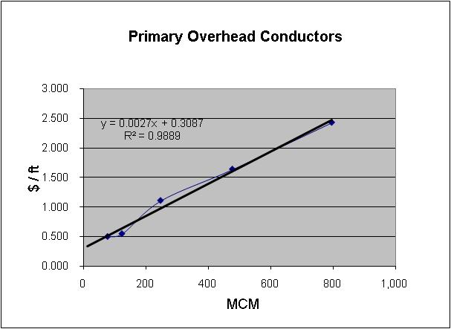

Account 365 – Overhead Primary Conductors

Size | MCM | $ / ft
#2 | 77.47 | .0498
1/0 | 123.30 | 0.546
4/0 | 246.90 | 1.108
477 | 477.00 | 1.637
795 | 795.00 | 2.428
Zero Intercept = 0.3087

Minimum Distribution System
Account 368 – Single Phase Transformer Regression
Schedule 6.2

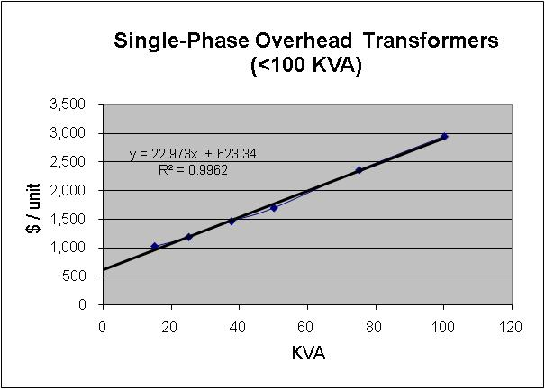

Account 368 – Singe Phase Overhead Transformers <100 KVA

KVA | $ / ea
15 | 1,028
25 | 1,190
37.5 | 1,465
50 | 1,699
75 | 2,360
100 | 2,947
Zero Intercept = 623.34

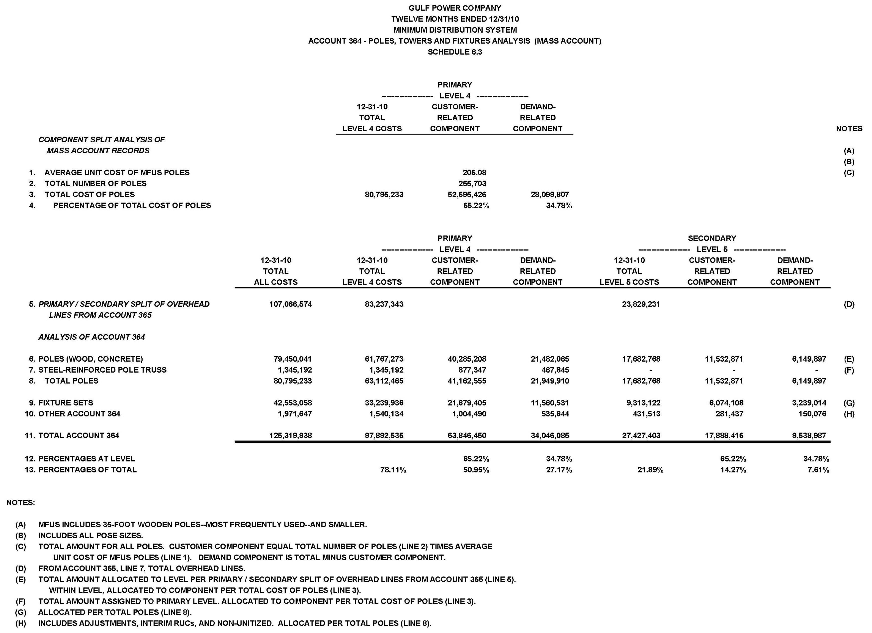
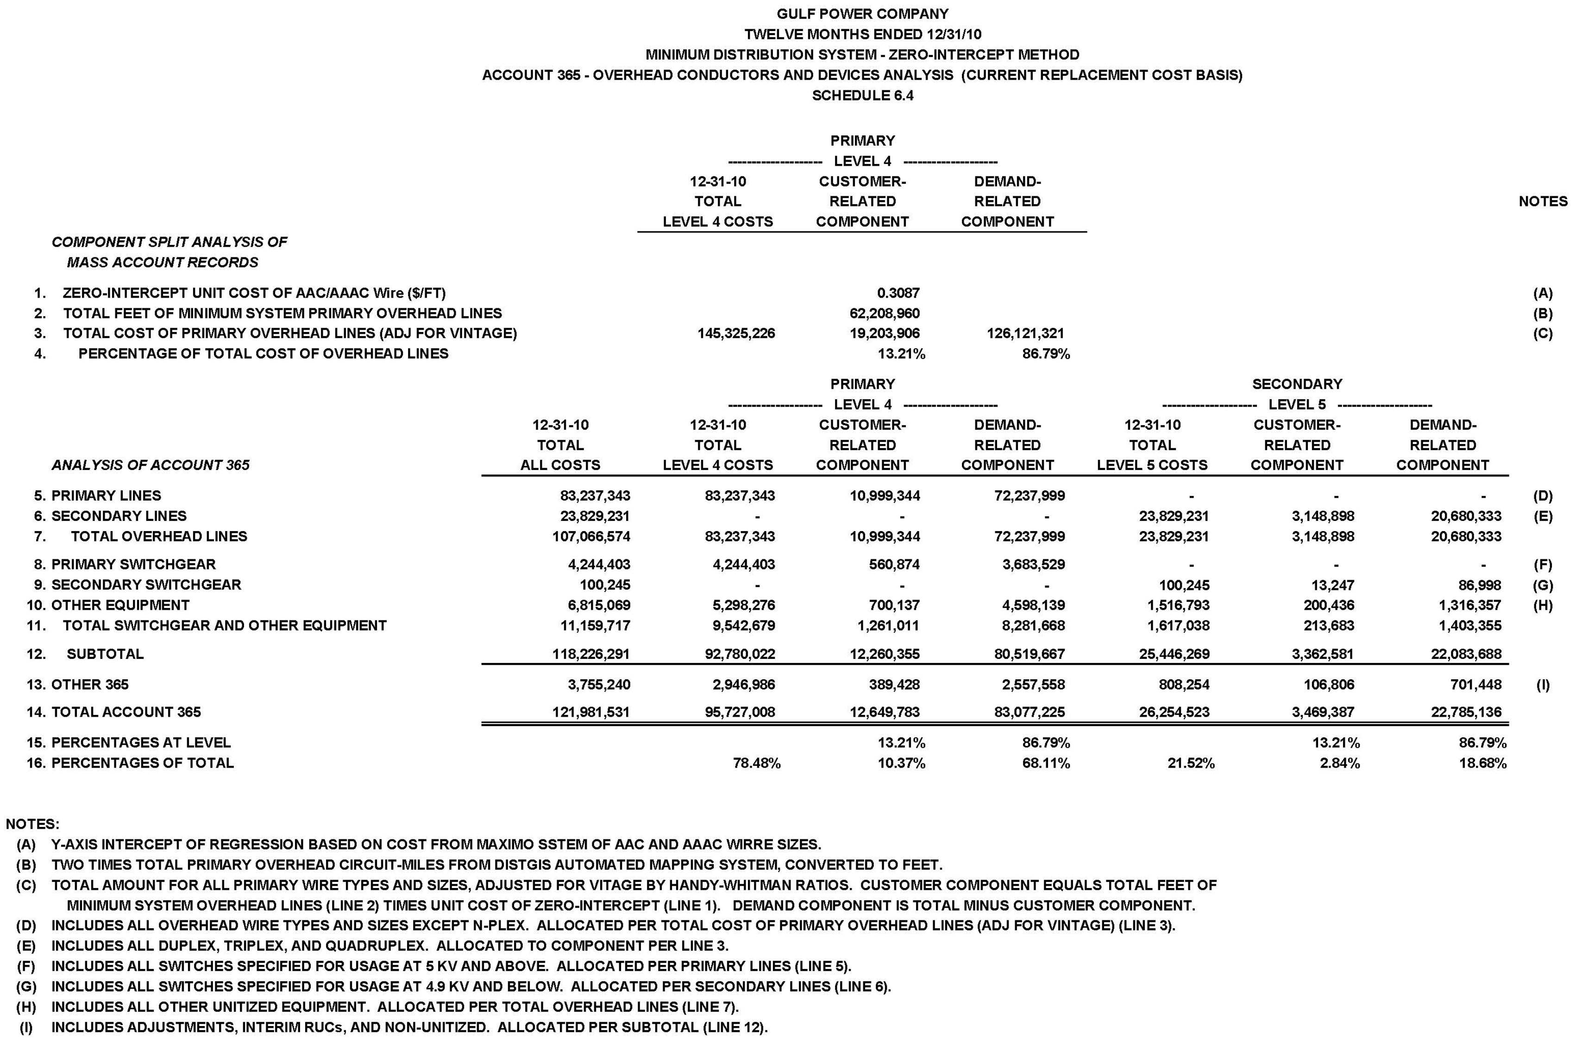

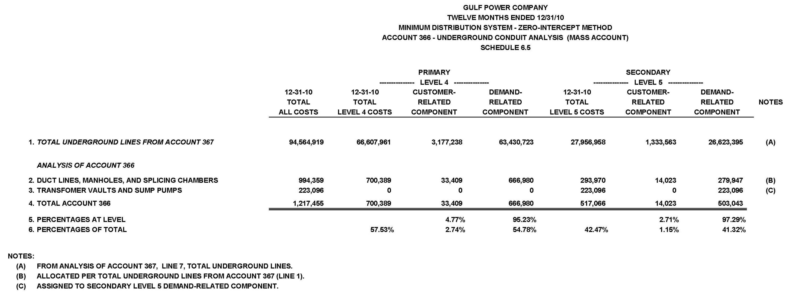

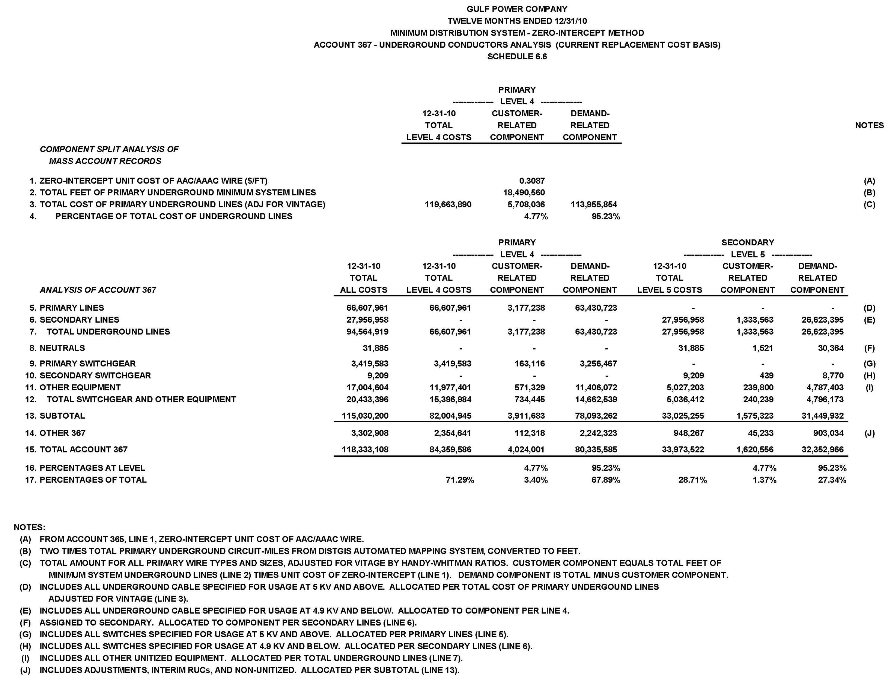

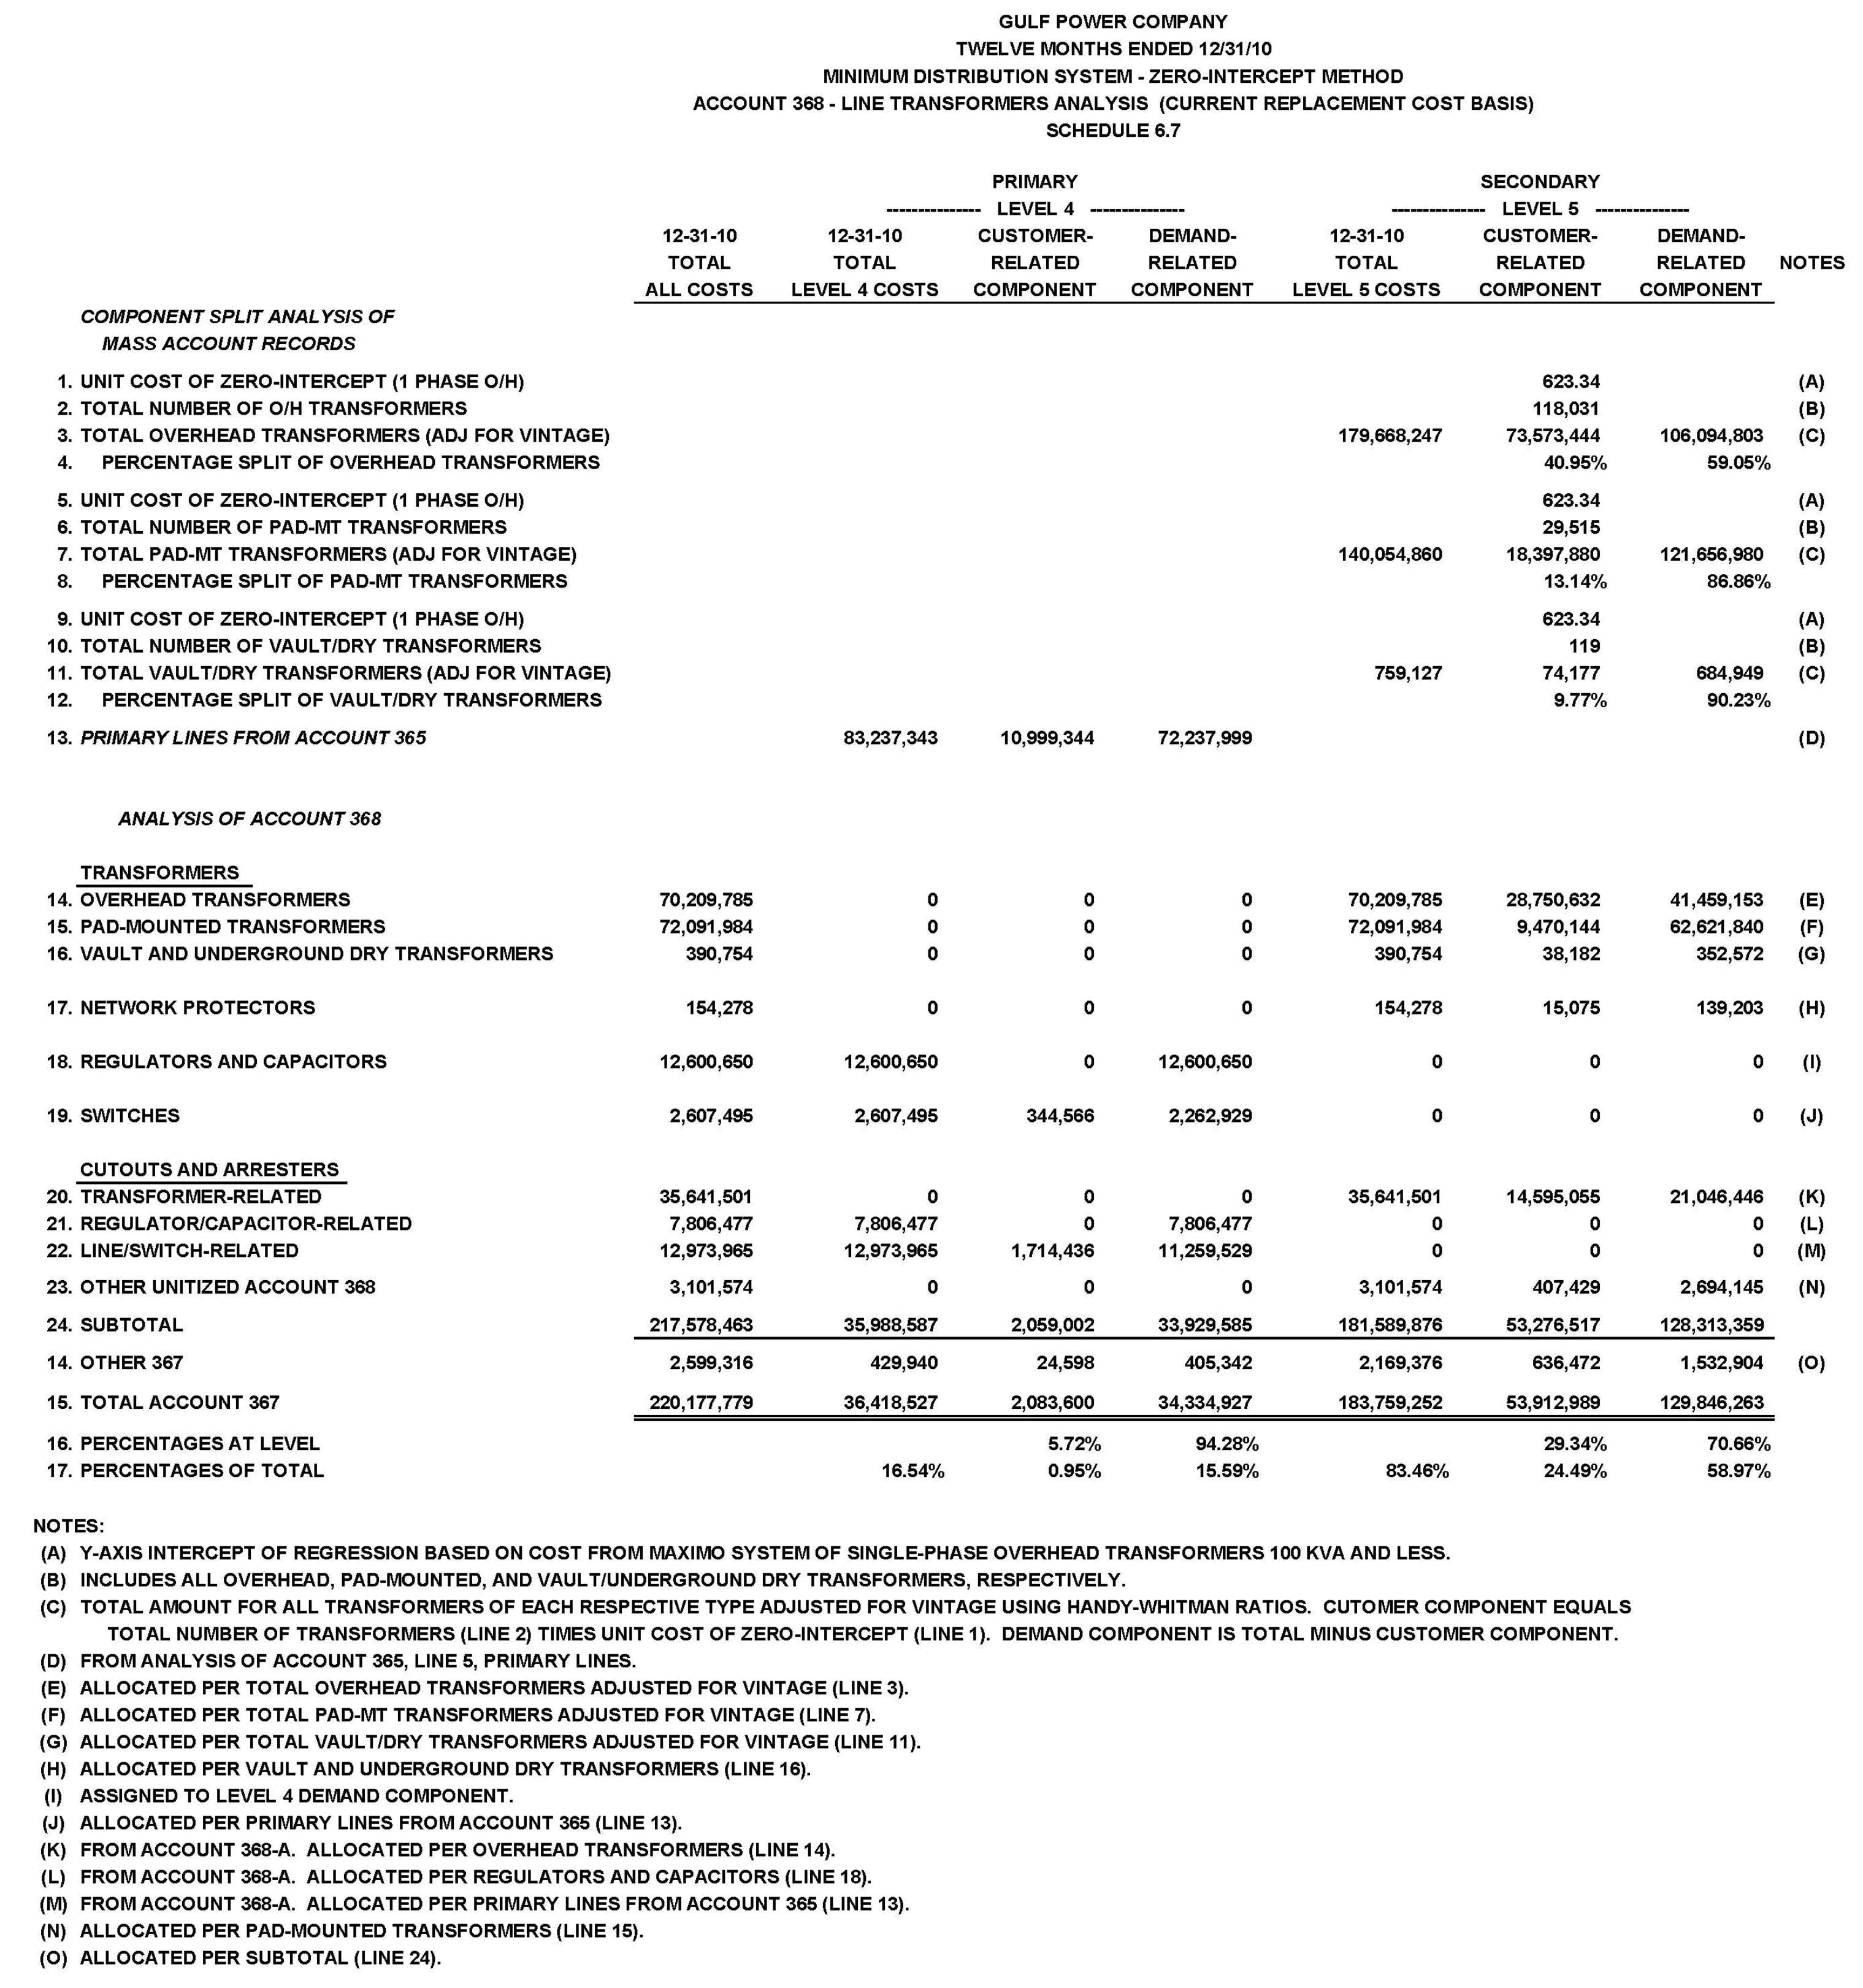

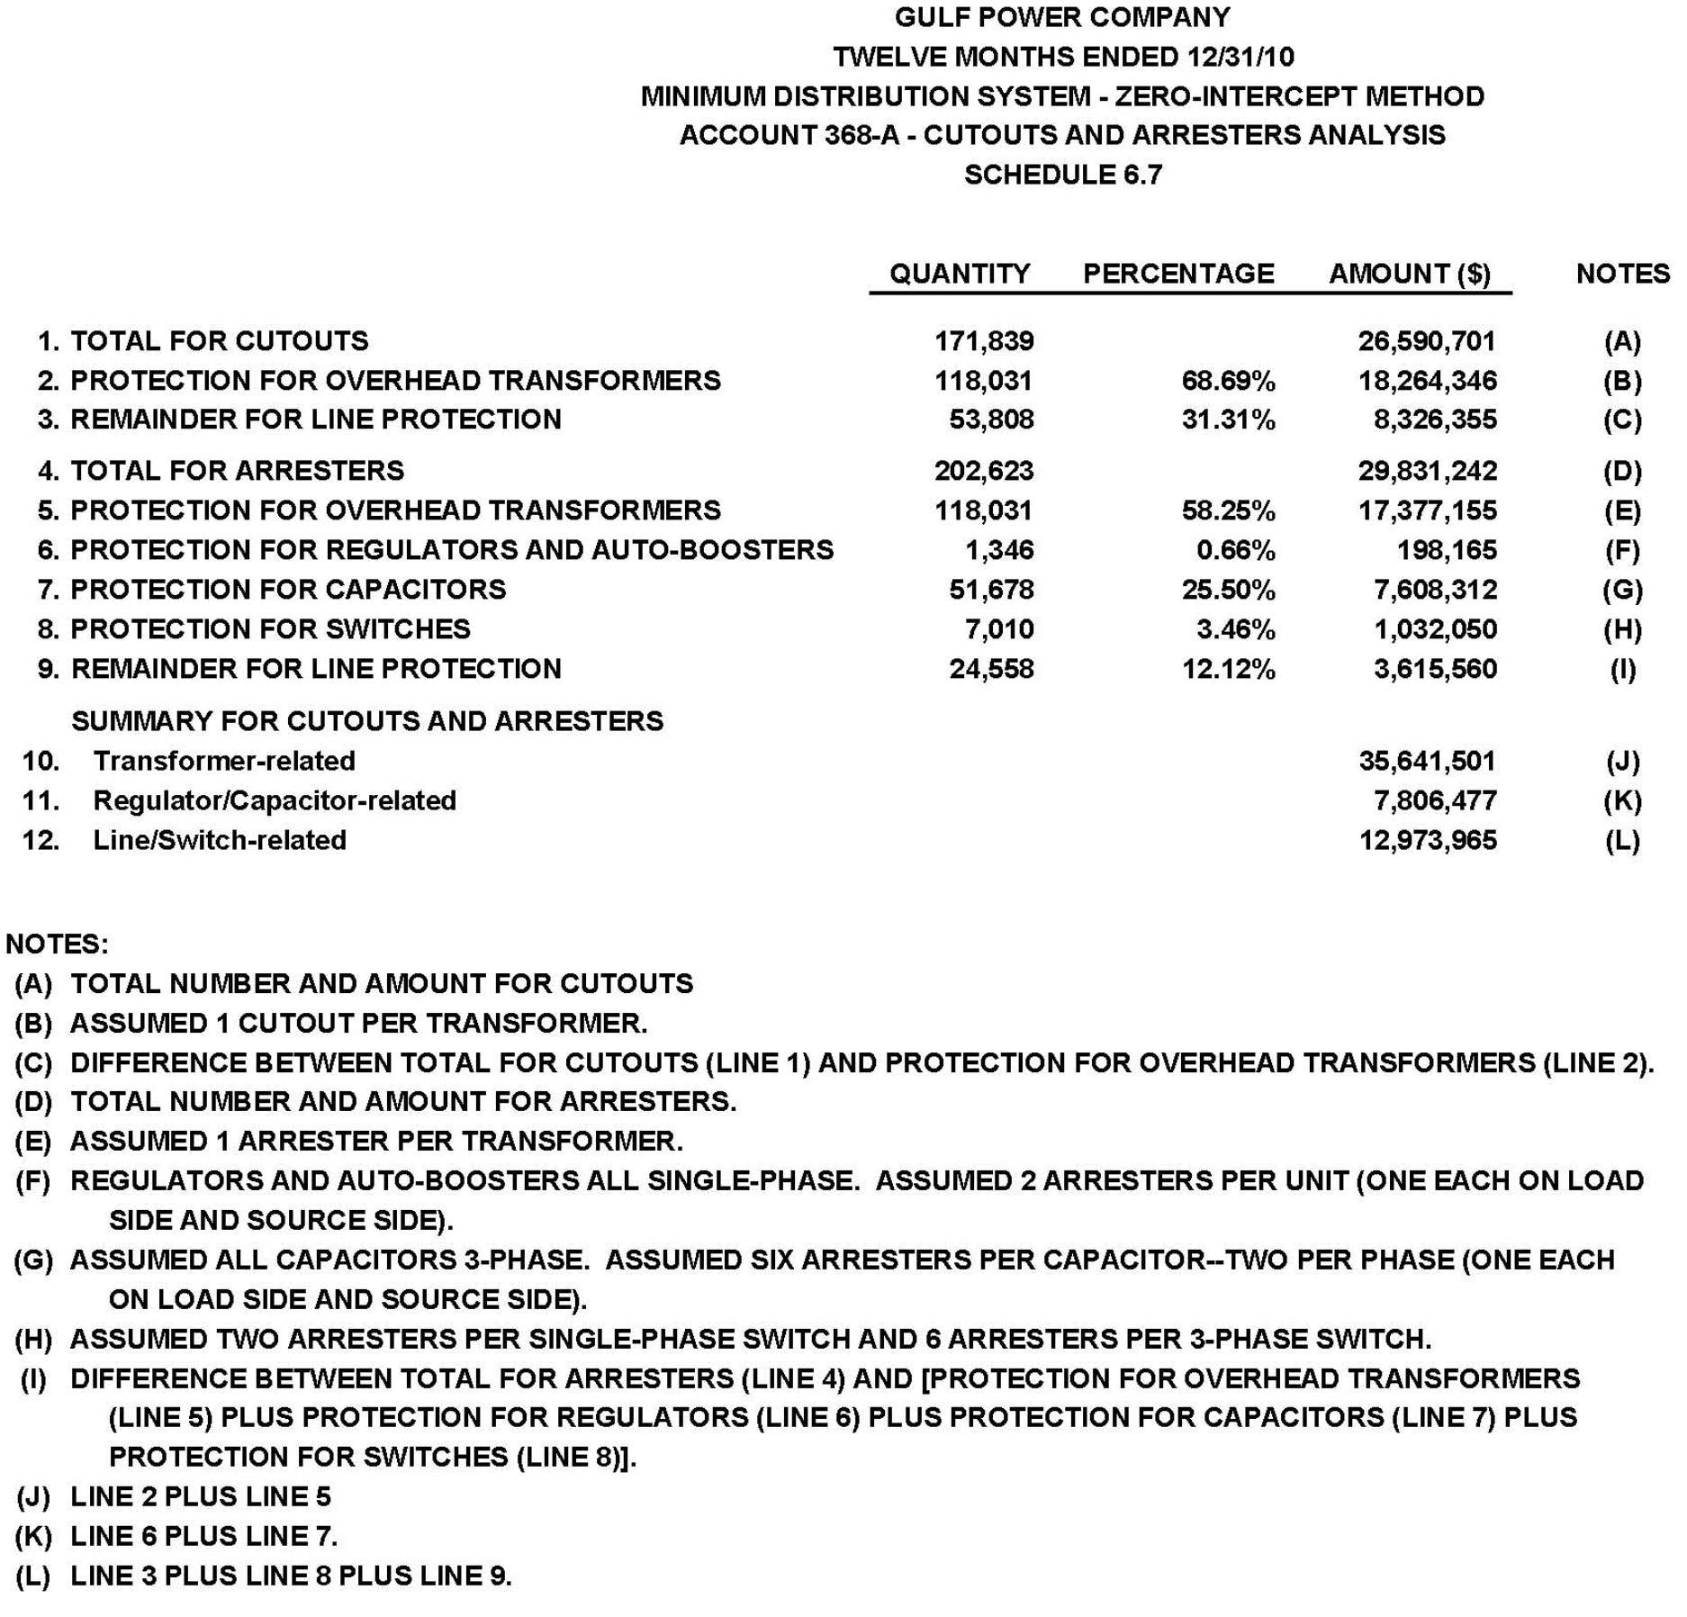

Gulf Power Company
Twelve Months Ended 12/31/10
Minimum Distribution System
Account 369 - Services Analysis (Mass Account)
Schedule 6.8

 |  |  |  | Secondary
 |  |  |  | ------------Level 5------------
 |  |  |  | 12-31-10 | Customer- | Demand-
 |  |  |  | Total | Related | Related | Notes
 |  |  |  | All Costs | Component | Component
1. | All Services |  |  | 93,066,265 | 93,066,265 | - | (A)
2. | Total Account 369 |  |  | 93,066,265 | 93,066,265 | -
3. | Percentages |  |  |  | 100%
Notes
(A) | Assigned to Secondary Level 5 Customer-Related Component.

Gulf Power Company
Twelve Months Ended 12/31/10
Minimum Distribution System
Account 370 - Meters Analysis (Mass Account)
Schedule 6.9

 |  |  |  | Secondary
 |  |  |  | ------------Level 5------------
 |  |  |  | 12-31-10 | Customer- | Demand-
 |  |  |  | Total | Related | Related | Notes
 |  |  |  | All Costs | Component | Component
1. | All Meters |  |  | 57,547,263 | 57,547,263 | - | (A)
2. | Total Account 370 |  |  | 57,547,263 | 57,547,263 | -
3. | Percentages |  |  |  | 100%
Notes
(A) | Assigned to Secondary Level 5 Customer-Related Component.

