Duke Energy Florida
Load & Fundamental Forecasting
Fall 2013 Forecast
Customers – Energy - Peak Demand
Work Papers

Ed Lynch
May 2014

Customer - Energy – Peak Demand Process
The first step in the process to develop Duke Energy Florida’s (DEF) projections of customers, energy & peak demand is to develop a consistent set of forecasting assumptions that reflect the environment in which the company will be producing and selling electric energy. DEF employs a forecasting process which includes the use of models purchased from Itron Corporation. The MetrixND software is Itron, Inc.’s proprietary model which employs a statistically adjusted end-use or “SAE” methodology that combines the benefits of both econometric and end-use forecasting methodologies. The SAE approach captures the impact of economic drivers, such as income and population growth on electricity consumption, while also estimating historical residential and commercial class end-use appliance consumption using company and EIA saturation surveys, and projections of nationally legislated appliance efficiency standards to capture the declining use per appliance. The combination of these two methodologies is considered “state of the art” for electric utilities in capturing both past and future behavior on electric energy consumption
Economic & Demographic Assumptions:
Duke Energy subscribes to Moody’s Analytics (MA) for National, State and sub-State economic and demographic data. The MA July 2014 projection of the Florida economy was used as input, along with the University of Florida - Bureau of Economic & Business Research’s March 2013 Florida Population/Household projection. All economic and demographic data, as well as the company meter-reading schedule and projected price of electricity developed in the corporate financial model, are loaded into MetrixND.
The three “snapped” pictures below show the directories that contain all the files in alphabetical order (with linkages) that encompass the DEF customer, energy and peak demand forecast. The first two items in the first picture are directories (“DSM-PEV-PV” and “Itron ND Models_Inputs & Output”) which are opened up in picture #2 and picture #3, respectively.
File Description - Picture #1 (below):
- CF_201309.xlsx – File containing History and Final retail Customer Forecast by class. Links show that monthly history come from File #8 (Trueup_EDB_CUS.xls) where billed customers get adjusted for “Event-Driven Billing” (EDB). This procedure “time-aligns” customer bills for the pace of the meter-reading process. The result is to align historical bill counts to one bill for each customer each month. Other links in this file pull in results from Intron’s MetrixND customer models. File shows charts of projections.
- cobwn2013.xlsx – Shows historic monthly actual reported and weather adjusted class of business (COB) retail MWh sales. It contains ratios that define monthly “shares” of Seasonal Service Rate (SSR) customer MWh as % of Non-SSR residential MWH. Seasonal residential customer MWH is not modeled, but is projected off historical percentages of non-seasonal MWh.
- Hist_HHds-Pop-HHsize_201309.xlsx – A file containing historical households, population and average household size by Florida county and a projection of average household size.
- MoCoinMW.xls – Historical DEF monthly coincident peak MW.
- Msalcus.xlsx - Historical DEF monthly billed MWh and customers.
- msc_201309_Itron.xlsx – A file that historic recorded billing month (BM) and Calendar month (CM-simulated) MWH data, historic recorded (not EDB adjusted) customer data by retail class & wholesale data by contract. It also contains, in consecutive rows below the history, the final projected MWH & customer forecast from File # 6 – Retail_BM_MWH_Itron.xlsx. This file consolidates the retail customer and energy forecast with the wholesale jurisdictional projections by contract.
- MW_201309.xlsx – A file that has all the coincident monthly peak history and forecast by component. It contains monthly tabs showing how the DEF retail peak is projected by month. The excel linear regression models are to the right of the historical (model input) data. Links show historical and projected customer data coming from CF_201309.xlsx and demand response data from Picture #3 File #1. There are “Presentation Tabs” that summarize the data in the monthly tabs. There is a “monthly Peaks” tab that shows all the components of the MW forecast by month, and an “Interruptible” tab that shows the projection of DEF’s Interruptible & Curtailable MW customers (non-firm).
- Phos_mwh_mw_201308.xlsx – has the DEF forecast of large Industrial Phosphate mining & processing customers who make up 33% of DEF industrial MWH sales. Mine shutdowns or startups are significant enough to handle explicitly in the energy forecast (Retail_BM_MWH_Itron.xlsx) and in the non-firm MW forecast (MW_201309.xlsx).
- Retail_BM_MWH_Itron.xlsx – This file links to and aggregates all MetrixND class sales models (Billing & Calendar month) to calculate total retail jurisdictional MWH and customers (from CF_201309.xlsx). It also shows where adjustments for Roof-top Solar (PV), electric vehicles (EV), specific large adjustments (self-service generation) and energy efficiency are applied to the monthly energy forecast.
- SF_201309_Itron.xlsx – This file pulls data from File #6 and File #4 to present final historical and projected MWH energy data by month and year for the DEF System, Retail, Wholesale and by Retail class for the billing month and calendar month, applying both retail and wholesale loss factors, a projection of “Company Use” MWH to result in the final projection of System Requirements.
- Trueup_EDB_CUS.xlsx – mentioned earlier, this is a file containing monthly numbers of customers by retail class on a “reported” basis and on a “corrected” basis so the aggregate by class reflects a “truer” monthly figures. The pace of the meter-reading process can vary the real amount each month.
- Work Papers – Documentation.docx – This word document you are reading now.
- WP_201308_D_E_BR.xlsx – A file containing wholesale MW, MWH and Base Revenue projections by month and by contract. This file get linked into msc_201309_Itron.xlsx.

Picture #1:
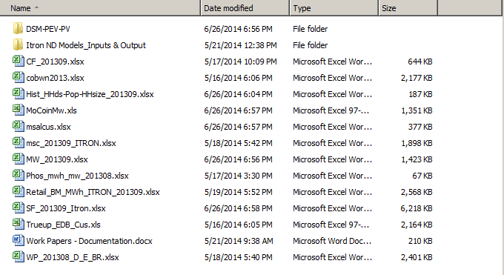
1
2
3
4
5
6
7
8
9
10
11
12
13
File Description - Picture #2 (below):
- 20130227 Power Prices from Duke 2013 Fundamental.xlsx – A file containing a projection of electric price by major RTO developed by the Duke Fundamental Forecasting section with help from the consulting firm Energy Ventures Analysis, Inc. The DEF forecast uses the FRCC projection. This projection is developed from an all-encompassing review of all energy supply & demand conditions nationwide. A specific assumption in this price projection is the inclusion of a carbon tax in 2020, which Load Forecasting smoothed in over the 2020-2025 period.
- Com Intensities.xlsx – An Itron developed commercial SAE annual file listing ten historical and projected commercial class end use intensities. The trend incorporates all federally legislated appliance (end use) efficiency standards that are in effect or scheduled to be in effect on a future date.
3.-7. Retail Class customer models run in the MetrixND software and exported to Excel. Separate Tabs in each file show input data, Model statistics, Predicted results and more.
- econ201308.xlsx - Columns of historical and projected economic data mostly from Moody’s Analytics. Some series show company data such as monthly average billing days, electric price and weather. Not all columns in this file were used in the forecasting models!!
- Electric Revenue Summary_2012 12&0 v3.xlsx – Internal Duke Financial Planning & analysis file containing the five year projection of monthly Florida revenues by class by billing component for the years 2013-2017. The energy forecast uses the class average price per kWh as input to the sales models.
- mEcon.xlsx – Very similar to File #8 but this file contains all Florida economic data that was imported into MetrixND. Again, not every series was incorporated into a model.
- Prices_DEF_Final – Final series of retail class electric prices that were imported into MetrixND and used in sales models.
- ResIndices.xlsx – An Itron developed residential SAE annual file listing twenty historical and projected residential class end use appliance intensities. The trend incorporates all federally legislated appliance (end use) efficiency standards that are in effect or scheduled to be in effect on a future date.
- – 28. Itron energy models exported to Excel. Main models will contain a “_B_” in filename and project billing month MWH or Kwh/customer. Files with a “_C_” in filename contain calendar based projections and only differ from Billed models by applying calendar weather and other calendar-based variables rather than billing month based variables.
Picture #2:
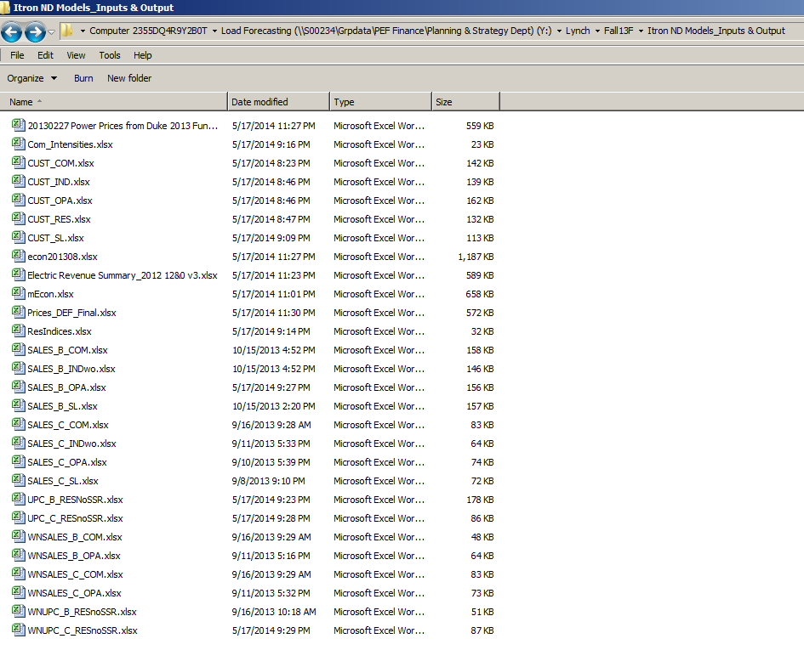
1
2
3
4
5
6
7
8
9
10
11
12
13
14
15
16
17
18
19
20
21
22
23
24
25
26
27
28

File Description - Picture #3 (below):
- DSM-Dispatchable MW Savings-20130713.xlsx – History & forecast Demand Response MW capability
- DSM-NonDisp MW-20130716.xlsx – History & forecast conservation program MW reductions
- DSM-NonDisp MWH-20130716.xlsx – History & forecast conservation program MWH reductions
- NEM Forecast – Fall 2013 – submitted 081513.xlsx – Monthly and annual forecast of net metered (photovoltaic solar energy) energy reductions for DEF service area.
- Scenarios for PEV 2013.xlsx – Monthly & annual Plug-in Electric Vehicle energy addition impacts forecast.

Picture #3: 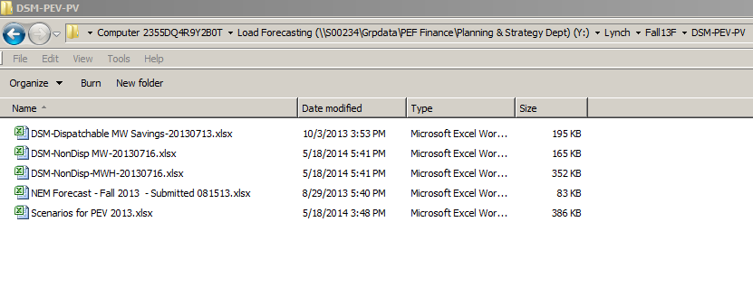
1
2
3
4
5

