BEFORE THE FLORIDA PUBLIC SERVICE COMMISSION

In re: Request by Gulf Power Company to modify its underground residential differential tariffs. | DOCKET NO. 150112-EI  ORDER NO. PSC-15-0274-TRF-EI  ISSUED: July 6, 2015

The following Commissioners participated in the disposition of this matter:

ART GRAHAM, Chairman
LISA POLAK EDGAR
RONALD A. BRISÉ
JULIE I. BROWN
JIMMY PATRONIS

ORDER APPROVING GULF POWER COMPANY’S
UNDERGROUND RESIDENTIAL DISTRIBUTION TARIFFS

BACKGROUND

On April 1, 2015, Gulf Power Company (Gulf) filed its revised underground residential distribution (URD) tariff. These tariffs reflect the additional costs the customer must pay for initial service above the standard overhead service. The tariffs approved herein are shown in Attachment A. Gulf’s current charges were approved in Order No. PSC-12-0531-TRF-EI (2012 Order). On April 13, 2015, Gulf waived the 60-day suspension date. Our staff issued two data requests to Gulf. We have jurisdiction over this matter pursuant to Sections 366.03, 366.04, 366.05, and 366.06, Florida Statutes.

Rule 25-6.078, Florida Administrative Code (F.A.C.), defines investor-owned utilities’ (IOUs) responsibilities for filing updated URD tariffs. IOUs are required to file supporting data and analyses for URD tariffs at least once every three years. The URD tariffs provide standard charges for underground service in new residential subdivisions and represent the additional costs the utility incurs to provide underground service in place of standard overhead service. The cost of standard overhead construction is recovered through base rates from all ratepayers. In lieu of overhead construction, customers have the option of requesting underground facilities. Costs for underground construction have historically been higher than for standard overhead construction and the additional cost is paid by the customers as contribution-in-aid-of construction (CIAC). Typically the URD customer is the developer of the subdivision.
DECISION
Gulf’s URD charges are based on two standard model subdivisions: (1) a 210-lot low density (LD) subdivision, and (2) a 176-lot high density (HD) subdivision. While actual construction may differ, the model subdivisions are designed to reflect average subdivisions. Gulf explained that both subdivision underground designs were updated to reflect changes in construction standards, resulting in minor increases to the affected materials.

Table 1 displays the currently approved and proposed URD differentials for the LD and HD subdivisions. The charges shown are per-lot charges. Gulf’s URD tariff also provides for reduced charges if the customer chooses to supply and/or install the primary and secondary trench and duct system.
Table 1
Comparison of URD Differential Per Lot
 | Current Differential Per Lot | Proposed Differential Per Lot
210-Lot Low Density | $427 | $402
176-Lot High Density | $458 | $521

As shown in the table above, the differential per-lot has decreased for the LD subdivision and increased for the HD subdivision. The calculation of Gulf’s proposed URD charges are based on: 1) updated labor and material costs; and 2) calculation of operational costs.

Updated labor and material costs. The installation costs of both underground and overhead facilities include the material and labor costs to provide primary, secondary, and service distribution lines as well as transformers. The costs of poles are specific to overhead service while the costs of trenching and backfilling are specific to underground service. The current URD charges are based on 2012 labor and material costs, and the proposed charges are based on 2015 costs. Table 2 compares the per-lot 2012 and 2015 underground and overhead labor and material costs for the two subdivisions.

Table 2
Labor and Material Costs per Lot
 | 2012 Costs | 2015 Costs | Difference
Low Density
Underground labor/material costs | $2,258 | $2,307 | $49
Overhead labor/material costs | $1,701 | $1,715 | $14
Per lot differential | $557 | $592 | $35
High Density
Underground labor/material costs | $1,803 | $1,895 | $92
Overhead labor/material costs | $1,325 | $1,331 | $6
Per lot differential | $478 | $564 | $86

As indicated in the table above, the changes in total labor and material cost differentials are minimal for the two model subdivisions. Gulf stated that the overall increases in LD and HD underground labor and material costs result from increases in the cost of contract labor (used for trenching and the installation of duct work) and are somewhat mitigated by decreases in material costs. Specifically, the decrease in material costs is driven by the volume procurement of transformers. The increase in overhead costs is minimal.
Calculation of operational costs. Rule 25-6.078(4), F.A.C., provides that the differences in Net Present Value (NPV) of operational costs between overhead and underground systems, including average historical storm restoration costs over the life of the facilities, be included in the URD charge. Operational costs include operations and maintenance (O&M) costs and capital costs. The inclusion of the operational costs are intended to capture longer term costs and benefits of undergrounding. Gulf used its actual historical O&M and capital expenses for the period 2010 through 2014 to calculate the operational difference for overhead and underground facilities.
Table 3 below compares the 2012 and 2015 NPV calculations of operational cost differentials between overhead and underground systems on a per-lot basis.

Table 3
NPV of Operational Costs per Lot
 | 2012 Calculation | 2015 Calculation | Difference
Low Density
Underground | $379 | $436 | $57
Overhead | $509 | $626 | $117
Per lot differential | -$130 | -$190 | -$60
High Density
Underground | $238 | $274 | $36
Overhead | $258 | $317 | $59
Per lot differential | -$20 | -$43 | -$23

Gulf used the same methodology as updated in the 2012 Order and originally approved in Order No. PSC-10-0563-TRF-EI. Gulf’s NPV calculation used a 32-year life of the facilities and a 6.72 percent discount rate. We note that operational costs may vary among IOUs as a result of differences in size of service territory, miles of coastline, regions subject to extreme winds, age of the distribution system, or construction standards.
For LD subdivision lots, the proposed labor and material differential is a $35 increase from current costs. The operational cost savings not only offset the $35 increase, but serve to reduce the proposed differential an additional $25 from the current differential. For the HD subdivision lots, the proposed labor and material differential is an $86 increase from the current differential. The operational cost savings reflect a decrease of $23 from the current differential, for a total increase of $63 from the current differential.
Having reviewed Gulf’s proposed URD charges and associated tariffs, its accompanying work papers, and data request responses, we find that the proposed URD charges are reasonable and hereby approve them effective June 18, 2015.
Based on the foregoing, it is
ORDERED by the Florida Public Service Commission that Gulf Power Company’s proposed Underground Residential Distribution tariffs and associated changes contained in Attachment A are hereby approved effective June 18, 2015. It is further
ORDERED that if a protest is filed within 21 days of the issuance of this order, this tariff shall remain in effect with any revenues held subject to refund, pending resolution of the protest. If no timely protest is filed, this docket shall be closed upon the issuance of a consummating order.
By ORDER of the Florida Public Service Commission this 6th day of July, 2015.

/s/ Carlotta S. Stauffer
CARLOTTA S. STAUFFER
Commission Clerk
Florida Public Service Commission
2540 Shumard Oak Boulevard
Tallahassee, Florida 32399
(850) 413-6770
www.floridapsc.com

Copies furnished: A copy of this document is provided to the parties of record at the time of issuance and, if applicable, interested persons.

SBr

NOTICE OF FURTHER PROCEEDINGS

The Florida Public Service Commission is required by Section 120.569(1), Florida Statutes, to notify parties of any administrative hearing or judicial review of Commission orders that is available under Sections 120.57 or 120.68, Florida Statutes, as well as the procedures and time limits that apply. This notice should not be construed to mean all requests for an administrative hearing or judicial review will be granted or result in the relief sought.

Mediation may be available on a case-by-case basis. If mediation is conducted, it does not affect a substantially interested person's right to a hearing.

The Commission's decision on this tariff is interim in nature and will become final, unless a person whose substantial interests are affected by the proposed action files a petition for a formal proceeding, in the form provided by Rule 28-106.201, Florida Administrative Code. This petition must be received by the Office of Commission Clerk, 2540 Shumard Oak Boulevard, Tallahassee, Florida 32399-0850, by the close of business on July 27, 2015.

In the absence of such a petition, this Order shall become final and effective upon the issuance of a Consummating Order.

Any objection or protest filed in this docket before the issuance date of this order is considered abandoned unless it satisfies the foregoing conditions and is renewed within the specified protest period.

ATTACHMENT A
Page 1 of 5

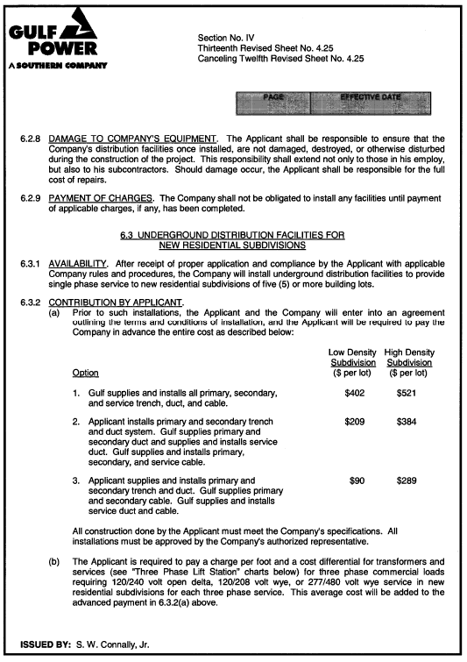

ATTACHMENT A
Page 2 of 5

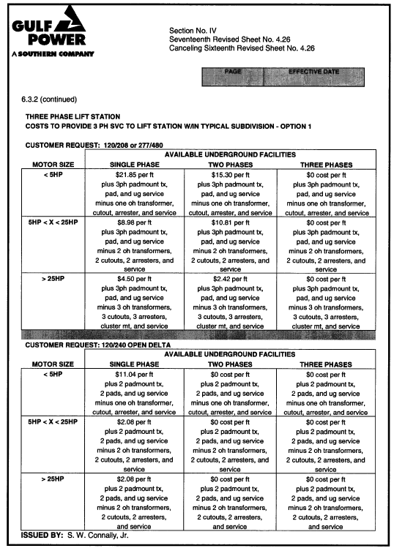
ATTACHMENT A
Page 3 of 5

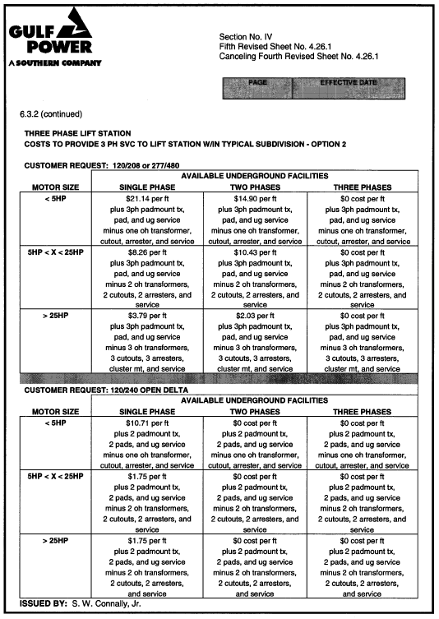
ATTACHMENT A
Page 4 of 5

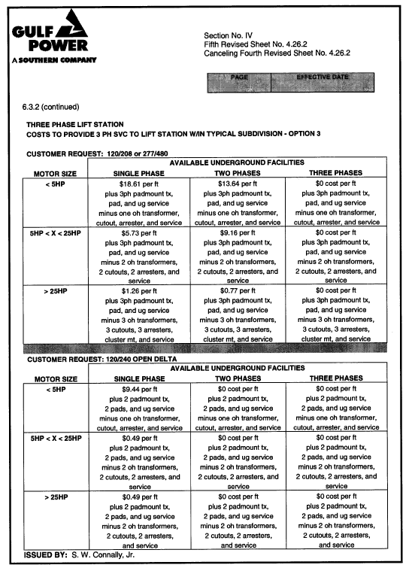

ATTACHMENT A
Page 5 of 5
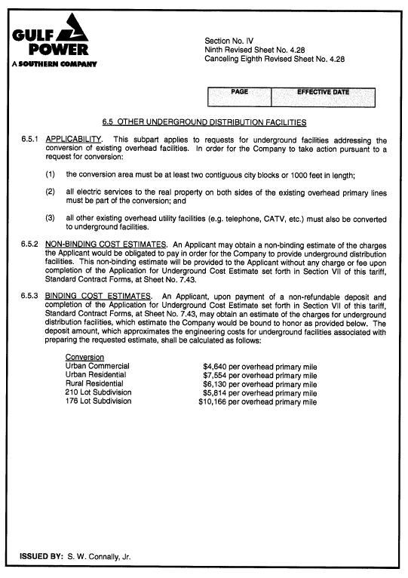

Order No. PSC-12-0531-TRF-EI, issued October 4, 2012, in Docket No. 120075-EI, In re: Request by Gulf Power Company to modify its underground residential differential tariffs.
$402 is calculated as follows: $592 (Table 1-2) + ($190) (Table 1-3) = $402.
Order No. PSC-10-0563-TRF-EI, issued September 14, 2012, in Docket No. 100165-EI, In re: Request to revise 2010 overhead/underground residential differential cost data by Gulf Power Company.

