State of Florida   |  | Public Service Commission  Capital Circle Office Center ● 2540 Shumard Oak Boulevard  Tallahassee, Florida 32399-0850  -M-E-M-O-R-A-N-D-U-M-
DATE: | August 13, 2015
TO: | Office of Commission Clerk (Stauffer)
FROM: | Office of the General Counsel (Corbari, Ames)  Office of Telecommunications (Casey)
RE: | Docket No. 150158-TX – Initiation of show cause proceedings against Sun-Tel USA, Inc. for apparent violation of Section 364.335(2), F.S., (Application for Certificate of Authority), Section 364.183(1), F.S., (Access to Company Records), Rule 25-4.0665(20), F.A.C., (Lifeline Service), and Rule 25-4.0051, F.A.C., (Current Certificate Holder Information).
AGENDA: | 08/27/15 – Regular Agenda – Proposed Agency Action - Interested Persons May Participate
COMMISSIONERS ASSIGNED: |  |  | All Commissioners
PREHEARING OFFICER: |  |  | Administrative
CRITICAL DATES: |  |  | None
SPECIAL INSTRUCTIONS: |  |  | None

Case Background
By Order No. PSC-99-1491-PAA-TX, issued August 3, 1999, in Docket No. 990713-TX, Sun-Tel USA, Inc. (Sun-Tel or company) was granted Certificate Number 7126 to provide local exchange telecommunication services in the State of Florida. The Order specified that Sun-Tel is required to comply with all applicable provisions of Chapter 364, Florida Statutes (F.S.), and Chapters 25-4 and 25-24, Florida Administrative Code (F.A.C.). By Order No. PSC-10-0634-PAA-TX, issued October 25, 2010, in Docket No. 100124-TX, the Florida Public Service Commission (Commission) granted eligible telecommunications carrier (ETC) designation status to the company in 86 non-rural AT&T Florida wire centers. This recommendation addresses Sun-Tel’s apparent violations of Section 364.335(2), F.S., Application for certificate of authority, Section 364.183(1), F.S., Access to Company Records, Rule 25-4.0665 (20), F.A.C., Lifeline Service, and Rule 25-4.0051, F.A.C., Current Certificate Holder Information. The Commission has jurisdiction pursuant to Chapter 364, F.S., Rule 25-4.0665 F.A.C., and Rule 25-4.0051, F.A.C.

Discussion of Issues

Issue 1:
Should the Commission order Sun-Tel to show cause in writing within 21 days of the date of the order why it should not be penalized $2,000 or its Certificate No. 7126 and ETC designation should not be cancelled for apparent violations of Section 364.335(2), and Section 364.183(1), F.S., and Rules 25-4.0665 (20), and 25-4.0051, F.A.C.?

Recommendation:
Yes. The Commission should order Sun-Tel to show cause in writing within 21 days of the issuance of the Commission Order why it should not be penalized $2,000 or its Certificate No. 7126 and ETC designation cancelled for apparent violations of Section 364.335(2), and 364.183(1), F.S., and Rules 25-4.0665 (20), and 25-4.0051, F.A.C. Specifically, staff recommends that Sun-Tel be directed to pay a penalty of $2,000, update the Company’s Corporate Registration with the Florida Secretary of State, and update company contact information with the Commission Clerk in order to maintain its CLEC certificate. In order to maintain Sun-Tel’s ETC designation, staff recommends that Sun-Tel should complete the above requirements for its CLEC certificate, provide the required Lifeline quarterly data from the fourth quarter 2014 through the second quarter 2015, and provide proof that it has the ability to offer the services that are supported by federal universal service support mechanisms either using its own facilities or a combination of its own facilities and resale of another carrier's services.
Sun-Tel USA, Inc.s response must contain specific allegations of fact or law. If Sun-Tel USA, Inc. fails to respond to the show cause order or request a hearing pursuant to Section 120.57, F.S., within 21 days and/or remit the penalty, the facts should be deemed admitted and the company’s certificate No. 7126 and ETC designation should be cancelled. If a penalty is assessed and paid by the company, the Commission will remit the penalty to the State of Florida General Revenue Fund pursuant to Section 364.285, F.S.
Further, staff recommends that if the company responds to the show cause order by remitting the penalty, updating the company’s Corporate Registration with the Florida Secretary of State, submitting the required Lifeline quarterly data, and providing proof that it has the ability to offer the services that are supported by federal universal service support mechanisms either using its own facilities or a combination of its own facilities and resale of another carrier's services, this show cause matter will be considered resolved, and the docket closed.
(Corbari, Ames, Casey)

Staff Analysis:
Factual Allegations

Section 364.335(2), F.S., Application for certificate of authority

Pursuant to Section 364.335(2), F.S.:

The commission shall grant a certificate of authority to provide telecommunications service upon a showing that the applicant has sufficient technical, financial, and managerial capability to provide such service in the geographic area proposed to be served. The applicant shall ensure continued compliance with applicable business formation, registration, and taxation provisions of law. (emphasis added)

Staff reviewed the Florida Secretary of State Corporation database (See, Attachment A – Copy of Sun-Tel’s Expired Corporate Registration) and found that the company does not have a current Florida Corporate Registration, in apparent violation of Section 364.335(2) F.S. Staff contacted Sun-Tel, via letter dated February 23, 2015, and certified letter dated April 13, 2015, to advise the Company of the expired registration (See Attachment B & C). To date, the Company has neither responded to staff’s correspondence, nor updated its Corporate Registration.

Rule 25-4.0665(20), F.A.C. Lifeline Service

Rule 25-4.0665(20), F.A.C. provides the following:

Eligible telecommunications carriers offering Link-Up and Lifeline service must submit quarterly reports to the Commission no later than 30 days following the ending of each quarter as follows: First Quarter (January 1 through March 31); Second Quarter (April 1 through June 30); Third Quarter (July 1 through September 30); Fourth Quarter (October 1 through December 31). The quarterly reports shall include the following data:

(a) The number of Lifeline subscribers, excluding resold Lifeline subscribers, for each month during the quarter.
(b) The number of subscribers who received Link-Up for each month during the quarter.
(c) The number of new Lifeline subscribers added each month during the quarter.
(d) The number of transitional Lifeline subscribers who received discounted service for each month during the quarter.
(e) The number of residential access lines with Lifeline service that were resold to other carriers each month during the quarter.

As an ETC, Sun-Tel is required to submit Lifeline quarterly data as required by Rule 25-4.0665 (20), F.A.C. Sun-Tel has failed to submit the required Lifeline quarterly data for the fourth quarter 2014, first quarter 2015, and 2nd quarter 2015. In Sun-Tel’s 2010 ETC designation docket, Sun-Tel submitted a signed “Applicant Certification” stating that it would follow all Florida Statutes, Florida Administrative Rules, and Florida PSC Orders relating to Universal Service, Eligible Telecommunications Carriers, and the Florida Link-Up and Lifeline Program (See Attachment D), but has apparently failed to do so. On May 7, 2015, staff sent an e-mail to Sun-Tel about its failure to submit the quarterly Lifeline data required by rule. A response was requested by May 22, 2015. The e-mail advised Sun-Tel that its ETC designation may be revoked for failing to follow Lifeline rules. Staff also advised Sun-Tel that it may voluntarily rescind its ETC designation if it so chose. No response has been received by staff.

Rule 25-4.0051, F.A.C., Current Certificate Holder Information

Rule 25-4.0051, F.A.C., requires each certificated company to file updated information for the following items with the Office of Commission Clerk within 10 days after any changes to the following:

- The address of the certificate holder’s main corporate and Florida offices (if any) including street name and address and post office box, city, state and zip code.

- Telephone number, name, and address of the individual who is to serve as primary liaison with the Commission in regard to the ongoing Florida operations of the certificated company.

Staff sent a letter to Sun-Tel on February 23, 2015 (See Attachment B), notifying it that Rule 25-4.0051, F.A.C., requires continued compliance with Florida applicable business formation, registration, and taxation provisions of law. The letter advised Sun-Tel that its Florida corporate registrationappears as inactive, and requested that Sun-Tel provide documentation within 30 days that the Company is actively registered. The letter also advised Sun-Tel that failure to comply may result in cancellation of the Company’s certificate. No response was received to staff’s letter. Staff also attempted to call Sun-Tel using the telephone number provided by the Company and listed in the Commission Master Commission Directory. A recording stated that the call could not be competed as dialed. Staff subsequently found a telephone number listed on Sun-Tel’s 2014 RAF return and called it multiple times. Voicemails were left each time, but staff never received a return phone call.

Staff subsequently sent a certified letter to Sun-Tel on April 13, 2015 (See Attachment C), advising the Company that no response was received to staff’s first letter, and Section 364.183(1), F.S., requires a telecommunications company to provide access to company records. The certified letter advised the Company that if it failed to respond by May 1, 2015, Commission staff may open a docket and initiate show-cause proceedings against the Company. No response was received to the certified letter. The U.S. Post Office shows the certified letter as unclaimed on May 5, 2015 (See Attachment E).

Section 364.183(1), F.S. Access to Company Records

The Commission requires a telecommunications company to provide access to company records per Section 364.183(1), F.S.:

The commission shall have access to all records of a telecommunications company which are reasonably necessary for the disposition of matters within the commission’s jurisdiction. The commission may require a telecommunications company to file records, reports or other data directly related to matters within the commission’s jurisdiction in the form specified by the commission and may require such company to retain such information for a designated period of time. Upon request of the company or other person, any records received by the commission which are claimed by the company or other person to be proprietary confidential business information shall be kept confidential and shall be exempt from s. 119.07(1) and s. 24(a), Art. I of the State Constitution. (emphasis added)

Sun-Tel apparently violated Section 364.183(1), F.S., by not updating the company’s Corporate Registration with the Florida Secretary of State, not updating the Company contact information with the Commission Clerk, not submitting the required Lifeline quarterly data from the fourth quarter 2014 through the second quarter 2015, and not responding to staff’s February 23, 2015 letter, or April 13, 2015 correspondence.

BellSouth Telecommunications, LLC d/b/a AT&T Florida v. Sun-Tel USA, Inc.

On July 22, 2013, staff learned that BellSouth Telecommunications, LLC d/b/a AT&T Florida (AT&T Florida) filed a complaint against Sun-Tel for breach of contract in the United States District Court for the Southern District of Florida Miami Division. Sun-Tel did not respond to the Complaint or Summons as required by law.

The AT&T Florida/Sun-Tel interconnection agreement required Sun-Tel to make timely payments to AT&T Florida for all services billed, including disputed amounts, on or before the next billing date. The breach of contract occurred due to unpaid charges for telecommunications services. Sun-Tel did enter into a settlement agreement with AT&T Florida which provided that Sun-Tel would satisfy the indebtedness through six monthly payments with an initial installment payment of $90,000. The initial Sun-Tel $90,000 check was subsequently dishonored by the bank for insufficient funds.

As a result of Sun-Tel’s failure to satisfy its indebtedness, AT&T Florida suspended Sun-Tel’s order processing on November 18, 2011, and discontinued service to Sun-Tel on December 14, 2011. The Court subsequently found in favor of AT&T Florida and found in favor of BellSouth in the amount of $833,034.

Federal Communications Commission Lifeline Rules

In Sun-Tel’s 2010 ETC designation docket, Sun-Tel submitted a signed “Applicant Certification” stating that it would follow all FCC Rules, FCC Orders, and regulations contained in the Telecommunications Act of 1996 regarding Universal Service, ETCs, Link-Up and Lifeline, and toll limitation service. (See Attachment D) C.F.R. §54.201(d), Definition of eligible telecommunications carriers, provides that a company designated as an ETC shall, throughout the service area for which the designation is received offer the services that are supported by federal universal service support mechanisms either using its own facilities or a combination of its own facilities and resale of another carrier's services, and advertise the availability of such services and the charges therefore using media of general distribution.

As discussed above, AT&T Florida disconnected service to Sun-Tel on December 14, 2011. Therefore, Sun-Tel cannot offer the services required of an ETC by FCC rule, and is in apparent violation of C.F.R. §54.201(d).

Staff Recommendation

Certificated companies are charged with the knowledge of the Commission's rules and statutes. Additionally, "[i]t is a common maxim, familiar to all minds that ‘ignorance of the law’ will not excuse any person, either civilly or criminally." Barlow v. United States, 32 U.S. 404, 411 (1833). In making similar decisions, the Commission has repeatedly held that certificated companies are charged with the knowledge of the Commission’s Rules and Statutes, and the intent of Section 364.285(1) is to penalize those who affirmatively act in opposition to those orders, rules, or statutes.

The procedure followed by the Commission in dockets such as this is to consider the Commission staff’s recommendation and determine whether or not the fact(s) warrant requiring the company to respond. If the Commission approves staff’s recommendation, the Commission issues an Order to Show Cause. A show cause order is considered an administrative complaint by the Commission against the company. If the Commission issues a show cause order, the company is required to file a written response. The response must contain specific allegations of disputed fact. If there are no disputed factual issues, the company’s response should so indicate. The response must be filed within 21 days of service of the show cause order on the respondent.

The company has two options if a show cause order is issued. The company may respond and request a hearing pursuant to Sections 120.569 and 120.57, F.S. If the company requests a hearing, a hearing will be scheduled to take place before the Commission, after which a final determination will be made. Alternatively, the company may respond to the show cause order by remitting the penalty. If the company pays the penalty and resolves all the issues, this show cause matter will be considered resolved, and the docket closed.

In the event the company fails to timely respond to the show cause order, the company is deemed to have admitted the factual allegations contained in the show cause order. The company’s failure to timely respond is also a waiver of its right to a hearing. Additionally, a final order will be issued imposing the sanctions set out in the show cause order.

Pursuant to Section 364.285, F.S., the Commission is authorized to impose upon any entity subject to its jurisdiction a penalty of not more than $25,000 for each offense, if such entity is found to have refused to comply with or to have willfully violated any lawful rule or order of the Commission, or any provision of Chapter 364. Each day a violation continues is treated as a separate offense. Each penalty is a lien upon the real and personal property of the company and is enforceable by the Commission as a statutory lien.

Willfulness is a question of fact. Therefore, part of the determination the Commission must make in evaluating whether to penalize a company is whether the company willfully violated the rule, statute, or order. Section 364.285, F.S., does not define what it is to “willfully violate” a rule or order. In Commission Order No. 24306, issued April 1, 1991, in Docket No. 890216-TL titled In Re: Investigation Into The Proper Application of Rule 25-14.003, F.A.C., Relating To Tax Savings Refund for 1988 and 1989 For GTE Florida, Inc., the Commission stated that “willful implies an intent to do an act, and this is distinct from an intent to violate a statute or rule." The plain meaning of "willful" typically applied by the Courts in the absence of a statutory definition, is an act or omission that is done “voluntarily and intentionally” with specific intent and “purpose to violate or disregard the requirements of the law.” Fugate v. Fla. Elections Comm’n, 924 So. at 76.

Staff believes that Sun-Tel has knowingly failed to comply with the provisions of Sections 364.335(2), and 364.183(1), F.S., and Rules 25-4.0665 (20), and 25-4.0051, F.A.C., and as a result, Sun-Tel’s act(s) were “willful” in the sense intended by Section 364.285, F.S., and Fugate. Staff therefore recommends that Sun-Tel should be ordered to show cause in writing, within 21 days of the issuance of the Commission Order, why it should not be penalized $2,000 or its certificate No. 7126 and ETC designation cancelled for apparent violations of Sections 364.335(2), F.S., and 364.183(1), F.S., and Rules 25-4.0665 (20), and 25-4.0051, F.A.C. Staff asserts that the penalty amount recommended of $500 per violation is consistent with amounts imposed for similar violations.

Sun-Tels response must contain specific allegations of fact or law. If Sun-Tel fails to respond to the show cause order or request a hearing pursuant to Section 120.57, F.S., and/or the penalty is not paid within the 21-day response period, the facts should be deemed admitted and the company’s certificate No. 7126 and ETC designation should be cancelled. If the company pays the assessed penalty, the Commission will remit the penalty to the State of Florida General Revenue Fund pursuant to Section 364.285, F.S.

In addition, staff recommends that the show cause order incorporate the following conditions:

- This show cause order is an administrative complaint by the Florida Public Service Commission, as petitioner, against Sun-Tel USA, Inc. as respondent.

- The company shall respond to the show cause order within 21 days of service on the company, and the response shall reference Docket No. 150158-TX In re: Initiation of show cause proceedings against Sun-Tel USA, Inc. for apparent violation of Section 364.335(2), F.S., (Application for Certificate of Authority), Section 364.183(1), F.S., (Access to Company Records), Rule 25-4.0665(20), F.A.C., (Lifeline Service), and Rule 25-4.0051, F.A.C., (Current Certificate Holder Information).

- The company has the right to request a hearing to be conducted in accordance with Sections 120.569 and 120.57, F.S., and to be represented by counsel or other qualified representative.

- Requests for hearing shall comply with Rule 28-106.2015, F.A.C.

- The company’s response to the show cause order shall identify those material facts that are in dispute. If there are none, the petition must so indicate.

- If the company files a timely written response and makes a request for a hearing pursuant to Sections 120.569 and 120.57, F.S., a further proceeding will be scheduled before a final determination of this matter is made.

- A failure to file a timely written response to the show cause order will constitute an admission of the facts herein alleged and a waiver of the right to a hearing on this issue.

- In the event that the company fails to file a timely response to the show cause order, and the respective penalty is not received, Sun-Tel USA, Inc.’s Certificate No. 7126 and ETC designation should be cancelled and this docket closed administratively.

Further, staff recommends that if the company responds to the show cause order by remitting the penalty, updating the company’s Corporate Registration with the Florida Secretary of State, submitting the required Lifeline quarterly data, and providing proof that it has the ability to offer the services that are supported by federal universal service support mechanisms either using its own facilities or a combination of its own facilities and resale of another carrier's services, this show cause matter will be considered resolved, and the docket closed.

Issue 2:
Should this docket be closed?

Recommendation:
No. If Issue 1 is approved, then Sun-Tel will have 21 days, from the issuance of the Order to Show Cause, to respond in writing why it should not be assessed a penalty or have its certificate and ETC designation canceled. If Sun-Tel timely responds, in writing, to the Order to Show Cause, updates the company’s Corporate Registration with the Florida Secretary of State, updates its Company contact information with the Commission Clerk, files the required Lifeline quarterly data, provides proof that it has the ability to offer the services that are supported by federal universal service support mechanisms either using its own facilities or a combination of its own facilities and resale of another carrier's services, and timely pays the assessed penalty of $2,000, the penalty should be deposited in the Florida General Revenue Fund pursuant to Section 364.285(1), Florida Statutes, and the docket closed administratively.
If Issue 1 is approved and Sun-Tel fails to timely respond to the Order to Show Cause or request a hearing, fails to update the company’s Corporate Registration with the Florida Secretary of State, fails to update its Company contact information with the Commission Clerk, fails to file the required Lifeline quarterly data, fails to provide proof that it has the ability to offer the services that are supported by federal universal service support mechanisms either using its own facilities or a combination of its own facilities and resale of another carrier's services, or fails to timely pay the assessed penalty of $2,000, then Sun-Tels Certificate No. 7126 and ETC designation should be canceled and the docket closed administratively. (Corbari, Ames, Casey)

Staff Analysis:
If Issue 1 is approved, then Sun-Tel will have 21 days, from the issuance of the Order to Show Cause, to respond in writing why it should not be assessed a penalty or have its certificate and ETC designation canceled. If Sun-Tel timely responds, in writing, to the Order to Show Cause, updates the company’s Corporate Registration with the Florida Secretary of State, updates its Company contact information with the Commission Clerk, files the required Lifeline quarterly data, provides proof that it has the ability to offer the services that are supported by federal universal service support mechanisms either using its own facilities or a combination of its own facilities and resale of another carrier's services, and timely pays the assessed penalty of $2,000, the penalty should be deposited in the Florida General Revenue Fund pursuant to Section 364.285(1), Florida Statutes, and the docket closed administratively.
If Issue 1 is approved and Sun-Tel fails to timely respond to the Order to Show Cause or request a hearing, fails to update the company’s Corporate Registration with the Florida Secretary of State, fails to update its Company contact information with the Commission Clerk, fails to file the required Lifeline quarterly data, fails to provide proof that it has the ability to offer the services that are supported by federal universal service support mechanisms either using its own facilities or a combination of its own facilities and resale of another carrier's services, or fails to timely pay the assessed penalty of $2,000, then Sun-Tels Certificate No. 7126 and ETC designation should be canceled and the docket closed administratively.

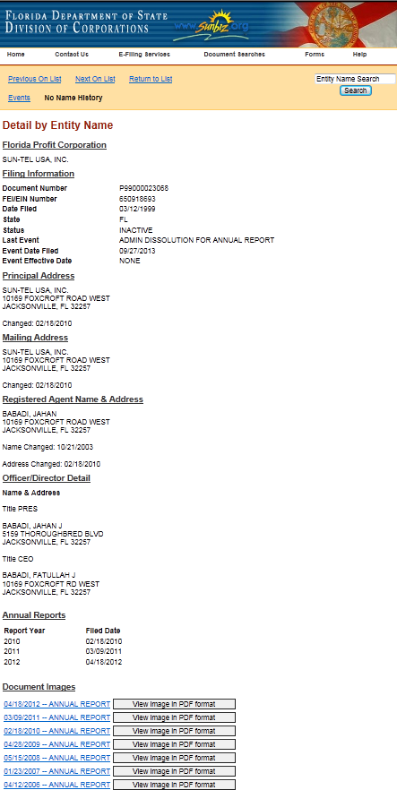
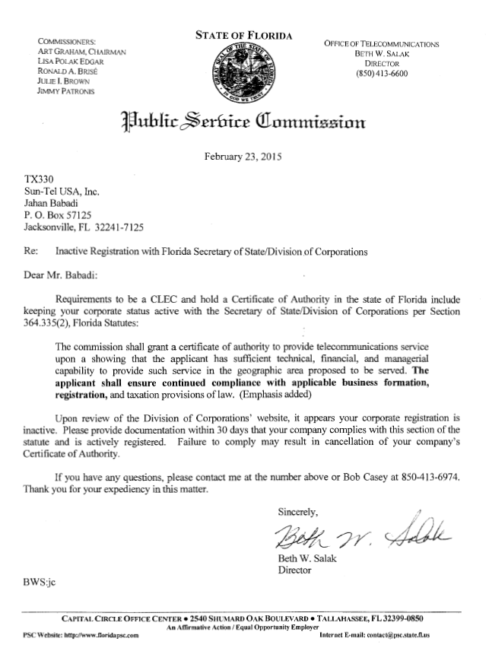
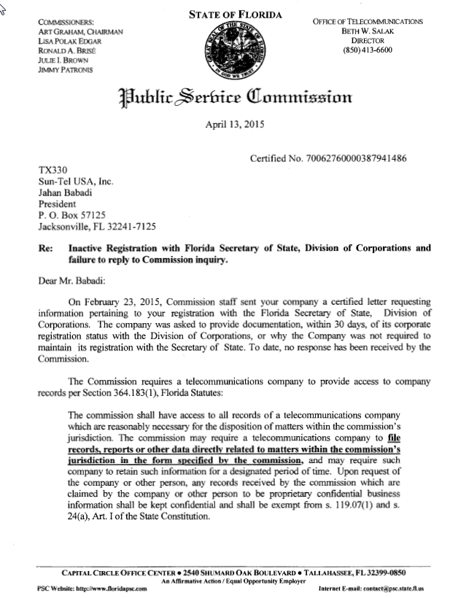

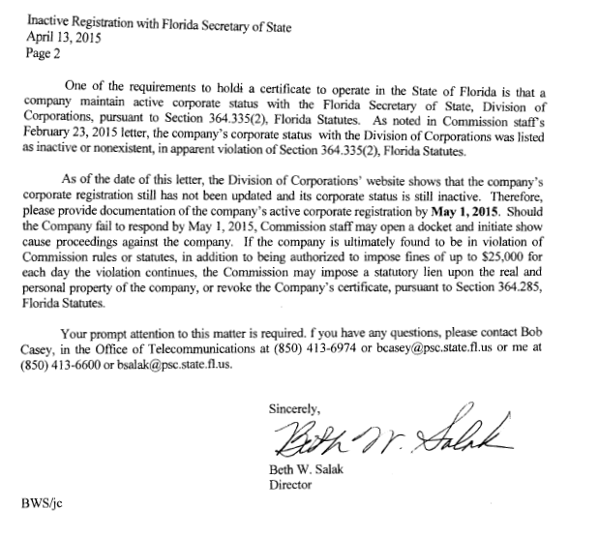

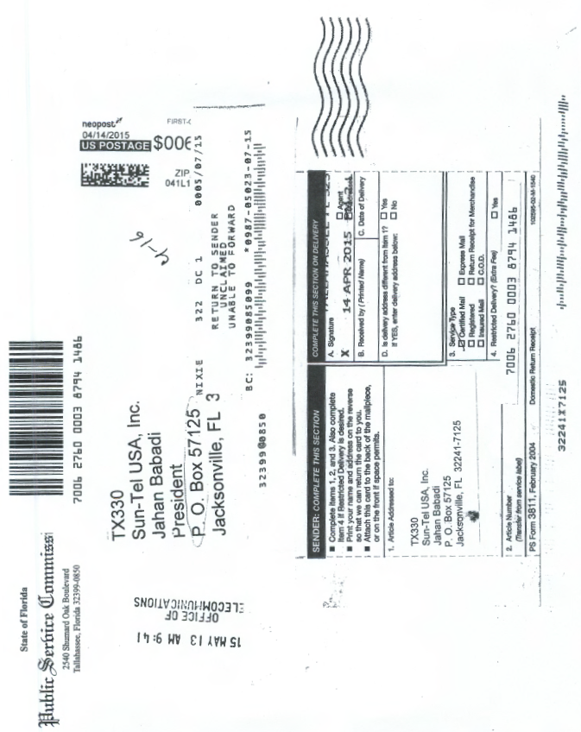

BellSouth Telecommunications LLC, d/b/a/ AT&T Florida vs. Sun-Tel USA, Inc., Case 1:13-cv-22610-UU
See, Order No. PSC-11-0250-FOF-WU, issued June 13, 2011, in Docket No. 100104-WU, In re: Application for increase in water rates in Franklin County by Water Management Services, Inc.; Order No. PSC-07-0275-SC-SU, issued April 2, 2007, in Docket No. 060406-SU, In re: Application for staff-assisted rate case in Polk County by Crooked Lake Park Sewerage Company; and Order No. PSC-05-0104-SC-SU, issued January 26, 2005 in Docket Nos. 020439-SU and 020331-SU; In re: Application for staff-assisted rate case in Lee County by Sanibel Bayous Utility Corporation; In re: Investigation into alleged improper billing by Sanibel Bayous Utility Corporation in Lee County in violation of Section 367.091(4), Florida Statutes. See also, Florida State Racing Commission v. Ponce de Leon Trotting Association, 151 So.2d 633, 634 (Fla. 1963), and Commercial Ventures, Inc. v. Beard, 595 So.2d 47, 48 (Fla. 1992) (utilities are subject to the rules published in the Florida Administrative Code).
See, Section 364.285(1), F.S.
Fugate v. Fla. Elections Comm’n, 924 So. 2d 74, 75 (Fla. 1st DCA 3006), citing, Metro. Dade County v. State Dep't of Envtl. Prot., 714 So. 2d 512, 517 (Fla. 3d DCA 1998).

