BEFORE THE FLORIDA PUBLIC SERVICE COMMISSION

In re: Initiation of show cause proceedings against Sun-Tel USA, Inc. for apparent violation of Section 364.335(2), F.S., (Application for Certificate of Authority), Section 364.183(1), F.S., (Access to Company Records), Rule 25-4.0665(20), F.A.C., (Lifeline Service), and Rule 25-4.0051, F.A.C., (Current Certificate Holder Information). | DOCKET NO. 150158-TX  ORDER NO. PSC-15-0391-SC-TX  ISSUED: September 16, 2015

The following Commissioners participated in the disposition of this matter:

ART GRAHAM, Chairman
LISA POLAK EDGAR
RONALD A. BRISÉ
JULIE I. BROWN
JIMMY PATRONIS

ORDER TO SHOW CAUSE

BY THE COMMISSION:

CASE BACKGROUND AND FACTUAL ALLEGATIONS

By Order No. PSC-99-1491-PAA-TX, issued August 3, 1999, in Docket No. 990713-TX, Sun-Tel USA, Inc. (Sun-Tel or Company) was granted Certificate Number 7126 to provide local exchange telecommunication services in the State of Florida. The Order specified that Sun-Tel is required to comply with all applicable provisions of Chapter 364, Florida Statutes (F.S.), and Chapters 25-4 and 25-24, Florida Administrative Code (F.A.C.). By Order No. PSC-10-0634-PAA-TX, issued October 25, 2010, in Docket No. 100124-TX, we granted eligible telecommunications carrier (ETC) designation status to the Company in 86 non-rural AT&T Florida wire centers.

This matter addresses Sun-Tel’s apparent violations of Section 364.335(2), F.S., Application for certificate of authority, Section 364.183(1), F.S., Access to Company Records, Rule 25-4.0665 (20), F.A.C., Lifeline Service, and Rule 25-4.0051, F.A.C., Current Certificate Holder Information.

We have jurisdiction pursuant to Chapter 364, F.S., Rule 25-4.0665 F.A.C., and Rule 25-4.0051, F.A.C.

Factual Allegations

Pursuant to Section 364.335(2), F.S.:

The commission shall grant a certificate of authority to provide telecommunications service upon a showing that the applicant has sufficient technical, financial, and managerial capability to provide such service in the geographic area proposed to be served. The applicant shall ensure continued compliance with applicable business formation, registration, and taxation provisions of law.

Section 364.183(1), F.S., provides that:

The commission shall have access to all records of a telecommunications company which are reasonably necessary for the disposition of matters within the commission’s jurisdiction. The commission may require a telecommunications company to file records, reports or other data directly related to matters within the commission’s jurisdiction in the form specified by the commission and may require such company to retain such information for a designated period of time. Upon request of the company or other person, any records received by the commission which are claimed by the company or other person to be proprietary confidential business information shall be kept confidential and shall be exempt from s. 119.07(1) and s. 24(a), Art. I of the State Constitution.

In addition, Rule 25-4.0051, F.A.C., (Current Certificate Holder Information) requires each certificated company to file updated information for the following items with the Office of Commission Clerk within 10 days after any changes to the following:

- The address of the certificate holder’s main corporate and Florida offices (if any) including street name and address and post office box, city, state and zip code.

- Telephone number, name, and address of the individual who is to serve as primary liaison with the Commission in regard to the ongoing Florida operations of the certificated company.

Finally, Rule 25-4.0665(20), F.A.C., (Lifeline Service) requires

Eligible telecommunications carriers offering Link-Up and Lifeline service must submit quarterly reports to the Commission no later than 30 days following the ending of each quarter as follows: First Quarter (January 1 through March 31); Second Quarter (April 1 through June 30); Third Quarter (July 1 through September 30); Fourth Quarter (October 1 through December 31). The quarterly reports shall include the following data:

(a) The number of Lifeline subscribers, excluding resold Lifeline subscribers, for each month during the quarter.
(b) The number of subscribers who received Link-Up for each month during the quarter.
(c) The number of new Lifeline subscribers added each month during the quarter.
(d) The number of transitional Lifeline subscribers who received discounted service for each month during the quarter.
(e) The number of residential access lines with Lifeline service that were resold to other carriers each month during the quarter.

Our staff’s review of the Florida Secretary of State Corporation database found that Sun-Tel did not have a current Florida Corporate Registration, as required by Section 364.335(2) F.S. Our staff contacted Sun-Tel, via letter dated February 23, 2015, to advise the Company of the expired registration. To date, the Company has neither responded to Commission staff’s correspondence, nor updated its Corporate Registration. Additionally, the letter dated February 23, 2015, requested Sun-Tel provide documentation within 30 days that the Company is actively registered and advised Sun-Tel that failure to comply may result in cancellation of the Company’s certificate. No response was received from the Company.

Our staff also attempted to call Sun-Tel using the telephone number provided by the Company and listed in our Master Directory. A recording stated that the call could not be competed as dialed. Subsequently, our staff found a telephone number listed on Sun-Tel’s 2014 RAF return and called it multiple times. Voicemails were left each time, but our staff never received a return phone call. On April 13, 2015, our staff sent Sun-Tel a certified letter, advising the Company that no response was received to the first letter, and that Section 364.183(1), F.S., requires a telecommunications company to provide access to company records. The certified letter advised the Company that, if it failed to respond by May 1, 2015, our staff would open a docket and initiate show-cause proceedings against the Company. No response was received to our staff’s April 13, 2015, certified letter. The letter was returned to by the U.S. Post Office as “unclaimed” on May 5, 2015.

Sun-Tel has also failed to submit the required Lifeline quarterly data for the fourth quarter 2014, first quarter 2015, and 2nd quarter 2015. In Sun-Tel’s 2010 ETC designation docket, Sun-Tel submitted a signed “Applicant Certification” stating that it would follow all Florida Statutes, Florida Administrative Rules, and our Orders relating to Universal Service, Eligible Telecommunications Carriers, and the Florida Link-Up and Lifeline Program. On May 7, 2015, our staff sent an e-mail to Sun-Tel regarding its failure to submit the quarterly Lifeline data required by rule and requested a response from Sun-Tel by May 22, 2015. Our staff’s e-mail advised Sun-Tel that its ETC designation may be revoked for failing to follow Lifeline rules. Sun-Tel was also advised it may voluntarily rescind its ETC designation if it so chose. No response has been received from Sun-Tel.

BellSouth Telecommunications, LLC d/b/a AT&T Florida v. Sun-Tel USA, Inc.

On July 22, 2013, our staff learned that BellSouth Telecommunications, LLC d/b/a AT&T Florida (AT&T Florida) filed a complaint against Sun-Tel for breach of contract in the United States District Court for the Southern District of Florida, Miami Division. Sun-Tel did not respond to AT&T Florida’s Complaint or Summons as required by law.

The AT&T Florida/Sun-Tel interconnection agreement required Sun-Tel to make timely payments to AT&T Florida for all services billed, including disputed amounts, on or before the next billing date. The breach of contract occurred due to unpaid charges for telecommunications services. Sun-Tel did enter into a settlement agreement with AT&T Florida which provided that Sun-Tel would satisfy the indebtedness through six monthly payments with an initial installment payment of $90,000. The initial Sun-Tel $90,000 check was subsequently dishonored by the bank for insufficient funds.

As a result of Sun-Tel’s failure to satisfy its indebtedness, AT&T Florida suspended Sun-Tel’s order processing on November 18, 2011, and discontinued service to Sun-Tel on December 14, 2011. The Court subsequently found in favor of AT&T Florida and found in favor of BellSouth in the amount of $833,034.

Federal Communications Commission Lifeline Rules

In Sun-Tel’s 2010 ETC designation docket, Sun-Tel submitted a signed “Applicant Certification” stating that it would follow all FCC Rules, FCC Orders, and regulations contained in the Telecommunications Act of 1996 regarding Universal Service, ETCs, Link-Up and Lifeline, and toll limitation service. (See Attachment D) C.F.R. §54.201(d), Definition of eligible telecommunications carriers, provides that a company designated as an ETC shall, throughout the service area for which the designation is received offer the services that are supported by federal universal service support mechanisms either using its own facilities or a combination of its own facilities and resale of another carrier's services, and advertise the availability of such services and the charges therefore using media of general distribution.

As discussed above, AT&T Florida disconnected service to Sun-Tel on December 14, 2011. Therefore, Sun-Tel cannot offer the services required of an ETC by FCC rule, and is in apparent violation of C.F.R. §54.201(d).

DECISION

Show cause standard

Certificated companies are charged with the knowledge of this Commission's rules and statutes. Additionally, "[i]t is a common maxim, familiar to all minds that ‘ignorance of the law’ will not excuse any person, either civilly or criminally." Barlow v. United States, 32 U.S. 404, 411 (1833). In making similar decisions, we have repeatedly held that certificated companies are charged with the knowledge of the Commission’s Rules and Statutes, and the intent of Section 364.285(1) is to penalize those who affirmatively act in opposition to those orders, rules, or statutes.

The procedure followed by this Commission in dockets such as this is to consider the our staff’s recommendation and determine whether or not the fact(s) warrant requiring the company to respond. If we approve our staff’s recommendation, we issue an Order to Show Cause. A show cause order is considered an administrative complaint by us against the company. If a show cause order is issued, the company is required to file a written response. The response must contain specific allegations of disputed fact. If there are no disputed factual issues, the company’s response should so indicate. The response must be filed within 21 days of service of the show cause order on the respondent.

A company has two options if a show cause order is issued. The company may respond and request a hearing pursuant to Sections 120.569 and 120.57, F.S. If the company requests a hearing, a hearing will be scheduled to take place before the Commission, after which a final determination will be made. Alternatively, the company may respond to the show cause order by remitting the penalty. If the company pays the penalty and resolves all the issues, this show cause matter will be considered resolved, and the docket closed.

In the event the company fails to timely respond to the show cause order, the company is deemed to have admitted the factual allegations contained in the show cause order. The company’s failure to timely respond is also a waiver of its right to a hearing. Additionally, a final order will be issued imposing the sanctions set out in the show cause order.

Pursuant to Section 364.285, F.S., this Commission is authorized to impose upon any entity subject to its jurisdiction a penalty of not more than $25,000 for each offense, if such entity is found to have refused to comply with or to have willfully violated any lawful rule or order of this Commission, or any provision of Chapter 364. Each day a violation continues is treated as a separate offense. Each penalty is a lien upon the real and personal property of the company and is enforceable by this Commission as a statutory lien.

Willfulness is a question of fact. Therefore, part of the determination we must make in evaluating whether to penalize a company is whether the company willfully violated the rule, statute, or order. Section 364.285, F.S., does not define what it is to “willfully violate” a rule or order. In Commission Order No. 24306, issued April 1, 1991, in Docket No. 890216-TL titled In Re: Investigation Into The Proper Application of Rule 25-14.003, F.A.C., Relating To Tax Savings Refund for 1988 and 1989 For GTE Florida, Inc., we stated that “willful implies an intent to do an act, and this is distinct from an intent to violate a statute or rule." The plain meaning of "willful" typically applied by the Courts in the absence of a statutory definition, is an act or omission that is done “voluntarily and intentionally” with specific intent and “purpose to violate or disregard the requirements of the law.” Fugate v. Fla. Elections Comm’n, 924 So. at 76.

Ruling

We find that the facts outlined above demonstrate Sun-Tel knowingly failed to comply with the provisions of Sections 364.335(2), and 364.183(1), F.S., and Rules 25-4.0665 (20), and 25-4.0051, F.A.C., and, as a result, Sun-Tel’s act(s) were “willful” in the sense intended by Section 364.285, F.S., and Fugate. Therefore, we order Sun-Tel shall show cause in writing, within 21 days of the issuance of the our Order, why it should not be penalized $2,000.00 or its certificate No. 7126 and ETC designation cancelled for apparent violations of Sections 364.335(2), F.S., and 364.183(1), F.S., and Rules 25-4.0665 (20), and 25-4.0051, F.A.C.

ORDER TO SHOW CAUSE, RESPONSE, AND CLOSING THE DOCKET

This show cause order is an administrative complaint by the Florida Public Service Commission, as petitioner, against Sun-Tel USA, Inc. as respondent. Sun-Tel shall respond to the show cause order within 21 days of service on the Company, and the response shall reference Docket No. 150158-TX In re: Initiation of show cause proceedings against Sun-Tel USA, Inc. for apparent violation of Section 364.335(2), F.S., (Application for Certificate of Authority), Section 364.183(1), F.S., (Access to Company Records), Rule 25-4.0665(20), F.A.C., (Lifeline Service), and Rule 25-4.0051, F.A.C., (Current Certificate Holder Information).

Sun-Tel has the right to request a hearing to be conducted in accordance with Sections 120.569 and 120.57, F.S., and to be represented by counsel or other qualified representative. Requests for hearing shall comply with Rule 28-106.2015, F.A.C.

Any response to this Order must contain specific allegations of fact or law and shall identify those material facts that are in dispute. If there are no material facts in dispute, the response must so indicate. Should Sun-Tel file a timely, written response that raises material questions of fact and requests a hearing pursuant to Sections 120.569 and 120.57, F.S., a further proceeding will be scheduled before a final determination of this matter is made.

A failure to file a timely, written response to this Order shall constitute an admission of the facts herein alleged and a waiver of the right to a hearing on this issue. In the event that Sun-Tel fails to file a timely, written response to the show cause order, the penalties will be deemed assessed, Sun-Tel USA, Inc.’s Certificate No. 7126 and ETC designation will be cancelled and this docket closed administratively.

Should Sun-Tel respond to this Order by remitting the penalty, updating the Company’s Corporate Registration with the Florida Secretary of State, submitting the required Lifeline quarterly data, and providing proof that it has the ability to offer the services that are supported by federal universal service support mechanisms either using its own facilities or a combination of its own facilities and resale of another carrier's services, this show cause matter will be considered resolved, and the docket closed administratively.

Based on the foregoing, it is

ORDERED by the Florida Public Service Commission that Sun-Tel USA, Inc. show cause, in writing, within 21 days why it should not be penalized $2,000 or its Certificate No. 7126 be cancelled and its Eligible Telecommunications Carrier designation be revoked for violating Sections 364.335(2), and 364.183(1), F.S., and Rules 25-4.0665 (20), and 25-4.0051, F.A.C. Sun-Tel USA, Inc.’s response shall reference Docket No. 150158-TX In re: Initiation of show cause proceedings against Sun-Tel USA, Inc. for apparent violation of Section 364.335(2), F.S., (Application for Certificate of Authority), Section 364.183(1), F.S., (Access to Company Records), Rule 25-4.0665(20), F.A.C., (Lifeline Service), and Rule 25-4.0051, F.A.C., (Current Certificate Holder Information). It is further,

ORDERED that Sun-Tel USA, Inc.’s response to this Order to Show Cause shall contain specific allegations of fact and law and shall identify those material facts that are in dispute. If there are no material facts in dispute, the response must so indicate. It is futher,

ORDERED that, should Sun-Tel USA, Inc. file a timely, written response that raises material questions of fact and make a request for a hearing pursuant to Sections 120.569 and 120.57, F.S., a further proceeding shall be scheduled before a final determination of this matter is made. It is further,

ORDERED that a failure to file a timely, written response to this Order to Show Cause shall constitute an admission of the facts herein alleged and a waiver of the right to a hearing on this matter. It is further,

ORDERED that, in the event that Sun-Tel USA, Inc. fails to file a timely response to this Order to Show Cause, the penalties will be deemed assessed, its Certificate No. 7126 will be cancelled, its Eligible Telecommunications Carrier designation revoked, and a Final Order will be issued. It is further,

ORDERED that, in the event Sun-Tel USA, Inc. responds to this Order to Show Cause by remitting the $2,000 penalty, updates its Corporate Registration with the Florida Secretary of State, updates its Company contact information with the Commission Clerk, files the required Lifeline quarterly data, and provides proof that it has the ability to offer the services that are supported by federal universal service support mechanisms either using its own facilities or a combination of its own facilities and resale of another carrier's services, this show case matter will be considered resolved, and this docket closed administratively. It is further.

ORDERED that any penalty amount collected by this Commission from Sun-Tel USA, Inc., in connection with this matter, shall be deposited in the Florida General Revenue Fund, pursuant to Section 364.285(1), F.S.

By ORDER of the Florida Public Service Commission this 16th day of September, 2015.

/s/ Carlotta S. Stauffer
CARLOTTA S. STAUFFER
Commission Clerk
Florida Public Service Commission
2540 Shumard Oak Boulevard
Tallahassee, Florida 32399
(850) 413-6770
www.floridapsc.com

Copies furnished: A copy of this document is provided to the parties of record at the time of issuance and, if applicable, interested persons.

LAA

NOTICE OF FURTHER PROCEEDINGS OR JUDICIAL REVIEW

The Florida Public Service Commission is required by Section 120.569(1), Florida Statutes, to notify parties of any administrative hearing that is available under Section 120.57, Florida Statutes, as well as the procedures and time limits that apply. This notice should not be construed to mean all requests for an administrative hearing will be granted or result in the relief sought.

Mediation may be available on a case-by-case basis. If mediation is conducted, it does not affect a substantially interested person's right to a hearing.

This order is preliminary, procedural or intermediate in nature. Any person whose substantial interests are affected by this show cause order may file a response within 21 days of issuance of the show cause order as set forth herein. This response must be received by the Office of Commission Clerk, 2540 Shumard Oak Boulevard, Tallahassee, Florida 32399-0850, by the close of business on October 7, 2015.

Failure to respond within the time set forth above shall constitute an admission of all facts and a waiver of the right to a hearing and a default pursuant to Rule 28-106.111(4), Florida Administrative Code. Such default shall be effective on the day subsequent to the above date.

If an adversely affected person fails to respond to this order within the time prescribed above, that party may request judicial review by the Florida Supreme Court in the case of any electric, gas or telephone utility or by the First District Court of Appeal in the case of a water or wastewater utility by filing a notice of appeal with the Office of Commission Clerk, and filing a copy of the notice of appeal and the filing fee with the appropriate court. This filing must be completed within thirty (30) days of the effective date of this order, pursuant to Rule 9.110, Florida Rules of Appellate Procedure.

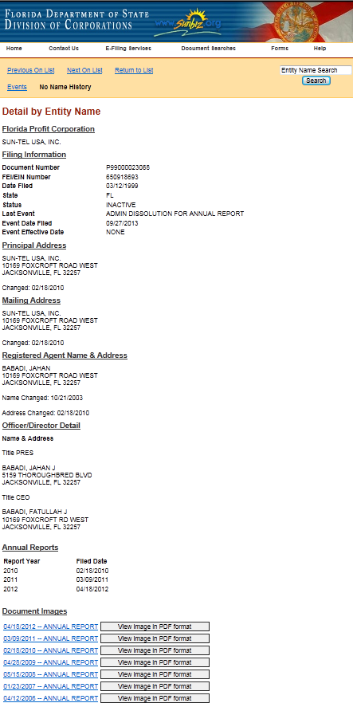
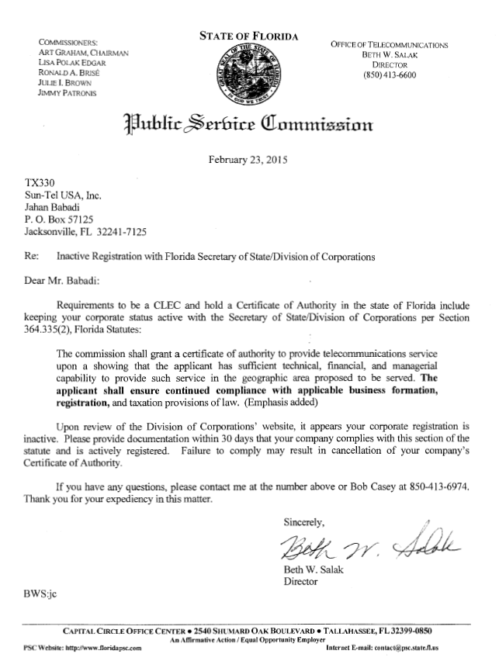
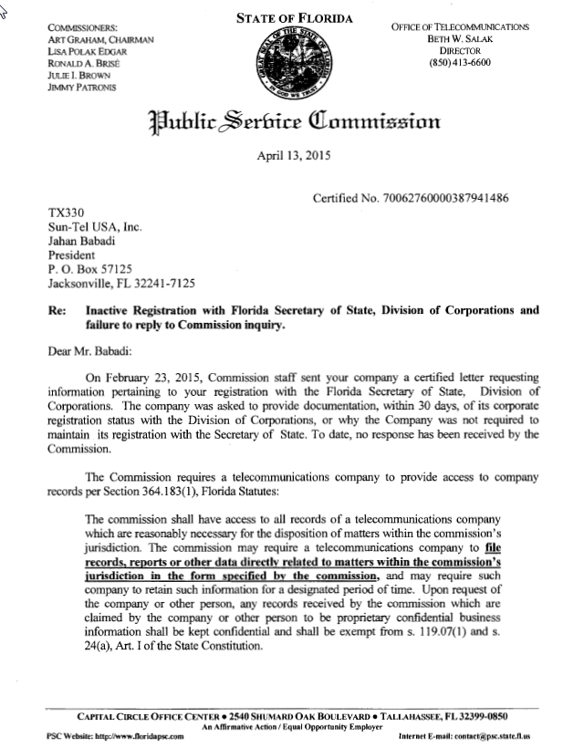
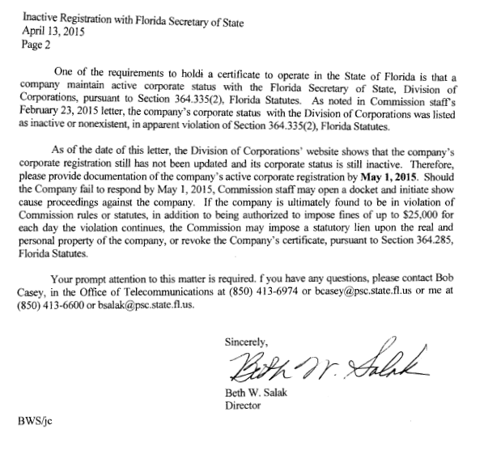
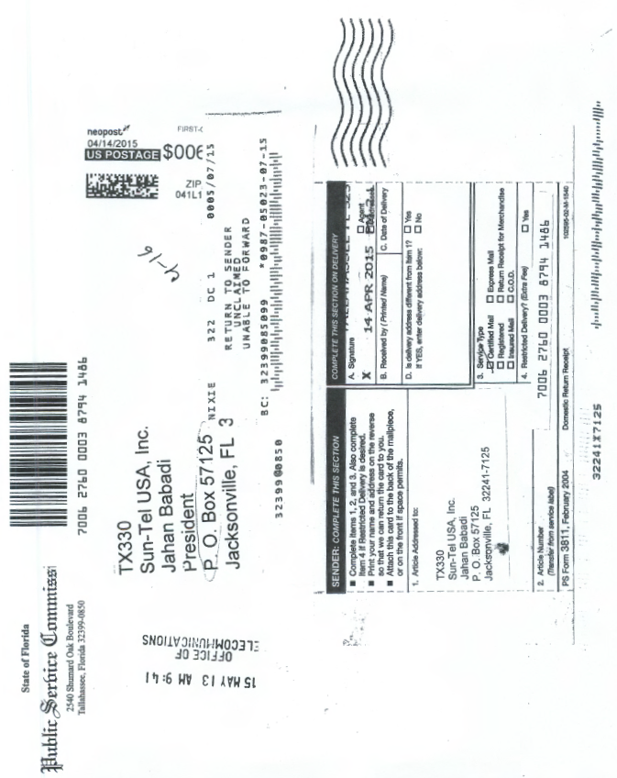

See, Attachment A, Screenshot of Florida Secretary of State Corporation Database, evidencing Sun-Tel USA, Inc.’s Expired Corporate Registration.
See, Attachment B, Copy of Commission staff’s letter dated February 23, 2015, to Sun-Tel USA, Inc.
Id.
See, Attachment C, Copy of Commission staff’s April 13, 2015, certified letter to Sun-Tel USA, Inc.
See, Attachment E, return of Staff’s certified letter dated April 13, 2015, as unclaimed as of May 5, 2015.
See, Attachment D, Copy of Sun-Tel USA, Inc.’s Applicant Certification, evidencing certifications made by the Sun-Tel USA, Inc. in support of its petition for ETC designation.
BellSouth Telecommunications LLC, d/b/a/ AT&T Florida vs. Sun-Tel USA, Inc., United States District Court for the Southern District of Florida Miami Division, Case No. 1:13-cv-22610-UU.
See, Order No. PSC-11-0250-FOF-WU, issued June 13, 2011, in Docket No. 100104-WU, In re: Application for increase in water rates in Franklin County by Water Management Services, Inc.; Order No. PSC-07-0275-SC-SU, issued April 2, 2007, in Docket No. 060406-SU, In re: Application for staff-assisted rate case in Polk County by Crooked Lake Park Sewerage Company; and Order No. PSC-05-0104-SC-SU, issued January 26, 2005 in Docket Nos. 020439-SU and 020331-SU; In re: Application for staff-assisted rate case in Lee County by Sanibel Bayous Utility Corporation; In re: Investigation into alleged improper billing by Sanibel Bayous Utility Corporation in Lee County in violation of Section 367.091(4), Florida Statutes. See also, Florida State Racing Commission v. Ponce de Leon Trotting Association, 151 So.2d 633, 634 (Fla. 1963), and Commercial Ventures, Inc. v. Beard, 595 So.2d 47, 48 (Fla. 1992) (utilities are subject to the rules published in the Florida Administrative Code).
See, Section 364.285(1), F.S.
Fugate v. Fla. Elections Comm’n, 924 So. 2d 74, 75 (Fla. 1st DCA 3006), citing, Metro. Dade County v. State Dep't of Envtl. Prot., 714 So. 2d 512, 517 (Fla. 3d DCA 1998).
Penalty assessed is $500 per violation, which is consistent with amounts imposed by this Commission for similar violations.

