BEFORE THE FLORIDA PUBLIC SERVICE COMMISSION

In re: Joint petition by Tampa Electric Company, Duke Energy Florida, and Mosaic Fertilizer, LLC, for approval of intermittent electric standby power agreement. | DOCKET NO. 150177-EI  ORDER NO. PSC-15-0414-PAA-EI  ISSUED: October 1, 2015

The following Commissioners participated in the disposition of this matter:

ART GRAHAM, Chairman
LISA POLAK EDGAR
RONALD A. BRISÉ
JULIE I. BROWN
JIMMY PATRONIS

NOTICE OF PROPOSED AGENCY ACTION
ORDER APPROVING PROPOSED INTERMITTENT ELECTRIC STANDBY POWER AGREEMENT BETWEEN TAMPA ELECTRIC COMPANY, DUKE ENERGY FLORIDA, AND MOSAIC FERTILIZER, LLC

BY THE COMMISSION:

NOTICE is hereby given by the Florida Public Service Commission that the action discussed herein is preliminary in nature and will become final unless a person whose interests are substantially affected files a petition for a formal proceeding, pursuant to Rule 25-22.029, Florida Administrative Code (F.A.C.).

Background

On July 31, 2015, Tampa Electric Company (Tampa Electric), Duke Energy Florida (Duke), and Mosaic Fertilizer, LLC (Mosaic) (jointly petitioners) filed a joint petition for approval of an intermittent electric standby power agreement (agreement). Mosaic is in the business of mining and processing phosphate, and manufacturing fertilizer. Mosaic has operations in the service territories of Tampa Electric, Duke, and other utilities. On August 21 and August 31, 2015, the petitioners provided responses to staff’s data requests. It appears that this agreement is the first of its type to come before this Commission. We have jurisdiction pursuant to Section 366.04, Florida Statutes (F.S.).
Discussion
We find that the proposed intermittent electric standby power agreement between Tampa Electric, Duke, and Mosaic shall be approved as it is consistent with this Commission’s policy of encouraging agreements, promotes renewable energy, and has no immediate impact on Tampa Electric’s and Duke’s general body of ratepayers.
The proposed agreement addresses the supply of electric service to certain Mosaic facilities located in Hardee County. Specifically, the Mosaic facilities at issue are the South Pierce Generating Facilities (South Pierce) and the South Pasture Beneficiation Plant (Pasture Plant). The agreement will allow Tampa Electric to provide intermittent standby power to Mosaic during infrequent periods when generation from the South Pierce facility is not sufficient to serve the South Pasture load. The agreement becomes effective on the date of a final order approving the agreement for an initial term of ten years with an automatic ten-year extension if all the parties to the agreement agree on an extension. Alternatively, the parties can petition this Commission for a change in the agreement. The proposed agreement is shown in Attachment A of this order.
Mosaic Facilities
South Pierce
South Pierce is a qualifying cogeneration facility which consists of two steam-turbine generators that generate energy from waste heat captured during the fertilizer production process. Mosaic uses the electricity generated to self-service the South Pierce facility and sells excess energy to Tampa Electric under the as-available COG-1 tariff. Tampa Electric provides service to South Pierce under the Interruptible Standby and Supplemental Service rate schedule.
Pasture Plant
The Pasture Plant produces fertilizer products and is currently served by Duke under the Interruptible General Service rate schedule. The Pasture Plant is located in Peace River Electric Cooperative’s (Peace River) service territory; however, pursuant to the territorial agreement between Duke and Peace River, Duke provides service to the Pasture Plant because the facility requires service at transmission level. The petitioners state that Peace River has read the agreement and Peace River’s consent to approval and implementation of the agreement is attached as Exhibit B to the petition.
Transmission Line
Mosaic plans to build a ten-mile 69 kilovolt transmission line to connect the South Pierce generating facilities to the Pasture Plant. The transmission line is referred to in the agreement as the South Pasture Tie Line. Once Mosaic completes the construction of the transmission line, Mosaic will direct the excess energy generated at the South Pierce facilities to serve the full load of the Pasture Plant and the as-available sales to Tampa Electric will be reduced or eliminated. Mosaic anticipates the transmission line will be constructed by March 31, 2016. The transmission line will be owned by Mosaic and solely located on Mosaic-owned property, with the exception of crossings of public right of ways such as roads. This type of arrangement is referred to as self-service. We note that self-service is to be differentiated from self-service wheeling, which means transmission or distribution service provided by a public utility to enable a retail customer to transmit electrical power generated by the customer at one location to the customer’s facilities at another location.
Proposed Agreement
The proposed agreement is designed for Tampa Electric to provide intermittent standby power to Mosaic during infrequent periods when generation from the South Pierce facility is not sufficient to serve the South Pasture load. As stated above, Tampa Electric currently provides standby power to the South Pierce facility and will continue to do so, while Duke provides service to the Pasture Plant. Once Mosaic’s transmission line connects the South Pierce facility to the Pasture Plant, Duke will not be able to provide standby power to the Pasture plant because only one utility can be connected electrically to the Mosaic facilities at a time. The petitioners explained that should the South Pierce facility go off-line, even for a short period of time, such that Tampa Electric’s standby service picks up, the time and expense associated with converting the Pasture Plant load over to Duke would not be economic to the parties. Mosaic explained that a switch from cogeneration service to Duke service and back translates into over $300,000 in production losses.
The petitioners explained that the infrequent circumstance under which Tampa Electric would provide standby power to the Pasture Plant is when the South Pierce facility is de-rated or off-line for repair or maintenance or when the Pasture Plant and other Mosaic load exceeds the output of the South Pierce facility. If the South Pierce generation reduction is to be of a more extended nature or if there is an interruption on the Mosaic transmission line, then the South Pasture load will be transferred to Duke, consistent with the terms of the agreement.
The proposed agreement also provides for a 3,500 Megawatt-hour annual cap on the amount of standby power Tampa Electric can provide to Mosaic. In response to Commission staff’s data request, the petitioners explained that the purpose of the negotiated cap is to ensure that Tampa Electric’s standby service to Mosaic under the proposed agreement is infrequent and intermittent in nature only. The agreement provides that if the cap is exceeded, Mosaic will disconnect the Pasture Plant from the South Pierce facility and connect the Pasture Plant to Duke and purchase power from Duke. Once Mosaic has purchased a certain amount of electricity from Duke as outlined in the agreement, Mosaic will reconnect the Pasture Plant to its facilities and the cap will be reset to zero.
Decision
The Supreme Court found that an individual does not have the right to service by a particular utility merely because the individual deems it advantageous. However, the proposed agreement for intermittent standby power is confined to unique and limited circumstances as presented by the facts of this case. The agreement maintains the current territorial boundaries for Tampa Electric and Duke, while allowing Mosaic to self-generate power to serve the Pasture Plant load. Furthermore, this Commission has recognized in several prior orders the need for flexibility in the provision of electric service to Mosaic’s mining operations. The proposed agreement is consistent with this Commission’s policy of encouraging agreements, promotes renewable energy, and has no immediate impact on Tampa Electric’s and Duke’s general body of ratepayers. Therefore, we find that the proposed intermittent electric standby power agreement between Tampa Electric, Duke, and Mosaic shall be approved.
Based on the foregoing, it is

ORDERED by the Florida Public Service Commission that the proposed intermittent electric standby power agreement between Tampa Electric Company, Duke Energy Florida, and Mosaic Fertilizer, LLC is approved. It is futher

ORDERED that the provisions of this Order, issued as proposed agency action, shall become final and effective upon the issuance of a Consummating Order unless an appropriate petition, in the form provided by Rule 28-106.201, Florida Administrative Code, is received by the Commission Clerk, 2540 Shumard Oak Boulevard, Tallahassee, Florida 32399-0850, by the close of business on the date set forth in the “Notice of Further Proceedings” attached hereto. It is further

ORDERED that in the event this Order becomes final, this docket shall be closed.

By ORDER of the Florida Public Service Commission this 1st day of October, 2015.

/s/ Carlotta S. Stauffer
CARLOTTA S. STAUFFER
Commission Clerk
Florida Public Service Commission
2540 Shumard Oak Boulevard
Tallahassee, Florida 32399
(850) 413-6770
www.floridapsc.com

Copies furnished: A copy of this document is provided to the parties of record at the time of issuance and, if applicable, interested persons.

MAL

NOTICE OF FURTHER PROCEEDINGS OR JUDICIAL REVIEW

The Florida Public Service Commission is required by Section 120.569(1), Florida Statutes, to notify parties of any administrative hearing that is available under Section 120.57, Florida Statutes, as well as the procedures and time limits that apply. This notice should not be construed to mean all requests for an administrative hearing will be granted or result in the relief sought.

Mediation may be available on a case-by-case basis. If mediation is conducted, it does not affect a substantially interested person's right to a hearing.

The action proposed herein is preliminary in nature. Any person whose substantial interests are affected by the action proposed by this order may file a petition for a formal proceeding, in the form provided by Rule 28-106.201, Florida Administrative Code. This petition must be received by the Office of Commission Clerk, 2540 Shumard Oak Boulevard, Tallahassee, Florida 32399-0850, by the close of business on October 22, 2015.

In the absence of such a petition, this order shall become final and effective upon the issuance of a Consummating Order.

Any objection or protest filed in this/these docket(s) before the issuance date of this order is considered abandoned unless it satisfies the foregoing conditions and is renewed within the specified protest period.

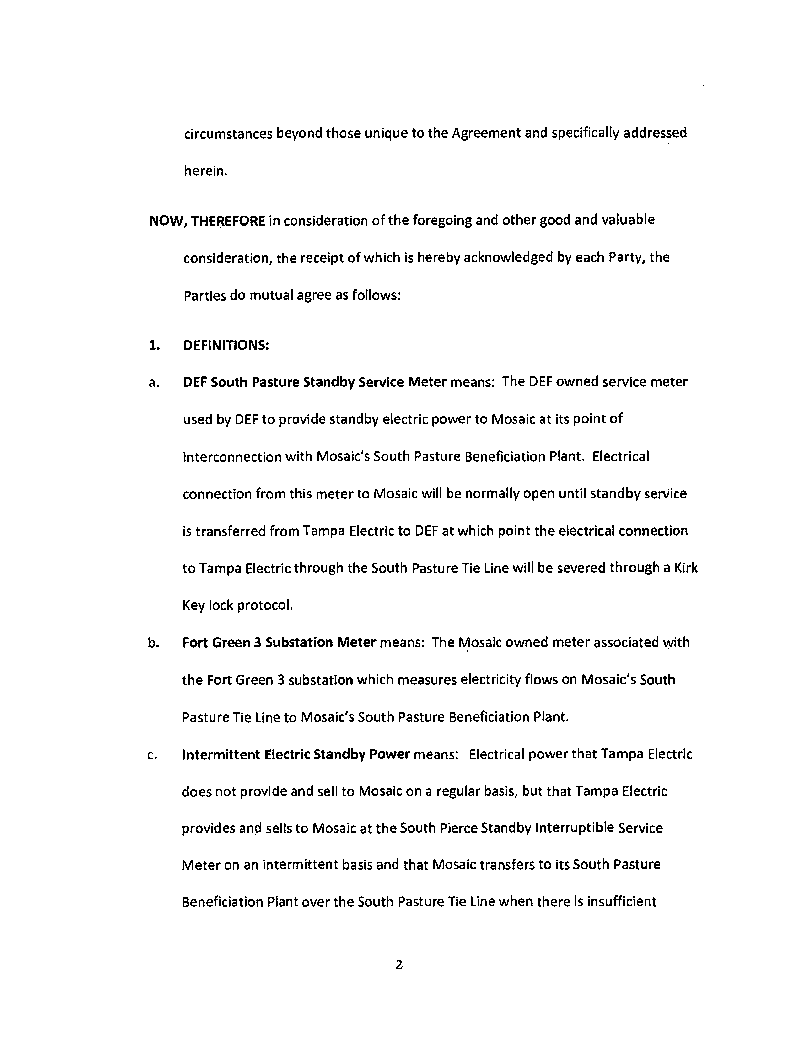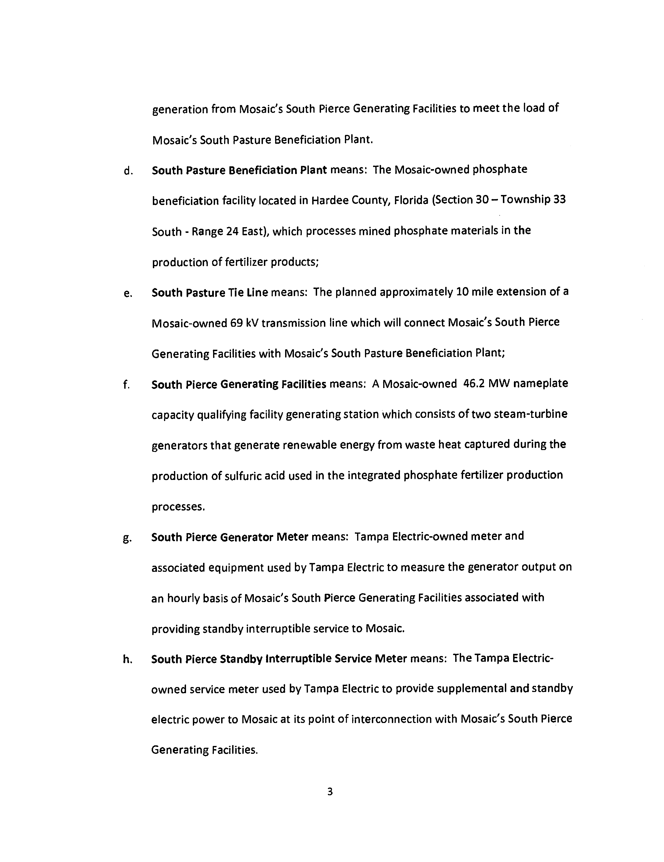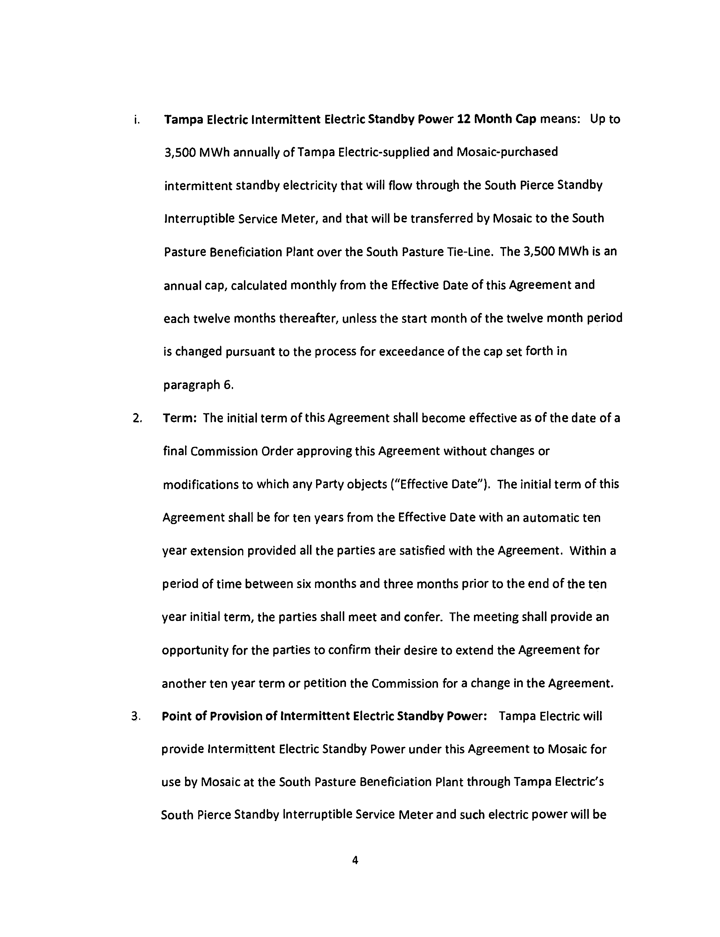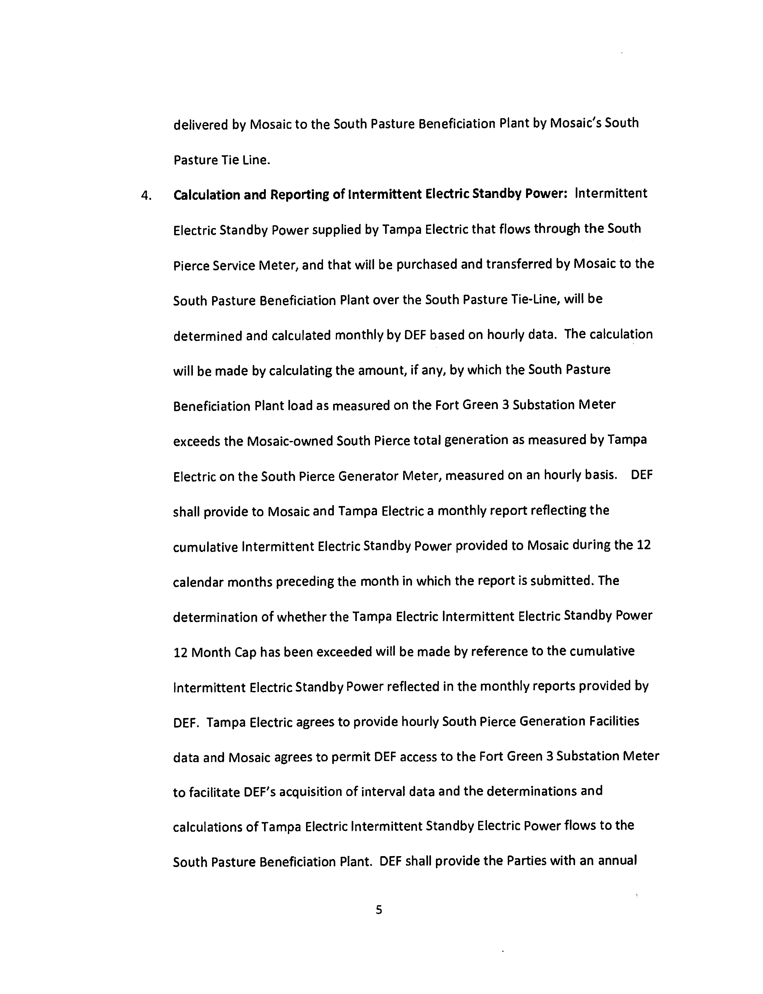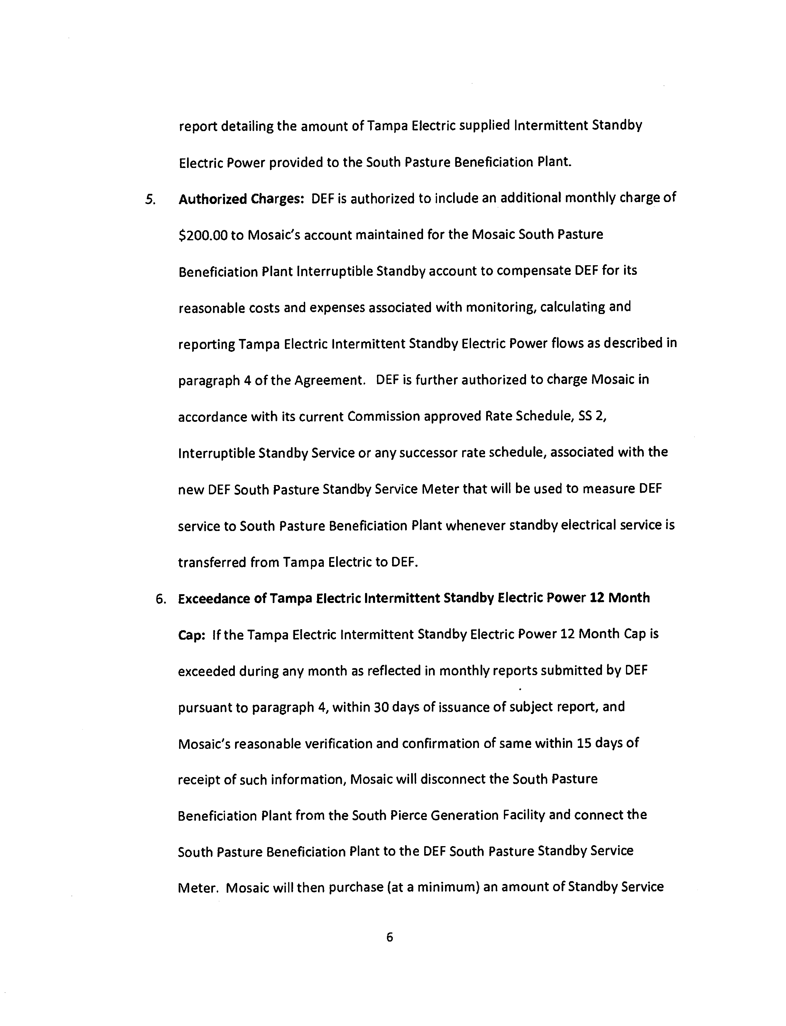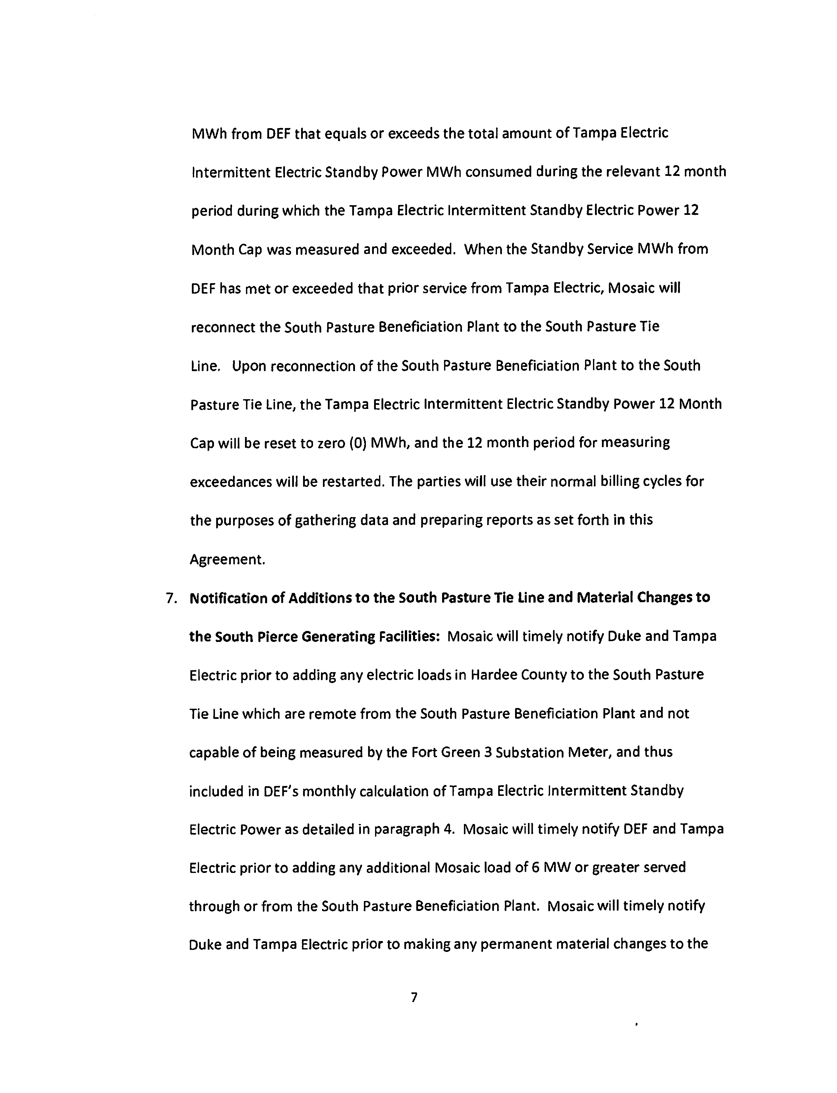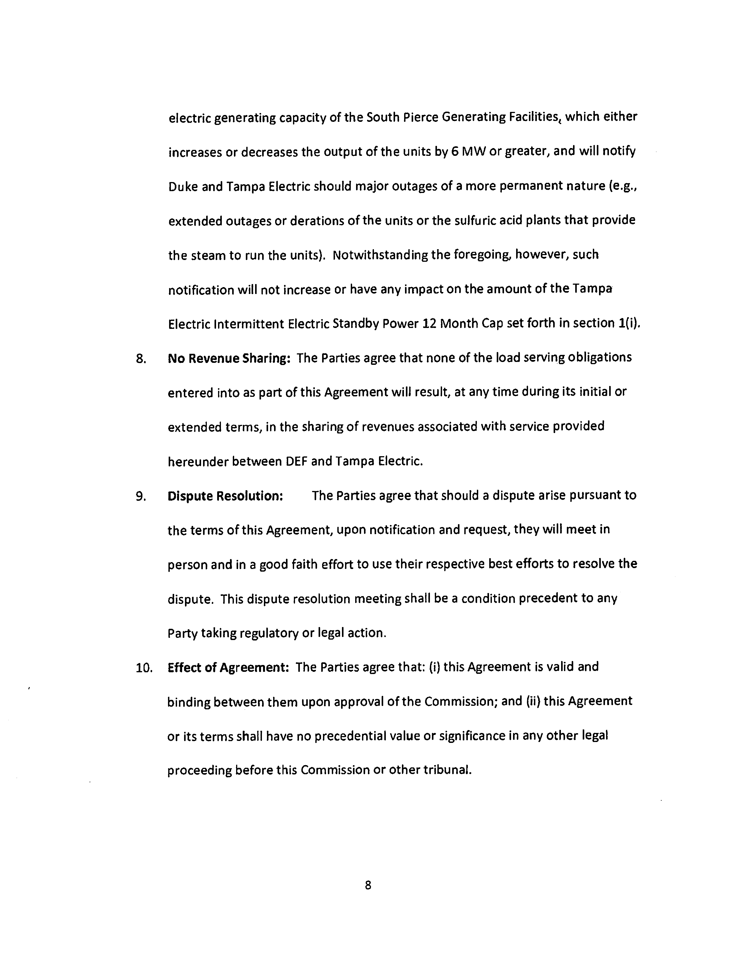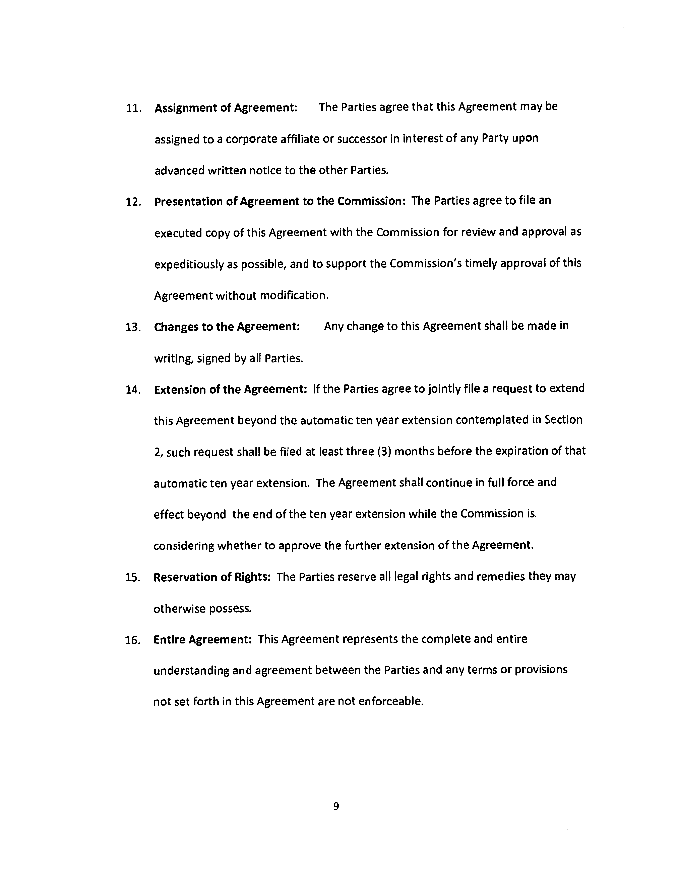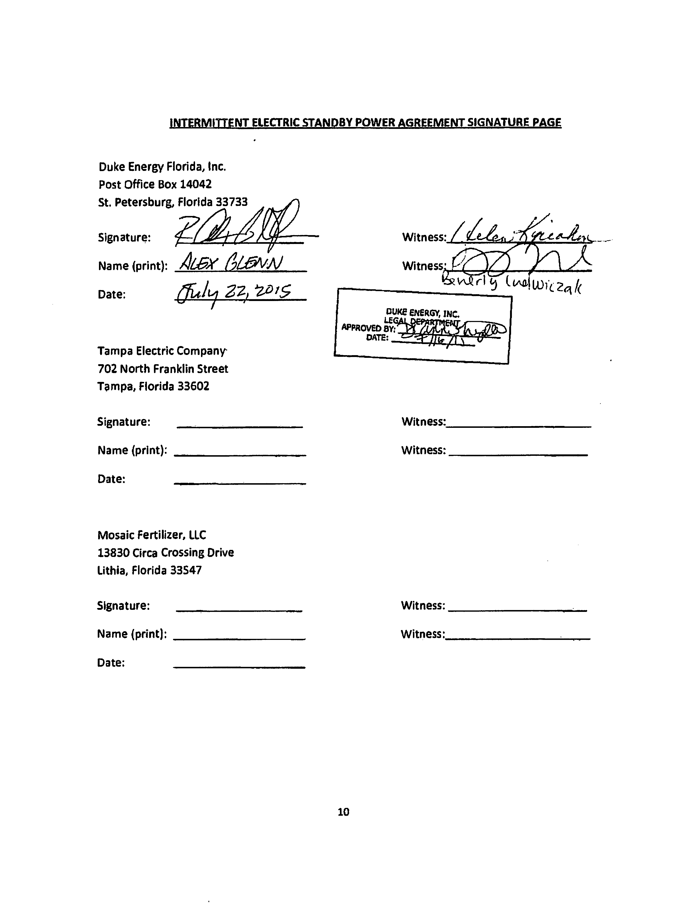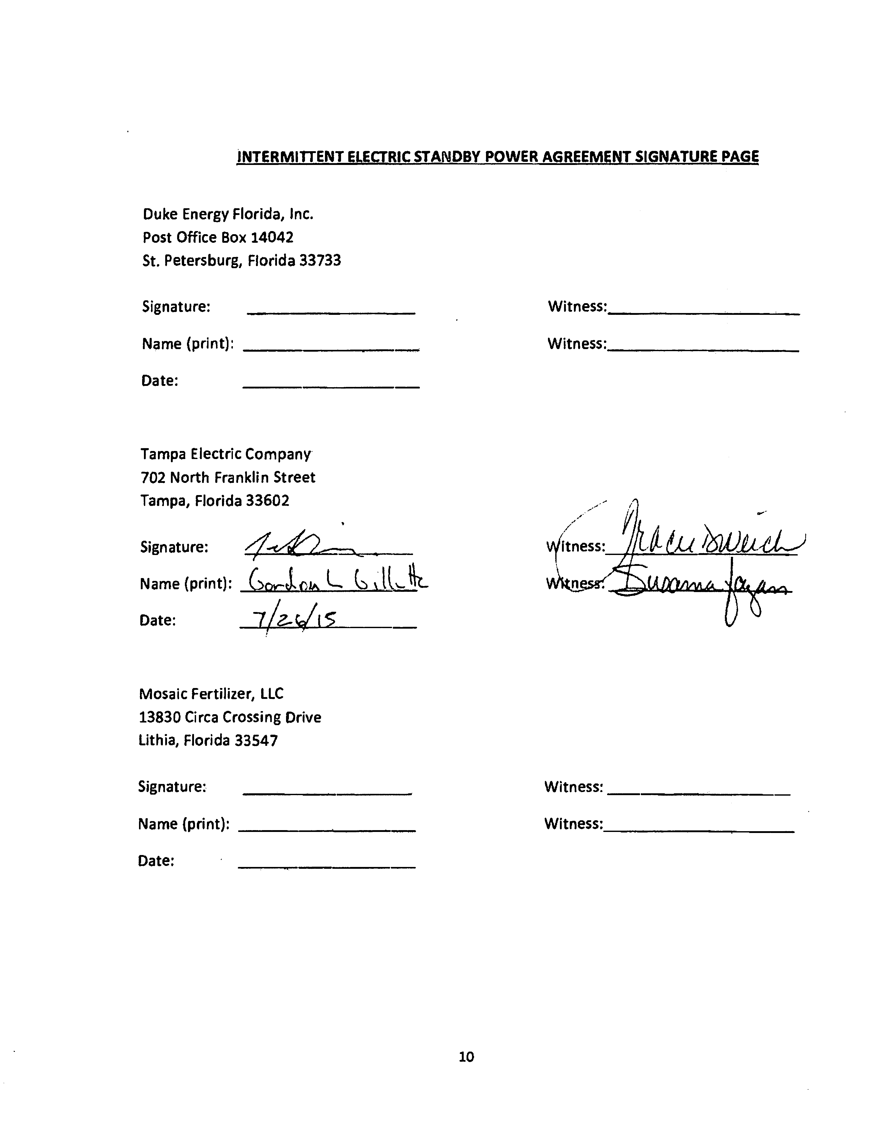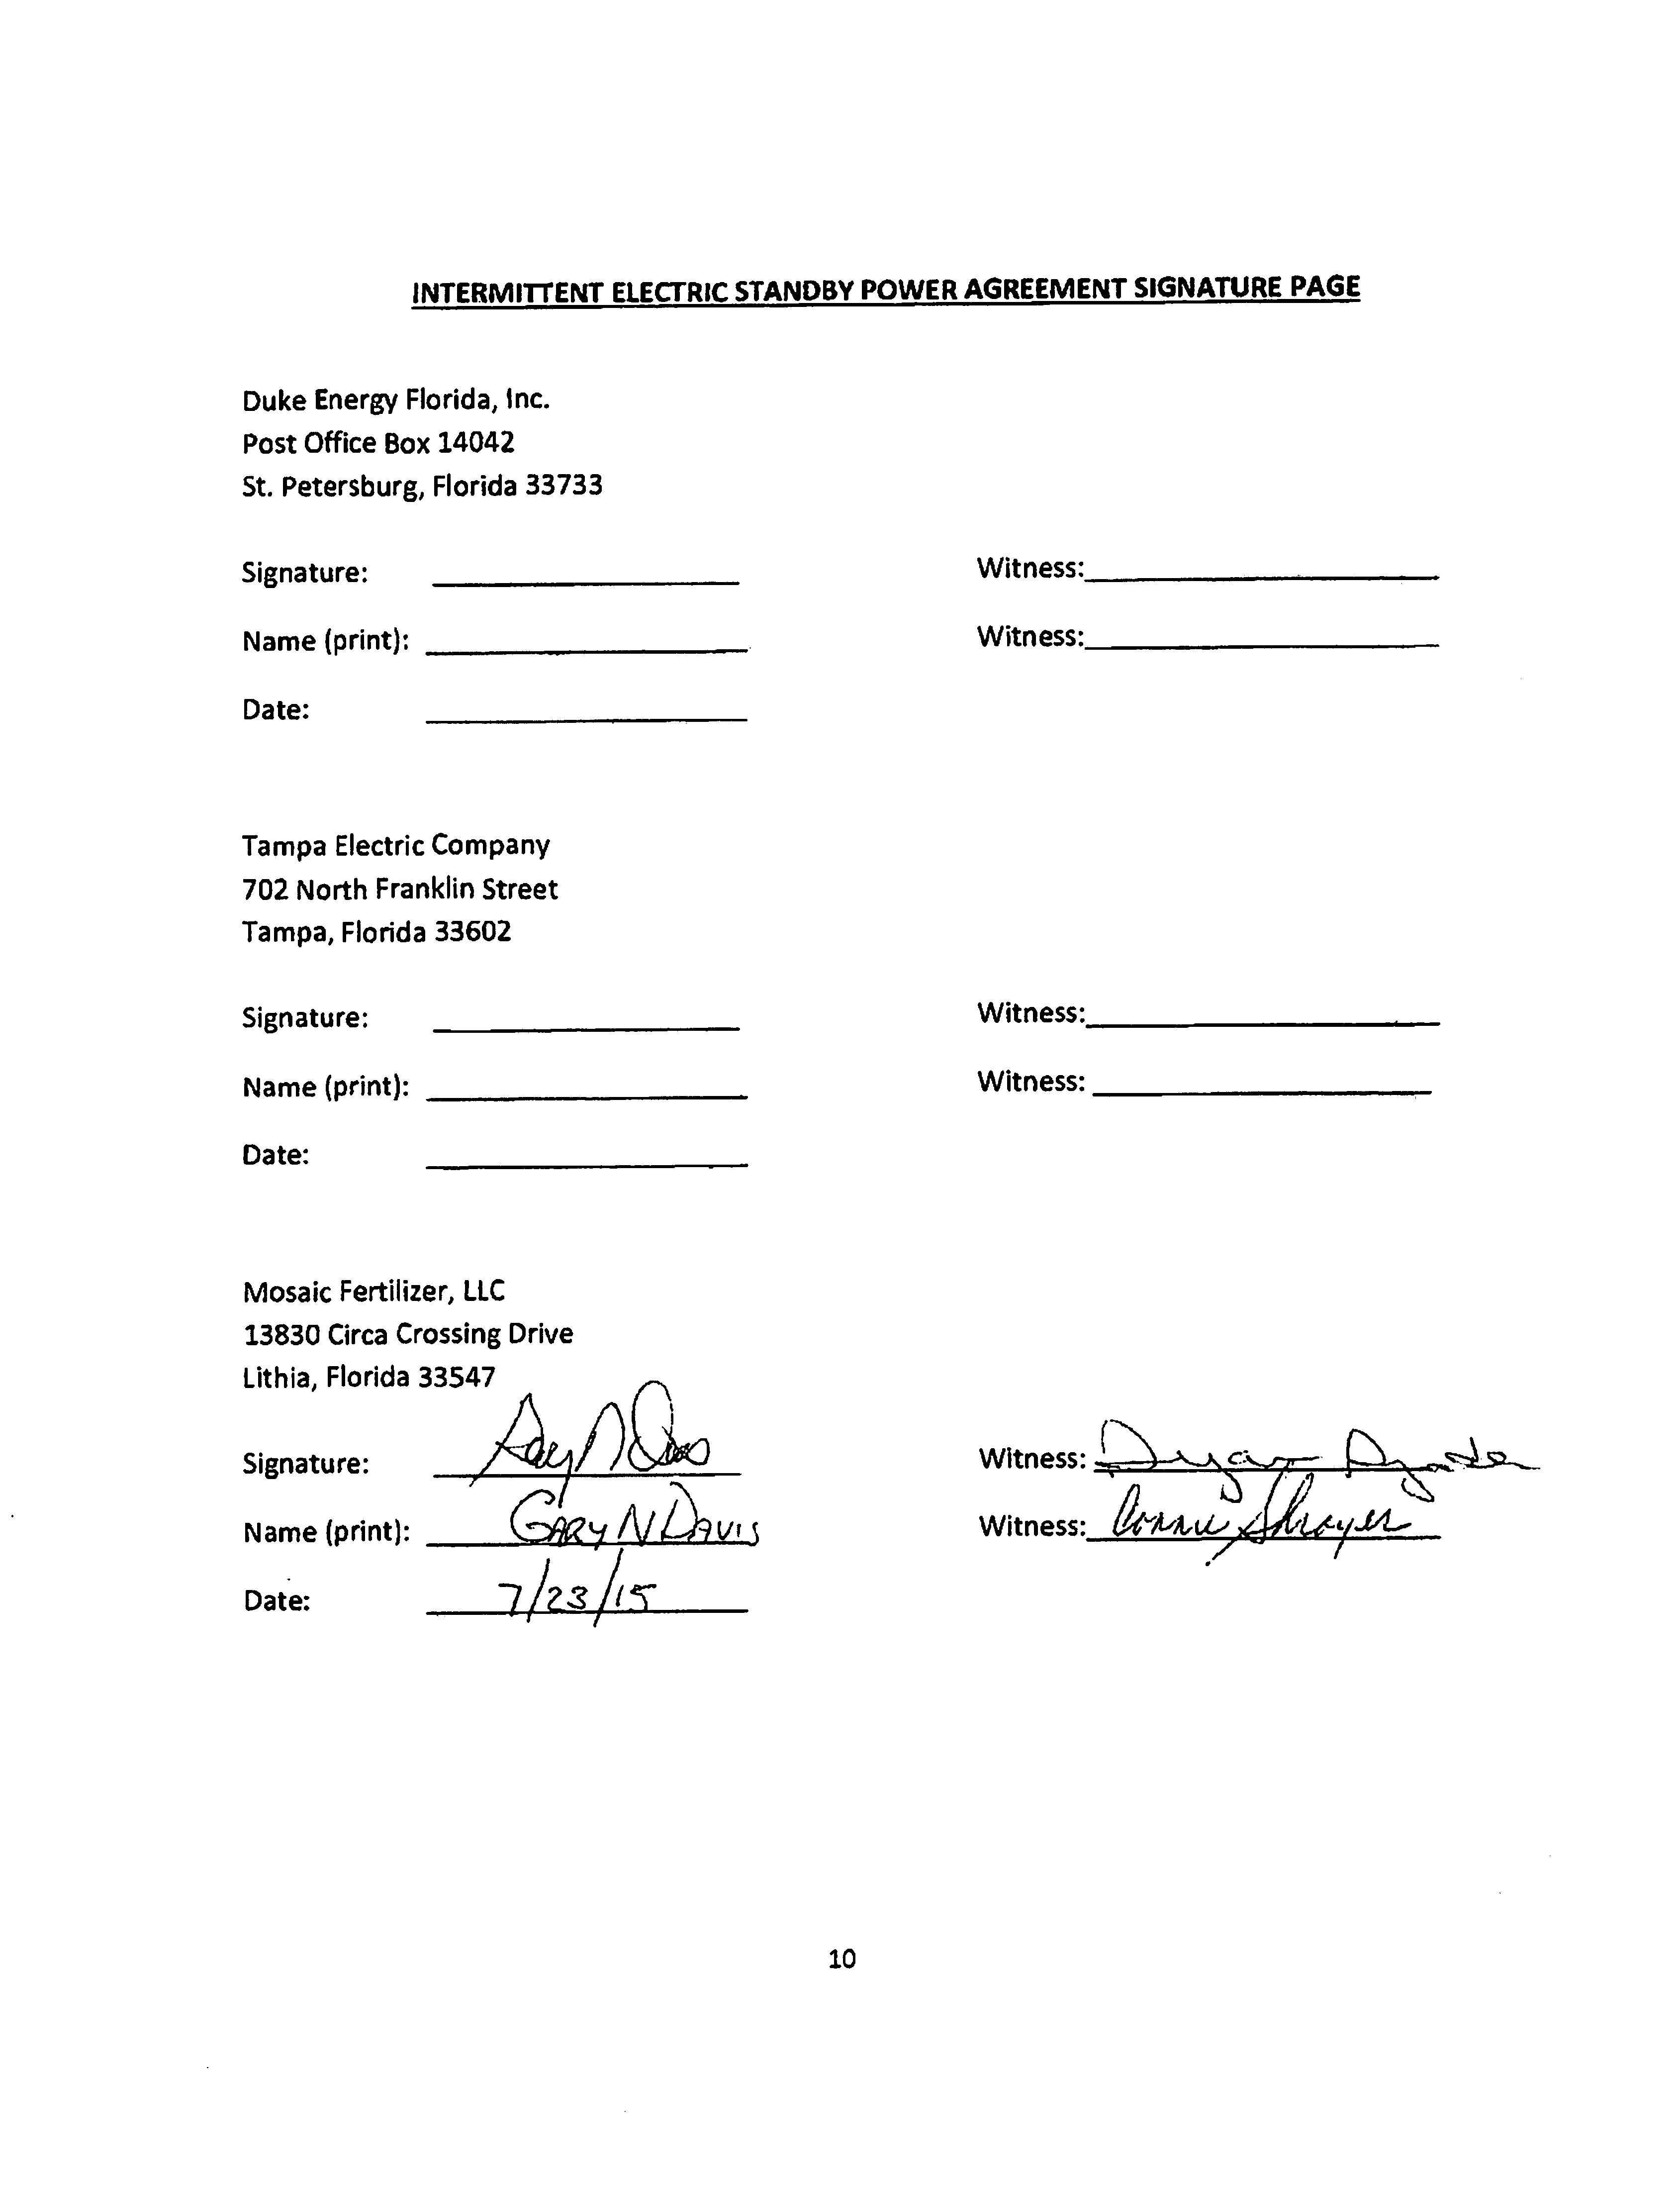

Storey v. Mayo, 217 So. 2d 304 (Fla. 1968).
Order No. PSC-10-0580-PAA-EU, issued September 22, 2010, in Docket No. 100336-EU, In re: Joint petition for approval to extend territorial settlement agreement by Progress Energy Florida, Inc., Tampa Electric Company, and The Mosaic Company and Order No. PSC-02-0929-AS-EI, issued July 11, 2002, in Docket No. 020105-EI, In re: Joint petition of Florida Power Corporation and Tampa Electric Company for expedited declaratory relief concerning provision of electric service to an industrial customer’s facilities located in Tampa Electric Company’s Commission-approved service territory.

