State of Florida   |  | Public Service Commission  Capital Circle Office Center ● 2540 Shumard Oak Boulevard  Tallahassee, Florida 32399-0850  -M-E-M-O-R-A-N-D-U-M-
DATE: | April 22, 2016
TO: | Office of Commission Clerk (Stauffer)
FROM: | Division of Economics (Guffey)  Office of the General Counsel (Leathers)
RE: | Docket No. 160056-EU – Joint petition to reopen and extend the term of existing territorial agreement in Columbia, Lafayette, Madison, and Suwannee Counties, by Suwannee Valley Electric Cooperative and Duke Energy Florida, LLC.
AGENDA: | 05/05/16 – Regular Agenda – Proposed Agency Action - Interested Persons May Participate
COMMISSIONERS ASSIGNED: |  |  | All Commissioners
PREHEARING OFFICER: |  |  | Patronis
CRITICAL DATES: |  |  | None
SPECIAL INSTRUCTIONS: |  |  | None

Case Background
On March 9, 2016, Suwannee Valley Electric Cooperative (Suwannee) and Duke Energy Florida, LLC (DEF) filed a joint petition to reopen and extend the term of their existing territorial agreement in Columbia, Lafayette, Madison, and Suwannee counties.

The Commission first approved in 1995 a territorial agreement between Suwannee and DEF in Columbia, Lafayette, Madison, and Suwannee counties in Order No. PSC-95-0351-FOF-EU. This original agreement had a 20-year term which expired on March 14, 2015. In PAA Order No. PSC-15-0128-PAA-EU the Commission extended the terms of the agreement until March 14, 2016, to give the joint petitioners additional time to negotiate a new territorial agreement. The joint petitioners were not able to conclude their negotiations by March 14, 2016, and therefore request to reopen and extend the term of their agreement until September 14, 2016. All other provisions of the territorial agreement remain in effect. The proposed stipulation to reopen and extend the term of the territorial agreement is shown as Attachment A to the recommendation. The Commission has jurisdiction over this matter pursuant to Section 366.04, Florida Statutes (F.S.).

Discussion of Issues

Issue 1:
Should the Commission approve the proposed stipulation between Suwannee and DEF to reopen and extend the existing territorial agreement until September 14, 2016?

Recommendation:
Yes, the Commission should approve the proposed stipulation between Suwannee and DEF to reopen and extend the existing territorial agreement until September 14, 2016. (Guffey)

Staff Analysis:
Pursuant to Section 366.04(2)(d), F.S., the Commission has the jurisdiction to approve territorial agreements between and among rural electric cooperatives, municipal electric utilities, and other electric utilities. Unless the Commission determines that the agreement will cause a detriment to the public interest, the agreement should be approved.

The joint petitioners explained that they have been conducting discussions regarding a new territorial agreement, however, it has become apparent to the petitioners that additional time is needed to successfully conclude their negotiations toward a new territorial agreement. The proposed stipulation as shown in Attachment A to the recommendation will extend the expiration date of the agreement from March 14, 2016, to September 14, 2016, upon approval by the Commission.

In originally approving the agreement in 1995, the Commission found that the agreement is “in the public's interest and that its adoption will further the Commission's policy of avoiding unnecessary and uneconomic duplication of facilities.” Staff believes that the requested extension of time is reasonable and does not appear to be detrimental to the parties or to the public interest. Therefore, staff recommends approval of the proposed stipulation between Suwannee and DEF to reopen and extend the existing territorial agreement until September 14, 2016.

Issue 2:
Should this docket be closed?

Recommendation:
If no protest is filed by a person whose substantial interests are affected within 21 days of the issuance of the Order, this docket should be closed upon the issuance of a Consummating Order. (Leathers)

Staff Analysis:
If no protest is filed by a person whose substantial interests are affected within 21 days of the issuance of the Order, this docket should be closed upon the issuance of a Consummating Order.

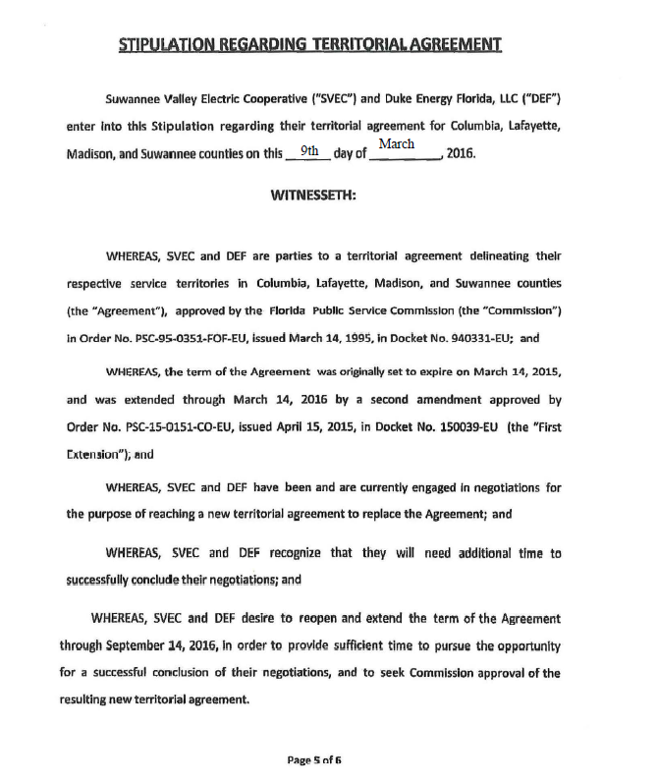

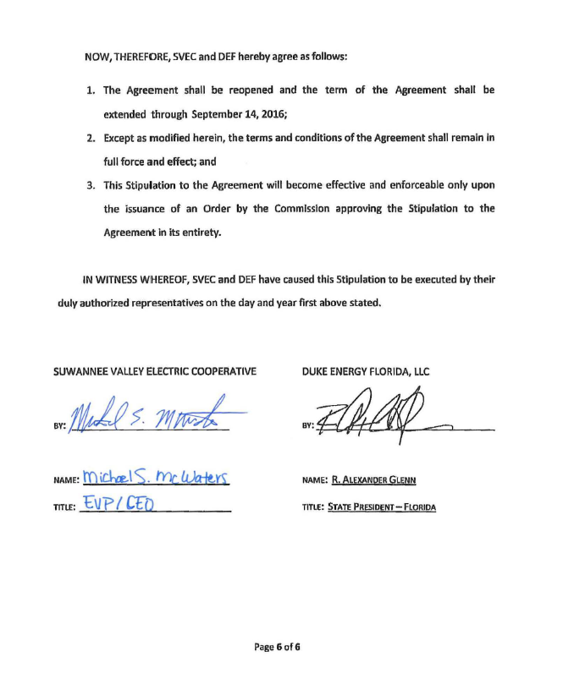

Order No. PSC-95-0351-FOF-EU, issued March 14, 1995, in Docket No. 940331-EU, In Re: Petition to resolve territorial dispute with FLORIDA POWER CORPORATION by SUWANNEE VALLEY ELECTRIC COOPERATIVE, INC.
Order No. PSC-15-0128-PAA-EU, issued March 20, 2015, in Docket No. 150039-EU, In Re: Joint petition to reopen and extend the term of existing territorial agreement in Columbia, Lafayette, Madison, and Suwannee Counties, by Suwannee Valley Electric Cooperative, Inc. and Duke Energy Florida, Inc.
Utilities Commission of the City of New Smyrna Beach v. Florida Public Service Commission, 469 So. 2d 731 (Fla. 1985).
Order No. PSC-95-0351-FOF-EU.

