State of Florida   |  | Public Service Commission  Capital Circle Office Center ● 2540 Shumard Oak Boulevard  Tallahassee, Florida 32399-0850  -M-E-M-O-R-A-N-D-U-M-
DATE: | April 22, 2016
TO: | Office of Commission Clerk (Stauffer)
FROM: | Office of the General Counsel (Corbari, Lherisson)  Division of Accounting and Finance (Mouring)  Office of Auditing and Performance Analysis (Lehmann, Vinson)  Division of Economics (Draper)  Division of Engineering (Ballinger, Moses)
RE: | Docket No. 150259-GU – Initiation of show cause proceedings against Peoples Gas System for apparent violations of Sections 368.01 - 05, F.S., and Chapter 25-12, F.A.C.
AGENDA: | 05/05/16 – Regular Agenda – Show Cause – Interested Persons May Participate
COMMISSIONERS ASSIGNED: |  |  | All Commissioners
PREHEARING OFFICER: |  |  | Edgar
CRITICAL DATES: |  |  | None
SPECIAL INSTRUCTIONS: |  |  | None

Case Background
Pursuant to Chapter 368 – Part 1, Florida Statutes (F.S.), (Gas Safety Law), and the United States Gas Pipeline Statute, the Florida Public Service Commission (Commission) is charged with establishing, administering and enforcing the rules and regulations governing safety standards of any entity “engaged in the operation of gas transmission or distribution facilities” in the State of Florida. Chapter 25-12, Florida Administrative Code (F.A.C.), prescribes the various safety standards, rules and regulations adopted by the Commission, including the Minimum Federal Safety Standards and reporting requirements prescribed by the U.S. Department of Transportation Pipeline and Hazardous Materials Safety Administration (PHMSA), that govern entities engaged in the operation of gas transmission or distribution facilities in Florida. Any person or entity who violates any rule or regulation adopted by the Commission under the Gas Safety Law is subject to a civil penalty of up to “$25,000 for each violation for each day the violation persists,” or a maximum penalty of “$500,000 for any related series of violations.” In addition, the Commission may initiate an action for an injunction in any state court to compel the observance of the Gas Safety Law, or “any rule, regulation or requirement of the [C]ommission made thereunder.”

Commission Gas Safety Inspection Process

Pursuant to 49 U.S.C. §§ 60105-60106, the Commission is certified by PHMSA to inspect natural gas systems, and to administer and enforce the rules and regulations governing safety standards of any entity engaged in operating gas transmission or distribution facilities in Florida. Commission safety engineering field inspectors must perform gas transmission and distribution safety inspections of gas entities operating in Florida at various prescribed intervals.

Commission field inspectors use various PHMSA and Commission forms when performing inspections in order to verify, for example, that the operator’s records, procedures, personnel qualifications and pipeline systems are in compliance with prescribed regulations. Once the field inspector completes an inspection, the inspector submits the completed forms to the Commission’s Bureau of Safety Chief with a memorandum outlining any apparent rule violation(s) observed during the inspection and the inspector’s reason(s) for recommending that a violation be issued to the utility. The Chief reviews the results of the inspection, the inspector’s comments on any apparent violation observed, and any applicable safety rules and regulations.

If the Chief concurs with the findings detailed in the field inspector’s report, the Chief issues a letter to an official of the utility with the inspection results, including any apparent rule violation observed during the system inspection. The Chief’s letter is emailed to the utility official, along with the field inspector’s memorandum and completed forms.

If any rule violation was observed during a field inspection, the utility is given 30 days to respond to the Chief’s letter. The utility’s response must identify what action has been, or is being taken, to remedy any apparent violation observed or state the reason(s) the utility disputes the violation. Once the utility notifies the Chief that the apparent violation has been remedied, the Commission field inspector will verify that the apparent violation was corrected and issue a closure memorandum to the Chief. A letter is then issued by the Chief to the utility closing the apparent violation.

Peoples Gas Systems

Peoples Gas Systems (PGS or Company) is a public utility as defined by §366.02, F.S., and subject to the regulatory jurisdiction of the Commission under Chapter 366, F.S., regarding rates and service, and under the Gas Safety Law on safety issues. PGS operates the largest natural gas distribution system in Florida. Headquartered in Tampa, Florida, PGS sells and transports natural gas to approximately 345,000 residential, commercial and industrial customers in 25 counties throughout Florida, which are separated into 14 geographic divisions. Under the administrative and operational control of its 14 divisions, PGS owns, operates, and/or maintains a system of approximately 12,500 miles of distribution mains and 160 miles of transmission lines and operates approximately 1,250 regulator stations and 80 gate stations.

Each PGS division, and 7 transmission pipelines operated by PGS, are subject to inspection by Commission safety engineering field inspectors, resulting in the possibility of at least 21 separate Commission field inspections a year. The Company’s distribution and transmission integrity management plans and other required plans are also periodically inspected by Commission field inspectors.

PGS Compliance History (2013 – 2015)

Based on numerous safety and compliance deficiencies identified by the Commission’s Bureau of Safety, the Commission initiated a management audit of PGS in 2013 to review and examine the processes, systems, and internal controls used by PGS to perform inspections of its distribution facilities. The purpose of the audit was to assess the Company’s compliance with Commission and PHMSA’s rules and regulations and to determine the adequacy of the Company’s management oversight of compliance issues. In September 2013, the Commission published the results of the audit titled a “Review of Peoples Gas Distribution Facility Inspections” (2013 Audit). The 2013 Audit found that between 2010 and 2013:

- PGS failed to timely complete inspections;
- PGS failed to comply with Commission rules;
- PGS’ Management had knowledge of noncompliance;
- PGS’ lack of oversight of and attention to compliance inspection reviews permitted detected compliance deficiencies to develop and persist;
- PGS’ inadequate record-keeping and internal planning systems permitted compliance deficiencies to develop and persist; and
- PGS acknowledged the magnitude of its compliance deficiencies.

In response to the 2013 Audit, PGS developed a corrective action plan to address its compliance deficiencies and adopted organizational and operational changes in order to better address its compliance deficiencies.

In June 2015, a review of PGS operations, including recent field and record inspections, conducted by Commission field inspectors, indicated that PGS continued to have safety and compliance deficiencies. The field inspections observed repeat violations of many of the rules identified in the 2013 Audit, not only in the Company’s Tampa and St. Petersburg Divisions, but in its other divisions across Florida.

In July 2015, Commission executive staff met with PGS representatives to discuss the Company’s ongoing safety and compliance deficiencies and the possibility of enforcement action by the Commission. Immediately following the July meeting, Commission audit staff initiated a follow-up audit of the Company’s system to assess the adequacy and effectiveness of the Company’s response to the 2013 Audit and corrective actions taken by PGS since the 2013 Audit.

The Commission published the results of the follow-up audit titled “Peoples Gas System Distribution Facility Inspections Follow-up Audit” (2015 Audit) in November 2015. The Commission’s 2015 Audit found that:

- PGS failed to complete leak surveys timely as required by Rule 25-12.040, F.A.C., during the period October 2013 through September 2015;
- PGS management-level employees failed to maintain and document adequate awareness of, and accountability for, required inspection activities during 2014 and 2015, creating an opportunity for inspection results to be falsified and remain undetected;
- PGS failed to achieve the intended full use and benefits of the GL Essentials system by September 2015;
- PGS reduced the value and effectiveness of its Division Compliance Reviews as a result of changes made during 2014 and 2015 to the scope, content and structure of the reviews; and
- TECO Energy Audit Services failed to play a sufficient role in auditing PGS operations.

The results of the 2015 Audit demonstrated that PGS continued to have serious safety and compliance deficiencies after the 2013 Audit and did not adequately address the compliance deficiencies outlined in its corrective action plan submitted to the Commission in response to the 2013 Audit. The 2015Audit found that PGS compliance initiatives following the 2013 Audit appropriately targeted the greatest needs for improvement and made some progress. However, the 2015 Audit also found that substantial additional efforts were needed to accomplish a change in culture and practices within the Company to fully support compliance with state and federal safety regulations. Finally, the 2015 Audit noted that additional monitoring by the Commission was necessary to confirm that such changes were accomplished.

OPC Petition

On December 7, 2015, the Office of the Public Counsel (OPC) filed a petition with the Commission, requesting that the Commission issue an order to show cause against PGS for violations of Chapter 25-12, F.A.C., impose fines, and order rate relief. OPC based its Petition largely on the results of the two Commission audits of the PGS distribution facilities in 2013 and 2015.

PGS Response to OPC Petition

On December 18, 2015, PGS filed a Response to OPC’s petition. PGS acknowledged that the Commission’s 2013 audit disclosed violations of Commission rules and areas in which PGS needed improvement to address compliance. PGS also affirmed that the Company would fully cooperate with OPC and the Commission to resolve its compliance issues and would continue to work to improve and update its programs, processes and controls to instill a culture of safety in its team members.

Initiation of Show Cause Proceeding

On February 10, 2016, an informal meeting was held between Commission staff, OPC, and PGS representatives to discuss the scope of the docket, which included 172 violations cited by the Commission between June 1, 2013 and December 31, 2015. PGS did not dispute 140 of the violations. At the meeting, PGS presented comments on 32 violations that PGS did not merit finable violations. After reviewing the violations, the applicable rules, and the information presented by PGS, staff removed 16 of the 32 violations disputed by PGS for the purposes of assessing penalties only.

On February 25, 2016, staff issued a Notice of Violation and Initiation of Show Cause Proceeding to PGS for 156 apparent violations of Section 368.01-05, F.S., and Chapter 25-12, F.A.C. In addition, Commission Executive Director and Deputy General Counsel filed a memorandum in the docket to change the title of the docket and designate non-executive staff as “prosecutorial” and “advisory” pursuant to Cherry Commun. v. Deason, 652 So. 2d 803 (Fla. 1995). Although not procedurally required at the time, the staff designation was implemented at the request of PGS and OPC in an effort to foster settlement negotiations.

Settlement

In early April 2016, PGS, OPC and Commission prosecutorial staff met to negotiate a possible settlement of the issues this docket. On April 18, 2016, PGS filed a proposed Settlement Agreement, in which Commission prosecutorial staff and OPC joined, in an effort to fully resolve all matters in this docket.

This recommendation addresses the Settlement Agreement proffered by PGS, OPC and Commission prosecutorial staff. A copy of the Settlement Agreement is attached hereto as Attachment “A.”

The Commission is vested with jurisdiction in this matter pursuant to Sections 368.01-.061, F.S.

Discussion of Issues

Issue 1:
Should the Commission approve the proposed Settlement Agreement to resolve Peoples Gas System’s apparent violations of Sections 368.01-.05, F.S., and Chapter 25-12, F.A.C., and all claims set forth in the petition filed by OPC in this docket?

Recommendation:
Yes. The Settlement Agreement provides a reasonable resolution of the outstanding issues in the docket. Staff recommends that the Settlement Agreement is in the public interest and promotes administrative efficiency. Therefore, the Commission should approve the Settlement Agreement to resolve Peoples Gas Systems’ apparent violations of Sections 368.01-.05, F.S., and Chapter 25-12, F.A.C., that occurred between June 1, 2013 and December 31, 2015, including any alleged violations of reasonably related rules or standards outlined in Appendix A of the Settlement Agreement that may have occurred up to the date the Settlement Agreement takes effect, and all claims set forth in the petition filed by OPC in this docket. (Corbari, Lherisson, Ballinger, Moses, Lehmann, Vinson, Draper, Mouring)

Staff Analysis:

The goal of any show cause proceeding is to ensure compliance with applicable law and Commission rules and orders. Pursuant to Section 368.061(1), F.S., the Commission is authorized to impose upon any entity subject to its jurisdiction a civil penalty of up to “$25,000 for each violation for each day the violation persists,” or a maximum penalty of “$500,000 for any related series of violations,” if such entity is found to have refused to comply with or to have willfully violated a rule or regulation adopted by the Commission under the Gas Safety Law. In addition, pursuant to Section 368.061(2), F.S., the Commission may consider a proposal addressing an appropriate amount of penalties for violations of gas safety rules and statutes.

On April 18, 2016, PGS filed a proposed Settlement Agreement, in which Commission prosecutorial staff and OPC joined. The Settlement Agreement resolves: (1) the Company’s apparent violations of Sections 368.01-.05, F.S., and Chapter 25-12, F.A.C., that occurred between June 1, 2013 and December 31, 2015, including any alleged violations of reasonably related rules or standards outlined in Appendix A of the Settlement Agreement that may have occurred up to the date the Settlement Agreement takes effect; and (2) all claims set forth in the petition filed by OPC in this docket. The provisions of the Settlement Agreement are contingent upon approval by the Commission in its entirety, without modification. Highlights of the attached Settlement Agreement are outlined below.

- PGS will admit the 140 violations of Sections 368.01-.05, F.S., and Chapter 25-12, F.A.C., cited by Commission field inspectors between June 2013 and December 31, 2015.

- PGS will submit a one-time penalty payment in the amount of $1,000,000 to the Commission, pursuant to Section 368.061(1), F.S., within 30 days of the Commission’s approval of the Settlement Agreement. Upon receipt, the Commission will forward the payment to the General Revenue Fund.

- PGS will implement a one-time credit of $2,000,000 to its Cast Iron/Bare Steel Replacement Rider (Rider CI/BSR). Customers subject to the Rider CI/BSR monthly surcharges will experience the benefit of the credit through a reduction of the Company’s 2017 Rider CI/BSR monthly surcharges.

- PGS will take action to ensure its managers, employees and contractors understand the high priority placed by the Company upon safety and facilities inspection compliance, and a zero tolerance policy toward falsification of records; and, if necessary, take appropriate actions (including, but not limited to, the reassignment of employees) to help ensure effective safety and regulatory compliance.

- By December 31, 2016, PGS will develop a plan and timetable for implementing internal controls improvements and audits that PGS and/or TECO Audit Services (AS) determines are needed as a result of the KPMG/AS investigation report, and submit such plan to Commission staff for review.

- TECO AS will actively participate and/or oversee any needed audits and implementation of the Settlement Agreement requirements, and make regular reports to the Board of Directors Audit Committee (or a successor thereto) regarding the overall effectiveness of the PGS compliance program and implementation of the Settlement Agreement requirements.

- PGS will reinstitute the annual pipeline safety compliance reviews conducted by the Company between 2009 and 2013, and TECO AS (or a qualified person or department independent of PGS Gas Delivery) will conduct and document regular reviews of the compliance review results.

- PGS will implement the use of GL Essentials by all contractors conducting facilities inspections by December 31, 2016 and closely monitor the use of GL Essentials by employees and contractors to identify and address any training needs.

- PGS will not recover from PGS customers certain incremental costs incurred as a result of implementing certain corrective measures identified in the Settlement Agreement, including but not limited to the costs associated with the KPMG/AS investigation.

- Certain PGS obligations required by the Settlement Agreement will terminate 4 years after the date of the Commission’s order approving the Settlement Agreement. PGS will continue to be responsible for complying with all Commission and PHMSA safety rules following the expiration of the Settlement Agreement term.

As stated above, the Commission may consider a proposal addressing an appropriate amount of penalties for violations of gas safety rules and statutes, pursuant to Section 368.061(2), F.S. In considering such a proposal, the Commission must consider the appropriateness of such penalty to the size of the company charged, the gravity of the violation, and the good faith of the company charged in attempting to achieve compliance after notification of a violation. Staff recommends that the Settlement Agreement is reasonable under Section 368.061(2), F.S. The $3,000,000 total monetary component of the Settlement Agreement, along with the additional compliance obligations, sends a strong signal not only to PGS, the largest natural gas utility and distribution system in Florida, but to all natural gas systems in Florida that compliance with gas safety rules and regulations is of paramount importance and that violations of safety rules and regulations will be enforced by this Commission. Moreover, PGS has been cooperative and transparent in working to achieve a resolution of its safety compliance issues, and has committed to continue to work to improve its safety programs, processes and controls.

In addition, the goal of any show cause proceeding is to ensure compliance with applicable law and Commission rules and orders. Staff recommends that the Settlement Agreement accomplishes this goal and provides a remedy for past violations. Staff believes that, taken in its entirety, the Settlement Agreement provides a reasonable resolution of the outstanding issues in Docket No. 150259-GU. Staff further believes that the Commission’s approval of the Settlement Agreement is in the public interest, as the Settlement Agreement addresses the Company’s compliance deficiencies and provides for future compliance with Commission statutes and rules. Finally, staff believes that Commission approval of the Settlement Agreement promotes administrative efficiency and avoids the time and expense of a hearing.

Therefore, staff recommends that the Commission approve the Settlement Agreement proffered by Peoples Gas Systems, OPC and Commission prosecutorial staff to resolve the Company’s apparent violations of Sections 368.01-.05, F.S., and Chapter 25-12, F.A.C., that occurred between June 1, 2013 and December 31, 2015, including any alleged violations of reasonably related rules or standards outlined in Appendix A of the Settlement Agreement that may have occurred up to the date the Settlement Agreement takes effect, and all claims set forth in the petition filed by OPC in this docket.

Issue 2:
Should the docket be closed?

Recommendation:
No. If the Commission approves staff’s recommendation in Issue 1, then the docket may be closed administratively upon receipt of Peoples Gas System’s petition for approval of its 2017 Rider CI/BSR monthly surcharges, demonstrating its implementation of the $2,000,000 one-time credit and receipt of the $1,000,000 penalty payment. Should Peoples Gas System fail to comply with any of the terms of the proposed Settlement Agreement, staff requests that the Commission authorize the Office of the General Counsel to pursue all reasonable means necessary to enforce the terms of the Settlement Agreement, including any Commission Order approving same, pursuant to Sections 120.69 and 368.061, F.S., including, but not limited to, initiating an action in circuit court. (Corbari, Lherisson)

Staff Analysis:

If the Commission approves staff’s recommendation in Issue 1, then:

- Peoples Gas Systems shall submit a penalty payment in the amount of $1,000,000 to the Commission within 30 days of the Commission approving the Settlement Agreement;
- Upon receipt of the penalty, the Commission shall forward the payment to the Department of Financial Services for deposit into the General Revenue Fund;
- Peoples Gas Systems shall issue a one-time credit in the amount of $2,000,000 to customers subject to its Cast Iron/Bare Steel Replacement Rider (Rider CI/BSR) to reflect O&M savings within Rider CI/BSR in the month following the Commission’s approval of this Settlement Agreement;
- Peoples Gas Systems shall clearly identify the inclusion of the $2,000,000 one-time credit in its 2016 Rider CI/BSR petition for approval of its 2017 Rider CI/BSR monthly surcharges;
- Peoples Gas Systems shall include, and clearly identify, schedules concurrently with the Company’s 2017 petition for approval of its 2018 Rider CI/BSR surcharges to verify that the Company issued the one-time credit; and
- The Office of Public Counsel’s petition shall be dismissed.

Upon receipt of Peoples Gas Systems petition for approval of its 2017 Rider CI/BSR monthly surcharges, demonstrating its implementation of the $2,000,000 one-time credit and receipt of the $1,000,000 penalty payment, the docket may be closed administratively. Should Peoples Gas Systems fail to comply with any of the terms of the proposed Settlement Agreement, staff requests that the Commission authorize the Office of the General Counsel to pursue all reasonable means necessary to enforce the terms of the Settlement Agreement, including any Commission Order approving same, pursuant to Sections 120.69 and 368.061, F.S., including, but not limited to, initiating an action in circuit court.

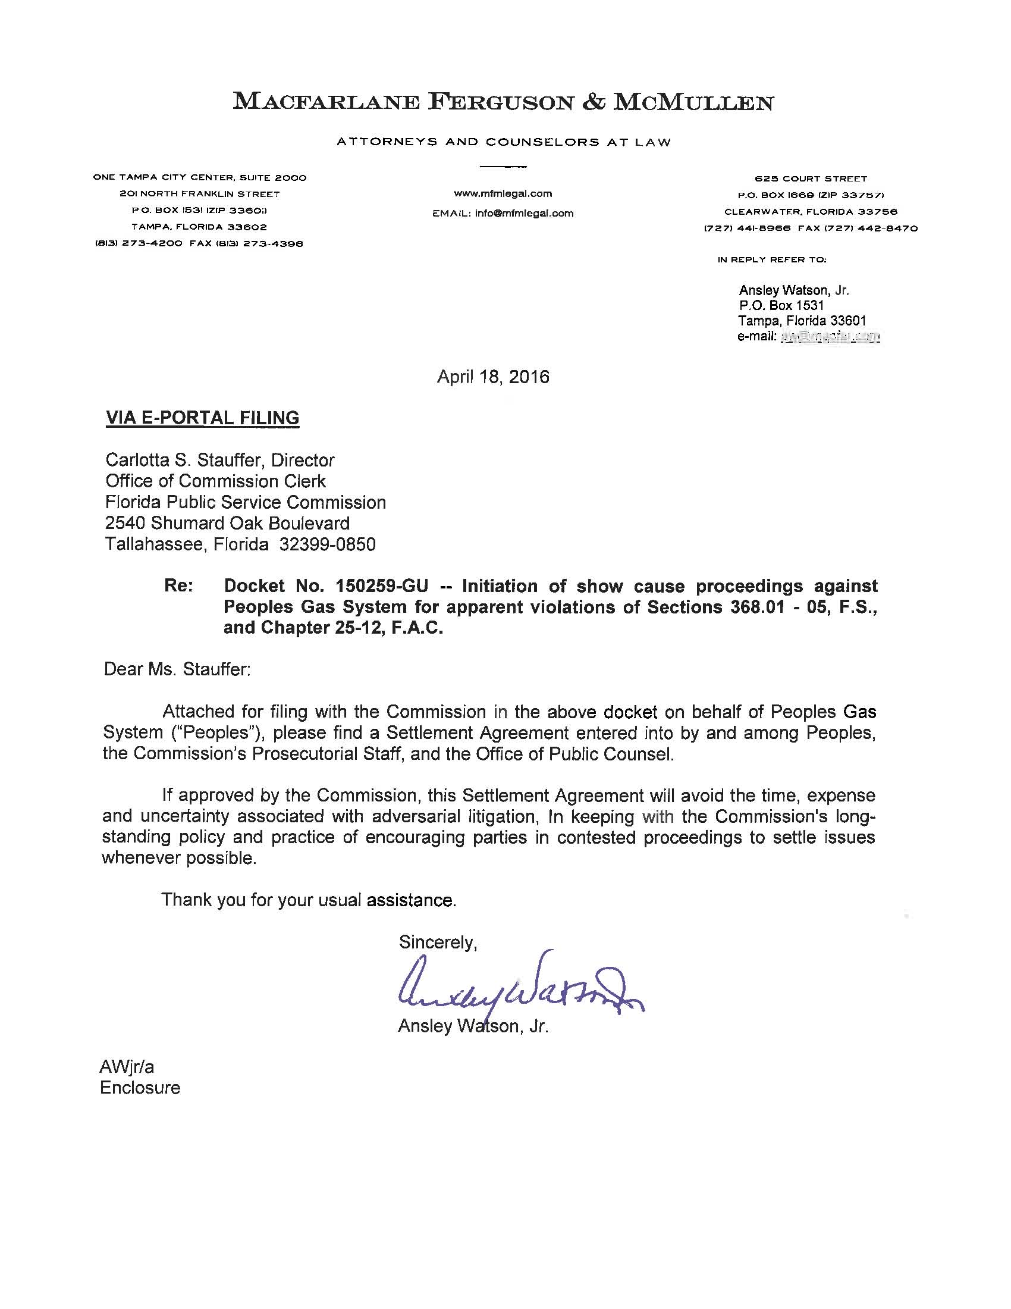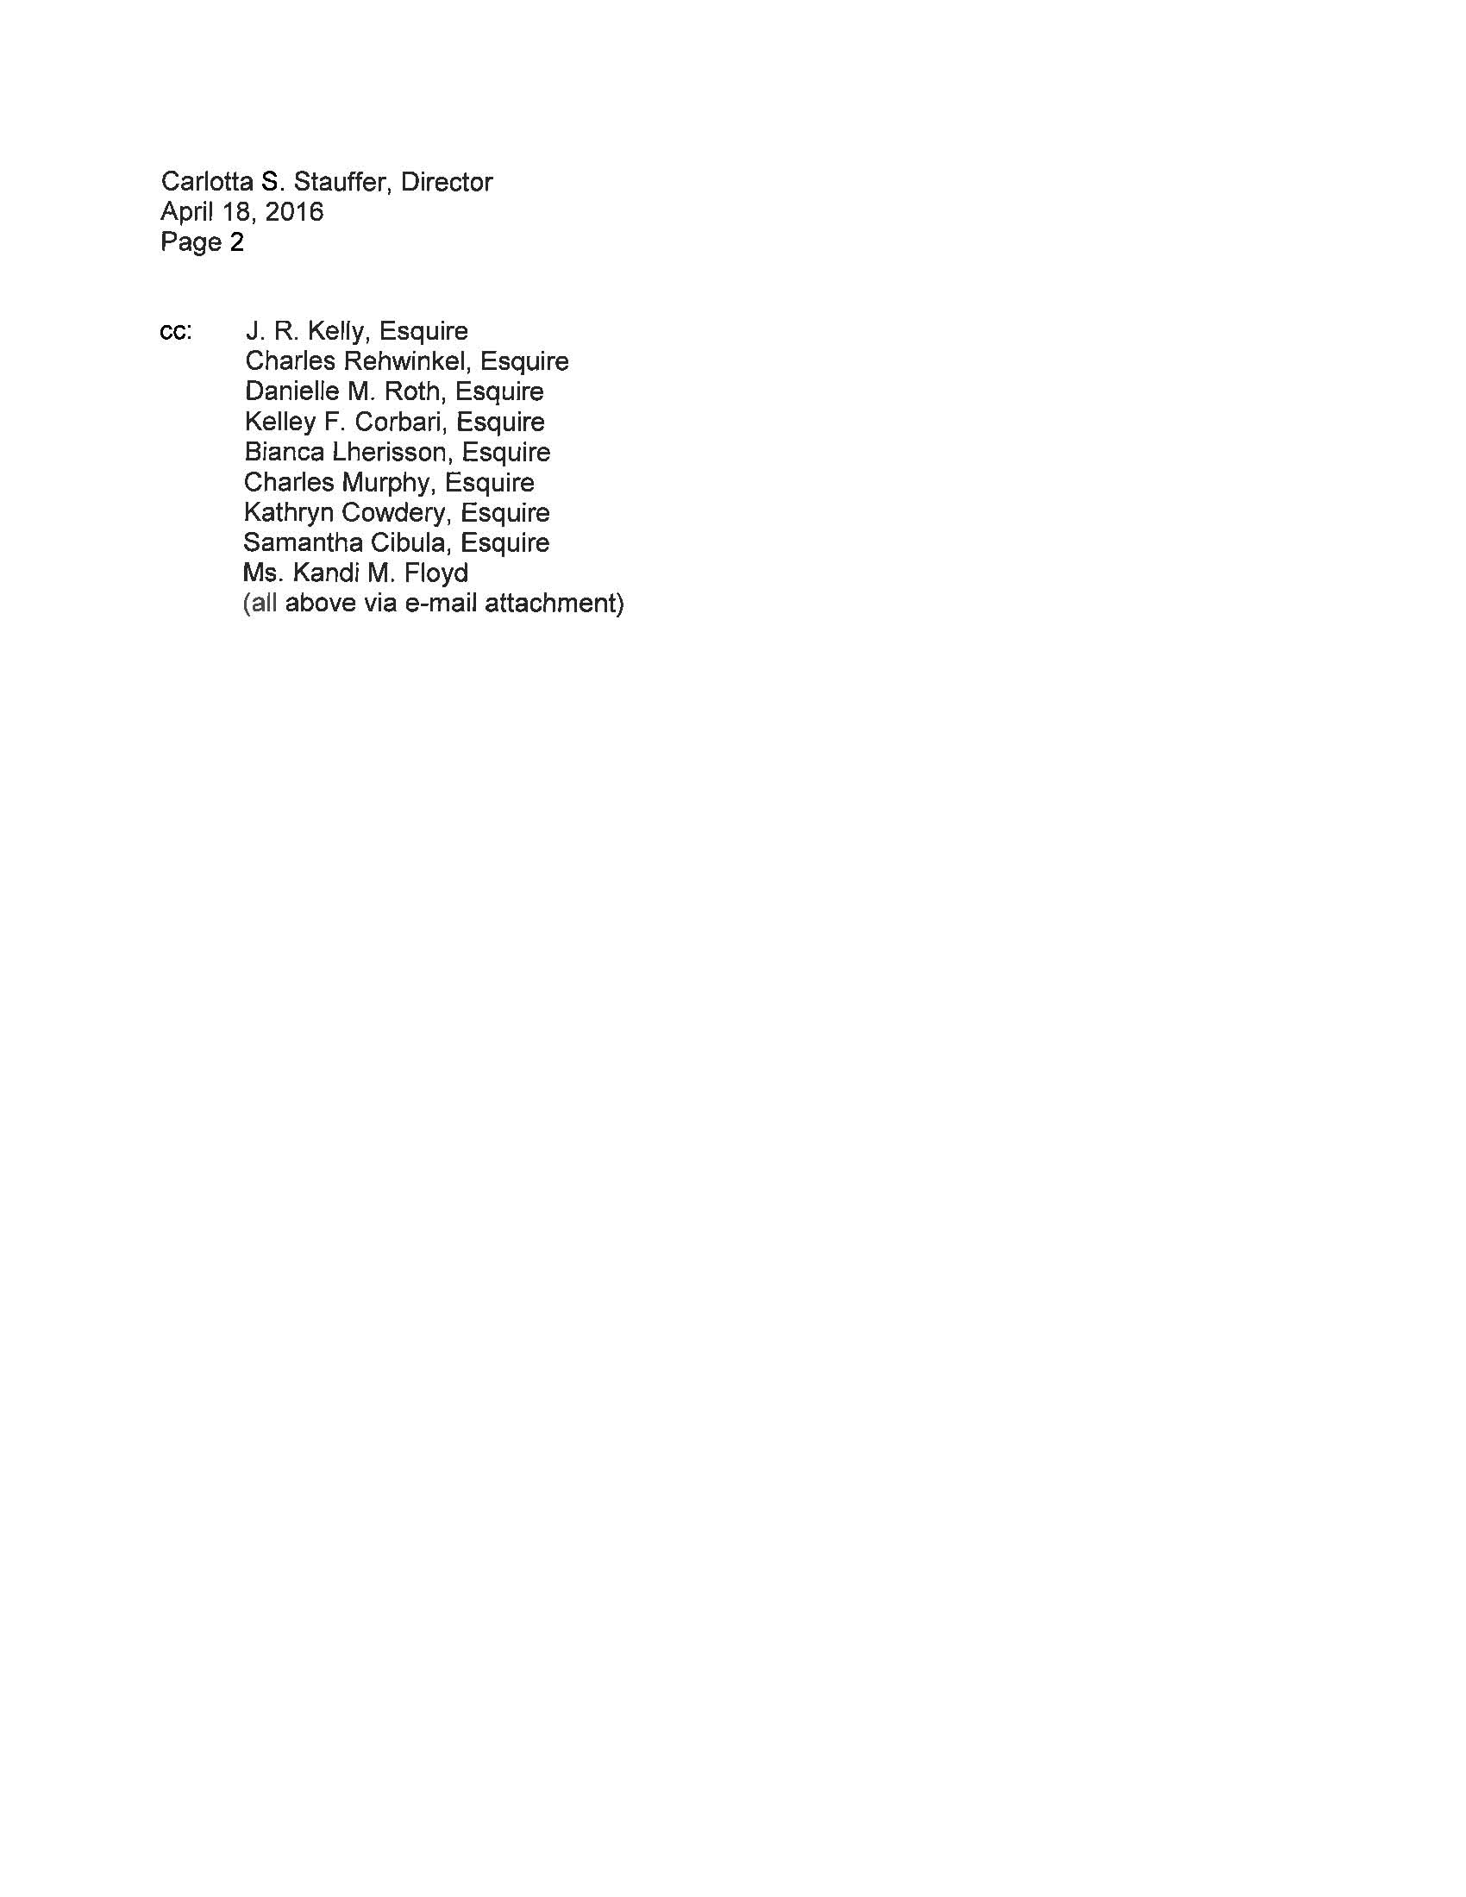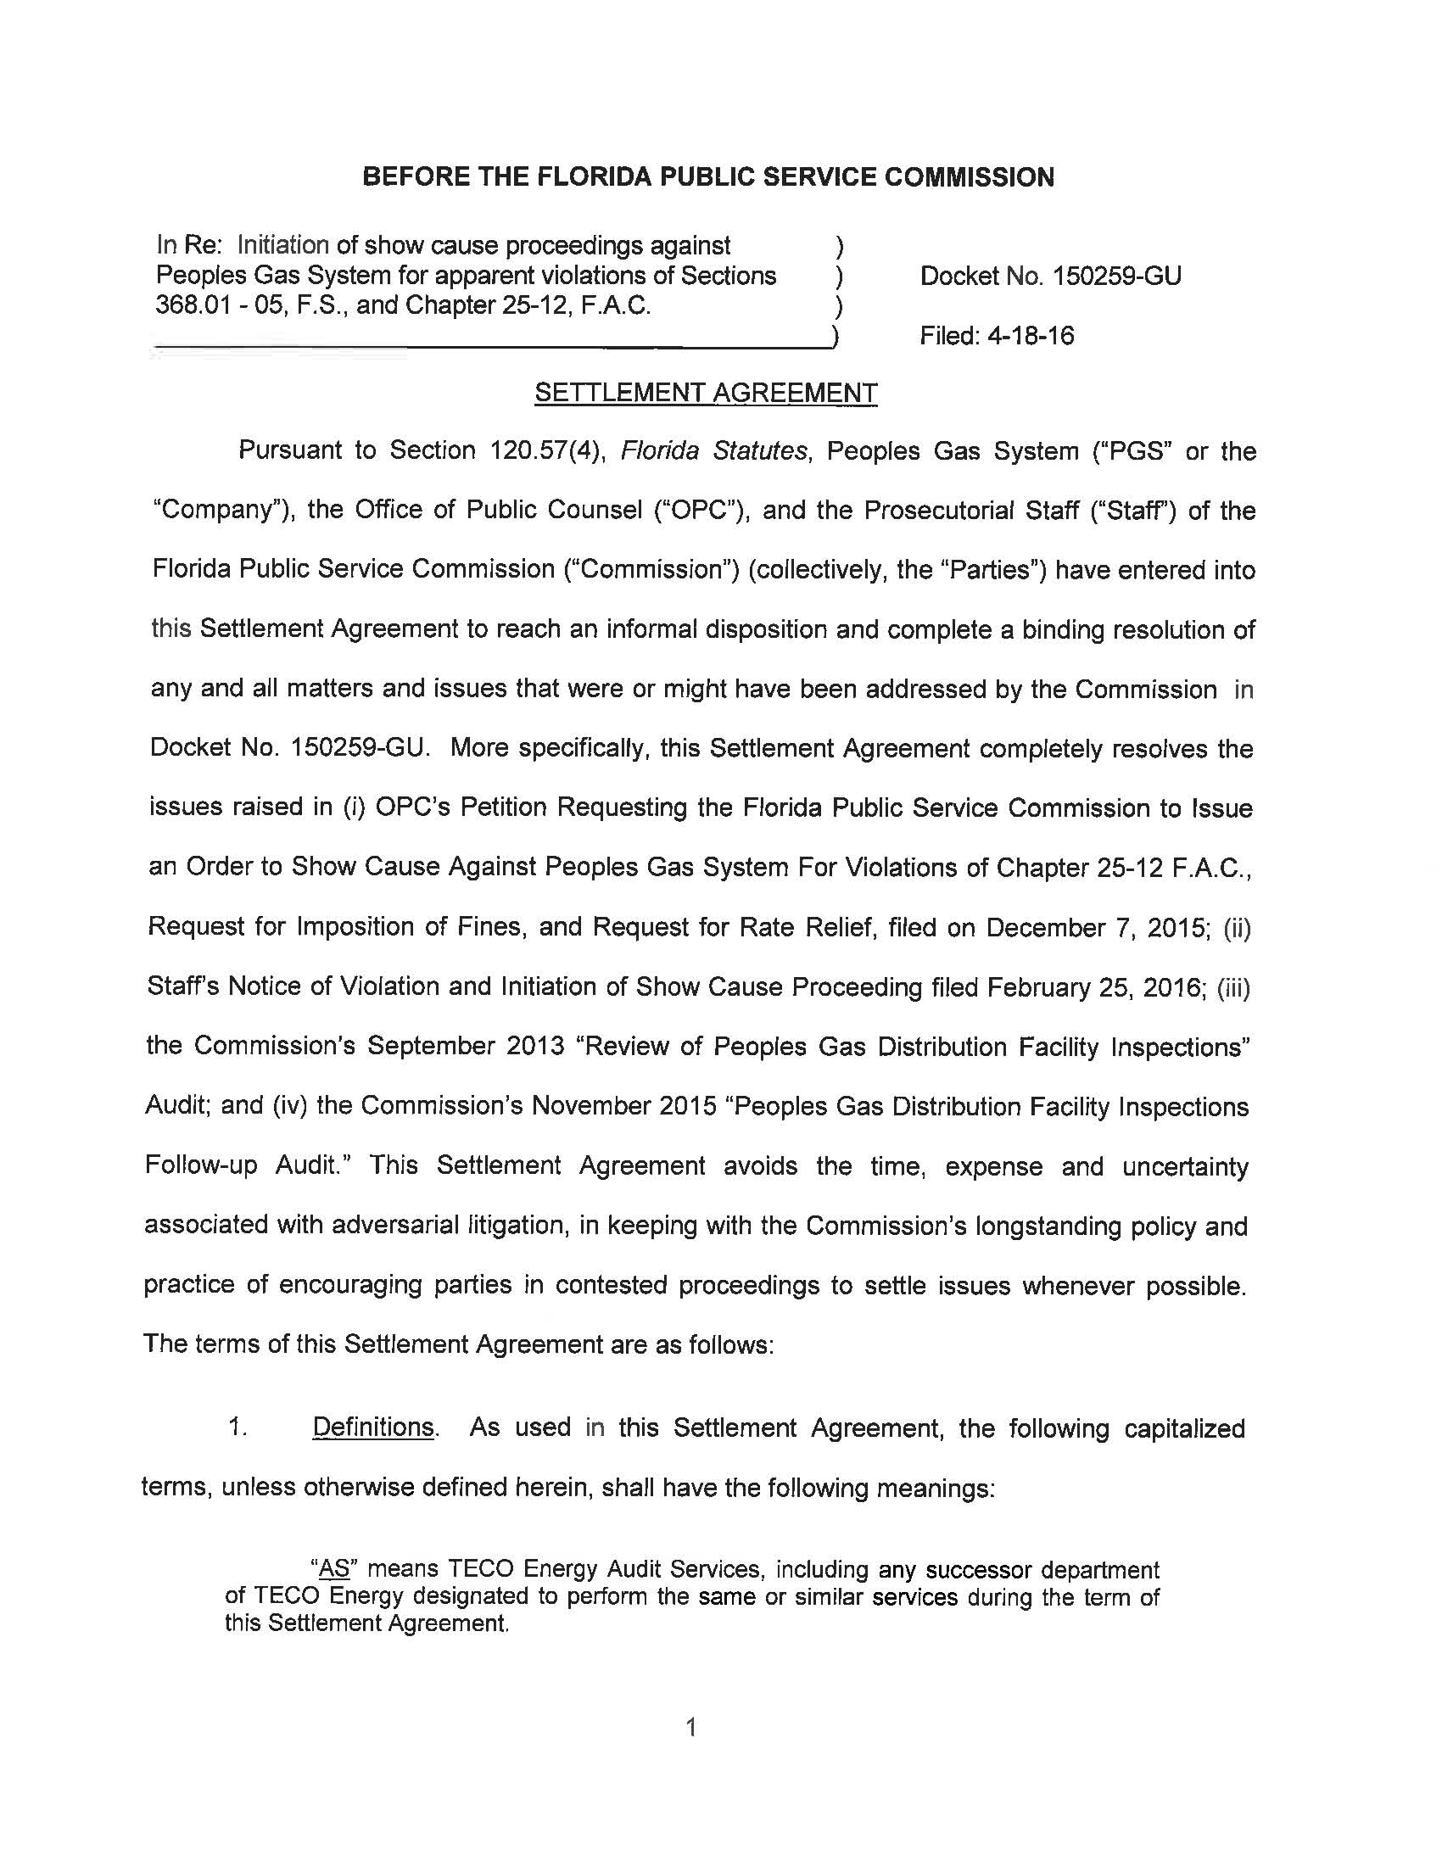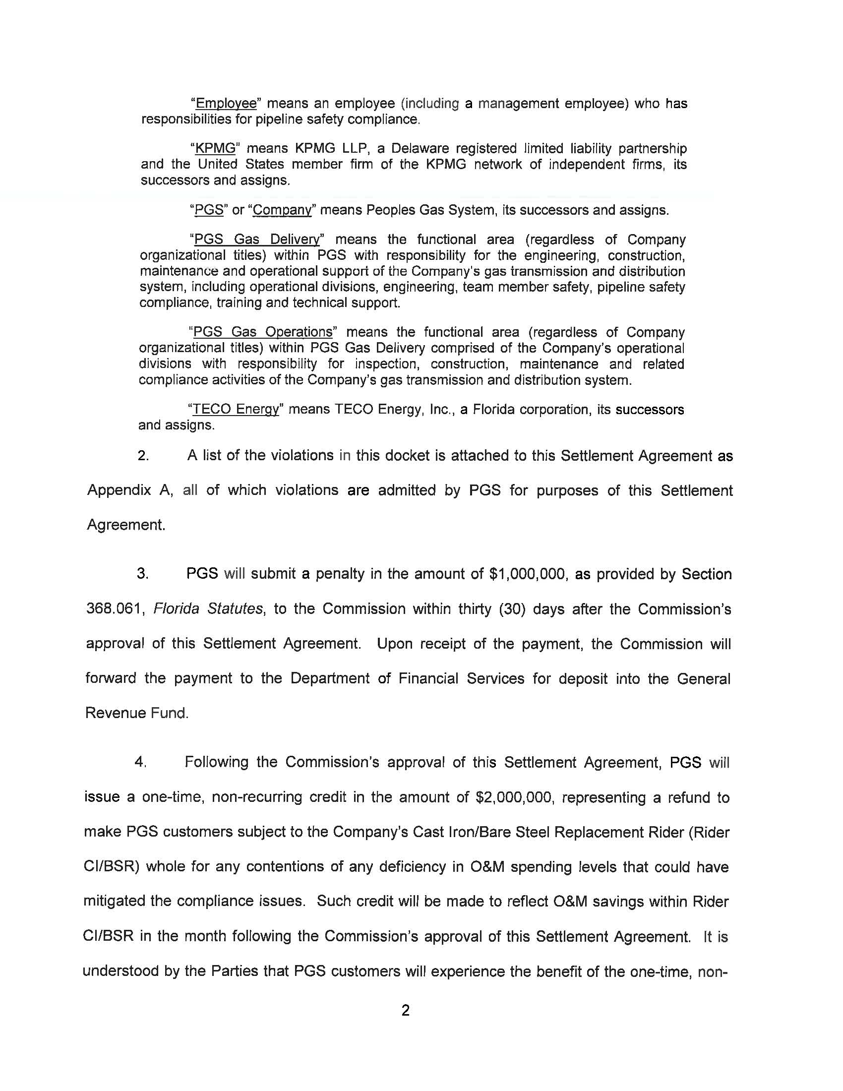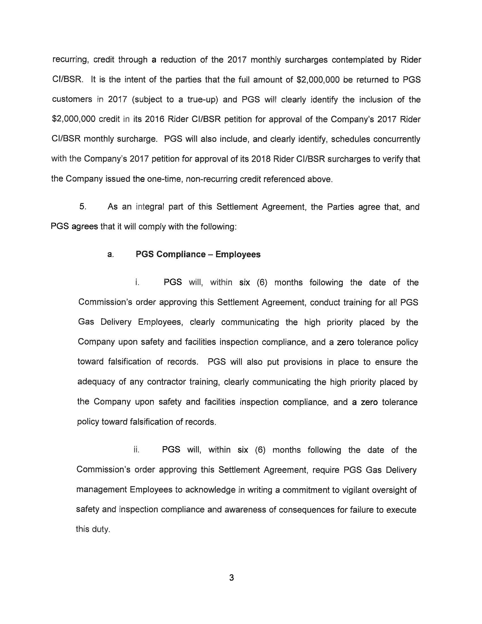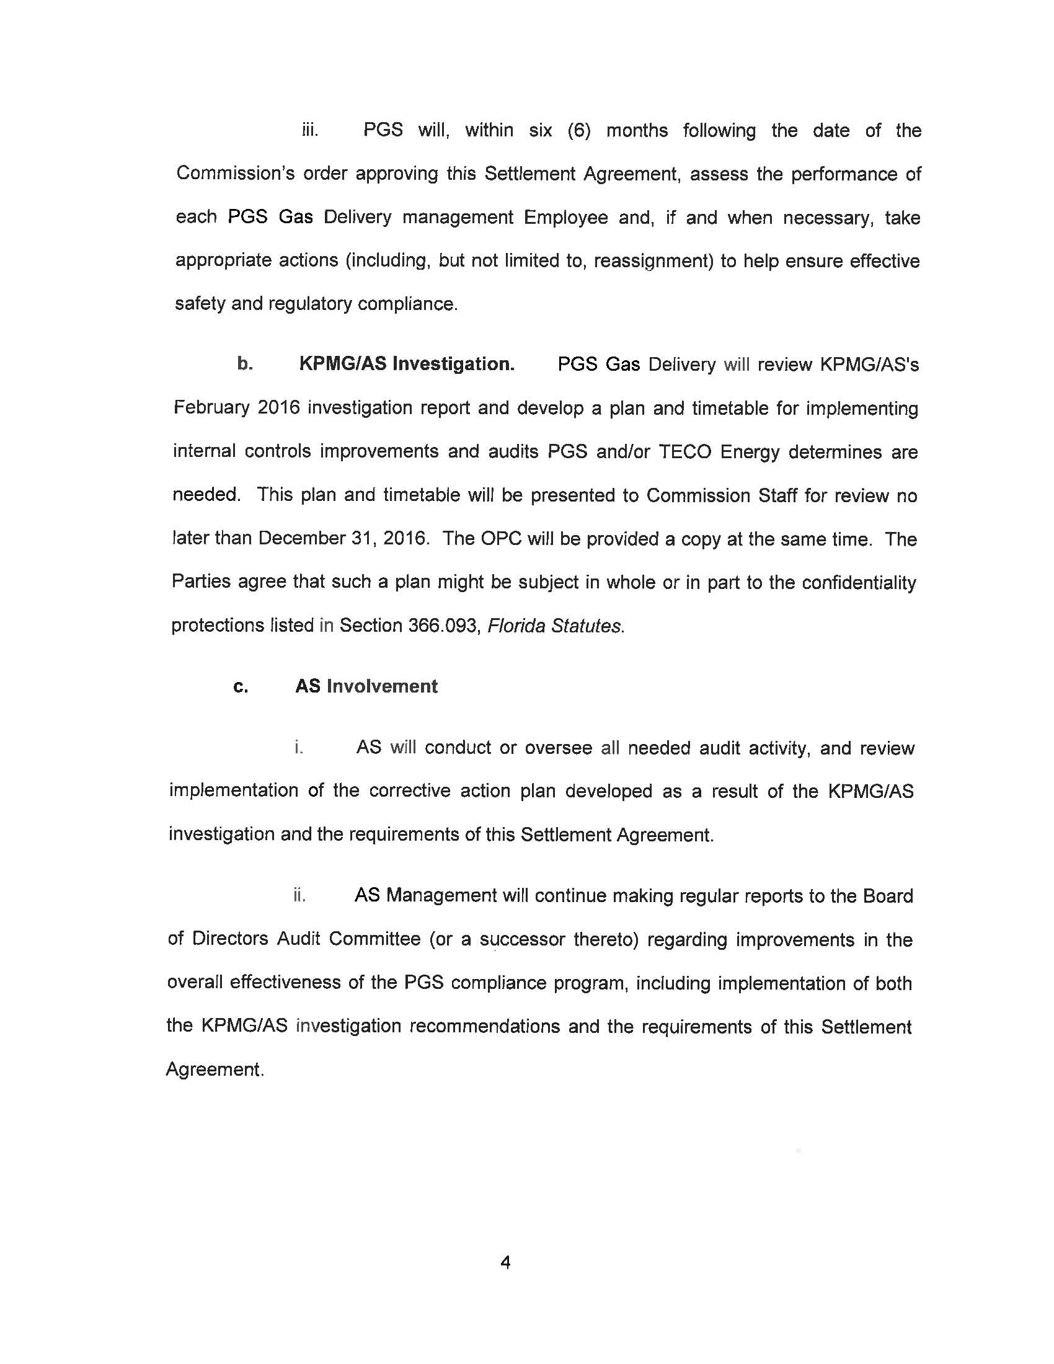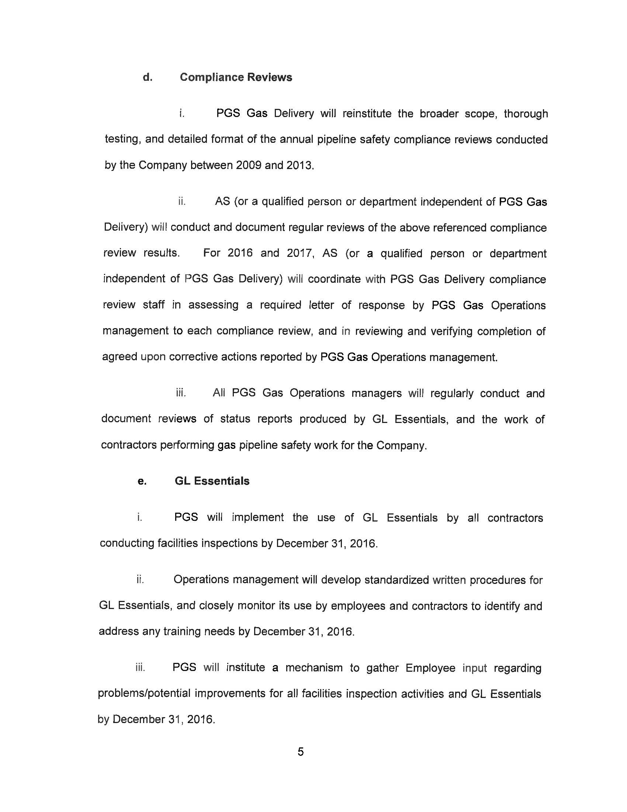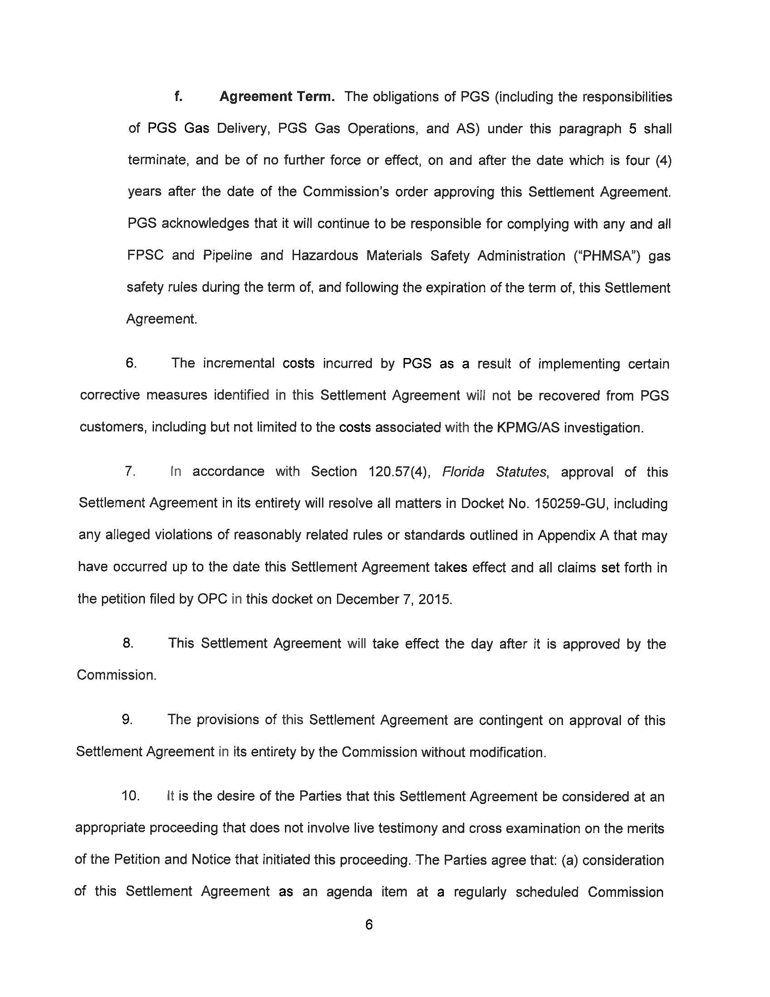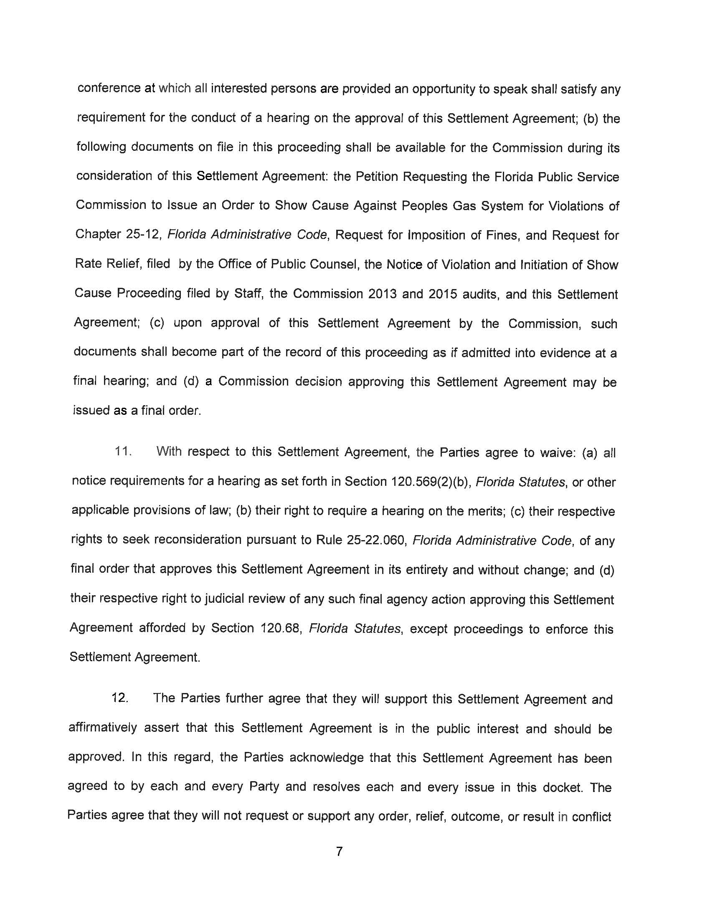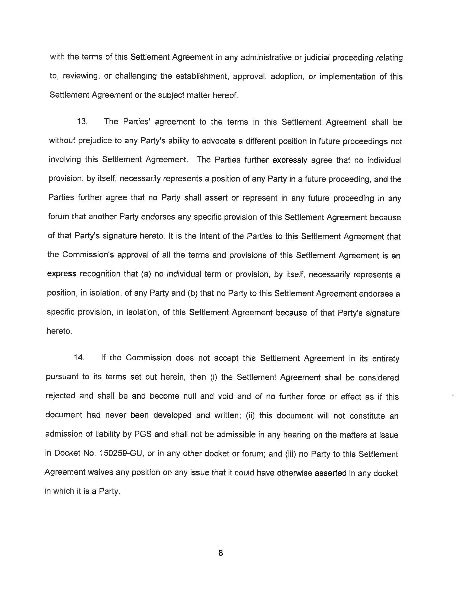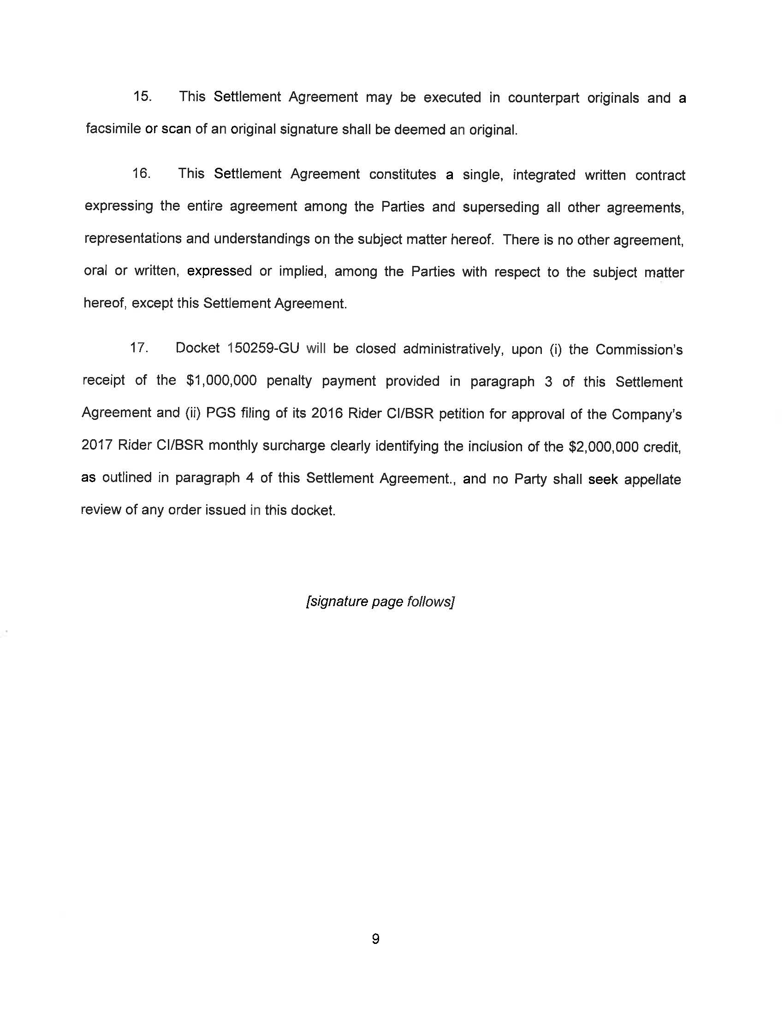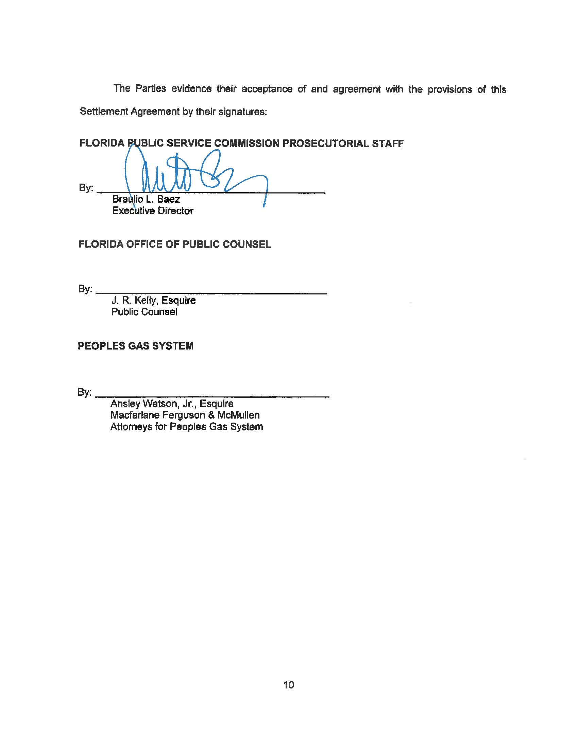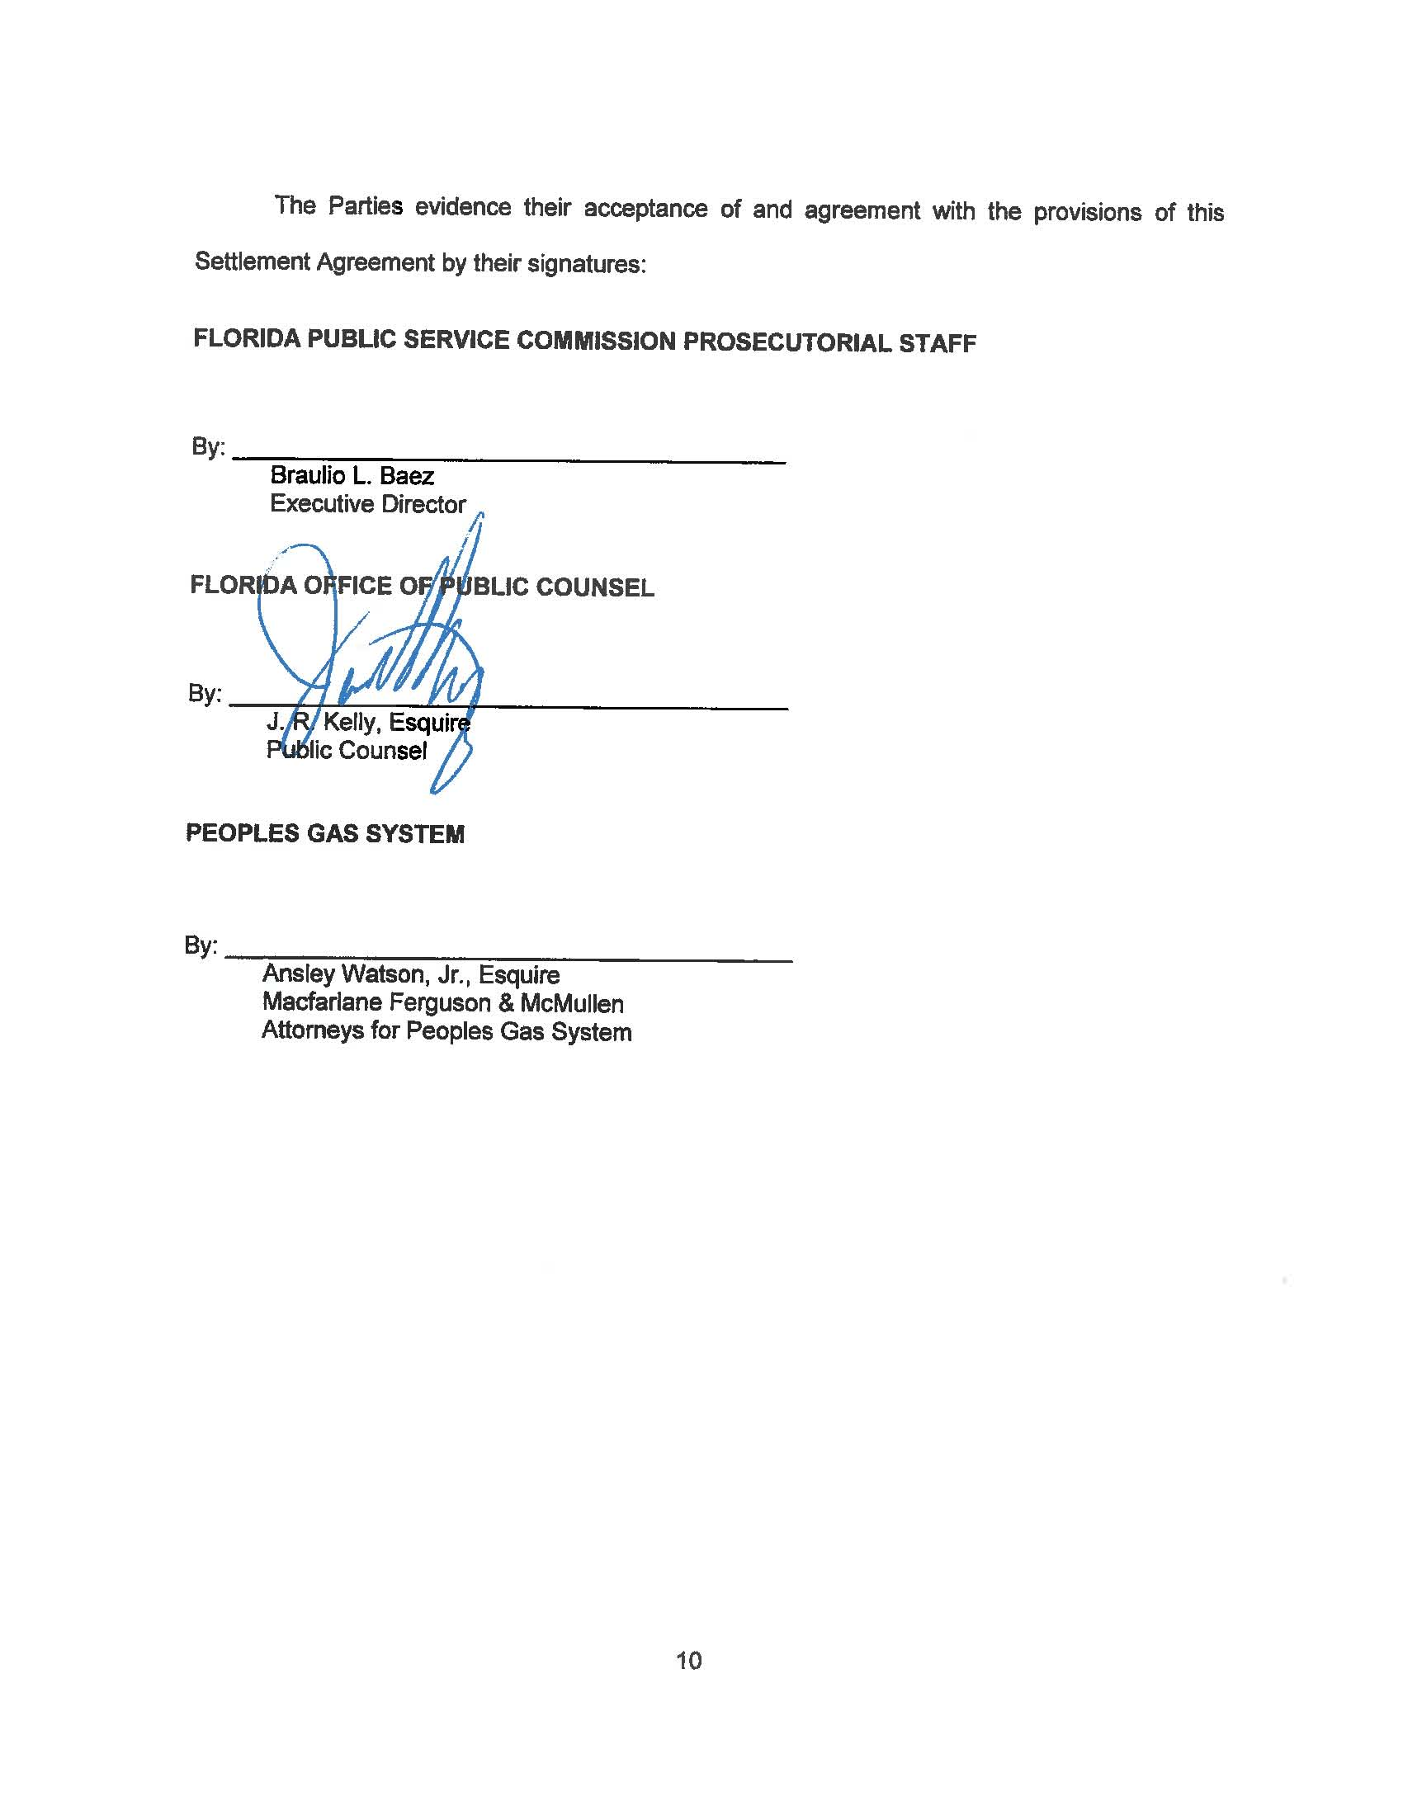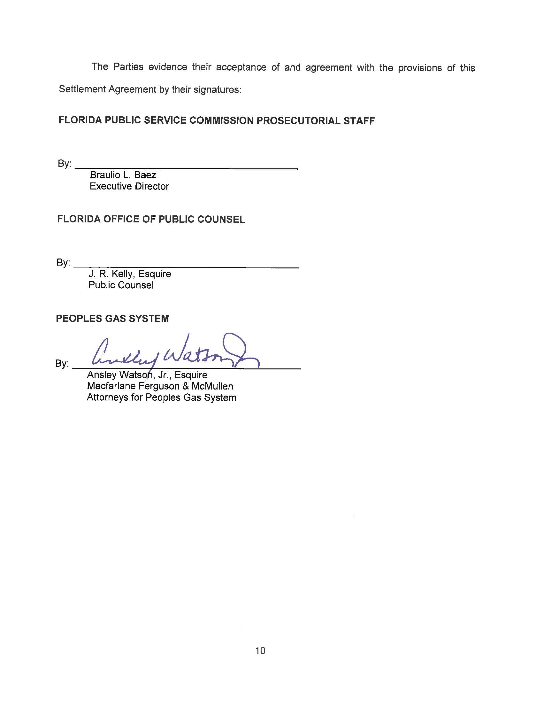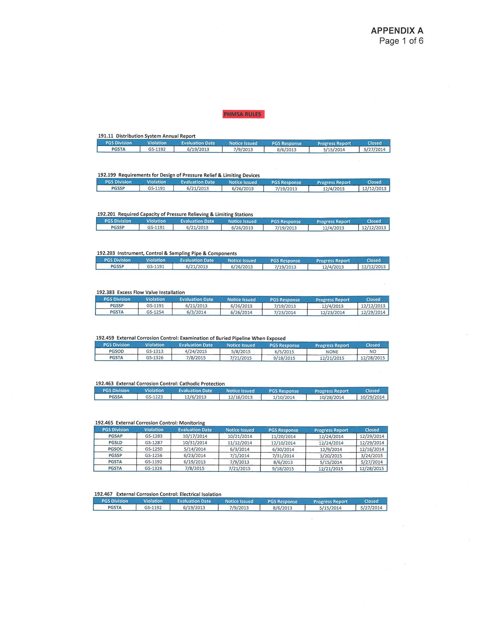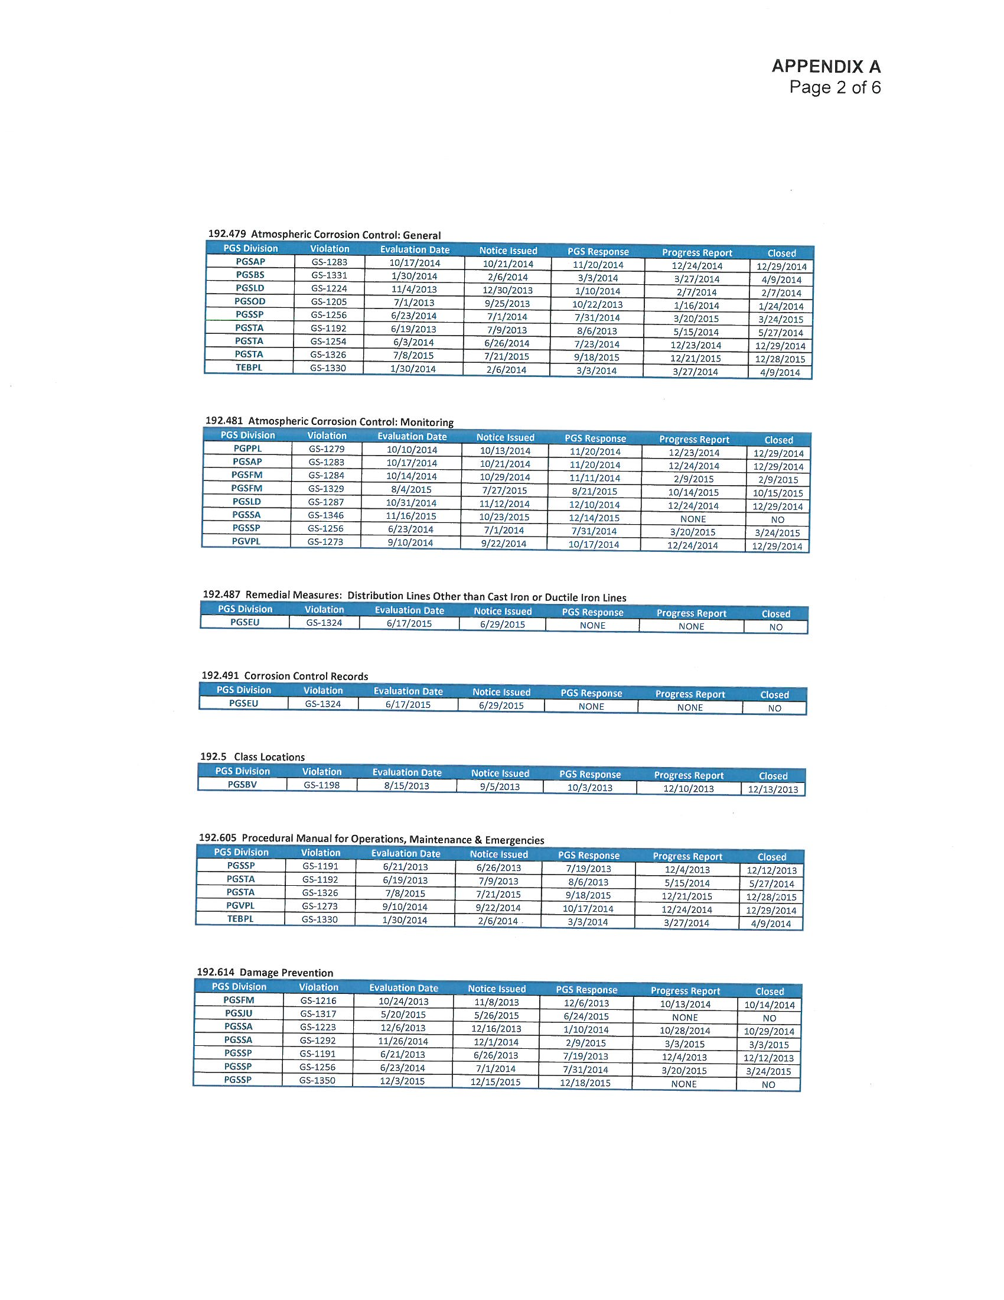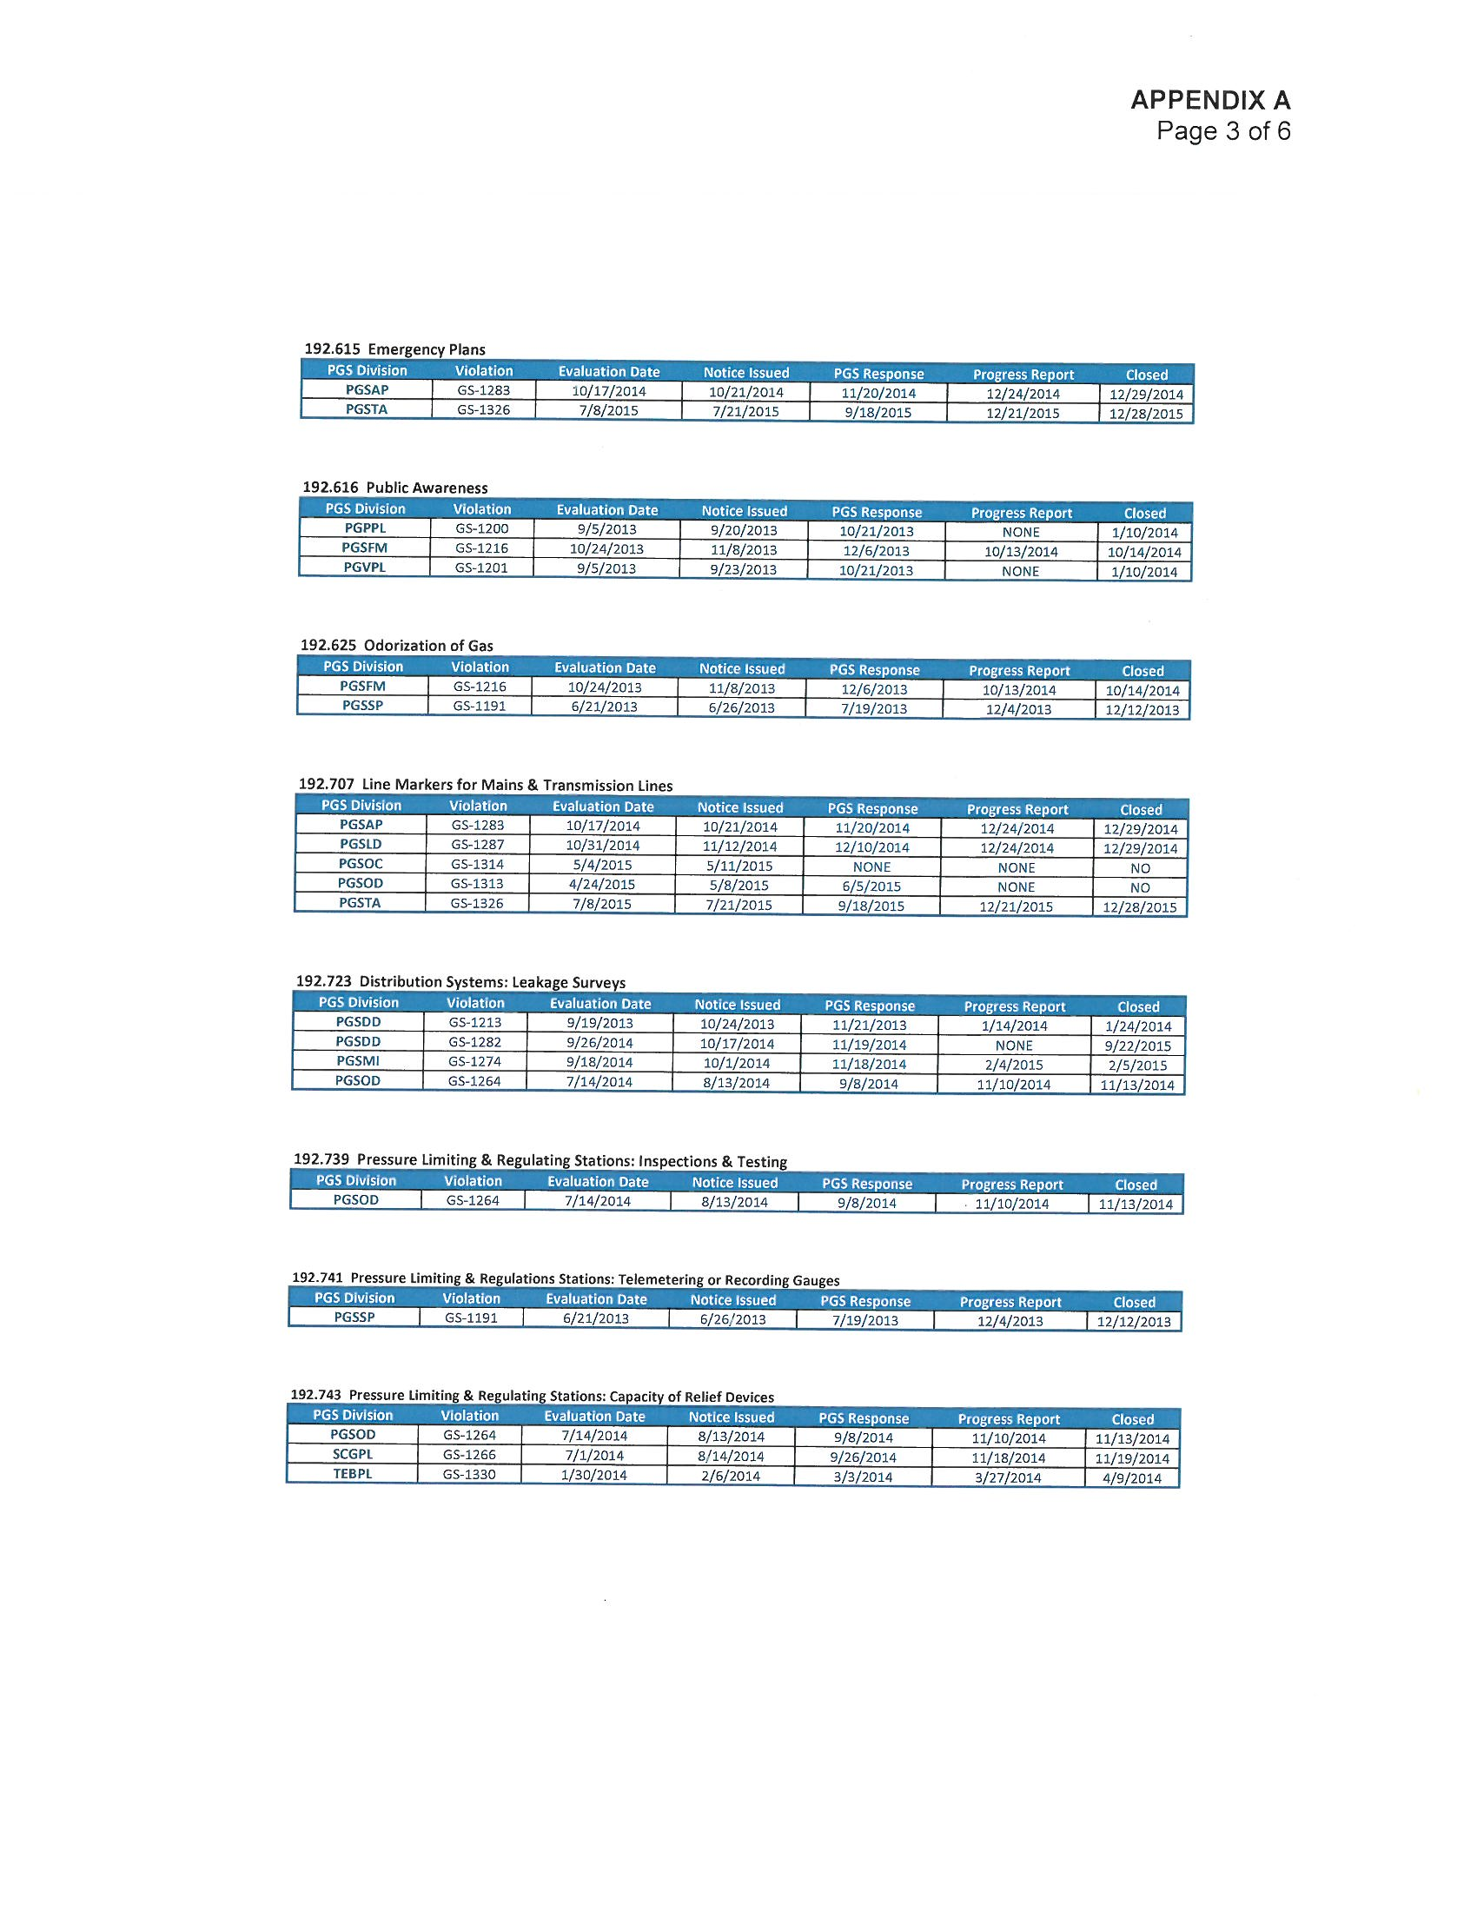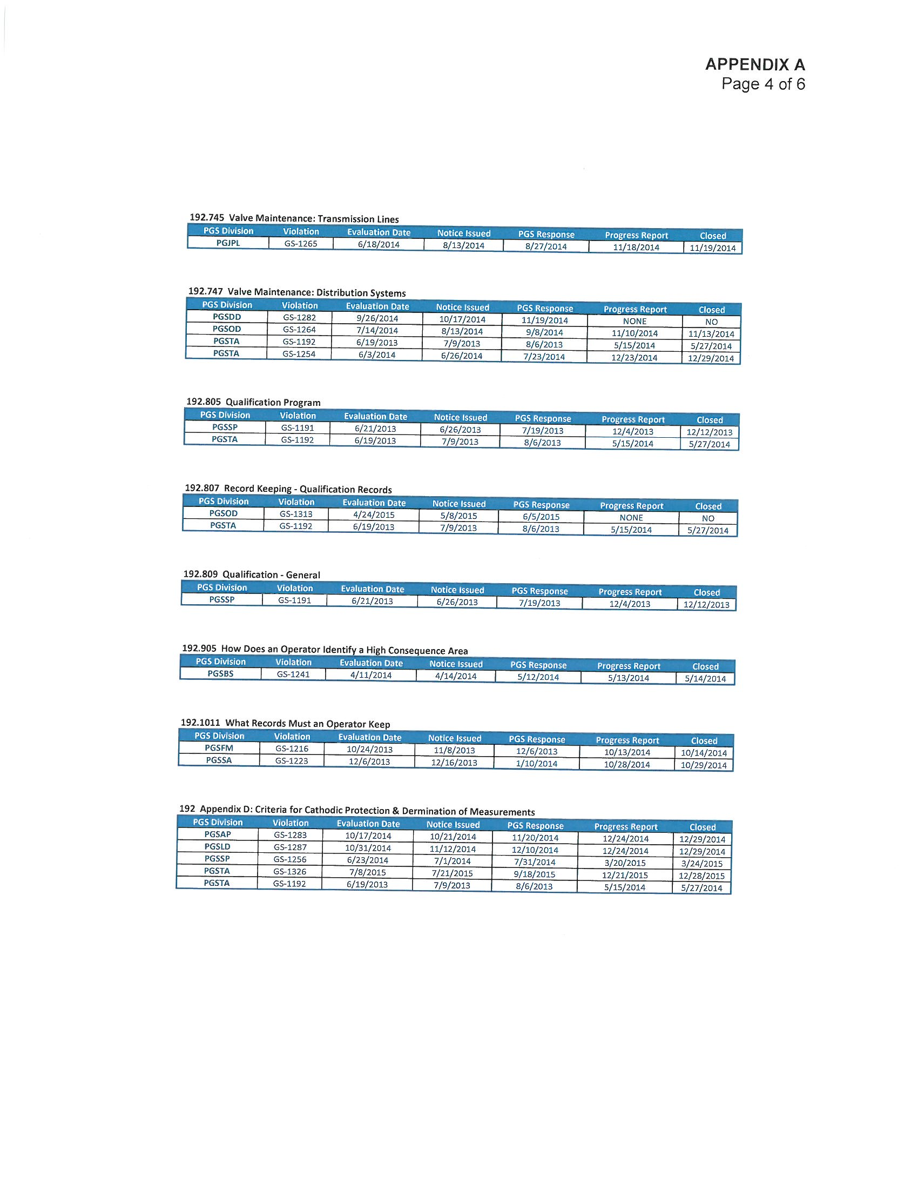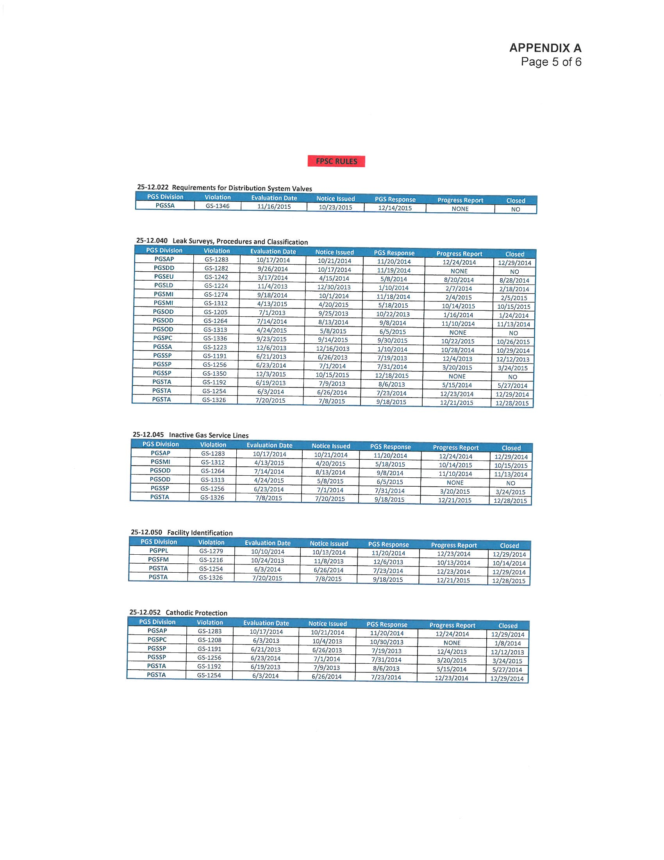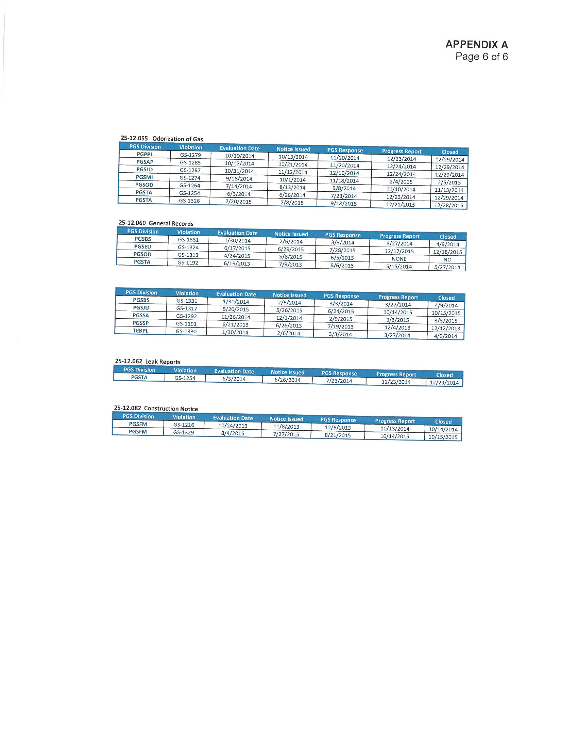

Sections 368.01-.061, F.S., (“The Gas Safety Law of 1967”).
49 U.S.C. §§60105-60106 (2006) (governing State Pipeline Safety Program certifications and agreements).
Section 368.05(1), F.S.; see also, http://primis.phmsa.dot.gov/comm/FactSheets/States/FL_State_PL_Safety_Regulatory_Fact_Sheet.htm?nocache=1609.
Rule 25-12.005, F.A.C.
Section 368.061(1), F.S.
Id. at subsection (3).
“Utility” as used in this section, means any entity engaged in operating gas transmission or distribution facilities in Florida.
A gate station is a point of interconnection between the utility's facilities and the facilities of interstate or intrastate natural gas pipelines.
FPSC “Review of Peoples Gas Distribution Facility Inspections – September 2013,” http://www.floridapsc.com/Files/PDF/Publications/Reports/General/Electricgas/PeoplesGas2013.pdf.
2013 Audit, p. 3-4.
2013 Audit, p. 15-29, “PGS Response to Commission Audit Findings,” and p. 37-44, Appendix 3 “PGS Initial Corrective Action Plans for Tampa and St. Petersburg Divisions.”
Although the Commission’s 2013 Audit was limited to the PGS Tampa and St. Petersburg Divisions, Commission audit staff noted that most of the Company’s internal procedures, practices and controls examined and described in the Audit applied statewide. See 2013 Audit, p. 1.
FPSC “Peoples Gas Distribution Facility Inspections Follow-up Audit – November 2015,” http://www.floridapsc.com/Files/PDF/Publications/Reports/General/Electricgas/PGS_follow-up_audit.pdf.
GL Essentials is a real-time electronic management tracking system for monitoring all PGS inspection activities such as leak and atmospheric surveys, cathodic protection, and regulator and valve inspections.
2015 Audit, p. 3-5.
Id. p. 3.
Document No. 07756-15.
Document No. 07838-15.
Document No. 01019-16.
Docket initially captioned as In Re: Petition Requesting the Florida Public Service Commission to Issue an Order to Show Cause Against Peoples Gas System for Violations of Chapter 25-12, F.A.C., Request for Imposition of Fines, and Request for Rate Relief.
Document No. 01024-16.
As part of the Settlement Agreement, Commission prosecutorial staff agreed to recede from the 16 violations not previously stricken by staff following the February 10, 2016, meeting for the purposes of assessing penalties only.
Section 368.061(2), F.S.

