State of Florida   |  | Public Service Commission  Capital Circle Office Center ● 2540 Shumard Oak Boulevard  Tallahassee, Florida 32399-0850  -M-E-M-O-R-A-N-D-U-M-
DATE: | June 23, 2016
TO: | Office of Commission Clerk (Stauffer)
FROM: | Office of Telecommunications (Bates, Fogleman, Salak, Williams)  Office of Auditing and Performance Analysis (Vinson, Lehmann)  Office of the General Counsel (Page)
RE: | Docket No. 140029-TP – Request for submission of proposals for relay service, beginning in June 2015, for the deaf, hard of hearing, deaf/blind, or speech impaired, and other implementation matters in compliance with the Florida Telecommunications Access System Act of 1991.
AGENDA: | 07/07/16 – Regular Agenda – Proposed Agency Action for Issue 1 – Interested Persons May Participate
COMMISSIONERS ASSIGNED: |  |  | All Commissioners
PREHEARING OFFICER: |  |  | Administrative
CRITICAL DATES: |  |  | September 1, 2016 – Effective date of Florida Telecommunications Relay, Inc. budget. Notification of any change in the Telecommunications Access System Act surcharge must be made to carriers prior to September 1, 2016.
SPECIAL INSTRUCTIONS: |  |  | Anticipate the need for sign language interpreters and assisted listening devices. Please place near the beginning of the agenda to reduce interpreter costs.  This recommendation replaces the recommendation that was deferred from the 5/5/16 Commission Conference.

Case Background
The Florida Relay System provides deaf and hard of hearing persons access to basic telecommunications services by using a specialized Communications Assistant that relays information between the deaf or hard of hearing person and the other party to the call. The primary function of the Florida Relay System is accomplished by the deaf or hard of hearing person using a Telecommunications Device for the Deaf where the person using the Telecommunications Device for the Deaf types a message to the Communications Assistant who in turn voices the message to the other party, or a Captioned Telephone which displays real-time captions of the conversation.
The Telecommunications Access System Act of 1991 (TASA) established a statewide telecommunications relay system which became effective May 24, 1991. TASA is authorized pursuant to Chapter 427, Florida Statutes (F.S.). Section 427.701(1), F.S., provides that the Florida Public Service Commission (Commission or FPSC) shall establish, implement, promote, and oversee the administration of the statewide telecommunications access system to provide access to telecommunications relay services by persons who are deaf, hard of hearing or speech impaired, or others who communicate with them. It is estimated that approximately 2.5 to 3 million of the estimated 20 million persons living in Florida have been diagnosed as having a hearing loss. This system provides telecommunications service for deaf or hard of hearing persons functionally equivalent to the service provided to hearing persons.
TASA provides funding for the distribution of specialized telecommunications devices and provision of intrastate relay service through the imposition of a surcharge of up to $.25 per landline access line per month. Accounts with over 25 access lines are billed for only 25 lines. Pursuant to Section 427.704(4)(a)1, F.S., a surcharge is collected only from landline access lines.
Florida Telecommunications Relay, Inc. (FTRI), a non-profit corporation formed by the local exchange telephone companies, was selected by the Commission to serve as the Telecommunications Access System Act Administrator. On July 1, 1991, the local exchange telecommunications companies began collecting an initial $.05 per access line surcharge pursuant to Order No. 24581. Since July 1, 1991 the surcharge, which is currently $.12 per month, has changed to reflect FTRI budgetary needs and potential Federal Communications Commission (FCC) mandates.
Chapter 427, F.S., requires that the relay system be compliant with regulations adopted by the FCC to implement Title IV of the Americans with Disabilities Act. The FCC mandates the minimum requirements for services a state must provide, certifies each state program, and periodically proposes changes in the stipulated services.

The current relay service provider in Florida is Sprint. The FPSC awarded the contract to Sprint, effective March 1, 2015, for a period of three years. The contract contains options to extend the contract for four additional one-year periods, and requires mutual consent by both parties to extend the contract.

Staff sent a data request to FTRI on a number of issues included in its proposed budget. FTRI’s responses to staff’s data request are included in the docket file. In order to perform additional analysis, staff deferred this item from the May 5, 2016 Agenda Conference. This time allowed staff to thoroughly review additional information for the FTRI proposed budget and to assess the budget results for Fiscal Year 2015/2016 using the latest actual information which became available on May 16, 2016. Based on having more actual data for Fiscal Year 2015/2016, staff has estimated the actual FTRI expenses for Fiscal Year 2015/2016 and they are presented in Option 2 under Issue 1 of the recommendation. Staff used actual data from June 2015 through March 2016 and estimated the fourth quarter by averaging the first three quarters of the fiscal year.

In 2013 the Office of Auditing and Performance Analysis performed a management audit of FTRI. The audit produced seven findings and corresponding recommended actions (Attachment C). To assist the current analysis, audit staff updated portions of its analysis and conducted a limited assessment of improvements FTRI has implemented in response to the 2013 findings.

Through its recent analysis, audit staff concluded that FTRI had undertaken largely responsive and reasonable efforts to implement the suggested improvements from 2013. However, audit staff noted that FTRI’s Fiscal Year 2016/2017 proposed expenditures interrupts a three-year trend of reducing total expenditures.

Staff contacted FTRI and its Board and requested that the FTRI budget be refiled using the actual amounts for expenses from the previous year. The Board voted to keep the budget as they originally filed it.

Decertification from the National Deaf-Blind Equipment Distribution Program
FTRI was certified by the FCC to participate in the National Deaf-Blind Equipment Distribution Program (NDBEDP) and receive reimbursement from the Federal TRS Fund in 2012. Under current FCC guidelines, FTRI is reimbursed for some expenses related to administering the program, including equipment purchased and distributed, assessment of clients, and training of clients. Administrative costs are capped at 15 percent of the reimbursement expenses.
As presented in Attachment B, on March 28, 2016, after it submitted its Fiscal Year 2016/2017 proposed budget, FTRI submitted a letter to the Commission communicating that it will decertify from the NDBEDP. In the letter, FTRI explains that the FTRI Board directed that participation in the NDBEDP not adversely impact FTRI’s TASA function in Florida. FTRI further explains that its continued participation in the NDBEDP would result in absorbing some of the cost through its state relay budget. FTRI revenues for Fiscal Year 2015/2016 from the NDBEDP for Q1 and Q2 were $66,149 and expenses were $76,702, resulting in a net loss of $10,553.
FTRI believes continued participation in the program may lead to increased losses due to the 15 percent administrative cap. Further, FTRI states that reimbursable expenses are shifting to lower cost equipment offered through the program, yielding a lower administrative reimbursement using the 15 percent cap.
If FTRI decertifies with the FCC, it is anticipated that the program and its offered services will continue with another entity distributing the NDBEDP equipment for the deaf-blind, low-income Floridians. The FCC will make that determination after reviewing interested applicants’ proposals.

The full impact of continuing to participate in the NDBEDP on FTRI’s proposed Fiscal Year 2016/2017 budget would be a projected $61,820 loss as presented by FTRI in its Fiscal Year 2015/2016 Estimated Revenue & Expenses as presented in Attachment A.

The purpose of this recommendation is to address the FTRI proposed Fiscal Year 2016/2017 budget and determine what the relay surcharge should be for the upcoming fiscal year. The Commission is vested with jurisdiction pursuant to Chapter 427, F.S.

Discussion of Issues

Issue 1:
Should the Commission approve FTRI’s proposed budget, excluding the National Deaf-Blind Equipment Distribution Program, for Fiscal Year 2016/2017, and should the Commission maintain the current Telecommunications Relay Service (TRS) surcharge of $0.12 per month?

Recommendation:
No, staff recommends that the budget expenses should be reduced by $601,238. Attachment D reflects the line-by-line adjustments that are being recommended. The surcharge should be reduced to $0.11 beginning September 1, 2016. If necessary, FTRI should be allowed to use the surplus account if there is a revenue shortfall in Fiscal Year 2016/2017. (Salak, Fogleman, Williams, Bates, Vinson, Lehmann, Page)

Staff Analysis:

Traditional Telecommunications Relay Service
Minutes of use for traditional TRS have been declining. Sprint’s projections indicate that traditional minutes will continue to decline during the 2016/2017 Fiscal Year. Traditional relay users are transitioning to Internet Protocol Relay, Video Relay Service, Captioned Telephone Service, Internet Protocol Captioned Telephone Service, Internet Protocol Speech-to-Speech (STS) service, and wireless service. The traditional TRS cost as approved in Sprint’s contract remains at $1.09 per session minute.

CapTel Service
CapTel service uses a specialized telephone that provides captioning of the incoming call for a deaf or hard of hearing person. Sprint’s projections show that CapTel minutes of use will also decrease during the 2016/2017 Fiscal Year. The CapTel cost as approved in the Sprint contract remains at $1.63 per session minute.
Florida Telecommunications Relay Inc. Budget
Attachment A reflects FTRI’s 2016/2017 Fiscal Year proposed budget, which was reviewed and adopted by FTRI’s Board of Directors prior to filing with the Commission. The proposed budget includes a decrease in expenses of approximately $774,299 from the Fiscal Year 2015/2016 Commission approved budget. The FTRI 2016/2017 proposed budget projects total operating revenues to be $8,269,418 and total expenses to be $7,977,633. FTRI believes the Telecommunications Relay surcharge should remain at $0.12 per access line for the 2016/2017 Fiscal Year.
Sprint’s estimated Fiscal Year 2016/2017 traditional Telecommunications Relay surcharge minutes of use are 1,013,262 at a rate of $1.09 per minute for a total of $1,104,456. Sprint’s estimated CapTel minutes of use for Fiscal Year 2016/2017 are 1,280,726 at a rate of $1.63 per minute for a total of $2,087,583.
The biggest decrease in expense in the budget arises from relay provider services, resulting in $779,460 in savings when compared to the Fiscal Year 2015/2016 Commission approved budget. The largest increase in the budget is associated with FTRI Outreach. FTRI’s Outreach expense increased by $153,674 over the Fiscal Year 2015/2016 Commission approved budget and FTRI’s 2015/2016 estimated expenditures for Outreach.
Not including Category I, the relay provider expense or NEBEDP, FTRI’s proposed budget includes a net increase in expenses for categories II-V of $1,386 compared to the approved budget for Fiscal Year 2015/2016; $383,346 compared to FTRI’s estimated actual for Fiscal Year 2015/2016; and $305,387 compared to staff’s estimate of actual expense for Fiscal Year 2015/2016.

A comparison of FTRI’s Fiscal Year 2015/2016 Commission approved budget and FTRI’s Fiscal Year 2016/2017 proposed budget as filed is shown in Table 1 below.
Table 1
FTRI Fiscal Year 2016/2017 Budget Comparison
 | Commission Approved  2015-2016 | FTRI Proposed  2016-2017
Operating Revenue:
Surcharges | $8,249,890 | $7,762,706
Interest Income | 33,941 | 34,188
NDBEDP | 468,749 | 472,524
Total Operating Revenue | $8,752,580 | $8,269,418
Operating Expenses:
Relay Provider Services | $3,971,499 | $3,192,039
Equipment and Repairs | 1,690,386 | 1,621,478
Equipment Distribution And Training | 1,054,737 | 950,403
Outreach | 574,626 | 728,300
General & Administrative | 991,935 | 1,012,889
NDBEDP | 468,749 | 472,524
Total Expenses | $8,751,932 | $7,977,633
Annual Surplus | 648 | 291,785
Total Surplus | $15,723,243 | $16,274,881
Source: FTRI’s Fiscal Year 2016/2017 proposed budget.

Analysis
Staff believes there are several approaches that could be used to determine the appropriate FTRI budget for Fiscal Year 2016/2017. Staff will provide three options for the Commission’s consideration as presented in Attachment D. As previously mentioned, Relay and CapTel expenses from Sprint (Category I) are projected to decline as a result of reduced minutes. All other expense categories in FTRI’s Fiscal Year 2016/2017 proposed budget are projected to increase over the actual expenses for Fiscal Year 2015/2016 as presented by FTRI.

Staff believes that Category I, the Sprint relay charges, should not be adjusted for any of the three options. The minutes of use have been projected by Sprint. It has multi-state experience with such projections and its historic projections have proven to be reasonable. In addition, staff believes that FTRI’s projection methodology of the revenues for Fiscal Year 2016/2017 is reasonable and should also be used for the three options.

Option 1: Adjustments to the Budget on a Line-by-Line Basis
The number of access lines assessed the relay surcharge is declining and has been for a number of years. The costs of Florida’s relay program are being spread among a fewer number of consumers as the number of landlines decline. In addition, the equipment that can be distributed by FTRI’s equipment distribution program is limited by the relay statute. Based upon the premise that wireline access lines are declining and the number of FTRI eligible clients is declining as customers convert from landline to other technologies, Option 1 is designed to adjust each of the expense categories to insure that the expenses reflect the necessary costs to serve the program. With this goal in mind, staff recommends the following adjustments to the FTRI budget.

In the 2013 management audit report, audit staff calculated FTRI’s “core” operating expenditures per new client added. Core operating expenditures was defined as expenses for equipment, equipment distribution, repairs, training, outreach and general administration. The following chart displays updated results.

Table 2
Florida Telecommunications Relay, Inc.
Core* Operating Expenditures per New Client
Fiscal Year 2010-2017
 | FY ‘10-‘11 | FY ‘11-‘12 | FY ‘12-‘13 | FY ‘13-‘14 | FY '14-'15 | Projected  FY '15-'16 | Budget  FY '16-'17
Total Core* Expenditures | $5,891,703 | $5,066,067 | $4,634,021 | $4,166,422 | $4,071,914 | $4,007,686 | $4,313,070
Total New Clients | 24,399 | 19,287 | 15,078 | 13,671 | 13,408 | 13,408** | 13,408**
Ratio Expenditures/  New Client | $241 | $263 | $307 | $305 | $304 | $299 | $322
*Core expenditures include Equipment/Repairs/Distribution/Training, Outreach, and General/Administrative
**Assumed for illustration purposes by audit Staff to equal 2014-2015 total

Staff and FTRI recognize that FTRI provides service to more clients than just the new ones; however, this chart provides focus on the dollar impact of FTRI’s outreach efforts. Within its Fiscal Year 2016-2017 budget, FTRI proposes increased core operating expenses, which combined a continued decline in new clients, would result in a significant increase costs per new client.

Category I-Relay Service
As previously discussed, staff recommends that no adjustments should be made to this category.

Category II-Equipment & Repairs
Category II reflects the purchases of the equipment to be distributed to clients and the repairs that FTRI must do to keep the equipment in working order. Staff has reviewed the workpapers to determine the amounts of equipment purchases for the year. Most of the line items are based upon the historic twelve-month period to determine the level that will be needed for the upcoming year. Staff is recommending several adjustments in this category:

- VCP Hearing Impaired equipment should be reduced from $1,434,745 to $1,291,270, a reduction of $143,475. Staff believes the recommended reduction in Category IV-Outreach will decrease demand. VCP Hearing Impaired equipment is currently the equipment most widely distributed. The $143,475 adjustment represents ten percent of the FTRI proposed amount budgeted for this line item.

- TeliTalk Speech Aid equipment should be reduced from $15,000 to $10,000. The actual amount for Fiscal Year 2015/2016 appears to be below the estimated amount for Fiscal Year 2015/2016. FTRI indicates it missed one of the state events that generates interest in the TeliTalk Speech Aid equipment, so staff suggests a $5,000 disallowance in the budget rather than further decreasing the amount.

- VRS-Signaling equipment should be reduced from $15,246 to $10,000. The actuals for Fiscal Year 2015/2016 appears to be lower than projected. However, a price increase is expected. Staff is recommending a $5,246 adjustment to account for the lower demand in the last year, but accounting for the price increase.

- Equipment Accessories/Supplies should be reduced from $1,886 to $900 since there was lower expense in Fiscal Year 2015/2016 than expected. Staff recommends a $986 reduction in the allowed budget request.

Category III-Equipment Distribution & Training
Category III reflects the cost of the distribution of equipment throughout the state and the training of consumers in the use of the equipment. FTRI contracts with Regional Distribution Centers (RDCs), many of which are non-profit agencies, to perform these functions throughout Florida. Currently there are 23 RDCs.

Based upon staff’s estimates of the actual costs of the RDCs for Fiscal Year 2015/2016, staff believes the requested amount is already below actual costs for Fiscal Year 2015/2016. However, staff proposes decreasing the amount since staff believes demand for equipment will decline if staff’s recommendation in Category IV-Outreach is adopted. Consistent with the adjustment for equipment, the amount in the budget is adjusted by ten percent for a total of $90,108. Staff also believes an adjustment to Training Expense for RDCs is appropriate by decreasing the proposed budget amount by $800. Much of the training is conducted through webinars which should reduce the costs.

Category IV-Outreach
FTRI has requested $728,300, an increase of $153,674 over last year’s budget for Outreach. FTRI’s Outreach expense includes RDC Outreach at community events; printed materials such as brochures, postcards, banners, and flyers; a marketing campaign including newspaper advertising, magazines, social media, and other marketing tools; partnerships with service provider associations; and attendance at statewide conferences. The marketing campaign and the RDC Outreach are the two most expensive programs in the overall Outreach plan. FTRI has made commitments for this budget year to spend the total amount of the Outreach budget for Fiscal Year 2015/2016. Staff recommends that the proposed FTRI Outreach budget be adjusted from $728,300 to $500,000 with FTRI determining where the Outreach dollars should be spent. Reducing the Outreach is consistent with the basic premises of Option 1. The recommended amount is $74,626 less than the amount budgeted and spent in Fiscal Year 2015/2016. Staff recommends that Outreach should be reduced by $228,300.

Category V-General & Administrative
Category V reflects the expenses associated with FTRI’s office and furnishings, employees, contracted services (auditors, attorney, computer consultants), computers and other operating expenses. It should be noted that FTRI has reduced its full-time employees from 15 to 10 since Fiscal Year 2010/2011.

Staff is recommending that the following adjustments be made to Category V’s proposed budget:

- Advertising should be reduced by $1,313. FTRI states that they increased the amount for advertising vacancies based on the assumptions of two vacancies and possibly needing to advertise for each vacant position twice. During Fiscal Year 2015/2016, FTRI had two vacancies and has not needed to advertise twice.

- Legal expense should be reduced from $72,000 to $36,000. FTRI has had the same law firm on retainer for many years. The attorney attends the board meetings and writes the minutes, reviews Request For Proposals, reviews contracts, and advises on legal issues as they arise. It would appear that paying the attorney an hourly rate may be more cost effective than paying a retainer. Staff recommends that the attorney fees be cut in half, an adjustment of $36,000.

- Consultation-Computer expense should be reduced from $15,980 to $8,100. For Fiscal Year 2015/2016, staff and FTRI’s actual expenses were about $8,100. FTRI’s proposed budget for this account includes Network Administration for the FTRI server in the Tallahassee office and additional desktop computer support for four hours a week for $50 per hour. Staff recommends the budget should be based on last year’s budget amount for an adjustment of $7,880.

- Insurance-Health/Life Disability expense should be reduced from $165,735 to $147,949. When determining the amount to propose for this insurance in the budget, FTRI made the decision to exclude a reduction for Health Care Credit stating there is uncertainty in the credit amount and whether it will exist during the entire budget period due to legislation. Staff recommends the full credit of $17,786 from Fiscal Year 2015/2016 be used to adjust the FTRI budget amount.

- Insurance-Health/Life Disability expense should be reduced by another $16,299.83. This amount is related to the short-term disability and long-term disability that FTRI provides as a benefit. While this insurance may be beneficial to the employee, it goes well beyond what an organization must offer its employees. The landline customers should not be required to pay for this type of insurance.

- Retirement should be reduced by $14,232. Currently, 11.1 percent of salaries is put into a retirement account for the employees. The employees are not required to pay for any of their retirement. This adjustment would reflect that only 8.1 percent of the salaries would be paid by FTRI with the rest being paid by the employee. Many companies require matching of retirement contributions. In addition to paying the 11.1 percent, FTRI would still need to pay the 2.34 surcharge to the pension benefit company.

- Employee Compensation should be reduced by $12,653. Included in FTRI’s proposed budget is a three percent compensation increase for all employees. Based on historic information, raises are not given across the board annually. However, most employees have received a salary increase within the past three years. Given the audit finding that the employee related expenses per FTE are high, no increase should be allowed for this budget cycle.

- Temporary Employment is used mainly when an employee resigns. During the hiring period, a temporary employee is hired to do tasks that cannot wait for the permanent position to be filled. Temporary employees are also sometimes used to help in times of extreme workload. Staff suggests the proposed budget amount should be reduced by $9,400. The employment compensation includes the full salary for ten people. If the Salary is included in the employment compensation account and the temporary employment account, staff believes there is double counting. Staff recommends an adjustment of $9,400 be made to this account leaving $1,000 if there are times of high workload.

- Taxes-Payroll should be reduced by $959 as a result of staff’s recommendation to eliminate the three percent increase in Employment Compensation.

- Travel and Business Expense is used for travel to non-outreach trips, conferences and training. The budget includes two trips that were not included in last year’s budget. In addition, it is not anticipated that Fiscal Year 2015/2016 Travel and Business Expense will be any greater than $11,430 and will more than likely be lower. Staff recommends reducing this budget by $8,700, from $18,700 to $10,000.

- Employee Training should be adjusted by $2,100. One of the items in the budget is a meeting that falls outside of the time frame for Fiscal Year 2016/2017. The Employee Training expense account is proposed by FTRI to be $5,300. After the adjustment, the budget for this account would be $3,200.

The total difference between staff’s Option 1 budget and FTRI’s proposed budget is $601,238. Under Option 1, the TRS surcharge may be reduced to $0.11 from the current $0.12. There is an allowance for a margin of error of $427,710 before the surplus fund would need to be used. If the Commission chooses to reduce the surcharge to $0.11, staff recommends that FTRI be able to use the money from the surplus account to cover any shortfalls in revenue for Fiscal Year 2016/2017.

Option 2 Adjustments to the Budget to Reach Last Year’s Actual Expenses
Under Option 2, FTRI’s budget for Fiscal Year 2016/2017 would be predicated on the actual expense level for Fiscal Year 2015/2016. For Fiscal Year 2015/2016, FTRI estimated the actual expenses by including six months of actual data and six months of estimated data based on a combination of actual data and projections of any changes.
On May 16, 2016, FTRI filed its quarterly report with actual data for the third quarter of Fiscal Year 2015/2016. Staff used that information to update the “actual” amounts for Fiscal Year 2015/2016 with nine months (three quarters) of actual data and three months (one quarter) of estimated data. Staff estimated the fourth quarter by averaging the first three quarters of actual data and using it as a proxy for the fourth quarter.
Staff made three category exceptions in its calculations of its actual results. First, Category I-Relay Services includes the amount recommended for Fiscal Year 2016/2017 in all options. The second adjustment is to Category IV-Outreach. The outreach money has been committed so the amount budgeted for this item for Fiscal Year 2015/2016 will substantially be used by year end. The last proposed adjustment is to Category V-Advertising. Staff recognizes that FTRI currently has one vacancy; however actual advertising expenses for Fiscal Year 2014/2015 were significantly below average during this time period. Staff believes that a better estimate for advertising expenses would be an average based on actual expenses for the prior three years.
Since staff’s results for Fiscal Year 2015/2016 are based on more actual data, staff believes staff’s estimates for Fiscal Year 2015/2016 should be used for purposes of this option and should be considered the actual results for Fiscal Year 2015/2016.
The total expenses would be $7,199,722. This represents a reduction from FTRI’s proposed budget of $305,387. FTRI will be given the flexibility to determine where the reductions would occur in Categories II-V. The Category I-Relay Services should remain as projected.
Under Option 2, the surcharge should remain at $0.12. However, the Commission could reduce the surcharge to $0.11 with the understanding that the difference would be taken from the surplus account. Under the revenue forecast, at least $48,519 would be removed from the surplus account.

Option 3 The Budget as Proposed by FTRI
In Option 3, FTRI’s proposed budget operating revenue of $7,796,894 and proposed budget expenses of $7,505,109, excluding the National Deaf-Blind Equipment Distribution Program, for Fiscal Year 2016/2017, would be approved, and the current TRS surcharge of $0.12 per month would be maintained. FTRI would be allowed to increase its outreach expenses as a pilot to targeted newspaper insert program with data to be filed with its annual budget request indicating the program’s effectiveness. FTRI’s budget is
building upon past experience using the targeted newspaper insert ad strategy, RDC outreach partnerships, and a comprehensive marketing plan to expand its outreach efforts. FTRI’s goal is to promote, educate, and increase awareness about FTRI, the Equipment Distribution Program (EDP), and Florida Relay, with the ultimate goal of recruiting new clients.
FTRI has experimented with newspaper inserts from 2012 to present. FTRI plans to advertise the relay program all year, primarily using insert advertisements in newspapers. In support of its advertising strategy, and as discussed earlier, FTRI presents the following points:
- Scarborough, a Nielsen service, released a report in March 2015 that 71.7 percent of US populations 65+ still read the Daily or Sunday newspaper.

- Scarborough also reported that 71.9 percent of the total Top 7 Florida markets read a Daily or Sunday paper (Tampa-St. Pete-Sarasota, Miami-Ft. Lauderdale, Orlando-Daytona Beach-Melbourne, West Palm Beach-Ft Pierce, Jacksonville).

- In an article published in January 2015 by Pew Research Center, 84 percent of people 65+ still have landlines.

The newspaper inserts are targeted to zip codes with a high population of residents over 65 years old. Statistics indicate that one in three people over 65 have a hearing loss. FTRI has conducted various Outreach projects in the past including newspaper, community events, and joint efforts with the Regional Distribution Centers. However, the strategy of using newspaper insert advertisements on a statewide basis is a new and more intense effort.
The idea of using insert advertisements that can be pulled out of newspapers may prove to have a positive impact on the relay program. Under this option, the targeted newspaper insert program could be approved on a pilot basis during the Fiscal Year 2016/2017 budget year. FTRI could present its results and findings in its proposed Fiscal Year 2017/2018 budget to the Commission to determine its effectiveness. During the April 13, 2016 TASA meeting, a member of the TASA Committee shared that his organization has seen an increase in the distribution of equipment as result of FTRI’s outreach efforts. If this program is successful, the expenses for equipment, maintenance, and repair should increase over estimated expenses as reflected in FTRI’s proposed budget.
FTRI believes potential benefits of FTRI’s newspaper ad strategy is confirmed by comparing the Scarborough and Pew Research Center data showing that a large percentage of the population 65 and older read the daily newspaper and still have landline phones, to the FTRI data on clients served. Ninety-one percent of FTRI’s new clients during the Fiscal Year 2014/2015 budget year were age 60 or older. More clients in the 80 to 89 age group received equipment than those of any other age group.
In addition, FTRI’s outreach strategy for Fiscal Year 2016/2017 would continue to focus on RDC Agreements, digital ad networks, email blasts, and social media such as Facebook, Twitter, and Google Ad Words. Further, FTRI plans to continue to build partnerships with similar organizations that serve similar target populations.
The Commission’s audit staff conducted a performance analysis audit of FTRI in 2013 and issued several recommendations related to FTRI’s operations, including the establishment of evaluative measures to assess RDC performance. In response to the audit recommendation to establish RDC performance measures, FTRI implemented a $50 expense cap per new client for RDC outreach events. FTRI believes its efforts appear to have produced positive results in reducing outreach event expenses and more successfully reaching clients as recommended by the 2013 performance audit.
If FTRI’s primary goal of increasing outreach efforts is to expand participation in the Florida relay program, FTRI equipment distribution, equipment repair, and RDC training and equipment distribution should also increase.
Under Option 3, the surcharge should remain at $0.12. The Commission could still reduce the surcharge to $0.11 with the understanding that the difference would be taken from the surplus account. Under this option, at least $355,107 would be removed from the surplus account.
Conclusion
Staff has reviewed FTRI’s Fiscal Year 2016/2017 Fiscal Year budget request and has provided three options for the Commission to consider. Staff recommends Option 1 which makes specific adjustments to FTRI’s Fiscal Year 2016/2017 as reflected in Attachment D. Staff further recommends that the TRS surcharge be reduced to $0.11 per month per access line up to 25 access lines for the Fiscal Year 2016/2017, effective September 1, 2016. Staff also recommends that FTRI be granted the flexibility to move budgeted funds within the same category, if needed, for expense categories II through V, with one exception. Specifically, this flexibility would not extend to employee related expenses in Category V. The Commission should order all telecommunications companies to begin billing the $0.11 surcharge for the Fiscal Year 2016/2017, effective September 1, 2016. If there are any revenue shortfalls, the surplus account should be used to cover the shortfall for Fiscal Year 2016/2017.
Issue 2:
Should the Commission approve the appointments of Mr. Tom D'Angelo and Mr. Tim Wata to the TASA Advisory Committee effective immediately?

Recommendation:
Yes. Staff recommends that the Commission approve the appointments of Mr. Tom D'Angelo and Mr. Tim Wata to the TASA Advisory Committee effective immediately. (Williams, Bates, Page)

Staff Analysis:
Section 427.706, Florida Statutes, provides that the Commission shall appoint an advisory committee of up to 10 members to assist the Commission with Florida’s relay system. By statute, the advisory committee provides the expertise, experience, and perspective of persons who are deaf, hard of hearing, or speech impaired to the Commission and the administrator during all phases of the development and operation of the telecommunications access system. The advisory committee advises the Commission and the administrator on the quality and cost-effectiveness of the telecommunications relay service and the specialized telecommunications devices distribution system. Members of the committee are not compensated for their services but are entitled to per diem and travel expenses provided through the Florida Public Service Commission’s Regulatory Trust Fund.
Mr. Tom D'Angelo and Mr. Tim Wata were nominated for appointment to the TASA Advisory Committee by the Florida Association of the Deaf. If approved by the Commission, they will replace Mr. Jon Ziev and Mr. Louis Schwarz who both resigned their positions on the TASA Advisory Committee as representatives for the Florida Association of the Deaf.
Mr. D’Angelo has over 15 years’ experience in the telecommunications industry. Mr. D’Angelo’s previous positions include serving as the Florida Account Manager with Sprint Relay and Outreach Director for Communication service for the Deaf. Mr. D’Angelo is currently an active member of the Florida Association of the Deaf.
Mr. Wata has vast technical experience in Computer Science. Mr. Wata is currently a Staff research Engineer with Lockheed Martin Corporation. In addition to volunteering with the Florida Association of the Deaf, Inc., Mr. Wata also has volunteered with the Deaf Service Center of Greater Orlando, Inc., the Center for Independent Living in Central Florida, Inc., and the Florida Rehabilitation Advisory Council.
Therefore, staff recommends that the Commission approve the appointments of Mr. Tom D'Angelo and Mr. Tim Wata to the TASA Advisory Committee effective immediately.

Issue 3:
Should this docket be closed?

Recommendation:
No. A Consummating Order should be issued for Issue 1, unless a person whose substantial interests are affected by the Commission’s decision files a protest within 21 days of the issuance of the proposed agency action. The docket should remain open to address all matters related to relay service throughout the life of the current Sprint contract. (Williams, Bates, Page)

Staff Analysis:
A Consummating Order should be issued for Issue 1, unless a person whose substantial interests are affected by the Commission’s decision files a protest within 21 days of the issuance of the proposed agency action. The docket should remain open to address all matters related to relay service throughout the life of the current Sprint contract.

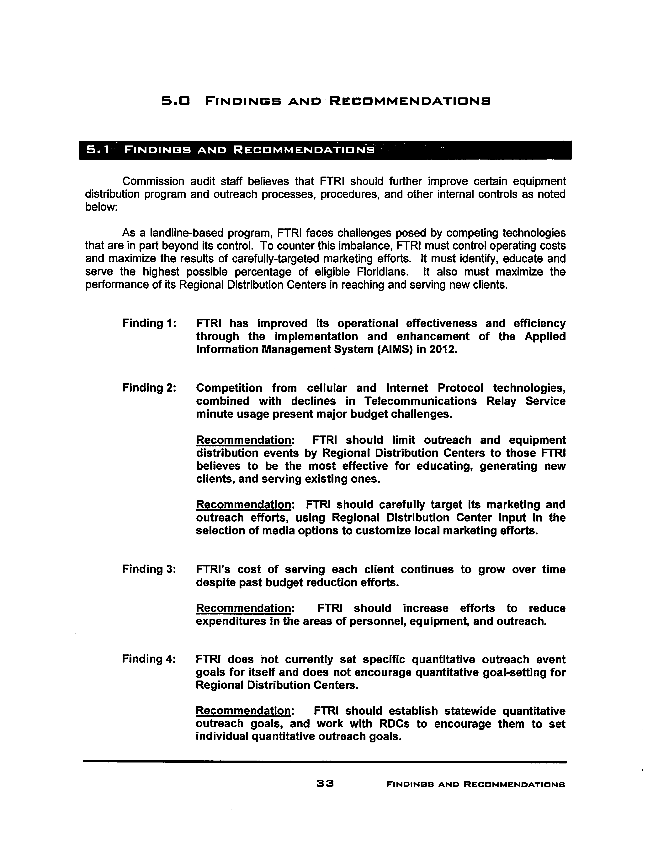
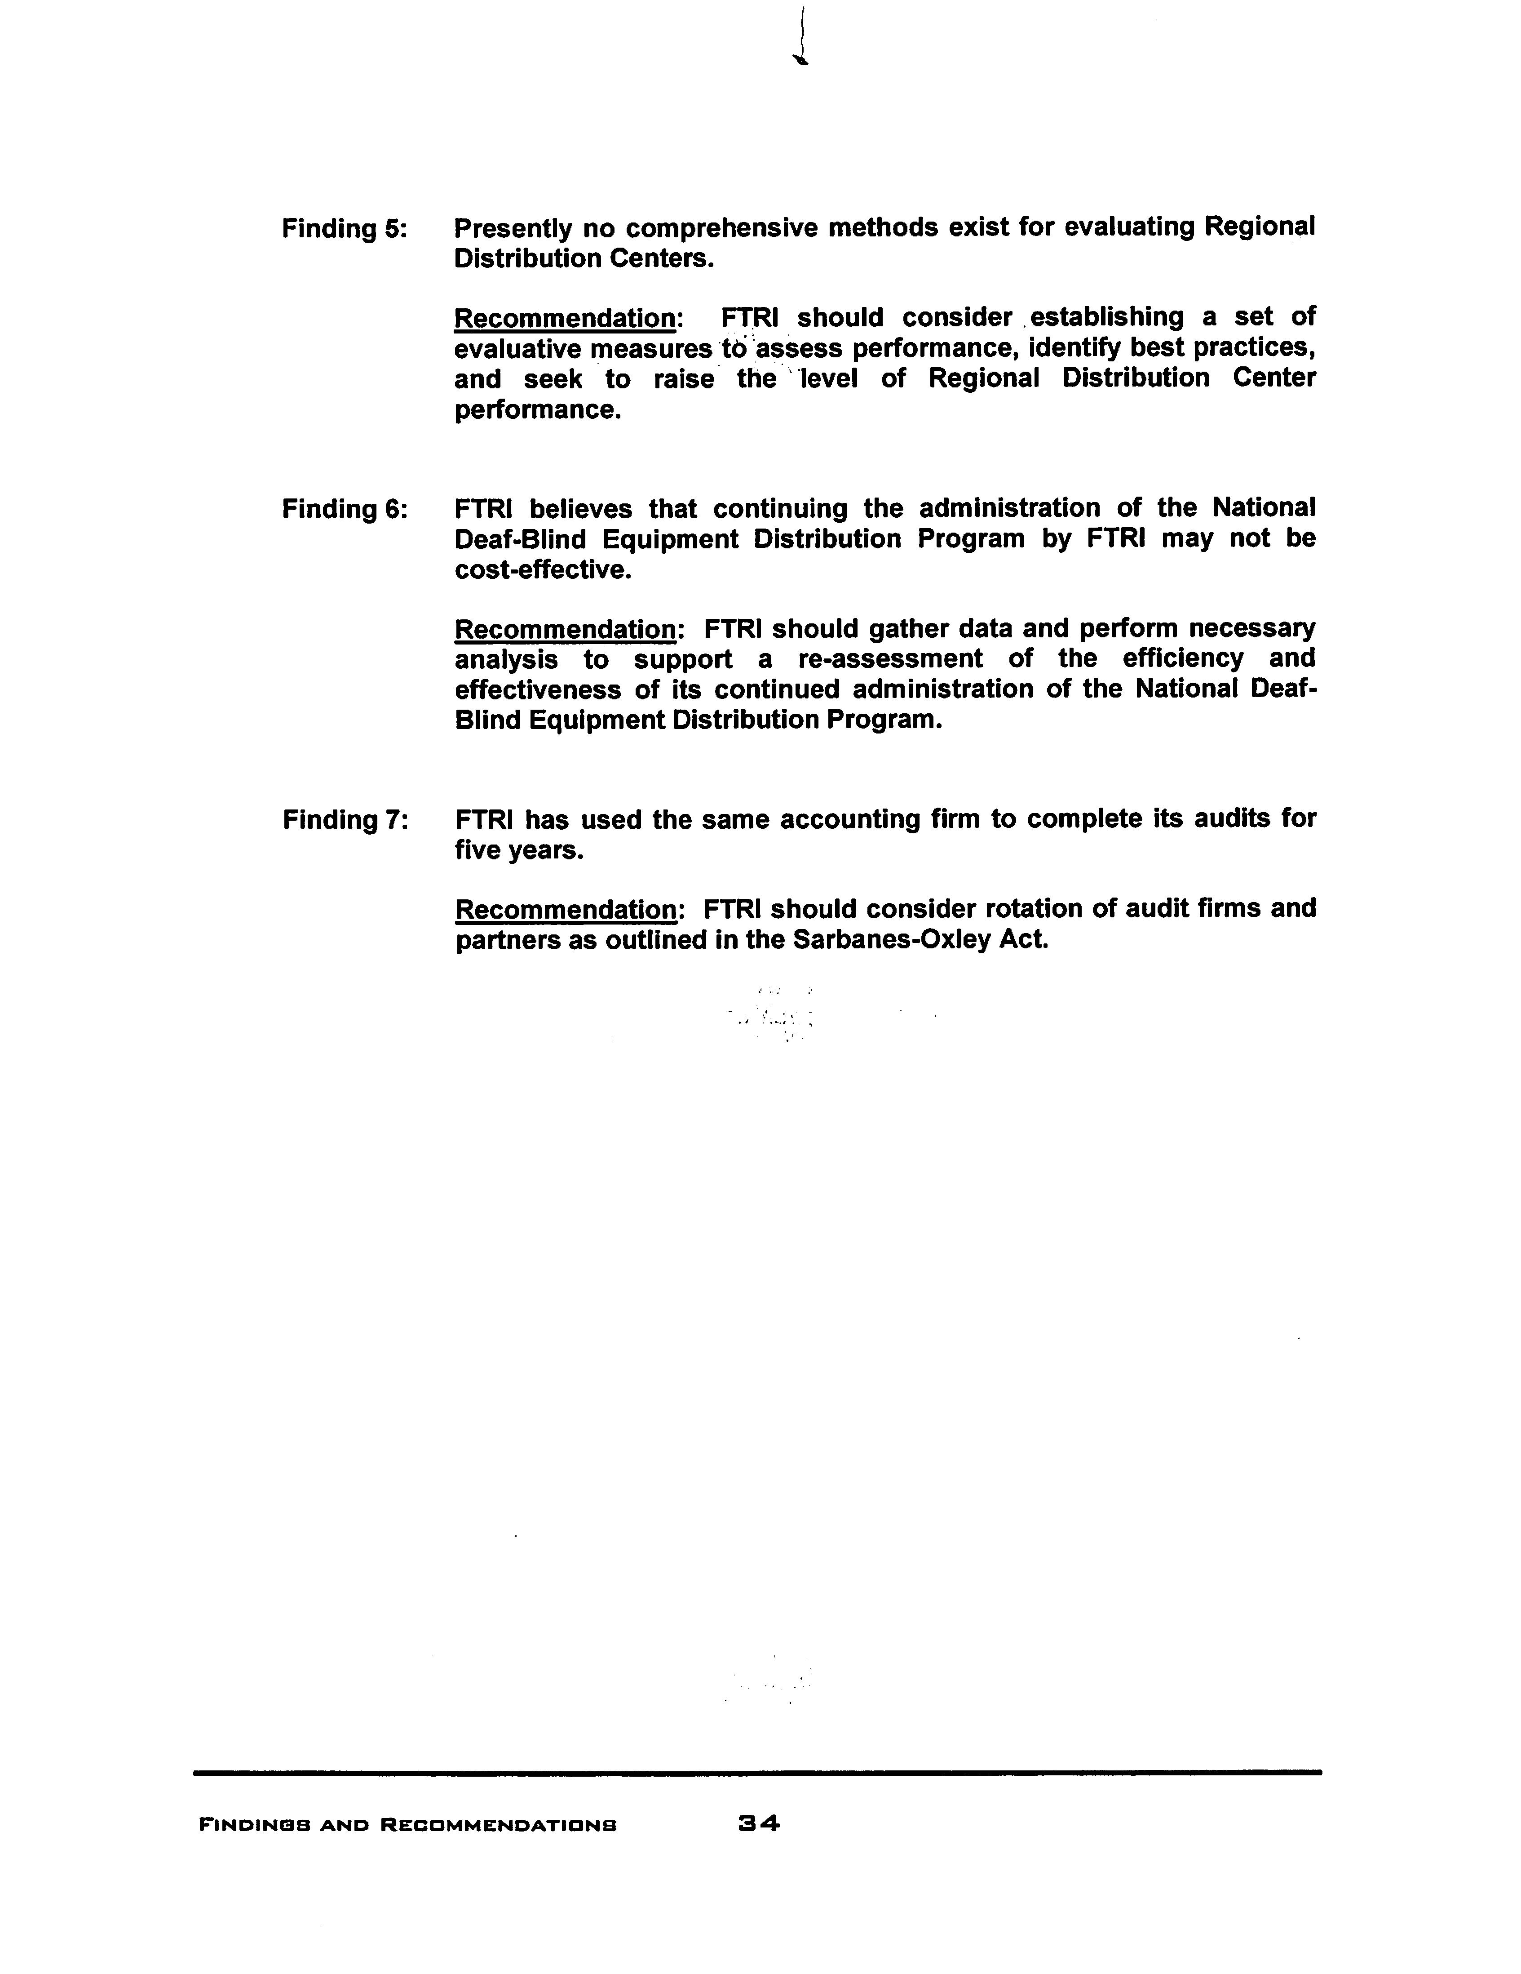

FTRI Budget Options
 |  | 2015/2016 APPROVED BUDGET | 2016/2017 PROPOSED BUDGET | OPTION 1 | OPTION 2 | OPTION 3
REVENUE @ $0.11 @ $0.12 @ $0.12
1 | Surcharge | 8,249,890 | 7,762,706 | 7,297,393 | 7,762,706 | 7,762,706
2 | Interest | 33,941 | 34,188 | 34,188 | 34,188 | 34,188
3 | NDBEDP | 468,749 |  |  |  | -
 | TOTAL OPERATING REV. | 8,752,580 | 7,796,894 | 7,331,581 | 7,796,894 | 7,796,894
4 | Surplus Account | 15,722,595 | 15,983,096
 | TOTAL REVENUE | 24,475,175 | 23,779,990
OPERATING EXPENSES
CATEGORY I - RELAY SERVICES
5 | DPR Provider | 3,971,499 | 3,192,039 | 3,192,039 | 3,192,039 | 3,192,039
 | SUBTOTAL CATEGORY I | 3,971,499 | 3,192,039 | 3,192,039 | 3,192,039 | 3,192,039
CATEGORY II - EQUIPMENT & REPAIRS
6 | TDD Equipment | - | - | - | - | -
7 | Large Print TDD | - | 568 | 568 | - | 568
8 | VCO/HCO-TDD | 720 | 1,150 | 1,150 | 1,533 | 1,150
9 | VCO-Telephone | - | - | - | - | -
10 | Dual Sensory Equipment | 5,000 | 5,000 | 5,000 | - | 5,000
11 | CapTel Phone Equipment | - | - | - | - | -
12 | VCP Hearing Impaired | 1,440,645 | 1,434,745 | 1,291,270 | 1,415,745 | 1,434,745
13 | VCP Speech Impaired | 1,386 | 693 | 693 | 689 | 693
14 | TeliTalk Speech Aid | 18,000 | 15,000 | 10,000 | 7,200 | 15,000
15 | Jupiter Speaker phone | - | - | - | - | -
16 | In Line Amplifier | - | - | - | - | -
17 | ARS-Signaling Equipment | 6,501 | 5,418 | 5,418 | 1,589 | 5,418
18 | VRS-Signaling Equipment | 16,080 | 15,246 | 10,000 | 6,968 | 15,246
19 | Accessories & Supplies | 2,980 | 1,886 | 900 | 481 | 1,886
20 | Telecom Equipment Repair | 199,074 | 141,772 | 141,772 | 89,829 | 141,772
 | SUBTOTAL CAT II | 1,690,386 | 1,621,478 | 1,466,771 | 1,524,034 | 1,621,478

CATEGORY III - EQUPMENT DISTRIBUTION & TRAINING
21 | Freight - Telecomm Equipment | 74,314 | 47,325 | 47,325 | 43,225 | 47,325
22 | Regional Distribution Centers | 978,423 | 901,078 | 810,970 | 981,481 | 901,078
23 | Workshop Expense | - | - | - | - | -
24 | Training Expense for RDCs | 2,000 | 2,000 | 1,200 | 624 | 2,000
 | SUBTOTAL CAT III | 1,054,737 | 950,403 | 859,495 | 1,025,330 | 950,403
CATEGORY IV - OUTREACH
25 | Outreach Expense | 574,626 | 728,300 | 500,000 | 574,626 | 728,300
 | SUBTOTAL CAT IV | 574,626 | 728,300 | 500,000 | 574,626 | 728,300
CATEGORY V - GENERAL AND ADMINISTRATIVE
26 | Advertising | 2,641 | 2,633 | 1,320 | 1,340 | 2,633
27 | Accounting/Audit | 24,896 | 22,300 | 22,300 | 26,140 | 22,300
28 | Legal | 72,000 | 72,000 | 36,000 | 71,400 | 72,000
29 | Consultation-Computer | 23,970 | 15,980 | 8,100 | 7,187 | 15,980
30 | Dues/Subscriptions | 3,034 | 2,798 | 2,798 | 3,439 | 2,798
31 | Office Furniture | 250 | 250 | 250 | - | 250
32 | Office Equipment Purchase | 12,500 | 9,990 | 9,990 | 4,507 | 9,990
33 | Office Equipment Lease | 1,886 | 1,876 | 1,876 | 1,695 | 1,876
34 | Insurance -Health/Life/Disability | 158,262 | 165,735 | 131,649 | 114,077 | 165,735
35 | Insurance-Other | 8,897 | 9,844 | 9,844 | 10,748 | 9,844
36 | Office Expense | 16,524 | 17,496 | 17,496 | 14,197 | 17,496
37 | Postage | 9,917 | 8,124 | 8,124 | 4,489 | 8,124
38 | Printing | 1,537 | 1,295 | 1,295 | 719 | 1,295
39 | Rent | 91,280 | 93,419 | 93,419 | 93,921 | 93,419
40 | Utilities | 5,808 | 5,281 | 5,281 | 5,065 | 5,281
41 | Retirement | 58,575 | 59,694 | 45,462 | 59,101 | 59,694
42 | Employee Compensation | 408,471 | 430,264 | 417,611 | 393,852 | 430,264
43 | Temporary Employment | 8,000 | 10,400 | 1,000 | 9,640 | 10,400
44 | Taxes - Payroll | 32,507 | 32,916 | 31,957 | 29,669 | 32,916
45 | Taxes - Unemployment Comp | 1,863 | 1,663 | 1,663 | 2,012 | 1,663
46 | Taxes - Licenses | 65 | 65 | 65 | - | 65
47 | Telephone | 18,670 | 16,708 | 16,708 | 15,595 | 16,708
48 | Travel & Business Expense | 16,296 | 18,700 | 10,000 | 9,755 | 18,700
49 | Equipment Maintenance | 1,353 | 1,287 | 1,287 | 937 | 1,287
50 | Employee Training | 7,000 | 5,300 | 3,200 | 567 | 5,300
51 | Meeting Expense | 5,733 | 6,871 | 6,871 | 3,641 | 6,871
52 | Miscellaneous | - | - | - | - | -
 | SUBTOTAL CAT V | 991,935 | 1,012,889 | 885,566 | 883,693 | 1,012,889
CATEGORY VI
53 | NDBEDP | 468,749 | - | - | - | -
 | SUBTOTAL CAT VI | 468,749 | - | - | - | -
 | TOTAL EXPENSES | 8,751,932 | 7,505,109 | 6,903,871 | 7,199,422 | 7,505,109
 | REVENUES LESS EXPENSES | 648 | 291,785 | 427,710 | 597,172 | 291,785

2015 Florida Coordinating Council for the Deaf and Hard of Hearing Biennial Report to Governor Rick Scott, the Florida Legislature & the Supreme Court and “Demographics and Statistics,” Florida Telecommunications Relay, Inc., http://ftri.org/index.cfm/go/public.view/page/12, accessed on April 21, 2016.
Florida Telecommunications Relay, Inc. projects a 4 percent decrease in landline access lines subject to the relay surcharge for the budget year 2016/2017.
The NDBEDP, also known as iCanConnect, provides equipment needed to make telecommunications, advanced communications, and the Internet accessible to low-income individuals who have both significant vision loss and significant hearing loss. It was established and funded by the Federal Communications Commission in an effort to comply with the 21st Century Video and Communications Accessibility Act, a federal law that requires people with disabilities to have access to modern communications technology that enables distance communication.
IP Relay allows people who have difficulty hearing or speaking to communicate through an Internet connection using a computer and the Internet, rather than a TTY and a telephone.
Video Relay Service is a form of Telecommunications Relay Service that enables persons with hearing disabilities who use American Sign Language to communicate with voice telephone users through video equipment, rather than through typed text. Video equipment links the VRS user with a TRS operator so that the VRS user and the operator can see and communicate with each other in signed conversation. Because the conversation between the VRS user and the operator flows much more quickly than with a text-based TRS call, VRS has become a popular form of TRS.
A telephone that displays real-time captions of a conversation. The captions are typically displayed on a screen embedded into the telephone base.
IP captioned telephone service allows the user to simultaneously listen to, and read the text of, what the other party in a telephone conversation has said, where the connection carrying the captions between the service and the user is via an IP addressed and routed link.
Speech-to-Speech (STS) relay service utilizes a specially trained CA who understands the speech patterns of persons with speech disabilities and can repeat the words spoken by such an individual to the other party to the call. IP STS uses the Internet, rather than the public switched telephone network, to connect the consumer to the relay provider. Instead of using a standard telephone to make the relay call, an IP STS user can use a personal computer or personal digital assistant (PDA) device and, with the installation of softphone application software, can make a voice call via the Internet to the relay provider. The call is initiated by the user clicking on an icon on his or her computer or PDA; the relay user is then connected to a CA over the Internet and tells the CA the number to be dialed; the CA then connects the IP STS user with the called party and relays the call between the two parties.
National Deaf Blind Equipment Distribution Program.
The Federal Communications Commission may mandate state funding of Video Relay Service, Internet Protocol Relay Service, and Internet Protocol Captioned Telephone Service. It is estimated that at a minimum $32 million would be needed to adequately fund the state program. The Commission, by Order PSC-06-0469-PAA-TP, issued June 1, 2006, in Docket No. 040763-TP, maintained the Florida Telecommunications Relay Service surcharge at $0.15/month for one year in lieu of a surcharge reduction, to prepare the state Telecommunications Relay Service Fund for assuming intrastate costs of Video Relay Service and Internet Protocol Relay, and to allow time to determine how the costs should be recovered should the need arise.
VCP Hearing Impaired Equipment – Volume Control Telephones for individuals who are hard of hearing.
TeliTalk Speech Aid Equipment – Allows an individual with a Laryngectomee to speak on the phone using a built in speech aid.
VRS-Signaling Equipment – Video telephone that allows individuals to communicate via a sign language interpreter.
$0.11 was used for ten months and $0.12 was used for two months

