State of Florida   |  | Public Service Commission  Capital Circle Office Center ● 2540 Shumard Oak Boulevard  Tallahassee, Florida 32399-0850  -M-E-M-O-R-A-N-D-U-M-
DATE: | September 29, 2016
TO: | Office of Commission Clerk (Stauffer)
FROM: | Division of Engineering (Lewis, King)  Division of Economics (Bruce)  Office of the General Counsel (Janjic, Crawford)
RE: | Docket No. 130209-SU – Application for expansion of certificate (CIAC) (new wastewater line extension charge) by North Peninsula Utilities Corp.
AGENDA: | 10/11/16 – Regular Agenda – Proposed Agency Action for Issue 2 – Interested Persons May Participate
COMMISSIONERS ASSIGNED: |  |  | All Commissioners
PREHEARING OFFICER: |  |  | Edgar
CRITICAL DATES: |  |  | None
SPECIAL INSTRUCTIONS: |  |  | None

Case Background
North Peninsula Utilities Corporation (NPUC or Utility) is a Class B utility, which provides wastewater service to 569 customers in Volusia County. The City of Ormond Beach provides water to the area. NPUC’s 2015 Annual Report lists operating revenues of $221,963 and a net operating income of $3,600. NPUC bought the assets of Shore Utility Corp. in 1989 and filed five subsequent territory amendments, which were all approved by the Commission. On August 2, 2013, the Utility filed an application to amend its wastewater certificate, pursuant to Section 367.045, Florida Statutes (F.S.), and Rule 25-30.036, Florida Administrative Code (F.A.C.). In addition, the Utility requested implementation of a main extension charge and a flat rate adjustment of three percent per year to monthly rates for five years. On November 4, 2013, NPUC withdrew its request for the flat rate adjustment. Staff identified several deficiencies in the certificate amendment filing and met with the Utility’s representatives. At that meeting, it was disclosed that there were potential objections to the territory amendment by Volusia County and the City of Ormond Beach. As such, the processing of the application was put on hold.

On March 10, 2014, the Utility filed a revised application to amend its service territory based upon negotiations with the City of Ormond Beach and Volusia County. The revised application included less territory than its original filing and a proposed tariff for a $795 main extension charge. Pursuant to Order No. PSC-14-0273-PCO-SU, issued May 29, 2014, the Commission suspended the proposed tariff to allow staff sufficient time to review all pertinent information. On July 21, 2014, NPUC filed additional information to address the deficiencies previously identified by staff. On October 20, 2014, NPUC representatives met with staff to discuss the amended application and on January 13, 2015, NPUC filed supplemental information to address staff’s concerns.

On April 2, 2015, staff filed a written recommendation that:

- NPUC’s revised application be denied because the application failed to demonstrate a need for service in the territory requested.
- Denial of the application obviated the need for a main extension charge.
- The service availability policy should be revised to reflect that there are no service availability charges because the plant is fully depreciated.

On April 3, 2015, NPUC requested that the item be deferred from the April 16, 2015 Commission Conference so that representatives of the Utility could again meet with staff. The deferral was granted and a noticed informal meeting was convened on April 20, 2015. At that meeting, NPUC informed staff that it was removing certain areas from the previously filed request for territory expansion, abandoning its three-phased approach to expanding the territory, and withdrawing its request for a main extension charge. A map outlining the changes in territory was provided at the meeting, and on May 26, July 24, and August 27, 2015, additional data was filed by the Utility.

On October 22, 2015, staff filed a written recommendation that recommended denial of NPUC’s application for the same reasons described in the April 2, 2015 recommendation. On November 5, 2015, the Commission deferred staff’s recommendation to allow the Utility to reevaluate its plan to provide service to the requested areas. On February 10, 2016, NPUC again revised its plan. The February 10, 2016, revision removed certain areas from its original request. The filing also contained cost estimates to serve the remaining areas for which the Utility seeks to serve. Accurate legal descriptions for the proposed annexed areas were provided to staff on June 28, 2016. This recommendation addresses NPUC’s application as modified on February 10, 2016. The Commission has jurisdiction pursuant to Section 367.045, F.S.

Discussion of Issues

Issue 1:
Should North Peninsula Utilities Corporation’s proposed territory amendment be approved?

Recommendation:
Yes in part and no in part. It is in the public interest to amend wastewater certificate number 249-S to include the territory as described in Attachment A, with the exception of the addition identified as Area 4 (i.e., Capri Drive), effective the date of the Commission’s vote. The resultant order should serve as NPUC’s amended certificate and should be retained by the Utility. If the Commission agrees with staff’s recommendation, the Utility should revise its territorial description to exclude Area 4 and file the revision within ten (10) days of the Commission’s vote. (Bruce, Janjic, Lewis)

Staff Analysis:
Based on NPUC’s application to amend its authorized service territory as well as additional information provided by the Utility staff believes that NPUC is in compliance with the governing statute, Section 367.045, F.S., and Rule 25-30.036, Florida Administrative Code (F.A.C.), Application for Amendment to Certificate of Authorization to Extend or Delete Service Area. The application contains proof of compliance with the noticing provisions set forth in Rule 25-30.030, F.A.C, Notice of Application and of Customer Meeting. No objections to the application have been received and the time for filing such has expired. Adequate service territory maps and territory descriptions have also been provided.
NPUC currently provides wastewater service in the north peninsula area of Volusia County pursuant to wastewater certificate number 249-S. NPUC’s 2016 Application identifies seven (7) distinct areas to be annexed. Service availability charges for each of the seven areas are discussed in Issue 2. Attachment A to this recommendation provides an illustration of NPUC’s proposed territory expansion as well as a brief description of each territory.
Rule 25-30.036, F.A.C., requires a utility to provide a statement showing the need for service in the area requested. All residences in the territory NPUC seeks to serve currently have wastewater treatment in place, either by privately owned and maintained septic tanks or existing wastewater treatment (package) plants.
Staff’s previously filed recommendations, addressing NPUC’s application, recommended that the Commission deny the Utility’s application because the Utility failed to demonstrate a need for service in the territory requested. Specifically, staff was concerned that the existing residents, in the territory NPUC seeks to add, likely would not connect to NPUC’s system unless required by the county. Staff’s October 22, 2015, recommendation states:
Staff believes that as long as the county continues to issue permits for replacement and repair of existing wastewater treatment systems and mandatory interconnection is not required, customers are highly unlikely to voluntarily connect to NPUC’s system....Without an enforced mandatory interconnection, a customer is unlikely to abandon a functioning septic system to connect to NPUC.

On December 22, 2015, the Volusia County Commission revised its ordinances to mandate connection to a municipal or privately owned wastewater provider when the facilities become available. The ordinance further requires residents to connect within five years of installation of wastewater facilities. Giving consideration to the revised ordinance, staff believes NPUC has reasonably demonstrated a need for service in the areas requested.
In the previous recommendation, staff had concerns regarding the vague conditions for obtaining service in certain areas that NPUC was seeking to serve. The Utility was advocating that individual customer service requests would be evaluated and the customer may or may not have to pay for the collection lines depending on the situation or facilities required. Another of staff’s concerns was that NPUC’s plan appeared to expect customers living along the interior streets between John Anderson Drive and Ocean Shores Blvd (A1A), wishing to connect, to pay for the construction of collection lines. NPUC’s request, as amended on February 10, 2016, no longer contains the areas discussed above. Therefore, the Utility’s amendment appears to mitigate staff’s prior concerns.
As previously discussed, NPUC is proposing service expansion in seven distinct areas. One of the areas that NPUC is proposing to serve consists of 55 homes/lots and is located on Capri Drive. This area is identified as Area 4 in Attachment A. Volusia County constructed a wastewater main along Capri Drive that is currently not in use. Upon confirmation of a service request within the specified area, NPUC proposed to install a new lift station with a grinder pump and connect it to the existing wastewater main.
Staff recommends denial of the addition of Area 4 because NPUC has not provided documentation showing that Volusia County would permit NPUC access to the existing wastewater main on Capri Drive. NPUC states that an agreement concerning the Capri Drive facilities cannot be finalized until Capri Drive lies within the territory of NPUC. Approving extension to Area 4 could lead to a situation in which the Utility would be required to serve customers with infrastructure that it may not be permitted to access. Under such a scenario NPUC may not be able to adequately address customer concerns or quality of service issues that are associated with the wastewater main. Therefore, staff recommends that the Commission deny the addition of Area 4.
The Utility provided analysis as well as an engineer’s statement to demonstrate that the Utility has adequate capacity to serve the additional territory. Based on the analysis provided, more than 60 percent of NPUC’s wastewater treatment plant is available to serve future customers. Staff believes that the documentation provided by the Utility adequately demonstrates that NPUC has sufficient plant capacity to serve the additional territory. Additionally, at this time there does not appear to be any outstanding Consent Orders or Notices of Violation from DEP associated with NPUC’s wastewater treatment plant.

Conclusion
Based on the information above, staff recommends it is in the public interest to amend wastewater certificate number 249-S to include the territory as described in Attachment A, with the exception of the addition identified as Area 4 (i.e., Capri Drive), effective the date of the Commission’s vote. The resultant order should serve as NPUC’s amended certificate and should be retained by the Utility. If the Commission agrees with staff’s recommendation, the Utility should revise its territorial description to exclude Area 4 and file the revision within ten (10) days of the Commission’s vote.

Issue 2:
What are the appropriate service availability charges for NPUC?

Recommendation:
New customers requesting service should be required to either install the mains necessary to connect to the Utility and donate those lines to the Utility, or the Utility may extend the required lines and collect a main extension charge based on whether a road crossing and force main are required. A main extension charge associated with a road crossing of $762 per equivalent residential connection (ERC) and a main extension charge with no road crossing of $444 per ERC should be approved. The recommended main extension charges should be based on an estimated 250 gallons per day per ERC of treated wastewater demand. Also, staff recommends a force main extension charge of $1.25 per linear foot where the Utility will need to extend its force main to provide service. The Utility should be required to file tariffs reflecting the revised service availability policy and charges. The approved service availability policy and charges should be effective for connections made on or after the stamped approval date of the tariff pursuant to Rule 25-30.475, F.A.C. (Bruce)

Staff Analysis:
As mentioned earlier, NPUC is requesting authority to add seven service areas to its existing territory, which are referred to as proposed service areas 1, 2, 3A, 3B, 3C, 4, and 5. However, as discussed in Issue 1, staff recommended proposed service Area 4 not be approved. The proposed service areas include properties with small package plants, septic tanks, and vacant lots. In addition, the Utility’s existing service territory includes an undeveloped eight-acre parcel of land.

Currently, the Utility does not have an approved plant capacity or main extension charge. The Utility’s plant capacity charge was eliminated in a prior docket, because continued collection would have resulted in a contribution level at build out in excess of the 75 percent maximum guideline, pursuant to Rule 25-30.580, F.A.C. All collection lines needed to serve the existing service territory are installed with the exception of the eight-acre parcel. In addition, all of the collection system is contributed property and is fully depreciated. The Utility’s existing service availability policy provides that in instances where the Utility undertakes the installation of collection lines, in lieu of the developer’s installation of such facilities, such installation will be at the cost and expense of the developer. The Utility will provide laterals for wastewater service to the developer’s lot line ready for a plumber’s “hook-up.” The Utility’s practice has been to connect new customers without charge for the installation of the service line to the Utility’s collection system when a vacant lot is developed.

Rule 25-30.580, F.A.C., establishes guidelines for designing service availability charges. Pursuant to the rule, the maximum amount of contributions-in-aid-of construction (CIAC), net of amortization, should not exceed 75 percent of the total original cost, net of accumulated depreciation, of the Utility’s facilities and plant when the facilities and plant are at their designed capacity. The minimum amount of CIAC should not be less than the percentage of such facilities and plant that is represented by the water transmission and distribution system or wastewater collection system.

The Utility originally proposed a main extension charge of $795, but the request was withdrawn as a result of a revised filing. In the Utility’s recent filing, the Utility provided the incremental cost that would be incurred in order to provide service to each of the respective proposed service areas as shown below in Table 2-1. However, the Utility did not propose any service availability charges that correspond to the incremental cost.

Table 2-1
Estimated Main Extension Costs
 | Service Area | Estimated Cost | Number Connections
1 | Kingston Shores Condominiums | $150,000 | 106
2 | John Anderson Drive (Ormond Beach Plaza) | $13,100 | 10
3A | John Anderson Drive (Seabridge) | $8,200 | 6
3B | Mid John Anderson Drive | $13,500 | 26
3C | Southerly John Anderson Drive | $13,800 | 18
5 | Fairwinds Shores Condominiums | $72,000 | 102
Source: Document No. 008676-16

Service to customers in the proposed service areas will require installation of force mains and laterals. In some areas, a single main extension is needed to connect a particular property; however, in areas where there are single family homes or duplexes, a main extension may serve multiple properties. In December of 2015, Volusia County enacted an ordinance that requires mandatory connection to municipal or investor owned wastewater facilities within five years when such facilities become available. At this time, the Utility is not investing in the proposed infrastructure until there is request for service. Requests for service may either not materialize in any particular proposed service area or come at varying times.

Staff believes it is appropriate to recommend a main extension charge for future connections in areas where a single main extension may serve multiple properties. This will allow those customers to pay their pro rata share of the average cost of the infrastructure needed to provide service to their property. In order to determine the appropriate main extension charge, staff evaluated the Utility’s estimated costs to extend service. Staff determined that there are several scenarios under which service may be provided to the respective service areas. Service may be provided either with or without a road crossing to a force main. In some instances, the Utility may need to install an additional force main to provide service. As result, staff determined the average cost of the main extension charge with a road crossing and one without a road crossing. In addition, staff calculated a per linear foot force main charge. Typically, staff would develop a single main extension charge per connection that would reflect the pro rata share of the cost of the lines. However, the circumstances of the amendment are unique because of the uncertainty of the need for the service and the disparity in the cost to provide service to each distinct area. As a result, staff believes that a more reasonable approach is to design a main extension charge that would allow those customers to pay their pro rata share of the average cost of the infrastructure needed to provide service to their property.

Based on the above, staff recommends that, consistent with the guidelines in Rule 25-30.580, F.A.C., new customers requesting service should either install the mains necessary to connect to the Utility and donate those lines to the Utility or, the Utility may extend the required lines and collect a main extension charge based on whether a road crossing is required. A main extension charge associated with a road crossing of $762 per ERC and a main extension charge with no road crossing of $444 per ERC should be approved. The recommended main extension charges should be based on an estimated 250 gallons per day of treated wastewater demand. Also, staff recommends a force main extension charge of $1.25 per linear foot, based on the average cost per connection, where the Utility will need to extend its force main to provide service.

Summary
New customers requesting service should be required to either install the mains necessary to connect to the Utility and donate those lines to the Utility or, the Utility may extend the required lines and collect a main extension charge based on whether a road crossing and force main are required. A main extension charge associated with a road crossing of $762 per ERC and a main extension charge with no road crossing of $444 per ERC should be approved. The recommended main extension charges should be based on an estimated 250 gallons per day per ERC of treated wastewater demand. Also, staff recommends a force main extension charge of $1.25 per linear foot, based on the average cost per connection, where the Utility will need to extend its force main to provide service. The Utility should be required to file tariffs reflecting the revised service availability policy and charges. The approved service availability policy and charges should be effective for connections made on or after the stamped approval date of the tariff pursuant to Rule 25-30.475, F.A.C .

Issue 3:
Should this docket be closed?

Recommendation:
If no person whose substantial interests are affected by the proposed agency action files a protest within 21 days of the issuance of the order, a consummating order should be issued, and the docket should remain open for staff’s verification that the revised tariff sheets have been filed by the Utility and approved by staff. If a protest is filed within 21 days of the issuance of the Order, the tariff should remain in effect subject to refund pending the resolution of the protest, and the docket should remain open. (Janjic)

Staff Analysis:
If no person whose substantial interests are affected by the proposed agency action files a protest within 21 days of the issuance of the order, a consummating order should be issued, and the docket should remain open for staff’s verification that the revised tariff sheets have been filed by the Utility and approved by staff. If a protest is filed within 21 days of the issuance of the Order, the tariff should remain in effect subject to refund pending the resolution of the protest, and the docket should remain open.

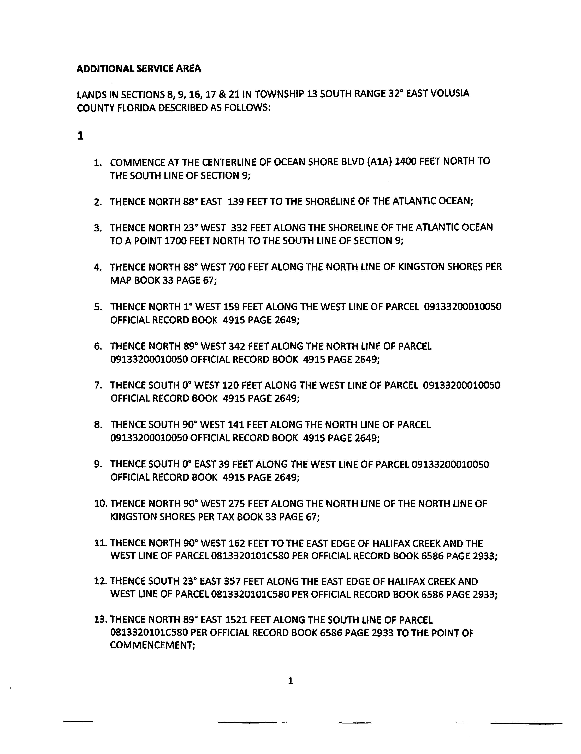

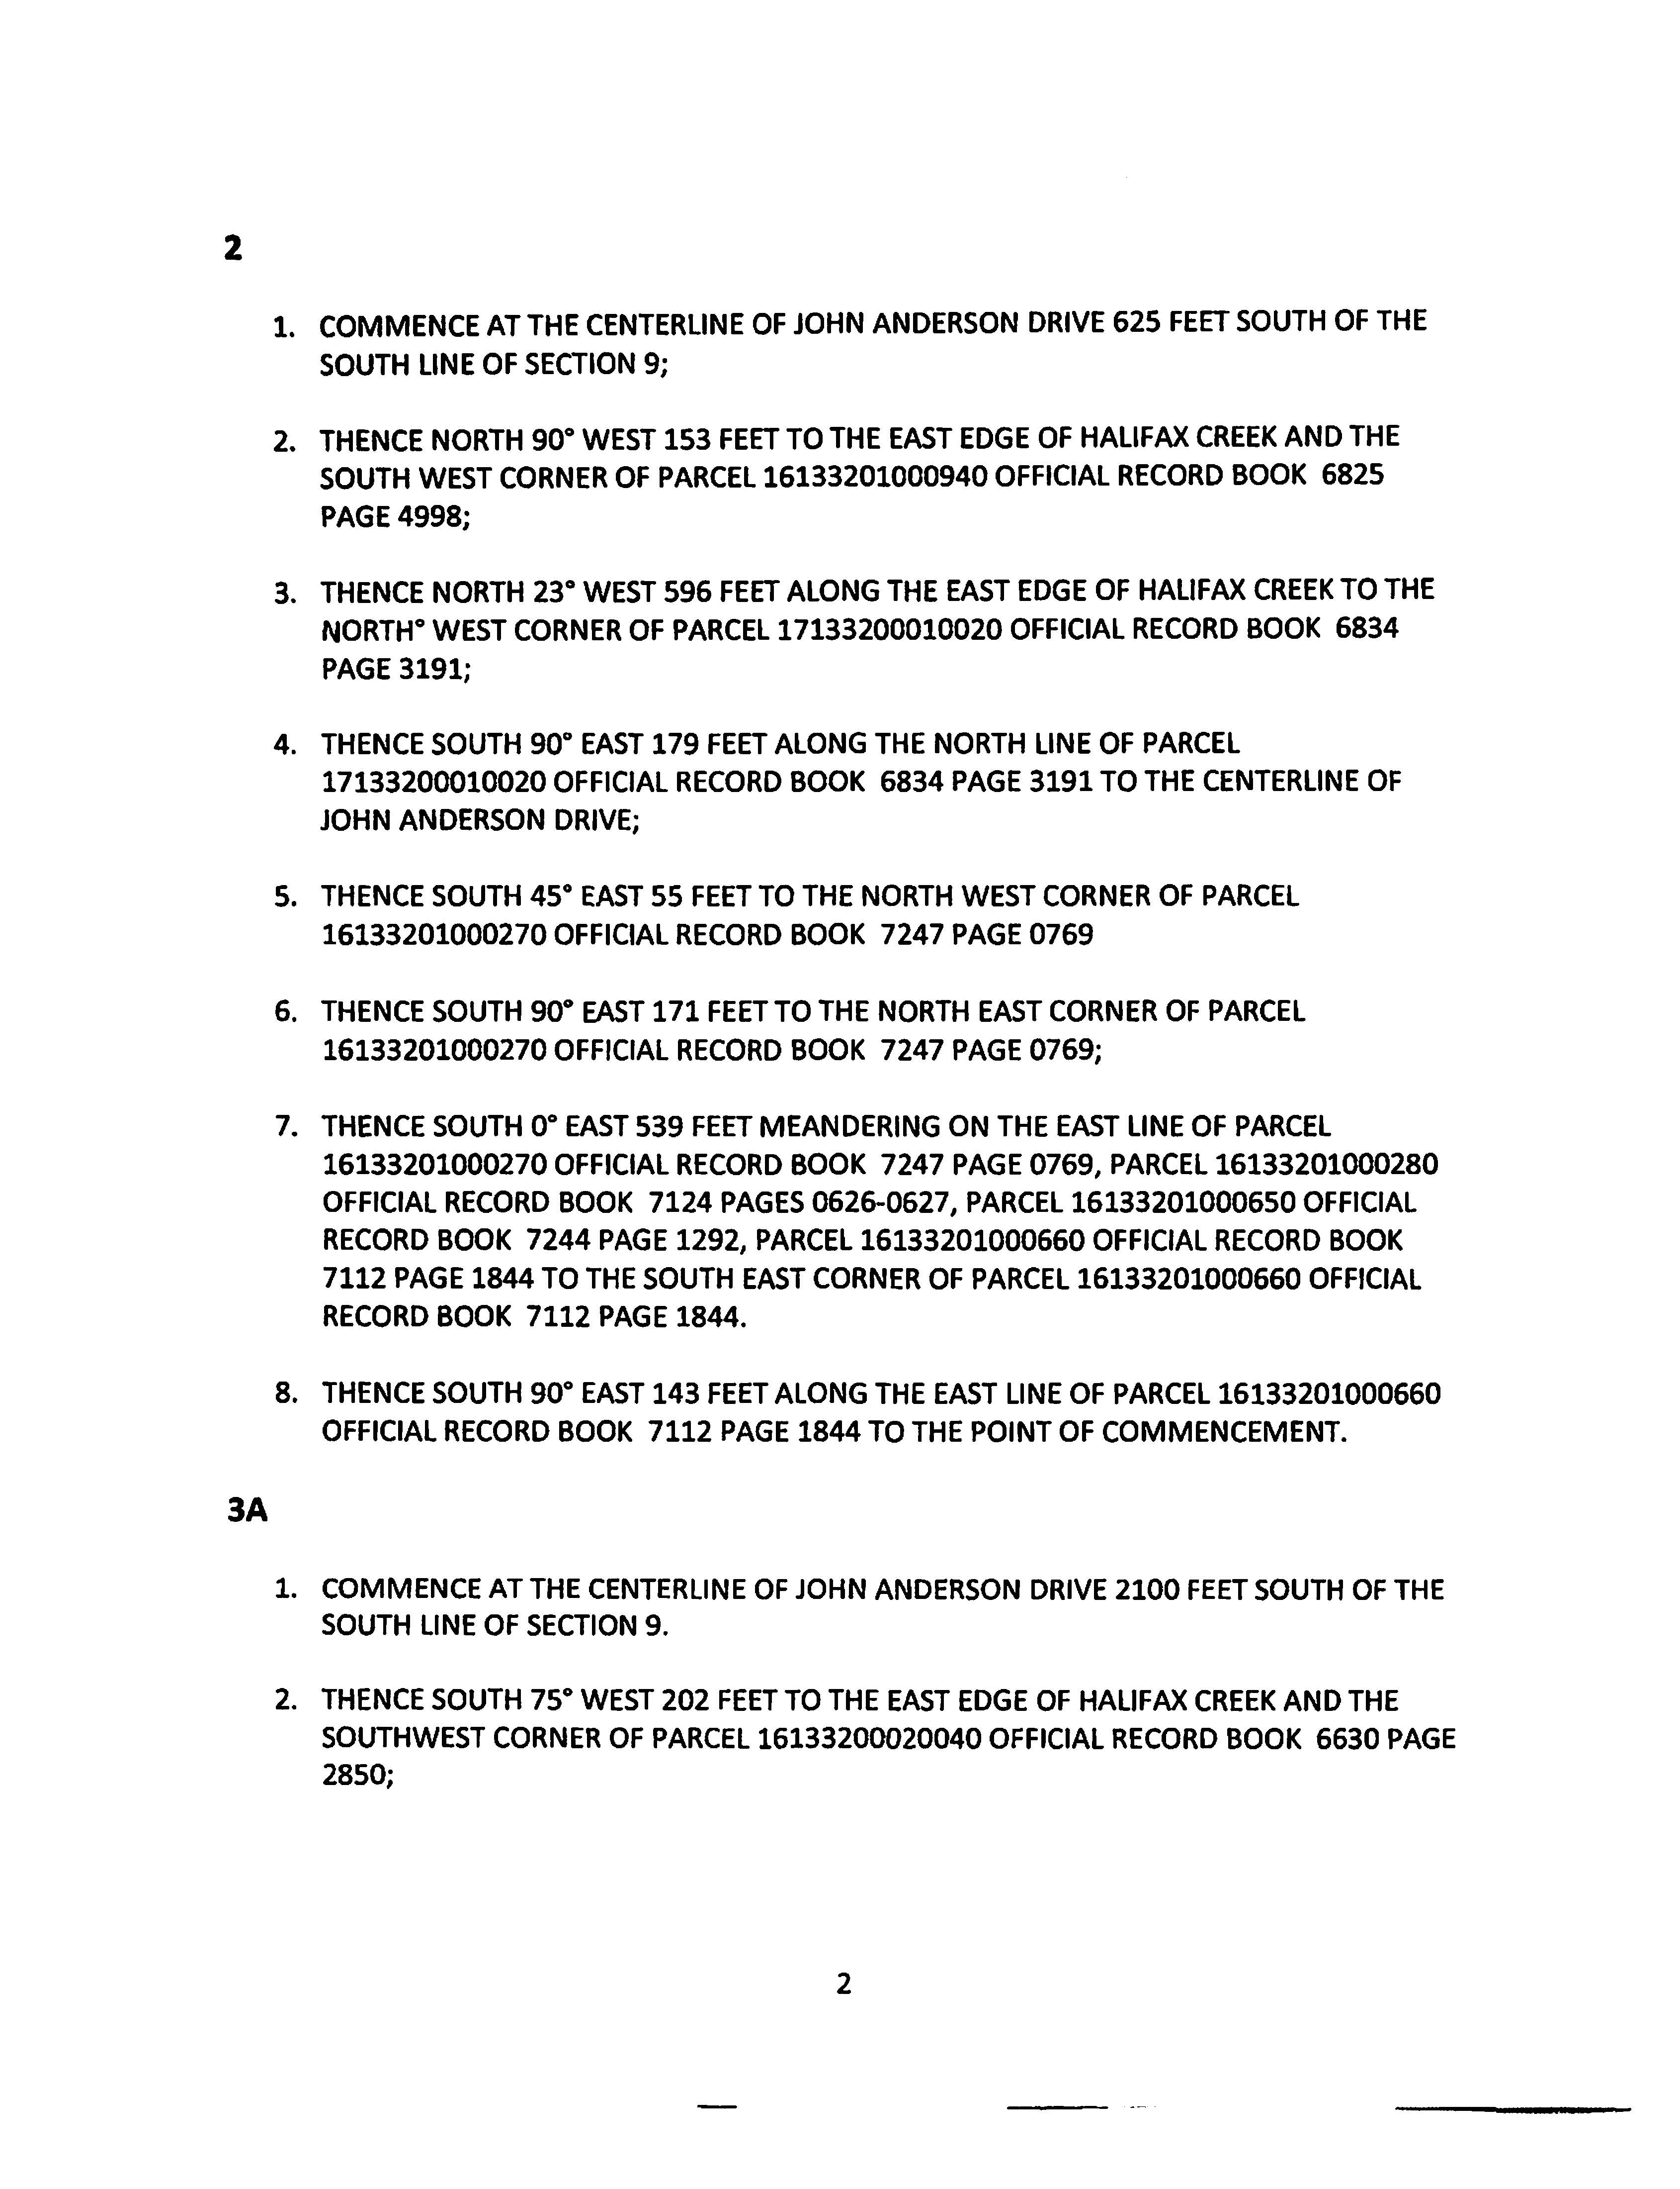

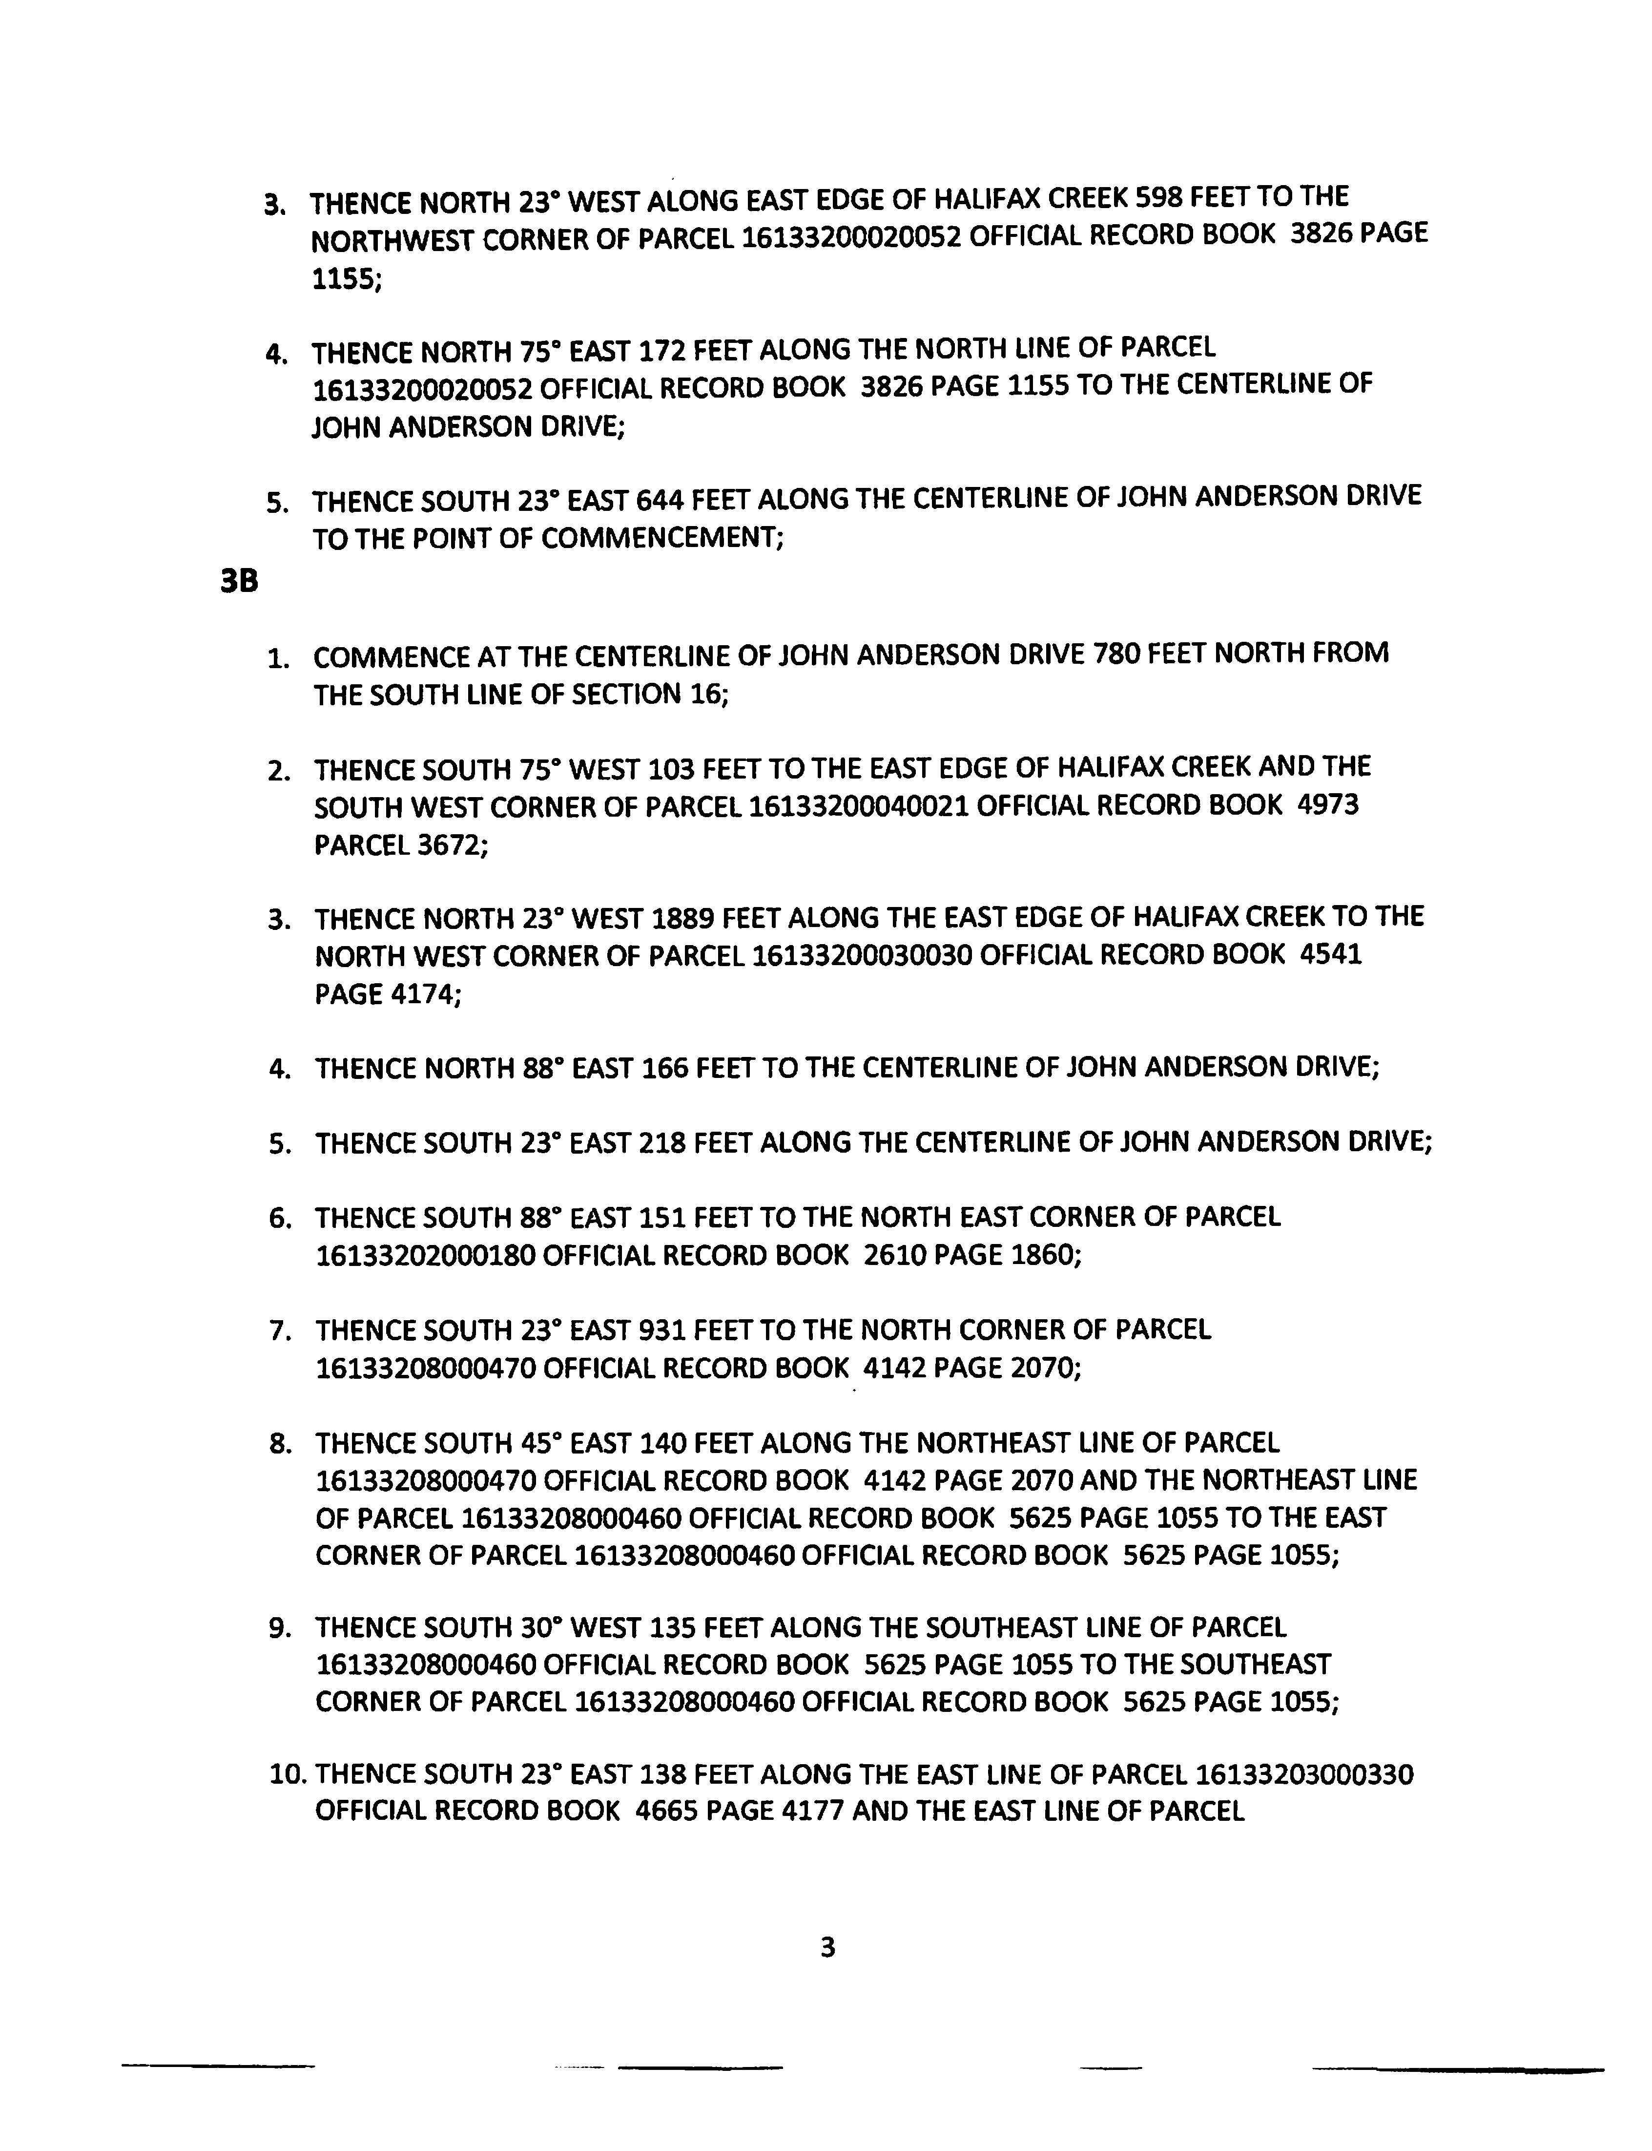

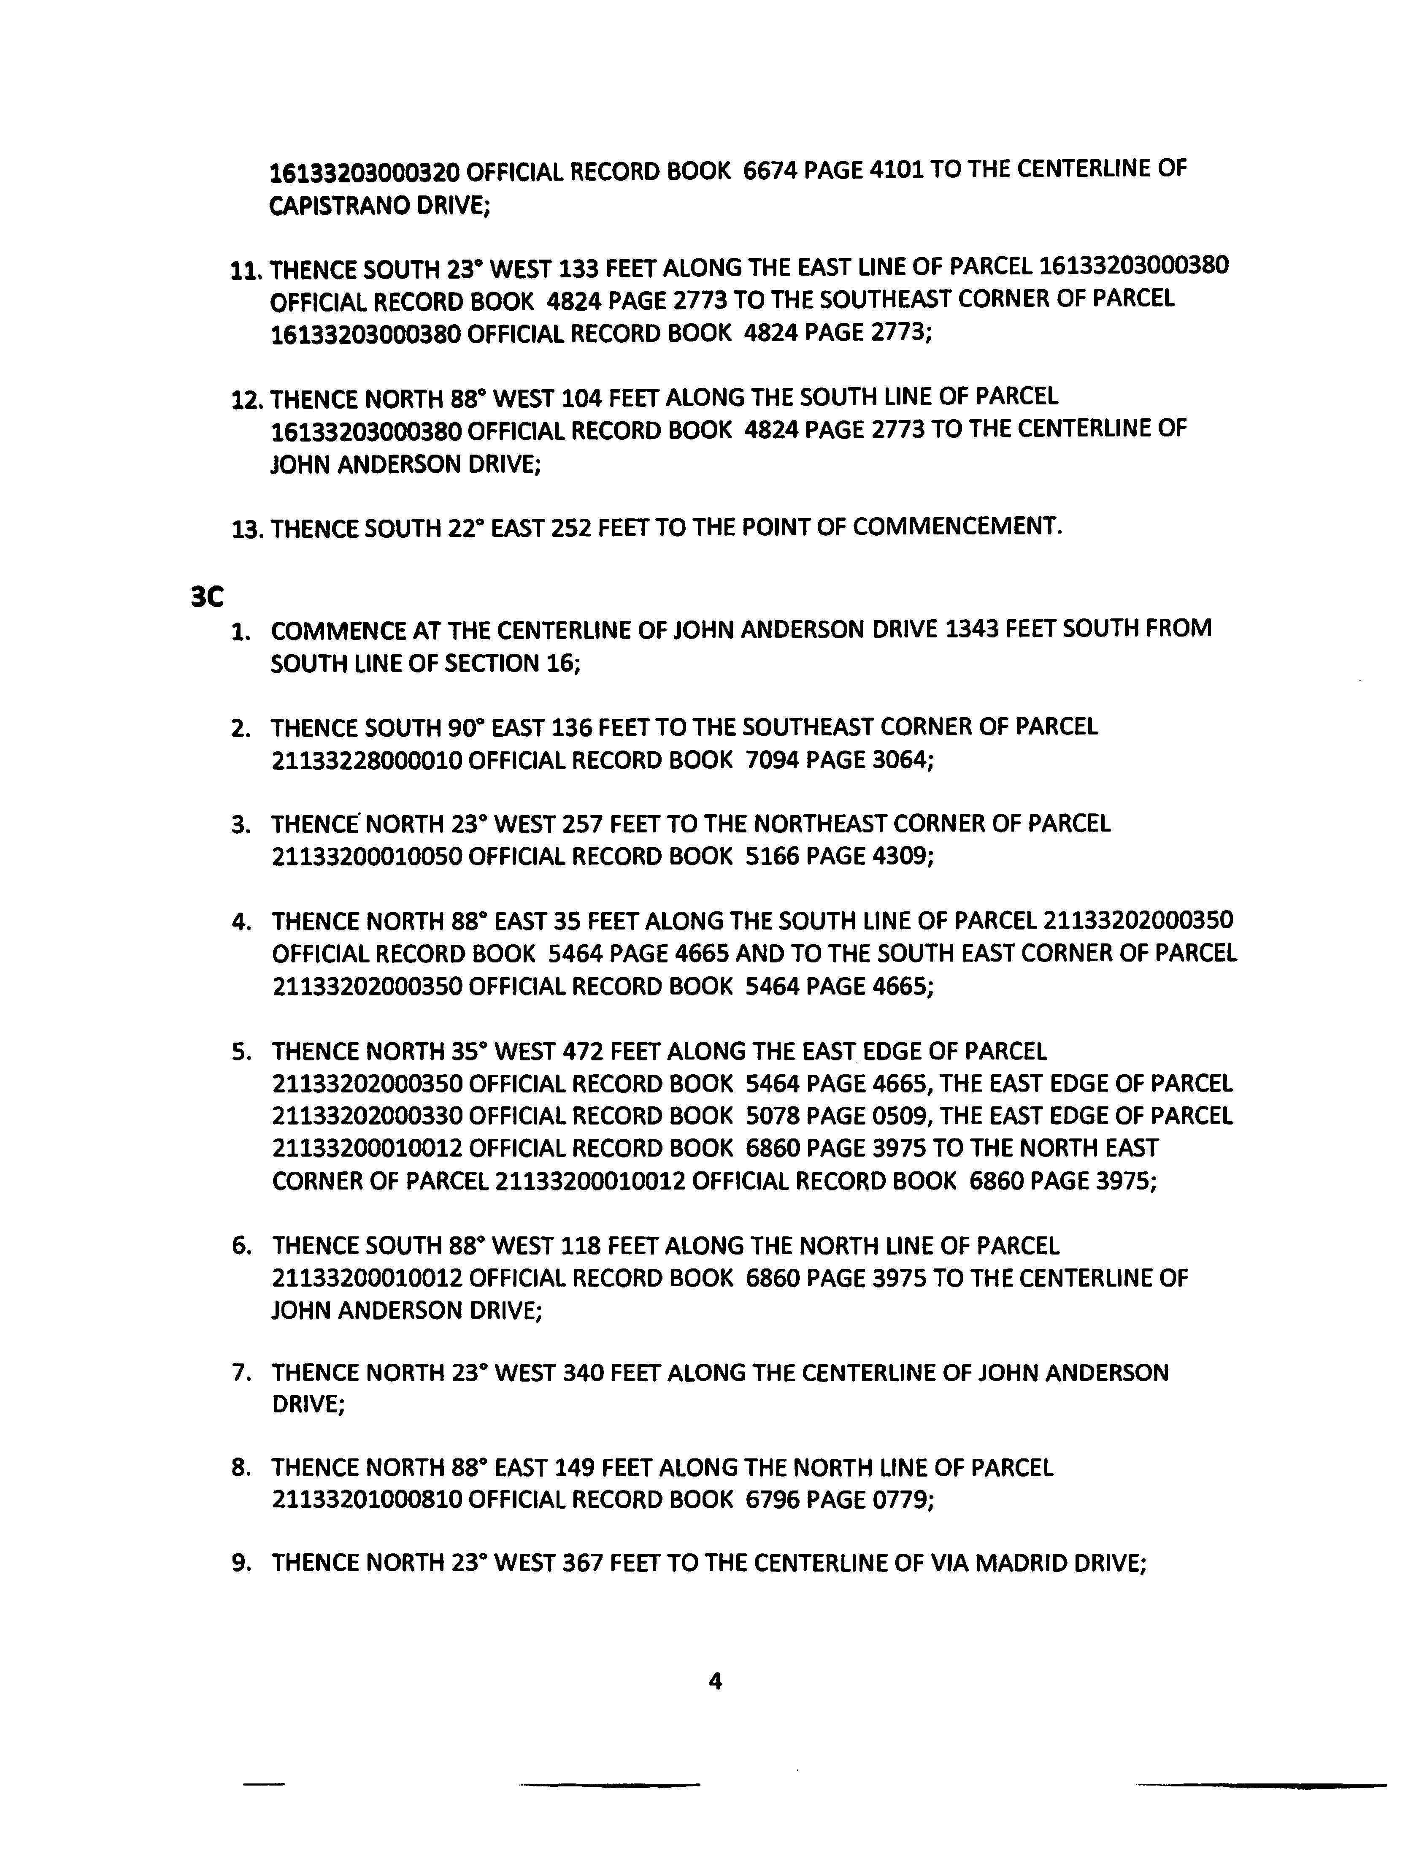

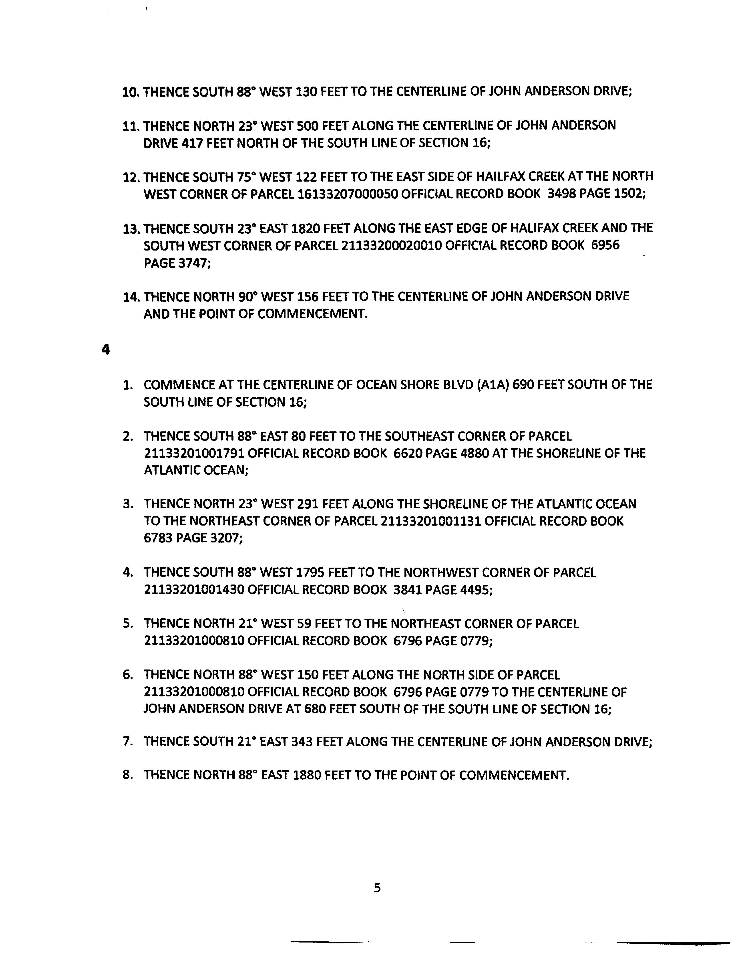

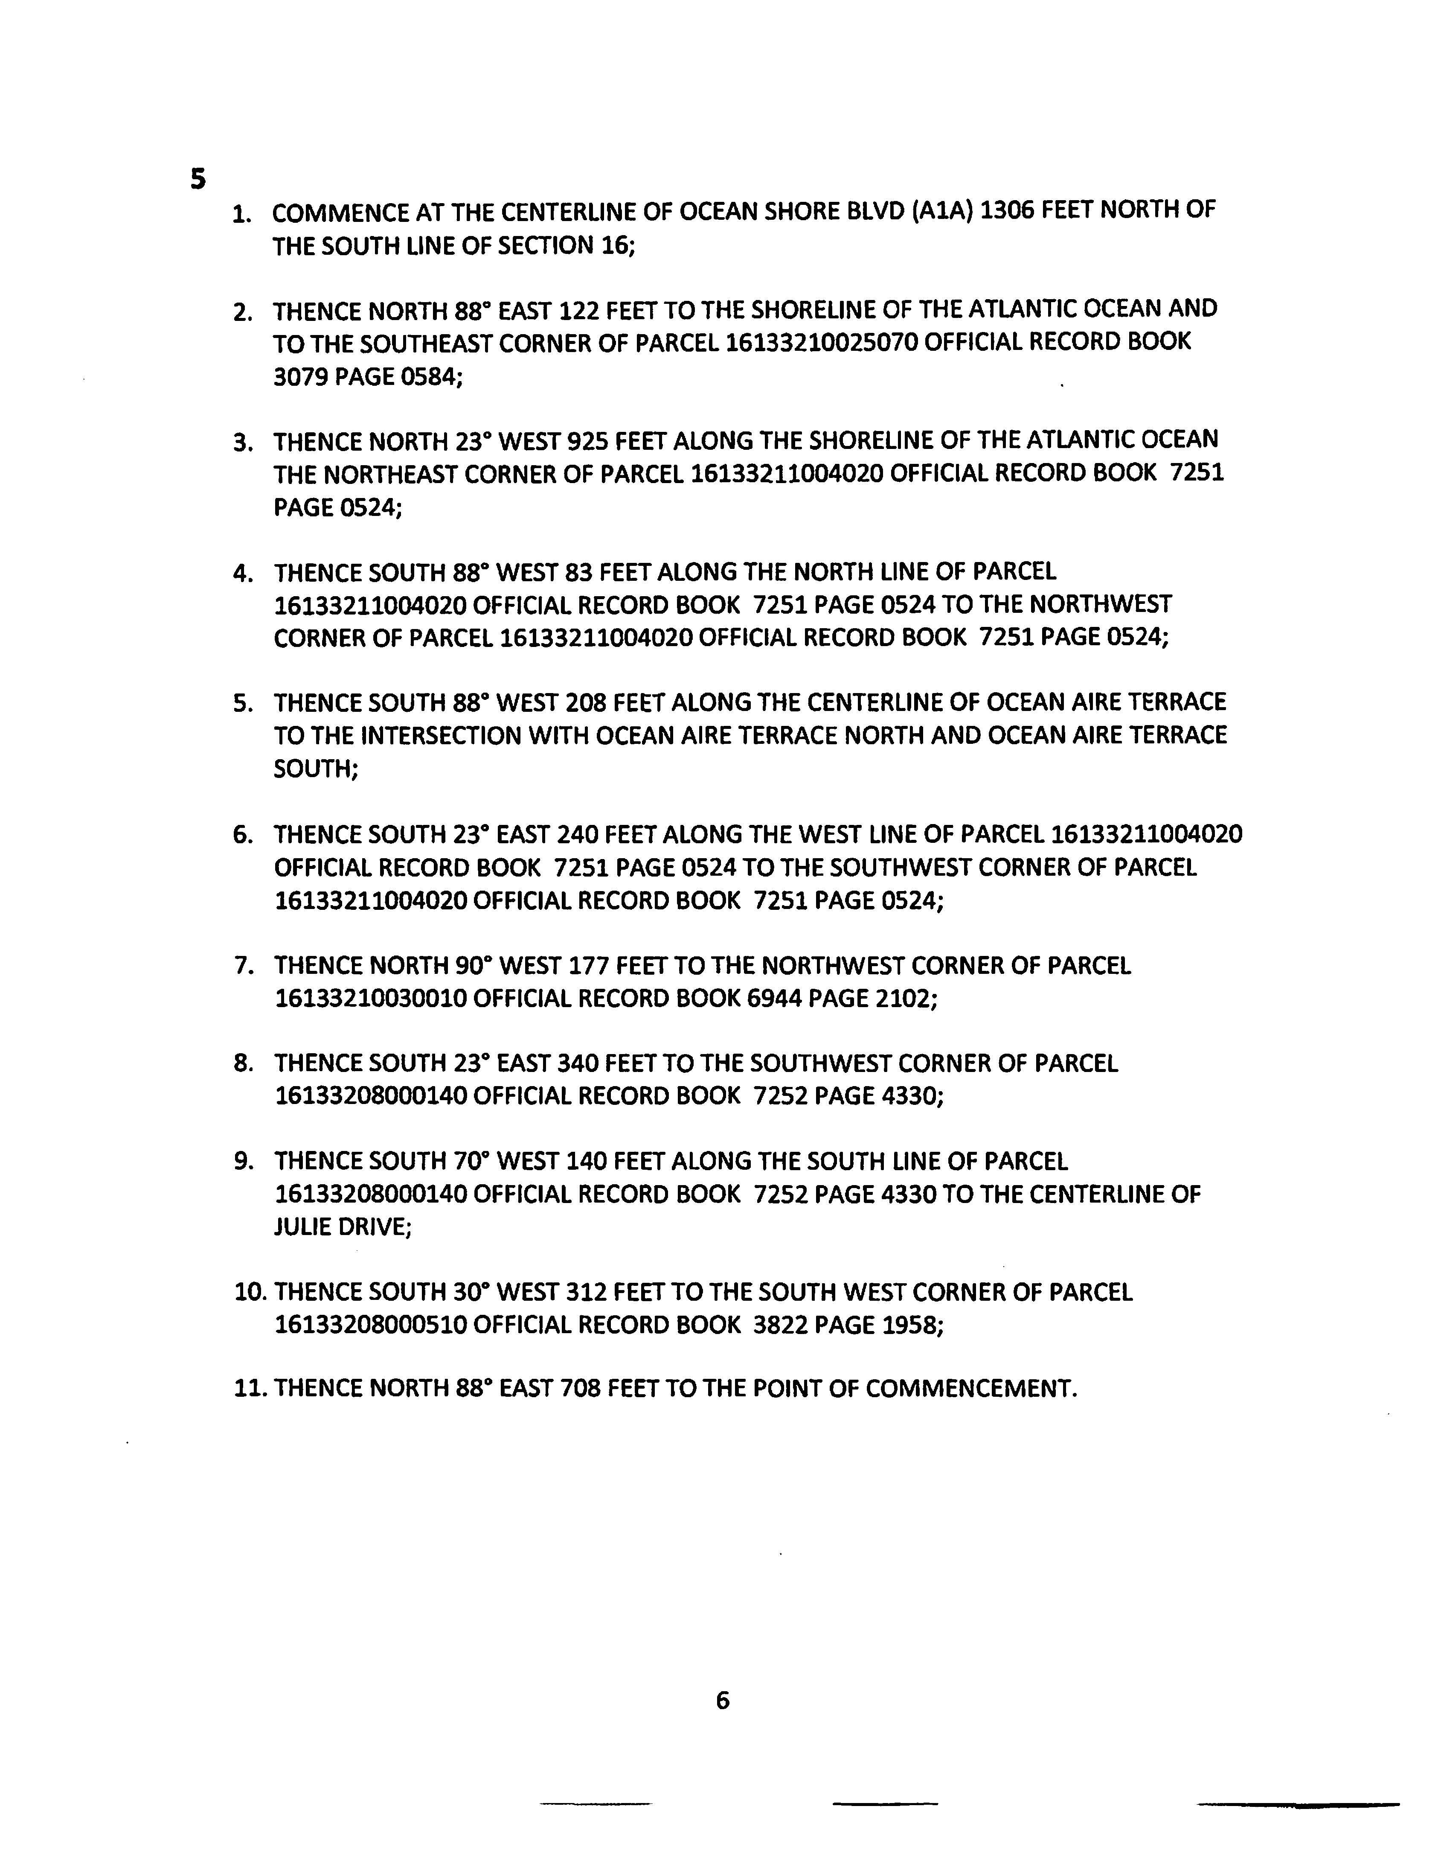

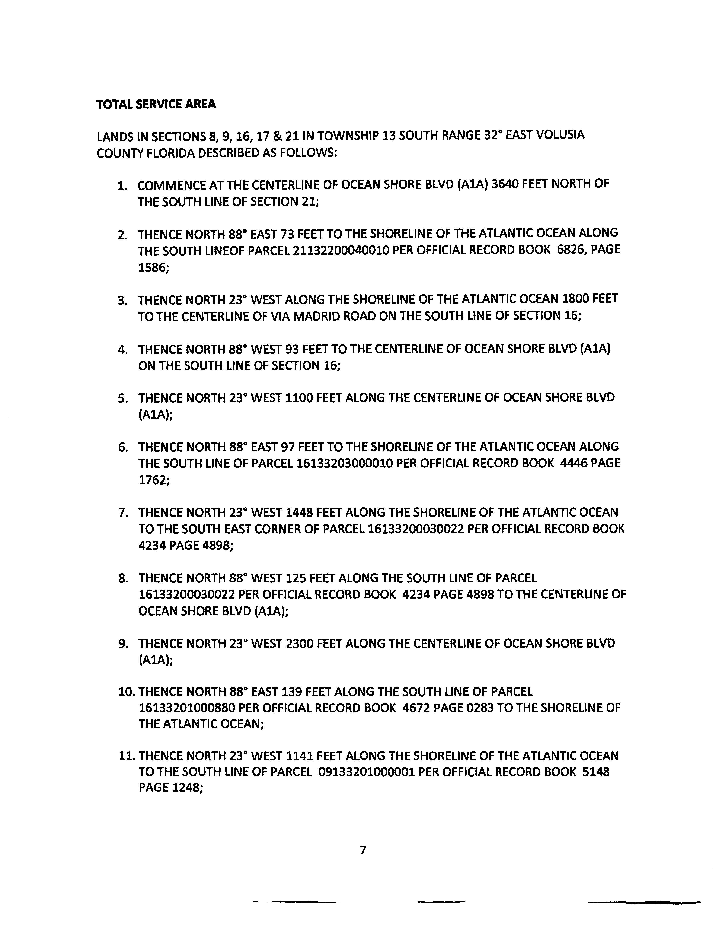



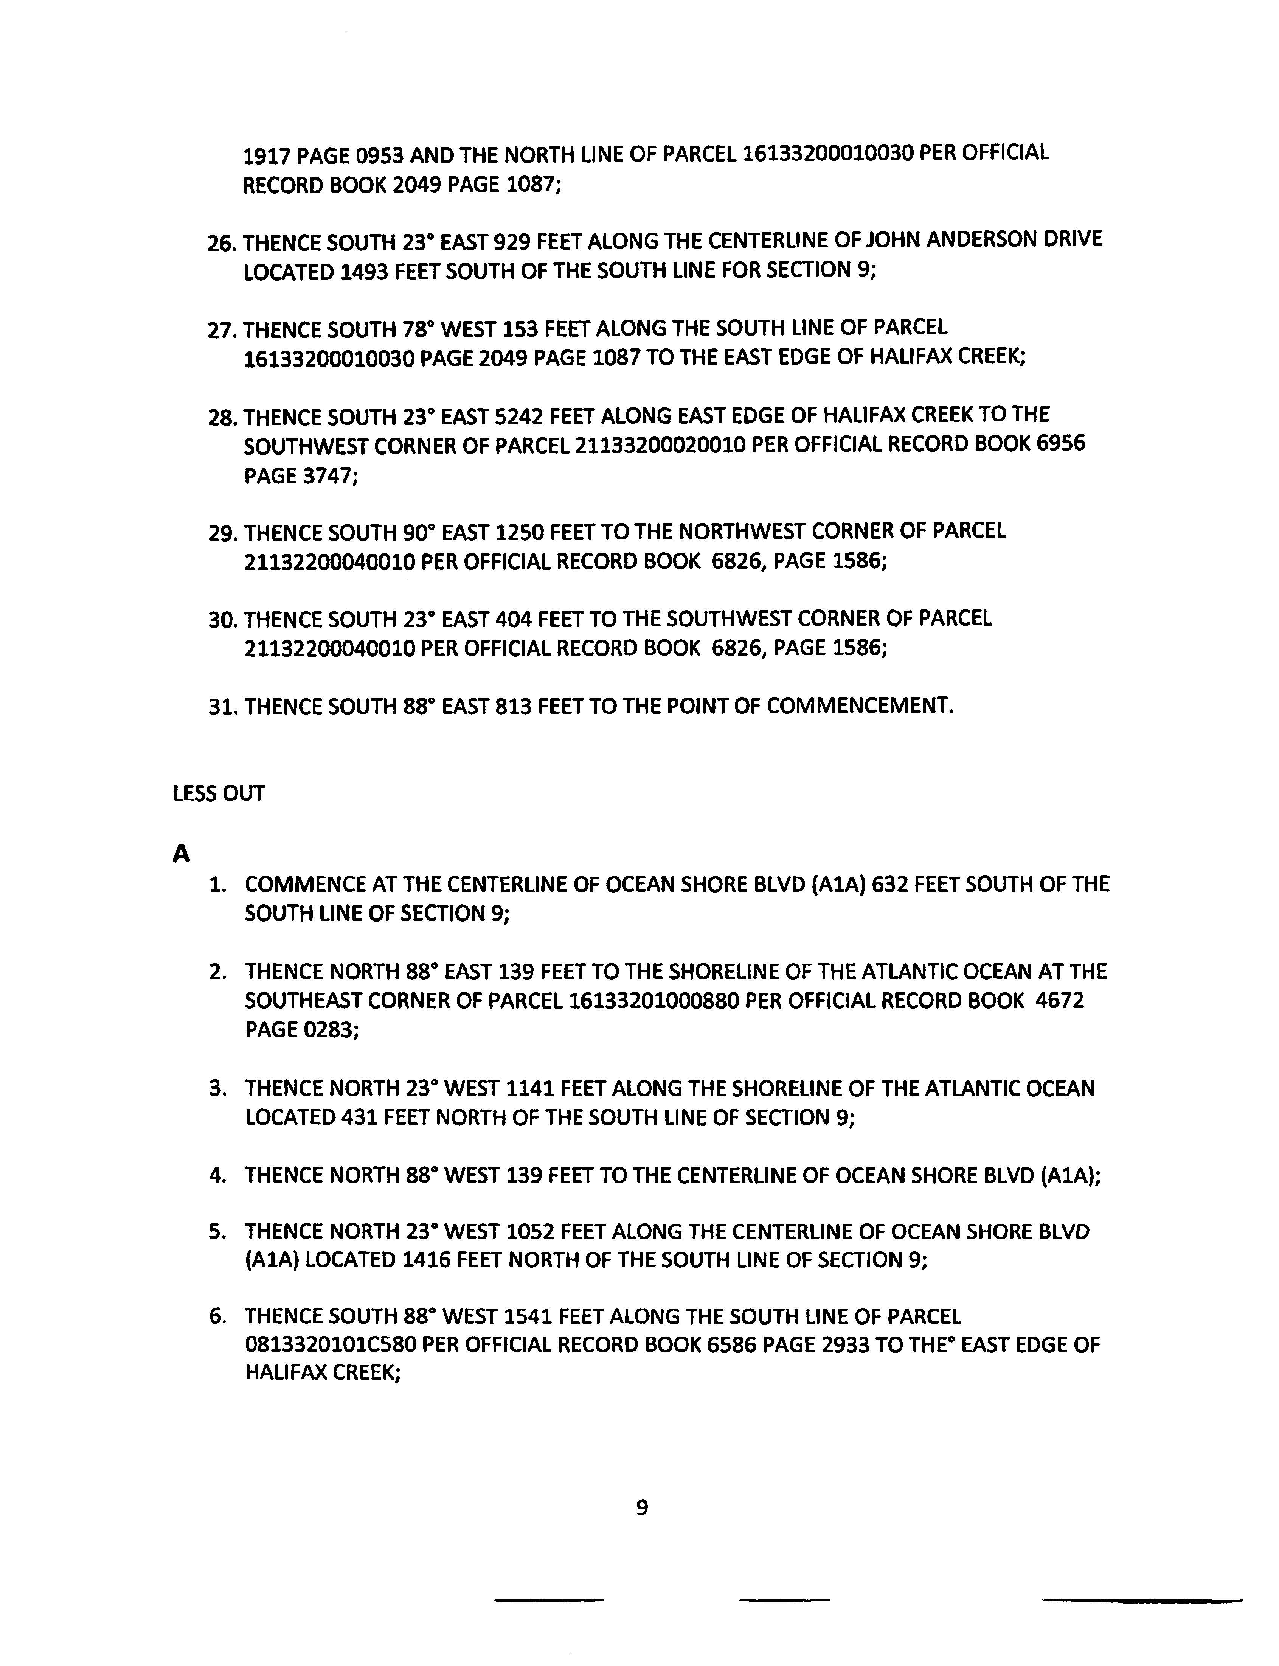

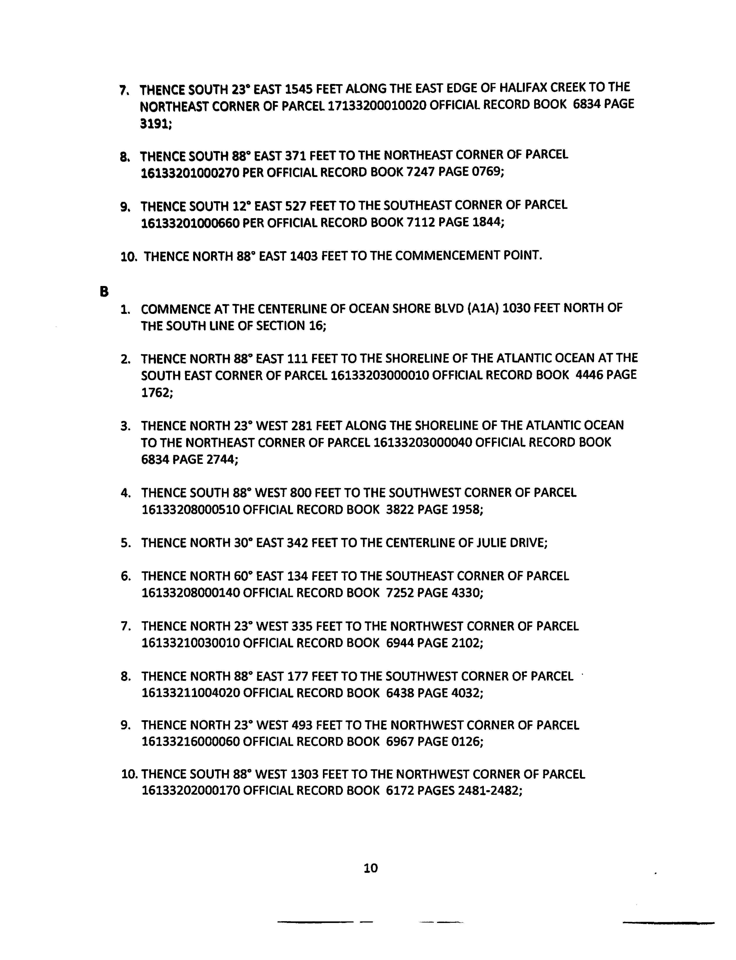

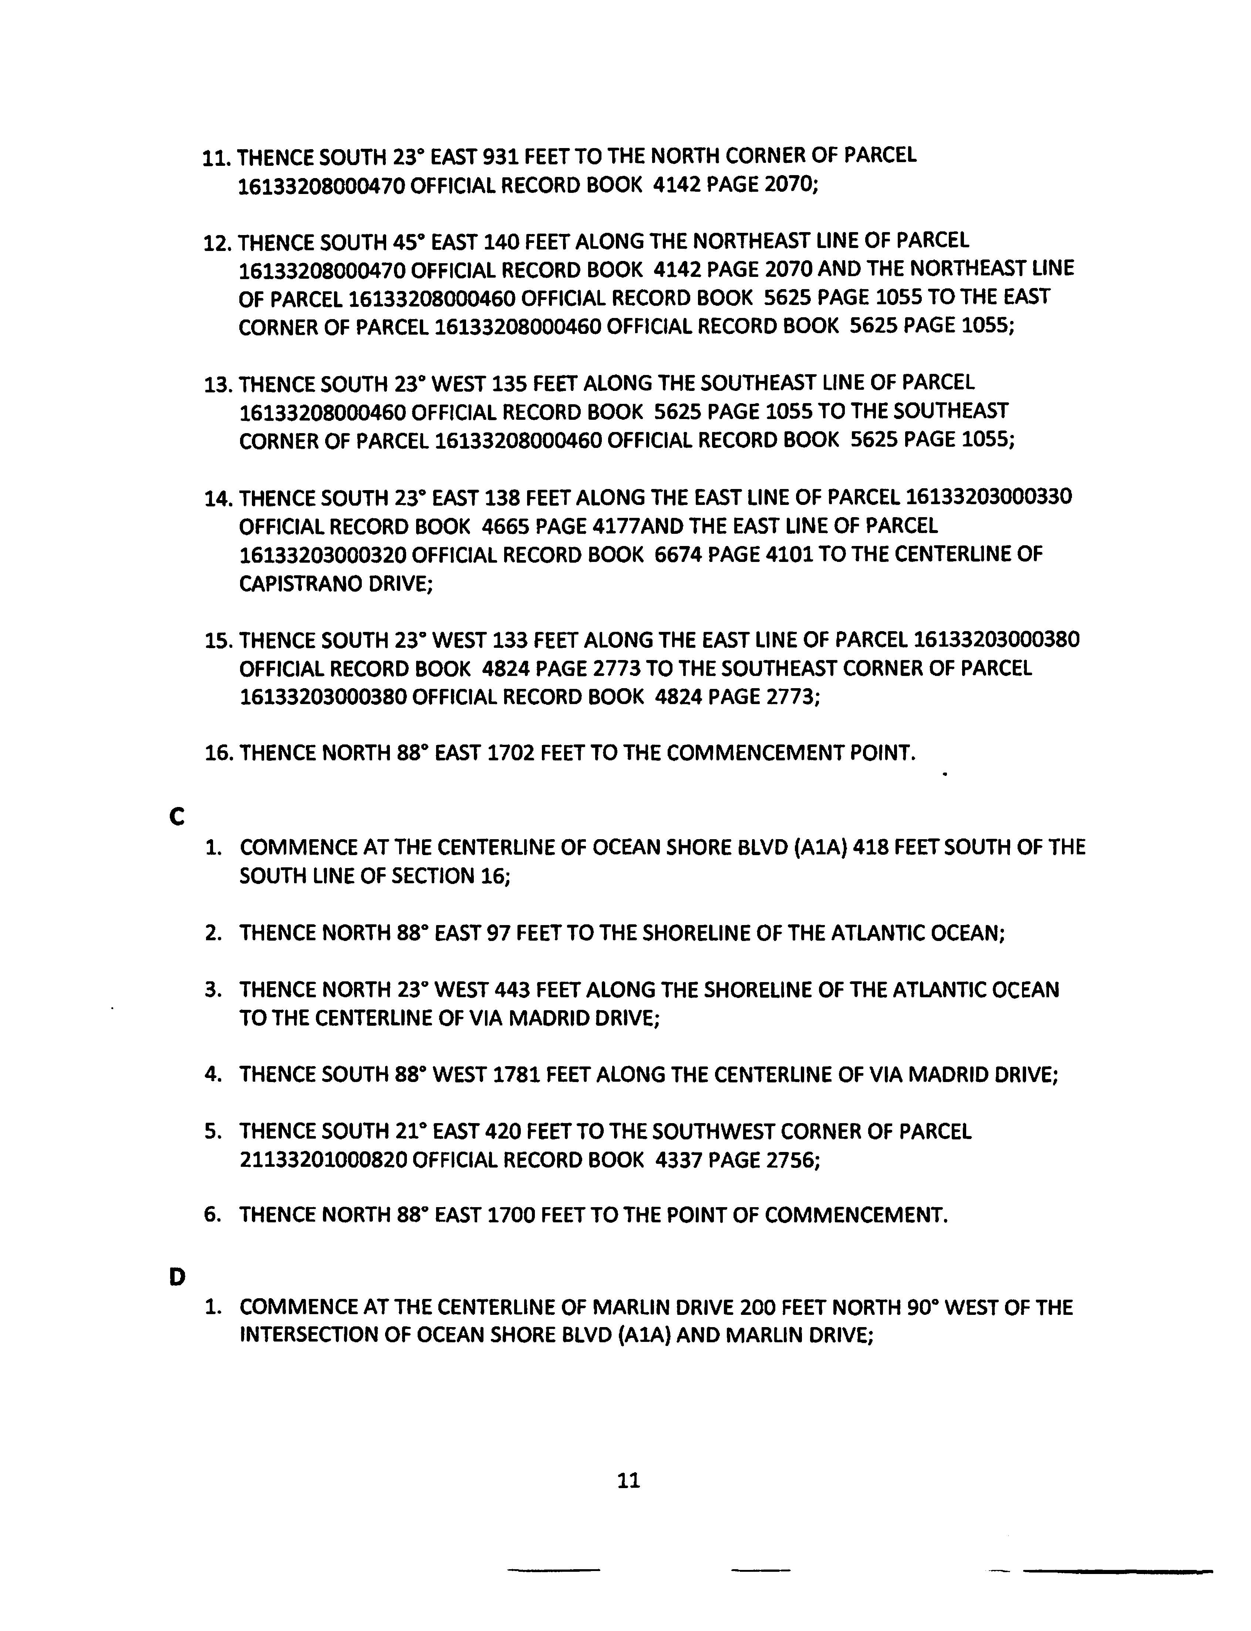

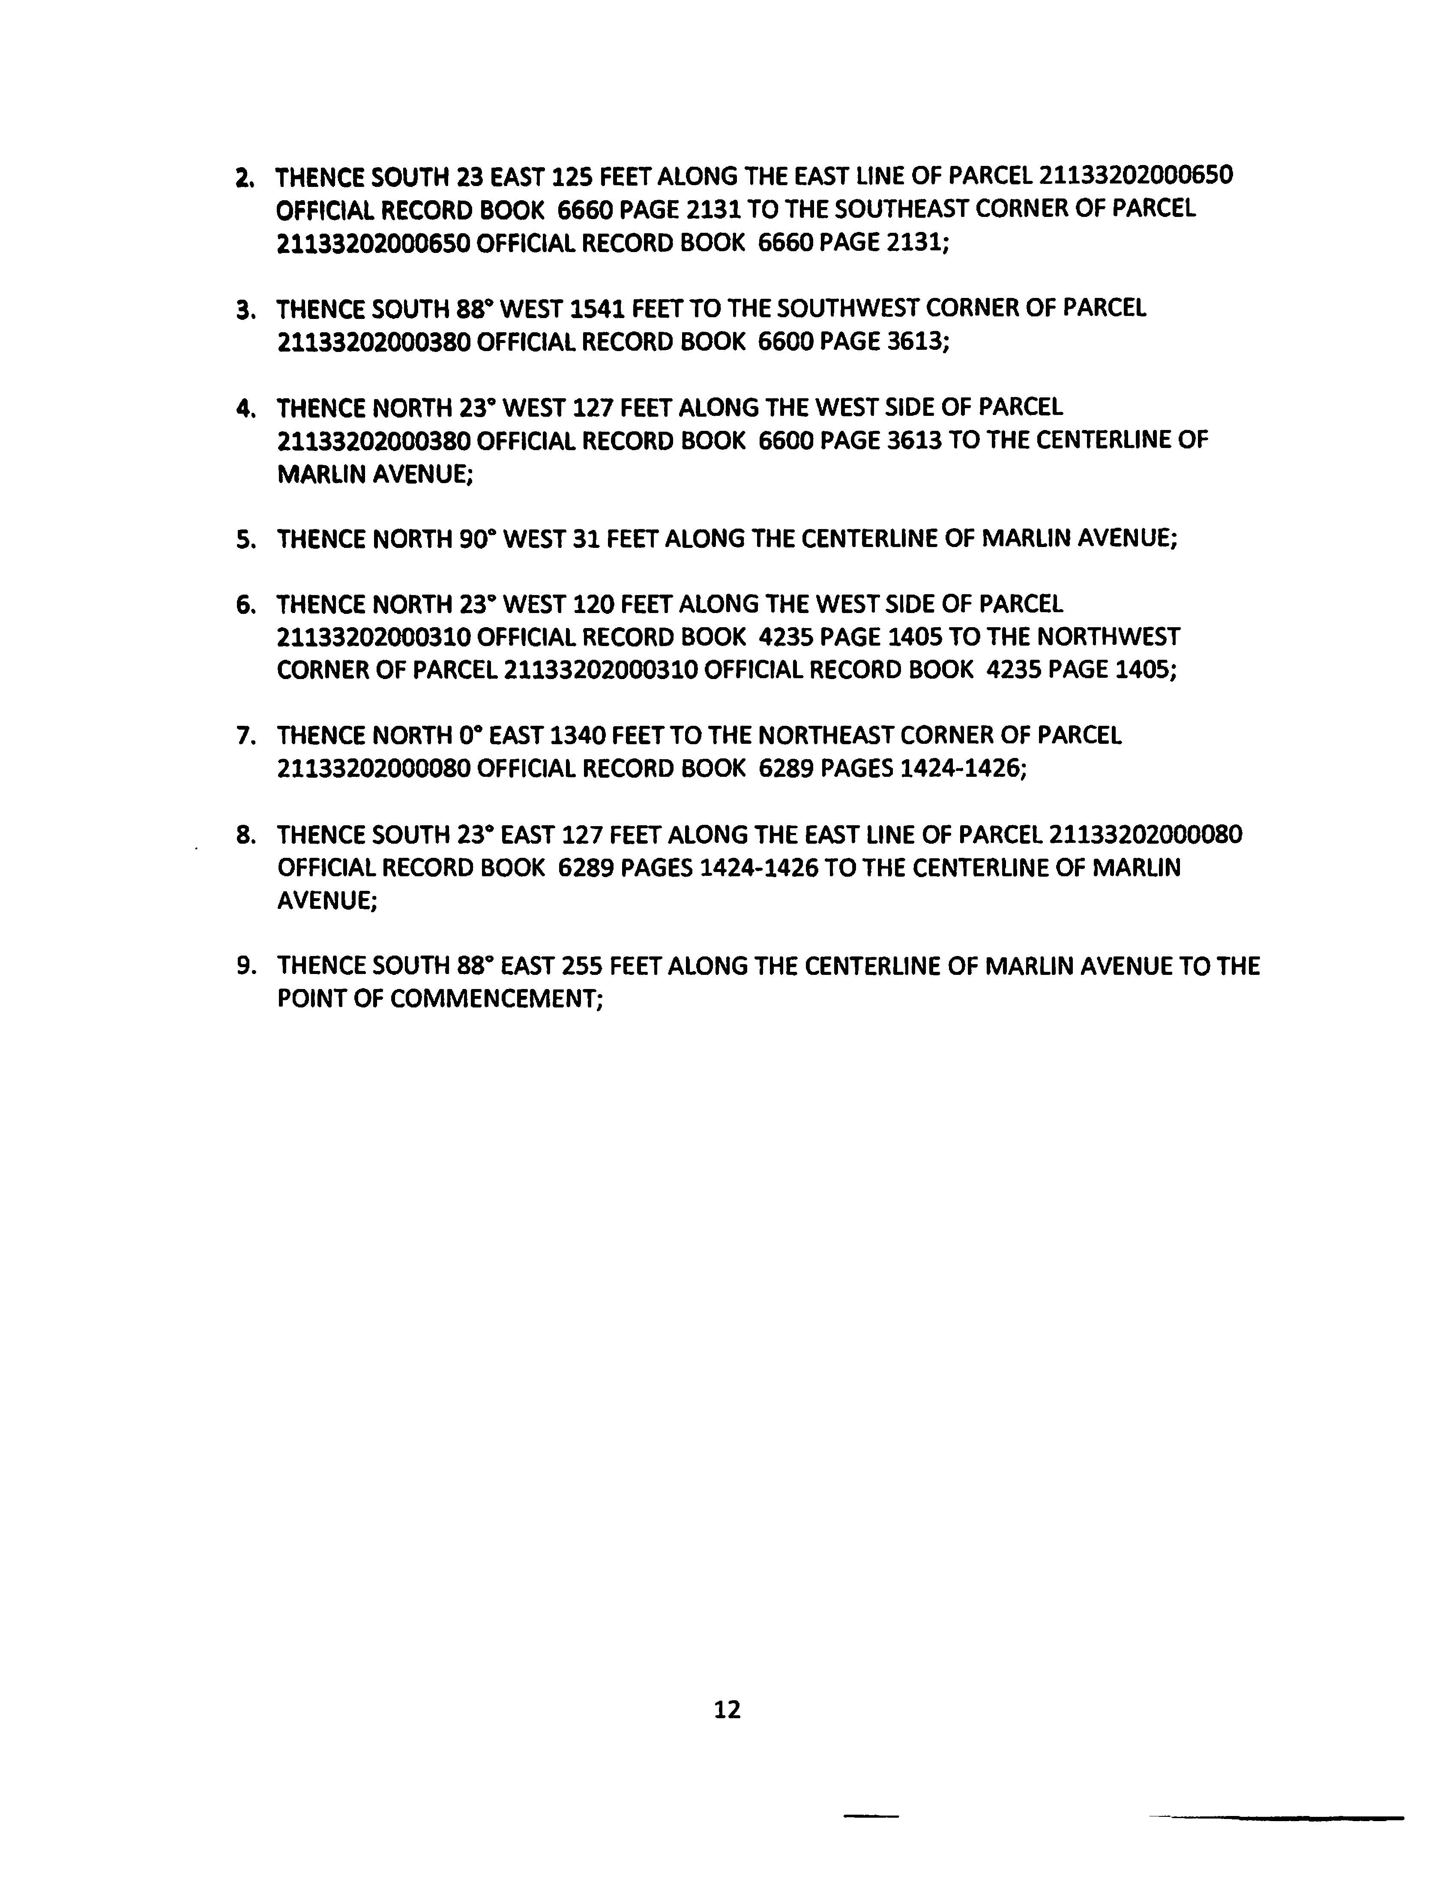

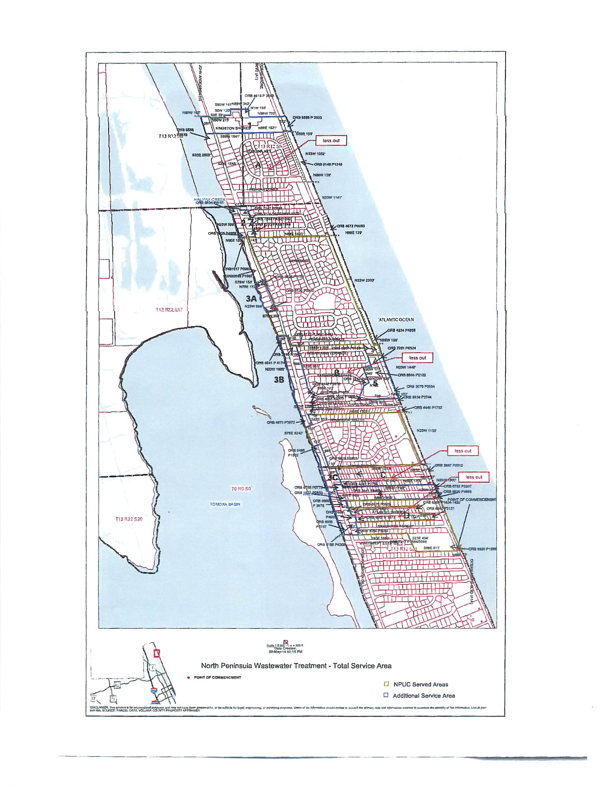

Order No. 22445, issued October 6, 2008, in Docket No. 891016-SU, In re: Application of North Peninsula Utilities Corporation for transfer of Certificate No. 249-S from Shore Utility Corporation in Volusia County.
Order No. PSC-14-0273-PCO-SU, issued May 29, 2014, in Docket No. 130209-SU, In re: Application for expansion of certificate (CIAC) (new wastewater line extension charge) by North Peninsula Utilities Corp.
See Document No. 04082-16
Order No. 16184, issued June 4, 1986, in Docket No. 850121-SU, In re: Application of Shore Utility Corporation for a staff-assisted rate case in Volusia County, Florida.

