State of Florida   |  | Public Service Commission  Capital Circle Office Center ● 2540 Shumard Oak Boulevard  Tallahassee, Florida 32399-0850  -M-E-M-O-R-A-N-D-U-M-
DATE: | September 29, 2016
TO: | Office of Commission Clerk (Stauffer)
FROM: | Division of Accounting and Finance (Slemkewicz, D. Buys, Mouring)  Division of Economics (Hudson, Johnson)  Division of Engineering (King, Mtenga)  Office of the General Counsel (Mapp)
RE: | Docket No. 150269-WS – Application for limited proceeding water rate increase in Marion, Pasco, and Seminole Counties, by Utilities, Inc. of Florida.
AGENDA: | 10/11/16 – Regular Agenda – Proposed Agency Action – Interested Persons May Participate
COMMISSIONERS ASSIGNED: |  |  | All Commissioners
PREHEARING OFFICER: |  |  | Brisé
CRITICAL DATES: |  |  | None
SPECIAL INSTRUCTIONS: |  |  | None

Case Background
Utilities, Inc. of Florida (UIF or Utility) is a Class A utility providing water and wastewater service to twenty-seven systems in the following counties: Charlotte, Highlands, Lake, Lee, Marion, Orange, Pasco, Pinellas, Polk, and Seminole. On December 30, 2015, the Utility requested a limited proceeding water rate increase for Marion, Pasco, and Seminole Counties. UIF is a wholly-owned subsidiary of Utilities, Inc. (UI). The Utility’s last rate case was in 2012.
The petition for a limited proceeding was filed pursuant to Rule 25-30.446, Florida Administrative Code (F.A.C.). Driving the limited proceeding were (1) galvanized service line replacement costs in Marion County, (2) loss of irrigation customers, plant additions, and purchased water costs in Pasco County, and (3) interconnection plant addition costs in Seminole County.
On March 24, 2016, the Office of Public Counsel (OPC) filed its notice of intervention in this proceeding, and an Order acknowledging intervention was issued on April 4, 2016. Prior to the notice of intervention, OPC submitted a letter, dated February 2, 2016, outlining concerns that OPC had with the Utility’s petition for Marion, Pasco, and Seminole Counties. UIF responded to OPC’s concerns in a letter dated March 2, 2016.
An estimated 500 customers attended the 2 customer meetings held in New Port Richey (Pasco County) on April 12, 2016, with 175 customers providing comments. No customers attended the meeting held on April 13, 2016, in Ocala for the customers in Marion and Seminole Counties.
UIF notified the Commission of its intent to file an application for a rate increase on April 28, 2016, for all regulated systems in Florida. Docket No. 160101-WS was assigned to the forthcoming consolidated proceeding. The Minimum Filing Requirements were filed on August 31, 2016, for Docket No. 160101-WS, based on a historical test year ended December 31, 2015.
By letter dated June 8, 2016, UIF requested that the portion of this limited proceeding addressing a rate increase in Pasco County be bifurcated from the portion addressing rate increases in Marion and Seminole Counties. OPC filed a response to UIF’s bifurcation request on June 13, 2016. As a result, rate increases were addressed at the July 7, 2016 Commission Conference for Marion and Seminole Counties only. The Commission’s vote on the limited proceeding for Marion and Seminole Counties was codified in Order No. PSC-16-0296-PAA-WS, issued July 27, 2016. A consummating order was issued in Order No. PSC-16-0342-CO-WS on August 22, 2016.
In its initial filing, UIF’s request for Pasco County was separated into Phase I regarding the loss of revenue associated with customer-installed irrigation wells, and Phase II associated with UIF’s interconnection to Pasco County for bulk provision of water to UIF’s Summertree customers. The Bulk Water Agreement between UIF and Pasco County was executed on August 9, 2016, and is included as Attachment A.
By letter dated August 11, 2016, the Utility withdrew its request for the Phase I rate increase for Pasco County to be deferred and considered later in the consolidated rate case docket. On August 18, 2016, OPC requested a deferral of the decision to consider any rate increase until (1) the actual amount of any Southwest Florida Water Management District (SWFWMD) grants have been taken into account; (2) any possible overearnings have been evaluated; (3) any potential customer savings from the UIF consolidation have been evaluated; and (4) the quality of water service issues have been addressed and resolved.
The Commission considered the Phase II rate increase at the September 13, 2016 Commission Conference and deferred the matter. Based on discussions at the Commission Conference, staff has revised the recommendation.
The Phase I rate increase for Pasco County will be addressed in Docket No. 160101-WS. This recommendation only addresses the requested Phase II rate increase directly related to the interconnection with Pasco County to address water quality issues.
The Commission has jurisdiction pursuant to Sections 367.081 and 367.0822, Florida Statutes (F.S.).

Discussion of Issues

Issue 1:
Should the Utility's requested increase associated with the Pasco County Interconnect Phase II be approved?

Recommendation:
Yes, as modified by staff.
- The Commission should approve a water rate increase of $47,836 (or 5.45 percent) which is driven in large part by the expense related to the retirement of the abandoned wells, and the purchased water expense pursuant to the Bulk Water Agreement with Pasco County (Attachment A).
- In addition, the estimated $200,000 net cost to retire the abandoned wells, as well as the use of the hydro tank and its $5,000 salvage value, should be reviewed in the forthcoming consolidated rate case in Docket No. 160101-WS.
- Further, UIF should be directed to provide secondary water quality results for portions of its Summertree distribution system at least every six months. Samples should be taken from the same sites labeled “nearby system site” shown in Appendix A of the CPH Engineering Report for consistency purposes. Such results should be filed with the Commission for informational purposes. The first report should be filed no later than two months after the completion of the interconnection with Pasco County.
- Pursuant to Order No. PSC-14-0025-PAA-WS, the 100-basis point reduction in return on equity and water testing requirement should remain in place until the water quality is deemed satisfactory by the Commission. (Slemkewicz, Mtenga, Hudson)

Staff Analysis:
As a result of UIF’s withdrawal of its Pasco County Phase I request, staff has modified the Utility’s original request for Pasco County Phase II to recognize rate case expense in operating expense. Staff also reduced the annualized revenues to reflect the effects of the loss of irrigation customers. Accordingly, the requested rate increase is $52,547 (or 6.05 percent) as shown on Schedule No. 1. Staff’s analysis is based on the modified amounts. However, with regard to UIF’s calculated rate increase of $52,547 (or 6.05 percent) for Pasco County Phase II, staff would note that the Utility made an error in its calculation of the income subject to state and federal income taxes. In calculating the taxable income amount, UIF multiplied the decreased rate base amount by the total overall ROR of 8.03 percent. The proper calculation would be to multiply the decreased rate base amount by only the common equity weighted cost component of the ROR. In its calculation, staff used a common equity weighted cost component of 4.41 percent rather than the total overall ROR of 7.22 percent. Based on its adjustments, staff has calculated a water rate increase of $47,836 (or 5.45 percent) for Pasco County Phase II as shown in Schedule No. 1.

Rate Base
The Utility requested a rate base reduction of $356,579 to reflect the abandonment of water wells in Pasco County Phase II. The rate base components were Retirements and Cash Working Capital.

Retirements
In its filing, UIF reduced rate base by the net book value of $363,697 for the retirement of the abandoned wells.
By Order No. PSC-14-0025-PAA-WS (2014 Order), the Commission found the quality of water in the Summertree water system to be unsatisfactory and ordered that the revenue requirement for the Summertree water system be subject to a 100-basis point reduction in return on equity (or approximately $23,115 annually) until the Utility demonstrated that the water quality had been restored to the point where it is deemed satisfactory by this Commission. To address the water quality issues, the Commission ordered several future actions that would need to be taken by the Utility to satisfy the concerns of its customers:
- Coordinate with the OPC to develop a customer engagement plan;
- identify suitable treatment options to address the secondary water quality issues including an estimated rate impact to customers;
- consider the cost and feasibility of connecting to the Pasco County water system with the purchase of bulk water from the County; and
- present options to Summertree customers and conduct a survey to determine customer preferences.
As directed by the 2014 Order, OPC, who was the facilitator, coordinated community meetings between the Utility and Summertree residents beginning in January 2014. A total of 30 meetings were held from 2014 through 2016 with a group consisting of representatives of the Summertree residents, the Utility, OPC and in some instances Pasco County Commissioners and/or Florida State Legislators. OPC compiled thorough minutes of the meetings and provided periodic updates to Commission staff.
On April 28, 2014, a meeting was held to discuss the treatment alternatives analysis report prepared by CPH Engineering (CPH Report) that was submitted by UIF to the group. The CPH Report outlined three possible solutions to the water quality issues: construction of a centralized water treatment plant with upgraded treatment; upgraded water treatment at each well site; or interconnection with Pasco County. As noted on pages 8 and 10 of the CPH Report, the elevated color concentrations in the distribution system were most likely due to the buildup of biomass. Specifically, the CPH Report recommended that prior to any treatment modifications, the Utility should “thoroughly flush the distribution system to remove any [possible] biomass in the system and repeat the flushing process at least annually.” The CPH Report also indicated that interconnecting with Pasco County would require the Utility to decommission its four production wells and each of their associated water treatment facilities to conform to the rules and regulations of SWFWMD. The CPH Report concluded that the interconnection was the lowest cost option that would provide improved water quality with respect to iron, odor and color. The CPH Report ultimately recommended that “Utilities Inc. of Florida pursue a potable water interconnection with Pasco County, including a thorough cleaning of the distribution system.”
In accordance with the 2014 Order, OPC coordinated subsequent meetings between the Utility and representatives of Summertree residents to discuss the different options, with UIF ultimately proposing the recommendation of the Pasco County Interconnection. To solicit customer input, OPC organized a survey ballot, the language of which was finalized in January 2016. The ballot asked the residents whether Summertree should interconnect with Pasco County and to rate the quality of water service provided by UIF. Ballots were mailed to approximately 1,172 customers in March 2016. A total of 876 valid survey responses were returned with 830 of the residents voting in favor of the interconnection and 746 rating the quality of service as unsatisfactory. As noted in the case background, 175 customers provided comments at the April 12, 2016 customer meetings. The majority of the comments focused on the unsatisfactory quality of service provided by UIF.
While the interconnection with Pasco County should improve water quality, the final impact on water quality can be determined only after the completion of the interconnection and the implementation of a flushing protocol. Therefore, the Utility should be directed to provide secondary water quality results for portions of its Summertree distribution system at least every six months until the Commission finds the water quality to be satisfactory. Samples should be taken from the same sites labeled “nearby system site” shown in Appendix A of the CPH Report for consistency purposes. Such results should be filed with the Commission for informational purposes. The first report should be filed no later than two months after the completion of the interconnection with Pasco County. Pursuant to the 2014 Order, the 100-basis point reduction in return on equity should remain in place until the water quality is deemed satisfactory by the Commission.
As previously discussed, the abandonment of the wells and the interconnection with Pasco County was considered to be the lowest cost option. The Bulk Water Agreement with Pasco County (Attachment A) provides that the $896,141 initial connection fee will be paid for by Pasco County from a grant provided by the Florida Department of Environmental Protection (FDEP). Staff recommends that rate base be reduced by the $363,697 net book value of the abandoned wells to reflect their removal from rate base.

Working Capital Allowance
UIF included a working capital allowance of $7,118 for Pasco County Phase II. This amount represents 1/8th of the O&M expense increase of $56,941. However, staff has made several adjustments to O&M expense that increased the O&M expense to $63,638 as explained in the “O&M Expense” section below. As a result, staff recommends that the appropriate amount of incremental working capital is $7,955 ($63,638÷8), or $837 higher than the amount included by UIF.
After reviewing UIF’s requested rate base decrease of $356,579, staff recommends that rate base be decreased by $355,742 for Pasco County Phase II as shown on Schedule No. 1. The $837 difference reflects the change in working capital.

Rate of Return
Per Schedule No. 11 of its filing, UIF calculated an 8.03 percent rate of return (ROR). This ROR was based on a capital structure ended December 31, 2014, that only included long-term debt with a cost rate of 6.65 percent and common equity with a return on equity of 9.38 percent. The capital structure used by UIF is inconsistent with the capital structure used in the Utility’s last rate case for Pasco County. In addition, Rule 25-30.445(4)(e), F.A.C., requires that the weighted average cost of capital be calculated based on the most recent 12-month period and include all of the appropriate capital structure components. In this instance, the most recent period available is the 12 months ended December 31, 2015. UIF calculated a December 2015 ROR of 7.85 percent on Schedule F-5 of its 2015 Annual Report. However, UIF did not use the appropriate equity cost rate of 9.38 percent or the minimum 2.00 percent cost rate for customer deposits pursuant to Rule 25-30.311(4)(a), F.A.C. Based on the foregoing, staff recalculated a December 2015 ROR of 7.22 percent as shown in Schedule No. 2.

Operating Expense
UIF requested an increase to operating expense, excluding income taxes, of $89,692 for Pasco County Phase II. The increase is based on increases for the abandoned well amortization, purchased water expense, and rate case expense that are partially offset by decreases in depreciation expense, O&M expense, and taxes other than income.

Depreciation Expense
UIF decreased its depreciation expense by $22,778 as a result of the abandonment of the water wells. In staff’s review of the Utility’s filing, it was noted that an $804 contributions in aid of construction (CIAC) component of the depreciation expense was not included in the total amount. Otherwise, the calculation of the depreciation expense reduction is in accordance with Rule 25-30.140, F.A.C. The inclusion of the $804 CIAC component lowers the total depreciation expense reduction to $21,974.

Abandoned Wells Amortization Expense
UIF calculated an annual amortization expense of $65,022 for the recovery of the $563,697 related to the retirement of the abandoned wells. This represents an 8.67 year amortization period. The $563,697 is the sum of the $363,697 net book value and the $200,000 net cost to retire the abandoned wells. On Schedule No. 16 of its filing, UIF estimated that the gross cost to retire the abandoned wells was $220,000. The Utility reduced the gross amount by $20,000 for anticipated SWFWMD funding resulting in a net retirement cost of $200,000.
In it’s response to OPC’s February 2, 2016 letter outlining certain issues and concerns, UIF stated that the hydro tank at well 13 would either be relocated to an Orangewood system well site or have no salvage value. At the September 13, 2016 Commission Conference, OPC noted that testimony filed in the consolidated rate case in Docket No. 160101-WS stated that the hydro tank will be repurposed at the Cypress Lakes system. Subsequent to the Commission Conference held on September 13, 2016, OPC submitted a letter concerning the calculation of the amortization expense. OPC raised concerns about the value of a hydro tank that will be transferred for use by a system in another county. The net book value of the hydro tank included in the calculation is $57,622 which does not include any salvage value. UIF filed a response to OPC’s letter on September 22, 2016, stating that the salvage value would be less than $5,000. In staff’s opinion, the approximate salvage value of $5,000 should be recognized as a reduction to the net book cost of $363,697 used in the amortization expense calculation.
Rule 25-30.433(9), F.A.C., prescribes the calculation for determining the appropriate amortization period for forced abandonment or the prudent retirement of plant assets prior to the end of their depreciable life. Based on the amounts in its filing, UIF followed the specified calculation except for the return on net book value amount and the hydro tank salvage value. The Utility applied the 8.03 percent rate of return to the total cost of $563,697 rather than just the net book value of $363,697. Rule 25-30.433(9), F.A.C., specifically states that the amount should be “equal to the rate of return that would have been allowed on the net invested plant that would have been included in rate base before the abandonment or retirement.”
In its calculation, staff used its recommended 7.22 percent rate of return and applied it against the net book value of $358,697. This results in an annual amortization expense of $45,633 and an amortization period of 12.24 years. UIF and staff’s calculations are summarized in Table 1-1 below. Because the $220,000 gross retirement cost and the $20,000 of anticipated State funding are only estimates, staff believes that these amounts should be reviewed in the upcoming consolidated rate case and be adjusted if needed. In addition, the use of the hydro tank and its estimated $5,000 salvage value should also be reviewed and adjusted if needed.

Table 1-1
Abandoned Wells Amortization Expense Increase
 | UIF | STAFF
Net Book Value | $363,697 | $363,697
Tank Salvage Value | 0 | (5,000)
Net Cost to Retire | 200,000 | 200,000
Total Cost | $563,697 | $558,697
Rate of Return | 8.03% | 7.22%
Return on Net Book Value | $45,287 | $25,898
Depreciation Expense | 19,735 | 19,735
Annual Amortization Expense | $65,022 | $45,633
Amortization Period | 8.67 Years | 12.24 Years

O&M Expense
UIF requested an increase of $56,941 to O&M expense. The increase is based on increases for purchased water expense and rate case expense that are partially offset by a decrease in O&M expense related to the abandoned wells.

Well Abandonment O&M Expense
UIF included an O&M expense decrease of $46,245 related to the well abandonments. This was an annualized amount based on actual O&M expenses for the 11 months ended November 30, 2015. In response to a staff data request, the Utility updated the amounts to include the actual amounts for the 12 months ended December 31, 2015. This resulted in a $48,609 decrease in O&M expenses. Staff has reviewed the items included in the O&M expense reduction and they appear to be appropriate. The calculation of the $48,609 O&M expense reduction is shown in Table 1-2 below.
Table 1-2
Well Abandonment O&M Expense
Expense Category | Amount
Electric Power – Water System | $10,453
Chemicals | 11,769
Outside Service Expense | 1,260
Salaries and Wages | 3,000
Fleet Transportation Expense | 1,000
Maintenance Testing | 6,000
Maintenance – Water Plant | 15,127
Total O&M Decrease | $48,609

Purchased Water Expense
UIF sold 55.5 million gallons of water in the Summertree subdivision during 2014. In calculating the purchased water expense necessary to replace the water previously produced by its abandoned wells, the Utility reduced the gallons sold by 32.4 million gallons to reflect the reduction in irrigation-related sales. In determining the total gallons of water to be purchased, UIF added 2.3 million gallons (10 percent) for flushing and another 2.3 million gallons (10 percent) for other losses. Per Rule 25-30.4325(1)(e), F.A.C., excessive unaccounted for water (EUW) is unaccounted water in excess of 10 percent of the amount of water produced. In rate cases, it is Commission practice to only make EUW adjustments if the 10 percent threshold is exceeded. In staff’s opinion, UIF’s estimated 10 percent factor for “other losses” appears to be reasonable. UIF then calculated an estimated purchased water expense of $99,101 based on the purchase of 27.8 million gallons from Pasco County at a bulk water rate of $3.57/Kgal. This rate is established in the Bulk Water Agreement (Attachment A) in Section III, paragraph D, page 4 of 11. Staff has reviewed the Utility’s calculation methodology and agrees that it is appropriate.
In response to a staff data request concerning the possible inclusion of duplicate bills in its calculation on Schedule No. 15 of its filing, UIF updated the amount of the reduced irrigation gallons to 30.7 million. Using UIF’s methodology and the updated amount of reduced irrigation gallons, staff has calculated a purchased water expense of $106,398. A comparison of the Utility’s calculation and staff’s calculation is presented in Table 1-3 below.
Table 1-3
Pasco County Phase II Purchased Water Expense Calculation
 | UIF |  | Staff
Total Gallons Sold – Summertree (2014) | 55,541,000 |  | 55,541,000
Irrigation Gallons Reduction | (32,408,260) |  | (30,704,830)
Gallons Difference | 23,132,740 |  | 24,836,170
Water Gallons Needed for Flushing (10%) | 2,313,274 |  | 2,483,617
Other Losses (10%) | 2,313,274 |  | 2,483,617
Total Water Needed From Pasco County | 27,759,288 |  | 29,803,404
Bulk Water Rate ($/Kgal) | $3.57 |  | $3.57
Total Cost of Purchased Water | $99,101 |  | $106,398

Rate Case Expense
UIF estimated that rate case expense would be $16,338, resulting in a 4-year amortization of $4,085. In its petition, UIF included all of the rate case expense associated with the Pasco County portion of the filing in the Phase I portion of its filing. Staff has included the rate case expense related to Pasco County in Phase II because the primary focus of Phase I was to calculate the gallonage reduction related to the loss of irrigation customers. This information is required to calculate the appropriate purchased water expense for Phase II. Based on the decision in Order No. PSC-16-0296-PAA-WS, which addressed the amount of rate case expense related to Marion and Seminole Counties and updated amounts for Pasco County from the Utility, UIF has provided a revised rate case expense for Pasco County of $25,090.
Based on a review of the rate case expense of $25,090, staff has made two adjustments. Mr. Friedman, the attorney representing UIF, will be traveling to attend the Commission Conference scheduled for October 11, 2016. In addition to UIF, Mr. Friedman also will be representing another unrelated utility at the Commission Conference in Docket No. 150010-WS. Mr. Friedman bills UIF $2,880 for 8 hours of travel time to attend the Commission Conference, as well as $510 for travel related expenses. Because Mr. Friedman will be representing two clients at the Commission Conference, staff believes that UIF should only be billed for half of the estimated travel related expenses. As a result, the total estimated rate case expense should be reduced by $1,695, resulting in an adjusted total of $23,395. The 4-year amortization amount is $5,849 as shown on Schedule No. 3. The 4-year rate reduction for rate case expense is $6,112.
Based on staff’s adjustments, the recommended net increase in O&M expense is $63,638.

Taxes Other Than Income
The Utility included decreased taxes other than income (TOTI) of $9,493. The reduction was due to a decrease in property taxes as a result of the retirement of the wells. Staff has made an adjustment to recognize the effect on payroll taxes from the $3,000 reduction in O&M salary expense. The FICA, FUTA and SUTA composite rate is 14.67 percent. The resulting adjustment is a reduction of $440 ($3,000 x 14.67 percent). The adjusted total TOTI reduction is $9,933.
Based on staff’s review, the appropriate operating expense increase, excluding income taxes, is $77,364 as shown in Schedule No. 1 attached to this recommendation.

Calculation of Water Rate Increase
UIF calculated a rate increase of $52,547 (or 6.05 percent) for Pasco County Phase II. Based on the adjustments discussed above, staff has calculated a water rate increase of $47,836 (or 5.45 percent) for Pasco County Phase II as shown in Schedule No. 1. The Bulk Water Agreement with Pasco County (Attachment A) contains a provision that Pasco County is not obligated to provide service, nor is UIF obligated to purchase service, “until the rates necessary to receive such service have been approved by the Florida Public Service Commission” (Section VIII, paragraph G, page 10 of 11).

Issue 2:
What is the appropriate application of the recommended rate increase and the effective date and implementation date?

Recommendation:

- Staff’s recommended rate increase of 5.45 percent for Pasco County should be applied as an across-the-board increase to existing service rates for the Orangewood and Summertree systems.
- The rates, as shown on Schedule No. 4, should be effective for service rendered on or after the stamped approval date on the tariff sheets pursuant to Rule 25-30.475(1), F.A.C. The Utility should file revised tariff sheets and a proposed customer notice to reflect the Commission-approved rates.
- In addition, the approved rates should not be implemented until the interconnection is in-service and staff has approved the proposed customer notice and the notice has been provided to the customers. The Utility should provide proof of the date notice was given within 10 days of the date of the notice.
The rates should be reduced as shown on Schedule No. 4, to remove rate case expense grossed up for regulatory assessment fees and amortized over a 4-year period. The decrease in rates should become effective immediately following the expiration of the four-year rate case expense recovery period, pursuant to Section 367.0816, F.S. (Johnson)

Staff Analysis:
Staff recommends that service rates for UIF be designed to allow the Utility the opportunity to generate annual service revenues of $925,458 for Pasco County. The annualized service revenues before the rate increase are $877,622, resulting in a $47,836 increase to services revenues. The corresponding percentage increase is 5.45 percent. Due to relatively low increase, staff recommends that the increase should be applied across-the-board to existing service rates.
Staff recommends that the rate increase of 5.45 percent for Pasco County be applied as an across-the-board increase to existing service rates for the Orangewood and Summertree systems. The rates, as shown on Schedule No. 4, should be effective for service rendered on or after the stamped approval date on the tariff sheets pursuant to Rule 25-30.475(1), F.A.C. The Utility should file revised tariff sheets and a proposed customer notice to reflect the Commission-approved rates. In addition, the approved rates should not be implemented until the interconnection is in-service and staff has approved the proposed customer notice and the notice has been received by the customers. The Utility should provide proof of the date notice was given within 10 days of the date of the notice. The rates should be reduced as shown on Schedule No. 4, to remove rate case expense grossed up for regulatory assessment fees and amortized over a 4-year period. The decrease in rates should become effective immediately following the expiration of the four-year rate case expense recovery period, pursuant to Section 367.0816, F.S.

Issue 3:
Should the recommended rates be approved for the Utility on a temporary basis, subject to refund with interest, in the event of a protest filed by a party whose interests are substantially affected other than the Utility?

Recommendation:
Yes. The recommended rates should be approved for the Utility on a temporary basis, subject to refund, in the event of a protest filed by a party whose interests are substantially affected other than the Utility. UIF should file revised tariff sheets and a proposed customer notice to reflect the Commission-approved rates. The approved rates should be effective for service rendered on or after the stamped approval date on the tariff sheet, pursuant to Rule 25-30.475(1), F.A.C. In addition, the temporary rates should not be implemented until after the interconnection is in-service, staff has approved the proposed notice, the notice has been received by the customers, and only after the Utility has provided written guarantee of its corporate undertaking in a cumulative amount of $73,812. If the recommended rates are approved on a temporary basis, the rates collected by the Utility should be subject to the refund provisions discussed in the staff analysis. In addition, after the increased rates are in effect, pursuant to Rule 25-30.360(6), F.A.C., the Utility should file reports with the Commission Clerk’s office no later than the 20th of each month indicating the monthly and total amount of money subject to refund at the end of the preceding month. (Mouring, Slemkewicz, D. Buys, Mapp)

Staff Analysis:
This recommendation proposes an increase in rates. A timely protest might delay what may be a justified rate increase resulting in an unrecoverable loss of revenue to the Utility. As a result, staff recommends that the recommended rates be approved as temporary rates.
Section 367.0822(1), F.S., provides
Upon petition or by its own motion, the commission may conduct limited proceedings to consider, and action upon, any matter within its jurisdiction, including any matter the resolution of which requires a utility to adjust its rates. The commission shall determine the issues to be considered during such a proceeding and may grant or deny any request to expand the scope of the proceeding to include other related matters. However, unless the issue of rate of return is specifically address in the limited proceeding, the commission shall not adjust rates if the effect of the adjustment would be to change the last authorized rate of return.
While Section 367.0822(1), F.S., does not expressly provide for the granting of temporary rates, it is well settled Commission precedent that temporary rates in the event of a protest may be approved on a case-by-case basis.
Further, Section 367.081(2), F.S., provides that this Commission must fix rates that are just, reasonable, compensatory, and not unfairly discriminatory. Pursuant to its authority to grant just and reasonable rates, the Commission has granted emergency and temporary rates in limited proceedings where a timely protest might delay what may be a justified rate increase resulting in an unrecoverable loss of revenue to the Utility. Similarly, in the instant case, staff believes that the granting of temporary rates is warranted because a timely protest of the PAA Order may delay a justified rate increase for several months while the matter is adjudicated at hearing. Moreover, staff believes that the ratepayers are adequately protected because all rates collected by the Utility will be subject to the corporate undertaking as discussed below.
For the foregoing reasons, staff believes that the recommended rates should be approved for the Utility on a temporary basis, subject to the corporate undertaking discussed below. In order to ensure that the Utility may not unfairly benefit from the issuance of temporary rates and in order to comport with the granting of temporary rates in proceedings filed pursuant to Sections 367.081 and 367.0814, F.S., staff further recommends that temporary rates only be allowed in the event of a protest filed by an entity or individual other than the Utility

Corporate Undertaking Memorandum
UIF is a wholly-owned subsidiary of UI, which provides all investor capital to its subsidiaries. Based on the amount subject to refund for Pasco County, the incremental increase in UI’s corporate undertaking is $31,891. In Order No. PSC-16-0296-PAA-WS, the Commission approved UI’s request for a corporate undertaking for Marion and Seminole Counties of $30,961 and $10,960, respectively. The total corporate undertaking amount currently outstanding is $41,921. Based on the amount subject to refund for Pasco County, the total cumulative outstanding guarantee would increase to $73,812.
The criteria for a corporate undertaking include sufficient liquidity, ownership equity, profitability, and interest coverage to guarantee any potential refund. Staff reviewed UI’s 2013, 2014, and 2015 financial statements to determine if the company can support a corporate undertaking on behalf of its subsidiary. In its 2013 financial statements, UI reported an insufficient working capital amount and an inadequate current ratio and interest coverage ratio. In 2014, UI reported insufficient working capital and an inadequate current ratio; however, the interest coverage ratio improved to adequate. In 2015, UI had sufficient working capital, and both the current ratio and interest coverage ratio were adequate. In addition, UI achieved sufficient profitability and reported adequate ownership equity over the entire 3-year review period.
Based on staff’s review of the financial reports submitted by UI, staff believes UI has adequate resources to support a corporate undertaking in the amount requested. Based on this analysis, staff recommends that a cumulative corporate undertaking of $73,812 is acceptable contingent upon receipt of the written guarantee of UI and written confirmation that the cumulative outstanding guarantees on behalf of UI-owned utilities in other states will not exceed $1.2 million (inclusive of all Florida utilities).
The brief financial analysis above is only appropriate for deciding if UI can support a corporate undertaking in the amount proposed and should not be considered a finding regarding staff’s position on other issues in this proceeding.
The Utility should maintain a record of the amount of the corporate undertaking memorandum, and the amount of revenues that are subject to refund. In addition, after the increased rates are in effect, pursuant to Rule 25-30.360(6), F.A.C., the Utility should file reports with the Commission Clerk’s office no later than the 20th of each month indicating the monthly and total amount of money subject to refund at the end of the preceding month.
Further, in no instance should the maintenance and administrative costs associated with the refund be borne by the customers. These costs are the responsibility of, and should be borne by, the Utility. Irrespective of the form of security chosen by the Utility, an account of all monies received as a result of the rate increase should be maintained by the Utility. If a refund is ultimately required, it should be paid with interest calculated pursuant to Rule 25-30.360(4), F.A.C.
Conclusion
The recommended rates should be approved for the Utility on a temporary basis, subject to refund, in the event of a protest filed by a party other than the Utility. UIF should file revised tariff sheets and a proposed customer notice to reflect the Commission-approved rates. The approved rates should be effective for service rendered on or after the stamped approval date on the tariff sheet, pursuant to Rule 25-30.475(1), F.A.C. In addition, the temporary rates should not be implemented until after the interconnection is in-service and staff has approved the proposed notice, and the notice has been received by the customers. The temporary rates should only be implemented after the Utility has provided written guarantee of its corporate undertaking in a cumulative amount of $73,812. If the recommended rates are approved on a temporary basis, the rates collected by the Utility should be subject to the refund provisions discussed in staff’s analysis. In addition, after the increased rates are in effect, pursuant to Rule 25-30.360(6), F.A.C., the Utility should file reports with the Commission Clerk’s office no later than the 20th of each month indicating the monthly and total amount of money subject to refund at the end of the preceding month.

Issue 4:
Should this docket be closed?

Recommendation:
If no person whose substantial interests are affected by the proposed agency action files a protest within 21 days of the issuance of the order, a consummating order should be issued. The docket should remain open for staff’s verification that the revised tariff sheets and customer notice have been filed by the Utility and approved by staff. Once these actions are complete, this docket should be closed administratively. (Mapp)

Staff Analysis:
If no person whose substantial interests are affected by the proposed agency action files a protest within 21 days of the issuance of the order, a consummating order should be issued. The docket should remain open for staff’s verification that the revised tariff sheets and customer notice have been filed by the Utility and approved by staff. Once these actions are complete, this docket should be closed administratively.

UTILITIES, INC. OF FLORIDA - PASCO COUNTY - PHASE II |  |  |  | SCHEDULE NO. 1
WATER REVENUE REQUIREMENTS INCREASE |  |  | DOCKET NO. 150269-WS
 |  | MODIFIED UTILITY FILING (a)(b)(c) |  | STAFF RECOMMENDATION
Line No.
1 | Utility Plant in Service (UPIS) | - |  | -
2 | Retirements | ($363,697) |  | ($363,697)
3 | Accumulated Depreciation | - |  | -
4 | Contributions in Aid of Construction (CIAC) | - |  | -
5 | Accumulated Amortization of CIAC | - |  | -
6 | Cash Working Capital | 7,118 |  | 7,955
7 | Total Increase in Rate Base | ($356,579) |  | ($355,742)
8 | Weighted Cost of Capital | 8.03% |  | 7.22%
9 | Return Required | ($28,633) |  | ($25,685)
10 | Decrease in Depreciation Expense Due to Retirements | ($22,778) |  | ($21,974)
11 | Increase in Recovery of Abandoned Wells | 65,022 |  | 45,633
12 | Increase in CIAC Amortization | - |  | -
13 | Decrease in O&M from Well Abandonments | (46,245) |  | (48,609)
14 | Increase In O&M for Purchased Water Expense | 99,101 |  | 106,398
15 | Increase in Rate Case Expense | 4,085 | (c) | 5,849
16 | Decrease in Taxes Other Than Income Taxes | (9,493) |  | (9,933)
17 | Total Increase in Operating Expenses Before Income Taxes | $89,692 |  | $77,364
18 | Total Taxable Income | ($28,633) |  | ($15,688)
19 | Multiply by State Income Tax (5.5%) | (1,575) |  | (863)
20 | Total Federal Taxable Income | ($27,058) |  | ($14,825)
21 | Multiply by Federal Income Tax (34%) | (9,200) |  | (5,041)
22 | Total Revenue Increase Before RAF (L9 + L17 + L19 + L21) | $50,284 |  | $45,776
23 | Multiply by RAF (4.5%) | 2,263 |  | 2,060
24 | Total Water Revenue Increase | $52,547 |  | $47,836
25 | Annualized Revenues | $868,816 | (a)(b) | $877,622
26 | Percentage Increase in Rates | 6.05% |  | 5.45%
27 | 4-Year Rate Reduction (Rate Case Expense) |  |  | $6,112
NOTES:
(a) Adjusted by staff to exclude the Pasco County - Phase I increase
(b) Adjusted by staff to exclude revenues for reduced irrigation customer volumes
(c) Adjusted by staff to include rate case expense

UTILITIES, INC. OF FLORIDA |  |  | SCHEDULE NO. 2
CAPITAL STRUCTURE |  |  | DOCKET NO. 150269-WS
DECEMBER 31, 2015
 | AMOUNT | RATIO | COST RATE | WEIGHTED COST
PER 2015 ANNUAL REPORT
Common Equity | $5,330,494 | 46.96% | 10.69% | 5.02%
Preferred Stock | - | 0.00% | 0.00% | 0.00%
Long Term Debt | 4,751,261 | 41.86% | 6.66% | 2.79%
Short Term Debt | 14,899 | 0.13% | 10.08% | 0.01%
Customer Deposits | 53,988 | 0.48% | 6.00% | 0.03%
Tax Credits - Wtd. Cost | - | 0.00% | 0.00% | 0.00%
Deferred Income Taxes | 1,199,429 | 10.57% | 0.00% | 0.00%
Total | $11,350,071 | 100.00% |  | 7.85%
STAFF RECOMMENDATION
Common Equity | $5,330,494 | 46.96% | 9.38% | 4.41%
Preferred Stock | - | 0.00% | 0.00% | 0.00%
Long Term Debt | 4,751,261 | 41.86% | 6.66% | 2.79%
Short Term Debt | 14,899 | 0.13% | 10.08% | 0.01%
Customer Deposits | 53,988 | 0.48% | 2.00% | 0.01%
Tax Credits - Wtd. Cost | - | 0.00% | 0.00% | 0.00%
Deferred Income Taxes | 1,199,429 | 10.57% | 0.00% | 0.00%
Total | $11,350,071 | 100.00% |  | 7.22%

UTILITIES, INC. OF FLORIDA - PASCO COUNTY - PHASE II |  |  |  |  |  |  |  |  |  | SCHEDULE NO. 3
RATE CASE EXPENSE |  |  |  |  |  |  |  |  | DOCKET NO. 150269-WS
 | UIF FILING PHASE I |  | EXPENSES (a)  AS OF 7/7/16 |  | UIF ADJUSTED  PRIOR ADDITIONAL EXPENSES (b)(c) |  | NEW ADDITIONAL  EXPENSES (c) |  | STAFF ADJUSTMENTS |  | UPDATED  TOTAL
Filing Fee | $750 |  | $750 |  | $0 |  | $0 |  | $0 |  | $750
Legal Fees | 12,000 |  | 7,152 |  | 4,860 |  | 6,660 |  | (1,440) |  | 17,232
Legal Expenses | 0 |  | 843 |  | 1,376 |  | 515 |  | (255) |  | 2,479
Customer Notices | 2,840 |  | 1,963 |  | 0 |  | 0 |  | 0 |  | 1,963
FedEx | 0 |  | 103 |  | 0 |  | 0 |  | 0 |  | 103
UIF Travel Costs | 749 |  | 0 |  | 434 |  | 434 |  | 0 |  | 868
Total Rate Case Expense | $16,339 |  | $10,811 |  | $6,670 |  | $7,609 |  | ($1,695) |  | $23,395
4-Year Amortization | $4,085 |  |  |  |  |  |  |  |  |  | $5,849
Notes:
(a) Document No. 04394-16
(b) Document No. 05631-16
(c) Document No. 07735-16

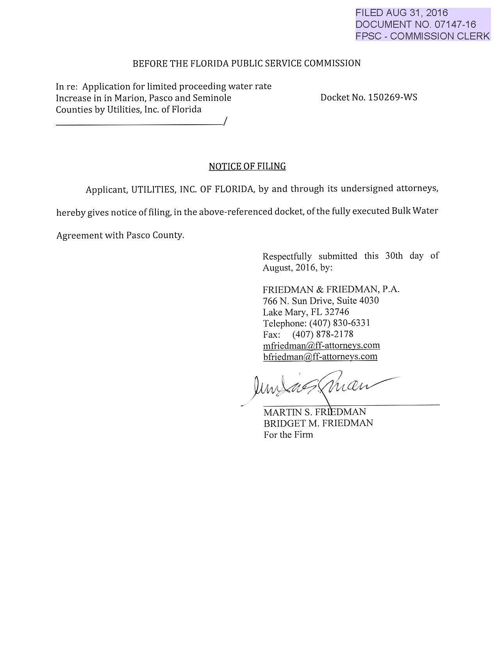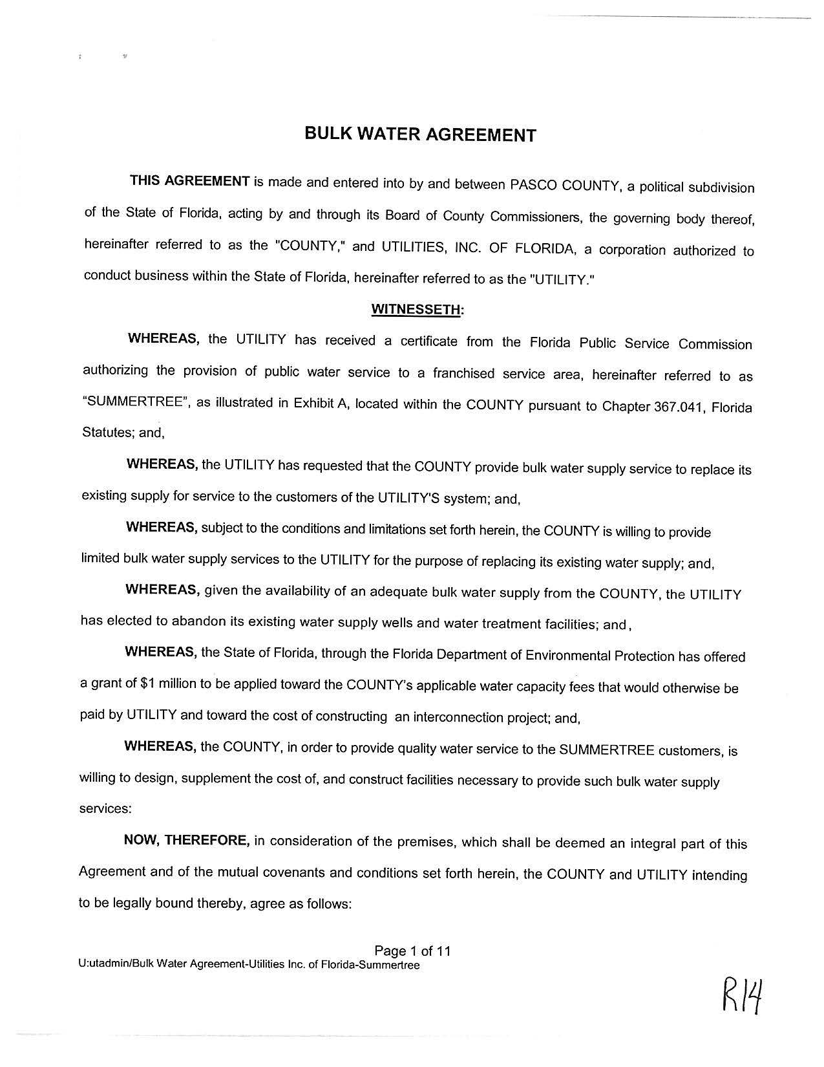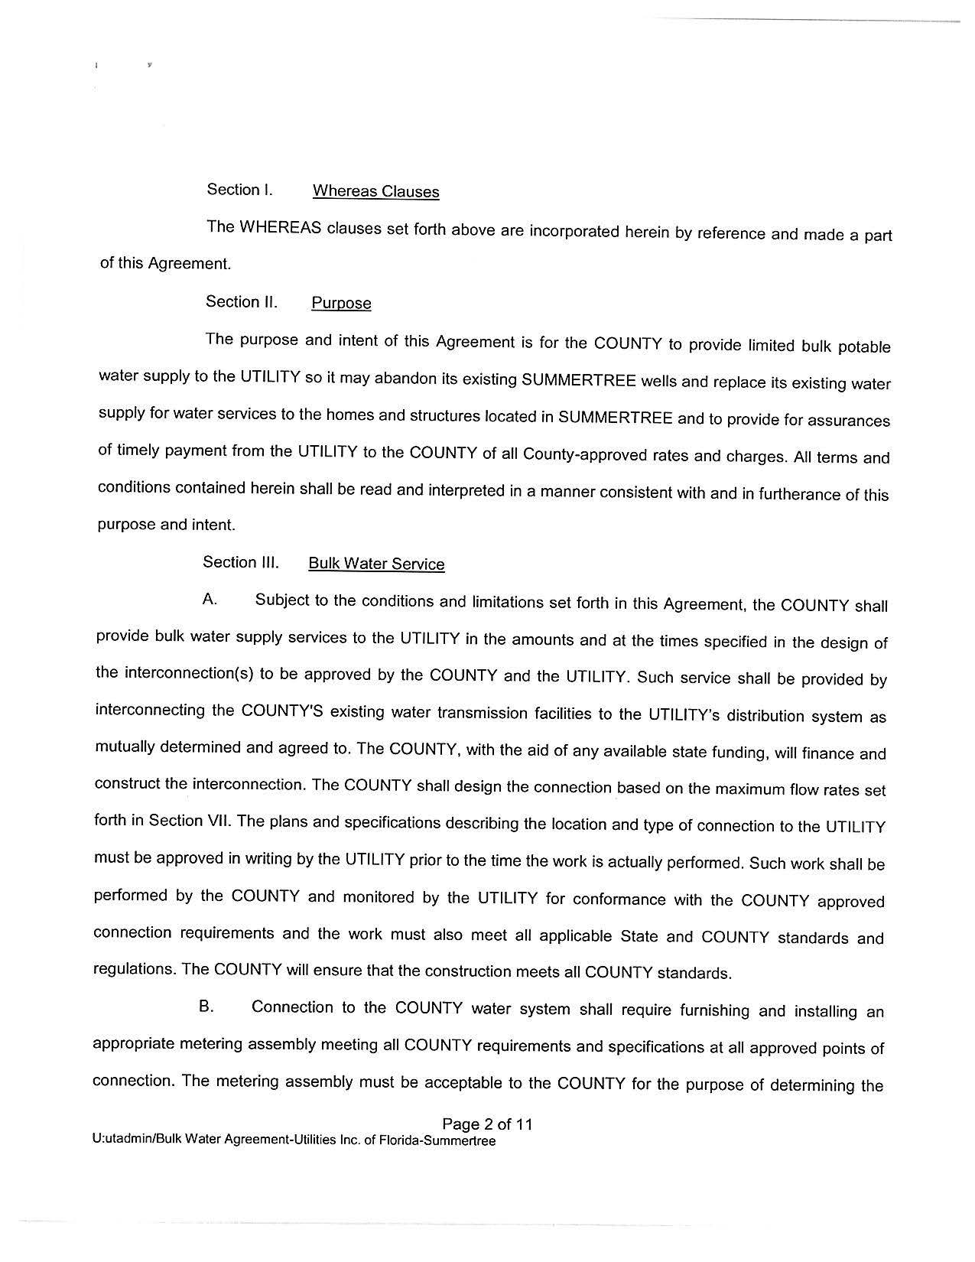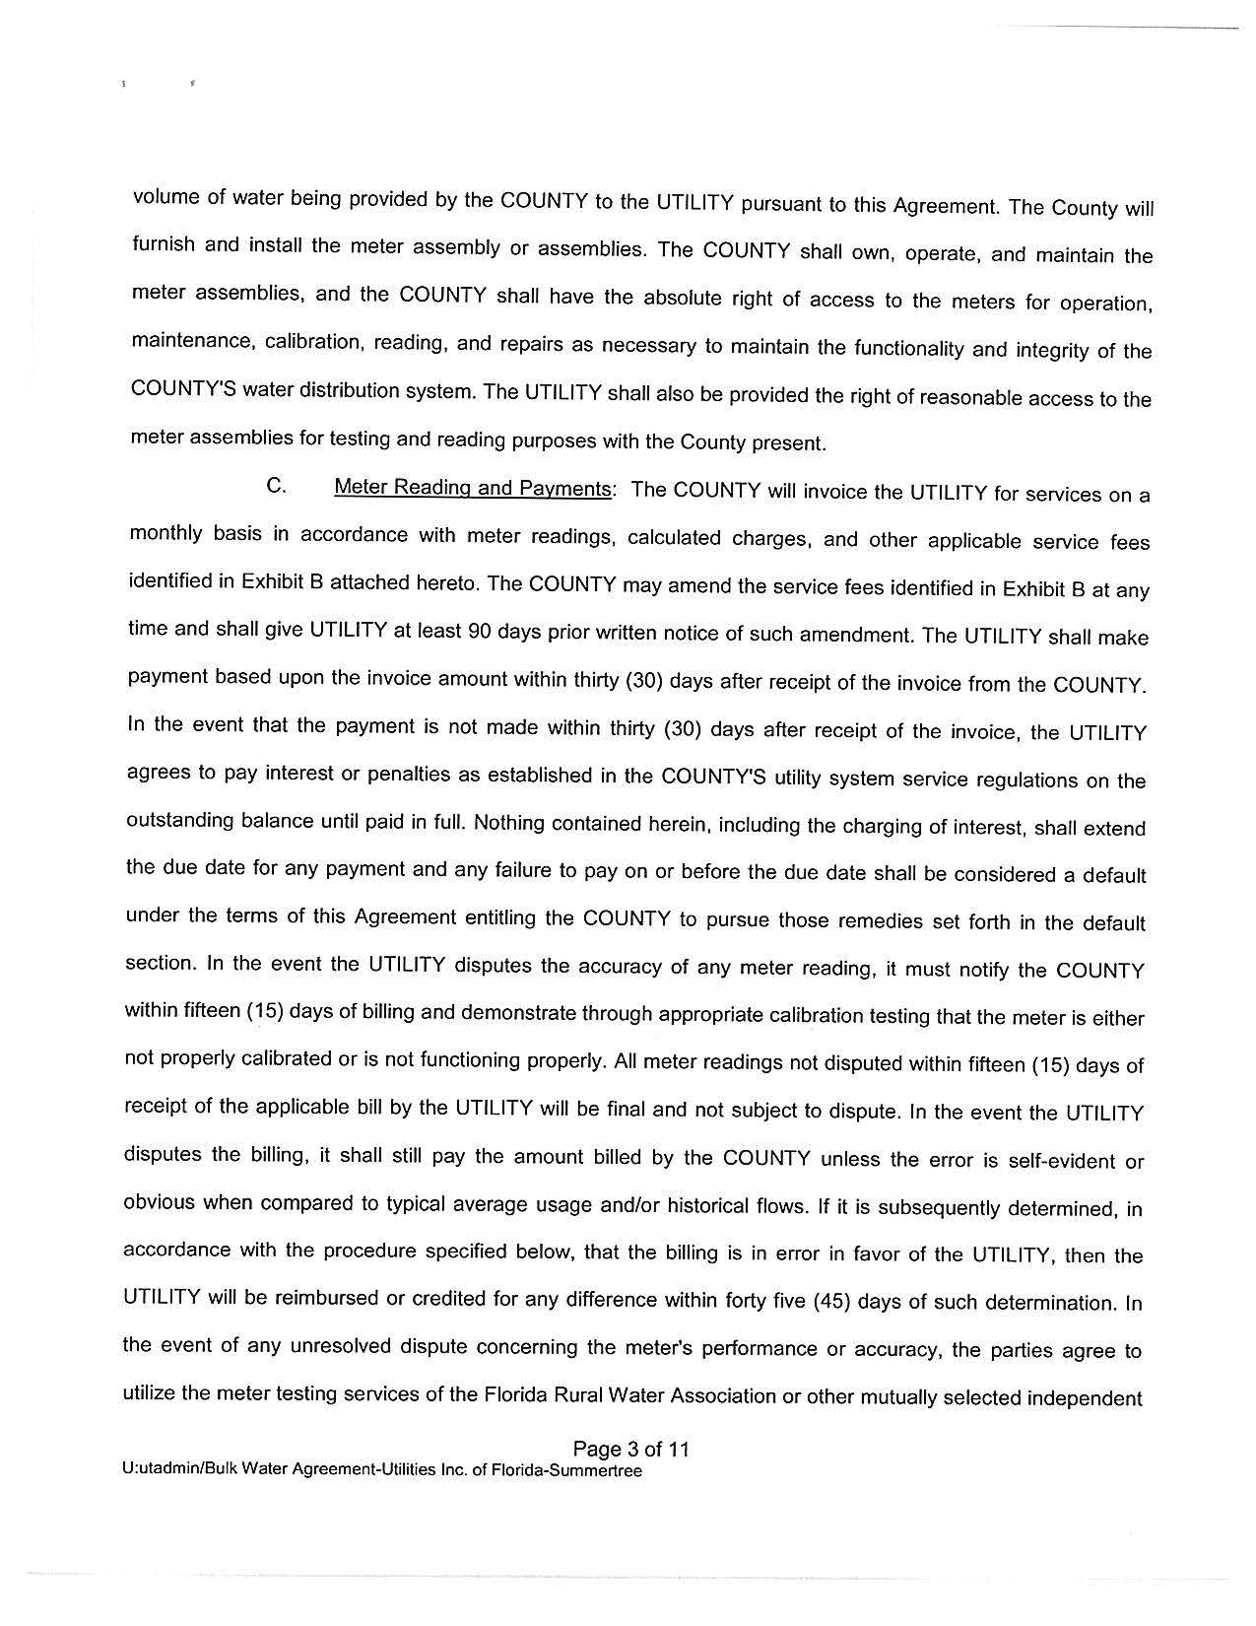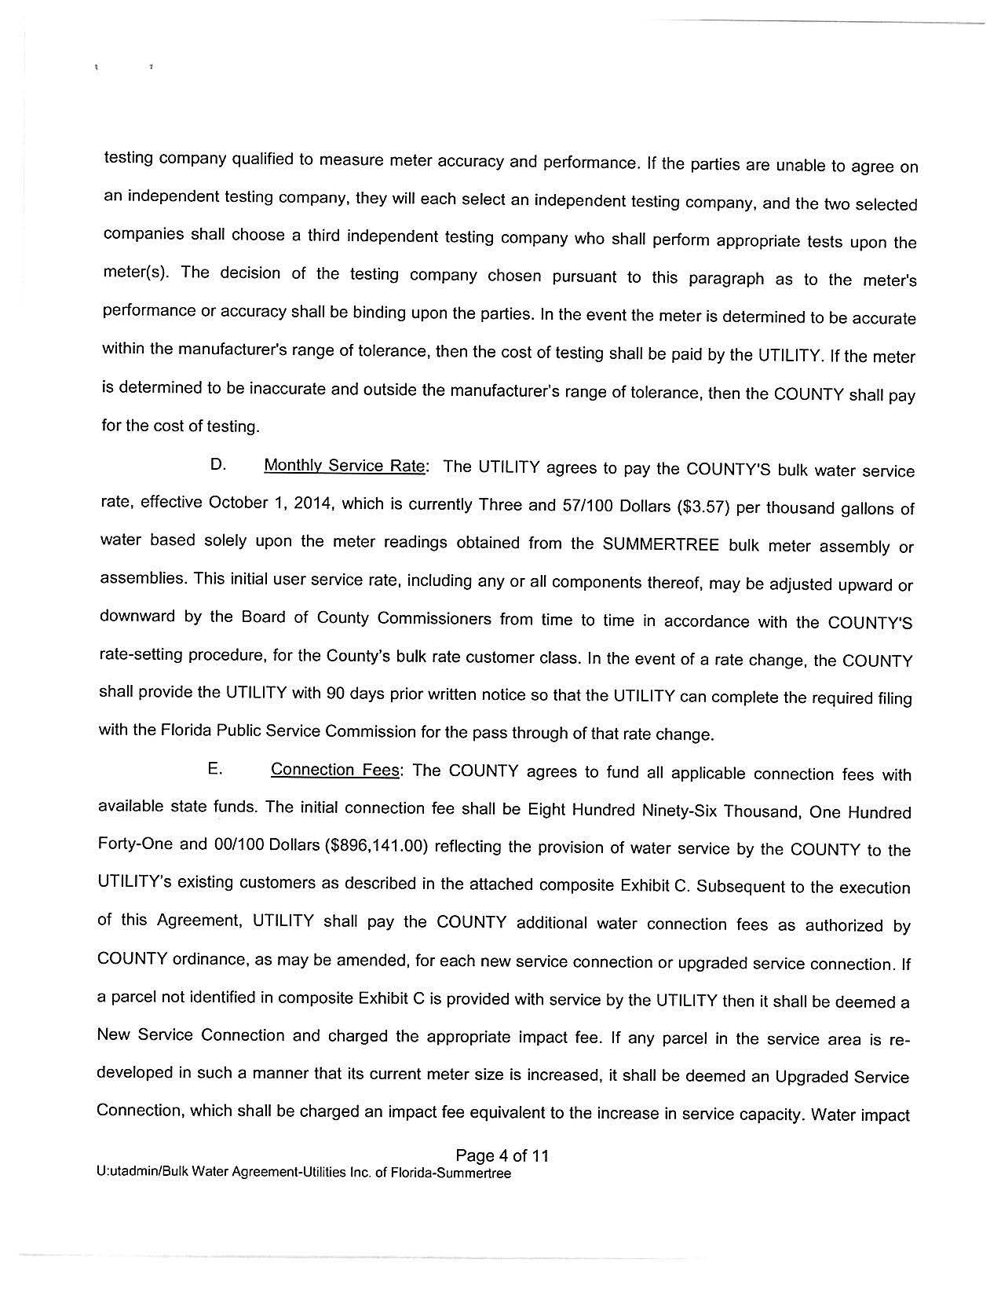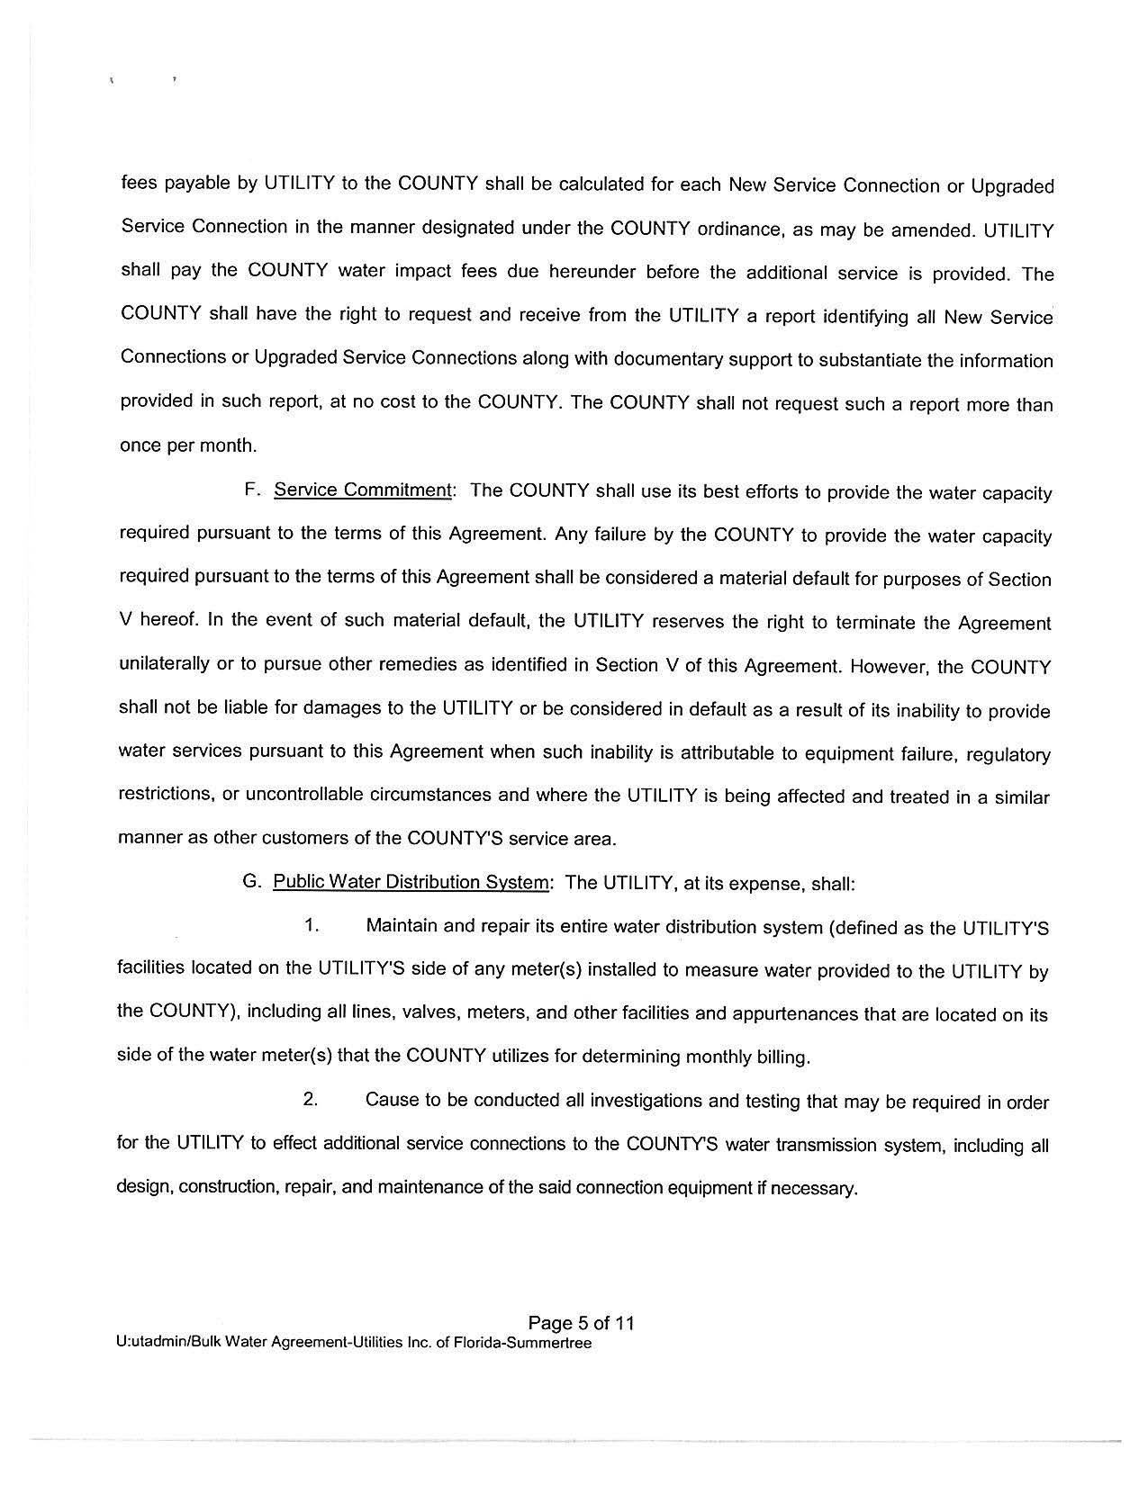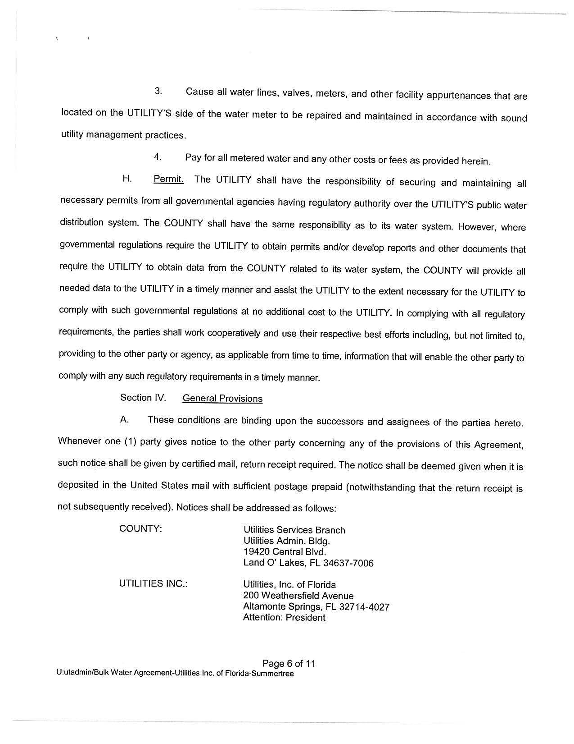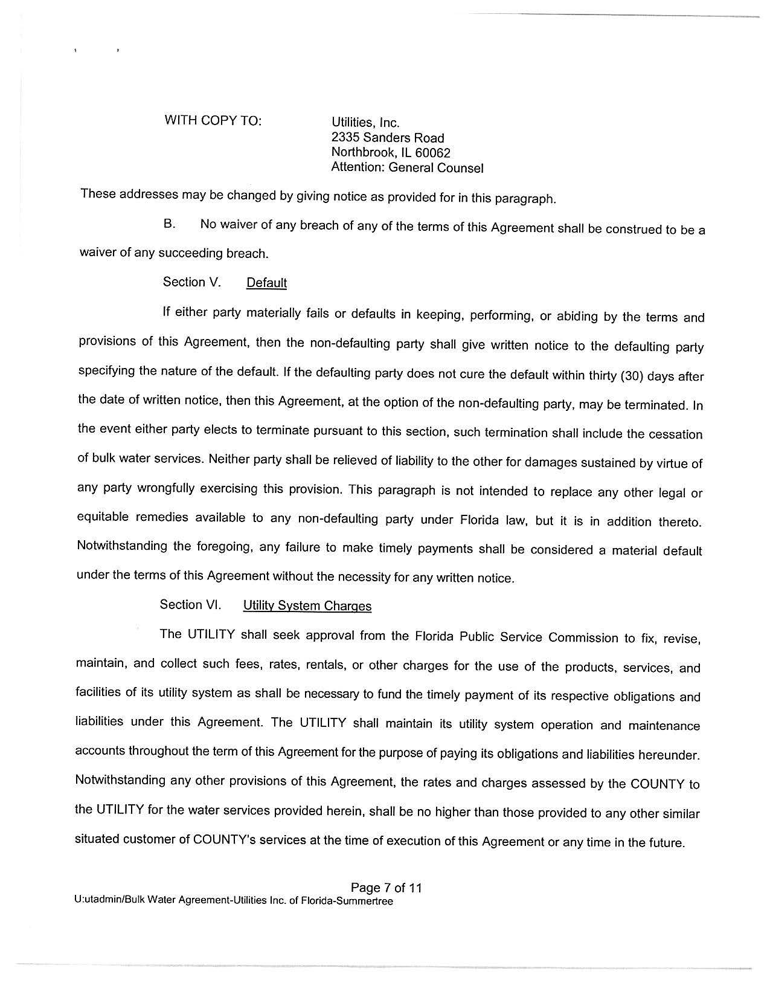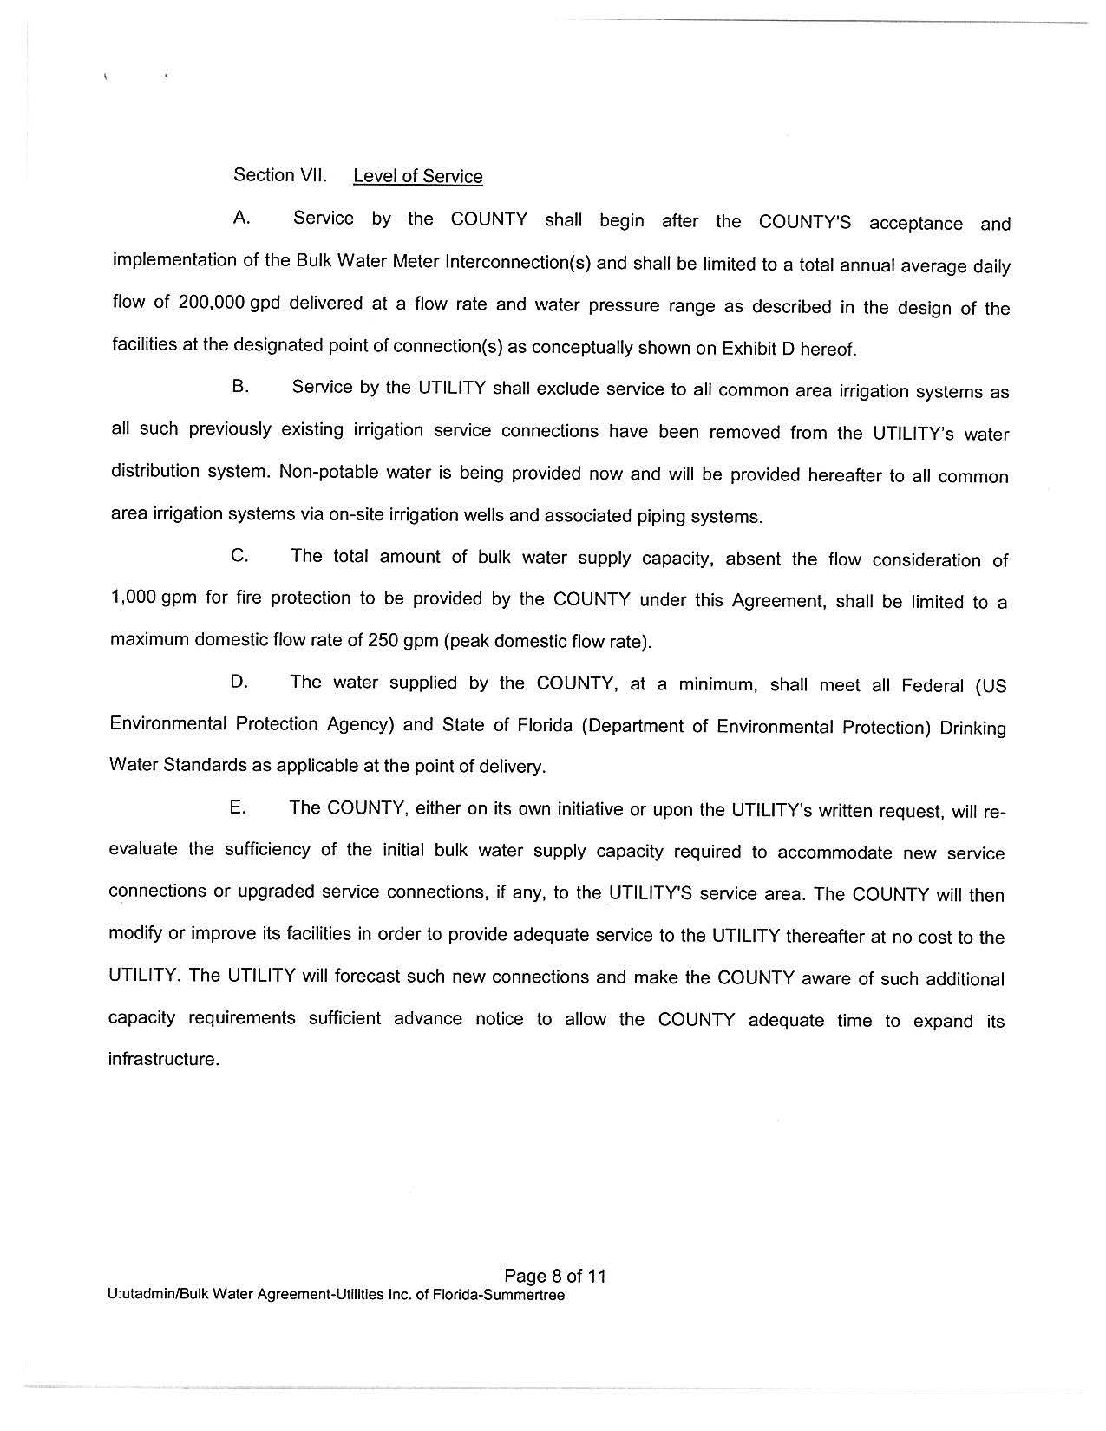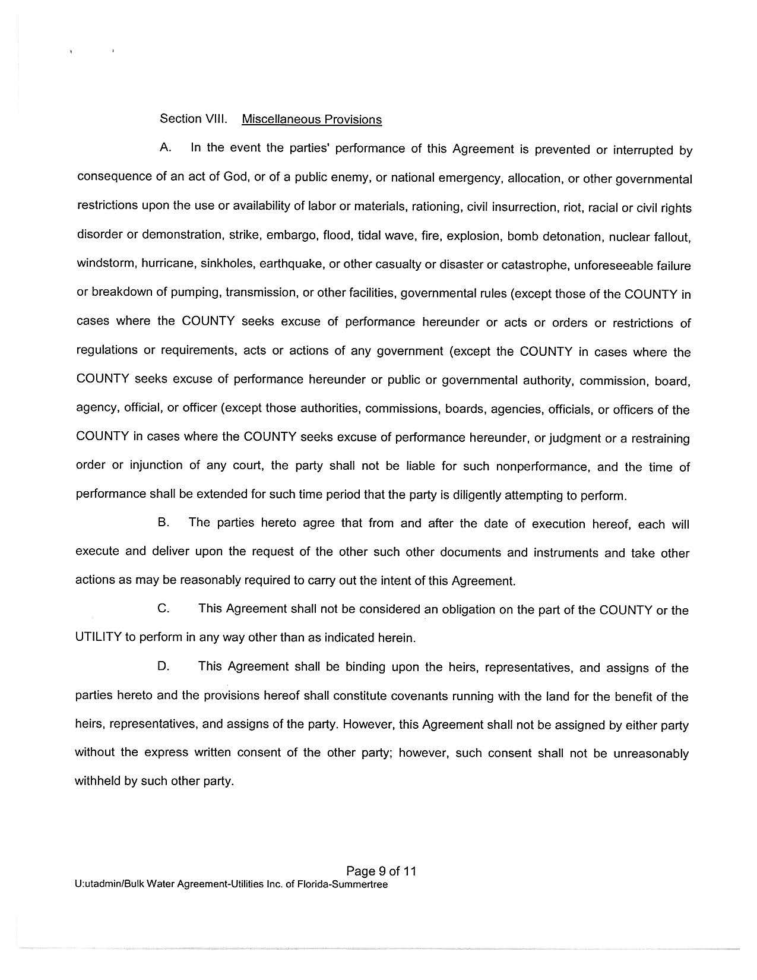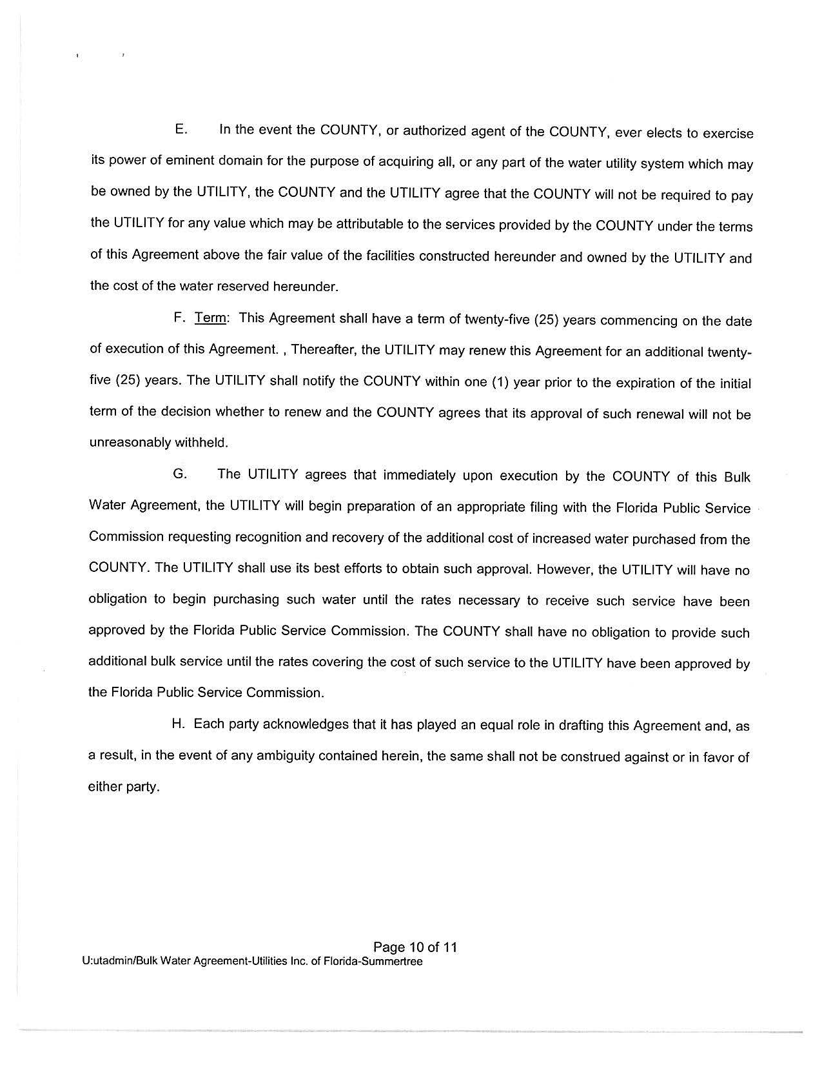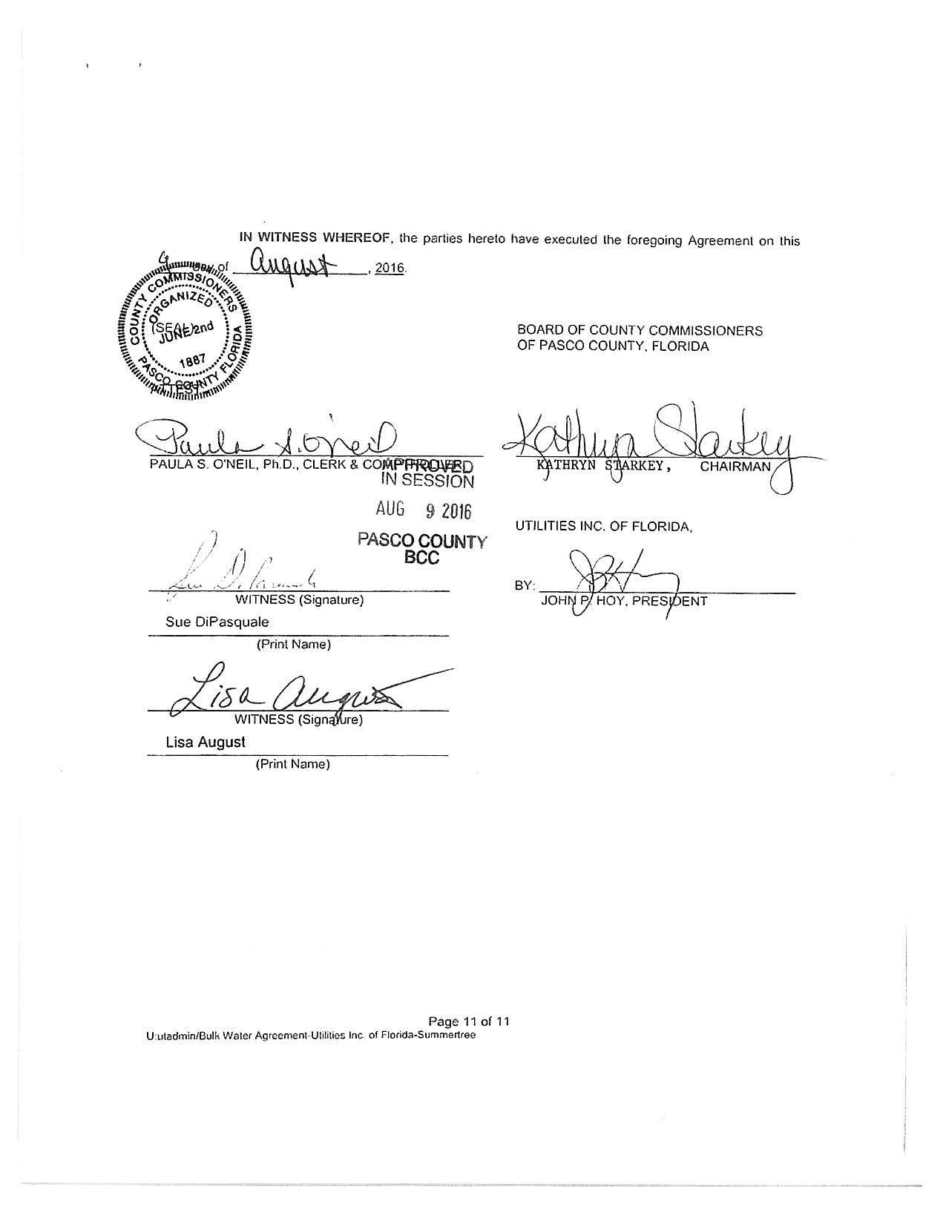

Order No. PSC-14-0025-PAA-WS, issued January 10, 2014, in Docket No. 120209-WS, In re: Application for increase in water and wastewater rates in Marion, Orange, Pasco, Pinellas, and Seminole Counties by Utilities, Inc. of Florida.
On April 12, 2016, the Commission acknowledged the reorganization and name change of UI’s systems in Florida. The instant docket applies only to the former Utilities, Inc. of Florida systems, and does not include Labrador Utilities, Inc. in Pasco County. Order No. PSC-16-0143-FOF-WS, issued April 12, 2016, in Docket No. 150235-WS, In re: Joint application for acknowledgement of corporate reorganization and request for approval of name changes on water and/or wastewater certificates of Cypress Lakes Utilities, Inc. in Polk County; Utilities, Inc. of Eagle Ridge in Lee County; Utilities, Inc. of Florida in Marion, Orange, Pasco, Pinellas, and Seminole Counties; Labrador Utilities, Inc. in Pasco County; Lake Placid Utilities, Inc. in Highlands County; Lake Utility Services, Inc. in Lake County; Utilities, Inc. of Longwood in Seminole County; Mid-County Services, Inc. in Pinellas County; Utilities, Inc. of Pennbrooke in Lake County; Utilities, Inc. of Sandalhaven in Charlotte County; Sanlando Utilities Corporation in Seminole County; and Tierra Verde Utilities, Inc. in Pinellas County, to Utilities, Inc. of Florida.
Order No. PSC-16-0135-PCO-WS
Document No. 00669-16
Document No. 01120-16
Docket No. 160101-WS, In re: Application for increase in water and wastewater rates in Charlotte, Highlands, Lake, Lee, Marion, Orange, Pasco, Pinellas, Polk, and Seminole Counties by Utilities, Inc. of Florida.
Document No. 03459-16
Document No. 03641-16
Document No. 06480-16
Document No. 06823-16
Order No. PSC-14-0025-PAA-WS, issued January 10, 2014, in Docket 120209-WS, In re: Application for increase in water and wastewater rates in Marion, Orange, Pasco, Pinellas, and Seminole Counties by Utilities Inc. of Florida, pp.4-8.
Document No. 05631-16
Document No. 07147-16, p.4
Document No. 06923-16
Order No. PSC-14-0025-PAA-WS, issued January 10, 2014, in Docket No. 120209-WS, In re: Application for increase in water and wastewater rates in Marion, Orange, Pasco, Pinellas, and Seminole Counties by Utilities, Inc. of Florida, p.65.
Document No. 01120-16, p.6
Document No. 07710-16, p.49 (Commission Conference Transcript)
Document No. 07491-16
Document No. 07735-16
UIF Petition, Schedule No. 17
Document No. 00869-16, Staff’s First Data Request No. 3
Order No. PSC-14-0025-PAA-WS, issued January 10, 2014, in Docket No. 120209-WS, In re: Application for increase in water and wastewater rates in Marion, Orange, Pasco, Pinellas, and Seminole Counties by Utilities, Inc. of Florida, p.8.
Document No. 00869-16, Staff’s First Data Request No. 21.
Order No. PSC-16-0296-PAA-WS, issued July 27, 2016.
Documents No. 05631-16 and 07735-16
Docket No. 150010-WS, Application for staff-assisted rate case in Brevard County by Aquarina Utilities, Inc.
Federal Insurance Contributions Act (7.65 percent)
Federal Unemployment Tax Act (6.00 percent)
State Unemployment Tax Act (1.02 percent)
Document No. 07147-16, p.10 (see Attachment A)
Document No. 06975-16
The recommended rates are for illustrative purposes only because the interim rate case rates will be implemented prior to the effective date for the LIMP rates.
Order No. PSC-09-0651-PAA-SU, issued September 28, 2009, in Docket No. 090121-SU, In re: Application for limited proceeding rate increase in Seminole County by Alafaya Utilities, Inc.; and Order No. PSC-10-0682-PAA-WS, issued November 15, 2010, in Docket No. 090349-WS, In re: Application for limited proceeding rate increase in Polk County by Cypress Lakes Utilities, Inc.

