BEFORE THE FLORIDA PUBLIC SERVICE COMMISSION

In re: Petition for approval of stipulation to amend revised and restated stipulation and settlement agreement by Duke Energy Florida, LLC. | DOCKET NO. 160151-EI  ORDER NO. PSC-16-0425-PAA-EI  ISSUED: October 3, 2016

The following Commissioners participated in the disposition of this matter:

JULIE I. BROWN, Chairman
LISA POLAK EDGAR
ART GRAHAM
RONALD A. BRISÉ
JIMMY PATRONIS

NOTICE OF PROPOSED AGENCY ACTION
ORDER APPROVING THE THIRD STIPULATION TO AMEND THE REVISED AND RESTATED STIPULATION AND SETTLEMENT AGREEMENT BY DUKE ENERGY FLORIDA, LLC.

BY THE COMMISSION:

NOTICE is hereby given by the Florida Public Service Commission that the action discussed herein is preliminary in nature and will become final unless a person whose interests are substantially affected files a petition for a formal proceeding, pursuant to Rule 25-22.029, Florida Administrative Code (F.A.C.).

In 2013, Duke Energy Florida, LLC (DEF) announced its decision to retire its nuclear plant, Crystal River Unit 3 (CR3), in Citrus County, Florida. The retirement of CR3 was the subject of two settlement agreements. The first settlement agreement, reached in 2012, was a global settlement that addressed several issues, including issues related to a potential CR3 retirement. The second settlement agreement, the Revised and Restated Stipulation and Settlement Agreement (RRSSA), reached in 2013, replaced and supplanted the 2012 settlement agreement. The parties to the RRSSA were DEF, the Office of Public Counsel (OPC), the Florida Industrial Power Users Group (FIPUG), the Florida Retail Federation (FRF), and White Springs Agricultural Chemicals, Inc., d/b/a PCS Phosphate (PCS Phosphate).
The RRSSA contemplated that DEF would recover through increased base rate charges the combined costs of two items associated with the retirement of CR3, the projected Dry Cask Storage (DCS) facility costs and the CR3 Regulatory Asset. Subsequent to approval of the RRSSA, this Commission approved two amendments. Collectively, these amendments allowed for securitization of the CR3 Regulatory Asset, leaving only the DCS facility costs to be recovered through base rates.
On June 15, 2016, DEF filed a petition for approval of a Third Stipulation to Amend the RRSSA (Third RRSSA Amendment). All parties to the RRSSA, including DEF, OPC, FIPUG, FRF, and PCS Phosphate, are signatories to the Third RRSSA Amendment.
We have jurisdiction pursuant to Sections 366.04 and 366.05, Florida Statutes (F.S.).

In its petition for approval of the Third RRSSA Amendment, attached to this Order as Attachment A, DEF states that the parties requested changes would shift recovery of the DCS facility costs from increases in base rates to the CCR Clause. Prior to the modifications, DCS facility costs would have been recovered through uniform percentage increases in demand and energy rates, updated at least once every 4 years for a period up to 20 years, and with true-up through the CCR Clause.
Recognizing our previous decision, the deferral of amortization for some costs associated with the DCS facility is included in the Third RRSSA Amendment. The time period for amortization of capital costs associated with the DCS could also be modified through agreement of all parties and our approval. Cost allocation will remain based upon the methodology outlined in the RRSSA.
The Third RRSSA Amendment alters two paragraphs within the RRSSA to reflect the shift from base rates to the CCR Clause. Paragraph 5(e)(1) is amended to reflect the DCS facility costs are not to be combined with the CR3 Regulatory Asset, but rather are to be recovered through the CCR Clause. DEF states the parties determined that to preserve the intended cost recovery allocation of DCS facility costs, the Third RRSSA Amendment is necessary given the change in circumstances of the CR3 Regulatory Asset. As noted by DEF in response to Commission staff’s data request, the CR3 Regulatory Asset was securitized in June 2016 and is now held in a bankruptcy-remote facility and for all intents and purposes is isolated from further regulatory action. DEF notes it did not seek to add the DCS facility costs to this balance for securitization due to outstanding legal actions with the DOE stemming from its failure to remove spent nuclear fuel from the CR3 facility. Upon approval, DEF will be required to credit the CCR Clause for any applicable award from the DOE. We shall have an opportunity to review DCS facility costs on an annual basis in the CCR Clause proceedings, including DOE awards.
Paragraph 21, which addresses those portions of the RRSSA that extend beyond December 2018, is amended to reflect that recovery of DCS facility costs through the CCR Clause may continue past 2018. Prior to the modifications, the recovery of DCS facility costs would have ended with the CR3 Regulatory Asset or approximately 20 years.
We find that the Third RRSSA Amendment contained in Attachment A of this Order is in the public interest and is therefore approved. Recovery of the Dry Cask Storage (DCS) facility costs through the Capacity Cost Recovery Clause (CCR Clause) will allow annual review and adjustment, including potential credits from Department of Energy (DOE) awards.
Based on the foregoing, it is

ORDERED by the Florida Public Service Commission that the Third Revised and Restated Stipulation and Settlement Agreement Amendment contained in Attachment A of this Order is in the public interest and is hereby approved. Recovery of the Dry Cask Storage (DCS) facility costs through the Capacity Cost Recovery Clause (CCR Clause) will allow annual review and adjustment, including potential credits from Department of Energy (DOE) awards. It is further
ORDERED that the provisions of this Order, issued as proposed agency action, shall become final and effective upon the issuance of a Consummating Order unless an appropriate petition, in the form provided by Rule 28-106.201, Florida Administrative Code, is received by the Commission Clerk, 2540 Shumard Oak Boulevard, Tallahassee, Florida 32399-0850, by the close of business on the date set forth in the “Notice of Further Proceedings” attached hereto. It is further

ORDERED that if no protest if filed by a person whose substantial interests are affected within 21 days of the issuance of the Order, this docket shall be closed upon the issuance of a Consummating Order.

By ORDER of the Florida Public Service Commission this 3rd day of October, 2016.

/s/ Carlotta S. Stauffer
CARLOTTA S. STAUFFER
Commission Clerk
Florida Public Service Commission
2540 Shumard Oak Boulevard
Tallahassee, Florida 32399
(850) 413-6770
www.floridapsc.com

Copies furnished: A copy of this document is provided to the parties of record at the time of issuance and, if applicable, interested persons.

DJ

NOTICE OF FURTHER PROCEEDINGS OR JUDICIAL REVIEW

The Florida Public Service Commission is required by Section 120.569(1), Florida Statutes, to notify parties of any administrative hearing that is available under Section 120.57, Florida Statutes, as well as the procedures and time limits that apply. This notice should not be construed to mean all requests for an administrative hearing will be granted or result in the relief sought.

Mediation may be available on a case-by-case basis. If mediation is conducted, it does not affect a substantially interested person's right to a hearing.

The action proposed herein is preliminary in nature. Any person whose substantial interests are affected by the action proposed by this order may file a petition for a formal proceeding, in the form provided by Rule 28-106.201, Florida Administrative Code. This petition must be received by the Office of Commission Clerk, 2540 Shumard Oak Boulevard, Tallahassee, Florida 32399-0850, by the close of business on October 24, 2016.

In the absence of such a petition, this order shall become final and effective upon the issuance of a Consummating Order.

Any objection or protest filed in this/these docket(s) before the issuance date of this order is considered abandoned unless it satisfies the foregoing conditions and is renewed within the specified protest period.

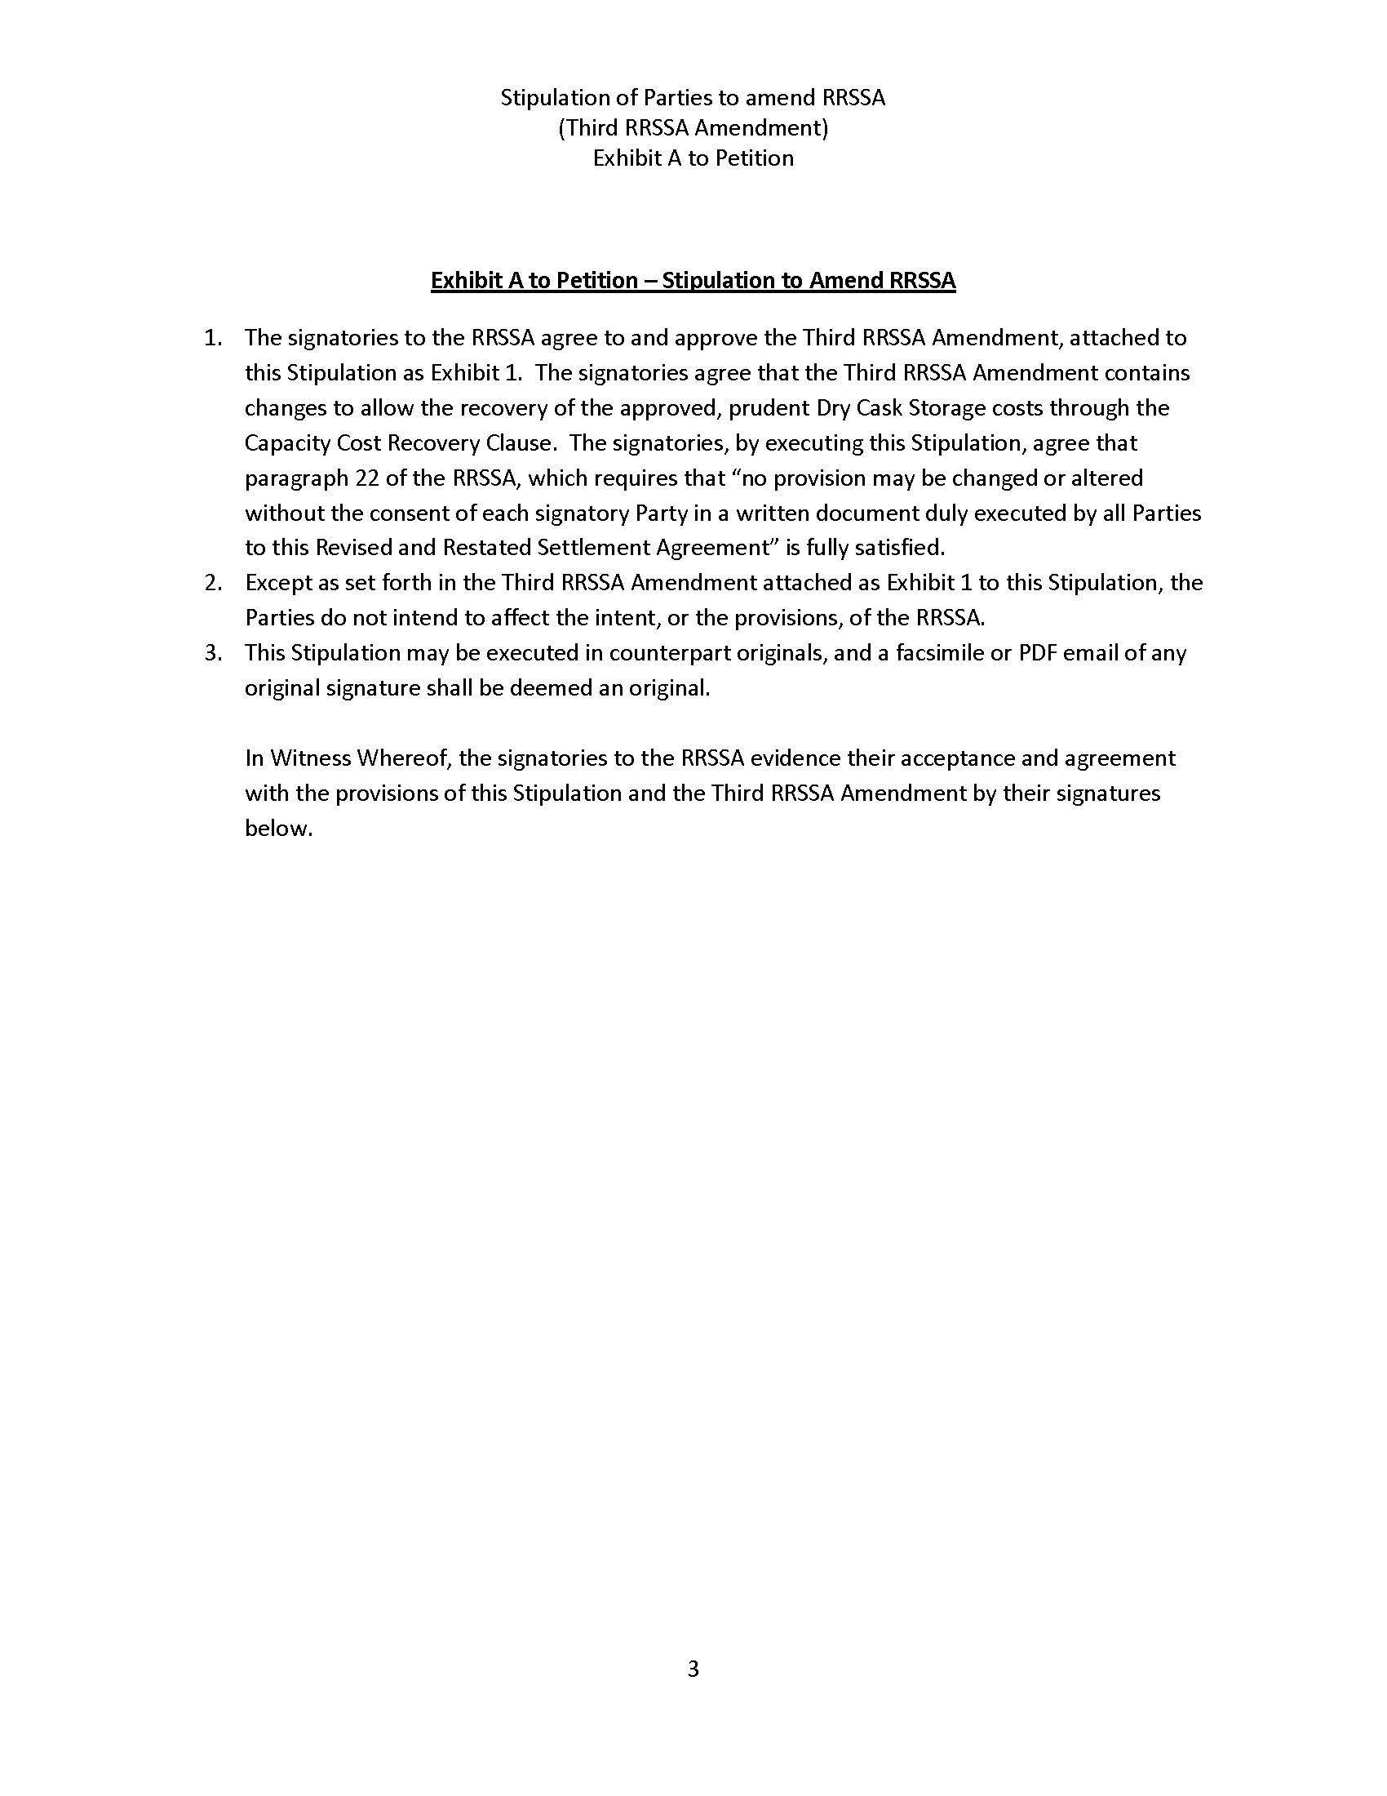

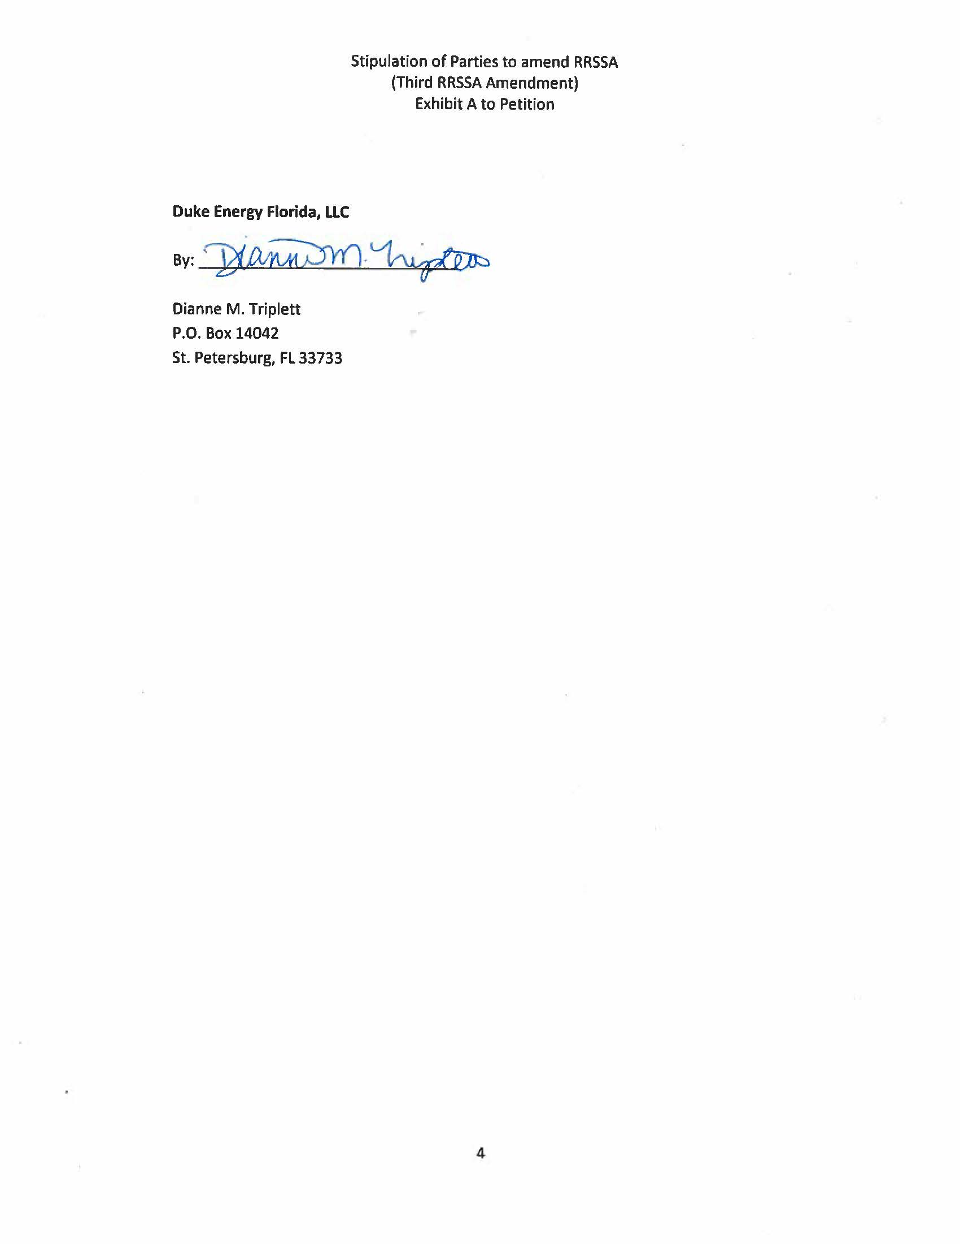

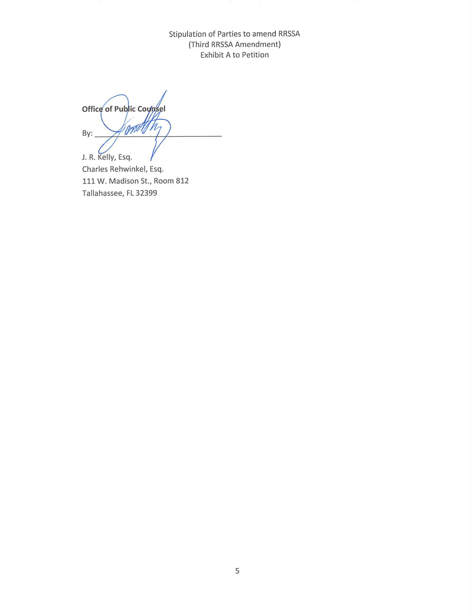

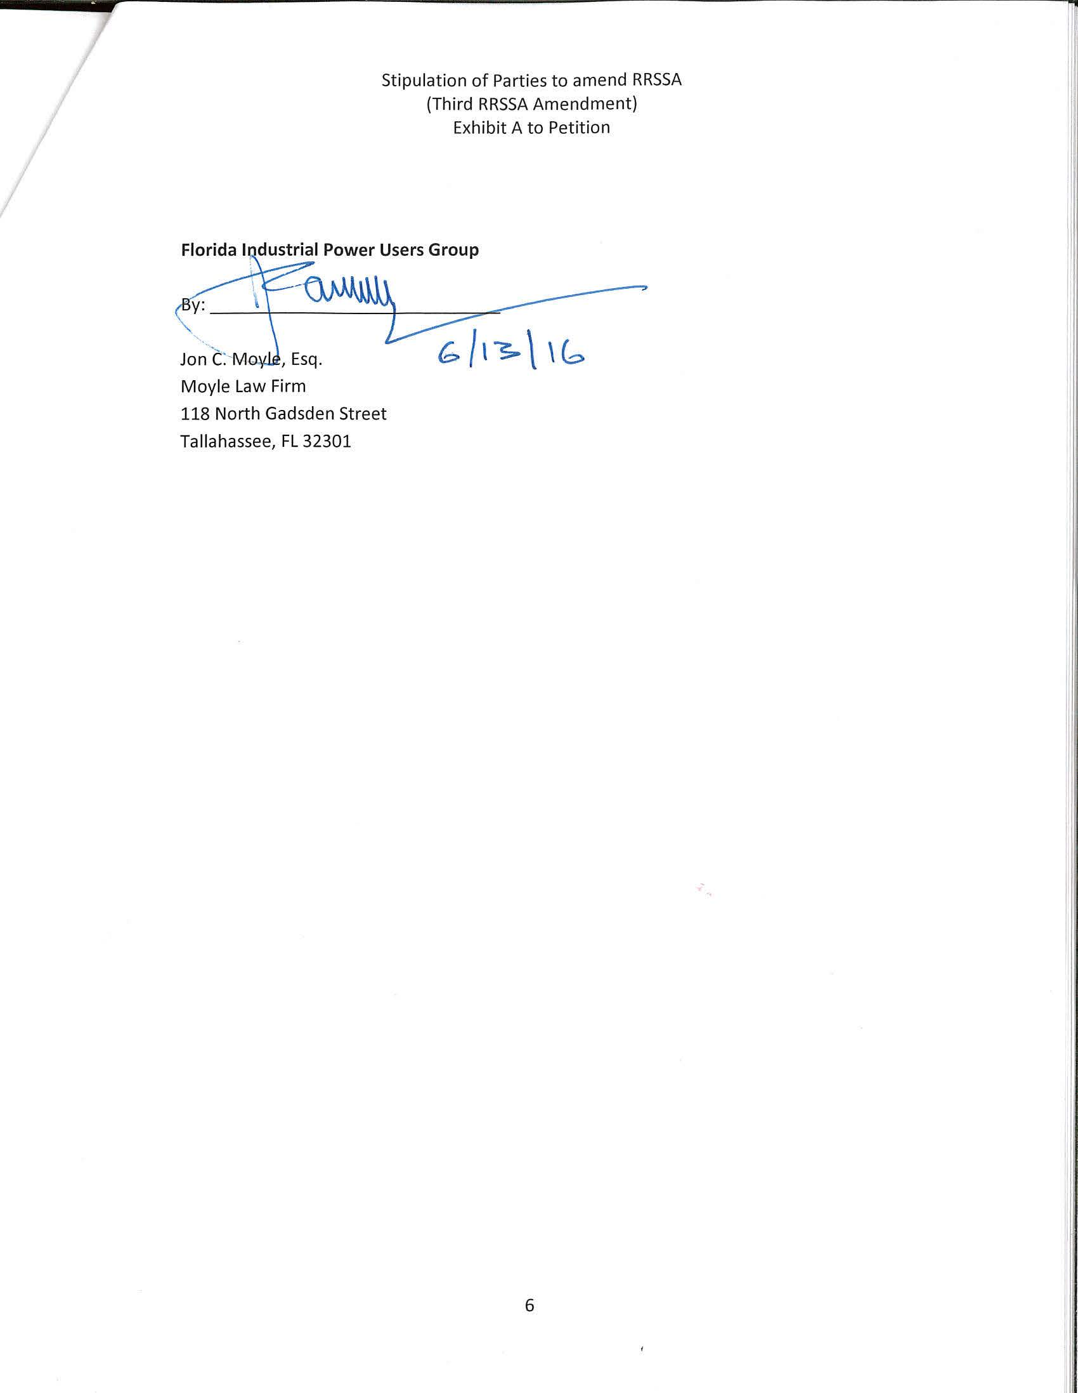

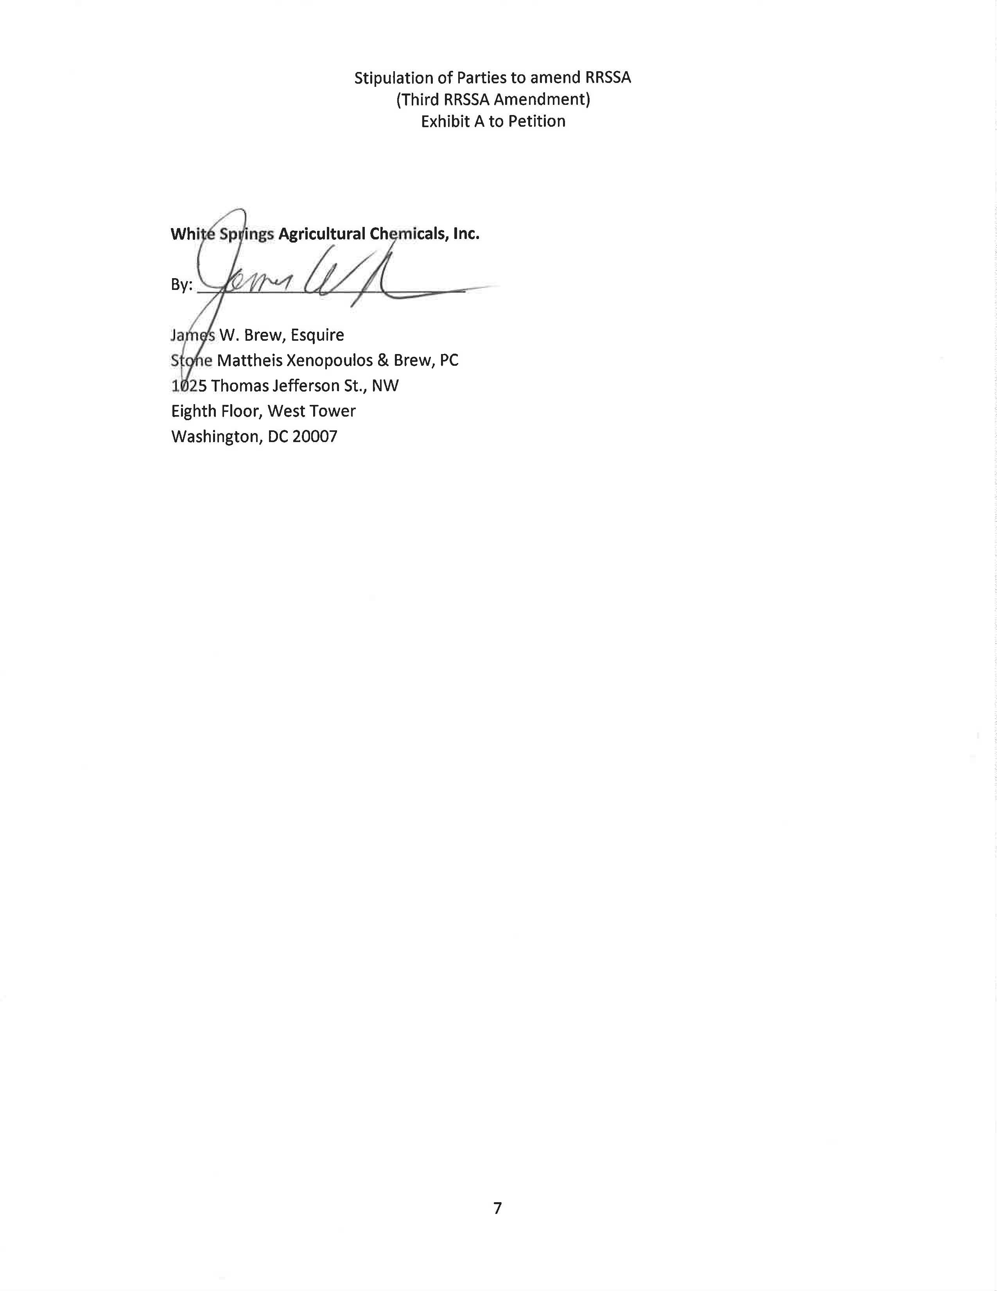

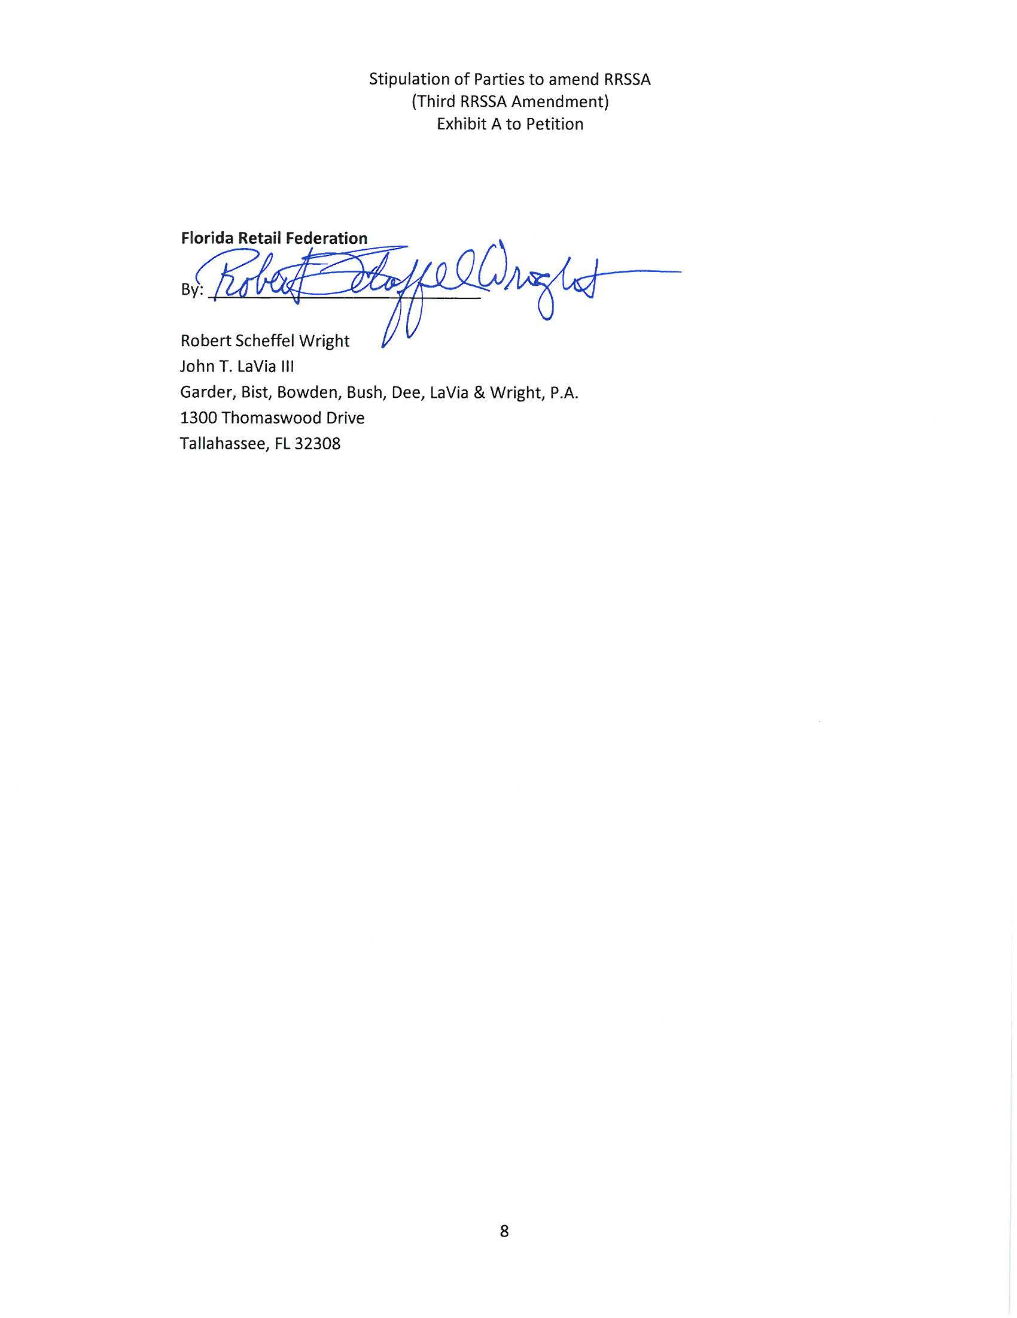

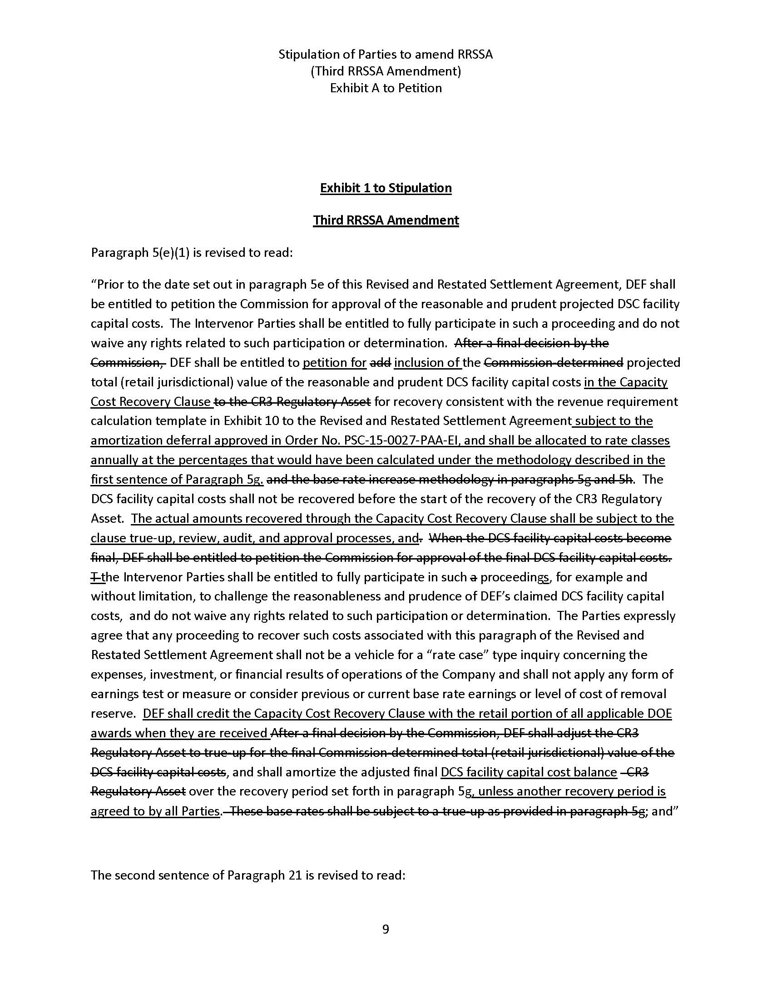

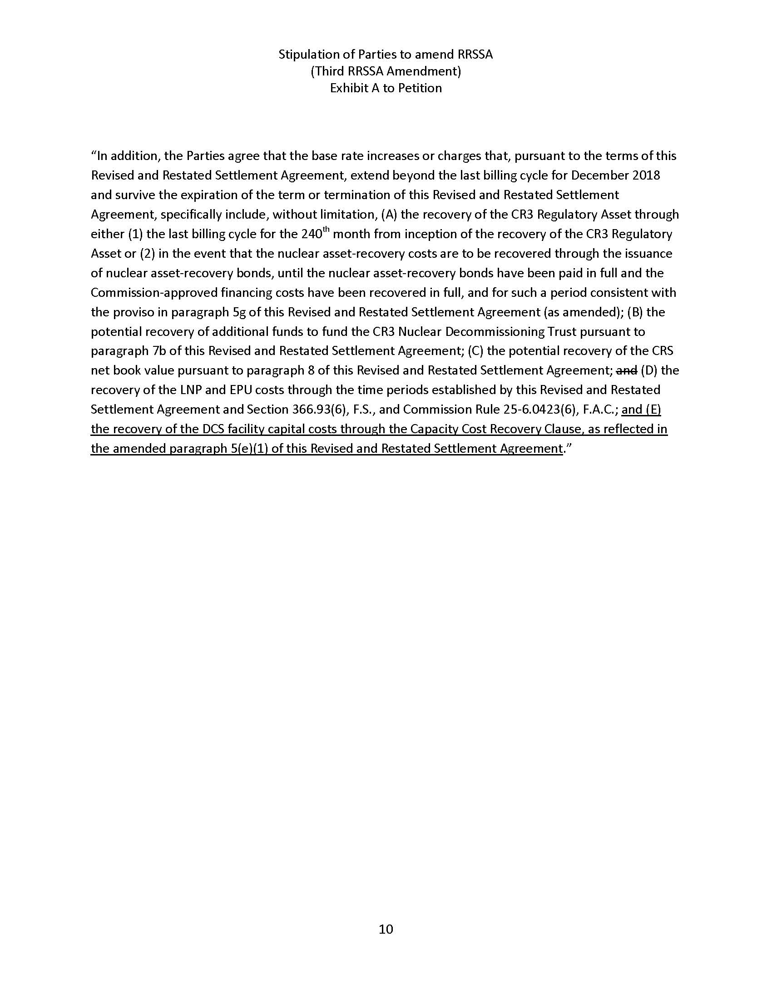

Order No. PSC-12-0104-FOF-EI, issued March 8, 2012, in Docket No. 120022-EI, In re: Petition for limited proceeding to approve stipulation and settlement agreement by Progress Energy Florida, Inc.
Order No. PSC-13-0598-FOF-EI, issued November 12, 2013, in Docket No. 130208-EI, In re: Petition for limited proceeding to approve revised and restated stipulation and settlement agreement by Duke Energy Florida, Inc. d/b/a Duke Energy.
Order No. PSC-15-0465-S-EI, issued October 14, 2015, in Docket Nos. 150148-EI, In re: Petition for approval to include in base rates the revenue requirement for the CR3 regulatory asset, by Duke Energy Florida, Inc. and 150171-EI, In re: Petition for issuance of nuclear asset-recovery financing order, by Duke Energy Florida, Inc. d/b/a Duke Energy, and Order No. PSC-16-0138-FOF-EI, issued April 5, 2016, in Docket Nos. 150148-EI, In re: Petition for approval to include in base rates the revenue requirement for the CR3 regulatory asset, by Duke Energy Florida, Inc. and 150171-EI, In re: Petition for issuance of nuclear asset-recovery financing order, by Duke Energy Florida, Inc. d/b/a Duke Energy.
Order No. PSC-15-0027-PAA-EI, issued January 7, 2015, in Docket No. 140113-EI, In re: Petition for approval to construct an independent spent fuel storage installation and an accounting order to defer amortization pending recovery from the Department of Energy, by Duke Energy Florida, Inc.

