State of Florida   |  | Public Service Commission  Capital Circle Office Center ● 2540 Shumard Oak Boulevard  Tallahassee, Florida 32399-0850  -M-E-M-O-R-A-N-D-U-M-
DATE: | May 24, 2017
TO: | Office of Commission Clerk (Stauffer)
FROM: | Division of Economics (Rome, Draper)  Office of the General Counsel (Brownless)
RE: | Docket No. 170096-EI – Petition for approval of revised customer security deposit tariff sheets, by Florida Power & Light Company.
AGENDA: | 06/05/17 – Regular Agenda – Tariff Filing – Interested Persons May Participate
COMMISSIONERS ASSIGNED: |  |  | All Commissioners
PREHEARING OFFICER: |  |  | Administrative
CRITICAL DATES: |  |  | 06/27/17 (60-Day Suspension Date)
SPECIAL INSTRUCTIONS: |  |  | Place following Docket No. 170093-EI

Case Background
On April 28, 2017, Florida Power & Light Company (FPL or Company) filed a petition requesting Commission approval of amendments to Tariff Sheet Nos. 4.020, 6.040, 6.050, 9.400, and 9.410 regarding customer deposits. During the 2015 session, the Florida Legislature enacted House Bill 7109 which was incorporated into Chapter 2015-129, Laws of Florida. Among other things, the legislation created Section 366.05(1)(b) and (c), Florida Statutes (F.S.). Paragraph (1)(b) addresses billing periods and Paragraph (1)(c) addresses customer deposits. These laws became effective on July 1, 2015. The Commission adopted amendments to Rules 25-6.100 (Customer Billings) and 25-6.097 (Customer Deposits), Florida Administrative Code (F.A.C.), respectively, to implement the laws enacted in July 2015.
FPL is requesting tariff modifications at this time to ensure that the Company’s tariff language continues to conform to the applicable statutes and Commission rules. On May 18, 2017, FPL filed an amended version of Tariff Sheet No. 6.050 that was inadvertently not included with the original petition. The Commission has jurisdiction in this matter pursuant to Sections 366.03, 366.05, and 366.06, F.S.

Discussion of Issues

Issue 1:
Should the Commission approve FPL's proposed tariff modifications?

Recommendation:
Yes, the Commission should approve FPL’s requested modifications to Tariff Sheet Nos. 4.020, 6.040, 6.050, 9.400, and 9.410, as reflected in Attachment A, effective June 5, 2017. (Rome, Draper)

Staff Analysis:
FPL’s proposed tariff modifications are designed to conform FPL’s tariff to the applicable statutes and Commission rules. The two tariff modifications are discussed below.

Billing Period
Section 366.05(1)(b), F.S., provides that if the Commission authorizes a public utility to charge tiered rates based upon levels of usage and to vary its regular billing period, the utility may not charge a customer a higher rate because of an increase in usage attributable to an extension of the billing period; however, the regular meter reading date may not be advanced or postponed more than five days for routine operating reasons without prorating the billing for the period. The Commission amended Rule 25-6.100, F.A.C., to implement the statutory changes. The prior rule specified that the regular meter reading date may be advanced or postponed not more than 5 days without a proration of the billing for the period, but did not address the application of tiered rates to extended billing periods. Tiered rates, such as FPL’s residential energy charges, apply a higher energy charge to usage above 1,000 kilowatt-hours.
FPL has proposed to add language to Tariff Sheet No. 6.050 to reflect the statutory requirements and to include the Company’s current billing practices in its tariff. The revised tariff sheet addresses both the proration of charges when billing periods are varied by more than five days, as well as the prohibition against charging higher tiered rates if the extension of a billing period of more than five days causes a customer’s energy consumption to exceed the Company’s tier threshold of 1,000 kilowatt-hours. FPL has represented to staff that its current business practices regarding bill proration and administration of tiered rates are in compliance with Section 366.05(1)(b), F.S.

Customer Deposits
Section 366.05(1)(c), F.S., provides that for an existing account, the total deposit may not exceed two months of average actual charges. For a new service request, the total deposit may not exceed two months of projected charges. Once a new customer has had continuous service for a 12-month period, the amount of the deposit shall be recalculated using actual data. Any difference between the projected and actual amounts must be resolved by the customer paying the additional amount that may be billed by the utility or the utility returning any overcharge.
The Commission amended Rule 25-6.097(1), F.A.C., to state that the utility’s methodology for determining customer deposits for existing and new accounts shall conform to Section 366.05(1)(c), F.S. The prior rule language already required that the total amount of a deposit not exceed twice the average monthly bill.
FPL’s proposed amendments to Tariff Sheet Nos. 6.040 and 6.050 conform to the new statutory language regarding the recalculation of the deposit after 12-months. FPL’s proposed amendments to Tariff Sheet Nos. 6.040 and 6.050 comport with this language by providing that: (a) if the recalculated deposit amount based on the previous 12-months billing history is less than the customer’s current deposit amount, the difference between the deposit amounts will be applied as a credit to the customer account; and (b) if the recalculated deposit amount exceeds the customer’s current deposit amount, the Company may request an additional deposit amount. FPL also proposed some administrative revisions to Tariff Sheet Nos. 4.020, 9.400, and 9.410 to conform to Rule 25-6.097, F.A.C.
Pursuant to Rule 25-6.097(3), F.A.C., utility customers receive refunds of their deposits with interest after a period of 23 months of continuous service, assuming their payment record is satisfactory. Therefore, for the majority of utility customers, the deposit amount recalculation after a 12-month period of continuous service occurs only once.

Conclusion
Based on a review of the applicable statutes, Commission rules, and proposed tariffs filed by FPL, staff believes that the tariff sheet revisions conform to the applicable statutes and Commission rules. Therefore, staff recommends that the Commission approve FPL’s requested modifications to Tariff Sheet Nos. 4.020, 6.040, 6.050, 9.400, and 9.410, as reflected in Attachment A, effective June 5, 2017.

Issue 2:
Should this docket be closed?

Recommendation:
If Issue 1 is approved and a protest is filed within 21 days of the issuance of the order, the tariffs should remain in effect, with any revenues held subject to refund, pending resolution of the protest. If no timely protest is filed, this docket should be closed upon the issuance of a consummating order. (Brownless)

Staff Analysis:
If Issue 1 is approved and a protest is filed within 21 days of the issuance of the order, the tariffs should remain in effect, with any revenues held subject to refund, pending resolution of the protest. If no timely protest is filed, this docket should be closed upon the issuance of a consummating order.

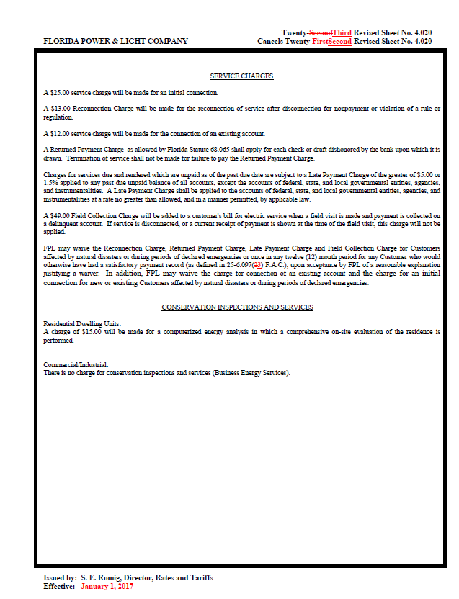
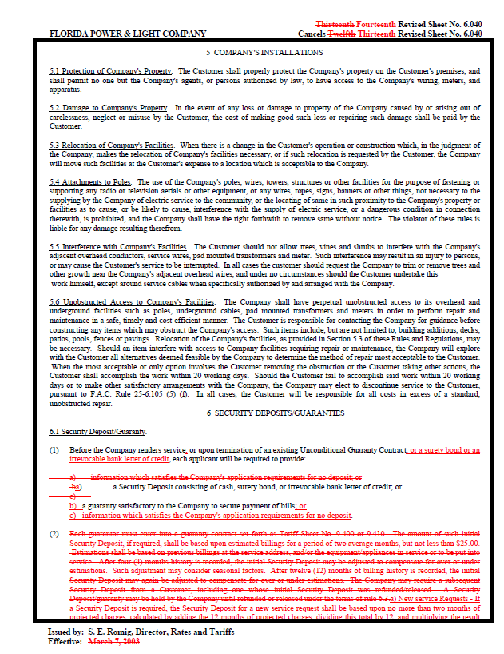
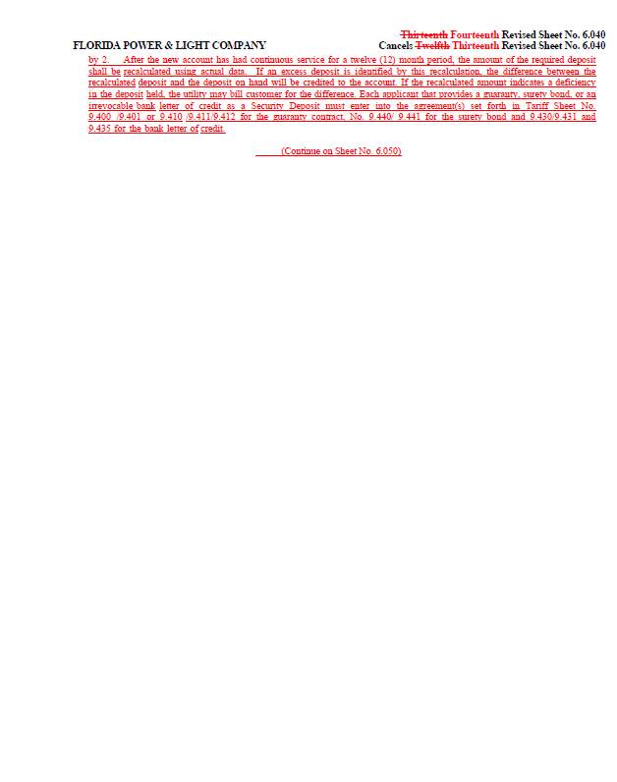
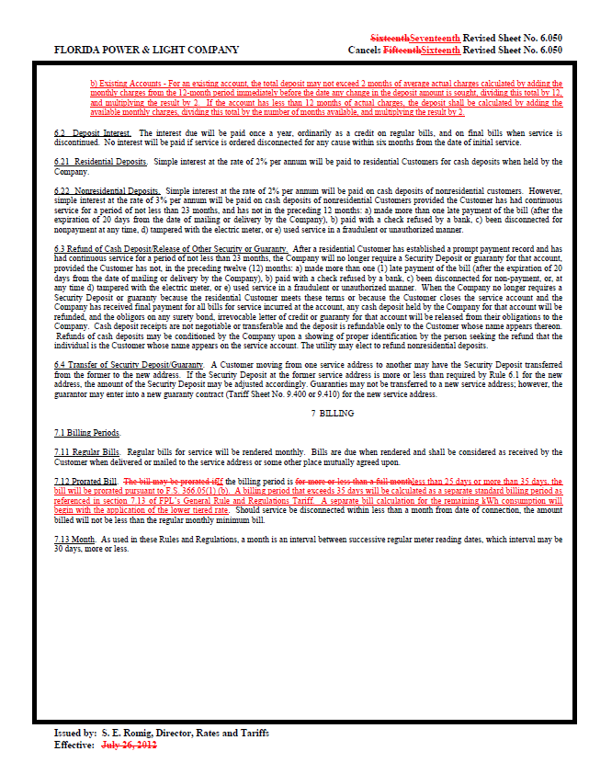
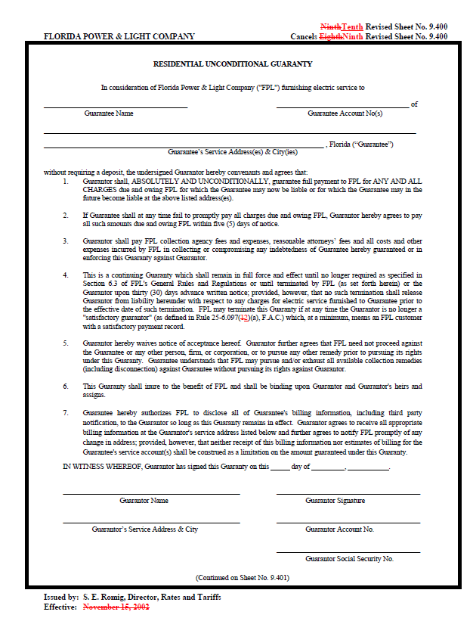
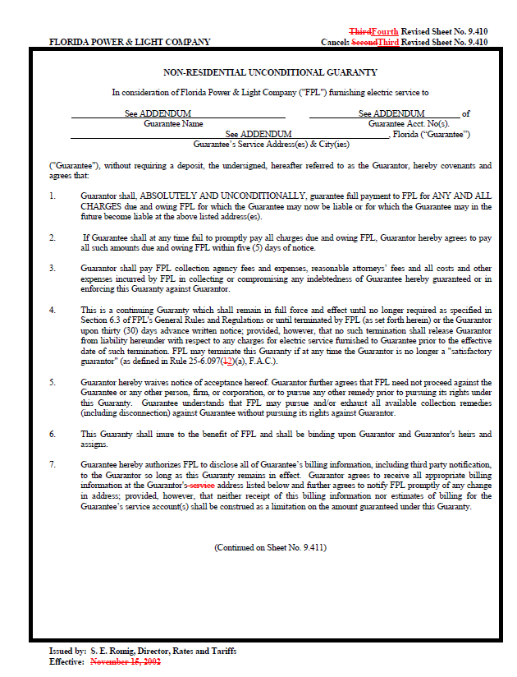

Order No. PSC-16-0024-FOF-PU, issued January 12, 2016, in Docket No. 150241-PU, In re: Proposed amendments to Rules 25-6.093, Information to Customers; 25-6.097, Customer Deposits; 25-6.100, Customer Billings; 25-7.079, Information to Customers; 25-7.083, Customer Deposits; and 25-7.085, Customer Billing, F.A.C.
Id.
Id.

