State of Florida   |  | Public Service Commission  Capital Circle Office Center ● 2540 Shumard Oak Boulevard  Tallahassee, Florida 32399-0850  -M-E-M-O-R-A-N-D-U-M-
DATE: | March 26, 2019
TO: | Office of Commission Clerk (Teitzman)
FROM: | Office of the General Counsel (Schrader, Crawford, King)  Division of Economics (Merryday, Draper)  Division of Engineering (Ballinger, Graves)
RE: | Docket No. 20180125-EU – Complaint against Gulf Power Company for expedited enforcement of territorial order, by Gulf Coast Electric Cooperative, Inc.
AGENDA: | 04/02/19 – Regular Agenda – Proposed Agency Action – Interested Persons May Participate
COMMISSIONERS ASSIGNED: |  |  | All Commissioners
PREHEARING OFFICER: |  |  | Brown
CRITICAL DATES: |  |  | None
SPECIAL INSTRUCTIONS: |  |  | None

Case Background
This docket pertains to a territorial dispute between Gulf Coast Electric Cooperative (GCEC) and Gulf Power Company (Gulf Power) over new service to a sewage treatment lift facility (Lift Facility) that was constructed by St. Joe Company. The ultimate customer of the Lift Facility is Bay County, and the Lift Facility was transferred to Bay County after the completion and commissioning of the facility.

To resolve a long-standing dispute between GCEC and Gulf Power regarding electric service in certain areas of Washington and Bay Counties, GCEC and Gulf Power entered into a Territorial Agreement (Territorial Agreement). The Territorial Agreement set out procedures and guidelines by which the parties were to address subtransmission, distribution, and new requests for service. The Commission approved this Territorial Agreement by Order Nos. PSC-01-0891-PAA-EU, issued April 9, 2001, and PSC-01-0891A-PAA-EU, issued March 26, 2002 (collectively referred to herein as the Territorial Order).

The Territorial Agreement does not use a traditional “lines-on-the-ground” territorial boundary. Rather, the Territorial Agreement establishes procedures for the parties to follow upon receiving a request for service from a customer.

On May 23, 2018, GCEC filed a complaint against Gulf Power in the instant docket alleging, in essence, that Gulf Power did not comply with the notice procedures of the Territorial Agreement and seeking expedited enforcement of the Territorial Agreement in GCEC’s favor to service the new Lift Facility. After filing an answer to GCEC’s complaint, Gulf Power filed a Motion for Summary Final Order on June 6, 2018. At the December 11, 2018 Agenda Conference, the Commission voted to grant Gulf Power’s Motion for Summary Final Order and denied GCEC’s Motion for Summary Final Order as moot. Prior to the issuance of an order on that vote, staff filed a recommendation on February 21, 2019, stating that staff believed it had incorrectly advised the Commission on Gulf Power’s Motion for Summary Final Order and recommended that the Commission vacate its December 11, 2018 votes to grant Gulf Power’s Motion for Summary Final Order and deny GCEC’s Motion for Summary Final Order, and reconsider the parties’ motions. Staff’s recommendation, ultimately, was to deny both Gulf Power’s and GCEC’s Motions for Summary Final Order. At the request of the parties, and in order to allow for further discussion of settlement of this matter, the Commission deferred consideration of the recommendation until the April 2, 2019 Agenda Conference.

On March 20, 2019, GCEC and Gulf Power filed a Joint Motion to Approve Settlement Agreement and Amendment to Territorial Agreement (Joint Motion) to resolve all matters in this docket and clarify current language in the notice procedure for future application.
The parties’ proposed settlement resolves the question regarding which electric utility should service the Lift Facility and also proposes to revise the Territorial Agreement. The parties state that the proposed Settlement Agreement and revisions to the Territorial Agreement are null and void unless the Commission approves them in their entirety by “non-appealable” final order.

The proposed Settlement Agreement provides that:

- Gulf Power relinquish service to the Lift Facility to GCEC.
- Gulf Power remove 3,000 linear feet of lines beginning at the Lift Facility and extending west to a demarcation point bisecting the right-of-way on a specified highway.
- GCEC be permitted to extend easterly its lines and facilities 11,000 linear feet beginning at its existing facilities.
- GCEC agree not to assess any additional charges to the Lift Facility as a result of GCEC taking over service to that facility.
- The parties agree to not further extend lines from a demarcation point along the right-of-way of a specified highway.

The Settlement Agreement also calls for GCEC to withdraw its complaint in this docket if the Commission grants the Joint Motion in its entirety.

The parties state that the proposed revisions to the Territorial Agreement are intended to forestall future disputes regarding interpretation of that Agreement and avoid further uneconomic duplication of facilities. In summary, the proposed revisions:

- Provide that the requested utility must deliver notice by certified mail to the other utility for certain service requests from a customer the intent to fulfill such a request. The proposed revisions also provide the persons to whom such a notice must be sent.
- Define the term “all relevant information” to clarify what information must be provided in the notice to the other utility about a service request from a customer.
- Revise the deadline for the other utility to reply to the notice from the requested utility from five to ten days.
- Require the utility responding to the notice to do so in writing.

At this time, it is appropriate for the Commission to discuss and vote on whether to approve the Settlement Agreement and First Amendment to Territorial Agreement as requested in the Joint Motion by Gulf Power and GCEC (attached as Appendix A, incorporating the revised page 2).
Pursuant to Section 366.04(2)(d), F.S., and Rule 25-6.0440, Florida Administrative Code (F.A.C.), the Commission has the jurisdiction to approve territorial agreements between and among rural electric cooperatives, municipal electric utilities, and other electric utilities. Unless the Commission determines that the agreement will cause a detriment to the public interest, the agreement should be approved.
After review of the Joint Motion and the proposed revisions to the Territorial Agreement, it appears that the proposed amendments to the Territorial Agreement are in the public interest and would enable Gulf Power and GCEC to serve their customers in an efficient manner. It appears that the proposed amendments would avoid uneconomic duplication of facilities and would not cause a decrease in the reliability of electric service to the customers. The joint movants state that they have worked together to resolve the issues in this docket and voluntarily have entered into the Settlement Agreement. The joint movants further state that their Settlement Agreement fairly and reasonably balances the various positions of the parties regarding the issues in this docket, and serves the best interests of Gulf Power’s and GCEC’s customers and the public interest in general. As such, it appears that the proposed revisions to the Territorial Agreement between Gulf Power and GCEC and the Settlement Agreement can be approved in the public interest.
If the Commission grants the Joint Motion and the Commission order becomes final, the Settlement Agreement provides that GCEC must withdraw its complaint in this matter. If the Commission grants the Joint Motion, the Commission should vacate its votes from the December 11, 2018, Agenda Conference, because the Motions for Summary Final Order would be moot with the approval of the Settlement Agreement.
The Commission has jurisdiction pursuant to Section 366.04, Florida Statutes (F.S.).
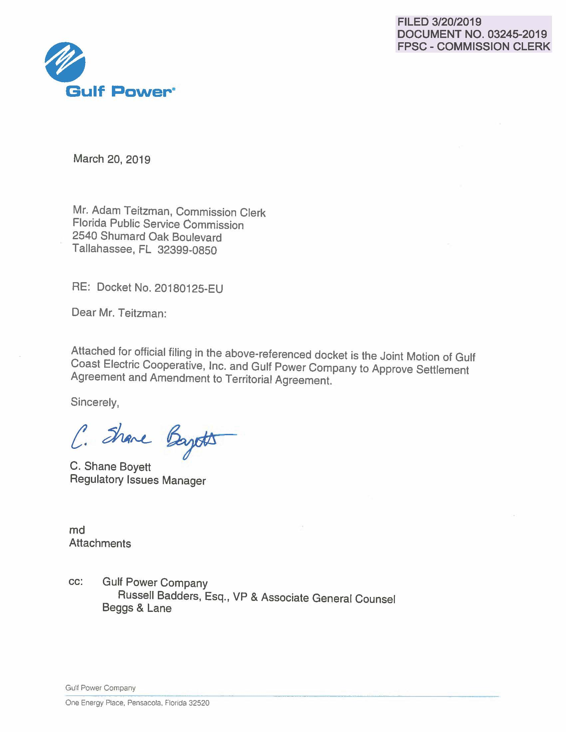

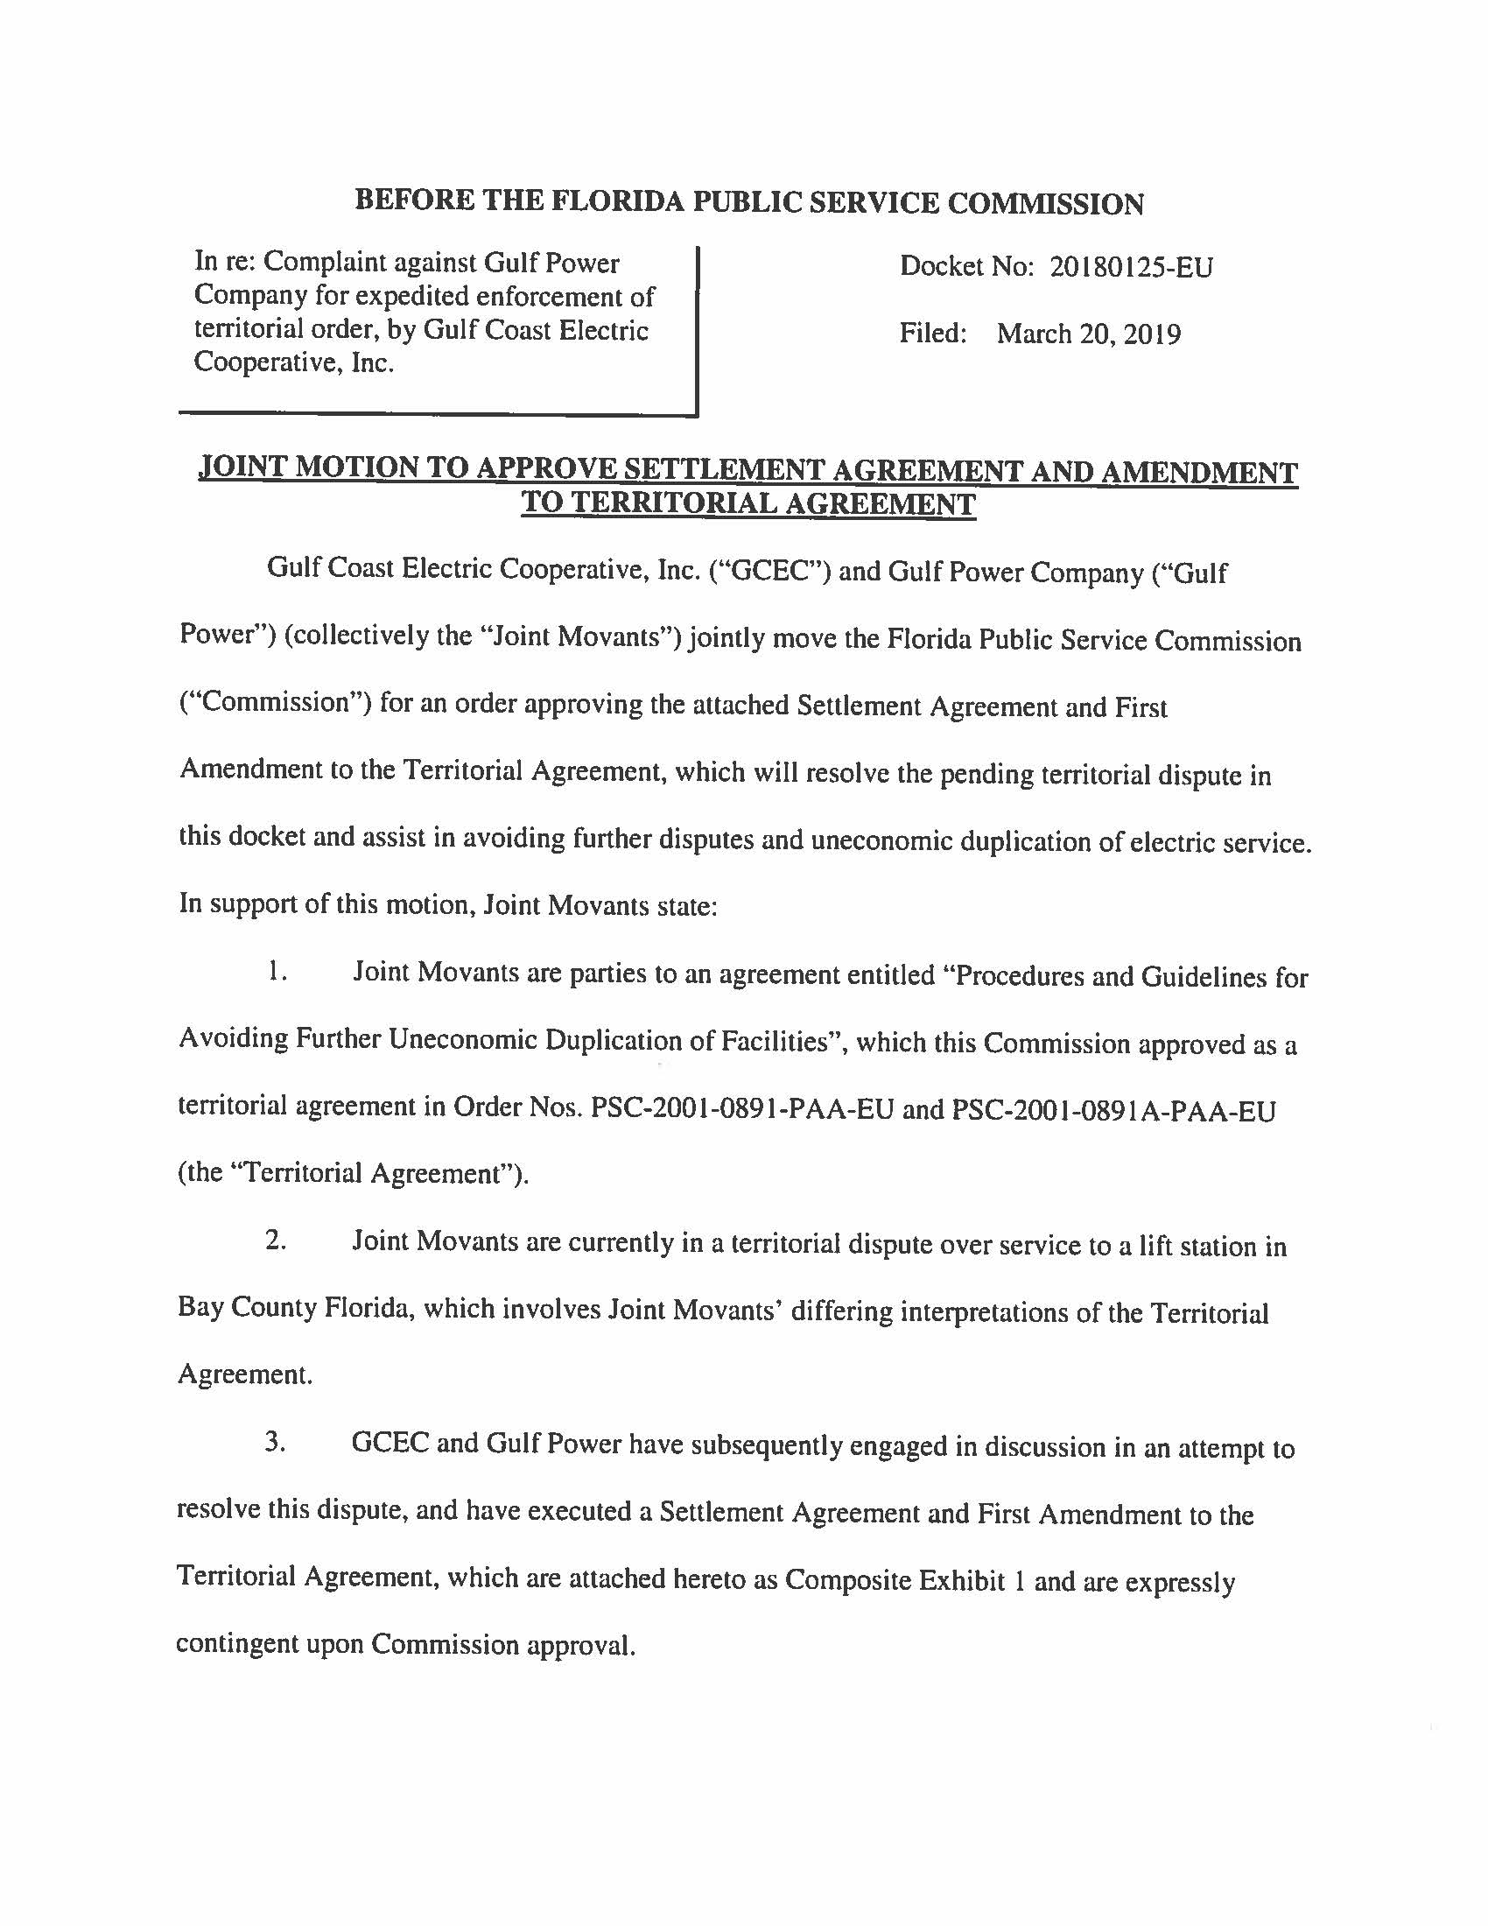

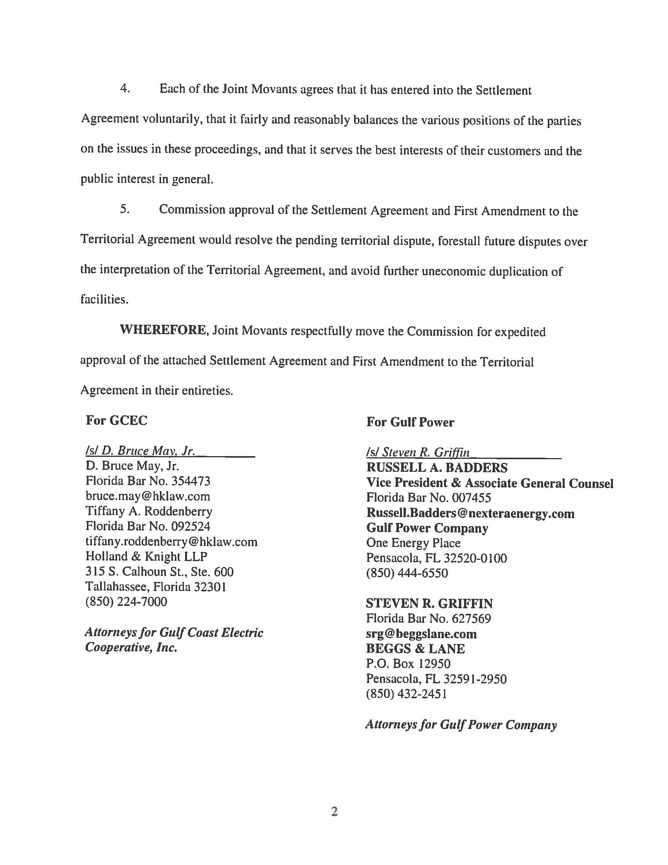

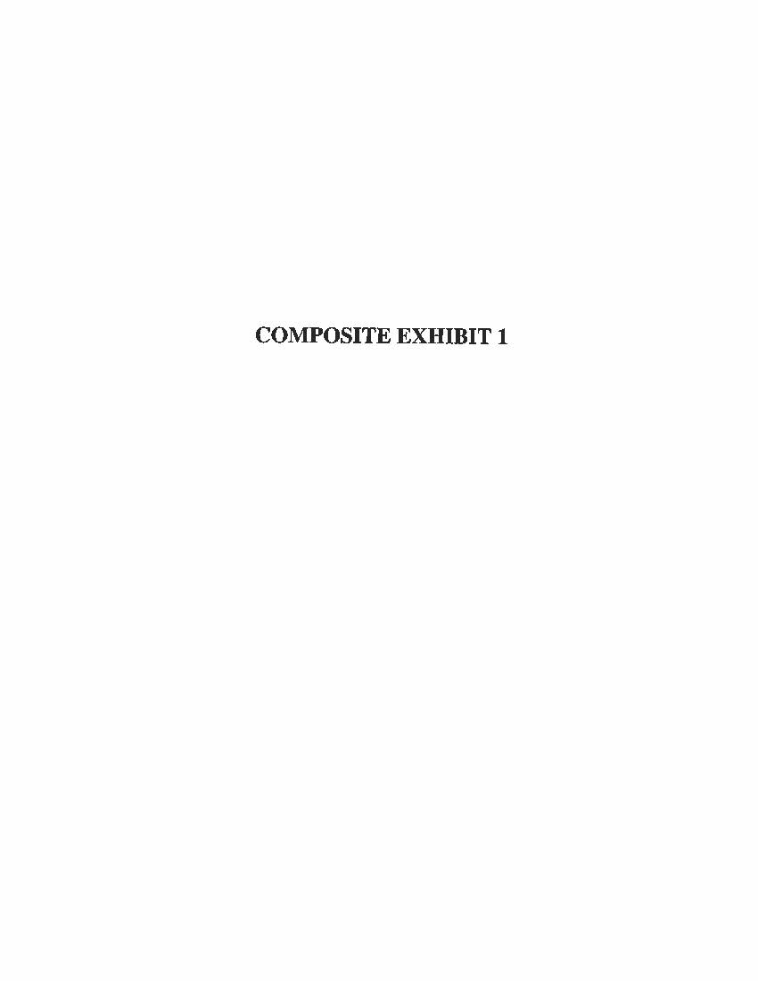

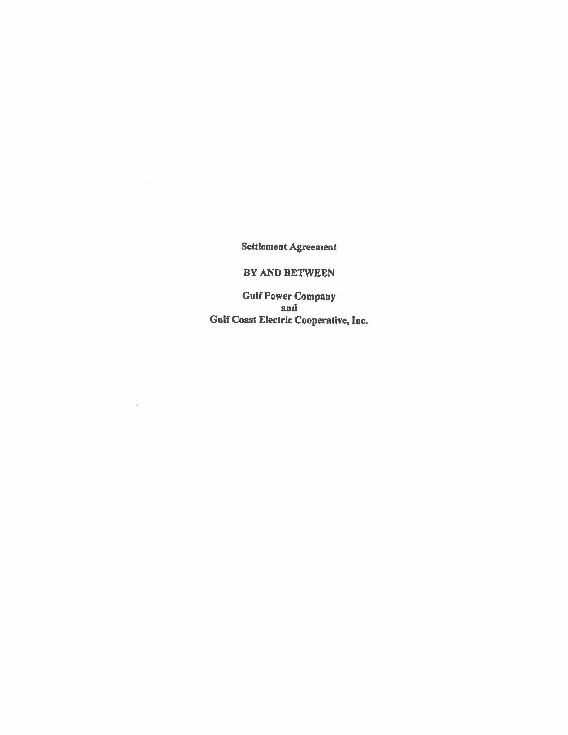

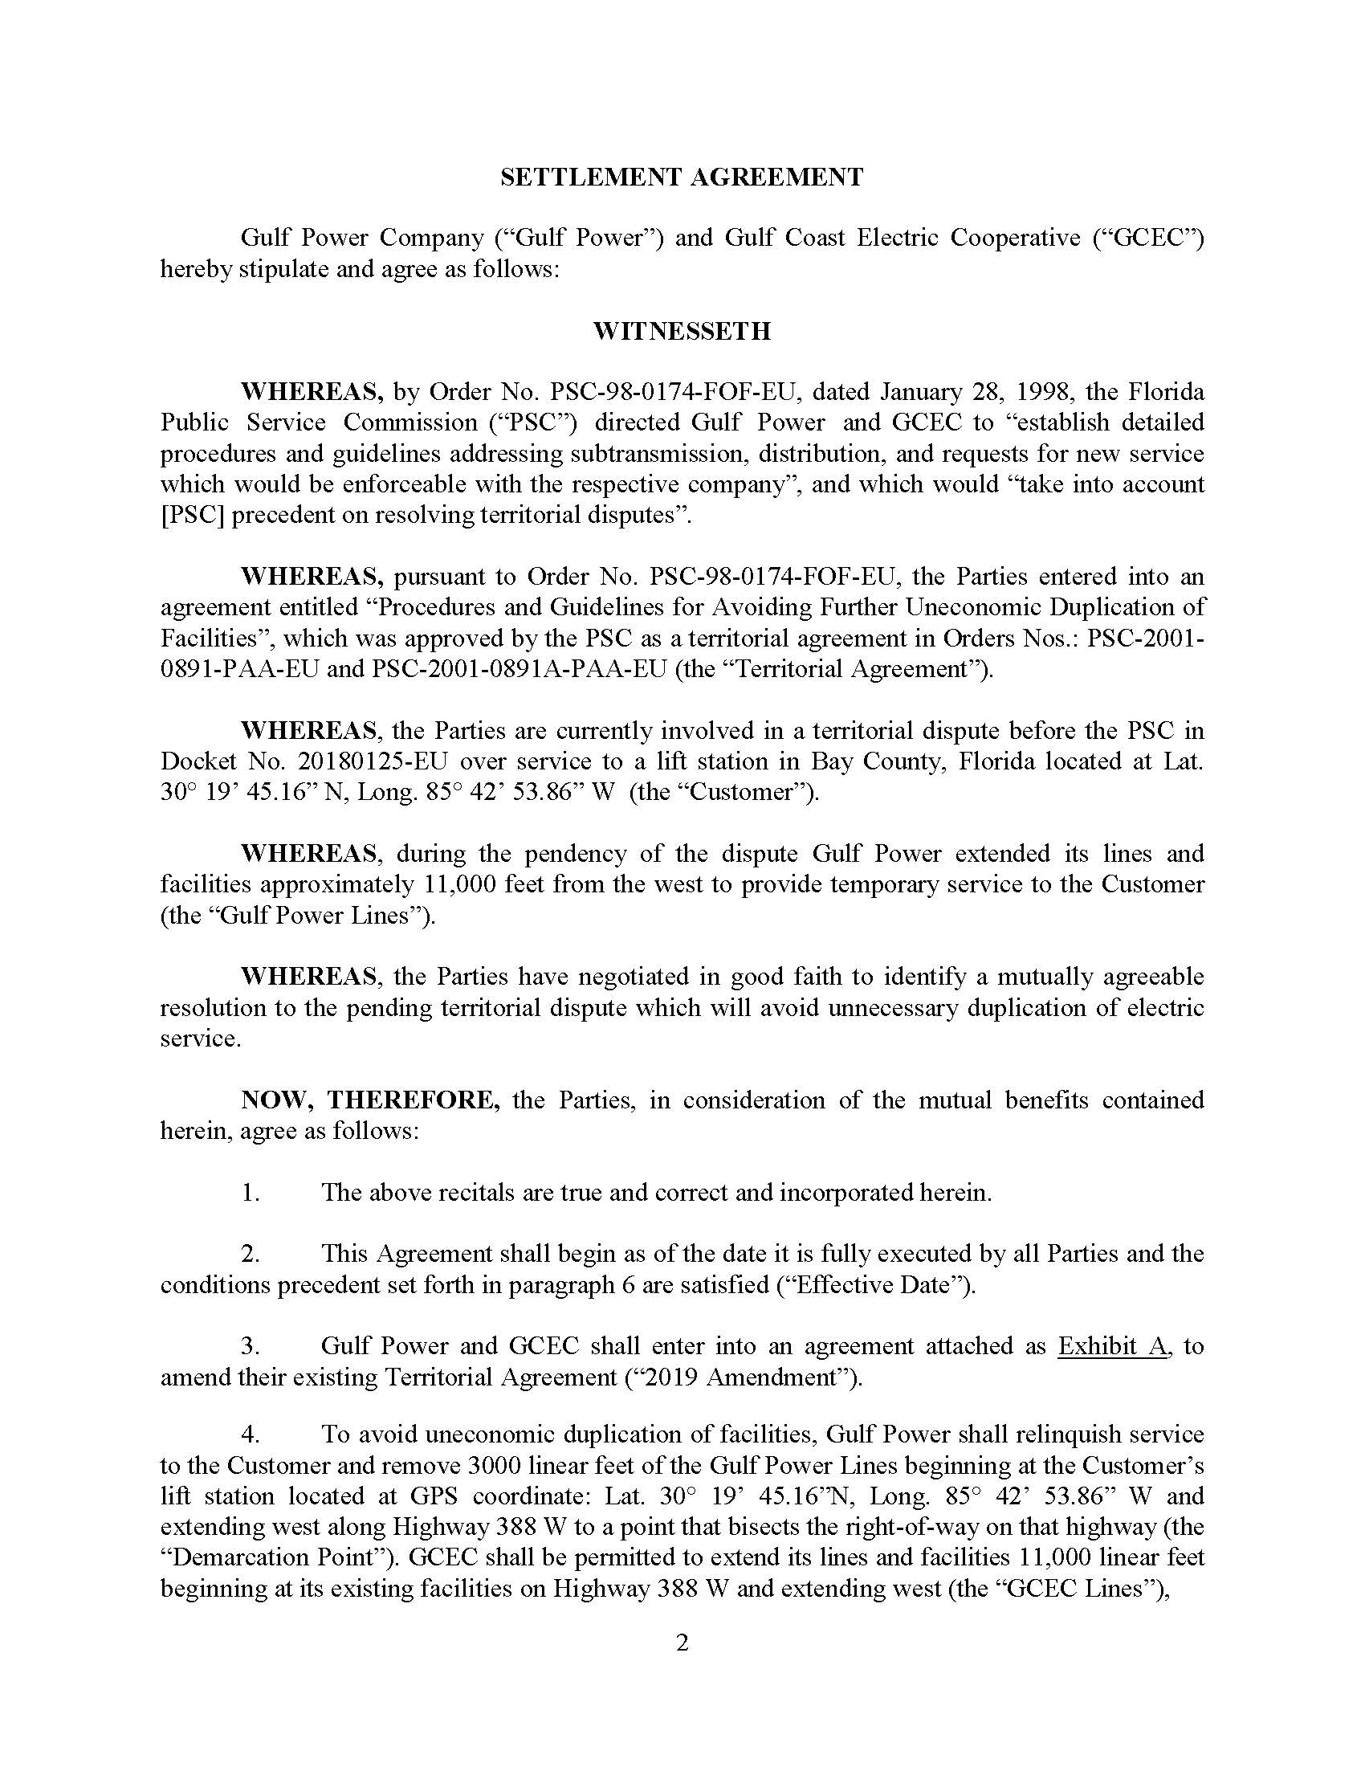

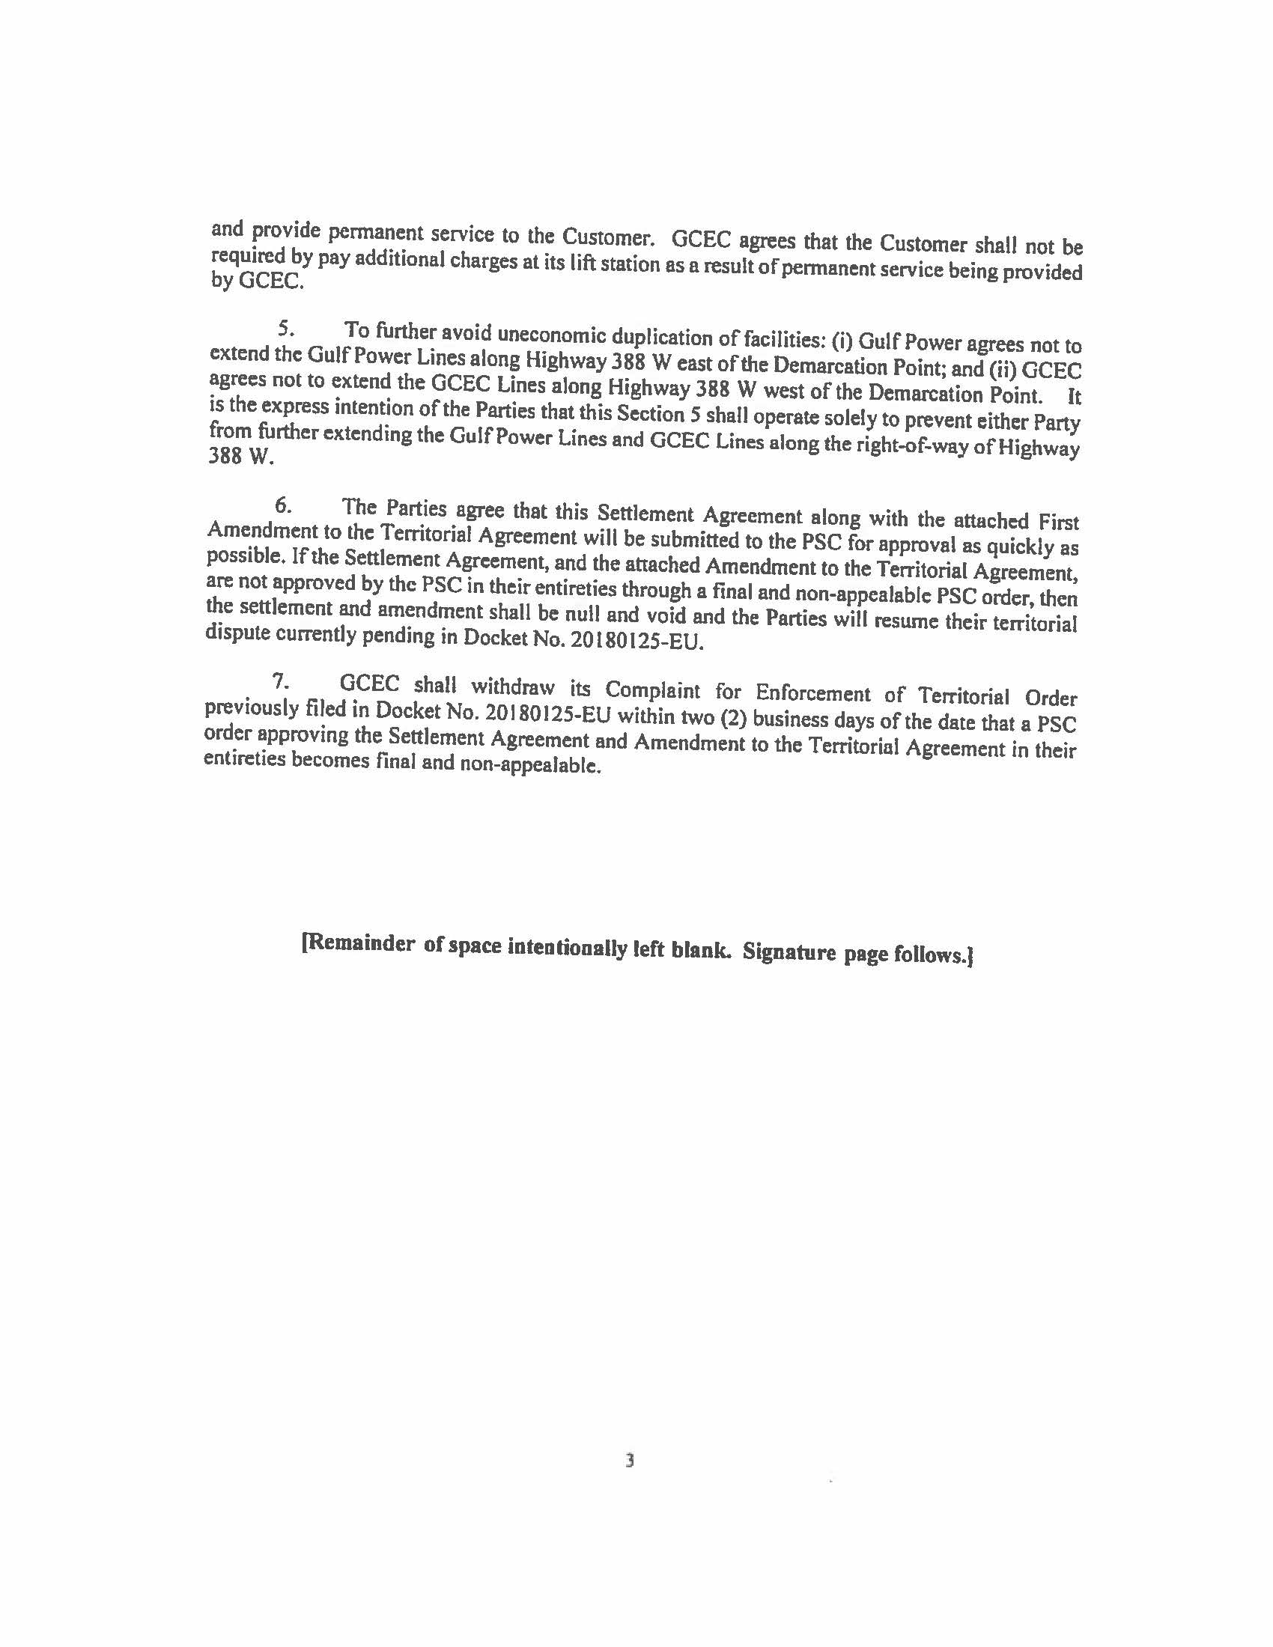

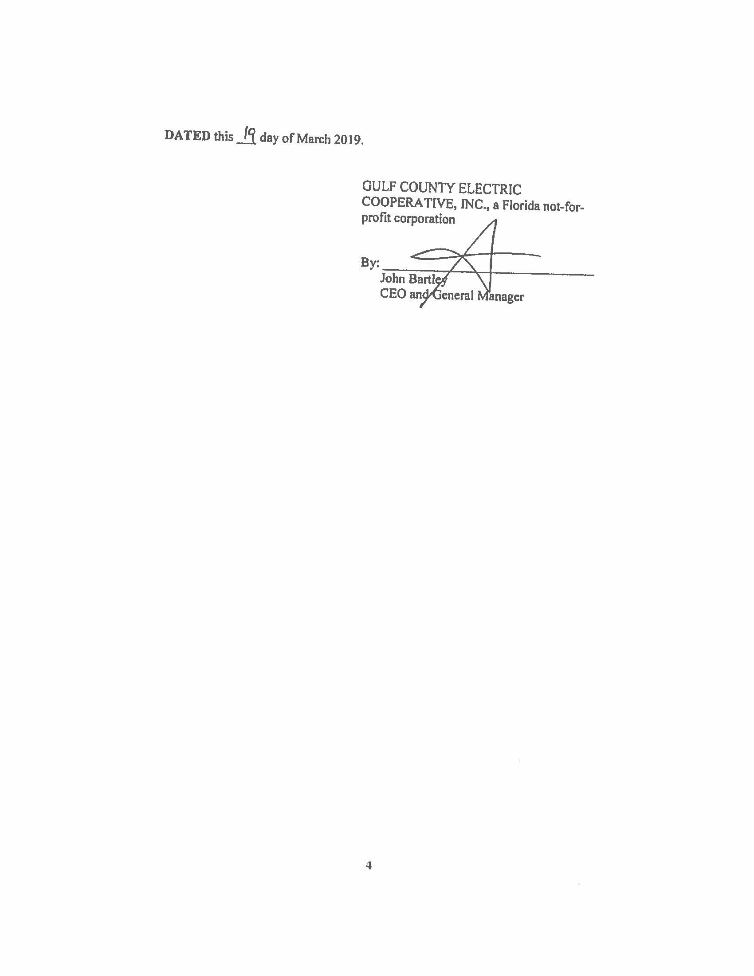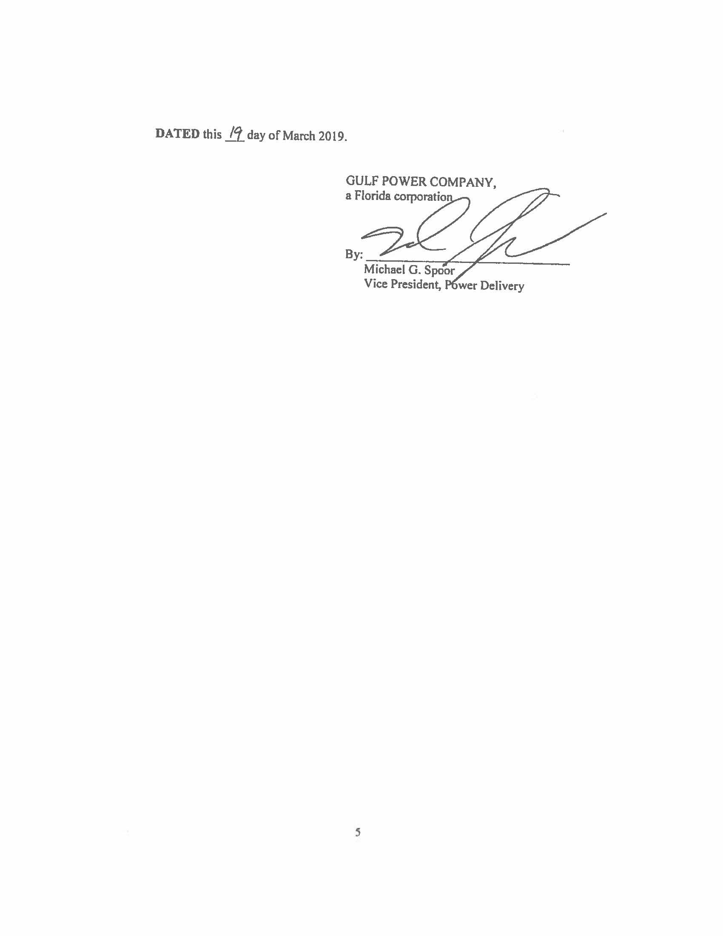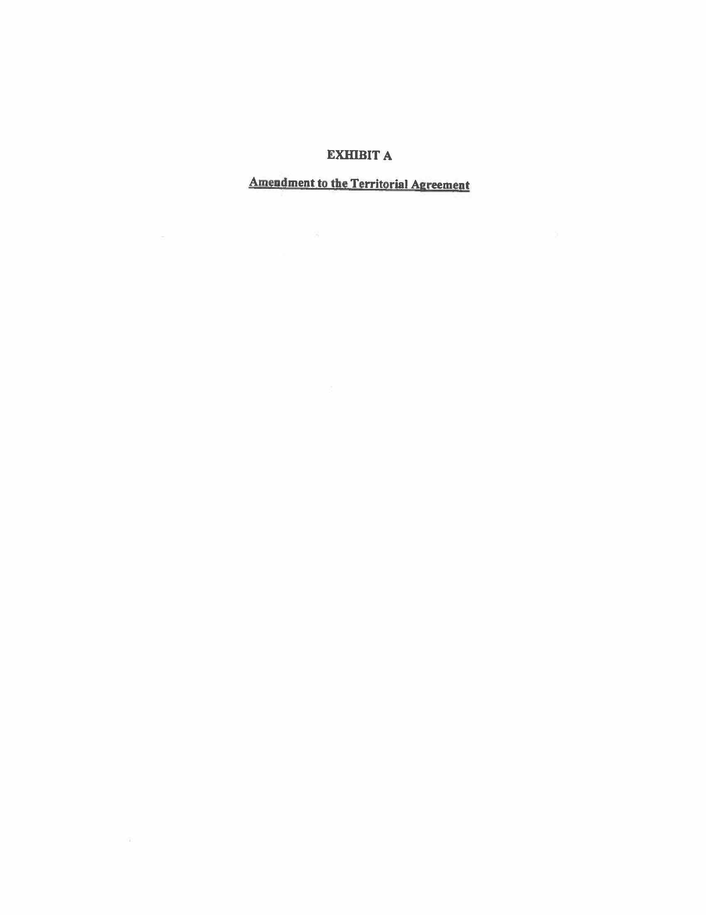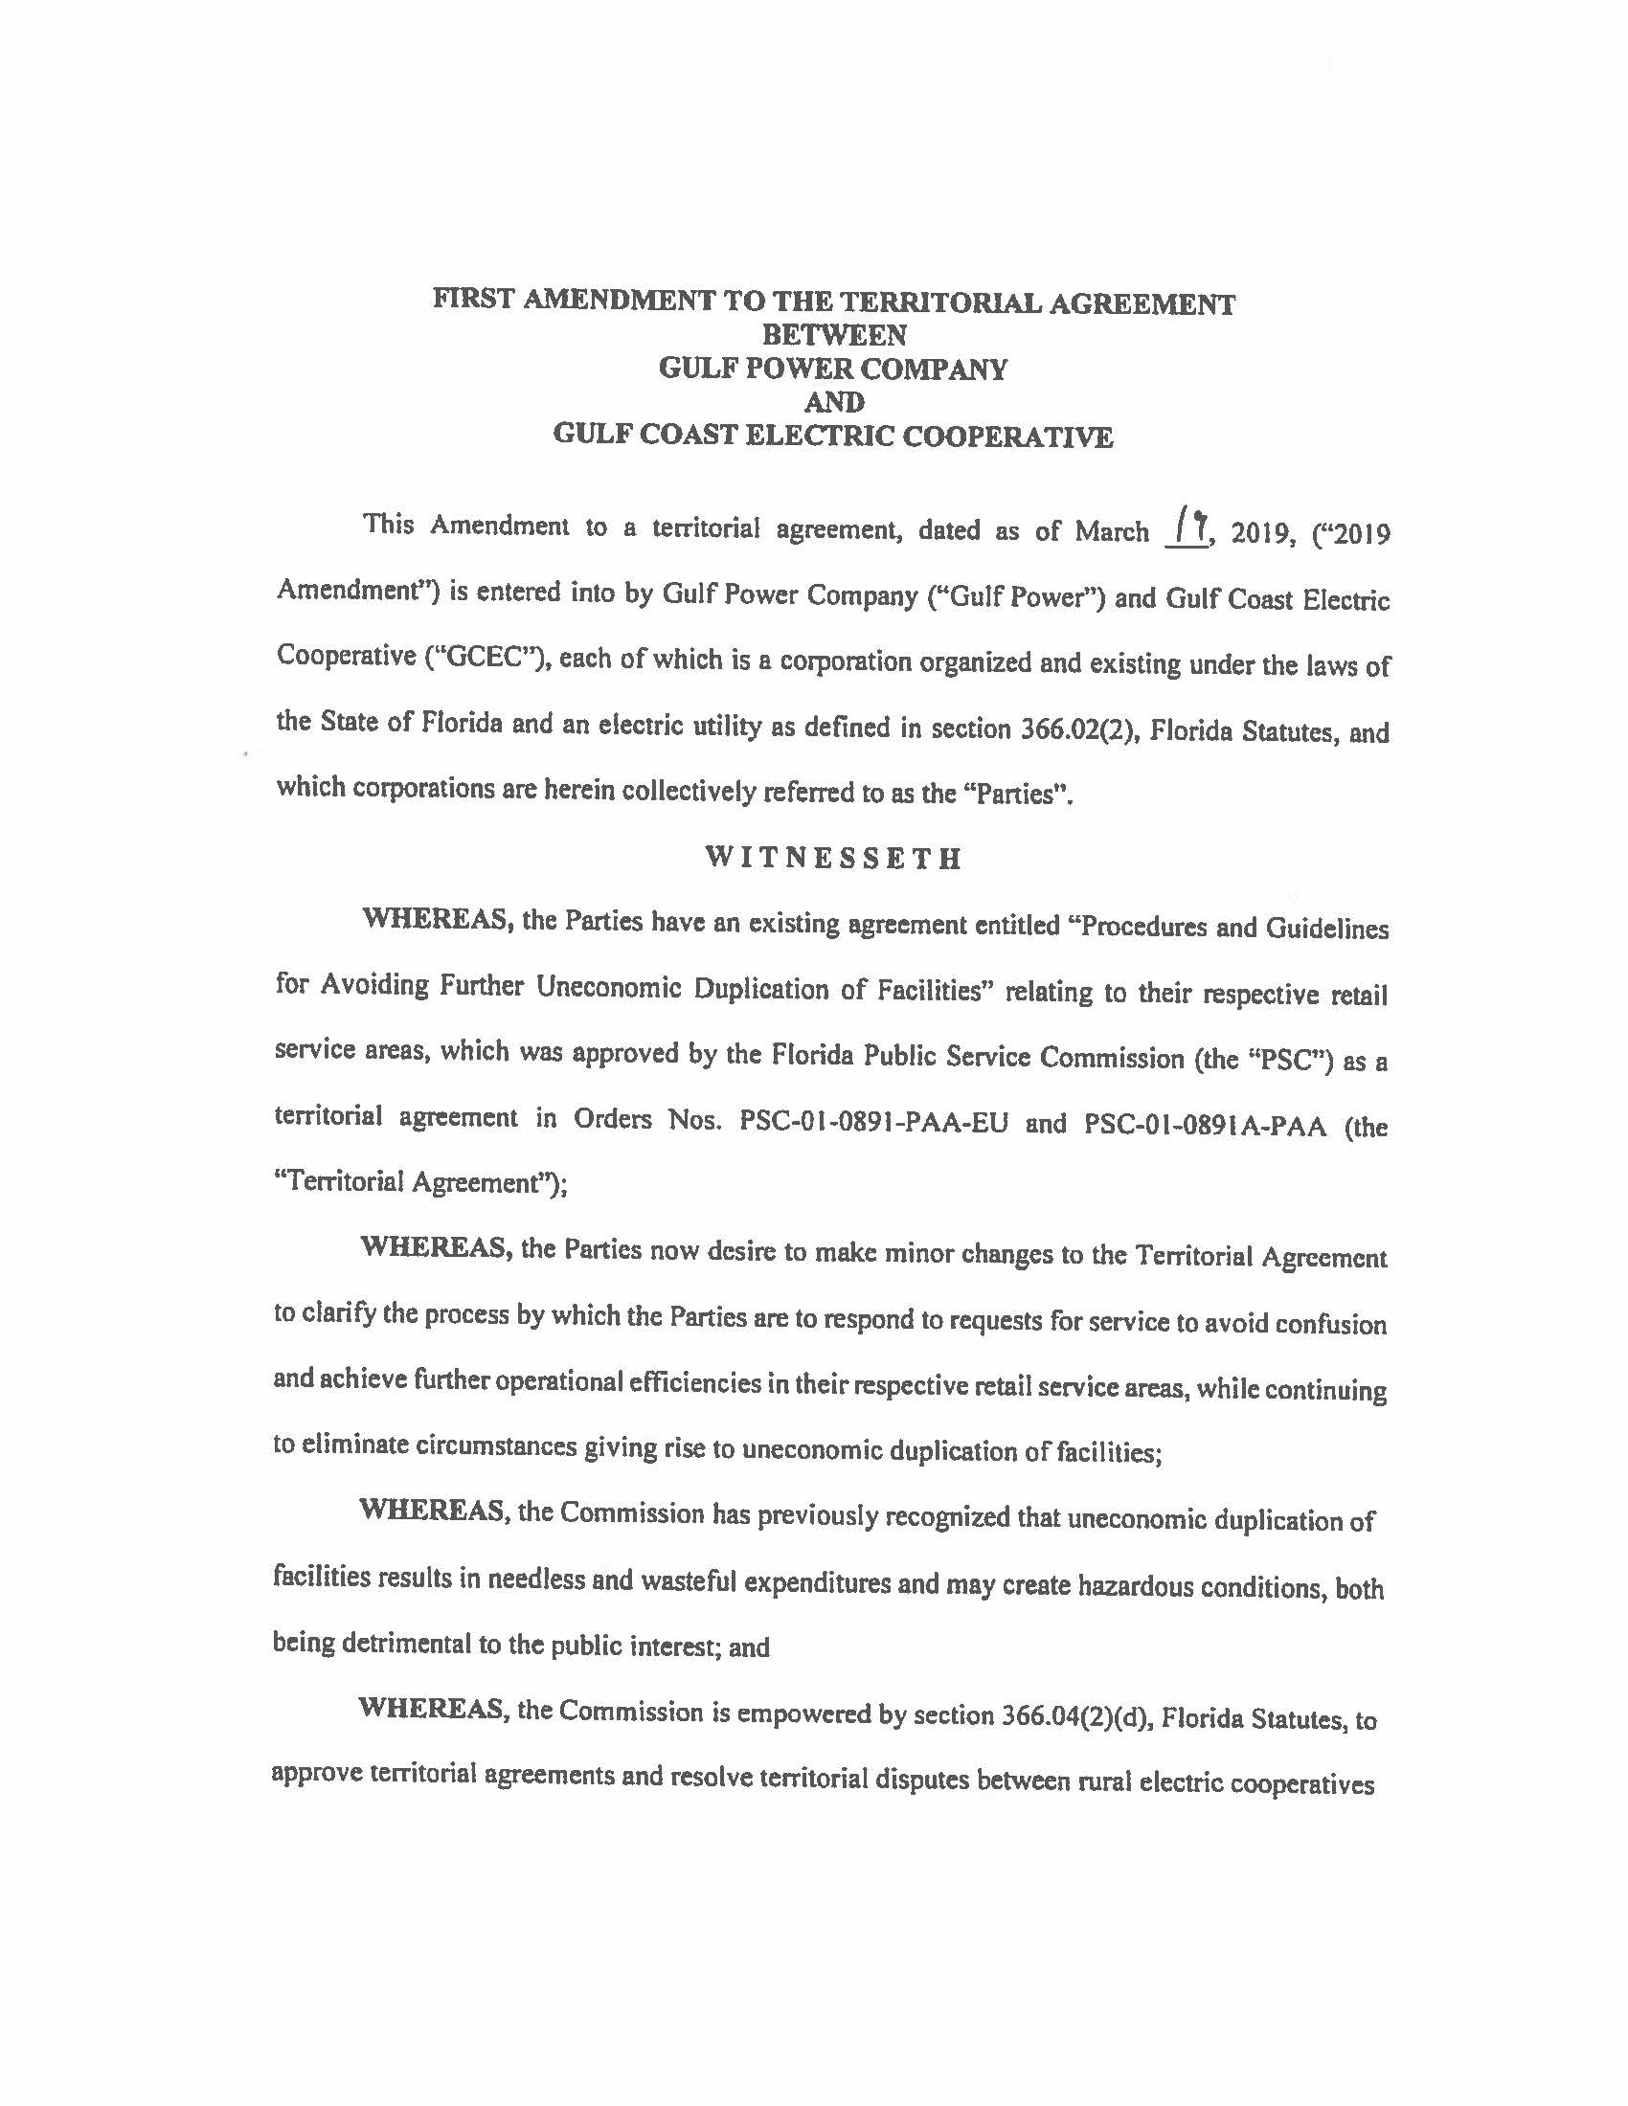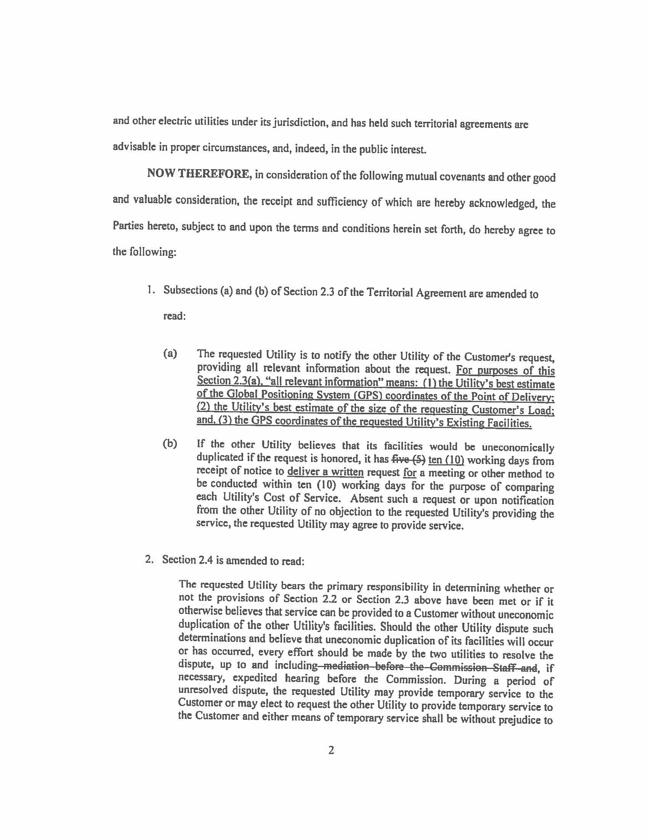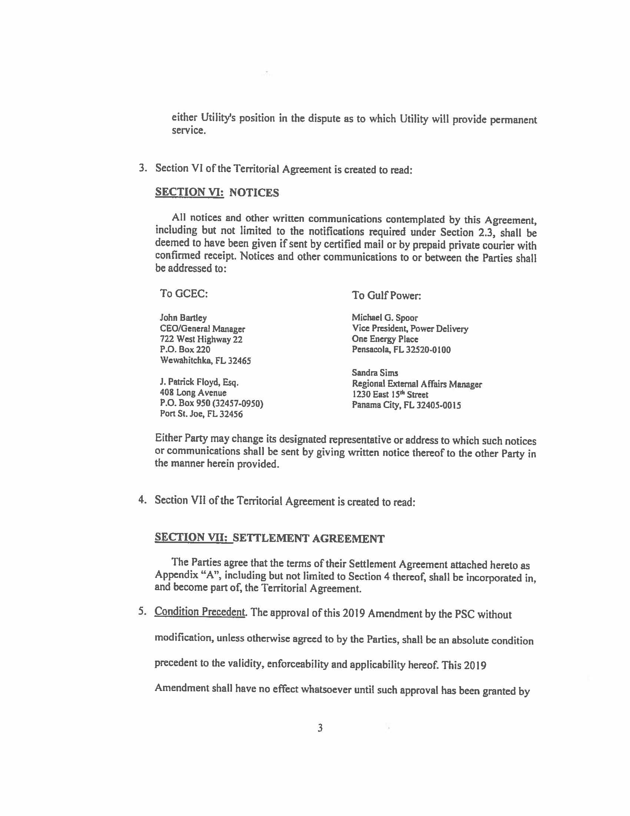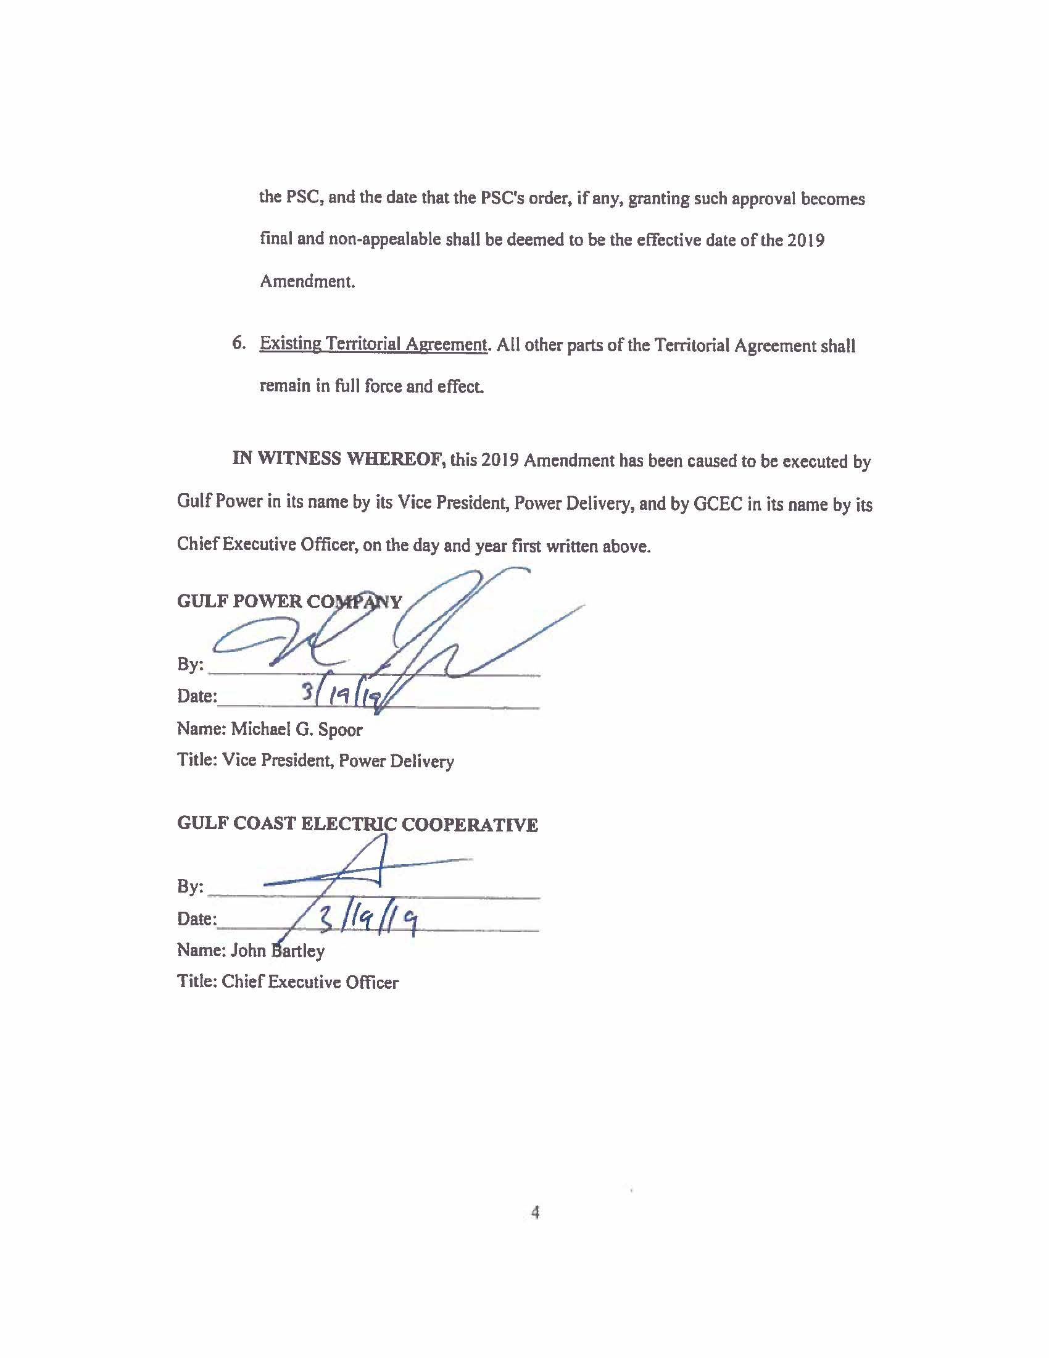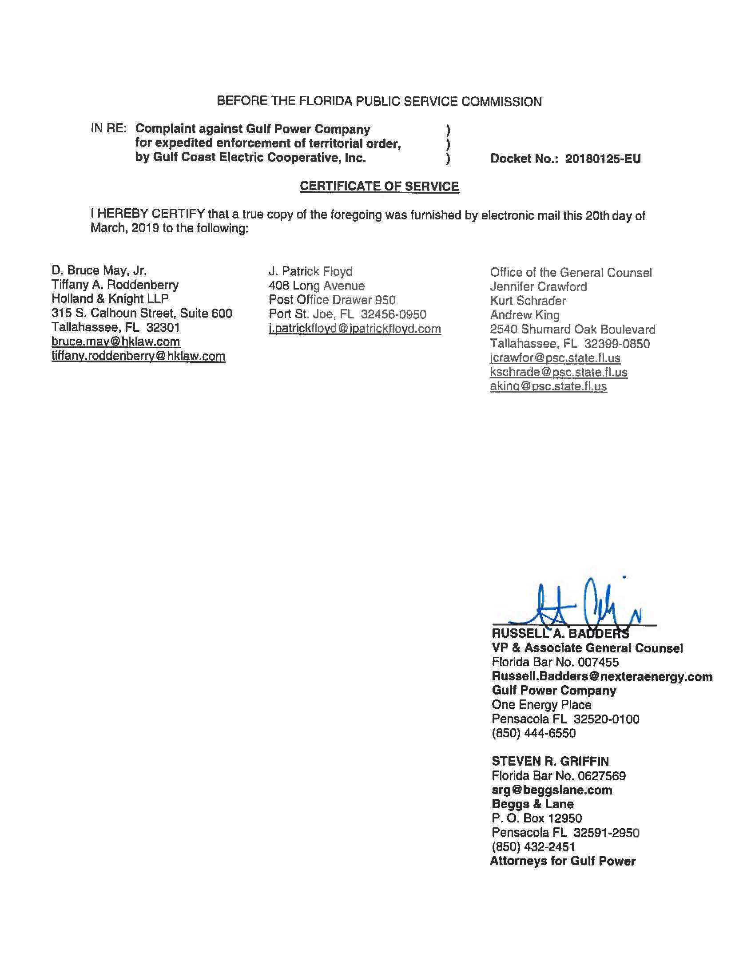

See Order No. PSC-01-0891-PAA-EU, issued April 9, 2001, in Docket No. 930885-EU, In re: Petition to resolve territorial dispute with Gulf Coast Electric Cooperative, Inc. by Gulf Power Company; and Order No. PSC-01-0891A-PAA-EU, issued March 26, 2002, in Docket No. 930885-EU, In Re Petition to resolve territorial dispute with Gulf Coast Electric Cooperative, Inc. by Gulf Power Company.
On March 22, 2019, the parties filed a revised page 2 of the Settlement Agreement, correcting an inadvertent typographical error.
The Commission may approve the settlement in its entirety; however, the nature of the decision is a Proposed Agency Action that will become a final order 21 days after the PAA order is issued if there is no request for a hearing. The Commission does not have the authority to enter a “non-appealable” final order.
Utils. Comm’n of the City of New Smyrna Beach v. Fla. Pub. Serv. Comm’n, 469 So. 2d 731, 732–33 (Fla. 1985).

