BEFORE THE FLORIDA PUBLIC SERVICE COMMISSION

In re: Joint petition for approval of modification to territorial agreement in Lake and Sumter Counties, by City of Leesburg and Duke Energy Florida, LLC. | DOCKET NO. 20200201-EU  ORDER NO. PSC-2020-0509-PAA-EU  ISSUED: December 21, 2020

The following Commissioners participated in the disposition of this matter:

GARY F. CLARK, Chairman
ART GRAHAM
JULIE I. BROWN
DONALD J. POLMANN
ANDREW GILES FAY

NOTICE OF PROPOSED AGENCY ACTION
ORDER APPROVING TERRITORIAL AGREEMENT

BY THE COMMISSION:

NOTICE is hereby given by the Florida Public Service Commission that the action discussed herein is preliminary in nature and will become final unless a person whose interests are substantially affected files a petition for a formal proceeding, pursuant to Rule 25-22.029, Florida Administrative Code (F.A.C.).

I. Background
On August 27, 2020, Duke Energy Florida, LLC. (Duke), and the City of Leesburg (Leesburg) filed a joint petition for approval of the first amendment to their existing territorial agreement (First Amendment) in Lake and Sumter Counties. Duke and Leesburg are parties to a currently effective territorial agreement that we approved in 2015. The proposed First Amendment to the current territorial agreement, approved herein, and the maps depicting the modified territorial boundaries are included in Attachment A.
We have jurisdiction over this matter pursuant to Section 366.04, Florida Statutes (F.S.).

II. Decision
Pursuant to Section 366.04(2)(d), F.S., and Rule 25-6.0440(2), F.A.C., we have jurisdiction to approve territorial agreements between and among rural electric cooperatives, municipal electric utilities, and other electric utilities. Unless we determine that the agreement will cause a detriment to the public interest, the agreement should be approved.

Proposed First Amendment to the Territorial Agreement

The joint petitioners executed their First Amendment to the Territorial Agreement (see Attachment A) on August 28, 2020. The intent of the First Amendment is to reallocate vacant land pursuant to Article III and modify the territorial boundaries pursuant to Section 3.1 of the agreement. The exchange of land will form more compact and contiguous service territories for future development and avoid duplication of facilities in Lake and Sumter Counties. There are no customer or infrastructure transfers contemplated in this proposed First Amendment. Through the First Amendment, the joint petitioners seek to more accurately define the portions of their respective service areas and gain operational efficiencies.
The land areas proposed to be reallocated are currently vacant. Therefore, no notice to customers was required pursuant to Rule 25-6.0440(1), F.A.C. However, there are conceptual plans for a residential development of approximately 900 dwelling units in the area allocated to Leesburg. Although the area reallocated to Duke has no conceptual development plans at the moment, future development for this area is projected to be equal to that of Leesburg’s conceptual development plans.
As stated in paragraph 6 of the petition, with the exception of the modifications contained in the First Amendment, the terms and conditions of the existing agreement remain unchanged and in effect. The First Amendment to the existing Agreement shall become effective and enforceable upon the issuance of our order and shall remain in effect until July 29, 2045.

Conclusion

After reviewing the joint petition, the proposed First Amendment to the Territorial Agreement, and the entire record of this docket, we approve Leesburg’s and Duke’s proposed First Amendment to their existing territorial agreement in Lake and Sumter Counties. We find that the approval of the First Amendment will allow the parties to reallocate land and form more compact, contiguous service areas for future development, avoid duplication of facilities, and promote efficient customer service to existing and future customers of both utilities.

Based on the foregoing, it is

ORDERED by the Florida Public Service Commission that the proposed First Amendment to the existing territorial agreement in Lake and Sumter Counties between Duke Energy Florida, LLC., and the City of Leesburg is hereby, approved. It is further

ORDERED that, with the exception of the modifications contained in the First Amendment, the terms and conditions of the existing agreement remain unchanged and in effect. It is further

ORDERED that the First Amendment to the existing Agreement shall become effective and enforceable upon the issuance of our order and shall remain in effect until July 29, 2045. It is further

ORDERED that the provisions of this Order, issued as proposed agency action, shall become final and effective upon the issuance of a Consummating Order unless an appropriate petition, in the form provided by Rule 28-106.201, Florida Administrative Code, is received by the Commission Clerk, 2540 Shumard Oak Boulevard, Tallahassee, Florida 32399-0850, by the close of business on the date set forth in the “Notice of Further Proceedings” attached hereto. It is further

ORDERED that in the event this Order becomes final, this docket shall be closed.

By ORDER of the Florida Public Service Commission this 21st day of December, 2020.

/s/ Adam J. Teitzman
ADAM J. TEITZMAN
Commission Clerk
Florida Public Service Commission
2540 Shumard Oak Boulevard
Tallahassee, Florida 32399
(850) 413-6770
www.floridapsc.com

Copies furnished: A copy of this document is provided to the parties of record at the time of issuance and, if applicable, interested persons.
WLT

NOTICE OF FURTHER PROCEEDINGS OR JUDICIAL REVIEW

The Florida Public Service Commission is required by Section 120.569(1), Florida Statutes, to notify parties of any administrative hearing that is available under Section 120.57, Florida Statutes, as well as the procedures and time limits that apply. This notice should not be construed to mean all requests for an administrative hearing will be granted or result in the relief sought.

Mediation may be available on a case-by-case basis. If mediation is conducted, it does not affect a substantially interested person's right to a hearing.

The action proposed herein is preliminary in nature. Any person whose substantial interests are affected by the action proposed by this order may file a petition for a formal proceeding, in the form provided by Rule 28-106.201, Florida Administrative Code. This petition must be received by the Office of Commission Clerk, 2540 Shumard Oak Boulevard, Tallahassee, Florida 32399-0850, by the close of business on January 11, 2021.

In the absence of such a petition, this order shall become final and effective upon the issuance of a Consummating Order.

Any objection or protest filed in this/these docket(s) before the issuance date of this order is considered abandoned unless it satisfies the foregoing conditions and is renewed within the specified protest period.

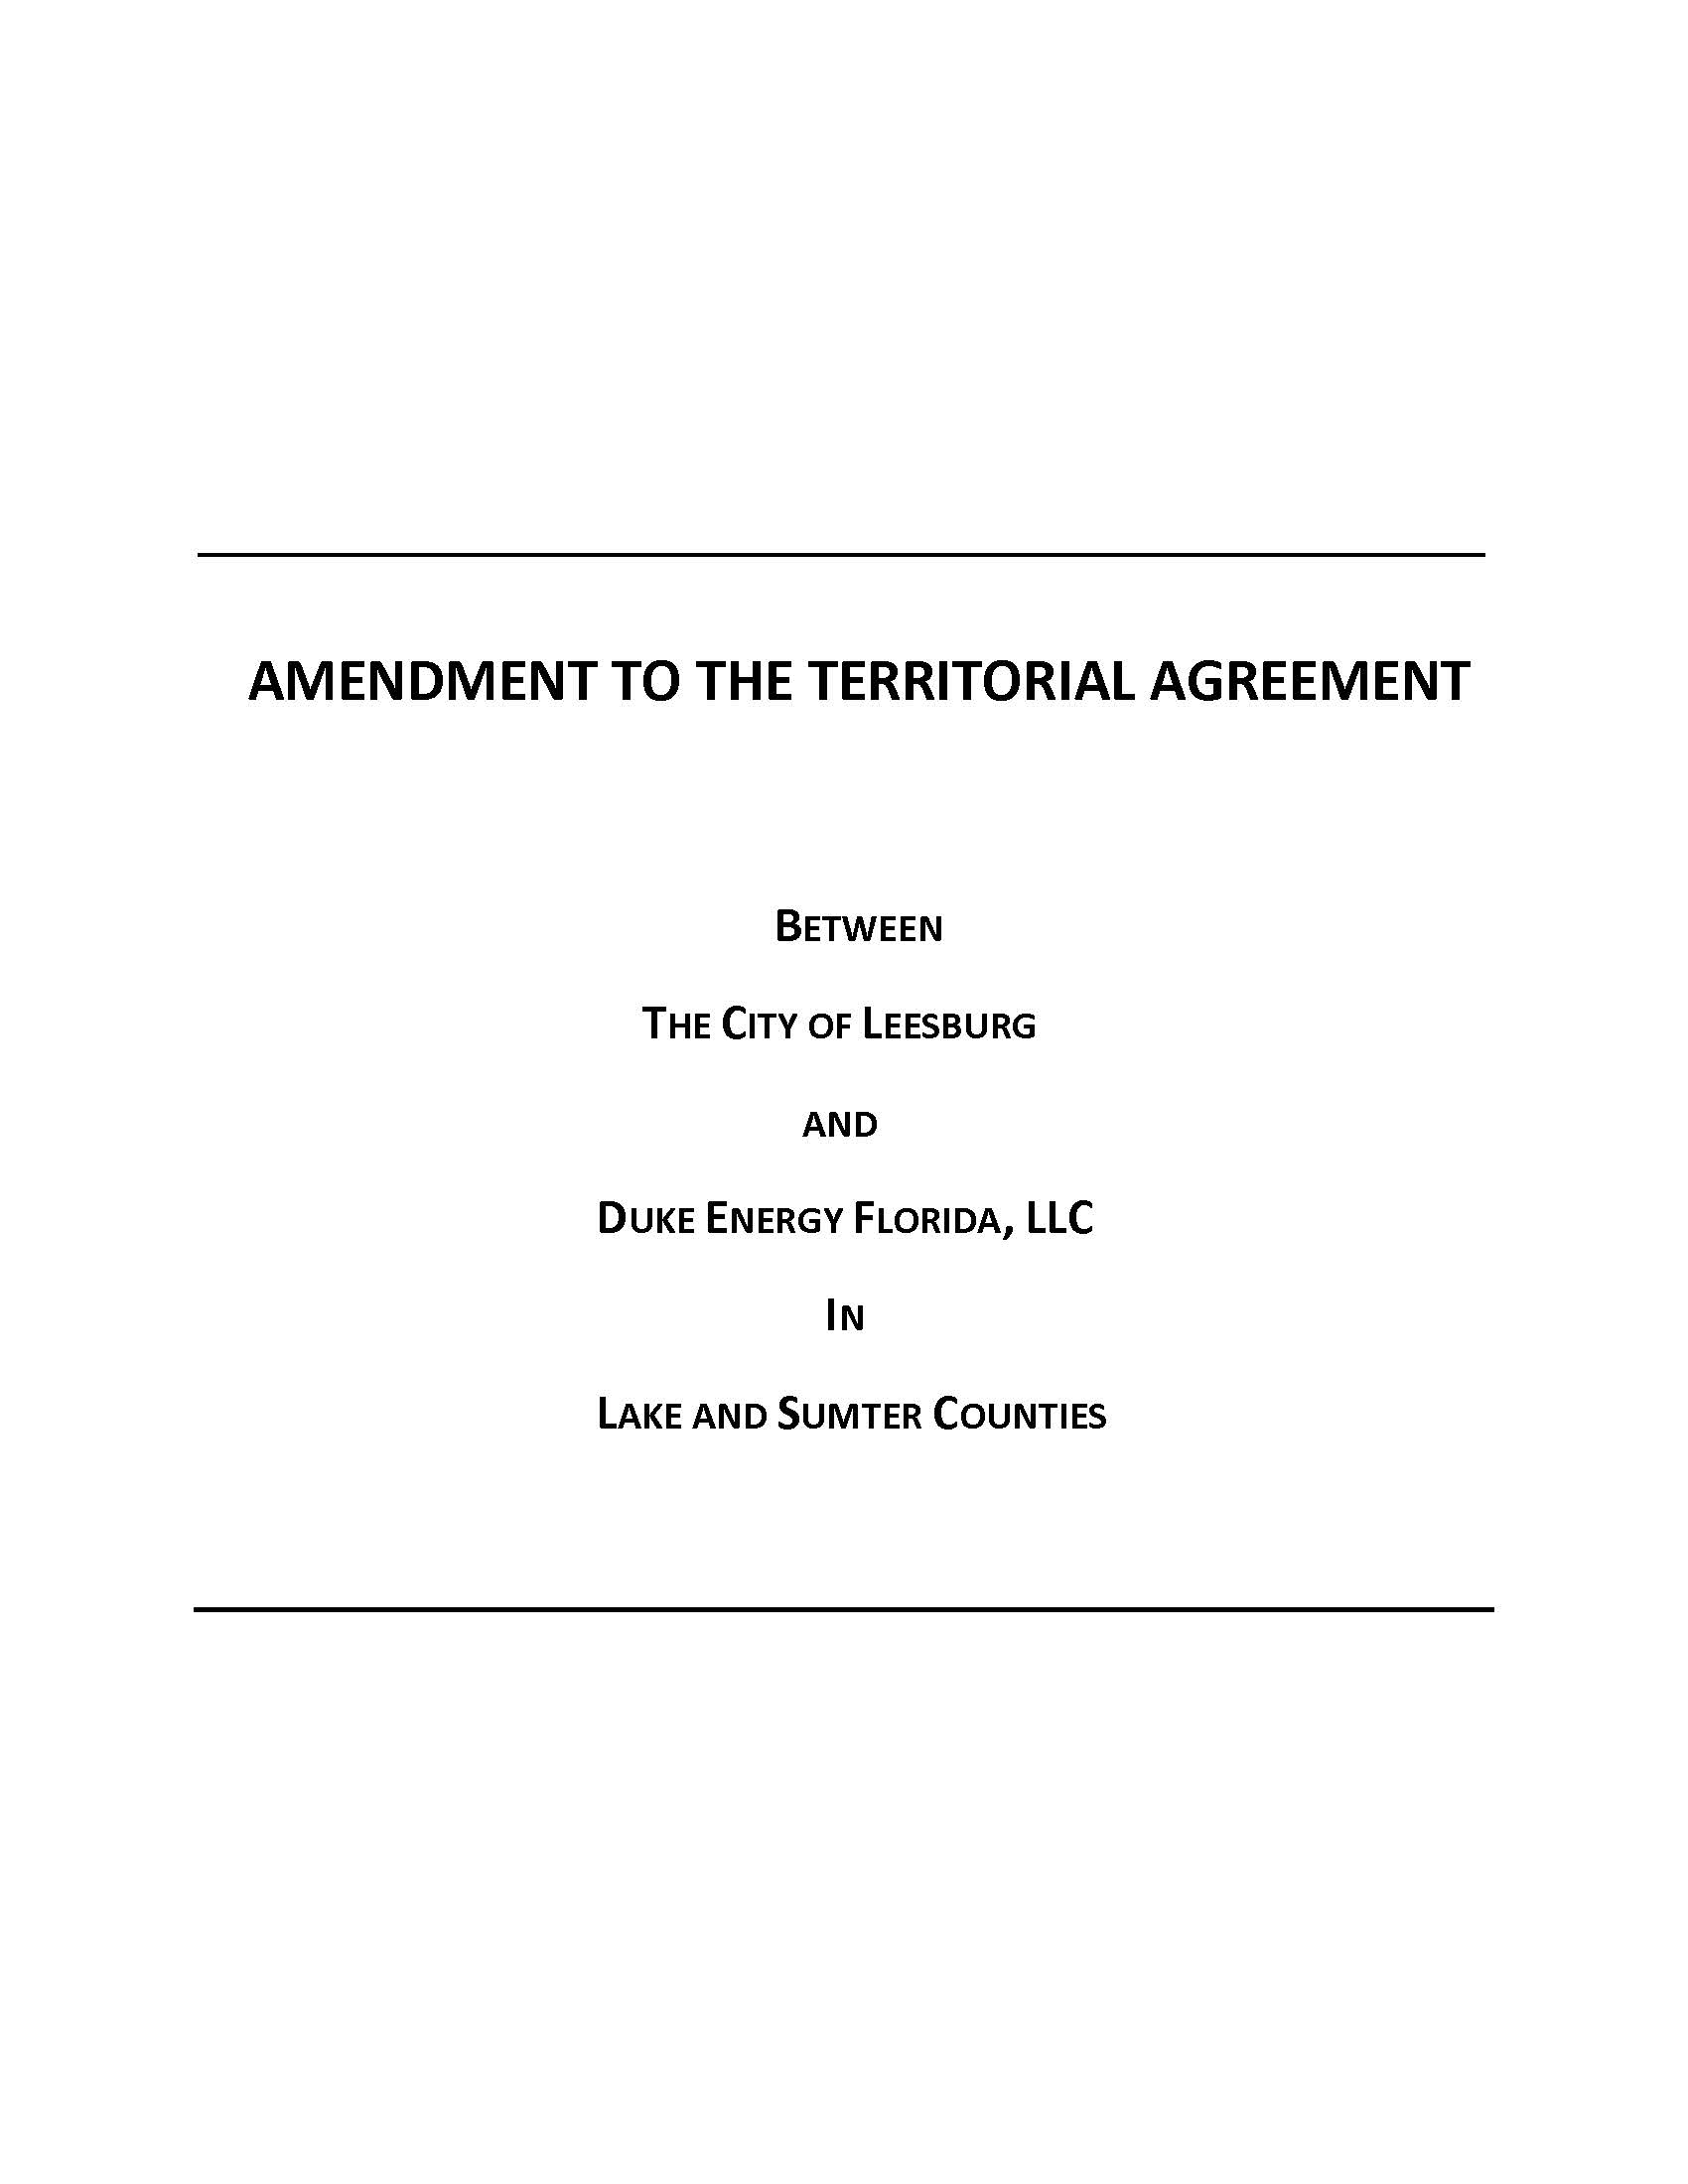

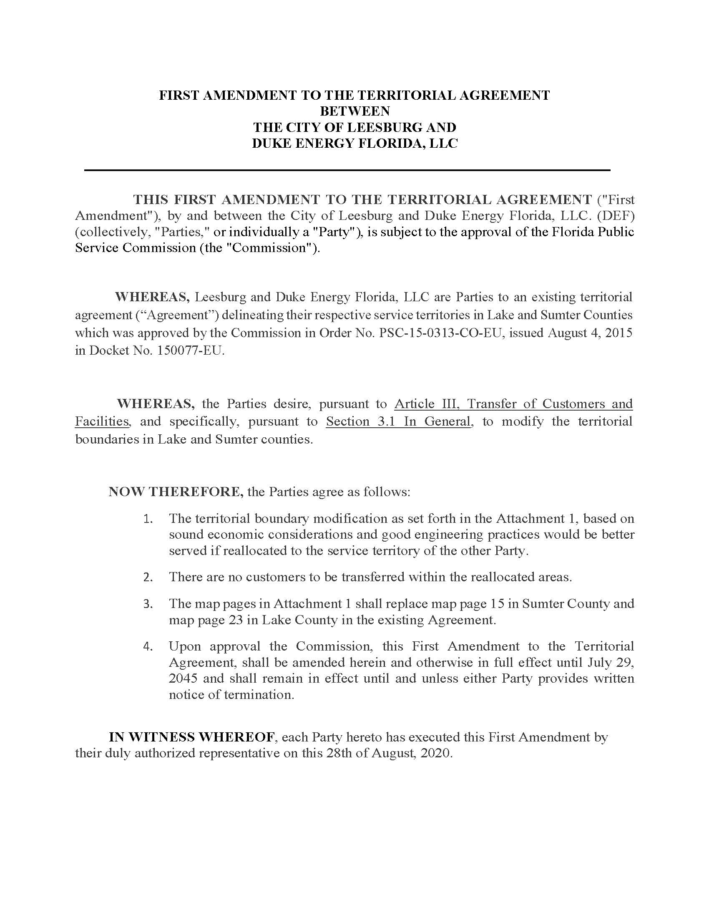

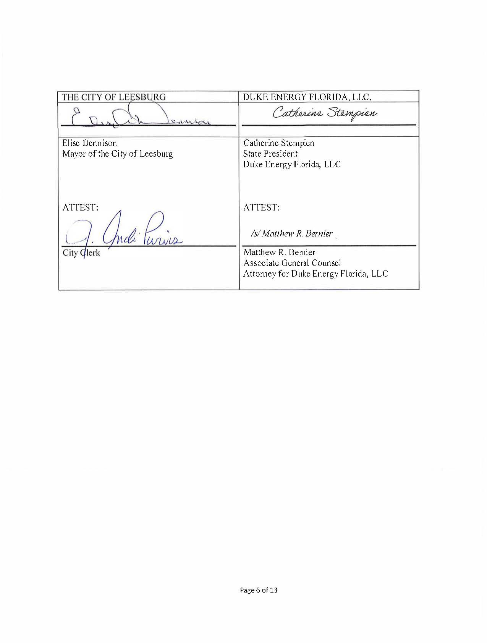

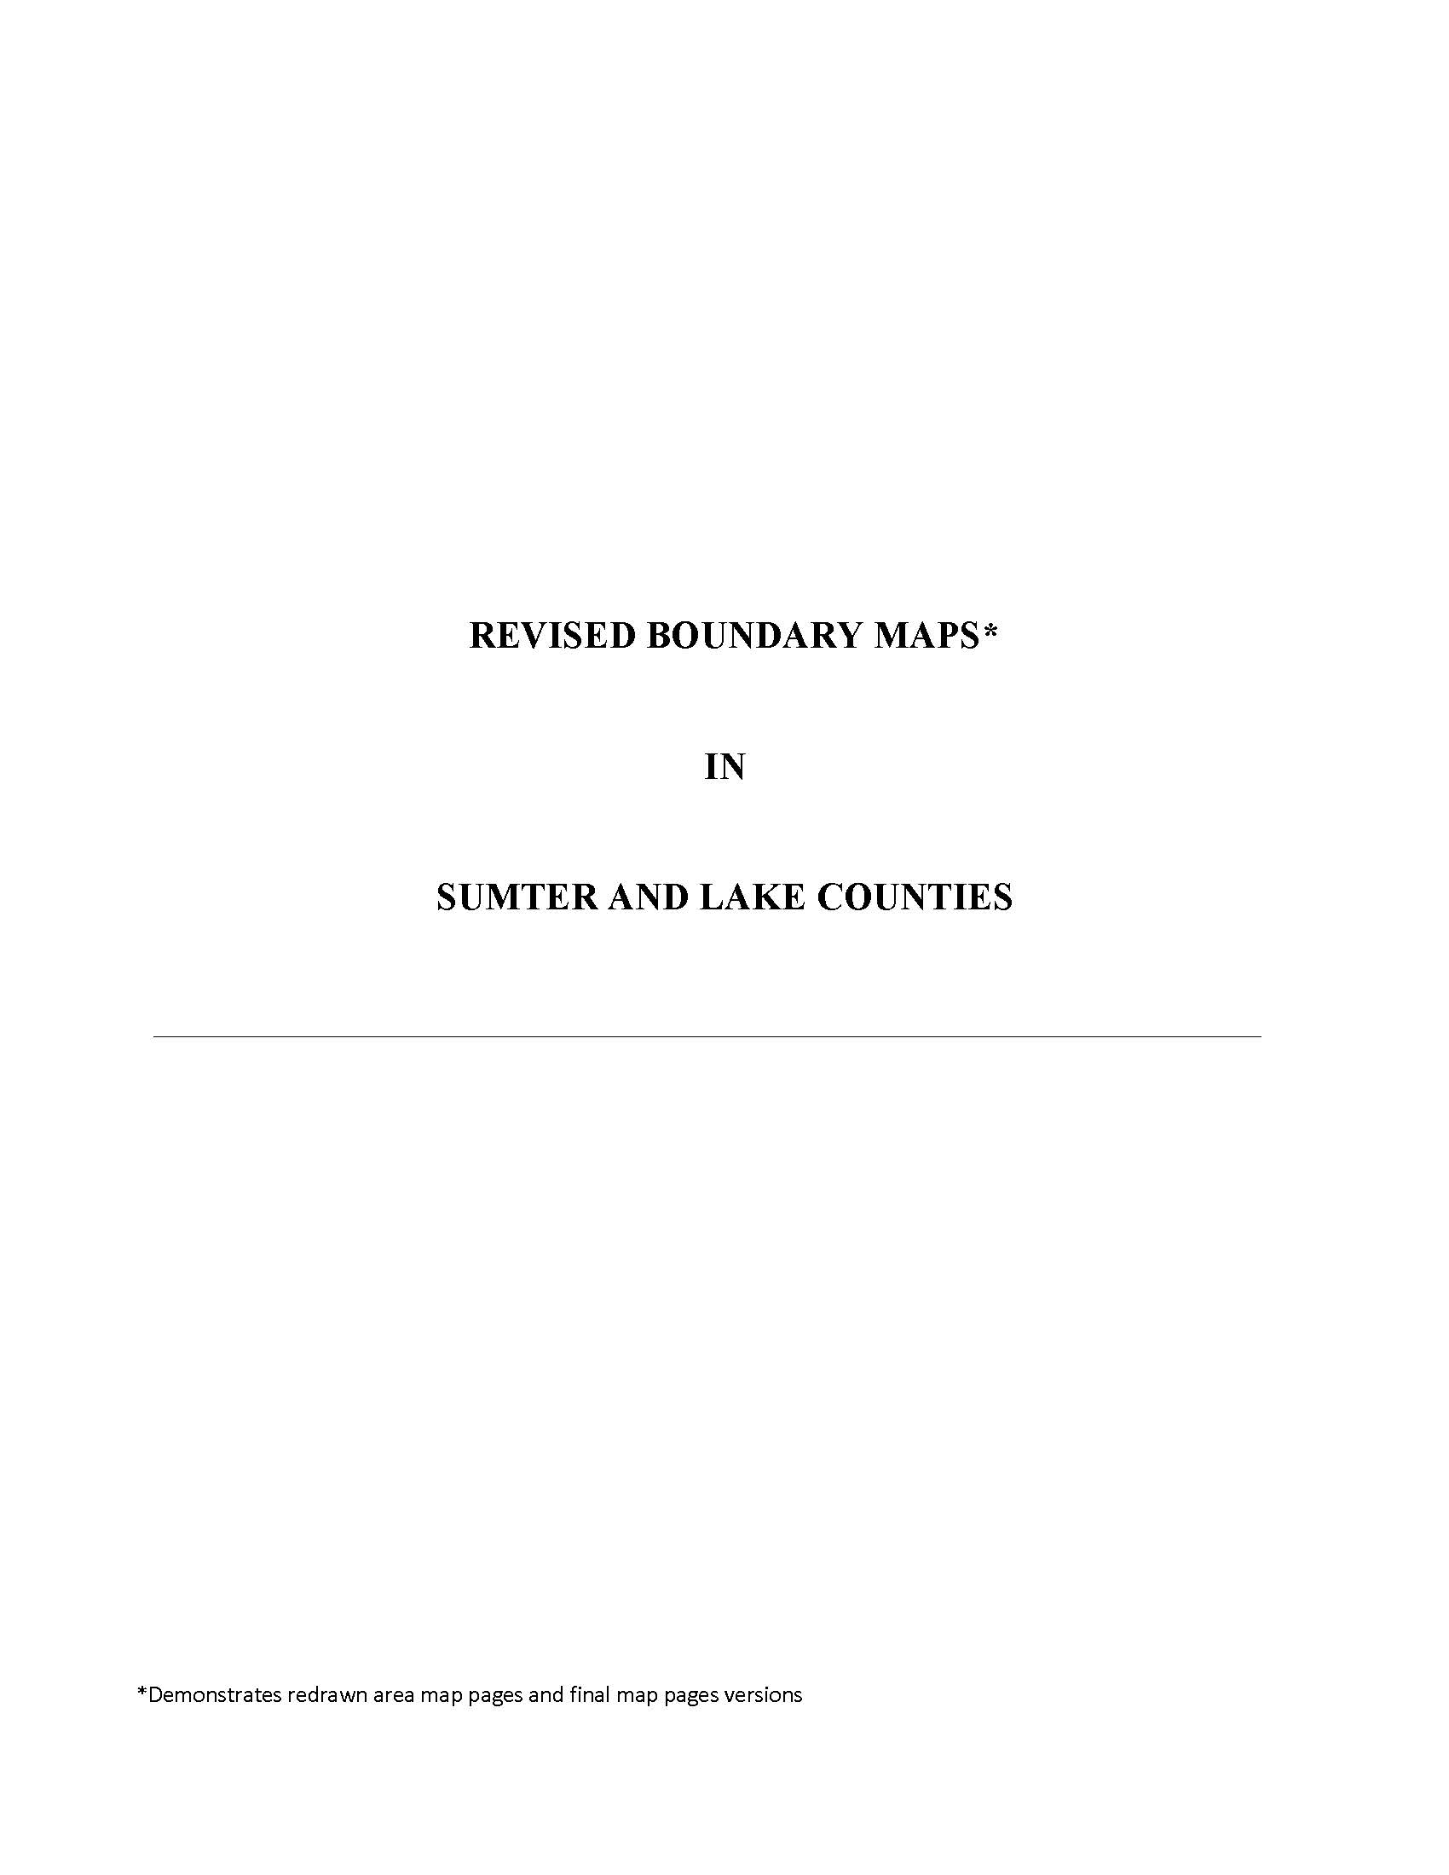

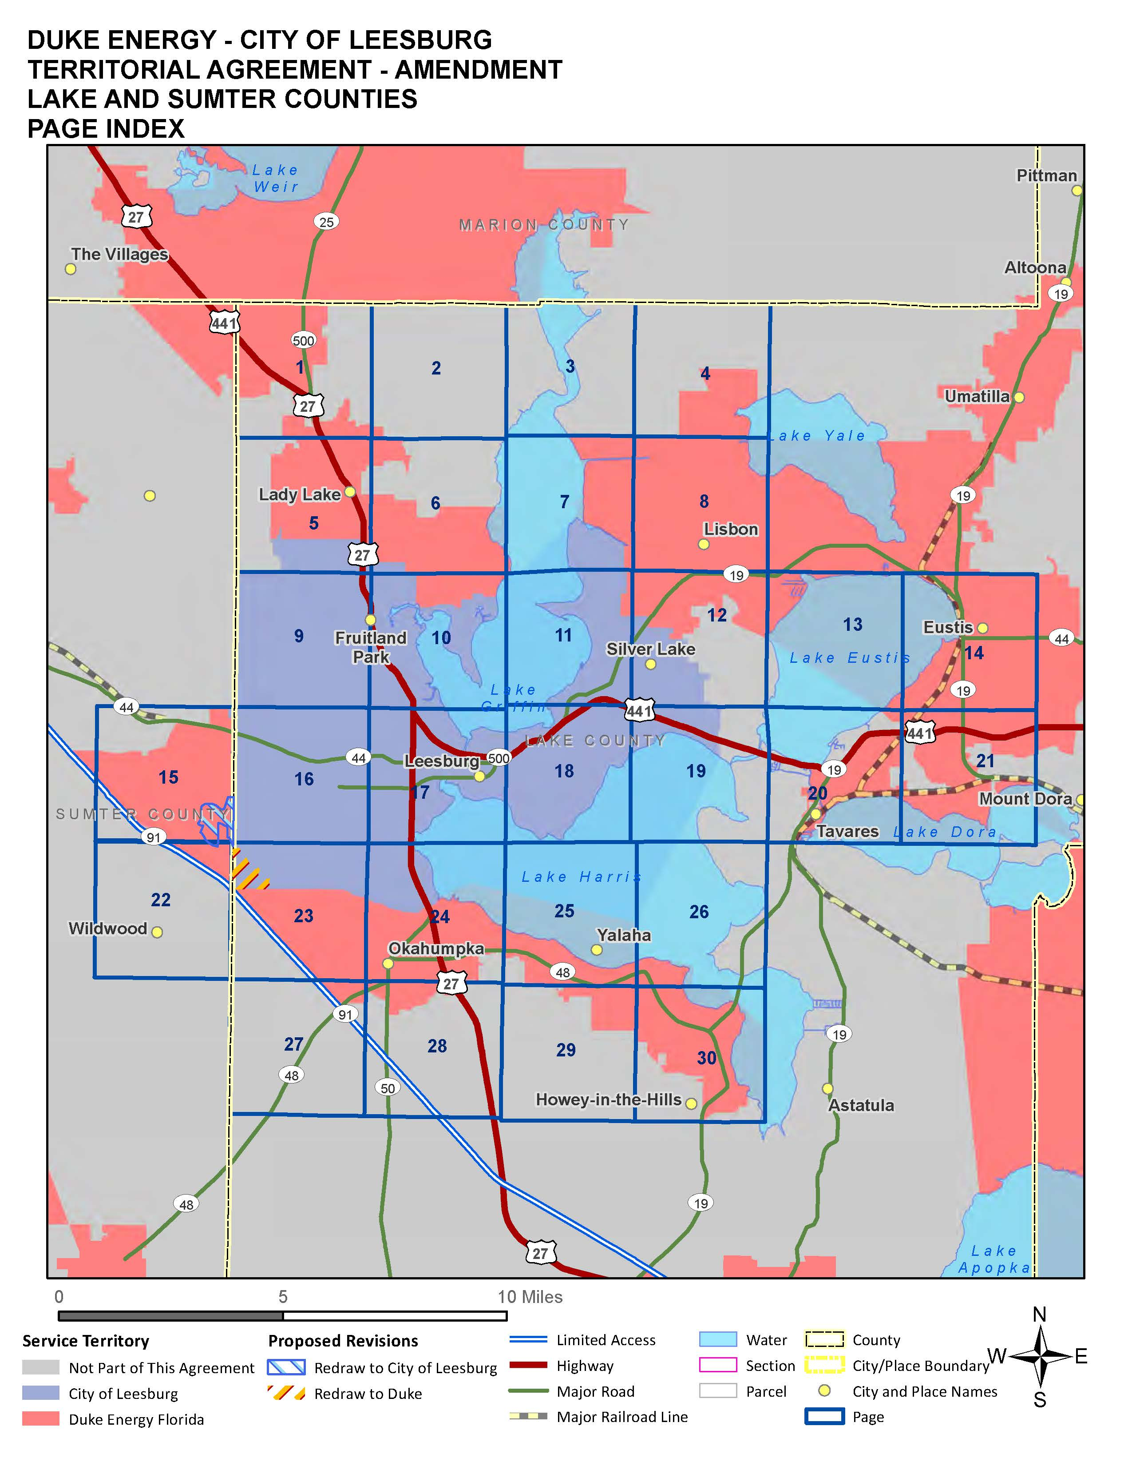

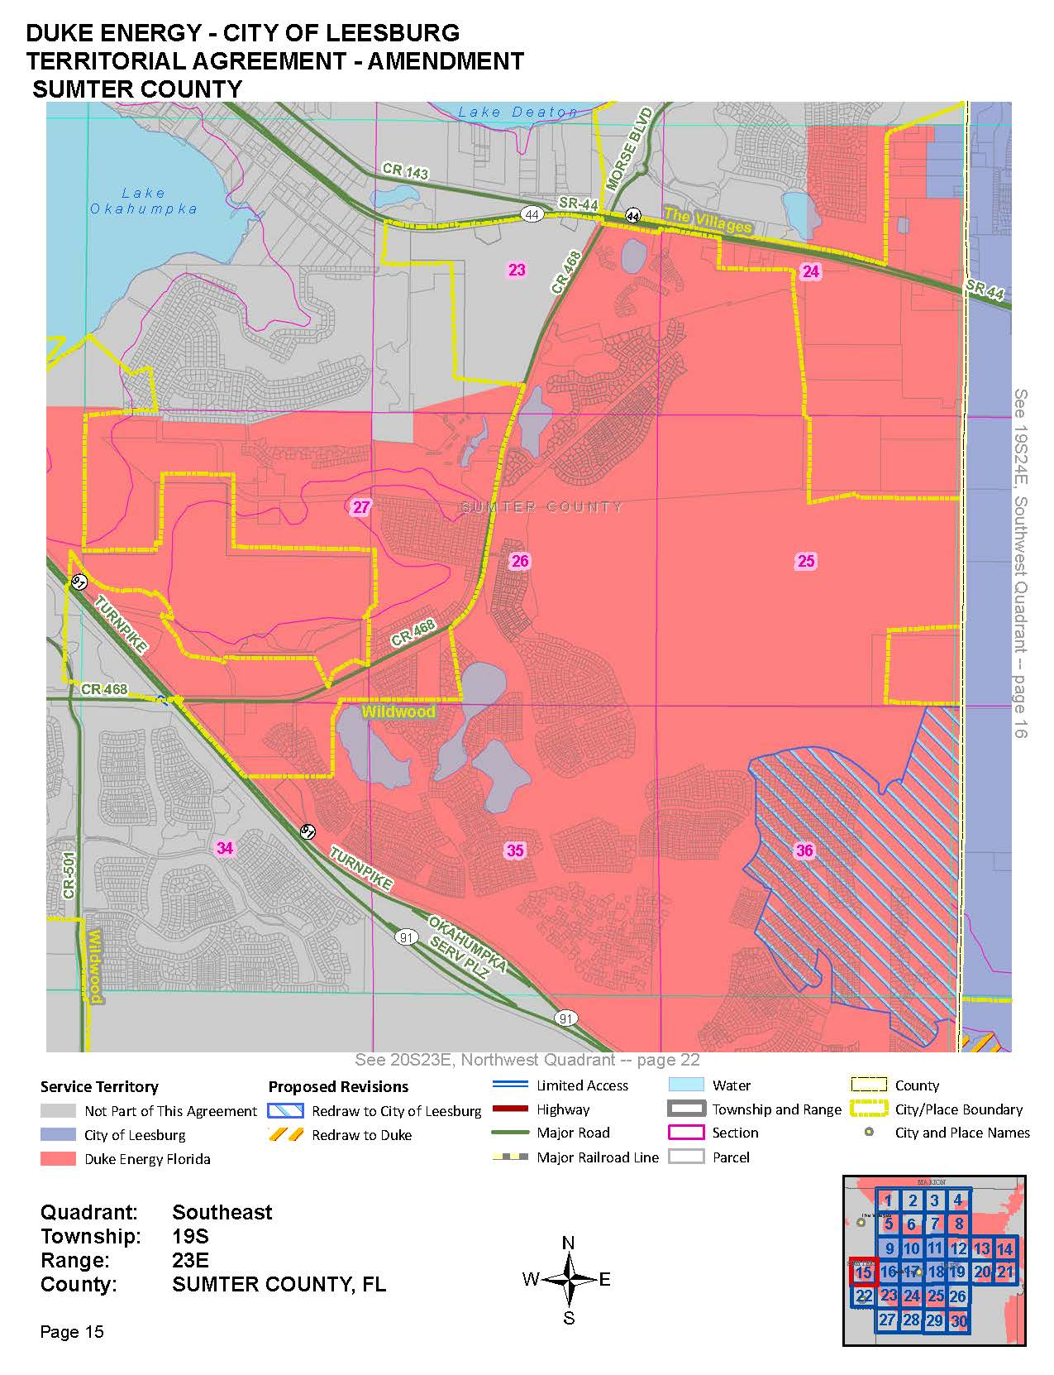

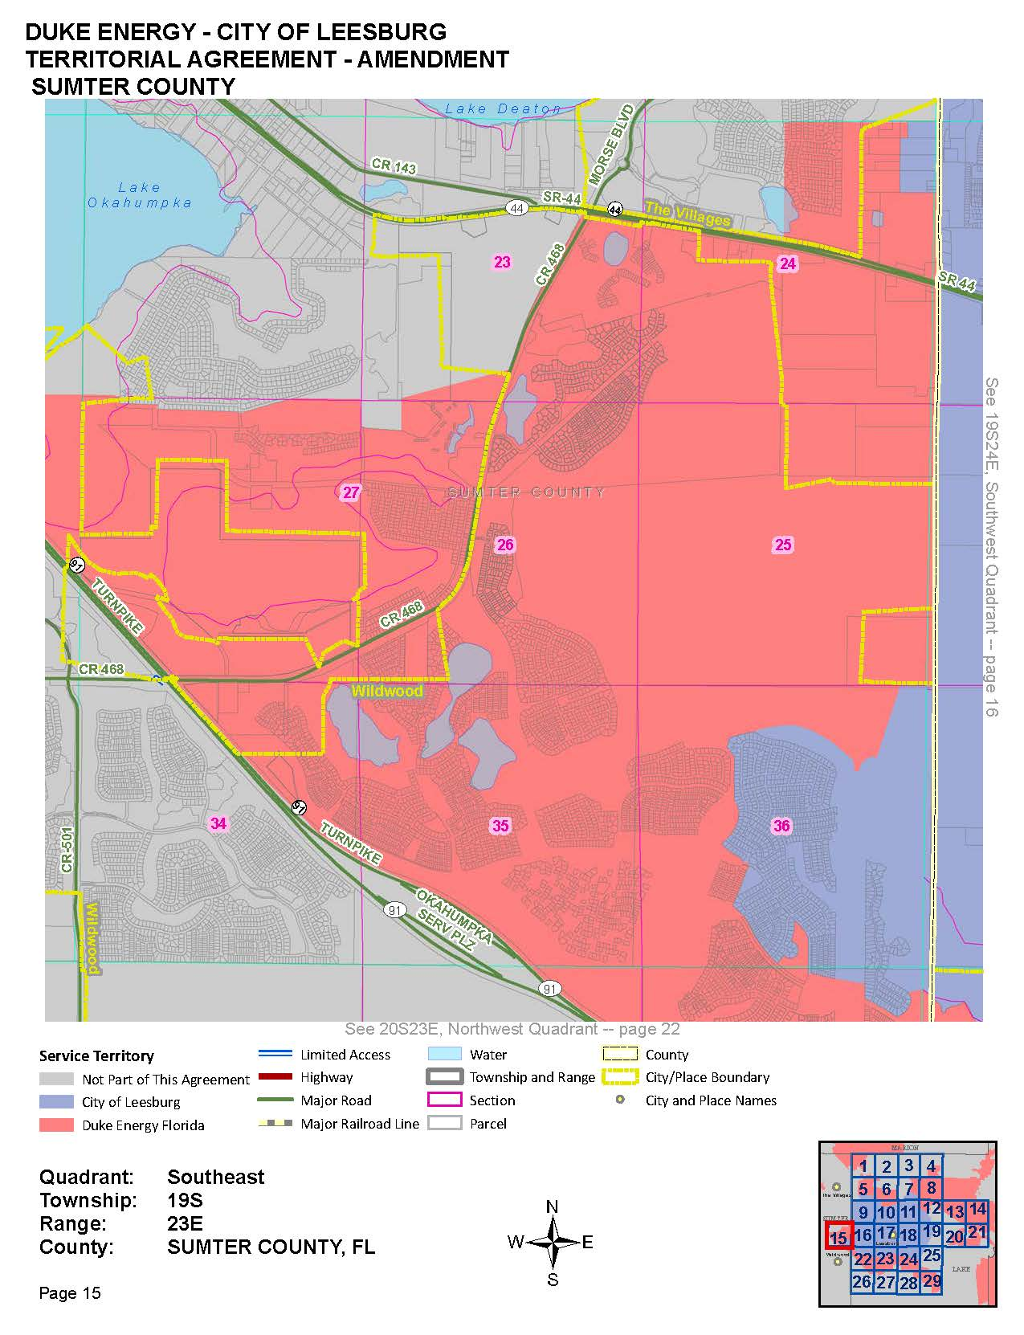

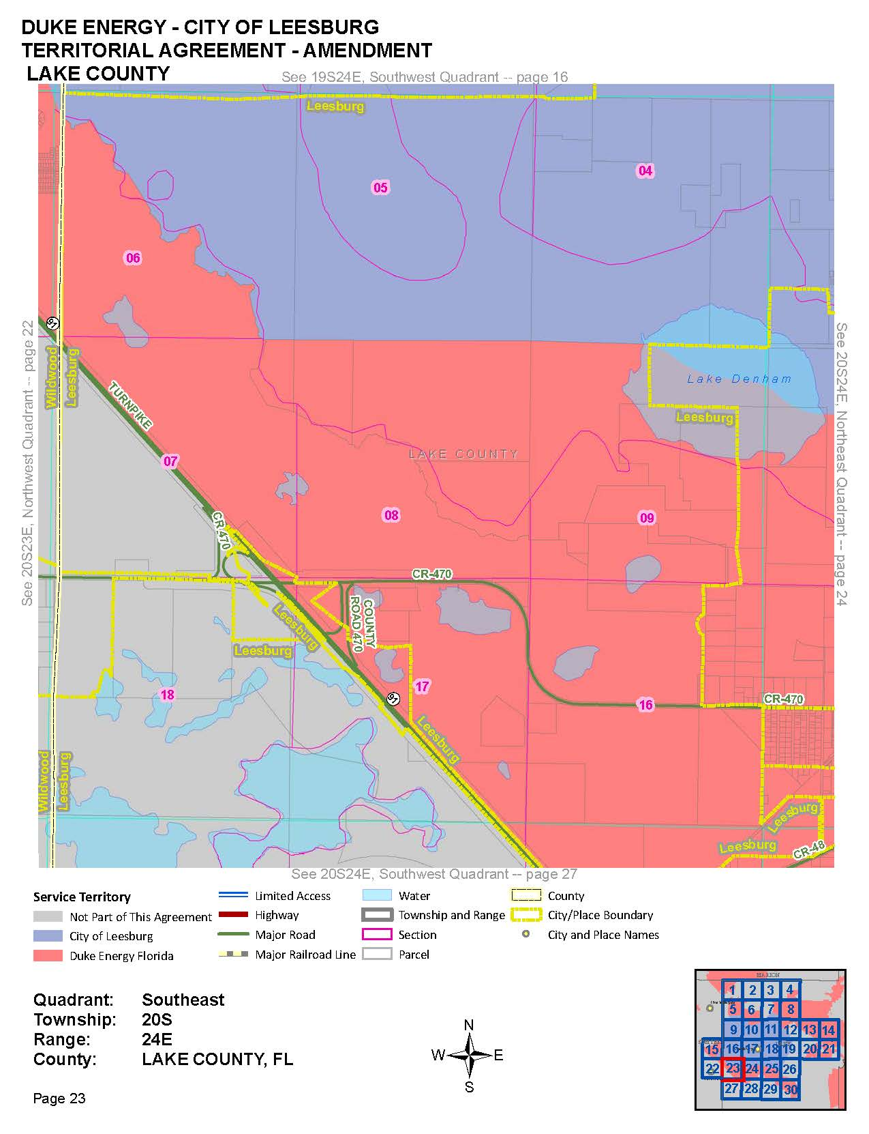

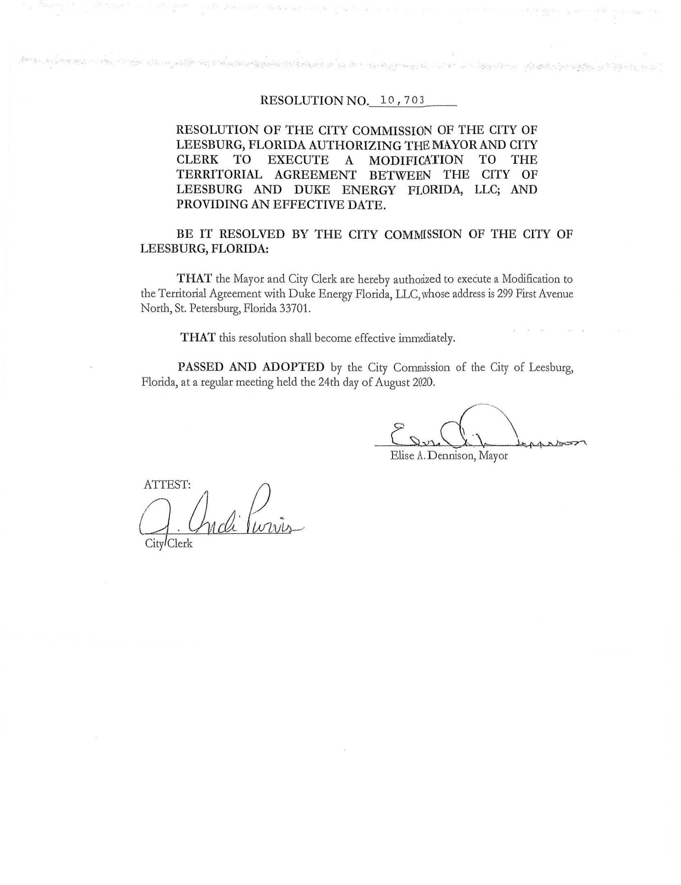

Order No. PSC-15-0278-PAA-EU, issued July 7, 2015, in Docket No. 150077-EU, In re: Joint petition for approval of territorial agreement in Lake and Sumter counties by the City of Leesburg and Duke Energy Florida, Inc.
Utilities Commission of the City of New Smyrna Beach v. Florida Public Service Commission, 469 So. 2d 731 (Fla. 1985).

