State of Florida   |  | Public Service Commission  Capital Circle Office Center ● 2540 Shumard Oak Boulevard  Tallahassee, Florida 32399-0850  -M-E-M-O-R-A-N-D-U-M-
DATE: | December 22, 2020
TO: | Office of Commission Clerk (Teitzman)
FROM: | Division of Economics (Ward, Coston, Draper)  Office of the General Counsel (Brownless)
RE: | Docket No. 20200218-EI – Joint petition for approval of intermittent electric standby power agreement, by Tampa Electric Company, Duke Energy Florida, and Mosaic Fertilizer, LLC.
AGENDA: | 01/05/21 – Regular Agenda – Proposed Agency Action – Interested Persons May Participate
COMMISSIONERS ASSIGNED: |  |  | All Commissioners
PREHEARING OFFICER: |  |  | Brown
CRITICAL DATES: |  |  | None
SPECIAL INSTRUCTIONS: |  |  | None

Case Background
On September 17, 2020, Tampa Electric Company (Tampa Electric), Duke Energy Florida, LLC (Duke), and Mosaic Fertilizer, LLC (Mosaic) (jointly Petitioners) filed a joint petition for approval of an amendment to their intermittent electric standby power agreement. The agreement was originally approved in Order No. PSC-15-0414-PAA-EI (2015 order) to allow Tampa Electric to provide intermittent standby power to Mosaic’s South Pasture Beneficiation Plant. Mosaic is in the business of mining and processing phosphate and manufacturing fertilizer. Mosaic has operations in the service territories of Tampa Electric, Duke, and other utilities within the state. The Commission has jurisdiction over this matter pursuant to Sections 366.03, 366.04, 366.05, and 366.06, Florida Statutes (F.S.).

Discussion of Issues

Issue 1:
Should the Commission approve the proposed amendment to the intermittent electric standby power agreement between Tampa Electric, Duke, and Mosaic?

Recommendation:
Yes. The Commission should approve the proposed amendment to the current intermittent electric standby power agreement between Tampa Electric, Duke, and Mosaic, effective on the date of a final Commission order approving the amendment. The amended agreement is consistent with the Commission’s policy of encouraging agreements, promotes renewable energy, and has no immediate impact on Tampa Electric’s and Duke’s general body of ratepayers. (Ward, Coston, Draper)

Staff Analysis:
The current agreement as approved in the 2015 order and the proposed amendment address the supply of electric service to certain Mosaic facilities located in Hardee County. Specifically, the Mosaic facilities at issue are the South Pierce Generating Facilities (South Pierce), the South Pasture Beneficiation Plant (South Pasture), the Bartow Generating Facilities (Bartow), and the South Fort Meade Beneficiation Plant (South Fort Meade). The current agreement allows Tampa Electric to provide intermittent standby power to Mosaic during infrequent periods when generation from the South Pierce facility is not sufficient to serve the South Pasture load.
The proposed amendment would expand Mosaic’s ability to utilize its self-generated renewable energy to serve its own facilities by adding the provision of electricity from Mosaic’s Bartow facility, which generates power, to Mosaic’s South Fort Meade facility. Under the proposed amendment, Tampa Electric would also provide intermittent electric standby power to Mosaic’s South Fort Meade facility when generation from the South Pierce or Bartow facilities is not sufficient. The amendment would become effective on the date of a final Commission order approving the amendment. The proposed amendment is shown in Attachment A of the recommendation.

Description of Mosaic’s Facilities
Maps of the current Mosaic facilities and the facilities and associated changes to Mosaic’s operations that would be accomplished by the proposed agreement are shown in Attachment B, pages 1 and 2, of the recommendation. The South Pierce and South Pasture facilities were at issue in the 2015 order; the proposed amendment addresses the provision of electricity to the Bartow and South Fort Meade facilities.

South Pierce
South Pierce is a qualifying cogeneration facility which consists of two steam-turbine generators that generate electricity from waste heat captured during the fertilizer production process. Mosaic uses the electricity generated to self-service the South Pierce facility and directs the excess electricity generated to serve the full load of the South Pasture plant. As addressed in the 2015 order, in the event generation from the South Pierce facility is not sufficient to serve the South Pasture load, Tampa Electric provides standby power to the South Pierce facility. Tampa Electric only serves the load at South Pasture when the South Pierce cogeneration is off-line for repair or maintenance, or the combined load of the South Pierce and South Pasture facilities exceeds the output of the South Pierce cogeneration facility. Such intermittent electric service is characterized as standby service. The South Pierce and South Pasture plant are connected via a transmission line owned by Mosaic and located on Mosaic-owned property. The South Pierce facility is located in Tampa Electric’s service territory.

South Pasture
The South Pasture plant produces fertilizer products and is currently served by Tampa Electric under the intermittent electric standby power agreement approved in the 2015 order. The South Pasture plant is located in Peace River Electric Cooperative’s (Peace River) service territory. Prior to approval of the current agreement, Duke provided service to the South Pasture plant because the facility requires service at transmission level and Peace River does not have transmission level facilities in the area. Pursuant to the current agreement, which provided for Tampa Electric to provide standby power to the South Pasture load, Duke no longer provides standby power to the South Pasture plant, because only one utility can be connected to the Mosaic facilities at a time. Commission approval of the current agreement was necessary to allow Tampa Electric to provide standby service to South Pasture which is located in an area Duke is permitted to serve.

Bartow
Bartow is a qualifying cogneration facility which consists of two steam-turbine generators that generate renewable energy from waste heat captured during the fertilizer production process. Mosaic uses the electricity generated to self-service the South Fort Meade facility and sells any excess energy to Tampa Electric under the as-available COG-1 tariff. Tampa Electric provides standby service to Bartow, which is located in Tampa Electric’s service territory.

South Fort Meade
The South Fort Meade plant produces fertilizer products and is currently served by Duke under the Interruptible General Service rate schedule. South Fort Meade is located in Peace River’s service territory; however, pursuant to a territorial agreement between Duke and Peace River, Duke provides service to South Fort Meade because the facility requires service at transmission level. The Petitioners state that Peace River has read the amended agreement and Peace River's consent to approval and implementation of the amended agreement is attached as Exhibit C to the petition.

Mosaic’s Transmission Lines
Mosaic owns a 10-mile 69 kilovolt transmission line that connects the South Pierce facility to the South Pasture facility. As shown in Attachment B, page 2 of 2, to the recommendation, Mosaic plans to extend this transmission line to connect the South Pierce and Bartow facilities to the South Pasture and the South Fort Meade facilities. Mosaic stated that they plan to have this extension, which is known as the South Pasture South Fort Meade Tie Line, completed by the third quarter of 2021. The transmission line will be owned by Mosaic and solely located on Mosaic-owned property, with the exception of crossings of public right of ways, such as roads. This type of arrangement is referred to as self-service.

Proposed Amendment
The primary purpose of the proposed amendment is to expand Mosaic’s ability to utilize its renewable energy to serve its own facilities by connecting the Bartow generating facility, once construction of the new transmission line is complete, to the South Pasture and South Fort Meade facilities. If the amendment is approved and the transmission line extension completed, Tampa Electric would also be able to provide intermittent standby power to Bartow and South Fort Meade. Commission approval of the proposed amendment is required, because the South Fort Meade facility is currently served by Duke. As discussed in the 2015 order, only one utility can be connected electrically to the Mosaic facilities at a time.
The Petitioners explained that the infrequent circumstance under which Tampa Electric would provide standby power to the South Pasture or South Fort Meade facilities is when the generating South Pierce or Bartow facilities are de-rated or offline for repair or maintenance, or when the South Pasture or South Fort Meade load exceeds the output of the South Pierce and Bartow facilities.
The current and the proposed agreement include a 3,500 Megawatt-hour annual cap on the amount of standby power Tampa Electric can provide to Mosaic. If the cap is exceeded, Mosaic would disconnect the South Pasture and South Fort Meade facilities from its generation facilities and connect the two facilities to Duke. The purpose of the negotiated cap is to ensure that Tampa Electric’s standby service is infrequent and intermittent. Once Mosaic has purchased a certain amount of electricity from Duke as outlined in paragraph 6 of the proposed agreement, Mosaic will reconnect its facilities and the cap will be reset to zero.

Conclusion

As noted in the 2015 order, the Florida Supreme Court found that an individual does not have the right to service by a particular utility merely because the individual deems it advantageous. However, the proposed amendment to the agreement for intermittent standby power is confined to unique and limited circumstances as presented by the facts of this case. The amended agreement maintains the current territorial boundaries for Tampa Electric and Duke, while allowing Mosaic to self-generate power to serve its South Pasture and South Fort Meade loads.

Staff recommends that the Commission should approve the proposed amendment to the current intermittent electric standby power agreement between Tampa Electric, Duke, and Mosaic, effective on the date of a final Commission order approving the amendment. The proposed amended agreement is consistent with the Commission's policy of encouraging agreements, promotes renewable energy, and has no immediate impact on Tampa Electric's and Duke's general body of ratepayers.
Issue 2:
Should this docket be closed?

Recommendation:
Yes. If no protest is filed by a person whose substantial interests are affected within 21 days of the issuance of the Order, this docket should be closed upon the issuance of a Consummating Order. (Brownless)

Staff Analysis:
If no protest is filed by a person whose substantial interests are affected within 21 days of the issuance of the Order, this docket should be closed upon the issuance of a Consummating Order.

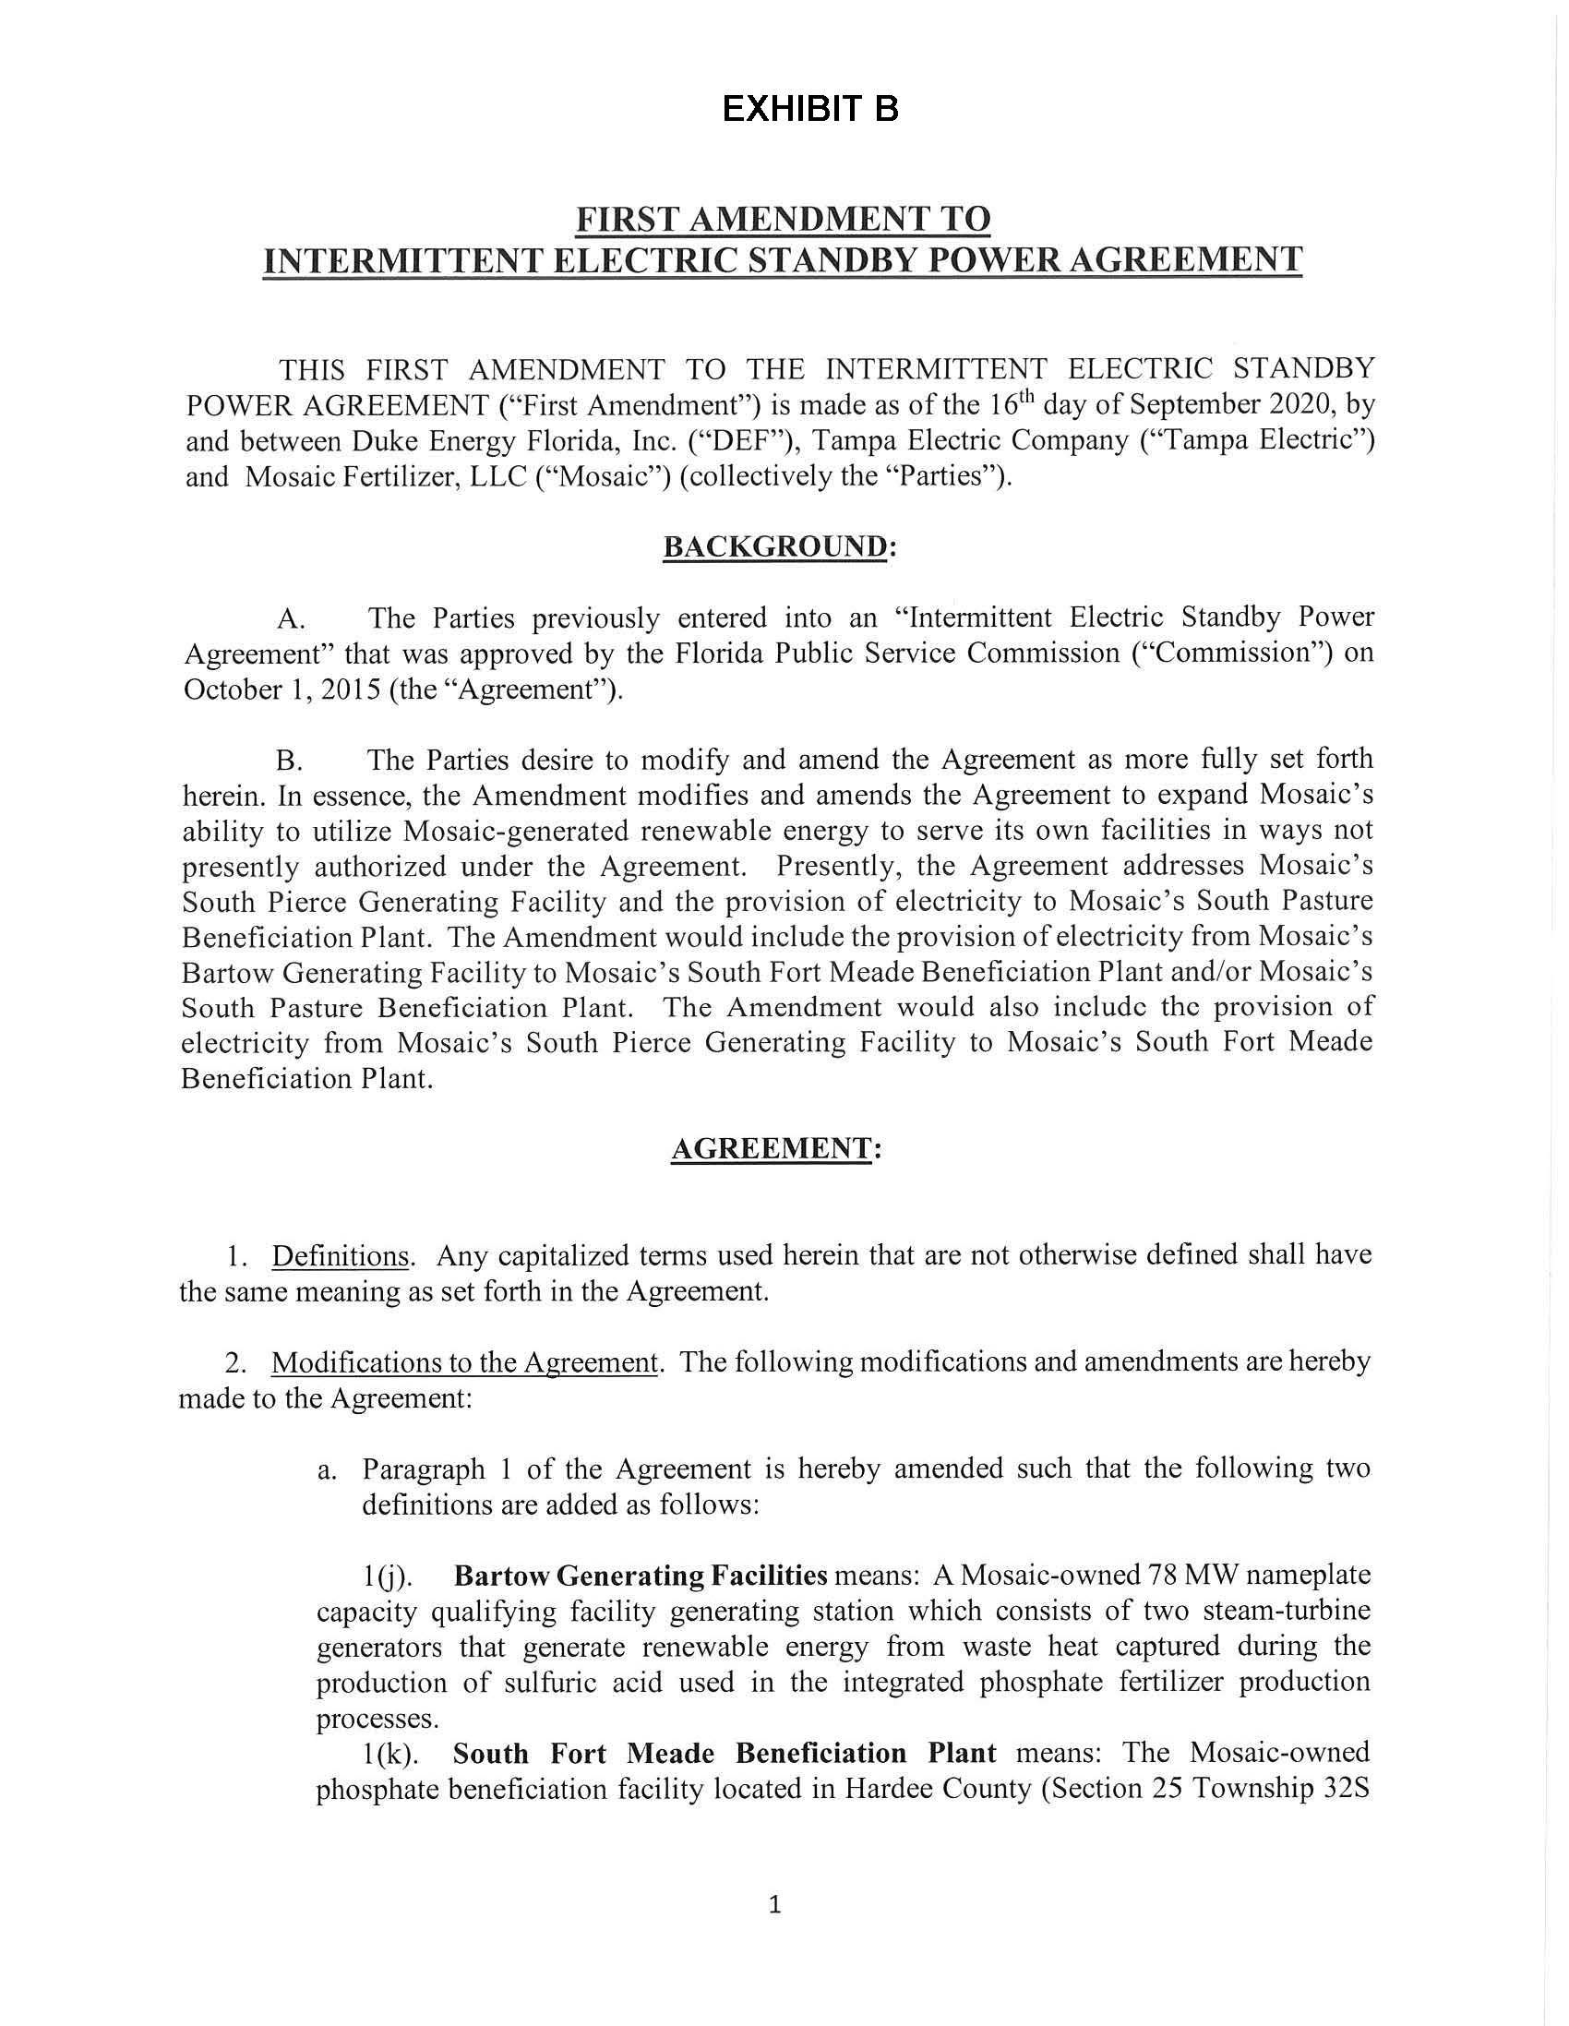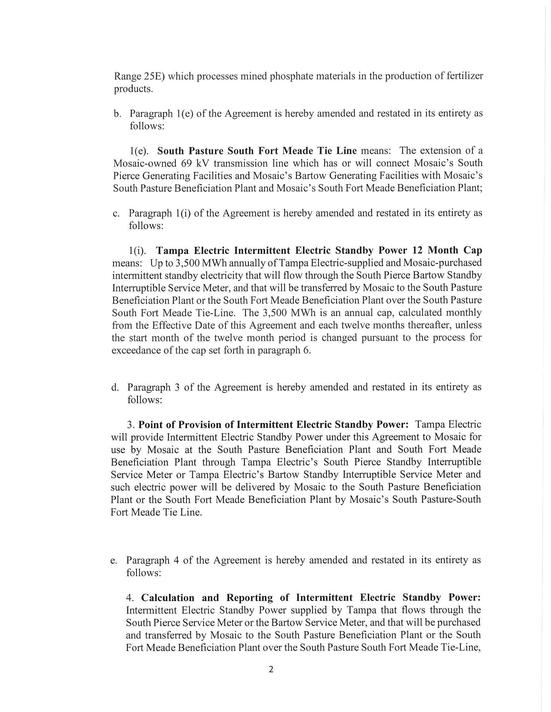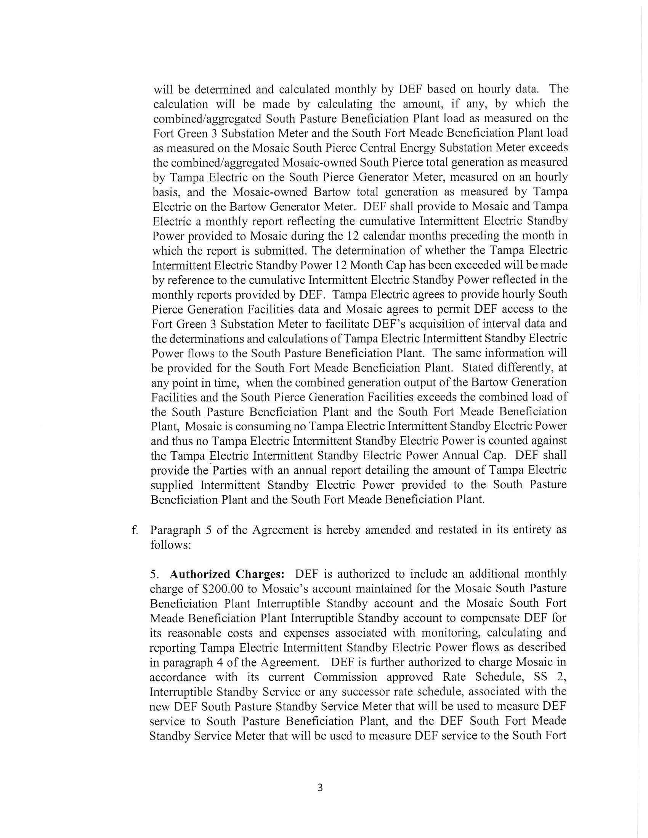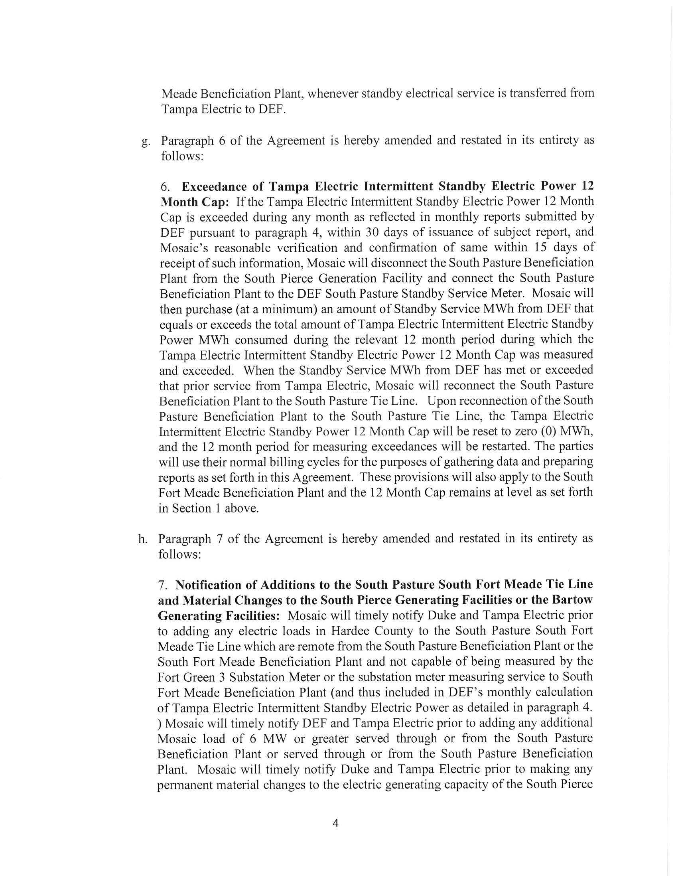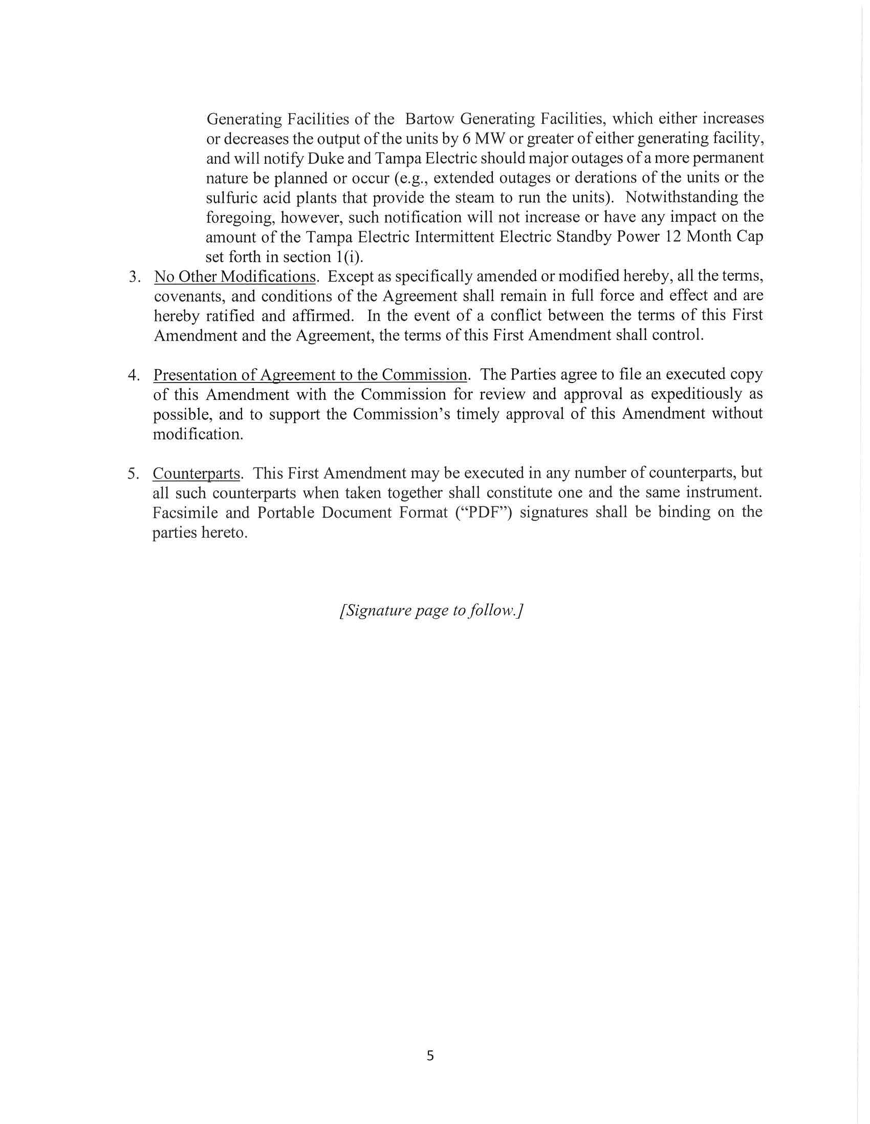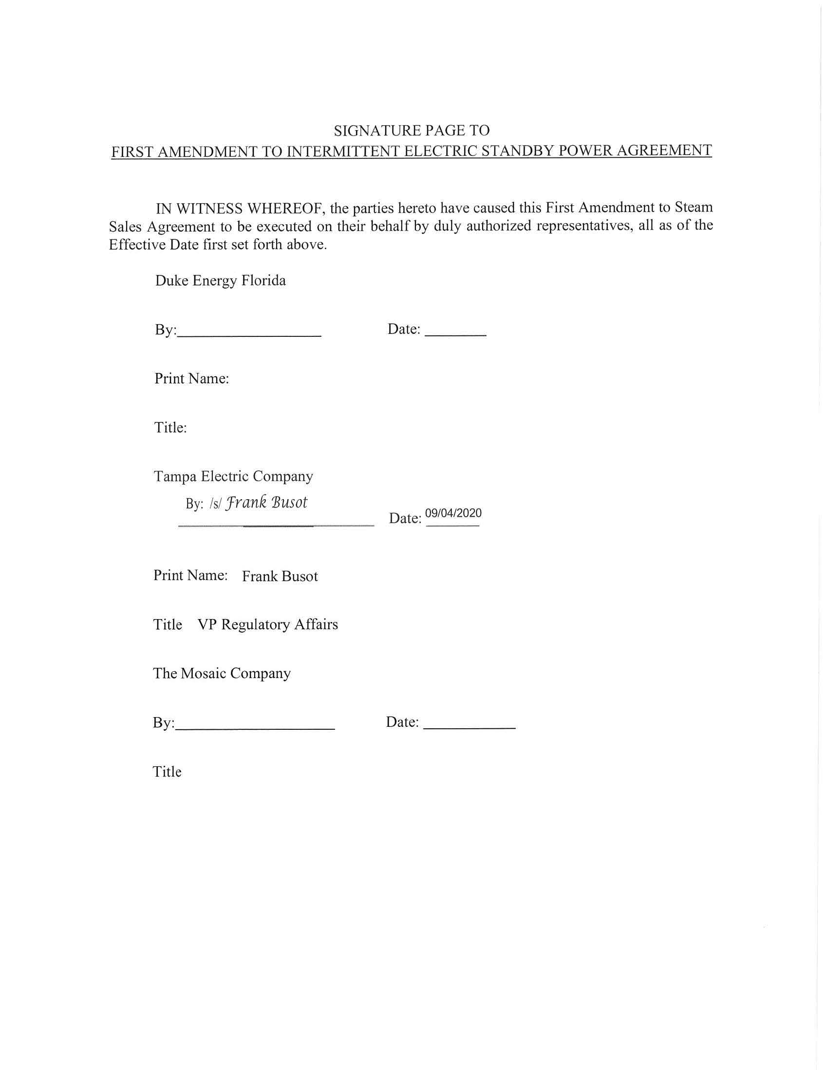
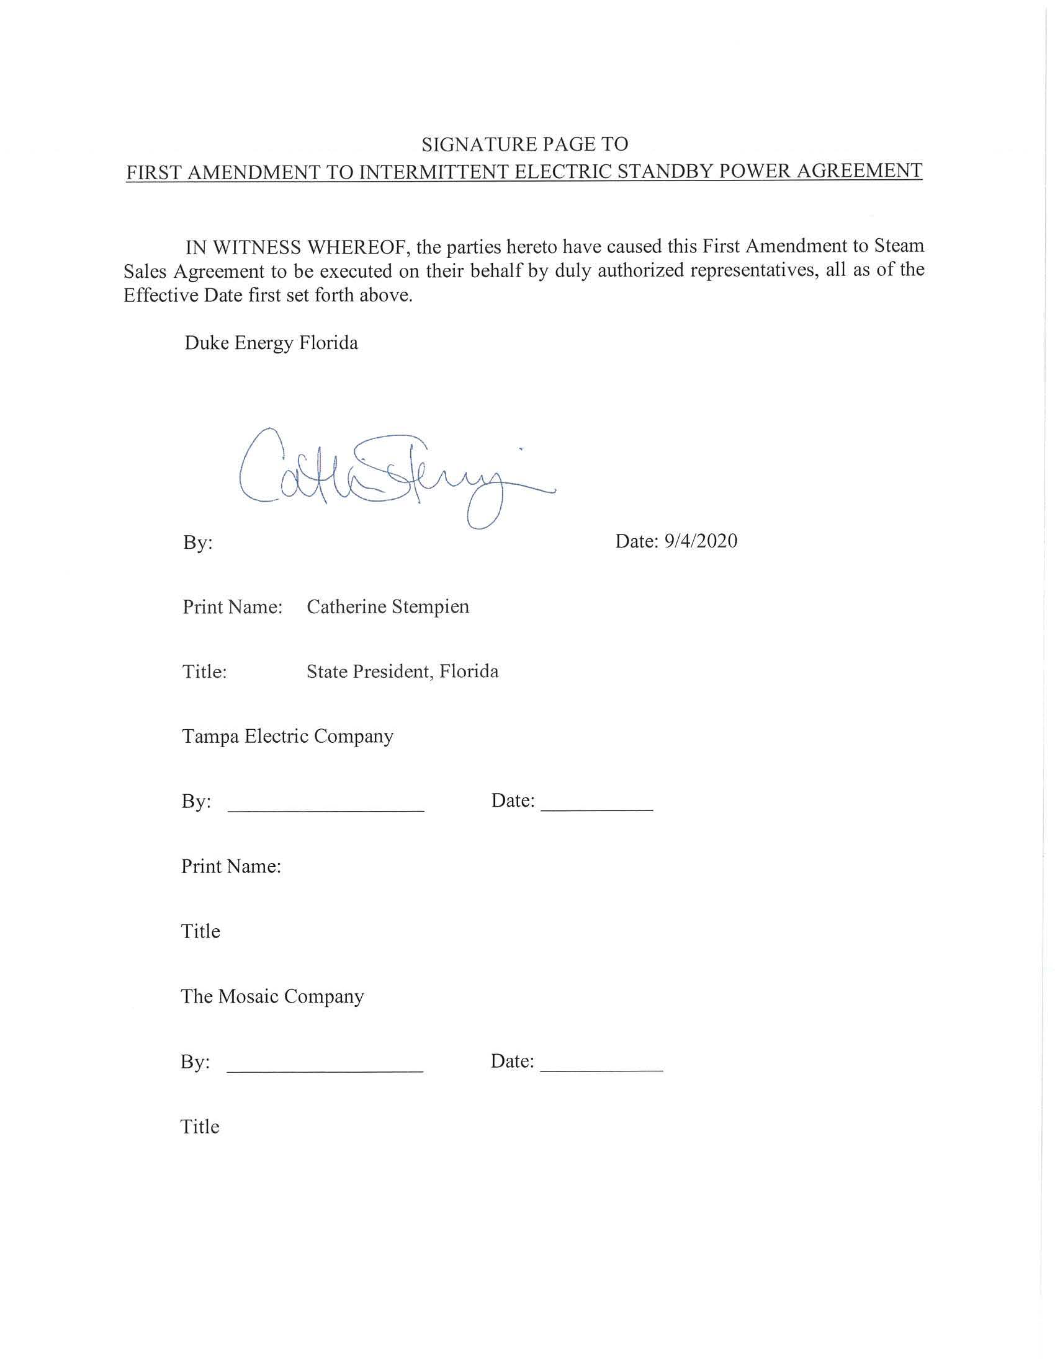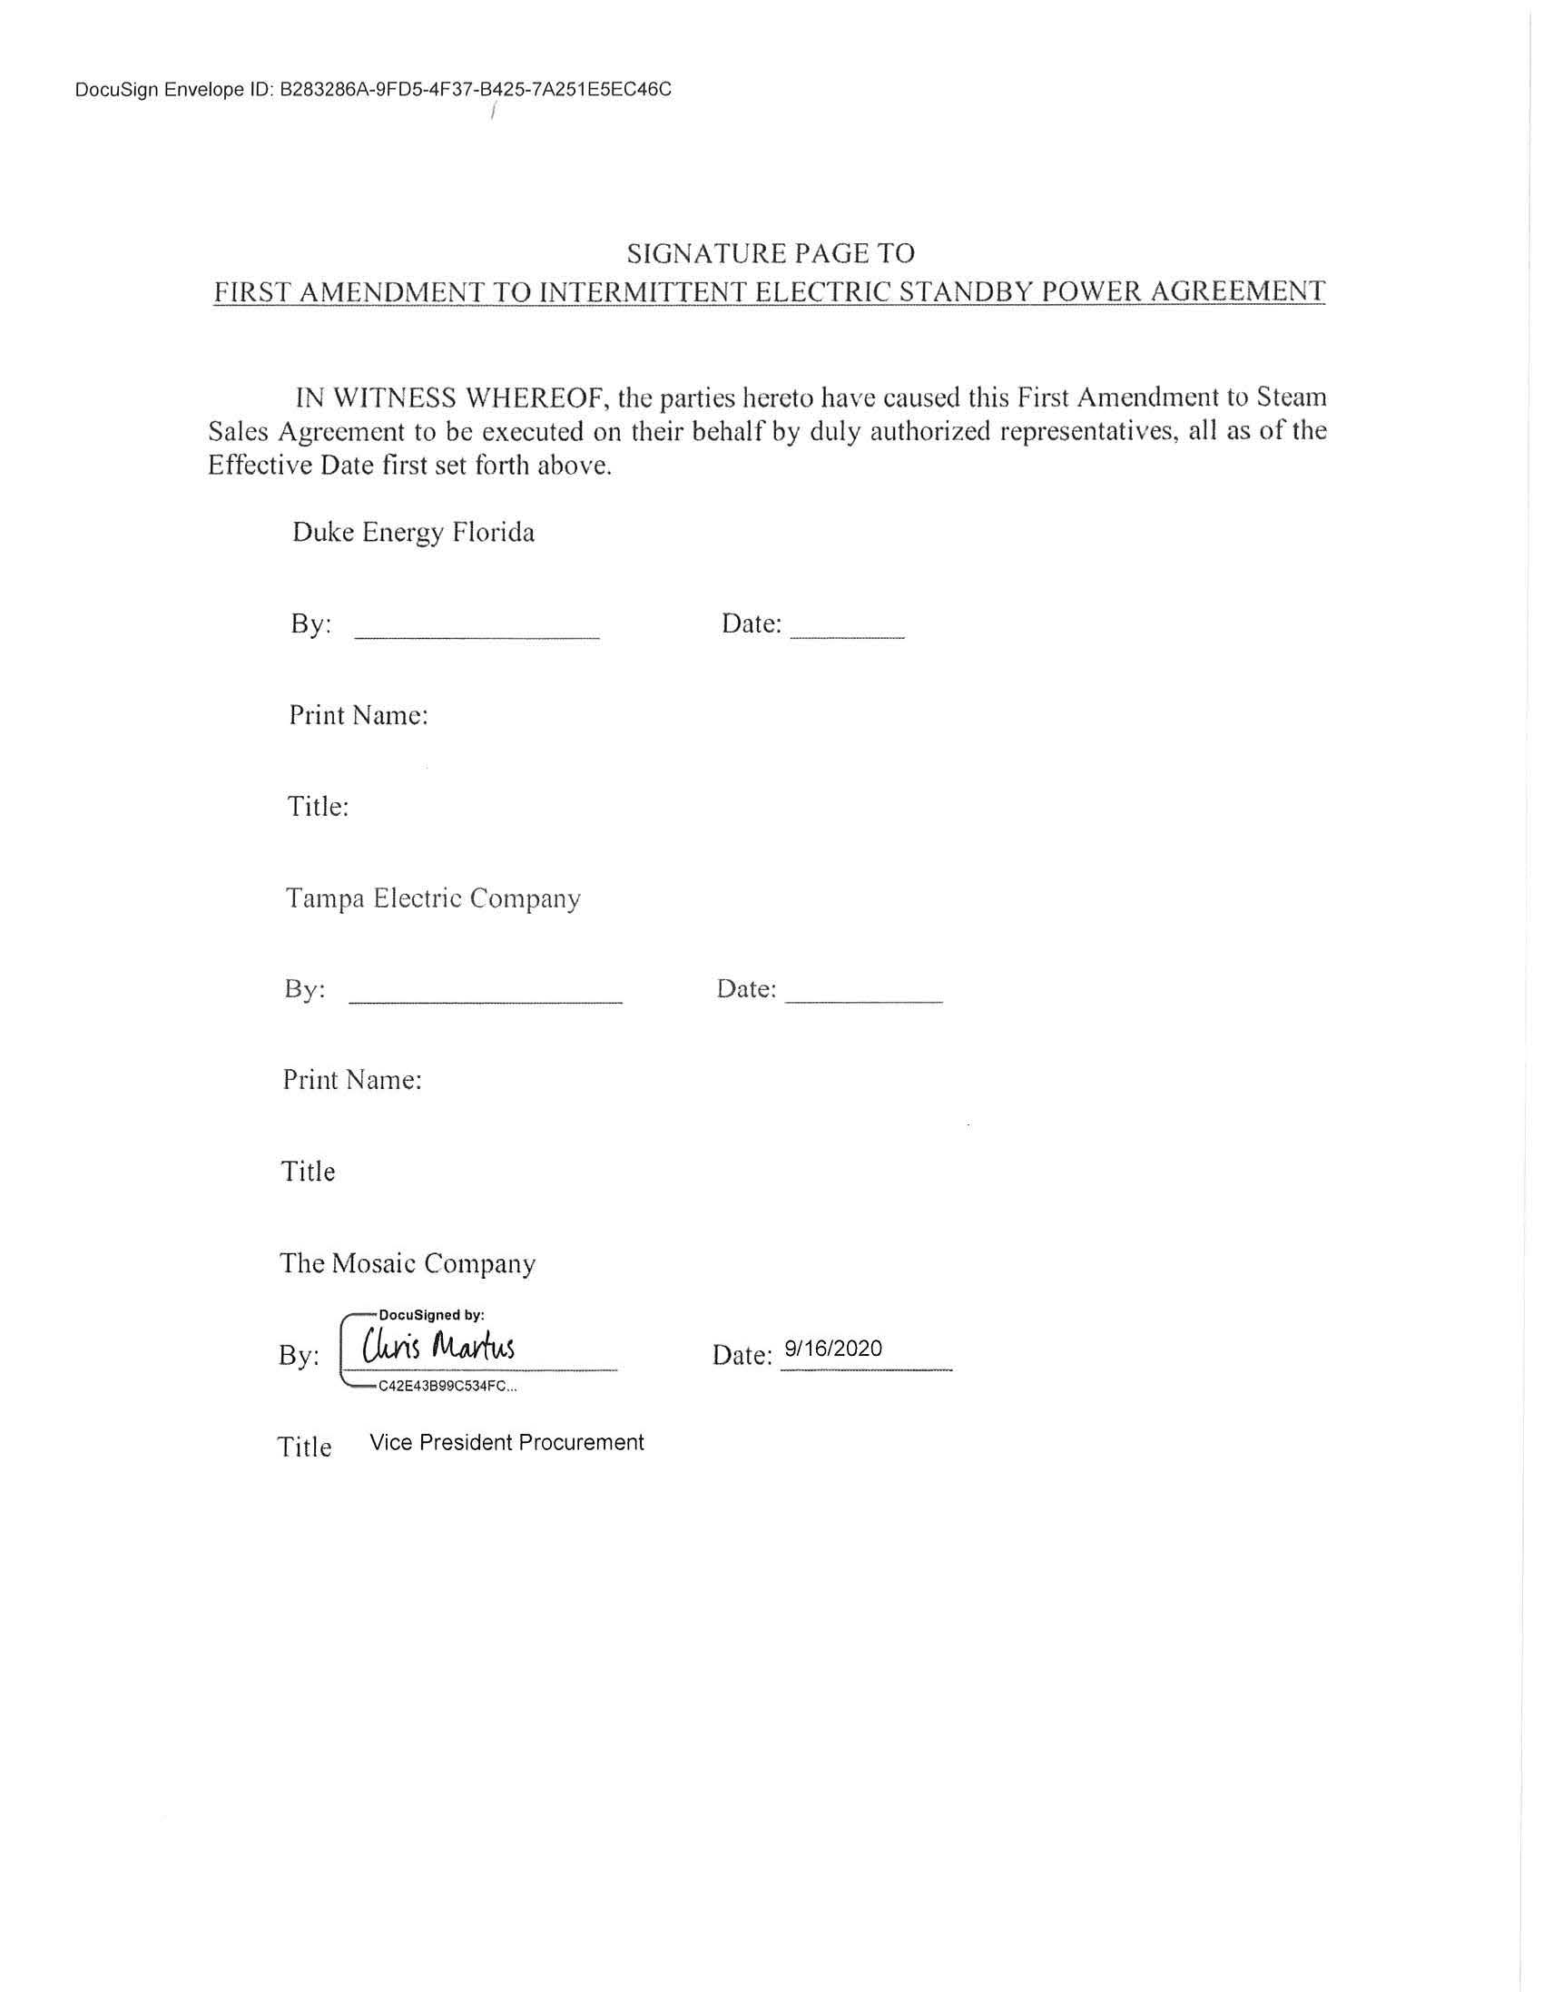

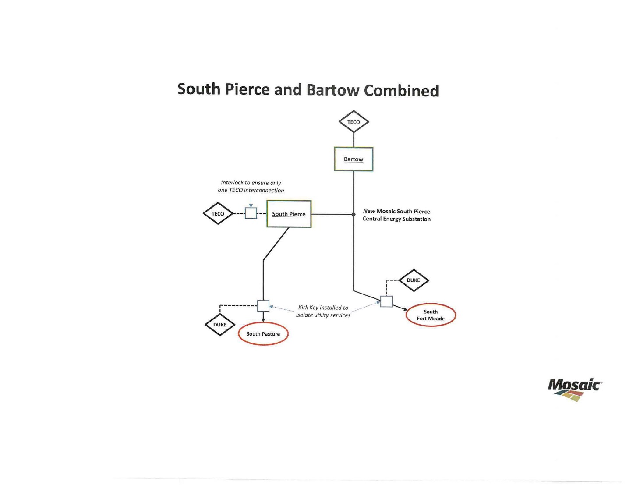

Order No. PSC-15-0414-PAA-EI, issued October 1, 2015, in Docket No. 20150177-EI, In re: Joint petition by Tampa Electric Company, Duke Energy Florida, and Mosaic Fertilizer, LLC, for approval of intermittent electric standby power agreement.
Rule 25-17.080, Florida Administrative Code (F.A.C.), defines the criteria a small power producer must meet to qualify as a cogeneration facility. Pursuant to Rule 25-17.082, F.A.C., each investor-owned utility shall purchase electricity produced and sold by qualifying facilities at rates which have been agreed upon by the utility and qualifying facility or at the utility’s published tariff.
Order No. PSC-2019-0048-PAA-EU, issued January 28, 2019, in Docket No. 20180159-EU, In re: Joint petition for approval of amendment to territorial agreement in Hardee, Highlands, Polk, and Osceola Counties, by Peace River Electric Cooperative and Duke Energy Florida, LLC.
Storey v. Mayo, 217 So. 2d 304 (Fla. 1968)

