State of Florida   |  | Public Service Commission  Capital Circle Office Center ● 2540 Shumard Oak Boulevard  Tallahassee, Florida 32399-0850  -M-E-M-O-R-A-N-D-U-M-
DATE: | June 25, 2021
TO: | Office of Commission Clerk (Teitzman)
FROM: | Division of Engineering (Kistner, Ellis)  Office of the General Counsel (Weisenfeld)
RE: | Docket No. 20210065-EQ – Petition for approval of amended standard offer contract (Schedule COG-2), by Duke Energy Florida, LLC.
AGENDA: | 07/08/21 – Regular Agenda – Proposed Agency Action – Interested Persons May Participate
COMMISSIONERS ASSIGNED: |  |  | All Commissioners
PREHEARING OFFICER: |  |  | Administrative
CRITICAL DATES: |  |  | None
SPECIAL INSTRUCTIONS: |  |  | None

Case Background
Section 366.91(3), Florida Statutes (F.S.), requires each investor-owned utility (IOU) to continuously offer to purchase capacity and energy from renewable generating facilities and small qualifying facilities. Florida Public Service Commission (Commission) Rules 25-17.200 through 25-17.310, Florida Administrative Code (F.A.C.), implement the statute and require each IOU to file with the Commission, by April 1 of each year, a revised standard offer contract based on the next avoidable fossil fueled generating unit of each technology type identified in the utility’s current Ten-Year Site Plan. On April l, 2021, Duke Energy Florida, LLC (DEF) filed a petition for approval of its amended standard offer contract and rate schedule COG-2, based on its 2021 Ten-Year Site Plan. The Commission has jurisdiction over this amended standard offer contract pursuant to Sections 366.04 through 366.055, and 366.91, F.S.

Discussion of Issues

Issue 1:
Should the Commission approve the amended standard offer contract and rate schedule COG-2 filed by Duke Energy Florida, LLC?

Recommendation:
Yes. The provisions of DEF’s amended standard offer contract and associated rate schedule COG-2 conform to all requirements of Rules 25-17.200 through 25-17.310, F.A.C. The amended standard offer contract provides flexibility in the arrangements for payments so that a developer of renewable generation may select the payment stream best suited to its financial needs. (Kistner)

Staff Analysis:
Section 366.91(3), F.S., and Rule 25-17.250, F.A.C., require that DEF, an IOU, continuously make available a standard offer contract for the purchase of firm capacity and energy from renewable generating facilities (RF) and small qualifying facilities (QF) with design capacities of 100 kilowatts (kW) or less. Pursuant to Rules 25-17.250(1) and (3), F.A.C., the standard offer contract must provide a term of at least 10 years, and the payment terms must be based on the utility’s next avoidable fossil-fueled generating unit identified in its most recent Ten-Year Site Plan, or if no avoided unit is identified, its next avoidable planned purchase. DEF has identified a 214 megawatt (MW) natural gas-fueled combustion turbine (CT) as the next planned generating unit in its 2021 Ten-Year Site Plan. The projected in-service date of the unit is June 1, 2027.
Under DEF’s standard offer contract, the RF/QF operator commits to certain minimum performance requirements based on the identified avoided unit, such as being operational and delivering an agreed upon amount of capacity by the in-service date of the avoided unit, and thereby becomes eligible for capacity payments in addition to payments received for energy. The standard offer contract may also serve as a starting point for negotiation of contract terms by providing payment information to an RF/QF operator, in a situation where one or both parties desire particular contract terms other than those established in the standard offer.
In order to promote renewable generation, the Commission requires the IOU to offer multiple options for capacity payments, including the options to receive early or levelized payments. If the RF/QF operator elects to receive capacity payments under the normal or levelized contract options, it will receive as-available energy payments only until the in-service date of the avoided unit (in this case June 1, 2027), and thereafter, begin receiving capacity payments in addition to the energy payments. If either the early or early levelized option is selected, then the operator will begin receiving capacity payments earlier than the in-service date of the avoided unit. However, payments made under the early capacity payment options tend to be lower in the later years of the contract term because the net present value (NPV) of the total payments must remain equal for all contract payment options.
Table 1 contains DEF’s estimates of the annual payments for each payment option available under the revised standard offer contract to an operator with a 50 MW facility, operating at a capacity factor of 95 percent, which is the minimum capacity factor required under the contract to qualify for full capacity payments. Normal and levelized capacity payments begin with the projected in-service date of the avoided unit (June 1, 2027).
Table 1 - Estimated Annual Payments to a 50 MW Renewable Facility
(95% Capacity Factor)
Year | Energy Payment | Capacity Payment (By Type)
Year | Energy Payment | Normal | Levelized | Early | Early Levelized
Year | $(000) | $(000) | $(000) | $(000) | $(000)
2022 | 8,627 | - | - | - | -
2023 | 7,544 | - | - | - | -
2024 | 7,167 | - | - | - | -
2025 | 7,608 | - | - | 2,529 | 2,678
2026 | 8,657 | - | - | 2,553 | 2,681
2027 | 9,677 | 1,893 | 1,997 | 2,578 | 2,683
2028 | 11,293 | 3,276 | 3,426 | 2,603 | 2,685
2029 | 12,746 | 3,307 | 3,429 | 2,628 | 2,687
2030 | 14,176 | 3,339 | 3,431 | 2,653 | 2,690
2031 | 14,392 | 3,371 | 3,434 | 2,679 | 2,692
2032 | 14,828 | 3,404 | 3,438 | 2,704 | 2,695
2033 | 15,171 | 3,436 | 3,441 | 2,731 | 2,697
2034 | 16,198 | 3,470 | 3,444 | 2,757 | 2,700
2035 | 17,207 | 3,503 | 3,447 | 2,784 | 2,702
2036 | 18,167 | 3,537 | 3,451 | 2,811 | 2,705
2037 | 18,489 | 3,571 | 3,454 | 2,838 | 2,708
2038 | 19,487 | 3,606 | 3,458 | 2,865 | 2,711
2039 | 21,514 | 3,641 | 3,461 | 2,893 | 2,714
2040 | 23,182 | 3,676 | 3,465 | 2,921 | 2,717
2041 | 24,485 | 3,712 | 3,469 | 2,950 | 2,720
Total | 290,613 | 50,740 | 50,243 | 46,476 | 45,863
Total (NPV) | 142,477 | 22,896 | 22,896 | 22,896 | 22,896

Source: DEF’s Response to Staff’s First Data Request
DEF’s standard offer contract, in type-and-strike format, is included as Attachment A to this recommendation. The changes made to DEF’s amended tariff sheets are consistent with the updated avoided unit. In addition to changes associated with the avoided unit, DEF made other minor revisions to its tariff sheets. For example, on Sheet No. 9.442, DEF added additional language allowing RF/QFs to request data regarding on-peak hours, and noted that they may change over time, with a 12-month notice provision.

Conclusion
Staff recommends that the amended standard offer contract and rate schedule COG-2 be approved as filed. The provisions of DEF’s amended standard offer contract and associated rate schedule conform to all requirements of Rules 25-17.200 through 25-17.310, F.A.C. The amended standard offer contract provides flexibility in the arrangements for payments so that a developer of renewable generation may select the payment stream best suited to its financial needs.

Issue 2:
Should this docket be closed?

Recommendation:
Yes. This docket should be closed upon issuance of a consummating order, unless a person whose substantial interests are affected by the Commission’s decision files a protest within 21 days of the issuance of the Commission’s Proposed Agency Action Order. Potential signatories should be aware that, if a timely protest is filed, DEF’s standard offer contract may subsequently be revised. (Weisenfeld)

Staff Analysis:
This docket should be closed upon the issuance of a consummating order, unless a person whose substantial interests are affected by the Commission’s decision files a protest within 21 days of the issuance of the Commission’s Proposed Agency Action Order. Potential signatories should be aware that, if a timely protest is filed, DEF’s standard offer contract may subsequently be revised.

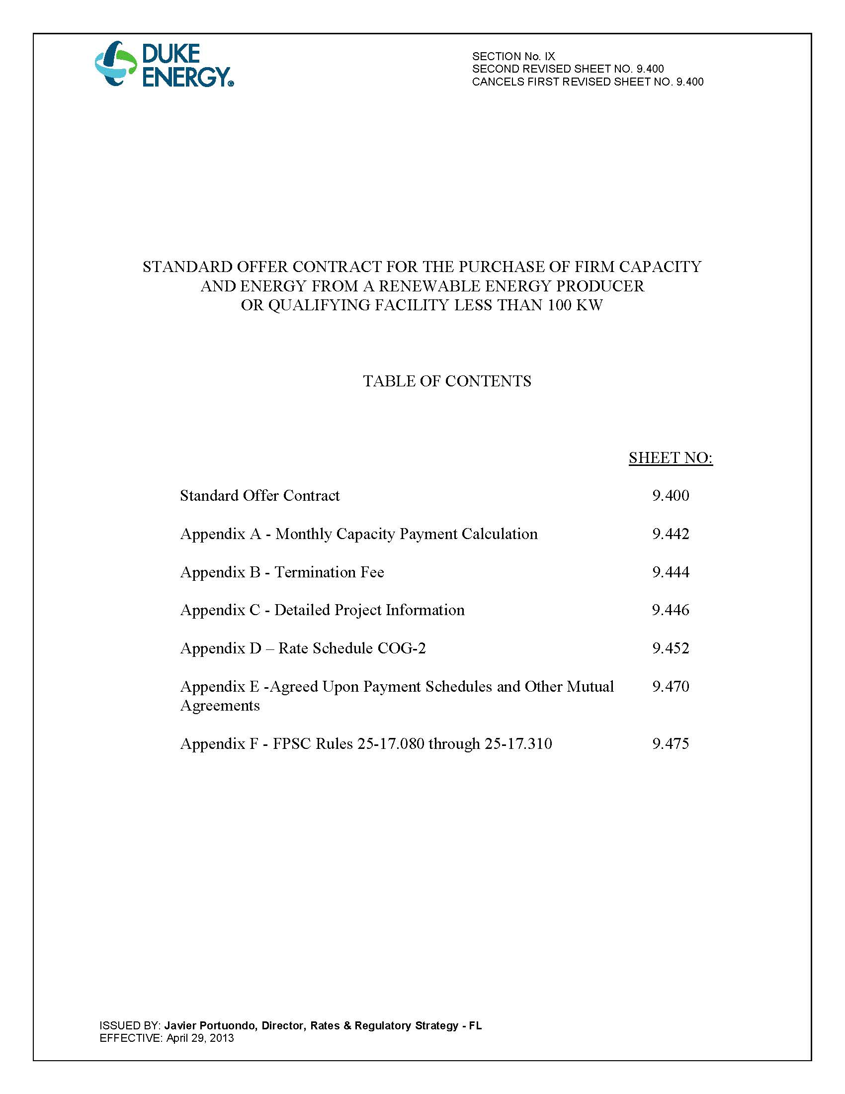

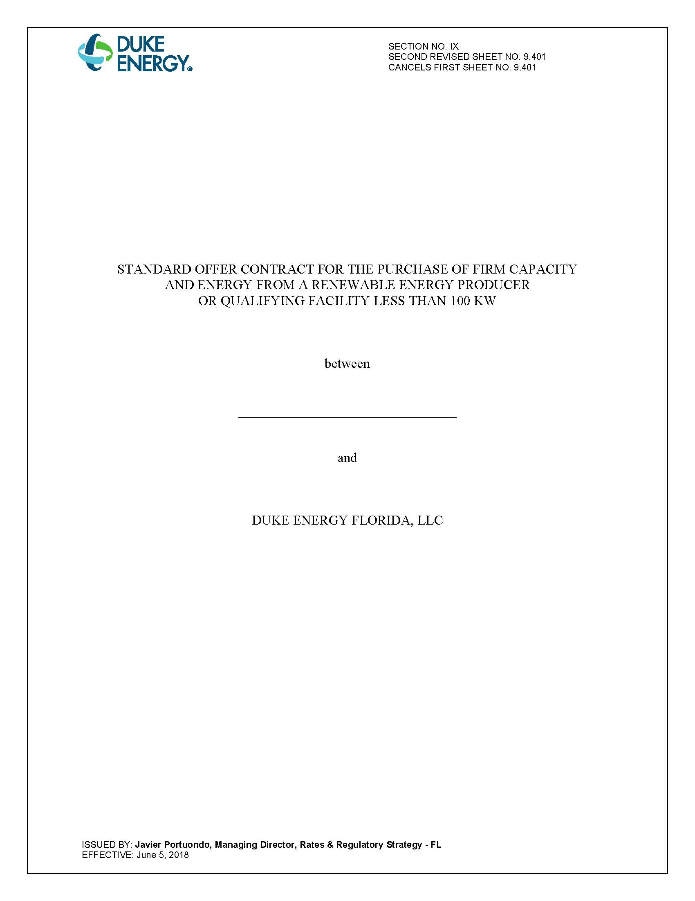

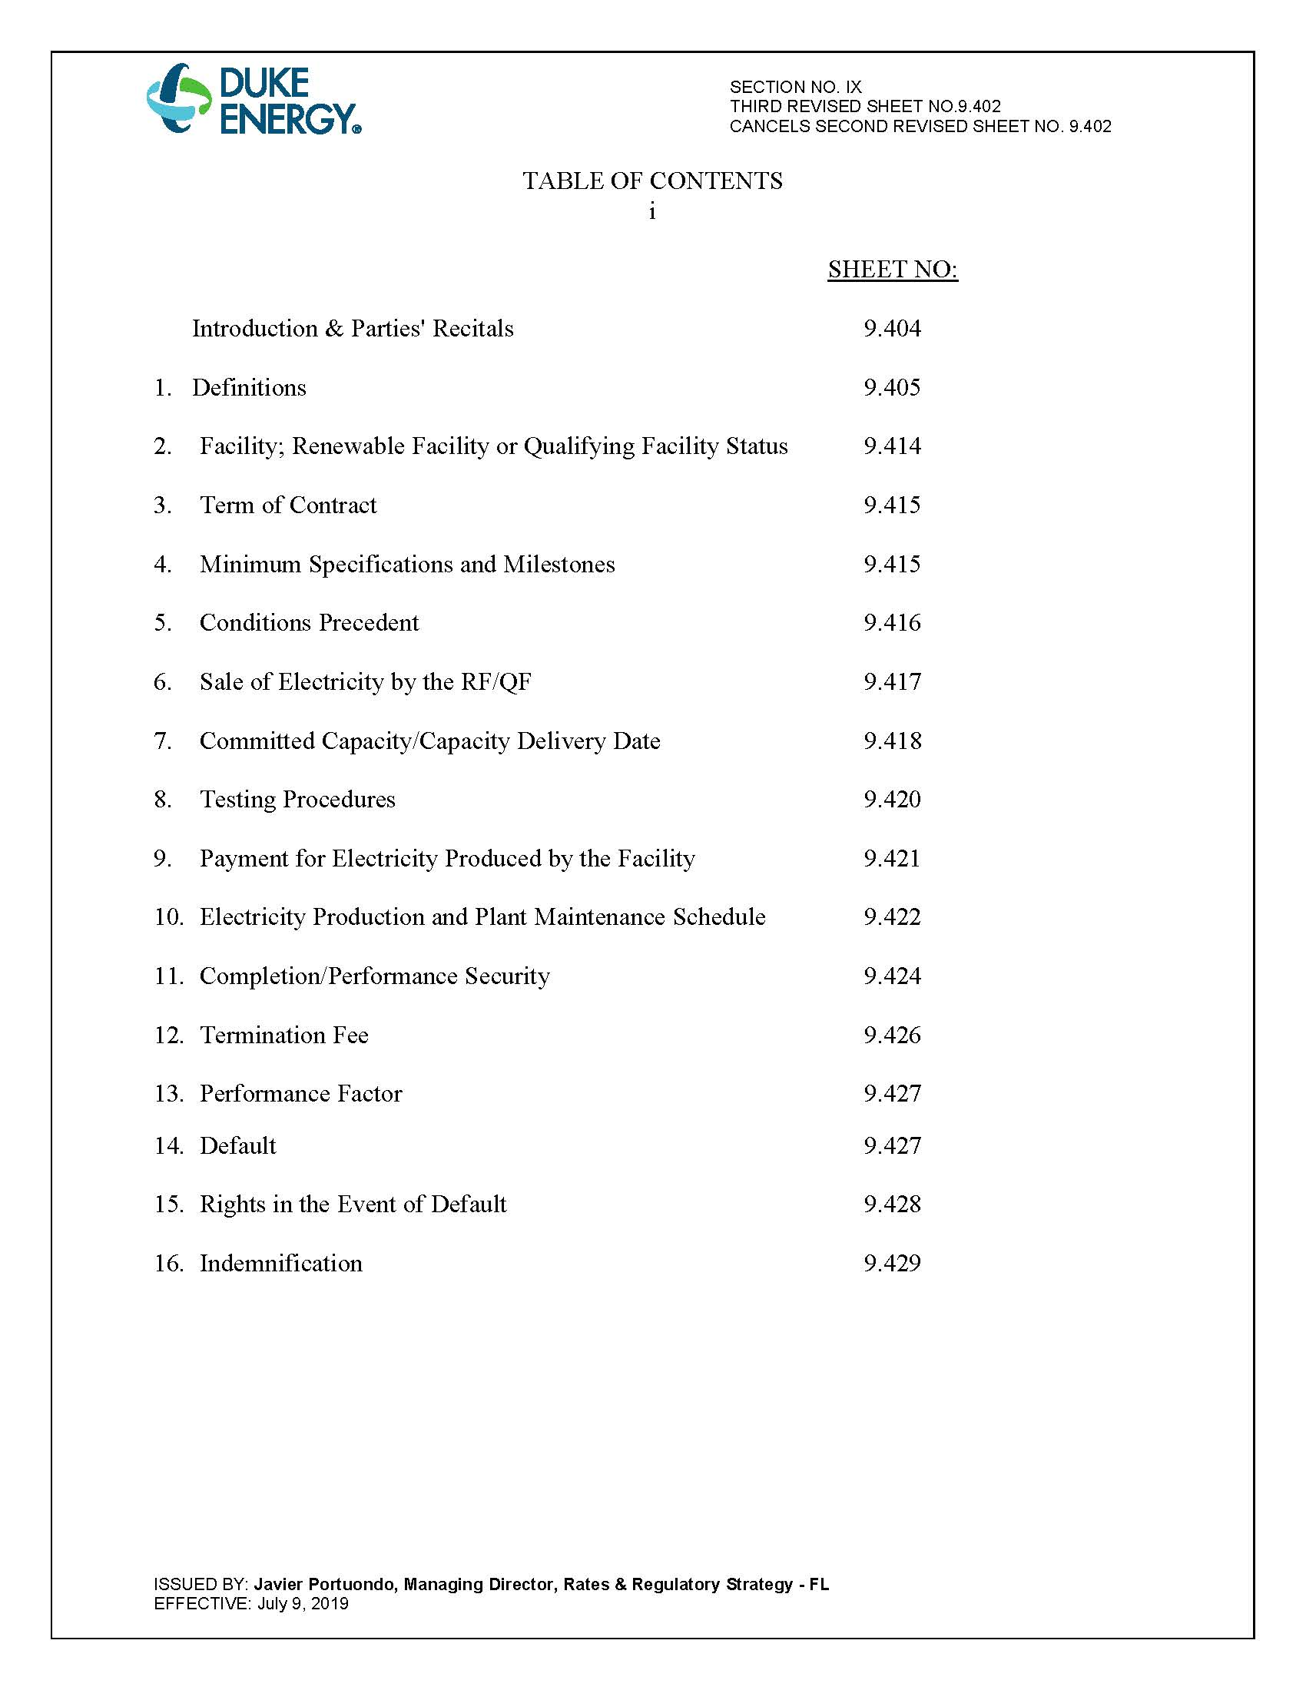

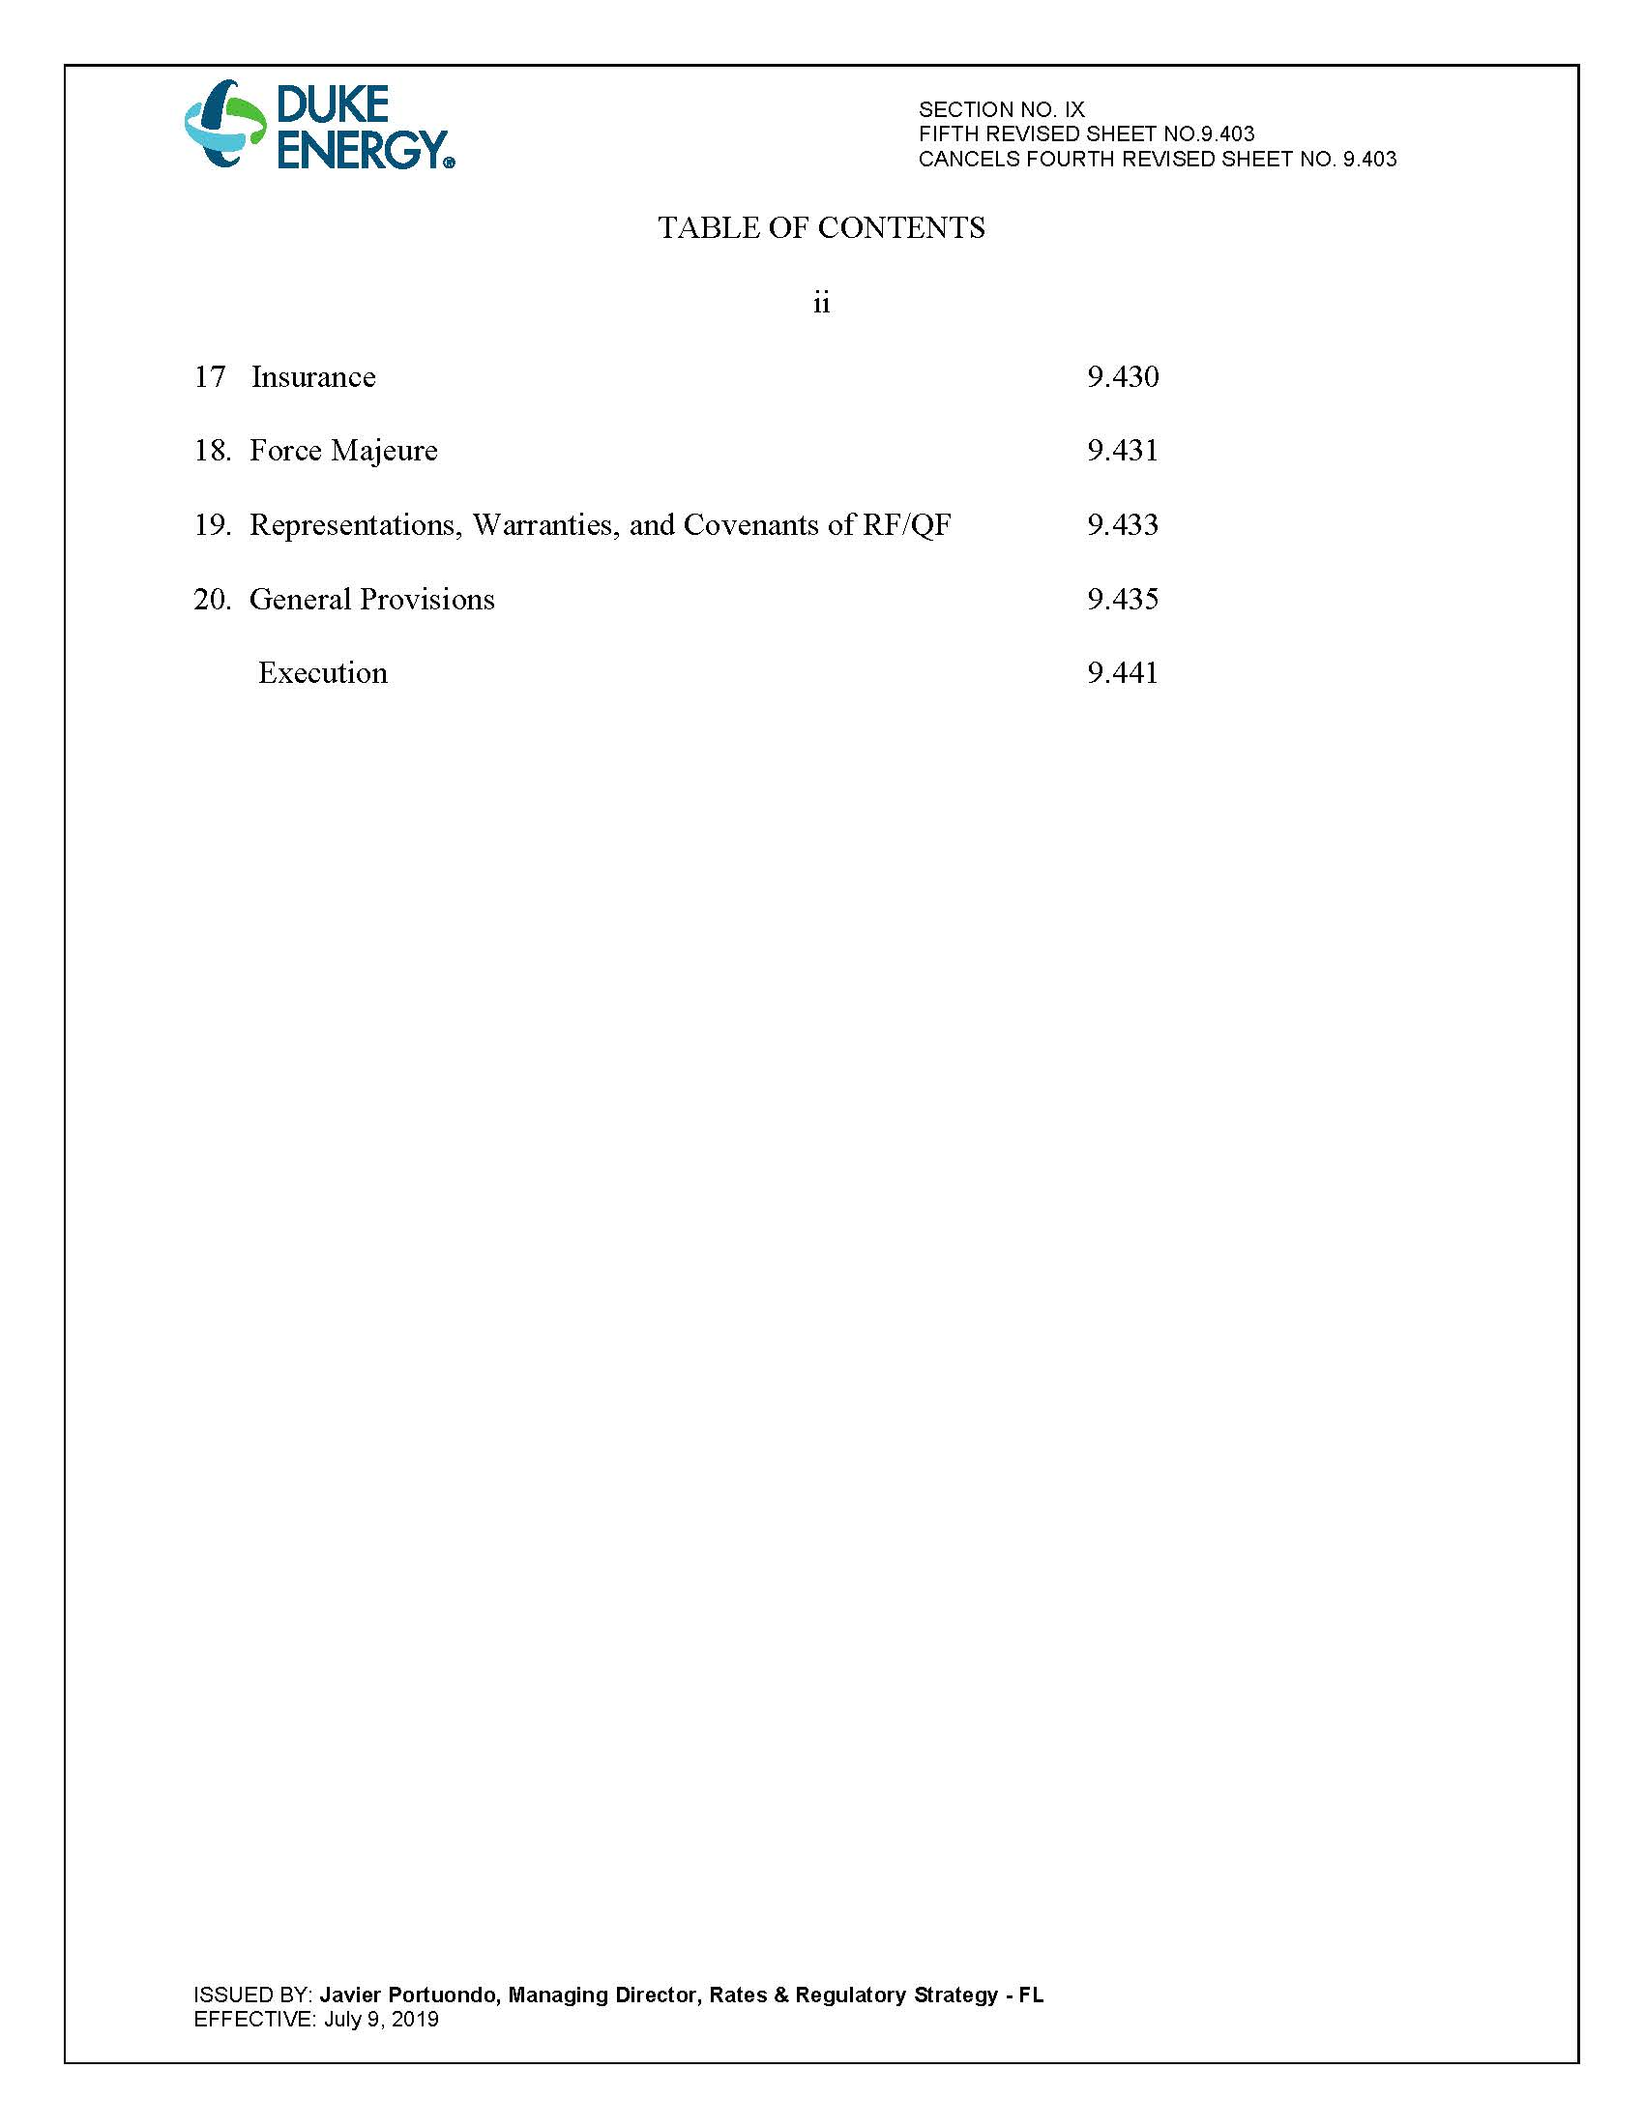

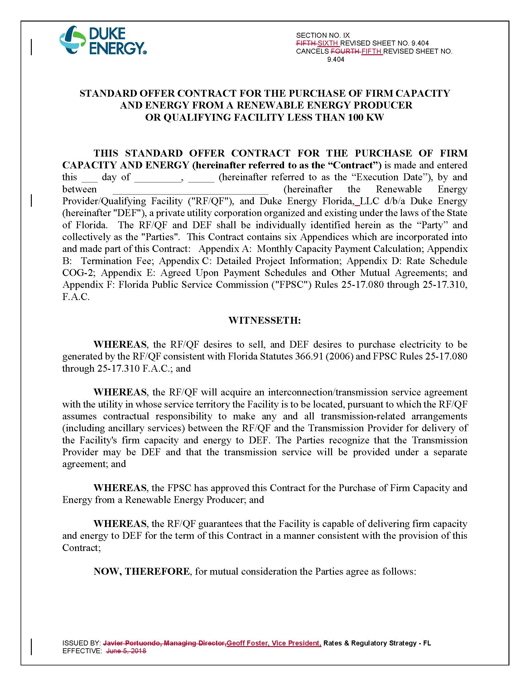

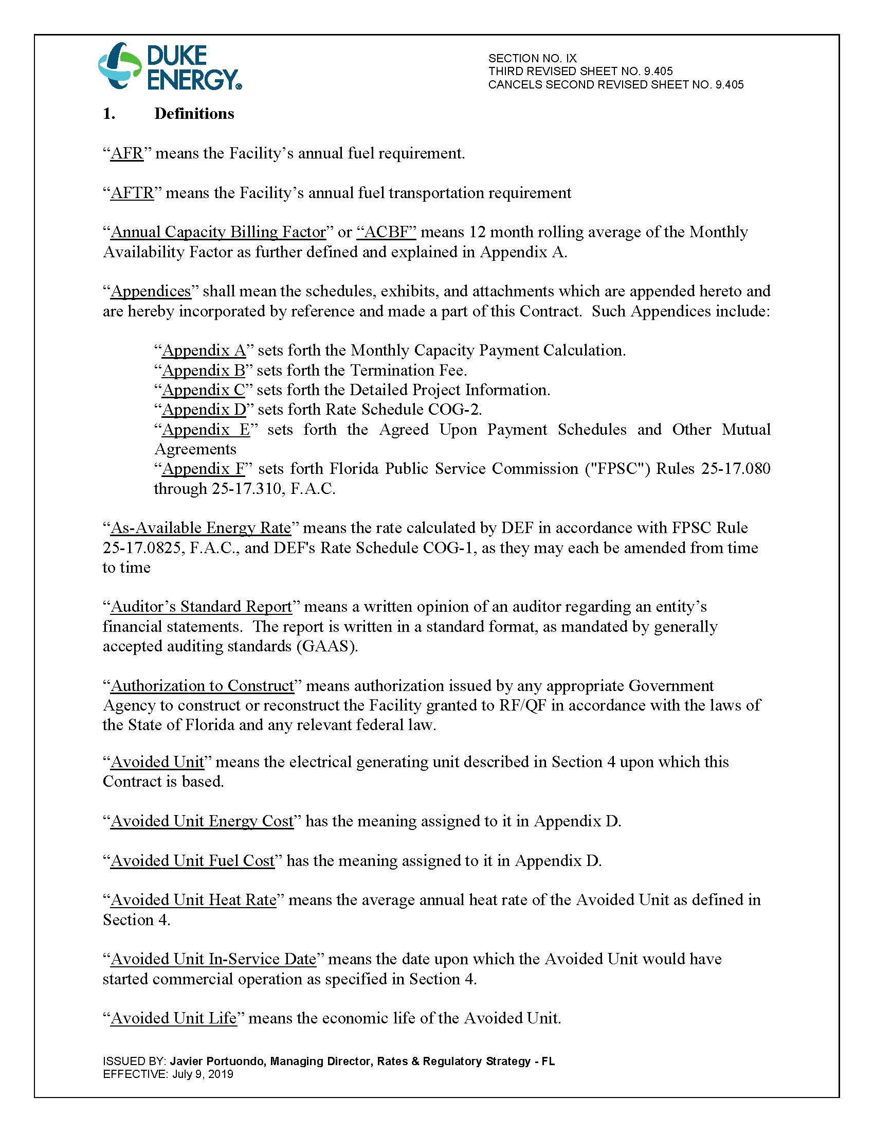

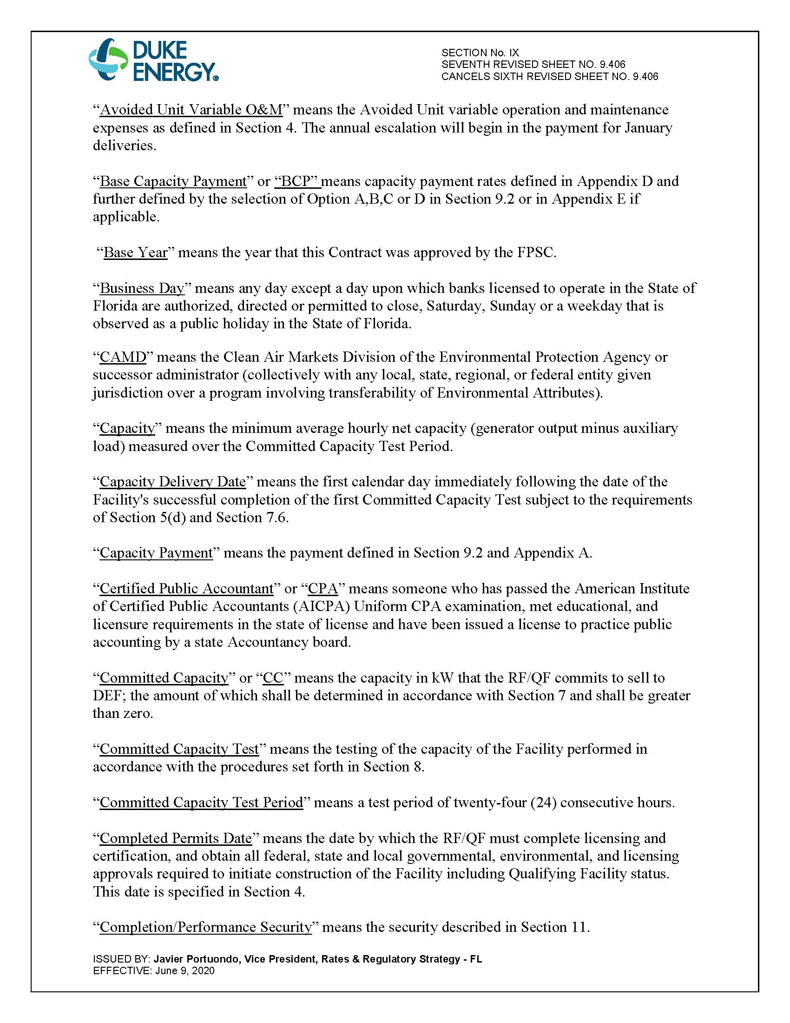

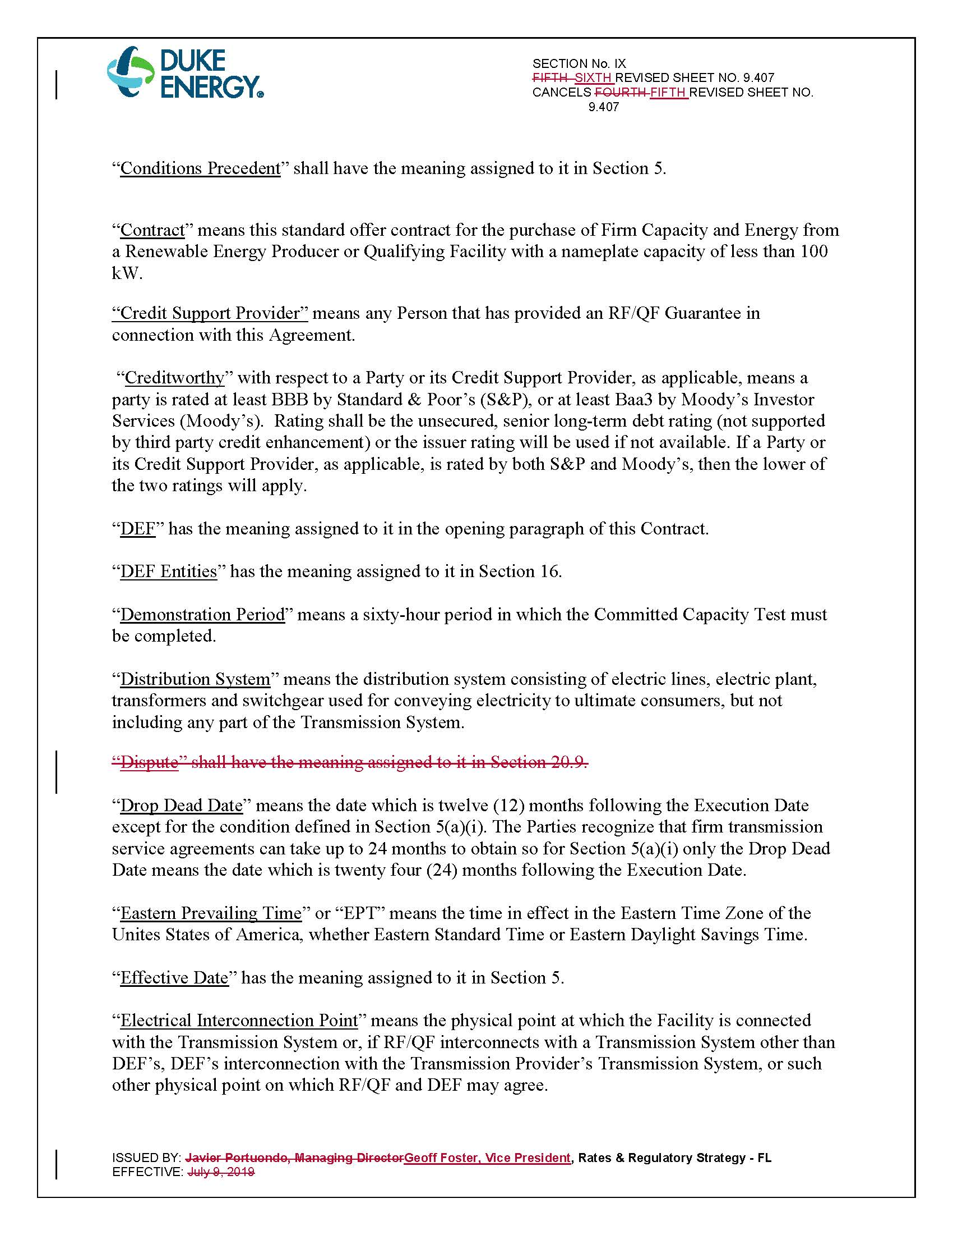

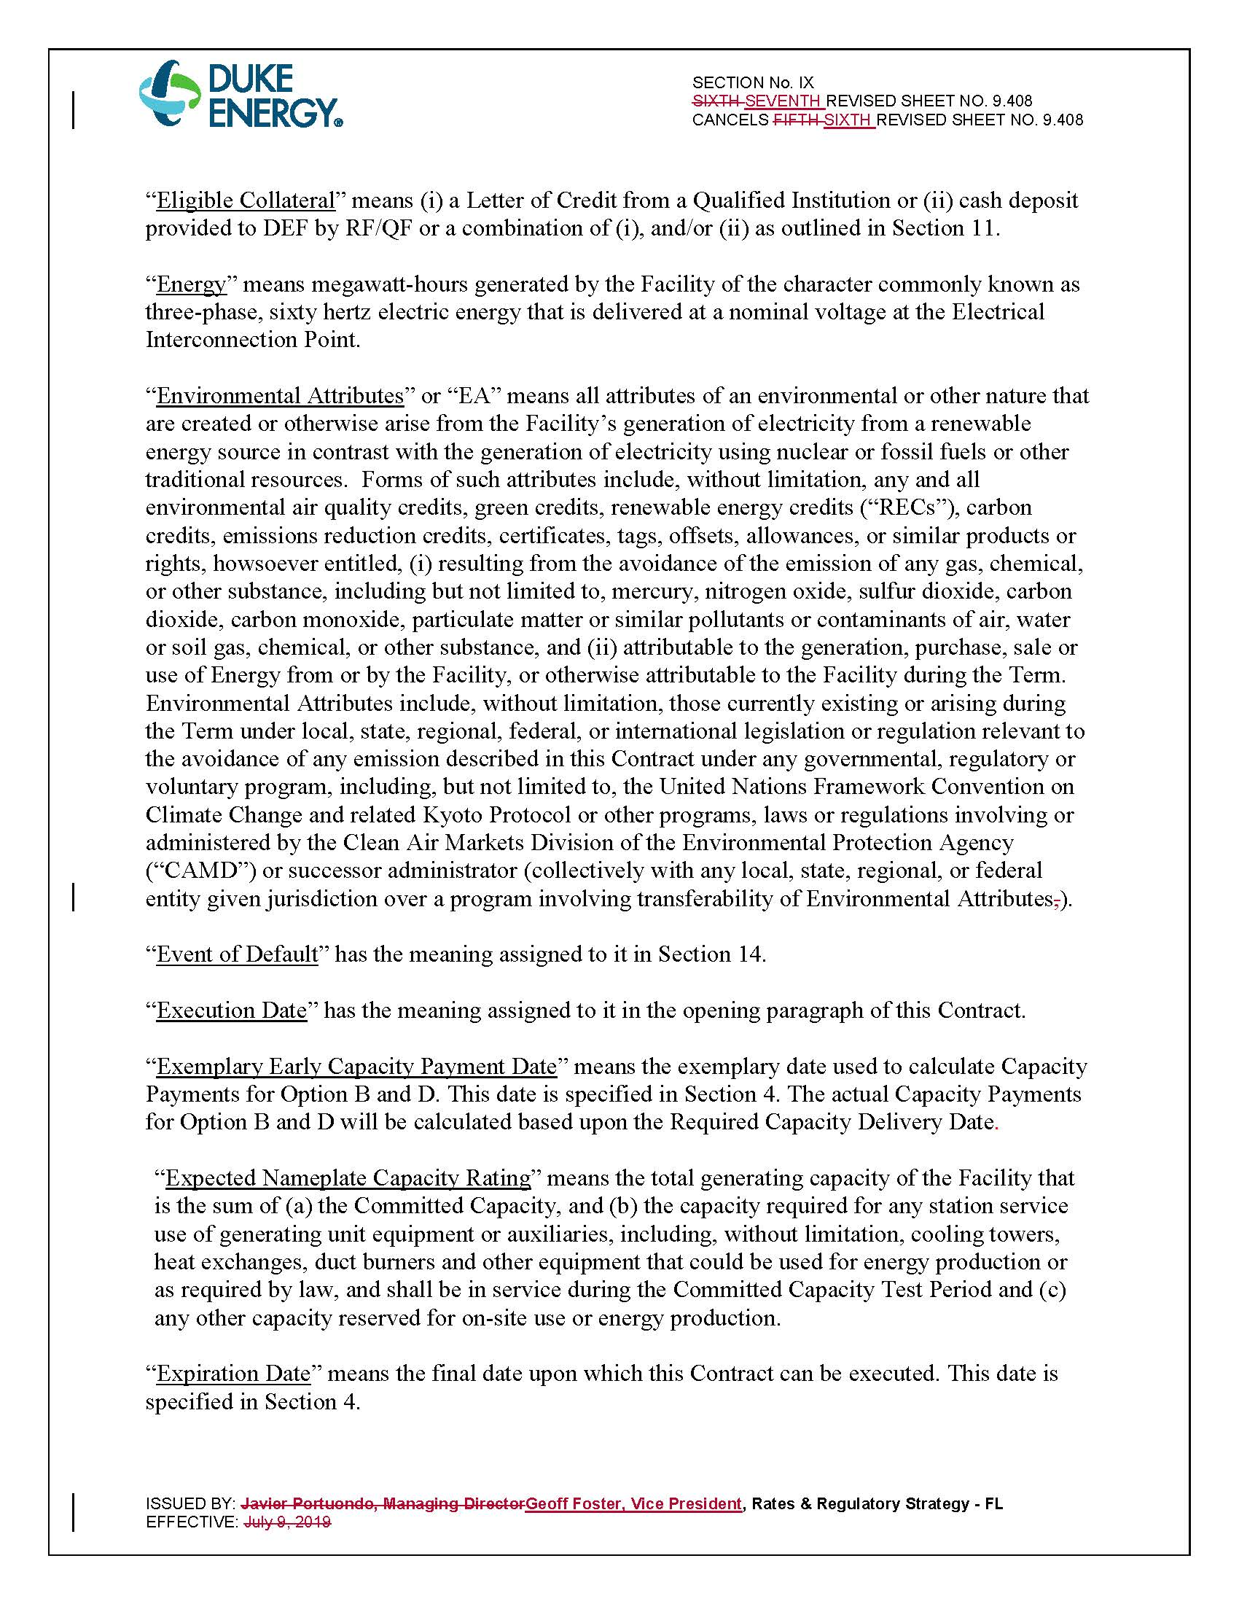

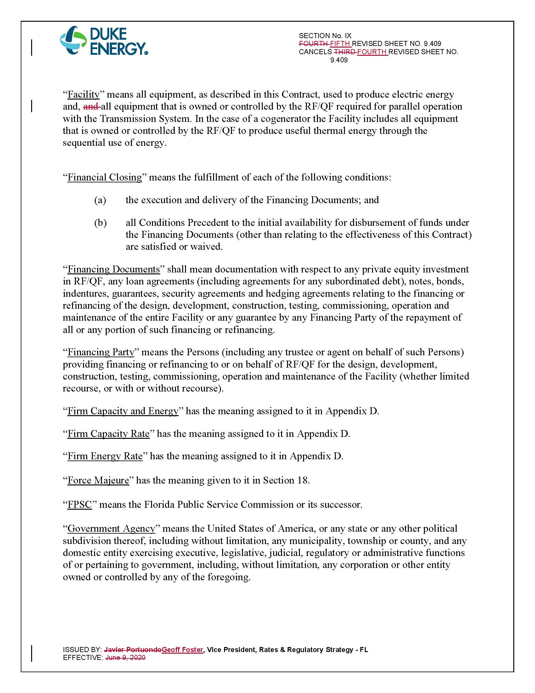

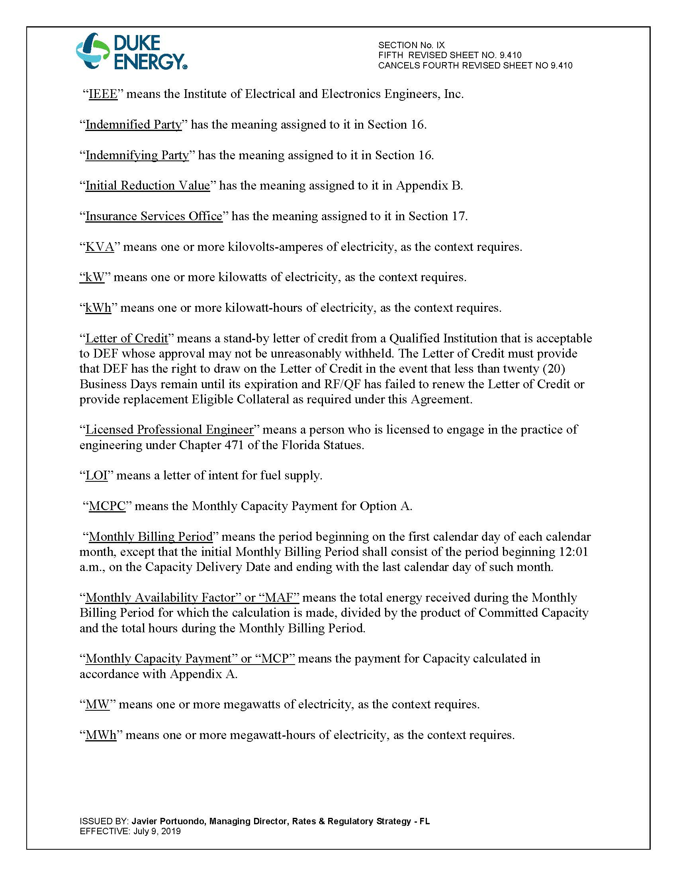

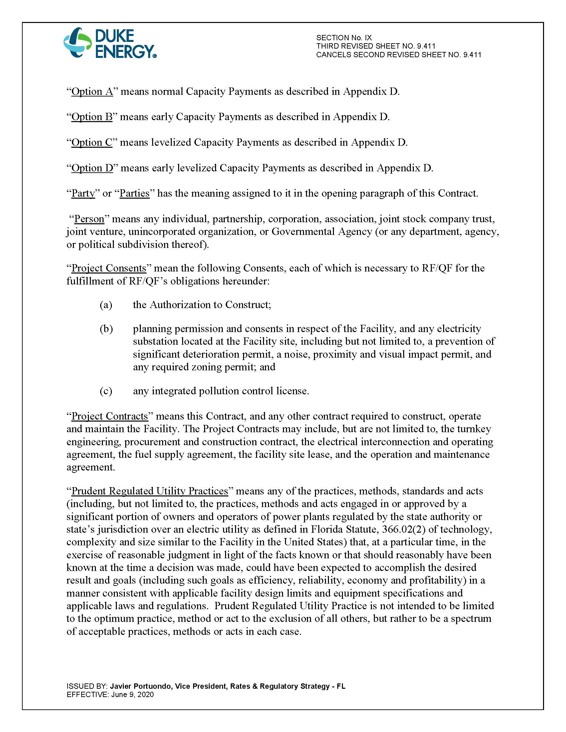

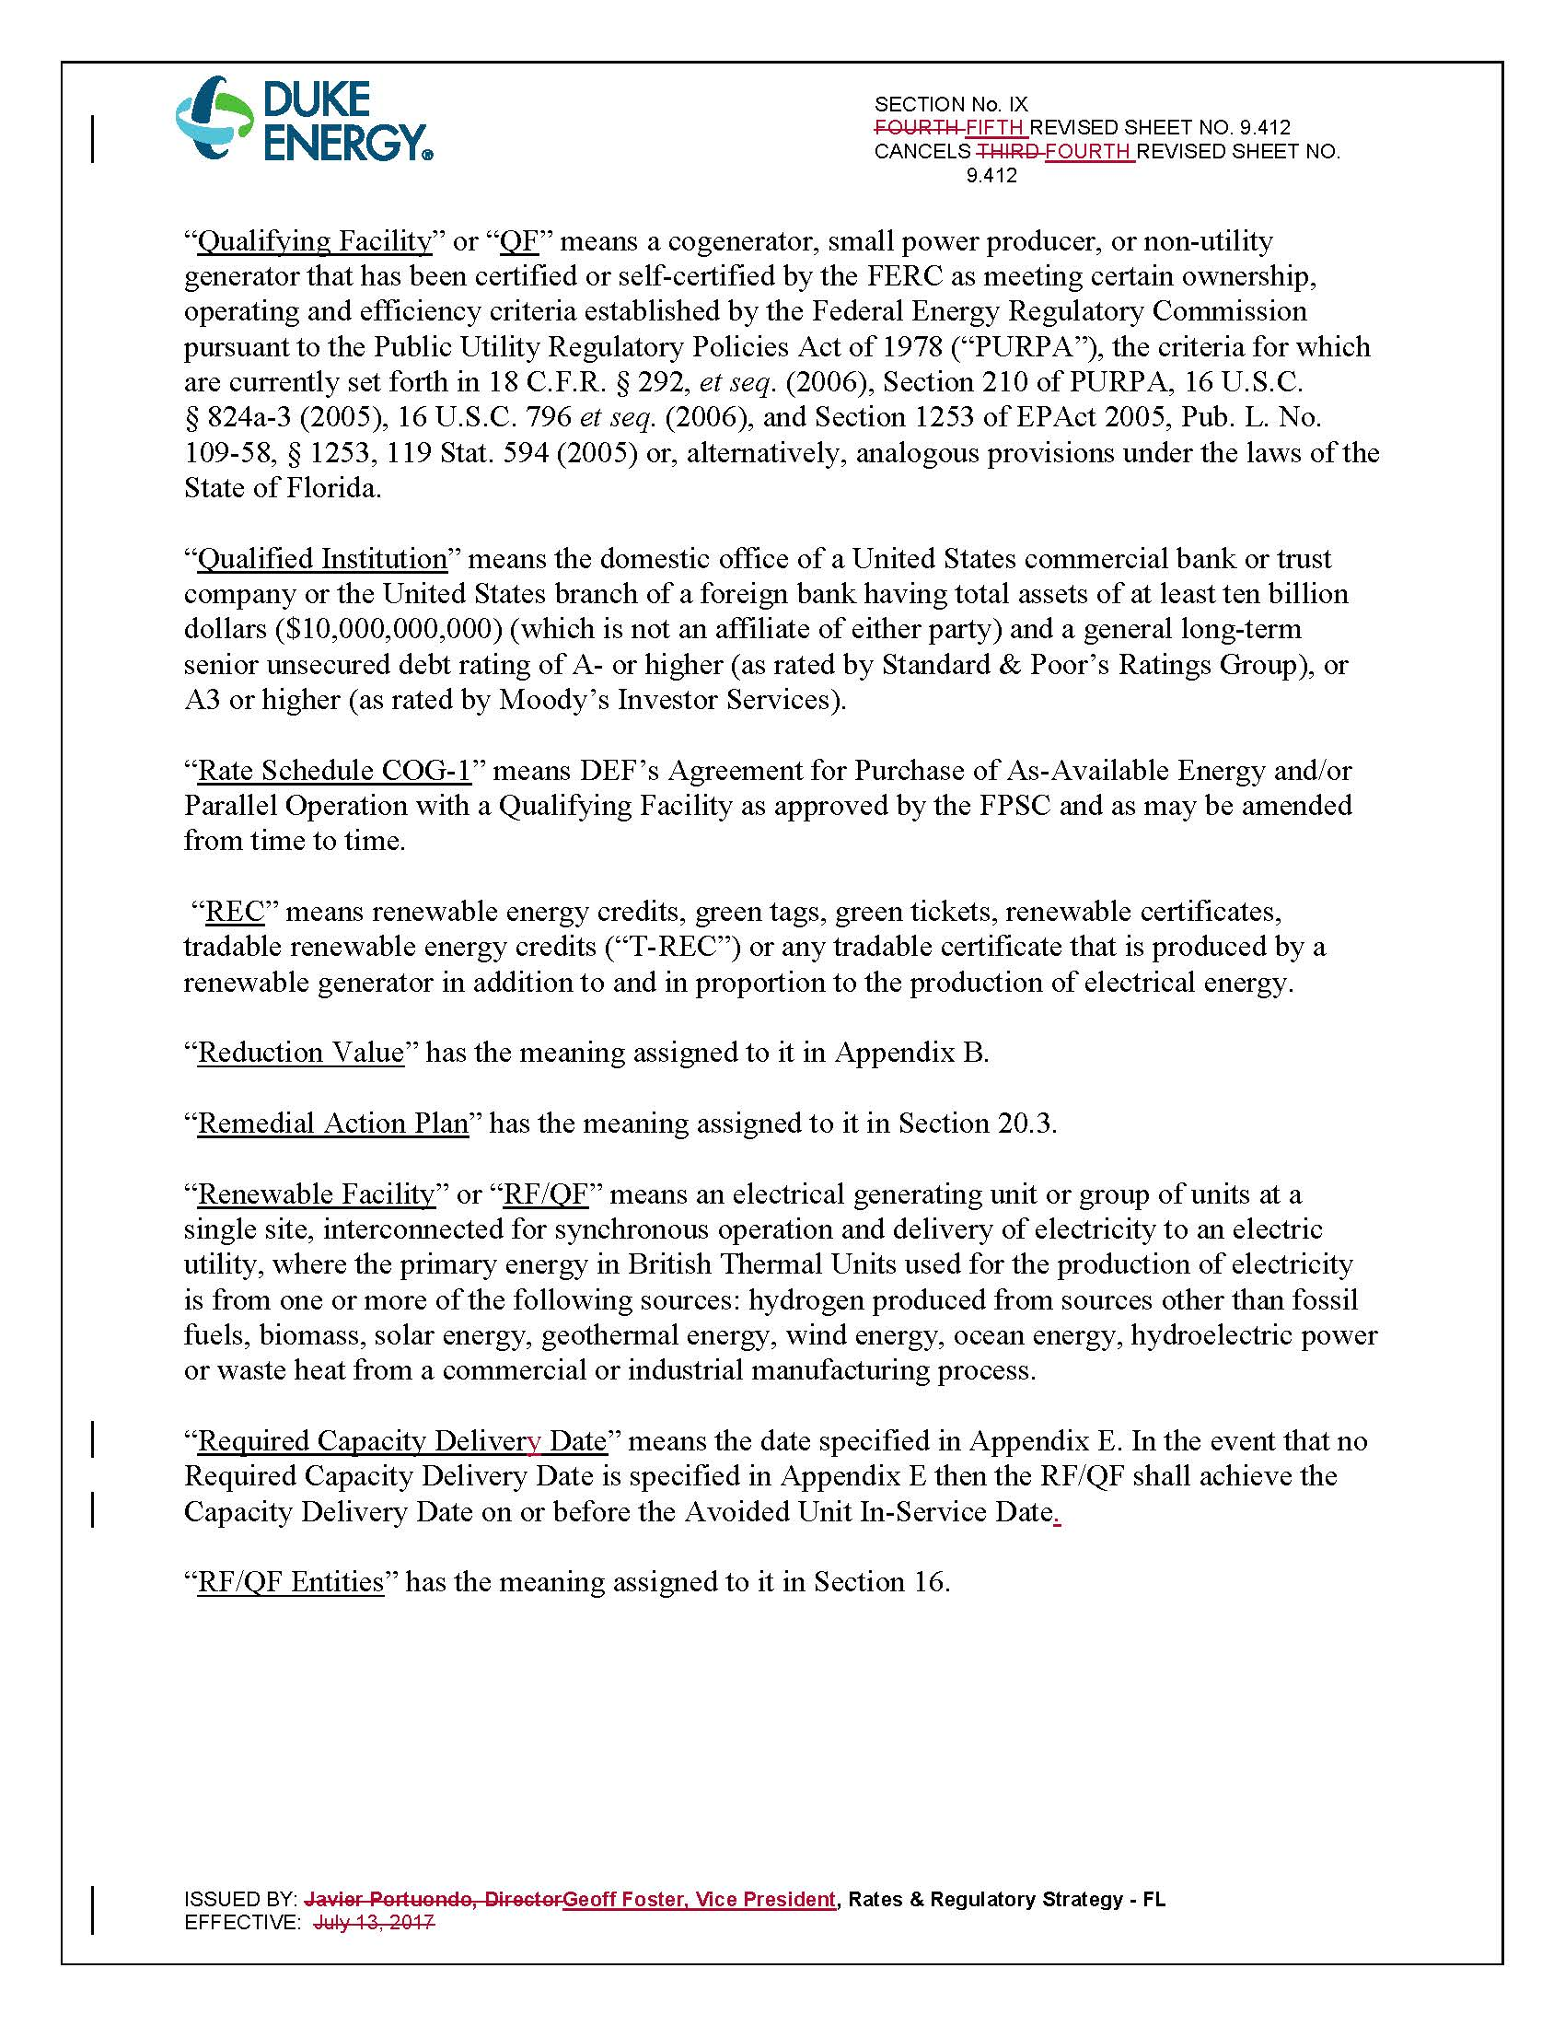

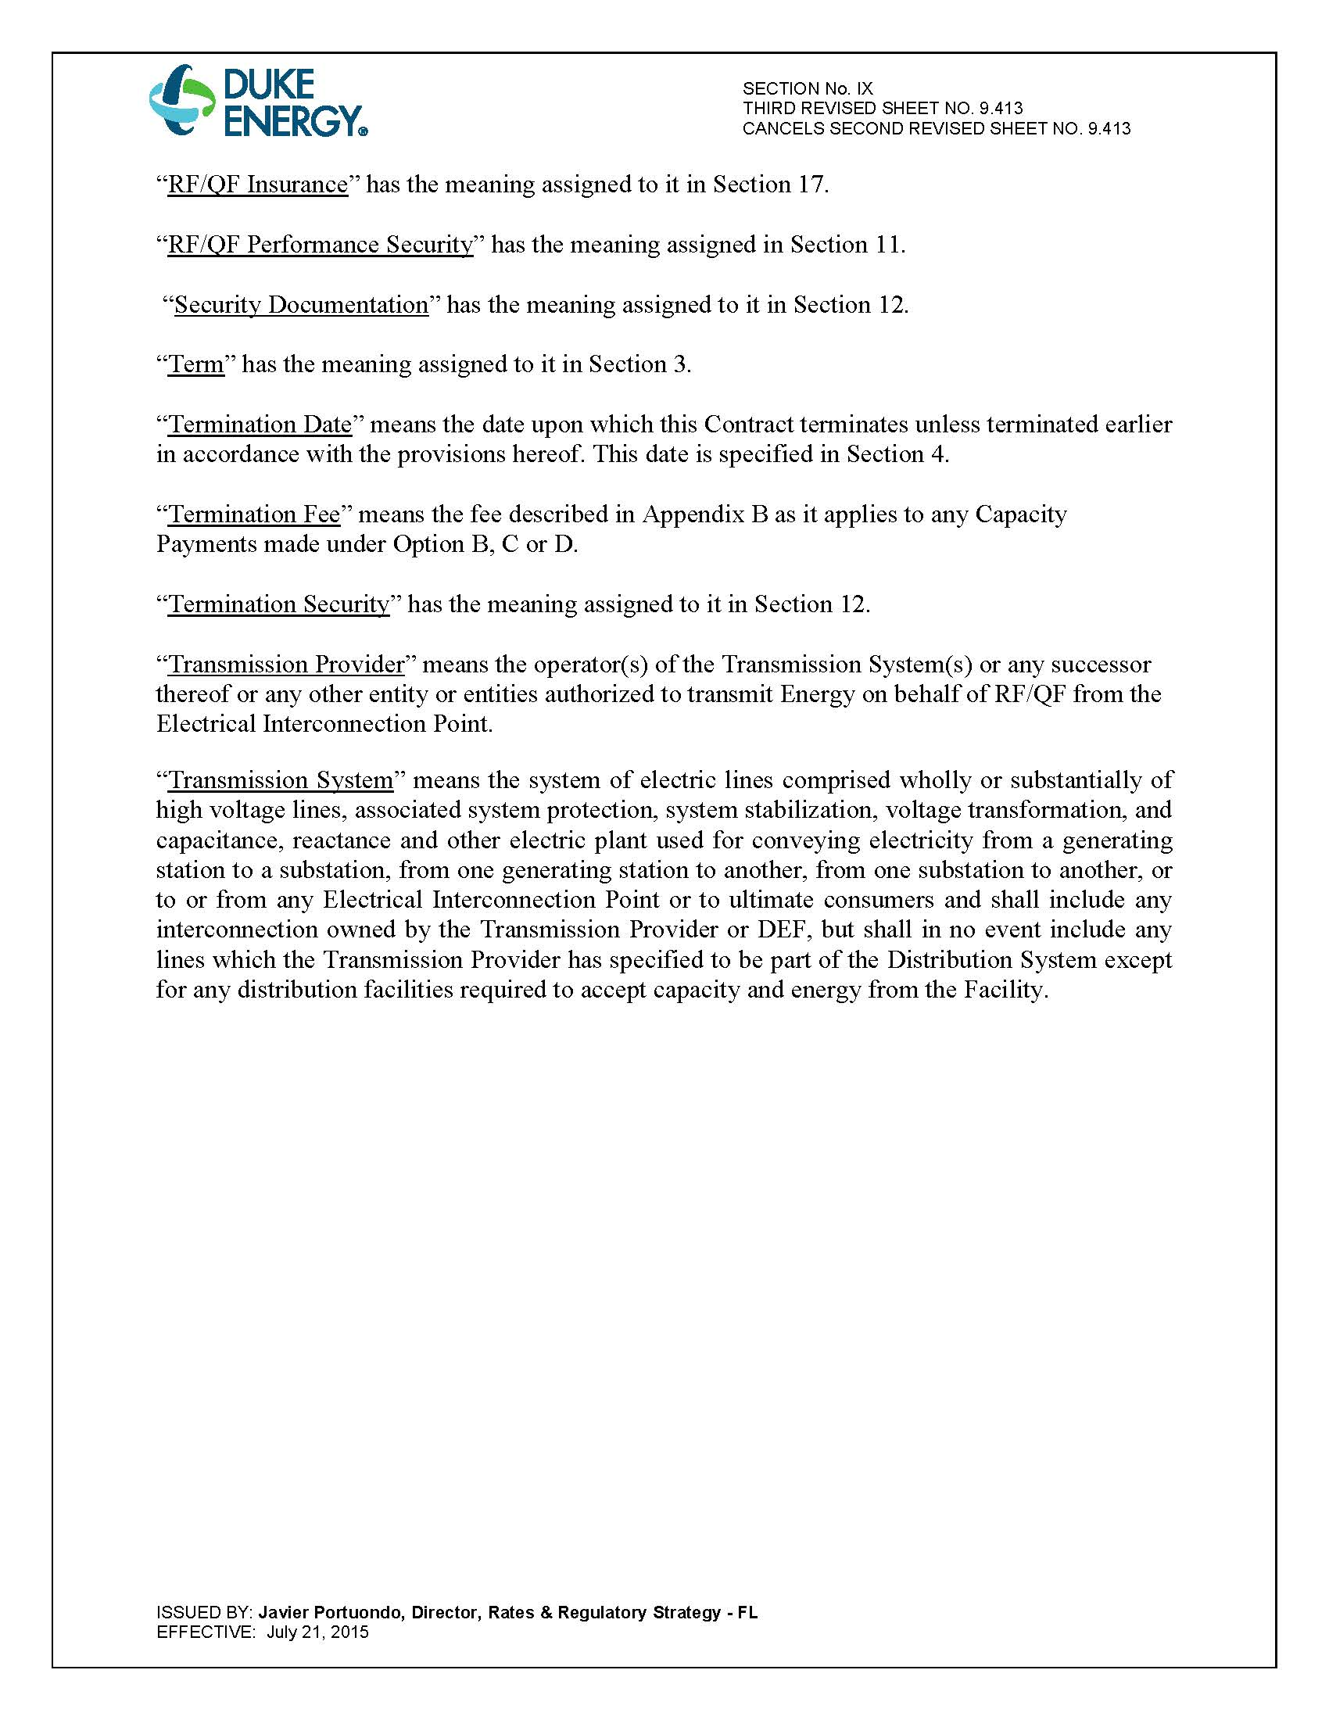

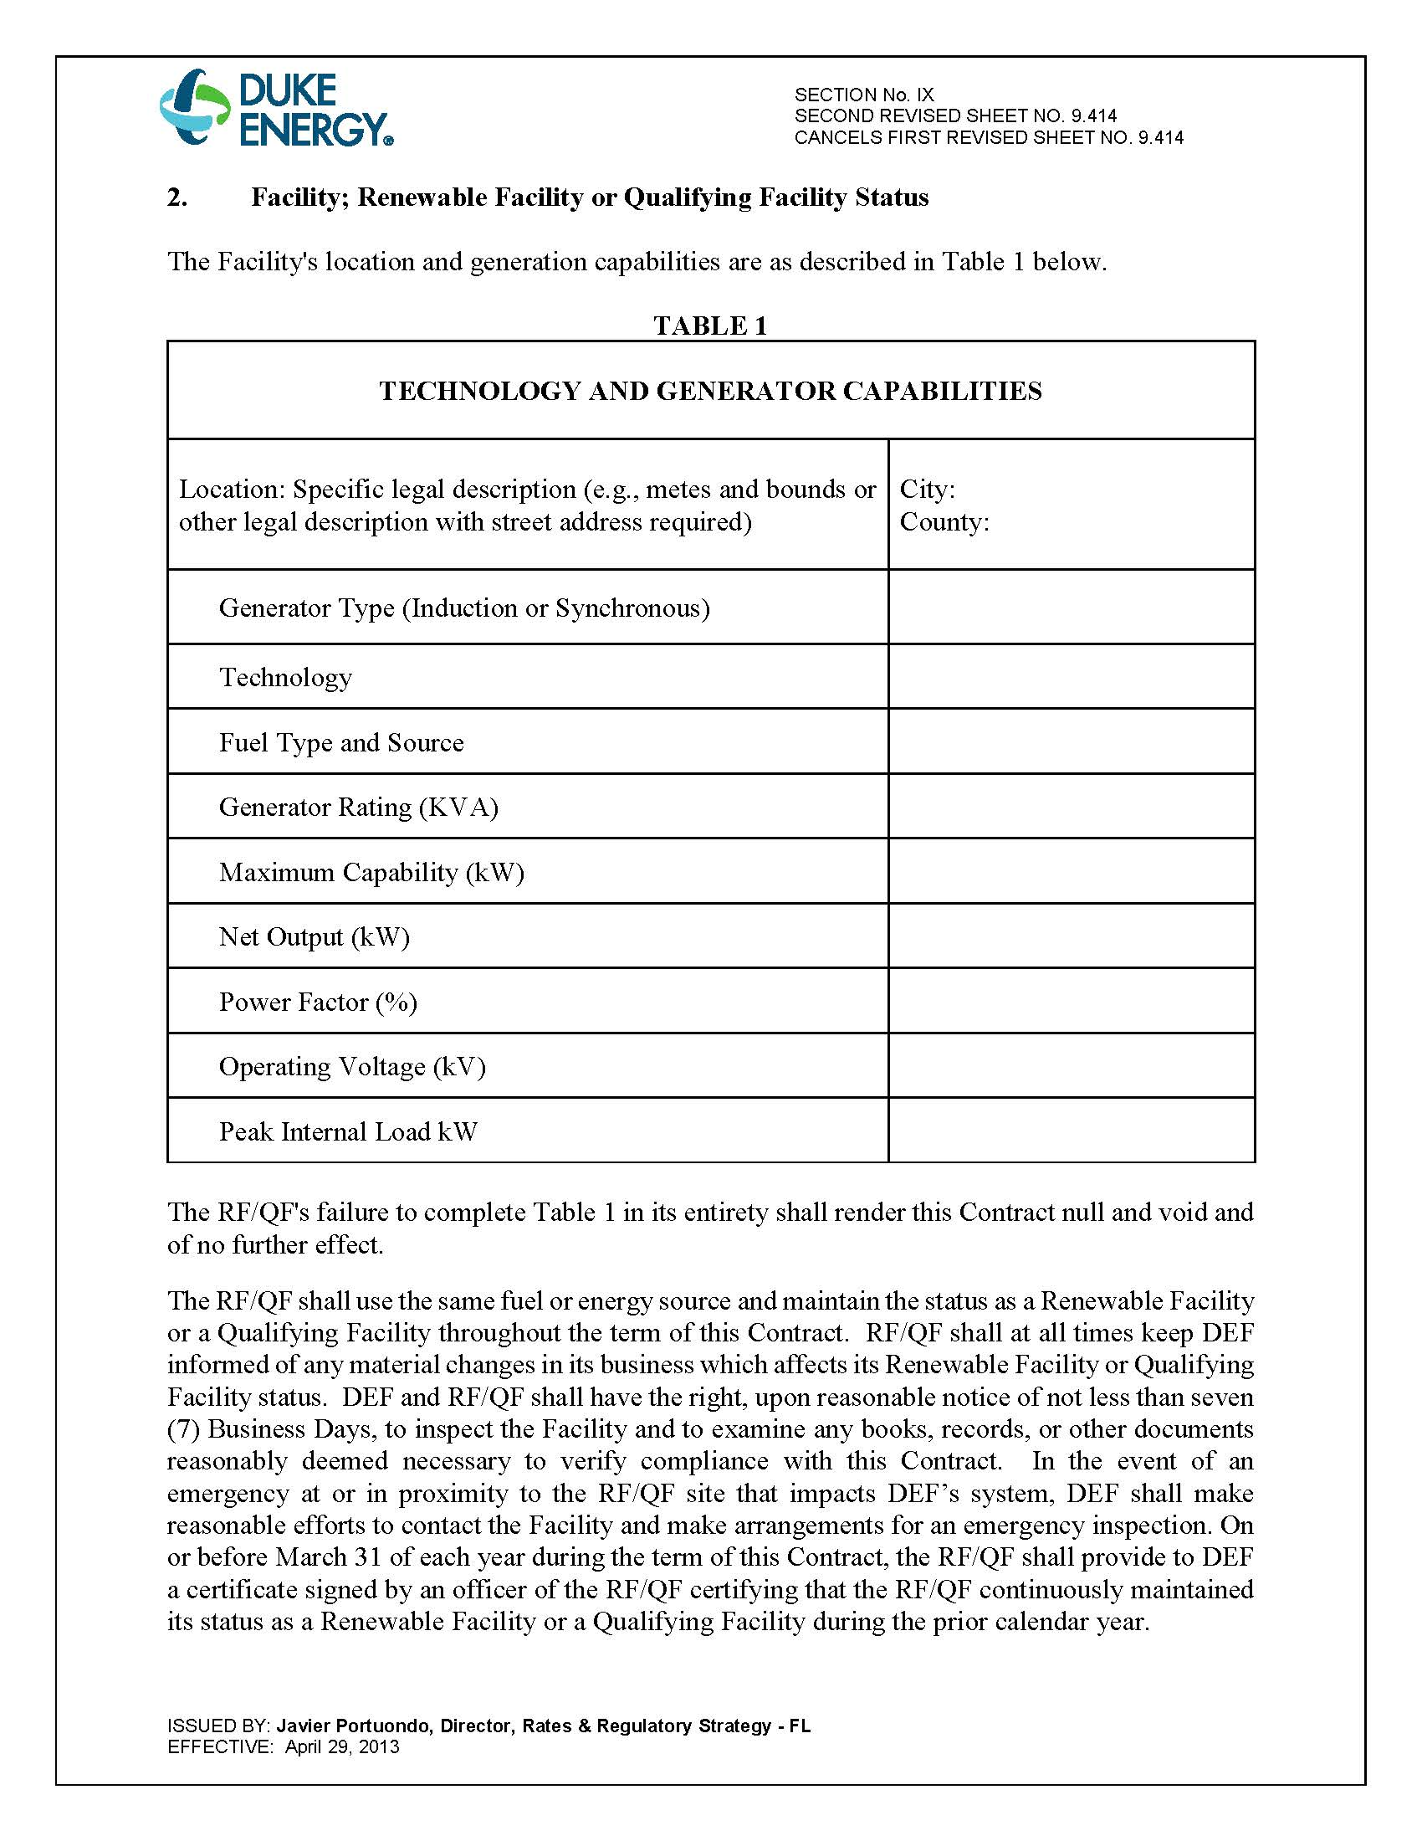

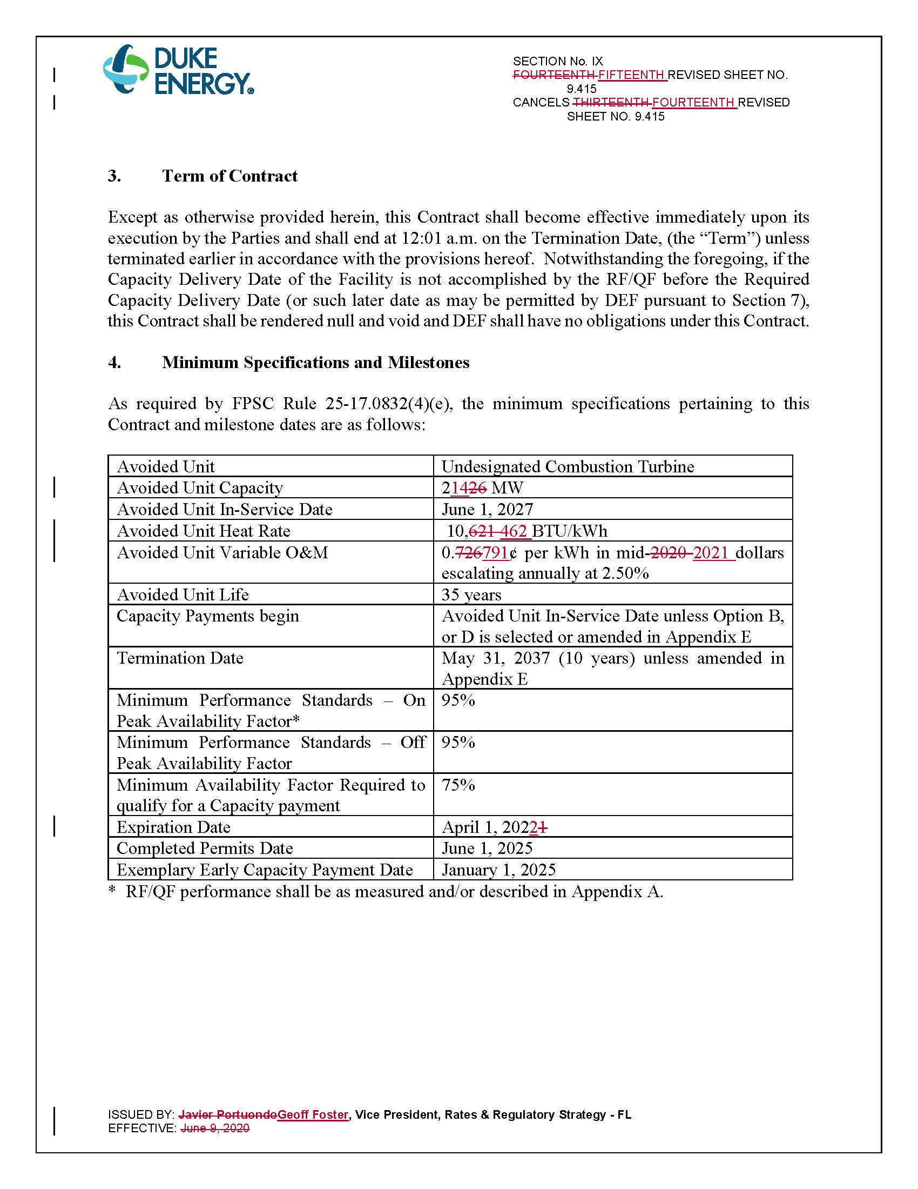

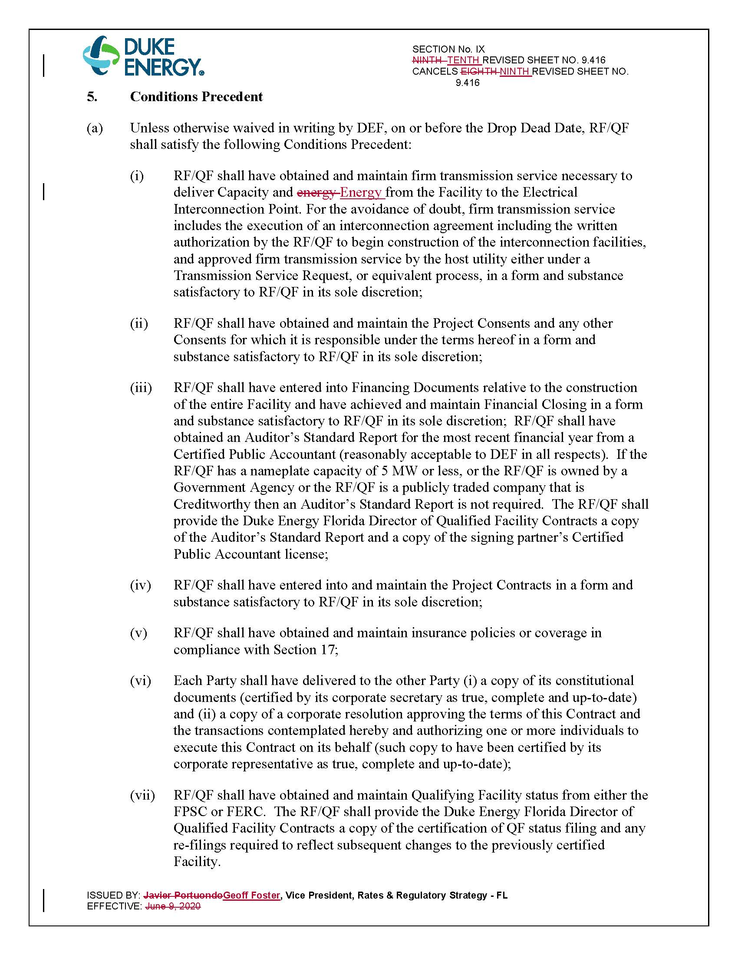

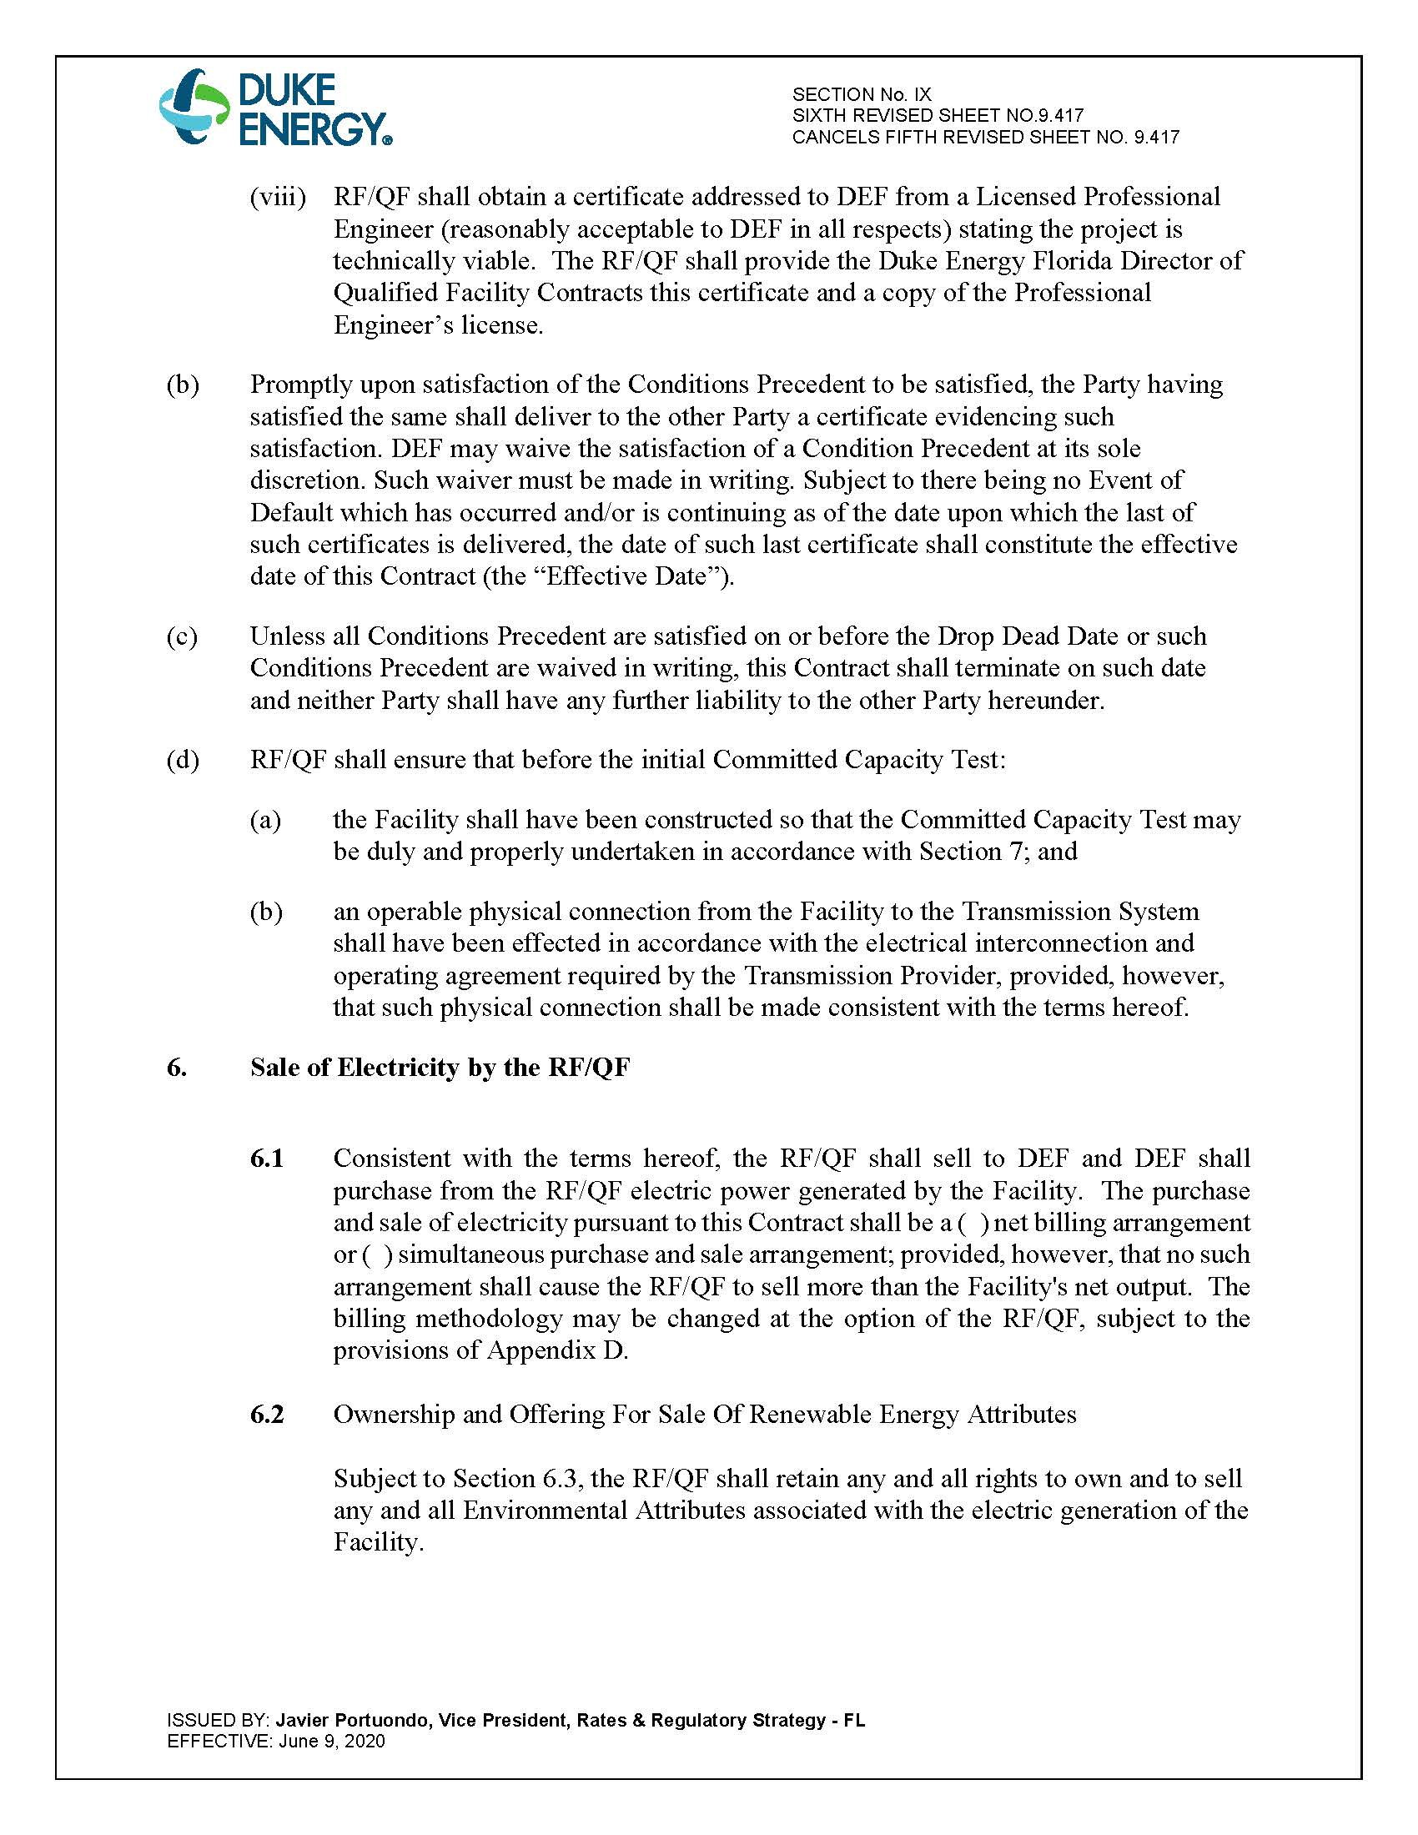

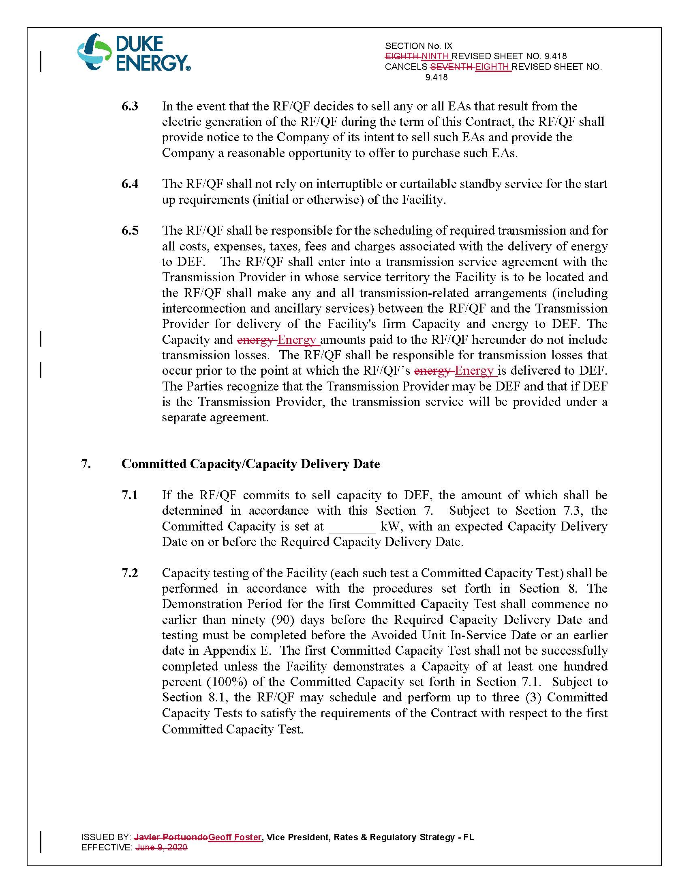

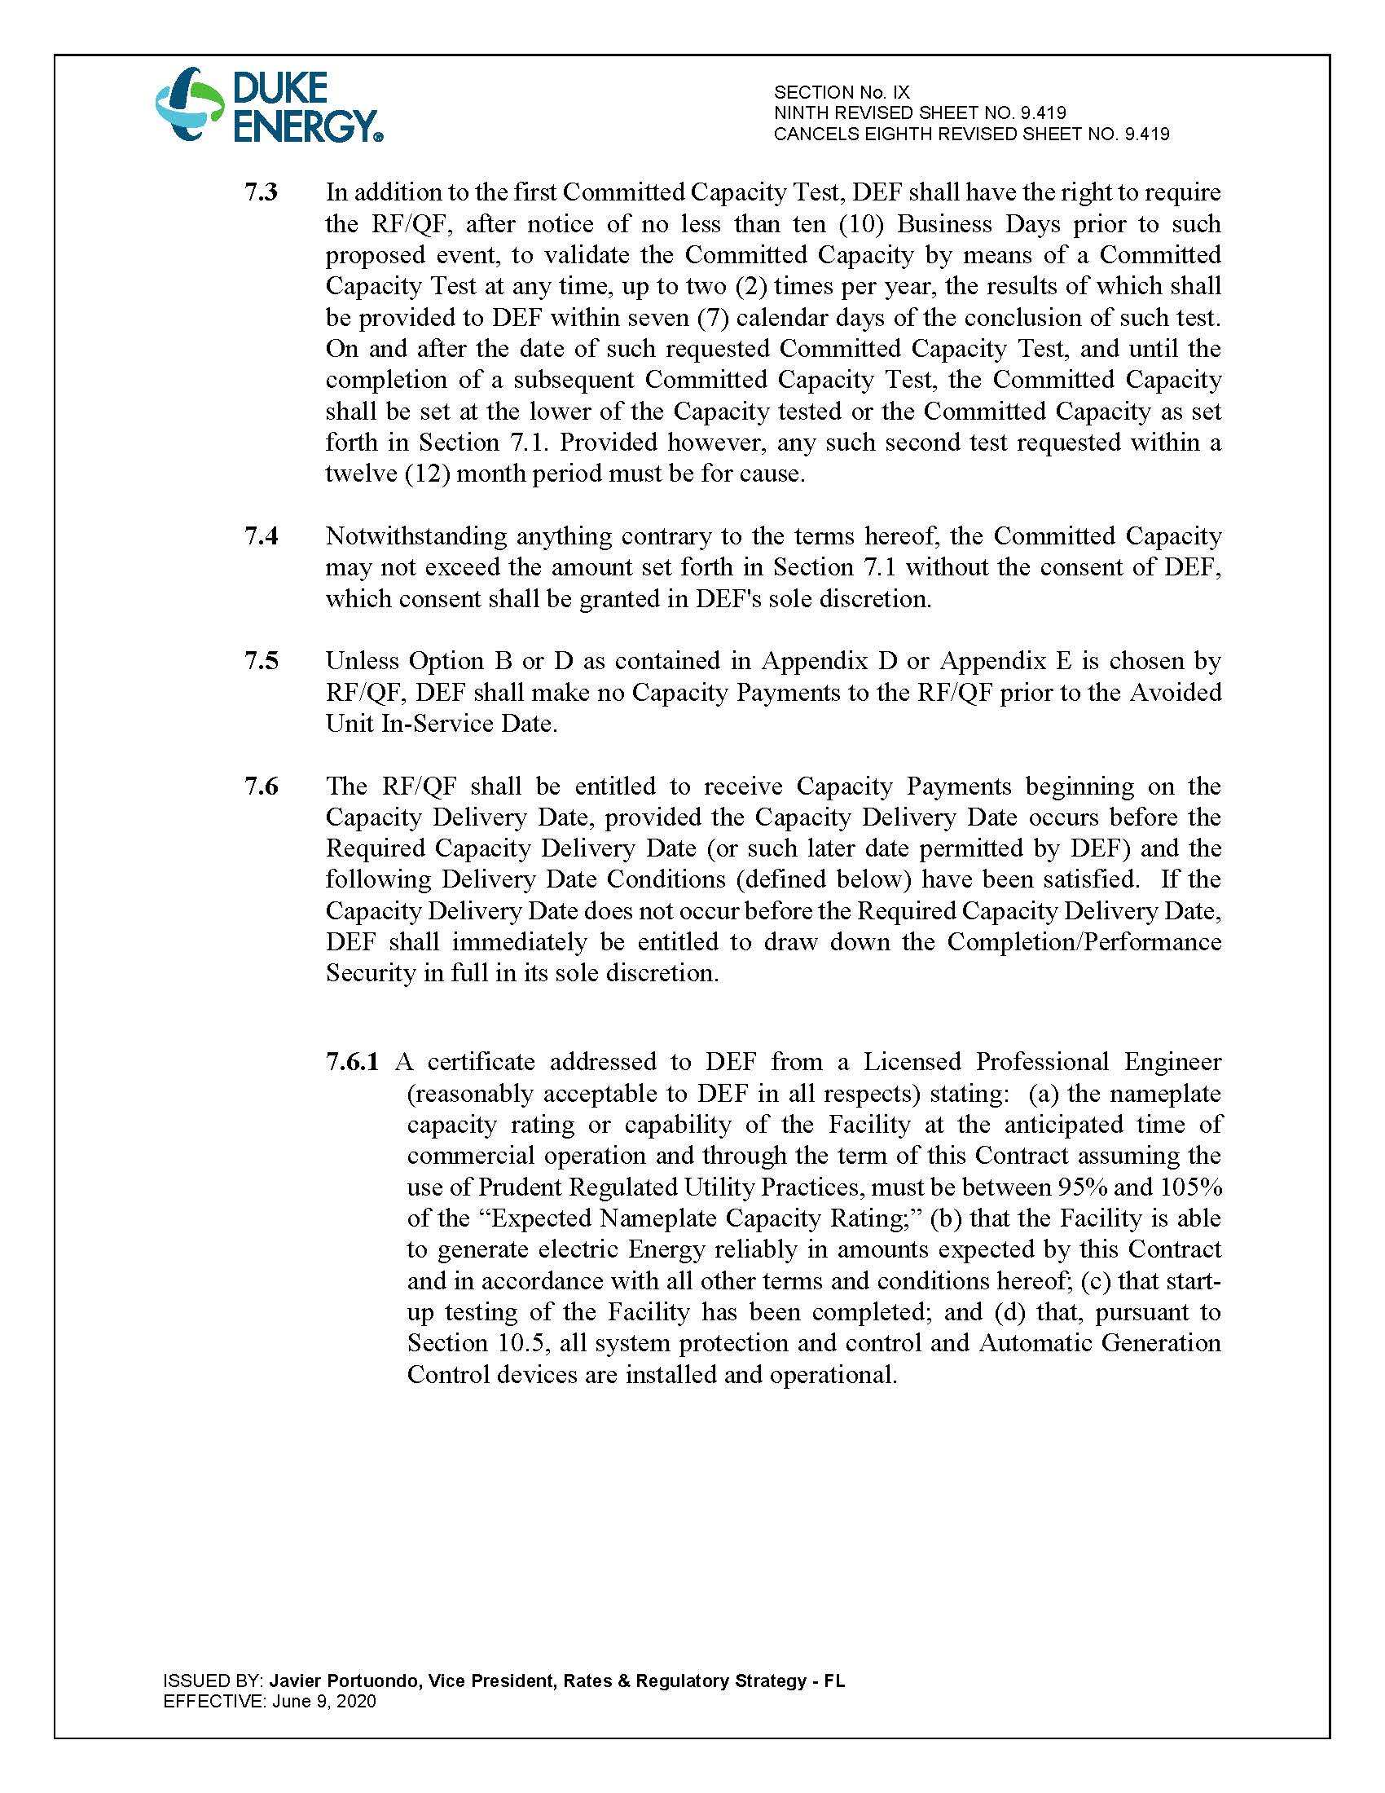

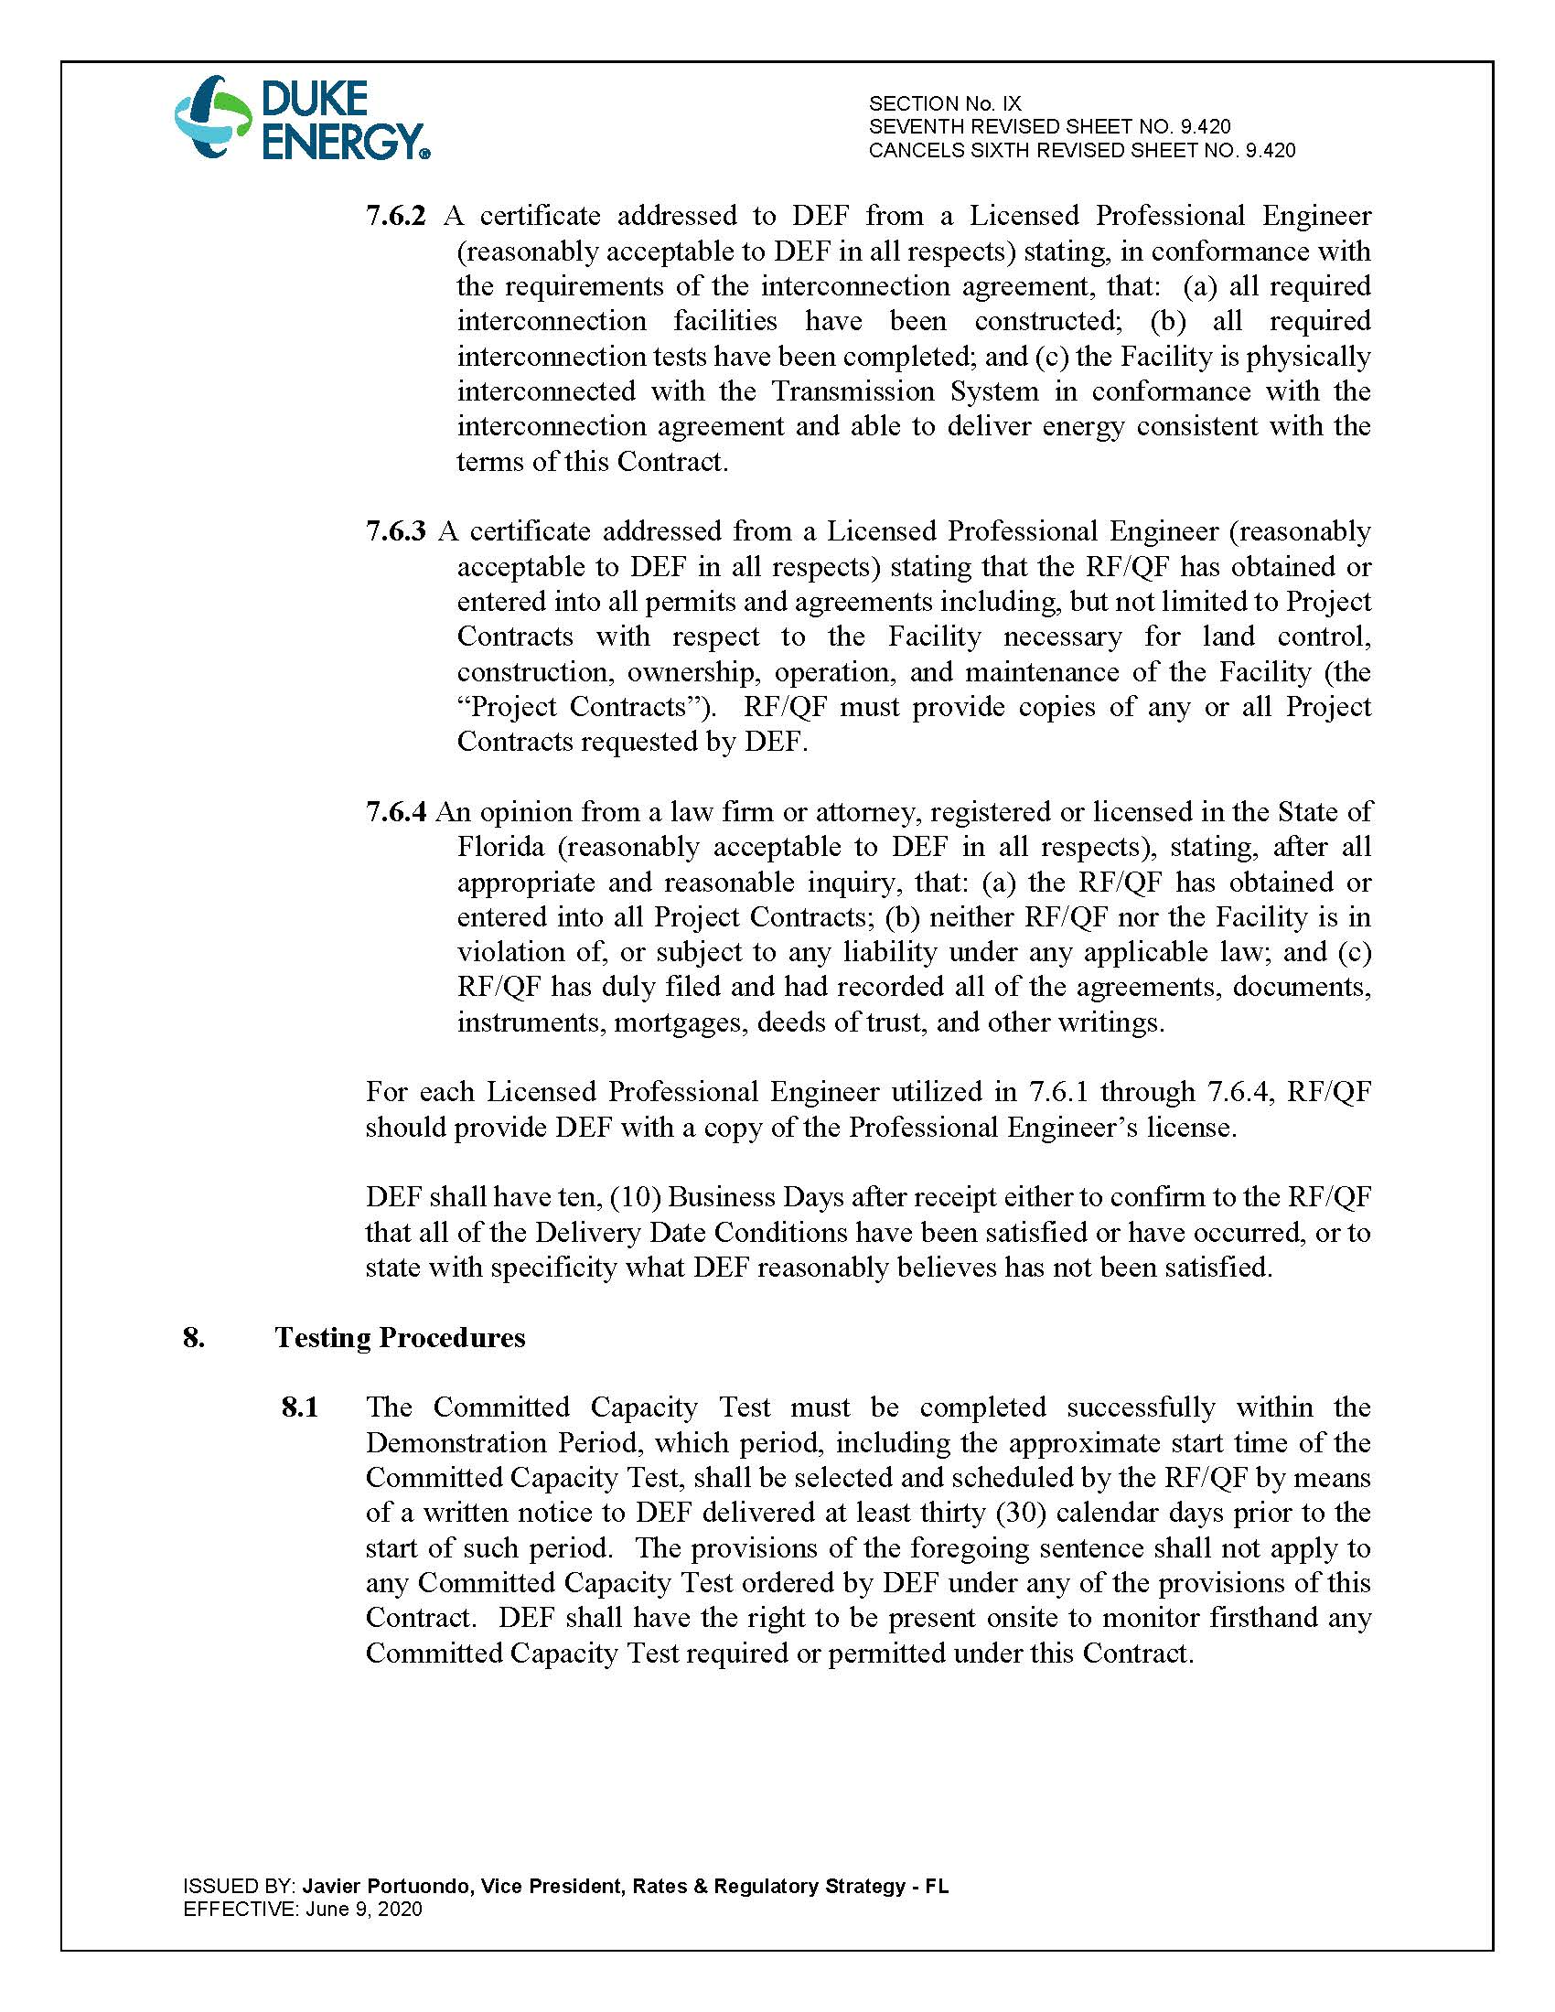

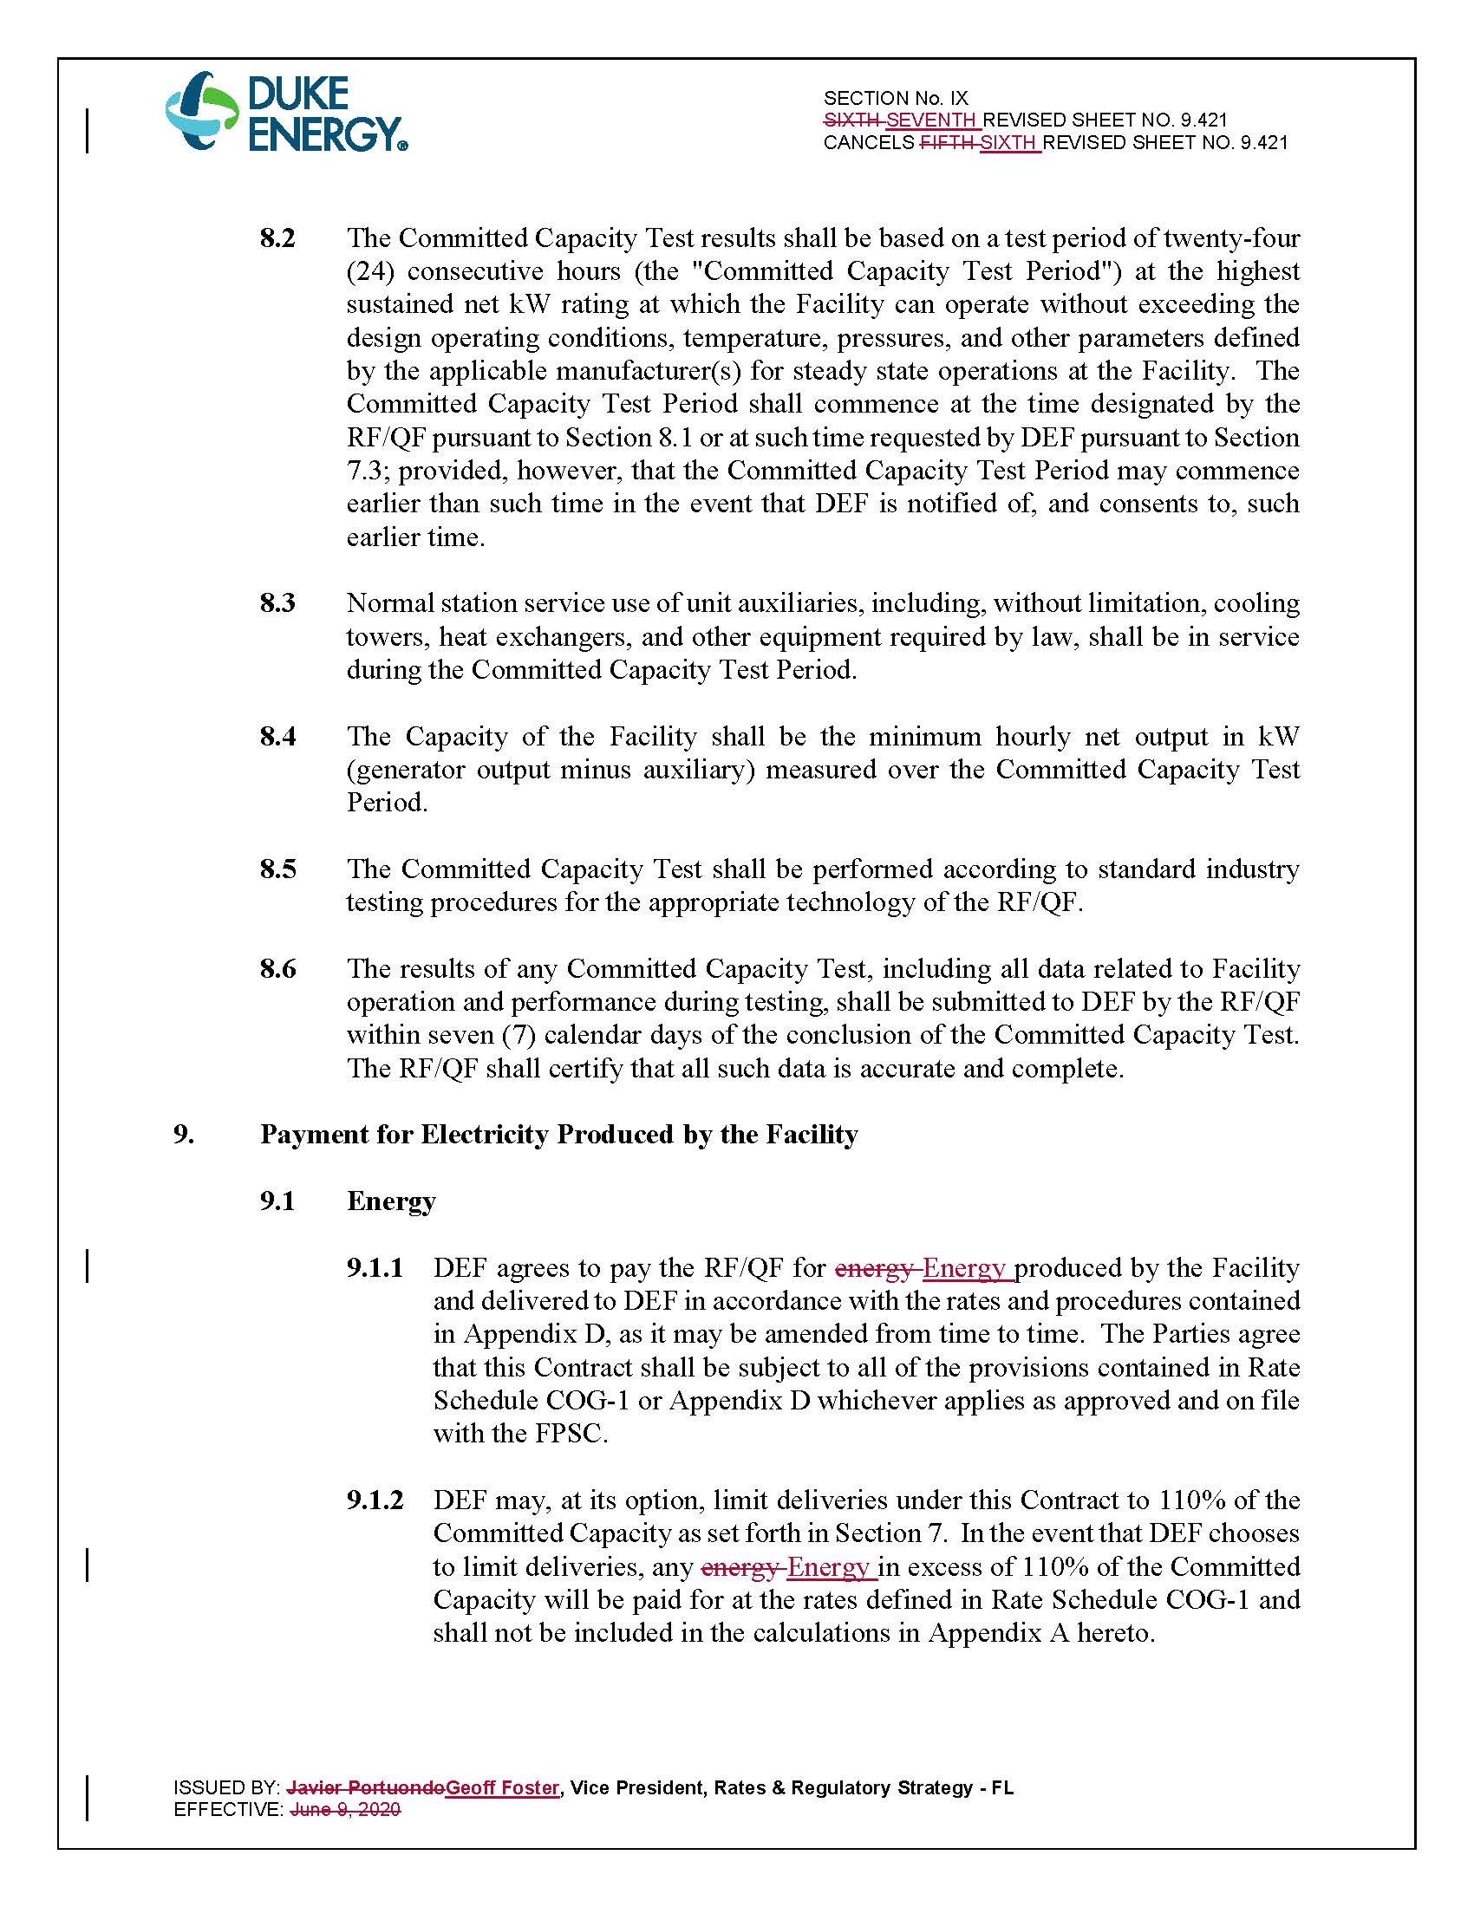

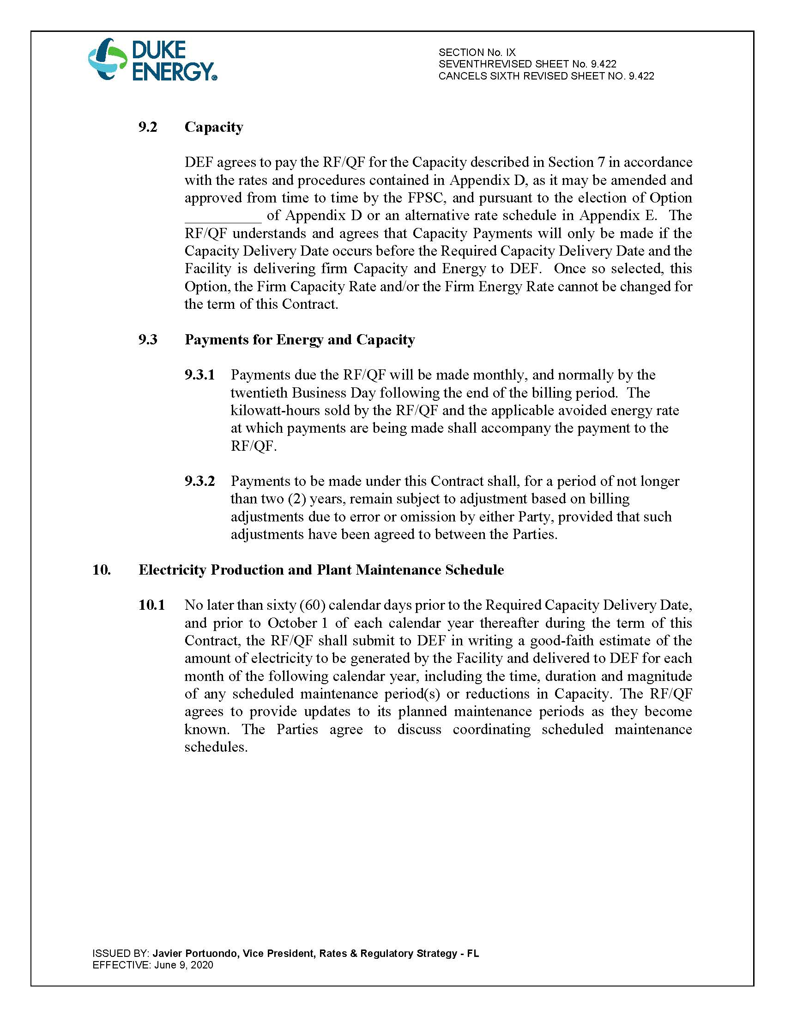

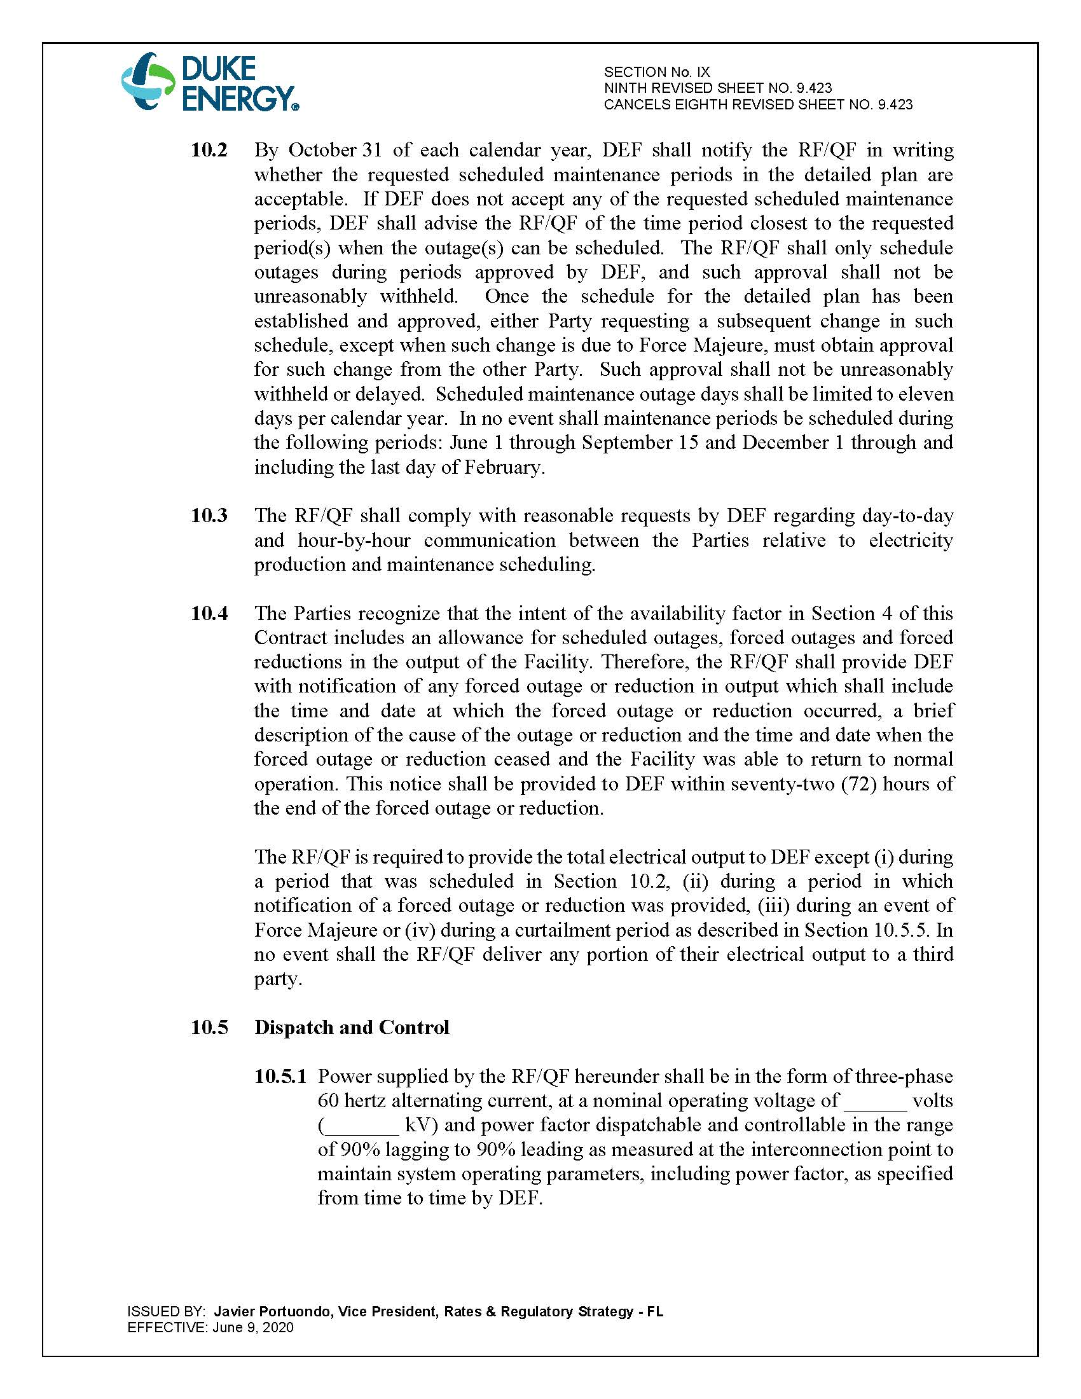

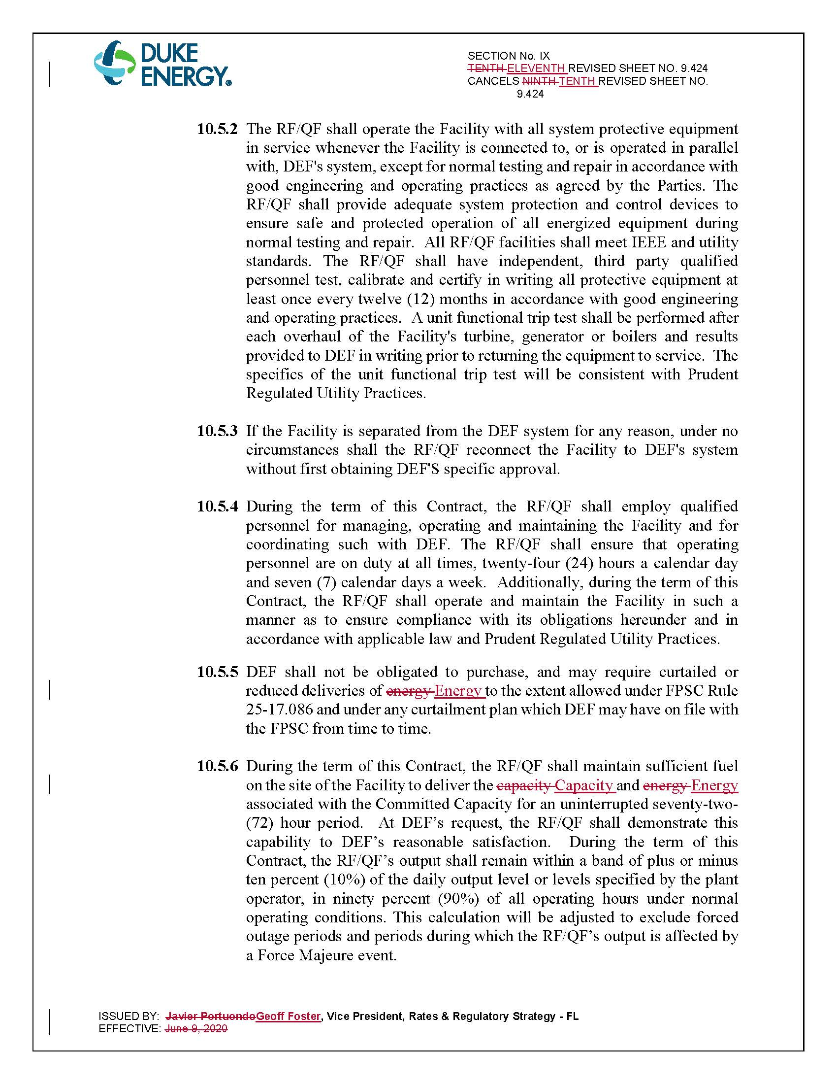

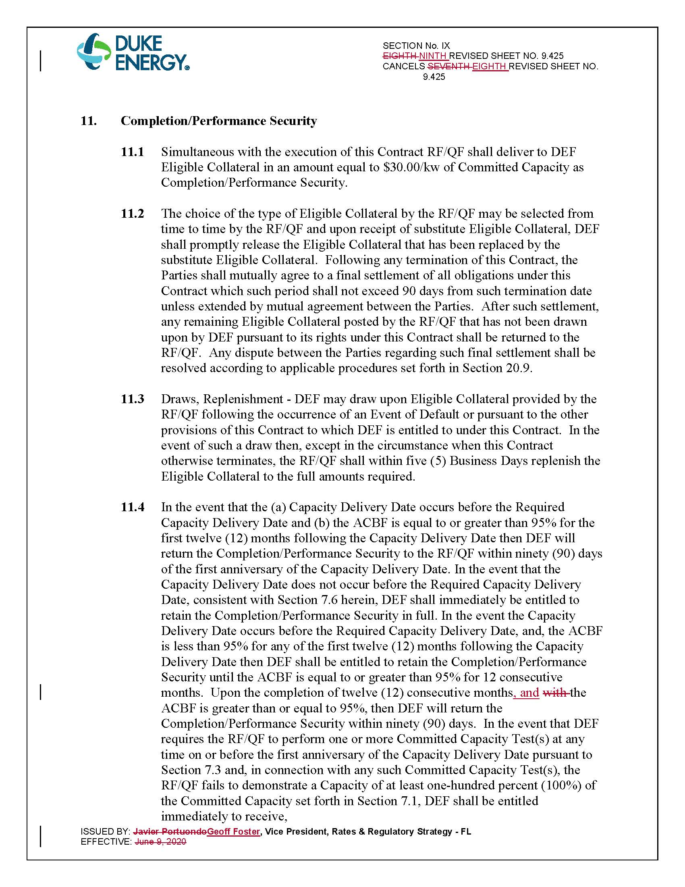

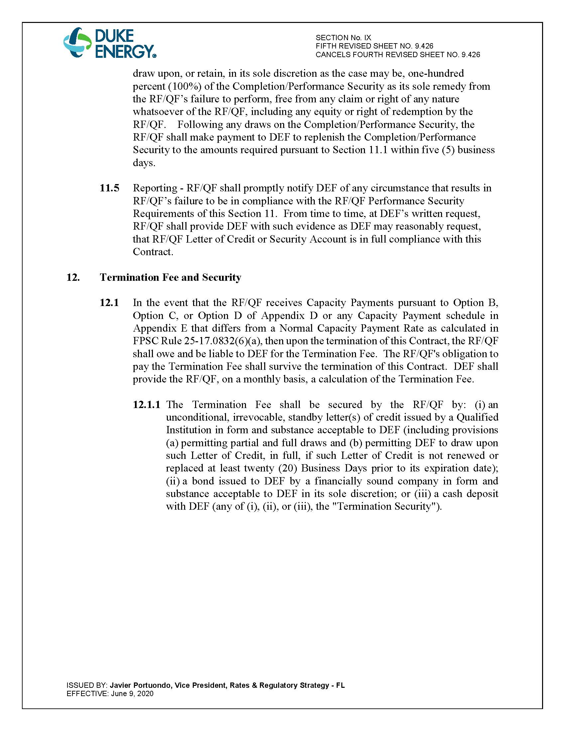

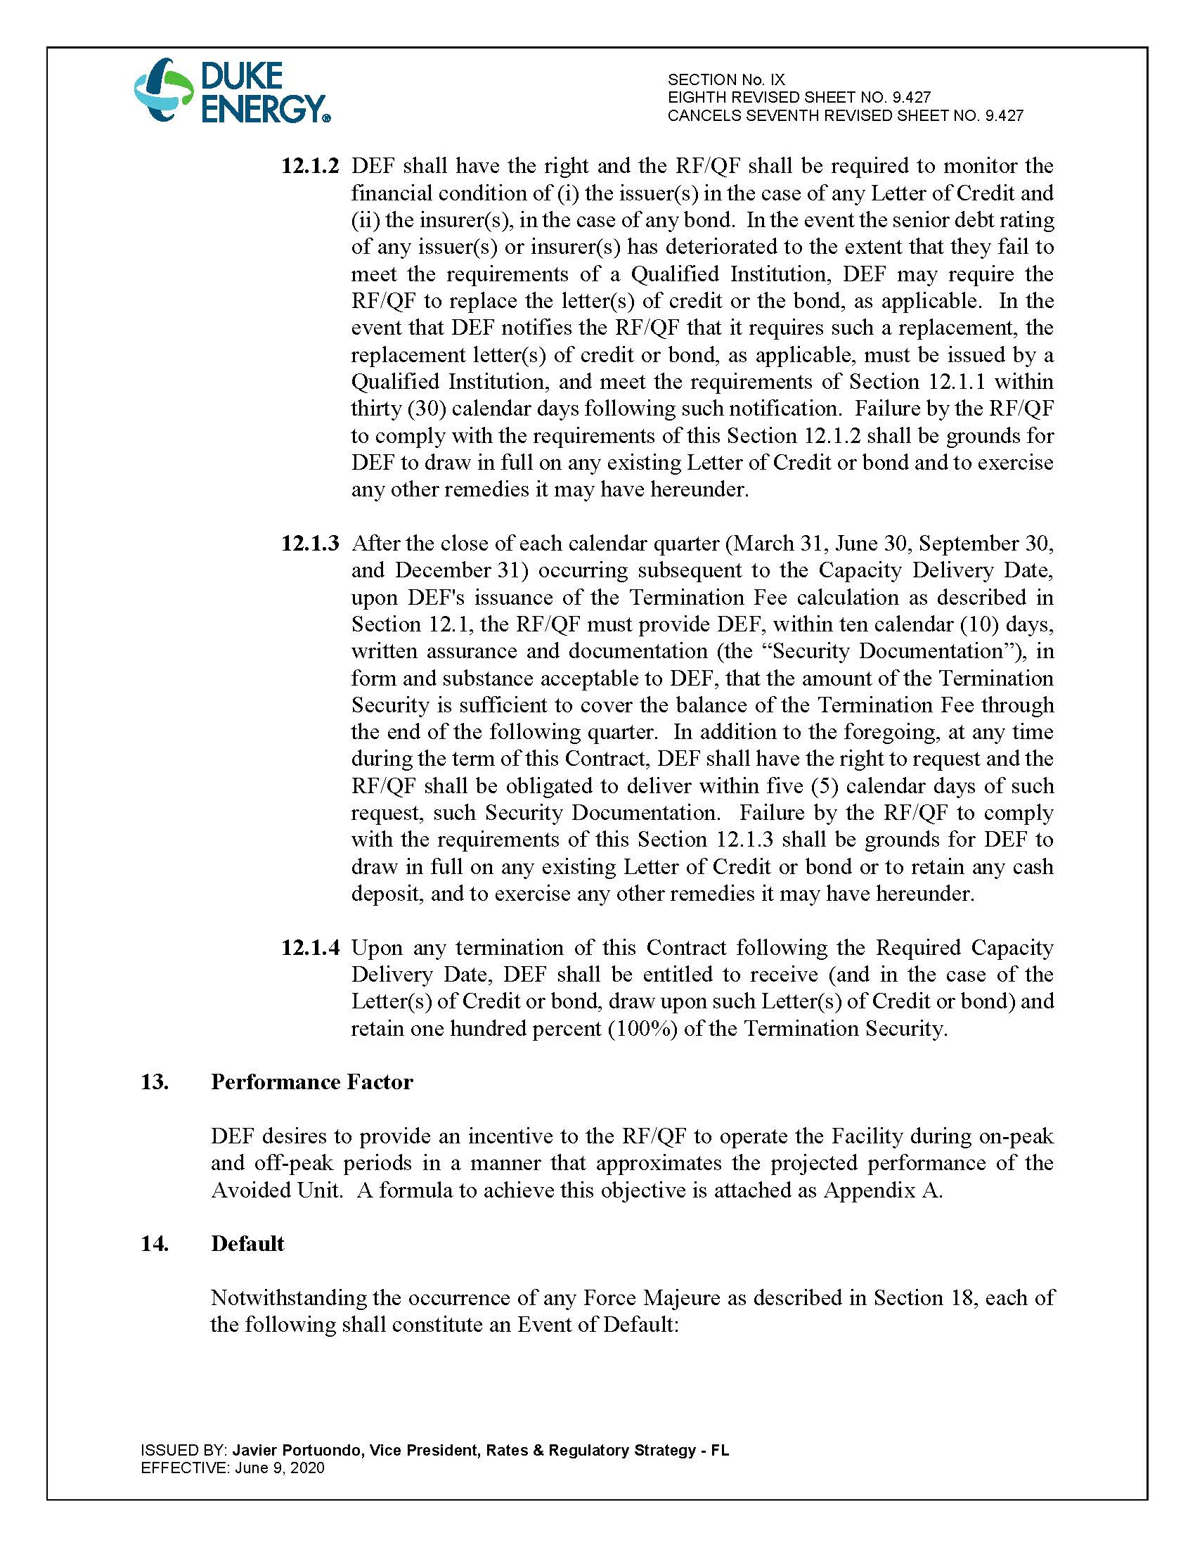

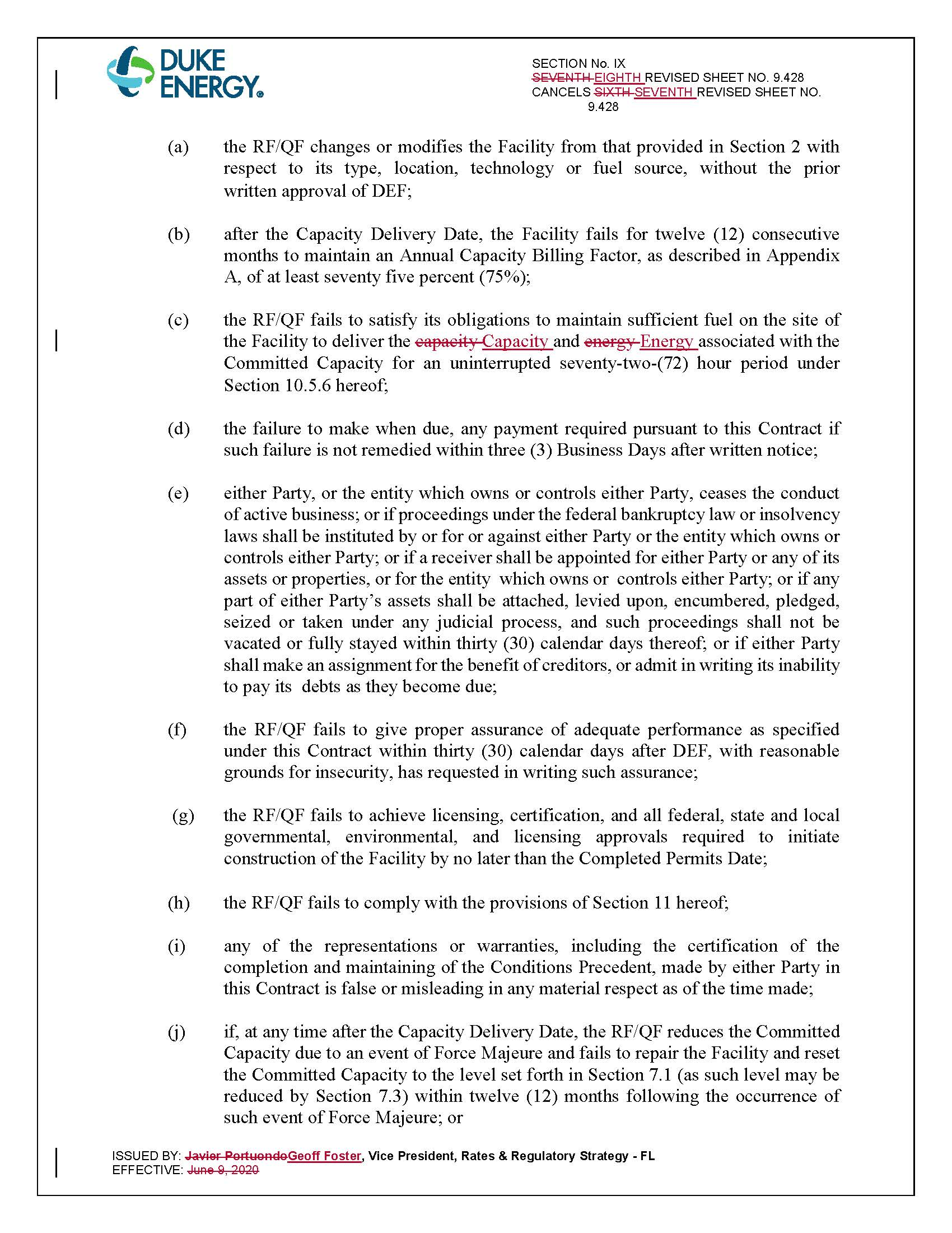

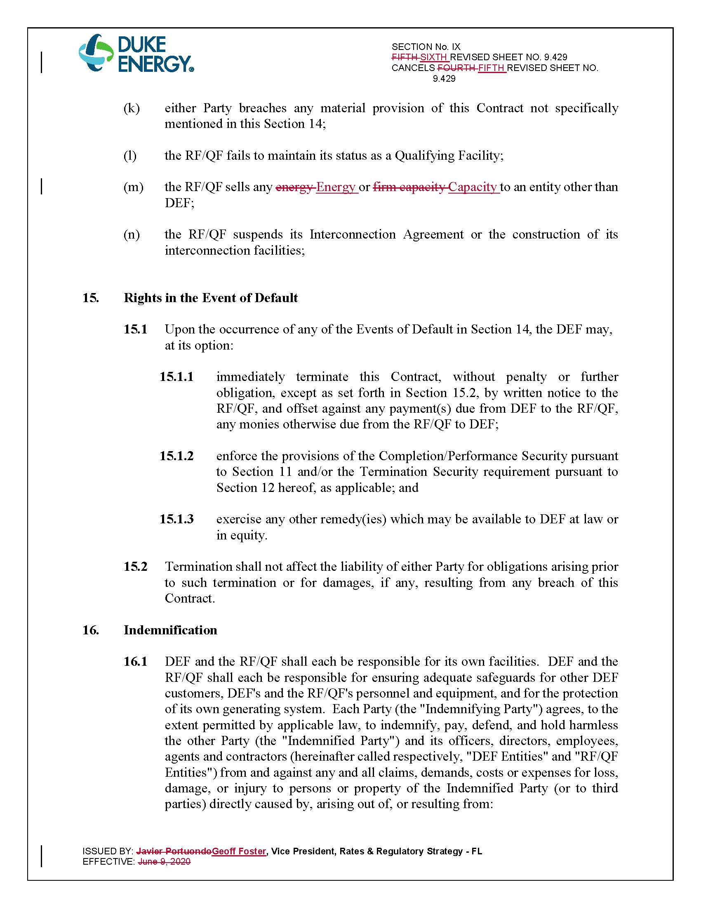

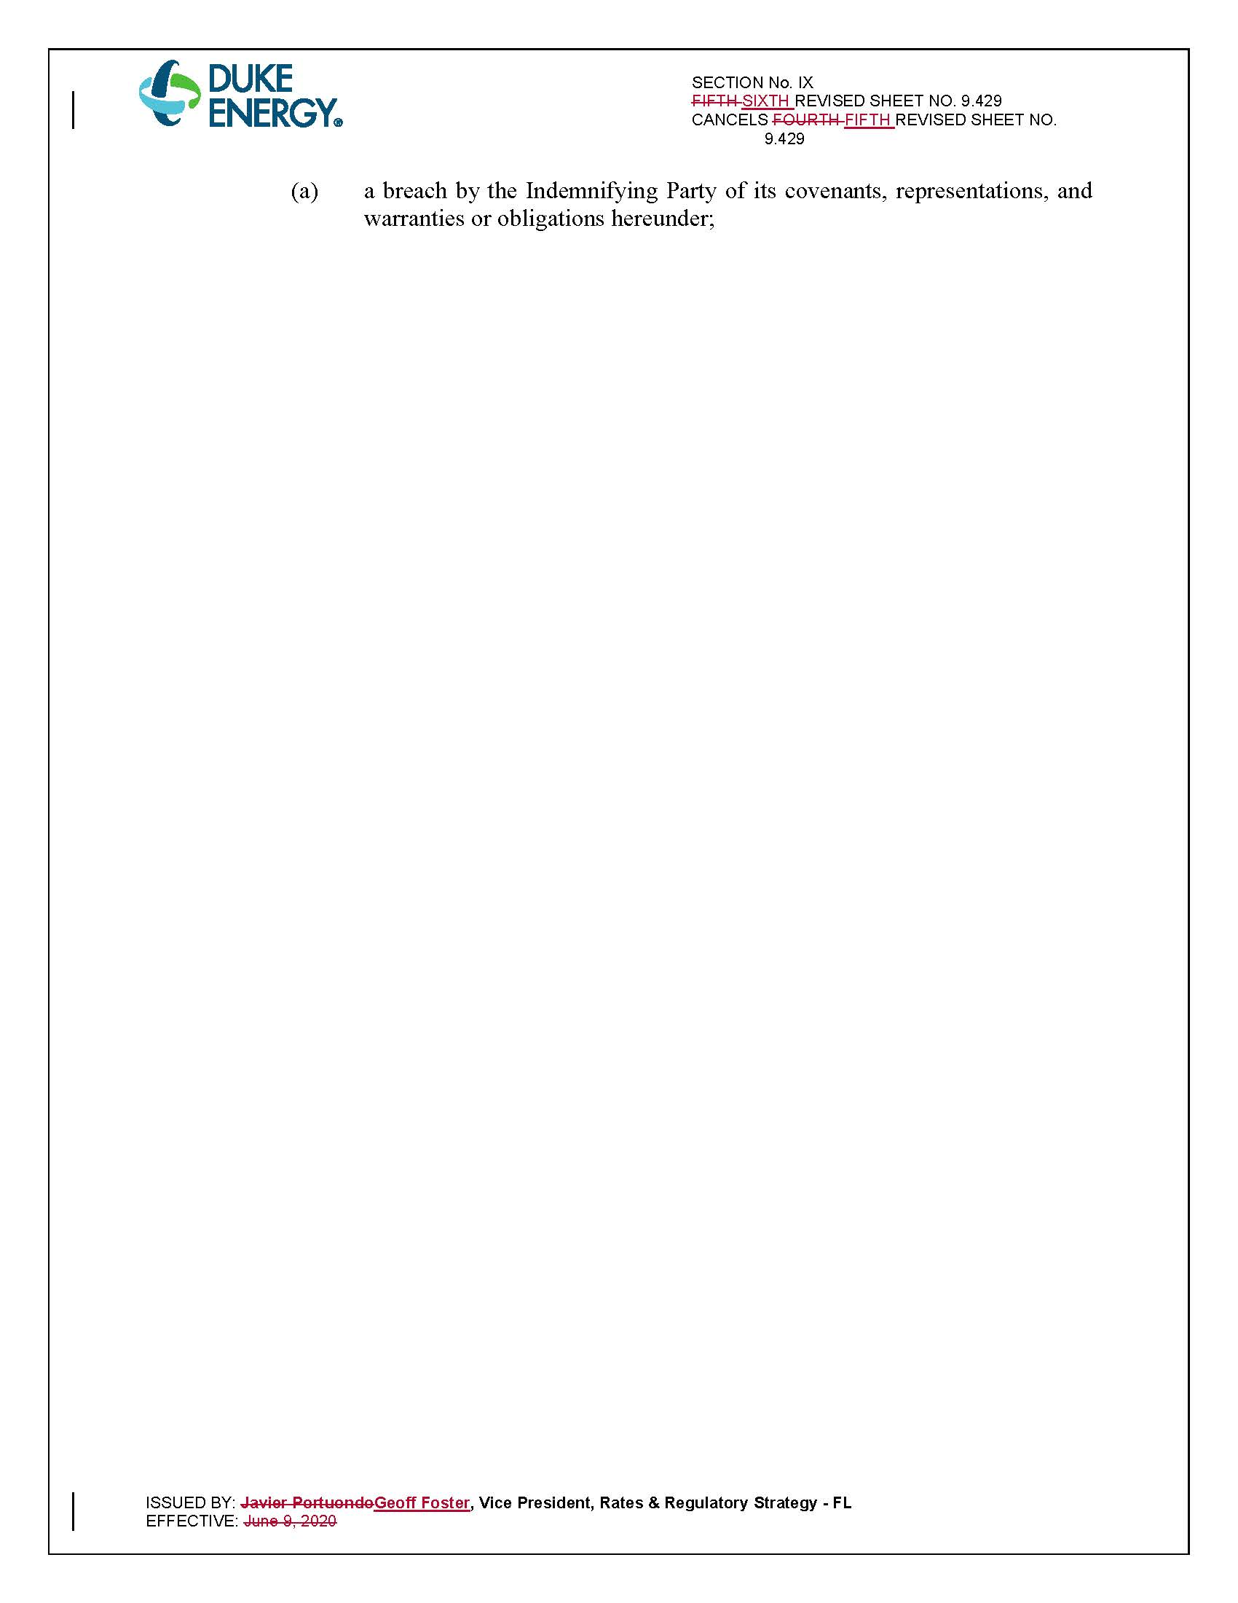

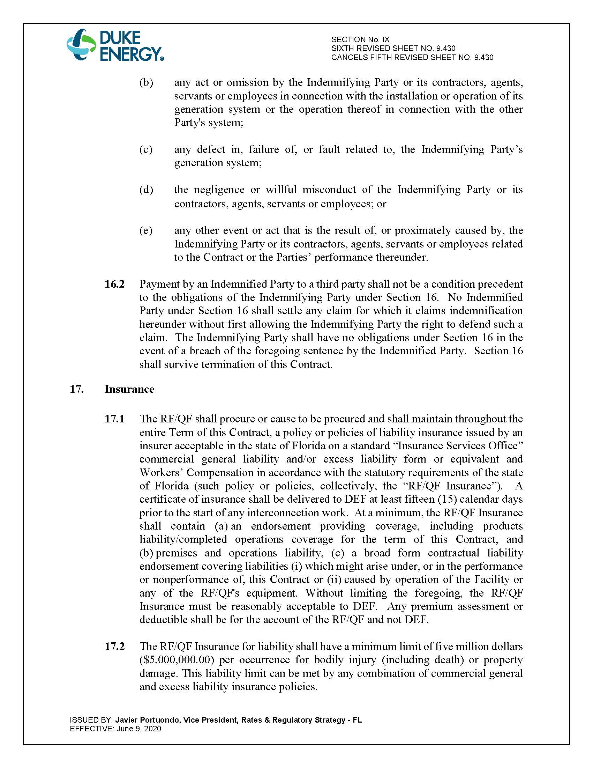

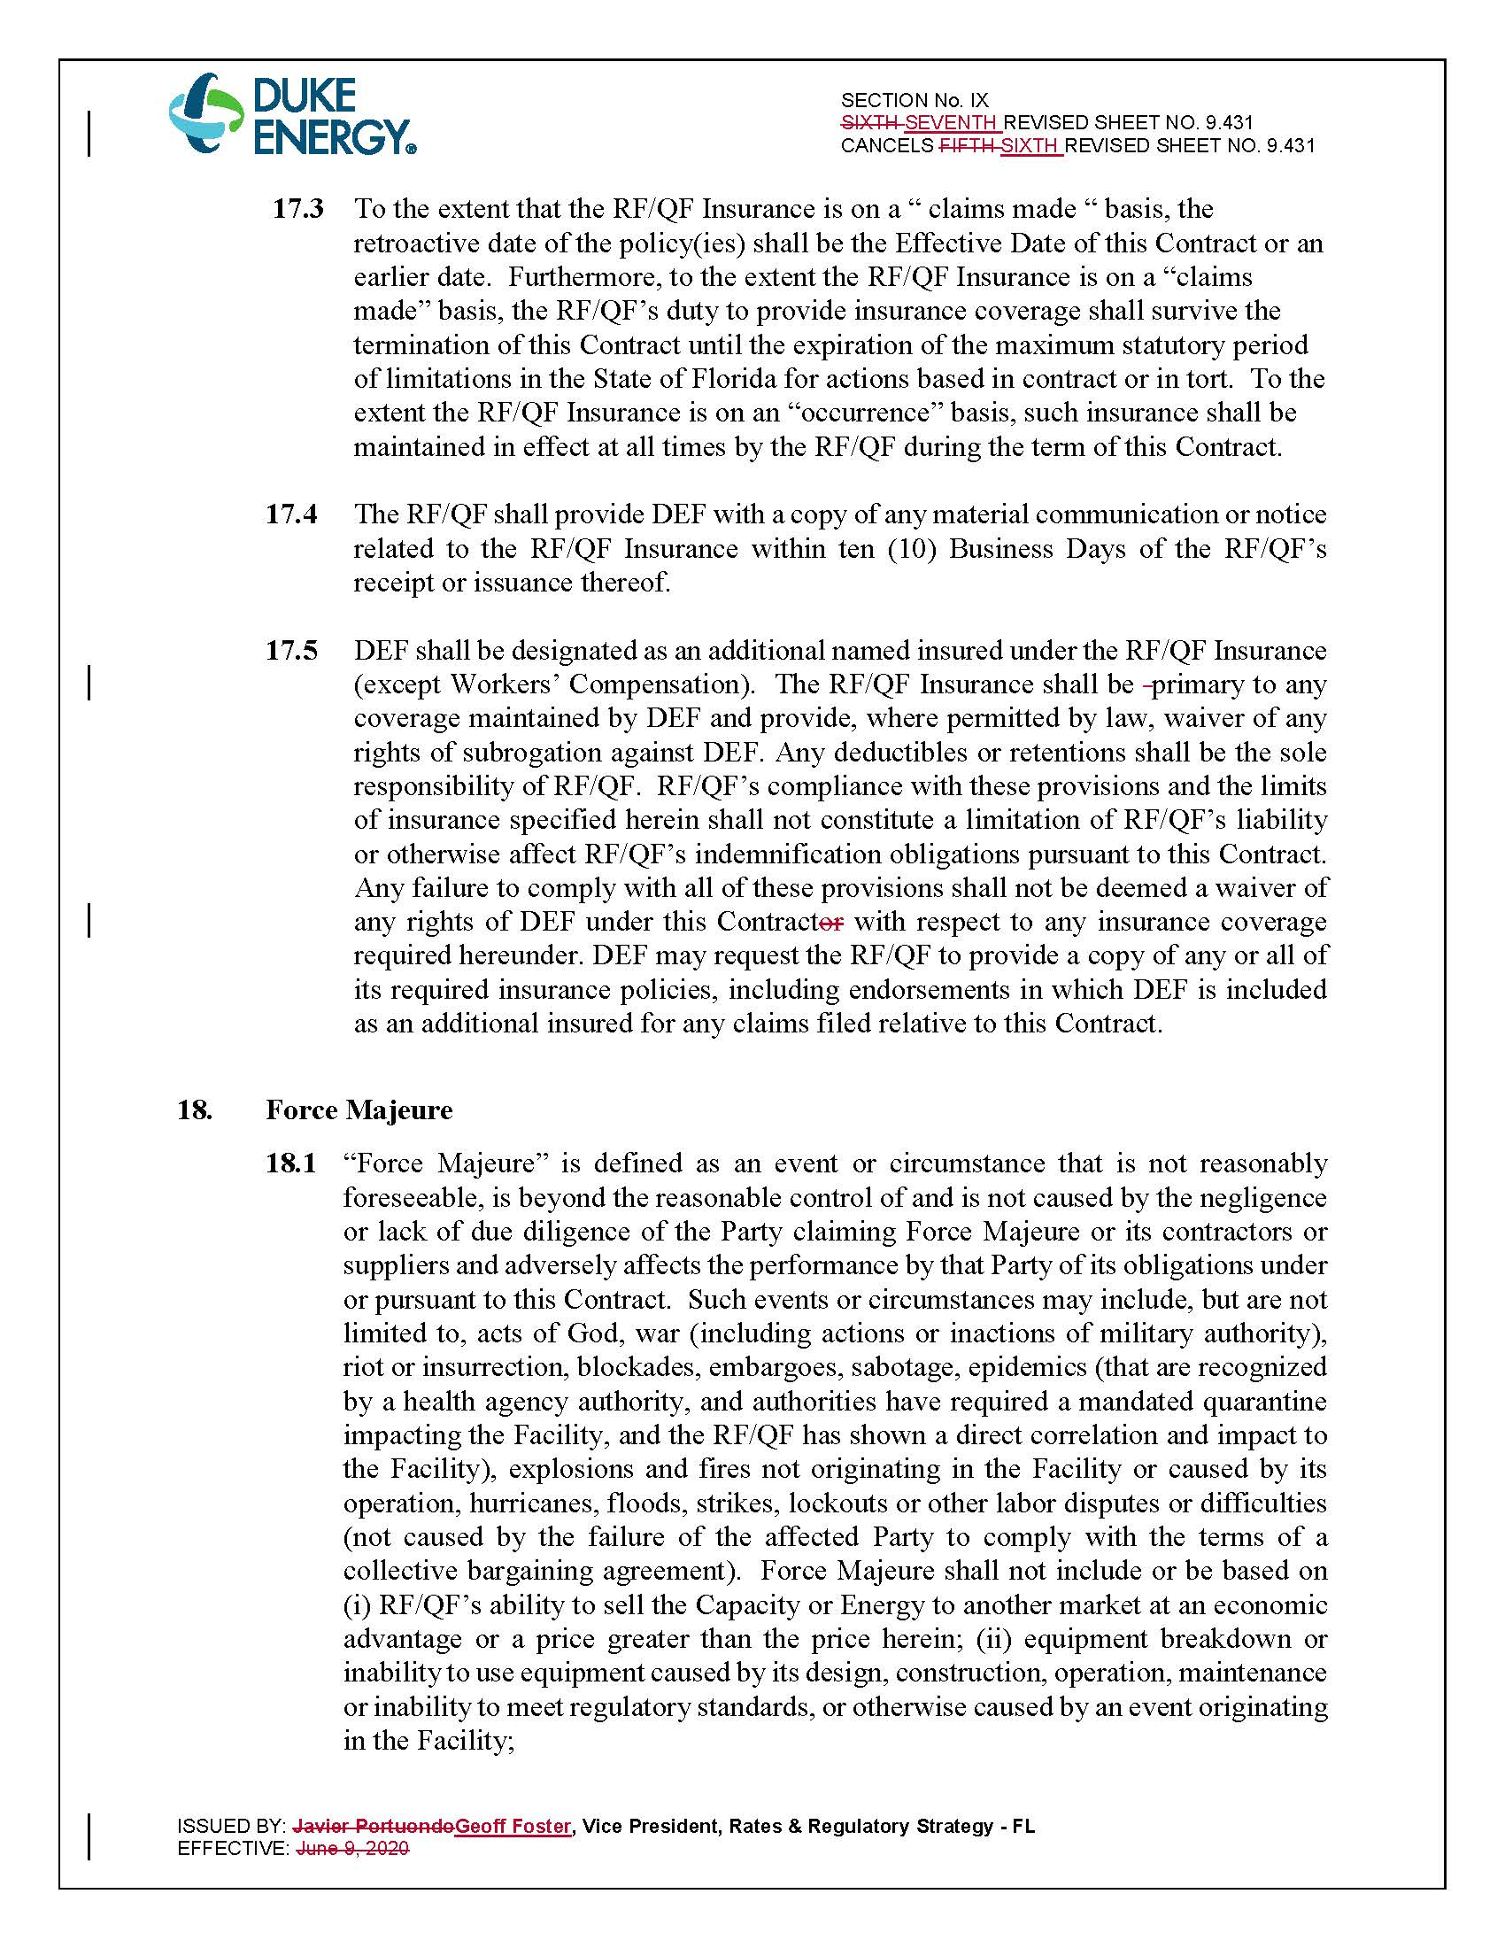

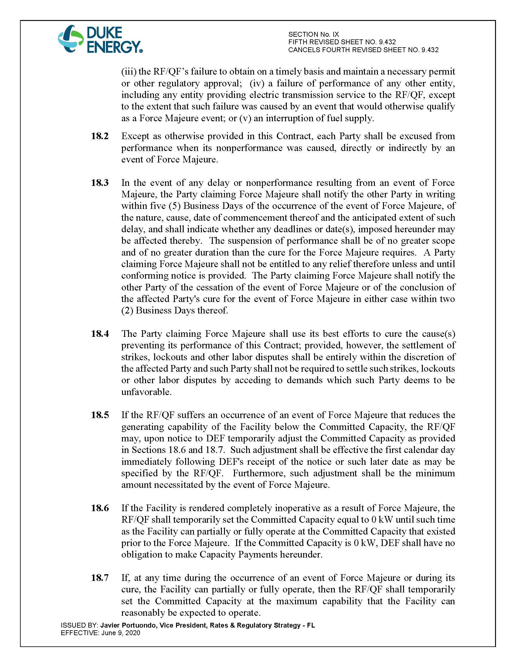

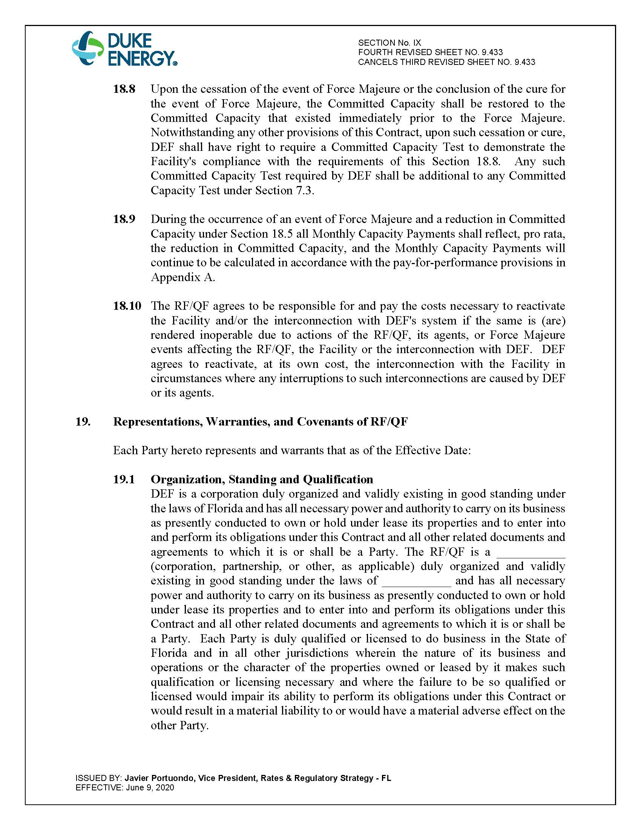

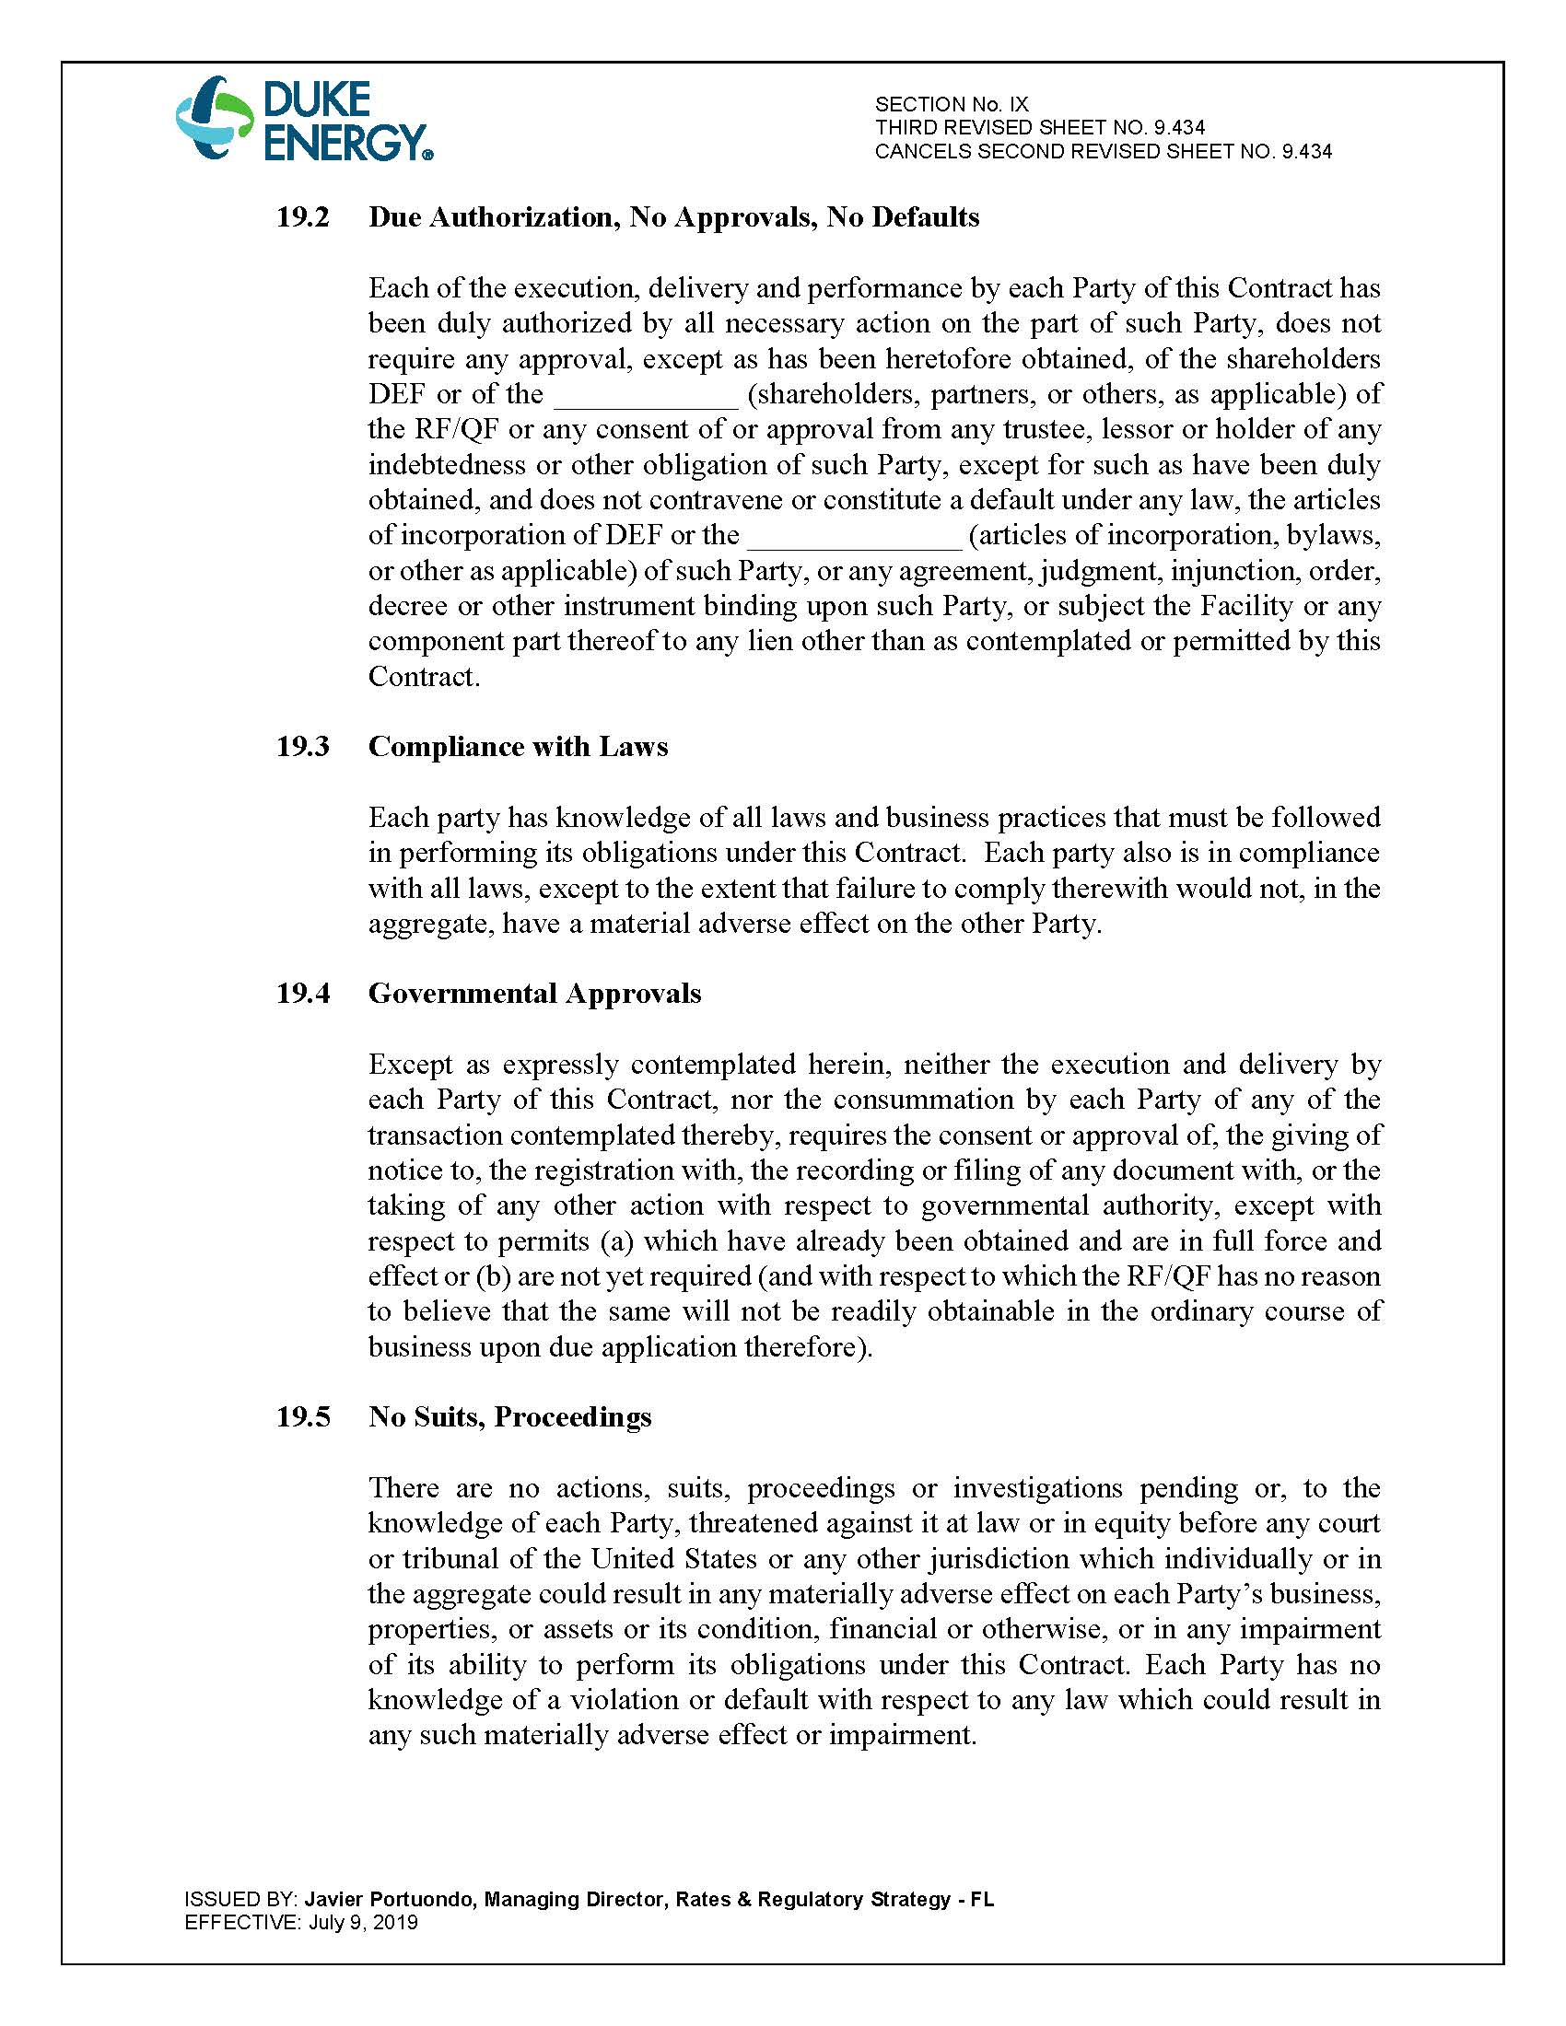

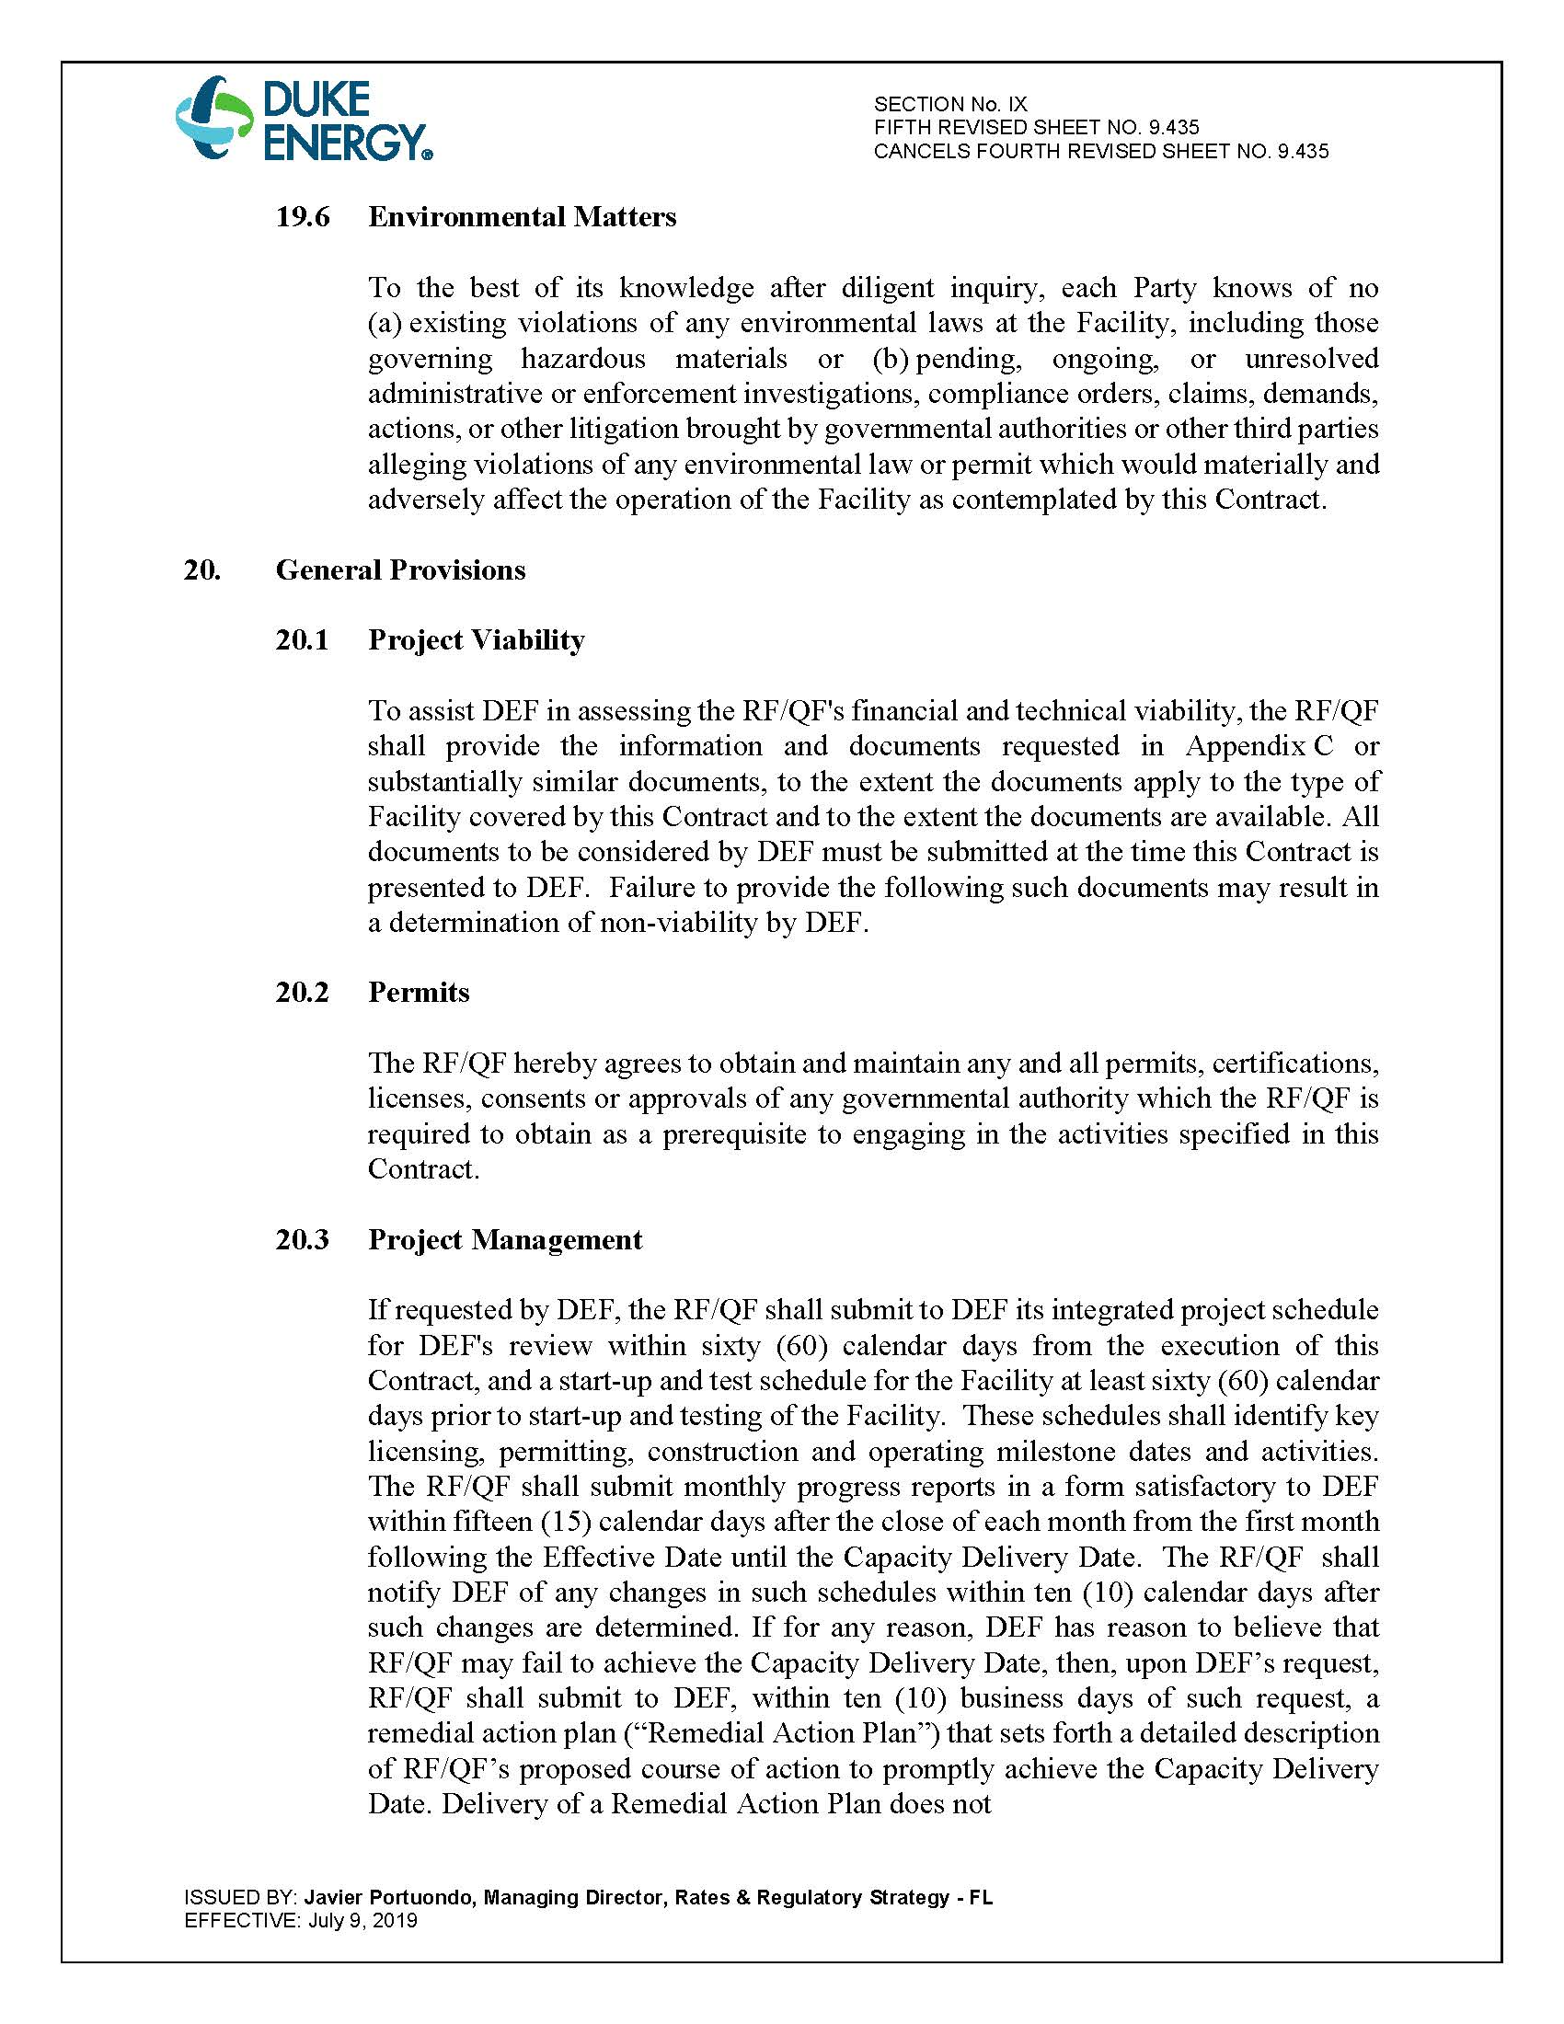

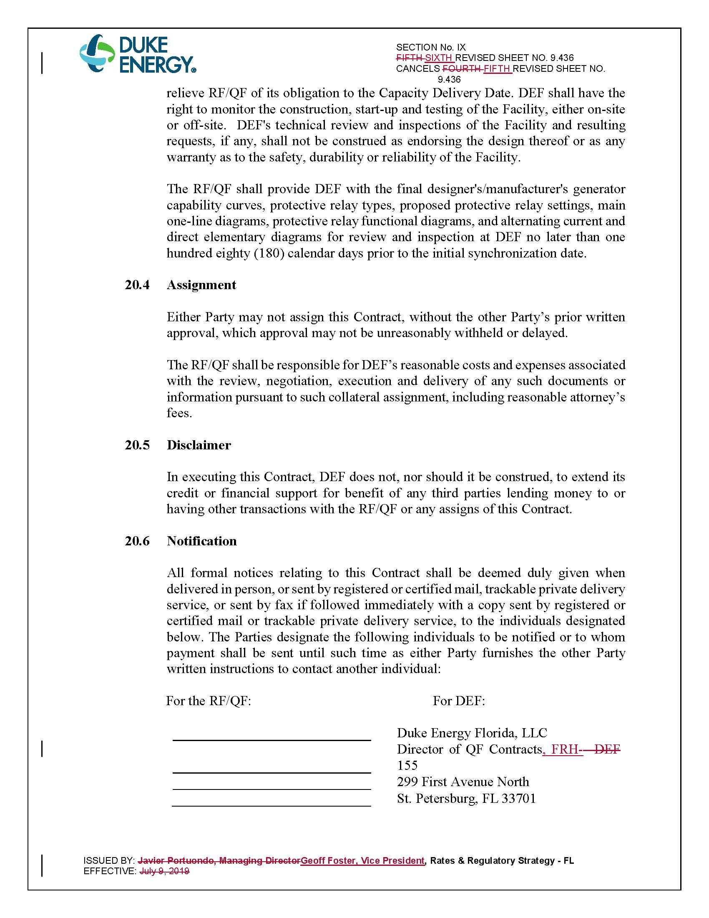

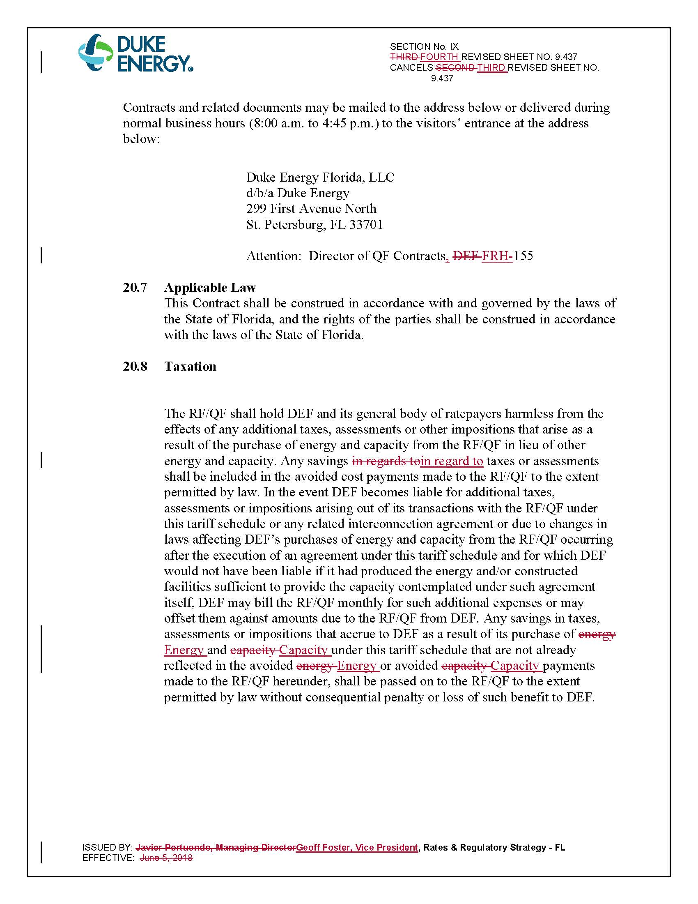

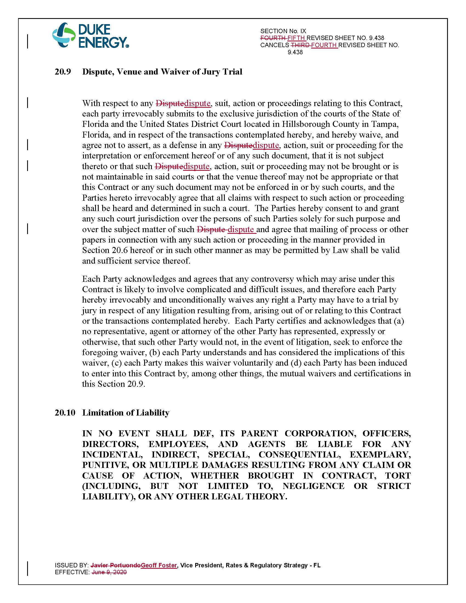

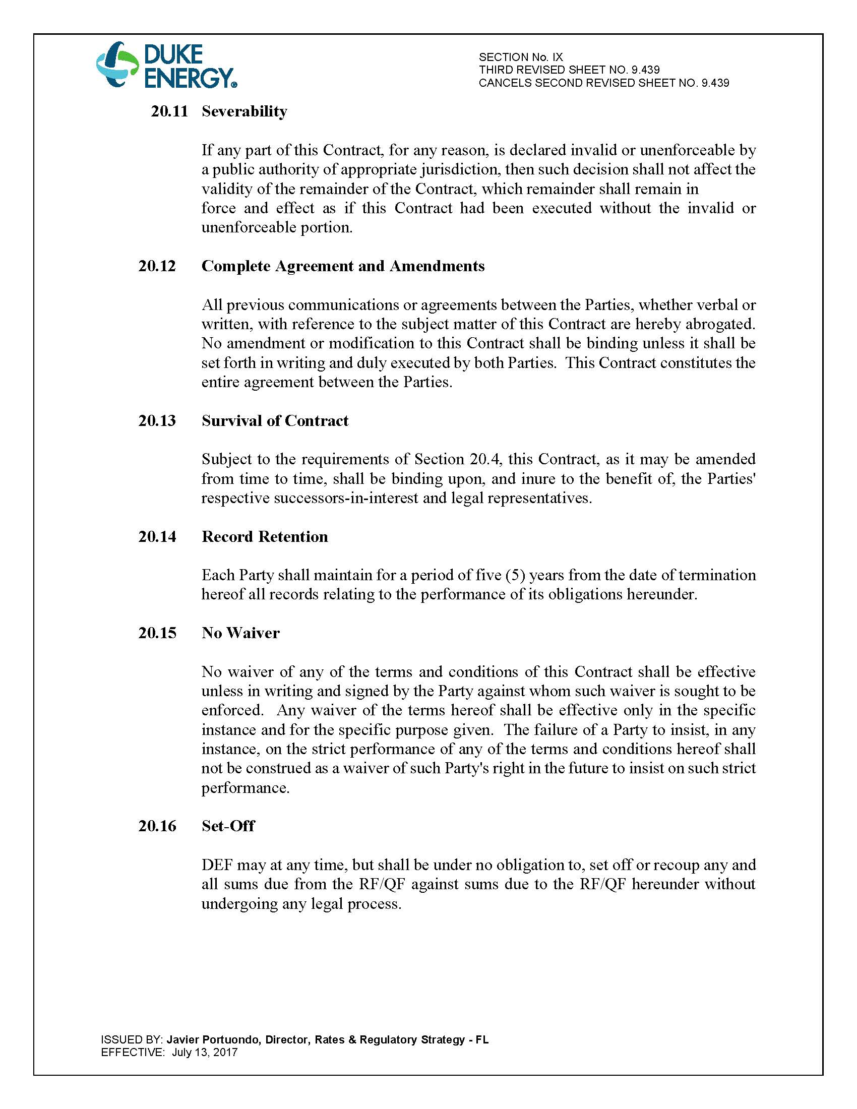

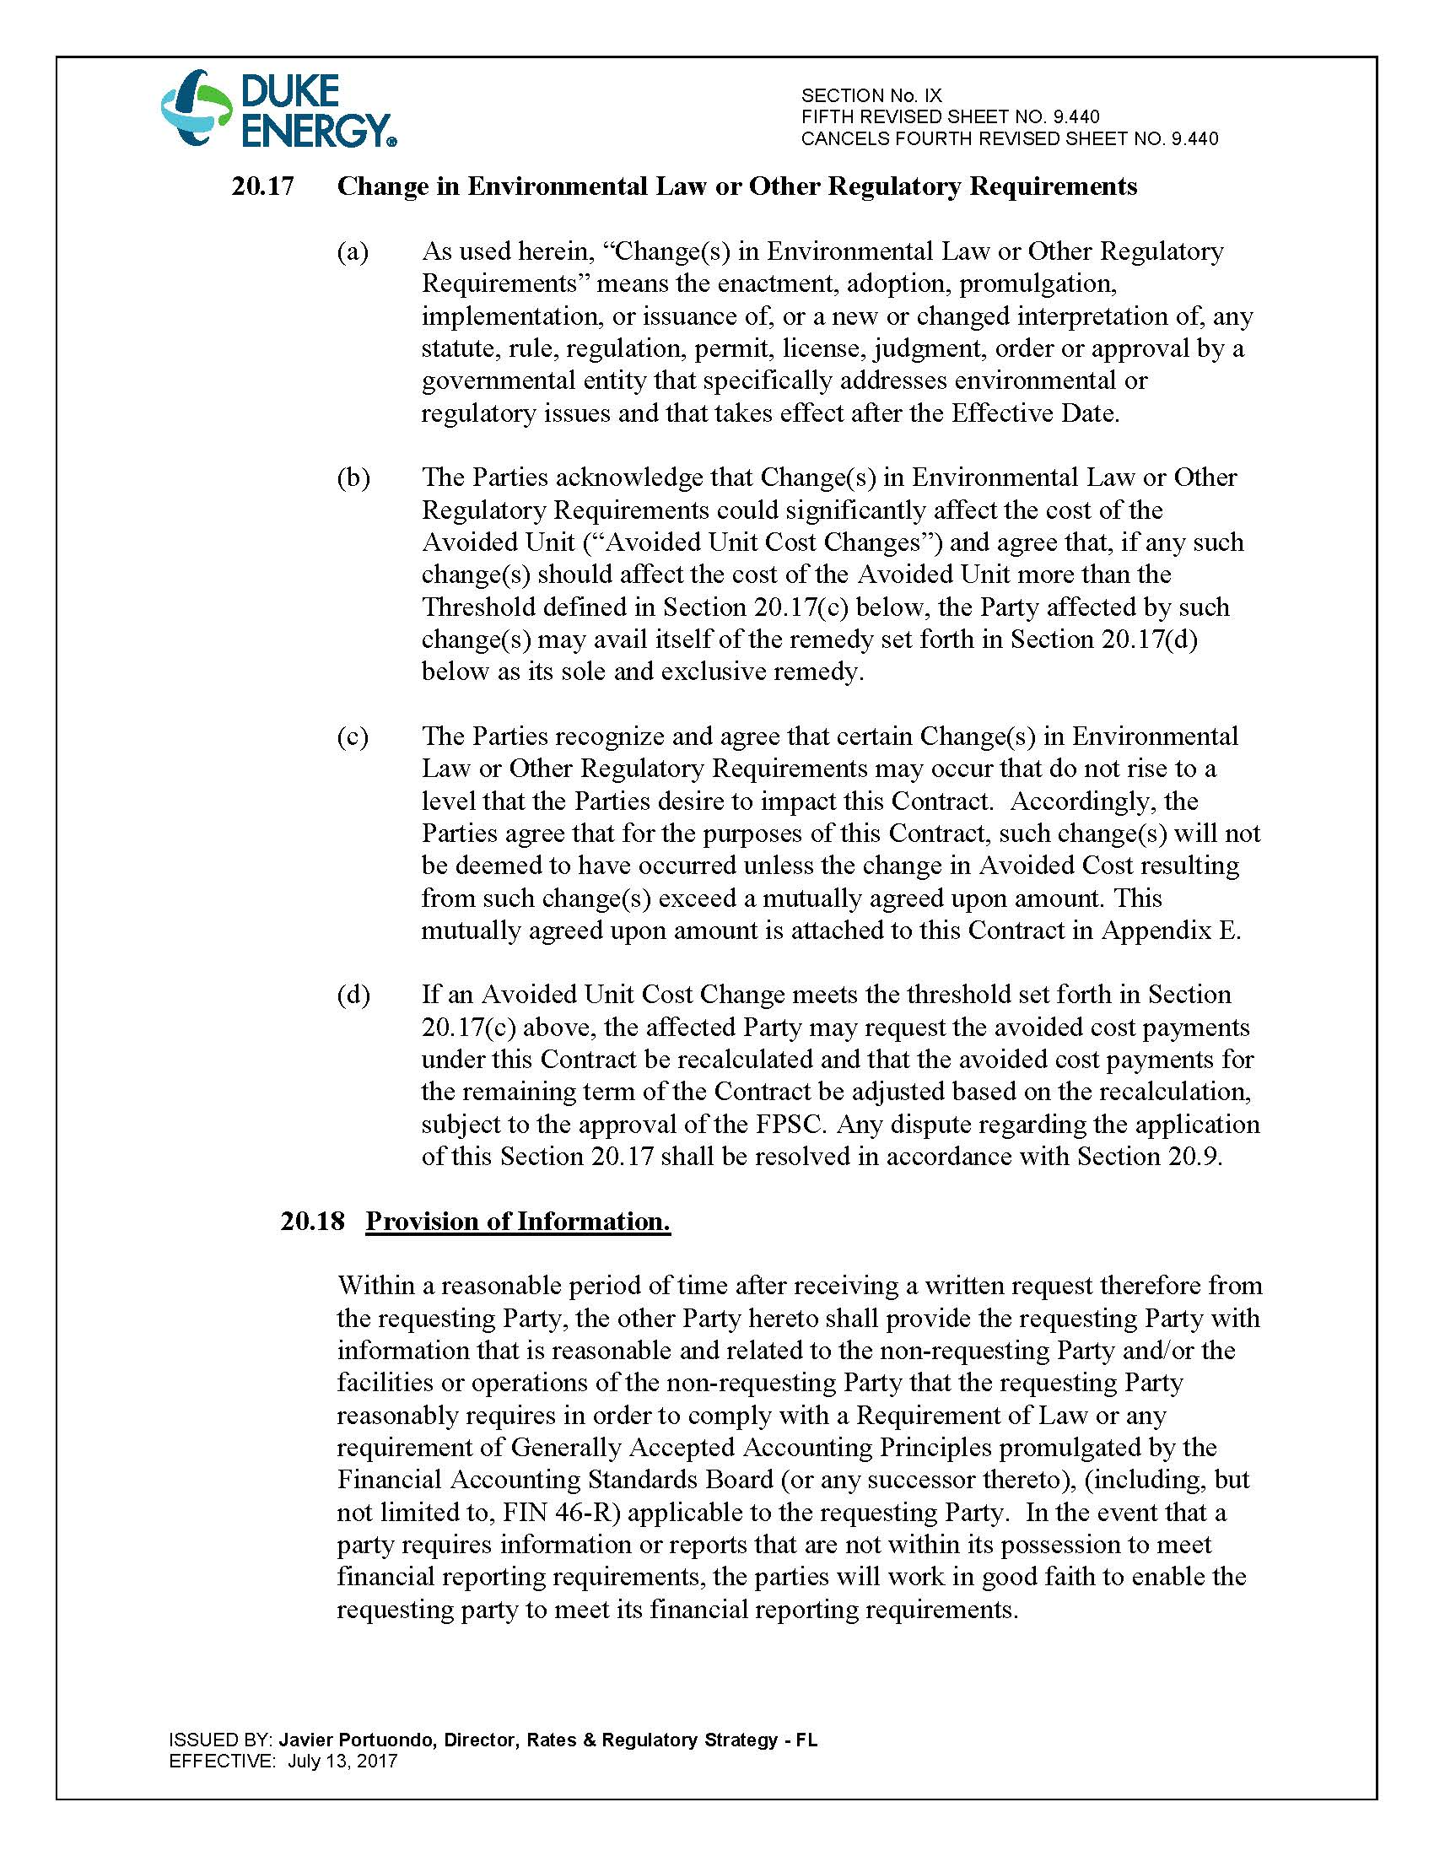

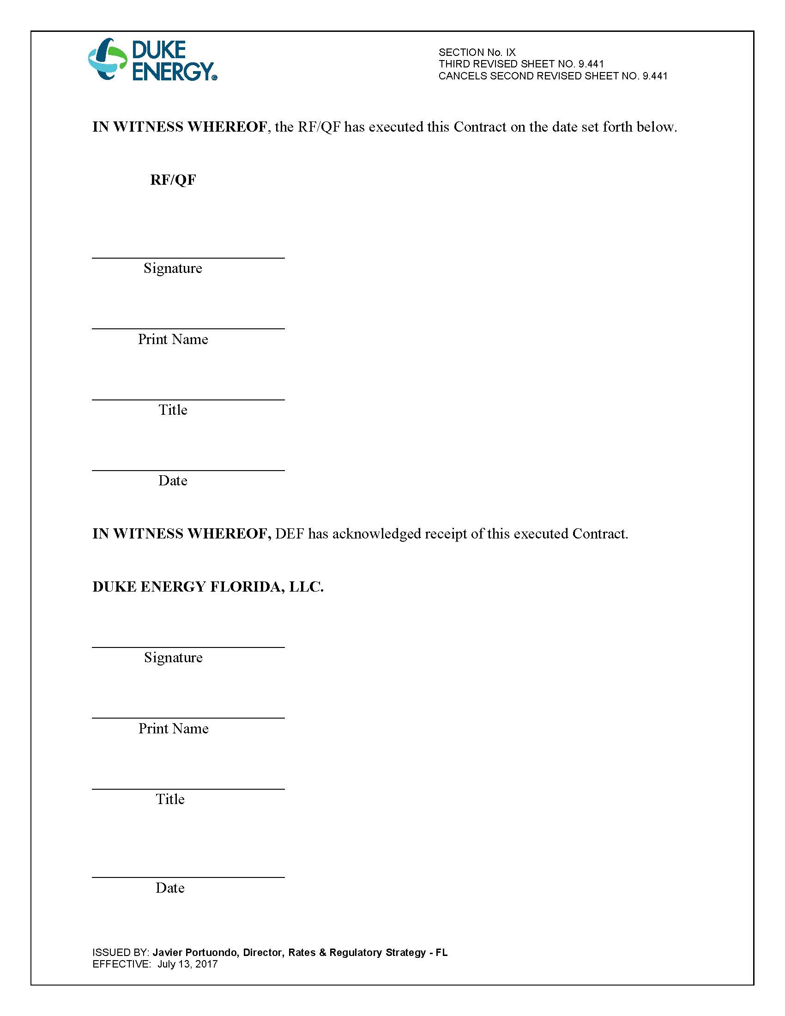

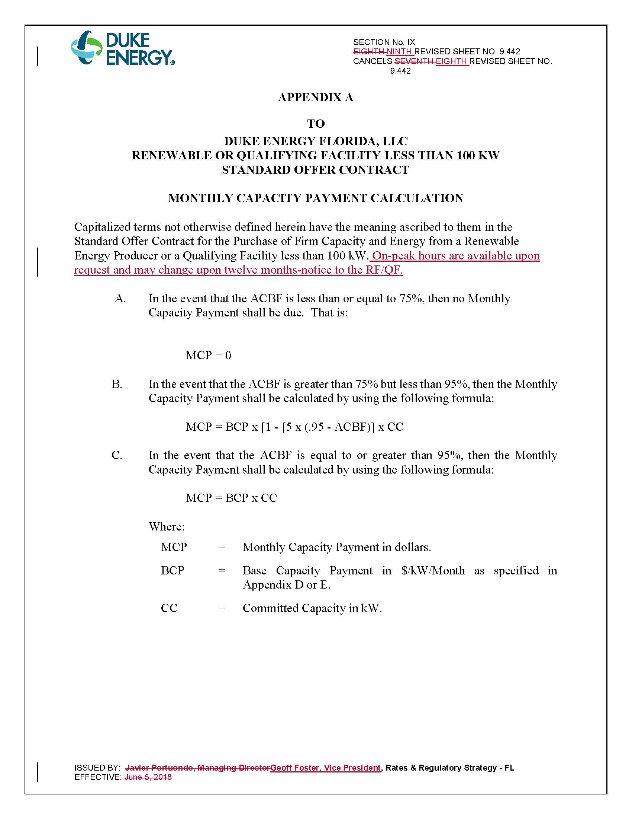

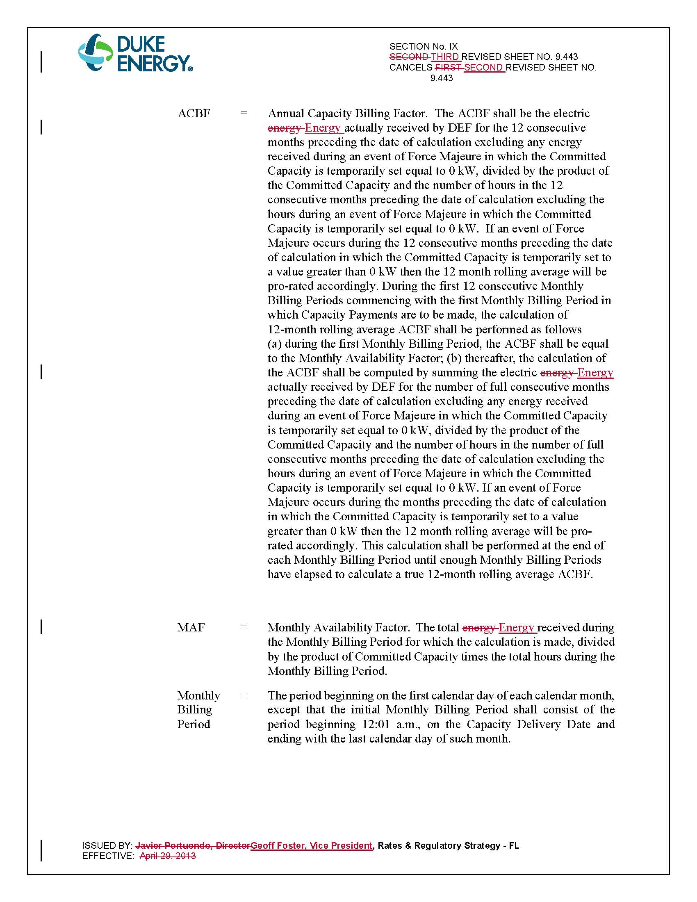

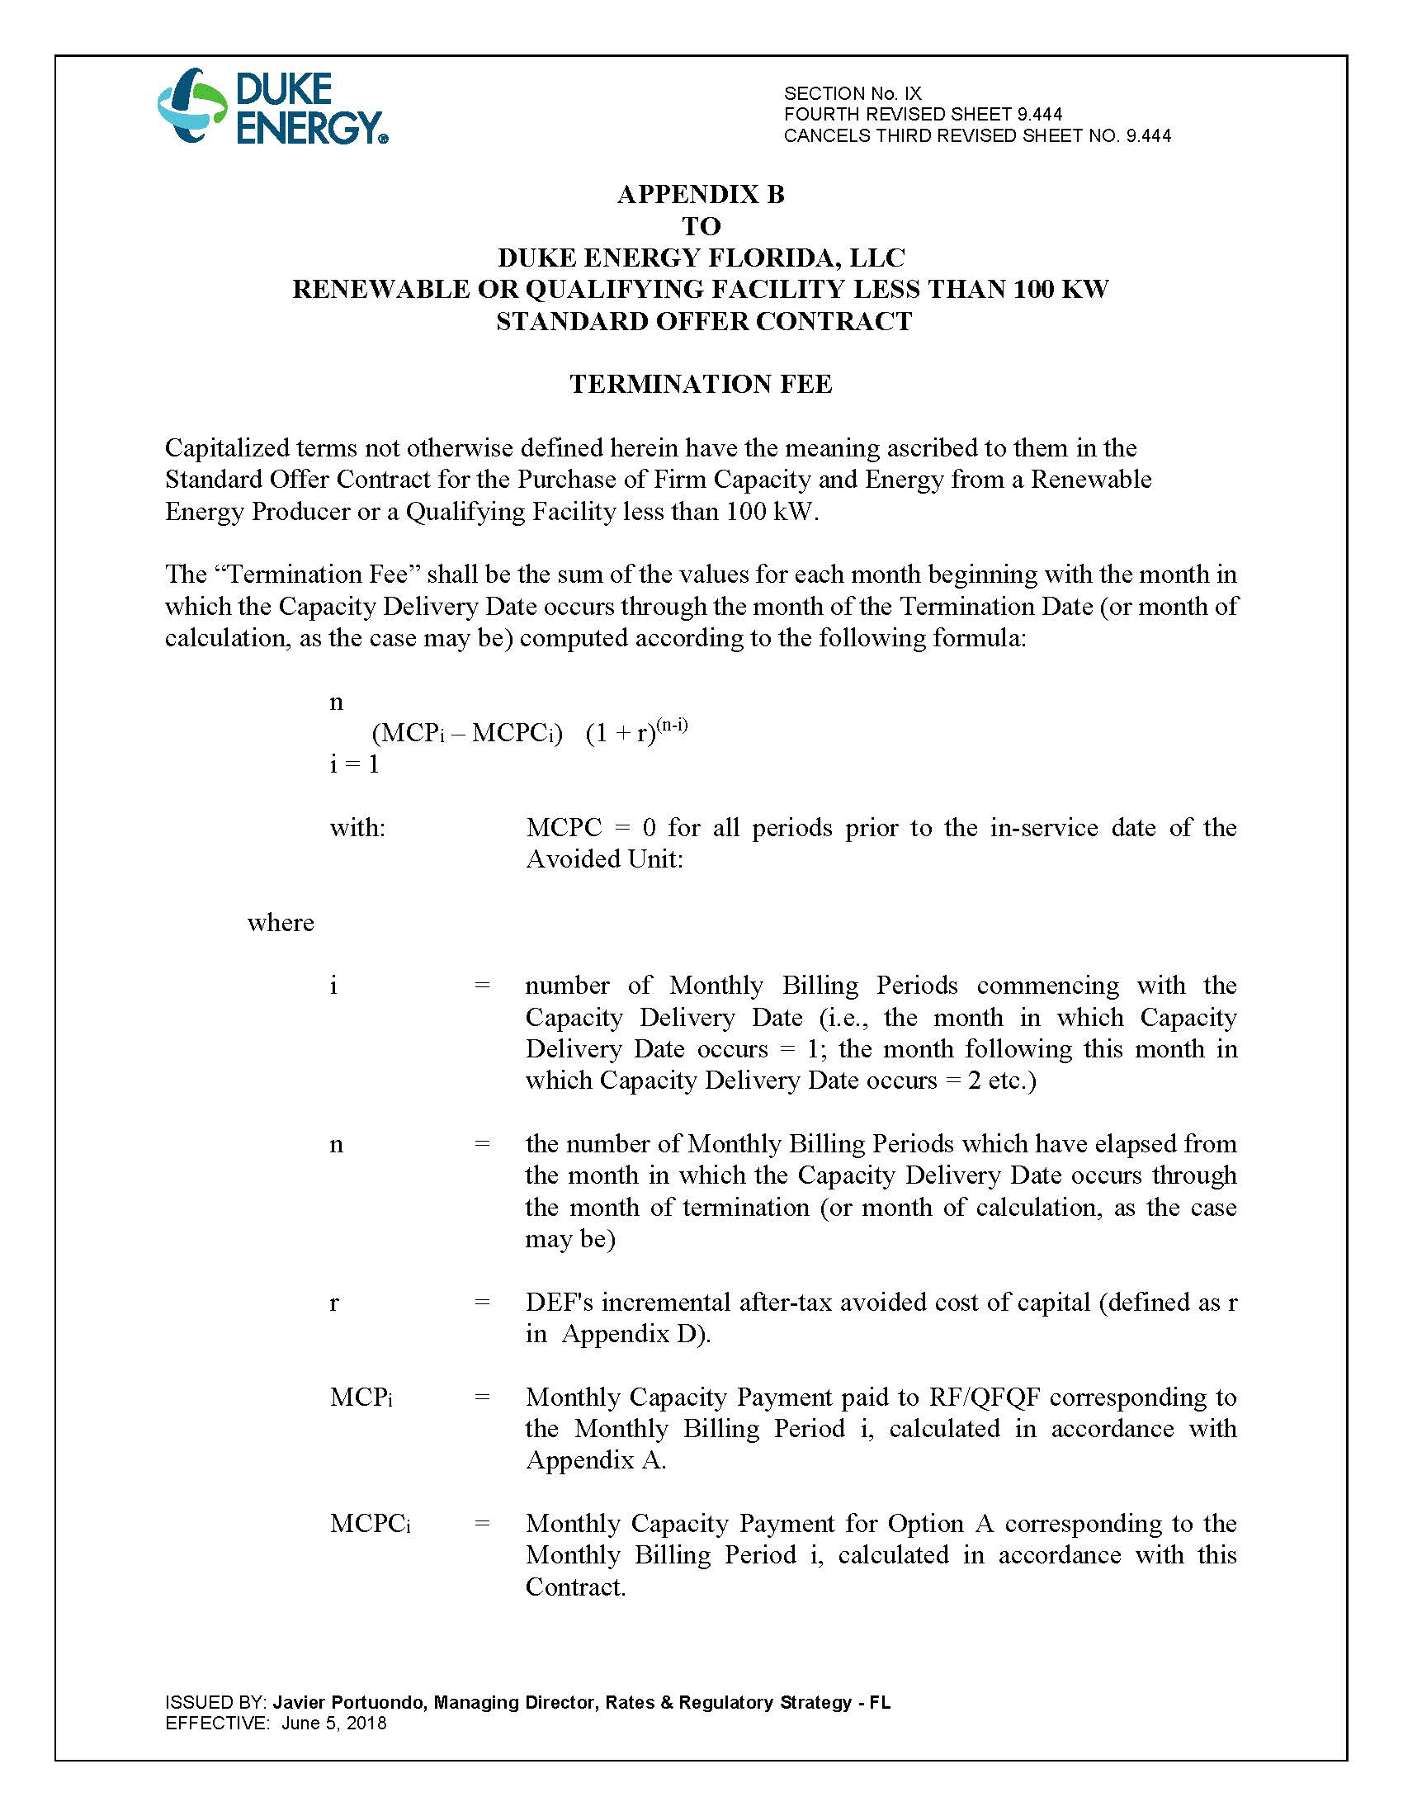

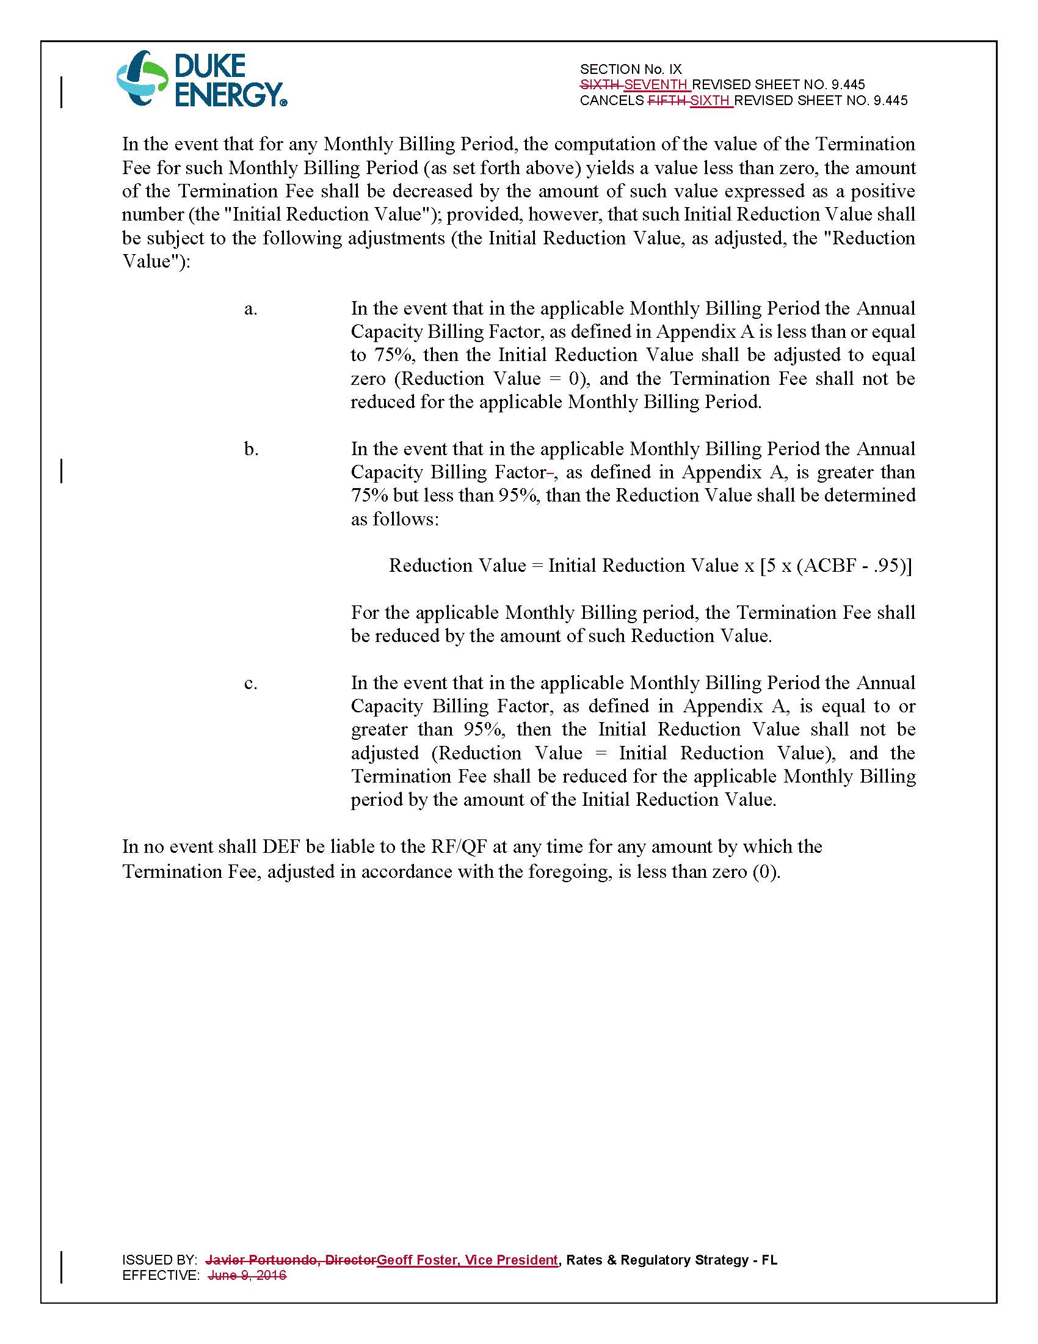

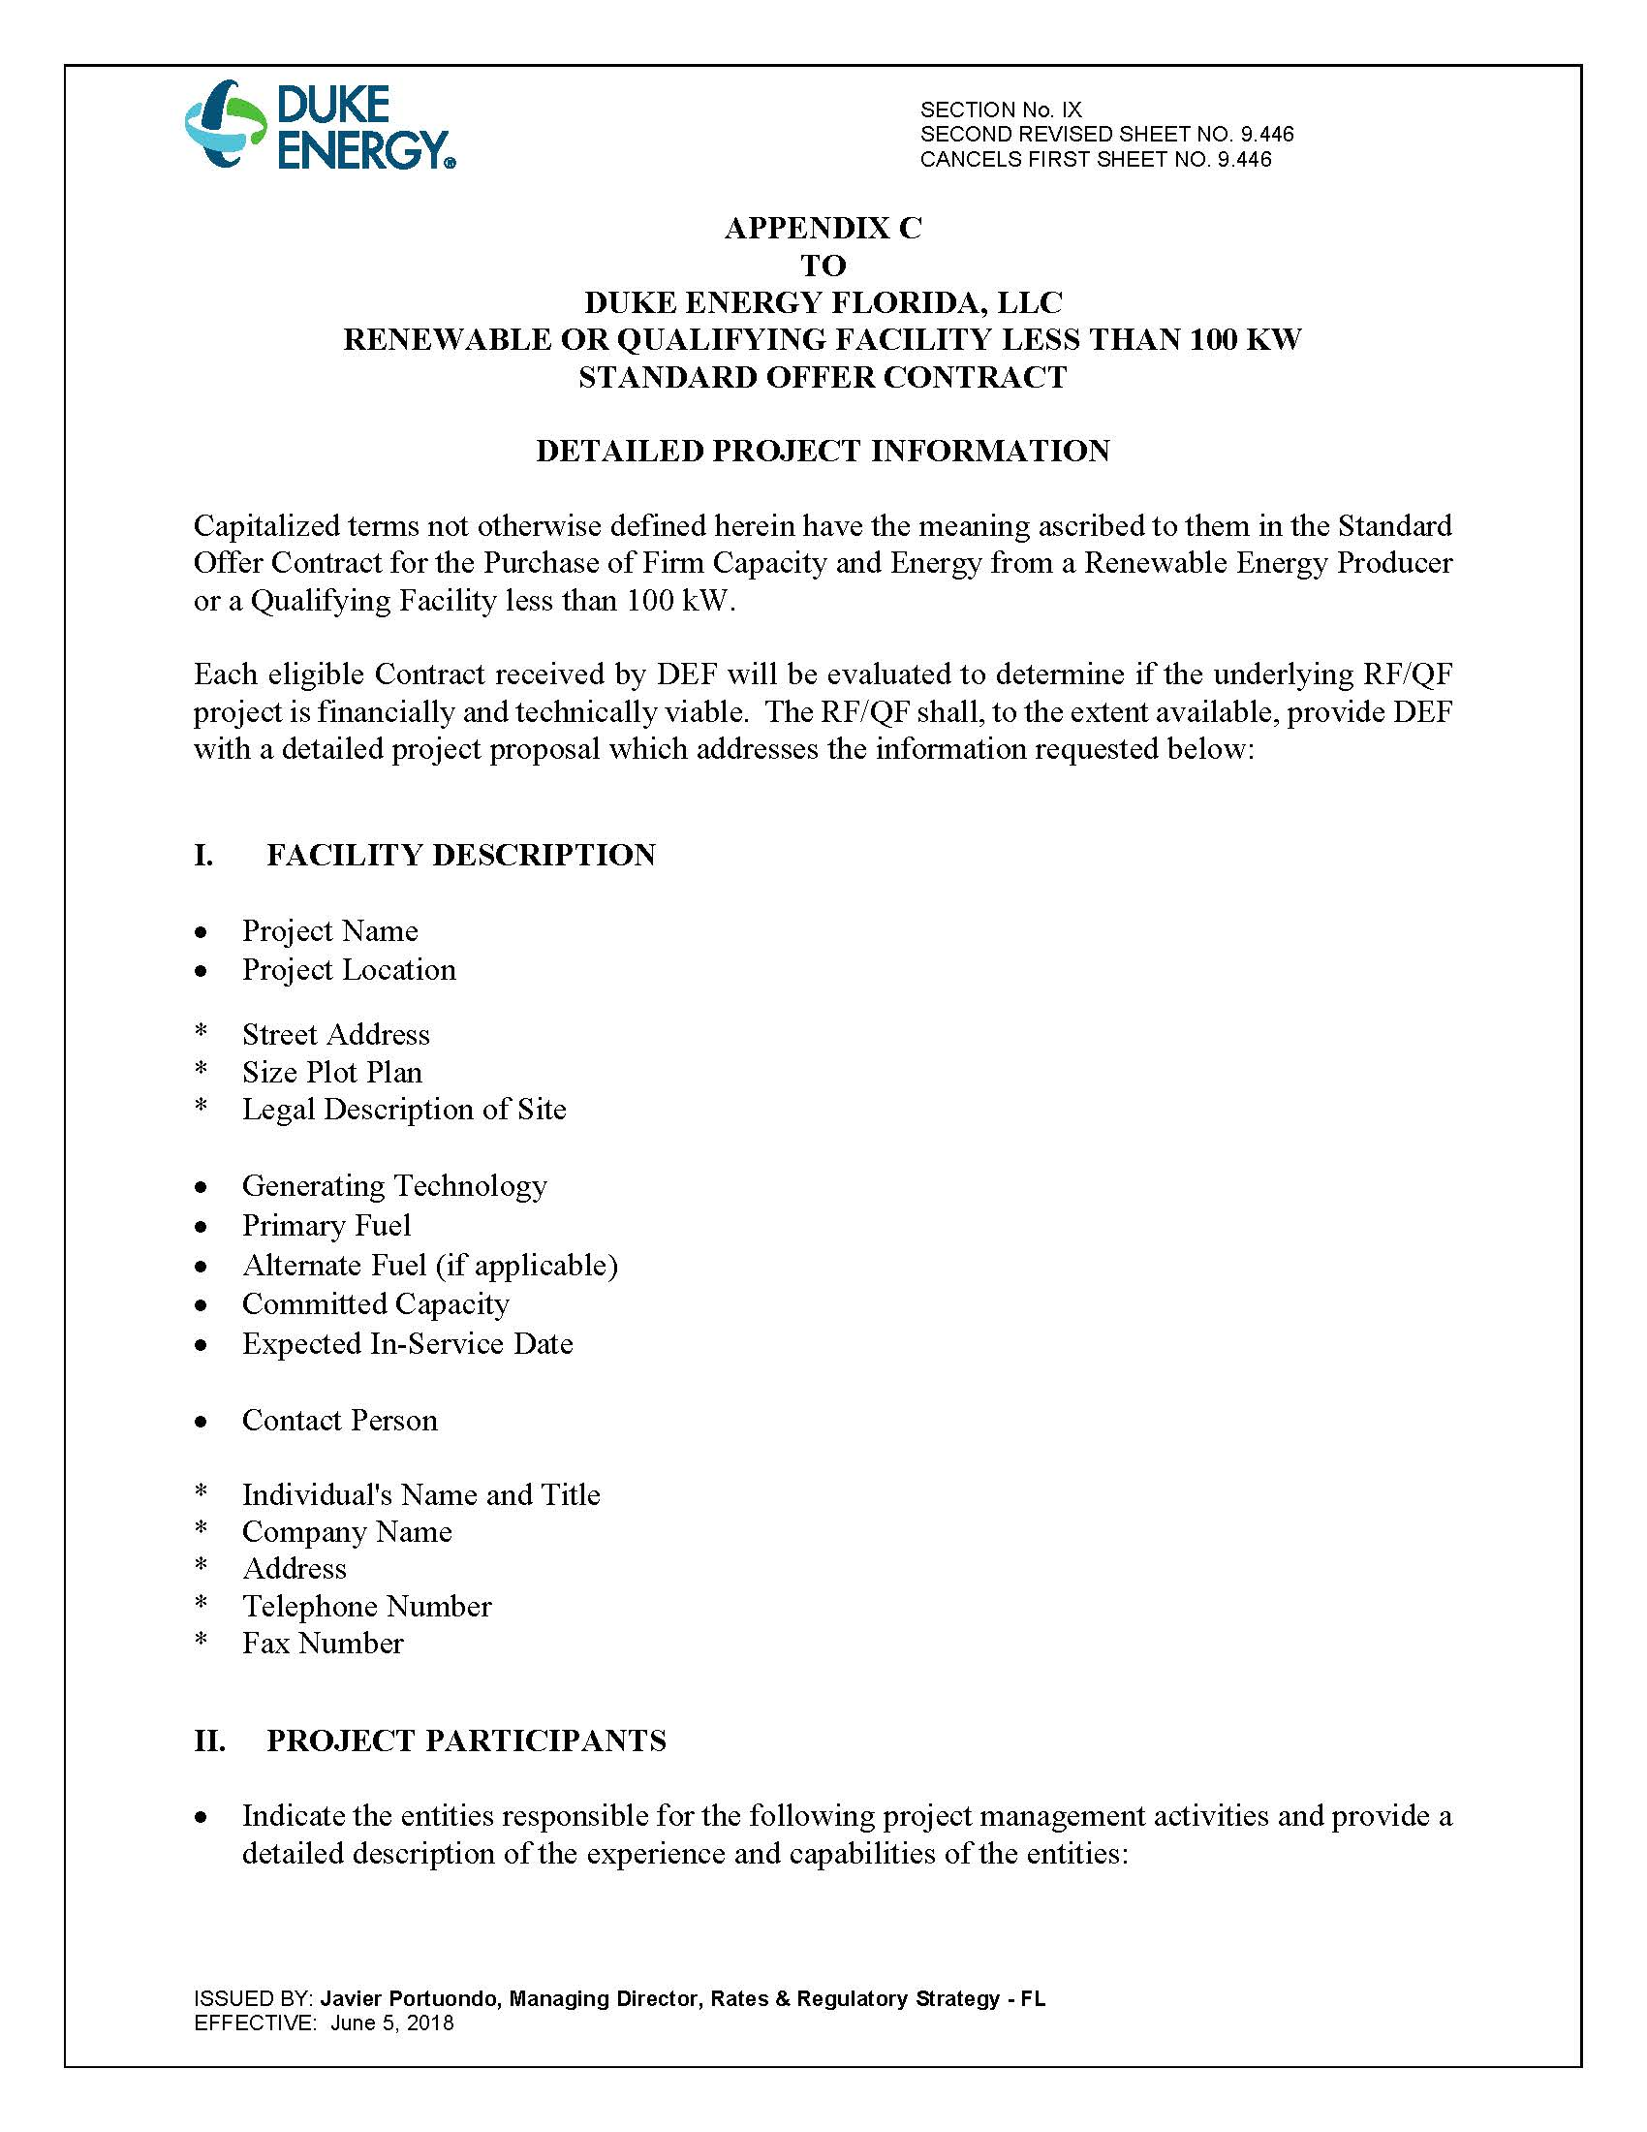

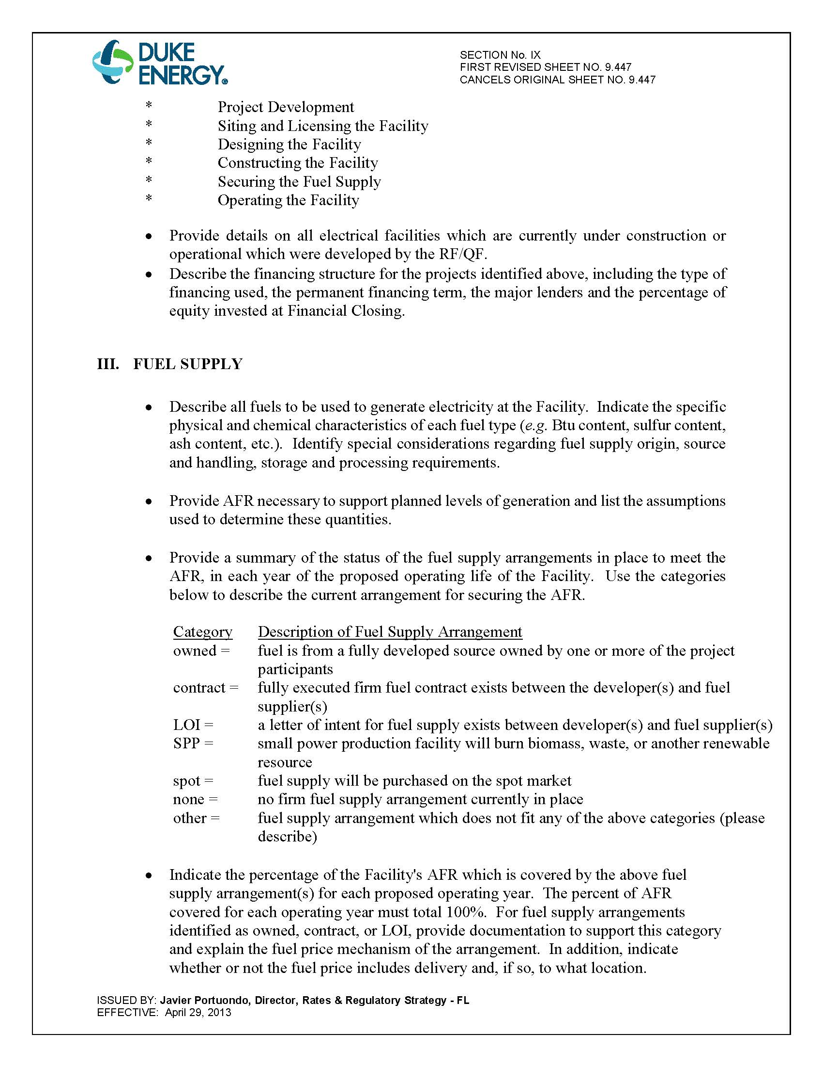

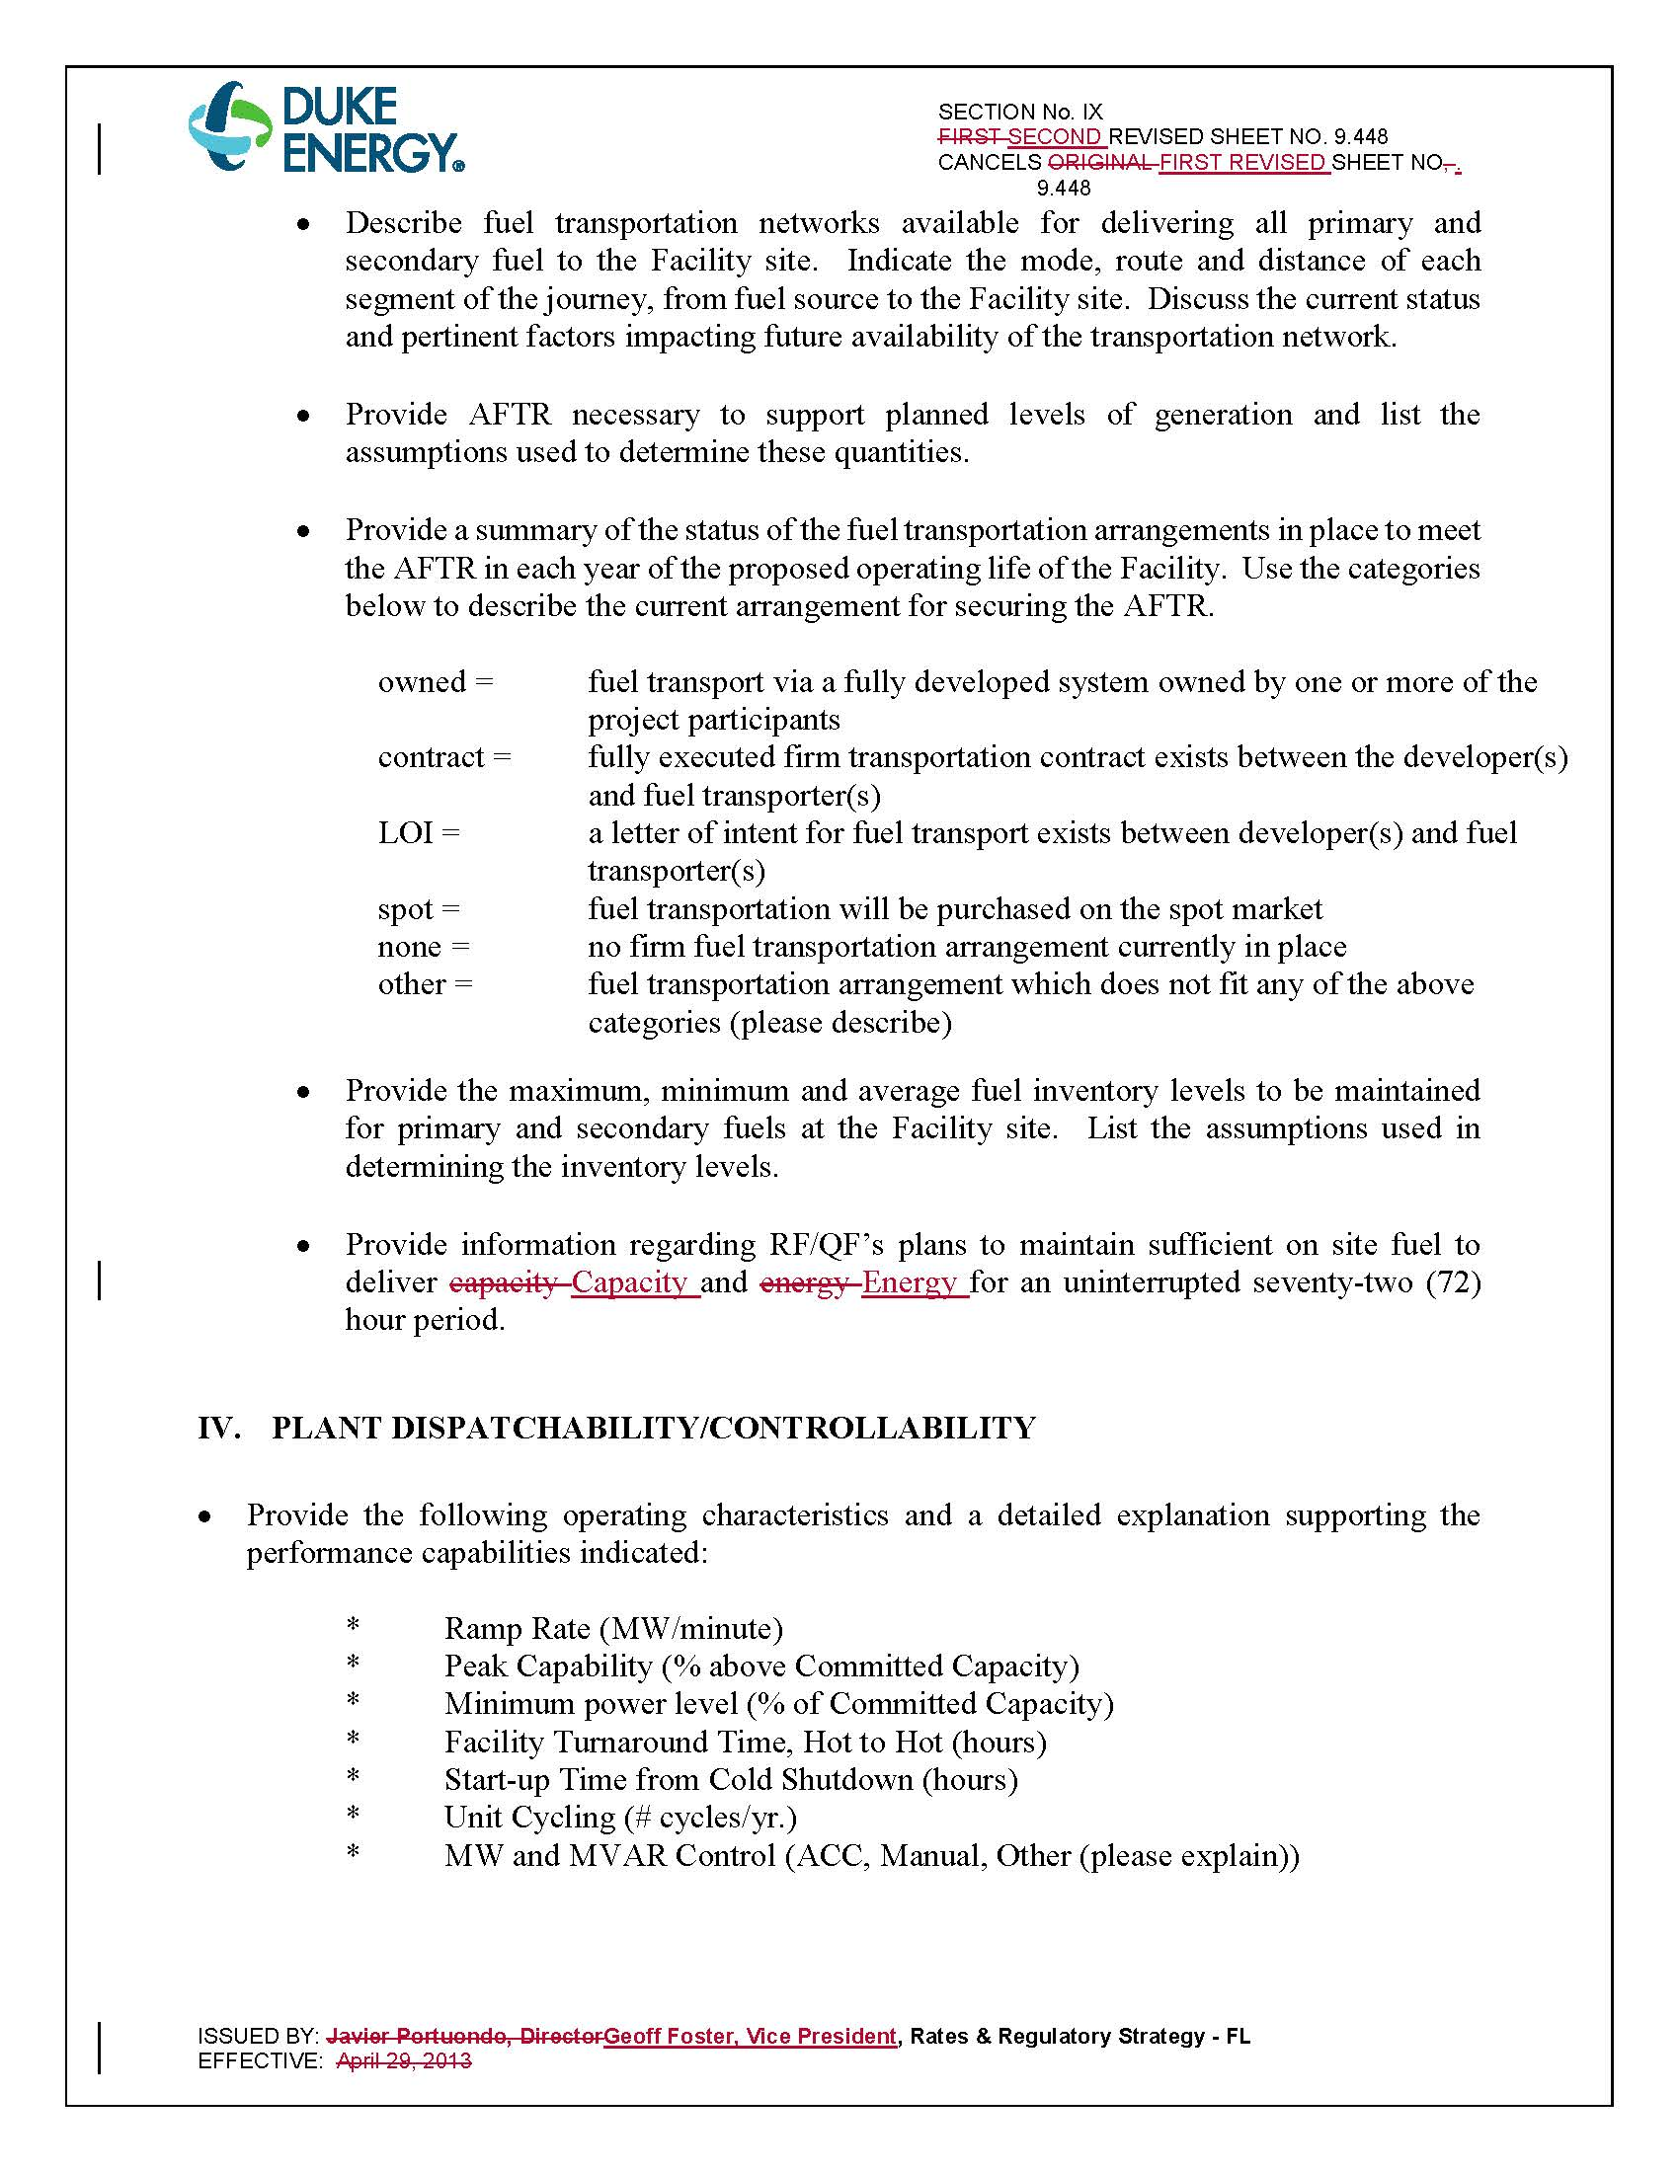

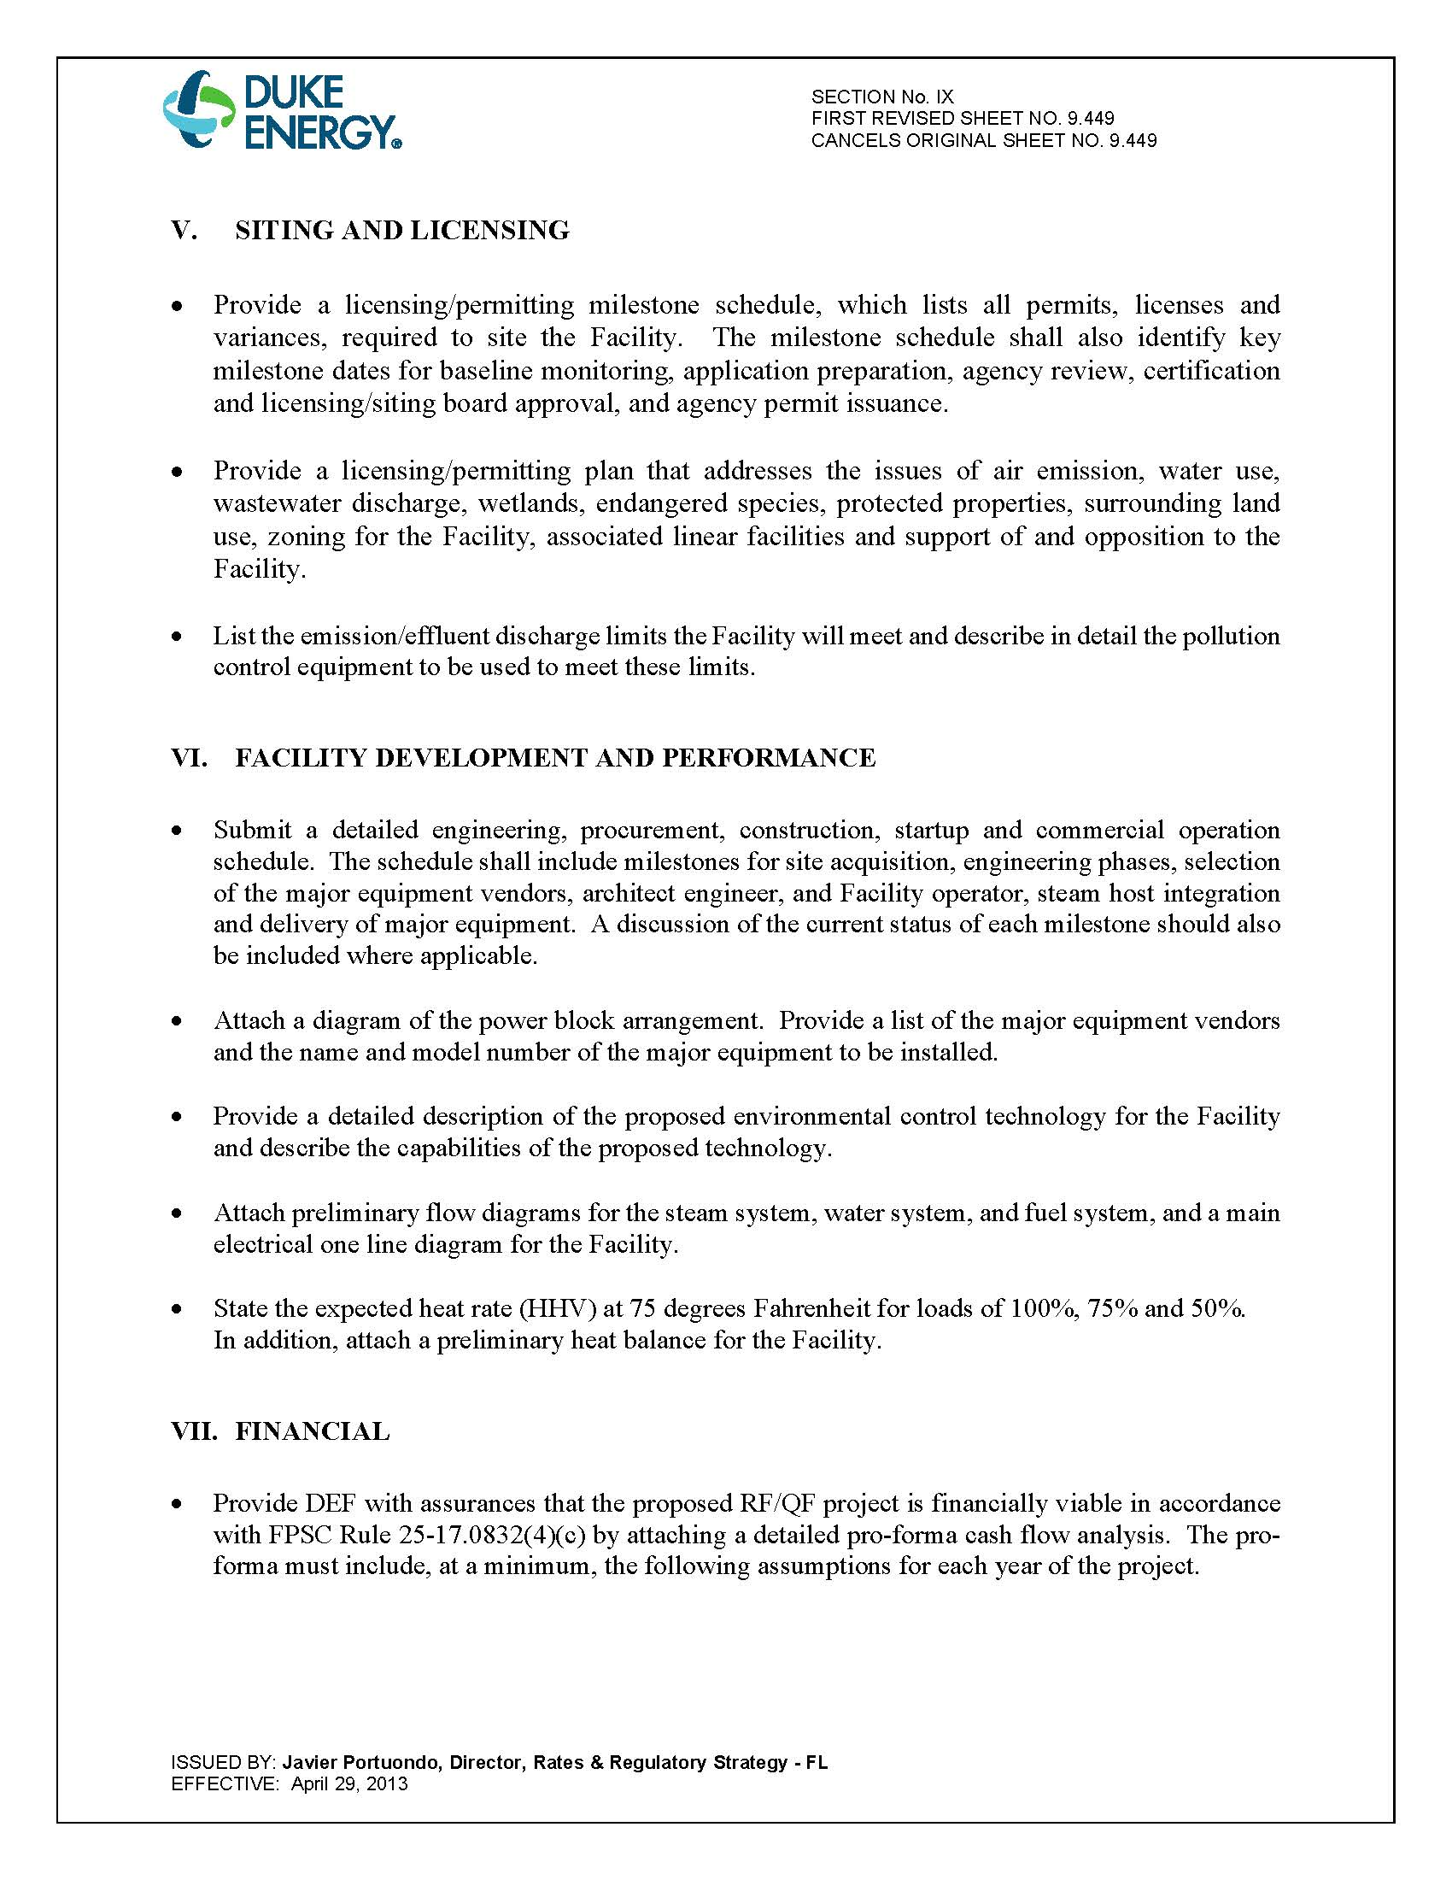

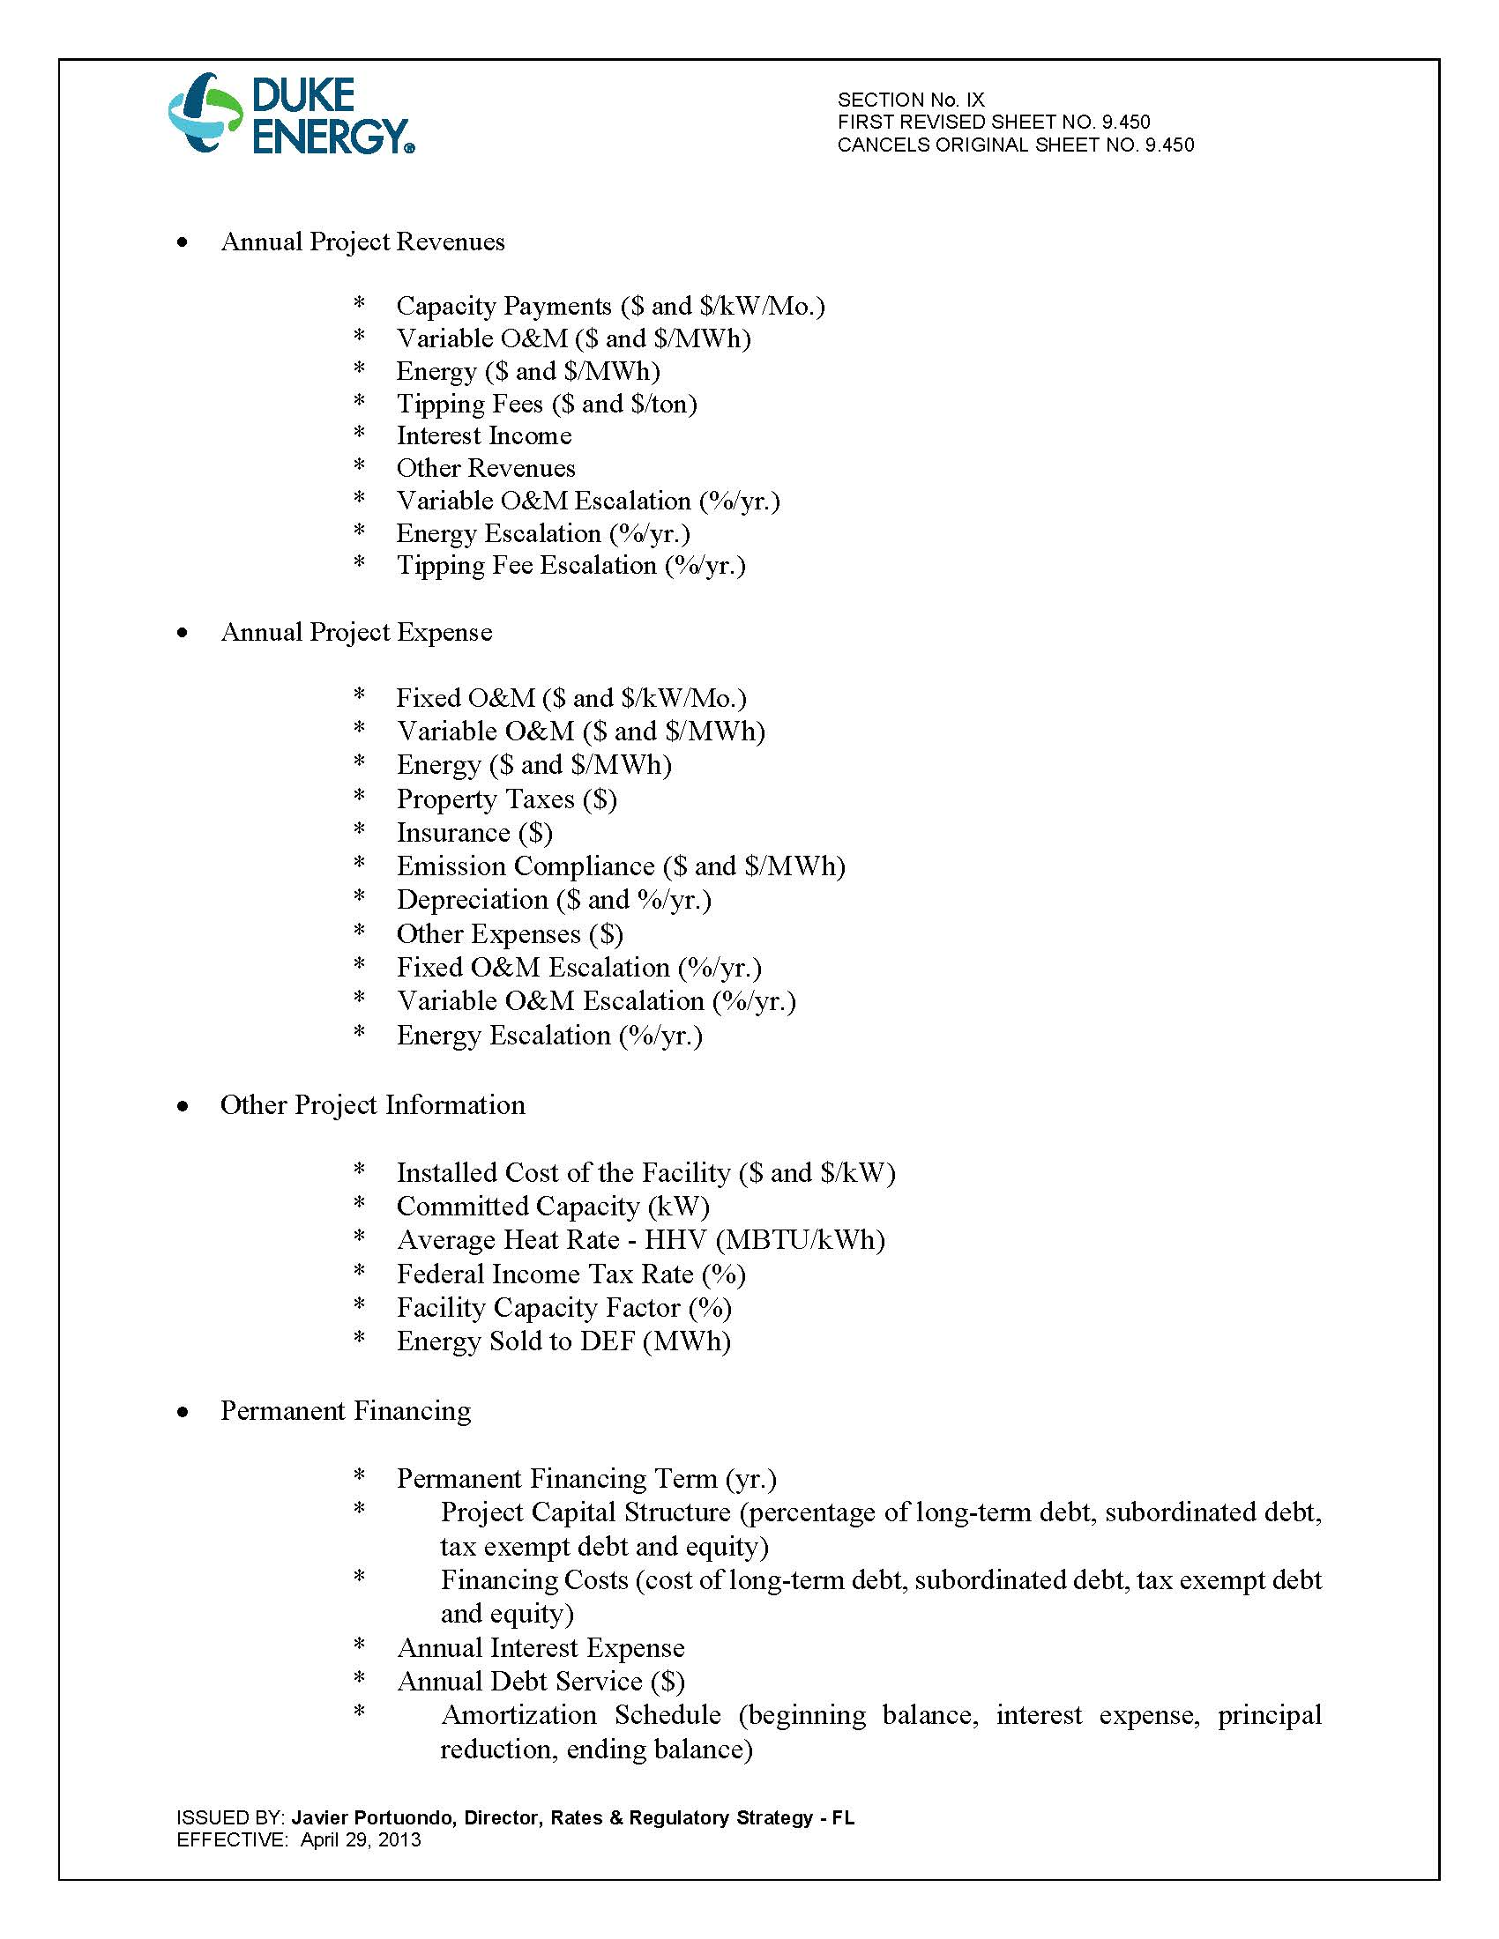

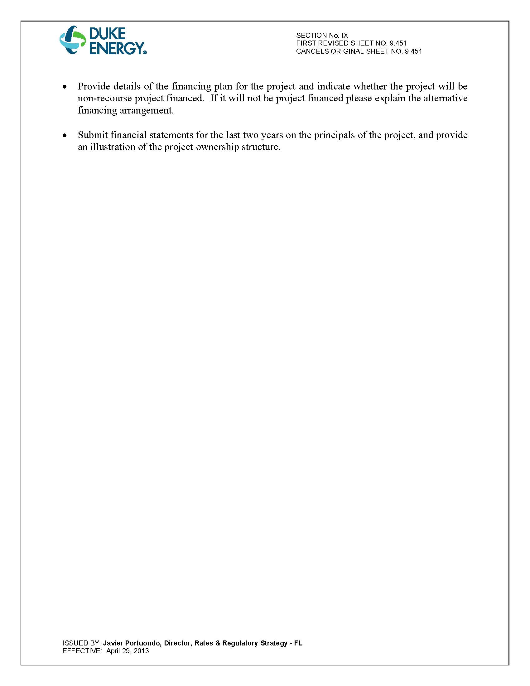

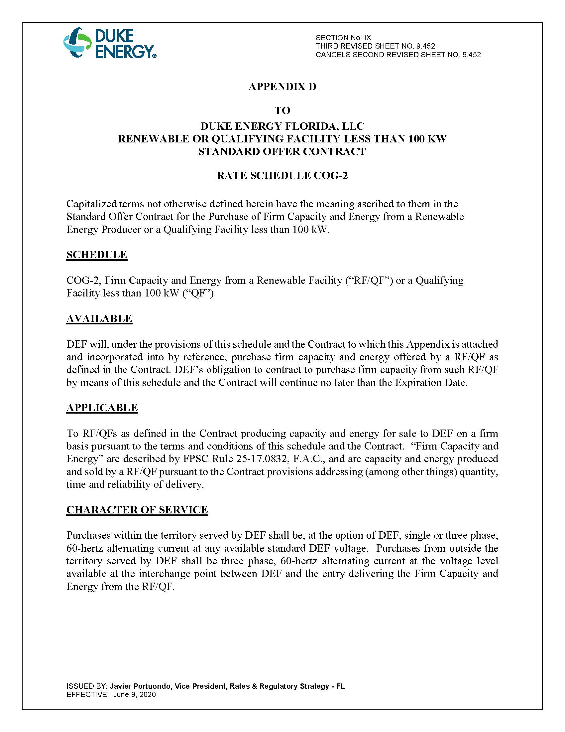

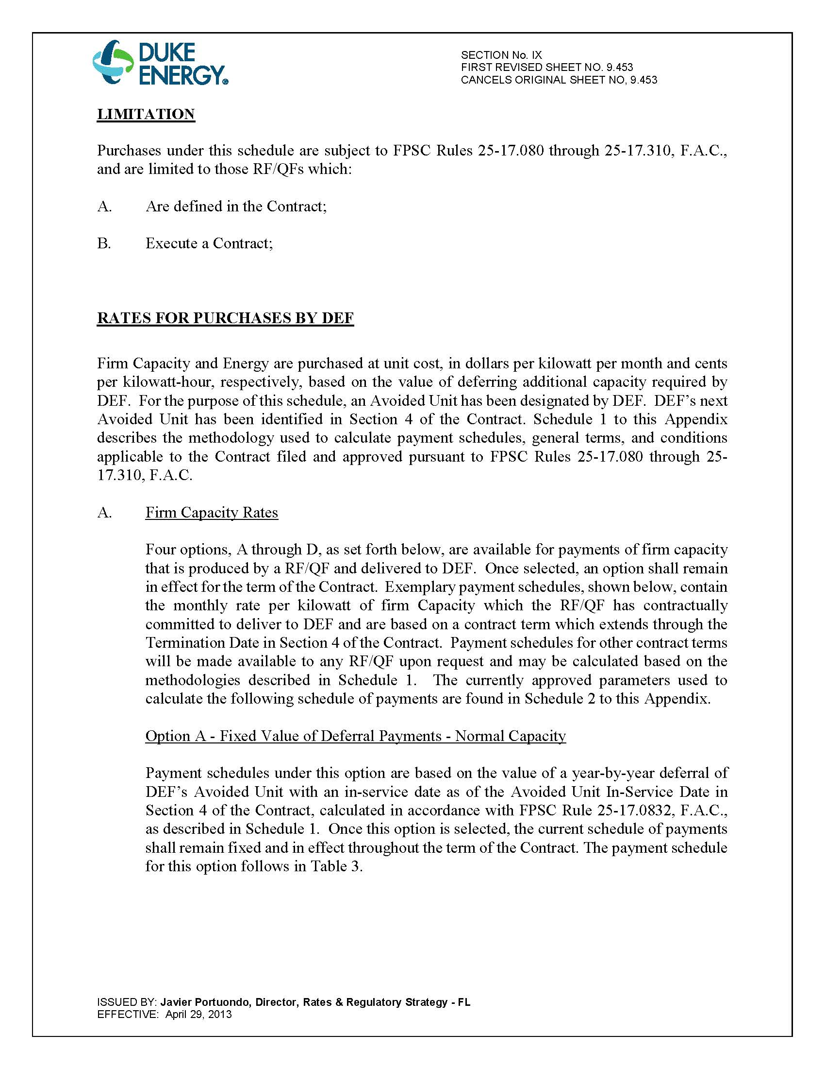

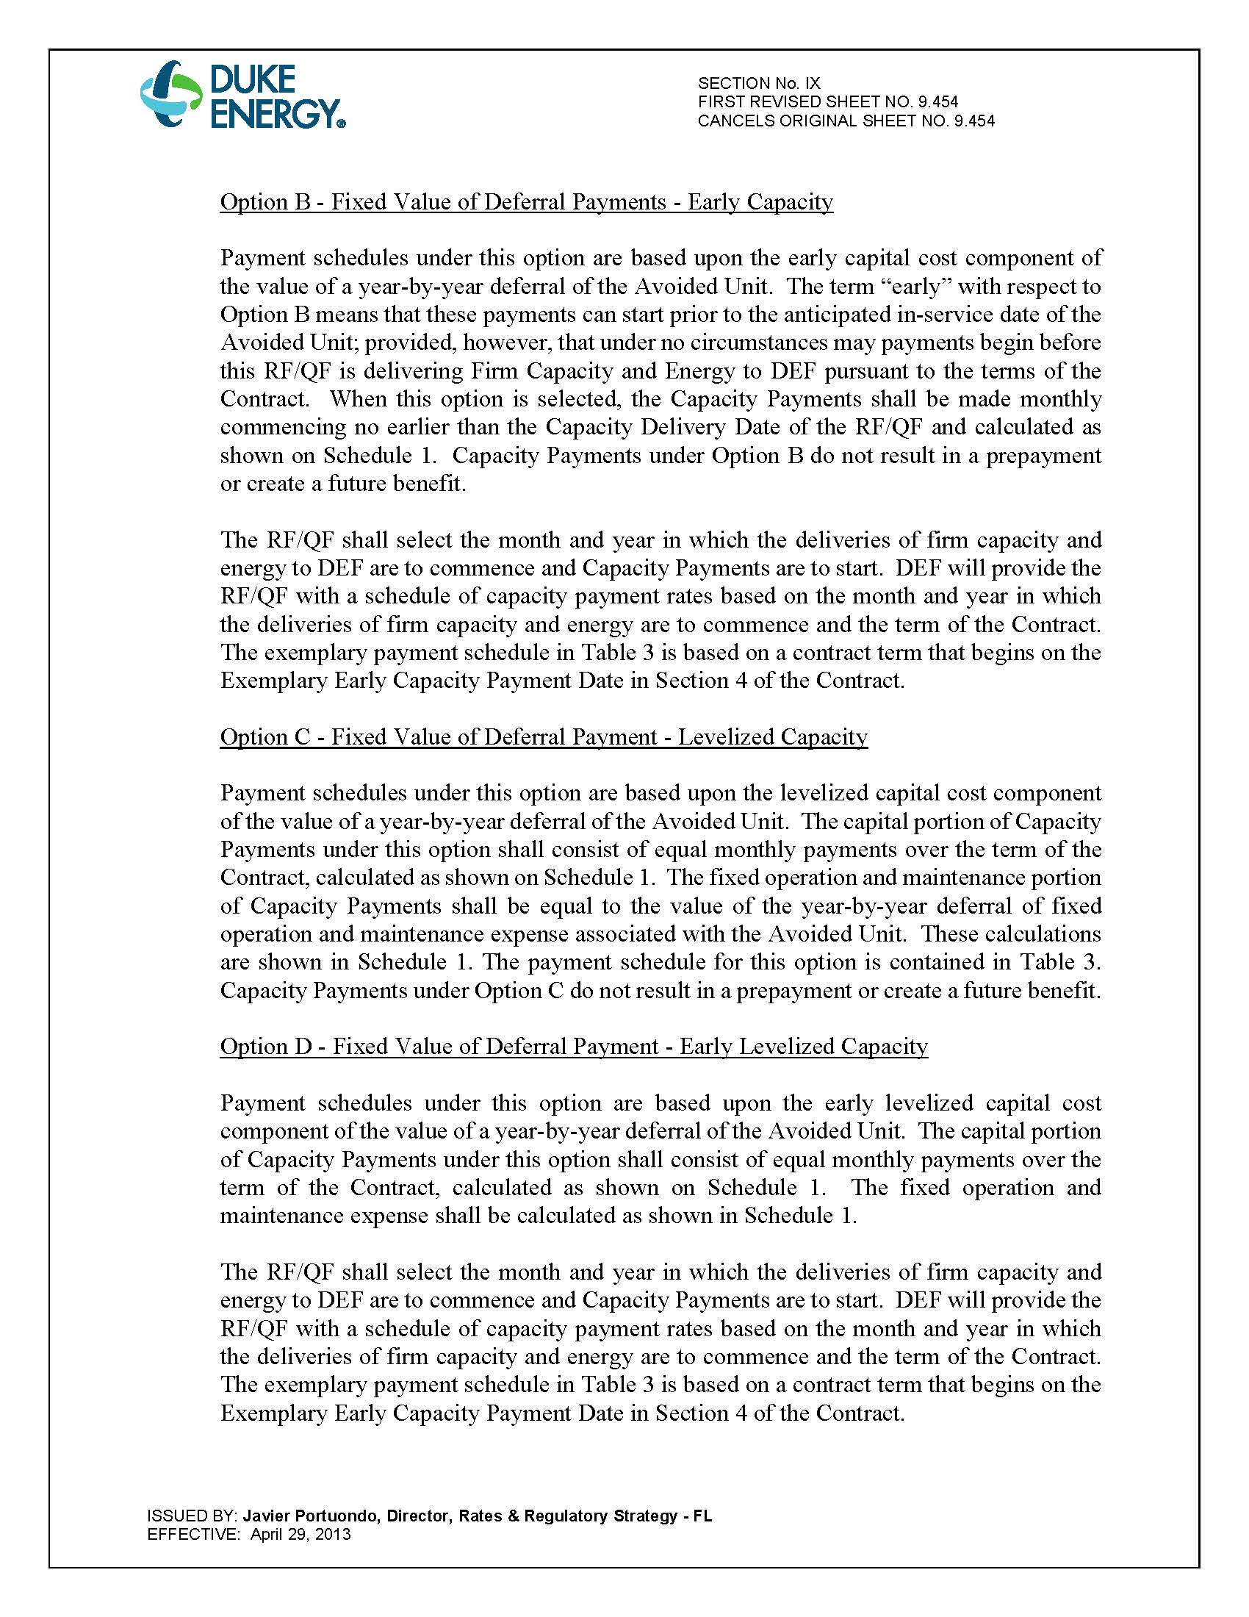

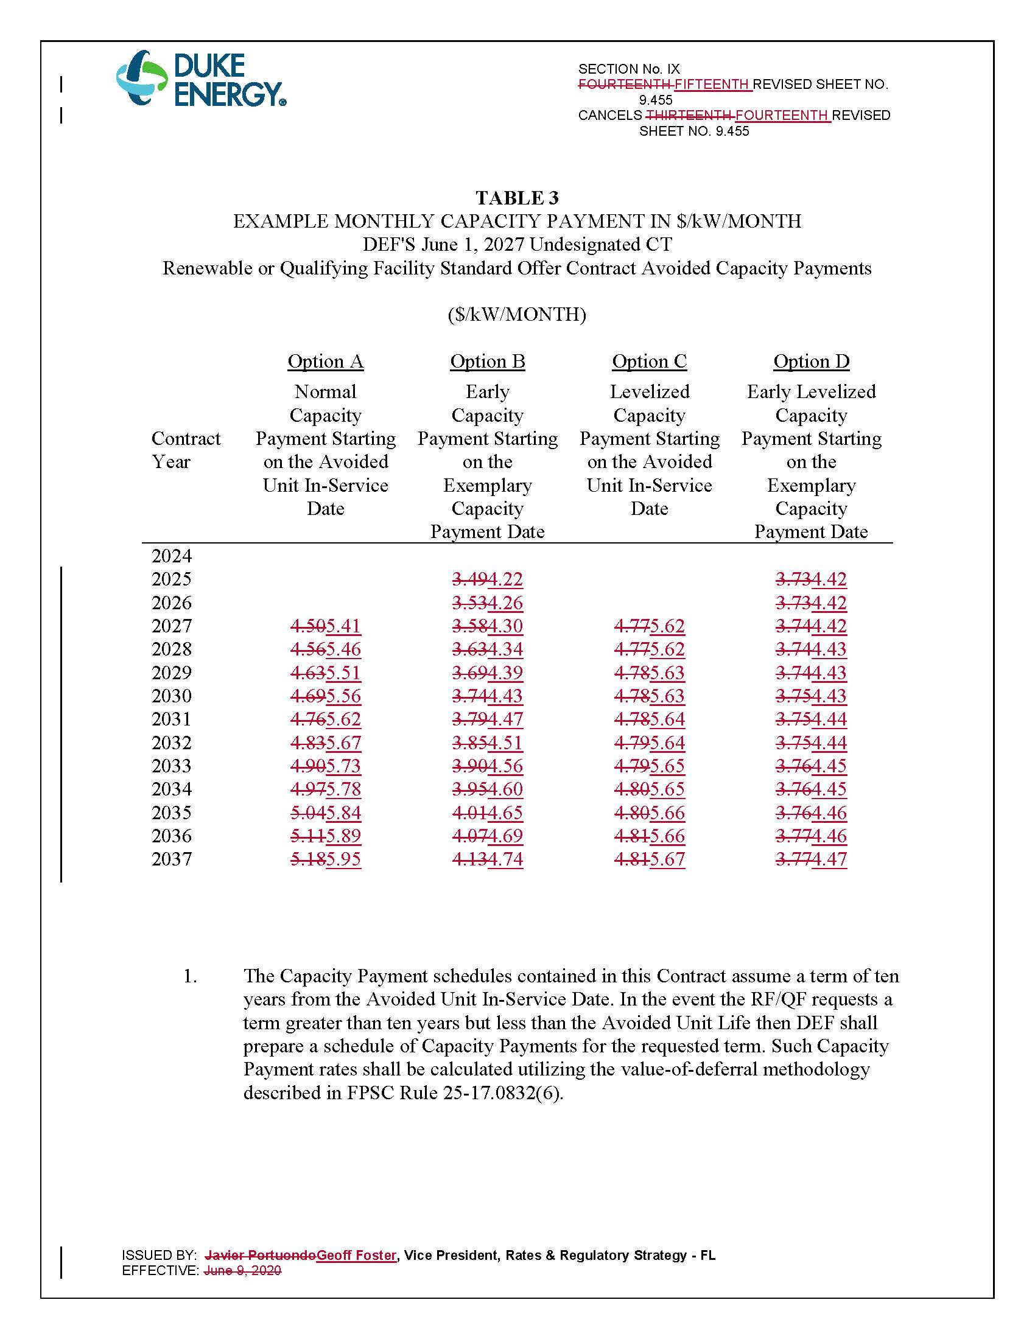

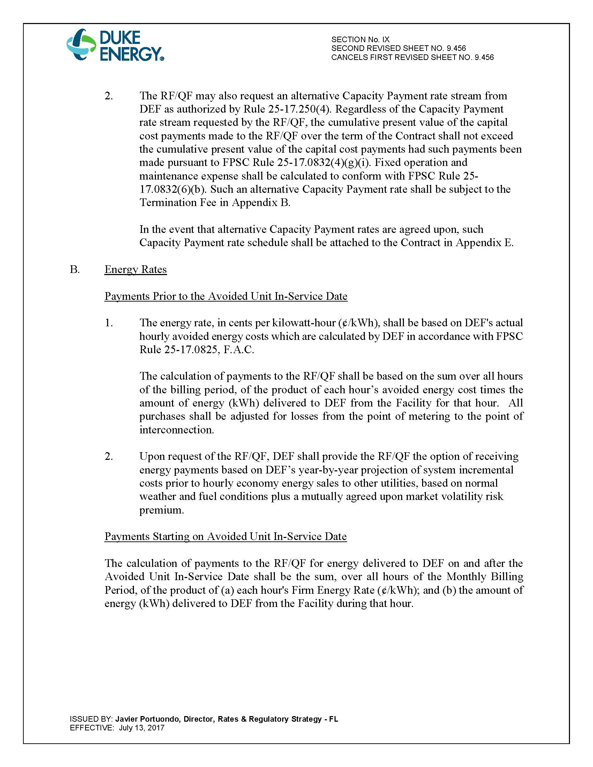

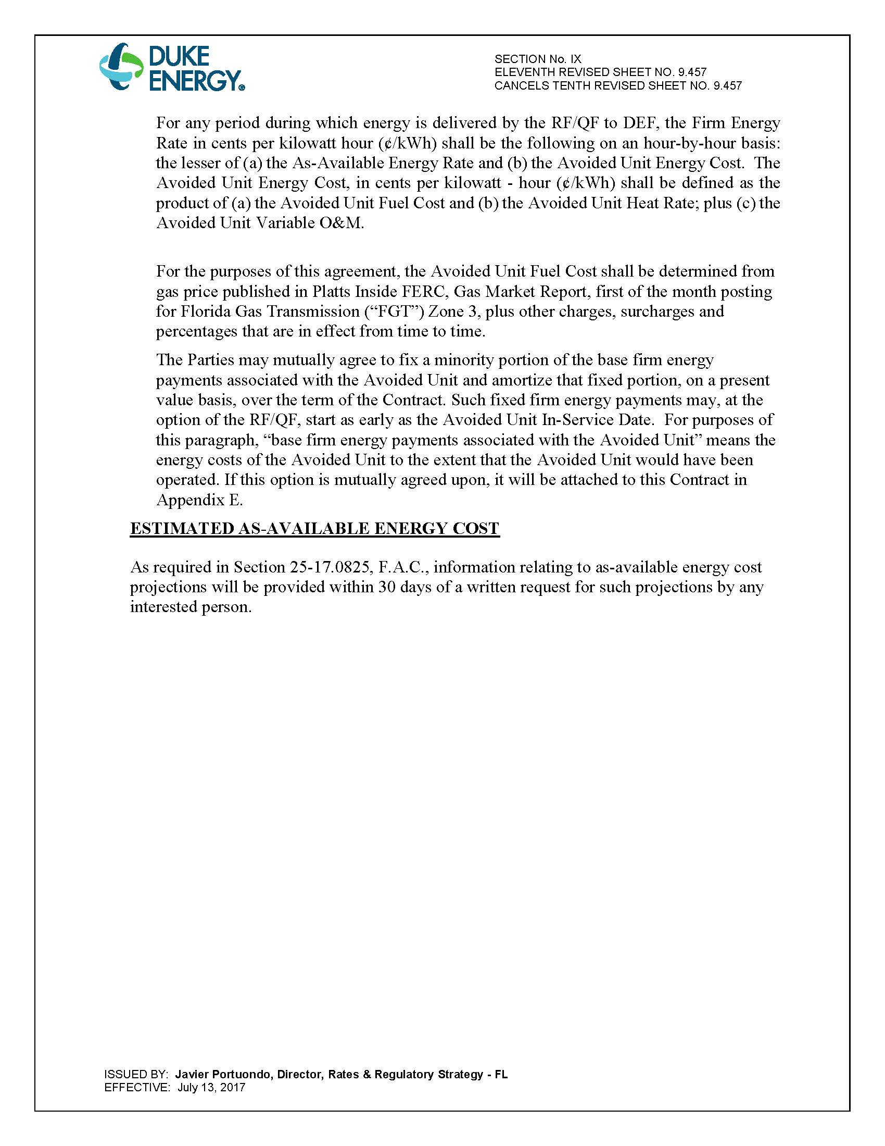

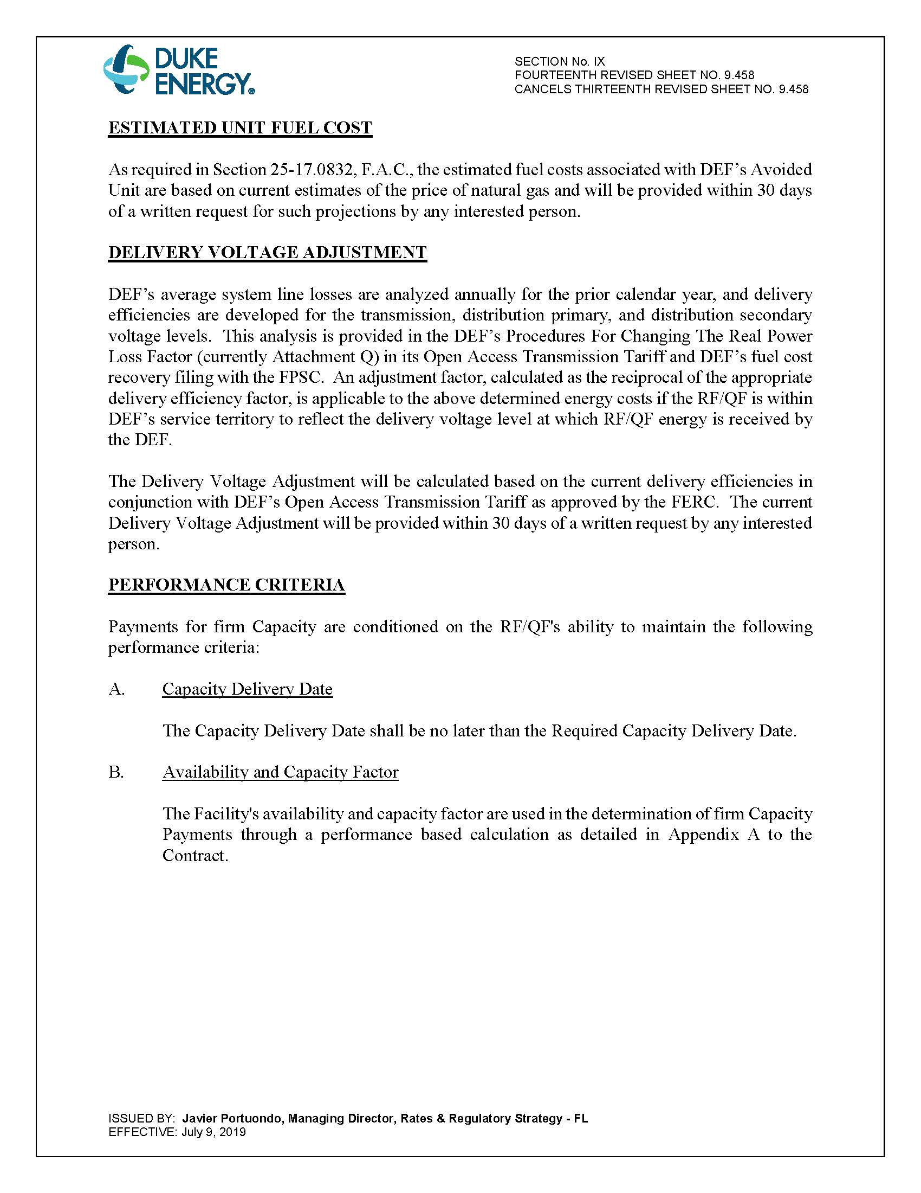

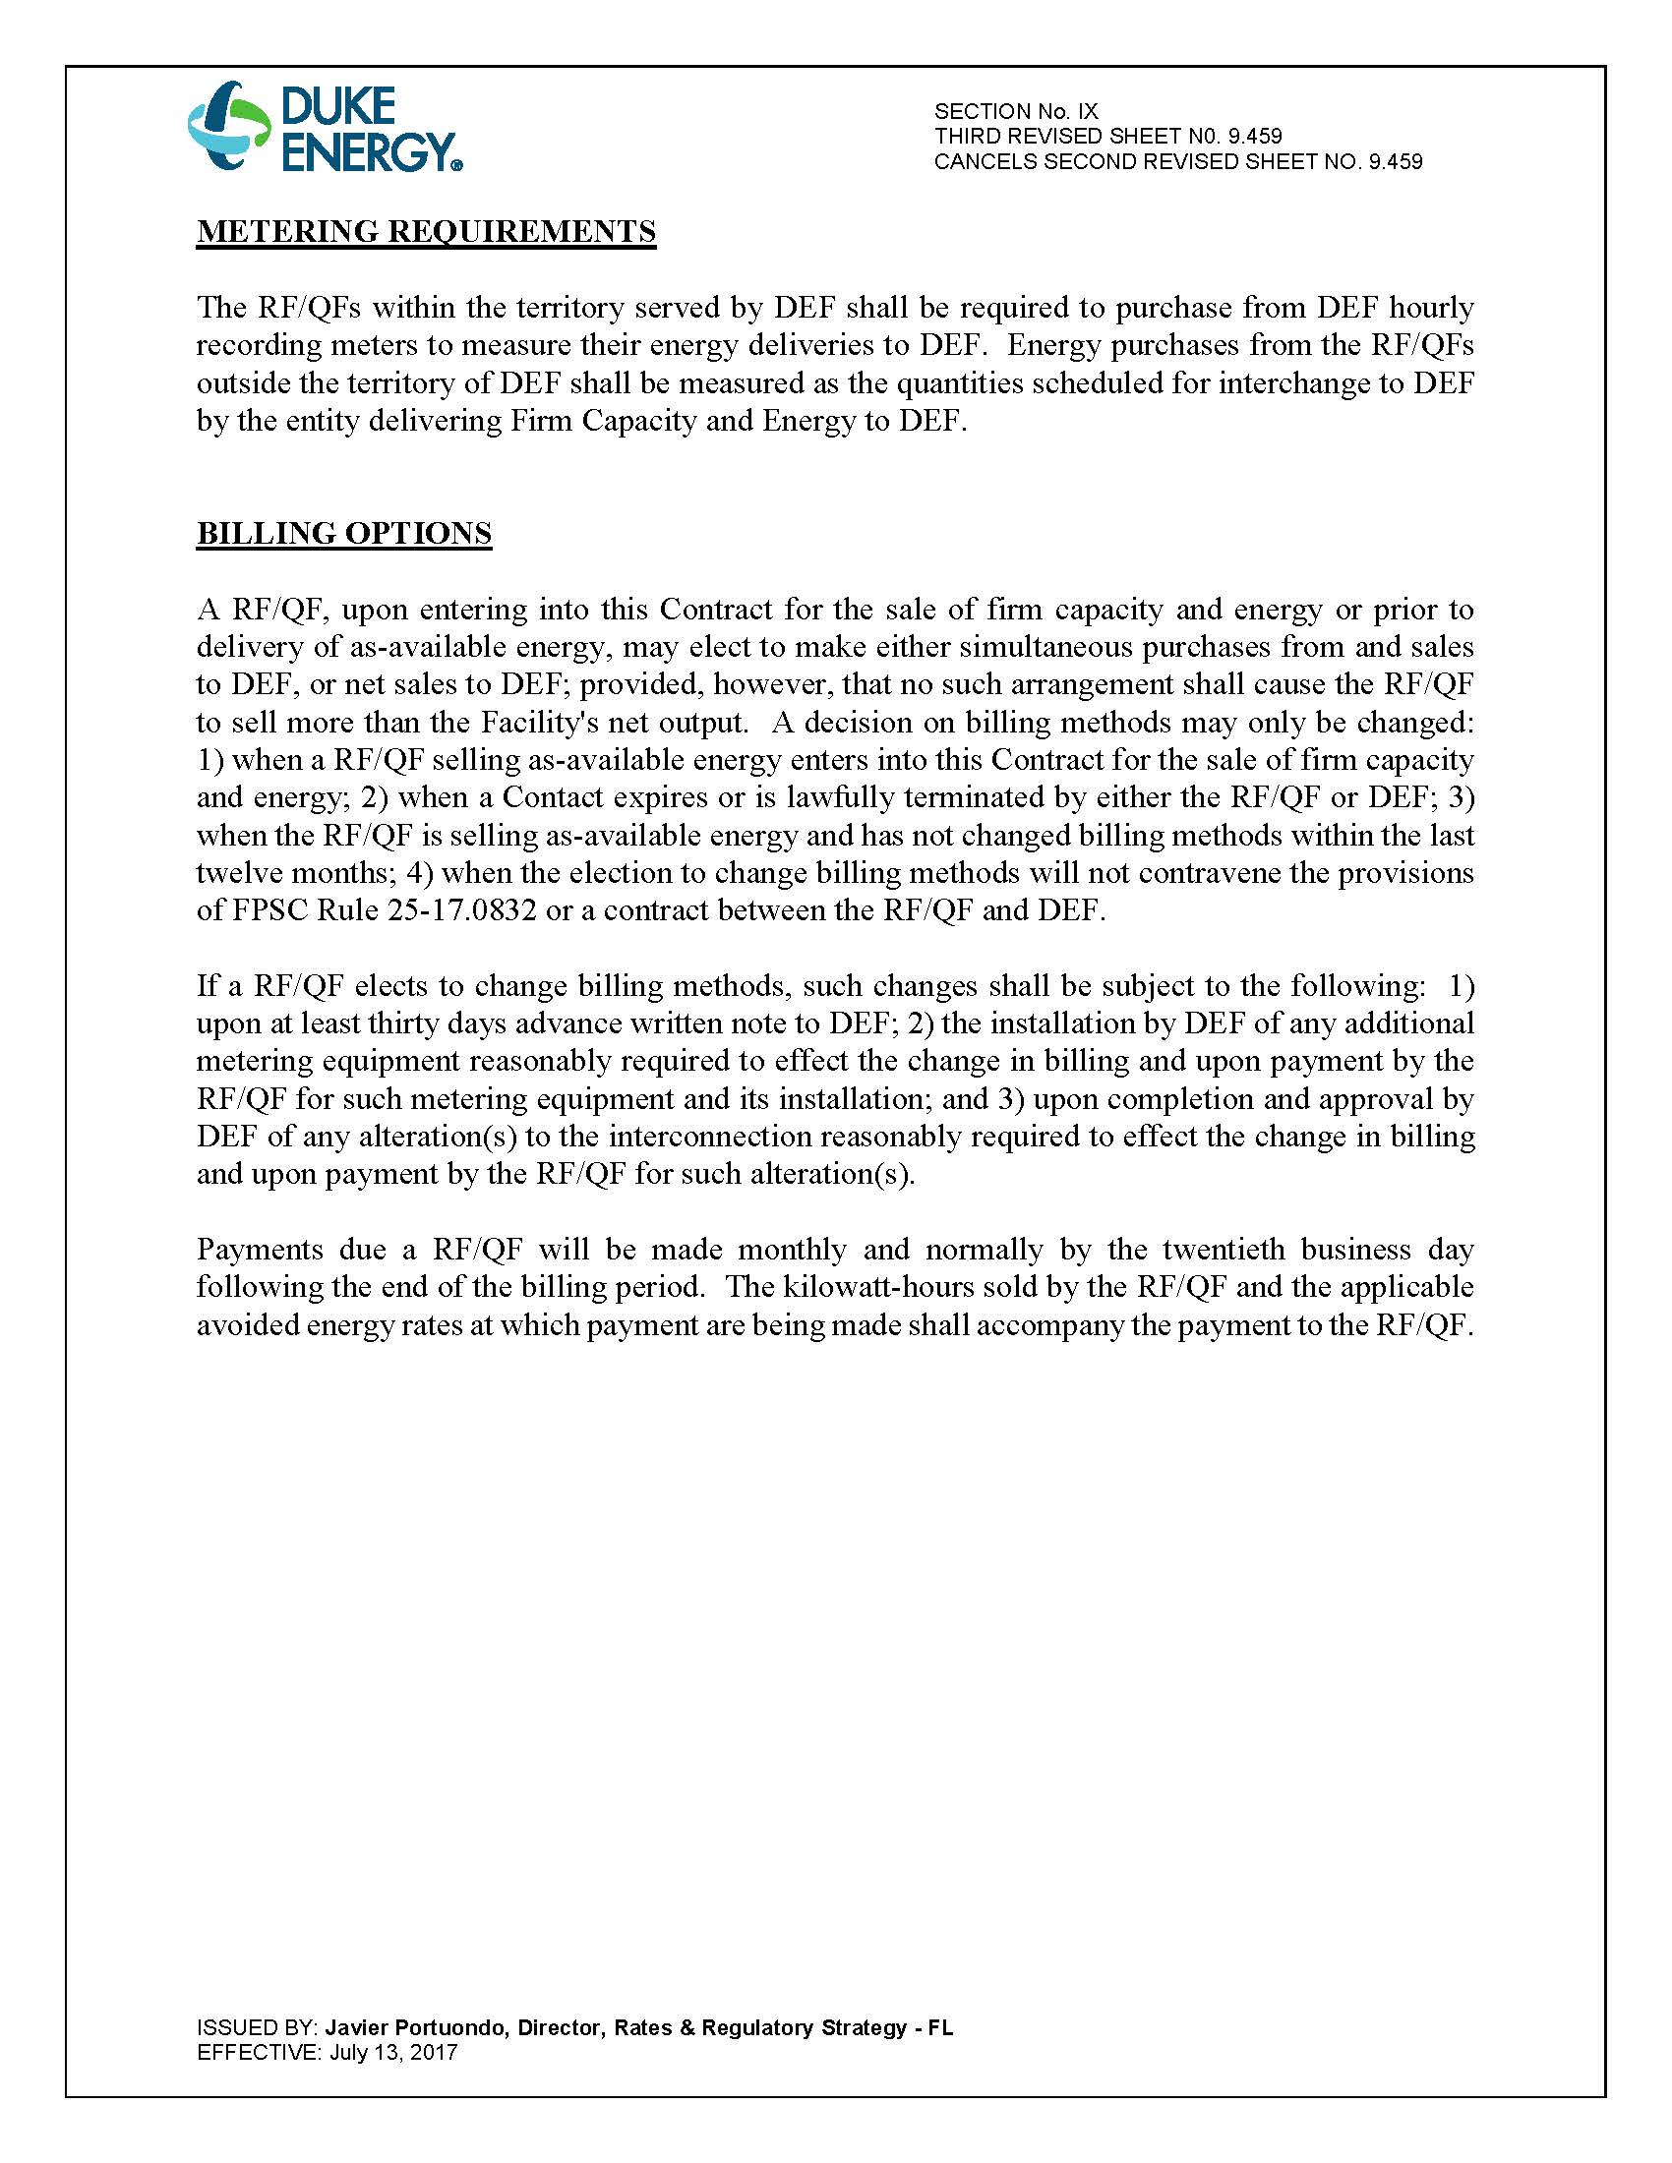

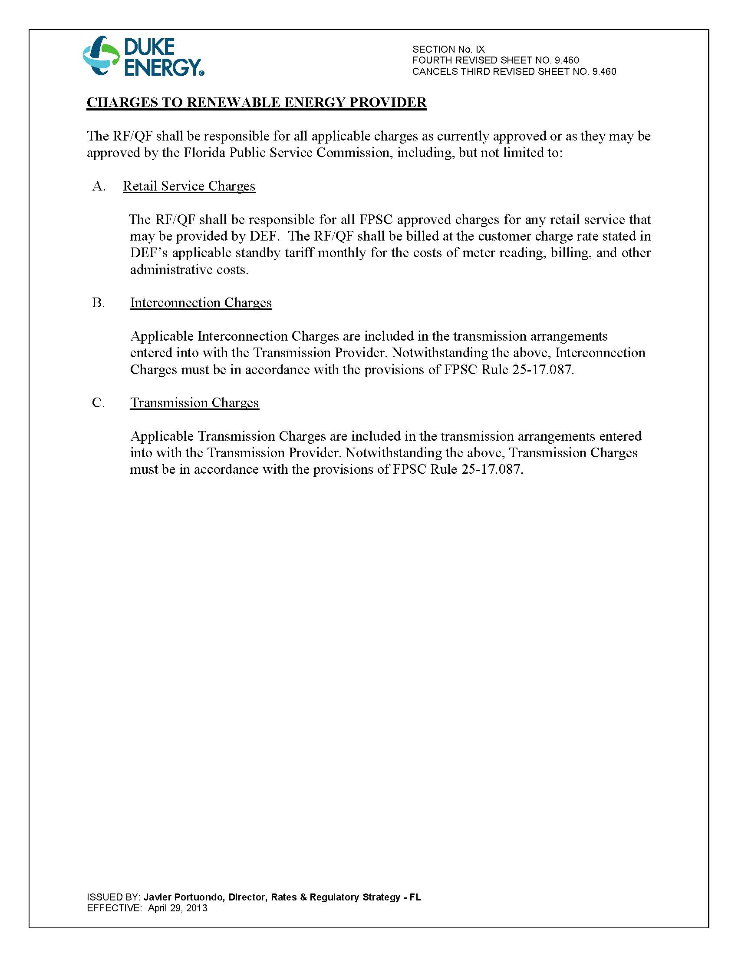

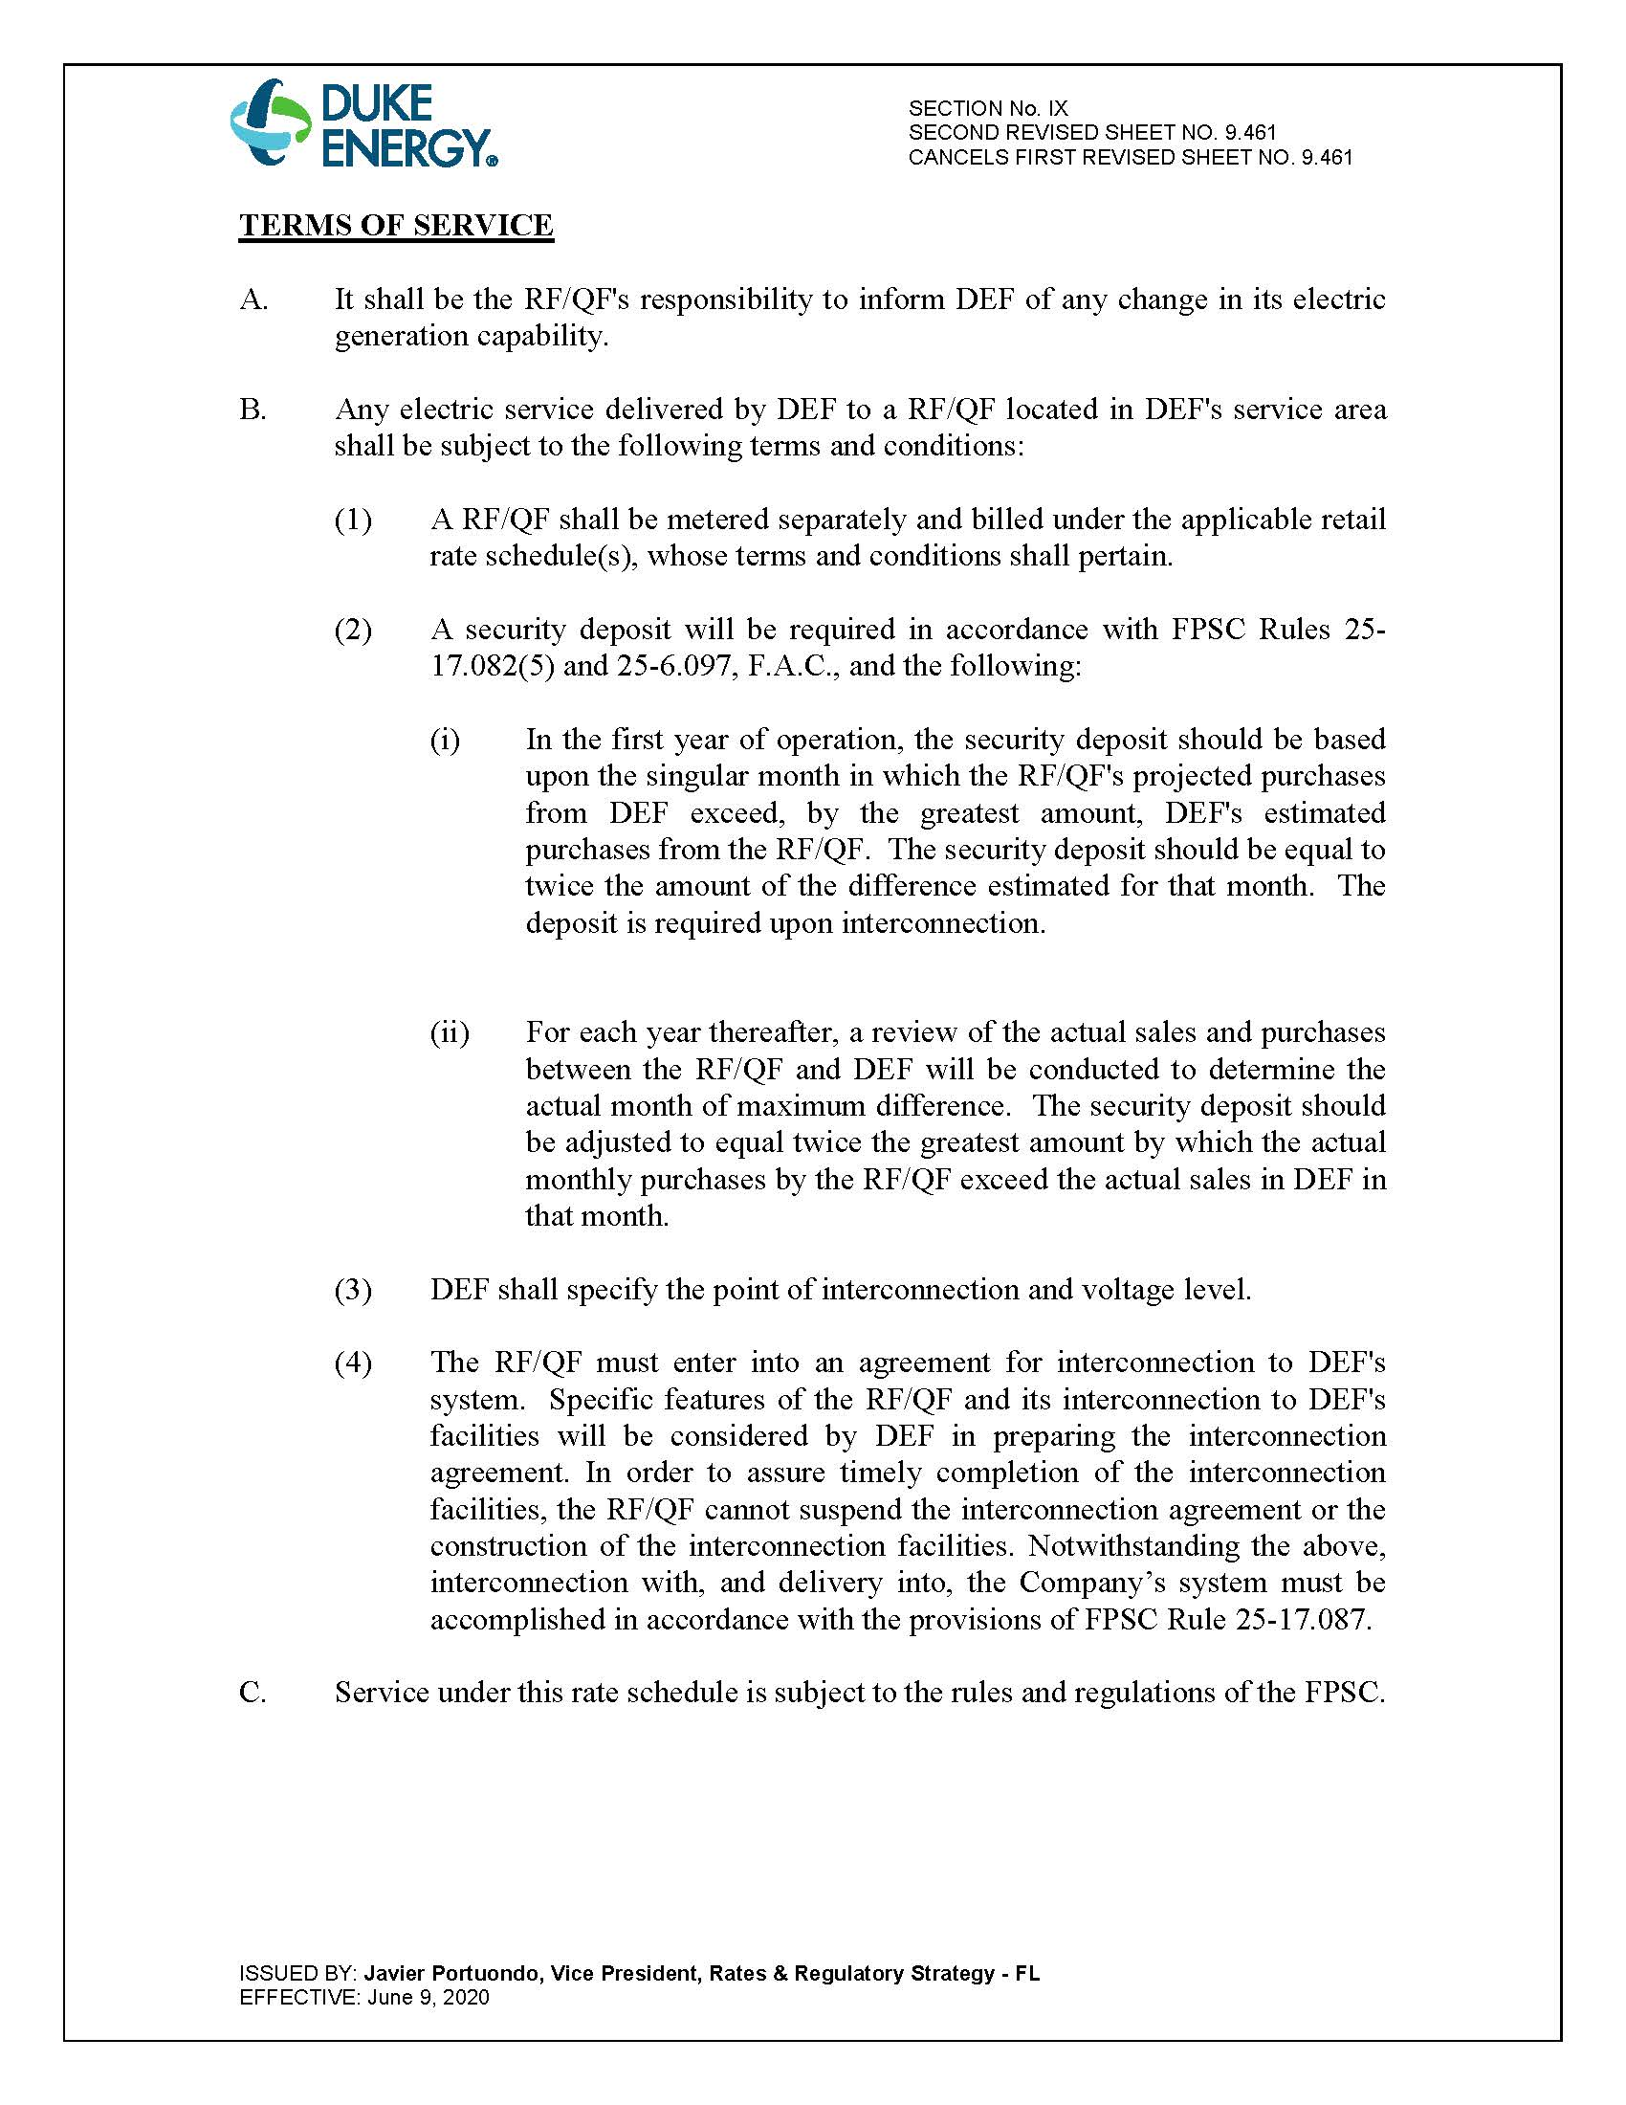

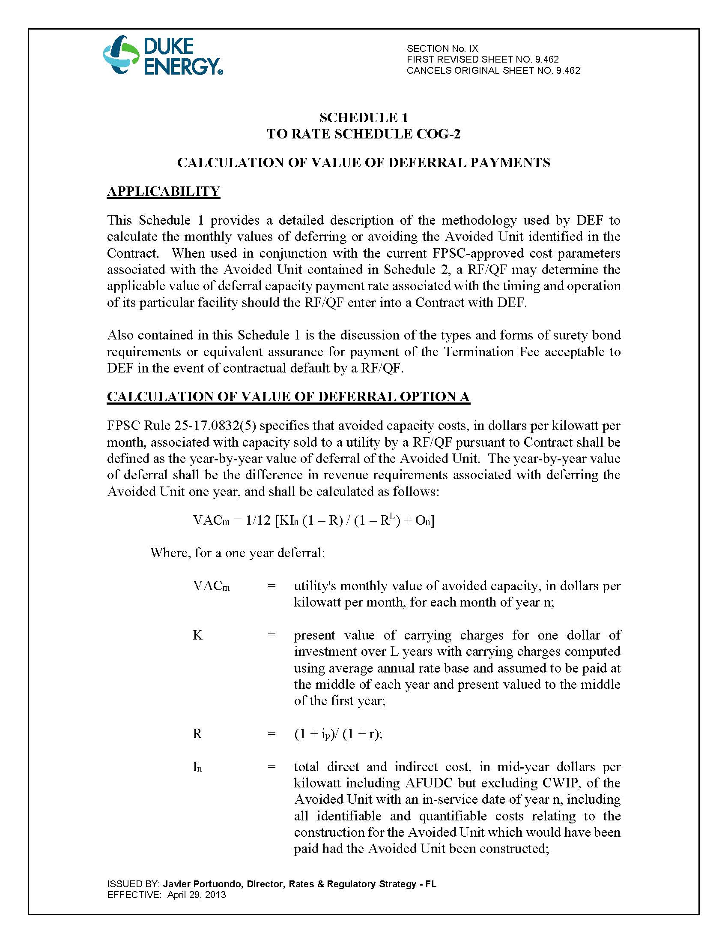

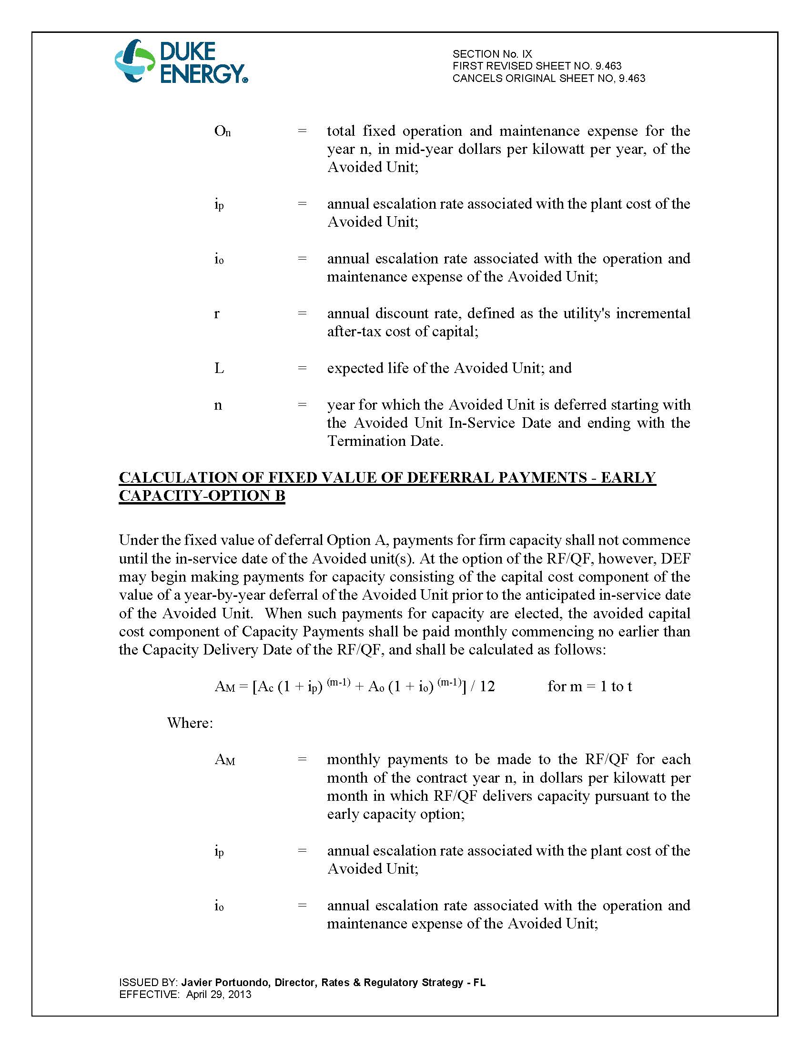

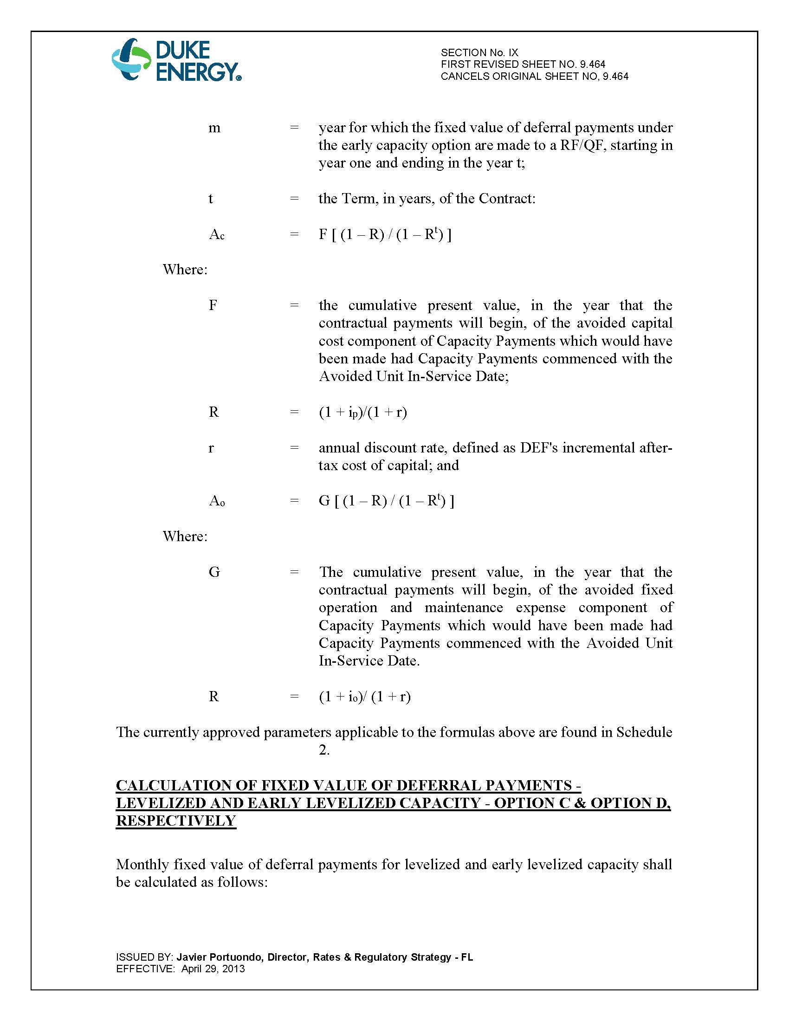

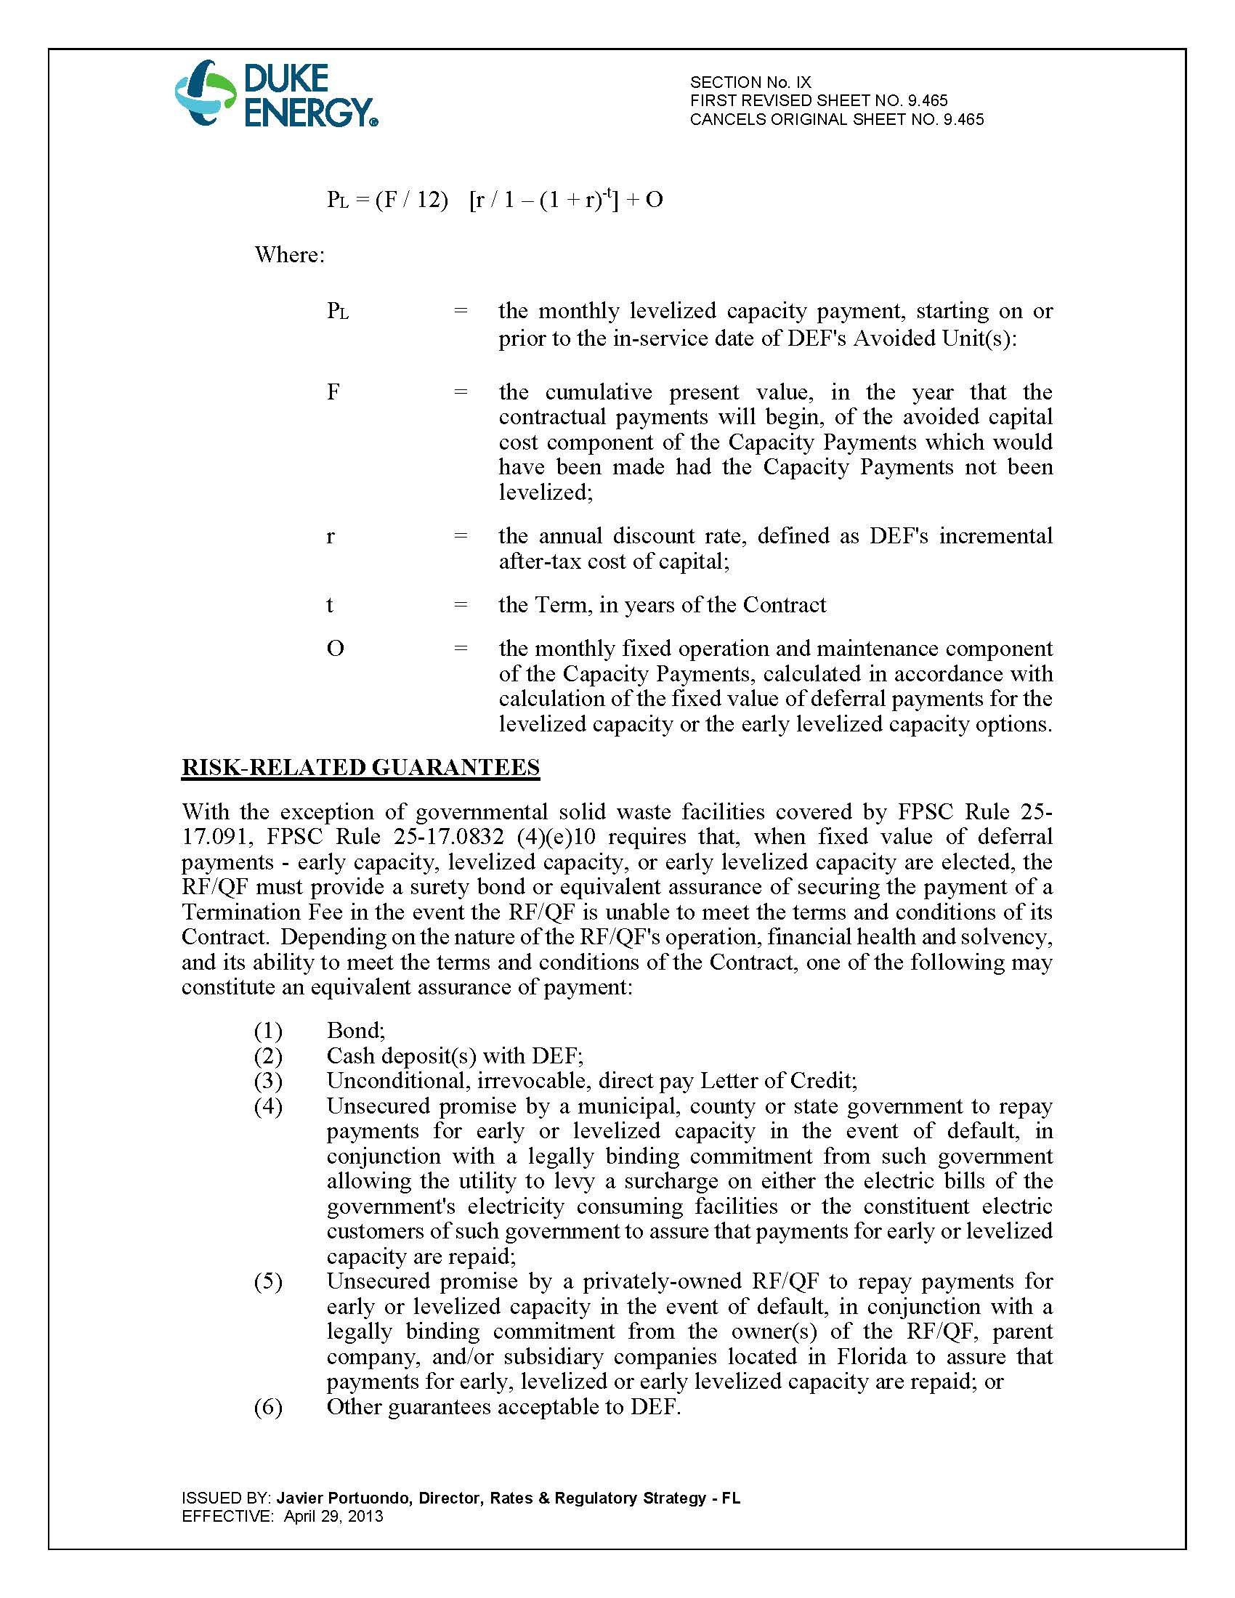

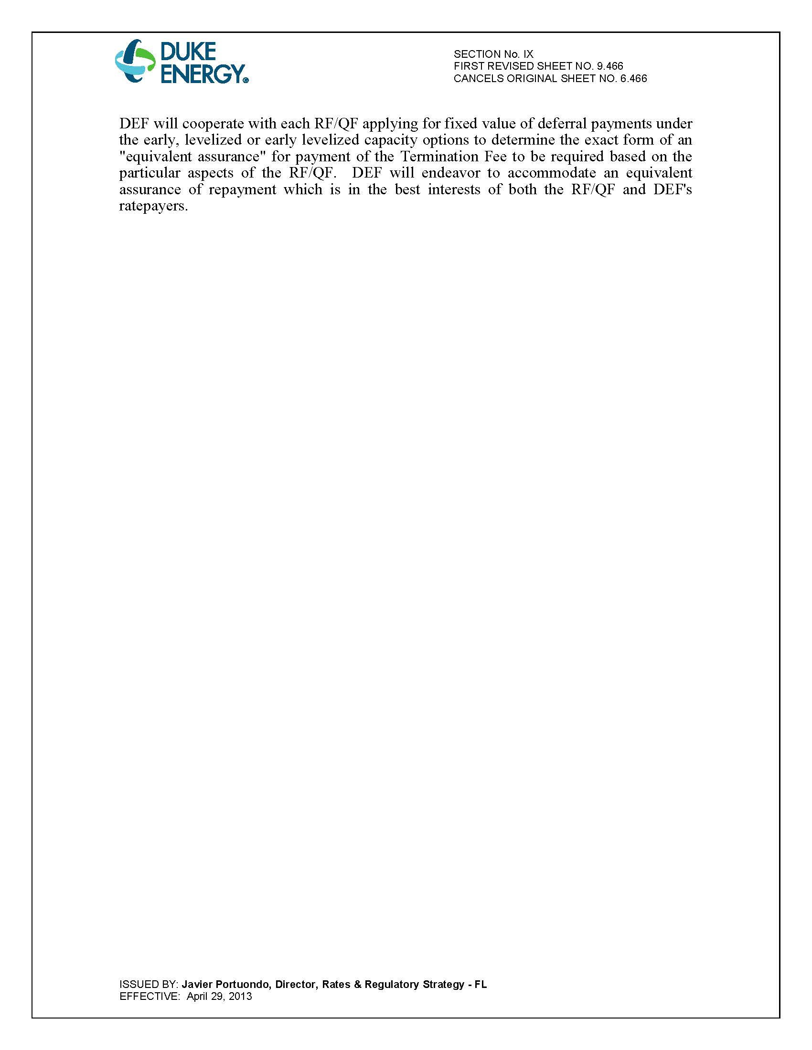

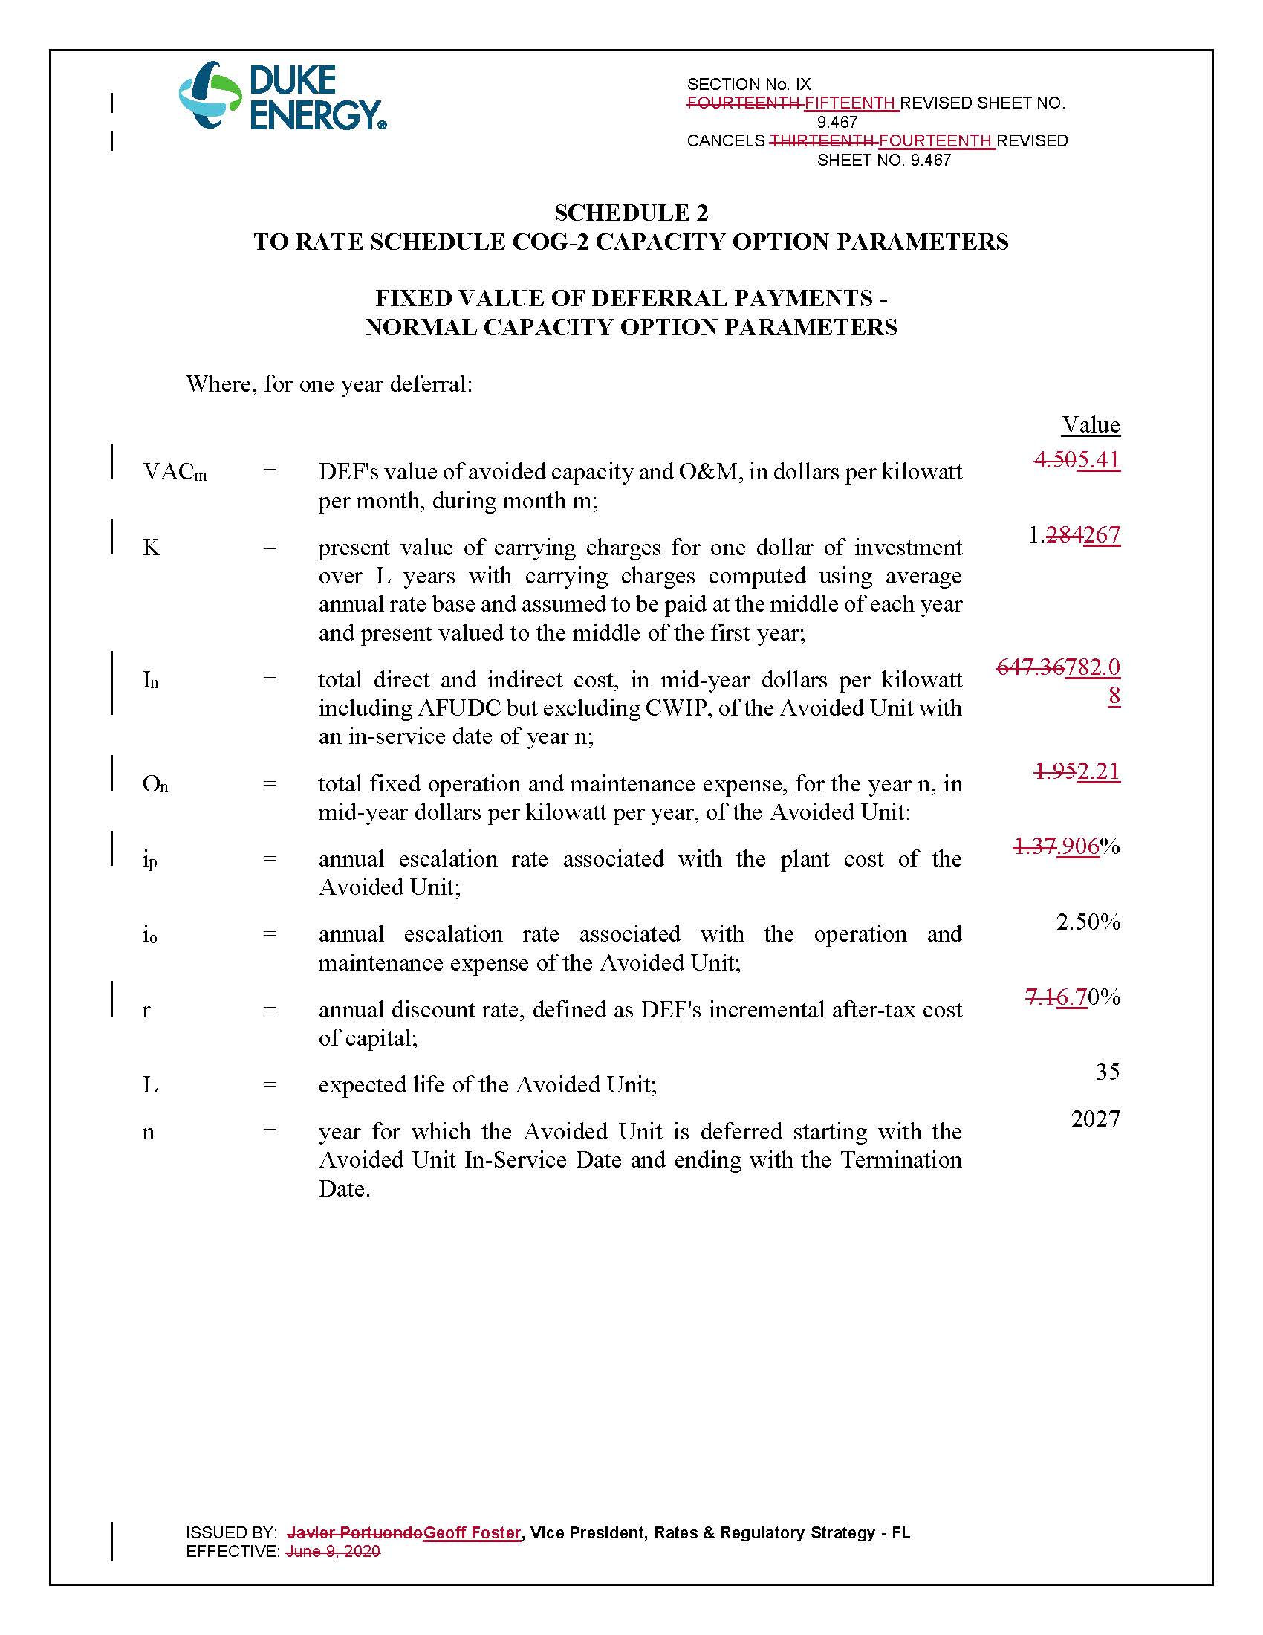

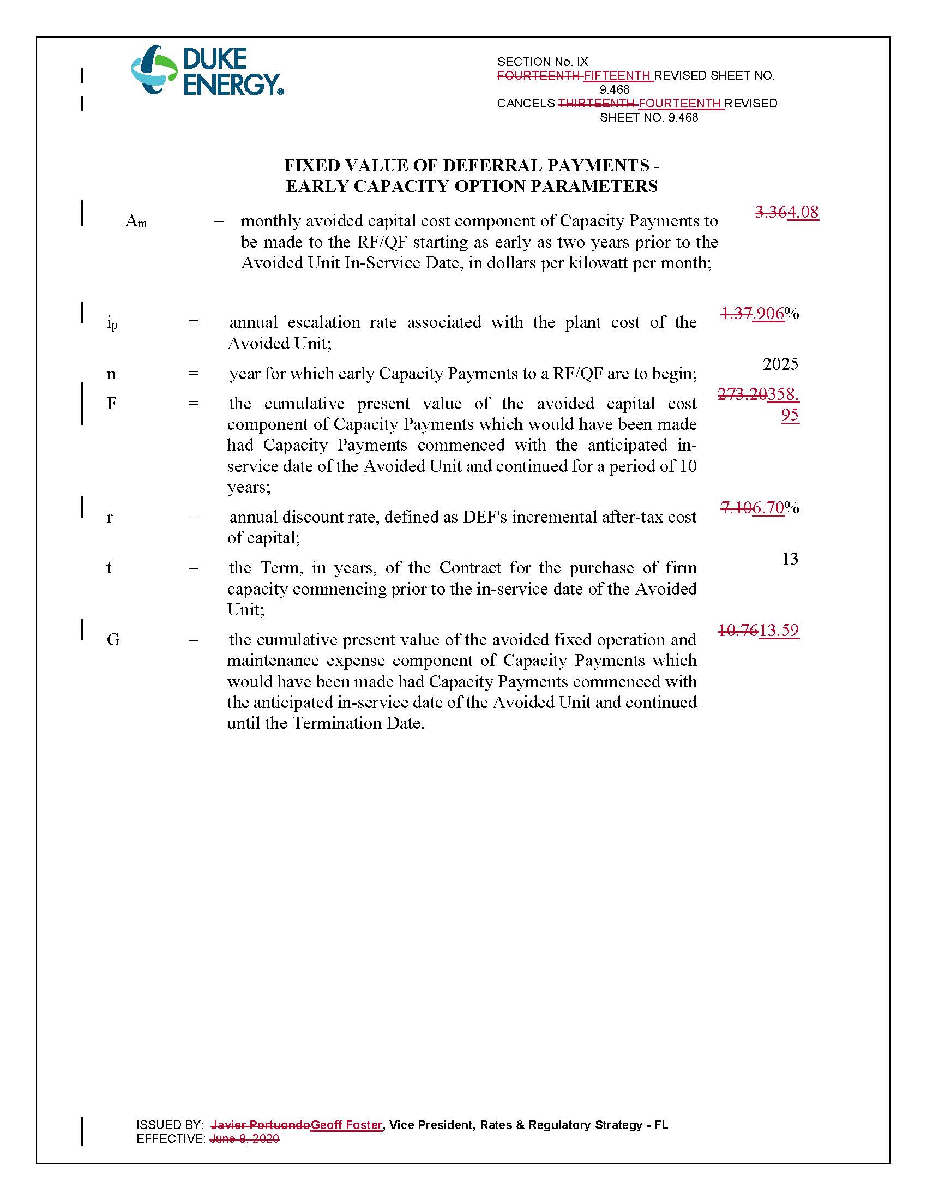

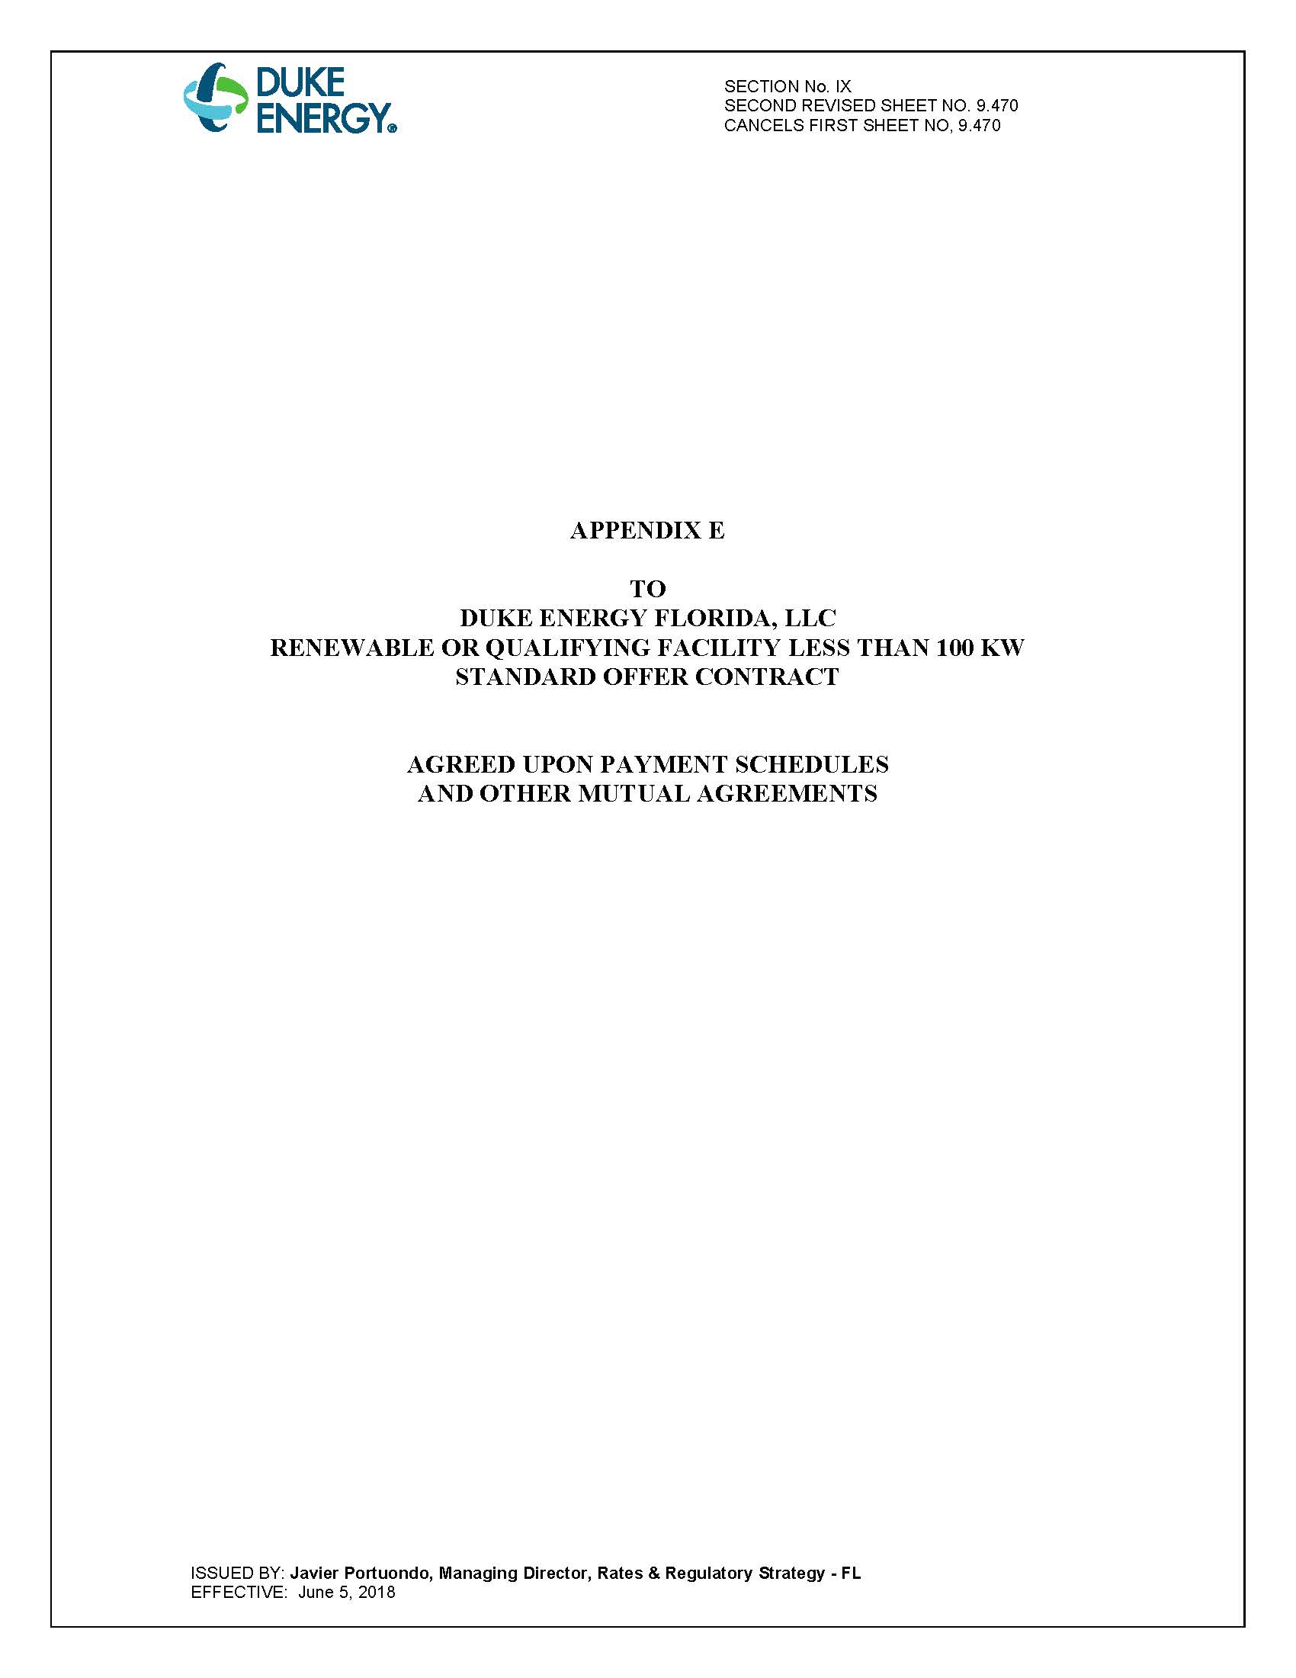

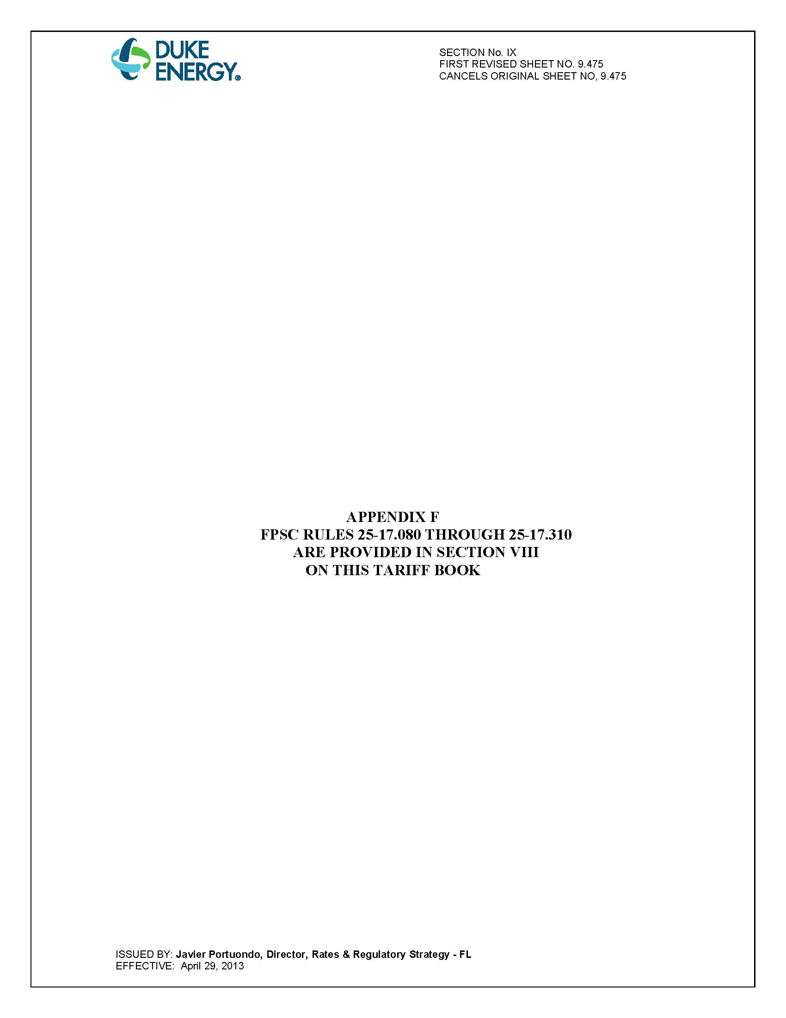

Document No. 03691-2021, filed April 26, 2021, in Docket No. 20210065-EQ.

