BEFORE THE FLORIDA PUBLIC SERVICE COMMISSION

In re: Petition for approval of standard offer contract and request for temporary waiver of rule on annual filing, by Florida Public Utilities Company. | DOCKET NO. 20210068-EQ  ORDER NO. PSC-2021-0234-PAA-EQ  ISSUED: June 29, 2021

The following Commissioners participated in the disposition of this matter:

GARY F. CLARK, Chairman
ART GRAHAM
ANDREW GILES FAY
MIKE LA ROSA
GABRIELLA PASSIDOMO

NOTICE OF PROPOSED AGENCY ACTION
ORDER GRANTING TEMPORARY WAIVER
OF RULE 25-17.250(1), FLORIDA ADMINISTRATIVE CODE, AND
ORDER APPROVING FLORIDA PUBLIC UTILITY COMPANY’S
STANDARD OFFER CONTRACT AND SCHEDULE

BY THE COMMISSION:

NOTICE is hereby given by the Florida Public Service Commission that the action discussed herein is preliminary in nature and will become final unless a person whose interests are substantially affected files a petition for a formal proceeding, pursuant to Rule 25-22.029, Florida Administrative Code (F.A.C.).

Background
Section 366.91(3), Florida Statutes (F.S.), requires each investor-owned utility (IOU) to continuously offer to purchase capacity and energy from renewable generating facilities and small qualifying facilities. Florida Public Service Commission (Commission) Rules 25-17.200 through 25-17.310, Florida Administrative Code (F.A.C.), implement the statute and require each IOU to file with this Commission, by April 1 of each year, a revised standard offer contract based on the next avoidable fossil fueled generating unit of each technology type identified in the utility’s current Ten-Year Site Plan (TYSP). On April l, 2021, Florida Public Utilities Company (FPUC) filed a petition for approval of its standard offer contract and request for temporary waiver of Rule 25-17.250(1), F.A.C. If granted, the rule waiver would allow FPUC to forgo filing a standard offer contract until such a time as the Company enters into a new contract or contracts for power supply to its electric divisions.
FPUC’s standard offer contract filing does not reflect any changes or revisions from the filing approved by Order No. PSC-2020-0166-PAA-EQ. We have jurisdiction over this standard offer contract pursuant to Sections 120.542, 366.04 through 366.055, and 366.91, F.S.

Decision

Rule Waiver

Rule 25-17.250(1), F.A.C., requires each electric investor-owned utility (IOU) to file with this Commission by April 1 of each year a standard offer contract for the purchase of firm capacity and energy from renewable generating facilities and small qualifying facilities with a design capacity of 100 kW or less. The standard offer contracts reflect each IOU’s next avoided unit shown in its most recent TYSP. The rule further requires that “[e]ach investor-owned utility with no planned generating unit identified in its TYSP shall submit a standard offer based on avoiding or deferring a planned purchase.” As FPUC is a non-generating electric IOU, it does not file a TYSP and has no avoidable generating units.

Rule 25-17.250(2)(a), F.A.C., provides that in order to ensure that each IOU continuously offers a contract to producers of renewable energy, each standard offer contract shall remain open until: 1) a request for proposal is issued for the utility’s planned generating unit, or 2) the IOU files a petition for a need determination or commences construction for generating units, or 3) the generating unit upon which the standard offer contract was based is no longer part of the IOU’s generation plan, as evidenced by a petition to that effect filed with this Commission or by the utility’s most recent TYSP.
In its petition, FPUC asks that it be granted a temporary waiver from the requirement to file its standard offer contract annually on April 1 of each year until such time as the Company has entered into a new contract or contracts for power supply to its electric divisions. FPUC is a party to a long-term purchase power contract with Florida Power & Light and Gulf Power Company that extends to 2026. FPUC states that granting a waiver from the filing requirement would enable the Company to avoid for up to five years the cost and use of resources necessary to accomplish the yearly filing, since the Company’s standard offer contract will not change until its purchased power agreements change. FPUC provides that in the event that the Company’s purchased power agreements change sooner and in a manner that it becomes necessary to amend the Company’s standard offer contract, that the Company would make a revised standard offer filing as soon as necessary to reflect such changes to its purchased power agreement.

Pursuant to 120.542(6), F.S., FPUC’s request for a rule waiver was submitted to Florida Administrative Weekly for publication. Interested parties had until May 13, 2021, to submit written comments. No public comment was received.

Section 120.542, F.S., authorizes us to grant variances or waivers to the requirements of its rules where the person subject to the rules demonstrates that the purpose of the underlying statute has been or will be achieved by other means, and when application of a rule would create substantial hardship or would violate principles of fairness. "Substantial hardship" as defined in this Section means “a demonstrated economic, technological, legal, or other type of hardship to the person requesting the variance or waiver.”

The underlying statutory provision pertaining to Rule 25-17.250(1), F.A.C., is Section 366.91, F.S. Section 366.91(1), F.S., states:

The Legislature finds that it is in the public interest to promote the development of renewable energy resources in this State. Renewable energy resources have the potential to help diversify fuel types to meet Florida’s growing dependency on natural gas for electric production, minimize the volatility of fuel costs, encourage investment within the State, improve environmental conditions, and make Florida a leader in new and innovative technologies.

Section 366.91(3), F.S., enumerates requirements to promote the development of renewable energy resources. In summary:

- By January 1, 2006, each investor-owned electric utility (IOU) and municipal utility subject to the Florida Energy Efficiency and Conservation Act (FEECA) of 1980 must continuously offer to purchase capacity and energy from specific types of renewable resources;

- The contract shall be based on the utility’s full avoided costs, as defined in Section 366.051, Florida Statutes; and,

c) Each contract must provide a term of at least ten years.

We find that FPUC has demonstrated it will suffer a substantial hardship if the provisions of Rule 25-17.250(1), F.A.C., are strictly applied, and therefore, FPUC has provided a basis for a waiver of the rule. Granting FPUC a waiver of Rule 25-17.250(1), F.A.C., would help the Company avoid unnecessary costs and allocation of resources to produce a filing that is otherwise redundant of the prior year’s filing and is already in compliance with the pertinent rules and statutes. A waiver of Rule 25-17.250(1), F.A.C., allows us to continue promoting the development of renewable energy resources in Florida because it allows FPUC to offer an economically feasible standard offer contract for renewable energy.

Standard Offer Contract
Section 366.91(3), F.S., and Rule 25-17.250, F.A.C., require that FPUC, as an IOU, continuously make available a standard offer contract for the purchase of firm capacity and energy from renewable generating facilities (RF) and small qualifying facilities (QF) with design capacities of 100 kilowatts (kW) or less. Pursuant to Rules 25-17.250(1) and (3), F.A.C., the standard offer contract must provide a term of at least 10 years, and the payment terms must be based on the utility’s next avoidable fossil-fueled generating unit identified in its most recent TYSP, or if no avoided unit is identified, its next avoidable planned purchase.
FPUC has determined that no changes are necessary from last year’s filing that was approved by Order No. PSC-2020-0166-PAA-EQ, issued in Docket No 20200109-EQ. Attachment A of this Order reflect identical provisions approved last year.
In conclusion, we find that FPUC’s proposed standard offer contract shall be approved as filed. The provisions of FPUC’s standard offer contract conform to all requirements of Rules 25-17.200 through 25-17.310, F.A.C., and shall therefore be approved and made effective as of the date of our vote.
Based on the foregoing, it is

ORDERED by the Florida Public Service Commission that Florida Public Utility Company’s petition for a temporary waiver of Rule 25-17.250(1), Florida Administrative Code, is hereby granted. It is further

ORDERED that Florida Public Utility Company’s standard offer contract and schedule are approved. It is further

ORDERED that the provisions of this Order, issued as proposed agency action, shall become final and effective upon the issuance of a Consummating Order unless an appropriate petition, in the form provided by Rule 28-106.201, Florida Administrative Code, is received by the Commission Clerk, 2540 Shumard Oak Boulevard, Tallahassee, Florida 32399-0850, by the close of business on the date set forth in the “Notice of Further Proceedings” attached hereto. It is further

ORDERED that in the event this Order becomes final, this docket shall be closed.
By ORDER of the Florida Public Service Commission this 29th day of June, 2021.

/s/ Adam J. Teitzman
ADAM J. TEITZMAN
Commission Clerk
Florida Public Service Commission
2540 Shumard Oak Boulevard
Tallahassee, Florida 32399
(850) 413-6770
www.floridapsc.com

Copies furnished: A copy of this document is provided to the parties of record at the time of issuance and, if applicable, interested persons.

AJW

NOTICE OF FURTHER PROCEEDINGS OR JUDICIAL REVIEW

The Florida Public Service Commission is required by Section 120.569(1), Florida Statutes, to notify parties of any administrative hearing that is available under Section 120.57, Florida Statutes, as well as the procedures and time limits that apply. This notice should not be construed to mean all requests for an administrative hearing will be granted or result in the relief sought.

Mediation may be available on a case-by-case basis. If mediation is conducted, it does not affect a substantially interested person's right to a hearing.

The action proposed herein is preliminary in nature. Any person whose substantial interests are affected by the action proposed by this order may file a petition for a formal proceeding, in the form provided by Rule 28-106.201, Florida Administrative Code. This petition must be received by the Office of Commission Clerk, 2540 Shumard Oak Boulevard, Tallahassee, Florida 32399-0850, by the close of business on July 20, 2021.

In the absence of such a petition, this order shall become final and effective upon the issuance of a Consummating Order.

Any objection or protest filed in this/these docket(s) before the issuance date of this order is considered abandoned unless it satisfies the foregoing conditions and is renewed within the specified protest period.

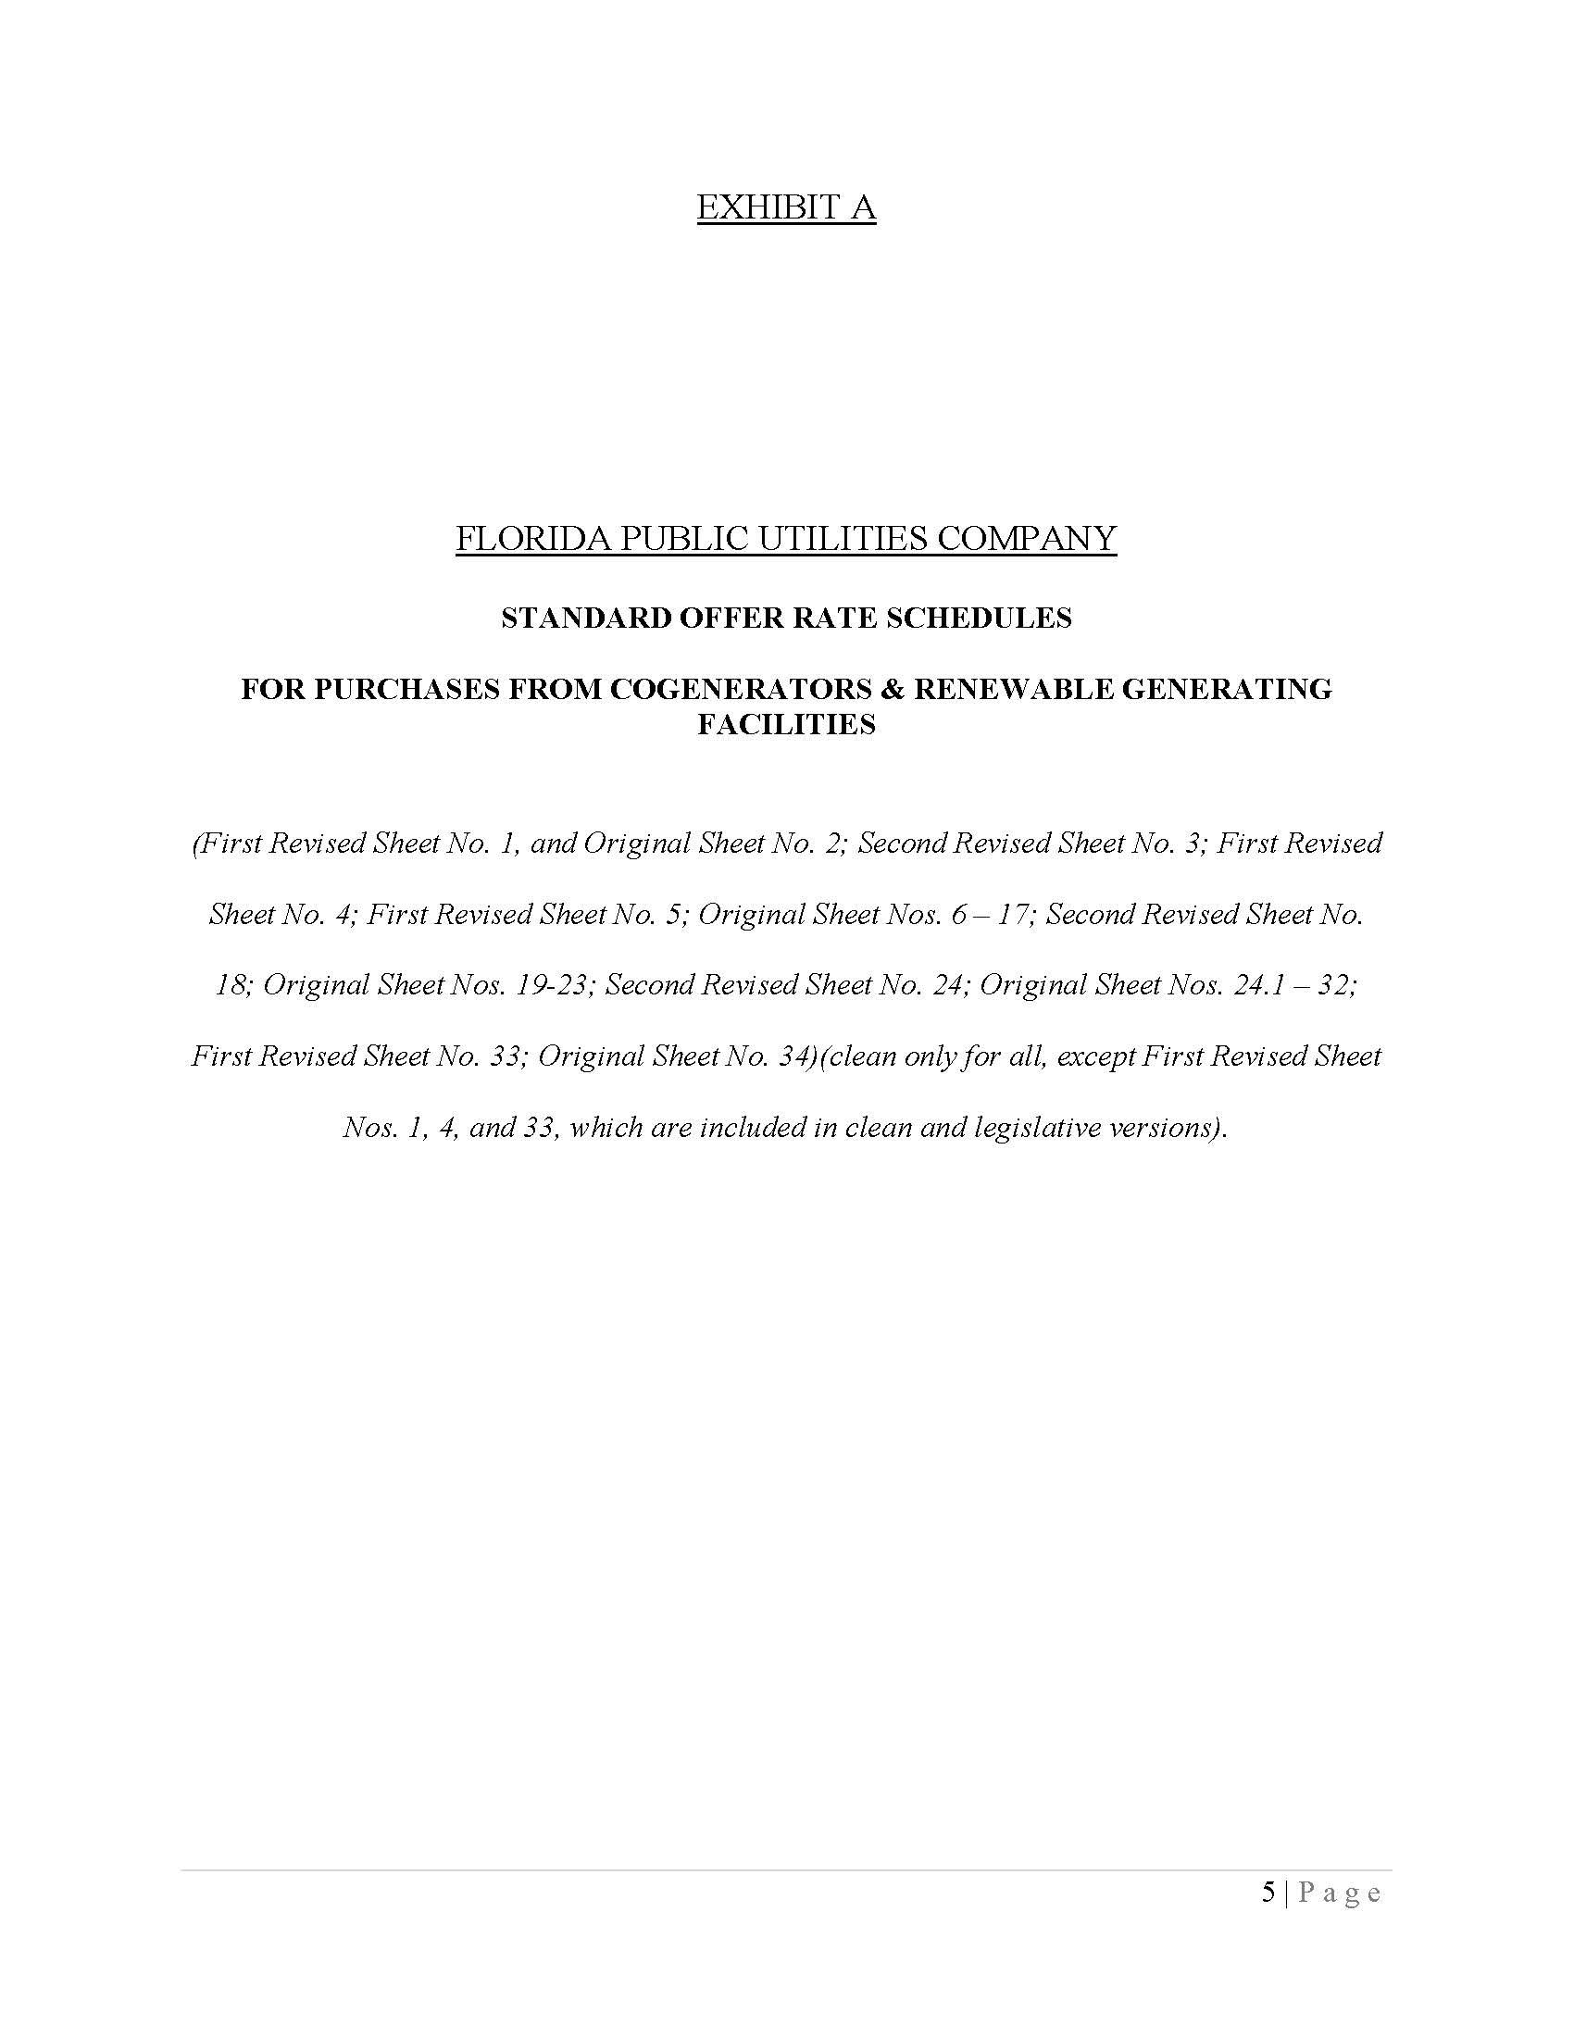

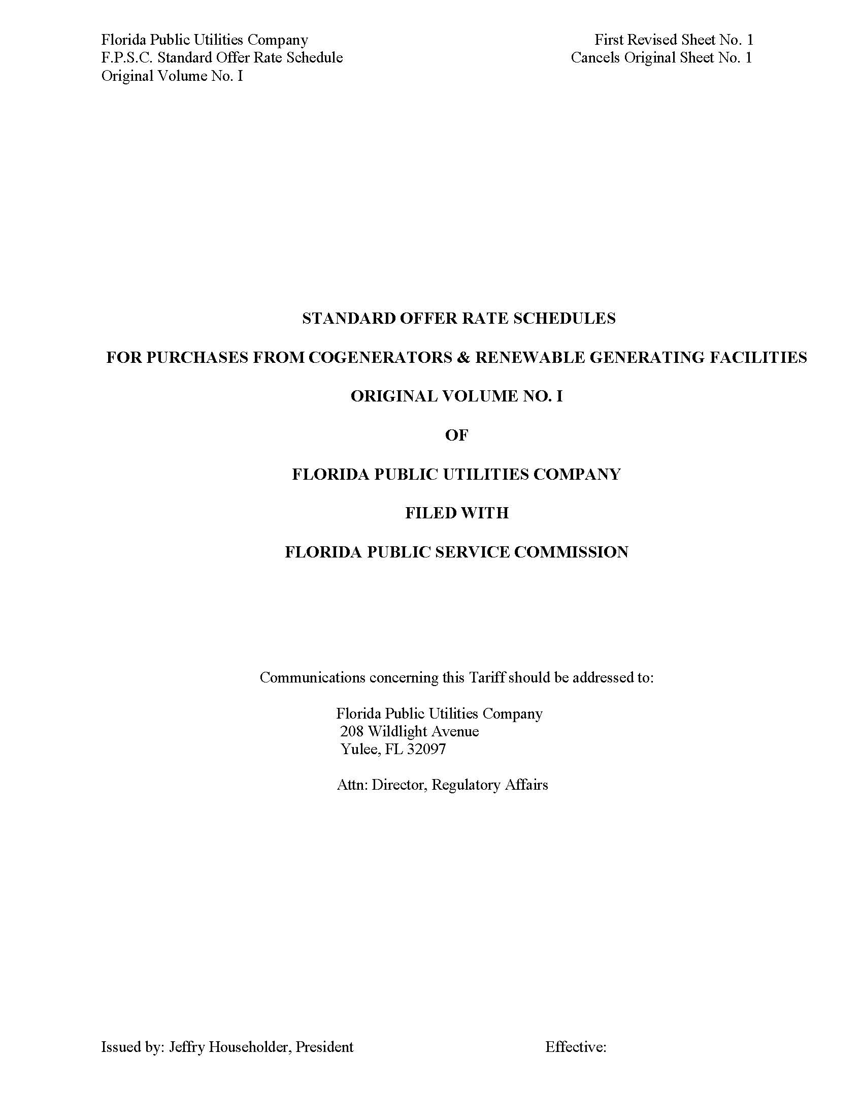
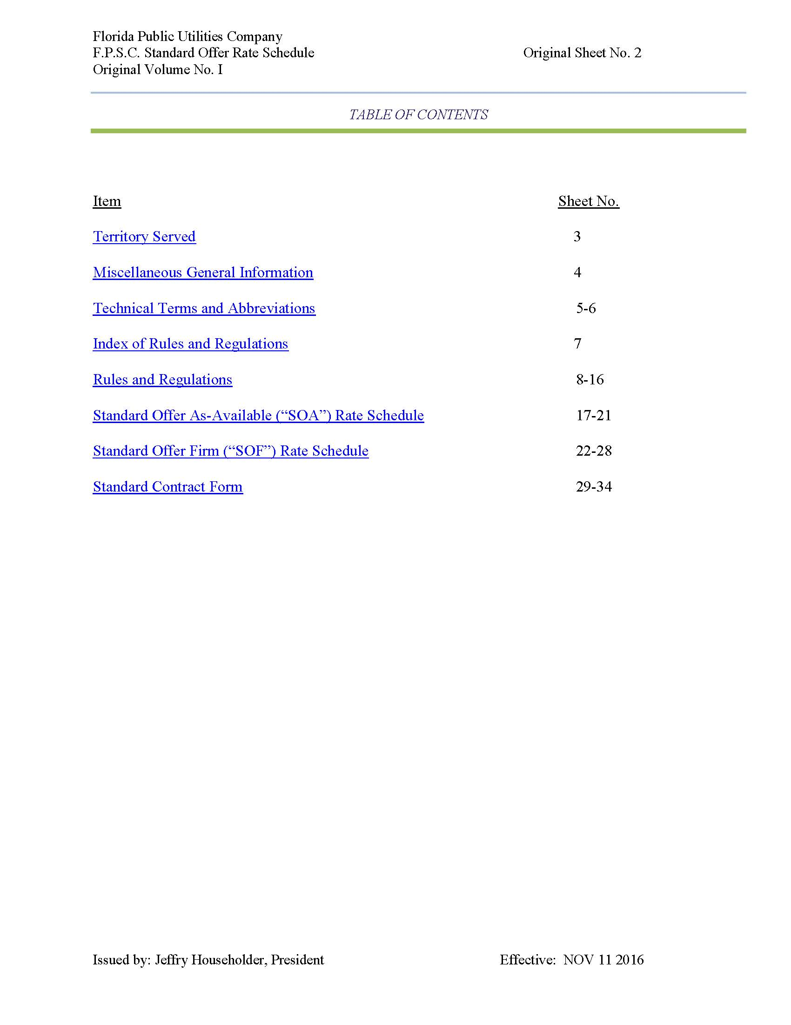
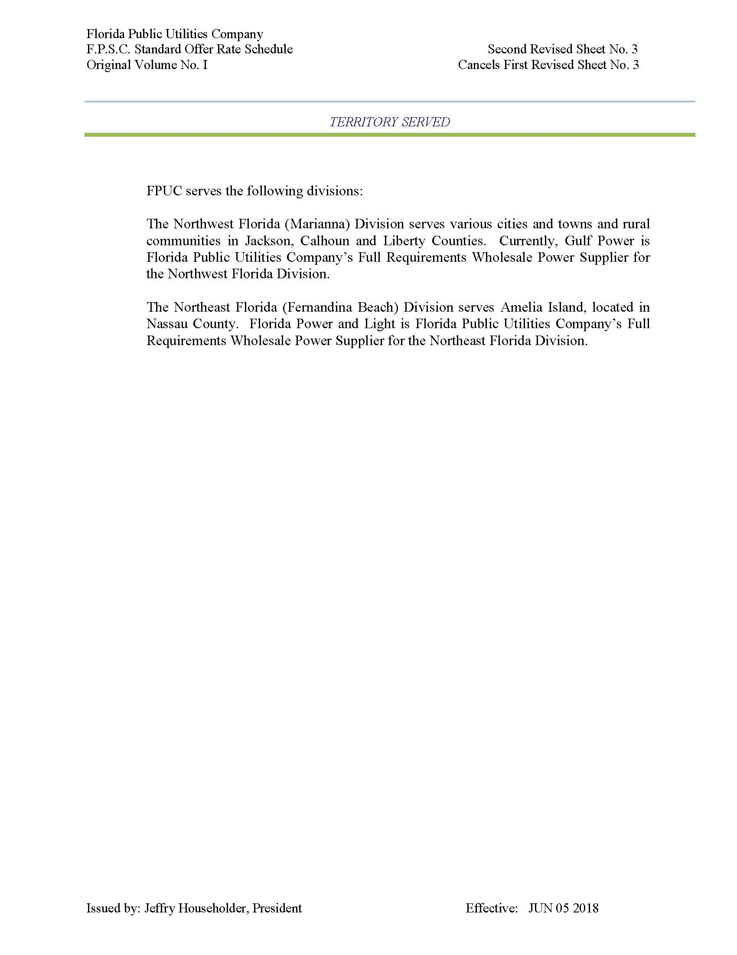
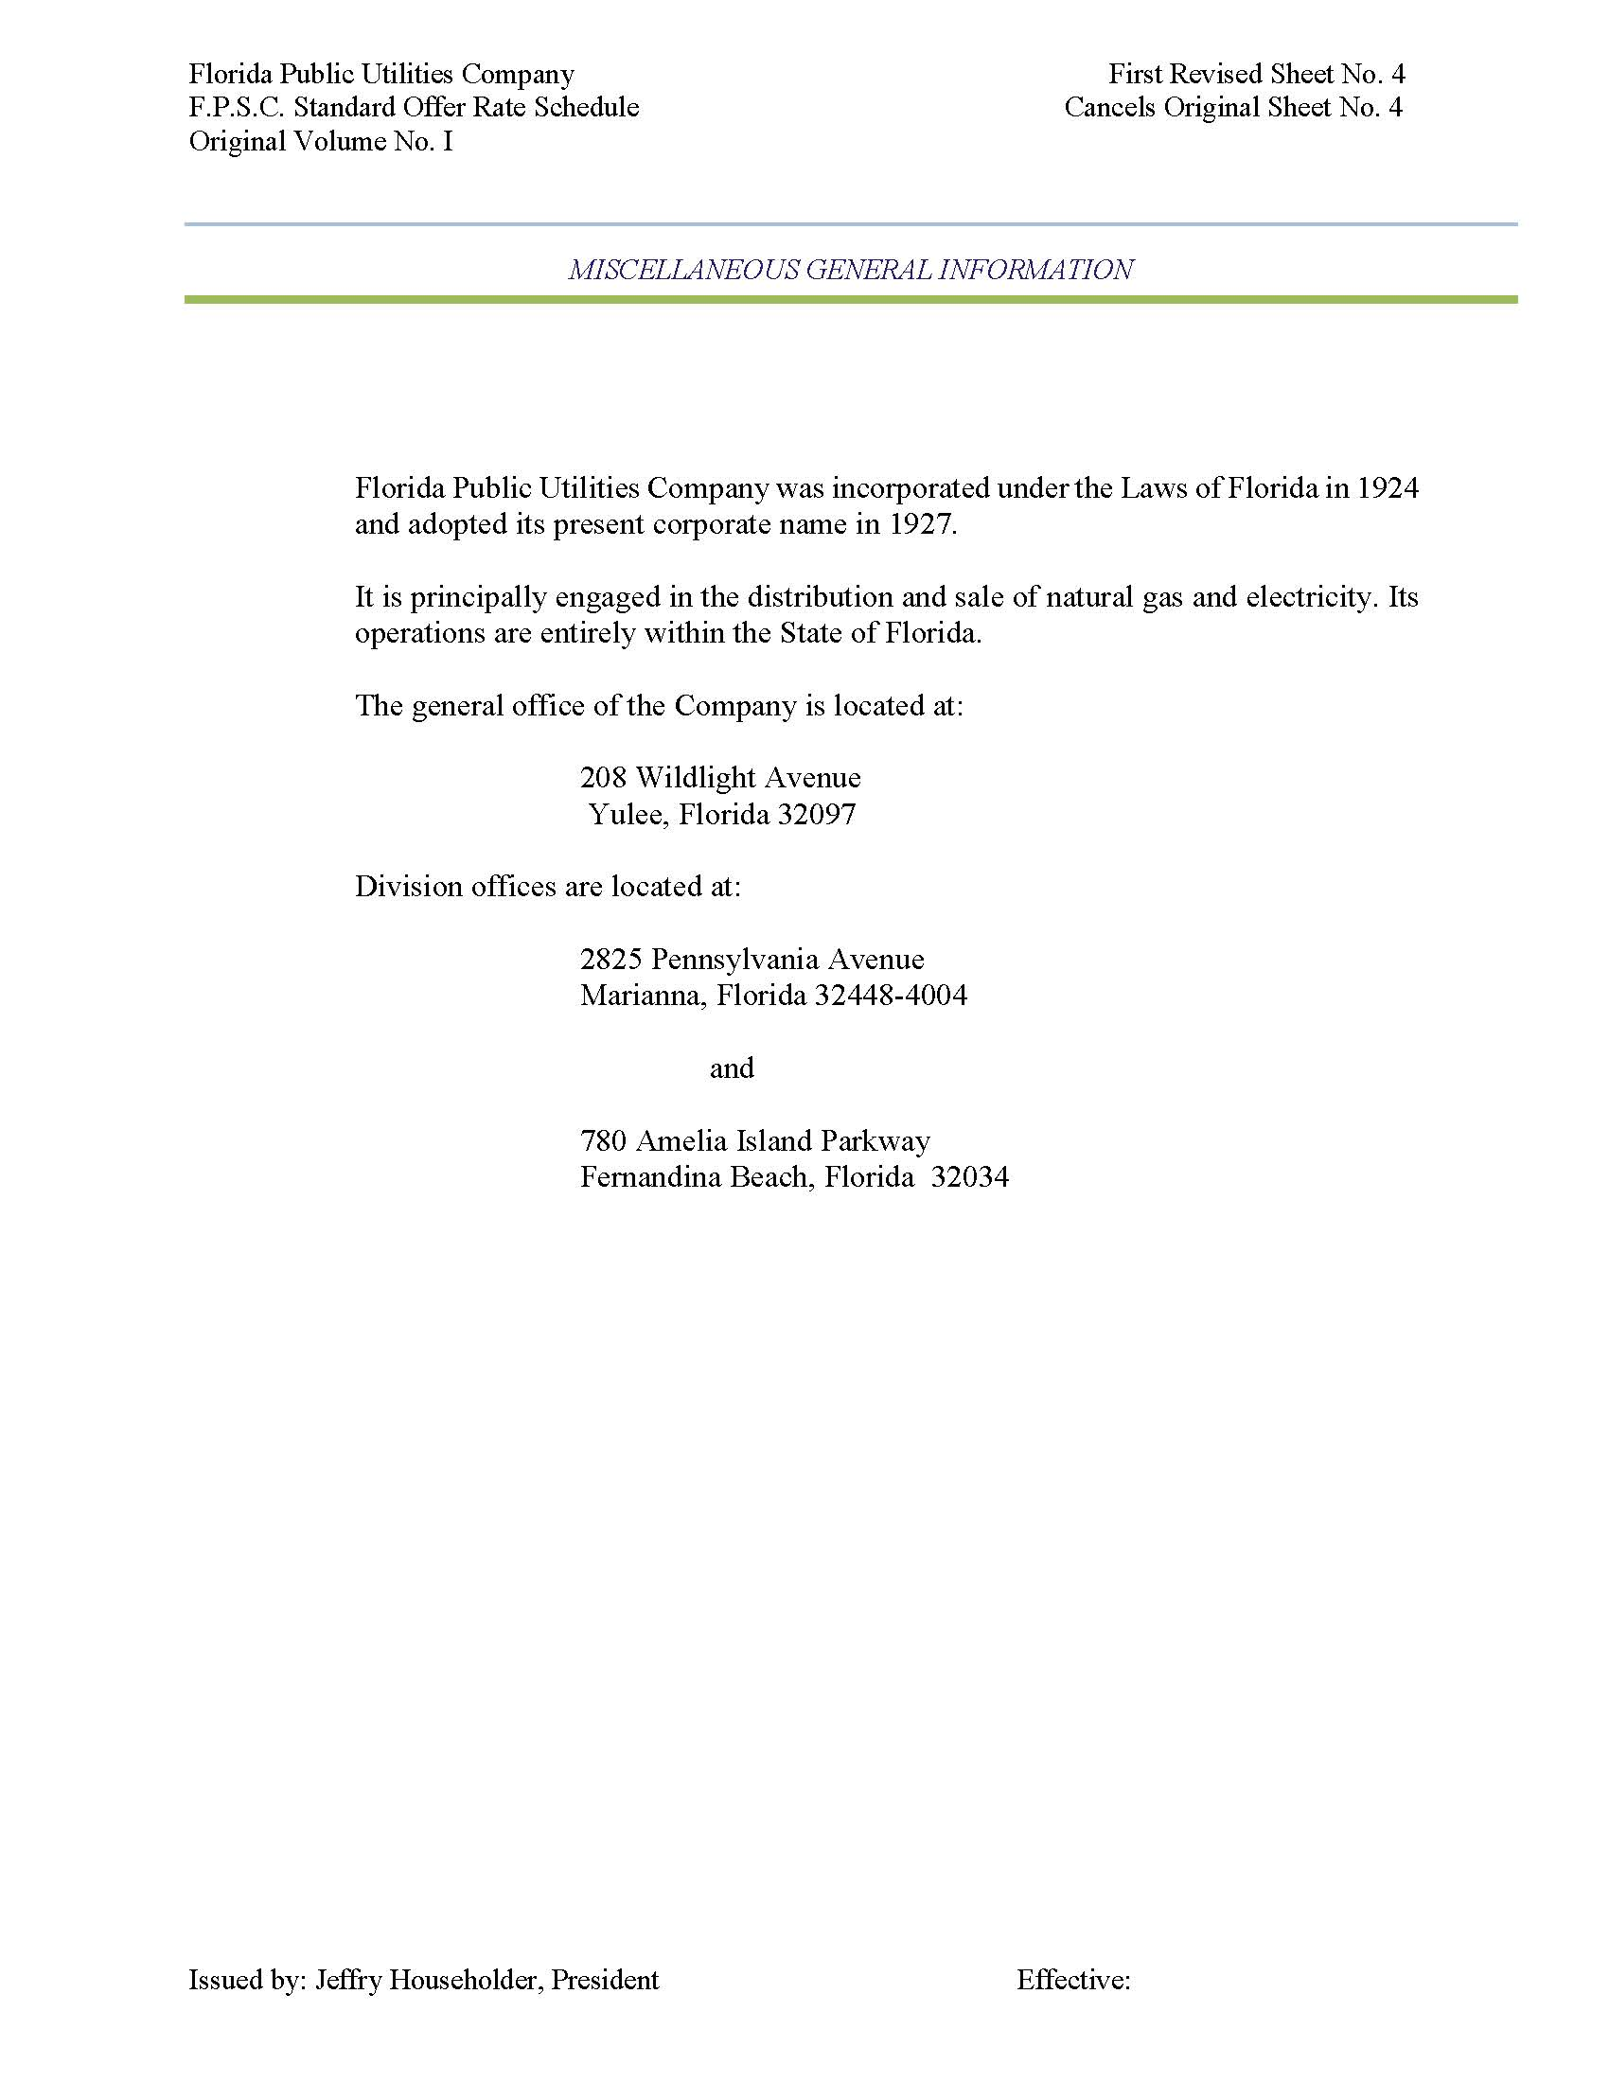
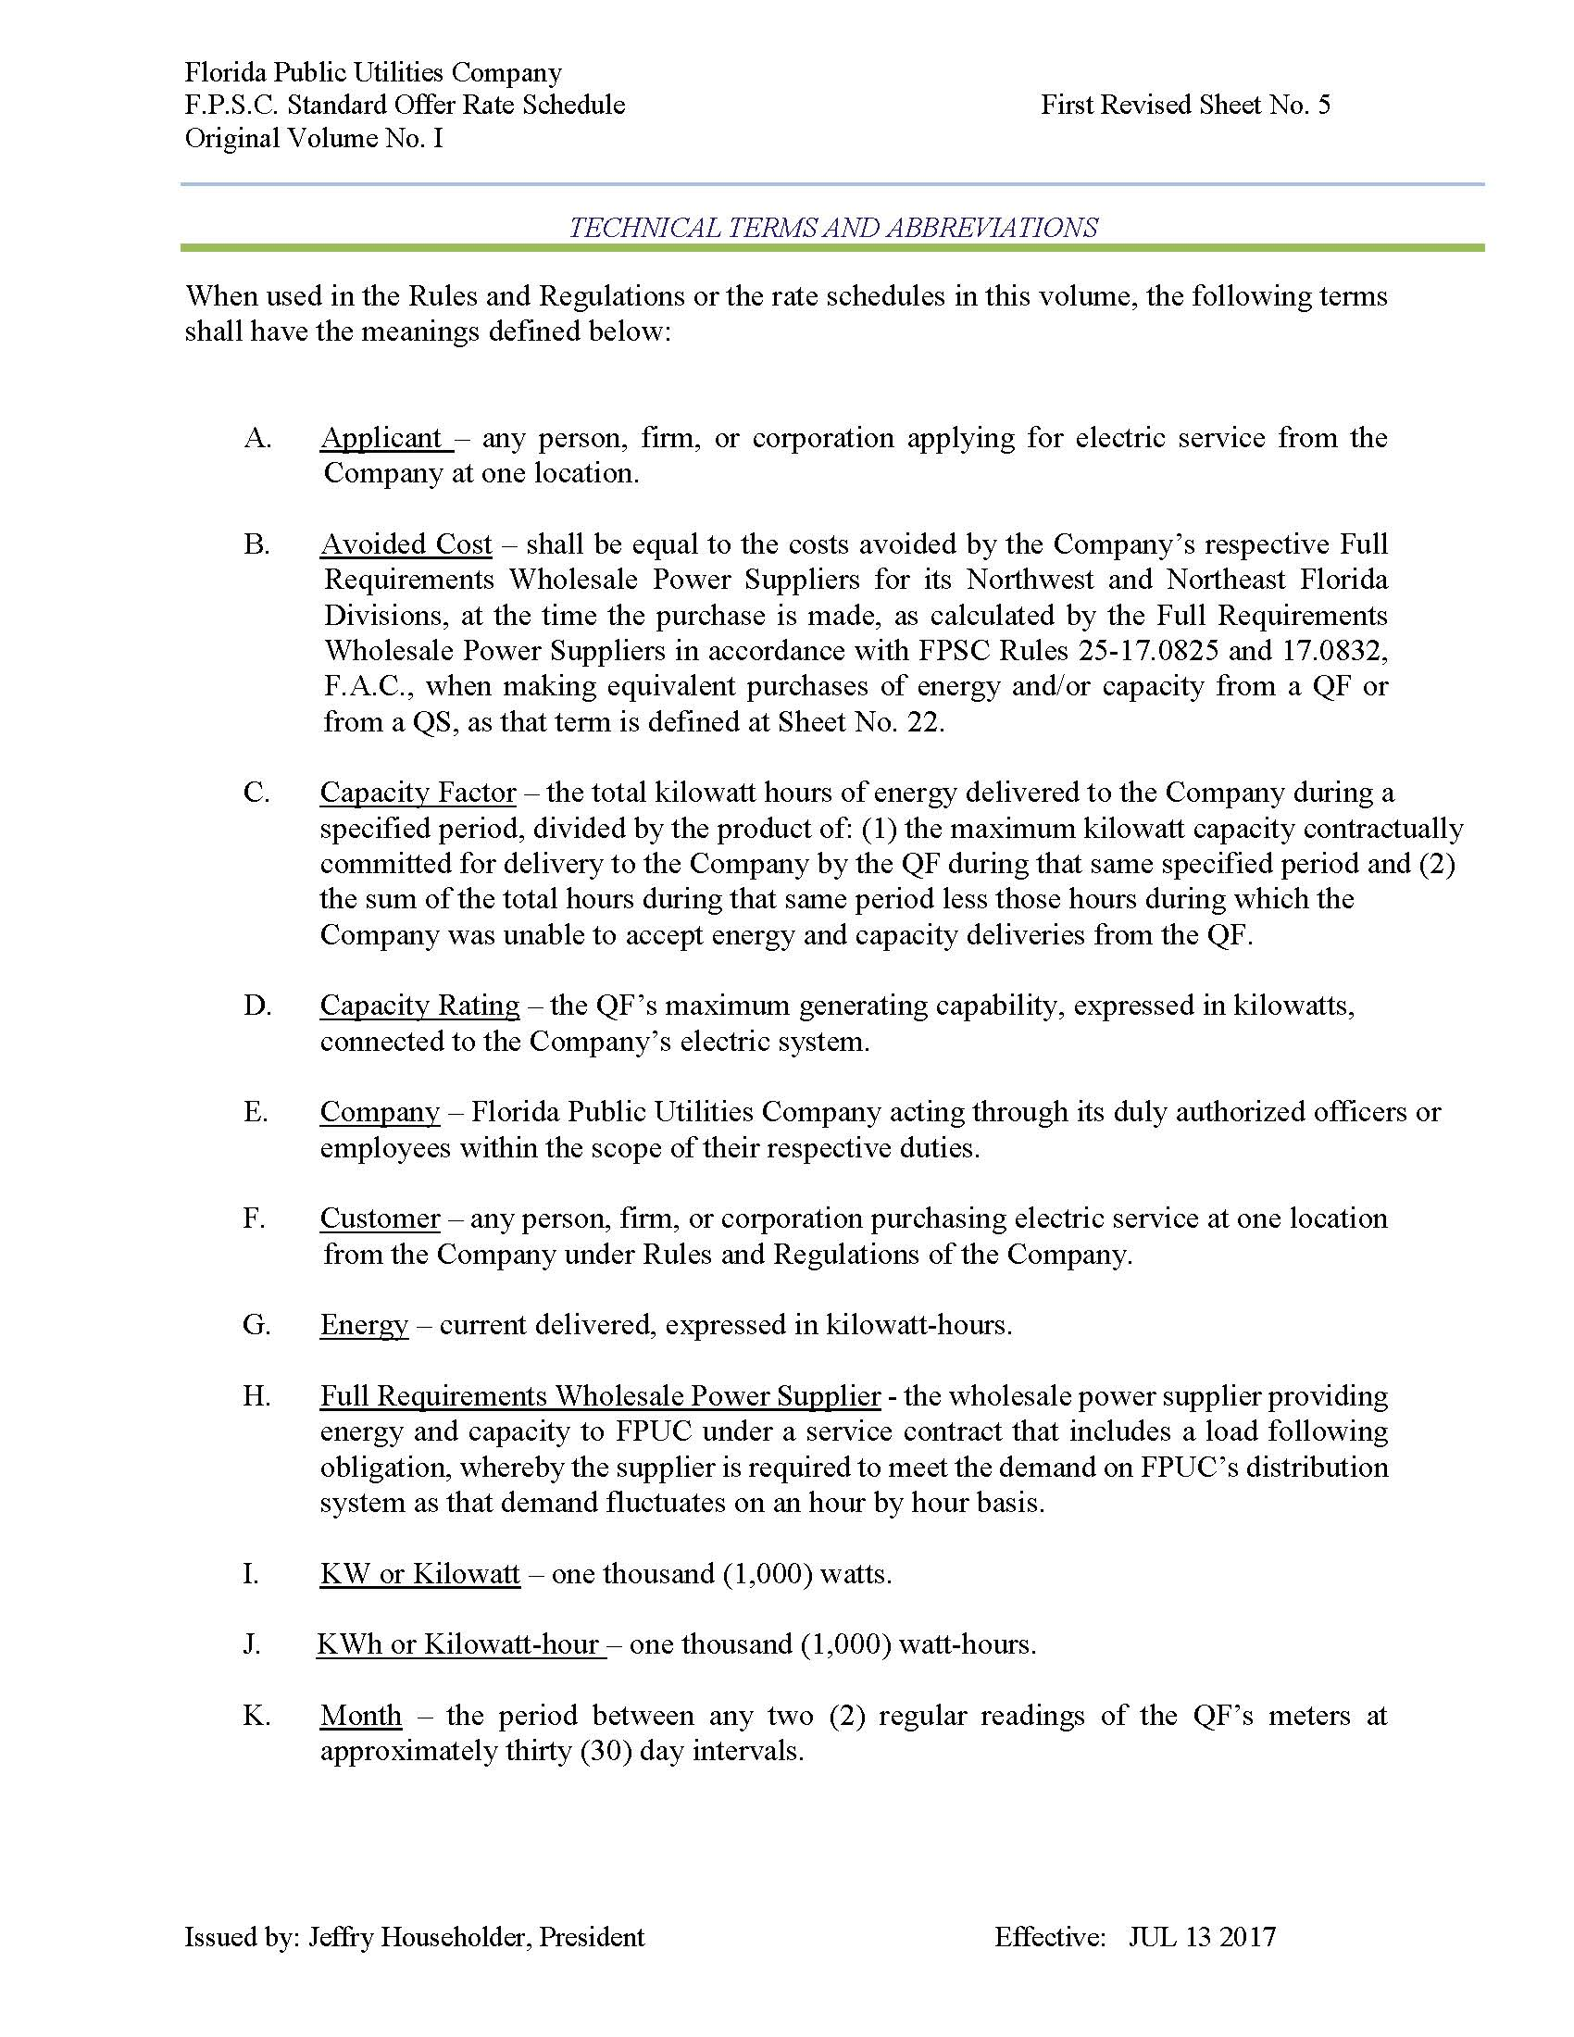
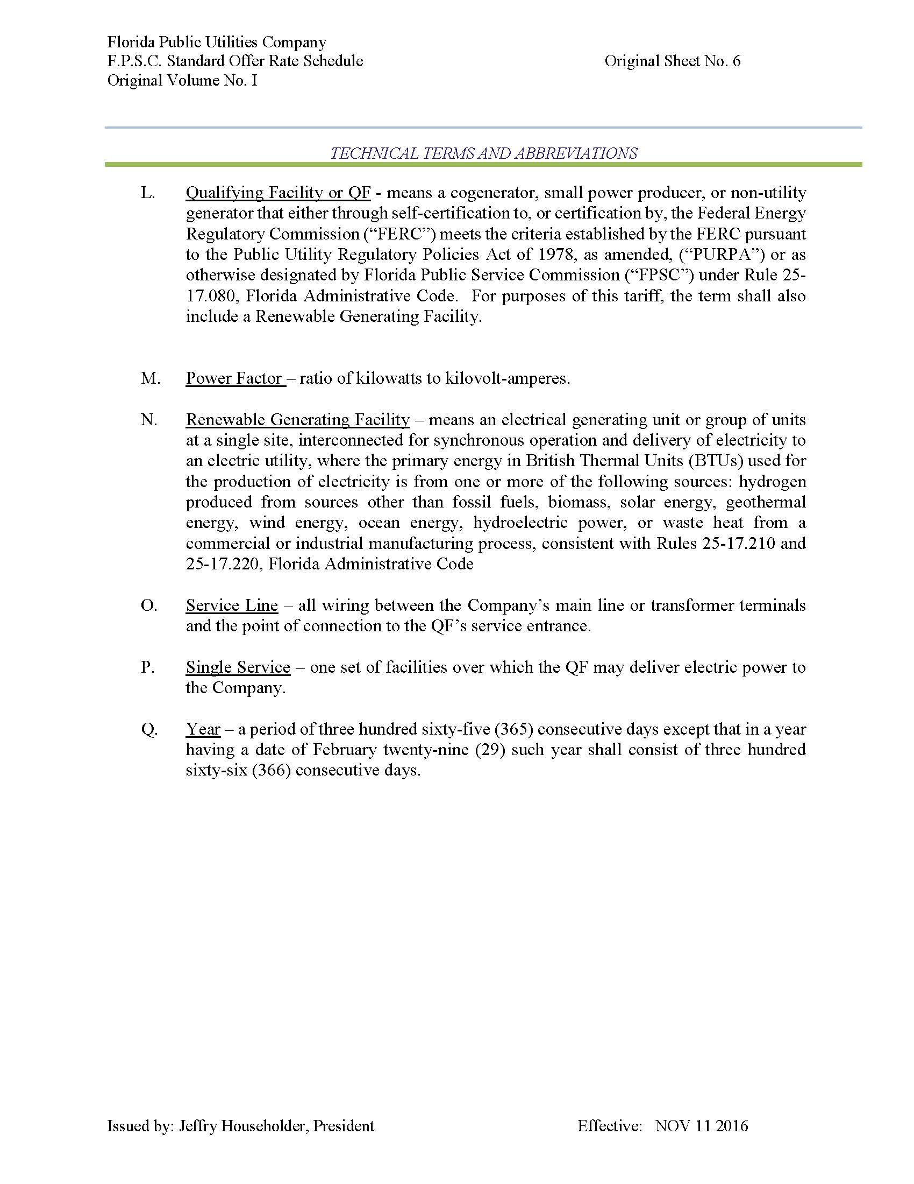
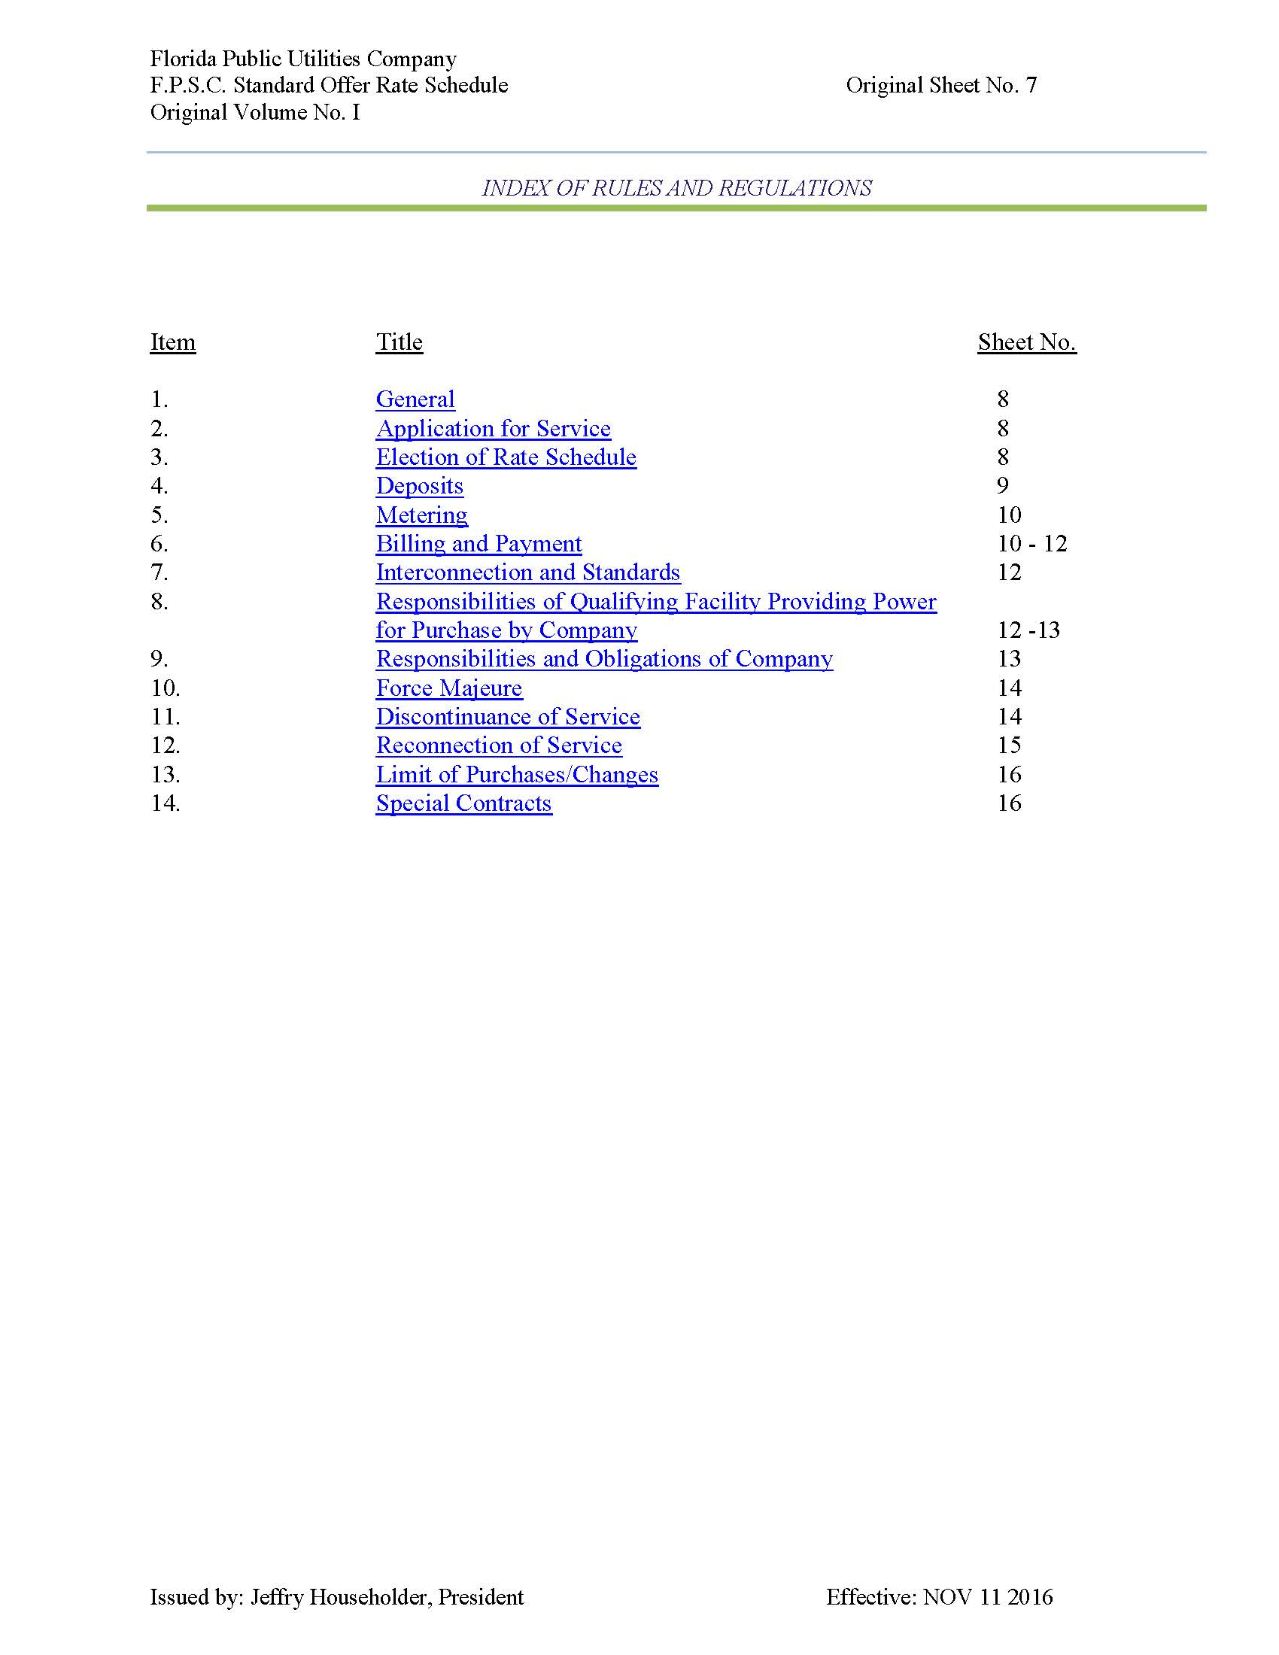
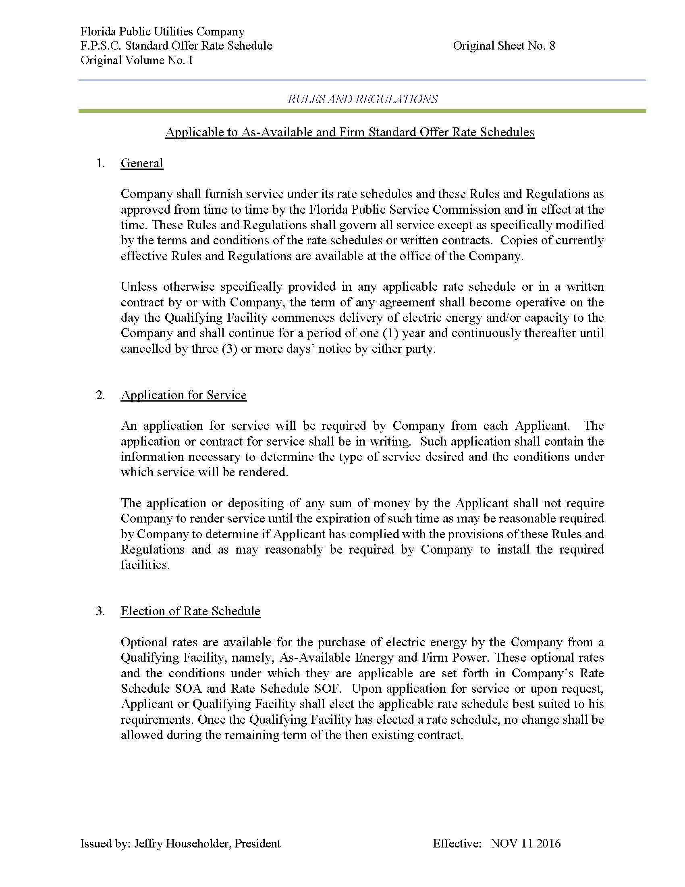
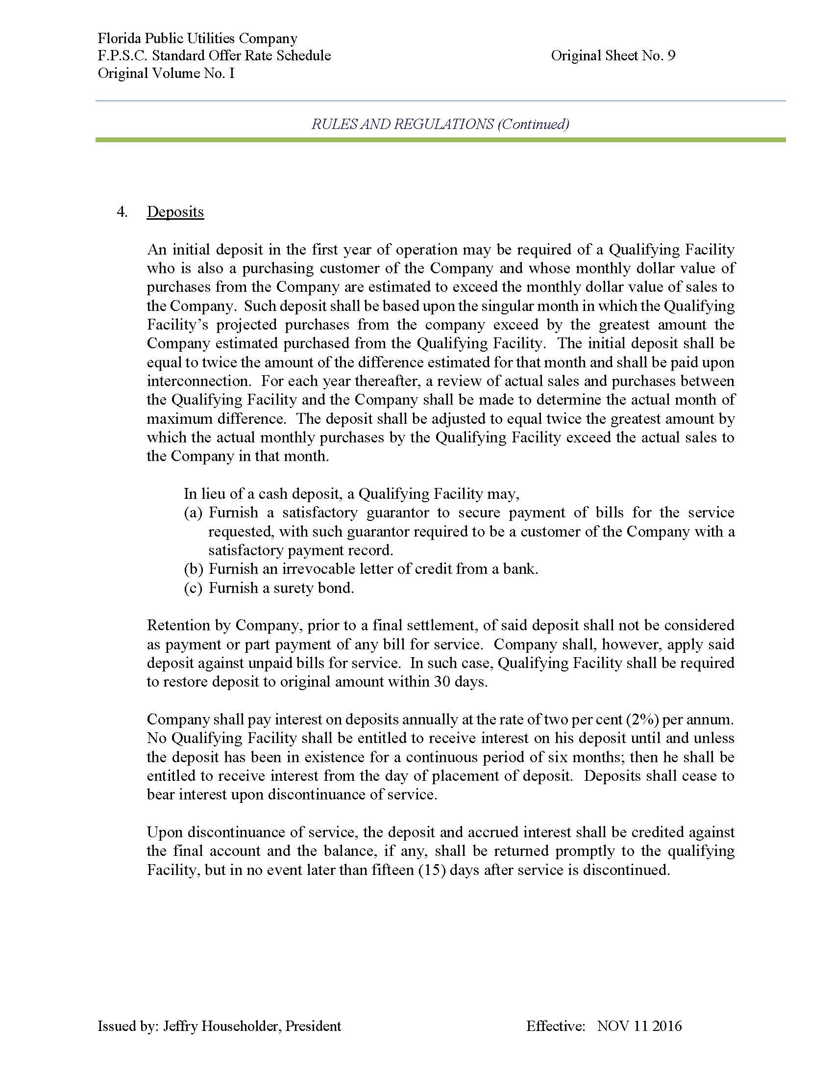
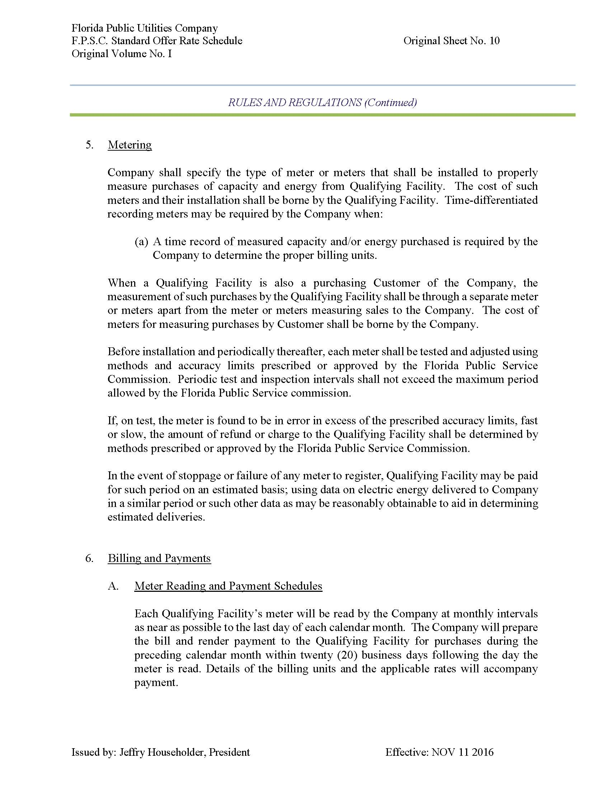
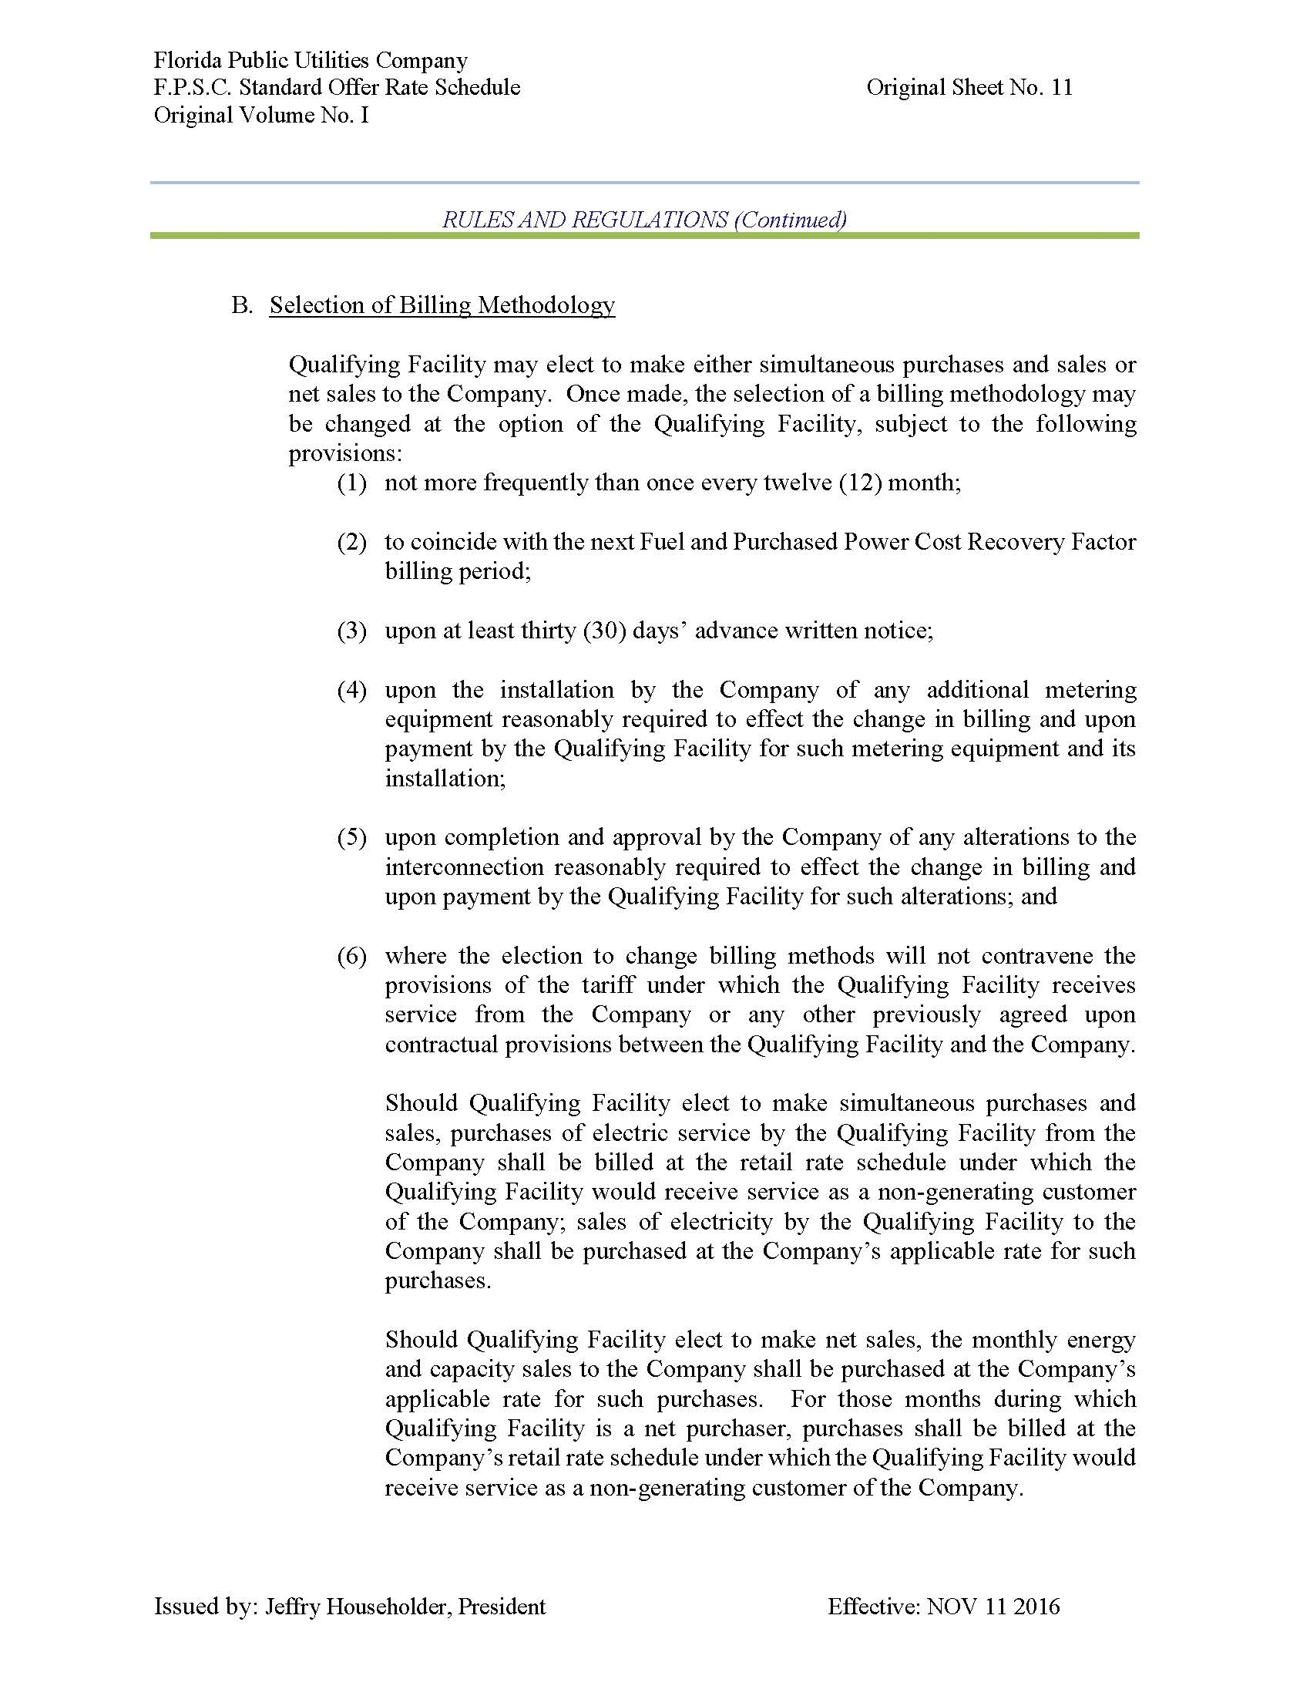
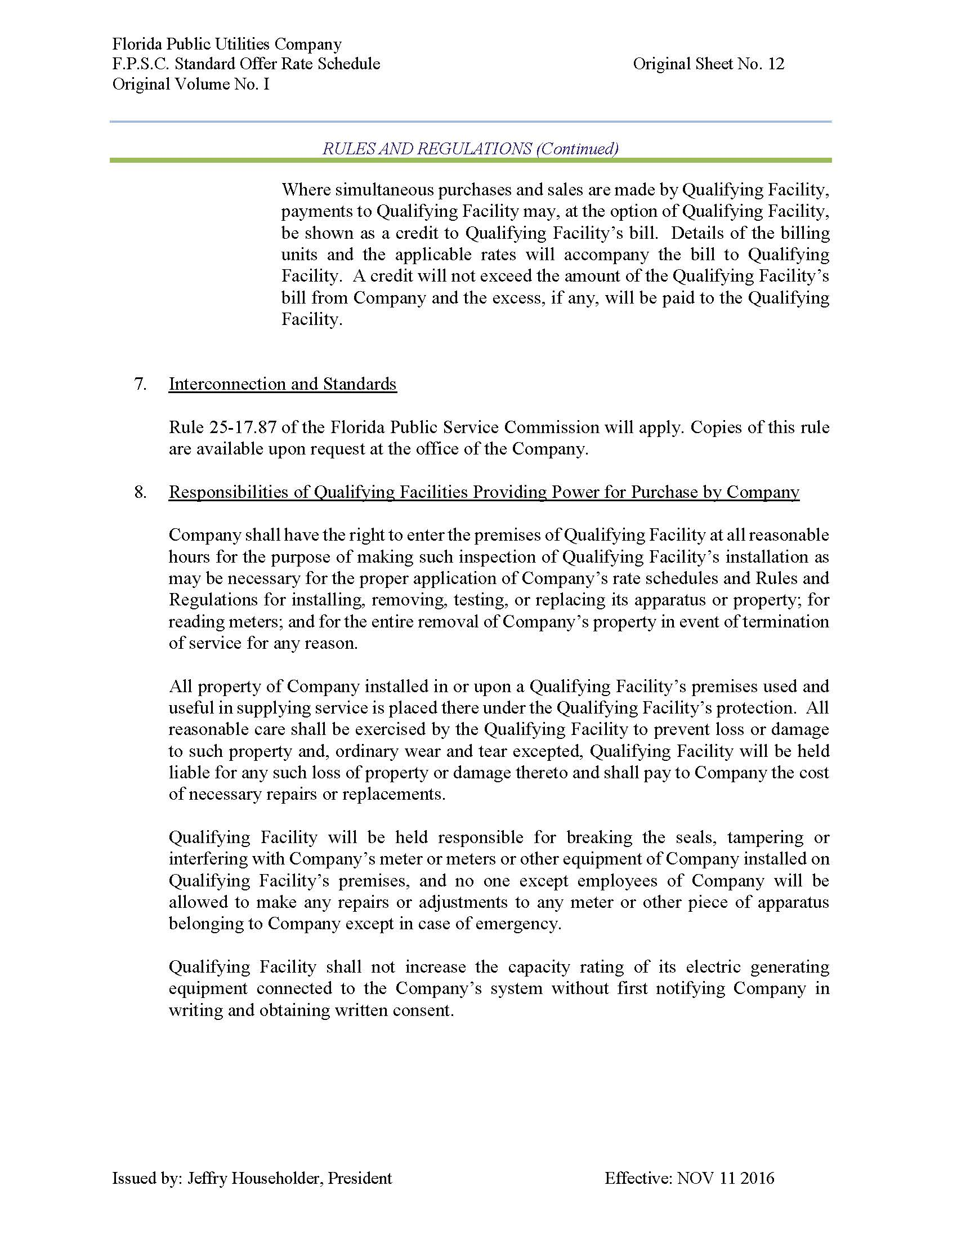
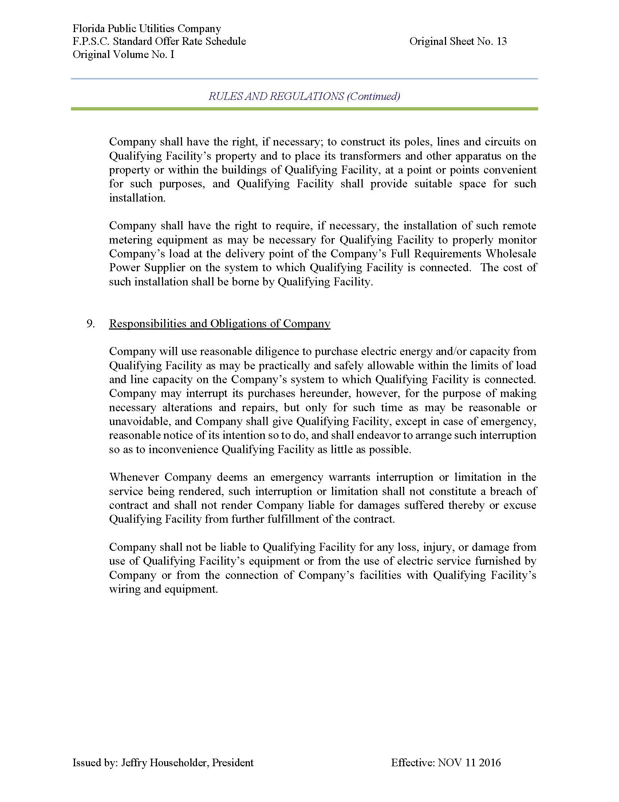
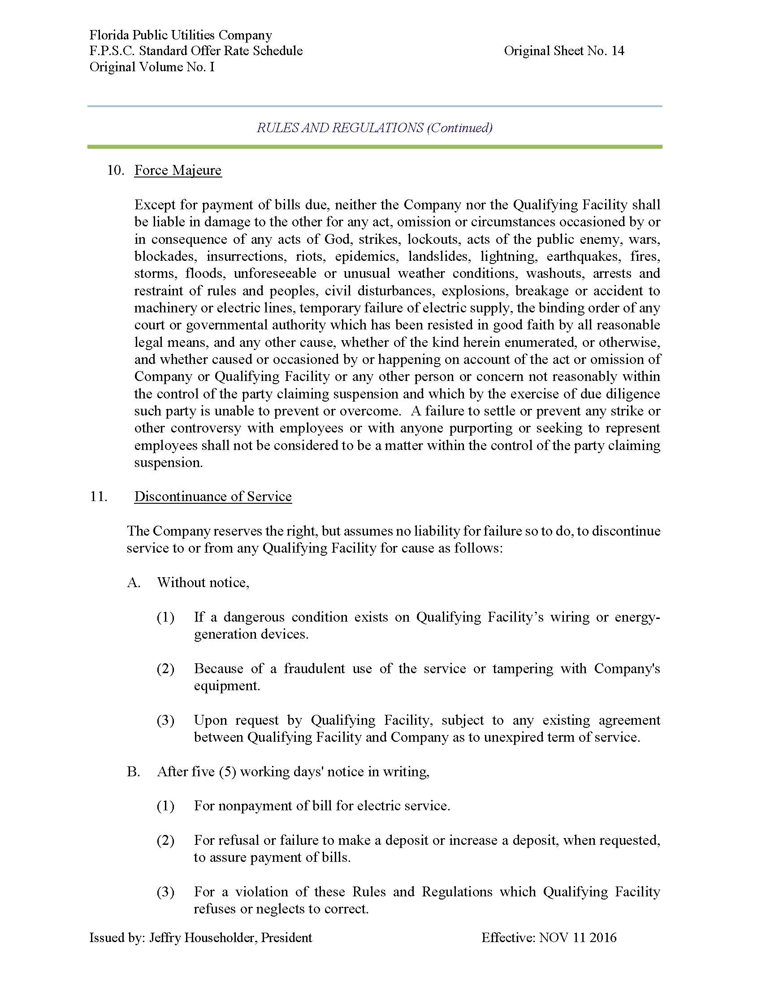
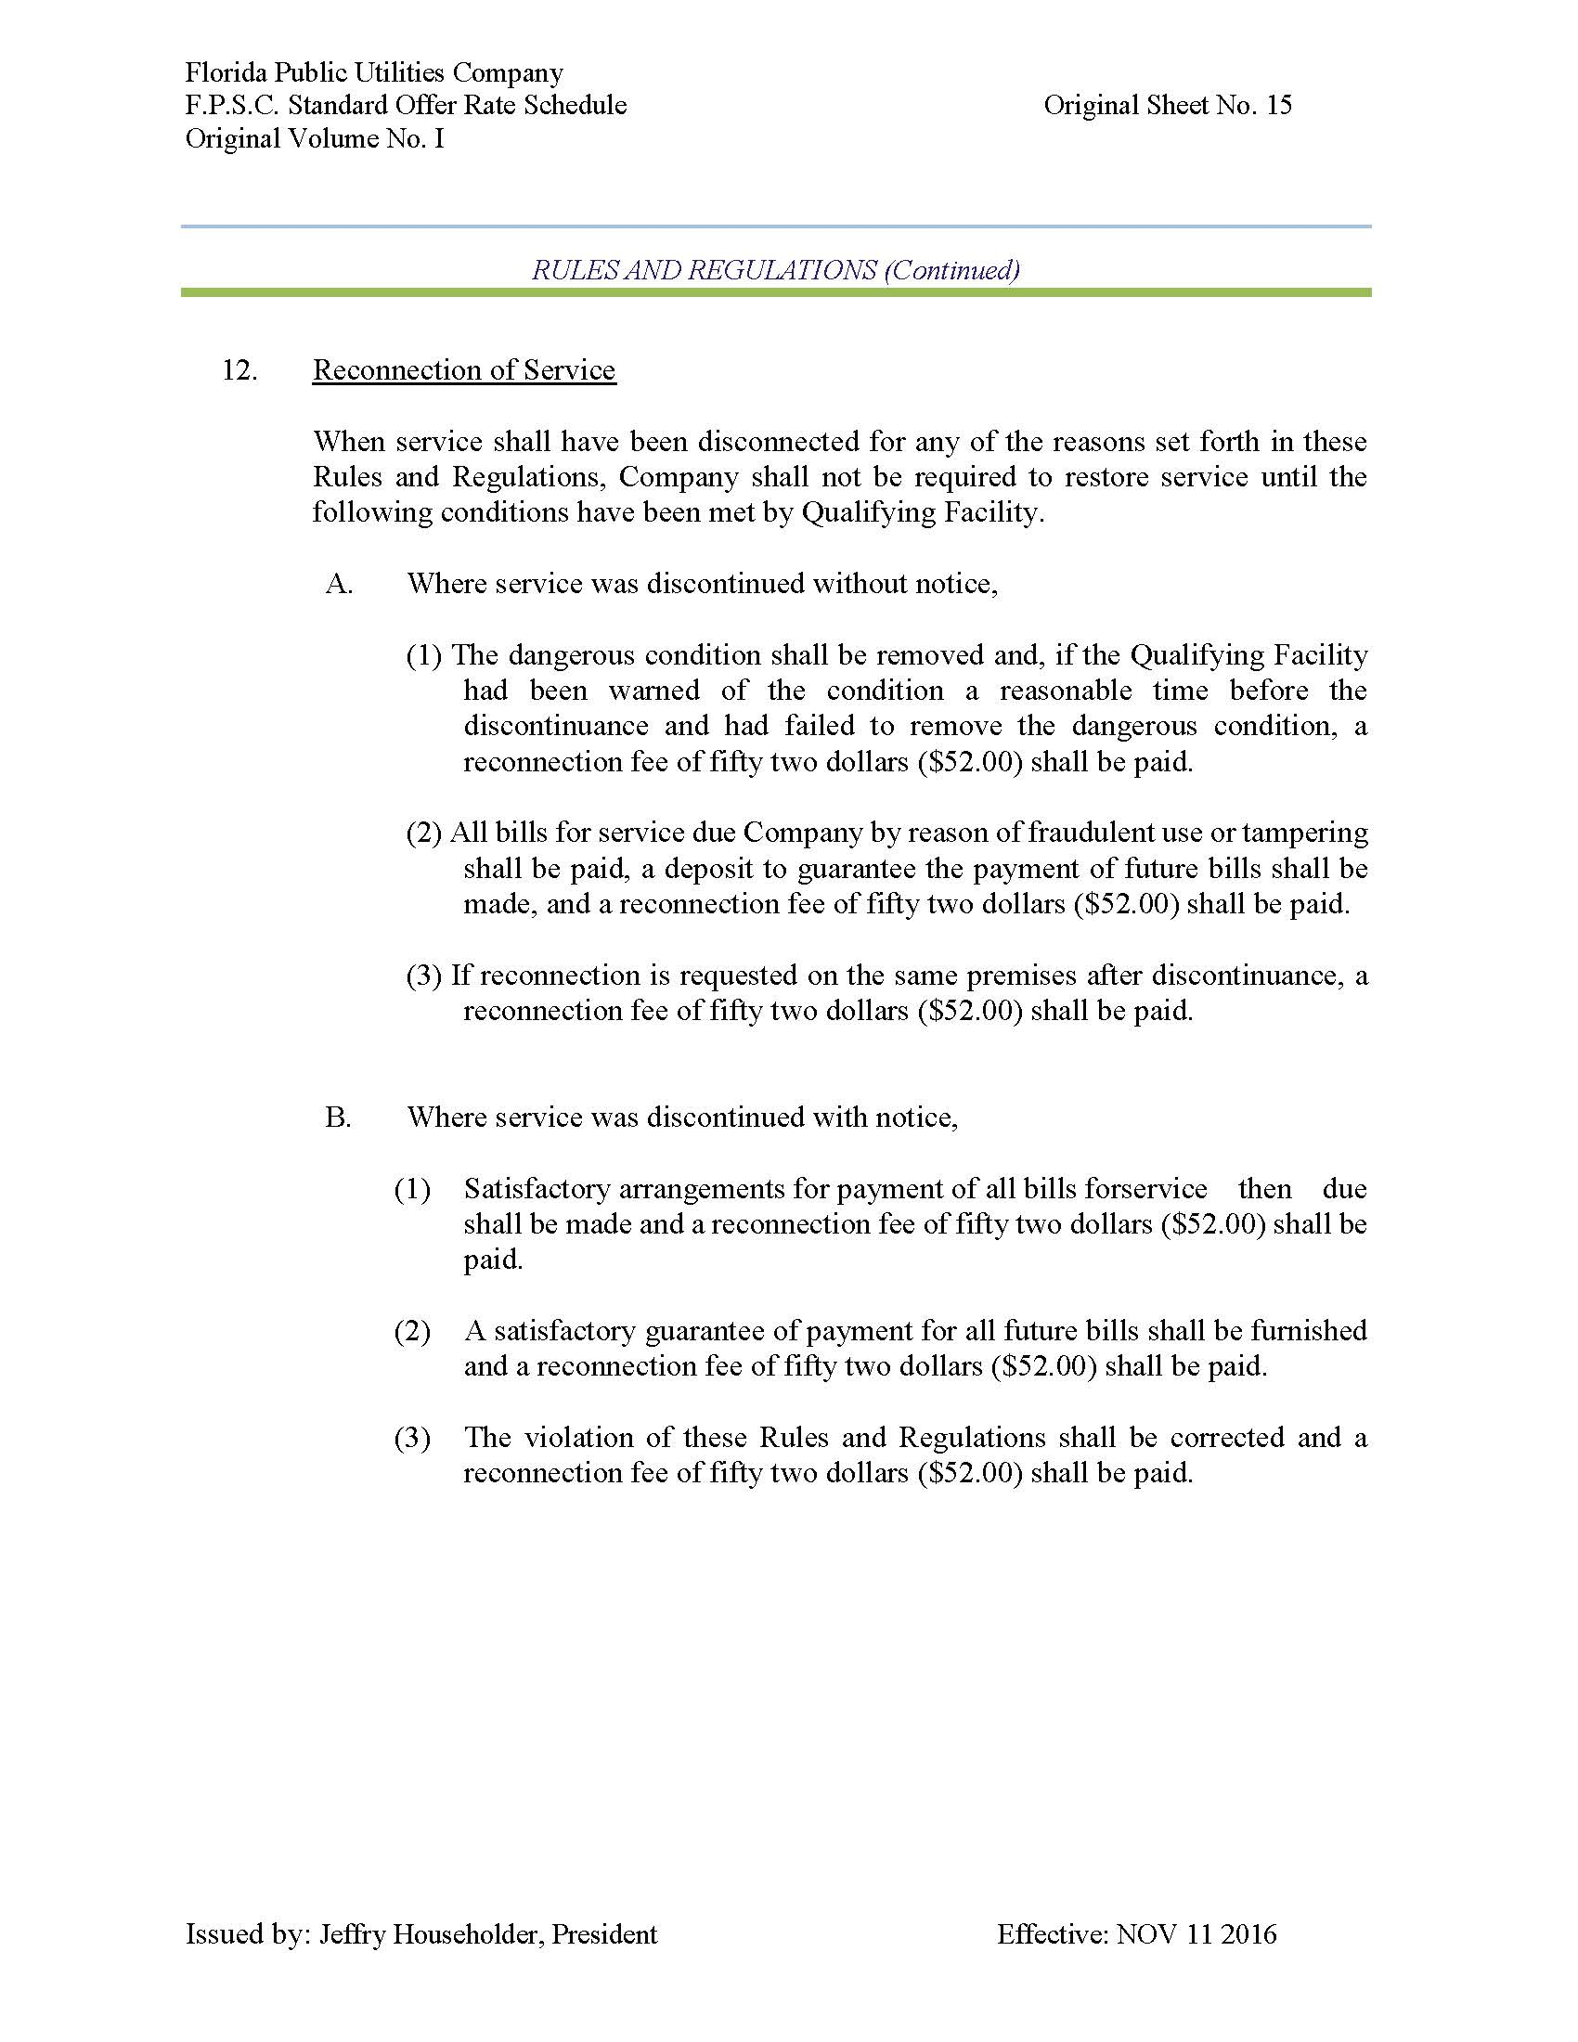
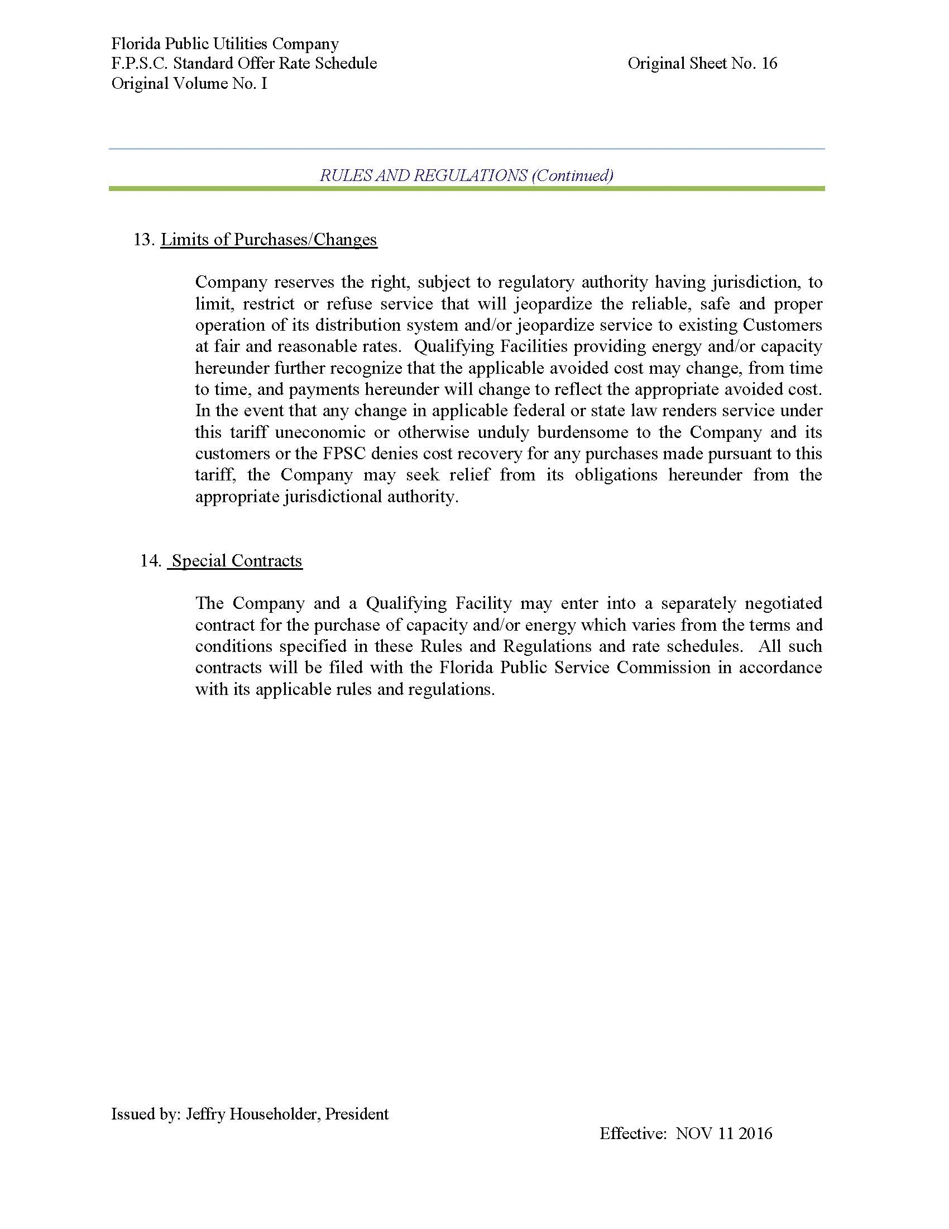
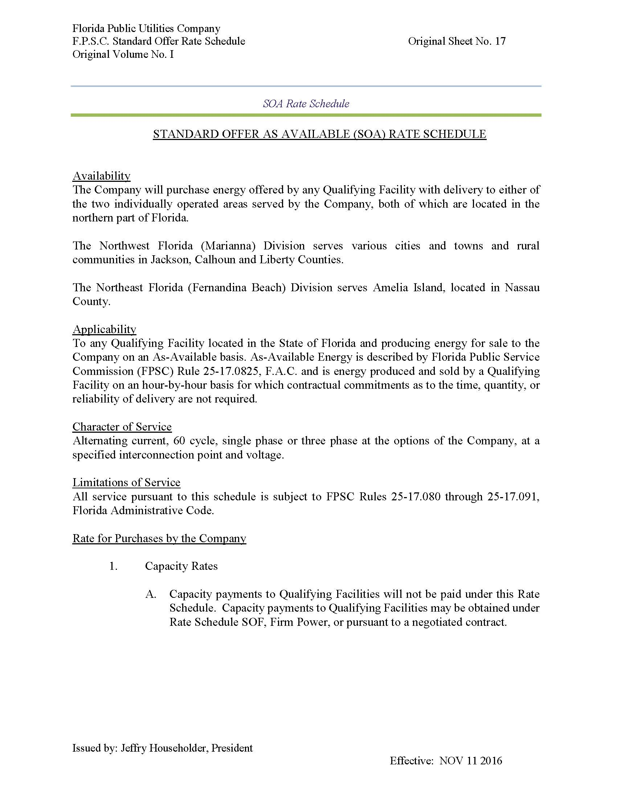
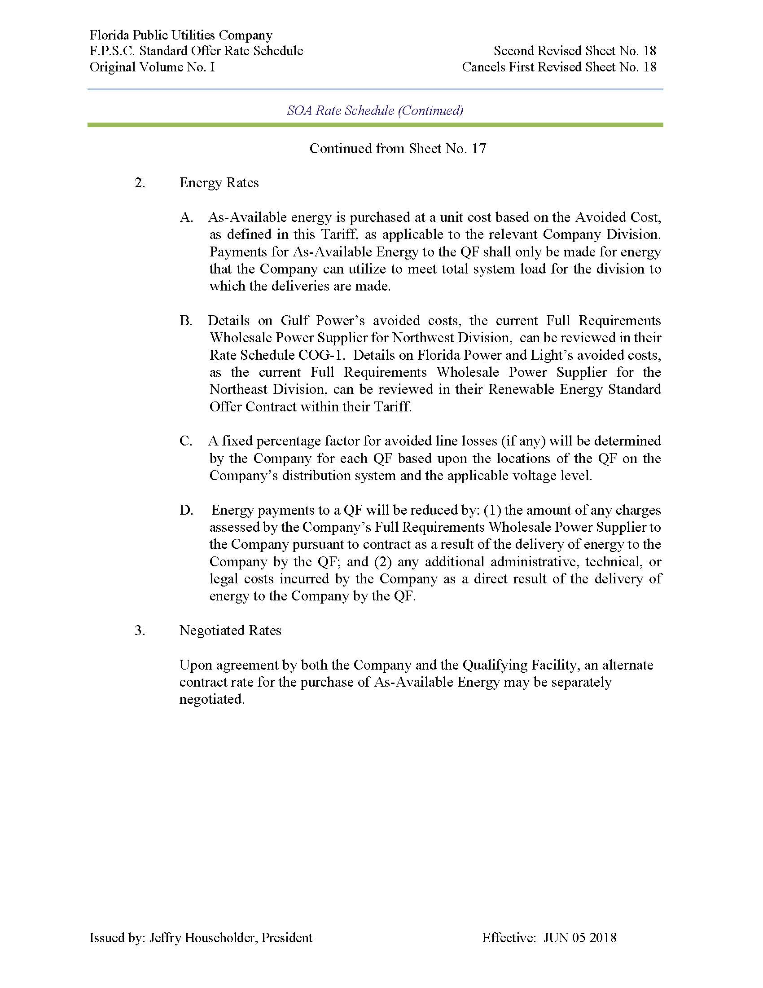
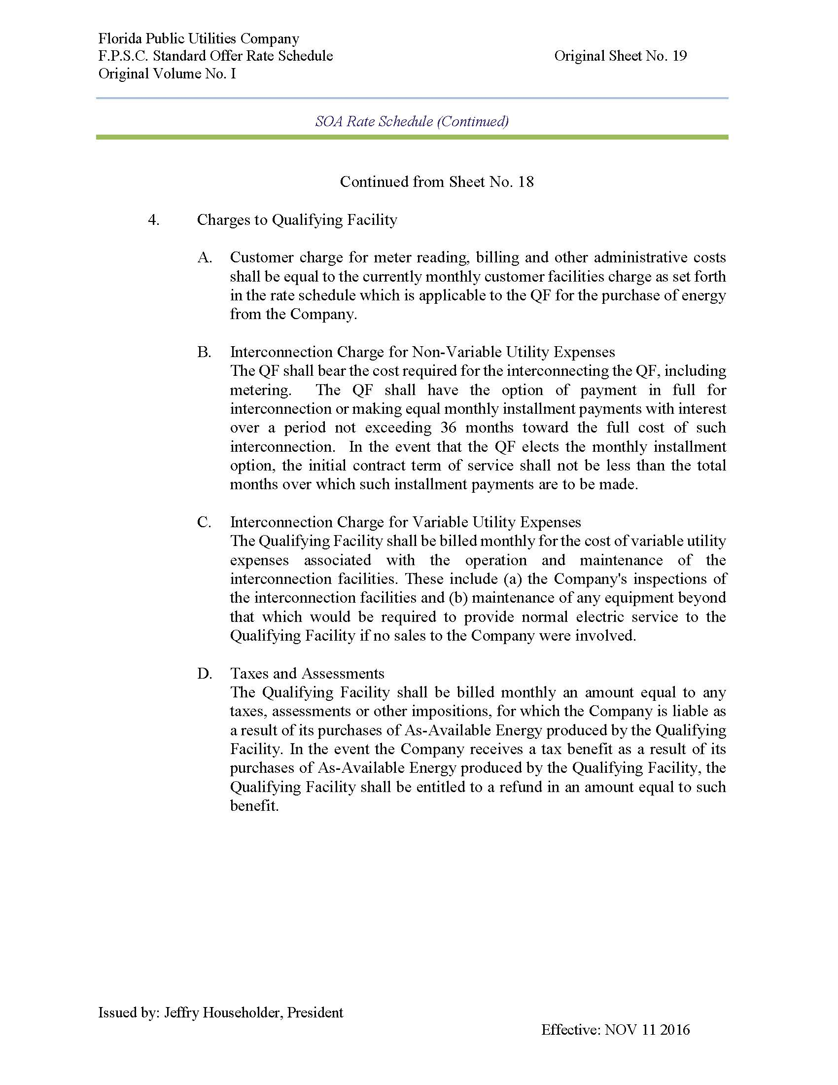
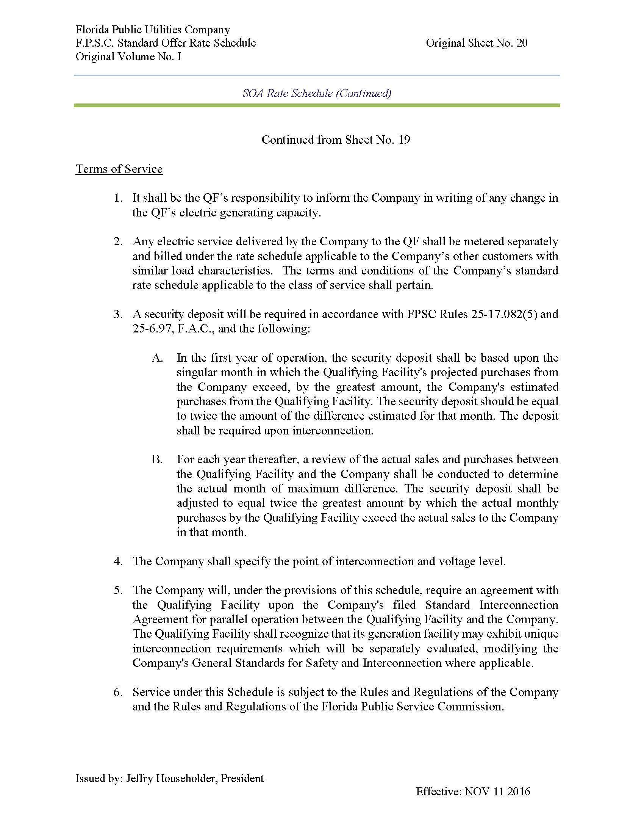
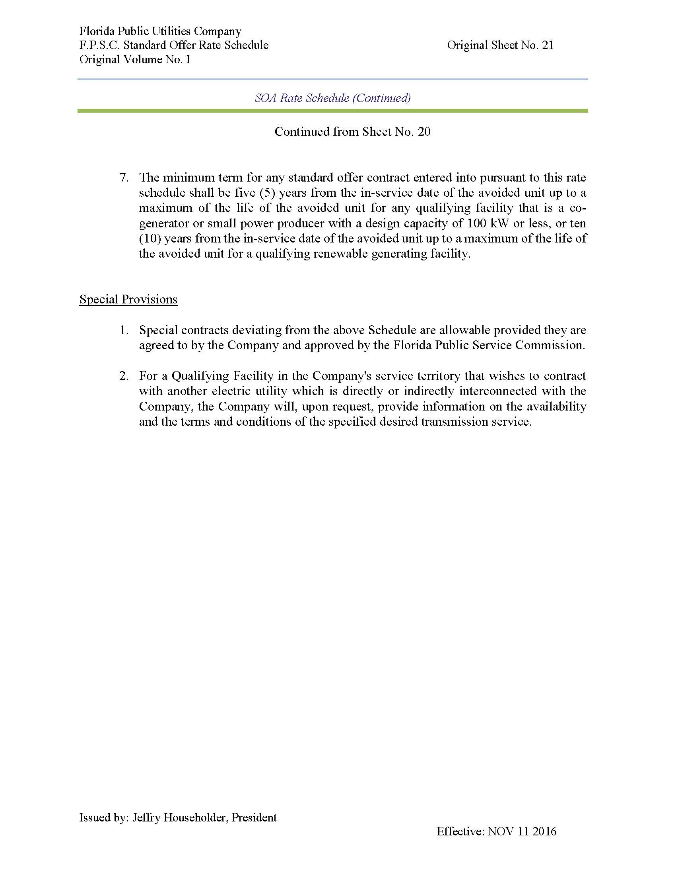
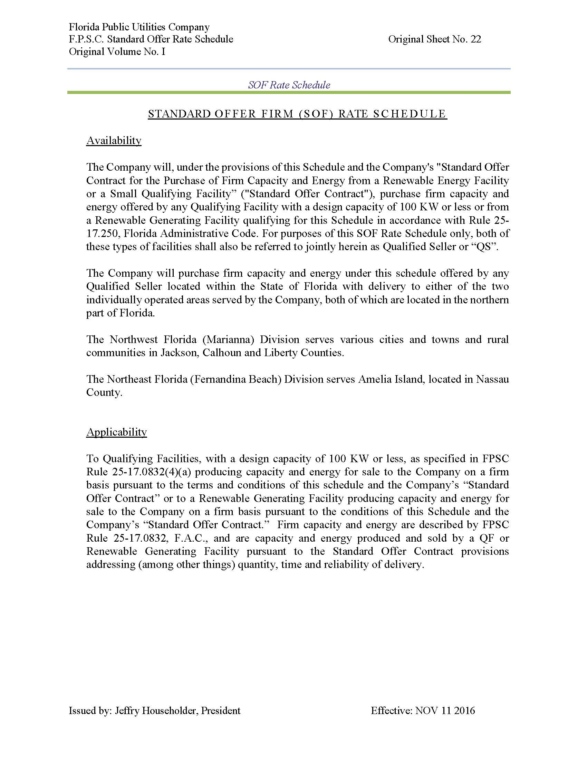
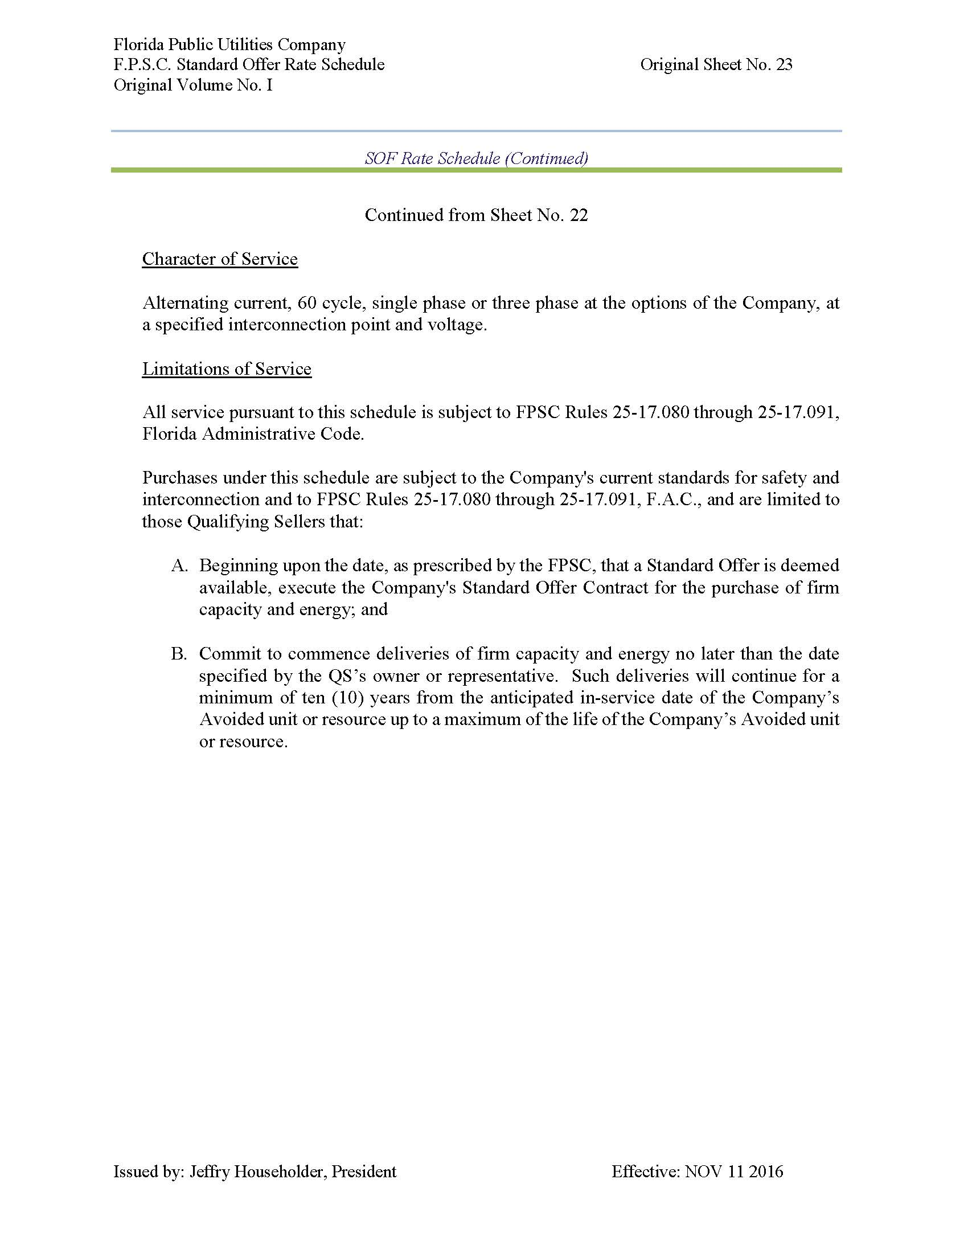
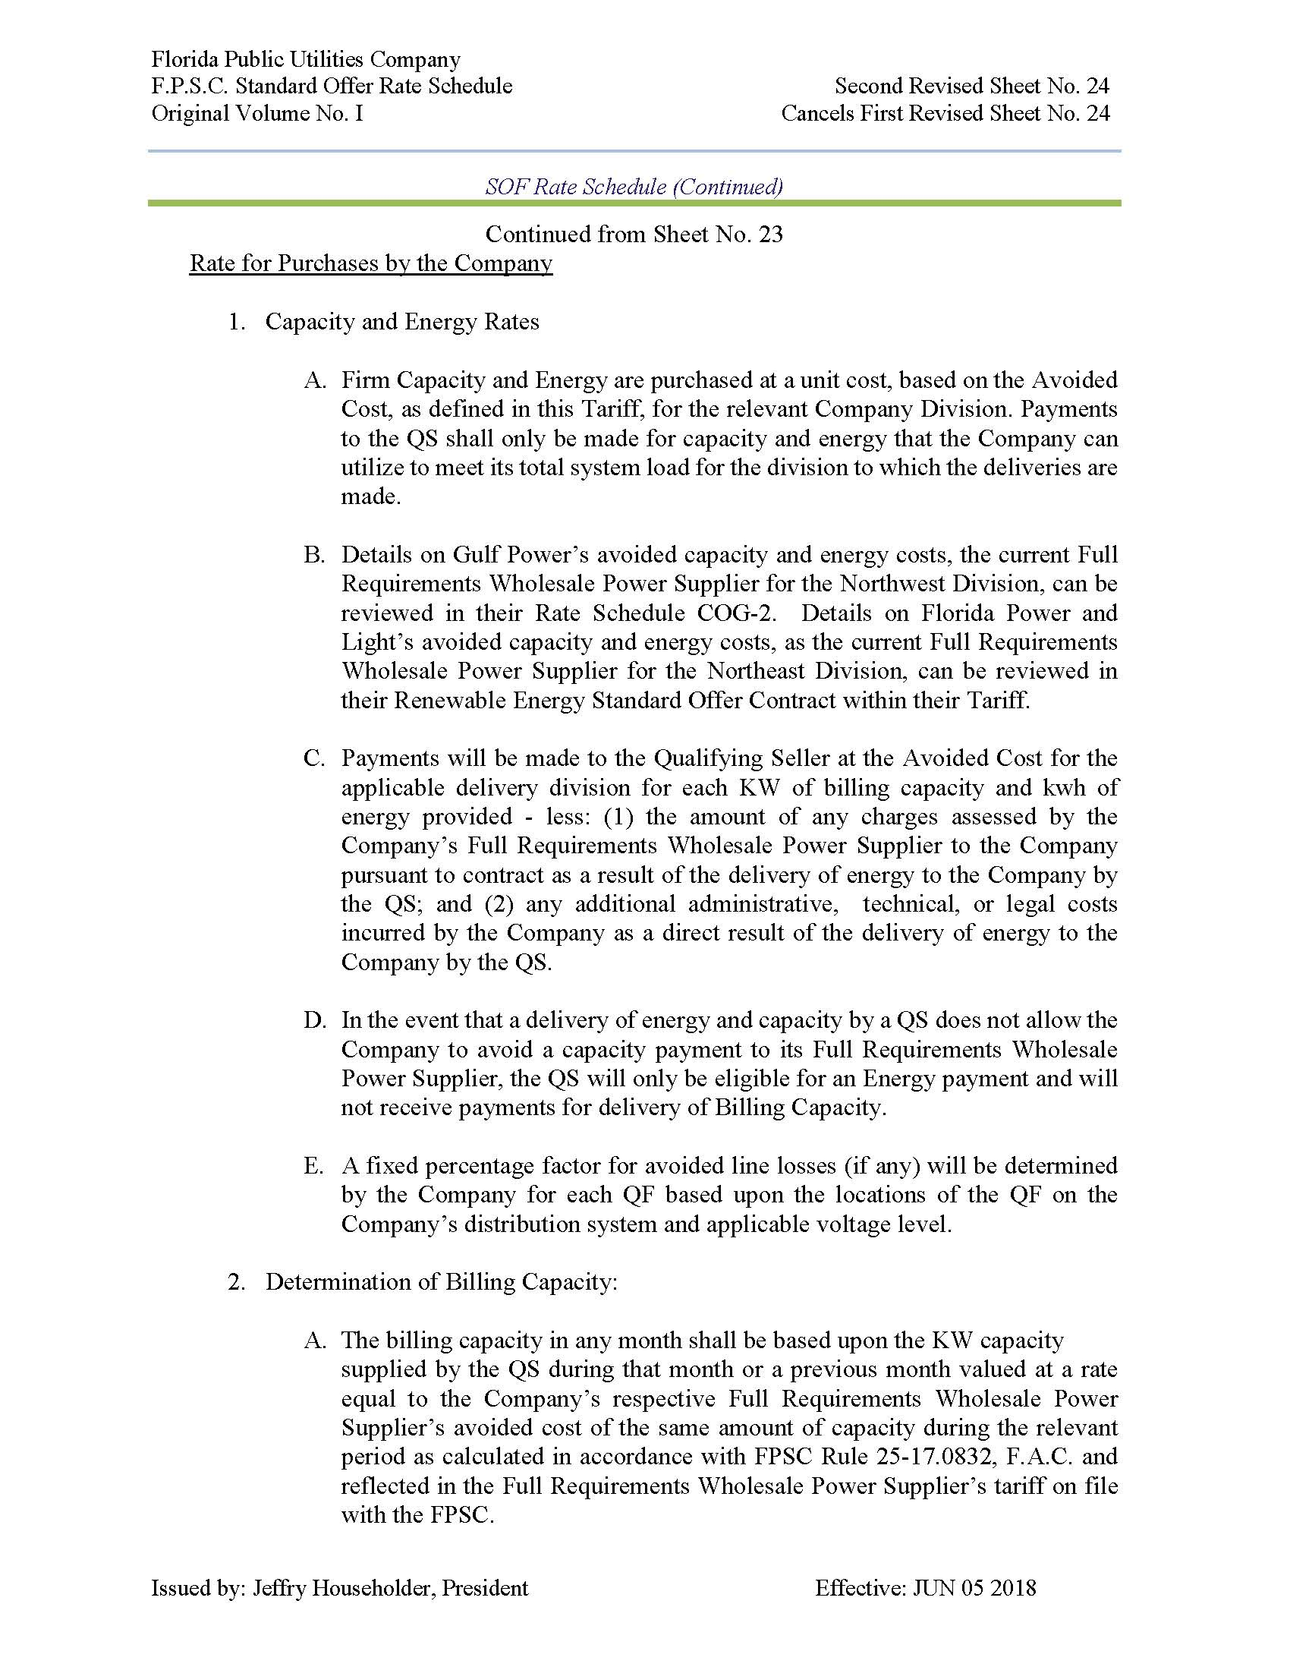
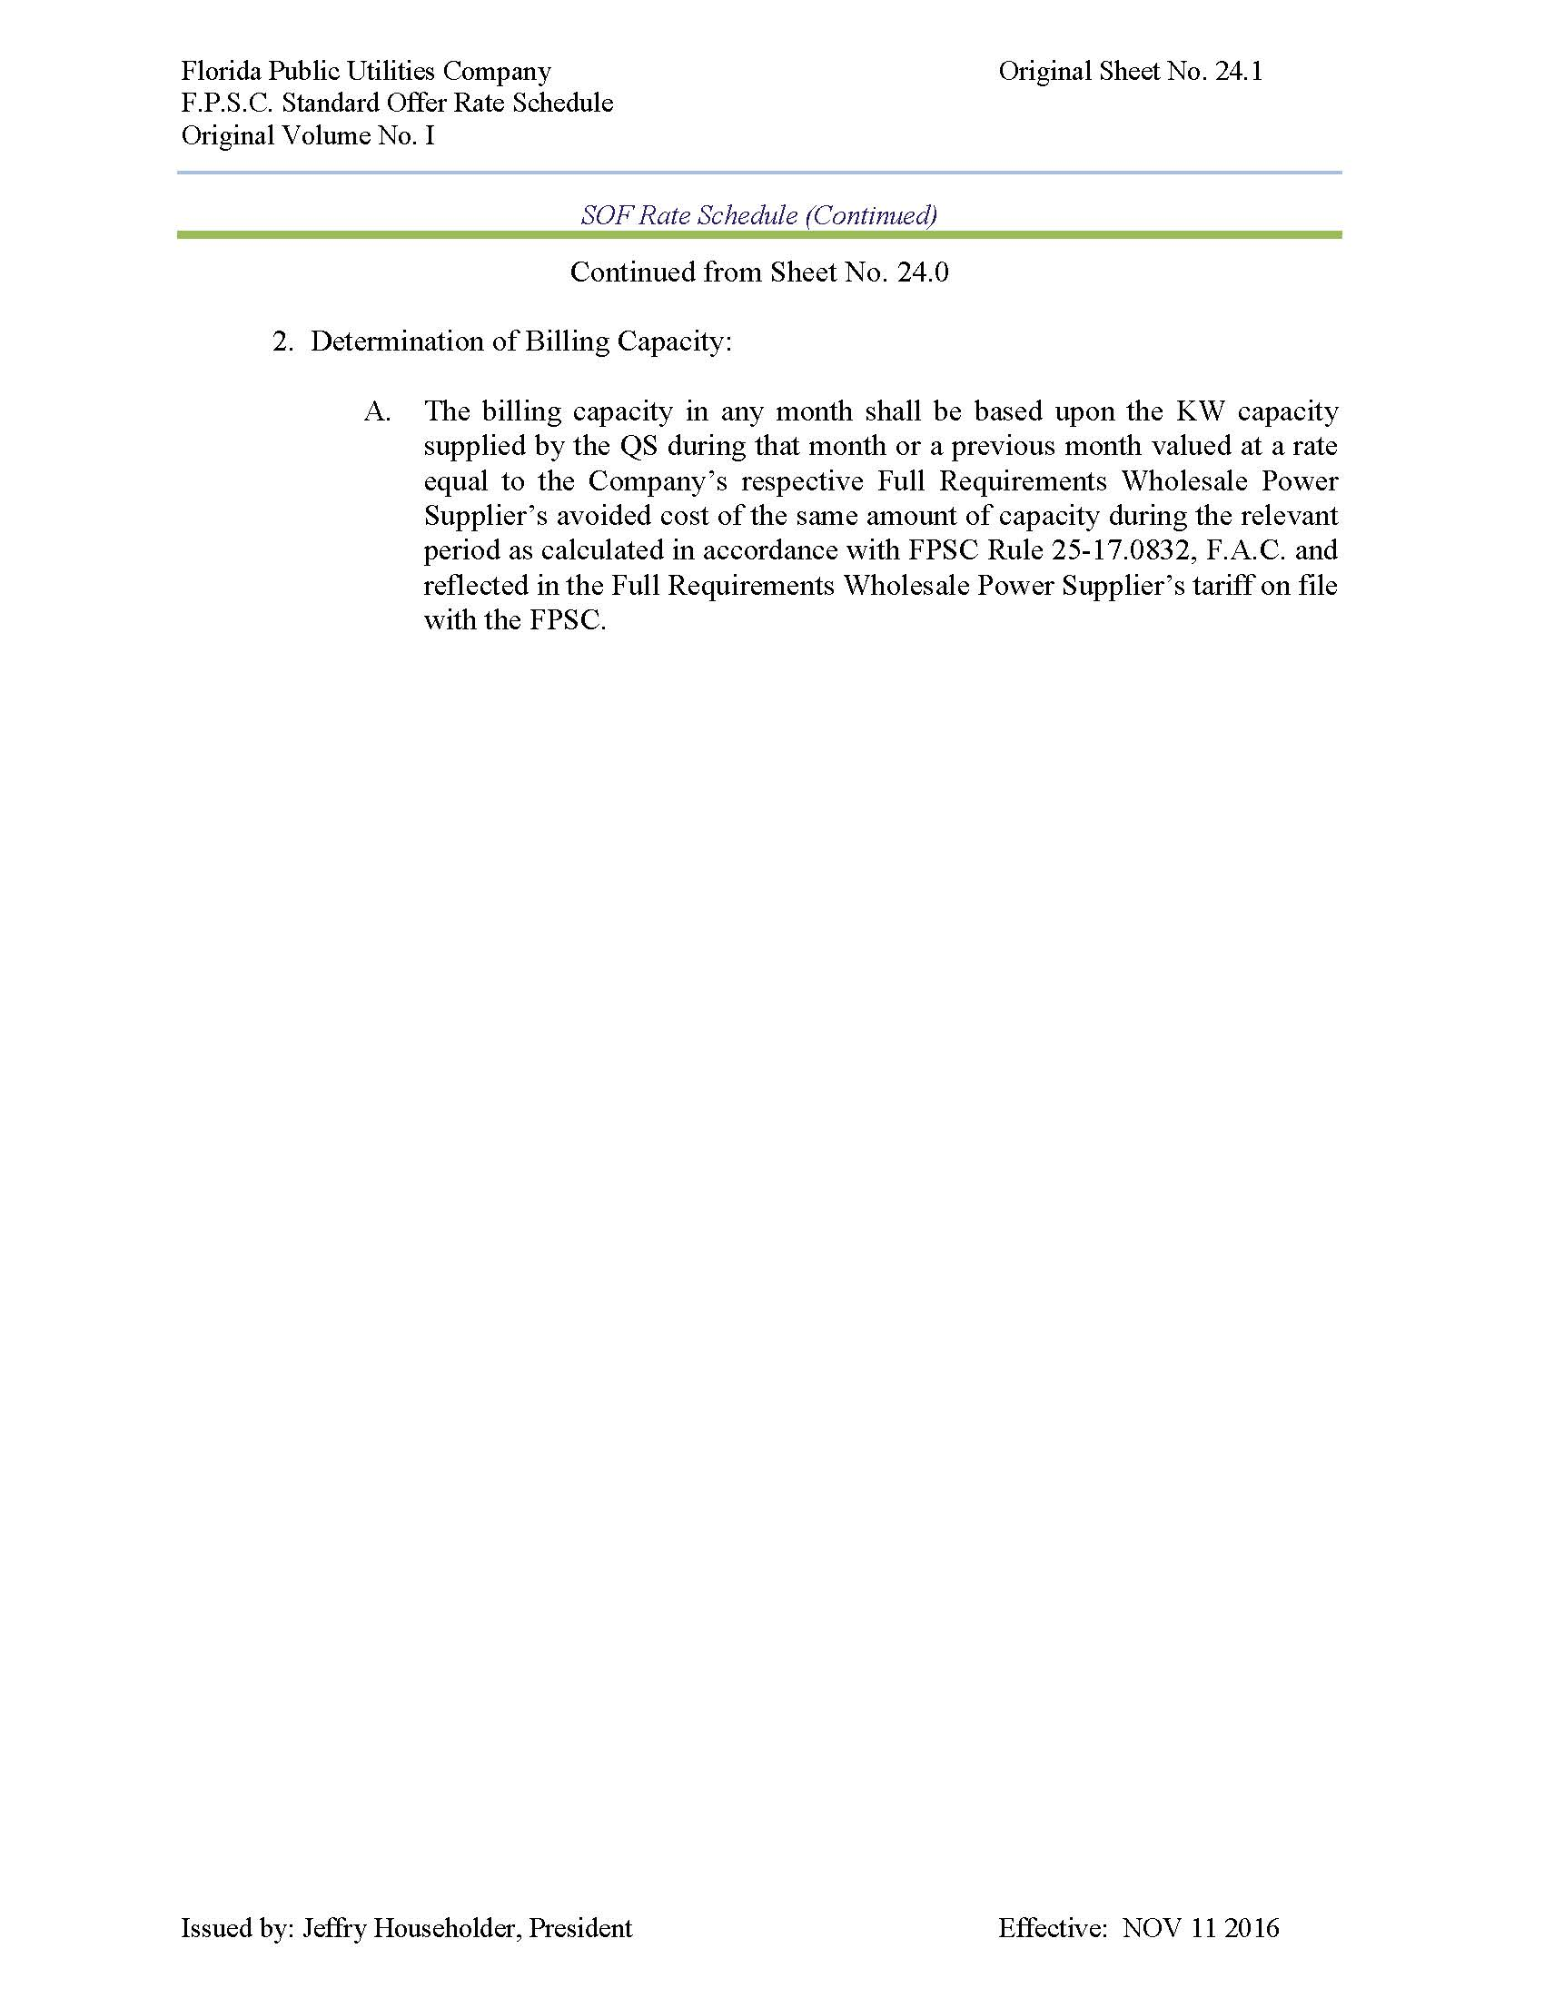
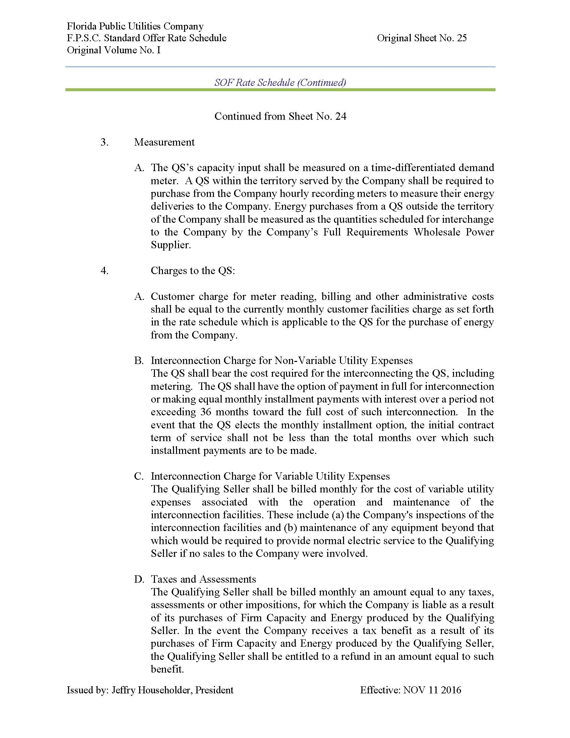
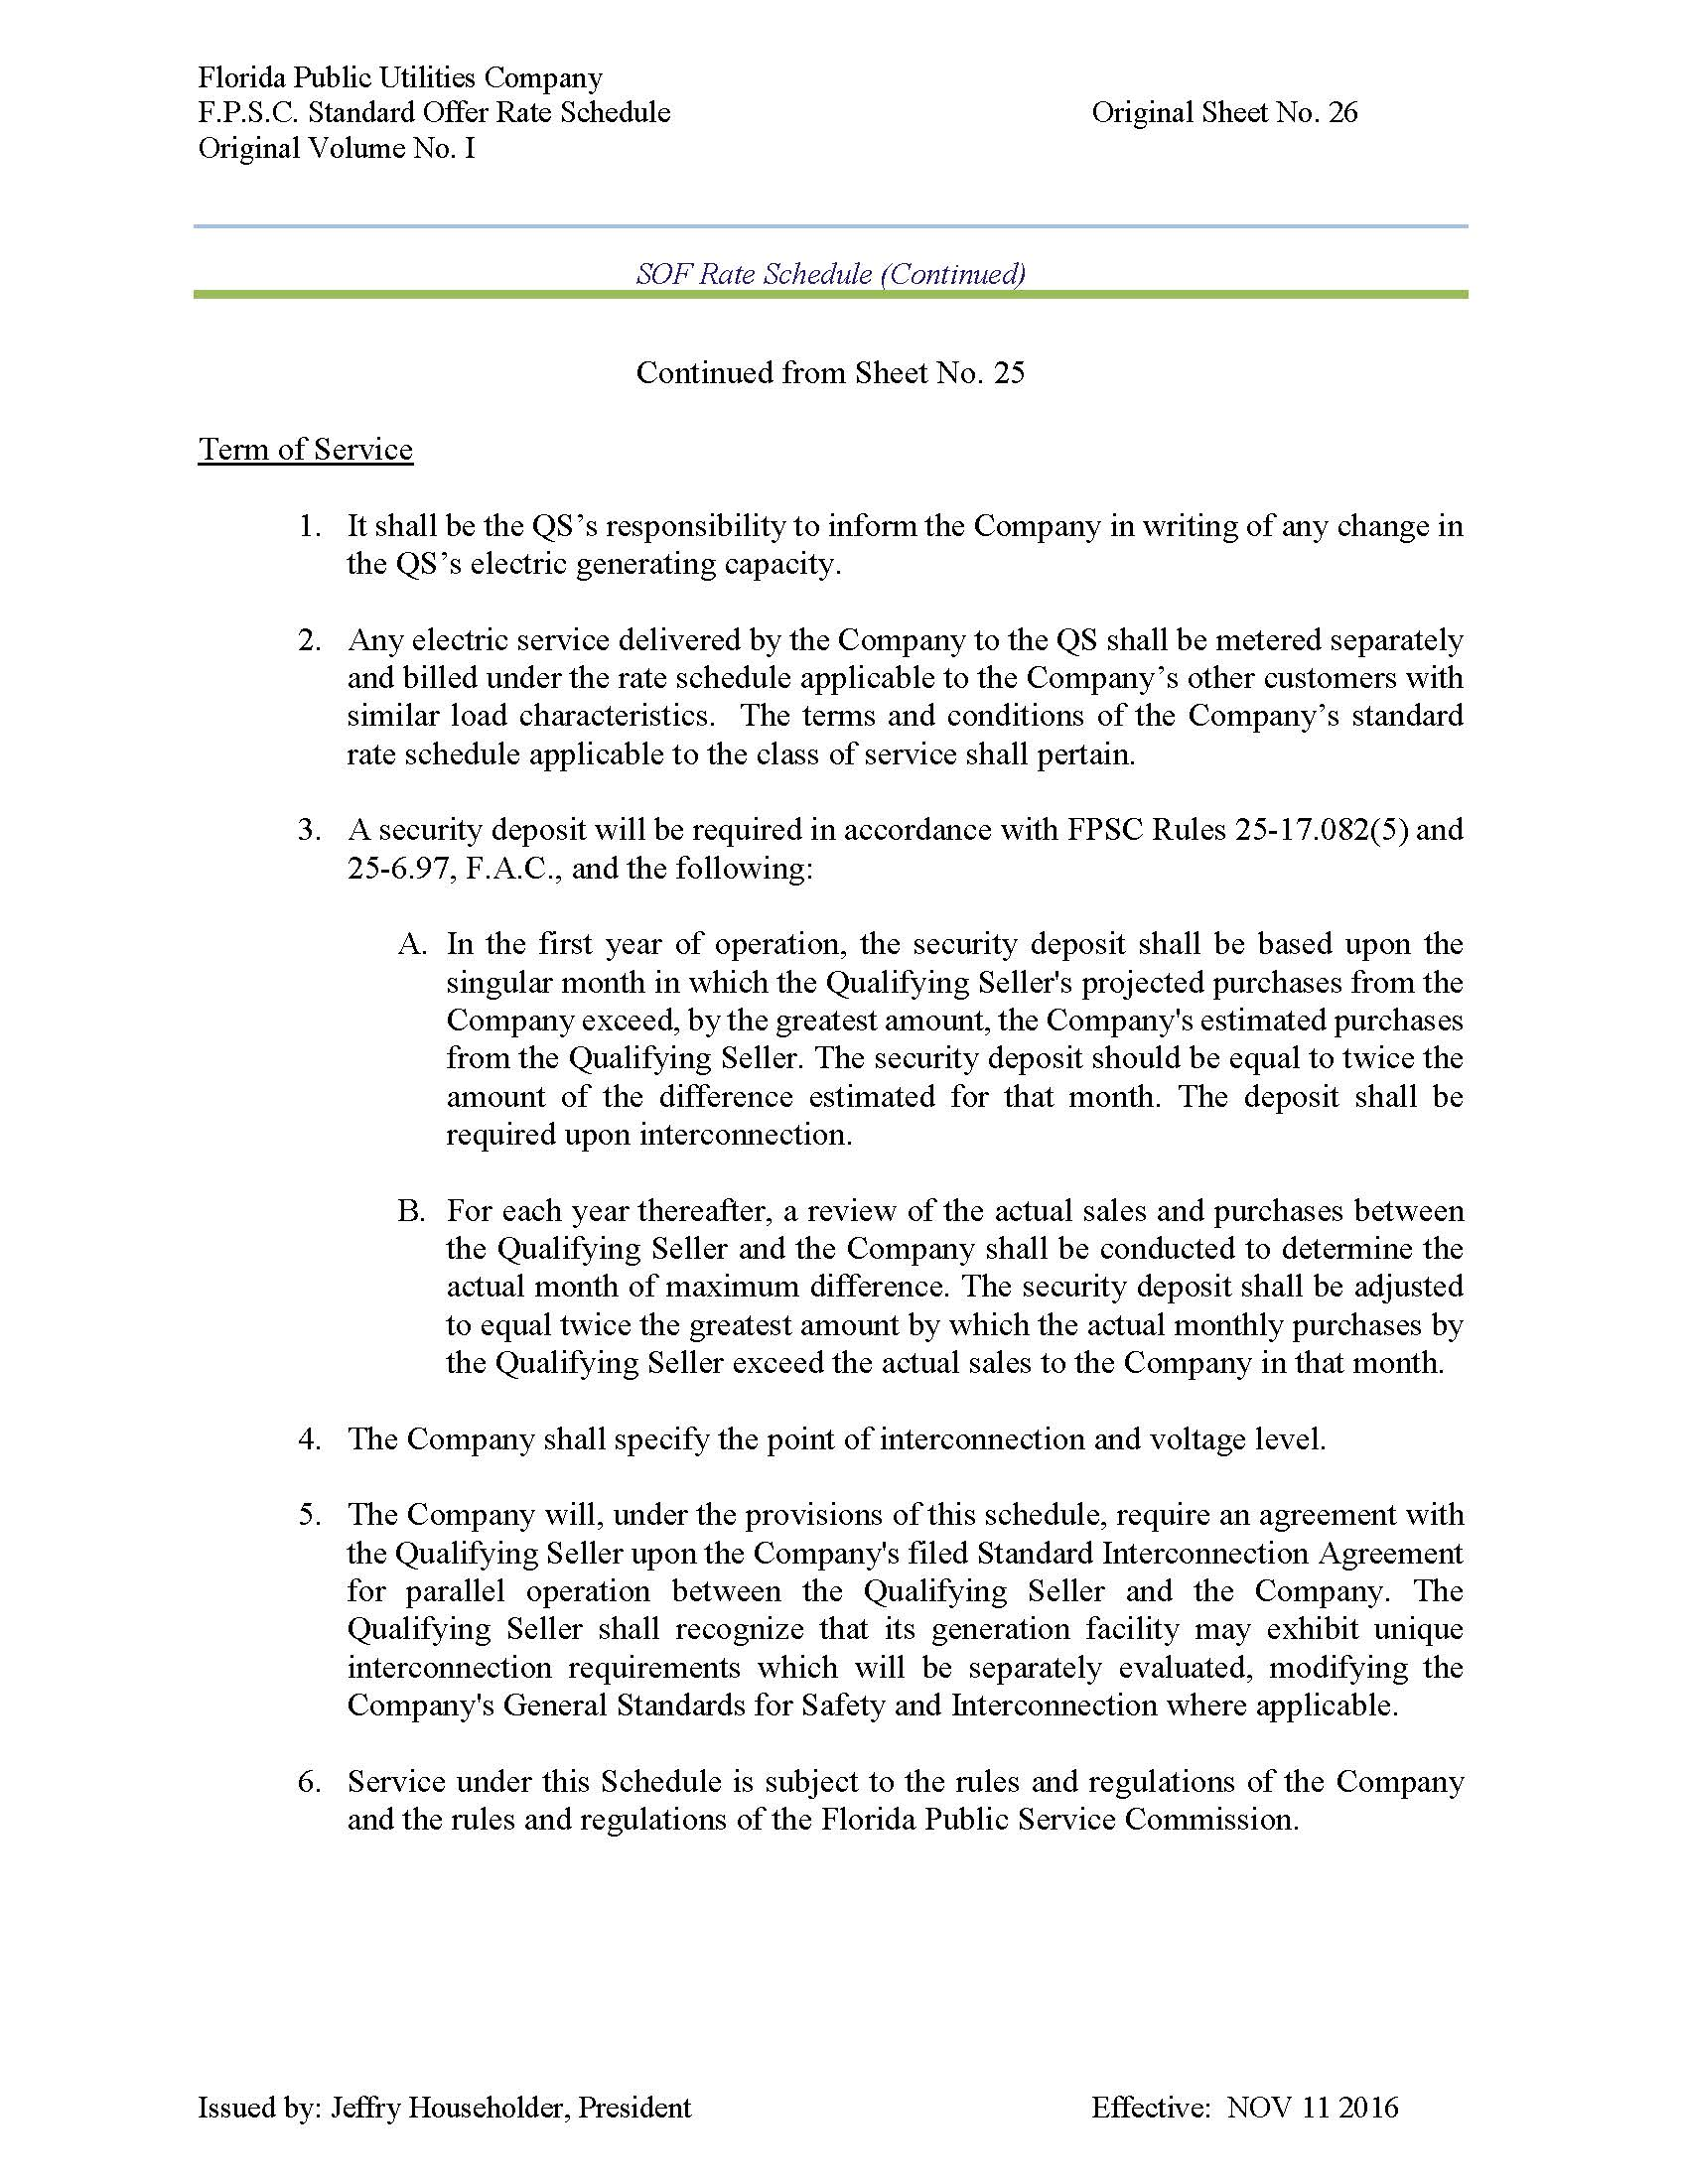
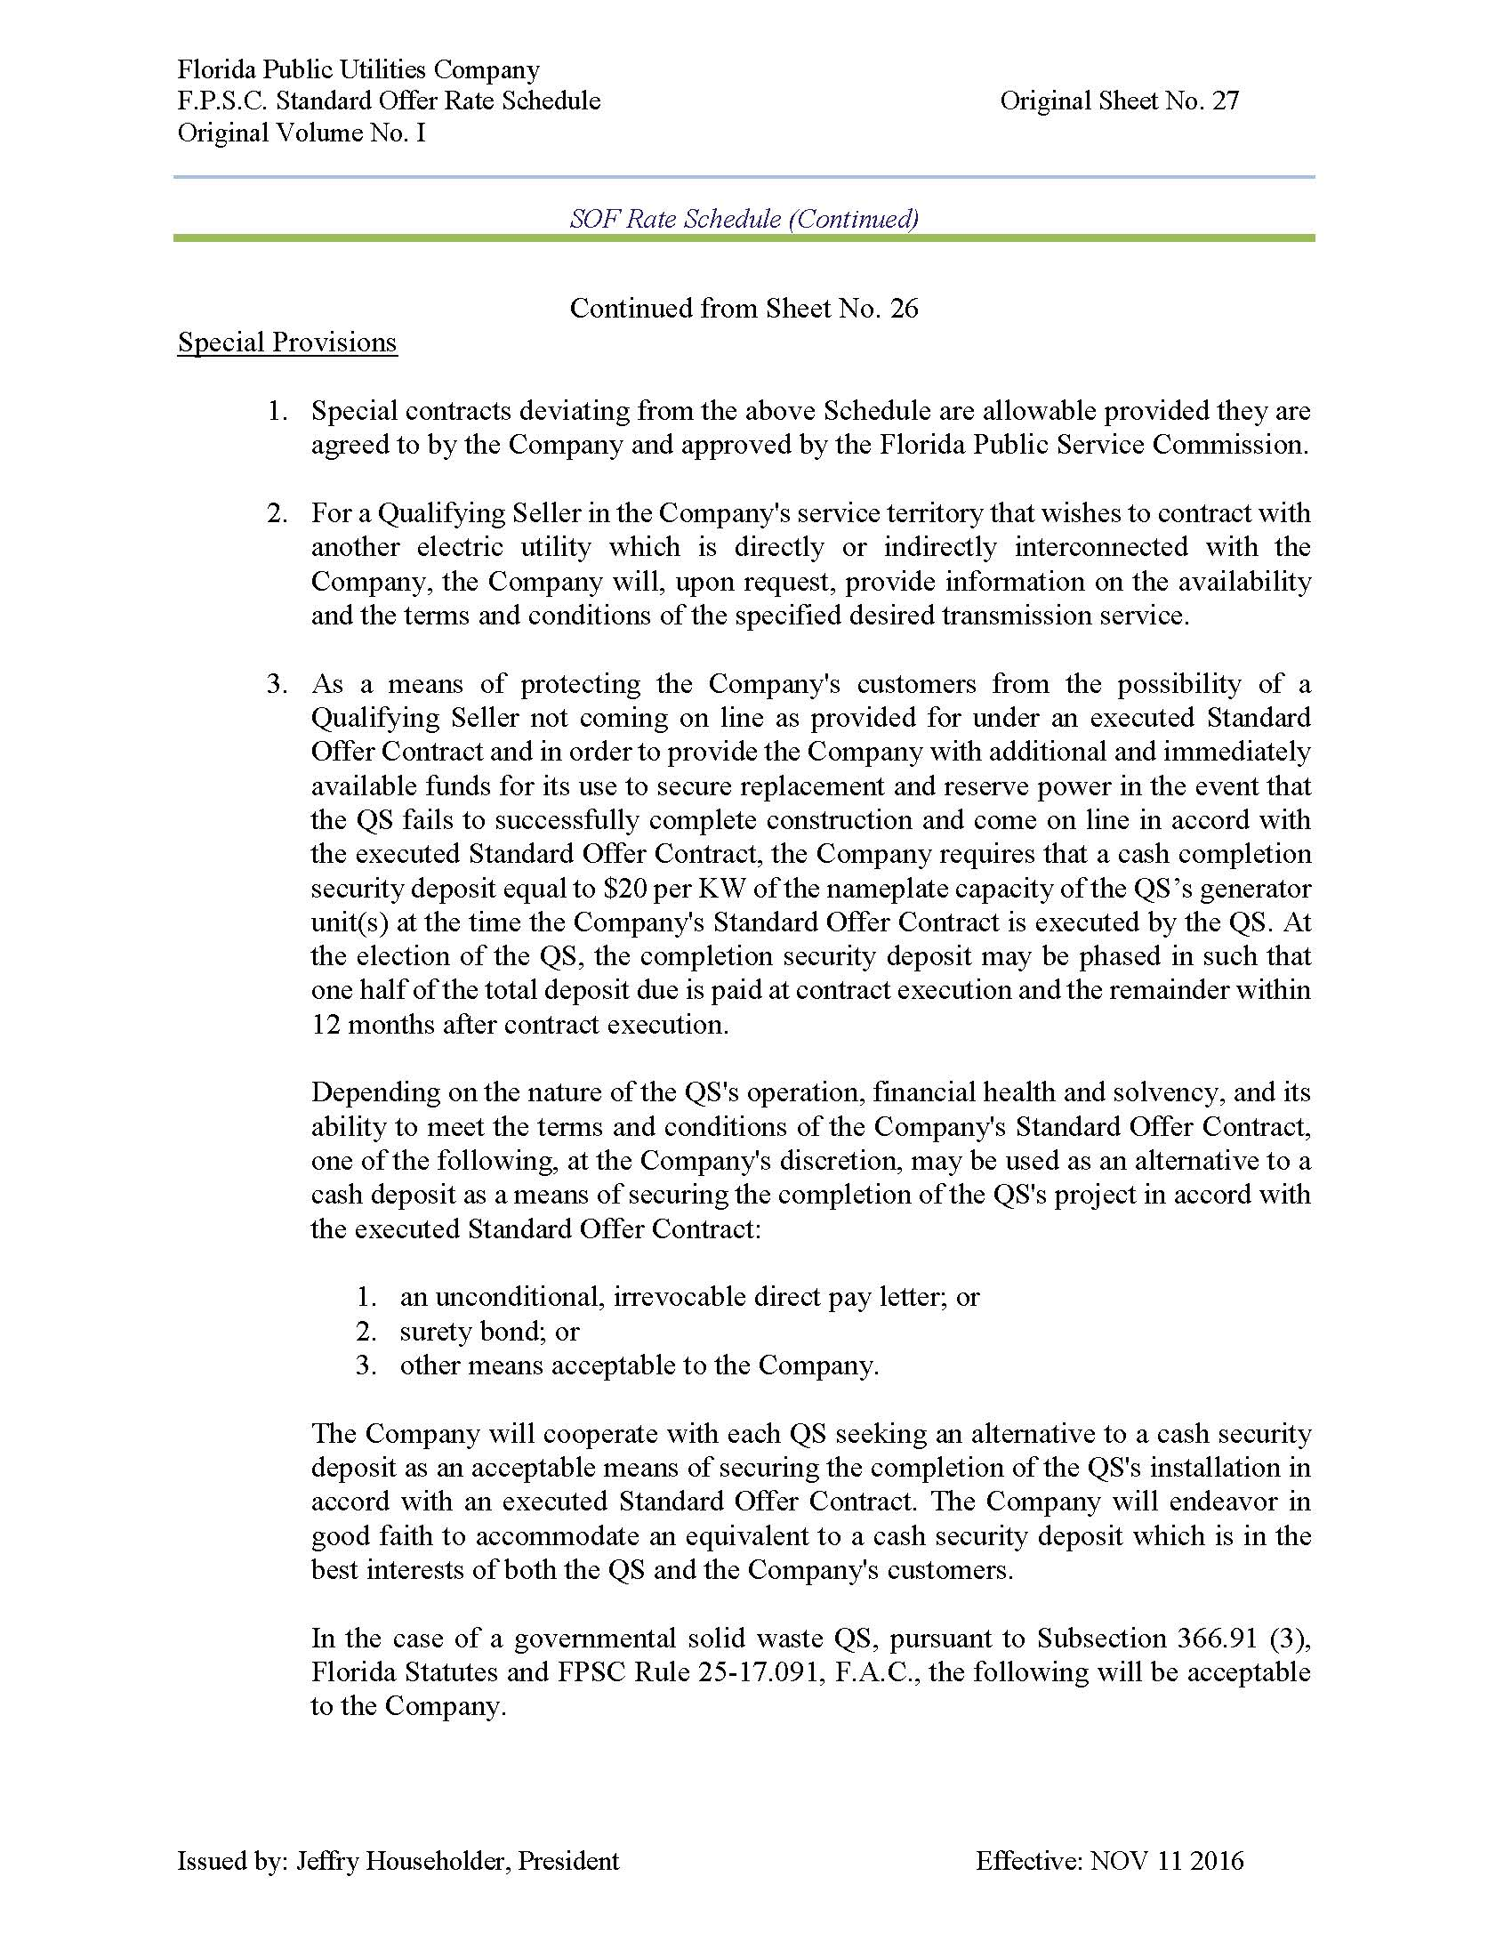
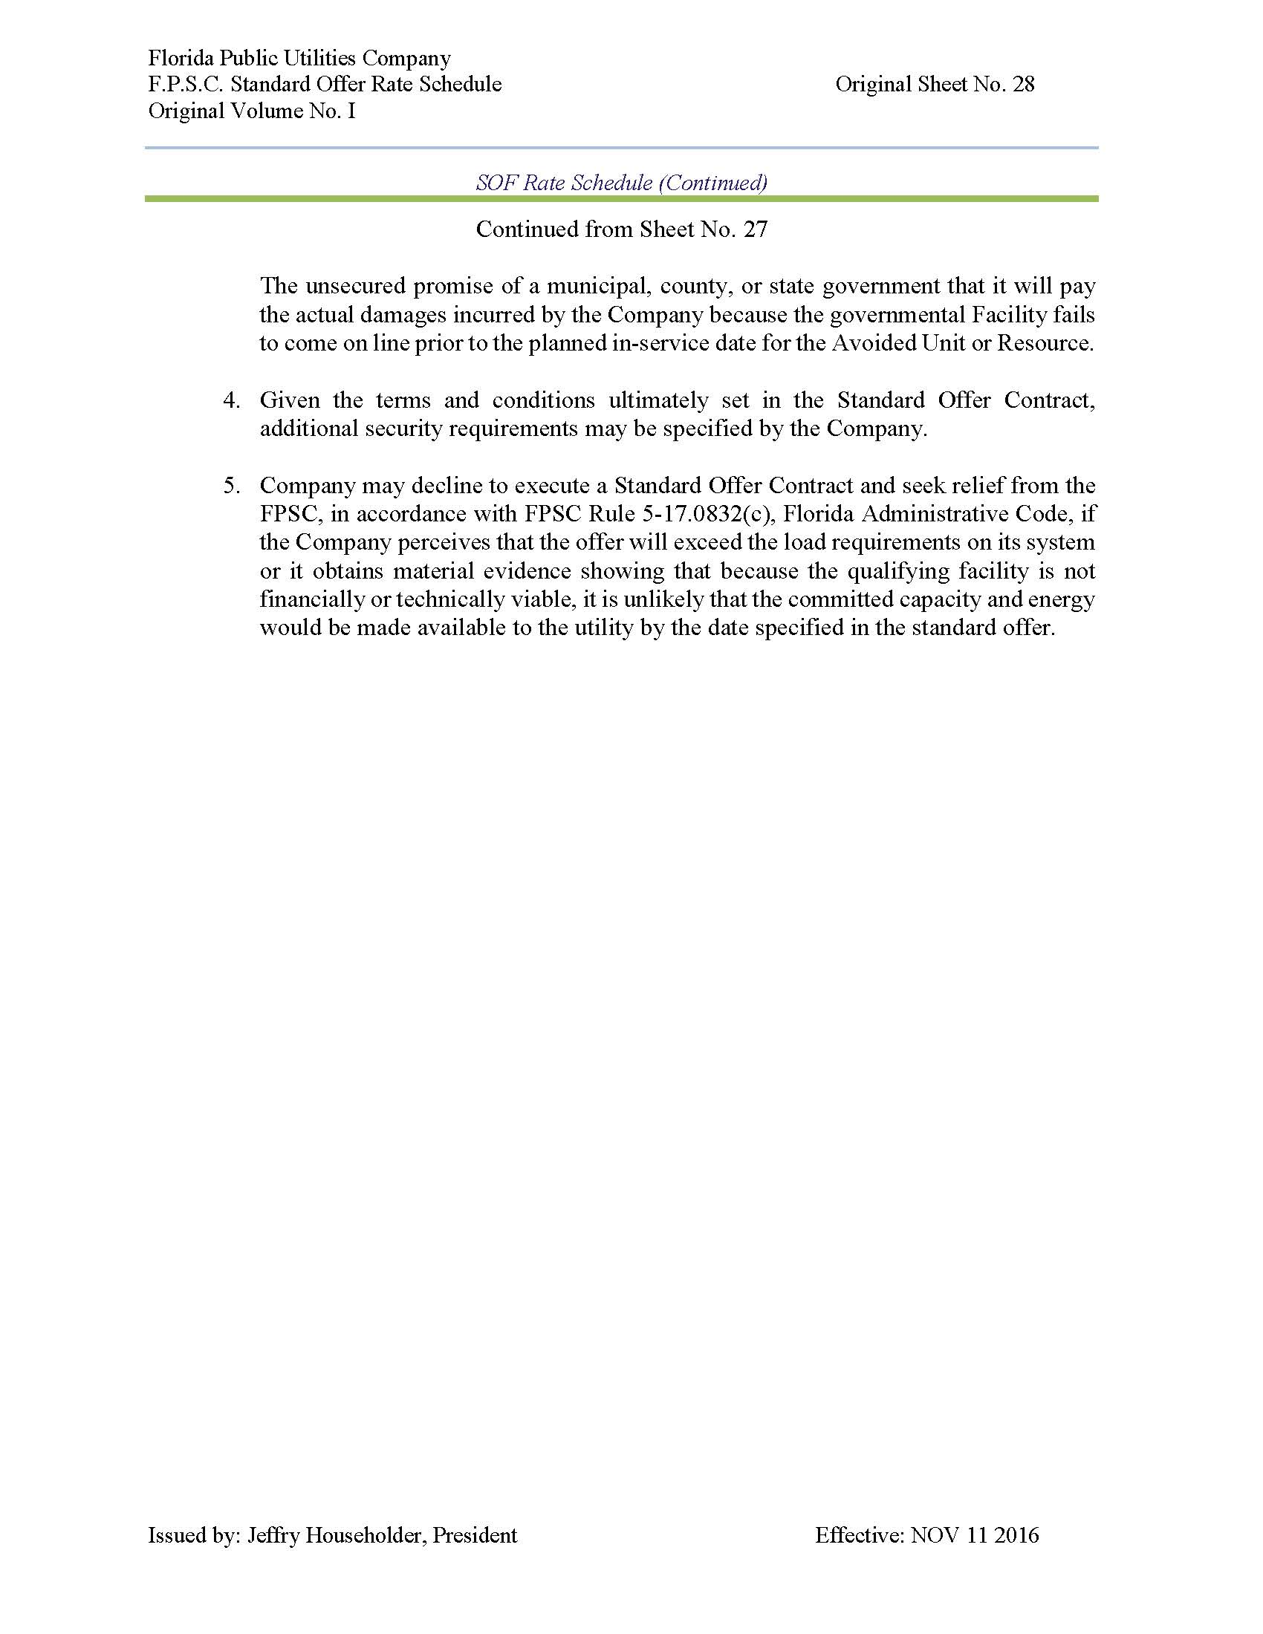
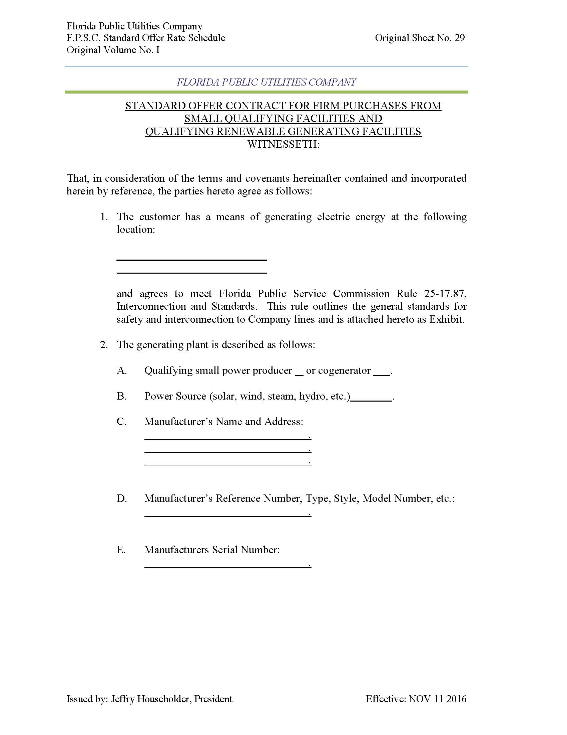
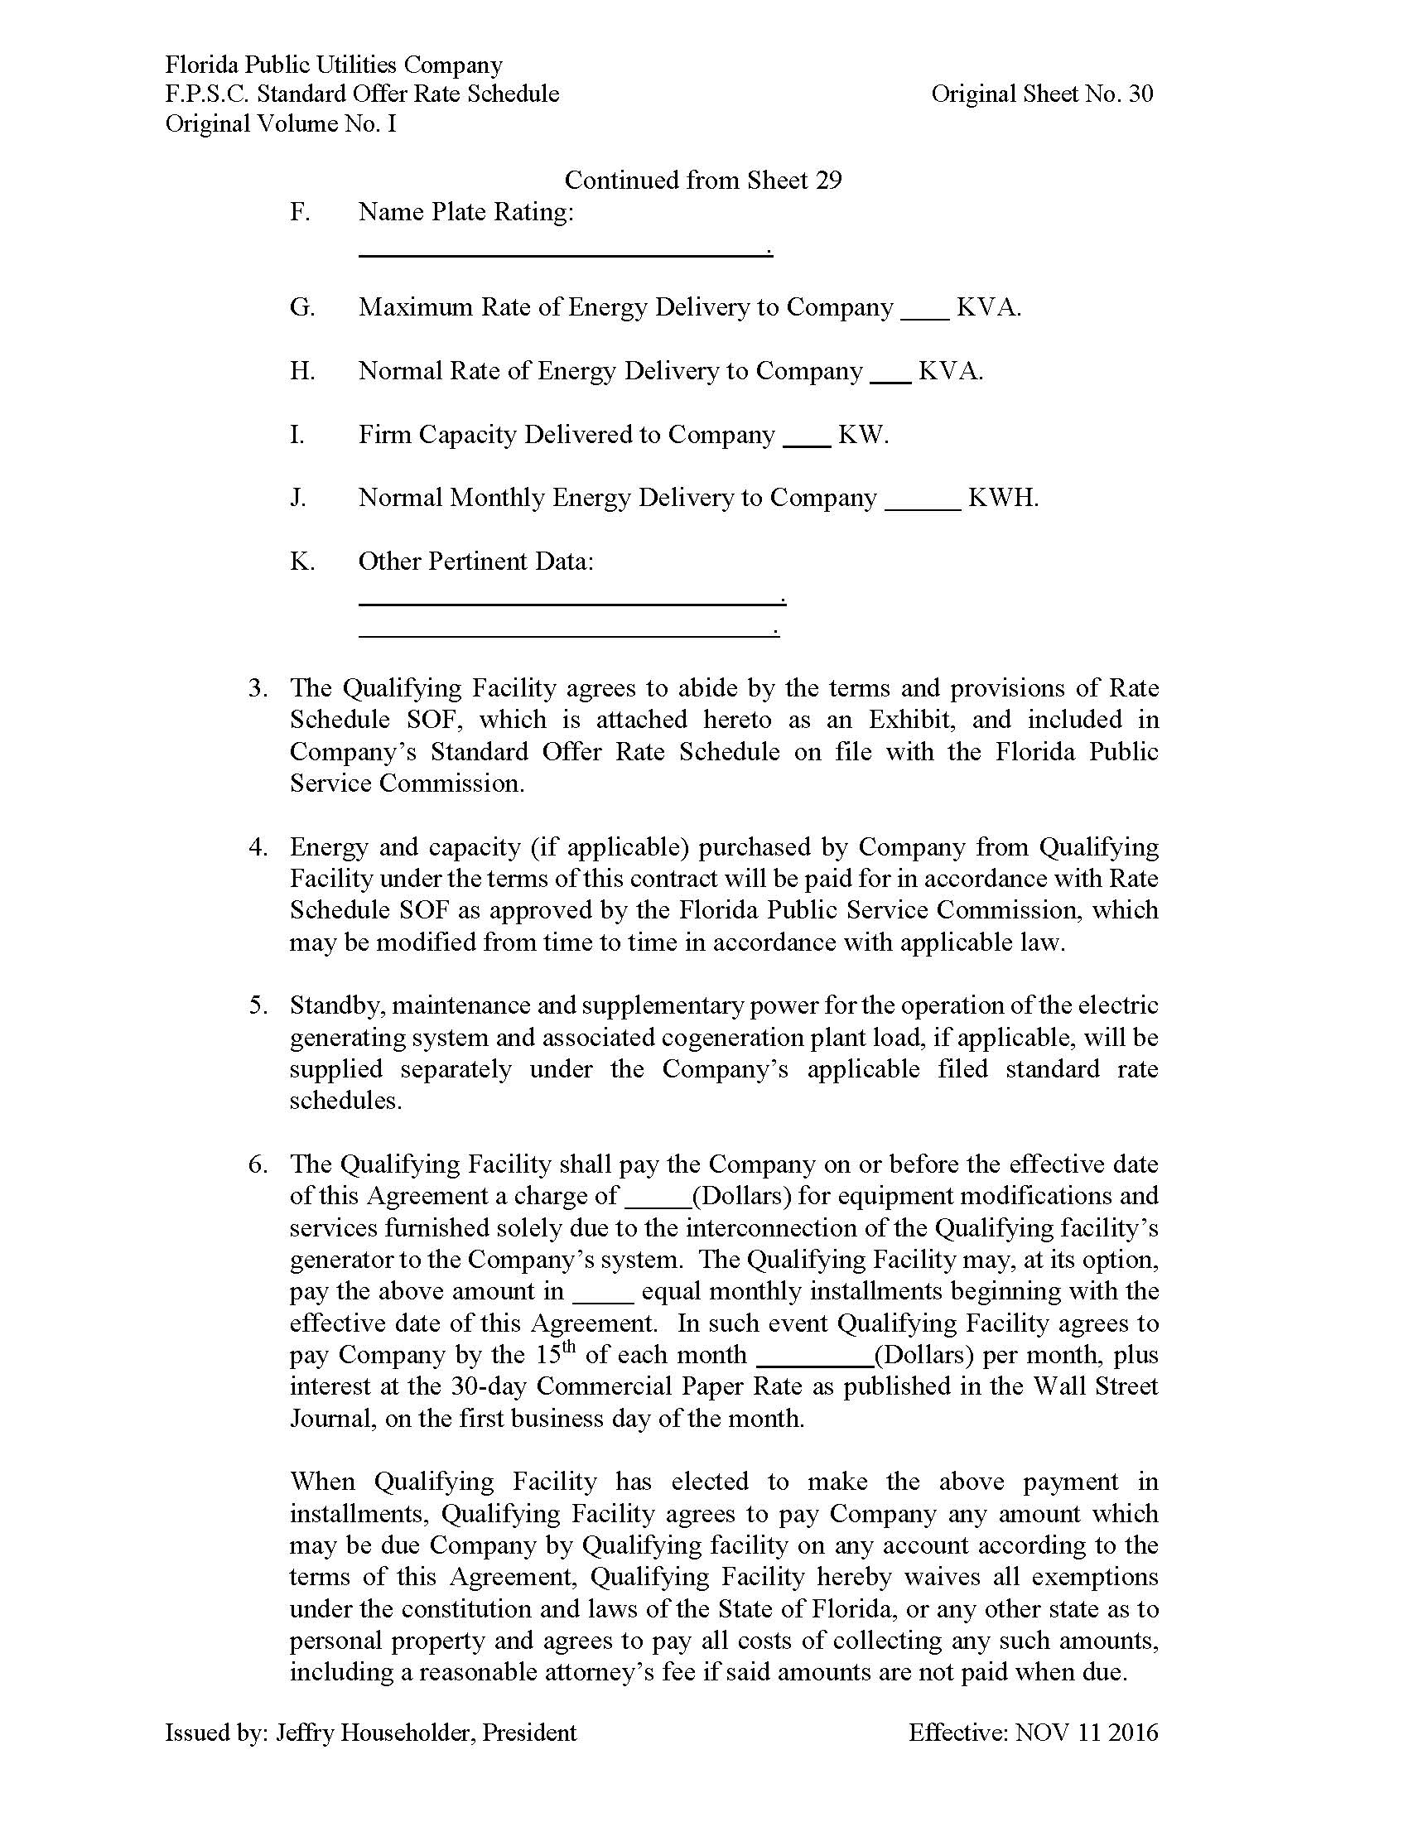
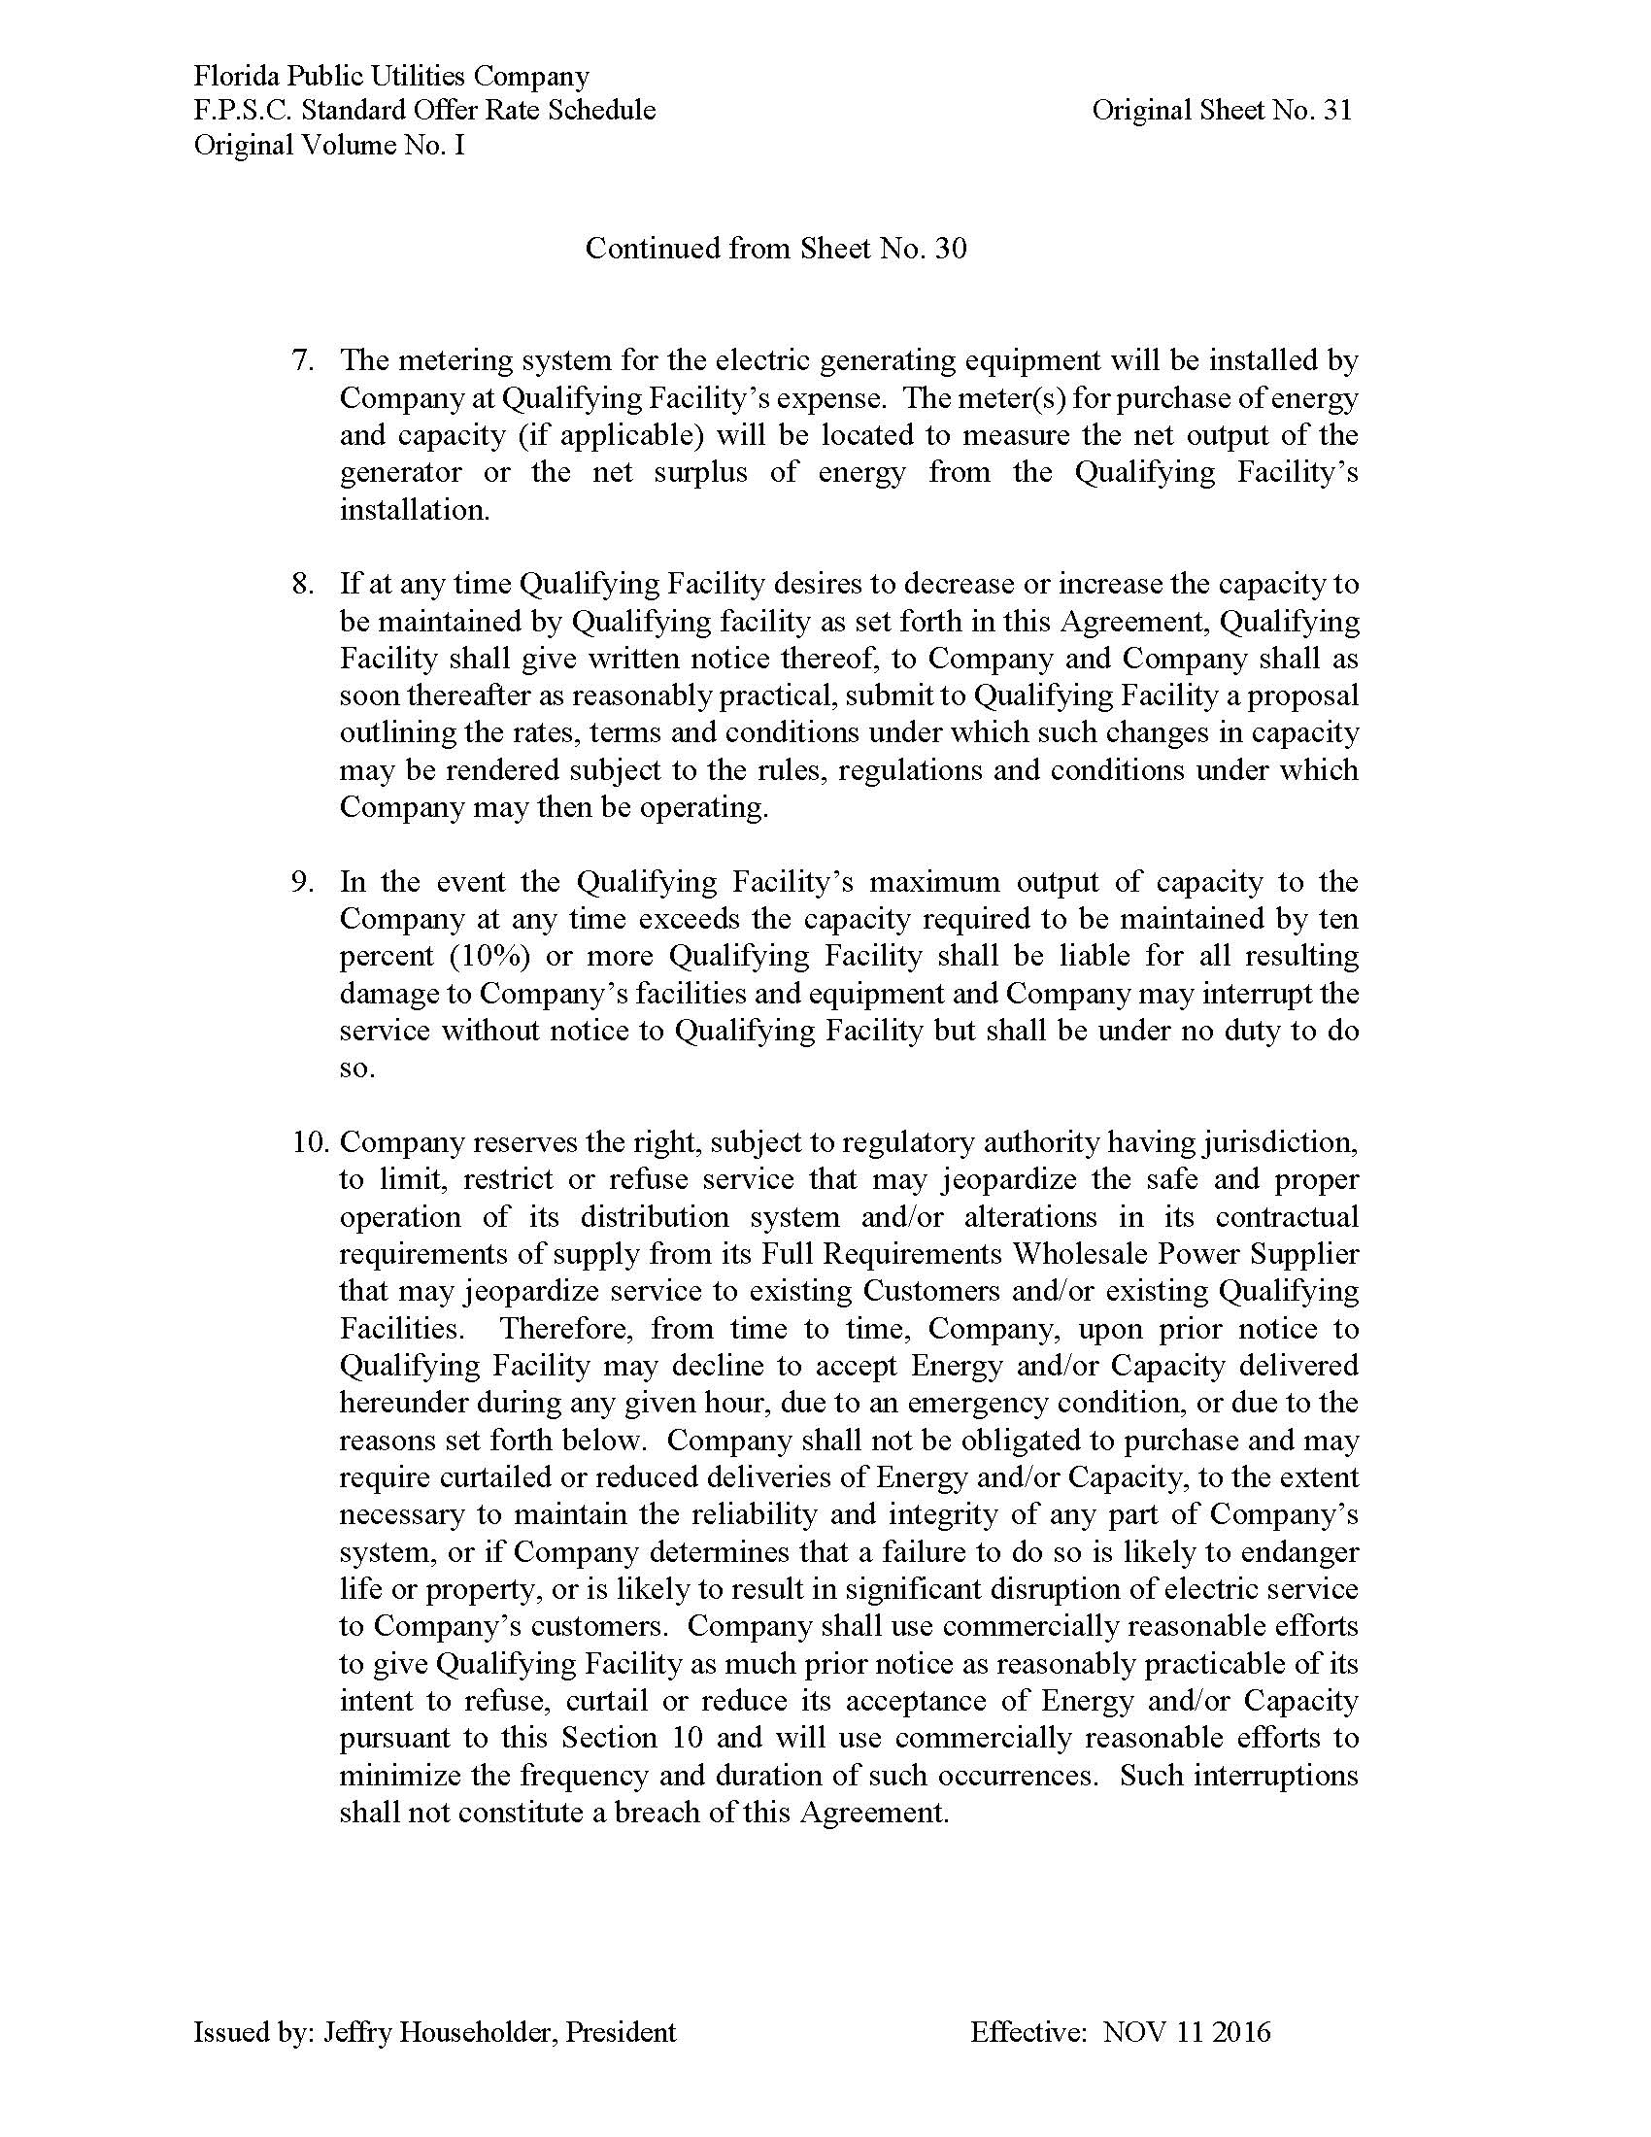
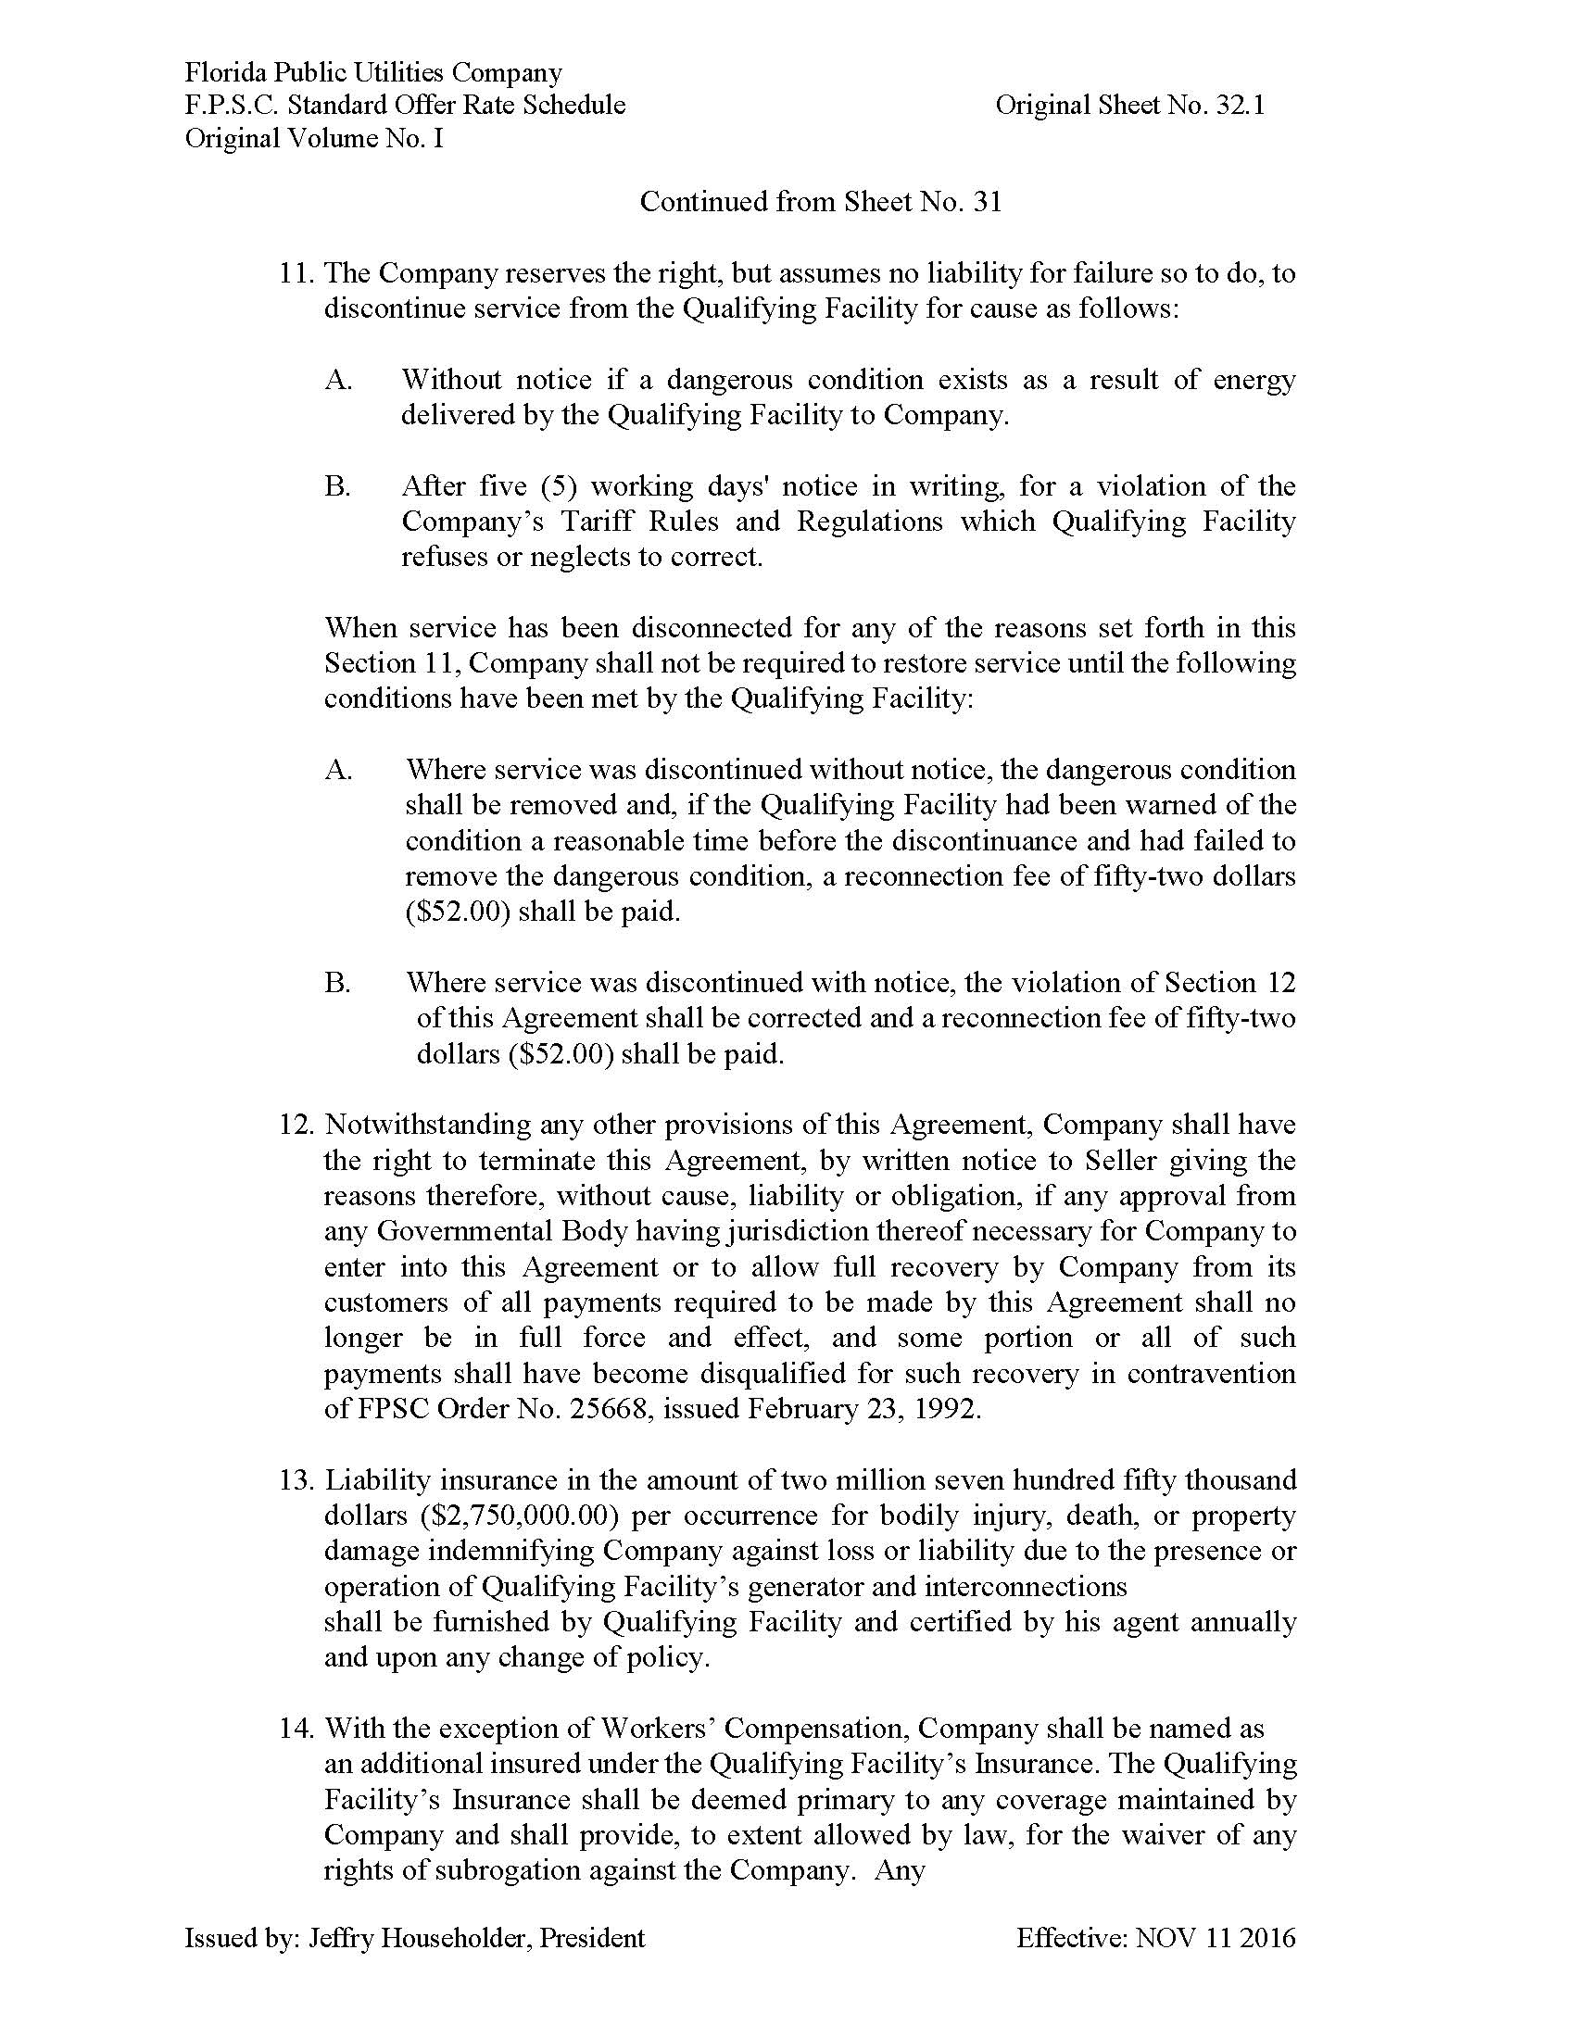
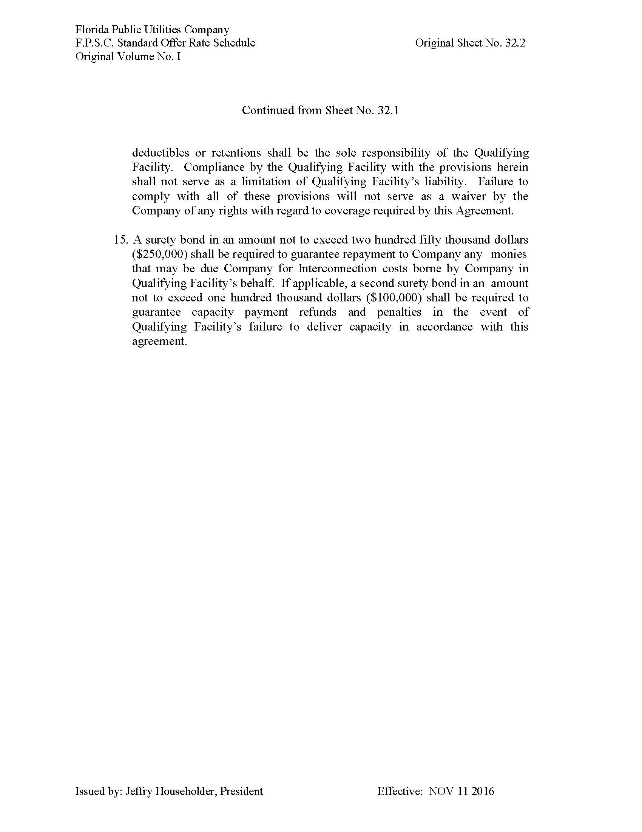
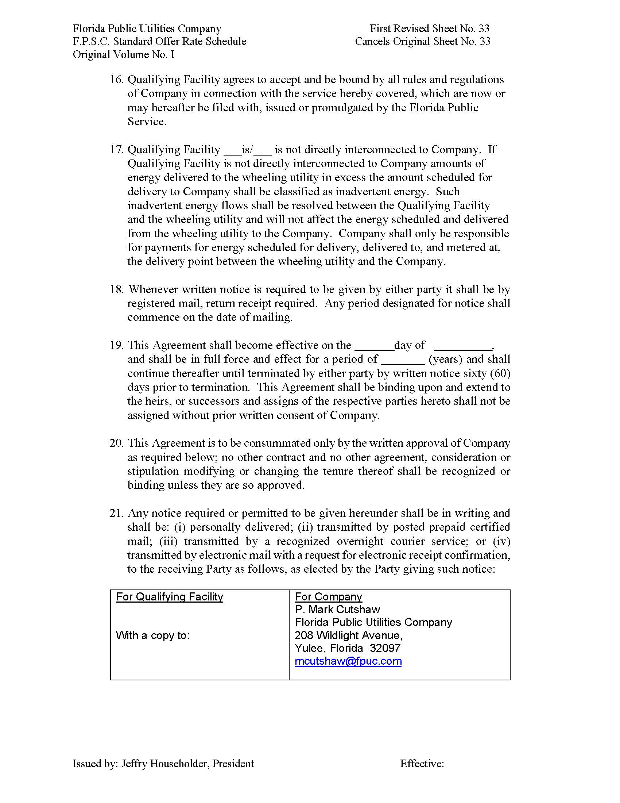
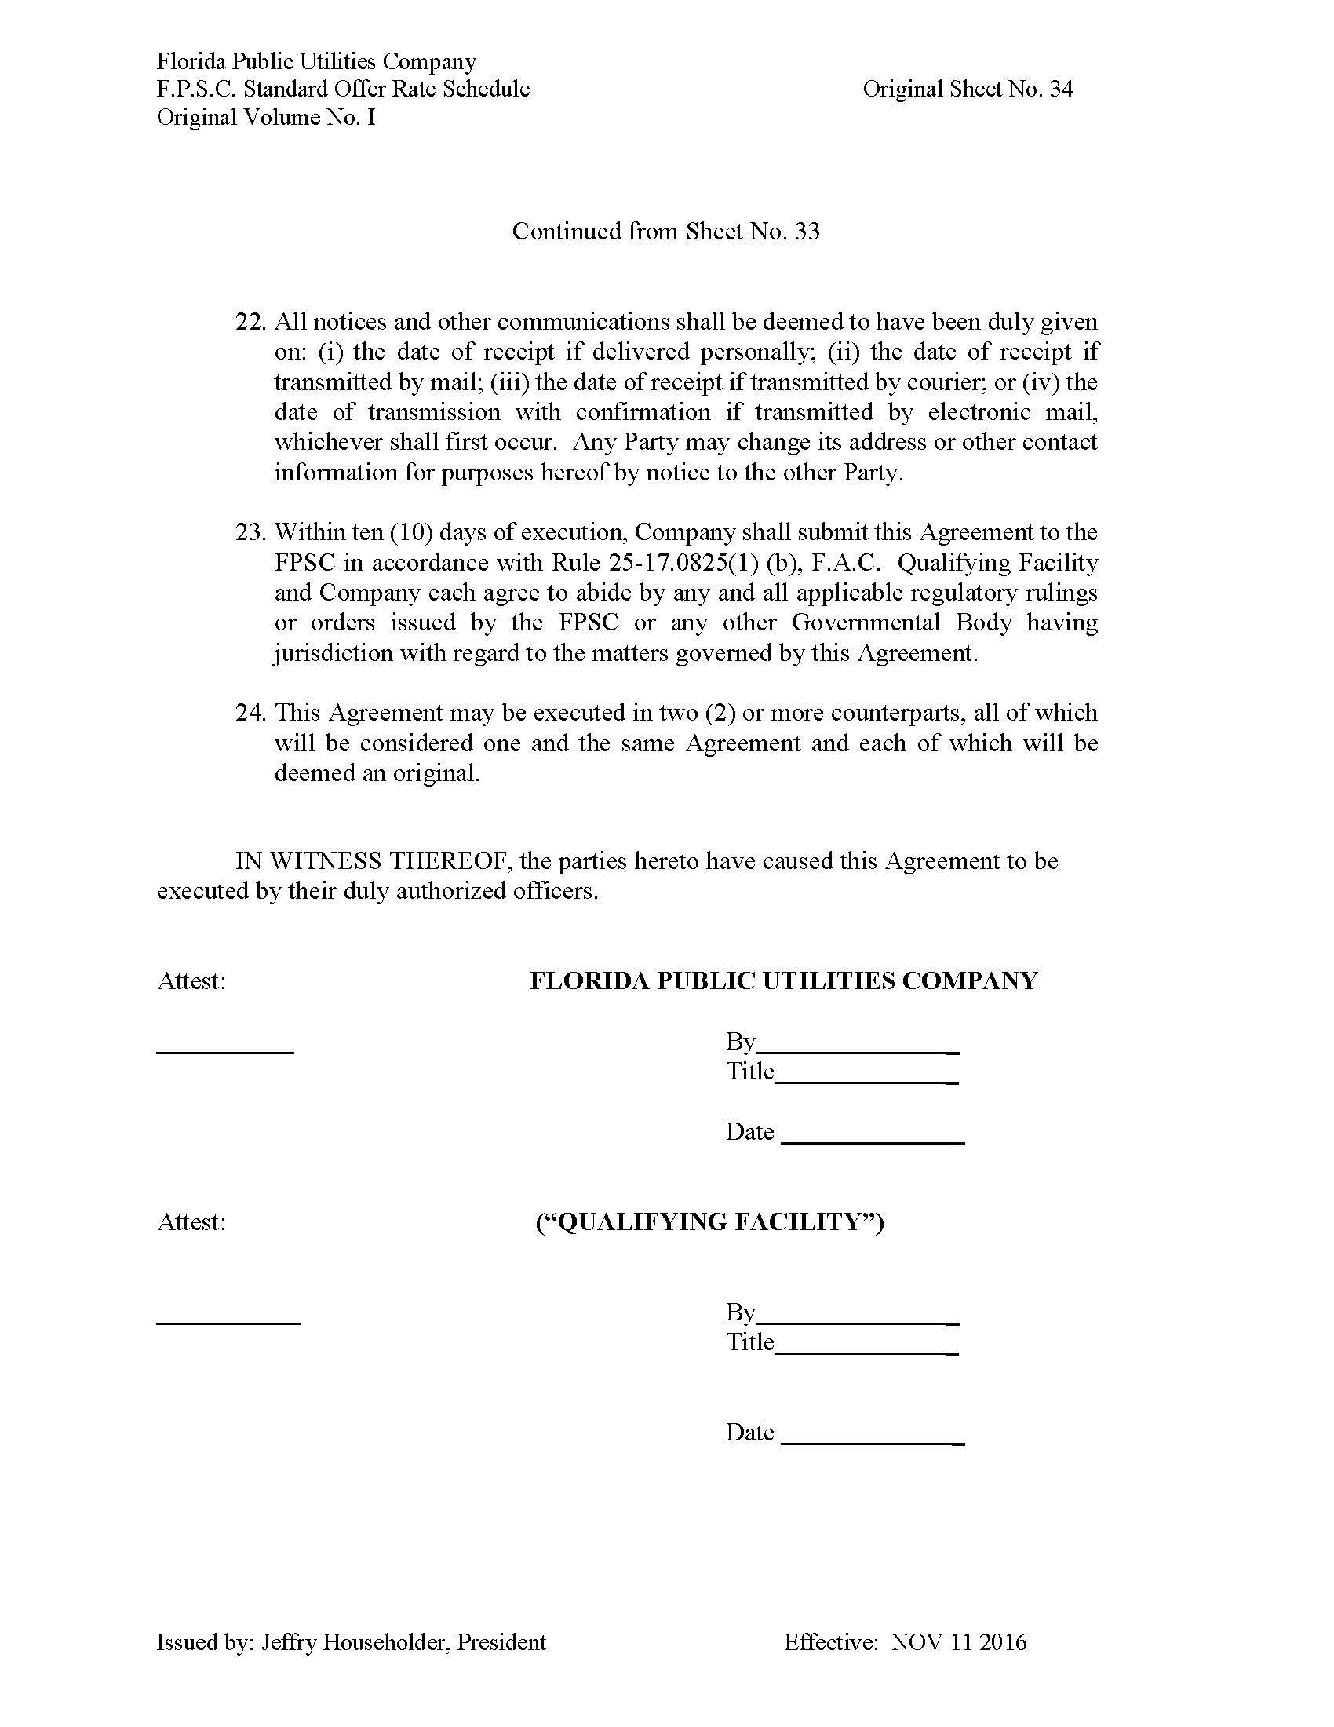
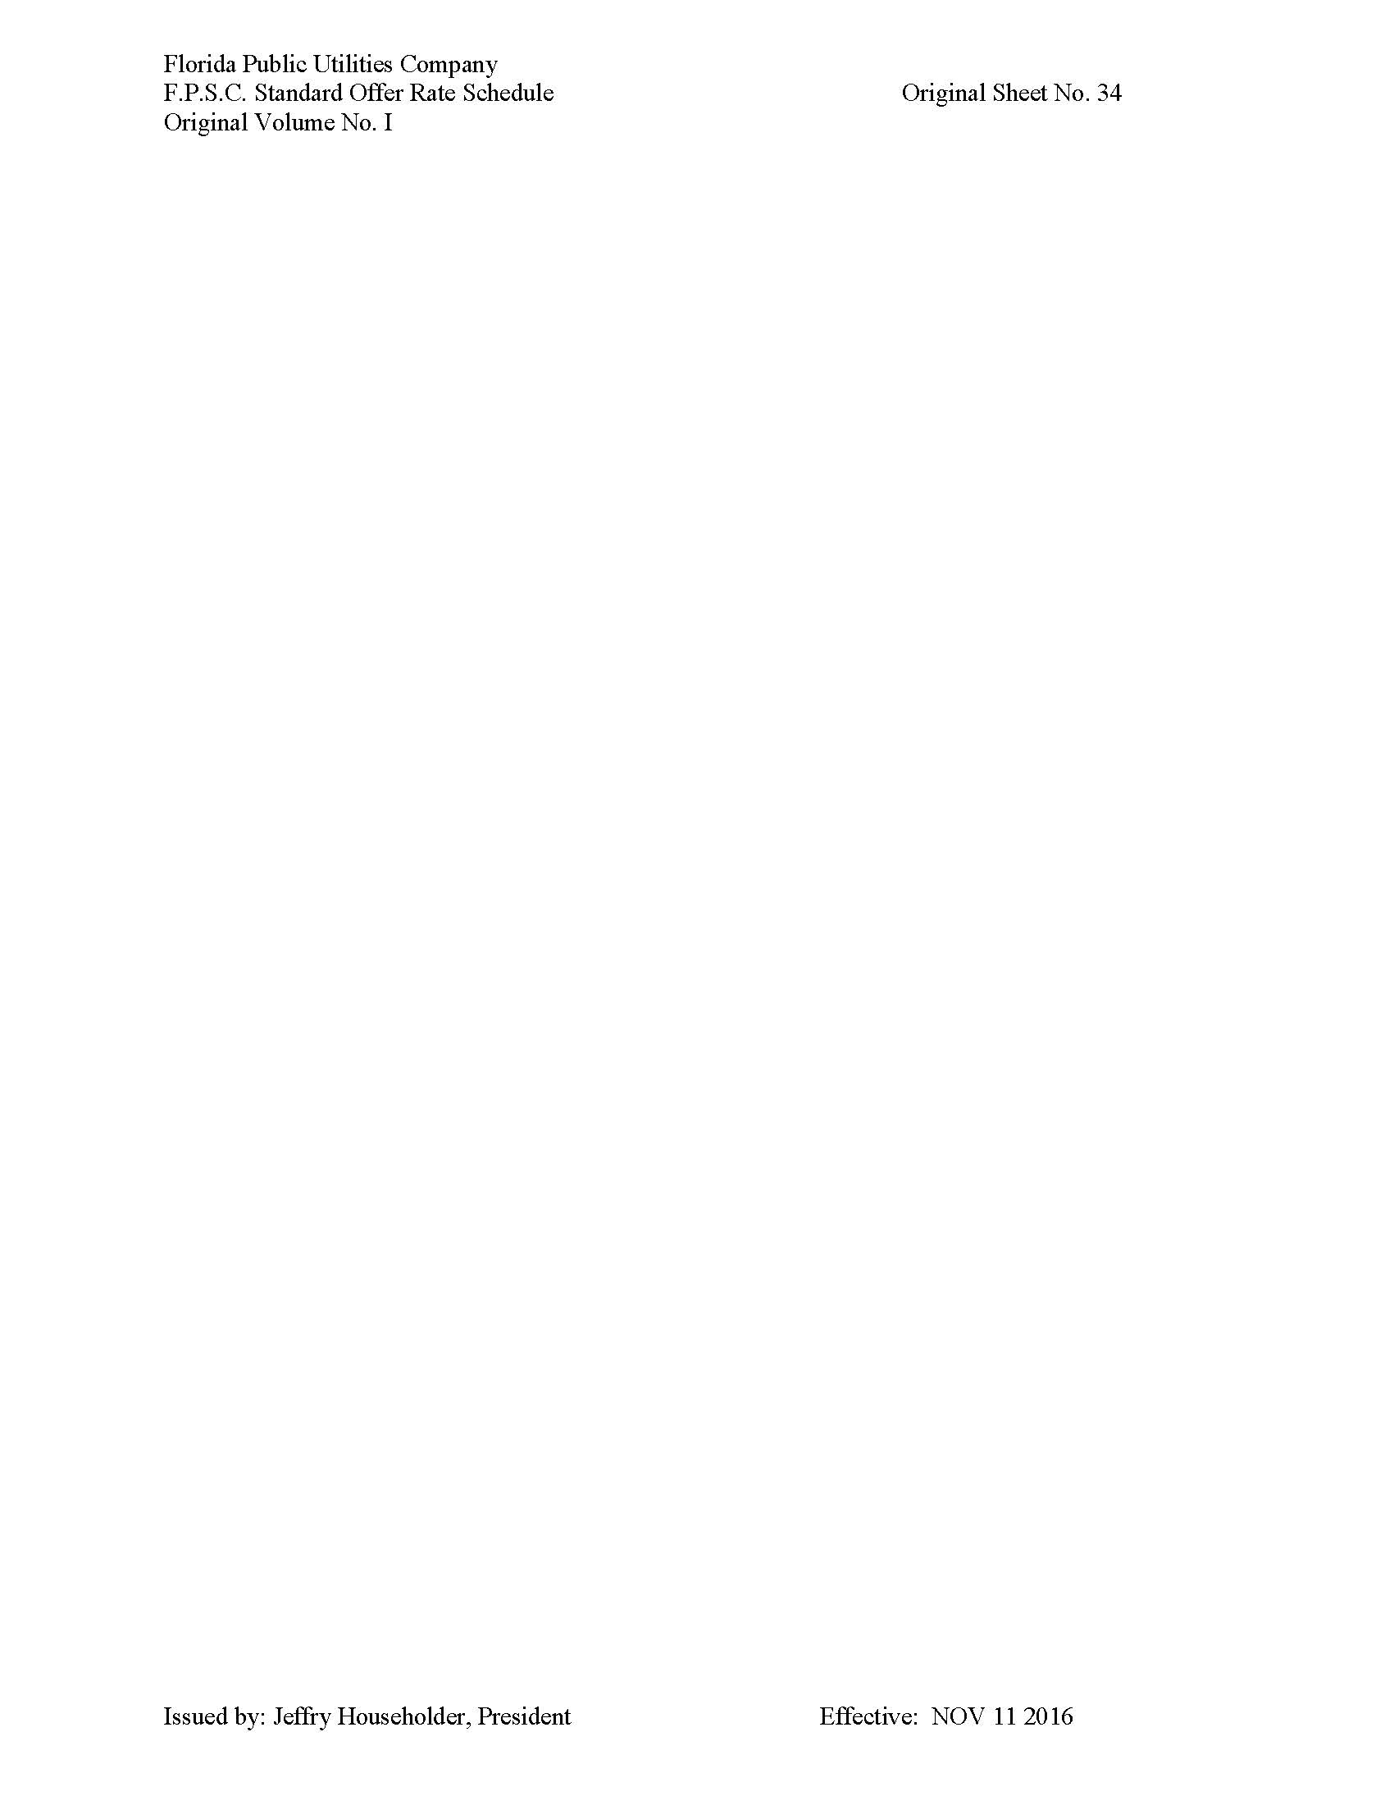
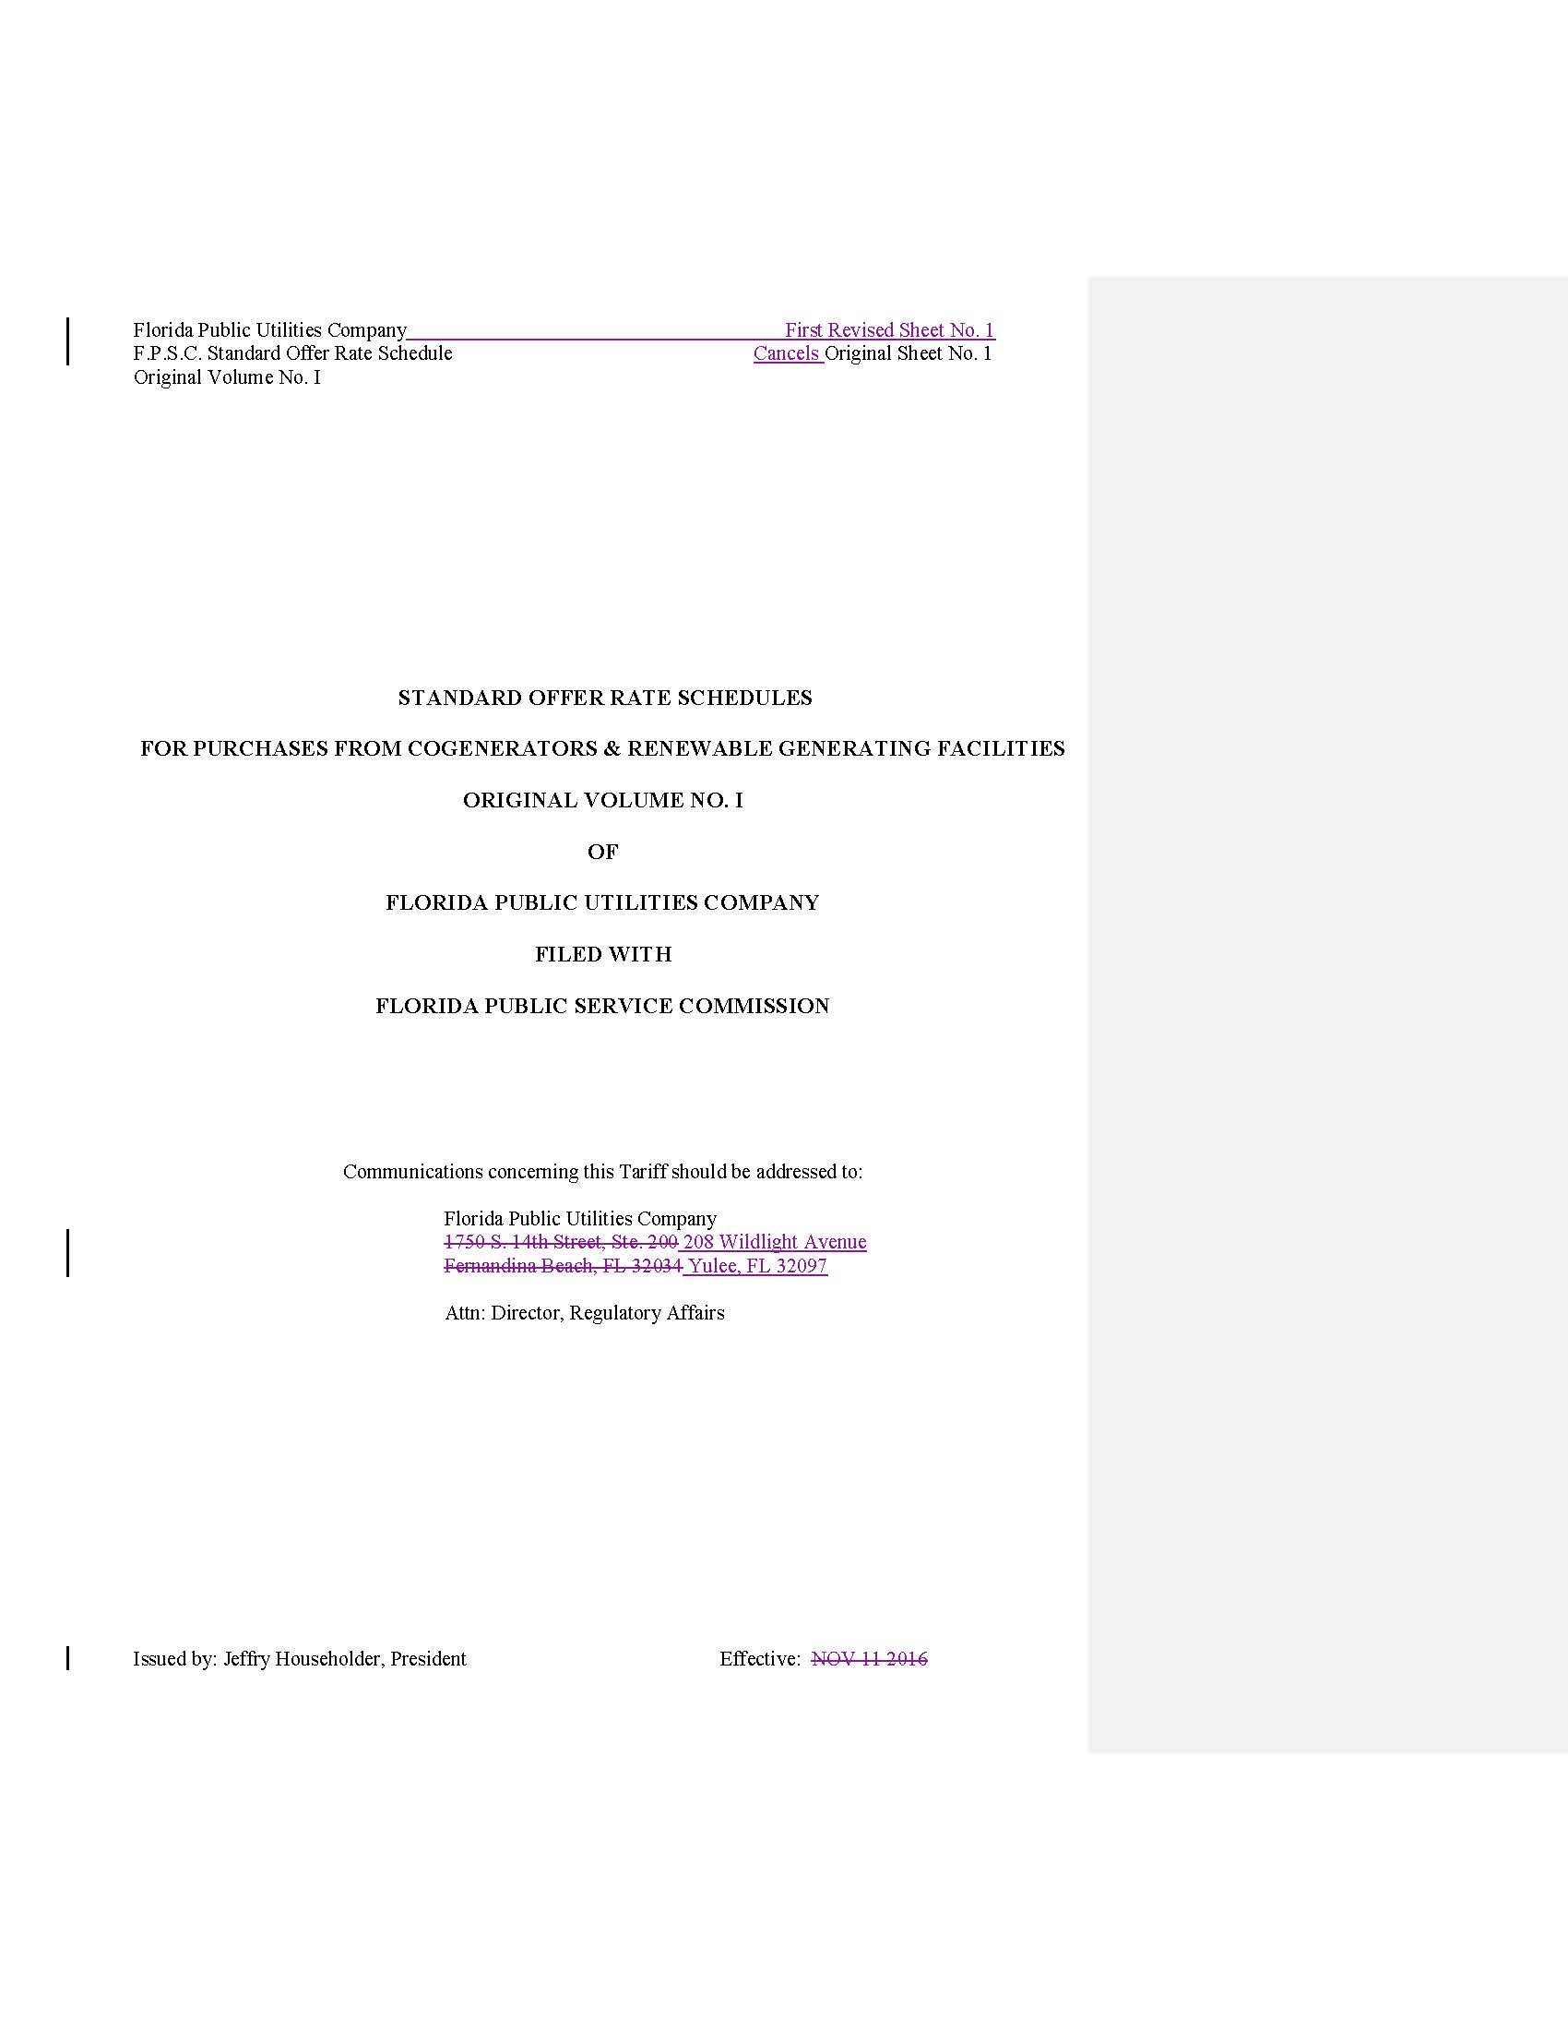
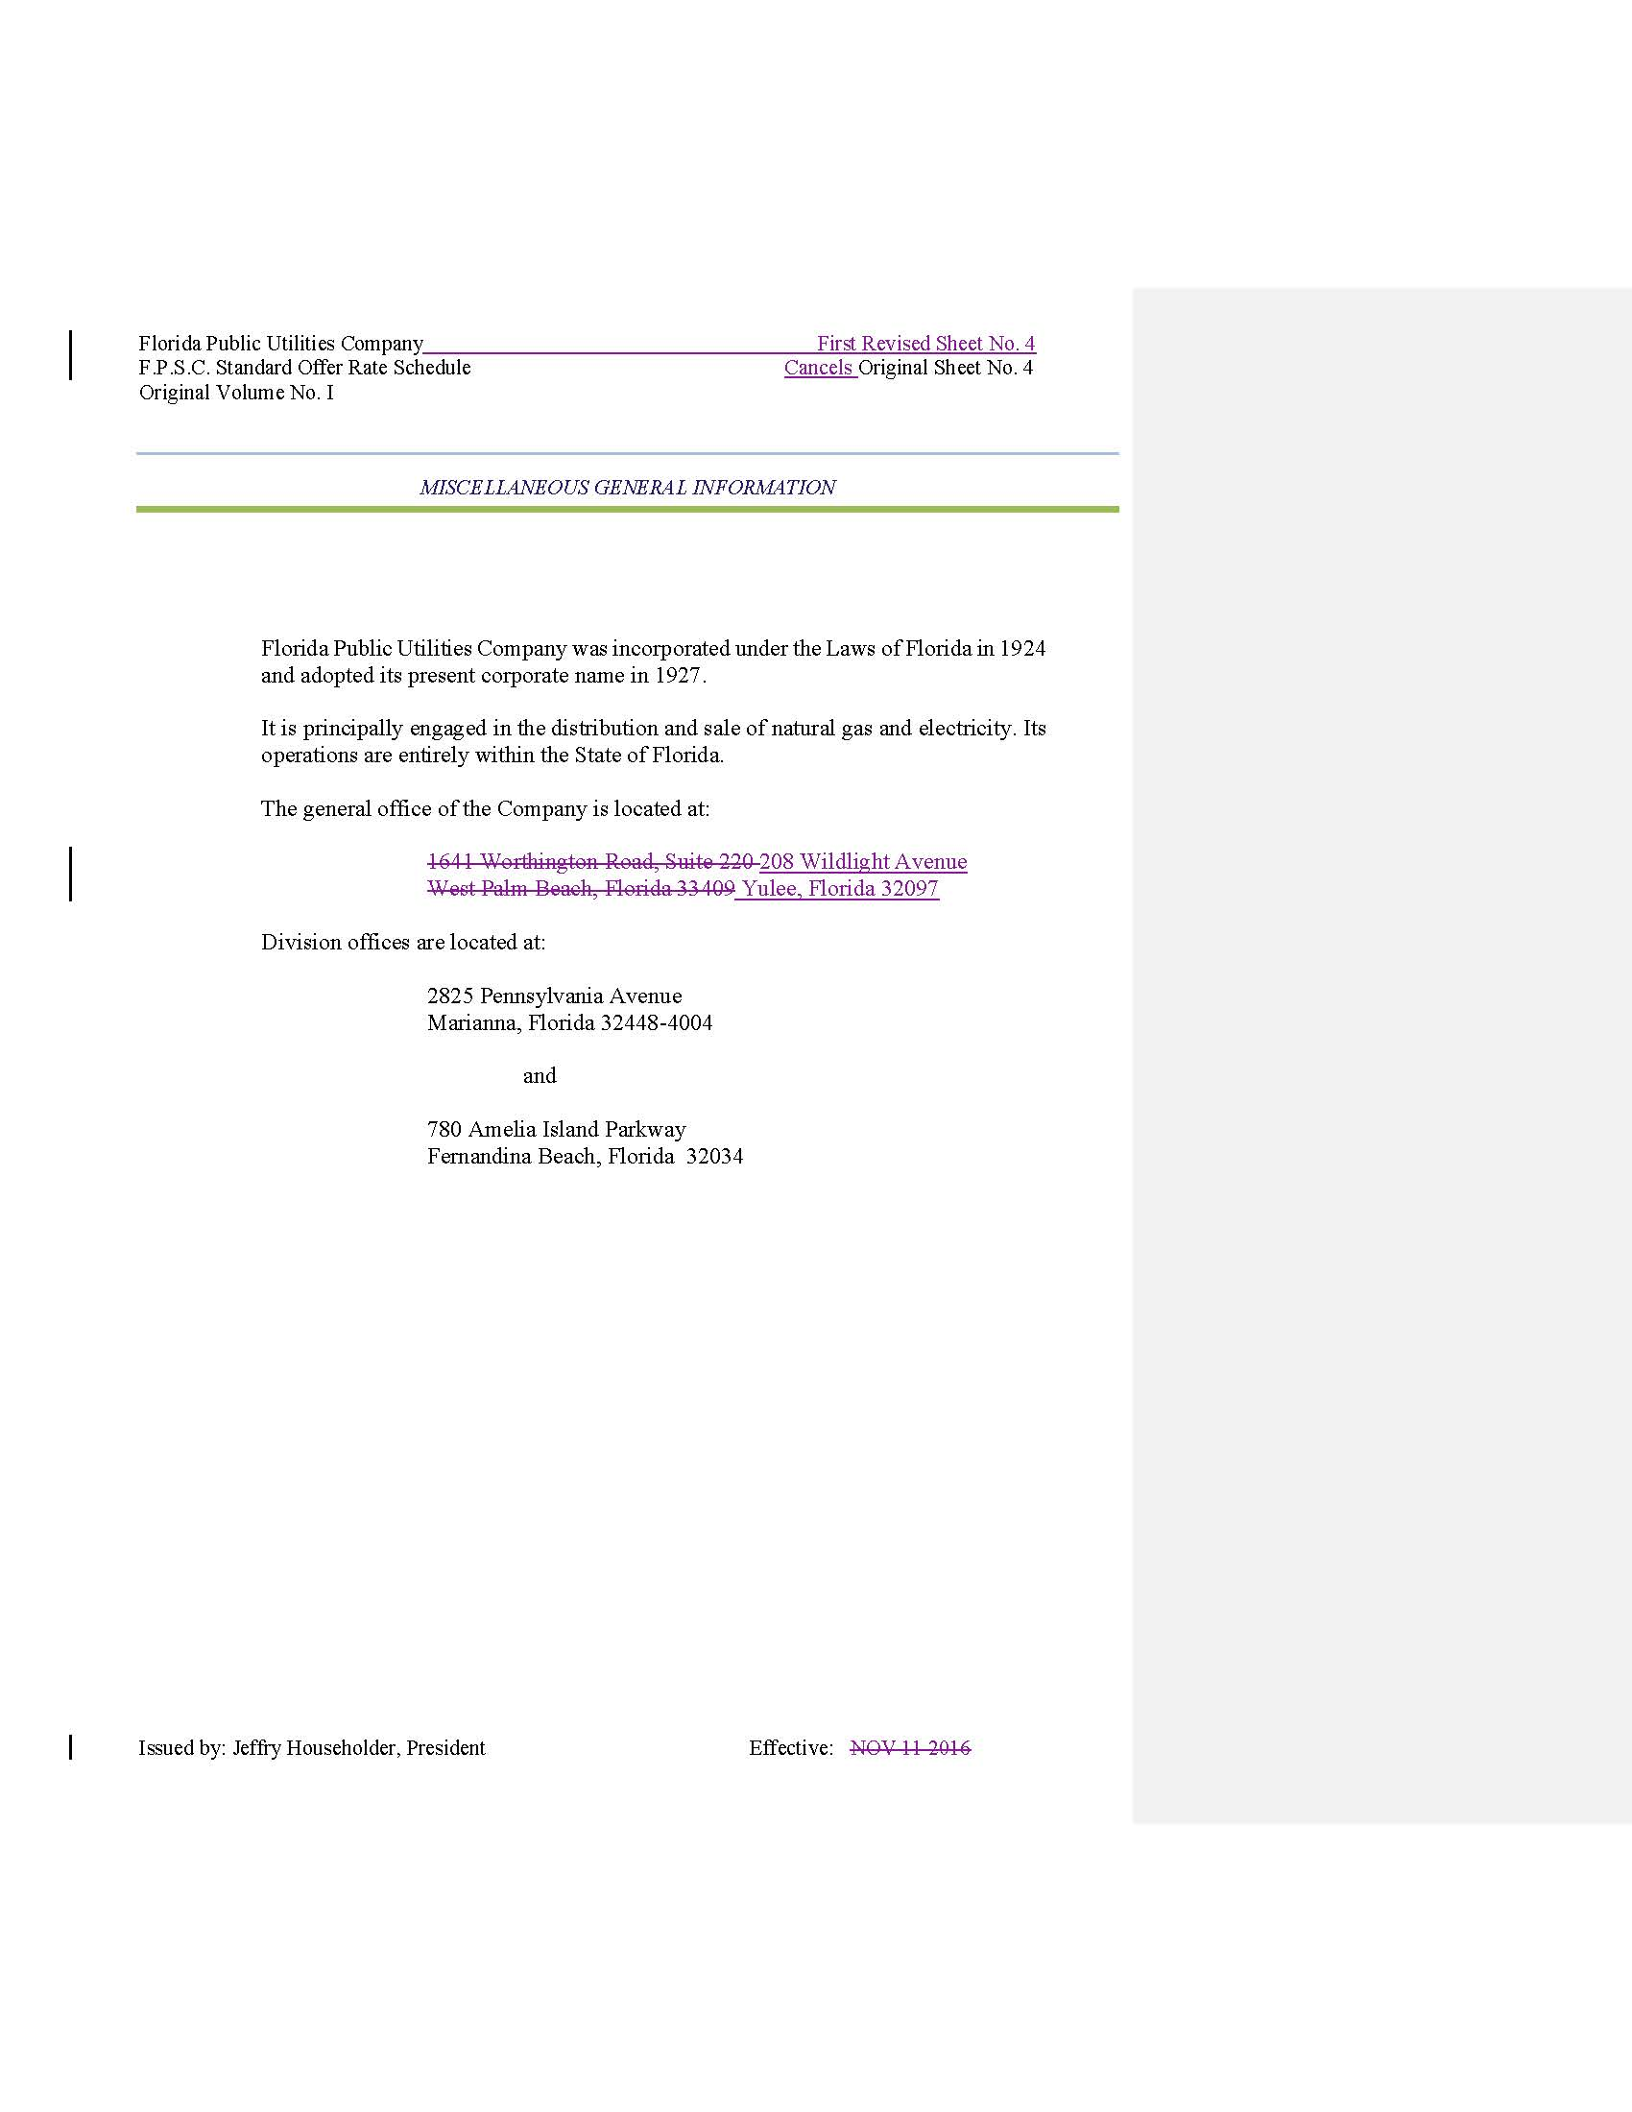
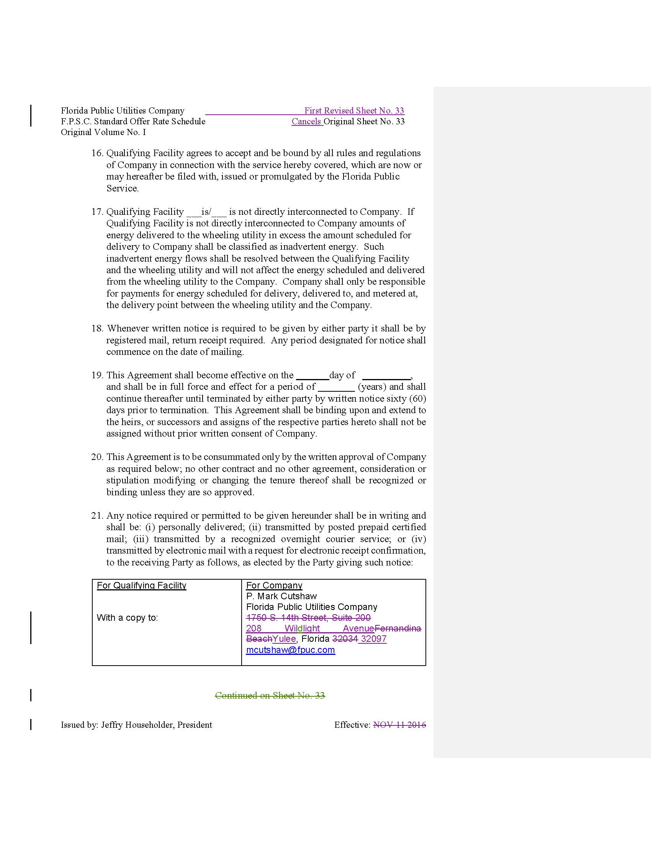

Order No. PSC-2020-0166-PAA-EQ, issued May 22, 2020, in Docket No. 20200109-EQ, In re: Florida Public Utilities Company's Petition for Approval of 2020 Standard Offer Contract.

