State of Florida   |  | Public Service Commission  Capital Circle Office Center ● 2540 Shumard Oak Boulevard  Tallahassee, Florida 32399-0850  -M-E-M-O-R-A-N-D-U-M-
DATE: | July 21, 2022
TO: | Office of Commission Clerk (Teitzman)
FROM: | Division of Engineering (Maloy, Ramos)  Division of Accounting and Finance (Thurmond, Sewards)  Division of Economics (Bruce, Hudson)  Office of the General Counsel (J. Crawford)
RE: | Docket No. 20220019-WU – Application for transfer of water facilities of Neighborhood Utilities, Inc. and water Certificate No. 430-W to CSWR-Florida Utility Operating Company, LLC, in Duval County.
AGENDA: | 08/02/22 – Regular Agenda – Proposed Agency Action for Issues 2, 3, and 4 - Interested Persons May Participate
COMMISSIONERS ASSIGNED: |  |  | All Commissioners
PREHEARING OFFICER: |  |  | Graham
CRITICAL DATES: |  |  | None
SPECIAL INSTRUCTIONS: |  |  | None

Case Background
Neighborhood Utilities, Inc. (Neighborhood, Utility, or Seller) is a Class C water utility providing service to approximately 439 residential and 4 general service customers in Duval County. The Utility is located in the St. Johns River Water Management District (SJRWMD) in the Water Resource Caution Area. Wastewater service is provided by septic tanks. In its 2021 Annual Report, the Utility reported operating revenues of $183,323 and a net operating loss of $18,732.
The Florida Public Service Commission (Commission) granted an original water certificate to Neighborhood in 1984. The Commission approved an amendment in 2011. The rates for the Utility were last set by the Commission in 2016.
On January 14, 2022, CSWR-Florida Utility Operating Company, LLC (CSWR-Neighborhood or Buyer) filed an application with the Commission for the transfer of Certificate No. 430-W from Neighborhood to CSWR-Neighborhood in Duval County. The sale will close after the Commission has voted to approve the transfer. In its application, the Buyer has requested a positive acquisition adjustment, which is discussed in Issue 3.
Intervention by the Office of Public Counsel (OPC) was acknowledged on March 3, 2022. OPC and staff have issued a number of discovery and data requests to CSWR-Neighborhood in this docket.
This recommendation addresses the transfer of the water system and Certificate No. 430-W, the appropriate net book value of the water system for transfer purposes, and the request for an acquisition adjustment. The Commission has jurisdiction pursuant to Sections 367.071 and 367.081, Florida Statutes (F.S.).

Discussion of Issues

Issue 1:
Should the transfer of Certificate No. 430-W in Duval County from Neighborhood Utilities, Inc. to CSWR-Florida Utility Operating Company, LLC be approved?

Recommendation: Yes. The transfer of the water system and Certificate No. 430-W is in the public interest and should be approved effective the date that the sale becomes final. The resultant Order should serve as the Buyer’s certificate and should be retained by the Buyer. The Buyer should submit the executed and recorded deed for continued access to the land upon which its facilities are located and copies of its permit transfer applications to the Commission within 90 days of the Order approving the transfer, which is final agency action. If the sale is not finalized within 90 days of the resultant Order, the Buyer should file a status update in the docket file. The Utility’s existing rates, late payment charge, service availability charges, non-sufficient funds charges, and initial customer deposits as shown on Schedule No. 2, should remain in effect, until a change is authorized by this Commission in a subsequent proceeding. The tariff pages reflecting the transfer should be effective on or after the stamped approval date on the tariff sheets, pursuant to Rule 25-30.475(1), Florida Administrative Code, (F.A.C.). The Seller is current with respect to annual reports and regulatory assessment fees (RAFs) through December 31, 2021, and the Buyer should be responsible for filing annual reports and paying RAFs for all future years. (Maloy, Thurmond, Bruce)

Staff Analysis: On January 14, 2022, CSWR-Neighborhood filed an application for the transfer of Certificate No. 430-W from Neighborhood to CSWR-Neighborhood in Duval County. The application complies with Section 367.071, F.S., and Commission rules concerning applications for transfer of certificates. The sale to CSWR-Neighborhood will become final after Commission approval of the transfer, pursuant to Section 367.071(1), F.S.
Noticing, Territory, and Land Ownership
CSWR-Neighborhood provided notice of the application pursuant to Section 367.071, F.S., and Rule 25-30.030, F.A.C. No objections to the transfer were filed, and the time for doing so has expired. The application contains a description of the service territory, which is appended to this recommendation as Attachment A. In its response to staff’s September 8, 2021 deficiency letter, CSWR-Neighborhood provided an unrecorded warranty deed as evidence that the buyer will have long-term use of the land upon which the treatment facilities are located pursuant to Rule 25-30.037(2)(s), F.A.C. CSWR-Neighborhood should submit the executed and recorded deed to the Commission within 90 days of the Order approving the transfer.

Purchase Agreement and Financing
Pursuant to Rule 25-30.037(2)(g), (h), and (i), F.A.C., the application contains a statement regarding financing and a copy of the purchase agreement, which includes the purchase price, terms of payment, and a list of the assets purchased. There are no guaranteed revenue contracts, or customer advances of Neighborhood that must be disposed of with regard to the transfer. CSWR-Neighborhood will review all leases and developer agreements and will assume or renegotiate those agreements on a case-by-case basis prior to closing. Any customer deposits will be refunded to customers by the Seller prior to the closing. According to the purchase and sale agreement, the total purchase price for the assets is $460,000. According to the Buyer, the closing has not yet taken place and is dependent on Commission approval of the transfer, pursuant to Section 367.071(1), F.S.

Facility Description and Compliance
The Utility’s water treatment plant is rated at 360,000 gallons per day (gpd). Raw water is drawn from a single well, with an emergency water source of JEA Major Grid at a capacity of 360,000 gpd. The raw water is treated by hypochlorination. The water is stored in a 2,000 gallon hydropneumatic tank and two ground tanks, with a capacity of 15,000 gallons and 25,000 gallons, before distribution.

Staff reviewed the Utility’s most recent Florida Department of Environmental Protection (DEP) inspection reports. In 2019, the Utility was issued a warning letter for its on-site generator not functioning, which failed in 2017 during a power outage from Hurricane Irma. The DEP conducted an inspection of the water treatment facility on July 1, 2020, and it was found to be in violation of the DEP’s rules and regulations. The July 1, 2020 Sanitary Survey addressed a leaking service pump and well pump, bio growth in the casing of the well pump, as well as the non-functional on-site generator. Thereafter, the DEP issued a Consent Order on April 1, 2022. The Consent Order addressed the same violations as the Utility’s most recent sanitary survey. The Utility addressed the violations set forth in the Consent Order and the actions required by the DEP have been completed. Furthermore, the Utility is currently passing all DEP secondary water standards.

CSWR-Neighborhood provided copies of the Utility’s current permits from the DEP and SJRWMD pursuant to Rule 25-30.037(2)(r)(1), F.A.C. The Buyer should provide copies of its permit transfer applications, reflecting the change in ownership, to the Commission within 90 days of the Order approving the transfer. In the Buyer’s application, CSWR-Neighborhood provided its assessment of Neighborhood’s water system, and lists several improvements and repairs it recommends be made to the system. The Buyer’s suggested repairs and improvements, which do not appear to be required by a governmental authority, are discussed further in Issue 3.

Technical and Financial Ability
Pursuant to Rule 25-30.037(2)(l) and (m), F.A.C., the application contains statements describing the technical and financial ability of the Buyer to provide service to the proposed service area. As referenced in the transfer application, the Buyer will fulfill the commitments, obligations, and representation of the Seller with regards to Utility matters. CSWR-Neighborhood’s application states that it owns and operates more than 257 water/wastewater systems in Missouri, Arkansas, Kentucky, Louisiana, Texas, Mississippi, North Carolina, Arizona, and Tennessee that service approximately 70,000 water and 110,000 wastewater customers. The Buyer plans to use qualified and licensed contractors to provide routine operation and maintenance of the systems, as well as to handle billing and customer service. Staff reviewed the financial statements of CSWR-Neighborhood and believes the Buyer has documented adequate resources to support the Utility’s water operations. Based on the above, staff recommends that the Buyer has demonstrated the technical and financial ability to provide service to the existing service territory.

Rates, Charges, and Initial Customer Deposits

The Utility's rates, charges, and initial customer deposits were last approved in a 2016 staff-assisted rate case. Since the Utility’s last rate case, the rates were decreased to remove an expired rate case expense amortization. Rule 25-9.044(1), F.A.C., provides that in the case of a change of ownership or control of a Utility, the rates, classifications, and regulations of the former owner must continue unless authorized to change by this Commission. In addition, the Utility has miscellaneous service charges. The late payment charge of $4.30 is appropriate. However, the remaining miscellaneous service charges do not conform to Rule 25-30.460, F.A.C., and are discussed in Issue 4. Therefore, staff recommends that the Utility's existing rates, late payment charge, service availability charges, non-sufficient funds charges, and initial customer deposits as shown on Schedule No. 2, should remain in effect, until a change is authorized by this Commission in a subsequent proceeding. The tariff pages reflecting the transfer should be effective on or after the stamped approval date on the tariff sheets, pursuant to Rule 25-30.475(1), F.A.C.

Regulatory Assessment Fees and Annual Report
Staff has verified that the Utility is current on the filing of annual reports and RAFs through December 31, 2021. The Buyer should be responsible for filing the Utility’s annual reports and paying RAFs for all future years.

Conclusion
Based on the foregoing, staff recommends the transfer of the water system and Certificate No. 430-W is in the public interest and should be approved effective the date that the sale becomes final. The resultant Order should serve as the Buyer’s certificate and should be retained by the Buyer. The Buyer should submit the executed and recorded deed for continued access to the land upon which its facilities are located and copies of its permit transfer applications to the Commission within 90 days of the Order approving the transfer, which is final agency action. If the sale is not finalized within 90 days of the transfer Order, the Buyer should file a status update in the docket file. The Utility’s existing rates, late payment charge, service availability charges, non-sufficient funds charges, and initial customer deposits as shown on Schedule No. 2, should remain in effect, until a change is authorized by this Commission in a subsequent proceeding. The tariff pages reflecting the transfer should be effective on or after the stamped approval date on the tariff sheets, pursuant to Rule 25-30.475(1), F.A.C. The Seller is current with respect to annual reports and RAFs through December 31, 2021, and the Buyer should be responsible for filing annual reports and paying RAFs for all future years.

Issue 2:
What is the appropriate net book value for CSWR-Florida Utility Operating Company, LLC’s water system for transfer purposes?

Recommendation:
For transfer purposes, the net book value (NBV) of the water system is $60,063 as of January 31, 2022. Within 90 days of the date of the consummating order, CSWR-Neighborhood should be required to notify the Commission in writing that it has adjusted its books in accordance with the Commission’s decision. The adjustments should be reflected in the Utility’s 2022 Annual Report when filed. (Thurmond)

Staff Analysis:
Rate base was last established on November 23, 2016, by Order No. PSC-2016-0537-PAA-WU. The purpose of establishing NBV for transfers is to determine whether an acquisition adjustment should be approved. CSWR-Neighborhood’s request for a positive acquisition adjustment is addressed in Issue 3. The NBV does not include normal ratemaking adjustments for used and useful plant or working capital. The Utility’s NBV has been updated to reflect balances as of January 31, 2022. Staff’s recommended NBV, as described below, is shown on Schedule No. 1.
Utility Plant in Service (UPIS)
According to the Utility’s general ledger, the total UPIS balance was $672,155 as of December 31, 2021. Staff auditors compiled the plant additions and retirements to UPIS from June 30, 2015, to January 31, 2022, and traced supporting documentation. As a result, staff recommends an increase to UPIS of $1,299 as of January 31, 2022. Accordingly, staff recommends a total UPIS balance of $673,454 as of January 31, 2022.
Land
The Utility’s general ledger reflected a land balance of $1,000 as of June 30, 2015. There have been no additions to land since June 30, 2015. Therefore, staff recommends no adjustments to its land balance.

Accumulated Depreciation
According to the Utility’s general ledger, the total accumulated depreciation balance was $540,622 as of December 31, 2021. Staff auditors recalculated depreciation accruals for all water accounts since the last rate case through January 31, 2022, using audited UPIS balances and the depreciation rates established by Rule 25-30.140, F.A.C. As a result, staff recommends that the accumulated depreciation balance be increased by $21,745 as of January 31, 2022. Accordingly, staff recommends a total accumulated depreciation balance of $562,367 as of January 31, 2022.

Contributions-in-Aid-of-Construction (CIAC) and Accumulated Amortization of CIAC
According to the Utility’s general ledger, the CIAC balance and accumulated amortization of CIAC were $76,431 and $0, respectively, as of December 31, 2021. Staff auditors traced CIAC and accumulated amortization of CIAC balances from June 30, 2015, to January 31, 2022, using supporting documentation. As a result, staff recommends that the CIAC balance be increased by $193,145 as of January 31, 2022. Staff also recommends that the accumulated amortization of CIAC balance be increased by $217,552 as of January 31, 2022. Accordingly, staff recommends total CIAC and Accumulated Amortization of CIAC balances of $269,576 and $217,552, respectively, as of January 31, 2022.

Net Book Value
The Utility’s general ledger reflected a NBV of $56,102 as of December 31, 2021. Based on the adjustments described above, staff recommends a NBV of $60,063 as of January 31, 2022. Staff’s recommended NBV and the National Association of Regulatory Utility Commissioners, Uniform System of Accounts (NARUC USOA) balances for UPIS and accumulated depreciation are shown on Schedule No. 1 as of January 31, 2022. As addressed in Issue 3, a positive acquisition adjustment should not be recognized for ratemaking purposes.
Conclusion
Based on the above, staff recommends a NBV of $60,063 as of January 31, 2022, for transfer purposes. Within 90 days of the date of the consummating order, the Buyer should be required to notify the Commission in writing, that it has adjusted its books in accordance with the Commission’s decision. The adjustments should be reflected in the Utility’s 2022 Annual Report when filed.

Issue 3:
Should a positive acquisition adjustment be recognized for ratemaking purposes?

Recommendation: No. Pursuant to Rule 25-30.0371, F.A.C., a positive acquisition adjustment should not be granted as the Buyer failed to demonstrate extraordinary circumstances. (Thurmond, Maloy)

Staff Analysis:
In its filing, the applicant requested a positive acquisition adjustment be included in the calculation of the Utility’s rate base. An acquisition adjustment results when the purchase price differs from the NBV of the assets at the time of acquisition. Pursuant to Rule 25-30.0371, F.A.C., a positive acquisition adjustment results when the purchase price is greater than the NBV and a negative acquisition adjustment results when the purchase price is less than the NBV. A positive acquisition adjustment, if approved, increases rate base.
According to the purchase agreement, the Buyer will purchase the Utility for $460,000. As discussed in Issue 2, staff is recommending a NBV of $60,063. This would result in a positive acquisition adjustment of $399,937.
Any entity that believes a full or partial positive acquisition adjustment should be made has the burden to prove the existence of extraordinary circumstances. Rule 25-30.0371(2), F.A.C., states:
In determining whether extraordinary circumstances have been demonstrated, the Commission shall consider evidence provided to the Commission such as anticipated improvements in quality of service, anticipated improvements in compliance with regulatory mandates, anticipated rate reductions or rate stability over a long-term period, anticipated cost efficiencies, and whether the purchase was made as part of an arms-length transaction.
If a purchase price above depreciated original cost is used to determine rate base, without the requirement for extraordinary circumstances, it could encourage utilities to "swap assets" and inappropriately increase costs to customers.

Deferral
In discovery, CSWR-Neighborhood stated that it intends to ask for deferral of a decision regarding the requested acquisition adjustment. In its application, the Buyer laid out factors such as improvements to quality of service, cost efficiencies, and rate stability. These are discussed below and staff recommends that these factors do not constitute extraordinary circumstances. In response to discovery, the Buyer agreed that after rate base is set, if a company provides support in a separate and subsequent case that there are utility assets that were not previously recorded, then the company can prospectively recover the unrecorded amount of that investment. Therefore, if the Buyer finds assets were incorrectly recorded on the Seller’s balance sheet, the Buyer can support those costs and recover them in a future rate case which is Commission practice and not considered extraordinary circumstances.
In the past, the Commission has approved positive acquisition adjustments for three separate natural gas utilities: the acquisition of Florida City Gas by AGL Resources, Inc., the acquisition of Florida Public Utilities Company (FPUC) by the Florida Division of Chesapeake Utilities Corporation, and the acquisition of Indiantown Gas Company by FPUC. In all three cases, the buyers provided detailed information estimating net savings to customers that could be achieved should the transfer and acquisition adjustment be approved. In addition, all three utilities acknowledged that if the estimated cost savings did not materialize or were less than represented, that some or all of the granted positive acquisition adjustments could be removed prospectively. In contrast, CSWR-Neighborhood stated that such estimates cannot be given at this time and thus requested the decision regarding the acquisition adjustment be deferred until it has the information to estimate net cost savings to customers. Staff believes the cases noted above demonstrate that a buyer that has undertaken the appropriate level of due diligence has the ability and responsibility to provide estimated net cost savings to customers at the time of transfer.
Pursuant to Commission practice, the buyer has the burden to prove extraordinary circumstances at the time of transfer. Staff believes in the instant case the Buyer has failed to provide proof of extraordinary circumstances. Further, the Buyer had multiple opportunities to provide pertinent information needed to determine if a positive acquisition adjustment is appropriate. As such, staff recommends the Commission deny the request to defer a decision on the positive acquisition adjustment.
Finally, it is long-standing Commission practice to address the disposition of any positive or negative acquisition adjustment at the time of transfer. Pursuant to Section 120.68(7)(e)3., F.S., when agencies change their established policies, practices and procedures, they must give an explanation for the deviation. Staff does not believe the facts in this case warrant such a deviation. As such, staff believes the deferral of a positive acquisition adjustment decision in this docket would result in an unnecessary deviation from Commission practice.

Improvements in Quality of Service and Compliance with Regulatory Mandates
In its application, CSWR-Neighborhood listed six business practices that it believes will improve the quality of service to its customers: (1) provision of 24-hour emergency service phone numbers; (2) on-call emergency service personnel who are required to respond to emergency service calls within prescribed time limits; (3) a computerized maintenance management system; (4) access to resources not usually available to comparably sized systems and the ability to supplement local personnel with resources owned by the parent and sister companies; (5) online bill payment options; and (6) an updated website for customer communication, bulletins, procedures, etc.

Staff reviewed the complaints filed with the Commission for the five-year period prior to the application, January 2017 to March 2022. For the five-year period, the Commission recorded a total of two customer complaints pertaining to billing. Additionally, in its application, CSWR-Neighborhood indicated that the Utility has not received any customer complaints pertaining to secondary water standards during the past five years. As discussed in Issue 1, staff also reviewed the Utility’s most recent DEP inspection reports. While the Utility was issued a Consent Order on April 1, 2022, the Utility has addressed the violations and completed DEP’s requirements set forth in the Consent Order.
Based on the Commission’s complaint data and the DEP’s reports, it does not appear that the Utility currently has issues with respect to quality of service and regulatory compliance such that they would warrant extraordinary efforts to remedy. For this reason, staff does not believe CSWR-Neighborhood has demonstrated extraordinary circumstances for its requested positive acquisition adjustment. Instead, staff believes that the proposed anticipated improvements in quality of service and compliance with regulatory mandates demonstrates CSWR-Neighborhood’s intention to responsibly execute its obligations as a utility owner. While staff does not believe the Utility’s anticipated improvements justify its requested positive acquisition adjustment, these improvements may be considered for prudency and cost recovery in a future rate proceeding.

Anticipated Cost Efficiencies and Rates
In its application, the Buyer stated that based on its size, the anticipated consolidation of many small systems under one financial and managerial entity would result in operational cost efficiencies particularly in the areas of:
- PSC and environmental regulatory reporting
- Managerial and operational oversight
- Utility asset planning
- Engineering planning
- Ongoing utility maintenance
- Utility record keeping
- Customer service responsiveness
- Improved access to capital necessary to repair and upgrade Neighborhood’s systems to ensure compliance with all health and environmental requirements and ensure service to customers remains safe and reliable
In response to discovery, the Buyer provided an estimated annual reduction of operation and maintenance (O&M) expense of approximately $20,000. However, with a requested acquisition adjustment of $399,937, the requested amount is approximately six and one-half times greater than the system’s current NBV of $60,063. Even if the Buyer was able to achieve these savings in O&M expense, the inclusion of the requested acquisition adjustment in rate base and the inclusion of the annual amortization expense in the net operating income calculation, would result in an increased revenue requirement. By operation of math, the overall impact would be a net increase to customer rates.
The Buyer also stated that CSWR-Neighborhood would bring long-term rate stability to the Utility, should the transfer be approved. Staff agrees that economies of scale and potential consolidation of several systems in Florida, as proposed by CSWR-Neighborhood, could bring some amount of long-term rate stability. However, absent specific and detailed support for these assertions, the Buyer has failed to meet its burden of demonstrating extraordinary circumstances. Moreover, Neighborhood has exhibited rate stability. The Utility has had only two staff-assisted rate cases, seven price indices, and one pass-through increase since it was granted its water certificate in 1984.
Staff’s recommendation is consistent with the Commission’s decision in Order No. PSC-2020-0458-PAA-WS. In that docket, the buyer identified estimates of anticipated cost efficiencies, including a reduction in O&M expense and a reduction of cost of capital that would result from the transfer. Additionally, the buyer cited several improvements it made to the water treatment plant and wastewater lift station since acquisition to improve the quality of service and compliance with regulatory mandates. While the Commission acknowledged that the buyer accomplished cost savings, it did not believe the actions performed demonstrated extraordinary circumstances that would justify approval of a positive acquisition adjustment.
Staff’s recommendation is also consistent with the Commission’s decisions for CSWR-Florida Utility Operating Company, LLC’s request for a positive acquisition adjustment in Order Nos. PSC-2022-0116-PAA-SU, PSC-2022-0120-PAA-WU, and PSC-2022-0115-PAA-WS. In those cases, it was determined that CSWR-Florida Utility Operating Company, LLC failed to provide sufficient evidence of extraordinary circumstances and was denied a positive acquisition adjustment in all three cases. In those cases, CSWR-Florida Utility Operating Company, LLC also requested a deferral of the decision regarding the positive acquisition adjustments which was denied by the Commission. Staff finds the facts of this case similar to the three cases discussed above.

Conclusion
Pursuant to Rule 25-30.0371, F.A.C., staff recommends a positive acquisition adjustment not be granted as the Buyer did not demonstrate extraordinary circumstances. Staff believes the Buyer’s anticipated improvements in quality of service and compliance with regulatory mandates do not illustrate extraordinary circumstances and instead demonstrates CSWR-Neighborhood’s intentions to responsibly provide utility service.

Issue 4:
Should CSWR-Florida Utility Operating Company, LLC’s miscellaneous service charges be revised to conform to amended Rule 25-30.460, F.A.C.?

Recommendation:
Yes. The miscellaneous service charges should be revised to conform to the recent amendment to Rule 25-30.460, F.A.C. The tariff should be revised to reflect the removal of initial connection and normal reconnection charges. CSWR-Neighborhood should be required to file a proposed customer notice to reflect the Commission-approved charges. The approved charges should be effective on or after the stamped approval date on the tariff sheet pursuant to Rule 25-30.475(1), F.A.C. In addition, the approved charges should not be implemented until staff has approved the proposed customer notice and the notice has been received by customers. CSWR-Neighborhood should provide proof of the date notice was given within 10 days of the date of the notice. CSWR-Neighborhood should be required to charge the approved miscellaneous service charges until authorized to change them by the Commission in a subsequent proceeding. (Bruce)

Staff Analysis:
Effective June 24, 2021, Rule 25-30.460, F.A.C., was amended to remove initial connection and normal reconnection charges. The definitions for initial connection charges and normal reconnection charges were subsumed in the definition of the premises visit charge. The Utility’s miscellaneous service charges consist of initial connection and normal reconnection charges. The normal reconnection charge is more than the premises visit charge. Since the premises visit entails a broader range of tasks, staff believes the premises visit charge should reflect the amount of the normal reconnection charge of $34 for normal hours and $38 for after hours. Therefore, staff recommends that the initial connection and normal reconnection charges be removed, the premises visit charge should be revised to $34 for normal hours and $38 for after hours, and the definition for the premises visit charge be updated to comply with amended Rule 25-30.460, F.A.C. The Utility’s existing and staff’s recommended miscellaneous service charges are shown below in Tables 4-1 and 4-2.
Table 4-1
Utility Existing Miscellaneous Service Charges
 | Normal Hours | After Hours
Initial Connection Charge | $19.00 | $21.00
Normal Reconnection Charge | $34.00 | $38.00
Violation Reconnection Charge | $30.00 | $32.00
Premises Visit Charge  (in lieu of disconnection) | $19.00 | $21.00

Table 4-2
Staff Recommended Miscellaneous Service Charges
 | Normal Hours | After Hours
Violation Reconnection Charge | $30.00 | $32.00
Premises Visit Charge | $34.00 | $38.00
Conclusion
Based on the above, staff recommends the miscellaneous service charges be revised to conform to the recent amendment to Rule 25-30.460, F.A.C. The tariff should be revised to reflect the removal of initial connection and normal reconnection charges. CSWR-Neighborhood should be required to file a proposed customer notice to reflect the Commission-approved charges. The approved charges should be effective on or after the stamped approval date on the tariff sheet pursuant to Rule 25-30.475(1), F.A.C. In addition, the approved charges should not be implemented until staff has approved the proposed customer notice and the notice has been received by customers. CSWR-Neighborhood should provide proof of the date notice was given within 10 days of the date of the notice. CSWR-Neighborhood should be required to charge the approved miscellaneous service charges until authorized to change them by the Commission in a subsequent proceeding.

Issue 5:
Should this docket be closed?

Recommendation:
Yes. If no protest to the proposed agency action is filed by a substantially affected person within 21 days of the date of the issuance of the order, a consummating order should be issued and the docket should be closed administratively upon Commission staff’s verification that the revised tariff sheets have been filed, the Buyer has notified the Commission in writing that it has adjusted its books in accordance with the Commission’s decision, proof that appropriate noticing has been done pursuant to Rule 25-30.4345, F.A.C., and the Buyer has submitted the executed and recorded warranty deed and that the Buyer has submitted a copy of its application for permit transfer to the DEP within 90 days of the Commission’s Order approving the transfer. (J. Crawford)

Staff Analysis:
If no protest to the proposed agency action is filed by a substantially affected person within 21 days of the date of the issuance of the order, a consummating order should be issued and the docket should be closed administratively upon Commission staff’s verification that the revised tariff sheets have been filed, the Buyer has notified the Commission in writing that it has adjusted its books in accordance with the Commission’s decision, proof that appropriate noticing has been done pursuant to Rule 25-30.4345, F.A.C., and the Buyer has submitted the executed and recorded warranty deed and that the Buyer has submitted a copy of its application for permit transfer to the DEP within 90 days of the Commission’s Order approving the transfer.

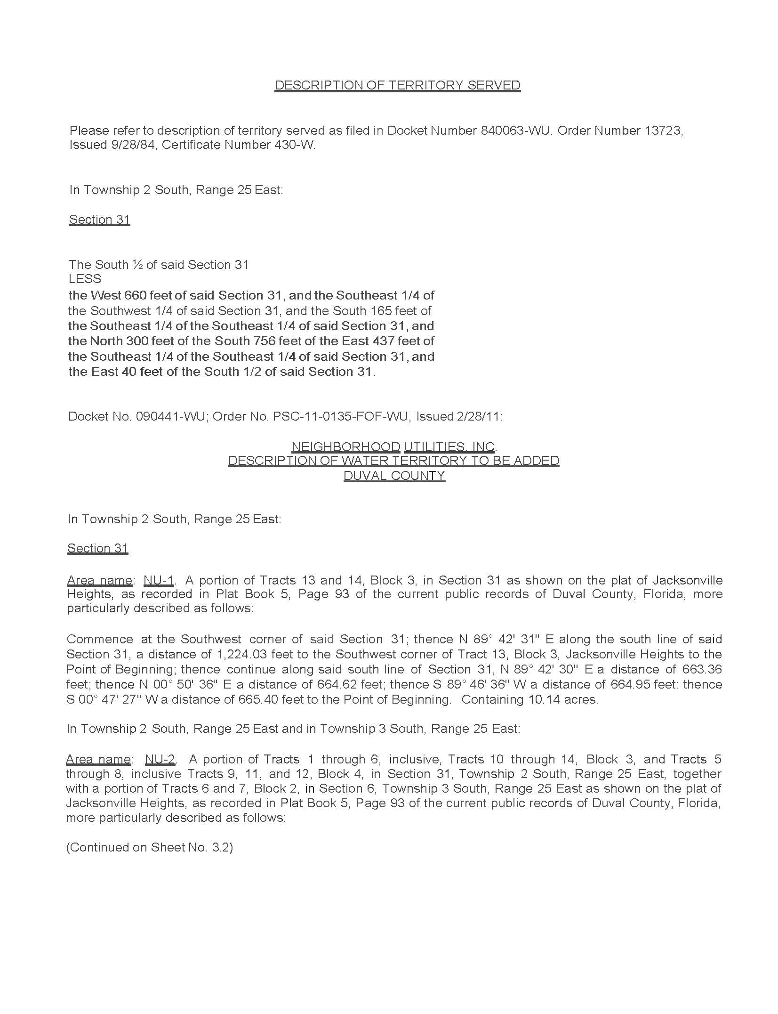
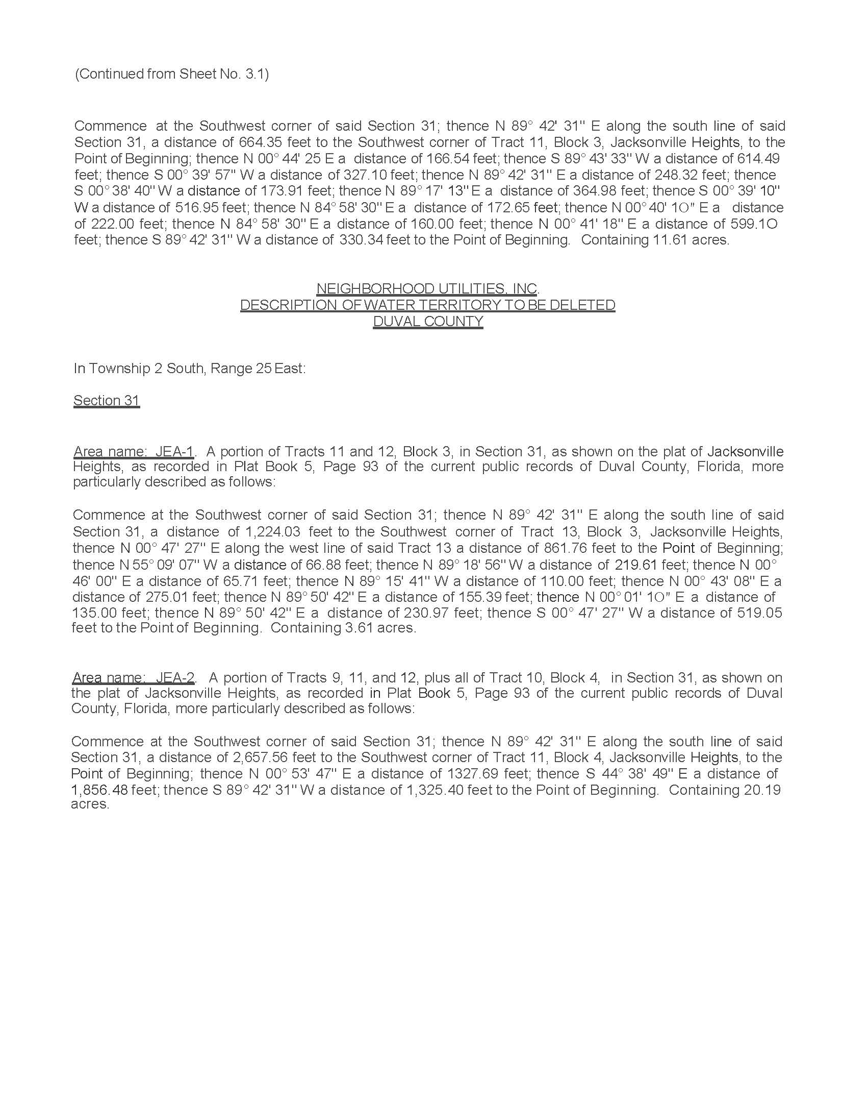

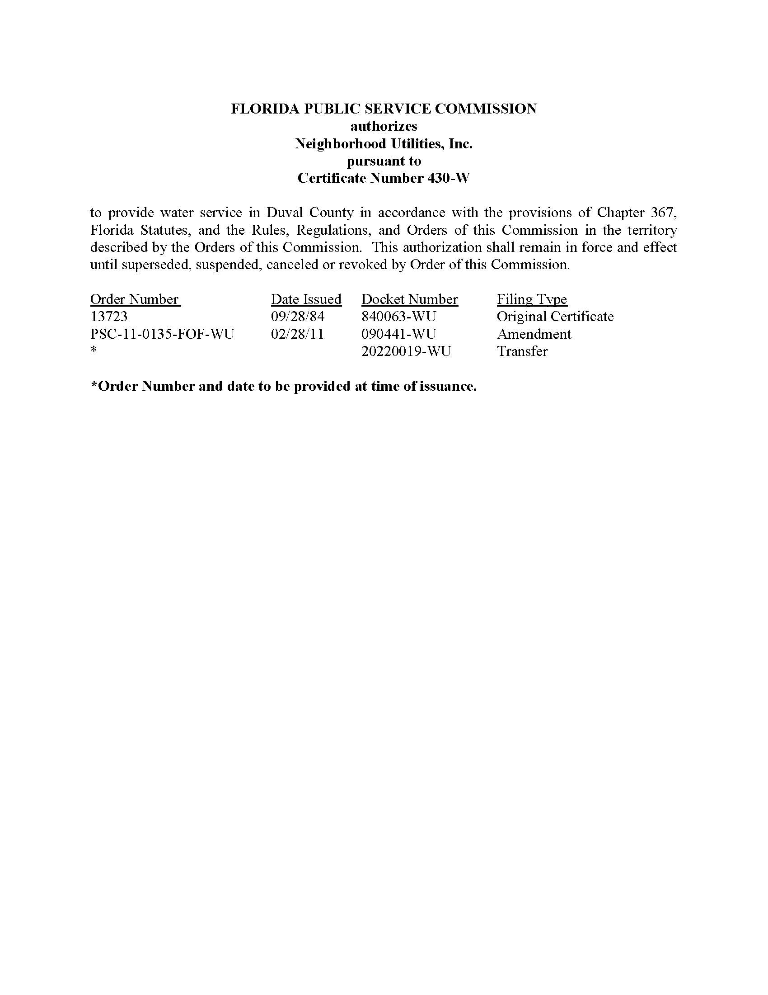

CSWR-Florida Utility Operating Company, LLC
Neighborhood Utilities, Inc.

Schedule of Net Book Value as of January 31, 2022

Description | Balance  Per Utility  12/31/21 | Adjustments |  | Staff  1/31/22
Utility Plant in Service | $672,155 | $1,299 | A | $673,454
Land & Land Rights | 1,000 | - |  | 1,000
Accumulated Depreciation | (540,622) | (21,745) | B | (562,367)
CIAC | (76,431) | (193,145) | C | (269,576)
Amortization of CIAC | 0 | 217,552 | D | 217,552
Total | $56,102 | $3,961 |  | $60,063

CSWR-Florida Utility Operating Company, LLC
Neighborhood Utilities, Inc.

Explanation of Adjustments to Net Book Value as of January 31, 2022

Explanation | Amount
- UPIS
To reflect the appropriate balance. | $1,299
- Accumulated Depreciation
To reflect the appropriate balance. | (21,745)
- CIAC
To reflect the appropriate balance. | (193,145)
- Accumulated Amortization of CIAC
To reflect the appropriate balance. | 217,552
Total Adjustments to Net Book Value as of January 31, 2022 | ($3,961)

CSWR-Florida Utility Operating Company, LLC
Neighborhood Utilities, Inc.

Schedule of Staff’s Recommended Account Balances as of January 31, 2022

Account  No. | Description | UPIS | Accumulated Depreciation
304 | Structures & Improvements | $14,967 | ($13,179)
305 | Collecting & Impounding Reservoirs | 90,940 | (81,390)
307 | Wells and Springs | 45,388 | (45,388)
309 | Supply Mains | 2,708 | (557)
311 | Pumping Equipment | 58,328 | (57,907)
320 | Water Treatment Equipment | 33,508 | (31,588)
330 | Distribution Reservoirs & Standpipes | 30,830 | (13,655)
331 | Transmission and Distribution Mains | 248,307 | (202,216)
333 | Services | 64,444 | (40,761)
334 | Meters and Meter Installations | 32,587 | (32,587)
335 | Hydrants | 35,812 | (34,961)
339 | Other Plant Misc. Equipment | 13,921 | (7,018)
340 | Office Furniture and Equipment | 1,714 | (1,158)
 | Total | $673,454 | $562,367

CSWR-Florida Utility Operating Company, LLC
Neighborhood Utilities, Inc.
Monthly Water Rates

Residential and General Service
Base Facility Charge by Meter Size
5/8” x 3/4” |  | $8.44
3/4” |  | $12.66
1” |  | $21.09
1 1/2” |  | $42.19
2” |  | $67.50
3” |  | $134.99
4” |  | $210.93
6” |  | $421.86
Charge per 1,000 gallons - Residential
0 – 5,000 gallons |  | $4.34
5,001 – 10,000 gallons |  | $5.34
Over 10,000 gallons |  | $8.00
Charge per 1,000 gallons – General Service |  |  |  | $4.81
Initial Customer Deposits

Meter Size | Residential | General Service
5/8” x 3/4” | $58.00 |  | 2x the average estimated monthly bill
All over 5/8” x 3/4” | 2x the average estimated monthly bill |  | 2x the average estimated monthly bill

Miscellaneous Service Charges
Late Payment Charge | $4.30
NSF Charges | Pursuant to Section 68.065, F.S.

Service Availability Charges
Meter Installation Charge
5/8” x 3/4” |  | $206.00
All other meter sizes |  | Actual Cost
Plant Capacity Charge
Residential-per ERC (350 GPD) |  | $420.00
All others per gallon |  | $1.20

Order No. 13723, issued September 28, 1984, in Docket No. 19840063-WU, In re: Application of Neighborhood Utilities, Inc., for a certificate to operate a water utility in Duval County.
Order No. PSC-11-0135-FOF-WU, issued February 28, 2011, in Docket No. 20090441-WU, In re: Application for amendment of Certificate No. 430-W to add territory in Duval County by Neighborhood Utilities, Inc.
Order No. PSC-16-0537-PAA-WU, issued November 23, 2016, in Docket No. 20150181-WU, In re: Application for staff-assisted rate case in Duval County by Neighborhood Utilities, Inc.
Document No. 01594-2022.
Order No. PSC-16-0537-PAA-WU, issued November 23, 2016, in Docket No. 20150181-WU, In re: Application for staff assisted rate case by Neighborhood Utilities, Inc.
Id.
Order No. PSC-16-0537-PAA-WU, issued November 23, 2016, in Docket No. 20150181-WU, In re: Application for staff-assisted rate case in Duval County by Neighborhood Utilities, Inc.
Net book value is calculated through the date of the closing. According to the Utility’s application, the closing will not occur until after the transaction receives Commission approval. Therefore, staff is relying on the most current information provided to staff auditors at the time of the filing.
Order No. PSC-07-0913-PAA-GU, issued November 13, 2007, in Docket No. 20060657-GU, In re: Petition for approval or acquisition adjustment and recognition of regulatory asset to reflect purchase of Florida City Gas by AGL Resources, Inc.; Order No. PSC-12-0010-PAA-GU, issued January 3, 2012, in Docket No. 20110133-GU, In re: Petition for approval of acquisition adjustment and recovery of regulatory assets, and request for the consolidation of regulatory filings and records of Florida Public Utilities Company and Florida Divisions of Chesapeake Utilities Corporation; Order No. PSC-14-0015-PAA-GU, issued January 6, 2014, in Docket No. 20120311-GU, In re: Petition for approval of positive acquisition adjustment to reflect the acquisition of Indiantown Gas Company by Florida Public Utilities Company.
Order No. PSC-2020-0458-PAA-WS, issued November, 23, 2020, in Docket No. 20190170-WS, In re: Application for transfer of facilities and Certificate Nos. 259-W and 199-S in Broward County from Royal Utility Company to Royal Waterworks, Inc.
Order No. PSC-2022-0116-PAA-SU, issued March 17, 2022, in Docket No. 20210133-SU, In re: Application for transfer of facilities of North Peninsula Utilities Corporation and wastewater Certificate No. 249-S to CSWR-Florida Utility Operating Company, LLC, in Volusia County. ; Order No. PSC-2022-0120-PAA-WU, issued March 18, 2022, in Docket No. 20220095-WU, In re: Application for transfer of water facilities of Sunshine Utilities of Central Florida, Inc. and water Certificate No. 363-W to CSWR-Florida Utility Operating Company, LLC, in Marion County; Order No. PSC-2022-0115-PAA-WS, issued March 15, 2022, in Docket No. 20210093-WS, Application for transfer of water and wastewater systems of Aquarina Utilities, Inc., water Certificate No. 517-W, and wastewater Certificate No. 450-S to CSWR-Florida Utility Operating Company, LLC, in Brevard County.
Order No. PSC-2021-0201-FOF-WS, issued June 4, 2020, in Docket No. 20200240-WS, In re: Proposed amendment of Rule 25-30.460, F.A.C., Application for Miscellaneous Service Charges.

