State of Florida   |  | Public Service Commission  Capital Circle Office Center ● 2540 Shumard Oak Boulevard  Tallahassee, Florida 32399-0850  -M-E-M-O-R-A-N-D-U-M-
DATE: | October 20, 2022
TO: | Office of Commission Clerk (Teitzman)
FROM: | Division of Economics (Hudson)  Office of the General Counsel (Rivera-Pacheco, Crawford)
RE: | Docket No. 20220147-SU – Application for approval of a new classes of service for bulk wastewater service in Pasco County, by Ni Florida, Inc.
AGENDA: | 11/01/22 – Regular Agenda – Tariff Filing – Interested Persons May Participate
COMMISSIONERS ASSIGNED: |  |  | All Commissioners
PREHEARING OFFICER: |  |  | Administrative
CRITICAL DATES: |  |  | 11/1/22 (60-Day Suspension Date Waived until November 1, 2022)
SPECIAL INSTRUCTIONS: |  |  | None

Case Background
Ni Florida, Inc. (Ni Florida or utility) is a Class A utility serving only water customers in Lee County and only wastewater customers in Pasco County. This filing is for its wastewater system. The utility provides wastewater service to approximately 2,820 customers. For its wastewater, Ni Florida is a reseller and purchases wastewater treatment from Pasco County. According to its 2021 Annual Report, the utility reported wastewater operating revenues of $2,401,726 and wastewater operating expenses of $2,155,625.
Pursuant to Section 367.091(5), Florida Statutes (F.S.), on August 24, 2022, Ni Florida filed an application for new classes of service for bulk wastewater service. Along with the application, the utility filed Second Revised Sheet No. 11, Original Sheet No. 12.3, and Original Sheet No. 12.4. Ni Florida has entered into agreements to provide bulk wastewater service to Shadow Wood West and Shadow Wood Village (entities), which are in its certificated service territory. Both entities are exempt from Commission regulation pursuant to Section 367.022(5), F.S., because they provide service only to tenants on their properties. Ni Florida has indicated that there is a sense of urgency to connect the entities. For Shadow Wood Village, specifically, its wastewater treatment facilities are nearing capacity and will be unable to accommodate additional homes on the system. Although Shadow Wood West is not at capacity, it is being included for administrative efficiency because it is contiguous and a similar development as Shadow Wood Village.
This recommendation addresses Ni Florida’s proposed tariff sheets to provide bulk wastewater service. The Commission has jurisdiction pursuant to Section 367.091, F.S.

Discussion of Issues

Issue 1:
Should Ni Florida’s proposed tariffs containing the bulk service wastewater rates for Shadow Wood Village and Shadow Wood West be approved?

Recommendation:
Yes, the utility’s proposed tariffs containing the bulk service wastewater rates should be approved. As shown in Attachment 1, Ni Florida’s Second Revised Sheet No. 11, Original Sheet No. 12.3, and Original Sheet No. 12.4 should be approved as filed. The utility should file a proposed customer notice for the two bulk service customers to reflect the Commission-approved rates. The approved rates should be effective for service rendered on or after the stamped approval date of the tariffs pursuant to Rule 25-30.475(1), Florida Administrative Code (F.A.C.), provided that the notice of the tariff has been received by the two bulk service customers impacted. The utility should provide proof of the date notice was given within 10 days of the date of the notice. The utility’s request for a generic bulk service tariff should be denied. (Hudson)

Staff Analysis:
As discussed in the case background, Ni Florida entered into bulk service agreements to provide bulk wastewater service to Shadow Wood Village and Shadow Wood West. The utility has ample excess capacity to meet the immediate requirements of the entities. The connection of the entities will not cause an interruption of wastewater service to existing customers.
Ni Florida has an existing tariff for bulk wastewater service to manufactured homes. In Order No. PSC-16-0525-PAA-WS, the bulk wastewater service rate was determined by multiplying the number of manufactured homes behind the meter times .8 to determine the number equivalent residential connections (ERCs). For the entities, Ni Florida proposed rates that are consistent with the methodology established in its last rate case for manufactured homes’ bulk wastewater service rates. Shadow Wood Village has 215 manufactured homes behind the meter resulting in 172 ERCs while Shadow Wood West has 45 manufactured homes resulting in 36 ERCs. The bulk wastewater service rate for each entity consists of a base facility charge (BFC) based on the respective ERCs times the utility’s existing BFC of $26.29 for the 5/8” x 3/4” meter size and the existing bulk service gallonage charge ($9.27). As a result, staff believes the proposed rates are reasonable.
The proposed bulk service wastewater rates will provide Ni Florida with additional revenues of $147,245. With these additional revenues, the utility is still earning within its authorized range of return. The entities are not fully built out. Thus, although the tariff will define the number of ERCs at the time of the filing of the instant application, at all times the utility should be billing based on the number of ERCs behind the meter as with the methodology prescribed above. At such time Ni Florida comes in for a rate proceeding, the tariff will be updated to reflect the most current ERCs. If new connections are added and additional revenues are collected, staff’s annual report surveillance will allow monitoring of the utility’s earning levels for potential overearnings.
In addition, Ni Florida indicated that it has additional territory that could be subject to similar residential developments. As a result, the utility in its petition asked the Commission to consider a generic bulk service tariff for administrative efficiency and reduction in regulatory lag. Ni Florida did not file an actual generic bulk service tariff with its petition. If granted, in its filing Ni Florida committed to filing a separate filing if a unique situation arises. With any new similarly planned development, the utility may furnish the new class of service and charge just, reasonable, and compensatory rates and file with the Commission within 10 days after the service is furnished pursuant to Section 367.091(5), F.S., which minimizes any regulatory lag concern by the utility. Staff believes the Commission’s authority to review bulk service agreements and evaluate the impact bulk customers have on the utility’s earnings at the onset of service should be preserved. Therefore, at this time, staff does not believe a generic bulk service tariff is appropriate, and this request should be denied.
Conclusion
The utility’s proposed tariffs containing the bulk service wastewater rates should be approved. As shown in Attachment 1, Ni Florida’s Second Revised Sheet No. 11, Original Sheet No. 12.3, and Original Sheet No. 12.4 should be approved as filed. The utility should file a proposed customer notice for the two bulk service customers to reflect the Commission-approved rates. The approved rates should be effective for service rendered on or after the stamped approval date of the tariffs pursuant to Rule 25-30.475(1), F.A.C., provided that the notice of the tariff has been received by the two bulk service customers impacted. The utility should provide proof of the date notice was given within 10 days of the date of the notice. The utility’s request for a generic bulk service tariff should be denied.

Issue 2:
Should this docket be closed?

Recommendation:
Yes. If Issue 1 is approved, the tariff sheets should become effective on or after the stamped approval date on the tariff sheets pursuant to Rule 25-30.475, F.A.C. If a protest is filed within 21 days of the issuance of the Order, the tariff should remain in effect with the revenues held subject to refund pending resolution of the protest, and the docket should remain open. If no timely protest is filed, the docket should be closed upon the issuance of a Consummating Order. (Rivera-Pacheco)

Staff Analysis:
If Issue 1 is approved, the tariff sheets should become effective on or after the stamped approval date on the tariff sheets pursuant to Rule 25-30.475, F.A.C. If a protest is filed within 21 days of the issuance date of the Order, the tariff should remain in effect with revenues subject to refund pending resolution of the protest, and the docket should remain open. If no timely protest is filed, the docket should be closed upon the issuance of a Consummating Order.

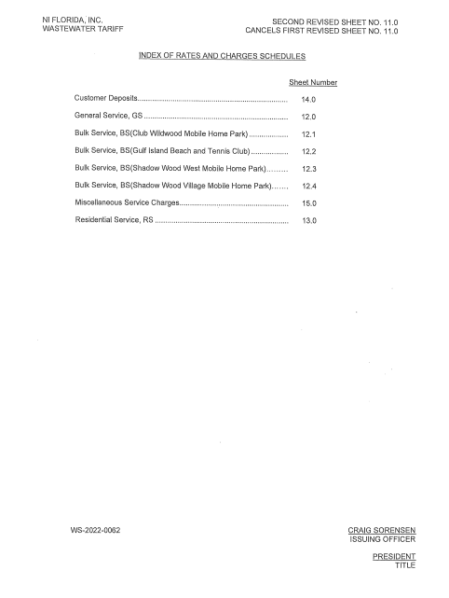

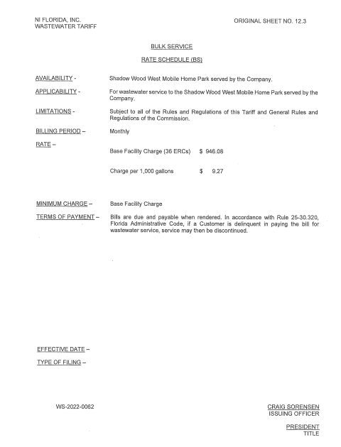

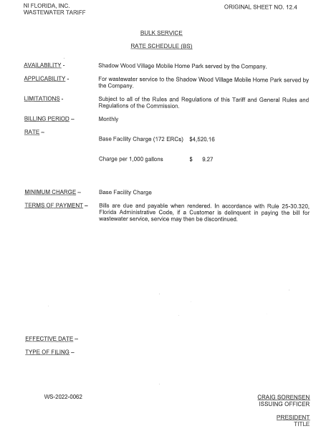

Order No. 2016-0525-PAA-WS, issued November 21, 2016, in Docket No. 20160030-WS, In re: Application for increase in water rates in Lee County and wastewater rates in Pasco County by Ni Florida, LLC.

