BEFORE THE FLORIDA PUBLIC SERVICE COMMISSION

In re: Petition for approval of 2021 true-up, projected 2022 true-up, and 2023 revenue requirements and surcharges associated with cast iron/bare steel pipe replacement rider, by Peoples Gas System. | DOCKET NO. 20220152-GU  ORDER NO. PSC-2022-0405-TRF-GU  ISSUED: November 21, 2022

The following Commissioners participated in the disposition of this matter:

ANDREW GILES FAY, Chairman
ART GRAHAM
GARY F. CLARK
MIKE LA ROSA
GABRIELLA PASSIDOMO

ORDER APPROVING TARIFF

BY THE COMMISSION:

Background
On September 1, 2022, Peoples Gas System (Peoples or utility) filed a petition for approval of its final 2021 true-up, projected 2022 true-up, and 2023 revenue requirement and surcharges associated with the cast iron/bare steel replacement rider (CI/BSR Rider or rider). The rider was originally approved in Order No. PSC-12-0476-TRF-GU (2012 order) to recover the cost of accelerating the replacement of cast iron and bare steel pipes through a surcharge on customers' bills. In the 2012 order, we found that "replacement of these types of pipelines is in the public interest to improve the safety of Florida's natural gas infrastructure, and reduce the possibility of loss of life and destruction of property should an incident occur." Peoples' current surcharges were approved in Order No. PSC-2021-0429-TRF-GU (2021 order).

In Order No. PSC-17-0066-AS-GU, we approved a comprehensive settlement agreement between PGS and the Office of Public Counsel (OPC). The settlement agreement, in part, added problematic plastic pipe (PPP) installed in the company's distribution system to eligible replacements under the rider. PPP was manufactured before 1983 and has significant safety concerns. In certain areas, the PPP is interspersed with, or connected to, the cast iron/bare steel pipe that is being replaced under the rider. As provided for in the settlement agreement, PPP replacements are included in the calculation of the 2023 rider surcharges.

In Order No. PSC-2022-0134-PAA-GU, we granted Peoples’ petition to address the impact of changes to Florida state income tax rates. Specifically, we allowed Peoples to increase the 2023 rider surcharges by $253,079 to reflect the impact of the change in Florida income tax rates in 2021 and 2022.

On September 14, 2022, Peoples waived the 60-day file-and-suspend provision of Section 366.06(3), Florida Statutes (F.S.), by email. During the evaluation of the petition, our staff a data request, for which responses were received on October 17, 2022. Attachment B contains the proposed tariff. We have jurisdiction over this matter pursuant to Sections 366.03, 366.04, 366.05, and 366.06, F.S.

Decision
The CI/BSR Rider charges have been in effect since January 2013 and were projected to be in effect for 10 years with replacement projects completed by the end of 2022. In response to staff’s first data request, Peoples stated that it needs an additional year to complete the cast iron/bare steel replacements due to complications related to the COVID-19 pandemic. Peoples expects to have 3.4 miles of cast iron/bare steel replacements remaining in 2023.

Rider PPP charges have been in effect since 2017. In 2022, Peoples’ cast iron/bare steel replacement activity focused in the areas of Miami, Tampa, St. Petersburg, Orlando, Eustis, Jacksonville, Lakeland, Daytona, Avon Park, and Ocala. In 2023, Peoples states it will focus on replacement projects in Miami, Tampa, St. Petersburg, Orlando, Eustis, Jacksonville, Lakeland, Daytona, Avon Park, Jupiter, and Ocala. The replacement of PPP is expected to continue until 2028.

Attachment A, attached to this order, contains tables which display the replacement progress and forecasts for CI/BSR Rider (Table 2) and for PPP (Table 3). Additionally, Peoples provided Table 1 which consolidates actual and projected CI/BSR and PPP miles replaced investment and revenue requirements for each year of the replacement program.

True-ups by Year
Peoples' calculation for the 2023 revenue requirement and surcharges includes a final true-up for 2021, an actual/estimated true-up for 2022, and projected costs for 2023. Pursuant to the 2012 order, the capital expenditures for 2017 through 2019 exclude the first $1 million of facility replacements each year because that amount is included in rate base. Peoples has included depreciation expense savings as discussed in the 2012 order; however, the utility has not identified any operations and maintenance savings.

Final True-up for 2021
Exhibit A shows that the revenues collected for 2020 were $5,206,120 compared to a revenue requirement of $1,186,869, resulting in an over-recovery of $4,019,251. The final 2020 under-recovery of $4,581,212, 2021 over-recovery of $4,019,251, and interest associated with any over- and under-recoveries, results in a final 2021 under-recovery of $563,794.

Actual/Estimated 2022 True-up
In Exhibit B, Peoples provided actual revenues for January through July and forecast revenues for August through December of 2022, totaling $5,190,196, compared to an actual/estimated revenue requirement of $5,092,683, resulting in an over-recovery of $97,513. The final 2021 under-recovery of $563,794, 2022 over-recovery of $97,513, state tax rate change recovery adjustment of $253,079, and interest associated with any over- and under-recoveries, results in a total 2022 under-recovery of $721,168.

Projected 2023 Costs
Exhibit C shows Peoples projects investment or capital expenditures of $24,817,804 for the replacement of cast iron/bare steel infrastructure and PPP in 2023. As shown in Table 1 of Attachment A, this consists of the CI/BSR infrastructure investment of $4,733,434 and the PPP investment of $20,084,370. The return on investment (which includes federal income taxes, regulatory assessment fees, and bad debt), depreciation expense (less savings), and property tax expense associated with that investment are $8,033,927. After adding the total 2022 under-recovery of $721,168, the total 2023 revenue requirement is $8,755,095. Table 1 below displays the 2023 revenue requirement calculation.
Table 0
2023 Revenue Requirement
2023 Projected Expenditures | $24,817,804
Return on Investment | $5,941,404
Depreciation Expense (less savings) | $1,034,085
Property Tax Expense | $1,058,439
2023 Revenue Requirement | $8,033,927
Plus 2022 Under-recovery | $721,168
Total 2023 Revenue Requirement | $8,755,095
Source: Page 1 of 2 in Exhibit C in petition (Docket No. 20220152-GU)
Proposed Surcharges
As established in the 2012 order, the total 2023 revenue requirement is allocated to rate classes using the same methodology that was used for the allocation of mains and services in the cost of service study used in Peoples' most recent rate case. After calculating the percentage of total plant costs attributed to each rate class, the respective percentages were multiplied by the 2023 revenue requirement resulting in the revenue requirement by rate class. Dividing each rate class's revenue requirement by projected therm sales provides the rider surcharge for each rate class.

We find it appropriate to approve the 2023 rider surcharge for residential customers of $0.03111 per therm (compared to the current surcharge of $0.02014). The 2023 monthly bill impact will be $0.62 for a residential customer who uses 20 therms. The tariff page provided is Attachment B, attached to this order.

Conclusion

We reviewed Peoples’ filings, supporting documentation, and the calculations. They are reasonable and accurate consistent with the methodology approved in the 2012 order. Therefore, we hereby approve Peoples’ proposed 2023 Rider CI/BSR surcharges, effective for the period January through December 2023.

Based on the foregoing, it is

ORDERED by the Florida Public Service Commission that Peoples Gas System’s proposed CI/BSR Rider surcharges for the period January through December 2023 are hereby approved, effective for the period January through December 2023. It is further

ORDERED that if a protest is filed within 21 days of issuance of the Order, the tariff shall remain in effect with any charges held subject to refund pending resolution of the protest. It is further

ORDERED that if no timely protest is filed, this docket shall be closed upon the issuance of a Consummating Order.

By ORDER of the Florida Public Service Commission this 21st day of November, 2022.

/s/ Adam J. Teitzman
ADAM J. TEITZMAN
Commission Clerk
Florida Public Service Commission
2540 Shumard Oak Boulevard
Tallahassee, Florida 32399
(850) 413-6770
www.floridapsc.com

Copies furnished: A copy of this document is provided to the parties of record at the time of issuance and, if applicable, interested persons.

AAW

NOTICE OF FURTHER PROCEEDINGS

The Florida Public Service Commission is required by Section 120.569(1), Florida Statutes, to notify parties of any administrative hearing or judicial review of Commission orders that is available under Sections 120.57 or 120.68, Florida Statutes, as well as the procedures and time limits that apply. This notice should not be construed to mean all requests for an administrative hearing or judicial review will be granted or result in the relief sought.

Mediation may be available on a case-by-case basis. If mediation is conducted, it does not affect a substantially interested person's right to a hearing.

The Commission's decision on this tariff is interim in nature and will become final, unless a person whose substantial interests are affected by the proposed action files a petition for a formal proceeding, in the form provided by Rule 28-106.201, Florida Administrative Code. This petition must be received by the Office of Commission Clerk, 2540 Shumard Oak Boulevard, Tallahassee, Florida 32399-0850, by the close of business on December 12, 2022.

In the absence of such a petition, this Order shall become final and effective upon the issuance of a Consummating Order.

Any objection or protest filed in this docket before the issuance date of this order is considered abandoned unless it satisfies the foregoing conditions and is renewed within the specified protest period.

Table 1
Peoples’ CI/BSR Replacement Program Progress
Year | CI/BS Miles Replaced | PPP Miles Replaced | CI/BS Investment | PPP Investment | CI/BS Revenue Requirement | PPP Revenue Requirement
2017 | 51 | - | $17,588,366 | $2,915,802 | $6,868,302 | $74,021
2018 | 62 | 56 | $27,035,678 | $15,890,424 | $8,510,823 | $848,201
2019 | 52 | 42 | $35,821,371 | $17,425,589 | $11,075,229 | $2,706,161
2020 | 55 | 43 | $32,317,184 | $11,115,571 | $14,817,804 | $4,358,010
2021 | 14 | 38 | $23,726,642 | $19,812,603 | $1,347,321 | $(160,452)
2022 | 22.6 | 42 | $12,726,454 | $13,257,487 | $3,198,966 | $1,893,717
2023 | 3 | 56 | $4,733,434 | $20,084,370 | $4,427,140 | $3,606,787
2024 | - | 53 | - | $21,113,609 | $4,719,944 | $5,790,505
2025 | - | 50 | - | $20,422,085 | $4,665,567 | $7,934,661
2026 | - | 48 | - | $20,065,464 | $4,604,292 | $9,995,517
2027 | 0.4* | 45 | - | $19,320,794 | $4,542,798 | $11,974,082
2028 | - | 43 | - | $20,464,387 | $4,481,301 | $13,934,519
Source: Response to Commission staff’s first data request.
*The 0.4 CI/BS miles shown in 2027 are a result of a 5-year construction moratorium in effect in the City of Miami preventing completion before 2027.

Table 2
Peoples’ CI/BSR Replacement Progress
Year | Main Replacements |  |  |  |  | Service Replacements
Year | Replaced Cast Iron (miles) | Replaced Bare Steel (miles) | Remaining Cast Iron at Year End (miles) | Remaining Bare Steel at Year End (miles) | Total Miles Remaining of CI/BS Mains | Replaced Number of Bare Steel Services | Total Number of Remaining Bare Steel Services
2012 | - | - | 100 | 354 | 454 | - | 14,978
2013 | 13 | 38 | 87 | 316 | 403 | 907 | 14,071
2014 | 2 | 15 | 85 | 298 | 383 | 7,964 | 6,107
2015 | 26 | 60 | 59 | 238 | 297 | 1,019 | 5,088
2016 | 15 | 35 | 44 | 203 | 247 | 1,050 | 6,963
2017 | 15 | 36 | 29 | 178 | 207 | 1,135 | 4,279
2018 | 10 | 52 | 18 | 126 | 144 | 1,970 | 2,309
2019 | 8 | 44 | 10 | 83 | 93 | 649 | 1,660
2020 | 4 | 51 | 6 | 35 | 41 | 423 | 1,237
2021 | 3.5 | 10.5 | 2 | 24 | 26 | 191 | 998
2022 | 1.8 | 20.8 | 0.2 | 3.2 | 3.4 | 500 | -
Source: Response to Commission staff’s first data request.

Table 3
Peoples’ PPP Replacement Program Progress
Miles | Replaced PPP (miles) | Total Remaining PPP Mains (miles) | Replaced Number of PPP Services | Total Number of Remaining PPP Services
2016 | - | 551 | - | 28,237
2017 | - | 509 | 1,396 | 26,841
2018 | 56 | 461 | 3,941 | 24,741
2019 | 42 | 418 | 2,349 | 20,420
2020 | 43 | 370 | 1,702 | 18,718
2021 | 38 | 337 | 882 | 17,683
2022 | 42 | 295 | Not Yet Determined | -
2023 | 56 | 239 | Not Yet Determined | -
2024 | 53 | 186 | Not Yet Determined | -
2025 | 50 | 136 | Not Yet Determined | -
2026 | 48 | 88 | Not Yet Determined | -
2027 | 45 | 43 | Not Yet Determined | -
2028 | 43 | - | Not Yet Determined | -
Source: Response to Commission staff’s first data request.

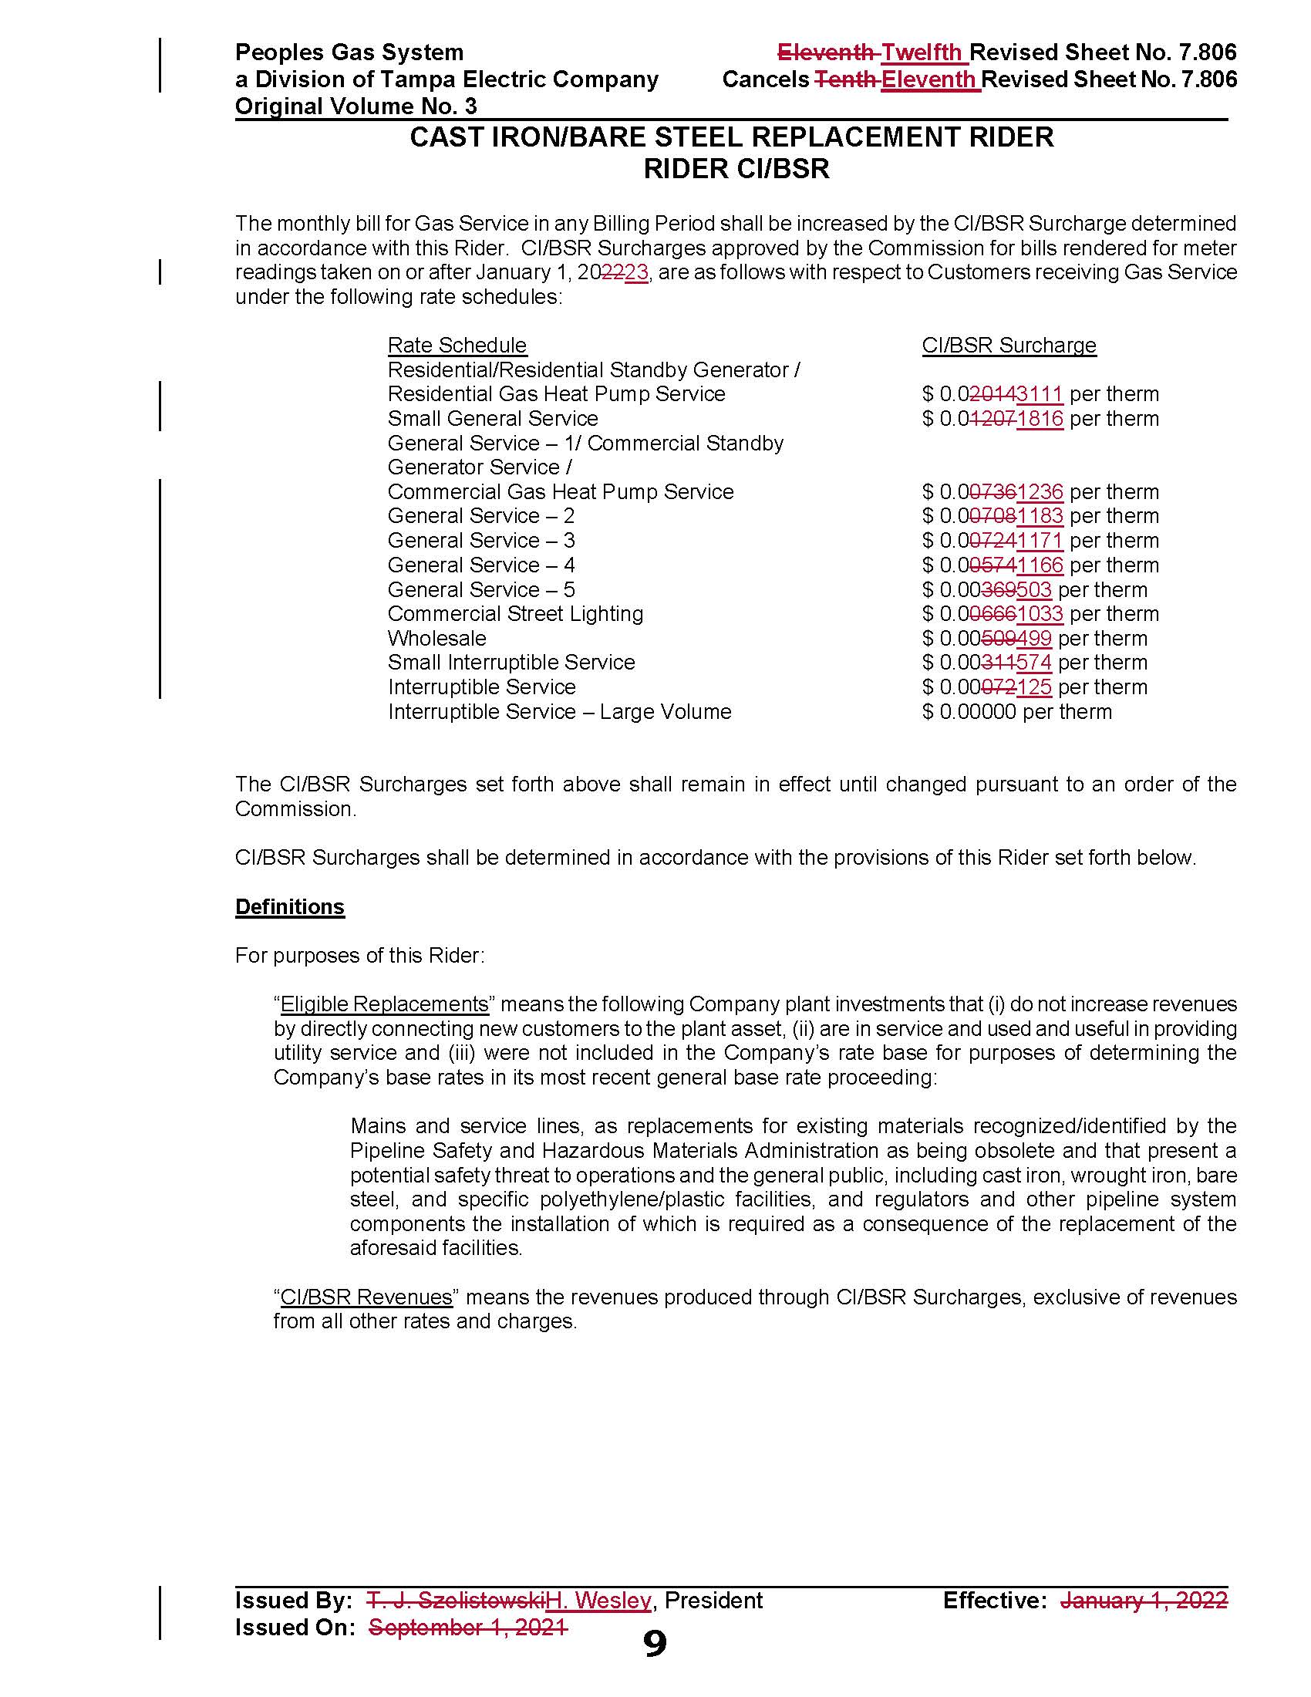

Order No. PSC-12-0476-TRF-GU, issued September 18, 2012, in Docket No. 20110320-GU, In re: Petition for approval of Cast Iron/Bare Steel Pipe Replacement Rider (Rider CI/BSR), by Peoples Gas System.
Order No. PSC-2021-0429-TRF-GU, issued November 19, 2021, in Docket No. 20210148-GU, In re: Petition for approval of 2020 true-up, projected 2021 true-up, and 2022 revenue requirements and surcharges associated with cast iron/bare steel replacement rider, by Peoples Gas System.
Order No. PSC-17-0066-AS-GU, issued February 28, 2017, in Docket No. 20160159-GU, In re: Petition for approval of settlement agreement pertaining to Peoples Gas System’s 2016 depreciation study, environmental reserve account, problematic plastic pipe replacement, and authorized ROE.
Order No. PSC-2022-0134-PAA-GU, issued April 11, 2022, in Docket No. 20220018-GU, In re: Petition for limited proceeding to address the impact of changes to Florida state income tax rates, by Peoples Gas System.

