BEFORE THE FLORIDA PUBLIC SERVICE COMMISSION

In re: Joint petition for approval of territorial agreement in Santa Rosa County, by the Okaloosa Gas District and the City of Milton. | DOCKET NO. 20220164-GU  ORDER NO. PSC-2023-0060-PAA-GU  ISSUED: January 20, 2023

The following Commissioners participated in the disposition of this matter:

ANDREW GILES FAY, Chairman
ART GRAHAM
GARY F. CLARK
MIKE LA ROSA
GABRIELLA PASSIDOMO

NOTICE OF PROPOSED AGENCY ACTION
ORDER APPROVING JOINT PETITION FOR TERRITORIAL AGREEMENT

BY THE COMMISSION:

NOTICE is hereby given by the Florida Public Service Commission that the action discussed herein is preliminary in nature and will become final unless a person whose interests are substantially affected files a petition for a formal proceeding, pursuant to Rule 25-22.029, Florida Administrative Code (F.A.C.).

BACKGROUND
On September 22, 2022, the City of Milton (Milton) and the Okaloosa Gas District (District), collectively the parties, filed a joint petition seeking approval of a new Territorial Agreement (Agreement) delineating their respective service boundaries in Santa Rosa County. Presently, both Milton and the District provide retail natural gas service to customers in contiguous areas in Santa Rosa County pursuant to service territories established by the Florida Legislature.

The Florida Legislature enacted Chapters 61-2489 and 29334 (1953), Laws of Florida, to establish Milton’s and the District’s natural gas service areas respectively. Therefore, the parties in this docket currently do not have a Commission-approved territorial agreement. The purpose of the proposed Agreement is to clearly define, by mutual agreement, specific service boundaries of the parties within Santa Rosa County and avoid duplication of services and facilities. No customers will be transferred pursuant to the Agreement. The Agreement, Laws of Florida describing Milton’s and the District’s current service areas, and map depicting the service boundaries are shown in Attachment A of this order.

DECISION
Pursuant to Section 366.04(3)(a), Florida Statutes (F.S.), and Rule 25-7.0471, F.A.C., we have jurisdiction to approve territorial agreements between natural gas utilities. Section 366.04(3)(c), F.S., defines natural gas utility to include municipalities and gas districts. Unless we determine that the Agreement will cause a detriment to the public interest, it will be approved.

The Proposed New Territorial Agreement

Milton, the county seat of Santa Rosa County, is serving approximately 4,500 natural gas customers in a defined area pursuant to Chapter 71-773, Laws of Florida. Chapter 71-773, Laws of Florida, is included as Exhibit A to the petition and page 11 of 27 of Attachment A to the order.

The Okaloosa Gas District is an independent special district created and established by the Florida Legislature in 1953 to own and operate natural gas transmission and distribution systems in Okaloosa County. In 2000, the Legislature expanded in Chapter 2000-443, Laws of Florida, the District’s service area to include portions of Santa Rosa and Walton counties. Chapter 2000-443, Laws of Florida, is included in Exhibit A to the petition and on pages 12 through 23 of Attachment A to this order. The District provides natural gas service to 50,996 residential, commercial, and industrial customers within its entire service area and to approximately 4,800 customers in Santa Rosa County. In response to our staff’s first data request, the parties explained that under the provisions of Chapter 71-773, Laws of Florida, and Chapter 2021-262, Laws of Florida, both parties were granted the right to serve some of the same geographic areas, which has resulted in some overlapping service areas.

In 2021, the Florida Legislature enacted Chapter 2021-262, Laws of Florida, to expand the service area of the District to include all of Santa Rosa and Walton counties except for certain areas explicitly excluded. Specifically, the City of Milton and its rights to serve natural gas customers within its territorial grants are excluded from the District’s service area. Chapter 2021-262, Laws of Florida, is shown in Exhibit B to the petition and on pages 24 through 26 of Attachment A to this order.

Chapter 2021-262, Section 3(1)(a), Laws of Florida, provides the following language:

The area within the corporate limits of the City Town of Milton and the surrounding territory presently served by the gas distribution system of said city town; however, nothing in this act shall be construed to restrict or limit the City of Milton’s right to serve gas customers within its territorial grants and in all areas where the district territories overlap with territories of the City of Milton authorized by chapter 61-2489 and chapter 71-773, Laws of Florida;

The underlined language shows the amendment from Chapter 2000-443, Laws of Florida, and is shown on page 24 of 27 of Attachment A of the order. Through this proposed Agreement, the parties stated that they desire to clearly define their specific territorial boundaries within Santa Rosa County, provide efficient service to customers, and avoid duplication of service and facilities.

There are no customer or infrastructure facility transfers contemplated in this proposed Agreement. The initial term of the Agreement is for 25 years and unless modified by mutual agreement, the Agreement will be renewed every five years thereafter.

Conclusion
After review of the joint petition and the petitioners’ joint responses to staff’s data request, we agree the new Agreement is in the public interest and will enable Milton and the District to serve their current and future customers efficiently in Santa Rosa County. The proposed Agreement will clearly define specific service boundaries within Santa Rosa County between Milton and the District and will avoid duplication of facilities and services. Therefore, we approve the proposed new Agreement between the City of Milton and the Okaloosa Gas District in Santa Rosa County.

Based on the foregoing, it is

ORDERED by the Florida Public Service Commission that the proposed territorial agreement between the City of Milton and the Okaloosa Gas District in Santa Rosa County shall be approved. It is further

ORDERED that the provisions of this Order, issued as proposed agency action, shall become final and effective upon the issuance of a Consummating Order unless an appropriate petition, in the form provided by Rule 28-106.201, Florida Administrative Code, is received by the Commission Clerk, 2540 Shumard Oak Boulevard, Tallahassee, Florida 32399-0850, by the close of business on the date set forth in the “Notice of Further Proceedings” attached hereto. It is further

ORDERED that in the event this Order becomes final, this docket shall be closed.

By ORDER of the Florida Public Service Commission this 20th day of January, 2023.

/s/ Adam J. Teitzman
ADAM J. TEITZMAN
Commission Clerk
Florida Public Service Commission
2540 Shumard Oak Boulevard
Tallahassee, Florida 32399
(850) 413-6770
www.floridapsc.com

Copies furnished: A copy of this document is provided to the parties of record at the time of issuance and, if applicable, interested persons.

AAW

NOTICE OF FURTHER PROCEEDINGS OR JUDICIAL REVIEW

The Florida Public Service Commission is required by Section 120.569(1), Florida Statutes, to notify parties of any administrative hearing that is available under Section 120.57, Florida Statutes, as well as the procedures and time limits that apply. This notice should not be construed to mean all requests for an administrative hearing will be granted or result in the relief sought.

Mediation may be available on a case-by-case basis. If mediation is conducted, it does not affect a substantially interested person's right to a hearing.

The action proposed herein is preliminary in nature. Any person whose substantial interests are affected by the action proposed by this order may file a petition for a formal proceeding, in the form provided by Rule 28-106.201, Florida Administrative Code. This petition must be received by the Office of Commission Clerk, 2540 Shumard Oak Boulevard, Tallahassee, Florida 32399-0850, by the close of business on February 10, 2023.

In the absence of such a petition, this order shall become final and effective upon the issuance of a Consummating Order.

Any objection or protest filed in this/these docket(s) before the issuance date of this order is considered abandoned unless it satisfies the foregoing conditions and is renewed within the specified protest period.

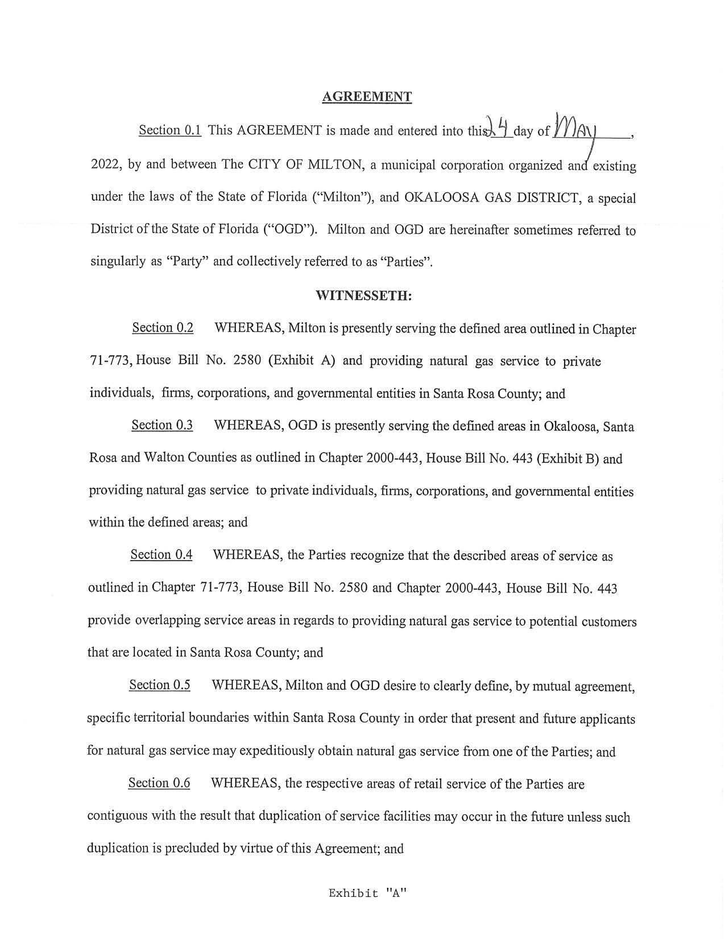
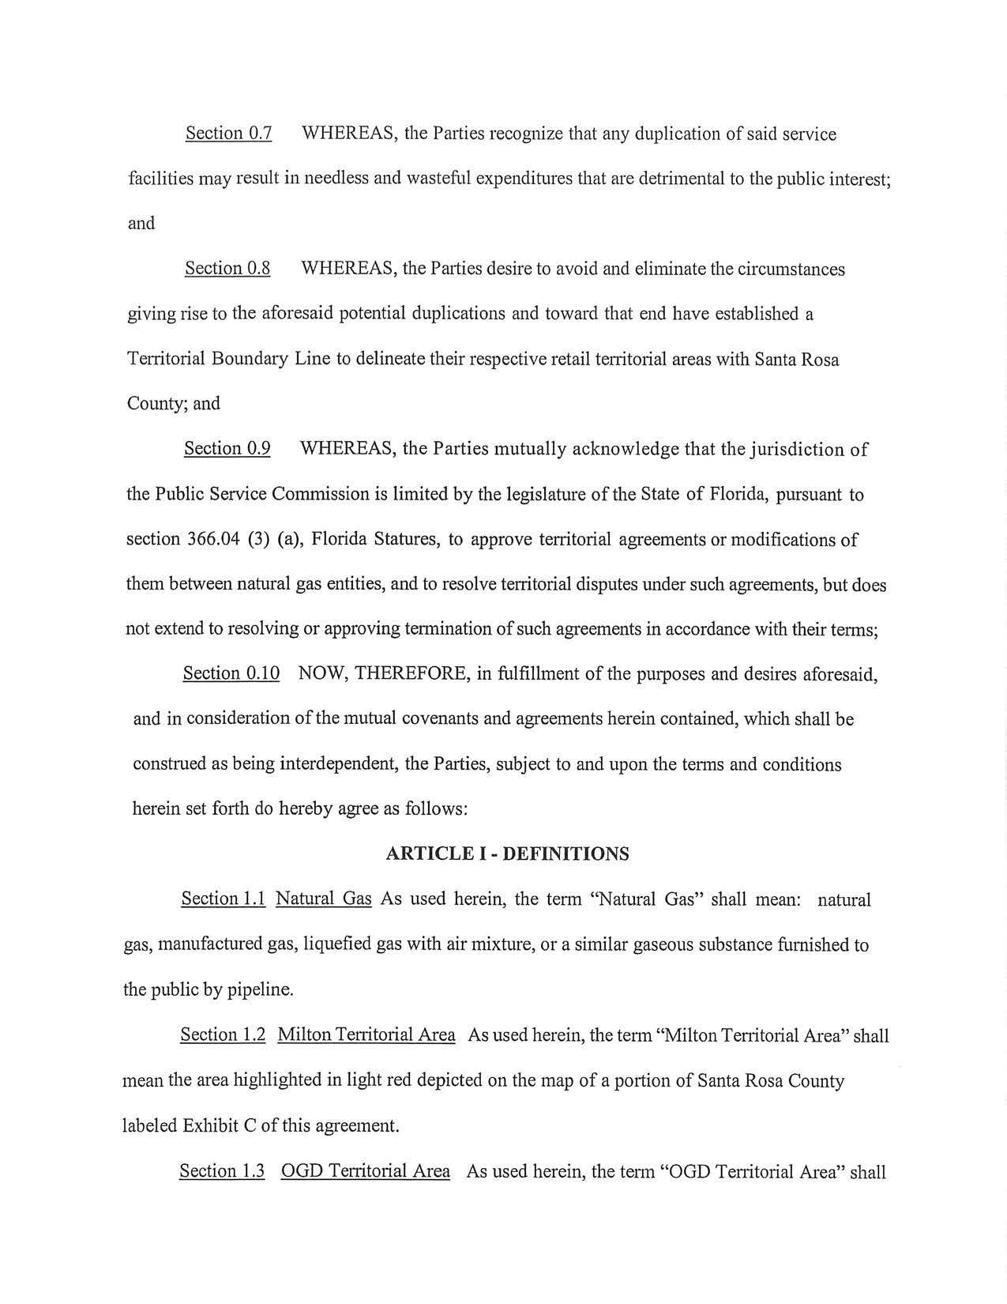
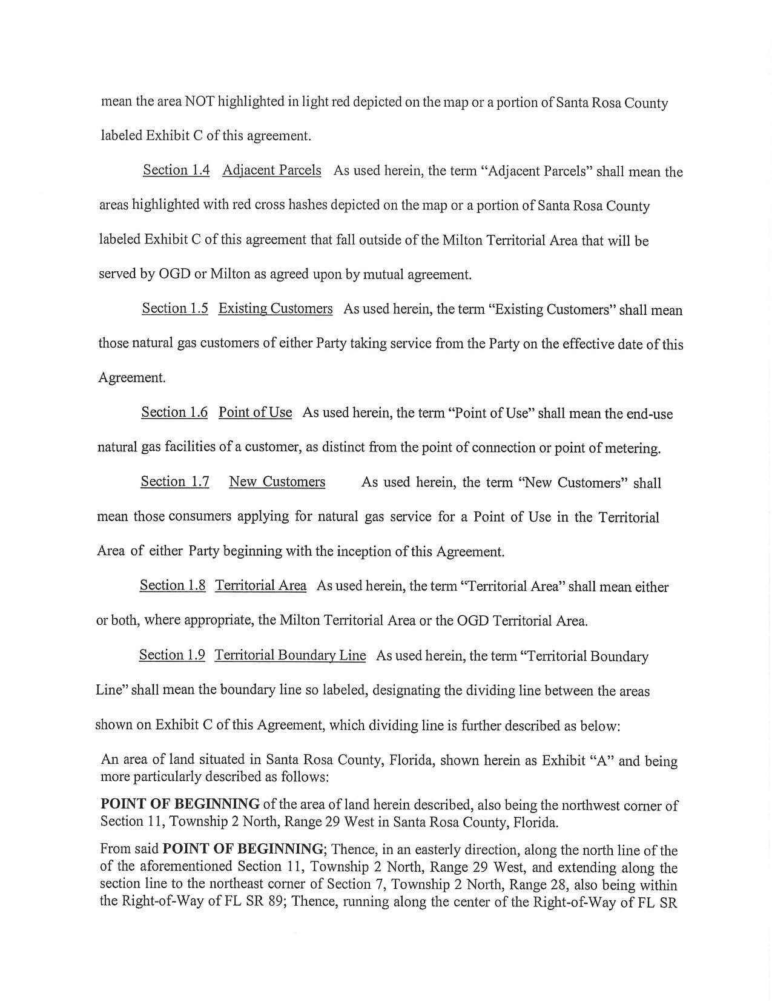
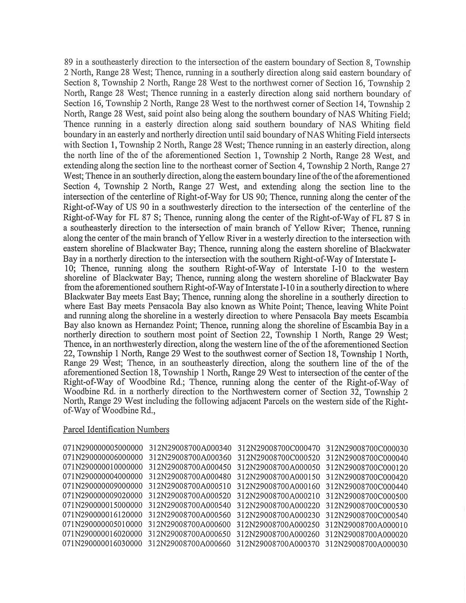
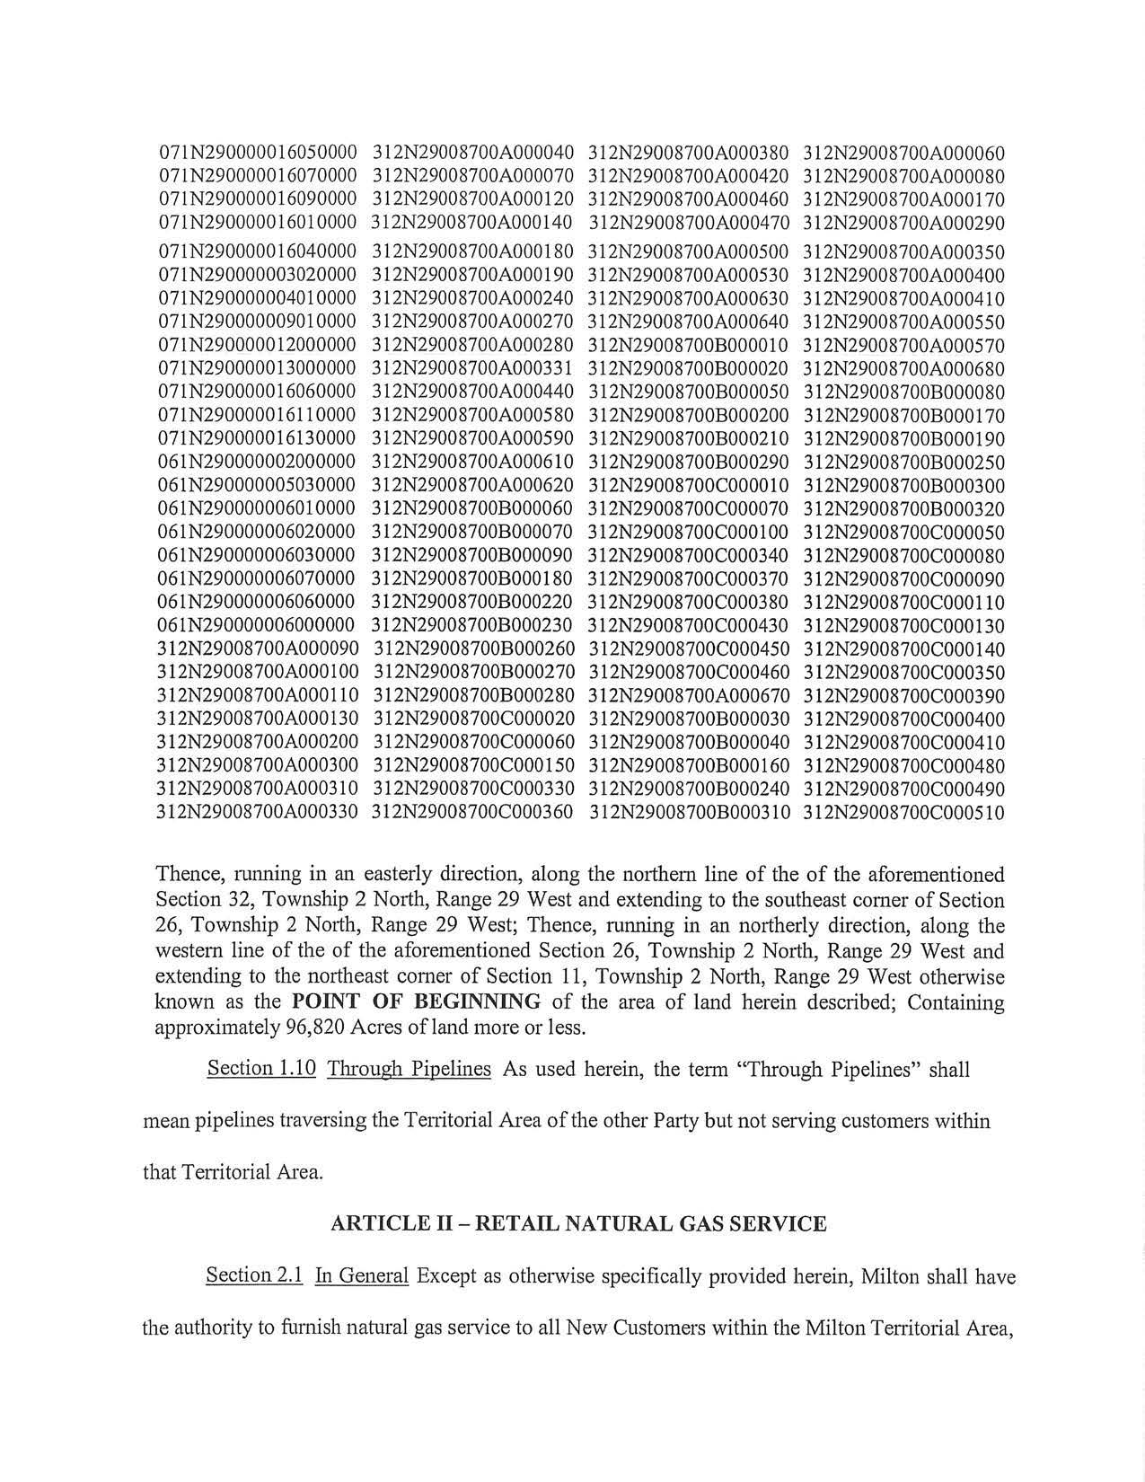
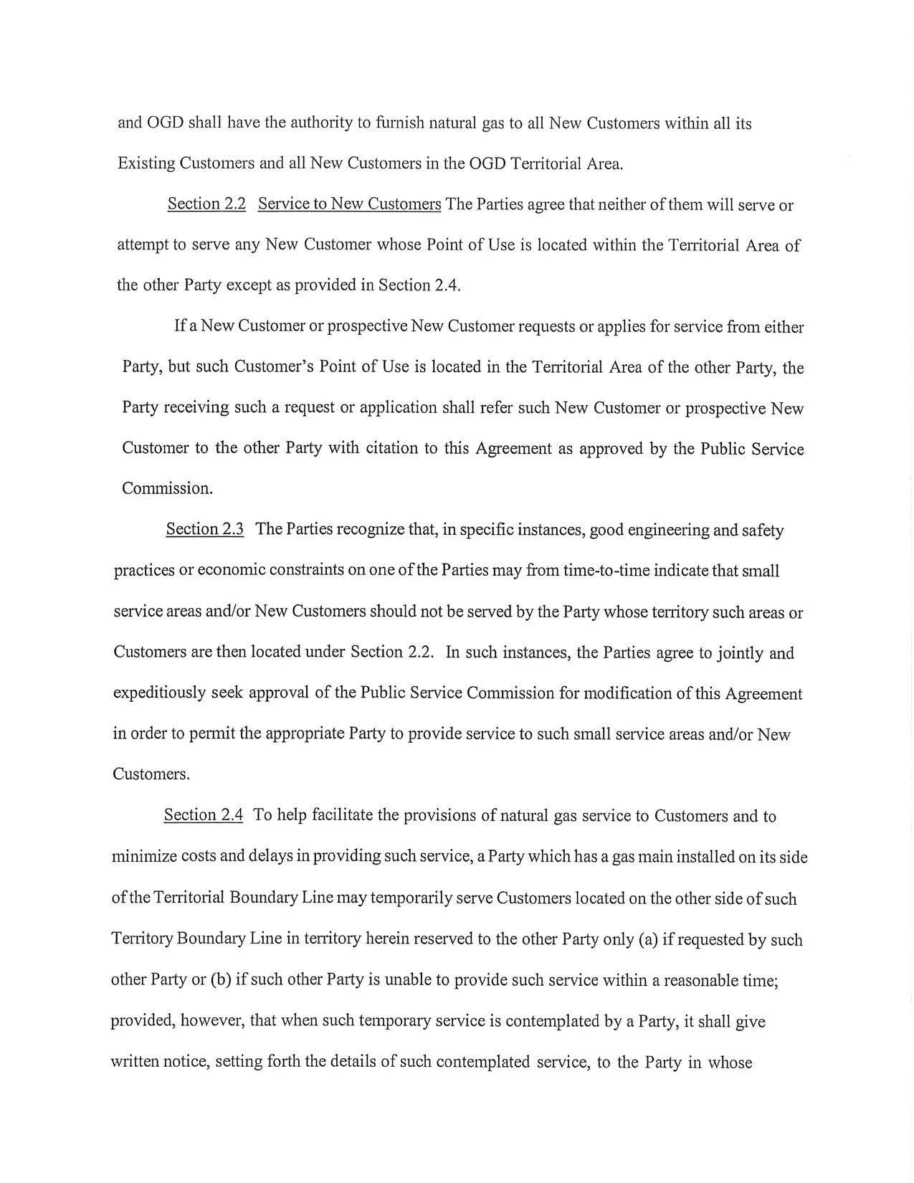
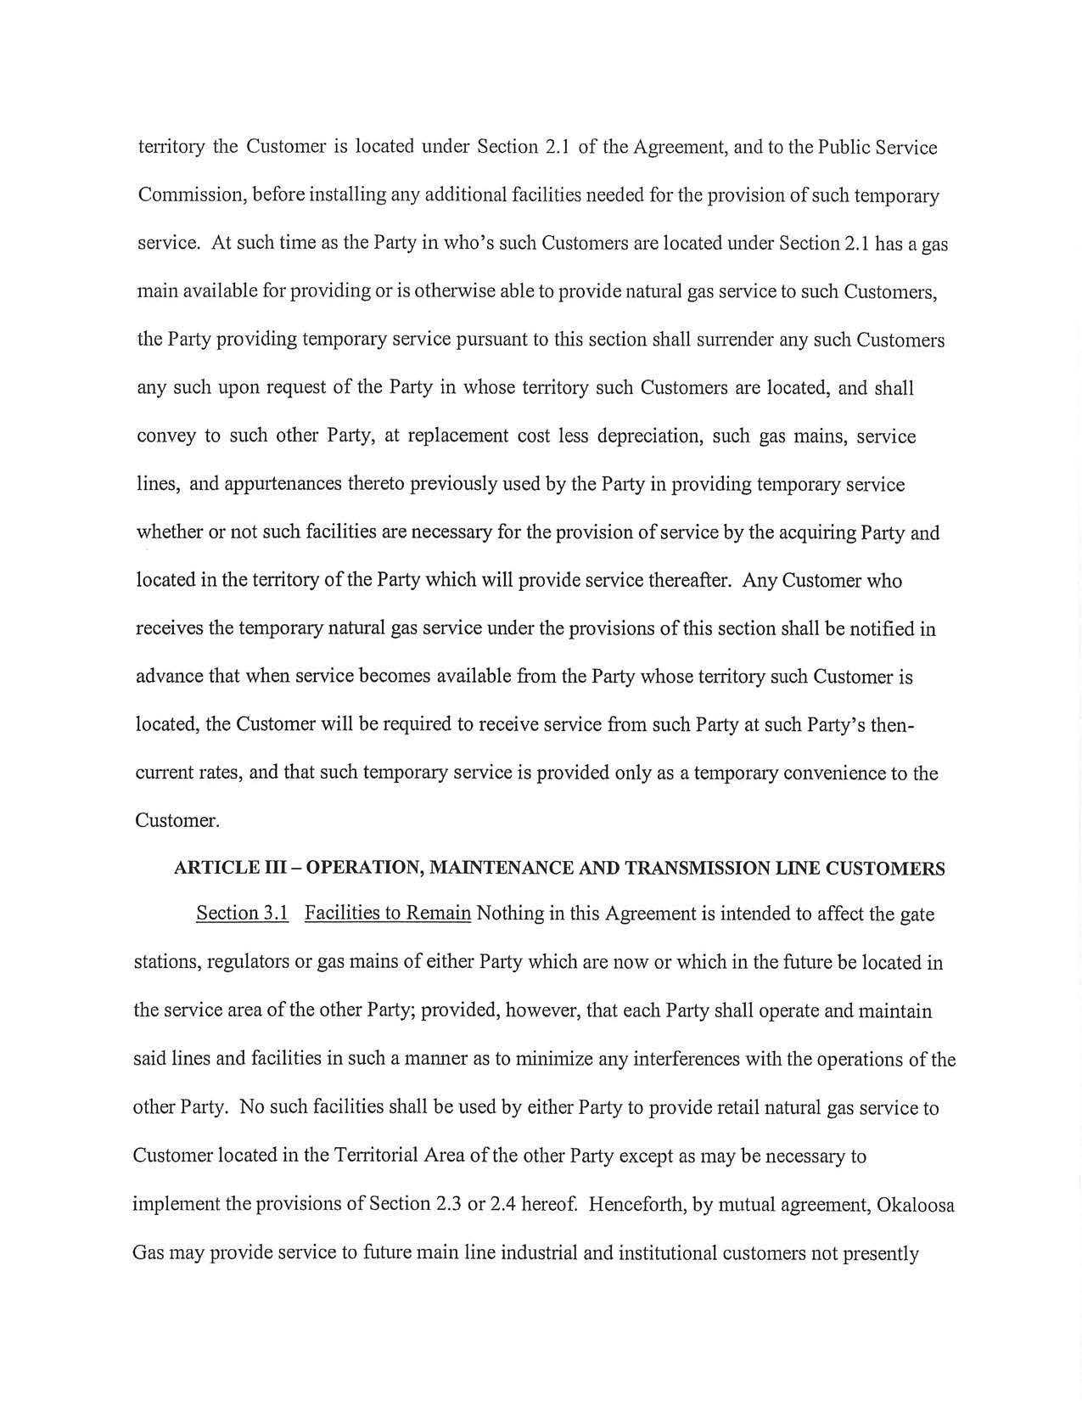
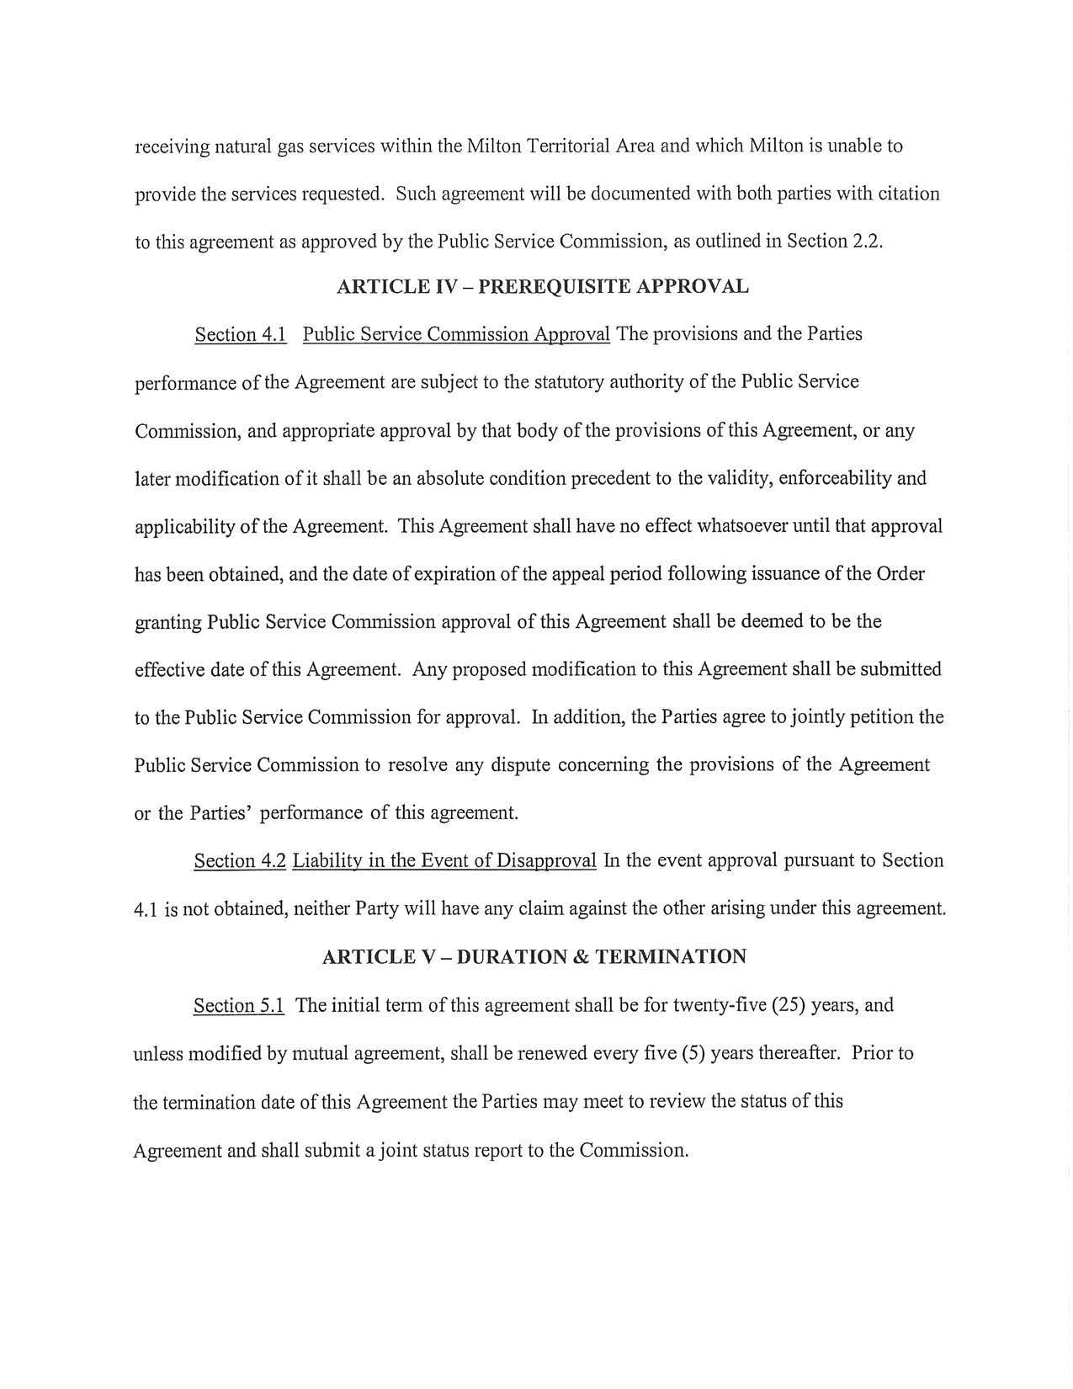
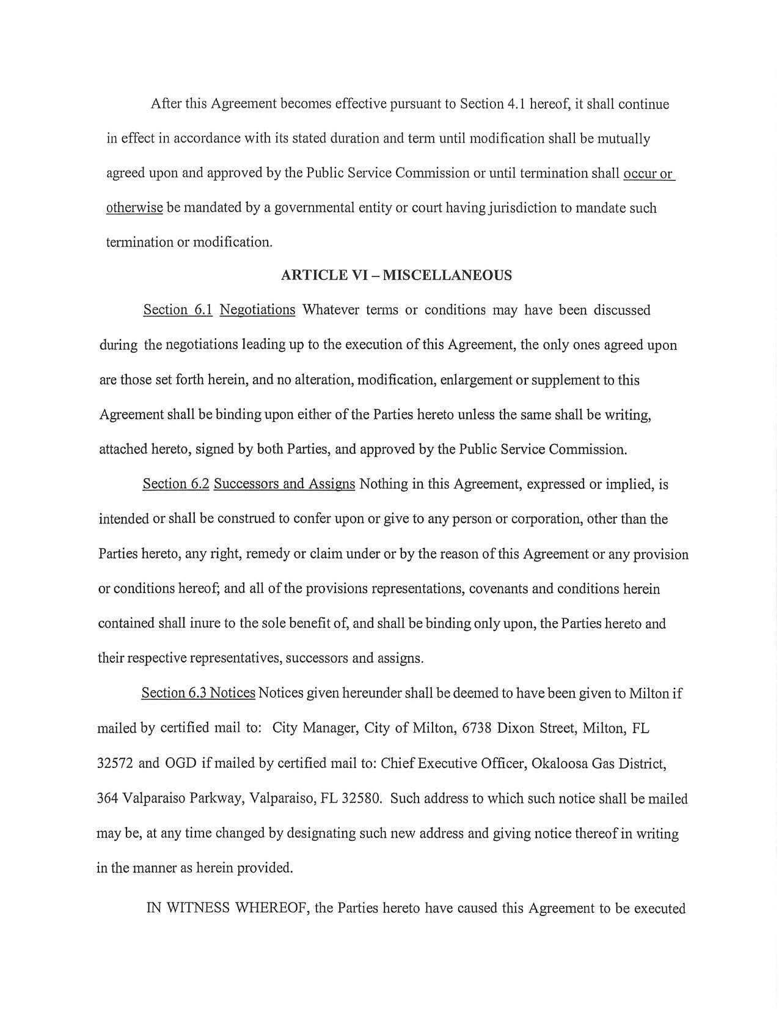
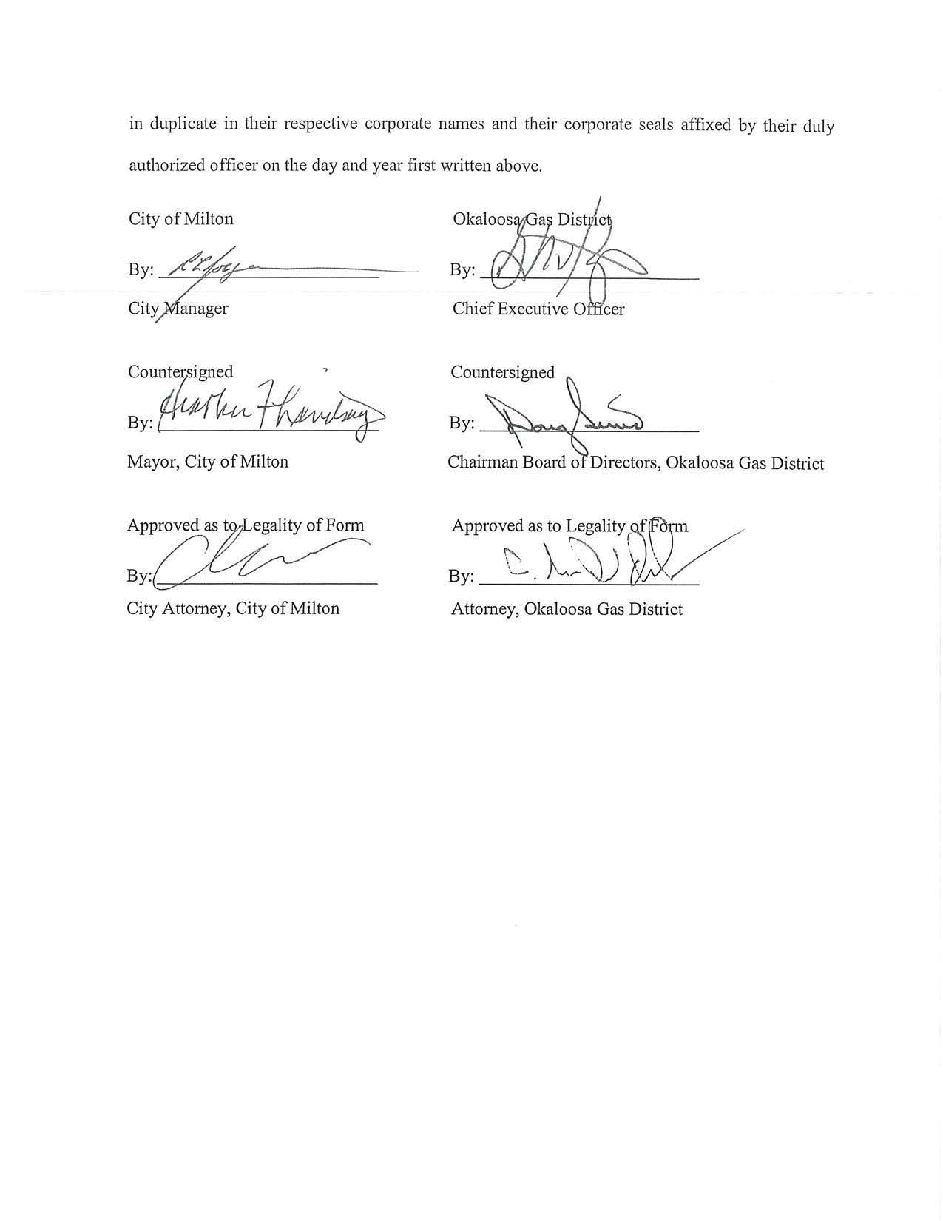
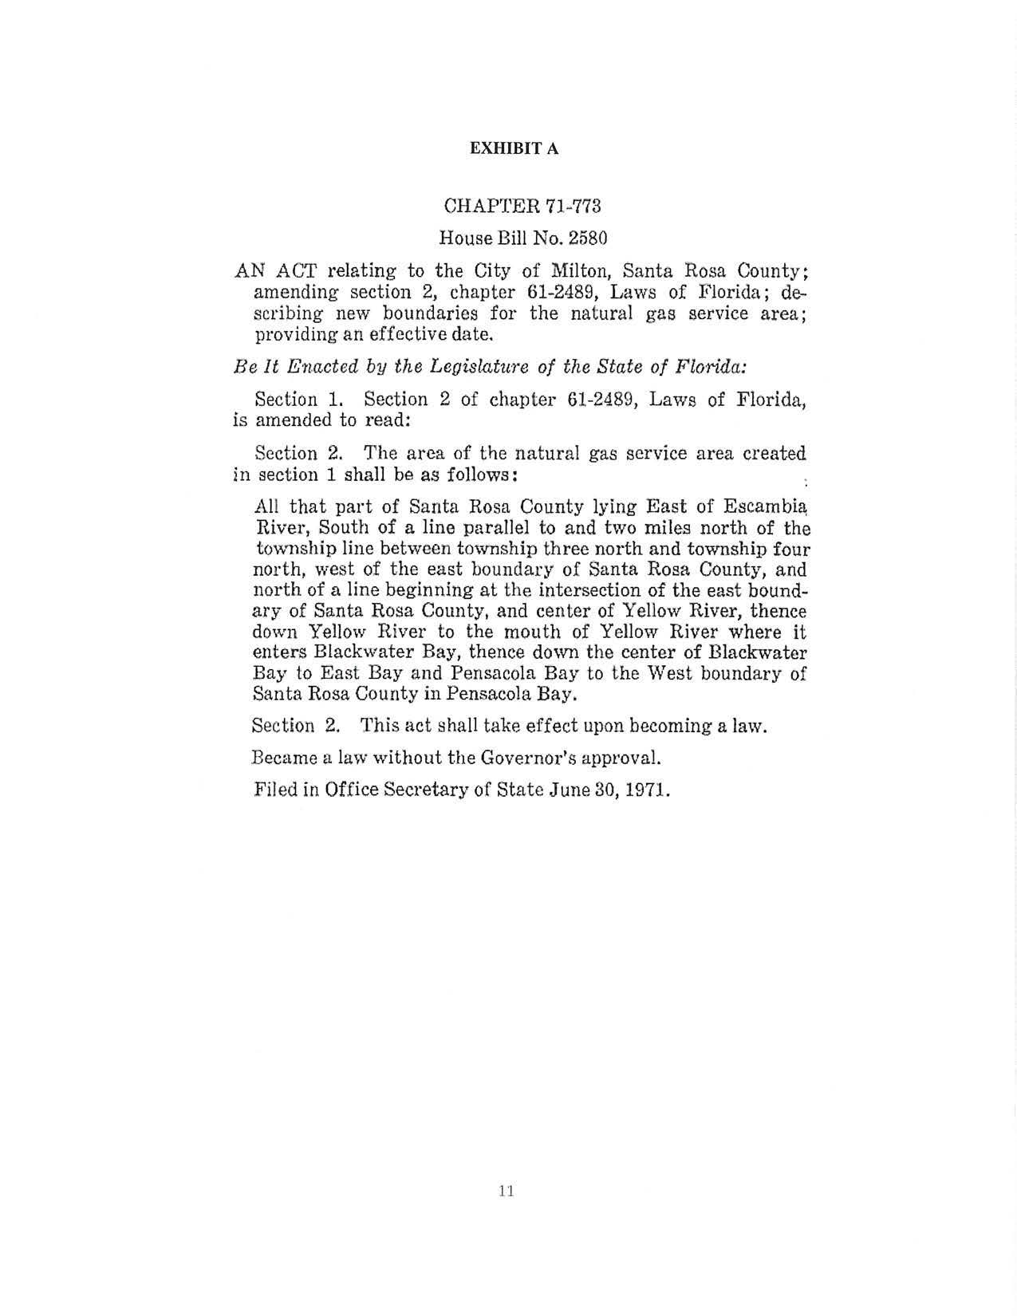
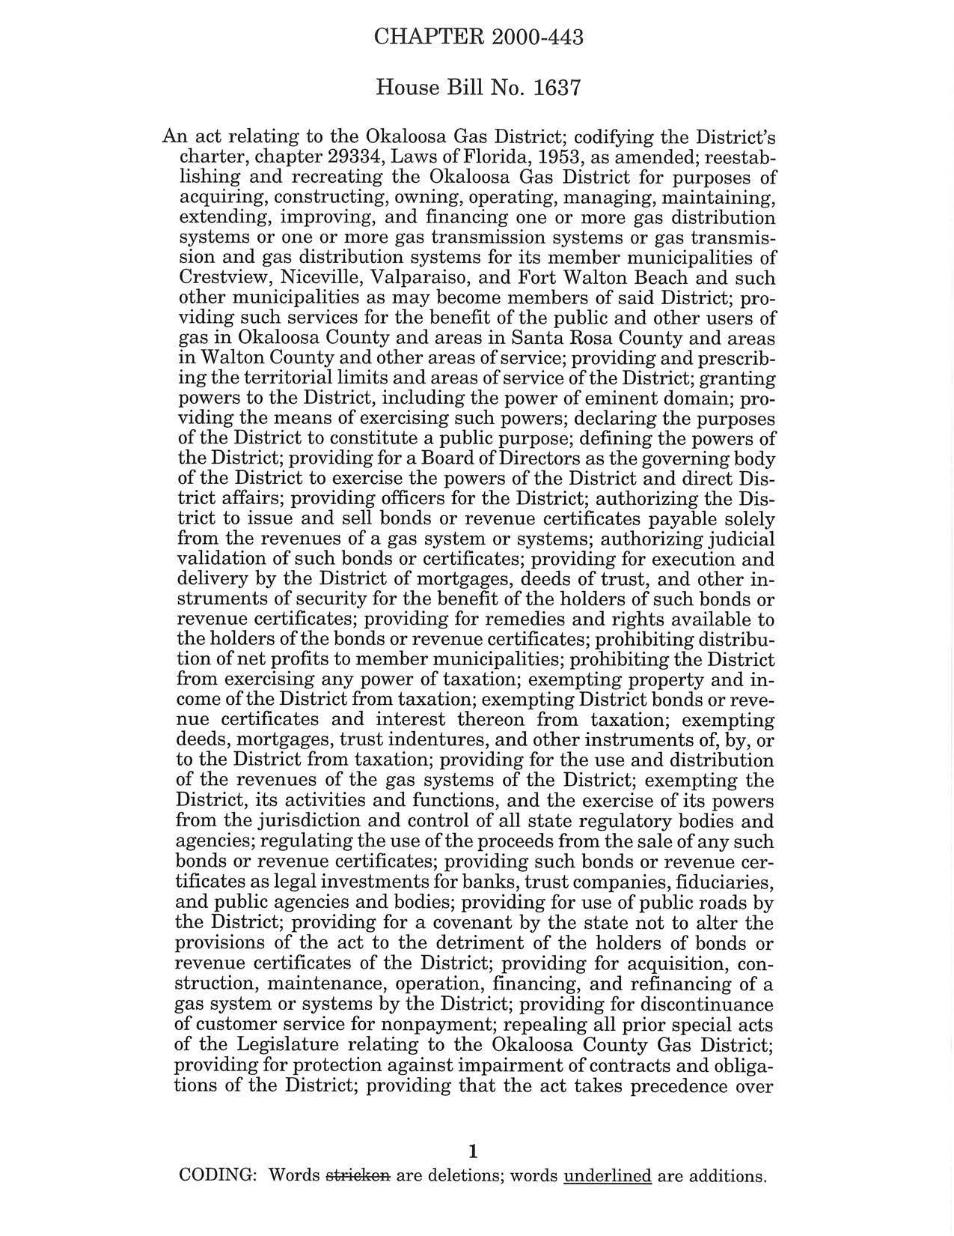
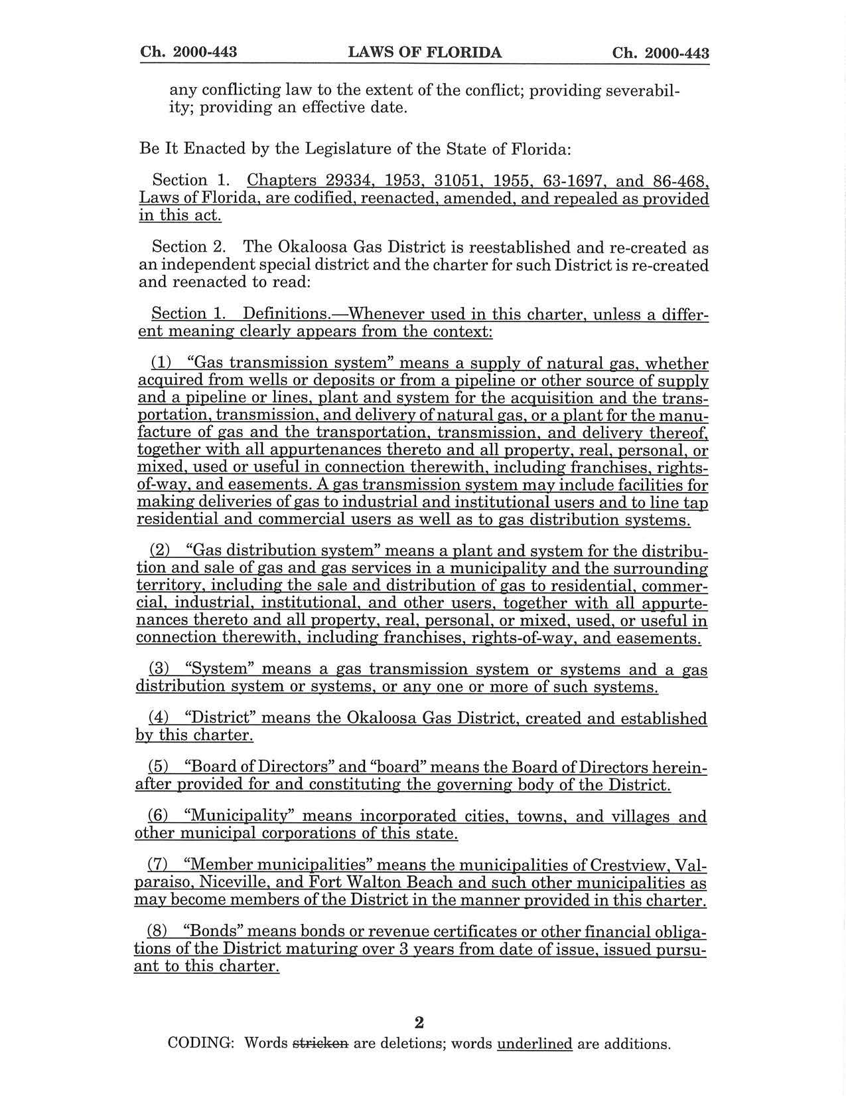
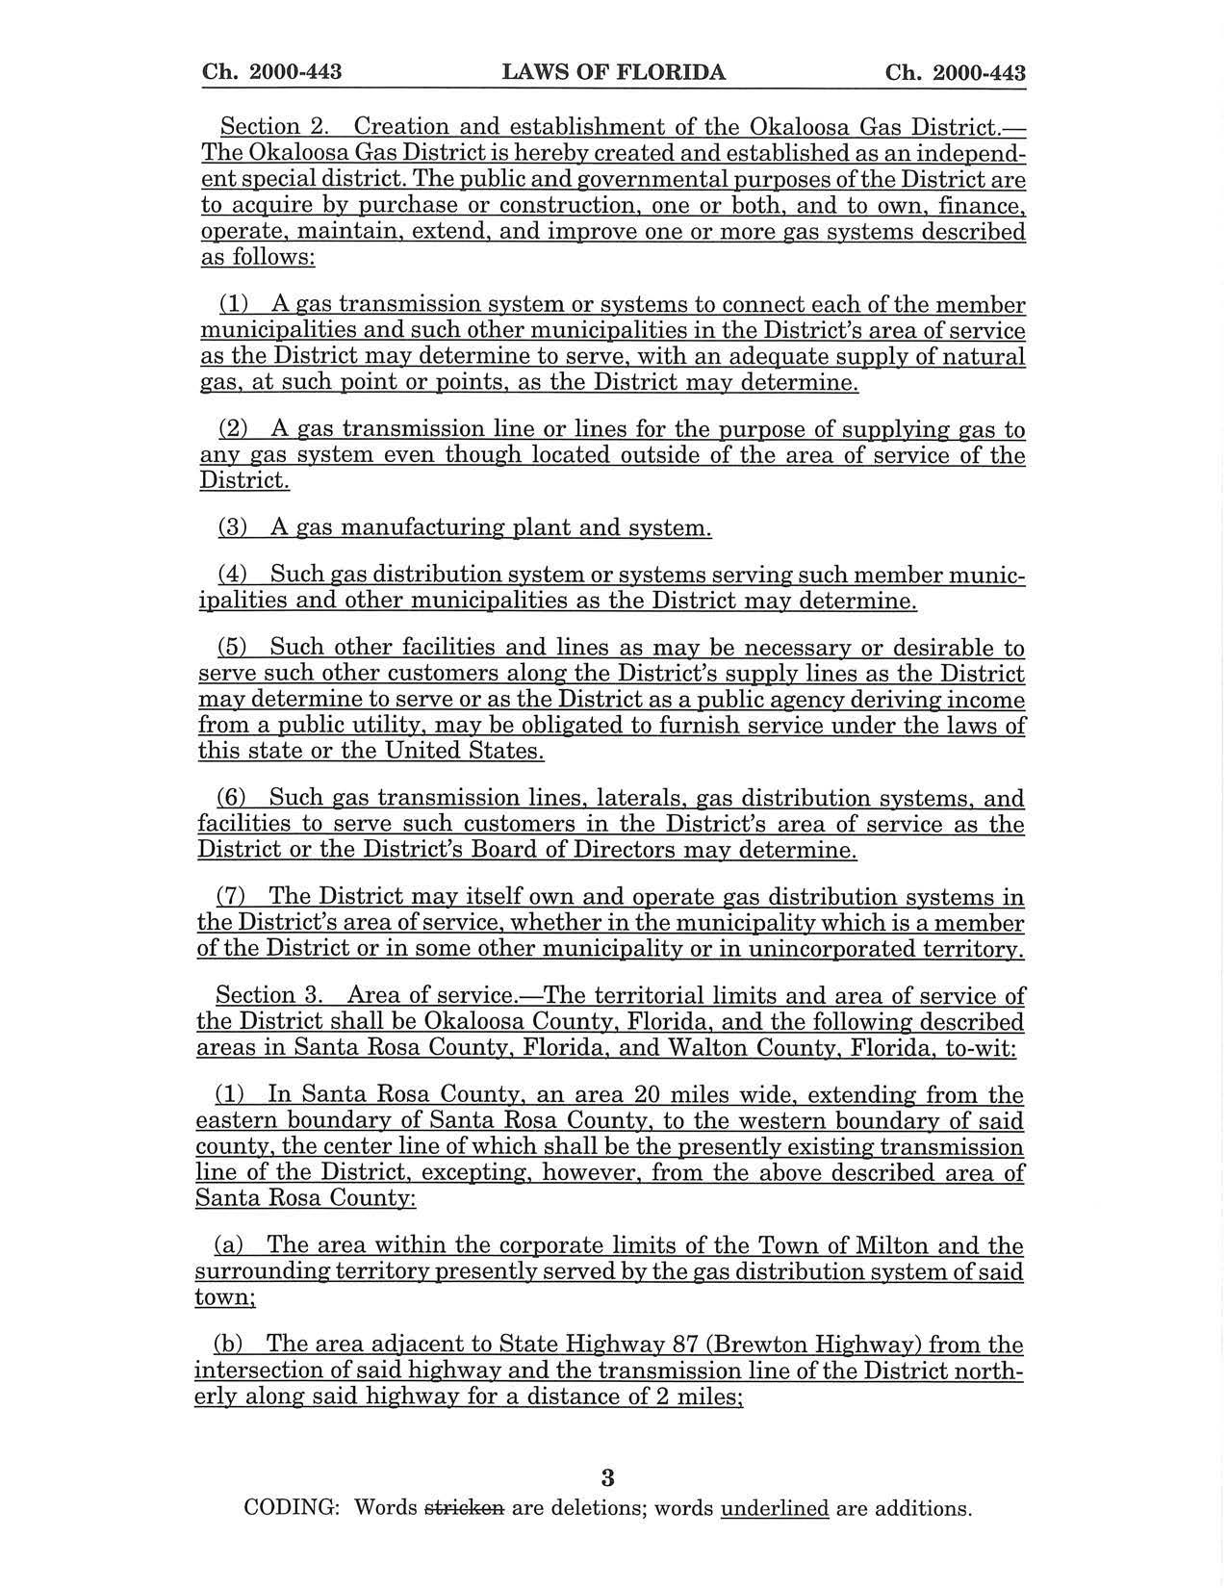
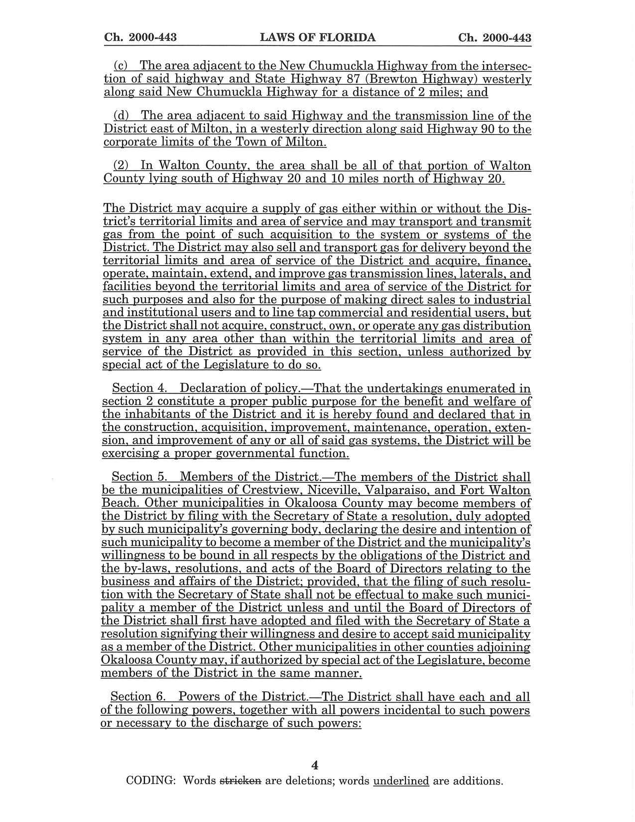
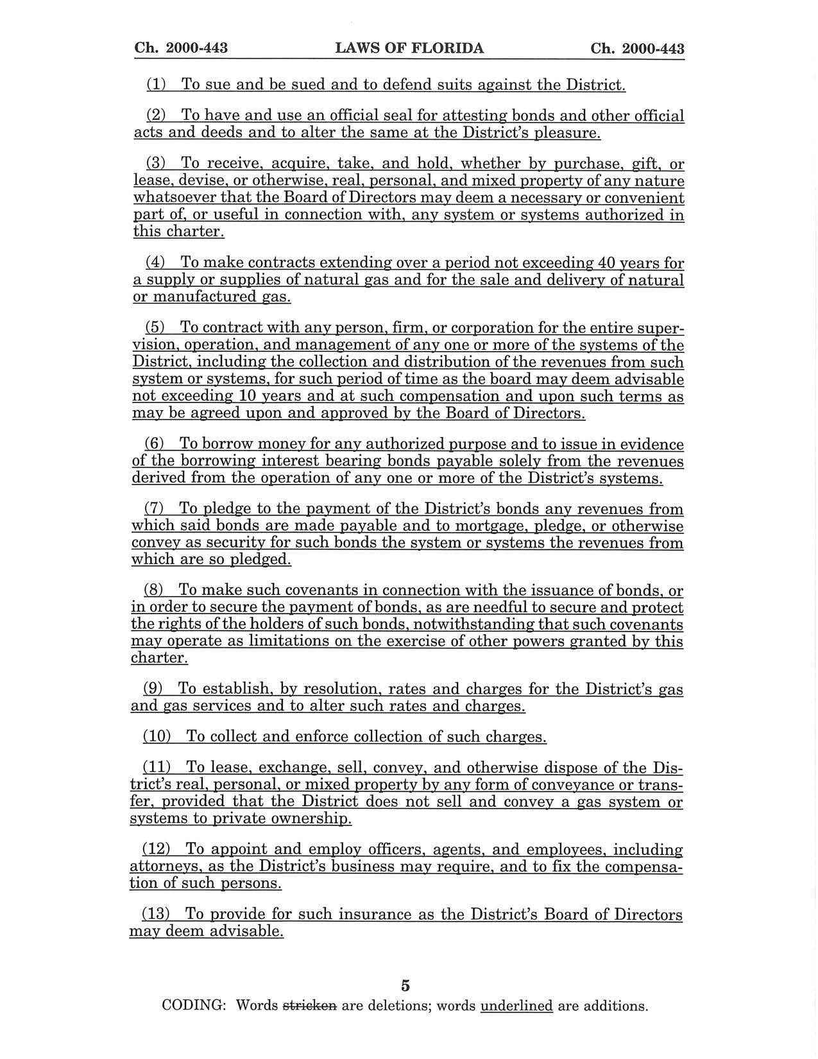
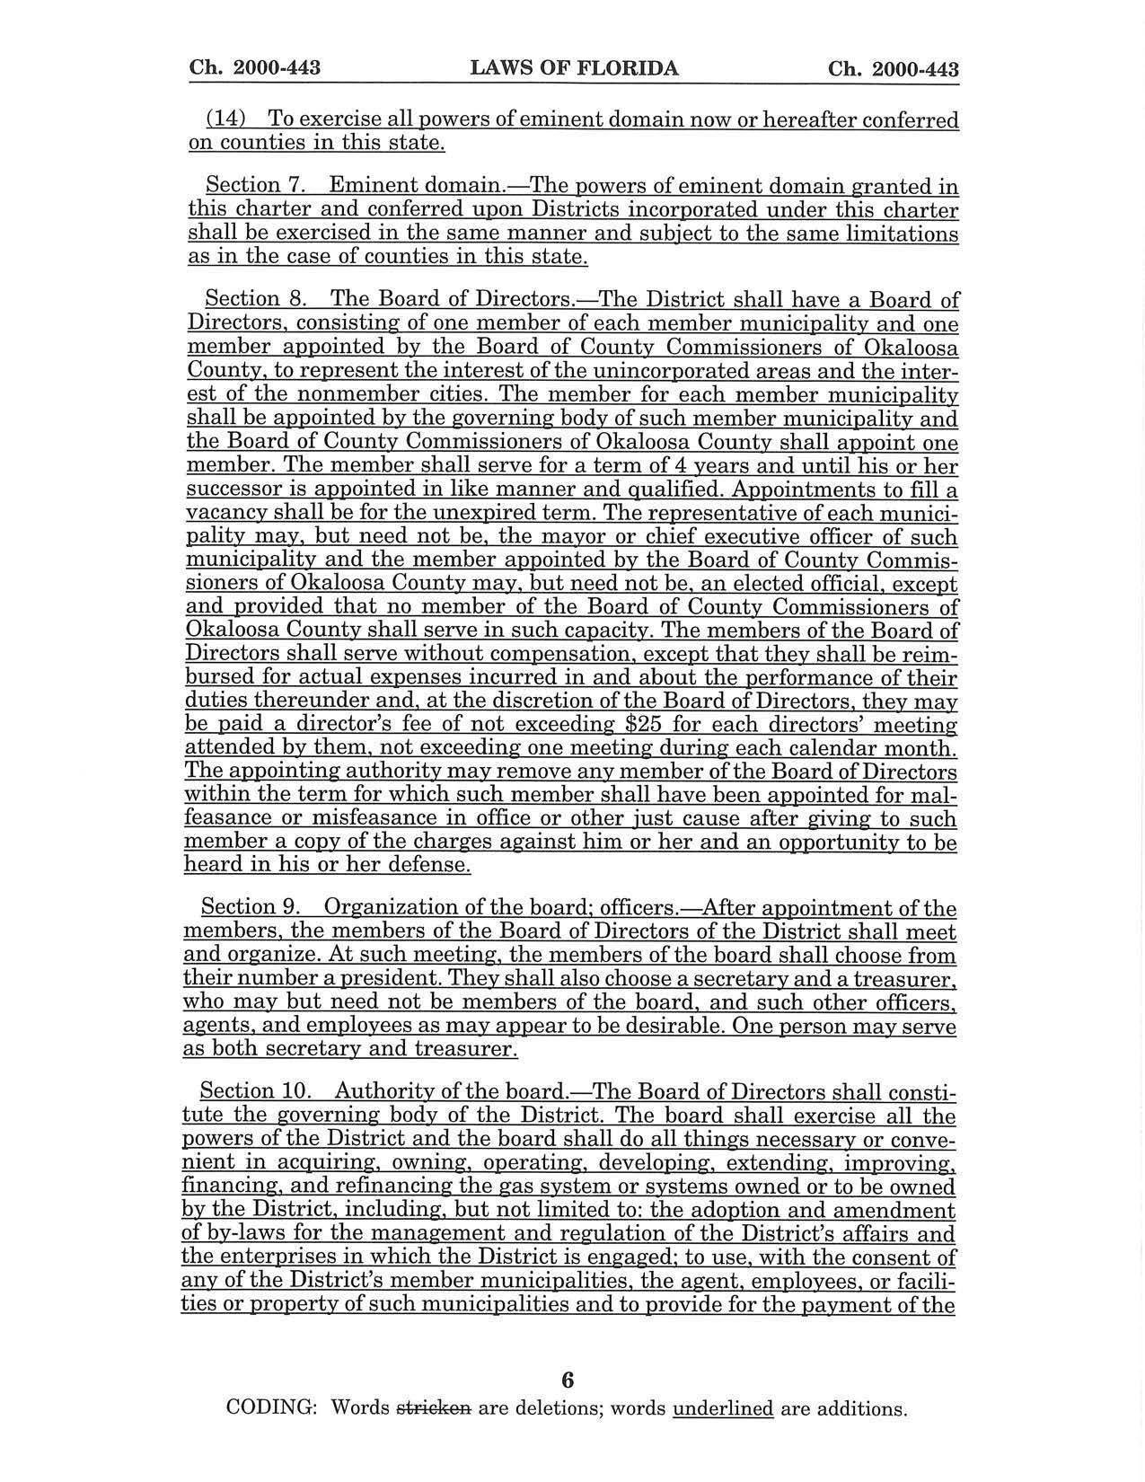
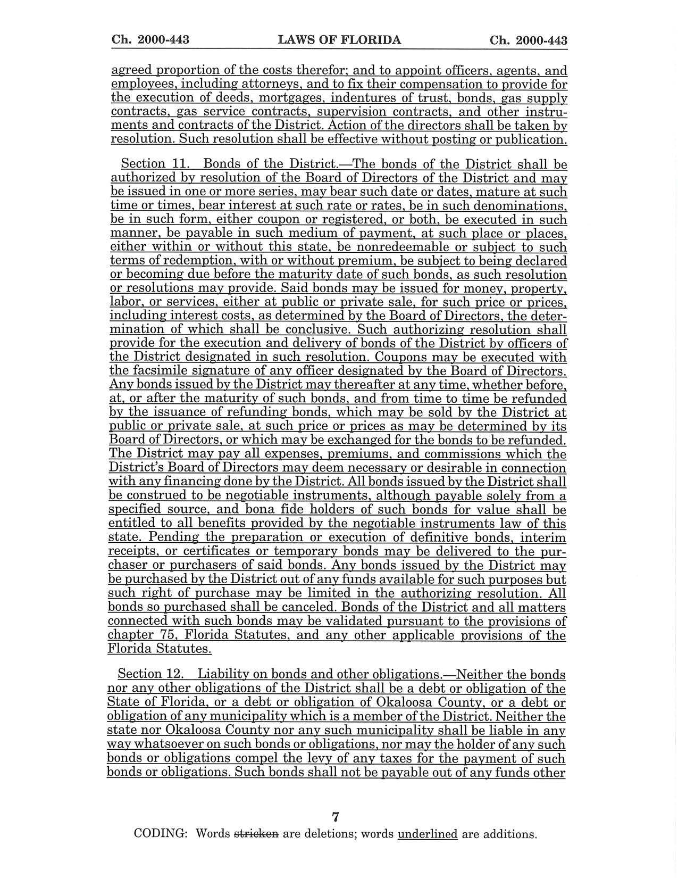
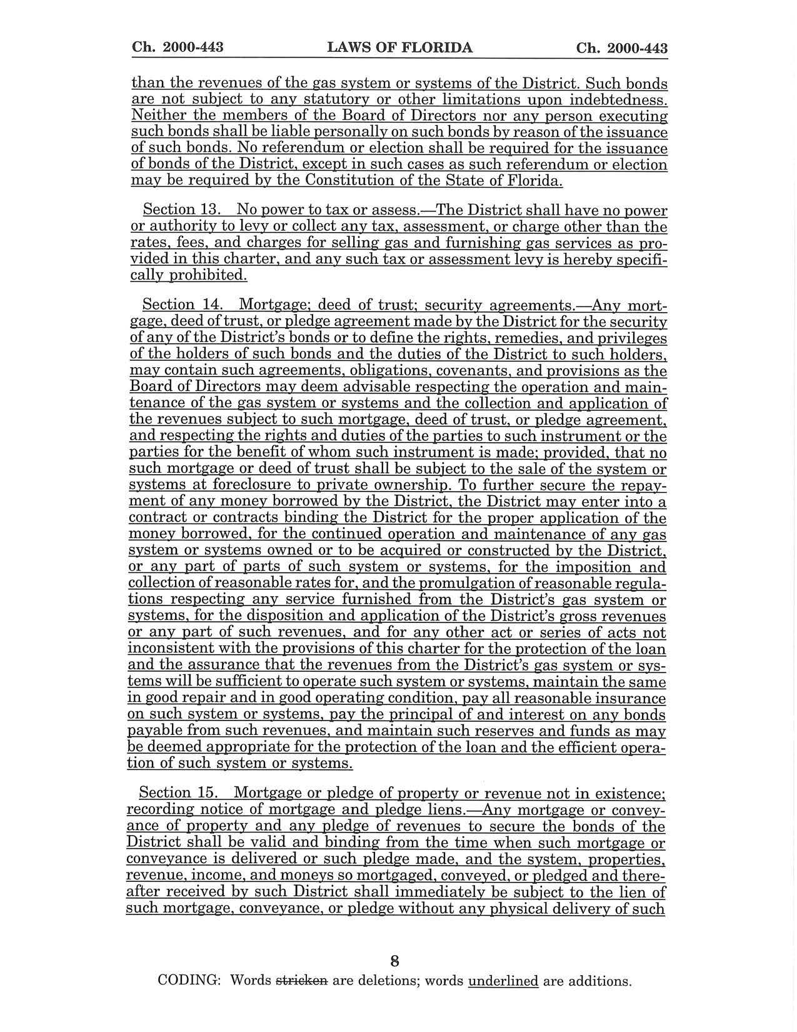
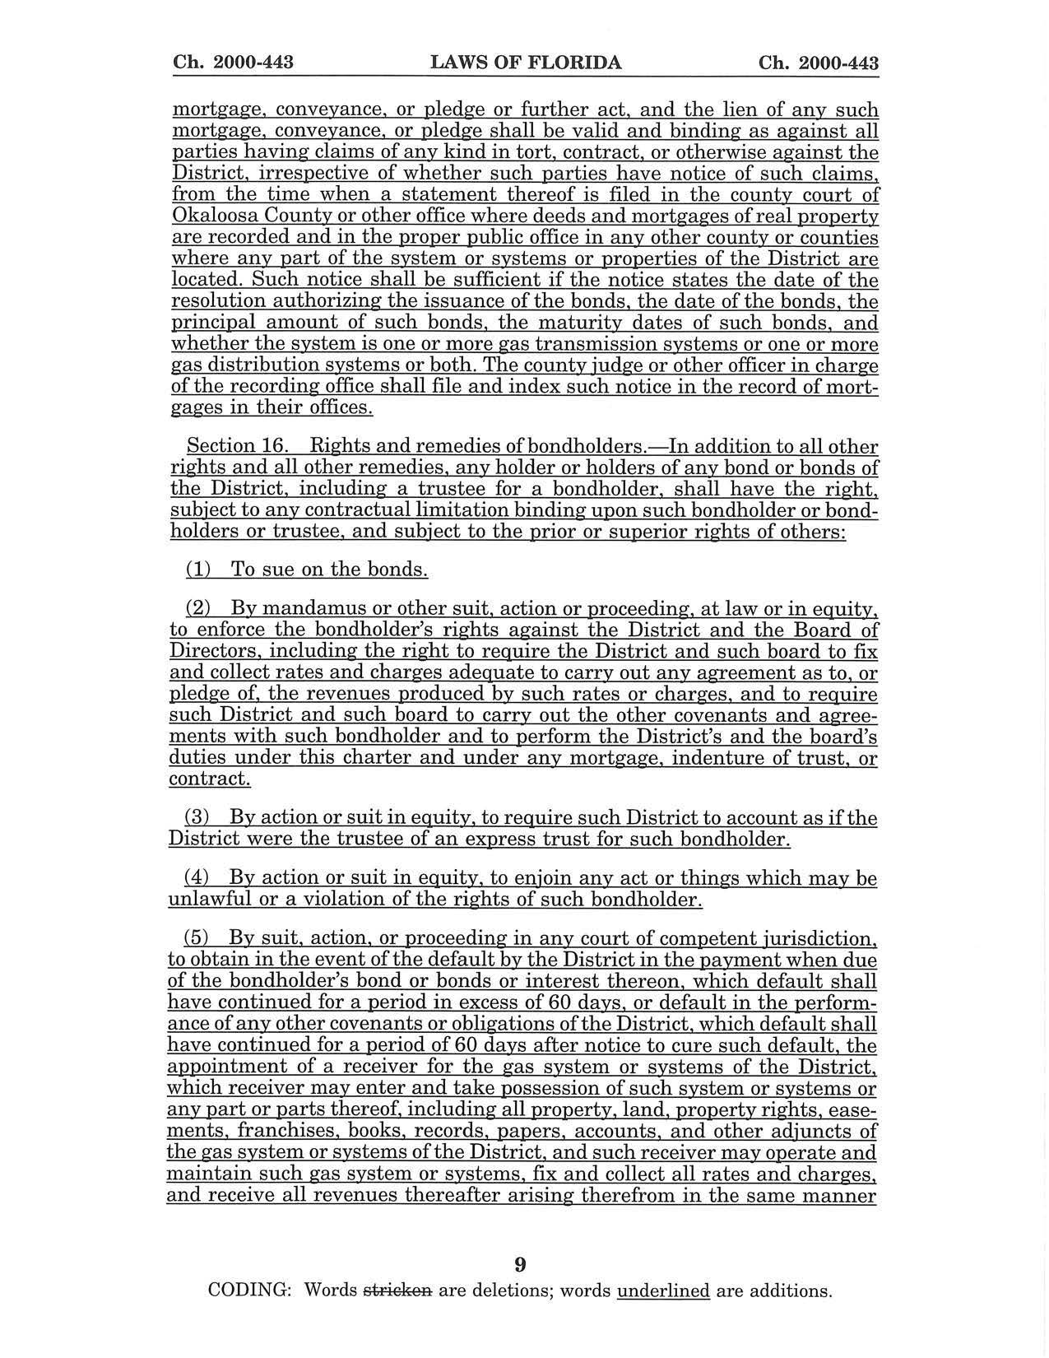
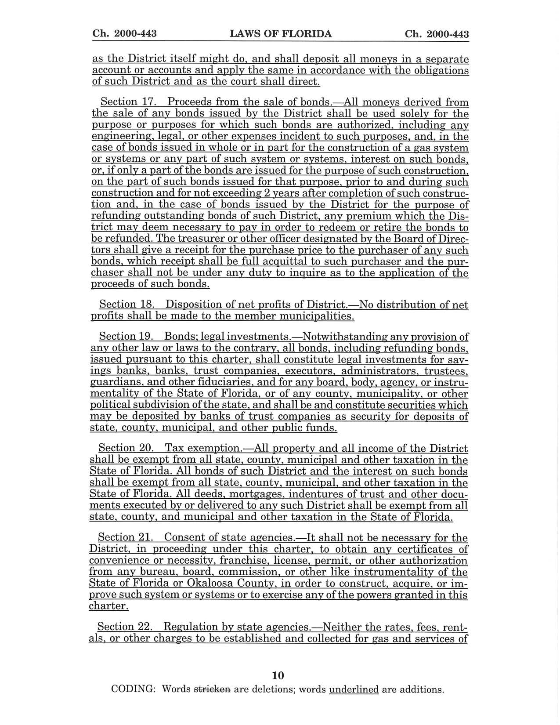
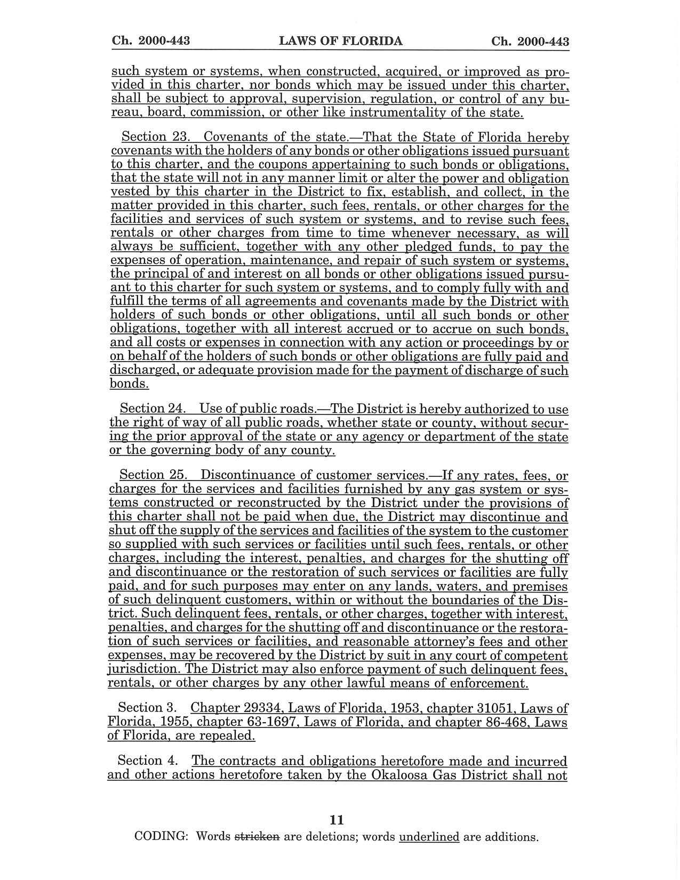
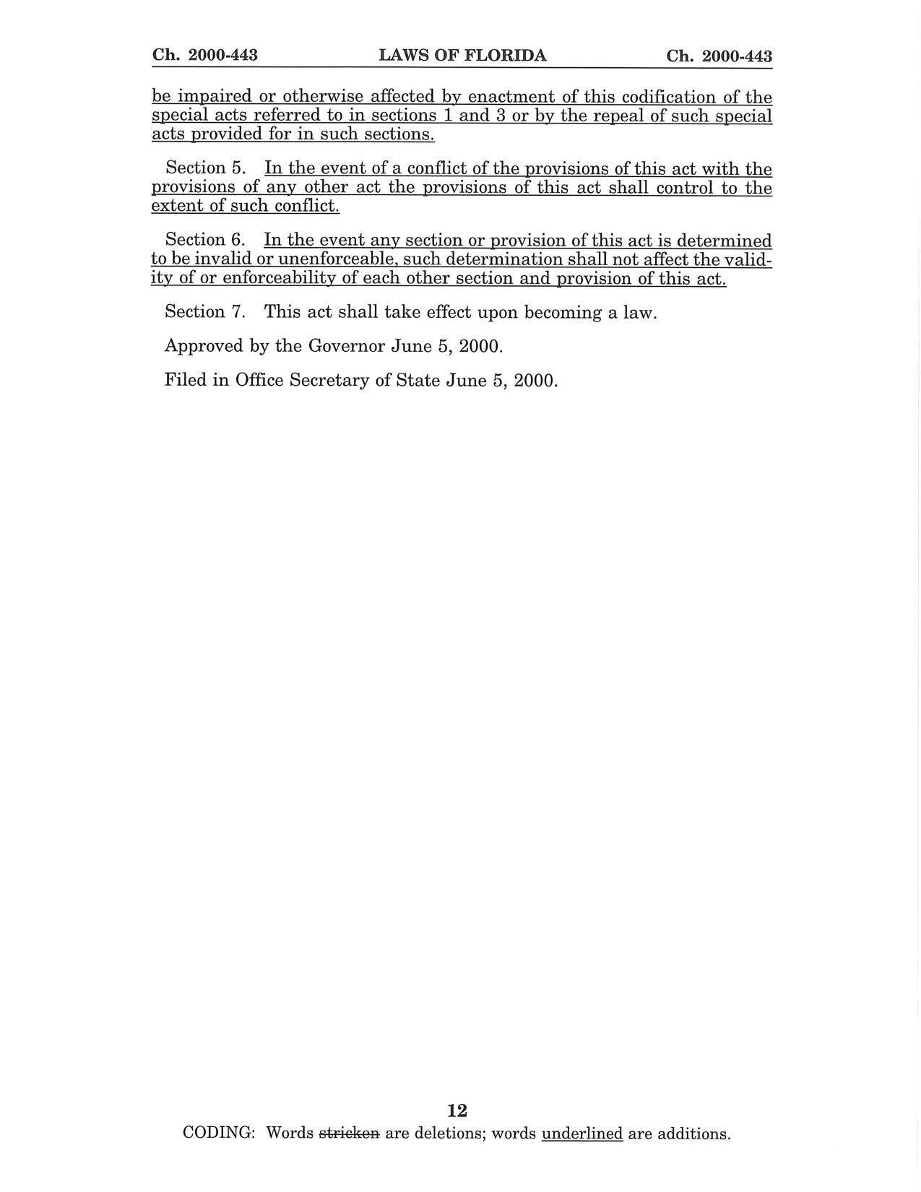
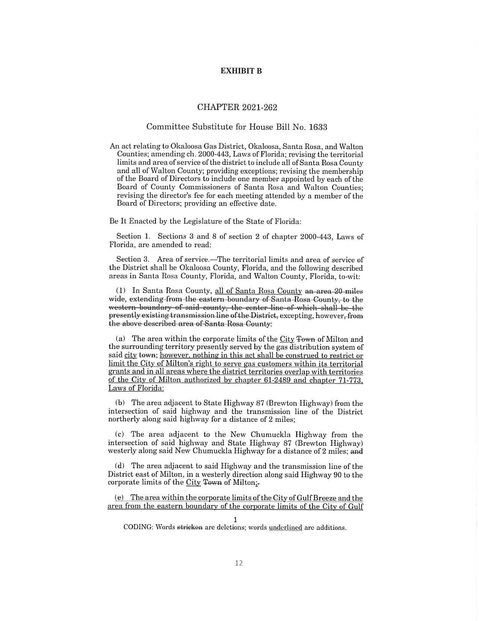
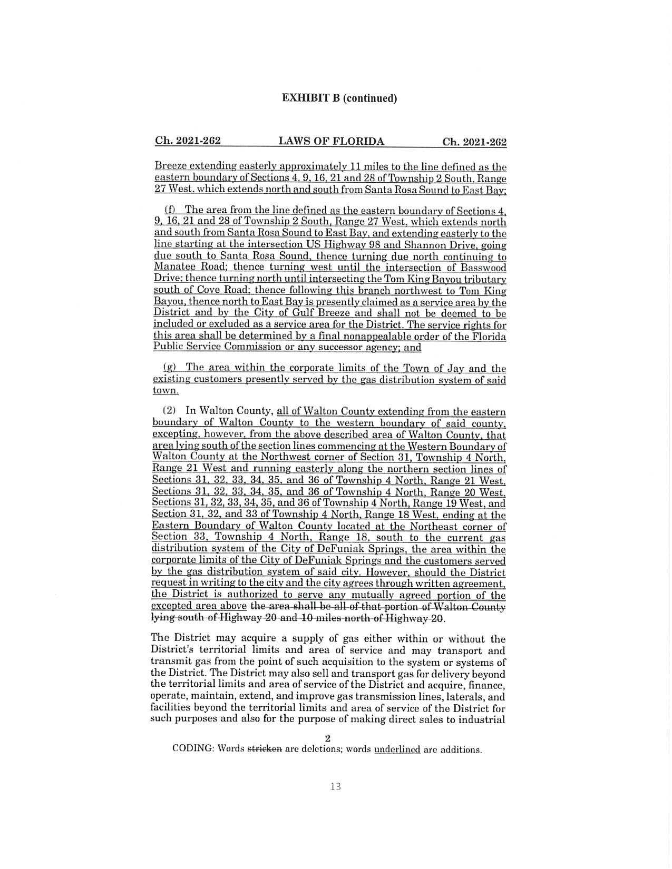
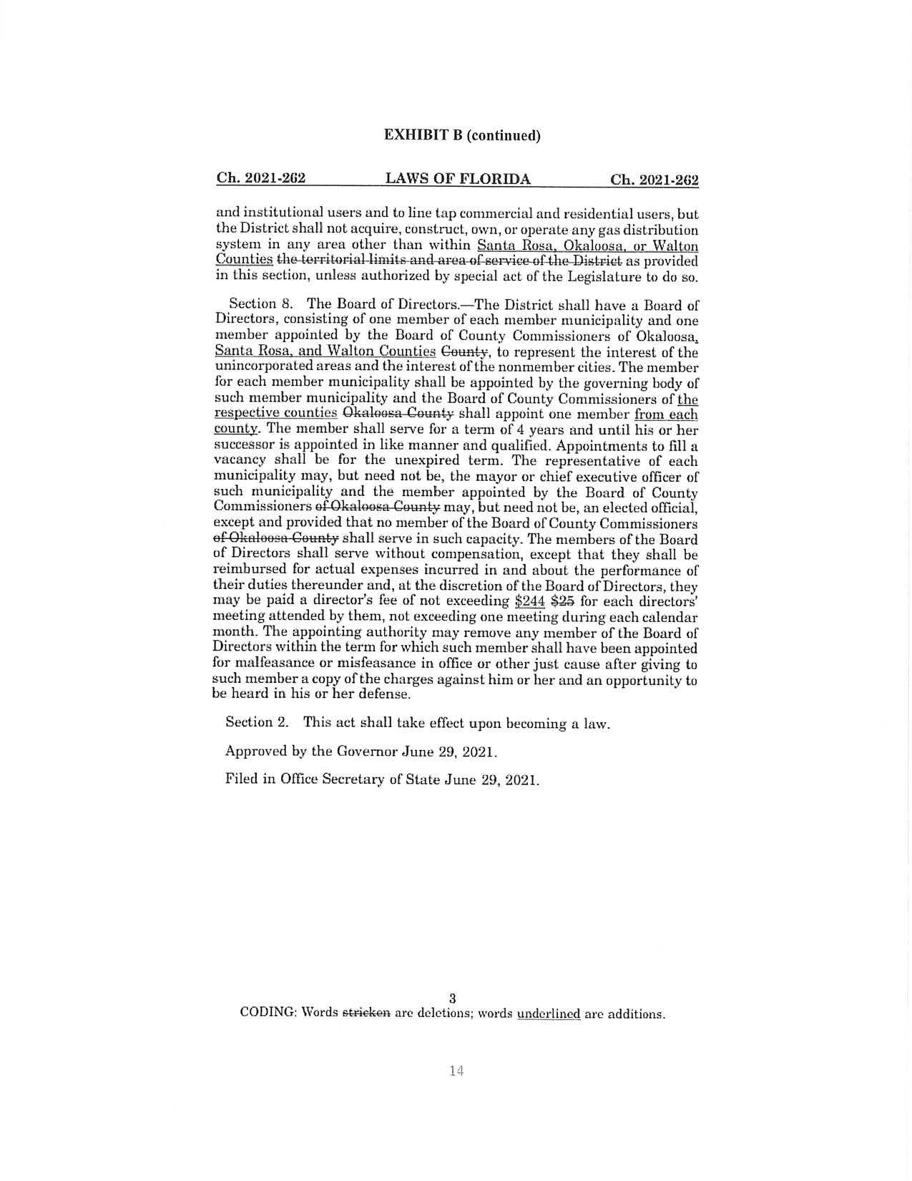
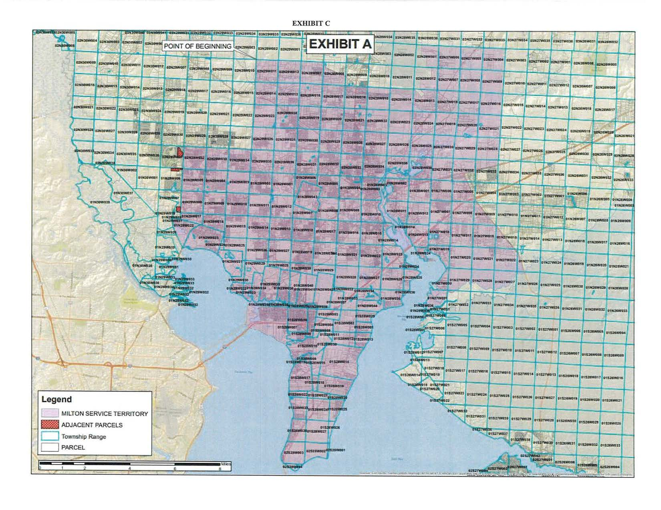

Response No. 5 in Staff’s First Data Request, Document No. 11469-2022.
Utilities Commission of the City of New Smyrna Beach v. Florida Public Service Commission, 469 So. 2d 731 (Fla. 1985).
Chapter 71-773 amended Chapter 61-2489, Laws of Florida.
Chapter 29334, Laws of Florida.
Response No. 2 in Staff’s First Data Request, Document No. 11469-2022.
Response No. 5 in Staff’s First Data Request, Document No. 11469-2022.
Chapter 2021-262 amended Chapter 2000-443, Laws of Florida.

