State of Florida   |  | Public Service Commission  Capital Circle Office Center ● 2540 Shumard Oak Boulevard  Tallahassee, Florida 32399-0850  -M-E-M-O-R-A-N-D-U-M-
DATE: | April 14, 2023
TO: | Office of Commission Clerk (Teitzman)
FROM: | Division of Economics (Hampson, Draper)  Division of Accounting and Finance (Norris)  Office of the General Counsel (Harper, Sparks)
RE: | Docket No. 20220069-GU – Petition for rate increase by Florida City Gas.
AGENDA: | 04/25/23 – Regular Agenda – Post-Hearing Decision – Participation is Limited to Commissioners and Staff
COMMISSIONERS ASSIGNED: |  |  | Fay, Passidomo, La Rosa
PREHEARING OFFICER: |  |  | Fay
CRITICAL DATES: |  |  | 05/31/23 (12-Month Effective Date)
SPECIAL INSTRUCTIONS: |  |  | None

Case Background
On May 31, 2022, Florida City Gas (FCG or Company) filed a petition seeking the Florida Public Service Commission’s (Commission) approval of a rate increase and associated depreciation rates. FCG is a natural gas local distribution company providing sales and transportation of natural gas, and is a public utility subject to this Commission’s regulatory jurisdiction under Section 366.02, Florida Statutes (F.S.). FCG currently serves approximately 116,000 residential, commercial, and industrial natural gas customers in Miami-Dade, Broward, St. Lucie, Indian River, Brevard, Palm Beach, Hendry, and Martin counties.

An administrative hearing was held on December 12-13, 2022. At the hearing, the Commission approved the following stipulated issues: 10, 14, 16, 18, 20, 21, 30, 32, 33, 37, 43, 44, 48, 56, 63, 64, 69, 70, 72 and 73. At the March 28, 2023 Special Agenda Conference, the Commission approved an incremental increase in operating revenues of $14,149,121. The total Company target revenues, including other operating revenues, is $88,033,271. The staff-calculated final revenue requirement calculations that reflect the Commission-approved increase to operating revenues are contained in Attachment A to the recommendation.

At the March 28, 2023 Special Agenda Conference, the Commission approved the Company’s cost of service study in Issue 58 and the revenue increase allocation to the rate classes in Issue 59. This recommendation addresses the issues that were not addressed at the March 28, 2023 Special Agenda Conference: Issue 60 (customer charges), Issue 61 (distribution charges), Issue 62 (demand charges), Issue 65 (effective date), Issue 66 (approval of tariffs), and Issue 73 (close docket).

On April 7, 2023, the Company filed a revised cost of service study and associated tariffs reflecting the final Commission-approved revenue requirement. The proposed customer, distribution, and demand charges are calculated in the revised cost of service study and shown in the attached tariffs. The tariffs are included in Attachment B to the recommendation. The Commission has jurisdiction over this matter pursuant to Chapter 366, F.S., including Sections 366.06 and 366.071, F.S.

Discussion of Issues

Issue 60:
Are FCG’s proposed Customer Charges appropriate?

Recommendation:
The proposed customer charges as provided in the tariffs in Attachment B to the recommendation should be approved. (Hampson, Norris)

Position of the Parties

FCG:
Yes. The appropriate customer charges are those shown in 2023 Test Year MFRs E-2 and H-1 (1 of 2). (DuBose)

OPC:
No position.

FEA:
No position.

FIPUG:
Adopt position of OPC.

Staff Analysis:

PARTIES’ ARGUMENTS

FCG
FCG did not provide an argument. (FCG BR 87)

OPC
OPC did not provide an argument. (OPC BR 59)

FEA
FEA did not provide an argument. (FEA & FIPUG BR 29)

FIPUG
FIPUG adopted the position of OPC, but did not provide an argument. (FEA & FIPUG BR 29)

ANALYSIS

The customer charges, in combination with the per therm distribution charges shown in Issue 61 and the demand charges shown in Issue 62, are designed to allow the Company to recover the total Commission-approved revenue requirement. Further, the Commission approved the Company’s proposed cost of service methodology in Issue 58 and the allocation of the revenue increase to rate classes in Issue 59 at the March 28, 2023 Special Agenda Conference. The proposed customer charges reflect the approved revenue requirements and cost of service methodology; therefore, the proposed charges provided in the tariffs in Attachment B to the recommendation should be approved.

Issue 61:
Are FCG’s proposed per therm Distribution Charges appropriate?

Recommendation:
The proposed per therm distribution charges as provided in the tariffs in Attachment B to the recommendation should be approved. (Hampson, Norris)

Position of the Parties

FCG:
Yes. The appropriate per therm Distribution Charges are those shown in 2023 Test Year MFRs E-2 and H-1 (1 of 2). (DuBose)

OPC:
No position.

FEA:
No position.

FIPUG:
Adopt position of OPC.

Staff Analysis:

PARTIES’ ARGUMENTS

FCG
FCG did not provide an argument. (FCG BR 87)

OPC
OPC did not provide an argument. (OPC BR 59)

FEA
FEA did not provide an argument. (FEA & FIPUG BR 29-30)

FIPUG
FIPUG adopted the position of OPC, but did not provide an argument. (FEA & FIPUG BR 29-30)

ANALYSIS

Staff has reviewed the Company’s revised cost of service filing and it reflects the Commission-approved total Company revenue requirement. Further, the Commission approved the Company’s proposed cost of service methodology in Issue 58 and the allocation of the revenue increase to rate classes in Issue 59 at the March 28, 2023 Special Agenda Conference. The proposed per therm distribution charges reflect the approved revenue requirements and cost of service methodology; therefore, the proposed charges provided in the tariffs in Attachment B to the recommendation should be approved.

Issue 62:
Are FCG’s proposed Demand Charges appropriate?

Recommendation:
The proposed demand charges as provided in the tariffs in Attachment B to the recommendation should be approved. (Hampson, Norris)

Position of the Parties

FCG:
Yes. The appropriate Demand Charges are those shown in 2023 Test Year MFRs E-2 and H-1 (1 of 2). (DuBose)

OPC:
No position.

FEA:
No position.

FIPUG:
Adopt position of OPC.

Staff Analysis:

PARTIES’ ARGUMENTS

FCG
FCG did not provide an argument. (FCG BR 87)

OPC
OPC did not provide an argument. (OPC BR 59)

FEA
FEA did not provide an argument. (FEA & FIPUG BR 30)

FIPUG
FIPUG adopted the position of OPC, but did not provide an argument. (FEA & FIPUG BR 30)

ANALYSIS

Staff has reviewed the Company’s revised cost of service filing and it reflects the Commission-approved total Company revenue requirement. Further, the Commission approved the Company’s proposed cost of service methodology in Issue 58 and the allocation of the revenue increase to rate classes in Issue 59 at the March 28, 2023 Special Agenda Conference. The proposed demand charges reflect the approved revenue requirements and cost of service methodology; therefore, the proposed charges provided in the tariffs in Attachment B to the recommendation should be approved.

Issue 65:
What is the appropriate effective date for FCG’s revised rates and charges?

Recommendation:
The rates and charges approved by the Commission should become effective May 1, 2023. The Commission should approve the proposed tariffs as provided in Attachment B to the recommendation. (Hampson, Norris)

Position of the Parties

FCG:
Pursuant to the statutory eight-month suspension period in Section 366.06(3), F.S., FCG’s filing requested a February 1, 2023 effective date for new base rates. (DuBose)

OPC:
The effective date of FCG’s revised rates and charges should allow for time for implementation promptly after the Commission’s final order in this matter.

FEA:
No position.

FIPUG:
Adopt position of OPC.

Staff Analysis:

PARTIES’ ARGUMENTS

FCG
FCG did not provide an argument. (FCG BR 87)

OPC
OPC did not provide an argument. (OPC BR 59)

FEA
FEA did not provide an argument. (FEA & FIPUG BR 30)

FIPUG
FIPUG adopted the position of OPC, but did not provide an argument. (FEA & FIPUG BR 30)

ANALYSIS

FCG provided a notification of the proposed rate increase to its customers during the month of August 2022, and also posted notice of the rate increase on its website. The notification included a comparison between current and proposed rates, and that the rates ultimately approved by the Commission will not exceed those identified in the notice. FCG will also provide a direct notice to customers during May 2023, which will identify the final, Commission-approved rates and charges. Staff has reviewed the direct notice and believes the notice reflects the rates and charges approved by the Commission.
Staff recommends that the rates and charges approved by the Commission should become effective May 1, 2023. The Commission should approve the proposed tariffs as provided in Attachment B to the recommendation.

Issue 66:
Should the Commission give staff administrative authority to approve tariffs reflecting Commission approved rates and charges?

Recommendation:
Yes, the Commission should give staff administrative authority to approve tariffs reflecting the Commission-approved rates and charges, as provided in Attachment B to the recommendation. (Hampson, Norris)

Position of the Parties

FCG:
Yes. The Commission should approve tariffs reflecting the Commission’s approved rates and charges. The Commission should direct staff to verify that the revised tariffs are consistent with the Commission’s decision. (Dubose)

OPC:
No position.

FEA:
No position.

FIPUG:
Adopt position of OPC.

Staff Analysis:

PARTIES’ ARGUMENTS

FCG
FCG did not provide an argument. (FCG BR 87)

OPC
OPC did not provide an argument. (OPC BR 59)

FEA
FEA did not provide an argument. (FEA & FIPUG BR 30)

FIPUG
FIPUG adopted the position of OPC, but did not provide an argument. (FEA & FIPUG BR 30)

ANALYSIS

Commission staff has reviewed the revised cost of service study and associated tariffs, which were revised to reflect the final Commission-approved revenue requirement. Reviewing the documentation provided by FCG, staff believes that the revised cost of service study and associated tariffs are in accordance with the Commission vote from the March 28, 2023 Special Agenda Conference. The Commission should approve the proposed tariffs as provided in Attachment B to the recommendation.

Issue 73:
Should this docket be closed?

Recommendation:
After the final order is issued, this docket should be closed. (Harper, Sparks)

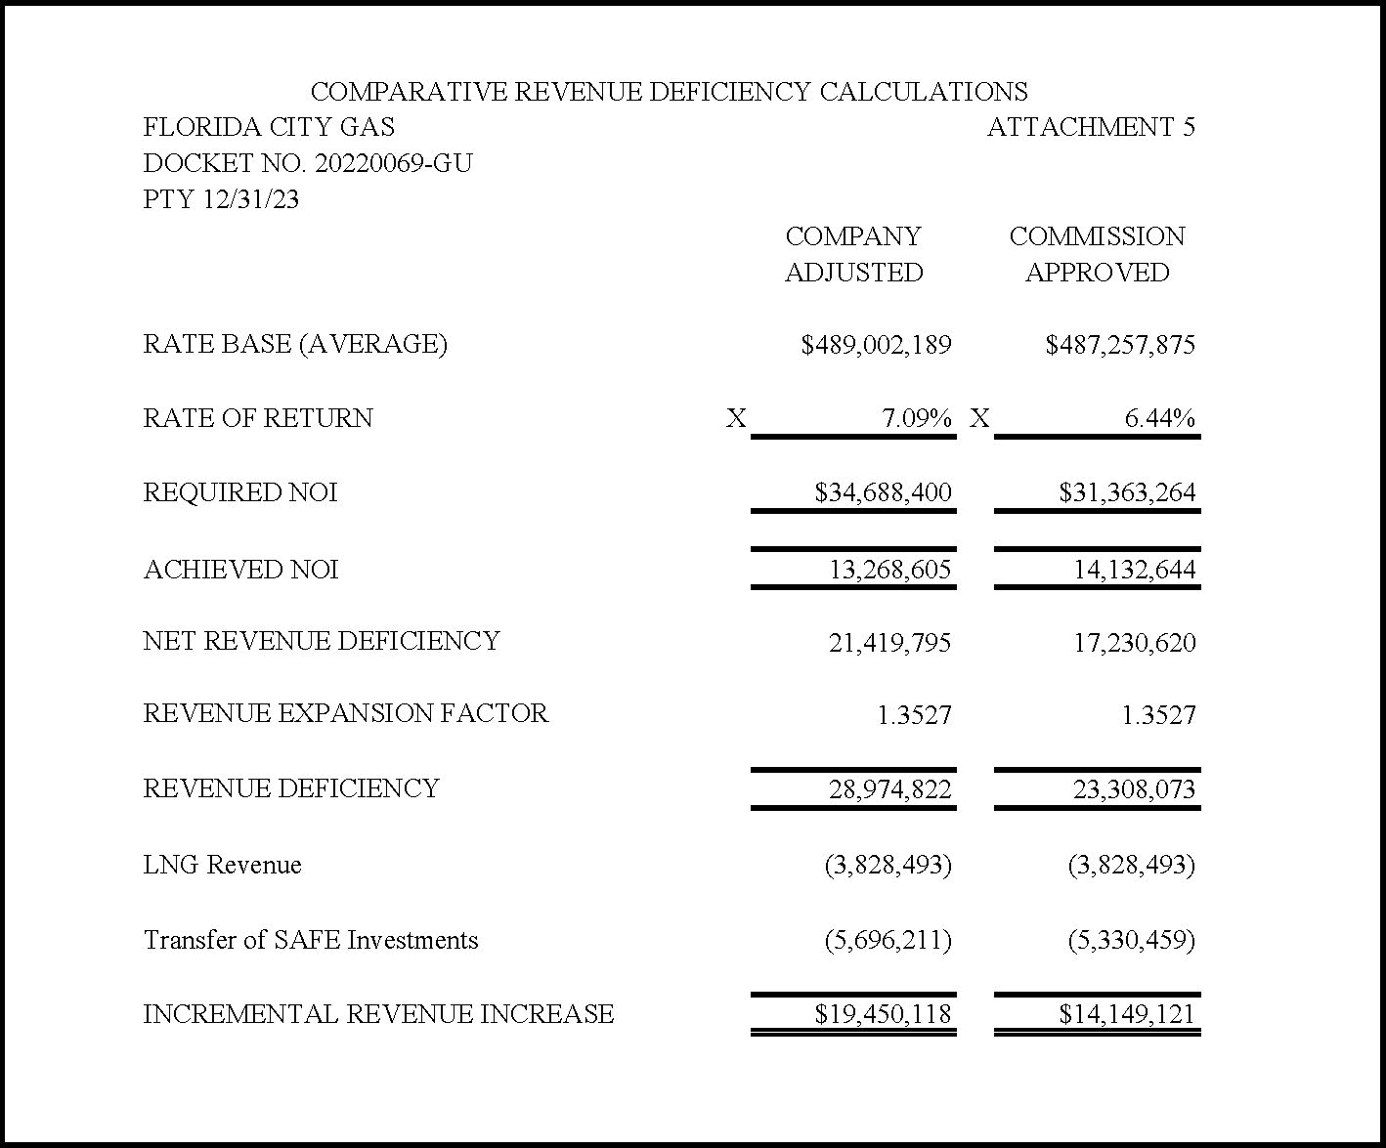
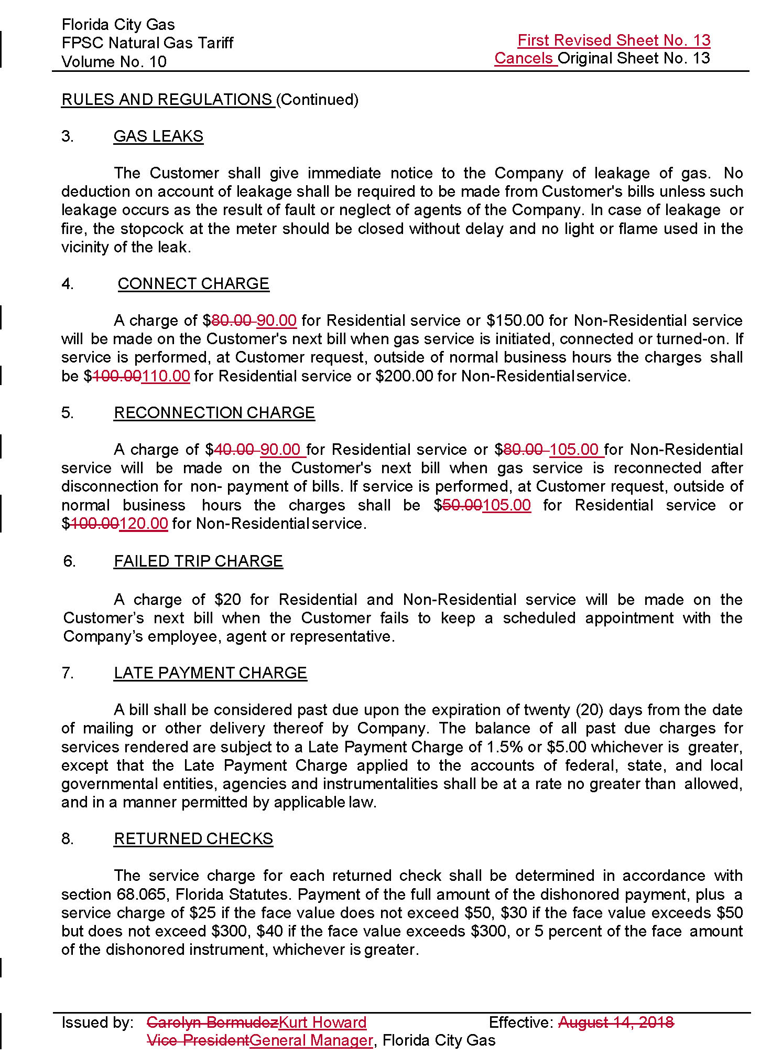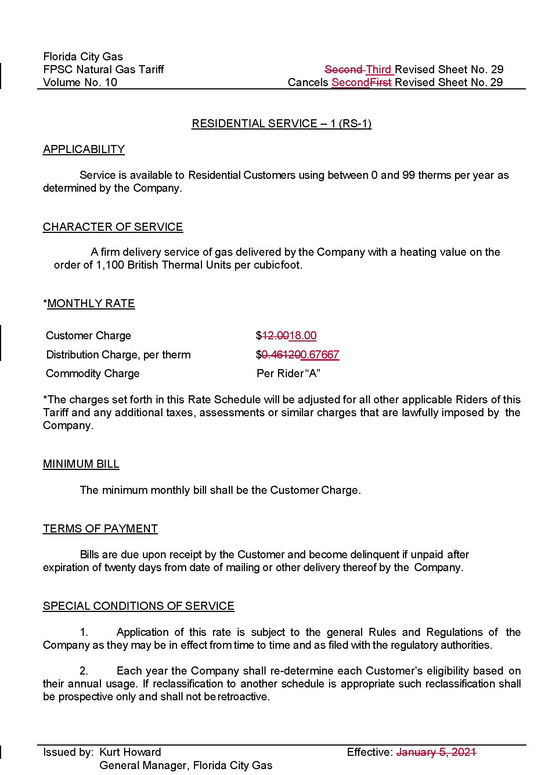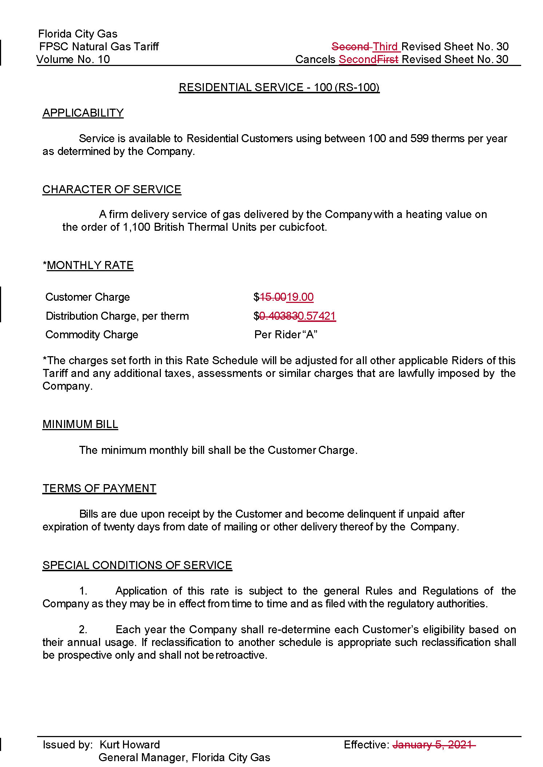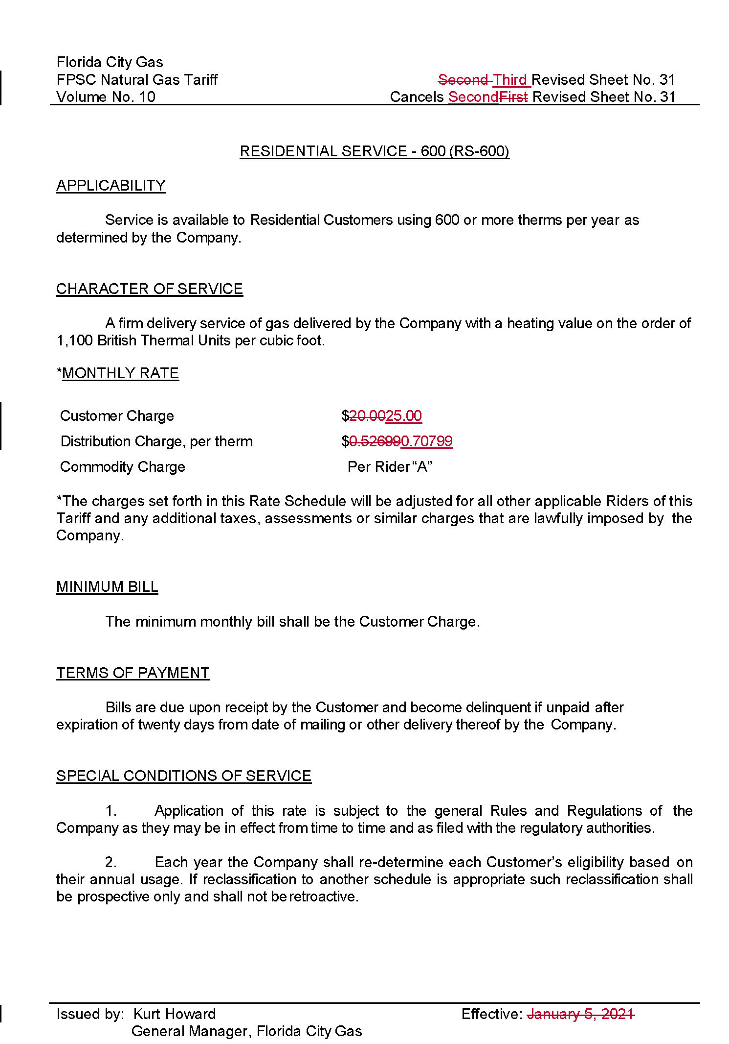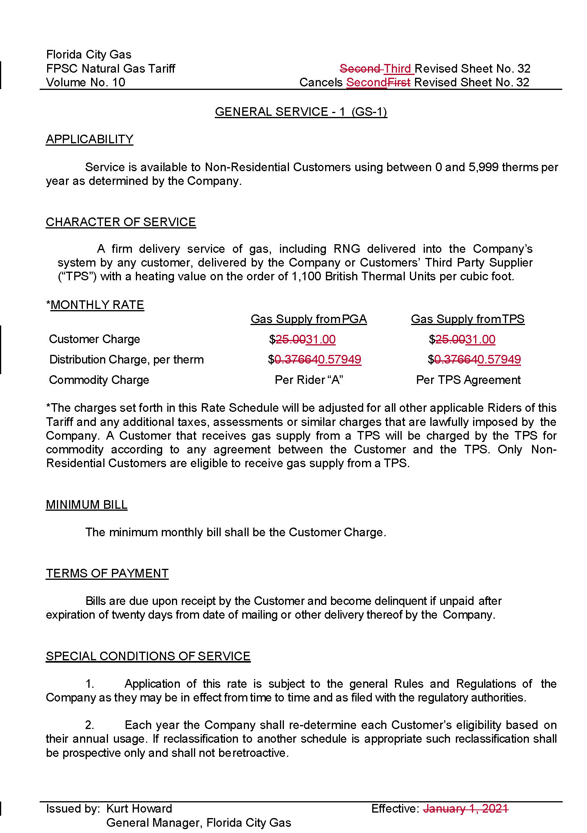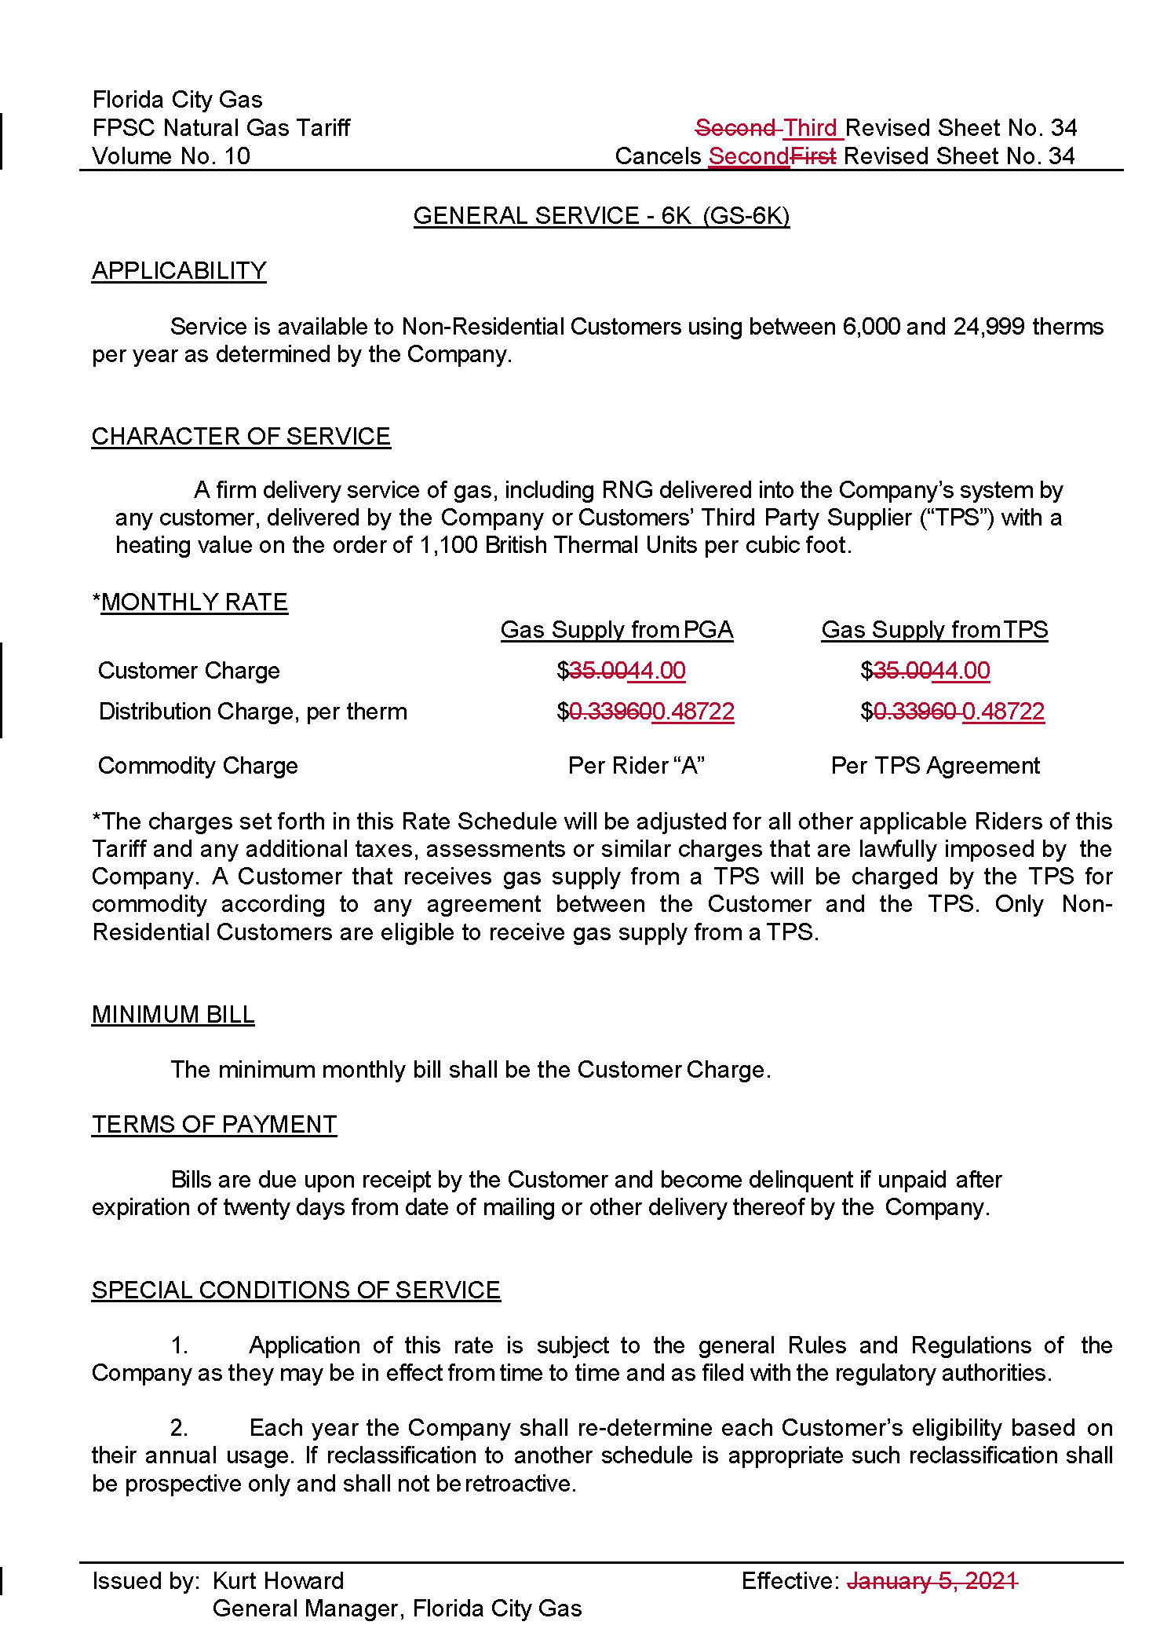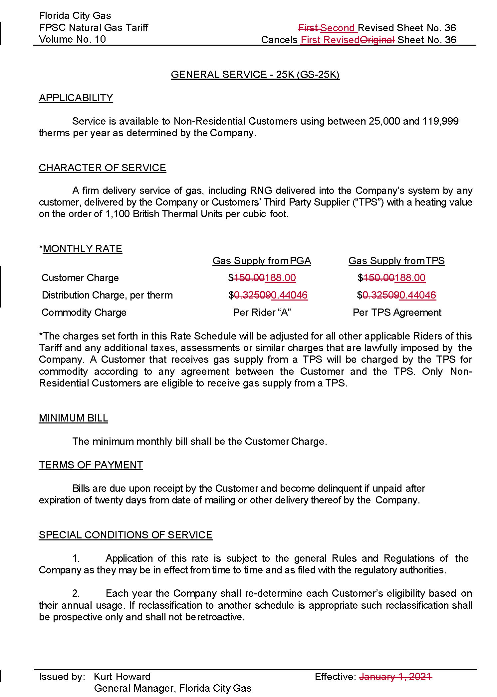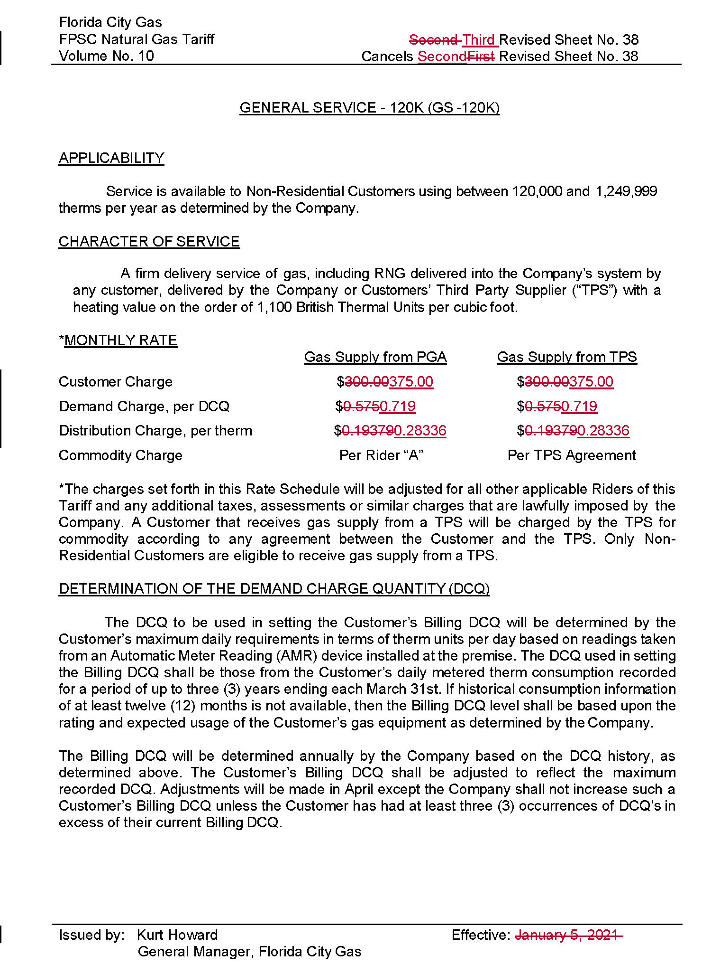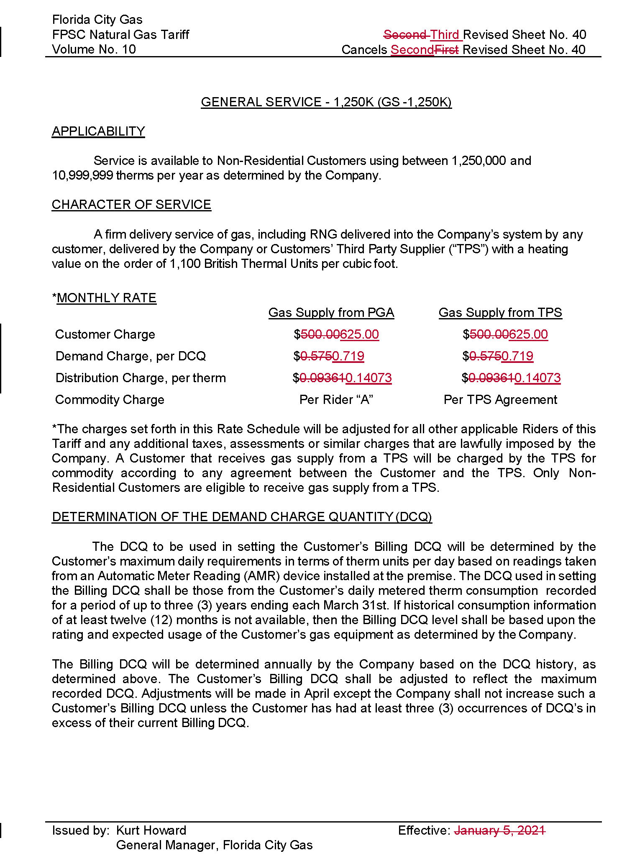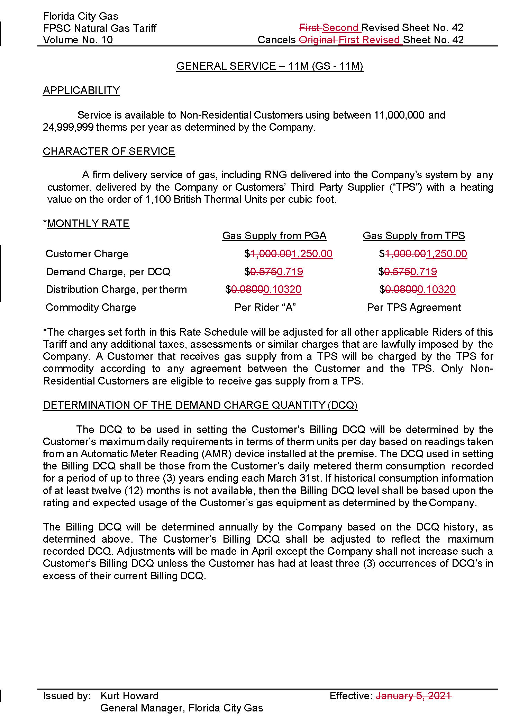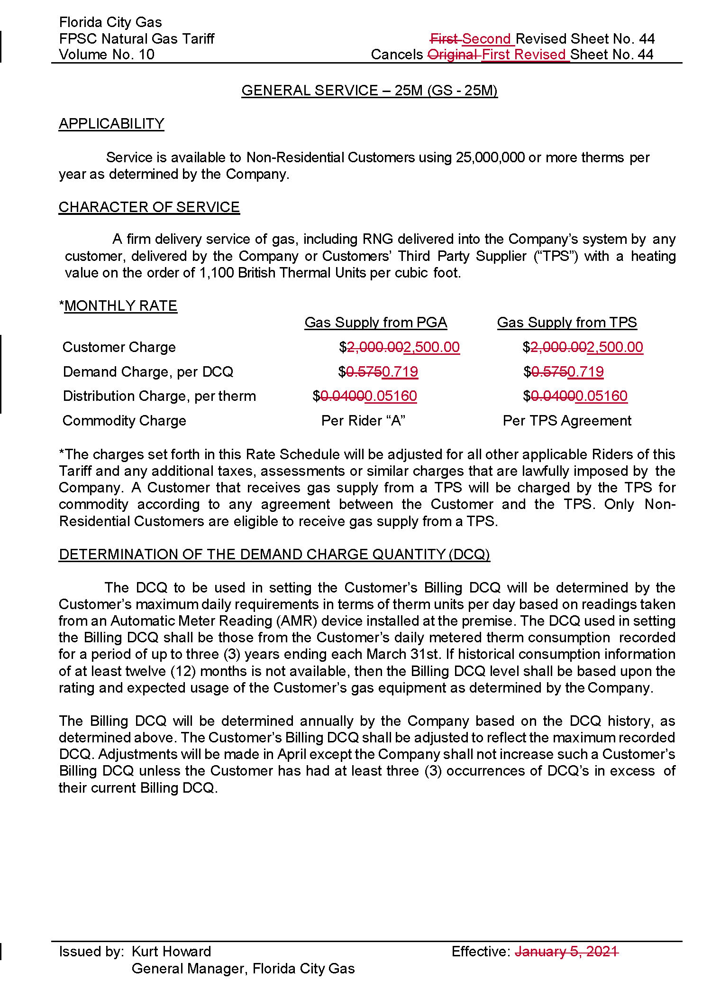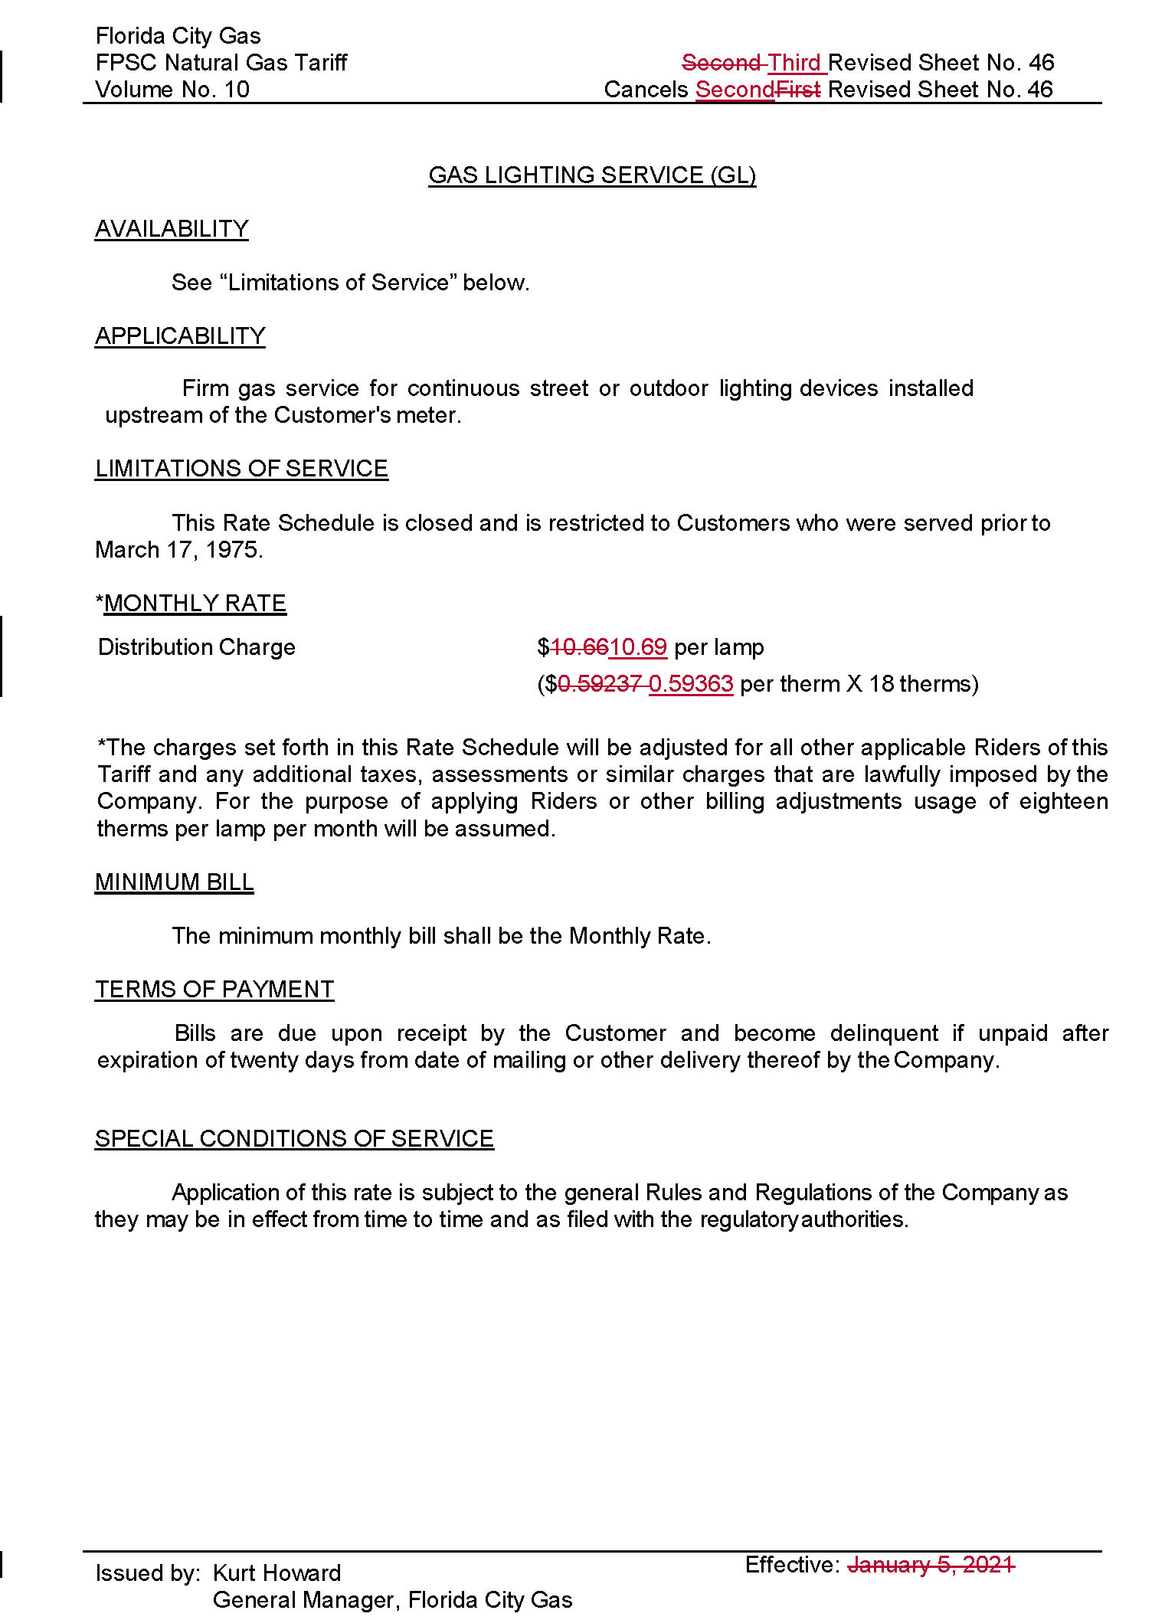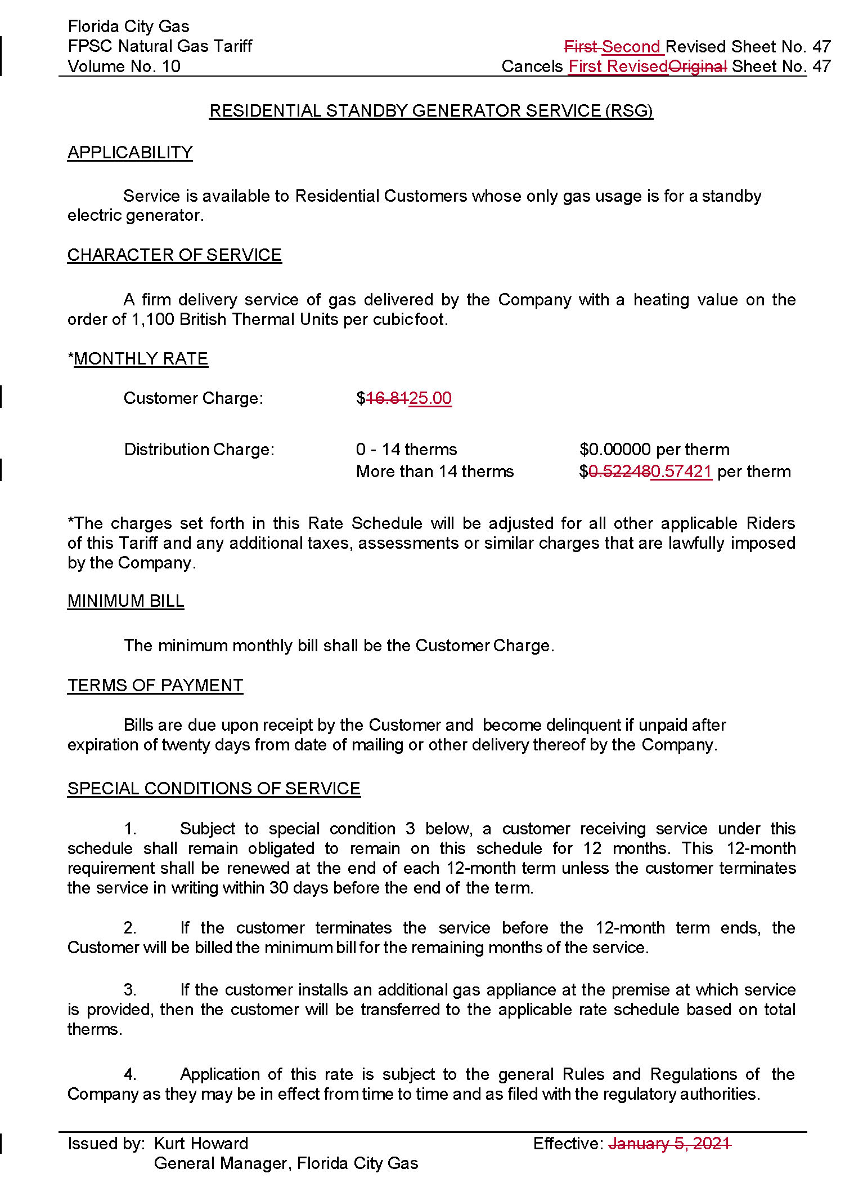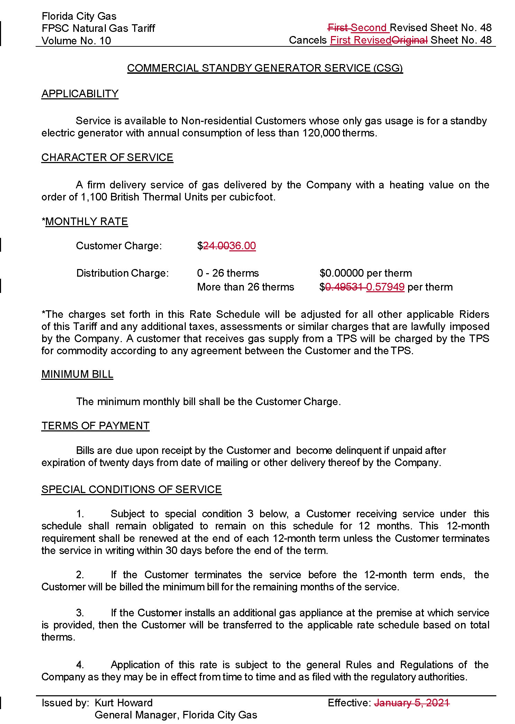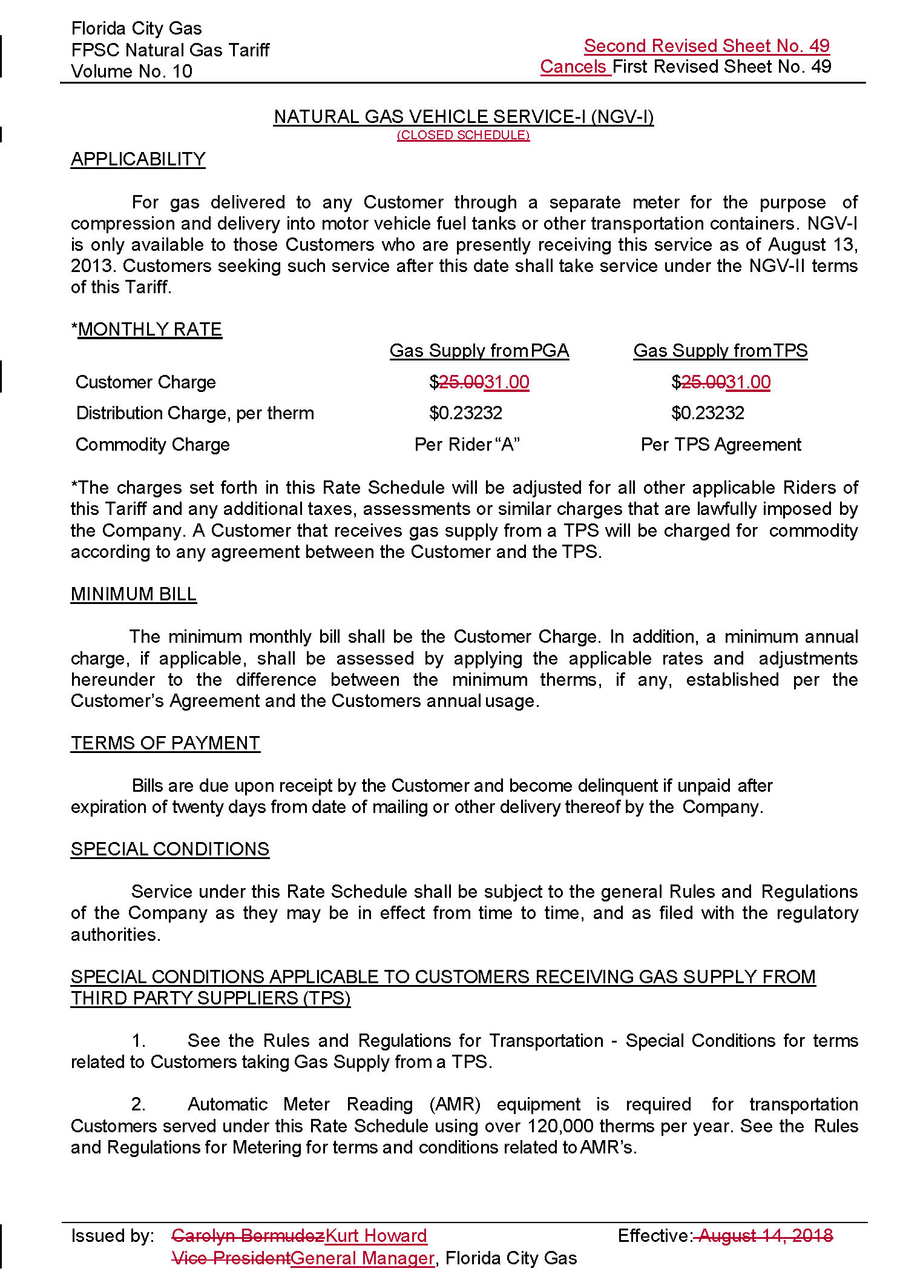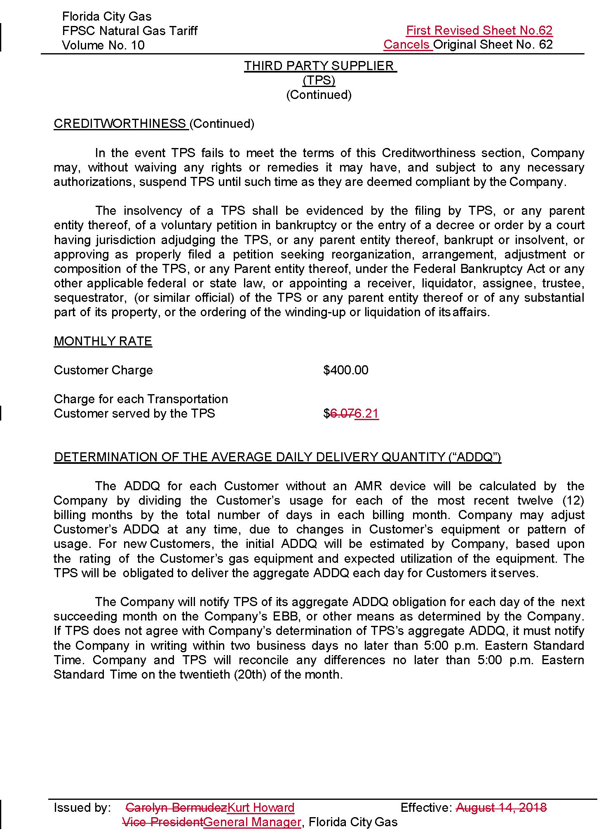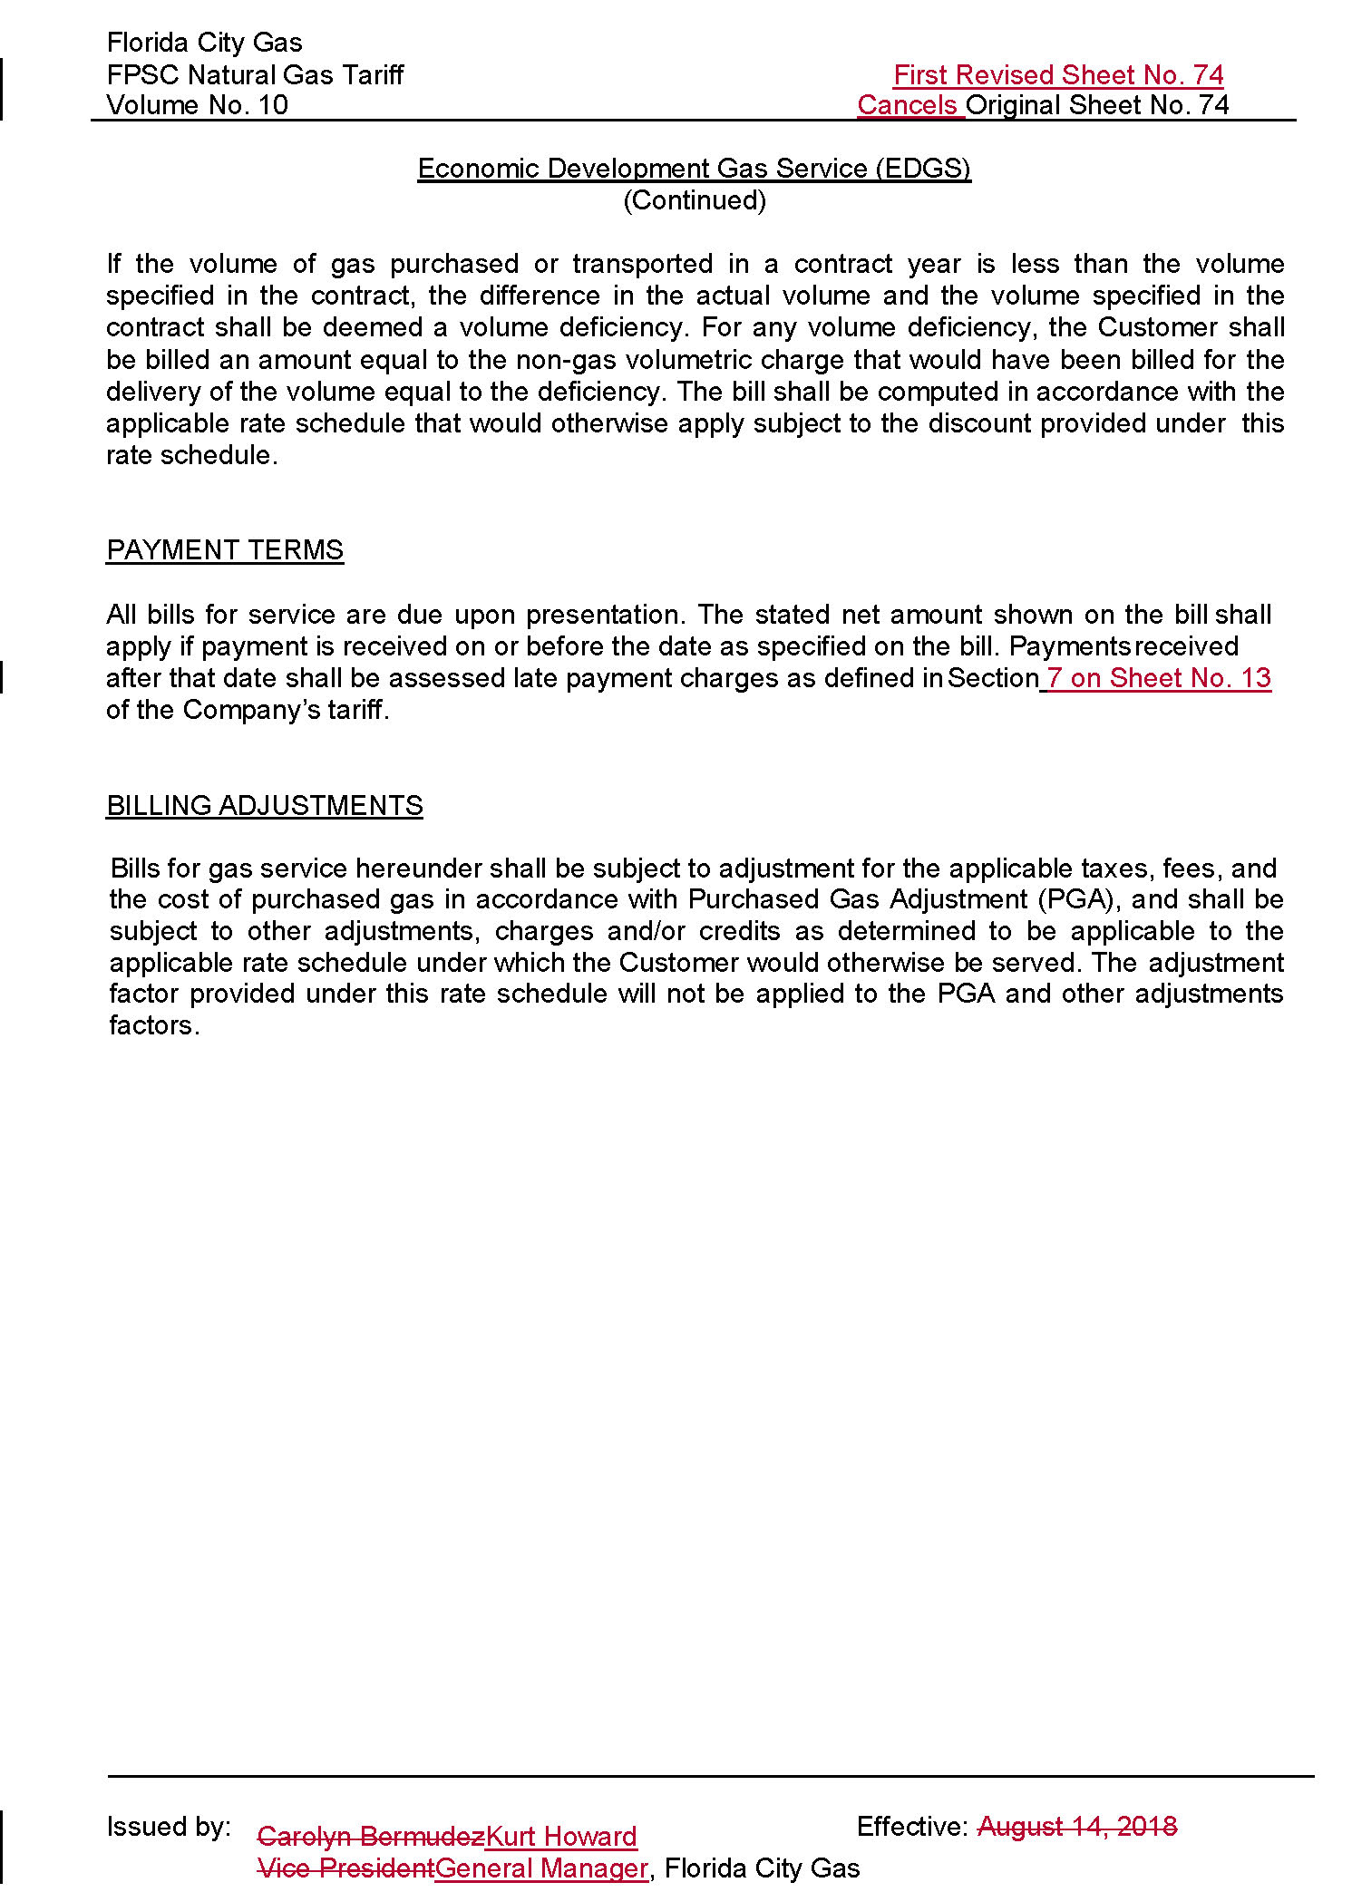

The incremental operating revenue increase shown does not include the revenues associated with the transfer of SAFE investments, as approved in Issue 10, nor the LNG facility previously approved by the Commission. As provided on Attachment A, the total increase to base rates is $23,308,073 when the LNG revenue of $3,828,493 and the SAFE revenue of $5,330,459 are included.
See Schedule H-1, page 1 of 6, line 1, of the revised cost of service (Document No. 02578-2023).
Document No. 02578-2023.
Document No. 02578-2023.

