State of Florida   |  | Public Service Commission  Capital Circle Office Center ● 2540 Shumard Oak Boulevard  Tallahassee, Florida 32399-0850  -M-E-M-O-R-A-N-D-U-M-
DATE: | June 1, 2023
TO: | Office of Commission Clerk (Teitzman)
FROM: | Division of Engineering (Wooten, Ellis, King, Knoblauch)  Office of the General Counsel (Imig)
RE: | Docket No. 20230046-EQ – Petition for approval of renewable energy tariff and standard offer contract, by Florida Power & Light Company.
AGENDA: | 06/13/23 – Regular Agenda – Proposed Agency Action - Interested Persons May Participate
COMMISSIONERS ASSIGNED: |  |  | All Commissioners
PREHEARING OFFICER: |  |  | Administrative
CRITICAL DATES: |  |  | None
SPECIAL INSTRUCTIONS: |  |  | None

Case Background
Section 366.91(3), Florida Statutes (F.S.), requires each investor-owned utility (IOU) to continuously offer to purchase capacity and energy from renewable generating facilities and small qualifying facilities. Florida Public Service Commission (Commission) Rules 25-17.200 through 25-17.310, Florida Administrative Code (F.A.C.), implement the statute and require each IOU to file with the Commission, by April 1 of each year, a revised standard offer contract based on the next avoidable fossil-fueled generating unit of each technology type identified in the utility’s current Ten-Year Site Plan (TYSP). On April 3, 2023, Florida Power & Light Company (FPL) filed a petition for approval of its amended standard offer contract based on its 2023 TYSP. The Commission has jurisdiction over this amended standard offer contract pursuant to Sections 366.04 through 366.055, and 366.91, F.S.

Discussion of Issues

Issue 1:
Should the Commission approve the renewable energy tariff and amended standard offer contract filed by Florida Power & Light Company?

Recommendation:
Yes. The provisions of FPL’s renewable energy tariff and amended standard offer contract conform to the requirements of Rules 25-17.200 through 25-17.310, F.A.C. The amended standard offer contract offers multiple payment options so that a developer of renewable generation may select the payment stream best suited to its financial needs. (Wooten, Knoblauch)

Staff Analysis:
Section 366.91(3), F.S., and Rule 25-17.250, F.A.C., require that an IOU continuously make available a standard offer contract for the purchase of firm capacity and energy from renewable generating facilities (RF) and small qualifying facilities (QF) with design capacities of 100 kilowatts (kW) or less. Pursuant to Rules 25-17.250(1) and (3), F.A.C., the standard offer contract must provide a term of at least 10 years, and the payment terms must be based on the utility’s next avoidable fossil-fueled generating unit identified in its most recent TYSP, or if no avoided unit is identified, its next avoidable planned purchase. While FPL’s 2023 TYSP does not feature an avoidable fossil-fueled generating unit or planned purchases that could be deferred during the planning period, FPL has identified a 1,991 megawatt (MW) combined cycle with a projected in-service date of June 1, 2033, as the next avoidable planned generating unit based on its current planning process. In order to comply with the rule, the Commission has previously approved using a unit outside of the TYSP planning period as the avoided unit for standard offer contract purposes.
Under FPL’s standard offer contract, the RF/QF operator commits to certain minimum performance requirements based on the identified avoided unit, such as being operational and delivering an agreed upon amount of capacity by the in-service date of the avoided unit, and thereby becomes eligible for capacity payments in addition to payments received for energy. The standard offer contract may also serve as a starting point for negotiation of contract terms by providing payment information to an RF/QF operator, in a situation where one or both parties desire particular contract terms other than those established in the standard offer.
In order to promote renewable generation, the Commission requires each IOU to offer multiple options for capacity payments, including the options to receive early or levelized payments. If the RF/QF operator elects to receive capacity payments under the normal or levelized contract options, it will receive as-available energy payments only until the in-service date of the avoided unit (in this case June 1, 2033), and thereafter, begin receiving capacity payments in addition to firm energy payments. If either the early or early levelized option is selected, then the operator will begin receiving capacity payments earlier than the in-service date of the avoided unit. However, payments made under the early capacity payment options tend to be lower in the later years of the contract term because the net present value (NPV) of the total payments must remain equal for all contract payment options.
Table 1 contains FPL’s estimates of the annual payments for each payment option available under the revised standard offer contract to an operator with a 50 MW facility operating at a capacity factor of 94 percent, which is the minimum capacity factor required under the contract to qualify for full capacity payments. Normal and levelized capacity payments begin with the projected in-service date of the avoided unit (June 1, 2033) and continue for 10 years, while early and early levelized capacity payments begin 4 years prior to the in-service date, or 2029 for this example.

Table 1 - Estimated Annual Payments to a 50 MW Renewable Facility
(94% Capacity Factor)
Year | Energy Payment | Capacity Payment
Year | Energy Payment | Normal | Levelized | Early | Early Levelized
Year | $(000) | $(000) | $(000) | $(000) | $(000)
2024 | 16,263 | - | - | - | -
2025 | 14,648 | - | - | - | -
2026 | 14,581 | - | - | - | -
2027 | 14,793 | - | - | - | -
2028 | 12,878 | - | - | - | -
2029 | 11,500 | - | - | 1,620 | 1,812
2030 | 11,465 | - | - | 2,811 | 3,106
2031 | 11,752 | - | - | 2,870 | 3,106
2032 | 10,675 | - | - | 2,929 | 3,106
2033 | 11,553 | 2,792 | 3,029 | 2,990 | 3,106
2034 | 11,858 | 4,844 | 5,192 | 3,052 | 3,106
2035 | 10,887 | 4,945 | 5,192 | 3,116 | 3,106
2036 | 12,682 | 5,048 | 5,192 | 3,181 | 3,106
2037 | 13,318 | 5,153 | 5,192 | 3,247 | 3,106
2038 | 14,875 | 5,260 | 5,192 | 3,314 | 3,106
2039 | 14,581 | 5,369 | 5,192 | 3,383 | 3,106
2040 | 15,128 | 5,481 | 5,192 | 3,454 | 3,106
2041 | 15,149 | 5,595 | 5,192 | 3,526 | 3,106
2042 | 14,788 | 5,712 | 5,192 | 3,599 | 3,106
2043 | 15,608 | 2,400 | 2,163 | 1,512 | 1,294
Total | 258,385 | 52,599 | 51,920 | 44,605 | 43,485
Total (NPV) | 129,412 | 16,890 | 16,890 | 16,890 | 16,890
Source: FPL’s Response to Staff’s First Data Request

FPL’s standard offer contract, in type-and-strike format, is included as Attachment A to this recommendation. The changes made to FPL’s tariff sheets are consistent with the updated avoided unit. Revisions include updates to calendar dates and payment information which reflect the current economic and financial assumptions for the avoided unit.

Conclusion
The provisions of FPL’s renewable energy tariff and amended standard offer contract conform to the requirements of Rules 25-17.200 through 25-17.310, F.A.C. The amended standard offer contract offers multiple payment options so that a developer of renewable generation may select the payment stream best suited to its financial needs.

Issue 2:
Should this docket be closed?

Recommendation:
Yes. This docket should be closed upon issuance of a consummating order, unless a person whose substantial interests are affected by the Commission’s decision files a protest within 21 days of the issuance of the Commission’s Proposed Agency Action Order. Potential signatories should be aware that, if a timely protest is filed, FPL’s standard offer contract may subsequently be revised. (Imig)

Staff Analysis:
This docket should be closed upon the issuance of a consummating order, unless a person whose substantial interests are affected by the Commission’s decision files a protest within 21 days of the issuance of the Commission’s Proposed Agency Action Order. Potential signatories should be aware that, if a timely protest is filed, FPL’s standard offer contract may subsequently be revised.

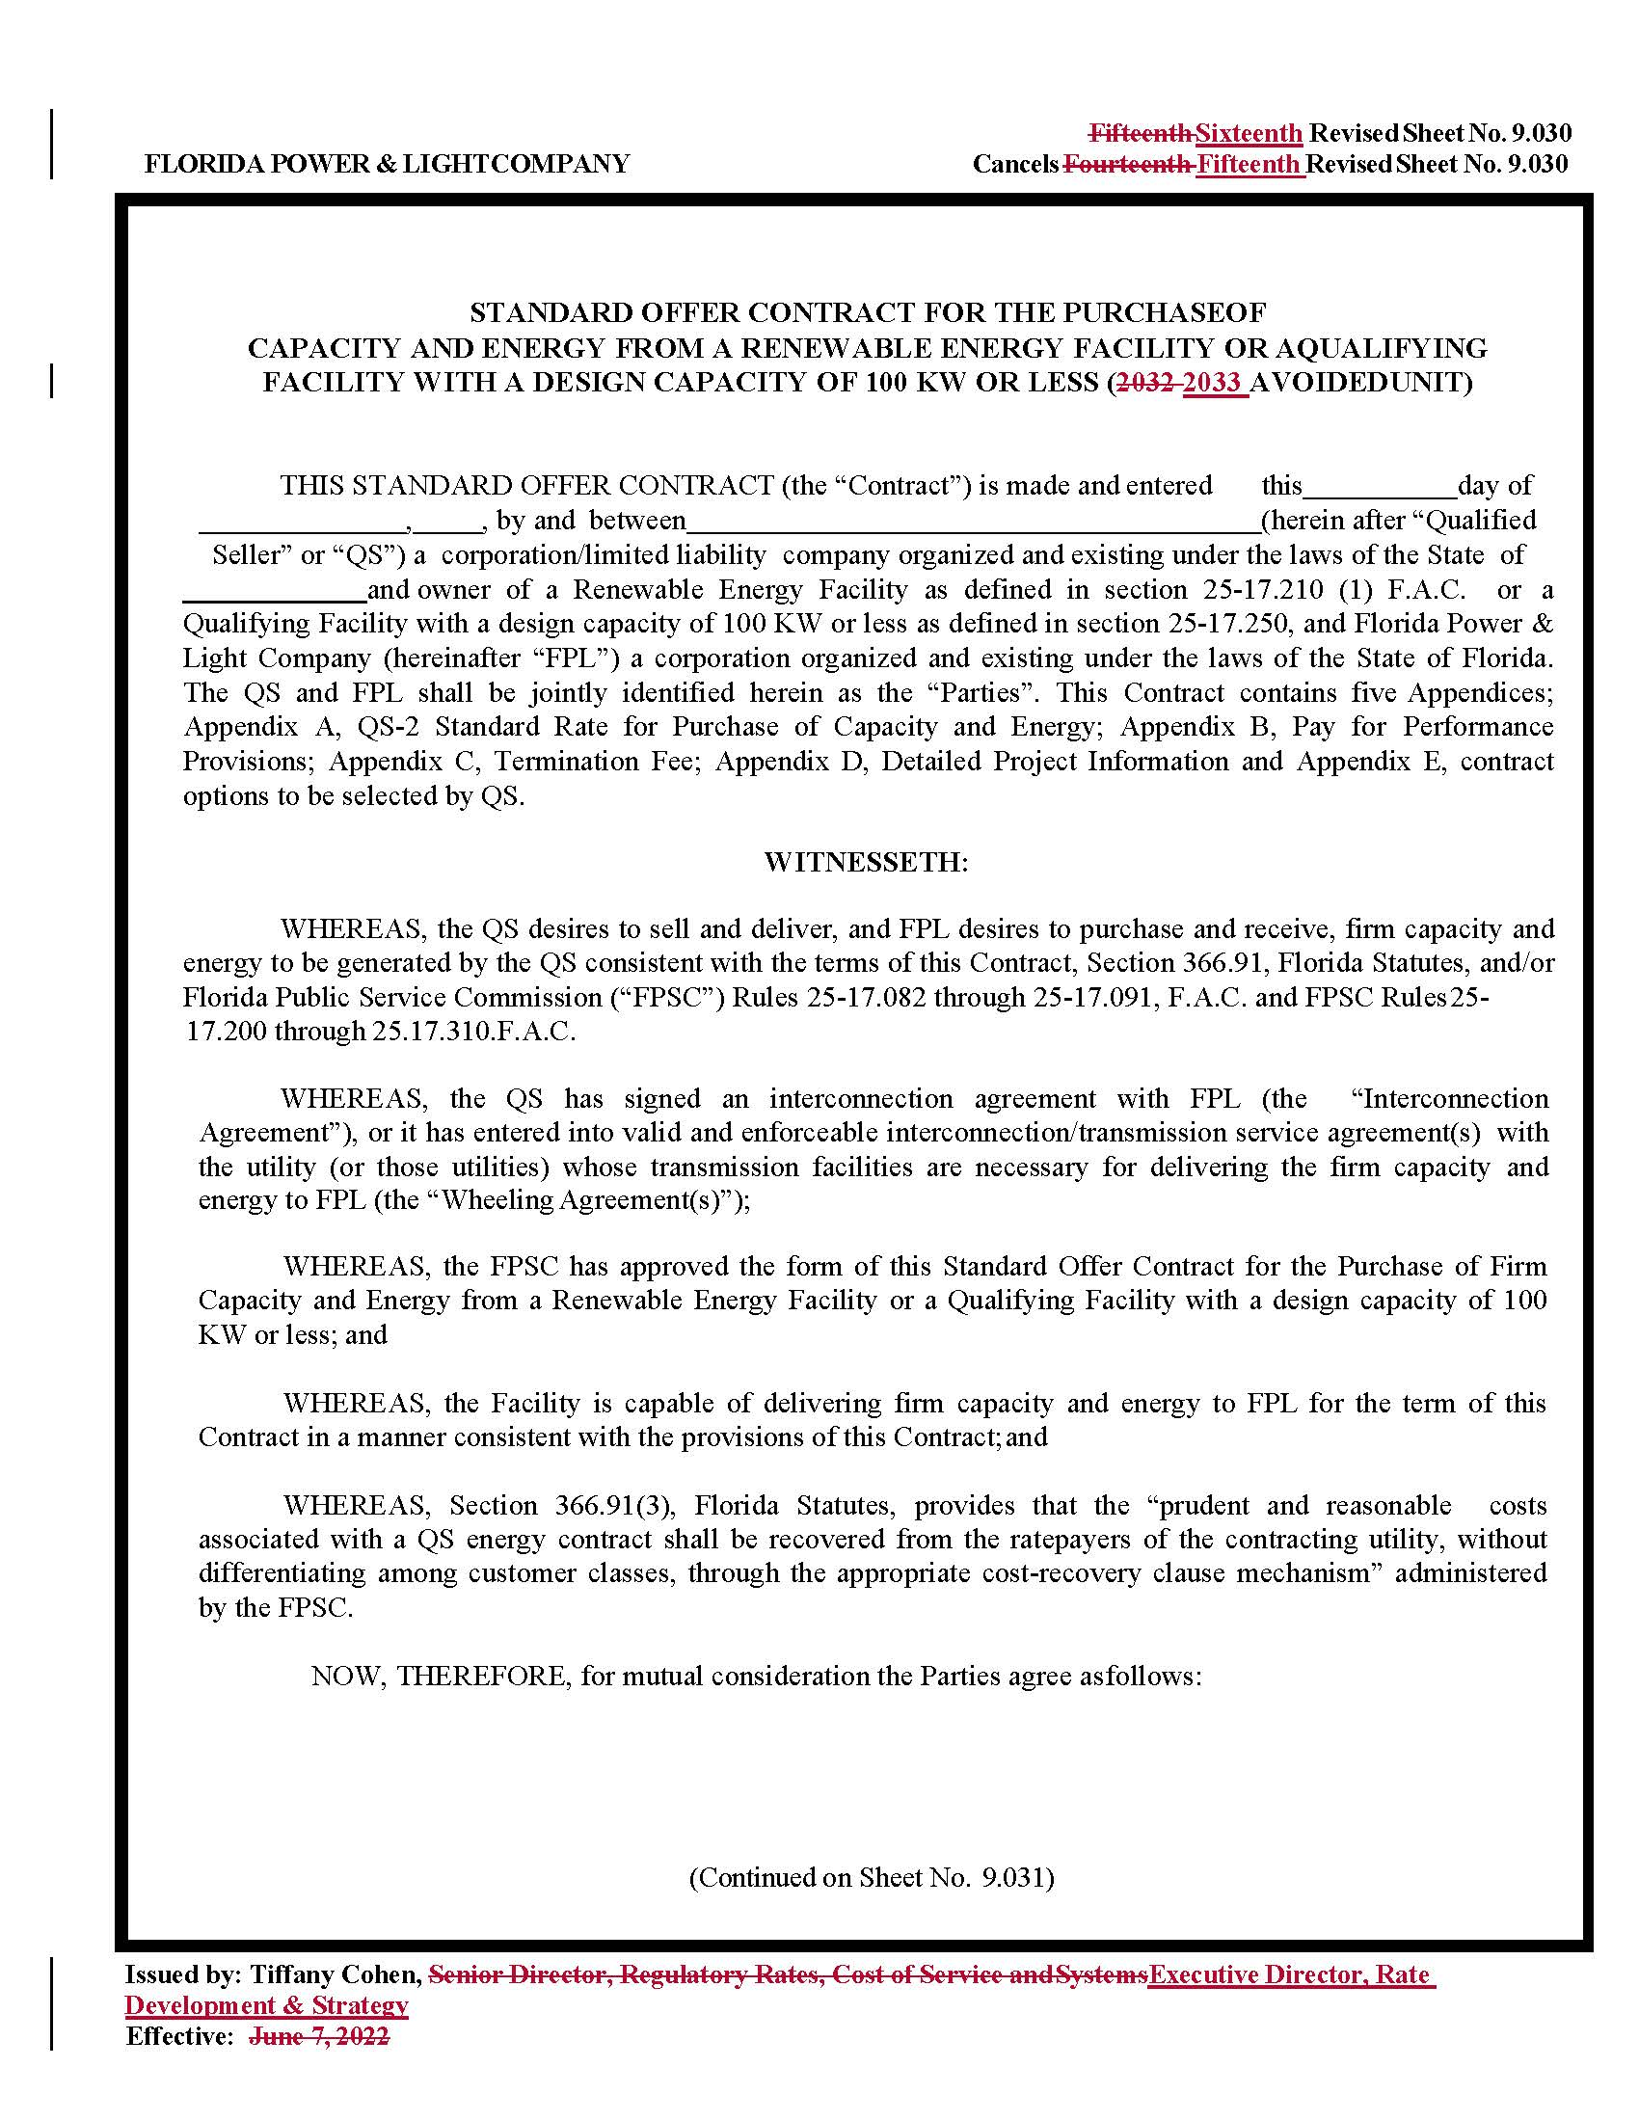

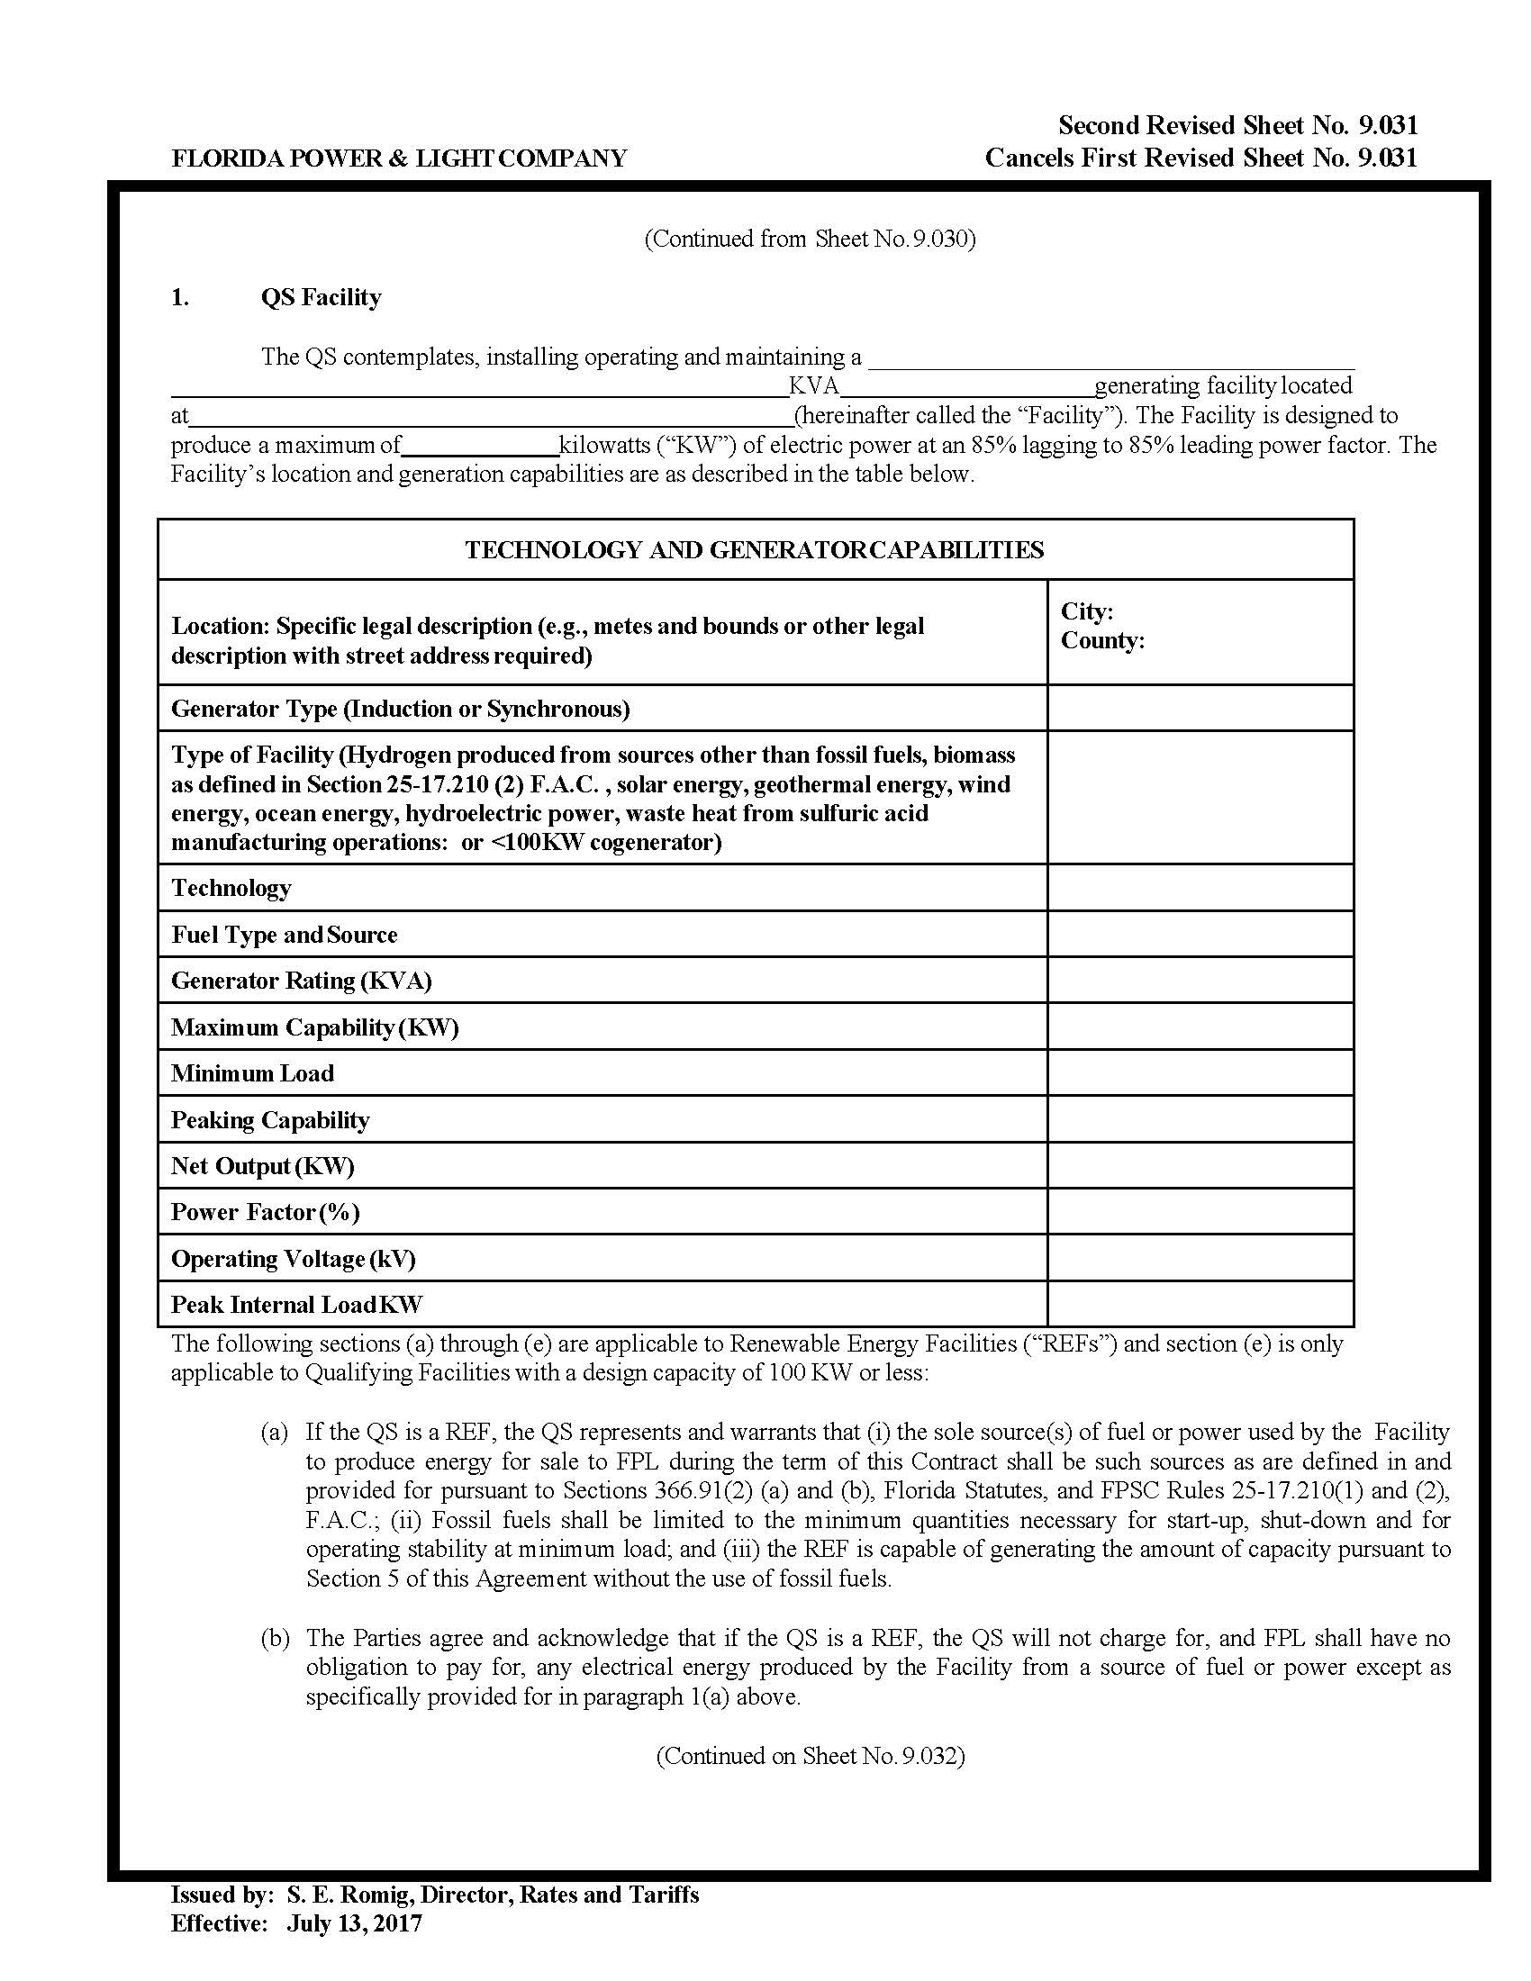

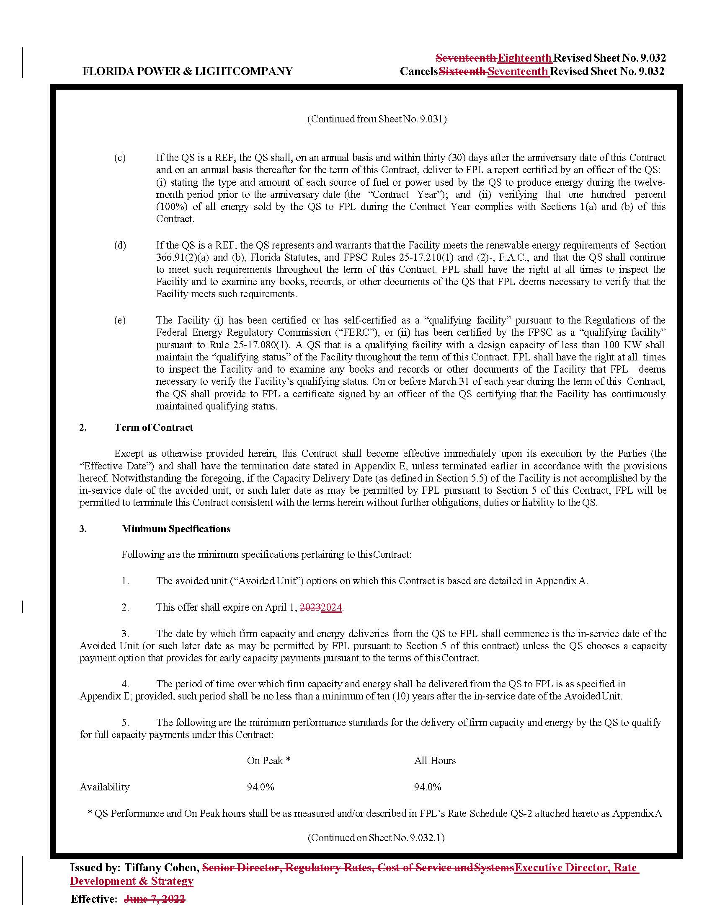

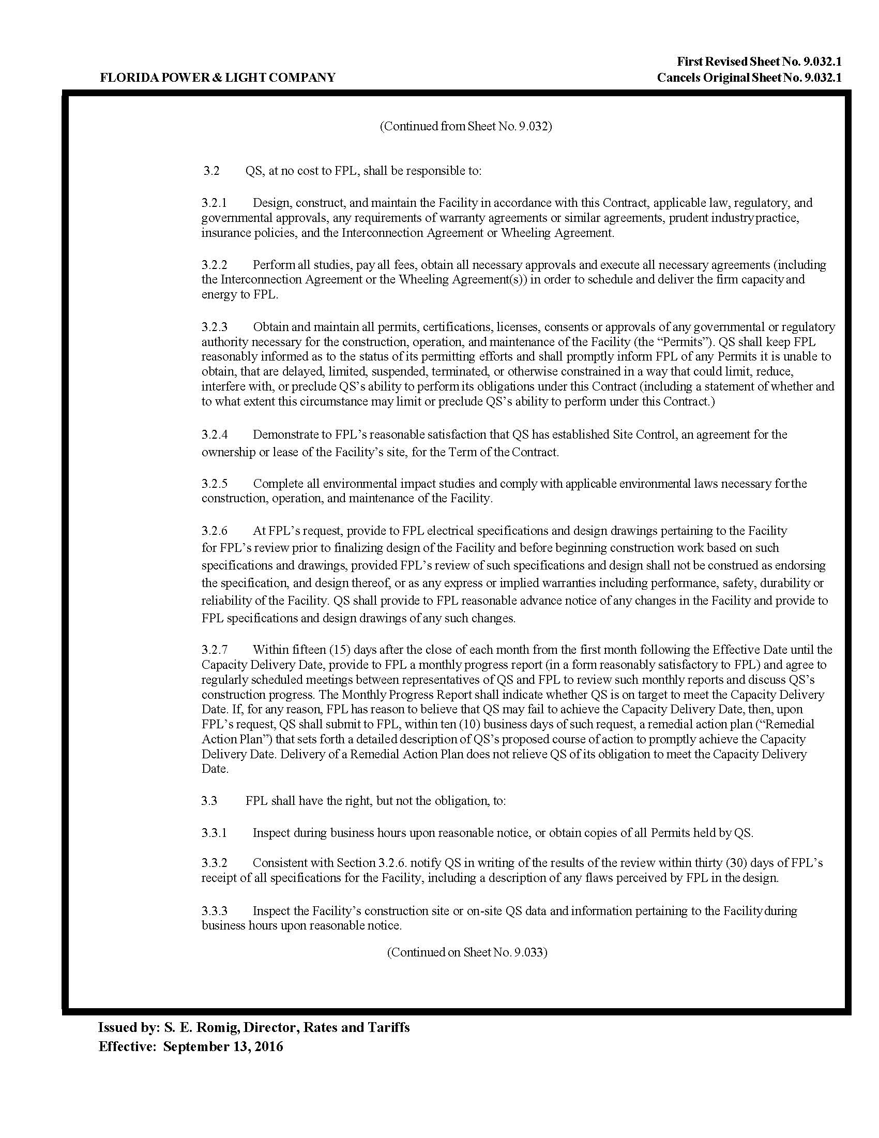

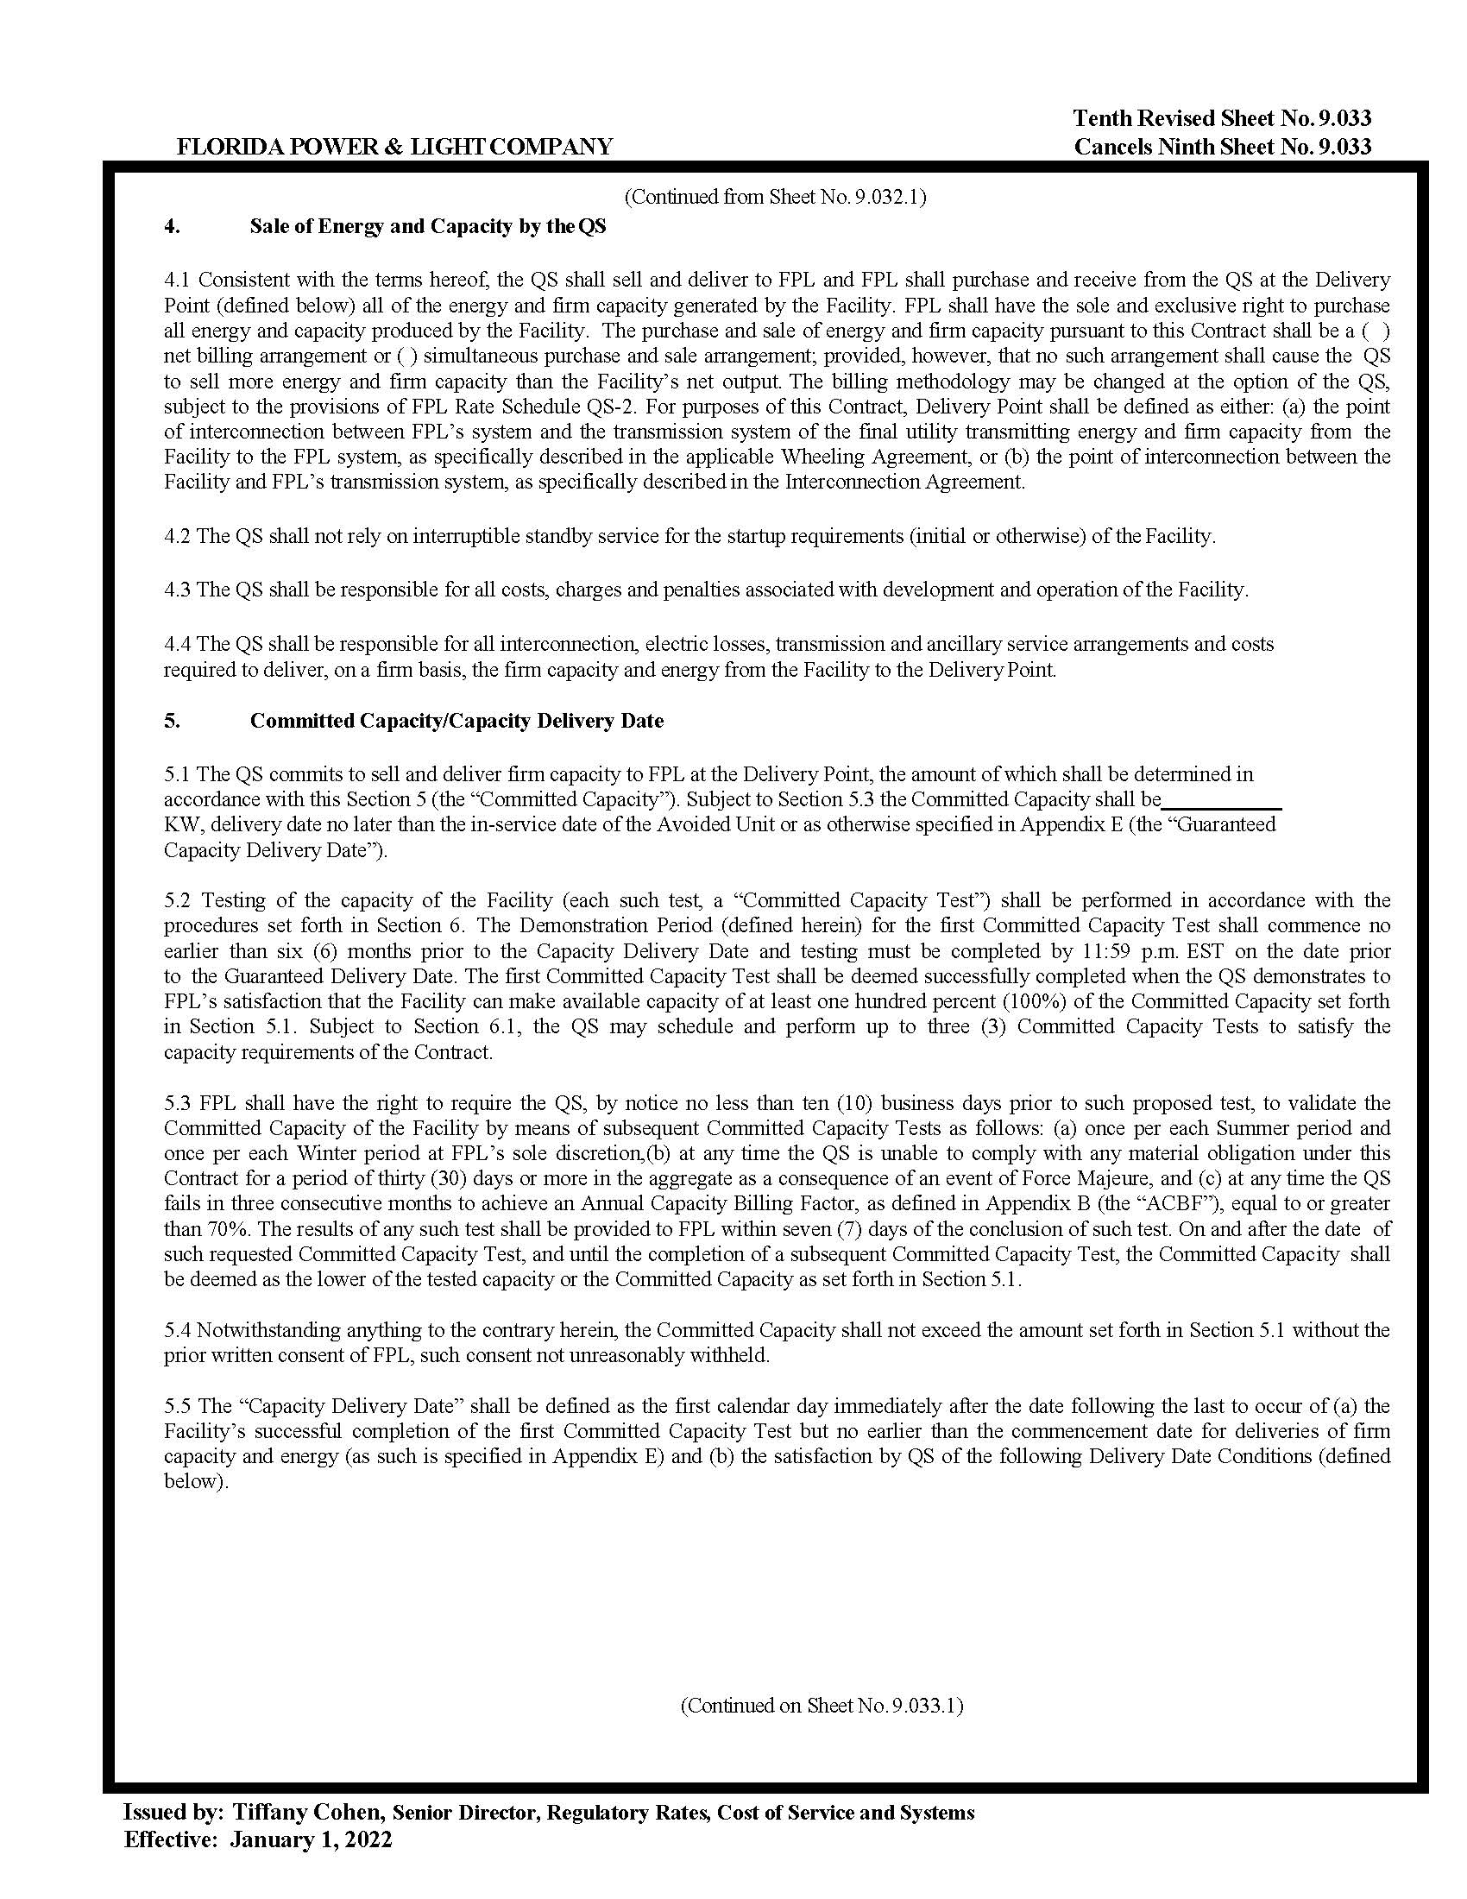

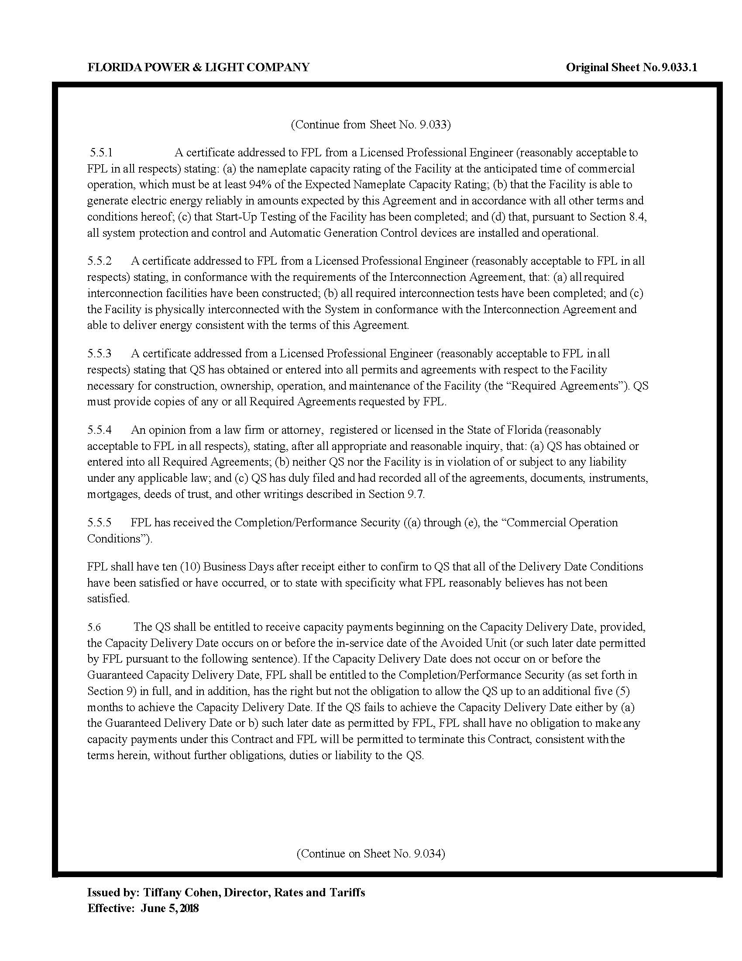

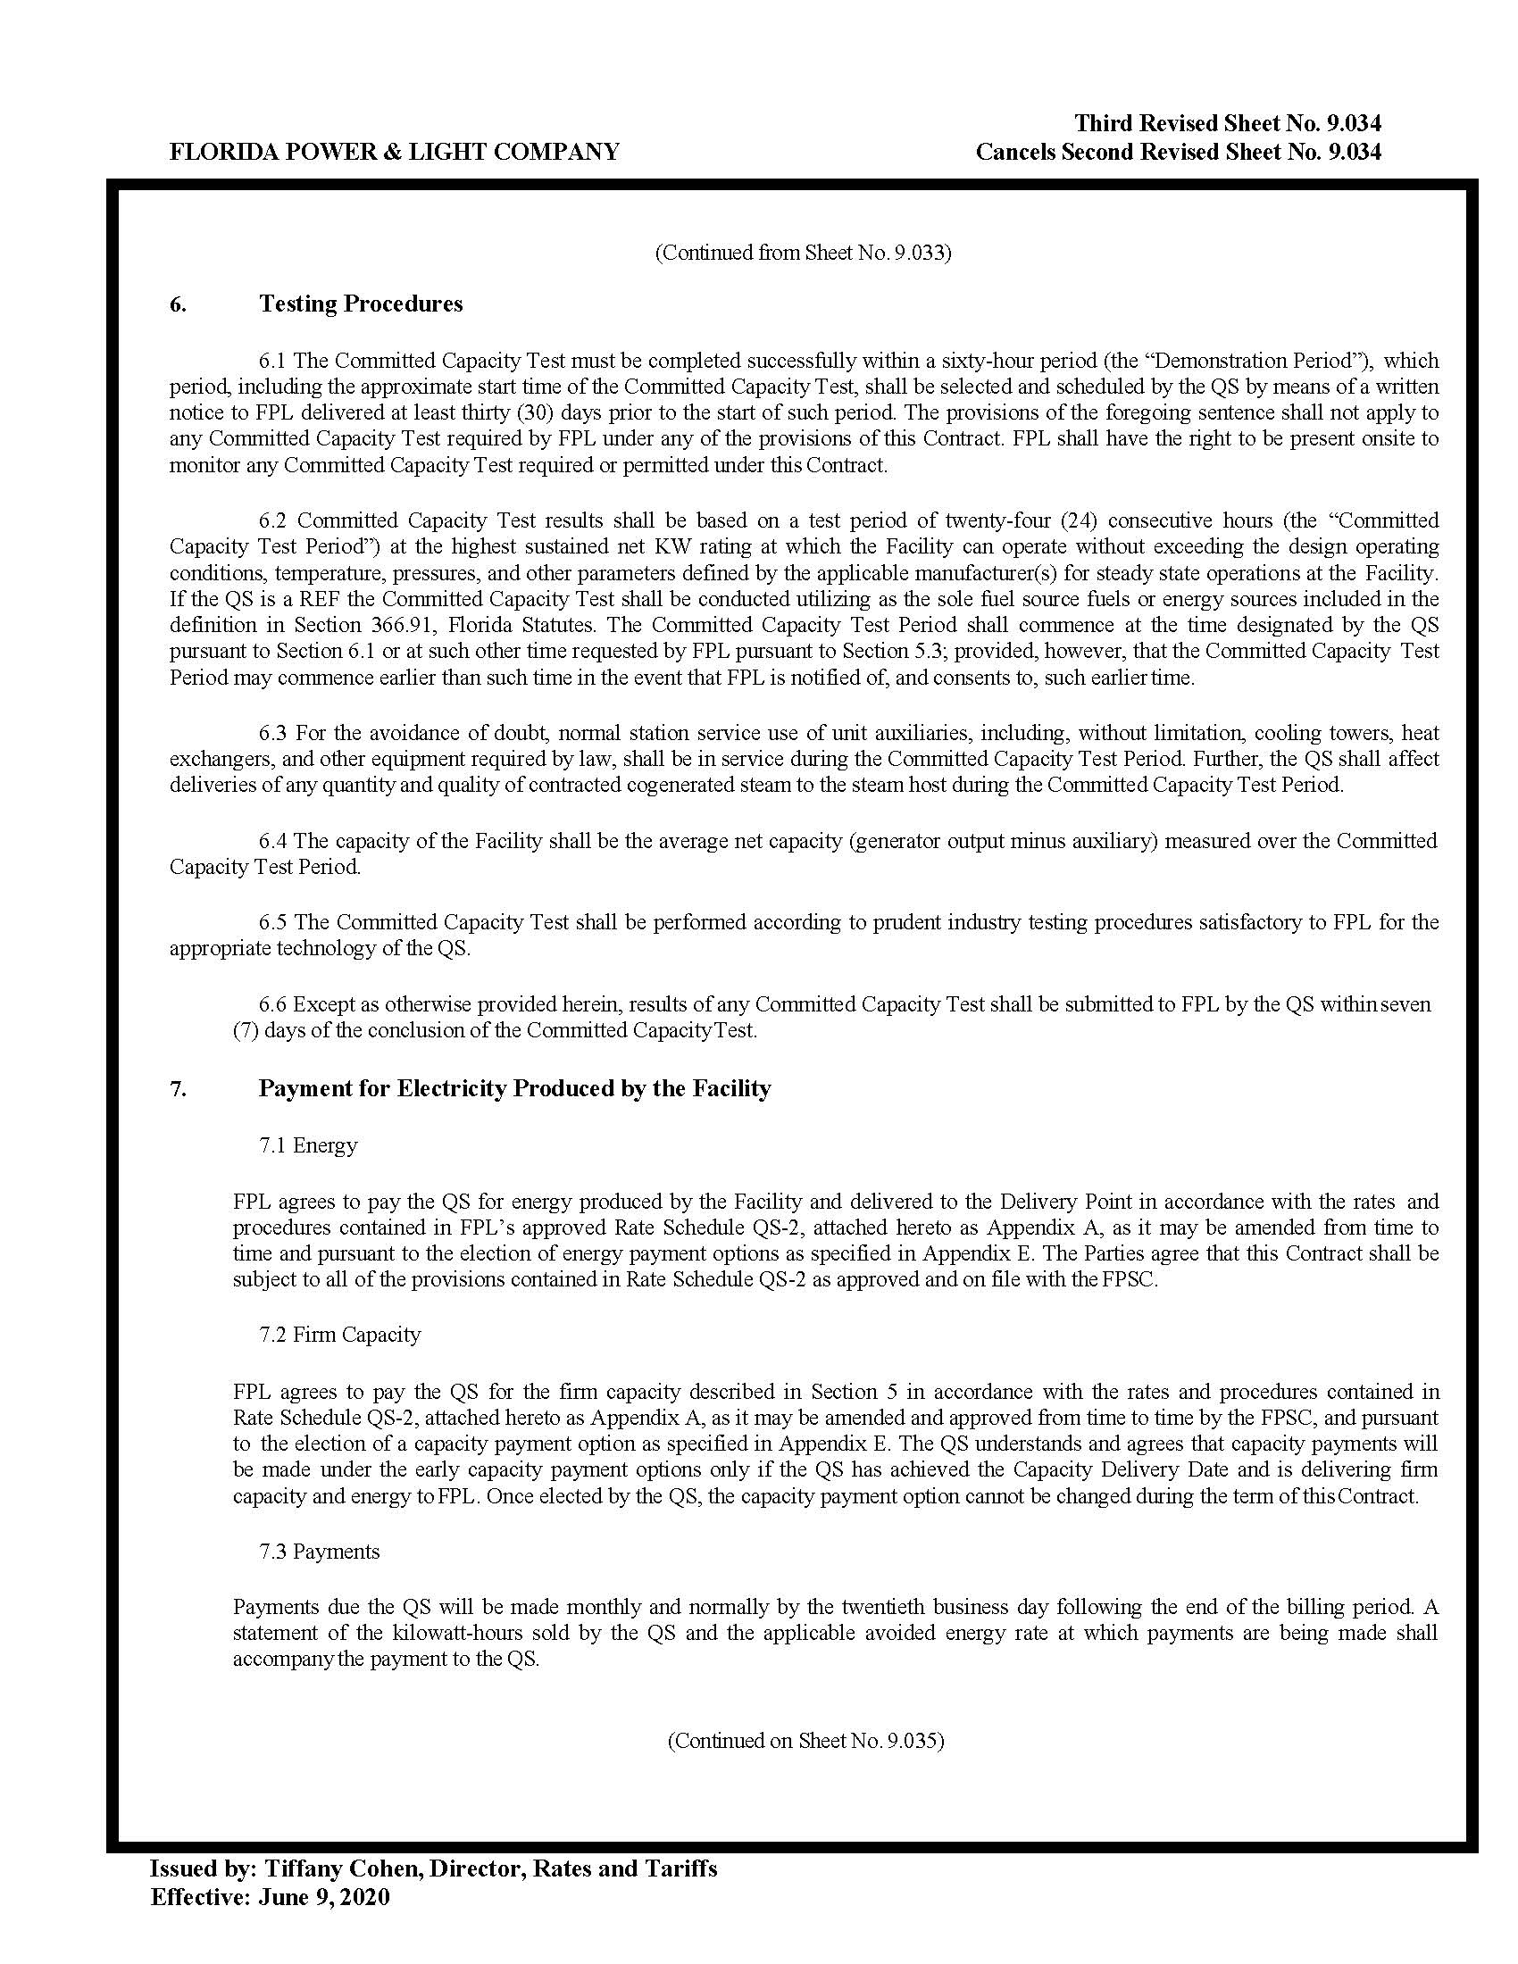

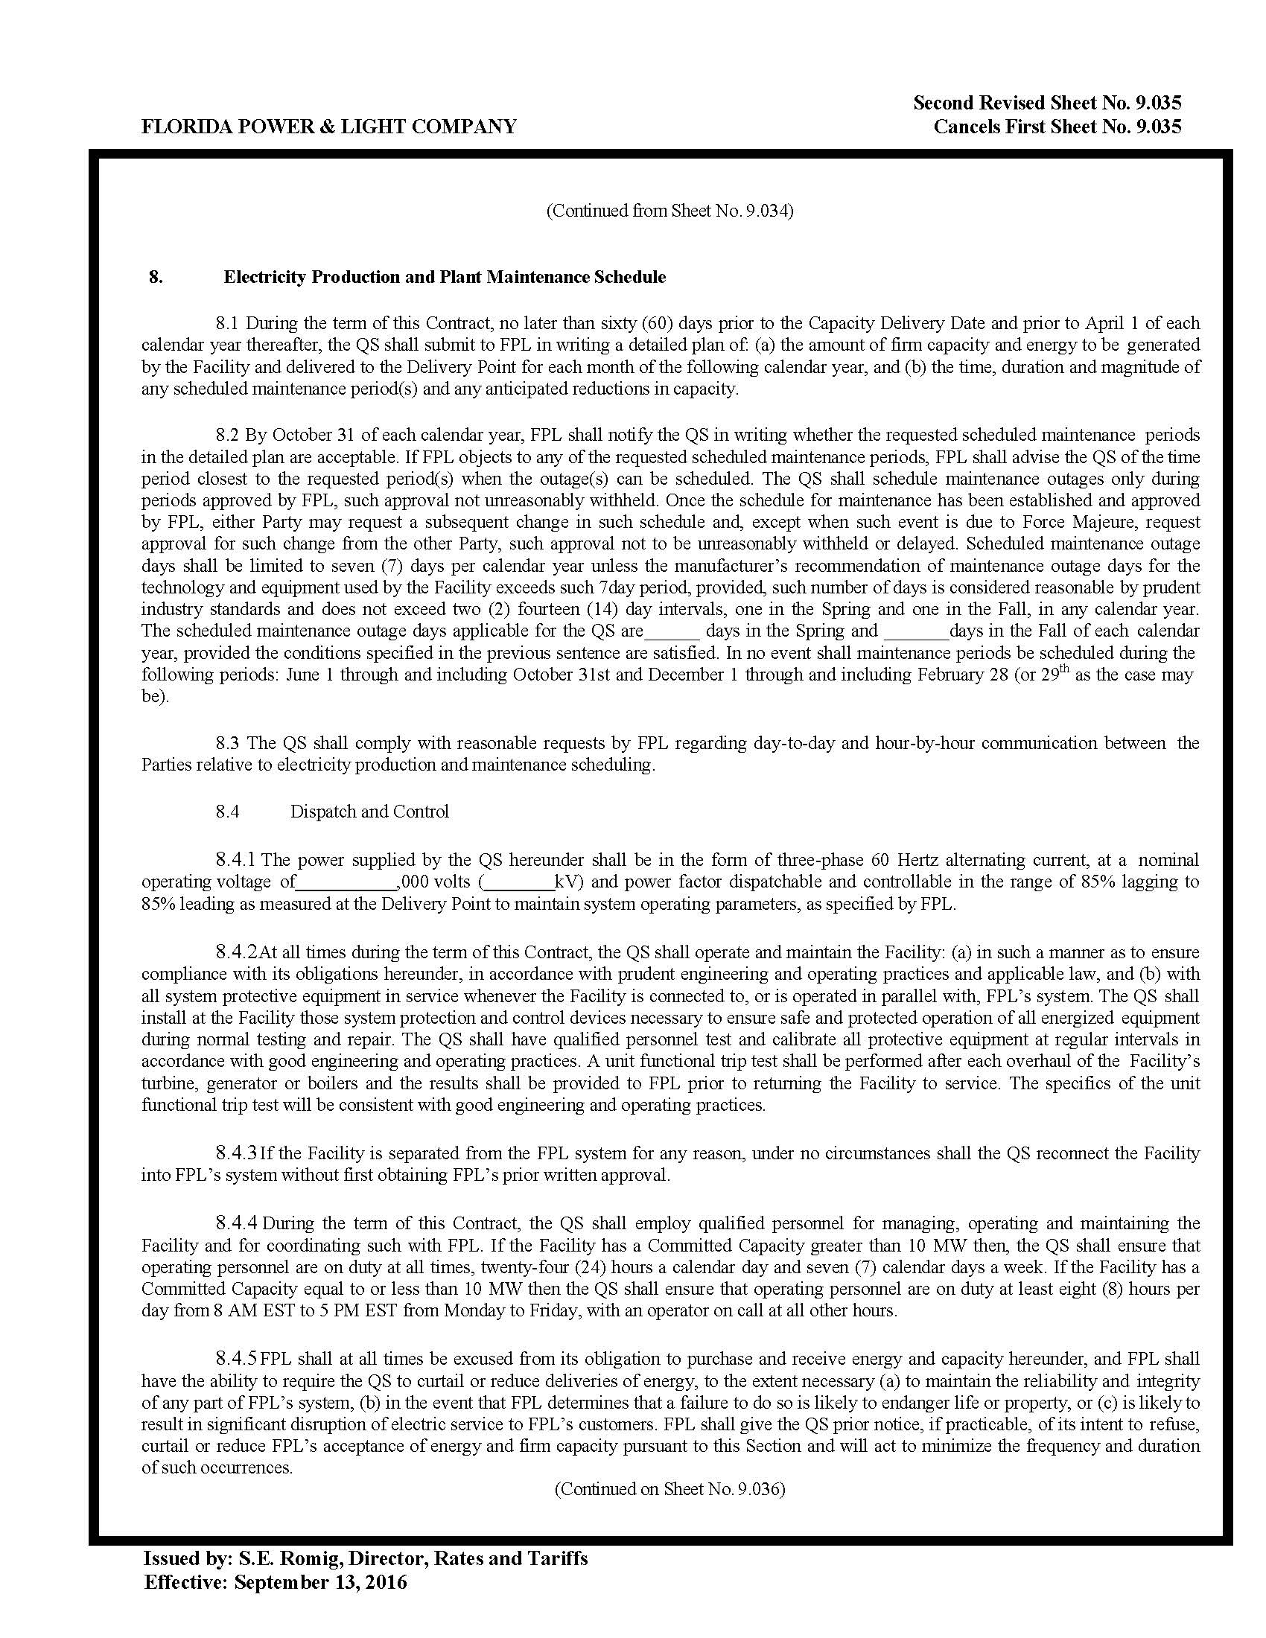

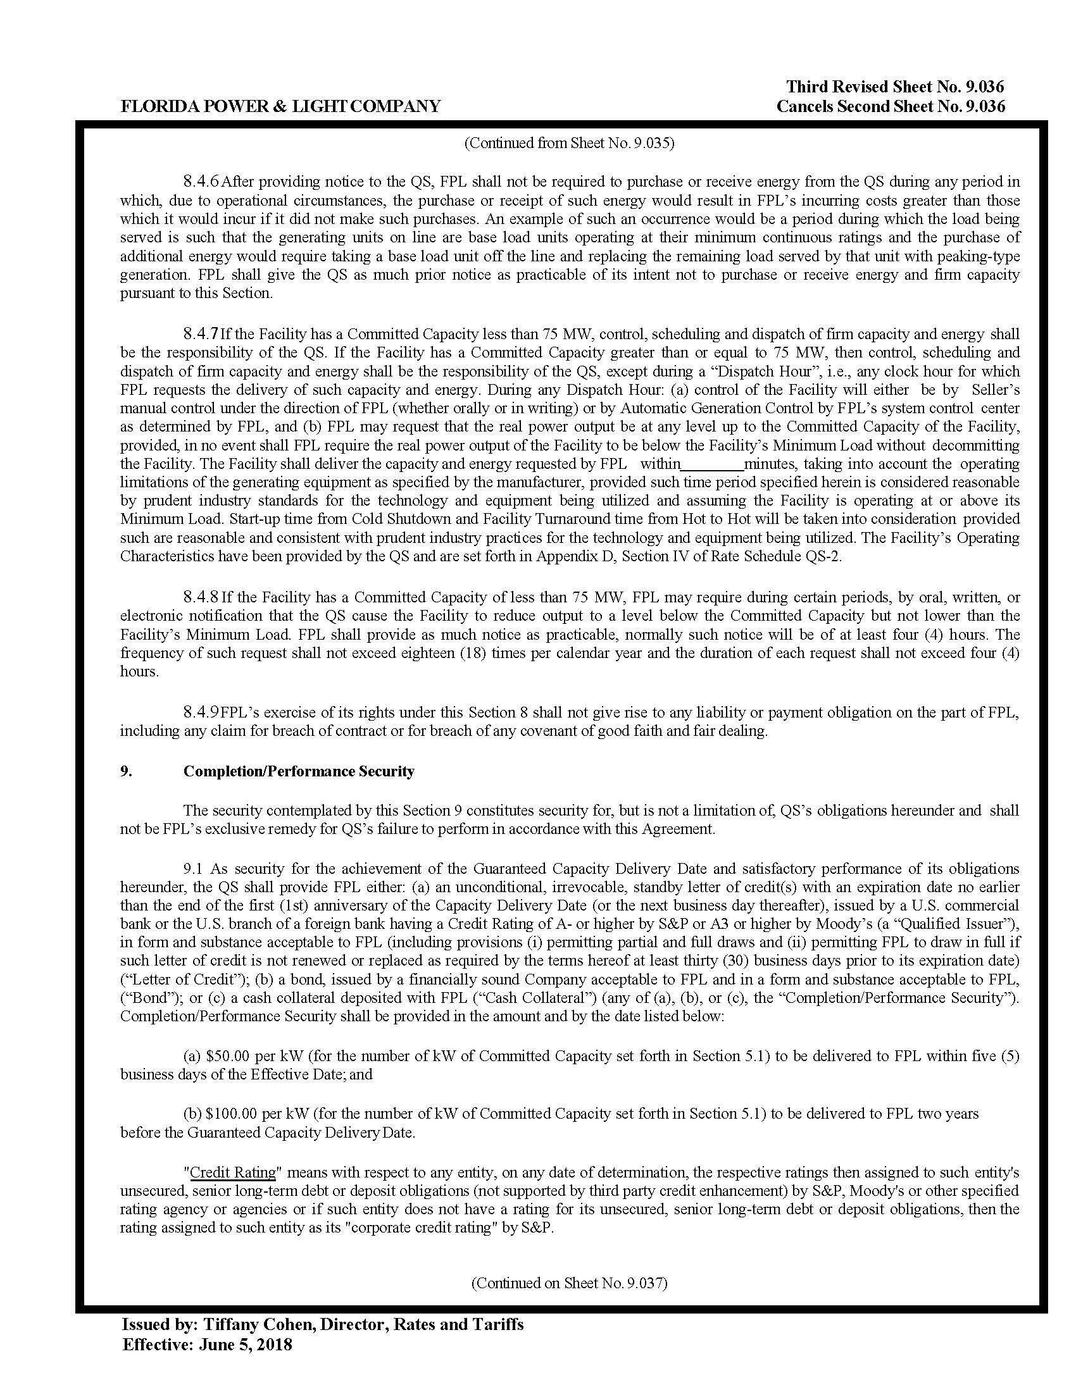

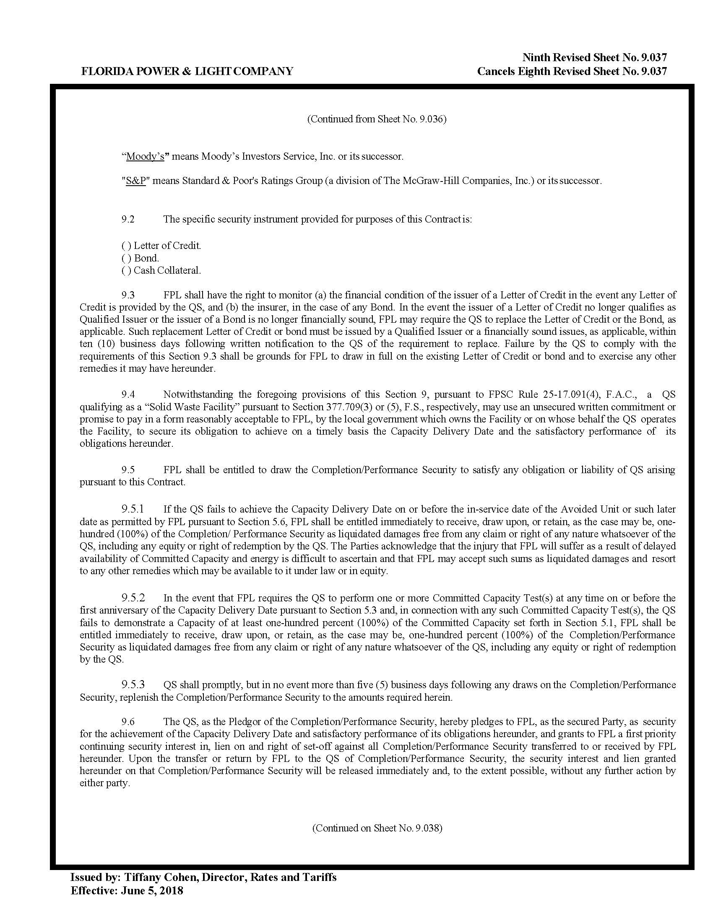

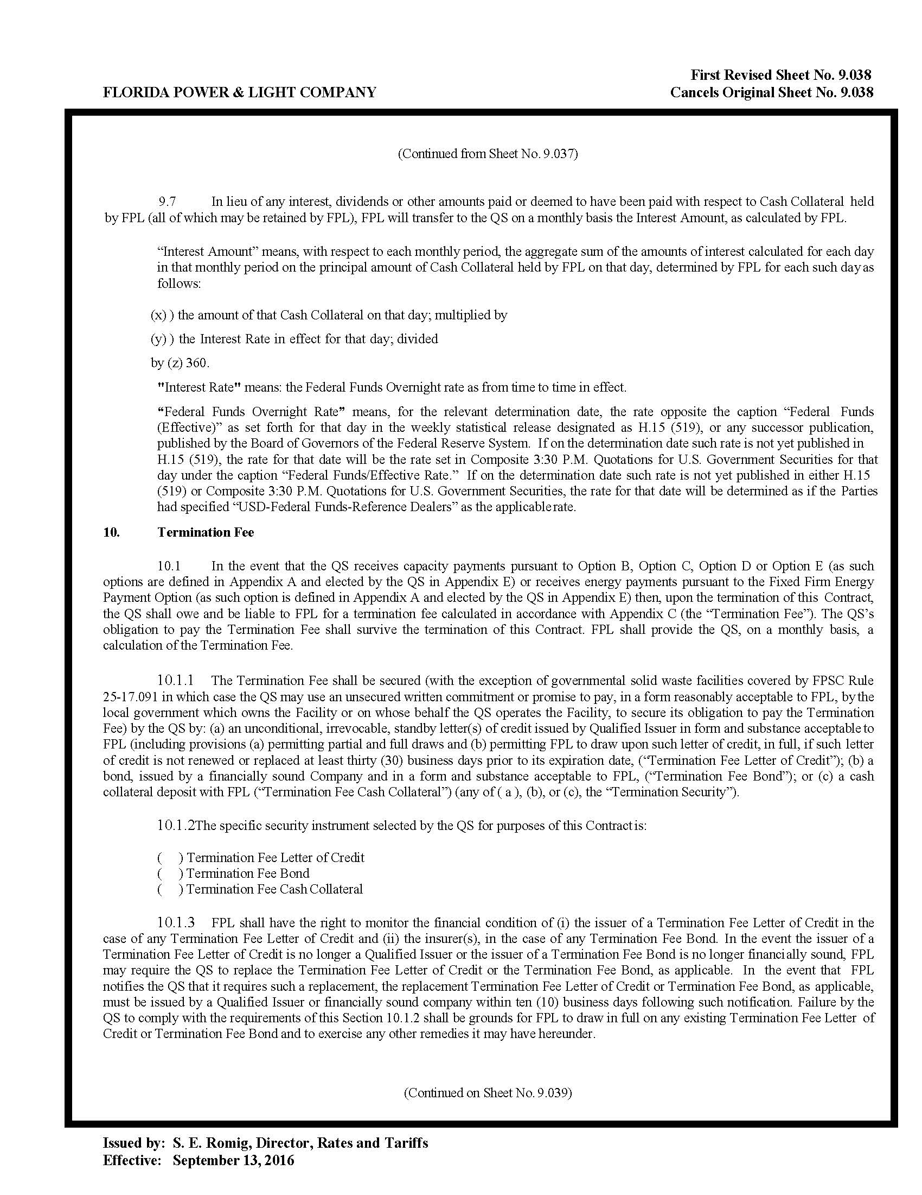

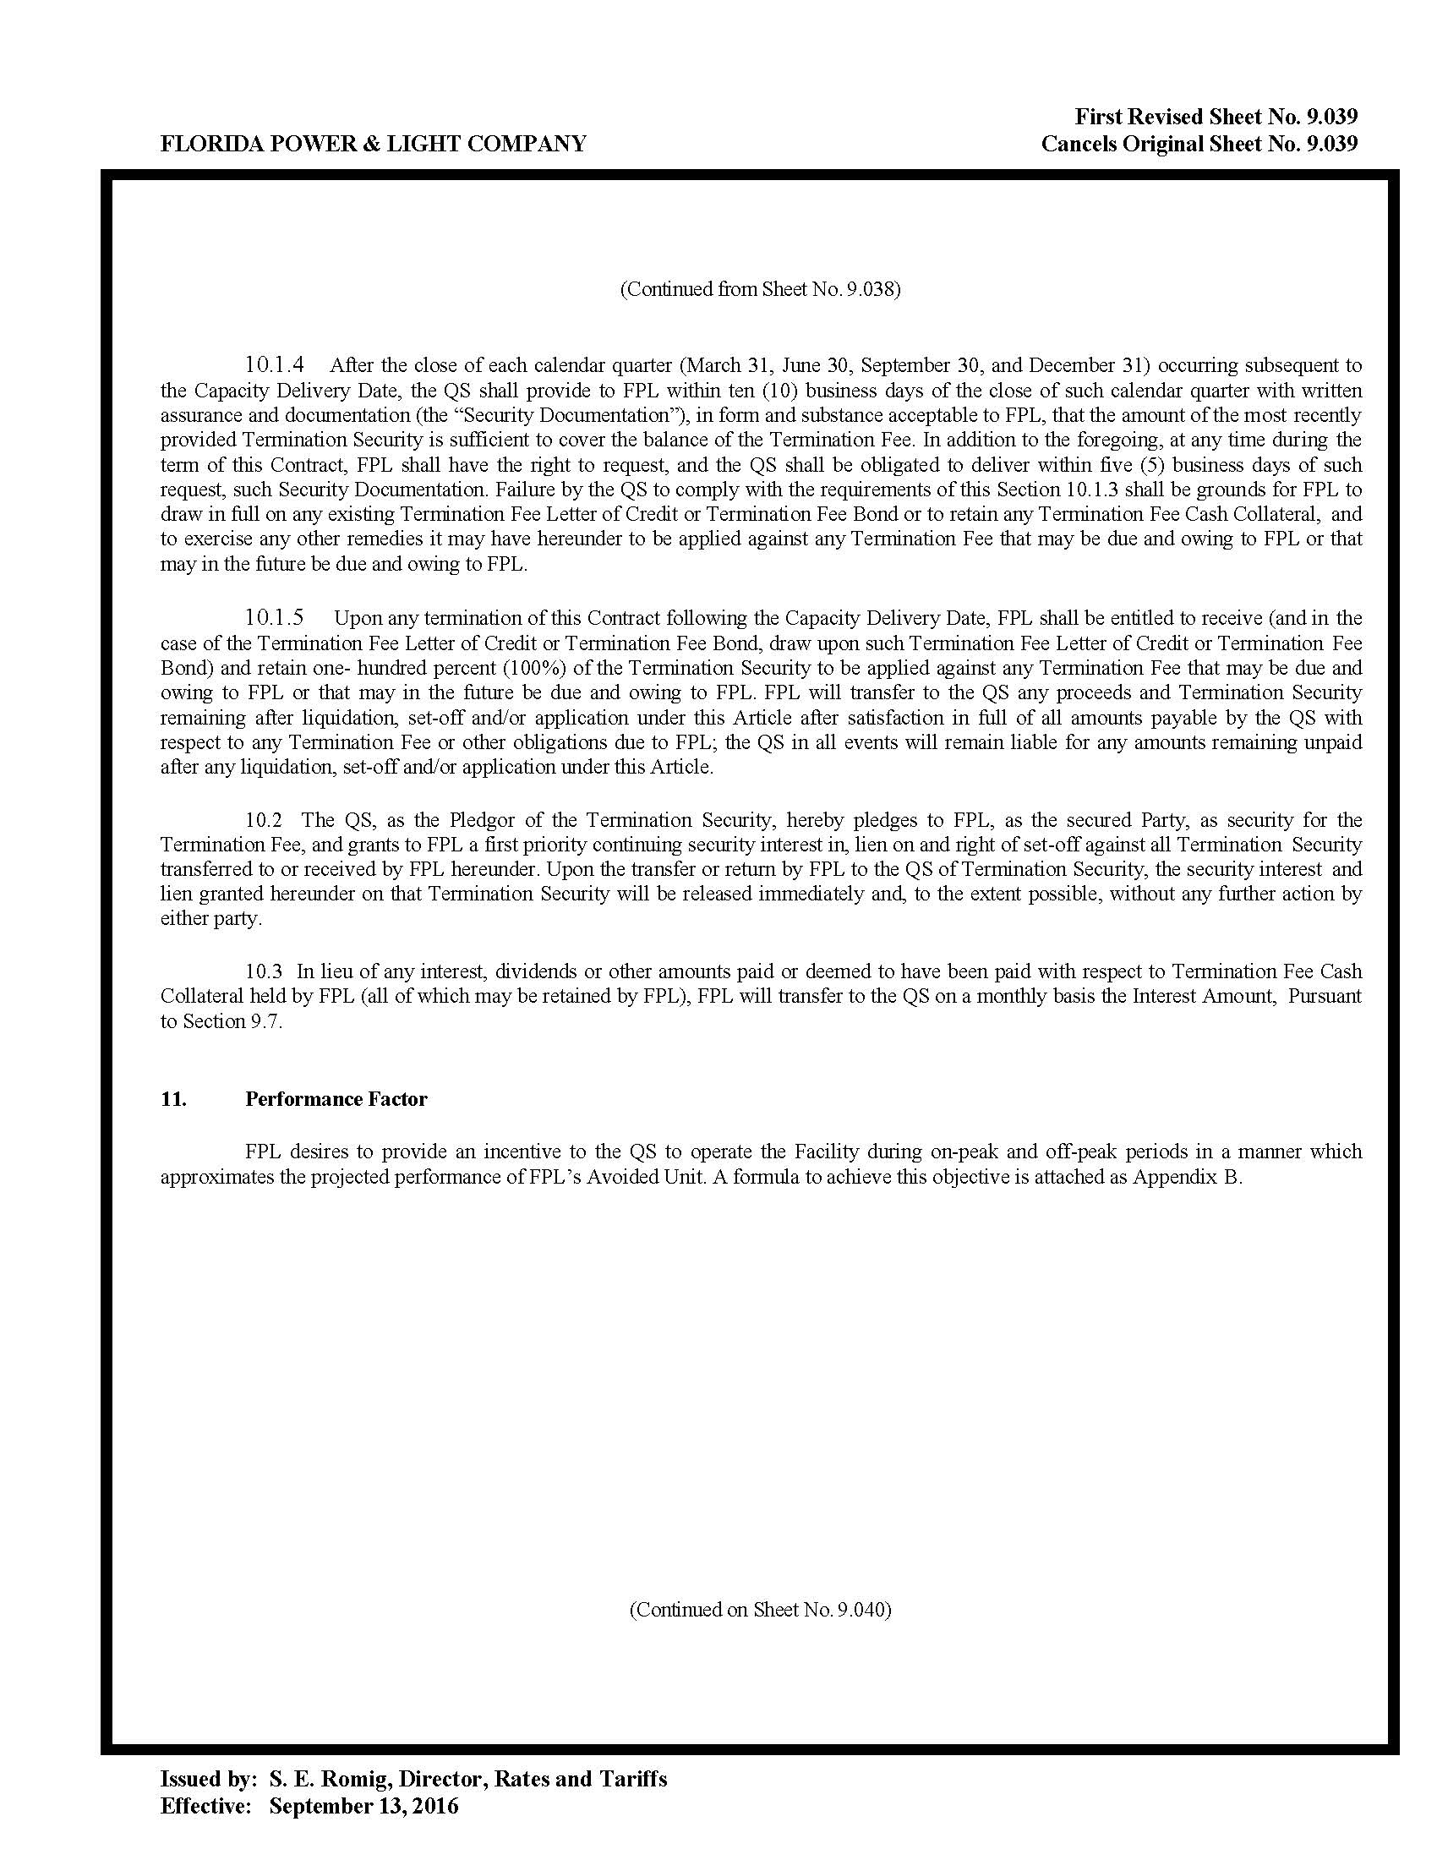

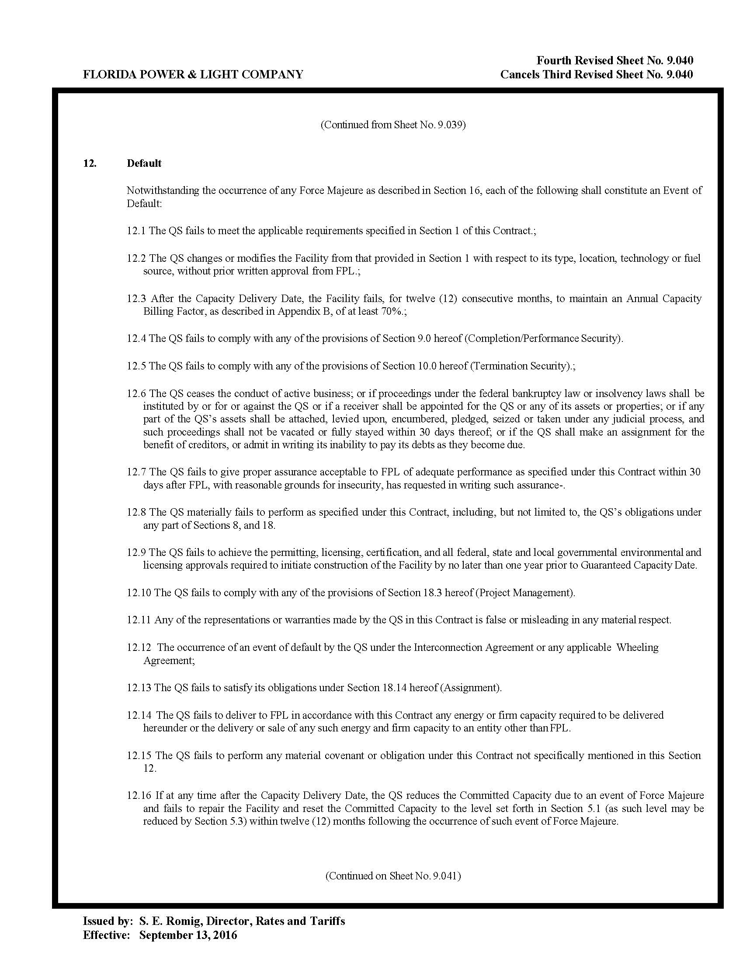

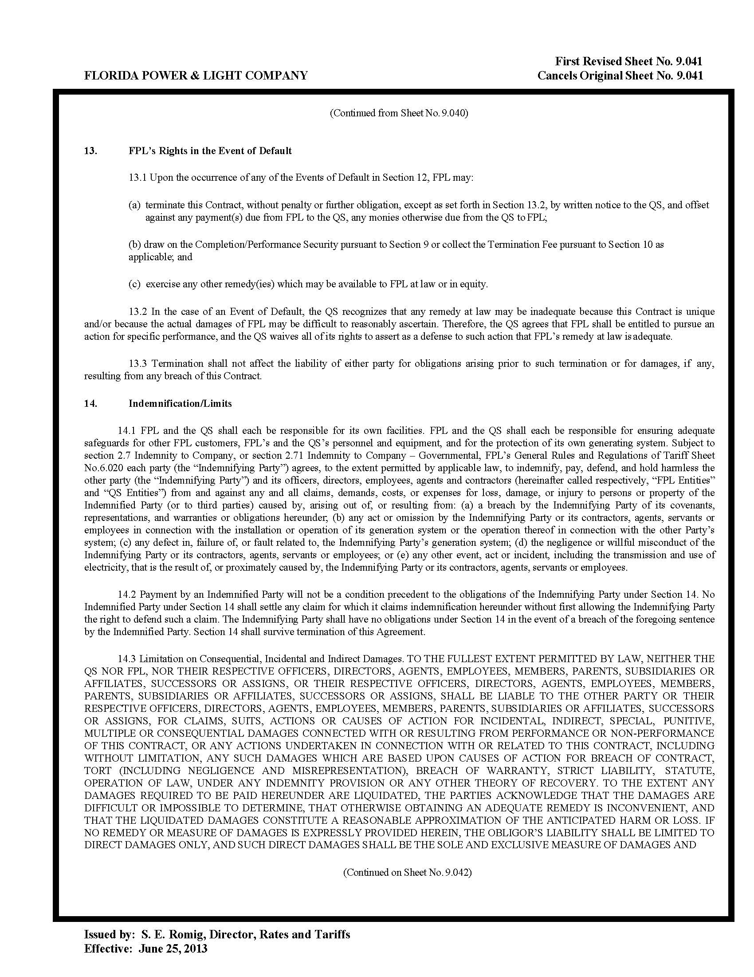

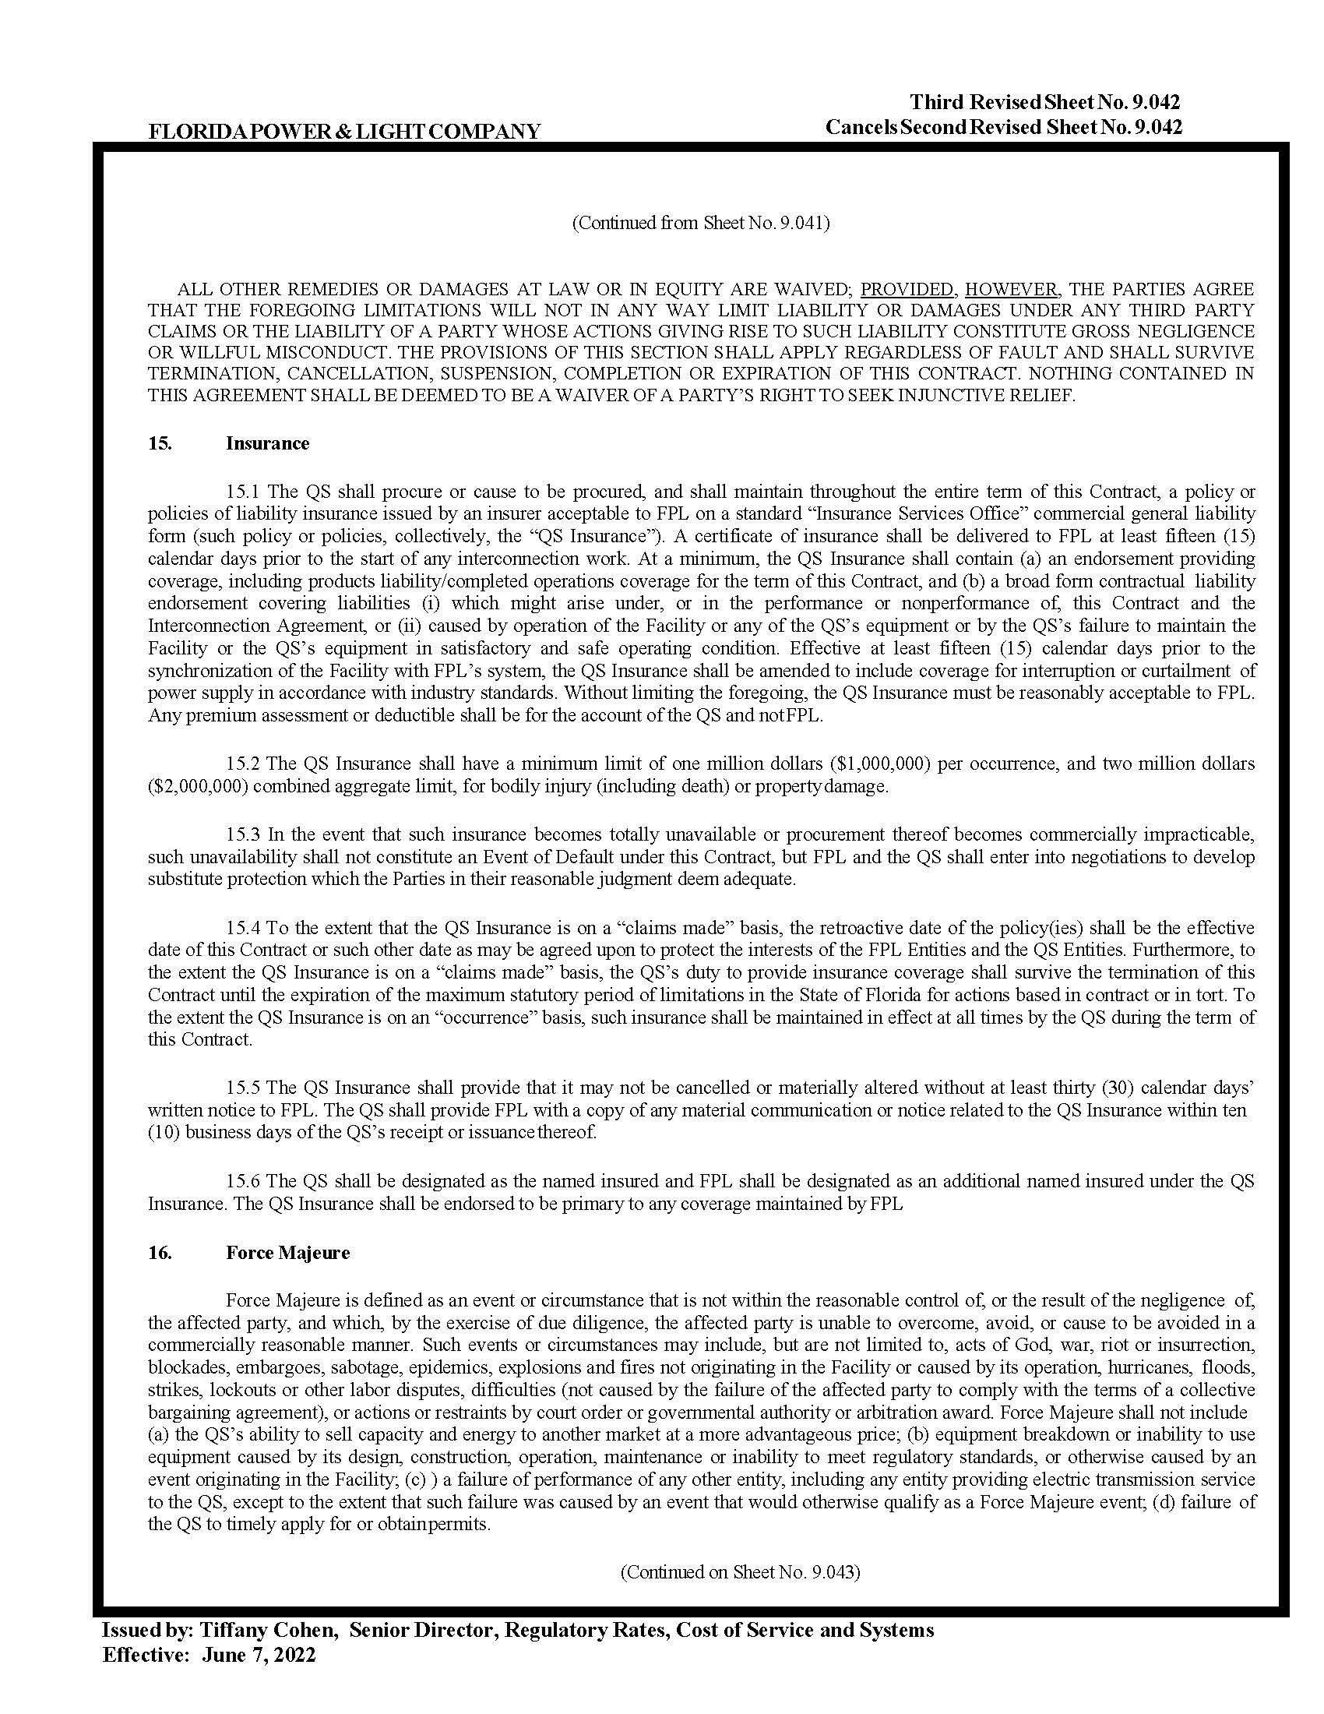

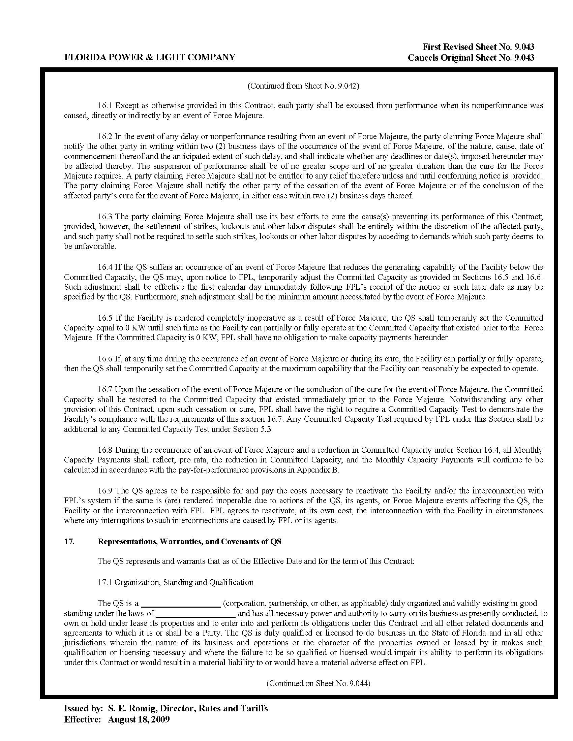

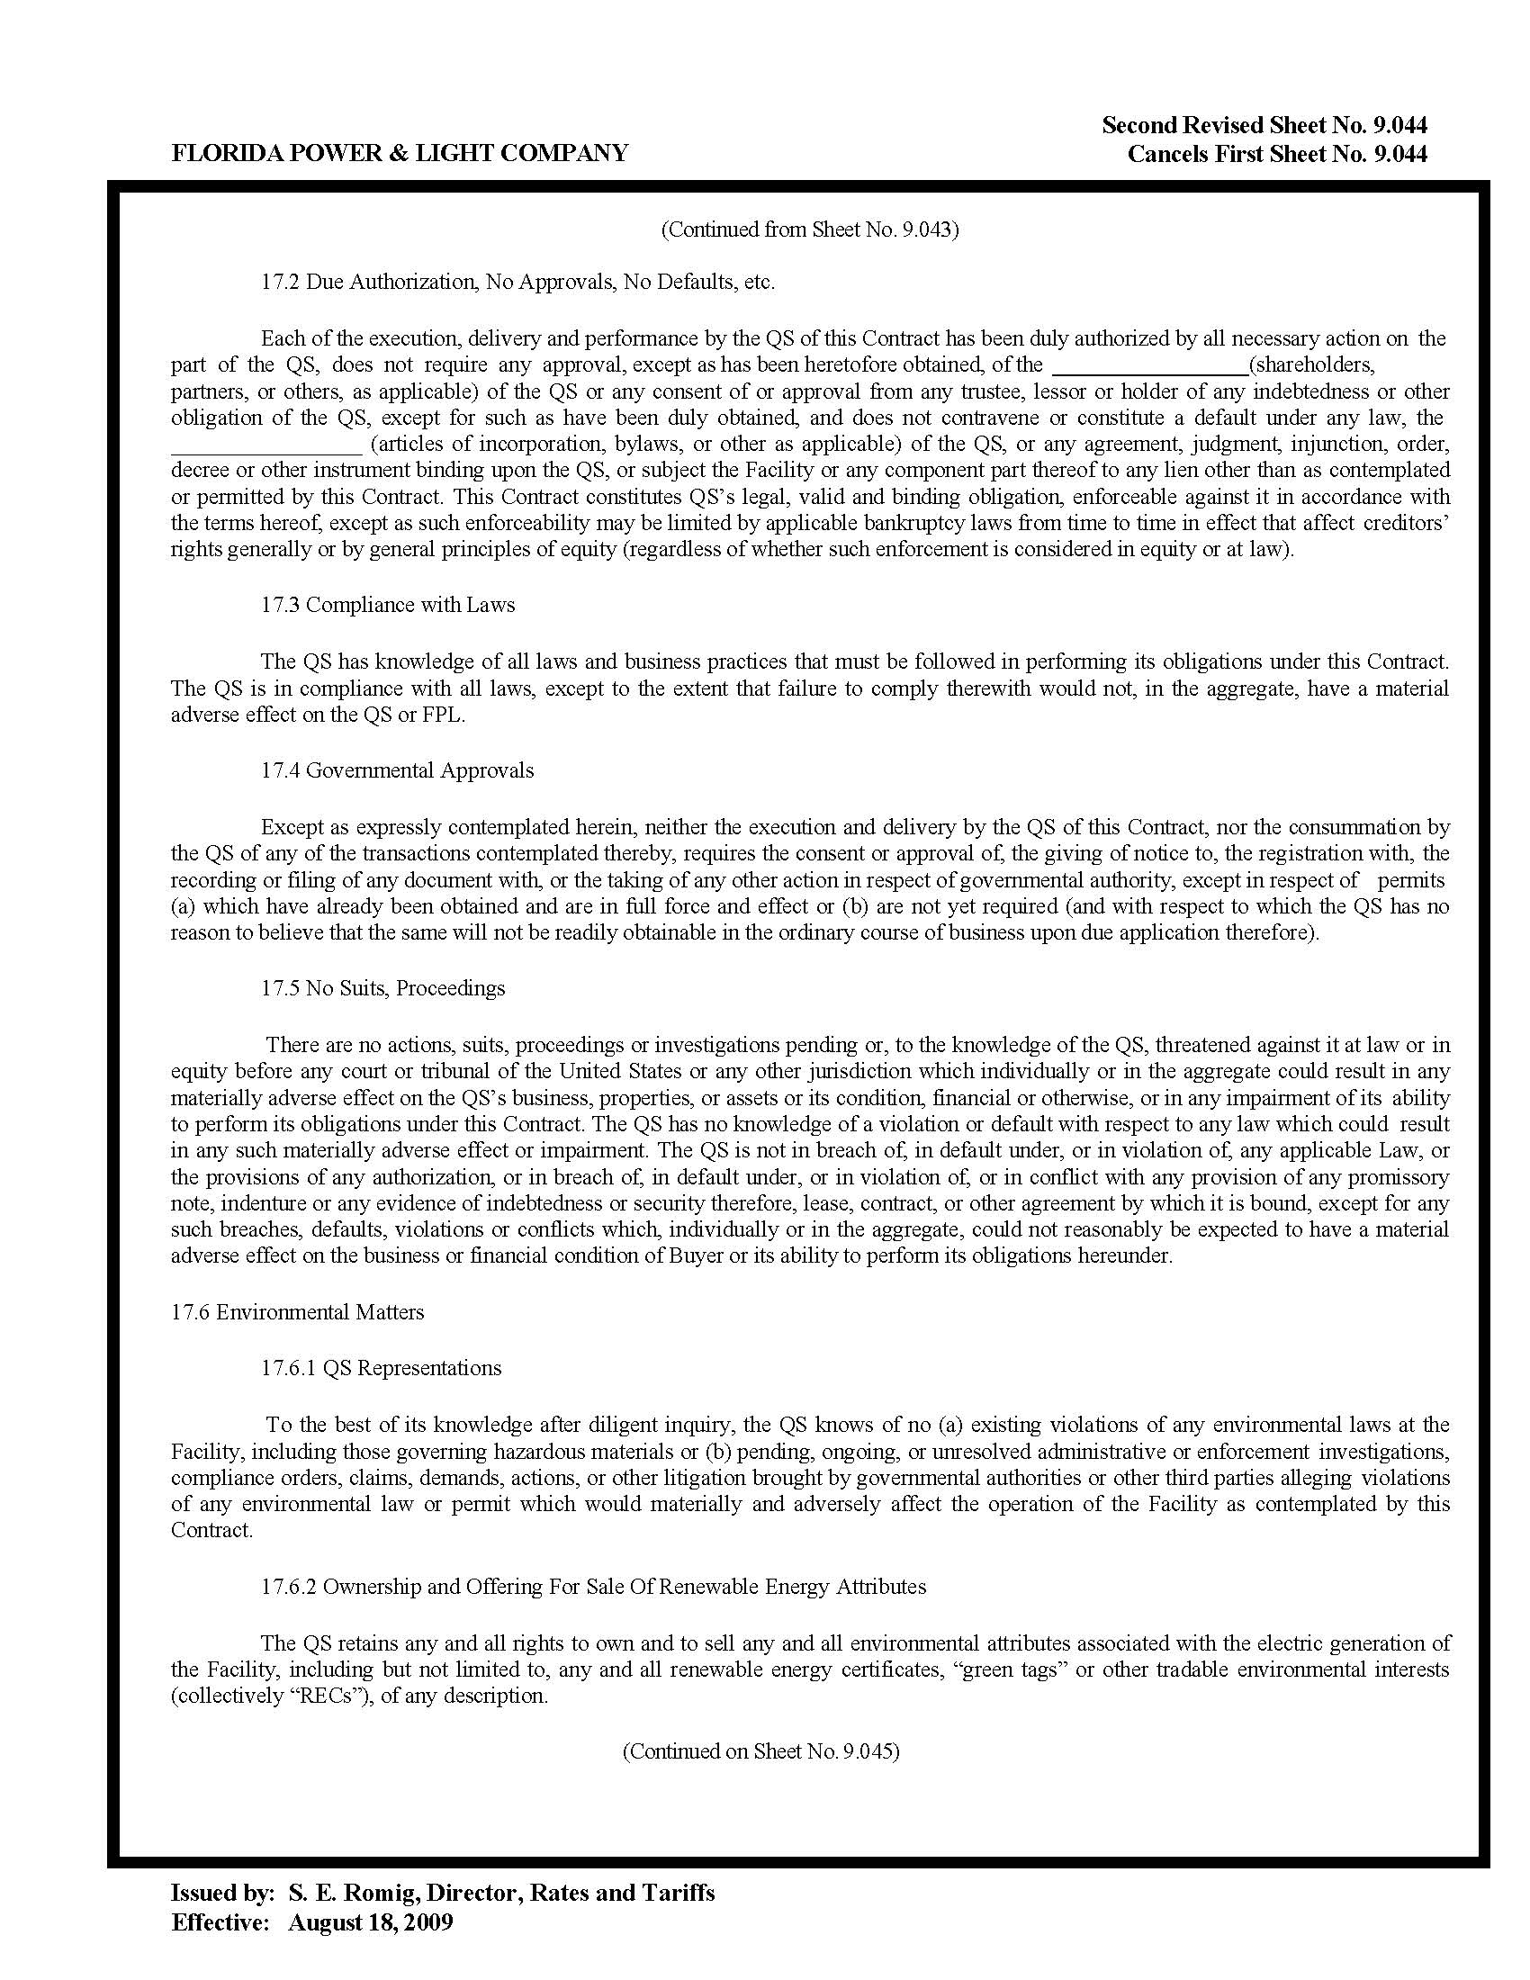

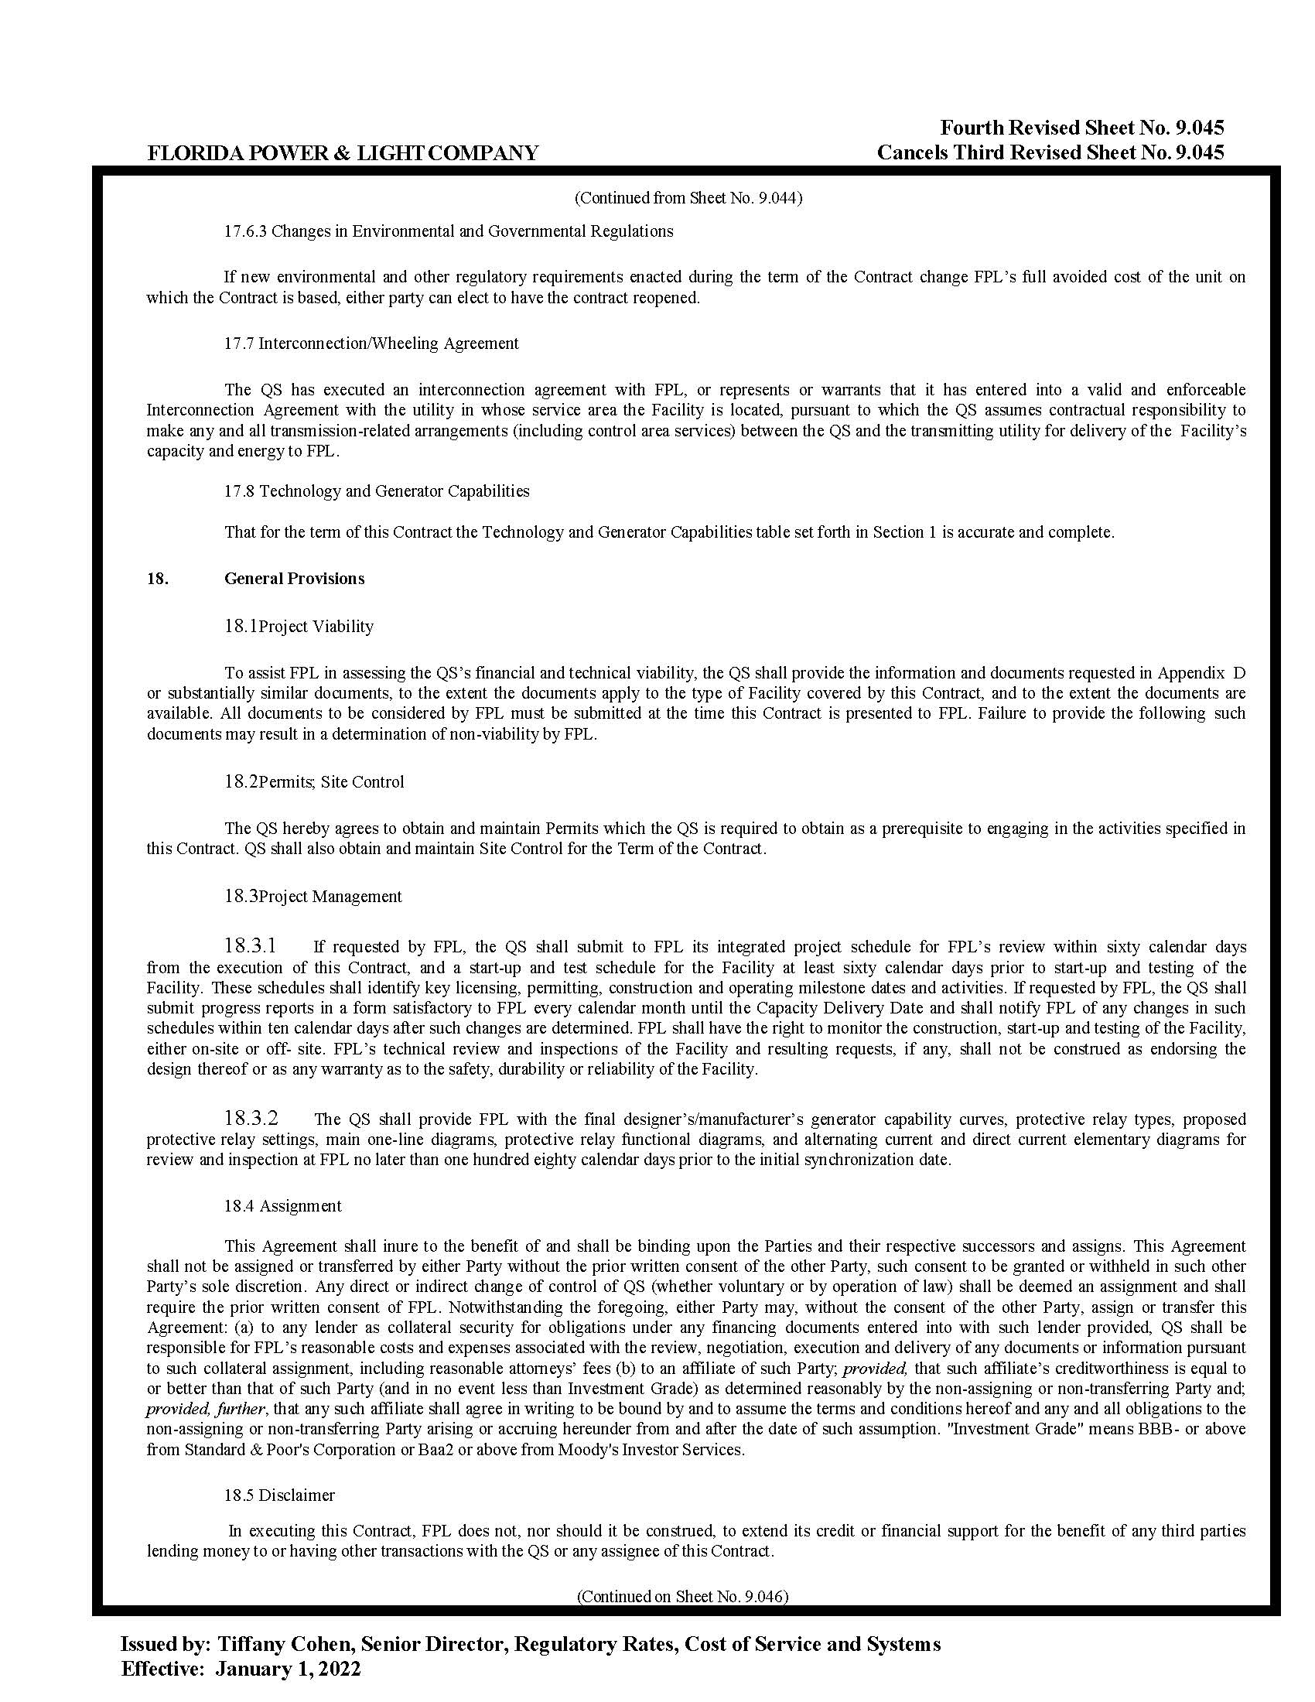

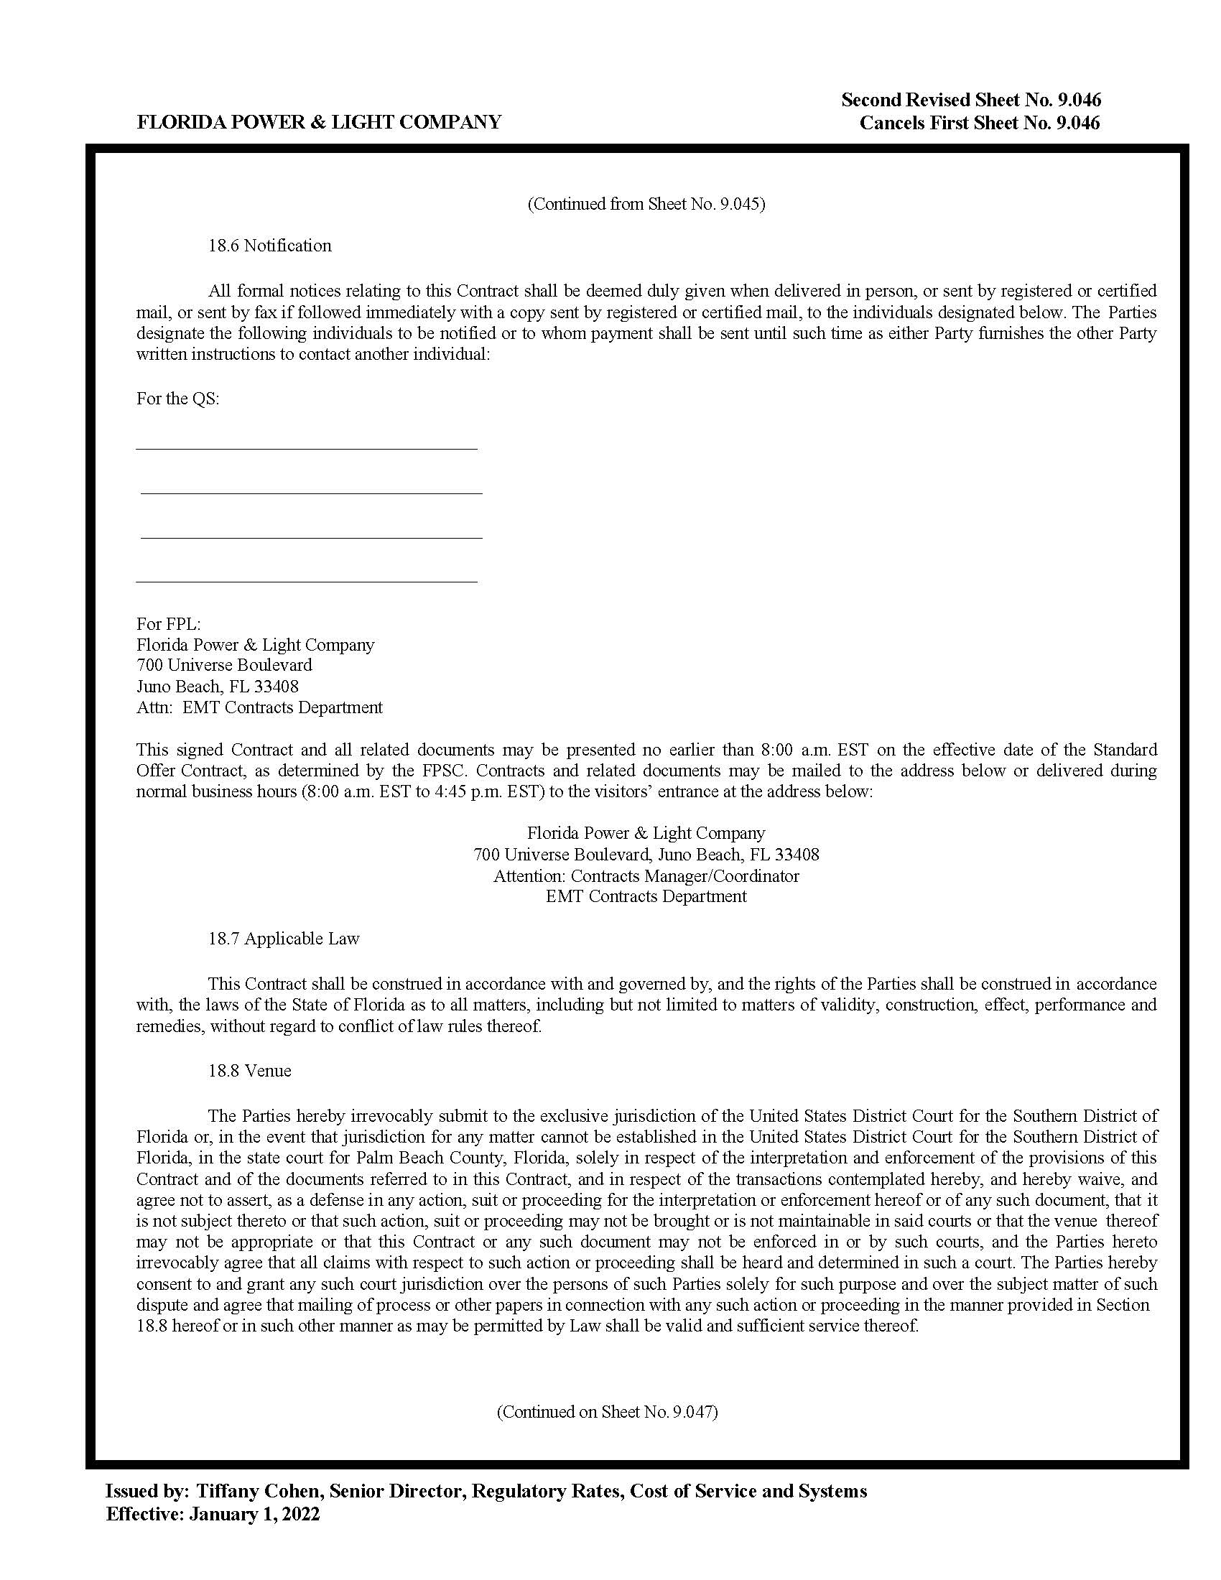

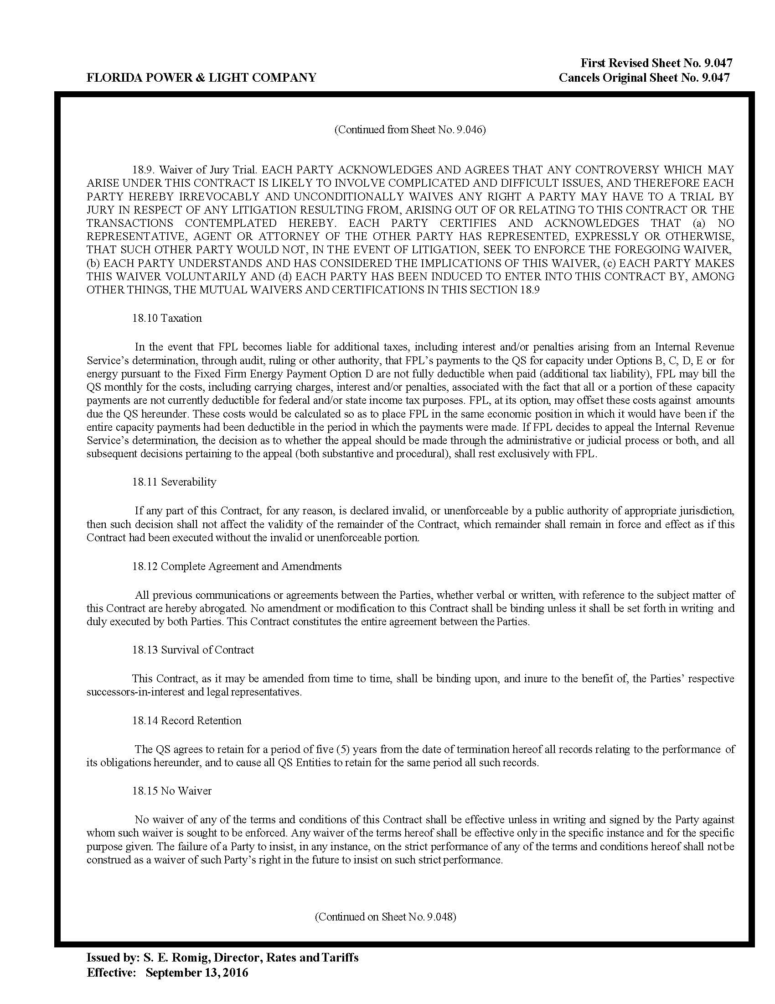

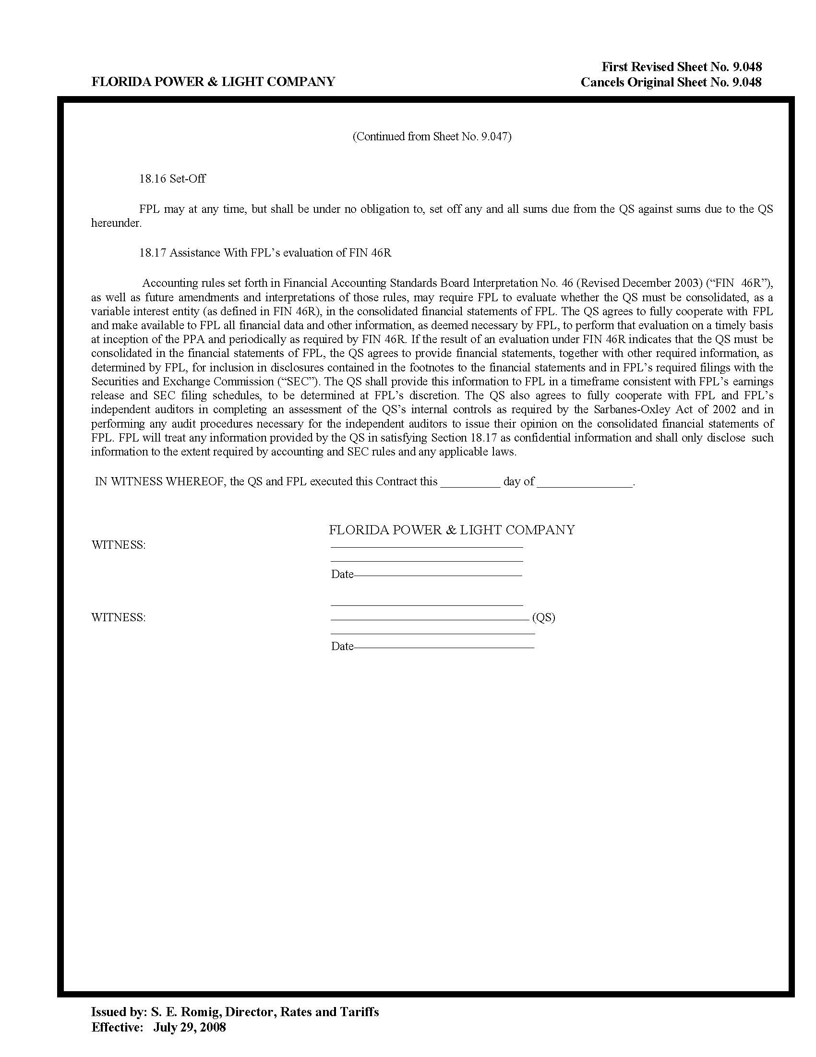

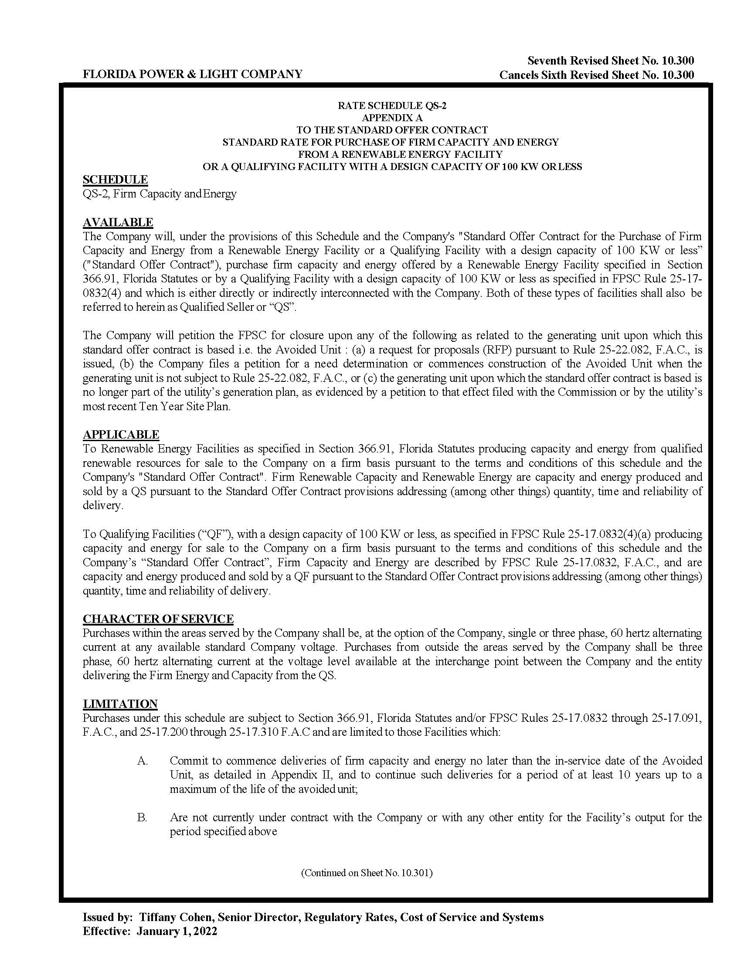

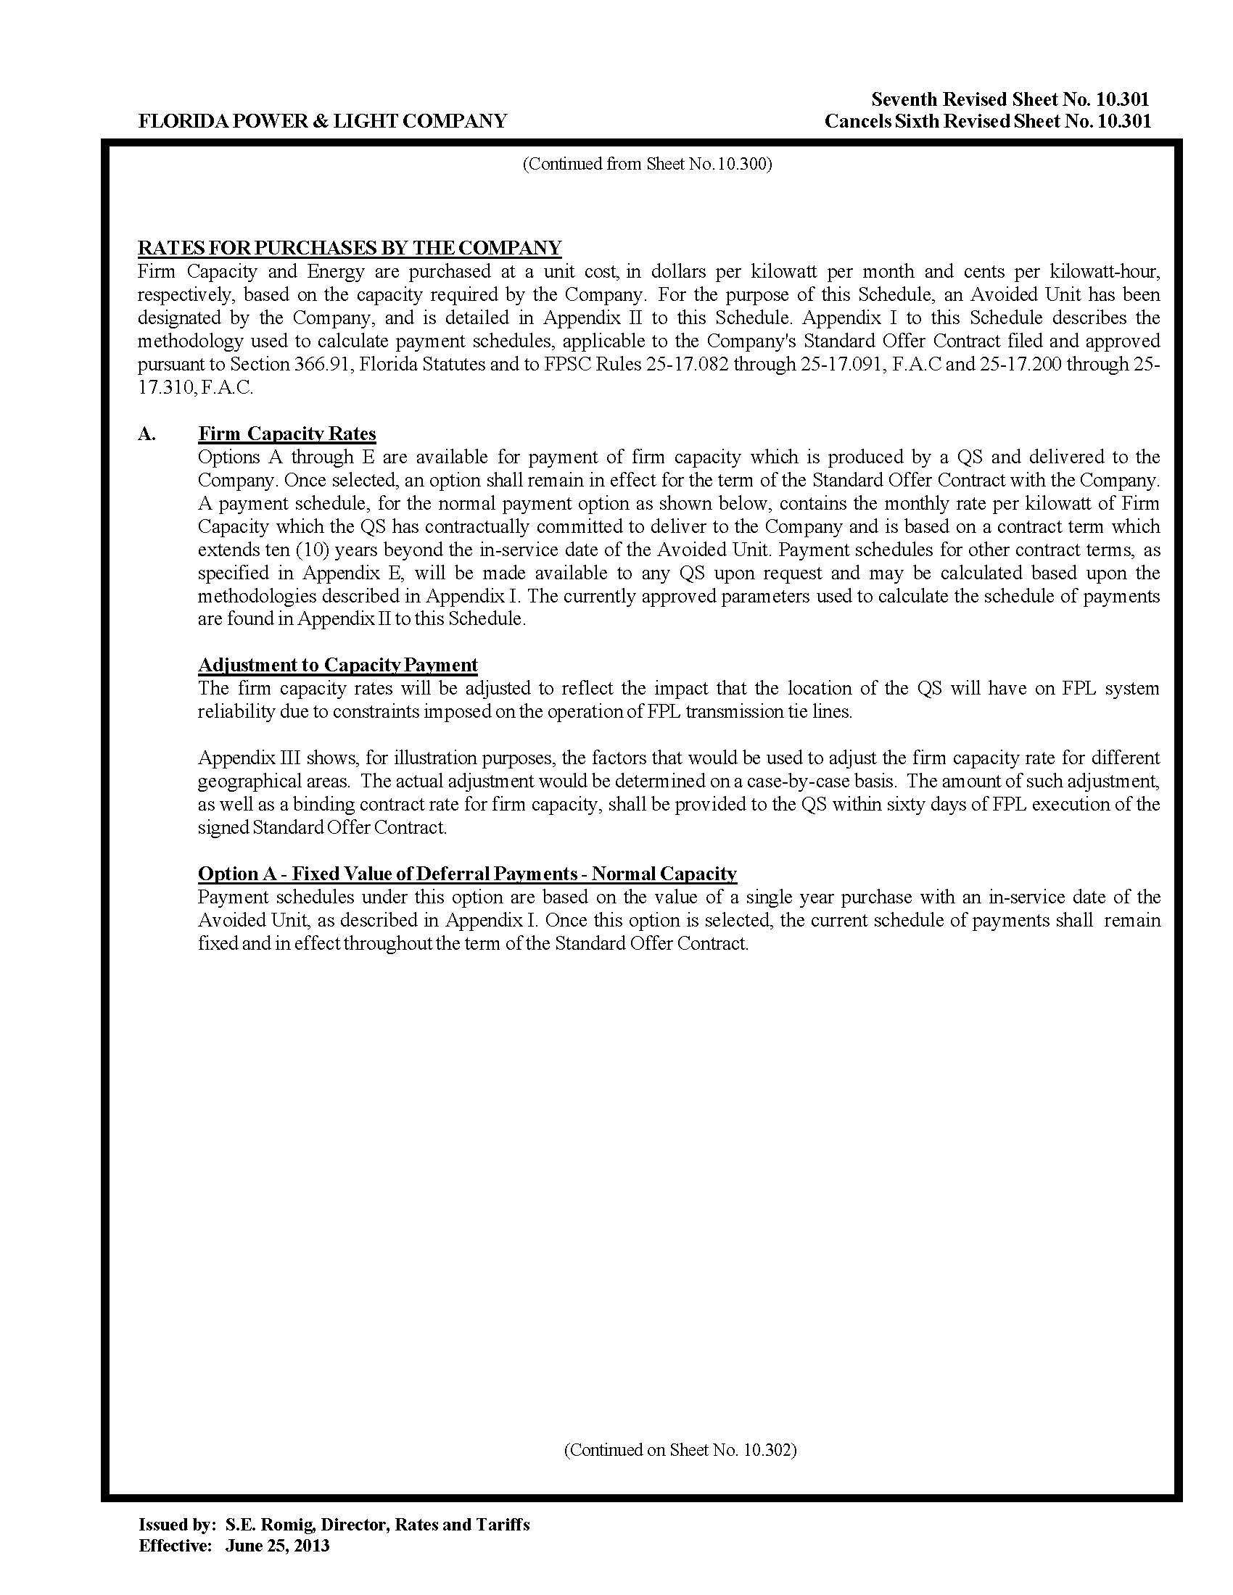

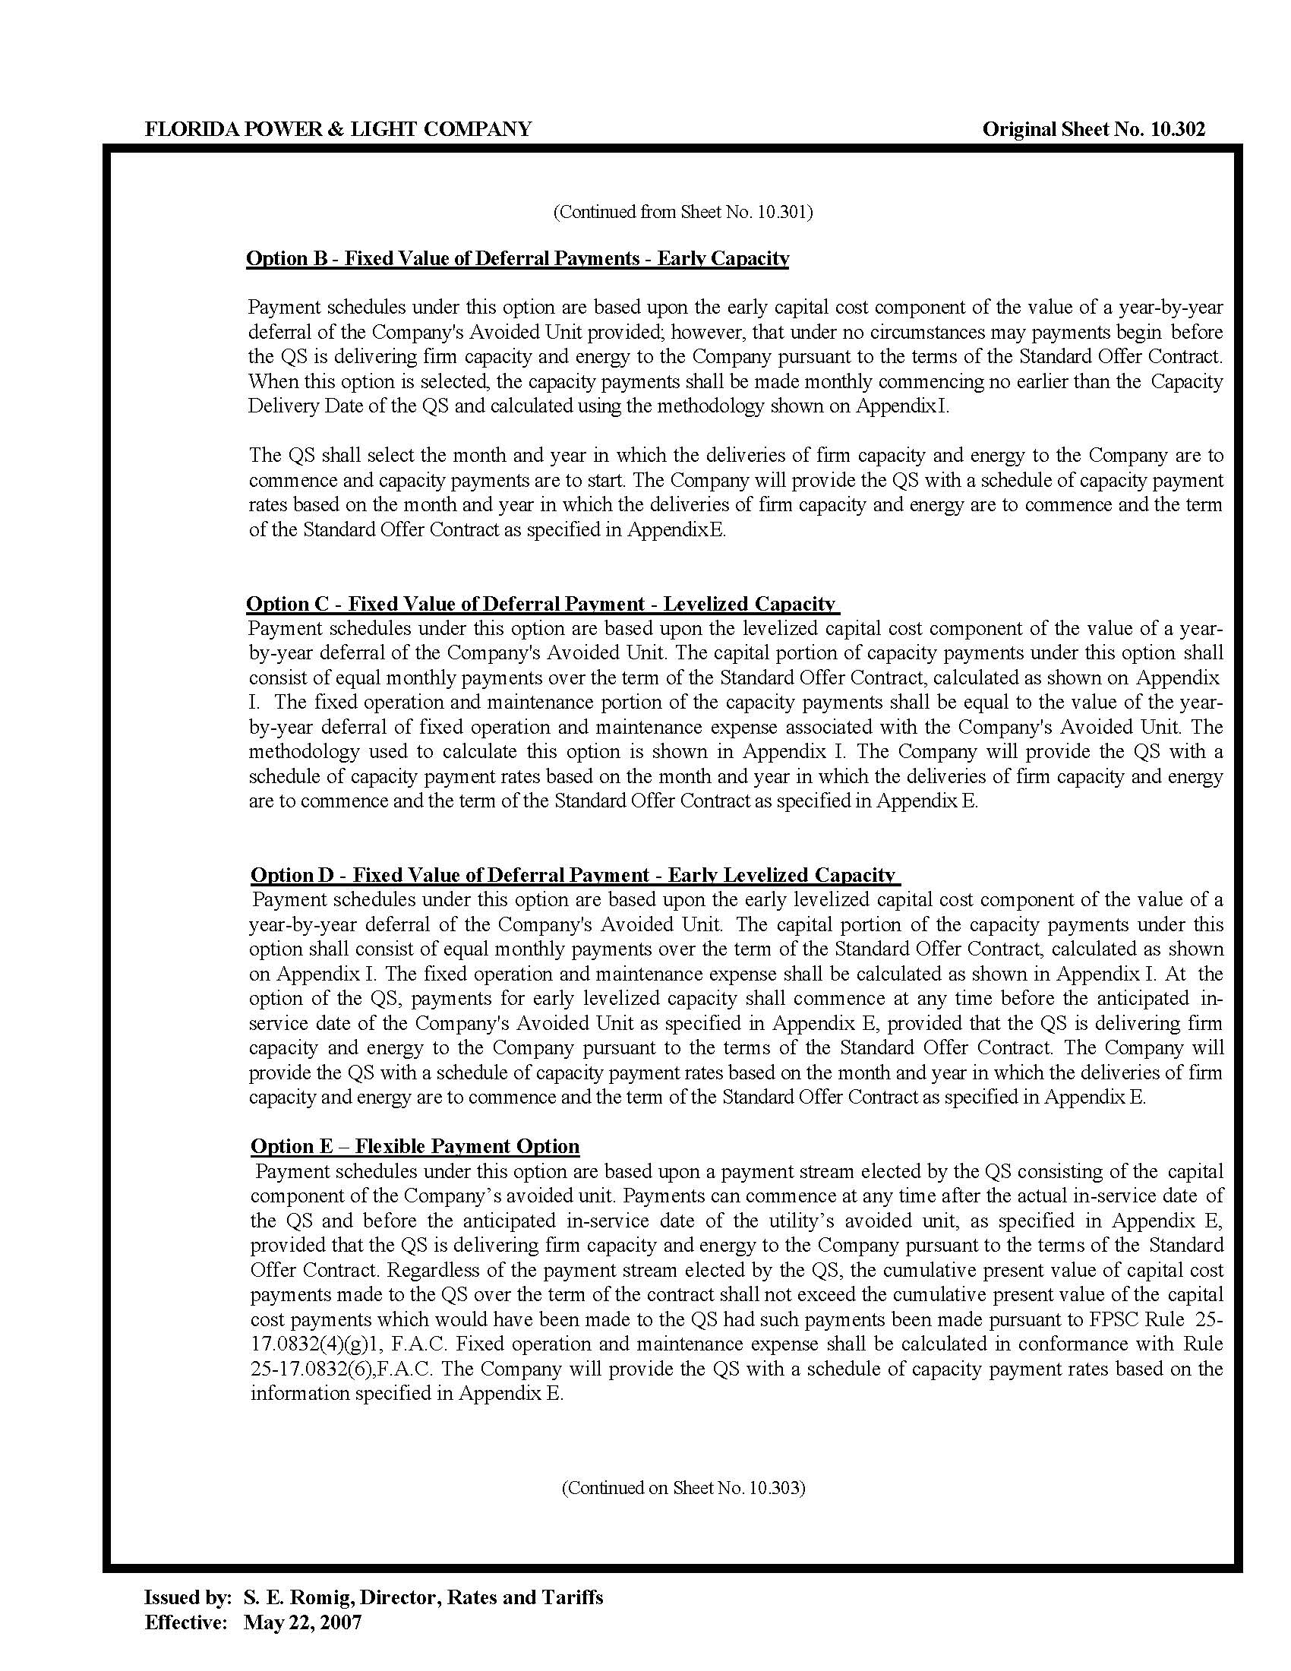

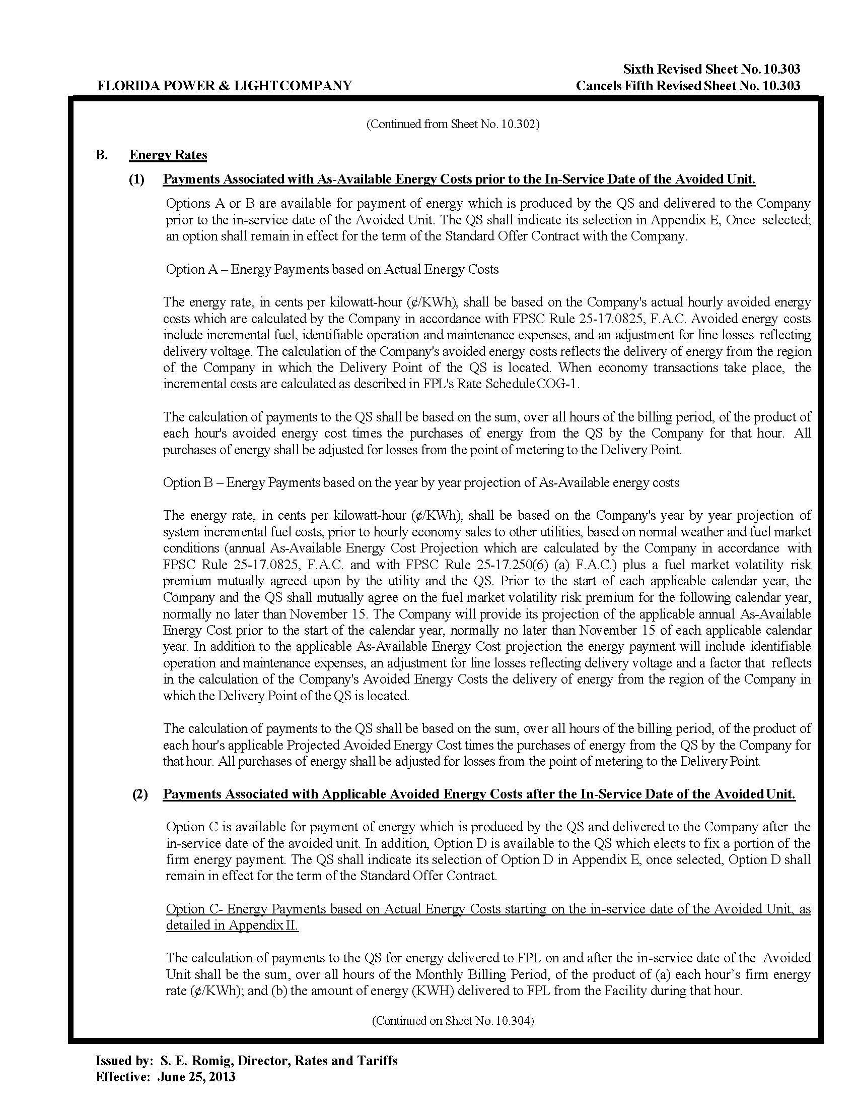

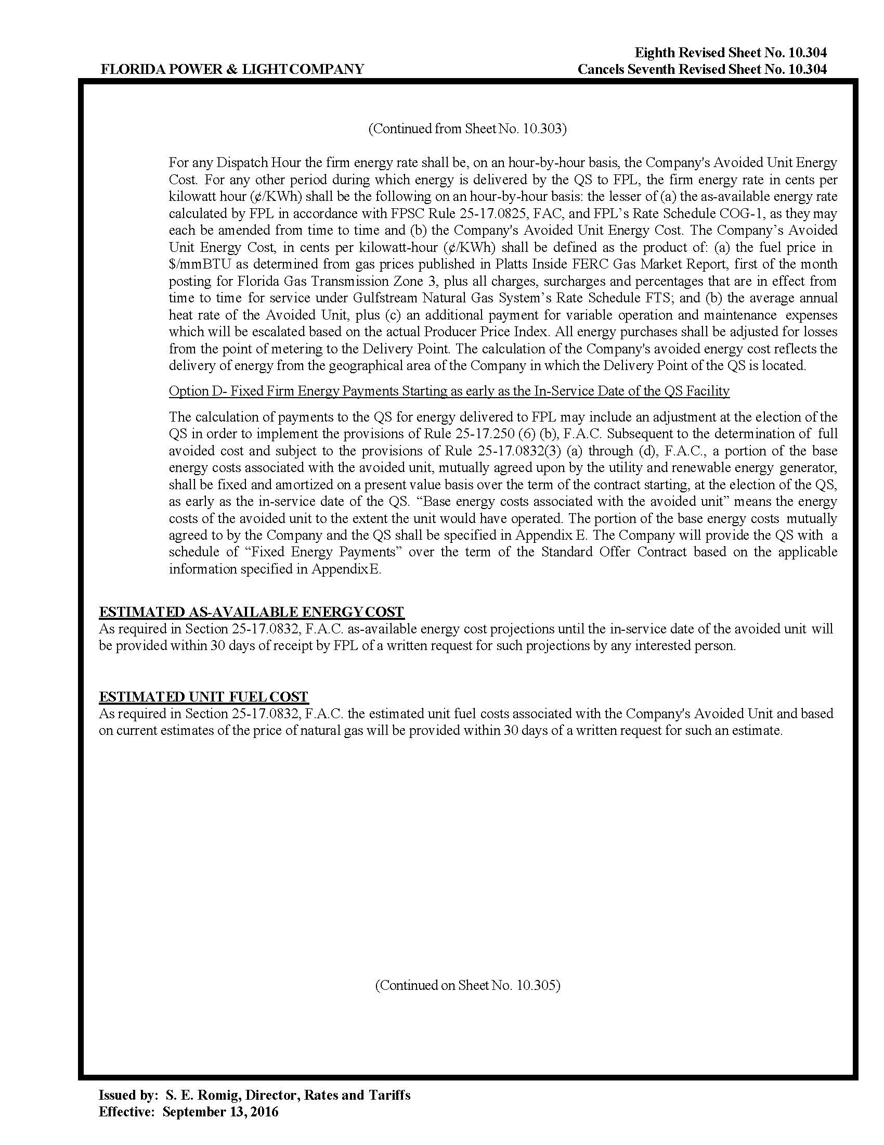

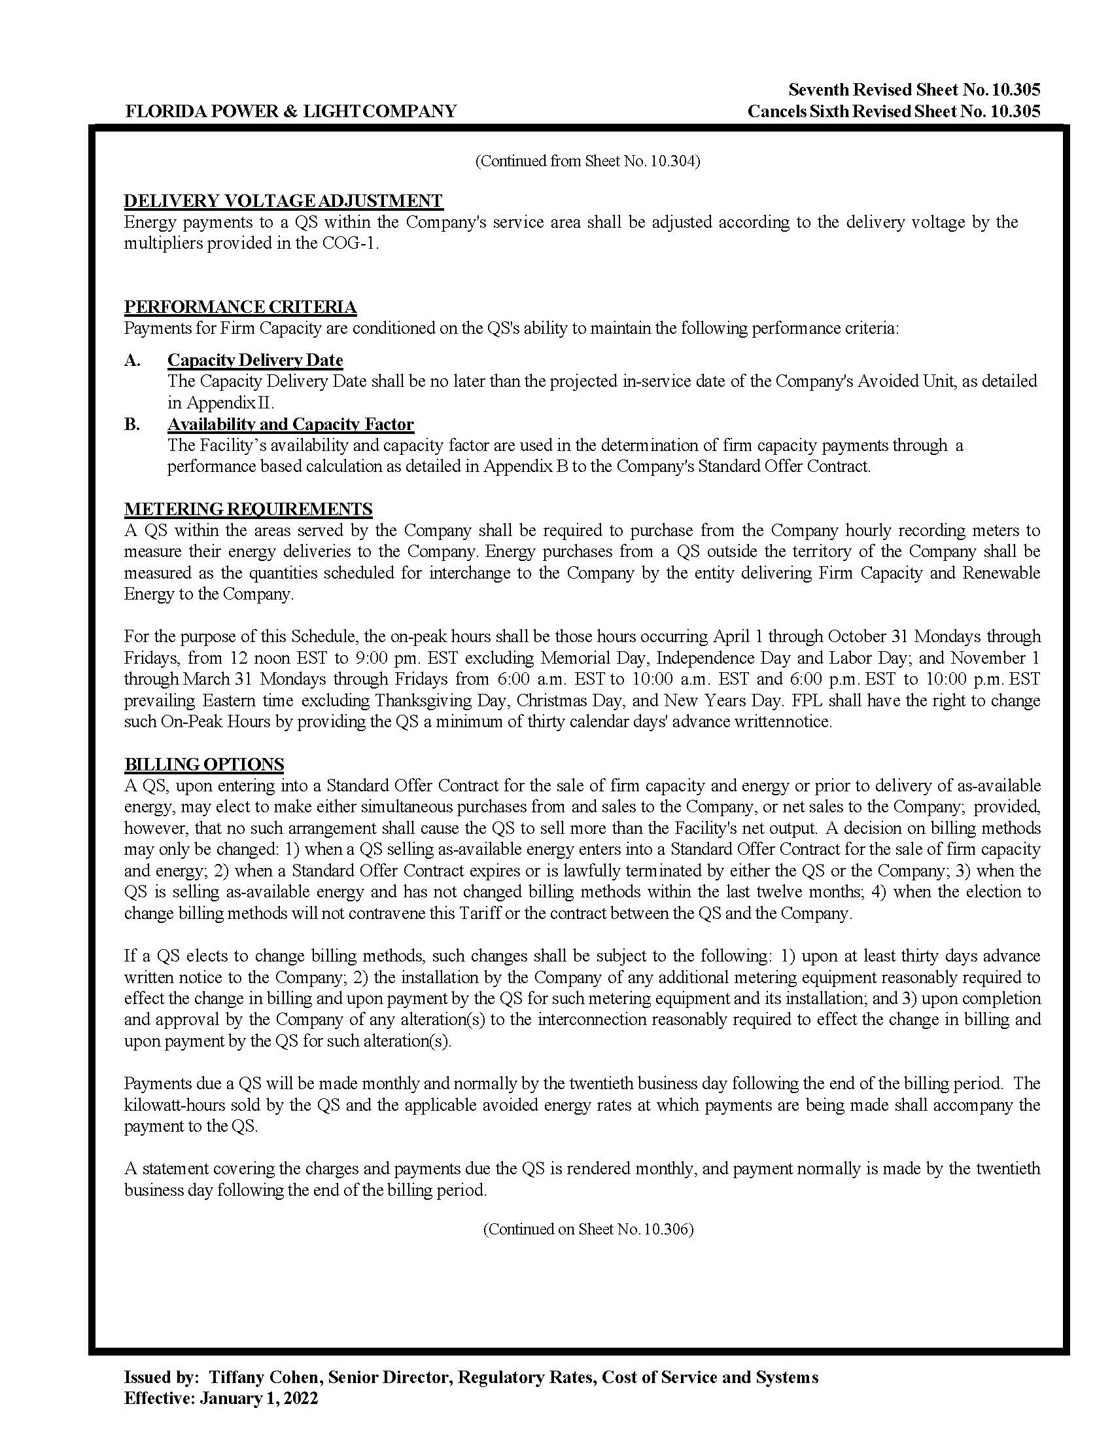

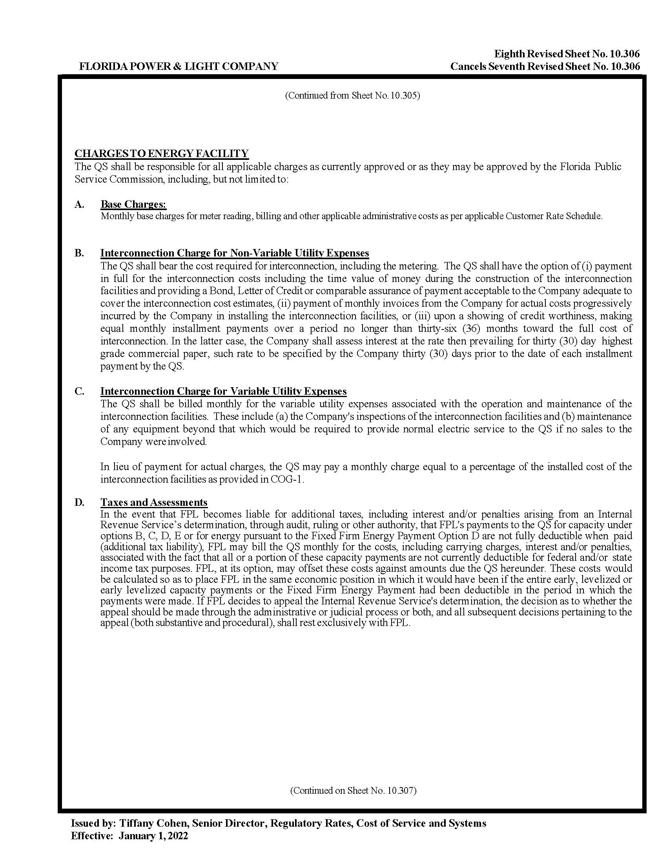

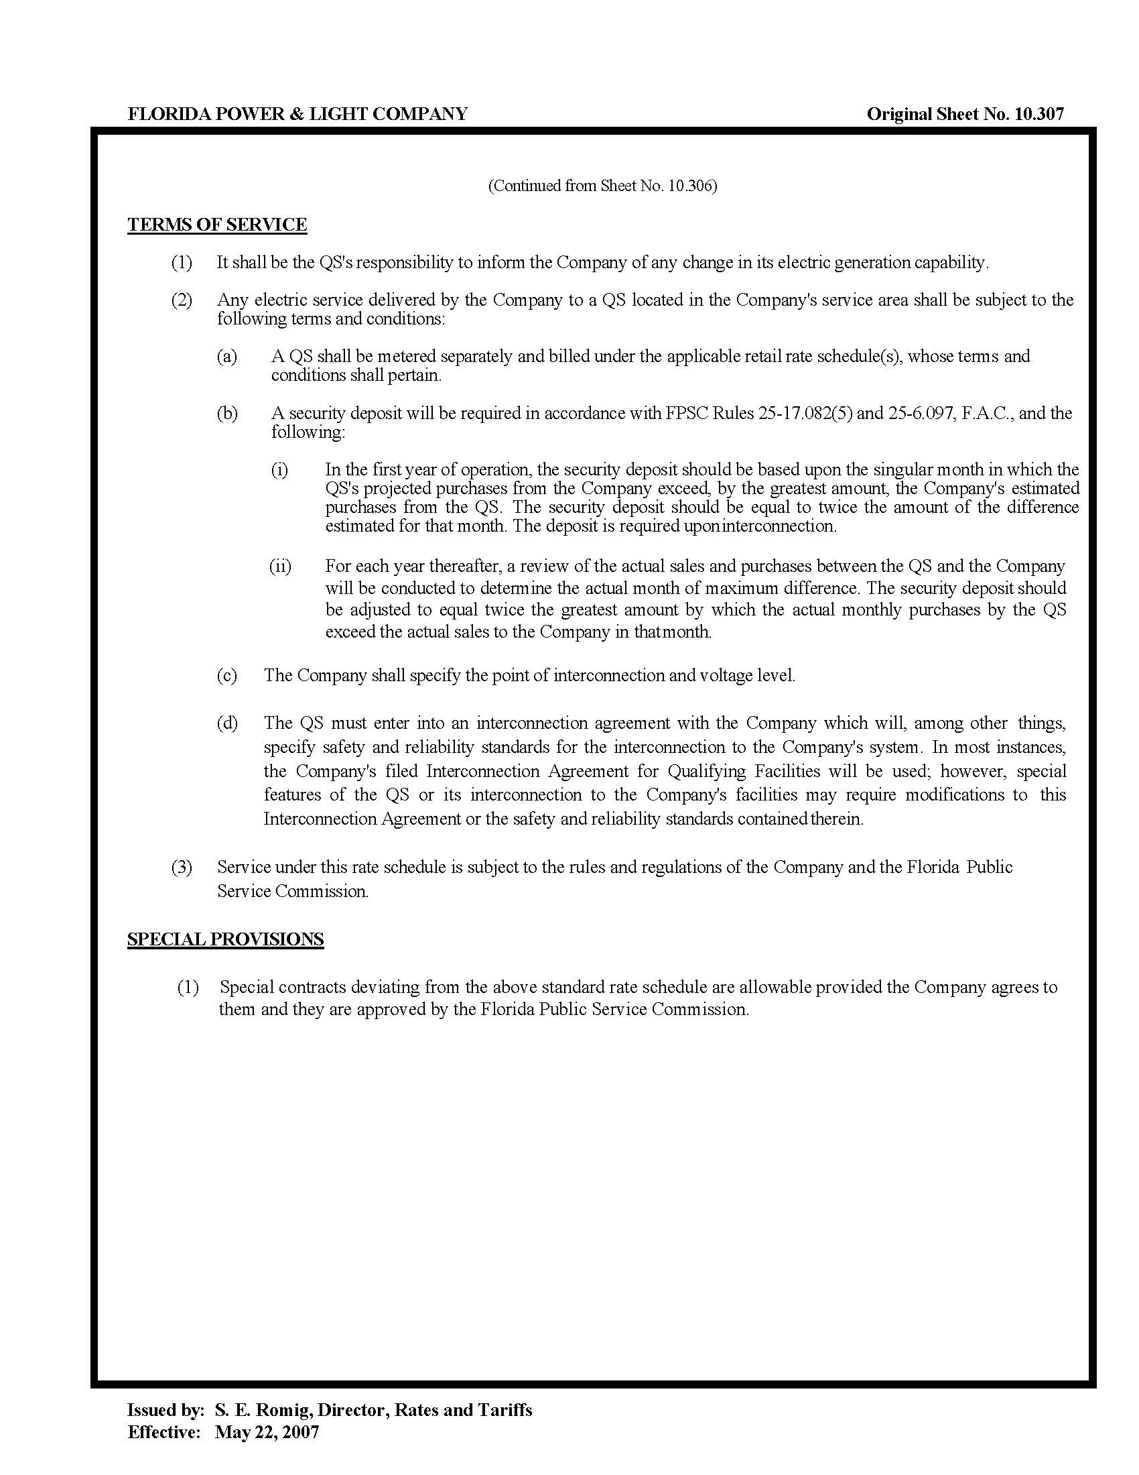

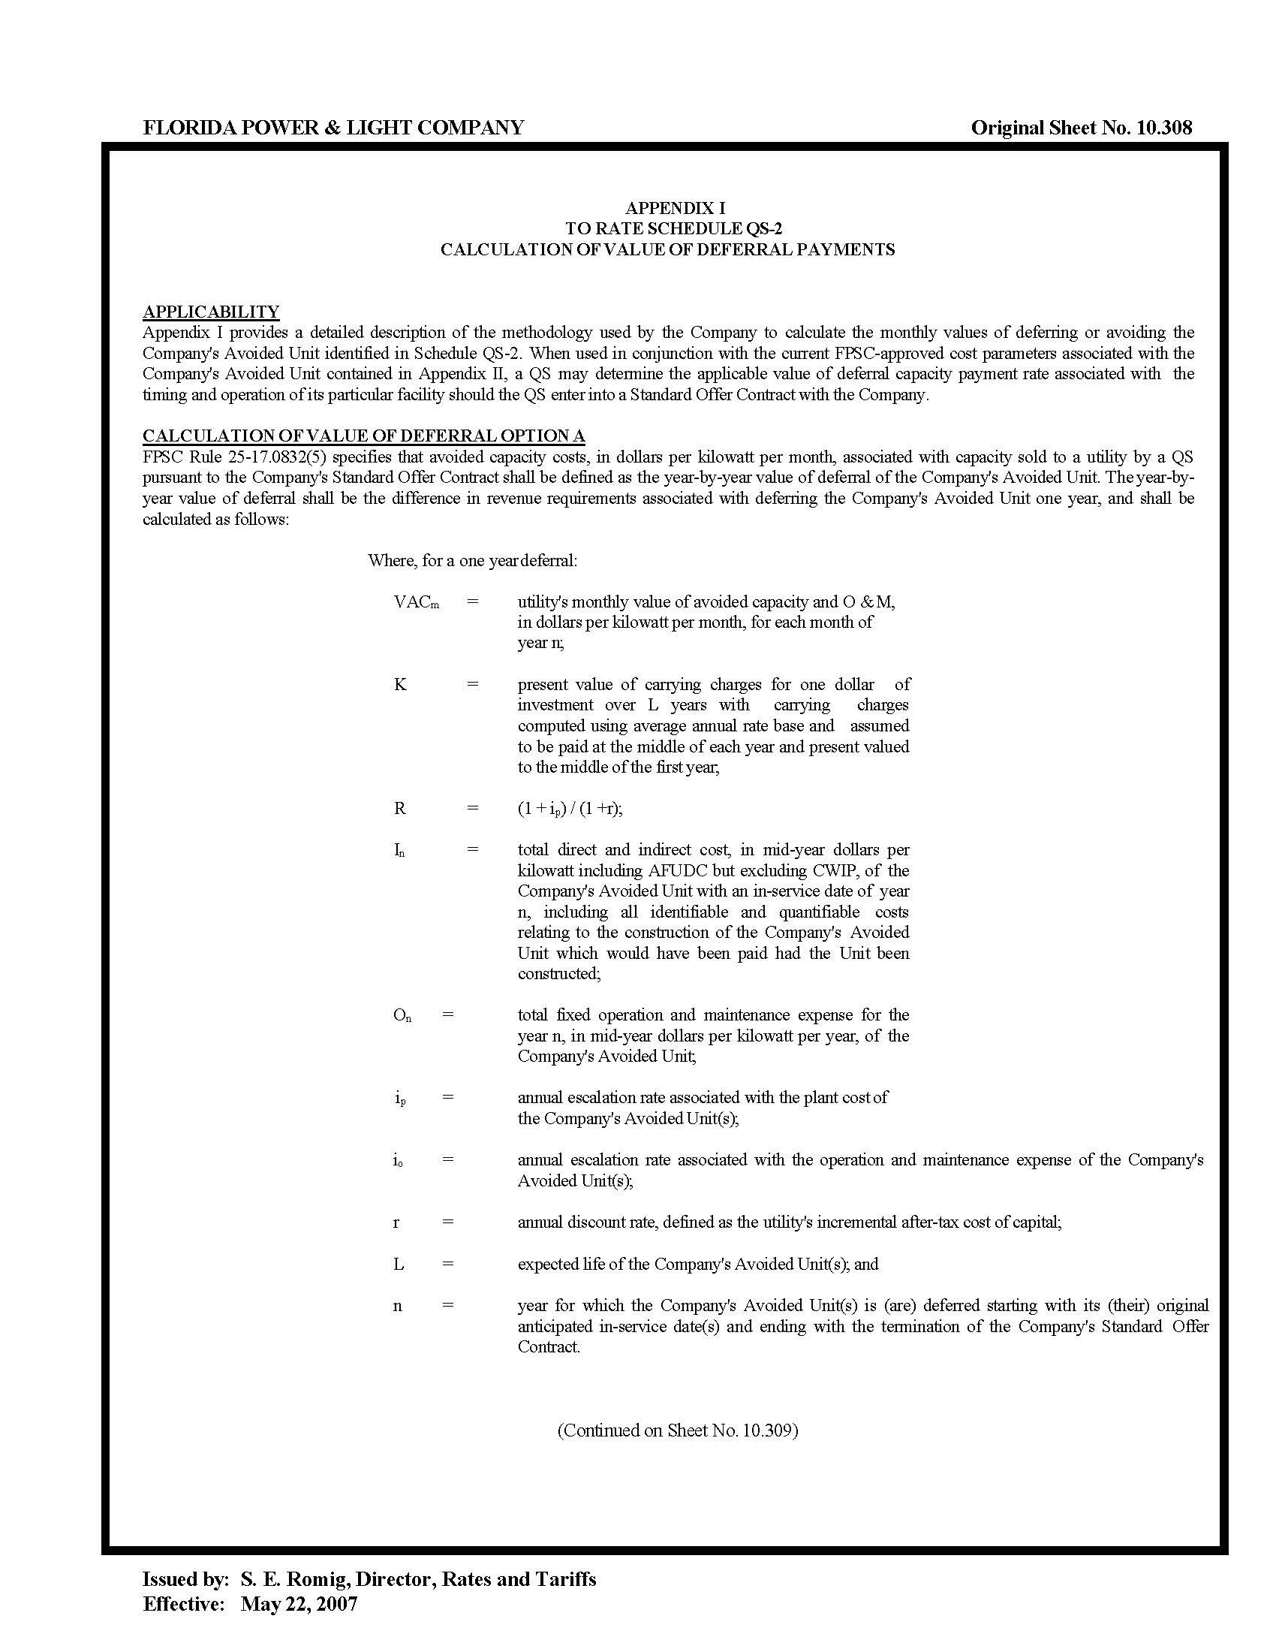

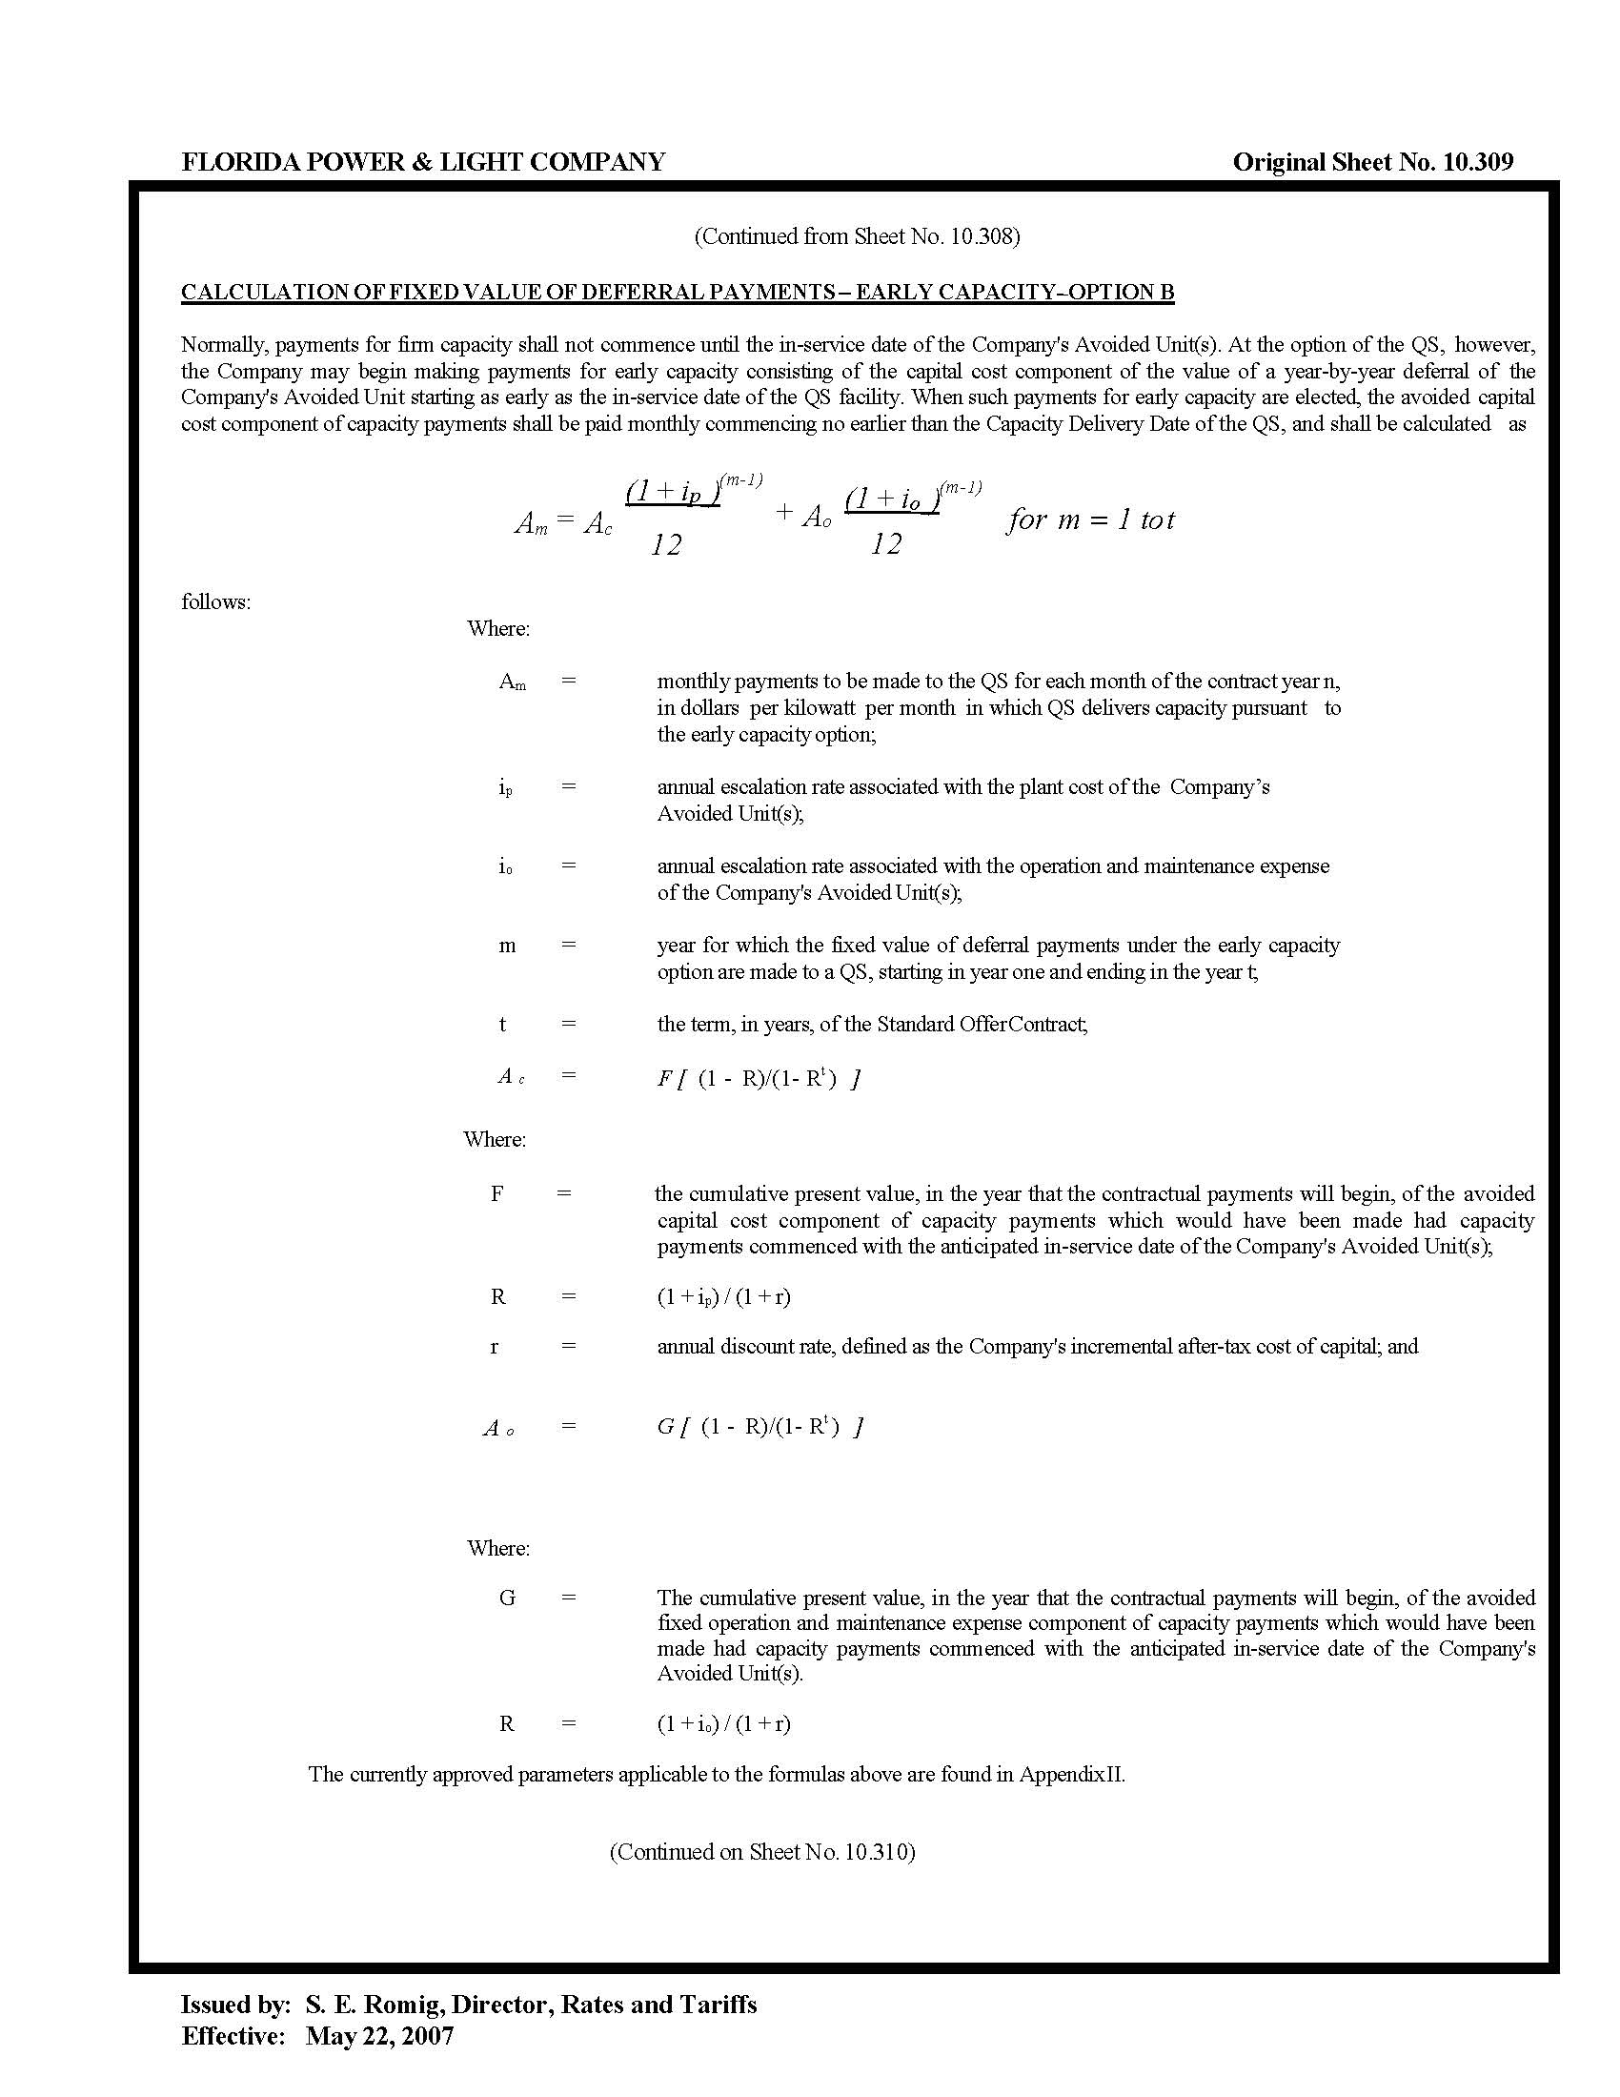

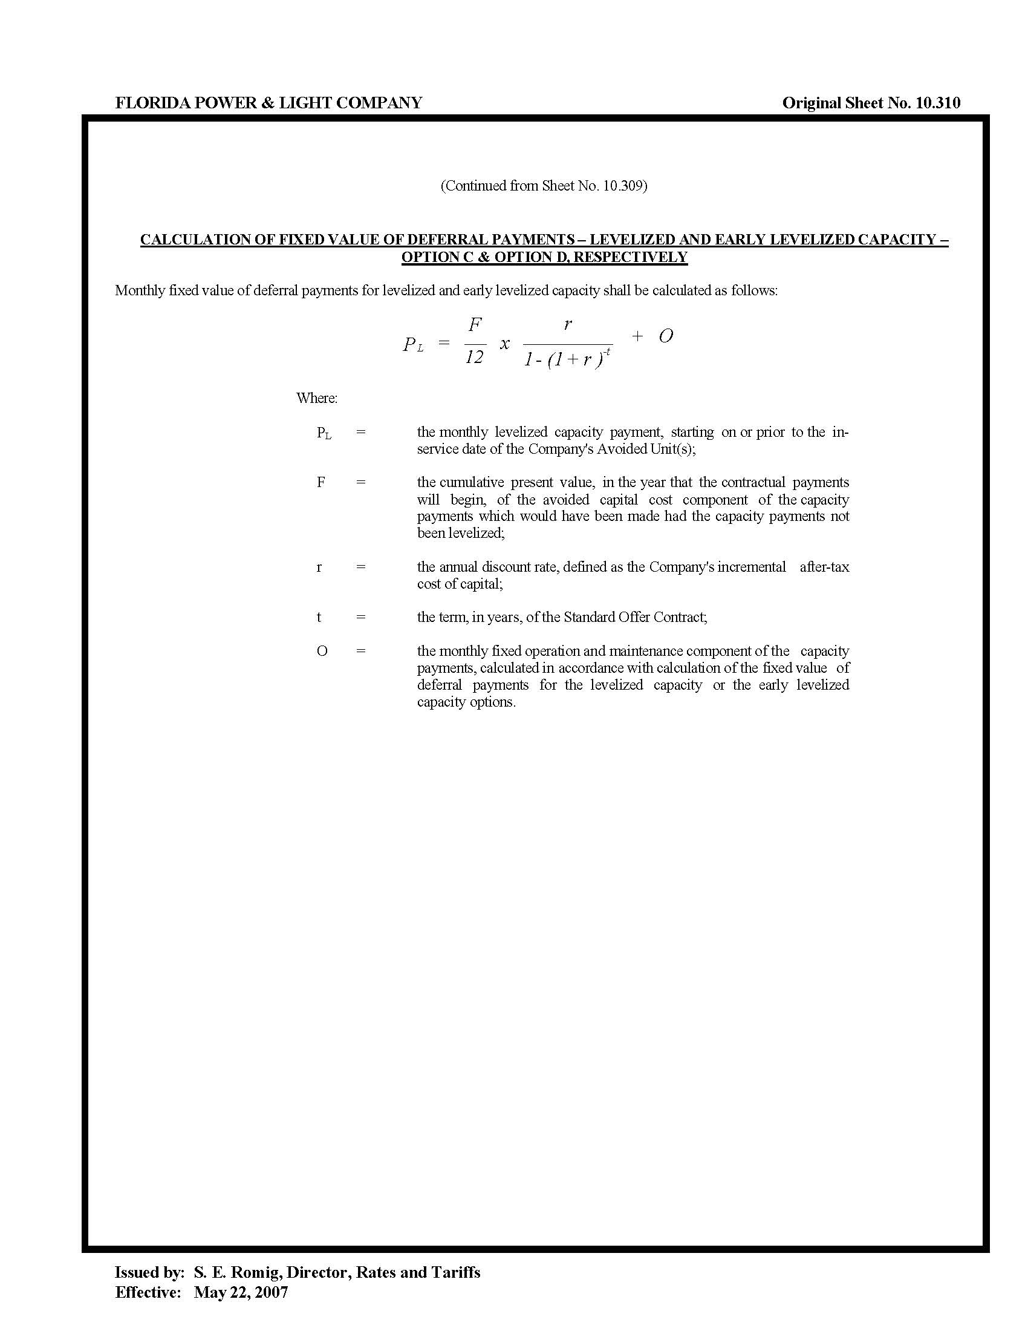

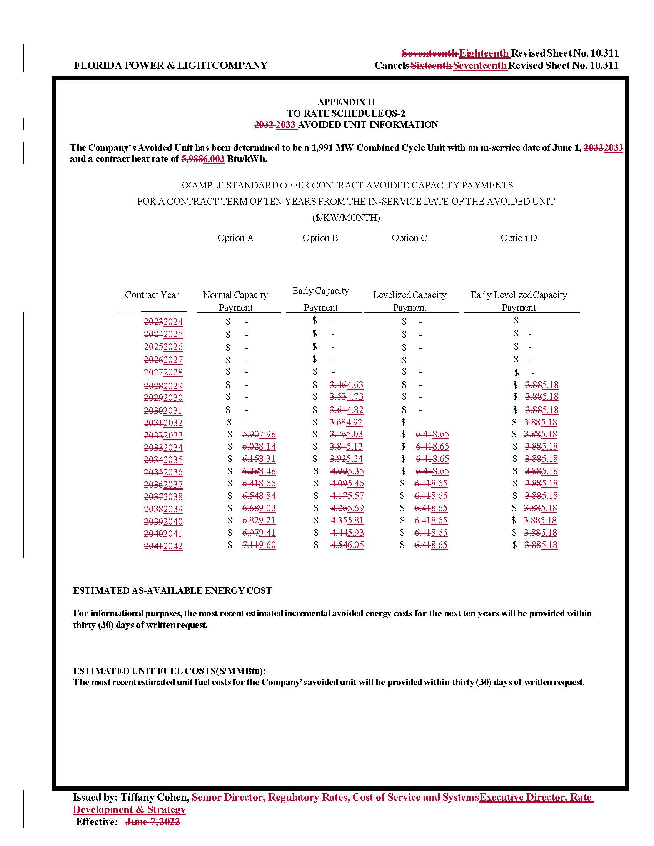

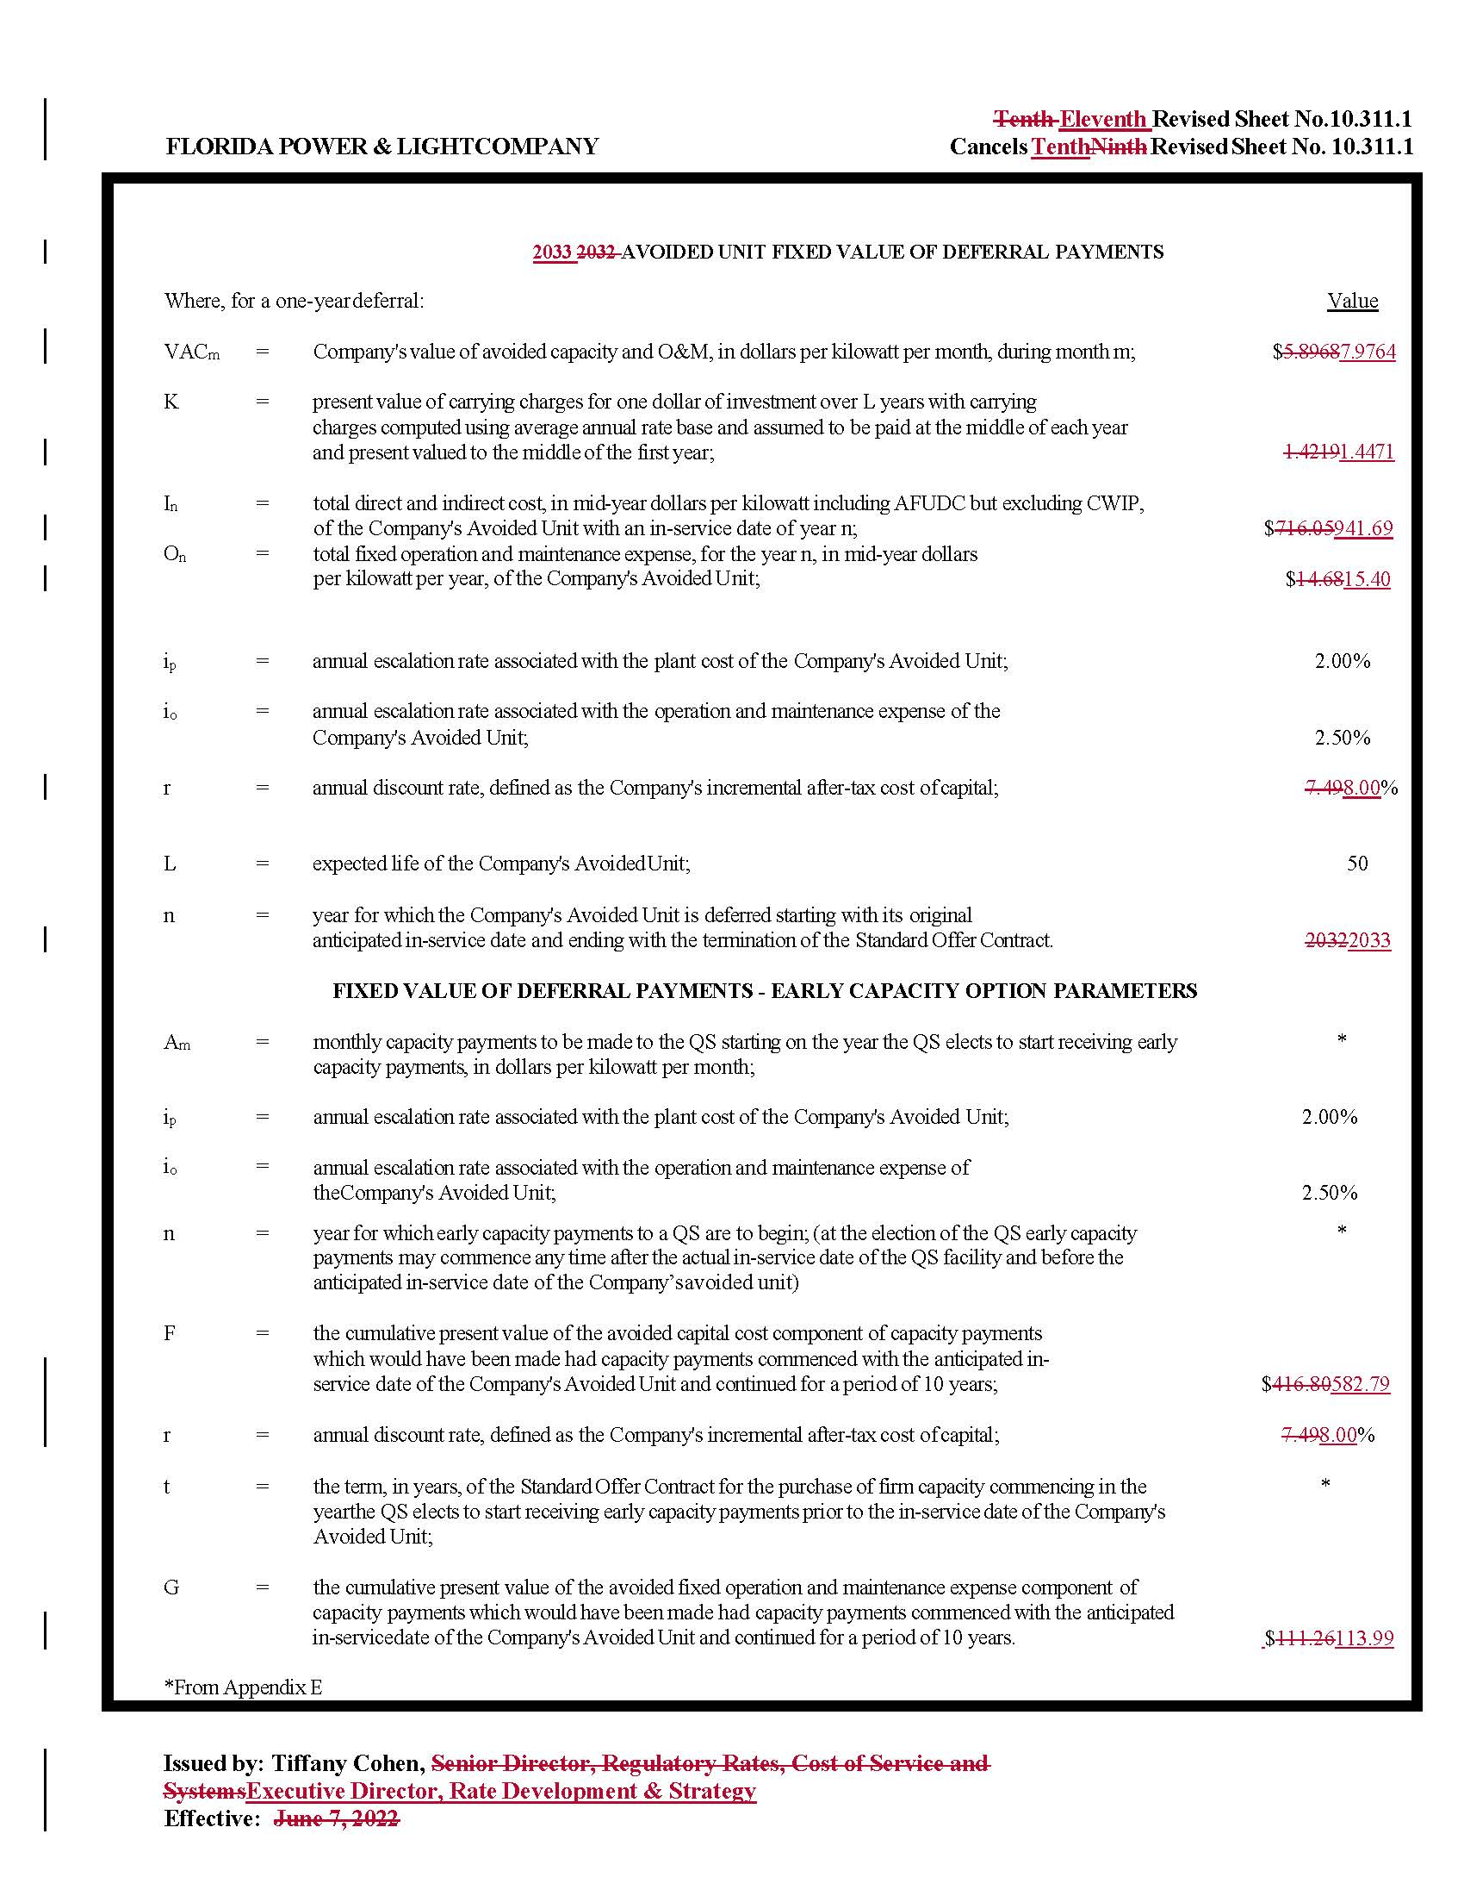

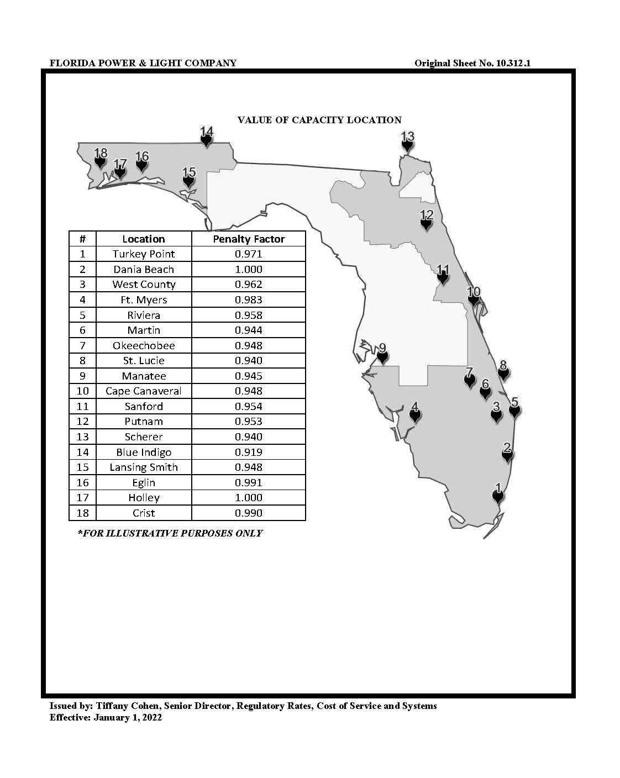

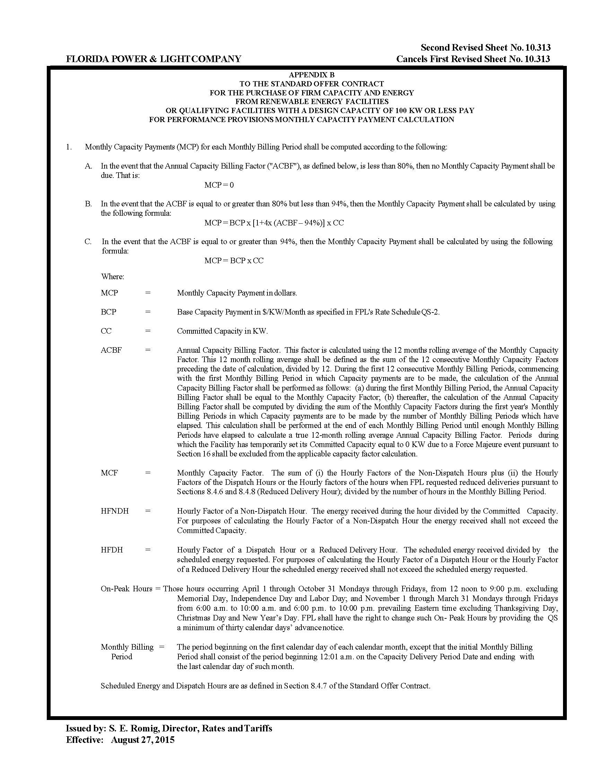

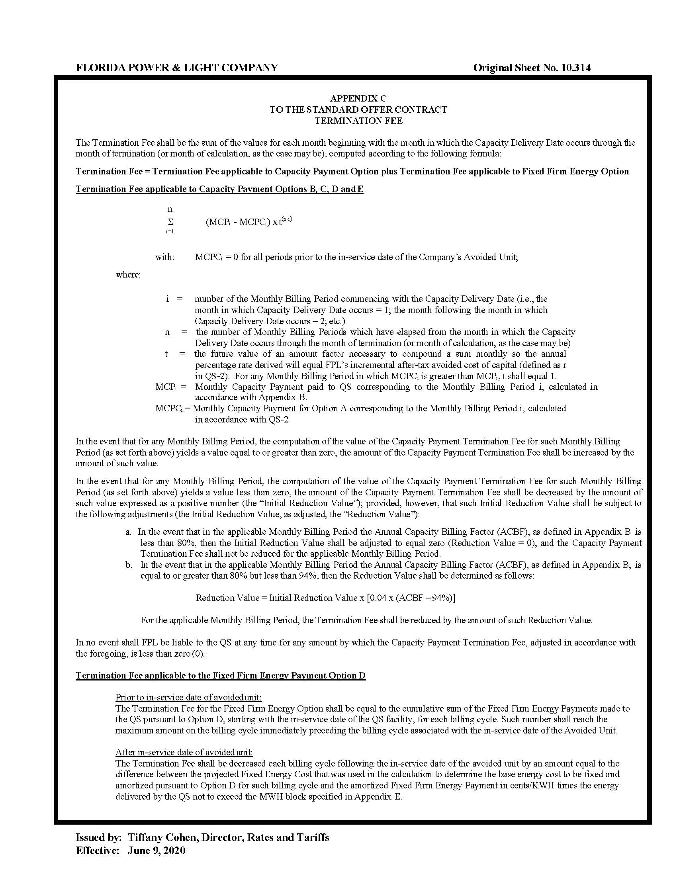

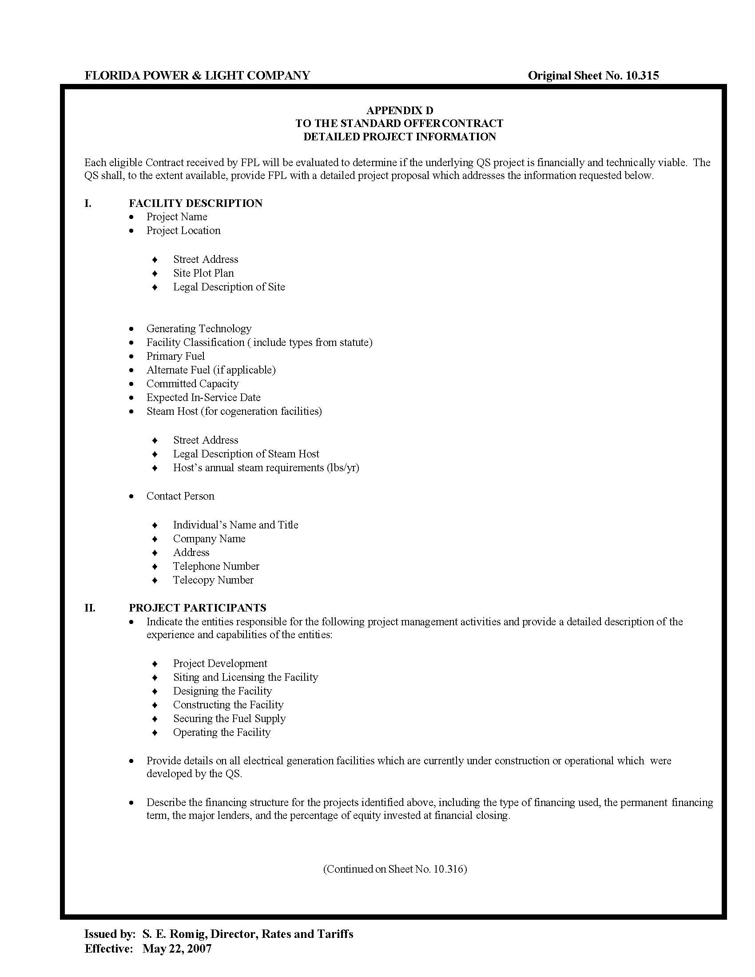

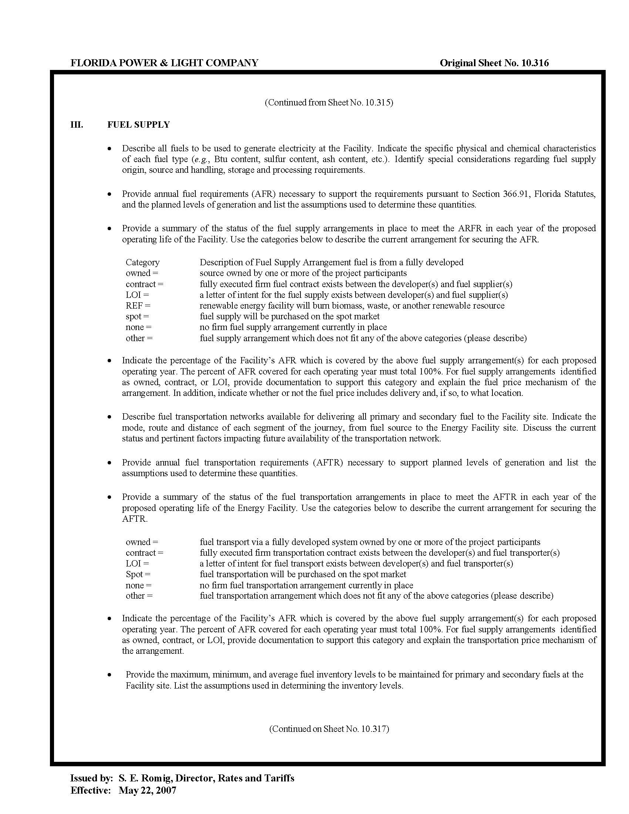

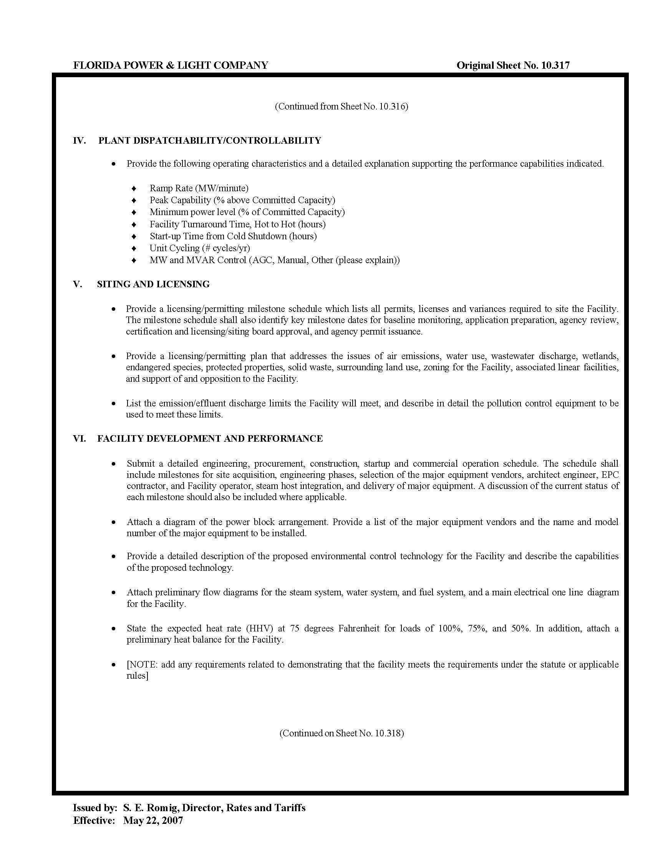

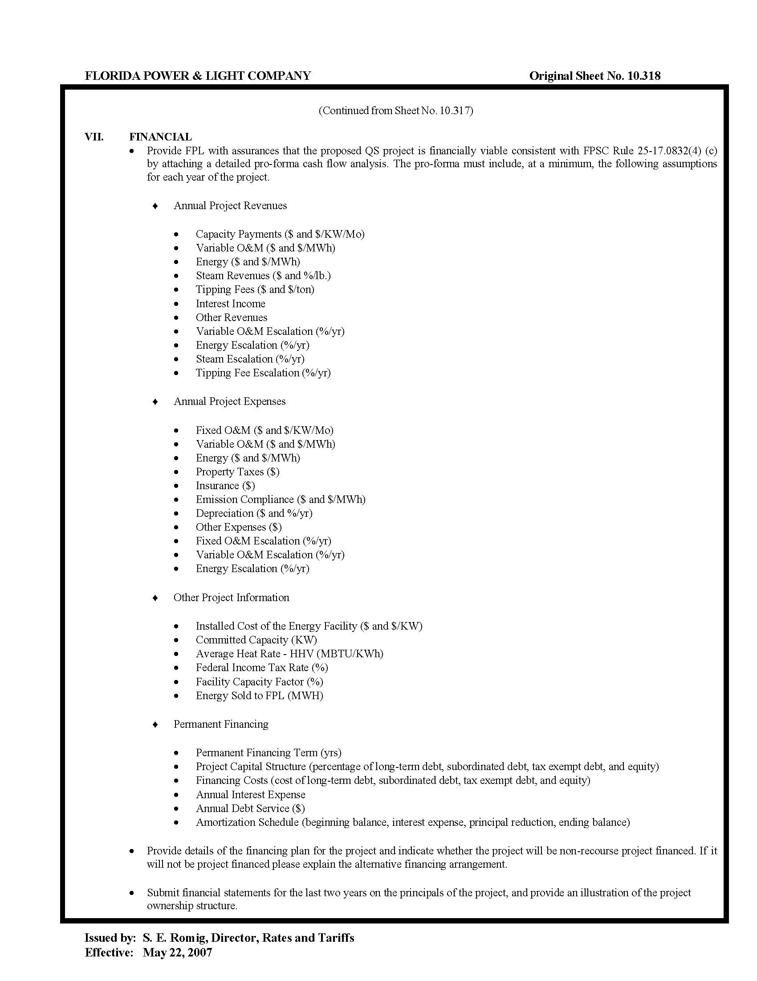

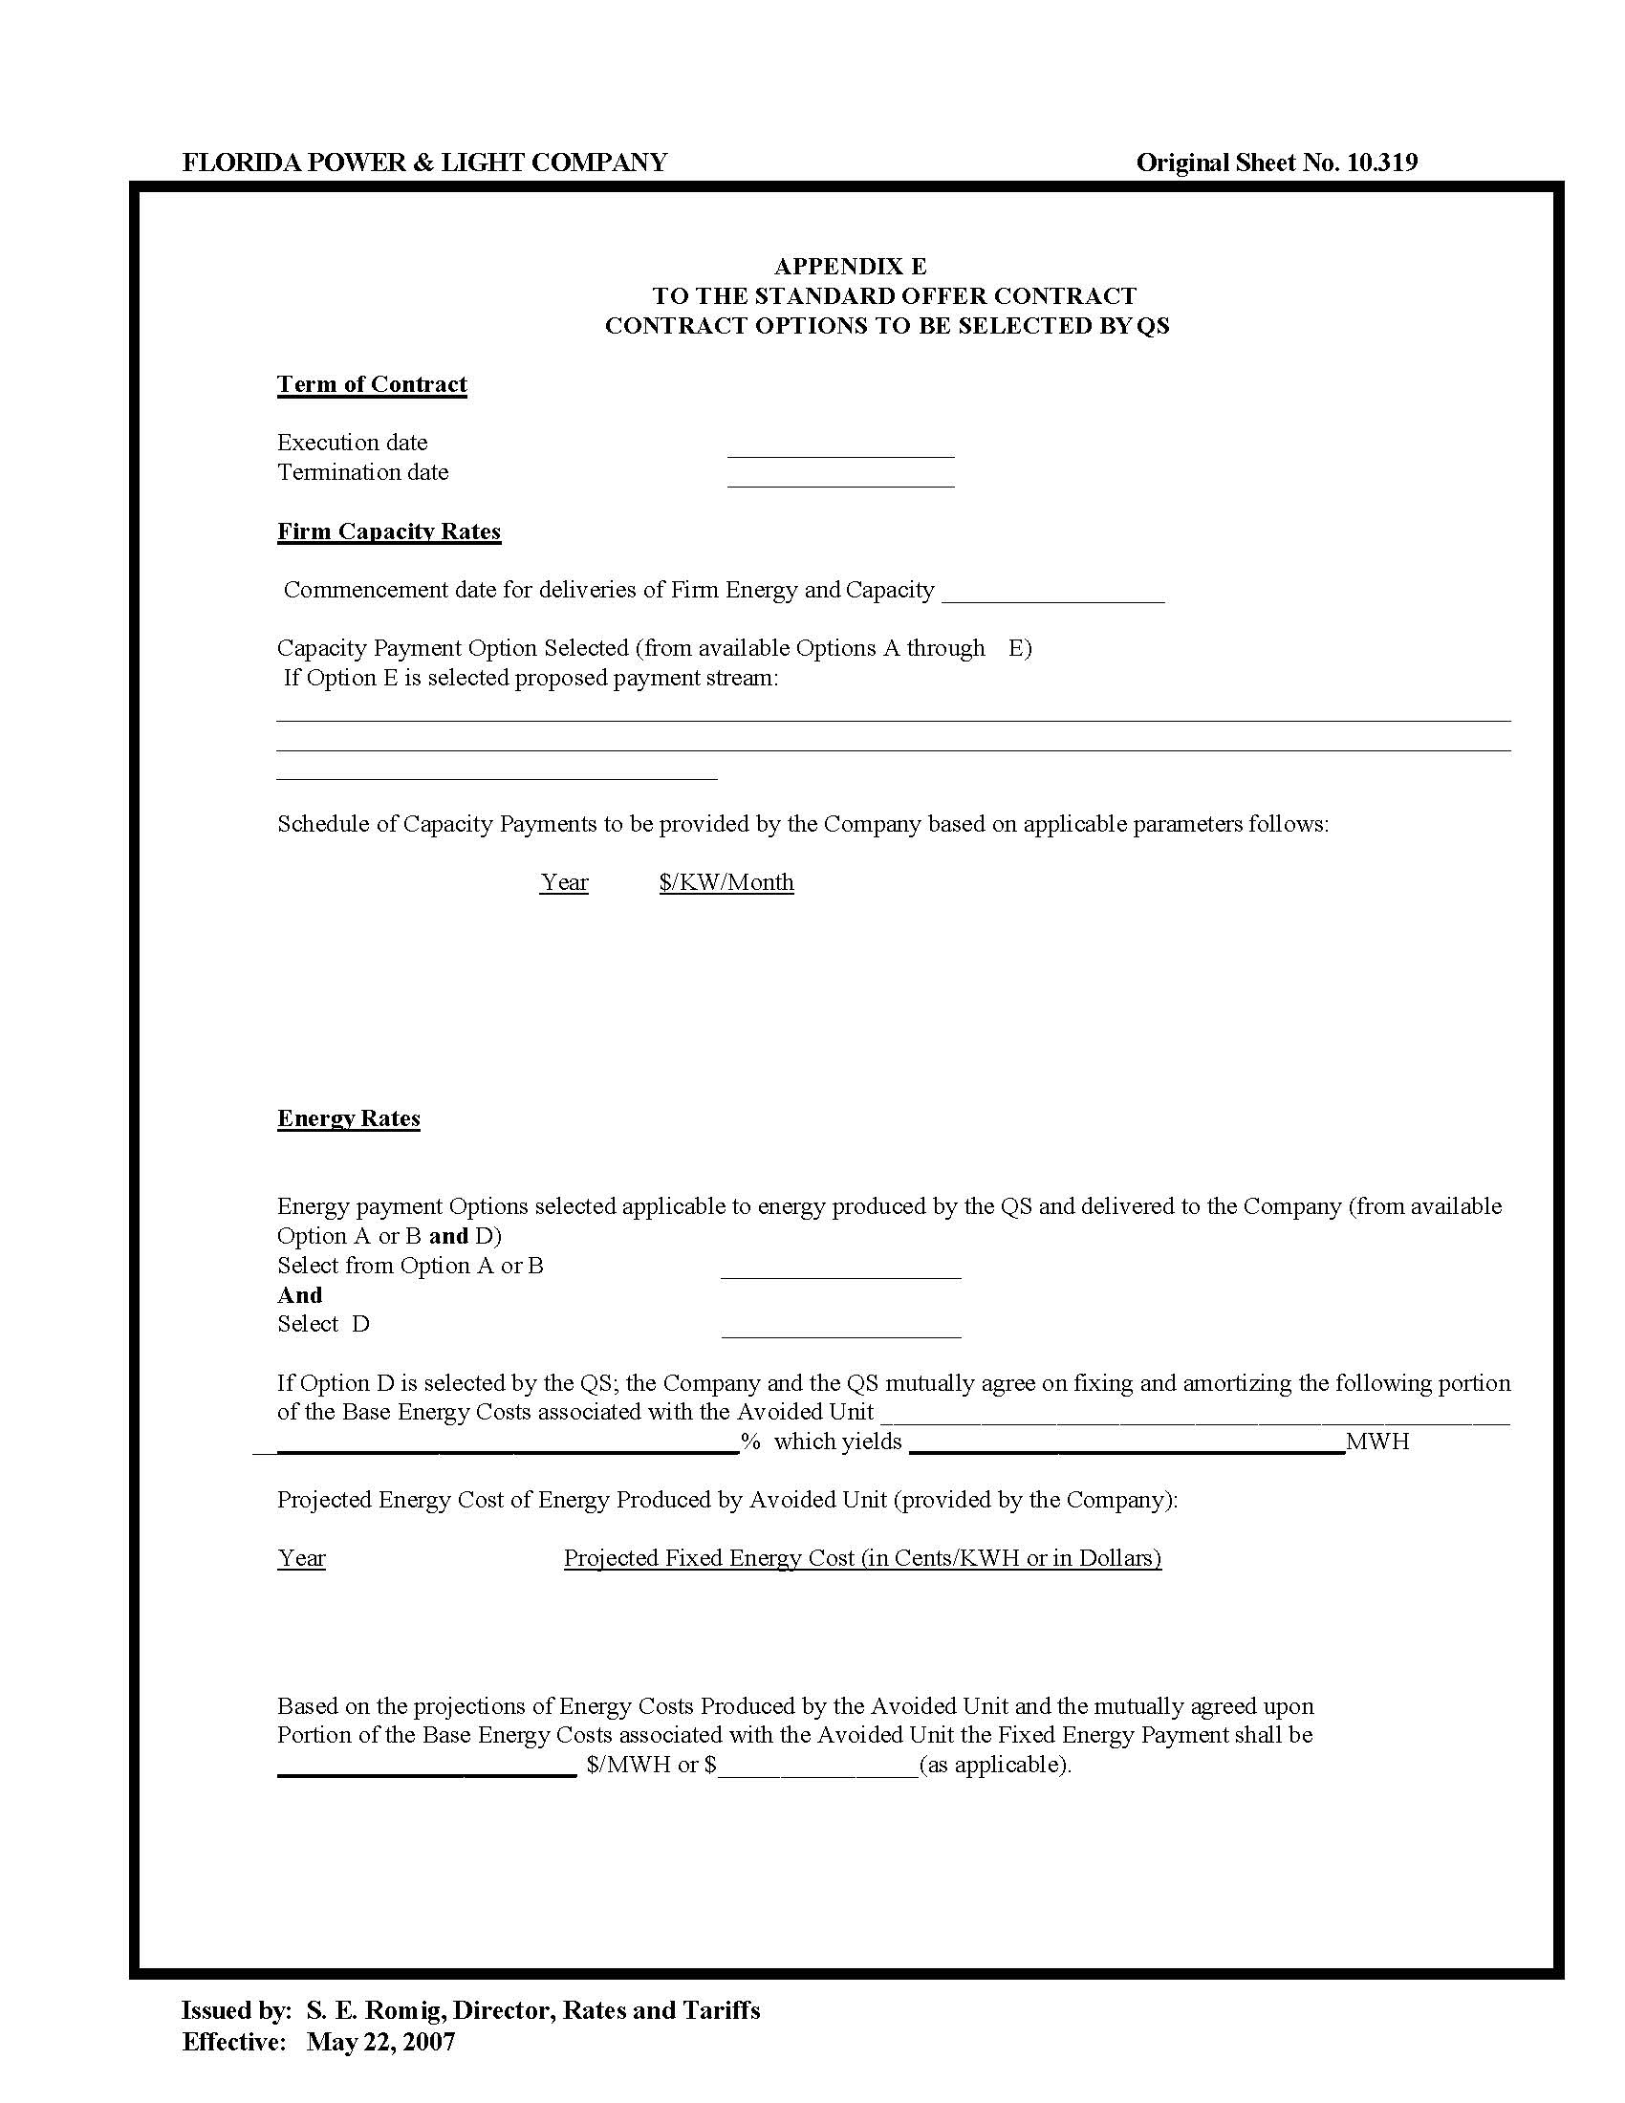

See Order No. PSC-2018-0316-PAA-EQ, issued June 20, 2018, in Docket No. 20180083-EQ, In re: Petition for approval of renewable energy tariff and standard offer contract, by Florida Power & Light Company; Order No. PSC-2020-0212-PAA-EQ, issued June 26, 2020, in Docket No. 20200114-EQ, In re: Florida Power & Light Company’s Petition for Approval of a Renewable Energy Tariff and Standard Offer Contract; Order No. PSC-2020-0213-PAA-EQ, issued June 26, 2020, in Docket No. 20200115-EQ, In re: Petition for approval of new standard offer for purchase of firm capacity and energy from renewable energy facilities or small qualifying facilities and rate schedule QS-2, by Gulf Power Company; and Order No. PSC-2022-0203-PAA-EQ, issued June 9, 2022, in Docket No. 20220072-EQ, In re: Petition for approval of revised standard offer contract and a revised accompanying rate schedule QS-2, by Florida Power & Light Company.
Document No. 03056-2023, filed May 2, 2023, in Docket No. 20230046-EQ.

