BEFORE THE FLORIDA PUBLIC SERVICE COMMISSION

In re: Fuel and purchased power cost recovery clause with generating performance incentive factor. | DOCKET NO. 20230001-EI  ORDER NO. PSC-2023-0185-PCO-EI  ISSUED: June 27, 2023

The following Commissioners participated in the disposition of this matter:

ANDREW GILES FAY, Chairman
ART GRAHAM
GARY F. CLARK
MIKE LA ROSA
GABRIELLA PASSIDOMO

ORDER APPROVING FLORIDA POWER & LIGHT
COMPANY’S MID-COURSE CORRECTION

BY THE COMMISSION:

BACKGROUND

On May 19, 2023, Florida Power & Light Company (FPL or Company), filed for a mid-course correction of its 2023 fuel cost recovery charges (MCC Petition). The Company last filed for a mid-course correction of its fuel charges in March 2023. The Company’s March 2023 mid-course correction was approved at the April 4, 2023 Commission Conference. Following the March 2023 mid-course correction, the Company’s projected fuel-related revenue requirement continued to shift downward. This projected cost shift prompted the Company to file for a subsequent mid-course correction (instant petition) to incorporate the reduction into customer rates.

Mid-Course Corrections

Mid-course corrections are used by this Commission between annual clause hearings whenever costs deviate from revenue by a significant margin. Under Rule 25-6.0424, Florida Administrative Code (F.A.C.), commonly referred to as the “mid-course correction rule,” a utility must notify us whenever it expects to experience an under- or over-recovery of certain service costs greater than 10 percent. The notification of a 10 percent cost-to-revenue variance shall include a petition for mid-course correction to the fuel cost recovery or capacity cost recovery factors, or shall include an explanation of why a mid-course correction is not practical.

FPL’s Petition

In its MCC Petition, the Company currently estimates an additional $359 million reduction of fuel-related costs for the 2023 period relative to its previous estimate. FPL is proposing to apply approximately $256 million of this cost reduction to the time period July 2023 through December 2023, and the remaining approximately $103 million is proposed to be included in its 2024 fuel cost recovery factors. The Company is requesting that its revised fuel cost recovery factors and associated tariff become effective beginning with the July 2023 billing cycle.

We are vested with jurisdiction over the subject matter of this proceeding by the provisions of Chapter 366, Florida Statutes (F.S.), including Sections 366.04, 366.05, and 366.06, F.S.

DECISION

FPL submitted its last mid-course correction petition on March 1, 2023, to address a predicted over-recovery of 2023 fuel costs. At that time, the Company’s 2023 net over-recovery of fuel costs was approximately $494 million. FPL proposed to account for approximately $379 million of the 2023 over-recovery during 2023 (specifically May 2023 through December 2023), and defer the remaining approximate $115 million to be included in 2024. FPL states the purpose of implementing the cost reduction over this period is to partially offset the bill impact associated with the storm restoration costs approved for collection from April 2023 through March 2024 in Docket No. 20230017-EI. Due to the corresponding change in 2023 interest expense by applying the fuel cost recovery factors approved in Order No. PSC-2023-0122-PCO-EI, that balance now amounts to approximately $109 million.

Following its last mid-course correction, the Company has subsequently updated its 2023 fuel cost projection. FPL now projects its 2023 fuel-related costs are approximately $359 million lower than estimated in February 2023. This reduction is primarily due to lower assumed prices for natural gas. The main factors influencing the decline in natural gas prices in 2023 are elevated quantities of natural gas in storage and increased natural gas production compared to previous years.

The Company developed the instant proposed mid-course correction factors using nine months of forecasted sales data (July 2023 through March 2024). The factors proposed in this proceeding are currently contemplated to be charged for six months in 2023. As is typical procedure, later this year newly developed 12-month-applicable factors will be proposed for authorization to begin with the first billing cycle of January 2024.

Projected 2023 Fuel Cost Recovery Position

FPL’s estimated 2023 fuel-related costs have decreased since the filing of its previous mid-course correction in March 2023. The Company now estimates a reduction to its 2023 fuel-related costs in the amount of $358,764,356. The Company proposes to apply $256,094,786 of this amount to rates in 2023, and $102,669,570 to rates in 2024.

The primary factor driving the change in projected 2023 fuel costs is lower than previously assumed pricing for natural gas. The underlying market-based natural gas price data used for the 2023 fuel cost projection was sourced on February 1, 2023. This underlying data was used to produce an estimated average 2023 delivered natural gas cost of $4.95 per million British thermal unit (MMBtu). However, FPL now estimates its average cost of delivered natural gas in 2023 will be $4.38 per MMBtu, representing a decrease of (11.5) percent. The updated cost estimate was based on natural gas futures/prices sourced on May 1, 2023, or roughly three months later than the previous estimate used to set current rates.

We have compared the June through December 2023 commodity-only, i.e., excluding delivery cost, price projection for natural gas underlying the Company’s mid-course correction filing with current market prices. The arithmetic average of FPL’s commodity-only natural gas price projection for the seven-month period June through December 2023 is $2.75 per MMBtu. FPL’s pricing information was sourced on May 1, 2023. Using information sourced on May 26, 2023, we calculate an average natural gas (commodity-only) price of $2.71 per MMBtu for the same seven-month period. The results of this comparison indicate that natural gas prices over the relevant timeframe have decreased since the development of the MCC Petition. However, natural gas prices are continuously subject to market-influencing forces and therefore can be volatile.

Mid-Course Percentage

Using the values shown on Schedule E1-B of the MCC Petition and following the methodology prescribed in Rule 25-6.0424(1)(a), F.A.C., the mid-course percentage is equal to the estimated end-of-period total net true-up, including interest, divided by the current period’s total actual and estimated jurisdictional fuel revenue applicable to period, or ($733,450,360) / $3,502,348,466. This calculation results in a mid-course correction level of (20.9) percent at December 31, 2023.

Fuel Factor

FPL’s currently-authorized annual levelized fuel factor is 3.526 cents per kilowatt-hour (kWh). The Company is requesting to decrease its currently-approved 2023 annual levelized fuel factor beginning July 2023 to 3.142 cents per kWh, or by (10.9) percent.

Bill Impacts

In Tables 1 and 2 below, the bill impacts of the mid-course correction proposal on typical residential customers using 1,000 kWh of electricity a month in FPL’s Peninsular and Northwest (former Gulf Power Company) service territories are shown.
Table 1
FPL Peninsular Service Territory
Monthly Residential Billing Detail for the First 1,000 kWh
Invoice Component | Currently-Authorized Charges  June 2023  ($) | Proposed Charges  Beginning  July  2023  ($) | Difference  ($) | Difference  (%)
Base Charge | $80.11 | $80.11 | $0.00 | 0.0%
Fuel Charge | 32.24 | 28.39 | (3.85) | (11.9%)
Conservation Charge | 1.22 | 1.22 | 0.00 | 0.0%
Capacity Charge | 2.12 | 2.12 | 0.00 | 0.0%
Environmental Charge | 3.12 | 3.12 | 0.00 | 0.0%
Storm Protection Plan Charge | 3.82 | 3.82 | 0.00 | 0.0%
Storm Restoration Surcharge | 15.30 | 15.30 | 0.00 | 0.0%
Transition Rider | (1.58) | (1.58) | 0.00 | 0.0%
Gross Receipts Tax and Regulatory Assessment Fee | 3.60 | 3.50 | (0.10) | (2.8%)
Total | $139.95 | $136.00 | ($3.95) | (2.8%)
Source: Document No. 03296-2023.

FPL’s currently-authorized total residential charge for the first 1,000 kWh of usage for June 2023 is $139.95. If the Company’s mid-course correction proposal is approved, then the current total residential charge for the first 1,000 kWh of usage beginning in July will be $136.00, a decrease of approximately (2.8) percent. Concerning non-residential customers, FPL reported that bill decreases based on average levels of usage for small-sized commercial customers would range from approximately (2.8) to (3.6) percent, (3.6) percent for medium-sized commercial customers, (3.9) percent for large-sized commercial customers, and (6.4) percent for industrial customers.
Table 2
FPL Northwest Service Territory
Monthly Residential Billing Detail for the First 1,000 kWh
Invoice Component | Currently-Authorized Charges  June  2023  ($) | Proposed Charges  Beginning  July  2023  ($) | Difference  ($) | Difference  (%)
Base Charge | $80.11 | $80.11 | $0.00 | 0.0%
Fuel Charge | 32.24 | 28.39 | (3.85) | (11.9%)
Conservation Charge | 1.22 | 1.22 | 0.00 | 0.0%
Capacity Charge | 2.12 | 2.12 | 0.00 | 0.0%
Environmental Charge | 3.12 | 3.12 | 0.00 | 0.0%
Storm Protection Plan Charge | 3.82 | 3.82 | 0.00 | 0.0%
Storm Restoration Surcharge | 15.30 | 15.30 | 0.00 | 0.0%
Transition Rider | 16.85 | 16.85 | 0.00 | 0.0%
Gross Receipts Tax and Regulatory Assessment Fee | 4.08 | 3.98 | (0.10) | (2.5%)
Total | $158.86 | $154.91 | ($3.95) | (2.5%)
Source: Document No. 03296-2023.

FPL’s currently-authorized Northwest total residential charge for the first 1,000 kWh of usage for June 2023 is $158.86. If the Company’s mid-course correction proposal is approved, the current total Northwest residential charge for the first 1,000 kWh of usage beginning in July will be $154.91, a decrease of approximately (2.5) percent. Concerning non-residential customers, FPL reported that bill decreases based on average levels of usage for small-sized commercial customers would range from approximately (2.4) to (3.2) percent, and (3.2) percent for medium-size commercial customers, and (3.4) percent for large-size commercial customers. A figure associated with an industrial class for the Northwest service territory was not identified.

Based upon the above analysis, we find that FPL’s MCC Petition indicates a need for its fuel recovery factors to be revised. The Company’s currently projected 2023 fuel-related costs have been reduced by $358,764,356. The Company proposes to account for $256,094,786 of this fuel cost reduction in the current period and defer $102,669,570 to 2024.

Therefore, we approve adjustments to FPL’s 2023 fuel cost recovery factors decreasing the 2023 factor by $256,094,786 and deferring a further reduction of $102,669,570 until 2024.

Effective Date

Over the last 20 years in the Fuel Clause docket, we have considered the effective date of rates and charges of revised fuel cost recovery factors on a case-by-case basis. We have approved fuel cost recovery factor rate decreases effective sooner than the next full billing cycle after the date of our vote with the range between the vote and the effective date being from 25 to 2 days. The rationale for that action is that it was in the customers’ best interest to implement the lower rate as soon as possible.

In its MCC Petition, FPL proposes to lower its 2023 fuel factors, beginning with the July 2023 billing cycle. In the instant case, there are 20 days between our vote on June 13, 2023, and the beginning of FPL’s July 2023 billing cycle (July 3, 2023).

Concerning advisement of the instant request, the Company has engaged in numerous outreach efforts regarding the potential bill impacts of this proceeding. Specifically, FPL issued a press release on May 19, 2023, informing its customers of the MCC proposal. Also on May 19, the Company informed its customers of the potential adjustments related to the mid-course correction through a web-based billing information portal titled “2023 Bills.” The Company also notified major business and governmental accounts/customers on May 22, 2023. General notification, or “billing inserts,” began to be added to customer bills on May 22nd as well.

Given that adequate notice has been given to its customers and that this request is for a rate reduction, we find that the fuel cost recovery factors, as shown on Appendix A, shall become effective with the first billing cycle of July 2023.

Therefore, it is

ORDERED by the Florida Public Service Commission that adjustments to Florida Power & Light Company’s fuel cost recovery factors shall be made to reduce its currently-approved 2023 fuel cost recovery factors by $256,094,786 and deferring a further reduction of $102,669,570 until 2024. It is further

ORDERED that the fuel cost recovery factors, as shown on Appendix A to this order, shall become effective with the first billing cycle of July 2023. It is further

ORDERED that the fuel and purchased power cost recovery clause docket is an on-going proceeding and shall remain open.

By ORDER of the Florida Public Service Commission this 27th day of June, 2023.

/s/ Adam J. Teitzman

ADAM J. TEITZMAN
Commission Clerk
Florida Public Service Commission
2540 Shumard Oak Boulevard
Tallahassee, Florida 32399
(850) 413-6770
www.floridapsc.com

Copies furnished: A copy of this document is provided to the parties of record at the time of issuance and, if applicable, interested persons.

SBr

NOTICE OF FURTHER PROCEEDINGS OR JUDICIAL REVIEW

The Florida Public Service Commission is required by Section 120.569(1), Florida Statutes, to notify parties of any administrative hearing or judicial review of Commission orders that is available under Sections 120.57 or 120.68, Florida Statutes, as well as the procedures and time limits that apply. This notice should not be construed to mean all requests for an administrative hearing or judicial review will be granted or result in the relief sought.

Mediation may be available on a case-by-case basis. If mediation is conducted, it does not affect a substantially interested person's right to a hearing.

Any party adversely affected by this order, which is preliminary, procedural or intermediate in nature, may request: (1) reconsideration within 10 days pursuant to Rule 25-22.0376, Florida Administrative Code; or (2) judicial review by the Florida Supreme Court, in the case of an electric, gas or telephone utility, or the First District Court of Appeal, in the case of a water or wastewater utility. A motion for reconsideration shall be filed with the Office of Commission Clerk, in the form prescribed by Rule 25-22.0376, Florida Administrative Code. Judicial review of a preliminary, procedural or intermediate ruling or order is available if review of the final action will not provide an adequate remedy. Such review may be requested from the appropriate court, as described above, pursuant to Rule 9.100, Florida Rules of Appellate Procedure.

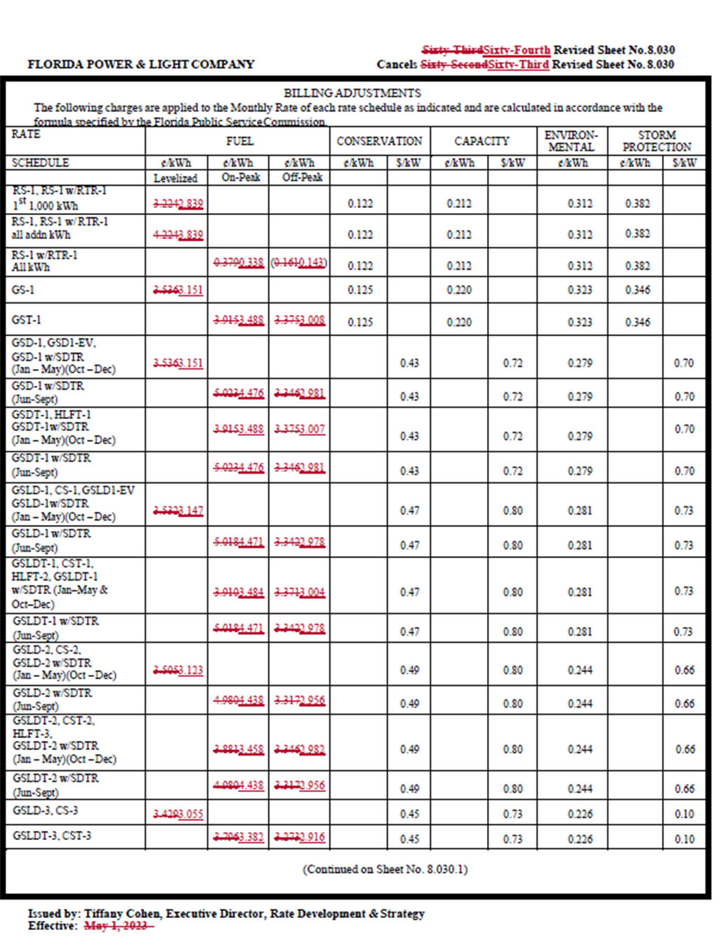
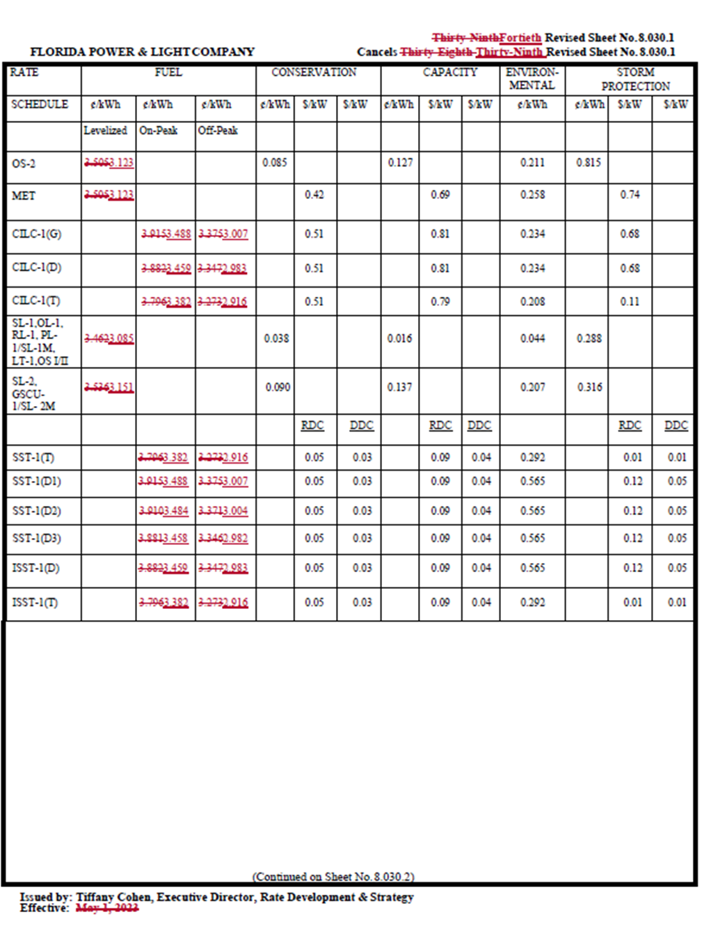

Document No. 03296-2023.
Order No. PSC-2023-0122-PCO-EI, issued April 11, 2023, Docket No. 20230001-EI, In re: Fuel and purchased power cost recovery clause with generating performance incentive factor.
Document No. 01638-2023.
Order No. PSC-2023-0110-PCO-EI, issued March 23, 2023, in Docket No. 20230017-EI, In re: Petition for limited proceeding for recovery of incremental storm restoration costs related to Hurricanes Ian and Nicole, by Florida Power & Light Company.
Document No. 03382-2023.
May 2023 U.S. Energy Information Administration Short-Term Energy Outlook, https://www.eia.gov/outlooks/steo/pdf/steo_full.pdf
Document No. 01638-2023.
Document No. 03296-2023.
Document No. 01638-2023.
Id.
Document No. 03296-2023.
Id.
We obtained its natural gas pricing information from the CME Group Inc. CME Group pricing information with respect to natural gas can be located through the following web address: https://www.cmegroup.com/markets/energy/natural-gas/natural-gas.quotes.html
Document No. 03382-2023.
Document No. 03296-2023, Schedule E1-B.
By Order No. PSC-2023-0108-PCO-EI, FPL received authorization to defer ($1,201,340,636) of its 2022 fuel cost under-recovery to 2024. Additionally, through Order No. PSC-2023-0122-PCO-EI, FPL received authorization to defer $115,279,411 of its 2023 fuel cost over-recovery to 2024. Accounting for these deferrals, the mid-course percentage is equal to $352,610,865/$3,502,348,466, or 10.1 percent.
Document No. 03296-2023.
Order No. PSC-2023-0122-PCO-EI.
Document No. 03382-2023.
Order No. PSC-2023-0122-PCO-EI.
Document No. 03382-2023.
Order No. PSC-2023-0122-PCO-EI.
Document No. 03382-2023.
Id.

