State of Florida   |  | Public Service Commission  Capital Circle Office Center ● 2540 Shumard Oak Boulevard  Tallahassee, Florida 32399-0850  -M-E-M-O-R-A-N-D-U-M-
DATE: | October 27, 2023
TO: | Office of Commission Clerk (Teitzman)
FROM: | Division of Accounting and Finance (D. Buys, Mason, McGowan, Norris)  Division of Economics (Hampson)  Office of the General Counsel (M. Thompson, Sandy)
RE: | Docket No. 20230019-EI – Petition for recovery of costs associated with named tropical systems during the 2019-2022 hurricane seasons and replenishment of storm reserve, by Tampa Electric Company.
AGENDA: | 11/9/23 – Regular Agenda – Interested Persons May Participate
COMMISSIONERS ASSIGNED: |  |  | All Commissioners
PREHEARING OFFICER: |  |  | Graham
CRITICAL DATES: |  |  | None
SPECIAL INSTRUCTIONS: |  |  | None

Case Background
On January 23, 2023, Tampa Electric Company’s (TECO or Company) filed a petition for a limited proceeding seeking authority to implement a storm restoration recovery charge to recover $130.9 million for the incremental restoration costs related to Tropical Storms Alberto, Nestor, and Eta, and Hurricanes Dorian, Elsa, Ian, and Nicole (Collectively, "the storms"), the implementation of the GPS software ARCOS, as well as the replenishment of its storm reserve. Included in the $130.9 million is interest charged for Hurricanes Ian and Nicole. TECO filed its petition pursuant to the provisions of the 2021 Stipulation and Settlement Agreement (2021 Settlement).
By order issued March 27, 2023, the Commission approved TECO’s tariff revisions and an interim storm restoration recovery charge, effective with the first billing cycle of April 2023 through March 2024, subject to a final true-up.
On August 16, 2023 the Company filed a supplemental petition requesting an amended interim storm surcharge to reflect an increase of $3.6 million in incremental storm costs, for a total of $134.5 million, based on updated actual and accrued costs. TECO also requested to modify the 12-month recovery period approved by the Commission, to extend cost recovery through the last billing cycle of December 2024. The current recovery period approved in Order No. PSC-2023-0116-PCO-EI was for the period April 2023 through the last billing cycle of March 2024.
On September 29, 2023, TECO filed a petition for approval of final/actual storm restoration costs and the associated true-up process related to the Storms. A formal evidentiary hearing has been scheduled for May 1-2, 2024.
The Commission has jurisdiction over this matter pursuant to Sections 366.04, 366.05, 366.06, and 366.076, Florida Statutes.

Discussion of Issues

Issue 1:
Should the Commission authorize TECO to implement an amended interim storm restoration recovery charge and modified recovery period?

Recommendation:
Yes. The Commission should authorize TECO to implement an amended interim storm restoration recovery charge, subject to refund, and modified recovery period. After the actual costs are reviewed for prudence and reasonableness, and are compared to the actual amount recovered through the interim storm restoration recovery charge, a determination will be made whether any over/under recovery has occurred. The disposition of any over or under recovery, and associated interest, will be considered by the Commission at a later date. (Mason)

Staff Analysis:
As stated in the Case Background, TECO filed a supplemental petition requesting an amended interim storm surcharge to reflect an increase of $3.6 million in incremental storm costs, for a total of $134.5 million, based on updated actual and accrued costs. TECO also requested to modify the 12-month recovery period approved by the Commission, to extend cost recovery through the last billing cycle of December 2024.
The initial interim petition was filed pursuant to the provisions of the 2021 Settlement. Pursuant to Section II.B of the Process Improvements portion of the 2019 Storm Cost Settlement Agreement, the Company commissioned an external audit to review the incremental storm restoration costs for Hurricane Ian. In its amended petition, TECO asserted that the total, actual incremental storm restoration costs for Hurricane Ian were $120,851,632, an increase of $1,635,341, as affirmed by the PricewaterhouseCoopers audit.
The Company also received additional invoices through July 31, 2023, for a total of $122,727,694 million in costs associated with Hurricane Ian. TECO additionally updated its final costs for Hurricane Nicole, which results in an increase of $78,753. All other costs remained the same. The Company’s updated costs result in a total increase of $3.6 million in incremental storm costs, for a total of $134.5 million. TECO requested a modified recovery period to spread cost recovery for the remaining unrecovered incremental storms costs over an additional nine months to reduce the impact of the increase on monthly customer bills.
Pursuant to Paragraph 8b of the 2021 Settlement, the Company may petition the Commission to increase the initial 12-month recovery at rates greater than $4.00 per 1,000 kWh if the total costs are in excess of $100 million in a given calendar year, inclusive of the amount needed to replenish the storm reserve. Based on the total recovery requested in its initial petition, $130.9 million or $10.22 per 1,000 kWh, TECO met the threshold for requesting a recovery period longer than the 12 months it initially petitioned. The amended interim storm surcharge falls below $4.00 per 1,000 kWh, but that is a function of spreading the remaining total costs, which increased from the initial petition, over an additional 9 months.
The approval of an interim storm restoration recovery charge is preliminary in nature and is subject to refund pending further review of the Company’s total actual storm restoration costs reflected in its petition filed on September 29, 2023. After the actual costs are reviewed for prudence and reasonableness, and are compared to the actual amount recovered through the interim storm restoration recovery charge, a determination will be made whether any over/under recovery has occurred. The disposition of any over or under recovery, and associated interest, will be considered by the Commission at a later date.
Based on a review of the information provided by TECO in its supplemental petition, the Commission should authorize TECO to implement an amended interim storm restoration recovery charge, subject to refund, and modified recovery period. This would enable the interim storm surcharge originally approved by Order No. PSC-2023-0116-PCO-EI to reflect the known and measurable changes identified by the Company and modify the recovery period to spread the cost recovery over a longer period. After the actual costs are reviewed for prudence and reasonableness, and are compared to the actual amount recovered through the interim storm restoration recovery charge, a determination should be made whether any over/under recovery has occurred. The disposition of any over or under recovery, and associated interest, should be considered by the Commission at a later date.

Issue 2:
What is the appropriate security to guarantee the amount collected subject to refund through the amended interim storm restoration recovery charge?

Recommendation:
The appropriate security to guarantee the funds collected subject to refund is a corporate undertaking. (McGowan)

Staff Analysis:
Staff recommends that all funds collected subject to refund be secured by a corporate undertaking. The criteria for a corporate undertaking include sufficient liquidity, ownership equity, profitability, and interest coverage to guarantee any potential refund. TECO requested a modified 12-month collection period from January 2024 through December 2024 for Interim Storm Cost Recovery Charges of $134,471,119 related to the Storms, including the ARCOS cost. Staff reviewed TECO’s three most recent annual reports filed with the Commission (2022, 2021, and 2020) to determine if the Company can support a corporate undertaking to guarantee the funds collected for recovery of incremental storm restoration costs related to all the weather events. TECO’s financial information demonstrates the Company has deficient levels of liquidity; that is, current assets are less than current liabilities. However, the Company has sufficient levels of ownership equity, profitability, and interest coverage to support a potential refund of $134.5 million. TECO’s average net income for the three years 2022, 2021, and 2020 is almost three times the requested corporate undertaking amount ($399.6 million vs. $134.5 million). Moreover, it is improbable TECO will be required to refund the entire requested amount.
Staff believes TECO has adequate resources to support a corporate undertaking in the amount requested. Based on this analysis, staff recommends that a corporate undertaking of $134.5 million is acceptable. This brief financial analysis is only appropriate for deciding if the Company can support a corporate undertaking in the amount proposed and should not be considered a finding regarding staff's position on other issues in this proceeding.

Issue 3:
Should the Commission approve TECO's proposed amended interim storm restoration recovery charge tariff as shown in Attachment A to the recommendation?

Recommendation:
Yes. The Commission should approve TECO’s proposal to revise the storm surcharge factors and associated tariff, as shown in Attachment A to this recommendation. The tariff should become effective the first billing cycle of January 2024 and conclude with the last billing cycle of December 2024. The proposed storm surcharge factors should be subject to final true-up once the final total actual storm-related costs are known and filed. (Hampson)

Staff Analysis:
TECO has proposed to decrease the currently effective storm surcharge factors, as discussed in Issue 1. In paragraph 15 of the petition, TECO stated that the updated surcharges were developed using the cost-of-service allocation methodology approved in the Company’s most recent rate case. Staff has reviewed the allocation to rate classes and believes that the allocations provided on Exh 2, page 4 of 5, of the petition are consistent with those approved in TECO’s most recent rate case. Furthermore, staff has reviewed the derivation of the surcharges provided on Exh 2, page 5 of 5, of the petition. Staff believes that the surcharges have been calculated correctly, using projected kilowatt hour (kWh) sales for January through December 2024.
The proposed storm surcharge factors are shown on First Revised Tariff Sheet No. 6.024. For residential customers the proposed surcharge would be 0.219 cents per kWh, which equates to a total surcharge of $2.19 for a 1,000 kWh monthly bill. The current surcharge is 1.022 cents per kWh, which equates to a total surcharge of $10.22 for a 1,000 kWh monthly bill. The proposed storm surcharge factors would be included in the non-fuel energy charge on customer bills.
Staff recommends that the Commission should approve TECO’s proposal to revise the storm surcharge factors and associated tariff, as shown in Attachment A to this recommendation. The tariff should become effective the first billing cycle of January 2024 and conclude with the last billing cycle of December 2024. The interim storm restoration surcharge factors should be subject to final true-up once the final total actual storm-related costs are known and filed.

Issue 4:
Should this docket be closed?

Recommendation:
No, this docket should remain open pending final reconciliation of actual recoverable storm costs with the amount collected pursuant to the interim storm restoration recovery charge and the calculation of a refund or additional charge if warranted. (M. Thompson)

Staff Analysis:
No, this docket should remain open pending final reconciliation of actual recoverable storm costs with the amount collected pursuant to the interim storm restoration recovery charge and the calculation of a refund or additional charge if warranted.

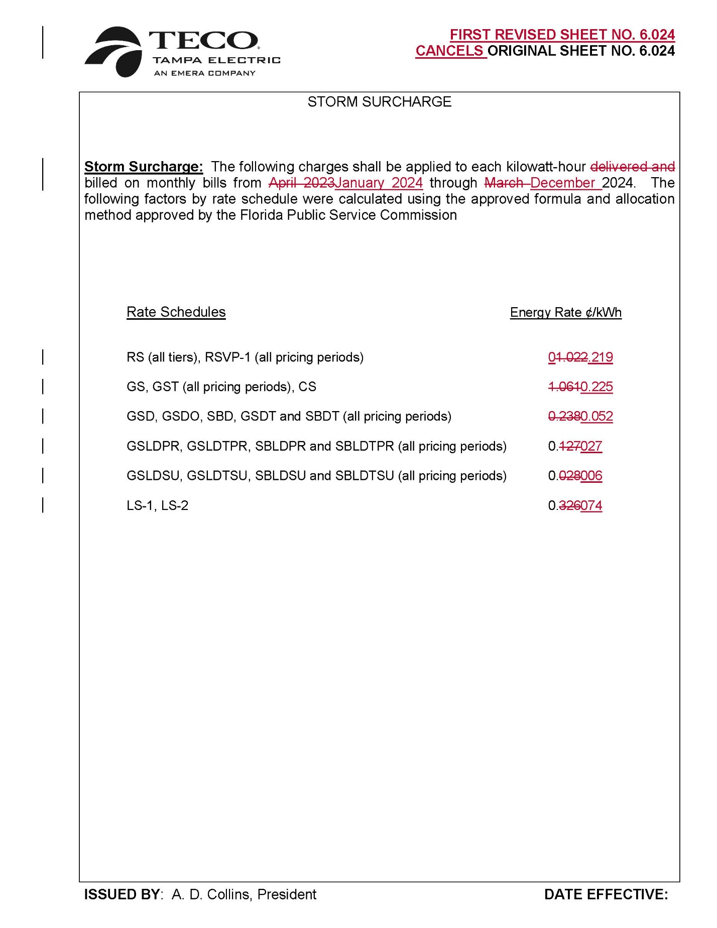

See Order No. PSC-2021-0423-S-EI, issued on November 10, 2021, in Docket Nos. 20210034-EI, In re: Petition for rate increase by Tampa Electric Company, and 20200264-EI, In re: Petition for approval of 2020 depreciation and dismantlement study and capital recovery schedules, by Tampa Electric Company. Pursuant to the Future Process Improvements in the Storm Cost Settlement Agreement, TECO was required to establish a policy under which vendor crews would be tracked “to the maximum extent possible” using GPS software such as ARCOS. Tampa Electric began implementation of the ARCOS application in 2019.
Order No. PSC-2023-0116-PCO-EI issued on March 27, 2023, in Docket No. 20230019-EI.

