State of Florida   |  | Public Service Commission  Capital Circle Office Center ● 2540 Shumard Oak Boulevard  Tallahassee, Florida 32399-0850  -M-E-M-O-R-A-N-D-U-M-
DATE: | November 21, 2023
TO: | Office of Commission Clerk (Teitzman)
FROM: | Division of Economics (Bruce)  Office of the General Counsel (Thompson)
RE: | Docket No. 20230112-WU – Request for approval of new class of service in Okaloosa County by North Florida Community Water Systems.
AGENDA: | 12/05/23 – Regular Agenda – Tariff Filing – Interested Persons May Participate
COMMISSIONERS ASSIGNED: |  |  | All Commissioners
PREHEARING OFFICER: |  |  | Administrative
CRITICAL DATES: |  |  | 12/10/2023 (60-Day Suspension Date)
SPECIAL INSTRUCTIONS: |  |  | None

Case Background
North Florida Community Water Systems, Inc. (NFCWS or utility) provides water and wastewater service to several counties including a system in Okaloosa County. The utility’s Okaloosa County system provides water service to approximately 236 residential customers. The utility has never had a rate case, but recently had a price index that was approved by the Commission in 2023.

On October 10, 2023, pursuant to Section 367.091(5), Florida Statutes (F.S.), NFCWS filed a request to include additional base facility charges (BFC) based on the American Water Works Association (AWWA) meter equivalents for larger meter sizes. The utility indicated in its application that it had a request to install a one-inch meter size in the Okaloosa water system. According to the utility’s current tariff, the utility only has a BFC for a 5/8 x 3/4 inch meter size for both residential and general service classes. This recommendation addresses the utility’s request to include additional BFCs up to a six-inch meter size to the residential and general service tariffs as shown in Attachment A to the recommendation. The Commission has jurisdiction pursuant to Section 367.091, F.S.

Discussion of Issues

Issue 1:
Should NFCWS's proposed tariff which includes BFCs for additional meter sizes based on the AWWA meter equivalents for the residential and general service classes be approved?

Recommendation:
Yes, the utility’s proposed tariff which includes BFCs for additional meter sizes based on the AWWA meter equivalents for the residential and general service classes should be approved. The utility’s proposed Second Revised Sheet No. 12.4 and Second Revised Sheet No. 13.4 should be approved as filed. The approved tariffs should be effective on the date of the Commission vote. Since no current customers are affected by the proposed tariff revisions, no customer notices are required. (Bruce)

Staff Analysis:
In its application, the utility is requesting BFCs for meter sizes up to 6 inches for the residential and general service classes. As mentioned earlier, the utility’s residential and general service tariff only has a BFC for meter size of 5/8 x 3/4 inches. The utility’s proposed BFCs for the additional meter sizes are calculated by using the utility’s existing residential BFC of $33.86 for the 5/8 x 3/4 inch size meter as a foundation, and then applying the AWWA’s meter equivalent factor. The AWWA meter equivalent factors are contained in Rule 25-30.055, Florida Administrative Code. NFCWS’s proposed BFCs for the residential and general service meters based on the AWWA meter equivalents are shown in Table 1-1

Table 1-1
Current and Proposed Residential and General Service BFC Charges
Meter Size | AWWA Meter Factor | BFC
5/8" x 3/4" | 1 | $33.86
3/4" | 1.5 | $50.79
1" | 2.5 | $84.65
1-1/2" | 5 | $169.30
2" | 8 | $270.88
3" | 16 | $541.76
4" | 25 | $846.50
6" | 50 | $1,693.00
Source: Utility’s filing

Conclusion

The utility’s proposed tariff which includes BFCs for additional meter sizes based on the AWWA meter equivalents for the residential and general service classes should be approved. The utility’s proposed Second Revised Sheet No. 12.4 and Second Revised Sheet No. 13.4 should be approved as filed. The approved tariffs should be effective on the date of the Commission vote. Since no current customers are affected by the proposed tariff revisions, no customer notices are required.
Issue 2:
Should this docket be closed?

Recommendation:
Yes. If Issue 1 is approved, the tariff sheets should become effective on the date of the Commission vote. If a protest is filed within 21 days of the issuance of the Order, the tariff should remain in effect with the revenues held subject to refund pending resolution of the protest, and the docket should remain open. If no timely protest is filed, the docket should be closed upon the issuance of a Consummating Order. (Thompson)

Staff Analysis:
If Issue 1 is approved, the tariff sheets should become effective on the date of the Commission vote. If a protest is filed within 21 days of the issuance of the Order, the tariff should remain in effect with the revenues held subject to refund pending resolution of the protest, and the docket should remain open. If no timely protest is filed, the docket should be closed upon the issuance of a Consummating Order.

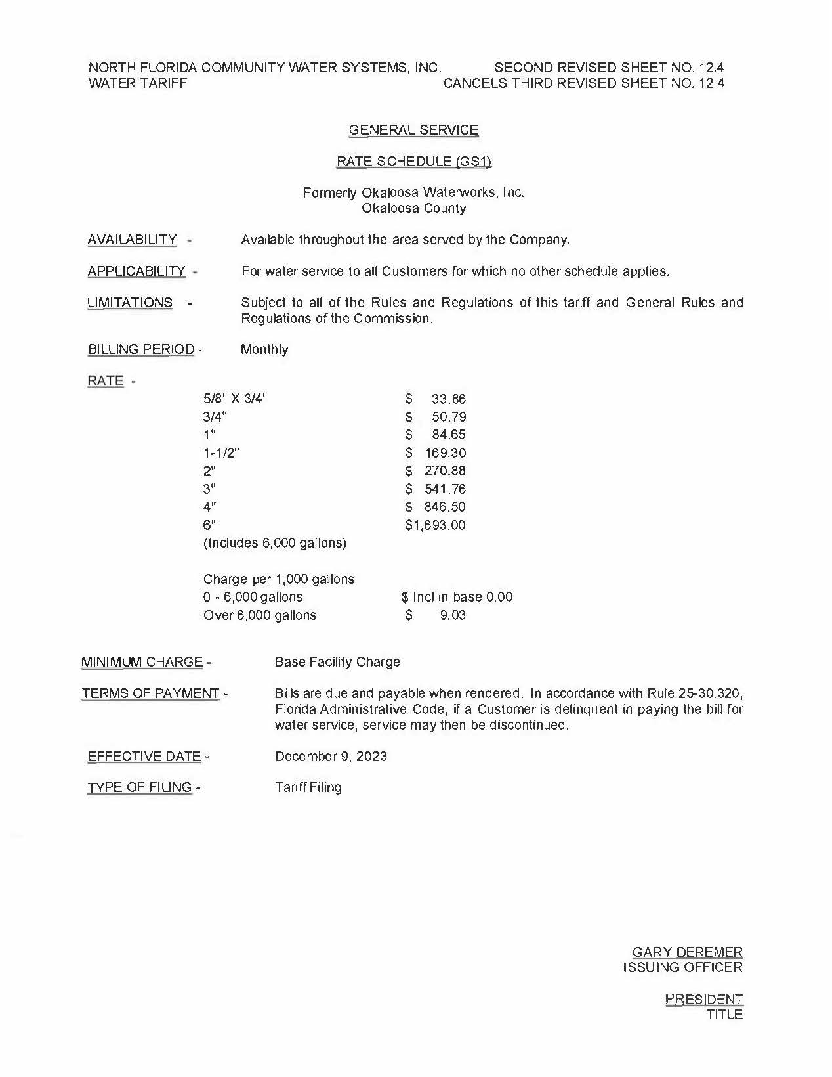

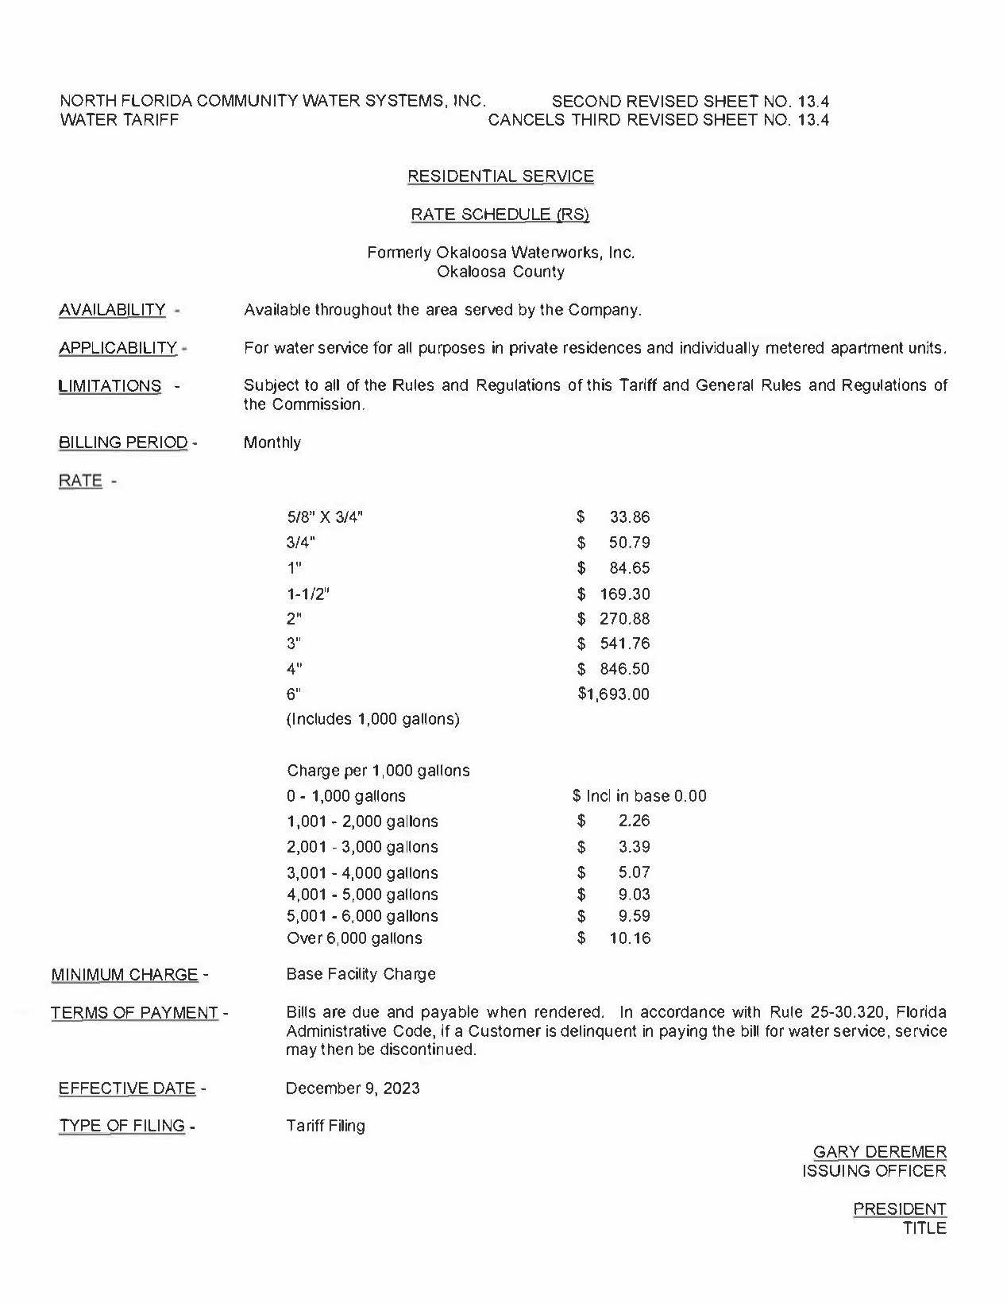

Number of customers as reported in 2022 Annual Report ending December 31, 2022.
North Florida Community Water Systems, Inc. Water Tariff Nos. 12.4 and 13.4.

