BEFORE THE FLORIDA PUBLIC SERVICE COMMISSION

In re: Petition for rate increase by Peoples Gas System, Inc. | DOCKET NO. 20230023-GU
In re: Petition for approval of 2022 depreciation study, by Peoples Gas System, Inc. | DOCKET NO. 20220219-GU
In re: Petition for approval of depreciation rate and subaccount for renewable natural gas facilities leased to others, by Peoples Gas System, Inc. | DOCKET NO. 20220212-GU  ORDER NO. PSC-2023-0388-FOF-GU  ISSUED: December 27, 2023

The following Commissioners participated in the disposition of this matter:

ANDREW GILES FAY, Chairman
ART GRAHAM
GARY F. CLARK
MIKE LA ROSA
GABRIELLA PASSIDOMO

APPEARANCES:

J. JEFFRY WAHLEN, JR.; MALCOLM MEANS; and VIRGINIA PONDER, ESQUIRES, Ausley McMullen, Post Office Box 391, Tallahassee, Florida 32302
On behalf of Peoples Gas System, Inc. (PGS).

WALT TRIERWEILER, ESQUIRE, Public Counsel; CHARLES REHWINKEL, ESQUIRE, Deputy Public Counsel; PATRICIA CHRISTENSEN, and MARY WESSLING, ESQUIRES, Office of Public Counsel, c/o The Florida Legislature, 111 W. Madison Street, Suite 812, Tallahassee, Florida 32399-1400
On behalf of the Office of Public Counsel (OPC).

JON C. MOYLE and KAREN PUTNAL, ESQUIRES, Moyle Law Firm, 118 North Gadsden Street, Tallahassee, Florida 32301
On behalf of Florida Industrial Power Users Group (FIPUG).

MAJOR THOMPSON, RYAN SANDY, DANIEL DOSE, and AUSTIN WATROUS, ESQUIRES, Florida Public Service Commission, 2540 Shumard Oak Boulevard, Tallahassee, Florida 32399-0850
On behalf of the Florida Public Service Commission (Staff).

MARY ANNE HELTON, ESQUIRE, Deputy General Counsel, Florida Public Service Commission, 2540 Shumard Oak Boulevard, Tallahassee, Florida 32399-0850
Advisor to the Florida Public Service Commission.

KEITH C. HETRICK, ESQUIRE, General Counsel, Florida Public Service Commission, 2540 Shumard Oak Boulevard, Tallahassee, Florida 32399-0850
Florida Public Service Commission General Counsel.

ORDER GRANTING IN PART AND DENYING IN PART
PEOPLES GAS SYSTEM, INC.’S PETITION FOR A RATE INCREASE

BY THE COMMISSION:

Table of Contents
Section Issue Page
Background 4

I. Test Period and Forecasting 6

A. Projected Test Year 6

B. Customer and Therm Forecasts 7

C. Estimated Gas Revenues 7

II. Quality of Service 7

A. Quality of Service 7

III. Depreciation Study 8

A. Renewable Natural Gas Subaccount, Depreciation Rate, and Implementation Date 8

B. Vehicle Retirements 9

C. Depreciation Parameters 10

D. Depreciation Study Date 22

E. Theoretical Reserve Imbalance 23

F. Corrective Depreciation Reserve Measures 24

G. Implementation Date for Revised Depreciation Rates and Other Schedules 28

IV. Rate Base 28

A. Adjustments for Non-Utility Activities 28

B. Removal of Costs Attributable to Operations of Seacoast Gas Transmission 29

C. Cast Iron/Bare Steel Rider Adjustments 30

D. Advanced Metering Infrastructure Pilot 31

E. New River RNG Project 33

F. Brightmark RNG Project 33

G. Alliance Dairies RNG Project 33

H. Work and Asset Management Program 33

I. Acquisition Adjustment and Accumulated Amortization of Acquisition Adjustment 36

J. Plant in Service 36

K. Accumulated Depreciation and Amortization 38

L. Construction Work in Progress 39

M. Working Capital Allowance Adjustments for Under- and Over-Recoveries 40

N. Unamortized Rate Case Expense 40

O. Working Capital 40

P. Rate Base 40

V. Cost of Capital 41

A. Accumulated Deferred Taxes 41

B. Cost Rate of Unamortized Investment Tax Credits 42

C. Amount and Cost Rate of Customer Deposits 43

D. Cost Rate of Short-Term Debt 43

E. Cost Rate of Long-Term Debt 45

F. Adjustments for Non-Utility Investments 51

G. Equity Ratio 52

H. Return on Equity 55

I. Capital Structure and Weighted Average Cost of Capital 71

VI. Net Operating Income 74

A. Removal of Purchased Gas Adjustment, Natural Gas Conservation Cost Recovery Clause, and CI/BSR Revenues and Expenses 74

B. Removal of Non-Utility Activities Including Depreciation and Amortization
Expense 75

C. Uncollectible Accounts and Bad Debt 76

D. Non-Labor Trend Factors 76

E. Contractor and Contract Services 76

F. Employees 79

G. Salaries and Benefits 85

H. Adjustments for Lobbying, Charitable Contributions, Sponsorships, and
Advertising 89

I. Economic Development Expense 89

J. Storm Damage Accrual and Reserve Cap 89

K. Adjustments for Merger & Acquisition Development 89

L. Rate Case Expense 90

M. O&M Expenses 90

N. Depreciation and Amortization Expense 94

O. Taxes Other Than Income 95

P. Parent Debt Adjustment 96

Q. Income Tax Expense 98

R. Total Operating Expenses 99

S. Net Operating Income 99

VII. Revenue Requirements 100

A. Revenue Expansion Factor and NOI Multiplier 100

B. Annual Operating Revenue Increase 100

VIII. Cost of Service and Rate Design 104

A. Cost-of-Service Study 104

B. Allocation of Rate Increase 104

C. Customer Charges 104

D. Distribution Charges 105

E. Miscellaneous Service Charges 105

F. Revised Annual Residential Reclassification Review 105

G. Residential and Commercial Generator Rate Design Revision 105

H. Revised Termination Fee for Natural Choice Transportation Program 106

I. Revised Individual Transportation Administration Fee 106

J. Minimum Volume Commitment Provision and Agreement 106

K. Non-Rate Related Tariff Modifications 106

L. Revised Tariffs 106

M. Effective Date of Rates and Charges 107

IX. Other Issues 107

A. Long-Term Debt Cost Rate True-Up Mechanism 107

B. Legal Entity Separation of PGS 110

C. Description of Adjustments 113
Attachment 1 (Comparative Average Rate Base) 116
Attachment 2 (Capital Structure) 117
Attachment 3 (Comparative Net Operating Income) 118
Attachment 4 (Net Operating Income Multiplier) 120
Attachment 5 (Comparative Revenue Deficiency Calculations) 121
Attachment 6 (Revised Tariffs) 122

Background

On April 4, 2023, Peoples Gas System, Inc. (PGS or Company) filed a petition seeking our approval of a rate increase and associated depreciation rates. PGS is a natural gas distribution company providing sales and transportation of natural gas, and is a public utility subject to our regulatory jurisdiction under Chapter 366, Florida Statutes (F.S.). PGS is a wholly-owned subsidiary of TECO Gas Operations, Inc. and provides service to approximately 470,000 customers in 39 of Florida’s 67 counties.
PGS requested an increase of approximately $139.3 million in base rates. Of that amount, about $11.6 million is associated with revenue requirements transferred from the Cast Iron/Base Steel Replacement Rider. The remaining $127.6 million is necessary, according to PGS, for the Company to earn a fair return on its investment. PGS based its request on a 13-month average rate base of $2.4 billion for the projected test year ending December 31, 2024. The requested overall rate of return is 7.42 percent based on a mid-point return on equity (ROE) of 11.00 percent. The Company did not request an interim rate increase.
On December 15, 2022, PGS filed its petition in Docket No. 20220212-GU (RNG Depreciation Docket) seeking approval of a new depreciation rate and subaccount for renewable natural gas facilities leased to others. On December 28, 2022, PGS filed its petition seeking approval of the Company’s 2022 Depreciation Study in Docket No. 20220219-GU (Depreciation Study Docket). On April 4, 2023, PGS filed a motion seeking to consolidate the RNG Depreciation Docket, the Depreciation Study Docket, and the rate proceeding in Docket No. 20230023-GU. By Order No. PSC-2023-0128-PCO-GU, issued April 12, 2023, the three dockets were consolidated. In Order No. PSC-2023-0157-PCO-GU, we suspended the proposed permanent increase in rates and charges.
PGS stated that even though it made efforts to increase cost savings and efficiency, PGS is expected to earn a return on equity of less than 8 percent in 2023, which places the Company at the bottom of its approved ROE range. PGS is seeking rate relief because of statewide growth and construction, higher depreciation expenses, changing pipeline safety and security regulations, higher inflation, and higher cost of capital in the financial markets.
The Company’s last rate case, in Docket No. 20200051-GU, was resolved by our approval of a Stipulation and Settlement Agreement (2020 Agreement). The 2020 Agreement allowed PGS to generate an additional $58 million in revenues for the projected test year ended December 31, 2021. The 2020 Agreement also authorized a return on equity of 9.90 percent. The 2020 Agreement will expire on December 31, 2023. It also authorized PGS to amortize $34 million of depreciation reserve surplus as a depreciation expense from 2020 through 2023.
By Order No. PSC-2023-0082-PCO-GU, we acknowledged intervention by the Office of Public Counsel (OPC). By Order No. PSC-2023-0129-PCO-GU, we granted intervention to the Florida Industrial Power Users Group (FIPUG). The two parties (collectively, “Joint Parties”) filed a joint post-hearing brief.
We held two in-person service hearings in Pembroke Pines and Tampa on June 28 and June 29, 2023, respectively, and four virtual service hearings on July 10 and July 11, 2023. Out of the six customer service hearings, two customers expressed concerns over a potential rate increase. We also received letters from ten customers that were placed in correspondence in the docket. All of the customers urged us not to increase their gas rates during these financially challenging times and contended that the proposed rate increases are excessive and unreasonable.
An administrative hearing was held September 12-15, 2023. At the hearing, we approved Type 1 stipulations and Type 2 stipulations for certain issues, which are described throughout this order.
Prior to filing for this rate case, the Company decided to move PGS out as a separate legal entity from Tampa Electric Company (TECO) in what will be discussed as the “2023 Transaction.” The 2023 Transaction was effective on January 1, 2023, and restructured the Company so that TECO would no longer be a direct parent company of PGS. Both PGS and TECO are still under the umbrella of the same parent company, Emera Incorporated (Emera).
This order addresses the requested permanent rate increase. We have jurisdiction over this matter pursuant to Chapter 366, F.S., including Sections 366.06 and 366.071, F.S.

Decision

- Test Period and Forecasting

Projected Test Year

Parties’ Arguments
PGS witness Parsons stated that the Company selected the 2024 projected test year, comprised of the twelve-month period ending December 31, 2024, as the test year in this proceeding. Witness Parsons argued that utilizing the 2024 calendar year as the test year is appropriate because it is “representative of the Company’s projected revenues and projected cost of service, capital structure and rate base required to provide safe, reliable, and cost-effective service to its customers during the period when the Company’s new rates will be in effect.” PGS also noted that there are “no pending or anticipated merger activities involving Peoples that would cast doubt on the reasonableness of the 2024 test year data or financial forecast.” The Company proposed the new base rates become effective for the first billing cycle of January 2024.
The Joint Parties agree that with appropriate adjustments, the 2024 test year may be representative of the period of time in which rates will be in effect.

Analysis
In general, a projected test year methodology is the process whereby a Company uses forecasted data for a twelve-month period to match its average revenues with its average expenses and average rate base investment for the same period. Witness Parsons testified that, with the exception of its accelerated preparation to meet the filing schedule for this rate case, PGS’s 2024 projected test year was developed “using the same process used to develop the Company’s annual budgets, including capital expenditure and income statement forecasts.”
While the Joint Parties proposed adjustments to other issues, the Joint Parties did not cite any objections to the appropriateness of the 2024 test year itself. Further, the Joint Parties did not propose any alternative to the projected test year as proposed in this case for setting customer rates.
PGS’s proposed 2024 test year will result in a matching of the Company’s revenues to be produced during the first twelve months in which the new rates would be in effect, with average rate base investment and average expenses for the same period. Therefore, we find that the Company’s projected test period of the twelve months ending December 31, 2024, is appropriate.

Customer and Therm Forecasts
At the hearing, we approved a type 2 stipulation as follows: The Company used linear regression models for both customer counts and average use for the test year. These models are both theoretically and statistically strong as measured by model coefficient and overall model fit statistics. The chosen modeling framework has been adopted by numerous utilities in the United States and Canada for forecasting.

Estimated Gas Revenues
At the hearing, we approved a type 2 stipulation as follows: Residential and small commercial customer and sales forecasts were used to estimate the 2024 test year revenues at current rates. These forecasts were prepared using theoretically and statistically strong models that have been adopted by numerous utilities in the United States and Canada for forecasting.

- Quality of Service

Quality of Service

Parties’ Arguments

In its brief, PGS argued that its quality of service is adequate. The Company highlighted that only two individuals spoke during the six customer service hearings, neither of which expressed a negative view of the Company’s gas service. PGS witness Sparkman testified that the Company has an evolving strategy that is focused on customer service and simplified customer experiences, which has led to PGS receiving several industry awards for its customer service. Additionally, witness Sparkman argued that customer complaints filed with this Commission have decreased by approximately 43 percent in 2022 and PGS has not had any Commission infractions over the last seven years. The Company argued it has low complaint levels and PGS witness Wesley testified that the complaint levels of PGS are lower than those presented in the last rate cases of Florida City Gas (FCG) and Florida Public Utilities Company (FPUC).

The Joint Parties argued that the quality of service received by customers does not justify the magnitude of PGS’s requested rate increase. In support of their argument, the Joint Parties referenced the testimony received at the customer service hearings, which highlighted the requested rate increase amount of PGS.

Analysis
Pursuant to Section 366.041(1), F.S., in fixing rates we are authorized to give consideration, among other things, to the efficiency, sufficiency, and adequacy of the facilities provided and the services rendered. We held two in-person service hearings in Pembroke Pines and Tampa on June 28 and June 29, 2023, respectively, and four virtual service hearings on July 10 and July 11, 2023. Out of the six customer service hearings, two customers expressed concerns over a potential rate increase. There was no customer testimony that posed any quality of service concerns. In addition, no intervening party witness addressed this matter in their prefiled testimony or during the hearing.
PGS serves approximately 470,000 customers. Staff witness Calhoun testified that from June 1, 2018, through May 31, 2023, 265 complaints were logged with us with 99 of those being transferred to PGS. The average of these complaints, 53 per year, results in an overall complaint rate of 0.01 percent per year. Of the 265 complaints, approximately 49 percent concerned billing issues, while approximately 51 percent involved quality of service issues. Additionally, witness Calhoun testified that of the 265 complaints, none appeared to demonstrate a violation of Commission Rules. To date, there were ten customer comments filed in the docket file, all of which expressed concerns regarding PGS’s proposed rate increase.
Pursuant to Rule 25-7.018, Florida Administrative Code (F.A.C.), each utility shall keep a complete record of all interruptions affecting the lesser of 10 percent or 500 or more of its division meters. PGS provided two separate instances where this Rule applied. On June 13, 2022, a contractor failed to confirm the location of the gas main before commencing work. The contractor’s directional drill damaged a 4-inch plastic main under Lutz Lake Fern Road and as a result, affected the service of 505 customers. PGS reported that it took approximately three days to restore 95 percent of the customers affected by this interruption. On September 27, 2022, the service of 823 customers was interrupted due to Hurricane Ian across the Sarasota and Ft. Myers divisions. Excluding Ft. Myers Beach (143 accounts), service was restored within 48 hours of the interruption or upon customer return. Both of these interruptions were beyond the control of the Company.
Based on a review of all witness and customer testimony and consideration of the information presented above, we find that the Company’s quality of service is adequate.
- Depreciation Study

Renewable Natural Gas (RNG) Subaccount, Depreciation Rate, and Implementation Date
At the hearing, we approved a type 2 stipulation as follows: We shall approve a new subaccount under Account 104 (Gas Plant Leased to Others) to be denominated “Account 336.01 – RNG Plant Leased – 15 Years” and a depreciation rate of 6.7 percent for that subaccount effective January 1, 2023. The proposed new depreciation rate will ensure that the cost recovery period for the Brightmark RNG Project (Section IV.F) will match the period over which the project will generate revenues, that the costs of the project will be removed by the time the customer takes ownership of the RNG plant assets at the end of the contract term and will prevent the Company from experiencing a gain or loss on the sale of the assets at the end of the contract term. The new subaccount will facilitate application of the new depreciation rate.

Vehicle Retirements

Parties’ Arguments
PGS argued that, pertaining to the retirement of vehicles in the test year, no adjustment to the calculation of test year Net Operating Income (NOI) or rate base is needed. PGS explained that the Company did not include vehicle depreciation expense in the depreciation expense component of the 2024 test year NOI. PGS stated that it included the vehicle depreciation expense in a transportation cost allocation that was reflected in the test year Operation & Maintenance (O&M) Expense and capital expenditures. PGS further explained that including expected vehicle retirements in 2023 and 2024 would equally reduce plant in service and accumulated depreciation and would have the effect of slightly increasing test year rate base due to the lower depreciation expense in the test year.
PGS also argued that it has met the burden of proof of demonstrating the level of 2023 and 2024 vehicle expense is necessary for several reasons. These reasons all relate to the size of PGS’s territory and the number of miles that must be driven by employees to maintain the safety and reliability of PGS’s system.
The Joint Parties argued that the company did not reflect retirements associated with the replacement of older vehicles which has the effect of overstated rate base and depreciation expense over time. Given other compensating adjustments in allocations, this is no longer a contested issue.

Analysis
PGS witness Parsons testified that the Company did not reflect vehicle retirements in Account 392.01 – Auto & Truck Less Than ½ Ton on MFR G-2, pages 23 and 26. She stated that PGS identified $1,706,817 of retirements for 2023 and $1,571,627 of retirements for 2024 that should have been reflected on MFR G-2 for that account. Witness Parsons further stated that reflecting these retirements would have the effect of reducing the 2024 test year depreciation expense (as derived from the depreciation study) by $243,046. However, witness Parsons explained that this reduction in depreciation expense would have had no impact on test year net operating income due to the fact that PGS charges vehicle depreciation expense “through a transportation cost allocation to O&M and capital expenditures and is not included in depreciation expense in determining NOI.” We have verified that these retirements were not reflected in the MFRs, as well as the fact that no depreciation expense for Account 392.01 was included in the projected test year depreciation expense calculation.
With regard to NOI, witness Parsons further testified that neither the transportation cost allocation nor the FERC O&M budget were impacted by the potential increase in vehicle depreciation expense. Witness Parsons explained that the Company did not increase the transportation allocation to account for the increased vehicle depreciation expense in O&M, but instead simply trended the existing 2022 vehicle transportation costs forward for inflation and customer growth in areas that utilized the vehicles. Therefore, witness Parsons testified that the calculation of the test year NOI would not have been affected by any adjustment to vehicle retirements in the test year.
Separate from her explanation of the vehicle additions and retirement’s effect on NOI, PGS witness Parsons also testified as to the effects of the vehicle retirements on rate base. Witness Parsons clarified that reflecting the vehicle retirements on MFR G-2 would equally reduce PGS’s plant and reserve balances, thereby having no impact on rate base. Witness Parsons added that rate base could be slightly increased due to the lower test year depreciation expense that would result from the lower plant balances in Account 392.01. Witness Parsons also stated that since the increased vehicle depreciation expense was not factored into the 2023 and 2024 Capital Expenditures, there would be no rate base impacts due to the lower depreciation expense. Witness Parsons’ Exhibit No. RBP-2, Document No. 8 shows the potential rate base and NOI impacts if vehicle retirements had been reflected in the MFRs.
In their position on this issue, the Joint Parties stated that the Company did not properly reflect retirements related to new vehicles. However, the Joint Parties further explained that due to other adjustments being made in this case, this issue is no longer contested.

Conclusion
Both PGS and the Joint Parties took the position that vehicle retirements did not properly match vehicle additions in rate base. However, PGS stated that no adjustments are necessary, while the Joint Parties indicated this is no longer a disputed issue due to other compensating adjustments. Therefore, even though vehicle retirements do not match vehicle additions in rate base, no adjustments to net operating income or rate base are necessary because any corrective adjustments would be immaterial.

Depreciation Parameters

Parties’ Arguments
PGS stated “the Commission should find that Mr. Watson’s depreciation rates and parameters as presented in Exhibit 32, Document No. 3 are appropriate.” The Company argued that these rates were calculated in accordance with the applicable Commission Rule, based on a Commission-approved methodology, and utilizing the most current data and information available. PGS stated that its witness Watson used the straight-line method, Average Life Group procedure, remaining life technique depreciation system to prepare PGS’s instant depreciation study. The Company attested that witness Watson used the same methodology to prepare the study that was used by PGS and approved by us in the Company’s last base rate case.
PGS contended that OPC witness Garrett did not perform his own depreciation study, but instead considered PGS’s study and proposed extending the average service lives (ASL) of five plant accounts. The Company argued that witness Garrett “only utilized one placement and experience band to arrive at his service life recommendations, while depreciation treatises recommend the use of multiple bands.”
PGS further asserted that witness Garrett’s choice to utilize a short placement band of the years 1983-2021 violates the principles of actuarial analysis by failing to analyze trends in service lives over time. Additionally, the Company argued that witness Garrett relied solely on the output of a statistical model and ignored company-specific experience and operational information, an inaccurate method for setting asset lives. PGS argued that, for each of these reasons, the Joints Parties’ approach is unreasonable and we should reject its recommended adjustments to service lives.
The Joint Parties claimed that OPC witness Garrett correctly calculated the depreciation rates. Witness Garrett testified that he used a straight-line method, the average life procedure, the remaining life technique, and the broad group model to analyze the Company’s actuarial data. The Joint Parties stated that witness Garrett recommended the adoption of different average service lives for five of the plant accounts based on his analysis of the best Iowa curve to fit the “observed life table” (OLT) curve; and he accomplished this analysis through a combination of visual and mathematical curve-fitting techniques, as well as professional judgement.
Witness Garrett proposed longer lives for Accounts 37600 and 37602, respectively. The Joint Parties stated that witness Garrett focused his statistical analysis on the relatively newer vintages in Account 37600, because “the Company’s bare steel replacement program that began around 2013, which focused on retiring assets from vintages spanning from the 1930s through the 1960s.” The Joint Parties asserted that witness Garrett’s choice of life-curve combination is a mathematically closer fit to the OLT curve than the Company’s choice. The Joint Parties provided the same argument with respect to Account 37602, and asserted that witness Garrett’s results showed his choice was a mathematically slightly closer fit to the OLT curve than the Company’s choice.
For each of Accounts 37900, 38002 and 38200, witness Garrett also proposed a longer ASL than PGS. The Joint Parties argued that witness Garrett’s results showed his choice was a mathematically closer fit to the OLT curve of Account 37900. Similarly, the Joint Parties also argued that witness Garrett’s choices were a mathematically slightly closer fit to the respective OLT curve of Accounts 38002 and 38200 than the Company’s choices.
While PGS witness Watson argued that witness Garrett only presented one band in his exhibits and work papers, he conceded that witness Garrett said he reviewed multiple placement and experience bands, and also conceded that his own study did not present all of the possible placement and experience bands for the accounts. The Joint Parties further argued that PGS witness Watson took issue with witness Garrett’s lack of consideration of the subject matter experts’ input, yet witness Watson himself “qualified his reliance on the Company’s experts by saying he validates their opinions based on his own engineering experience and from doing theses studies for many years.”
The Joint Parties asserted that “[g]iven that witness Watson has only testified on one or two occasions for a non-utility party, and he mostly develops depreciation studies while acknowledging that customer interests generally critique them, his observations may lack objectivity.”
The Joint Parties concluded that witness Garrett’s recommendations are “better fittings” of the Iowa Curve to the OLT curve both mathematically and also based on considerations of factors impacting the data.

Analysis
In this proceeding, parties proffered various proposals of the depreciation parameters and resulting depreciation rates. Two of the proposals remain unresolved: (1) PGS’s revised depreciation study filed July 2023, that is based on the actual and estimated activities and data of plant accounts ending December 31, 2023 (2023 Study), and (2) OPC’s proposed adjustments to PGS’s 2023 Study.
The remaining life depreciation rate of a plant account is designed to recover the remaining unrecovered plant balance over the remaining life of the associated investment in that account. Rule 25-7.045(1)(e), F.A.C., prescribes the formula for determining this rate.
For each of PGS’s plant accounts, the Company’s witness Watson proffered a proposal of an ASL with a specific curve (retirement dispersion) to determine the average remaining life (ARL) of the account, which, in turn, is used to calculate the remaining life depreciation rate of the account. OPC witness Garrett also provided an ASL-curve proposal for each of the accounts. Table 1 shows the parameters for the five accounts in dispute between the two proposals:

Table 1
Differences in Proposed Depreciation Parameters
Account No. | Account  Title | Current |  | PGS Proposed  (Watson) |  | OPC Proposed  (Garrett)
Account No. | Account  Title | ASL  (yrs) | Curve  Type | ASL  (yrs) | Curve  Type | ASL  (yrs) | Curve  Type
37600 | Mains Steel | 65 | R1.5 | 65 | R1.5 | 70 | R1.5
37602 | Mains Plastic | 75 | R2 | 75 | R2 | 82 | R2
37900 | Meas & Reg Station Equip City | 50 | R2.5 | 52 | R2 | 60 | R2
38002 | Services Plastic | 55 | R1.5 | 55 | R2.5 | 62 | R2
38200 | Meter Installations | 44 | R1 | 45 | R1.5 | 55 | R0.5

Average Service Life and Curve
Our natural gas utility depreciation rule requires a gas company to conduct a depreciation study at least once every five years. To determine an account’s ASL for the coming five years, historical data as well as the prospective outlook for the account are considered. Actuarial analysis, also known as the Retirement Rate Method, is commonly used in evaluating historical asset retirement experience when vintage data is available and sufficient retirement activity is present. Historical data, including plant additions, retirements, and transfers, is organized by vintage and transaction year to develop an OLT to depict the percentage of the assets surviving at each age interval.
The OLT is plotted as a survivor curve and the area under the curve represents the average life of the plant assets in the account being analyzed. An OLT curve is rarely smooth and typically incomplete due to plant assets in the account not reaching zero percent surviving yet. However, in order to calculate a particular account’s ARL, there must be a complete curve as well as an ASL. Standard mortality curves, such as the Iowa Curves, are used to compare with, or fit, the OLT curve for this purpose. The ASL and its associated best fitted Iowa Curve together describes the life estimate of the account. This ASL-curve combination, in turn, is used to calculate the ARL of the account. Data “bands” refer to the period of placement and experience years that are analyzed. They are used in this curve-comparing/fitting process to define what portion of the OLT curve is to be evaluated. The curve-fitting process is a critical step of the service life analysis, and involves a combination of visual and mathematical curve-fitting techniques, as well as professional judgment.
In this proceeding, both witness Watson and Garrett used the Retirement Rate Method in their service life analyses, but the historical data bands analyzed by each witness were different. Witness Watson claimed that he analyzed five or more placement and experience bands for each account at issue in the proceeding where sufficient retirement data exists. He testified that:
I ran an overall placement band with two experience bands: the overall experience band, 1983–2021, and 1997–2021 to isolate experience in those transaction years. I also ran the 1983–2021 placement band with the 1983–2018 and 1997–2021 experience bands. If sufficient data existed for life analysis, I also ran an overall band of 1997–2021.
Witness Garrett’s life analysis used placement and experience bands with both bands being from 1983-2021. He testified that:
While I also considered the other banding periods Mr. Watson presented, I focused on OLT curves under the 1983-2021 placement and experience bands because this time period strikes a good balance between considering a sufficient amount of data for analysis and considering relatively newer data. In this particular case, most of the accounts discussed below have been affected by asset replacement programs in which relatively newer assets may have different life characteristics than older assets. Thus, it can be instructive to focus on relatively newer vintage years when conducting analyses.
Witness Watson disagreed with witness Garrett. He asserted that witness Garrett’s selection of the data bands supporting his life analysis has the following errors:
- Violates the principles behind actuarial analysis by only using one placement and experience band (thereby not analyzing trends in life through time).
- Discards relevant data in analyzing his single band by using a novel (non-industry standard) approach that cuts off and ignores Company-specific experience.
- Ignores both company-specific operational information and reasonable engineering expectations for the life of assets.
Witness Watson also contested that witness Garrett was not consistent in the placement and experience bands he relied on for his ASL recommendation:
- In the 2017 [PGS rate] case, witness Garrett did not specifically state the placement experience band used for each account, but it appears the placement band is the longest experience available from his Exhibits and workpapers.
- In the 2020 [PGS rate] case, witness Garrett used a non-existent experience band that included 12 or more years with no retirements as his only band.
- In this case, witness Garrett relied on placement and experience bands of 1983-2021 for his recommendations.
Witness Watson further argued against witness Garrett’s life analysis and ASL recommendations as witness Garrett did not consider information from the Company’s subject matter experts. He stated:
The lives witness Garrett selected for the five accounts at issue are beyond what would reasonably be expected for the mix and types of assets within these accounts. If the majority of the dollars in a particular account are associated with assets that have projected lives between 20 and 40 years, an overall life for the account of 60 years for that account will not be reasonable. Simply recommending the output of a statistical model without validating against operational realities or reasonable norms is not an accurate way to set asset lives.
In responding to OPC’s question whether he would agree that the Company subject matter experts are only giving their estimates with regard to different lives for different equipment, witness Watson expounded that, with their estimates, the experts are also “giving their understanding [of asset lives] based on operating those assets for many years.” Witness Watson testified that there were two additional considerations which validated the estimates provided by the Company’s experts. One consideration was witness Watson’s own understanding as an engineer and his own understanding of the assets and their lives based on the number of depreciation studies he’s conducted for many, many companies during his career. The second consideration that he included for validating the experts estimates was that the Company’s opinions were in line with his expectations and the industry’s expectations, concluding “they supported each other.”
OPC also questioned whether witness Watson relied on the subject matter experts, the employees of PGS, for the Company’s specific information to develop his curve. Witness Watson testified that he did not solely depend on such information, but instead he relied on the historical books and records of the Company to make his service life selection, and used the information from the experts to support the selection. He further expounds:
I will look at the actual experience of the company, and I will understand if there are changes that are happening to the assets operationally that would impact what I would project, and also understand what’s in the account and expected lives of the account.
Based on the record evidence discussed above, we find that the approach that witness Watson chose to perform his asset life analysis is more comprehensive than witness Garrett’s approach. It is consistent with the core concept of the Retirement Rate Method and more comprehensively incorporates the assets’ specific operational information which is important in the assets’ life analysis.
The account-specific analysis for the five accounts in dispute between PGS and the Joint Parties follows:

Account 37600 – Distribution Mains Steel
The currently-approved ASL for this account is 65 years with a R1.5 curve, also denoted as 65 R1.5. PGS witness Watson proposed to retain these parameters. OPC witness Garrett proposed to increase ASL to 70 years with the same R1.5 curve. Witness Watson disagreed with witness Garrett’s life proposal.
PGS personnel indicated that the driving forces of retirements for the account include inadequate capacity of the steel pipes since they were originally built when gas demand was not as prevalent as today’s demand; some steel pipes have not been cathodically protected for their full life, and steel will corrode if scratched. Witness Watson asserted that witness Garrett’s proposal “does not appear to factor in the life expectations for specific assets in this account as communicated by Company [experts].”
Regarding the curve-fitting process which determines the selected ASL-curve combination, witness Watson testified that his proposed combination was based on his evaluation of five different placement and experience bands. He argued that “witness Garrett only examines one band for his proposal,” and pointed out that “[a]s stated in NARUC’s Public Utility Depreciation Practices, it is important to look at different placement bands and experience bands.” He further averred that “[b]y selecting only one band (and having the errors discussed earlier), witness Garrett’s analysis doesn’t fully analyze or accurately represent the Company’s historical experience.” Witness Watson also asserted that the OLT witness Garrett used in life analysis is not long enough to meet criteria recommended by authoritative texts that witness Garrett quoted himself.
In previous dockets, witness Garrett recommended a 55 R2 life for this account and a 65 R1.5 life for this same account. Witness Watson claimed that “[i]t does not seem logical that three years later, these same assets would last 7.7 percent longer than witness Garrett’s recommendation [that] he supported less than three years ago – especially when he does not speak to any operational reason for the change.”
We reviewed all the graphical curve-fitting presentations together with all the data and information proffered by both witnesses. We find that witness Watson’s life analysis is more persuasive, and a 65 R1.5 life proposal is reasonable for the account at this point in time, because it is derived from an appropriate depreciation asset life analysis and incorporated with the Company-specific assets’ operational information, and within the range of other Florida gas utilities. We also note that an ASL of 65 years is within the industry’s current ASL range for this account, which is 40 to 65 years with an average of 56 years.

Account 37602 – Distribution Mains Plastic
The currently-approved ASL for this account is 75 R2. Witness Watson proposed to retain the existing parameters. Witness Garrett proposed to extend the ASL to 82 years. Witness Watson disagreed with witness Garrett’s life proposal.
Witness Watson testified that this account is more mature with assets that are replaced on an ongoing basis, and Company subject matter experts indicated the retirements of the account would be focusing on pre-1984 pipe, with the newer pipe likely to last 75 years. He claimed that his proposal recognized both the indications in the life analysis, which included examination of 17 different fits across multiple placement and experience bands, and the account-specific information from Company experts. Witness Watson asserted that Witness Garrett’s life proposal is excessive. He contested that witness Garrett’s proposal seems illogical as it would make PGS have assets in this account that last 17.1 percent longer than witness Garrett recommended for the same assets of another Florida utility without providing an operational reason to explain the difference.
The industry’s current ASL range for this account is 40 to 75 years with an average of 62 years. We find that a 75 R2 life proposal is reasonable for the account at this point in time, because it is derived from an appropriate depreciation asset life analysis, incorporated with the Company-specific assets’ operational information, and within the range of other Florida gas utilities. It is also in line with our recognized and generally accepted principle of gradualism.

Account 37900 – Distribution Measuring & Regulating Equip – City Gate
The currently-approved life for this account is 50 R2. Witness Watson proposed to moderately increase the ASL from 50 to 52 years. Witness Garrett proposed to increase the life to 60 years, and claimed that he did “not believe Watson’s proposed average life of 52 years is long enough given the data presented at this time.” Witness Watson disagreed with witness Garrett’s proposal.
This account is composed of city gate distribution measuring and regulating station-related piping, regulators, controls, odorizers, and other equipment. Witness Watson testified that PGS is beginning to build new city gates and is doing more capital improvements than in the past, and newer stations are expected to last longer than older ones. He also attested that different assets in the account may have different service lives, and Company subject matter experts indicated that “50 years seems reasonable from an operational perspective.” Witness Watson claimed that witness Garrett did not appear to factor in the life expectations for specific assets in this account as communicated by Company experts.
Witness Watson also argued that witness Garrett’s proposal was based on examining one placement-experience band which ends at approximately 92.36 percent of the account’s OLT data. He contested that the placement-experience band that witness Garrett used “is not statistically valid. It’s too short to make any predictions from it.”
Witness Watson further stated that witness Garrett’s recommended ASL represents an increase of 15.4 percent when compared to existing parameters and contested that “[t]his level of change at one time without an operational justification is unreasonable, is not supported by the evidence, and should be rejected.” Witness Watson additionally opined that:
In Docket No. 20170179-GU for Florida City Gas, witness Garrett recommended a 39 R0.5 life for this account. In Docket No. 20220069-GU for Florida City Gas, witness Garrett recommended a 45 S3 life for this account. It does not seem logical that Peoples would have assets in this account that last 33.3 percent longer than witness Garrett’s recommendation for another Florida utility.
After reviewing the account-specific data, information, curve-fitting graphs, and the related testimonies presented by both witnesses, we find that an estimate of 52 R2 life is appropriate for the account at this time. This life estimate is slightly longer than the high end of the industry’s current ASL range for the account, which is 32 to 50 years with an average of 41 years, but is still in line with our recognized and generally accepted principle of gradualism.

Account 38002 – Distribution Services Plastic
The currently-approved ASL-curve combination for this account is 55 R1.5. Witness Watson proposed retaining the current ASL with a slight shift in retirement dispersion: 55 R2.5. Witness Garrett proposed to increase the ASL to 62 years with an R2 curve. Witness Watson disagreed with witness Garrett’s proposal.
Witness Watson argued that, as with other accounts, witness Garrett’s recommendation “[did] not appear to factor in the life expectations for specific assets in this account as communicated by Company [experts]” and “only examines one band for his proposal.” He further claimed that, with witness Garrett’s recommended 1983-2021 placement and experience band, the OLT “is too short a stub to be predictive of the life of the account (only going to 84 percent surviving).” In his rebuttal testimony, witness Watson proffered four graphs, each visually comparing the fit of the curve to the account’s actual data for placement-experience bands selected by him versus the bands selected by witness Garrett. It appears to us that the 55 R2.5 life proposal is a better fit of the actual activity in this account.
Witness Watson also argued that witness Garrett’s proposal of a 7-year increase to the ASL is excessive. He claimed that this level of change without operational reasons is both unreasonable and not supported by the evidence. Witness Watson further pointed out that witness Garrett recommended a 54 R2.5 life and a 55 R2.5 life for this account in prior dockets., He stated that it did “not seem logical that Peoples would have assets in this account that last 12.7 percent longer than witness Garrett’s recommendation for another Florida utility.”
Based on the review of the evidence presented, we find that a 55 R2.5 life proposal is appropriate at this point in time for Account 38002. The ASL is within the industry’s current ASL range for the account, which is 40 to 60 years with an average of 53 years.

Account 38200 – Distribution Meter Installations
The currently-approved parameters for this account is 44 R1. Witness Watson proposed to increase the current ASL to 45 years with a slight shift in retirement dispersion to R1.5. Witness Garrett proposed to increase the ASL to 55 years with a R0.5 dispersion. Witness Watson disagreed with witness Garrett’s proposal.
At the time of preparing the 2023 Study, this account’s average age of survivors and average age of retirements is 12.09 years and 13.72 years, respectively. Witness Watson testified that “[t]his information demonstrates that this is an account with newer assets and retirements that have occurred before a full cycle of activity has occurred.” He also cited interview notes with Company subject matter experts to show the factors that influence the life of the account and argued that “witness Garrett does not appear to factor in the life expectations for specific assets in this account as communicated by Company [experts].” Witness Watson further presented several graphs, each visually comparing the fit against the account’s actual data for placement-experience bands selected by him versus the bands selected by witness Garrett. Witness Watson claimed that his life proposal is a better visual match.
Witness Garrett’s proposed ASL represents an increase of 11 years, or a 25 percent change. Witness Watson asserted that this level of change at one time without operational reasons is unreasonable and it is not supported by the evidence. He further emphasized that for the same account, witness Garrett recommended a 34 S3 and a 35 R3 for this account in prior dockets, and claimed that “[i]t does not seem logical that Peoples would have assets in this account that last 57.14 percent longer than witness Garrett’s recommendation for another Florida utility.”,
We find that a life proposal of a 45 R1.5 is reasonable for this account at this point in time. It is derived from an appropriate depreciation asset life analysis, incorporated with the Company-specific assets’ operational information, and within the industry’s current ASL range which is 34 to 45 years with an average of 41 years. This is also in line with our recognized and generally accepted principle of gradualism regarding the rate increase.

Average Remaining Life
The ARL is the average number of in-service years left for plant currently in service. An account’s ARL is determined by the account’s age, its ASL, and the associated curve. As such, witnesses Watson and Garrett’s ARL proposals are in dispute for the same five aforementioned accounts due to the difference in each account’s ASL-curve proposals. Based on our approved ASL and curves for each account, the appropriate ARLs for each account are listed in Table 2.

Net Salvage
The net salvage is gross salvage minus cost of removal. An account’s net salvage percentage is based on the account’s historical data, but is also prospective in outlook. No intervenor disagreed with PGS’s net salvage percentage proposals presented in its 2023 Study. We have reviewed these proposals and find them all to be reasonable based on the evidence in the record, including the data and corresponding analysis.

Reserve Percentage
An account’s reserve percentage represents the portion of the account’s investment accumulated through depreciation expense to date unless restated to another level. It is calculated by dividing the book reserve by the original cost of plant. PGS proffered the reserve percent, or reserve position, for each of its accounts. The parties had no dispute regarding this parameter as it was calculated directly from the actual data of each respective account.

Depreciation Rates
For each of PGS’s accounts, witness Watson calculated the remaining life depreciation rate based on his account-specific parameter proposals. The resulting remaining life depreciation rates, or depreciation rates, were used to determine PGS’s proposed test year depreciation expense for the instant proceeding. We have verified witness Watson’s calculations and confirmed that they are consistent with the prescribed formula of Rule 25-7.045(1)(e), F.A.C., for determining an account’s remaining life depreciation rate.
Witness Garrett also performed the calculation for all the accounts which results in three sets of depreciation rate proposals from OPC. The first one, “Depreciation Rate Development – 2023 Study (With Book Reserve and Adjusted Parameters),” was developed by using witness Garrett’s proposed depreciation parameters. It results in an overall depreciation rate of 2.47 percent for all plant accounts studied. The second one, “Depreciation Rate Development – 2023 Study (With Theoretical Reserve and Adjusted Parameters),” was developed also by using witness Garrett’s proposed depreciation parameters. It results in an overall depreciation rate of 2.64 percent for all plant accounts studied. The third depreciation rate proposal, “Depreciation Rate Development – 2023 Study (Unadjusted Parameters),” was developed by using witness Watson’s proposed depreciation parameters. It results in an overall depreciation rate of 2.69 percent for all plant accounts studied.
We have also verified witness Garrett’s depreciation rate calculations. The aforementioned second depreciation rate proposal from witness Garrett leads to the amount of the depreciation theoretical reserve imbalance of $221 million that is the Joint Parties’ primary recommendation for Section III.E. We note that Garrett’s rate proposal was developed by using a calculation method that deviates from what is prescribed by our depreciation rule pertaining to gas service by gas public utilities, Rule 25-7.045, F.A.C.
We agree with the depreciation rates proposed by witness Watson. These rates are derived from the depreciation parameters (ASLs, ARLs, net salvage, and reserve percentages) which are best supported by the record in this case, and the associated calculations are in accordance with Rule 25-7.045, F.A.C.

Conclusion
Based on the record evidence, we approve the depreciation parameters and resulting depreciation rates for each plant account as shown in Table 2. The resultant test year depreciation expense, based on the approved depreciation rates in this issue, is addressed in Section VI.N, infra.

Table 2
Commission-Approved Depreciation Parameters and
Resulting Remaining Life Depreciation Rates

Depreciation Study Date
At the hearing, we approved a type 2 stipulation as follows: Although the terms of the 2020 Agreement we approved in Order No. PSC-2020-0485-FOF-GU, suggests otherwise, the Company agrees with OPC that the depreciation rates that become effective on January 1, 2024 shall be calculated using a depreciation study date of December 31, 2023.

Theoretical Reserve Imbalance

Parties’ Arguments
PGS stated that the appropriate theoretical reserve imbalance is a surplus of $160.4 million as of December 31, 2023, based on the recommended life and net salvage parameters as reflected in Exhibit 32, Document No. 3.
PGS argued that OPC presented an alternative calculation of the theoretical reserve surplus as of December 31, 2023, based on its proposed adjustments to PGS’s depreciation parameters. The Company contended that OPC’s recommended adjustments are unreasonable, do not follow sound depreciation practice, and those adjustments and OPC’s resulting theoretical reserve surplus should be rejected.
The Joint Parties stated that OPC witness Garrett identified four options regarding the depreciation reserve surplus amount in his testimony. The Joint Parties’ primary recommendation is to use OPC witness Garrett’s proposed ASLs, which results in a depreciation reserve surplus of $221,024,192. The Joint Parties asserted that, should we adopt all of PGS witness Watson’s depreciation lives, the depreciation reserve surplus would be $159,474,313.

Analysis
Our natural gas utility depreciation Rule 25-7.045(4)(k), F.A.C., provides that an account’s theoretical reserve amount is determined by the account’s book investment minus the account’s future accruals and future net salvage. The reserve imbalance of an account is the difference between the account’s calculated theoretical reserve and its book reserve. If the book reserve amount is larger than the theoretical reserve amount, this account presents a reserve surplus at a specific point in time.
PGS witness Watson calculated a $160.392 million reserve surplus for PGS’s plant accounts based on his proposed depreciation parameters. OPC witness Garrett calculated a $221.024 million reserve surplus by applying his proposed adjusted depreciation parameters. This amount is the Joint Parties’ primary recommendation regarding the reserve imbalance. Witness Garrett also calculated a $159.474 million reserve surplus by adopting PGS witness Watson’s proposed depreciation parameters.
Pursuant to Rule 25-7.045(4)(k), F.A.C., and the prescribed formula along with the depreciation parameters that we approved in Section III.C, supra, the calculated theoretical reserve imbalance for each category of PGS’s plant accounts is as shown in Table 3:

Table 3
Theoretical Reserve Imbalance
Account Type | Reserve Imbalance  (as of 12/31/2023)
Distribution | $152,368,138
Transportation | $3,216,382
General | $3,772,298
Gathering and LNG Plant | $1,035,3413
Total Plant | $160,392,158

Conclusion
Based on the application of the depreciation parameters that we approved in Section III.C and application of the formula prescribed in Rule 25-7.045, F.A.C., the resulting imbalance is a surplus of $160.4 million.

Corrective Depreciation Reserve Measures

Parties’ Arguments
PGS stated that its witness Watson designed his proposed depreciation rates to eliminate the theoretical depreciation reserve surplus over the remaining life of the depreciable assets and the average remaining life for the accounts where the Company proposed general plant amortization.
PGS argued that OPC’s recommendation to amortize the reserve surplus over ten years is a departure from the remaining life technique, and as such, it does not follow normal depreciation study practice. PGS also contested that OPC’s recommendation is also inconsistent with OPC’s position in the recent FCG case, which was to follow the remaining life technique.
PGS recommended that we follow standard depreciation study practice and amortize the surplus using the remaining life technique.
The Joint Parties proposed that “a relatively conservative return” of the theoretical depreciation reserve surplus should be implemented over 10 years “or a little less than half the time proposed by PGS.” The Joint Parties argued that the reserve surplus reflects an overpayment from PGS’s customers, and that current customers have overpaid due to excessive depreciation rates. The Joint Parties further argued that their proposed conservative return should occur for the benefit of the customers who overpaid in rates for depreciation expense and to implement a more moderate treatment of “PGS’s enormous rate increase request.” The Joint Parties stated, “These customers can and should receive the benefits of lower depreciation rates and base revenues in the near future through a shorter amortization period of the reserve surplus, rather than pushing those overpayment-driven benefits into the next several decades for the benefit of future generations of customers.” The Joint Parties claimed that if OPC witness Kollen’s proposed $221.024 million reserve surplus, calculated using OPC witness Garrett’s proposed depreciation parameters and depreciation rates, is amortized in 10 years, the depreciation expense will be reduced by $17.625 million and revenue requirement will be reduced by $16.980 million.
Supporting the shorter amortization period, the Joint Parties stated that, with Order No. PSC-2010-0153-FOF-EI, we ordered Florida Power & Light Company (FPL) to amortize its reserve surplus over a four-year period, and “[t]his policy is consistent with any number of prior orders dealing with imbalances that are deficits involving amortization periods between one and seven years.”
The Joint Parties concluded that, “[g]iven the Company’s position that they will defer to Commission policy and will not be financially harmed by the return of the overpayment of depreciation expense,” the theoretical reserve surplus should be amortized over a 10 year period.

Analysis
This section addresses whether any corrective measures should be taken with regard to the theoretical reserve imbalances identified in Section III.E. The remaining life technique is the most common method we use to address reserve imbalances (surplus or deficit). As indicated in Rule 25-7.045(1)(e), F.A.C., this method self-corrects the imbalances over the remaining life of the plant assets. We have also approved some other corrective measures. In some cases, we have approved an amortization of a certain portion of the surplus over a period of time that is shorter than the remaining life. In other cases, we have approved the amortization of the entire surplus over a specific period (years) shorter than the remaining life.
In PGS’s 2018 case, we approved a reserve surplus correction using the remaining life technique. In the Company’s 2020 case, we approved a Settlement Agreement which permitted the amortization of a $34 million portion of the reserve surplus, which was approximately 12.6 percent of the total surplus amount. Table 4 shows the details:
Table 4
PGS’s Identified Theoretical Reserve Surplus and the Correction Measures

The Joint Parties contested that the surplus, when measured against the entire theoretical depreciation reserve, is between 22 percent and 33 percent. As shown in Table 4, based on our finding in Section III.E, the surplus amount of $160,392,158 is 22 percent when measured against the entire theoretical depreciation reserve. We note that as shown in Table 4, in PGS’s 2020 case, the surplus was 50.6 percent (or 44.2 percent after taking into account the $34 million amortization) when measured against the theoretical depreciation reserve. Also shown in Table 4, in PGS’s 2018 case, the surplus was 28.8 percent when measured against the theoretical depreciation reserve. In essence, we approved PGS to use the remaining life technique to correct its reserve surplus when the surplus amount was respectively 28.8 percent and 44.2 percent and measured against the entire theoretical depreciation reserve.
For the theoretical reserve surplus identified in the instant case, PGS proposed to amortize the entire amount over the remaining life of the plant assets. OPC proposed to amortize the entire amount over 10 years.
PGS witness Watson asserted that OPC’s proposal “contradicts sound depreciation theory.” He further explained that:
Reserve imbalances change in each depreciation study (as evidenced by the decrease in surplus since the last study). Depreciation theory and the use of the remaining life technique in calculating depreciation rates will spread any surplus (or deficit) over the remaining life of the asset group.
In responding to OPC’s question, “apart from your recommendation [. . .] what amortization period should be used if it’s shorter than the remaining life,” witness Watson answered “I don’t believe there is another option that would be appropriate other than the remaining life approach.” He further argued that the exact amount of surplus at one point in time can vary based on the different ways by which an analyst chooses to look at the plant assets. Witness Watson pointed out that the reserve surplus declined between PGS’s last case and this case, and “it will drop further as moving further forward.”
We note that within the three years since our approval of the 2020 Settlement Agreement, applying the remaining life technique resulted in PGS’s reserve surplus decreasing from $234.9 million (after amortizing $34 million from the original $268.9 million) to $160.4 million, as shown in Table 4. This decrease indicates that the remaining life technique worked to significantly reduce the surplus.
Regarding the use of a method other than the remaining life technique to correct the reserve imbalance, witness Watson opined that “[it] is a policy decision, not a depreciation theory decision.” He further testified that he believed “it is not a valid depreciation theory, that if we were to do that, it would be a policy decision, not a[n . . .] appropriate depreciation theory decision.”
OPC witness Kollen recommended that “the Commission remove the theoretical depreciation reserve surplus from the calculation of the depreciation rates and separately amortize the reserve surplus over ten years.” He argued that a ten year amortization of the surplus will mitigate the customer rate increase requested by the Company in the current proceeding, and return the excessive depreciation expense that was recovered from customers in prior years to the customers who paid that expense through their base rates. Specifically, the Joint Parties claimed that if OPC witness Kollen’s proposed $221.024 million reserve surplus, calculated using OPC witness Garrett’s proposed depreciation parameters and depreciation rates, is amortized in 10 years, the depreciation expense will be reduced by $17.625 million and revenue requirement will be reduced by $16.980 million.
We do not agree with the first portion of witness Kollen’s recommendation. His proposal to “remove the theoretical depreciation reserve surplus from the calculation of the depreciation rates” does not comport with Rule 25-7.045(1)(e), F.A.C., Depreciation, as explained in Section III.C of this order.
We agree with witness Kollen’s argument that amortization of the reserve surplus can mitigate the Company’s currently requested customer rate increase, and would return the excessive depreciation expense to the current customers. When responding to a question about whether he was aware that our prior policy decisions involving accelerated surplus amortization resulted in monies returned to ratepayers sooner rather than later, due in part, to concerns about intergenerational unfairness, witness Watson testified, “I think you are going to create intergenerational unfairness by returning it as well [. . .] returning it is not going to solve any problems. It’s actually going to cost your customers more in the long-term.”
The existence of a reserve surplus means that, under present estimations, a theoretical excess recovery of plant investment has occurred to date, so there is a smaller amount of investment left to be recovered over the remaining life of the asset. As a result, current and future customers will receive the benefit of the existing reserve surplus through lower depreciation rates (all other things equal) and a lower return on rate base. However, if the identified reserve surplus is amortized, the depreciation rates set in future proceedings would be higher, plus the Company would have an increased rate base on which to earn a return, all of which would drive up costs to ratepayers.
More specifically, any amortized amount of the reserve surplus represents a reduction to the accumulated depreciation, or depreciation reserve, previously recovered by the Company from customers through rates. The identified $160.4 million reserve surplus, as of December 31, 2023, is an indication that customers, at that point in time, have excessively reimbursed PGS its investment by $160.4 million theoretically; plus they have paid the Company its cost of capital of this investment. By statute, a public utility is allowed the opportunity to recover its cost of, and earn a fair return on, plant investment that is used and useful in providing service to customers. If this $160.4 million of reserve surplus is amortized, such as what is proposed by the Joint Parties, customers can expect to pay increased depreciation expense resulting from future rate setting proceedings in order to allow that returned surplus to be collected again. In addition, customers have to pay for the Company’s cost of capital on the $160.4 million from now until the associated plant investment is completely recovered again. This would impose an extra financial burden on customers.
Given the above, it is clear that, while amortizing the reserve surplus can reduce customer rates in this proceeding, higher customer rates will likely have to be imposed on customers in future rate case proceedings. Additionally, OPC provided no details as to how the amortization of the $160.4 million reserve surplus would be implemented.
Therefore, the appropriate method to correct the reserve surplus, from the standpoint of depreciation theory, is the remaining life technique. As shown in Table 4, the ratios of surplus to plant balance, to reserve balance, and to theoretical reserve do not provide a compelling reason to abandon the utilization of the remaining life technique for reserve surplus correction in this case. The remaining life technique is the appropriate corrective measure to address the $160.4 million depreciation theoretical reserve surplus identified in the current case. It is consistent with our decisions in a majority of prior depreciation studies and rate case proceedings, fair to customers as a whole, and supported by sound depreciation theory.

Conclusion
Based on the record evidence and our analysis, we approve the use of the remaining life technique for correcting the theoretical reserve imbalance identified in Section III.E.

Implementation Date for Revised Depreciation Rates and Other Schedules
At the hearing, we approved a type 2 stipulation as follows: The implementation date for revised depreciation rates, capital recovery schedules, and amortization schedules shall be January 1, 2024.

- Rate Base

Adjustments for Non-Utility Activities
At the hearing, we approved a type 2 stipulation as follows: All required adjustments to remove non-utility items have been included in the 2024 projected test year, as shown on MFR Schedule G-1, page 4.

Removal of Costs Attributable to Operations of Seacoast Gas Transmission

Parties’ Arguments
PGS has proposed adjustments to its original petition related to the operating costs of Seacoast Gas Transmission (SGT). More specifically, the adjustments are related to the amount of corporate overhead costs attributable to SGT. The effect of the proposed adjustment in this issue is a revenue requirement reduction of $189,347. The Company also states it is willing to conduct a comprehensive study of the services and costs that SGT receives from PGS.
Throughout the proceeding and in their brief, the Joint Parties raised a number of concerns regarding the methodology by which PGS attributes costs to SGT. In general, the Joint Parties are concerned that ratepayers now, and in the future, could potentially be subsidizing the Company’s non-regulated activities such as the operations of SGT. This concern is heightened given the additional staffing/hiring proposals being made in this case. The Joint Parties recognize the Company, in response to OPC discovery, proposed a “good faith” adjustment to account for additional costs attributable to SGT operations. However, due to the issues raised in this proceeding, the Joint Parties’ request that we direct PGS to conduct a comprehensive review of its relationship to SGT, and revise its procedures to accurately describe the circumstances when SGT imposes direct and indirect demands on PGS resources, including the need to maintain the availability of resources to service the needs of SGT.

Analysis
The primary purpose of this issue is to identify and ensure an appropriate amount of costs attributable to the operations of SGT is removed from PGS’s 2024 projected test year. SGT is an affiliated limited liability company that conducts business in the areas of natural gas pipeline design, construction, and operation. SGT is a “sister company” to PGS, while both SGT and PGS are wholly-owned subsidiaries of TECO.
Valuing and accounting for the labor and other cost support provided by PGS to its affiliates is being performed in the following three ways. The first is by directly charging the labor cost to the affiliate. The second method is through a standard labor distribution where a PGS employee allocates a fixed portion of their worktime to the affiliate. While the third method is through an overhead allocation method, namely and in this instance, the Modified Massachusetts Method (MMM).
The contention is that the MMM understates the allocation of corporate overhead costs. This is a result of how the MMM functions relative to the operating profile of SGT. More specifically, the MMM allocates corporate overhead costs based on the ratios of net revenues, payroll and benefits costs, and property, plant, and equipment between PGS, TECO Partners Inc., and SGT. Since SGT does not have any employees, the MMM - without further modification - will likely under-allocate corporate overhead costs from PGS to SGT. We note the initial or as-filed 2024 test year overhead costs allocated by PGS to SGT are $1,595,205.
In recognition of this matter, PGS proposed to include the directly-allocated or charged 2022 historical test year payroll and benefits amount of $1,150,287 in the MMM calculation. By doing so, the costs assigned to SGT increases by $180,225. After accounting for assumed inflation in 2023 and 2024 of 2.8 percent and 2.2 percent respectively, the adjusted cost amount equals $189,347. After grossing-up for the regulatory assessment fee and bad debt expense, this figure increases (revenue requirement reduction) to $190,837. We find that using the directly-allocated labor cost for computing an allocation for associated corporate overhead costs is a reasonable approach as it appears to be a fair representation of the actual labor support/cost provided to SGT.
There was an additional proposed SGT-related O&M adjustment of $8,359 contained within PGS witness Parson’s rebuttal testimony. This adjustment is with respect to the “agreed upon [O&M] reductions with [OPC].” We note that this adjustment is related to the 2022 base recoverable O&M expense which the 2024 projected test year is partially predicated on. After grossing-up for the regulatory assessment fee and bad debt expense, this figure increases (revenue requirement reduction) to $8,425. This adjustment is addressed in Section VI.M.
A portion of the OPC’s cross-examination of witness Parsons centered around PGS’s willingness to file a comprehensive cost study of the services and support it provides to SGT as part of its next base rate proceeding if we so direct. To that end, the Joint Parties do recommend that we direct PGS to conduct a comprehensive review of its relationship to SGT, and revise its procedures to accurately describe the circumstances when SGT imposes direct and indirect demands on PGS resources, including the need to maintain the availability of resources to service the needs of SGT. When asked if the Company was willing to conduct and produce such a study, witness Parsons replied “of course.” Given the matters raised with respect to accurately and fully valuing the support PGS provides to SGT, a comprehensive procedural review and associated cost study would benefit us in our analysis of the Company’s next base rate case.
With the previously-allocated $1,595,205, and the additional adjustments of $8,359 and $189,347 discussed above, the total amount of overhead costs (before gross-up) removed from the 2024 projected test year attributable to SGT is $1,792,911. Further, the Joint Parties’ recommendation to have PGS file a cost study of the support it provides SGT as part of its next base rate case has merit.

Conclusion
An additional $189,347, before gross-up, shall be removed from the Company’s as-filed proposed revenue requirement to account for additional costs attributable to the operations of SGT. We also direct PGS to file a comprehensive procedural review and associated cost study of the support it provides to SGT contemporaneously with its next base rate proceeding.

Cast Iron/Bare Steel Rider (CI/BSR) Adjustments
At the hearing, we approved a type 2 stipulation as follows: The appropriate CI/BSR investment amounts as of December 31, 2023 to be transferred into rate base are $91,733,660 for plant in service, $2,808,776 for Construction Work in Progress and $1,273,990 for accumulated depreciation, as shown on Exhibit No. RBP-1, Document No. 2, lines 2-4.

Advanced Metering Infrastructure (AMI) Pilot

Parties’ Arguments
PGS argued that the AMI Pilot should be approved because it will allow PGS to assess the benefits to gas customers of a technology widely used in the electric utility industry. The potential benefits PGS identified include cost reductions, remote disconnection and leak and outage detection, and improved billing accuracy and customer information on individual usage. PGS contended that the Pilot was sized such that the Pilot cost was balanced with the need to provide a large enough sample to test the benefits of the Pilot. PGS asserted that the Hillsborough County area was selected as the location for the Pilot due to the ability to connect to TECO’s existing AMI infrastructure. PGS averred that its AMI Pilot is similar to the pilot we approved for FCG.
The Joint Parties argued that the costs associated with PGS’s AMI Pilot should be disallowed because PGS has not demonstrated the prudence of the Pilot. The Joint Parties asserted that PGS has not satisfied its burden of proof because it admitted that only a small number of gas utilities have deployed AMI technology to date, and stated that it was still evaluating opportunities to connect to TECO’s existing AMI technology. The Joint Parties contended that PGS should be required to further evaluate the experimental AMI technology before customers cover the costs of the Pilot.

Analysis
PGS is requesting a research and development pilot to evaluate AMI infrastructure with two-way communication capability. As part of the pilot, PGS would collect data on the durability of the proposed smart meters, especially with regard to corrosion, and usage of two-way communications for central control of meter functions, such as remote connects and disconnects, and improved customer information on usage. The proposed pilot would be over a four-year period, with one year of installation and three years of operation, and consist of 5,000 smart devices with related back-office technology support installed in the Hillsborough County area where PGS can connect to TECO’s existing AMI network. The estimated total cost of the AMI Pilot is $2.2 million in capital expenditures, with annual O&M expenses estimated at $100,000. PGS’s AMI Pilot is largely similar to FCG’s AMI Pilot, approved in its most recent base rate proceeding.
PGS witness O’Connor testified that although AMI technology is widely used by electric utilities, only a small number of gas utilities have deployed this technology. We note that the recent approval of FCG’s AMI Pilot would make PGS the second gas utility in Florida to implement AMI technology. As such, the feasibility of AMI technology usage by gas utilities in Florida is still being determined. Under the AMI Pilot, PGS intends to determine whether deploying AMI technology could result in cost reductions through remote meter reading, leak and outage detection, and disconnection capabilities. The AMI Pilot would also allow PGS to evaluate improvements regarding billing accuracy and customer information on usage. Witness O’Connor contended that replacing 5,000 meters under the AMI Pilot would provide a large enough sample to test the benefits of smart meters with AMI technology on PGS’s system without creating excessive costs, as this represents approximately seven percent of PGS’s customer meters in the Hillsborough County area. Hillsborough County was selected due to it being in PGS’s Tampa service area, which would allow PGS to pay TECO to connect to its existing AMI network and avoid costs associated with PGS having to create its own standalone AMI network.
No intervenor addressed this matter in their prefiled testimony or during the hearing. However, in their brief, the Joint Parties argued that the costs associated with PGS’s AMI Pilot should be disallowed because PGS has not satisfied its burden of proof regarding the prudence of the Pilot. As discussed above, PGS witness O’Connor acknowledged that, while common in the electric industry, AMI technology has only been deployed by a limited number of gas utilities. We note that, traditionally, it has been our practice that pilot programs serve as vehicles for utilities to explore new technologies or processes, and assess the benefits using a sample prior to permanent implementation. As such, the newness of AMI technology to the gas industry, specifically in Florida, lends credibility to PGS’s proposal for a pilot program to allow this technology to be further evaluated prior to full scale implementation. Regarding PGS evaluating whether it could connect to TECO’s existing AMI technology, PGS indicated in response to discovery that it has confirmed that it can connect to TECO’s existing AMI network for the Pilot.
We have reviewed PGS’s AMI Pilot request and agree with PGS that customers and the Utility could potentially benefit from implementation of AMI technology due to the potential for reduced costs for the Utility, and, as a result, the customers. As no gas utility in Florida has implemented system-wide deployment of AMI technology, the benefits of such implementation need to first be assessed and a pilot program provides the means to do so. As such, we approve PGS’s proposed AMI Pilot. In addition, PGS shall provide a final report with a summary of the findings to us within 90 days of completion of the AMI Pilot. This summary should include the findings with regard to the project cost, meter installation, maintenance, and corrosion performance, as well as sample reports including information such as customer daily usage, remote meter communication performance, and billing accuracy impacts.

Conclusion
The AMI Pilot is hereby approved and PGS shall provide a final report with a summary of the findings to us within 90 days of completion of the AMI Pilot. No adjustments are necessary.

New River RNG Project
At the hearing, we approved a type 1 stipulation as follows: The New River RNG Project (interconnection) was planned and executed based on and in reliance on the Company’s Rate Schedule RNGS and will be included above the line in the calculation of the Company’s 2024 revenue requirement, with whether to use deferral accounting for the project as proposed by OPC to be decided under subsequent issues. Subject to our approval in this docket of the Company’s new Renewable Natural Gas Interconnection Service tariff (RNGIS) to be effective January 1, 2024 as agreed to with OPC, the Company will close its RNGS tariff to new projects effective August 29, 2023, so New River and Brightmark will be the only two projects it undertakes under that rate schedule.

Brightmark RNG Project
At the hearing, we approved a type 1 stipulation as follows: The Brightmark RNG Project (bio conditioning and interconnection) was planned and executed based on and in reliance on the Company’s Rate Schedule RNGS and will be included above the line in the calculation of the Company’s 2024 revenue requirement, with whether to use deferral accounting for the project as proposed by OPC to be decided under subsequent issues. Subject to our approval in this docket of the Company’s new Renewable Natural Gas Interconnection Service tariff (RNGIS) to be effective January 1, 2024 as agreed to with OPC, the Company will close its RNGS tariff to new projects effective August 29, 2023, so New River and Brightmark will be the only two projects it undertakes under that rate schedule.

Alliance Dairies RNG Project
At the hearing, we approved a type 1 stipulation as follows: The Alliance Dairies RNG Project shall be accounted for on an unregulated, below-the-line basis and the Company’s proposed revenue requirement shall be increased by approximately $220,000 to reflect the movement of this project below the line.

Work and Asset Management (WAM) Program

Parties’ Arguments
PGS asserted that WAM is used by most utilities and will allow the Company to use capital and O&M resources more effectively through better planning and work management. PGS witness Richard testified there were no cost savings benefits associated with WAM in its initial filing, but later identified $750,000 in cost savings by reducing O&M costs in its revised revenue requirement for the 2024 test year. PGS proposed a reduction of $750,000 to O&M expense in an effort to combine the 2024 and 2025 expected O&M cost-saving benefits in the 2024 test year to recognize the WAM benefits. PGS argued that the adjustment made by the Company to reflect WAM cost savings for ratemaking purposes is reasonable.
The Joint Parties stated that they are not seeking disallowance of the cost of WAM or denying the efficiency provided by WAM. The Joint Parties argued that PGS is requesting full cost recovery for WAM initially filed its case without reflecting any savings in the test year. The Joint Parties further argued that WAM should be a basis for limiting hiring.

Analysis
The WAM system is a centralized asset management program that would consolidate the management of new construction, system reliability, maintenance and compliance into a single interconnected system. Additionally, this program would allow PGS to track all planning, design, construction, use, and retirement of PGS’s assets throughout the life of each asset. WAM was initially deployed in two phases, with Phase 1 implemented in November 2022 and Phase 2 implemented in May 2023. Phase 1 was intended to address the needs of the Engineering, Construction and Technology team and Phase 2 was intended to address the needs of the Gas and Safety Operations teams. The initial implementation cost of the WAM project was $34.3 million. PGS determined that WAM required additional functionality beyond the initial implementation, which will be integrated by the end of September 2023. PGS required an additional $4.4 million in capital associated with the additional functionality, which PGS has not included for rate recovery in this proceeding.
PGS’s Gas and Safety Operations teams formerly utilized five independent legacy systems, some of which are no longer supported by their respective vendors, in completing their work. The legacy systems handled compliance activities, service and emergency orders, work tracking for distribution services, leak remediation tracking, and locate responses ticketing whose functions would be incorporated within WAM into a single program.

WAM Efficiency Savings
PGS witness Richard testified that the implementation of WAM would facilitate PGS’s ability to more efficiently execute work planning, enhance customer service, enhance system safety and provide centralized asset management. WAM would also reduce the risk associated with PGS’s reliance on independent legacy systems, allow for the digitization and standardization of processes that are currently manually completed, and allow for integration with existing financial and customer systems. PGS witness O’Connor claimed that WAM would enable PGS to more easily coordinate work activities, better manage the scheduling and dispatch of work, increase optimization of work, and improve data collection that allows for more informed decision making. The witness also claims that once WAM is fully implemented the length of time required for jobs would be quantifiable which would allow PGS to optimize employee work duties. PGS anticipates that cost-savings would be realized as WAM provides efficiency improvements by more effective use of capital and O&M resources. Cost-savings would come in the form of PGS avoiding hiring new team members and contractor services.
Witness Richard indicated in direct testimony that there were minimal cost-savings in the 2024 test year associated with the project. In agreeance, witness O’Connor asserted in direct testimony that as WAM is intended to streamline PGS’s future productivity and efficiency, and has only been implemented since 2023, immediate cost savings were not expected. The witness further asserted that the first one to two years of WAM’s implementation would include team members becoming more familiar with the system, PGS obtaining data that would be utilized to facilitate software optimization, and fully integrating WAM’s features and functions into existing systems. However, in the late filed exhibit to witness Richard’s first deposition, “WAM Benefits Realization Metrics 2022 Update,” PGS indicated WAM was projected to provide O&M and capital benefits starting in 2023. Witness Richard testified that the document was created in November 2020 while seeking approval for the original business plan and updated in March 2022 after PGS became more familiar with the WAM technology. The witness clarified that due to project delays, the first full year of operation was delayed from 2023 to 2024 along with all subsequent benefits.
The evidence shows that PGS expected a total O&M savings of $363,000 and $726,000, in 2024 and 2025 respectively. The record additionally indicates that PGS expected a capital savings of $144,750 and $289,500 in 2024 and 2025, respectively. At the hearing, witness Parsons provided an exhibit updating the Company’s revenue requirement to reflect revisions from her rebuttal testimony and positions updated prior to the hearing. In the revised revenue requirement, PGS revised its estimate to reflect $750,000 of cost-savings in the 2024 test year associated with the WAM implementation. The Company indicated that it intended to bring forward the 2025 O&M cost-savings into the test year as a proxy for anticipated offset labor costs due to WAM and would achieve these cost savings via reducing O&M costs, which would likely come from reducing internal and external labor costs. Witness O’Connor testified that achieving the $750,000 reduction in O&M expense for 2024 would be difficult for PGS to achieve.
We note that the proffered amount of $750,000 in reduced O&M expense exceeds the expected test year O&M WAM savings by approximately $386,786 and the expected year two savings by $23,571. Bringing forward year two savings into the test year will provide immediate savings for PGS customers that would otherwise go unrealized due to the lag expected with PGS gathering data and optimizing its processes. Because of these facts, we find the proffered $750,000 amount to be an adequate proxy for savings expected from WAM. The adjustment of $750,000 to O&M expense is reflected in Section VI.M, which addresses projected test year O&M expenses.
No party disputed the efficiencies gained by WAM. In fact, in their brief, the Joint Parties stated that it was not seeking disallowance of the cost related to WAM. However, the Joint Parties argued that the cost-savings that WAM is projected to provide are not being fully realized in the projected test year, such as curtailing the need for additional employee hiring. We find that the evidence in the record shows that the Company is adequately recognizing those savings by bringing forward year two savings into the 2024 test year. The Company’s need for additional employees is discussed in Section VI.F.

Conclusion
PGS has properly reflected the cost saving benefits of $750,000 in reduced O&M expenses to be gained from implementation of the WAM system as a proxy for anticipated offset labor costs due to WAM is appropriate and no further adjustments shall be made.

Acquisition Adjustment and Accumulated Amortization of Acquisition Adjustment
At the hearing, we approved a type 1 stipulation as follows: As shown on MFR Schedule B-6, page 1, as of December 31, 2022, the Company has fully amortized the $5,031,897 of acquisition adjustments and the related net rate base amount is $0.

Plant in Service

Parties’ Arguments
PGS stated that the appropriate amount of plant in service for the projected test year of 2024 is $3,298,318,785, which includes reductions due to the removal of the Alliance Dairies RNG project. PGS projected over $1 billion in capital expenditures to support customer growth, enhance customer service, and enhance the safety and reliability of its system. PGS witness Richard asserted that PGS’s capital investments are made to serve increasing customer demand in the areas of growth projects; reliability, resiliency, and efficiency projects; and legacy pipe replacement projects, and not just to grow rate base.
PGS explained that the Company determines its capital costs based on the scale of the customer or project in order to develop a capital budget that reflects a reasonable total amount of capital spending. However, PGS stated that construction distribution system projects’ costs have increased over the recent years and are projected to continue to rise due to higher materials costs; strong industry demand for external contractors; governmental, regulatory, and compliance requirements, including permitting and maintenance of traffic requirements; higher costs to retire, remove, and restore existing plant; and new construction safety protocols and enhanced construction management, inspection, and quality control activities.
PGS explained that the Joint Parties’ use of 5-year averages, in their recommended reduction to projected test year plant in service, fails to recognize the Company’s capital governance changes that have improved the capital budgeting process and capital spending controls, including building a new budgeting tool for distribution work to better predict a division’s work. PGS asserted that these improvements allow the Company to improve its budgeting process and reduce variances between budgeted and actual capital costs. PGS argued that the Joint Parties’ claim that the Company will not spend its 2023 and 2024 capital budget should be rejected, as well as any proposed capital adjustments, as the Company spent more than budgeted on capital in 2022 and projects to spend its 2023 capital budget.
The Joint Parties stated that we should make adjustments to PGS’s request for 100 percent of its projected rate base for 2023 and 2024 due to concerns with the Company’s ability to spend up to its projected levels. Furthermore, the Joint Parties claimed that PGS is having difficulty closing construction work-in-progress (CWIP) despite proposing an ambitious 2023 budget. The Joint Parties argued that PGS’s “Capital Management Improvement Plan” would be effective in 2024 at the earliest, and these tools are still a work in progress.
The Joint Parties stated that PGS has failed to fully spend its capital budget in each of the most recent five years, with an average weighted underspending of 6.5 percent. The Joint Parties stated that in 2021, the last rate case test year, PGS appeared to go under budget by 2.6 percent, but the Joint Parties pointed out this fails to account for major additions to the rate base. In 2021, $48 million was added to the rate base for a liquid natural gas (LNG) and RNG project, with PGS using its Integrated Resource Process as reason that we should approve the projects; however, the Joint Parties pointed out that the LNG project was never completed and the RNG project was completed two years late, which goes against the idea that PGS met the 2021 capital budget. The Joint Parties also cited PGS’s delayed Summerville-Dade City Connector and the FGT to JEF projects.
The Joint Parties acknowledged that delays are expected, but claimed that the problem with delays relative to the rate base are that they lead to customers being overcharged and shareholders benefitting if actual capital spending comes in under budget. Witness Kollen argued that the Company’s track record gives precedence for us to be cautious in approving all of the requested projected base rate. The Joint Parties cited further evidence regarding PGS’s development of projected plant in service additions, claiming that it is a false foundation for the 2023 capital budget. The Joint Parties stated that witness Parsons testified that in 2023, year-to-date closures of CWIP fell short of plant in service to the amount of over $220 million, which the Joint Parties used to question the Company’s ability to meet 2024 budgets, as actual plant closure in 2022 also fell short of projections and carried over to 2023. The Joint Parties further posited that the 2022 and 2023 budgets, where PGS had or is expected to have underrun CWIP closures to plant in service, should be considered the best evidence and suggests that 2024 capital expenditures will not be met. The Joint Parties acknowledged that the Company argued against the Joint Parties’ conclusions, citing its new budgeting, governance, and asset management process improvement measures. While the Joint Parties accepts the implementation of these programs as useful for the future, they claimed that because the measures are untimely and cannot influence the accuracy of the capital budget, that they should not be used to justify the approval of the rate base in this case. The Joint Parties based this assessment on the fact that the 2023 and 2024 budgets were established in the summer of 2022. At that time, the Company’s new measures were still under development or not yet developed, and therefore can’t provide cost controls for the test year. The Joint Parties used this line of reasoning to recommend a disallowance of $33.331 million of purely projected rate base from the test year, which yields an adjusted revenue requirement of $2.963 million in return on rate base and $905,000 in depreciation expense after gross-up.

Analysis
In its initial filing, PGS requested $3,308,320,402 for projected test year plant in service. PGS witness Parsons stated in her direct testimony that PGS applied the same accounting principles, methods, and practices that the Company employed for its historical data and the forecasted data for the 2024 projected test year to create the budget for 2024. OPC witness Kollen declared in his testimony that the capital budget was created outside of the Company’s normal course of business and is excessive considering the Company does not use all budgeted funds it has had approved in prior years for capital projects. In her rebuttal testimony, witness Parsons stated that the timing of the budget was different than previous years in order to meet the schedule of this rate case and to account for use of a forecasted test year. Witness Parsons also noted that PGS has not used budgeted funds in prior years due to the impact of the COVID-19 pandemic, which created unique and unprecedented operational changes.
PGS maintained its stance that the budget is reasonable and prudent, and is needed to support customer growth, enhance customer service, and enhance the safety and reliability of its system. Contrary to PGS, the Joint Parties maintained in their brief that PGS failed to capture all circumstances that might impact an underspend and failed to meet its burden of demonstrating that its projections are fully reliable.
The Company has requested test year cost-recovery for $362 million associated with capital projects. For all capital projects, our staff requested detailed information that included the project need, project capital, and how the Company determined the project was the least-cost alternative. For the major expansion projects, such as the Sumterville-Dade City Connector, our staff additionally requested the Company provide all alternatives considered and a detailed cost breakdown. Upon reviewing the Company’s responses, we have determined that PGS selected projects that were reasonable and the least-cost alternative when possible. We therefore approve of PGS’s capital projects reflected in the projected test year.
However, fallout adjustments from other issues have been made to reduce projected test year plant in service. The stipulation in Section IV.G addresses the removal of the Alliance Dairies RNG project from the Company’s request, but it only cites the total corresponding adjustment to revenue requirement. Based on a detailed breakdown of the cost components for the Alliance Dairies RNG project, the fallout adjustment to projected test year plant in service shall be a reduction of $11,530,336. Further, based on our ruling in Section VI.F to disallow recovery of the new Real Estate employee positions, the balance shall be decreased by $314,216 to remove the capitalized salaries and benefits associated with the three positions. As in Section VI.F, the total adjustment reflects the payroll and benefits data for each specific position. In total, projected test year plant shall be decreased by $11,844,552. As such, the appropriate level of projected test year plant in service shall be $3,296,475,850.

Conclusion
Based on the stipulation in Section IV.G and our ruling in Section VI.F, we find that projected test year plant in service shall be reduced by $11,844,552. As such, the appropriate level of projected test year plant in service shall be $3,296,475,850.

Accumulated Depreciation and Amortization

Parties’ Arguments
PGS stated that it has made five adjustments to accumulated depreciation that are reflected in its revised net revenue requirement increase, but the level of projected test year plant accumulated depreciation and amortization depends on the outcome of the other rate base and depreciation issues.
The Joint Parties stated that the resolution of this issue is dependent upon our decision in Section IV.J.

Analysis
This is a fallout issue. Based on a detailed breakdown of the cost components for the Brightmark and Alliance Dairies RNG projects, the fallout adjustments to the stipulations in Sections III.A and IV.G shall be an increase of $477,092 for the accelerated depreciation of Brightmark assets and a reduction of $507,203 for the removal of Alliance. Based on our findings in Section III.C and VI.N regarding the Company’s updated Depreciation Study and corrections to the New River RNG project depreciation, fallout adjustments shall be made to decrease the projected test year balance by $127,147 and $101,319, respectively. In total, projected test year accumulated depreciation and amortization shall be decreased by $258,577. As such, the appropriate level of projected test year accumulated depreciation and amortization in service shall be $922,567,707.

Conclusion
Based on the stipulations in Sections III.A and IV.G and our findings in Sections III.C and VI.N, projected test year accumulated depreciation and amortization shall be decreased by $258,577. As such, the appropriate level of projected test year accumulated depreciation and amortization shall be $922,567,707.

Construction Work in Progress

Parties’ Arguments
PGS stated that, as shown in Section IV.J, the Company budgeting process is reliable and CWIP should not be adjusted according to the Joint Parties’ proposal. PGS claimed that due to the Company updating its 2023 budget and reflecting this in its 2024 budget, the Joint Parties’ use of budgeted amounts of CWIP for 2021 is misplaced. PGS acknowledged that actual CWIP for 2022 varied from the budget primarily due to large projects that accrued allowance for funds used during construction; however, the Company explained that the CWIP variances created by these projects would not affect rate base or CWIP. Furthermore, the Company asserted that it exceeded its 2022 budget and expects to spend its capital budget for 2023, and believes the test year CWIP balance should not be adjusted.
The Joint Parties stated that the resolution of this issue is dependent upon our decision regarding Section IV.J.

Analysis
This is a fallout issue. In Section IV.J, no adjustments to the projected test year associated with the budgeted level of capital expenditures are necessary. As such, no related adjustments to CWIP are necessary.
As discussed in Section VI.M, we approve an adjustment to decrease O&M expenses by $2,125,283 to increase the amount of A&G expense being capitalized. OPC witness Kollen proposed the A&G expense adjustment in his testimony, but he did not recognize the corresponding increase in rate base that would result in the capitalization of additional expense. PGS witness Parsons testified that if we made an adjustment to increase the capitalization of A&G, it should also increase rate base. Further, OPC witness Kollen testified that once the A&G credit is then capitalized to relevant construction projects, it is included in CWIP before being included in plant in service. As such, an adjustment to CWIP is an appropriate method to reflect the corresponding increase to rate base. Therefore, based on our finding in Section VI.M to increase the transfer of A&G expense, projected test year CWIP shall be increased by $2,125,283. The appropriate level of projected test year CWIP shall be $26,434,732.

Conclusion
Based on our finding in Section VI.M, projected test year CWIP shall be increased by $2,125,283. As such, the appropriate level of projected test year CWIP shall be $26,434,732.

Working Capital Allowance Adjustments for Under- and Over-Recoveries
At the hearing, we approved a type 2 stipulation as follows: The Company has made the proper adjustments to the Working Capital Allowance to reflect under recoveries and over recoveries in the projected test year related to the Purchased Gas Adjustment, Energy Conservation Cost Recovery, and CI/BSR as shown in MFR Schedule G-1, pages 2 and 3.

Unamortized Rate Case Expense
At the hearing, we approved a type 1 stipulation as follows: The Company did not include unamortized rate case expense in working capital for the 2024 projected test year.

Working Capital
At the hearing, we approved a type 2 stipulation as follows: The appropriate amount of projected test year working capital is a negative $28,047,011 as shown on MFR Schedule G-1, page 1, line 11.

Rate Base

Parties’ Arguments
PGS argued that the Joint Parties’ proposal to increase the allocation of administrative and general (A&G) expenses to rate base should be rejected, as PGS has shown its allocation of A&G expenses are reasonable. PGS recommended using the Company’s revised proposed rate base of $2,355,546,414, unless we accept the Joint Parties’ proposal on Section VI.M, in which case a corresponding increase to rate base should be made to reflect the increase of allocated A&G expense.

The Joint Parties stated that the resolution of this issue is dependent upon our decision regarding Sections IV.J, VI.M, and VII.B.

Analysis
This is a fallout issue of Section IV, which addresses the projected test year balance of each rate base component. Based on the stipulation of Working Capital in Section IV.O and the adjustments we approved to the projected test year balances of plant in service, accumulated depreciation and amortization, and CWIP in Sections IV.J, IV.K, and IV.L, respectively, the appropriate level of rate base for the projected test year shall be $2,357,327,760.

Conclusion
The appropriate level of projected test year rate base shall be $2,357,327,760.

- Cost of Capital

Accumulated Deferred Taxes

Parties’ Arguments
PGS witness Parsons argued the amount of accumulated deferred income taxes (ADITs) to include in the capital structure is $279,720,428. This reflects three adjustments to the $280,240,209 amount shown on MFR Schedule G-3, page 2. The first adjustment ($4,486 decrease) was related to changes in accumulated depreciation, as discussed in Section IV.K. The second adjustment was to remove the deferred taxes associated with the Alliance Dairies RNG project, as discussed in Section IV.G ($489,300 decrease). The third adjustment was for the decrease in rate base discussed in Section IV.P, allocated pro rata over all sources of capital ($25,995 decrease).
OPC witness Kollen argued that the correct amount of ADITs to include in the capital structure is $286,705,000. This is the result of witness Kollen’s recommendation of $904,439,158 for accumulated depreciation and amortization (see Section IV.K), which corresponds to an increase of $6,464,791 in ADITs when reconciled to the capital structure pro rata over all sources of capital.

Analysis
PGS’s and the Joint Parties’ recommended amount of ADITs in the projected test year capital structure differs slightly. PGS requested a total ADITs balance of $280,240,209 to include in the projected test year capital structure, which is presented on MFR Schedule G-3, page 2. PGS witness Parsons subsequently made three adjustments to PGS’s as-filed request. The first adjustment was a $4,486 decrease of deferred taxes related to the Company’s proposed net adjustment in accumulated depreciation (see Section IV.K). The second adjustment is to remove the deferred taxes associated with Alliance Dairies RNG project, a $489,300 decrease (see Section IV.G). The third adjustment was a $25,995 decrease to deferred taxes related to the removal of the Alliance Dairies RNG project plant in service (see Section IV.P). The end result is a final requested ADITs balance of $279,720,428. OPC witness Kollen recommended a total ADITs balance of $286,705,000. The difference in the Joint Parties’ recommended amount arises from witness Kollen’s recommendation to change depreciation expenses. This results in a $6,464,791 increase in ADIT’s as well as a $532,000 decrease to the base revenue requirement.
There is no difference in opinion between PGS and the Joint Parties with regard to the effects of the stipulation on Section IV.G regarding the Alliance Dairies RNG project, which resulted in a $489,300 decrease in ADITs. In Section IV.P, we approve a total rate base amount of $2,357,327,760. When this amount is reconciled pro rata over all sources, excluding customer deposits, to our approved capital structure, the corresponding amount of ADITs based on a ratio of 11.77 percent (see Section V.I) shall be $277,551,630.

Conclusion
For the aforementioned reasons, the appropriate amount of ADITs to include in the projected test year capital structure shall be $277,551,630.

Cost Rate of Unamortized Investment Tax Credits

Parties’ Arguments
PGS witness Parsons argued that because the Alliance Dairies RNG project will be moved below the line (see Section IV.G) that there will be no unamortized investment tax credits (ITCs) in the projected test year capital structure, and therefore the issue is essentially moot.
OPC witness Kollen stated that all the applicable Joint Parties adjustments that affect the cost rate of unamortized ITCs are appropriate, and result in cost rate for the test year of 6.73 percent.

Analysis
This is a fallout issue. The appropriate cost rate for unamortized ITCs is determined by the jurisdictional capital structure and associated cost rates of long-term debt, short-term debt, and common equity. Based on our findings in Section V, the cost rate of the unamortized ITCs is calculated using the sum of the weighted average cost of the appropriate jurisdictional capital structure and cost rates of long-term debt, short-term debt, and common equity, as shown in Table 5.

Table 5
Projected Test Year Investment Tax Credits Component Cost
Capital Component | Jurisdictional Adjusted Capital | Capital Ratio | Component Costs | Weighted Average Cost
Long-Term Debt | $830,722,209 | 40.48% | 5.54% | 2.24%
Short-Term Debt | $99,496,189 | 4.85% | 4.85% | 0.24%
Common Equity | $1,122,029,733 | 54.67% | 10.15% | 5.55%
Total | $2,052,248,131 |  |  | 8.03%

We note that when PGS filed its petition, the ITCs for the projected test year capital structure included the Alliance Dairies RNG project. Due to fallout from Section IV.G, that project has been moved outside of rate base, meaning that the basis for including the associated ITCs in the projected test year capital structure is no longer applicable. This means that the dollar amount of the ITCs shall be zero for the projected test year capital structure.

Conclusion
Due to fallout from Section IV.G, there shall not be any unamortized ITCs included in the projected test year capital structure. However, the appropriate cost rate for unamortized ITCs for the projected test year capital structure shall be 8.03 percent.

Amount and Cost Rate of Customer Deposits
At the hearing, we approved a type 1 stipulation as follows: The amount of customer deposits for the 2024 projected test year is $27,528,000. The cost rate of the customer deposits to include in the projected test year capital structure is 2.53 percent, as shown on MFR Schedule G-3, page 2, line 4.

Cost Rate of Short-Term Debt

Parties’ Arguments
PGS argued the appropriate cost rate for short-term debt for inclusion in the projected test year capital structure is 4.85 percent as shown on MFR G-3, page 4. PGS witness McOnie argued that the cost rate reflects PGS’s forecasted short-term interest expense on a stand-alone basis on its credit quality and that the short-term debt cost rate is based upon on the Secured Overnight Financing Rate (SOFR) plus credit spreads and program fees. Witness McOnie contended that the short-term debt cost rate in PGS’s 2020 rate case, approved by us in the 2020 Agreement, was 1.15 percent. Witness McOnie argued that since 2020, the underlying overnight borrowing rate increased by approximately 425 basis points. This is a result of the U.S. Federal Reserve increasing the overnight borrowing rate. This is the main cause for the rise in short-term borrowing costs. Witness McOnie further argued that we have consistently allowed utilities to recover the short-term debt costs for the projected test year through base rates, and should not reverse this precedent. Witness McOnie claimed that a departure from past precedents by not allowing the recovery of market-based interest rates would impact rating agency assessments of the regulatory environment and the Company’s ability to generate cash flow.
OPC witness Kollen argued that PGS is not entitled to recover its predicted market-based cost rate of 4.85 percent for short-term debt. Witness Kollen further argued that we should set PGS’s cost of short-term debt at 3.81 percent to retain the lower cost debt previously allocated to the Company when it was a subsidiary of TECO and to shift new costs resulting from the 2023 Transaction away from customer rates, as further discussed in Section IX.B. Additionally referring to PGS’s requested Private Letter Ruling (PLR) from the Internal Revenue Service (IRS) regarding the 2023 Transaction, witness Kollen argued we are not required to recognize the higher cost of the new debt for ratemaking purposes, regardless of the structure of the 2023 Transaction and the PLR from the IRS. Witness Kollen argued that the IRS has no statutory authority - nor does the PLR itself direct this Commission - to provide recovery of the Company’s requested cost of debt. The Joint Parties noted that the last forecasted earnings surveillance report (ESR) for the consolidated PGS and TECO operations ending December 31, 2022 (submitted February 28, 2022) showed a 0.39 percent cost for short-term debt.

Analysis
OPC witness Kollen did not provide any specific arguments regarding the appropriateness of PGS’s proposed cost rate for short-term debt of 4.85 percent. Rather, witness Kollen argued that because the separation of PGS from TECO will result in higher costs to PGS customers, we should approve a lower cost of debt to shift the effects from the 2023 Transaction away from customer rates. The amount witness Kollen used to quantify the additional costs to customers from the 2023 Transaction was about $8.9 million, and was determined from PGS’s response to discovery. The Joint Parties argued that we should set the Company’s cost of short-term debt below the market-based cost for PGS’s projected test year. Witness Kollen recommended a cost rate for short-term debt of 3.81 percent, combined with his recommended cost rate for long-term debt, which together would reduce the revenue requirement by $8.895 million and nullify the increased costs to customers resulting from the 2023 Transaction.
PGS witness McOnie explained, and we agree, that we have consistently accepted that short-term debt costs included in the capital structure should reflect the actual and forecasted cost of debt for ratemaking purposes. We note that in rate cases with a projected test year, as is the case here, it is common practice for a utility to estimate debt cost rates for prospective debt issuances and calculate the cost of short-term and long-term debt accordingly. Witness McOnie contended that a departure from past precedent by not allowing the recovery of market-based interest rates would impact rating agency assessments of the regulatory environment and PGS’s cash flow generating ability.
We reviewed the Joint Parties’ reference to PGS’s ESR short-term debt cost rate of 0.39 percent, and note that the referenced ESR is a forecast for the 2022 year that was submitted February 28, 2022. This was before the U.S. Federal Reserve increased the overnight borrowing rate, and thus the cited ESR could not take this factor into consideration. Further, PGS’s historic base year cost rate for short-term debt (ending December 31, 2023) is 4.22 percent (as seen in MFR Schedule G-3, page 1 of 11) and reflects the changes to overnight borrowing rates not reflected in the Joint Parties’ cited source. We further note that short-term debt is, by definition, for a period of one year or less. Therefore, using a cost rate from previous years is inappropriate.
We note that most of the Joint Parties’ arguments in this issue relate to the 2023 Transaction’s effect on PGS’s projected cost rate for its short-term debt which are mostly identical to their arguments in Section V.E for PGS’s projected cost rate for long-term debt. Therefore, we address the Joint Parties’ arguments related to the 2023 Transaction in Sections V.E. and IX.B.

Conclusion
We reviewed PGS’s estimate for the projected test year short-term debt cost rate, which is based on the SOFR plus credit spreads and program fees, and find PGS’s estimate to be reasonable. With this in mind, and additionally taking into consideration that the Joint Parties did not provide any specific arguments as to the market-based appropriateness of PGS’s proposed short-term debt cost rate, we agree with PGS. We therefore approve a cost rate for short-term debt of 4.85 percent for the projected test year capital structure.

Cost Rate of Long-Term Debt

Parties’ Arguments
PGS argued that OPC did not present testimony contesting the Company’s forecasted long-term debt cost rate, but proposed that the incremental borrowing expenses attributable to the 2023 Transaction be disallowed. PGS addressed that proposal in Section IX.B. PGS argued its proposed 5.54 percent long-term debt rate reflects the Company’s forecasted long-term debt borrowing costs on a stand-alone basis, reflecting forecasted market conditions and the Company’s credit quality. PGS explained the Company plans to issue $825 million of long-term debt in three tranches with differing terms to mitigate the long-term costs of debt and refinancing risks. PGS estimated its cost rates based on underlying U.S. Treasury rates sourced by Bloomberg, plus a forecasted spread for a typical gas distribution company with a BBB+ credit rating. PGS argued that the increase in long-term interest rates since the Company’s last base rate proceeding is attributable to the efforts of the Federal Reserve to combat inflation by increasing its overnight borrowing rate. PGS asserted that we have consistently concluded that utilities should recover their projected debt costs through base rates and a departure from this practice would negatively impact rating agency assessments of the Company’s regulatory environment and cash flow generating ability. PGS confirmed the Company is in the process of obtaining an independent, standalone credit rating and is making progress toward that goal. PGS argued the Company’s proposed amount of long-term debt for the test year reflects the $832,185,531 of long-term debt on MFR G-3, page 2, adjusted for the decrease in rate base in Section IV.P, and increased for a pro-rata allocation over investor sources of capital offset for change in accumulated deferred income taxes in Section V.A.
The Joint Parties argued that PGS’s customers will have to pay a higher rate for long-term debt than they otherwise would have if the 2023 Transaction had not occurred. The Joint Parties argued the 2023 Transaction requires PGS to issue new and significantly higher cost of debt to “repay” the entirety of its share of long-term debt acquired by TECO. PGS’s requirement to “repay” the debt is due to the Intracompany Debt Agreement (IDA) that needs to be paid back by December 31, 2023, to avoid a potential tax liability of $150 million. The Joint Parties argued this harms PGS’s customers for the foreseeable future and will permanently increase PGS’s cost structure until all new debt fully matures 30 years from now. In addition, the Joint Parties argued the effect of paying off the IDA at a blended cost rate of 5.57 percent results in an increase in the overall weighted cost of debt by 29 basis points and an increase in revenue requirement of approximately $7.1 million. The Joint Parties argued that the reallocation of lower-cost legacy debt from PGS to TECO for ratemaking purposes, which is replaced with higher cost debt, is a subsidization by PGS customers for the benefit of TECO customers. The Joint Parties argued that PGS will incur additional costs, i.e., independent audit fees and credit rating agency fees, associated with issuing its own debt that it did not incur while a division of TECO. The Joint Parties argued that the consolidated surveillance report for PGS and TECO for December 2022 shows a 3.81 percent cost rate for long-term debt.
In its brief for Section V.I, the Joint Parties argued that although PGS witness McOnie asserted that PGS’s capital structure and ROE are two of the key variables that rating agencies consider when reviewing a utility’s debt level and cash flow as part of the rating agencies’ process to assign a credit rating, he ignored the impact the 2023 Transaction would have on PGS’s financial strength and access to capital. The Joint Parties argued that PGS would have a credit rating of BBB+ if it was still a division of TECO, but the 2023 Transaction will likely cause a one notch lower credit rating for PGS. The Joint Parties also argued that all three credit rating agencies have reduced TECO’s credit rating outlook from stable to negative as a result of the spin-off of PGS. Further, the Joint Parties argued PGS’s plans to use the private placement market to purchase its debt capital will cost more than accessing debt capital in the public market through TECO. The Joint Parties argued the impact of the Company’s decision to undertake the 2023 Transaction is to increase financing costs to customers. The Joint Parties recommended that we should approve a cost rate of 4.61 percent to retain the savings from the lower-cost debt previously allocated to it, regardless of the Company’s actual cost of the new debt issued to replace the former allocation.

Analysis
According to PGS, as a result of the 2023 Transaction, PGS must begin securing its own debt capital by borrowing from lenders and pay off the IDA with TECO by December 31, 2023, so the PGS restructuring will be considered a non-taxable asset transfer for Federal income tax purposes. Failure by PGS to pay off the IDA would potentially create a Federal income tax liability of $150 million for PGS and its customers. The Joint Parties did not refute PGS’s position on the potential tax liability, but rather argued that PGS should not have structured the 2023 Transaction in the manner it did. The 2023 Transaction requires PGS to issue its own debt by December 31, 2023, pursuant to the terms of the IDA between TECO and PGS. Prior to the 2023 Transaction, TECO issued all long-term debt and short-term debt sufficient to meet the debt financing requirements for both its electric business and its PGS gas division. The debt then was allocated between the electric business and the PGS division based on the respective financing requirements for each year. The 2023 Transaction ended this relationship and prospectively reallocates the existing long-term debt originally issued by TECO on behalf of PGS back to TECO.
Both the Joint Parties and PGS agree that the 2023 Transaction increased PGS’s long-term debt cost for the 2024 projected test year. PGS estimated the impact of the 2023 Transaction will increase the cost of long-term debt from 3.97 percent in 2022 to 5.54 percent in 2024. PGS has not quantified any short-term financial benefits from the 2023 Transaction. However, PGS witness Wesley explained the 2023 Transaction provides long-term benefits by isolating PGS from potential incidents (natural disasters or detrimental business issues not related to PGS) that could impair TECO’s ability to provide capital to PGS.
The Joint Parties did not contest PGS’s forecasted long-term debt cost rate of 5.54 percent. OPC witness Garrett did not specifically address the long-term debt cost rate in his testimony, and he used PGS’s proposed cost of long-term debt of 5.54 percent in his recommended authorized rate of return for PGS. Instead, the Joint Parties argued that we should set PGS long-term debt rate at 4.61 to recognize the historical debt that was allocated from TECO when PGS was a division of TECO. Witness Kollen asserted the effect of the Joint Parties’ recommendation is a $8.895 million reduction in revenue requirement for long-term and short-term debt combined.
In their brief, the Joint Parties cited to an ESR for the consolidated PGS and TECO operations for December 31, 2022, and argued it showed a long-term debt cost rate of 3.81 percent. We reviewed the document and note that the referenced ESR is a forecasted ESR that was submitted on February 28, 2022. We note that this was before the U.S. Federal Reserve Board increased interest rates, and thus, the cited forecast, at that time, could not have taken this factor into consideration. We further note that PGS’s historic base year cost rate for long-term debt (ending December 31, 2023) is 4.58 percent (as seen in MFR Schedule G-3, page 1 of 11) and reflects the changes to interest rates not reflected in the Joint Parties’ cited source.
As shown on MFR Schedule G-3, page 8, the long-term debt cost rate of 5.54 percent is based on forecasted debt issuances of $825 million during 2023 and $100 million in 2024. PGS witness McOnie testified the $825 million inaugural debt issuance during 2023 is forecasted to occur using three tranches of differing terms; $325 million of 5-year notes at 5.40 percent, $300 million of 10-year notes at 5.47 percent, and $200 million of 30-year notes at 6.00 percent. Witness McOnie explained the Company cannot predict the specific time of year this will occur, but the Company budgeted the 2023 issuance to occur on September 30, 2023. Evidently, the issuance date will be later than September 30, 2023, as explained by witness McOnie, possibly in late October, November or December. However, the 2024 issuance still assumes a June 30, 2024, financing date for $100 million of 10-year notes at 5.37 percent. The embedded cost of long-term debt as a result of combining the four tranches of debt issuances is 5.54 percent as shown on MFR Schedule G-3, page 3.
PGS intends to engage credit rating agencies in 2023 to assess the stand-alone credit rating of PGS and assign an indicative credit rating as part of the rating evaluation service provided by the rating agencies. Witness McOnie explained the rating agencies will assess the outcome of the instant rate case in addition to other business and financial risk assessments and provide a final credit rating. PGS is targeting a credit rating of BBB+, which is two notches above the minimum investment grade rating of BBB-.
In their brief for Section V.I, the Joint Parties argued that as a result of the 2023 Transaction, TECO’s credit rating outlook from all three rating agencies changed from stable to negative. In their brief, the Joint Parties asserted that in September 30, 2022, TECO had a BBB+ credit rating from S&P, A3 from Moody’s, and A from Fitch, with a stable outlook. In the December 31, 2022 TECO 10-K, the potential business risk related to the $150 million potential tax liability as of January 1, 2023, related to the legal separation of PGS was addressed. TECO’s credit rating outlook changed to negative in December 2022 for all three rating agencies. The credit agencies’ outlook continued to remain negative for TECO as of June 30, 2023. However, witness McOnie explained the negative outlook will continue to be the case for a twelve-to-eighteen-month period. Witness McOnie also explained the reason for the negative outlook:
Tampa Electric is part of the Emera family of companies. Emera was placed on negative outlook due to the legislative action in Nova Scotia that pertained to Bill 212, I believe, that capped Nova Scotia Power rates rate increase at 1.8 percent per filed document. Each of the rating agencies viewed the political interference extremely negative to the regulatory process. In addition to that, the credit metrics were down from the higher gas prices at Tampa Electric, and there was an under-recovery period during -- leading into the end of 2022. So, these two factors combined, along with the delay in cash flows from the Labrador Island link, caused each of the rating agencies to place Emera on negative outlook. Because Tampa Electric is one of our group of families, its rating agency practice is to put the entire group on negative outlook.
According to witness McOnie, the main drivers for the increase in the long-term cost of debt in the 2024 test year is the increase in the U.S. Treasury Bond rates. PGS’s requested cost rate for its newly issued long-term debt is based on the prevailing yield on U.S. Treasury Bonds plus an additional credit risk spread associated with a BBB+ credit rating. Witness McOnie’s direct testimony filed on April 2, 2023, indicated the forecasted rate for 30-year U.S. Treasury Bonds was 3.89 percent and 3.76 percent for the third and fourth quarters of 2023, respectively. During cross examination, OPC witness Garrett confirmed that as of September 13, 2023, the yield on 30-year U.S. Treasury Bonds was 4.34 percent. Witness McOnie explained the Federal Reserve’s decision to increase interest rates to mitigate inflation caused short-term interest rates to increase more than long-term interest rates which is commonly referred to as an inverted yield curve. That is, short-term debt is more costly than long-term debt. However, the interest rates for 30-year U.S. Treasury Bonds have remained anchored to approximately 4.00 percent due to expectations that the economy will slow down in the future.
We agree with witness McOnie that issuing three tranches of debt for terms of five, ten and thirty years would be prudent and mitigate refinancing risk. Issuing a 30-year note would mitigate the risk of continued rising interest rates because the prevailing rate on 30-year U.S. Treasury Bonds is in line with its long-term average yield of 4.46 percent. The 5-year and 10-year notes should afford PGS the opportunity to refinance at short-term interest rates that are more reflective of their 30-year averages of 3.38 percent and 3.90 percent, respectively. Currently, short-term debt cost rates are much higher than their historical averages.
PGS proposed an additional adjustment to ensure the accuracy of its long-term debt cost rate. Because the long-term debt cost rate is prospective and based on assumed debt issuances by PGS that have yet occurred, PGS proposed a long-term debt true-up mechanism that is discussed in Section IX.A. PGS believes the long-term debt true-up mechanism will provide a fair one-time adjustment to base rates reflecting the actual long-term debt cost achieved in 2023.
OPC witness Kollen recommended that we should approve a long-term debt cost rate of 4.61 percent. Witness Kollen obtained his recommended long-term debt cost rate from PGS’s discovery response to OPC’s First Set of Interrogatories, No. 100, wherein the Company quantified the effect of the legal separation of PGS from TECO. The long-term debt cost rate of 4.61 percent was derived from a blended rate of 4.04 percent for the historical debt issued by TECO on behalf of PGS and a forecasted cost rate of 5.64 percent and 5.54 percent for two new issuances of long-term debt.
OPC witness Kollen asserted that Emera structured the 2023 Transaction, including the Intercompany Debt Agreement, for its benefit and that it will harm PGS customers. The Joint Parties argued that the structure of the 2023 Transaction and the consequences of its implementation will deny PGS of the benefits of the lower-cost, historical debt that had been issued specifically to PGS to meet its financing requirements. Witness Kollen contended the reallocation of the historical lower-cost, long-term debt from PGS back to TECO benefits TECO’s customers and, is in essence, a subsidy from PGS to TECO in the amount of $7.1 million annually until TECO’s base rates are reset in its next rate case sometime in 2025. Further, witness Kollen asserted PGS failed to explain why it did not consider a separate intercompany loan from TECO to PGS that would preserve the historical lower-cost debt beyond 2023.
Witness McOnie disagreed with witness Kollen’s assertion and explained the Company evaluated whether to continue the historical borrowing arrangement between the two utilities or preserve the allocation of lower-cost, long-term debt to PGS as part of the 2023 Transaction, but decided that entering into an IDA along with PGS issuing its own short-term and long-term debt to repay the IDA in 2023 and fund future capital needs was the best long-term solution for PGS and its customers. PGS argued that the objective of the 2023 Transaction was to insulate PGS from TECO from the contagion risk of the other respective affiliates through legal, operating, and financial structures. Witness McOnie explained that PGS has implemented organizational changes to structurally isolate itself from its TECO affiliate through its own separate management team, separate accounting records, and adheres to arm’s length transaction protocols when doing business with affiliates. Further, Emera decided that PGS establishing its own borrowing arrangement and ceasing its reliance on TECO as a creditor and source of capital was the best way to achieve bankruptcy remoteness.
On rebuttal, witness McOnie testified we have a long history of allowing utilities to recover their projected long-term and short-term borrowing costs through customer rates, and that we should not depart from this practice in this case. Witness McOnie explained that we have consistently accepted that long-term debt costs included in the capital structure should reflect the actual and forecasted cost of debt for ratemaking purposes. We note that in rate cases with projected test years, as is the case here, it is common practice for the utility to estimate debt cost rates for prospective debt issuances and calculate the cost of long-term debt accordingly. Witness McOnie contended that a departure from past precedent by not allowing the recovery of market-based interest rates would impact rating agency assessments of the regulatory environment and PGS’s cash flow generating ability respectively. As pointed out by witness McOnie, since the forecasted long-term borrowing costs are market-based, and reflect actual interest obligations, a disallowance of the recovery of the full interest expense amount could potentially be considered unconstructive by rating agencies.
PGS witness McOnie rebutted the Joint Parties’ argument that the 2023 Transaction results in a subsidy in favor of TECO and its customers and asserted that to the extent that the 2023 Transaction benefits TECO and its customers in the short term, the Joint Parties should also recognize that TECO’s historical practice of borrowing on behalf of PGS benefitted PGS’s customers through lower interest rates and avoided stand-alone expenses such as independent audit and credit rating agency fees. Witness McOnie asserted that except for interest rate differences associated with different credit ratings, PGS and TECO will over time borrow at approximately the same interest rates, because the long-term debt issued at historically low interest rates and enjoyed by the customers of both utilities will over time be replaced with new debt at the then current market rates.
We do not find the Joint Parties’ argument for us to set PGS’s cost of long-term debt below its actual forecasted market-based cost to be persuasive and there is no evidence in the record that Emera’s decision to legally separate PGS involved malfeasance or was a deliberate plan to benefit TECO at the expense of PGS’s customers (see Section IX.B). Emera made a business decision to spin PGS off into a new company for which we have no authority to approve or deny. The Joint Parties’ argument that PGS customers are entitled to past debt cost rates that were obtained by TECO under the previous divisional organizational relationship was not based on any Commission precedent or legal argument, nor was it convincing. If Emera sold PGS to another entity as opposed to the restructuring, PGS would not be entitled to the historical long-term debt cost from TECO. In this case, PGS demonstrated that its 2023 Transaction meets IRS requirements for a tax-free transaction which includes PGS divesting from TECO and issuing its own debt. Otherwise, PGS could be liable for $150 million of capital gains tax. The Joint Parties’ recommendation to not allow PGS to recover its actual market-based cost of long-term debt in the Company’s allowed overall rate of return will reduce PGS revenue below a level necessary to recover its interest expense. This revenue reduction would consequently not allow PGS to earn its authorized return on equity and could be considered non-compensatory.

Conclusion
Based on the aforementioned, we approve a forecasted long-term debt cost rate of 5.54 percent for the projected test year ending December 31, 2024.

Adjustments for Non-Utility Investments

Parties’ Arguments
PGS asserted it made the proper adjustments to remove all non-utility investments from the projected test year common equity balance as shown on MFR G-3, page 2, and Exhibit RBP-1, Document No. 9, attached to witness Parsons’ direct testimony and Exhibit 218 (revised revenue increase).
The Joint Parties took no position on this issue in their brief.

Analysis
In its initial filing, PGS presented its projected test year capital structure based on a 13-month average as of December 31, 2024, consisting of common equity in the amount of $1,124,006,187 (adjusted) on MFR Schedule G-3, page 2, line 1. Exhibit RBP-1, Document No. 9, attached to PGS witness Parsons’ direct testimony, detailed the Company’s projected test year reconciliation of capital structure to rate base that showed its specific adjustments to remove non-utility investments from common equity. The reconciled items with specific adjustments to the projected test year common equity balance reflected within Exhibit RBP-1, Document No. 9, included a total of three adjustments to the following: (1) Property Held for Future Use; (2) Investments in Subsidiaries; and (3) Non-utility Adjustments to Rate Base. In addition, a type 2 stipulation was approved for Section IV.A that all required adjustments to remove non-utility items from Plant in Service, Accumulated Depreciation, and Working Capital have been included in the projected test year, as shown on MFR Schedule G-1, page 4. Typically, if all non-utility activities have been removed from rate base, corresponding adjustments are made to remove non-utility activities from the capital structure. We reviewed the Company’s adjustments and concur with PGS that the non-utility items have properly been removed from common equity.
Further, no argument was proffered on behalf of the Joint Parties concerning whether PGS has made the proper adjustments to remove all non-utility investments from the projected test year common equity balance.

Conclusion
PGS has made the proper adjustments to remove all non-utility investments from the projected test year common equity balance and no additional adjustments are necessary.

Equity Ratio

Parties’ Arguments
PGS argued its requested equity ratio of 54.7 percent from investor sources is the same equity ratio we previously approved in the 2020 Settlement Agreement by Order No. PSC-2020-0485-FOF-GU and is consistent with the equity ratios that have been maintained by the Company since 1998. PGS contended that an equity ratio of 54.7 percent is entirely consistent with two Florida-based peers given the 55.1 percent equity ratio approved by us for FPUC and the 59.6 percent equity ratio approved for FCG. PGS also argued the Company’s 54.7 percent equity ratio compares favorably to the equity ratios maintained by the gas companies in witness D’Ascendis’s proxy group that he used to develop his recommended return on equity for PGS. PGS argued the maintenance of the requested equity ratio, coupled with an appropriate ROE, should lead to adequate coverage ratios, and provide the financial strength and credit parameters necessary to achieve the Company’s targeted credit rating of BBB+ and assure access to capital. PGS argued Joint Parties’ proposed equity ratio of 49 percent would not be sufficient to maintain the Company’s financial integrity. PGS contended that financial integrity refers to a relatively stable condition of liquidity and profitability in which the Company can meet its financial obligations to investors while maintaining the ability to attract investor capital as needed on reasonable terms, conditions, and costs. PGS argued a more highly leveraged capital structure with a lower overall authorized return will render it more difficult for PGS to achieve credit metrics sufficient to support its targeted rating of BBB+.
The Joint Parties argued that PGS’s equity ratio should be set to equal the average equity ratio of the gas utilities in witness Garrett’s proxy group which equates to 49.2 percent. The Joint Parties contended that PGS witness D’Ascendis’s conclusion that PGS’s proposed equity ratio is reasonable because it is within the range of the equity ratios of his gas proxy group is flawed. The Joint Parties argued that every company in the gas utility proxy group has an equity ratio of less than 49 percent, with the exception of Atmos Energy Corp. which has an equity ratio of 62 percent. The Joint Parties contended that since PGS’s equity ratio is higher than the proxy group average, it has less financial risk than the gas utility proxy group. The Joint Parties argued that OPC witness Garrett demonstrated that PGS’s proposed equity ratio is clearly too high and results in excessively high capital costs and utility rates. In addition, witness Garrett contended that competitive firms maximize their value by minimizing their weighted average cost of capital (WACC) by recapitalizing and increasing their debt financing. Witness Garrett opined that because utilities have low levels of risk and operate a stable business, they can afford to operate with relatively higher levels of debt (lower equity ratio) to achieve their optimal capital structure. The Joint Parties also argued that because interest expense is deductible, increasing debt also adds value to the firm by reducing the firm’s tax obligation. The Joint Parties argued that under a rate base, rate of return model, a higher WACC results in higher rates, all else held constant. The Joint Parties contended the rate base, rate of return model does not incentivize utilities to operate at the optimal capital structure, and consequently, utilities can increase their revenue requirement by increasing their WACC, not by minimizing it. Thus, the Joint Parties argued, there is no incentive for a regulated utility to minimize its WACC by lowering its equity ratio, and therefore, a commission standing in the place of competition must ensure that the regulated utility is operating at the lowest reasonable WACC.

Analysis
In its filing, PGS requested a projected test year capital structure consisting of an equity ratio of 54.7 percent based on investor-supplied capital for rate setting purposes. We approved PGS’s current equity ratio of 54.7 percent as part of the 2020 Settlement Agreement in the Company’s last rate case by Order No. PSC-2020-0485-FOF-GU. PGS witness D’Ascendis testified that PGS requested equity ratio of 54.7 percent is consistent with the range of common equity ratios maintained by the gas utility proxy group, and therefore, is appropriate for ratemaking. For 2022, the range of the equity ratios of the six gas utilities in the proxy group was 34.43 percent to 62.61 percent with an average equity ratio of 48.83 percent. Witness D’Ascendis testified that in order to continue to provide safe and reliable service to its customers, PGS must meet the needs and serve the interests of its various stakeholders, including its customers, shareholders, and bondholders. The interests of these stakeholder groups are aligned with maintaining a healthy balance sheet, strong credit ratings, and a supportive regulatory environment, so that the Company has access to capital on reasonable terms in order to make necessary investments.
OPC witness Garrett contended that regulated utilities can generally afford to have higher debt levels than other industries because regulated utilities have large amounts of fixed assets, stable earnings, and low risk relative to other industries, they can afford to have relatively higher debt ratios (lower equity ratios). Further, OPC witness Garrett contended that under the rate base rate of return model, a higher WACC results in higher rates, all else held constant. The Joint Parties asserted that because there is no incentive for a regulated utility to minimize its WACC a commission standing in the place of competition must ensure that the regulated utility is operating at the lowest reasonable WACC. OPC witness Garrett’s arguments are based on basic financial theory and are misapplied to ratemaking and not persuasive. Simply setting PGS equity ratio to the average of the gas utility proxy group for the sole purpose of lowering rates without analyzing the effect on the Company’s individual financial metrics is not a convincing argument.
To assess a reasonable equity ratio for PGS, witness Garrett examined the capital structures of the gas utility proxy group and the debt ratios in other industries. Based on his analysis, witness Garrett concluded the average equity ratio of the gas utility proxy group is 49 percent, which he noted is lower than PGS’s proposed equity ratio of 54.7 percent. In addition, witness Garrett testified that there are nearly 2,000 companies in the U.S. with debt ratios higher than 50 percent and equity ratios lower than 50 percent. Witness Garrett compared the equity and debt ratios of Cable Television, Power and Telecom (other utilities) which are all below 50 percent. Witness Garrett concluded PGS’s proposed debt ratio is clearly too low (and its equity ratio is too high). Witness Garrett asserted PGS’s high equity ratio results in excessively high capital costs and utility rates and recommended that PGS’s equity ratio should be no more than 49 percent.
PGS witness McOnie disagreed with OPC’s proposal to reduce PGS equity ratio. In rebuttal, witness McOnie asserted that in credit rating agencies’ view the regulatory environment is a key consideration in determining the creditworthiness of an energy utility. The regulator determines an appropriate capital structure and establishes the allowed return on equity, and these are two of the key variables that go into determining a utility's revenue requirement, and by extension, the debt level and cash flow generating capability of the company. Witness McOnie contended a change to either or both will have an impact on the company’s financial metrics and creditworthiness. PGS’s obligation to serve its customers and the significant capital expenditure requirements needed to maintain and grow its system is better served by stronger financial integrity. Witness McOnie concluded that the maintenance of the requested capital structure, coupled with an appropriate return on equity, should lead to adequate coverage ratios, and provide the financial strength and credit parameters necessary to achieve the Company’s targeted credit rating and assure access to capital.
Witness Garrett admitted that he did not perform any quantitative analysis on what affect his recommendation to reduce PGS’s equity ratio and allowed ROE would have on PGS’s financial metrics, or financial integrity. While this line of questioning was regarding witness Garrett’s ROE testimony and not specifically about the equity ratio, witness Garrett testified that “There is no analysis that I performed that I did not present in my testimony and work papers.” Therefore, it is a reasonable presumption that witness Garrett did not consider the effect of his recommended equity ratio of 49.0 percent in combination with his recommended ROE of 9.0 percent on PGS forecasted credit metrics and financial integrity. It is a widely accepted paradigm in the financial community that the equity ratio and allowed return on equity are inextricably related. As explained by witness Garrett:
The cost of equity of any particular company is necessarily connected with its capital structure. This is because there is a direct relationship between risk and return. That is, the higher (lower) risk, the higher (lower) expected return. All else held constant, companies with higher amounts of leverage have higher levels of financial risk. Since we are using a proxy group of companies to assess a fair cost of equity estimate for PGS, we must also factor in the capital structures of those companies into the analysis – failing to do so is an analytical error. Since PGS’s debt ratio is lower and the equity ratio is higher than the proxy group average, it has less financial risk than the proxy group. This discrepancy in debt ratio and equity ratio must be accounted for.
Based on the risk-return paradigm, a company with a higher equity ratio in its capital structure, all else being equal, will have less financial risk and should have a comparatively lower return on equity. We agree with PGS that witness Garrett’s recommendation to reduce the equity ratio and the ROE at the same time would result in a significant reduction to the revenue requirement of PGS and could possibly have a negative affect on the quality of PGS’s credit metrics and financial integrity.

Conclusion
Based on record evidence, and in conformity with our past practice of using a capital structure that approximates the Company’s actual sources of capital, PGS’s projected equity ratio of 54.7 percent for the projected test year is reasonable and appropriate. Accordingly, we find the appropriate equity ratio is 54.7 percent as a percentage of investor-supplied capital.

Return on Equity (ROE)

Parties’ Arguments
PGS argued that competent, substantial evidence in the record supports an ROE of 11.0 percent with a range of plus or minus 100 basis points. PGS cited the order in our decision regarding the 2022 FCG rate case and argued that we explained:
Neither case law nor statute mandates that the awarded ROE be tied to the result of a particular financial model. Instead, the Commission will establish a reasonable ROE that is consistent with Hope and Bluefield and supported by competent, substantial evidence in the record. The Commission has a long history of establishing an ROE midpoint and a range of 100 basis points on either side to create a range of reasonableness and ensure rate stability.
PGS argued that witness D’Ascendis’s approach to estimating PGS’s required return on equity by applying multiple generally accepted cost of common equity models to a proxy group consisting of six comparable publicly traded companies is reasonable and appropriate. PGS asserted that witness D’Ascendis and OPC witness Garrett agree that an ROE analysis should be based on the use of multiple models and both witnesses used two of the same cost of equity models (the discounted cash flow, or DCF Model, and the capital asset pricing model, or CAPM) and shared the same proxy group of companies. PGS argued that witness D’Ascendis’s ROE analysis constitutes competent, substantial evidence that we may rely on in establishing a reasonable ROE that is consistent with Hope and Bluefield. PGS argued that while OPC witness Garrett followed the same general approach to estimating an ROE as witness D’Ascendis, the results of his analysis are unreasonable and lack credibility. In its brief, PGS pointed out that in PGS’s last rate case in 2020, witness Garrett recommended that we adopt an ROE of 9.5 percent. PGS argued that although witness Garrett agreed that capital costs have increased since 2020, he nonetheless recommended that we reduce PGS’s authorized ROE by 90 basis points to 9.0 percent. Hence, PGS argued that witness Garrett’s recommended ROE is simply irreconcilable with the now higher cost of capital and should be rejected.
Finally, PGS argued that we recently approved effective equity returns or weighted cost of equity (equity ratio times equity return) of approximately 5.65 percent and 5.66 percent for FPUC and FCG, respectively. PGS argued that given PGS’s proposed equity ratio of 54.7 percent, to obtain a comparable weighted cost of equity of 5.65 percent, the ROE would work out to be approximately 10.33 percent (5.65% ÷ 54.7% = 10.33%). PGS concluded that although FPUC and FCG may be different than PGS, we should consider its recent decisions and the upward trend in interest rates when setting the Company’s mid-point return on equity.
The Joint Parties argued we should reject PGS’s exorbitant proposed ROE of 11.0 percent and adopt witness Garrett’s more reasonable ROE of 9.0 percent, or in the alternative, award PGS the most current annual national average for natural gas local distribution companies of 9.4 percent. The Joint Parties argued an ROE of 9.0 percent gradually moves PGS’s current authorized ROE of 9.9 percent, which is excessive based on current market conditions, toward the actual, current market-based ROE of 8.5 percent based on witness Garrett’s application of the CAPM.
The Joint Parties argued the DCF Model and CAPM used by witness Garrett are consistent with the legal standards set forth in the Hope and Bluefield decisions. The Joint Parties argued witness Garrett’s recommended ROE of 9.0 percent complies with the Hope and Bluefield standards and allows PGS to maintain its financial integrity and satisfy the claims of its investors. The Joint Parties argued that the results from witness Garrett’s cost of equity models closely estimate PGS’s true cost of equity which comports with the U.S. Supreme Court’s decision in the Hope case. The Joint Parties argued that witness Garrett correctly stated that the legal standards do not mandate that awarded ROEs must exactly match the cost of capital, but instead must reflect the true cost of capital. The Joint Parties contended that ROEs awarded through the regulatory process may be influenced by outside factors such as settlements and other political factors, not true market conditions, and relying on awarded ROEs from other jurisdictions bears little relation to market-based cost of equity. The Joint Parties argued since 1990, utilities have been awarded ROEs above the market return. The Joint Parties argued witness Garrett’s estimated market cost of equity is 9.3 percent, and because utility stocks are less risky than the market, they should be below the market cost of equity. The Joint Parties further argued the failure to closely track the actual market-based cost of capital is detrimental to customers and Florida’s economy because these much higher returns result in an inappropriate transfer of wealth from Florida ratepayers to shareholders. The Joint Parties argued that because witness Garrett is an attorney who has practiced law at a regulatory commission, his legal interpretation that the Hope and Bluefield cases allows for gradualism and supports his true market-based cost of equity is appropriate. Whereas, witness D’Ascendis, who is not an attorney, failed to recognize the main issue that awarded ROEs generally have been greater than the actual market-based cost of equity. The Joint Parties also disagreed with witness D’Ascendis’s interpretation of Hope and Bluefield that the investor-required ROE should equal the allowed ROE, and that the Hope and Bluefield standards are not as rigid as he contended. The Joint Parties’ argument supporting witness Garrett’s gradualism theory was best explained in witness Garrett’s summary of his testimony:
Despite the fact that the indicated cost of equity for PGS under my CAPM analysis is only 8.5 percent, it is my opinion that a nine-percent awarded ROE for PGS is reasonable under the circumstances. This is primarily due to the fact that PGS’s current awarded ROE of 9.9 percent is significantly higher than a reasonable estimate of the company’s market-based cost of equity. One could argue that it is preferable for awarded ROEs to gradually change rather than abruptly. An awarded ROE of 9.0 percent would partially mitigate the excess wealth from Florida customers to shareholders, while gradually moving the company toward [the] actual market-based cost of equity.

Analysis
The ROE is the allowed cost of common equity included in a utility’s regulatory capital structure to determine the overall rate of return used to establish a revenue requirement. PGS’s common equity is not publicly traded, and as such, a market-based cost rate for the Company cannot be directly observed. Consequently, both PGS witness D’Ascendis and OPC witness Garrett applied cost of equity financial models to a proxy group of publicly traded gas distribution companies (gas proxy group) with similar risk to PGS to derive estimates of the investor required ROE. OPC witness Garrett used the same gas proxy group as that of witness D’Ascendis. Both OPC and PGS witnesses used the DCF Model and the CAPM to estimate the cost of equity. Witness Garrett applied the Hamada Formula to his CAPM to account for the difference between his recommended equity ratio of 49.0 percent and PGS’s requested equity ratio of 54.7 percent. In addition, witness D’Ascendis employed two risk premium models (RPM): a predictive risk premium model and a risk premium using an adjusted total market approach. Witness D’Ascendis also applied the DCF Model, CAPM and RPM to a non-price regulated group of companies he argued were similar in total risk to the gas proxy group and obtained a result of 12.3 percent. Witness D’Ascendis did not consider the results from his non-price regulated proxy group in his determination of his recommended range of indicated ROEs for PGS. Consequently, in the interest of brevity, this order will not include an analysis of witness D’Ascendis’s non-price regulated proxy group testimony.
In his rebuttal testimony, witness D’Ascendis updated the results of the cost of equity models used in his direct testimony. Therefore, we find it is more appropriate to evaluate witness D’Ascendis’s ROE model results used in his rebuttal testimony than his direct testimony because the market-based data is more recent and reflects recent interest rates. Witness D’Ascendis used the same ROE models and methodology in his rebuttal testimony as he did in his direct testimony.
In general, witness D’Ascendis employed assumptions and methods that produced a high ROE estimate, while OPC witness Garrett used assumptions and methods that produced a low ROE estimate. As a result of their respective assumptions used in the cost of equity models, our approved ROE is greater than OPC’s recommended ROE of 9.0 percent and lower than PGS’s requested ROE of 11.0 percent. The range of results of the witnesses’ cost of equity models is 7.50 percent to 11.74 percent. The witnesses’ cost of equity model results are summarized in Table 6.
Table 6
Summary of Cost of Equity Model Results
ROE Model | PGS witness D’Ascendis | OPC witness  Garrett
DCF – with analyst growth estimates | 9.60% | 8.30%
DCF – with sustainable growth estimates |  | 7.50%
CAPM | 11.74% | 8.50%
CAPM with Hamada Formula |  | 8.10%
Risk Premium | 11.42%
Range of Results | 9.60% - 11.74% | 7.50% - 8.50%
Average of Results | 10.92% | 8.10%
Recommended ROE | 11.00% | 9.00%

Legal Standard
The landmark Hope and Bluefield U.S. Supreme Court cases established standards for setting a fair rate of return for equity investment in utilities providing service to the public. Under the Hope and Bluefield decisions, the U.S. Supreme Court established that a fair rate of return should be commensurate with the returns on investments in other enterprises having corresponding risks, should be sufficient to assure confidence in the financial integrity of the utility, support reasonable credit quality, and allow a company to raise capital at reasonable costs and terms. Therefore, PGS witness D’Ascendis asserted, it is important that the authorized ROE reflect the risks and prospects of PGS’s operations and supports the Company’s financial integrity from a stand-alone perspective as measured by its combined business and financial risks.
Witness D’Ascendis acknowledged that in prior rate cases for PGS, we have approved the use of multiple cost of equity models that satisfy the terms for determining a fair rate of return as laid out by Hope and Bluefield. In particular, he contended that we recognized the market-based approaches such as the DCF model and the CAPM as being consistent with the market-based standards of a fair return enunciated in Hope and Bluefield. In its brief, PGS made the following statement regarding our decision in Order No. PSC-10-0153-FOF-EI for FPL’s rate case:
The Commission has previously stated that the models used by Mr. D’Ascendis “are generally recognized as being consistent with the market-based standards of a fair return enunciated in the Hope and Bluefield decisions.”
PGS’s statement is in need of clarification. First witness D’Ascendis did not testify in the 2009 FPL rate case. Second, upon review of this order, we actually stated:
Financial models have been developed to estimate the investor-required ROE for a company. Market-based approaches such as the Discounted Cash Flow (DCF) model, Capital Asset Pricing Model (CAPM), and ex ante Risk Premium (RP) model are generally recognized as being consistent with the market-based standards of a fair return enunciated in the Hope and Bluefield decisions.
To be clear, in the order cited by PGS, we did not approve witness D’Ascendis’s models as he presented them in this case. Further, witness D’Ascendis’s Predictive Risk Premium Method (PRPM) using the Generalized Autoregressive Conditional Heteroscedasticity (GARCH) approach was developed in 2011 and was not used by any witnesses in the 2009 FPL rate case.
Witness Garrett opined that the Hope standard makes it clear that the allowed return should be based on the actual cost of capital. Witness Garrett contended that his ROE of 9.0 percent will comply with the U.S. Supreme Court’s standards established in Hope and Bluefield and allow PGS to maintain its financial integrity and satisfy the claims of its investors. Witness Garrett further opined that an allowed ROE that is set far above the actual cost of equity is contrary to the Hope and Bluefield standards and results in an excess transfer of wealth from the customers to the utility. Witness Garrett’s gradualism theory is based on his narrow interpretation of the Hope and Bluefield standards which he opined supports his argument that the “actual market-based cost of equity” is equal to the results of his estimated cost of equity and would support the financial integrity of the Company simply because his recommended ROE gradually reduces the Company’s ROE, but is still higher than the results of his cost of equity analysis or the Company’s actual cost of equity. Witness D’Ascendis testified that the national average of awarded ROEs for natural gas companies in 2022 ranged from 9.0 percent to 10.2 percent, with an average of around 9.6 percent. Based on the comparable awarded ROEs for other natural gas companies in the U.S., witness Garrett’s recommended ROE may not be commensurate with returns on investments in other enterprises having corresponding risks, and it is certainly at the bottom of the range of awarded ROEs.
Witness Garrett failed to demonstrate that his recommended ROE of 9.0 percent would satisfy the Hope and Bluefield requirement that the awarded ROE would support PGS’s financial integrity so as to maintain its credit quality and attract capital on reasonable terms. Witness Garrett admitted that he did not perform any separate analysis to determine if his recommended adjustments to reduce PGS’s current allowed ROE by 90 basis points and equity ratio from 54.7 percent to 49 percent would “maintain” PGS’s credit quality. OPC witness Kollen calculated that the impact of witness Garrett’s recommended ROE and equity ratio would be a reduction to revenue requirement of $38.5 million. As explained by PGS witness McOnie, credit rating agencies evaluate business risk, financial risk, and regulatory risk to determine a company’s credit rating. Financial risk is based on financial ratios covering cash flow and leverage (debt ratio) analysis. The primary business risk credit rating agencies focus on is regulatory risk. Regulatory risk is based upon transparency, predictability, and stability of the regulatory environment, timeliness of operating and capital cost recovery, regulatory independence, and financial stability. Regulation in Florida has historically been supportive of maintaining the credit quality of the state’s utilities, and that has benefited customers by allowing utilities to provide for their customers’ needs consistently and at a reasonable cost. Witness McOnie testified that a more highly leveraged capital structure with a lower overall authorized ROE will render it more difficult for the Company to achieve credit metrics sufficient to support its targeted rating of BBB+. Hence, the record makes it clear that any substantial change to reduce PGS’s cash flow could lower its credit rating.

Proxy Group Gas Companies
Because PGS is not publicly traded and does not issue publicly traded equity securities, a group of publicly traded companies that have comparable risk characteristics to PGS must be used as a proxy that the cost of equity models may be applied to determine the required ROE. Witness D’Ascendis selected six companies from the Value Line Investment Survey’s Natural Gas Utility Group. The gas proxy group includes Atmos Energy Corp.; New Jersey Resources Corp.; NiSource, Inc.; Northwest Natural Holding Co.; ONE Gas, Inc.; and Spire, Inc. Witness D’Ascendis testified that the use of proxy companies is consistent with the Hope and Bluefield comparable risk standards.
OPC witness Garrett did not take issue with witness D’Ascendis’s proxy group and opined, “There could be reasonable arguments made for the inclusion or exclusion of a particular company in a proxy group; however, the cost of equity results are influenced far more by the underlying assumptions and inputs to the various financial models than the composition of the proxy groups.”
We find that the proxy group of gas companies used by both PGS witness D’Ascendis and OPC witness Garrett is reasonable and comparable to PGS for the reasons explained by witness D’Ascendis.

Cost of Equity Models

Discounted Cash Flow Model
The DCF model is based on the theory that a stock’s current price represents the present value of all expected future cash flows in the form of dividends discounted at the appropriate risk-adjusted rate of return. In its basic form, the DCF model is expressed as the dividend yield of a stock, plus the expected long-term growth rate: ROE = (dividend ÷ stock price) + growth rate. This is known as the single-stage constant growth DCF model. Both witnesses used an adjusted version of the single-stage constant growth DCF model by adjusting the annual dividend for expected growth expressed as: ROE = [(dividend (1 + growth rate)) ÷ stock price] + growth rate. Witness Garrett used the full value of the growth rate in his DCF calculation to adjust the dividend upwards, whereas witness D’Ascendis used ½ of the growth rate. Although witness D’Ascendis testified that DCF theory calls for using the full growth rate, he used one-half the growth rate in his DCF calculations because the utilities in the gas proxy group increase their quarterly dividends at various times of the year which we agree is a reasonable assumption. We find that the witnesses’ use of an adjusted DCF model to account for growth in dividend payments from the utilities is appropriate.
Witness D’Ascendis’s DCF model results for the six proxy group gas companies in his rebuttal testimony ranged from 8.81 percent to 11.44 percent with an average of 9.72 percent. Witness Garrett’s DCF model results using a sustainable growth rate ranged from 6.6 percent to 8.3 percent with an average of 7.5 percent. Witness Garrett also calculated a DCF result using analysts’ estimated dividend growth rate published by Value Line and obtained a range from 4.7 percent to 10.3 percent with an average of 8.3 percent.
The difference between witness Garrett’s and witness D’Ascendis’s DCF model results are primarily caused by differences in their estimated growth rates. Witness Garrett’s average growth rate for the proxy group is 4.7 percent using analysts’ growth rate estimates of the dividends declared and 3.9 percent using a sustainable growth rate based on the Gross Domestic Product (GDP) of the U.S. economy. Witness D’Ascendis’s average growth rate for the proxy group is 6.12 percent based on an average of three sources of published analysts’ estimates from Value Line, Zacks, and Yahoo! Finance. Witness D’Ascendis relied on analysts’ five-year forecasts of earnings per share growth in his DCF analysis. Witness D’Ascendis explained that over the long run there can be no growth in dividends per share without growth in earnings per share. Witness D’Ascendis asserted that analysts’ earnings expectations have a more significant influence on market prices than dividend expectations, and therefore, using projected earnings growth rates in a DCF analysis provides a better match between investors’ market price appreciation expectations and the growth rate component in the DCF model.
Witness Garrett argued that witness D’Ascendis incorrectly used short-term growth rate estimates from third-party analysts in the DCF model analysis which should use long-term growth estimates. Witness Garrett argued that analysts’ earnings forecasts are short-term growth rate projections which are unreasonably high and are not sustainable in the long term. Witness Garrett asserted that a fundamental concept in finance is that no firm can grow forever at a rate higher than the growth of the economy in which it operates as measured by the GDP. Witness Garrett testified that the Congressional Budget Office’s 2022 long-term budget outlook forecast for the U.S. GDP is 3.90 percent, and thus, the growth rate in the constant growth DCF model should be no more than 3.90 percent. Witness Garrett opined that theoretically the stable growth DCF model should consider only sustainable growth rates which are appropriate for estimating the growth for utilities, because they are in the sustainable growth stage of the industry life cycle. Witness Garrett contended that once a company is in the maturity stage of the industry life cycle it is not necessary to consider higher short-term growth rates in the DCF model, but rather it is preferable to analyze the cost of capital using a stable growth DCF model with a sustainable growth rate. Witness Garrett opined it is reasonable to assume that a regulated utility would grow at a rate that is less than GDP. On cross-examination, witness Garrett agreed that quantitatively utilities earnings can grow by more than the GDP for an extended period of time, but asserted that when choosing a growth rate one has to be careful that it is not too high.
Witness D’Ascendis took issue with witness Garrett’s growth rate of 3.90 percent based on the forecasted GDP. Witness D’Ascendis asserted that witness Garrett’s growth rate is not based on any measure of company-specific growth, or growth in the utility industry in general. Further, GDP is a measure of the total output of goods and services in an economy and is not a market-based measure. Witness Garrett’s dividend yield is calculated using the proxy group utilities’ individual market price and expected dividends, but his growth rate is the same for all companies. Witness D’Ascendis contended that under the DCF model’s strict assumptions, expected growth and dividend yields are inextricably linked, and assuming the same growth rate for all companies has no basis in theory or practice.
Witness Garrett’s argument to use the GDP growth rate in his DCF model is not supported by persuasive evidence. We agree with witness D’Ascendis that the growth rate should reflect a measure of the utilities’ individual growth, and not a generic measure of the output of the entire economy. However, we agree with witness Garrett that witness D’Ascendis use of earnings per share growth rates overestimated the growth of cash flows from the companies. Earnings per share are not actual cash flows realized by the investor, whereas dividends declared is a more accurate measure of the cash flow provided to the investor. Both witnesses’ models using analyst forecasts from well-established and recognized sources are comparable and reasonable. Therefore, we find that equal weight should be given to the witnesses’ DCF model results using analyst forecasts. The average of both witnesses’ DCF model results is 9.0 percent.

Capital Asset Pricing Model
The CAPM is a market-based model that estimates the cost of equity for a stock as a function of a risk-free return plus a market risk premium. The market risk premium is defined as the incremental return of the stock market as a whole, less the risk-free rate multiplied by the beta for the individual security. The beta is expressed as the volatility of an individual security compared against the stock market as a whole. A beta value of 1.0 indicates the individual security has the same volatility as the stock market. A beta value of less than 1.0 is considered less risky than the stock market as a whole and a beta value greater than 1.0 is considered more risky. The basic CAPM equation requires only three inputs to estimate the cost of equity: (1) the risk-free rate; (2) the beta coefficient; and (3) the market equity risk premium expressed in this equation: ROE = risk-free rate + Beta × (market return – risk-free rate). Witness D’Ascendis used two variations of the CAPM, the traditional CAPM and the Empirical CAPM (ECAPM). The average of the mean and median of the results of his application of the CAPM and ECAPM in his rebuttal testimony is 11.74 percent. Witness Garrett used the traditional form of the CAPM to calculate a cost of equity of 8.5 percent.

Risk Free Rate
Although witness D’Ascendis and Garrett used different methods to estimate the risk-free rate, both witnesses used the same risk-free rate of 3.8 percent based on the 30-year U.S. Treasury Bonds. Witness D’Ascendis based his estimate on the average of the forecasted expected yields for the six quarters ending in the third quarter of 2024, and long-term projections for the years 2024 to 2028 and 2029 to 2033. Witness Garrett based his estimate on the 30-day average of the then current 30-year U.S. Treasury Bond yields from April 14, 2023, through May 25, 2023.

Beta Coefficient
Witness D’Ascendis used a slightly lower beta coefficient in his application of the CAPM than witness Garrett. Witness Garrett used the average beta coefficient of 0.84 for the gas proxy group as published by Value Line. Witness D’Ascendis also used the beta coefficient of 0.84 from Value Line, but he also included the average beta coefficient of 0.685 for the gas proxy group as published by Bloomberg and averaged the Value Line beta with the Bloomberg beta to derive a final average beta of 0.76.

Market Equity Risk Premium
The most significant difference between the witnesses’ application of the CAPM is their respective estimates of the market equity risk premium (MRP). The MRP is an estimate of the expected return on the stock market less the estimated risk-free rate. Witness D’Ascendis derived a MRP of 10.0 percent as compared to witness Garrett’s estimated MRP of 5.6 percent. To derive his MRP, witness D’Ascendis used six different measures from three sources. Three of witness D’Ascendis measures used historical market data from Kroll that averaged 8.85 percent. The other three used projected returns on the market, two using market-based data from Value Line and a third using market-based data from Bloomberg. The projected MRP using the projected market data averaged 11.17 percent. Witness D’Ascendis estimated MRP of 11.17 percent using projected data indicates the total return on the stock market is expected to average 15 percent per year.
However, for Measure 6 in witness D’Ascendis’s MRP derivation, there is a discrepancy between his market-based MRP using Bloomberg data as presented in his direct testimony versus his rebuttal testimony. In his direct testimony witness D’Ascendis presented a total return on the market of 11.06 percent and an MRP of 7.15 percent based on Bloomberg data for the S&P 500 Index. In his rebuttal testimony, witness D’Ascendis presented a total market return of 15.68 percent and an MRP of 11.88 percent for the Bloomberg data. This result is suspect as all the other MRP measures in Document No. 5, page 2, in witness D’Ascendis’s rebuttal analyses decreased from his direct testimony to his rebuttal testimony. Therefore, it is reasonable to assume that it is unlikely the total return on the market based on the S&P 500 using Bloomberg data would increase by 42 percent (11.06 percent to 15.68 percent) when all the other market-data based measures used by witness D’Ascendis decreased. Consequently, we find that the 11.06 percent total return on the market in his direct testimony shall be used in place of 15.68 percent used in his rebuttal testimony, which would result in a revised MRP of 7.26 percent for Measure 6.
As pointed out by witness Garrett, an MRP based on historical data is convenient and easy to calculate; however, there are disadvantages to relying on a historical MRP for the application of the CAPM. Because the CAPM application in this case should be forward-looking, using historical data is not ideal. Therefore, witness Garrett relied on MRPs reported in expert surveys and his application of the implied MRP which witness Garrett contended is the best method to use. Witness Garrett applied a variation of the DCF model to the current value of the S&P 500 to calculate an expected return on the entire market of 9.3 percent. Witness Garrett’s ERP was developed using the average of four estimates. The first ERP of 5.7 percent was obtained from a 2023 survey published by the IESE Business School. Witness Garrett explained the survey involves conducting a survey of experts including professors, analysts, chief financial officers and other executives around the country about what they believe the MRP is. A second MRP estimate published by Kroll (formerly Duff & Phelps) was 6.0 percent. A third estimate using an implied MRP methodology from Dr. Aswath Damodaran indicated a MRP of 5.1 percent. The average of all four estimates used by witness Garrett was 5.6 percent.
In addition to the traditional CAPM, witness D’Ascendis also applied the ECAPM to the gas proxy group and derived an average indicated ROE of 12.0 percent. Witness D’Ascendis asserted that the traditional CAPM underestimates the ROE for companies with low betas as is the case with the gas proxy group and the ECAPM accounts for this tendency. The average results from witness D’Ascendis’s application of the ECAPM in his rebuttal testimony was 60 basis points higher than his traditional CAPM results (12.0 percent as compared to 11.4 percent) Witness Garrett disagreed with witness D’Ascendis and asserted there are three problems with witness D’Ascendis’s use of the ECAPM. First, the Value Line betas for the gas proxy group have already been adjusted upward to account for the low-beta bias. Second, there is empirical evidence that Value Line betas overstate betas from low-beta industries like utilities. Third, witness Garrett contended that witness D’Ascendis’s ECAPM and CAPM applications include overestimates of the MRP. When compared with other independent sources for the MRP which range from 5.6 percent to 6.0 percent, witness D’Ascendis’s MRP is nearly twice as high as the average MRP from reputable sources, and as a result, is overstated and less reliable. Further, witness D’Ascendis’s estimated projected market return of 15 percent that he used in his MRP calculation is unreasonably high.
Witness D’Ascendis contended that witness Garrett’s use of surveys to estimate the MRP in the CAPM are not widely used by practitioners. Witness D’Ascendis cited to Dr. Damodaran, who was also cited and relied upon by witness Garrett, that few practitioners are inclined to use surveys because they are too sensitive to recent stock price movements, not objective based on to whom the surveys are presented and the questions asked, and they are more reflective of the recent past than forecasts into the future. Further, witness D’Ascendis asserted the determination of the MRP as calculated by Kroll is not transparent, although witness D’Ascendis uses Kroll information in his own derivation of the MRP. Lastly, witness D’Ascendis contended that witness Garrett’s implied MRP is based on a series of questionable assumptions and followed the approach described by Dr. Damodaran’s method to calculate an implied MRP. Witness D’Ascendis’s main concern with witness Garrett’s implied MRP calculation was the growth rate of 6.64 percent used in his DCF application. Witness D’Ascendis recalculated witness Garrett’s implied MRP using an updated growth rate of 9.79 percent and obtained a required return on the market of 10.0 percent and a MRP of 6.2 percent, but asserted that the revised results still produce ROE estimates far below any reasonable measure. Using the traditional CAPM, witness Garrett’s revised CAPM using a MRP of 6.2 percent produced a result of 9.0 percent. (9.0% = 3.8% + 0.84(10% - 3.8%)) Witness Garrett agreed that since the time he filed his direct testimony the risk-free rate he used in his CAPM has increased, and as a result, the results of his CAPM using analyst growth forecasts would be closer to 9.0 percent rather than 8.5 percent.
In his CAPM MRP calculation, witness D’Ascendis included a MRP result of 10.88 percent by applying a predictive risk premium model to the Kroll Historical Data and we find that it should be disregarded as discussed in the remainder of this section. As discussed above, witness D’Ascendis’s Measure 6 MRP should be revised from 11.88 percent to 7.26 percent. With those two adjustments, witness D’Ascendis CAPM MRP would be 8.91 percent instead of 10.01 percent. With the adjusted MRP of 8.91 percent, witness D’Ascendis CAPM would be 10.66 percent (10.66% = 0.77(8.91%) + 3.8%)

Risk Premium Model (RPM)
The RPM recognizes that common equity capital has a greater investment risk than debt capital, and as a result, investors require higher returns on common stocks than bonds to compensate them for bearing the additional risk. Witness D’Ascendis derived an estimated ROE of 11.42 percent using the average of two different RPMs: a RPM using his adjusted total market approach (TMARPM), and a predictive RPM (PRPM) developed by his firm. The TMARPM result was 11.0 percent and the PRPM result was 11.82 percent. Witness Garrett did not include an additional risk premium analysis in his testimony citing that the CAPM is a risk premium model.

Total Market Approach RPM
In his TMARPM, witness D’Ascendis estimated a projected yield on A2-rated public utility bonds of 5.47 percent, which is equivalent to the average bond rating of the gas proxy group, and added an equity risk premium (ERP) of 5.54 percent to the A2-rated public utility bond yield for a result of 11.0 percent. To estimate a projected A2-rated bond yield, witness D’Ascendis added a 0.71 percent yield spread to the forecasted Aaa-rated corporate bond yield of 4.76 percent as published by Blue Chip Financial Forecasts. Witness D’Ascendis estimated a yield spread of 0.71 percent by calculating the difference between an Aaa-rated corporate bond and an A2-rated corporate bond as published by Bloomberg Professional Service. The projected A2-rated public utility bond yield as estimated by witness D’Ascendis was 5.47 percent.
To estimate the ERP in his TMARPM, witness D’Ascendis used the average of three different derivations: a beta-adjusted total market ERP, an ERP based on the S&P Utilities Index, and an ERP based on a regression analysis of the awarded authorized ROEs for natural gas distribution utilities.
For his beta-adjusted total market approach, witness D’Ascendis relied on six different ERP measures reflecting the ERP for the stock market as compared to Moody’s average Aaa and Aa rated corporate bond yields. His total market ERP results ranged from 5.82 percent to 10.92 percent with and average of 8.95 percent. Witness D’Ascendis multiplied the average beta of the gas proxy group to his average total market ERP to obtain a beta-adjusted forecasted ERP of 6.89 percent. As discussed in the following PRPM section, we find that all of witness D’Ascendis’s analyses using the PRPM shall be disregarded. Consequently, witness D’Ascendis ERP of 9.77 percent derived from Kroll Equity Risk Premium based on the PRPM on Line 3 in Document No. 4 shall be disregarded. With this adjustment, his average equity risk premium would have been 6.76 percent as opposed to 6.89 percent.
For his S&P Utilities Index ERP, witness D’Ascendis calculated three ERP estimates based on long-term historical holding period returns for large company common stocks less the average historical yield on Moody’s A2-rated public utility bonds for the period 1928 to 2021, and two ERP estimates based on the expected returns of the S&P Utilities Index. His results ranged from 4.2 percent to 5.44 percent with an average of 4.83 percent. As discussed in the following PRPM section, we find that all of witness D’Ascendis’s analyses using the PRPM shall be disregarded. Consequently, witness D’Ascendis’s forecasted ERP of 5.44 percent based on the PRPM in Document No. 4, Line No. 3, shall be disregarded. With this adjustment, his average equity risk premium would have been 4.63 percent as opposed to 4.83 percent.
For his third ERP estimate, witness D’Ascendis used a regression analysis to estimate the difference between regulatory awarded ROEs and the yields on Moody’s A2-rated public utility bonds for 818 rate cases during the period from January 1, 1980, through July 20, 2023, and obtained a result of 4.90 percent. This was in increase of 19 basis points from his direct testimony.
As a result of our adjustments to remove witness D’Ascendis’s ERP estimates using his PRPM, witness D’Ascendis’s ERP would be 5.43 percent and his TMARPM result would be 10.9 percent.
OPC witness Garrett disagreed with witness D’Ascendis’s use of risk premium models in addition to the CAPM, which witness Garrett asserted is itself a risk premium model that has been utilized by companies for decades for the purpose of estimating the cost of equity. In particular, witness Garrett contended that witness D’Ascendis’s risk premium models rely in part on utility bond yields dating back to 1928, which is of questionable relevance because a cost of equity estimation is a forward-looking process. Further witness Garrett asserted that witness D’Ascendis’s ERP regression analysis model that compared regulatory awarded ROEs dating back to 1980 to then-current bond yields effectively perpetuate the discrepancy between awarded ROEs that are consistently higher than the market-based cost of equity.

Predictive RPM (PRPM)
Witness D’Ascendis utilized a risk premium method that estimates a risk-return relationship by analyzing the volatility of past economic time series data and using that result to predict future levels of risk and risk premiums. This method was developed from the work of Robert F. Engle who shared the Nobel Prize in Economics in 2003 for his ARCH model. ARCH is an acronym for Autoregressive Conditional Heteroscedasticity. Witness D’Ascendis, along with other colleagues, applied a generalized form of the ARCH model, or GARCH, to develop the PRPM. Witness D’Ascendis explained that the inputs to his GARCH model are the historical returns on the common shares of each of the gas proxy group’s companies, minus the historical monthly yield on long-term U.S. Treasury securities through July 2023. Using GARCH, he calculated each of the gas proxy group companies’ projected equity risk premium using Eviews© statistical software. When the GARCH model is applied to the historical return data, it produced a predicted GARCH variance series and a GARCH coefficient. Multiplying the predicted monthly variance by the GARCH coefficient and then annualizing it produces the predicted annual equity risk premium. He then added the forecasted 30-year U.S. Treasury bond yield of 3.80 percent to each company’s PRPM-derived equity risk premium to arrive at an indicated ROE for each company. Witness D’Ascendis’s PRPM produced a range of results of 8.66 percent to 19.1 percent for the gas proxy group, with an average of 11.61 percent. Witness D’Ascendis eliminated the highest result of 19.1 percent for ONE Gas, Inc. because it was too high and the GARCH coefficient was not statistically significant. In comparison, the DCF Model and CAPM results for ONE Gas, Inc. were 8.84 percent and 10.91 percent, respectively.
In April 2013, witness D’Ascendis co-authored an article published in The Electricity Journal that compared the results of his PRPM with the results of the DCF Model and the CAPM for estimating the cost of equity. Witness D’Ascendis agreed that in the article it states that “[F]or the most part, the PRPM produces a higher average indicated ROE than both the DCF and CAPM.” The authors concluded that in their opinion, “the PRPM benefits ratemaking with an additional model to estimate ROE.” To that end, the authors have been including the PRPM in their rate-of-return testimonies and the model has been presented publicly in several venues. Witness D’Ascendis also agreed that the PRPM he utilized in his testimony in the instant case produced higher results than his CAPM and DCF Model.
As pointed out by the Joint Parties in their brief, witness D’Ascendis testified on behalf of utility companies in over 130 rate cases and his testimony that included his PRPM was partly accepted only twice. Witness D’Ascendis alluded to two water rate cases, one each in South Carolina and North Carolina, in which he testified and included his PRPM method. In the South Carolina rate case for Carolina Water Service, Inc., witness D’Ascendis testified the ROE should fall within a range of 10.45 percent to 10.95 percent and the South Carolina Commission ultimately found a ROE of 10.50 percent, at the low end of witness D’Ascendis’s range, was supported by the evidence. The South Carolina Commission did not specifically discuss or approve witness D’Ascendis’s PRPM method but found his arguments persuasive and apparently used the average of the results of all his cost of equity models, including the PRPM, of 10.51 percent as a basis for its decision. In the North Carolina case for Carolina Water Service, Inc., the North Carolina Commission found witness D’Ascendis’s RPM using his total market approach, not his PRPM, to be credible. The North Carolina Commission found that analyses using interest rate forecasts rely unnecessarily on projections and approved the use of current interest rates rather than projected near-term or long-term interest rates.
Witness D’Ascendis admitted that his PRPM produces a ROE which is forward-looking and not associated with a definite time period. Further, witness D’Ascendis agreed that while other utility witnesses use the PRPM method, no other practitioners use the PRPM and combine it within their testimony the way he does. Witness D’Ascendis also confirmed that his PRPM is not easily verified by using simple algebra which is possible for the DCF Model and CAPM and requires the use of statistical software to derive and test.
As discussed above, witness D’Ascendis’s PRPM suffers from a lack of transparency, is used only by a few ROE witnesses testifying on behalf of utilities, has not been widely relied upon by other regulatory jurisdictions, and routinely produces ROE results that are higher than both the DCF Model and CAPM which are widely accepted and relied upon by the regulatory community. We find that there is persuasive evidence in the record that the PRPM method developed and used by witness D’Ascendis in all his cost of equity analyses produces an unreasonably excessive ROE and shall be disregarded.

Flotation Costs
OPC witness Garrett contended that PGS is asking us to award PGS a cost of equity that is more than 150 basis points above its market-based cost of equity and it is especially inappropriate to suggest that flotation costs should be considered in any way to increase an already inflated ROE proposal. Therefore, the Joint Parties argued that flotation costs should be disallowed from a technical and policy standpoint. OPC witness Garrett disagreed with the inclusion of flotation costs in the cost of equity for PGS. Witness Garrett also opined that when an underwriter markets a firm’s securities to investors, the investors are well aware of the underwriter’s fees and have already considered and accounted for flotation costs when making their decision to purchase shares at the quoted price. As a result, witness Garrett opined, there is no need for PGS’s shareholders to receive additional compensation to account for costs they have already considered and to which they agreed. Witness Garrett contended that investors of competitive firms do not expect additional compensation for flotation costs, and therefore it would not be appropriate for this Commission to stand in place of competition to award a utility’s investors with additional compensation. Witness Garrett’s argument is not persuasive and we agree with witness D’Ascendis that it is appropriate to include a flotation cost adjustment when using ROE models to estimate the cost of equity.
In PGS’s last rate case in 2008, we did not make a specific adjustment for flotation costs, but in our order we stated that we have traditionally recognized a reasonable adjustment for flotation costs in the determination of the investor required return. Witness D’Ascendis asserted it is important to recognize flotation costs in the allowed ROE because there is no other mechanism in ratemaking paradigm through which such costs can be recovered. Historical flotation costs are a permanent loss of investment income to the utility and should be accounted for. Witness D’Ascendis explained that for each dollar that is issued at market price, a small percentage is expensed and is permanently unavailable for investment in utility rate base. Because these expenses are charged to capital accounts and not expensed on the income statement, the only way to restore the full value of that dollar of issuing price with an assumed investor required return of 10.00 percent is for the net investment, $0.95, to earn more than 10.00 percent to net back to the investor a fair return on that dollar. Witness D’Ascendis contended that all of the cost of equity models assume no transaction costs and an adjustment to the cost of equity needs to be made to account for the flotation costs and make the utility whole. Consequently, it is appropriate to include a flotation cost adjustment when using ROE models to estimate the cost of equity. Witness D’Ascendis calculated the flotation cost adjustment based on the actual flotation costs of Emera and adjusted the dividend yield in his DCF Model to estimate the effect of the flotation cost on the DCF cost rate. We find witness D’Ascendis’s method to determine the flotation cost is credible and provided persuasive evidence for his recommendation to include a flotation cost of 9 basis points.

Business Risk Adjustment
To reflect PGS’s specific business risks, witness D’Ascendis made an upward adjustment of 20 basis points to reflect PGS smaller relative size, high level of customer growth, overall performance, and capital investment plans. Witness Garrett argued that firm-specific business risk factors are not rewarded by the market and systemic risk (i.e., interest rate risk, inflation risk, and other risks that affect all stock market listed companies) is the only type of risk for which investors expect a return. Witness Garrett asserted that investors do not require additional compensation for assuming these firm-specific risks. Witness Garrett opined that investors eliminate firm-specific risk through diversification and do not expect a higher return for assuming the firm-specific risk in any one company. For the reasons cited herein, we agree with witness Garrett that business risk is reflected in the stock price investors pay for a stock and a specific adjustment to the cost of equity for business risk is not necessary.

Small Size Premia
Witness D’Ascendis asserted that because PGS is smaller in size relative to the gas proxy group, PGS is less able to cope with significant events that affect sales, revenues, and earnings. Therefore, since smaller firms are riskier, investors generally demand greater returns from smaller firms to compensate for less marketability and liquidity of their securities. Witness D’Ascendis cited to three sources supporting his assertion that investors require higher returns on stocks of small firms than on otherwise similar stocks of large firms. Witness D’Ascendis contended that consistent with the financial principle of risk and return, increased relative risk due to small size must be considered in the allowed rate of return on common equity. Therefore witness D’Ascendis argued, our authorized ROE in this proceeding must appropriately reflect the unique risks of PGS, including its smaller relative size, which is justified and supported by evidence in the financial literature. Witness D’Ascendis quantified a small size risk adjustment for PGS based on its estimated market capitalization as compared to the market capitalization of the gas proxy group. Witness D’Ascendis estimated that the average market capitalization of the gas proxy group is 3.7 times that of PGS. Based on Kroll Associates Size Premia Decile Portfolio, the applicable premium for PGS would be 79 basis points.
OPC witness Garrett disagreed with witness D’Ascendis’s size adjustment and recommended we should reject PGS’s proposed size premium. Witness Garrett explained the size premium arose from a study in 1981 conducted by Banz, which indicated that during the period of 1936 through 1975 common stock of small firms had on average higher risk-adjusted returns that larger firms. Witness Garrett cited from the book, Triumph of the Optimists, published in 2002, that there were subsequent empirical studies that found the size effect phenomenon disappeared within a few years and the authors of the study concluded it is inappropriate to automatically expect there to be a small-cap premium on every stock. Further, witness Garrett cited an article by Kalesnik and Beck that stated in part:
Today, more than 30 years after the initial publication of Banz’s paper, the empirical evidence is extremely weak even before adjusting for possible biases. . . . The U.S. long-term size premium is driven by the extreme outliers, which occurred three-quarters of a century ago. . . . Finally, adjusting for biases . . . makes the size premium vanish. If the size premium were discovered today, rather than in the 1980s, it would be challenging to even publish a paper documenting that small stocks outperform large ones.
OPC witness Garrett made a persuasive argument that small company stocks do not necessarily outperform large company stocks, and therefore, an upward size adjustment to the market-based ROE is not warranted.

Capital Investment and Customer Growth
Witness D’Ascendis asserted that as addressed in PGS witness Fox’s direct testimony, PGS has experienced strong customer growth over the last five years and projects it will continue to experience relatively strong growth over the next five years. PGS plans to invest over $1 billion of capital from January 1, 2022 to December 31, 2024, to support its growth. Witness D’Ascendis asserted that the allowed ROE should enable PGS to finance capital expenditure requirements at reasonable rates, and maintain its financial integrity. Witness D’Ascendis contended that credit rating agencies recognize risks associated with increased capital expenditures, and from a credit perspective the additional pressure on cash flows associated with high levels of capital expenditures exerts corresponding pressure on credit metrics and, therefore, credit ratings. Witness D’Ascendis asserted that PGS has the highest ratio of projected capital expenditures to net plant as compared to the gas proxy group which indicates an increased business risk. In his direct testimony, witness D’Ascendis calculated PGS’s ratio of forecasted capital expenditures to net plant at 60 percent as compared to 39.5 percent for the median ratio of the gas proxy group based on 2021 information; a difference of 20.5 percentage points. In his rebuttal testimony, witness D’Ascendis updated his calculation and derived a capital expenditure to net plant ratio of 33 percent for PGS as compared to a median of 26.5 percent for the gas proxy group based on 2022 information; a difference of 6.5 percent. On cross examination, witness D’Ascendis agreed that the decrease in the difference from 20.5 percent to 6.5 percent indicated the relative risk for PGS on this measure decreased:
I would say, yeah, based on -- based on these numbers, but I don't know whether or not they -- well, I guess, yeah, I mean, I would agree with that, but the debt would still be outstanding, like, the capital would still be outstanding. But, yes, I would agree that going forward, the company is less risky than when they were when they filed based on this measure.
Witness D’Ascendis’s projected capital expenditures to net plant business risk measure suffers from a lack of credible evidentiary support and should be given little weight. Witness D’Ascendis agreed that the gas proxy group consists primarily of holding companies which are larger than PGS and have a significantly higher amount of net plant. By operation of math, a higher amount of net plant would reduce the ratio of projected capital expenditures to net plant. Further, witness D’Ascendis agreed that a better comparison would have been to use the operating gas companies owned by the holding companies, but the projected net plant for operating companies are not available. Finally, by witness D’Ascendis’s own admission PGS’s business risk by this measure has decreased from 2021 to 2022.

Financial Risk
Financial risk is created by the introduction of debt into the capital structure. The higher proportion of debt in the capital structure, the greater the financial risk. Consistent with the basic principle of risk and return, common equity investors require higher returns as compensation for bearing higher financial risk. PGS requested an equity ratio of 54.7 percent which is higher than the average equity ratio of the gas proxy group of 48.83. Based on the risk-return relationship, PGS has lower financial risk than the gas proxy group. However, witness D’Ascendis did not consider a downward adjustment to his recommended ROE to reflect the lower financial risk. He explained that the operating utilities under the publicly traded holding companies have a more comparable equity ratio and if taken together (holding company and operating company equity ratios). In his opinion, there is not a difference in risk to the capital structure. Witness D’Ascendis agreed that the operating subsidiary companies do not issue stock, so he relied on the holding companies market data in his cost of equity analyses to derive his recommended ROE. Witness D’Ascendis agreed he could not perform a ROE analysis on the operating companies because they are not publicly traded and do not have market data. According to financial theory, it is most appropriate to use the equity ratio of the publicly traded company proxy group to assess financial risk because the stock prices used in witness D’Ascendis’s ROE analysis are based on the equity ratios of the holding companies. Using the subsidiary operating companies to assess financial risk would be meaningless. OPC witness Garrett recommended an equity ratio of 49 percent for PGS based on the average of the gas proxy group. Witness Garrett did not make a specific adjustment for financial risk to his ROE analysis because there is not a difference between his recommended equity ratio and that of the average of the proxy group. However, witness Garrett did quantify the effect of using a higher equity ratio of the gas proxy group in his CAPM analysis by using the Hamada Model. His calculation demonstrated that the difference in equity ratios of 54.7 percent to 49 percent, or financial risk, equated to a reduction of 40 basis points to the ROE.

Conclusion
After making the adjustments to the witnesses’ ROE models discussed herein, the adjusted range of results for the gas proxy group is 9.0 percent to 10.9 percent. Record evidence supports the risk-return concept that utilities with lower financial risk should be allowed lower returns. The record evidence demonstrates PGS has a higher equity ratio than the average of the gas proxy group, and as such, it has less financial risk. Therefore, a downward adjustment to PGS’s ROE shall be recognized to reflect PGS’s lower financial risk as compared to the gas proxy group. In addition, the record evidence is clear that capital costs have increased since PGS’s last rate case in 2020 in which we authorized an ROE of 9.9 percent, and interest rates have increased during the course of this proceeding which may not be fully recognized in the financial cost of equity models presented by the witnesses. Therefore, on balance, we find the record evidence supports an ROE of 10.15 percent for PGS. This return is above the recent national average of awarded ROEs of approximately 9.5 percent and should enable PGS to generate the cash flow needed to meet its near term financial obligations, make the capital investments needed to maintain and expand its system, maintain sufficient levels of liquidity to fund unexpected events, and sustain confidence in Florida’s regulatory environment among credit rating agencies and investors. Accordingly, we find the appropriate ROE for establishing PGS’s projected test year revenue requirement is 10.15 percent with a range of plus or minus 100 basis points.

Capital Structure and Weighted Average Cost of Capital

Parties’ Arguments
PGS witness Parsons testified that the appropriate capital structure consists of 54.7 percent common equity, 40.5 percent long-term debt, and 4.8 percent short-term debt from investor sources. This is presented in Table 7. PGS witness McOnie contended the capital structure containing an equity ratio of 54.7 percent as proposed by PGS is consistent with the capital structure previously approved for PGS by us and is entirely consistent with the capital structures and equity ratios approved by us for FPUC (55.1 percent) and FCG (56.9 percent). Witness McOnie asserted that PGS’s proposed capital structure is appropriate for ratemaking purposes as it is both typical and important to have significant proportions of common equity in its capital structure. PGS argued Section V.I is a fallout issue that depends on the decisions made on other capital structure issues. Table 8 reflects PGS’s requested overall weighted average cost of capital and reflects the Company’s positions in Section V. In its brief for Section V.E, PGS argued the Company’s proposed amount of long-term debt for the test year reflects the $832,185,531 of long-term debt on MFR G-3, page 2, adjusted for the decrease in rate base in Section IV.P, and increased for a pro-rata allocation over investor sources of capital to offset for the change in accumulated deferred income taxes in Section V.A.
The Joint Parties argued OPC witness Kollen testified that the WACC is 5.87 based on witness Garrett’s 49 percent equity ratio and 9.0 percent ROE. The Joint Parties argued that witness Garrett’s combined ROE and capital structure recommendation is a combined $38.515 million reduction to PGS’s requested base rate increase. The Joint Parties argued the Company’s decision to undertake the 2023 Transaction with all its potential risks was executed solely at the discretion of the Company and its impact is an increase of financing costs to customers. The Joint Parties argued that PGS would have a credit rating of BBB+ if it was still a division of TECO, but the 2023 Transaction will likely cause a one notch lower rating for PGS. Joint Parties argued that we should take every opportunity to minimize the impacts of the 2023 Transaction to PGS’s customers by adopting the WACC proposed by OPC witnesses Kollen and Garrett. We note that most of the Joint Parties’ arguments in this issue relate to the 2023 Transaction’s effect on credit ratings, the cost rate for long-term debt, and the expectation by PGS for it’s customers to pay a higher-than market cost of capital to support the Company’s preferred credit ratings. Therefore, we address the Joint Parties’ arguments related to those subjects in Section V.E.

Analysis
The capital structure and WACC is a fall-out issue that incorporates the amounts and cost rates of the capital sources into a final WACC. The cost rates and amounts of the capital components were determined in Section V. In MFR Schedule G-3, page 2 of 11, PGS presented its requested projected test year capital structure based on a 13-month average as of December 31, 2024, consisting of common equity in the amount of $1,124,006,187 (54.7 percent), long-term debt in the amount of $832,185,531 (40.5 percent) and short-term debt in the amount of $99,671,451 (4.8 percent) as a percentage of investor-supplied capital. The initial capital structure submitted by PGS is summarized in Table 7.

Table 7
PGS Initial Adjusted Capital Structure and WACC
Capital Component | Amount (Adjusted) | Ratio | Cost Rate | Weighted Cost
Common Equity | $1,124,006,187 | 47.49% | 11.00% | 5.22%
Long-Term Debt | $832,185,531 | 35.16% | 5.54% | 1.95%
Short-Term Debt | $99,671,451 | 4.21% | 4.85% | 0.20%
Customer Deposits | $27,528,183 | 1.16% | 2.53% | 0.03%
Deferred Taxes | $280,240,209 | 11.84% | 0.00% | 0.00%
Investment Tax Credits | $3,156,892 | 0.13% | 8.49% | 0.01%
Total | $2,366,788,452 | 100% |  | 7.42%

In her rebuttal testimony, PGS witness Parsons included adjustments to rate base and the amount of ADITs related to depreciation adjustments. Based on those adjustments, PGS’s adjusted proposed capital structure for the 2024 test year as presented in its brief is summarized in Table 8.

Table 8
PGS Revised Adjusted Capital Structure and WACC
Capital Component | Amount (Adjusted) | Ratio | Cost Rate | Weighted Cost
Common Equity | $1,118,145,545 | 47.47% | 11.00% | 5.22%
Long-Term Debt | $827,335,811 | 35.12% | 5.54% | 1.94%
Short-Term Debt | $99,662,408 | 4.23% | 4.85% | 0.21%
Customer Deposits | $27,525,625 | 1.17% | 2.53% | 0.03%
Deferred Taxes | $279,720,428 | 11.87% | 0.00% | 0.00%
Investment Tax Credits | $3,156,598 | 0.13% | 8.49% | 0.00%
Total | $2,355,546,414 | 100% |  | 7.41%

The Joint Parties recommended we set PGS’s equity ratio at 49 percent with an ROE of 9.0 percent. The Joint Parties also recommended we set PGS’s long-term and short-term debt cost rates at 4.61 percent and 3.81 percent, respectively. OPC witness Kollen also made adjustments that increased the ADIT balance in the capital structure. The Joint Parties’ recommended adjusted capital structure and WACC are summarized in Table 9.
Table 9
Joint Parties’ Recommended Adjusted Capital Structure and WACC
Capital Component | Amount (Adjusted) | Ratio | Cost Rate | Weighted Cost
Common Equity | $1,008,304,000 | 42.60% | 9.00% | 3.83%
Long-Term Debt | $941,736,000 | 39.79% | 3.81% | 1.83%
Short-Term Debt | $99,358,000 | 4.24% | 4.85% | 0.16%
Customer Deposits | $27,525,625 | 1.17% | 1.16% | 0.03%
Deferred Taxes | $286,705,000 | 12.11% | 0.00% | 0.00%
Investment Tax Credits | $3,157,000 | 0.13% | 6.73% | 0.01%
Total | $2,366,788,000 | 100% |  | 5.87%

In Section V.G, we approved an equity ratio of 54.7 percent. In Section V.H, we approved a cost of equity of 10.15 percent. We agree with PGS’s proposed capital structure as presented in MFR Schedule G-3, page 2 of 11, with the adjusted capital component amounts described in PGS witness Parson’s rebuttal testimony. In her rebuttal testimony, PGS witness Parsons included adjustments to rate base and the amount of ADITs related to depreciation adjustments as discussed in Section V.A. We also approved a stipulation in Section IV.G to remove the Alliance Dairies RNG project from rate base that resulted in an adjustment to remove the associated ADITs and ITCs from the capital structure. Because all of the ITCs were realized through the investment in the Alliance Dairies RNG project, the ITC balance was decreased to zero. PGS noted in its brief that the capital structure and WACC would have to be updated to reflect that adjustment and our decisions regarding other capital structure issues. In addition, we approved a stipulation to the amount and cost rate for customer deposits of $27,528,000 at 2.53 percent. The capital structure shall be reconciled with the rate base adjustments over investor sources and deferred taxes after the proper adjustments to the ADIT balance are included. Our approved capital structure is summarized in Table 10.

Table 10
Commission-Approved Adjusted Capital Structure and WACC
Capital Component | Amount (Adjusted) | Ratio | Cost Rate | Weighted Cost
Common Equity | $1,122,029,733 | 47.604% | 10.15% | 4.83%
Long-Term Debt | $830,722,209 | 35.24% | 5.54% | 1.95%
Short-Term Debt | $99,496,189 | 4.22% | 4.85% | 0.20%
Customer Deposits | $27,528,000 | 1.17% | 2.53% | 0.03%
Deferred Taxes | $277,551,630 | 11.77% | 0.00% | 0.00%
Investment Tax Credits | $0 |  | 8.03% | 0.00%
Total | $2,357,327,760 | 100% |  | 7.02%*

Conclusion
A capital structure consisting of 54.7 percent common equity, 40.5 percent long-term debt, and 4.8 percent short-term debt as a percentage of investor sources shall be approved for the 13-month average test year ending December 31, 2024. A weighted average cost of capital of 7.016 percent shall be approved for establishing PGS’s projected test year revenue requirement and setting rates in this proceeding.

- Net Operating Income

Removal of Purchased Gas Adjustment, Natural Gas Conservation Cost Recovery Clause, and CI/BSR Revenues and Expenses
At the hearing, we approved a type 2 stipulation as follows: PGS made the proper adjustments to remove the Purchased Gas Adjustment, Natural Gas Conservation Cost Recovery Clause, and CI/BSR Revenues and Expenses from the projected test year, as shown on MFR Schedule G-2, pages 2-3.

Removal of Non-Utility Activities Including Depreciation and Amortization Expense

Parties’ Arguments
The Company testified that all appropriate adjustments have been made to remove all non-utility activities from operation expenses as shown in MFR Schedule G-2, pages 2-3 and in Exhibit 218, the revised revenue increase.
The Joint Parties have concerns about PGS’s basis for attributing costs associated with SGT. The Joint Parties argued that the current standard is based on an impermissibly narrow basis and allows for engineering-related costs to be attributed to SGT when the Company is actively working on a Seacoast project. The Joint Parties argued that this standard does not consider the workload put onto the Engineering, Construction, and Technology (ECT) department for potential SGT projects. The Joint Parties stated that there is evidence in 2022 where there were non-work order projects underway or being evaluated, but those activities did not have any cost allocated to SGT.
The Joint Parties emphasized their concern for the current standard of PGS executing tasks for an unregulated affiliate company and moreso that PGS is requesting to increase its employee headcount by a seven member team that would work within the Company’s business development organization on projects that could be affiliated with SGT. The Joint Parties are concerned the hiring needs proposed for the projected test year could be driven by the needs of SGT because SGT projects have the potential to redirect resources of PGS’s ECT team at any given time. The Joint Parties concluded that due to these factors the Company should mitigate the authorization of funding needed to hire the capital management team.
The Joint Parties argued that the Company could leverage its regulated operations funded by its customers to subsidize its unregulated ventures of SGT. The Company was understanding of the concerns and acted in good faith by making a reduction in the revenue requirement of $190,000. The Joint Parties agreed with the Company’s reduction and understood that the Company utilized a method that has not been challenged. Therefore, the Joint Parties recommended that we instruct the Company to redefine its method of attributing costs to SGT. The Joint Parties ascertained that the cost allocation manual (CAM) by TECO was not designed to determine the separation of costs between PGS and SGT. In the CAM it states, “Periodically, PGS may provide a service to its affiliates. When this occurs, PGS will direct charge that affiliate for these services. Direct charges are expenses directly tied back to service provided to an affiliate.” The Joint Parties deduced from the Company’s CAM that the approach is informal and does not provide an efficient approach of attributing the costs from PGS to SGT.
The Joint Parties urge us to instruct the Company to complete a comprehensive review of the relationship with SGT, with a focus on the procedures when SGT requires direct and indirect support from PGS, including the Company’s need to maintain open availability of resources to service SGT needs. The Joint Parties also requested that we direct the study to be filed in the next rate case and applied in any projected test year revenue.

Analysis
As addressed in Section IV.B, PGS agreed to reduce O&M expense by $189,347 to increase PGS’s overhead cost allocation to SGT as shown in Exhibit 218. The Joint Parties agreed with the methodology of this adjustment and, in lieu of seeking an additional adjustment, requested that we direct the Company to revisit its method of attributing costs to SGT. As discussed in Section IV.B, we find that a comprehensive procedural review and associated cost study would benefit us in our analysis of the Company’s next base rate case.
As reflected in the stipulation in Section VI.H and PGS witness Parsons’ testimony, the Company agreed upon an adjustment to reduce projected test year O&M expense by $500,000 to remove expenses associated with lobbying, charitable contributions, sponsorships, and institutional and image advertising. This adjustment is comprised of several adjustments including audit findings identified by staff witness Brown. Witness Brown's testimony identified several adjustments that reduced PGS's 2022 base rate recoverable O&M, including the reclassification of expenses related to the Tampa Bay Buccaneers as non-utility. The adjustment presented by witness Parsons reflects the inflationary factors applied to the projected test year. No further adjustments are necessary.

Conclusion
Although not completely removed in PGS's original filing, adjustments for non-utility activities are addressed by our finding in Section IV.B and the stipulation in Section VI.H. As such, no further adjustments are necessary.

Uncollectible Accounts and Bad Debt
At the hearing, we approved a type 1 stipulation as follows: The Bad Debt Expense is $1,611,232, as shown on MFR Schedule G-2, page 19b, line 7, and the bad debt rate of 0.2805 percent was incorporated into the Revenue Expansion Factor, as shown on MFR Schedule G-4.

Non-Labor Trend Factors
At the hearing, we approved a type 2 stipulation as follows: The appropriate non-labor trend factor for inflation is 2.80 percent and 2.20 percent for 2023 and 2024, respectively. The appropriate non-labor trend factor for customer growth is 3.81 percent and 3.23 percent for 2023 and 2024, respectively.

Contractor and Contract Services

Parties’ Arguments
PGS argues that the appropriate amount of projected test year contractor and contract services cost is $24,989,844 which reflects an adjustment of $190,000 for the decrease in the projected test year standalone audit fees. PGS asserts that contractors allow the Company to quickly adjust the size of its workforce to meet operational, performance, and geographic needs. PGS also asserts that the Company works to balance internal labor and contract labor costs, has already taken steps to reduce contractor expenses and that the proposed mix of labor and contracted services is necessary to properly maintain adequate levels of safety, reliability, and customer service.
The Joint Parties assert that PGS did not reduce contractor expenses by an amount that justified the increase in employees. The Joint Parties also assert that the Company filled 22 pipeline locator positions and two administrative support positions which displaced outside contract services. The Joint Parties argue that total cost savings provided by these replaced positions is approximately $206,000 and should be removed from the contractor and contract services cost.

Analysis
In PGS’s original filing, it stated that the appropriate amount of projected test year contractor and contract services costs that should be approved is $25,179,844. PGS later updated this total to $24,989,844 to account for a $190,000 adjustment based on standalone audit fees.
PGS witness Wesley testified that due to customer growth and increased work activity the Company has become more reliant on outside contractors. Witness Wesley asserted that from 2022 to 2024 PGS is expected to add approximately 28,000 new residential customers and 1,200 new commercial customers. PGS has experienced an increase in total work orders, attributed to customer growth, for all 14 of PGS’s service territories which is anticipated to continue into 2024. The evidence in the record shows that for all service areas from 2020 to 2024 there is a projected 18 percent increase in total work orders. Specifically, PGS witness O’Connor projected that work volumes in the Company’s Jacksonville service area for service, compliance, locates and meter readings are forecasted to experience double digit percentage growth in 2024. No parties disputed that customer growth has led to increased work activities. Witness O’Connor maintained that the use of contractors allows the Company to meet immediate needs related to operations, compliance, safety, maintenance, customer service and emergency response activities associated with the increase in work orders.
Witness O’Connor testified that in order to meet the higher workload and reduce the Gas Operation team’s dependence on contractors, 38 new apprentices were trained in 2022. The witness further testified that as internal labor headcount increases, PGS evaluates contractor expenses in an effort to reduce contractor costs. During cross-examination, the witness stated that when a new employee is hired a contractor cannot be immediately replaced. The witness explained that because it takes approximately 18 months to train a new employee, the Company would maintain an outside contractor while the employee is trained. The witness further explained that because of this overlap, there is no immediate cost savings between internal and external costs associated with new positions. The witness argued that the overlap of internal and external labor is necessary to manage the transition to internal labor while simultaneously maintaining safety, reliability and customer service levels. Additionally, PGS has to make considerations regarding future contractor availability and contractual terms that may disallow contracts to be immediately terminated. Due to the newly trained Gas Operations team employees, PGS reduced contractor expenses in the test year by $1.1 million by eliminating contractors for locates, leak surveys, and other work activities. The witness clarified that this reduction was primarily driven by financial considerations and reductions of contractor expenses is not sustainable long-term because continued balancing of employees and contractors is necessary to meet workload requirements.
OPC witness Kollen testified that PGS is already staffed for continued growth and that the Company did not reduce contractor expenses to match PGS’s requested increase in employees. In response to witness Kollen, witness O’Connor rebutted that there is no equivalent exchange between internal and external labor and the Company manages external labor to align with the required workload. The witness further rebutted that outside service expenses have decreased from previous years which is attributed to the increase in headcount. The evidence in the record shows that from 2020 to 2022, total outside service costs increased by $2,622,425 but from 2022 to 2024 are projected to decrease by $1,037,859. Furthermore, the evidence in the record also shows that as internal labor headcount increased in 2023, Gas Operations reflected a $1.6 million reduction in contractor costs.
We agree with the Company that the extended time required to train new employees may require an overlap of new internal labor with external labor in order to address the increase in work activities. We find that the Company’s $1.1 million reduction in test year contractor expenses, to account for new employees, serves as an example of PGS appropriately reducing contractor expenses once employees are available. In addition, PGS witness Bluestone testified that in 2023, PGS hired 118 positions and 24 of these positions would displace the use of outside services. The witness affirmed that of the 24 positions filled, 22 positions were pipeline locators and two were administrative specialists who have or will displace the use of outside services. Witness Bluestone further affirmed that there is a cost-savings of approximately $200,000 associated with the 22 displaced contracted pipeline locators and $6,000 associated with the two displaced contracted administrative specialists. We note that the Company did not remove these costs from its requested contractor and contract services cost. We find that the requested test year contractor expenses are necessary to maintain current and future system reliability, due to the increased work activities in PGS’s service areas. However, we agree with the Joint Parties and approve an adjustment of $206,000 associated with the displaced outside services. In their brief, the Joint Parties agreed with the removal of $206,000 in contractor and contract services due to positions being filed that displaced outside services.
Lastly, PGS stated that $3.9 million of contractor costs in the projected test year were attributed to the Alliance Dairies RNG project. The stipulation in Section IV.G addresses the removal of the Alliance Dairies RNG project from the Company’s request and a corresponding adjustment removing the $3.9 million of O&M expense associated with Alliance is reflected in Section VI.M. Therefore, we approve a reduction of $3.9 million to the appropriate projected test year contractor and contract services cost.
These adjustments shall be made to the projected test year contractor and contract services cost of $24,989,844, as reflected in PGS’s updated filing. Therefore, the appropriate projected test year contractor and contract services cost shall be $20,827,232.

Conclusion
We approve the $20,827,232 in projected test year contractor and contract services cost. This amount reflects an adjustment of $206,000 associated with displaced outside services and approximately $3.9 million associated with the stipulation in Section IV.G.

Employees

Parties’ Arguments
PGS stated in its brief that the number of employees for the projected test year should be an average of 837 after vacancy allowances, including its revised plans to forgo cost recovery for one Business Development Manager for RNG. The 837 average the Company proposed is comprised of an additional 90 employees in 2023 and 64 employees in 2024. Of the additional 90 employees, 63 were replacement positions at the end of December 2022. PGS witness Bluestone argued that the increase in team members is to strengthen the workforce to provide safe and reliable service to the growing Company’s system. Bluestone maintained that each budgeted position is carefully considered, with justifications identified by a functional team leader for each position.
PGS contended that the Joint Parties’ recommendation to remove all of the proposed new employees does not consider the current market challenges, nor the reasonable projection of additional needed employees to operate the system safely and reliably. PGS argued that through its combined testimony and discovery responses it has provided sufficient justifications for each proposed position, while the Joint Parties only made a generalized argument on the proposed additional positions. PGS concluded that we should reject the Joint Parties’ recommended adjustments of $9.762 million for staffing increases and $1.162 million for office supplies, and expenses for additional employees.
PGS witness O’Connor testified that Gas Operations are increasing due to customer growth, and the Company’s projections show that service-related work will grow by 6 percent annually, locate requests will increase 6 percent annually, and meter reading activities will increase 4 percent annually. Witness O’Connor stated that to keep up the growth in the industry, PGS will need more trained team members, because currently PGS in unable to keep up with industry standard of responding to 98.5 percent of damage calls within 60 minutes.
PGS witness Richard rationalized the need for new team members in the ECT area in 2023 and 2024 due to the growth in size and complexity of the Company. Witness Richard affirmed that the Company plans to hire 41 employees in the ECT area in 2023 and 2024, with 17 being replacements and 24 being new positions. Witness Richard justified each new position and explained the breakdown of the positions to be five in the Supply Chain; four in the Gas Control and Measurement and Regulation; seven in the support of the Capital Management; and the remaining eight positions will support the Design, Engineering, and Construction area.
PGS witness Bluestone addressed the need of 18 additional team members in support positions including three team members in Human Resources; six team members in Strategy, Marketing, and Communications; three team members in Regulatory and Pipeline Safety; three team members in Process Improvements and Analytics; and three team members in Real Estate. PGS witness Parsons attested to the need of the eight Finance positions.
The Joint Parties presented several arguments on why PGS should have to reduce the number of employees in the projected test year. Among those arguments made are: PGS had eliminated 21 vacant positions in the Gas Operations and Pipeline Safety fields, PGS did not reduce contractor expenses adequately to justify the increase of new employees, PGS’s actual employees reflected significant vacancies compared to employees budgeted, additional employees are discretionary, the Company already has sufficient team members for the continued customer growth and related infrastructure, and the requested positions do not include efficiencies from WAM. The Joint Parties also argued that all 65 requested positions for the 2024 projected test year should be removed due to being discretionary by the Company. The Joint Parties concluded that we should find the projected test year employees to be 746, the headcount at the time of the hearing, or a maximum amount of 777, to reflect the 30 additional positions that witness Bluestone attested were unfilled in 2023.
Witness Kollen testified that the additional employees are discretionary and the Company already has sufficient team members for the continued customer growth and related infrastructure. Witness Kollen also noted that the forecasted 2023 and 2024 employee counts were significantly greater compared to the actual employee count from 2019 through March 2023.
The Joint Parties stated that the Company forecasted 798 team members by December 31, 2023, and as of August 15, 2023, there are 746 team members, with 61 positions filled and 30 unfilled positions. The Joint Parties asserted that witness Bluestone’s testimony confirmed most new team members filled existing positions reflected by the fact that of the 61 positions filled, 46 were backfilled and/or replacements, while 15 were new positions. The Joint Parties affirmed that the Company must provide sufficient evidence for the requested increase in team members to be reasonable and prudent. The Joint Parties asserted that PGS has failed to provide justification considering the comparison of the base year and prior years.
The Joint Parties also provided an alternative approach to adjusting the test year level of employees, should we prefer a more targeted approach. The Joint Parties cited insufficient blanket statements as to the proposed staffing, impending WAM transformation, questionable hiring of contractor forces, and the lack of metrics to determine the need for new hires.
The Joint Parties provided targeted arguments on the new team members specifically in the ECT and Gas Operations areas. The Joint Parties argued that we should prohibit the cost of the 2024 component of the Capital Management Team because it is part of a project that is considered to bring benefits in the budgeting and cost control beyond the test year. The Joint Parties argued that due to the hiring not projected to occur before the second half of 2024 that the matching principle needs to be applied to ensure that costs and revenues are within the same period. The Joint Parties contended that under the current timeline, the ECT hires will not have any impact on the 2025 budget will most likely impact projects and capital budgeting for 2026. The Joint Parties also contended that PGS failed to demonstrate the need for the 29 proposed new hires in Gas Operations.
The Joint Parties used testimony from PGS witness O’Connor to highlight their concerns with insufficient justification and the lack of metrics related to hiring. The Joint Parties cited the identical justification provided by witness O’Connor for 61 positions regardless of the type of position. The Joint Parties continued that no objective metrics were utilized to determine geographical distribution of the proposed new hires. The Joint Parties reasoned that the amount of new employees is not appropriate due to witness O’Connor’s testimony that PGS was rated the highest in a national survey for its service and that it does not have any safety compliance issues. The Joint Parties contested that by hiring more employees in an area where tasks per employee is considerably higher than the Company’s average, as stated by witness O’Connor, it could lower efficiency. The Joint Parties also questioned hiring new employees in areas where tasks per employee are below the Company’s average because the Company has not provided a sufficient metric on its proposed hiring locations. The Joint Parties argued that PGS’s explanation provided in response to OPC Interrogatory No. 13 was generic and that the data pulled from Exhibits 27 and 188 does not provide a legitimate reason for the geographical locations of the proposed new hires.
The Joint Parties agreed that WAM will be beneficial to the Company by providing metrics that the Company can utilize in hiring both team members and contractors and will produce a reduction in costs overall. The Joint Parties disputed the 15 apprentices projected to be hired for the 2024 test year because of the lengthy time to train in order for them to work independently. The Joint Parties further disputed whether the apprentices would be needed with the implementation of WAM.
The Joint Parties claimed that by hiring individuals from its contracted services, the Company may have reduced its need to hire backfills or apprentices because they already have experience and knowledge of the industry. The Joint Parties raised concerns that the cost of contracted services could be lower in the projected test year because of the loss of workers now hired at PGS coupled with a difficult hiring environment. The Joint Parties attested to not being able to acquire sufficient data on this topic due to information coming out at the hearing and the Joint Parties continued that this should be considered a failure on the Company to meet its burden of proof.

Analysis
PGS requested recovery of 154 new employees in the projected test year. Ninety of the employees were to be added in 2023 and the remaining 64 employees in 2024. To explain the need for these new employees, PGS witnesses Rutkin, Parsons, Richard, O’Connor and Bluestone provided direct and rebuttal testimony to explain why the additional employee count is necessary and prudent for PGS.
Witness Rutkin stated that PGS intends to add new Gas Supply and Development positions in the next couple of years, equivalent to six replacement positions in 2023 and two replacement positions and three new positions in 2024. Witness Rutkin said that these additional positions are needed so that the Gas Supply and Development team can continue to support PGS’s efforts to provide safe and reliable gas systems to its growing customer base.
Witness O’Connor stated that additional team members are required in Gas Operations to meet future work requirements and to maintain safe and reliable operations to serve customers. For 2023, 38 additional employees are needed and 36 additional employees are needed for 2024. The new positions are needed to perform the incremental level of work activities driven by Florida’s growth, to comply with increasingly stringent compliance requirements and evolving risks across pipeline safety, damage prevention, and emergency management.
Witness Richard stated that the ECT team will have 33 new employees added in 2023 and eight new employees added in 2024, for a total of 41 additional employees. These additional employees will support customer growth, capital management, support services, a growing natural gas system through 24 hours monitoring of the natural gas system, and deliver greater value to customers through strategic materials and supplies contract management.
Witness Bluestone stated in her direct testimony that in order for PGS to strengthen its Human Resources (HR) function, the Company will need three new employees in HR to review internal processes and systems to ensure they appropriately support the Company’s growth, assist the Company’s team members with career advancement goals, and provide Company leaders with tools to keep PGS’s team members engaged. Witness Bluestone did not address the additional employees for the Strategy, Marking, and Communications, Real Estate, or Regulatory teams in her direct testimony, although she sponsored them on MFR Schedule G-2 page 19e.
Despite the many justifications for the additional employees provided by PGS witnesses in its direct testimony and throughout discovery, OPC witness Kollen proposed that we reject all new employee positions. Witness Kollen argued that the additional employees should be rejected because the additions are discretionary, PGS is already staffed for continued growth in customers and the related infrastructure, the Company’s actual employees reflected significant vacancies compared to budgeted, PGS did not reduce contractor costs by an amount that justifies the increase in new employees, and the additional employees do not reflect efficiencies in WAM.
In his rebuttal testimony, witness O’Connor disagreed with OPC witness Kollen’s assertion that the addition of employees is discretionary and that PGS is already sufficiently staffed for future work needs. Witness O’Connor asserted that if PGS does not increase headcount, locators will be required to perform more locates each day which could sacrifice quality and safety. As a result, higher compliance work volumes would be completed by team members working overtime and potentially cause burn-out or poor performance. Witness O’Connor also asserted in his rebuttal testimony that each service area must be considered to evaluate its ability to meet projected workload requirements, and he maintained that witness Kollen did not perform that evaluation. Witness O’Connor also disagreed with witness Kollen’s assertion that PGS has not reduced contractor expense by an amount that justifies the increase in new employees by noting that the outside services expenses for Gas Operations has decreased from past years. Witness O’Connor asserted that high work activity and inflation are driving an increase in O&M costs, but regardless of that, PGS found a balance between internal and external labor. To further rebut witness Kollen’s assertion on contractor costs, witness O’Connor pointed out that there is not an immediate one-for-one offset with an outside contractor as PGS’s headcount increases.
In her rebuttal testimony, witness Parsons addressed eight new employees in the Finance department, three of which were replacement positions. Witness Parsons stated that these eight employees are needed to support the new requirements related to PGS’s independent financings associated with the 2023 Transaction and replace the support being provided by TECO, provide financial and project evaluation support to the Gas Supply and Development team, and support enhanced financial profitability analysis to ensure appropriate revenue projections and rate analysis. In addition to the justification provided for the additional Finance positions in her rebuttal testimony, witness Parsons also asserted that the Company has proven its need for its forecasted new team members based on the growth of its system and increased work activity, the majority of which is non-discretionary; based on her rebuttal and direct testimony; responses to OPC Interrogatories; and the direct testimony of witnesses Wesley, O’Connor, Richard, and Bluestone, as well as the rebuttal testimonies of witnesses O’Connor, Richard, and Bluestone.
In his rebuttal testimony, witness Richard maintained that the gas system is growing in size and complexity and requires additional resources to ensure safe and reliable service. To further his point, witness Richard explained why each additional employee is needed by justifying all positions for each team and employee he sponsored in MFR schedule G-2.
The Joint Parties updated their position from witness Kollen’s recommendation in their post-hearing brief and proposed that the number of employees should remain at 746, the 2023 level as of the hearing, or a maximum of 777. The Joint Parties stated that customers should only fund positions that are filled as of the hearing or likely to be filled by the end of 2023, as we should only approve the revenue requirement for which PGS had satisfied its burden of proof. The Joint Parties also included an alternative method of removing employee positions and honed in on positions sponsored by witness O’Connor within Gas Operations. The Joint Parties argued that witness O’Connor provided contradictory evidence that fell short of the burden of proof for the 61 positions he sponsored, disputed his testimony regarding the metrics used for geographic hiring, and raised an issue with the employment of contractual labor.
In regards to the issues the Joint Parties raised with witness O’Connor at the hearing, we find that he adequately covered the issues raised. Witness O’Connor explained that the job descriptions are intentionally broad to cover all possible tasks that would be expected of a team member over the course of training. In terms of the geographic hiring, he explained that the process is quite dynamic and specific to each service area, including the projected workload, existing workforce, and level of experience within the workforce. The significant arguments presented in the Joint Parties’ brief regarding the employment of contractual labor are solely based on the witness affirming that some of the new hires may have come from the contractor workforce. Witness O’Connor added that the Company maintains a constructive relationship with its contractors in the instances when the contracted workforce finds and takes interest in posted PGS positions.
We have reviewed all information provided by PGS and agree that the additional employees sponsored by witnesses Richard, O’Connor, and Parsons were fully supported in their testimony and throughout the record. We also agree that the three HR positions sponsored by witness Bluestone were fully supported in her testimony and throughout the record. We approved additional O&M adjustments to reflect efficiencies from WAM and an additional reduction in contractual services in Sections IV.H and VI.E, respectively, based on the record evidence available, and no further adjustments related to these issues are necessary.
However, the Company did not provide adequate justification for the 15 positions in Strategy, Marketing, and Communications; Real Estate; Process Improvement and Analytics; and Regulatory and Pipeline Safety positions. In witness Bluestone’s rebuttal testimony, she disputed OPC witness Kollen’s assertion that the addition of employees was discretionary by referring to the testimonies of witnesses O’Connor, Richard, and Parsons. When asked about the positions she sponsored, witness Bluestone referenced the Company’s response to OPC Interrogatory 13. In the response to Interrogatory 13, witness Bluestone did not provide an explanation for the positions, but instead provided a brief description of each position. Witness Bluestone further described the functions of the team members in her rebuttal testimony and in response to discovery, but did not provide detail on why the additional positions are necessary for the Company. At the hearing, witness Bluestone stated that although she felt she could provide some knowledge on the needs and challenges in those functional areas, she is not the functional expert for those teams and does not have the personal knowledge to explain why the positions she sponsored in her rebuttal testimony are necessary and prudent for business. We do not approve these positions to be recovered for ratemaking purposes, because these positions were not adequately supported in testimony or record evidence.
Considering all information provided from all parties, we find that all Strategy, Marketing, and Communications; Real Estate; Process Improvement and Analytics; and Regulatory and Pipeline Safety team members shall be disallowed from the projected test year number of employees for ratemaking purposes. As such, projected test year salaries and benefits shall be reduced by $1,245,959 to reflect the removal of these positions. The total adjustment reflects the payroll and benefits data for each specific position. In addition to the removal of these 15 positions sponsored by witness Bluestone, we also disallow the Business Development Manager for RNG position as proposed by PGS, resulting in an additional reduction of $37,882. We also removed the Company’s corresponding increase in A&G expense associated with the additional employees in the projected test year, as addressed in Section VI.M.
In total, projected test year salaries and benefits shall be reduced by $1,283,841 to reflect our removal of the 16 employees. We find that PGS has provided sufficient record evidence to support 824 employees in the projected test year for ratemaking purposes.

Conclusion
The number of projected test year employees that shall be approved for ratemaking purposes is 824. As such, projected test year salaries and benefits shall be decreased by $1,283,841.

Salaries and Benefits

Parties’ Arguments
PGS testified that the appropriate amount of the projected test year salaries expense is $56,832,906, which reflects a reduction of $25,137 due to the salary of one Business Development Manager for RNG that is discussed further in Section VI.F. PGS contended the appropriate amount of the projected test year short-term incentive compensation included in FERC Account 920 is $8,046,556, and reflected in that amount is a reduction of $3,444 due to the mitigation of short-term incentive of one Business Development Manager for RNG as discussed in Section VI.F. The Company testified that the appropriate amount of projected test year employee pension and benefits included in FERC Account 926 is $12,255,566, which included a reduction of $9,301 of the benefits and loading of one Business Development Manager for RNG as discussed in Section VI.F.
PGS witness Bluestone testified that in order for the Company to attract and retain skilled and experienced team members it is crucial for the Company to offer a fair and market-based compensation and benefits package. Witness Bluestone continued that PGS’s total compensation and benefits package includes base salary, short-term incentive, long-term incentive, pension or 401K, paid time off, employee common share purchase plan, and medical, dental, and vision insurance plans. Witness Bluestone described the Company’s practice of benchmarking its total compensation against applicable markets for compensation. She contended that this provided evidence that the compensation practice and amounts are reasonable and appropriate for the 2024 projected test year. Witness Bluestone continued that the Company utilized an independent consultant, Mercer, to evaluate its healthcare plan and its pension and retirement savings plans. Based on a recent study, the Company ascertained that its healthcare plan and its pension and retirement savings plans are consistent with the median of the Company’s peer groups.
The Company argued that its budgeted 5 percent annual merit increase for non-union employees for 2023 and 2024 is justified because the actual wage increases of 2.2 percent for both 2020 and 2021 were lower than the overall level of inflation of 4.7 percent and 8 percent, respectively. Witness Bluestone emphasized the importance of having a budgeted merit increase of 5 percent in order to attract and retain team members but insisted that it does not mean that the actual merit raises for 2023 and 2024 will reach the budgeted 5 percent.
As the Joint Parties previously argued in Section VI.F, we should only fund 746 positions that were filled at the time of the hearing, or at most 777 positions to include approximately 30 positions that remain unfilled in 2023. This recommendation by the Joint Parties resulted in a proposed annual reduction in payroll and payroll related costs for staffing reductions, after being grossed up to $5.997 million. The Joint Parties also recommended that the requested 64 employees in the 2024 projected test year be removed, resulting in an annual reduction in payroll and payroll related costs for staffing reductions in the amount of $3.844 million, after being grossed-up.
OPC witness Kollen testified that a 5 percent escalation factor for the trended payroll expenses in 2023 and 2024 is unreasonable based on the Company’s historic factors and general inflation assumptions. Witness Kollen noted that the 5 percent trended factor was greater than any contractual union increase for 2023 and 2024 and exceeded inflation for 2023 and 2024 of 2.8 percent and 2.2 percent, respectively. Witness Kollen recommended utilizing escalation factors of 4 percent and 3 percent for the trended payroll in 2023 and 2024, respectively. Witness Kollen’s recommendation resulted in an adjustment of $1.918 million after being grossed-up for regulatory assessment fees and bad debt expense.
The Joint Parties emphasized that the Company’s pay is nearly at the national market average with a compensation ratio of 0.97 as of January 23, 2023, with the national market average being 1.0. Therefore, they argued that the 5 percent merit raises for 2023 and 2024 are not necessary in order for the Company to catch up to CPI as stated by PGS witness Bluestone. The Joint Parties contested that a 5 percent escalation factor was necessary in order for the Company to achieve competitive contracting, signing bonuses, moving expenses, and raises of existing employees and added that witness Bluestone testified that the Company’s merit increases would most likely be under 5 percent. The Joint Parties also noted that a 5 percent wage differential is included in the test year for the areas of Miami, Ft. Myers, Jupiter, and Ft. Lauderdale due to the increased cost of living and labor cost, as presented by witness Bluestone’s testimony.
The Joint Parties claimed the Company does not have justification for such a high increase considering that it is almost 2 percent higher than PGS’s merit increases from 2018 through 2021 and 1.25 percent higher than 2022. The Joint Parties continued the argument on the fact that PGS has given merit raises every year the last five years, in an amount greater than the CPI; therefore, the Company does not need to catch up. Witness Kollen’s recommended merit increases of 4 percent and 3 percent for 2023 and 2024, respectively, are greater than the projected CPI of 2.8 percent and 2.2 percent for 2023 and 2024, respectively.
The Joint Parties recommended three adjustments to the projected test year salaries and benefits, including a reduction of $5.997 million due to eliminate 29 requested positions in 2023; a reduction of $3.844 million to eliminate 64 requested positions in 2024, and a reduction of $1.918 million to reflect escalation factors of 4 percent and 3 percent for 2023 and 2024, respectively.

Analysis
Witness Bluestone stated in her direct testimony that PGS benchmarks its total compensation and benefits against applicable markets using relevant Company benchmarks for both compensation and benefits. She testified that the Company’s costs come in at the median of the market. To align total direct compensation (TDC) with the market, PGS first benchmarked positions against the labor market using data from the U.S. Mercer Benchmark database and the Willis Tower Watson MMPS Survey. With the information provided from these sources, PGS determined the compensation range, calculated the TDC and measured it against the market to determine where the team members’ compensation fell.
PGS formed a TDC package that consists of base pay, a short-term incentive plan (STIP), and a long-term incentive plan (LTIP). The STIP links PGS’s success to financial incentives for PGS’s team members for achieving the Company’s annual goals and objectives, allowing eligible team members to receive STIP payments based on the balanced scorecard and the particular team member’s performance multiplier. LTIP is administered through the Emera Performance Share plan that gives a grant of a performance share unit that has value tied to the value of Emera’s common stock.
Witness Bluestone declared that PGS has salaries that are at the median of the market and in support of PGS’s compensation philosophy that attracts, retains, and develops and incentives talent. PGS used the compensation ratio, which is a measurement of pay that compares a team member’s base compensation to the median compensation for similar positions within the target market. To have a compensation ratio of 1.0 would indicate that the team member’s base compensation would be at market. The Company’s team members were at an average .97 compensation ratio, which meant that the Company was paying just below the market median.
PGS benefits are administered as a shared service through TECO and the benefit plans are held at the TECO Energy Incorporated level. PGS used the Mercer Benefits Valuation Analysis study to compare the relative value a company’s overall benefit plan and its various components with other companies’ plans contained within the Benefits Data Source United States database. PGS has an index score that is slightly above the market for retirement, medical, dental, and short-term and long-term disability. Because of that, witness Bluestone stated in her direct testimony that this is what allows PGS to be competitive and attract skilled team members in the marketplace.
PGS retained Mercer Health Benefits to project future plan costs for the self-funded plans to evaluate the design and cost of its health care programs. To ensure its healthcare costs are reasonable, PGS partnered with industry experts such as Mercer, Blue Cross Blue Shield, and others, and has implemented a customized, comprehensive, best-in-market clinical care management program, directed members to high quality doctors and hospitals, improved member engagement, purchased stop-loss coverage through a coalition, implemented wellness initiatives, and implemented a pharmacy program that includes utilization oversight.
PGS has multiple pension and retirement savings plans that are evaluated by an independent consultant, Mercer, to provide actuarial assumptions and methods used for the pension valuation. Witness Bluestone declared that the actuarial assumptions and methods are reasonable and consistent with Financial Accounting Standards Board standard and industry practice and provide a reasonable basis for determining the level of pension costs included in PGS’s cost of service studies.
The Joint Parties did not provide an objection to PGS’s compensation or benefits plan, nor did they propose alternative options for compensation and benefits, including incentive compensation. We have reviewed all documentation provided by PGS related to its compensation and benefits plans and agree with the Company that these costs are reasonable and prudent. However, the Joint Parties did take issue with the escalation factors used to trend payroll expenses in the projected test year.
PGS asserted in its brief that the appropriate amount of projected test year salaries and benefits, including incentive compensation, should be $77,135,028. The Joint Parties asserted in their brief that based on the recommended adjustments laid out in Section VI.F regarding the limited number of employees they recommend and the alternative number of employees recommended, the annual reduction in payroll and payroll related expenses should be reduced by $5.997 million or $3.844 million, respectively. Further, the Joint Parties recommended a reduction of $1.918 million to adjust for the requested merit increase rates of 4 percent and 3 percent for 2023 and 2024, respectively.
Witness Bluestone stated in her direct testimony that the Company is projecting a 5 percent merit increase for 2023 and 2024. In response, OPC witness Kollen stated that the 5 percent merit increase requested by PGS is significantly greater than increases PGS has given in past years. OPC witness Kollen also pointed out the 5 percent merit increase is greater than the 2.8 percent and 2.2 percent trended inflation escalation factors for 2023 and 2024, respectively. Because of this, OPC witness Kollen recommended that the merit increases be lowered to 4 percent and 3 percent in 2023 and 2024, respectively, to be consistent with PGS’s historic practice of tracking general inflation for employees. Witness Bluestone maintained in her rebuttal testimony that the 5 percent merit increases are reasonable because PGS’s actual wage rate increases for 2020 and 2021 were lower than the overall level of inflation for those years and PGS needs to “catch up” with inflation.
We approve a merit increase of 4 percent for 2023 and 2024. According to the “PGS Average Salary Increase Compared to Market” in witness Bluestone’s direct testimony, PGS has been just below the market in salary increases for prior years and raising the salary increase to 5 percent for 2023 would place PGS above the market salary budget by almost 1 percent. Witness Bluestone argued that the actual merit increases for 2023 and 2024 would likely be less than 5 percent, but the Company must have the budgeted dollars to be competitive when contracting new hires, meet growing compensation demands due to market demands, and adjust compensation of existing employees who are at risk of being recruited away. We agree with witness Kollen’s recommendation to limit the merit increase to 4 percent for 2023. As shown in witness Bluestone’s direct testimony, the market salary increase for 2023 is about 4 percent, and witness Bluestone stated in her direct and rebuttal testimony that PGS used the market median to make projections for salaries. We agree that PGS should have the budgeted dollars for the reasons witness Bluestone provided in her testimony, and to be consistent with the projected market growth, we approve a 4 percent merit increase for 2024.
Based on the adjustments approved in Section IV.B to increase the allocation of labor to SGT and to decrease the number of employees in Section VI.F, projected test year salaries and benefits, shall be reduced by $189,347 and $1,283,841, respectively. Salaries and benefits in the projected test year shall also be reduced by $1,057,084 to account for the 1 percent decrease in merit increases for 2023 and 2024, resulting in a total decrease of $2,530,272. As such, projected test year salaries and benefits shall be $74,642,638.

Conclusion
The amount of projected test year salaries and benefits, including incentive compensation, shall be $74,642,638.

Adjustments for Lobbying, Charitable Contributions, Sponsorships, and Advertising
At the hearing, we approved a type 1 stipulation as follows: In its initial filing, PGS did not make the proper adjustments to remove lobbying, charitable contributions, sponsorships, and institutional and image advertising from the projected test year. However, as reflected in Witness Parsons’ rebuttal testimony, the Company has agreed to make an adjustment to the projected test year O&M expense of $500,000 to remove lobbying, charitable contributions, sponsorships, and institutional and image advertising. These adjustments arise from Commission Staff Audit findings, agreed upon reductions during a review of these items by OPC, and PGS self-disclosed reductions related to review of these items.

Economic Development Expense
At the hearing, we approved a type 2 stipulation as follows: The appropriate amount of added Economic Development expense in the 2024 test year is $265,498. This amount reflects the $367,920 stated in the direct testimony of witness O’Connor, pages 60-61, less a reduction of $102,422 for the adjustments described in Section VI.H related to economic development.

Storm Damage Accrual and Reserve Cap
At the hearing, we approved a type 1 stipulation as follows: The Company agrees to maintain its existing annual storm damage accrual of $380,000 and its existing storm reserve target of $3.8 million without prejudice to its ability to seek relief pursuant to Rule 25-7.0143(1)(j), F.A.C.

Adjustments for Merger & Acquisition Development

Parties’ Arguments
PGS witness Parsons stated in her rebuttal testimony that there are no merger and acquisition costs included in the Company’s 2024 test year O&M expenses. PGS witness Wesley confirmed on cross examination and confidential discovery responses that there is not an anticipated merger or acquisition to affect the 2024 projected test year. Therefore, the Company contended that it does not need to make an adjustment for merger and acquisition activity in the projected test year.
The Joint Parties stated that this issue is moot.

Analysis
PGS witness Parsons affirmed in her rebuttal testimony that the Company did not incur any outside services costs associated with merger and acquisition activity, nor did it receive any allocated costs from Emera or any affiliate associated with such activity. She further testified that since 2022 actual costs are the basis for the 2024 budget, there are no costs associated with merger and acquisition activity in the projected test year. The Joint Parties declared the issue moot in its post-hearing brief. As such, no adjustments are necessary to projected test year expenses related to merger and acquisition development or pursuit activity.

Conclusion
No adjustments are necessary to projected test year expenses related to merger and acquisition development or pursuit activity.

Rate Case Expense
At the hearing, we approved a type 2 stipulation as follows: The appropriate rate case expense is $2,778,647 and the amortization period shall be three years. This amount is a reduction from the $3,247,810 shown on MFR Schedule C-13.

O&M Expenses

Parties’ Arguments
PGS’s proposed amount of O&M expense is $144,856,712, which reflects the adjusted amount of O&M expense of $150,817,212 listed on MFR Schedule G-2, page 1, line 5. The adjustments are discussed by PGS witness Parsons in her rebuttal testimony and are as follows: a reduction of $500,000 discussed in Section VI.H, a reduction of $189,347 for increased overhead cost allocation to SGT discussed in Section IV.B, a reduction of $190,000 for the decrease in standalone audit fees discussed in Section VI.E, A reduction of $60,234 for updated treasury analyst costs, a reduction of $37,882 for removal of RNG business development manager discussed in Section VI.F, a reduction of $750,000 for WAM costs discussed in IV.H, a reduction of $3,956,653 for removal of Alliance as discussed in Section IV.G, a reduction of $120,000 for storm reserve adjustment as discussed in Section VI.J, and a reduction of $156,384 for a revised rate case expense amortization as discussed in Section VI.L.
PGS ascertained that the O&M expense in the 2024 projected test year is reasonable and necessary and is about $13 million below the $158.3 million benchmark. PGS argued that we should not approve the Joint Parties’ recommendation of reducing O&M expense and should not accept the $2.125 million reduction to A&G expense presented by the Joint Parties. PGS asserted that its proposed A&G allocation of $11 million in the 2024 test year is $3 million more than the allocation of 2020 and $2 million more than the allocation in 2021, it is consistent with the actual amount allocated in 2022, and it is reasonable due to the number of employees who charge time to A&G accounts and work on the Company’s capital program. PGS continued that if we decide to reduce A&G expenses, then a corresponding adjustment to increase rate base in Section IV.P will need to be made.
The Joint Parties asserted that the O&M expense for the 2024 projected test should be reduced by at least $46,595,000. The Joint Parties argued that the Company’s under-allocation of A&G expense to construction will be addressed in this issue due to it being a bottom-line O&M issue.
OPC witness Kollen noted that the $11 million transferred in 2022 for A&G allocations and proposed by the Company to be held constant for both 2023 and 2024 is an error. Witness Kollen proposed increasing this allocation by either 34.9 percent, if the proposed new hires are approved, or 19.3 percent, if the proposed new hires are excluded. The Joint Parties argued that this is a conservative percentage used by witness Kollen in his adjustment of the A&G transfer.
The Joint Parties contended that the Company’s proposed accounting treatment overstates the revenue requirements. The Joint Parties continued their contention that the most problematic issue with this is that a post-rate case increase in the transfer from the last rate case test year, 2021, provided an immediate increase in the Company’s earnings, while the customers’ rates stayed as established in the last rate case.
The Joint Parties recommended that even though the Company testified the amount to transfer is at its discretion, PGS did not demonstrate the reasonableness or prudence of the cost due to not performing any necessary studies or analysis required by the Uniform System of Accounts (USOA). Therefore, the Company did not meet its burden of proof. The Joint Parties asserted that we should reject the fixed amount of the A&G transfer based on the lack evidence provided alone.
The Joint Parties urged us to consider the effects of allowing the Company to make its own subjective assessment of this type of transfer. In the scenario that we set the rates based on the $11 million transfer and then the Company revised the test year income statement to transfer additional expenses to capital, it would result in rates that are excessive and would force customers to pay certain costs twice. The Joint Parties stated that this scenario happened after the 2020 rate case, when amounts approved for recovery as O&M expense were transferred to capital.
The Joint Parties testified that no evidence was provided by the Company to determine if the major project, FGT to Jacksonville Export Facility, would be ongoing in the test year. Therefore, the Company’s recommendation to remove this project from proposed test year recovery should be disregarded. Furthermore, the Joint Parties stated that the project does not need to be included in any test year rate base or even plant in service to draw an allocation of A&G expenses.
The Joint Parties also asserted that by the USOA standards it is required to base allocations on direct timecard distributions, or a special study provided by the Company. The Joint Parties noted that the Company did not complete either of those necessities. The Joint Parties cited Rule 25-7.014(1), F.A.C., that sets requirements and prohibitions on the ratemaking process based on the test year accounting and in any post-test year revision of the A&G transfer.
Witness Kollen observed the lack of consistency in the relationship between the capital spent and the A&G expense. The Joint Parties noted that the Company stated the allocation should correspond to the capital spent but evidence provided by the Company does not support that standard. The Joint Parties concluded that due to the Company not meeting its burden of proof or providing a justification on the fixed A&G transfer, the A&G transfer should be increased by $2.1423 million, before gross-up.

Analysis
Although this issue is a fallout issue of stipulations and our findings on other NOI issues, as listed in Tables 11 and 12, additional expenses included in projected test year O&M expenses will also be addressed.

A&G Transfer
OPC witness Kollen proposed that an adjustment be made to reduce O&M expense by $2.125 million to increase the amount of A&G expense that should be capitalized to construction work. The basis of this adjustment is that there is an $11 million credit included in Account 922 in the projected test year 2024, which is used to allocate A&G expense in Accounts 920 and 921 to capital expenditures. Witness Kollen testified that the Company significantly increased the capital expenditures and the A&G expenses compared to the historic base year 2022. Yet the Company held the Account 922 credit for A&G allocation to capital constant from 2022 to 2024.
PGS witness Parsons testified in her rebuttal that the Company deemed it reasonable to keep the A&G allocation to capital at $11 million in the 2023 and 2024 budgets as it had already increased the allocation from $8 million in 2020. Additionally, witness Parsons testified that the 2024 capital budget, excluding the FGT to JEF project, would be $314.2 million, which is lower than the capital expenditures in 2020 and 2022, which were $339 million and $325.2 million, respectively.
In their brief, the Joint Parties argued that the relationship between the A&G transfer to capital and capital expenditures are not consistent. From 2019 to 2020, capital expenditures increased by 68 percent but the A&G transfer remained constant at $8 million. From 2020 to 2021, capital expenditures decreased by 9 percent but the A&G transfer increased from $8 million to $9 million. Then, from 2021 to 2022, capital expenditures gradually increased by 2.6 percent but the A&G transfer increased from $9 million to $11 million.
Additionally, the Joint Parties argued that the USOA states that expenses allocated to direct construction costs are not permitted to be added arbitrarily, but that allocation should be based on direct time card distribution or a special study. PGS witness Parsons testified that the Company has not been able to refresh past studies given resource constraints. The Joint Parties argued that the Company failed to meet its burden of proof by performing any type of study to justify holding the A&G transfer to capital steady while A&G increased significantly from the historic base year 2022 to the projected test year 2024.
Witness Kollen based his proposed adjustment on the increase in A&G expenses from the historical base year 2022 to the projected test year 2024. Witness Kollen testified that the Company forecasted an increase in A&G Accounts 920 and 921 expense of 34.9 percent from 2022 to 2024. However, without including the increase in payroll to these accounts related to new employees the Company forecasted an increase of 19.3 percent for these accounts. Witness Kollen conservatively proposed using the 19.3 percent to increase the $11 million A&G allocation to capital, resulting in his proposed adjustment to reduce O&M expenses by $2.125 million.
We agree with the Joint Parties’ argument that, without an up-to-date study to justify the amount of A&G expense being allocated to capital projects, the Company did not meet its burden of proof to justify keeping the A&G transfer constant from 2022 to 2024. We agree with witness Kollen’s methodology for keeping the A&G transfer consistent with the growth in A&G from 2022 to 2024. Therefore, O&M expense shall be reduced by $2,125,283.

Audit Fees & Treasury Support
In her rebuttal testimony, witness Parsons testified that PGS was able to negotiate down audit fees from its 2024 standalone audit by $190,000, after the MFRs were filed. Witness Parsons also testified that the Company was able to update its 2024 budgeted Treasury support costs. The Company was able to add a treasury analyst position with a cost allocation to PGS of $50,000 and trustee costs of $40,000 in order to remove the 2024 budgeted TECO Treasury team cost allocation of $150,234 to PGS. The Joint Parties did not dispute these adjustments. Therefore, projected test year O&M expenses shall be reduced by $190,000 to reflect the Company’s adjustment to reduce the one time audit fee for 2024, and $60,234 ($150,234 - $40,000 - $50,000) to reflect the net reduction of costs for treasury support.

Fallout
Projected test year O&M expense shall reflect the fallout of stipulations and our findings in other issues, as reflected in the following tables.
Table 11
Fallout Adjustments from Stipulated Issues
Issue No. | Description | Amount
18 | Remove Alliance O&M | ($3,956,653)
44 | Lobbying, Contributions, Sponsorships, & Advertising | (500,000)
46 | Reduce Storm Reserve Accrual | (120,000
48 | Reduce Rate Case Expense Forecast | (156,384)
 | Total | ($4,733,037)

Table 12
Fallout Adjustments from Other Findings
Issue No. | Description | Amount
13 | Increase Allocation to Seacoast | ($189,347)
19 | WAM Efficiency O&M Reductions | (750,000)
41 | Reduce Redundant Outside Service | (206,000)
42 | Remove Unsupported New Employees | (1,245,959)
42 | Remove BDM Position | (37,882)
42 | Remove Employee Expense Related To Unsupported Employees | (92,919)
43 | Reduce Annual Increase to 4 Percent | (1,057,084)
 | Total | ($3,579,191)

Conclusion
The appropriate amount of projected test year O&M expenses for PGS shall be $140,129,467.

Depreciation and Amortization Expense

Parties’ Arguments
PGS claimed the appropriate approved amount of Depreciation and Amortization Expense for the 2024 projected test year to calculate NOI is $87,271,966. PGS derived this figure from taking the total Depreciation and Amortization Expense of $87,613,968 then reducing expenses by $252,303 based on an updated depreciation study and rates, $359,701 due to the removal of the Alliance Dairies RNG Project, and $51,505 to reflect the reclassification of the New River RNG Project assets to different accounts. PGS also noted that if we decide on a 15 year depreciation period for the Brightmark RNG Project pipeline extension, then depreciation expense will increase by $321,507. PGS recognized that OPC witness Garrett proposed extending the service lives of five accounts based on People’s study; however, PGS argued that for similar reasons as stated in Section III.B, the Joint Parties’ recommendations are unreasonable and no adjustments should be made based on witness Garrett’s testimony.
The Joint Parties recommended that we should reduce test year Depreciation and Amortization Expense by at least $26,404,000. The Joint Parties based their position on OPC witness Garrett’s recommendation that we accept the application of the December 31, 2023 depreciation study date as well as longer lives for the five accounts listed in Section III.C. The Joint Parties explained that witness Garrett made these recommendations based on the Iowa Curve that was found to best fit the OLT curve as well as other previously discussed factors, in Section III.C, affecting the data. OPC witness Kollen testified that this reduction results in a $7.257 million reduction in depreciation expense and a $6.991 million reduction in the base revenue requirement. Witness Kollen also testified that the stipulated study date of December 31, 2023 would result in a net reduction in base revenue requirement of $16.980 million, offset in part by witness Garrett’s changes to depreciation expense. The Joint Parties proposed that we adopt these changes, which would lead to a reduction of at least $26,404,000 to the projected test year Depreciation and Amortization Expense.

Analysis
This is a fallout issue. Based on the depreciation rates and the projected test year plant in service approved in Section III.C and IV.J, respectively, the implementation date of the depreciation rates stipulated in Section III.G, the accelerated depreciation period for RNG plant leased to others stipulated in Section III.A, as well as the outcome of the stipulations in Sections III.D and IV.G, we find several adjustments to the amount of projected test year depreciation and amortization expense that PGS proposed in MFR Schedule G-2.
First, depreciation expense shall be reduced by $252,303 to reflect our findings in Sections III.C and III.D. This adjustment is a result of PGS’s update to its originally-filed depreciation study and the calculation of depreciation rates as of December 31, 2023, rather than December 31, 2024. Second, depreciation expense shall also be reduced by $359,701 to reflect the removal of the Alliance Dairies RNG Project, as addressed by the stipulation in Section IV.G. Third, depreciation expense shall be reduced by $51,505 based on PGS’s proposed reclassification of certain New River RNG Project assets to different plant accounts. Finally, an increase to depreciation expense in the amount of $321,507 shall be approved to recognize the accelerated depreciation of the Brightmark RNG Project-associated pipeline extension over 15 years, per the stipulation in Section III.A. As such, projected test year depreciation and Amortization Expense shall be decreased by $342,002. The appropriate level of projected test year Depreciation and Amortization Expense shall be $87,271,967

Conclusion
Based on the stipulations in Sections III.D and IV.G and our findings in Sections III.C, III.D, and VI.N, projected test year Depreciation and Amortization Expense shall be decreased by $342,002. As such, the appropriate amount of projected test year Depreciation and Amortization Expense shall be $87,271,967.

Taxes Other Than Income (TOTI)

Parties’ Arguments
PGS stated that the appropriate level of TOTI in the projected 2024 test year is $29,604,654. The Company initially proposed a total of $31,701,341 in TOTI. PGS noted an error in the property tax forecast work papers and recommended that property tax be adjusted downward by $2,008,000 to correct this error. PGS further noted that property tax should be reduced by $88,687 for the removal of the Alliance Diaries RNG project. PGS argued that the use of the experience trend factor is reasonable and consistent with the Company’s experience and presented historical data, including a 5-year average, demonstrating the higher taxable values derived by taxing authorities than that proposed by PGS.
The Joint Parties stated that since PGS corrected an error by reducing the property tax by $2.008 million, they have dropped their objection to the use of the five-year trending analysis.

Analysis
In MFR Schedule G-2, page 1, PGS showed a total TOTI for the projected test year of $31,701,341. Through OPC discovery, PGS witness Parsons stated the Company estimated a property tax expense of $24,462,000 in 2024. However, PGS acknowledged an error in the calculation of its 2024 tangible personal property and property tax expense experience trend factor. The experience trend factor is used to account for the difference between estimated taxes and actual tax payed. As filed, the trend factor was 13.7 percent corresponding to a property tax expense of $24,462,000. After correcting the error, the trend factor became 3.7 percent corresponding to a property tax expense of $22,454,000. This results in a decrease of $2,008,000.
In direct testimony, OPC witness Kollen argued that an experience trend factor based on 2021 valuation was unjustified and unreasonable, due to being much greater than the 2022 factor, 0.8 percent. In rebuttal testimony, PGS witness Parsons argued that a 3.7 percent experience trend factor was within reason and supported this notion with the historical average of the past five years, 2018 - 2022. The 5-year average experience trend factor was 3.9 percent. During the hearing, witness Parsons stated that the 0.8 percent factor in 2022 was anomalous and stated that using one point in time is not the best practice in some cases. PGS witness Parsons restated that a 3.7 percent factor is conservative, being lower than the historical 5-year average of 3.9 percent including the anomalous 0.8 percent. We agree with the assessment of witness Parsons and find that an experience trend factor of 3.7 percent is reasonable.
Furthermore, based on stipulations and our findings in previous sections, additional corresponding adjustments to TOTI are necessary. Per the stipulation in Section IV.G, property tax shall be decreased by $88,687 for the removal of Alliance Dairies RNG. A reduction to salaries and benefits in Sections VI.F and VI.G, results in a corresponding reduction of $179,692 to payroll taxes. Therefore, we find that TOTI shall be reduced by a total of $2,276,379. As such, the appropriate amount of TOTI for the projected test year shall be $29,424,962.

Conclusion
Based on the stipulation in Section IV.G and our findings in Sections VI.F and VI.G, projected test year TOTI shall be decreased by $2,276,379. As such, the appropriate amount of TOTI for the projected test year shall be $29,424,962.

Parent Debt Adjustment

Parties’ Arguments
The Company’s proposed Parent Debt Adjustment amount of $3,084,000 is based on the Company’s proposed 54.7 percent equity ratio and complies with the current parent debt adjustment rule as explained in the direct testimony of PGS witness Parsons. There is no difference between the adjustment methodology used by PGS and the one used by the Joint Parties. The difference in amounts arises from the Joint Parties’ use of a lower equity ratio, which PGS argues we should not adopt for the reasons explained in Section V.G.
The Joint Parties argued the Parent Debt Adjustment required by the rule is $2,762,000 based on the level of common equity recommended by the Joint Parties. To the extent we approve a greater amount of equity in the Company’s capital structure, there should be a concomitant increase in the adjustment.

Analysis
PGS included a Parent Debt Adjustment of $3,084,000 pursuant to Rule 25-14.004, F.A.C., Effect of Parent Debt on Federal Corporate Income Tax, as shown in MFR Schedule C-26. The Company proposed to follow the same methodology in the 2024 projected test year as it did in its last rate case in Docket No. 20200051-GU. The methodology used by PGS comports with Rule 25-14.004(4), F.A.C., as described herein:
The adjustment shall be made by multiplying the debt ratio of the parent by the debt cost of the parent. This product shall be multiplied by the statutory tax rate applicable to the consolidated entity. This result shall be multiplied by the equity dollars of the subsidiary, excluding its retained earnings. The resulting dollar amount shall be used to adjust the income tax expense of the utility.
The Joint Parties did not oppose a Parent Debt Adjustment in this case. In its response to Staff’s 2nd Set of Interrogatories, No. 20, OPC stated that if we adopt OPC’s recommendation regarding the capital structure, the Parent Debt Adjustment reduction to income tax expense would be $2,762,000, a reduction of $322,000 from PGS’s Parent Debt Adjustment of $3,084,000. The parent debt adjustment would be based on an equity balance of $965,336,000 instead of PGS requested equity balance of $1,119,871,358. Joint Parties’ recommended adjustment to lower the common equity balance would result in an increase of $435,000 to their recommended revenue requirement for PGS. Both PGS and Joint Parties agreed that a Parent Debt Adjustment pursuant to Rule 25-14.004, F.A.C., is applicable in this case.
Based on our adjustments to the capital structure and common equity balance in Section V.I, the common equity balance for PGS shall be $1,122,029,733. The parent debt adjustment based on the adjusted common equity balance is $3,213,476 (1.13% × 25.345% × $1,122,029,733 = $3,213,476). This results in an increase to the Company’s proposed parent debt adjustment of $129,476. Consequently, the amount of projected test year income tax expense in Section VI.Q shall be decreased by $129,476. This decreases revenue requirement by $174,793 ($129,476 × 1.35 = $174,793)

Conclusion
We find that the appropriate amount of a Parent Debt Adjustment required by Rule 25-14.004, F.A.C., is $3,213,476.

Income Tax Expense

Parties’ Arguments
PGS acknowledged that Income Tax Expense is dependent on the results of any adjustments that we approve. Based on PGS’s revised revenue requirement, the Company proposed a 2024 test year Income Tax Expense of $3,770,671, which is the net test year Income Tax Expense of $3,093,175 including an income tax offset of $677,496.
The Joint Parties stated that this is a fallout issue, which depends on the adjustments made to revenue requirement.

Analysis
This is a fallout issue. Based on the stipulation in Section IV.G and our findings in Sections VI.M, VI.N, VI.O, and VI.P, projected test year Income Tax Expense shall be increased by $1,814,368. As such, the appropriate amount of Income Tax Expense for the projected test year, including current and deferred income taxes and interest synchronization, shall be $4,907,543.
Table 13
Commission-Approved Income Tax Expense
MFR Amount Requested | $3,093,175
Fallout Adjustments:
Parent Debt Adjustment | ($129,476)
Interest Synchronization | 22,684
Other Issues—Federal Income Tax | 1,504,258
Other Issues—State Income Tax | 416,902
Total Adjustments | $1,814,368
Adjusted Amount | $4,907,543

Conclusion
Based on the stipulation in Section IV.G and our findings in Sections VI.M, VI.N, VI.O, and VI.P, projected test year Income Tax Expense shall be increased by $1,814,368. As such, the appropriate amount of Income Tax Expense for the projected test year, including current and deferred income taxes and interest synchronization, shall be $4,907,543.

Total Operating Expenses

Parties’ Arguments
PGS proposed total operating expenses of $266,008,087, which is a decrease in Total Operating Expenses of $7,721,692.

The Joint Parties stated that this is a fallout issue, which depends on the adjustments made to revenue requirement.

Analysis
This is a fallout issue of Sections VI.M, VI.N, VI.O, and VI.Q, which address the projected test year amount of each component of Total Operating Expenses. Based on our adjustments to the projected test year amounts of O&M Expense, Depreciation and Amortization Expense, TOTI, and Income Tax Expense in Sections VI.M, VI.N, VI.O, and VI.Q, respectively, the appropriate amount of projected test year Total Operating Expenses shall be $262,238,021.

Conclusion
The appropriate amount of projected test year Total Operating Expenses shall be $262,238,021.

Net Operating Income (NOI)

Parties’ Arguments
PGS stated that this is a fallout issue, and the NOI will need to be calculated to reflect adjustments approved by us on other issues. The Company’s proposed NOI of $74,332,841 reflects two adjustments made to the initial proposed NOI of $72,337,240 as shown on MFR Schedule G-2, page 1, line 17. PGS stated the first adjustment is a decrease of $7,721,692 in total operating expenses as determined in Section VI.R and the second adjustment of $5,726,092 is for the removal of the Alliance project revenue, also reflected in the Company’s revised revenue requirement.
The Joint Parties stated that this is a fallout issue and maintained that PGS has not quantified the amount of the appropriate NOI that would remain after the revenue requirement adjustments.

Analysis
This is a fallout issue of projected test year revenues and Total Operating Expense in Section VI.R. Projected test year revenues shall be decreased by $5,726,092 to reflect the stipulation to remove the Alliance Dairies RNG project in Section IV.G. Based on the stipulation in Section IV.G and our finding in Section VI.R, the appropriate amount of projected test year NOI shall be $78,102,907.

Conclusion
Based on the stipulation in Section IV.G and our finding in Section VI.R, the appropriate amount of projected test year NOI shall be $78,102,907.

- Revenue Requirements

Revenue Expansion Factor and NOI Multiplier
At the hearing, we approved a type 1 stipulation as follows: The appropriate revenue expansion factor in this case is 74.0723 percent and the NOI multiplier proposed in this case is 1.3500, as shown on MFR Schedule G-4, page 1.

Annual Operating Revenue Increase

Parties’ Arguments
PGS stated this is a fallout issue, and the annual operating revenue increase will need to be calculated to reflect any adjustments that we approve on all other issues. The Company’s proposed annual operating revenue increase of approximately $135.3 million reflects a net decrease of approximately $3.9 million from the Company’s original request as discussed in the testimony of PGS witness Parsons.
PGS argued that we should not approve the Joint Parties’ proposed use of deferral accounting for the New River and Brightmark RNG projects. PGS attested that the annual contract revenues will not recover the annual revenue requirement in the early years and surpass the revenue requirement in the later years, as typical with all fixed-rate, long-term customer contracts. The Company affirmed that there is nothing improper about its accounting method which is a function of the depreciation expense reducing the net book value of an asset over the course of the asset’s useful life. The Company argued that the Joint Parties’ proposal of deferral accounting for the two RNG projects that were developed with the Company’s approved RNG tariff is inconsistent with our practice on the treatment of contract revenues and revenue requirement of other long term customer projects. Additionally, PGS argued that the application of deferral accounting would create an administrative burden to the Company.
The Joint Parties stated that we should approve a base revenue increase of no more than $42,903,000, including the transfer of CI/BSR revenues. The Joint Parties also discussed whether we should approve a revenue neutral revenue requirement related to RNG projects, Brightmark and New River. The Joint Parties stated that if the projects remain in the test year revenue requirement, it will inflict a revenue requirement increase of $1.5 million onto the customers. The Joint Parties noted the two main concerns with allowing the $1.5 million increase of the revenue requirement are that customers in 2024 and for the next several years will have to endure most of the costs, and there is no assurance that the customers will remain with the Company long enough to receive any benefit.
OPC witness Kollen supported creating a deferred asset as a solution to align costs to match with the customer contract revenue and shield the rest of the customers from taking on the cost. The Joint Parties noted that the Company reasoned the administrative burden and expense associated with creating a deferred asset would not be favorable, but if we approved a deferral then the Company could achieve the neutral revenue requirement as proposed by the Joint Parties. However, the Joint Parties contested that the cost tracking and accounting for this process is provided in the regulated cost of the test year revenue requirement and the administrative burden is not an adequate argument to reject the deferred asset. The Joint Parties affirmed that the Company did not present sufficient evidence that the revenue requirement including the RNG projects is reasonable or prudent, and therefore witness Kollen’s recommendation to neutralize the $1.533 million revenue requirement with a deferred asset should be accepted.

Analysis
Although this issue is a fallout of stipulations and our findings in previous issues, the remaining point of contention regarding the renewable natural gas projects stipulated in Sections IV.E and IV.F will also be addressed, as stipulated by the parties at the hearing.

New River and Brightmark RNG Projects
The costs associated with PGS’s New River and Brightmark RNG projects are included in rate base per the stipulations in Sections IV.E and IV.F. RNG is biogas extracted from above ground decomposing waste, such as animal and food waste, which has been upgraded to a pipeline quality similar to natural gas. Both of the RNG projects were developed under PGS’s Commission-approved RNG Service Tariff, which is now closed to new participants and being replaced with PGS’s new RNG Interconnection Service Tariff per the stipulations in Sections IV.E and IV.F.
The New River and Brightmark RNG projects involve production and transportation of RNG, with capital investments of $8.2 million and $42.7 million, respectively. The projects’ respective counterparties, Opal Fuels and Brightmark, are responsible for the payments over the 20 and 15 year project terms. The counterparties are required to pay levelized rates designed to recover the revenue requirements for the projects over the life of the contracts pursuant to each project’s RNG Service Agreement.
As explained by OPC witness Kollen, although project revenues offset project costs over the terms of the contracts, there is a difference between the revenues and project costs in the test year, which increases the revenue requirement for all customers in the test year. As reflected in the Company’s original petition, there are revenue requirement deficiencies in the test year of approximately $144,104 for New River, and approximately $1,389,000 for Brightmark. Because rates are established using only test year values, customers would be responsible for the test year deficiencies until we reset PGS’s rates.
OPC witness Kollen’s testimony initially only recommended the removal of the revenue requirement associated with the mismatch of RNG revenues and costs, so that all customers are neither harmed nor benefited from the RNG projects. His recommendation did not include any specific basis or method for adjusting the costs in excess of revenues in the test year. He further testified that he did not oppose the use of deferral accounting to address the mismatch, so long as the deferrals were not included in rate base since the levelized revenues associated with the projects already embed a return on rate base. At the hearing, witness Kollen provided additional support for reflecting the project as “revenue neutral” through the deferral of the costs. He explained that the test year would reflect the deferral of the mismatch in the first year of the contract, when costs exceed revenues, and over time, when revenues are greater than costs, the deferrals would start to reduce the balance to zero by the end of the contracts.
PGS witness Parsons testified that although the annual contract revenues from the customers will not recover the annual revenue requirement in the early years, they will exceed the annual revenue requirement in the latter years. She further argued that there is nothing improper about this situation, as it is a function of how depreciation expense reduces the net book value of assets subject to a fixed-rate, long term customer contract over the useful life of the assets. PGS witness Parsons compared the Company’s proposed treatment of contract revenues and the revenue requirement as being consistent with our treatment of other long-term customer projects, specifically pipeline extensions. PGS affirmed that this standard rate development is not unique to PGS’s RNG Tariff and maintained that most utilities formulate rates on this Commission-approved fundamental regulated principle. The Company explained that this approach provides rate certainty over the contract term, which is important to customers committing to long-term agreements.
Witness Parsons emphasized the administrative burden of deferral accounting for the two projects, which she characterized as being no different than most of the Company’s other projects. She contended that they weren’t any different than many of the Company’s other projects that don’t meet their revenue requirement in the early years, so it wasn’t ideal to expend the additional resources to treat them differently. In response to discovery, PGS stated that it had no precedent to base a request for deferral accounting on a customer contract.
As proposed by PGS, net benefits would not begin to accrue for the New River and Brightmark RNG projects until 2034 and 2037, respectively, based on each project’s cumulative present value revenue requirement analysis. Based on the Company’s analysis, the New River and Brightmark RNG projects would start showing revenue sufficiency in 2027 and 2029, respectively. However, this analysis and the calculation of the revenue deficiency in the test year does not reflect the adjusted capital structure components, accumulated depreciation, or depreciation expense as set out in this order.
The cost of service-based rate was developed in compliance with the tariff applicable to both RNG projects and recovered revenue requirement is comprised of the capital investment, a return on the investment, depreciation, O&M costs, and property taxes. Using the Company’s work papers, we recalculated the revenue requirement impact associated with each project based on the capital structure approved in Section V.I, and adjustments to accumulated depreciation and depreciation expense for both projects in Sections IV.K and VI.N, respectively. With contract revenues held constant, the New River RNG project revenues exceed costs in the allowed revenue requirement by approximately $32,000 and the Brightmark revenue deficiency is reduced to approximately $921,000, resulting in a net revenue deficiency of less than $900,000. In total, this represents approximately 0.20 percent of the total revenue requirement. Unadjusted for our findings, the revenue deficiency is approximately 0.33 percent.
We have previously cited Financial Accounting Standards Board's Accounting Standards Codification 980 Regulated Operations (FASB ASC 980) in previous decisions regarding the approval of regulatory assets. The recognition and establishment of regulatory assets are addressed in ASC 980, which allows a regulated entity to capitalize all or part of an incurred cost that would otherwise be charged to expense, provided that: 1) it is probable that future revenue in an amount at least equal to the capitalized cost will result from inclusion of that cost in allowable costs for ratemaking purposes; and 2) based on available evidence, the future revenue will be provided to permit recovery of the previously incurred cost rather than to provide for expected levels of similar future costs.
What witness Kollen proposed is an open-ended authorization to record the deferrals of costs in excess of revenue requirement until the revenues exceed costs, at which point the deferrals would start to reduce until the end of the contracts when they would be zero. In the projected test year, he describes it as a negative expense of $1.6 million to record as a deferral. As previously described, the total RNG project costs include several components, but only three of the components are incurred expenses—depreciation, property taxes, and O&M. They comprise less than half of the revenue requirement associated with each project combined, yet those would be the only costs eligible for deferral. The Joint Parties had no support or suggestion for a specific method of assigning costs to be deferred. The process would also require tracking the excess costs or revenues for each project annually, and it is not as simplistic as authorizing a regulatory asset in a lump sum to be amortized over a prescribed period.
The relative size of the total excess in the current test year (0.20 percent), which will ultimately benefit customers with its continued inclusion in rates, in conjunction with the administrative burden cited by the Company, does not support treating these projects differently in the projected test year with the imposition of deferral accounting. As such, we will not make an adjustment to address the revenues and costs associated with the New River and Brightmark RNG projects.

Fallout
Based on our findings in previous sections, the appropriate total annual operating revenue increase for the projected test year is $117,839,527, as reflected in the following table. The revenue increase reflects the revenues associated with the transfer of CI/BSR investments, as stipulated in Section IV.C. Based on the Company’s original request, the amount of CI/BSR transferred revenues was $11.6 million. We used the Company’s work papers to recalculate the revenues associated with the CI/BSR transfer using the approved capital structure. Based on our findings, the amount of CI/BSR transferred revenues is $11.2 million.
Table 14
Commission-Approved Annual Operating Revenue Increase
Operating Revenue Increase | $117,839,527
CI/BSR Revenue | (11,156,958)
Incremental Revenue Increase | $106,682,569

Conclusion
The appropriate annual operating revenue increase for the projected test year shall be $117,839,527. This amount includes a base rate increase of $11.2 million for revenue associated with the rate base transfer of CI/BSR investment.

- Cost of Service and Rate Design

Cost-of-Service Study
At the hearing, we approved a type 2 stipulation as follows: The Company’s cost of service study appropriately reflects cost causation, and each allocation factor is consistent with the factors that drive the underlying costs of providing service to customers.

Allocation of Rate Increase
At the hearing, we approved a type 2 stipulation as follows: The revenue increase granted shall be allocated to the rate classes to achieve an equalized rate of return for the Residential and Commercial rate classes and as shown for the Company’s proposed increase and rates on Document Nos. 6, 9, 10, 11, and 12 of Exhibit No. GT-1.

Customer Charges

Parties’ Arguments
PGS argued that this is a fallout issue based on the approved revenue requirement and our decisions on issues that impact the inputs to the Company’s stipulated cost of service methodology.
The Joint Parties did not provide an argument.

Analysis
The customer charges, in combination with the per therm distribution charges shown in Section VIII.D, are designed to allow the Company to recover the total approved revenue requirement. Further, we approved the Company’s proposed cost of service methodology in Section VIII.A and the allocation of the revenue increase to rate classes in Section VIII.B. The proposed customer charges reflect the approved revenue requirements and cost of service methodology; therefore, the proposed charges provided in the tariffs in Attachment 6 to the order, attached hereto, are approved.

Conclusion
The proposed customer charges as provided in the tariffs in Attachment 6 to this order are approved.

Distribution Charges

Parties’ Arguments
PGS argued that this is a fallout issue based on the approved revenue requirement and our decisions on issues that impact the inputs to the Company’s stipulated cost of service methodology.
The Joint Parties did not provide an argument.

Analysis
We have reviewed the Company’s revised cost of service filing and it reflects the approved total Company revenue requirement. Further, we approved the Company’s proposed cost of service methodology in Section VIII.A and the allocation of the revenue increase to rate classes in Section VIII.B. The proposed customer charges reflect the approved revenue requirements and cost of service methodology; therefore, the proposed per therm charges provided in the tariffs in Attachment 6, attached to this order, are approved.

Conclusion
The proposed per therm distribution charges as provided in the tariffs in Attachment 6 to this order are approved.

Miscellaneous Service Charges
At the hearing, we approved a type 2 stipulation as follows: We shall approve the Company’s proposed miscellaneous service charges as shown on Document No. 3 of Exhibit No. KLB-1. They are fair, just, and reasonable.

Revised Annual Residential Reclassification Review
At the hearing, we approved a type 2 stipulation as follows: The proposed revisions to the annual residential reclassification are reasonable and shall be approved.

Residential and Commercial Generator Rate Design Revision
At the hearing, we approved a type 2 stipulation as follows: The proposed revisions to the Company’s termination fee for the Natural Choice Transportation Program are reasonable and shall be approved.

Revised Termination Fee for Natural Choice Transportation Program
At the hearing, we approved a type 2 stipulation as follows: The proposed revisions to the termination fee for the Natural Choice Transportation Program are reasonable and shall be approved.

Revised Individual Transportation Administration Fee
At the hearing, we approved a type 2 stipulation as follows: The Company’s existing Individual Transportation Fee shall remain in effect.

Minimum Volume Commitment Provision and Agreement
At the hearing, we approved a type 2 stipulation as follows: The proposed revisions to the Company’s minimum volume commitment provision and agreement are reasonable and shall be approved.

Non-Rate Related Tariff Modifications
At the hearing, we approved a type 2 stipulation as follows: The proposed revisions to the Company’s non-rate related tariff modifications are reasonable and shall be approved.

Revised Tariffs

Parties’ Arguments
PGS argued that once we approve the Company’s customer and per therm charges, the Company should submit updated tariff sheets reflecting the new rates and charges, including those approved by stipulation, and our staff should be given administrative authority to approve the updated tariff pages.
The Joint Parties did not provide an argument.

Analysis
We have reviewed the revised cost of service study and associated tariffs, which were revised to reflect the final approved revenue requirement. Reviewing the documentation provided by PGS, we find that the revised cost of service study and associated tariffs are in accordance with our rulings contained in this order. We approve the proposed tariffs as provided in Attachment 6 to this order.

Conclusion
We approve PGS’s proposed tariffs reflecting the approved target revenues, as provided in Attachment 6 to this order.

Effective Date of Rates and Charges

Parties’ Arguments
PGS argued that the appropriate effective date for the Company’s revised rates and charges should be the first billing cycle in January 2024.
The Joint Parties did not provide an argument.

Analysis
PGS provided a notification of the proposed rate increase to its customers during the month of June 2023 and also posted notice of the rate increase on its website. The notification included a comparison between current and proposed rates, and that the rates ultimately approved by us will not exceed those identified in the notice. PGS will also provide a direct notice to customers during December 2023 and January 2024, which will identify the final, Commission-approved rates and charges.
Our staff reviewed the direct notice to ensure the notice reflects the rates and charges we approved. We therefore authorize the approved rates and charges to be effective as of the first billing cycle in January 2024.

Conclusion
The approved rates and charges shall become effective the first billing cycle in January 2024.

- Other Issues

Long-Term Debt Cost Rate True-Up Mechanism

Parties’ Arguments
PGS argued the Company’s one-time long-term debt cost rate (LTDR) true-up mechanism is described in the direct testimony of witness Parsons and should be approved for the reasons she explains therein. PGS will be seeking its own financing based on its own business profile and credit rating in late 2023. PGS argued that although the Company’s forecasted long-term debt interest rates are reasonable, there is uncertainty about the actual cost rates when the long-term debt is eventually issued. PGS asserted its LTDR true-up mechanism will ensure that the Company’s 2024 base rates will reflect the Company’s actual cost of long-term debt which is fair to both the customers and the Company. PGS argued its true-up mechanism would likely be viewed as credit positive by rating agencies.
The Joint Parties argued that we should not find that the 2023 Transaction is prudent in Section IX.B. However, the Joint Parties agreed that if we find otherwise, we should require PGS to true-up the long term debt cost rate after the Company’s first long-term debt issuance. The Joint Parties argued that if we disallow the incremental costs of long-term debt that would not have occurred but for the 2023 Transaction, we should only require the Company to true-up the LTDR after the first debt issuance on a one-time basis limited to the specific facts of TECO spinning off PGS.

Analysis
PGS proposed to use a one-time LTDR true-up mechanism adjustment to the base rates reflecting its actual cost for its inaugural long-term debt issuance in determining the projected test year revenue requirements. PGS witness Parsons testified that the Company is seeking its own financing based on the business risk profile and credit rating of PGS as a stand-alone entity. The purpose for the true-up mechanism is to reflect the actual market-based cost rates for PGS’s debt issuances in its capital structure and rates. Because PGS’s inaugural long-term debt issuance will occur after the final hearing, a new 13-month average LTDR should be calculated as shown in MFR Schedule G-3, page 3. PGS projected that its inaugural debt issuance will be approximately $825 million. A new calculation of the forecasted long-term debt cost rate for the projected test year would be updated to reflect the actual debt issuance principal amount and components of annual cost.
Witness Parsons explained that any change in the projected inaugural debt issuance principal amount of $825 million assumed in our approved cost of long-term debt would be offset by a specific adjustment so that the projected test year 13-month average principal amount of long-term debt does not change. Second, an adjustment would be made to replace our approved LTDR used in determining the Company’s approved WACC with the trued-up weighted average cost of long-term debt (Section V.I). The resulting adjusted WACC would be carried over to update our approved NOI (Section VI.S), and if there is an increase or decrease in revenue requirement, the difference would be passed on to customers through a limited proceeding to adjust base rates. PGS proposed that it would quantify the LTDR true-up impact to the revenue requirement through a one-time adjustment to base rates within 120 days after the Company completes its inaugural debt issuance. PGS proposed that the change to base rates would be applied to all customer classes consistent with the method approved by us in Order No. PSC-2018-0501-S-GU, which changed PGS’s base rates as a result of the Tax Cuts and Jobs Act of 2017. The method approved in that order was for the Company to submit the proposed tariff sheets reflecting the approved revenue requirement increase or decrease for administrative approval by our staff.
PGS proposed that for the time period between when the new approved base rates go into effect (first billing cycle in January 2024) and the implementation date of the LTDR true-up adjusted base rates, the Company will defer the rate impact of the LTDR true-up to its balance sheet for refund or collection through the CI/BSR in the subsequent year. If the amount of the LTDR true-up is less than $500,000, PGS proposed to defer the impact of the LTDR true-up to its balance sheet for collection or refund through the CI/BSR in the subsequent year, and will continue that process annually until the Company’s next base rate proceeding or other base rate adjustment being made through a limited proceeding.
The Joint Parties did not object to the one-time LTDR true-up mechanism for new debt that is issued unrelated to that required to replace the TECO debt allocated to PGS prior to the 2023 Transaction. OPC witness Kollen agreed that PGS’s proposed LTDR true-up would allow for a one-time adjustment to base rates to reflect the actual costs of long-term debt compared to the projected costs included in the Company’s application, whether the actual debt rates are higher or lower than projected. Witness Kollen contended that only the new long-term debt incremental to his recommended allocation of the former embedded long-term debt from TECO should be subject to the LTDR true-up. Witness Kollen asserted that the amount of long-term debt that was originally issued for PGS by TECO should be maintained in PGS’s embedded cost of debt and should not be subject to the LTDR true-up mechanism. Witness Kollen explained that if we accepted his recommendation, there would be approximately $500 to $600 million of existing debt that was issued by TECO for PGS that would not be subject to the LTDR true-up. As discussed in Section V.E, we do not accept the Joint Parties’ argument to maintain the portion of long-term debt originally issued by TECO on behalf of PGS and approve PGS’s forecasted long-term debt cost rate of 5.54 percent. Because PGS’s proposed long-term debt cost rate was unknown at the time the record in this proceeding closed, the Company’s proposed LTDR true-up mechanism is a prudent method to ultimately set the cost of long-term debt to reflect PGS’s actual market-based cost.
Further, as explained in Section V.E, we have consistently accepted that long-term debt costs included in the capital structure should reflect the actual and forecasted cost of debt for ratemaking purposes. In rate cases with projected test years, as is the case here, it is common practice for the utility to estimate debt cost rates for prospective debt issuances and calculate the cost of long-term debt accordingly. We agree with PGS witness McOnie that a departure from past precedent by not allowing the recovery of market-based interest rates could impact rating agency assessments of the regulatory environment and PGS’s cash flow generating ability respectively. As pointed out by witness McOnie, since the forecasted long-term borrowing costs are market-based, and reflect actual interest obligations, a disallowance of the recovery of the full interest expense amount could potentially be considered unconstructive by rating agencies. The recovery of interest expense for PGS is accounted for through the rate of return (WACC) applied to the rate base to determine the revenue requirement. If the WACC and subsequent revenue requirement do not include the actual cost of debt, the Company would experience either an under or over recovery of its interest expense. Therefore, a LTDR true-up mechanism will benefit both PGS and its customers by adjusting the approved long-term debt cost rate in Section V.E to match the PGS’s actual cost in its inaugural long-term debt issuance and ensure PGS is recovering its actual cost of debt through rates.

Conclusion
Based on the aforementioned, we approve PGS’s proposed long-term debt cost rate true-up mechanism.

Legal Entity Separation of PGS

Parties’ Arguments
PGS ascertained that there is no adjustment to be made to the 2024 projected test year due to the legal entity separation of PGS from TECO. PGS argued that the 2023 Transaction was a well thought out decision by the Company that put the long-term best interest of the customers first. PGS witness Wesley stated that the 2023 Transaction will help protect PGS against risks associated with being attached to an electric company and this transaction was completed on a tax free basis so that none of the involved parties incur a tax burden. The Company continued that the 2023 Transaction was completed to adopt a legal structure similar to many other regulated and unregulated utilities. PGS disagreed with the Joint Parties argument that PGS has disingenuous motives for the timing of the 2023 Transaction and asserted that it has a history of ensuring that its customers are taken care of and there is no documentation of PGS making any decisions to bring harm to its customers.
Regarding PGS’s new supply chain, PGS asserted that the new supply chain was planned and created separate from the 2023 Transaction and the costs that were associated with the implementation of the new supply chain team should not be included in the incremental costs of the 2023 Transaction. The Company stated the new supply chain positions are a reduction to the allocations from TECO, decreasing from $839,000 in 2022 to $382,000 in 2024. Regarding interest expense, the Company testified it only requested to recover projected costs of market-based, long-term and short-term debt, through its base rates. PGS contends that this is a practice we have regularly allowed.
The Company testified that it considered multiple interests when deciding on moving forward with the 2023 Transaction, including the consequence to its customers and us. The 2023 Transaction was designed to protect customers from the risk of harm in the long-term and for customers to benefit from the hard to quantify benefits of the spin-off. PGS testified that the new structure of the Company will allow it to be in control of the metrics of new market debt issuances and to optimize the amount of short-term and long-term debt based on only the needs of the Company. This new structure also gives the Company the ability to manage its own affairs in order to maintain its credit rating and reflect its own risk profile associated with the cost of debt. PGS argued it serves a different territory than TECO, PGS is growing differently than TECO, and the risks that both companies encounter are different which is why it was time for PGS to become a separate legal entity.
PGS testified that when the Company first came to be under TECO in 1997 it was relatively small compared to TECO, but now it has extended its service territory around the state well beyond the territory that TECO serves. PGS now serves more than half the number of customers served by TECO. The Company admittedly currently has the same board as TECO, but over time it will be able to fill the board of directors with different members that can solely focus on gas and the Company’s statewide service area. PGS asserted that by becoming its own entity in the 2023 Transaction it has protected its customers in the event of a catastrophic event at TECO which could cause financing and operating disruptions at PGS.
The Joint Parties recommended that we not allow $9.693 million in incremental costs associated with the 2023 Transaction, which would cause a reduction of $9.699 million in the revenue requirement. The incremental costs that the Joint Parties included are additional interest expense, cost of audited stand-alone statements, additional rating agency fees, and the additional treasury analyst position. The bulk of the incremental costs associated with the 2023 Transaction noted by the Joint Parties is the approximately $8.9 million associated with incremental interest expense. $7.1 million corresponds to the $570 million long-term debt to be exchanged under the intercompany loan agreement and $1.8 million is related to the rating differentials and short-term debt changes. The Joint Parties asserted the Company has failed to meet its burden of proof to demonstrate why customers should be responsible for the cost of the Company’s one-sided decision to spin PGS off from TECO. The Joint Parties contended that the only evidence provided by the Company referencing the 2023 Transaction is intangible, unquantified, and represents only proposed potential benefits. Since its 2016 purchase of TECO (and consequently PGS), Emera has considered spinning PGS off from TECO. In 2019, Emera began its due diligence and analyzed the risks and benefits of completing the transaction. The analysis performed by Emera contained a low-end and high-end estimate of the one-time cost Emera would endure, however the analysis did not include data on costs or benefits to the customers. According to the Joint Parties, the Company chose to carry out the 2023 Transaction at a time and in a manner that saved Emera shareholders $150 million in tax liability. The Joint Parties stated the timing of the 2023 Transaction created an approximate $9.69 million annual cost which PGS has requested to be recovered for the foreseeable future. The Joint Parties asserted that Emera had total control of when the spin-off would take place and it chose a time that was costly to customers due to the higher interest rates and the current credit rating issues faced by Emera and TECO that will trickle down to PGS’s credit rating and financing costs in the future.
The Joint Parties stated that there is scarce evidence to support any benefits to the customers resulting from the 2023 Transaction. The Joint Parties asserted PGS witness Wesley admitted that there would be higher financing costs short-term due to the 2023 Transaction but included two benefits to the customers. The Joint Parties stated the first benefit noted by the Company is that it has the option to create its own board of directors separate from TECO. However, the Joint Parties argued, that since the 2023 Transaction, PGS has only added one member to the board of directors and that member was also added to the board of TECO. The Joint Parties ascertained that this is only a potential benefit, and it seems the Company is not actively changing the board.
The Joint Parties indicated the second benefit to customers of the 2023 Transaction noted by witness Wesley is the claimed risk mitigation of having the assets and liabilities of TECO and PGS in separate legal entities. The Joint Parties contested that this benefit may ever occur due to the fact no one is able to predict a catastrophic event. The Joint Parties contended that the customers are already paying for risk mitigation through the recoverable insurance premiums and fees, and that the Company has proposed an increase to $7.9 million in insurance premiums and fees for the 2024 test year.
The Joint Parties asserted that we should deem the decisions made by PGS associated with the 2023 Transaction imprudent due to the lack of evidence provided by the Company showing quantifiable benefits to the customers. The Joint Parties argued the evidence shows that the structure and timing of the 2023 Transaction will save Emera shareholders $150 million in tax liability but cost PGS customers almost $10 million annually for the foreseeable future. The Joint Parties maintained that we should adjust PGS’s requested revenue requirement to reflect a reduction of $9,699,000.

Analysis
The Joint Parties argued PGS has failed to meet its burden of proof and that we should disallow all costs associated with the 2023 Transaction and reduce the requested revenue requirement by at least $9,699,000. Witness Wesley, in her direct testimony, presented the Company’s rationale for the 2023 Transaction including the benefits to customers. Witness Wesley testified that the 2023 Transaction: 1) provides a better platform for PGS as it grows and changes with evolving natural gas markets; 2) enables PGS to populate its board with board members more familiar with the natural gas industry; 3) allows PGS to manage the timing and amount of market debt issuances enabling more flexibility; and, 4) benefits customers by placing the assets and liabilities of the electric and gas operations in separate legal entities, thereby insulating customers from the effects of catastrophic events. Further, witness Wesley indicated PGS will continue to benefit from the provision of shared services from TECO. Witness Wesley stated, “For instance, we will continue to receive support from TECO’s legal, information technology, and customer experience team members. Our shared billing platform and online systems enable high quality customer contact at a more affordable cost-to-quality ratio than PGS might be able to afford on its own.”
The Joint Parties further argued PGS, in its 2019 due diligence review, did not include or even attempt to quantify any costs or benefits to customers. However, the 2019 due diligence report and both witness Wesley’s direct and rebuttal testimonies addressed the consequences of a catastrophic event. In her testimonies, witness Wesley stated:
Our customers also benefit from the risk mitigation effect that placing the assets and liabilities of gas and electric operations in separate legal entities will provide. Tampa Electric and Peoples will work diligently to be safe and avoid catastrophic accidents. However, events like the 2010 San Bruno explosion and the deadly 2020 Zogg Wildfire – on the gas and electric systems of Pacific Gas and Electric Company in California – show how accidents on one side of a dual system utility can threaten the other side. The new corporate structure and governance of Peoples, as Peoples Gas System, Inc., helps insulate Peoples’ customers from the impact of events that may occur in the future at Tampa Electric, and vice versa.
Of course, one of the significant, potential long-term benefits of the 2023 Transaction to customers will only be realized if Tampa Electric – our former debt capital provider – experiences a catastrophic natural disaster (e.g., a major hurricane hitting Tampa) or a different type of incident that (a) impairs its ability to provide debt capital to Peoples or (b) otherwise implicates Peoples’ customers in a business issue not directly related to the provision of service to Peoples customers. We hope that these kinds of events never occur but hope by itself is usually not a good strategy.
It is generally accepted that a catastrophic event involving a mid-size or large utility, such as those cited by witness Wesley, could result in billions of dollars of damage and liability. The types and sizes of catastrophic events that could occur to an electric or gas utility are only limited by one’s imagination. Making a list of all of them and their associated costs is neither useful nor necessary to determine it is beneficial to customers to legally separate TECO and PGS. In addition to the direct costs associated with a catastrophic event, a utility could have its bond rating lowered and have its ability to attract capital impaired. Both of which can be costly to a utility and its customers both in terms of dollars and quality of service. Consequently, we find that even though PGS did not explicitly quantify the dollar benefit of legally separating from TECO, it nonetheless has carried its burden of proof regarding the benefits to customers.
Finally, in its brief, the Joint Parties argued that, “Instead of deciding to undertake the 2023 Transaction at a time and in a manner that would mitigate and minimize the rate impact on customers, the Company chose to carry out the transaction at a time and in a manner that will save Emera shareholders $150 million in tax liability.” In her rebuttal testimony, witness Wesley stated, “The PLR TECO requested and received does not ‘require’ TECO and PGS to do anything, but it does assure them that the 2023 Transaction will not create a taxable capital gain or otherwise be considered a taxable event if the 2023 Transaction is executed as described in the PLR request.”
It is important to note that Emera shareholders will not receive a $150 million gain from the 2023 Transaction. As pointed out by witness Wesley, by executing the 2023 Transaction as described in the PLR request, a $150 million tax liability will be avoided. The 2023 Transaction can reasonably be described as a reorganization. As such, TECO and PGS reorganized and did so in a way that did not incur a tax liability – which is good business practice. It would be inappropriate to conclude that 2023 Transaction was executed to achieve a $150 million gain for Emera’s shareholders at the expense of PGS’s customers.

Conclusion
Based on the above analysis, we find no adjustments shall be made to the projected test year related to the legal entity separation of PGS.

Description of Adjustments

Parties’ Arguments
PGS stated that it did not object to the requirement to file, within 90 days after the date of the final order in this docket, a description of all entries or adjustments to its annual report, rate of return reports, and books and records which will be required as a result of our findings in this rate case.
The Joint Parties agreed that the Company should be required to file, within 90 days after the date of the final order in this docket, a description of all entries or adjustments to its annual report, rate of return reports, and books and records which will be required as a result of our findings in this rate case.

Analysis
Consistent with our practice, PGS shall be required to file, within 90 days after the date of the final order in this docket, a description of all entries or adjustments to its annual report, rate of return reports, and books and records which will be required as a result of our findings in this rate case.

Conclusion
PGS shall file, within 90 days after the date of the final order in this docket, a description of all entries or adjustments to its annual report, rate of return reports, and books and records.

Based on the foregoing, it is

ORDERED by the Florida Public Service Commission that Peoples Gas System, Inc.’s Petition for Rate Increase is granted in part and denied in part as set forth herein. It is further

ORDERED that each of the findings made in the body of this order is hereby approved in every respect. It is further

ORDERED that all matters contained in the attachments and schedules appended hereto are incorporated by reference. It is further

ORDERED that the revised tariffs submitted by Peoples Gas System, Inc. and the final rates and charges contained therein, as incorporated and attached to this order, are hereby approved. It is further

ORDERED that the approved rates and charges for Peoples Gas System, Inc. shall be effective for the first billing cycle in January 2024. It is further

ORDERED that Peoples Gas System, Inc. shall file, within 90 days after the issuance of this order, a description of all entries or adjustments to its annual report, rate of return reports, and books and records, which will be required as a result of our findings in this rate case. It is further

ORDERED that Peoples Gas System, Inc. shall file a comprehensive procedural review and associated cost study of the support it provides to Seacoast Gas Transmission contemporaneously with its next base rate proceeding. It is further

ORDERED that after this final order is issued, Dockets 20230023-GU, 20220219-GU and 20220212-GU shall be closed.

By ORDER of the Florida Public Service Commission this 27th day of December, 2023.

/s/ Adam J. Teitzman
ADAM J. TEITZMAN
Commission Clerk
Florida Public Service Commission
2540 Shumard Oak Boulevard
Tallahassee, Florida 32399
(850) 413-6770
www.floridapsc.com

Copies furnished: A copy of this document is provided to the parties of record at the time of issuance and, if applicable, interested persons.

MRT

NOTICE OF FURTHER PROCEEDINGS OR JUDICIAL REVIEW

The Florida Public Service Commission is required by Section 120.569(1), Florida Statutes, to notify parties of any administrative hearing or judicial review of Commission orders that is available under Sections 120.57 or 120.68, Florida Statutes, as well as the procedures and time limits that apply. This notice should not be construed to mean all requests for an administrative hearing or judicial review will be granted or result in the relief sought.

Any party adversely affected by the Commission's final action in this matter may request: 1) reconsideration of the decision by filing a motion for reconsideration with the Office of Commission Clerk, 2540 Shumard Oak Boulevard, Tallahassee, Florida 32399-0850, within fifteen (15) days of the issuance of this order in the form prescribed by Rule 25-22.060, Florida Administrative Code; or 2) judicial review by the Florida Supreme Court in the case of an electric, gas or telephone utility or the First District Court of Appeal in the case of a water and/or wastewater utility by filing a notice of appeal with the Office of Commission Clerk, and filing a copy of the notice of appeal and the filing fee with the appropriate court. This filing must be completed within thirty (30) days after the issuance of this order, pursuant to Rule 9.110, Florida Rules of Appellate Procedure. The notice of appeal must be in the form specified in Rule 9.900(a), Florida Rules of Appellate Procedure.

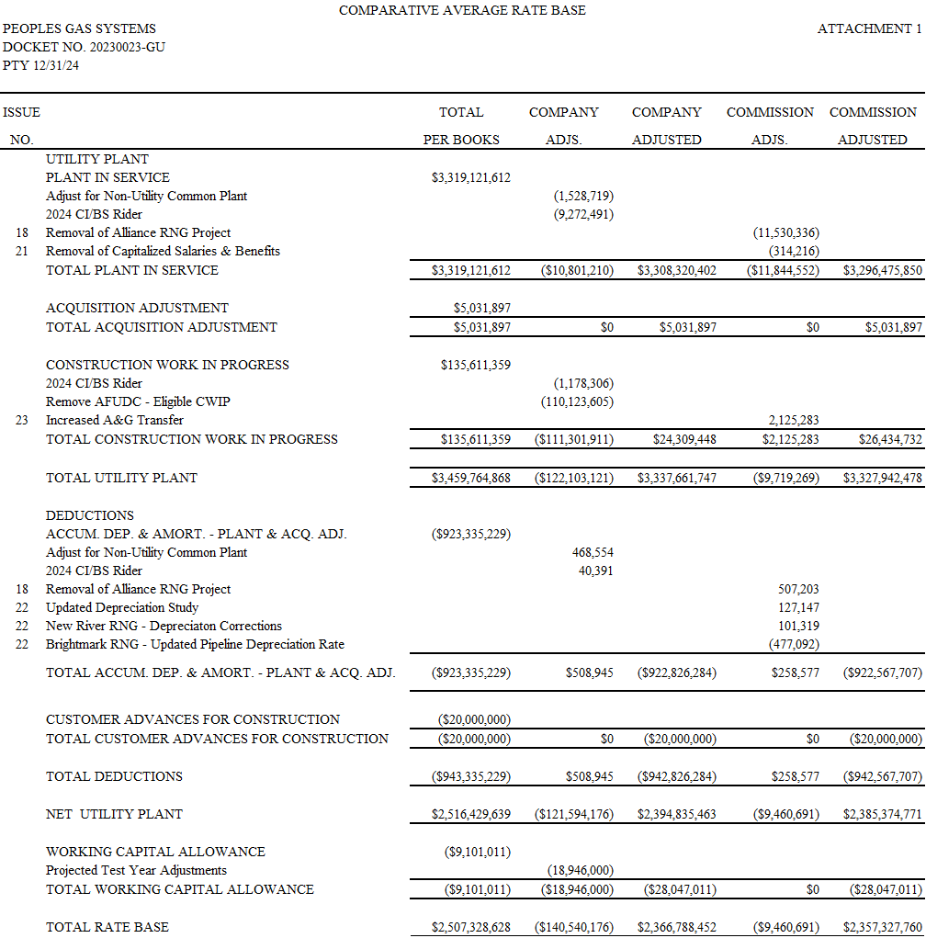

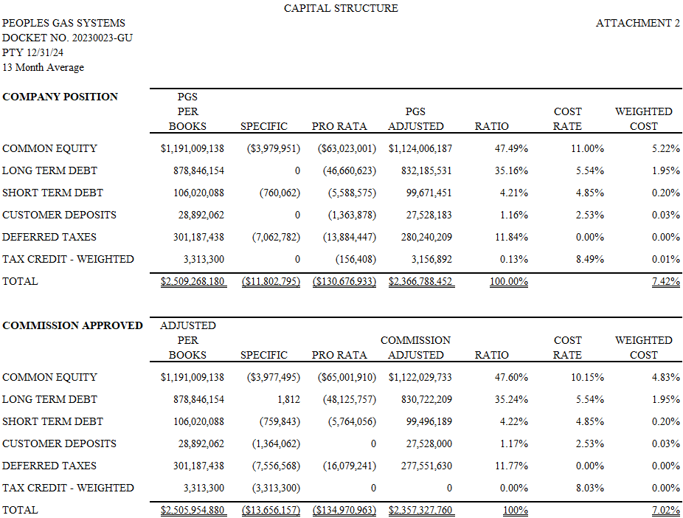

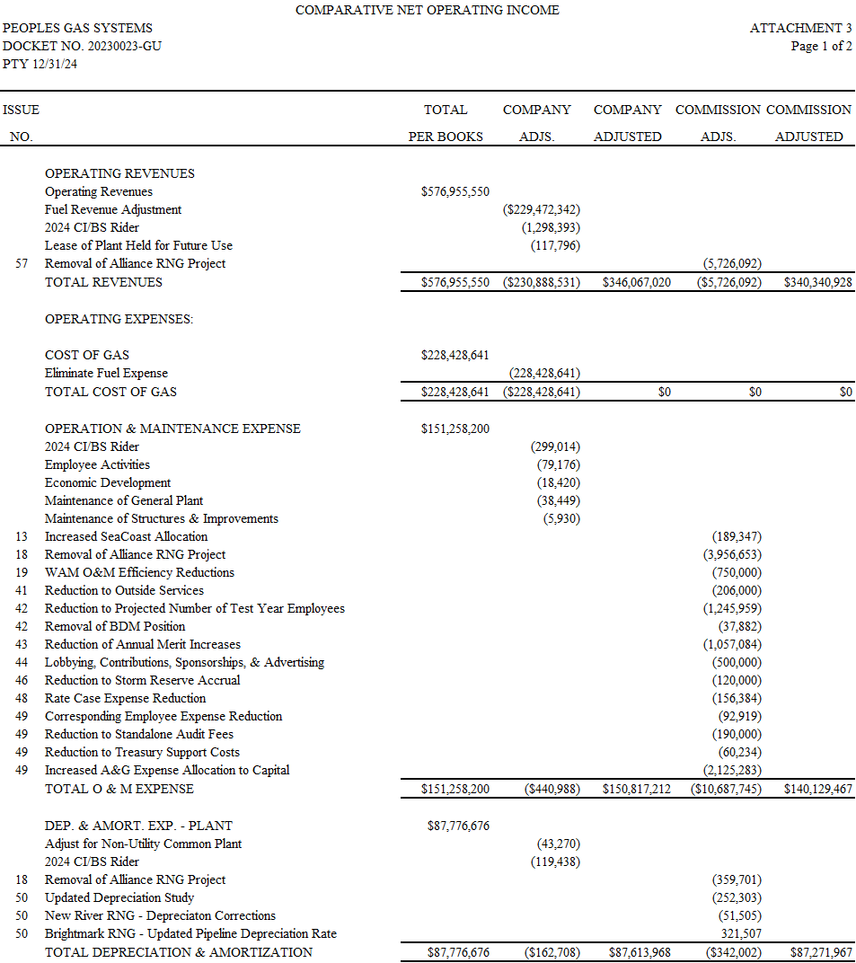

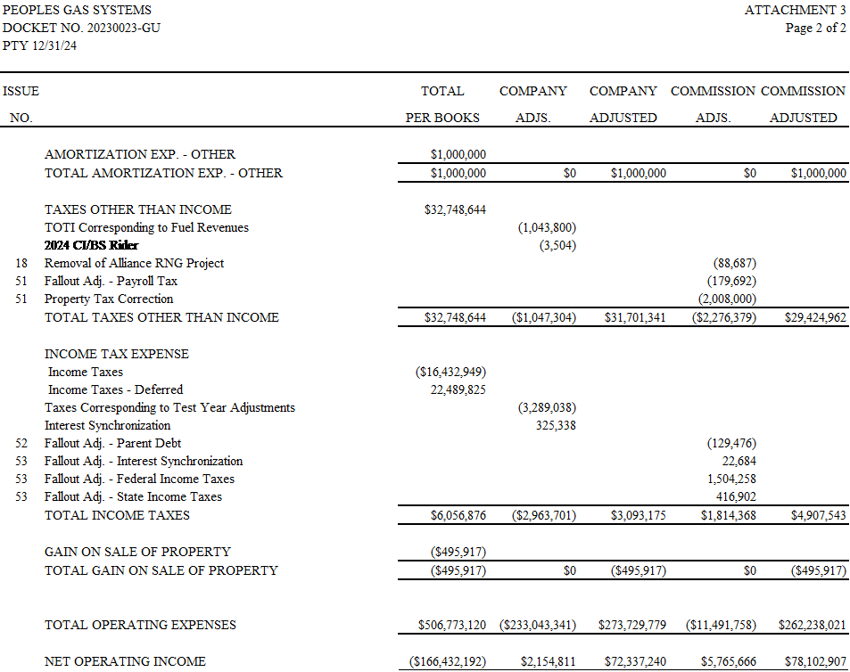

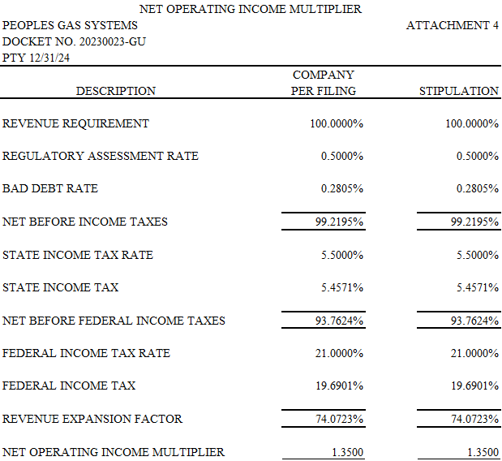

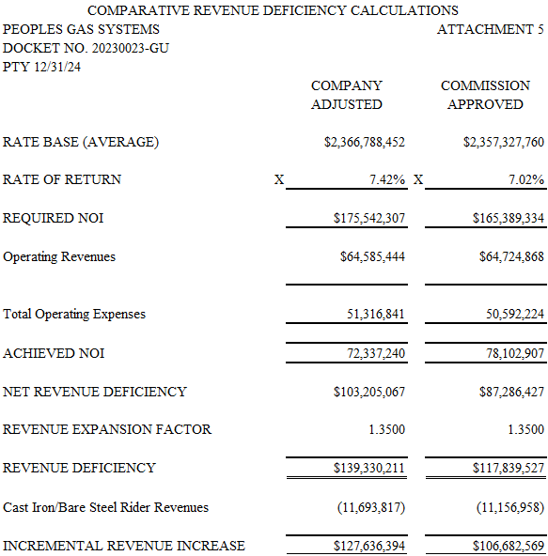

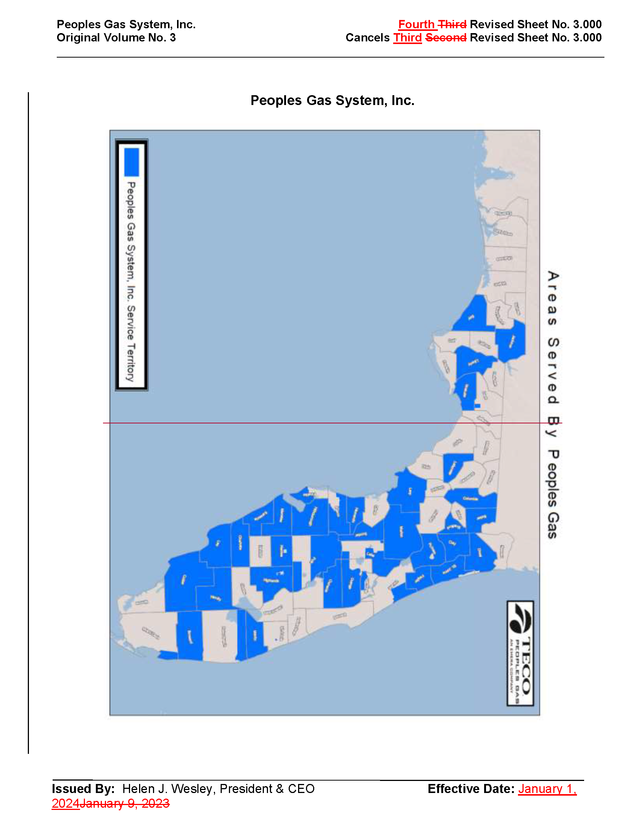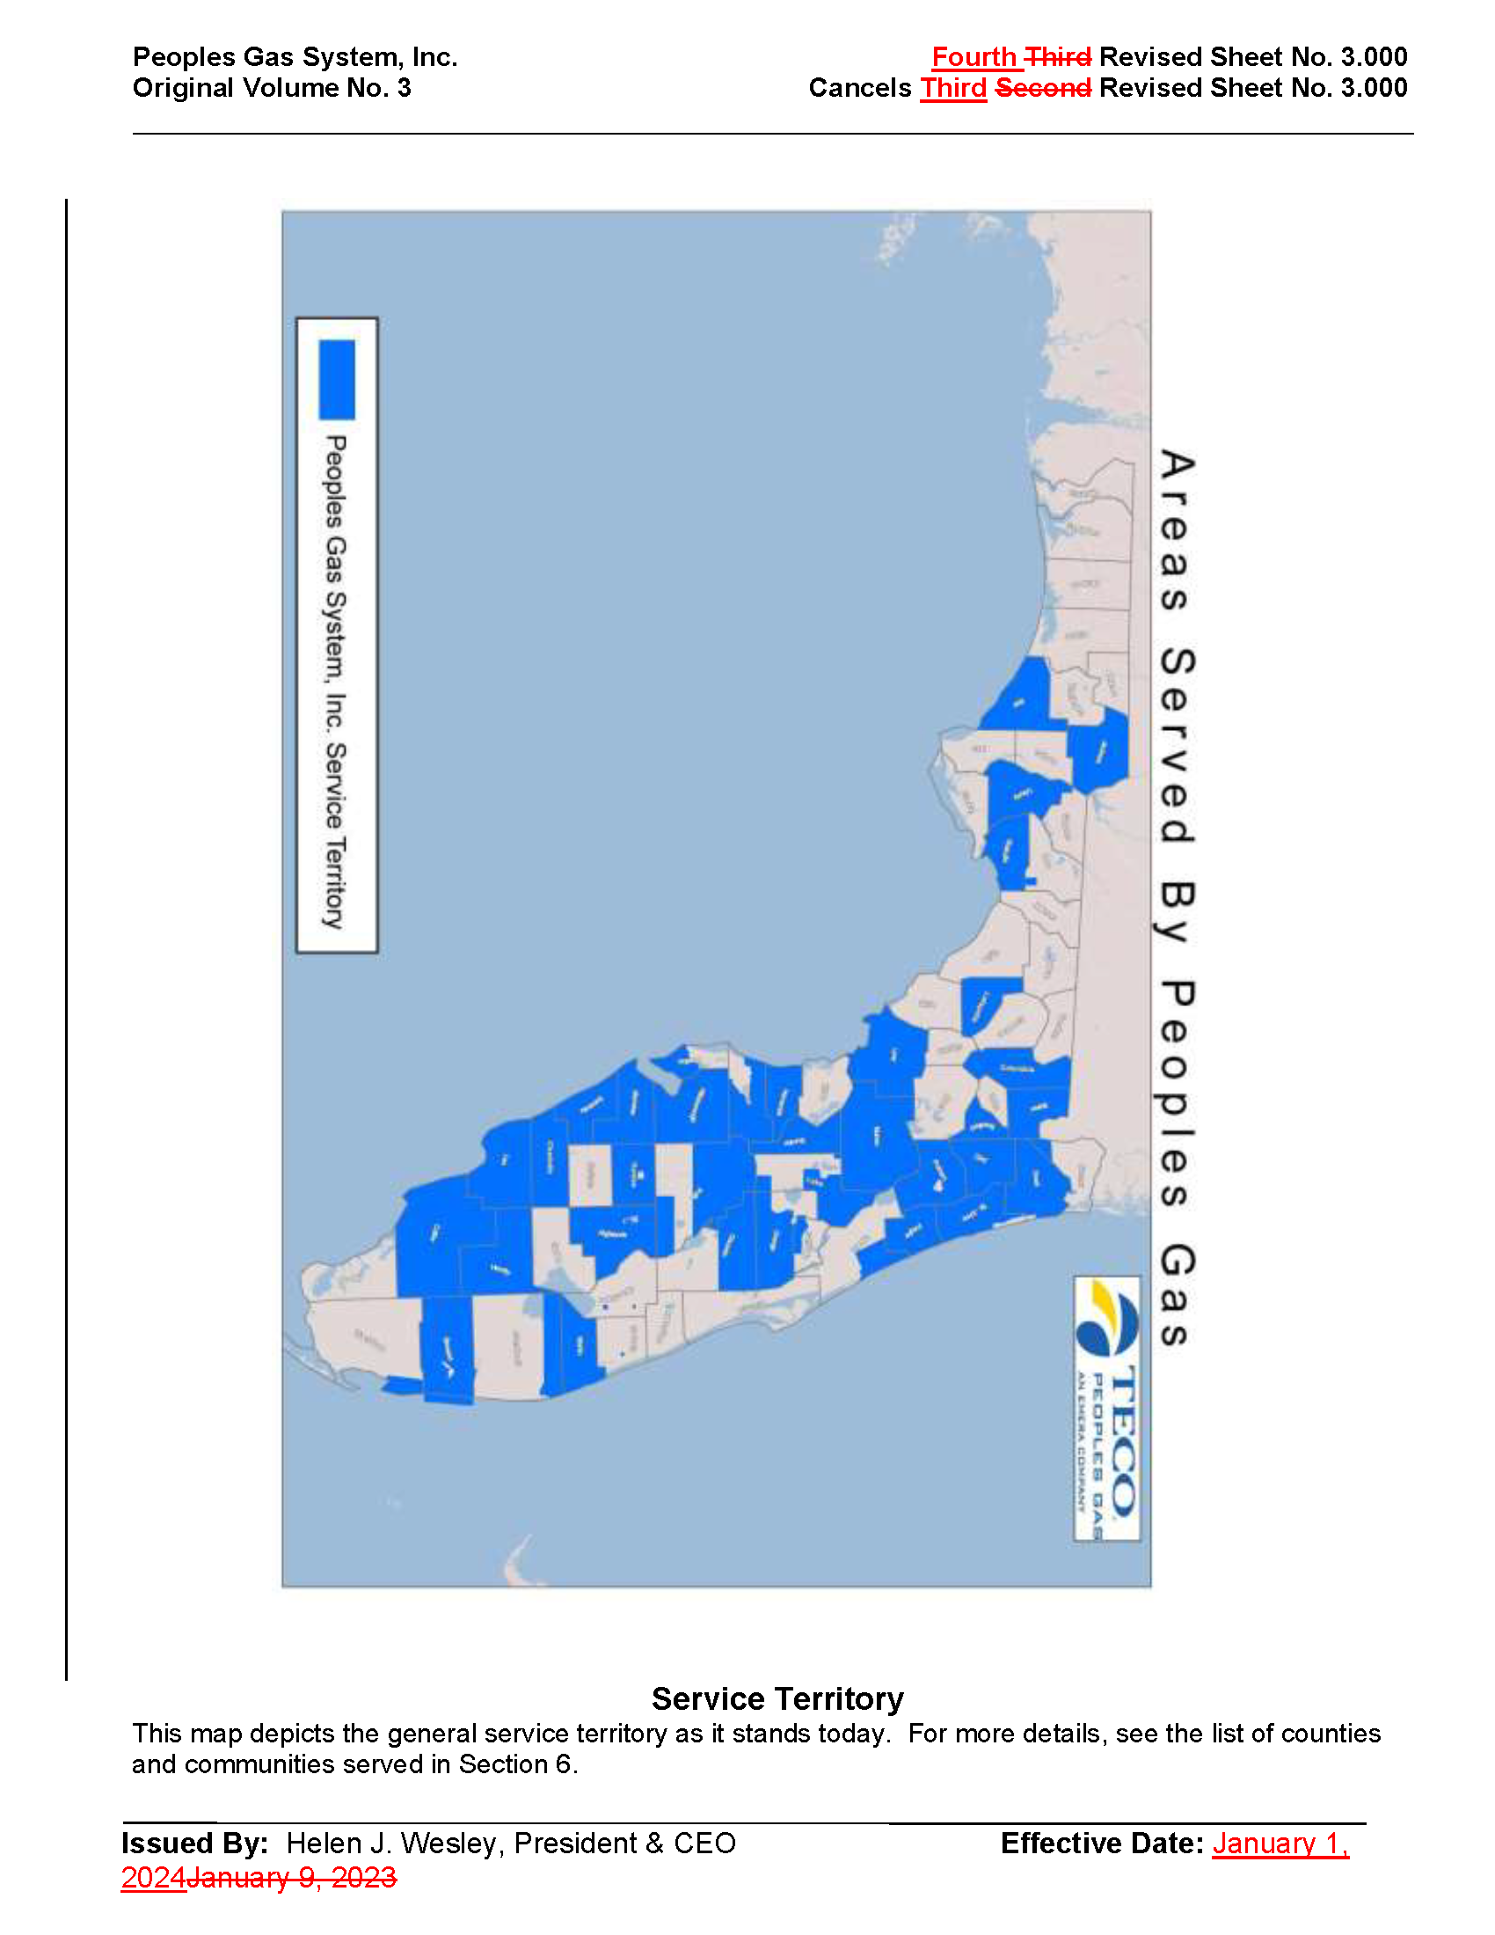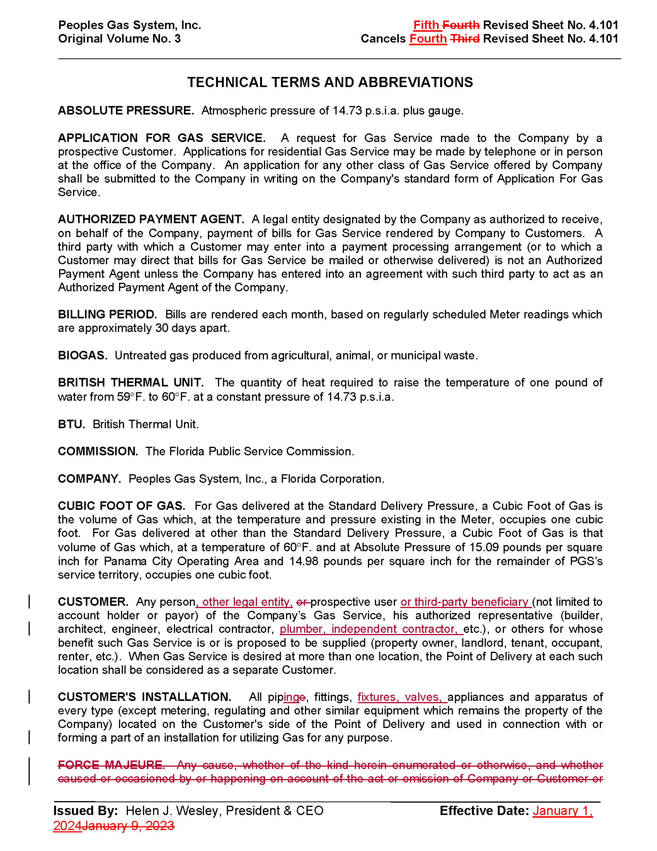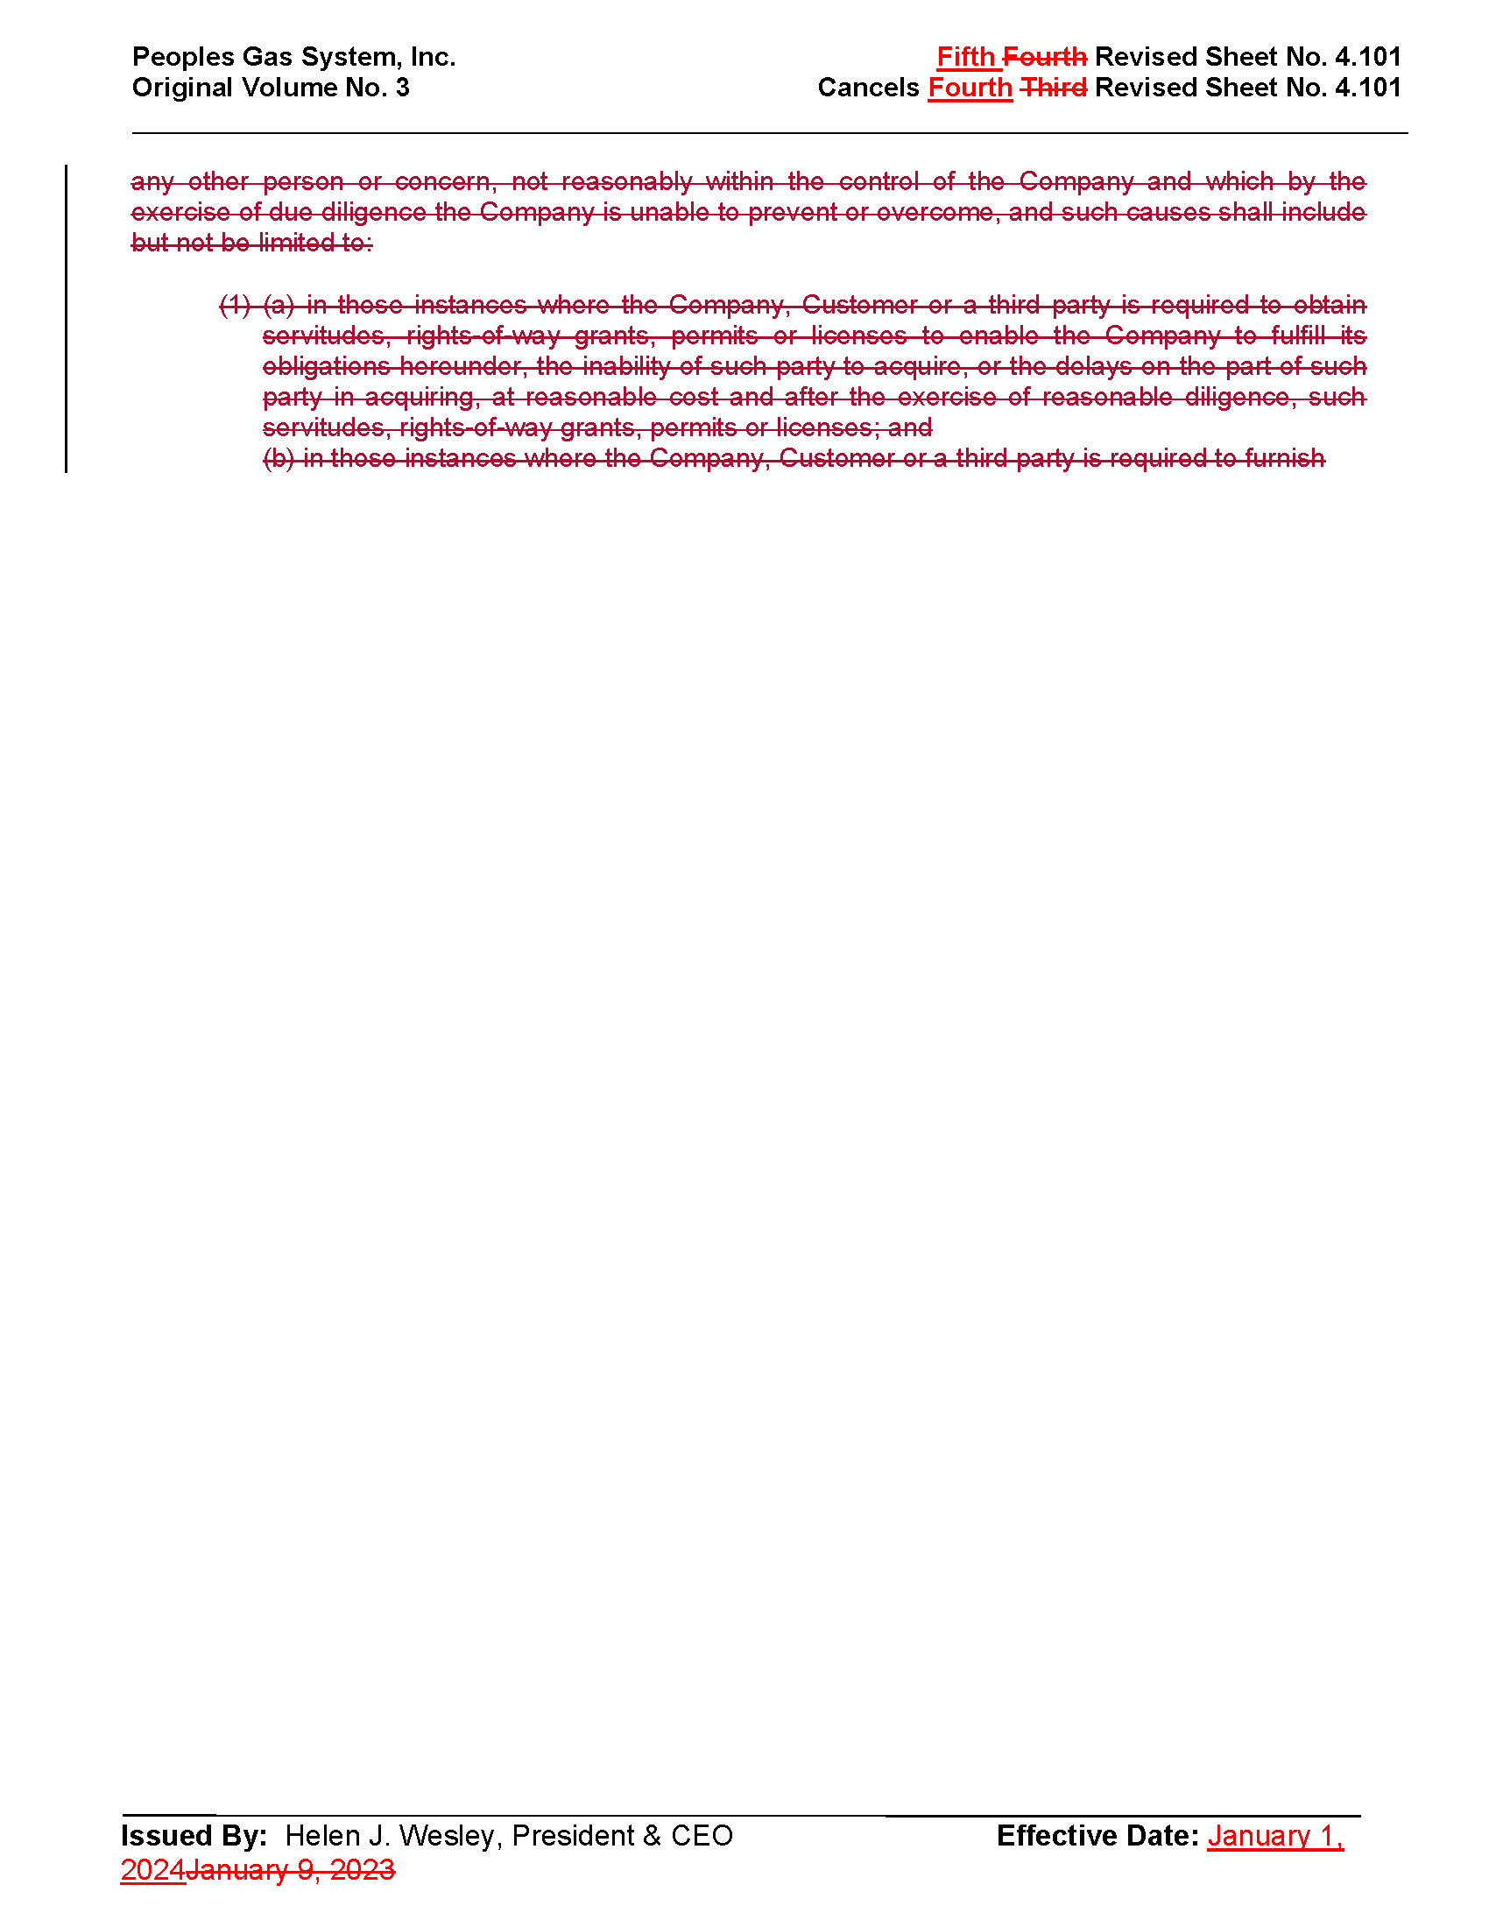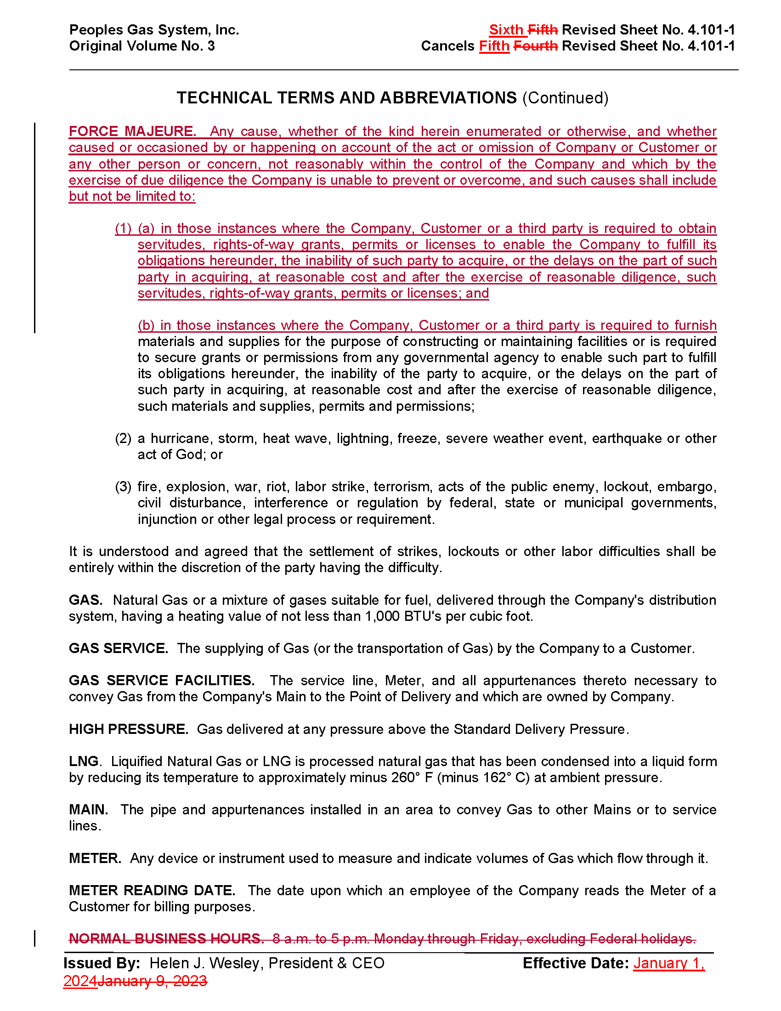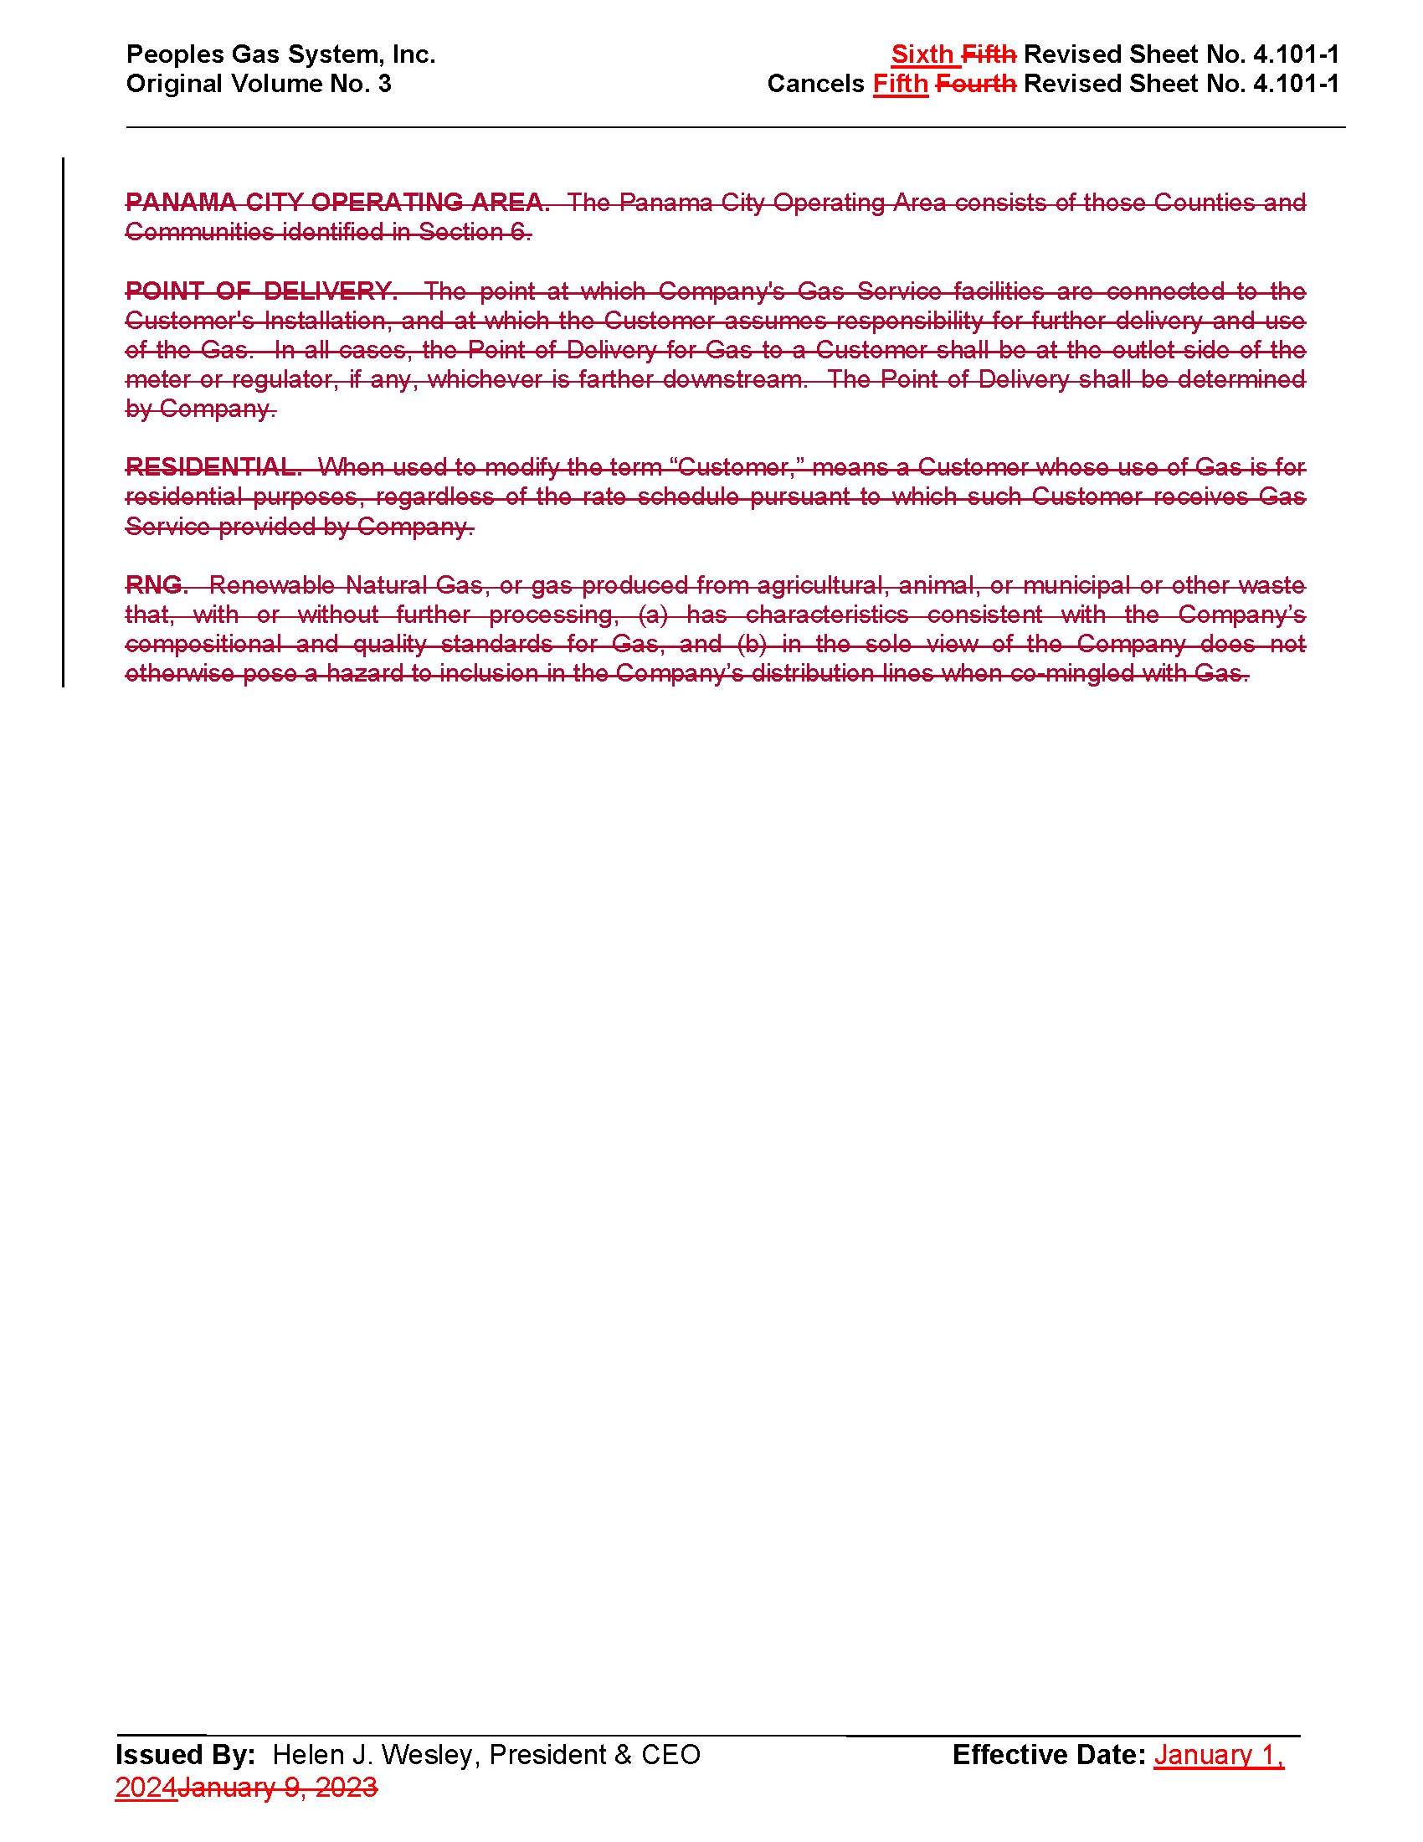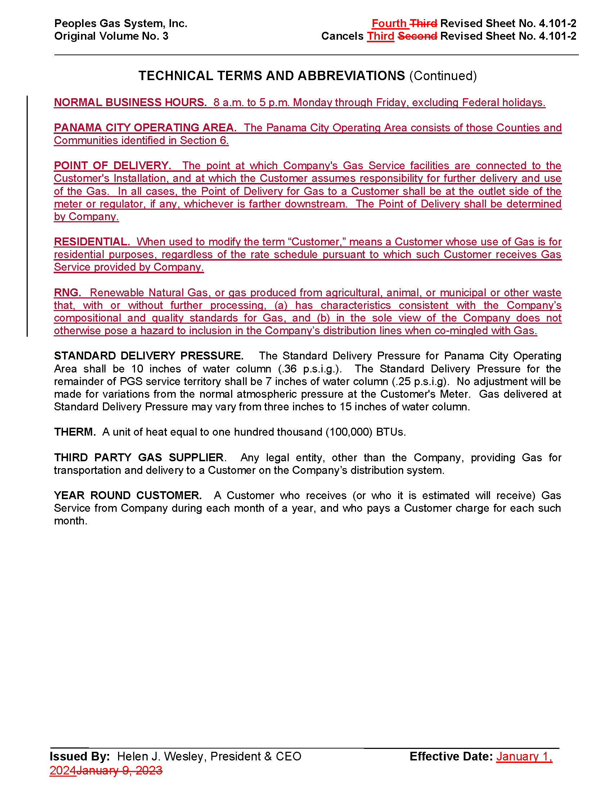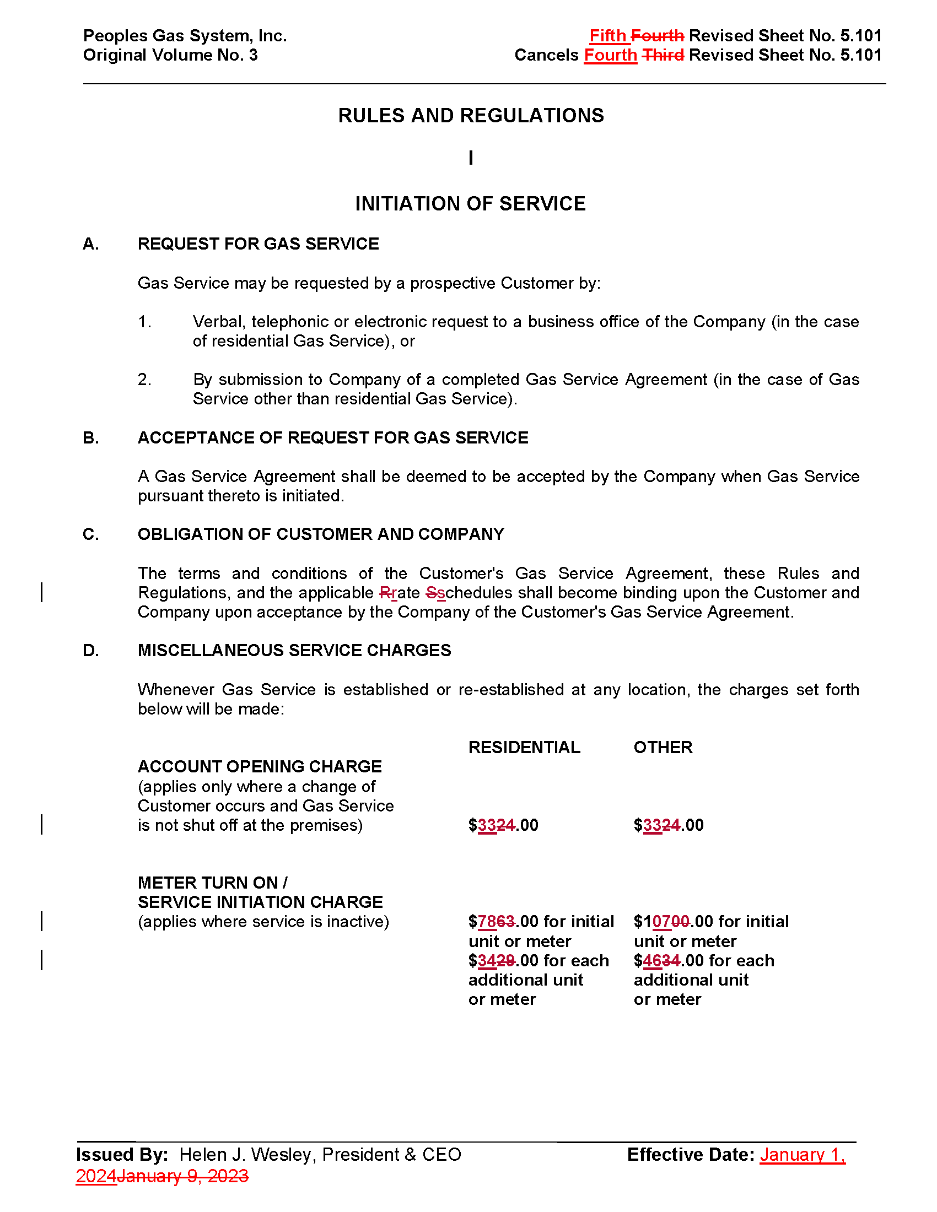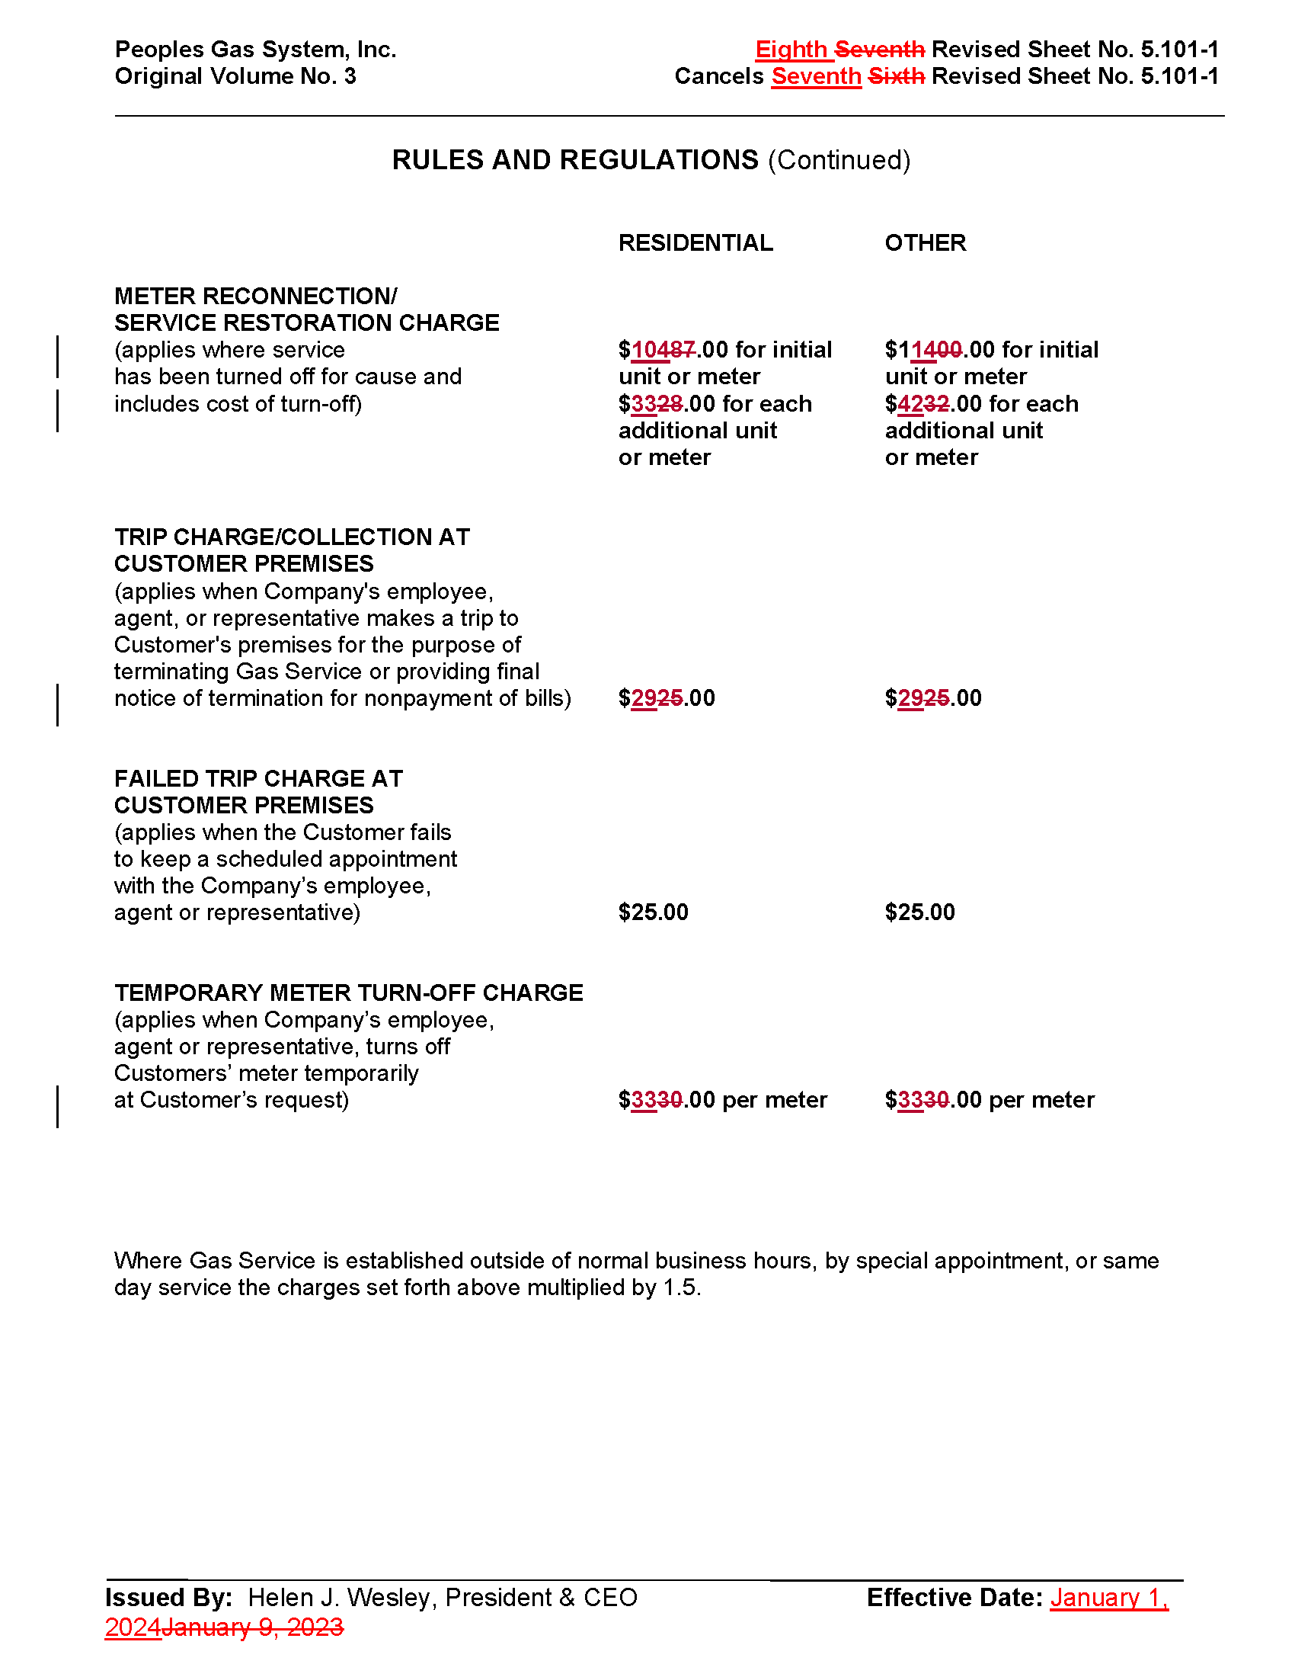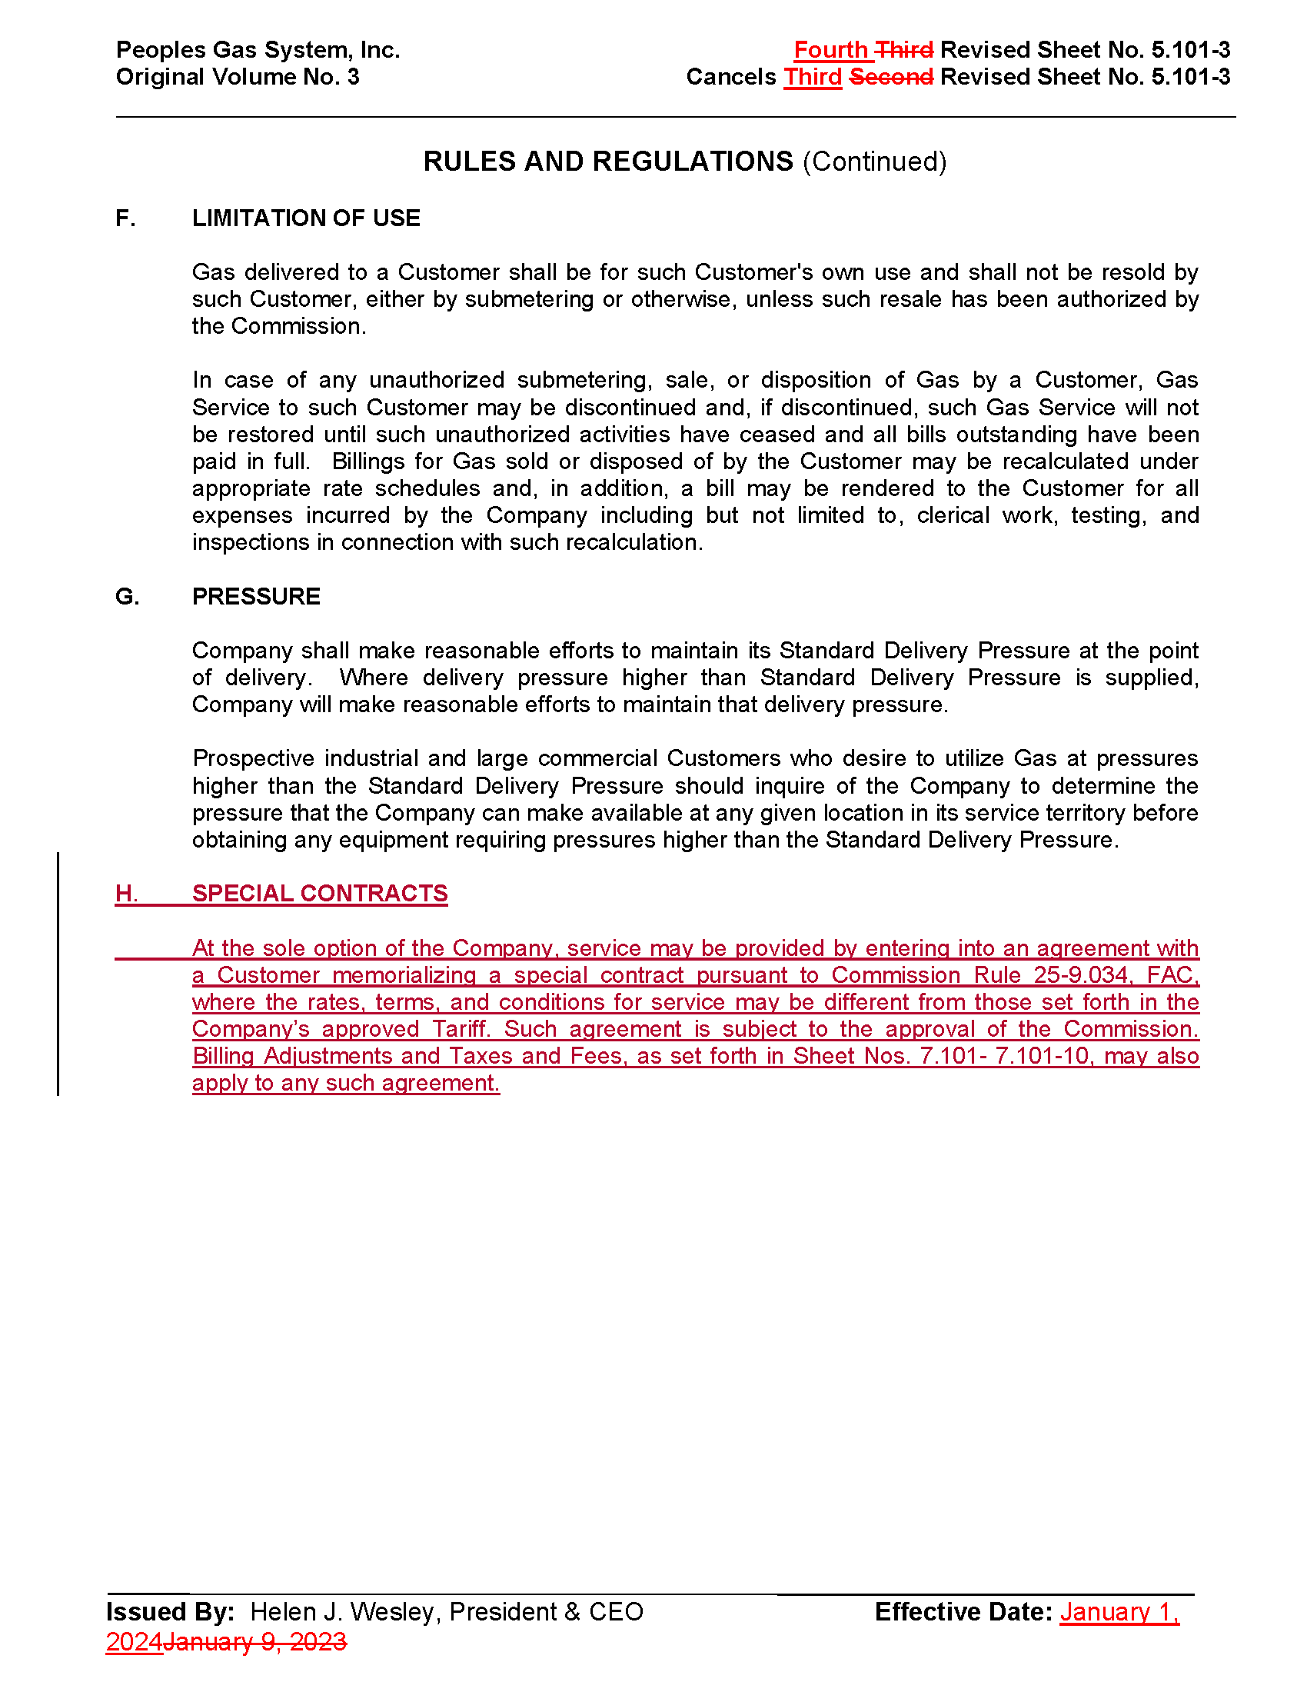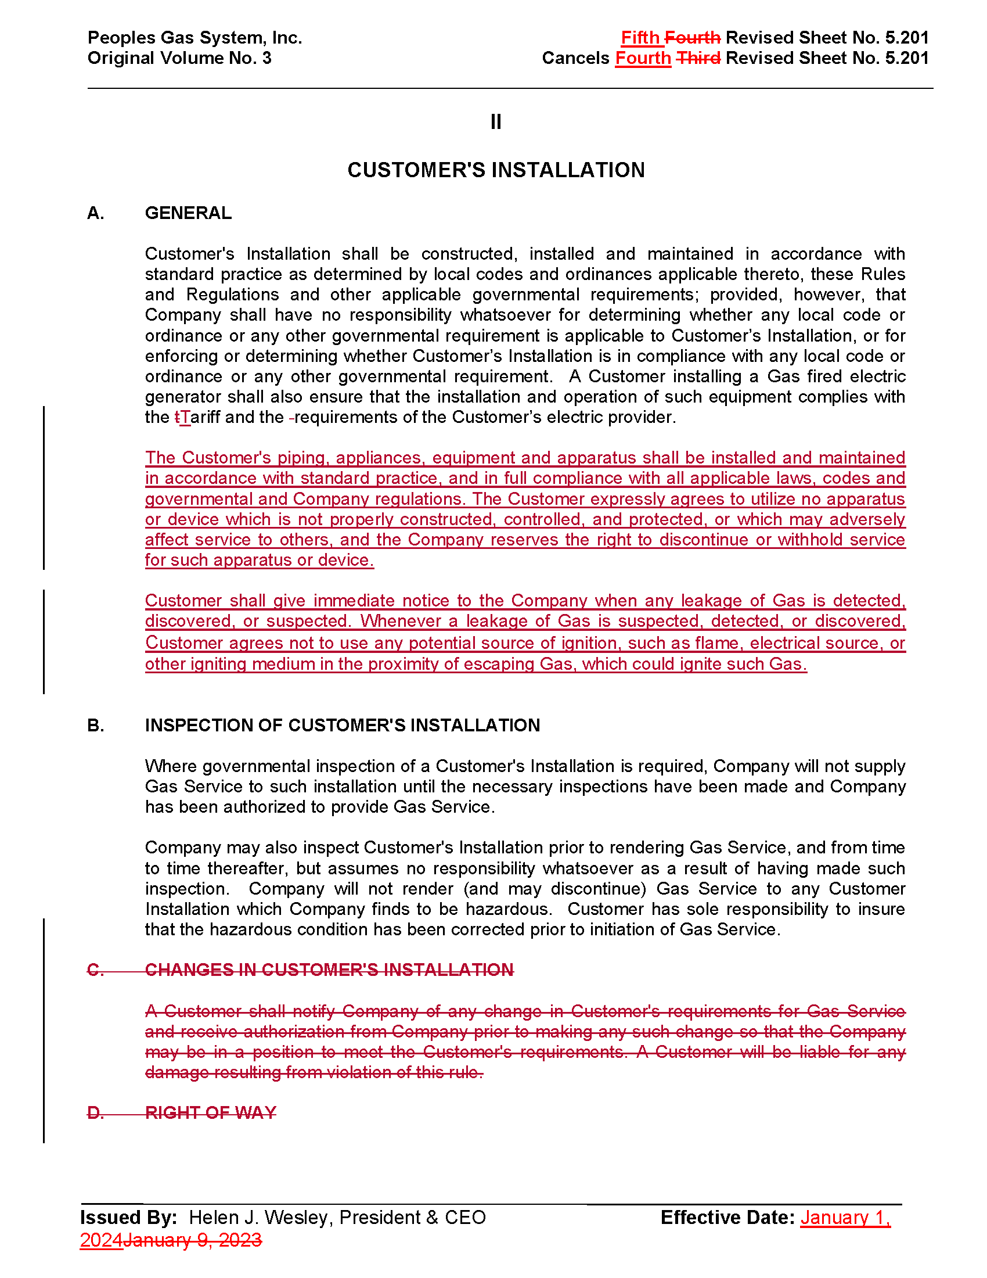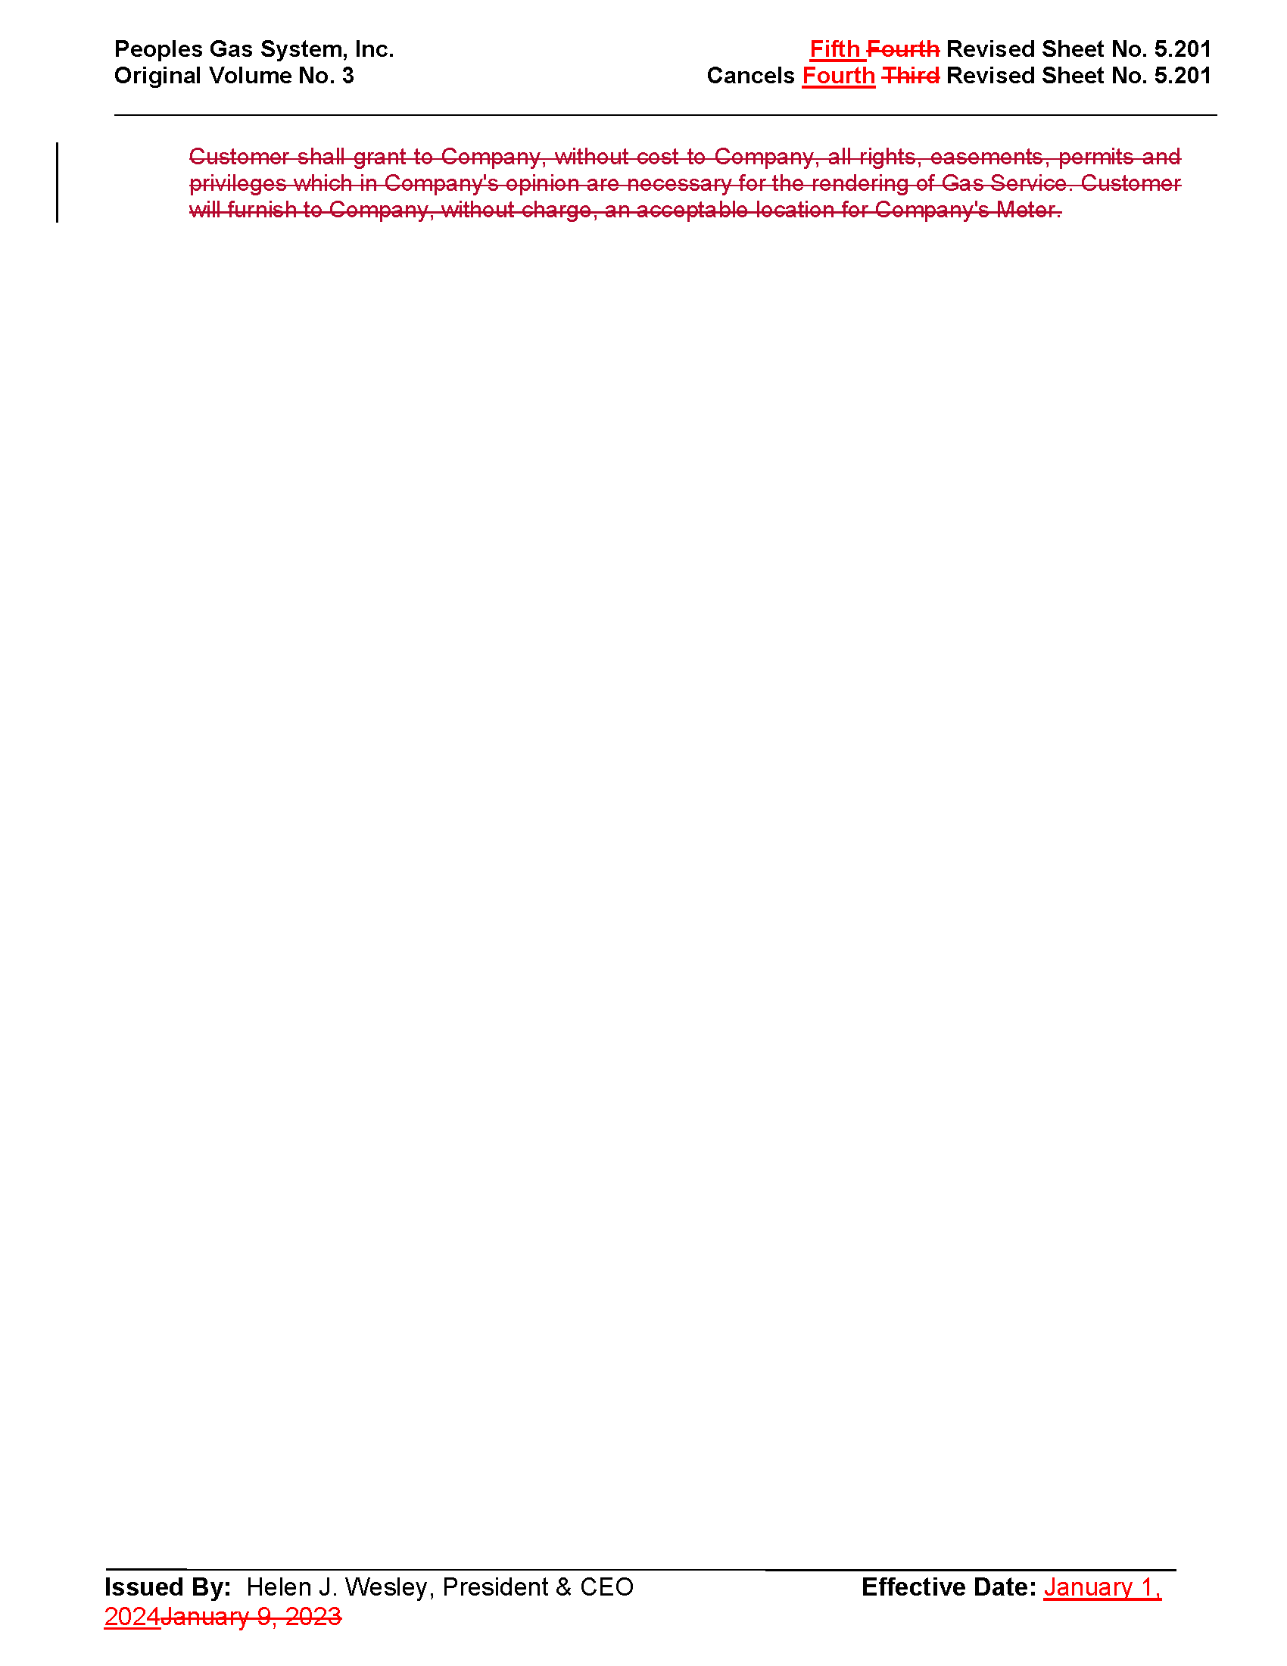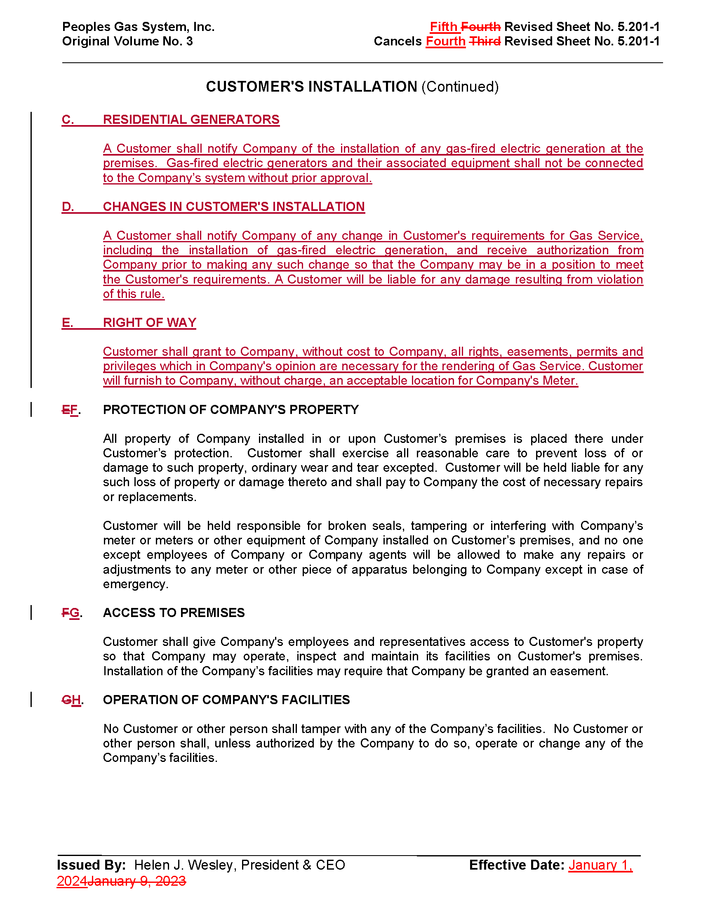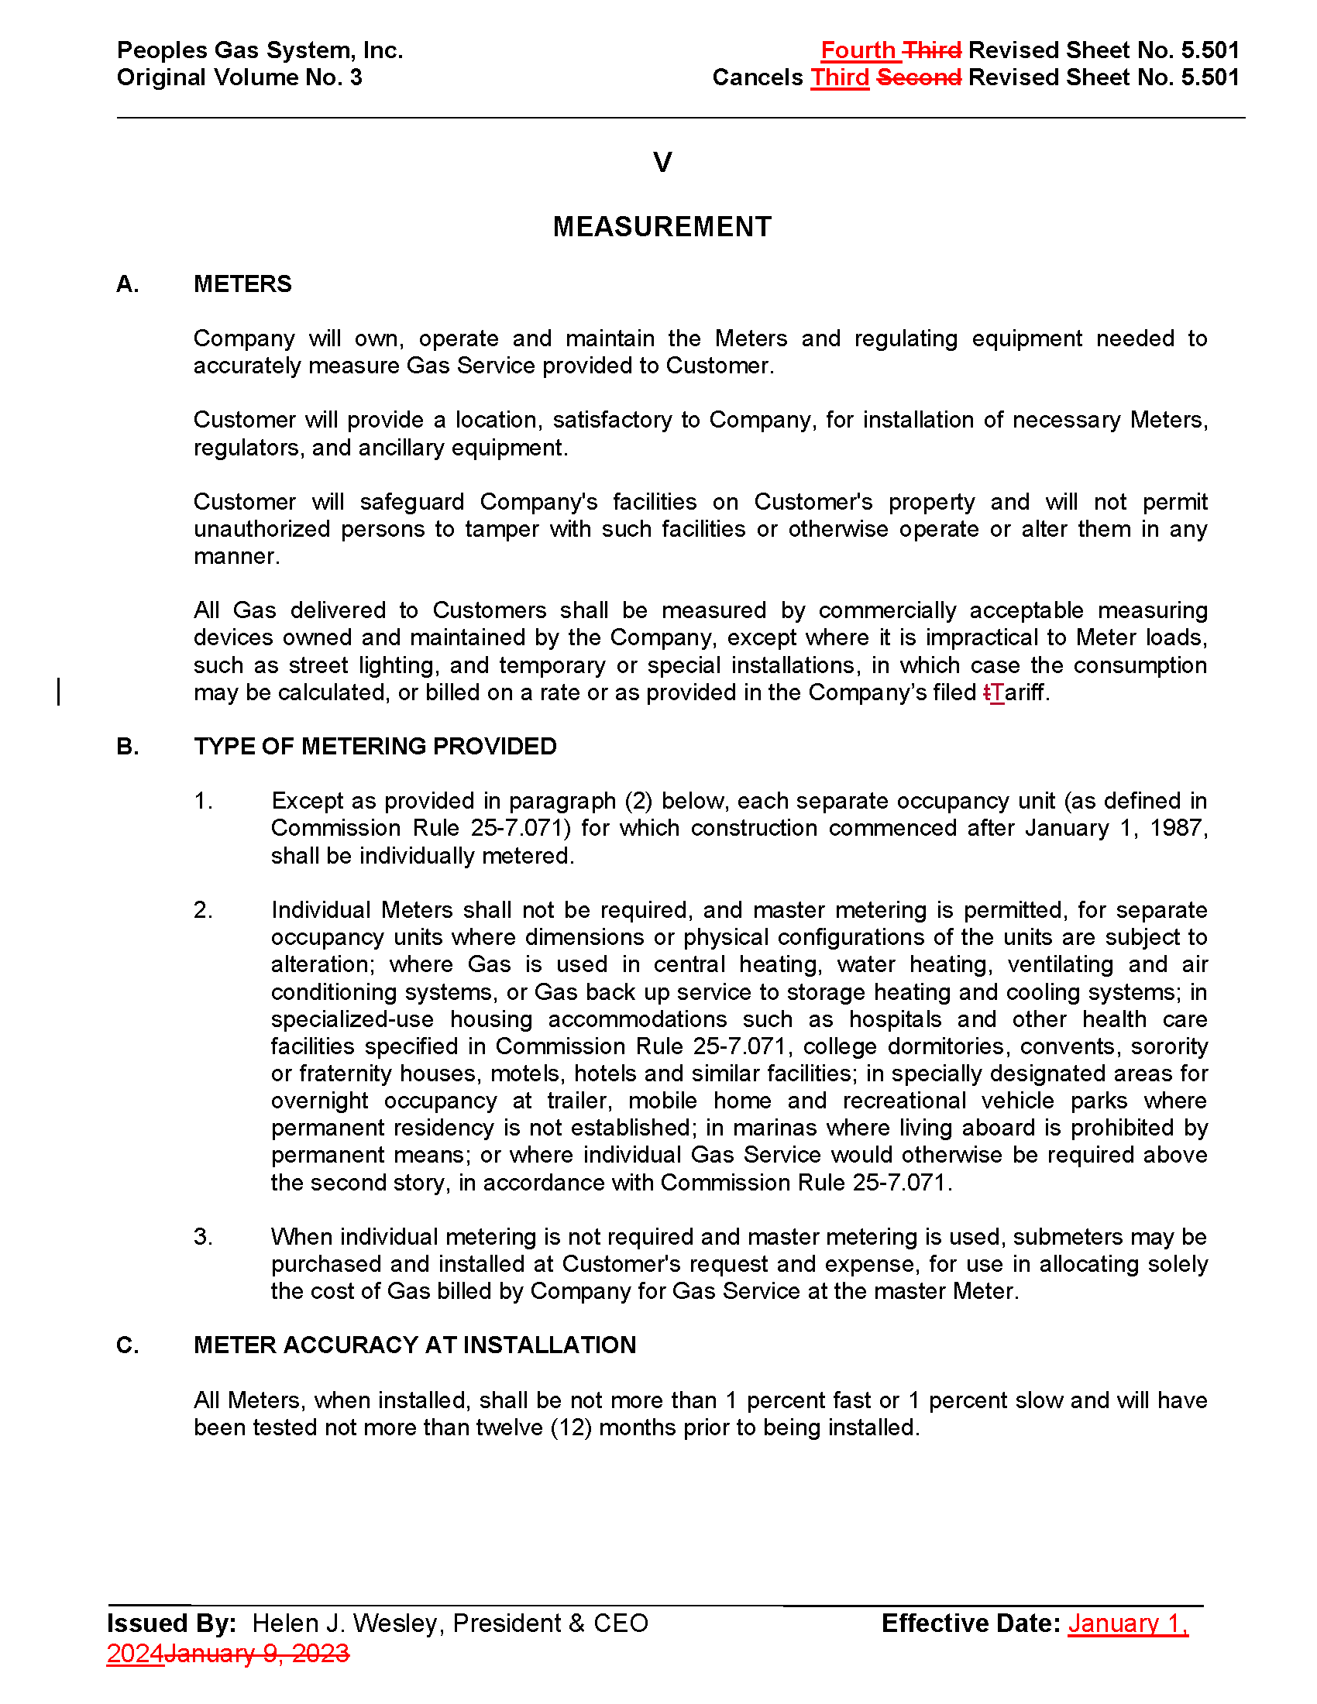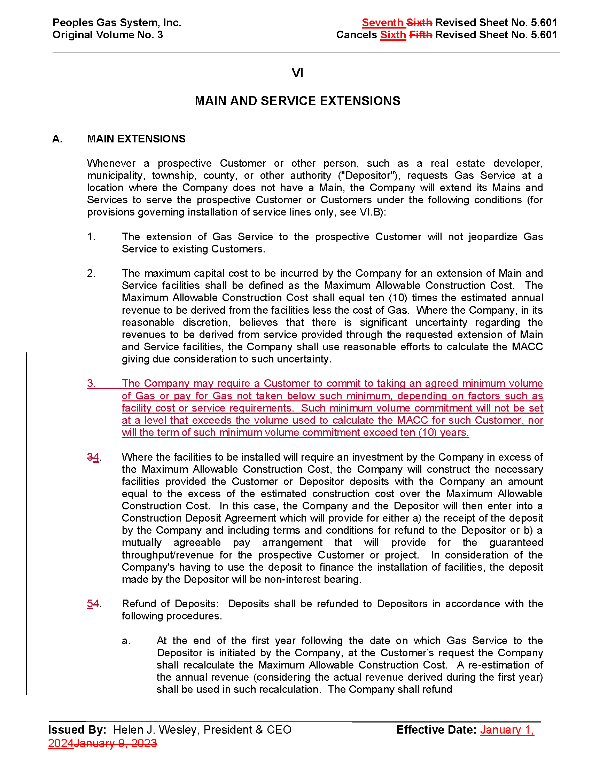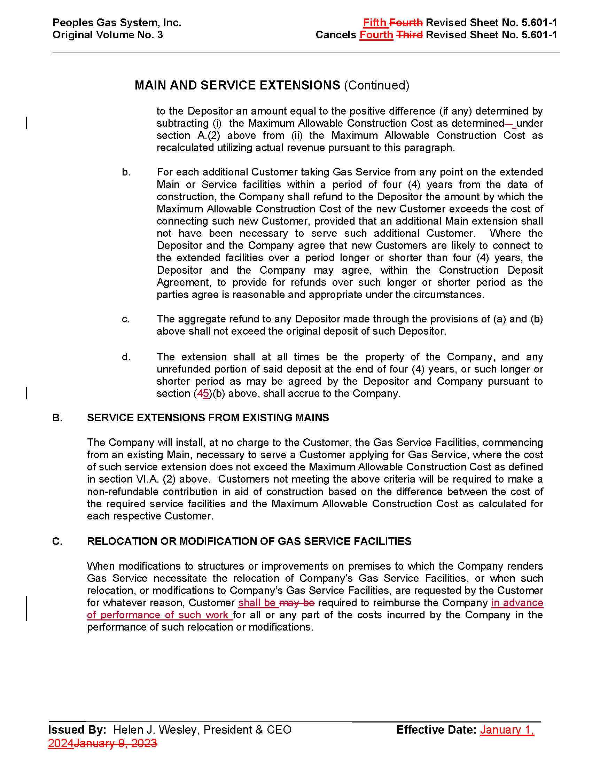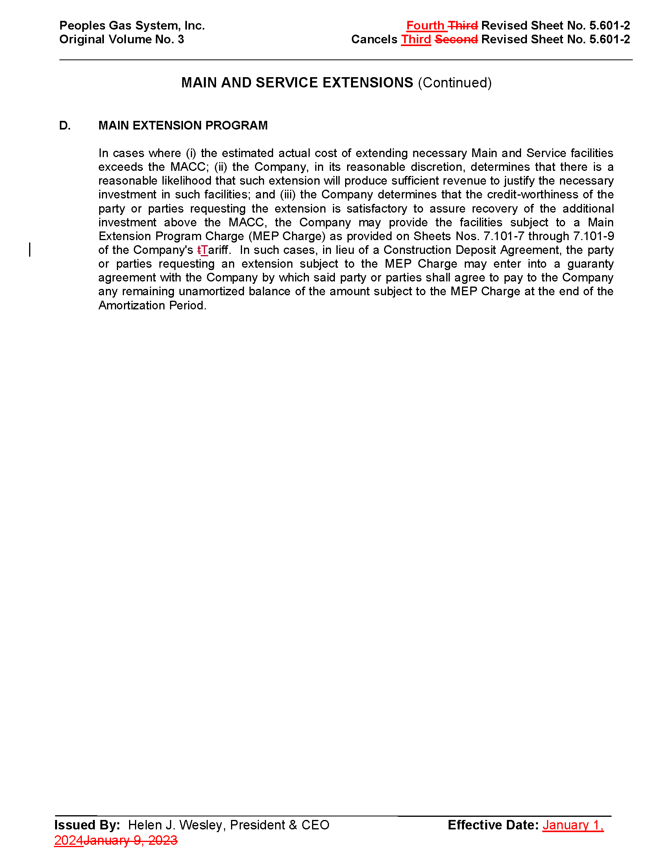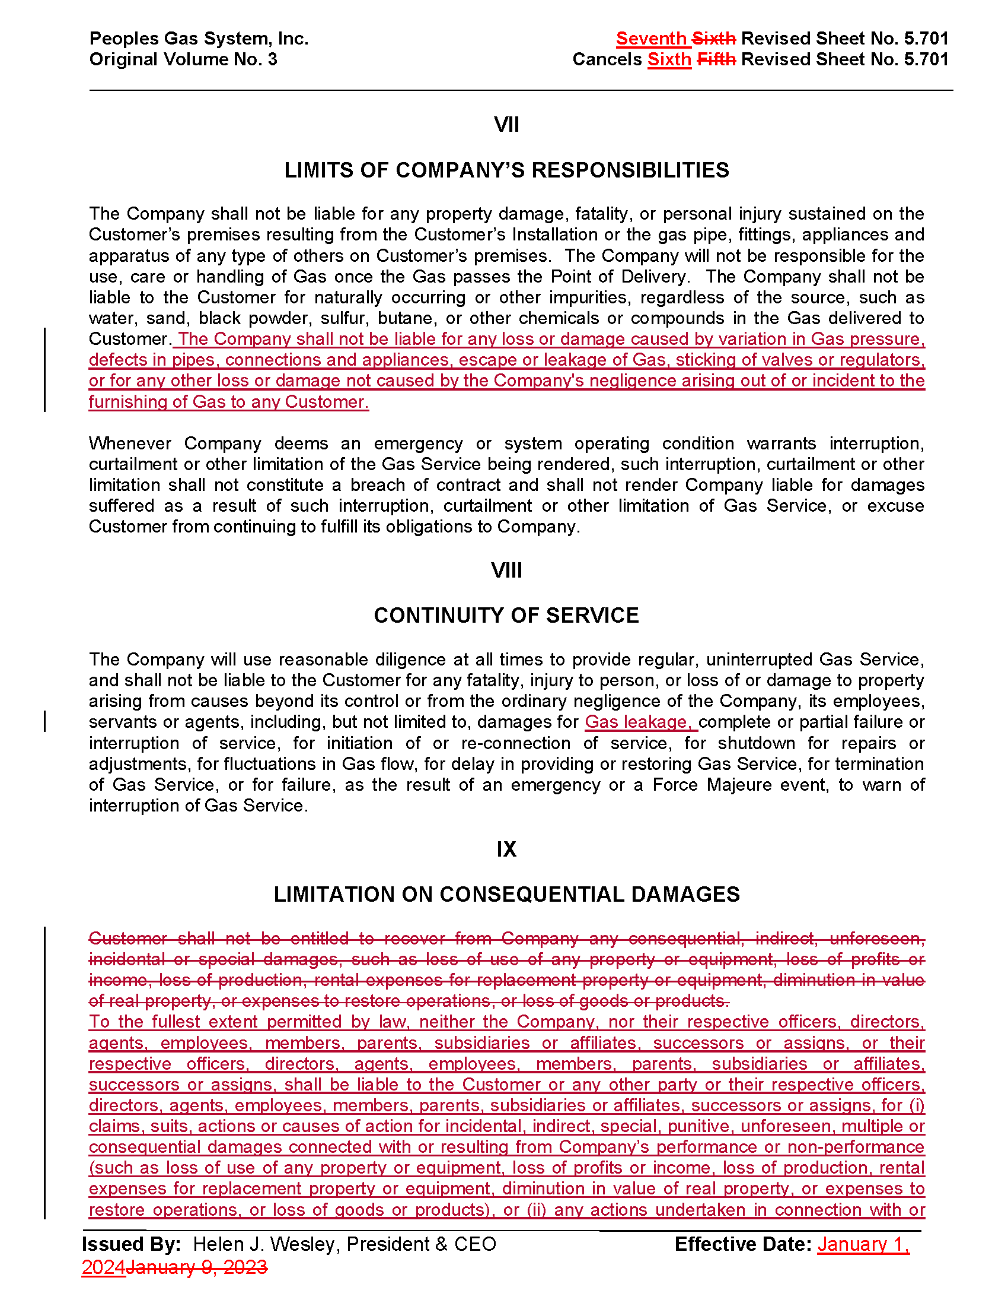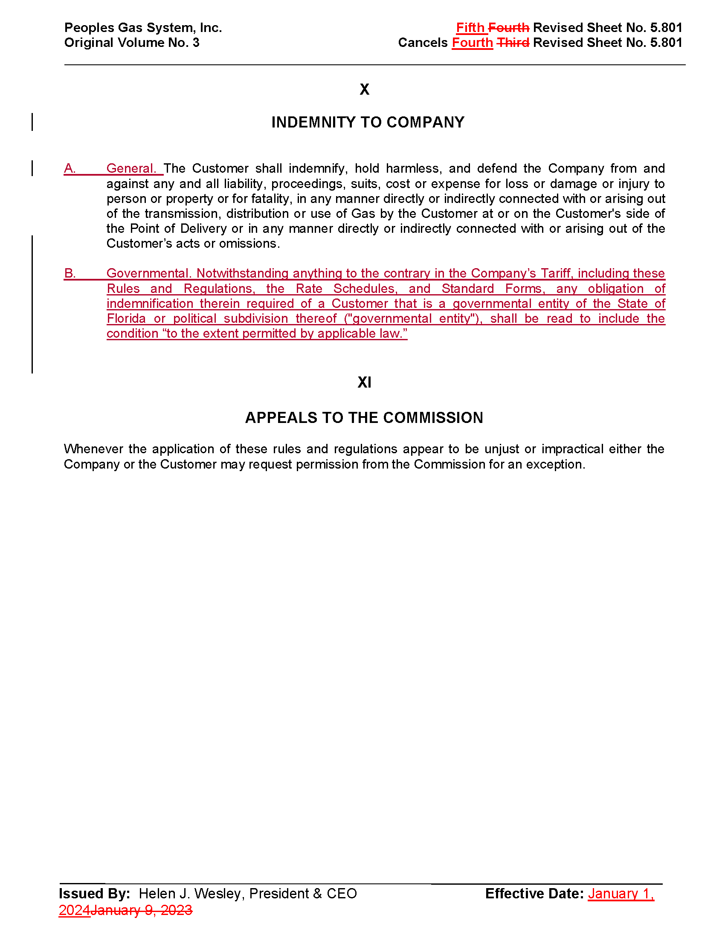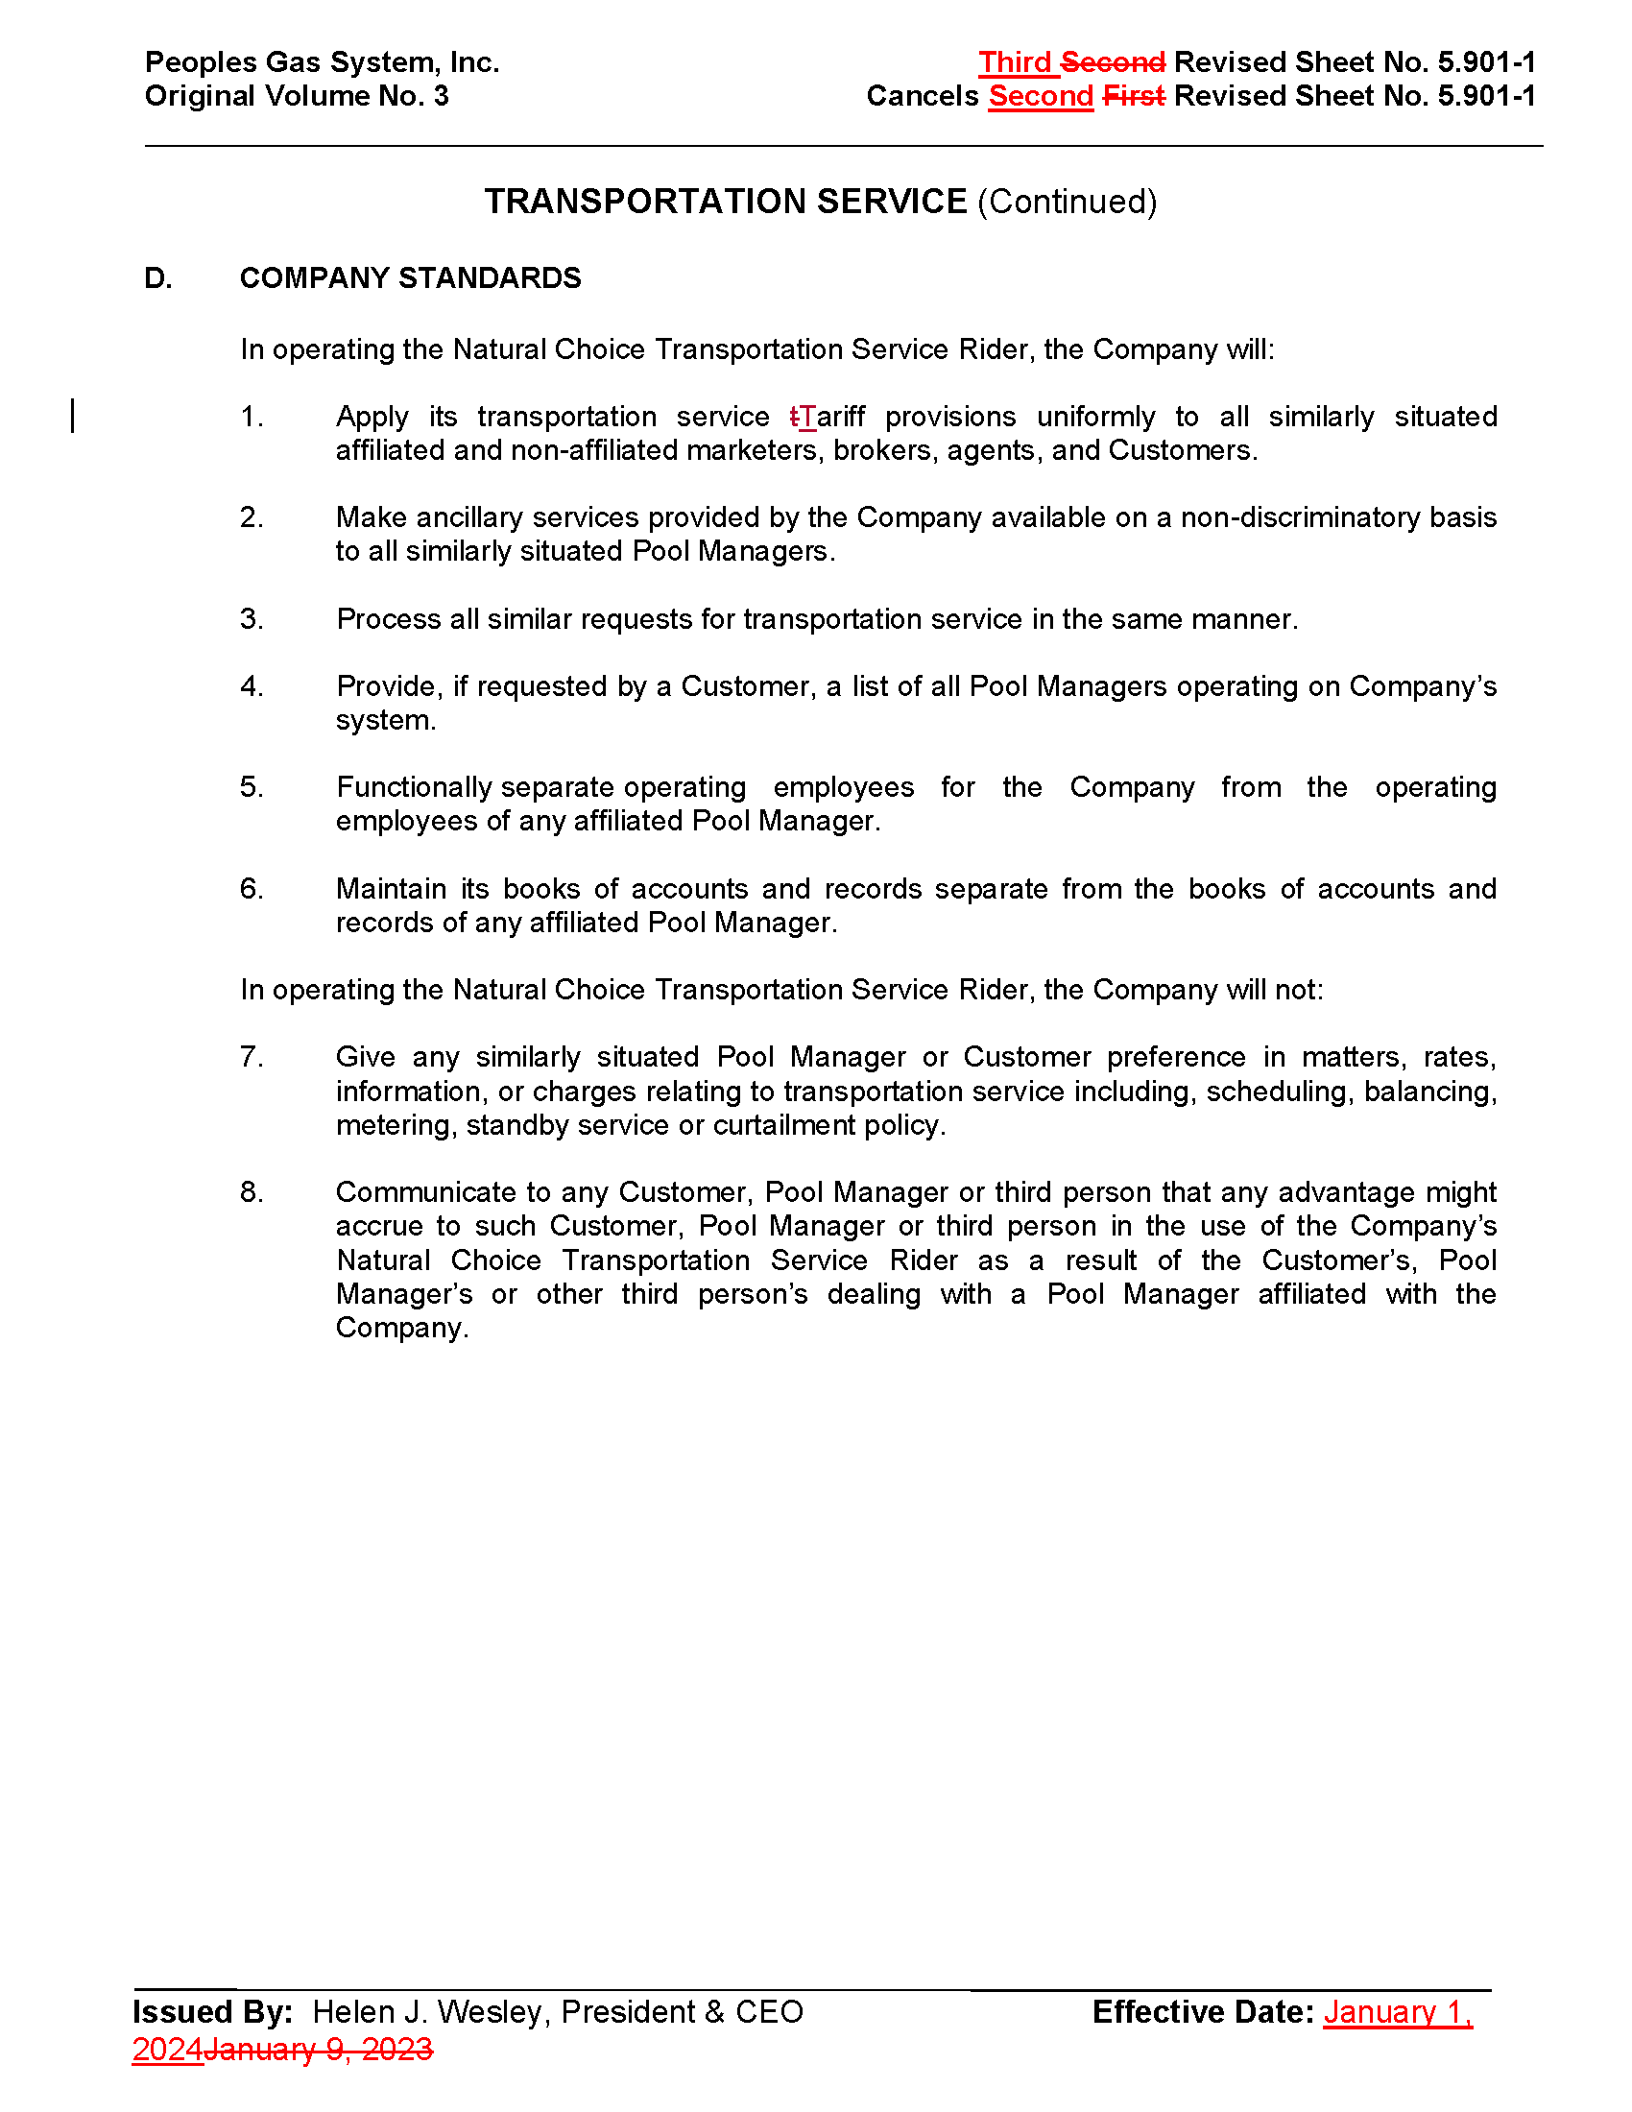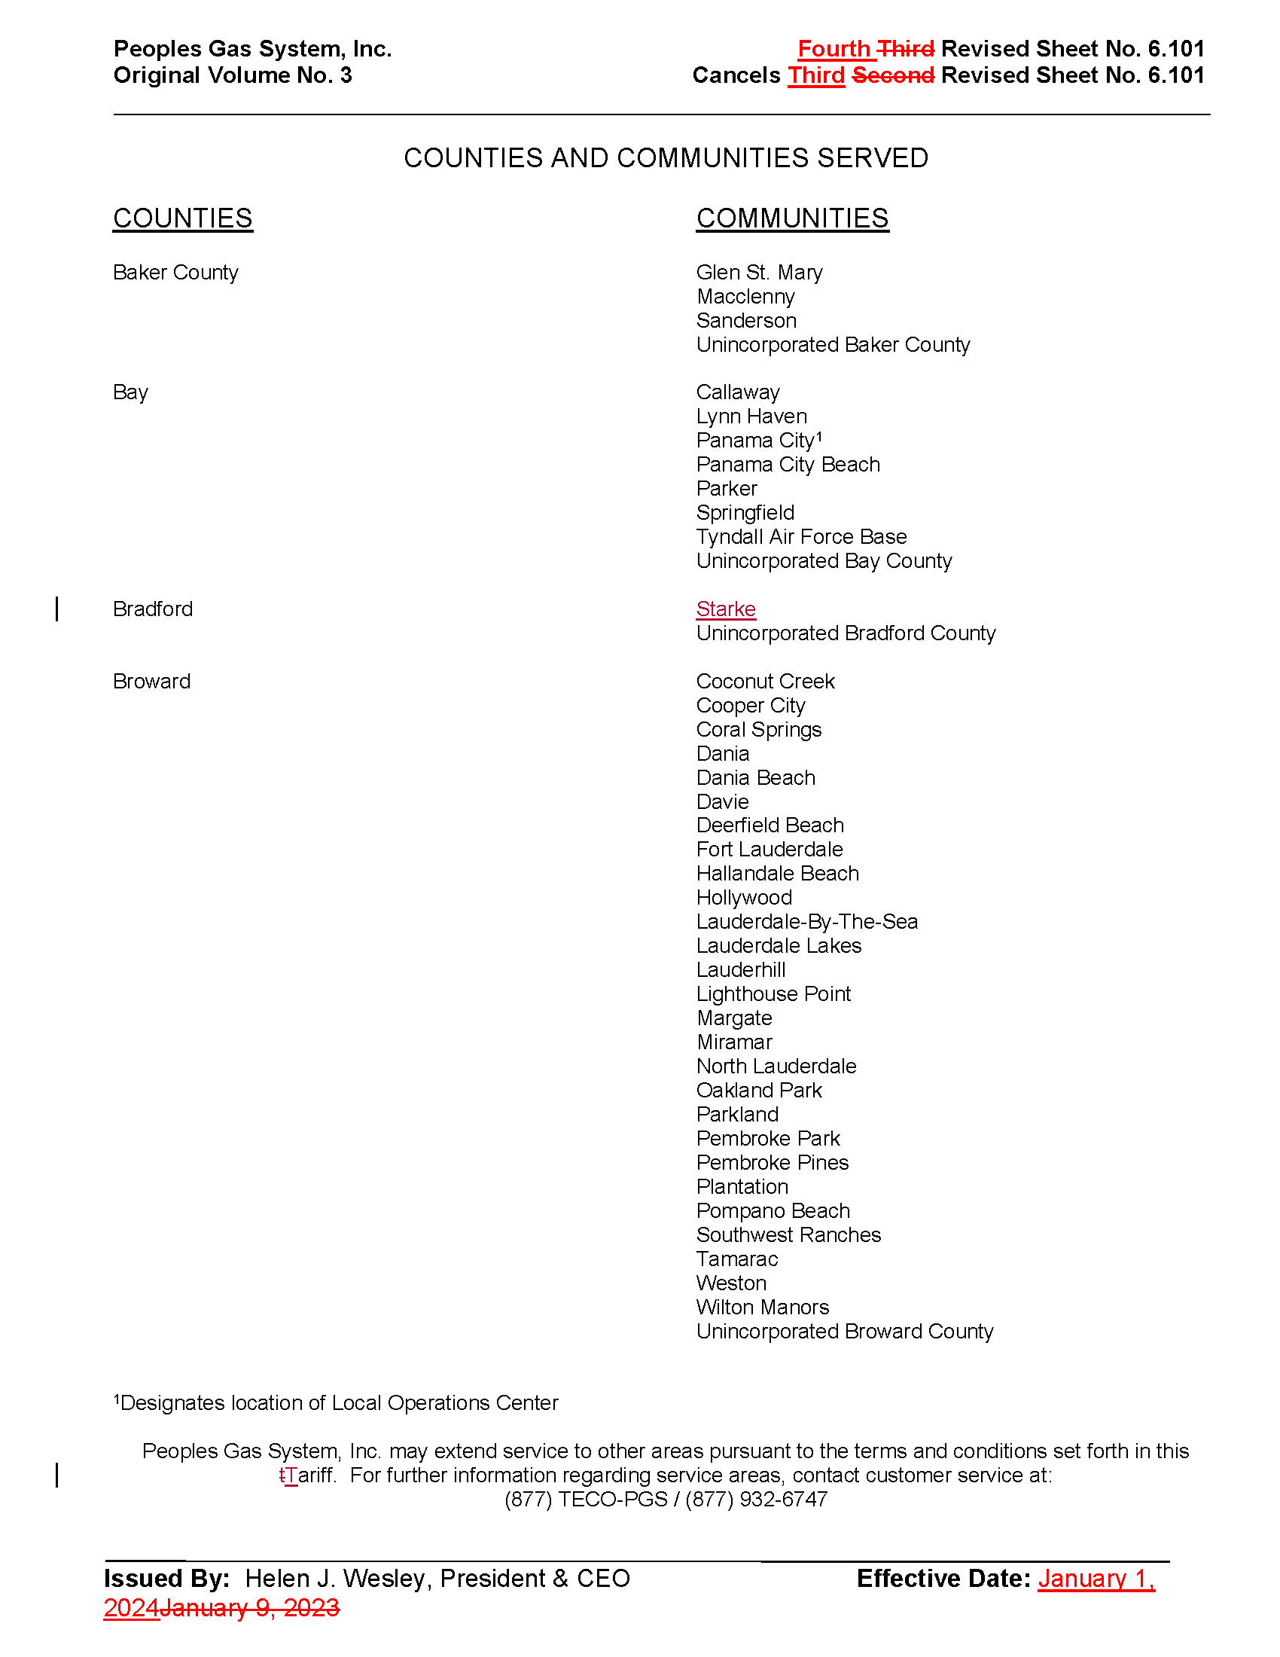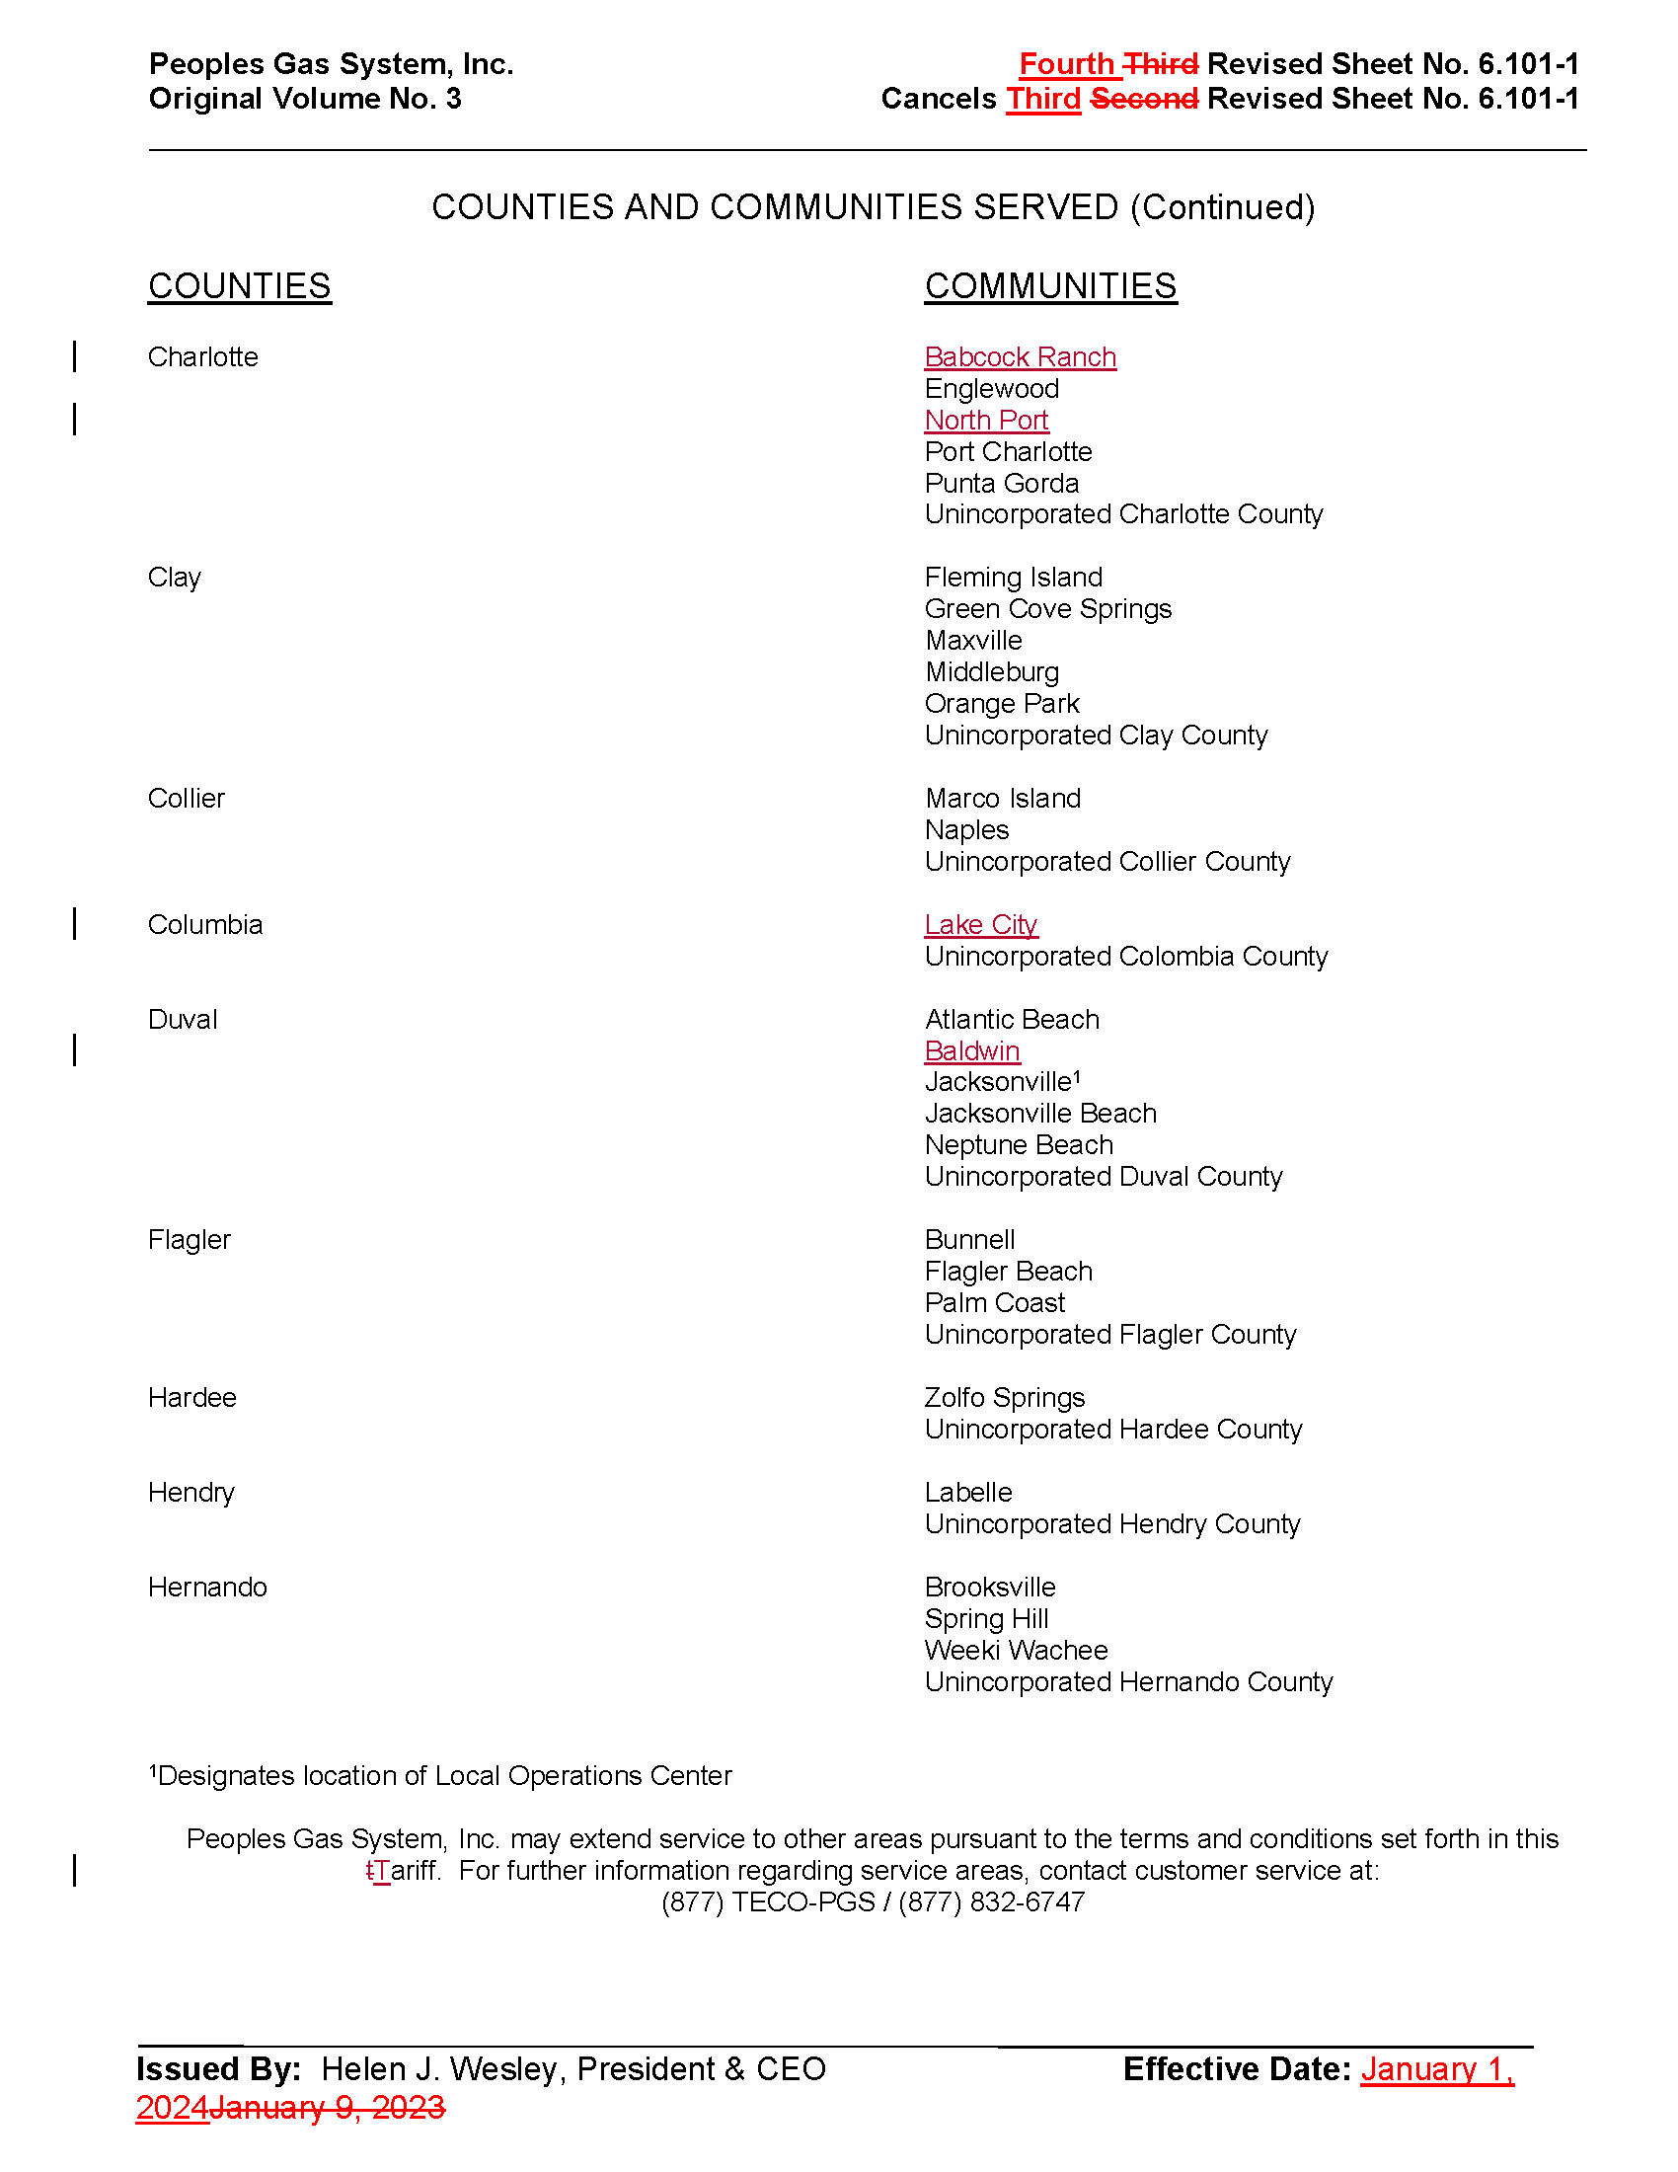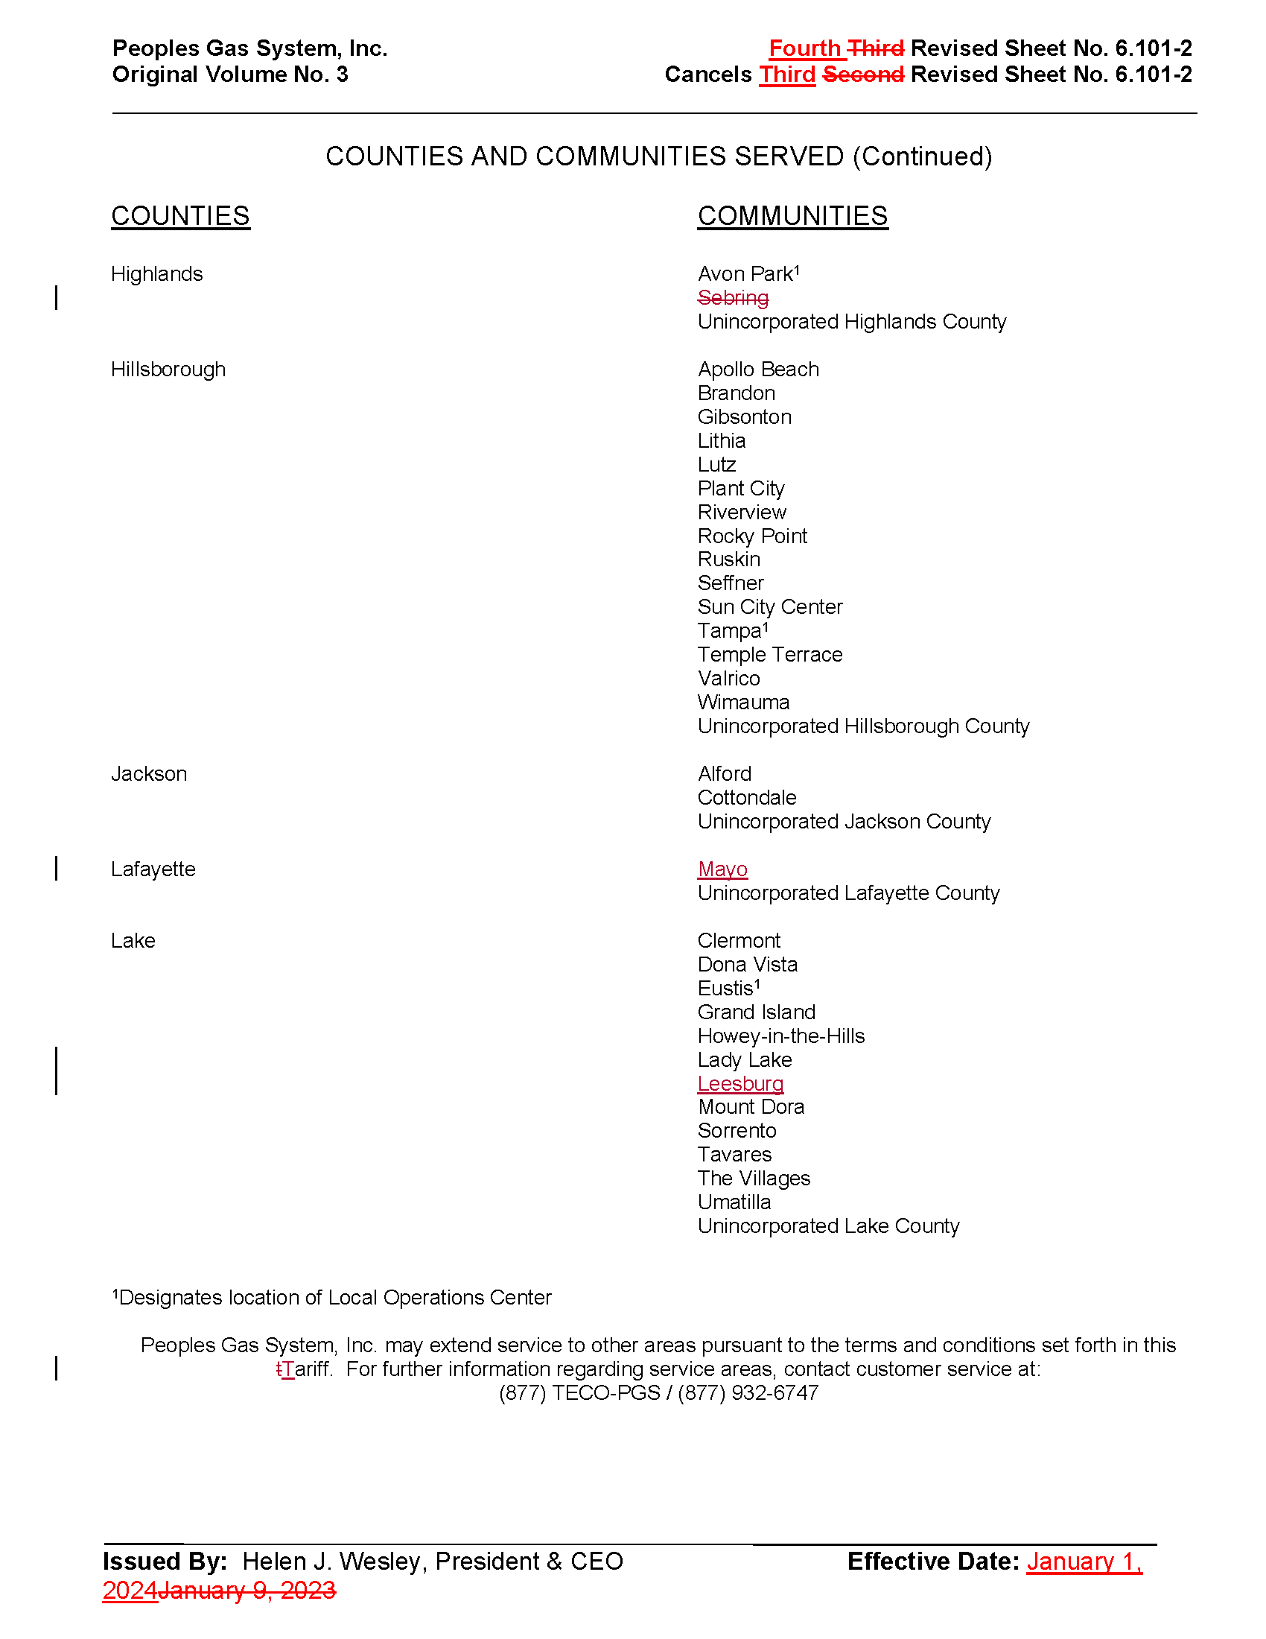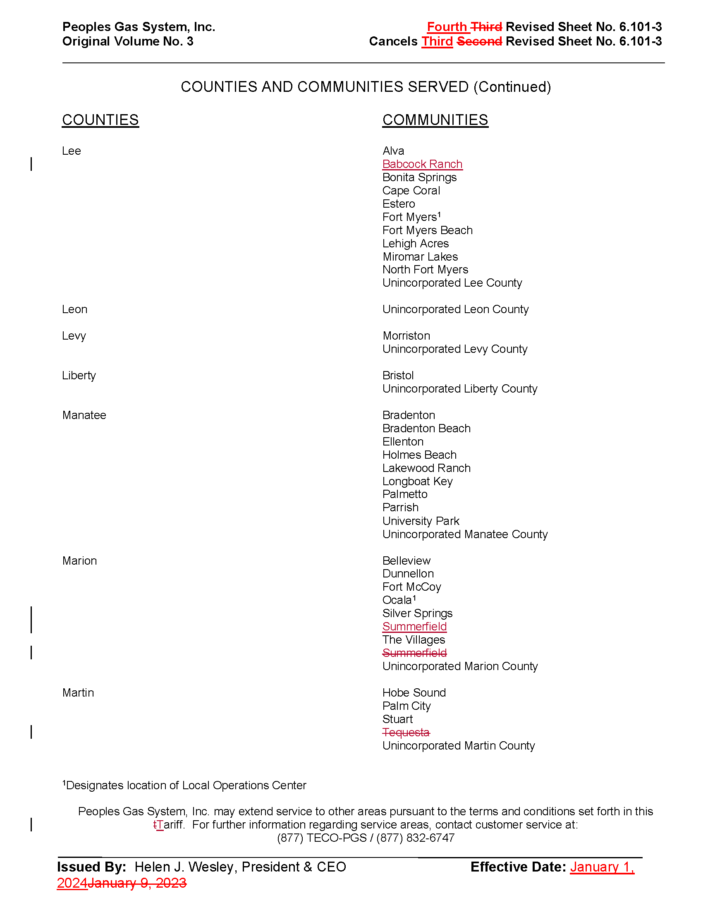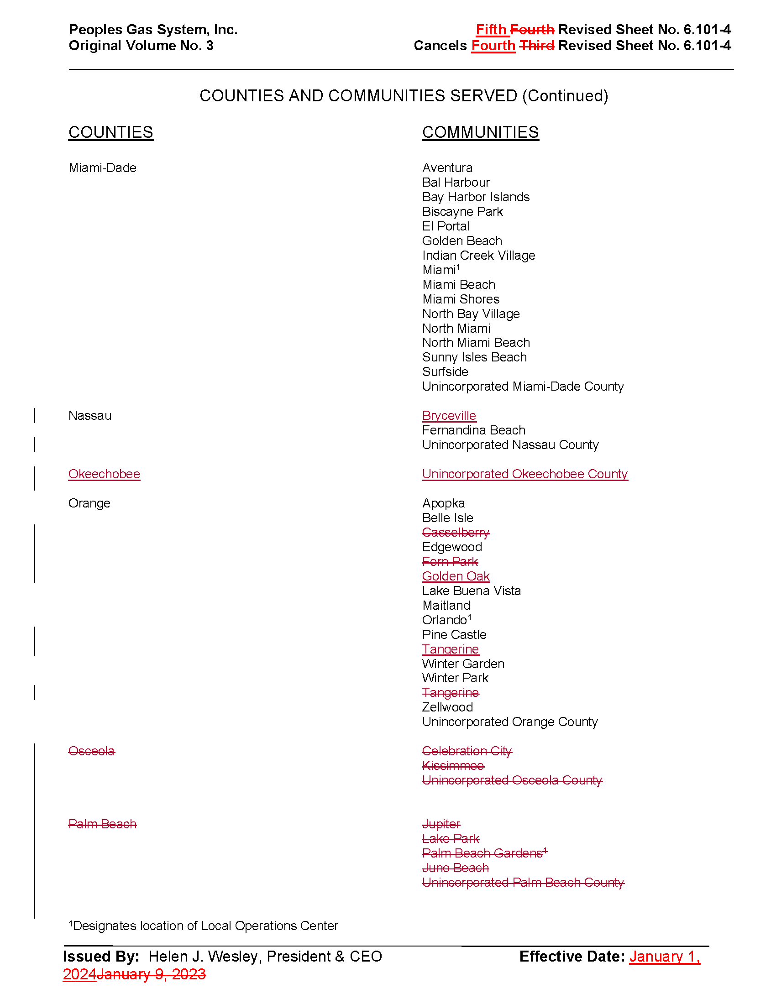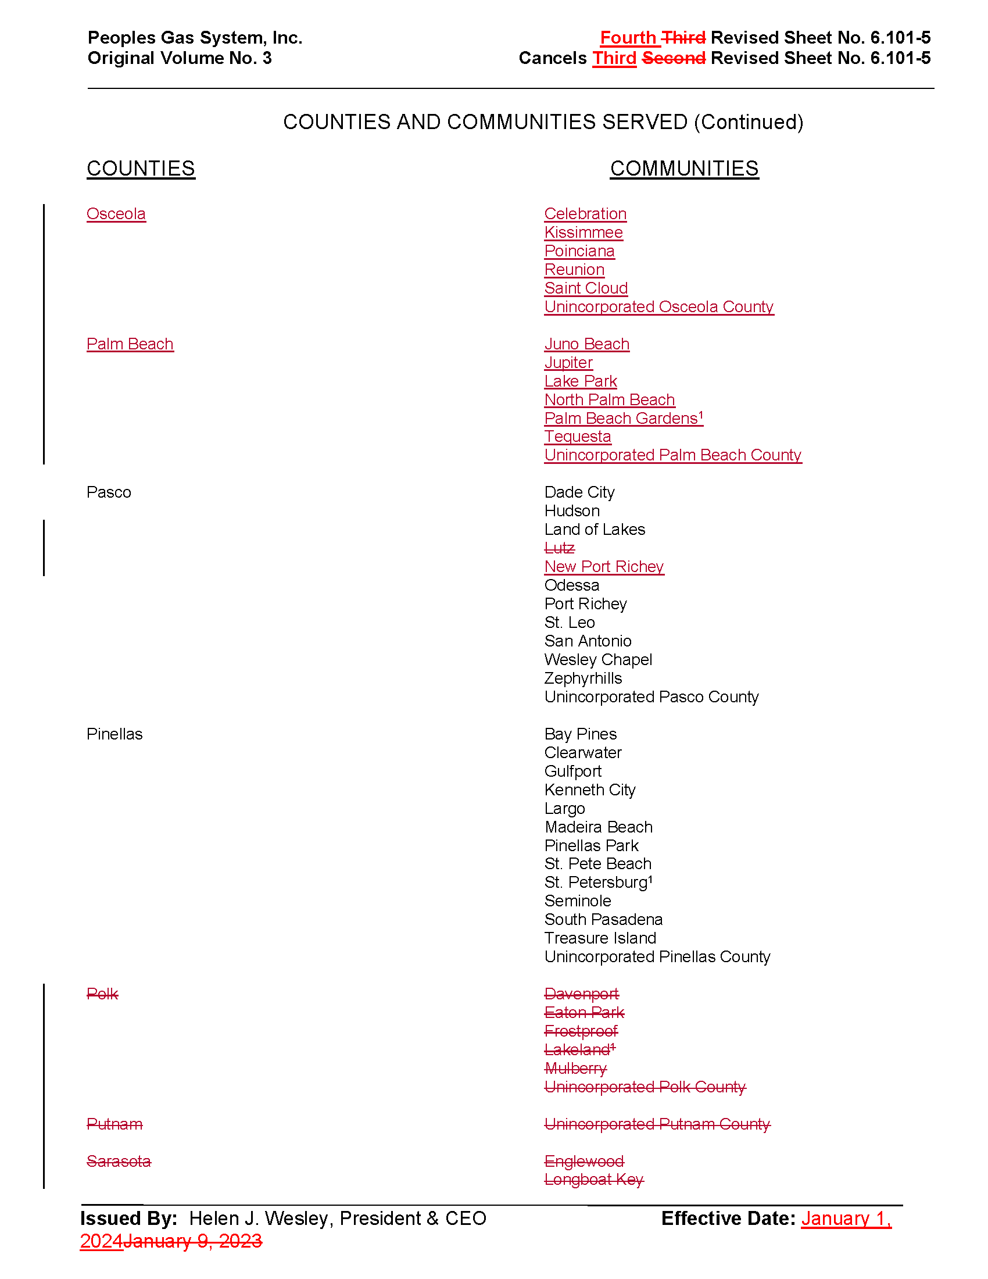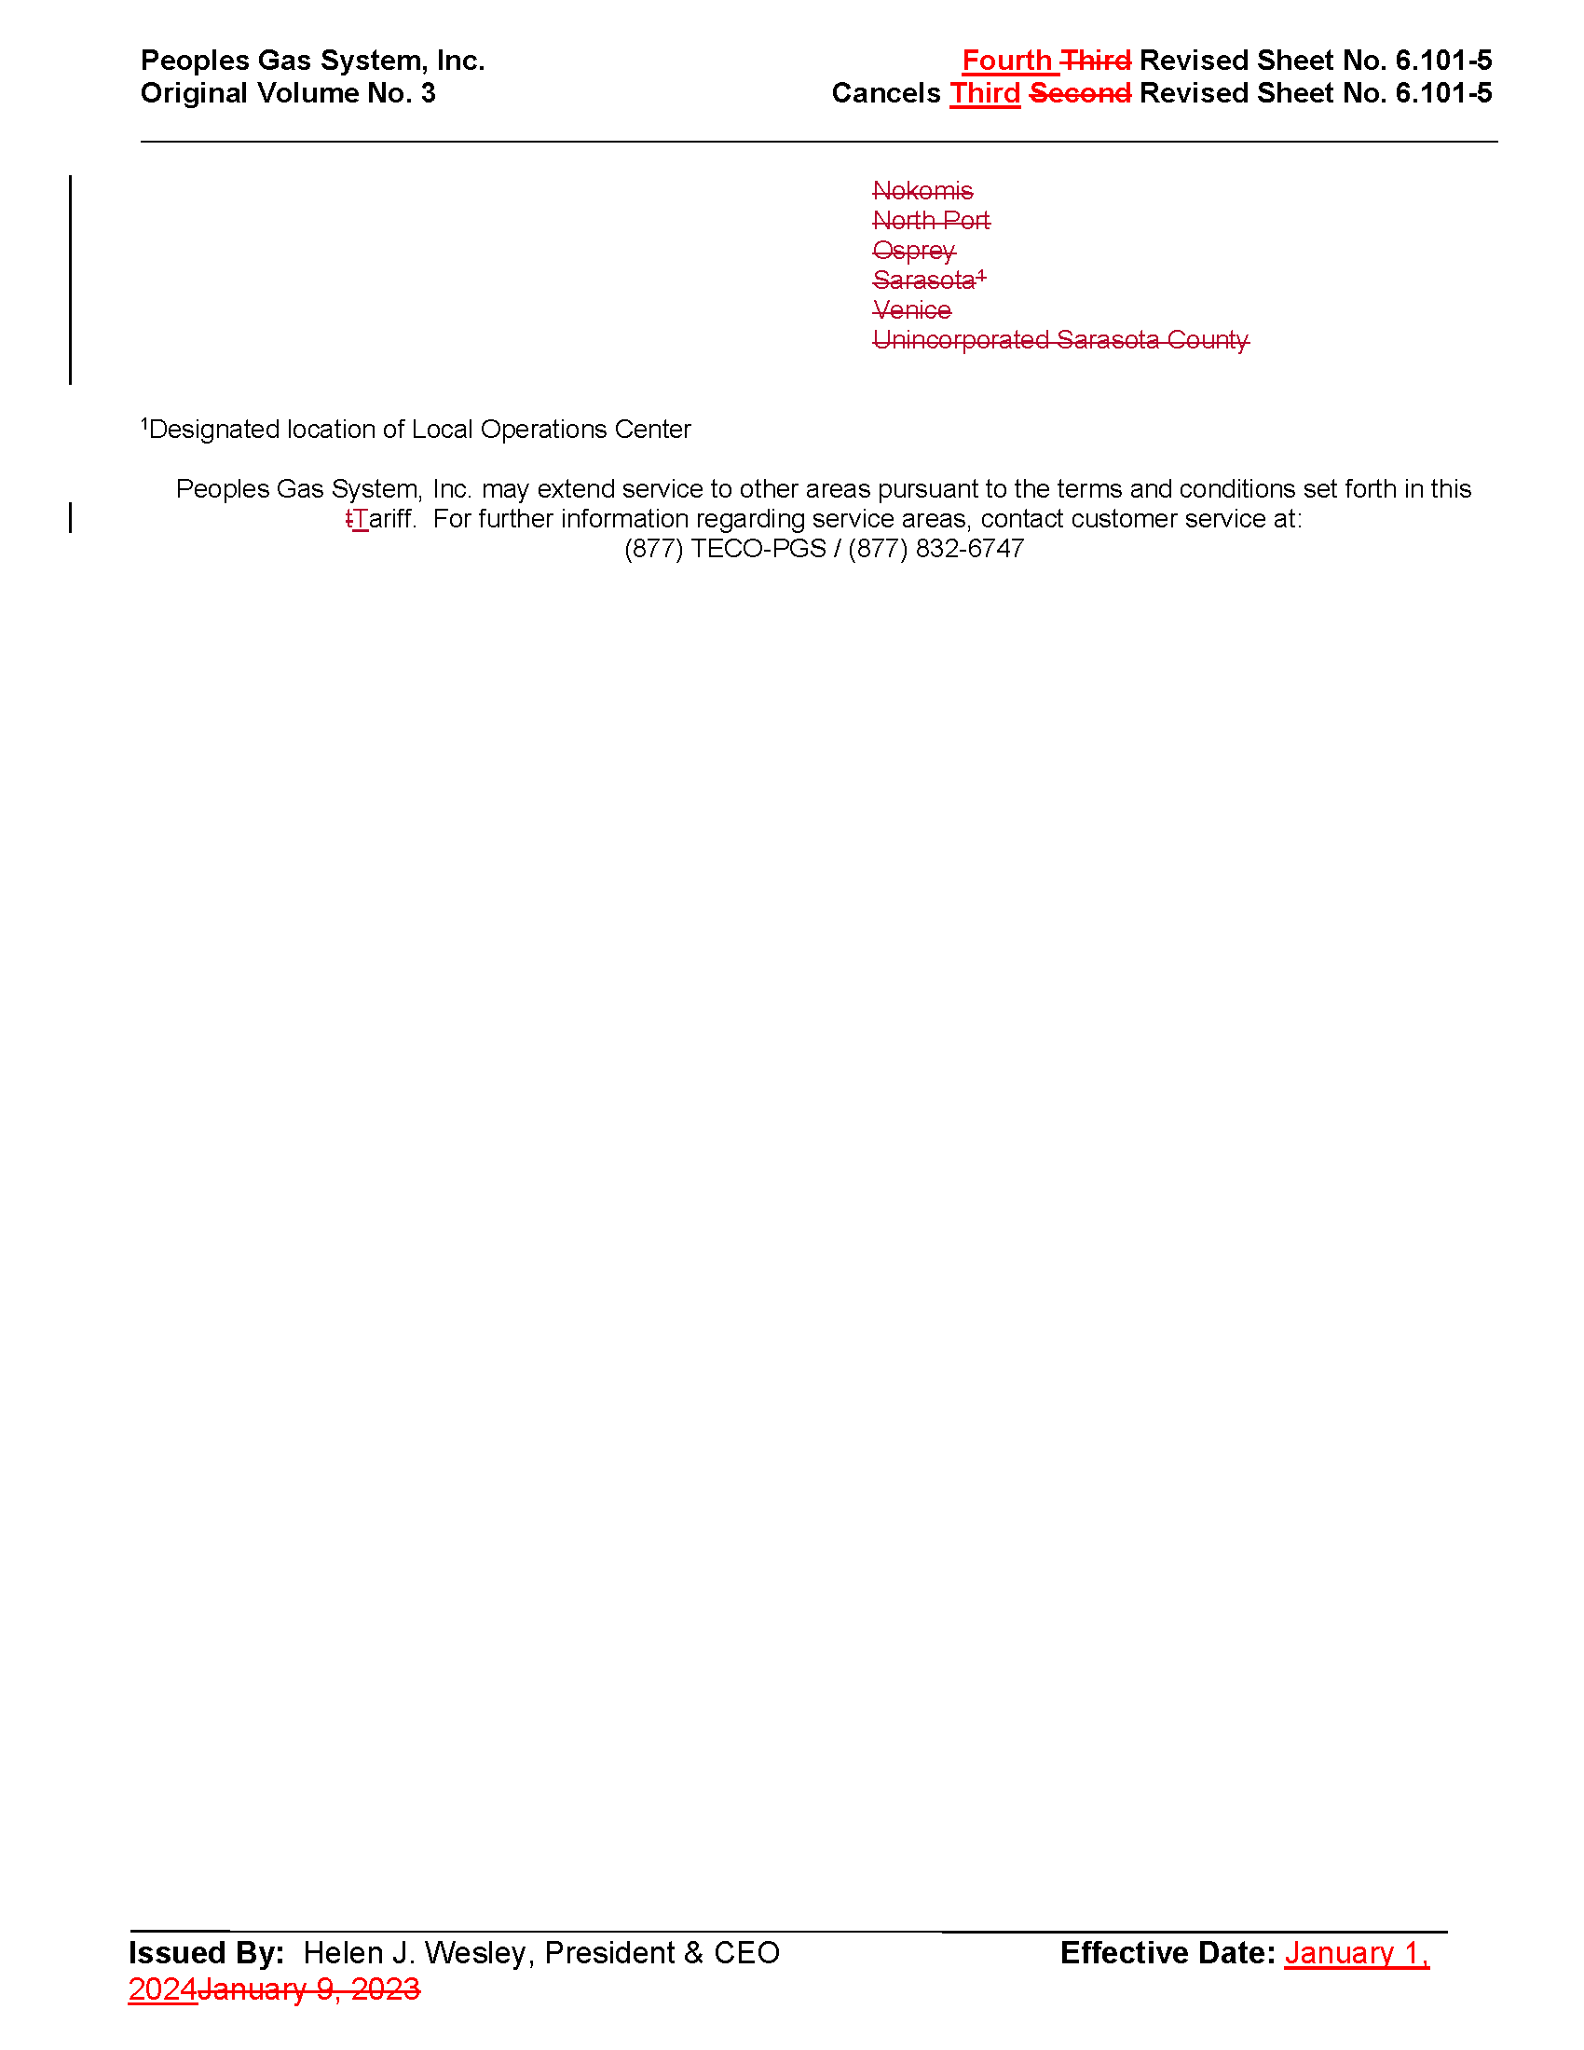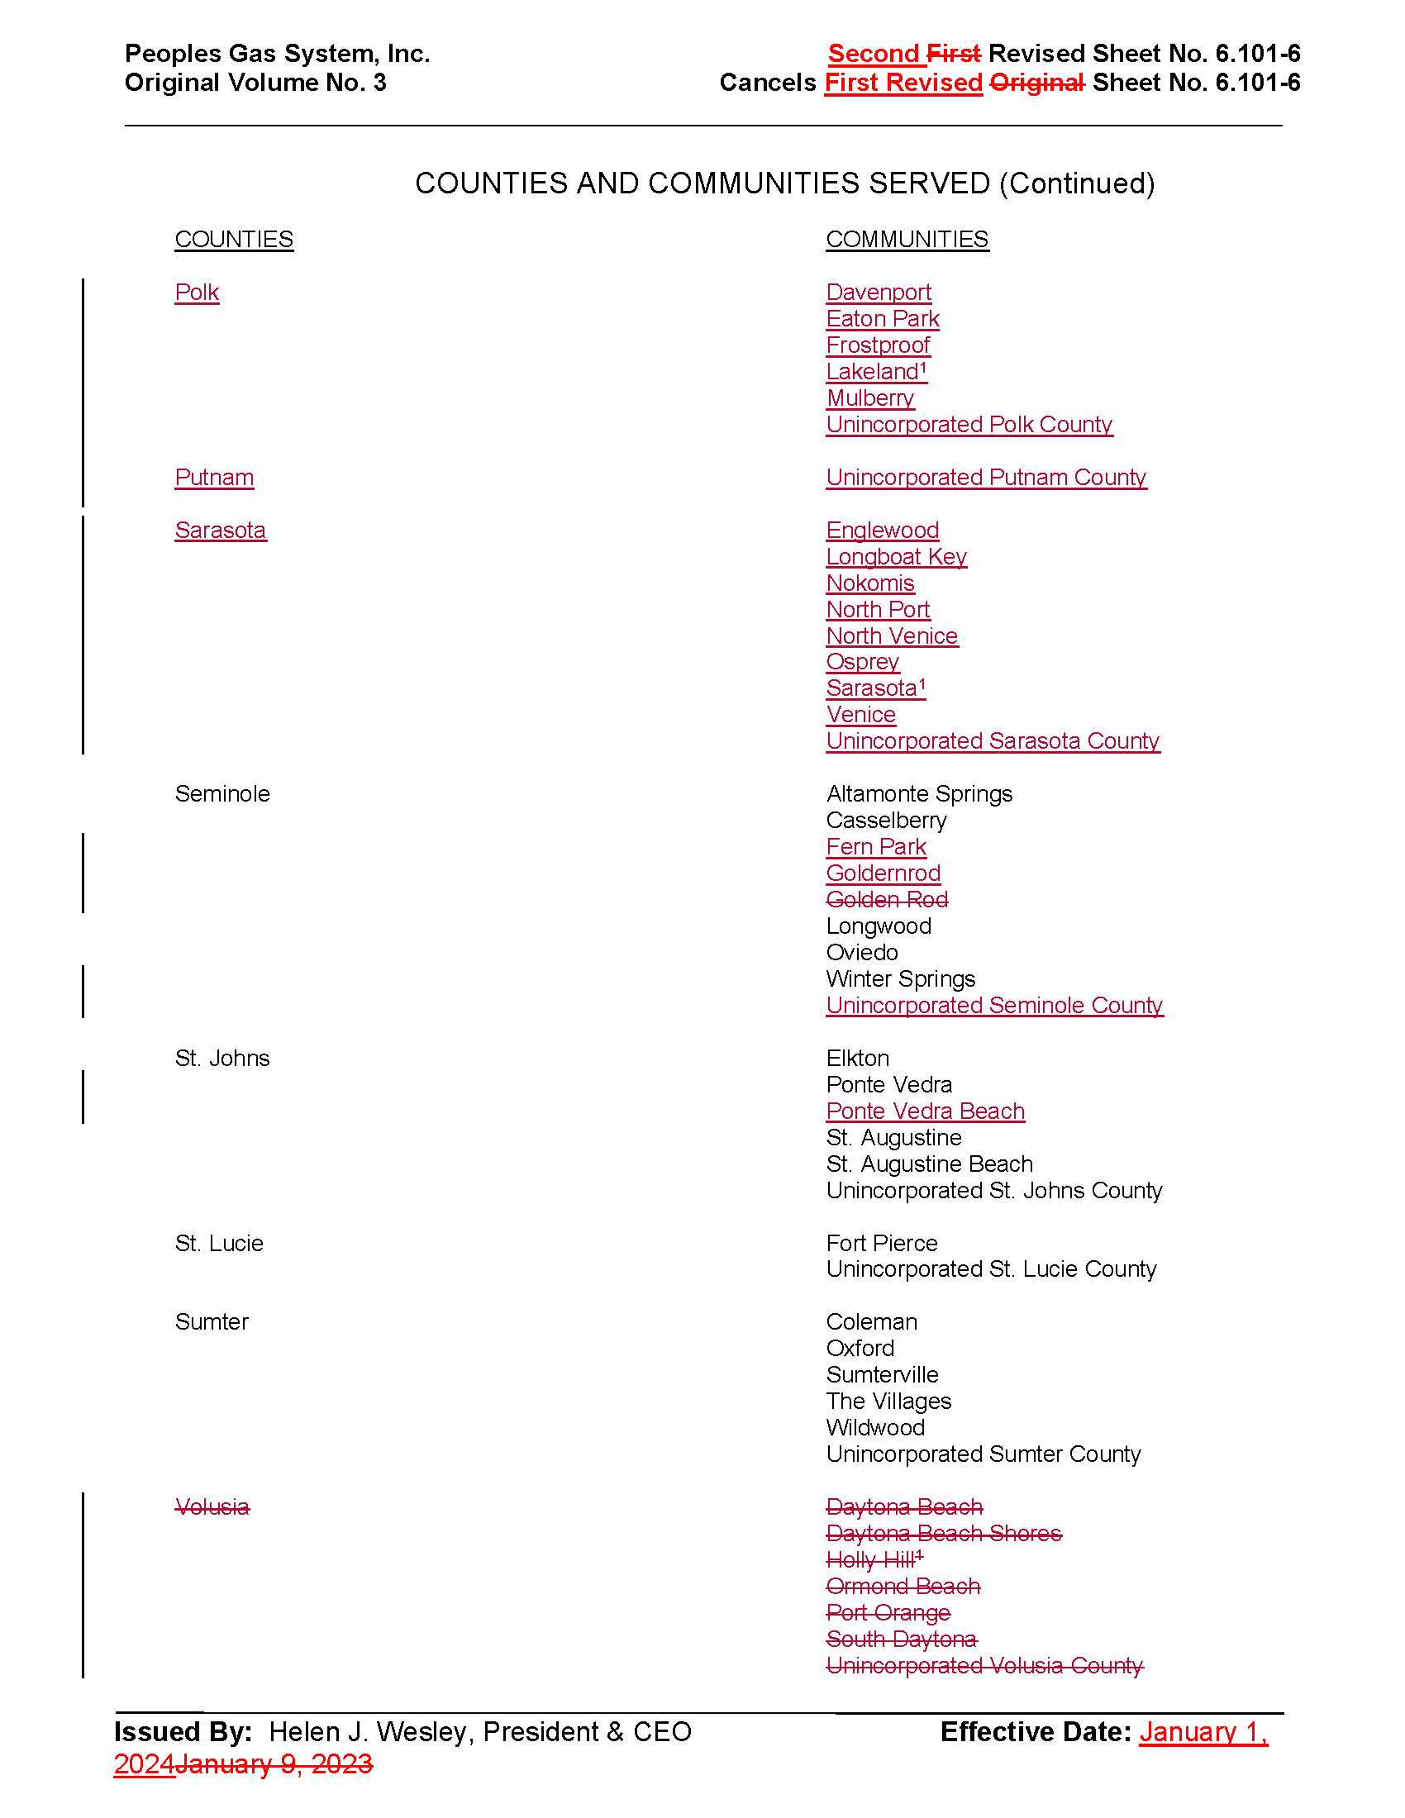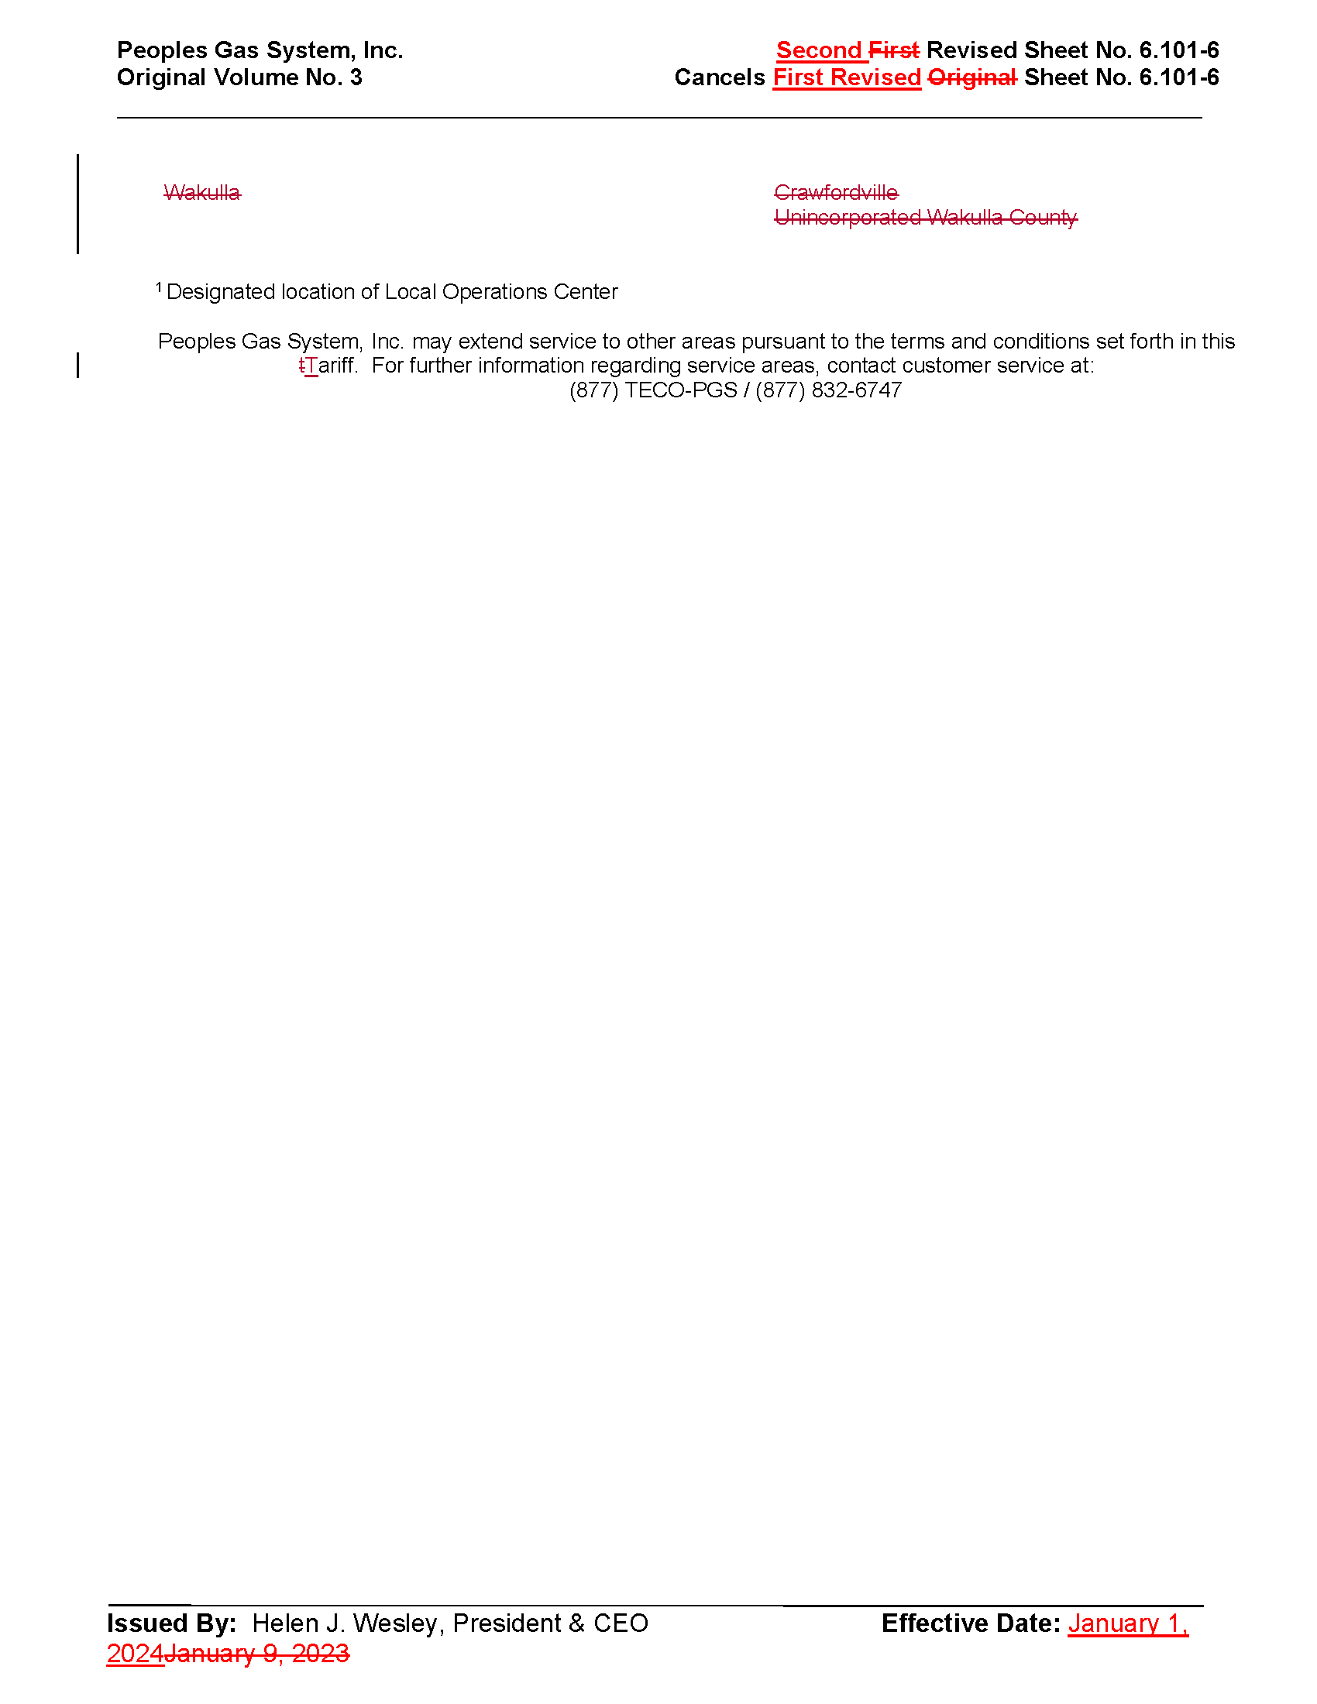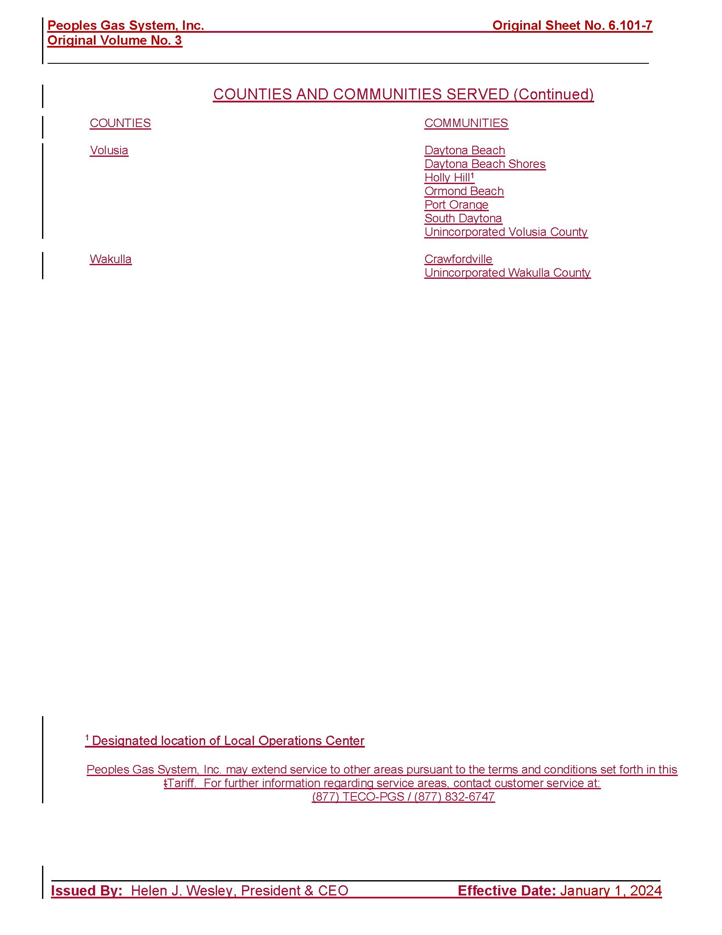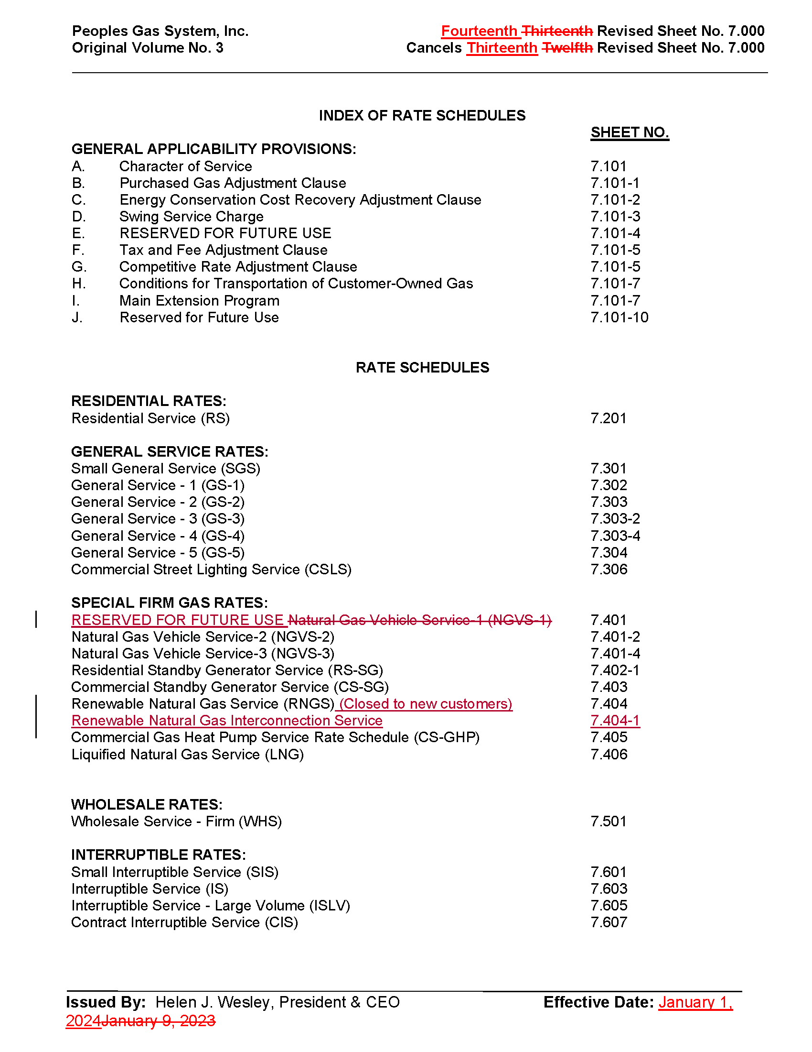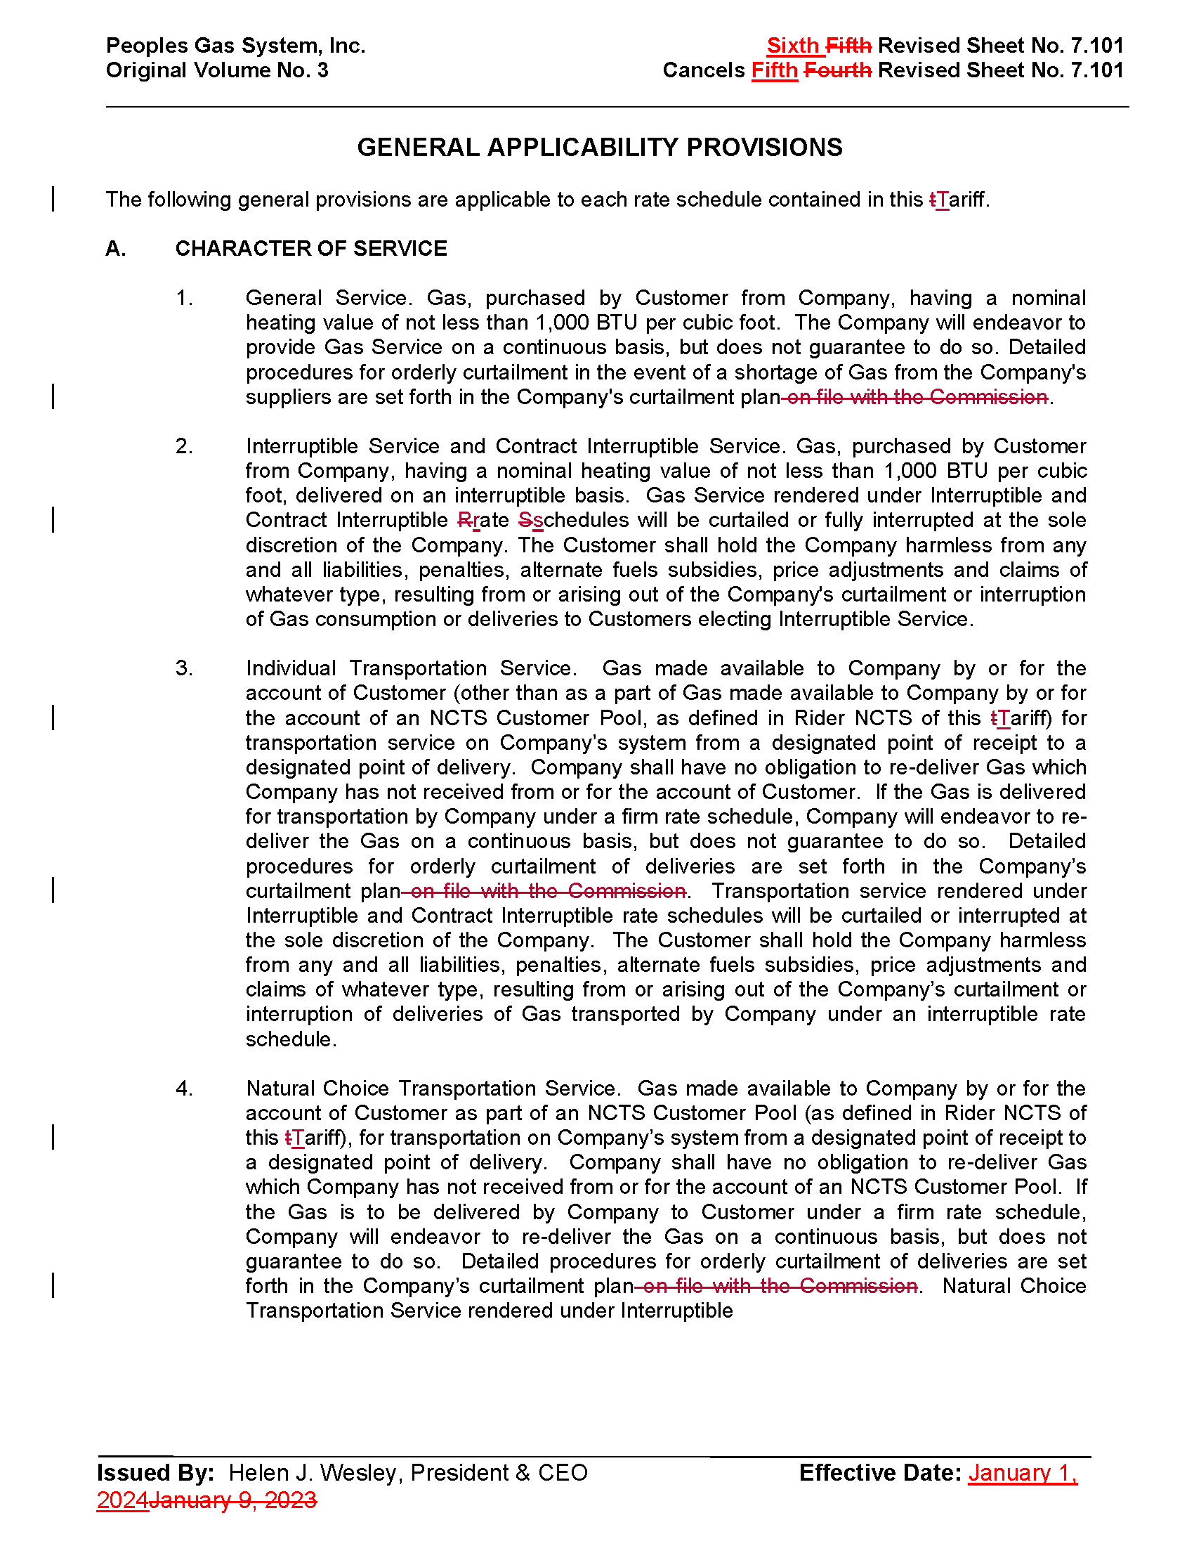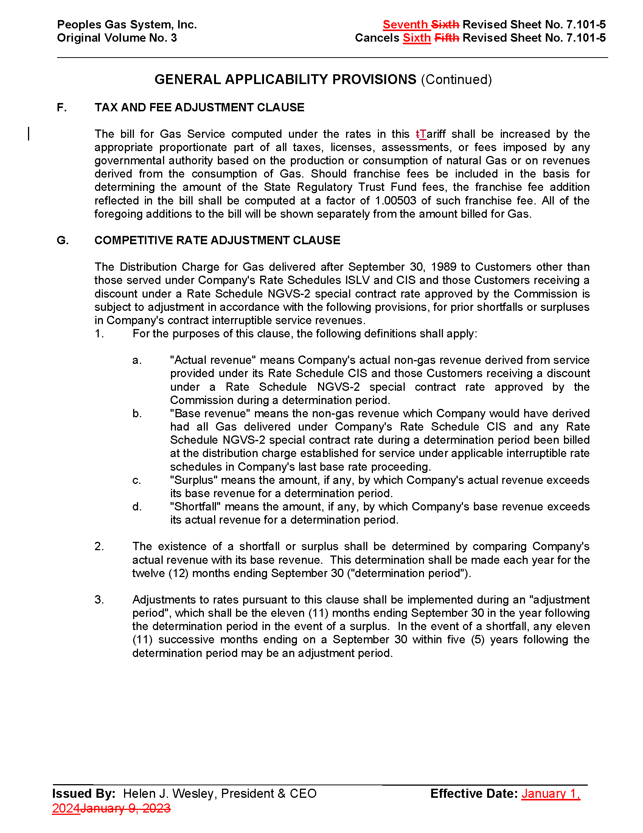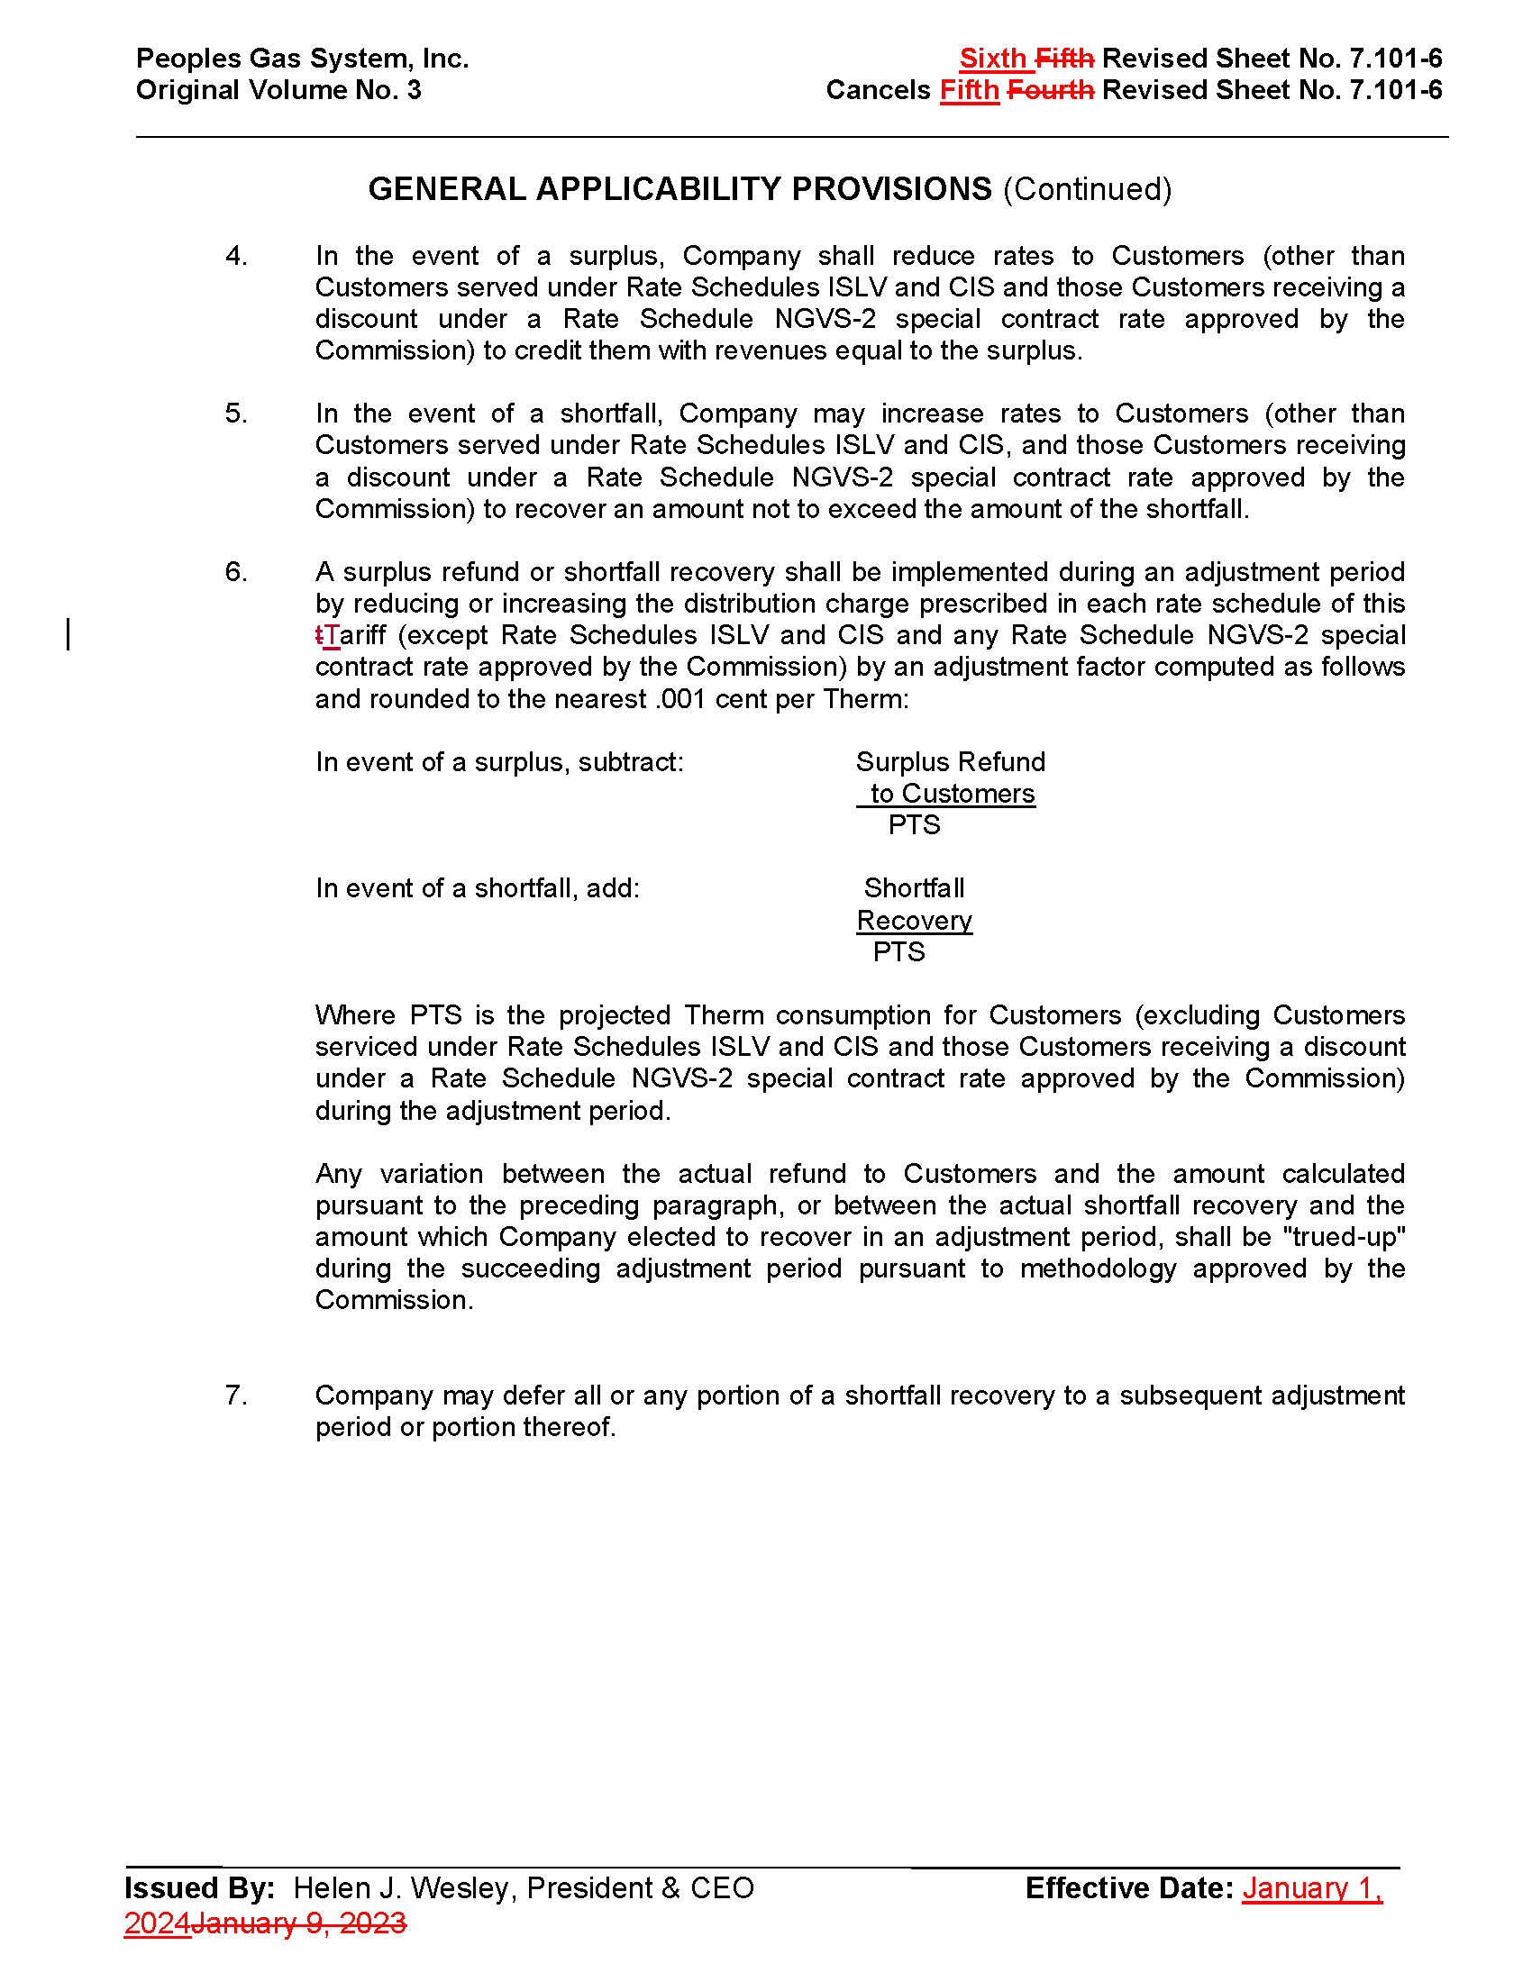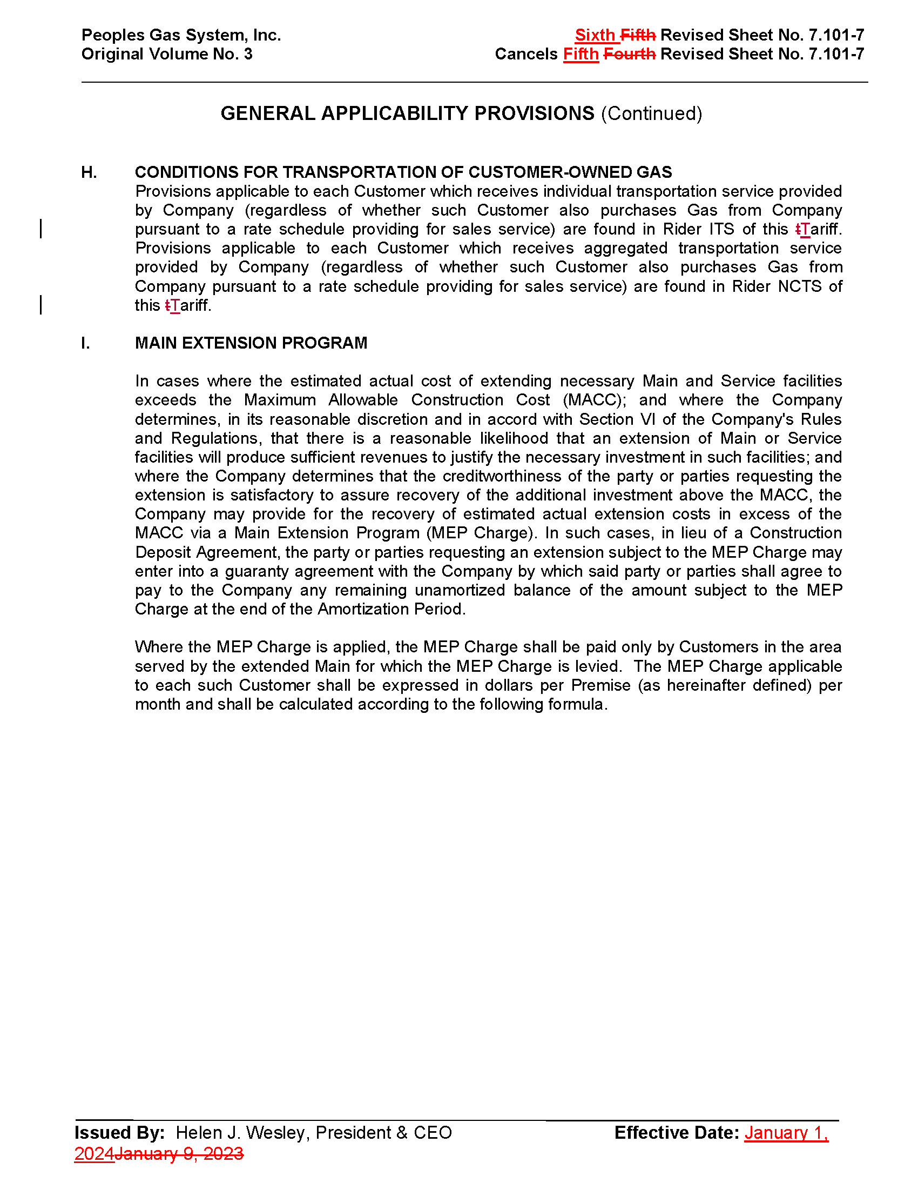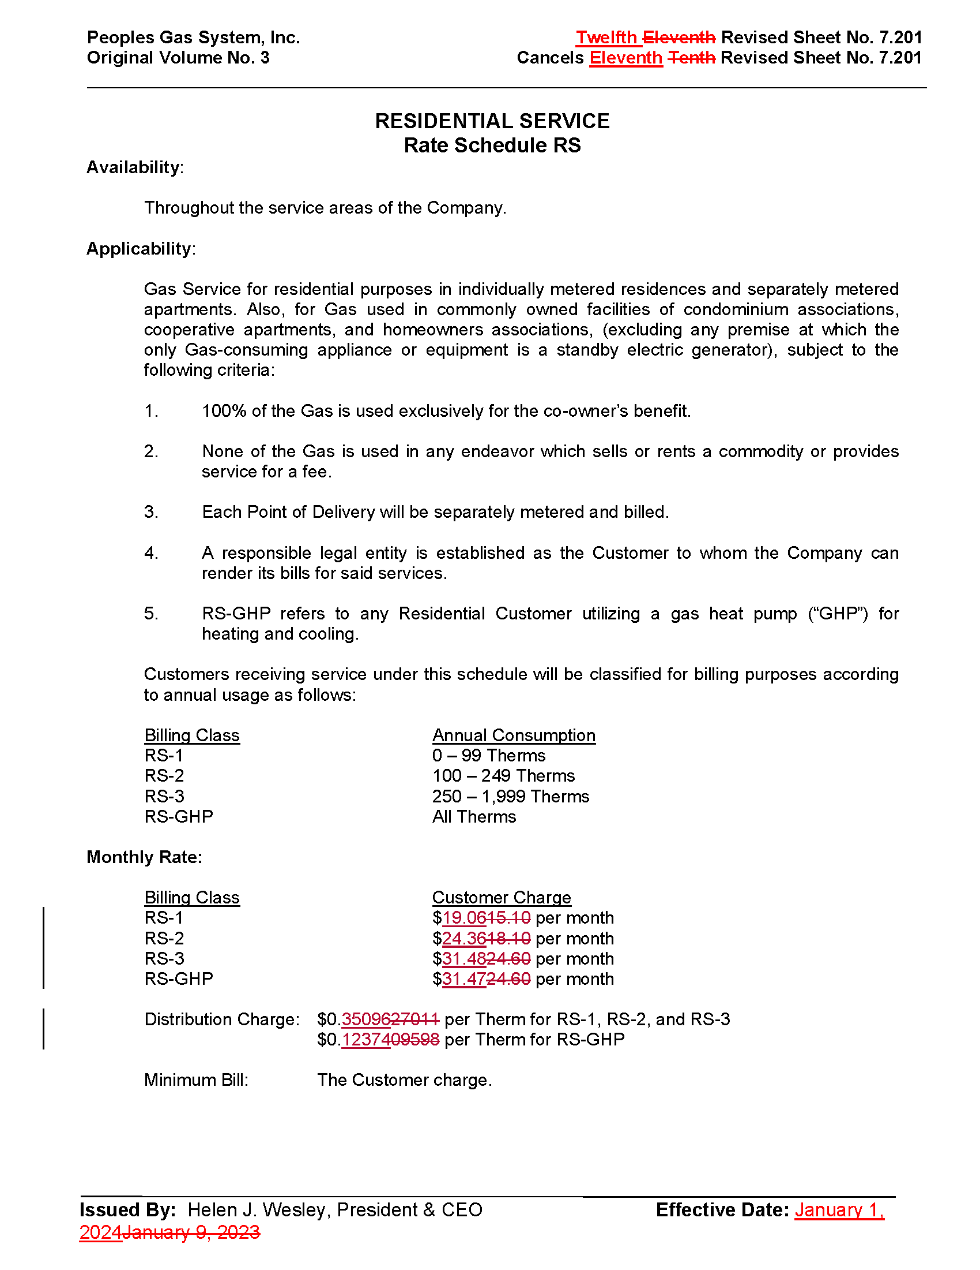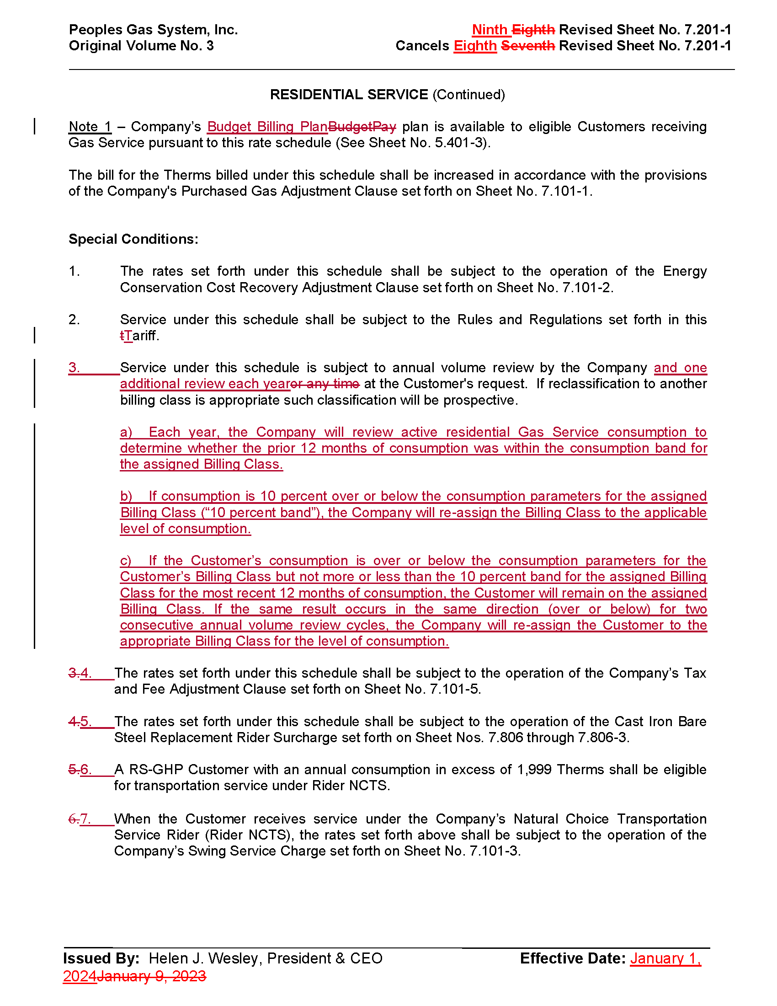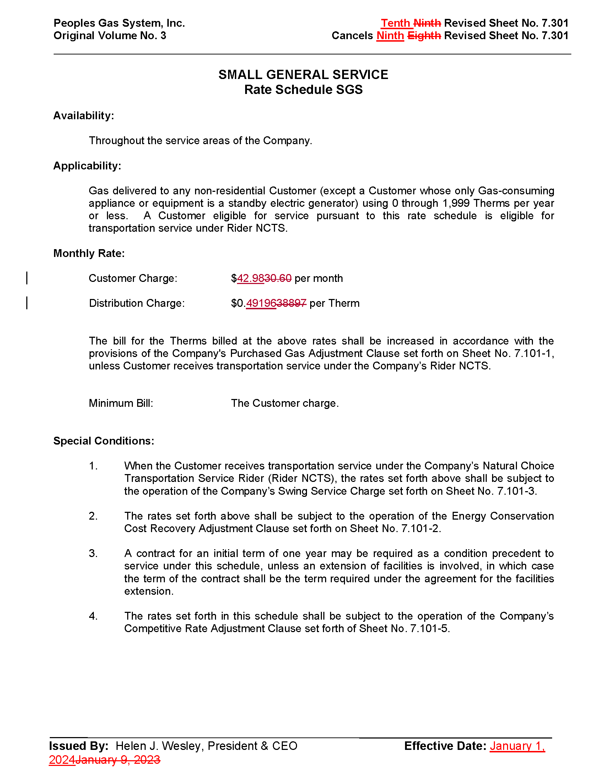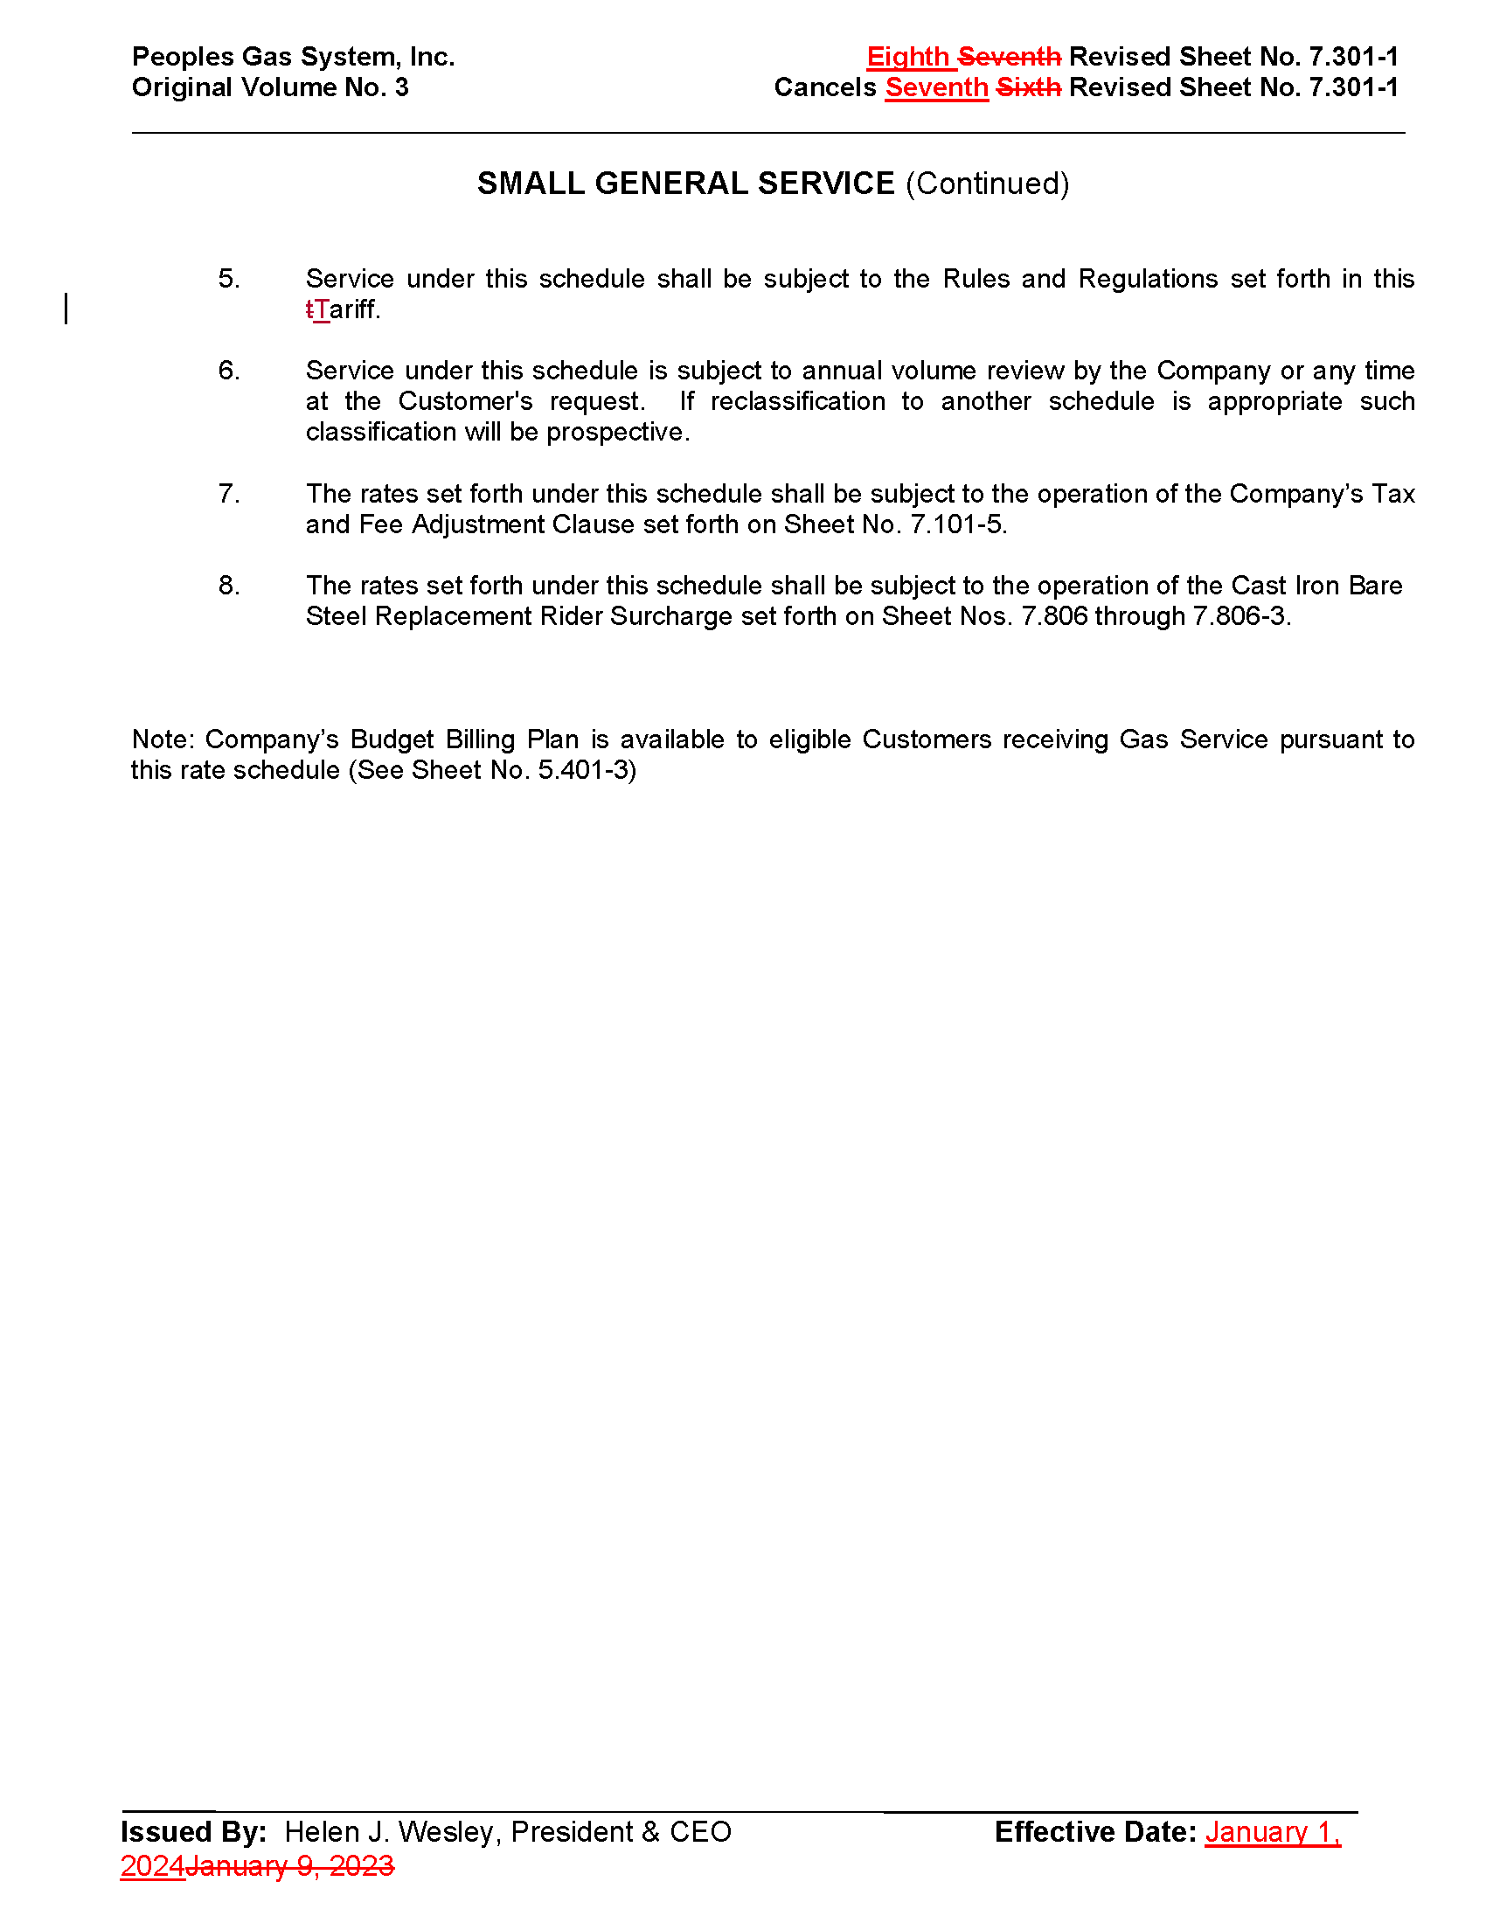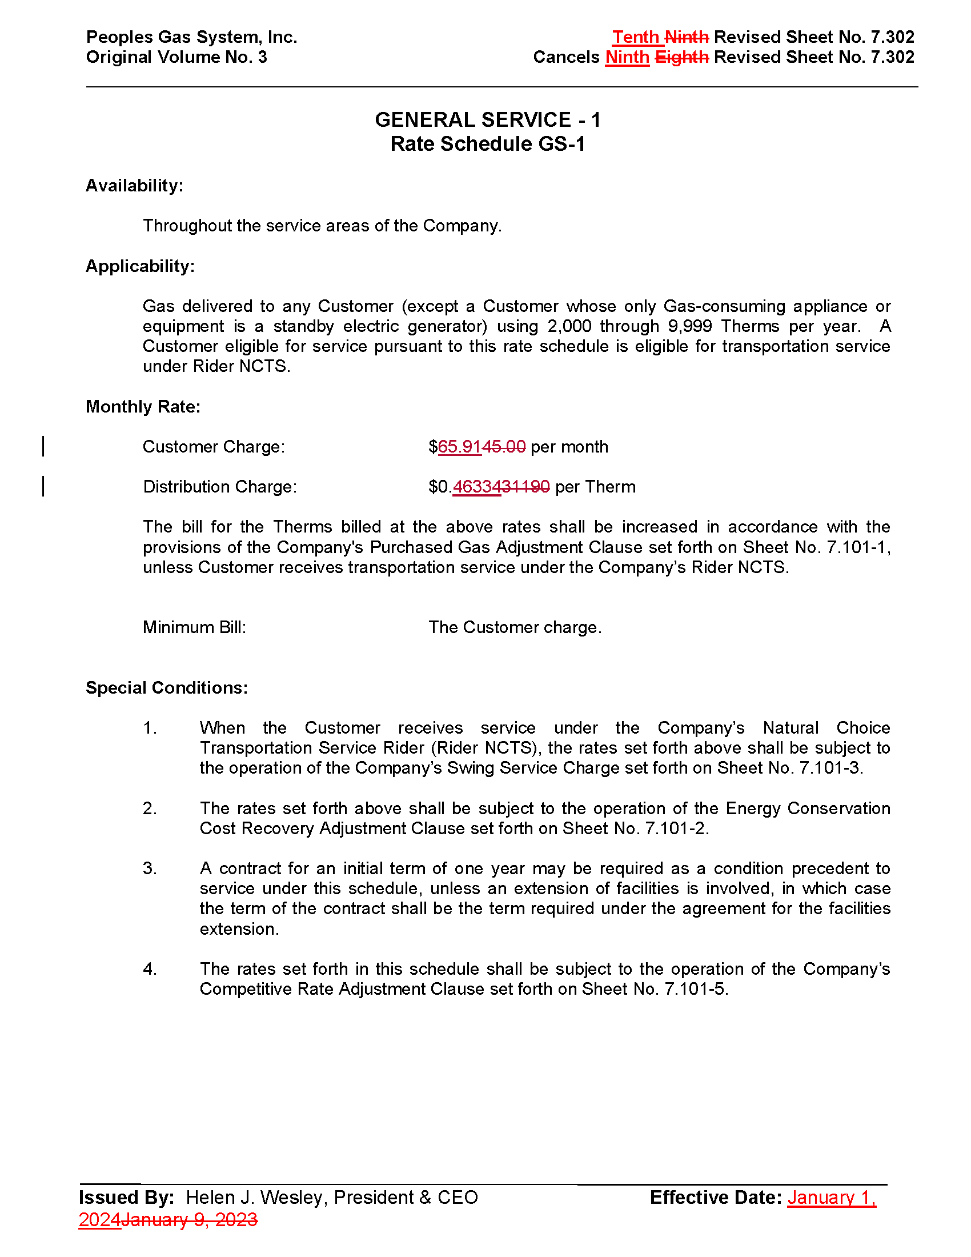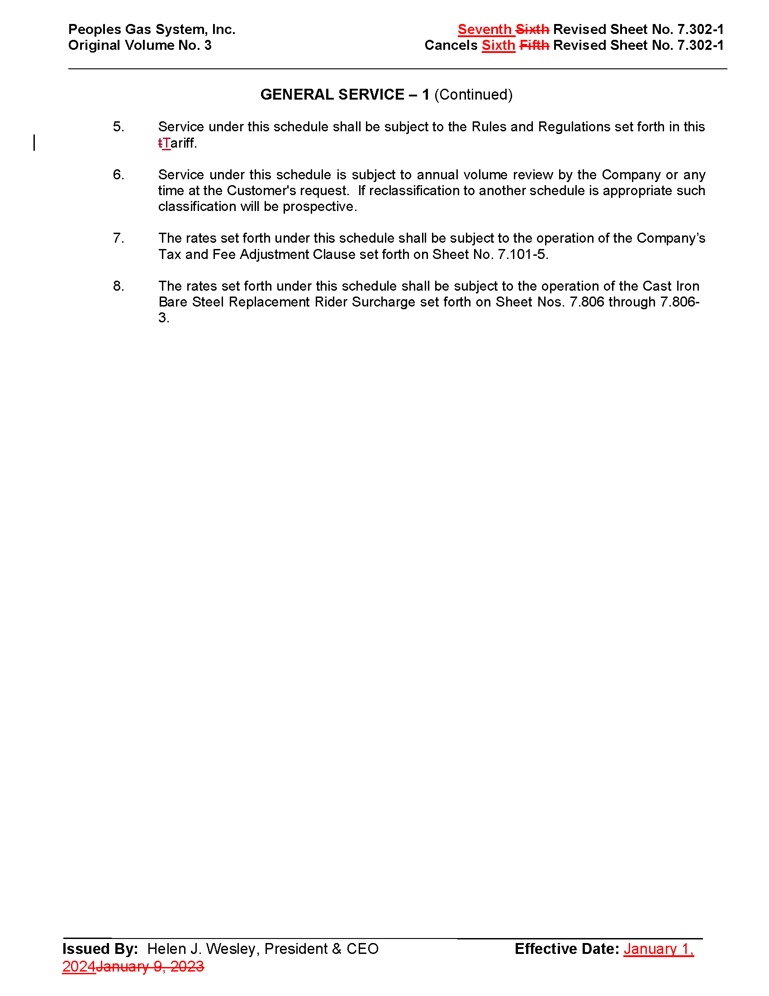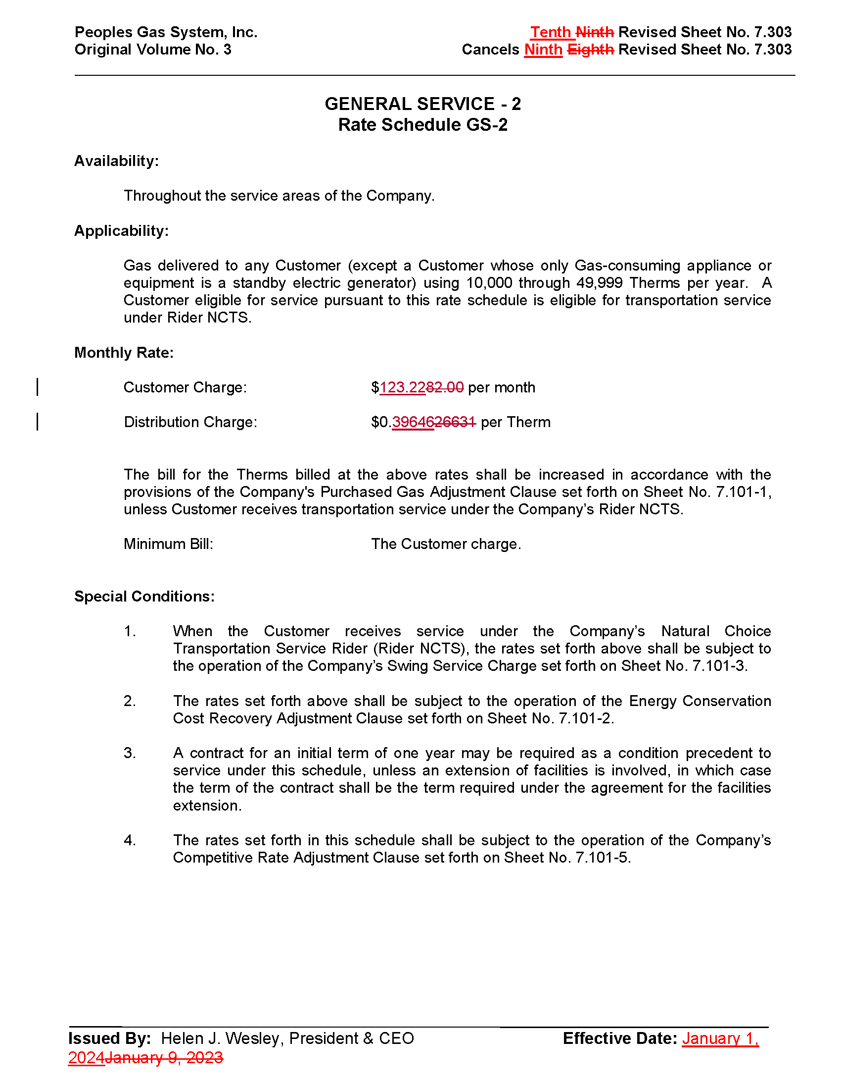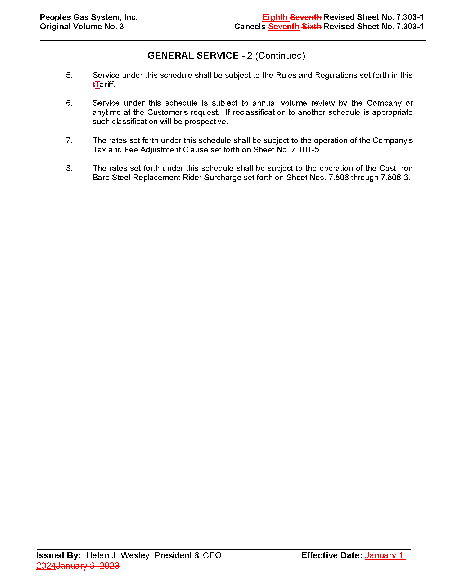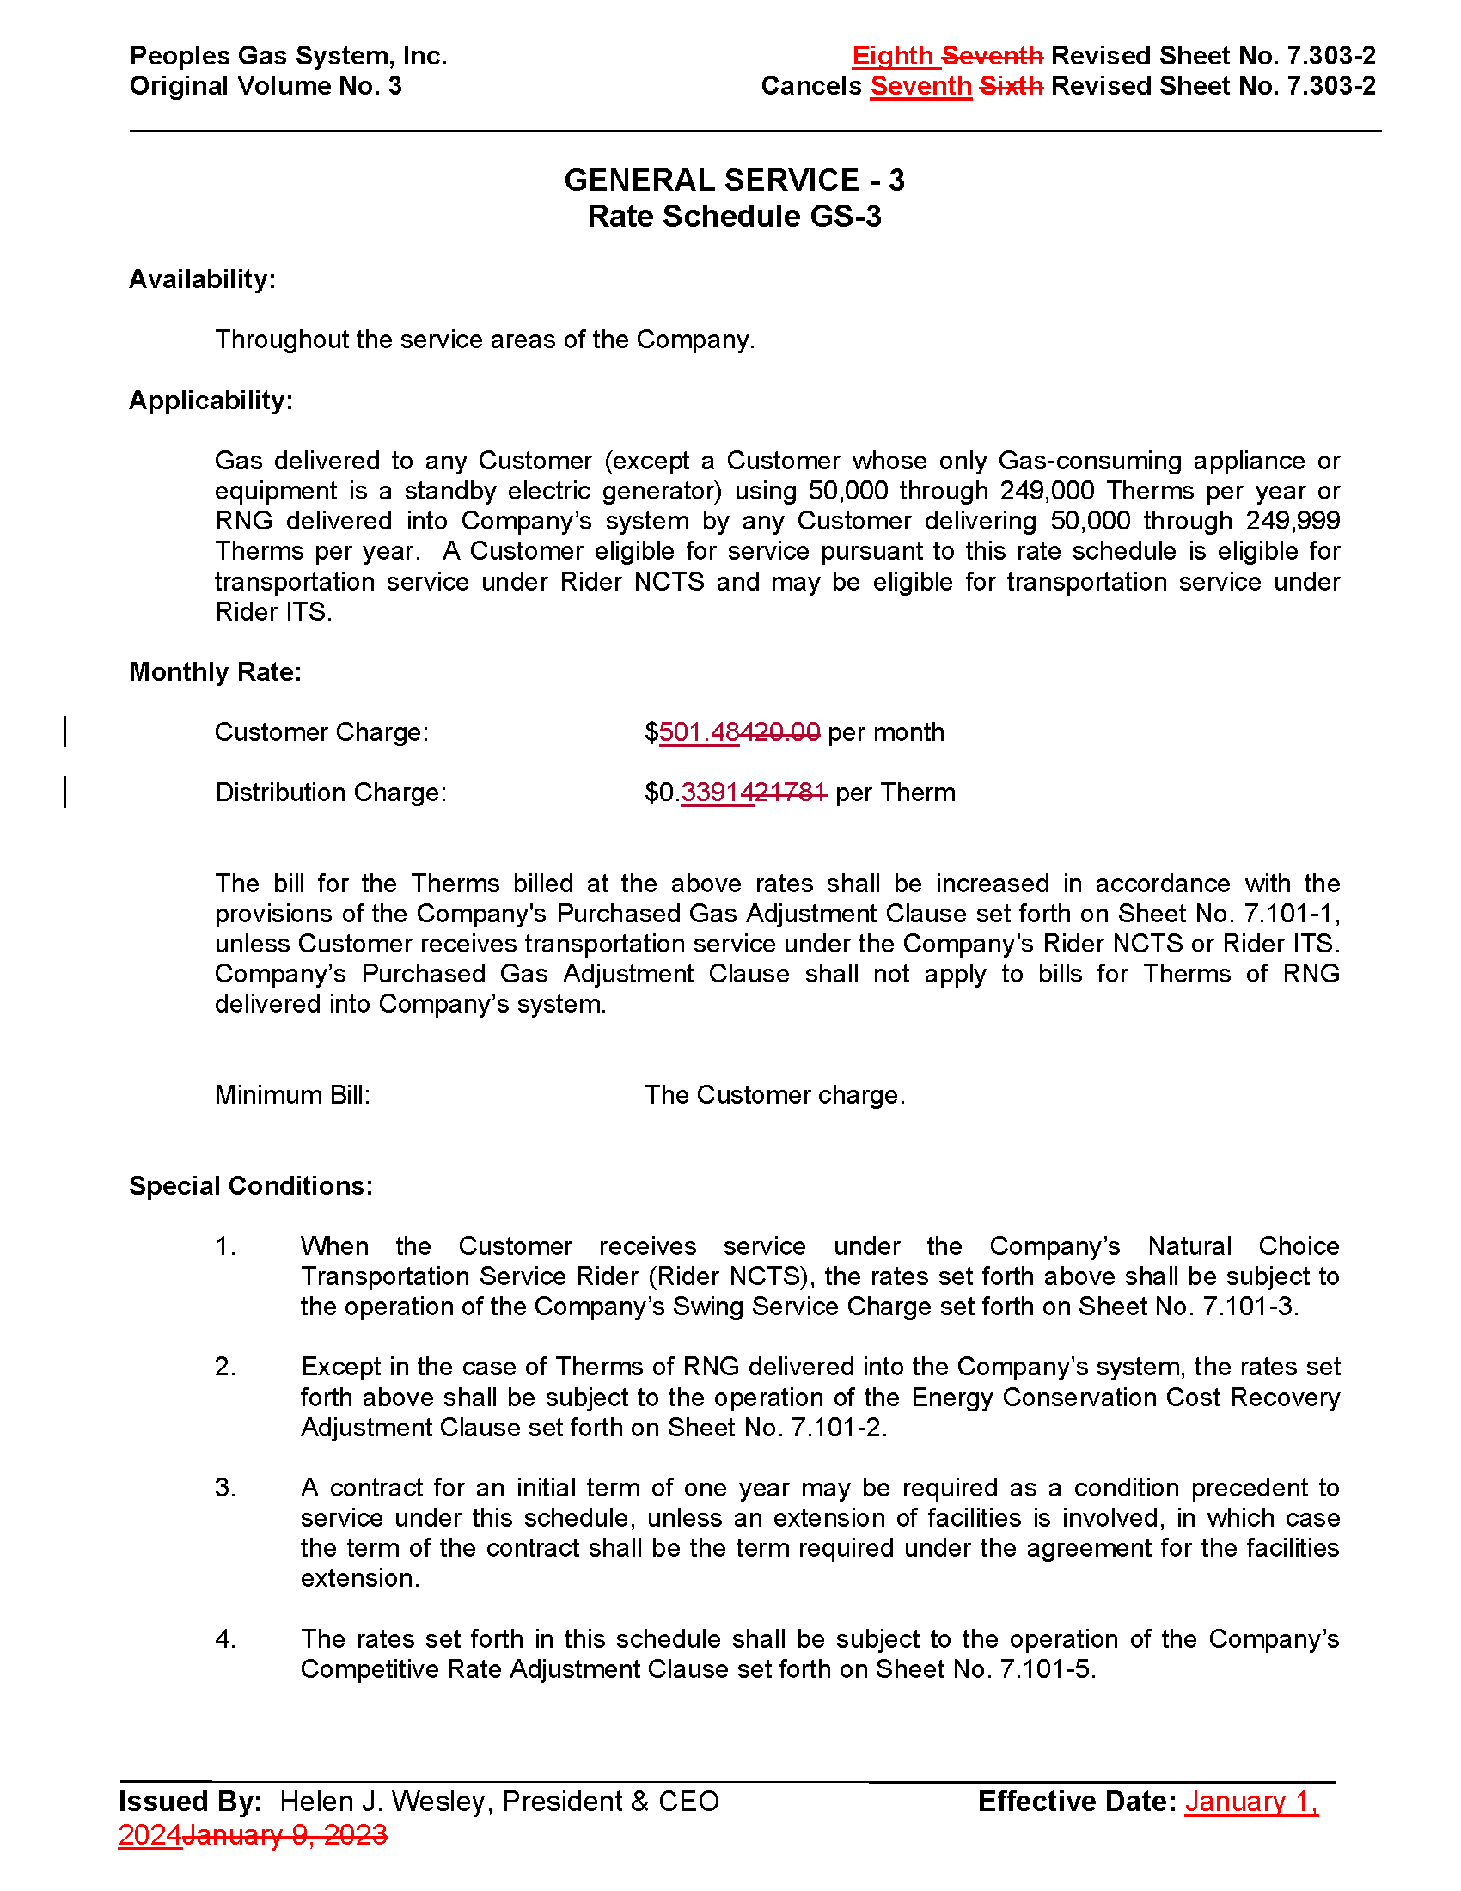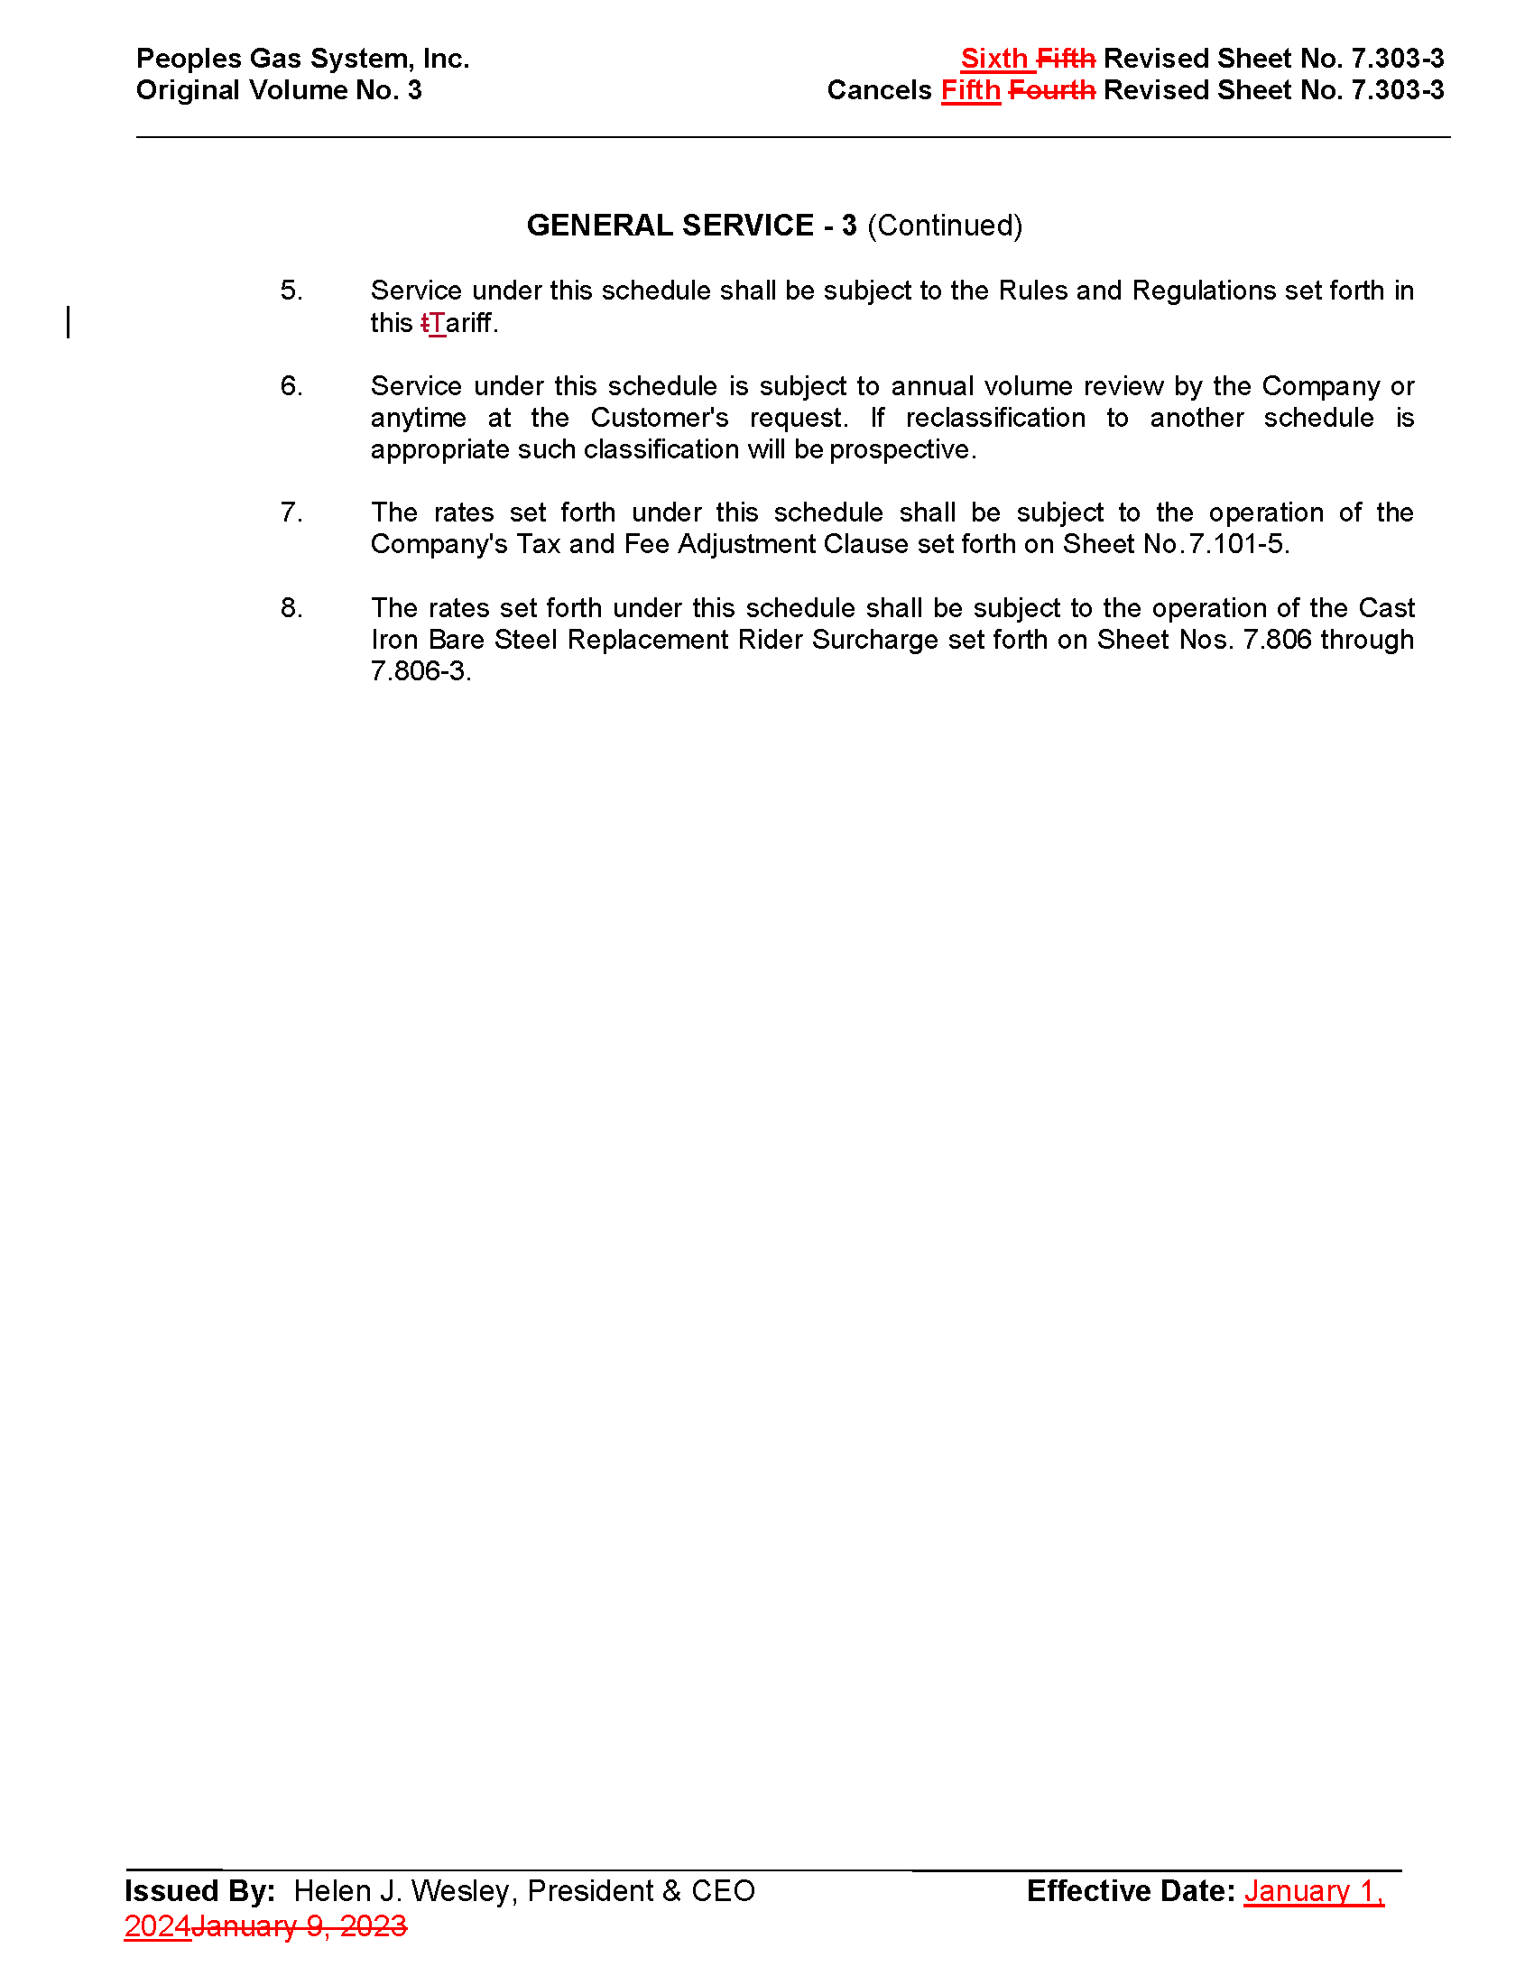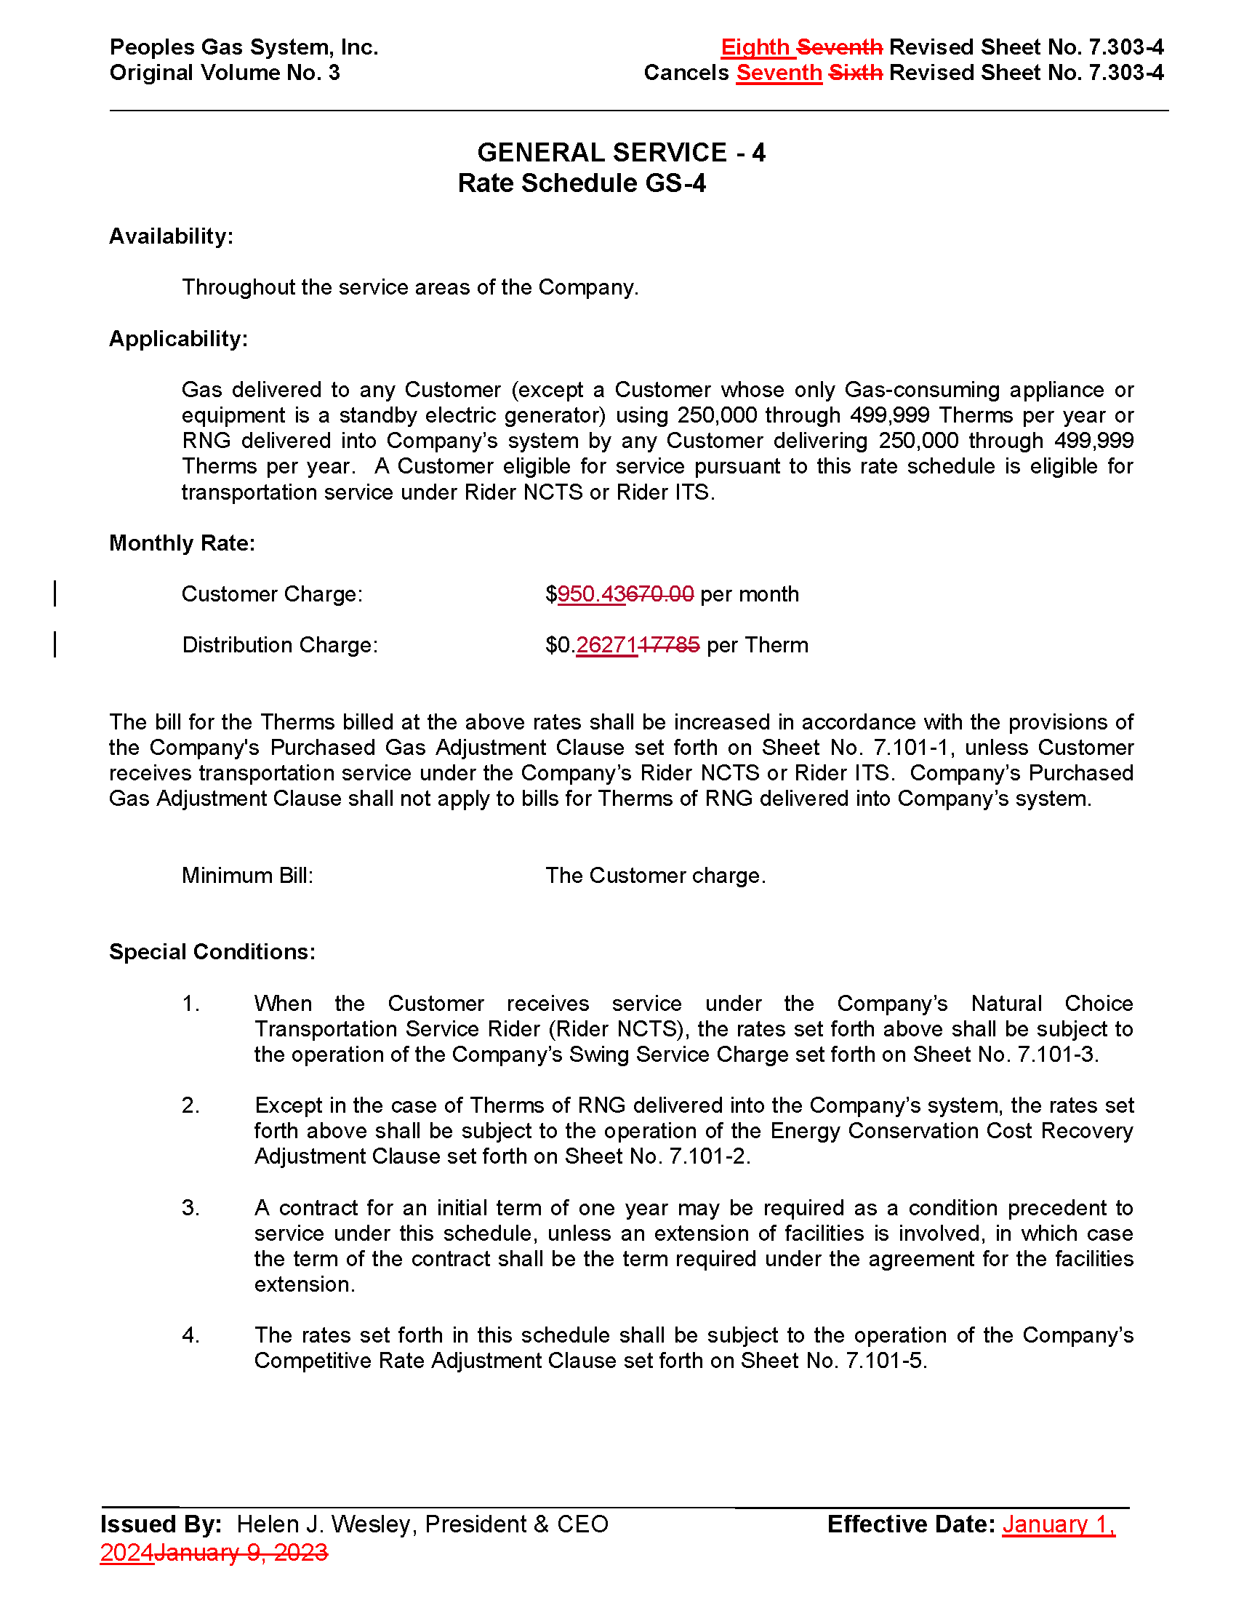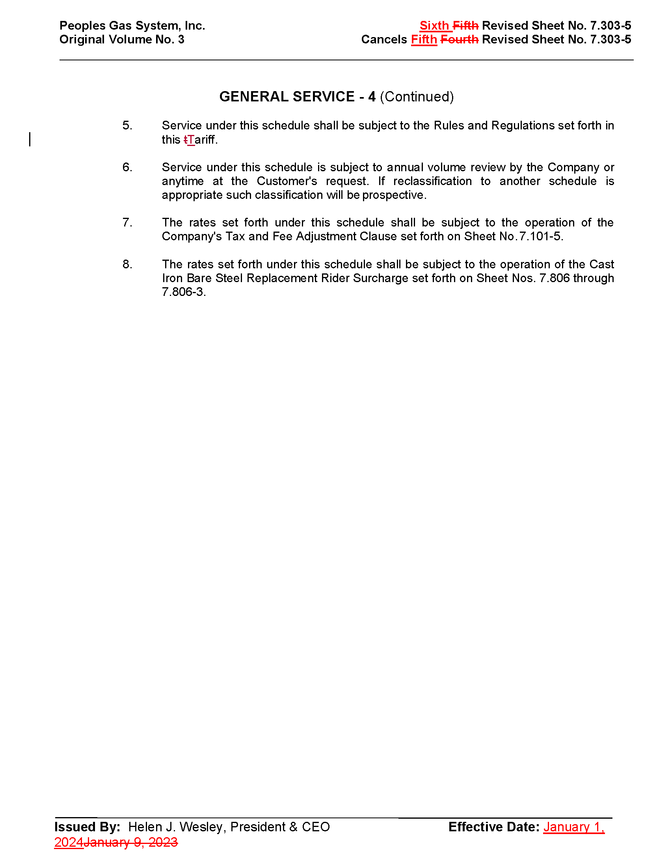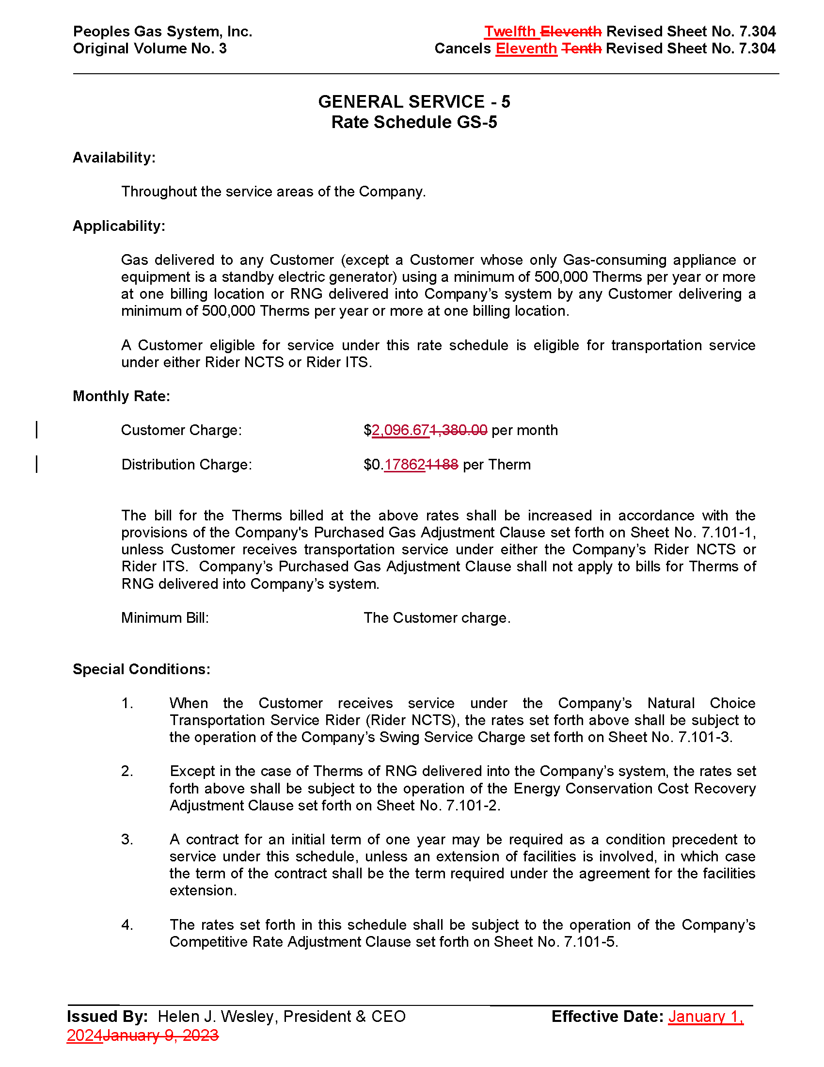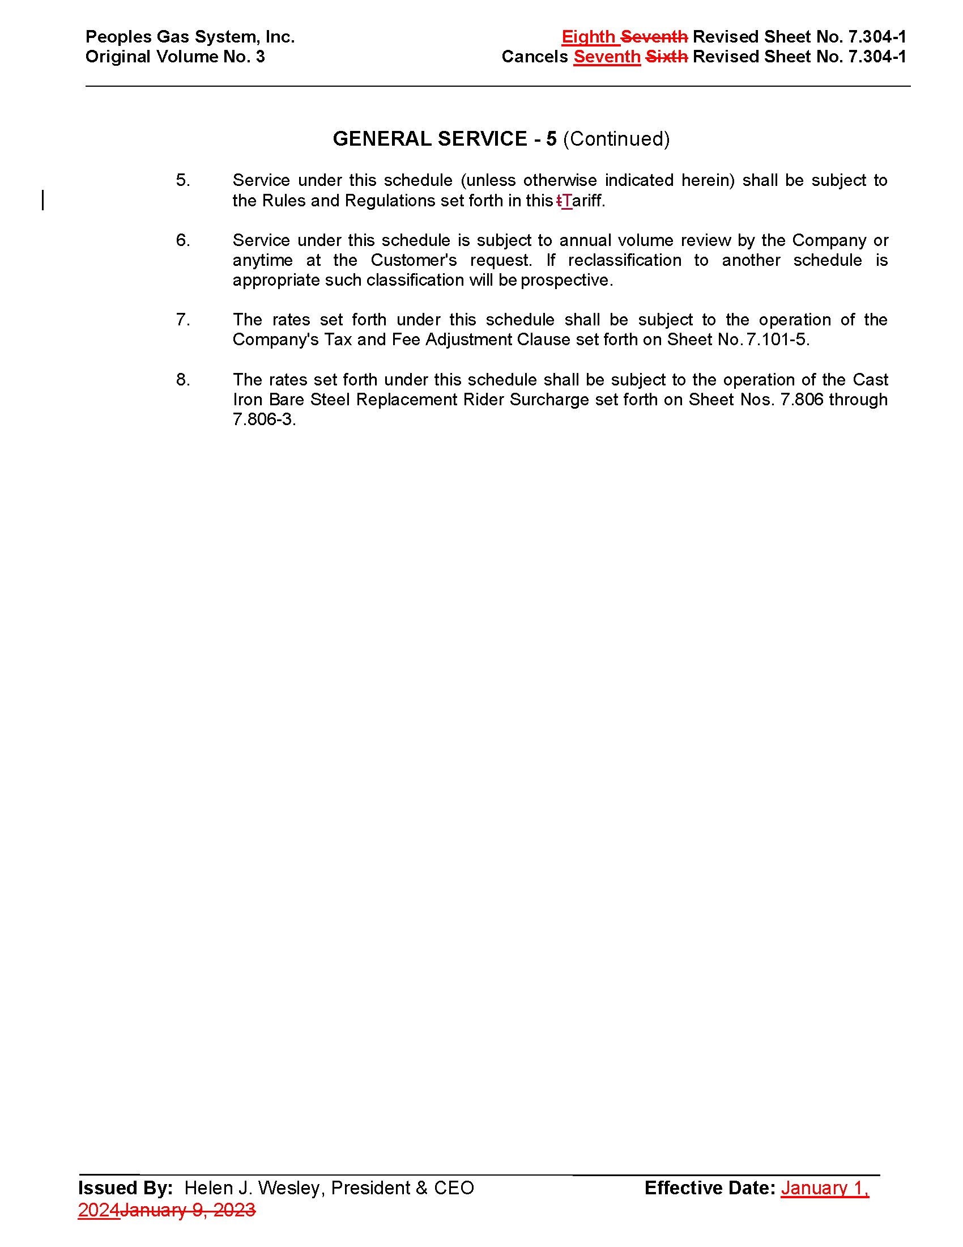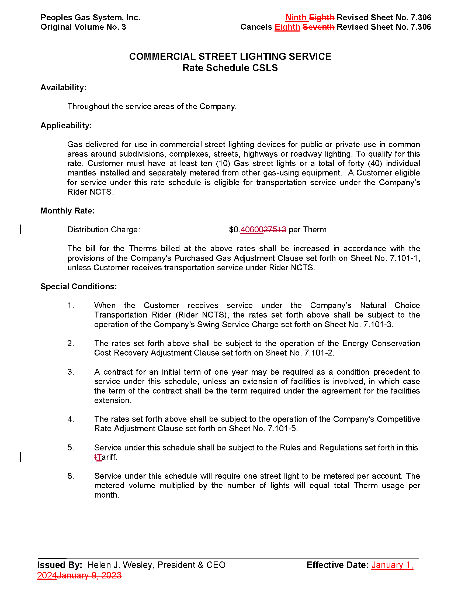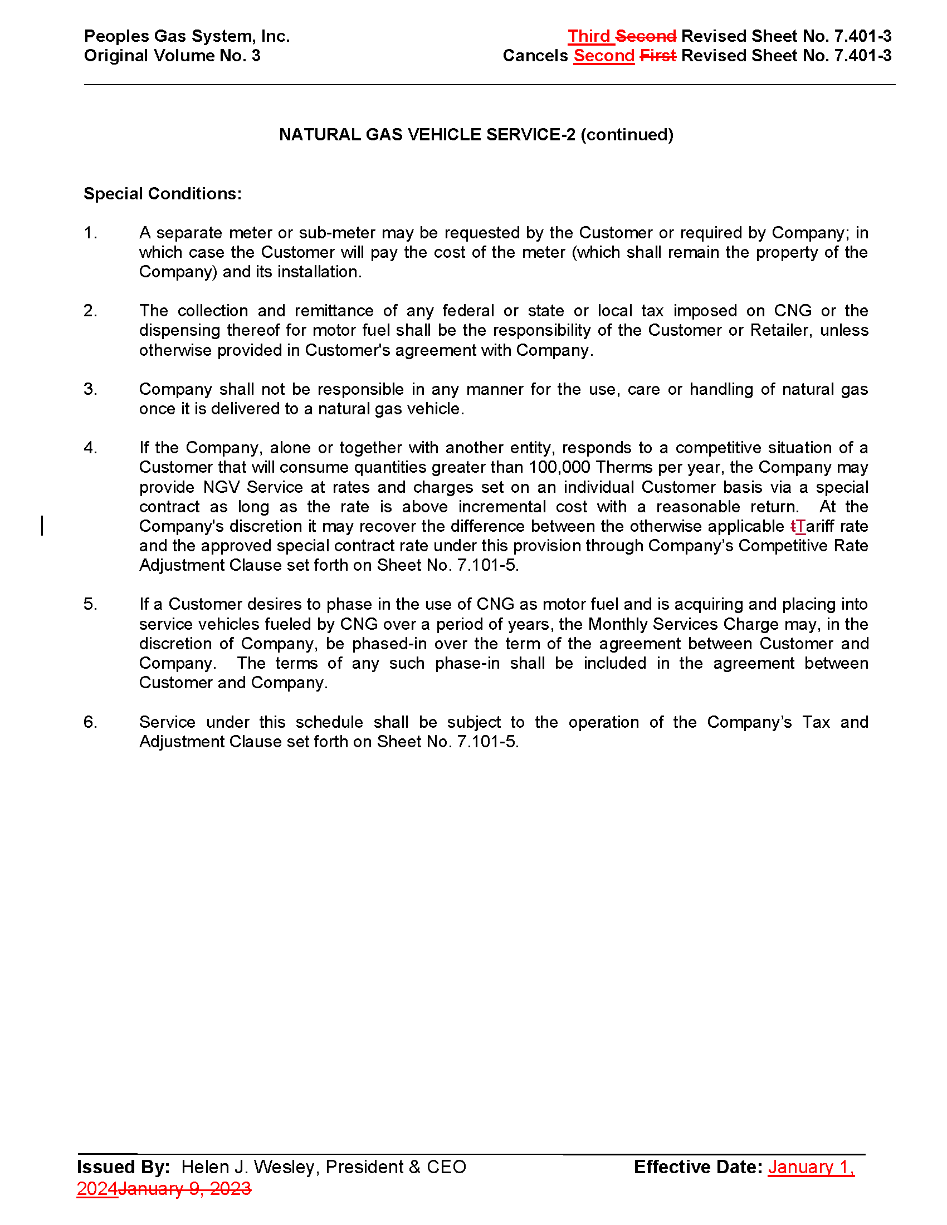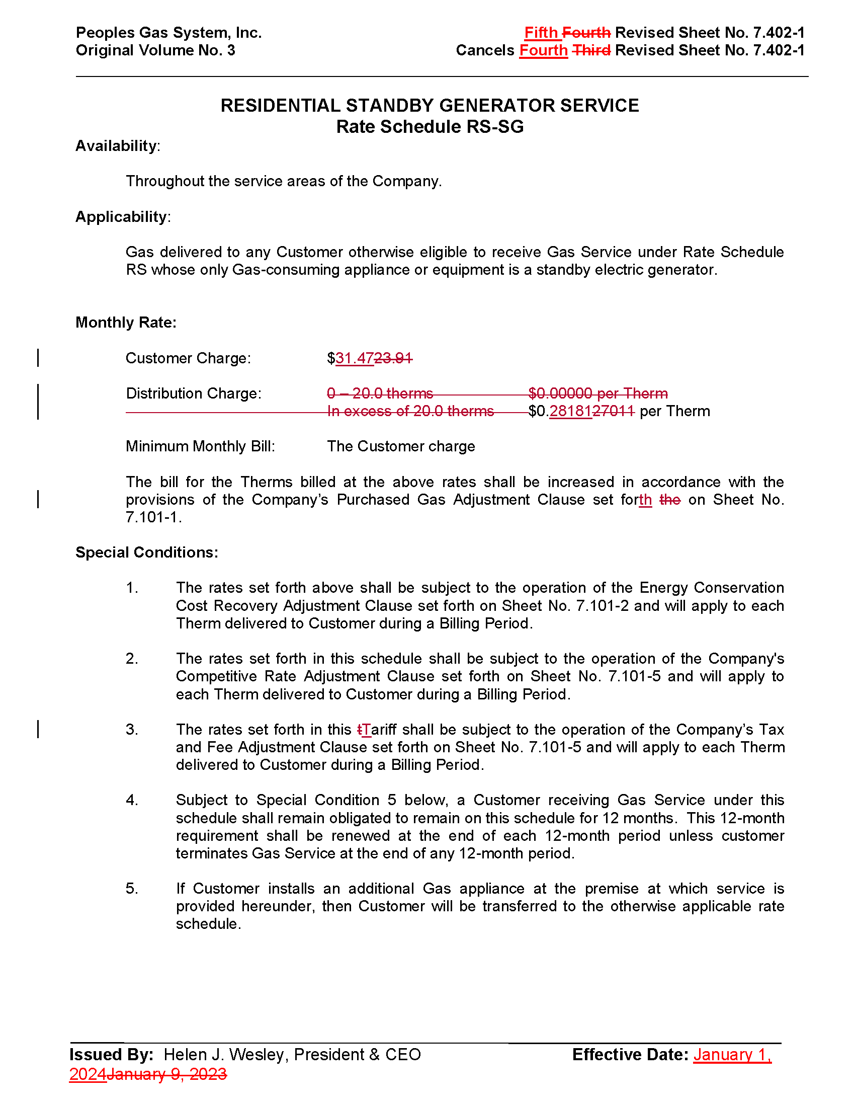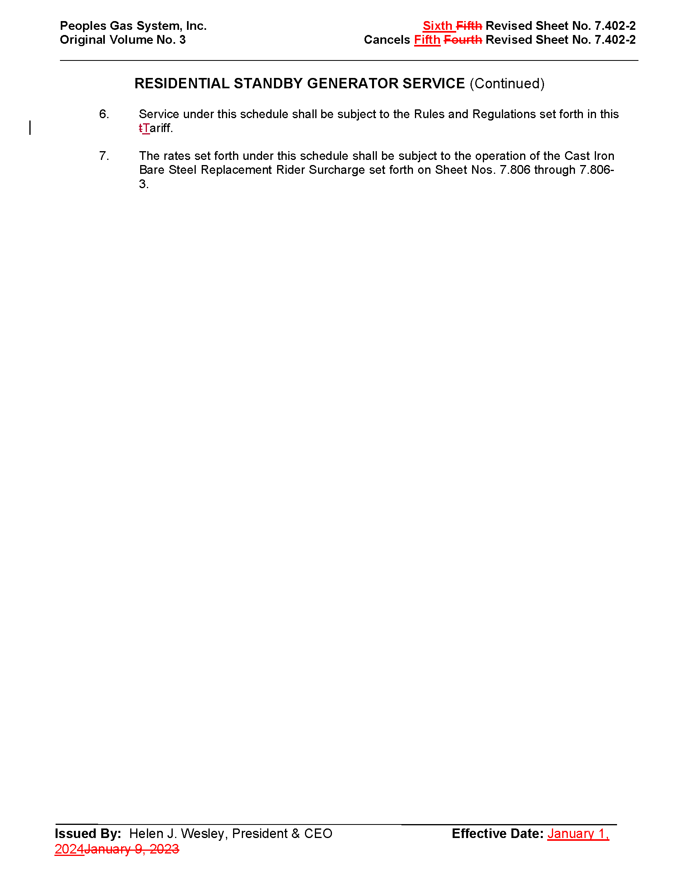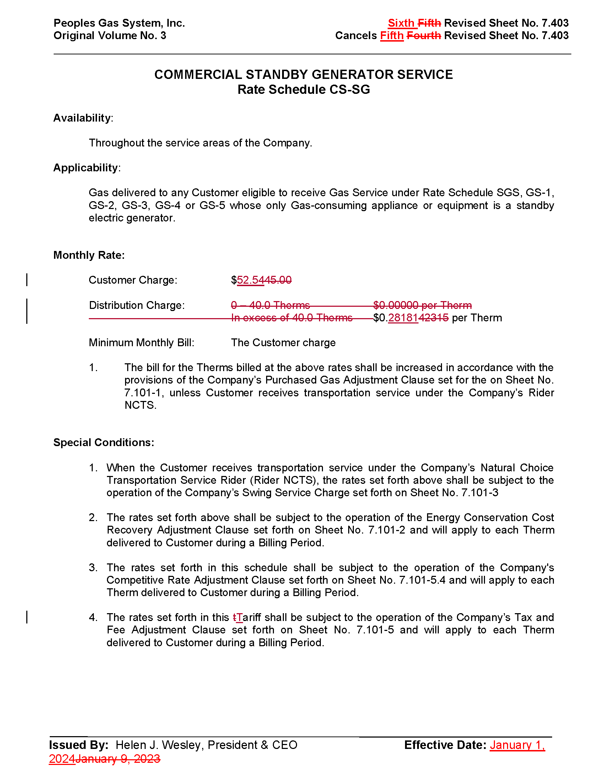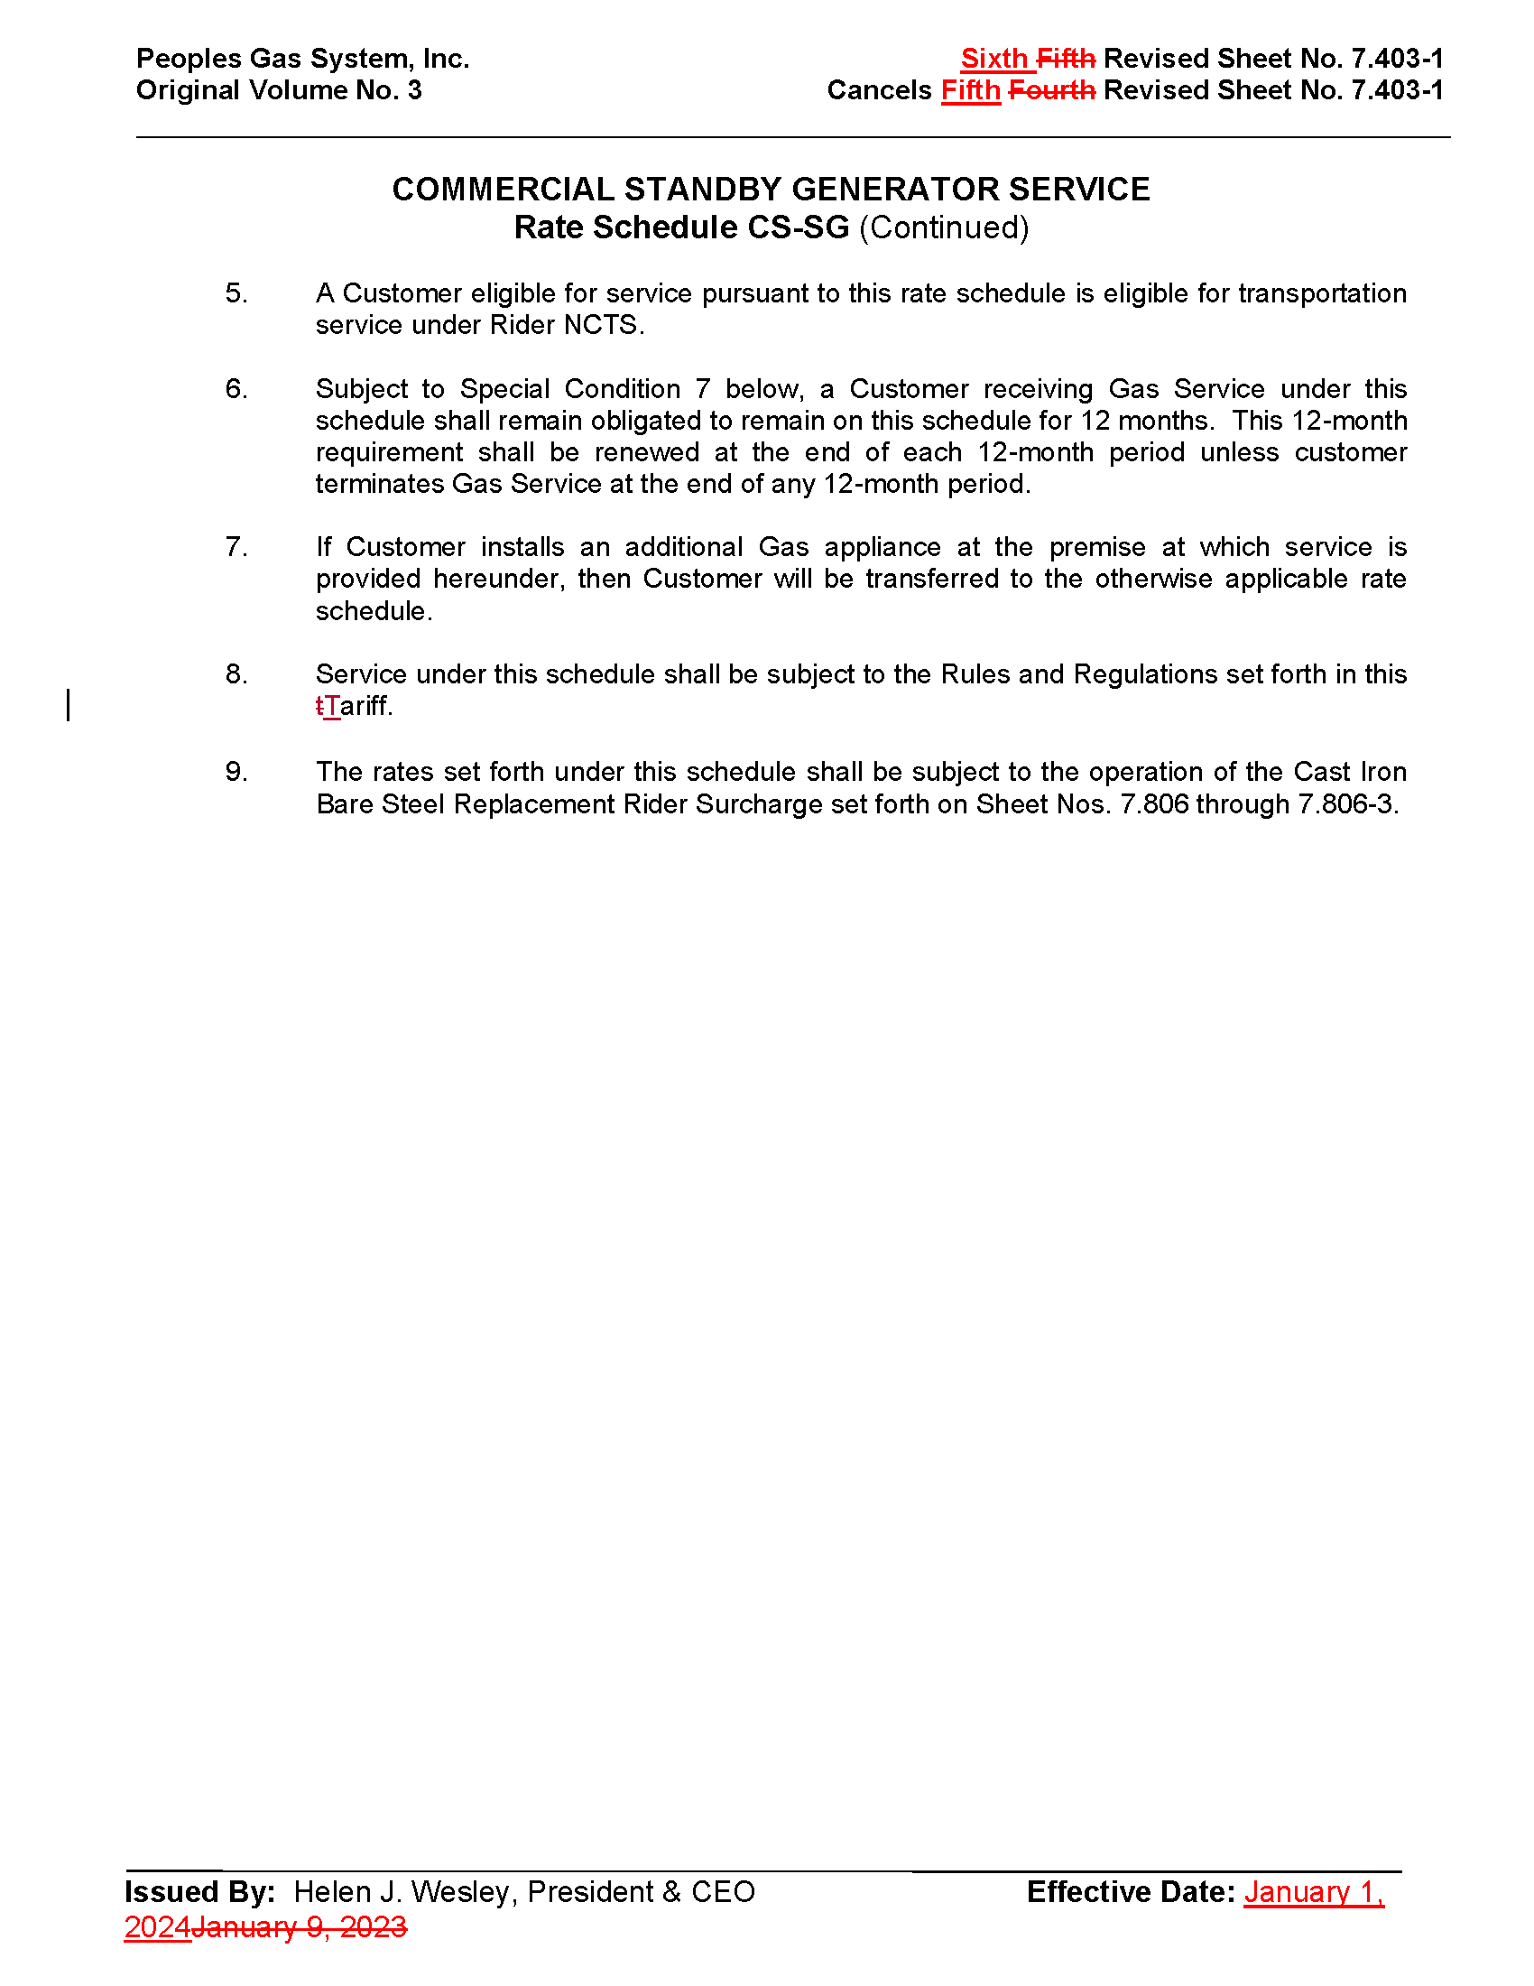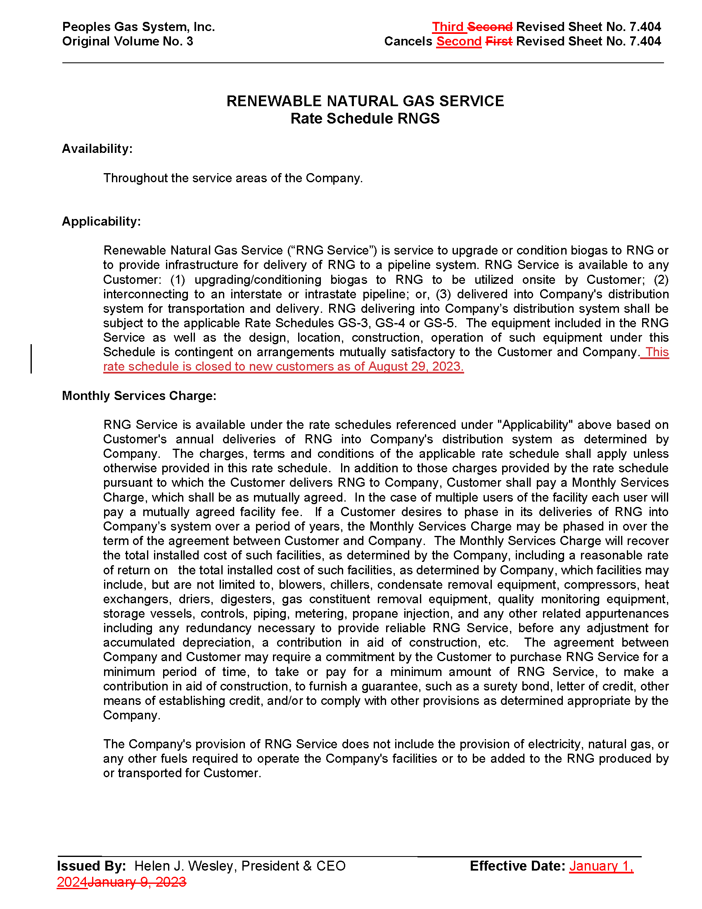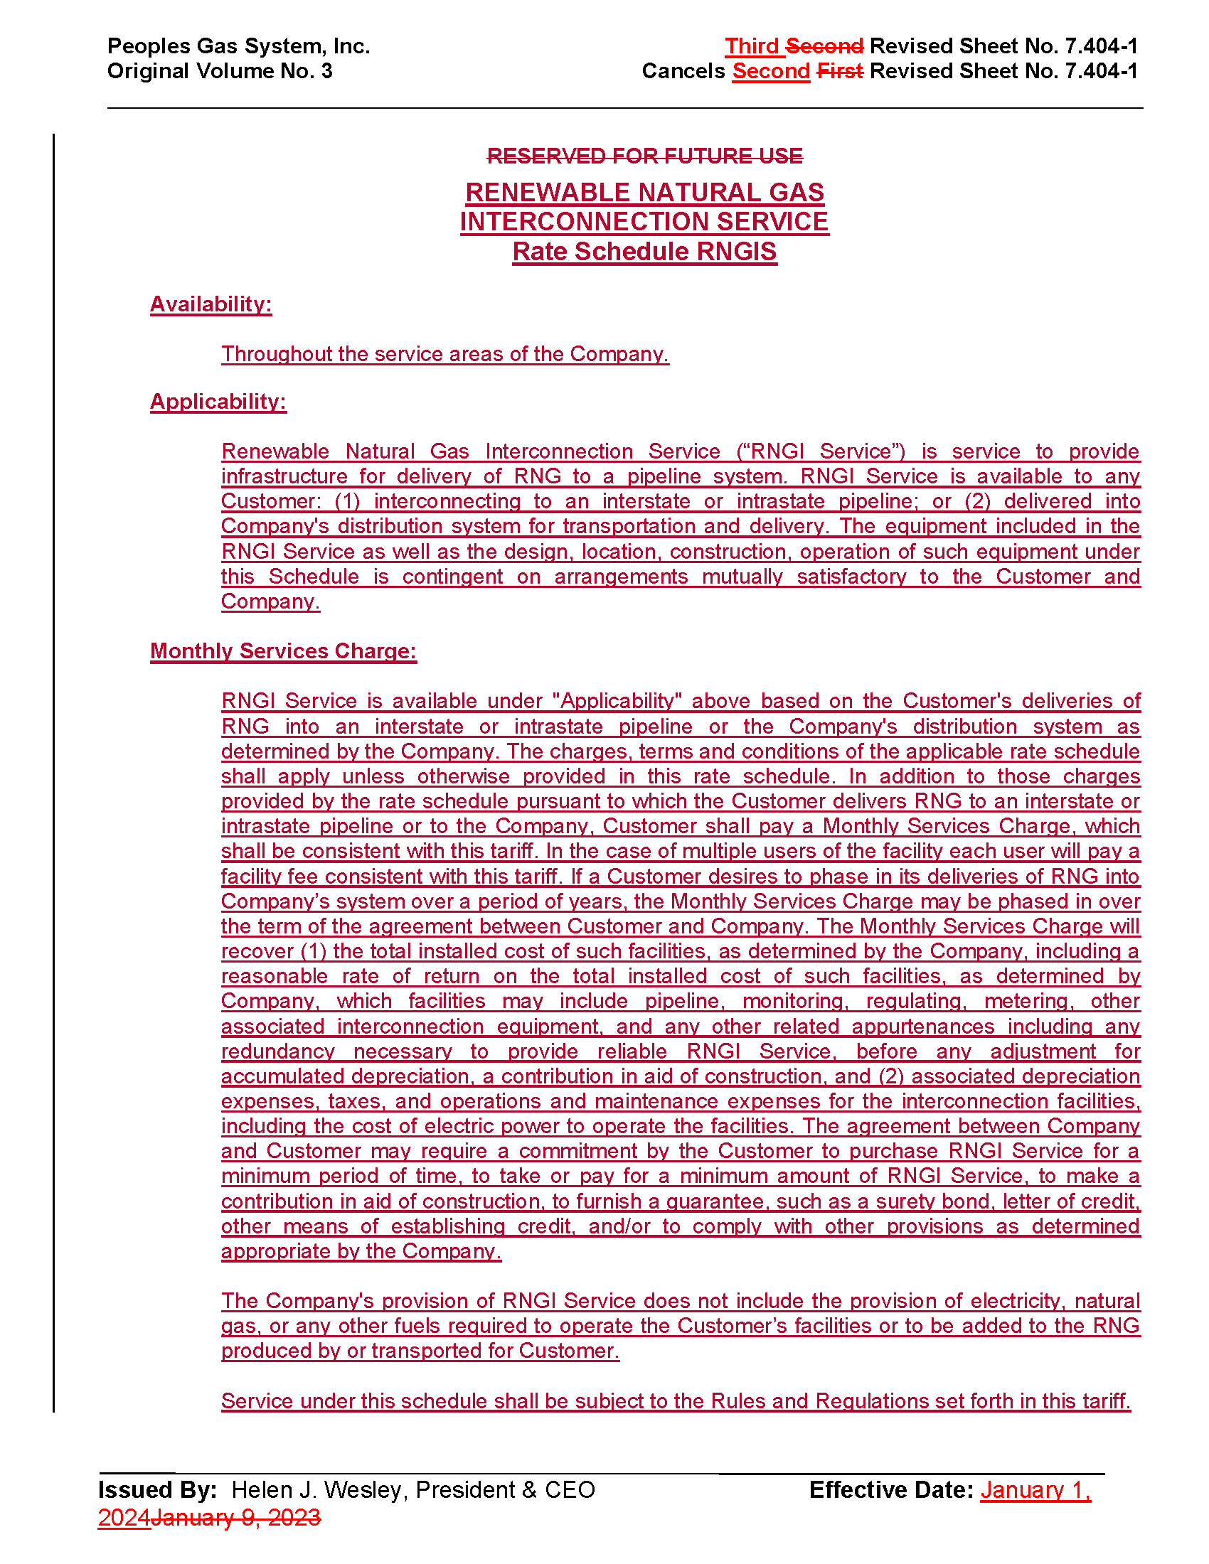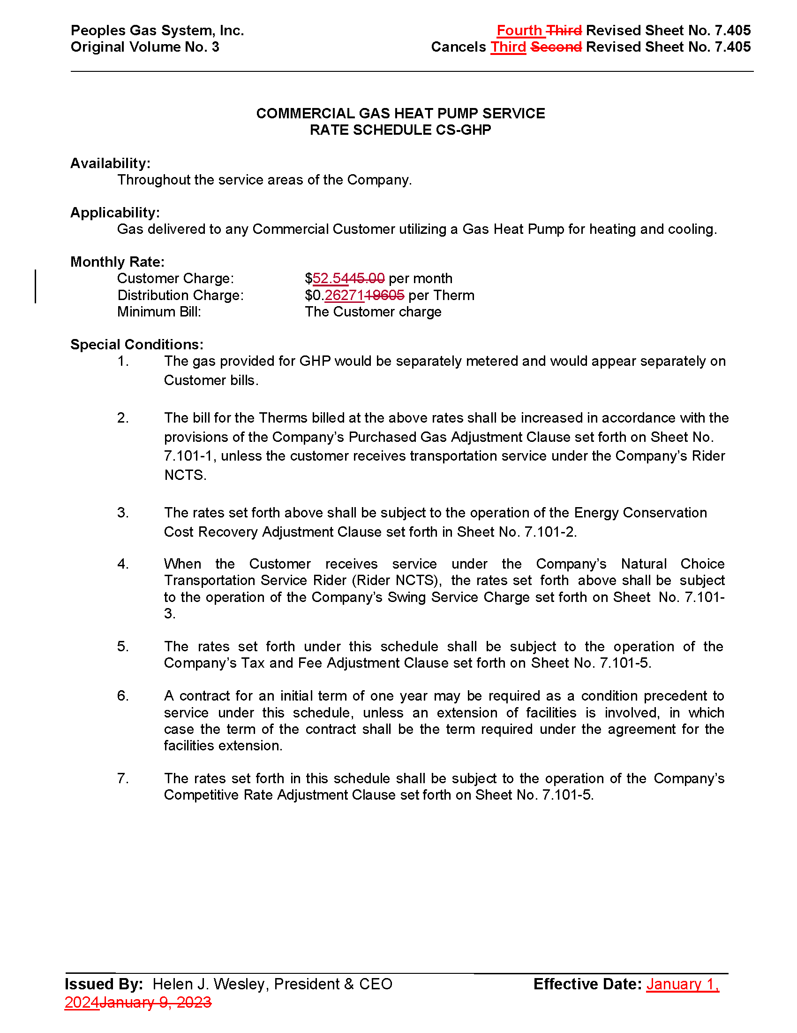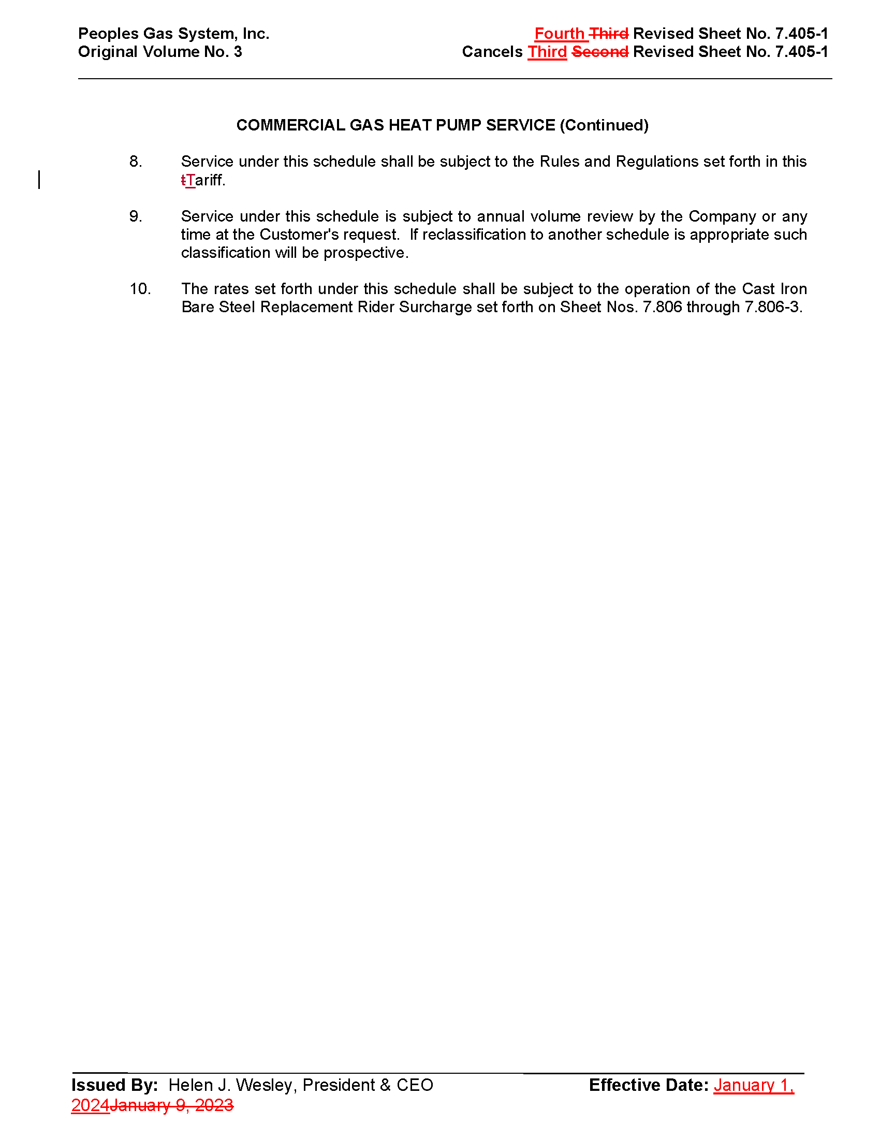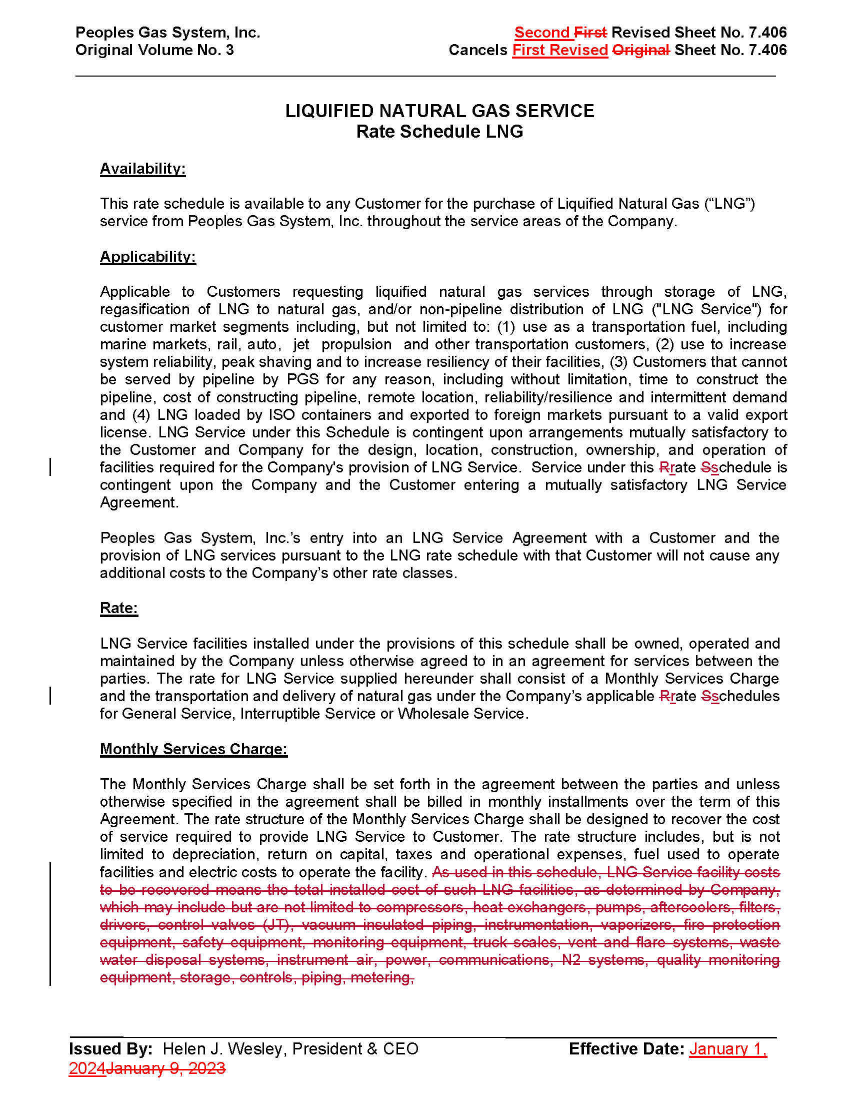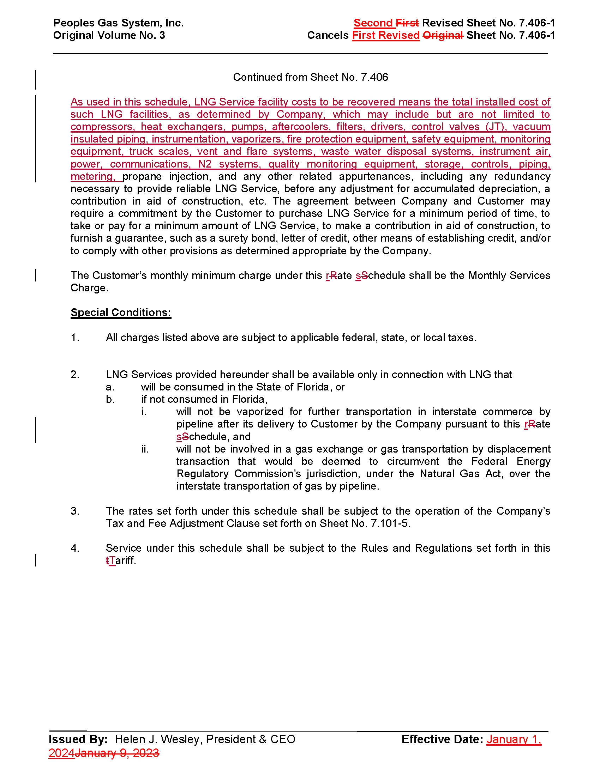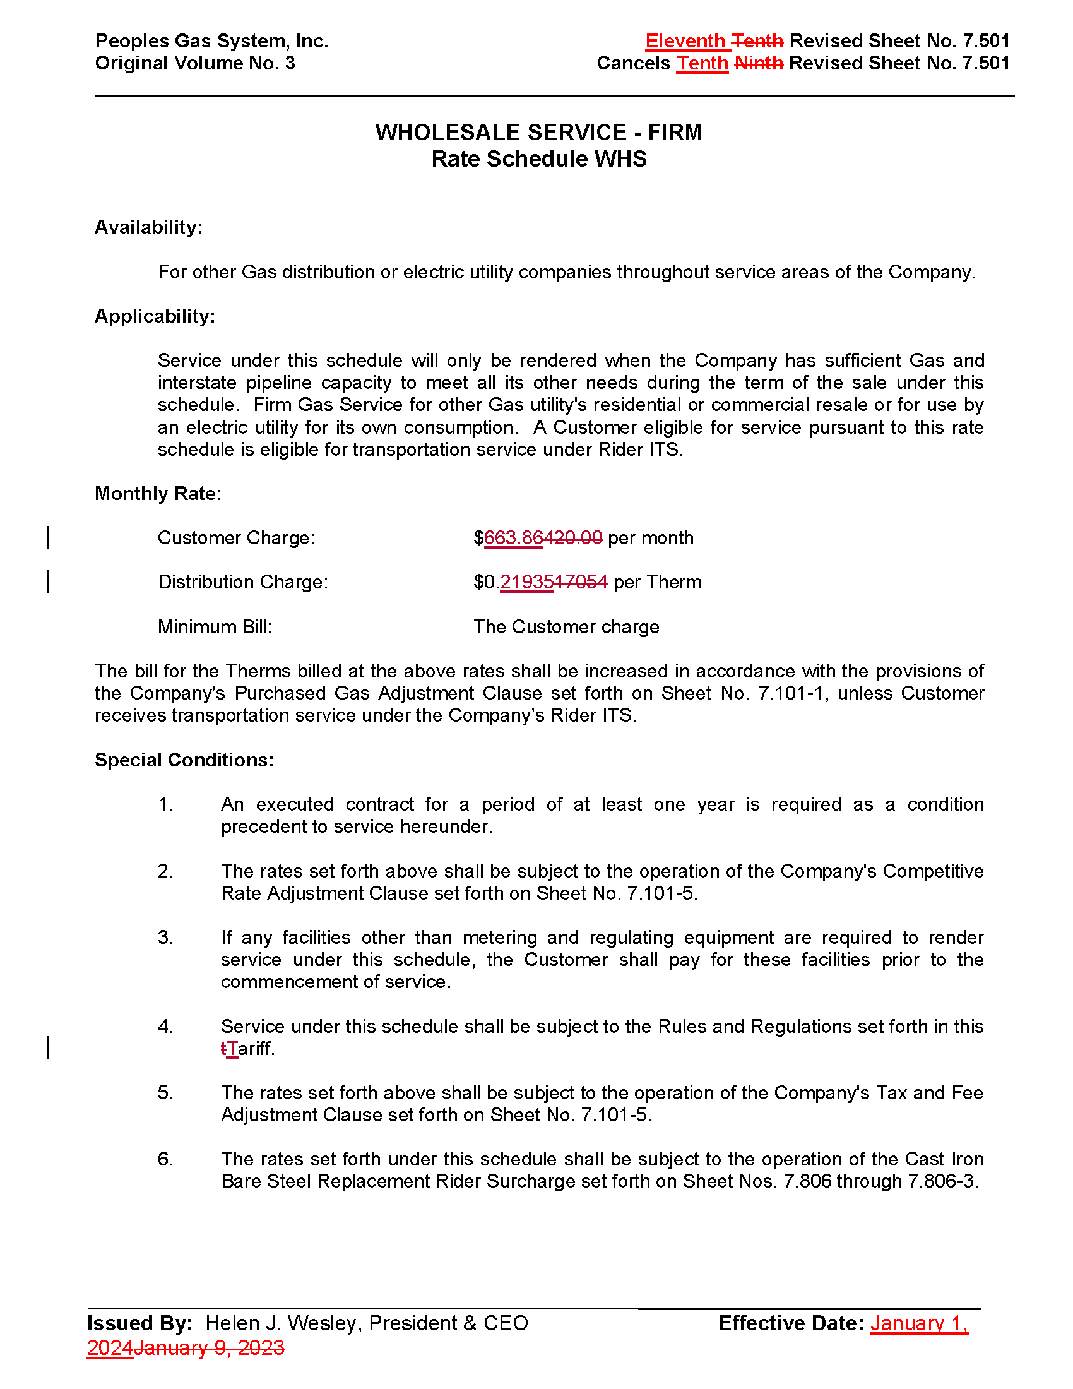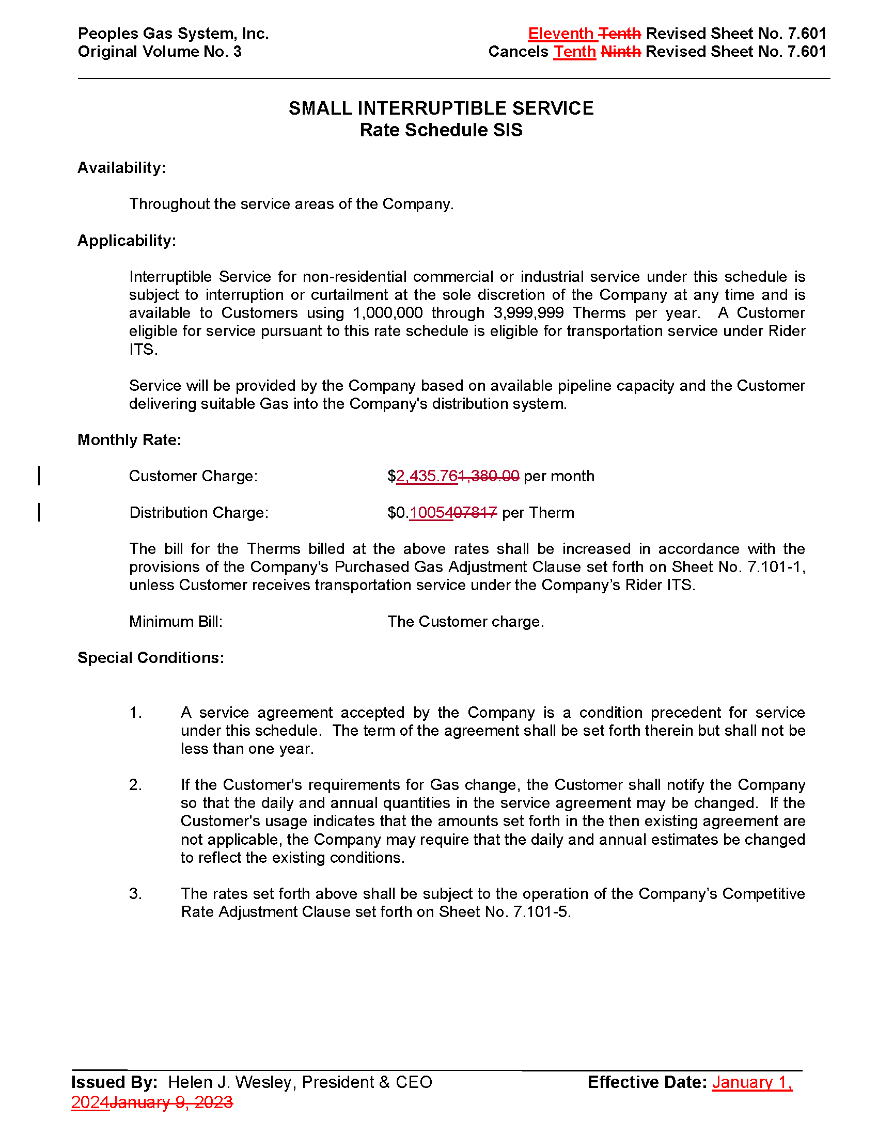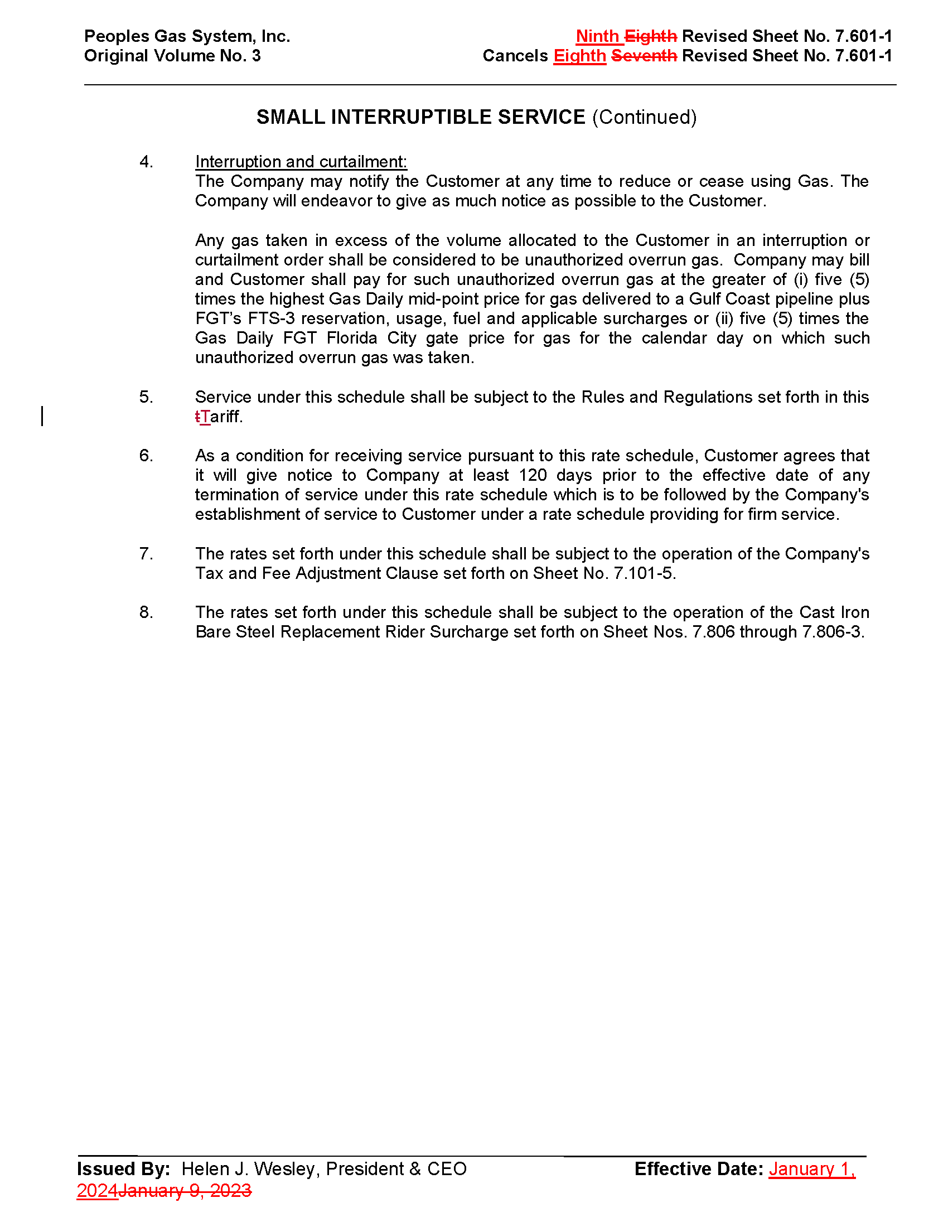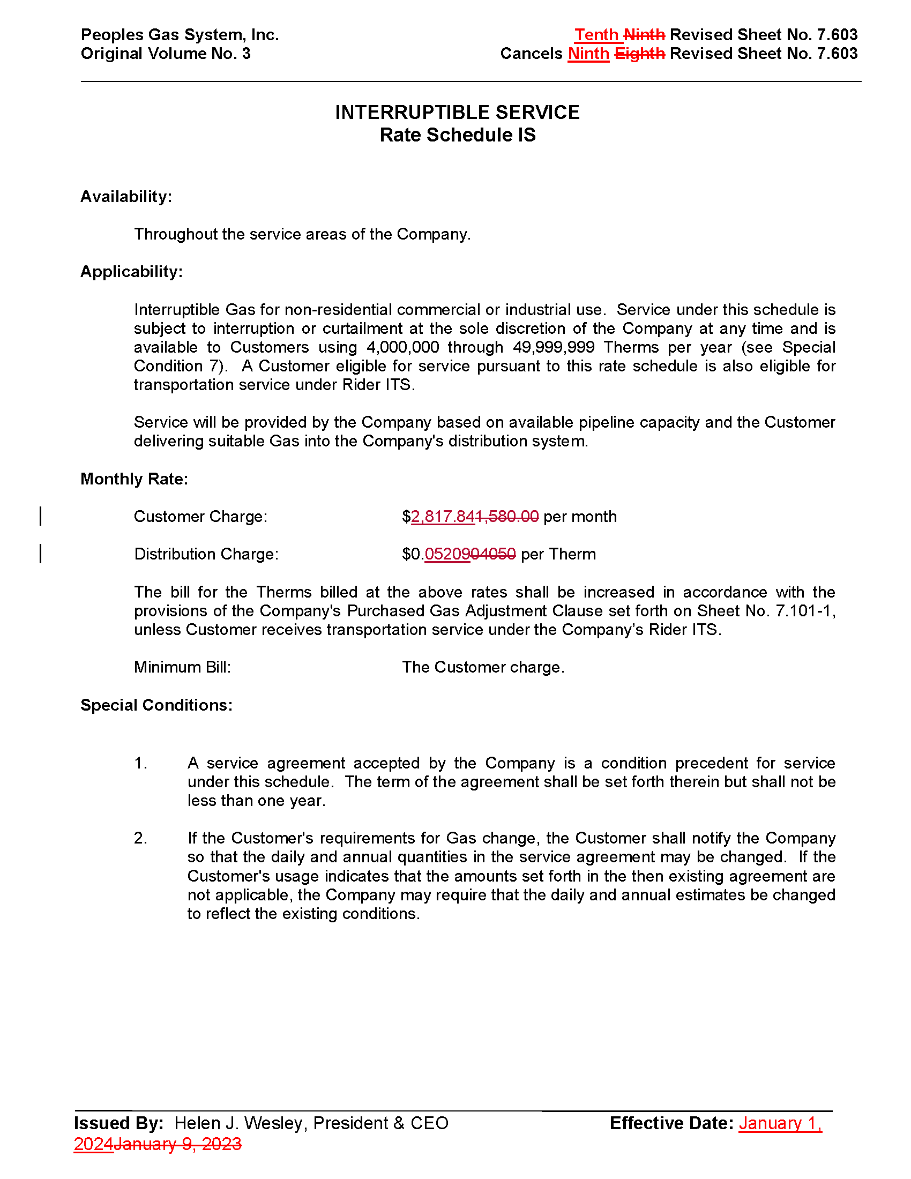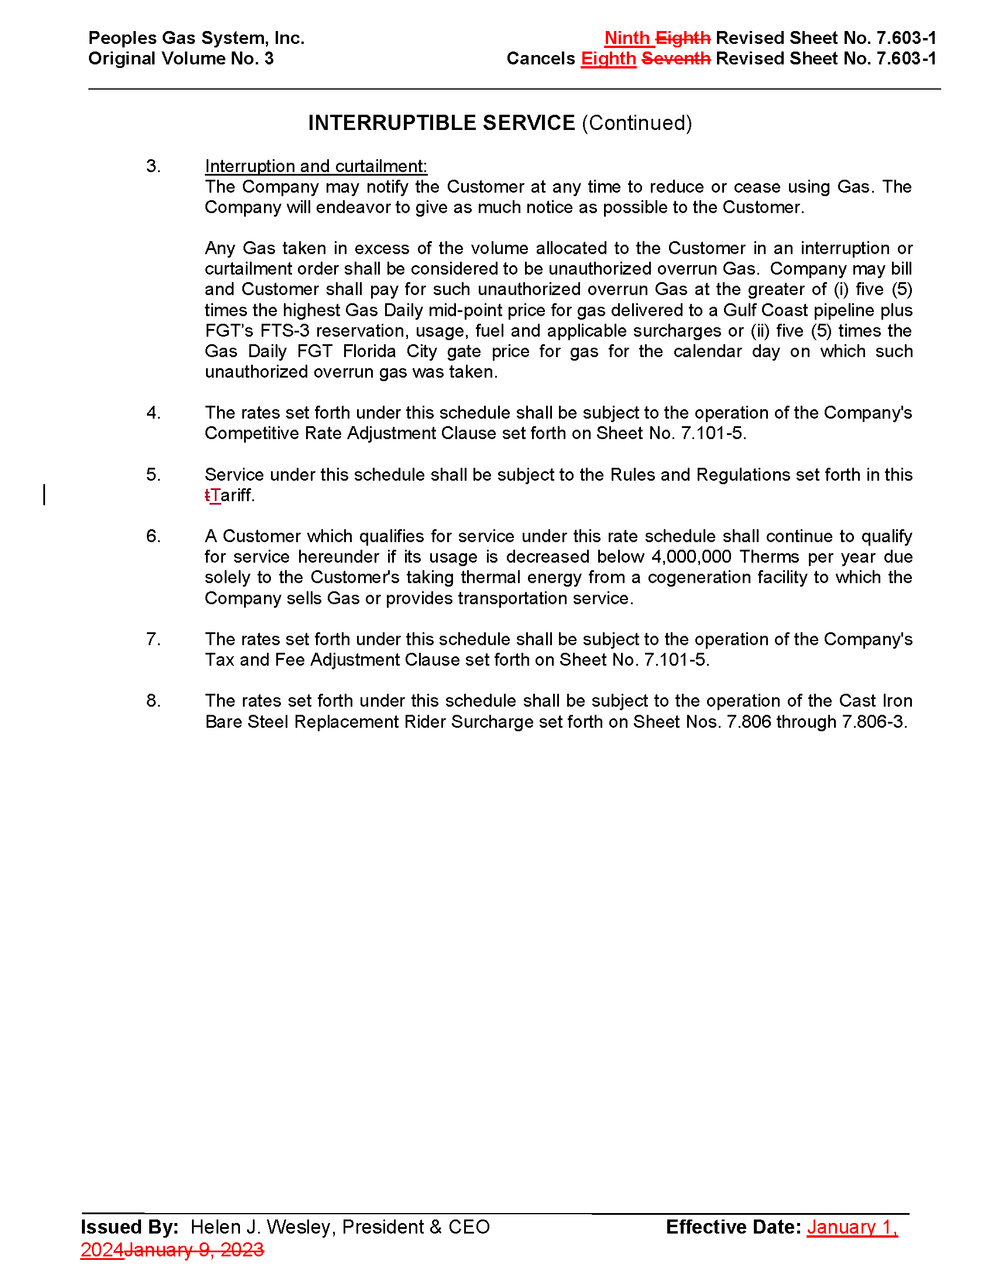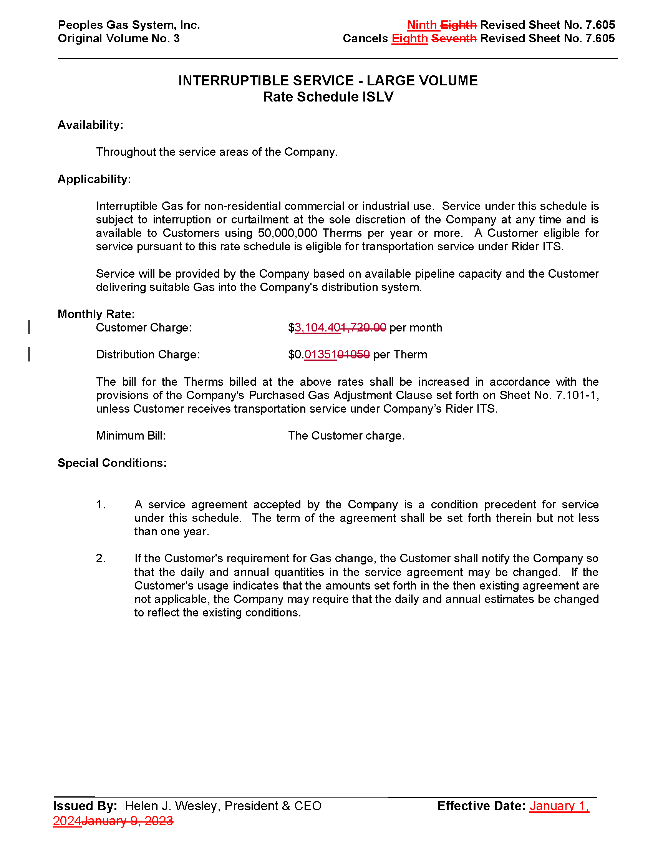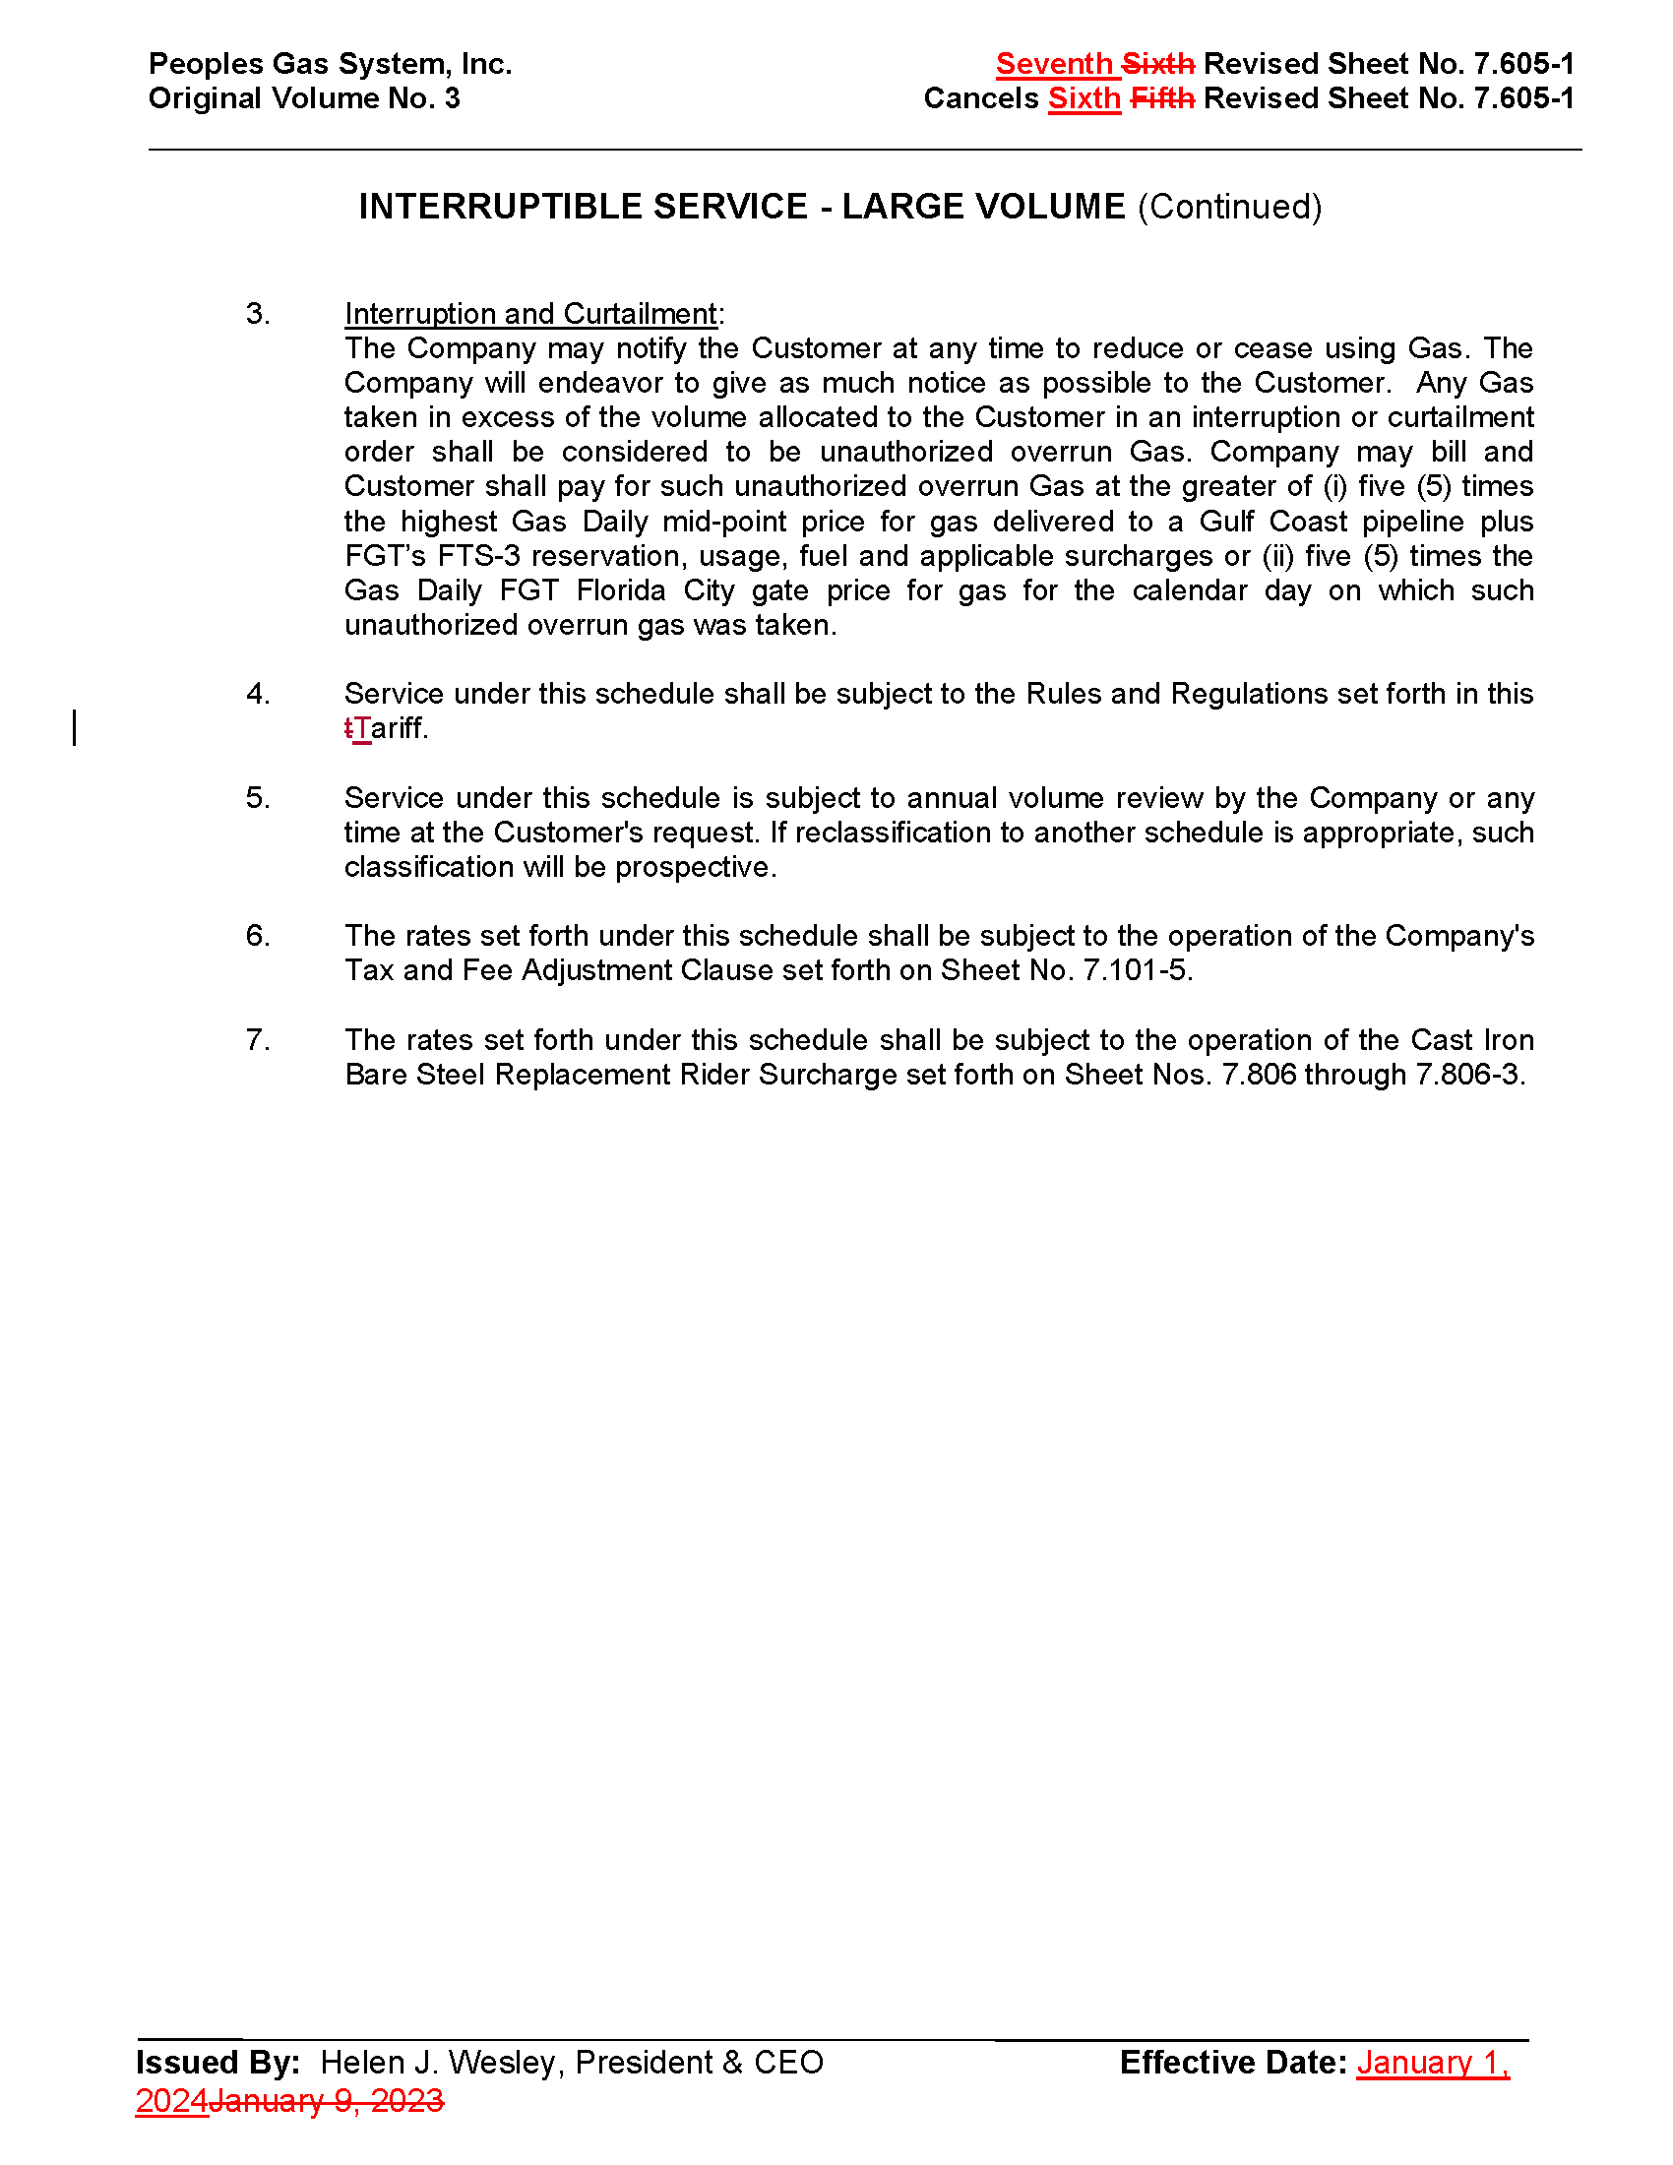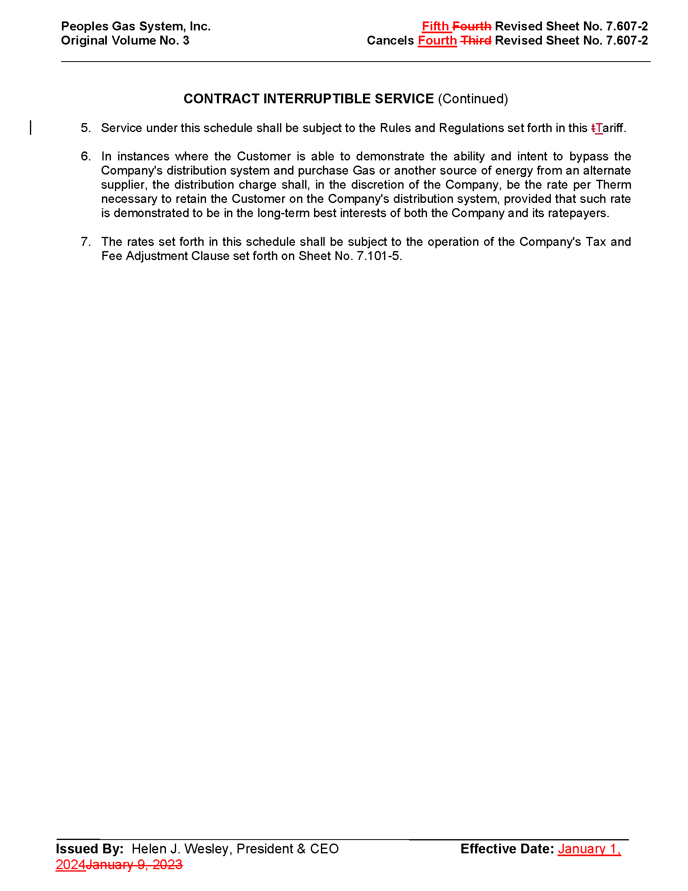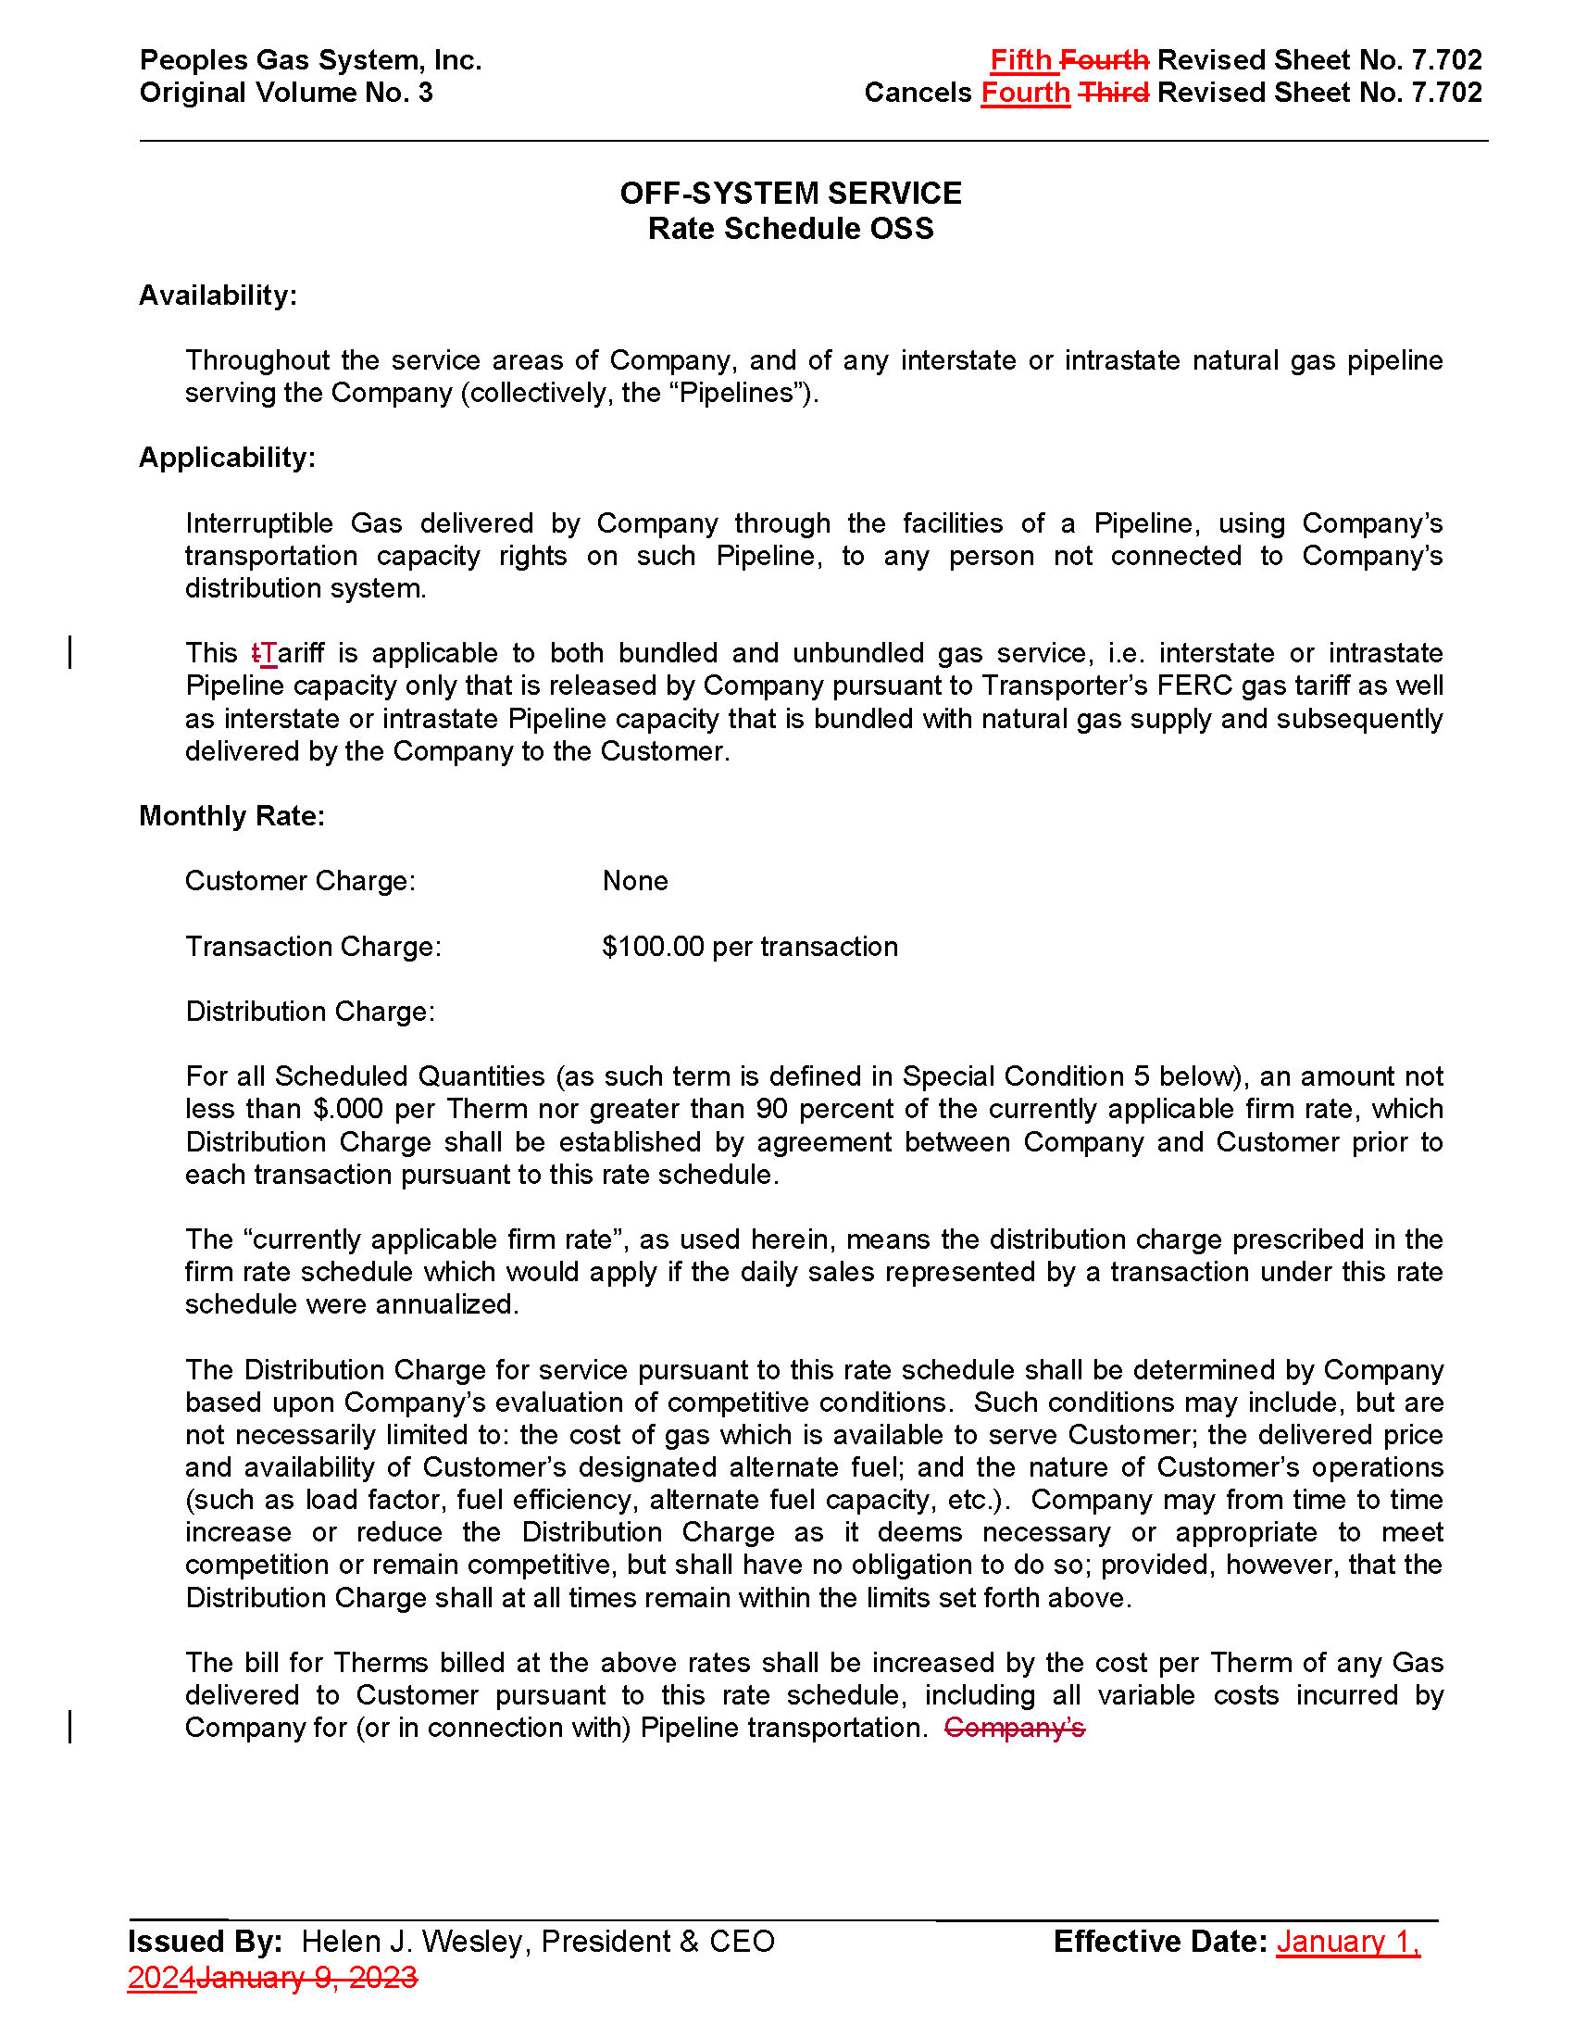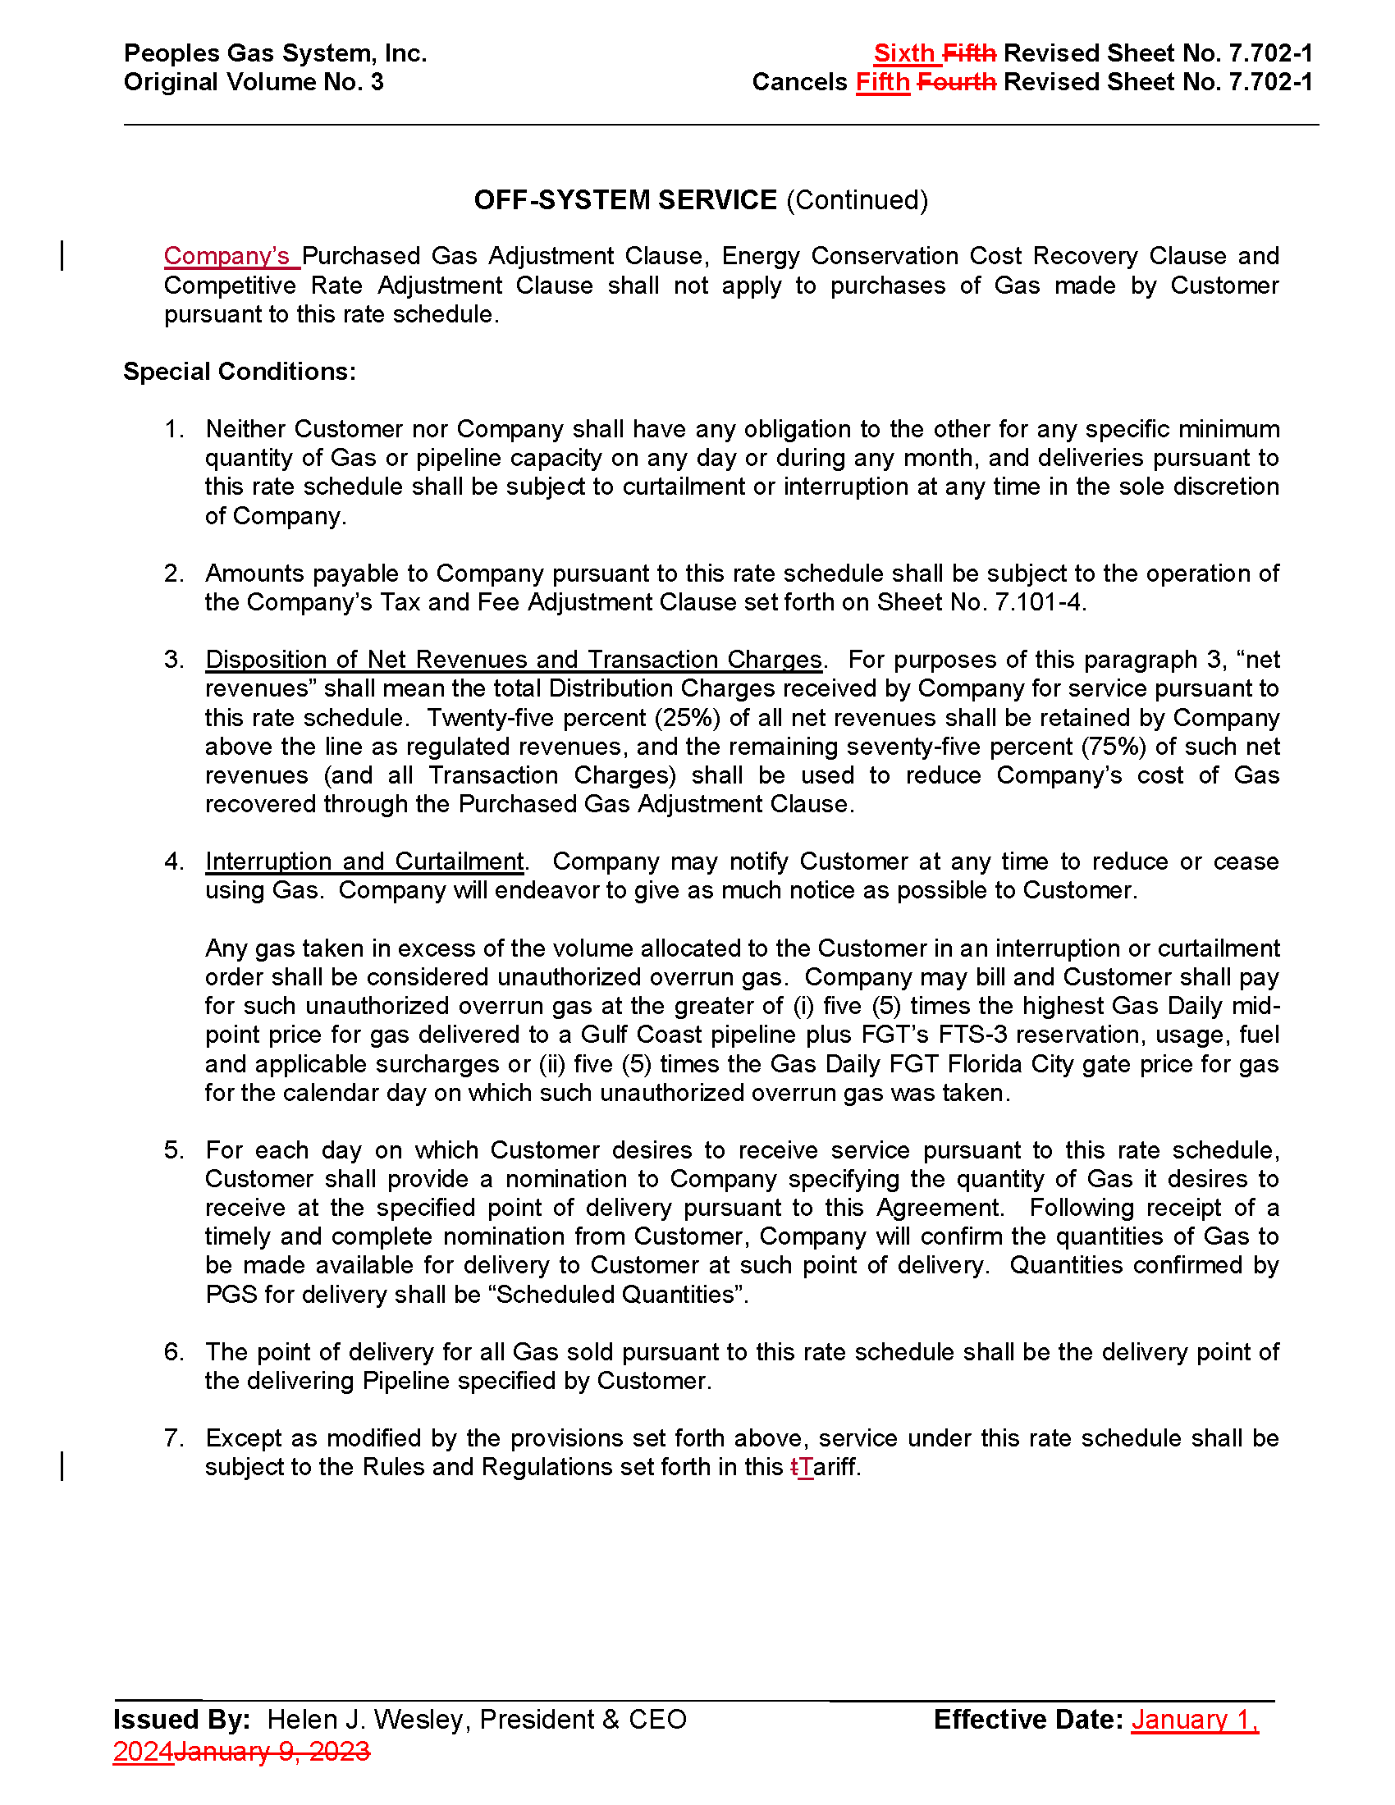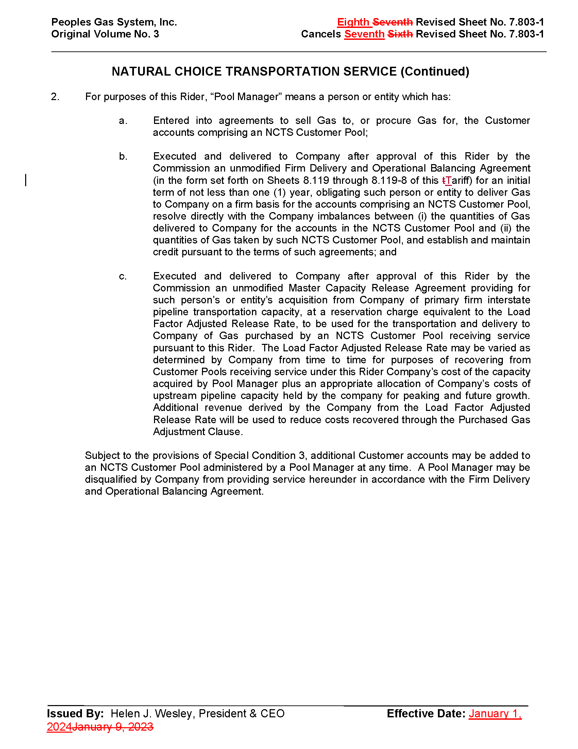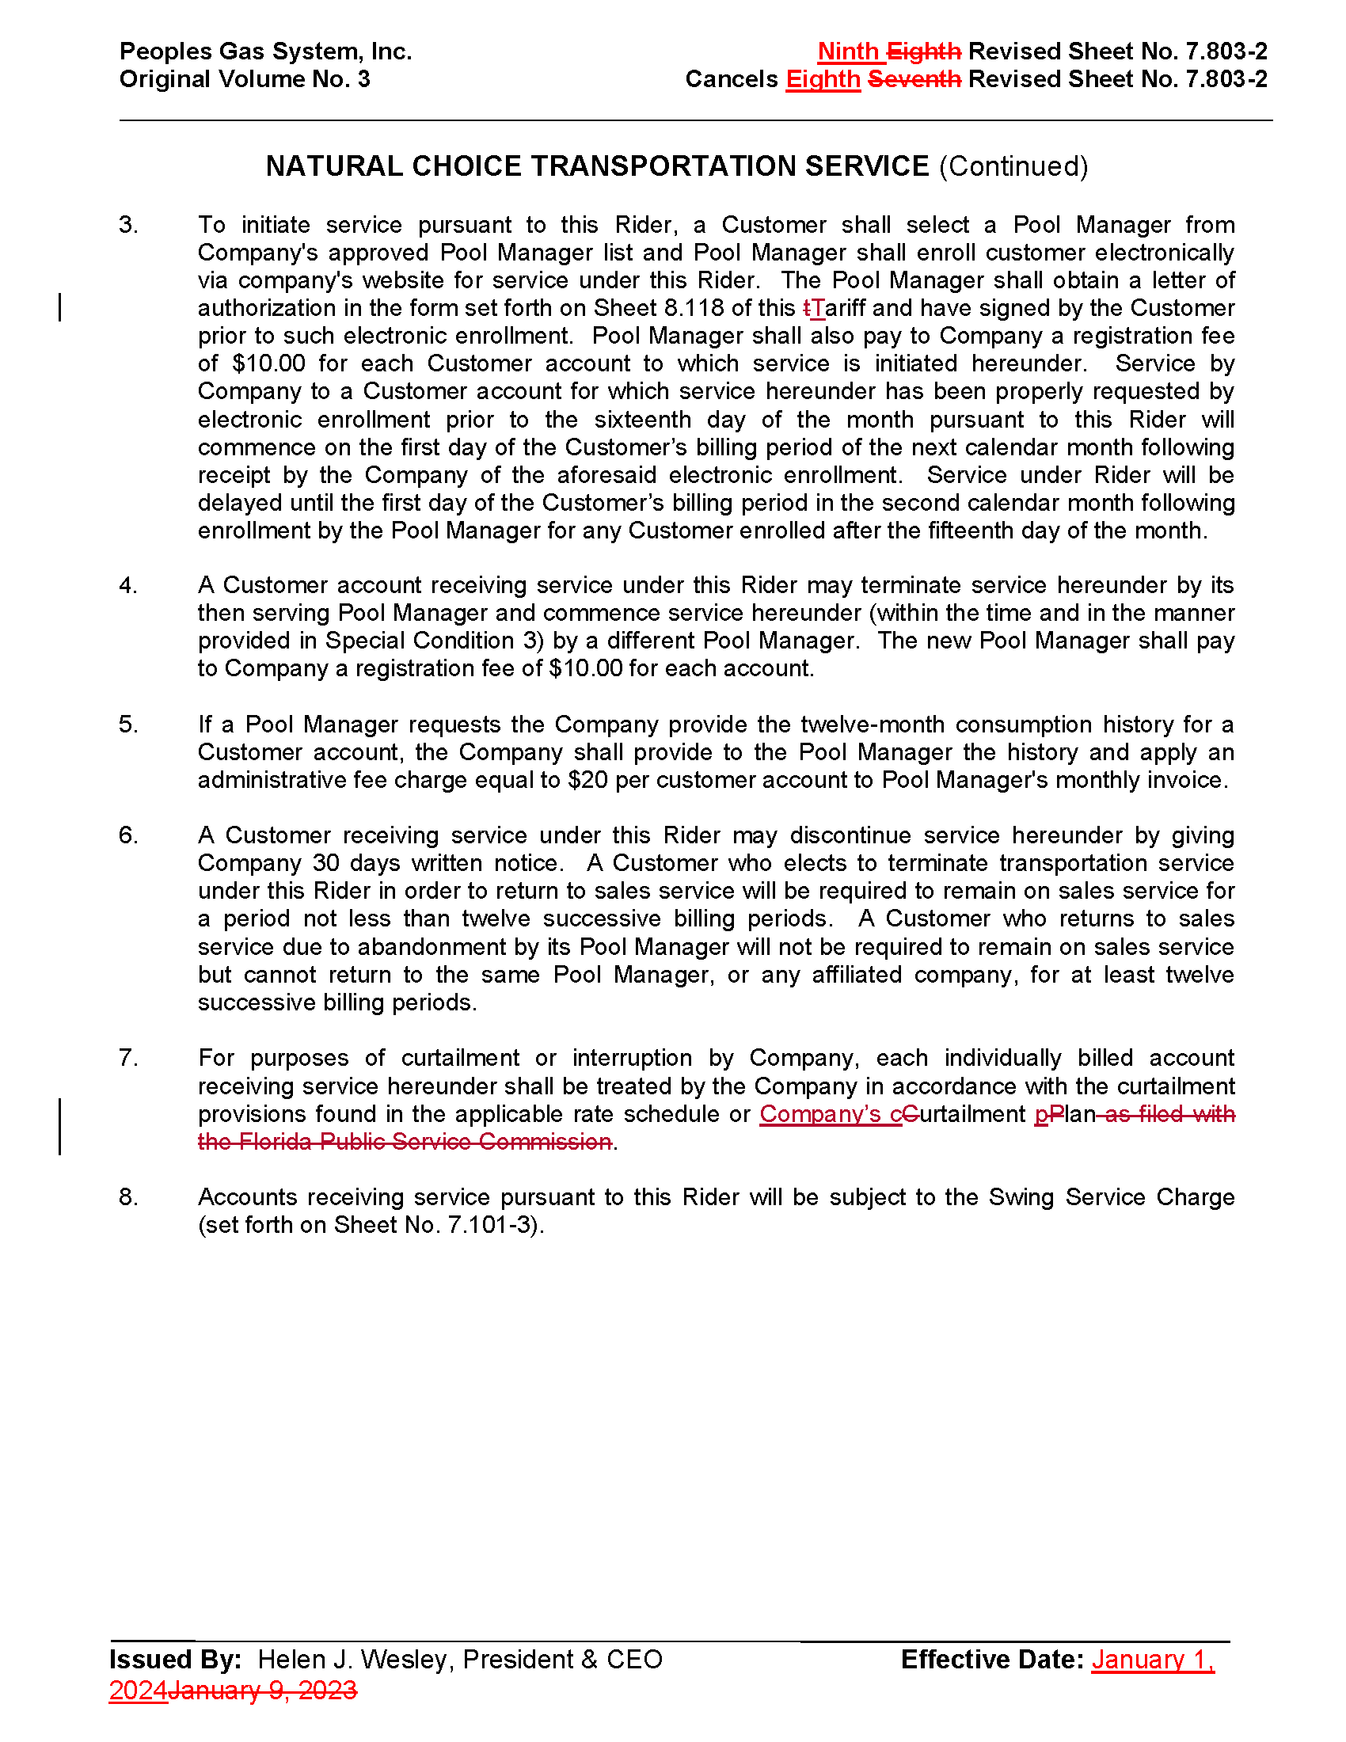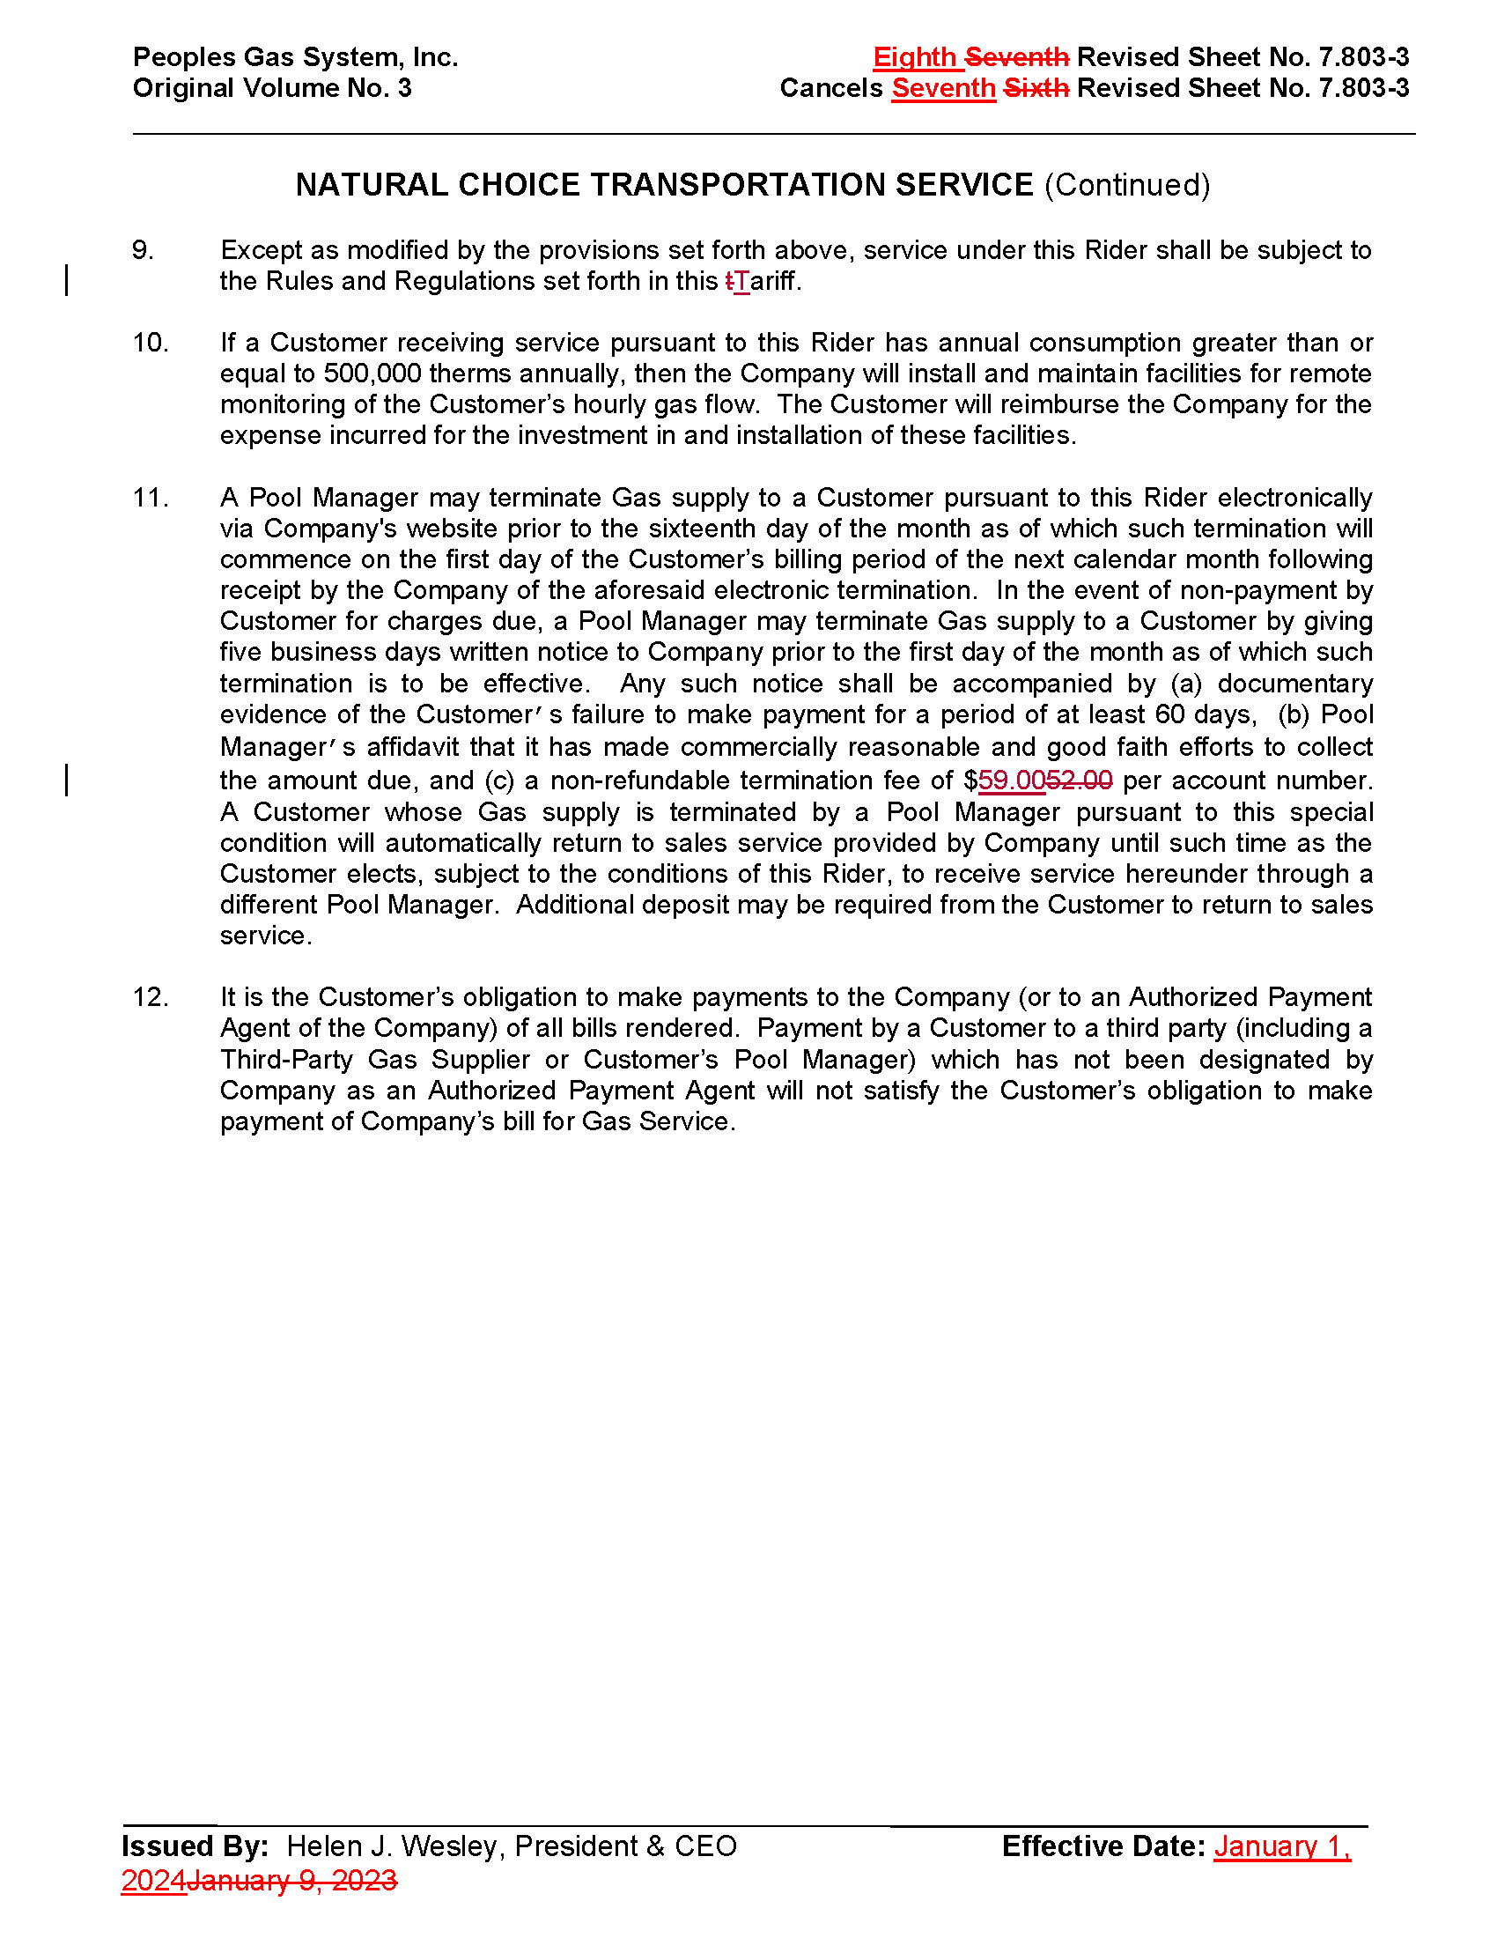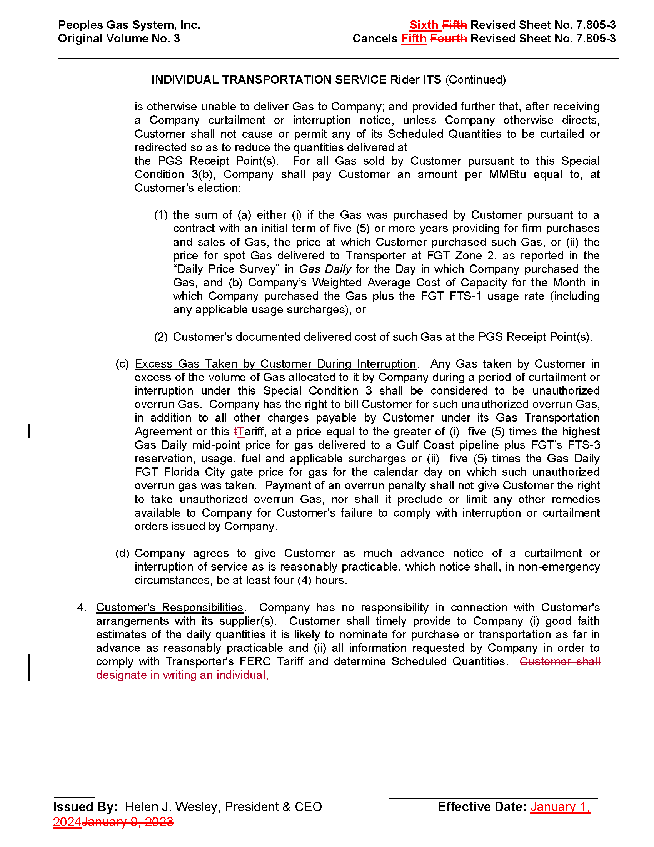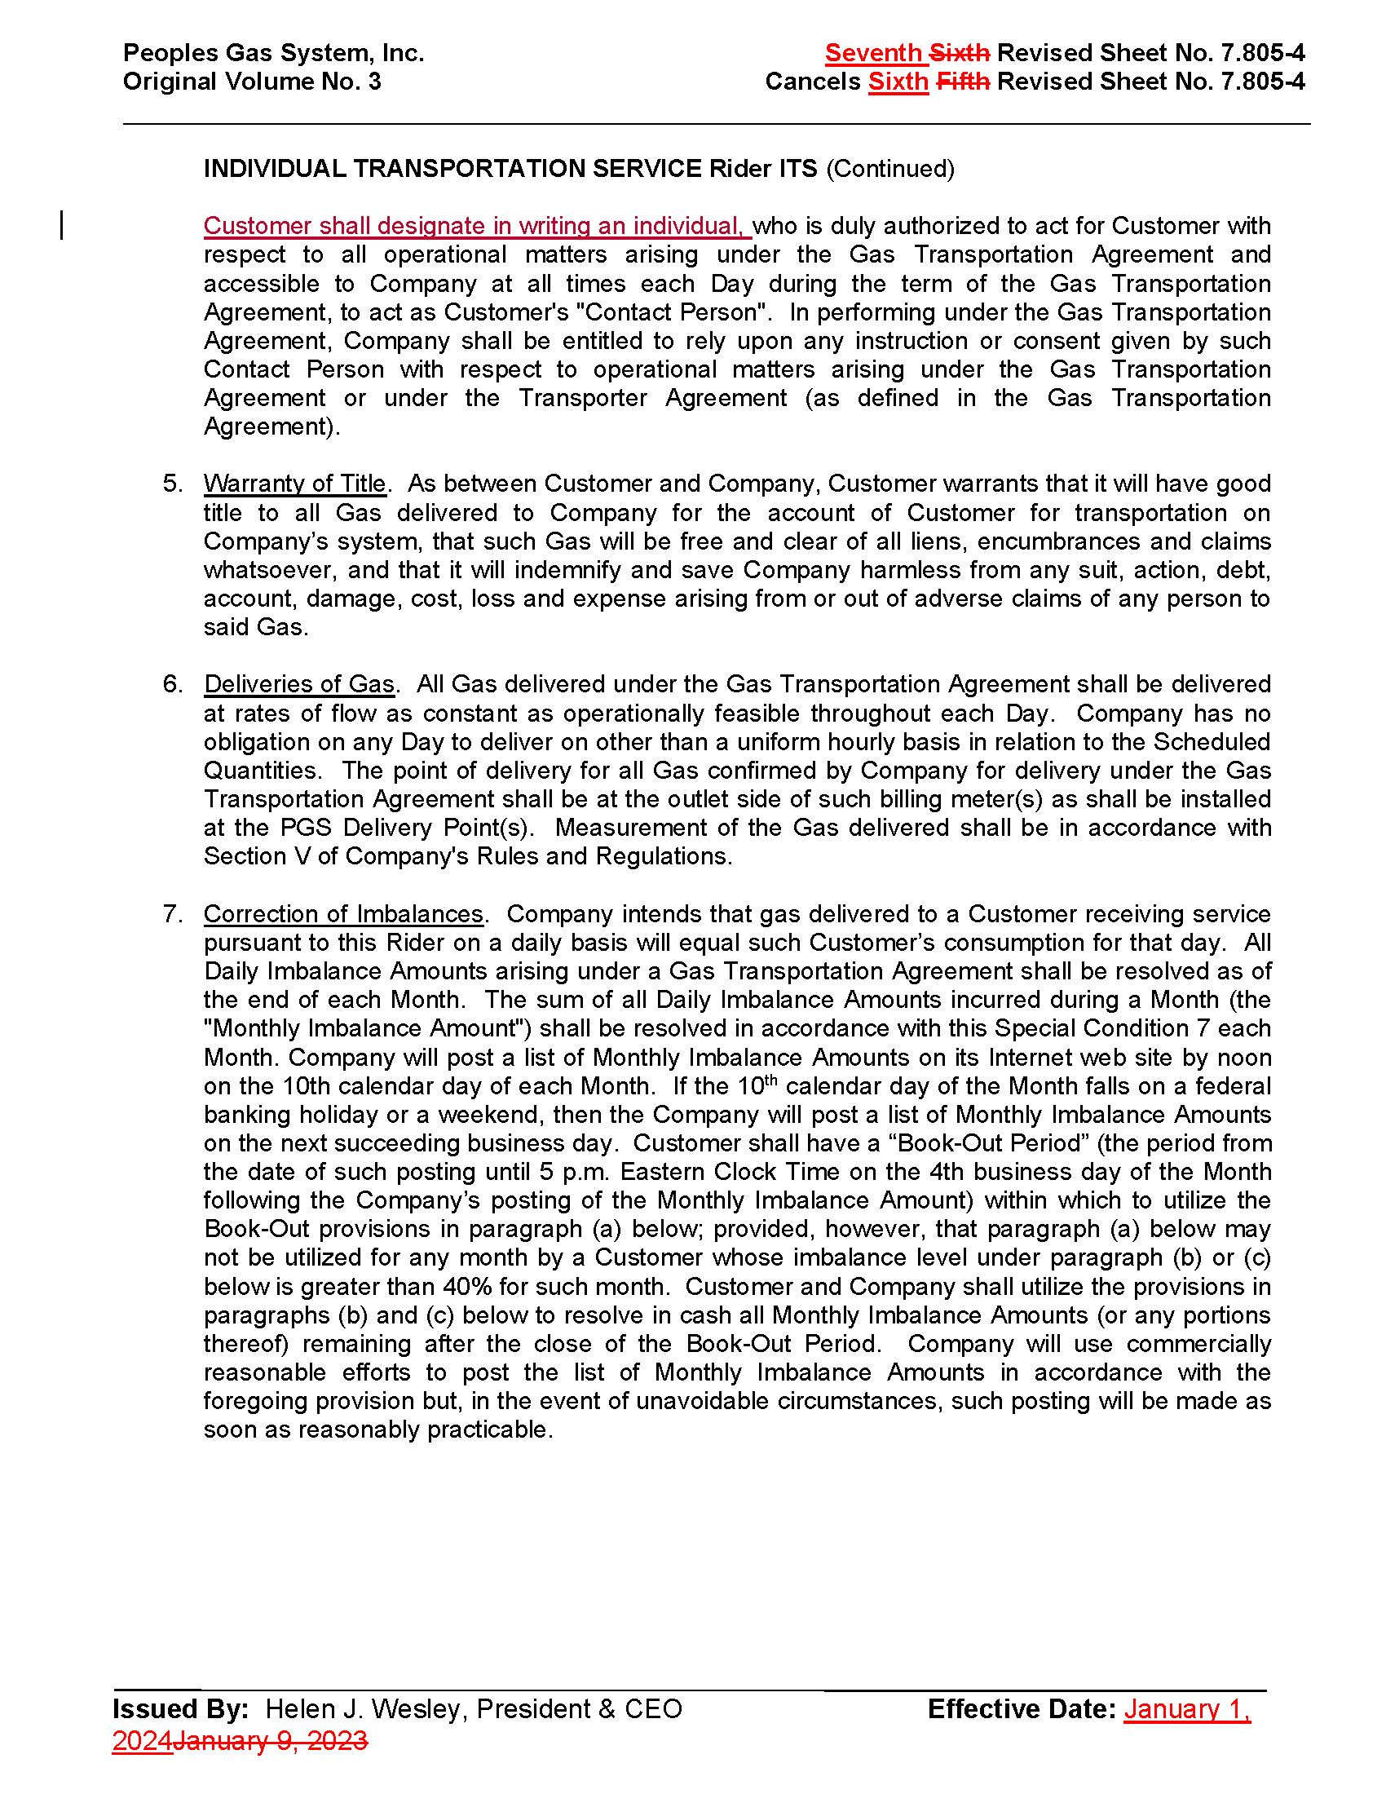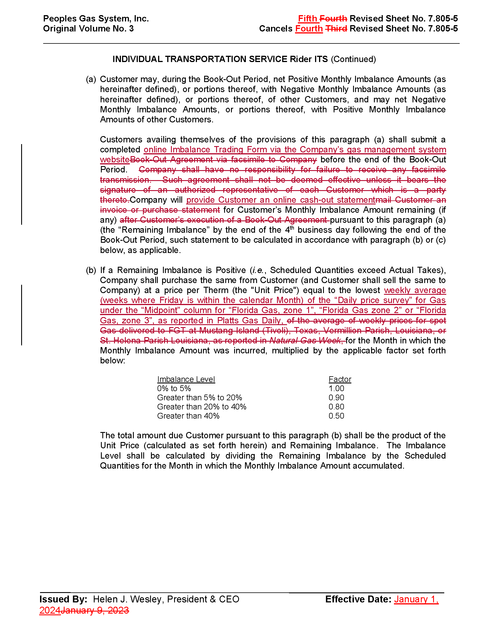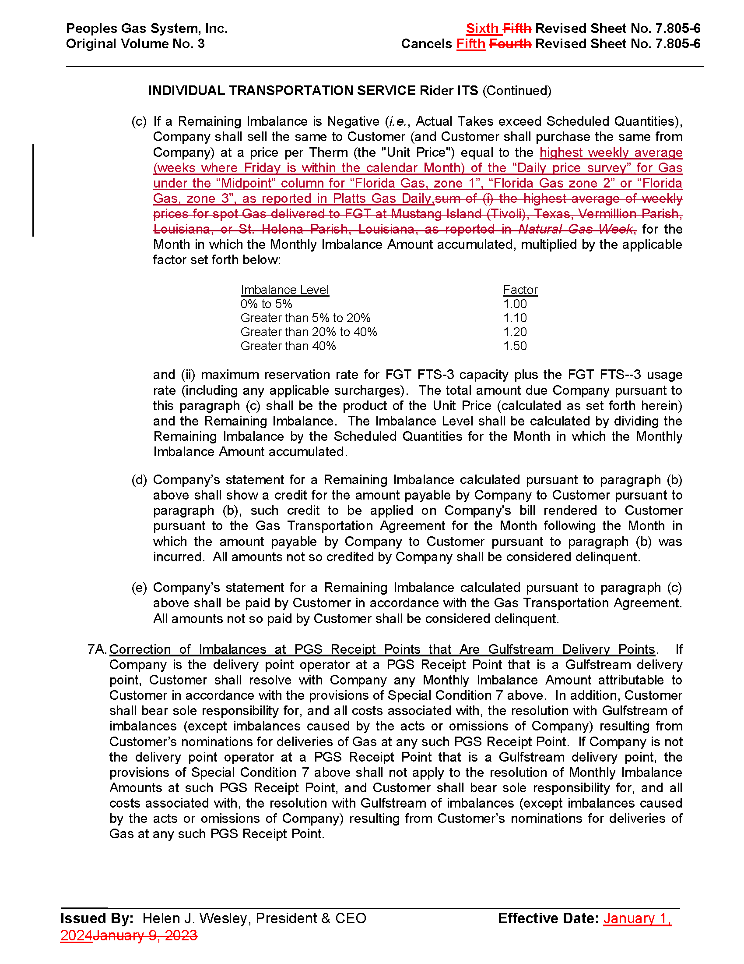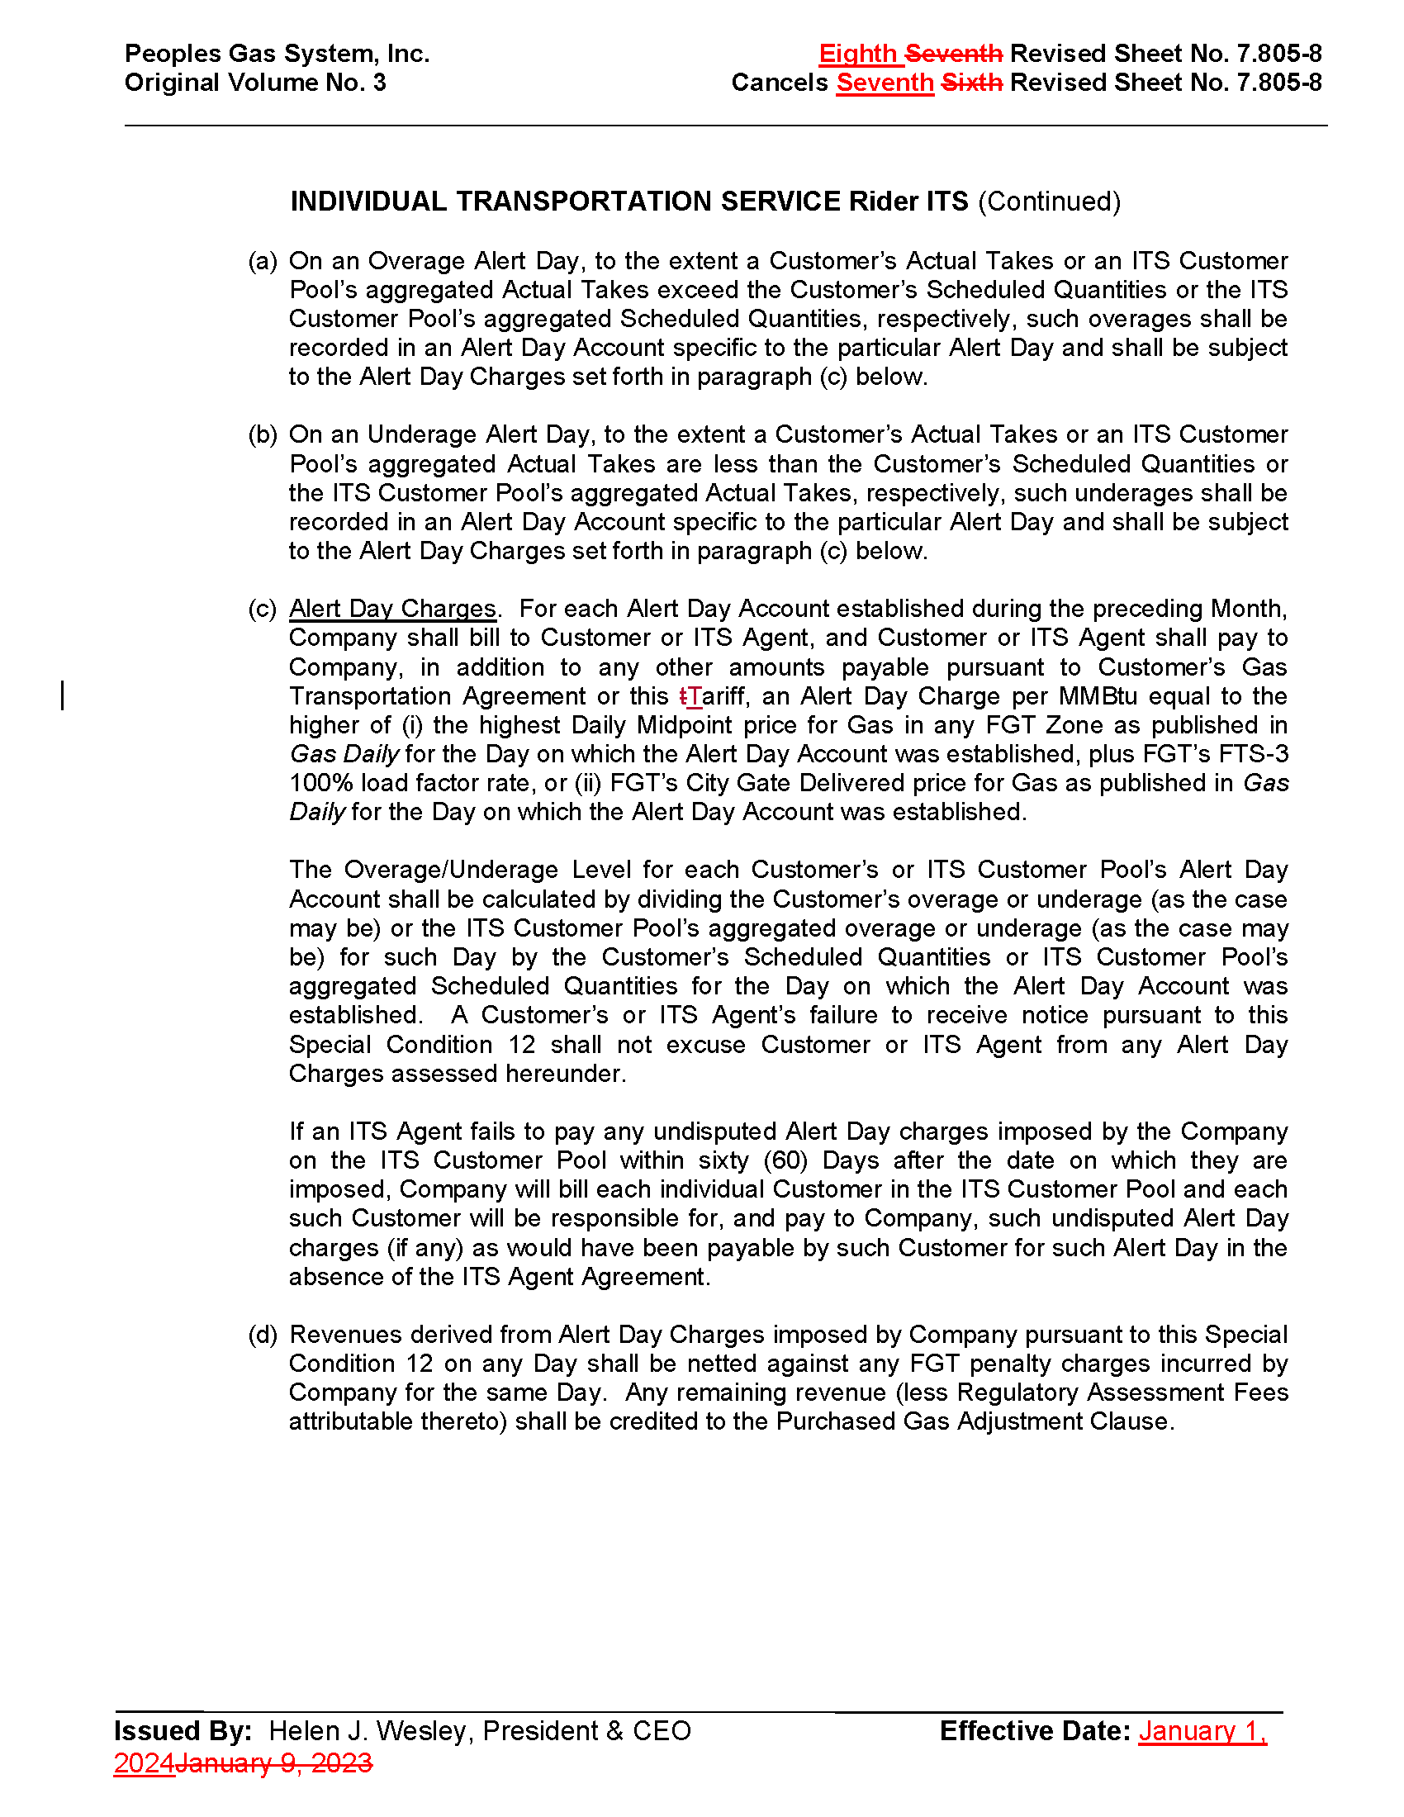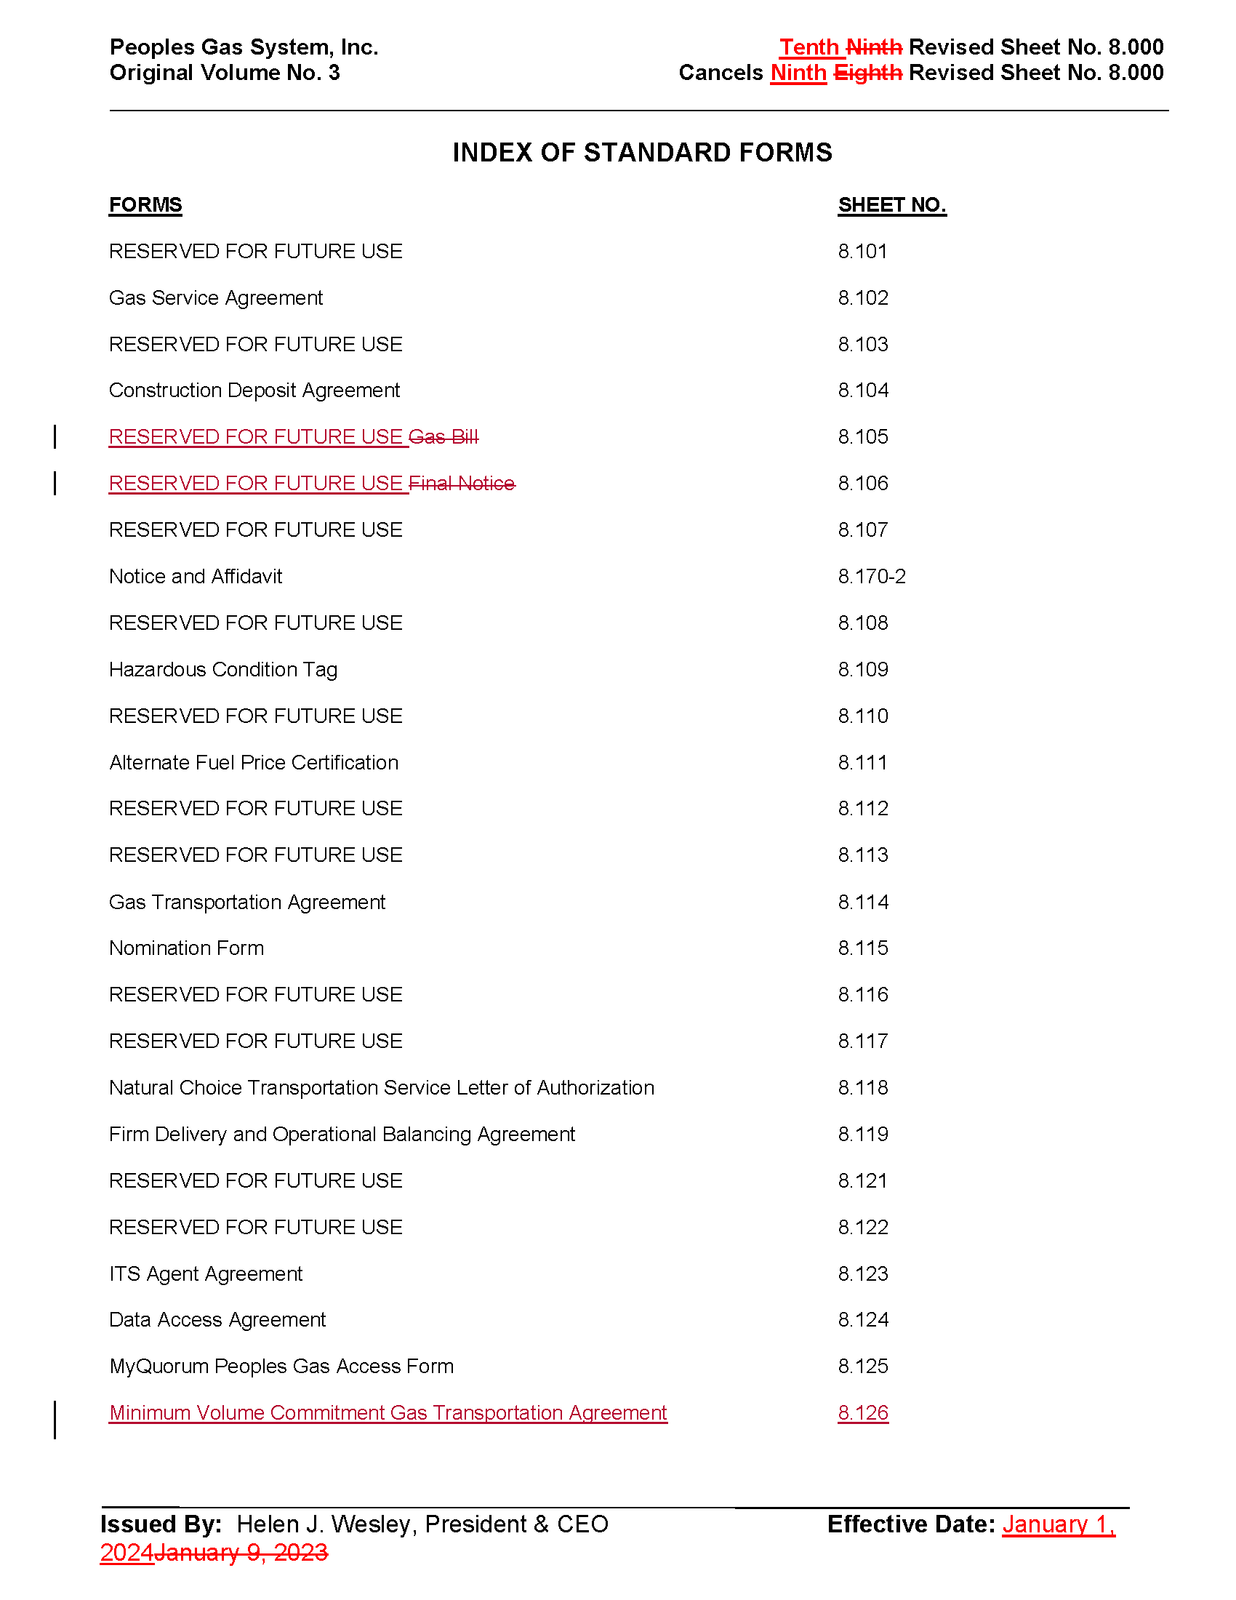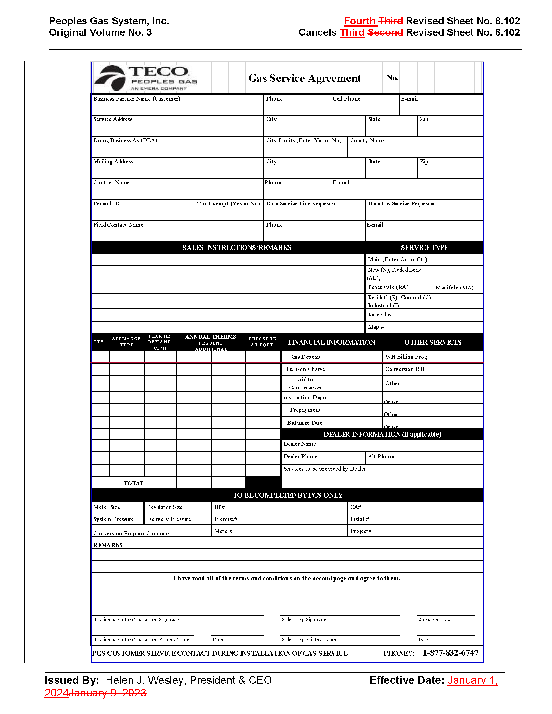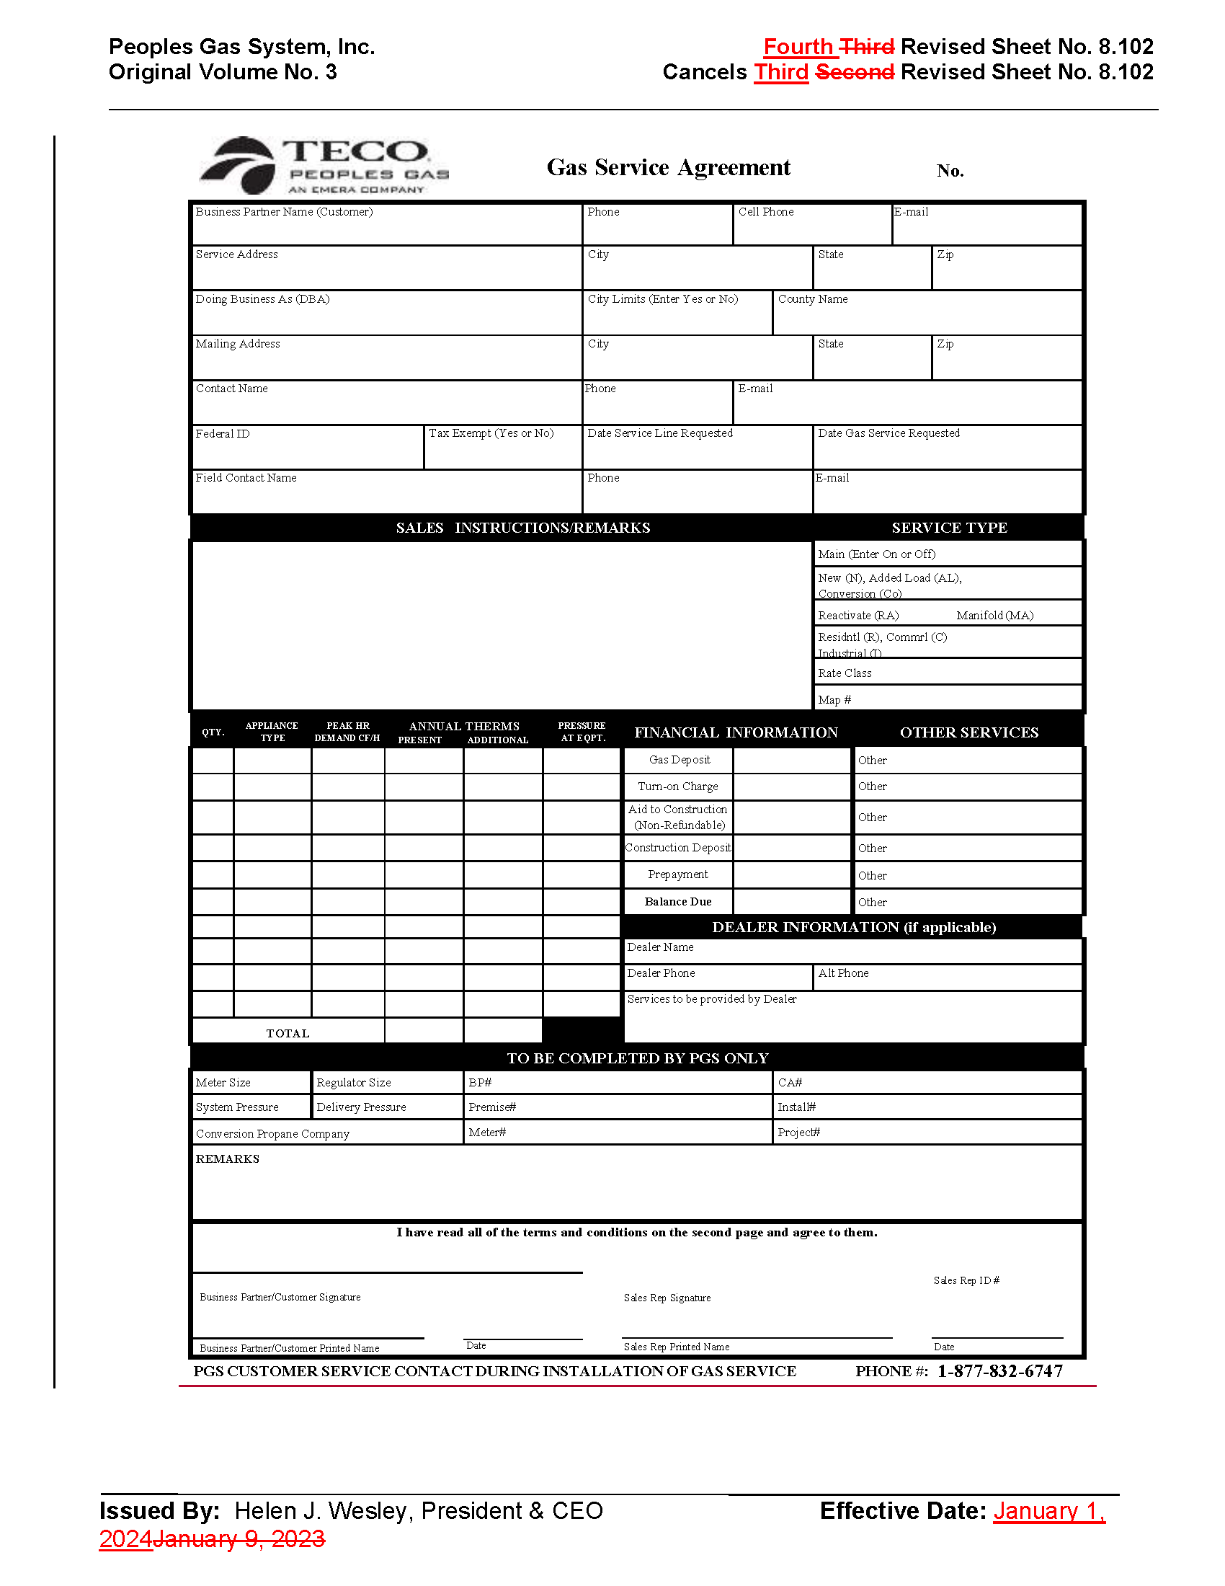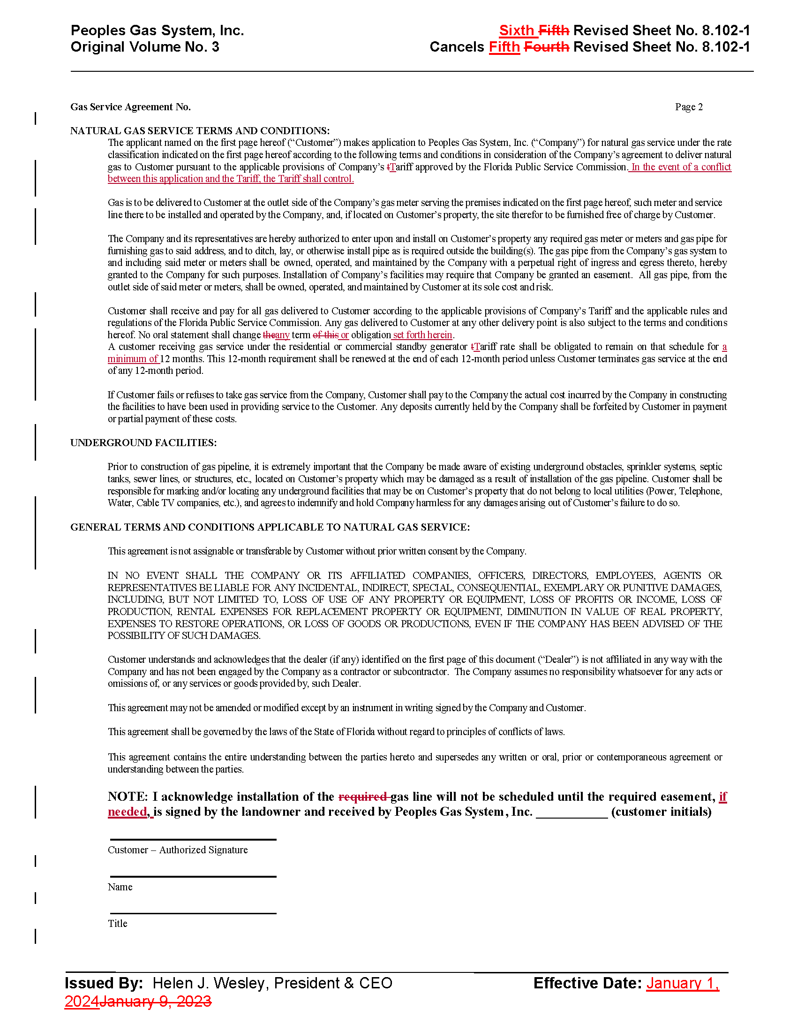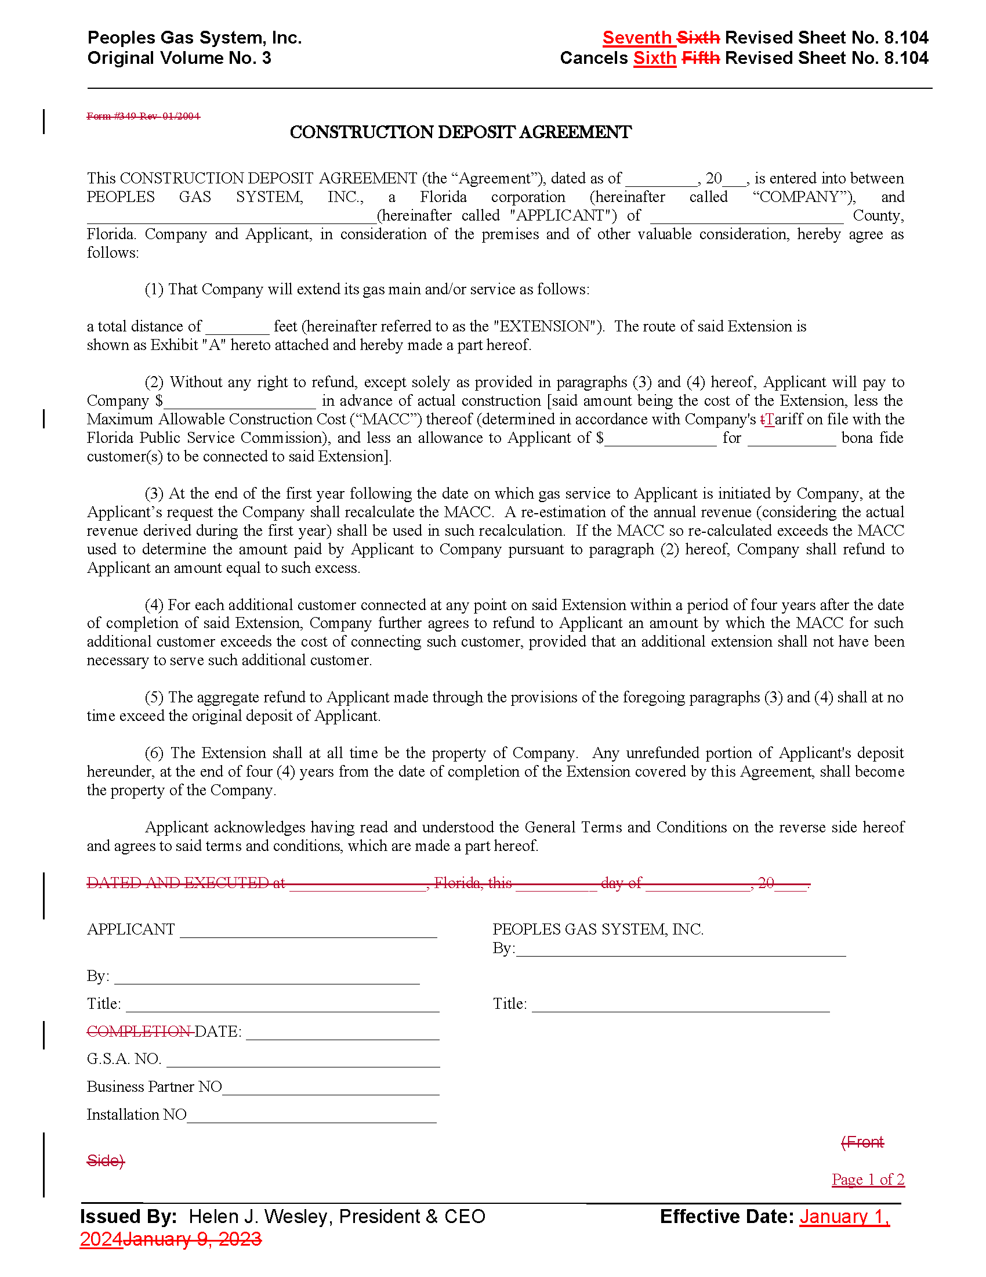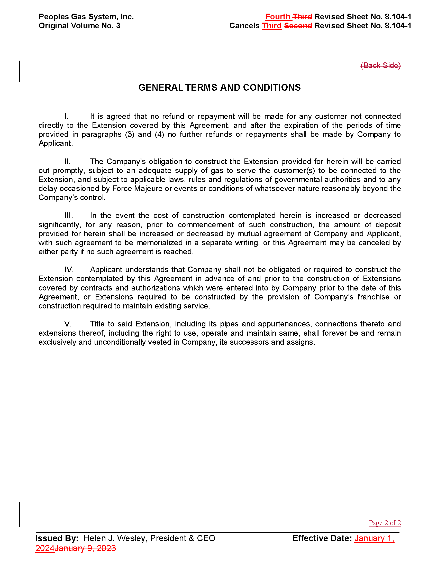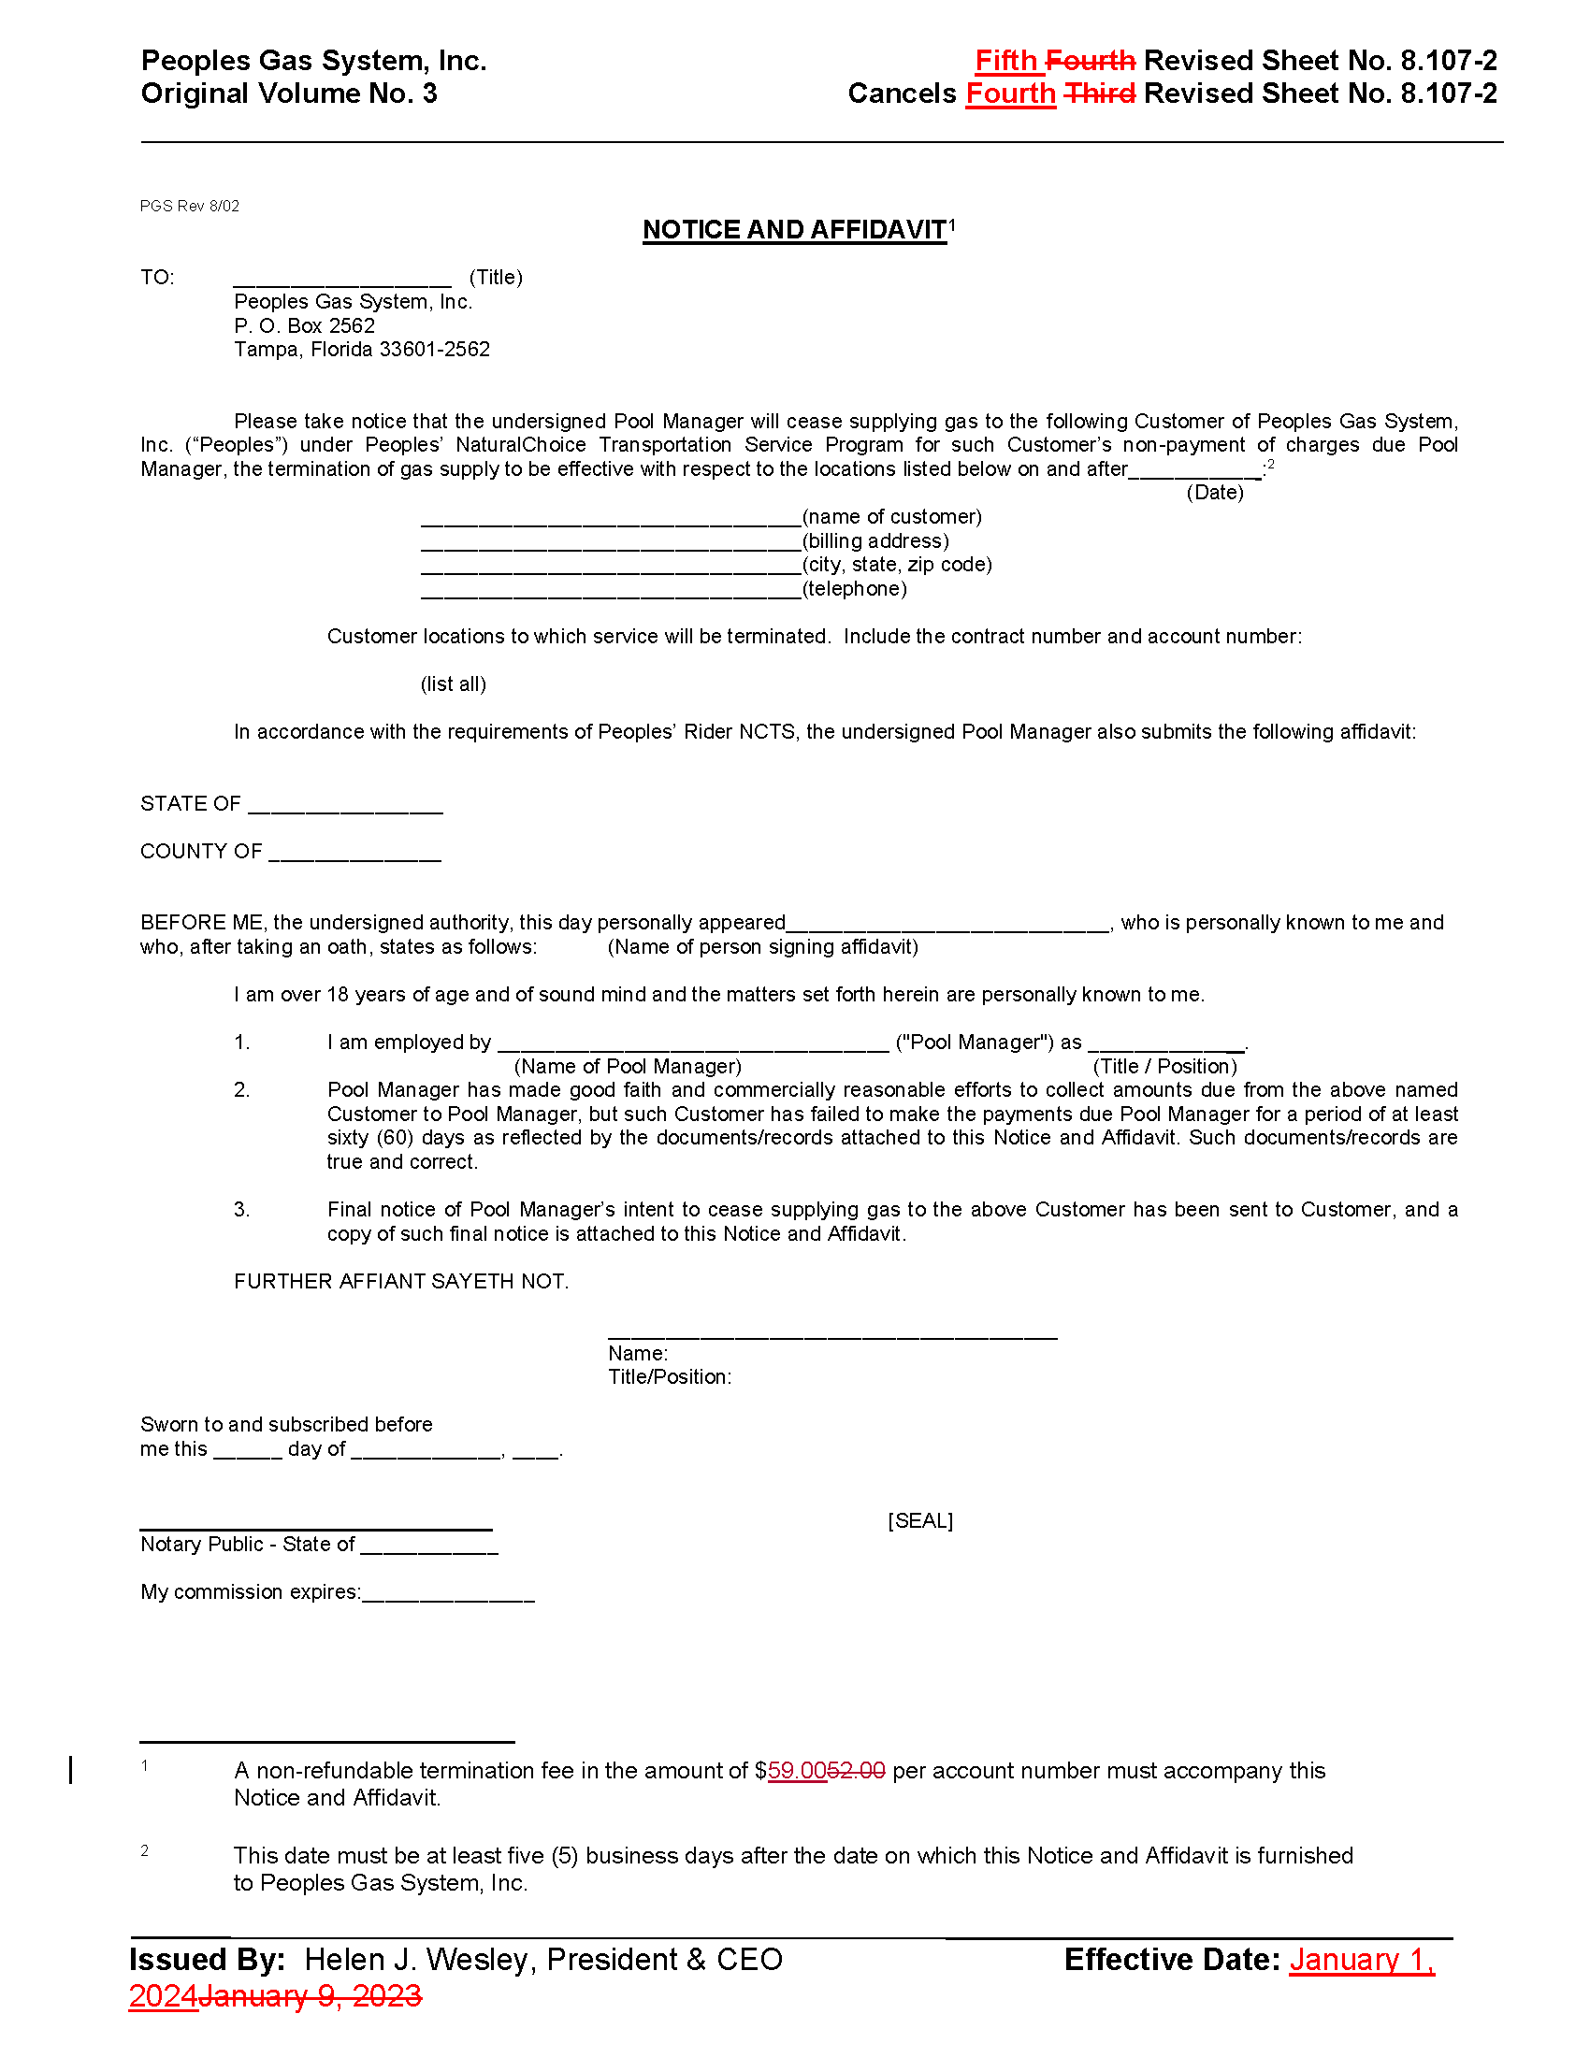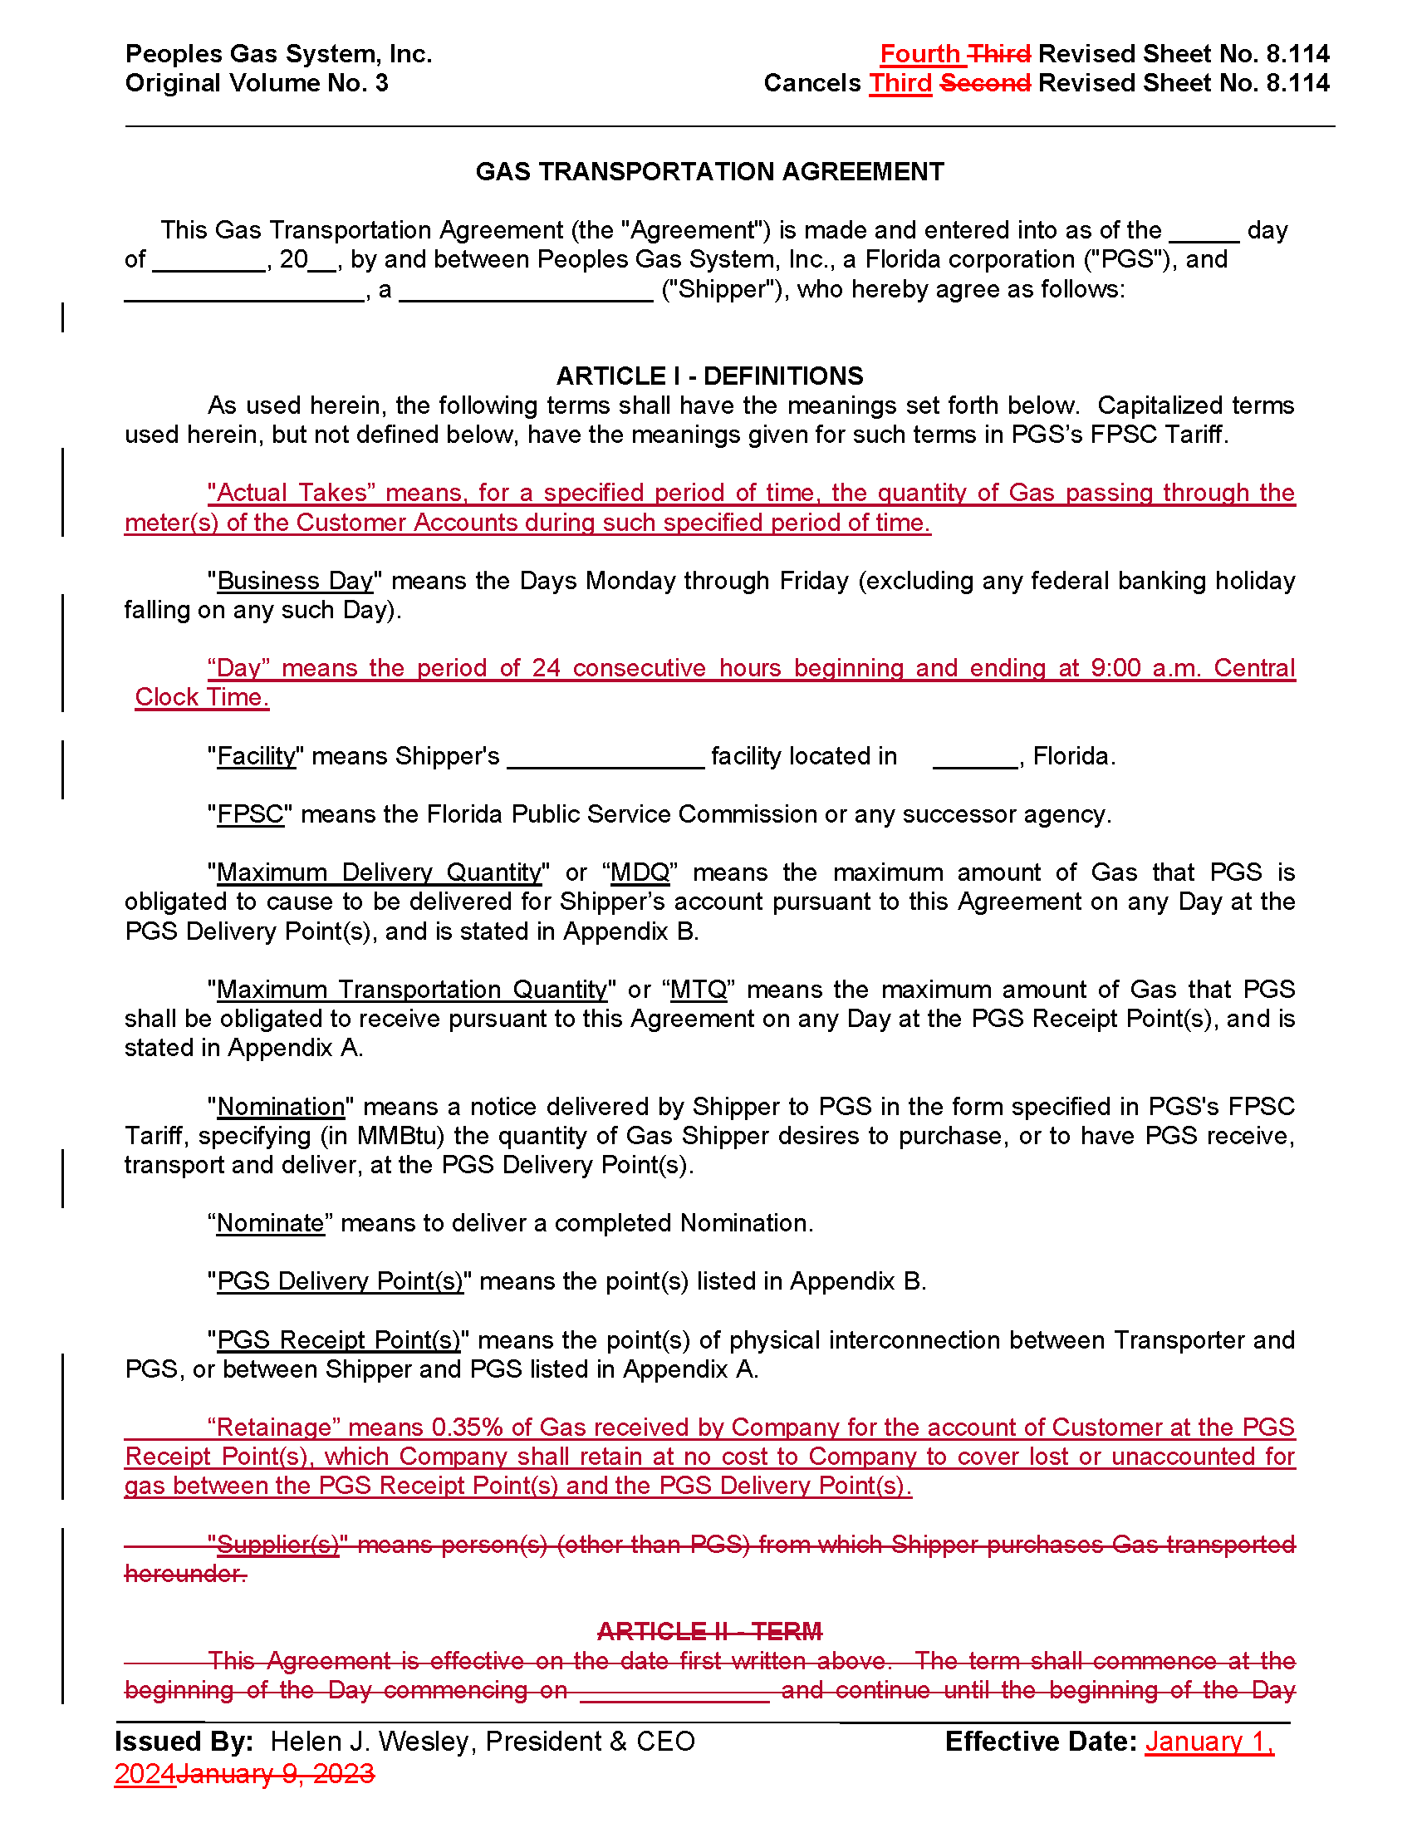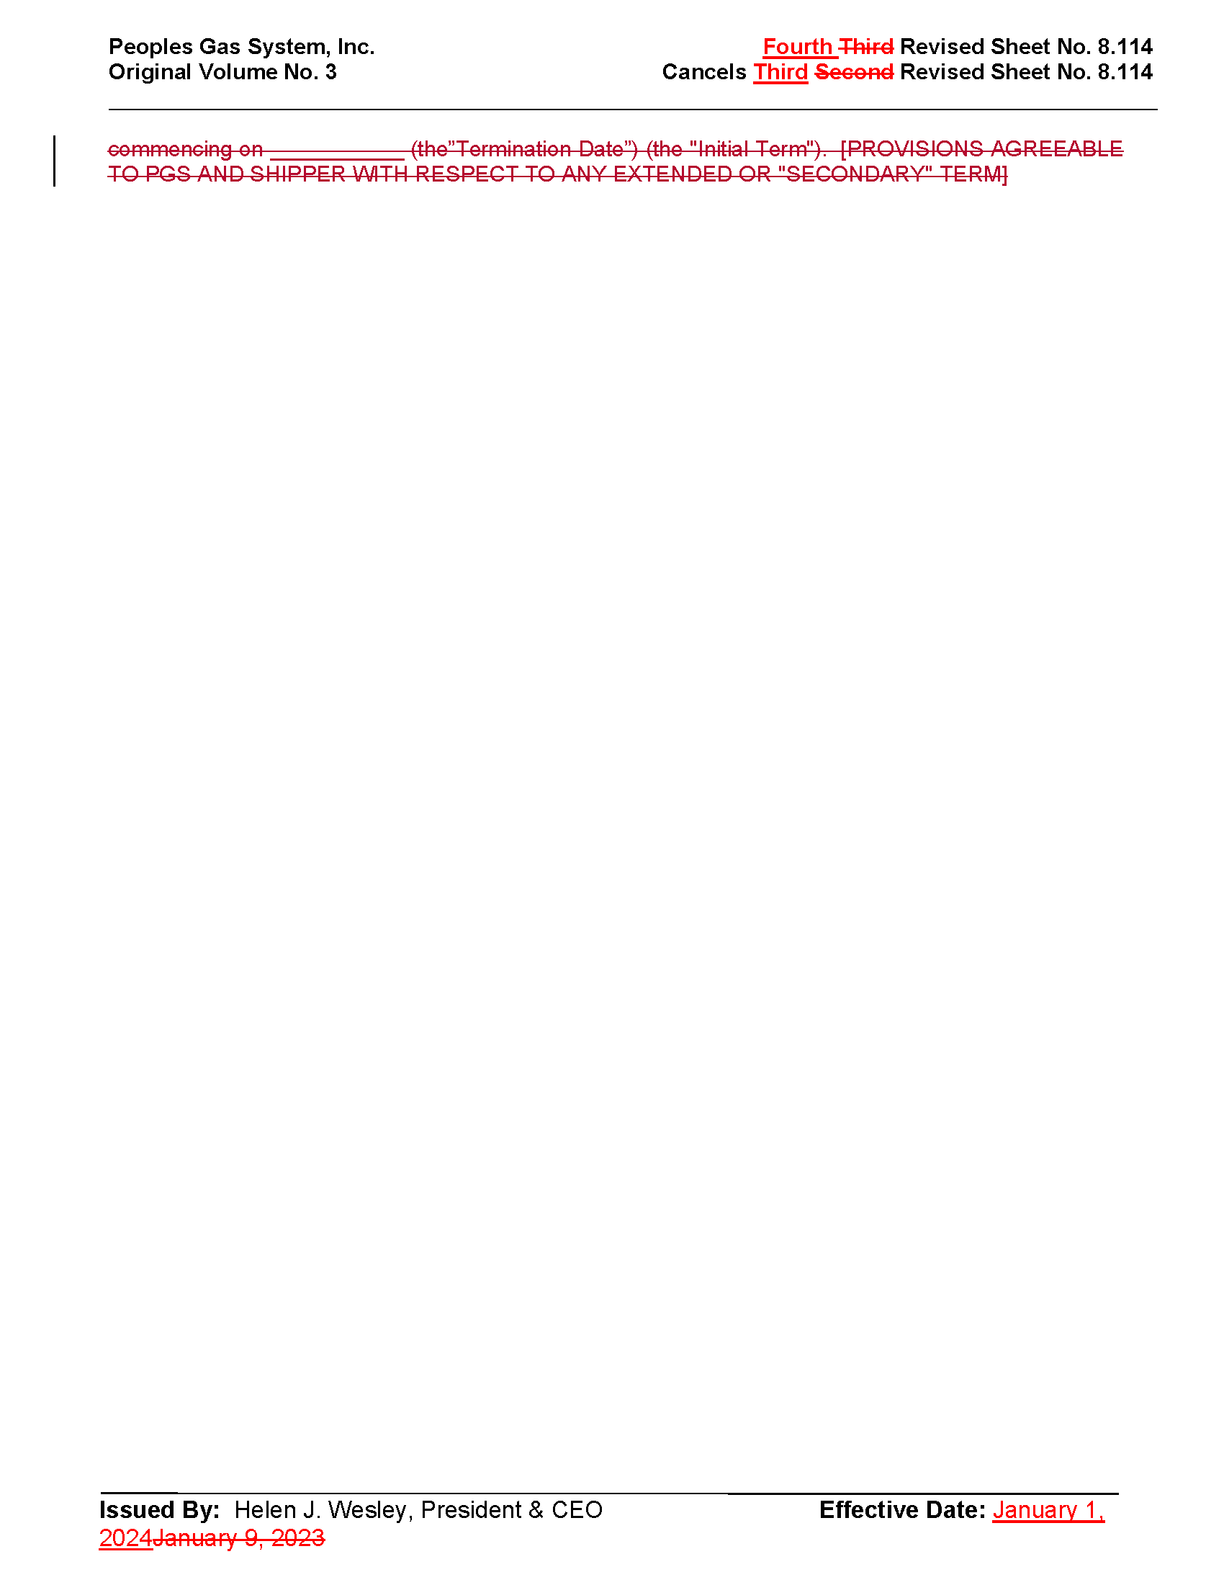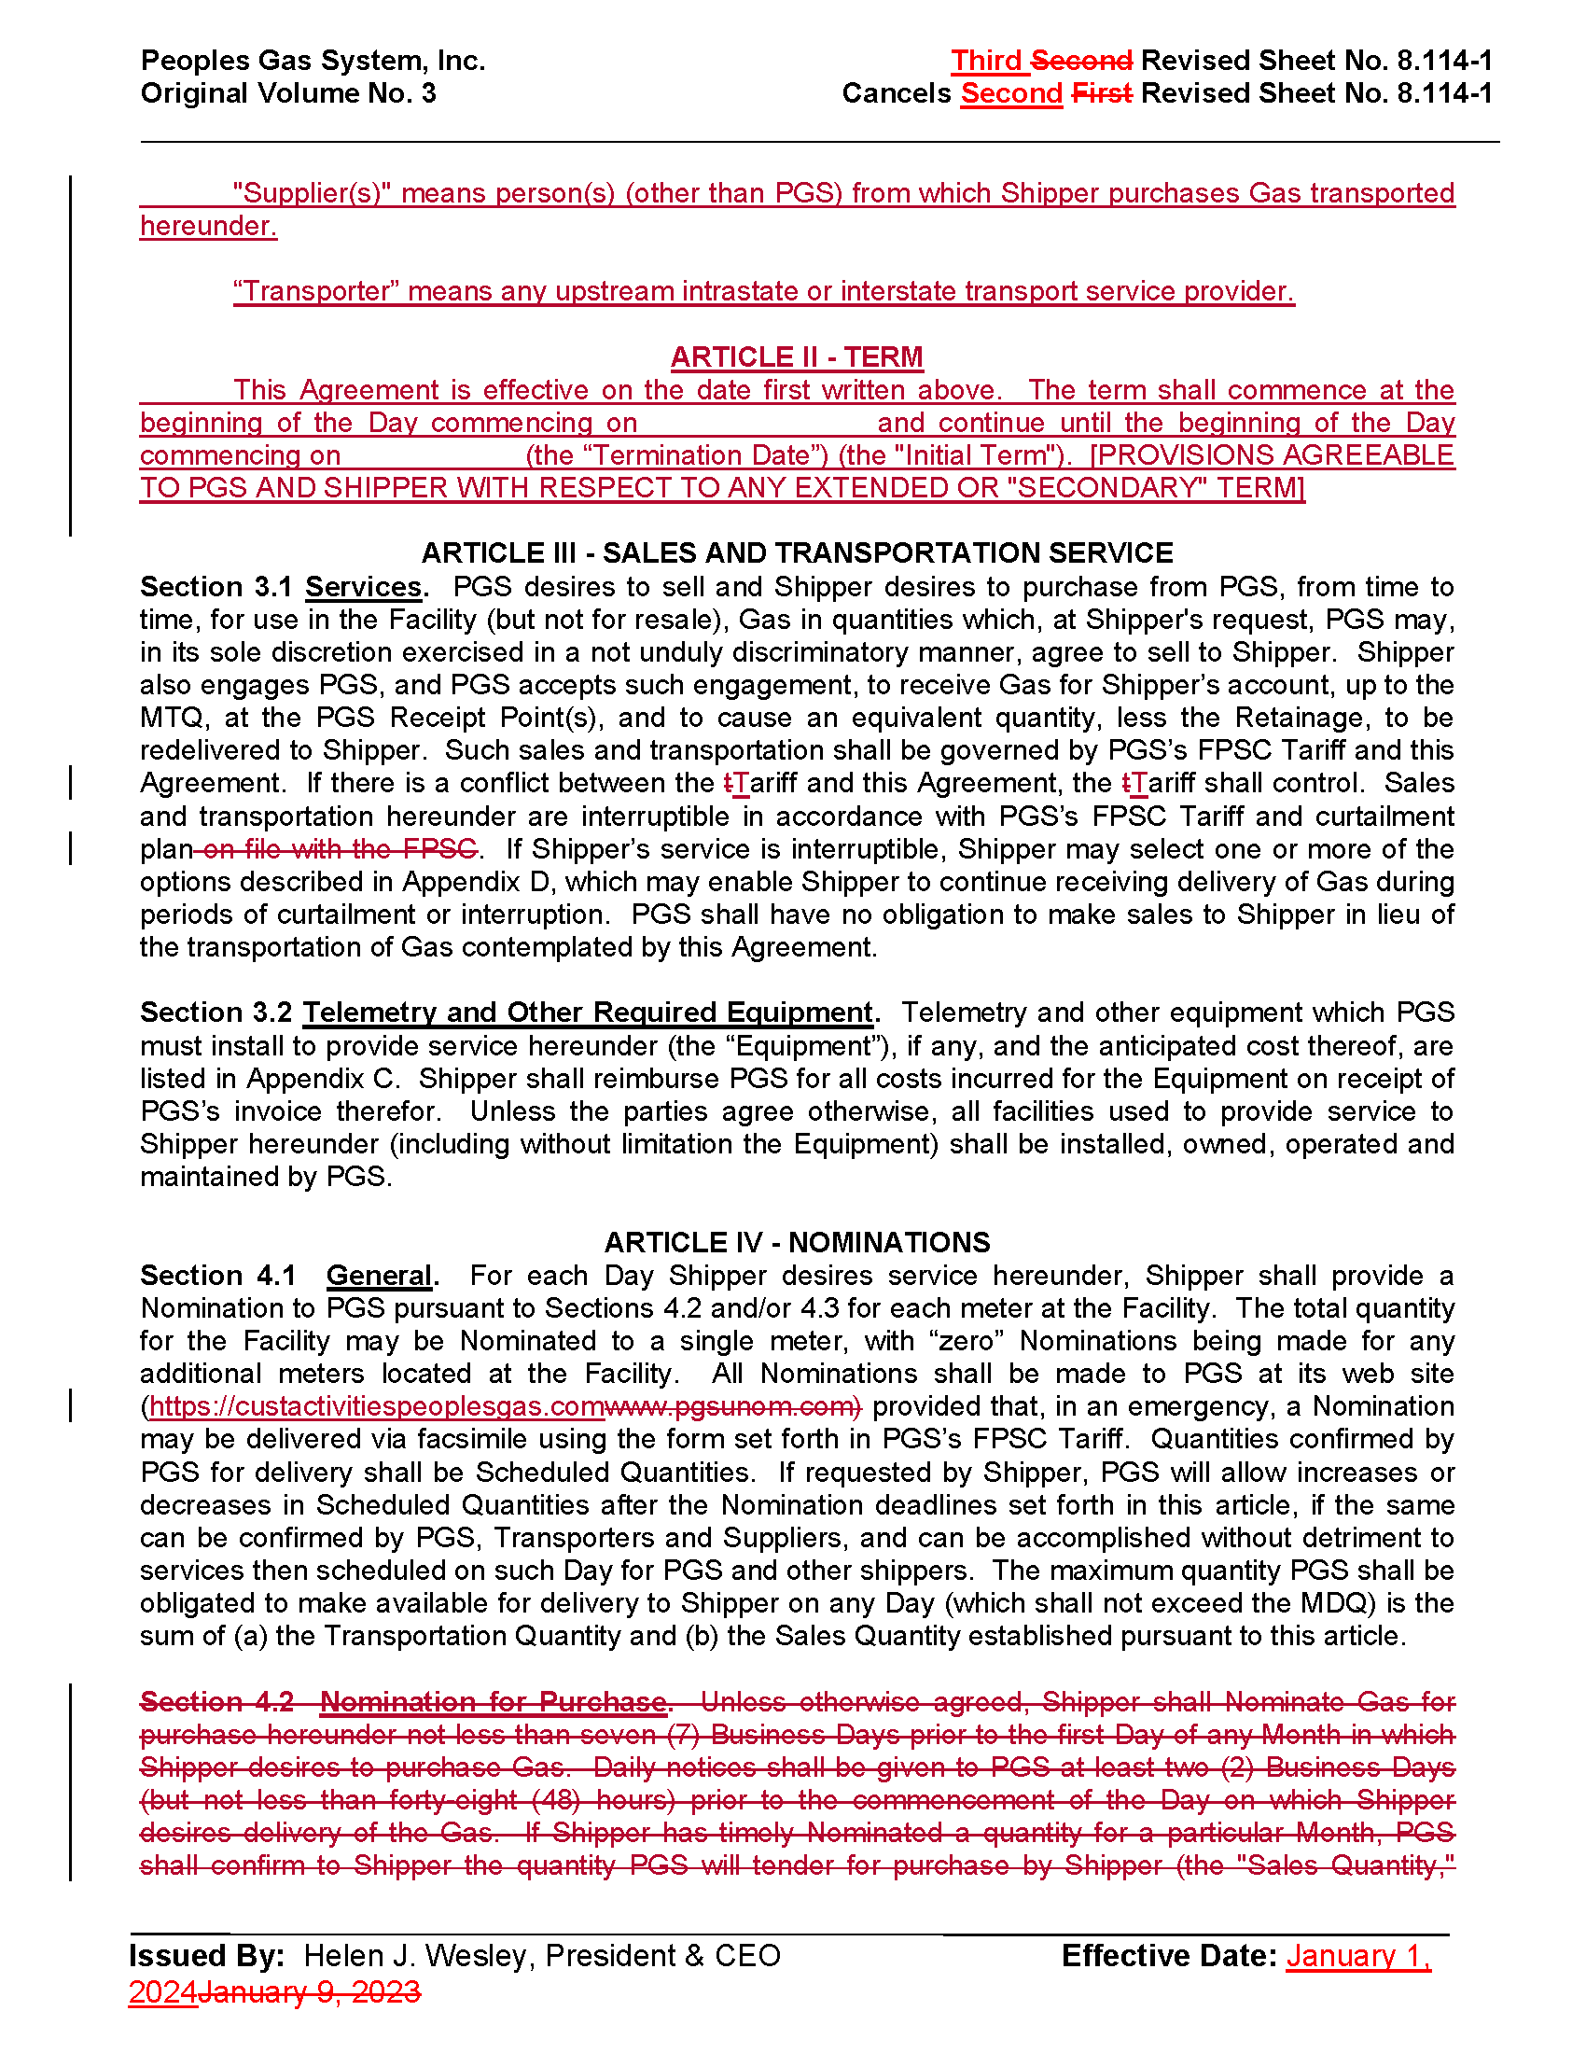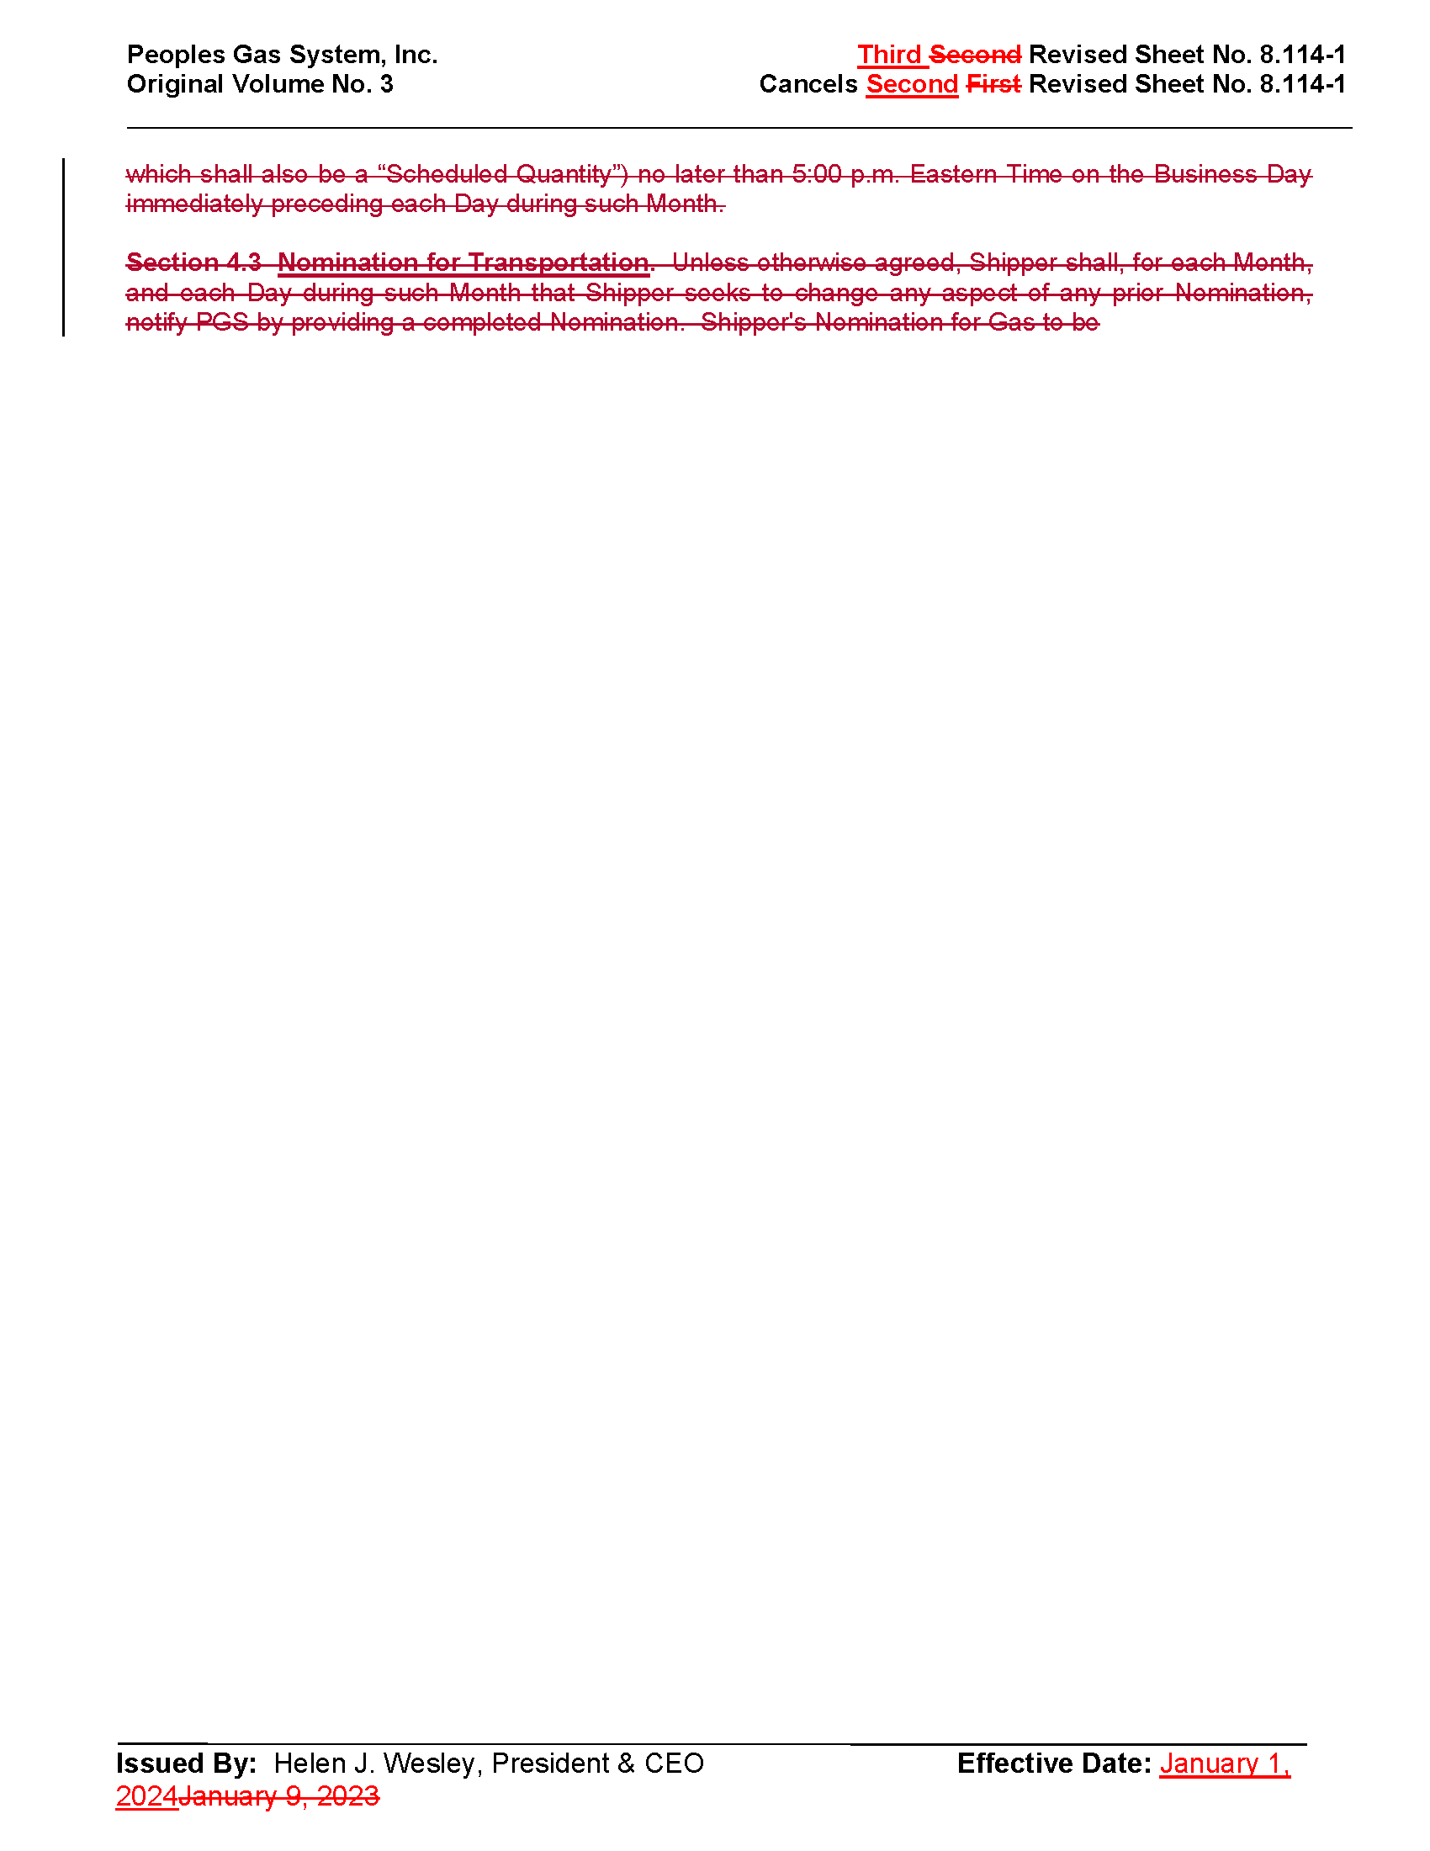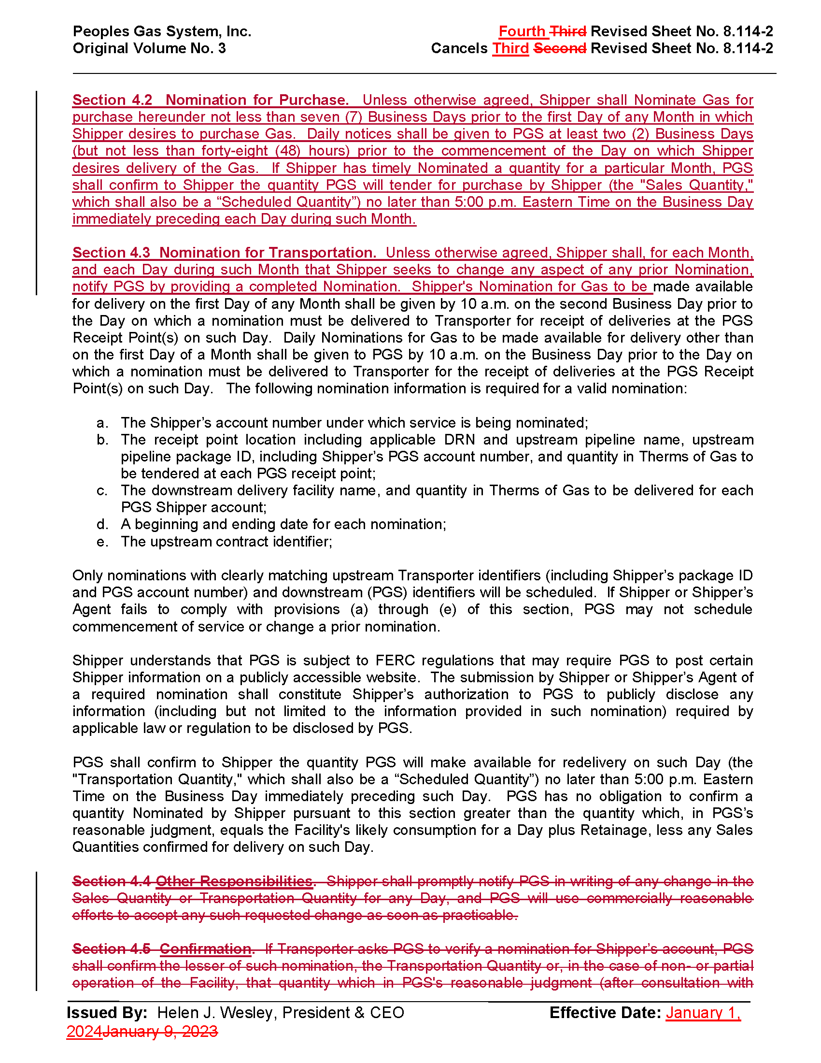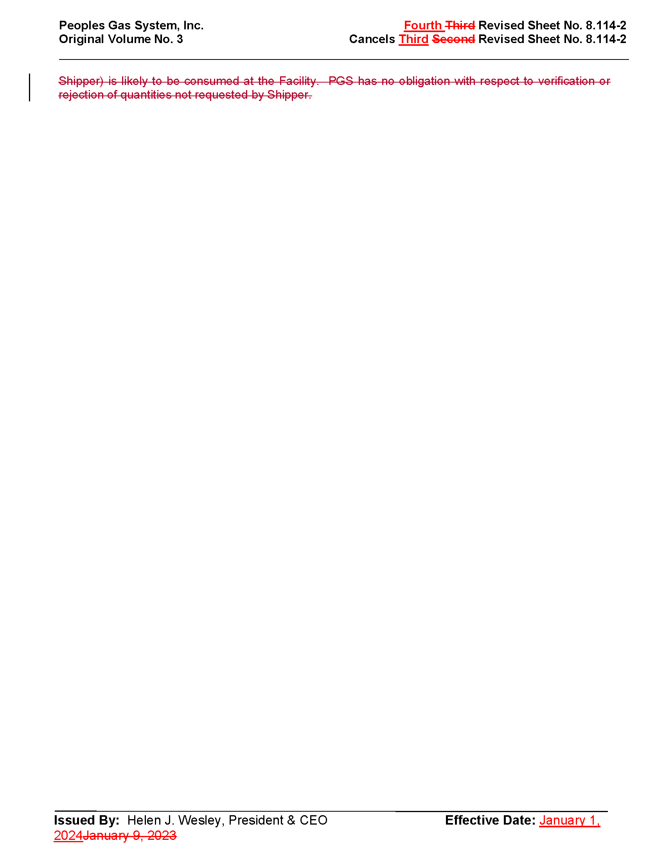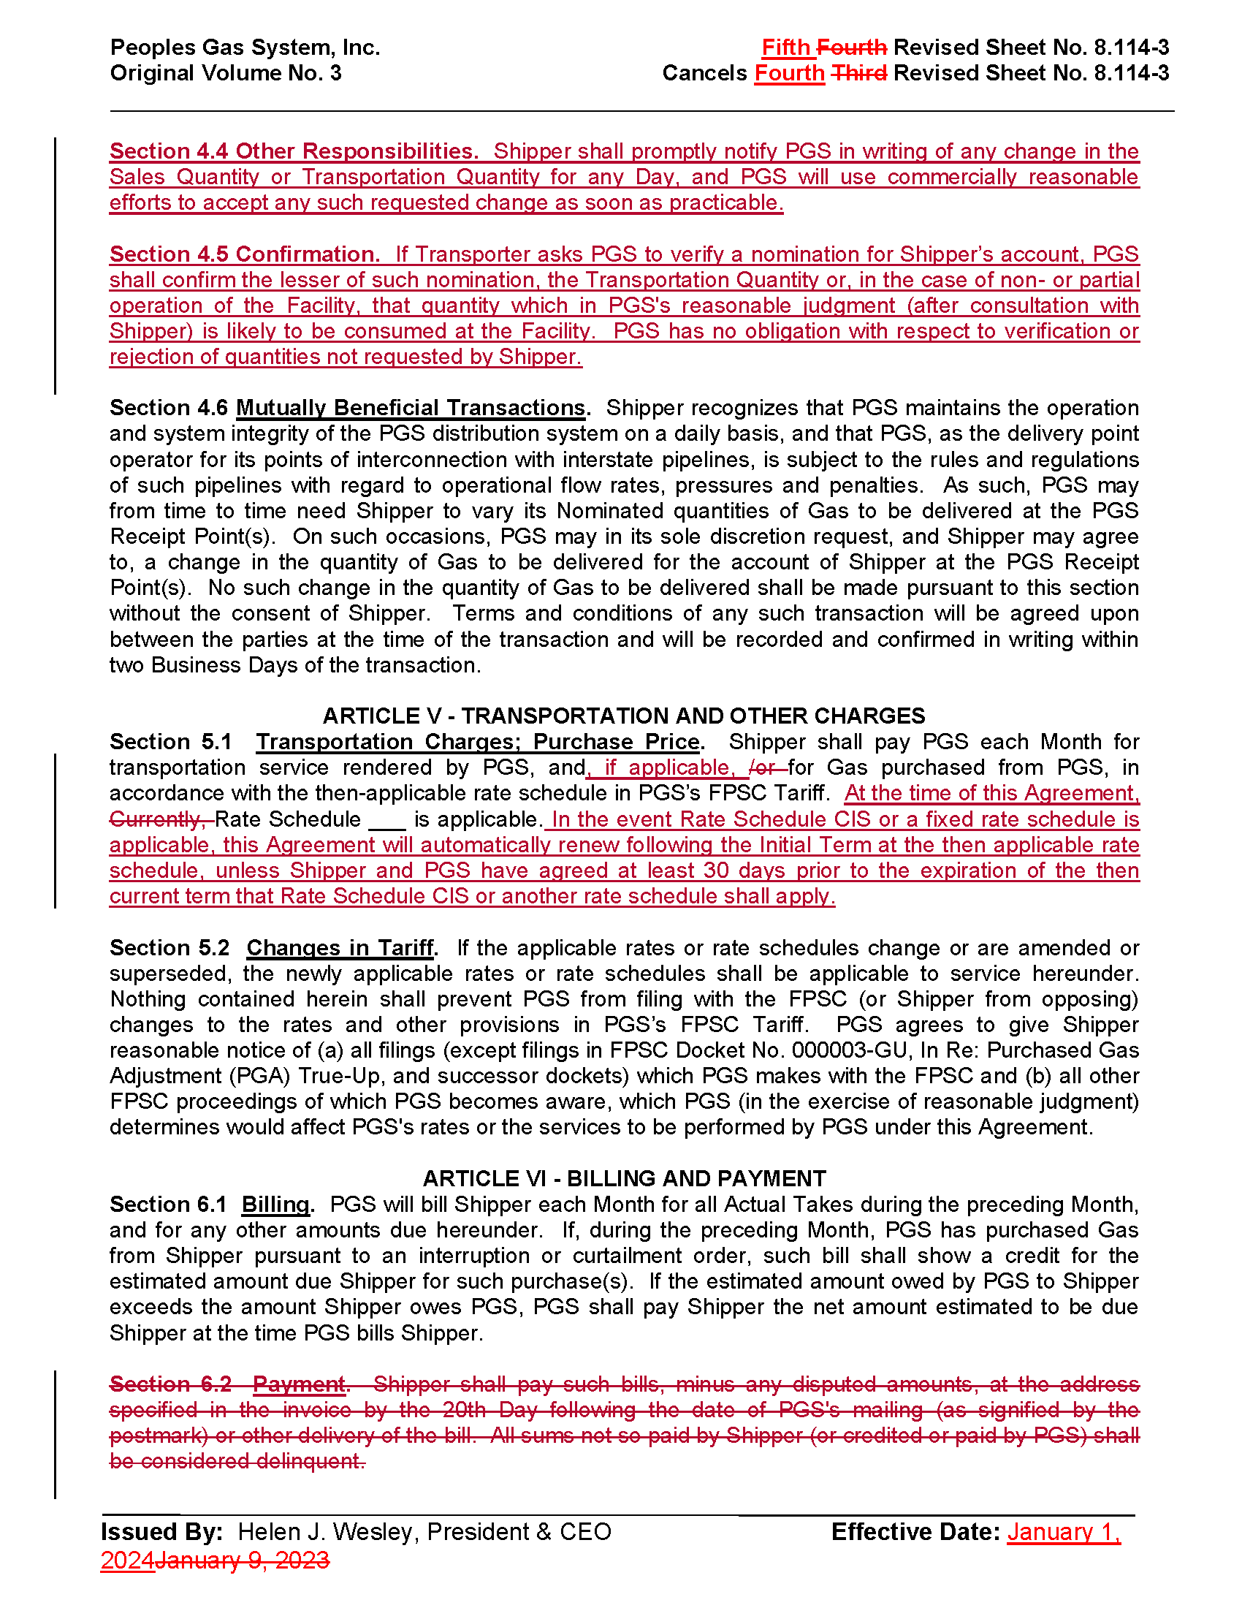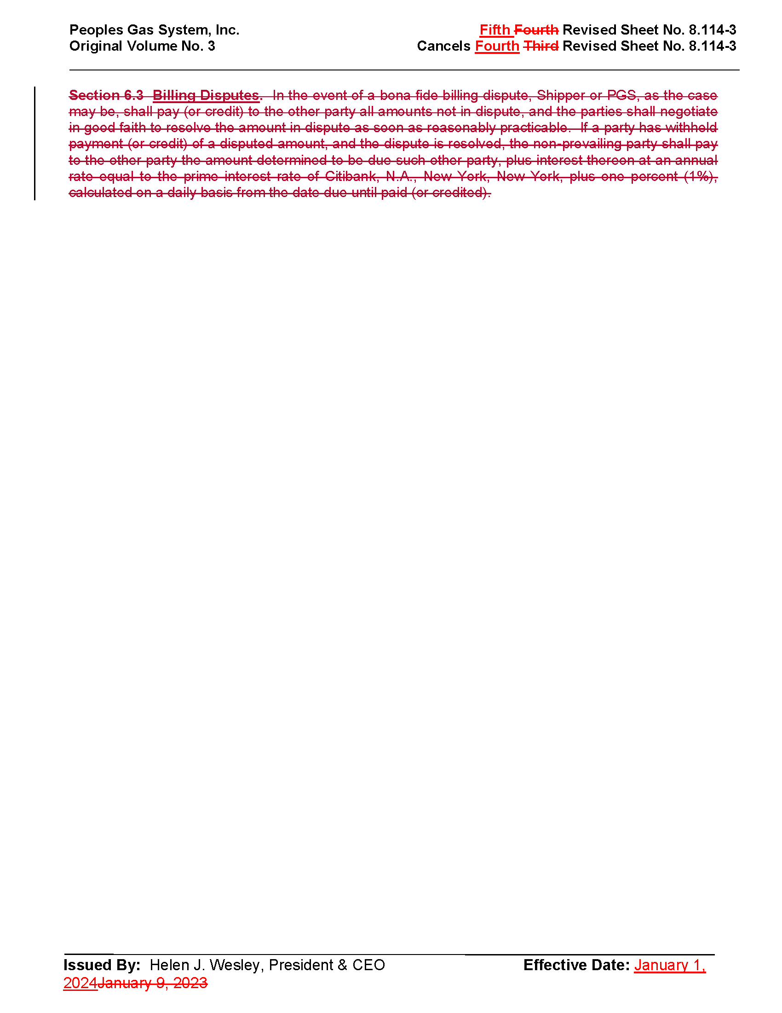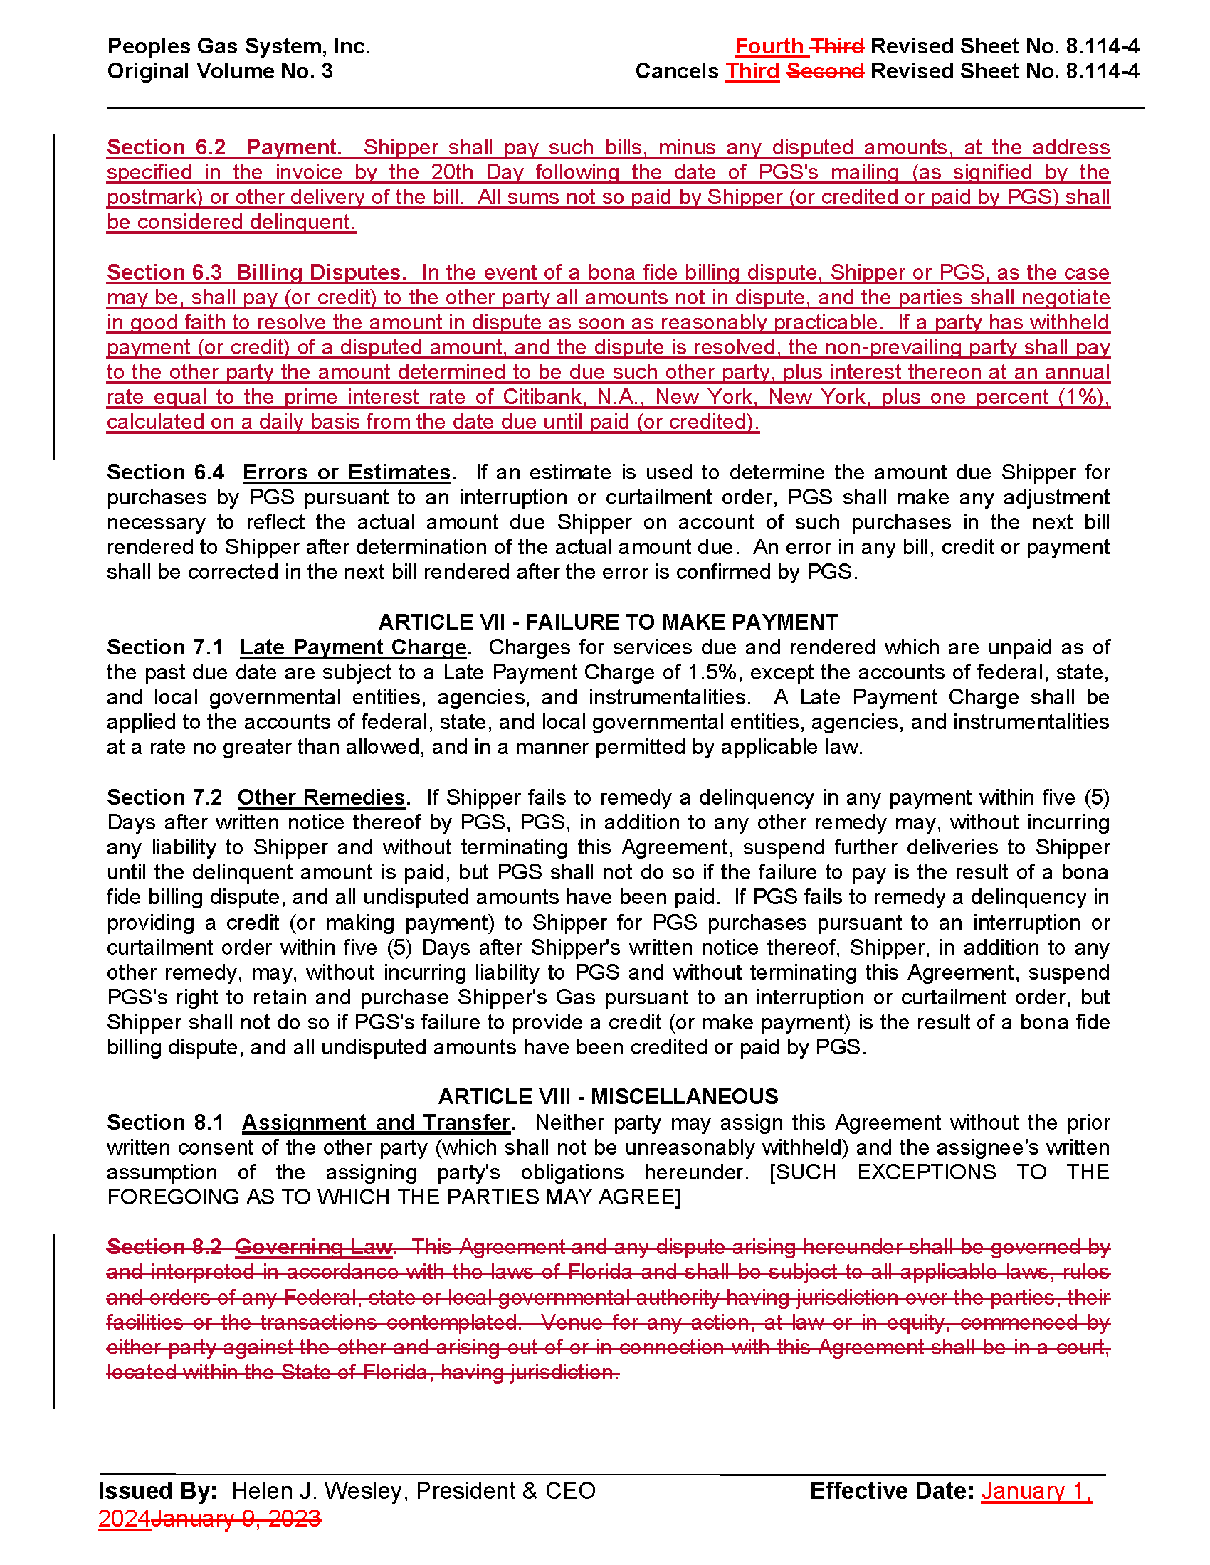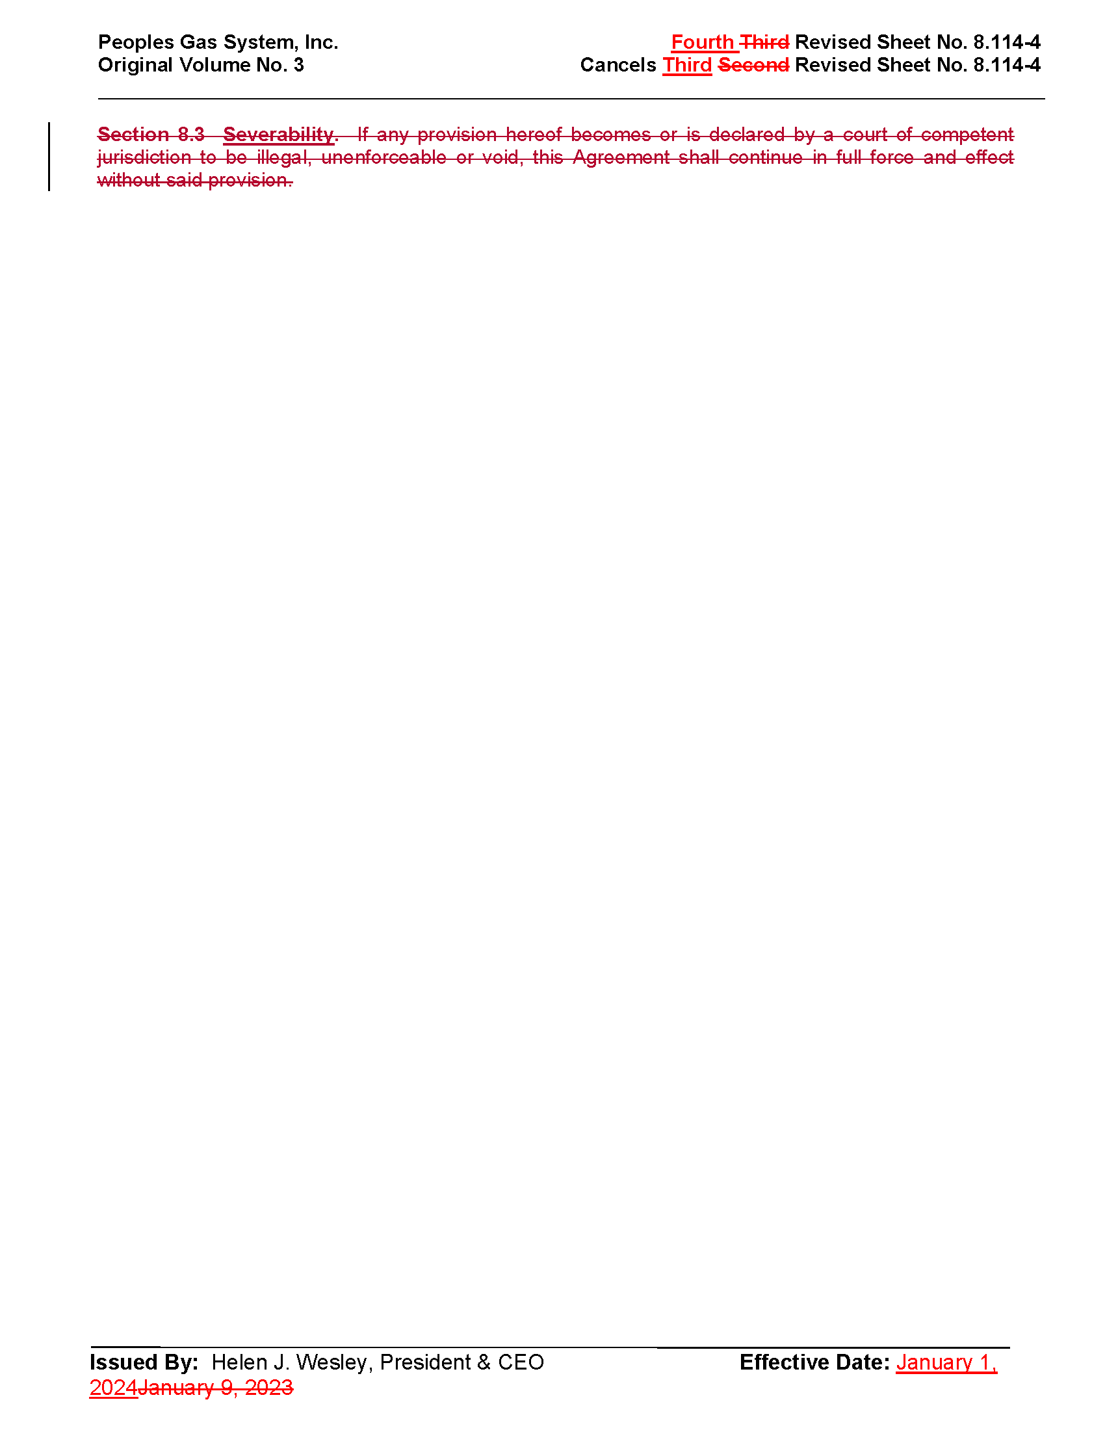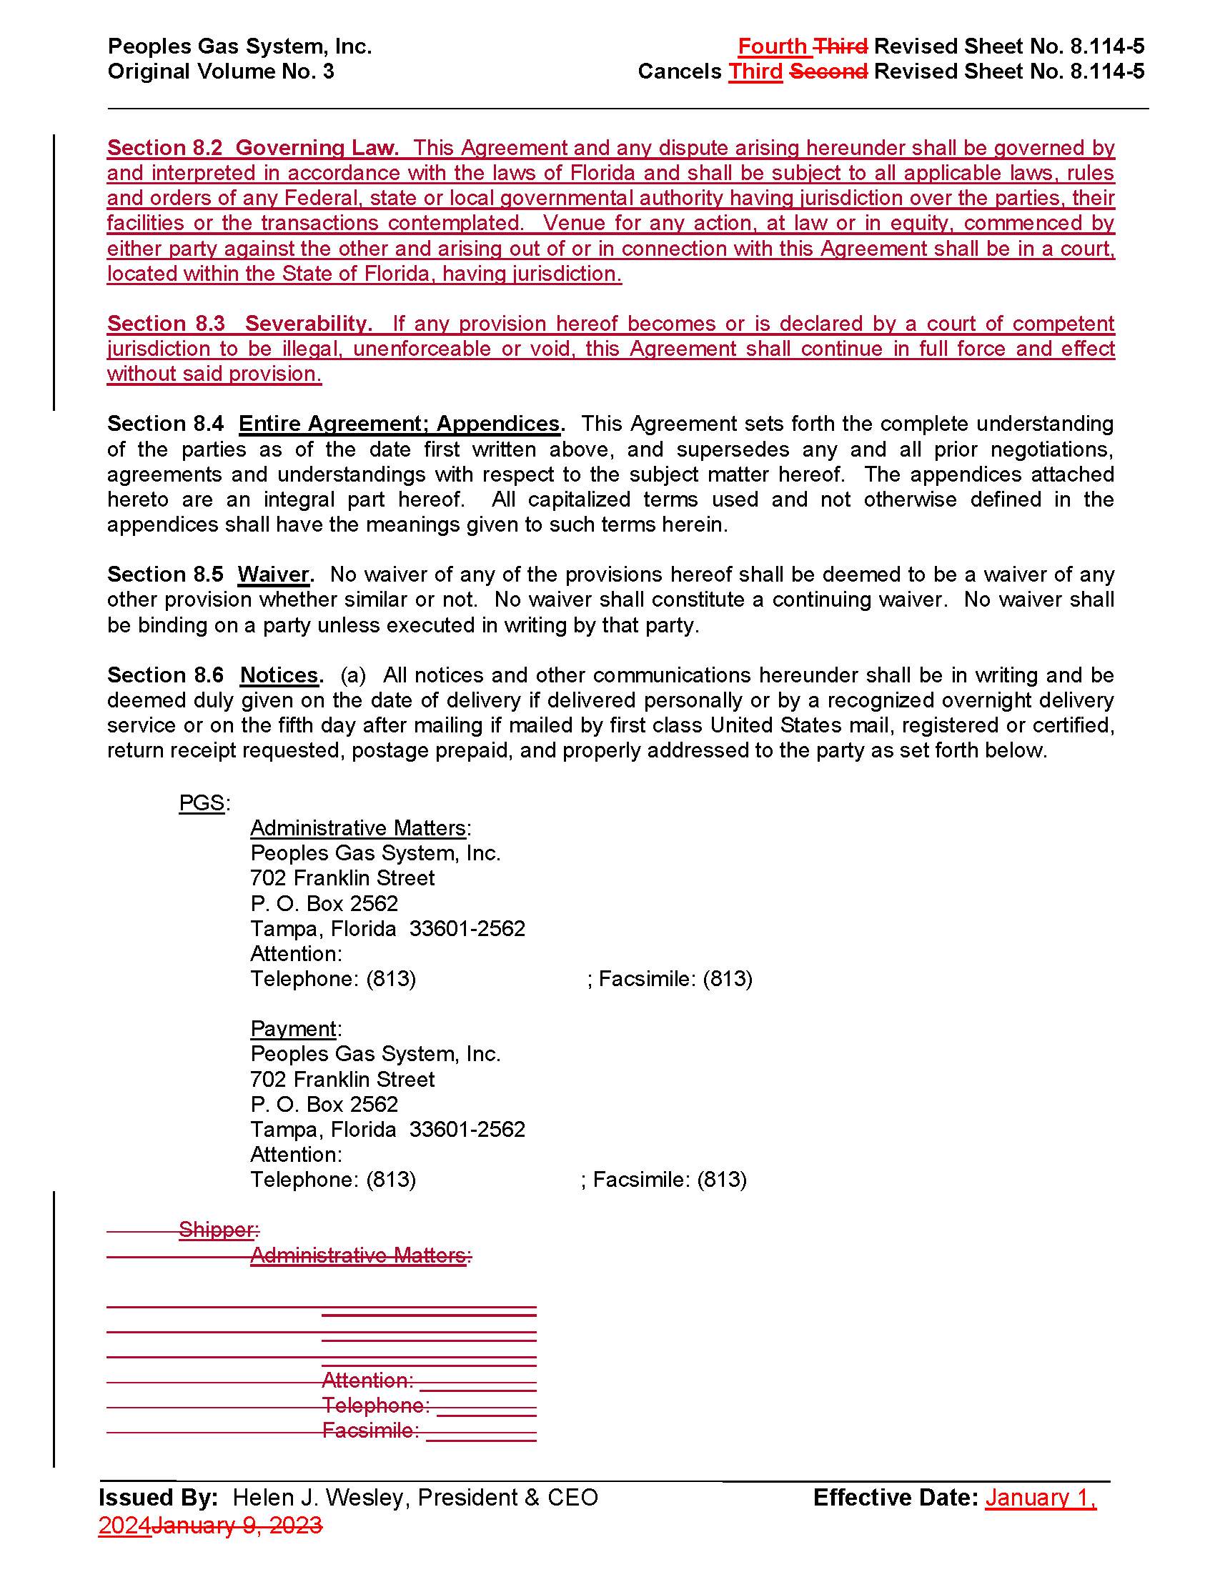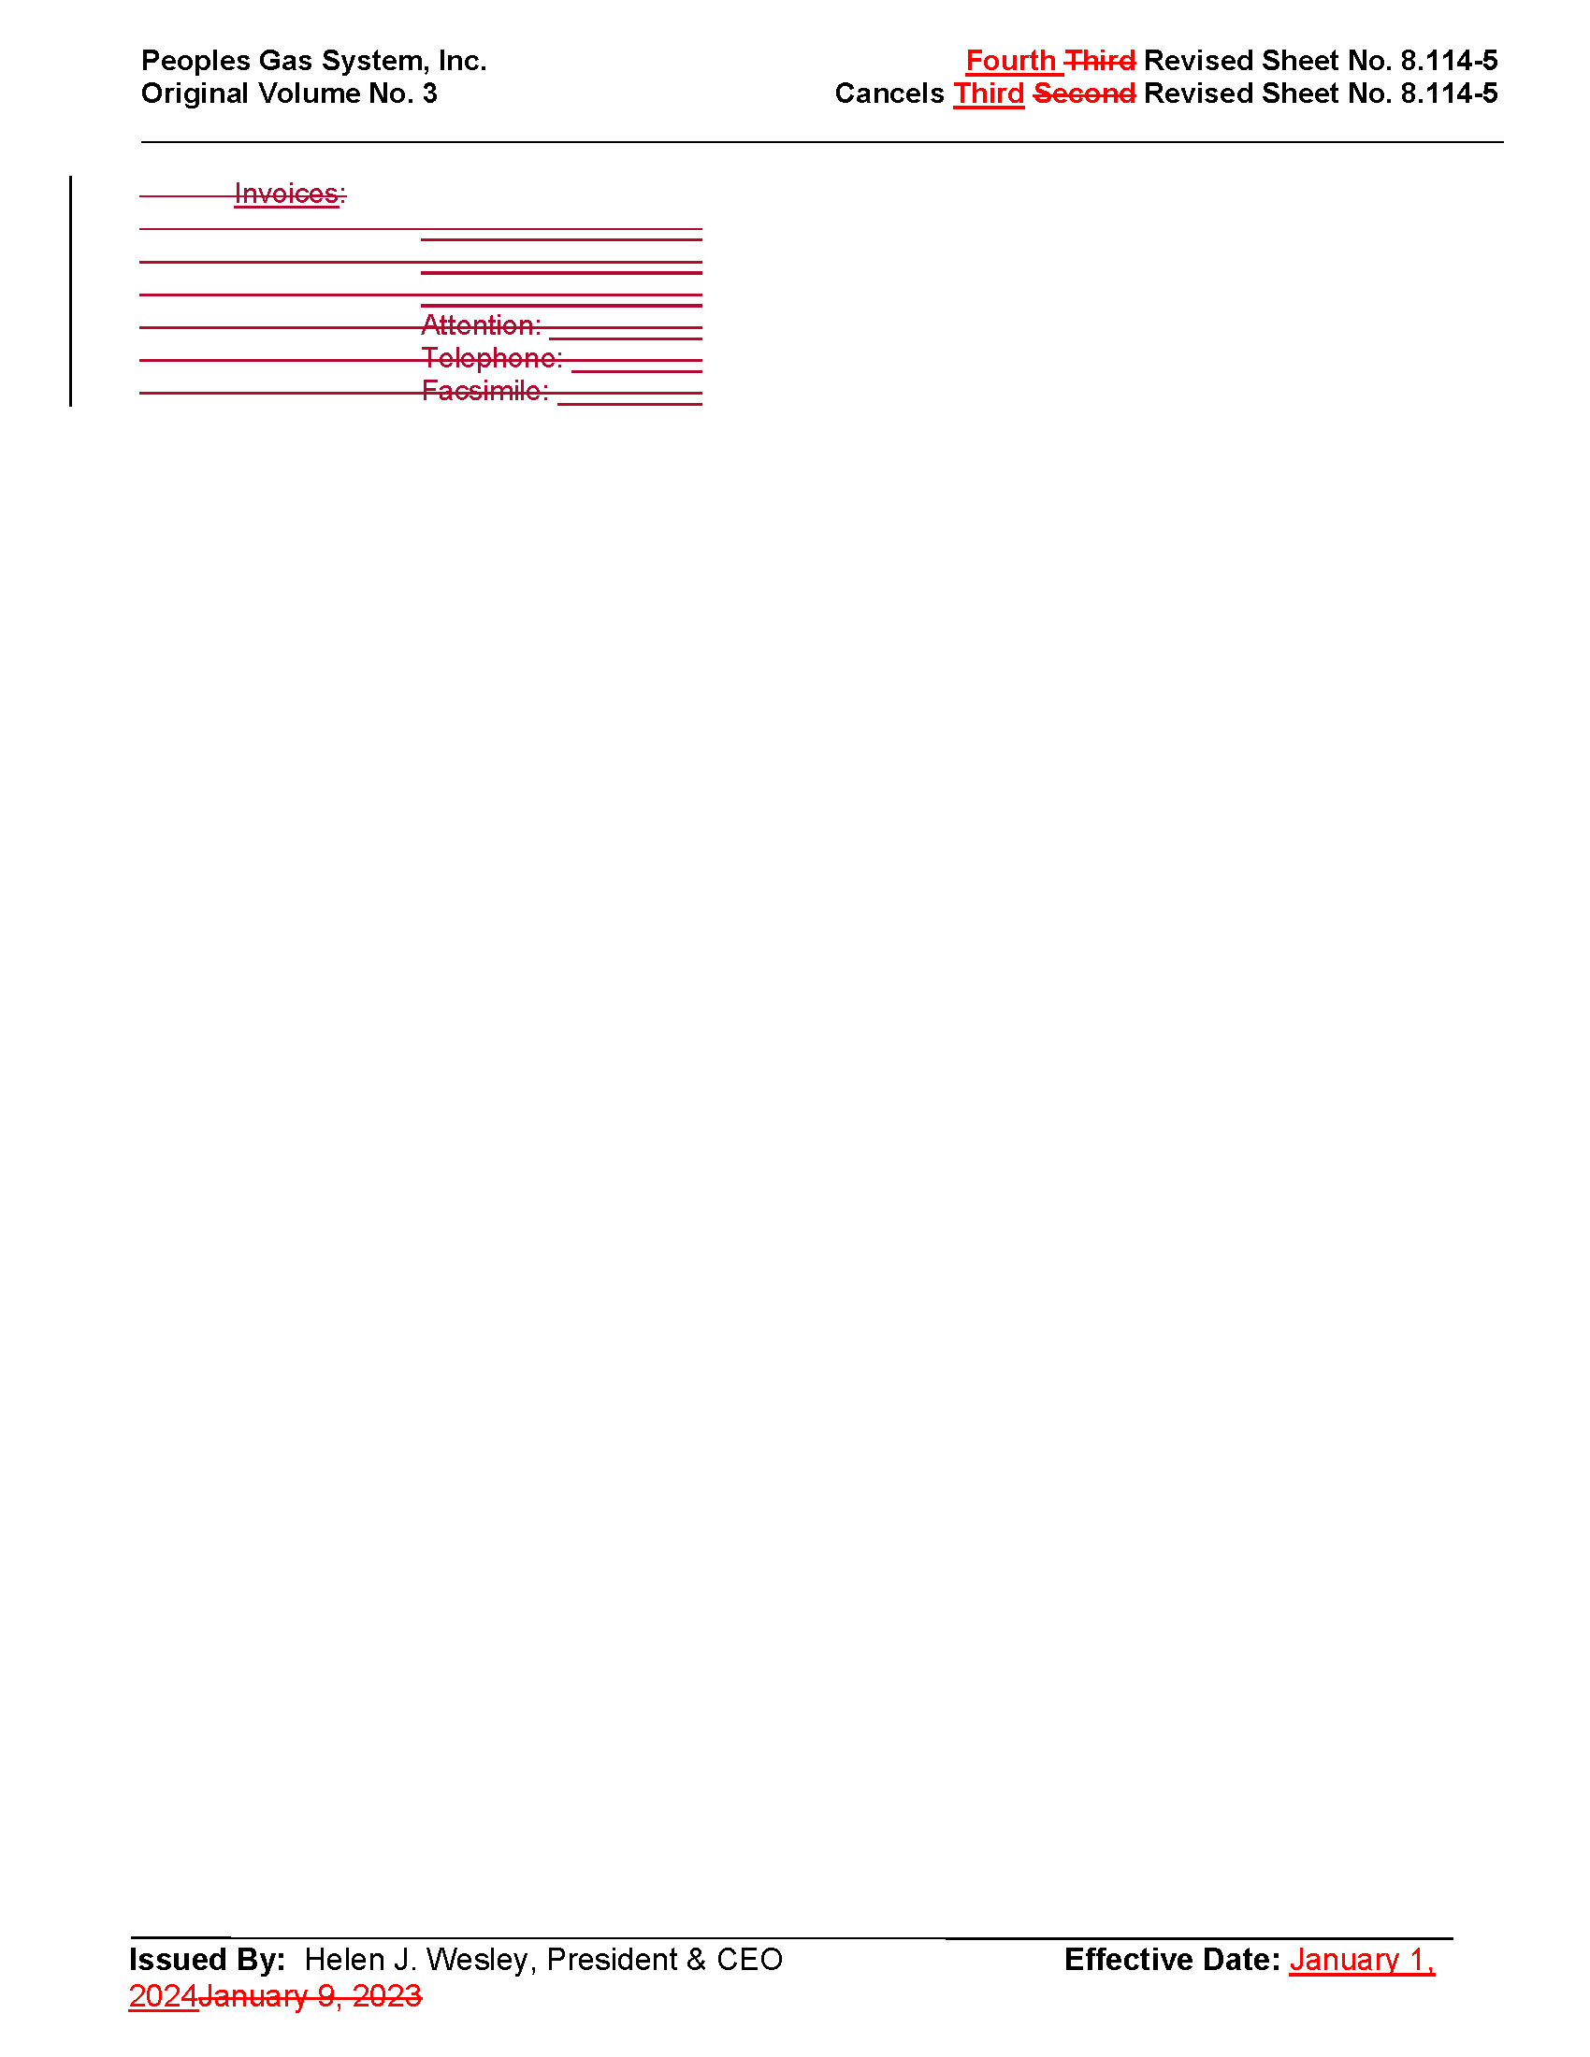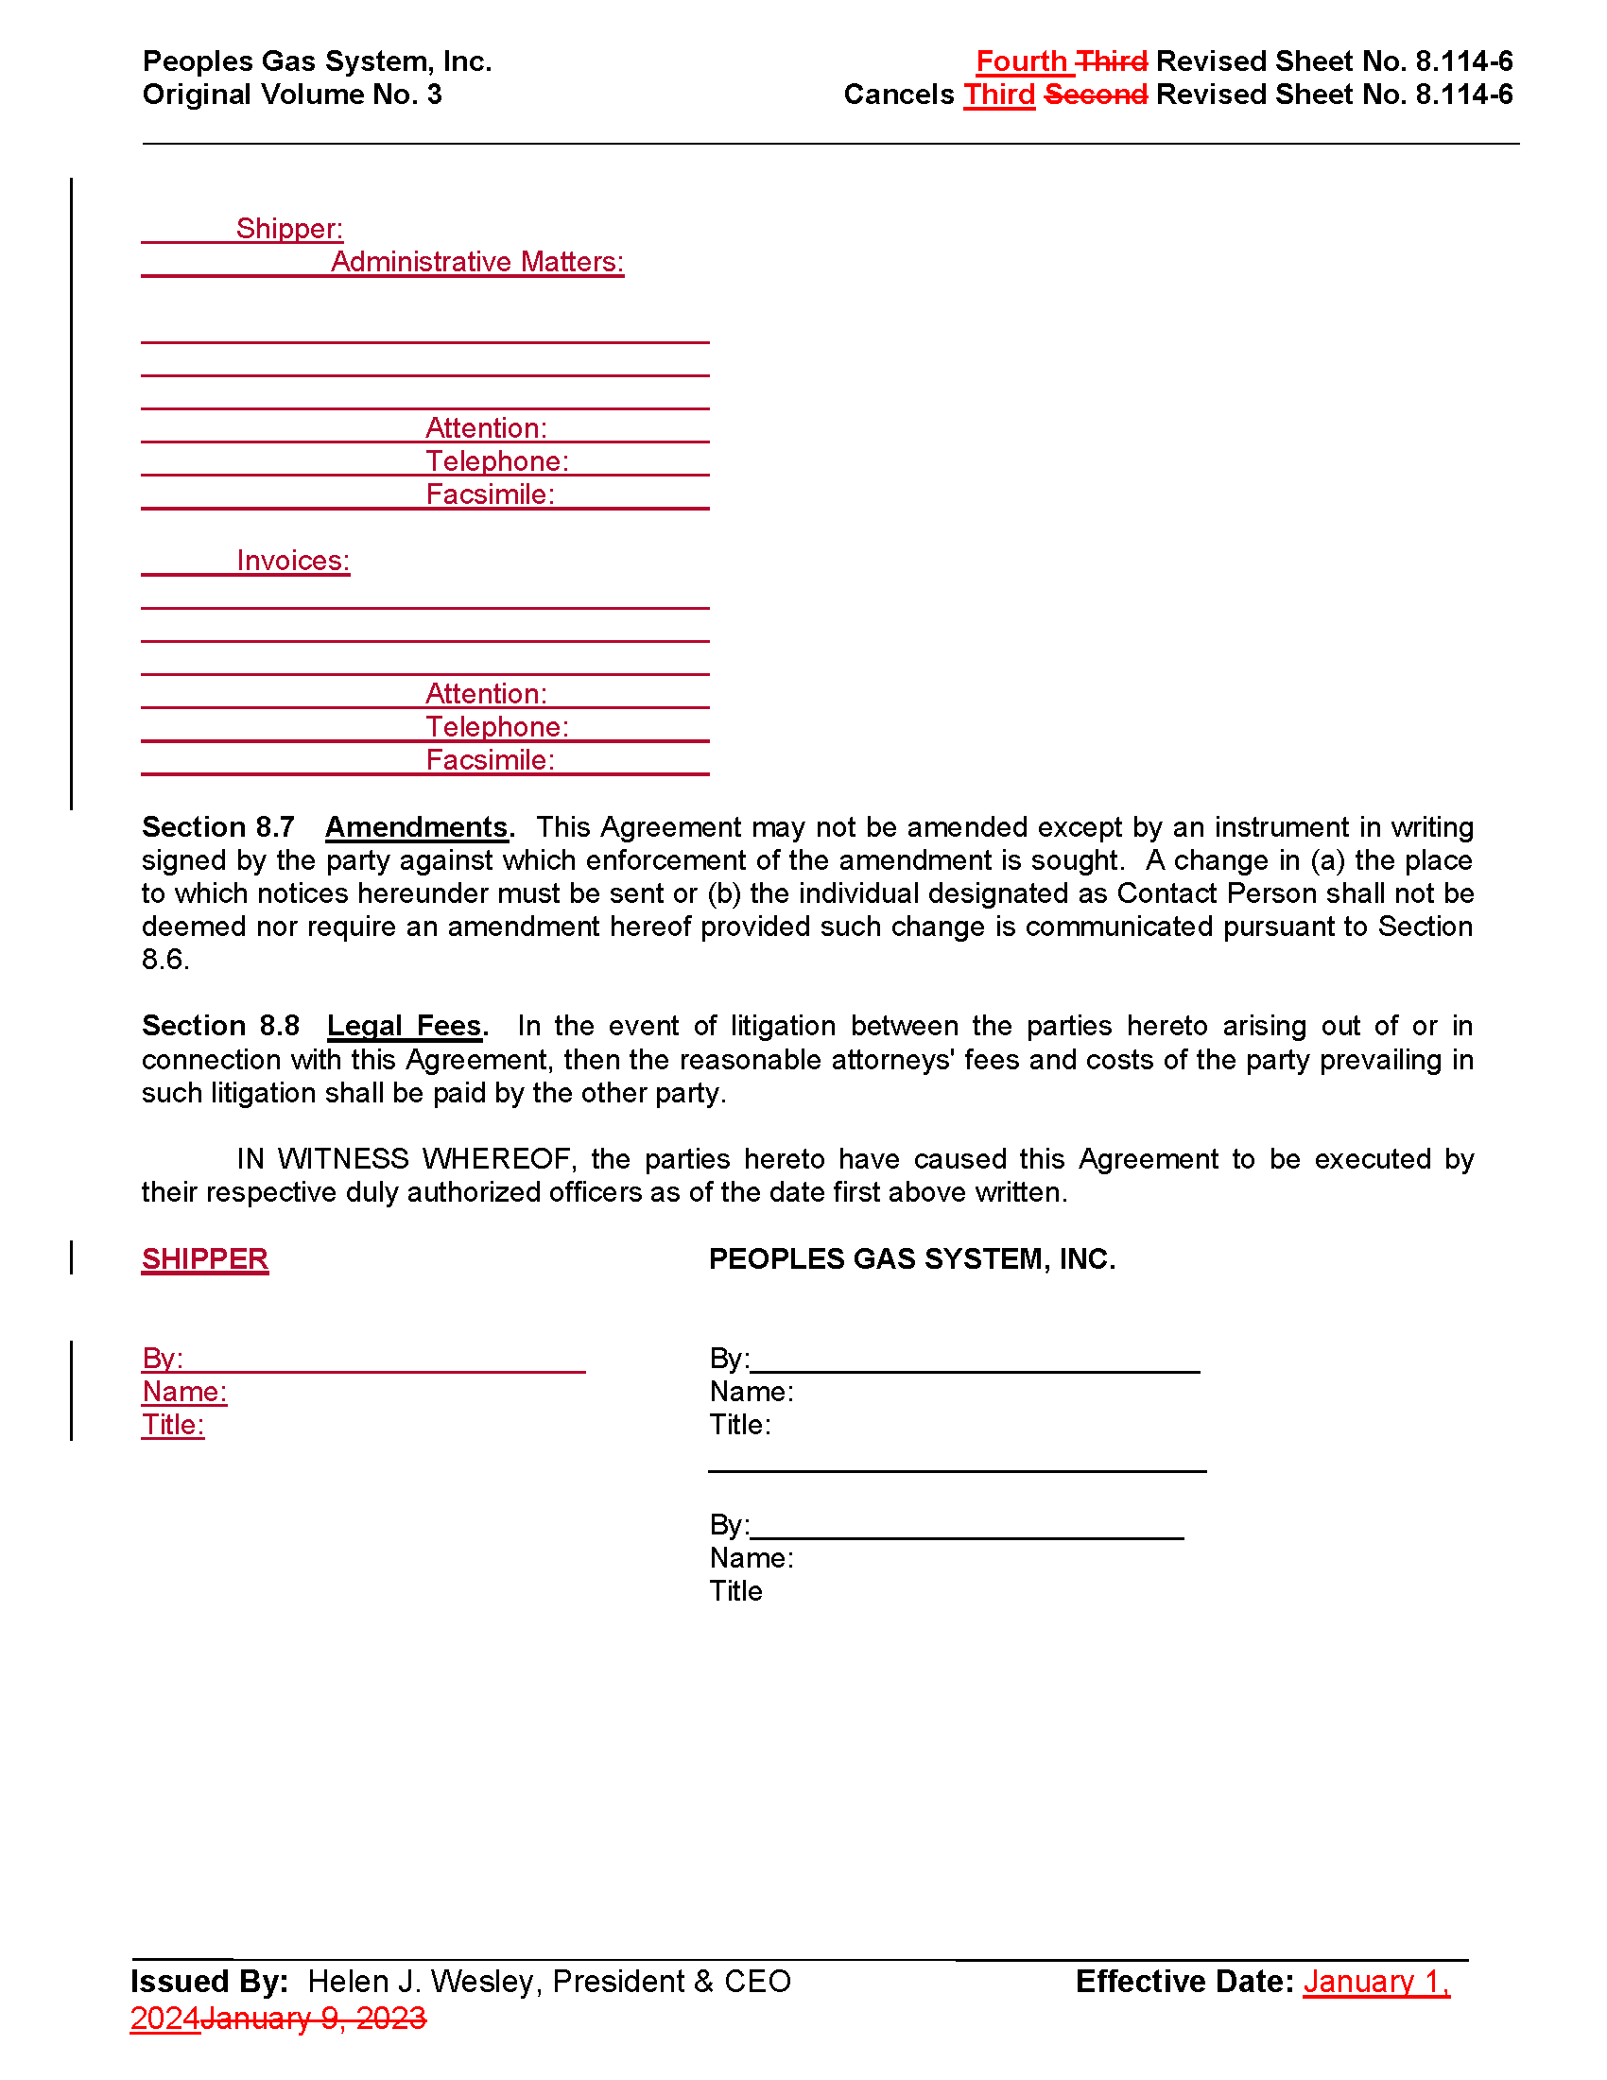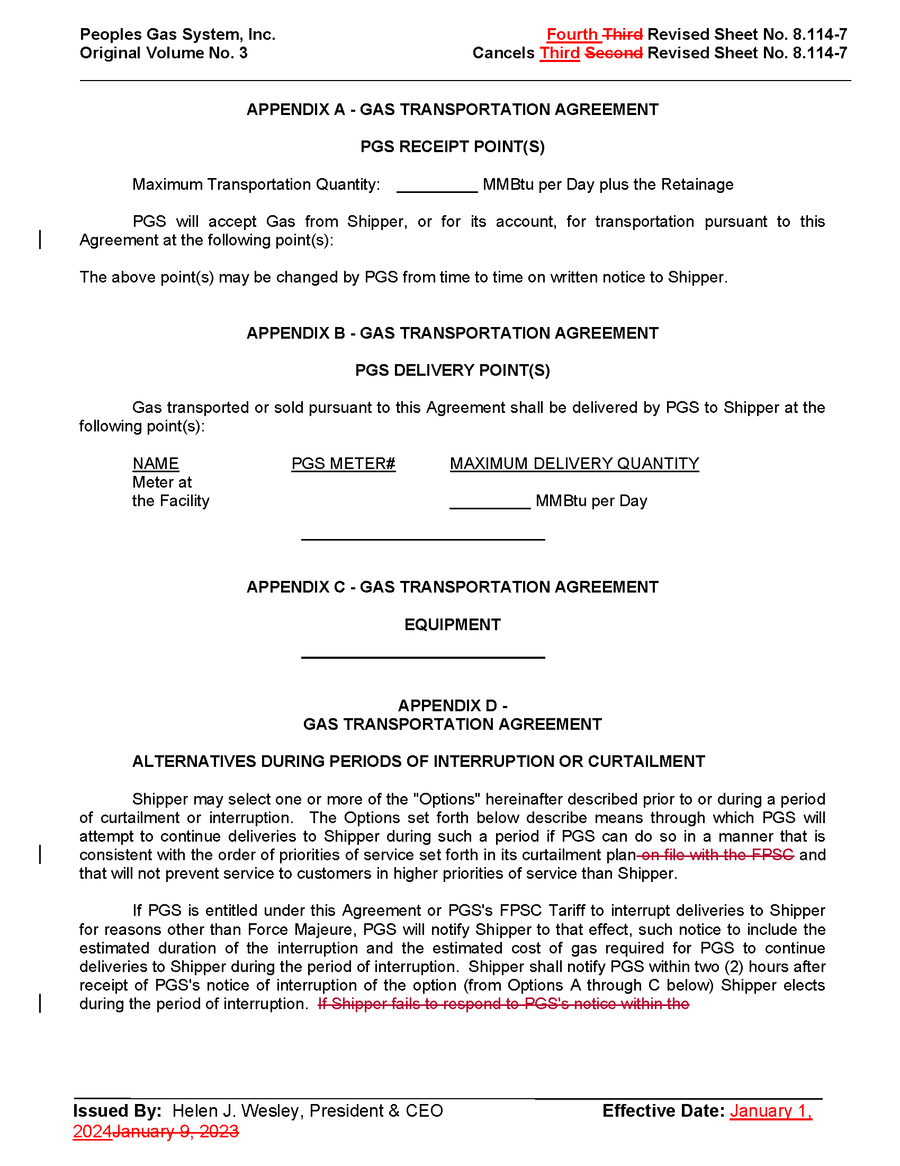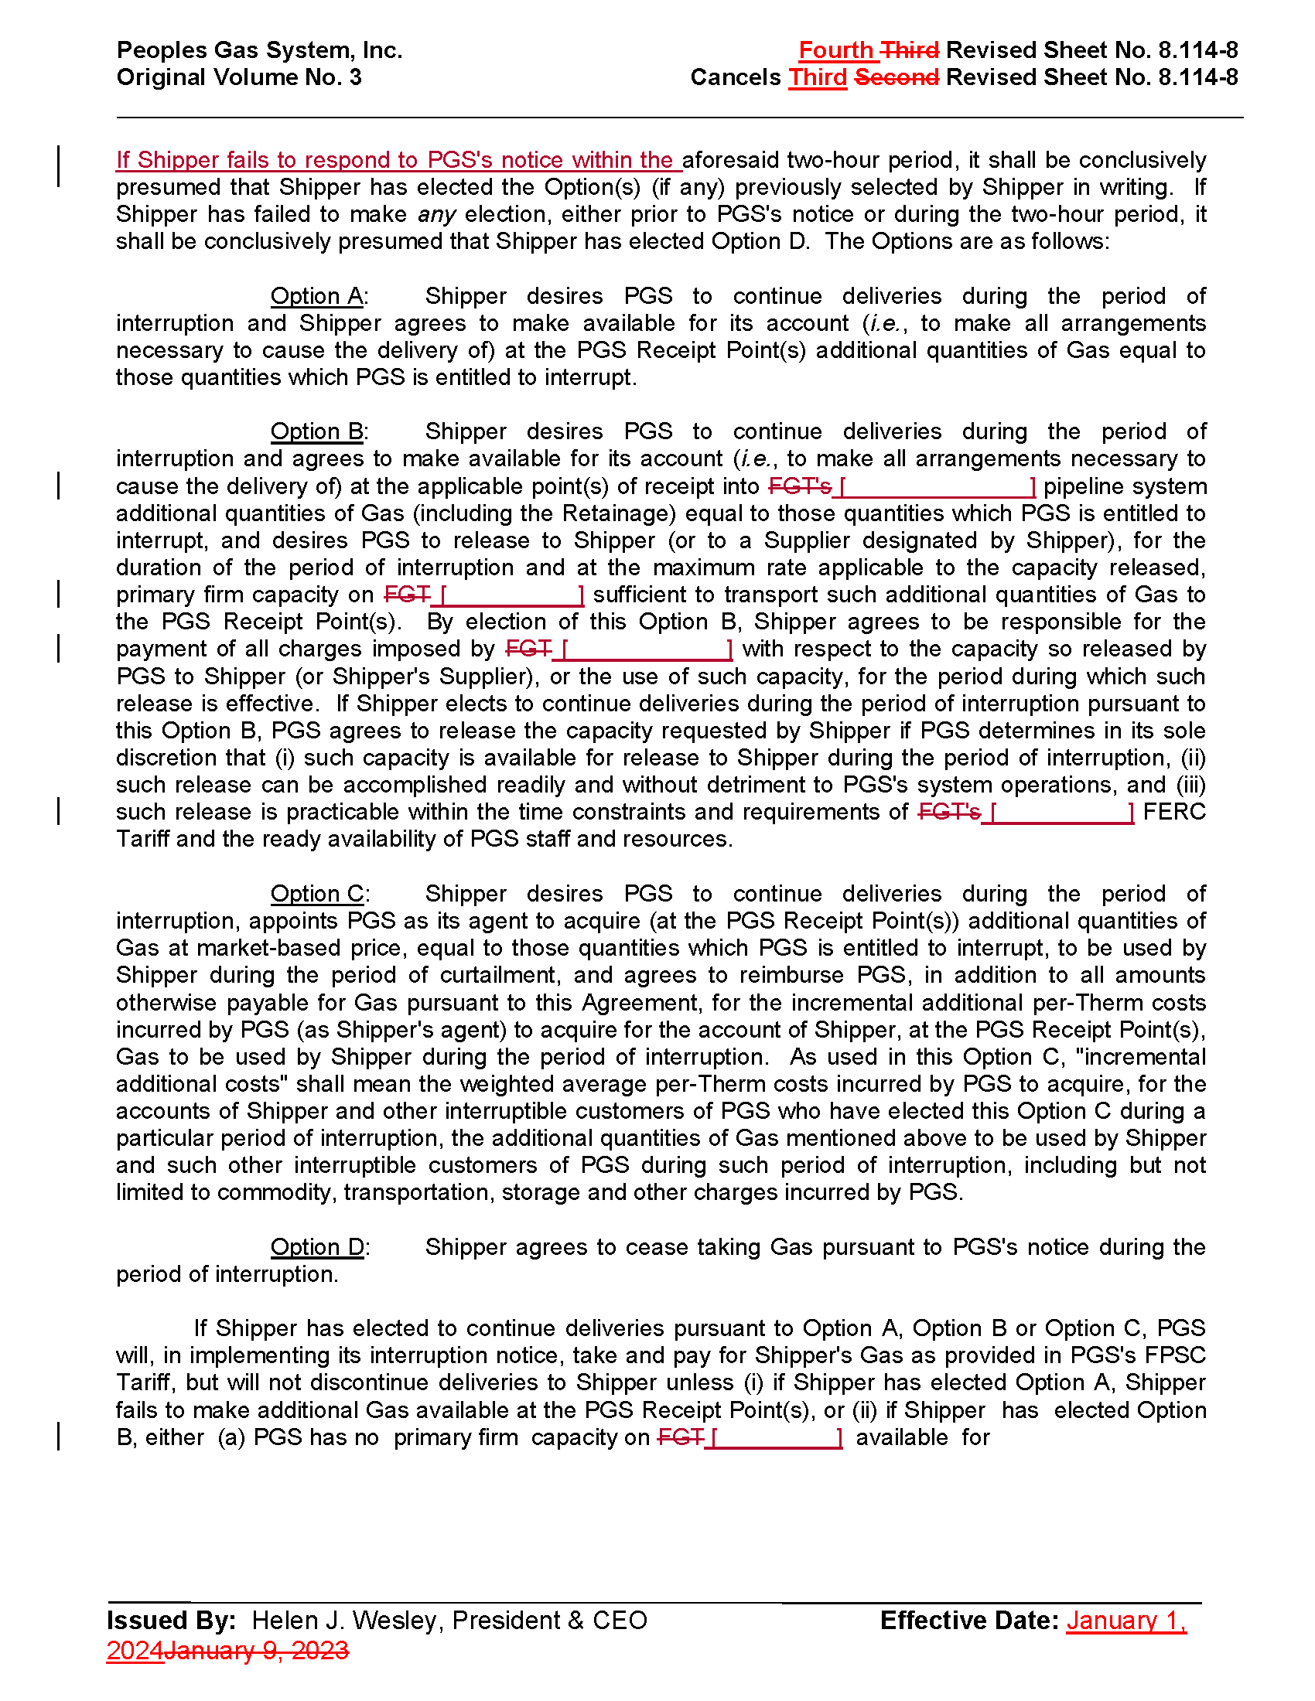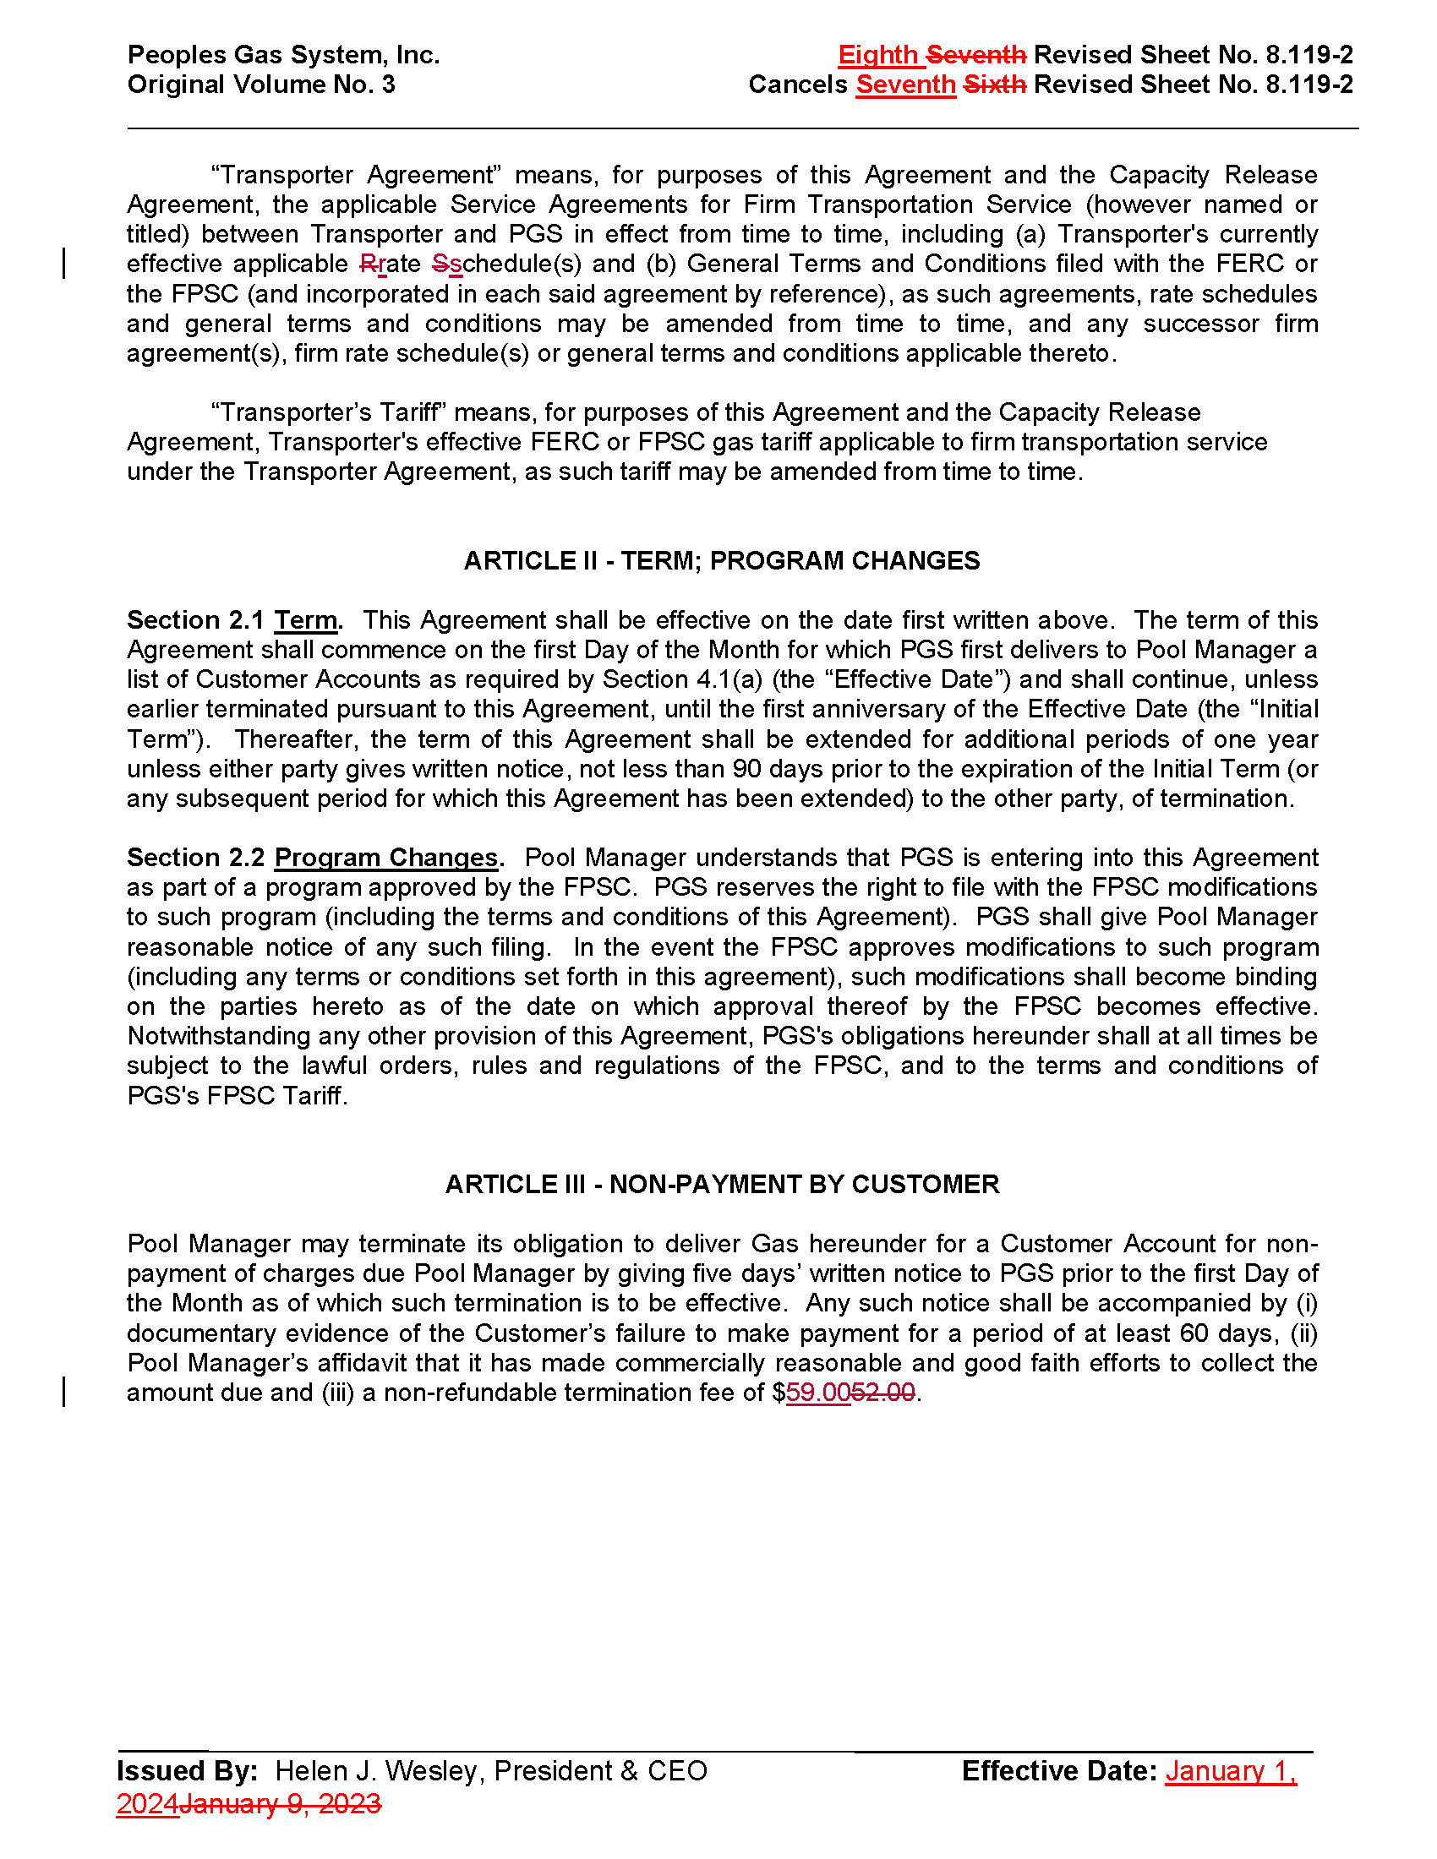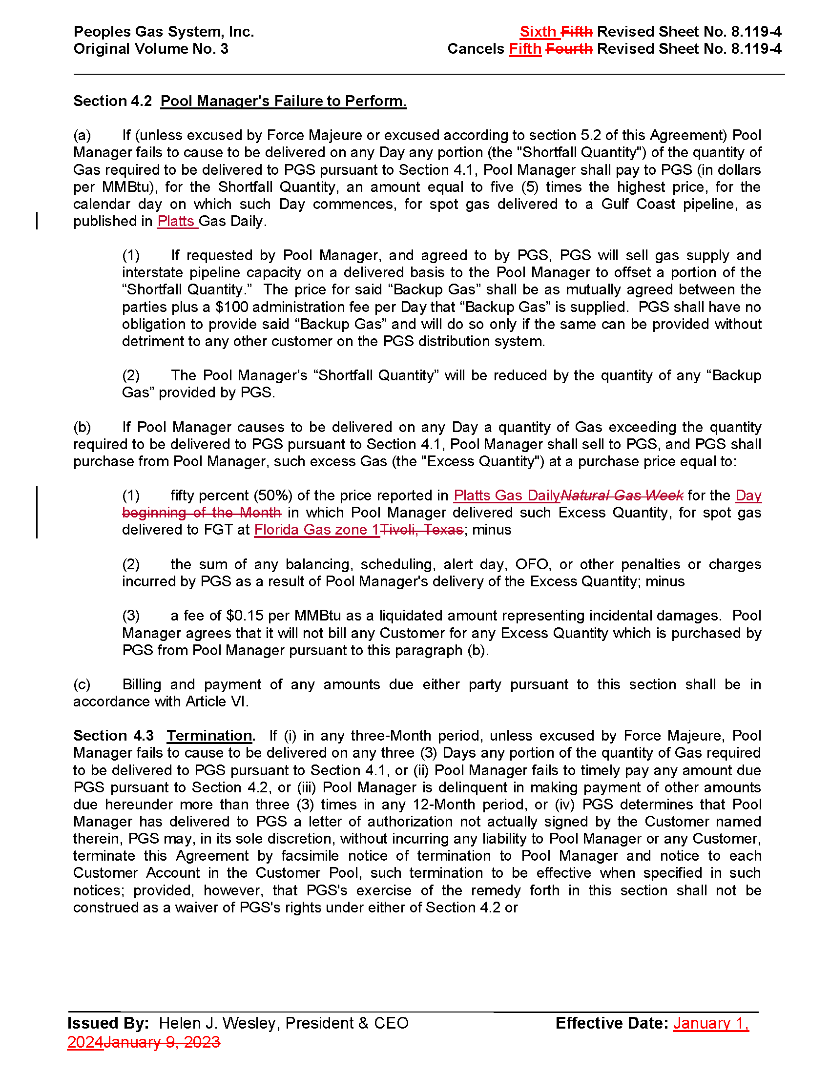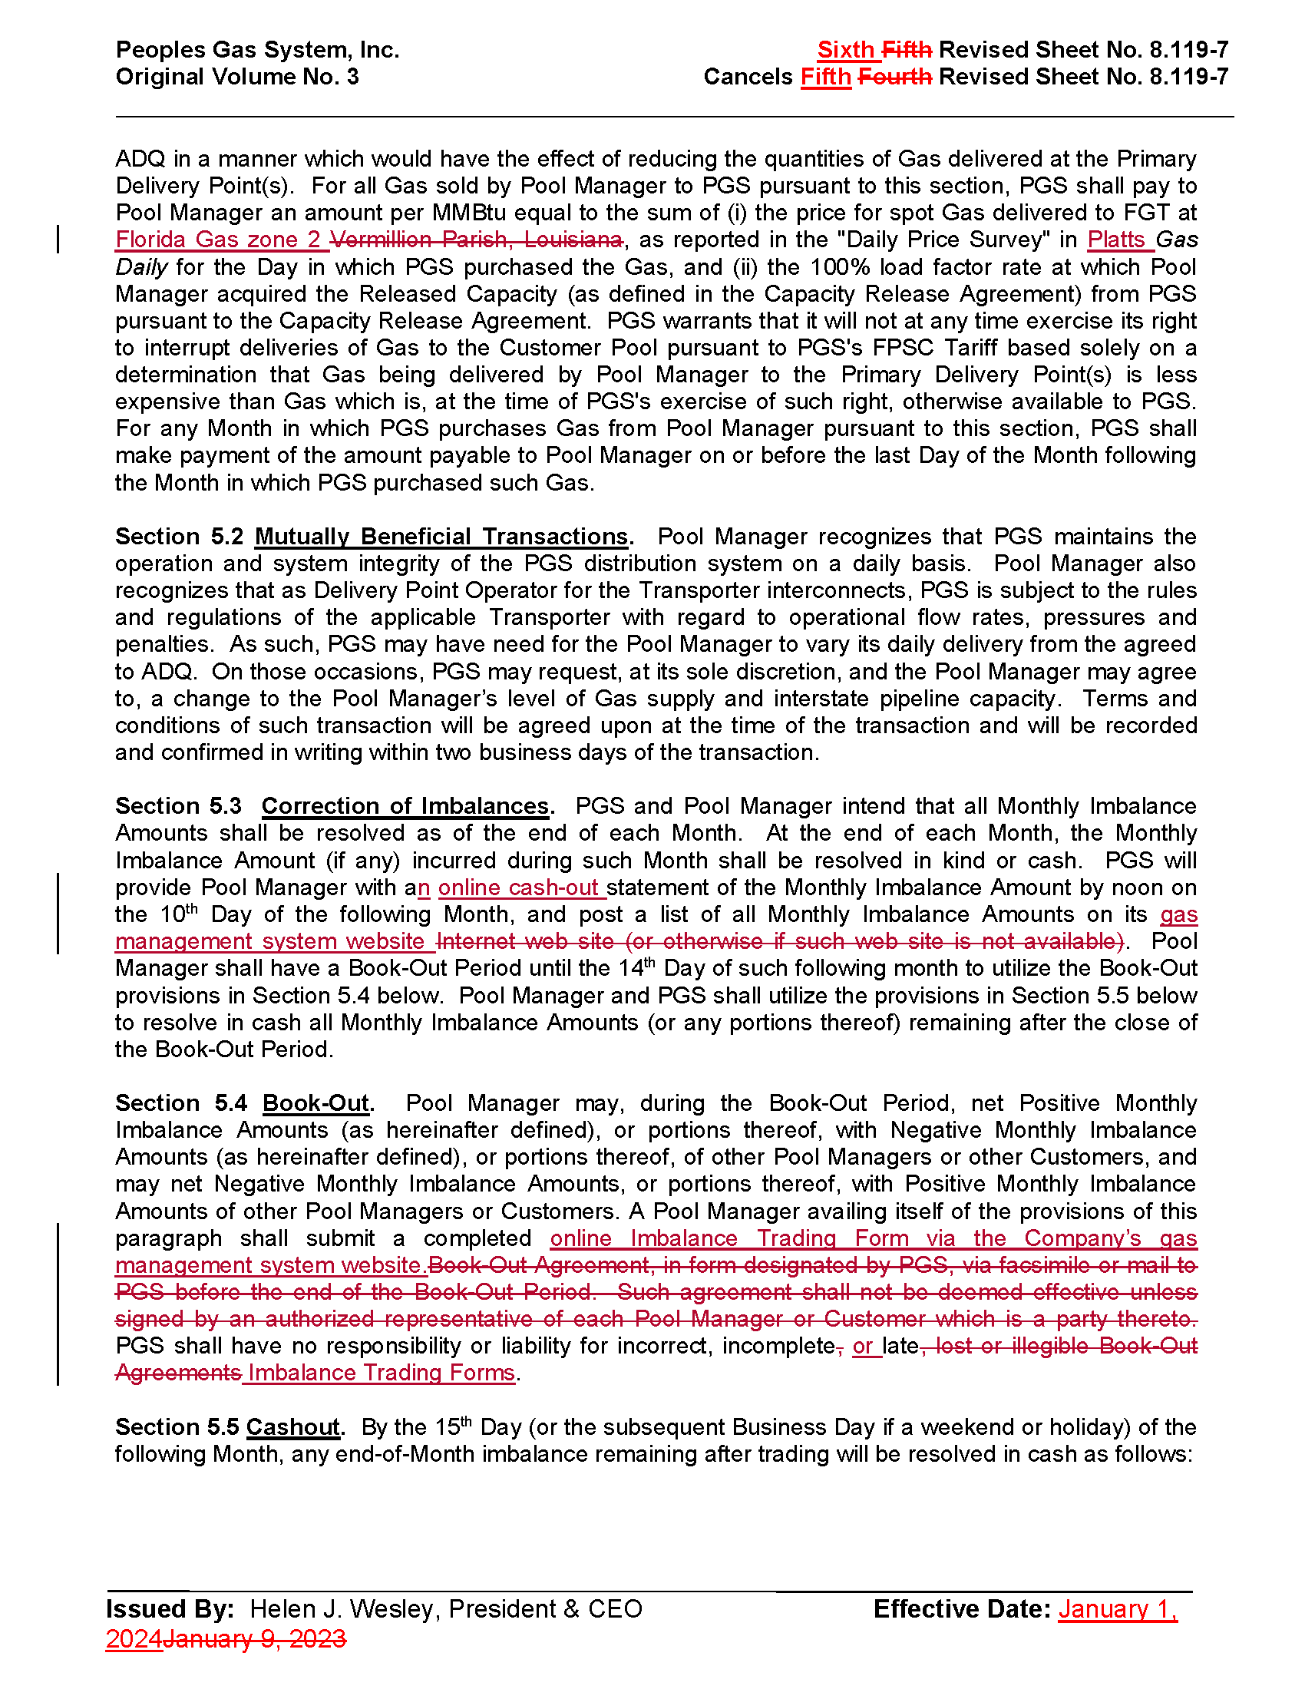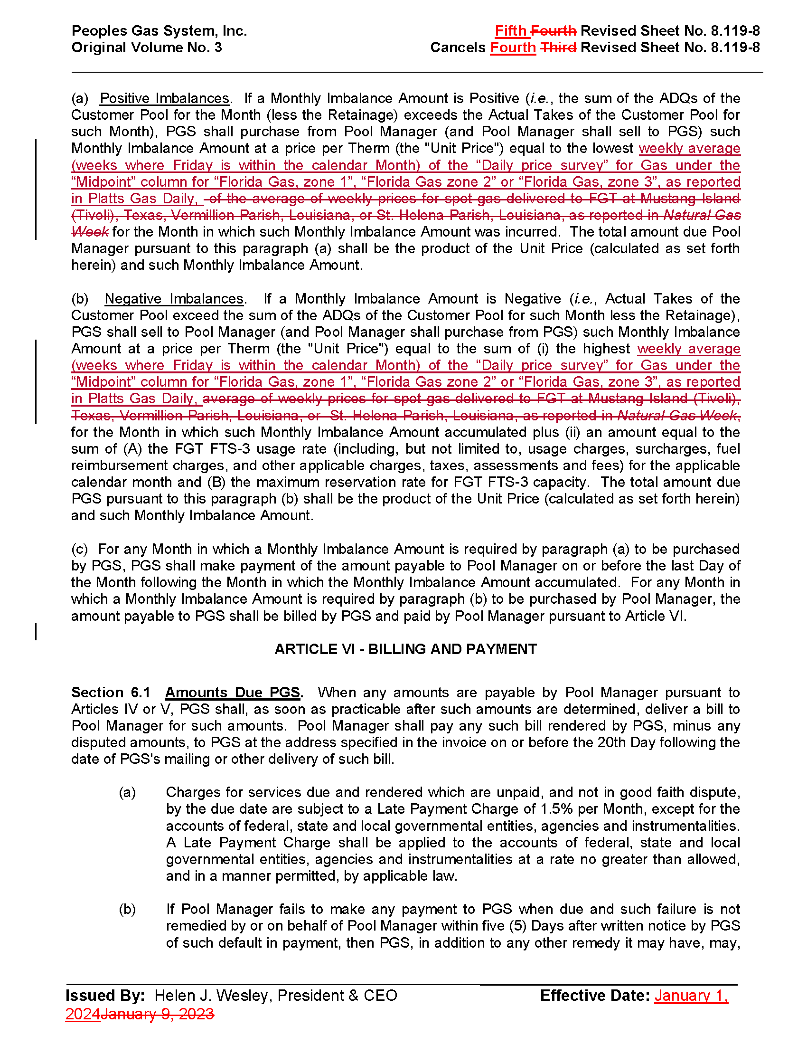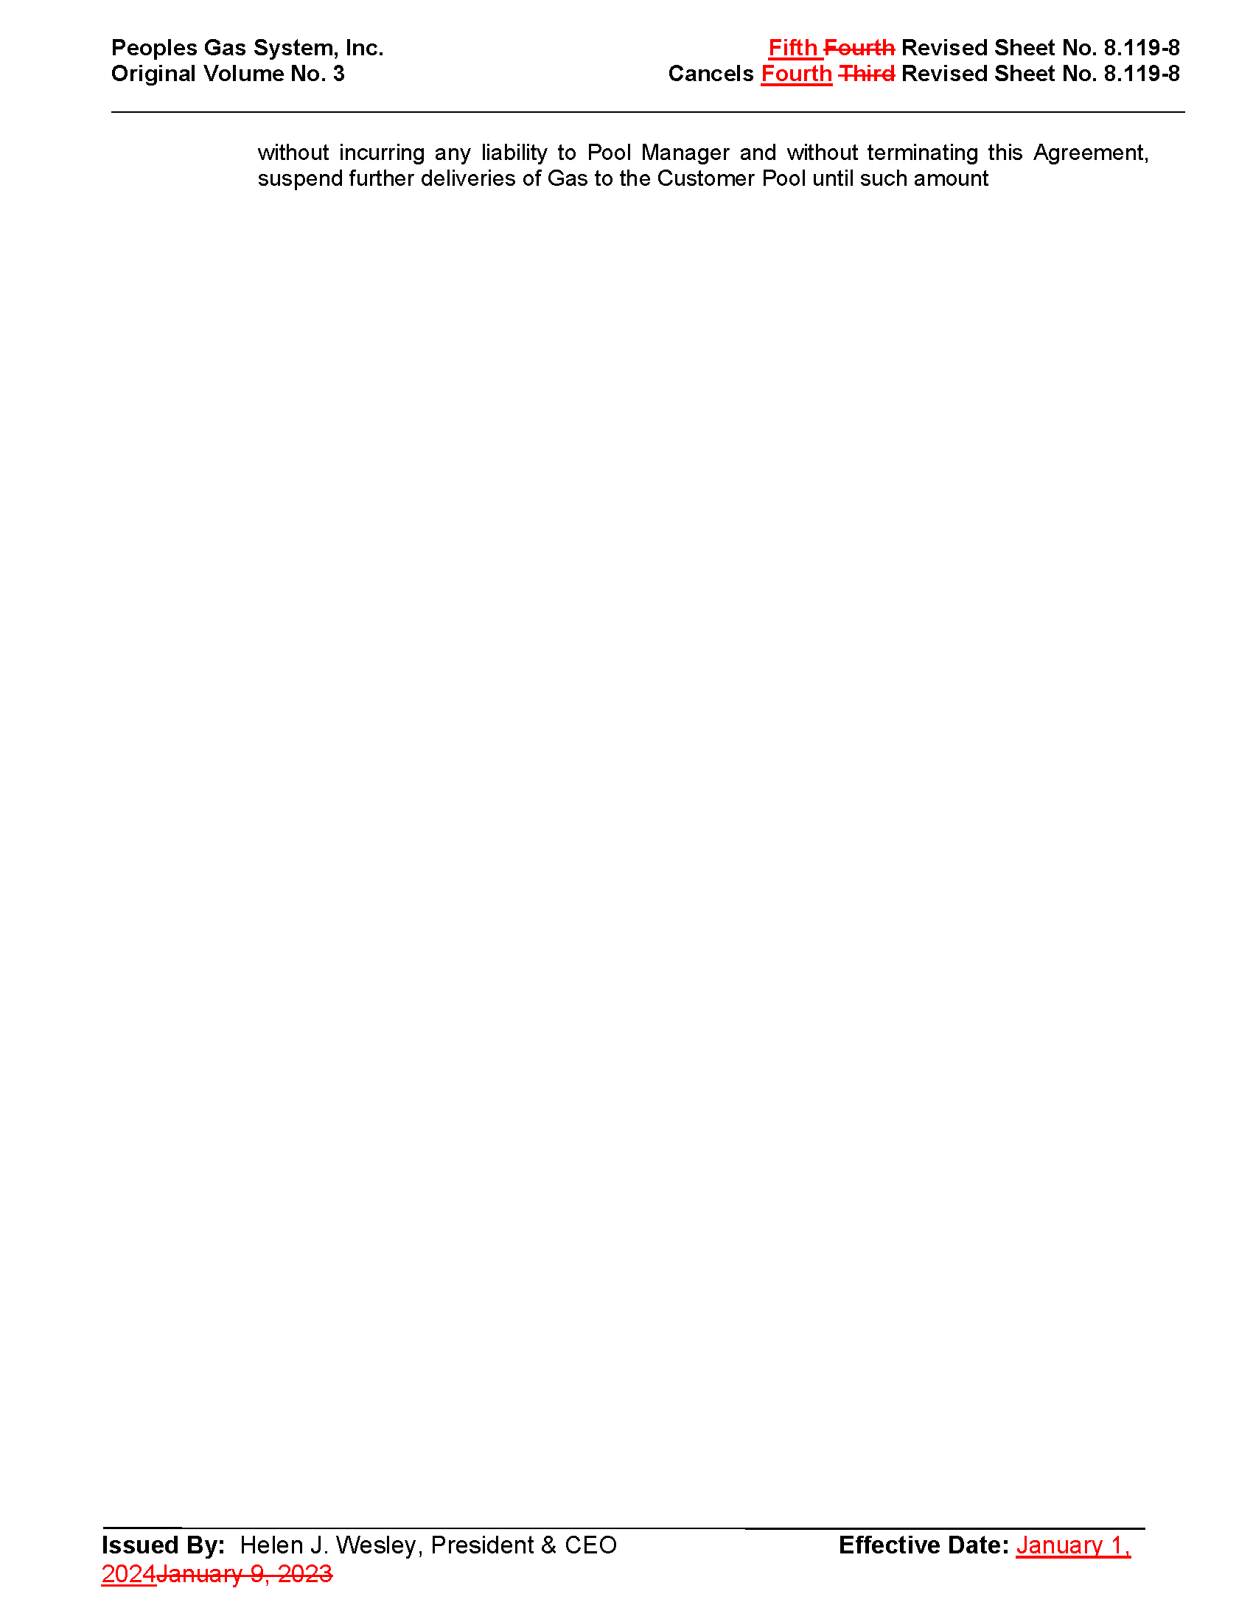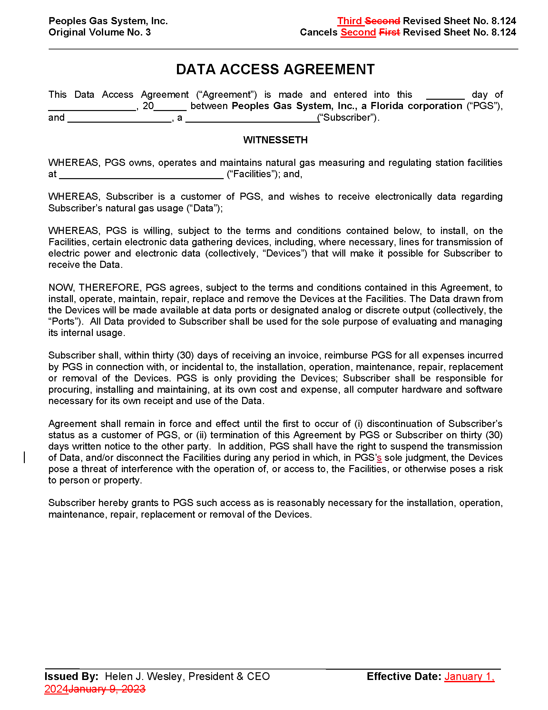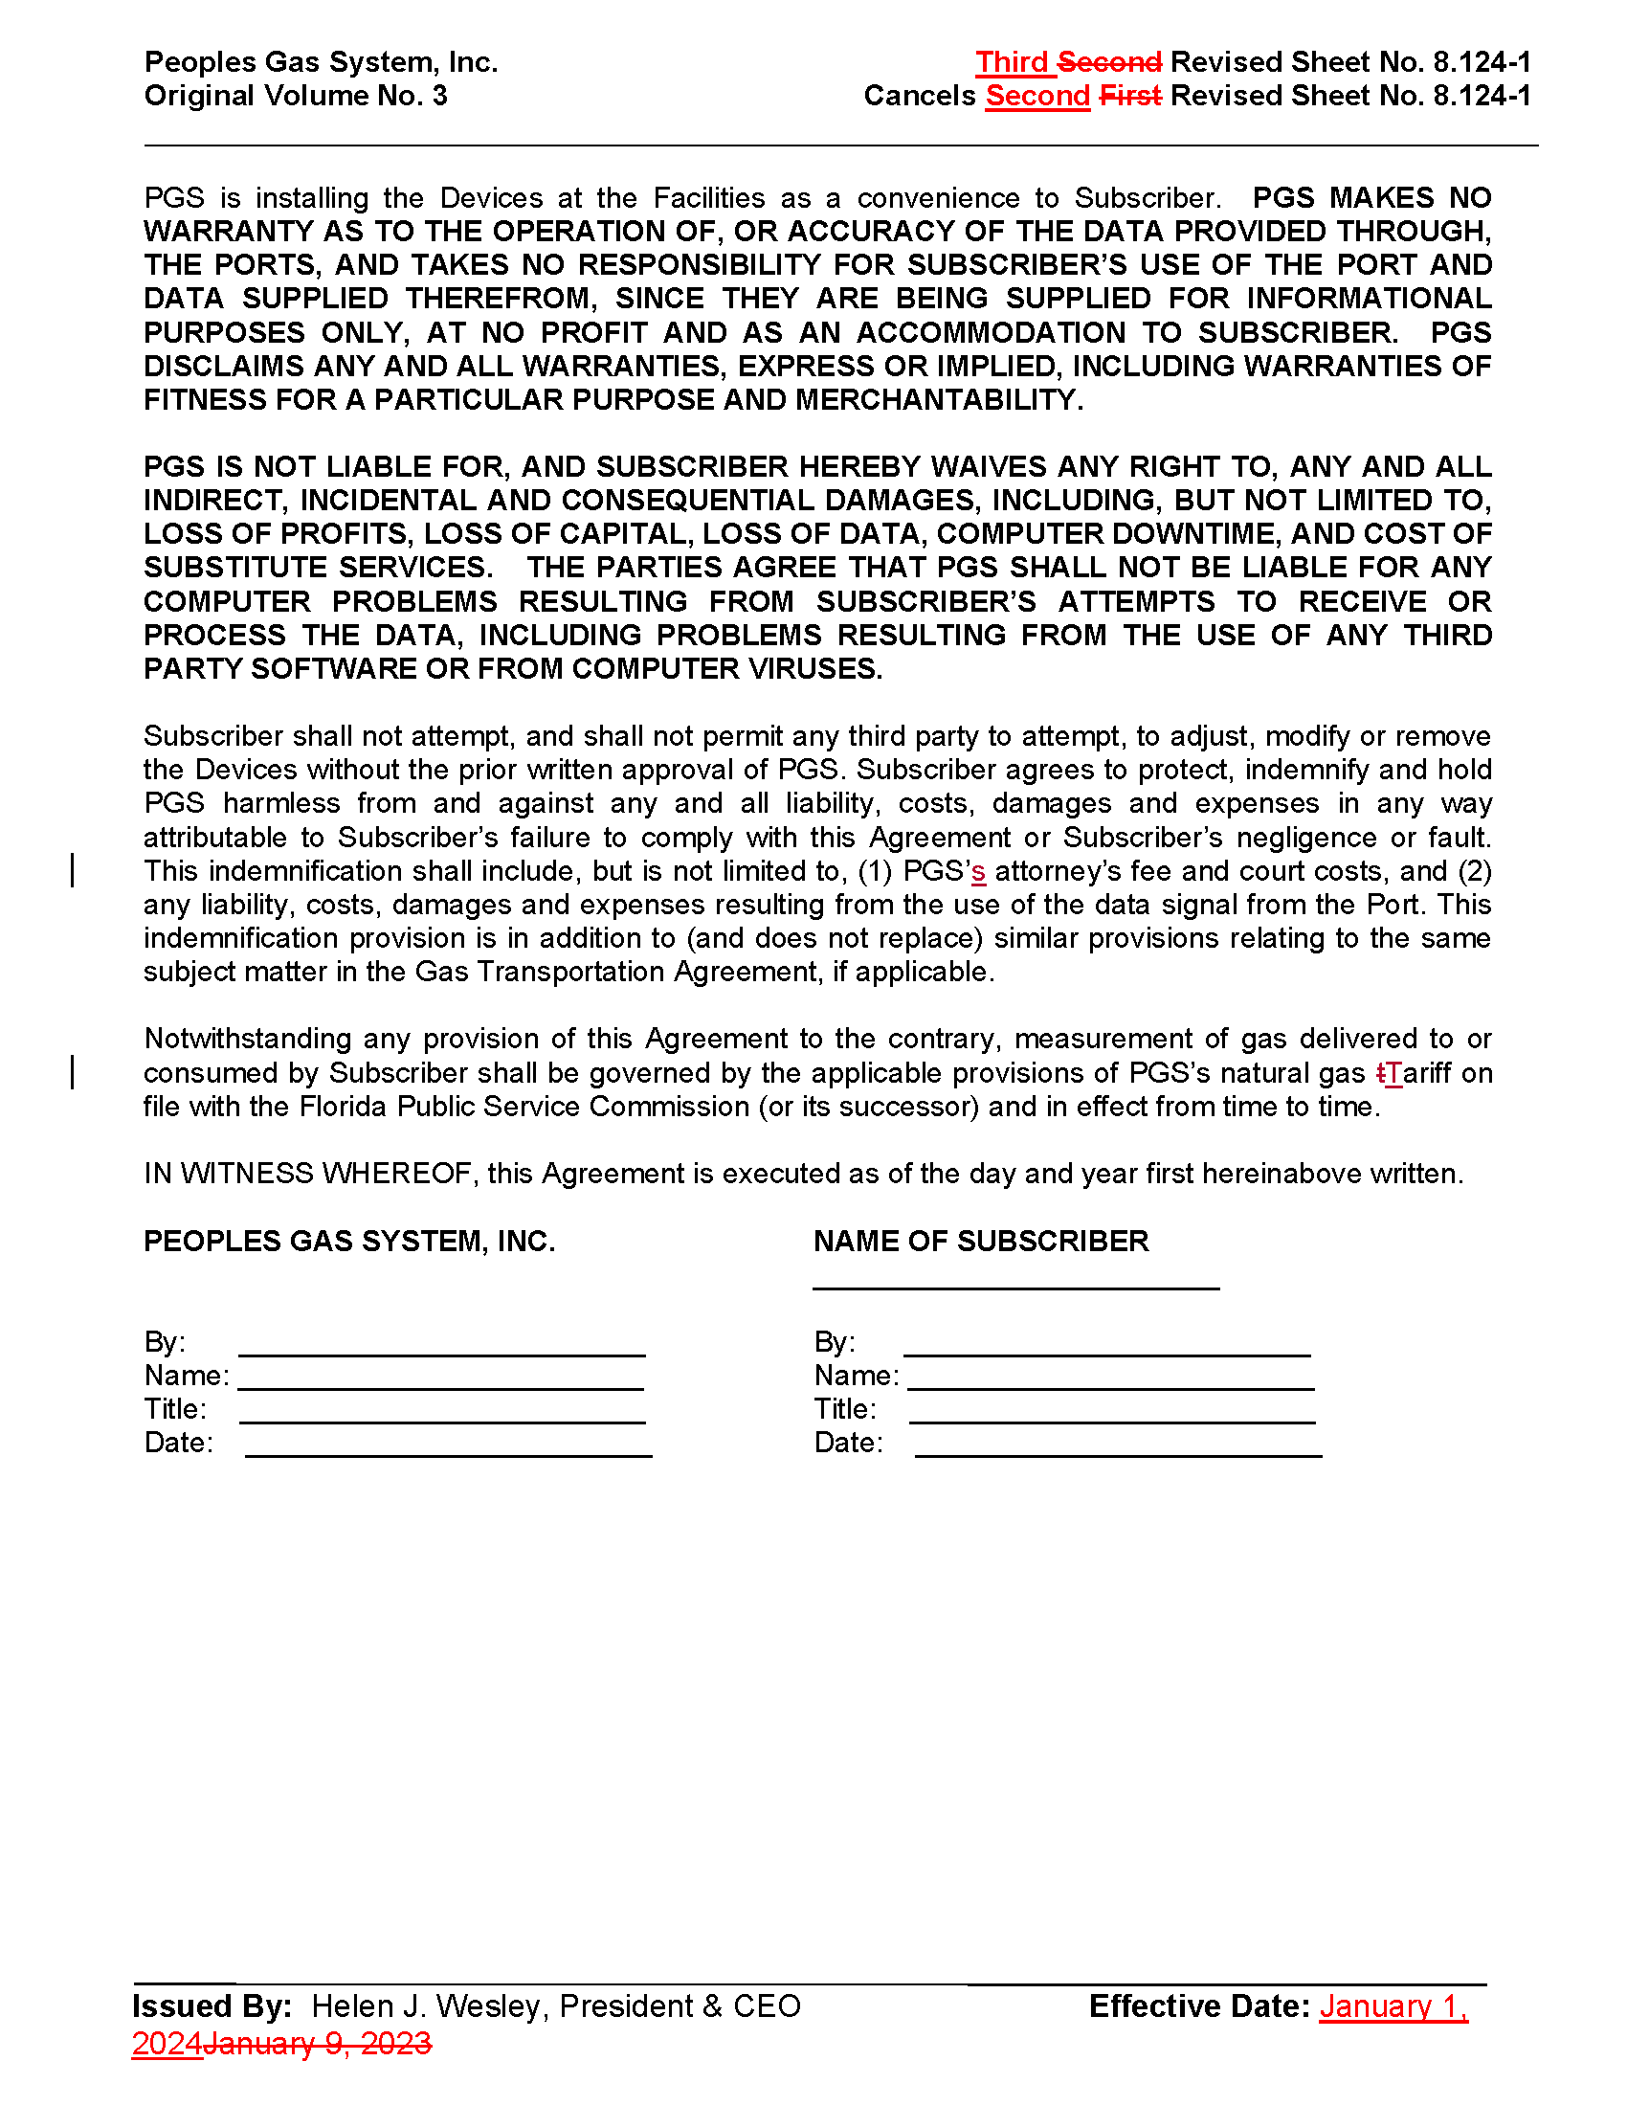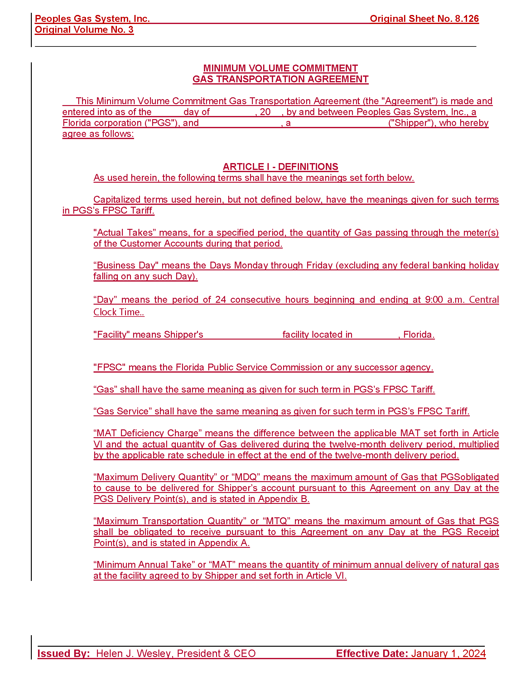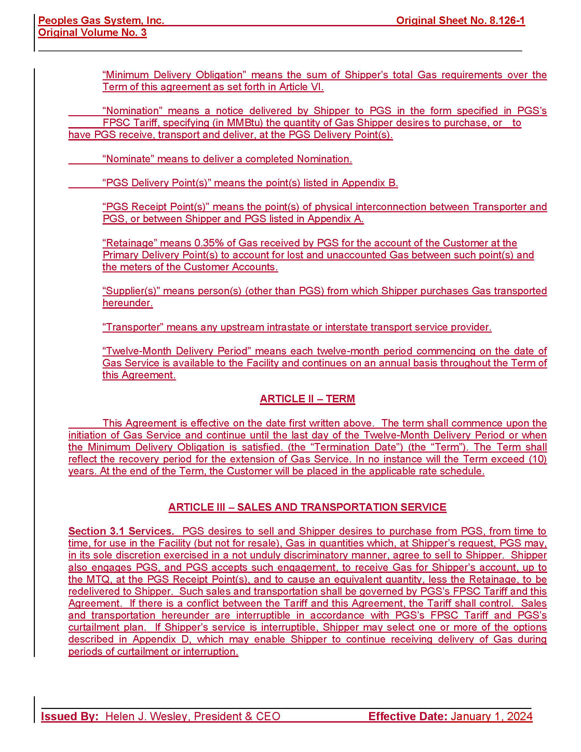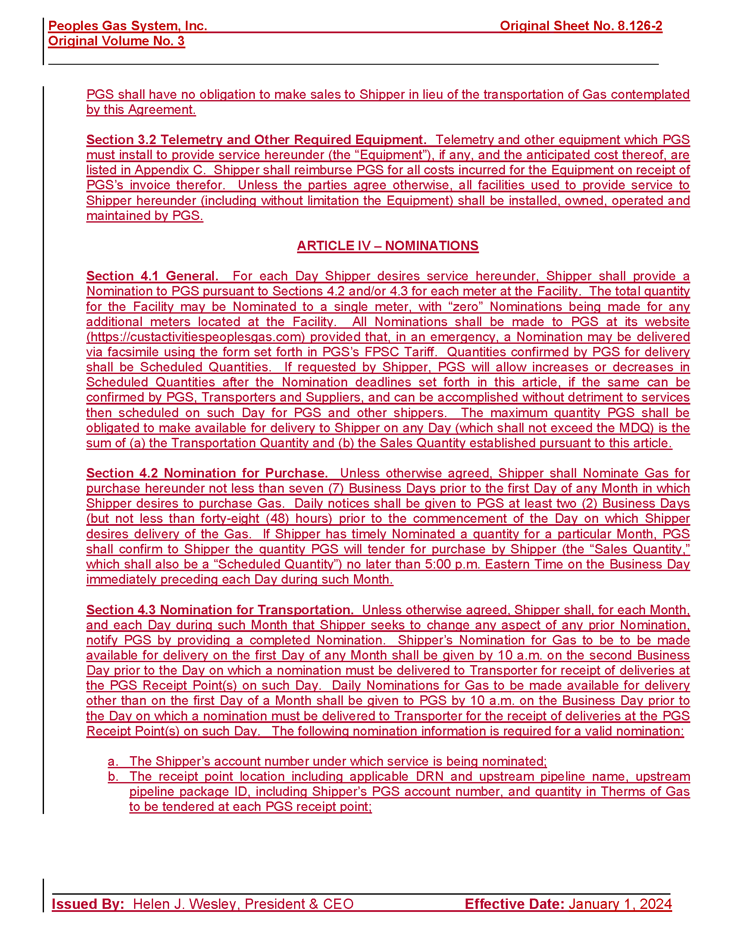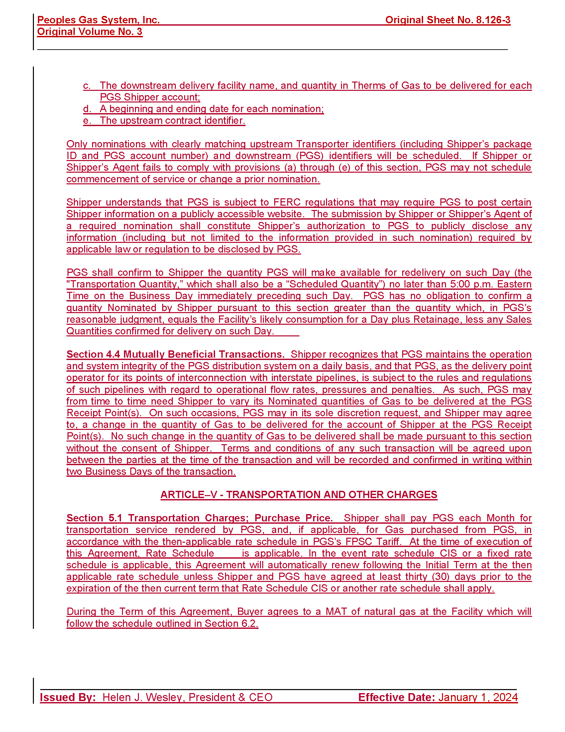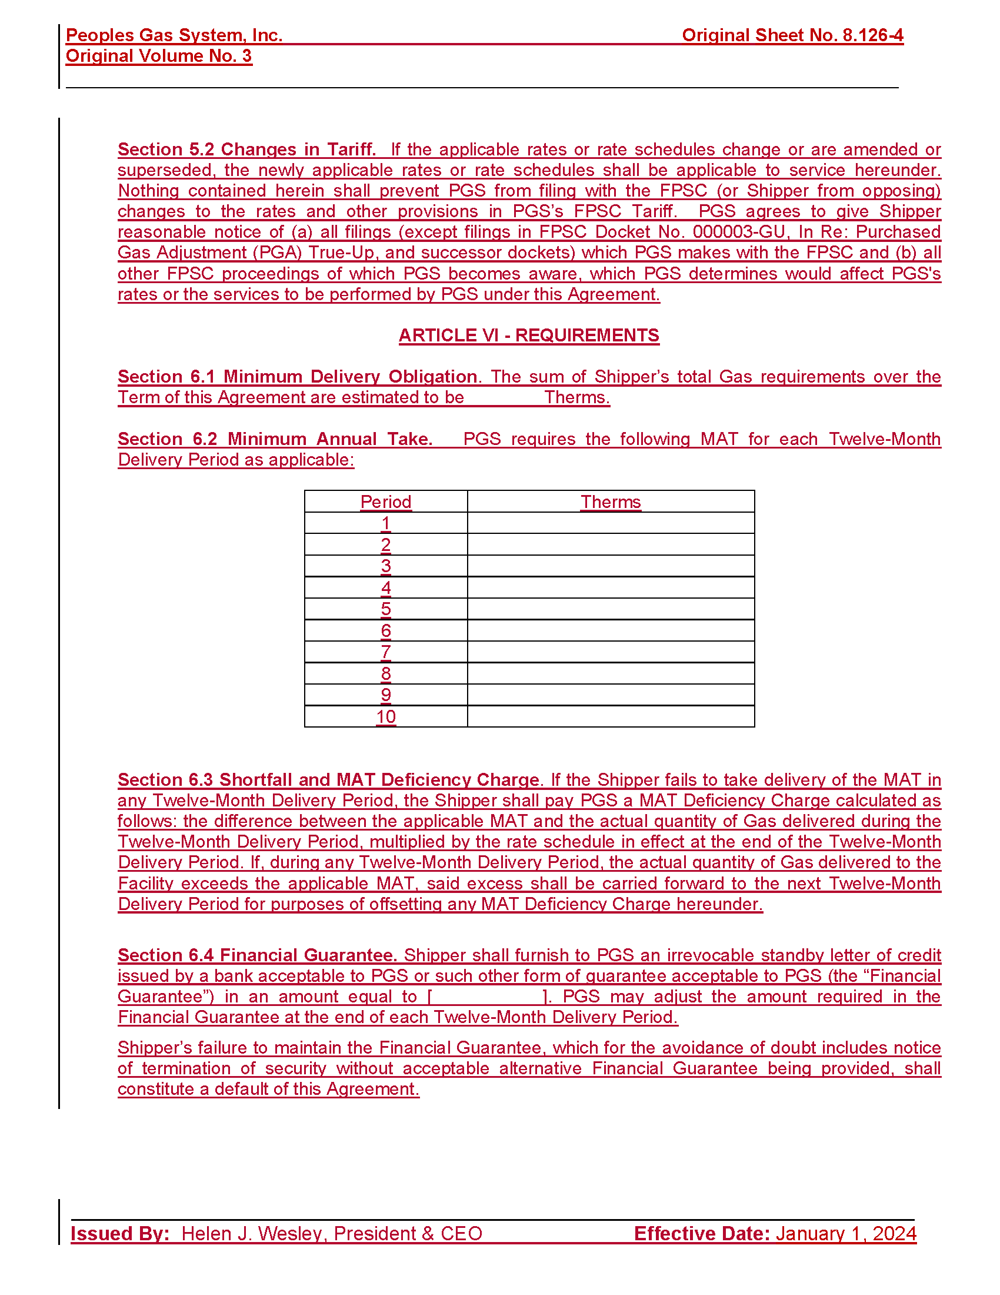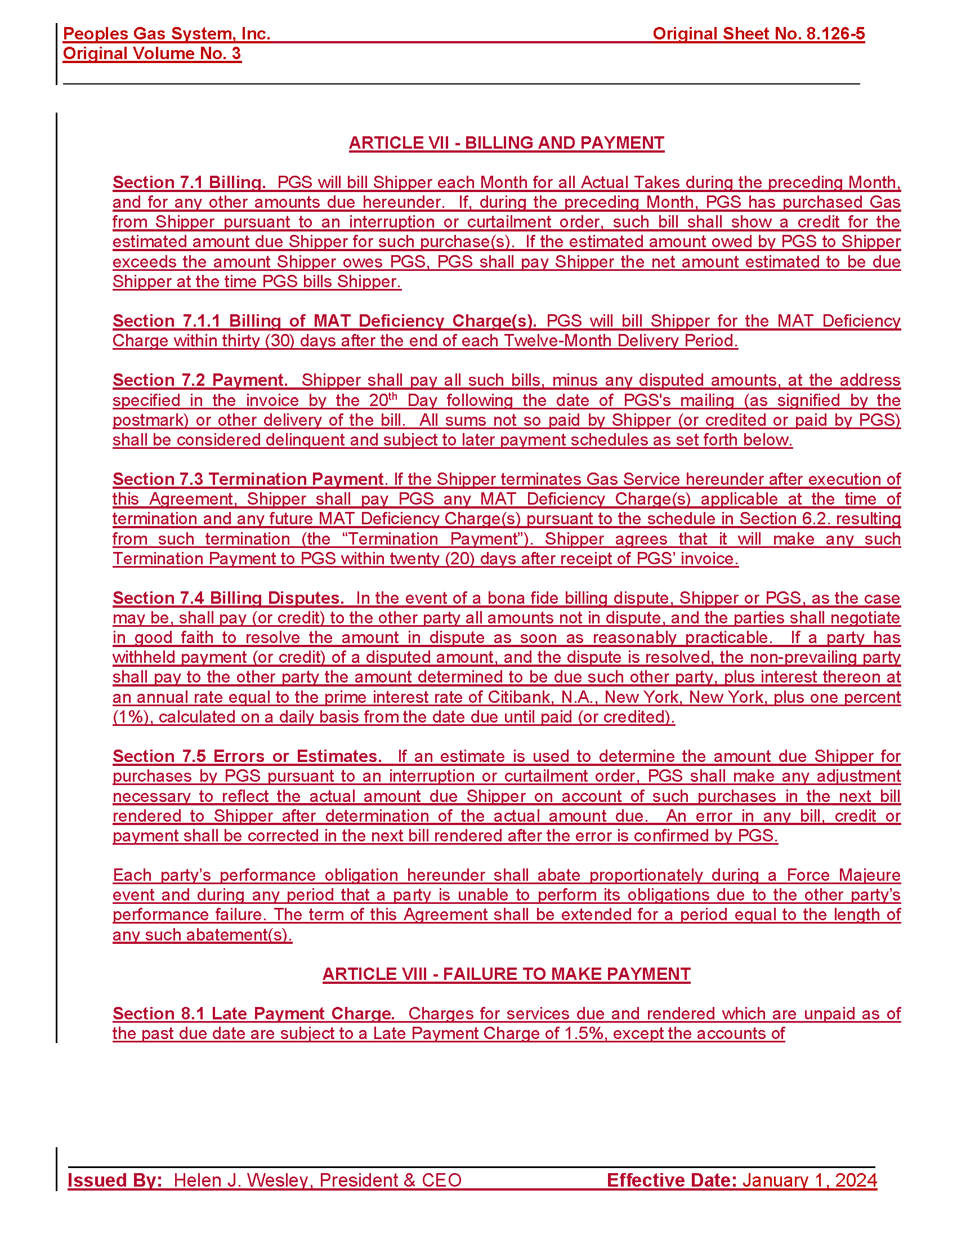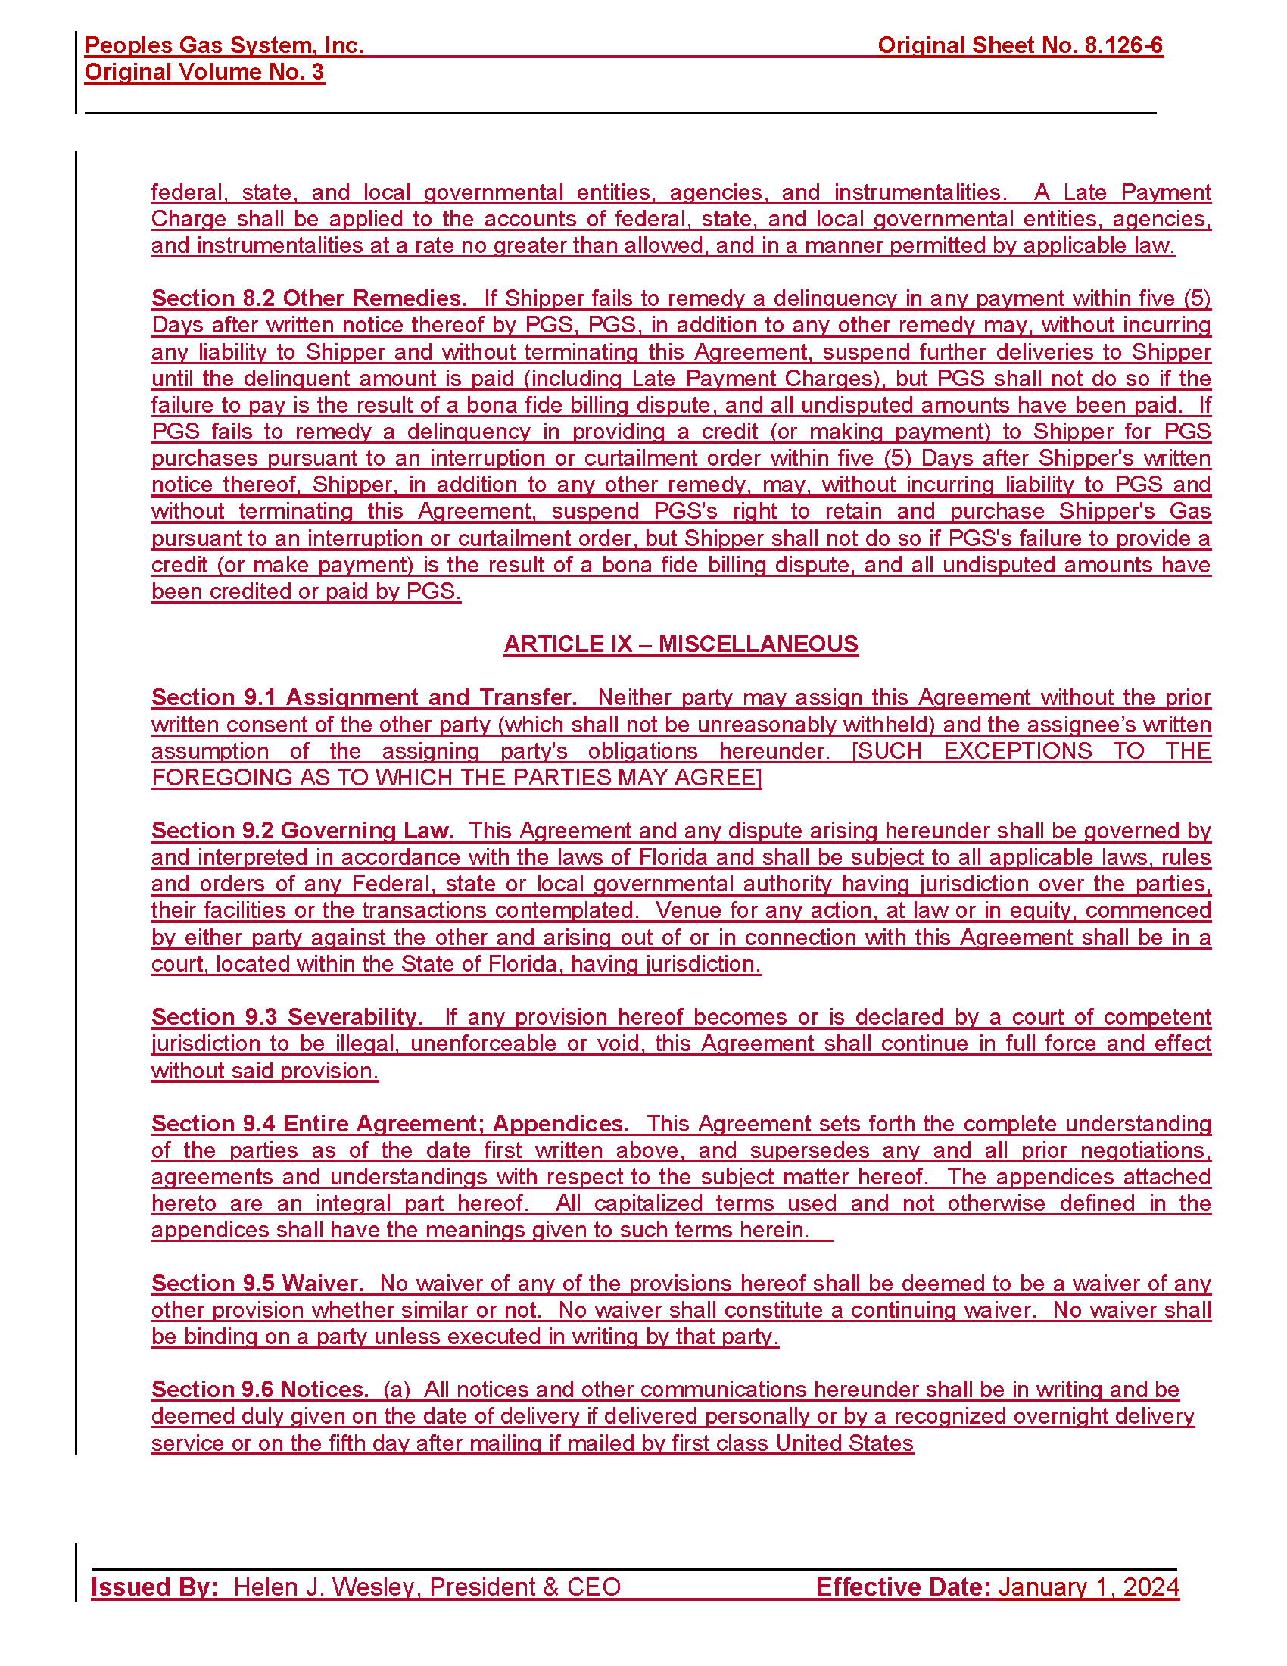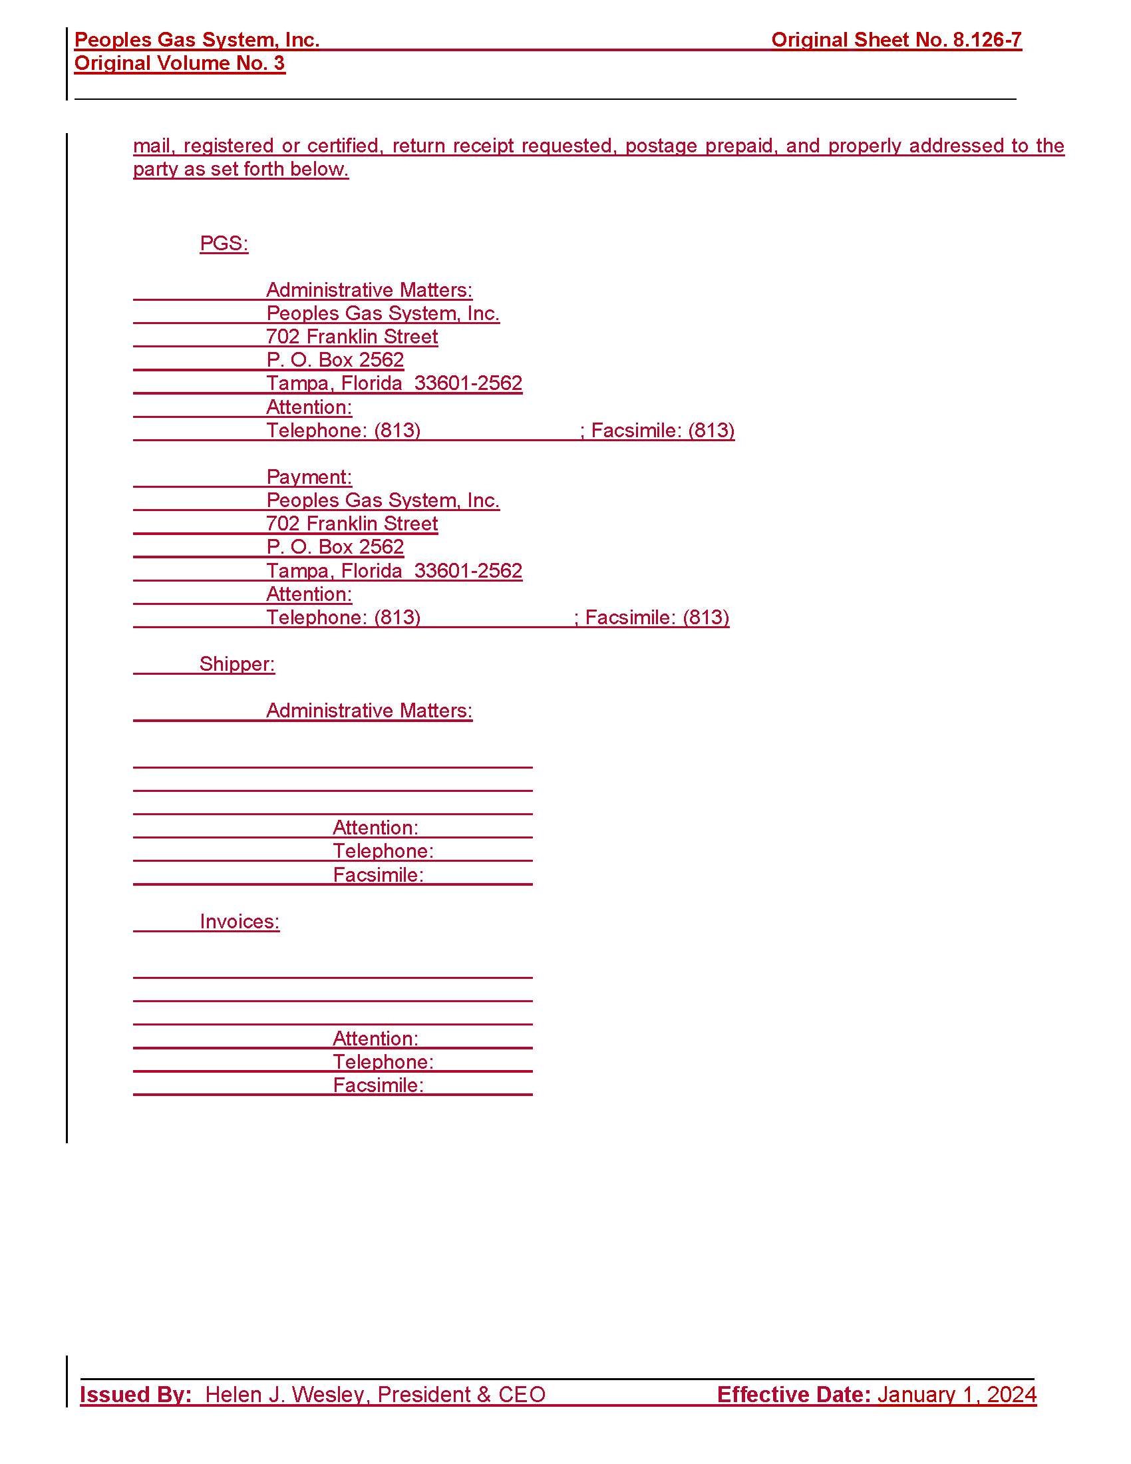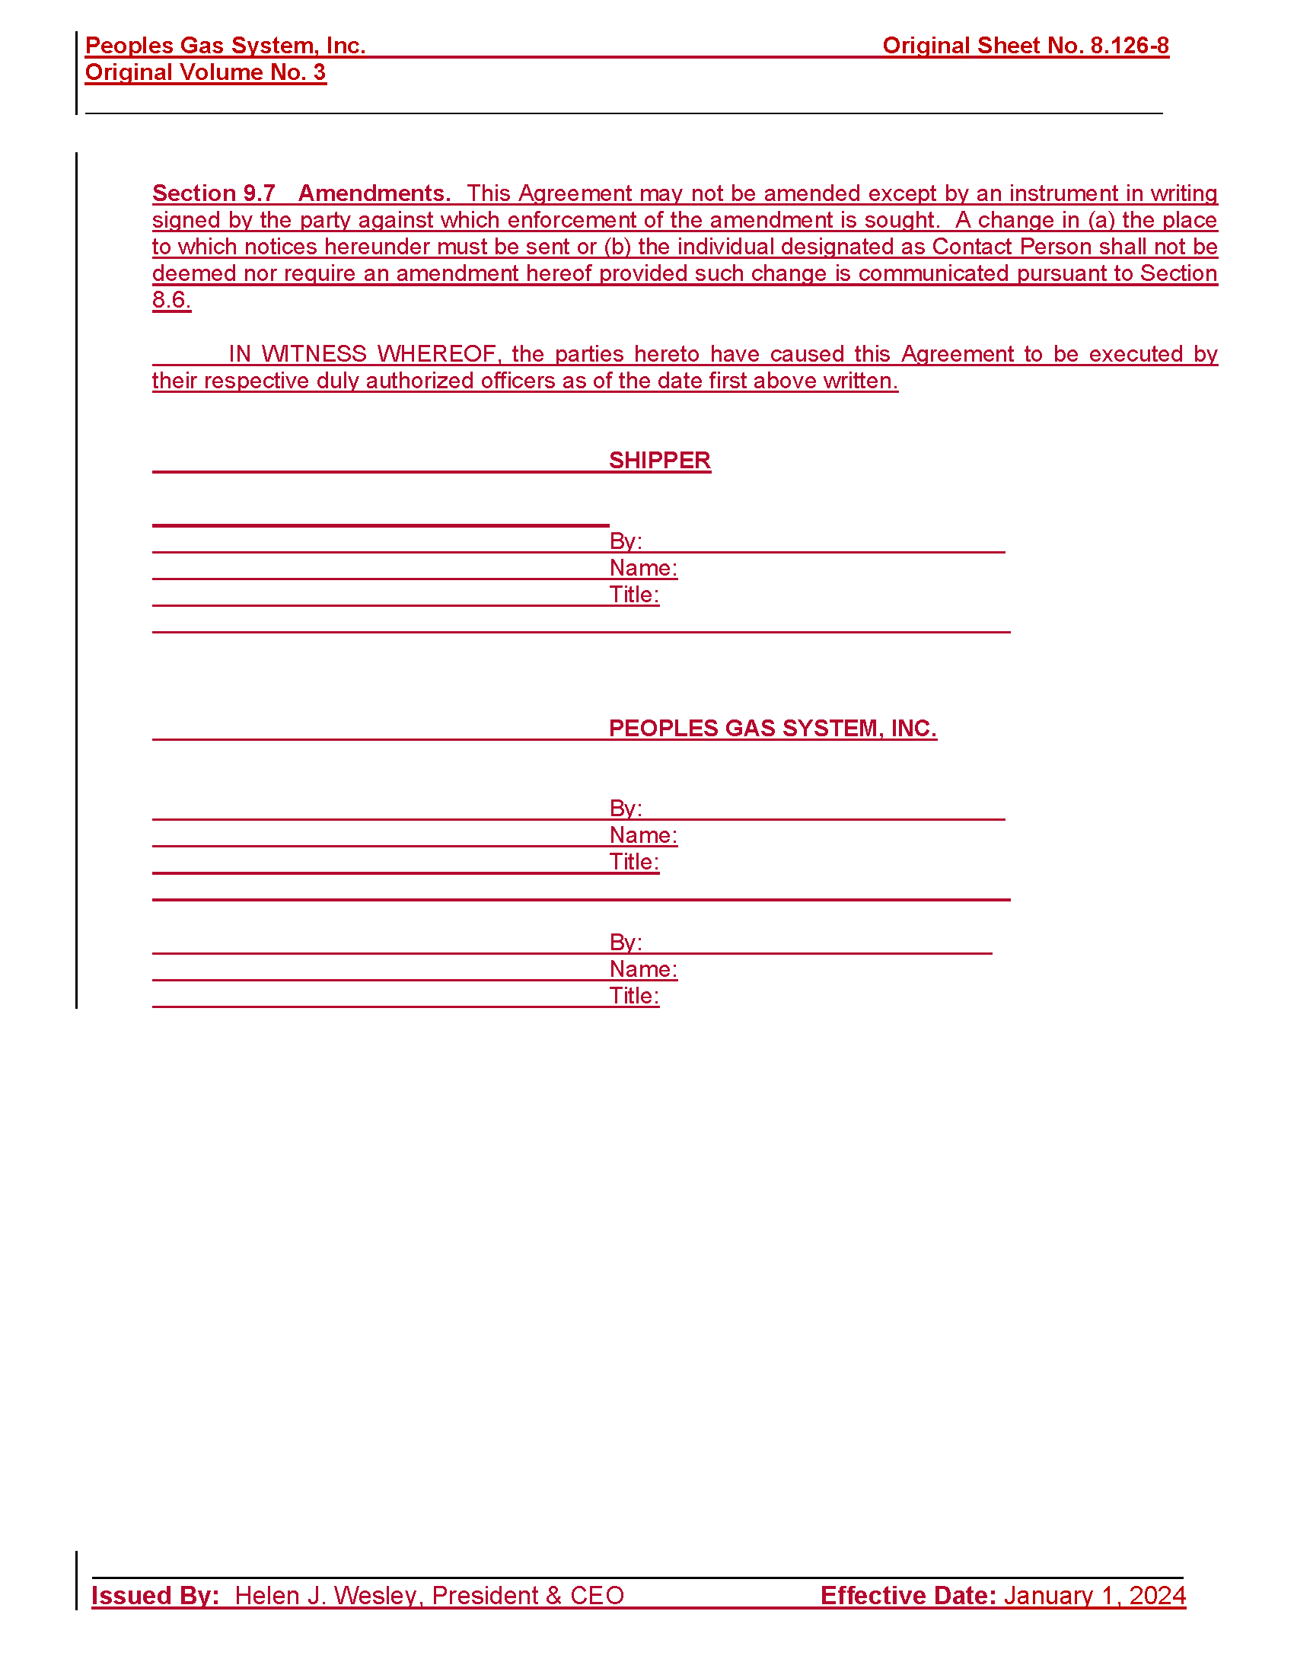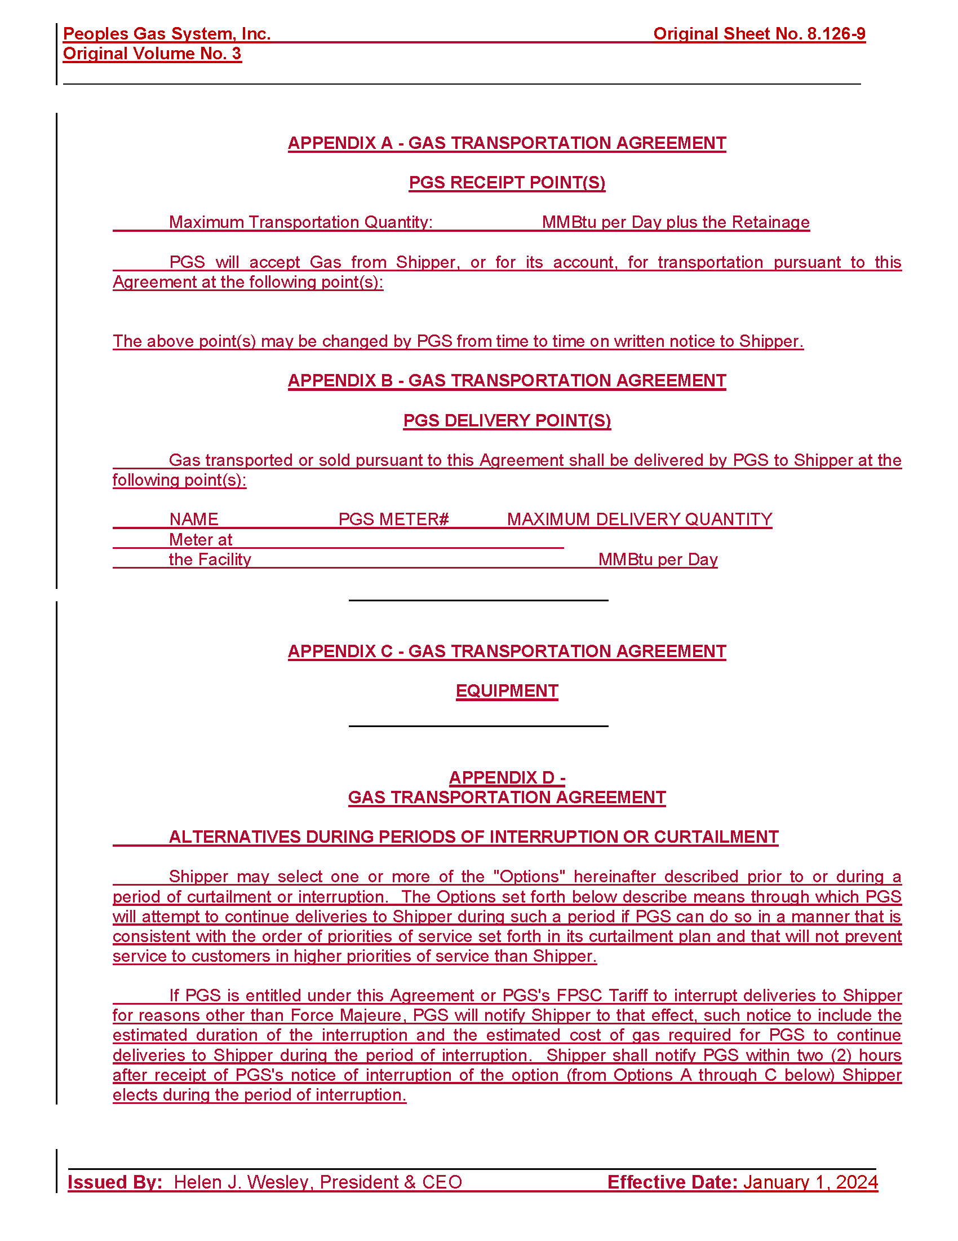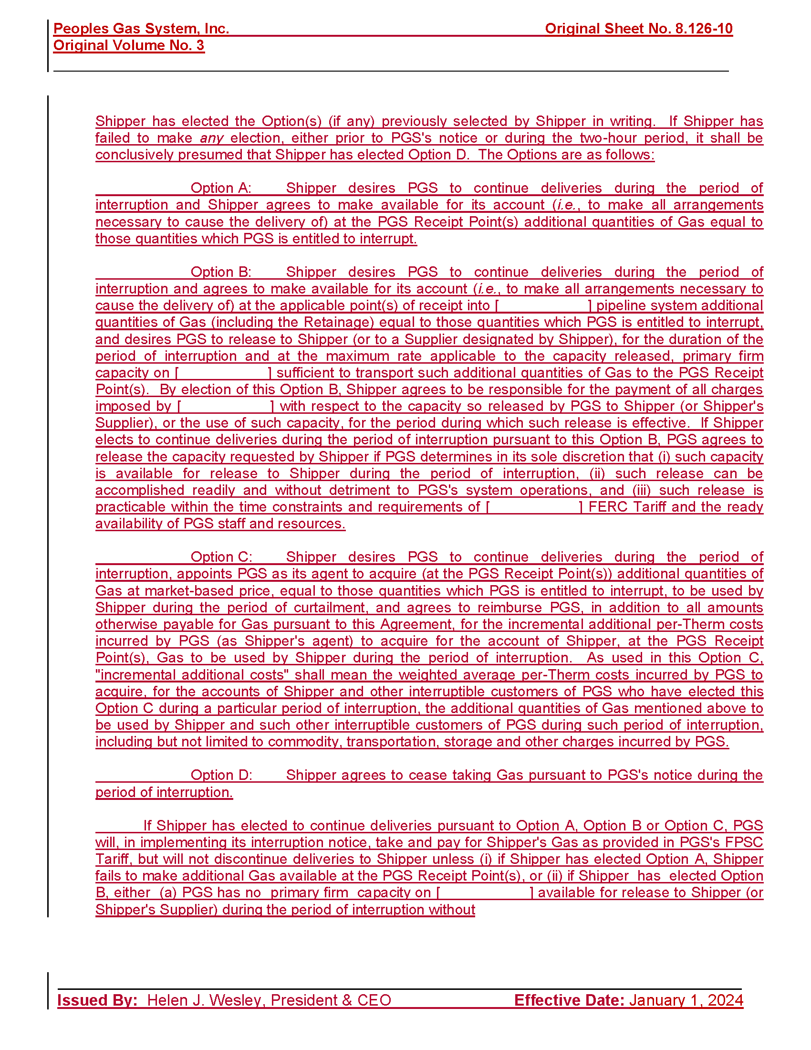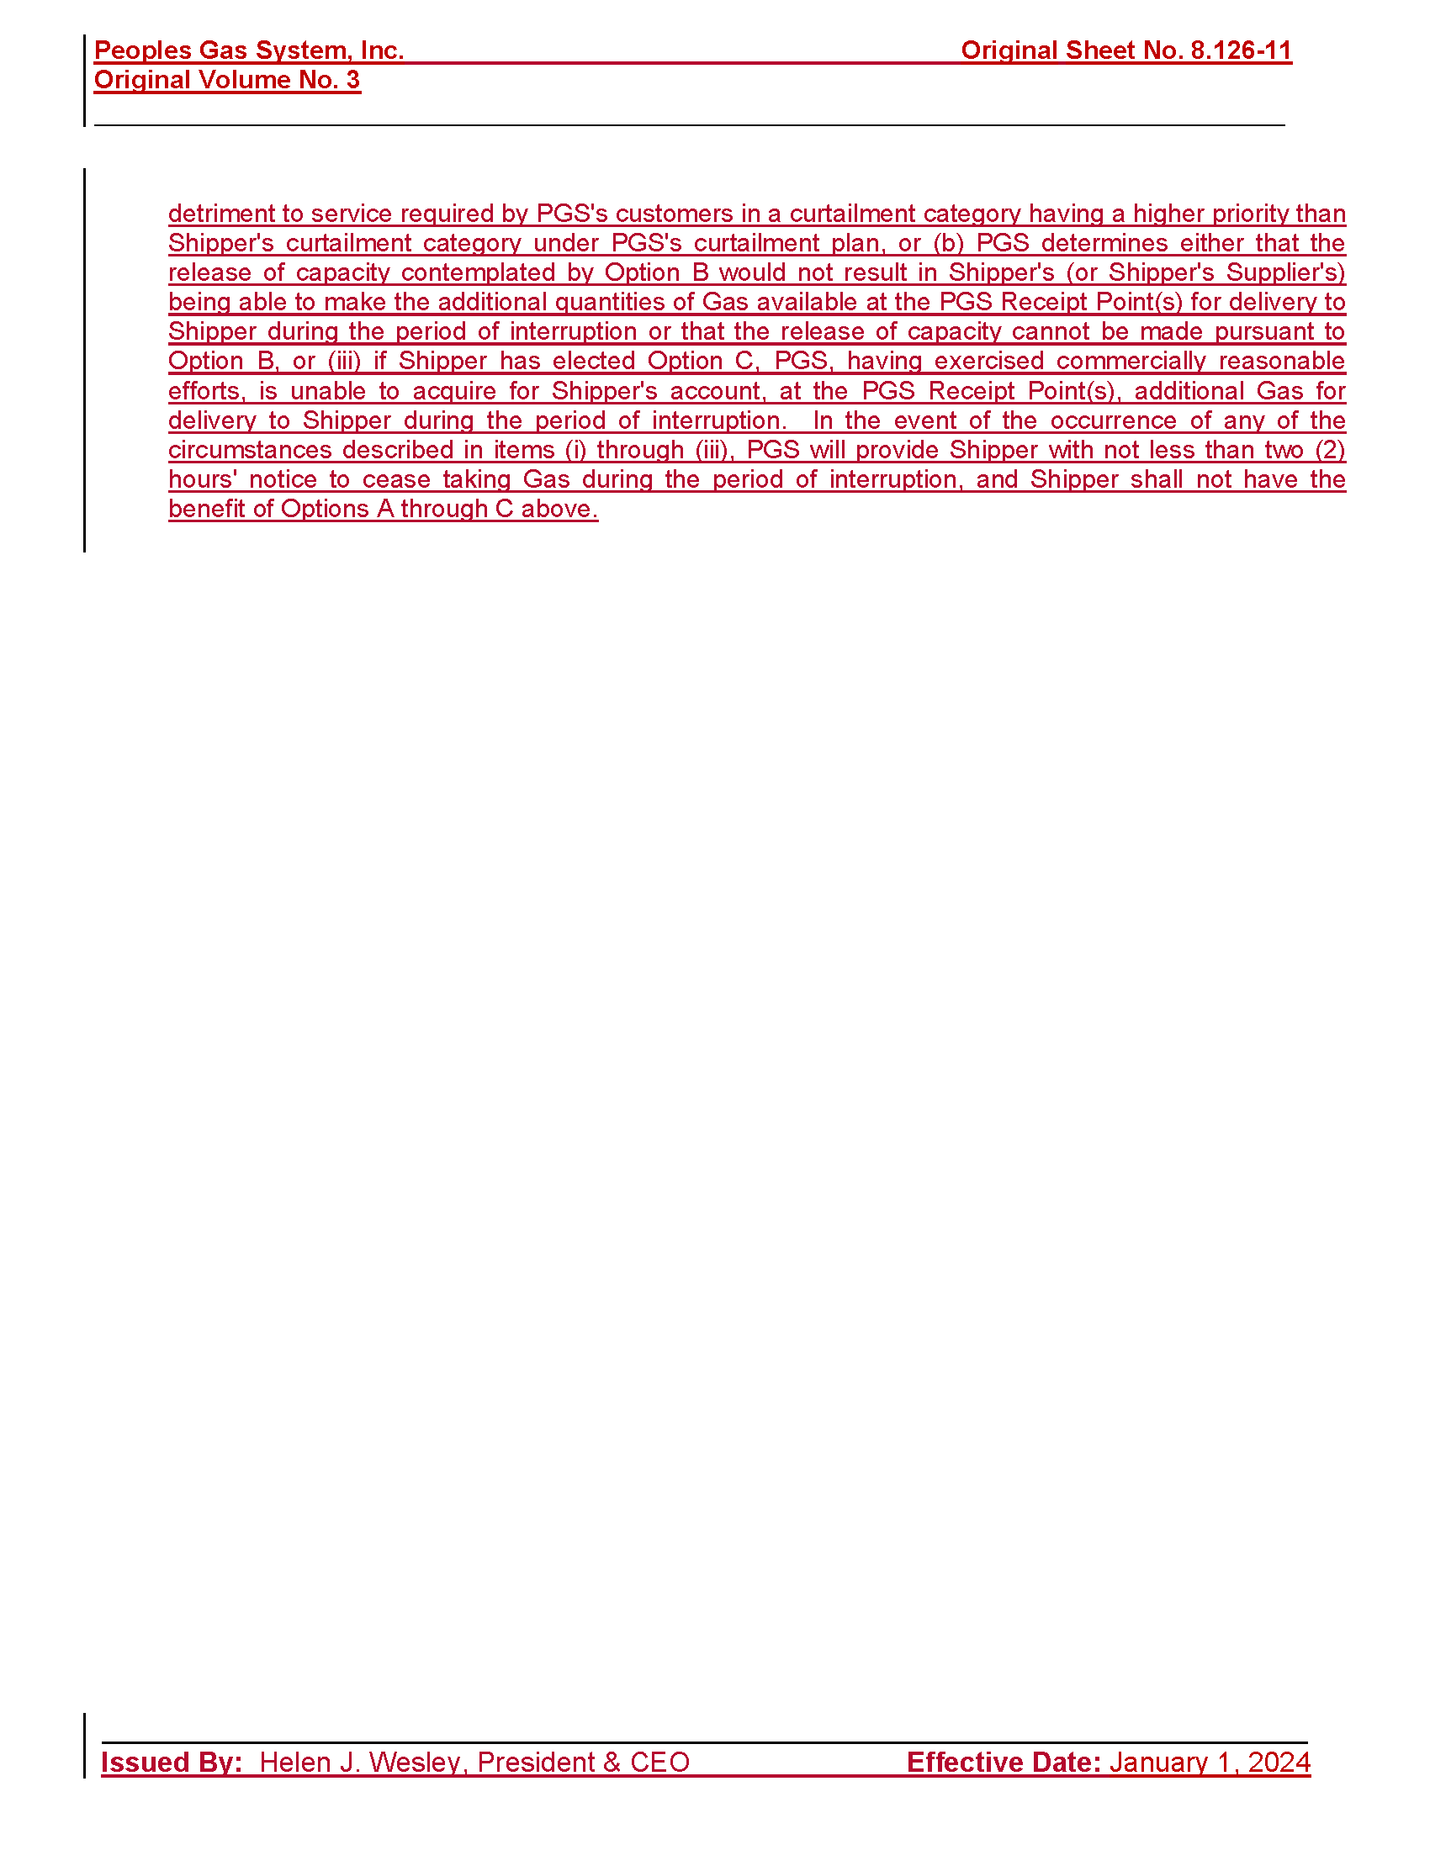

Order No. PSC-2020-0485-FOF-GU, issued December 10, 2020, in Docket No. 20200051-GU, In re: Petition for rate increase by Peoples Gas System.
A Type 1 stipulation occurs on an issue where the utility and intervenors agree on the resolution of the issue.
A Type 2 stipulation occurs when the utility and our staff, or the utility and at least one party adversarial to the utility, agree on the resolution of the issue and the remaining parties (including our staff if they do not join in the agreement) do not object to us relying on the agreed language to resolve that issue in a final order.
OPC’s position on each Type 2 stipulation is as follows: OPC takes no position on these issues, nor does it have the burden of proof related to them. As such, the OPC represents that it will not contest or oppose the Commission taking action approving a proposed stipulation between the Company and another party or staff as a final resolution of the issue. No person is authorized to state that the OPC is a participant in , or party to a stipulation on these issues, either in this docket, in an order of the Commission or in a representation to a Court.
Individual plant assets in an account do not normally have identical lives or investment amounts. An account’s ASL is the average number of years that the assets in the account are expected to be in-service.
A placement band is the vintages (a vintage refers to the year in which an asset was purchased) of plant assets that are being studied, and it is used to show the effects of technological and material changes over a specific era. An experience band means the transactions (such as retirements) that are happening over time to those vintage years of assets, and it is used to show the effects of business and operational changes during a set period.
Iowa Curves, which depict the retirement distributions, published in Bulletin 125, Statistical Analysis of Industrial Reporting, published in 1935, by Robley Winfrey of the Iowa State College Engineering Experimental Station, are widely-accepted representations of utility property retirement patterns. These are well established depreciation tools. Each curve is denoted by a letter and number. The letter defines when retirements are more likely to occur. An L curve implies that retirements tend to occur prior to the ASL while an R curve implies that retirements tend to occur after the ASL. The number portion of the Iowa Curve designation indicates how steep or flat the curve's shape is. For example, both R1 and R3 indicate that the majority of the retirements of the account are likely to occur after the ASL; and R3 curve indicates more retirements occur closer to the ASL, compared to R1 curve indicated.
The remaining life depreciation rate is the type of depreciation rate we use for determining appropriate customer rates.
Remaining Life Rate = (100% - Reserve % - Average Future Net Salvage %) ÷ Average Remaining Life in Years.
An account’s curve is a graphical representation of the retirement pattern for the plant assets of the account.
Rule 25-7.045(4)(a), F.A.C.
Transaction year is the year in which the asset was retired.
An OLT curve is only ever complete when all assets within the data set being analyzed are retired.
Docket No. 20160159-GU, In re: Petition for approval of settlement agreement pertaining to Peoples Gas System’s 2016 depreciation study, environmental reserve account, problematic plastic pipe replacement, and authorized ROE; Docket No. 20200051-GU, In re: Petition for rate increase by Peoples Gas System.
(70 – 65) / 65 = 7.7%
The industry’s current ASL range is determined based upon Order Nos. PSC-2020-0485-FOF-GU, issued December 10, 2020, in Docket No. 20200051-GU, In re: Petition for rate increase by Peoples Gas System; PSC-2022-0153-PAA-GU, issued April 22, 2022, in Docket No. 20210183-GU, In re: Petition for approval of 2021 depreciation study, by Sebring Gas System; PSC-2023-0103A-FOF-GU, issued April 6, 2023, in Docket No. 20220067-GU, In re: Petition for rate increase by Florida Public Utilities Company, Florida Division of Chesapeake Utilities Corporation, Florida Public Utilities Company - Fort Meade, and Florida Public Utilities Company - Indiantown Division; PSC-2023-0177-FOF-GU, issued June 9, 2023, in Docket No. 20220069-GU, In re: Petition for rate increase by Florida City Gas; and PSC-2023-0215-PAA-GU, issue July 26, 2023, in Docket No. 20230022-GU, In re: Petition for approval of 2022 Depreciation Study by St. Joe Natural Gas Company, Inc.
In Docket No. 20170179-GU, In re: Petition for rate increase by Florida City Gas, witness Garrett recommended an ASL of 59 years for this account. In Docket No. 20220069-GU, In re: Petition for rate increase by Florida City Gas, witness Garrett recommended an ASL of 70 years for this account.
As it pertains to depreciation and rate change, gradualism is the concept of making smaller adjustments over time as opposed to less frequent, large adjustments. See Order Nos. PSC-10-0131-FOF-EI, issued March 5, 2010, in Docket No. 090079-EI, In re: Petition for increase in rates by Progress Energy Florida; and PSC-2023-0177-FOF-GU, issued June 9, 2023, in Docket 20220069-GU, In re: Petition for rate increase by Florida City Gas.
A city gate is the entry point for gas being taken from a transmission system to a distribution system. PGS has over 90 city gates.
For example, odorizers may last 40-50 years, heaters may last 20-30 years, and regulators may last 30 years or more.
Respectively, placement and experience bands used by witness Watson are: 1) 1959-2021 and 1983-2021, 2) 1959-2021 and 1997-2021, and 3) 1983-2021 and 1983-2021; by witness Garrett is: 1) 1983-2021 and 1983-2021.
Docket No. 20170179-GU, In re: Petition for rate increase by Florida City Gas; Docket No. 20220069-GU, In re: Petition for rate increase by Florida City Gas.
(62 - 55) / 55 = 12.7%
Respective placement and experience bands used by witness Watson are: 1) 1939-2021 and 1983-2021, 2) 1939-2021 and 1997-2021, and 3) 1983-2021 and 1983-2021; used by witness Garrett is: 1) 1983-2021 and 1983-2021.
Dockets No. 20170179, In re: Petition for rate increase by Florida City Gas; 20220069-GU, In re: Petition for rate increase by Florida City Gas.
(55 - 35) / 35 = 57.14%
Id.
Rule 25-7.045, F.A.C.
Rule 25-7.045(1)(e) and (m), F.A.C., prescribes the respective formulas for calculating an account’s whole life depreciation rate and remaining life depreciation rate. Conventionally, we use the remaining life depreciation rate for the purpose of customer rate setting.
Rule 25-7.045, F.A.C., prescribes the formula to determine a plant account’s remaining life depreciation rate: Depreciation base percent (or plant minus future net salvage percentages) less book reserve percent, divided by the average remaining life of the account. However, witness Garrett’s proposal was determined for all accounts’ depreciation rates by subtracting the theoretical reserve from the depreciation base, rather than subtracting the book reserve from the depreciation base. This substitution impacted his calculation of the remaining life rate, and is in violation of the rule.
See Order Nos. PSC-10-0153-FOF-EI, issued March 17, 2010, in Docket No. 080677-EI, In re: Petition for increase in rates by Florida Power & Light Company; PSC-13-0023-S-EI, issued January 14, 2013, in Docket No. 120015-EI, In re: Petition for increase in rates by Florida Power & Light Company; PSC-16-0560-AS-EI, issued December 15, 2016, in Docket No. 1600621, In re: Petition for rate increase by Florida Power & Light Company; PSC-2020-0485-FOF-GU, issued December 10, 2020, in Docket 20200051-GU, In re: Petition for rate increase by Peoples Gas System; and PSC-2021-0446-S-EI, issued December 2, 2021, in Docket No. 20210015-EI, In re: Petition for increase in rates by Florida Power & Light Company.
Order No. PSC-2023-0177-FOF-GU, issued June 9, 2023, in Docket No. 20220069-GU, In re: Petition for rate increase by Florida City Gas.
Order Nos. PSC-2020-0485-FOF-GU, issued December 10, 2020, in Docket No. 20200051-GU, In re: Petition for rate increase by Peoples Gas System; and PSC-2018-0501-S-GU, issued October 18, 2018, in Docket No. 20180044-GU, In re: Consideration of the tax impacts associated with Tax Cuts and Jobs Act of 2017 for Peoples Gas System.
Order No. PSC-2020-0485-FOF-GU, p. 217.
Order No. PSC-2018-0501-S-GU, p. 39, 42.
Order No. PSC-2023-0177-FOF-GU, issued June 9, 2023, in Docket No. 20220069-GU, In re: Petition for rate increase by Florida City Gas.
Order No. PSC-2021-0237-PAA-EI, issued June 30, 2021, in Docket No. 20200234-EI, In re: Petition for approval of direct current microgrid pilot program and for variance from or waiver of Rule 25-6.065, F.A.C., by Tampa Electric Company.
The projected test year balance of plant in service, less the Company’s adjustment to reflect Common Plant allocations.
Order No. PSC-2020-0485-FOF-GU, issued December 10, 2020, in Docket No. 20200051-GU, In re: Petition for rate increase by Peoples Gas System.
A PLR is a statement by the IRS that interprets tax law at the request of a taxpayer .
Order Nos. PSC-10-0153-FOF-EI, issued March 17, 2020, In re: Petition for increase in rates by Florida Power & Light Company, p. 109-110, and PSC-10-0029-PAA-GU, issued January 14, 2010, In re: Petition for increase in rates by Florida Division of Chesapeake Utilities Corporation, p. 10.
An indicative credit rating is one that is unpublished and confidential which reflects the analysis of one or more hypothetical scenarios for a company.
Contagion risk is the spread of financial difficulties or economic crisis between affiliates.
Bankruptcy remoteness is a company within a corporate group whose bankruptcy has as little impact as possible on other entities within the group.
Order Nos. PSC-10-0153-FOF-EI, issued March 17, 2020, in Docket No. 20080677-EI, In re: Petition for increase in rates by Florida Power & Light Company, p. 109-110, and PSC-10-0029-PAA-GU, issued January 14, 2010, in Docket No. 20090125-GU, In re: Petition for increase in rates by Florida Division of Chesapeake Utilities Corporation, p. 10.
Order No. PSC-2020-0485-FOF-GU, issued December 10, 2020, in Docket No. 20200051-GU, In Re: Petition for rate increase by Peoples Gas System.
Both PGS witness D’Ascendis and OPC witness Garrett used the same gas utility proxy group in their equity ratio analysis.
Order No. PSC-2020-0485-FOF-GU.
Order No. PSC-2023-0103-FOF-GU, issued March 15, 2023, in Docket No. 20220067-GU, In re: Petition for rate increase by Florida Public Utilities Company, Florida Division of Chesapeake Utilities Corporation, Florida Public Utilities Company – Fort Meade, and Florida Public Utilities Company – Indiantown Division, p. 57.
DCF Model and CAPM refer to the Discounted Cash Flow Model and the Capital Asset Pricing Model. These cost of equity models are discussed in greater detail, infra.
Bluefield Water Works and Improvement Co. v. Public Service Commission, 262 U.S. 679, 692 (1923); Federal Power Commission v. Hope Natural Gas Co., 320 U.S. 591, 603 (1944). These cases are discussed in greater detail, infra.
Bluefield Water Works and Improvement Co. v. Public Service Commission, 262 U.S. 679, 692 (1923); Federal Power Commission v. Hope Natural Gas Co., 320 U.S. 591, 603 (1944). These cases are discussed in greater detail, infra.
Order No. PSC-10-0153-FOF-EI, issued March 17, 2010, in Docket No. 20080677-EI, In re: Petition for increase in rates by Florida Power & Light, p. 121.
Measure 6 is the Bloomberg Projected MRP based on the total return on the market using the S&P 500 index.
Aswath Damodaran is a Professor of Finance at the Stern School of Business at New York University and is renowned for his work in the field of investment valuation and has written several books on the subject.
Order No. PSC-2020-0485-FOF-GU, issued December 10, 2020, in Docket No. 20200051-GU, In re: Petition for rate increase by Peoples Gas System.
Order Nos. PSC-14-0698-PAA-GU, issued December 18, 2014, in Docket No. 20140016, In re: 2014 depreciation study by Florida Public Utilities Company; and PSC-13-1093-PAA-EI, issued May 6, 2013, in Docket No. 20120303, In re: Petition for approval for an accounting order to record in a regulatory asset or liability the unrealized and realized gains and losses resulting from financial accounting requirements related to interest rate derivative agreements, Progress Energy Florida, Inc.
Document No. 06067-2023.
Order No. PSC-2018-0501-S-GU, issued October 18, 2018, in Docket No. 20180044-GU, In re: Consideration of the tax impacts associated with Tax Cuts and Jobs Act of 2017 for Peoples Gas System, p. 8.
PGS’s Cast Iron/Bare Steel Replacement Rider was approved by Order No. PSC-12-0476-TRF-GU, issued September 18, 2012, in Docket No. 20110320-GU, In re: Petition for approval of Cast Iron/Bare Steel Pipe Replacement Rider (Rider CI/BSR), by Peoples Gas System.
Order Nos. PSC-10-0153-FOF-EI, issued March 17, 2020, in Docket No. 20080677-EI, In re: Petition for increase in rates by Florida Power & Light Company, p. 109-110; and PSC-10-0029-PAA-GU, issued January 14, 2010, in Docket No. 20090125-GU, In re: Petition for increase in rates by Florida Division of Chesapeake Utilities Corporation, p. 10.

