State of Florida   |  | Public Service Commission  Capital Circle Office Center ● 2540 Shumard Oak Boulevard  Tallahassee, Florida 32399-0850  -M-E-M-O-R-A-N-D-U-M-
DATE: | February 22, 2024
TO: | Office of Commission Clerk (Teitzman)
FROM: | Office of the General Counsel (Stiller) JSC  Division of Accounting and Finance (Buys, Cicchetti, Mouring) ALM  Division of Economics (Galloway, McNulty) EJD  Division of Engineering (Ellis, King, Ramos) TB
RE: | Docket No. 20210015-EI – Petition for rate increase by Florida Power & Light Company.
AGENDA: | 03/05/24 – Regular Agenda – Post-Hearing Decision – Participation is at the Commission’s discretion for Issues 1 and 2; Participation on Issue 3 is limited to Commissioners and staff
COMMISSIONERS ASSIGNED: |  |  | All Commissioners
PREHEARING OFFICER: |  |  | Clark
CRITICAL DATES: |  |  | None
SPECIAL INSTRUCTIONS: |  |  | None

Case Background
This proceeding is before the Commission on remand from the Florida Supreme Court. Also pending are two motions related to the remand: Floridians Against Increased Rates, Inc.’s Motion to Reopen the Evidentiary Record; and Florida Rising’s, League of United Latin American Citizens’, & Environmental Confederation of Southwest Florida’s Motion for Evidentiary Hearing. A brief recap of the history of this matter is provided for context.

This docket was opened January 11, 2021, when Florida Power & Light Company (FPL or Company) filed a letter providing notice that it would file a request for a base rate increase and requesting that we approve a test year for the filing. On March 12, 2021, FPL filed its petition, minimum filing requirements, and testimony for a base rate increase effective January 2022. Numerous parties intervened in this docket and undertook substantial discovery.

One week prior to the scheduled commencement of the final hearing, FPL and several intervening parties in this docket (Signatories) filed a Joint Motion for Approval of Settlement Agreement, with a copy of the subject Stipulation and Settlement (2021 Settlement). Intervenors Floridians Against Increased Rates (FAIR), the Environmental Confederation of Southwest Florida (ECOSWF), Florida Rising, Inc., and League of United Latin American Citizens of Florida (LULAC) (collectively “Intervenors”) did not join the Agreement and opposed the Joint Motion for Approval of Settlement Agreement.

On September 20, 2021, a final hearing was conducted on FPL’s base rate petition as well as the Joint Motion for Approval of the 2021 Settlement. On December 2, 2021, the Commission entered a Final Order Approving the 2021 Stipulation and Settlement Agreement. On December 9, 2021, the Commission entered an Order Amending that Final Order to correct several non-substantive scrivener’s errors relating to dates and references. This Order and Order No. PSC-2021-0446-S-EI will be referred to collectively as “the 2021 Final Order” in this Recommendation.

On December 28, 2021, FAIR timely filed an appeal of the 2021 Final Order. On January 3, Florida Rising, ECOSWF and LULAC (collectively “Florida Rising”) timely filed their appeal of the 2021 Final Order. The Florida Supreme Court consolidated these appeals and, on September 28, 2023, remanded this matter for further proceedings.

The Court’s remand is limited and specific. The Court neither affirmed nor reversed the Commission’s prior conclusion that the 2021 Settlement is in the public interest. The Court did not vacate the 2021 Final Order. Instead, the Court remanded for a further explanation of the Commission’s approval, which “includes considering the competing arguments made by the parties below in light of the factors relevant to the Commission’s decision, and supplying, given these arguments and factors, an explanation of how the evidence presented led to its decision.”

The Court did not establish a procedure for the Commission to follow on remand. Instead, the Court wrote as follows:
Subject to any statutory requirements, the form of the proceedings on remand will be up to the Commission, including the decision whether to allow the parties to present additional evidence.
On November 9, 2023, Commission staff conducted an informal meeting with the parties to this docket who were also parties to the Supreme Court appeal – FAIR, Florida Rising, and FPL – and presented a list of the “competing arguments” that appeared appropriate for consideration on remand. The parties agreed that this list was complete. As discussed below in Issue 3, staff has drafted for Commission consideration a draft Supplemental Order that addresses all of these arguments in the manner outlined by the Supreme Court’s opinion in FAIR. Staff drafted this Supplemental Order on the record that was before the Commission when the vote on the 2021 Settlement was taken in October 2021.

On February 6, 2024, FAIR filed a Motion to Reopen the Evidentiary Record. On February 7, 2024, Florida Rising filed a Motion for Evidentiary Hearing. Both Motions seeks to add evidence to the evidentiary record in this docket. On February 13, 2024, FPL filed a Response in Opposition to Motions to Reopen Record, in which the Company provided a consolidated response to both FAIR and Florida Rising’s Motions. Issues 1 and 2 of the recommendation address the FAIR and Florida Rising Motions. Issue 3 addresses the Supplemental Order.

The Commission has jurisdiction over this matter pursuant to the Court’s remand and the provisions of Chapter 120 and Sections 366.04, 366.05, and 366.06, Florida Statutes (F.S.).

Discussion of Issues

Issue 1:
Should Floridians Against Increased Rates, Inc.’s Motion to Reopen the Evidentiary Record be granted?

Recommendation:
No. FAIR seeks to reopen the record for the purpose of submitting evidence that was not in existence at the time the Commission voted and issued the 2021 Final Order. Because the Commission could not have relied on this evidence when the original decision was made, staff believes it would be improper to do so now and admit the FEECA Report. Moreover, staff believes that granting the Motion would create numerous fundamental procedural issues. (Stiller)

Staff Analysis:

When the Supreme Court remanded this proceeding to the Commission for a further explanation of its approval, the Court directed that the Commission “shall also consider the performance of each utility pursuant to [the Florida Energy Efficiency and Conservation Act] when establishing rates for those utilities over which the commission has ratesetting authority.” Section 366.82(10), F.S. (2021). Citing this direction and the discretion afforded the Commission in conducting this remand, FAIR filed a Motion to Reopen the Evidentiary Record. In the Motion, FAIR requests that the Commission reopen the evidentiary record for the limited and sole purpose of admitting the Commission’s Annual Report of Activities Pursuant to the Florida Energy and Conservation Act for 2021 (FEECA Report). FAIR asserts that the Commission must have the FEECA Report to comply with the Supreme Court’s remand.

FPL filed its response in opposition, arguing first that the existing record on FEECA is sufficient. FPL submitted prefiled testimony on a number of areas relevant to FEECA. FPL states that all Intervenors had the opportunity to respond to this testimony, and that several did present FEECA-related testimony. FPL also notes that virtually all of the documents sought to be submitted were not in existence when the Commission made its original decision.

By way of background, the Florida Energy Efficiency and Conservation Act (FEECA) is codified in Sections 366.80 through 366.83, and 403.519, F.S. When enacted in 1980, FEECA required the Commission to adopt conservation goals to increase the efficiency of energy consumption. In 2008, the Legislature amended FEECA to require the Commission to adopt conservation goals to increase the development of demand-side renewable energy systems. Pursuant to Section 366.82(6), F.S., the Commission must review the conservation goals of each utility subject to FEECA at least every five years. The Commission last established conservation goals for FPL in 2019.

The FEECA Report was prepared by the Commission pursuant to Section 366.82(10), F.S., which provides, in pertinent part, that “[]the commission shall require periodic reports from each utility and shall provide the Legislature and the Governor with an annual report by March 1 of the goals it has adopted and its progress toward meeting those goals.” The FEECA Report bears an issuance date of November 2021. The final evidentiary hearing in the base rate case concluded September 20, 2021. The Commission voted to approve the stipulation and settlement on October 26, 2021. The FEECA Report was not in existence on either of these dates.

Because the FEECA Report was prepared by the Commission pursuant to a statutory duty, it may be admissible in a proceeding in which it is relevant. However, the FEECA Report did not exist in this form until the record in this proceeding was closed and the decision made. Staff believes it would not be appropriate to place documents created post-hearing, post-decision in the record for purposes of making additional findings.

Additionally, FAIR’s request would necessitate opening the proceeding to provide FPL due process, leading to a potential procedural morass.

If one side were permitted to produce additional evidence, as suggested . . . , then the other side would necessarily have to be given the same privilege, and each side would of necessity have to be given the right of confrontation and cross-examination of the additional witnesses, and possibly rebuttal. We do not envision the Administrative Procedures Act as permitting such a never-ending process.

In conclusion, because the Commission could not have relied on this evidence when the original decision was made, staff believes it would be improper to do so now and admit the FEECA Report. Moreover, staff believes that granting the Motion would create numerous fundamental procedural issues. Staff notes that the draft Supplemental Order discussed in Issue 3 addresses the Florida Supreme Court’s direction that the Commission consider FEECA performance “to the extent practical.”

Issue 2:
Should Florida Rising’s, League of United Latin American Citizens’, and Environmental Confederation of Southwest Florida’s Motion for Evidentiary Hearing be granted?

Recommendation:
No. Florida Rising’s request that the Commission conduct a limited hearing specifically on FEECA is beyond the scope of this remand. As to the request to submit additional documentary evidence, virtually all of the evidence Florida Rising seeks to submit for Commission consideration was not in existence at the time the Commission issued the 2021 Final Order. Because the Commission could not have relied on this evidence when the original decision was made, staff believes it would be improper to now admit the various reports cited by Florida Rising (or have an evidentiary hearing on them). Moreover, staff believes that granting the Motion would create numerous fundamental procedural issues. These same procedural concerns apply to the materials proffered by Florida Rising that were in existence when the Commission made its prior decision. Reopening the record for purposes of admitting these materials would result in, essentially, a new hearing, when these materials could have been but were not admitted in the original rate case. (Stiller)

Staff Analysis:

Citing the same provisions in the FAIR opinion discussed above in Issue 1, Florida Rising filed a Motion for Evidentiary Hearing. While similar to FAIR’s Motion, Florida Rising seeks broader relief. Florida Rising first requests that the Commission schedule an evidentiary hearing solely on FPL’s FEECA performance. Alternatively, Florida Rising seeks to submit the FEECA Reports covering the years 2020, 2021, and 2023. By comparison, FAIR only sought to submit the 2021 FEECA Report. Florida Rising also seeks to submit the Demand Side Management (DSM) Reports from FPL for this same, three-year time period. Finally, Florida Rising seeks to submit data compiled by the United States Energy Information Agency (EIA) for the years 2020, 2021, and 2022. Florida Rising contends that the Commission must have this information in order to comply with the Supreme Court’s remand and the consideration of FPL’s FEECA performance.
FPL filed its response in opposition, arguing first that the existing record on FEECA is sufficient. FPL submitted prefiled testimony on a number of areas relevant to FEECA. FPL states that all Intervenors had the opportunity to respond to this testimony, and that several did present FEECA-related testimony. FPL also notes that virtually all of the documents sought to be submitted were not in existence when the Commission made its original decision.

As to the materials that were not in existence when the Commission made its prior decision and the request for an evidentiary hearing on those materials, the same analysis applies as set forth above in Issue 1. Staff believes this portion of the request suffers the same flaws and should be denied for the same reasons.
The EIA information in existence prior to October 2021 and the 2020 FEECA and DSM Reports were in existence when the Commission made its prior decision. Accordingly, Florida Rising could have sought to submit them in 2021 when this docket was litigated. No good cause for this failure is set forth in the Motion.
Allowing Florida Rising to submit this material would necessitate some sort of evidentiary hearing to comport with due process. Again, Florida Rising has demonstrated no cause for the Commission to take the extraordinary step of reopening a rate case to allow the presentation of evidence that could have been, but was not, introduced at the rate hearing.
For these reasons, staff recommends that the Commission deny Florida Rising’s Motion. The request that the Commission conduct a limited hearing specifically on FEECA is beyond the scope of this remand. As to the request to submit additional documentary evidence, virtually all of the evidence Florida Rising seeks to submit for Commission consideration was not in existence at the time the Commission issued the 2021 Final Order. Because the Commission could not have relied on this evidence when the original decision was made, staff believes it would be improper to now admit the various reports cited by Florida Rising (or have an evidentiary hearing on them). Moreover, staff believes that granting the Motion would create numerous fundamental procedural issues. These same procedural concerns apply with equal weight to the materials proffered by Florida Rising that were in existence when the Commission made its prior decision. Reopening the record for purposes of admitting these materials would result in, essentially, a new hearing, when these materials could have been but were not admitted in the original rate case. Staff notes that the draft Supplemental Order discussed in Issue 3 addresses the Florida Supreme Court’s direction that the Commission consider FEECA performance “to the extent practical.”

Issue 3:
How should the Commission respond to the Florida Supreme Court’s decision in Floridians Against Increased Rates, Inc. v. Clark, 371 So. 3d 905 (Fla. 2023)?

Recommendation:
Staff recommends that the Commission approve and enter the attached Supplemental Order. This Order affirms the Commission’s prior approval of the 2021 Settlement and provides the additional explanation requested by the Florida Supreme Court. (Stiller)

Staff Analysis:

As discussed in the Case Background and in greater detail in the attached draft Supplemental Order, the Commission entered the 2021 Final Order in December 2021, which approved the 2021 Stipulation and Settlement Agreement and closed FPL’s 2021 rate case. FAIR and Florida Rising separately filed appeals of the 2021 Final Order. The Florida Supreme Court consolidated these appeals and, on September 28, 2023, remanded this matter.

The Court’s remand is limited and specific. The Court neither affirmed nor reversed the Commission’s prior conclusion that the 2021 Settlement is in the public interest. The Court did not vacate the 2021 Final Order. Instead, the Court remanded for a further explanation of the Commission’s approval, which “includes considering the competing arguments made by the parties below in light of the factors relevant to the Commission’s decision, and supplying, given these arguments and factors, an explanation of how the evidence presented led to its decision.”

Attached is a draft Supplemental Order prepared by staff. This draft fully discusses the competing arguments forwarded by the parties in light of the factors identified by the Florida Supreme Court. Staff’s recommendation is that the Commission issue the Supplemental Order as its response to the remand.

Procedurally, this Supplement Order is itself a Final Order that affirms the 2021 Final Order. The parties will be afforded notice of the opportunity to appeal the Supplemental Order to the Florida Supreme Court. Staff recommends that the Commission approve and enter the attached Supplemental Order.

Issue 4:
Should this docket be closed?

Recommendation:
Yes. After the Supplemental Order on Remand is issued, this docket should be closed. (Stiller)

Staff Analysis:
The Florida Supreme Court closed its docket when it remanded this proceeding to the Commission. The only open docket on this matter is the present one before the Commission, and the only action remaining is to supplement the 2021 Final Order. Thus, the Supplemental Order on Remand should be issued in the same manner as a Final Order. Like a more typical Final Order, this Supplemental Order on Remand is the last act remaining for the Commission to undertake in this docket. Accordingly, after the Supplemental Order is issued, this docket should be closed.

Attachment
DRAFT Supplemental Final Order

BEFORE THE FLORIDA PUBLIC SERVICE COMMISSION

In re: Petition for rate increase by Florida Power & Light Company. | DOCKET NO. 20210015-EI  ORDER NO.  ISSUED:

The following Commissioners participated in the disposition of this matter:

MIKE LA ROSA, Chairman
ART GRAHAM
GARY F. CLARK
ANDREW GILES FAY
GABRIELLA PASSIDOMO

APPEARANCES:

R. WADE LITCHFIELD, Vice President and General Counsel; JOHN T. BURNETT, Vice President and Deputy General Counsel; MARIA J. MONCADA, Senior Attorney, and CHRISTOPHER WRIGHT, ESQUIRE, Florida Power & Light Company, 700 Universe Boulevard, Juno Beach, FL 33408
On behalf of Florida Power & Light Company (FPL).

RICHARD GENTRY, Public Counsel; PATRICIA A. CHRISTENSEN, Associate Public Counsel; ANASTACIA PIRRELLO, Associate Public Counsel; and CHARLES REHWINKEL, Deputy Public Counsel; Office of Public Counsel, c/o The Florida Legislature, 111 West Madison Street, Room 812, Tallahassee, Florida 32399-1400
On behalf of Office of the Public Counsel (OPC).

WILLIAM C. GARNER, ESQUIRE, Law Office of William C. Garner, PLLC, 3425 Bannerman Road, Unit 105, #414, Tallahassee, FL 32312
On behalf of the CLEO Institute Inc. (CLEO).

ROBERT SCHEFFEL WRIGHT and JOHN T. LAVIA, III, ESQUIRES, Gardner, Bist, Bowden, Dee, LaVia, Wright, Perry & Harper, P.A., 1300 Thomaswood Drive, Tallahassee, Florida 32308
On behalf of Floridians Against Increased Rates, Inc. (FAIR).

SCOTT L. KIRK, MAJ, USAF, AF/JAOE-ULFSC, ESQUIRE, 139 Barnes Drive, Suite 1, Tyndall Air Force Base, FL 32403
On behalf of the Federal Executive Agencies (FEA).

JON C. MOYLE, JR. and KAREN PUTNAL, ESQUIRES, Moyle Law Firm, P.A., 118 North Gadsden Street, Tallahassee, FL 32312
On behalf of the Florida Industrial Power Users Group (FIPUG).

FLOYD R. SELF, ESQUIRE, Berger Singerman, LLP, 313 North Monroe Street, Suite 301, Tallahassee, FL 32301 and T. SCOTT THOMPSON, ESQUIRE, Mintz, Levin, Cohn, Ferris, Glovsky and Popeo, P.C., 555 12th Street NW, Suite 1100, Washington, DC 20004
On behalf of Florida Internet & Television Association, Inc. (FIT).

JAMES W. BREW and LAURA WYNN BAKER, ESQUIRES, Stone Mattheis Xenopoulos & Brew, PC, 1025 Thomas Jefferson Street, NW, Eighth Floor, West Tower, Washington, D.C. 20007
On behalf of Florida Retail Federation (FRF).

BRADLEY MARSHALL and JORDAN LUEBKEMANN, ESQUIRES, Earthjustice, 111 S. Martin Luther King Jr. Blvd., Tallahassee, Florida 32301 and CHRISTINA I. REICHERT, ESQUIRE, Earthjustice, 4500 Biscayne Blvd., Ste. 201, Miami, Florida 33137
On behalf of Florida Rising, Inc., League of United Latin American Citizens of Florida, and Environmental Confederation of Southwest Florida, Inc. (Fla. Rising, LULAC, ECOSWF).

NATHAN A. SKOP, ESQUIRE, 420 NW 50th Boulevard, Gainesville, FL 32607
On behalf of Daniel and Alexandria Larson (Larsons).

GEORGE CAVROS, ESQUIRE, Southern Alliance for Clean Energy, 120 E. Oakland Park Blvd., Suite 105, Fort Lauderdale, FL 33334
On behalf of Southern Alliance for Clean Energy (SACE).

KATIE CHILES OTTENWELLER, ESQUIRE, Southeast Director, Vote Solar, 838 Barton Woods Road, Atlanta, GA 30307
On behalf of Vote Solar.

STEPHANIE U. EATON, ESQUIRE, Spilman Thomas & Battle, PLLC, 110 Oakwood Drive, Suite 500, Winston-Salem, NC 27103
On behalf of Walmart Inc. (Walmart).

SUZANNE S. BROWNLESS, SHAW P. STILLER, and BIANCA LHERISSON, ESQUIRES, Florida Public Service Commission, 2540 Shumard Oak Boulevard, Tallahassee, Florida 32399-0850
On behalf of the Florida Public Service Commission (Staff).

MARY ANNE HELTON, ESQUIRE, Deputy General Counsel, Florida Public Service Commission, 2540 Shumard Oak Boulevard, Tallahassee, Florida 32399-0850
Advisor to the Florida Public Service Commission.

KEITH C. HETRICK, ESQUIRE, General Counsel, Florida Public Service Commission, 2540 Shumard Oak Boulevard, Tallahassee, Florida 32399-0850
Florida Public Service Commission General Counsel.

SUPPLEMENTAL FINAL ORDER

BY THE COMMISSION:

BACKGROUND

This proceeding is before us on remand from the Florida Supreme Court. Before addressing the substance of this remand, we provide the following brief synopsis of the procedural history of this matter.

This docket was opened January 11, 2021, when the Florida Power & Light Company (FPL or Company) filed a letter notifying us that it would file a request for a base rate increase. On March 12, 2021, FPL filed its petition, minimum filing requirements, and testimony for a base rate increase effective January 2022. Numerous parties intervened in this docket and undertook substantial discovery.

One week prior to the scheduled commencement of the final hearing, FPL and several intervening parties in this docket (Signatories) filed a Joint Motion for Approval of Settlement Agreement, with a copy of the subject Stipulation and Settlement (2021 Settlement). Intervenors Floridians Against Increased Rates (FAIR), the Environmental Confederation of Southwest Florida (ECOSWF), Florida Rising, Inc., and League of United Latin American Citizens of Florida (LULAC) (collectively “Intervenors”) did not join the Agreement and opposed the Joint Motion for Approval of Settlement Agreement.

On September 20, 2021, we conducted a final hearing on FPL’s base rate petition as well as the Joint Motion for Approval of the 2021 Settlement. On December 2, 2021, we entered a Final Order Approving 2021 Stipulation and Settlement Agreement. On December 9, 2021, we entered an Ordering Amending that Final Order to correct several non-substantive scrivener’s errors relating to dates and references. This Order and Order No. PSC-2021-0446-S-EI will be referred to collectively as “the 2021 Final Order” in this Order. Copies of these Orders are appended hereto as Attachments A (PSC-2021-0446-S-EI) and B (PSC-2021-0446A-S-EI).

On December 28, 2021, FAIR timely filed an appeal of the 2021 Final Order. On January 3, Florida Rising, ECOSWF and LULAC (collectively “Florida Rising”) timely filed their appeal of the 2021 Final Order. The Florida Supreme Court consolidated these appeals and, on September 28, 2023, remanded this matter for further proceedings.

We have jurisdiction over this matter pursuant to the Court’s remand and the provisions of Chapter 120 and Sections 366.04, 366.05, and 366.06, Florida Statutes (F.S.).

SCOPE OF REMAND

The 2021 Final Order that was appealed and remanded addressed the numerous issues raised by the parties in three groups, described as follows:

[1] standing – whether FAIR’s request to intervene should be granted; [2] jurisdictional - whether we have the statutory authority to approve proposed rate recovery mechanisms as part of the 2021 Settlement; and [3] whether the 2021 Settlement should be approved.

As to the first issue group, no party appealed or cross-appealed the issue of FAIR’s standing and, accordingly, it was not the subject of the Supreme Court’s remand. We are not entering supplemental findings or conclusions regarding FAIR’s standing, and that section of the 2021 Final Order remains unchanged.

Turning to the second issue group, the Court did not question our statutory authority to consider the various tools and accounting approaches set forth in the 2021 Settlement.

Appellants raise other arguments in opposition to the Commission's approval of the settlement agreement. These arguments include challenges to the Commission's statutory authority to approve various pieces of the settlement agreement: the Storm Cost Recovery Mechanism; the Reserve Surplus Amortization Mechanism; the Asset Optimization Incentive, which includes the monetization of renewable energy credits; a corporate tax adjustment; the Solar Base Rate Adjustment mechanism (SoBRA); a construction incentive for solar generation sites constructed pursuant to SoBRA; and cost recovery related to the Green Hydrogen Pilot Program and a consummation payment FPL made to Jacksonville Electric Authority concerning the retirement of a coal-fired power generation unit. To the extent any of these challenges to the Commission's statutory authority is preserved, none gives us a reason to set aside the order under review.

Because the Court found our stated bases for jurisdiction to be sufficient, we are not entering supplemental findings or conclusions regarding our jurisdiction to consider the 2021 Settlement, and that section of the 2021 Final Order remains unchanged.

The only issue the Court remanded to us is whether the 2021 Settlement should be approved as being in the public interest. The Court neither affirmed nor reversed our prior conclusion that the 2021 Settlement is in the public interest. The Court did not vacate the 2021 Final Order. Instead, the Court remanded for a further explanation of our approval, directing that we specifically address certain matters:

That includes considering [A] the competing arguments made by the parties below in light of [B] the factors relevant to the Commission’s decision, and supplying, given these arguments and factors, an explanation of how the evidence presented led to its decision.

- Competing Arguments made by the Parties

The Court identified the arguments forwarded by FAIR, LULAC, and ECOSWF as follows:

1. Need for the rate increases in the settlement agreement
2. ROE range.
3. Equity-to-debt ratio.
4. RSAM.
5. Rate base investments (SoBRA).
6. Pilot programs (electric vehicle chargers, Green Hydrogen, Solar Power Facilities.
7. SolarTogether.
8. Minimum bill.
9. Extension of time for recovery of retirement costs of certain assets.

We have thoroughly reviewed Intervenors’ Prehearing Statements and Post Hearing Briefs to determine if there are any additional disagreements between, or arguments raised by, the parties that were not specifically identified by the Court. We found six arguments raised before us that were not expressly mentioned in the above-quoted paragraph. On November 9, 2023, Commission staff conducted an informal meeting with the parties to this docket who were also parties to the Supreme Court appeal – Intervenors and FPL – and presented the above list of arguments. These parties agreed to that list with the following additional issues:

10. Revenue allocation between classes.
11. FPL system overbuilt.
12. Storm cost recovery mechanism.
13. Federal tax adjustments.
14. Incentive mechanism for asset optimization.
15. Solar cap cost incentive.

- Factors Relevant to the Commission’s Decision

The Court identified certain factors that we must consider in this remand when we address these competing arguments:

The Legislature has provided that the Commission, in “fixing fair, just, and reasonable rates for each customer class, ... shall, to the extent practicable, consider the cost of providing service to the class, as well as the rate history, value of service, and experience of the public utility; the consumption and load characteristics of the various classes of customers; and public acceptance of rate structures.” § 366.06(1). The Commission “shall also consider the performance of each utility pursuant to [the Florida Energy Efficiency and Conservation Act] when establishing rates for those utilities over which the commission has ratesetting authority.” § 366.82(10), Fla. Stat. (2021). A reasonably explained decision from the Commission must reflect that those factors have been considered to the extent practicable.

The Court also noted additional factors that we may consider in appropriate circumstances at our discretion:

[T]he Commission can consider “the efficiency, sufficiency, and adequacy of the facilities provided and the services rendered; the cost of providing such service and the value of such service to the public; the ability of the utility to improve such service and facilities; and energy conservation and the efficient use of alternative energy resources.” § 366.041(1), Fla. Stat. (2021). And the Legislature has made clear that “it is in the public interest to promote the development of renewable energy resources in this state.” § 366.91(1), Fla. Stat. (2021). Evidence that these factors have been considered—where they are germane to determining whether the settlement agreement is in the public interest and results in rates that are fair, just, and reasonable—permits meaningful judicial review of the Commission’s conclusions.

The Commission can also consider non-statutory factors if it explains why they are relevant and how they relate to the Commission’s “historical and statutory role.” Sierra Club, 243 So. 3d at 911. For example, in the order under review, the Commission supported its decision by stating that “FPL’s residential 1,000 kWh bill [is] projected to remain 21% below the current national average” under the settlement agreement. Assuming that it can explain the relevance of this metric in light of “the purpose of the Commission,” id., the Commission can permissibly consider it in making its decision.

Consistent with the Court’s direction, we provide below our explanation of how the evidence presented on the parties’ competing arguments, in light of the identified factors, leads to our conclusion that approving the 2021 Settlement is in the public interest. We do so based on the existing record. All aspects of Order No. PSC-2021-0446-S-EI and Order No. PSC-2021-0446A-S-EI remain unchanged.

Supplemental Findings and Conclusions

In reviewing a settlement agreement, we first “make[] factual findings based on the evidence presented by the parties.” As the finder of fact, we must “consider all the evidence presented, resolve conflicts, judge credibility of witnesses, draw permissible inferences from the evidence, and reach ultimate findings of fact based on competent substantial evidence.” Each of those ultimate findings of fact must be based on a preponderance of the record evidence. The Florida Supreme Court defines “preponderance of the evidence” as follows:

The greater weight of the evidence, not necessarily established by the greater number of witnesses testifying to a fact but by evidence that has the most convincing force; superior evidentiary weight that, though not sufficient to free the mind wholly from all reasonable doubt, is still sufficient to incline a fair and impartial mind to one side of the issue rather than the other.

Our findings of fact regarding the competing arguments presented by the parties are set forth below.

Issue 1: The need for the rate increases in the Settlement Agreement.

In the original filing, FPL requested a comprehensive base revenue increase in 2022 of $1.108 billion, a subsequent year adjustment in 2023 of $607 million, and adjustments in 2024 and 2025 solely for solar generation (discussed below in Issue 5, Solar Base Rate Adjustment). T. Vol. 1 at 45. Capital initiatives account for most of the requested increases in 2022 and 2023, with inflation, customer growth, and changes in the weighted average cost of capital also affecting to the total. T. Vol. 1 at 213. The capital initiatives include improvements to reliability, upgrades and additions to the generation fleet, and hardening infrastructure. Id.

The 2021 Settlement lowers the rate increases originally proposed by FPL. The Agreement authorizes FPL to increase its base rates and service charges effective January 1, 2022, to generate an additional $692 million of annual revenue. The 2021 Settlement further authorizes FPL to increase its base rates and service charges effective January 1, 2023, to generate an additional $560 million of annual revenue.

FAIR asserts that the increase proposed in the 2021 Settlement – the largest (by dollar amount) in history for an investor-owned Florida utility – imposes rates that are unfair, unjust, and unreasonable because they exceed the level that FPL needs to fulfill its duty of providing safe and reliable service at the lowest possible cost. FAIR Witness Herndon testified that FPL can provide services at its current (2021) rates, and that only modest rate increases during the term of the 2021 Settlement (Settlement Term) are justified. T. Vol. 12 at 2651-53. Florida Rising argues that FPL’s rate base has quadrupled in sixteen years (2010-2025) and that the current increase in base rates reflects this continuing overspending pattern. Post-Hearing Brief (PHB) at 9.

In support of the need for the requested rate increases, FPL presented testimony that its 2022 test year jurisdictional adjusted ROE is projected to be 8.40 percent. T. Vol. 4 at 878 (Fuentes). This ROE is below the bottom of the currently-authorized ROE range. Id. FPL’s projected 2023 jurisdictional ROE is projected to be 7.03 percent, also below the bottom of FPL’s currently-authorized ranged. T. Vol. 4 at 880-81. Accordingly, continues FPL, the rate increases are necessary to ensure a fair return within the authorized range.

Additionally, FPL notes that the base rate increases in the 2021 Settlement represent a $383 million reduction from FPL’s original request for 2022 base rates, and a $45 million reduction from the request for 2023. FPL argues that even with the rate increases set forth in the 2021 Settlement, its typical residential customer bills remain twenty percent below the national average, and will remain stable and predictable over the Settlement Term. T. Vol. 12 at 2734 and 2793.

The common theme among Intervenors’ arguments is that FPL can provide reliable service to its customers at a far lower cost than requested in the 2021 Settlement. FPL’s response is that the entire financial and capital structure it has proposed – including the base rate increases – is necessary for it to continue providing current levels of service and value at a reasonable cost.

Virtually all of the operative provisions of the 2021 Settlement and the projects that are being placed into rate base are not new. With the exception of the Pilot Programs discussed below under Issue 7 and the minimum bill, every mechanism in the 2021 Settlement is a continuation, expansion, or modification of a prior approval. The requested debt to equity ratio is unchanged. Because FPL is continuing an existing path, we first examine existing rates and utility operations. While we must pass on each proposal on its merits on the record before us, an examination of utility performance under prior approvals can educate our decision-making.

In making this observation, we are guided by Section 366.06(1), F.S.:

In fixing fair, just, and reasonable rates for each customer class, the commission shall, to the extent practicable, consider the cost of providing service to the class, as well as the rate history, value of service, and experience of the public utility; the consumption and load characteristics of the various classes of customers; and public acceptance of rate structures.

In this same statute, the Legislature has directed us to “consider the cost of providing service to the class, as well as . . . the value of service.” Because Chapter 366, Florida Statutes, does not define “cost” or “value,” we look to dictionary definitions to ascertain the plain and ordinary meaning of “cost” and “value.” “Cost” is defined as “the amount or equivalent paid or charged for something.” “Value” is defined as “relative worth, utility, or importance.”

The evidence in this record demonstrates that FPL has delivered value to its customers at a relatively low cost. Residential rates remain well below the national average and below those charged by other Florida investor-owned-utilities. The capabilities of the FPL fleet, while characterized by Florida Rising as “overbuilt,” result in lower operation and maintenance expenses and a high degree of reliability while maintaining relatively low base rates. And while FAIR Witness Mac Mathuna offered an expert opinion that FPL could deliver this same reliable and safe service at lower rates than those requested in the 2021 Settlement, we find more persuasive the evidence presented by FPL that the rate increases proposed in the 2021 Settlement Agreement are needed to maintain an ROE in the authorized range, are based on a sound analysis of current and projected conditions in light of historical performance, and result in rates that are fair, just, and reasonable. We also note that these amounts were reduced from the original ask and are the result of compromise among the Signatories.

Issue 2: Return on Equity Range

The 2021 Settlement sets the regulatory return on common equity (ROE) at 10.6 percent for all purposes, with an authorized ROE range of 9.7 percent to 11.7 percent. This range is 90 basis points below the request contained in FPL’s original rate filing. If, at any time during the Term, but no more than once during the Term, the average 30-year United States Treasury Bond yield rate for any period of six consecutive months is at least 50 basis points greater than the yield rate on the date that the 2021 Settlement is filed with the Commission (Trigger), after filing notice with the Commission, FPL’s authorized ROE shall be increased by 20 basis points to be within a range of 9.8 percent to 11.8 percent, with a mid-point of 10.8 percent. This rate shall remain in effect from the Trigger date through the remainder of the Term, for any period in which FPL’s rates continue in effect after December 31, 2025, and/or until a final order is issued in a future proceeding changing FPL’s rates and its authorized ROE.

Florida Rising contends that this ROE is out-of-step with national trends. Citing the testimony of OPC Witness Woolridge, Florida Rising notes that the average authorized ROE for electric companies from 2000-2020 have slowly decreased from 12.5 percent to 9.39 percent. T. Vol. at 1186. Florida Rising also notes that we approved a 9.85 percent ROE mid-point for Duke Energy Florida and 9.95 percent for Tampa Electric Company in rate cases filed the same calendar year as FPL’s.

FAIR argues that a fair and reasonable ROE for FPL would be between 8.50 percent and 9.55 percent, depending on the corresponding capital structure (equity to debt ratio). FAIR Witness Mac Mathuna’s ultimate conclusion is “that the fair and reasonable ROE for FPL should be set at 8.56 percent and that FPL’s equity ratio should be set at 55.4 percent for purposes of setting FPL’s revenue requirements for 2022.” T. Vol. 12 at 2594.

FPL argues that its infrastructure risk profile is higher than most other utilities and that a higher ROE is necessary to attract investment due to this volatility. One aspect of this risk is created by Florida’s geography and FPL’s territory. FPL territory includes much of the west and east coasts of the Florida peninsula and now encompasses the former Gulf territory in the westernmost portions of the state’s panhandle. This expanse of low-lying coastline makes FPL’s territory especially vulnerable in the short term to tropical storm impacts and in the long-term to the effects of sea level rise. T. Vol. 10 at 2273. Based on current climate predictions, this risk is expected to increase. T. Vol. 10 at 2281. Additionally, nearly 40 percent of FPL’s customer accounts – 5.6 million – are located at the southern tip of the state in Miami-Dade and Broward Counties, the geography of which heightens transmission and reliability challenges. T. Vol. 10 at 2272.

Nuclear generation comprises 22 percent of FPL’s energy mix. T. Vol. 10 at 2272. Investors perceive risk with such generation, and this increased risk perception in turn requires a higher return to encourage investment.

In support of the as-filed request, FPL Witness Coyne testified that an ROE in the range of 10.5 to 11.5 percent would be reasonable based upon his cost of equity analyses. T. Vol. 9 at 2080. In reaching this conclusion, Witness Coyne used four modeling methodologies “to provide a robust analytical framework for determining FPL’s ROE without the undue influence of any single approach or set of assumptions.” Id. at 2082. Witness Coyne also testified that these models and their results should be examined in the context of current and projected market conditions. The global outbreak of coronavirus disease 2019 (COVID-19) and the measures taken to address it had an immediate and drastic effect on the 2020 economy. Id. at 2090-91. Higher volatility and uncertainty is expected to persist. Id. at 2093. According to Witness Coyne, actions the Federal Reserve has taken to address these market uncertainties and stimulus packages being considered by the United States Congress may increase inflation and cause interest rates to spike. Witness Coyne supports the lower ROE set forth in the 2021 Settlement Agreement, though lower than what he recommended, stating that it “is within the reasonable range” established by his comprehensive modeling methodologies. T. Vol. 12 at 2767.

Witness Barrett’s prefiled testimony sets forth in detail FPL’s ability to meet the unprecedented challenges posed by effects of the global outbreak of COVID-19 based on its financial position. Id. at 2254-57. Witness Barrett also testified regarding FPL’s continued financial strength during the recent volatility of utility investments. T. Vol. 10 at 2257. “FPL’s successful financing contrasts with other, lower credit issuers, who attempted to raise debt but ultimately had to pull their issuances from the market or saw significant higher spreads.” Id. at 1158.

The Florida Supreme Court wrote as follows regarding general considerations applicable to establishing the boundaries of an appropriate ROE range:

The rate of return which public utility companies may be allowed to earn is a question of vital importance to both rate payers and investors. An inadequate return may prevent satisfactory services to the public and concomitantly disappoint investors who will look for alternative sources of investment. The Public Service Commission is given the power to fix the return within certain limits. That return cannot be set so low as to confiscate the property of the utility, nor can it be made so high as to provide greater than a reasonable rate of return, thereby prejudicing the consumer.

In fixing a reasonable rate of return within this range, we are guided by the long-established Hope and Bluefield standard. Under this standard, a reasonable return is one that is commensurate with the return investors would expect from like investments of comparable risk, is reasonably sufficient to assure investor confidence that the utility is financially sound, and is adequate to attract capital on reasonable terms.

Regarding comparable risk, the preponderance of the evidence demonstrates that FPL’s infrastructure risk profile is different from most utilities, including those in the various proxy groups. Especially with the acquisition of Gulf, FPL’s territory includes appreciable expanses of low-lying coastline that bring inherent risk. The preponderance of the evidence demonstrates that this risk is likely to continue to increase over time due to storm frequency and severity as well as sea-level rise. Additionally, FPL faces investor uncertainty due to the perceived risks of nuclear-fueled energy. FPL must have an adequate ROE in order to attract capital on reasonable terms throughout a multi-year rate plan.

The preponderance of the evidence demonstrates that the Company’s overall capital structure has contributed to its ability to provide customers reliable service at reasonable rates while weathering tropical and financial storms. Continuing this strong capital structure can assure investors that the utility is financially sound, which in turn benefits all customers by attracting capital on reasonable terms.

Based on this record, we conclude that a regulatory ROE of 10.6 percent for all purposes, with an authorized ROE range of 9.7 percent to 11.7 percent, as set forth in the 2021 Settlement, is appropriate and in the public interest. We note that if the United States Treasury Bond yield meets the specified thresholds and this ROE is increased from 9.8 percent to 11.8 percent, base rates will not increase.

FAIR, Florida Rising, and FPL presented the testimony of numerous, well-qualified experts on this issue. Our ultimate determination rests in large part on the relative weight we have afforded the opinions of these experts. “[A] ‘battle of the experts’ has become the norm in modern trials. Courts must resolve the issues upon which the experts differ; that is their job in the absence of a jury, no matter how difficult or complex the issue becomes.” The finder of fact “is free to weigh the opinion testimony of expert witnesses, and either accept, reject or give that testimony such weight as it deserves considering the witnesses' qualifications, the reasons given by the witness for the opinion expressed, and all the other evidence in the case, including lay testimony.” In a prior case involving “a divergence of expert opinion as to the proper rate of return to be granted,” the Florida Supreme Court specifically held that “[i]t is the Commission’s prerogative to evaluate the testimony of competing experts and accord whatever weight to the conflicting opinions it deems appropriate.”

While all witnesses on these issues are extremely qualified in their areas of expertise and provided comprehensive analyses and well-reasoned conclusions based on the facts in this record, we find the testimony of FPL Witnesses Coyne and Barrett in this record to be more persuasive. Accordingly, we afford their testimony greater weight than the testimony offered by the other experts in making our specific findings and reaching our conclusions regarding both ROE and equity to debt ratio (discussed immediately below).

Issue 3: Equity to Debt Ratio

FPL proposes an equity ratio of 59.6 percent. This equity ratio is higher than the ratios we approved for TECO (54 percent) and DEF (53 percent) and above the average for the operating companies in the proxy group. Florida Rising argues that there is no record evidence to support a higher ratio for FPL, and argues that our approval should be in the range of 50-55 percent. PHB at 30. FAIR Witness Mac Mathuna’s ultimate conclusion is “that the fair and reasonable ROE for FPL should be set at 8.56 percent and that FPL’s equity ratio should be set at 55.4 percent for purposes of setting FPL’s revenue requirements for 2022.” T. Vol. 12 at 2594.

FPL’s proposed equity ratio of 59.6 percent is consistent with the ratios we have approved for FPL over the past twenty years. T. Vol. 10 at 2268. The preponderance of the evidence in this record supports continuing this ratio. As discussed above, we find that FPL has a unique risk profile, and the equity to debt ratio is part of FPL’s overall strategy to maintain financial strength and flexibility. T. Vol. 10 p. 2685.

Many of Intervenors’ factual arguments with respect to the equity to debt ratio mirror those with respect to the ROE. The remainder are variations on a common theme: that is, the combination of the equity ratio and ROE produce rates that are not fair, just, and reasonable. For the reasons discussed in this Order, we reach the contrary conclusion and find that the capital structure works as part of the 2021 Settlement Agreement as a whole to further the public interest and result in rates that are fair, just, and reasonable.

Issue 4: Reserve Surplus Amortization Mechanism (RSAM)

As part of its original filing in this docket, FPL submitted a depreciation study performed by FPL Witness Allis. Based on the application of the parameters resulting from FPL’s 2021 Depreciation Study, Witness Allis concluded that FPL had a “theoretical reserve imbalance of $437 million.” T. Vol 3 at 731-32. Put plainly, the analysis estimated that FPL had under-collected from its ratepayers, and had a $437 million theoretical reserve deficit as a result. Witness Allis explained his conclusion and its import as follows:

The terms “correct” or “incorrect” and the precision or exactness that they imply have no application in this context; rather, the theoretical reserve is an estimate at any given point in time based on the current plant balances and current life and net salvage estimates. It can provide a benchmark of a Company’s reserve position, but it should not be thought of as the “correct” reserve amount.

T. Vol. 3 at 730-31.

FPL then performed an alternative depreciation analysis using increased plant lives for the St. Lucie Nuclear Plant (60 years to 80 years), all combined cycle generating plants (40 years to 50 years), and all solar generating plants (30 years to 35 years). T. Vol. 4 at 751. For transmission, distribution, and general plant functions, FPL adopted the lives and/or net salvage values from “either the 2016 FPL Rate Settlement or FPL witness Allis’ 2021 Depreciation Study whichever results in longer lives and/or higher net salvage.” Id. Using the alternative depreciation parameters, FPL has a theoretical depreciation reserve surplus of $1.45 billion.

A preponderance of the evidence supports use of the alternative depreciation parameters. The St. Lucie Nuclear Plant extension is based on a reasonable expectation that the license renewal to be filed in 2021 will be granted. T. Vol. 4 at 752. The Company has a record of above-average plant performance, plant upgrades, and plans for the potential utilization of green hydrogen, all of which support extending the life of its combined cycle facilities from 40 years to 50 years. Id. at 752-53. Recent data indicate that a 35-year life for solar facilities is feasible. Id. at 753.

Whereas the theoretical reserve imbalance from the original depreciation study represented an under-collection, the reserve amount resulting from utilization of the alternative depreciation parameters represents an over-collection from the ratepayers. The RSAM is the accounting tool that governs FPL’s use of this reserve amount. Under the RSAM, FPL uses the reserve amount to absorb revenues and expenses such that it maintains a return on equity within its approved range. T. Vol. 11 at 2299. The Company records the increases and decreases in expenses that have been addressed by the RSAM in its surveillance reports. Id.

The RSAM operates under numerous conditions and limitations. The amount to be amortized is capped at $200 million in 2022, but is discretionary with FPL for each year thereafter. Amortization in each year of the Settlement Term is subject to the following conditions: (1) for any surveillance reports submitted by FPL in which its 12-month period ROE would otherwise fall below the bottom of the authorized range, FPL must amortize at least the amount necessary to maintain an ROE of at least the bottom of the authorized range; (2) FPL may not amortize an amount that would result in an ROE greater than the top of the authorized range for any 12-month period; and (3) FPL must debit depreciation expense and credit depreciation reserve in order not to exceed the top of its authorized range. Any unfunded storm reserve balance must be depleted prior to using the funded reserve to recover storm costs. During the Term, FPL must use all of its Reserve Amount to increase its ROE above the bottom of the ROE range before it may initiate a petition to increase base rates.

Florida Rising contends that we should not allow FPL to use the RSAM at its discretion because the Company has earned at the top of its regulatory range since the original adoption of the RSAM, and that such a return is not fair and reasonable. FAIR agrees with Florida Rising, and further argues that the RSAM provisions in the 2021 Settlement allow the transfer of a customer-created reserve to FPL investors via earnings at the top of the authorized range. FAIR argues that the RSAM should be limited in its application to those situations where FPL must utilize it to stay at the midpoint of its authorized range, and should not be available to earn above the midpoint.

FPL counters that the RSAM is essential for the Company to implement a four-year rate plan without the need to seek a change in rates. The RSAM allows the Company to address unexpected situations and changes in circumstances.

The RSAM has been in place since 2013 and has been a key to FPL implementing multi-year rate terms and avoiding multiple rate cases. During the most recent period (2017-2020) when FPL was operating under the 2016 Settlement, FPL was able to employ the RSAM to react to the 2017 Tax Reform and Jobs Act and address the unprecedented impacts related to the COVID pandemic without seeking a rate change. T. Vol. 10 at 2303-04. Even with those unexpected events, FPL was able to extend the term under its 2016 Settlement such that the rate increases sought here are effective January 2022 instead of January 2021. Id. The RSAM has provided this degree of rate stability since 2013. We find such rate stability, especially when accompanied by the low base rates as detailed in this Order, to be in the public interest.

Intervenors also argue that the RSAM is a financial tool that is essentially a “slush fund” used by FPL to maintain earnings at the top of its range, and that such an application of this mechanism is not in the public interest. The RSAM is used to respond to events and expenses not anticipated in the normal course of business. Day-to-day utility operations are generating revenues, and the combination of any number of factors in those operations can result in higher (or lower) earnings. The RSAM can (and does) serve as a tool to address the unexpected as FPL implements its plans over time. In that manner, the RSAM may indirectly contribute to higher earnings.

Issue 5: Rate base investments – SoBRA

The 2021 Settlement authorizes FPL to construct 1,788 megawatts (MW) of solar facilities projected to go into service in 2024 and 2025 or within one year following expiration of the minimum term. These projects are subject to an installed cost cap of $1,250 per kilowatt of AC power (kW_{AC}), less the cost of any land component allocated to such projects when the land is already included in rate base as Plant Held for Future Use. If leased land is used to construct a project, the lease expense will be converted to a capital cost surrogate in accordance with Commission precedent and used to measure performance against the $1,250 per kW_{AC} price cap.

FPL is authorized to make Solar Base Rate Adjustments (SoBRA) during the Settlement Term to recover the costs of these projects. FPL must file a request for cost recovery approval of the subject solar generation project in the Fuel and Purchased Power Cost Recovery Clause in the year before that project goes into service. T. Vol. 2 at 483. In that proceeding, the Commission will consider whether FPL’s cumulative present value of revenue requirements (CPVRR) is lower with the generation project than without, and will also determine the associated adjustments to rates and riders.

For each solar project that is approved for cost recovery, FPL’s base rates will be increased by the incremental annualized base revenue requirement (excluding any land component that is already included in base rates as Plant Held for Future Use) for the first 12 months of operation, but such recovery will not commence before the entire solar project is in service. Battery storage can be paired with the solar projects so long as the total cost remains below the $1,250 per kW_{AC} cap and the project is cost effective.

Florida Rising contends that we are without authority to approve this mechanism for two reasons. First, Florida Rising argues that to approve future rate increases based on planned construction of solar facilities violates Section 366.06, F.S. Second, Florida Rising argues that interim rate increases are allowed under Section 366.07, F.S., only upon a showing by the utility that it is not earning within its range of return. PHB at 45. The gist of both arguments is Florida Rising’s contention that we must conduct a hearing and make an appropriate determination at the time we allow interim rate hikes, and that to do so in advance violates the cited statutes and is illegal.

The Florida Supreme Court did not remand this matter for us to reconsider our authority to approve the SoBRA mechanism. Accordingly, we limit our discussion to whether approval of this mechanism is in the public interest in light of the factors identified by the Court in its remand.

The SoBRA mechanism was contained in the settlement agreements that we approved to resolve the FPL rate cases in both 2012 and 2016. This mechanism allows FPL to increase cost-effective solar incrementally over a defined period, with concurrent, gradual increases to rate base. Implementation of the SoBRA-based solar program has provided savings to customers while bringing a considerable number of solar projects into service. This increase in solar generation furthers Section 366.91(6), F.S., which provides:

The Legislature finds that it is in the public interest to promote the development of renewable energy resources in this state. Renewable energy resources have the potential to help diversify fuel types to meet Florida’s growing dependency on natural gas for electric production, minimize the volatility of fuel costs, encourage investment within the state, improve environmental conditions, and make Florida a leader in new and innovative technologies.

The opportunity for FPL to add solar generation during the Settlement Term furthers legislative intent to promote the development of renewable energy resources, to diversify the types of fuel used to generate electricity, and to improve environmental conditions. The rate increases that accompany the addition of this generation are gradual and predictable, thereby supporting rate stability over the Term

Issue 6: SolarTogether expansion

We approved the SolarTogether program (Phase I) the year before this rate case was filed by Order No. PSC-2020-0084-S-EI. This Order approved a Settlement Agreement executed by FPL, the Southern Alliance for Clean Energy, Vote Solar, and Walmart, Inc., and supported by amicus curiae Duke Energy Florida, LLC. Generally stated, SolarTogether is a voluntary program that provides FPL customers the opportunity to subscribe to a portion of new solar capacity built through the program by paying a subscription charge. This subscription charge (or fee) reflects the revenue requirement associated with constructing the solar facilities, and is recorded by FPL in base revenues as sales from electricity. Those participants will receive a subscription credit representing a portion of the system savings produced by that solar capacity. The credit will be recovered through the Fuel Clause.

The original approved size of the program (Phase I) is 1,490 MW, consisting of 20 individual solar power plants sized at 74.5 MW each. The 1,490 MW capacity is allocated 75 percent (1,117.5 MW) to commercial, industrial, and governmental customers and 25 percent (372.5 MW) to residential and small business. Customers may elect a subscription level equivalent to the capacity that would generate up to 100 percent of their previous 12 months’ total kilowatt-hour usage, subject to capacity availability. Participation in the Program is voluntary. The 1,490 MW of solar generation is projected to save customers $249 million. FPL estimates that 55 percent of the projected program benefits will flow to participants and 45 percent to the general body of customers.

The 2021 Settlement proposes to expand the program by an additional 1,788 MW at FPL’s discretion through 2025 such that the total capacity of SolarTogether would equal 3,278 MW. The 1,788 MW of incremental capacity will be allocated 40 percent to residential and small business customers (45 MW reserved for low-income participants) and 60 percent allocated to commercial, industrial, and governmental (20 percent of this commercial, industrial, and governmental capacity is reserved for participants located in the former Gulf territory). The allocation of benefits remains the same at 55 percent to participants and 45 percent to the general body of customers. The program is designed such that participants will receive 55 percent of the program benefits ($357 million), realizing full pay-back of their subscription fees by year 7, while paying 103.26 percent of the program’s revenue requirements. The general body of ratepayers will receive 45 percent ($292 million) of the program benefits and pay no subscription fee. Of this amount, $95 million is fixed.

Florida Rising contends that the program allocations in the program, as modified in the 2021 Settlement’ are discriminatory in that they do not match actual power consumption by FPL customers. Specifically, Florida Rising notes that residential consumption makes up 63 percent of FPL energy sales, yet residential customers are allocated less than that share in the current proposal. PHB at 57; T. Vol. 13 at 2866. Another feature of the SolarTogether program contested by Florida Rising involves the calculation of credits to those who participate in the program and benefits to the general body of ratepayers. Specifically, Florida Rising contends that the benefits to participants are much greater than those realized by non-participants, and are subsidized by the general body of ratepayers. Finally, Florida Rising also argues that FPL’s projections are skewed and SolarTogether is not a cost-effective way in which to construct the planned solar.

FPL’s overarching response to the specific arguments regarding the cost-effectiveness of SolarTogether is that the costs and benefits must be examined (1) over the life of the program and (2) as compared to the costs and benefits of continuing to construct non-solar power generation facilities. T. Vol. 12 at 2746-47 (Witness Bores) and 2787 (Witness Cohen). Over its life, the SolarTogether extension alone is projected to provide $425 million of CPVRR savings compared to the same time period without SolarTogether. Coupled with the 2020 SolarTogether (Phase I) approval, the total CPVRR for the program is projected to be $648 million. T. Vol. 12 at 2747. FPL estimates 55 percent of the projected benefits will flow to participants and 45 percent to the general body of customers.

Our initial approval of SolarTogether by Order No. PSC-2020-0084-S-EI expressly contemplates the possibility of FPL proposing an “FPL SolarTogether Phase II.” The preponderance of the evidence demonstrates that this expansion of SolarTogether is cost-effective and in the public interest.

FPL used the same cost-effectiveness analysis for this expansion as it did for the original program. T. Vol. 12 at 2746. This analysis basically compares the FPL fleet with and without the additional proposed solar generation, and supports the conclusion that the total CPVRR of the extended program is $648 million. Witness Bores convincingly demonstrated that the calculations offered by Florida Rising in support of their claim of an unduly discriminatory rate structure were based on a flawed assumption. T. Vol. 12 at 2765. We find the comprehensive analysis performed over the life of the extended SolarTogether program under the direction of FPL Witness Bores and its conclusion regarding CPVRR benefits to be more persuasive than mathematical snapshots offered by Florida Rising as impeachment of that analysis.

Further, we find the allocation of 55 percent of these projected benefits to participants and 45 percent to the general body of customers to be in the public interest and, as discussed below, to be part of a framework that results in fair, just, and reasonable rates. We also find that SolarTogether fairly distributes the new solar generation among classes, with Phase II increasing availability for residential and small business customers. Because SolarTogether fairly distributes generation and benefits among ratepayers, we reject Florida Rising’s argument that the program is unduly discriminatory.

Finally, as discussed below in the Public Interest section of this Order, our approval of Phase II of SolarTogether serves “the public interest to promote the development of renewable energy resources in this state.”

Issue 7: Pilot programs

Approval of the 2021 Settlement Agreement authorizes several pilot programs, three of which are challenged by Intervenors as set forth below.

Electric vehicle chargers

The Settlement Agreement authorizes six programs related to electric vehicles (EVs): (1) EVolution, a program to gather data and better plan for and design future EV investments ($30 million); (2) public fast charging program, designed to place utility-owned public EV fast charging stations ($100 million); (3) residential EV charging services pilot, providing opportunity for residential customers to have an EV charger installed, owned, operated, and maintained by FPL ($25 million); (4) commercial EV charging services pilot, providing opportunity for commercial customers to pay a fixed monthly charge for EV charging services via Company-owned, operated, and maintained equipment for fleet vehicles ($25 million); (5) new technologies and software, designed to evaluate emerging electric technologies and enhance service and resiliency for customers ($20 million); and (6) education and awareness, a suite of programs including school curriculums, promotion at conferences and gathering, and providing resources about electric options ($5 million). The EVolution program was presented by FPL in its original request and direct testimony. The other five programs were added by the 2021 Settlement.

The 2021 Settlement Agreement authorizes FPL to implement and recover the costs associated with these EV programs. Pursuant to the 2021 Settlement, only the reasonableness of amounts actually expended may be challenged. The cost of the infrastructure of the EV programs, including the installation and removal costs, are included in the jurisdictional rate base until recovered from customers. This total cost is estimated at $205 million over the Term, with certain offsets expected. Customer pricing for the commercial EV pilot is designed to recover all costs and expenses over the life of the assets and to be CPVRR neutral to the general body of ratepayers over the Term. The revenue requirements of the public fast charging program will be partially offset by revenue received under FPL’s tariff approved in Docket No. 20200170-EI, which establishes a rate for utility-owned public EV fast charging stations.

Florida Rising contends that these EV charging costs do not belong in rate base because they do not generate or provide electricity to the general body of customers and are not supported by any cost-benefit analysis. PHB 20.

Beginning in 1995 and continuing through the present, we have approved pilot EV programs for several Florida public utilities, including FPL. While each program differs in detail, they all serve the same general public interest goals.

As we have in those prior dockets, we find that understanding the impacts EVs will have on the local grid is in the public interest. The programs proposed by FPL are an effective means of gathering this information. Specifically, as EV ownership increases, utilities must increase their awareness of the impacts of EV charging on grid reliability and customer usage patterns. T. Vol. 12 at 2782. These programs will provide FPL with the data points needed to plan for these impacts.

Green hydrogen

FPL is authorized to implement a Green Hydrogen pilot project to evaluate how its combustion turbine units operate with a hydrogen fuel mix and learn how a hydrogen fuel production facility can be effectively used on-site with combustion turbine units. The pilot will be conducted at the existing Okeechobee Clean Energy Center and a 25 MW electrolyzer and storage facility will be built there. The estimated cost of this pilot program is $65 million with a projected in-service date of 2023. This estimated cost is included in rate base and is subject to challenge at a later date.

Florida Rising contends that the Green Hydrogen pilot is uneconomic, inefficient, and “ultimately an attempt by FPL to use its monopoly power to extract R&D rents from captive rate payers to subsidize its possible entry into wholesale sales of hydrogen.” PHB 21. Florida Rising Witness Rabago testified that hydrogen is categorically uneconomic on the scale proposed by FPL, and that even small-scale usage will be inefficient. T. Vol. 12 at 2961.

FPL Witness Valle testified that the Green Hydrogen pilot is designed, in part, to address the “curtailment” problem with solar energy. As detailed by Witness Valle, there is more instantaneous solar generation available at any given time than there is instantaneous customer demand. T. Vol 2 at 489. The pilot will use these peaks of solar energy to split water molecules into hydrogen and oxygen, with the hydrogen then being used as up to 5 percent of the fuel for one combustion turbine.

The Green Hydrogen pilot serves the recognized public interest in developing renewable energy sources. The dispute among the parties is whether this proposal is cost-effective. Florida Rising would have us conclude that this pilot should not be approved because separating and utilizing hydrogen as a fuel is not currently economic, i.e., cost-effective. We find the testimony of Witness Valle regarding the potential short and long-term benefits flowing from this pilot compared to its relatively small costs to be more persuasive on this issue, and to demonstrate that the Green Hydrogen pilot furthers the legislative intent to develop renewable energy resources.

Solar power facilities

Under the 2021 Settlement, FPL is authorized to offer a four-year solar power facilities pilot program where commercial and industrial customers on a metered rate may elect to have FPL install and maintain a solar facility on their site for a monthly tariff charge. All project costs and expenses will be recovered from participants through a fixed monthly charge over a ten-year term.

Florida Rising argues that this program does not serve the ratepayers at large and is not in useful service and, accordingly, is not allowable for inclusion in rate base for cost recovery. PHB at 9. Florida Rising argues that the provision of this type of solar infrastructure is and should continue to be addressed by public sector.

This pilot program serves the public interest in solar generation and energy diversification. Participation is voluntary and all costs and expenses are paid by participants.

Issue 8: $25 minimum bill

FPL’s customer charge for residential customers is $8.99 per month. The same charge for small commercial, non-demand customers is $12.51. The 2021 Settlement provides for the addition of a new minimum base bill of $25 for all residential and general service non-demand customers. Under this proposal, any customer whose volumetric charges and base charge combined are less than $25 for any month would receive a bill for $25. FPL data indicate that this proposal would apply to over 375,000 customers.

Florida Rising contends that the minimum base bill violates the principle of cost causation, which they describe as the principle “that customers should pay for cost they create, and not more or less, to the extent possible.” T. Vol. 10 at 2701. Florida Rising also contends that the minimum base bill discourages customer investment in energy efficiency and distributed generation.

The purpose of the minimum base bill, as stated by FPL, is to ensure that all ratepayers contribute their share to fixed system costs. FPL notes that all ratepayers receive service from the same general transmission and distribution system, with wires and poles necessarily connecting high and low usage customers alike. The base charge applicable to each customer covers only billing, metering, and customer service costs. Zero usage and low usage customers who pay only the base charge are not contributing to recovery for fixed transmission and distribution costs and are being subsidized by the remainder of the ratepayers. T. Vol. 12 at 2798.

We agree that low usage customers and seasonal residents rely on the same portions of the system as other customers. As the evidence shows, adding a minimum base bill ensures that those customers contribute to the costs of that system. T. Vol. 12 at 2799. We find that the minimum base bill more reasonably allocates fixed costs not covered by the base bill among all of these customers, and that recovering this amount results in rates that are fair, just, and reasonable.

Issue 9: Extension of time to recover retirement costs

FPL proposed in the filed rate case to amortize the costs of retired power plants and transmission facilities over ten years. The 2021 Settlement extends this retirement period from ten to twenty years. Florida Rising argues that this extension of the amortization period for retired assets unnecessarily increases costs to ratepayers and results in intergenerational inequities. Florida Rising Witness Rabago estimated the total cost of this extension to be $1.4 billion. T. Vol. 12 at 2704.

FPL Witness Bores testified that the extension of the amortization period allowed for a “significant reduction” in revenue requirements over the Term. T. Vol. 12 at 2762. As to the intergenerational argument, Witness Bores stated that the customers who pay for the retirements over the twenty-year period will realize the benefits of retiring plants in favor of more-efficient, lower-emission generation. Id. Witness Bores estimated the nominal cost of this extension to be $600 million, and that customers would be “relatively indifferent” to the impact of this amount on a discounted basis over the 10- to 20-year period. Id. at 2763; T. Vol. 13 at 2840.

Extending the amortization period from ten to twenty years reduces the revenue requirements for FPL over the Term. The customers who will pay these costs over the twenty-year period will be those who realize benefits from retiring the plants in question and replacing them with upgraded generation. We find this extension to be fair and to benefit the general body of ratepayers, while also resulting in rates that are fair, just, and reasonable.

Issue 10: Revenue allocations between classes

Intervenors argue that the revenue allocations between classes are flawed because FPL did not conduct a cost-of-service study and then base its allocations on the results of that study. Florida Rising Witness Rabago testified that the proposed rate structure is inequitable, and results in small business and residential customers subsidizing the electric bills of FPL’s larger, general service customers. T. Vol. 12 at 2686. Witness Rabago calculated this subsidy to be $1 billion over the Term. Id. at 2688.

FPL Witness Cohen testified that the revenue allocation under the 2021 Settlement is the result of a negotiated compromise. T. Vol. 12 at 2796. The resulting revenue allocation to the residential classes in the 2021 Settlement (59 percent) is slightly higher than that originally proposed but lower than the allocation we approved in the 2016 Settlement (66 percent). Witness Cohen stated that this allocation is consistent with prior settlements and complies with our principle of gradualism, “which limits the revenue increase for each rate class to 1.5 times the total system average increase, including adjustment clauses, and provides that no rate class receives a decrease in rate.” Id. Under the 2021 Settlement, the typical residential bill for customers in the former FPL service area will increase by 2.5 percent over the Settlement Term as compared to 3.4 percent under the original filing. T. Vol. 12 at 2795.

We find these revenue allocations to be reasonable. They are consistent with our past settlement approvals and comply with the principle of gradualism. The overall impact to the residential rate classes was reduced through the negotiation process and, as discussed below, results in rates that are fair, just, and reasonable.

Issue 11: FPL system overbuilt

Florida Rising contends that FPL’s investments in power plants and transmission and distribution are excessive and result in an unjustifiable rate base expansion. Florida Rising specifically contends that the Gulf Clean Energy Center 8 that FPL is constructing is unnecessary because it increases the reserve margin and decreases the loss of load probability (LOLP) far beyond currently-established thresholds. PHB at 11. Florida Rising contends that the scenarios upon which FPL relies to justify this construction are unlikely or, in some cases, “absurdist and not worth further responding to.” PHB at 12. Florida Rising also contends the transmission and distribution system is overbuilt, pointing specifically to the North Florida Resiliency Connection (NFRC). The end result, concludes Florida Rising, is that the FPL system is greatly overbuilt and overdependent on natural gas. PHB at 16.

We find that the greater weight of the evidence supports approval of the generation, transmission, and distribution system proposed by FPL. We do not agree with Florida Rising that FPL’s assumptions are unreasonable. The public interest dictates that a utility consider a wide range of possibilities in planning for a reliable system. FPL has done so. The choices the Company has made to account for contingencies are based on a thorough analysis of the available data.

We also do not agree with Florida Rising that the future of FPL is one that is overly-dependent on natural gas for generation. Natural gas is a reliable and primary means of providing base load generation. As discussed above, FPL has committed to a substantial expansion of its solar generation specifically to address climate change and generation diversity, including the pilot Green Hydrogen program.

Issue 12: Storm cost recovery mechanism

Under the 2021 Settlement, FPL is allowed to seek recovery of costs associated with any tropical storm or its successor without the application of any form of earnings test or measure and irrespective of previous or current base rate earnings or the remaining unamortized storm reserve. FPL’s recovery of storm costs on an interim basis will begin 60 days following the filing of a cost recovery petition and tariffs and will be based on a 12-month recovery period if the storm costs do not exceed $4.00/1,000 kWh on a monthly residential bill. Any additional costs exceeding $4.00/1,000 kWh may be recovered in subsequent years(s) as determined by the Commission. Storm related costs subject to interim recovery will be calculated and disposed of pursuant to Rule 25-6.0143, F.A.C. The storm reserve will be no less than $150 million. In the event that FPL incurs in excess of $800 million of qualifying storm costs in a given calendar year, it may petition to increase the initial recovery beyond $4.00/1,000 kWh. Storm cost recovery proceedings shall not be a vehicle for a “rate case” inquiry concerning FPL’s expenses, investment, or financial results.

Florida Rising contends that the storm cost recovery mechanism violates Sections 366.06 and 366.07, F.S., because it allows new rate increases prior to the Commission holding a public hearing and making a determination regarding “the sufficiency of current recovery structures.” PHB at 44. FPL responds that the mechanism is squarely within our rate-making authority, as evidenced by prior approvals, and serves the public interest, as demonstrated by the mechanism’s successful application over time. PHB at 52.

To the extent these arguments are directed to our jurisdiction to consider this mechanism, we need not revisit them. We find that the storm recovery mechanism serves an important public interest, especially in the context of the four-year rate plan. The ability to quickly seek approval and begin collecting a surcharge for storm recovery reduces regulatory lag and creates a more stable post-storm financial environment. This surcharge is followed by a final true-up hearing to ensure the correct amounts have been charged and collected. Finally, substantially affected parties are afforded a point-of-entry to participate in this hearing and contest the proposed recovery, ensuring that any aggrieved ratepayer has the opportunity to be heard.

Issue 13: Federal tax adjustment

If permanent federal or state tax changes are enacted effective for any of the tax years 2022 through the Term, the 2021 Settlement Agreement allows the base revenue requirement to be adjusted for the impacts of those changes within the latter of 90 days from when the tax becomes law or the effective date of the law, but in no instance prior to January 1, 2022. This adjustment will be made for all retail customers through a prospective adjustment to base rates. Any effects of a change in taxes on retail revenue requirements will be flowed back to, or collected from, customers through the Conservation Cost Recovery Clause on the same basis as used in any base rate adjustment.

Citing Section 366.07, F.S., Florida Rising contends that this provision allows for an unlawful “unilateral” adjustment to rates without a hearing and determination that FPL is earning below its authorized allowable range of return.

To the extent these arguments are directed to our jurisdiction to consider this mechanism, we need not revisit them.

Allowing an adjustment to the revenue requirement to account for a tax change without the need for a full rate case is in the public interest. Any decrease can be quickly flowed to the ratepayers. Any upward adjustment allows FPL to keep its earnings at the level we are approving in this Order, which will in turn allow the Company to continue providing service at present-day cost and value. We review any such changes and corresponding adjustments when FPL files a petition seeking approval for its proposed treatment of tax changes. Substantially affected persons – ratepayers – would have a point-of-entry at that time to present any evidence and argument regarding the proposed treatment.

Issue 14: Incentive mechanism for asset optimization

We first approved FPL’s asset optimization program as a four-year pilot as part of the 2012 Settlement in Order No. PSC-2013-0023-S-EI. The program was designed to allow FPL to create gains through electric wholesale purchases and sales, and asset optimization. T. Vol. 4 at 794. Allowable asset optimization under the pilot included gas storage utilization, production gas sales, capacity release of gas transportation and electric transmission, and asset management agreements. The overwhelming majority of the value from these activities was to be flowed to the customers through the Fuel and Purchased Power Cost Recovery Clause (Fuel Clause), thereby reducing customers’ annual fuel costs. As an incentive to maximize asset optimization, FPL would be entitled to a share of this added value if certain thresholds were exceeded. The Florida Supreme Court affirmed our Order approving the 2012 Settlement, specifically upholding our approval of the pilot incentive program.

At the end of the initial pilot’s term, we authorized FPL to continue the program, subject to certain modifications, in Order No. PSC-2016-0560-AS-EI. Under the program as modified in 2016, customers receive 100 percent of the first $40 million in savings realized from listed activities. T. Vol. 4 at 798. For all savings between $40 and $100 million, customers receive 40 percent and FPL receives 60 percent. For all savings above $100 million, FPL and its customers each receive 50 percent. Id. From 2013-2022, after netting out incremental O&M expenses, the program has resulted in a total benefit of $406.7 million. T. Vol. 4 at 800. Of this total, customers received $354.5 million (87 percent). FPL received $52.2 million (13 percent). Id.

Pursuant to the 2021 Settlement, the program is modified to apply to all fuel sources (not gas only) when it is reasonable and in the customers’ best interests based on system requirements, market demand, and the current market price of fuel or capacity. This includes renewable energy credits (RECs), which may be monetized and sold. Three annual savings thresholds are set: (1) FPL customers will receive 100 percent of the incentive mechanism gain up to $42.5 million; (2) FPL customers will receive 40 percent and FPL will receive 60 percent of incremental mechanism gains between $42.5 million and $100 million; and (3) FPL and its customers will each receive 50 percent of incremental mechanism gains in excess of $100 million. The per-MWh variable power O&M rate is set at $0.48/MWh. Optimization activities, variable power plant O&M rates, and savings thresholds will be considered “adjustable parameters” that FPL can request be reviewed and adjusted every four years in the Fuel Clause docket. Expenses, including incremental O&M costs, personnel, software and association hardware costs, will be recovered from customers through the Fuel Clause. T. Vol. 4 at 799.

Florida Rising contends that this program seeks recovery of costs that are not related to the generation, transmission, or distribution of electricity, that the savings from activities under the program are required to be kept in a separate account pursuant to Section 366.05, F.S., and, therefore, “the Commission does not have the legal authority to approve the mechanism.” PHB at 41.

The Supreme Court affirmed our approval of this program as a pilot, and subsequently confirmed our jurisdiction to approve the current mechanism. We are well within the bounds of our the legal authority in approving the amended program because the allowable activities – the purchase and sale of power, the creation and monetization of RECs, the sale of unneeded transmission rights, and the sale of gas, gas transportation, and gas storage – all involve the generation, transmission, or distribution of electricity, whether by gas or another fuel source.

We do not somehow lose the authority to approve the mechanism because FPL is not maintaining the savings in a separate account, as maintained by Florida Rising. The requirement to maintain separate accounts is found in Section 366.05(2), F.S., which provides in part:

Every public utility, as defined in s. 366.02 which in addition to the production, transmission, delivery or furnishing of heat, light, or power also sells appliances or other merchandise shall keep separate and individual accounts for the sale and profit deriving from such sales.

The prescribed activities in the program do not involve the sale of appliances or other merchandise. We conclude that this subsection is not applicable to the incentive program.

Turning to the Settlement Agreement, the modest proposed changes to the incentive program do not change its basic structure and operation. The program is reasonably expected to continue to provide savings through the efficient use of existing assets. The history of the program demonstrate that the overwhelming savings realized from Company actions have and will be flowed to the ratepayers. The amended thresholds continue to provide appropriate customer benefit and Company incentive. The inclusion of all fuel types – and renewable energy credits – in the program will allow it to evolve with the energy landscape and bring more customer benefit.

We find that the incentive program has and will continue to provide substantial benefit to the ratepayers and appropriate incentives to the Company, and is in the public interest. With the newly-approved program now applying to all fuel types, we find it appropriate for the incentive program to be administered through the Fuel Clause as set forth in the Settlement Agreement.

Issue 15: Solar cost cap incentive

The Settlement Agreement contains another incentive, this one found in the SoBRA program and referred to as “the solar cost cap incentive.” Florida Rising contends that this incentive provides FPL an illegal bonus payment over the “actual legitimate” cost of the installed facility. PHB at 43. It argues that 100 percent of any savings, not just the 75 percent under this incentive program, must be credited (or never charged) to the ratepayers.

Under the solar cost cap incentive, if the actual installed cost for any SoBRA project is less than the $1,250 kW_{AC} cap or adjusted cap, customers and FPL will share the difference between the actual cost and $1,250 kW_{AC} cap, or adjusted cap, with 75 percent of the difference benefiting customers and 25 percent of the difference benefiting FPL. The lower installed cost shall be the basis for the full revenue requirements and a one-time credit will be made through the Capital Cost Recovery Clause (CCRC). In order to determine the amount of this credit, a revised SoBRA factor will be computed using the same data and methodology incorporated into the initial SoBRA factor established under the terms of the 2021 Settlement. In lieu of capital expenditures on which the Annualized Base Revenue Requirement was based, the calculation of the installed cost will use the actual installed cost adjusted to reflect the incentive. Going forward, base rates will be adjusted to reflect the revised SoBRA factor. The difference between the cumulative base revenues since the implementation of the initial SoBRA factor and the cumulative base revenues that would have resulted from the revised SoBRA factor had it been in place during the same period will be credited to customers through the CCRC with interest at the 30-day commercial paper rate.

FPL notes that the revenue requirement related to the SoBRAs is based on “the base revenue requirements for the first twelve months of operation of the cost-effective solar projects,” such that any reduction realized by virtue of the incentive will also reduce the revenue requirement. T. Vol. 12 at 2722. Thus, the operation of the cost cap will never cause an increase of additional revenues from the SoBRAs above the estimated $140 million annually in 2024 and 2025.

No matter if it is labeled an “illegal bonus” or “incentive,” we look to the substance and operation of this provision to determine whether it should be approved. The provision is designed to encourage FPL to construct solar facilities in the most cost-efficient manner. It works in coordination with the overall efforts of FPL to ensure all equipment and contractors are subject to a competitive bidding process in order to produce the lowest cost. The ratepayers ultimately benefit by both the lower overall cost and the shared savings. The greater weight of the evidence demonstrates that providing this incentive promotes the construction of cost-efficient solar generation and is in the public interest.

THE PUBLIC INTEREST

After making factual findings, the second step in our analysis of a settlement agreement is for us to “decide[] whether the settlement agreement, in light of [our] findings of fact, is in the public interest and results in rates that are fair, just, and reasonable.” We review settlement agreements as a whole to determine whether to approve them as being in the public interest.

We initially note that the 2021 Settlement Agreement has been executed by numerous organizations with distinct and independent interests. The Office of Public Counsel, Florida Industrial Power Users Group, Florida Retail Federation, and Southern Alliance for Clean Energy originally joined the Stipulation and Settlement Agreement. On August 24, 2021, FPL filed notice that additional parties Vote Solar and the CLEO Institute, Inc. had joined in the Agreement. On August 27, 2021, FPL filed notice that the Federal Executive Agencies had also joined the Agreement. While not every party participated in negotiations or joined in the 2021 Agreement, the organizations who did participate and reached consensus represent a broad spectrum of ratepayers and interests.

The ultimate decision of whether a proposed, comprehensive resolution to a rate case should be approved rests on a determination of whether that resolution meets the very high threshold of being in the public interest. Even though this burden is substantial, the public interest remains a threshold. It does not require that the resolution be best for every ratepayer at all times in all situations. The question is whether the agreement as a whole is in the public interest and results in rates that are fair, just, and reasonable, and the answer is gleaned from the record presented to us.

1. Mandatory factors

In FAIR, the Court highlighted two statutory provisions that we are to apply to our review of the 2021 Settlement Agreement on remand.

The Legislature has provided that the Commission, in “fixing fair, just, and reasonable rates for each customer class, ... shall, to the extent practicable, consider the cost of providing service to the class, as well as the rate history, value of service, and experience of the public utility; the consumption and load characteristics of the various classes of customers; and public acceptance of rate structures.” § 366.06(1). The Commission “shall also consider the performance of each utility pursuant to [the Florida Energy Efficiency and Conservation Act] when establishing rates for those utilities over which the commission has ratesetting authority.” § 366.82(10), Fla. Stat. (2021). A reasonably explained decision from the Commission must reflect that those factors have been considered to the extent practicable.

As to Section 366.06(1), F.S., we begin our analysis with consideration of FPL’s capital structure. As previously discussed, the analyses used to support ROE and equity to debt ratio are sound. We agree with the conclusions of those analyses that FPL’s geographic challenges and business risk, primary among other factors, justify the ROE and ratio established in the 2021 Settlement Agreement. Our approval of a regulatory ROE of 10.6 percent for all purposes, with an authorized ROE range of 9.7 percent to 11.7 percent, and equity ratio of 59.6 percent, as set forth in the 2021 Settlement, will ensure that FPL has adequate and timely access to capital in order to continue supplying reliable service. We do not agree with the conclusions of Intevernors’ witnesses that FPL would enjoy the same or similar access to capital with a lower ROE and restructured equity to debt ratio, and find the opinions of FPL’s experts supporting this capital structure to be more persuasive.

As set forth in detail above, this overall capital structure is supported by mechanisms designed to support a four-year rate plan. One of those mechanisms is the RSAM. Our approval of the alternative depreciation study and the RSAM provides FPL with a tool to address unexpected expense and revenue impacts over the Settlement Term without the need to seek a rate increase. Without the RSAM, the multiyear rate plan would not be possible, and ratepayers would not enjoy long-term bill stability. FPL’s use of the RSAM in the unexpectedly challenging economic environment of the most recent rate period (2016-2020) evidences how ratepayers benefit by having this mechanism available.

As our findings above demonstrate, other mechanisms in the 2021 Settlement Agreement also contribute to FPL’s financial ability to operate under a multiyear rate plan. The storm cost recovery mechanism addresses unpredictable, but expected, tropical events. The process established under this mechanism allows FPL to obtain cost recovery in a timely manner and avoid regulatory lag. The subsequent true-up proceeding provides us and ratepayers with the opportunity to review incurred costs and total recovery.

The 2021 Settlement Agreement also contains provisions specifically designed to keep rates low over the Term. FPL extended the time to recover the retirement costs of certain plants and transmission facilities, thereby reducing revenue requirements and, ultimately, rates. FPL is also continuing, with slight modifications, its incentive mechanism for asset optimization. This program has already directed $354.5 million to customers. With the current modifications, these monetary benefits are expected to increase. Finally, FPL has instituted a voluntary solar cost cap initiative, whereby it self-incentivizes the construction of solar generation under the SoBRA program at a lower total cost.

Turning specifically to the cost of service, we note that the class allocations in the 2021 Settlement are the result of negotiations. Thus, as has been the case in prior settlements, these allocations are not accompanied by a separate cost-of-service study. The class allocations, however, were not cut from whole cloth and presented to us for a first-time review. The 2021 Settlement class allocations are consistent with prior, approved FPL settlements. Using those settlements and the recent rate history of FPL using those allocations as the most practical guideposts, we find that the 2021 Settlement class allocations result in fair, just, and reasonable rates. We also note that the percentage increases in rates for residential and small business customer classes are lower in the 2021 Settlement as compared to the original filing, and comply with the concept of gradualism as discussed above.

The input we received during the customer service hearings fully supports the conclusion that FPL has a history of providing excellent service to its customers. FPL also has a favorable rate history with its customers, with the typical 1000 kWh residential customer bill being about 10 percent lower than it was fifteen years ago.

The expert testimony supports our conclusion that the ROE requested by FPL is reasonable. Moreover, the requested rate increase amount as well as the ROE were reduced as a result of a negotiated settlement. Those same negotiations results in a significant boost in FPL’s commitment to the use and development of renewable energy resources.

Based on our consideration of all of the above, we find that the 2021 Settlement, taken as a whole, is in the public interest, and establishes rates that are fair, just, and reasonable in accordance with Section 366.06(1), F.S.

The second statute the Court directed us to consider in our determination of whether the 2021 Settlement should be approved is Section 366.82(10)¸ F.S. This provision is found in the Florida Energy Efficiency and Conservation Act (FEECA), the entirety of which is codified in sections 366.80 through 366.83, and 403.519, F.S. When enacted in 1980, FEECA required us to adopt appropriate goals to increase the efficiency of energy consumption. In 2008, the Legislature amended FEECA to require us to adopt appropriate goals to increase the development of demand-side renewable energy systems. Pursuant to Section 366.82(6), F.S., we must review the goals of each utility subject to FEECA at least every five years. We last established goals for FPL in 2019.

Section 366.82(11), F.S., establishes the Commission’s ratesetting authority over utility energy conservation program costs. Rule 25-17.015, F.A.C., establishes the energy conservation cost recovery clause (ECCR) as the mechanism for electric utilities, such as FPL, to seek approval of reasonable energy conservation expenses.

Pursuant to Rule 25-17.0021(4), F.A.C., within 90 days of a final order establishing or modifying goals, each investor-owned electric utility (IOU) must submit for our approval a Demand Side Management (DSM) plan designed to meet the utility’s approved goals, including information about the programs proposed within the plan. We last approved FPL’s DSM plan in 2020.

Intervenors argue that FPL’s established DSM programs should be reanalyzed and changed in this docket. We do not agree, and find that these wide-ranging arguments are more appropriately raised in FPL’s 2024 goal-setting, DSM plan, and the annual ECCR dockets.

While goals and DSM plans and programs are generally not subject to reexamination in a base rate case, FEECA does influence some of the underlying analyses. FPL properly accounted for incremental DSM in its load forecasts. T. Vol. 2 at 271-72 & 298. Additionally, the resource analyses conducted by FPL in this case followed and is consistent with our most recent order on conservation goals. T. Vol. 2 at 432-33.

We have considered the record evidence presented by all parties regarding FEECA as it relates to the issues that were identified and litigated, and find that the 2021 Settlement Agreement is in the public interest and establishes rates that are fair, just, and reasonable, consistent with section 366.82(10), F.S.

2. Case-specific factors

The Court in remanding this matter also listed several statutory provisions that “may” be germane to our disposition. One of the statutes cited by the Court expresses the Legislature’s intent “that it is in the public interest to promote the development of renewable energy resources in this state,” and is directly relevant to our finding that the 2021 Settlement is in the public interest and results in rates that are fair, just, and reasonable.

The Legislature included both solar energy and green hydrogen in the definition of “renewable energy” resources. The 2021 Settlement promotes the development of both. Using the SoBRA mechanism, FPL will construct 1,788 megawatts (MW) of solar generation through the Term. Phase II SolarTogether directly serves the purposes outlined in this statute by expanding the program by an additional 1,788 MW at FPL’s discretion through 2025 such that the total capacity of SolarTogether would equal 3,278 MW. The pilot solar power program will make on-site solar available on a voluntary basis to eligible participants. These approvals are consistent with and further the legislative public interest direction on renewable energy development. To ensure resulting rates are fair, just, and reasonable, SolarTogether and the pilot solar program are funded by program participants. The benefits of SolarTogether are shared among all ratepayers to ensure that the program is not unduly discriminatory in favor of either participants or non-participants. SoBRAs are funded by incremental base rate increases that must be first approved after a hearing to address cost-effectiveness.

The pilot program for green hydrogen aligns with this same legislative direction. Intervenors argue that this pilot should be rejected as ratepayer-funded research and development. This critique is misplaced. The Legislature has specifically directed that “it is in the public interest to promote the development of renewable energy resources.” “Development” includes “the act, process, or result of developing.” The statute does not state that the public interest is served only by the generation of power with renewable energy, which would be the result of successful development. The process of developing renewable energy is part of promoting its development, and that is exactly what is accomplished by the Green Hydrogen pilot.

The Court also stated that we may consider “the efficiency, sufficiency, and adequacy of the facilities provided and the services rendered; the cost of providing such service and the value of such service to the public; the ability of the utility to improve such service and facilities; and energy conservation and the efficient use of alternative energy resources.”

FPL has delivered high value service to its customers at a relatively low cost. Residential rates are at least 20 percent lower than the national average and below those charged by other Florida investor-owned-utilities. FPL has lower operation and maintenance expenses, with the best non-fuel O & M cost performance in the industry. The framework approved in the 2021 Settlement Agreement will foster continuation of these efficiencies, consistent with the legislative direction in Section 366.041(1), F.S.

CONCLUSION

When presented with a settlement agreement . . . , the Commission’s review shifts to the public interest standard: whether the agreement – as a whole – resolved all the issues, “establish rates that were just, reasonable, and fair, and that the agreement is in the public interest.

Consistent with this Court’s direction in FAIR, we have considered each of the parties’ competing arguments. In the final analysis, however, we are to examine the 2021 Settlement as a whole in making our ultimate determination. Taken as a whole and as supported by the record, the 2021 Settlement Agreement addresses and provides a full resolution of all issues in this docket. That resolution involves, among other compromises, reductions in proposed rate increases and a lowered ROE as compared to the as-filed request. Based on the host of compromises, the 2021 Settlement was signed by most of the parties to this docket. These parties represent a broad cross-section of ratepayers and interests. Those Intervenors who chose to not sign the 2021 Settlement Agreement were provided a full and fair opportunity to contest that proposed resolution consistent with the requirements of due process.

The preponderance of the evidence in this record demonstrates that the 2021 Settlement Agreement supports a multi-year rate plan, which in turn benefits customers and serves the public interest by providing long-term stability and predictability with respect to base rates. FPL is bringing an appreciable amount of renewable energy online with the SoBRA mechanism and Phase II of SolarTogether, and has proposed additional programs to promote the development of future renewable energy resources consistent with legislative direction. FPL has built a system that consistently ranks near the top nationally for reliability. FPL residential customer rates remain among the lowest in the state and nation.

Based upon our findings and conclusions above, we conclude that the 2021 Settlement is in the public interest, and results in rates that are fair, just, and reasonable.

Based on the foregoing, it is

ORDERED by the Florida Public Service Commission that Order No. PSC-2021-0446-S-EI, as amended by Order No. PSC-2021-0446A-S-EI and supplemented by this Supplemental Final Order, is affirmed. It is further

ORDERED that this docket shall be closed.

By ORDER of the Florida Public Service Commission this day of , .

ADAM J. TEITZMAN
Commission Clerk
Florida Public Service Commission
2540 Shumard Oak Boulevard
Tallahassee, Florida 32399
(850) 413-6770
www.floridapsc.com

Copies furnished: A copy of this document is provided to the parties of record at the time of issuance and, if applicable, interested persons.

SPS

NOTICE OF FURTHER PROCEEDINGS OR JUDICIAL REVIEW

The Florida Public Service Commission is required by Section 120.569(1), Florida Statutes, to notify parties of any administrative hearing or judicial review of Commission orders that is available under Sections 120.57 or 120.68, Florida Statutes, as well as the procedures and time limits that apply. This notice should not be construed to mean all requests for an administrative hearing or judicial review will be granted or result in the relief sought.

Any party adversely affected by the Commission's final action in this matter may request: 1) reconsideration of the decision by filing a motion for reconsideration with the Office of Commission Clerk, 2540 Shumard Oak Boulevard, Tallahassee, Florida 32399-0850, within fifteen (15) days of the issuance of this order in the form prescribed by Rule 25-22.060, Florida Administrative Code; or 2) judicial review by the Florida Supreme Court in the case of an electric, gas or telephone utility or the First District Court of Appeal in the case of a water and/or wastewater utility by filing a notice of appeal with the Office of Commission Clerk, and filing a copy of the notice of appeal and the filing fee with the appropriate court. This filing must be completed within thirty (30) days after the issuance of this order, pursuant to Rule 9.110, Florida Rules of Appellate Procedure. The notice of appeal must be in the form specified in Rule 9.900(a), Florida Rules of Appellate Procedure.

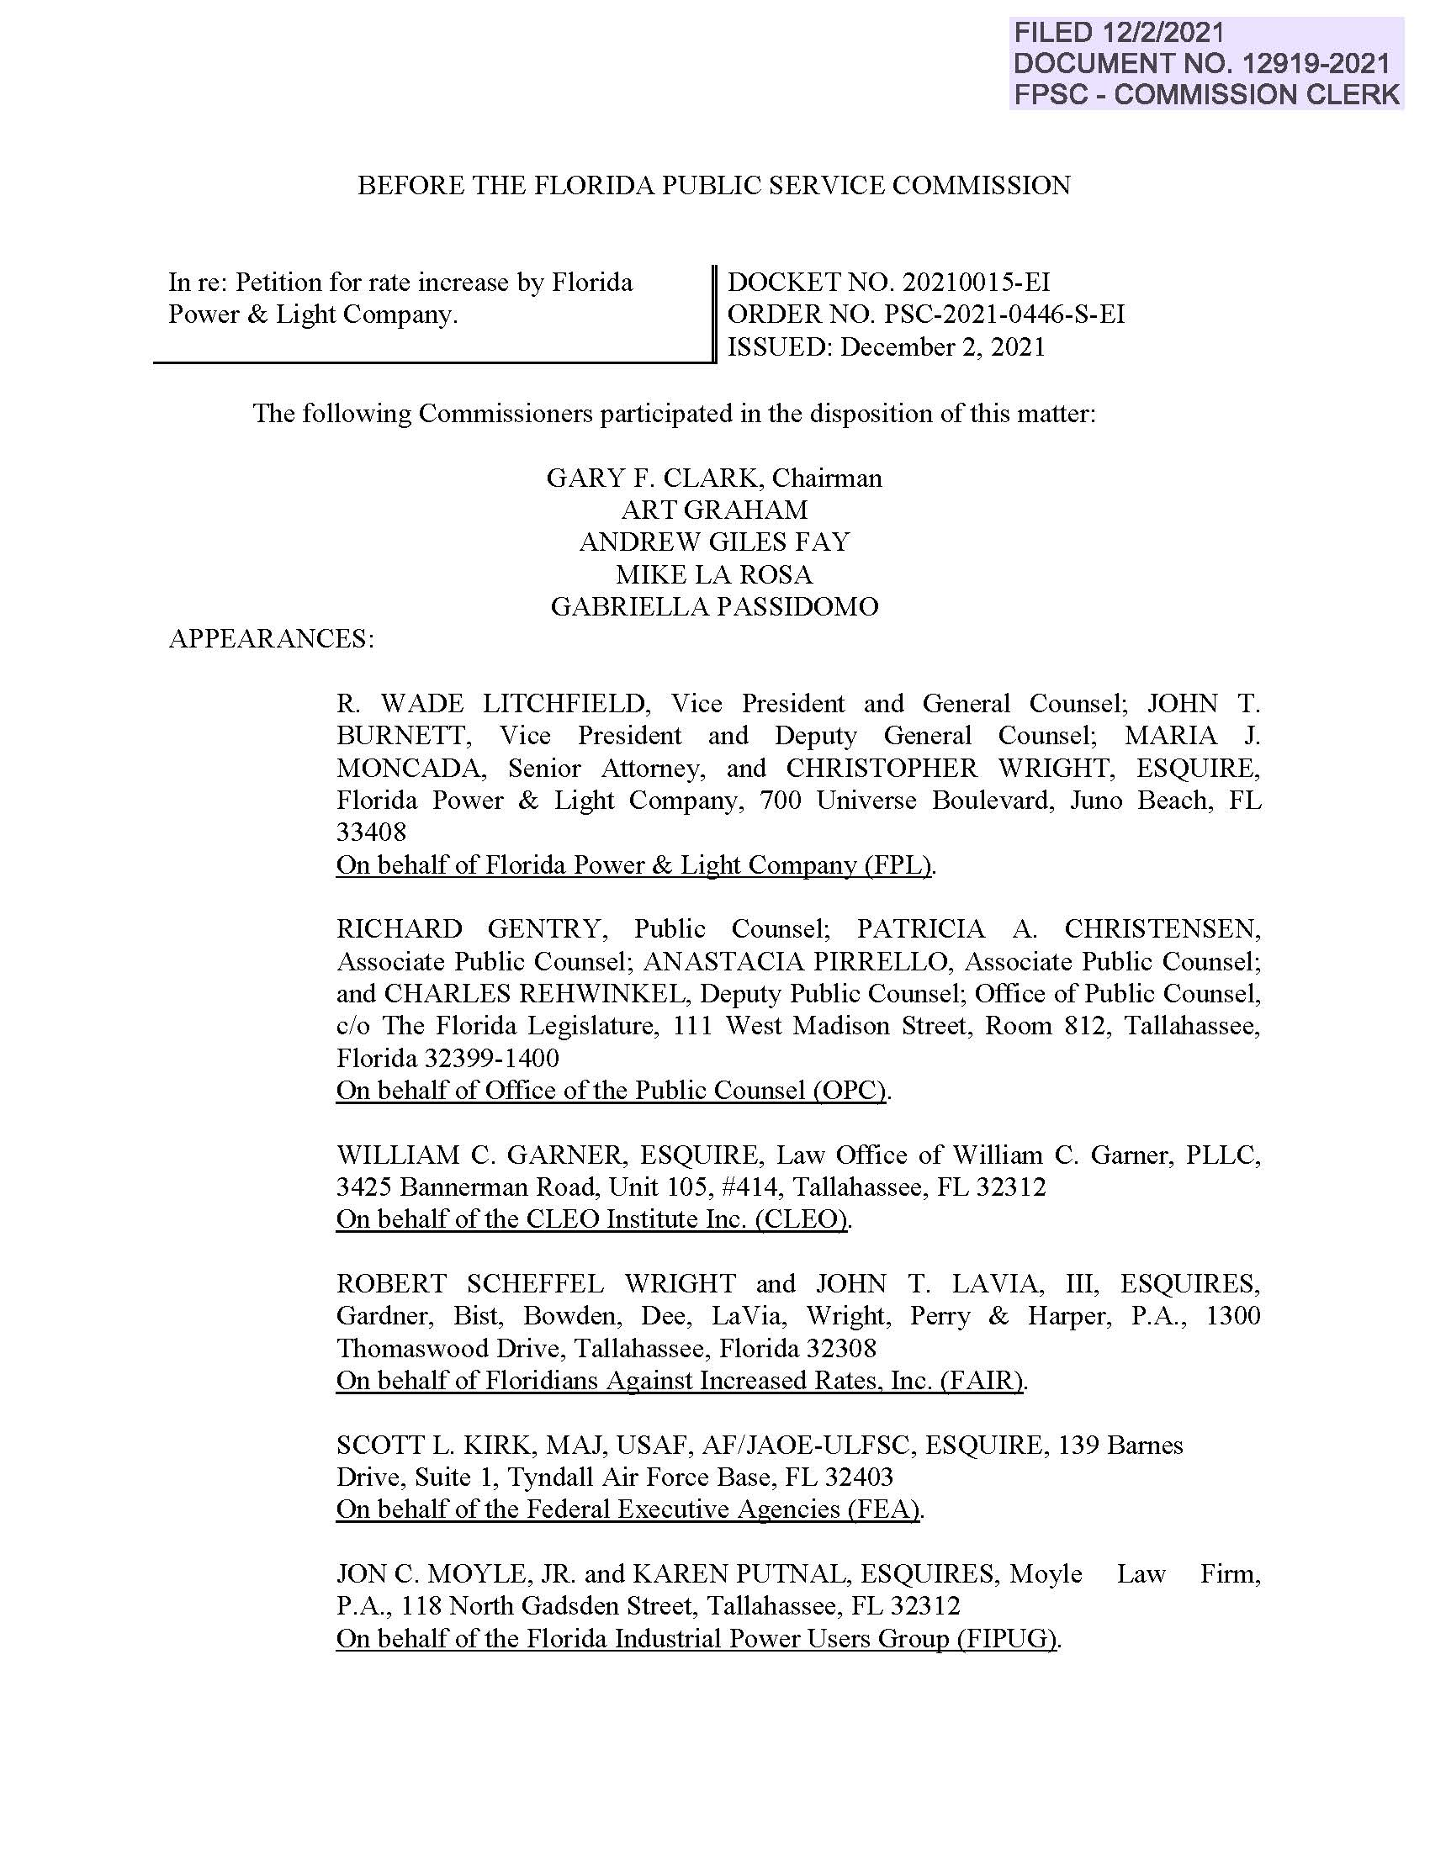

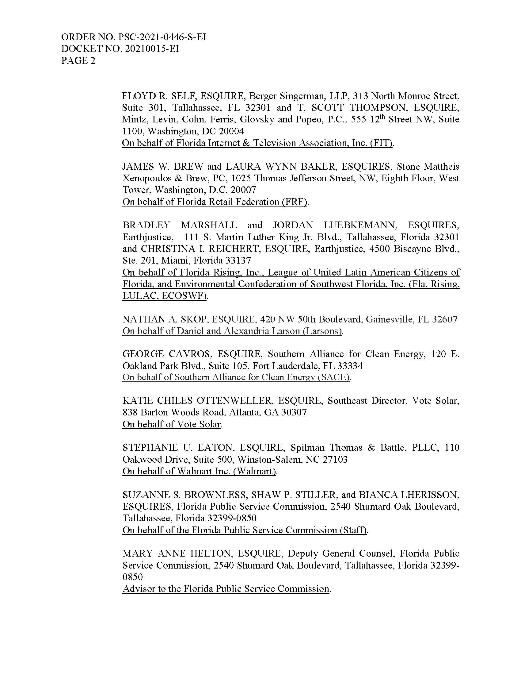

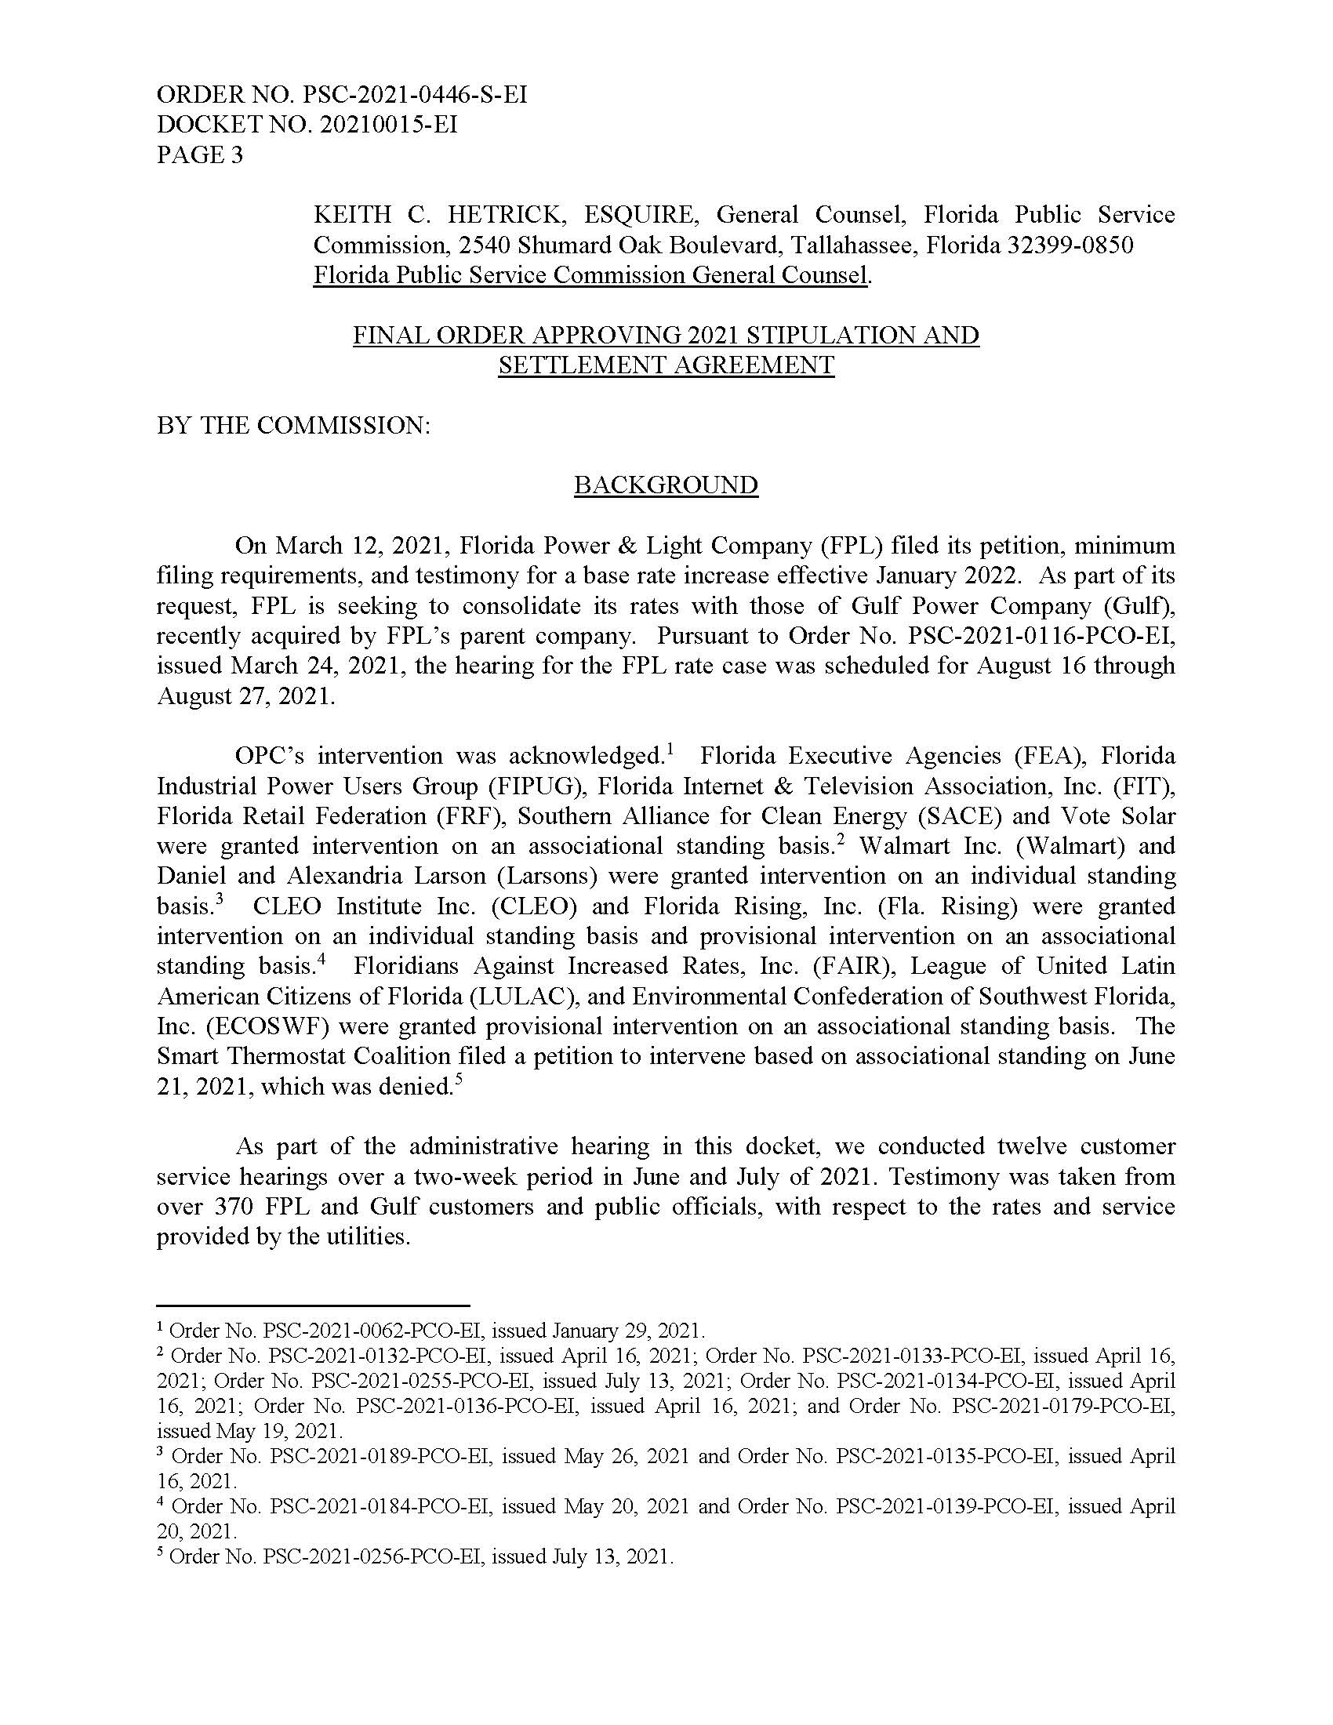

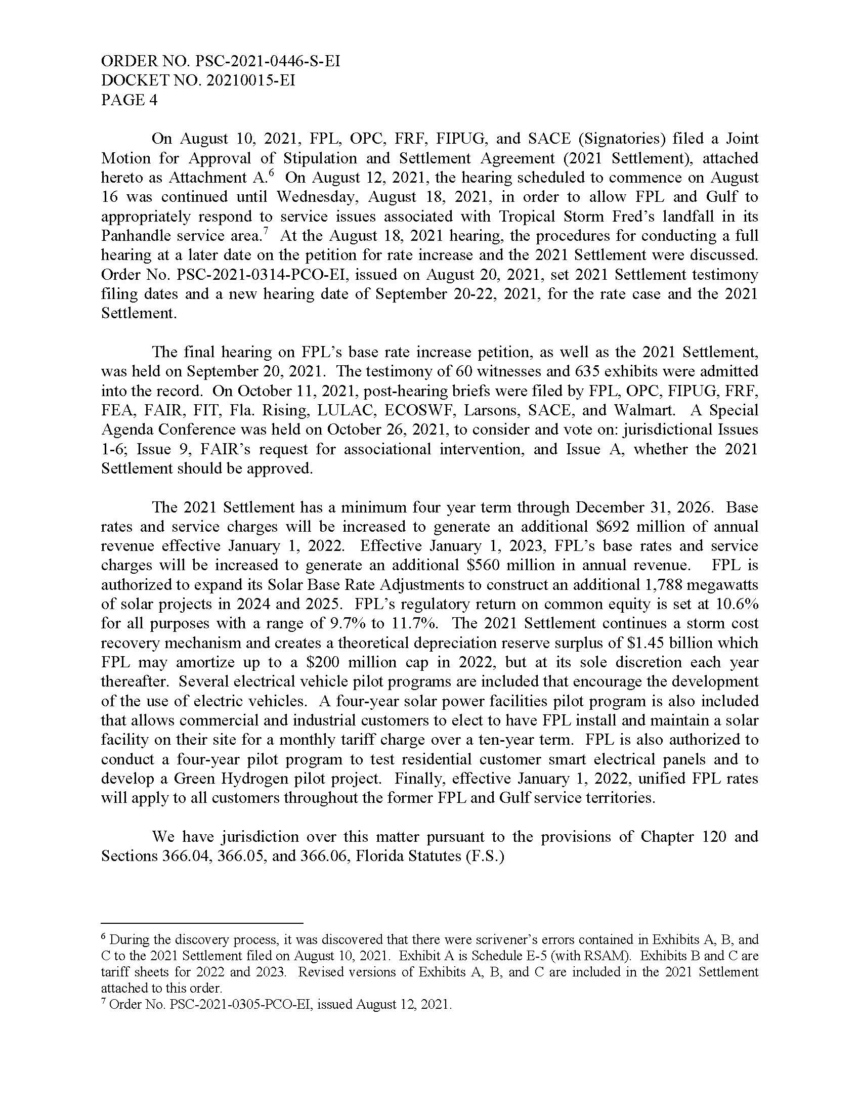

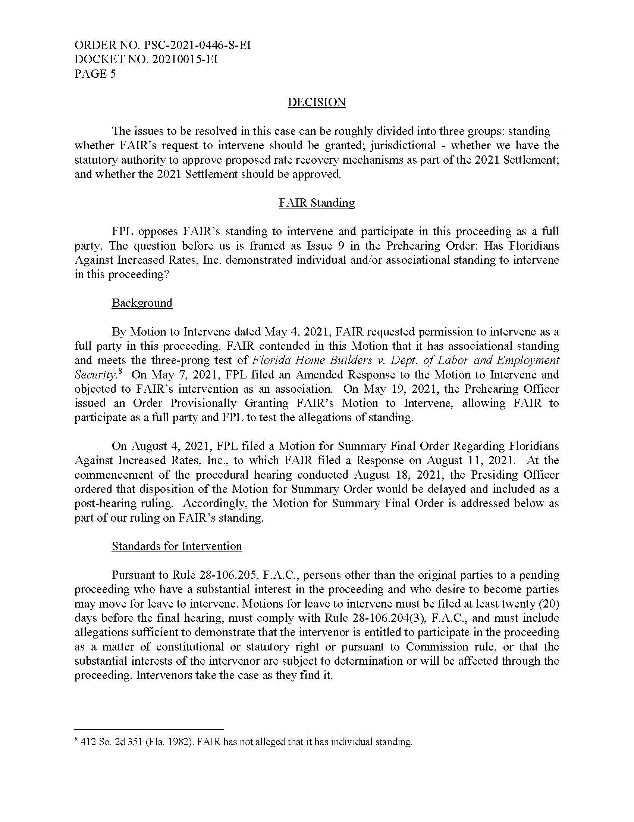

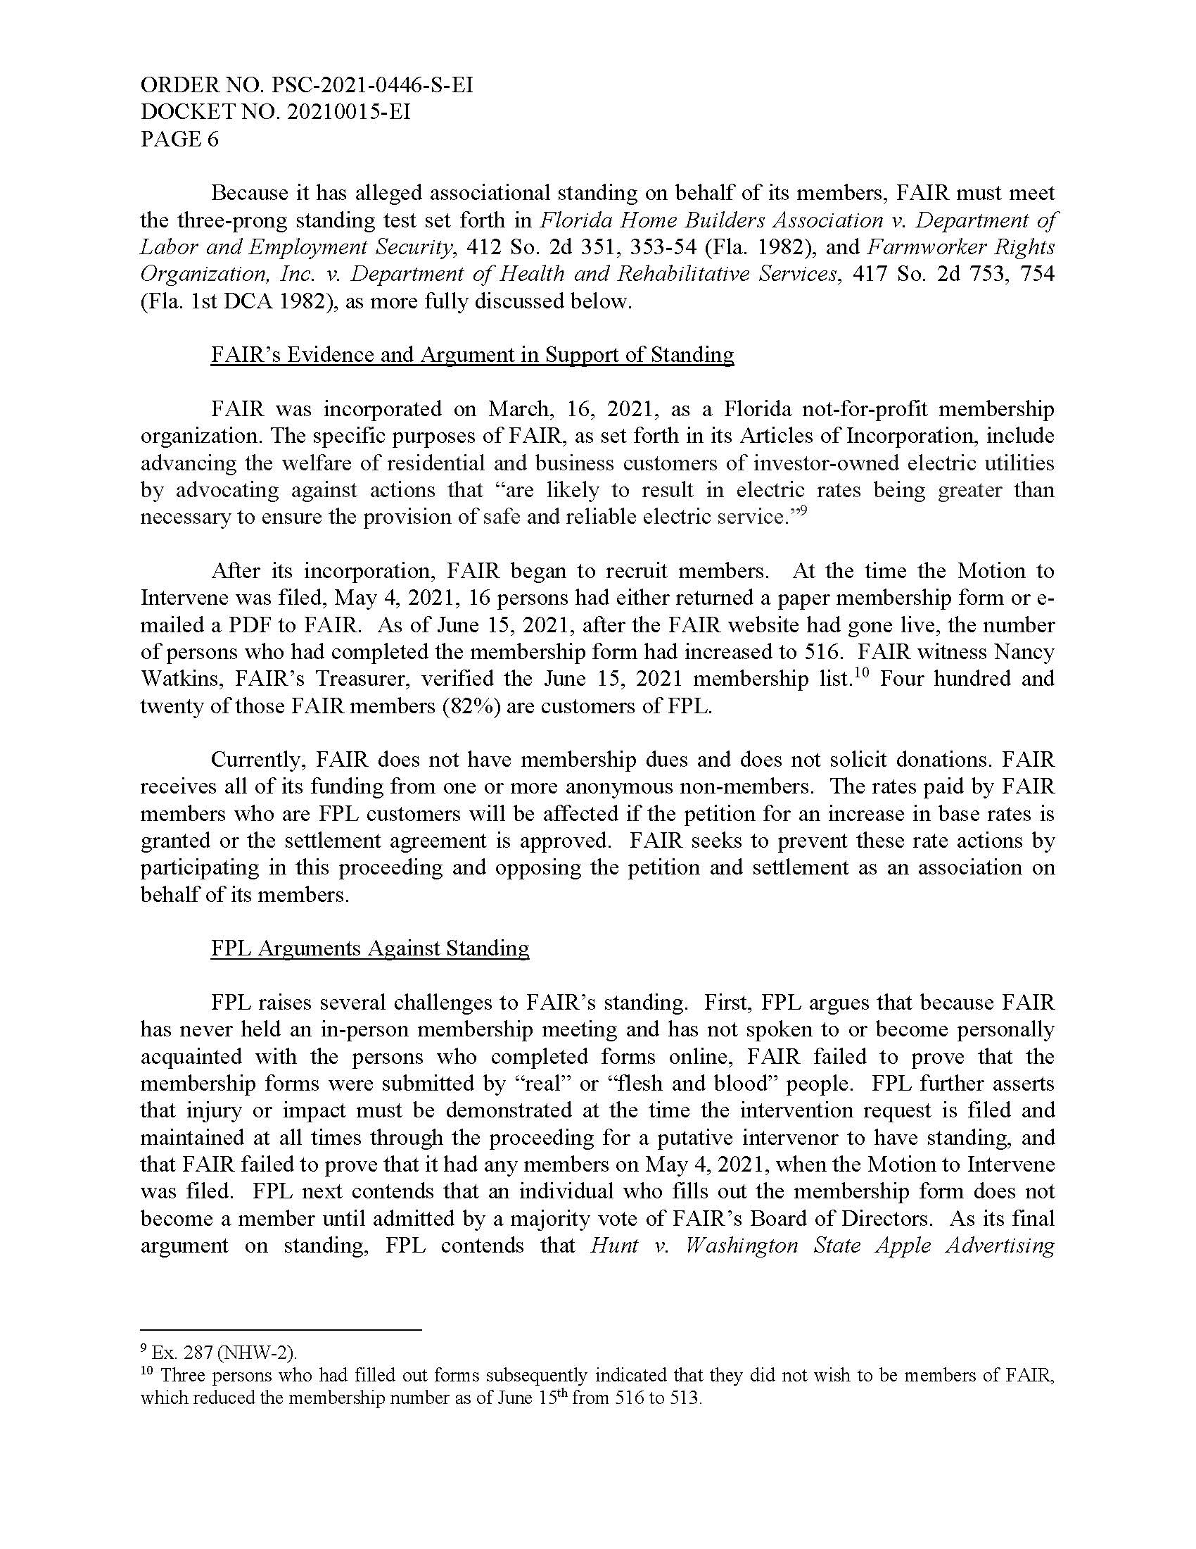

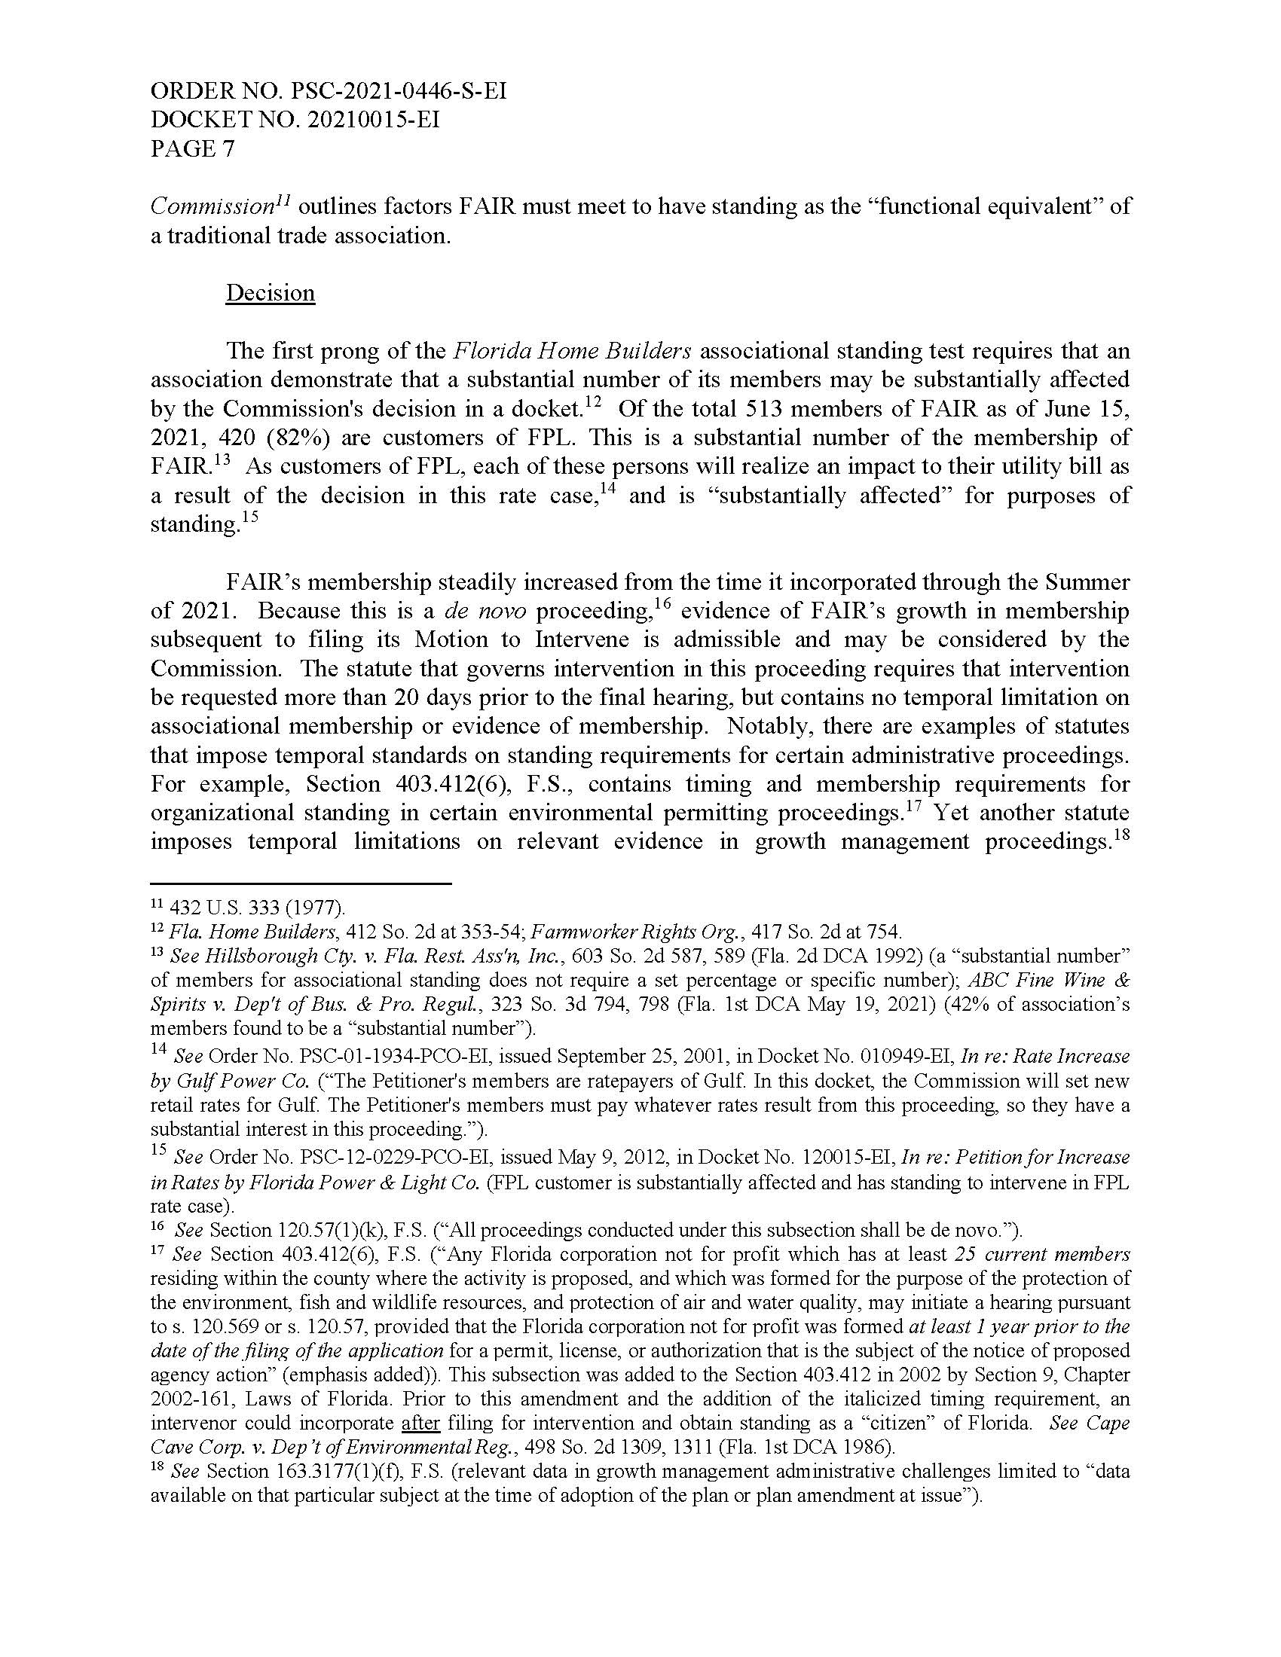

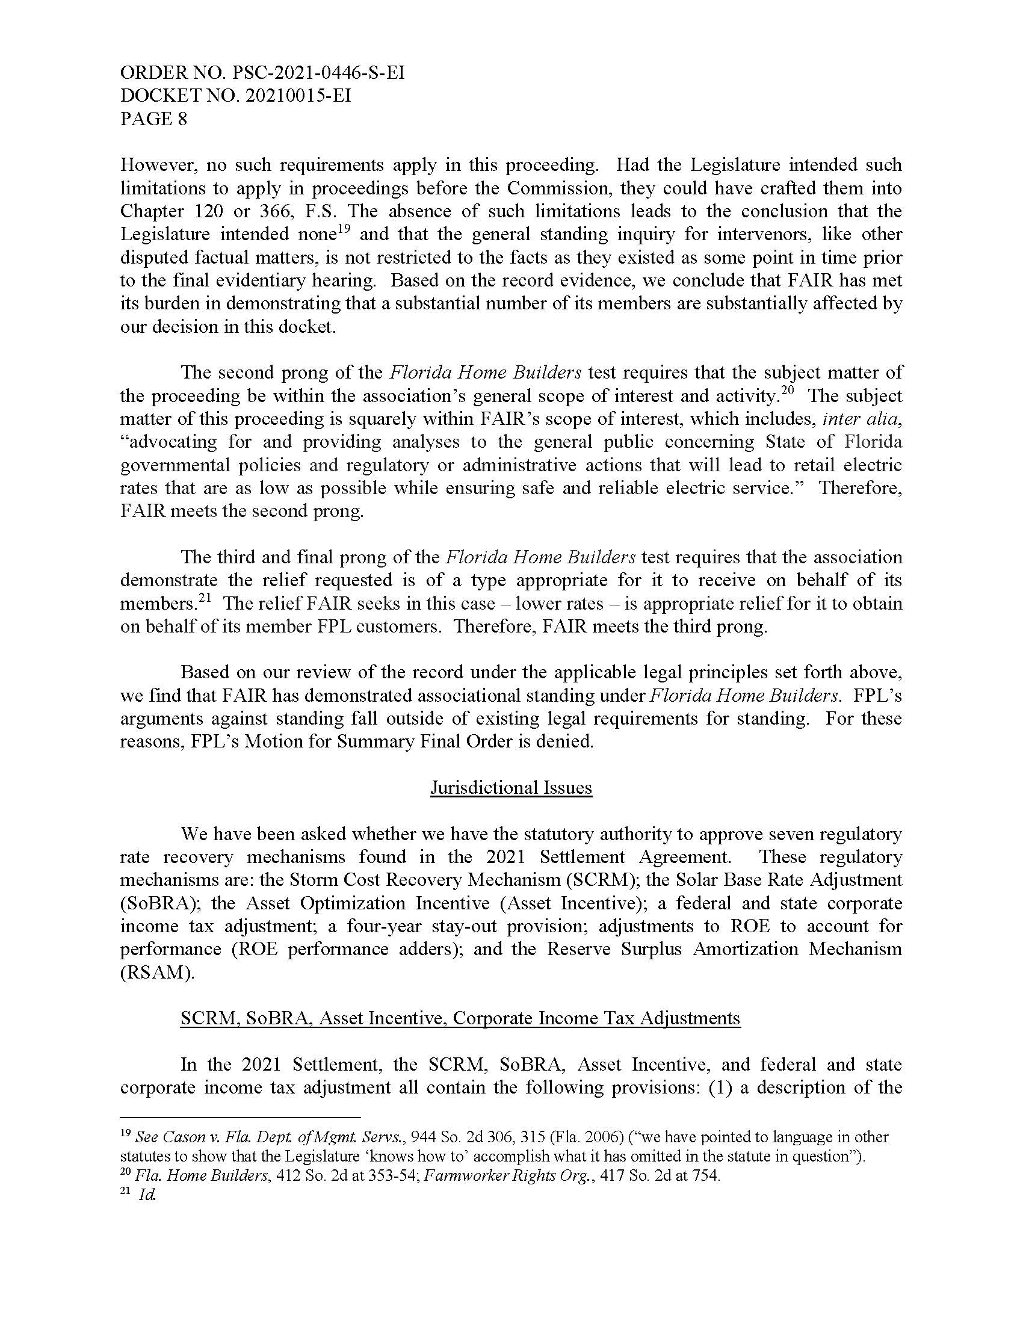

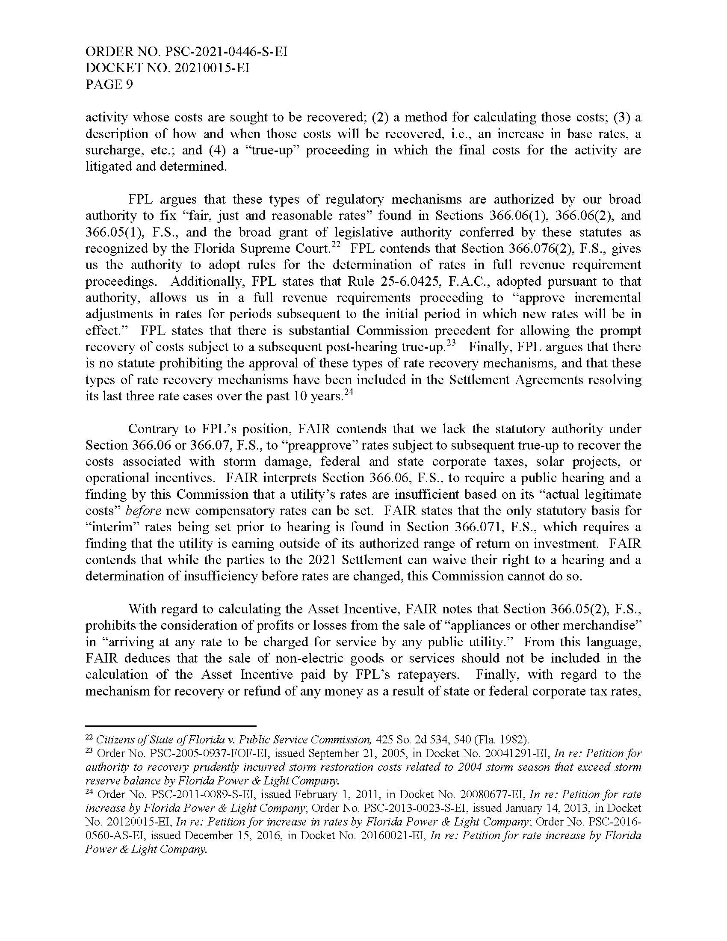

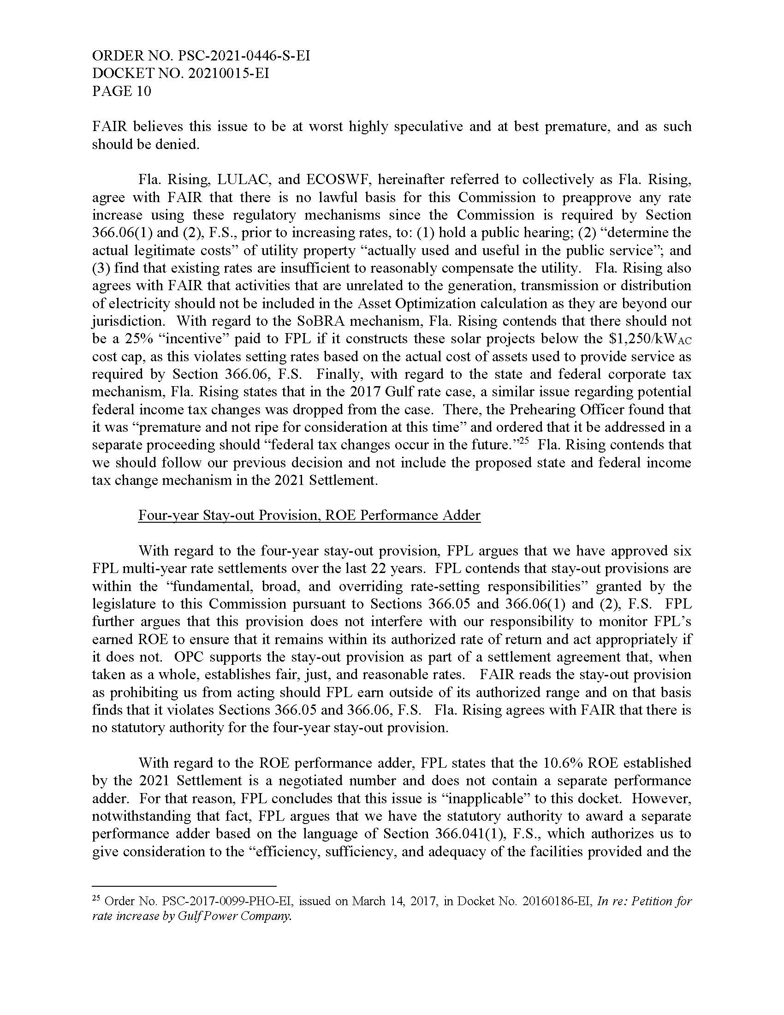

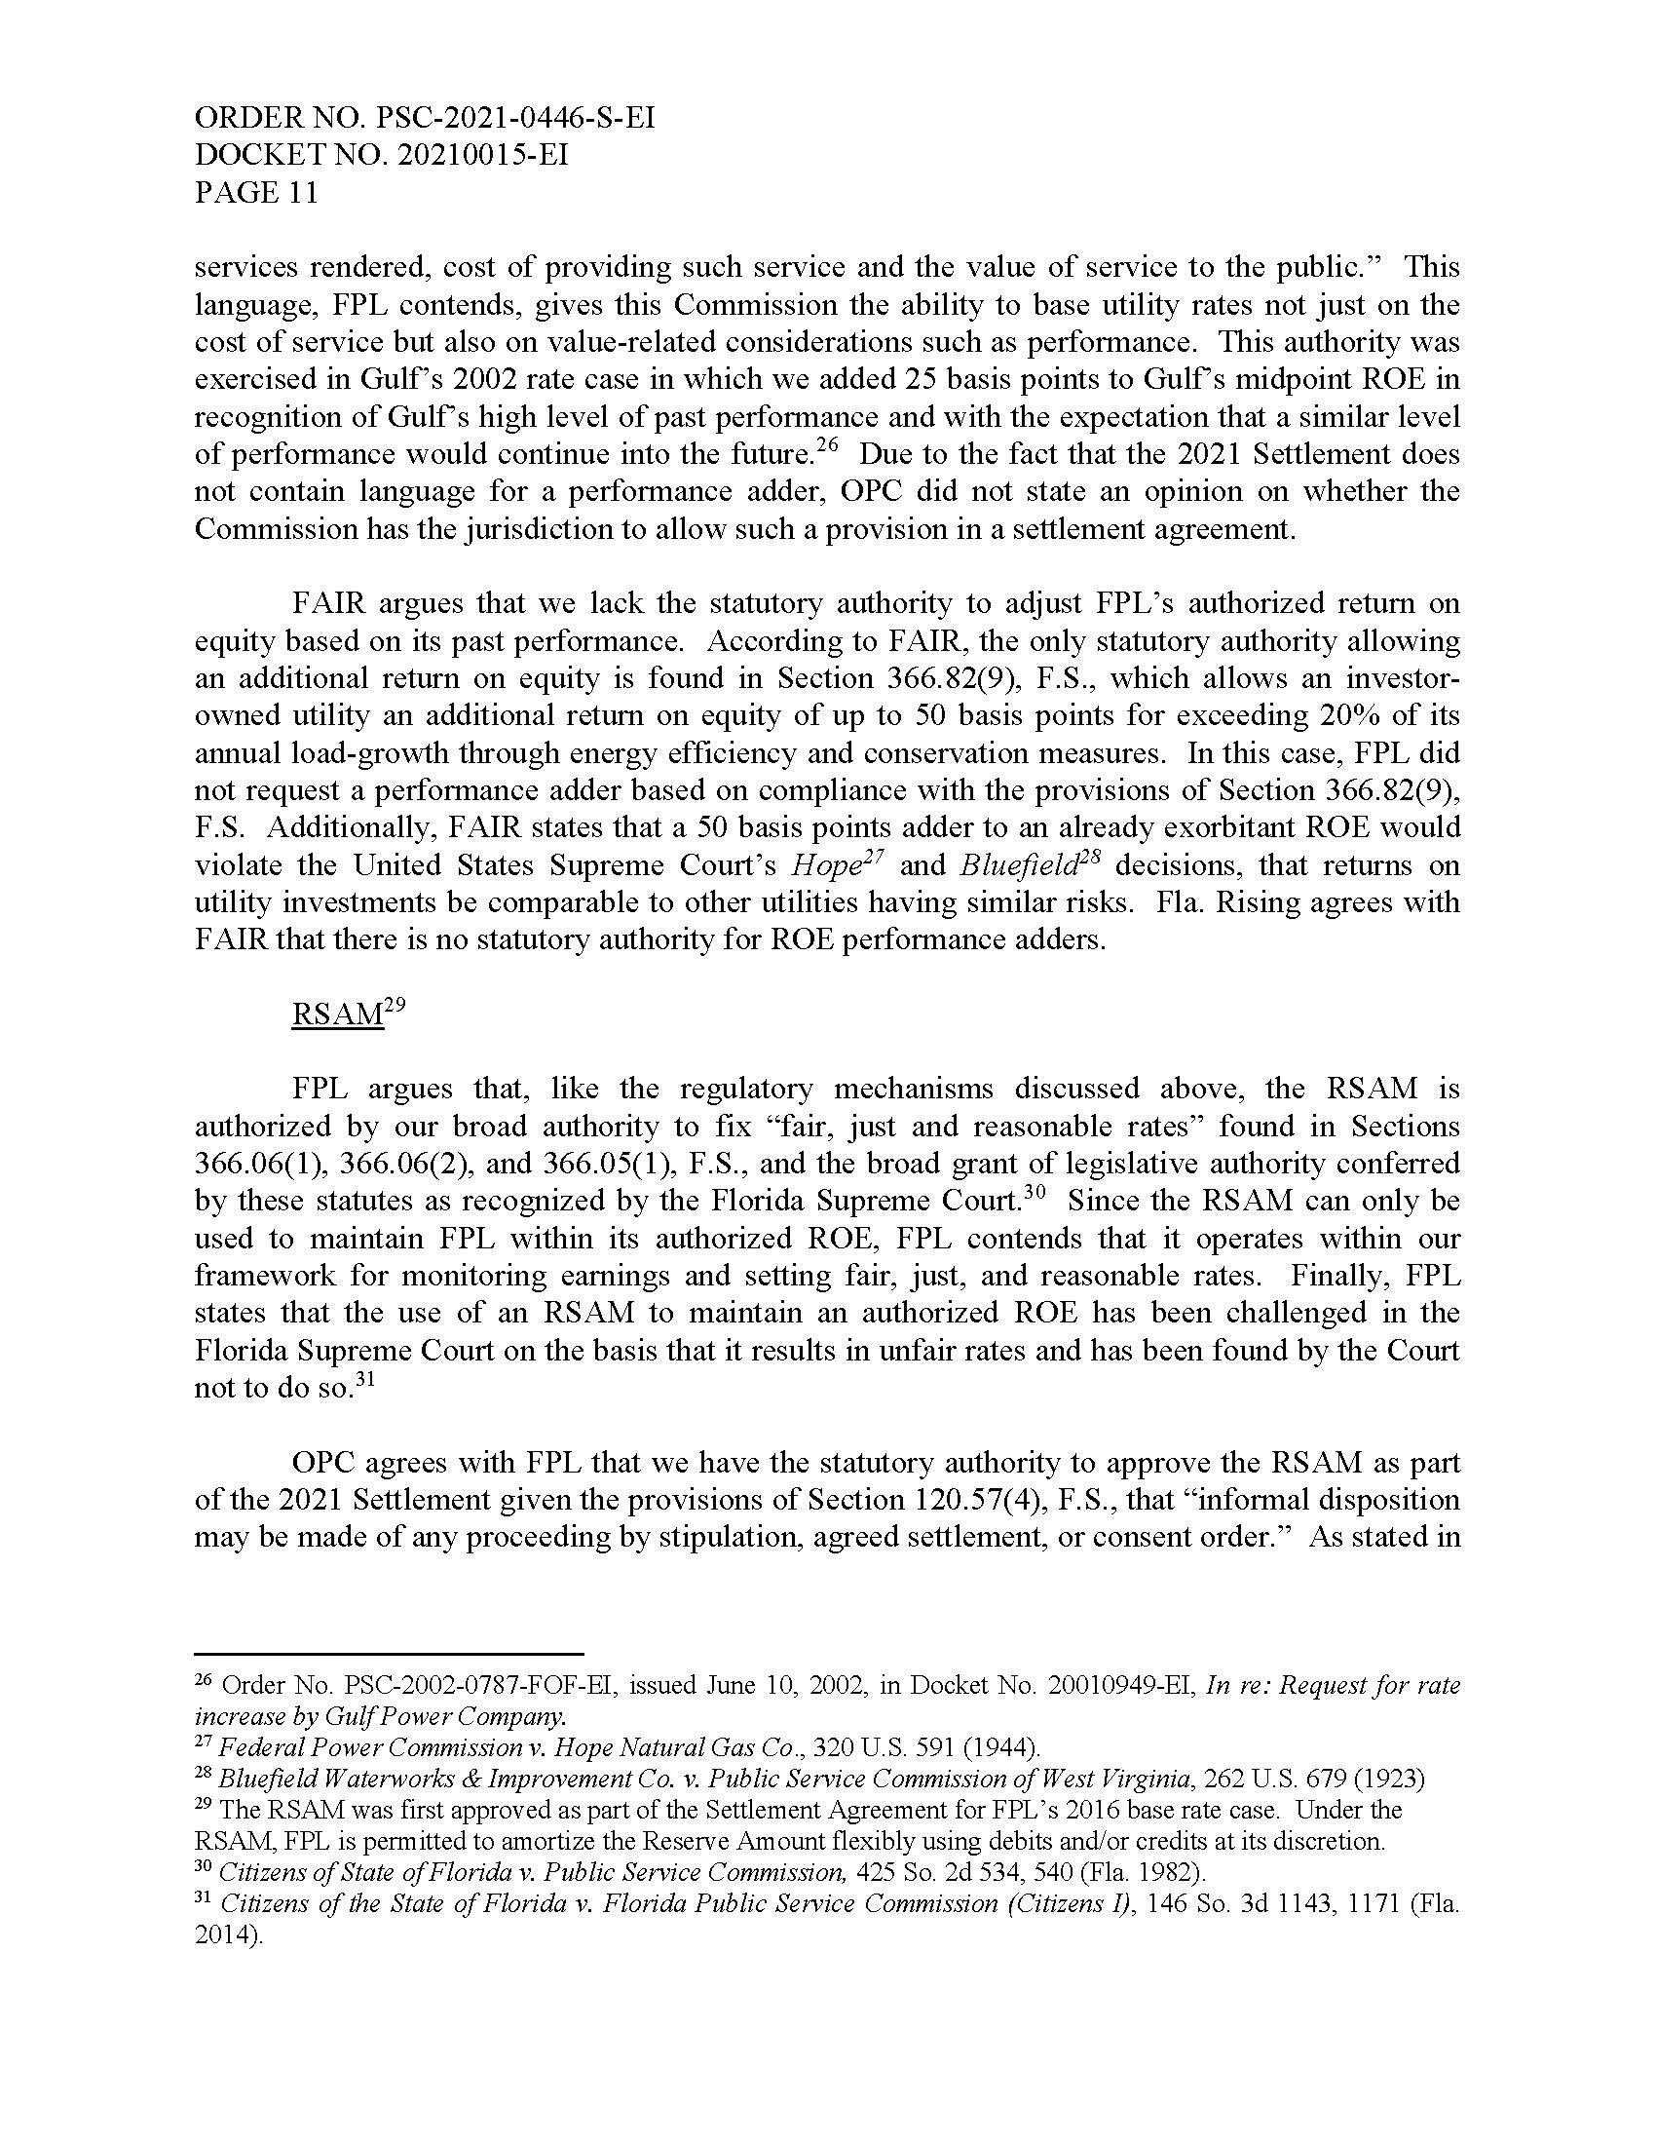

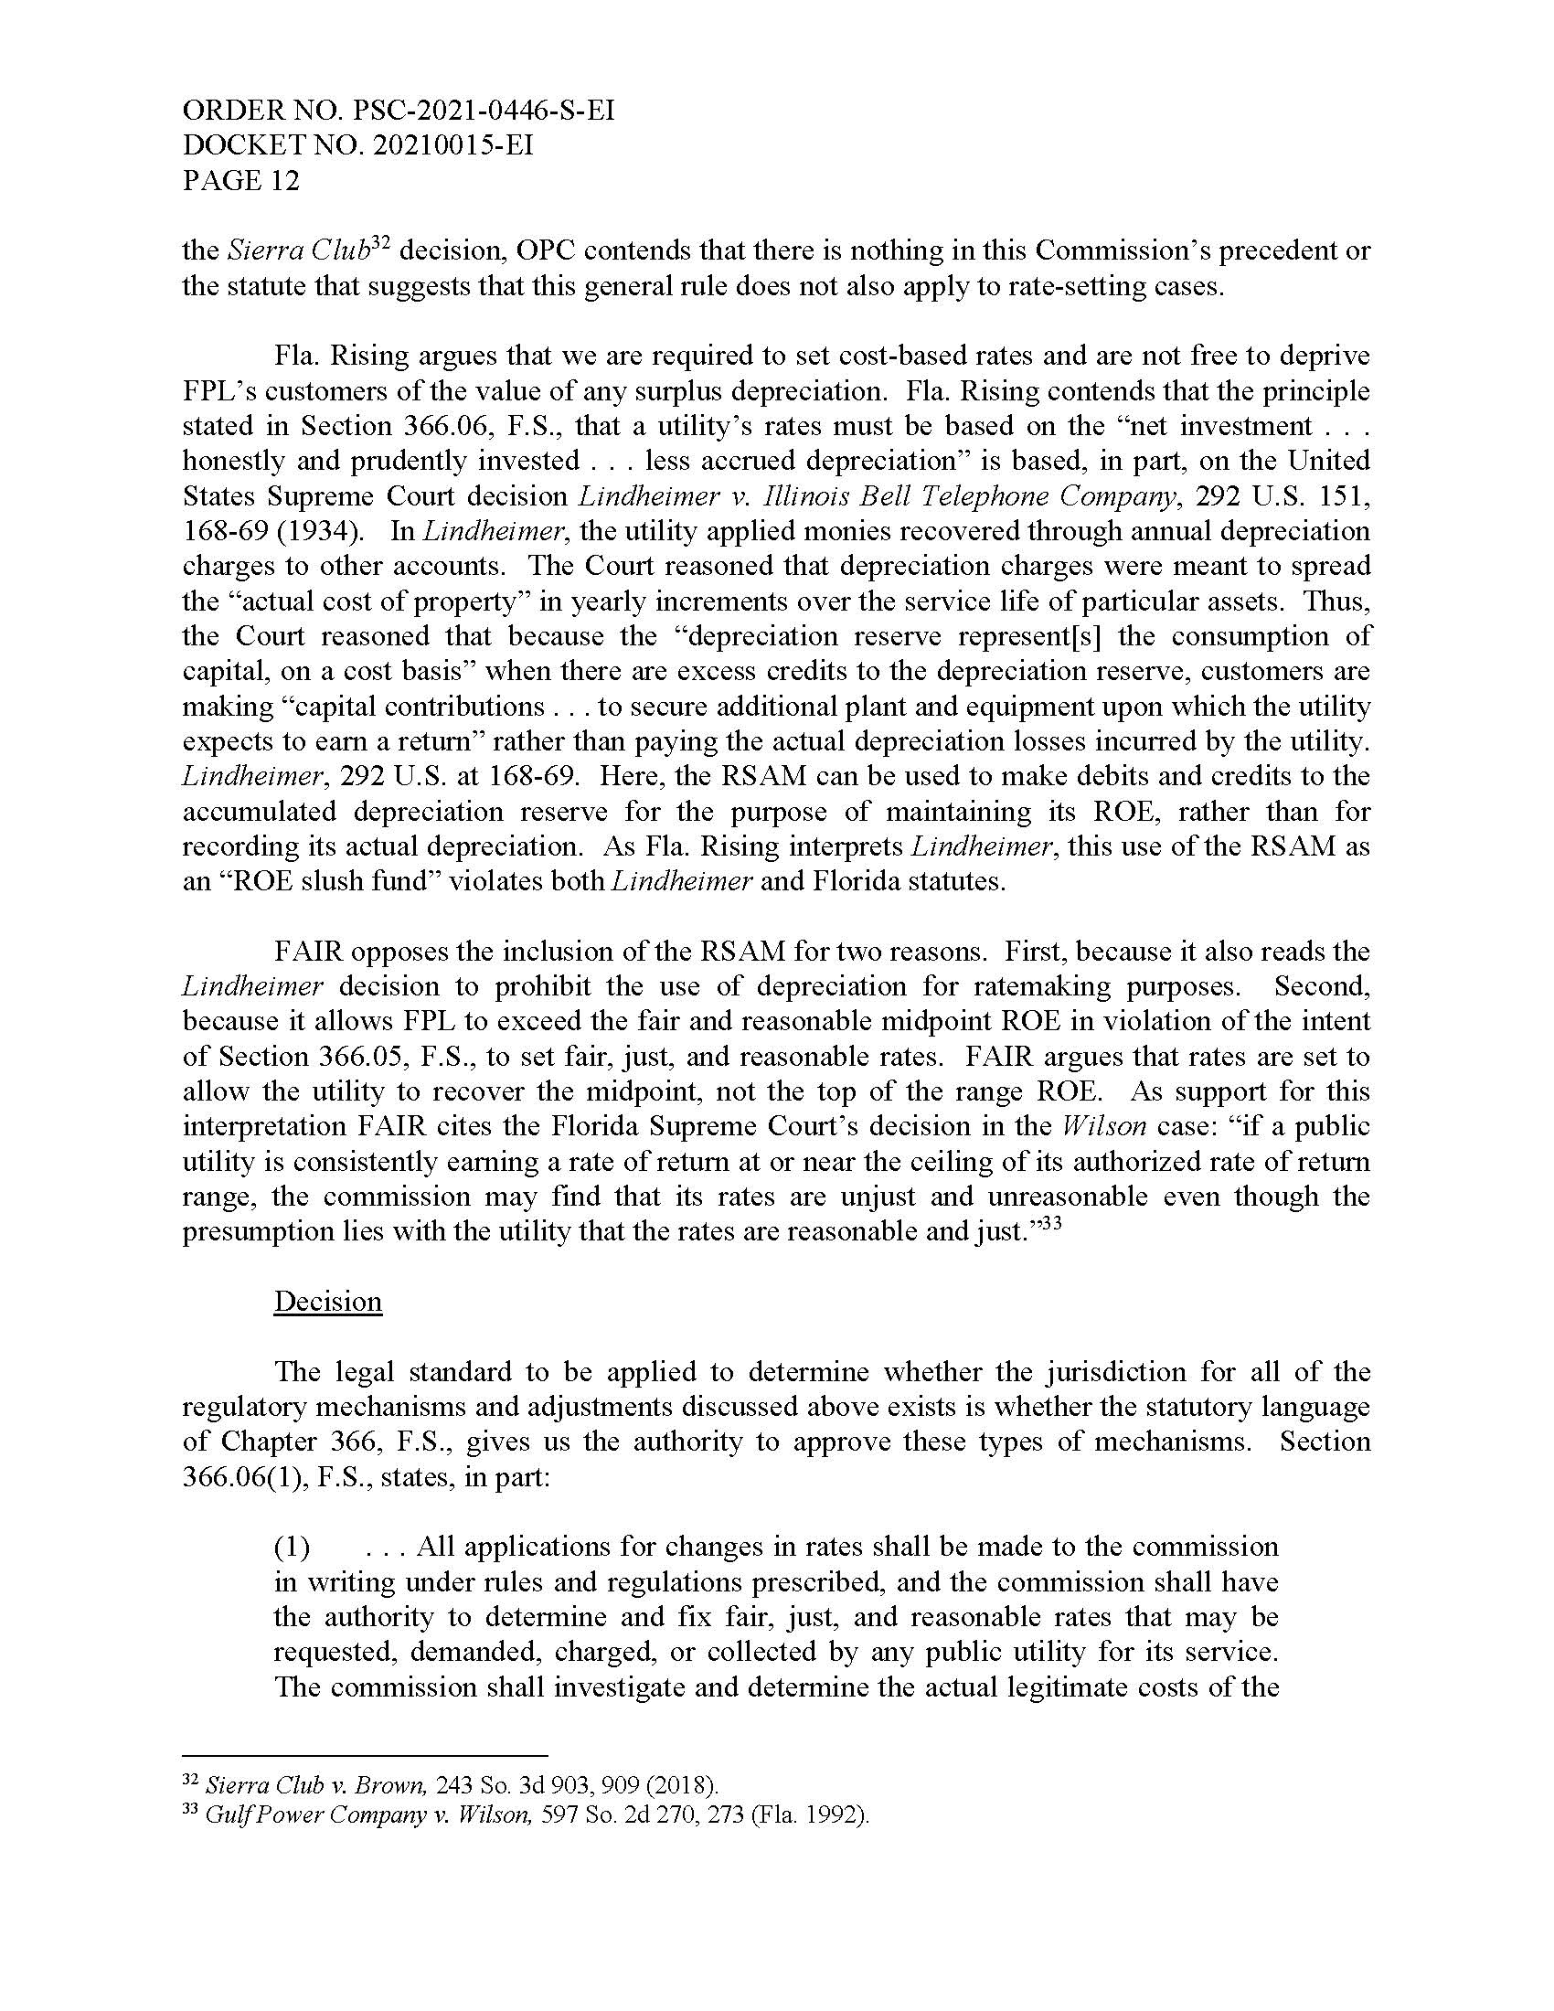

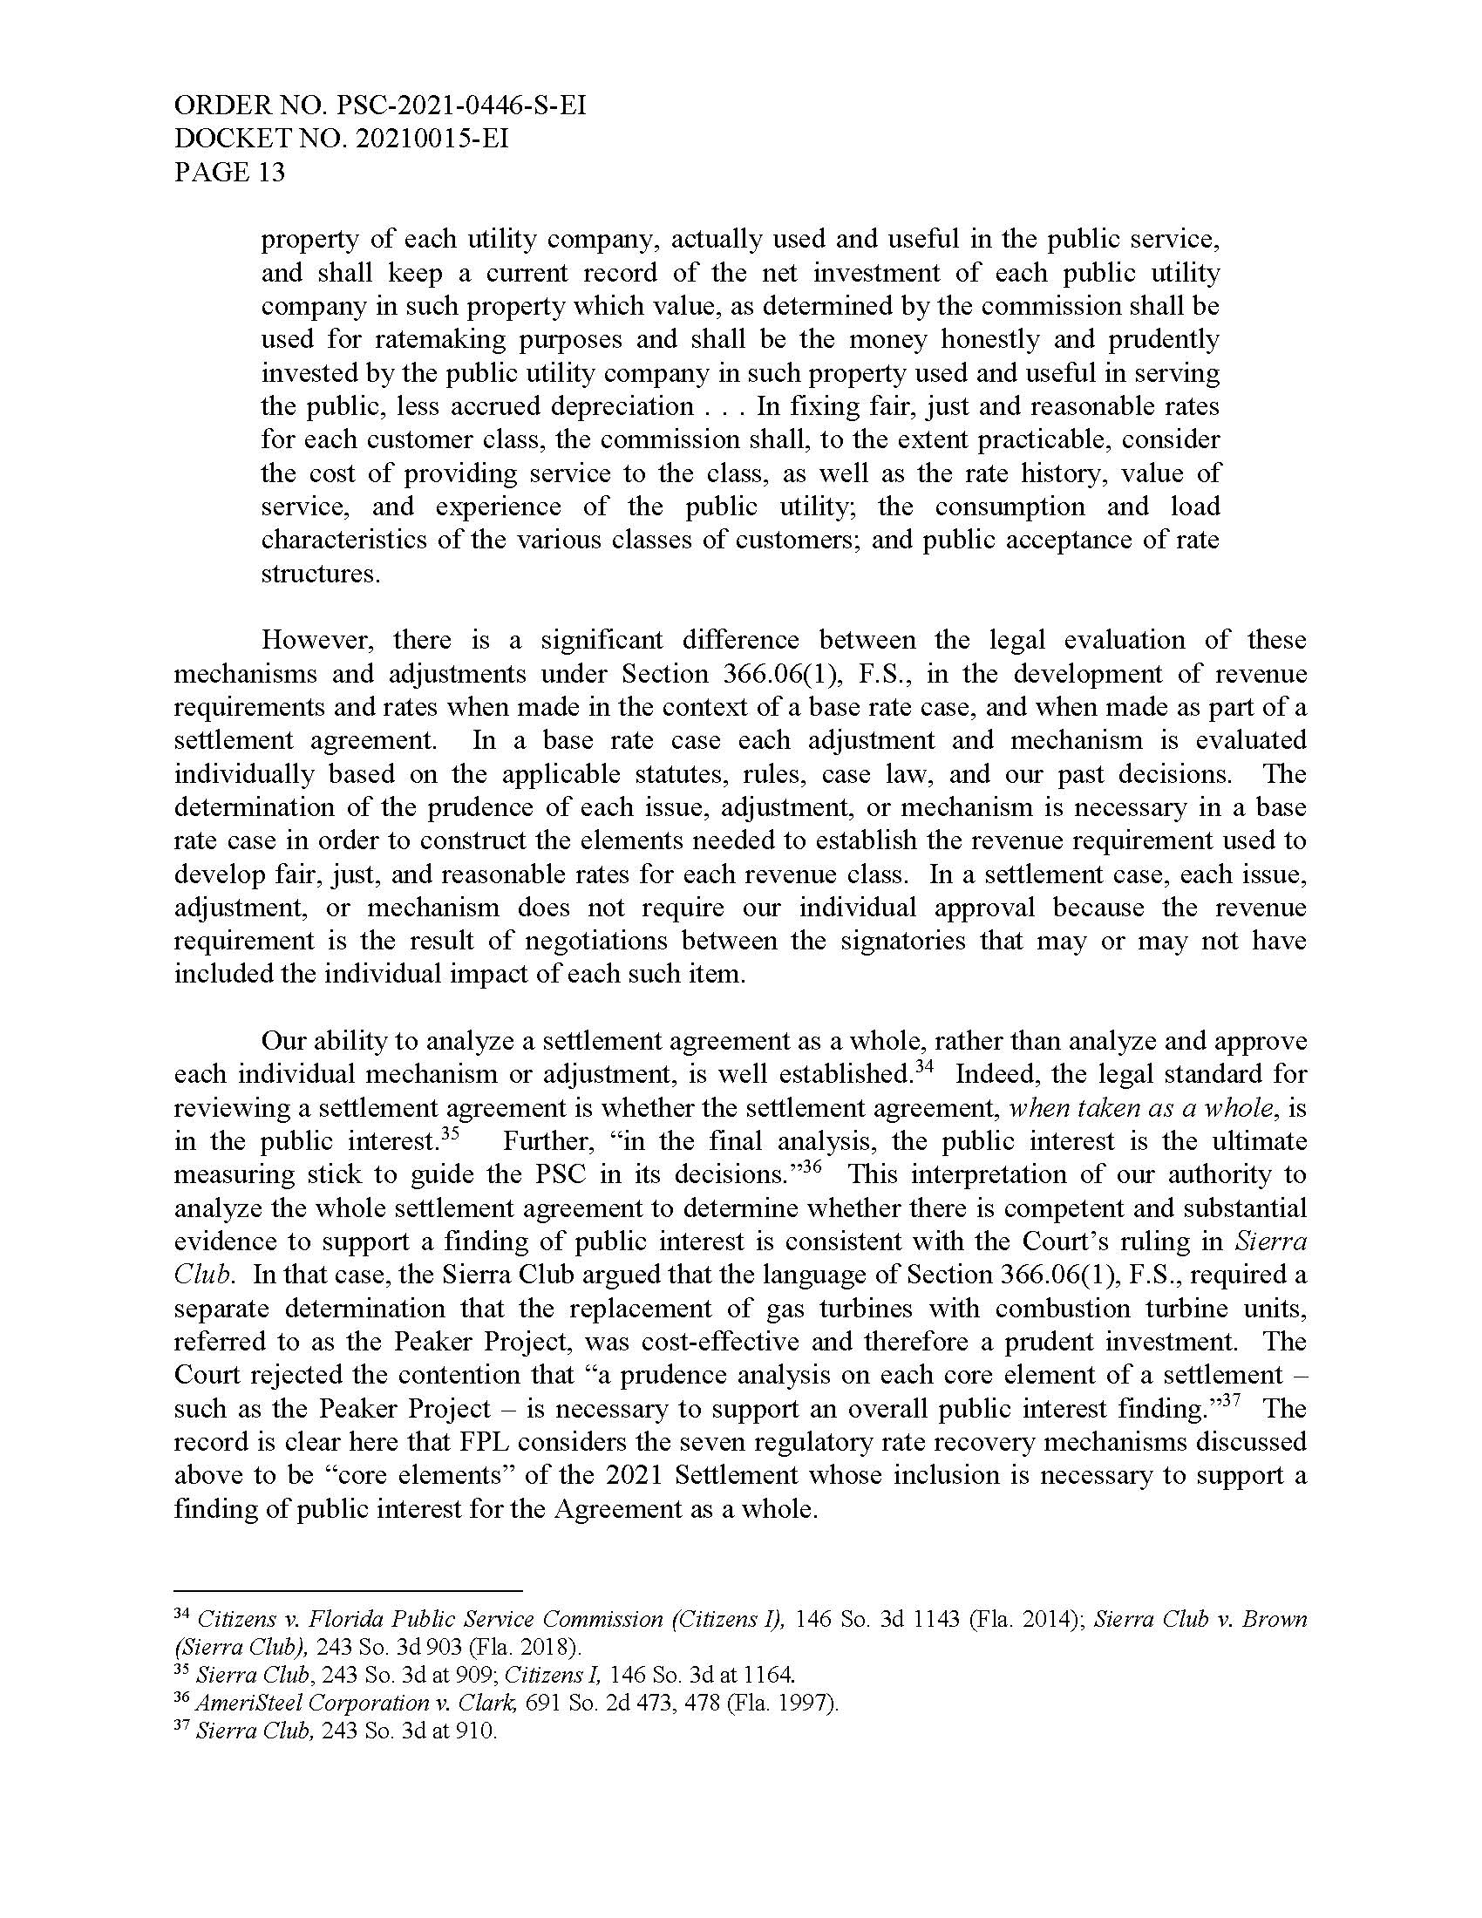

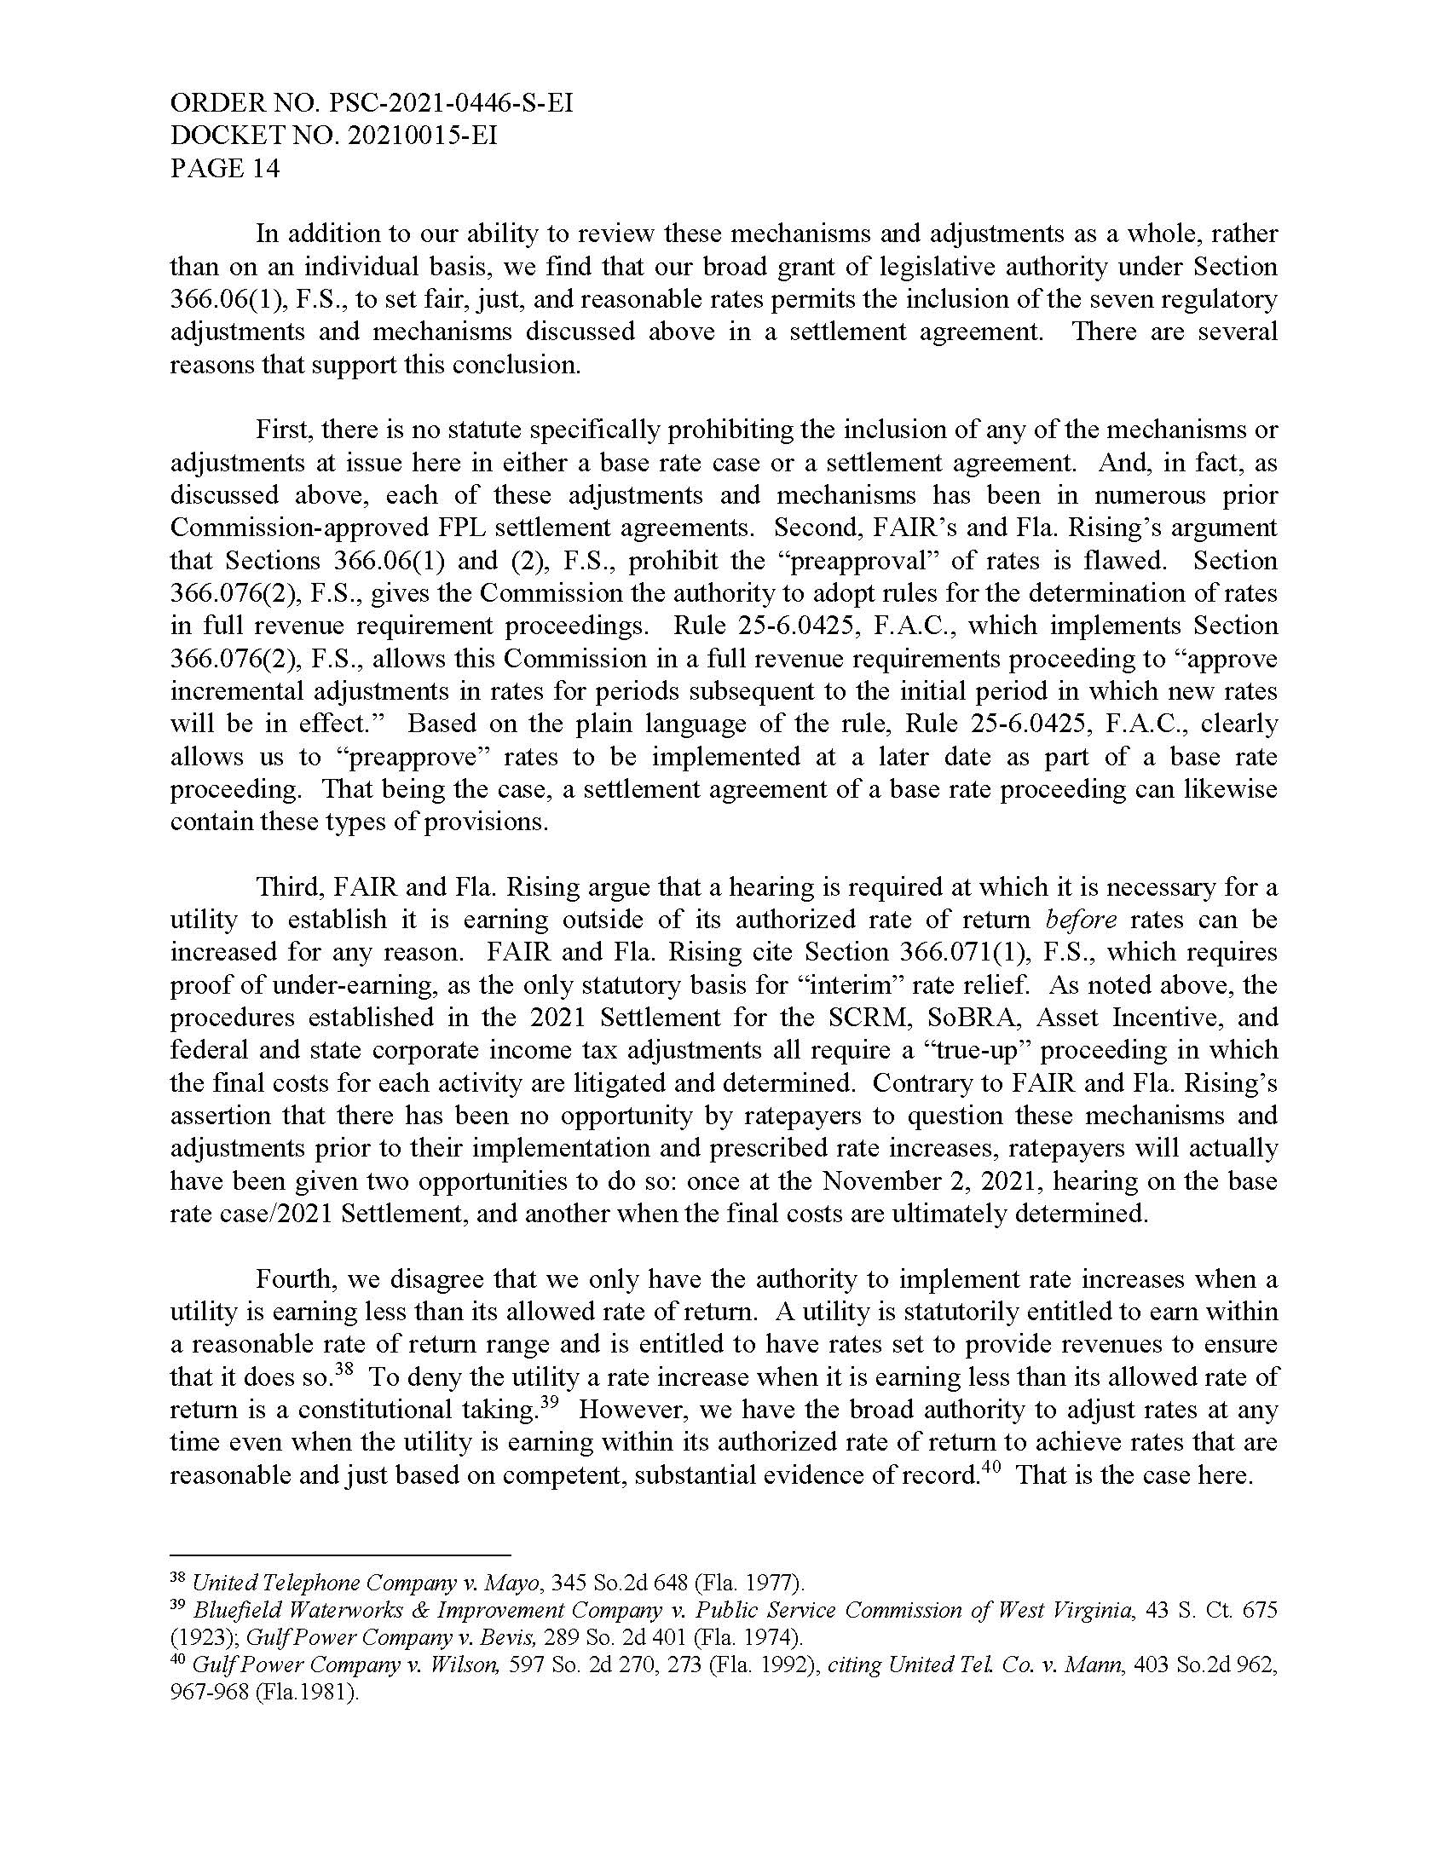

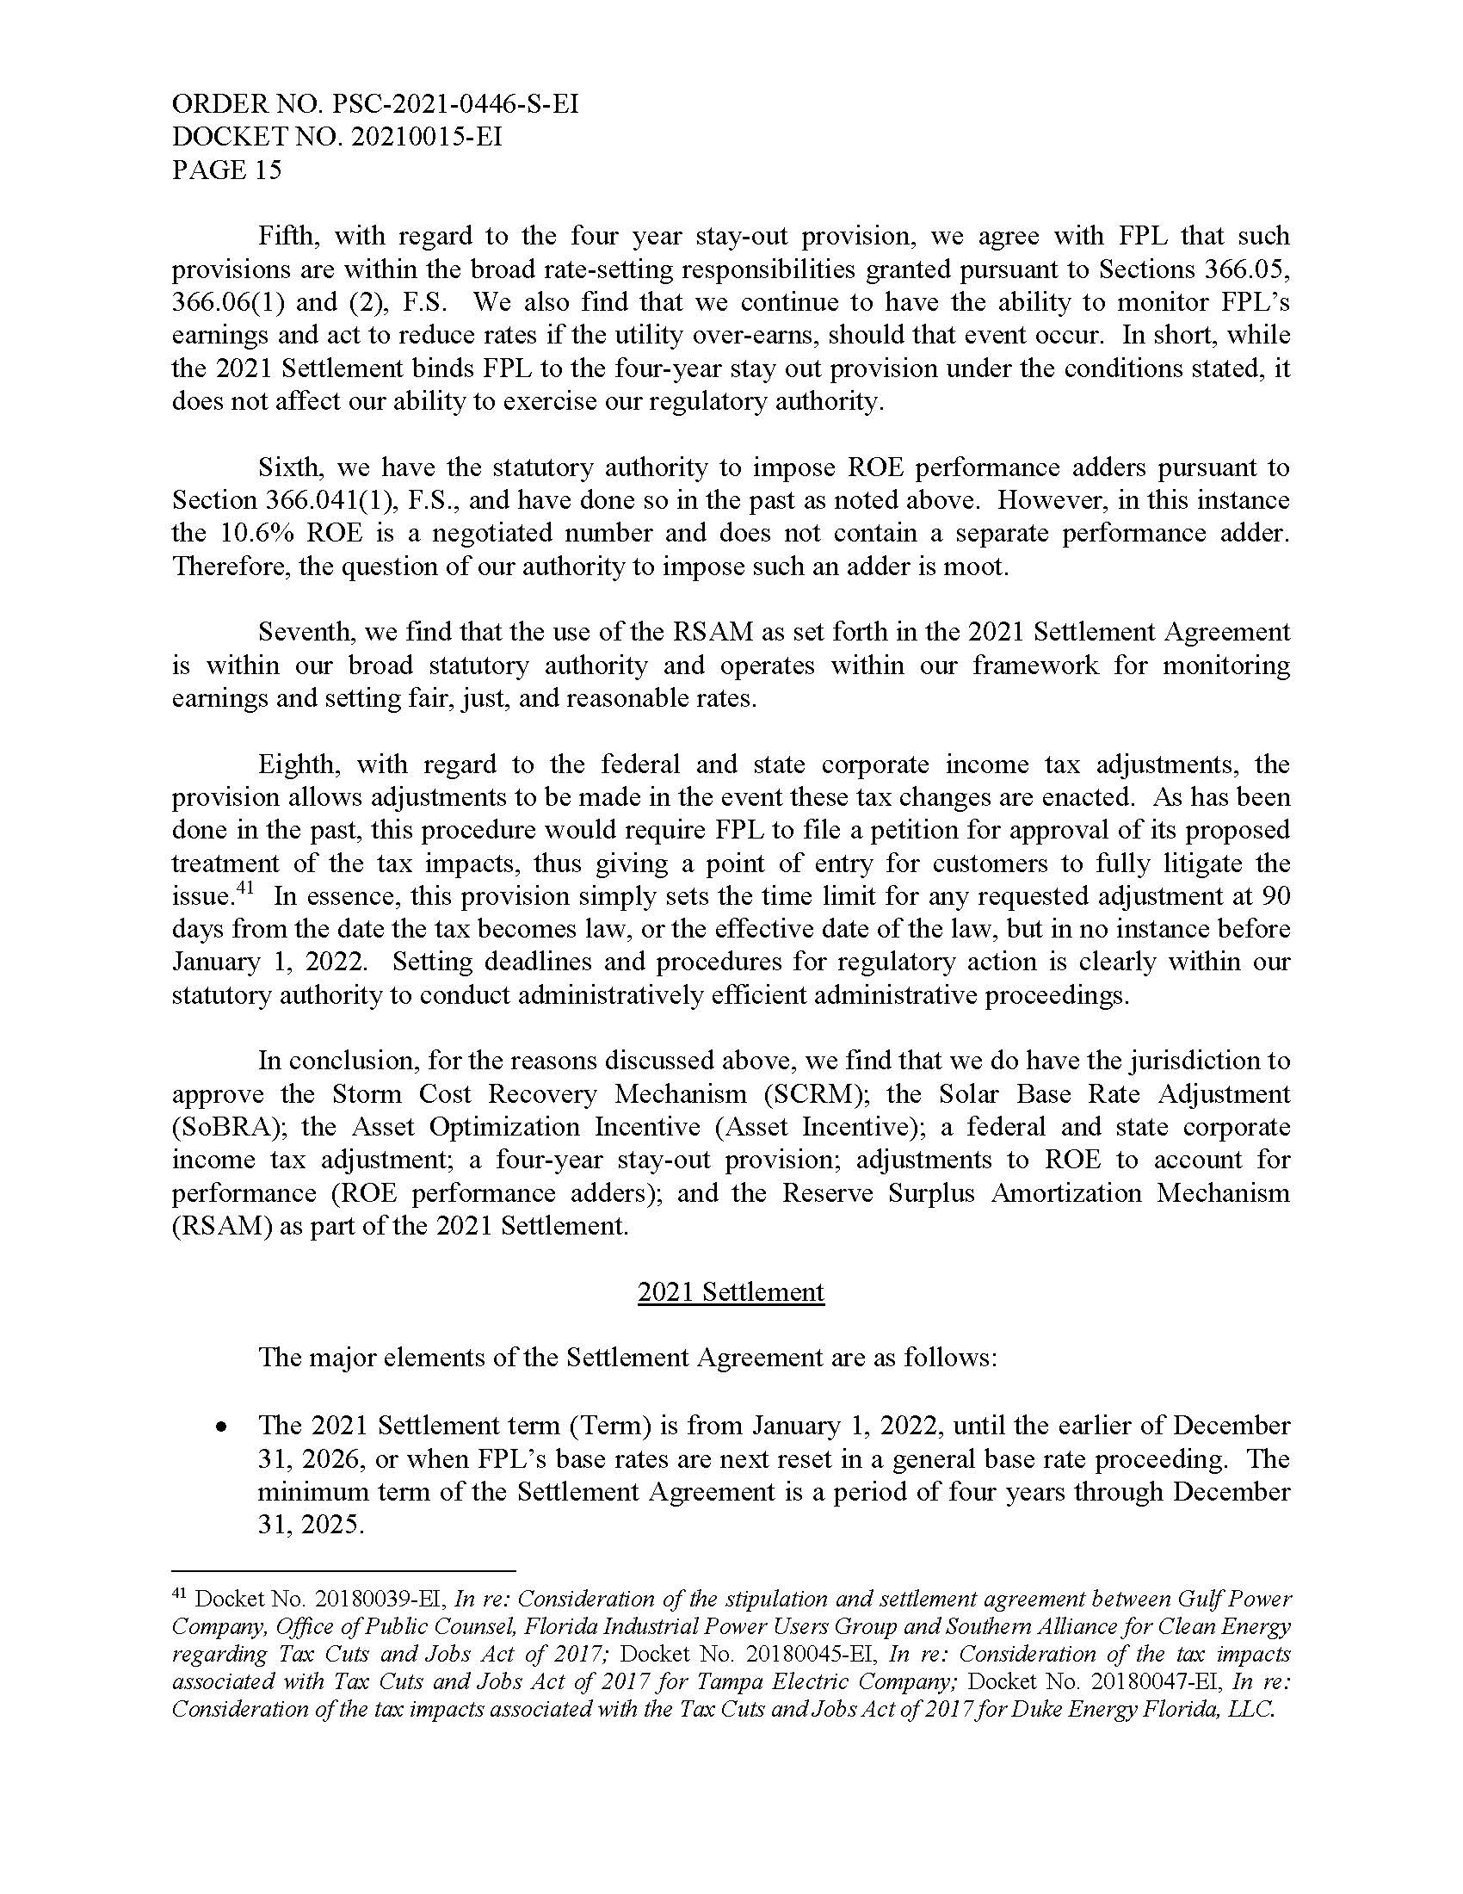

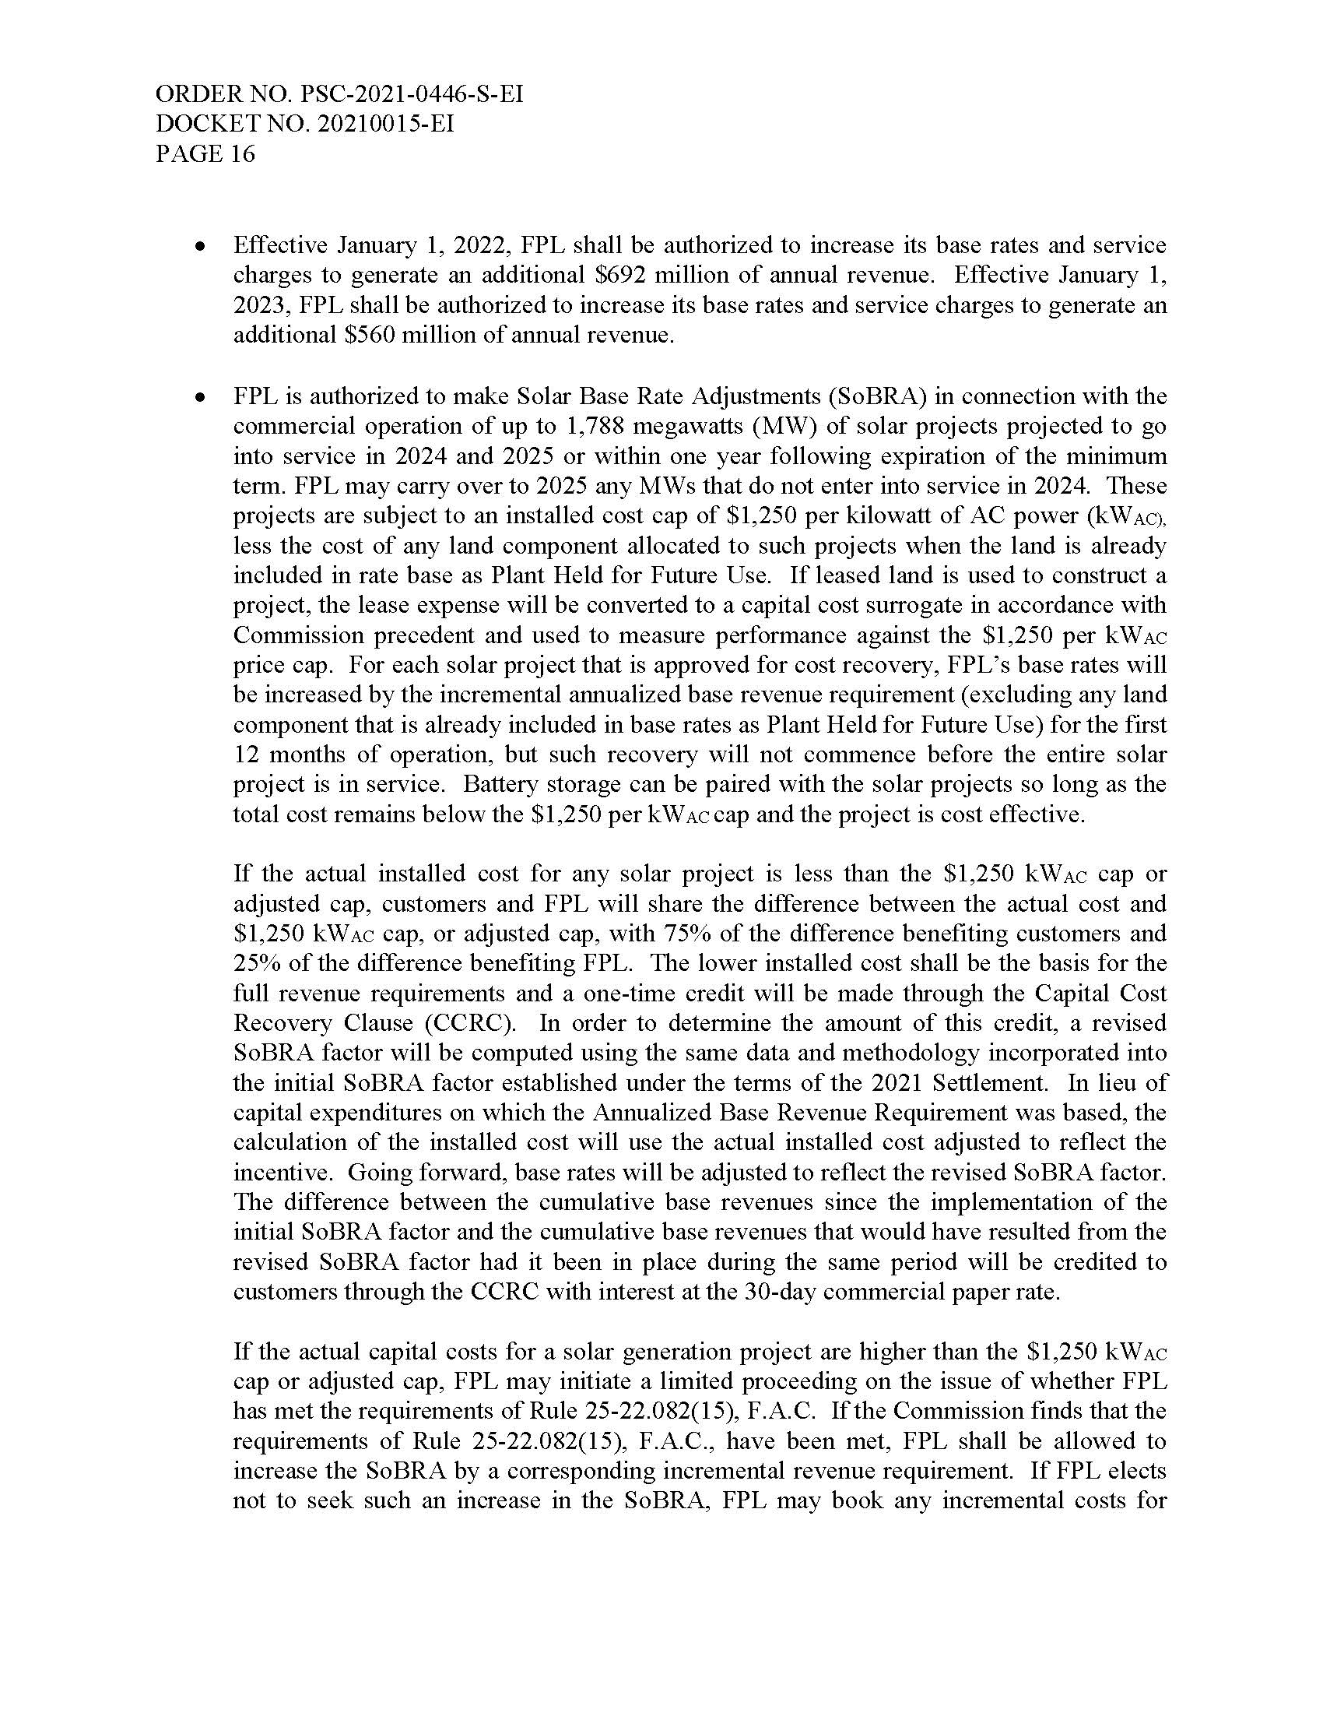

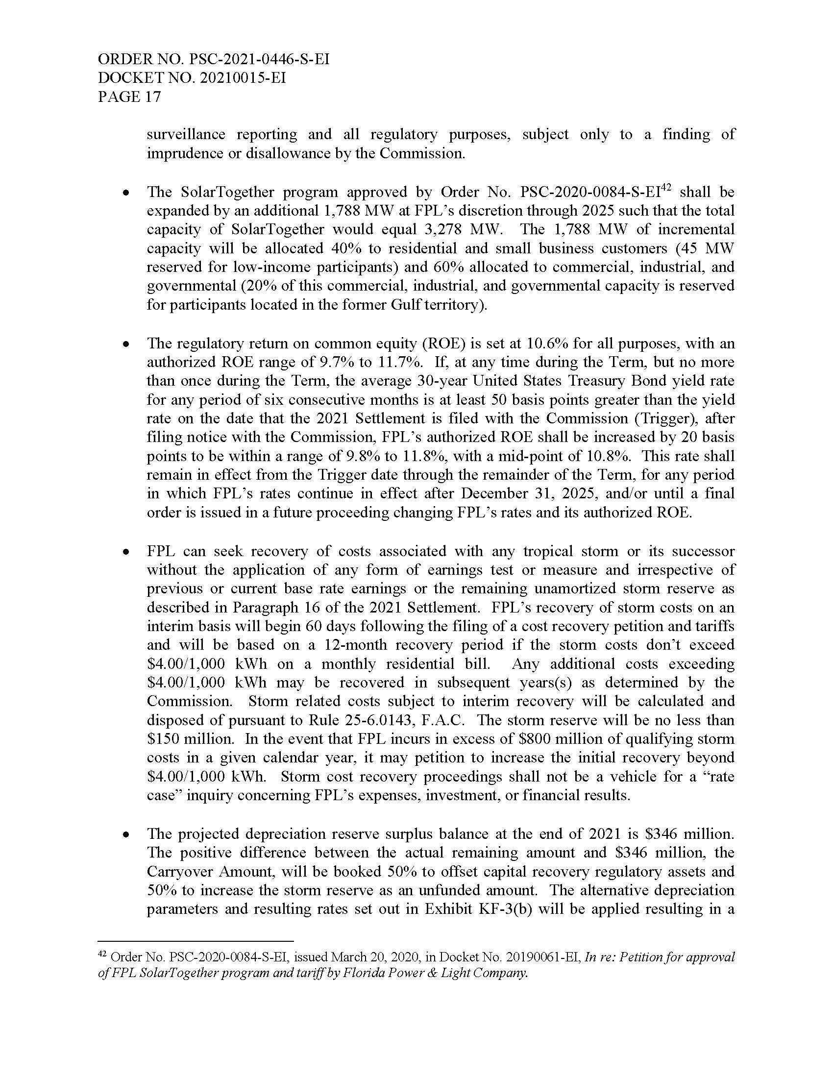

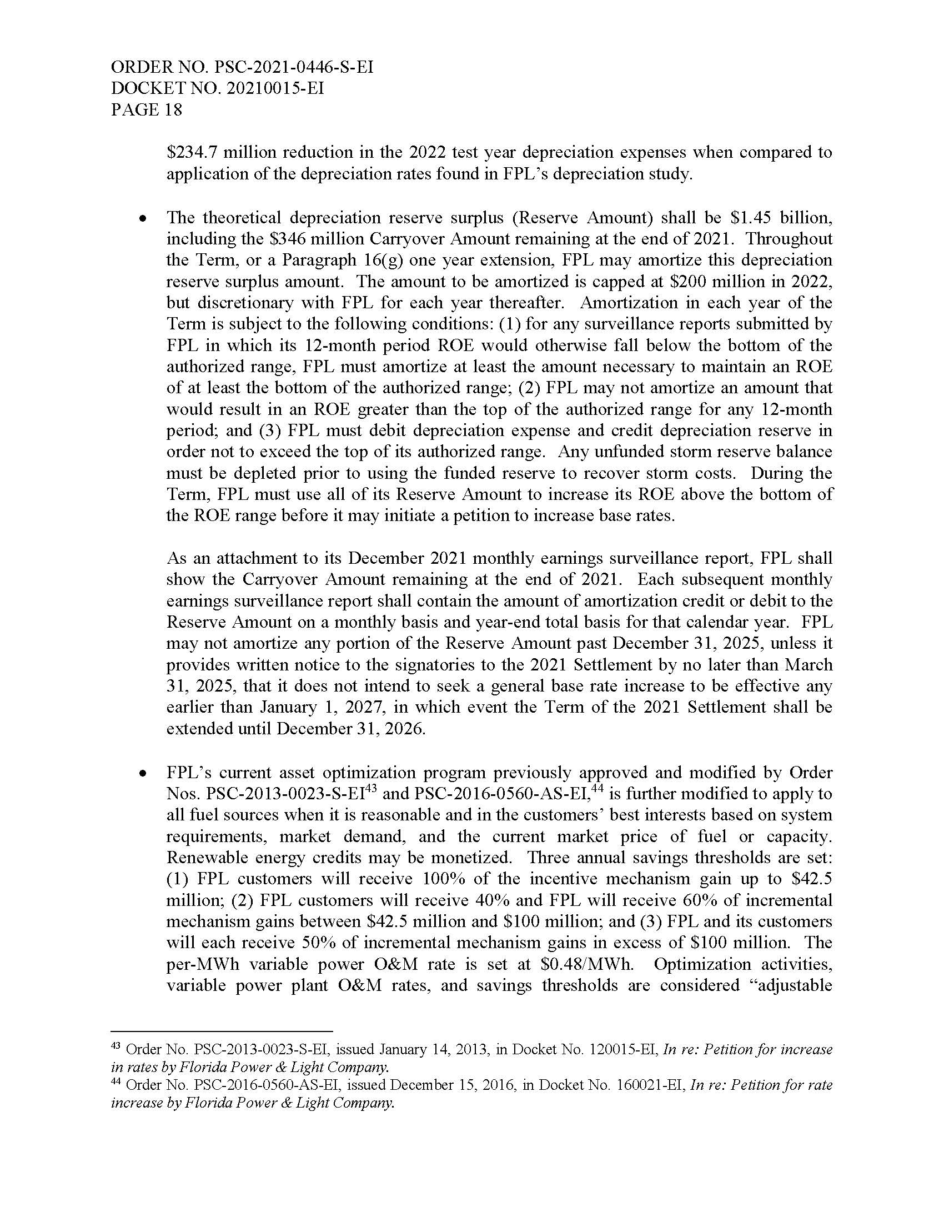

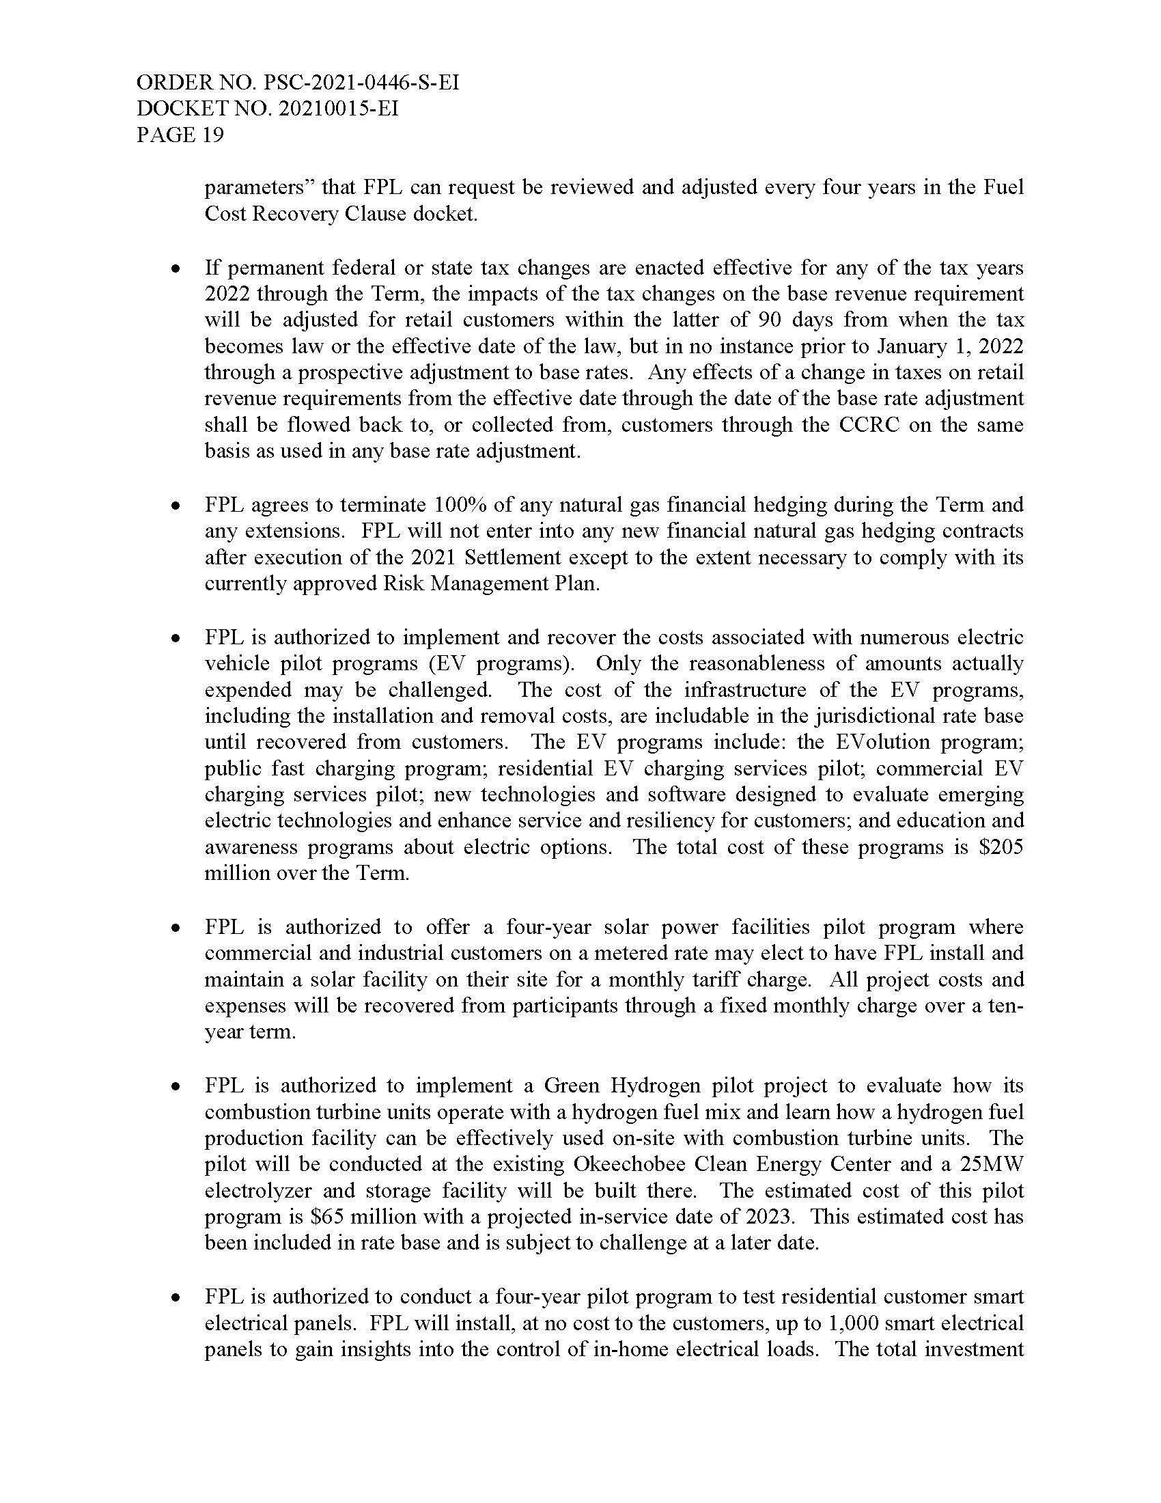

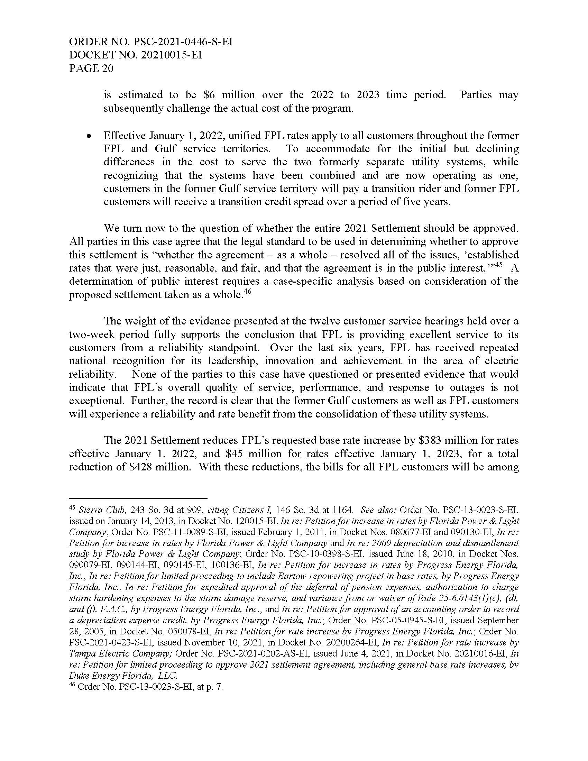

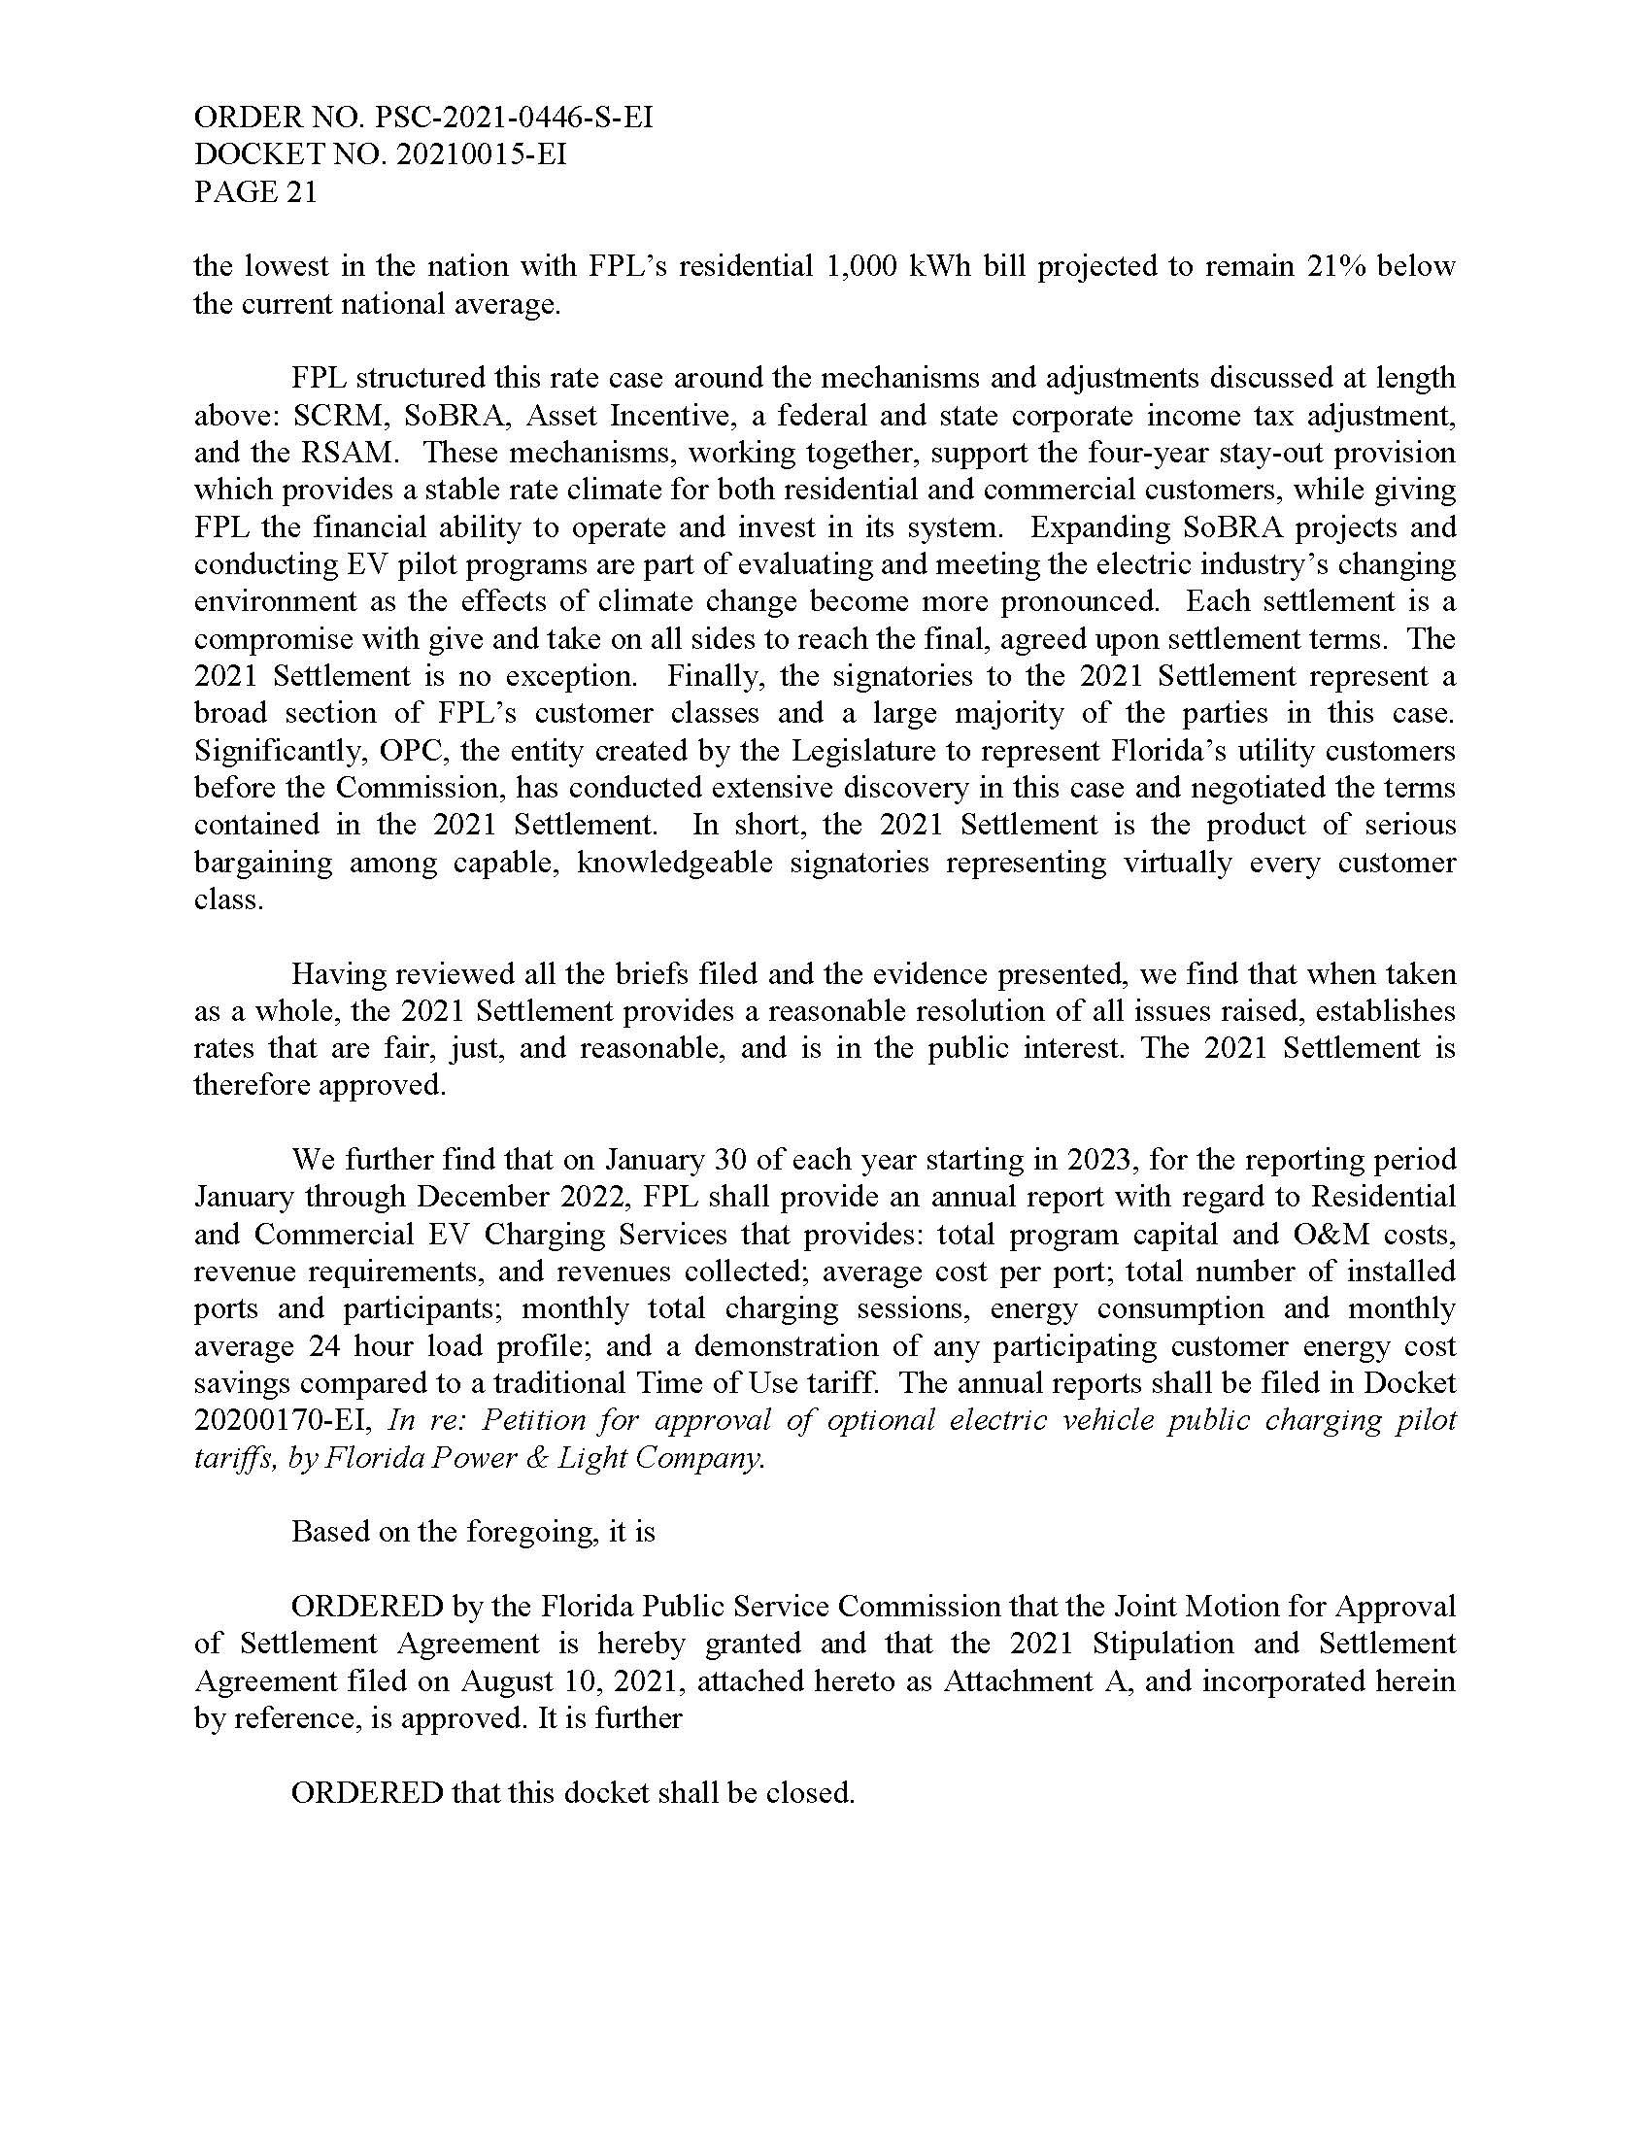

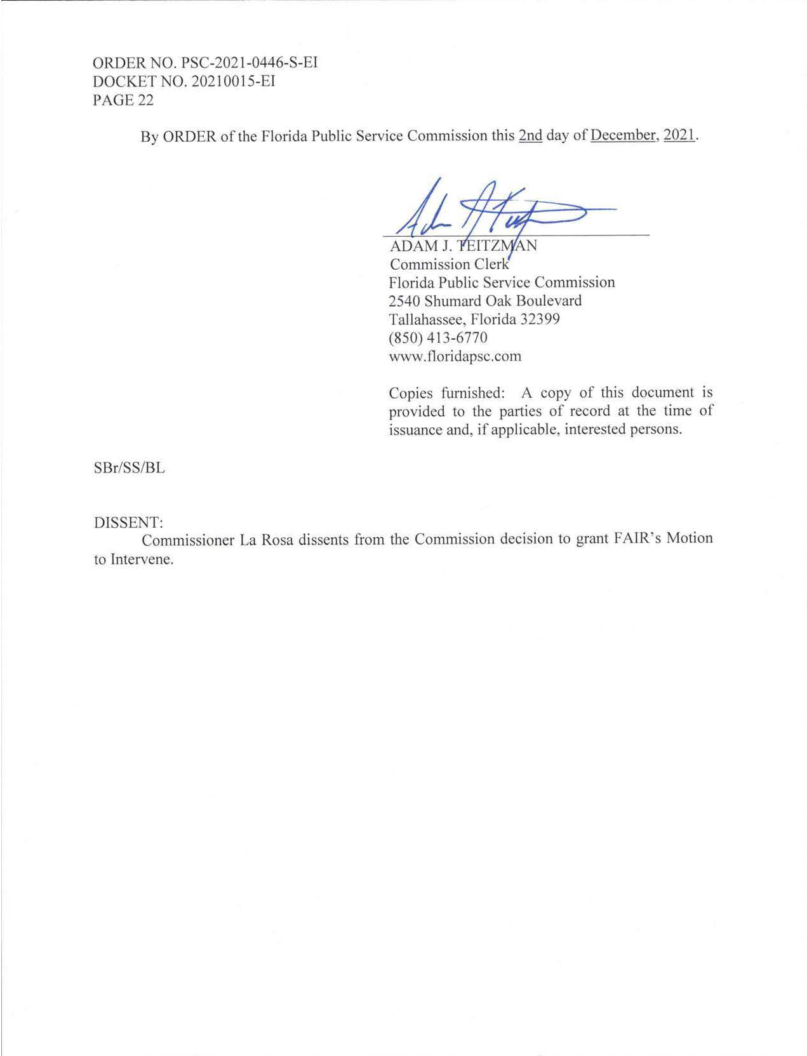

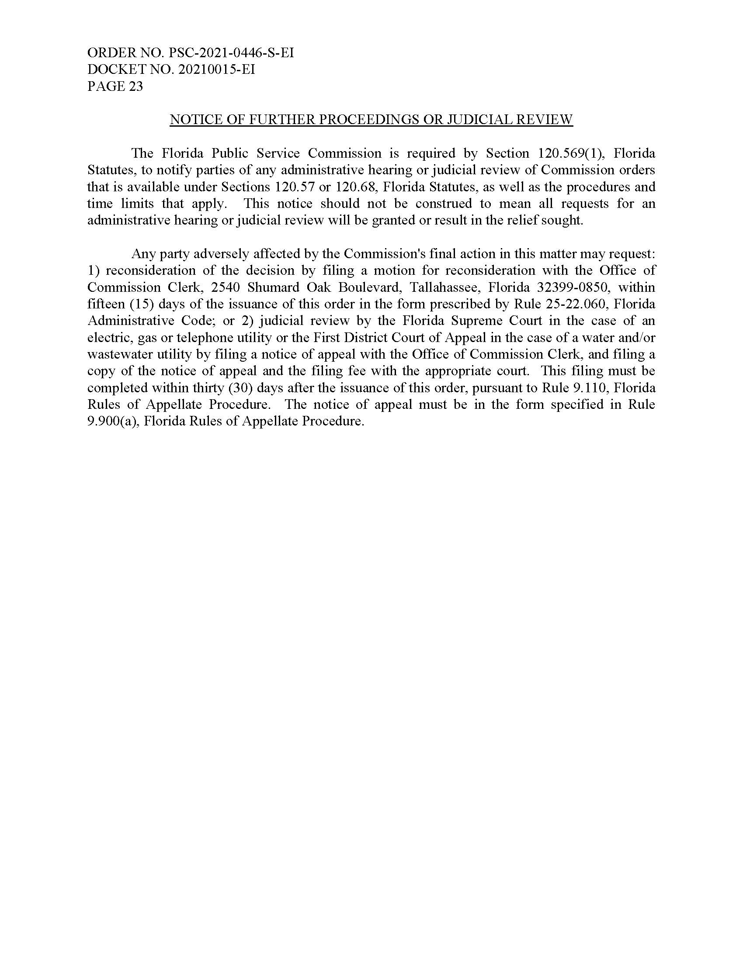

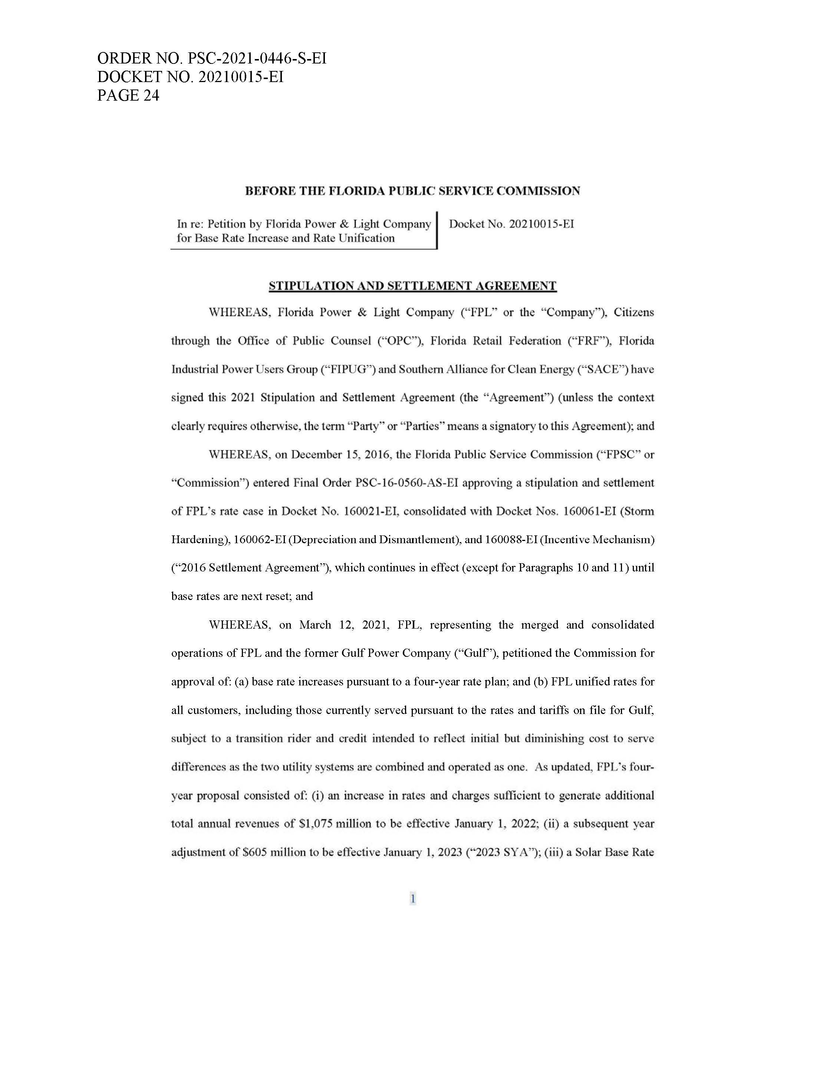

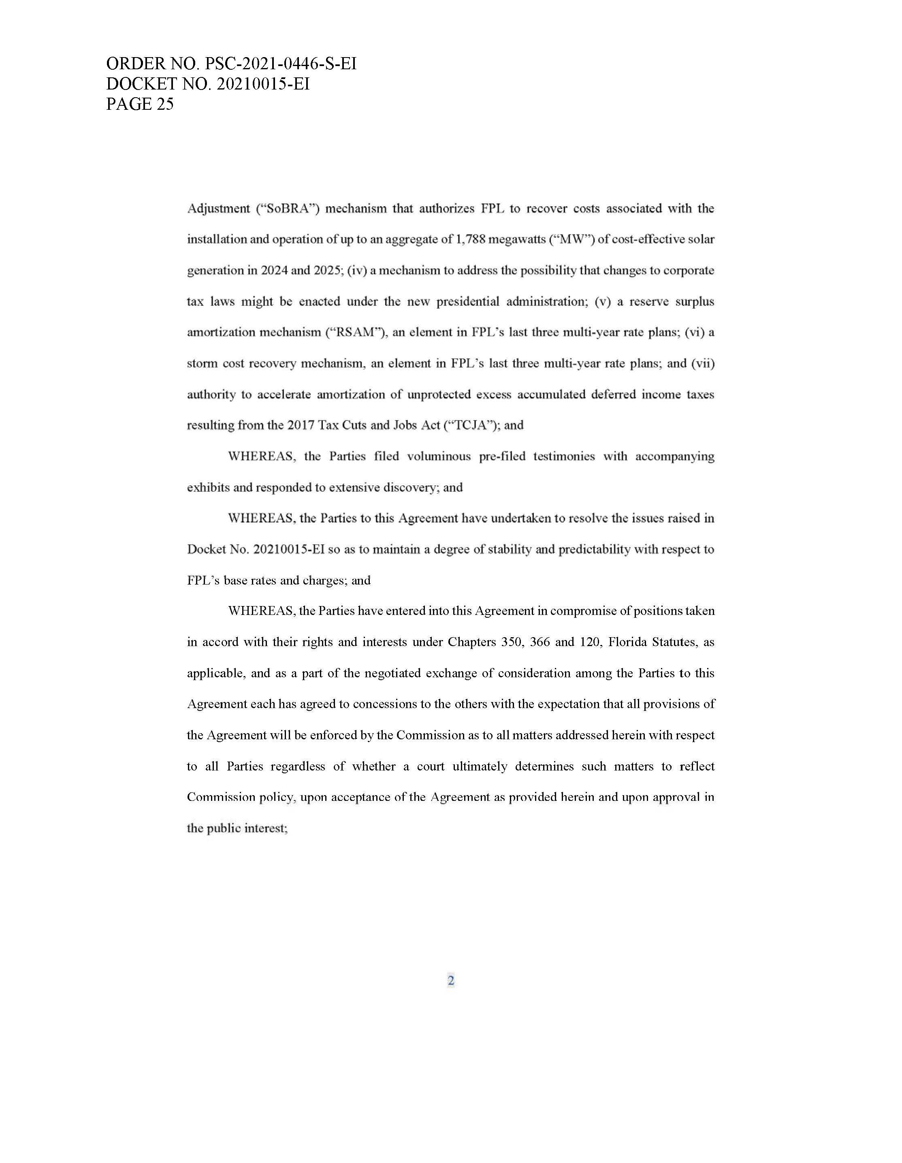

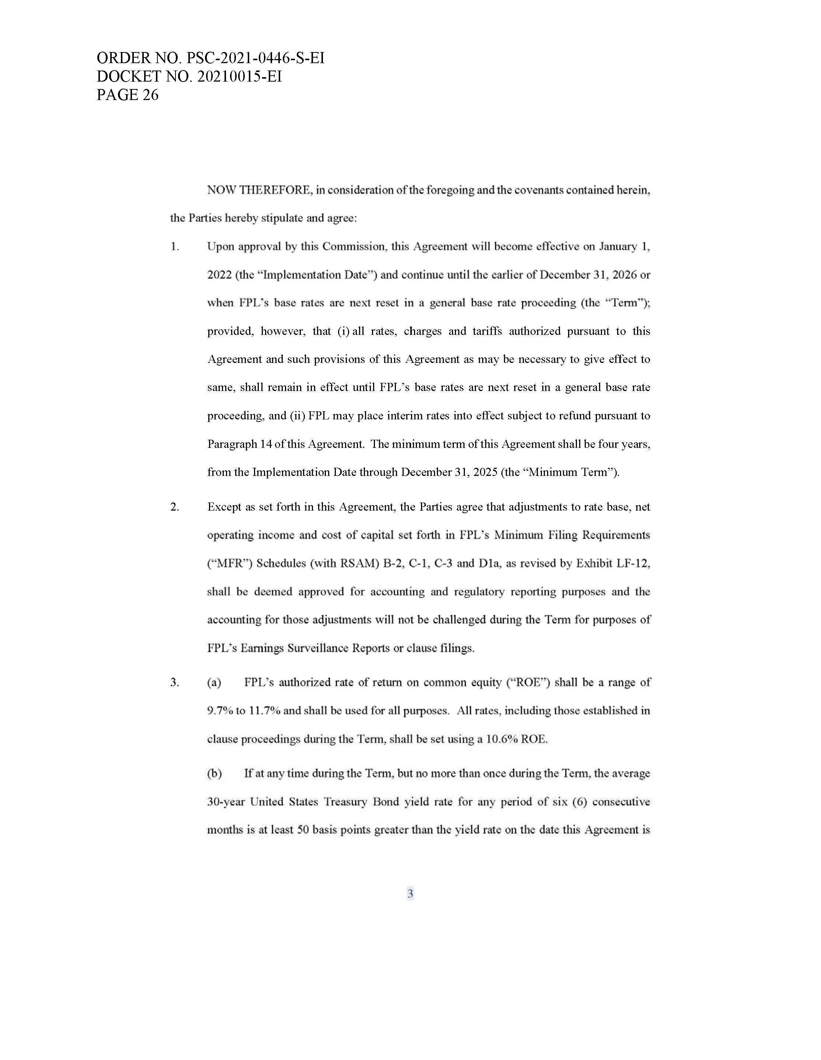

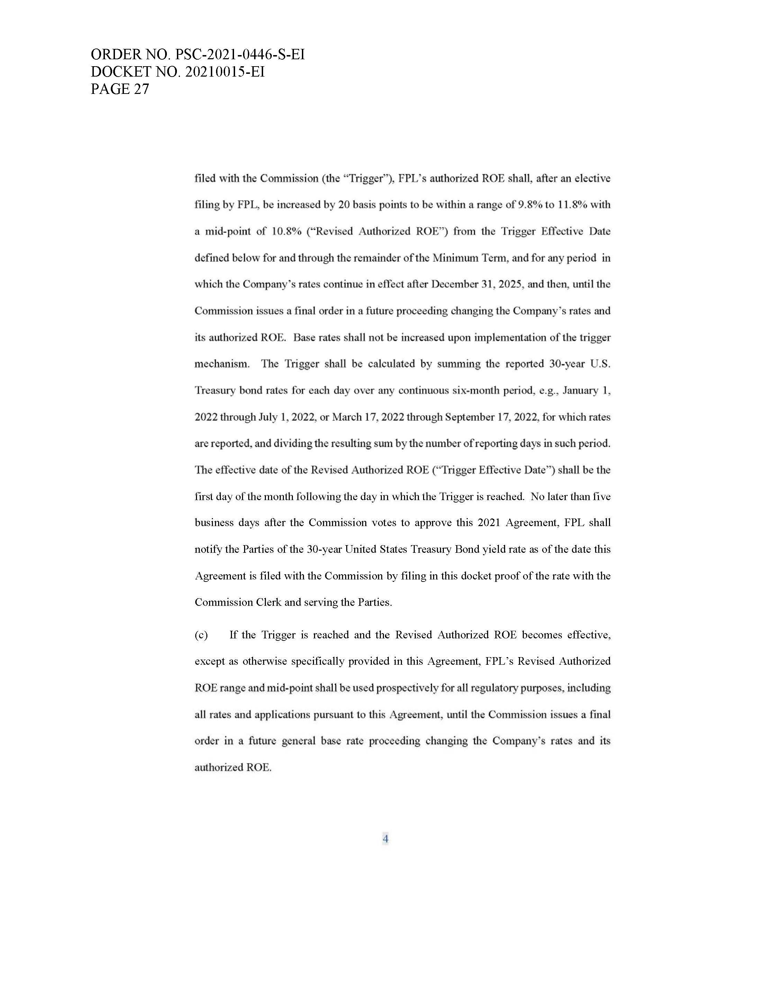

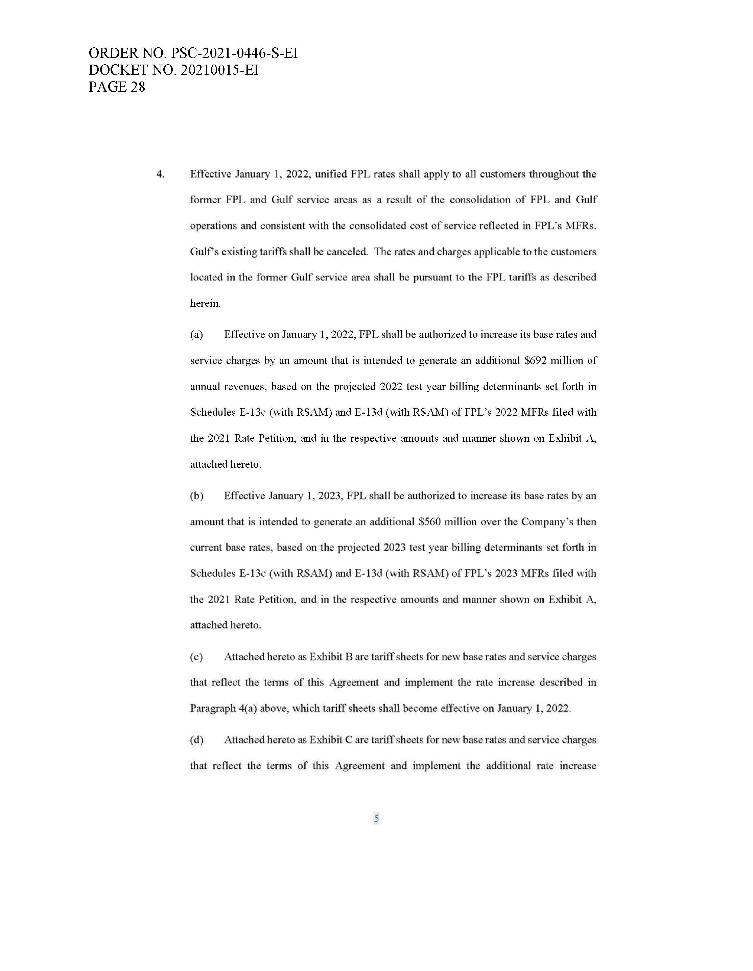

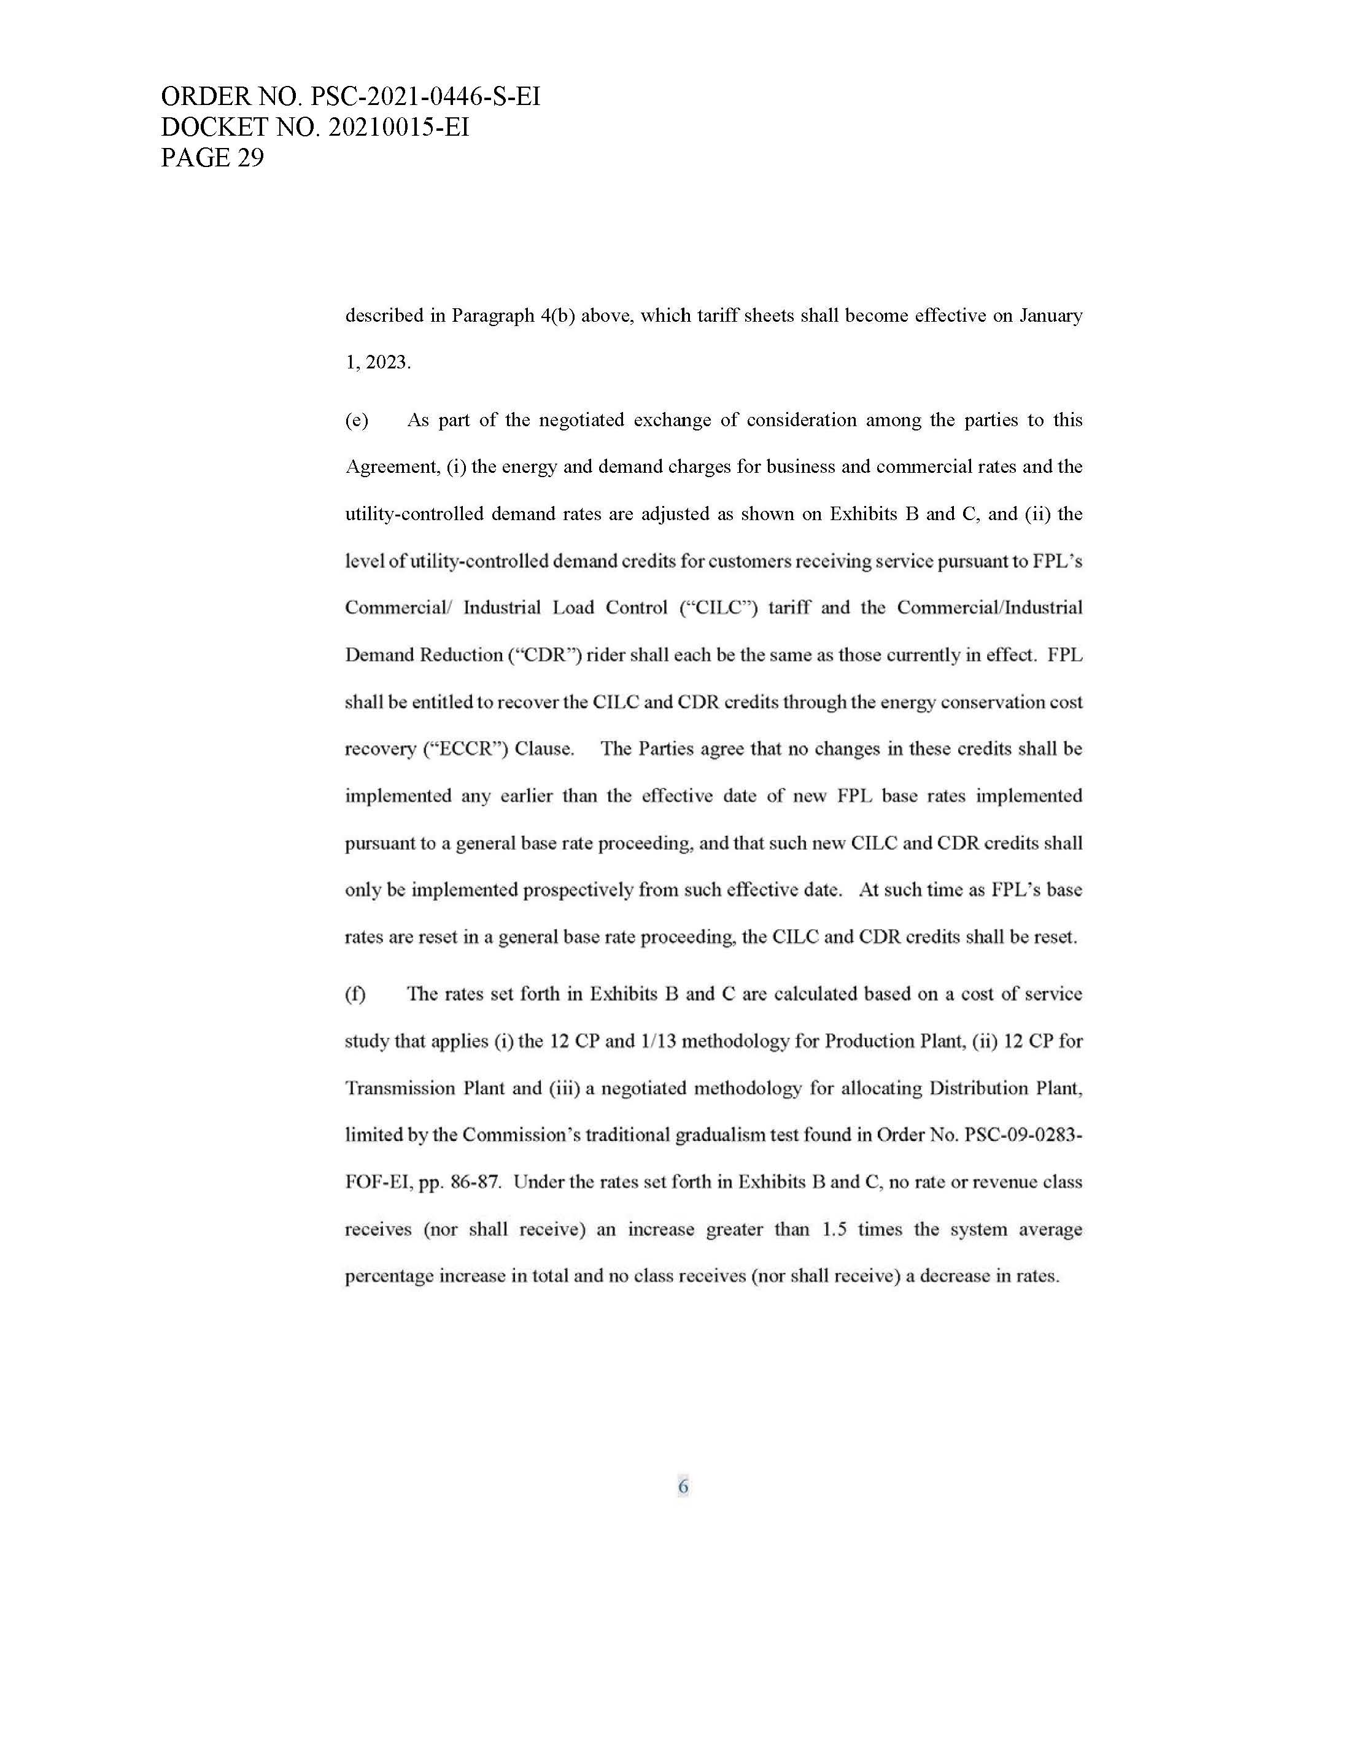

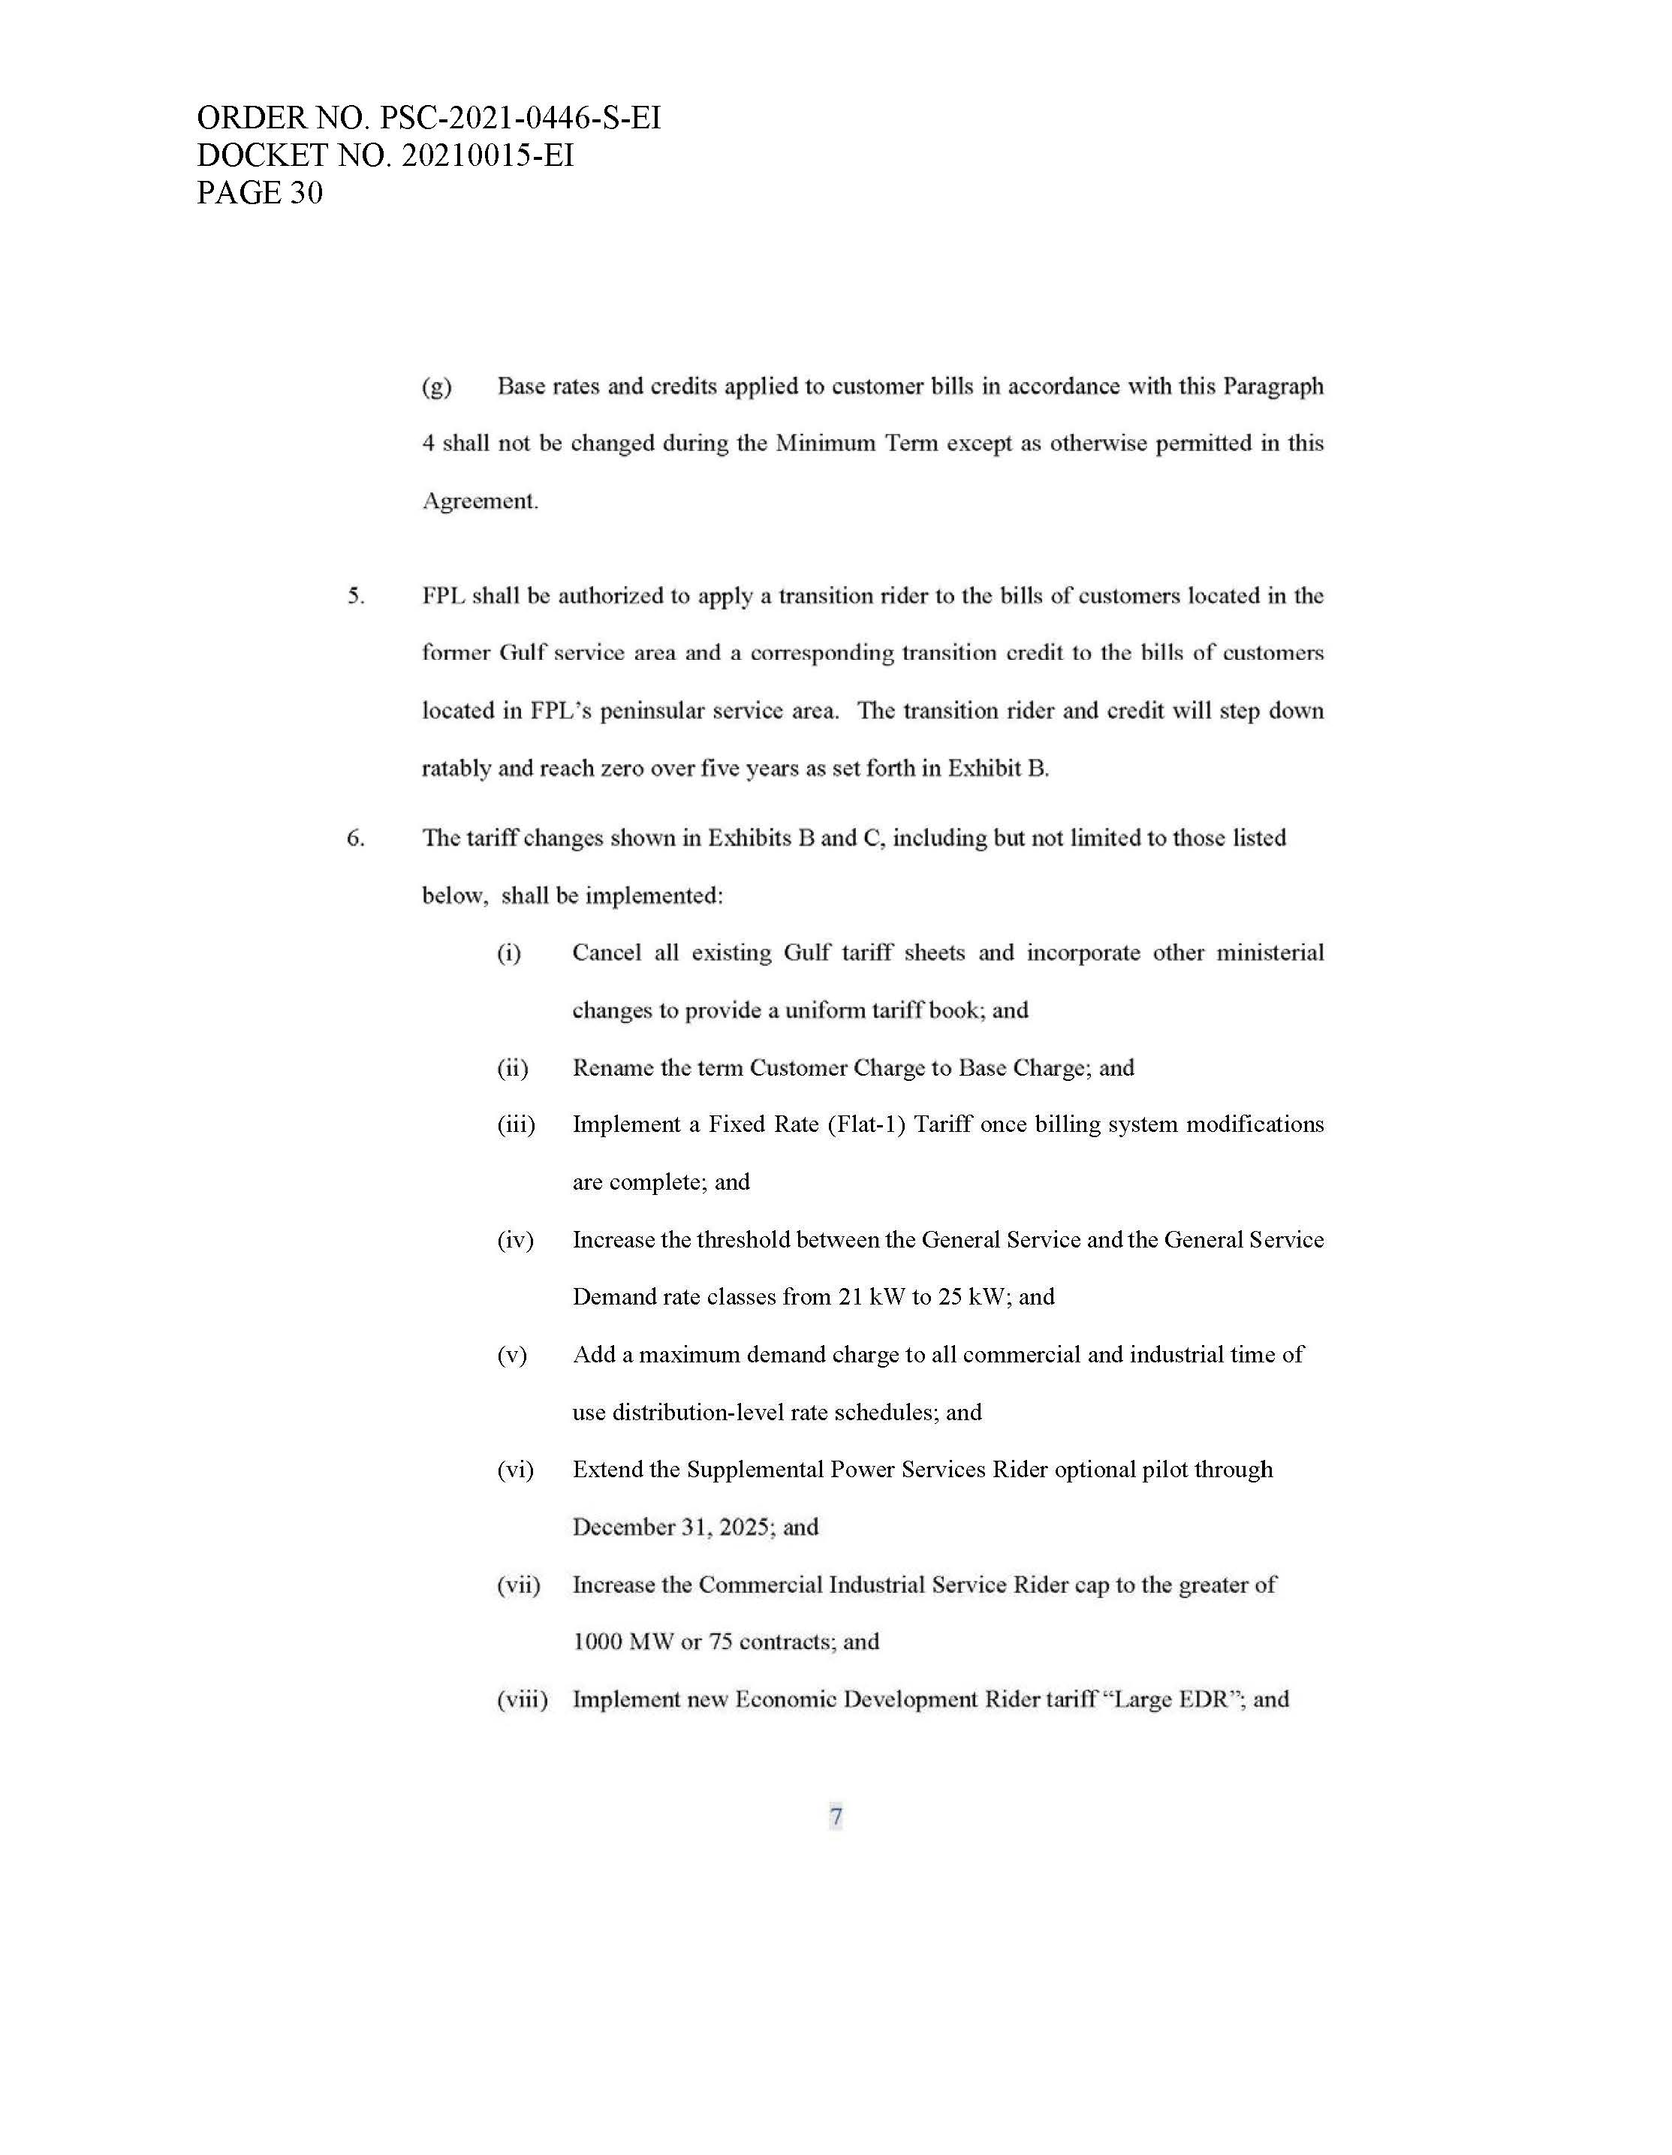

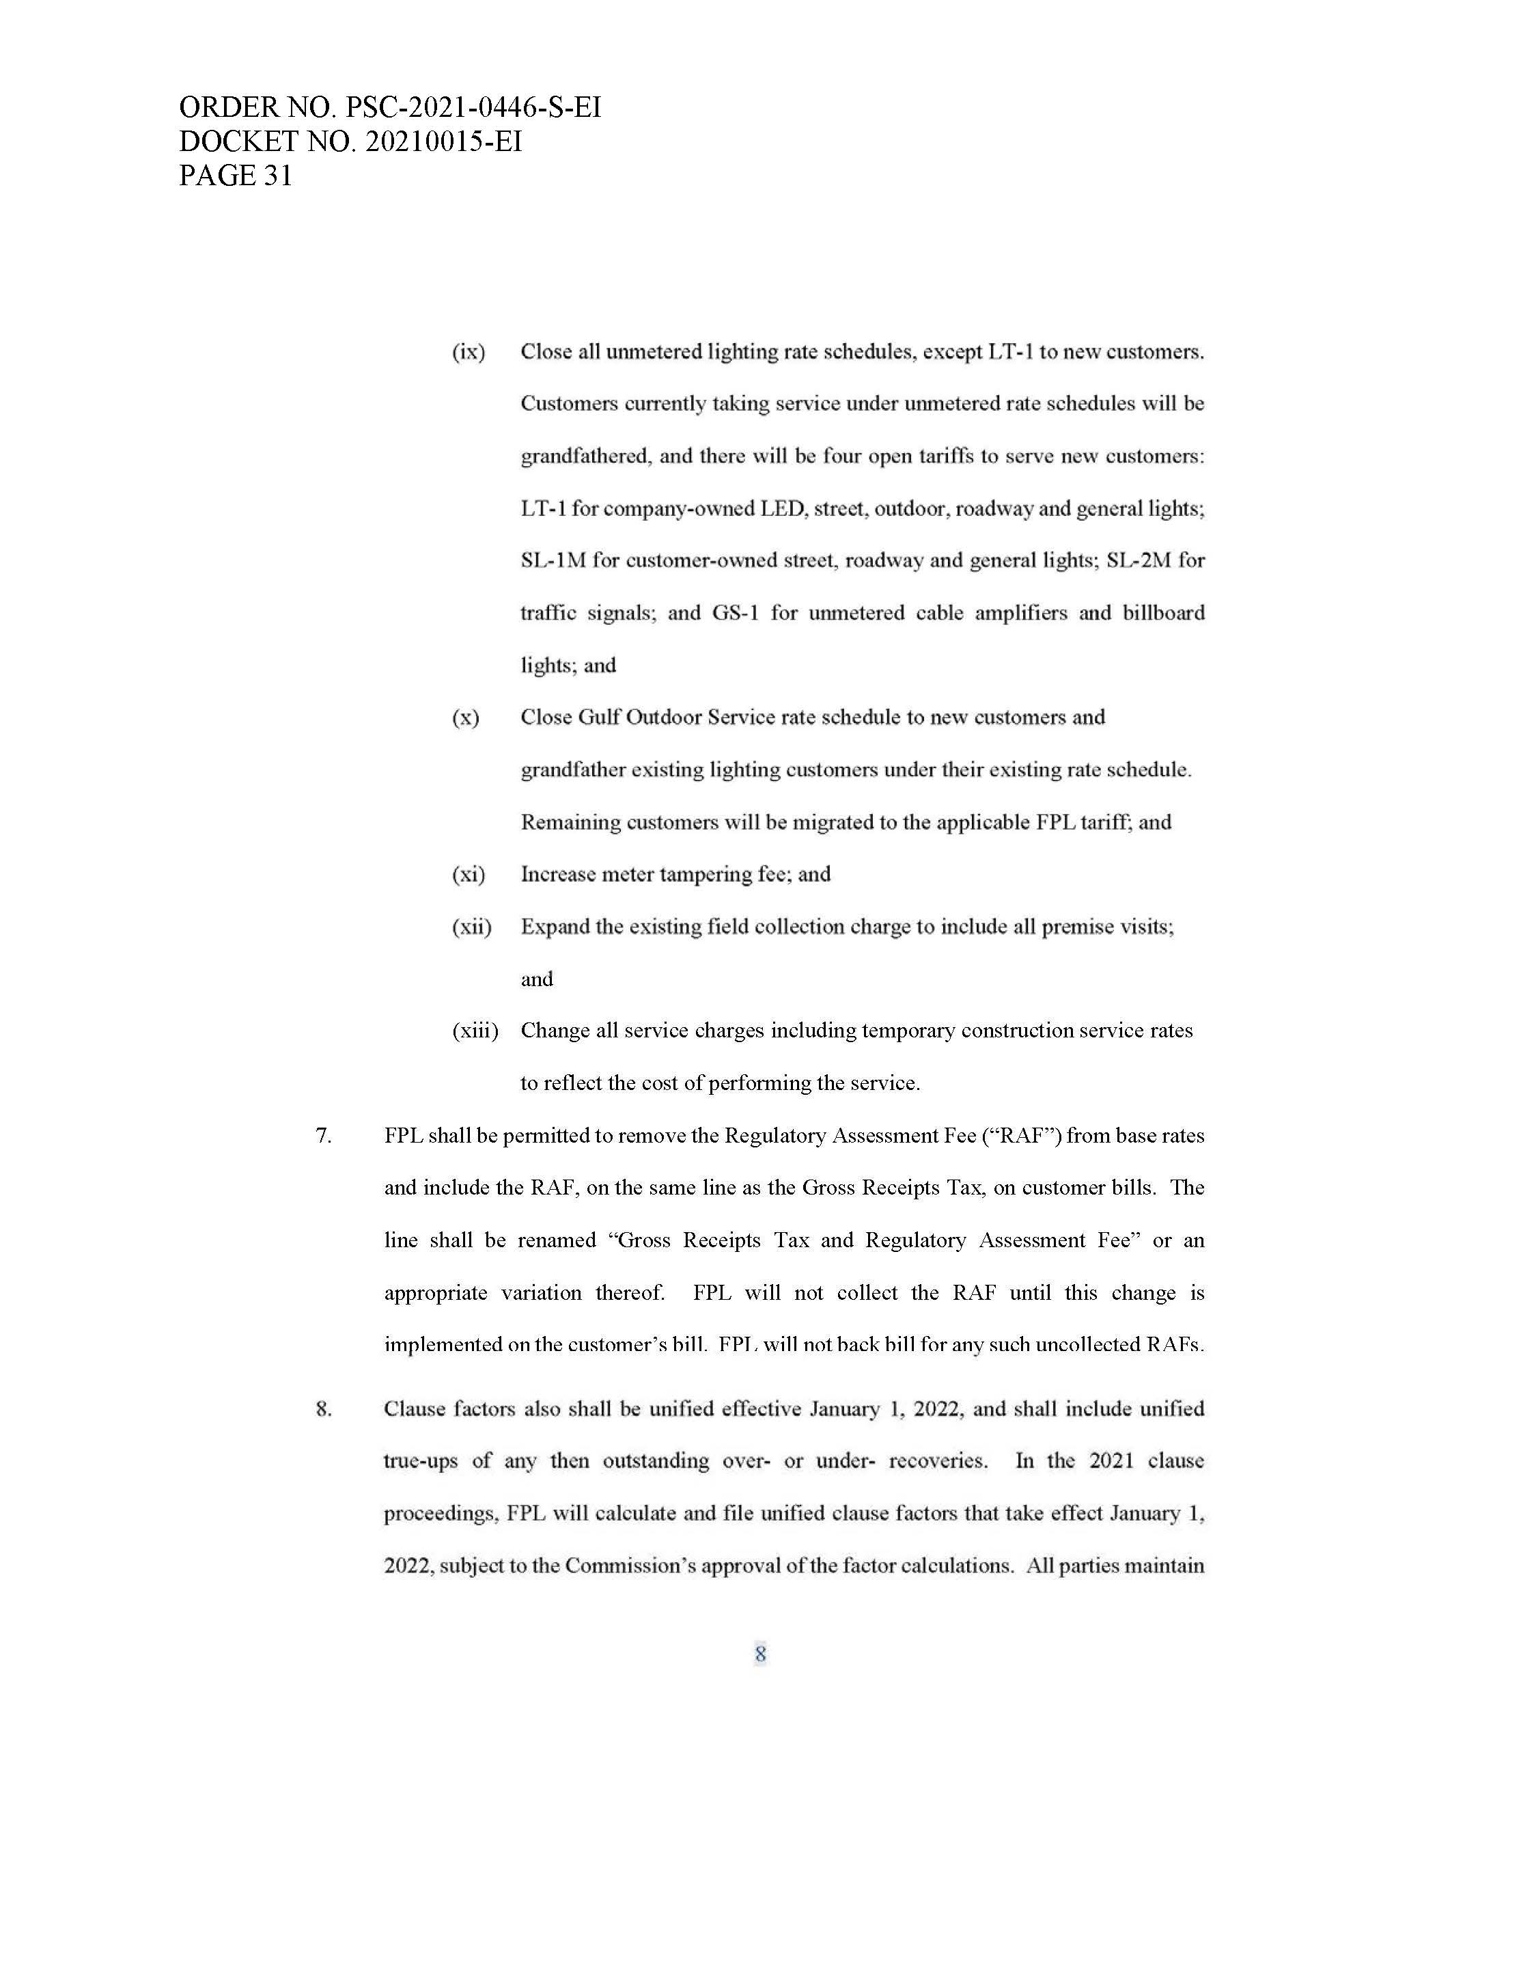

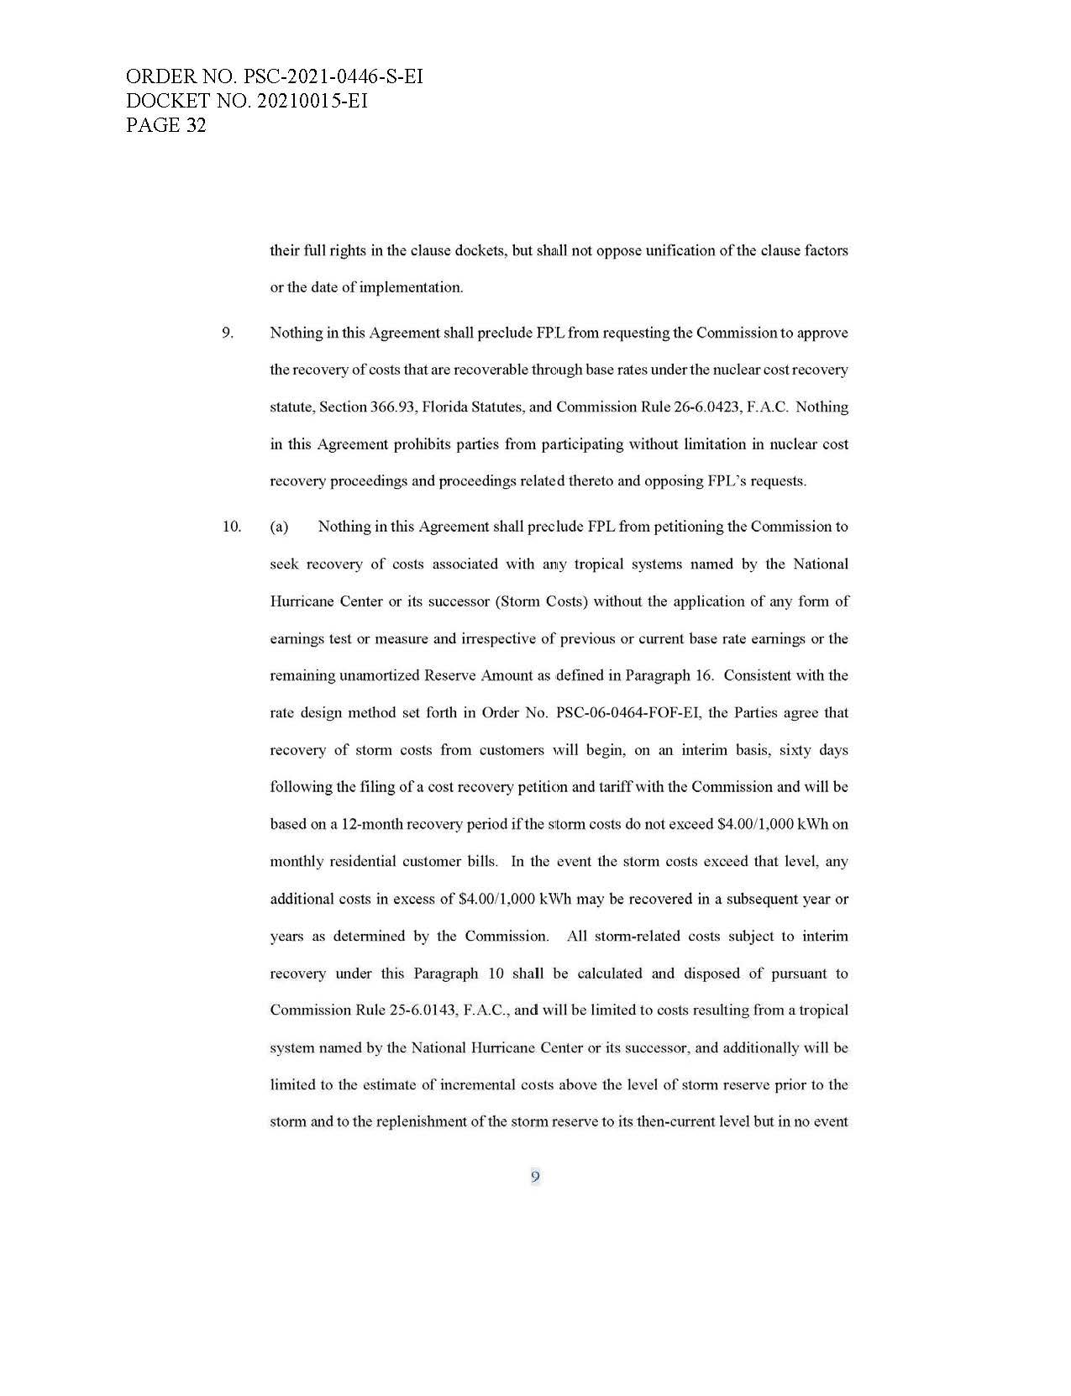

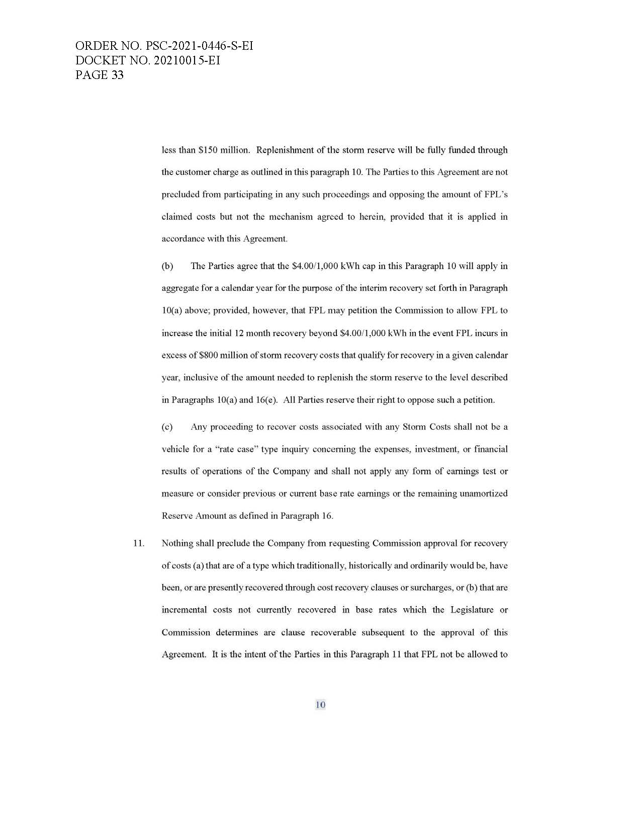

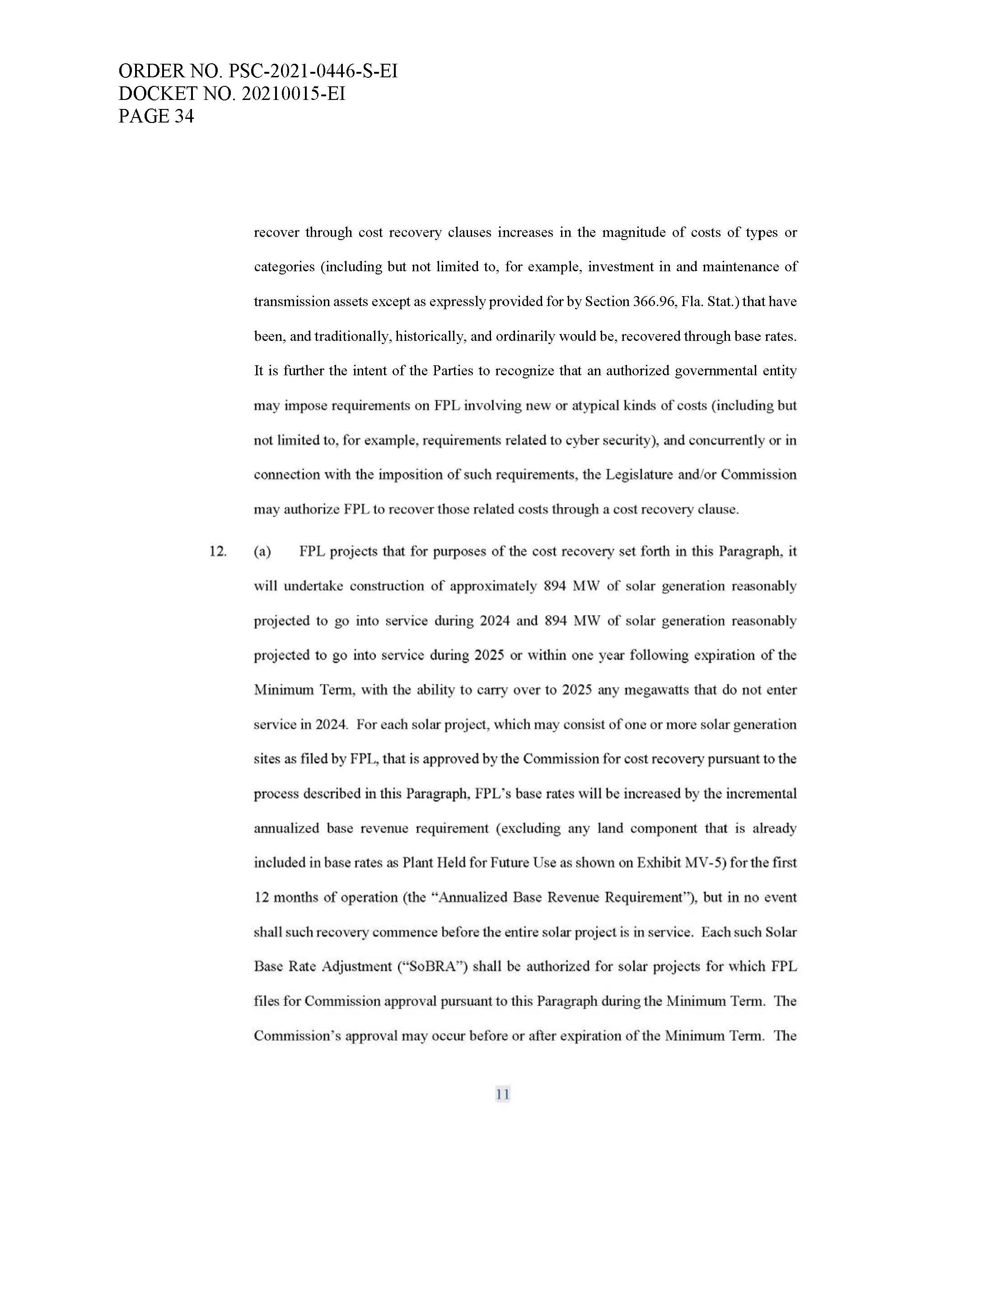

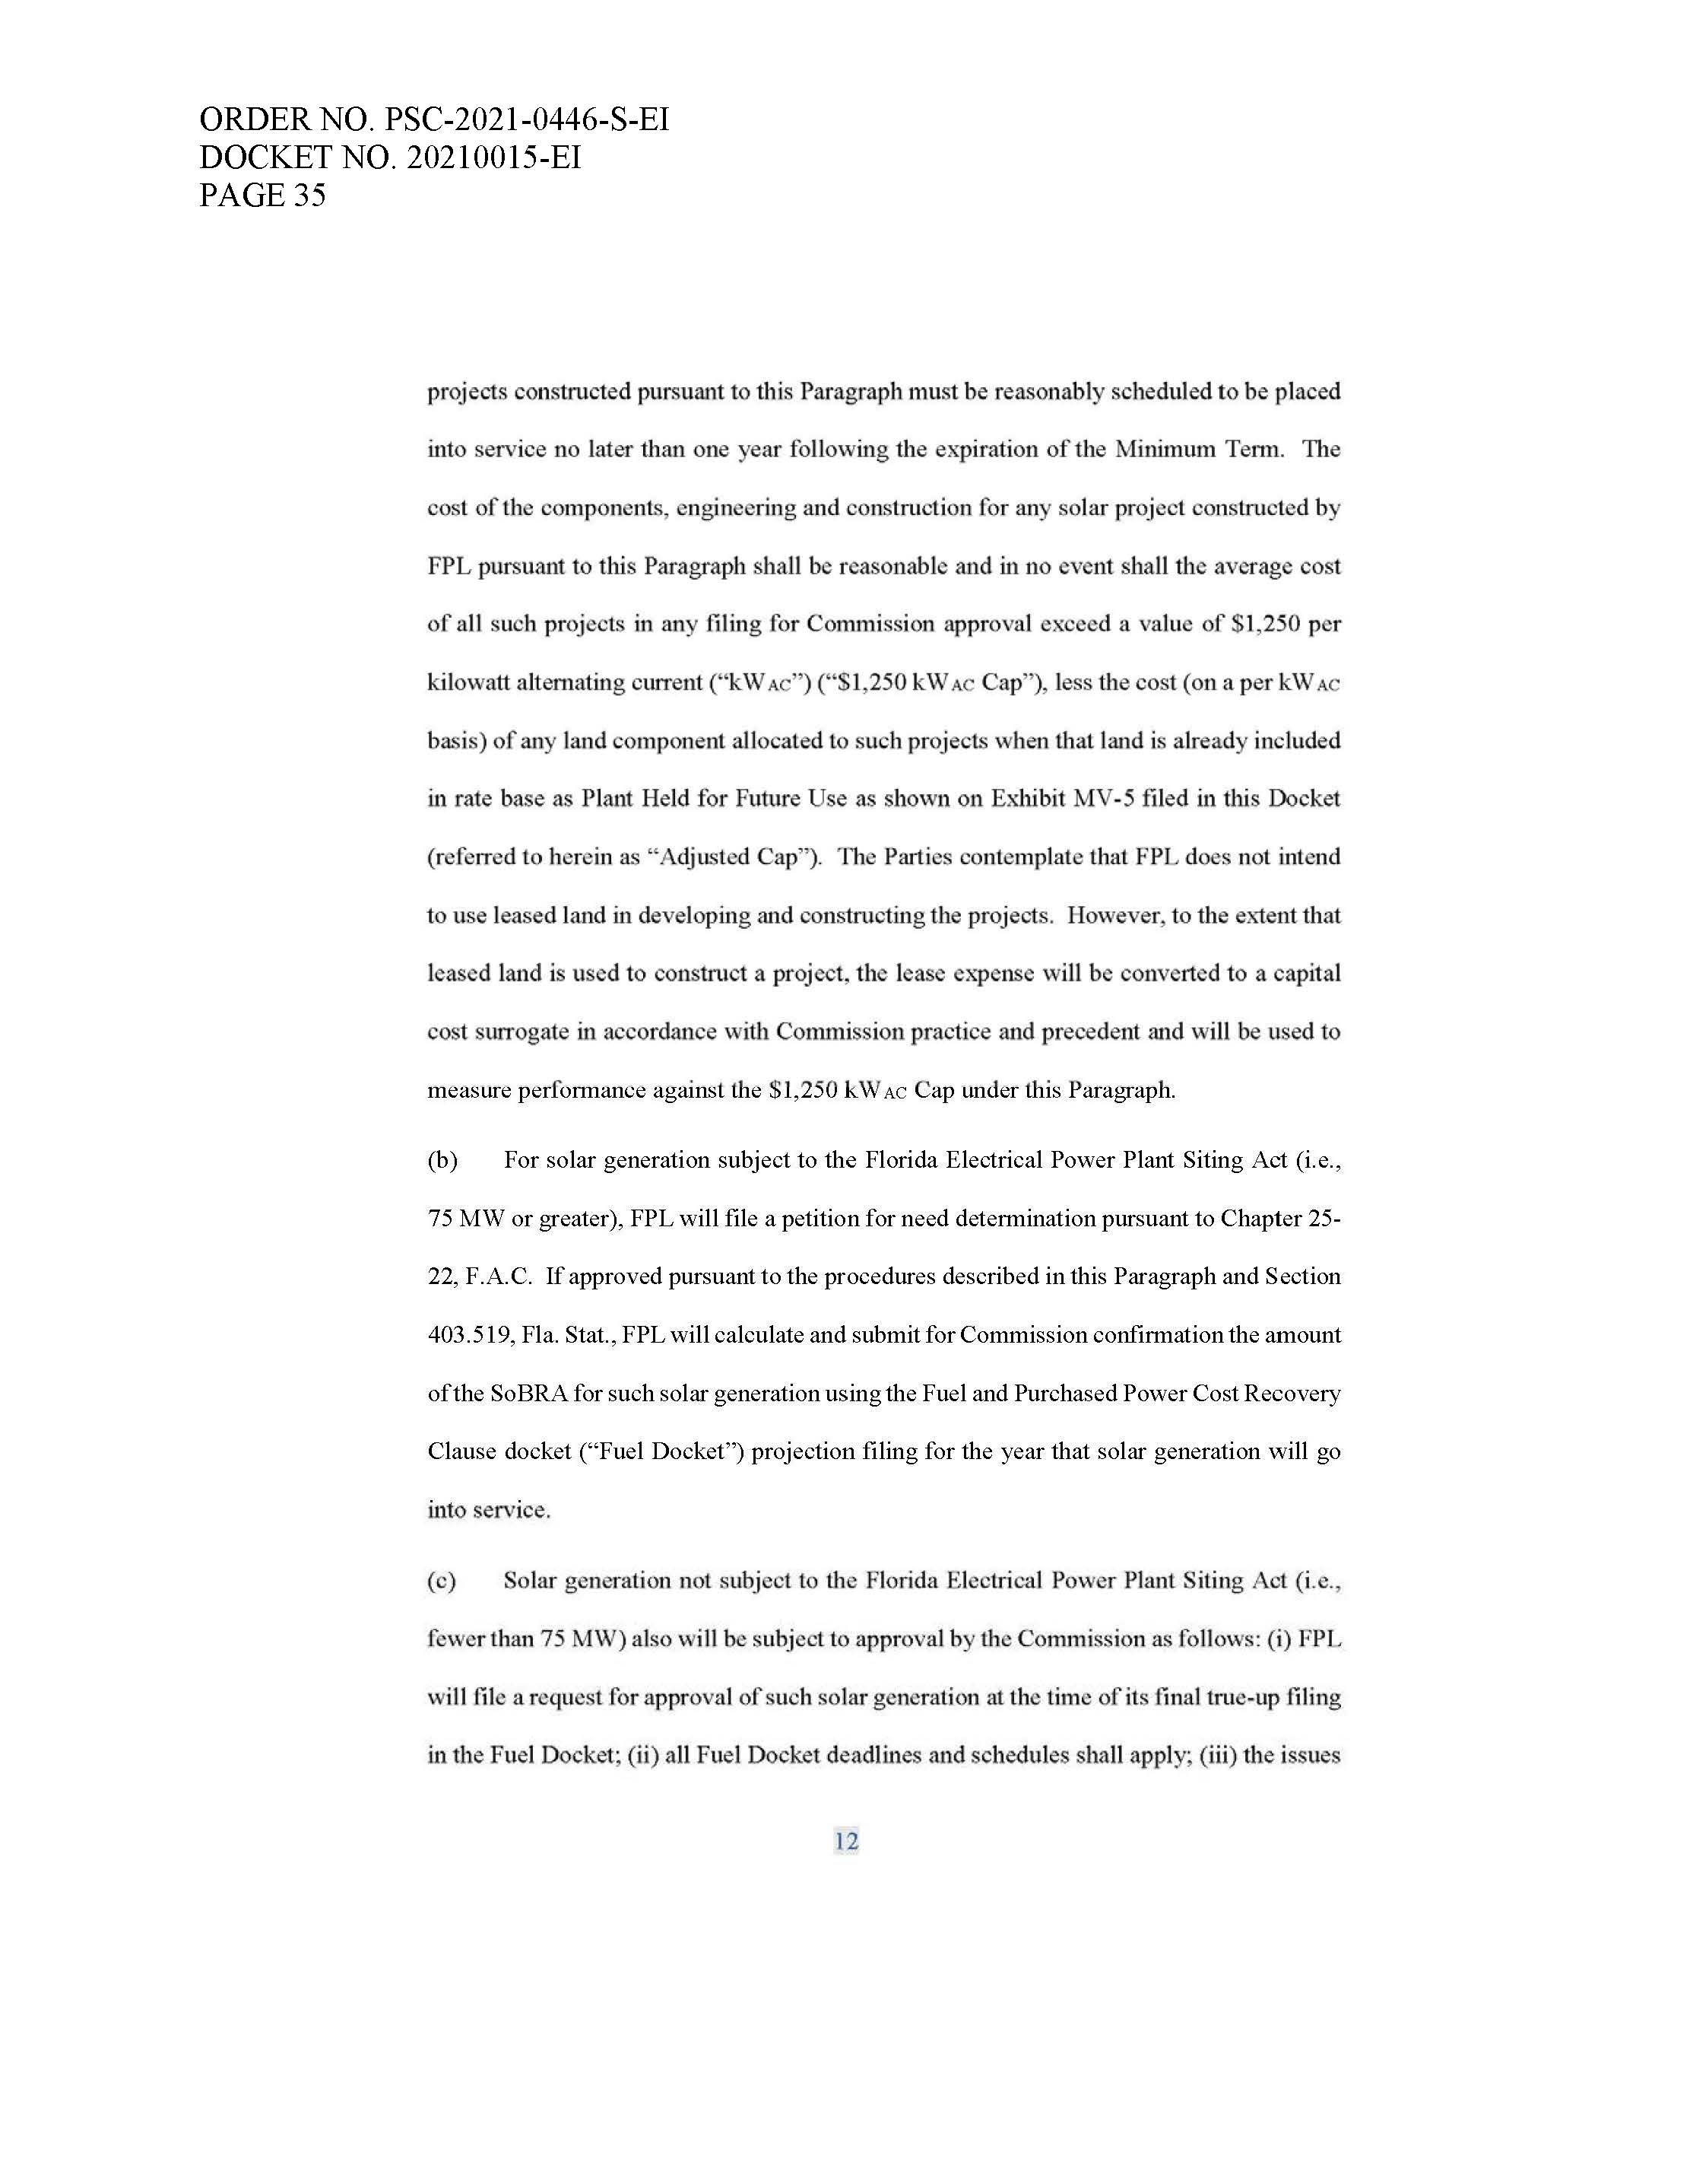

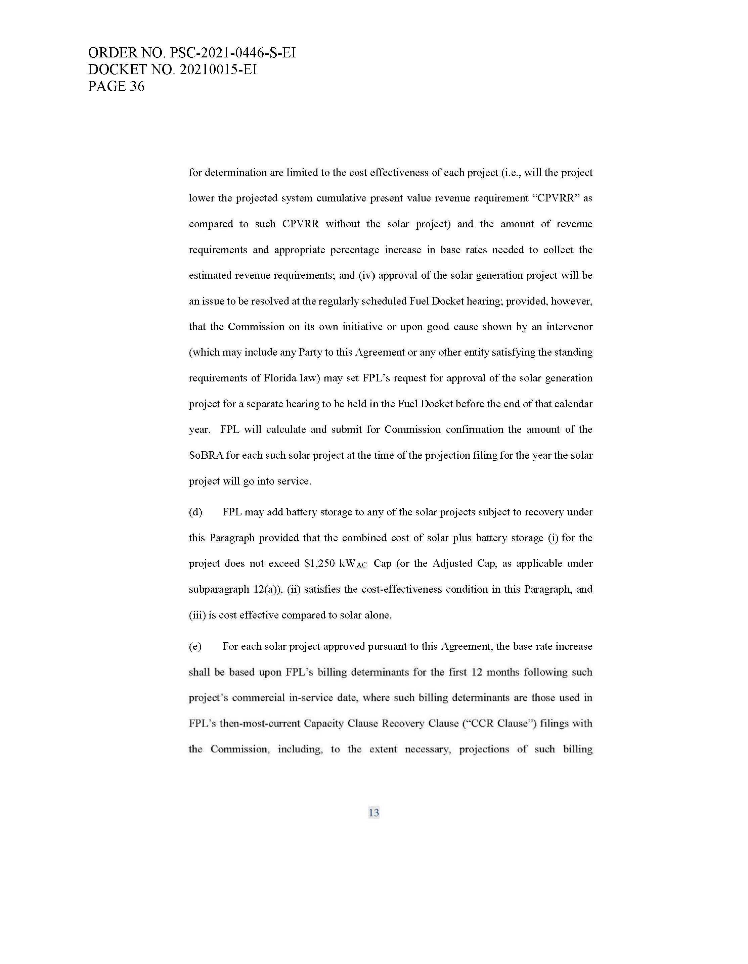

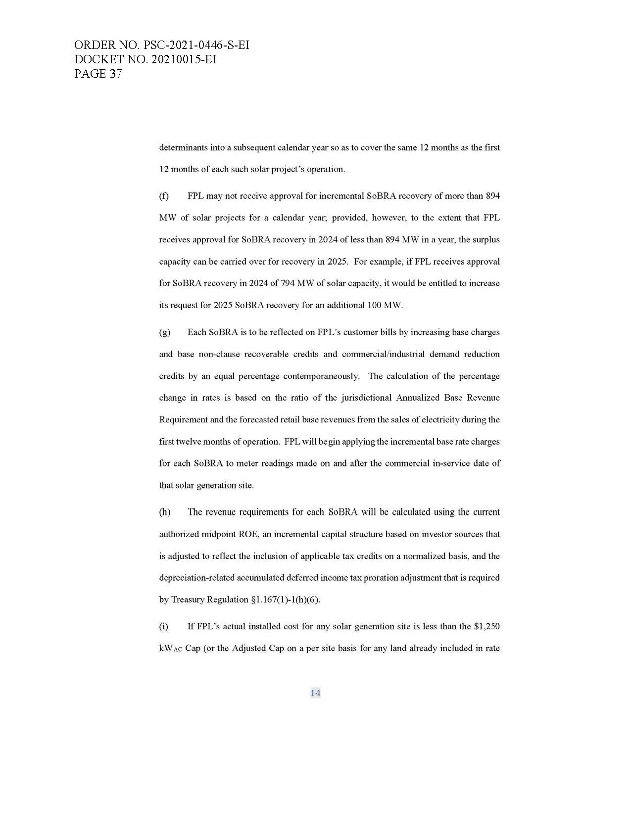

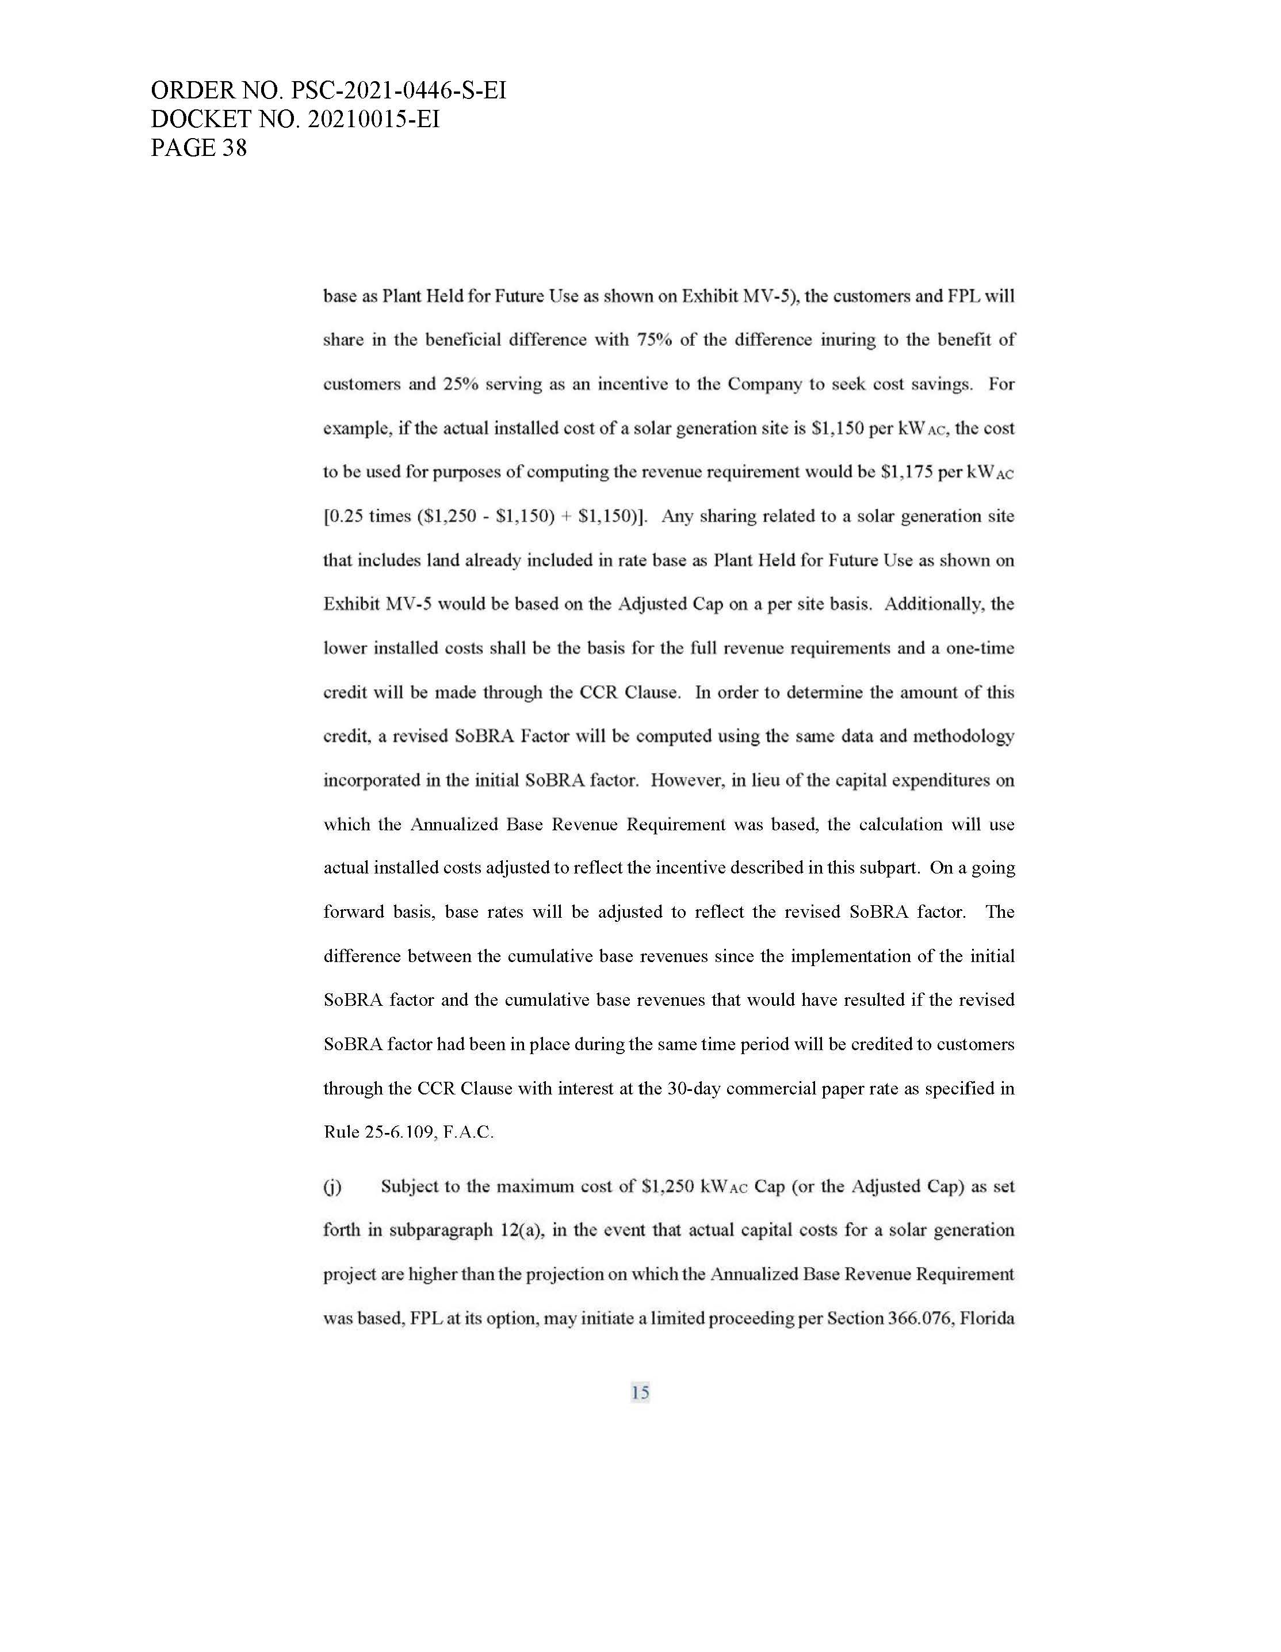

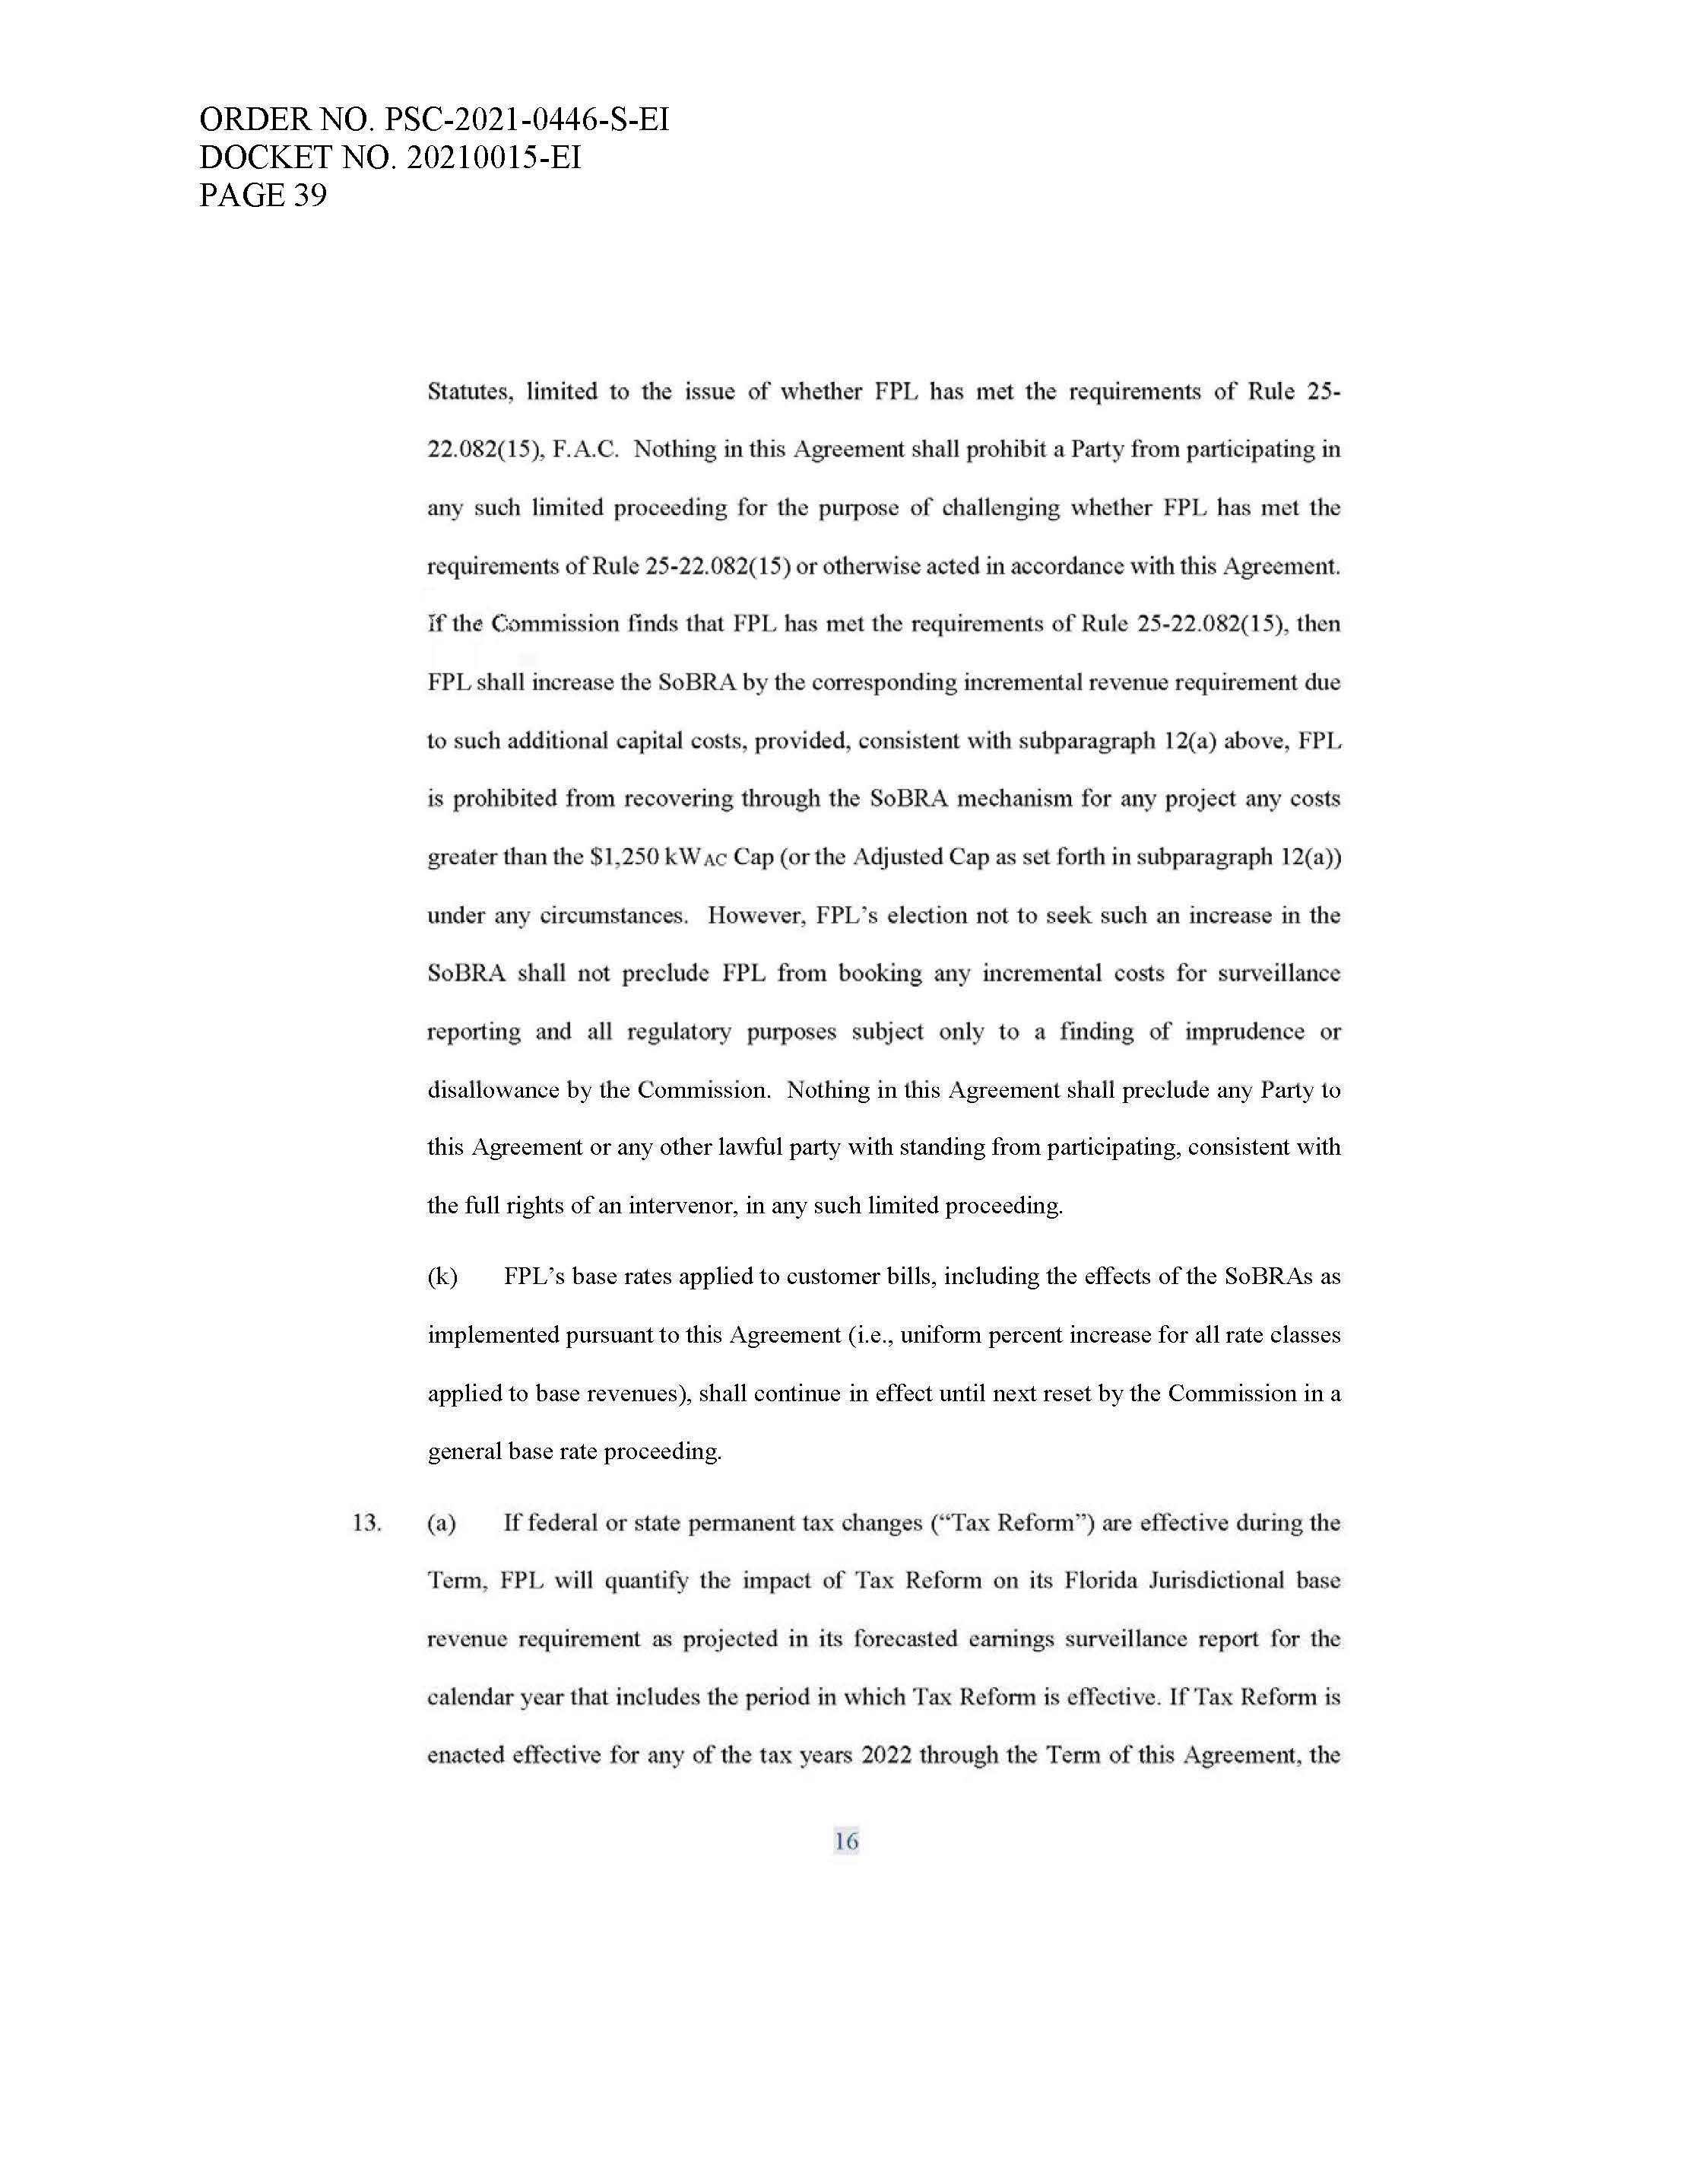

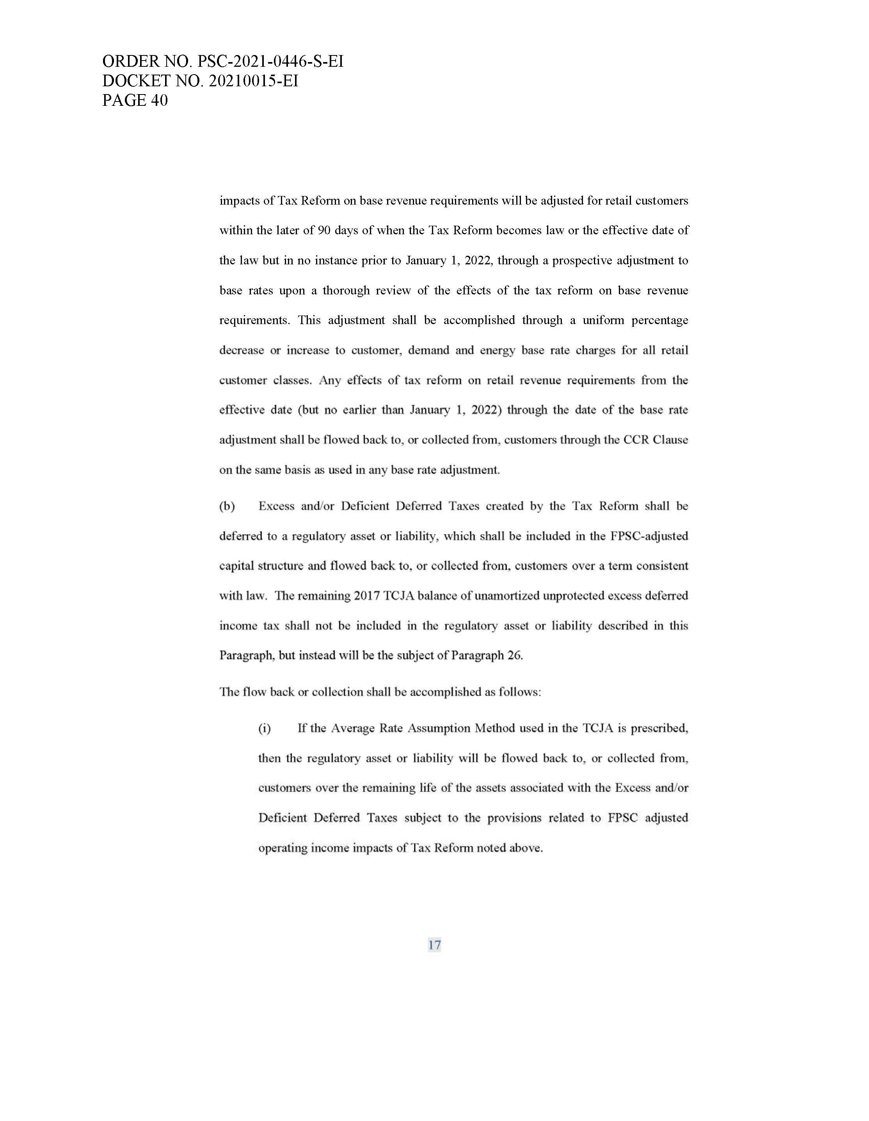

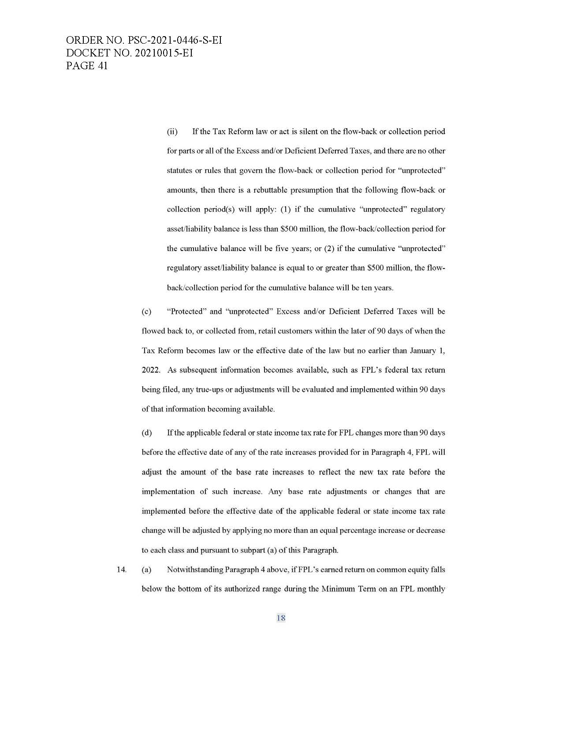

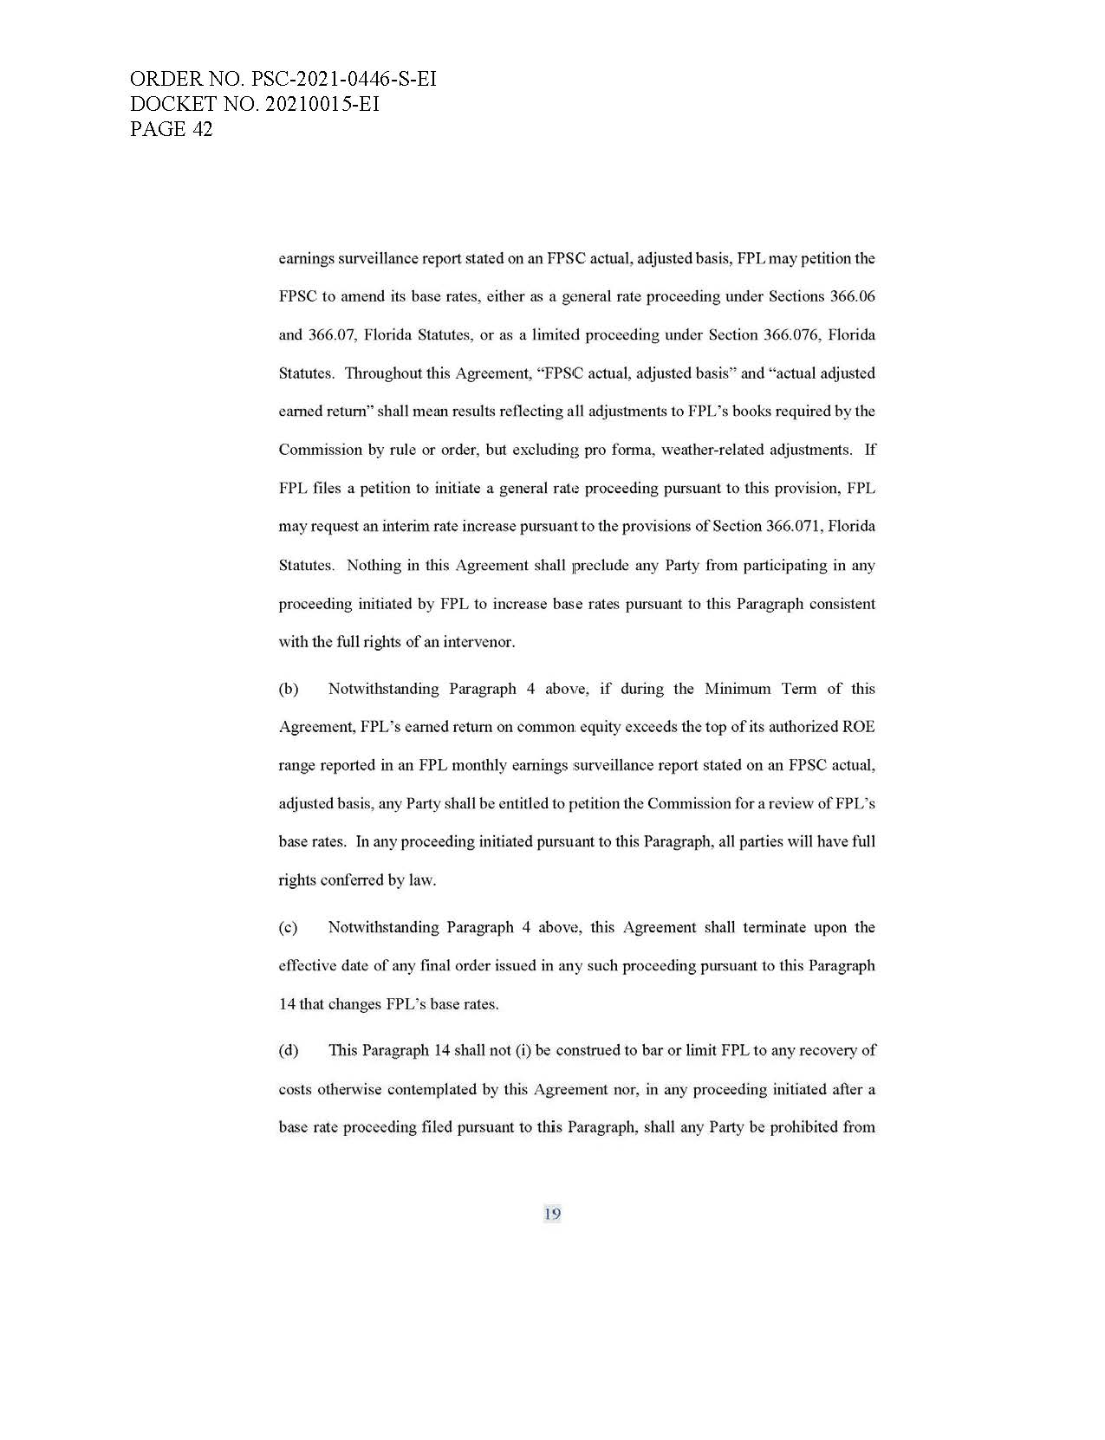

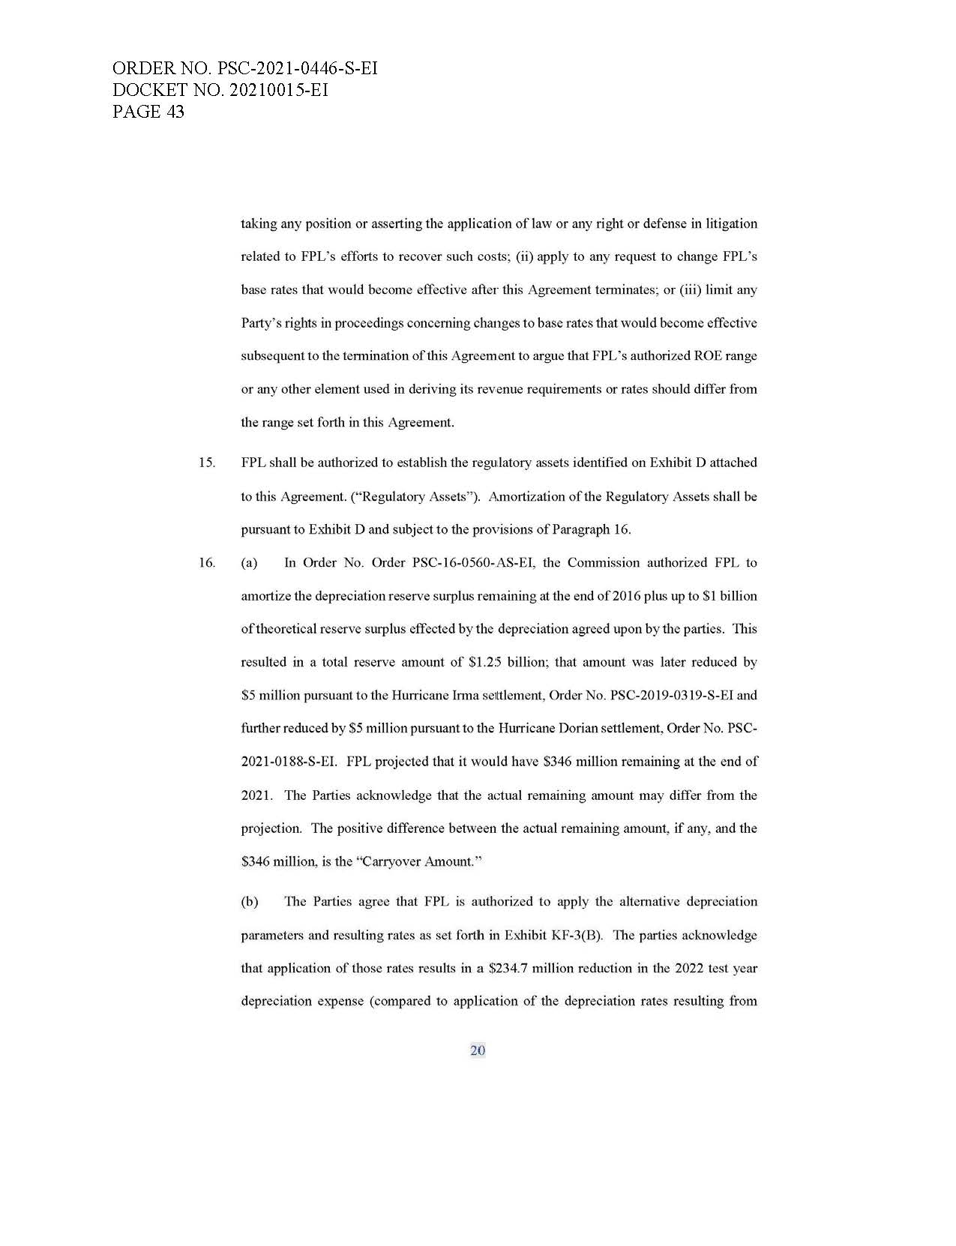

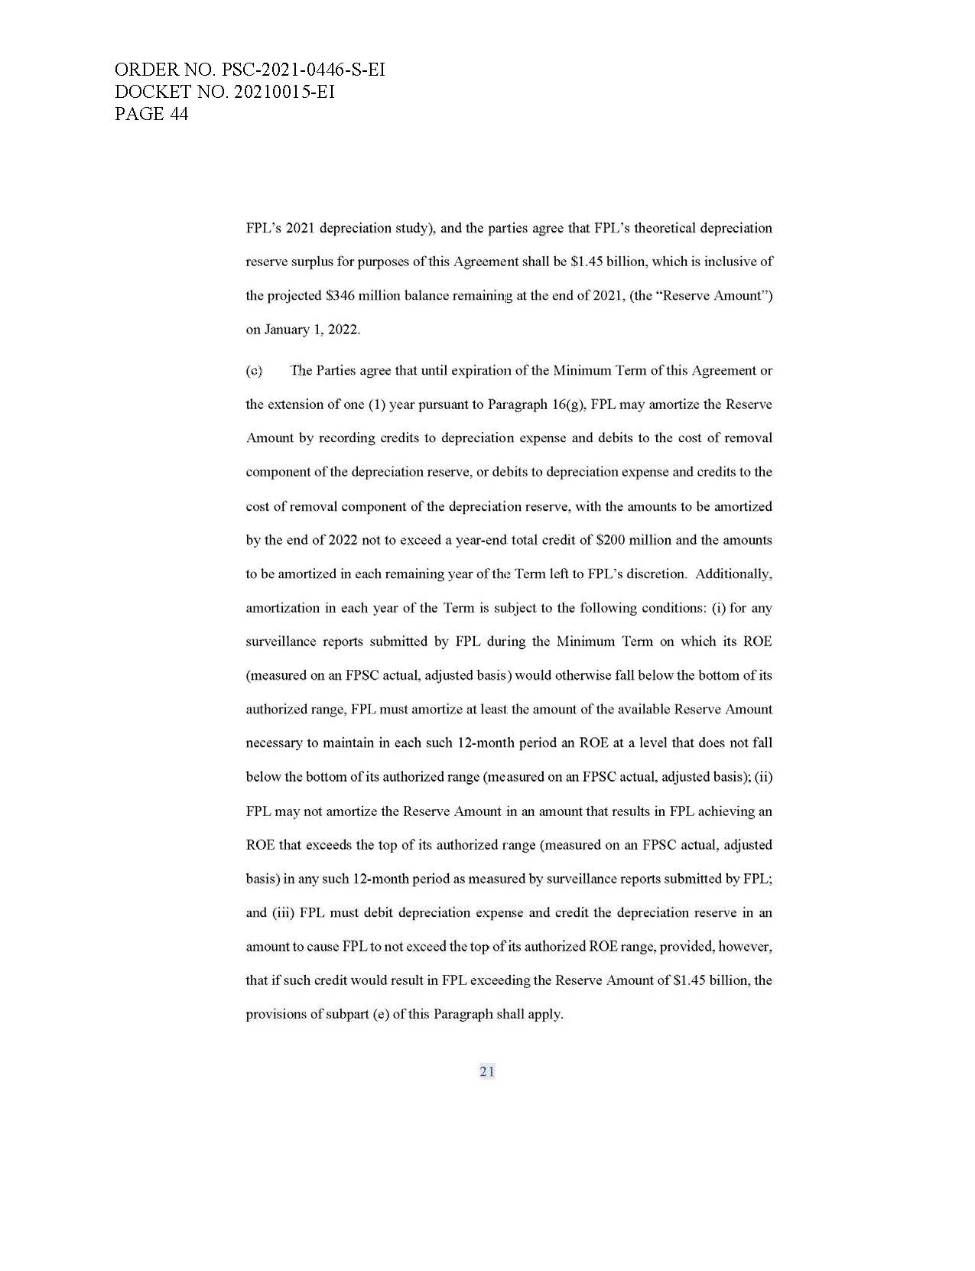

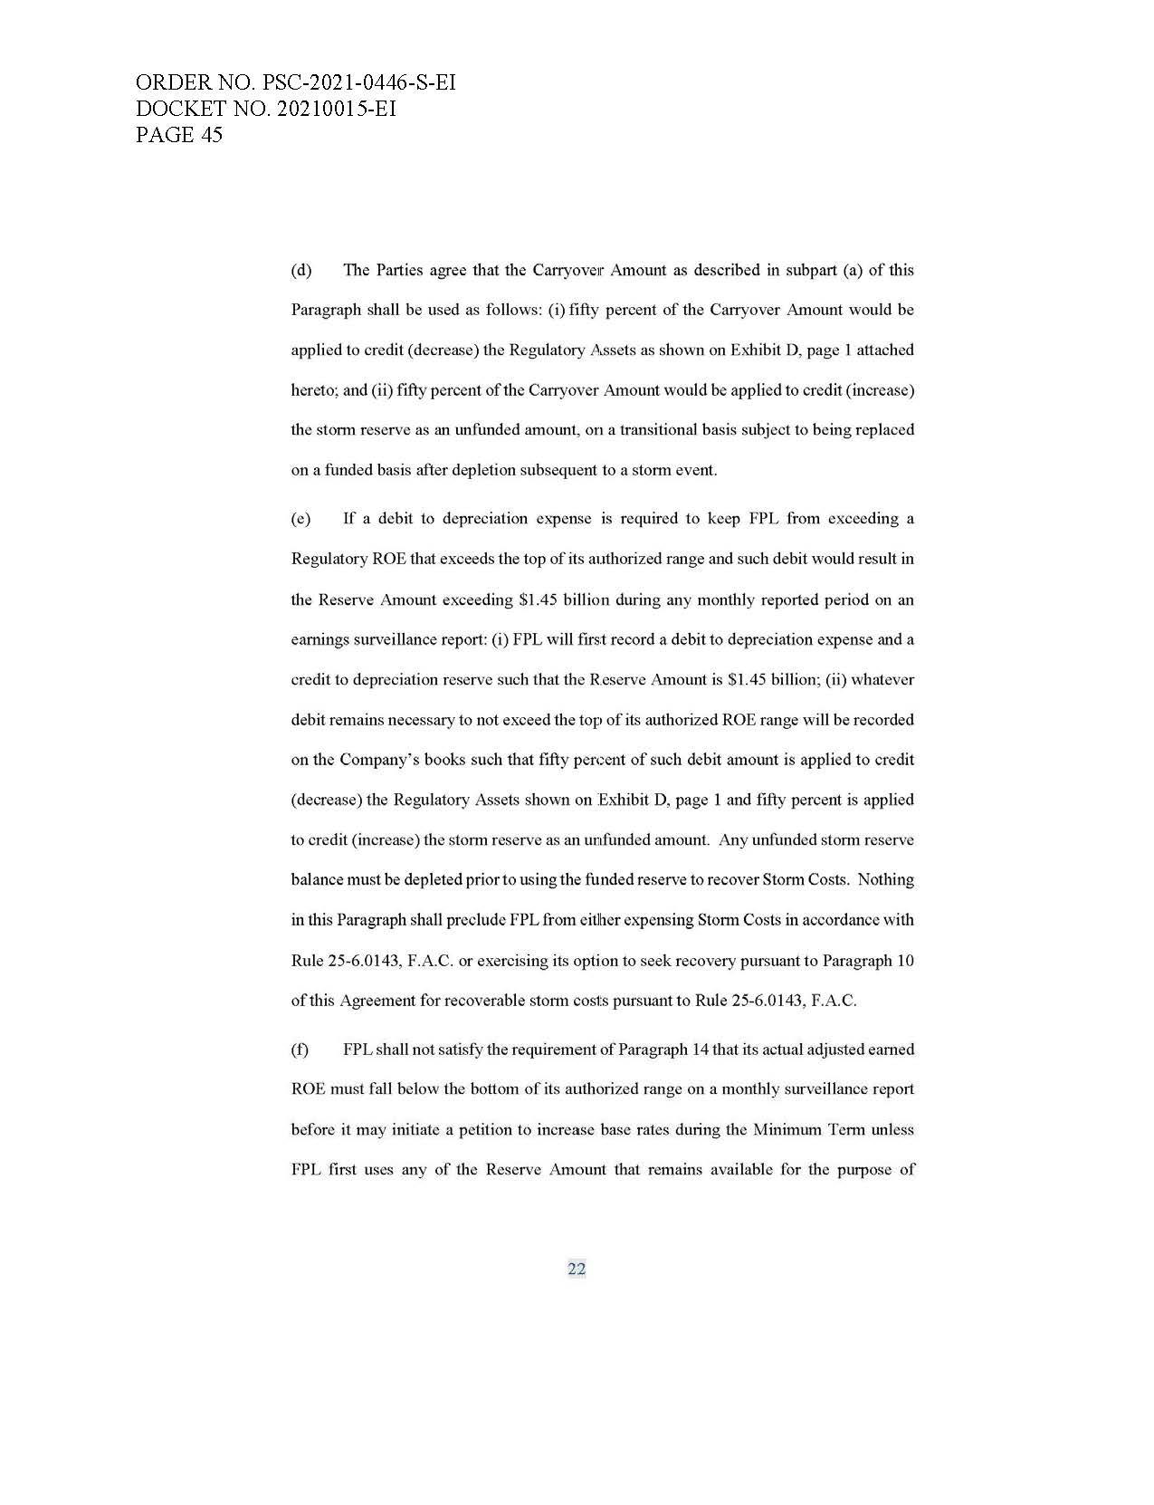

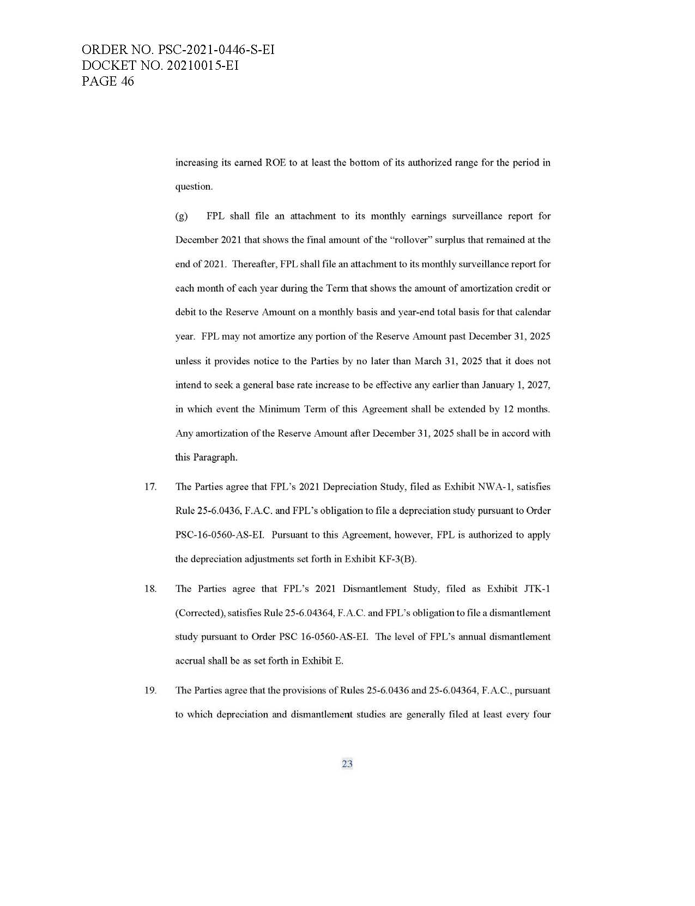

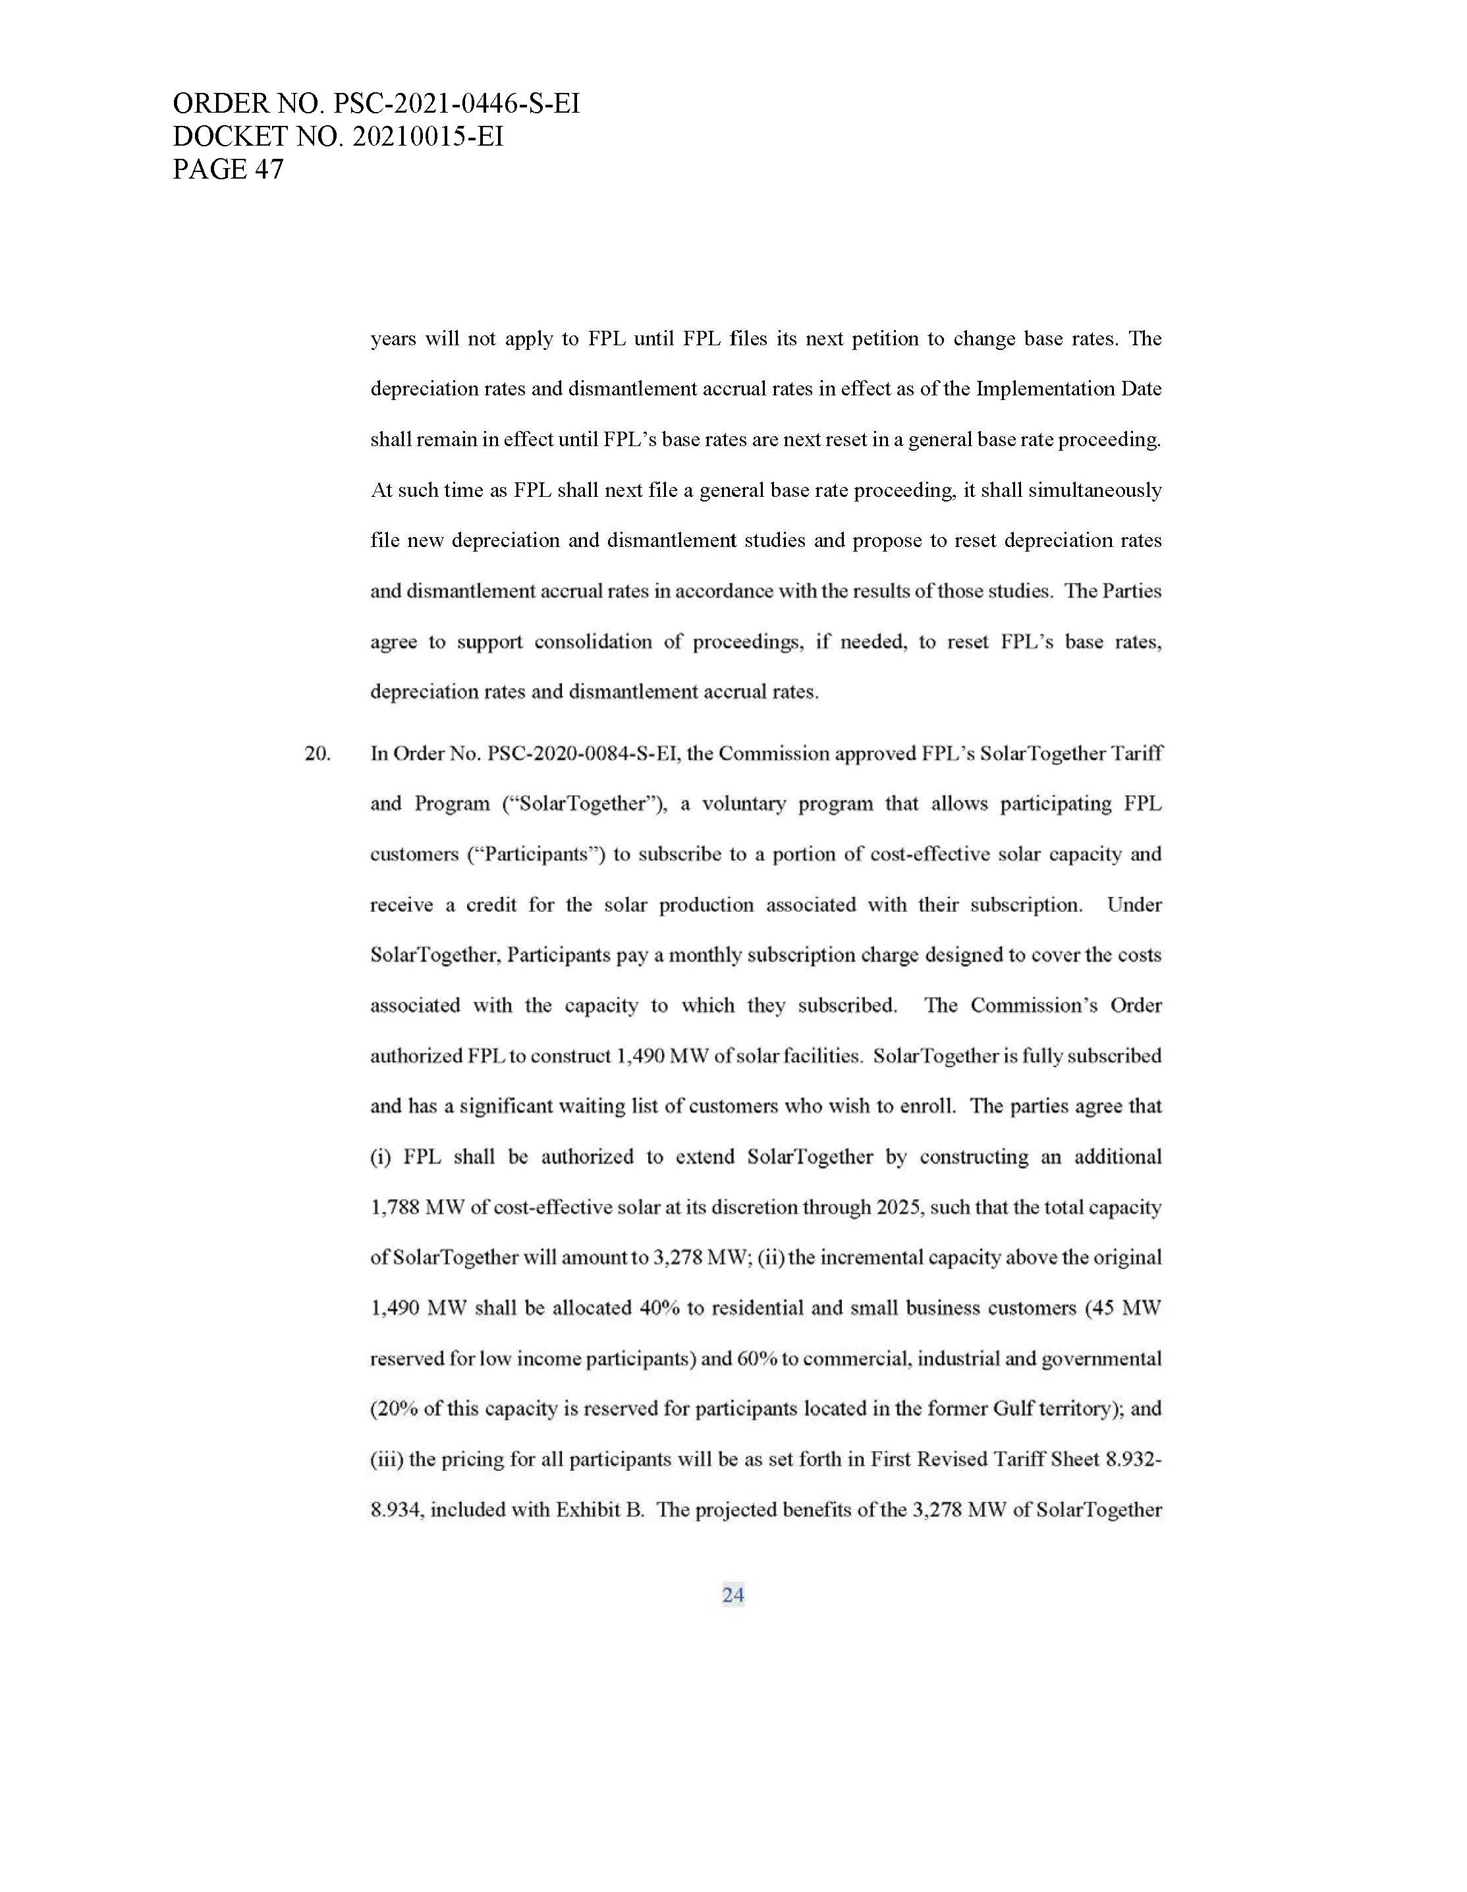

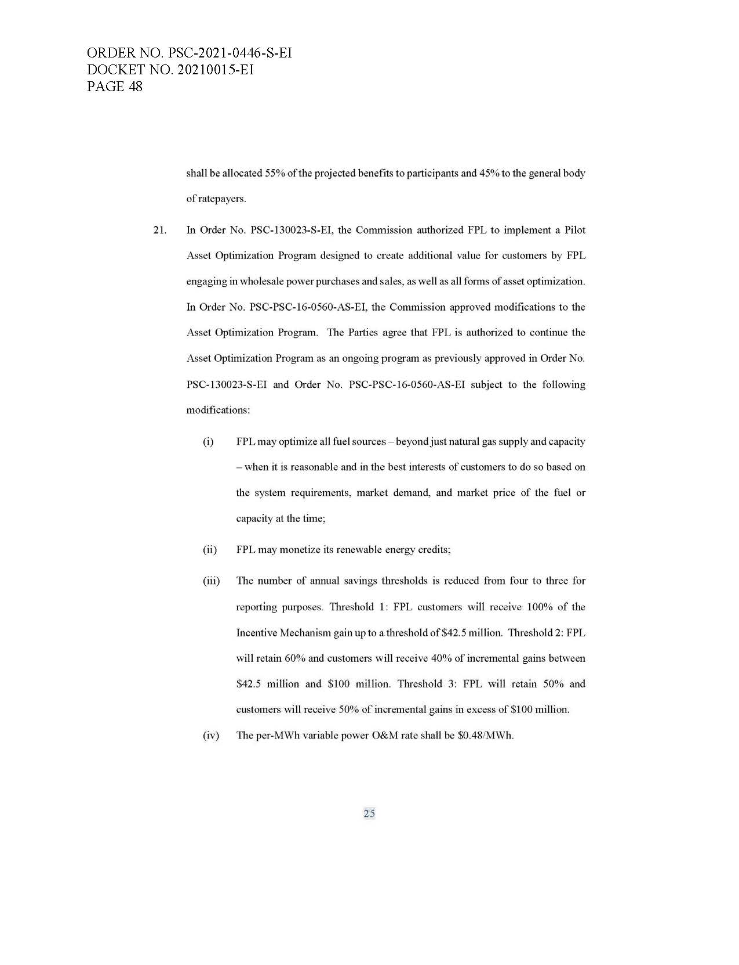

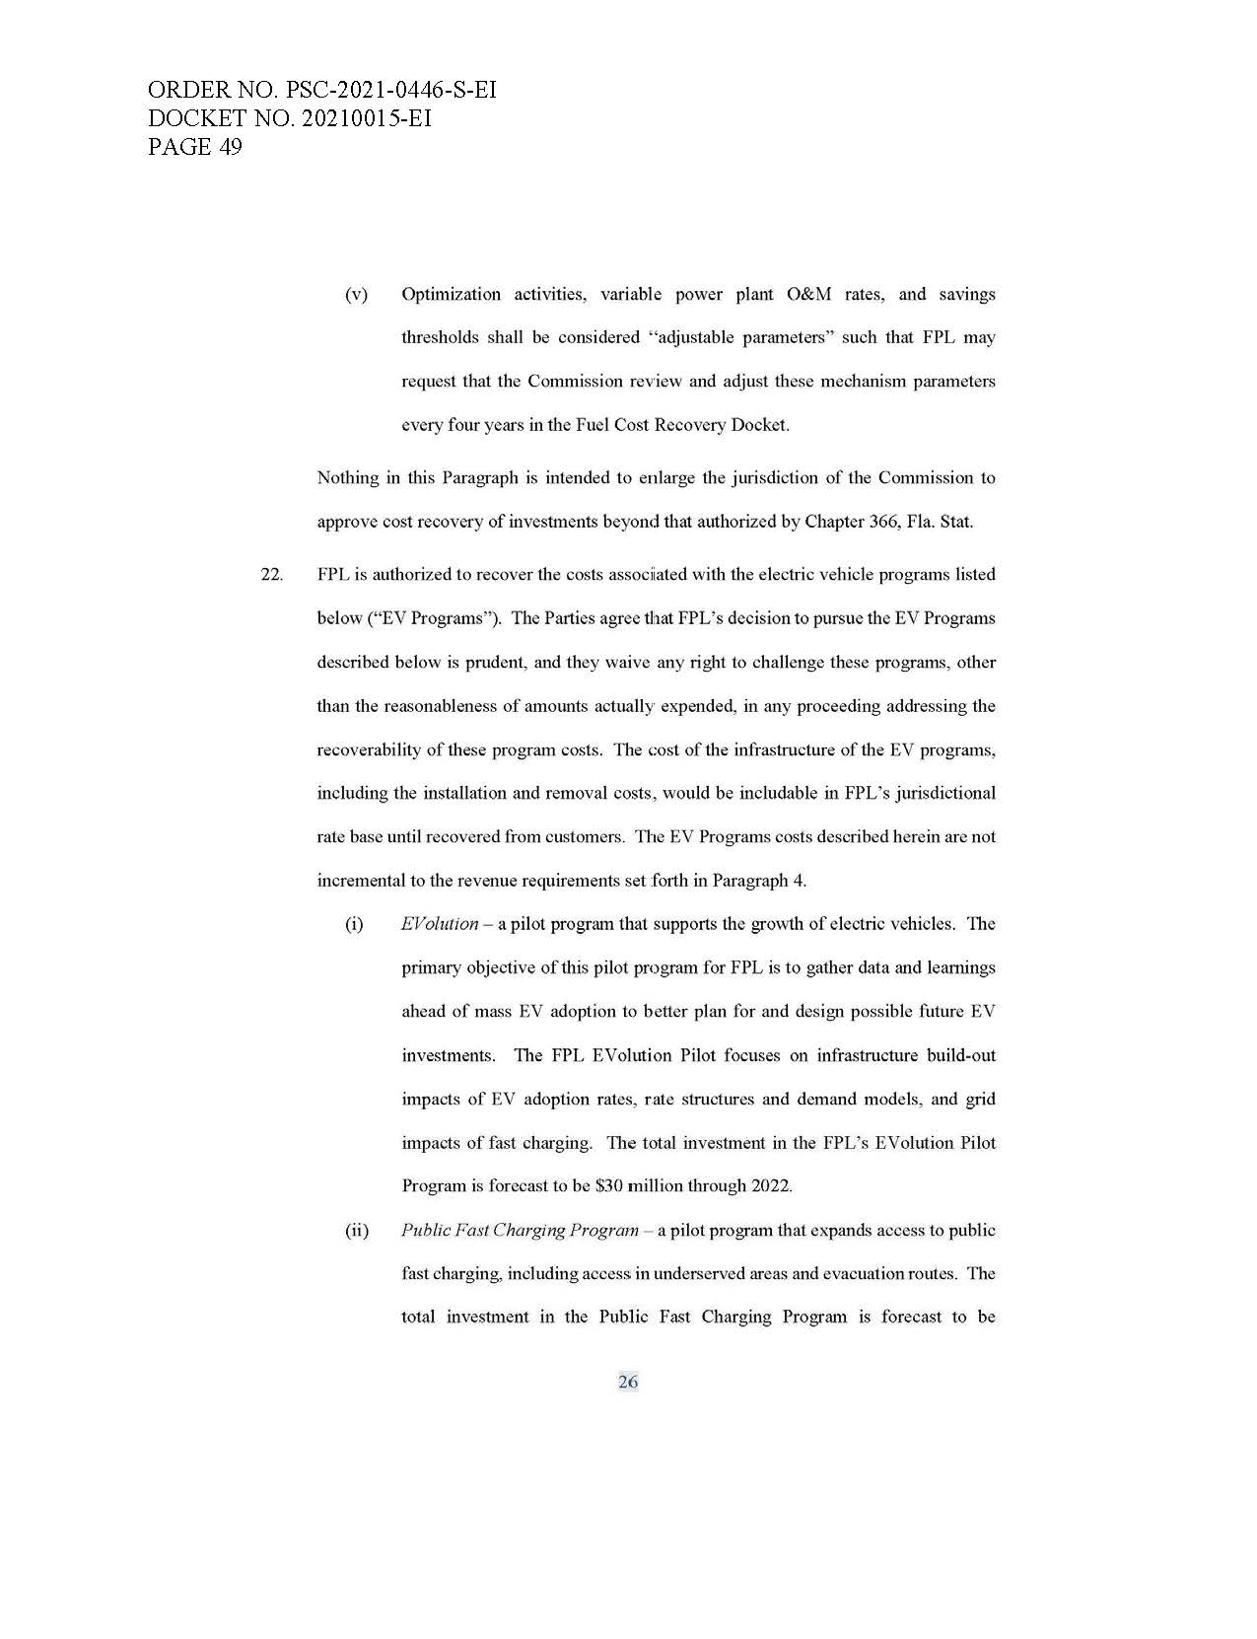

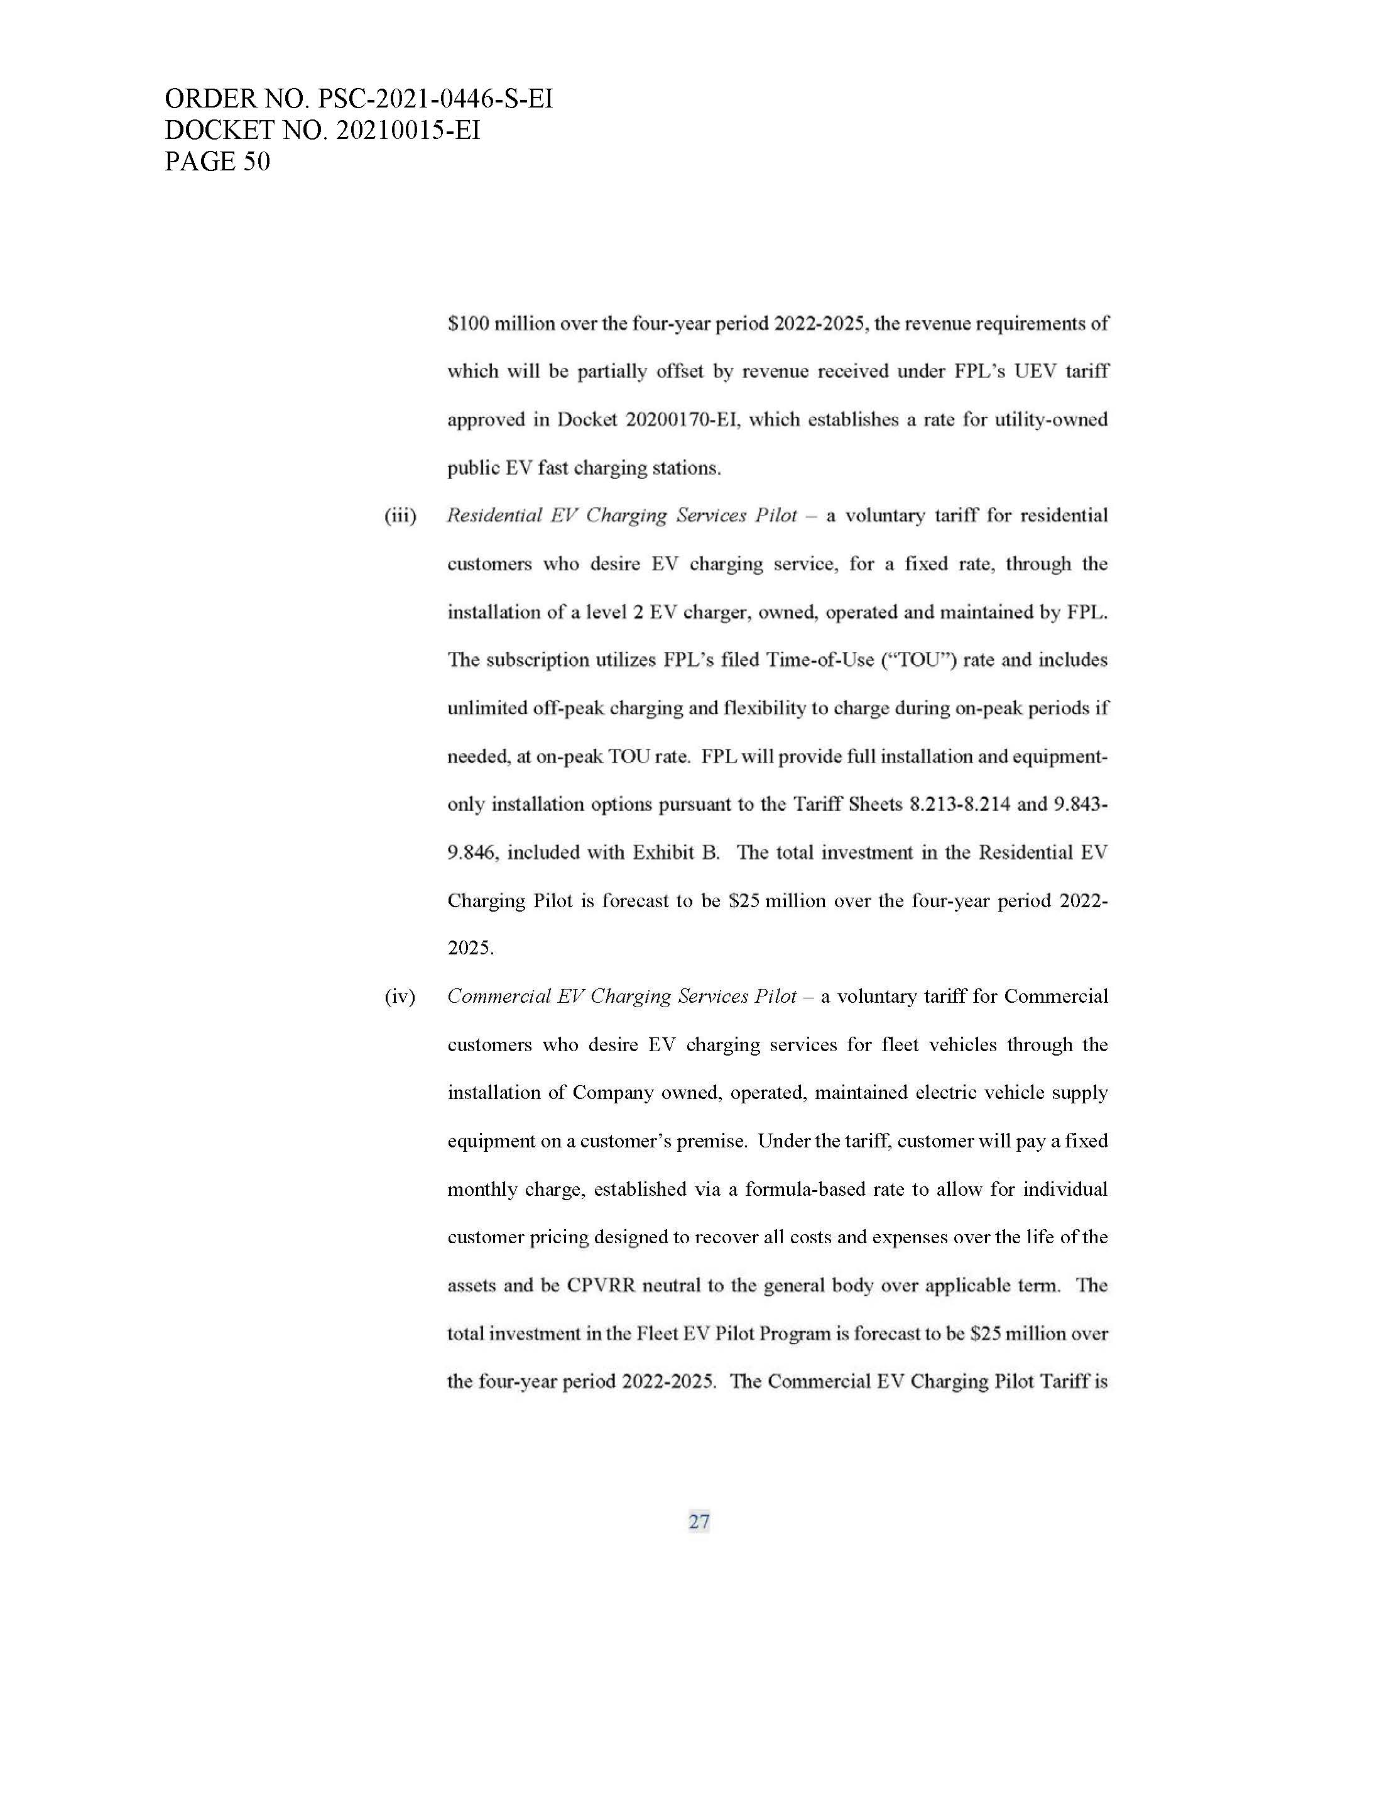

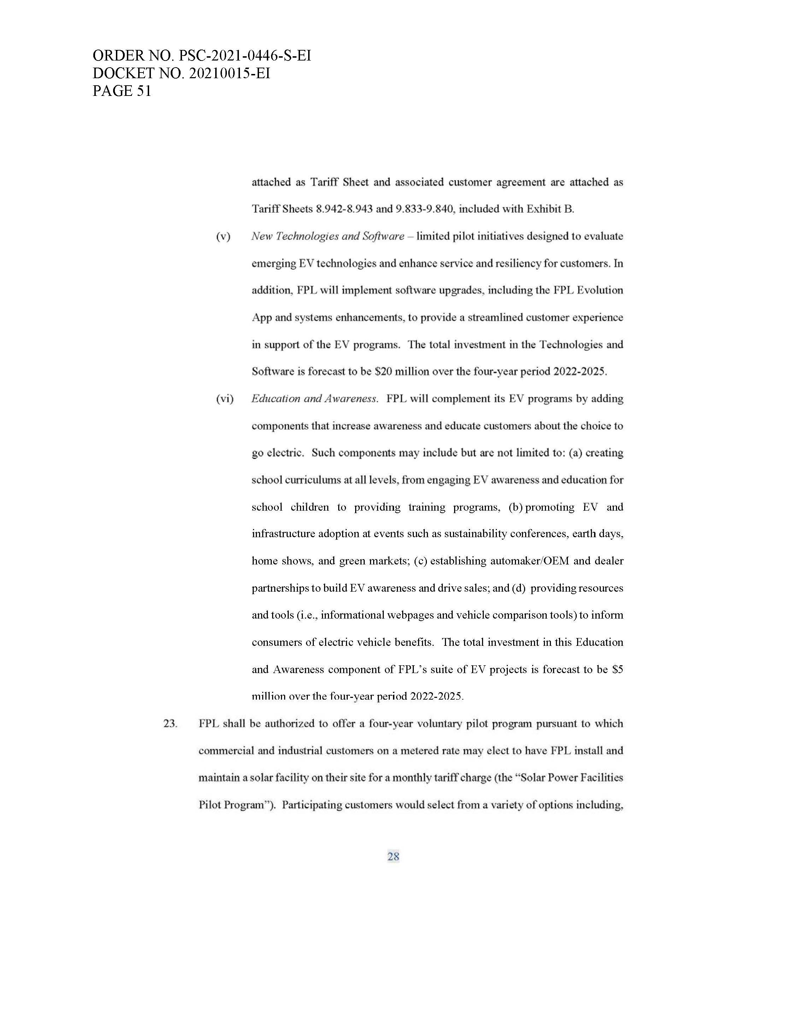

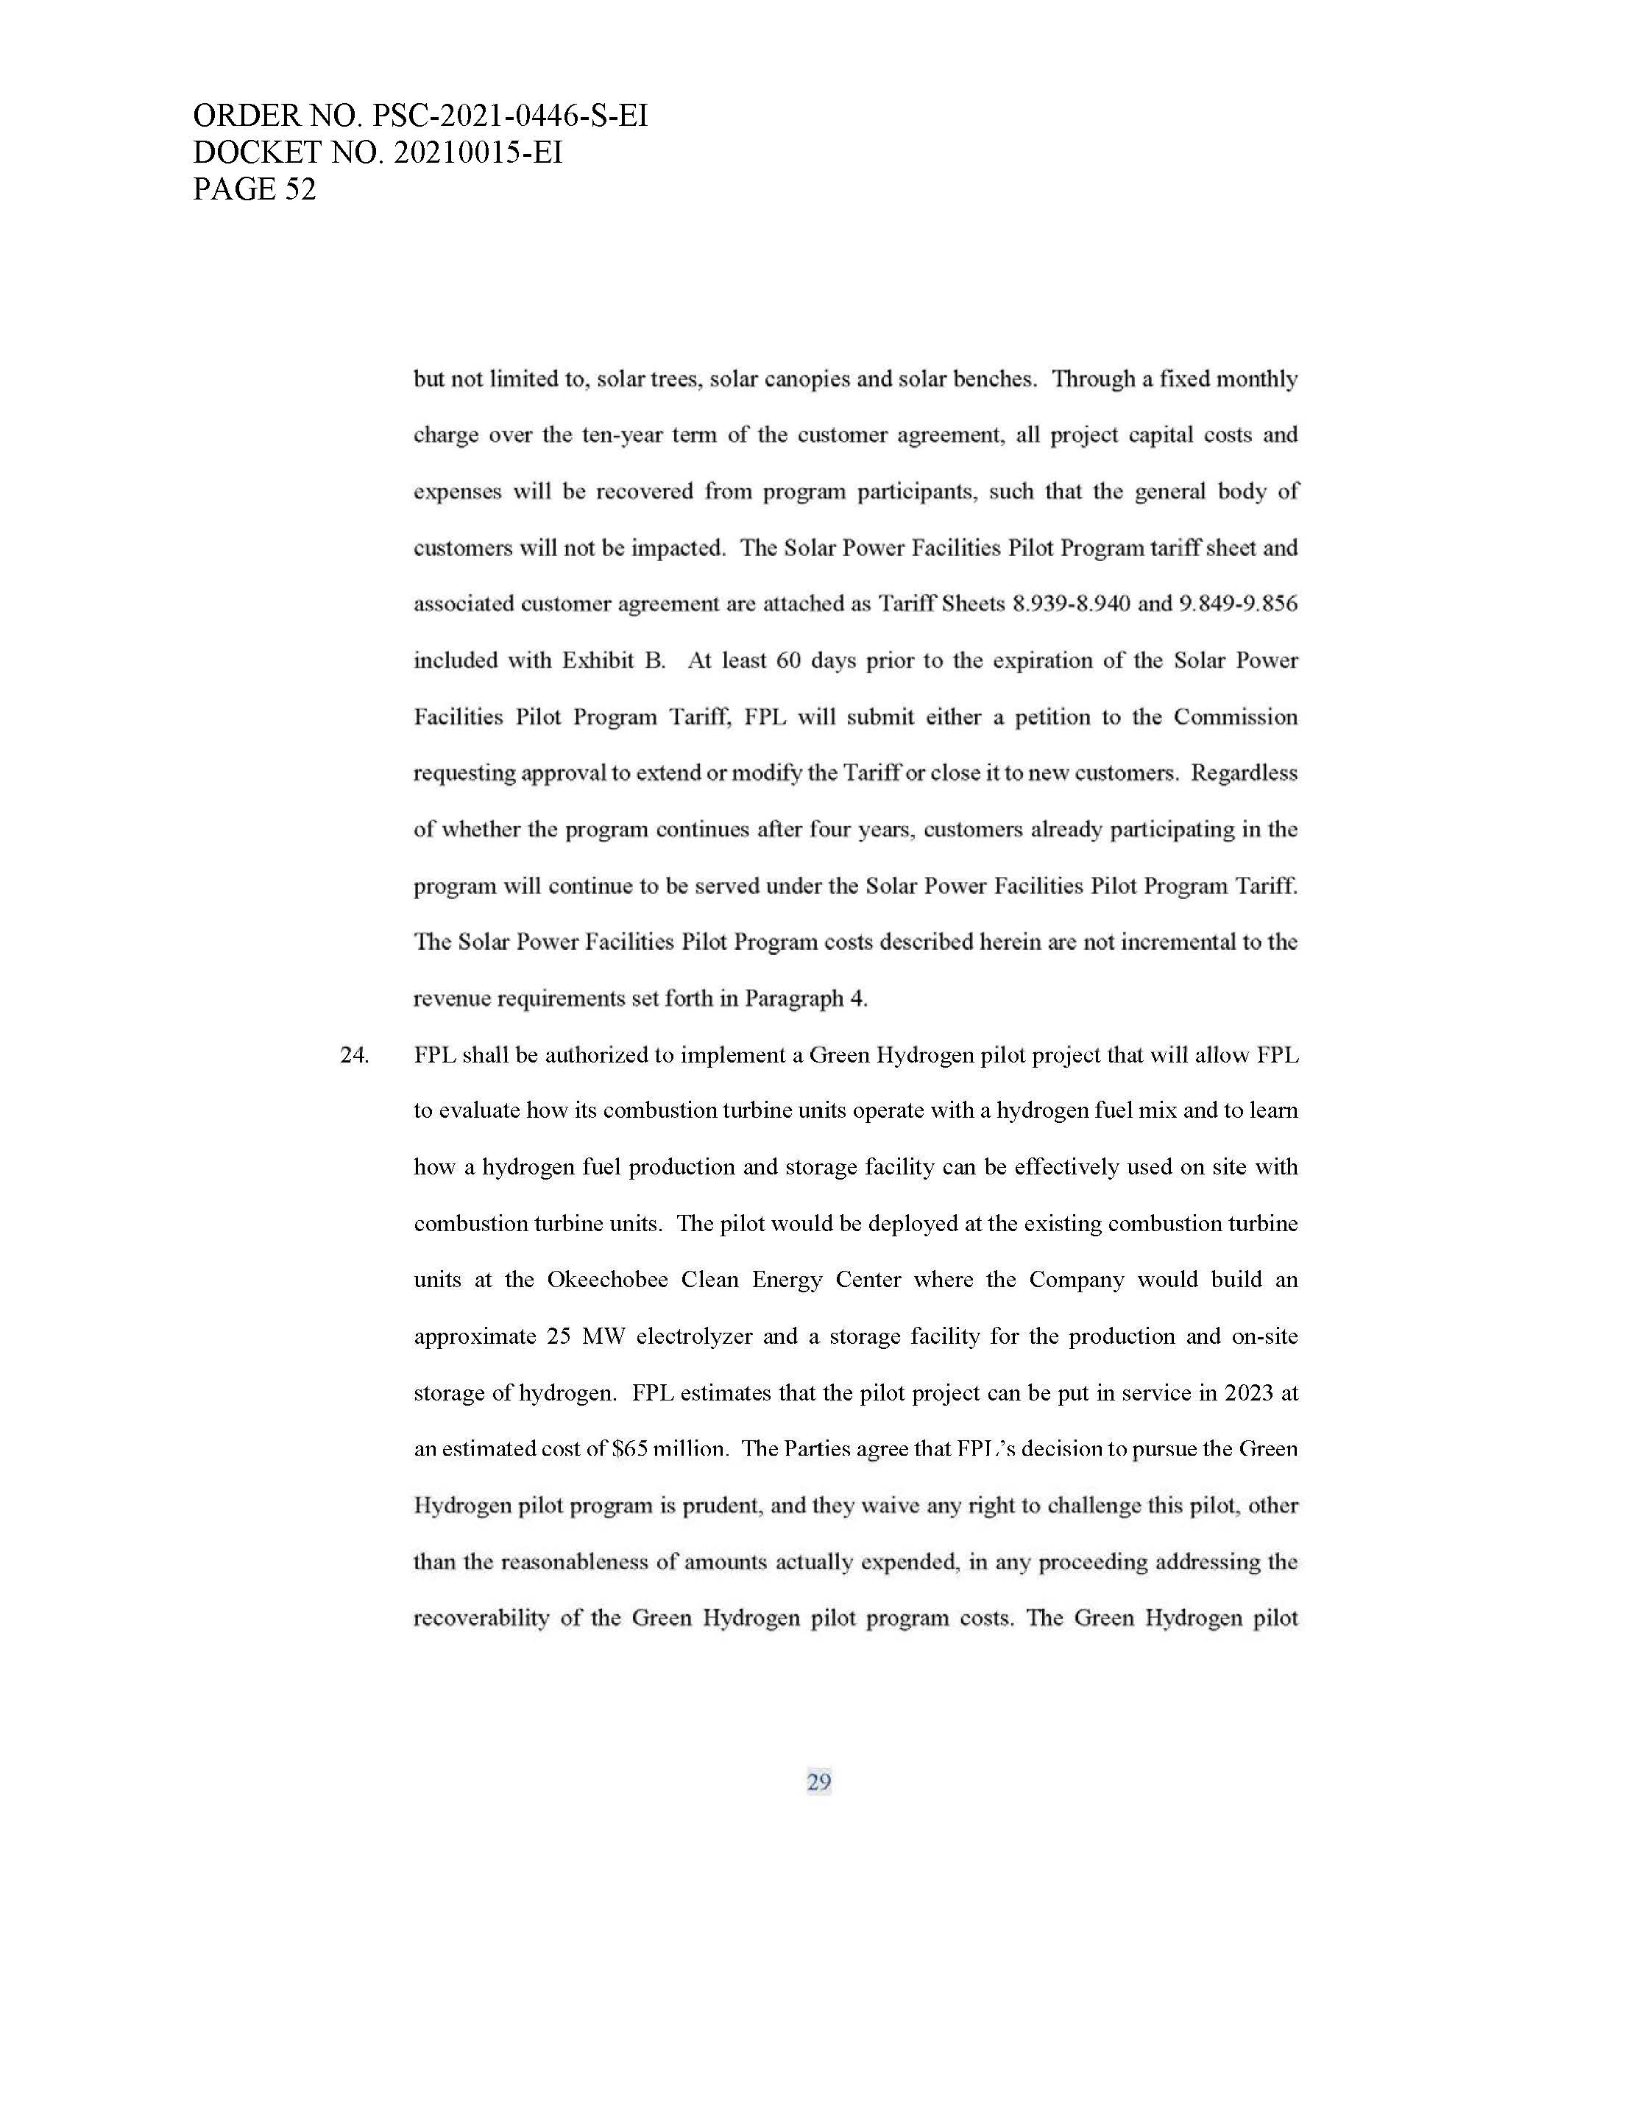

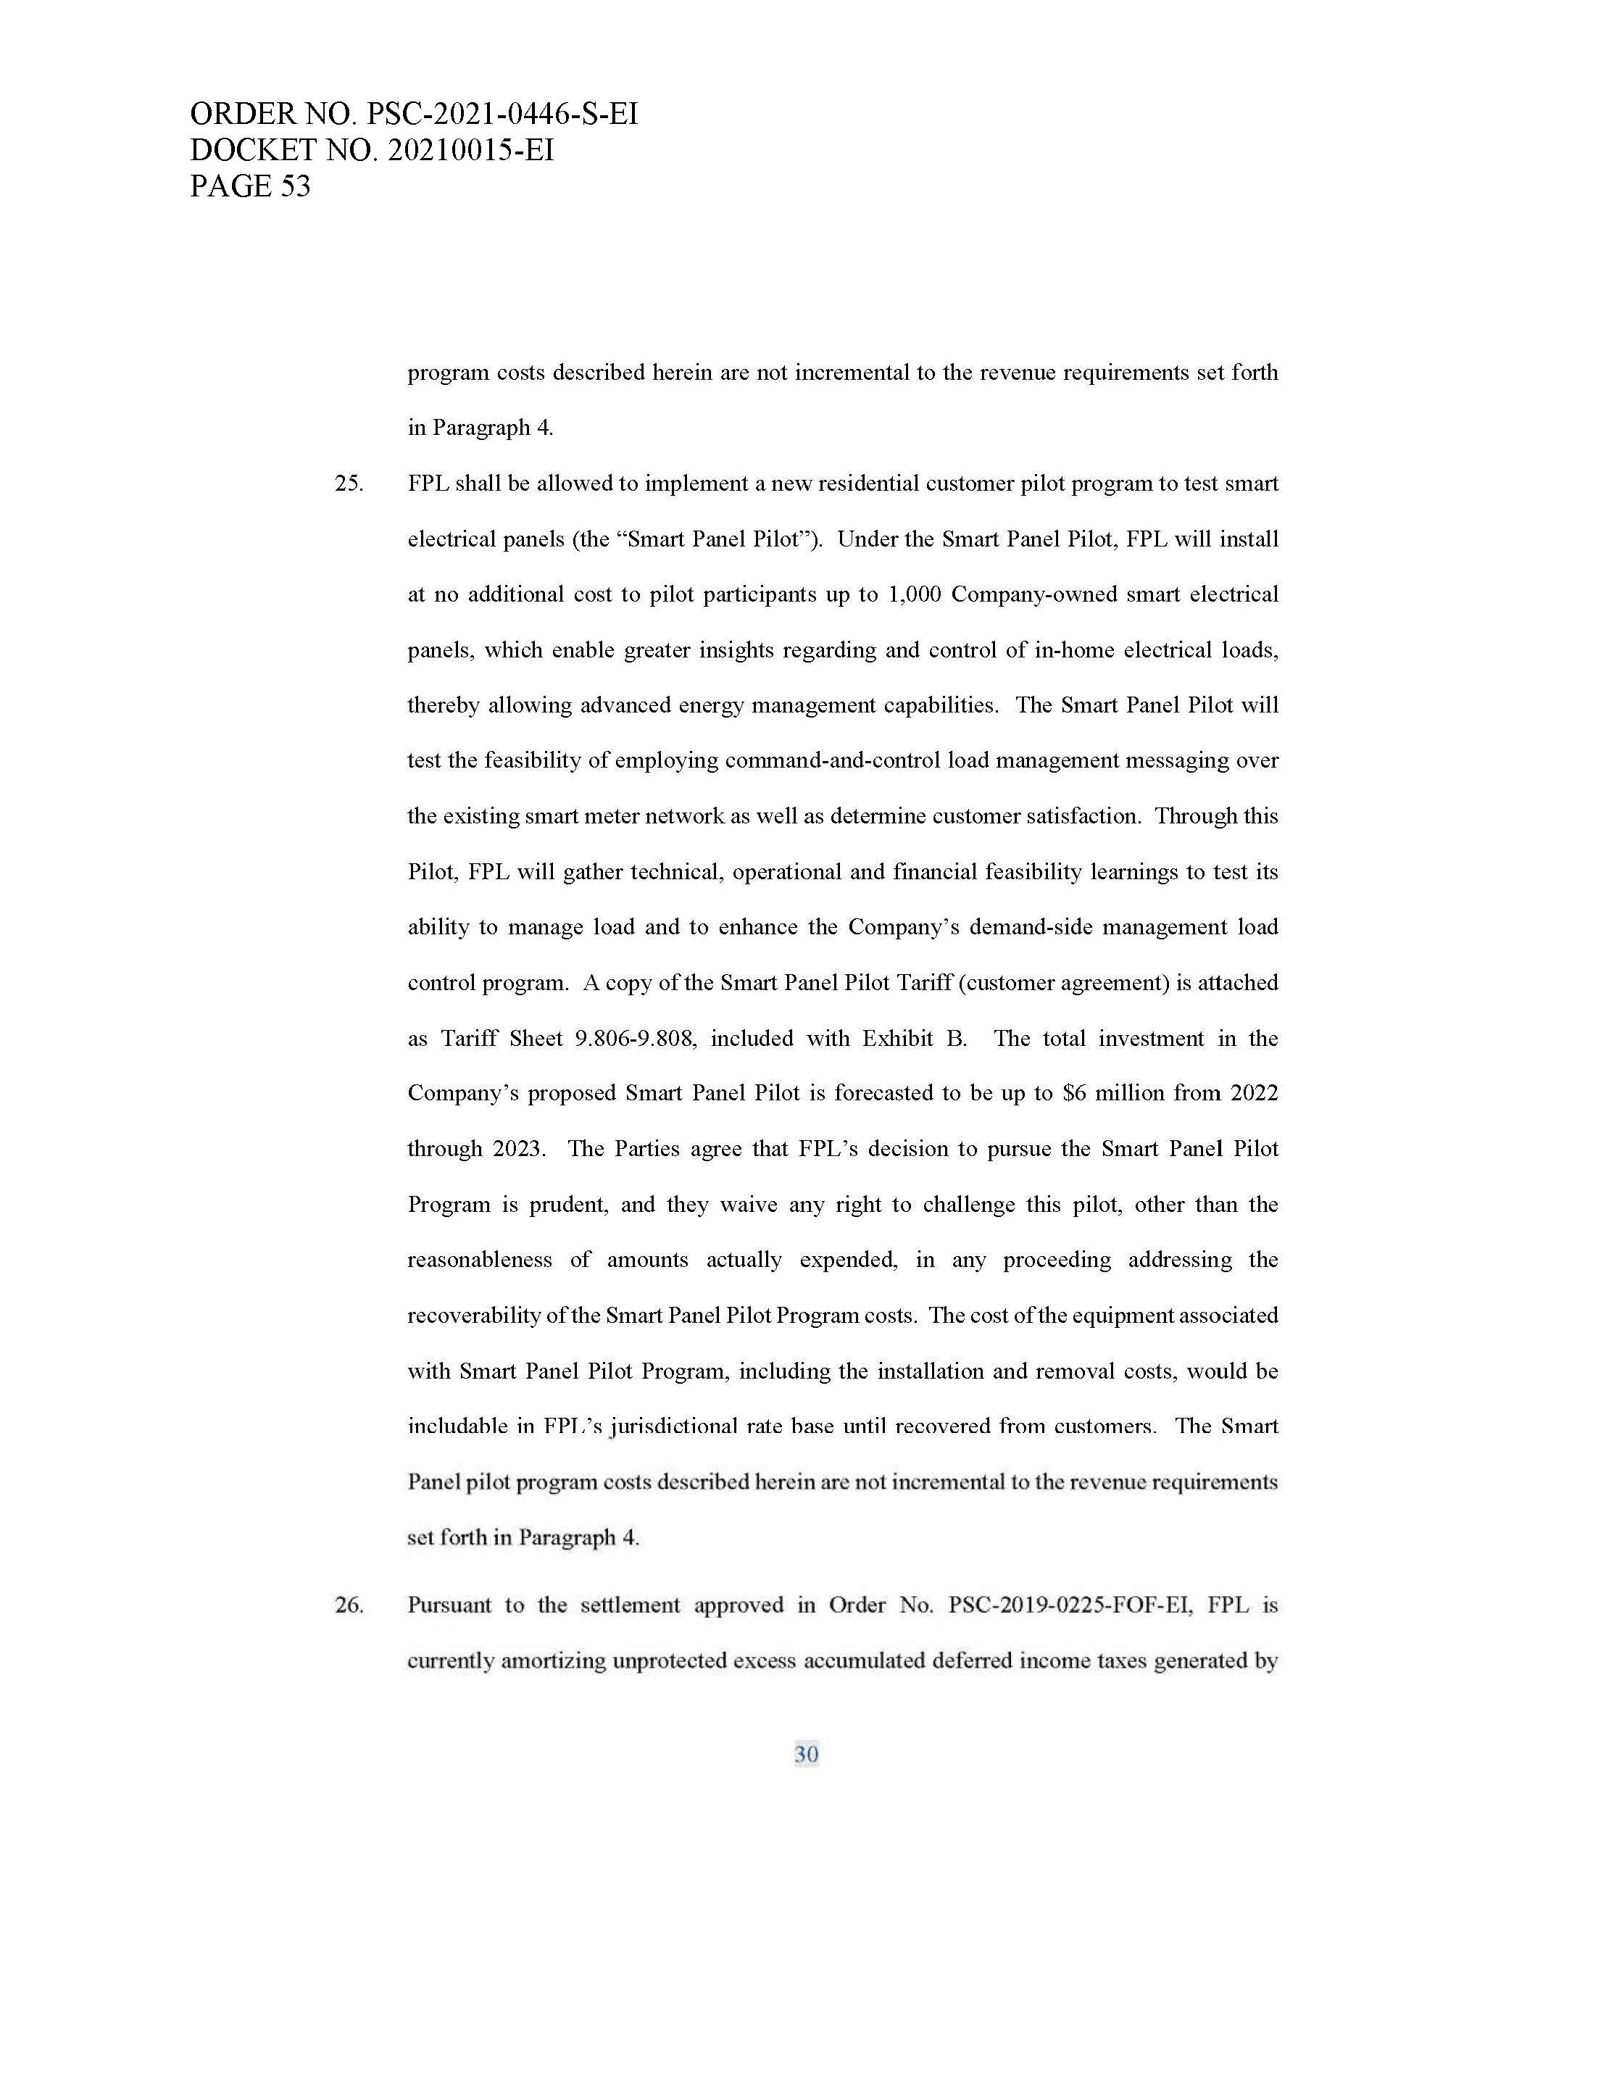

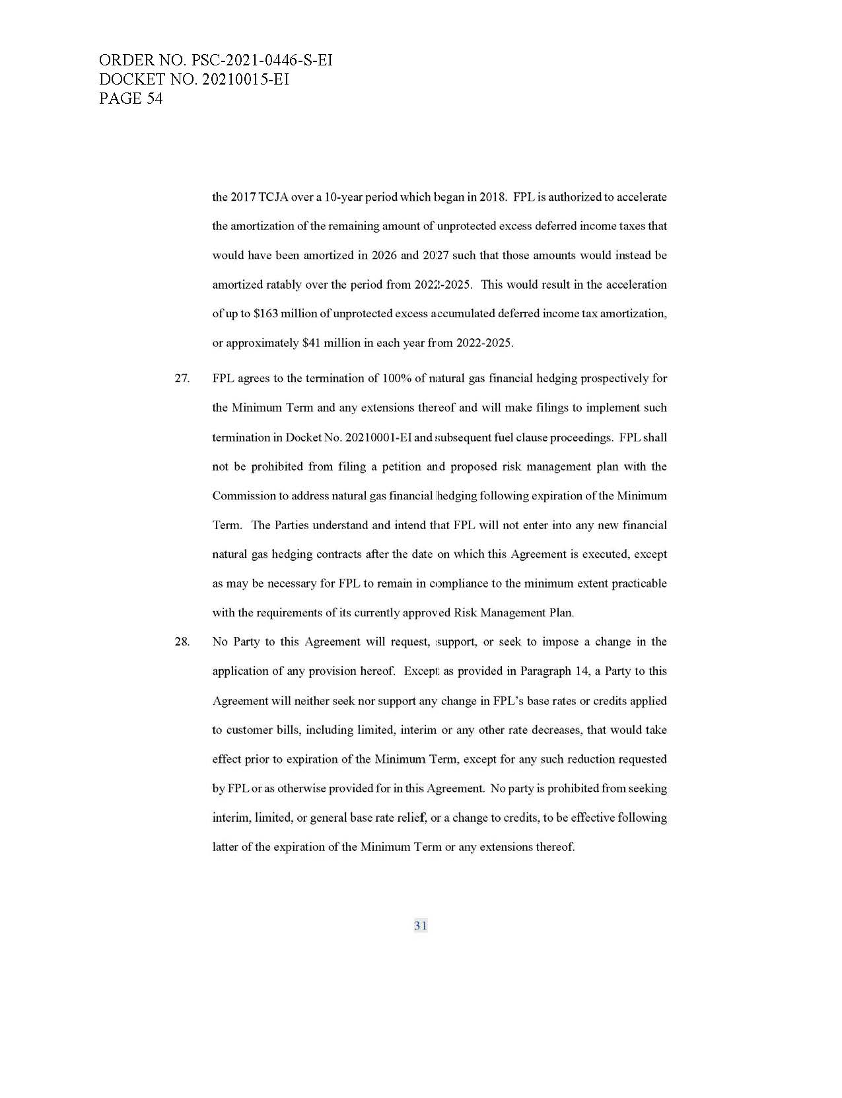

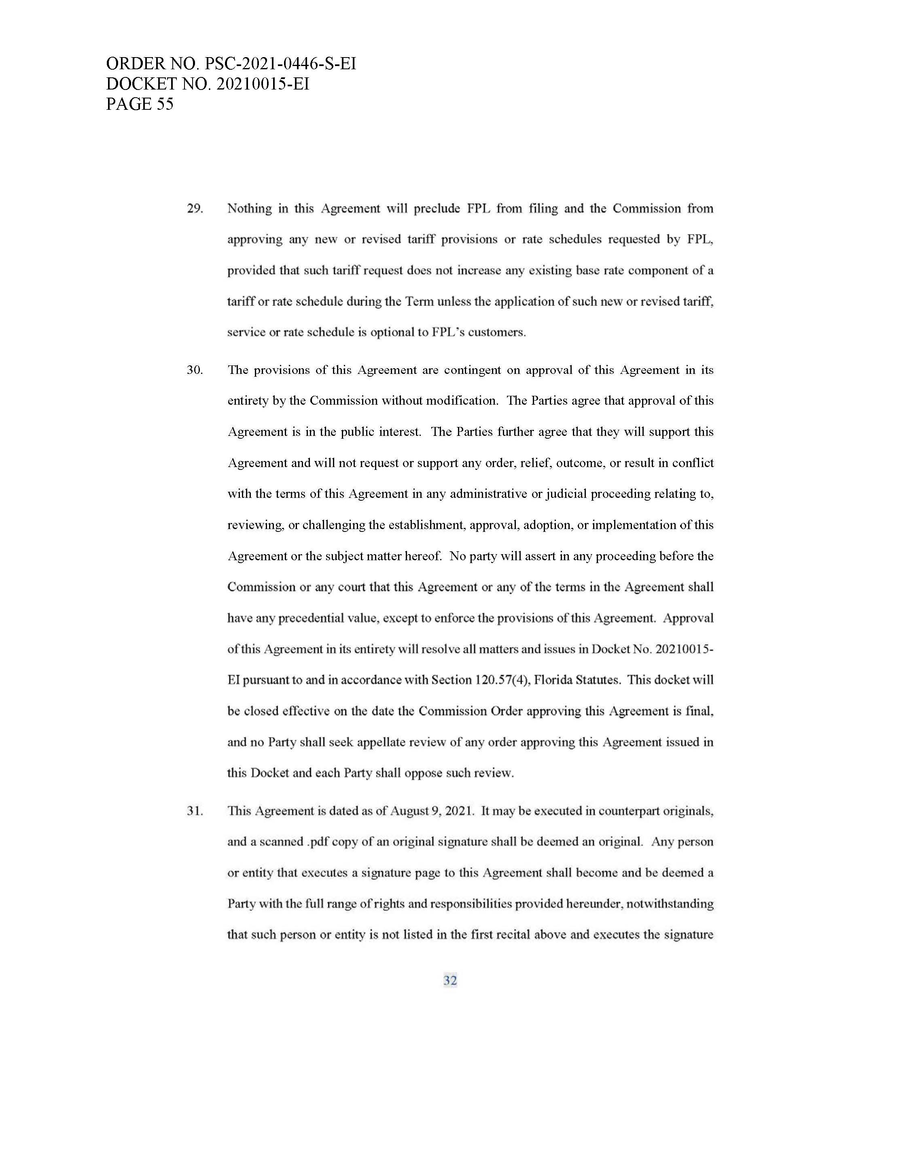

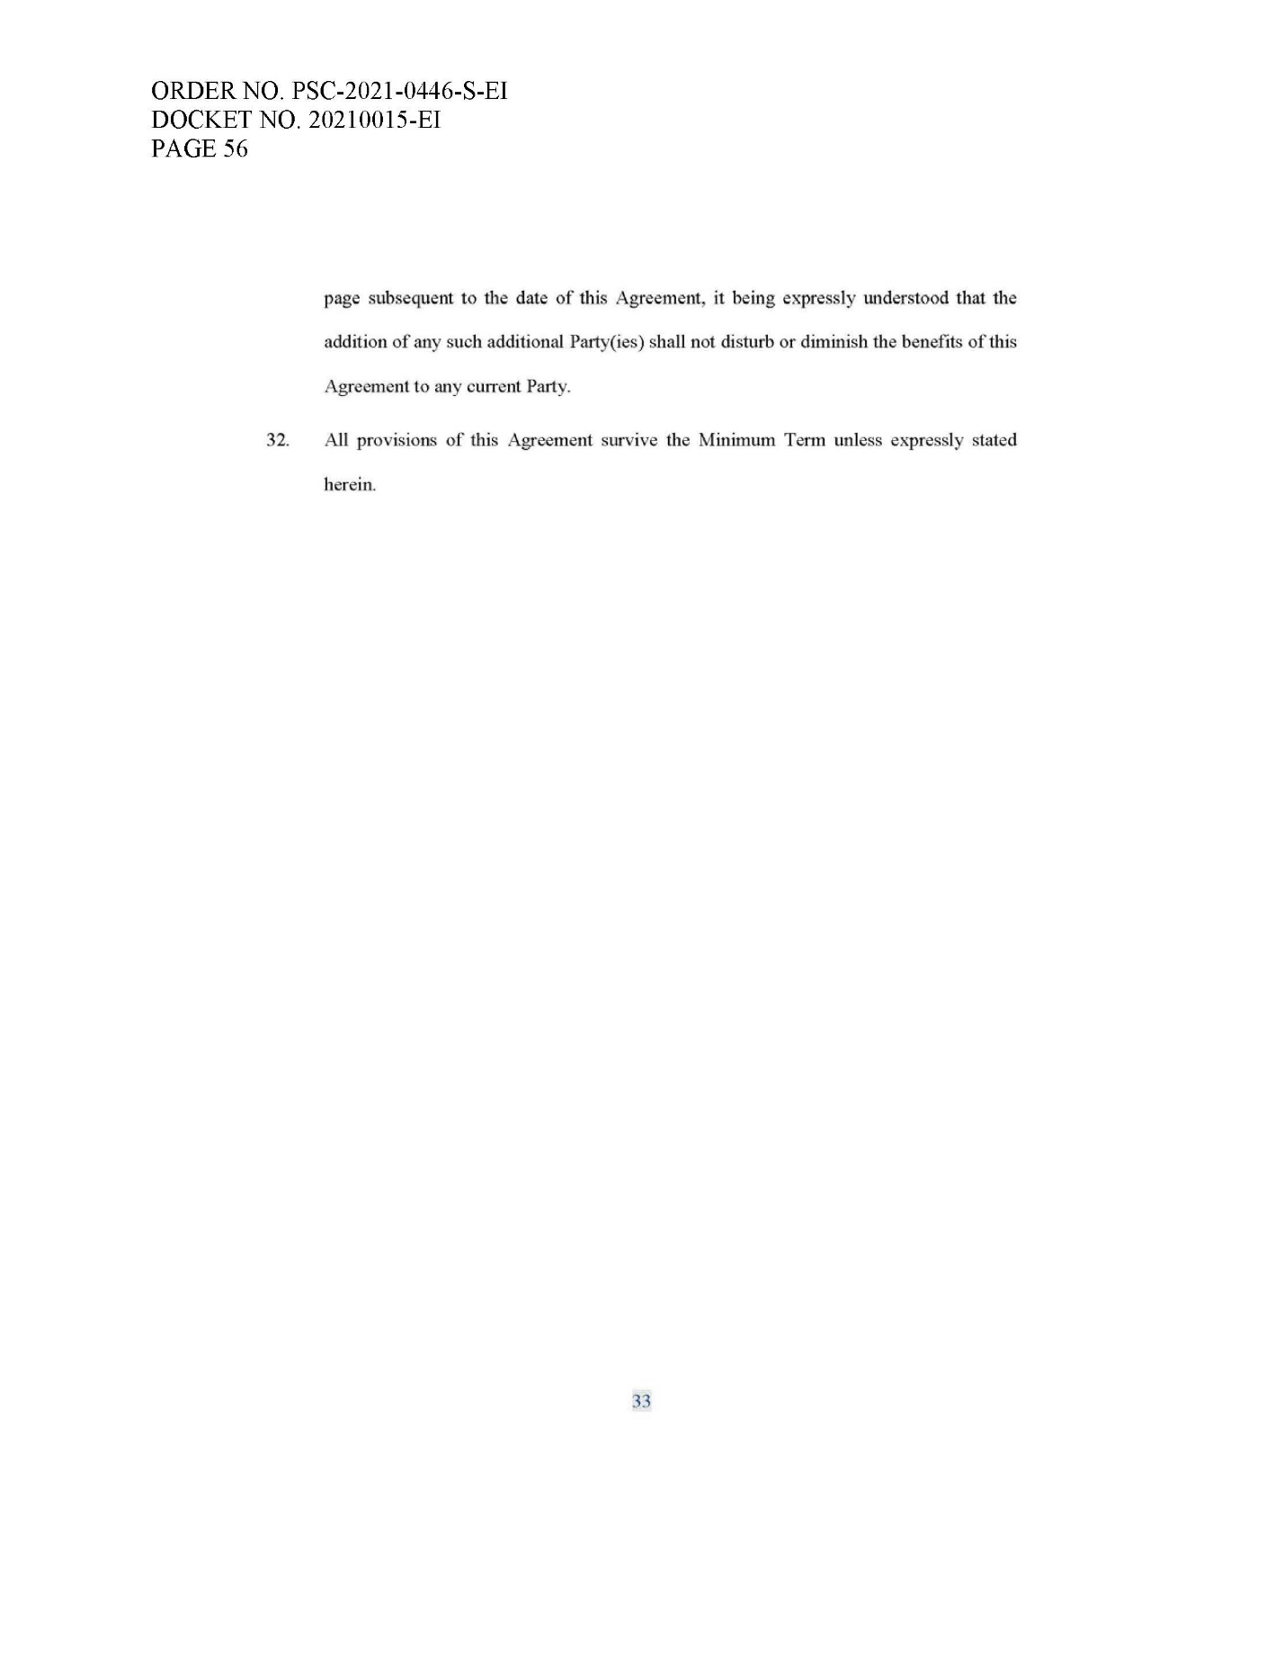

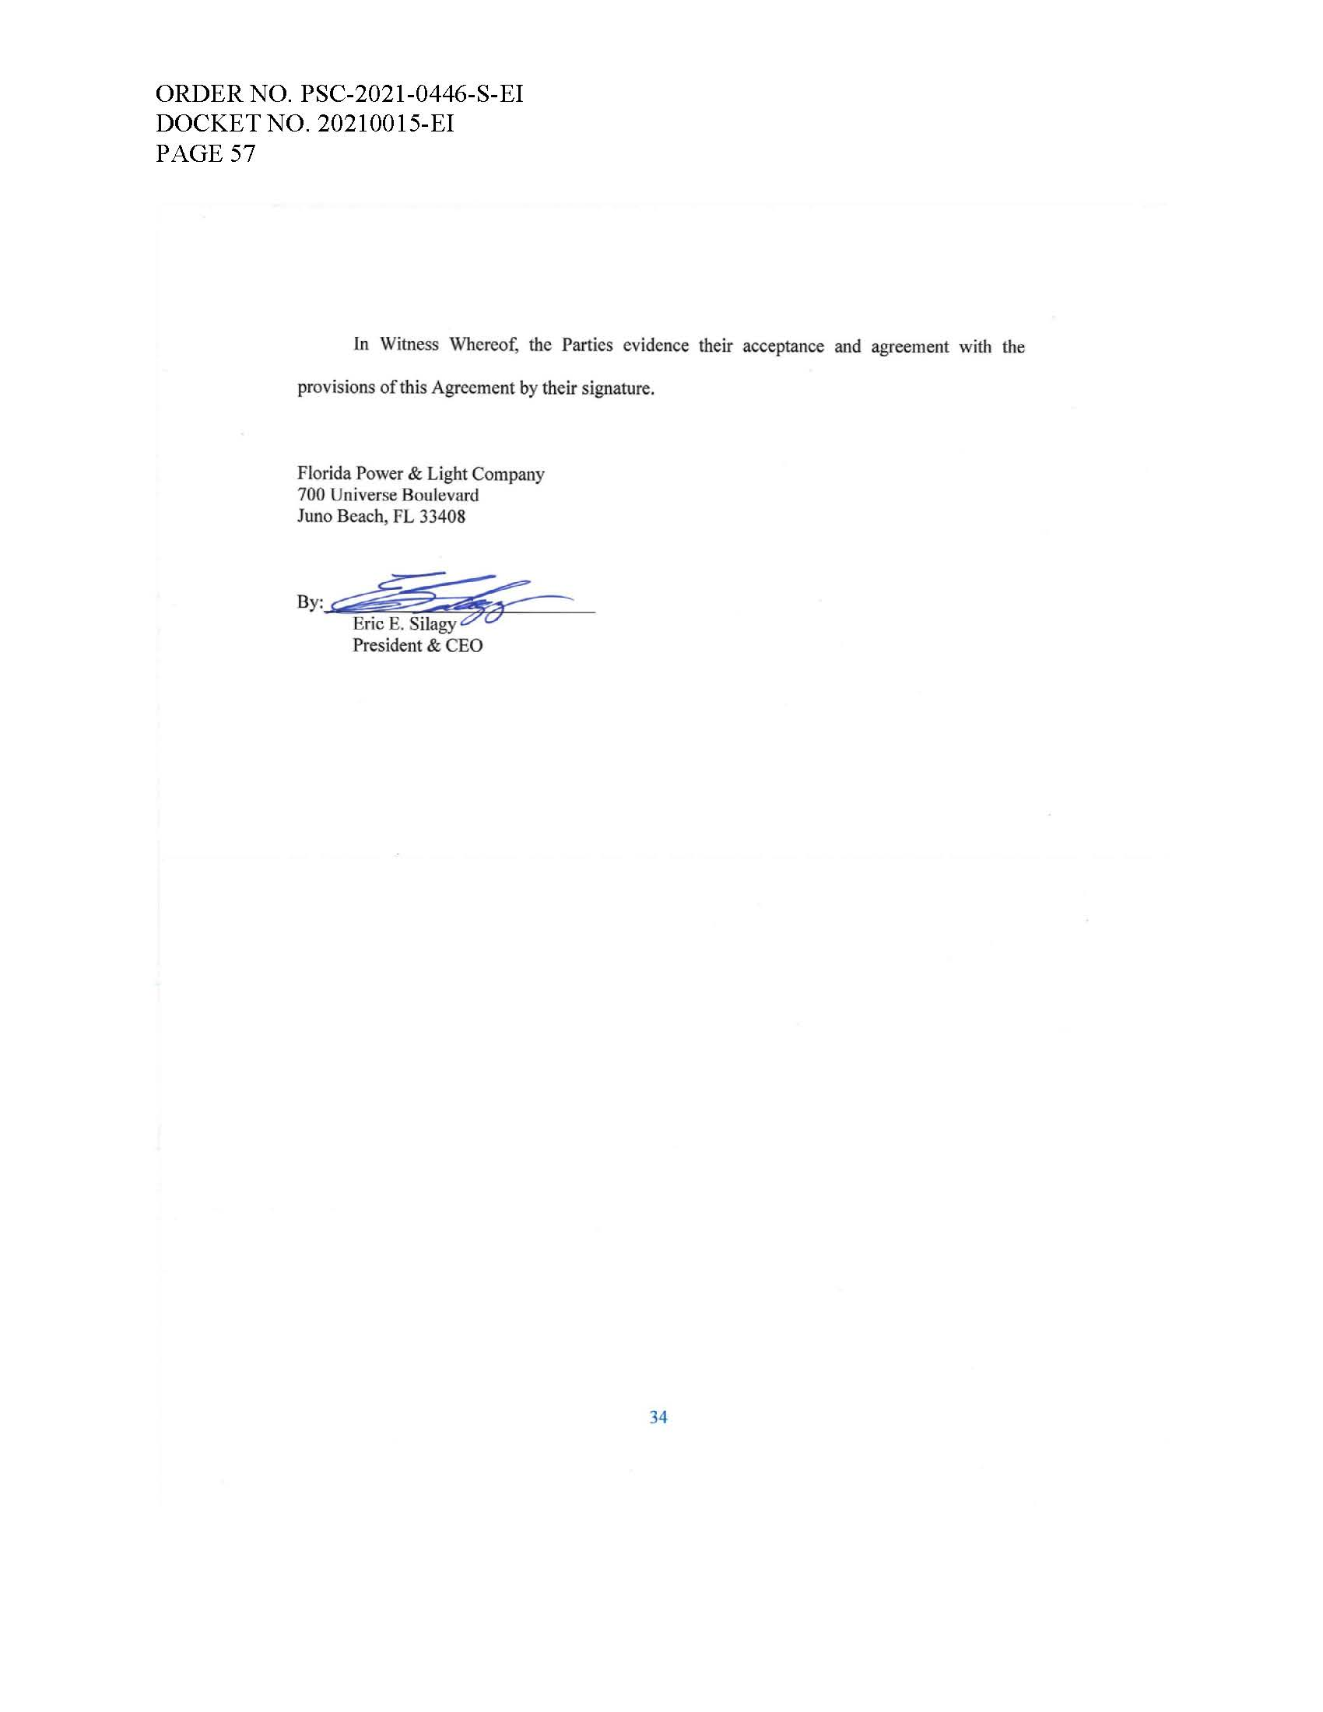

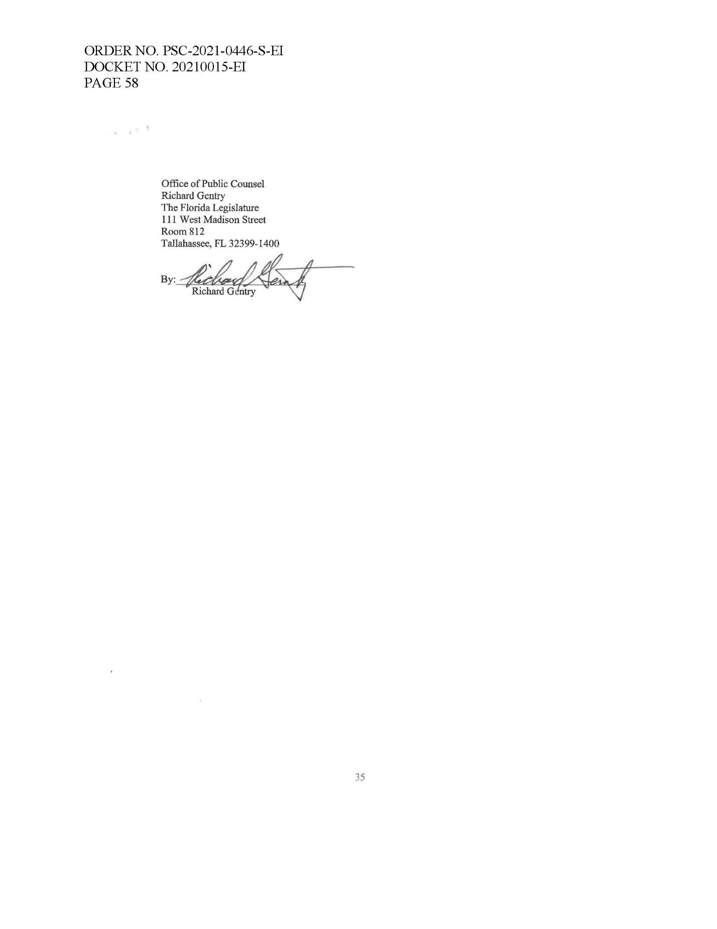

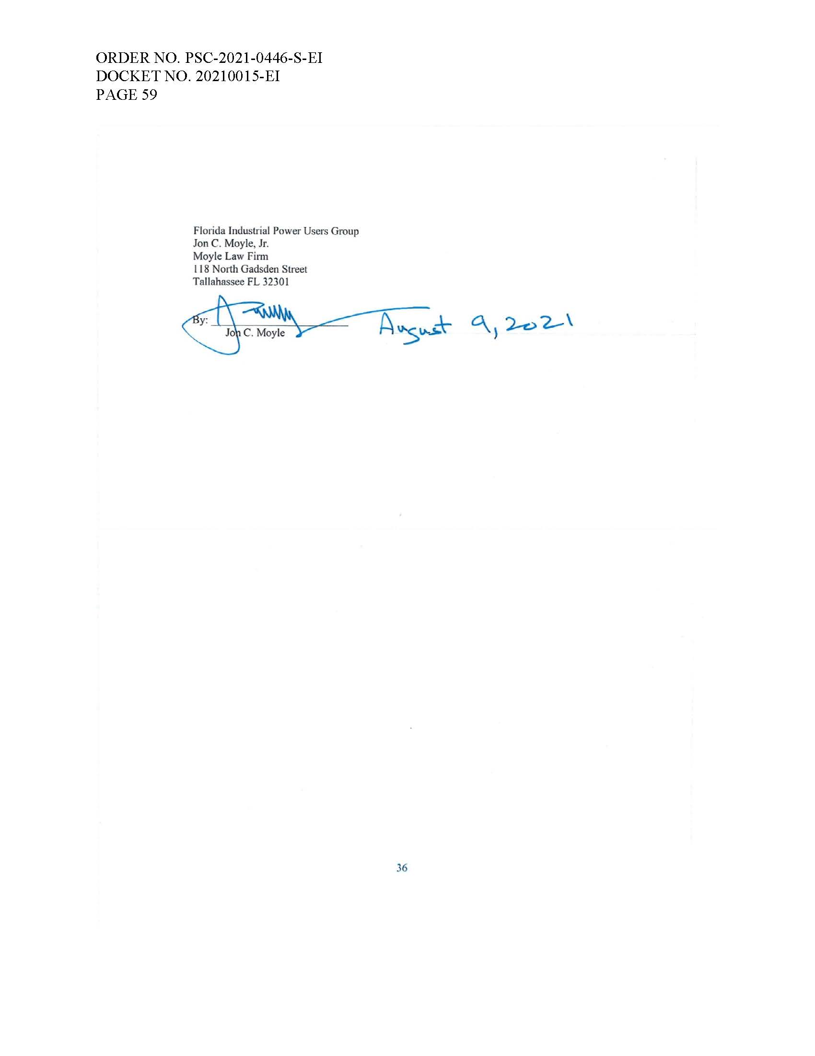

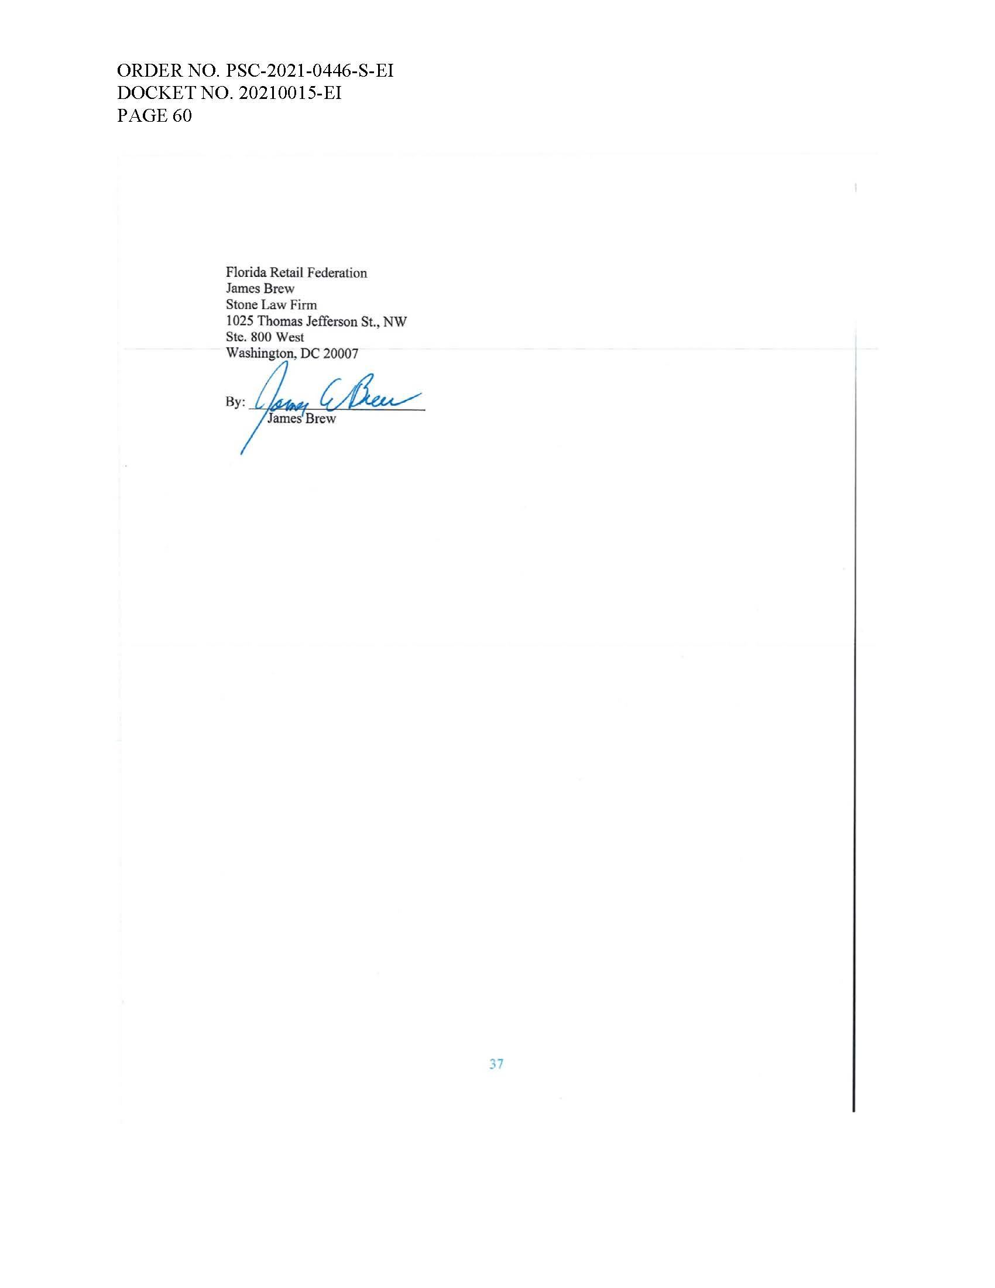

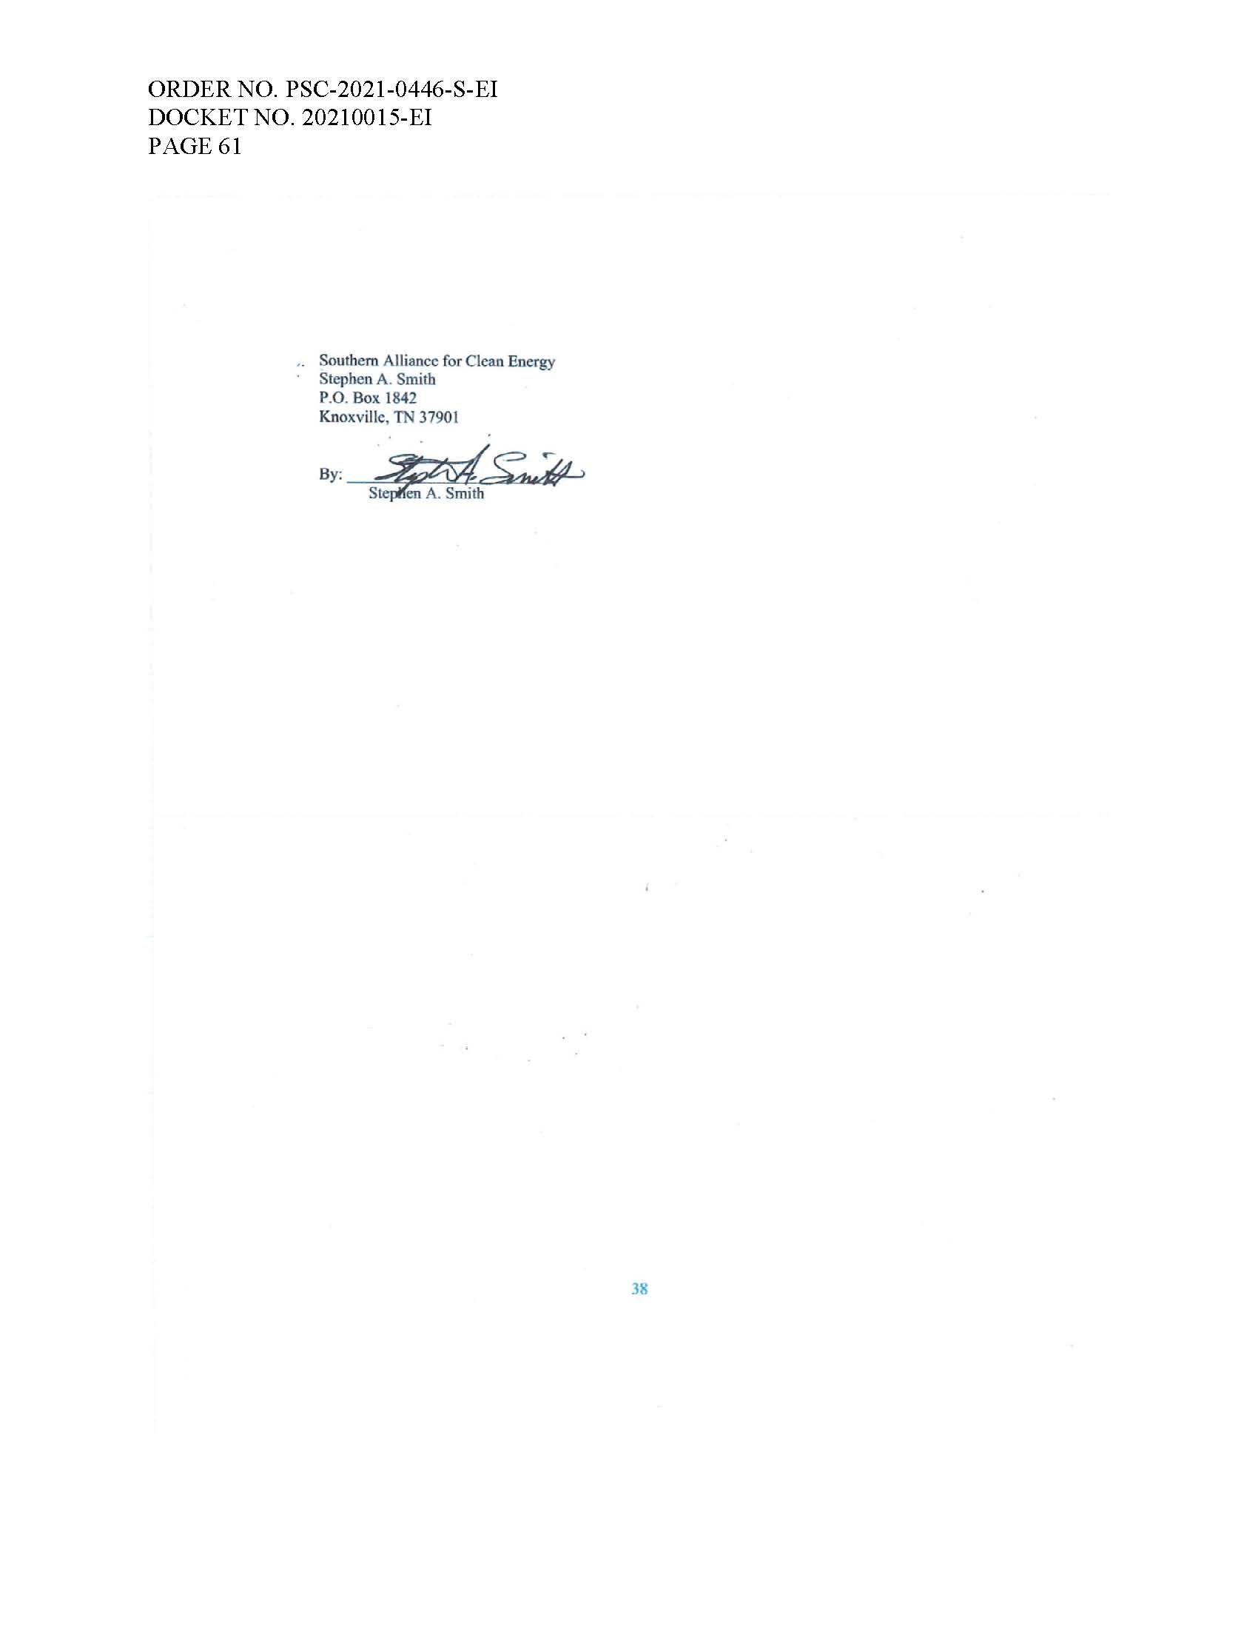

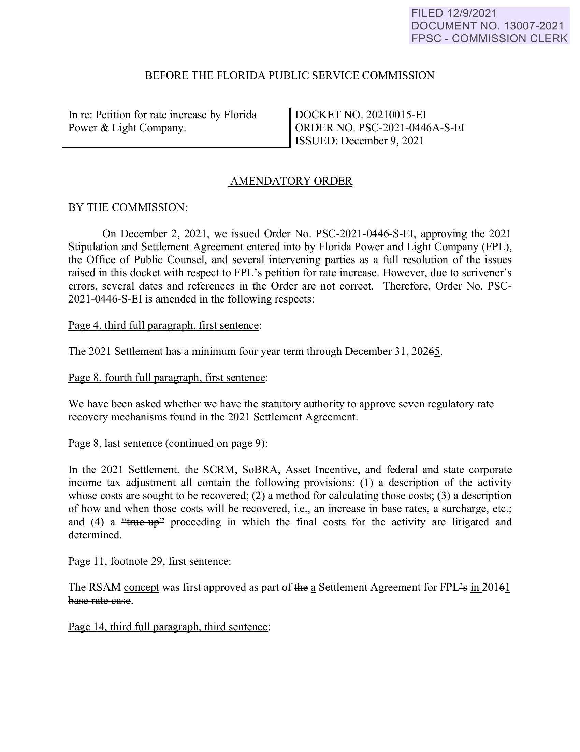

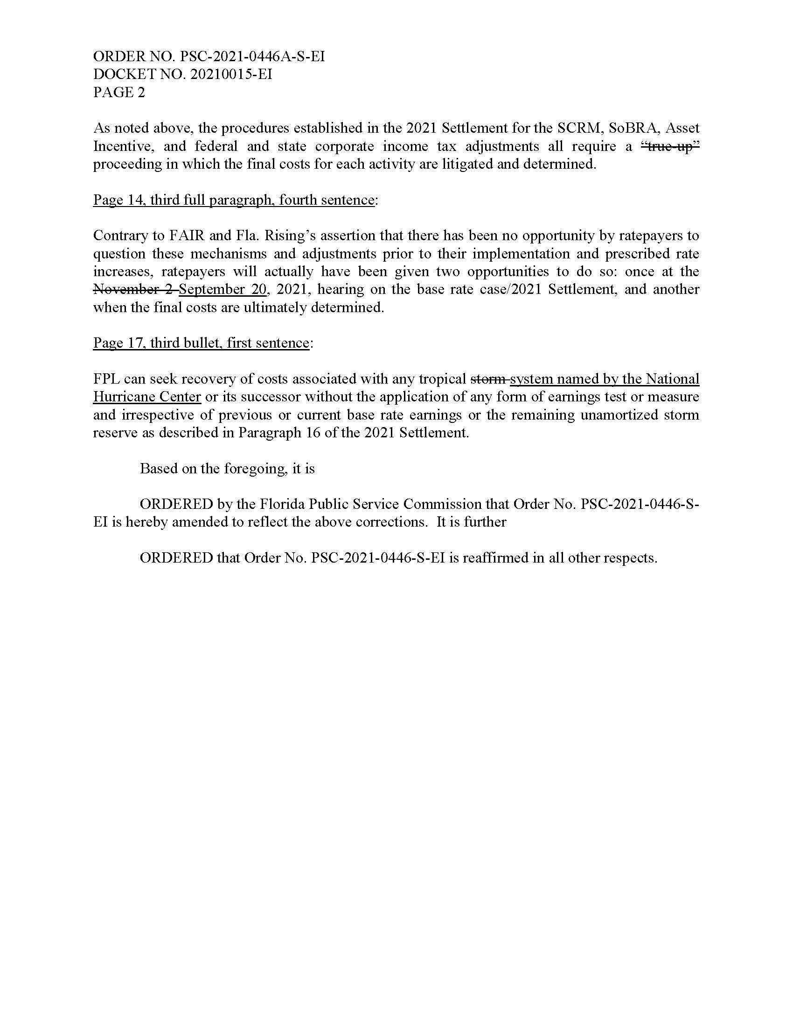

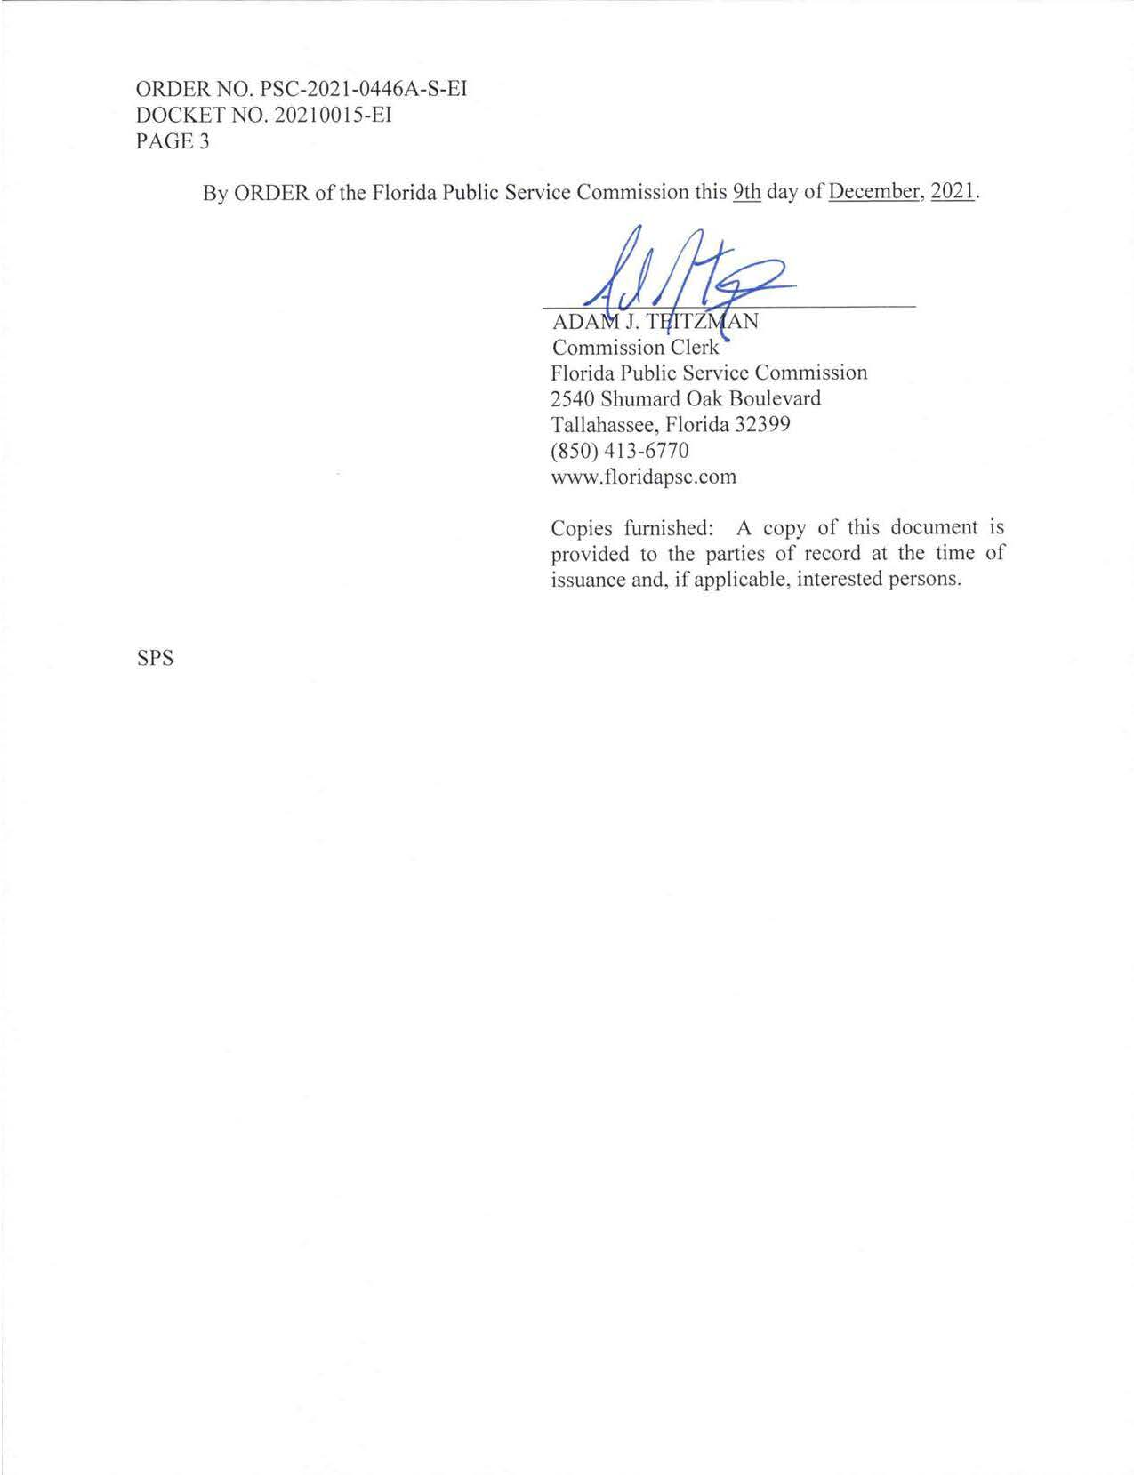

Floridians Against Increased Rates, Inc. v. Clark, 371 So. 3d 905 (Fla. 2023) (referred to hereafter as FAIR).
The Office of Public Counsel, Florida Industrial Power Users Group, Florida Retail Federation, and Southern Alliance for Clean Energy joined the Stipulation and Settlement Agreement. On August 24, 2021, FPL filed notice that additional parties Vote Solar and the CLEO Institute, Inc. had joined in the Agreement. On August 27, 2021, FPL filed notice that the Federal Executive Agencies had also joined the Agreement.
Order No. PSC-2021-0446-S-EI, issued December 2, 2021, in Docket No. 20210015-EI, In re: Petition for rate increase by Florida Power & Light Company.
Order No. PSC-2021-0446A-S-EI, issued December 2, 2021, in Docket No. 20210015-EI, In re: Petition for rate increase by Florida Power & Light Company. We will refer to this Order and Order No. PSC-2021-0446-S-EI collectively as the 2021 Final Order.
FAIR, 371 So. 3d at 912.
FAIR, 371 So.3d at 914
Id. at 912 (emphasis added).
Order No. PSC-2018-0509-FOF-EG, issued November 26, 2019, in Docket No. 20190015-EG, In re: Commission review of numeric conservation goals (Florida Power & Light Company).
See Lee v. Dep't of Health & Rehab. Servs., 698 So. 2d 1194, 1200 (Fla. 1997).
Cf. Lawnwood Med. Ctr., Inc. v. Agency for Health Care Admin., 678 So. 2d 421, 425 (Fla. 1st DCA 1996) (“Official recognition is not a device for agencies to circumvent the hearing officer's findings of fact by building a new record on which to make new findings.”).
See Citizens of State of Fla. v. Fla. Pub. Serv. Comm'n, 383 So. 2d 901, 904 (Fla. 1980) (official recognition “guarantees parties the basic rudiments of procedural due process notice and an opportunity to be heard before permitting agency action which may affect their vital interests”).
Fla. Dep't of Transp. v. J.W.C. Co., 396 So. 2d 778, 784 (Fla. 1st DCA 1981).
FAIR, 371 So. 3d at 912.
Floridians Against Increased Rates, Inc. v. Clark, 371 So. 3d 905 (Fla. 2023) (referred to hereafter as FAIR).
The Office of Public Counsel, Florida Industrial Power Users Group, Florida Retail Federation, and Southern Alliance for Clean Energy joined the Stipulation and Settlement Agreement. On August 24, 2021, FPL filed notice that additional parties Vote Solar and the CLEO Institute, Inc. had joined in the Agreement. On August 27, 2021, FPL filed notice that the Federal Executive Agencies had also joined the Agreement.
Order No. PSC-2021-0446-S-EI, issued December 2, 2021, in Docket No. 20210015-EI, In re: Petition for rate increase by Florida Power & Light Company.
Order No. PSC-2021-0446A-S-EI, issued December 2, 2021, in Docket No. 20210015-EI, In re: Petition for rate increase by Florida Power & Light Company. We will refer to this Order and Order No. PSC-2021-0446-S-EI collectively as the 2021 Final Order.
FAIR, 371 So. 3d at 907.
FAIR, 371 So. 3d at 905 (“[W]e remand this case to the Commission for an explanation of its decision consistent with the governing law as set forth in our case law and reiterated here.”).
FAIR, 371 So. 3d 912.
FAIR, 371 So. 3d 908-09.
Id. at 912 (emphasis added).
Id. at 912 (emphasis added).
FAIR¸371 So. 3d at 910.
Martuccio v. Dep't of Pro. Regul., Bd. of Optometry, 622 So. 2d 607, 609 (Fla. 1st DCA 1993) (citation omitted).
Fla. Stat. § 120.57(1)(j).
S. Fla. Water Mgmt. v. RLI Live Oak, LLC, 139 So. 3d 869, 872 n.1 (Fla. 2014).
The solar adjustments in 2024 and 2025 were not changed by the 2021 Settlement.
We need not discuss the prudence of every project being placed into rate base in determining whether a settlement agreement is in the public interest and results in rates that are fair, just, and reasonable. See Sierra Club v. Brown, 243 So. 3d 903, 911-12 (Fla. 2018).
T. Vol. 1 at 23-24 (FPL Witness Silagy)
Fla. Stat. § 366.06(1) (emphasis added).
Somers v. United States, 355 So. 3d 887, 891–92 (Fla. 2022).
https://www.merriam-webster.com/dictionary/cost, last checked 01/31/24.
https://www.merriam-webster.com/dictionary/value, last checked 01/19/24. Some common definitions of “value” are virtually the same as “cost.” However, assigning both terms the same definition and treating them as the same would not be consistent with the legislative directive that we consider cost as well as value. Moreover, courts have cautioned against ascribing the same meaning to two different terms when the legislature uses them in the statute. “The legislative use of different terms in different portions of the same statute is strong evidence that different meanings were intended.” Department of Business Regulation v. Durrani, 455 So. 2d 515, 518 (Fla. 1st DCA 1984). The placement of “value” in this statute between two retrospective terms – “rate history” and “experience of the public utility” – directs us to make an examination of the relative value of past service a part of our inquiry. Additionally, the Legislature’s use of the phrase “the value of such service to the public” in a different statute also addressing rates and the “efficiency” of facilities” reinforces our conclusion that our inquiry is to include overall utility performance beyond cost.
FPL residential bills are 40 percent below the average of the 20 largest (by number of customers) investor-owned utilities in the country. T. Vol. 1 at 20.
FPL’s reliability is 58 percent better than the national average.
T. Vol. 12 at 2596.
FPL Witness Bores identified the drivers of the increased revenue requirement behind the requested rate increases for 2022 and 2023. See T. Vol. 1 p. 212-37. Each of these drivers that has been specifically contested by Intervenors is discussed in the section of this Order under the specific issue headings.
Order No. PSC-2021-0202-AS-EI, issued June 4, 2021, in Docket No. 20210016-EI, In re: Petition for Limited Proceeding to Approve 2021 Settlement Agreement, Including General Base Rate Increase, by Duke Energy Florida, LLC.
Order No. PSC-2021-0423-S-EI, issued November 10, 2021, in Docket No. 20210034-EI, In re: Petition for rate increase by Tampa Electric Company.
We have long recognized that the ROE we approve for one company does not mandate that we approve a similar ROE for a different company. See United Telephone Co. v. Mayo, 345 So. 2d 648, 654 (Fla. 1977).
United Tel. Co. of Fla. v. Mayo, 345 So. 2d 648, 653 (Fla. 1977).
Federal Power Comm'n v. Hope Natural Gas Co., 320 U.S. 591 (1944); Bluefield Water Works and Improvement Co. v. Public Service Comm'n, 262 U.S. 679 (1923).
Hope, 320 U.S. at 603; Bluefield, 262 U.S. at 692-93.
The proxy groups also include both vertically integrated utilities that own generation assets, like FPL, and utilities that own no such assets (transmission and distribution utilities). Vertically integrated utilities have a higher business risk. T. Vol. 12 at 2180-81.
We have also reviewed and weighed the testimony relied upon by FAIR and Florida Rising that had been prefiled by OPC prior to entering the 2021 Settlement.
Rossi v. Brown, 581 So. 2d 615, 617 (Fla. 3d DCA 1991).
Wald v. Grainger, 64 So. 3d 1201, 1205 (Fla. 2011); see also Dep't of Agric. & Consumer Servs. v. Bogorff, 35 So. 3d 84, 88 (Fla. 4th DCA 2010) (“[T]he finder of fact is free to determine the reliability and credibility of expert opinions and, if conflicting, to weigh them as the finder sees fit.”).
Mayo, 345 So.2d at 654.
Order No. PSC-2021-0423-S-EI, issued November 10, 2021, in Docket No. 20210034-EI, In re: Petition for rate increase by Tampa Electric Company.
Order No. PSC-2021-0202-AS-EI, issued June 4, 2021, in Docket No. 20210016-EI, In re: Petition for Limited Proceeding to Approve 2021 Settlement Agreement, Including General Base Rate Increase, by Duke Energy Florida, LLC.
OPC Witness Woolridge calculated an average ratio of 44.5 percent using his proxy group and an average of 45.4 percent using FPL Witness Coyne’s proxy group. T. Vol. 6 at 1192.
Long-term rate stability and the resulting avoidance of the cost and expense of multiple rate cases as beneficial to ratepayers. See, e.g., Order No. PSC-01-0759-FOF-SU, issued March 26, 2001, in Docket No. 9709910SU, In re: Investigation into Rates and Charges of Florida Cities Water Co. – Lee Division (South Ft. Myers Wastewater System) for Potential Overearnings.
For instance, “FPL’s non-fuel O&M expense per customer and per MWh in 2019 were best in the nation by a wide margin.” T. Vol. 10 at 2289.
CPVRR means the total amount of revenue over the relevant term needed to cover capital and other expenses, operations and maintenance, depreciation, and the regulatory return on equity, discounted to present value.
Order No. PSC-13-0023-S-EI, issued January 14, 2013, in In re Petition for Increase in Rates by Florida Power & Light Co.; Order No. PSC-16-0560-AS-EI, issued December 15, 2016, in In re Petition for Rate Increase by Florida Power & Light Co.
T. Vol. 2 at 472 (FPL Witness Valle).
Order No. PSC-2020-0084-S-EI, issued March 20, 2020, in Docket No. 20190061-EI, In re: Petition for approval of FPL SolarTogether program and tariff by Florida Power & Light Company. Id. at 3.
We note that the Office of Public Counsel and Florida Industrial Power Users Group opposed our original approval of SolarTogether and contested the proposed settlement in 2020, but are signatories to the 2021 Settlement Agreement and do not oppose the expanded program.
This amount is included in the difference between 100 percent of base revenue requirements for the program and the amount paid by participants (103.26 percent) over the life of the program. T. Vol. 12 at 2748.
Order at 10, Stipulation and Settlement Agreement ⁋ 4(e).
Fla. Stat. § 366.91(6).
Order No. PSC-95-0853-FOF-EG, issued July 17, 1995, in Docket No. 950517-EG, In re: Petition for Approval of New Experimental Electric Vehicle Tariff by Tampa Electric Company; Order No. PSC-17-0178-S-EI, issued May 16, 2017, in Docket No. 160170-EI, In re: Petition for approval of 2016 depreciation and dismantlement studies, approval of proposed depreciation rates and annual dismantlement accruals and Plant Smith Units 1 and 2 regulatory asset amortization, by Gulf Power Company; Order No. PSC-2017-0451-AS-EU, issued November 20, 2019, in Docket No. 20170183-EI, In re: Application for limited proceeding to approve 2017 second revised and restated settlement agreement, including certain rate adjustments, by Duke Energy Florida, LLC; Order No. PSC-2020-0512-TRF-EI, issued December 21, 2020, in Docket No. 20200170-EI, In re: Petition for approval of optional electric vehicle public charging pilot tariffs, by Florida Power & Light Company; and Order No. PSC-2021-0144-PAA-EI, issued April 21, 2021, in Docket No. 20200220-EI, In re: Petition for approval of electric vehicle charging pilot program, by Tampa Electric Company.
The investments in these six pilots will be partially offset by any revenues received under the EV public charging pilot we approved for FPL in Order No. PSC-2020-0512-TRF-EI.
Hydrogen “produced or resulting from sources other than fossil fuels” – i.e., green hydrogen – is included in applicable statutory definition of “renewable energy.”§ 366.91(2), Fla. Stat.
FPL is changing reference to this charge from “customer charge” to “base charge.” T. Vol. 12 at 2798. The base charge is included in the new proposed minimum bill.
Witness Rabago stated that he could not “precisely” calculate this impact. T. Vol. 12 at 2703.
The LOLP is the probability that available generation capacity will not be able to meet a peak customer demand. Reserve margin is the amount of generation constructed to account for variations in load and unit availability. See Order No. 24989, issued August 29, 1991, in In re: Load Forecasts Generation Expansion Plans and Cogeneration Prices for Florida’s Electric Utilities.
To the extent Florida Rising is inviting a project-by-project prudence review, we decline to do so. See Sierra Club v. Brown, 243 So. 3d 903, 911-12 (Fla. 2018).
We have approved substantially the same mechanism in settlements of FPL’s last three rate cases. See Order Nos. PSC-2016-0560-AS-EI, PSC-2013-0023-S-EI, and PSC-2011-0089-S-EI.
Order No. PSC-2013-0023-S-EI, issued January 14, 2013, in Docket No. 120015-EI, In re: Petition for increase in rates by Florida Power & Light Company.
Prior to the pilot program, the only allowed activity under our standard sharing mechanism was economy power sales. T. Vol. 4 at 796.
Order No. PSC-2013-0023-S-EI at p. 4.
Citizens of State v. Fla. Pub. Serv. Comm'n, 146 So. 3d 1143, 1172 (Fla. 2014) (“[T]he Commission’s conclusion that the asset optimization incentive program is in the public interest and part of a reasonable resolution of disputed issues is supported by competent, substantial evidence.”).
Order No. PSC-2016-0560-AS-EI, issued December 15, 2016, in Docket No. 160021-EI, In re: Petition for rate increase by Florida Power & Light Company. This Order was appealed and affirmed by the Florida Supreme Court. Sierra Club v. Brown, 243 So. 3d 903 (Fla. 2018). The Court’s opinion makes no specific mention of the incentive program.
Citizens, 146 So. 3d at 1172.
FAIR, 371 So.2d at 907 fn. 2.
We do not find the holding in Citizens of Fla. v. Graham, 191 So. 3d 897 (Fla. 2016) to be applicable in this instance. The activities allowed under the program as modified all involve maximizing the use of existing utility assets presently employed for the transmission, generation, or distribution of electricity, whereas the questioned activity in Graham was the exploration of potential gas reserves for future applications.
If the actual capital costs for a solar generation project are higher than the $1,250 kW_{AC} cap or adjusted cap, FPL may initiate a limited proceeding on the issue of whether it has met the requirements of Rule 25-22.082(15), F.A.C. If the Commission finds that the requirements of Rule 25-22.082(15), F.A.C., have been met, FPL shall be allowed to increase the SoBRA by a corresponding incremental revenue requirement.
See T. Vol. 2 at 479-81.
FAIR, 371 So. 3d at 910.
See Sierra Club v. Brown, 243 So.3d 903, 909 (Fla. 2018).
FAIR, 371 So. 3d at 912.
See Fla. Stat. § 366.041(1).
Order No. PSC-2018-0509-FOF-EG, issued November 26, 2019, in Docket No. 20190015-EG, In re: Commission review of numeric conservation goals (Florida Power & Light Company).
Order No. PSC-2020-0274-PAA-EG, issued August 3, 2020, in Docket No. 20200056-EG, In re: Petition for approval of demand-side management plan and request for modify residential and business on call tariff, sheets, by Florida Power & Light Company.
Much of the testimony regarding DSM and FEECA was provided by witnesses for parties who entered into the 2021 Settlement (The Cleo Institute and Vote Solar). See, e.g., T. Vol. 7 at 1471-1423 (Witness Wilson) and Vol. 8 at 1871 (Witness Whited).
Docket No. 20240015-EG.
In FPL’s 2020 DSM docket, we specifically deferred consideration of two matters to this proceeding Order No. PSC-2020-0274-PAA-EG, issued August 3, 2020, in Docket No. 20200056-EG, In re: Petition for approval of demand-side management plan and request for modify residential and business on call tariff, sheets, by Florida Power & Light Company, at p. 4(“Florida Power & Light Company’s Commercial/Industrial Demand Reduction and Commercial/Industrial Load Control programs shall be addressed during the next Florida Power & Light Company base rate proceeding”). We find that the greater weight of the evidence in this record supports the requested revisions to those two measures. See T. Vol. 2 at 342-58 (FPL Witness Sim). The specific testimony regarding the benefits of program revisions is more pursuasive than Witness Rabago’s suggestion that the preferable solution is for FPL “to aggressively pursue program enrollment growth” under existing conditions. T. Vol. 14 at 2965-68 (Florida Rising Witness Rabago).
Fla. Stat. § 366.91(1).
Fla. Stat. § 366.91(2)(e).
Fla. Stat. § 366.91(1) (emphasis added).
https://www.merriam-webster.com/dictionary/development, last checked 01/31/24.
Fla. Stat. § 366.041(1).
The Court in FAIR also stated that we could rely upon non-statutory metrics, if such were demonstrated to be relevant, specifically referring to the findings in our 2021 Final Order regarding the comparison of FPL’s average 1000 kWh bill to the national average. As we have discussed herein, such comparisons provide a useful metric in determining the “value” of service as required by sections 366.06(1) and 366.041(1), F.S., and are within the statutory scope of our review.
Sierra Club v. Brown, 243 So.3d 903, 909 (Fla. 2018)(quoting Citizens of State v. Fla. Pub. Serv. Comm’n, 146 So.3d 1143, 1164 (Fla. 2014)).

