BEFORE THE FLORIDA PUBLIC SERVICE COMMISSION

In re: Petition for approval of transportation service agreement with Florida Public Utilities Company by Peninsula Pipeline Company, Inc. | DOCKET NO. 20230135-GU  ORDER NO. PSC-2024-0072-PAA-GU  ISSUED: March 20, 2024

The following Commissioners participated in the disposition of this matter:

MIKE LA ROSA, Chairman
ART GRAHAM
GARY F. CLARK
ANDREW GILES FAY
GABRIELLA PASSIDOMO

NOTICE OF PROPOSED AGENCY ACTION
ORDER APPROVING FIRM TRANSPORTATION
SERVICE AGREEMENTS

BY THE COMMISSION:

NOTICE is hereby given by the Florida Public Service Commission that the action discussed herein is preliminary in nature and will become final unless a person whose interests are substantially affected files a petition for a formal proceeding, pursuant to Rule 25-22.029, Florida Administrative Code (F.A.C.).

Background
On December 14, 2023, Peninsula Pipeline Company, Inc. (Peninsula) filed a petition seeking approval of two firm transportation service agreements (Agreements) between Peninsula and Florida Public Utilities Company (FPUC), collectively the Parties. The purpose of the Agreements is to increase supply capability and enhance reliability in Boynton Beach and New Smyrna Beach, Florida. Peninsula operates as an intrastate natural gas transmission company as defined by Section 368.103(04), Florida Statutes (F.S.). FPUC is a local distribution company subject to our regulatory jurisdiction pursuant to Chapter 366, F.S. FPUC provides natural gas service to residential, commercial, and industrial customers in Palm Beach and Volusia County, and receives deliveries of natural gas to serve these customers over interstate transmission pipelines owned by Florida Gas Transmission Company, LLC (FGT).

By Order No. PSC-07-1012-TRF-GP, Peninsula received approval of an intrastate gas pipeline tariff that allows it to construct and operate intrastate pipeline facilities and to actively pursue agreements with natural gas customers. Peninsula provides gas transportation service only; it does not engage in the sale of natural gas to customers. Pursuant to Order No. PSC-07-1012-TRF-GP, Peninsula is allowed to enter into certain gas transmission agreements without our prior approval. However, Peninsula is requesting our approval of the proposed Agreements as they do not fit any of the criteria enumerated in the tariff for which our approval would not be required. The Parties are subsidiaries of Chesapeake Utility Corporation, and agreements between affiliated companies must be approved by us pursuant to Section 368.105, F.S., and Order No. PSC-07-1012-TRF-GP.

FPUC has proposed to recover its payments to Peninsula through the Purchased Gas Adjustment (PGA) and swing service rider mechanisms. The PGA allows FPUC to periodically adjust the price of natural gas supplied to its customer to reflect the actual cost of gas purchased and delivered on behalf of the customers. The swing service rider allows FPUC to recover intrastate capacity costs from their transportation customers and is a cents per therm charge that is included in the monthly customer gas bill of transportation customers. While FPUC would incur costs associated with these service expansions, new load added to the system should help spread the costs over a larger customer base.

Pursuant to the proposed Agreements (Attachments A and B to this order), Peninsula would construct, own, and operate a new natural gas pipeline and acquire from FPUC an existing gate station with FGT for the Boynton Beach Project. The proposed projects would enable FPUC to serve Boynton Beach and New Smyrna Beach and potential future gas customers in Palm Beach and Volusia County, respectively. Furthermore, maps of the proposed projects are included in Attachment C to this order.

During the evaluation of the petition, Commission staff issued a data request to the Parties for which responses were received on February 7, 2024. We have jurisdiction over this matter pursuant to Sections 366.05(1), 366.06, and 368.105, F.S.

Decision
- Boynton Beach Project Firm Transportation Service Agreement

- Proposed Transportation Service Agreement for Boynton Beach

The Parties have entered into the proposed firm transportation service agreement to enable FPUC to reinforce its Boynton Beach distribution system and meet increased natural gas demand in Palm Beach County. The proposed Agreement has the added benefit of providing FPUC with an additional source of gas (via the Peninsula pipeline) and enhancing an existing gate station.

The proposed Agreement specifies an initial term of 20 years and thereafter shall be extended on a year-to-year basis, unless either party gives no less than 90 days of written notification of termination. If either party desires to negotiate modifications to the rates or terms of this Agreement, they may do so no less than 120 days prior to expiration of the current active term, subject to our approval of the amendment

- Proposed Boynton Beach Expansion Project

Referring to the map of the proposed project, phase 1 of the project, as shown by the red line, starting at an upgraded Peninsula gate station interconnection with FGT, Peninsula would construct 3 miles of 4-inch coated steel pipeline traveling east along Boynton Beach Blvd which would conclude at a Peninsula District Regulator Station (DRS). Phase 2 of the project, as depicted by the pink line, would start at the Peninsula DRS. Peninsula would construct 2 miles of 4-inch coated steel pipeline traveling east along Boynton Beach Blvd, and would conclude at the FPUC DRS. Both phases are projected to be completed in the first quarter of 2025.

In response to staff’s data request, the Parties stated that FPUC did not issue Formal Request for Proposals to other entities. FPUC explained that in previous discussions and requests with FGT for other projects, FGT has declined to bid on projects related to constructing, owning, and operating laterals such as the proposed expansion project in this petition, which are not a focus of FGT’s expansion activities.

- Anticipated System Benefits

In paragraph 2 of the petition, the Parties assert that the proposed project is needed to ensure sufficient additional gas supply and would provide operational support to FPUC’s system. The Parties explained that construction of the pipeline is necessary because the existing infrastructure is not adequate to serve the current communities. The Parties further explained that the proposed project would reinforce FPUC’s Boynton Beach distribution system with an additional source of interstate gas with the potential to provide nature gas service to future customers in Palm Beach County.

- Negotiated Monthly Reservation Payments to Peninsula

In paragraph 23 of the petition, the Parties expressed that the negotiated monthly reservation charge contained in the proposed Agreement is consistent with market rates, because the rates are substantially the same as rates set forth in similar agreements as required by Section 368.105(3)(b), F.S. The Parties explained that Peninsula would recover the pipeline construction costs through the monthly reservation charge to FPUC, as shown in Exhibit A to the proposed Agreement. The monthly reservation charge is designed to recover costs such as, but not limited to, engineering, permitting, materials, and installation costs associated with the pipeline and related facilities, ongoing maintenance including Pipeline and Hazardous Materials Safety Administration compliance, safety requirements, property taxes, gas control, and Peninsula’s return on investment.

- Conclusion

Based on the petition and the Parties’ responses to Commission staff’s data request, we approve the proposed firm transportation service agreement associated with the Boynton Beach project, dated December 11, 2023, between FPUC and Peninsula. The firm transportation service agreement is reasonable and meets the requirements of Section 368.105, F.S. Furthermore, the proposed firm transportation service agreement benefits FPUC’s current and potential future customers by ensuring that there is an uninterrupted supply of natural gas to Boynton Beach, Florida.

- Amendment to New Smyrna Beach Project Firm Transportation Service Agreement

- Proposed Amendment to the Transportation Service Agreement for New Smyrna Beach

By Order No. PSC-2017-0498-PAA-GU, Peninsula received approval of a firm transportation service agreement that allows it to construct a natural gas pipeline in the New Smyrna Beach area and relocate an existing gate station. The proposed New Smyrna Beach project and associated Agreement are an amendment to the 2017 firm transportation agreement.

The Parties have entered into the proposed amendment to the 2017 firm transportation service agreement to enable FPUC to reinforce its New Smyrna Beach distribution system and meet increased natural gas demand in Volusia County. The proposed Amendment has the added benefit of providing FPUC with an additional source of gas (via the Peninsula pipeline), an additional interconnect, and four new DRSs.

The proposed amendment specifies an initial term of 20 years and thereafter shall be extended on a year-to-year basis, unless either party gives no less than 90 days of written notification of termination. If either party desires to negotiate modifications to the rates or terms of this amendment, they may do so no less than 120 days prior to expiration of the current active term, subject to our approval of the amendment.

- Proposed New Smyrna Beach Expansion Project

Referring to the map of the proposed project, starting at a new DRS interconnection with FGT on South Ridgewood Ave in Volusia County, Peninsula would construct 14.8 miles of 4-inch coated steel pipeline and four new DRSs as shown on the red line. The project is projected to go in-service in the first quarter of 2025. The Parties assert that the selected route of the New Smyrna Beach expansion project provides the largest benefit to the area, to FPUC, and its customers.

In response to Commission staff’s data request, the Parties stated that FPUC did not issue Formal Request for Proposals to other entities. FPUC explained that in previous discussions and requests with FGT for other projects, FGT has declined to bid on projects related to constructing, owning, and operating laterals such as the proposed expansion project in this petition, which are not a focus of FGT’s expansion activities.

- Anticipated System Benefits

In paragraph 17 of the petition, the Parties expressed that this new project builds upon the original Peninsula pipeline system in order to reinforce portions of FPUC’s system in the southern portion of New Smyrna Beach, as well as areas along the project route that have also experienced growth since the approval of the original project. The Parties assert that construction of the pipeline is necessary because the existing infrastructure is not adequate to serve the current community. The Parties assert that the proposed project would reinforce FPUC’s New Smyrna Beach distribution system with an additional source of interstate gas with the potential to provide natural gas service to future customers in Volusia County.

FPUC explained that during the high demand months of the winter, it currently does not have sufficient capacity to meet its design-day needs in New Smyrna Beach. The New Smyrna Beach system experiences low pressure issues; therefore, FPUC is using compressed natural gas (CNG) to supplement supply in the area during the high demand months to ensure adequate supply. The Parties expressed that the Peninsula expansion of the existing service would provide a long-term solution for the system in New Smyrna Beach, reducing the need for seasonal CNG support in the area.

- Negotiated Monthly Reservation Payments to Peninsula

In paragraph 23 of the petition, the Parties assert that the negotiated monthly reservation charge contained in the proposed amendment is consistent with market rates, because the rate are substantially the same as rates set forth in similar agreements as required by Section 368.105(3)(b), F.S. The Parties explained that Peninsula would recover the pipeline and DRS construction costs through the monthly reservation charge to FPUC as shown in Exhibit A to the proposed Agreement. The monthly reservation charge is designed to recover costs such as, but not limited to, engineering, permitting, materials, and installation costs associated with the pipeline and related facilities, ongoing maintenance including Pipeline and Hazardous Materials Safety Administration compliance, safety requirements, property taxes, gas control, and Peninsula’s return on investment.

- Conclusion

Based on the petition and the Parties’ responses to Commission staff’s data request, we approve the proposed amendment to the firm transportation service agreement associated with the New Smyrna Beach project, dated December 11, 2023, between FPUC and Peninsula. The firm transportation service agreement is reasonable and meets the requirements of Section 368.105, F.S. Furthermore, the proposed firm transportation service agreement benefits FPUC’s current and potential future customers by ensuring that there is a sufficient supply of natural gas to New Smyrna Beach, Florida.

Based on the foregoing, it is

ORDERED by the Florida Public Service Commission that the proposed firm transportation service agreement associated with the Boynton Beach project dated December 11, 2023, between Florida Public Utilities Company and Peninsula Pipeline Company, Inc., is approved. It is further

ORDERED that the proposed amendment to the firm transportation service agreement associated with the New Smyrna Beach project, dated December 11, 2023, between Florida Public Utilities Company and Peninsula Pipeline Company, Inc., is approved. It is further

ORDERED that the provisions of this Order, issued as proposed agency action, shall become final and effective upon the issuance of a Consummating Order unless an appropriate petition, in the form provided by Rule 28-106.201, Florida Administrative Code, is received by the Commission Clerk, 2540 Shumard Oak Boulevard, Tallahassee, Florida 32399-0850, by the close of business on the date set forth in the “Notice of Further Proceedings” attached hereto. It is further

ORDERED that in the event this Order becomes final, this docket shall be closed.

By ORDER of the Florida Public Service Commission this 20th day of March, 2024.

/s/ Adam J. Teitzman
ADAM J. TEITZMAN
Commission Clerk
Florida Public Service Commission
2540 Shumard Oak Boulevard
Tallahassee, Florida 32399
(850) 413-6770
www.floridapsc.com

Copies furnished: A copy of this document is provided to the parties of record at the time of issuance and, if applicable, interested persons.

DD

NOTICE OF FURTHER PROCEEDINGS OR JUDICIAL REVIEW

The Florida Public Service Commission is required by Section 120.569(1), Florida Statutes, to notify parties of any administrative hearing that is available under Section 120.57, Florida Statutes, as well as the procedures and time limits that apply. This notice should not be construed to mean all requests for an administrative hearing will be granted or result in the relief sought.

Mediation may be available on a case-by-case basis. If mediation is conducted, it does not affect a substantially interested person's right to a hearing.

The action proposed herein is preliminary in nature. Any person whose substantial interests are affected by the action proposed by this order may file a petition for a formal proceeding, in the form provided by Rule 28-106.201, Florida Administrative Code. This petition must be received by the Office of Commission Clerk, 2540 Shumard Oak Boulevard, Tallahassee, Florida 32399-0850, by the close of business on April 10, 2024.

In the absence of such a petition, this order shall become final and effective upon the issuance of a Consummating Order.

Any objection or protest filed in this/these docket(s) before the issuance date of this order is considered abandoned unless it satisfies the foregoing conditions and is renewed within the specified protest period.

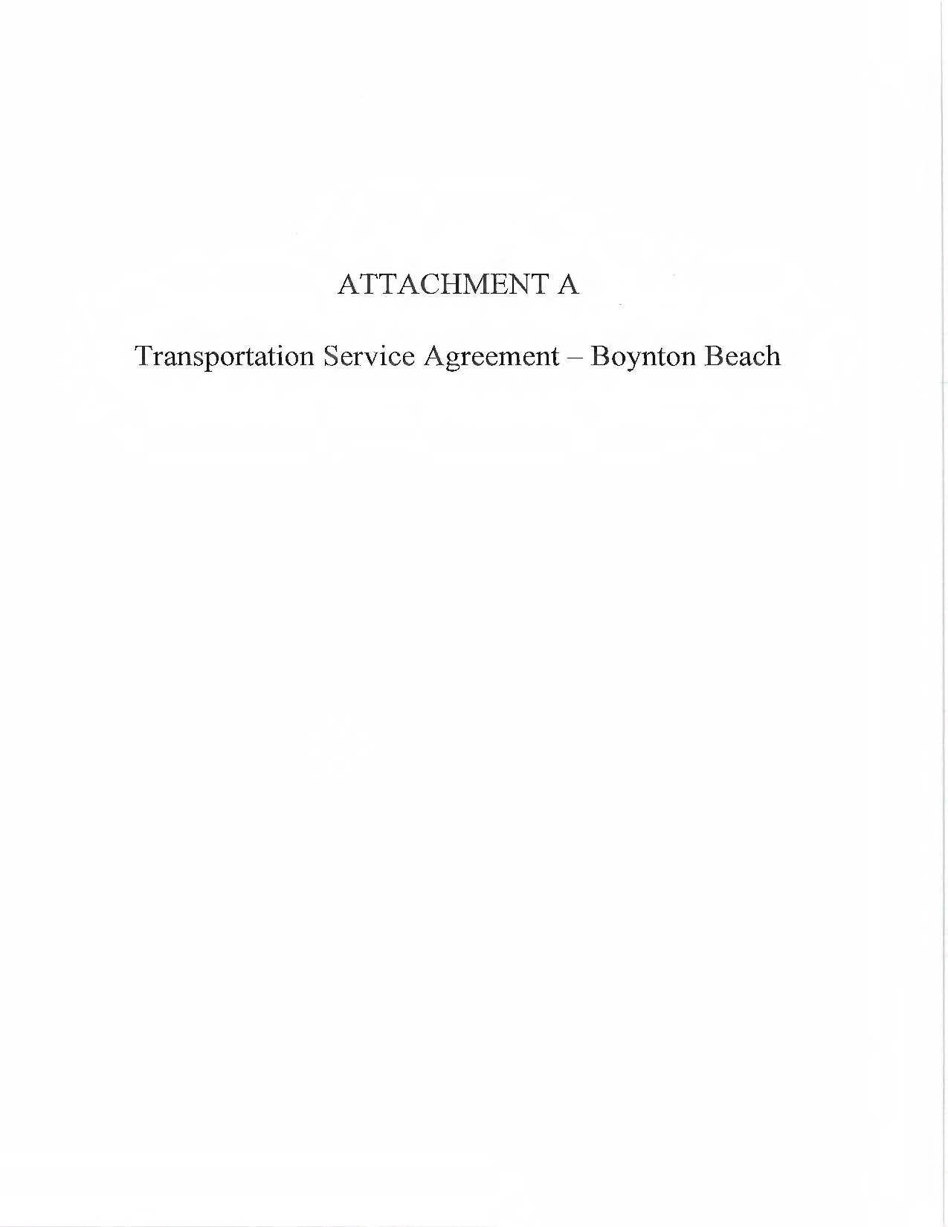
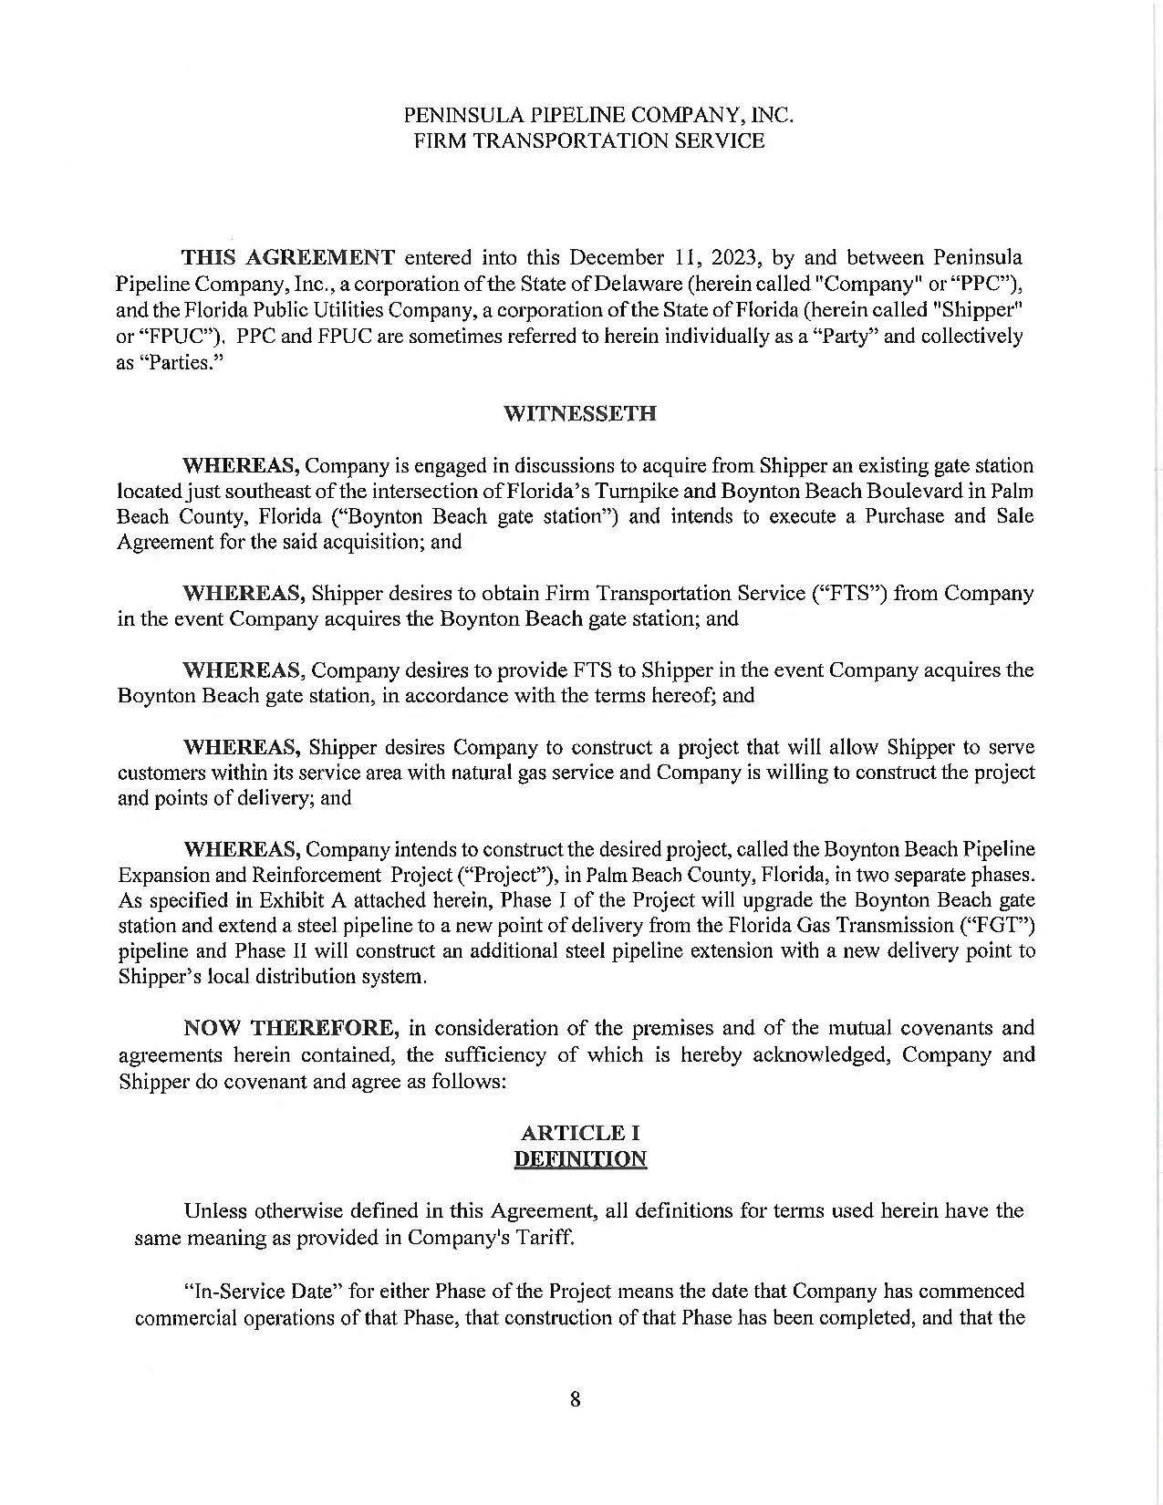
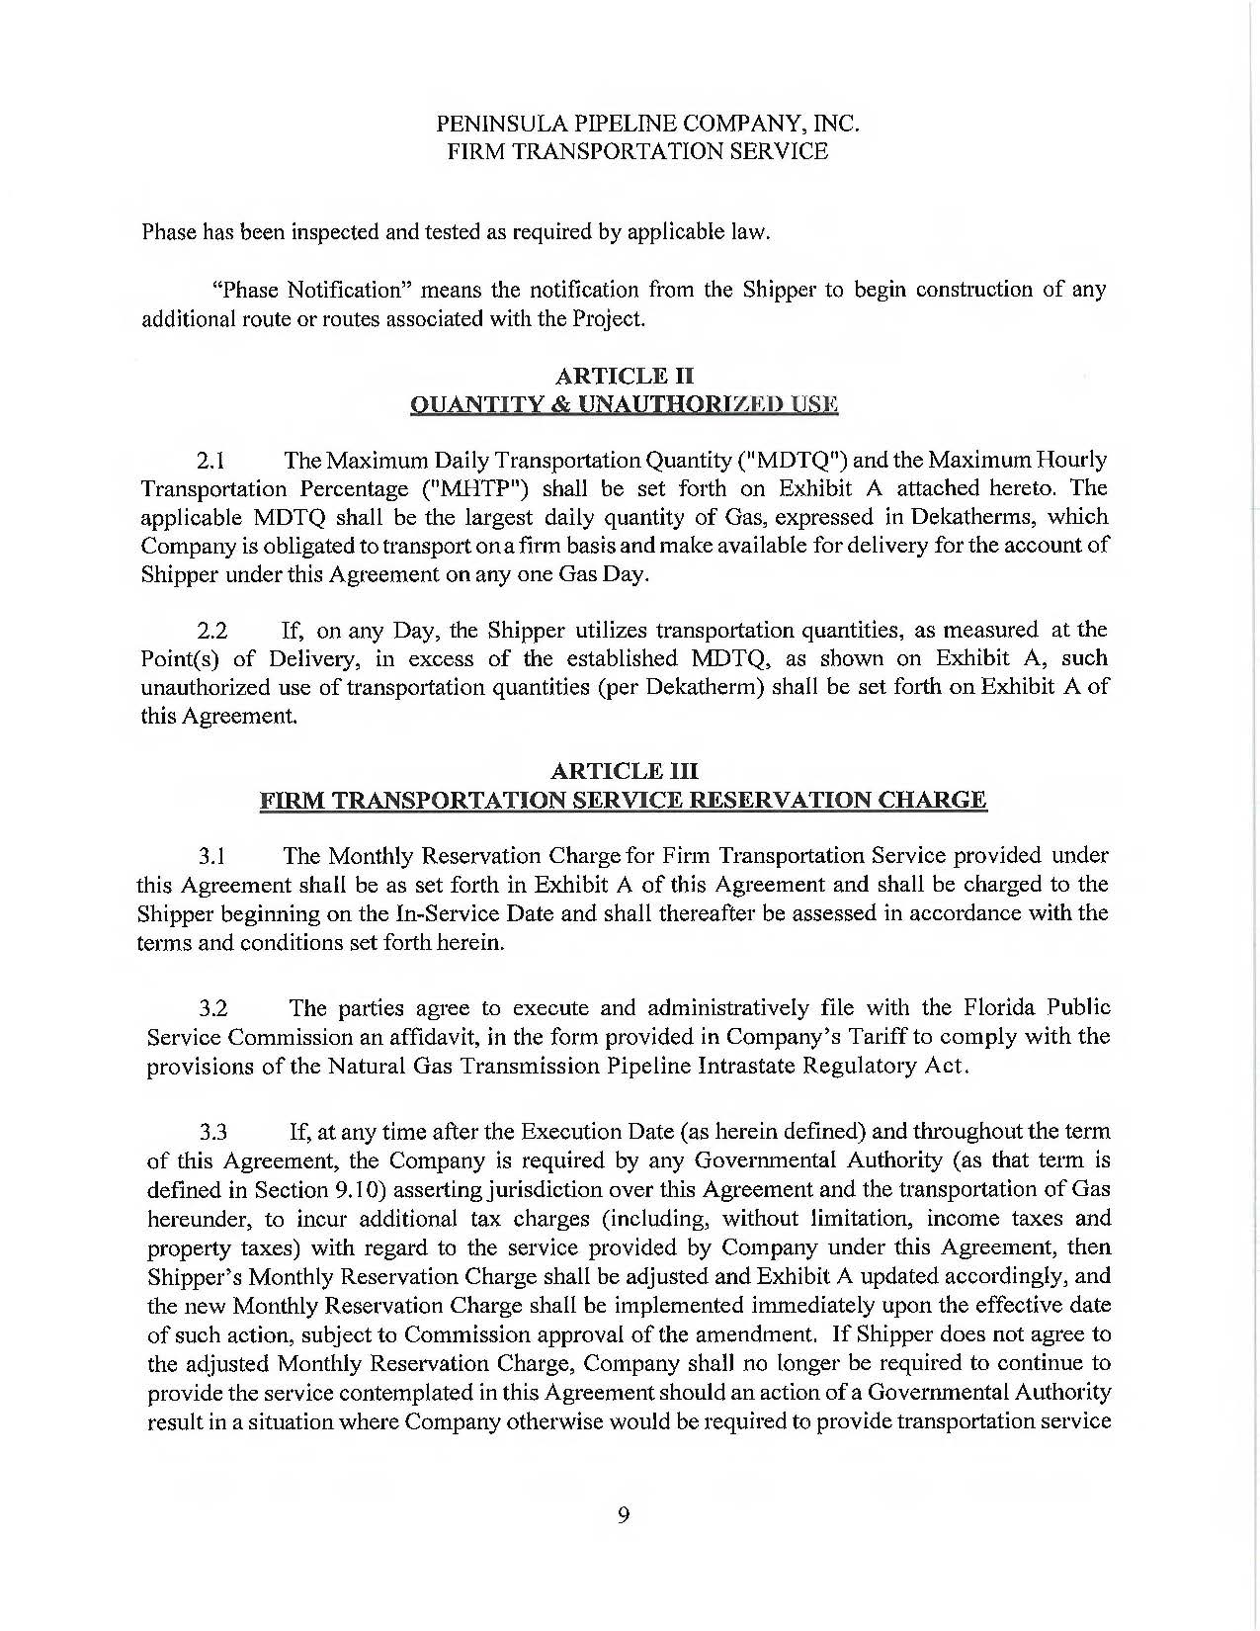
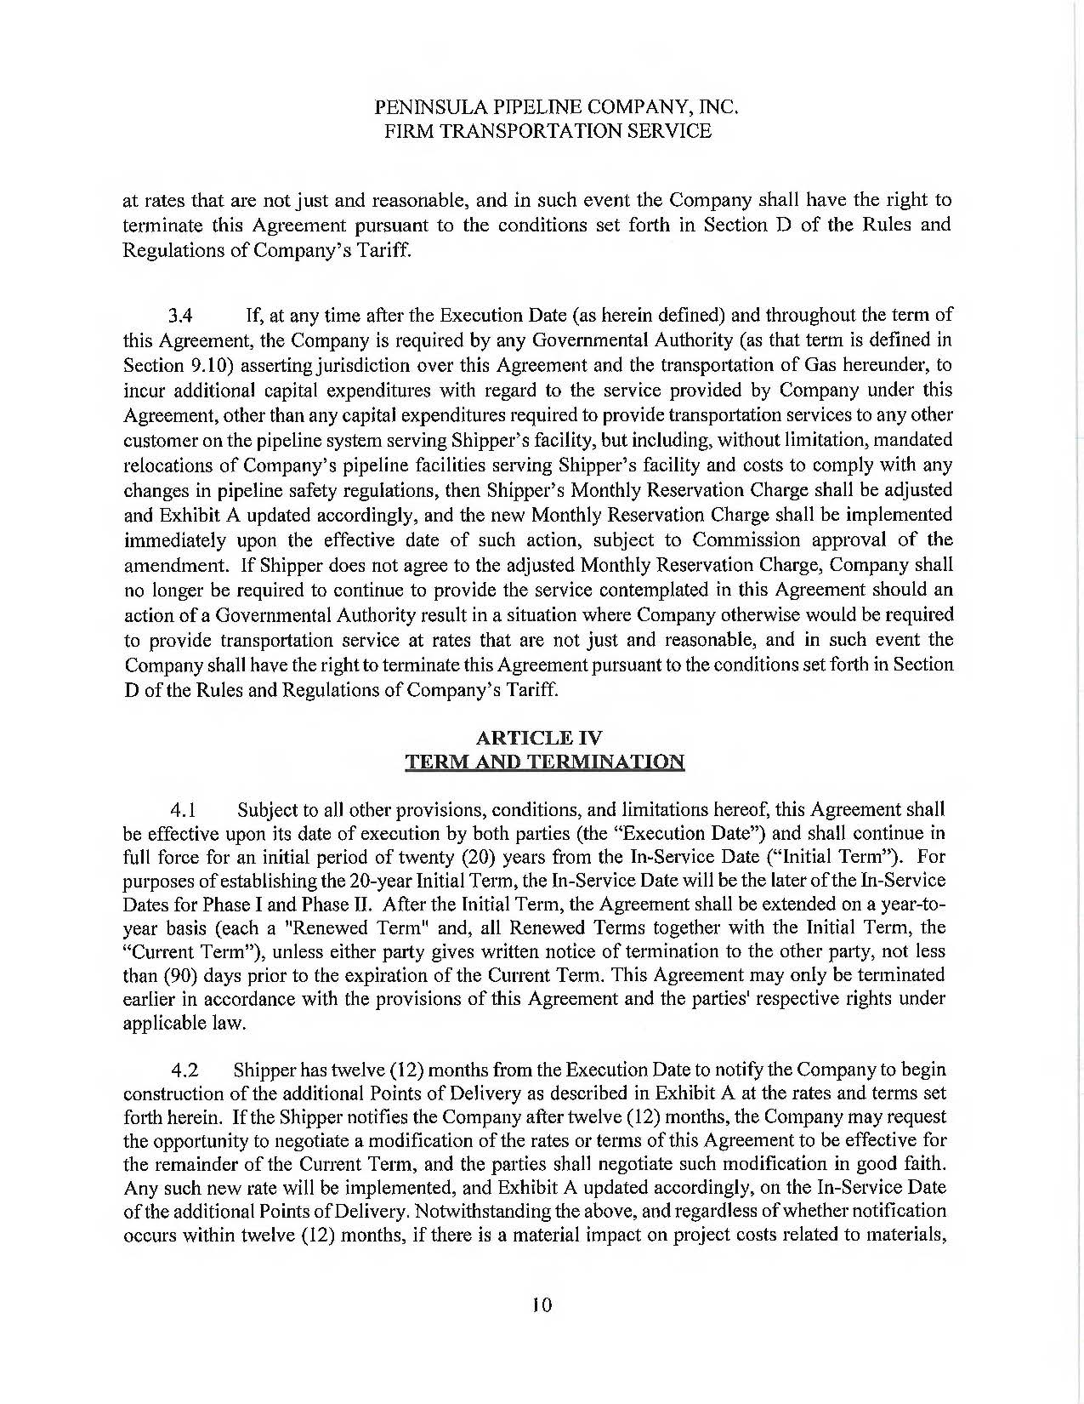
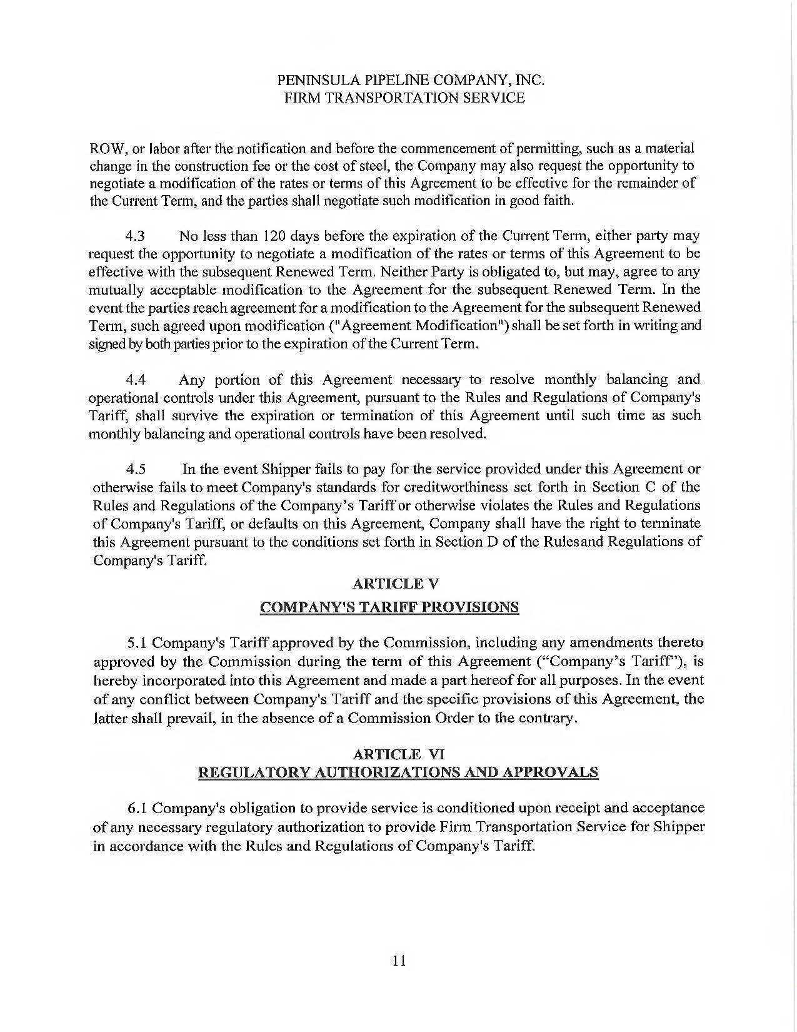
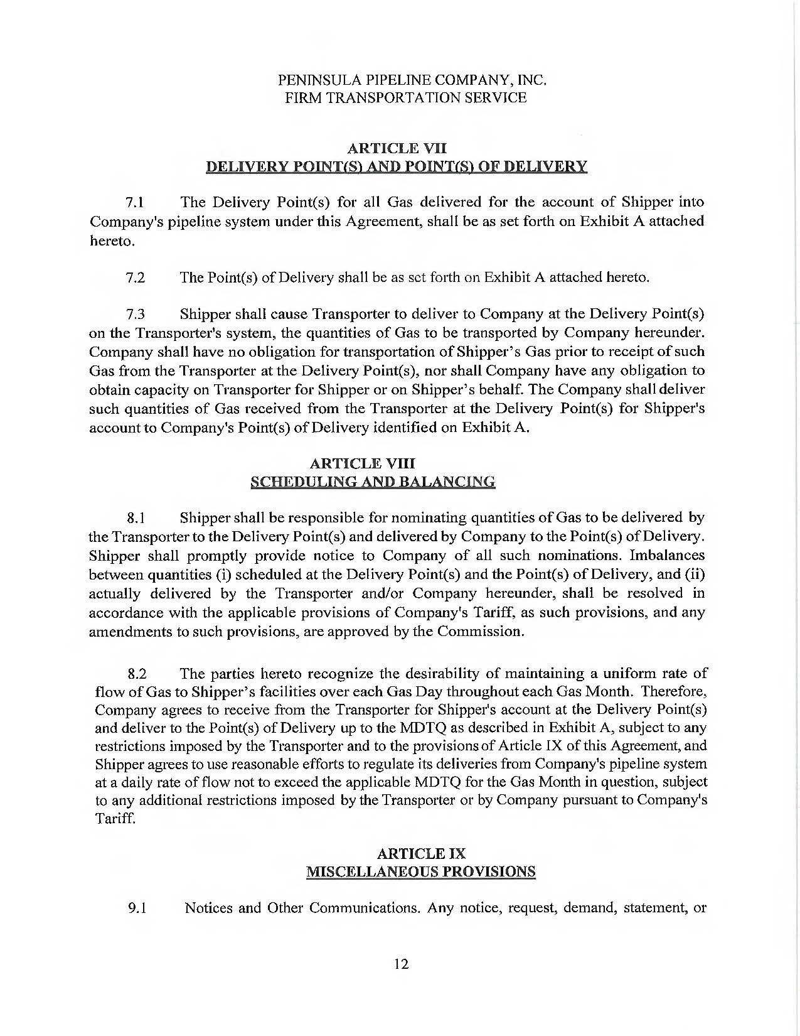
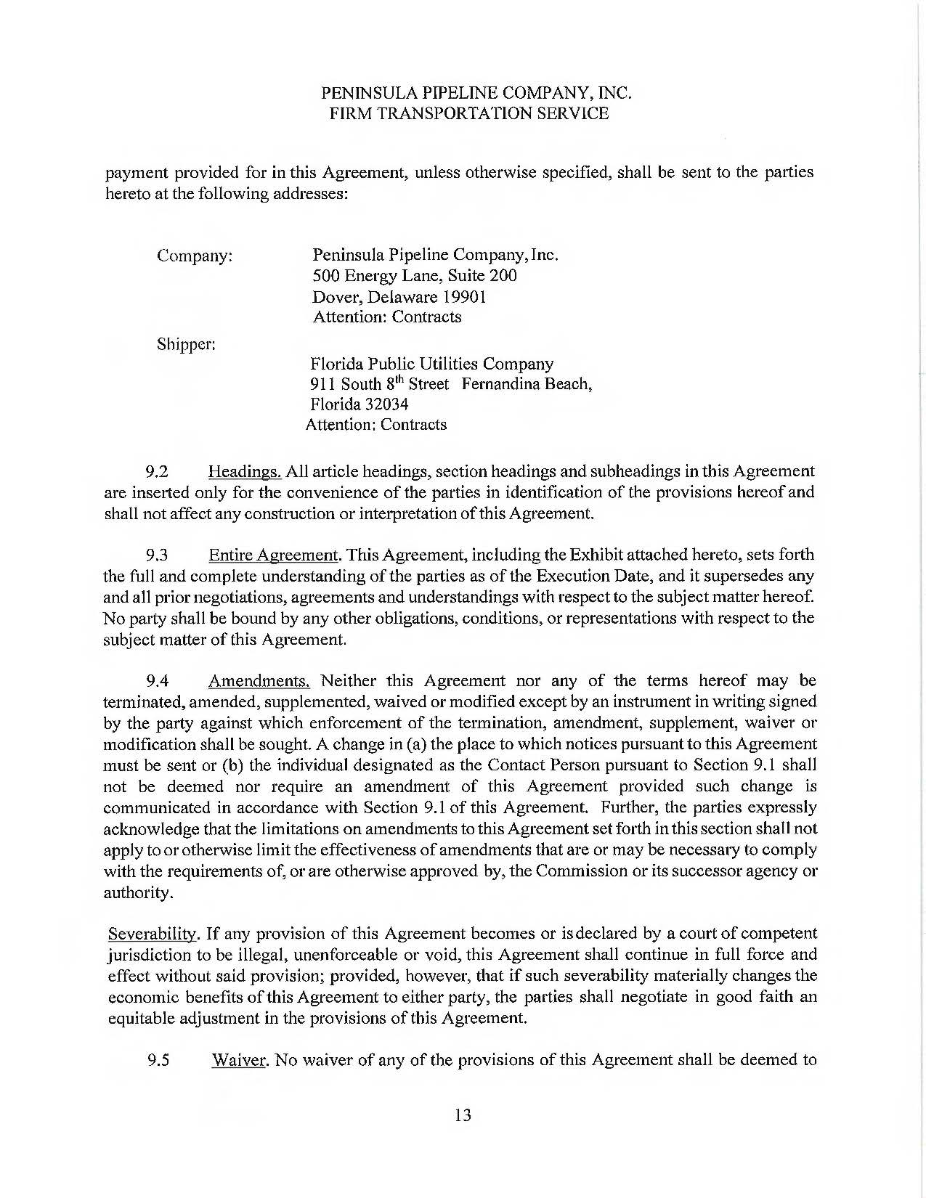
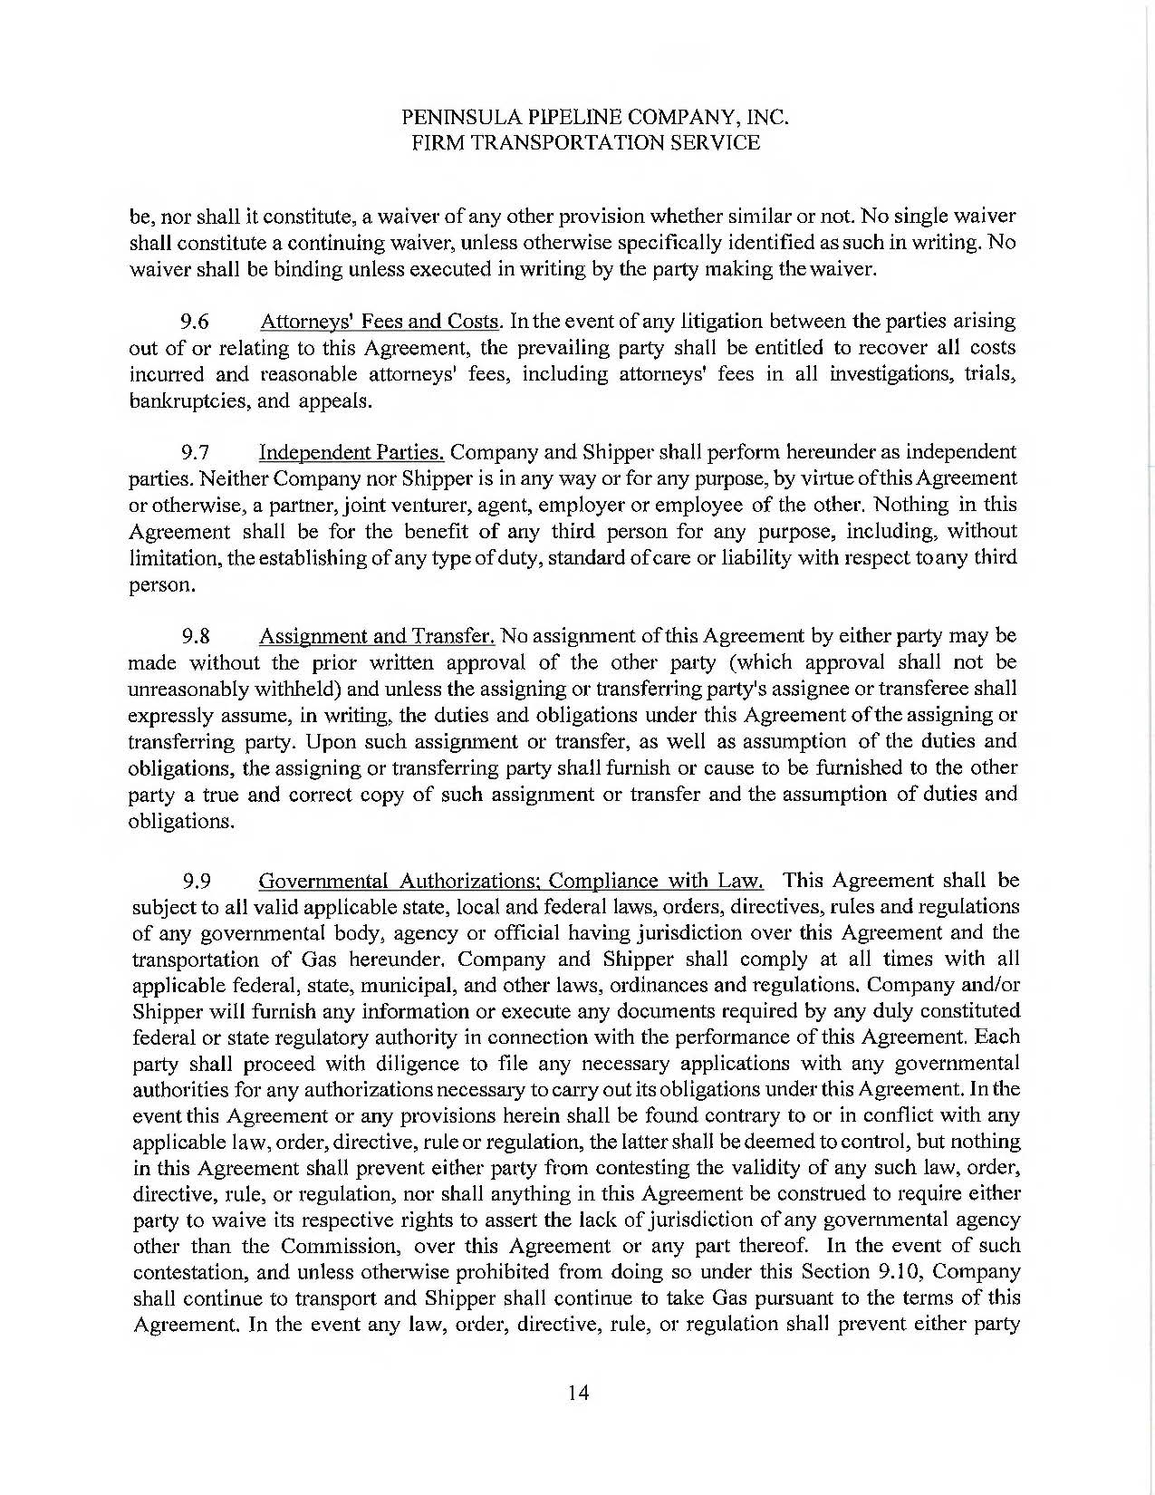
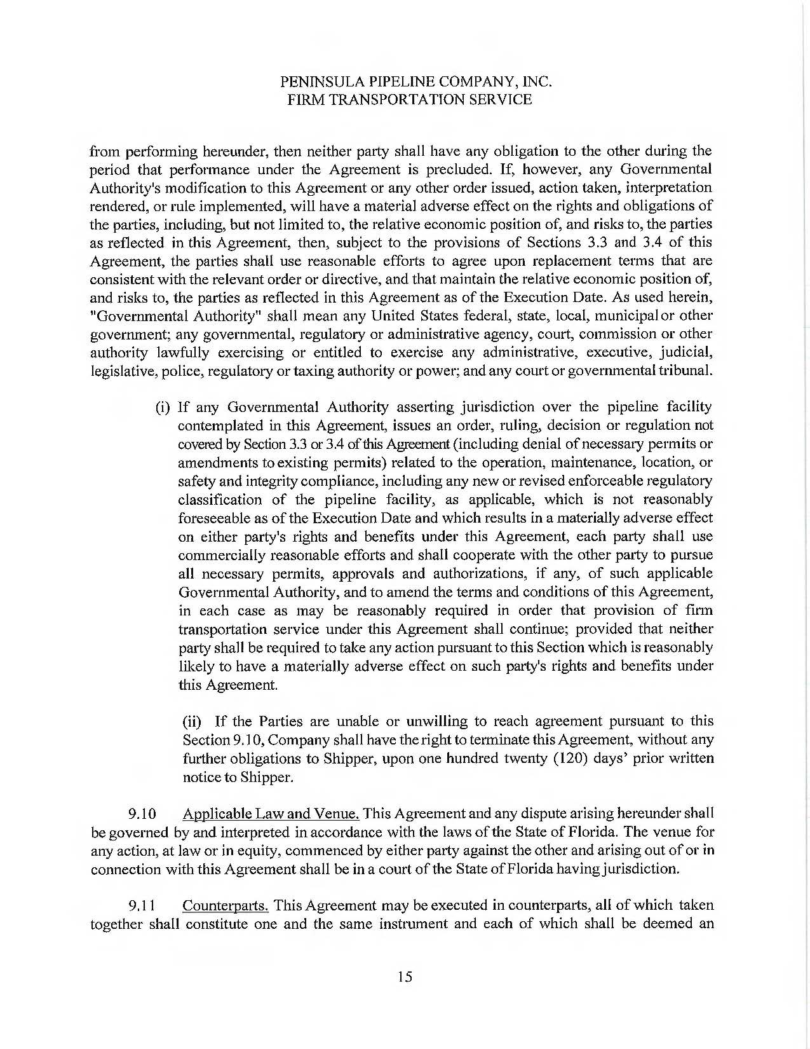
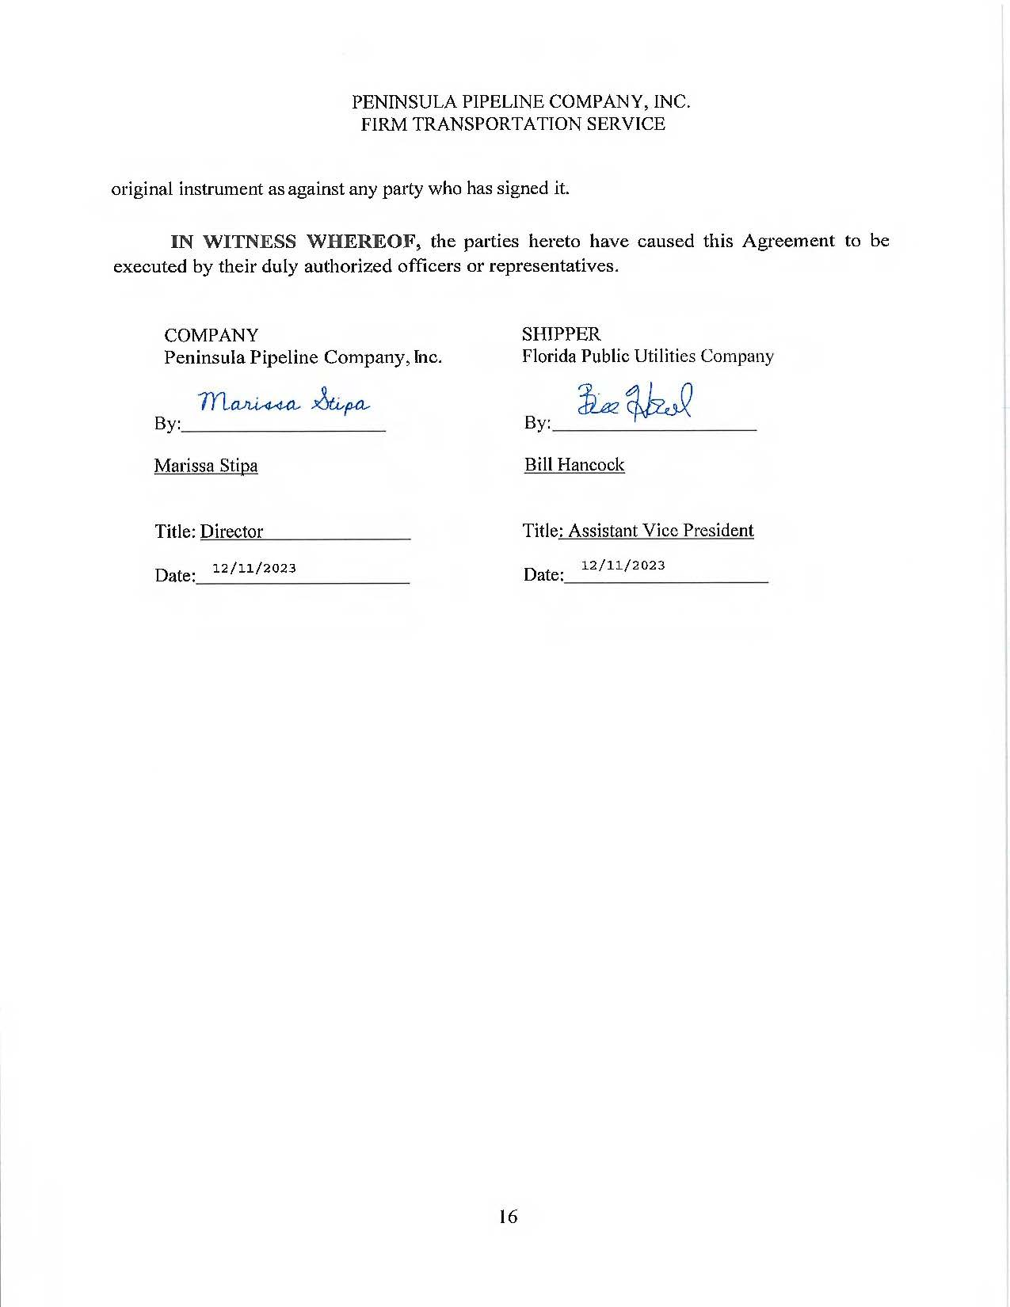
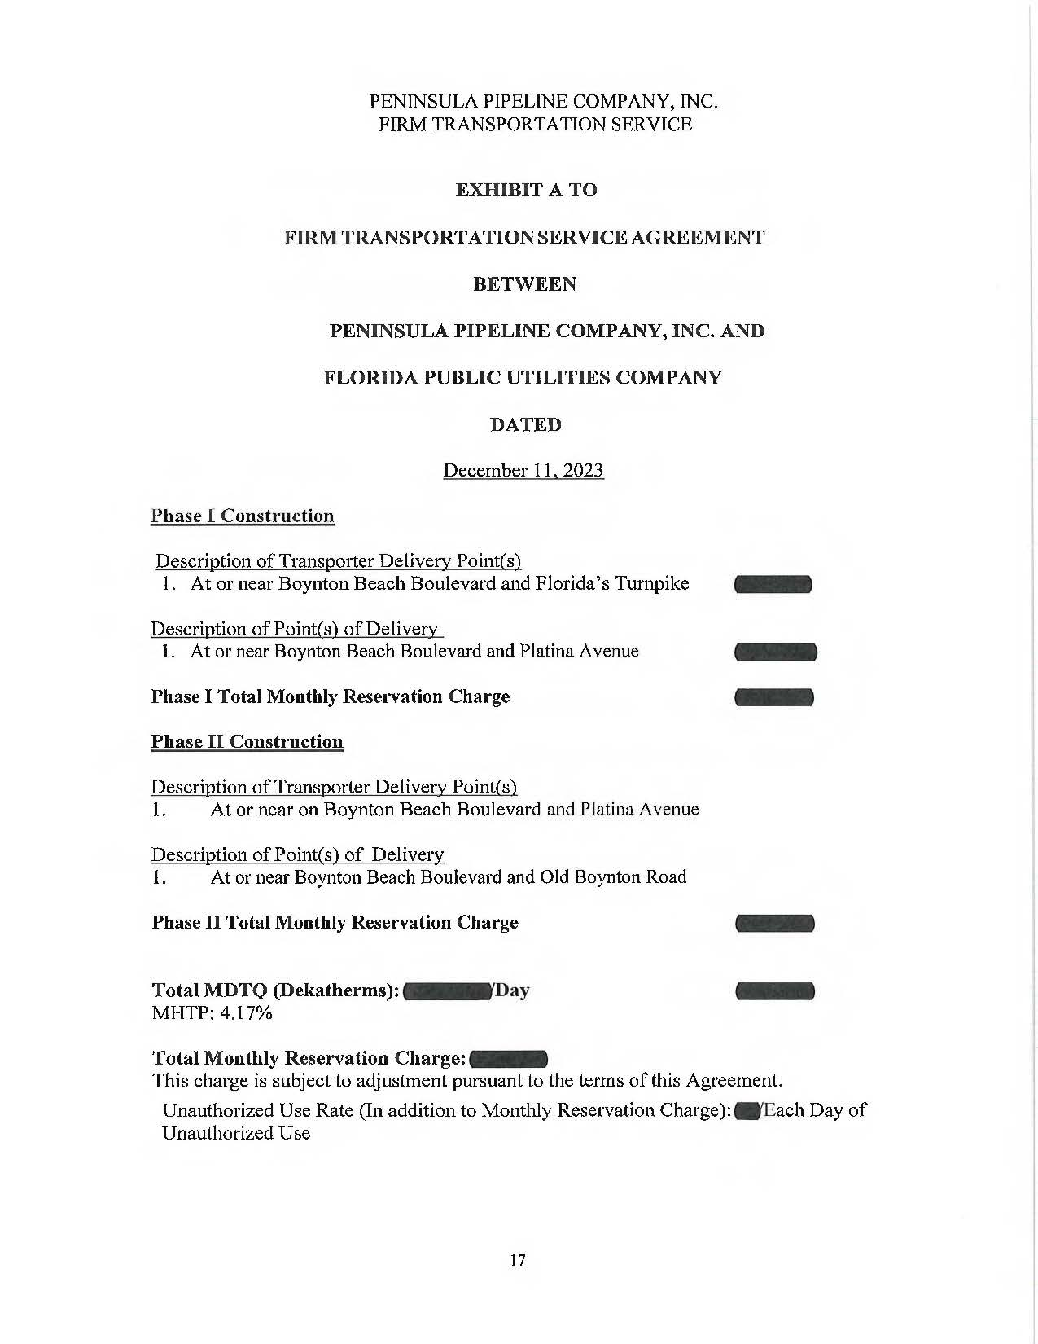
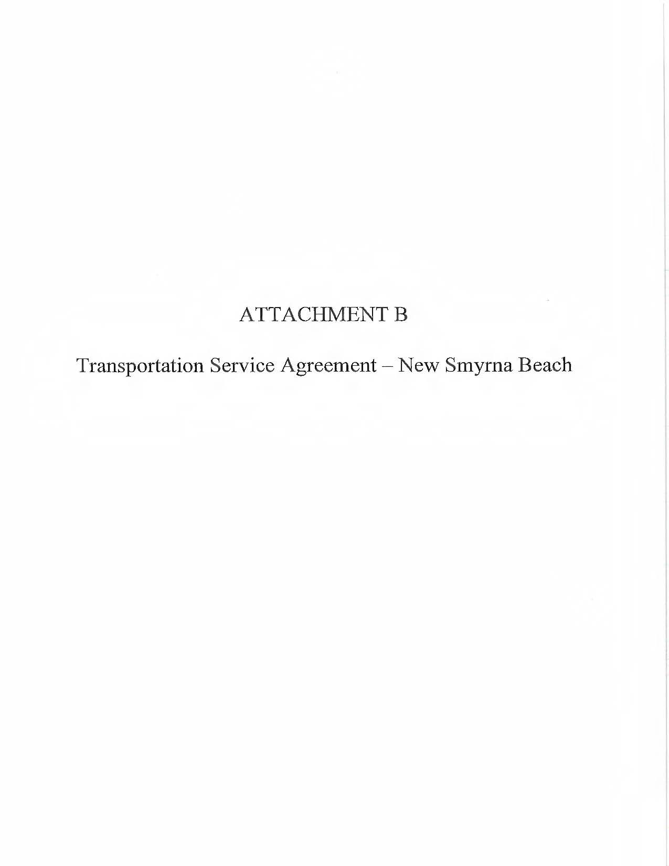
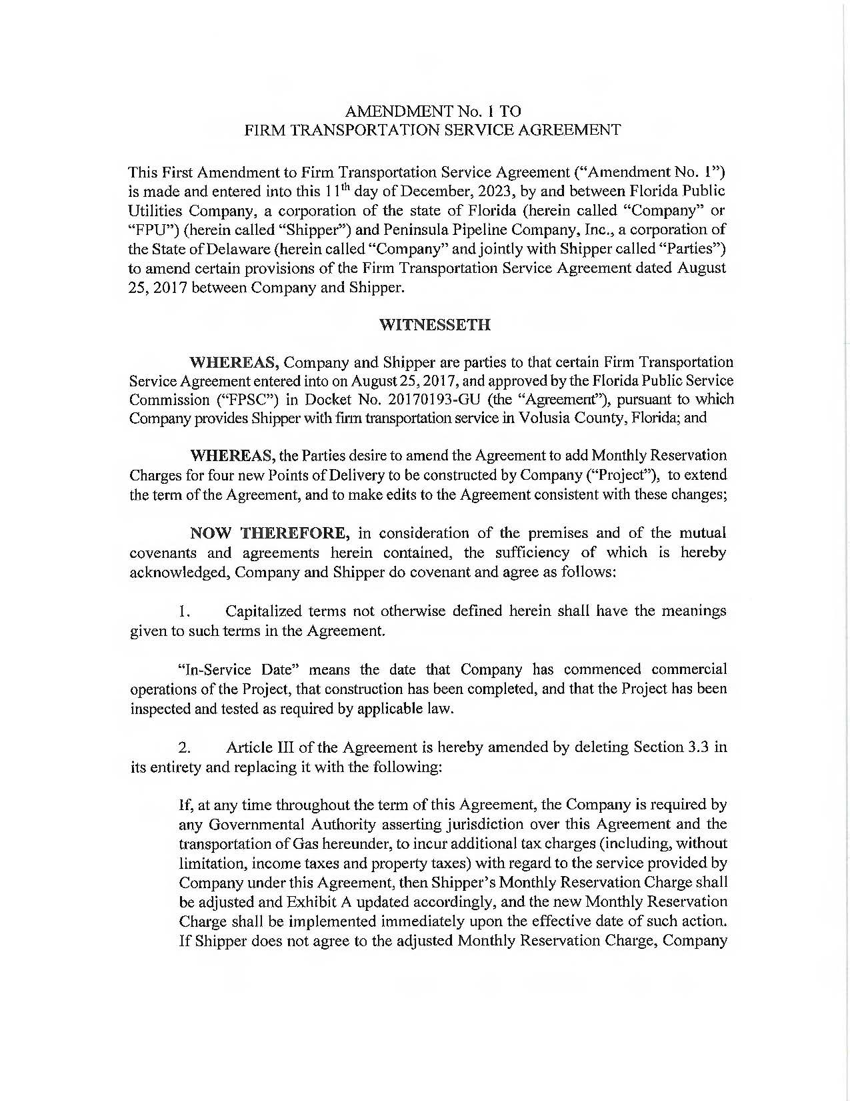
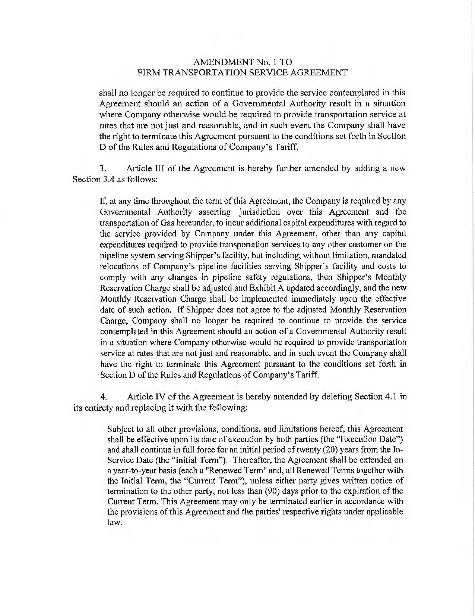
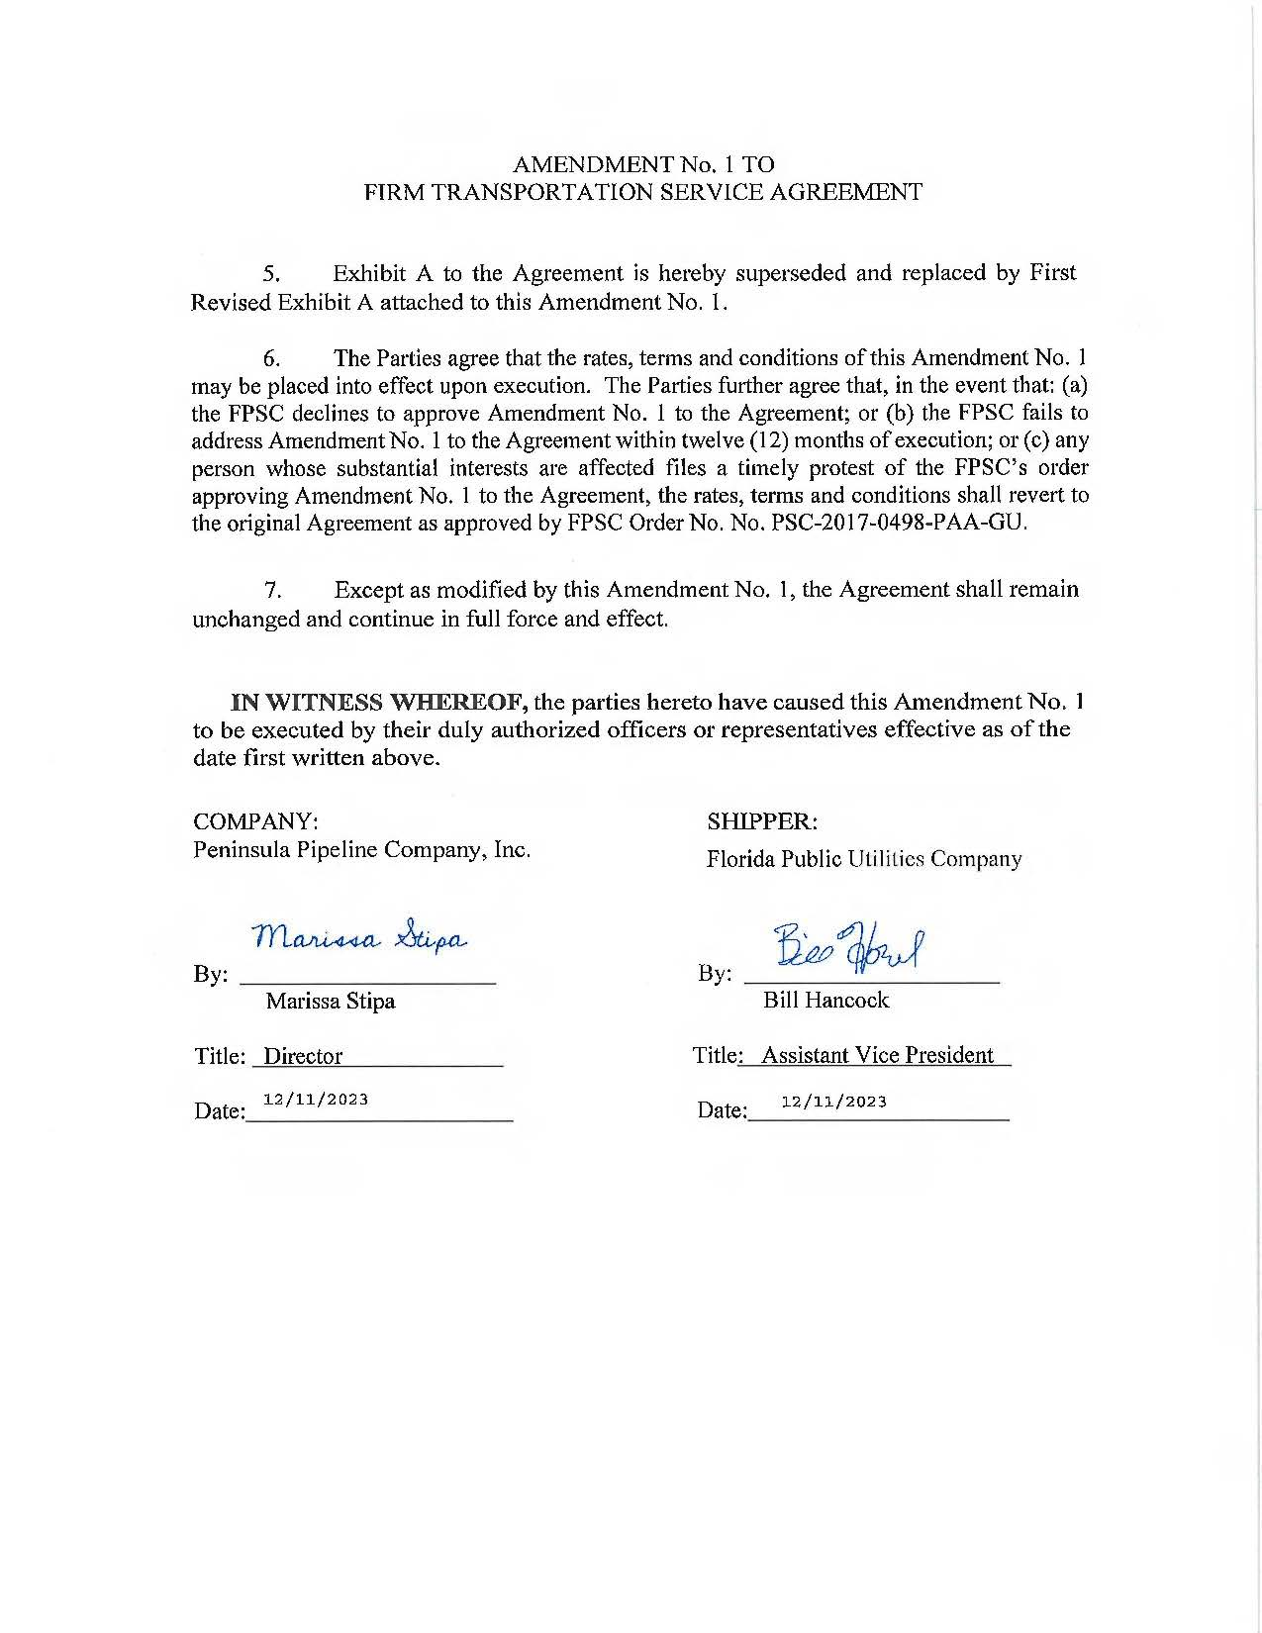
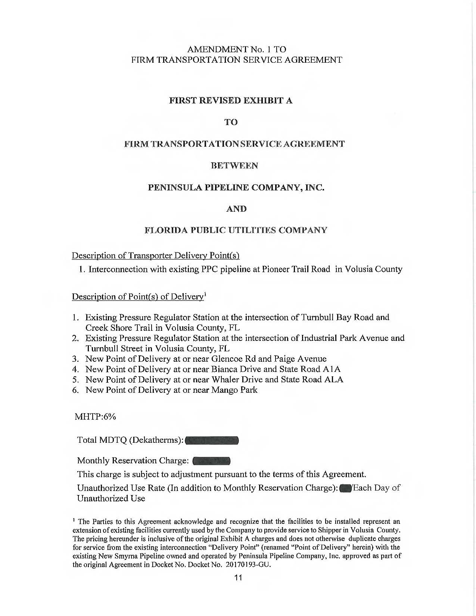

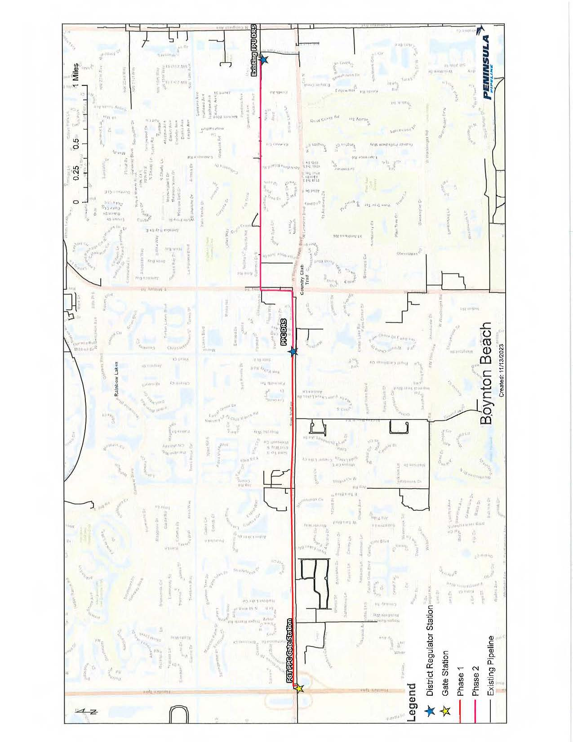
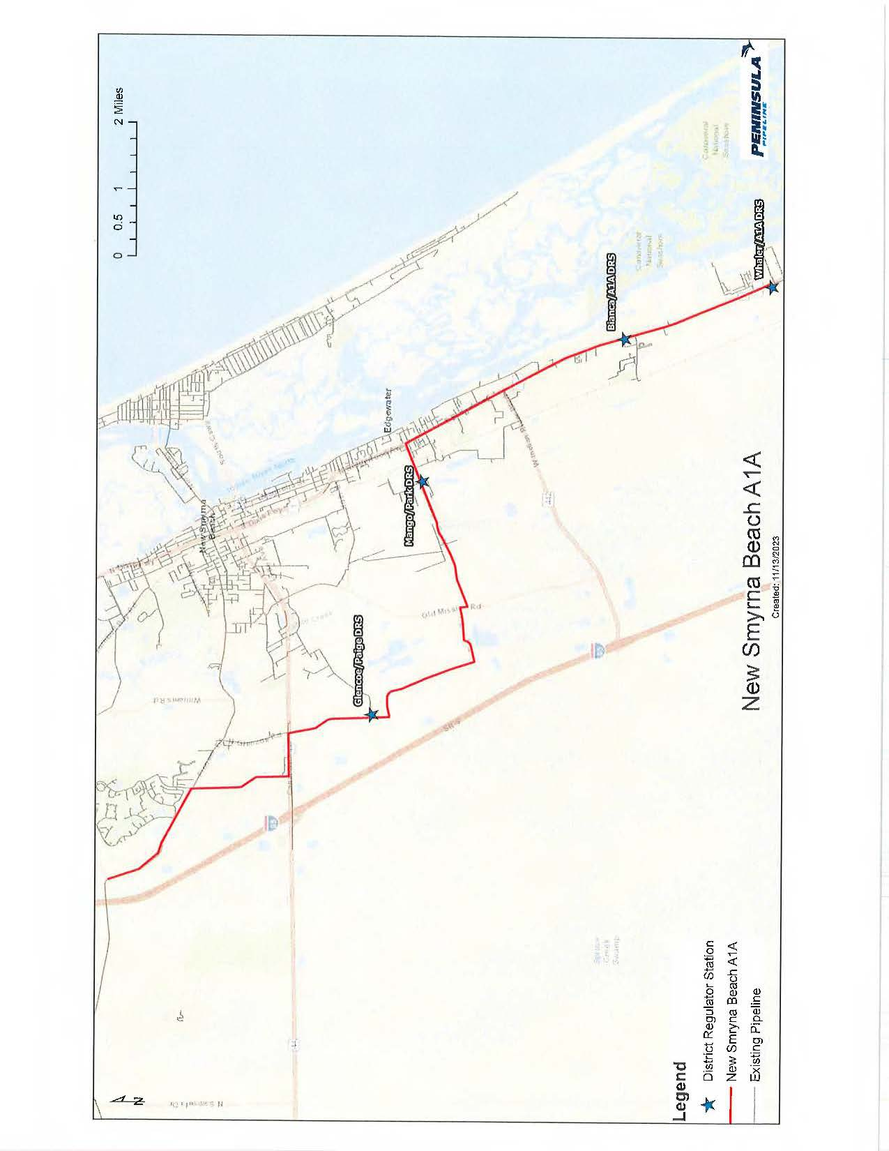

Order No. PSC-06-0023-DS-GP, issued January 9, 2006, in Docket No. 050584-GP, In re: Petition for declaratory statement by Peninsula Pipeline Company, Inc. concerning recognition as a natural gas transmission company under Section 368.101, F.S., et seq.
Order No. PSC-07-1012-TRF-GP, issued December 21, 2007, in Docket No. 070570-GP, In re: Petition for approval of natural gas transmission pipeline tariff by Peninsula Pipeline Company, Inc.
Peninsula Pipeline Company, Inc., Intrastate Pipeline Tariff, Original Sheet No. 11, Section 3.
Peninsula Pipeline Company, Inc., Intrastate Pipeline Tariff, Original Sheet No. 12, Section 4.
Joint Responses to Staff’s First Data Request, Document No. 00631-2024, Response No. 3.
Joint Responses to Staff’s First Data Request, Document No. 00631-2024.
Joint Responses to Staff’s First Data Request, Document No. 00631-2024, Response No. 5.
Order No. PSC-2017-0498-PAA-GU, issued December 29, 2017, in Docket No. 20170193-GU, In re: Petition for approval of transportation service agreement with Florida Public Utilities Company, by Peninsula Pipeline Company, Inc.
Joint Responses to Staff’s First Data Request, Document No. 00631-2024, Response No. 5.
Joint Responses to Staff’s First Data Request, Document No. 00631-2024, Response No. 6.

