State of Florida   |  | Public Service Commission  Capital Circle Office Center ● 2540 Shumard Oak Boulevard  Tallahassee, Florida 32399-0850  -M-E-M-O-R-A-N-D-U-M-
DATE: | April 25, 2024
TO: | Office of Commission Clerk (Teitzman)
FROM: | Division of Accounting and Finance (Higgins, Zaslow, G. Kelley)  Division of Economics (Hampson, P. Kelley)  Office of the General Counsel (Brownless, Sandy)
RE: | Docket No. 20240001-EI – Fuel and purchased power cost recovery clause with generating performance incentive factor.
AGENDA: | 05/07/24 – Regular Agenda – Interested Persons May Participate
COMMISSIONERS ASSIGNED: |  |  | All Commissioners
PREHEARING OFFICER: |  |  | Passidomo
CRITICAL DATES: |  |  | None
SPECIAL INSTRUCTIONS: |  |  | None

Case Background
On April 2, 2024, Tampa Electric Company (TECO or Company), filed for revision of its currently effective 2024 fuel cost recovery factors (MCC Petition). TECO’s currently effective fuel factors were approved last year at the November 1, 2023 final hearing. Underlying the approval of TECO’s 2024 fuel factors was the Florida Public Service Commission’s (Commission) review of the Company’s projected 2024 fuel- and capacity-related costs. These costs are recovered through fuel and capacity cost recovery factors that are set/reset annually in this docket.

Mid-Course Corrections
Mid-course corrections are used by the Commission between annual clause hearings whenever costs deviate from revenue by a significant margin. Under Rule 25-6.0424, Florida Administrative Code (F.A.C.), which is commonly referred to as the “mid-course correction rule,” a utility must notify the Commission whenever it expects to experience an under- or over-recovery of certain service costs greater than 10 percent. The notification of a 10 percent cost-to-revenue variance shall include a petition for mid-course correction to the fuel cost recovery or capacity cost recovery factors, or shall include an explanation of why a mid-course correction is not practical. The mid-course correction rule and its codified procedures are further discussed throughout this recommendation.

TECO’s Petition
In its MCC Petition, the Company currently estimates a net $137,918,831 million reduction in fuel-related costs for the 2024 period relative to its previous estimate. TECO is proposing to use June 2024 through May 2025 forecasted sales in determining its proposed mid-course fuel factors. If approved, this proposal will have the effect of reducing fuel cost recovery factors for the remainder of this year, as well as 2025. The mid-course correction amount and rate methodology are further discussed in Issue 1.

The Company is requesting that its revised fuel cost recovery factors and associated tariff become effective beginning with the first billing cycle of June 2024. The proposed effective date is further discussed in both Issues 1 and 2.

The Commission is vested with jurisdiction over the subject matter of this proceeding by the provisions of Chapter 366, Florida Statutes (F.S.), including Sections 366.04, 366.05, and 366.06, F.S.

Discussion of Issues

Issue 1:
Should the Commission modify TECO’s currently authorized fuel cost recovery factors for the purpose of incorporating its projected 2024 fuel cost reduction?

Recommendation:
Yes. Staff recommends the Commission authorize adjustments to TECO’s fuel cost recovery factors for the purpose of incorporating the Company’s currently projected 2024 fuel cost reduction. Accordingly, TECO’s currently authorized 2024 fuel cost recovery factors should be reduced by $137,918,831. (Zaslow, G. Kelley, Higgins)

Staff Analysis:
TECO participated in the Commission’s most-recent fuel hearing which took place on November 1, 2023. The fuel order stemming from this proceeding set forth the Company’s fuel and capacity cost recovery factors effective with the first billing cycle of January 2024. Following the issuance of the fuel order, the Company has subsequently updated its 2024 fuel cost projection. TECO now projects its 2024 fuel-related costs to be approximately $138 million (net) lower than estimated in August 2023. This reduction is primarily due to lower assumed prices for natural gas. The main factors influencing the decline in actual and projected natural gas prices in 2024 are elevated quantities of natural gas in storage and milder weather compared to previous years.

TECO Fuel and Purchased Power Mid-Course Correction
TECO filed for a mid-course correction of its fuel charges on April 2, 2024. The Company’s MCC Petition and supporting documentation satisfies the filing requirements of Rule 25-6.0424(1)(b), F.A.C.

The Company developed its proposed mid-course correction factors using twelve months of forecasted sales data, or June 2024 through May 2025. The factors proposed in this proceeding are currently contemplated to be charged for seven months in 2024. As is typical procedure, later this year newly developed 12-month-applicable factors will be proposed for authorization to begin with the first billing cycle of January 2025.

Actual Period-Ending 2023 Fuel Cost Recovery Position
Through its February 8, 2023, amended mid-course correction filing, TECO initially projected a period-specific 2023 over-recovery of fuel costs in the amount of $157,006,362. By its actual/estimated filing and in compliance with Order No. PSC-2023-0107-PCO-EI, the projected period-specific 2023 over-recovery of fuel costs was amended by $183,160,125. This resulted in a projected period-specific 2023 over-recovery of $340,166,487 and a total true-up under-recovery of ($112,834,024). However, the Company over-recovered this amount by $30,397,837 as its actual fuel cost recovery position at the end of 2023 is an under-recovery of ($82,436,187). This approximate $30.4 million difference is proposed for inclusion in rates through the instant proceeding.

Decreased pricing for natural gas is the primary driver of the approximate $340 million over-recovery of 2023 fuel costs discussed above. More specifically, the Company estimated an annual delivered natural gas cost of $7.49 per million British thermal unit (MMBtu) in its first fuel cost projection of 2023. However, as indicated in the Company’s December 2023 A-Schedule, TECO’s average 2023 cost of natural gas was $3.94 per MMBtu, representing a difference of 47.4 percent. Natural gas-fired generation comprised approximately 87.7 percent of TECO’s generation mix in 2023.

Projected 2024 Fuel Cost Recovery Position
TECO’s 2024 fuel-related revenue requirement has decreased substantially since the filing of its last cost projection in August 2023. More specifically, the results of this updated estimate are a reduction in TECO’s estimated 2024 fuel-related costs in the amount of $107,520,994. As mentioned above, the remaining amount of the 2023 over-recovery proposed for refund through new 2024 rates is $30,397,837. Thus, the proposed net or decremental amount for inclusion into 2024 rates is $137,918,831.

The primary factor driving the change in projected 2024 fuel costs is lower assumed pricing for natural gas. More specifically, the underlying market-based natural gas price data used for the 2024 fuel cost projection was sourced on June 23, 2023. This underlying data was used to produce an estimated average 2024 delivered natural gas cost of approximately $4.94 per MMBtu. However, as indicated in its MCC Petition, TECO now estimates its average cost of natural gas in 2024 will be $3.97 per MMBtu, representing a decrease of 19.6 percent. The updated cost estimate was based on the average natural gas futures/price over a five-day period ending March 7, 2024, or roughly eight months later than the previous estimate used to set current rates. Natural gas-fired generation is projected to comprise approximately 87.0 percent of TECO’s generation mix in 2024.

Recovery Period and Interest Premium
As proposed, the accounting period for 2024-applicable portion of the over-recovery is seven months, or beginning June 2024 and ending December 2024. Jurisdictional sales from June 2024 through May 2025 in the amount of 20,292,165 (meter) megawatt-hours were used to develop the mid-course correction factors proposed for approval in this proceeding.

TECO utilized the 30-day AA Financial Commercial Paper Rate published by the U.S. Federal Reserve to determine its actual 2023 and 2024 (January and February) interest amounts. The projected 2024 interest rate was developed via in-house modeling that produced a rate of 0.391 percent (2024 monthly average).

Mid-Course Correction Percentage
Following the methodology prescribed in Rule 25-6.0424(1)(a), F.A.C., the mid-course percentage is equal to the estimated end-of-period total net true-up, including interest, divided by the current period’s total actual and estimated jurisdictional fuel revenue applicable to period, or $137,918,831 / $648,701,011. This calculation results in a mid-course correction level of approximately 21.3 percent at December 31, 2024.

Fuel Factor
TECO’s currently approved annual levelized fuel factor beginning with the first January 2024 billing cycle is 3.837 cents per kilowatt-hour (kWh). The Company is requesting to decrease its currently-approved 2024 annual levelized fuel factor beginning June 2024 to 3.157 cents per kWh, a decrease of approximately 17.7 percent.

Bill Impacts
In Table 1-1 below, the bill impact of the mid-course correction on a residential customer using 1,000 kWh of electricity a month is shown. Following Table 1-1, staff discusses the impacts of the mid-course correction on non-residential customers.

Table 1-1
Tampa Electric Company
Monthly Residential Billing Detail for the First 1,000 kWh
Invoice Component | Currently Approved Charges  May 2024  ($) | Proposed Charges  Beginning  June 2024  ($) | Difference  ($) | Difference  (%)
Base Charge | $87.80 | $87.80 | $0.00 | 0.0%
Fuel Charge | 35.36 | 28.50 | (6.86) | (19.4%)
Conservation Charge | 2.15 | 2.15 | 0.00 | 0.0%
Capacity Charge | 0.62 | 0.62 | 0.00 | 0.0%
Environmental Charge | 0.89 | 0.89 | 0.00 | 0.0%
Storm Protection Plan Charge | 6.58 | 6.58 | 0.00 | 0.0%
Clean Energy Transition Mechanism | 4.30 | 4.30 | 0.00 | 0.0%
Storm Restoration Charge | 2.19 | 2.19 | 0.00 | 0.0%
Gross Receipts Tax | 3.59 | 3.41 | (0.18) | (5.0%)
Total | $143.48 | $136.44 | ($7.04) | (4.9%)
Source: Document No. 01529-2024.

TECO’s currently approved total residential charge for the first 1,000 kWh of usage for May 2024 is $143.48. If the Company’s mid-course correction is approved, then the current total residential charge for the first 1,000 kWh of usage beginning in June will be $136.44, a decrease of 4.9 percent. For non-residential rate classes, TECO reported that bill decreases based on average levels of usage for General Service customers would range from approximately 4.4 to 4.9 percent, and for General Service Demand customers, decreases would range from approximately 8.1 to 11.4 percent. TECO’s proposed tariff sheet is shown on Appendix A to this recommendation.

Optional Period
Staff investigated the effect on monthly bills of shortening the period proposed for developing rates from 12 to 7 months. For rate-setting purposes, the total base over-recovery is the same under the 7-month and 12-month scenarios; however, the impact of the 7-month scenario can be characterized as a greater reduction in the monthly fuel charge for a shorter period of time.

Table 1-2 below shows the bill impact to a residential customer using 1,000 kWh of electricity a month associated with the optional period scenario described in this section of the recommendation.

Table 1-2
Tampa Electric Company
Optional Monthly Residential Billing Detail for the First 1,000 kWh
Invoice Component | Currently  Approved Charges  May 2024  ($) | Optional Charges  Beginning  June  2024  ($) | Difference  ($) | Difference  (%)
Base Charge | $87.80 | $87.80 | $0.00 | 0.0%
Fuel Charge | 35.36 | 24.10 | (11.26) | (31.8%)
Conservation Charge | 2.15 | 2.15 | 0.00 | 0.0%
Capacity Charge | 0.62 | 0.62 | 0.00 | 0.0%
Environmental Charge | 0.89 | 0.89 | 0.00 | 0.0%
Storm Protection Plan Charge | 6.58 | 6.58 | 0.00 | 0.0%
Clean Energy Transition Mechanism | 4.30 | 4.30 | 0.00 | 0.0%
Storm Restoration Charge | 2.19 | 2.19 | 0.00 | 0.0%
Gross Receipts Tax | 3.59 | 3.30 | (0.29) | (8.1%)
Total | $143.48 | $131.93 | ($11.55) | (8.0%)
Source: Document No. 01648-2024.

TECO’s proposed fuel charge decrease results in a residential fuel charge, i.e., residential charge for the first 1,000 kWh of energy sales, of 2.850 cents per kWh. This factor produces a corresponding monthly fuel charge of $28.50. With respect to the optional period scenario, the associated residential factor would be 2.410 cents per kWh. This would result in a fuel charge of $24.10 for the first 1,000 kWh of energy usage. The estimated decrease in the monthly first-tier residential fuel charge under this scenario is approximately $11.26 (opposed to the as-filed proposal of $6.86), or going from $35.36 to $24.10. In percentage terms, the total bill decrease would be approximately 8.0 percent under the optional period scenario.

For non-residential customers, based on average levels of usage and specific rate schedules, TECO reported that bill decreases for General Service customers would range from approximately 6.9 to 7.8 percent, and for General Service demand customers, decreases would range from approximately 12.8 to 18.0 percent.

The hypothetical tariff associated with the optional period scenario was provided in response to Staff’s First Data Request, No. 11. However, the tariff was not included as an attachment to this recommendation.

Summary
TECO’s MCC Petition indicates a need for its fuel cost recovery factors to be revised. More specifically, the Company’s underlying 2024 projected fuel-related revenue requirement has been reduced by $107,520,994. Additionally, the Company proposes to incorporate its 2023 period-specific final over-recovery of $30,397,837 into the current period. Thus, TECO’s current fuel cost recovery factors should be reduced by $137,918,831. Sales from June 2024 through May 2025 should be used to develop the revised/mid-course correction fuel factors. The revised fuel cost recovery factors associated with staff’s recommendation are shown on Appendix A.

Conclusion
Staff recommends the Commission authorize adjustments to TECO’s fuel cost recovery factors for the purpose of incorporating the Company’s currently projected net 2024 fuel cost reduction. Accordingly, TECO’s currently authorized 2024 fuel cost recovery factors should be reduced by $137,918,831.

Issue 2:
If approved by the Commission, what is the appropriate effective date for TECO’s revised fuel cost recovery factors?

Recommendation:
The fuel cost recovery factors, as shown on Appendix A, should become effective with the first billing cycle of June 2024. (P. Kelley, Hampson, Brownless, Sandy)

Staff Analysis:
Over the last 20 years in the Fuel Clause docket, the Commission has considered the effective date of rates and charges of revised fuel cost factors on a case-by-case basis. The Commission has approved rate decreases to be effective less than 30 days after the date of the Commission vote because the rate decrease was in the customers’ best interest to be implemented as soon as possible. In its MCC Petition, TECO proposes to decrease its 2024 fuel factors beginning with the first billing cycle of June 2024.

In response to Staff’s First Data Request, TECO stated that it would - contingent on Commission approval - include a message on May customer bills explaining that the Company’s proposed rate decrease is set to begin in June billing cycle. Following the Commission’s determination on this matter, TECO will update its bill notices informing customers of the forthcoming rate changes. The Company has also engaged in several other outreach efforts regarding the potential bill impacts of the proceeding. Specifically, TECO issued a press release on April 2, 2024, informing its customers of the potential adjustments related to the mid-course correction through the Company’s online media center. The Company also separately contacted numerous large account customers via telephone, voicemail, and email to inform them of the proposal and the potential impact.

Conclusion
Staff recommends that the fuel cost recovery factors, as shown on Appendix A, become effective with the first billing cycle of June 2024.

Issue 3:
Should this docket be closed?

Recommendation:
No. The 20240001-EI docket is an on-going proceeding and should remain open. (Brownless, Sandy)

Staff Analysis:
The fuel docket is an on-going proceeding and should remain open.

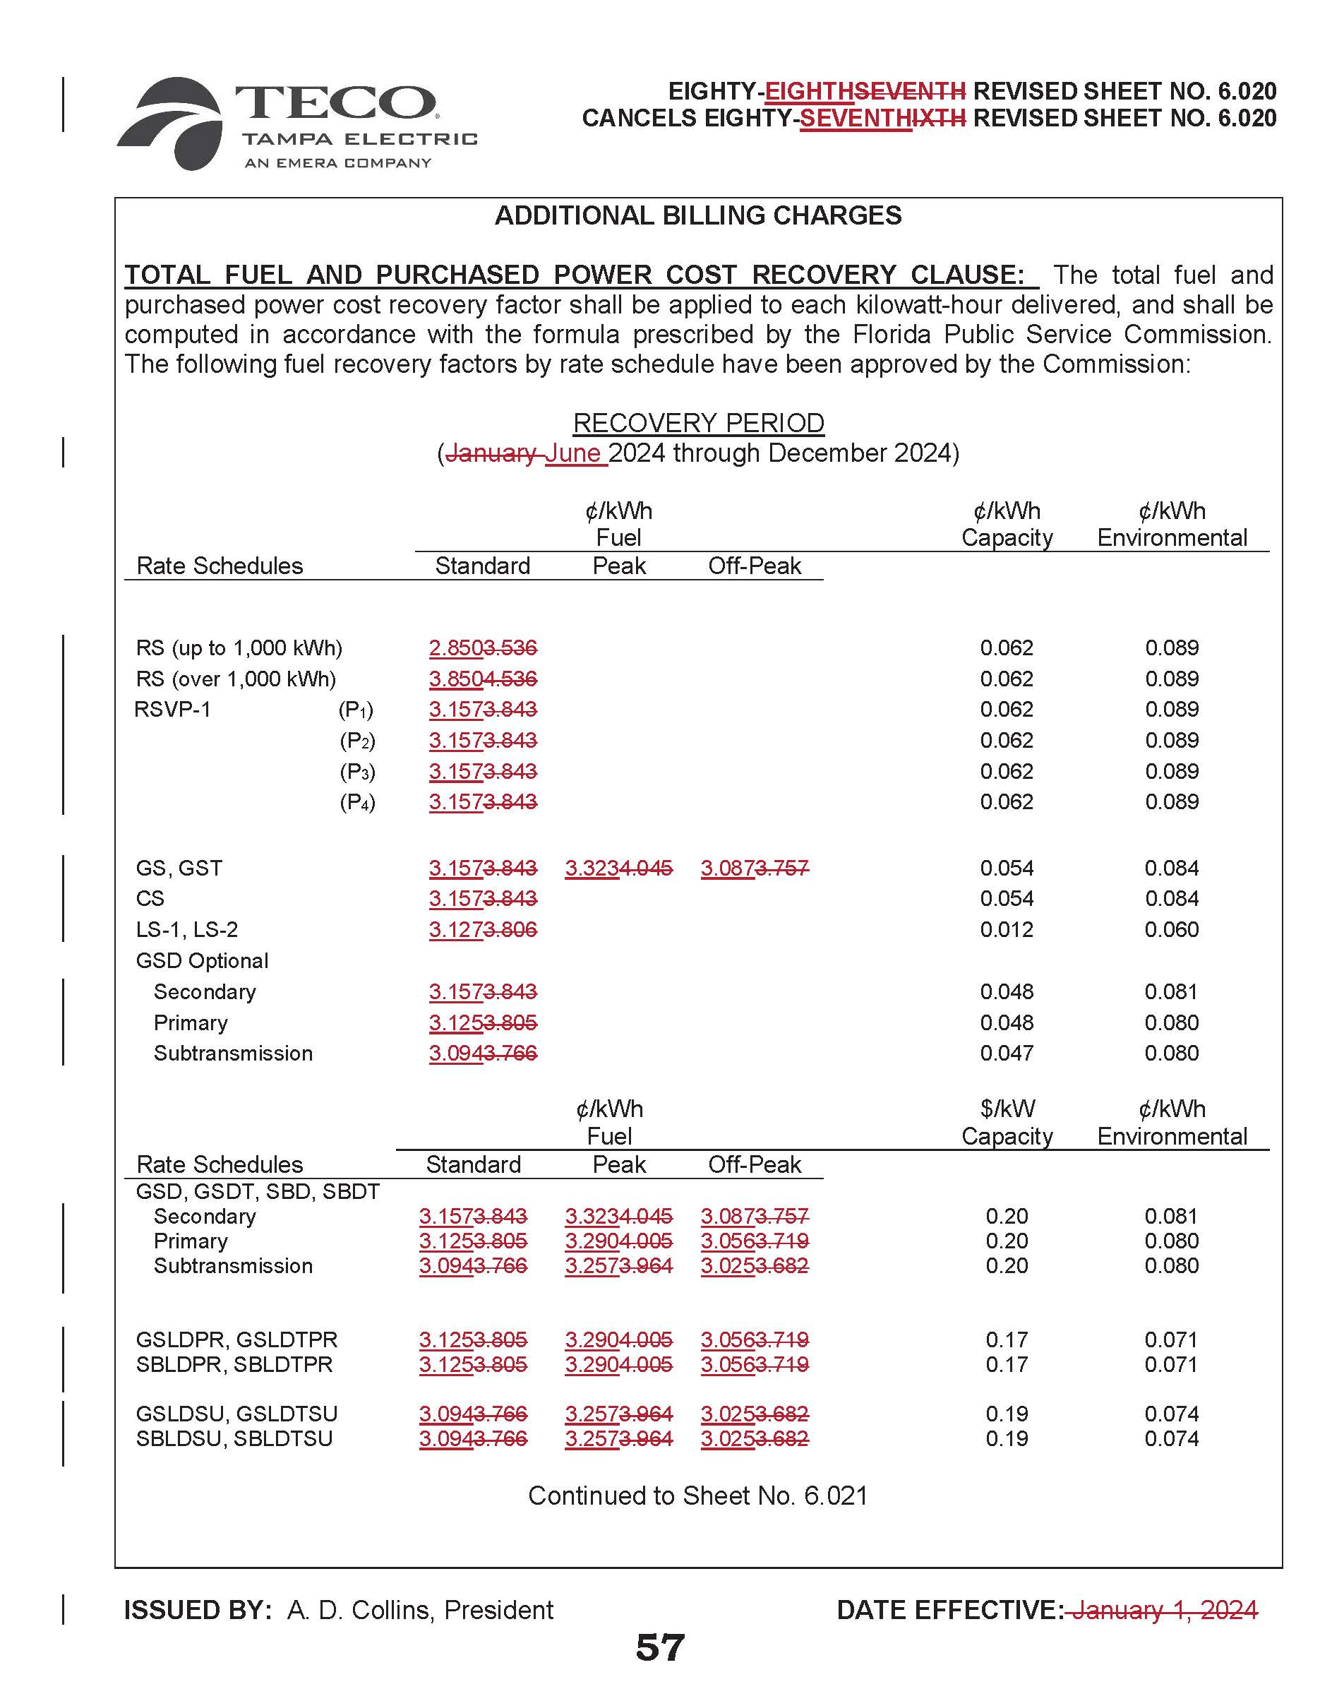

Document No. 01529-2024.
Order No. PSC-2023-0343-FOF-EI, issued November 16, 2023, in Docket No. 20230001-EI, In re: Fuel and purchased power cost recovery clause with generating performance incentive factor.
Id.
Document No. 04814-2023.
https://www.eia.gov/outlooks/steo/archives/apr24.pdf
Document No. 01529-2024.
Document No. 01008-2023.
Document No. 04317-2023. Further, staff notes the Company’s estimated end-of-period 2023 total under-recovery in the amount of ($112,834,024) is embedded in current rates per Order No. PSC-2023-0343-FOF-EI. This amount constitutes the remainder of the approximate ($518 million) net under-recovery of 2022 fuel costs ordered to be collected in 2023 and 2024 and is net of TECO’s 2023 mid-course true-up amount of ($64,989,253). See Order No. PSC-2023-0107-PCO-EI, issued March 23, 2023, in Docket No. 20230001-EI, In re: Fuel and purchased power cost recovery clause with generating performance incentive factor.
Document No. 01582-2024.
Document No. 05966-2023.
Document No. 00322-2024.
Id.
Document No. 04814-2023.
Document No. 01529-2024.
Hearing Exhibit No. 70, entered in Docket No. 20230001-EI.
Document No. 04814-2023.
Document No. 01529-2024.
Document No. 01648-2024.
Document No. 01529-2024.
Id.
Id.
Document No. 01687-2024, and The Federal Reserve System (U.S. Federal Reserve) published Commercial Paper Rates which can be located via the following link: https://www.federalreserve.gov/releases/cp/
Document Nos. 01529-2024 and 01687-2024.
Document No. 01529-2024, Schedule E2.
Order No. PSC-2023-0343-FOF-EI.
Document No. 01529-2024.
Order No. PSC-2023-0343-FOF-EI.
Document No. 01648-2024.
Document No. 01648-2024.
Id.
Id.
Order No. PSC-2024-0091-PCO-EI, issued April 10, 2024, in Docket No. 20240001-EI, In re: Fuel and purchased power cost recovery clause with generating performance incentive factor.
Document No. 01648-2024.
Id.

