BEFORE THE FLORIDA PUBLIC SERVICE COMMISSION

In re: Petition for approval of Amendment No. 1 to transportation service agreement between Peninsula Pipeline Company, Inc. and Florida Public Utilities Company. | DOCKET NO. 20240038-GU  ORDER NO. PSC-2024-0167-PAA-GU  ISSUED: May 23, 2024

The following Commissioners participated in the disposition of this matter:

MIKE LA ROSA, Chairman
ART GRAHAM
GARY F. CLARK
ANDREW GILES FAY
GABRIELLA PASSIDOMO

NOTICE OF PROPOSED AGENCY ACTION
ORDER APPROVING Amendment No. 1 to transportation
service agreement between Peninsula Pipeline
Company, Inc. and Florida Public Utilities Company

BY THE COMMISSION:

NOTICE is hereby given by the Florida Public Service Commission that the action discussed herein is preliminary in nature and will become final unless a person whose interests are substantially affected files a petition for a formal proceeding, pursuant to Rule 25-22.029, Florida Administrative Code (F.A.C.).

Background
On February 29, 2024, Peninsula Pipeline Company, Inc. (Peninsula) filed a petition seeking approval of amendment No. 1 to transportation service agreement (amendment) between Peninsula and Florida Public Utilities Company (FPUC). The purpose of the amendment is to increase supply capability and enhance reliability in St. Cloud, Florida. Peninsula operates as an intrastate natural gas transmission company as defined by Section 368.103(4), Florida Statutes (F.S.). FPUC is a local distribution company subject to our regulatory jurisdiction pursuant to Chapter 366, F.S. FPUC provides natural gas service to residential, commercial, and industrial customers in Osceola County, and receives deliveries of natural gas to serve these customers over interstate transmission pipelines owned by Florida Gas Transmission Company, LLC (FGT).
Peninsula provides gas transportation service only; it does not engage in the sale of natural gas to customers. By Order No. PSC-07-1012-TRF-GP (2007 Order), Peninsula received approval of an intrastate gas pipeline tariff that allows it to construct and operate intrastate pipeline facilities and to actively pursue agreements with natural gas customers. Pursuant to the 2007 Order, Peninsula is allowed to enter into gas transmission agreements that meet certain criteria without our prior approval. However, Peninsula is requesting our approval of the proposed amendment as it does not fit any of the enumerated criteria. Additionally, Peninsula and FPUC (collectively “the parties”) are subsidiaries of Chesapeake Utility Corporation, and agreements between affiliated companies must be approved by us pursuant to Section 368.105, F.S., and the 2007 Order.
In Order No. PSC-2022-0351-PAA-GU, we approved a firm transportation service agreement between Peninsula and FPUC (2022 agreement). FPUC needed the 2022 agreement to serve Osceola County by transporting natural gas from an existing city gate interconnection with FGT. The parties explained that amendment No. 1 reflects the expected new growth in the St. Cloud area and, therefore, they jointly developed the proposed plan to bring additional natural gas capacity into the area.
FPUC has proposed to recover its payments to Peninsula through the Purchased Gas Adjustment (PGA) and swing service rider mechanisms. The PGA allows FPUC to periodically adjust the price of natural gas supplied to its customer to reflect the actual cost of gas purchased and delivered on behalf of the customers. The swing service rider allows FPUC to recover intrastate capacity costs from their transportation customers and is a cents per therm charge that is included in the monthly customer gas bill of transportation customers. While FPUC would incur costs associated with these service expansions, new load added to the system should help spread the costs over a larger customer base.
Pursuant to the proposed amendment, Peninsula would construct, own, and operate two new natural gas pipelines and a new interconnect with FGT’s system. The proposed project would enable FPUC to better serve St. Cloud and future potential gas customers in Osceola County. A copy of the proposed amendment is appended to this Order as Attachment A.
During the evaluation of the petition, Commission staff issued two data requests to the parties for which responses were received on April 2 and 16, 2024. We have jurisdiction over this matter pursuant to Sections 366.05(1), 366.06, and 368.105, F.S.

Decision

1. Proposed Amendment to the Transportation Service Agreement for St. Cloud
The parties entered into the proposed firm transportation service agreement to enable FPUC to reinforce its St. Cloud distribution system and meet expected increased natural gas demand in Osceola County. The parties argue that the proposed amendment has the added benefit of providing FPUC with an additional source of gas (via the Peninsula pipelines) and building a new interconnection with the FGT pipeline.
In response to Commission staff’s second data request, the parties stated that they had a desire to amend the 2022 agreement to extend the term of the agreement. In the original 2022 agreement, the 20-year term begins on the “In-Service Date.” The amendment adds the additional phrase “Segment In-Service Dates” to the agreement. These dates are tied to the commencement of commercial operations of each new segment. The parties explained that, in effect, the amendment would extend the original 20-year term by the difference between the original in-service date and the last segment in-service date.
Pursuant to the 2022 agreement, after the expiration of the initial term, the agreement and proposed amendment were to be extended on a year-to-year basis, unless either party gives no less than 90 days of written notification of termination. If either party desires to negotiate modifications to the rates or terms of this agreement, they may do so no less than 120 days prior to expiration of the current active term, subject to our approval of the amendment.

2. Proposed St. Cloud Expansion Project

As described in paragraph 12 of the petition, part one of the south expansion would begin with Peninsula constructing a new interconnect with FGT. Peninsula would then construct 9.18 miles of 6-inch coated steel pipeline traveling along Canoe Creek Road and concluding at an existing pipeline along Hickory Tree Road. A copy of the project map is appended to this Order as Attachment B. The south expansion is shown on the project map as the longer blue line. The new interconnect with FGT is labeled on the map as “New St. Cloud FGT Tap.”
Part two of the south expansion project, as depicted by the shorter blue line on the project map, would start near the intersection of Canoe Creek Road and Nolte Road. Peninsula would construct approximately 0.67 miles of 6-inch coated steel pipeline following the right of way on Canoe Creek Road, and would terminating at the area of planned new development, Green Island Ranch. The parties explained in the petition that this development will consist of approximately 14,000 new homes.
The proposed north expansion project would begin from the previously discussed New St. Cloud FGT Tap. From this location, Peninsula would build approximately 3.09 miles of 6-inch coated steel pipeline following north along Hickory Tree and Narcoossee Road and terminating at a planned new development, Center Lake Branch. The parties explained in the petition that this development will consist of approximately 3,900 new homes.
In response to Commission staff’s first data request, the parties stated that FPUC did not issue Formal Request for Proposals to other entities. FPUC explained that in previous discussions and requests with FGT for other projects, FGT has declined to bid on projects related to constructing, owning, and operating laterals such as the proposed expansion project in this petition, which are not a focus of FGT’s expansion activities.

3. Anticipated System Benefits

In paragraph 10 of the petition, the parties expressed that this new project builds upon the original Peninsula pipeline system in order to reinforce portions of FPUC’s system. The parties further explained that the amendment reflects the construction of additional facilities necessary for FPUC to expand its service to serve new growth in the St. Cloud area. The parties further explained in paragraph 12 of the petition that the proposed project would reinforce FPUC’s St. Cloud distribution system with an additional source of interstate gas with the potential to provide natural gas service to future customers in Osceola County. In addition to the expected growth in residential customers discussed above, FPUC also expects approximately 44 commercial customers and one industrial customer to take natural gas service.

4. Option for Second Phase of Construction

In paragraph 14 of the petition, the parties discuss an option for a second phase of construction that can be built off the extensions of the initial project. FPUC anticipates additional growth in the St. Cloud area that would likely require additional pipeline capacity. The proposed optional phase will ensure that, within a timely manner, FPUC is able to request that Peninsula build the necessary pipeline facilities in the event of new growth. The rates for the optional second phase are based on current estimates, but would only be applicable within the defined time frame. If the optional second phase does materialize, the parties stated that they would negotiate new rates and file for approval of a new amendment.

5. Negotiated Monthly Reservation Payments to Peninsula

In paragraph 17 of the petition, the parties expressed that the negotiated monthly reservation charge contained in the proposed amendment is consistent with market rates, because the rates are substantially the same as rates set forth in similar agreements as required by Section 368.105(3)(b), F.S. The parties explained that Peninsula would recover the pipeline construction costs through the monthly reservation charge to FPUC, as shown in Exhibit B to the proposed amendment. The monthly reservation charge is designed to recover costs such as, but not limited to, engineering, permitting, materials, and installation costs associated with the pipeline and related facilities, ongoing maintenance including Pipeline and Hazardous Materials Safety Administration compliance, safety requirements, property taxes, gas control, and Peninsula’s return on investment.

6. Conclusion

Upon a full review of the petition and the parties’ responses to Commission staff’s data request, we approve the proposed amendment No. 1 to the firm transportation service agreement dated February 26, 2024, between FPUC and Peninsula. The firm transportation service agreement is reasonable and meets the requirements of Section 368.105, F.S. Furthermore, the proposed firm transportation service agreement benefits FPUC’s current and potential future customers by having an additional source of gas for the growing areas in Osceola County.

Based on the foregoing, it is

ORDERED by the Florida Public Service Commission that Amendment No. 1 to the transportation service agreement between Peninsula Pipeline Company, Inc. and Florida Public Utilities Company is hereby approved. It is further

ORDERED that the provisions of this Order, issued as proposed agency action, shall become final and effective upon the issuance of a Consummating Order unless an appropriate petition, in the form provided by Rule 28-106.201, Florida Administrative Code, is received by the Commission Clerk, 2540 Shumard Oak Boulevard, Tallahassee, Florida 32399-0850, by the close of business on the date set forth in the “Notice of Further Proceedings” attached hereto. It is further

ORDERED that in the event this Order becomes final, this docket shall be closed.

By ORDER of the Florida Public Service Commission this 23rd day of May, 2024.

/s/ Adam J. Teitzman
ADAM J. TEITZMAN
Commission Clerk
Florida Public Service Commission
2540 Shumard Oak Boulevard
Tallahassee, Florida 32399
(850) 413-6770
www.floridapsc.com

Copies furnished: A copy of this document is provided to the parties of record at the time of issuance and, if applicable, interested persons.

SPS

NOTICE OF FURTHER PROCEEDINGS OR JUDICIAL REVIEW

The Florida Public Service Commission is required by Section 120.569(1), Florida Statutes, to notify parties of any administrative hearing that is available under Section 120.57, Florida Statutes, as well as the procedures and time limits that apply. This notice should not be construed to mean all requests for an administrative hearing will be granted or result in the relief sought.

Mediation may be available on a case-by-case basis. If mediation is conducted, it does not affect a substantially interested person's right to a hearing.

The action proposed herein is preliminary in nature. Any person whose substantial interests are affected by the action proposed by this order may file a petition for a formal proceeding, in the form provided by Rule 28-106.201, Florida Administrative Code. This petition must be received by the Office of Commission Clerk, 2540 Shumard Oak Boulevard, Tallahassee, Florida 32399-0850, by the close of business on June 13, 2024.

In the absence of such a petition, this order shall become final and effective upon the issuance of a Consummating Order.

Any objection or protest filed in this/these docket(s) before the issuance date of this order is considered abandoned unless it satisfies the foregoing conditions and is renewed within the specified protest period.

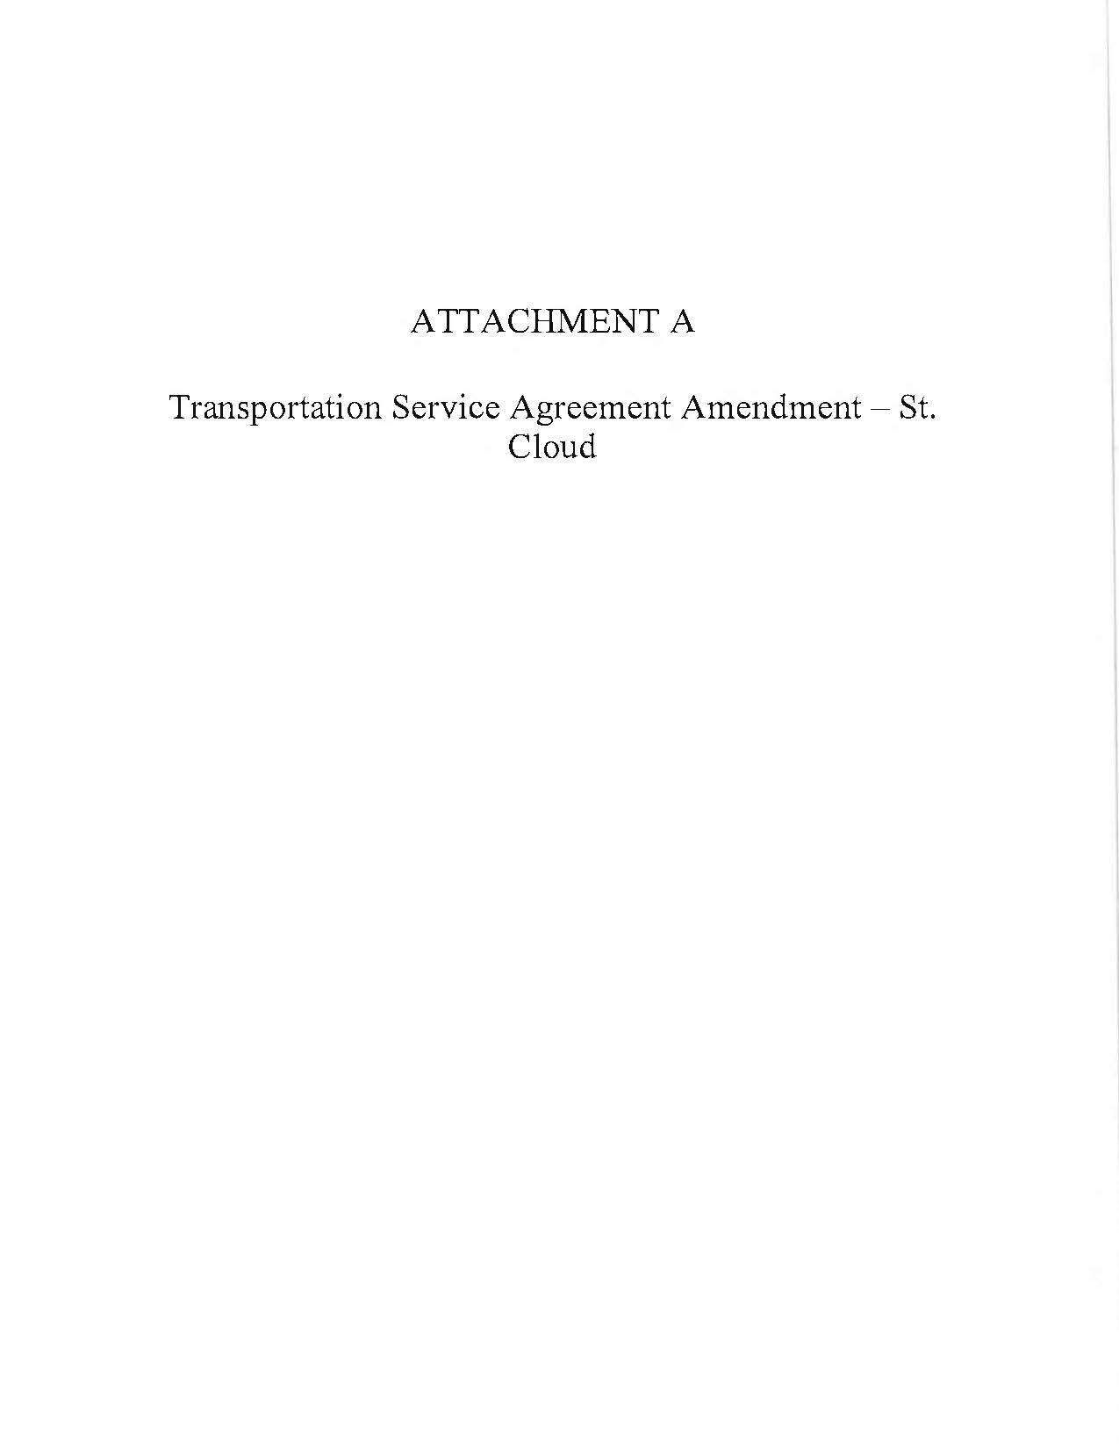

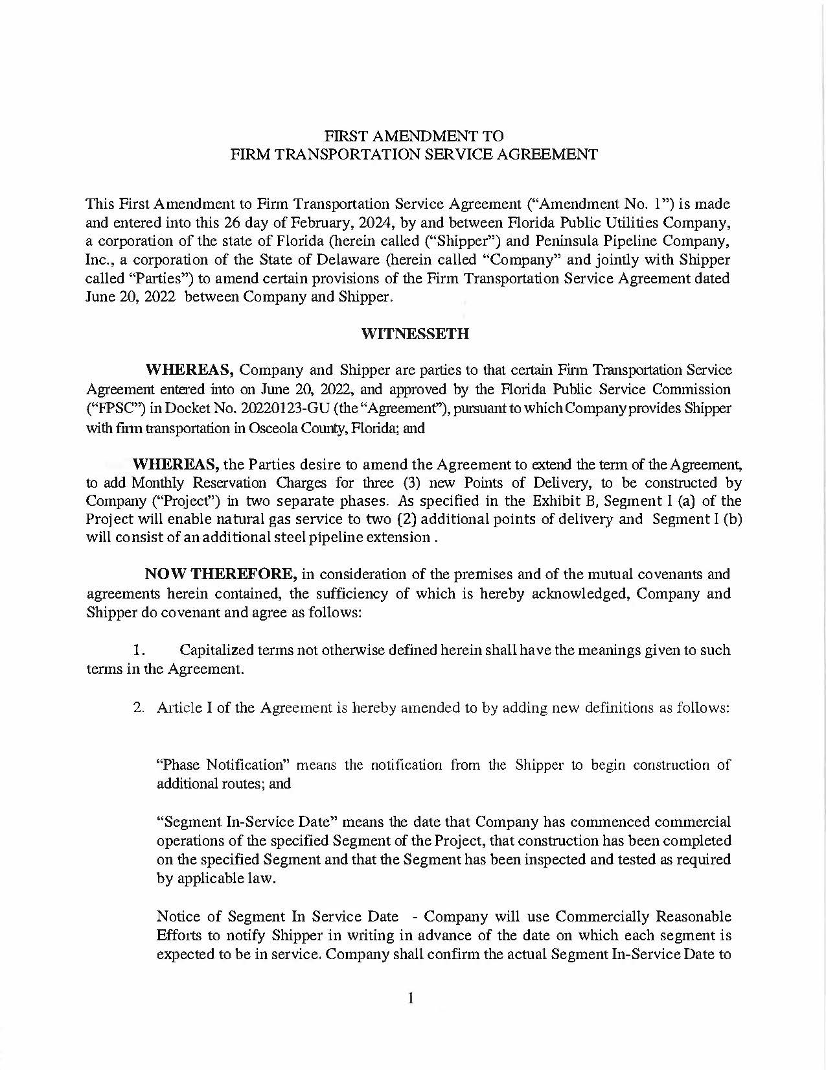

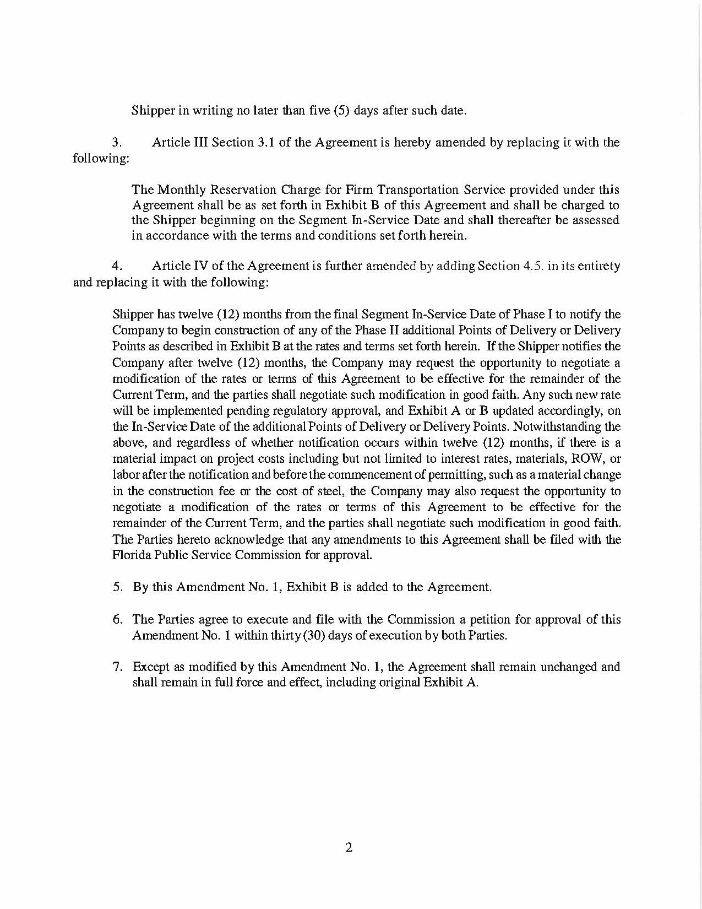

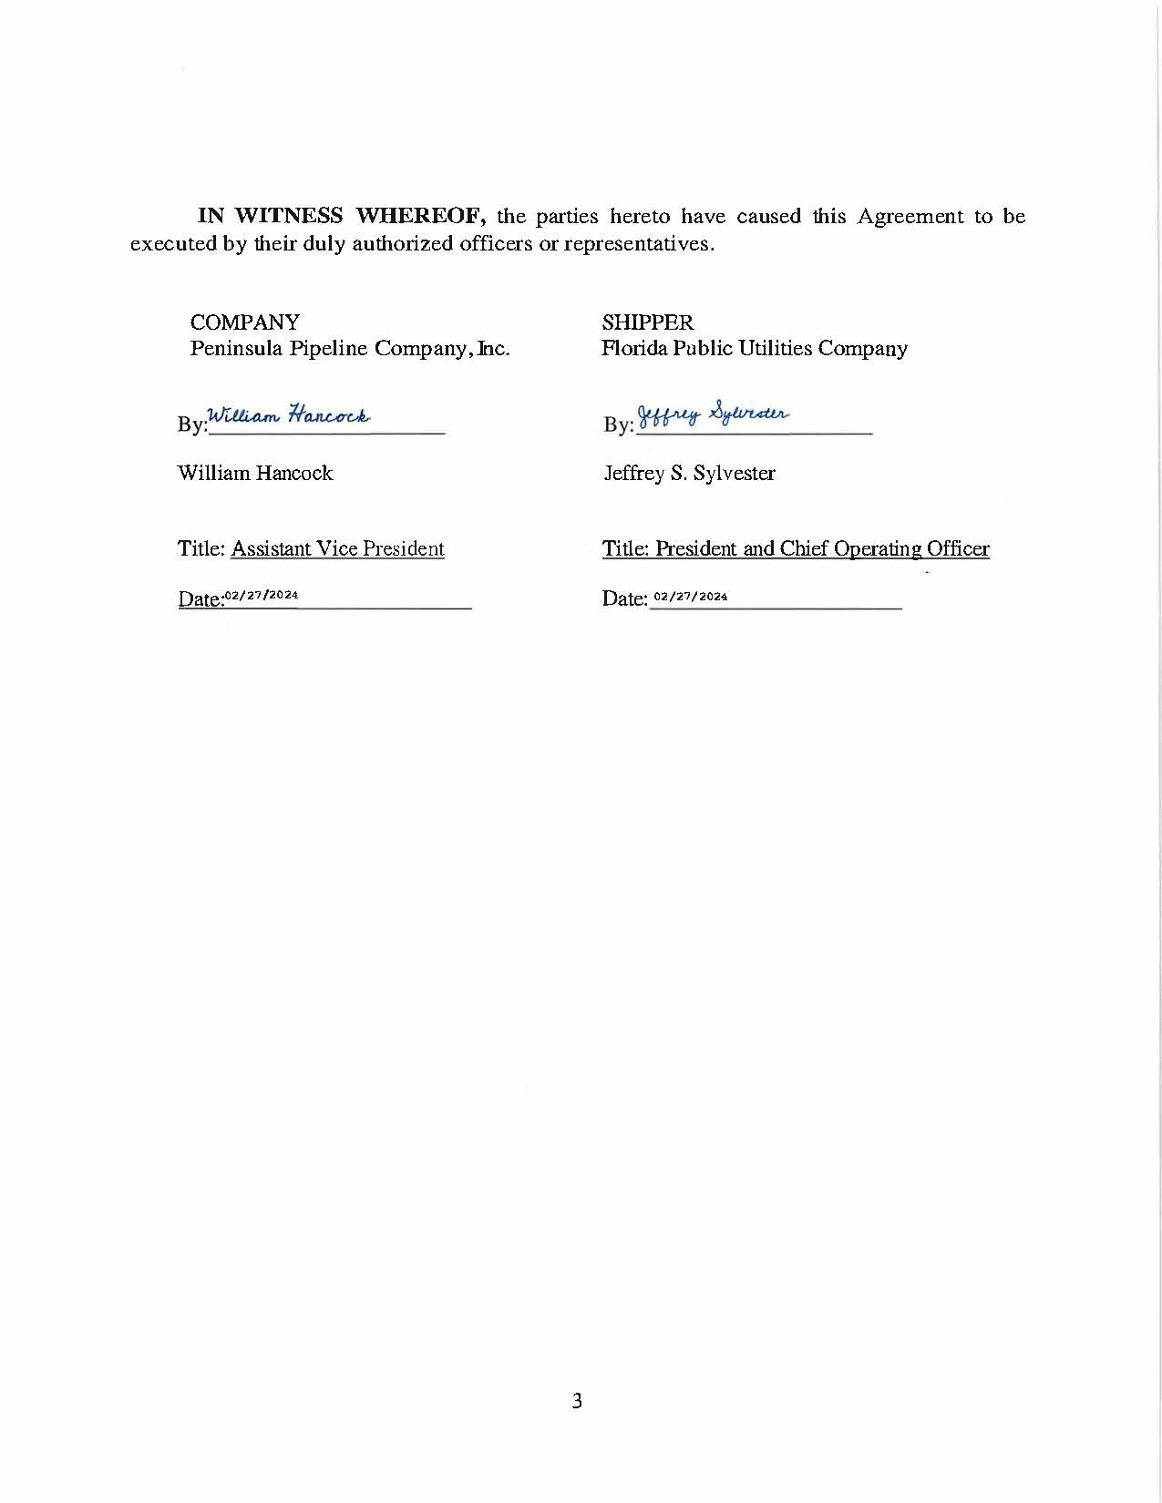

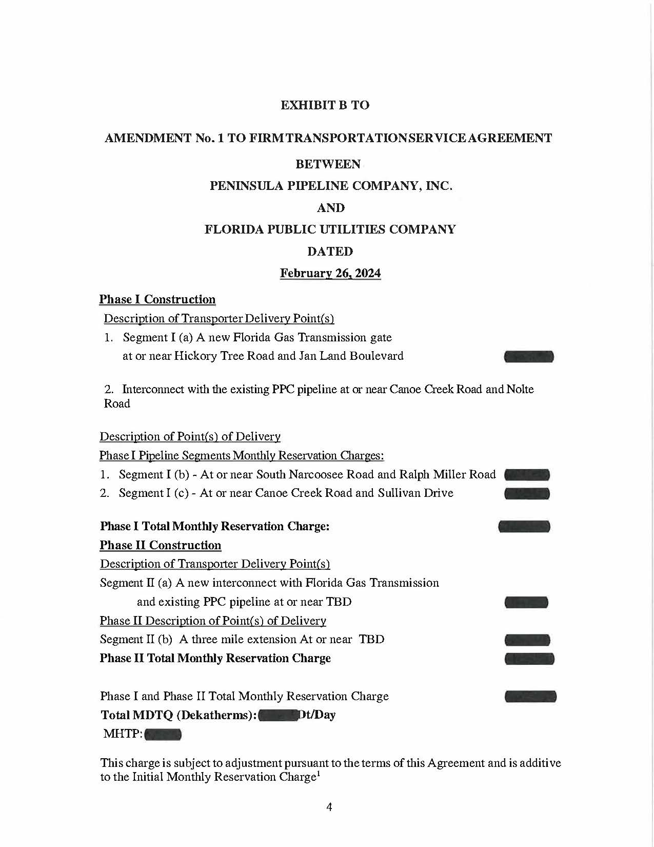





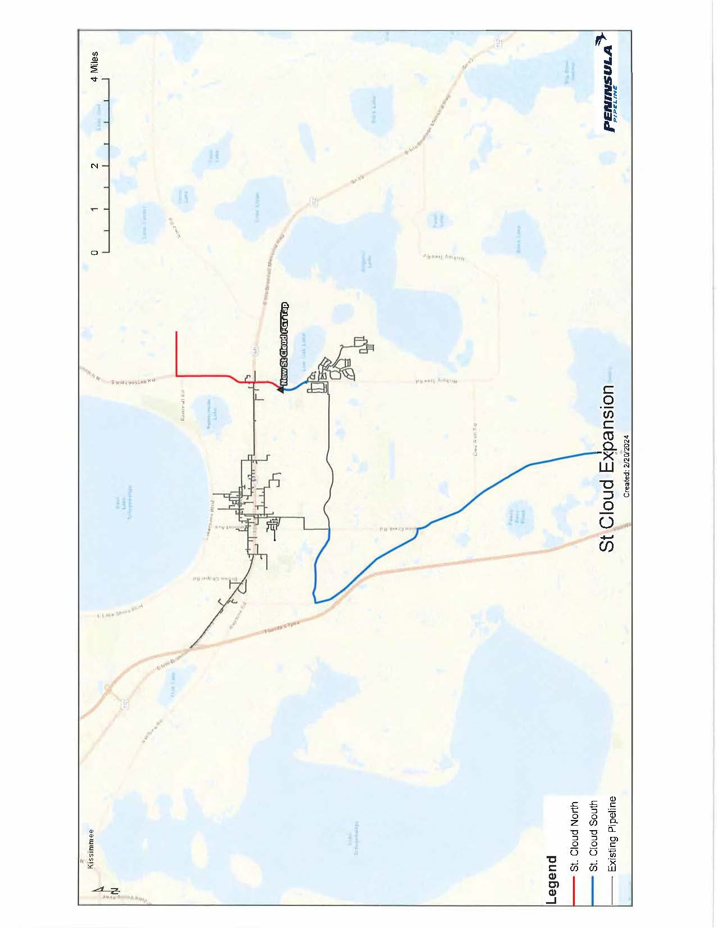

Order No. PSC-06-0023-DS-GP, issued January 9, 2006, in Docket No. 050584-GP, In re: Petition for declaratory statement by Peninsula Pipeline Company, Inc. concerning recognition as a natural gas transmission company under Section 368.101, F.S., et seq.
Order No. PSC-07-1012-TRF-GP, issued December 21, 2007, in Docket No. 20070570-GP, In re: Petition for approval of natural gas transmission pipeline tariff by Peninsula Pipeline Company, Inc.
Peninsula Pipeline Company, Inc., Intrastate Pipeline Tariff, Original Sheet No. 11, Section 3.
Peninsula Pipeline Company, Inc., Intrastate Pipeline Tariff, Original Sheet No. 12, Section 4.
Order No. PSC-2022-0351-PAA-GU, issued October 11, 2022, in Docket No. 20220123-GU, In re: Petition for approval of transportation service agreement to reflect expansion of St. Cloud by Florida Public Utilities Company and Peninsula Pipeline Company, Inc.

