State of Florida   |  | Public Service Commission  Capital Circle Office Center ● 2540 Shumard Oak Boulevard  Tallahassee, Florida 32399-0850  -M-E-M-O-R-A-N-D-U-M-
DATE: | June 27, 2024
TO: | Office of Commission Clerk (Teitzman)
FROM: | Office of Industry Development and Market Analysis (Day, Deas, Fogleman, Mallow)  Office of the General Counsel (Farooqi, Imig)
RE: | Docket No. 20240096-TP – Application for designation as an eligible telecommunications carrier in the State of Florida, by Amerimex Communications Corp. d/b/a SafetyNet Wireless.
AGENDA: | 07/09/24 – Regular Agenda – Proposed Agency Action – Interested Persons May Participate
COMMISSIONERS ASSIGNED: |  |  | All Commissioners
PREHEARING OFFICER: |  |  | Passidomo
CRITICAL DATES: |  |  | None
SPECIAL INSTRUCTIONS: |  |  | None

Case Background
On June 10, 2024, Amerimex Communications Corp. d/b/a SafetyNet Wireless (Amerimex or Company) filed a petition with the Florida Public Service Commission (Commission or FPSC) seeking designation as an eligible telecommunications carrier (ETC) for the sole purpose of providing Lifeline service to qualifying consumers throughout Florida. Amerimex is a provider of commercial mobile radio service (CMRS) and offers prepaid wireless telecommunications services to consumers as a reseller. Specifically, Amerimex uses the network infrastructure and wireless transmission facilities of T-Mobile USA, Inc. (T-Mobile) and AT&T Mobility, LLC (AT&T) to operate as a Mobile Virtual Network Operator. Amerimex is currently designated as an ETC providing Lifeline service in 17 other states.
As a CMRS provider, Amerimex is regulated as a common carrier pursuant to 47 U.S.C. § 153(11). Amerimex is a Georgia corporation that has authority to conduct business in Florida. Amerimex does not have a parent company or subsidiaries.

Amerimex asserts that it meets all applicable federal requirements for designation as a Lifeline only ETC in Florida pursuant to 47 U.S.C. § 214(e) and 47 C.F.R. § 54.201. Amerimex acknowledges and asserts that, if approved, it will comply with Sections 364.10 and 364.105, Florida Statutes (F.S.) and Rule 25-4.0665, Florida Administrative Code (F.A.C.), which govern Lifeline service and provide for a transitional discount for customers who no longer qualify for Lifeline. In addition to the federal rules and statutes discussed above, the Commission has jurisdiction in this matter pursuant to Section 364.10, F.S.

Section 214(e)(2) of the Telecommunications Act of 1996 (the Act) provides state public utility commissions with “primary responsibility” for the designation of ETCs. The Commission initially exercised this authority to designate both wireline and wireless carriers as ETCs. In 2011, the Florida Legislature removed the FPSC authority to designate wireless ETC providers. However, the Florida Legislature amended Section 364.10, F.S., in 2024 to specifically grant the Commission jurisdiction to address wireless ETC petitions for Lifeline purposes only.

Discussion of Issues

Issue 1:
Should Amerimex be granted ETC designation to provide Lifeline service throughout the state of Florida?

Recommendation:
Yes. Amerimex should be granted ETC designation to provide Lifeline service throughout the State of Florida. Staff also recommends that if there is a future change of Company ownership, the new owners should be required to file a petition with the Commission to demonstrate that it is in the public interest to maintain the Company’s ETC designation. (Day, Deas, Fogleman, Mallow)

Staff Analysis:
ETC designation is necessary for telecommunications companies to participate in the federal Lifeline program. Section 364.10, F.S., allows the Commission to approve Lifeline ETC petitions filed by requesting carriers. Specifically, Sections 364.10(3)(a) and (b), F.S., provide that the Commission has authority to designate a commercial mobile radio service provider as an ETC for the limited purpose of providing Lifeline service.
Federal rules outline the requirements for ETC designation. To obtain ETC designation to provide Lifeline services, federal rules require that carriers:
- Be a common carrier;
- Offer the services that are supported by the federal universal support mechanisms either using its own facilities or a combination of its own facilities and resale of another carrier’s services;
- Advertise the availability of its Lifeline service through a media of general distribution;
- Provide voice grade access to the public switch network or its functional equivalent;
- Offer minutes of use for local service at no additional charge to end users;
- Provide access to the emergency services available by local government or other public safety organizations;
- Provide Broadband Internet Access Service;
- Demonstrate financial and technical capability to provide Lifeline service; and
- Not charge Lifeline customers a monthly number-portability charge.
In addition, Florida law requires ETCs to:

- Offer a discounted transitional basic telecommunications service; and
- Participate in the Lifeline Promotion Process.
Forbearance of Facilities Requirements
Amerimex plans to offer all of the supported services enumerated under Section 254(c) of the Act through its wireless resale agreements with T-Mobile and AT&T. Therefore, it sought forbearance of the facilities requirement from the FCC. On December 26, 2012, the FCC approved Amerimex’s compliance plan as a condition of obtaining forbearance from the facilities requirement for the provision of Lifeline service. As part of its compliance plan Amerimex committed to do the following:
- Provide the supported services throughout the carriers’ designated areas;
- Remain functional in emergency situations;
- Comply with the Cellular Telecommunications and Internet Association's Consumer Code for Wireless Service;
- Demonstrate that it is financially and technically capable of providing the Lifeline service in compliance with federal rules; and
- Describe the terms and conditions of the broadband Internet access service plans offered to Lifeline subscribers.
Because Amerimex will offer the supported services and is compliant with the FCC requirements pursuant to 47 U.S.C. § 214(e) and 47 C.F.R. § 54.201, as well as the Florida specific requirements, Amerimex is eligible for designation as a Lifeline only ETC in Florida.
Financial, Managerial, and Technical Capabilities
As noted in its petition, Amerimex has offered service since 1998 and has not filed for any form of bankruptcy relief. The company has operated as an ETC in 17 states and has not been subject to ETC revocation proceedings in any state except for Wisconsin, which was reinstated. The company has over 20 years of technical and managerial experience, and it does not rely exclusively on Lifeline reimbursements for its operating revenues. As Amerimex will be providing resold wireless service, it will also rely upon the managerial and technical expertise of its underlying carriers.
Public Interest
State commissions are required to find that ETC designation is in the public interest. Amerimex asserts granting its ETC designation will bring Lifeline eligible consumers more choice in providers without creating an additional burden on the federal high-cost programs. In Florida, consumers are currently limited to three wireless Lifeline providers. These three companies represent 98 percent of the Lifeline market in Florida. The FPSC’s estimated Lifeline participation rate in Florida for the last two years has hovered around 18 percent of eligible households. Staff believes an increase in carriers servicing this market may increase participation through additional marketing and would serve the public interest.
Conclusion

Staff has reviewed Amerimex’s petition for ETC designation in Florida. Amerimex meets all the requirements for designation as an ETC. Additionally, the company has demonstrated sufficient financial, managerial, and technical capabilities. Therefore, staff recommends Amerimex should be granted an ETC designation throughout the State of Florida as identified in Attachment A of this recommendation. Staff further recommends that if there is a future change of Company ownership, the new owners should be required to file a petition with the Commission to demonstrate that it is in the public interest to maintain the Company’s ETC designation.

Issue 2:
Should this docket be closed?

Recommendation:
Yes. If no person whose substantial interests are affected by the proposed agency action files a protest within 21 days of the issuance of the Proposed Agency Action Order, this docket should be closed upon the issuance of a consummating order. (Farooqi)

Staff Analysis:
At the conclusion of the protest period, if no protest is filed, this docket should be closed upon the issuance of a consummating order.

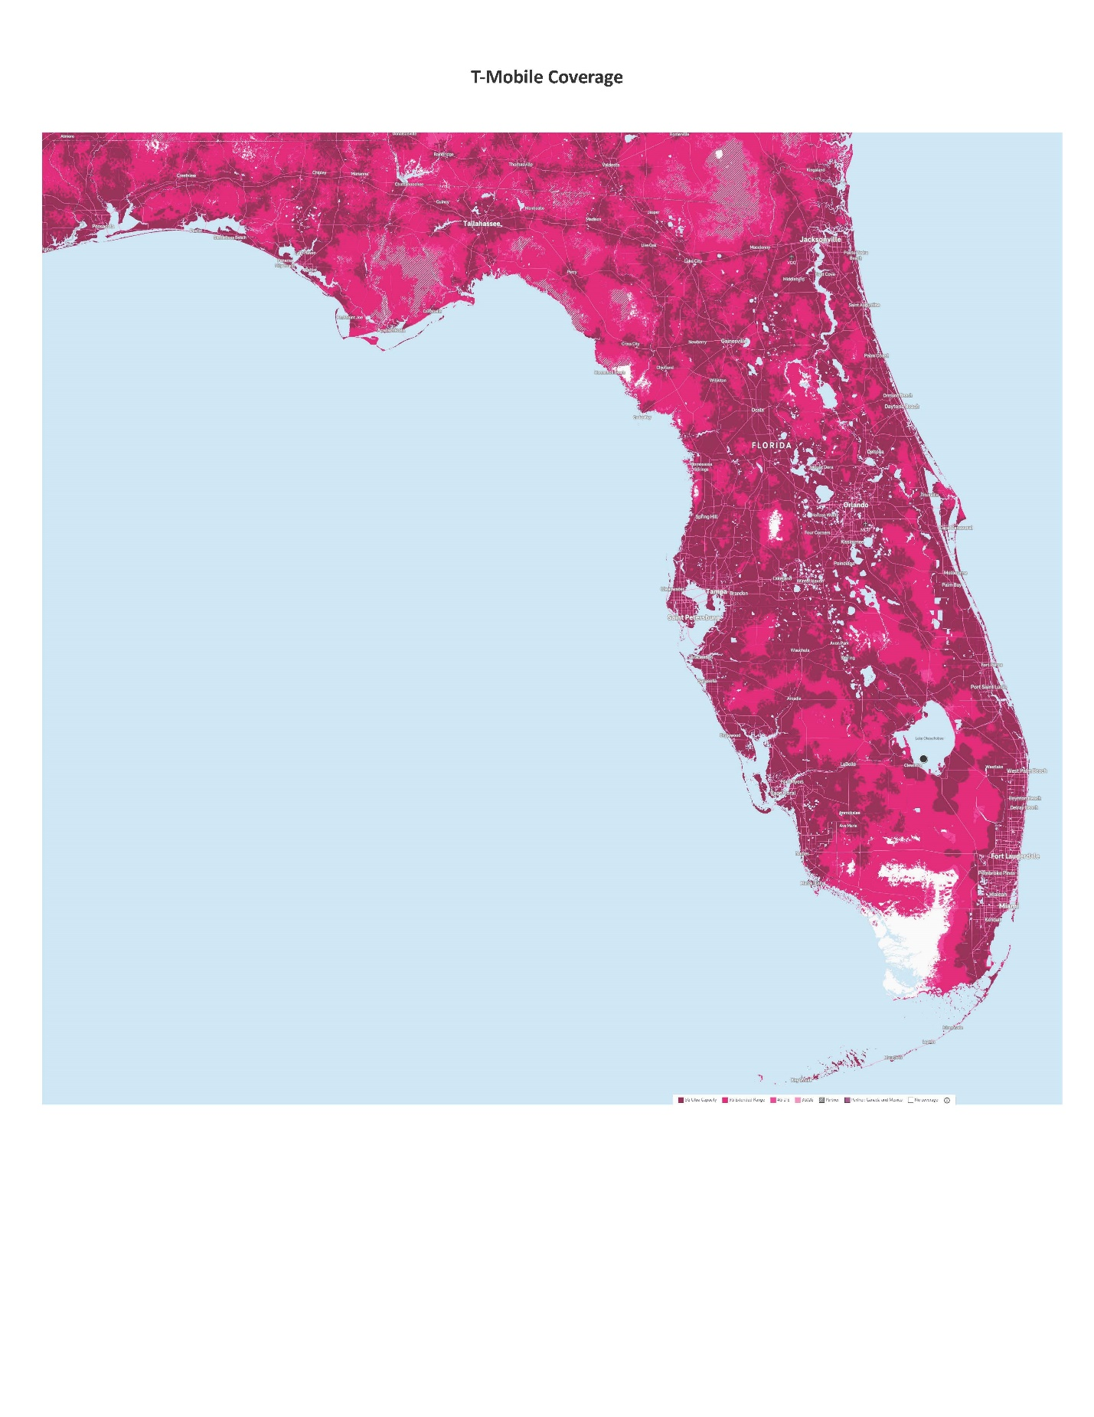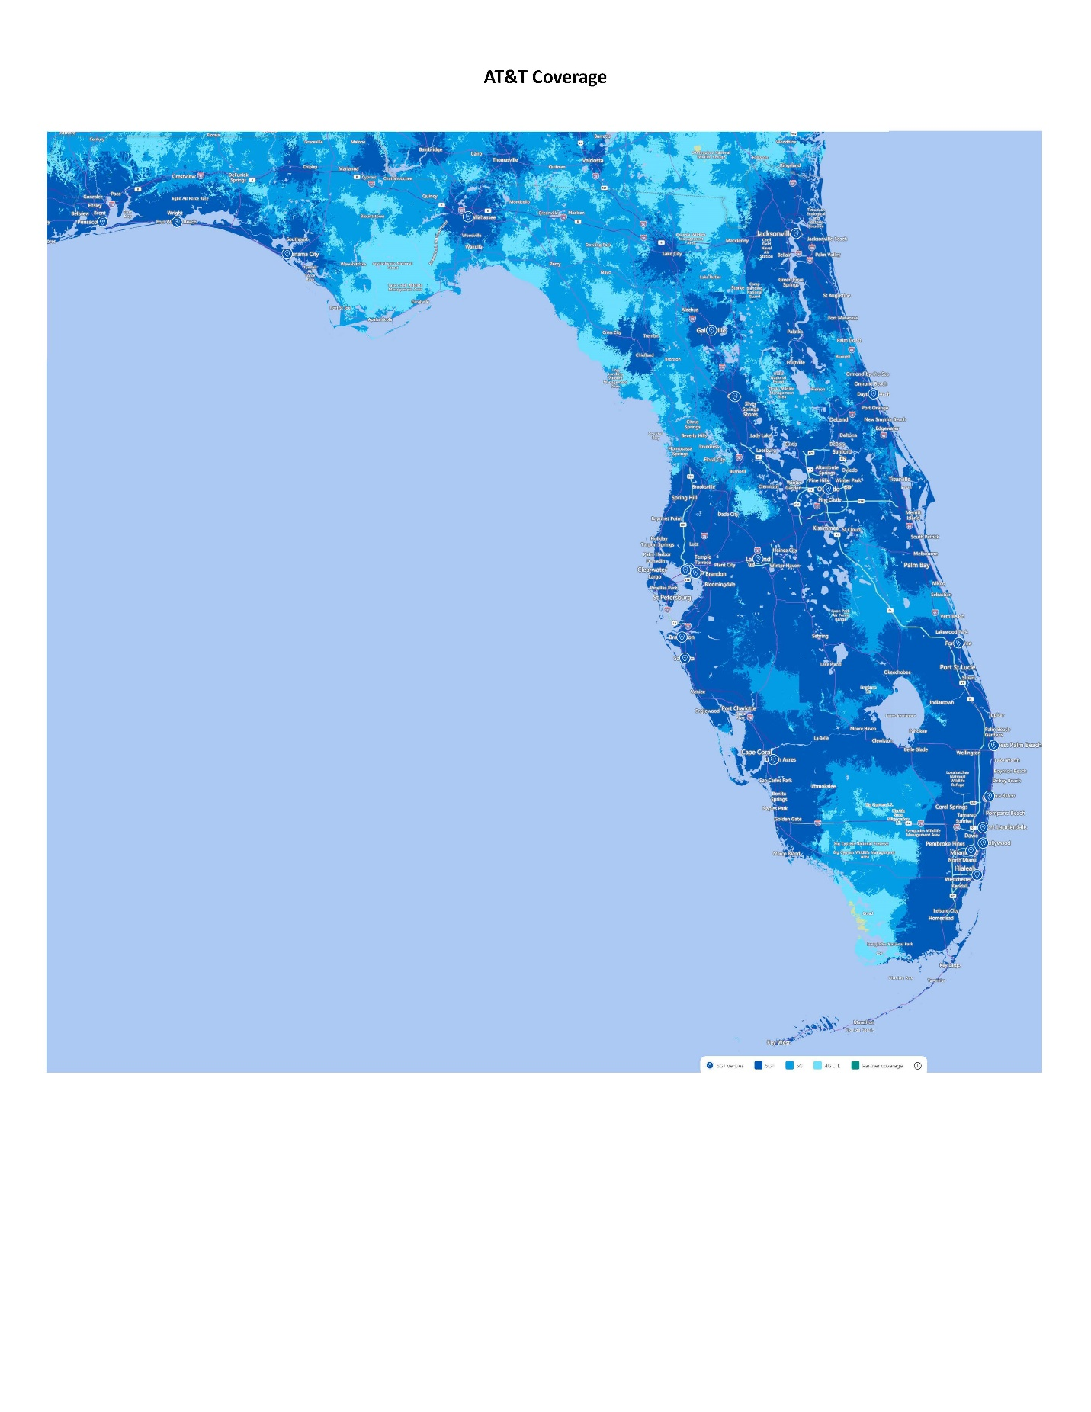

47 U.S.C. § 153(11) (defining a common carrier as “any person engaged as a common carrier for hire, in interstate or foreign communications by wire or radio . . . .”; 47 U.S.C. §332(c)(1)(A) (treating commercial mobile service providers as common carriers).
House Bill 1231 (2011), effective July 1, 2011.
Senate Bill 478 (2024), effective April 15, 2024.
47 C.F.R. § 54.201(a).
47 U.S.C. § 214(e)(1), 47 C.F.R. § 54.101, 47 C.F.R. § 54.201, and 47 C.F.R. § 54.401; While 47 C.F.R. § 54.101(a) also includes requirements addressing toll limitation services to qualifying low-income consumers, the FCC in its 2012 Lifeline and Link Up Reform Order (FCC 12-11) stated that: “ETCs are not required to offer toll limitation service to low-income consumers if the Lifeline offering provides a set amount of minutes that do not distinguish between toll and non-toll calls.”
Broadband Internet Access Service (BIAS) is defined as a mass-market retail service that provides the capability to transmit and receive data, but excluding dial-up service.
Section 364.105, F.S. states that each ETC shall offer a residential basic local telecommunications service at 70 percent of the residential local telecommunications service rate for any Lifeline subscriber who no longer qualifies for Lifeline for a period of 1 year after the date the subscriber ceases to qualify for Lifeline.
Rule 25-4.0665(3), F.A.C. The Lifeline Promotion Process is an electronic system developed in collaboration with the Florida Department of Children and Families, ETCs and the FPSC. This system helps assist ETCs and the FPSC in providing information on how to apply for Lifeline assistance to eligible customers.
47 C.F.R. § 54.202(a)
The Public Service Commission of Wisconsin (WI PSC) granted Amerimex designation as an ETC by Order effective June 5, 2014 in Docket No. 17090-TI-100. The WI PSC rescinded Amerimex’s ETC designation in Docket No. 5-TI-2723 effective July 30, 2020 because the Company had not yet offered Lifeline service in Wisconsin and did not respond to certain data requests issued by Staff. The Commission granted Amerimex’s petition for re-designation as an ETC in WI effective January 12, 2024 in Docket No. 17090-TI-101.
47 U.S.C. § 214(e)(2)
2023 Florida Lifeline Assistance Report, December 2023, Appendix C, p 24.
Ibid, p 13.

