BEFORE THE FLORIDA PUBLIC SERVICE COMMISSION

In re: Commission review of numeric conservation goals (Duke Energy Florida, LLC). | DOCKET NO. 20240013-EG  ORDER NO. PSC-2024-0429-FOF-EG  ISSUED: September 20, 2024

The following Commissioners participated in the disposition of this matter:

MIKE LA ROSA, Chairman
ART GRAHAM
GARY F. CLARK
ANDREW GILES FAY
GABRIELLA PASSIDOMO

FINAL ORDER APPROVING NUMERIC CONSERVATION GOALS
FOR DUKE ENERGY FLORIDA, LLC

APPEARANCES:

DIANNE M. TRIPLETT, MATTHEW R. BERNIER and STEPHANIE A. CUELLO, ESQUIRES, 299 First Avenue North, St. Petersburg, Florida 33701
On behalf of Duke Energy Florida, LLC (DEF).

SEAN T. GARNER, ERIK SAYLER and KELLY WRIGHT, ESQUIRES, Florida Department of Agriculture & Consumer Service, Office of General Counsel, The Mayo Building, 407 S. Calhoun Street, Suite 520, Tallahassee, Florida 32399-0800
On behalf of Florida Department of Agriculture & Consumer Services (FDACS).

JON C. MOYLE, JR. and KAREN A. PUTNAL, ESQUIRES, Moyle Law Firm, P.A., 118 North Gadsden Street, Tallahassee, Florida 32301
On behalf of Florida Industrial Power Users Group (FIPUG).

BRADLEY MARSHALL and JORDAN LUEBKEMANN, ESQUIRES, Earthjustice, 111 S. Martin Luther King Jr. Blvd., Tallahassee, Florida 32301
On behalf of Florida Rising, Inc. (FL Rising) and League of United Latin American Citizens (LULAC).

PETER J. MATTHEIS, MICHAEL K. LAVANGA and JOSEPH R. BRISCAR, ESQUIRES, Stone, Mattheis, Xenopoulos & Brew, PC, 1025 Thomas Jefferson Street, NW, Eighth Floor, West Tower, Washington, DC 20007
On behalf of Nucor Steel Florida, Inc. (Nucor).

JAMES W. BREW, LAURA WYNN BAKER and SARAH B. NEWMAN, ESQUIRES, Stone, Mattheis, Xenopoulos & Brew, PC, 1025 Thomas Jefferson Street, NW, Eighth Floor, West Tower, Washington, DC 20007
On behalf of White Springs Agricultural Chemicals, Inc. d/b/a PCS Phosphate – White Springs (PCS Phosphate).

WILLIAM C. GARNER, ESQUIRE, Law Office of William C. Garner, PLLC, 3425 Bannerman Road, Unit 105, No. 414, Tallahassee, Florida 32312
On behalf of Southern Alliance for Clean Energy (SACE).

STEPHANIE U. EATON, ESQUIRE, Spilman, Thomas & Battle, PLLC, 110 Oakwood Drive, Suite 500, Winston-Salem, North Carolina 27103
STEVEN W. LEE, ESQUIRE, Qualified Representative, Spilman, Thomas & Battle, PLLC, 1100 Bent Creek Blvd., Suite 101, Mechanicsburg, Pennsylvania 17050
On behalf of Walmart, Inc. (Walmart).

JACOB IMIG, JON RUBOTTOM, and ADRIA HARPER, ESQUIRES, Florida Public Service Commission, 2540 Shumard Oak Boulevard, Tallahassee, Florida 32399-0850
On behalf of the Florida Public Service Commission (Staff).

MARY ANNE HELTON, ESQUIRE, Deputy General Counsel, Florida Public Service Commission, 2540 Shumard Oak Boulevard, Tallahassee, Florida 32399-0850
Advisor to the Florida Public Service Commission.

KEITH C. HETRICK, ESQUIRE, General Counsel, Florida Public Service Commission, 2540 Shumard Oak Boulevard, Tallahassee, Florida 32399-0850
Florida Public Service Commission General Counsel

BY THE COMMISSION:

Background
Enacted in 1980, Sections 366.80 through 366.83, and 403.519, Florida Statutes (F.S.), are known collectively as the Florida Energy Efficiency and Conservation Act (FEECA). FEECA requires us to adopt appropriate goals to increase the efficiency of energy consumption and, pursuant to Section 366.82(6), F.S., we must review the goals of each utility subject to FEECA at least every five years.
The six electric utilities subject to FEECA, collectively known as the FEECA Utilities, are Florida Power & Light Company (FPL), Duke Energy Florida, LLC (DEF), Tampa Electric Company (TECO), Florida Public Utilities Company (FPUC), JEA, and Orlando Utilities Commission (OUC). Pursuant to Rule 25-17.0021, Florida Administrative Code (F.A.C.), numeric goals were last established for the FEECA Utilities by Order No. PSC-19-0509-FOF-EU, issued November 26, 2019. Therefore, new goals must be established by January 2025.

By Order No. PSC-2024-0022-PCO-EG, issued February 28, 2024, the dockets for each of the FEECA Utilities were consolidated for purposes of hearing, and controlling dates and a tentative list of issues were established.

White Springs Agricultural Chemicals, Inc. d/b/a/ PCS Phosphate – White Springs (PCS Phosphate) was granted leave to intervene on February 13, 2024. We acknowledged the intervention of the Office of Public Counsel (OPC) on February 28, 2024. We acknowledged the intervention of the Florida Department of Agriculture and Consumer Services (FDACS) on April 24, 2024. The Florida Industrial Power Users Group (FIPUG), the Florida League of United Latin American Citizens (LULAC), Florida Rising, Inc. (Florida Rising), and Nucor Steel Florida, Inc. (Nucor) were granted leave to intervene on April 25, 2024. The Southern Alliance for Clean Energy (SACE) and Walmart Inc. (Walmart) were granted leave to intervene on April 30, 2024. OPC withdrew from the proceeding on May 22, 2024.

Pursuant to Notice and in accordance with Rule 28-106.209, F.A.C., a hearing was held on August 8, 2024, in Tallahassee, Florida, before the above commissioners.

Decision

Legal Background

FEECA directs us to promote four key priorities: (1) reducing and controlling the growth rates of weather-sensitive peak demand and electricity usage, (2) increasing the efficiency and cost-effectiveness of the production and consumption of electricity and natural gas, (3) encouraging demand-side renewable energy systems, and (4) conserving expensive resources, particularly petroleum fuel. The Legislature emphasized that it is critical to utilize “efficient and cost-effective” conservation systems. Section 366.82, F.S., bifurcates our responsibility under FEECA into two separately docketed proceedings. First, in the goalsetting dockets, we must establish appropriate goals for increasing the efficiency of energy consumption and increasing the development of demand-side renewable energy systems. Following the adoption of goals, in the plan approval dockets, each FEECA Utility must file plans and programs to meet the goals within its service area. The present docket was opened to address the first, goalsetting portion of our FEECA proceedings for DEF.

FEECA requires that we establish goals designed to increase the conservation of expensive resources, such as petroleum fuels; reduce and control the growth rates of electric consumption; reduce the growth rates of weather-sensitive peak demand; and encourage development of demand-side renewable energy resources. Section 366.82(3), F.S., prescribes the following criteria for our evaluation of the conservation goals:

In developing the goals, the commission shall evaluate the full technical potential of all available demand-side and supply-side conservation and efficiency measures, including demand-side renewable energy systems. In establishing the goals, the commission shall take into consideration:
(a) The costs and benefits to customers participating in the measure.
(b) The costs and benefits to the general body of ratepayers as a whole, including utility incentives and participant contributions.
(c) The need for incentives to promote both customer-owned and utility-owned energy efficiency and demand-side renewable energy systems.
(d) The costs imposed by state and federal regulations on the emission of greenhouse gases.

The Commission implements FEECA for electric utilities through Rule 25-17.0021, F.A.C. Pursuant to that rule, for each FEECA Utility, we establish annual kilowatt (KW) and kilowatt-hour (KWh) goals for Residential and Commercial/Industrial customer classes. The goals are based on (1) an assessment of the technical potential of available conservation and efficiency measures, and (2) an estimate of the total cost-effective KW and KWh savings reasonably achievable through demand-side management (DSM) programs in each utility’s service area over a ten-year period. The goals we establish are annual targets for conservation, with KW goals relating to seasonal—summer and winter—demand savings, and annual KWh goals relating to annual energy savings.

Following the last goalsetting proceedings in 2019, after receiving feedback from the utilities, intervenors, and interested persons, we amended Rule 25-17.0021, F.A.C., to streamline our FEECA process by requiring utilities to file potential conservation programs along with their proposed goals. This allows us to analyze the utilities’ proposed goals based upon energy (KWh) and demand (KW) savings from customer participation in potential programs they plan to implement, thus giving us better information as to the appropriateness of the goals. Thus, although utility conservation plans and the underlying programs and measures to implement those plans are not approved at this time, each utility must include sufficient information related to the cost-effectiveness of its potential DSM programs to support the appropriateness of its proposed goals.
Analysis

Pursuant to Section 366.82, F.A.C., we must evaluate whether the goals requested by DEF are appropriate. Pursuant to the Prehearing Order, Order No. PSC-2024-0293-PHO-EG, issued August 2, 2024, a final list of issues was established for the consolidated hearing. Issues 1-7 address whether each utility, in developing its proposed goals, adequately addressed the considerations prescribed by statute and Commission rule. Issue 8 addresses, for the purpose of establishing goals for rate-regulated utilities, whether we should consider changing credit levels for demand response programs in the FEECA goalsetting proceedings or in their base rate proceedings. Issues 9-11 were specific only to FPL’s docket and thus not at issue for DEF. Issues 12 and 13 are the ultimate issues addressing, in light of the preceding issues, what conservation goals we should establish for DEF as required by Section 366.82, F.S.

Following a robust discovery process, we were presented with a series of proposed Type II stipulations, set forth below in Attachment A, that fully resolved all issues in this docket. DEF, PCS Phosphate, Nucor, LULAC, Florida Rising, SACE, and Walmart supported the stipulations. FIPUG supported the stipulations on Issues 8A and 8B at the August 8, 2024, hearing and took no position on all other stipulations. FDACS took no position on all issues. Commission staff recommended approval of the proposed stipulations. We approved the proposed stipulations by a bench vote at the August 8, 2024, hearing.

We find that each of the stipulations are supported by evidence in the record. We also find that the testimony and exhibits in the record adequately address the statutory considerations required by Section 366.82(3), F.S., and demonstrate that the goals stipulated for Issues 12 and 13, as set forth in Attachment A, will increase the conservation of expensive resources, such as petroleum fuels; reduce and control the growth rates of electric consumption; reduce the growth rates of weather-sensitive peak demand; and encourage development of demand-side renewable energy resources. In particular, we found the testimony and exhibits of DEF witnesses Jim Herndon and Tim Duff, as well as the discovery responses provided by DEF, support our finding that the stipulated goals are reasonable and consistent with the requirements of Section 366.82, F.S., and Rule 25-17.0021, F.A.C. For these reasons, we find the stipulated goals to be appropriate.

Conclusion

The stipulations listed in Attachment A address all the requirements of FEECA enumerated in Section 366.82, F.S., and satisfy the requirements of Rule 25-17.0021, F.A.C. Further, the conservation goals stipulated in Issues 12 and 13 are appropriate to advance the priorities of FEECA. Therefore, the goals stipulated in Issues 12 and 13 are adopted for DEF for the period 2025-2034.

Based on the foregoing, it is

ORDERED that Duke Energy Florida shall abide by the stipulations, findings, and rulings herein. It is further

ORDERED that Duke Energy Florida’s residential and commercial/industrial summer and winter megawatt (MW) and annual gigawatt-hour (GWh) goals are adopted as set forth in Attachment A, Exhibit A, Issue 12. It is further

ORDERED that Duke Energy Florida should continue to implement the provisions of Rule 25-6.065, F.A.C., Interconnection and Net Metering of Customer-Owned Renewable Generation, as an appropriate means to encourage the development of demand-side renewable energy. It is further

ORDERED that this docket shall be closed after the time for filing an appeal has run.

By ORDER of the Florida Public Service Commission this 20th day of September, 2024.

/s/ Adam J. Teitzman
ADAM J. TEITZMAN
Commission Clerk
Florida Public Service Commission
2540 Shumard Oak Boulevard
Tallahassee, Florida 32399
(850) 413-6770
www.floridapsc.com

Copies furnished: A copy of this document is provided to the parties of record at the time of issuance and, if applicable, interested persons.

JDI

NOTICE OF FURTHER PROCEEDINGS OR JUDICIAL REVIEW

The Florida Public Service Commission is required by Section 120.569(1), Florida Statutes, to notify parties of any administrative hearing or judicial review of Commission orders that is available under Sections 120.57 or 120.68, Florida Statutes, as well as the procedures and time limits that apply. This notice should not be construed to mean all requests for an administrative hearing or judicial review will be granted or result in the relief sought.

Any party adversely affected by the Commission's final action in this matter may request: 1) reconsideration of the decision by filing a motion for reconsideration with the Office of Commission Clerk, 2540 Shumard Oak Boulevard, Tallahassee, Florida 32399-0850, within fifteen (15) days of the issuance of this order in the form prescribed by Rule 25-22.060, Florida Administrative Code; or 2) judicial review by the Florida Supreme Court in the case of an electric, gas or telephone utility or the First District Court of Appeal in the case of a water and/or wastewater utility by filing a notice of appeal with the Office of Commission Clerk, and filing a copy of the notice of appeal and the filing fee with the appropriate court. This filing must be completed within thirty (30) days after the issuance of this order, pursuant to Rule 9.110, Florida Rules of Appellate Procedure. The notice of appeal must be in the form specified in Rule 9.900(a), Florida Rules of Appellate Procedure.

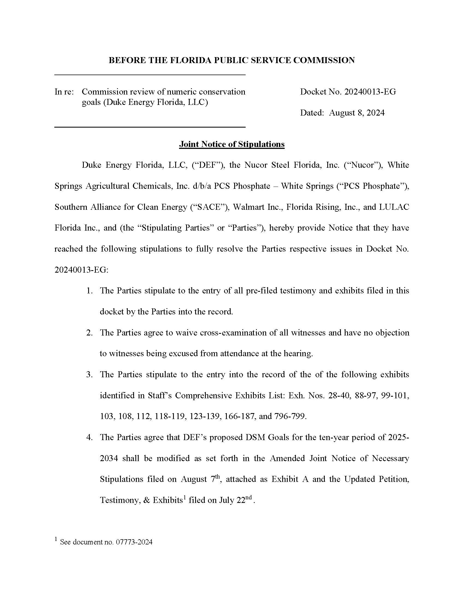
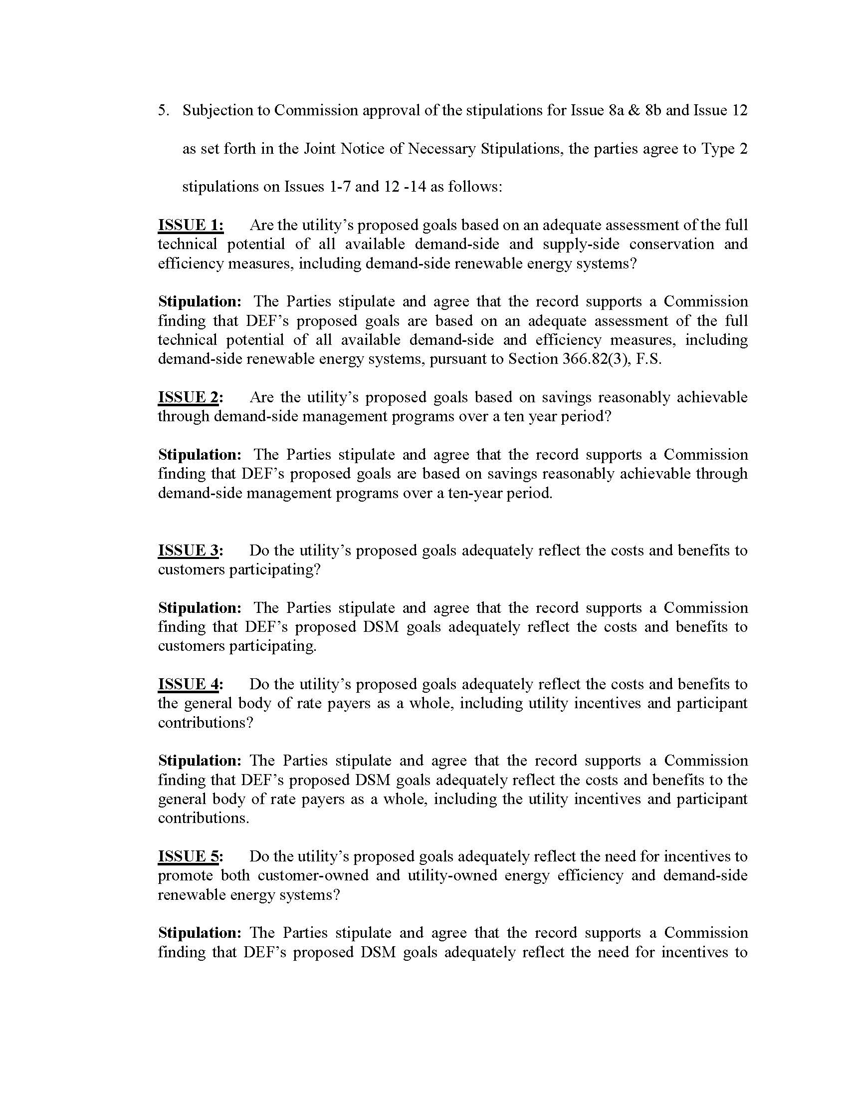

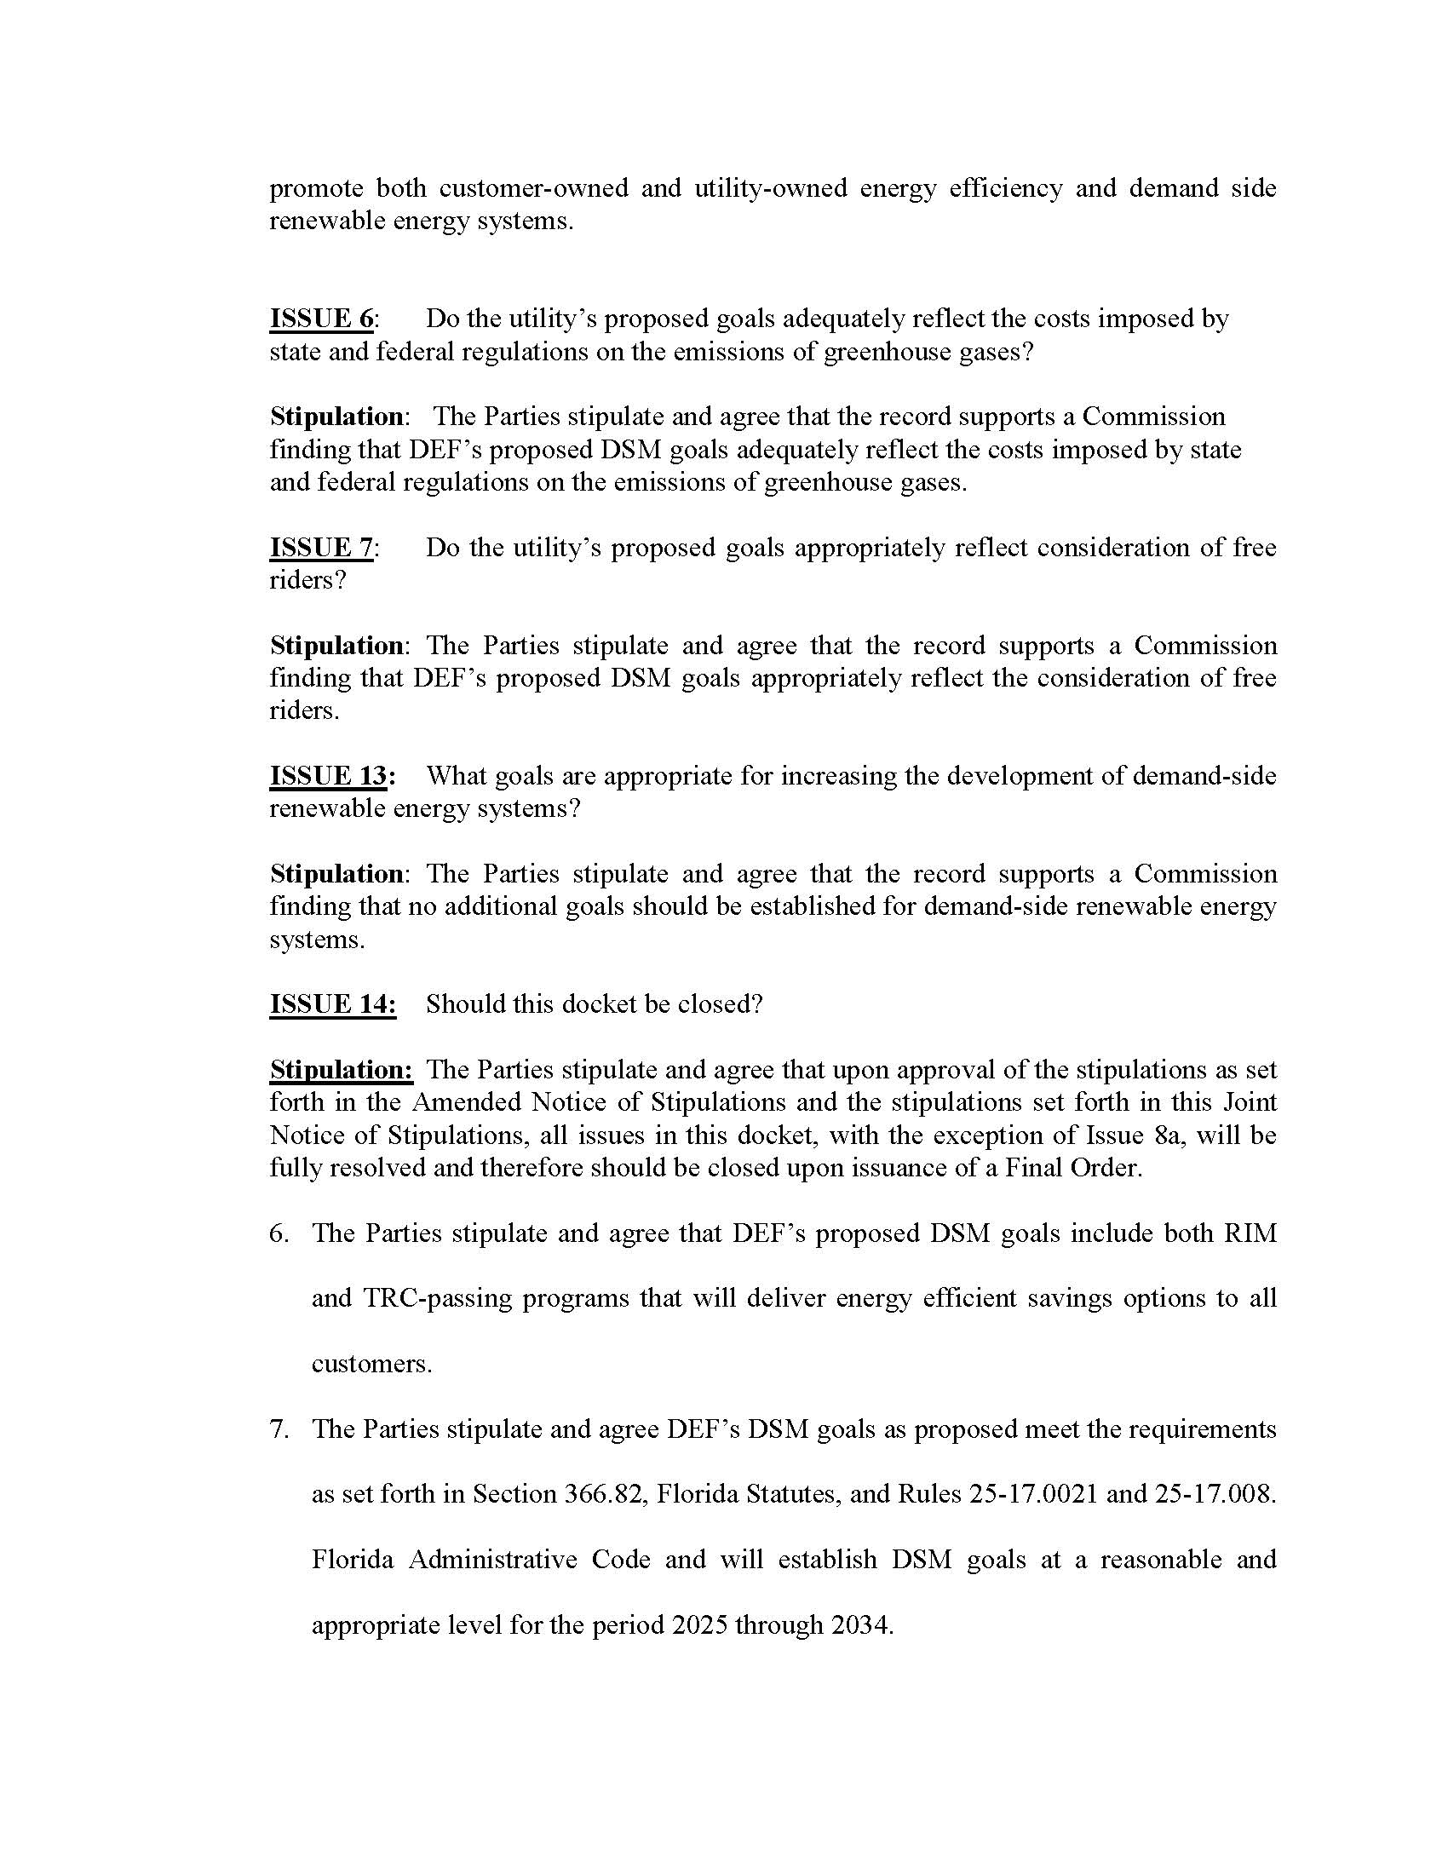

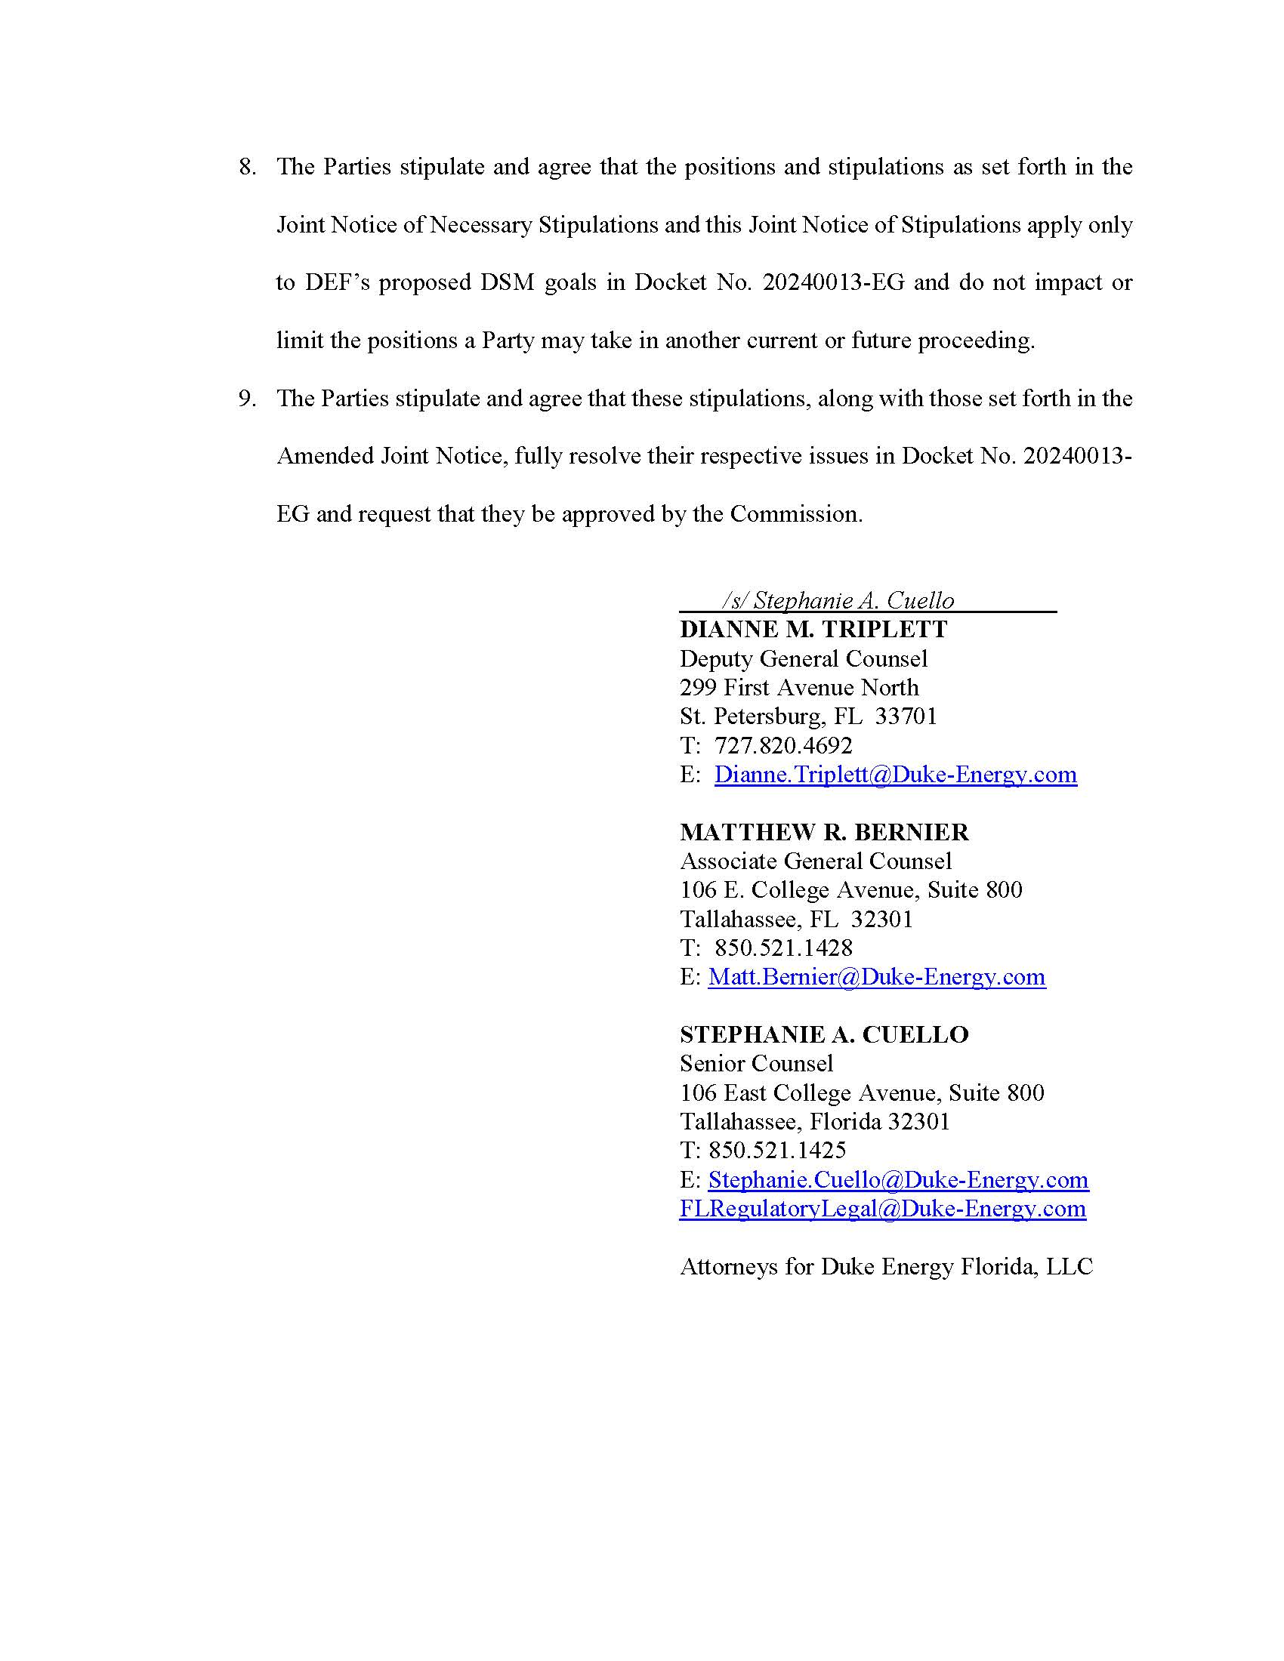

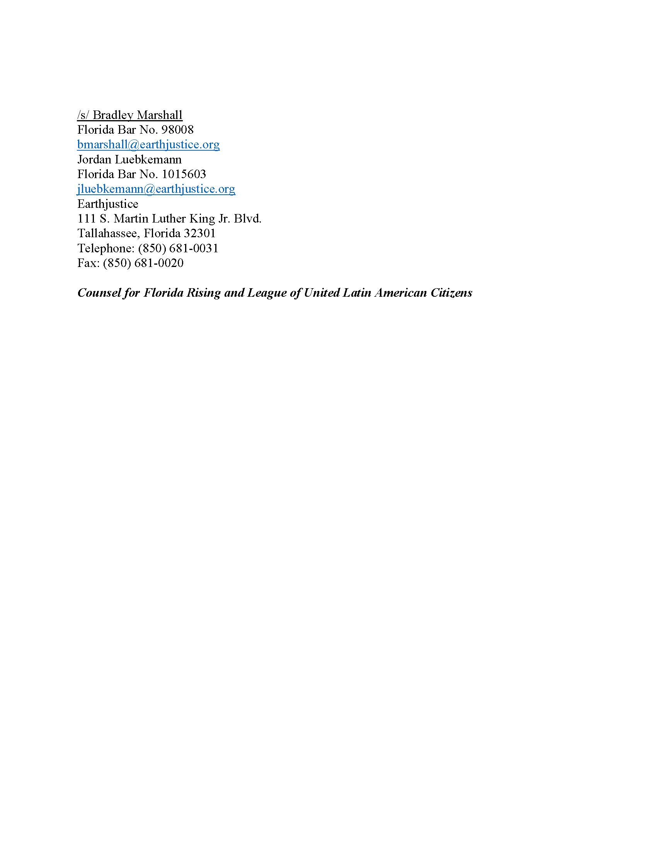

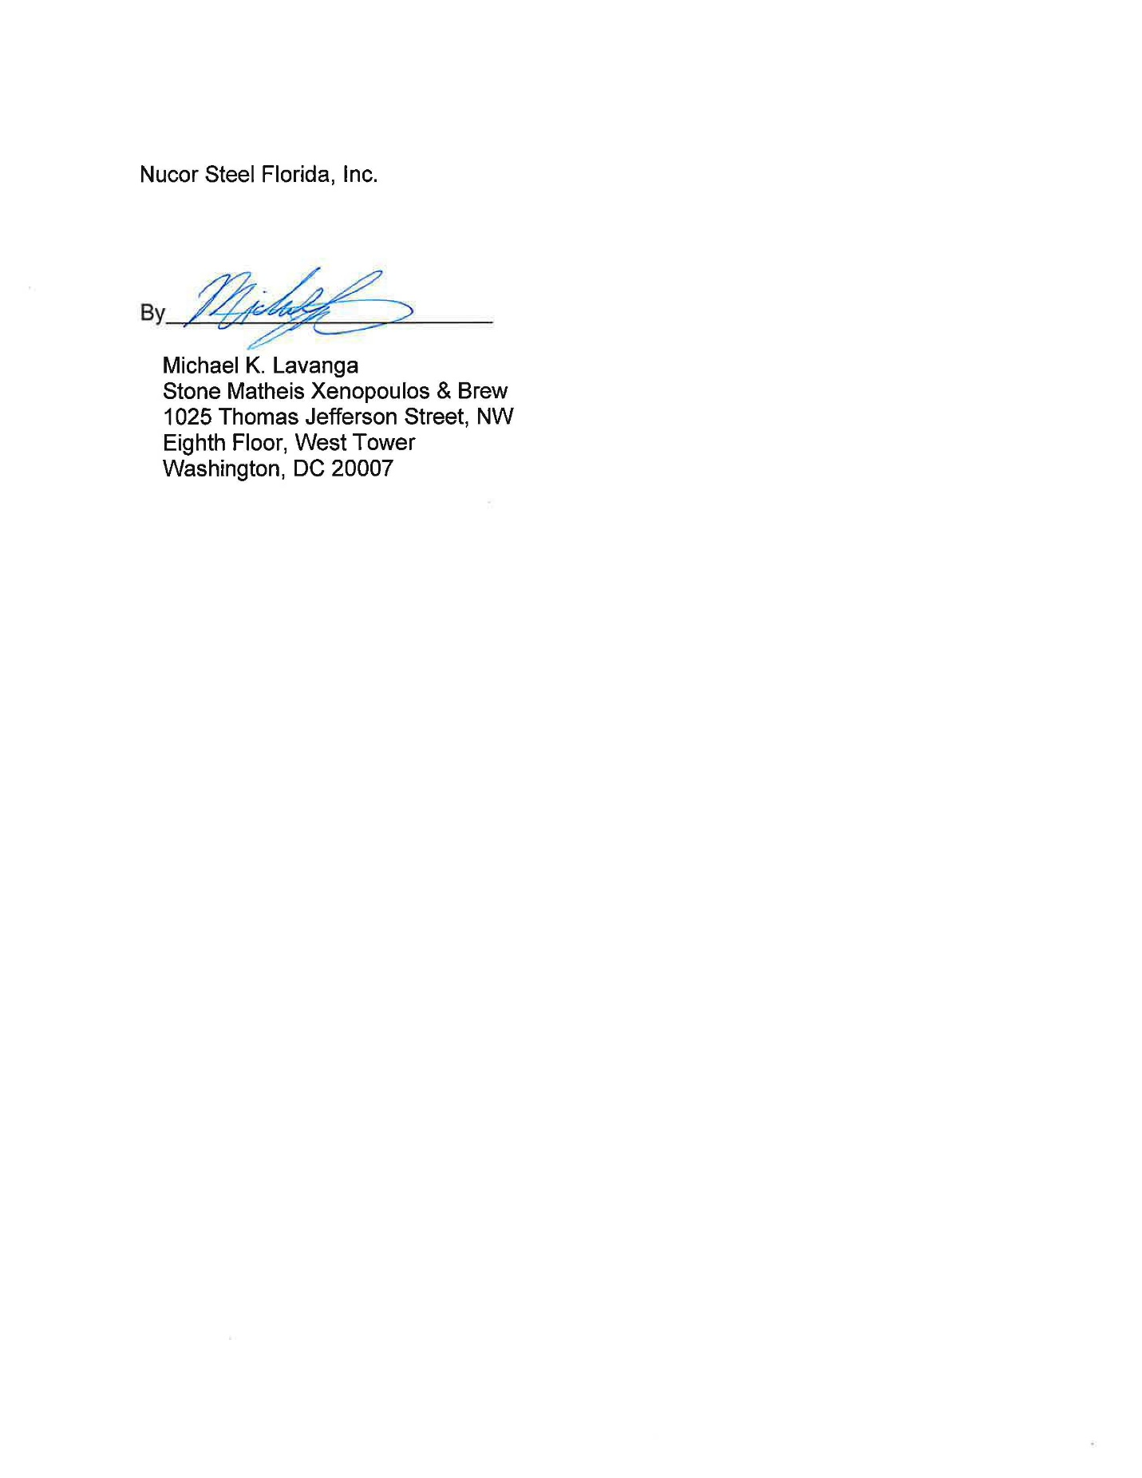

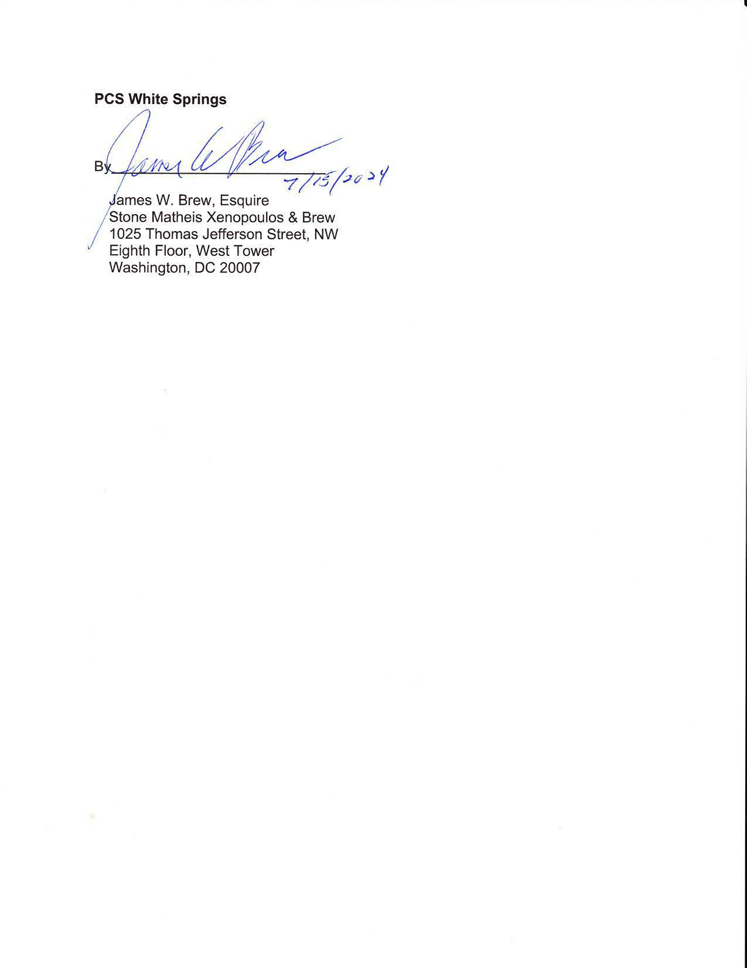

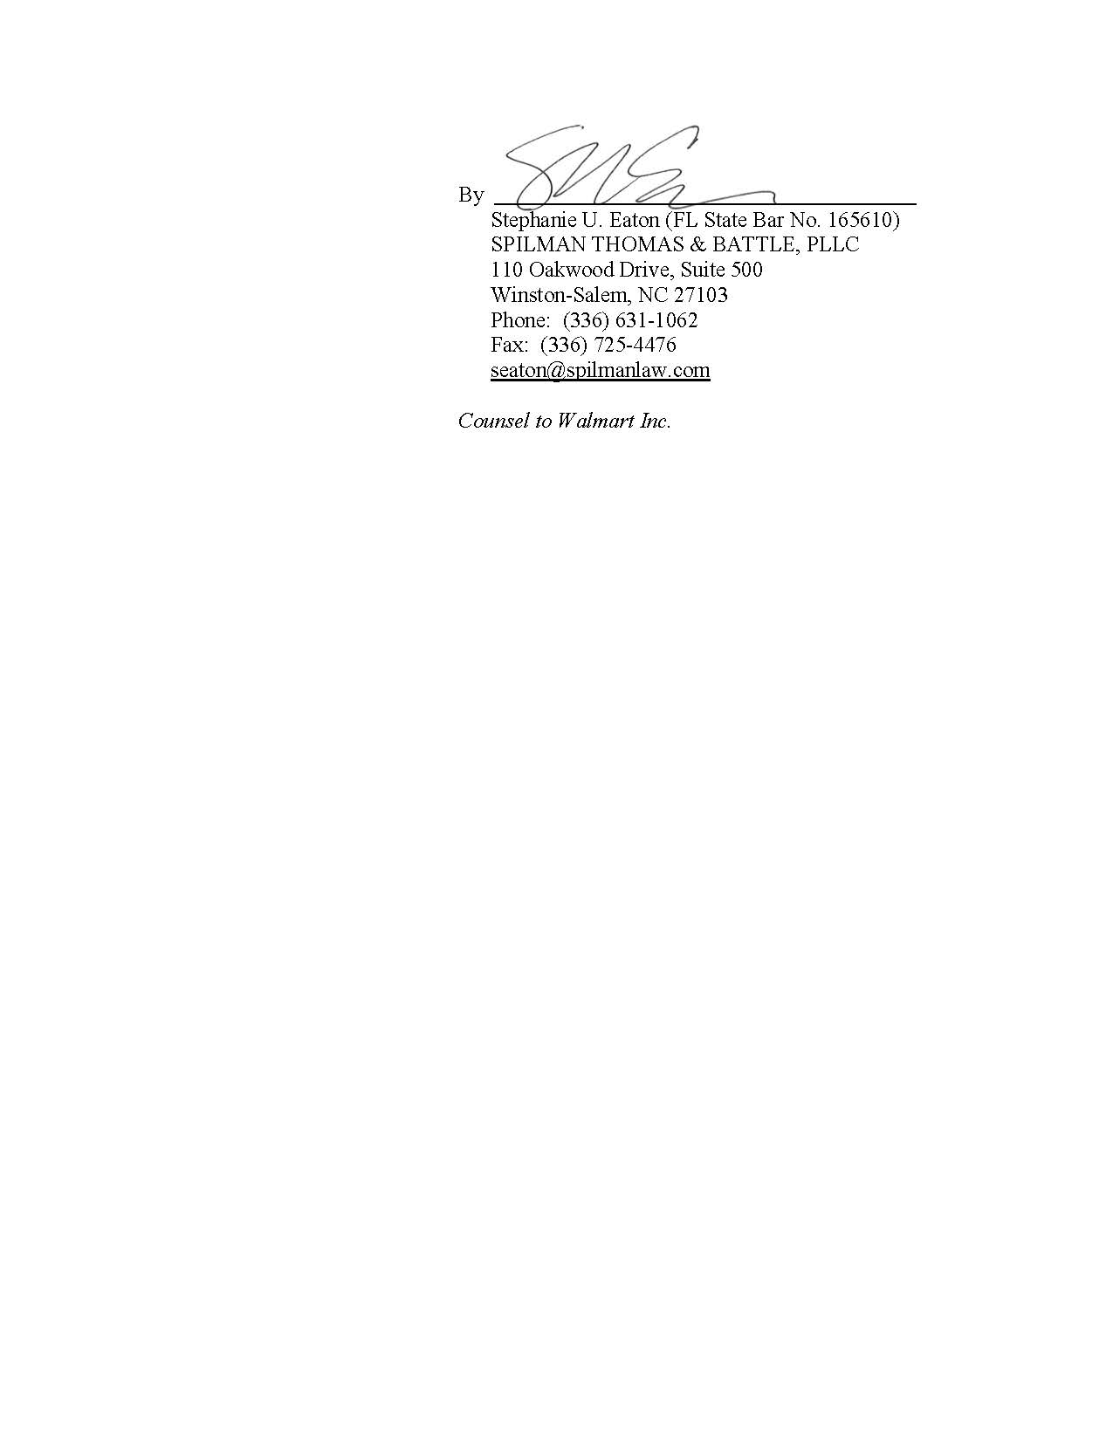

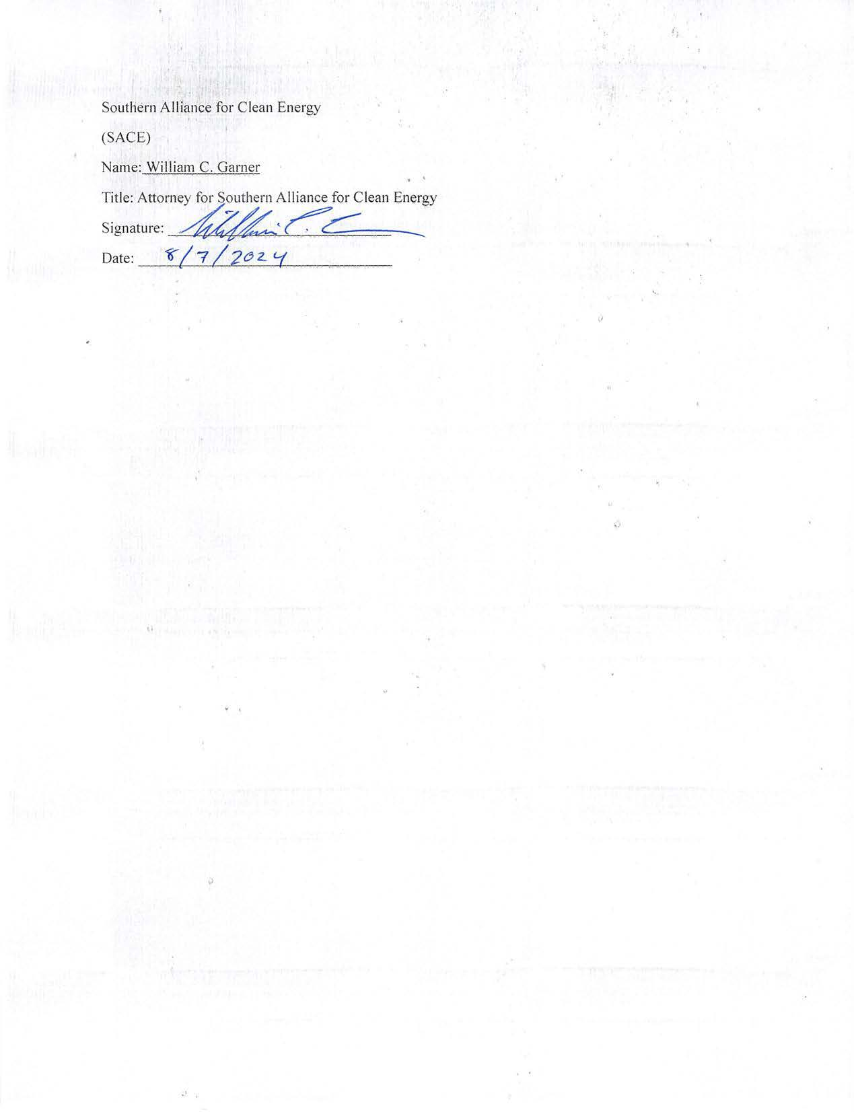



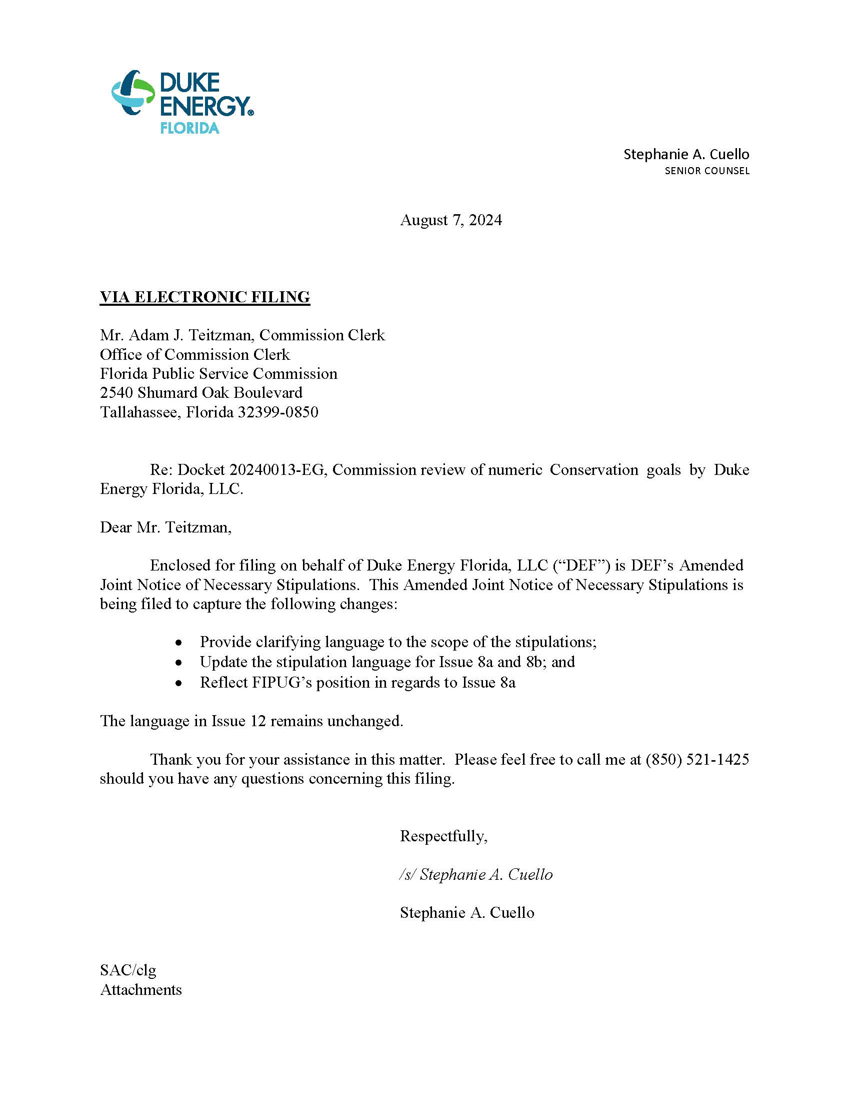

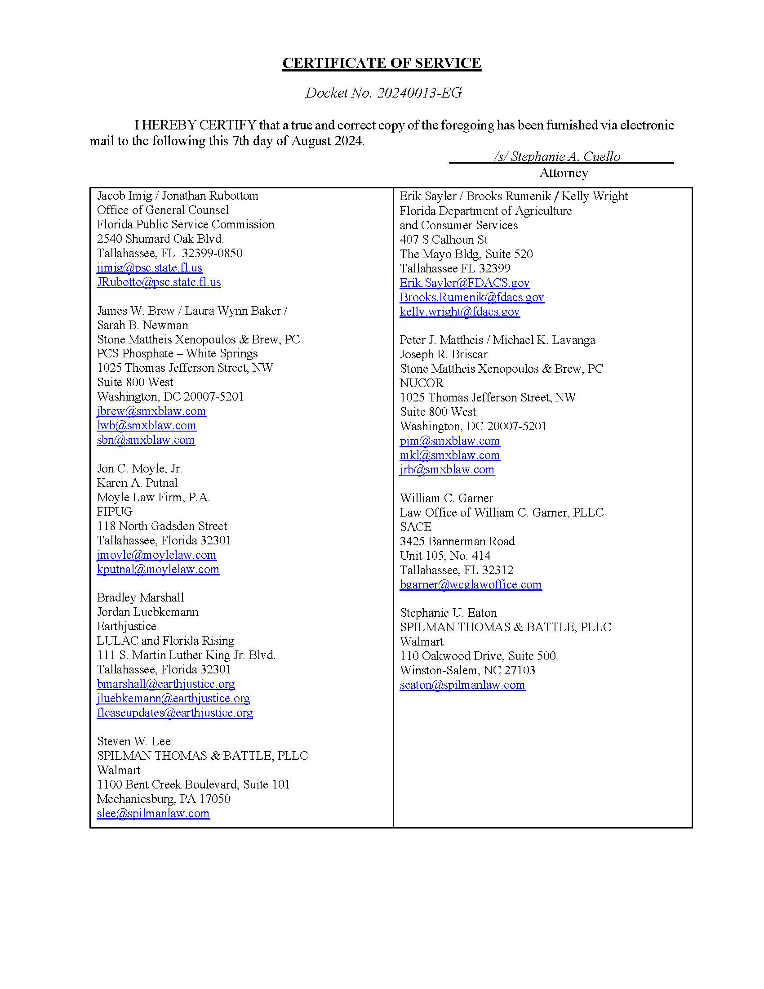

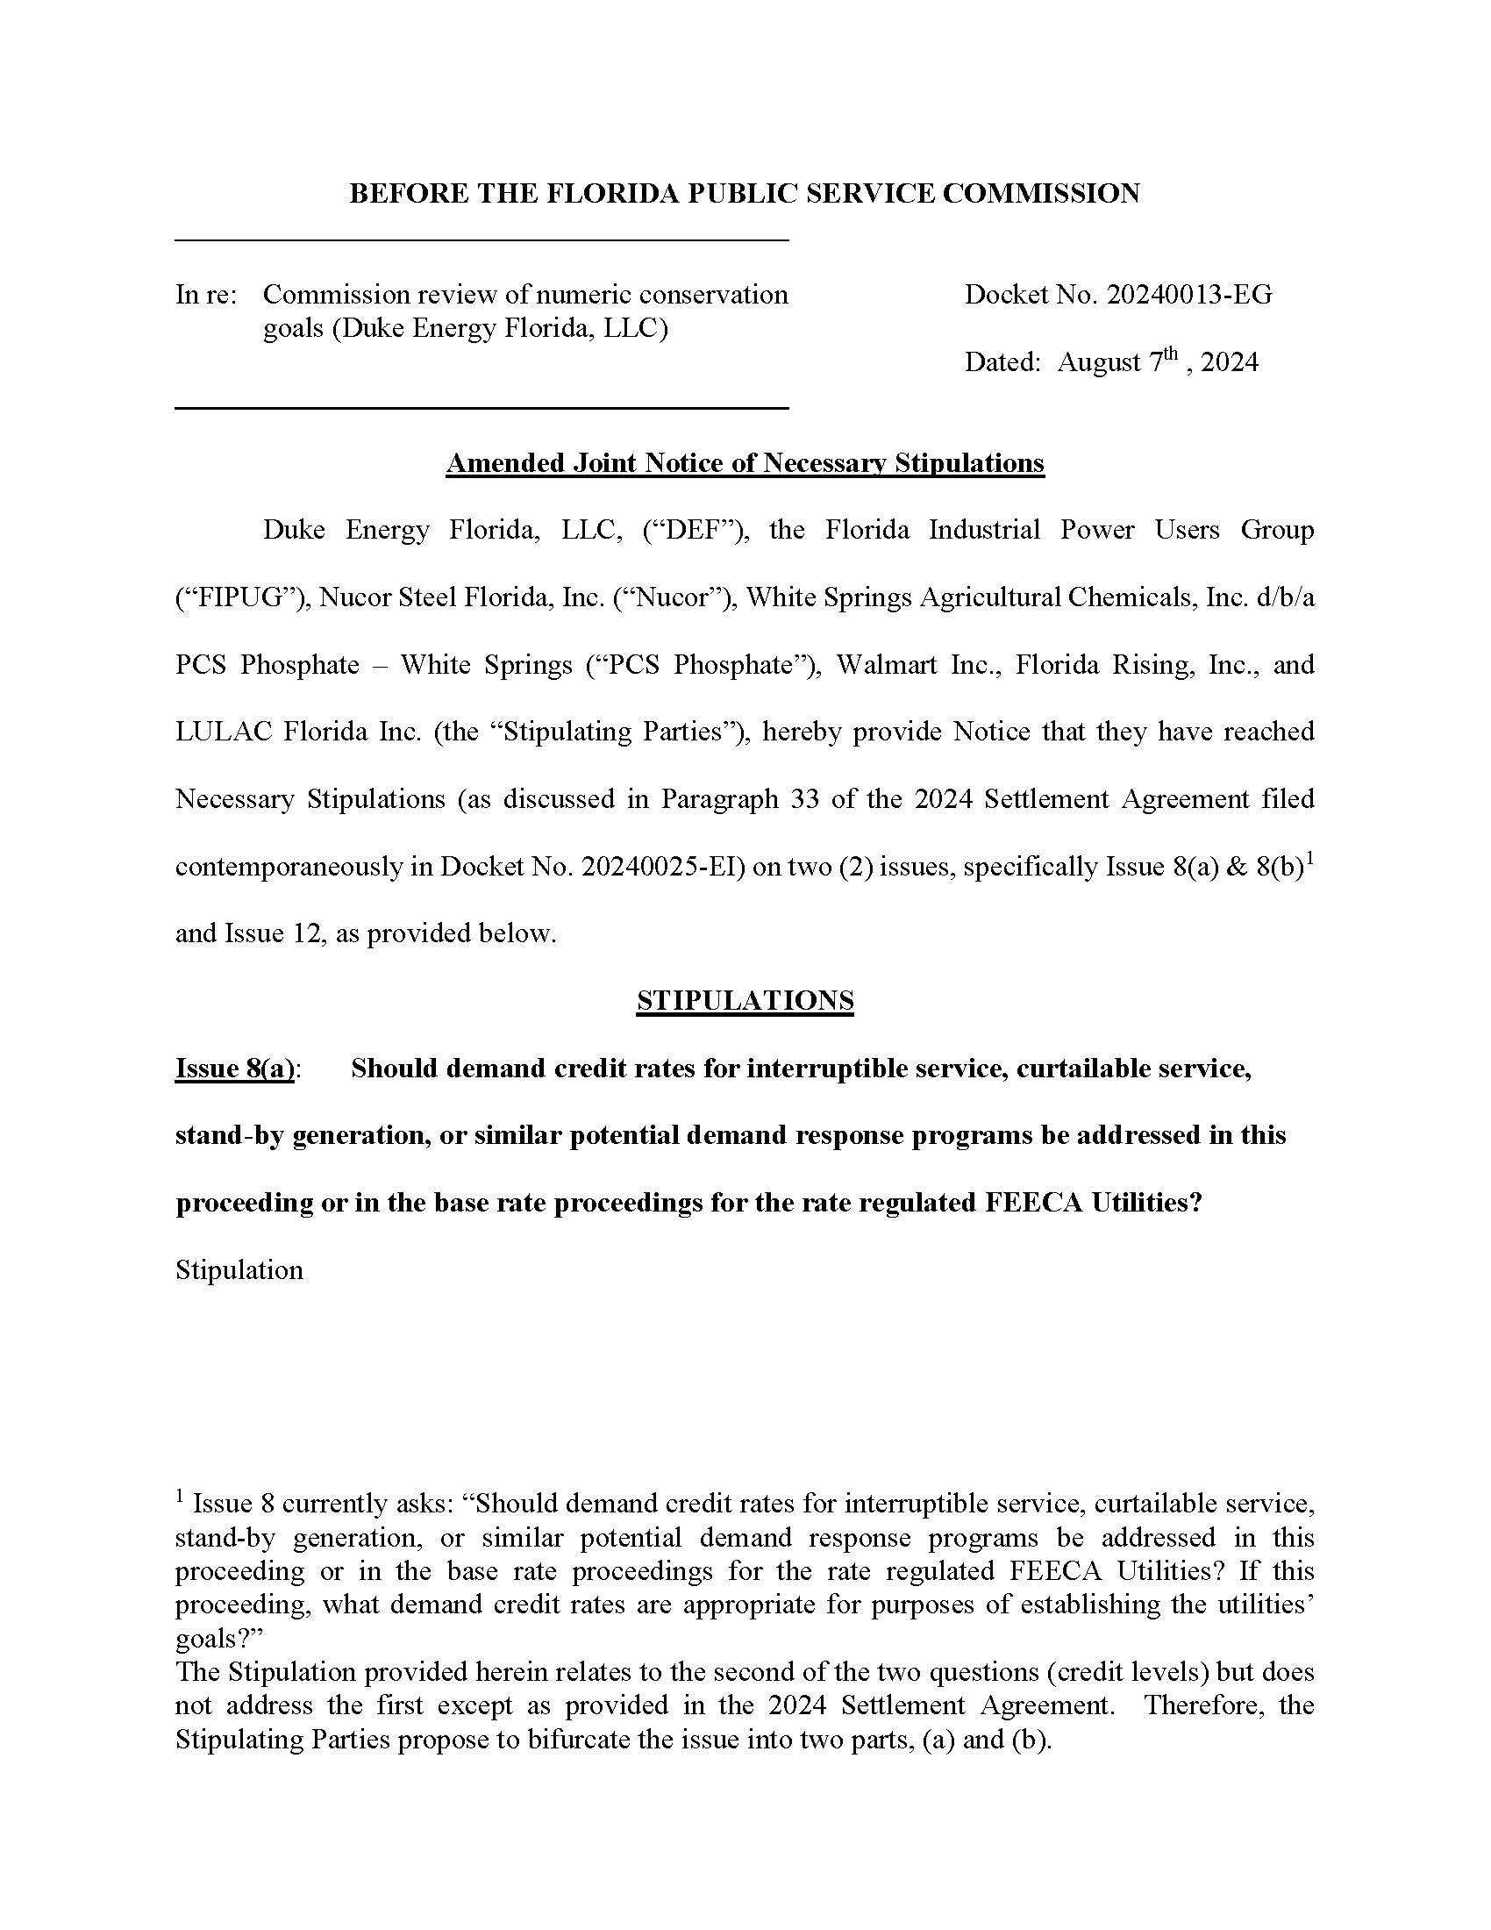

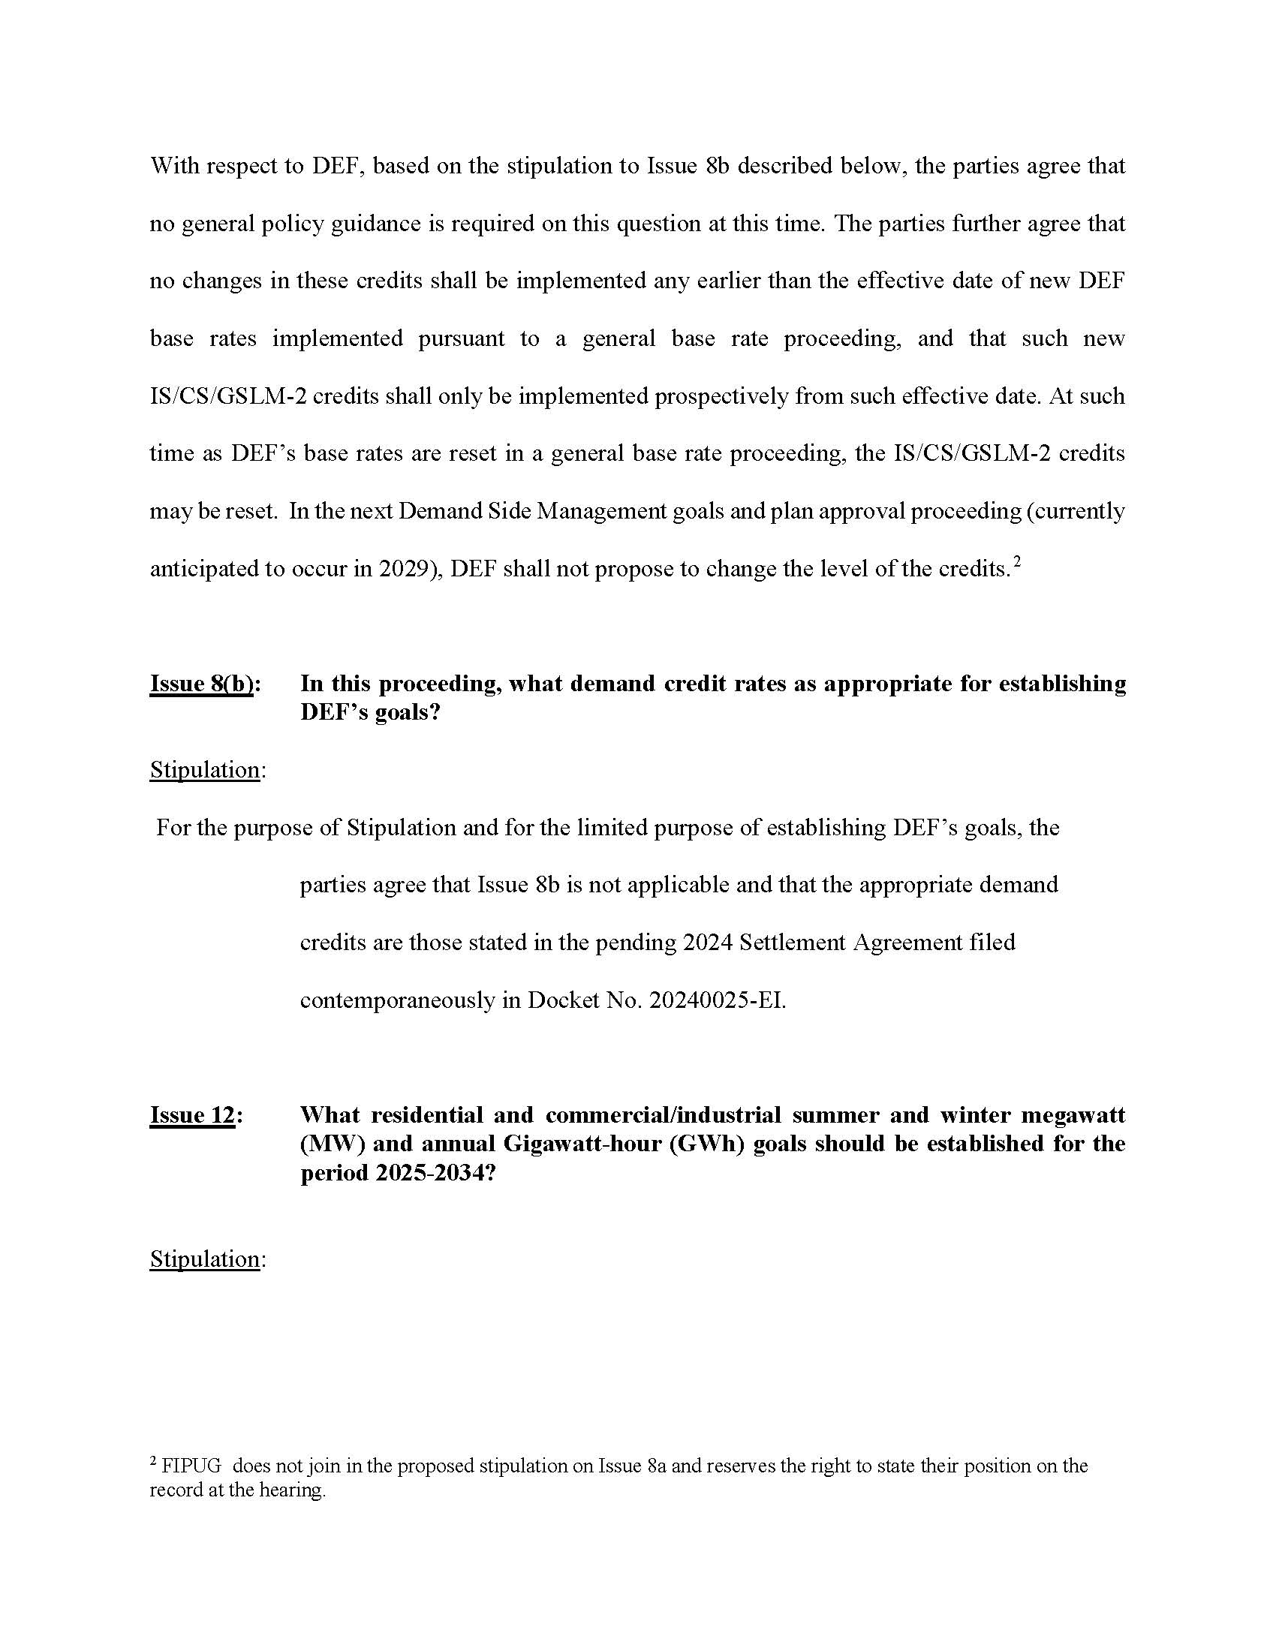

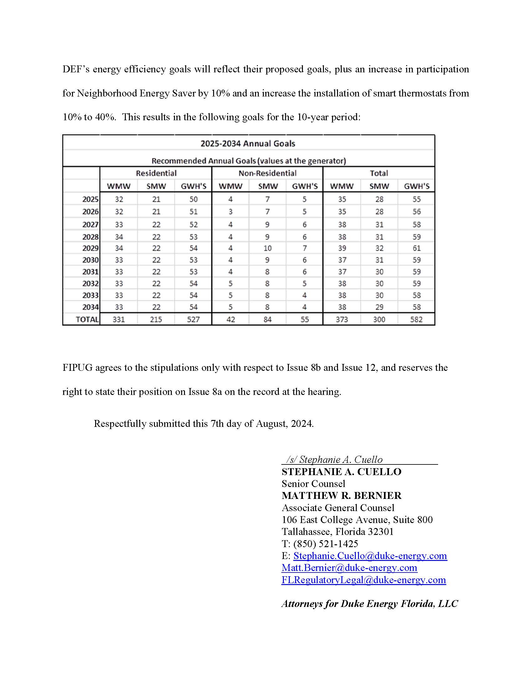

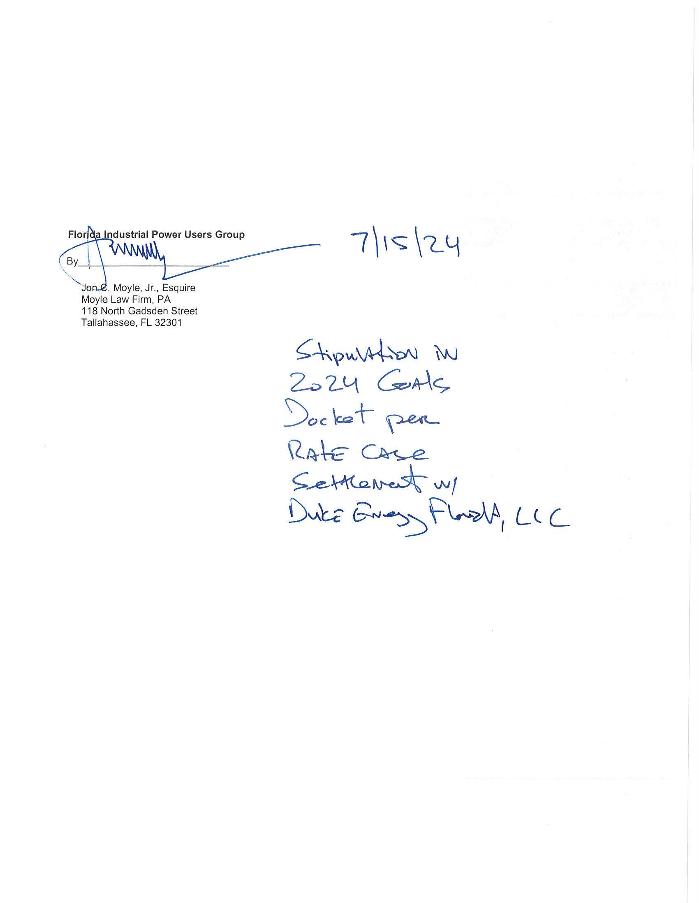

Order No. PSC-2024-0037-PCO-EG.
Order No. PSC-2024-0051-PCO-EG.
Order No. PSC-2024-0128-PCO-EG.
Order No. PSC-2024-0132-PCO-EG.
Order No. PSC-2024-0133-PCO-EG.
Order No. PSC-2024-0135-PCO-EG.
Order No. PSC-2024-0131-PCO-EG.
Order No. PSC-2024-0139-PCO-EG.
Order No. PSC-2024-0138-PCO-EG.
DN 00854-2024.
See Sections 366.81-366.82, F.S.
Section 366.81, F.S.
Section 366.82(2), F.S.
Rule 25-17.0021(1), F.A.C.
Id.
Section 366.82(7), F.S., addresses how we must evaluate and approve the utilities’ plans to implement the Commission-established goals during the subsequent plan approval proceeding.
A Type II stipulation is one in which the utility and Commission staff, or the utility and at least one party adversarial to the utility, agree on the resolution of an issue, and the remaining parties (including staff if they do not join in the agreement) do not object to the Commission relying on the agreed language to resolve that issue in a final order.

