BEFORE THE FLORIDA PUBLIC SERVICE COMMISSION

In re: Petition for rate increase by St. Joe Natural Gas Company, Inc. | DOCKET NO. 20240046-GU
In re: Natural gas conservation cost recovery. | DOCKET NO. 20250004-GU  ORDER NO. PSC-2025-0035-PAA-GU  ISSUED: January 30, 2025

The following Commissioners participated in the disposition of this matter:

MIKE LA ROSA, Chairman
ART GRAHAM
GARY F. CLARK
ANDREW GILES FAY
GABRIELLA PASSIDOMO SMITH

NOTICE OF PROPOSED AGENCY ACTION
ORDER GRANTING IN PART RATE INCREASE FOR
ST. JOE NATURAL GAS COMPANY, INC.
AND
FINAL ORDER FINDING NO REFUND OF INTERIM REVENUE
AND REQUIRING PROOF OF ADJUSTING BOOKS AND RECORDS

BY THE COMMISSION:

NOTICE is hereby given by the Florida Public Service Commission that the action discussed herein is preliminary in nature, except with regard to the interim refund and requiring proof of adjustment of books and records, and will become final unless a person whose interests are substantially affected files a petition for a formal proceeding, pursuant to Rule 25-22.029, Florida Administrative Code (F.A.C.).

Background
On May 29, 2024, St. Joe Natural Gas Company, Inc. (SJNG or Company) filed a petition seeking our approval to increase rates and charges. SJNG provides sales and transportation of natural gas and is a public utility subject to our regulatory jurisdiction under Chapter 366, Florida Statutes (F.S.). SJNG currently serves approximately 3,186 residential and commercial customers in Gulf and Bay Counties. In its original petition, SJNG requested an increase of $1,043,841 in additional gross annual revenues. According to SJNG, the requested increase will provide the Company with an opportunity to earn an overall rate of return of 6.05 percent on the Company's plant and property used to serve its customers based on a midpoint return on equity of 11.00 percent. The Company based its request on a 13-month average rate base of $3,381,746 for the projected test year ending December 2024. SJNG is also proposing to restructure its residential service class to reduce stratification within the residential classes. Per Rule 25-7.140(1)(d), F.A.C., SJNG has elected to use the five month Proposed Agency Action process authorized in Section 366.06(4), F.S.

SJNG’s last approved rate case was in 2008 in Docket No. 20070592-GU. More recently, in Docket No. 20230022-GU, we approved new depreciation rates with an implementation date of January 1, 2023. Notably, in Docket No. 20160033-GU, we approved SJNG's request to reallocate the $285,011 annual revenue deficiency resulting from the permanent loss of its largest customer, the Arizona Chemical Company, to the remaining customer classes. Also, in Docket No. 20200039-GU, we approved a temporary storm cost recovery surcharge to deal with Hurricane Michael recovery, as well as a base rate increase in January 2025 to reflect recovery of a regulatory asset of $77,761 associated with the remaining life value of lost capital assets. By Order No. 2024-0272-TRF-GU, the temporary storm cost recovery surcharge that was set to cease at the end of 2024 was terminated early on July 9, 2024, due to the Company reaching the agreed-upon amount the surcharge was intended to recover.

The Company stated that the key drivers for the proposed rate increase are: current rates not recovering its property tax expense or property insurance expense, increases to rate base associated with extensions to serve new customers, increasing operating expenses reflecting nearly 16 years of inflation, and increases in regulatory costs, particularly federal pipeline safety regulations.

In its petition, the Company also requested an interim rate increase of $612,209 based on a historic test year ended December 31, 2023. In Order No. PSC-2024-0379-PCO-GU, we approved an interim rate increase of $543,665. Due to the timeframe of the projected test year and available data reflected in the historic interim test year, the Company provided an updated filing reflecting actual data for the intermediate 2023 test year, which in turn updated the projected test year ending December 31, 2024. Based on this update to the 2023 intermediate test year, SJNG’s request increased to $1,113,241. Our audit staff reviewed this updated filing, instead of auditing the 2022 historic base year.

One virtual customer meeting was held on September 4, 2024. No customers participated in this meeting. No customer comments or letters have been filed in the correspondence side of the docket.

At the December 3, 2024 Agenda Conference, we approved an increase in annual operating revenues of $936,224. The total Company target revenues, including other operating revenues, is $2,506,009. The final revenue requirement calculation that reflects the approved increase to operating revenues is contained in Attachment 5 to this order.
At the December 3, 2024 Agenda Conference, we approved combining the RS-1 and RS-2 rate classes. As a result, SJNG was required to file revised Energy Conservation Cost Recovery (ECCR) factors and associated ECCR tariffs reflecting the combination of the two rate classes for approval at the January 7, 2025 rates Agenda. On December 13, 2024, SJNG filed revised ECCR factors and associated ECCR tariffs. The ECCR factors and associated tariffs are contained in Attachment 7 to this order.
We approved an interim revenue increase of $543,665 and interim rates effective September 8, 2024. The base rate portion for a residential bill for a RS-2 customer who uses 20 therms per month was $33.41 prior to interim rates. Currently, under interim rates the base rate portion is $51.85. Under the proposed rates, the base rate portion would increase to $57.32. The total bill, which includes the Purchased Gas Adjustment Factor and ECCR factors, would increase from $77.68 to $82.51 for an RS-2 customer who uses 20 therms per month. Prior to interim rates the total bill for an RS-2 customer using 20 therms per month was $59.24.
On December 17, 2024, the Company filed a revised cost of service study and associated tariffs reflecting our final approved revenue requirement. The proposed customer and per therm distribution charges are calculated in the revised cost of service study shown in the attached tariffs. Even though our approved revenue increase is lower than the Company’s request in its petition, the proposed therm distribution charges are higher than the charges that were contained in the Company’s petition. The Company’s cost of service included in its petition contained errors and, therefore, reflected charges that produced revenues that were less than the Company’s request. The tariffs included in Attachment 6 to this order reflect charges that are consistent with the our approved revenue increase.
We have jurisdiction over this matter pursuant to Chapter 366 F.S., including Sections 366.06 and 366.071, F.S.

Decision
- Test Period

In general, a projected test year methodology uses forecasted data for a 12-month period to match revenues and expenses with rate base investment. SJNG proposed the year ending December 31, 2024 as its test year for this docket, stating that it will “best reflect the Company's on-going operations with respect to customer base, investment requirements, throughput levels and overall cost of service at the time that the rates set in this proceeding will be in effect.”

We find that the 12-month period ending December 31, 2024, is a reasonable period for assessing SJNG’s financial and operational performance, allowing for a thorough evaluation of revenues, expenses, and rate base investment. Further, we note this proposed test period allows for projections that reflect current trends and anticipated future conditions, making it a sound period for regulatory and financial planning.

SJNG’s proposed 2024 test year provides a balanced approach that accounts for the evolving needs of the Company and its customers, while maintaining regulatory efficiency and transparency. Therefore, the projected test period of the 12 months ending December 31, 2024, is appropriate.

- Customers and Therms Forecasted
SJNG prepared its forecasts for the projected test year, for both customer counts and therm usage, utilizing historical data trends to develop its projections. As detailed in its MFRs, SJNG projected its customer count to increase by 7.1 percent to 3,412 customers, and its therm sales to increase by 5.5 percent to 1,103,398 therms in the 2024 test year.

In October 2018, SJNG suffered a significant loss of its customer base due to the effects of Hurricane Michael. In the years since (2019-2023), SJNG has experienced relatively steady recovery growth. In those years, the Company’s average annual customer growth was approximately 6.0 percent. We find that this average increase when compared to SJNG’s projected customer count increase of 7.1 percent for the test year is reasonable.

Similarly, in the same years since Hurricane Michael, the Company experienced average annual therm sales growth of approximately 11.5 percent. While the Company’s forecast of 5.5 percent therm sales growth for the test year may appear low, the average therm sales for the post-Hurricane Michael years is skewed due to significant therm sales increases in 2020 and 2021. Sales growth for the Company has slowed considerably in each year since 2021.

We reviewed SJNG’s customer count and therm sales projections at each customer class level for the 2024 test year. We find that the Company’s customer and therm sales projections for each customer class are reasonable with the exception of the therm sales projection for one customer class, the GS-4 rate class. As discussed in more detail below, this rate class includes Sacred Heart Hospital and the Gulf Correctional Institute (GCI). As SJNG explained, therm sales to GCI under the GC-4 rate class only occur during months when GCI experiences higher demand than is allowed under its contract with its gas vendor.

SJNG explained that GCI has a contractual agreement with Gas South. This gas is provided over SJNG’s distribution system. GCI was included in the Company’s filing as a customer, and listed in the FTS-4 rate class, which is the Company’s lone transportation service rate class.

We note that, as of August 30, 2024, SJNG’s GS-4 customer class had already exceeded the Company’s annual therm projection for that class. SJNG explained that when GCI requires more gas than scheduled from Gas South, SJNG will supply its system gas as needed to GCI and bill this additional system gas under the GS-4 customer class. Since this “additional” gas is unscheduled, and according to SJNG “without notice,” no additional therm sales for GCI were included in the Company’s forecast of therm sales for the GS-4 rate class for the test year. SJNG acknowledged that it has supplied 44,203 therms of system gas to GCI in 2024 as of September 30, 2024.

Based on the updated information from the Company, we find that SJNG’s determination to not recognize these additional therm sales to GCI in its original filing will result in an underestimated revenue forecast at current rates and potentially distort the Company’s revenue requirement percentage increase amount. An under-forecast of test year revenue at current rates, if not corrected, can be expected to impact the proposed test year percentage increase in revenues and ultimately customer rates.

An adjustment to SJNG’s therm sales will not only provide a more accurate representation of total therm sales and revenue for the test year, but also prevent SJNG’s customers from paying higher rates that may result from the under-forecasting of GS-4 therm sales. On October 21, 2024, SJNG provided an updated 2024 Test Year therm sales forecast for both the GS-4 and FTS-4 rate classes that properly accounts for the excess therm sales to GCI.

We reviewed the updated forecasts for the GS-4 and FTS-4 rate classes provided by SJNG and we find them to be a more accurate projection of the projected test year sales that the Company will actually realize. The updated therm sales information results in a 42,391 increase to the projected test year therm sales for the GS-4 rate class and a 2,694 reduction to the projected test year FTS-4 rate class.

We approve SJNG’s forecasts of customers and therms by rate class for the projected test year ending December 31, 2024 with two exceptions: (1) the projected test year sales projections for the GS-4 rate class shall be increased by 42,391 therms, and (2) the FTS-4 rate class sales shall be decreased by 2,694 therms.

- Estimated Gas Revenues

This section addresses whether SJNG’s estimated revenues from sales of gas by rate class at present rates for the projected test year is appropriate. As explained in Section 2, SJNG provided forecasted customer counts and therm sales for all of the Company’s rate classes for the 2024 test year. Once the forecasted customer counts and therm sales are established, they are multiplied by the Company’s respective current rates for each customer class and summed to yield total revenues from the sale of gas.
We confirmed that SJNG used the correct current rates for all customer classes in its calculations of test year revenue. However, as discussed in Section 2, we need to adjust SJNG’s therm sales forecasts for the GS-4 and FTS-4 rate classes to reflect more accurate and updated year-to-date sales data.
Table 1
2024 Test Year Revenues from Sales of Gas: GS-4 and FTS-4 Rate Classes
 | SJNG Proposed | Commission Approved | Difference
GS-4 Therm Sales | 108,755 | 151,146 | 42,391
Current Rate (per therm) | $0.15840 | $0.15840 | -
Energy Charge Revenue | $17,227 | $23,942 | $6,715
FTS-4 Therm Sales | 127,567 | 124,873 | (2,694)
Current Rate (per therm) | $0.15840 | $0.15840 | -
Energy Charge Revenue | $20,207 | $19,780 | ($447)
Source: SJNG MFR Schedule E-2, page 1 of 2; DN 09805-2024

Based on our findings in Section 2, SJNG’s test year revenues from sales of gas at present rates shall be increased from $1,401,291 to $1,407,579, an increase of $6,288.

SJNG’s estimated revenues from sales of gas by rate class at present rates for the projected test year are underestimated for the GS-4 and overestimated for the FTS-4 rate classes. SJNG’s estimated revenues from the sales of gas for all other rate classes are appropriate. The Company’s GS-4 rate class test year revenues shall be increased by $6,715 and the FTS-4 rate class revenues shall be decreased by $427, resulting in a net $6,288 increase to SJNG’s estimated test year revenues from sales of gas at present rates.

- Quality of Service

Pursuant to Section 366.041, F.S., in fixing rates, we are authorized to give consideration, among other things, to the efficiency, sufficiency, and adequacy of the facilities provided and the services rendered. As part of our review, we held a virtual customer meeting on September 4, 2024. The purpose of the meeting was to gather information regarding customer concerns about SJNG’s quality of service and its request for a rate increase. No customers participated in the meeting, and no customer comments were filed in the docket. SJNG serves approximately 3,186 customers.

A review of our Consumer Activity Tracking System indicated that there were nine complaints received from January 1, 2019, through October 28, 2024. Of the nine complaints, there were six complaints pertaining to billing and three complaints regarding improper disconnects. There was one apparent rule violation identified by our staff that occurred in August 2023. A proper disconnect notice was not sent to the customer, resulting in the interruption of service for one day. The Company apologized to the customer and restored service.

Pursuant to Rule 25-7.018, F.A.C., each gas utility shall keep a complete record of all interruptions affecting the lesser of 10 percent or 500 or more of its division meters. Based on the Company’s filing, there were no customer interruptions affecting either 10 percent or 500 meters during the historic 2023 test year.

Based on our review of the information discussed above, we find that SJNG’s quality of service is adequate.

- Depreciation Rates

Depreciation is a significant component of a utility’s cost, and an accurate calculation of depreciation expense is critical for projecting a utility’s total expenses for the test year. Utilizing the most current depreciation rates allow for a utility to closely align its financial projections with the actual, observed decline in asset value over time, resulting in the most accurate estimate of the revenue requirement for the projected test year.

Pursuant to Rule 25-7.0435(4)(a), F.A.C., SJNG filed its last depreciation study in January 2023, in Docket No. 20230022-GU. The depreciation rates were approved by Order No. PSC-2023-0215-PAA-GU in that docket, and were developed though a detailed analysis of SJNG’s assets and reflect their most current life and usage patterns. No new depreciation rates have been approved for this Company since the issuance of the aforementioned order.

Further, Rule 25-7.0435(2)(a), F.A.C., prescribes that no utility shall change any existing depreciation rate or initiate any new depreciation rate without our prior approval. Therefore, the depreciation rates approved by Order No. PSC-2023-0215-PAA-GU not only provide a reliable and accurate basis for determining the test year depreciation expense and will lead to the most accurate financial projections for the test year, but are also the rates that are required by our depreciation rule.

We find that the depreciation rates approved in SJNG’s last depreciation study by Order No. PSC-2023-0215-PAA-GU, issued July 26, 2023, shall be used for calculating the projected test year’s depreciation expense.

- Non-Utility Rate Base

In Audit Finding No. 8, our staff found that adjustments to Common Plant Allocated and Accumulated Depreciation listed in MFR Schedule F-1 were incorrect. Our staff adjusted Common Plant Allocated from $216,805 to $275,578 and Accumulated Depreciation from $125,229 to $141,309. Therefore, Plant-in-Service shall be decreased by $58,773 and Accumulated Depreciation shall be increased by $16,080 in the projected test year rate base related to non-utility activities.. The Company reviewed this audit finding and agreed with the adjustments.

- Plant-In-Service

SJNG filed Plant-in-Service of $9,549,790. Based on the adjustment from Section 6, we reduced Plant-in-Service by $58,773. Additional adjustments to the Company’s requested plant additions in the projected test year are necessary.

Requested Plant Additions
As discussed in the direct testimony of Andy Shoaf, SJNG requested cost recovery for two capital projects, as well as two vehicles, power operated equipment, and two office computers. Our total approved cost for plant additions is $340,045, which represents a reduction of $176,693. The reduction to the 13-month average Plant-in-Service balance in the projected test year is $59,800. The requested plant additions, amounts, and our approved adjustments to the Company’s MFRs are discussed below.

Encoder Receiver Transmitters (ERTs)
SJNG is in the process of replacing ERTs, which are used for the automatic meter reading of gas meters. SJNG began deploying the ITron 100-G ERT system approximately 13 years ago. SJNG’s existing ERTs need to be replaced due to battery failure. The Company most recently replaced 200 meters in January 2023 at a cost of $16,214 ($81.07 each). As part of this rate case, the Company requested cost recovery for the 3,000 residential meters remaining to be replaced and indicated that it anticipates these replacements would be completed over the next three years at a cost of $333,254. However, SJNG stated that it has been unable to purchase the remaining ERTs due to back order issues. While we do not dispute the need for the ERTs, there is no certainty as to when SJNG will obtain the replacement ERTs and it is not appropriate for SJNG to recover costs for a plant addition that does not have an anticipated in-service date. Due to the uncertainty of SJNG’s ability to obtain the ERTs, we do not approve of this plant addition at this time. The Company may petition us to recover the costs of the remaining meters once they have been acquired.

Trucks
SJNG requested two trucks, a regular cab and a crew cab, as replacements for existing vehicles. The vehicles being replaced are the oldest in its fleet with the highest mileage. These trucks were purchased more than 5 years ago and maintenance costs are increasing due to age and usage. SJNG stated that the new standard cab truck is used as a service vehicle, and the crew cab is used by the Company’s Operation Manager to inspect the distribution system. System inspections require a four-wheel drive vehicle in order to access remote areas of the system. The crew cab is also used to transport multiple employees to job sites. The Company explained that all of its service and manager vehicles are set up the same way in order to have all necessary equipment to perform duties and protect the trucks from wear and tear. This includes: added toolboxes, toroidal propane tanks and conversion kits, vinyl wraps with the Company’s name, and bed liners. The toroidal tanks are used to convert the trucks to run on propane, which saves SJNG fuel costs for these vehicles. SJNG included $127,988 in its MFRs to reflect the purchase of the two trucks. However, in response to our staff’s data requests, the Company provided invoices and quotes for trucks and accompanying accessories it purchased in late 2022 and 2023 as examples of costs to be incurred. This amounted to more than what was originally recorded in the MFRs. Our staff questioned this discrepancy through data requests and SJNG replied that the estimates included in the MFRs were early projections. We do not dispute SJNG’s need for the truck replacements and find that they are reasonable. Therefore, we approve $144,243 for the purchase of the trucks, toroidal propane tanks, conversion kits, toolboxes, vinyl wraps, and bed liners. This represents an increase of $16,255 over the amounts included in SJNG’s MFRs. However, SJNG has not yet purchased these trucks and indicated it intends to purchase them once cash flow allows. While we approve the purchase of these trucks and accompanying accessories, we also require that SJNG provide us a written update on the purchase status of the trucks within one calendar year of the issuance of the final order to this in this proceeding.

Tractor
In August 2024, SJNG purchased a new tractor. The Company also purchased various accessory components such as a backhoe, front loader, and a trailer for hauling the tractor to worksites. SJNG explained that this tractor is used to maintain more than 22 miles of right-of-way in its service territory. SJNG’s previous tractor was in disrepair, requiring $17,750 of engine repairs. Based on provided invoices, SJNG purchased the new tractor and its accessories for $77,600. At the time of purchase, SJNG received $20,000 as the trade-in value for the old tractor. In addition, SJNG stated that 25 percent of the tractor should be allocated to its non-utility business. Based on the above information, we find that this is a necessary replacement. Therefore, we approve $58,200 for the tractor and accessories. This represents an increase of $10,500 to the Company’s MFRs. However, we also find that an adjustment shall be made to the Company’s depreciation reserve by adding $15,000 ($20,000 x 75 percent) to reflect the trade-in value of the old tractor. Therefore, the overall rate base affect shall be a reduction of $4,500.

Computers
In its filing, SJNG requested $7,796 for two desktop computers, which were purchased in July 2024. These computers are replacements for older computers that were starting to show their age in terms of their operating systems’ speed. Based on a paid invoice submitted by SJNG, the total cost for the two Dell OptiPlex 7000-ST computers was $2,520 ($1,255 each), which is $5,276 less than SJNG’s original filing. We find that this request is reasonable and approve $2,520 for recovery of the costs of these computers.

City Gate Replacement
SJNG’s 2024 capital plan included replacing its primary City Gate Receipt Point (the point where the Company receives gas from the transmission system) to include a check meter for comparison of delivered volumes of gas from its supplier, Florida Gas Transmission Company (FGT). SJNG requested a check meter be included as part of this project due to recent billing issues with FGT. FGT’s meter is currently the only meter at SJNG’s receipt point from the FGT pipeline and installing this check meter would avoid any potential billing issues in the future. SJNG’s obtained quote included the purchase of an assembly to allow for remote monitoring. The contracted cost to build the new meter station and install the new check meter is $81,411. The meter and accompanying components were purchased for $34,439. This project also required an estimated $15,233 of preparatory site work and an additional $4,000 for a contractor to keep the site drained during the four-day installation. SJNG stated that it expects to have the city gate replacement completed by December 2024.

Despite the fact that witness Andy Shoaf included the need for the City Gate replacement in his testimony, no estimates for the project were included in the Company’s MFRs. This is because the MFRs were prepared prior to the testimony and prior to SJNG finding a reasonable bid from a contractor to complete the work. Due to heightened concerns regarding FGT’s measuring capabilities, the Company felt it necessary to request this project in the instant case. We agree that this is a valid concern and SJNG’s request is reasonable. Therefore, based on the estimates and invoices provided by SJNG, we find that the total cost of the project is $135,083.

Conclusion
In total, SJNG’s requested 2024 plant additions shall be decreased by $176,693. We approve an adjusted amount of $340,045 for SJNG’s 2024 plant additions. The appropriate amount of Plant-in-Service for the projected test year is $9,431,217. We find a reduction to the 13-month average Plant-in-Service of $59,800 associated with SJNG’s 2024 plant additions. We also find that SJNG shall provide us a written update on the purchase status of the trucks within one calendar year of the issuance of the final order to this in this proceeding.

- Accumulated Depreciation

SJNG’s original filing reflected a projected test year Accumulated Depreciation balance of $6,242,825. In addition to the adjustment discussed in Section 6 and corresponding adjustments from the Plant-in-Service adjustments in Section 7, there is one additional audit finding addressing Accumulated Depreciation.

As reflected in Audit Finding No. 4, the wrong depreciation rate was applied to Account 390. The Company used 1.8 percent, whereas the Commission-approved rate is 2.2 percent. Our audit staff noted that 23.93 percent of Account 390 was allocated to the Company’s non-regulated operations. The Accumulated Depreciation for Account 390 shall be increased by $357 and the allocated Accumulated Depreciation for Account 390 shall be increased by $86.

Based on the above adjustments and previous sections, Accumulated Depreciation shall increase by $11,930. Therefore, we find an Accumulated Depreciation balance of $6,254,754.

- Construction Work in Progress (CWIP)

On MFR Schedule G-1, page 1, the Company reflects a projected test year balance of CWIP to be $0. We do not find any adjustments.

- Working Capital

On MFR Schedule G-1, page 1, the Company reflected a projected test year balance of Working Capital of $74,822. We reviewed the levels of the components, including a cash balance of $126,764, non-utility adjustments, and verified that SJNG did not include unamortized rate case expense in Working Capital for the projected test year. We have no reductions to Working Capital. As such, we do not find any adjustments. The amount of projected test year Working Capital shall be $74,822.

- Rate Base

SJNG reflected a projected test year rate base of $3,381,787. Based on the adjustments in Sections 6, 7, and 8, we shall reduce rate base by $130,502. As such, we find a projected test year rate base of $3,251,285.

- Accumulated Deferred Income Taxes

SJNG requested a total accumulated deferred income tax (ADITs) balance of $989,098 be included in the 2024 projected test year capital structure, which is presented on MFR Schedule G-3, page 2. The Company filed supplemental MFR Schedules on August 19, 2024 which updated the amount to $1,235,741. SJNG witness Stitt testified that the appropriate level of deferred income taxes to be used in the determination of the Company’s capital structure for the projected test year is $989,098, based on the amount submitted in the original MFR Schedules. Upon review, our staff had concerns about the large amount of ADITs as compared to the Company’s rate base amount of $3,381,787, which is 36.54 percent of its capital structure. Upon our staff’s request, SJNG consulted with its accountant and determined that the ADIT balance included in its MFR Schedule reflected the per books total for both the Company’s regulated and non-regulated businesses. Subsequently, SJNG provided a calculation of the projected 2024 ADIT balance of $626,216 based on the regulated portion of the Company’s ADIT Balance. The revised amount is more reasonable given the ADIT balance approved in the Company’s 2008 rate case relative to the 2008 test year capital structure. After reconciliation of the capital structure to the rate base amount, the amount of ADITs is $602,050. Accordingly, the amount of accumulated deferred income taxes to include in the 2024 projected test year capital structure is $602,050.

- Customer Deposits

In its initial filing, SJNG presented its 2024 projected test year capital structure based on a 13-month average reflecting a customer deposit per book balance of $189,447 at a cost rate of 2.00 percent as shown on MFR schedule G-3, page 2 of 11, line 4. The Company made a specific adjustment of $137,325 to remove the customer deposits for the non-regulated business for an adjusted balance of $52,122.

We reviewed Supplemental MFR schedule G-3, page 7 of 11, and confirmed the calculation of interest on customer deposits complies with the requirements set forth in Rule 25-7.083(6)(a), F.A.C. After reconciliation of the capital structure to the rate base amount, the amount of customer deposits is $50,111. Accordingly, the amount and cost rate for customer deposits for the 2024 projected test year capital structure is $50,111 at a cost rate of 2.00 percent.

- Long Term Debt

In its initial filing, SJNG presented its 2024 projected test year capital structure based on a 13-month average consisting of long-term debt in the adjusted amount of $335,752 at a cost rate of 8.50 percent as reflected on MFR Schedule G-3, page 2 of 11. The Company filed supplemental MFR Schedules on August 19, 2024, which updated the amount to $302,639. SJNG witness Stitt affirmed that the Company is forecasting the capital budget requirements and some operating requirements will be funded with debt and all Company debt in the projected test year is anticipated to be long-term.

On MFR Schedule G-3, page 3 of 11, the Company calculated an embedded cost of long-term debt of 7.95 percent. This cost rate was based on dated interest rates. The long-term debt consisted of four debt issuances. Two of the loans are from the Shoaf Family Trust and the Costin Family Trust in the amounts of $150,000 each, at a cost rate of 6.50 percent, and included maturity dates of December 31, 2023. The other two loans are projected loans from Centennial Bank in the amounts of $500,000 and $300,000. SJNG’s President, Stuart Shoaf, testified the projected cost rate of long-term debt for the Centennial Bank Loans was based on conversations with local lending institutions and the actual 8.50 percent interest rate for a loan the Company recently obtained from Centennial Bank on February 9, 2024, for non-utility purposes. Our staff confirmed the cost rate of 8.50 percent is reflected in the loan agreement and we find that it is reasonable based on the current prime rate of 7.75 percent.

Regarding the loans from the Shoaf Family Trust and Costin Family Trust, SJNG explained the Company was unable to pay off the loans at maturity and the lenders renewed the loans in April 2024 at an interest rate of 8.00 percent. Given the documentation and information provided by the Company, and after recalculating the interest for the renewed loans, the proper cost rate for long-term debt is 8.36 percent for the projected test year. In Section 15, we find that the equity ratio shall be capped at 60.00 percent, which increases the long-term debt balance to $919,213. After reconciliation of the capital structure to the rate base amount, the amount of long-term debt is $883,741. Therefore, an amount of $883,741 for long-term debt at a cost rate of 8.36 percent shall be approved for inclusion in the projected test year capital structure.

- Equity Ratio

In its filing, SJNG requested an equity ratio of 82.00 percent, based on investor sources. In SJNG’s last rate case in 2008, we capped the Company’s equity ratio at 60.00 percent, reducing SJNG’s requested equity ratio of 84.40 percent. In that Order, we expressed our concern that SJNG was not using lower cost debt to leverage its operations and minimize its overall cost of capital. We also found that allowing SJNG an equity ratio that is greater than the average equity ratio maintained by other natural gas distribution companies offsets the business risks facing a small, privately held utility that is exposed to the financial and business risks discussed in Section 16. The equity ratios of the four other natural gas companies in Florida are summarized in Table 2.

Table 2
Natural Gas Company Equity Ratio
Natural Gas Company | Equity Ratio
Peoples Gas System, Inc. | 54.70%
Florida City Gas | 59.60%
Florida Public Utilities Co. | 55.10%
Sebring Gas System, Inc. | 38.43%
AVERAGE | 51.96%
Source: Commission Staff Analysis

The authorized equity ratios of the Florida natural gas utilities reflect the actual capitalization of the companies, and average 52.00 percent. Capping the equity ratio at 60.00 percent is greater than the equity ratio of the four Florida natural gas companies and would help offset SJNG’s business risks as compared to the other natural gas companies. This adjustment is consistent with the decision in SJNG’s last two rate cases in 2008 and 2001. Therefore, we find that an equity ratio of 60.00 percent is reasonable and an equity ratio of 60.00 percent, based on investor sources, shall be approved for the projected test year capital structure. The amount of equity that shall be included in the projected test year capital structure is $1,325,612.

- Return on Equity

SJNG’s currently authorized return on equity (ROE) of 11.00 percent was last established in 2008 by Order No. PSC-08-0436-PAA-GU. In its petition, SJNG requested us to maintain this same return on common equity for purposes of this proceeding. The Company did not file traditional cost of capital testimony with its petition in this case, citing the high cost of retaining an expert cost of capital witness, and that using the typical cost of equity analyses using financial models is problematic for a Company as small as SJNG. Instead, the Company submitted pre-filed testimony on what it believes is the appropriate cost rate for common equity. In his testimony, witness Stuart Shoaf, President of SJNG, recommended that we set SJNG’s ROE based on an assessment of the Company’s business risk, financial risk, and comparability with other similarly-situated natural gas utilities operating in Florida. Witness Shoaf also requested we set rates in this proceeding that would allow the Company an opportunity to earn a return on its investment consistent with the standards established by the U.S. Supreme Court decisions in the Hope and Bluefield cases. Those standards are summarized as follows: (1) the rate of return for a public utility should be similar to the returns of other financially sound businesses with comparable risk profiles, (2) the rate of return should be adequate to assure confidence in the financial integrity of the utility, and (3) the rate of return should be sufficient to support the credit requirements of the utility and enable it to attract the capital, at reasonable costs, needed to provide adequate and reliable service to consumers.

SJNG’s President provided a general assessment of the Company’s business risk factors. He explained that SJNG is an extremely small company compared to the other regulated natural gas distribution companies operating in Florida. A smaller company is more susceptible to a slow down in the economy, increased operating expenses, and declining gas consumption. Also, natural gas is not a monopoly fuel and all natural gas customers have fuel alternatives, including electric and propane. In addition, SJNG is dependent on a single large volume transportation customer, Gulf Correctional Institute, for 10 percent of its throughput and sales. In SJNG’s last rate case, the Company indicated 80 percent of its total sales were for two industrial customers, Gulf Correctional Institution and Arizona Chemical. Since the last rate case, Arizona Chemical closed its operations in 2009, and consequently, SJNG saw an annual revenue shortfall of just under $300,000. Additionally, in October 2018, Hurricane Michael targeted the heart of SJNG’s service territory causing catastrophic damage to the Company’s natural gas distribution system and the homes and businesses of its customers. Many of the customers rebuilt homes with more efficient gas or all electric appliances that reduced the amount of gas consumed. Witness Shoaf contended, and we are persuaded, that SJNG is exposed to greater business risk than the average natural gas distribution company in Florida.

Regarding financial risk, the Company has requested a capital structure containing an equity ratio as a percentage of investor supplied capital of 82.00 percent. In Section 15 of this Order, we set the cap of the equity ratio at 60.00 percent, based on investor sources. This level of equity capitalization is greater than the relative level of equity capital maintained by all four of the other Florida natural gas distribution companies. Normally, a company with a higher equity ratio is exposed to less financial risk than a comparable company with a lower equity ratio. In this case, even when capped at 60.00 percent SJNG has a comparably higher equity ratio than the average natural gas distribution company in Florida.

As pointed out in witness Shoaf’s testimony, Sebring Gas System, Inc. (Sebring) is the most comparable to SJNG due to its size and business risks. However, Sebring’s ROE of 11.00 percent was set based on an investor supplied equity ratio of 38.43 percent, which is less than half that of SJNG’s actual equity ratio of 82.00 percent. Even with an imputed equity ratio of 60.00 percent, SJNG has significantly less financial risk than Sebring. Accordingly, the authorized ROE should reflect SJNG’s low financial risk as compared to the other Florida natural gas distribution companies.

The table below summarizes the equity ratio, authorized ROE, WACC, and rate base as of June 30, 2024, of the five natural gas distribution companies in Florida. As shown in Table 3, SJNG currently has the lowest WACC of all the Florida gas companies. In Section 17, we found a WACC of 6.58 percent based on an equity ratio of 60.00 percent and an ROE of 10.50 percent. This capital structure and resulting WACC would bring SJNG within the range of WACCs currently authorized by us for the other Florida natural gas companies.

Table 3
Comparable Natural Gas Companies
Company | Rate Base | Equity Ratio | ROE | WACC | Year Set
Peoples Gas System, Inc. | $2,203,576,000 | 54.70% | 10.15% | 7.02% | 2023
Florida City Gas | $488,147,944 | 59.60% | 9.50% | 6.44% | 2023
Florida Public Utilities Co. | $482,410,455 | 55.10% | 10.25% | 5.97% | 2023
Sebring Gas System, Inc. | $4,464,446 | 38.43% | 11.00% | 6.81% | 2020
St. Joe Natural Gas Co. Inc. | $3,037,553 | 60.00% | 11.00% | 5.44% | 2009
Source: Staff Analysis

In addition, the most recent returns on equity we authorized for natural gas distribution companies have been similar, ranging from 9.50 percent to 10.25 percent. The average of the most recent authorized ROEs for the other natural gas utilities is 10.225 percent, excluding SJNG. SJNG and Sebring have the highest ROE to reflect their smaller size and greater exposure to other business risks. Table 4 shows the most recent returns on equity we have authorized for Florida natural gas distribution companies.

Table 4
Commission Orders for Comparable Natural Gas Companies
Company | Order Number | Issued | ROE
Peoples Gas System, Inc. | PSC-2023-0388-FOF-GU | December 27, 2023 | 10.15%
Florida City Gas | PSC-2023-0177-FOF-GU | June 9, 2023 | 9.50%
Florida Public Utilities Co. | PSC-2023-0103-FOF-GU | March 15, 2023 | 10.25%
Sebring Gas System, Inc. | PSC-2020-0047-PAA-GU | February 3, 2020 | 11.00%
St. Joe Natural Gas Co. Inc. | PSC-08-0436-PAA-GU | July 8, 2009 | 11.00%
Source: Staff Analysis

In addition, at the time of our decision in SJNG’s last rate case in July 2008, the yield on 30-year U.S. Treasury Bonds was 4.53 percent and is currently 4.49 percent. However, the long-term Baa corporate bond yield has declined by approximately 135 basis points from around 7.00 percent in July 2008 to 5.64 percent currently. This indicates capital costs between the two periods have declined slightly which suggests the access to capital at reasonable terms has remained similar, if not slightly improved.

In SJNG’s last rate case, we authorized an ROE of 11.00 percent with an equity ratio of 60.00 percent, which equated to a weighted average cost of equity of 3.65 percent in the Company’s approved capital structure in the 2008 rate case. Our ruling for an ROE of 10.50 percent in this proceeding, combined with an equity ratio of 60.00 percent provides the Company with a weighted average cost of equity of 4.28 percent. Although our ruling is a reduction to the Company’s ROE from the rate that was authorized in its last rate case, SJNG’s equity ratio of 60.00 percent provides the Company with a strong balance sheet and lower financial risk as compared to other utilities operating in Florida. Therefore, we find that an ROE of 10.50 percent combined with an equity ratio of 60.00 percent is reasonable, comports with the Hope and Bluefield requirements to set a fair rate of return commensurate with returns set for other companies of comparable risk, and will enable the Company to obtain the needed capital at reasonable terms to provide adequate and reliable service to its consumers.

Based on the aforementioned, an authorized ROE of 10.50 percent for SJNG, with a range of plus or minus 100 basis points is approved for establishing SJNG’s projected test year revenue requirement.

- Weighted Average Cost of Capital

For the projected test year ending December 31, 2024, SJNG filed a revised capital structure consisting of 82.00 percent common equity and 18.00 percent long term debt, based on investor sources. In Section 15, we approved a cap of the equity ratio at 60.00 percent. When reconciled to the rate base pro rata over all sources, the equity ratio decreased to 40.77 percent, and the long-term debt ratio increased to 27.18 percent. In addition to the investor sources of capital, the Company’s capital structure also includes 1.54 percent of customer deposits, 18.52 percent of ADITs, and 11.99 percent of deferred credits related to the imputation of pre-paid revenue for FCPC.

The 13-month average amounts reflect our approved amounts in Sections 12 through 15. As discussed in Section 14, we approved a cost rate for long-term debt of 8.36 percent. As discussed in Section 16, we approved an ROE of 10.50 percent. After these adjustments, a pro rata adjustment is made over all sources of capital to reconcile the capital structure to the rate base amount in Section 11. The approved capital structure and WACC for establishing the revenue requirement is summarized in Table 5.

Table 5
Approved Capital Structure and WACC
Capital Component | Adjusted Amount | Ratio | Cost Rate | Weighted Cost
Common Equity | $1,325,612 | 40.77% | 10.50% | 4.28%
Long-Term Debt | $883,741 | 27.18% | 8.36% | 2.27%
Customer Deposits | $50,111 | 1.54% | 2.00% | 0.03%
ADITs | $602,050 | 18.52% | 0.00% | 0.00%
FCPC Deferred Credits | $389,771 | 11.99% | 0.00% | 0.00%
TOTAL | $3,251,285 | 100.00% |  | 6.58%
Source: Staff Analysis

The net effect of these adjustments is an increase in the weighted average cost of capital from 6.05 percent as originally requested by the Company to 6.58 percent. Based upon the proper components, amounts, and cost rates associated with the capital structure for the test year ending December 31, 2024, the projected test year capital structure that we approve for establishing SJNG’s projected test year revenue requirement is 6.58 percent.

The projected test year capital structure that we approve consists of 40.77 percent common equity, 27.18 percent long term debt, 1.54 percent customer deposits, 18.52 percent deferred taxes, and 11.99 percent for the Florida Coast Paper Company (FCPC) deferred credits. The appropriate WACC that we approve for establishing SJNG’s projected test year revenue requirement is 6.58 percent.

- Non-Utility Operating Expenses

SJNG did not make the proper adjustments to remove all non-utility activities from projected test year net operating expenses. We have found three items the Company included in its filing that need to be addressed.

Property Insurance Expense
The Company noted an error in the calculation of property insurance expense because it was estimated using 2017 data. When the Company applied the 2023 allocation percentages, it reduced the actual 2023 amount to $43,382 from $60,501. Therefore, the projected test year property insurance expense shall be reduced by $17,633.

Rental Income and Expense
SJNG recorded rental expense of $9,865 for the projected test year. In response to our staff’s fourth data request, SJNG stated that, “[o]ffice rental income from non-regulated divisions … was omitted from the original MFRs filed and needs to be taken into account.” The rental adjustments include rental income of $14,494 for one building and additional rental expense of $3,240 from a different building. Both of these buildings are shared locations and the adjusted amounts have correct allocations.

Advertising Expense
SJNG included advertising expense of $1,276 for the projected test year. Audit Finding No. 11 found advertising expenses of $1,454 in the 2023 base year. SJNG included in that amount an incorrect allocation for a Chamber of Commerce expense, resulting in a reduction of $38. We also noted that the Company failed to allocate a cost for promotional attire totaling $735. To properly allocate that cost, we are reducing this cost by $100. Our total reduction for advertising expense is $138. Our reductions result in a 2023 total expense of $1,316. We find that the Company shall properly allocate these expenses in the future, but decline to make an adjustment to the $1,276 expense included in the projected test year.

Conclusion

SJNG did not remove all non-utility activities from projected test year net operating expenses. Therefore, we approve a decrease of $14,393 to the projected test year O&M expense for non-utility activities, as well as a corresponding increase of $14,494 to projected test year revenues.

- Salaries & Benefits

SJNG included a salaries expense of $769,803 for the projected test year. Our audit staff verified the salaries and hours of all regulated employees and did not have any findings. Our staff sent additional data request questions regarding the work hours, allocation methodology, and employee count to verify that this level of salary is appropriate for the Company.

We verified 2023 labor expenses of $724,588 for the regulated utility and verified that the appropriate amount of allocations took place for that year. Therefore, we have no allocation adjustments to make for salaries expense.

SJNG used a compound multiplier, found on MFR Schedule C-37, to justify the increased expenses from 2011. They take into account the increased number of customers and the increase in consumer price index (CPI) over the timeframe of 2011-2022. The calculations result in a multiplier of 1.3779. The Company then used this multiplier as a benchmarking tool to justify the increases requested. For most expenses, the Company used the 2006 base year to compare the benchmark to the requested expenses. The resulting calculations present a matching problem as the multiplier does not include the years prior to 2011, or the year 2023. Even with this discrepancy, the Company’s benchmark versus requested comparisons show little variance.

In regard to SJNG’s salaries expense, SJNG includes a comparison of CPI increases and salary increases from the years 2019-2022 on MFR Schedule C-33. This comparison shows that the Company has not increased wages at the same rate of CPI over that timeframe.

We find that the increase in salaries expense seen since 2022 is reasonable. We find that the expenses were allocated correctly and that the expenses have been reasonable based on inflation increases in the years prior to the filing of the rate case. Therefore, there shall be no adjustments. We shall include a salaries expense of $769,803 for the projected test year.
- Rate Case Expense

In its MFRs, SJNG requested $137,500 for rate case expense. We requested an update of the actual rate case expense incurred, with supporting documentation, as well as the estimated amount to complete the case. On October 18, 2024, the Company submitted its current invoices supporting a portion of the requested rate case expense, which totaled $71,770. They also provided a breakdown of the estimated expenses included in the filing of $130,000 for legal expenses and $7,500 for CPA/other expenses.

Pursuant to Section 367.081(7), F.S., we shall determine the reasonableness of rate case expense and shall disallow all rate case expense determined to be unreasonable. We have examined the requested actual expenses, supporting documentation, and estimated expenses as listed above for the current rate case. Based on our review, we find the following adjustments to SJNG requested rate case expense are appropriate.

In its MFRs, SJNG included $130,000 in legal fees to complete the rate case. In response to our staff’s eighth data request, the Company provided all current invoices for legal fees in relation to rate case expense totaling $71,770. The Company stated that the rest of the estimated expense is based off of a cost estimate provided by its attorney. We received an updated estimated legal fee for the case of $130,000, which did provide more detail as to how the amount was appropriate for the case. We believe this estimate is sufficient and approve legal fee expense of $130,000.

In its MFRs, SJNG included $7,500 in other expenses to complete the rate case. In response to our staff’s eighth data request, the Company provided information detailing that this expense was to cover the expenses of the CPA to complete the rate case. The expense was calculated based on previous billings from the CPA.

Based on the adjustments above, we approve the requested rate case expense of $137,500. When amortized over four years, this represents an annual expense of $34,375. However, SJNG’s original filing reflected annual amortization expense of $19,500. In the Company’s response to our staff’s eighth data request, it stated that the amount of $19,500 was accidentally left in the MFRs from a previous filing. As such, the net increase in annual amortization expense shall be $14,875.

- O&M Expenses

SJNG reflected projected O&M expenses of $1,497,821 in its original filing. In addition to adjustments made in Sections 18 and 20, additional adjustments are made herein.

The Company’s updated filing reflected an increase to O&M expenses of $69,790. In addition to our audit staff reviewing the updated 2023 O&M expenses, we verified that the increase to the projected test year reflected the same factors used in the Company’s original filing. The updated O&M expenses requested is $1,567,611.

In addition to adjustments made in Sections 18 and 20, we find it appropriate to make an additional adjustment to the Company’s Director Fees expense. The regulated utility has been paying the full amount of Director Fees prior to 2000 and has not been adjusted after the creation of the appliance and propane divisions of the Company. The Company stated that the Director Fees are only paid by the regulated operations because the Directors only operate as directors for the regulated division of the Company. However, we reviewed the minutes of past Annual Meetings of Shareholders and Directors and found that these meetings included discussion of all business of SJNG, including non-regulated businesses. Therefore, we allow only 36 percent of the Director’s Fees, the same allocation as payroll, which creates a reduction of $19,200 to O&M expense.

We find a total O&M expense of $1,548,893 for the projected test year. Therefore, we find an increase of $51,072 to projected test year O&M expenses.

- Depreciation and Amortization Expenses

The Company reflected Depreciation and Amortization Expense of $374,049 for the projected test year in its original filing. Based on adjustments in Sections 6, 7, and 8, we approve a decrease in depreciation expense of $3,246, and approve a Depreciation and Amortization Expense of $370,803 for the projected test year.

- Taxes Other Than Income (TOTI)

The Company recorded TOTI of $128,363 in its original MFRs. In its supplemental MFRs the Company made an adjustment of $41,990 to bring the total amount of TOTI to $170,353.

In its response to our eighth data request, SJNG explained that the increase was due to Gross Receipts Tax expense being removed from the calculation because it was not included in revenues. However, this does not explain the increase in the expense, unless it was accounting for the expense not included in the original filing. In Order No. PSC-01-1274-PAA-GU, we removed the Gross Receipts Tax embedded in base rates and separately stated on customer bills. As such, we deny increasing TOTI by $41,990 to reflect the Gross Receipts Tax in the adjusted filing amount.

An additional fallout adjustment for regulatory assessment fees (RAFs) is necessary based on the adjustments in Sections 4 and 18, resulting in an increase of $1,000. As such, we approve TOTI of $129,363 for the projected test year.

- Income Tax Expense

SJNG reflected total income taxes for the test year ending December 31, 2024 of $102,452, which was comprised entirely of deferred tax expense. Based on the Company’s updated filing and our staff’s Audit Finding No. 9, this amount was an error and shall be removed. No additional fallout adjustments are necessary based on the negative net operating income reflected in Section 26. Accordingly, the income tax expense for the projected test year shall be $0. Our revenue increase in Section 28 reflects the multiplier discussed in Section 27, which reflects income tax expense on the revenue increase.

The approved amount of projected test year Income Tax Expense is $0. Projected Income Tax Expense shall be decreased by $102,452.

- Total Operating Expenses

SJNG included total operating expense of $2,125,974 in the test year. The Company updated its filing with a total operating expense of $2,203,302. In the Company’s original filing, it reflected a projected test year amount of $23,289 labeled Interest Synchronization.” In its updated filing, it increased this amount by $68,000, for a total of $91,289. We find that this adjustment was made in error and is actually the interest expense that is associated with the additional loans discussed in Section 14. MFR Schedule G-6 also describes it as interest expense. Interest expense on loans is not included in Interest Synchronization and shall be removed. We are decreasing total operating expense by $23,289 to reflect the removal of the projected test year amount in its original filing.

Based on the adjustments made in previous issues and the adjustment to Interest Synchronization, we find a reduction of total operating expenses of $76,915. We find a total operating expense of $2,049,059 ($2,125,974 - $76,915) for the projected test year.

- Net Operating Income

SJNG included a net operating income of negative $576,971 in the projected test year. Based on the adjustments in the previous issues, we find an increase in net operating income of $97,697 for the projected test year. We approve a net operating income of negative $479,274 for the projected test year.

- Revenue Expansion Factor

SJNG included a revenue expansion factor of 74.874 percent in the filing. For the projected test year, the Company did not use the correct state income tax factor of 5.5 percent. The corrected state income tax decreases the revenue expansion factor to 74.058 percent. Therefore, we approve including a revenue expansion factor of 74.058 percent and a net operating income multiplier of 1.3503 for the projected test year.

- Revenue Increase

Based on the decisions we have made in all previous issues, the appropriate annual operating revenue increase for the projected test year is approved as $936,224. In its original filing, the Company’s MFRs reflected a total increase $1,043,841. Based on its update to the 2023 intermediate test year, SJNG’s request increased to $1,113,241.

Table 6
Revenue Increase
 | Company's Request | Commission Approved | $ Decrease | % Decrease
Original Filing | $1,043,841 | $936,224 | ($107,617) | 10.3%
Updated Filing | $1,113,241 | $936,224 | ($177,017) | 15.9%

- Cost of Service Methodology

The purpose of a cost of service study is to allocate the approved total revenue requirement of the utility system among the various rate classes. Then, base rates are designed to recover the total revenue requirement attributable to that class. Base rates for SJNG include the monthly fixed customer charge and the variable per-therm gas delivery service rate, which are addressed in Sections 35 and 36, respectively. In rate design, the fixed customer charge is typically determined first and represents a portion of the overall rate requirement. The per-therm gas delivery service rate is determined by taking the remaining revenue requirement, and dividing by the projected therm volume of each rate class.

Witness Andy Shoaf stated that the standard methodology we traditionally used formed the principal basis of the cost of service study. Traditionally, we follow the practice of gradualism, which limits the increase of each rate class to 1.5 times the system average increase in revenue, including adjustment clauses. The practice of gradualism, including limiting the increase to no greater than 1.5 times the system average percentage increase in total, has been affirmed in several of our prior orders. However, SJNG is proposing to increase revenues by 110.04 percent for the GS-2 rate class, which is more than 1.5 times the system average. In response to our staff’s fifth data request, SJNG stated that it would agree to limit the increase to 1.5 times the system total revenue increase as long as the revenue reduction in GS-2 is added back to one or more other rate classes. SJNG’s proposed cost of service also combined the RS-1 and RS-2 rate classes. As discussed in Section 34, we approved rate class consolidation.

Based on the above, we find that the appropriate cost of service methodology to be used in allocating costs to the various rate classes is reflected in the cost of service study contained in the MFRs. SJNG filed a revised cost of service study, including rates and tariffs that reflected our vote on all issues, on December 17, 2024.

- Customer Charges

The customer charges, in combination with the per therm Gas Delivery Service Rates shown in Section 31, are designed to allow the Company to recover the total revenue requirement we have approved herein. Furthermore, we approved the Company’s proposed cost of service methodology in Section 41 at our December 3, 2024 Agenda Conference. SJNG’s proposed customer charges reflect the approved revenue requirements and cost of service methodology; therefore, the proposed charges provided in the tariffs in Attachment 6 to this order shall be approved.
- Gas Delivery Service Rates

We have reviewed the revised cost of service study and associated tariffs, which were revised to reflect our approved revenue requirement. Reviewing the documentation provided by SJNG, we find that the revised cost of service study and associated tariffs are in accordance with our vote from our December 3, 2024 Agenda Conference. We approve the proposed tariffs as provided in Attachment 6 to this order.

- Miscellaneous Service Charges

The miscellaneous service charges are fixed charges that are paid when a specified activity occurs, such as the initial connection of a residence or business, a change of account, or a late payment. The miscellaneous service charges are designed to recover the billing, personnel, and other overhead costs associated with the specific charge.

Our approved miscellaneous service charges are contained in the table below. The table also shows SJNG’s present and proposed charges.

Table 7
SJNG Miscellaneous Service Charges
Miscellaneous Service Charges | Present | Proposed | Commission Approved
Residential Connect | $40 | $80 | $80
Residential Reconnect | $40 | $90 | $90
Non-residential Connection and Reconnection | $60 | $120 | $120
Change of Account | $26 | $66 | $66
Late Payment | $3 or 1.5% | $13 or 1.5% | $13 or 1.5%
Returned Check | $25 or 5% | $35 or 5% | Pursuant to Section 68.065, F.S.
After Normal Business Hours Service | 2x normal rate | 2x normal rate | 2x normal rate
Source: SJNG’s First Revised Tariff Sheets No. 27 and 28

The cost support for the increase in miscellaneous service charges is shown in Schedule E-3 of the MFRs, and illustrates that the increased rates are largely driven by increases in the cost of labor. As shown in the table, we have approved the same miscellaneous service charges as proposed by SJNG, except for the returned check charge. The Company proposed a charge of $35 or 5 percent or whichever is greater. Section 68.065, F.S., prescribes the appropriate assessment of charges for the collection of worthless checks or orders of payment. SJNG’s proposed minimum charge of $35 exceeds the amount allowed by statute. As currently set forth in Section 68.065(2), F.S., the following non-sufficient funds (NSF) charges may be assessed:

- $25, if the face value does not exceed $50,
- $30, if the face value exceeds $50 but does not exceed $300,
- $40, if the face value exceeds $300,
- or five percent of the face amount of the check, whichever is greater.

We find that the returned check charges must be consistent with Section 68.065, F.S.

Based on the above, the approved miscellaneous service charges are contained in Table 7. On December 17 and 19, 2024, the Company filed revised tariff sheets to reflect NSF charges as consistent with Section 68.065, F.S.

- Realtor Inspection Charge

SJNG proposed a new Realtor Inspection Charge of $105 for service activated for less than seven days for the sole purpose of an inspection to facilitate a real estate transaction. Pursuant to Rule 25-7.057, F.A.C., in the case of temporary service for short-term use, the Company may require the customer to pay all costs of making the service connection and removing the material after service has been discontinued, or to pay a fixed amount in advance to cover such expense; provided, however, that the customer shall be credited with reasonable salvage realized by the Company when service is terminated.

In response to our staff’s fifth data request, SJNG stated that it has been using the existing $40 connection charge for realtor inspections and classifying them as the same. SJNG also provided cost support for the Realtor Inspection Charge similar to Schedule E-3 included in the MFRs. The cost support provided illustrates that the charge includes costs for both the initial connection and for a second trip to lock off the meter at the site to discontinue service. The Company additionally clarified that whoever requests the service is responsible for the charge. We find the requested charge is reasonable and consistent with the rule. Based on the above, we approve the new Realtor Inspection Charge of $105.

- Residential Rate Structure

During its 2008 rate proceeding, we approved SJNG’s request to stratify its residential rate structure into three classes: RS-1, with an annual usage of less than 150 therms, RS-2, with an annual usage of 150-299 therms, and RS-3, with an annual usage of over 300 therms. However, in this rate proceeding, SJNG has proposed to consolidate its RS-1 and RS-2 rate classes due to similarity in usage and to improve administrative efficiency. Witness Stuart Shoaf explained that “with experience over time since the last rate case, the Company reached the conclusion that the stratification in its existing residential class is not warranted or practical.” In addition, witness Stuart Shoaf indicated the year-to-year revising of customers between the RS-1 and RS-2 rate classes based on relatively marginal changes in usage created administrative inefficiencies.

The proposed restructuring would leave SJNG with stratification over two rate classes, RS-2 and RS-3. The proposed RS-2 class will be available to customers who use less than 300 therms annually. The RS-3 class would continue to be available for customer who use over 300 therms annually. We find this change is reasonable and appropriate because it minimizes administrative inefficiencies due to shifting customers between RS-1 and RS-2.

Reducing the stratification to the residential classes will have an impact on the ECCR factors determined in the 2024 ECCR docket due to the timing of the final rates in this proceeding. We approved ECCR factors for the RS-1, RS-2, and RS-3 rate classes at our November 5, 2024 ECCR hearing. The currently-approved ECCR factors differ for the three residential rate classes. Because we are approving the reduction of stratification to two residential rate classes, SJNG was required to file recalculated ECCR factors, to reflect the combined RS-1 and RS-2 rate classes, for our approval at the subsequent rates agenda on January 7, 2025. The revised ECCR factors were also filed in the 20240004-GU ECCR docket.

Based on the above, SJNG’s proposal to combine the RS-1 class into RS-2 is approved. On December 17 and 19, 2024, SJNG filed revised tariffs to reflect the appropriate ECCR factors based on the two residential rate classes for our approval. The revised ECCR factors shall be effective concurrent with the effective date of revised base rates in this proceeding.

- Approval of Tariffs

We have reviewed the revised cost of service study and associated tariffs for revised base rates, which reflect the our approved revenue requirement. The documentation provided by SJNG is in accordance with our vote from the December 3, 2024 Agenda Conference. We also reviewed the revised ECCR factors and they have been calculated correctly to reflect the combination of the RS-1 and RS-2 rate classes. We approve the proposed tariffs as provided in Attachments 6 and 7 to this order.

- Rates & Charges Effective Date

SJNG will provide a direct notice to customers during January 2025 which will identify the approved rates and charges approved herein. This notice will also be posted to SJNG’s website.
Pursuant to Section 366.06(4), F.S., SJNG is entitled to place no more than its requested rates into effect subject to refund, upon notice to us and upon filing the appropriate tariffs. Should no protest be timely filed, SJNG shall be authorized to release the security holding rates subject to refund upon the expiration of the protest period and issuance of the consummating order. In the alternative, SJNG may implement the PAA rates approved herein upon the expiration of the protest period and issuance of the consummating order.

- Interim Refund

By Order No. PSC-2024-0379-PCO-GU, issued August 19, 2024, we authorized the collection of interim rates, subject to refund, pursuant to Section 366.071, F.S. The approved interim revenue requirement for SJNG was $2,196,392. The interim collection period is September 2024 through January 2025.

Pursuant to Section 366.071, F.S., adjustments made in the rate case test period that do not relate to the period interim rates are in effect shall be removed. Rate case expense is an example of an adjustment which is recovered only after final rates are established.

In this proceeding, the test period for establishment of interim rates is the 12-month period ended December 31, 2023. FPUC’s approved interim rates did not include any provisions for pro forma or projected operating expenses or plant. The interim increase was designed to allow recovery of actual interest costs, and the lower limit of the last authorized range for return on equity.

To establish the proper refund amount, we have calculated a revised interim revenue requirement utilizing the same data used to establish final rates for the 2024 projected test year. Items, such as rate case expense, were excluded because these items are prospective in nature and did not occur during the interim collection period. Using the principles discussed above, because the revenue requirement granted in Order No. PSC-2024-0379-PCO-GU for the December 2023 interim test year is less than the revenue requirement of $2,374,319, we find that no refund is required. Further, upon issuance of the final order in this docket, the corporate undertaking shall be released.

- Cost Allocation Manual (CAM)

SJNG operates natural gas, propane gas, and appliance businesses. As noted by Audit Finding No. 1, the Company provided how some costs are allocated between its three businesses, but it does not have a written CAM. This results in a lack of consistency and clarity in the Company’s allocation policies and procedures. This posed many difficulties in our review of SJNG’s filing.

Section 366.05(9), F.S., provides that we may require the filing of reports and other data by a public utility or its affiliated companies, including its parent company, regarding transactions, or allocations of common costs, among the utility and such affiliated companies. We may also require such reports or other data necessary to ensure that a utility’s ratepayers do not subsidize nonutility activities.

Therefore, we find that SJNG shall establish and maintain a CAM, as it is now involved in nonregulated activities. Additionally, this would facilitate the rate case process in a subsequent proceeding. The CAM must show whether transactions involve regulated or nonregulated products or services, and be organized and indexed so that the information contained therein can be easily accessed. The Company shall file its CAM with us, in Docket No. 20240046-GU, by December 31, 2025.

- Commission Ordered Adjustments

SJNG shall file, within 90 days after the date of the final order in this docket, a description of all entries or adjustments to its annual report, rate of return reports, and books and records which will be required as a result of our findings in this rate case.

Based on the foregoing, it is

ORDERED by the Florida Public Service Commission that St. Joe Natural Gas Company, Inc.’s Petition for Rate Increase is granted in part as set forth herein. It is further

ORDERED that the Utility is authorized to charge the new rates and charges as set forth in the body of this order and the attachments and schedules attached hereto. The approved rates shall remain in effect until we authorize a change in a subsequent proceeding. It is further

ORDERED that all matters contained in the attachments and schedules appended hereto are incorporated herein by reference. It is further

ORDERED that the Utility shall provide us with a written update on the purchase status of the trucks referenced in Section 7 herein within one calendar year of the issuance of the final order in this proceeding. It is further

ORDERED that no refund of the interim rate increase is required. Upon issuance of the final order in this docket, the corporate undertaking shall be released. It is further

ORDERED that the Utility must establish and maintain a Cost Allocation Manual. The Cost Allocation Manual must show whether transactions involve regulated or nonregulated products or services, and be organized and indexed so that the information contained therein can be easily accessed. The Company shall file its Cost Allocation Manual with us, in Docket No. 20240046-GU, by December 31, 2025. It is further

ORDERED that the Utility shall file, within 90 days after the date of the final order in this docket, a description of all entries or adjustments to its annual report, rate of return reports, and books and records which will be required as a result of our findings in this case. It is further

ORDERED that the provisions of this Order, issued as proposed agency action, shall become final and effective upon the issuance of a Consummating Order unless an appropriate petition, in the form provided by Rule 28-106.201, Florida Administrative Code, is received by the Commission Clerk, 2540 Shumard Oak Boulevard, Tallahassee, Florida 32399-0850, by the close of business on the date set forth in the “Notice of Further Proceedings” attached hereto. It is further

ORDERED that in the event this Order becomes final, Docket No. 20240046-GU shall be closed. Docket No. 20250004-GU, as a continuing docket for 20240004-GU, shall remain open.

By ORDER of the Florida Public Service Commission this 30th day of January, 2025.

/s/ Adam J. Teitzman
ADAM J. TEITZMAN
Commission Clerk
Florida Public Service Commission
2540 Shumard Oak Boulevard
Tallahassee, Florida 32399
(850) 413-6770
www.floridapsc.com

Copies furnished: A copy of this document is provided to the parties of record at the time of issuance and, if applicable, interested persons.

DD

NOTICE OF FURTHER PROCEEDINGS OR JUDICIAL REVIEW

The Florida Public Service Commission is required by Section 120.569(1), Florida Statutes, to notify parties of any administrative hearing that is available under Section 120.57, Florida Statutes, as well as the procedures and time limits that apply. This notice should not be construed to mean all requests for an administrative hearing will be granted or result in the relief sought.

Mediation may be available on a case-by-case basis. If mediation is conducted, it does not affect a substantially interested person's right to a hearing.

The action proposed herein, except with regard to the interim refund and the requirement of proof of adjustment of books and records, is preliminary in nature. Any person whose substantial interests are affected by the action proposed by this order may file a petition for a formal proceeding, in the form provided by Rule 28-106.201, Florida Administrative Code. This petition must be received by the Office of Commission Clerk, 2540 Shumard Oak Boulevard, Tallahassee, Florida 32399-0850, by the close of business on February 20, 2025.

In the absence of such a petition, this order shall become final and effective upon the issuance of a Consummating Order.

Any objection or protest filed in this/these docket(s) before the issuance date of this order is considered abandoned unless it satisfies the foregoing conditions and is renewed within the specified protest period.

Any party adversely affected by the Commission's final action in this matter may request: 1) reconsideration of the decision by filing a motion for reconsideration with the Office of Commission Clerk, 2540 Shumard Oak Boulevard, Tallahassee, Florida 32399-0850, within fifteen (15) days of the issuance of this order in the form prescribed by Rule 25-22.060, Florida Administrative Code; or 2) judicial review by the Florida Supreme Court in the case of an electric, gas or telephone utility or the First District Court of Appeal in the case of a water and/or wastewater utility by filing a notice of appeal with the Office of Commission Clerk, and filing a copy of the notice of appeal and the filing fee with the appropriate court. This filing must be completed within thirty (30) days after the issuance of this order, pursuant to Rule 9.110, Florida Rules of Appellate Procedure. The notice of appeal must be in the form specified in Rule 9.900(a), Florida Rules of Appellate Procedure.

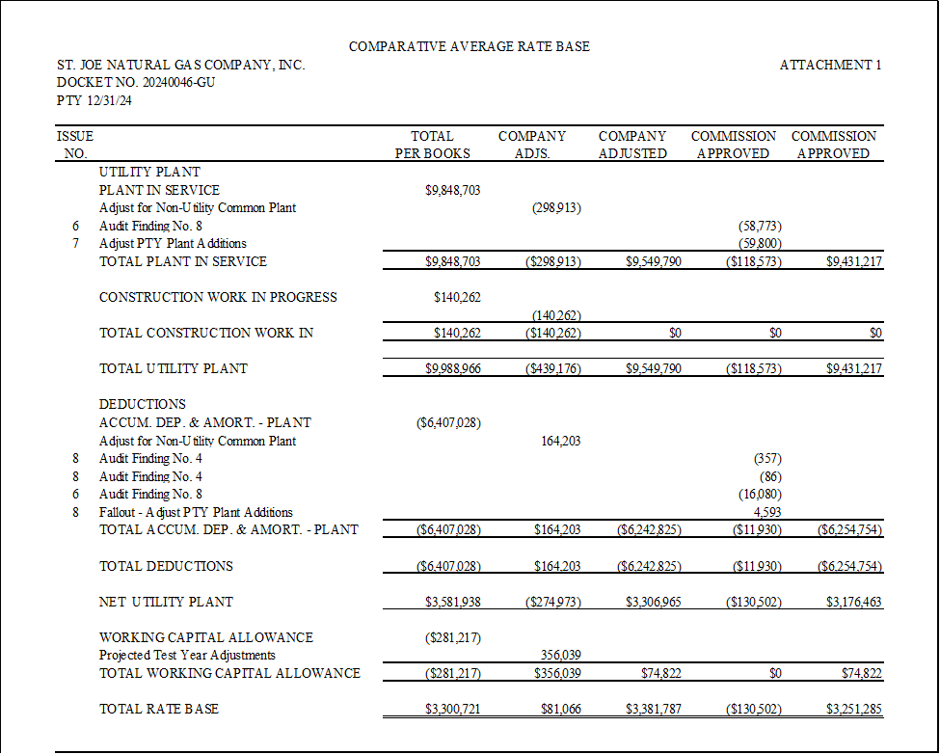

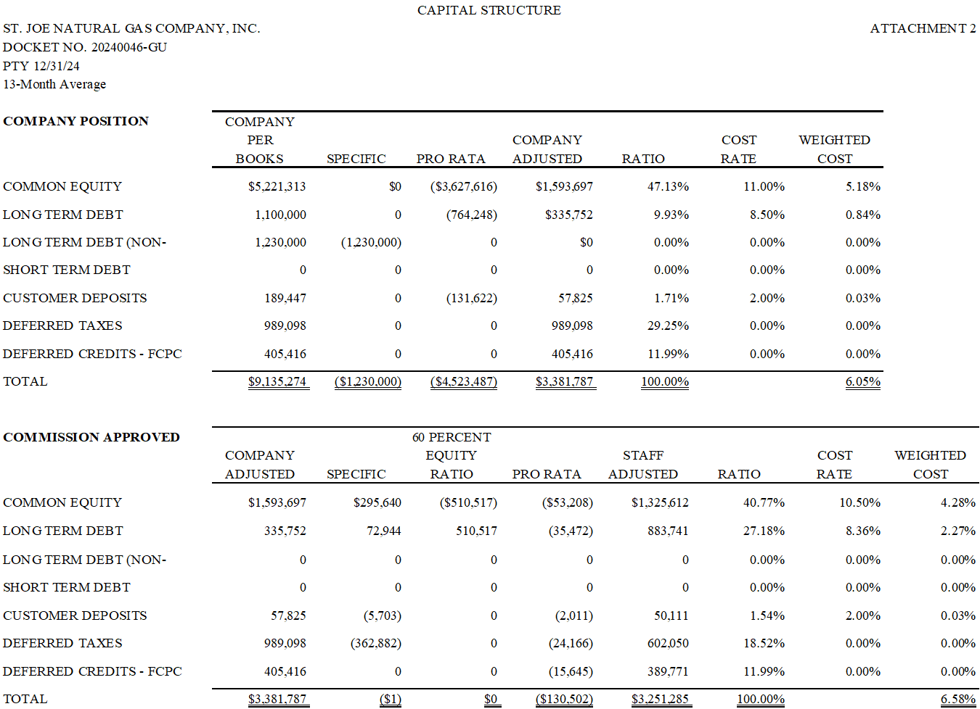
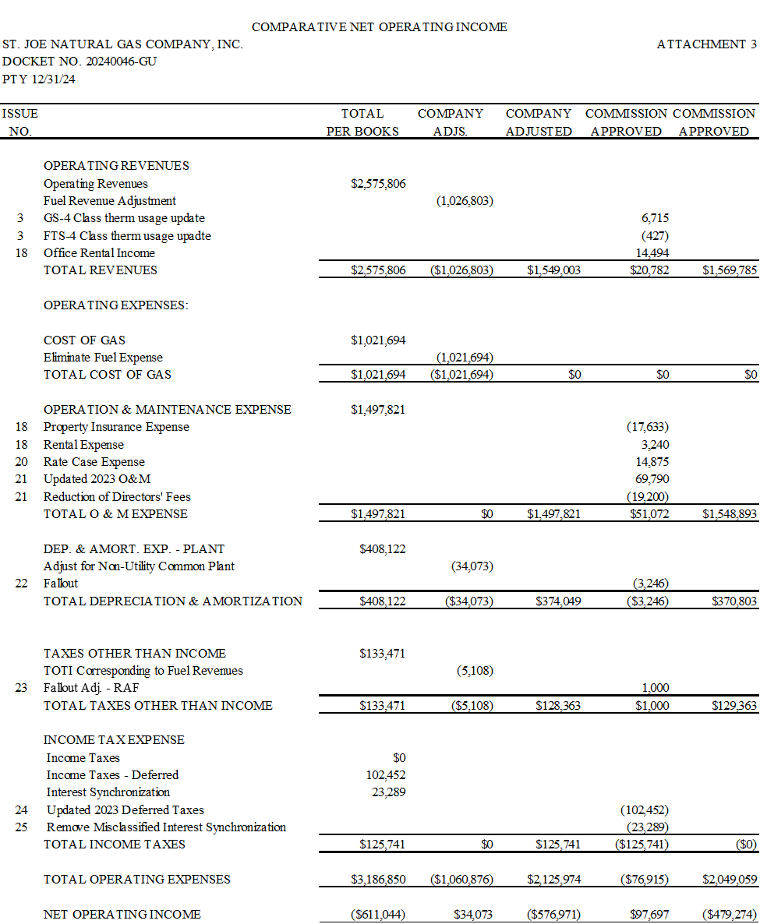
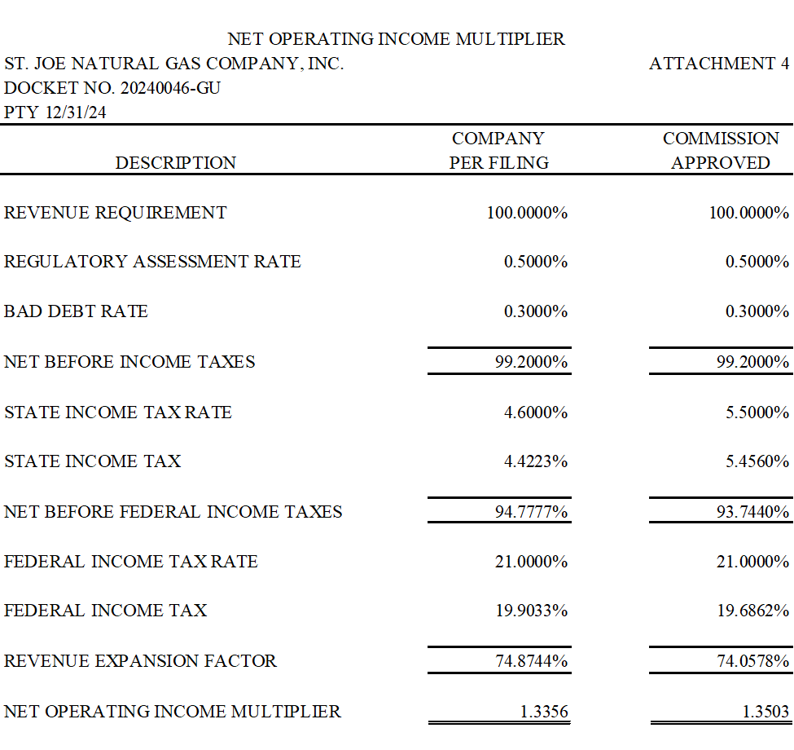
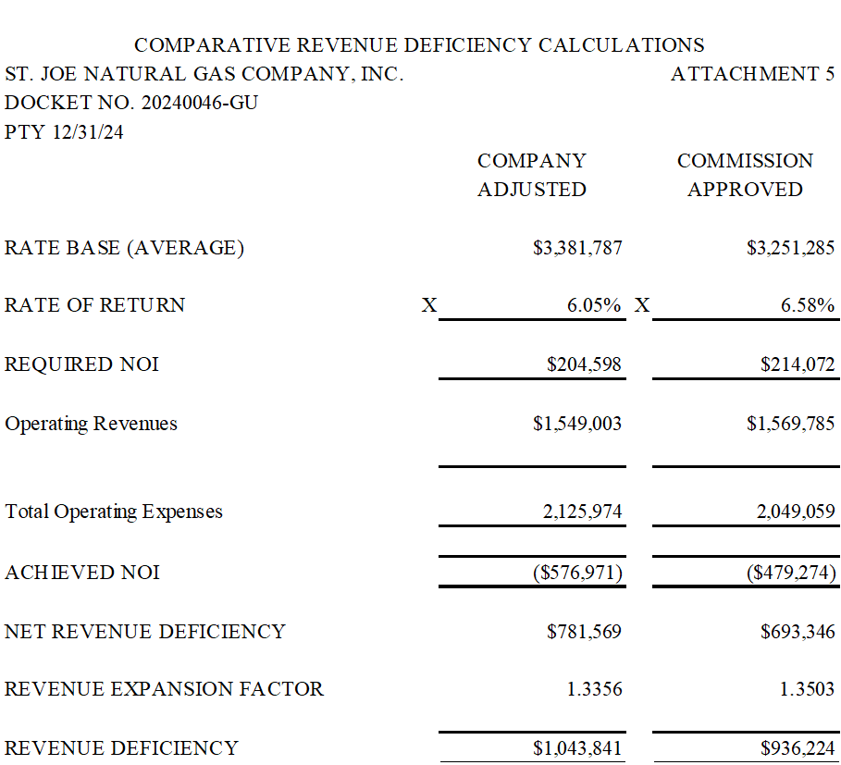
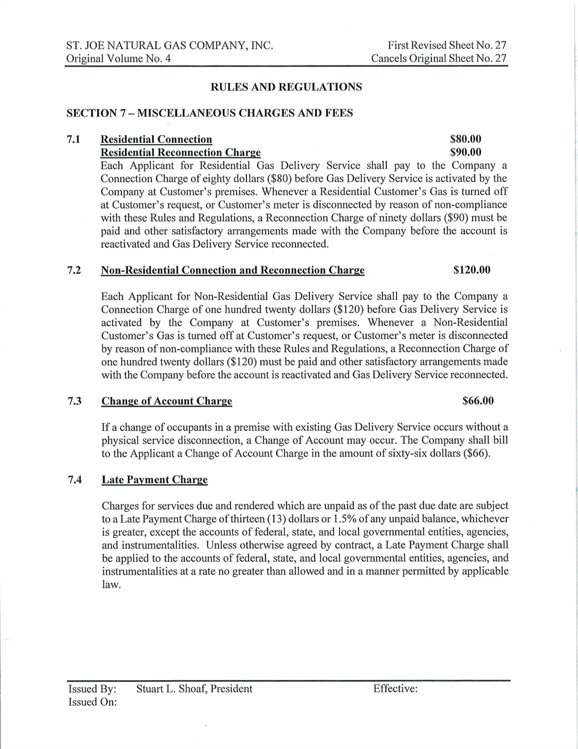
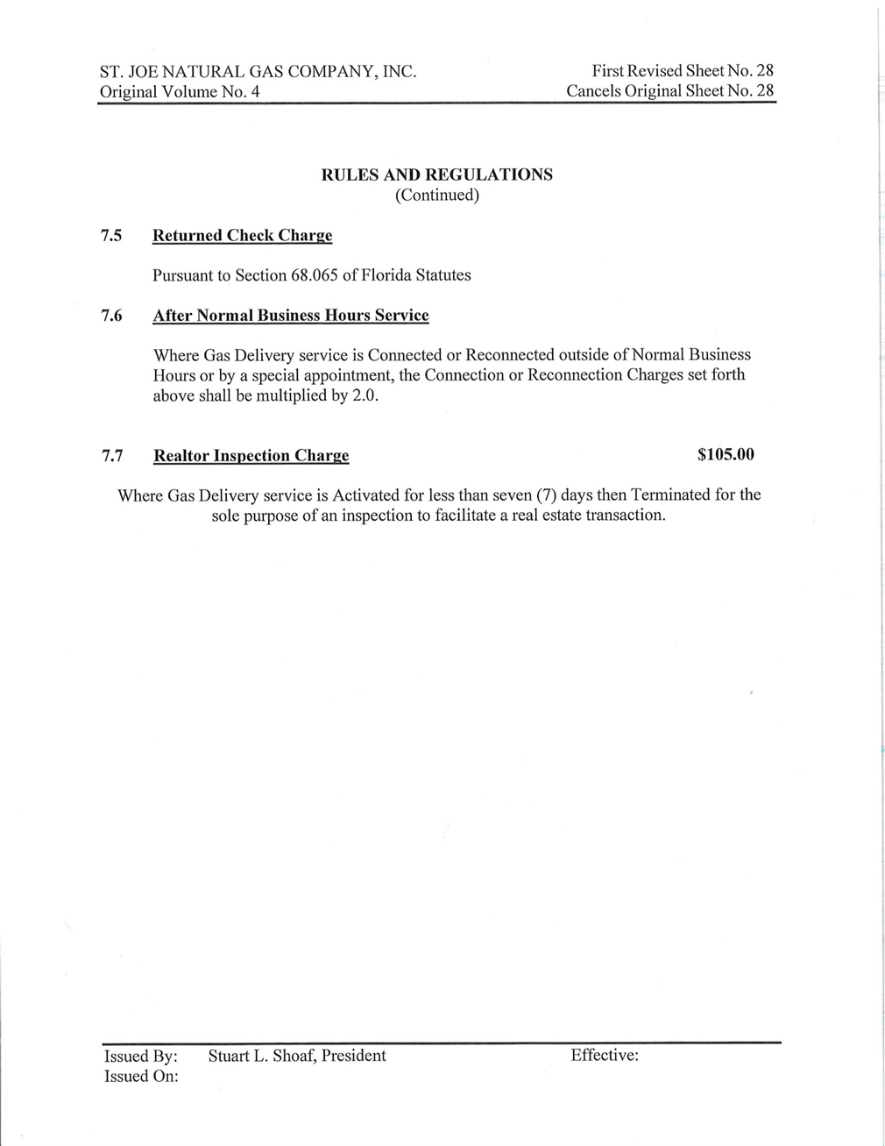
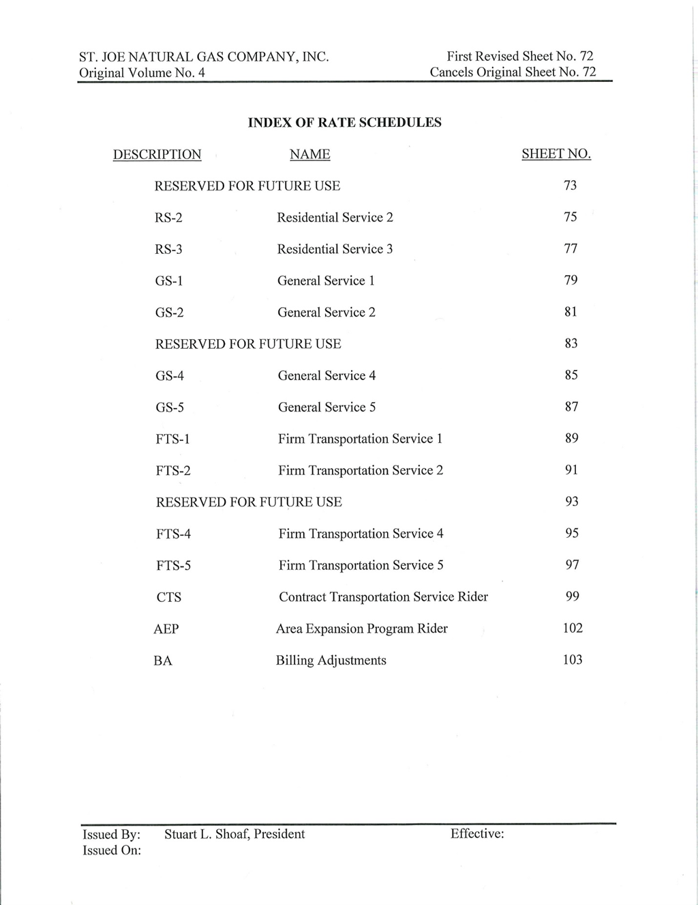
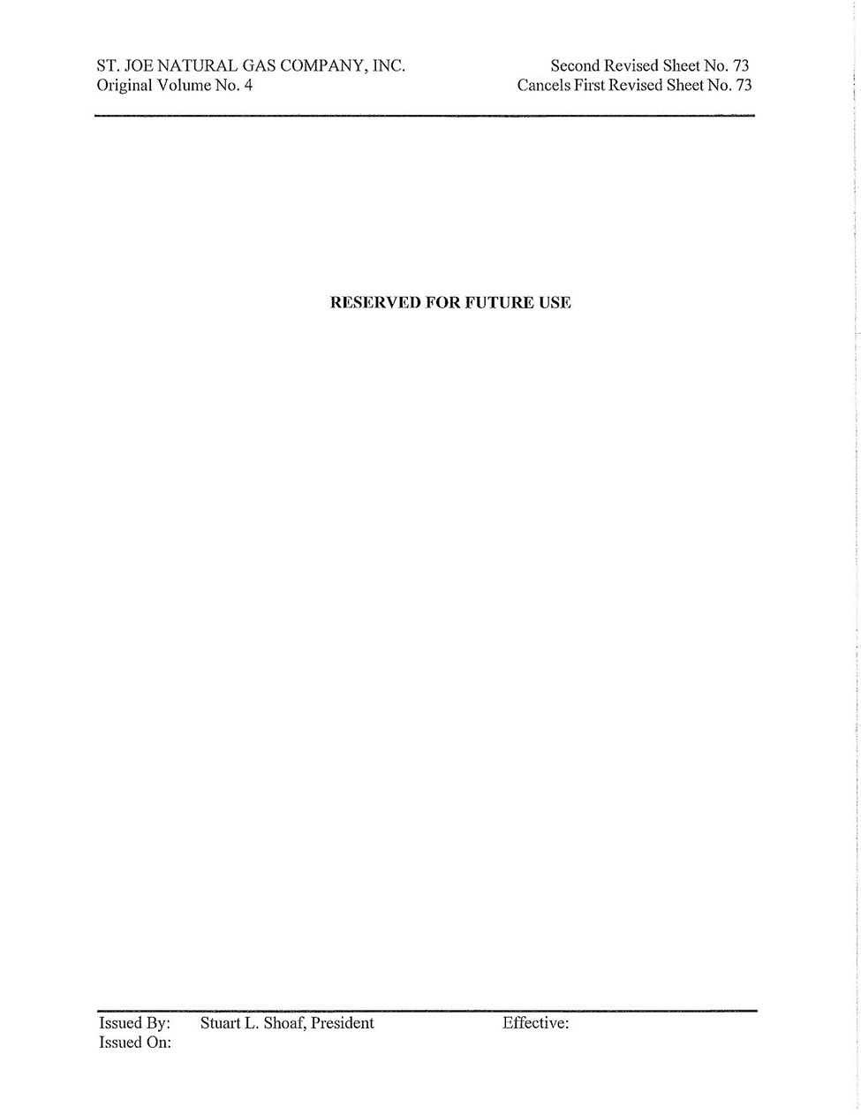
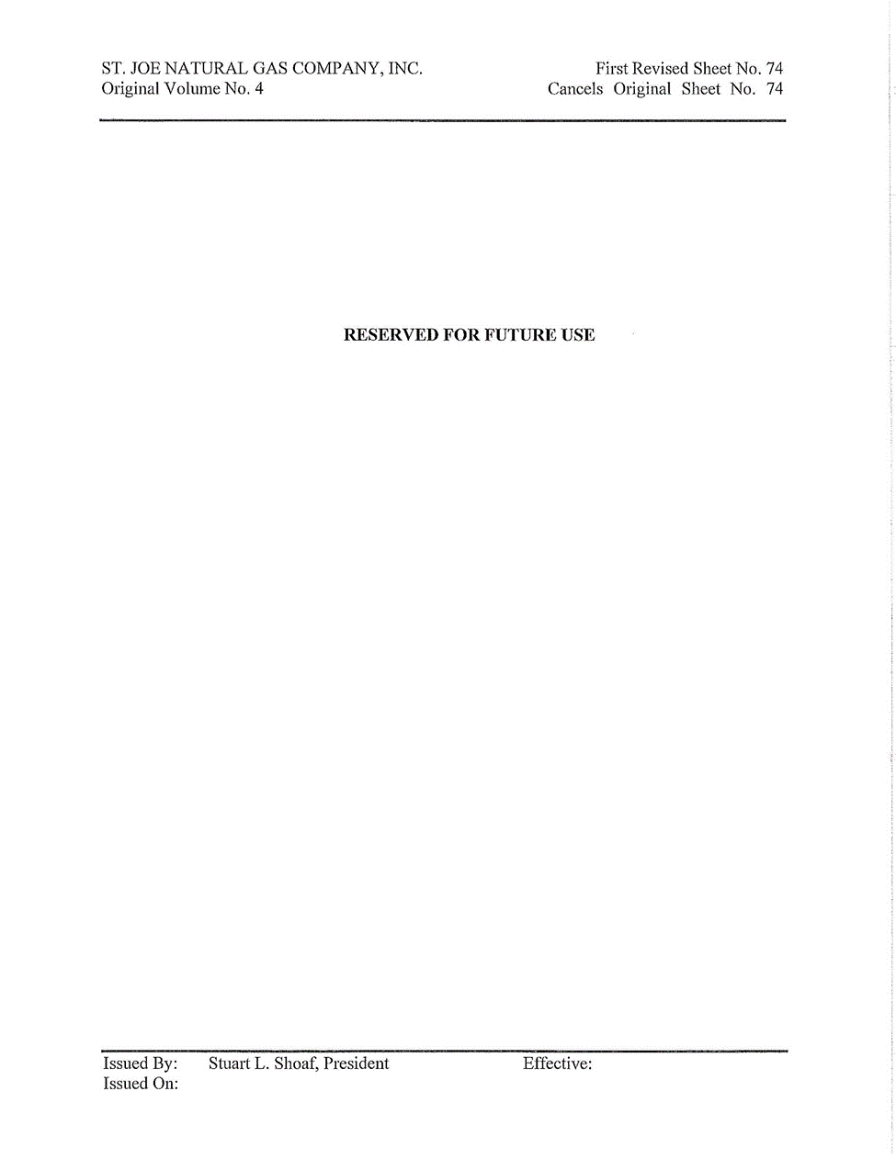
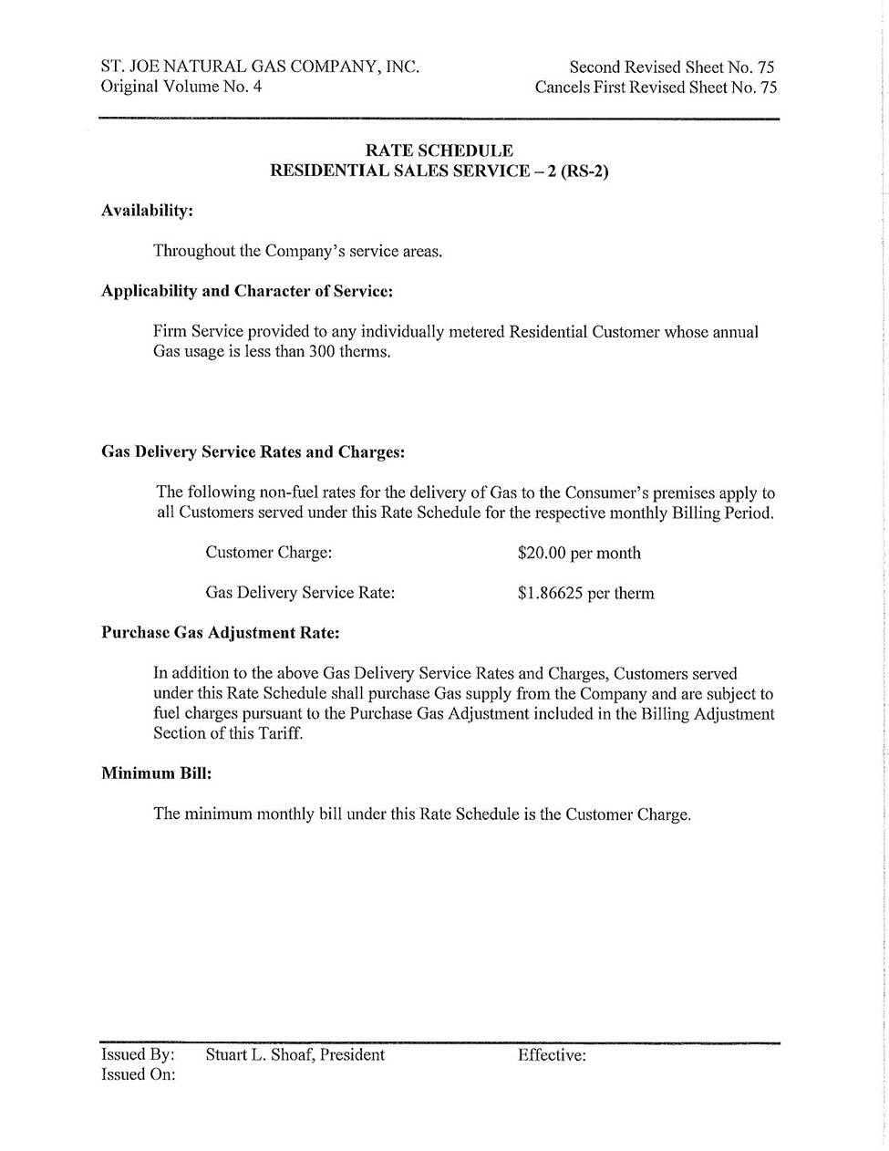
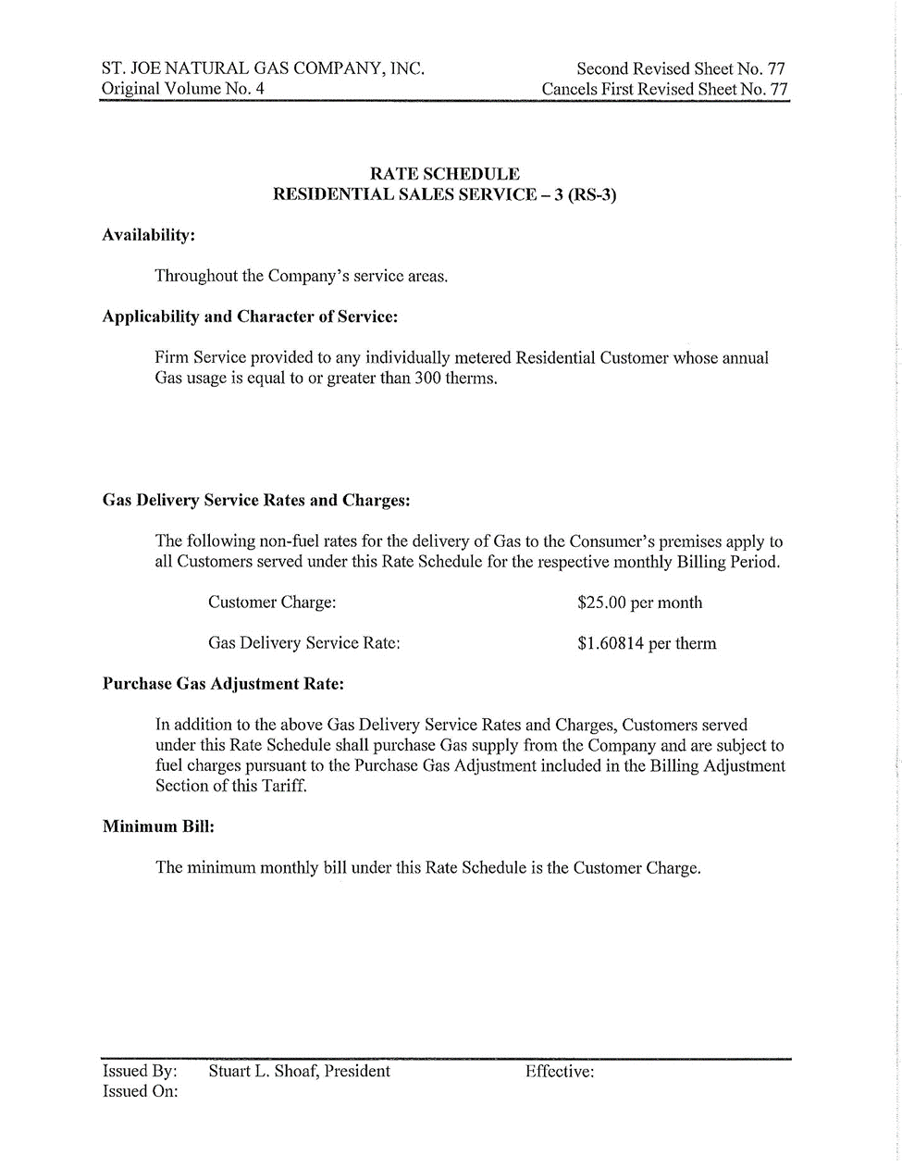
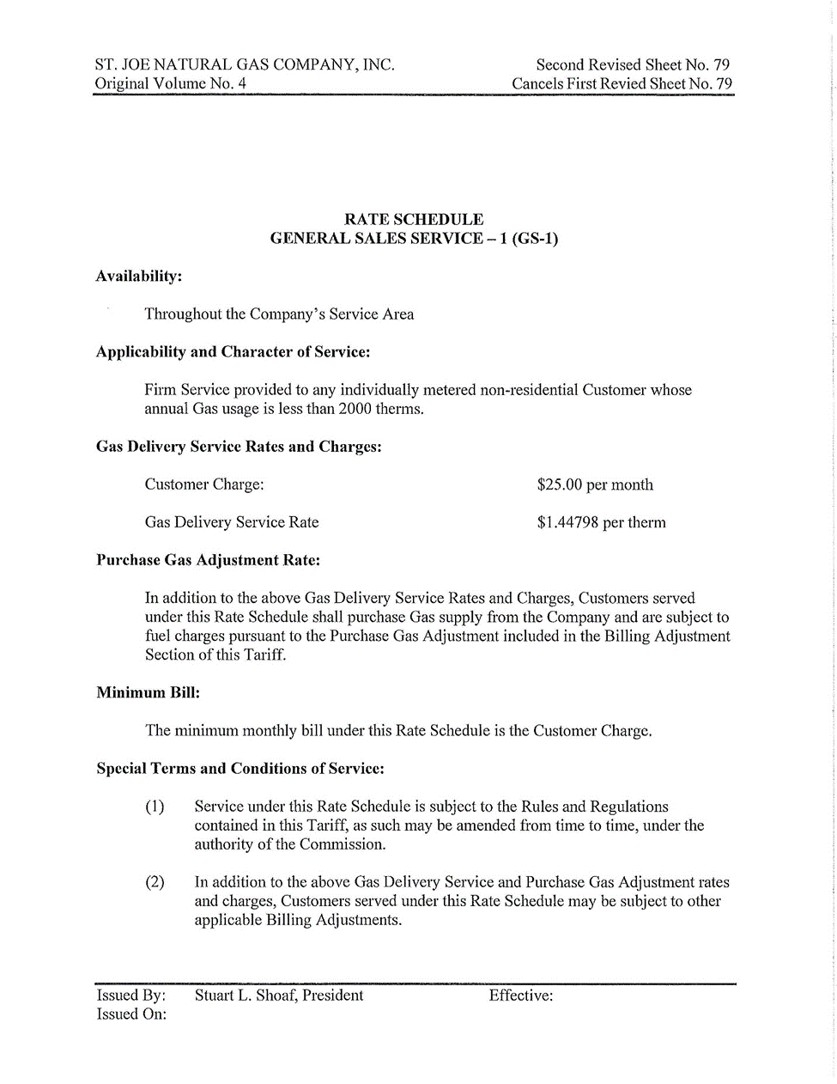
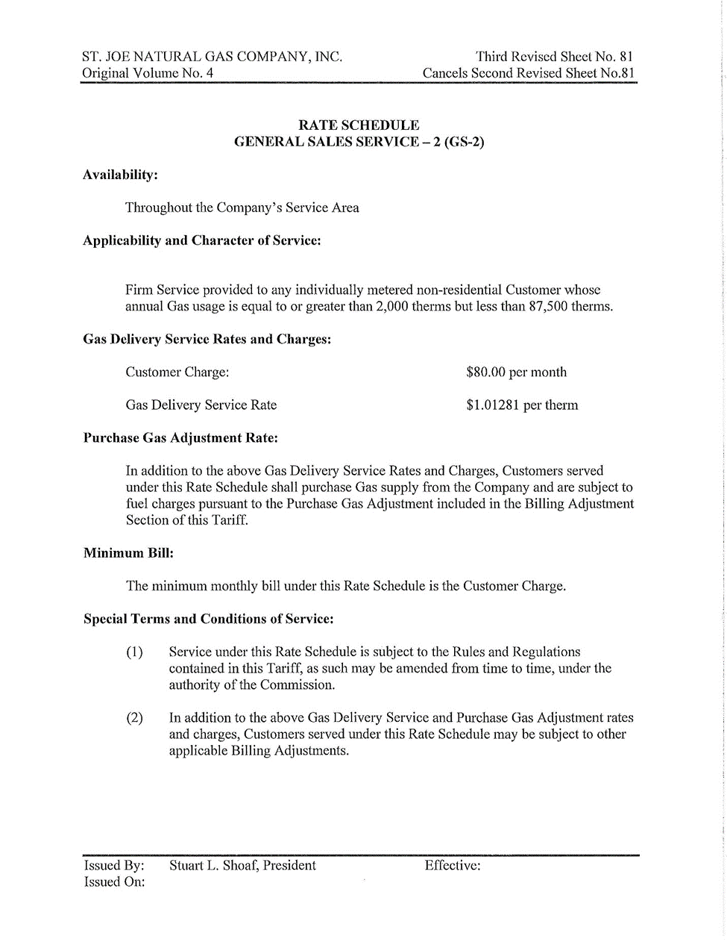
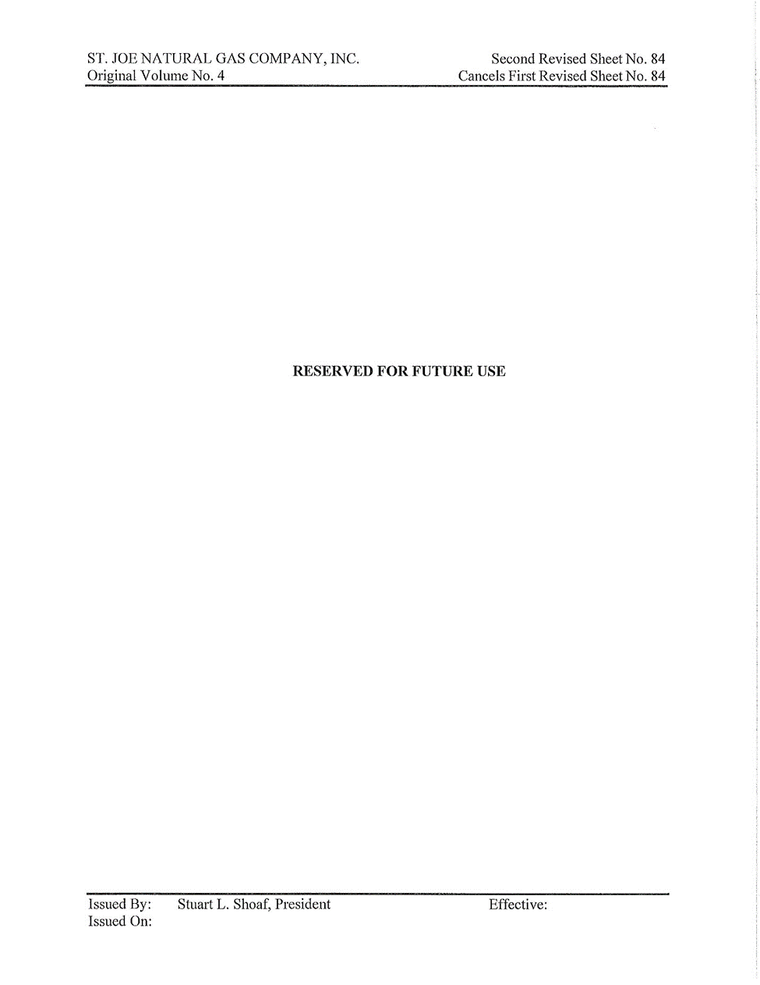
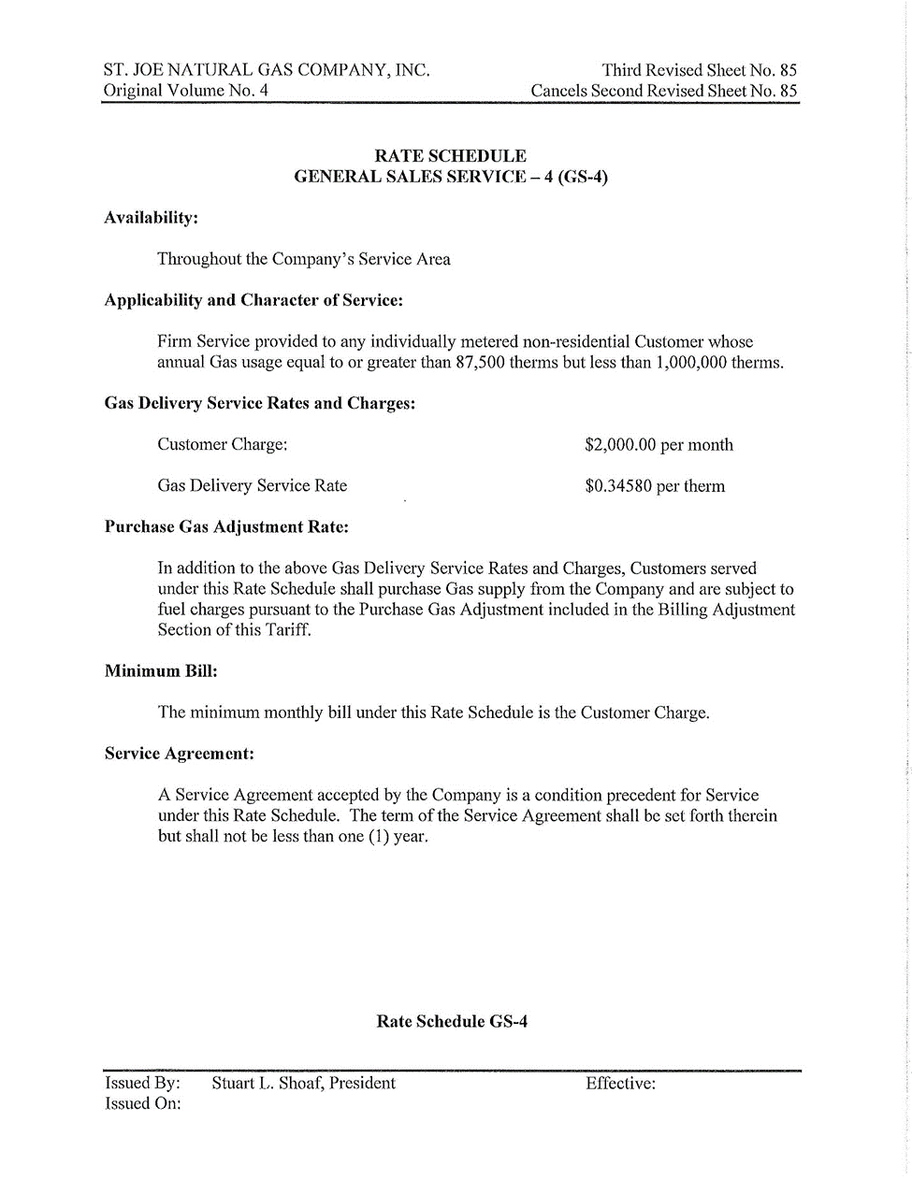
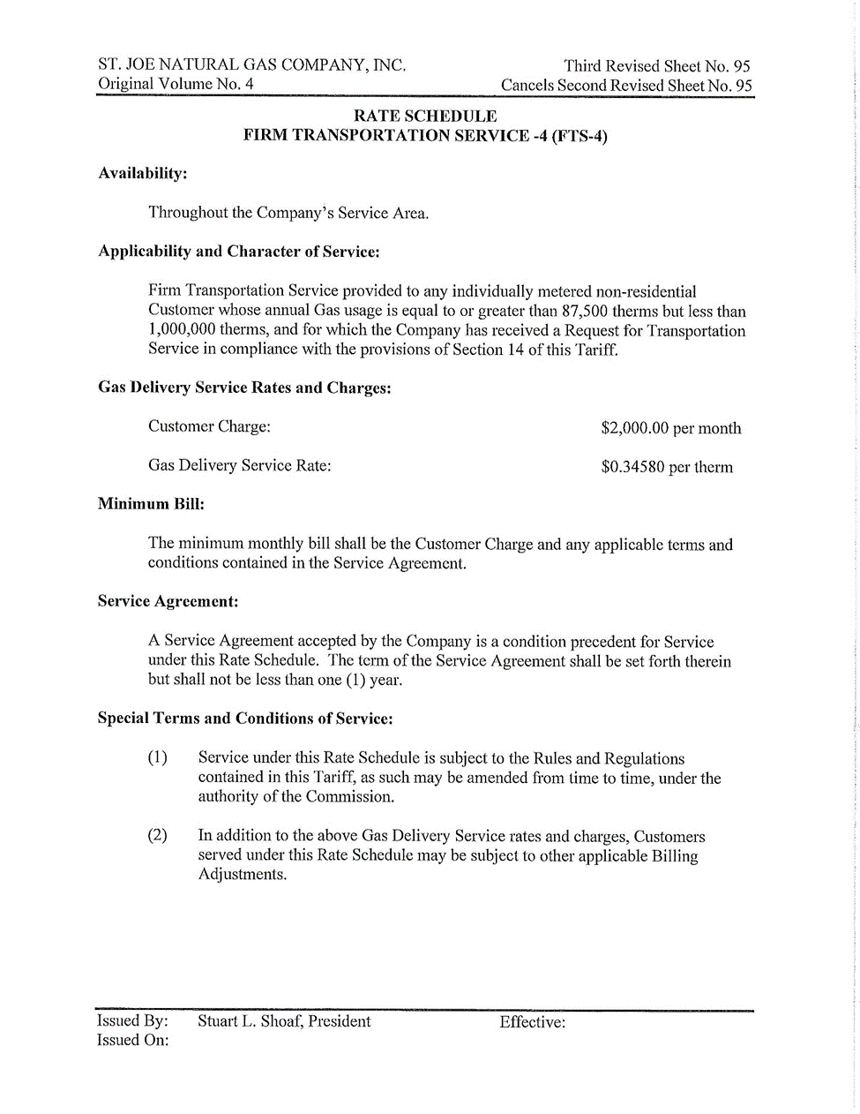
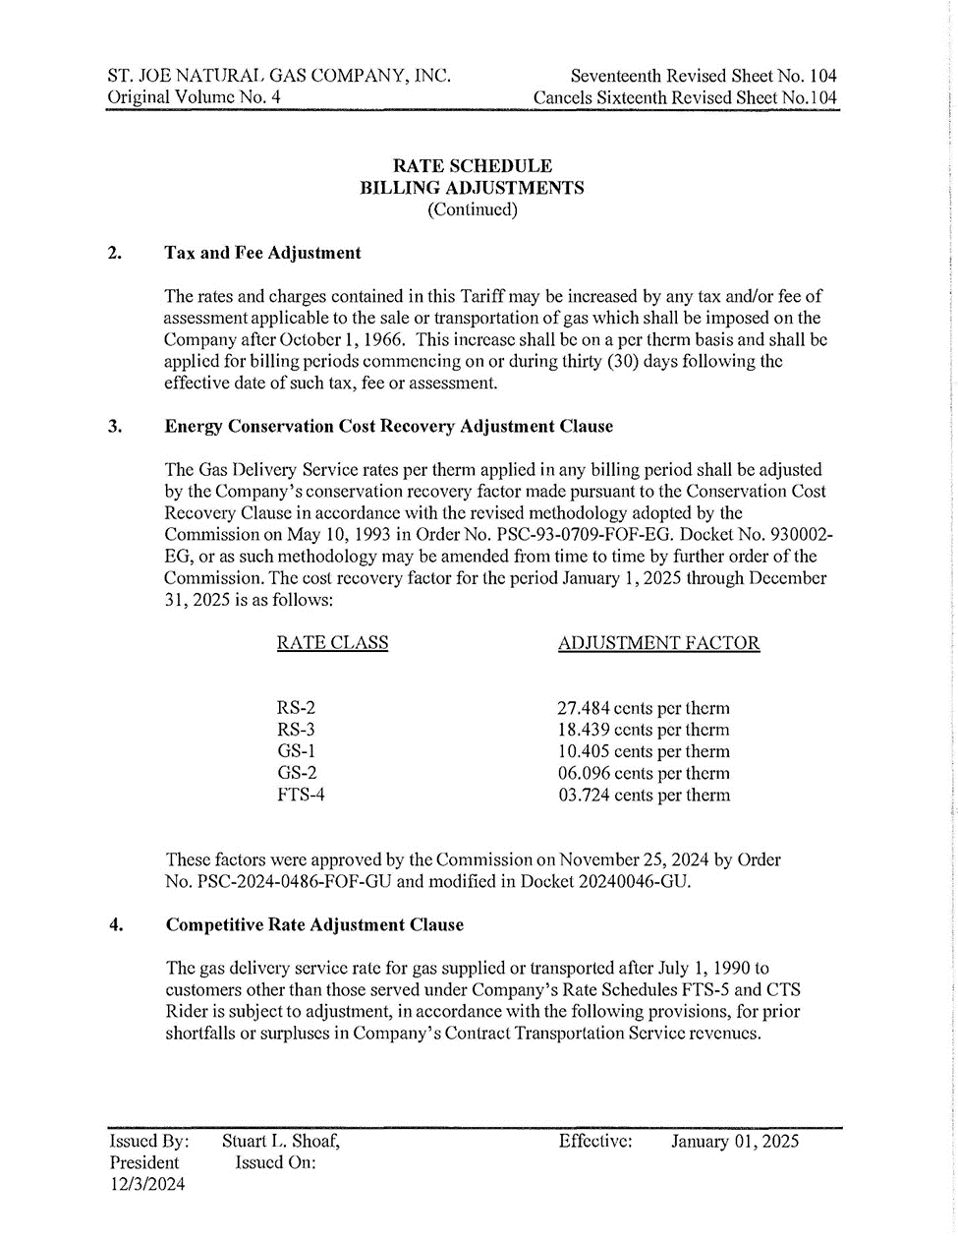

Order No. PSC-2008-0436-PAA-GU, issued July 8, 2008, in Docket No. 20070592-GU, In re: Petition for rate increase by St. Joe Natural Gas Company, Inc.
Order No. PSC-2016-0297-PAA-GU, issued July 27, 2016, in Docket No. 20160033-GU, In re: Petition for limited proceeding to restructure rates by St. Joe Natural Gas Company, Inc.
Order No. PSC-2021-0196-AS-GU, issued June 3, 2021, in Docket No. 20200039-GU, In re: Petition for approval to implement a temporary storm cost recovery surcharge, by St. Joe Natural Gas Company, Inc.
Order No. PSC-2024-0272-TRF-GU, issued July 26, 2024, in Docket No. 20200039-GU, In re: Petition for approval to implement a temporary storm cost recovery surcharge, by St. Joe Natural Gas Company, Inc.
Order No. PSC-2024-0379-PCO-GU, issued August 28, 2024, in Docket No. 20240046-GU, In re: Petition for rate increase by St. Joe Natural Gas Company, Inc.
Direct Testimony of Stuart Shoaf, page 17.
FPSC Data Requests
Order No. PSC-2023-0215-PAA-GU, issued July 26, 2023, in Docket No. 20230022-GU, In re: Petition for approval of 2022 Depreciation Study by St. Joe Natural Gas Company, Inc.
DN 09929-2024.
Document No. 09343-2024.
https://www.federalreserve.gov/releases/h15/.
Order No. PSC-08-0436-PAA-GU, issued July 8, 2008, in Docket No. 070592-GU, In re: Petition for rate increase by St. Joe Natural Gas Company, Inc.
Id.
Order No. PSC-01-1274-PAA-GU, issued June 8, 2008, in Docket No. 001447-GU, In re: Petition for rate increase by St. Joe Natural Gas Company, Inc.
Order No. PSC-08-0436-PAA-GU, issued July 8, 2008, in Docket No. 070592-GU, In re: Petition for rate increase by St. Joe Natural Gas Company, Inc.
Bluefield Water Works & Improvement Company v. Public Service Commission of West Virginia, et.al, 262 U.S. 679 (1923), and Federal Power Commission v. Hope Natural Gas Company, 320 U.S. 501 (1944).
In Order PSC-01-1274-PAA-GU, issued June 8, 2001, in Docket No. 001447-GU, In re: Request for rate increase by St. Joe Natural Gas Company, Inc., p. 20-21, we approved an accounting adjustment to recognize prepaid taxable extraordinary income related to the bankruptcy of FCPC that included the addition of a deferred tax liability to be amortized over 31 years in the capital structure at zero cost.
Order No. PSC-2001-1247-PAA-GU, issued June 8, 2001, in Docket No. 20001447-GU, In re: Petition for rate increase by St. Joe Natural Gas Company, Inc.
See Docket No. 20240004-GU, In re: Natural Gas Conservation Cost Recovery.
Order No. PSC-2024-0486-FOF-GU, issued November 25, 2024 in Docket No. 20240004-GU, In re: Natural Gas Conservation Cost Recovery.

